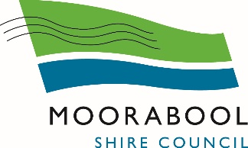

DISABILITY ACCESS and INCLUSION AWARDS

Information Guide

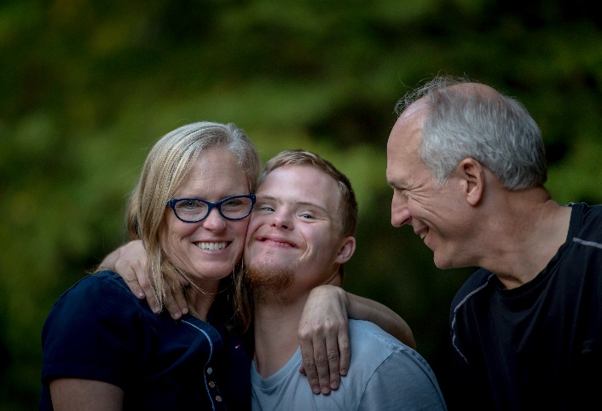

Updated September 2021

Moorabool Shire Council is committed to supporting the inclusion and contribution of people of all ages and abilities.

The Awards aim to:

- Encourage individuals, businesses and community organisations to deliver accessible and inclusive services;

- Publicly recognise and reward individuals, businesses and community organisations that demonstrate outstanding practices in the areas of access and inclusion;

- Raise awareness of the Federal Disability Discrimination Act (DDA) 1992 that makes it unlawful to discriminate against a person because of disability when providing goods, services, facilities or access to public premises;

- Increase community awareness of the barriers created by attitudes, practices and structures that limit the opportunities for people living with disability to fully participate in the life of the community.

The Disability Access and Inclusion Awards is an annual event where the Mayor or delegate presents the Awards on International Day of Disability on 3 December. Applications open in September.

SELECTION CRITERIA

Award Categories
Nominations will be assessed by a panel and awarded in one of the following three categories:

1 Access
Address common access barriers experienced by people affected by physical, cognitive, intellectual, neurological, sensory or mental health disability. This may include but is not limited to:
- Improving physical access to buildings or events
- Providing employment, learning or volunteering opportunities
- Developing accessible communications that meet a variety of needs
- Improving transport and/or parking
- Providing affordable services or opportunities
- Supporting carers
2 Service Delivery
Services that demonstrate best practice access and inclusion models that meet a variety of different needs and preferences. This may include existing or new initiatives.

3 Leadership and Innovation
Demonstrated initiative and innovation that raises awareness and influences others to value the contribution of people with disability.

Sustainable services and initiatives that have included the involvement of people with disability will be looked upon favourably.

NOMINATION PROCESS

Key Dates/Timelines
September/October | Promotion of Awards
November | Assessment Panel meets to assess applications
3 Dec 2021 | Awards to be presented on International Day of People with Disability

Who can be nominated?
All nominees must live, work, study, volunteer or regularly visit Moorabool Shire. Nominees must be:
- Local Businesses
- Community Service Organisations
- Incorporated not for profit groups
- Individuals

Completing Nomination Form
- Assistance to complete the nomination form is available. Details are provided on the nomination form;

- All nominations must be in writing using the Moorabool Disability Access and Inclusion Awards Nomination Form which is available in print and online;

- The application should provide detailed information on the reason for the nomination and a clear explanation of how the individual, business or organisation is improving the lives of people with disability;

- Additional information supporting the nomination can also be attached to the nomination form;

- Nominations will be accepted for more than one category for the same group or individual.

Communication
The Disability Access and Inclusion Awards are promoted through a variety of communication mediums that include:
- Local newspapers and print publications
- Council website and social media
- Business, Service and other Networks
- Local facilities such as libraries, recreation centres, child care centres and shopping hubs

Awards Presentation
Awards will be presented at a civic reception hosted by the Mayor or delegated Councillor in December each year, where possible, to coincide with the United Nations International Day of Disability on 3 December 2021.

