|  |  |
| --- | --- |
|  | |
| **MINUTES**  **Ordinary Council Meeting**  **Wednesday, 6 April 2022** | |
| **Date:** | **Wednesday, 6 April 2022** |
| **Time:** | **6.00pm** |
| **Location:** | **Council Chambers, Ballan and Online** |

**Order Of Business**

1 Opening of Meeting and Prayer 1

2 Acknowledgement of Country 1

3 Recording of Meeting 1

4 Present 1

5 Apologies 1

6 Confirmation of Minutes 1

7 Disclosure of Conflicts of Interest 2

8 Public Question Time 2

9 Petitions 4

10 Presentations/Deputations 4

11 Community Planning and Economic Development Reports 5

11.1 Notice of Rescission - PA2021196 Building and Works Associated with Existing Industrial Premises (Abattoir) at 6 Woolpack Road, Bacchus Marsh 5

12 Community Strengthening Reports 6

12.1 Draft Public Art and Collections Policy 6

13 Customer Care and Advocacy Reports 11

13.1 Proposed Road Renaming - Section of Duncan Street, Ballan off Simpson Street 11

13.2 Revenue and Rating Plan - Rate Strategy Review - Community Engagement 15

14 Community Assets & Infrastructure Reports 21

14.1 Notice of Motion 298 & 299 - Hard Waste Collection & Transfer Station Vouchers 21

15 Other Reports 34

16 Notices of Motion 35

16.1 Notice of Motion - Bacchus Marsh-Geelong Road 35

16.2 Notice of Motion - Mountain Bike Jump Park, Telford Park 36

17 Notices of Rescission 39

Nil

18 Mayor’s Report 39

18.1 Mayor's Report 39

19 Councillors’ Reports 40

20 Urgent Business 42

20.1 Bacchus Marsh Eastern Link Road 42

20.2 Bacchus Marsh Eastern Link Road 42

20.3 Bacchus Marsh Racecourse Recreation Reserve - Stage 1 Works 42

20.4 Feasibility of a Training Facility at the Equine Club at the Bacchus Marsh Racecourse Recreation Reserve for the Commonwealth Games 43

20.5 Feasibility of a Training Facility at the Equine Club at Bacchus Marsh Racecourse Recreation Reserve for the Commonwealth Games 43

20.6 Update Report on the Bacchus Marsh Racecourse Recreation Reserve Project Scope and Budget Shortfalls 44

21 Closed Session of the Meeting to the Public 44

Nil

22 Meeting Closure 44

1 Opening of Meeting and Prayer

The Mayor opened the meeting with the Council Prayer at 6.00pm.

2 Acknowledgement of Country

I acknowledge the Traditional Owners of the land on which we are meeting. I pay my respects to their Elders, past and present, and the Aboriginal Elders of other communities who may be here today.

3 Recording of Meeting

In accordance with Moorabool Shire Council’s Governance Rules, the meeting is livestreamed.

4 Present

Cr Tom Sullivan, Mayor West Moorabool Ward

Cr Tonia Dudzik , Deputy Mayor East Moorabool Ward

Cr Moira Berry East Moorabool Ward

Cr Rod Ward East Moorabool Ward

Cr David Edwards East Moorabool Ward

Cr Ally Munari Woodlands Ward

Cr Paul Tatchell Central Moorabool Ward

**Officers:**

Mr Derek Madden Chief Executive Officer

Ms Caroline Buisson General Manager Customer Care & Advocacy

Mr Phil Jeffrey General Manager Community Assets & Infrastructure

Ms Sally Jones General Manager Community Strengthening

Mr Henry Bezuidenhout Executive Manager Community Planning & Economic

Development

Ms Bec Carey-Grieve Arts, Culture & Events Officer

5 Apologies

Nil

6 Confirmation of Minutes

|  |
| --- |
| **Resolution**  **Moved:** Cr Tonia Dudzik  **Seconded:** Cr Ally Munari  **That the minutes of the Ordinary Council Meeting held on Wednesday 2 March 2022 be confirmed.**  **Carried** |

7 Disclosure of Conflicts of Interest

Cr Paul Tatchell declared a Conflict of Interest in relation to Agenda Item 13.1 .

8 Public Question Time

|  |  |  |  |
| --- | --- | --- | --- |
| **Name** | **Question/Response** | **CEO/GM/EM** | **Read at Meeting (Yes/No)** |
| Mr John Kowarsky, Ballan | Question:  Can Council please advise the date and what the Traffic Safety Audit undertaken at the intersection of Mill Park drive and Blackwood Road, Ballan, recommended? | Phil Jeffrey – GM  Community Assets & Infrastructure | Yes  Yes |
|  | **Response:**  A road safety audit was undertaken in December 2020 by an independent accredited contractor following completion of the masterplan for the Mill Park Reserve. The key points raised in the audit were sight distance improvements at the intersection, siting of the pedestrian access and signage and speed limit considerations. |  |
| Mr John Kowarsky, Ballan | Question:  Can Council please advise of its plans, if any, to improve safety for vehicles, cyclists and pedestrians using the Mill Park Swimming Pool and recreational area via Blackwood Road, Ballan. | Phil Jeffrey – GM  Community Assets & Infrastructure |
|  | **Response:**  As part of the response to the Road Safety Audit undertaken at the site, Council is proposing the following measures:   1. Improvements to sight distance at the intersection through vegetation management, some of which require approval prior to implementation. 2. Construction of a new separate pedestrian connection to the park incorporating a revised location based on the safety audit. 3. Making application to Department of Transport for a speed reduction at this location.   Note – correspondence from Mr Kowarsky has recently been received and responded to in relation to this matter. |  |

|  |  |  |  |
| --- | --- | --- | --- |
| Mr David Marnie, Parwan | Question:  Will Council seek an urgent meeting with relevant State Government Ministers to have the Woolpack Road option considered as a Bacchus Marsh East Link Route? | Henry Bezuidenhout, EM  Community Planning & Economic Development | Yes |
|  | **Response:**  It is the understanding of Council officers that the Woolpack Road option has been considered for the Bacchus Marsh Eastlink Road project. Council officers will endeavour to follow up on Mr Marnie’s request to write to the Minister. |  |  |
| Mr David Marnie, Parwan | Question:  Will Council seek an urgent meeting with relevant State Government Ministers to request urgent funding to commence solving Bacchus Marsh Township traffic congestion (and report back on the outcome)? | Phil Jeffrey – GM  Community Assets & Infrastructure | Yes |
|  | **Response:**  Over a long period, Council has been working on traffic improvements around Bacchus Marsh. This has been informed by the Bacchus Marsh integrated transport strategy that has successfully implemented and advocated for a number of projects in recent years, including but not limited to:   * The Halletts Way/O’Leary Way Southern extension * Halletts Way Northern extension * Melbourne bound freeway ramps and pedestrian overpass at Halletts Way * Gisborne Road/Western Freeway intersection upgrade * Main St/Gisborne Road traffic signals * The Eastern Link Road corridor planning study * Construction of the Aqualink cycle corridor   Whilst there is no single solution for traffic  improvement outcomes for Bacchus Marsh, Council will continue to implement and advocate for traffic improvement projects for the town, particularly with future residential growth areas being planned.  In conjunction with the first question relating to the Eastern Link Road project, officers would be happy to write to the relevant ministers seeking ongoing support for traffic improvements and seeking a meeting to discuss the issues. |  |  |

9 Petitions

Nil

10 Presentations/Deputations

|  |  |  |  |  |
| --- | --- | --- | --- | --- |
| **Item**  **No** | **Description** | **Name** | **Method** | **Position** |
| 11.1 | Notice of Rescission - PA2021196 Building and Works Associated with Existing Industrial Premises (Abattoir) at 6 Woolpack Road, Bacchus Marsh. | Mr Edward Lynch | Online | Objector |
| 11.1 | Notice of Rescission - PA2021196 Building and Works Associated with Existing Industrial Premises (Abattoir) at 6 Woolpack Road, Bacchus Marsh. | Mr Glenn Jacobsen | Online | Objector |
| 11.1 | Notice of Rescission - PA2021196 Building and Works Associated with Existing Industrial Premises (Abattoir) at 6 Woolpack Road, Bacchus Marsh. | Mr Joe Failli | Online | Objector |
| 13.1 | Proposed Road Renaming - Section of Duncan Street, Ballan off Simpson Street | Ms Helen Tatchell | Online | Objector |
| 13.2 | Revenue and Rating Plan - Rate Strategy Review - Community Engagement | Mr David Marnie | Online | Supporter |
| 13.2 | Revenue and Rating Plan - Rate Strategy Review - Community Engagement | Ms Kate Sharkey | Online | Supporter |

11 Community Planning and Economic Development Reports

Mr Edward Lynch addressed Council as an objector to Item 11.1

Mr Glenn Jacobsen addressed Council as an objector to Item 11.1

11.1 Notice of Rescission - PA2021196 Building and Works Associated with Existing Industrial Premises (Abattoir) at 6 Woolpack Road, Bacchus Marsh

**Author: Dianne Elshaug, Co-ordinator CEOs Office**

**Authoriser: Derek Madden, Chief Executive Officer**

**Attachments: Nil**

I, Councillor Moira Berry, give notice that at the next Ordinary Meeting of Council to be held on 6 April 2022, I intend to move the following rescission motion:

|  |
| --- |
| **Resolution**  **Moved:** Cr Moira Berry  **Seconded:** Cr Tonia Dudzik  **1. That the Resolution for Item 7.6 from the Development Assessment Committee held on 16 February 2022 be rescinded.**  **2. That the original recommendation as proposed by Officers be put back to Council for consideration, with an amendment to Condition 4 (operational) as follows:**  **(a) The proposed building must be removed from the site within seven years of the completion of the development unless otherwise agreed to by Council.**  **LOST**  **Cr Berry called for a Division:**  In Favour: Crs Tonia Dudzik, Moira Berry and Paul Tatchell  Against: Crs Tom Sullivan, David Edwards, Ally Munari and Rod Ward  **The Mayor declared the motion lost** |

RATIONALE

The timeframe of five years as proposed in the original recommendation is of insufficient time; seven years is a more reasonable timeframe.

I commend this Notice of Rescission to Council.

12 Community Strengthening Reports

12.1 Draft Public Art and Collections Policy

**Author: Bec Carey-Grieve, Arts, Culture and Events Officer**

**Authoriser: Sally Jones, General Manager Community Strengthening**

**Attachments: 1. Draft Public Art and Collections Policy (under separate cover)**

Purpose

The purpose of this report is to provide Councillors with the draft Public Art and Collections Policy and to seek Council approval to publicly exhibit the draft Policy for further community feedback which will inform the final Policy.

Executive Summary

• The Public Art and Collections Policy is a key deliverable contained within the recently adopted Arts and Culture Strategy Year 1 Annual Action Plan.

• By developing a framework and associated resourcing to support a Public Art Program, this Policy will address key priorities and challenges identified through extensive internal and external consultation undertaken in 2021, through the development of the Arts and Culture Strategy.

|  |
| --- |
| Resolution  **Moved:** Cr Paul Tatchell  **Seconded:** Cr Moira Berry  **That Council approves the Draft Art and Collections Policy provided as Attachment 1 for public exhibition and feedback.**  **Carried** |

Background

A key deliverable contained within the recently developed Arts and Culture Strategy Year 1 Annual Plan, is the development of a Public Art and Collections Policy to encourage and support the growth of public art in the Shire. Public Art provides many benefits and opportunities for the Shire including:

• Enhancing new and existing spaces;

• Celebrating our townships’ unique identities;

• Supporting our local creative sector;

• Increasing access to and participation in Public Art;

• Attracting visitors to the Shire.

The Policy supports other strategies currently in development such as the Visitor Economy Strategy. Research shows enhancing our communities through Public Art directly supports cultural tourism and economic development strategies, particularly in regional areas. The Australia Council for the Arts’ Domestic Tourism report showed Arts tourists are high value tourists, more likely to stay longer and spend more.

By developing a framework and associated resourcing to support a Public Art Program, this Policy will address key priorities and challenges identified through extensive internal and external consultation undertaken in 2021 through the development of the Arts and Culture Strategy, including:

• 94% of survey respondents feel local arts and cultural activities are important;

• 89% of survey respondents value having access to activities from a range of cultures;

• 87% of artist respondents felt experimentation was important to their practice;

• 68% of artists do not have access to local opportunities.

To achieve the outcomes of the Arts and Culture Strategy, eight pillars were developed. This Policy seeks to support the strategy priority areas to:

• Increase and diversify arts and cultural activity;

• Reduce barriers to delivering and participating in creative activities;

• Connect with our unique heritage and environment;

• Create moments of joy in everyday life;

• Use Arts and Culture to drive better outcomes for Council and the community.

A Policy scan, benchmarking and further internal consultation has been undertaken to inform this final draft.

The Policy will involve the following key stakeholders:

• All Council departments;

• Artists, both local and outside the Shire;

• Moorabool Shire Residents and Businesses;

• Tourists;

• Land Developers;

• Peak bodies;

• Industry experts.

Proposal

It is recommended that the Draft Public Art and Collections Policy be approved for public exhibition and feedback, to inform the final Policy to be presented at a future Ordinary Meeting of Council.

Council Plan

The Council Plan 2021-2025 provides as follows:

**Strategic Objective 1: Healthy, inclusive and connected neighbourhoods**

**Priority 1.3: Facilitate opportunities for the community to gather and celebrate**

The proposal to approve the draft Public Art and Collections Policy for public exhibition and feedback is consistent with the Council Plan 2021-2025.

Financial Implications

Following the Policy being adopted, an ongoing provision for Public Art will be allocated from Council’s annual budget. Funds will be allocated through the following processes:

• Council officers will apply for annual provision of funds through the budget process;

• A contribution for Public Art should be provided for any significant works undertaken by the Shire that are Community Facility projects or Streetscape enhancement projects. This contribution is one percent (1%) of the approved project budget (ex GST), with a maximum cap of $250,000;

• Council officers will collaborate with Developers who wish to contribute to Council’s public art fund.

Risk & Occupational Health & Safety Issues

|  |  |  |  |
| --- | --- | --- | --- |
| **Risk Identifier** | **Detail of Risk** | **Risk Rating** | **Control/s** |
| Policy is not adopted | Community expectations are not met.  There is no clear and consistent direction to guide decision making for the public art collection in the Shire. | Medium | The draft Policy has been benchmarked against best practice and will be publicly exhibited to provide opportunity for community feedback.  The draft Policy has been informed by Council’s Arts and Culture Strategy and community consultation. |

Communications & Consultation Strategy

| **Level of Engagement** | **Stakeholder** | **Activities** | **Location** | **Date** | **Outcome** |
| --- | --- | --- | --- | --- | --- |
| Consultation | Local Artists  Residents  Businesses  Creative Industry  Key Council Staff | Forums with community groups  1-1 interviews  Online forums  Arts and Culture Project Control Group  Capital Works Development committee | Bacchus Marsh  Ballan  Online | February 2021 – February 2022 | Over 100 participants.  Over 50 interviews conducted. |

|  |  |  |  |  |  |
| --- | --- | --- | --- | --- | --- |
|  | Public Survey | A survey was published on Moorabool’s Have Your Say Engagement hub for the development of the Arts and Culture Strategy | Have Your Say Moorabool webpage | March 2021 | 124 survey responses received |
|  | Drop in Consultations | Future Tense Consultancy and Moorabool’s Arts, Culture and Events Officer attended key arts and cultural events in the Shire | Bacchus Marsh Arts Council Exhibition opening, BM Music Bowl, St Anne’s pizza and music afternoon, Studio 22 youth space | March 2021 | In depth data was collected from respondents who may not have seen the survey or who were tourists who lived outside the Shire |
|  | Traditional Owner Consultations | Online consultations were conducted with Wurundjeri Woi Wurrung, Wadawurrung and Dja Dja Wurrung (including local artists) | Online | March/April 2021 | Key insights gathered from Traditional Owners (TO) including Elders and Artists residing in the Shire  3 TO Recognised Aboriginal Parties (RAP) interviews  3 TO reviews of the Strategy  6 Wadawurrung local artist interviews |
|  | Public Exhibition of Draft Public Art and Collections Policy | The draft Policy will be publicly exhibited | Online and public forum | April 2022 | All feedback received will inform the final Policy |

Victorian Charter of Human Rights & Responsibilities Act 2006

In developing this report to Council, the officer considered whether the subject matter raised any human rights issues. In particular, whether the scope of any human right established by the Victorian Charter of Human Rights and Responsibilities is in any way limited, restricted or interfered with by the recommendations contained in the report. It is considered that the subject matter does not raise any human rights issues.

Officer’s Declaration of Conflict of Interests

Under section 130 of the *Local Government Act 2020*, officers providing advice to Council must disclose any interests, including the type of interest.

*General Manager – Sally Jones*

In providing this advice to Council as the General Manager, I have no interests to disclose in this report.

*Author – Bec Carey Grieve, Arts, Culture and Events Officer*

In providing this advice to Council as the Author, I have no interests to disclose in this report.

Conclusion

Supporting the development of a Public Art and Collections Policy will provide a framework and resourcing to develop an ongoing Public Art program for the Shire. Public Art provides many benefits to the community and was a key deliverable in year 1 of the Arts and Culture Strategy Annual Plan.

13 Customer Care and Advocacy Reports

Cr Paul Tatchell declared a conflict of interest for Agenda Item 13.1 and left the meeting at 6.38pm.

Ms Helen Tatchell addressed Council as an objector to the recommendation.

13.1 Proposed Road Renaming - Section of Duncan Street, Ballan off Simpson Street

**Author: Tim Warfe, GIS Officer**

**Authoriser: Caroline Buisson, General Manager Customer Care & Advocacy**

**Attachments: Nil**

Purpose

The purpose of this report is to present Council with a proposal to rename the northern section of Duncan Street, Ballan off Simpson Street to meet the needs of Australia Post and Emergency Services Victoria.

Executive Summary

• Council is requested to formally approve the road renaming of the northern section of Duncan Street, Ballan and approve the submission to Geographic Names Victoria to be formally gazetted.

|  |
| --- |
| **Resolution**  Moved: Cr Tonia Dudzik  Seconded: Cr Ally Munari  **That Council approves the road renaming proposal be submitted to Geographic Names Victoria for approval, outlining the northern section of Duncan Street, Ballan to become Simpson Court, Ballan.**  The following alteration to the Motion was recommended and accepted by the Mover and Seconder:  That Council defer consideration of this item to allow for appropriate processes to be undertaken to approve naming of this court to Simpson Court.  Cr Edwards proposed a further alteration to the motion which was accepted by the Mover and Seconder therefore becoming the substantive motion:  **Moved:** Cr Tonia Dudzik  **Seconded:** Cr Ally Munari  **That Council defer consideration of this item until the review being conducted by the State Government in relation to naming conventions for new streets has been completed.**  **Carried** |

Background

There has been a request from the landowner at 26 Duncan Street, Ballan for Council to rename the section of road where her property is located. Duncan Street, Ballan is currently not contiguous, causing her property to be difficult to locate due to vehicles not being able to access this section of road via Inglis Street.  Potential issues for mail delivery and emergency service delays have also been raised as by the landowner.

There are 3 houses currently addressed to this section of Duncan Street. When it is officially renamed these property owners will need to have their addresses changed with their associates, State Government services and Australia Post.

Proposal

To rename the northern section of Duncan Street to “Shamrock Court”, as per the suggestion from the applicant. The section of road as shown in Figure 1 is the road in question. Council has consulted with the ratepayers and surrounding community as per the requirements set out by the Geographic Names Victoria guidelines. Council received one positive and one negative response to the community engagement.

Figure 1.

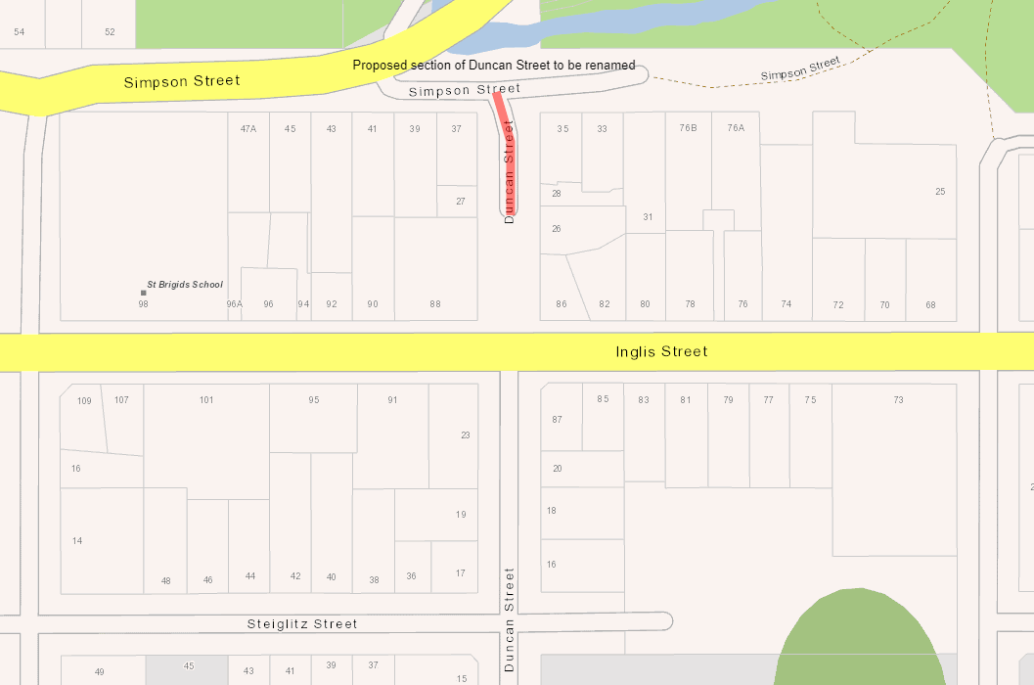

Council Plan

The proposal is not provided for in the Council Plan 2021-2025 and can be actioned by utilising existing resources.

Financial Implications

The financial implications associated with this report can be managed within the current year’s budget allocations.

Risk & Occupational Health & Safety Issues

There are potential risks associated with public safety due to emergency services not being able to access the section of Duncan Street in a timely manner.

Communications & Consultation Strategy

|  |  |  |  |  |  |
| --- | --- | --- | --- | --- | --- |
| **Level of Engagement** | **Stakeholder** | **Activities** | **Location** | **Date** | **Outcome** |
| Submit | Geographic Names Victoria | Submission of details via Victorian Editing Service website for approval | Website | May 2022 | To have road renaming formally gazetted |
| Request | Council works department | Order and install new street blade | CRM system request | June 2022 | Update the street signage |
| Notify | Affected property owners | Once approved by Geographic Names Victoria | Mail | June 2022 | Notify property owners and change addresses where applicable |

Victorian Charter of Human Rights & Responsibilities Act 2006

In developing this report to Council, the officer considered whether the subject matter raised any human rights issues. In particular, whether the scope of any human right established by the Victorian Charter of Human Rights and Responsibilities is in any way limited, restricted or interfered with by the recommendations contained in the report. It is considered that the subject matter does not raise any human rights issues.

Officer’s Declaration of Conflict of Interests

Under section 130 of the *Local Government Act 2020*, officers providing advice to Council must disclose any interests, including the type of interest.

*General Manager – Caroline Buisson*

In providing this advice to Council as the General Manager, I have no interests to disclose in this report.

*Author – Tim Warfe*

In providing this advice to Council as the Author, I have no interests to disclose in this report.

Conclusion

The submission as recommended in this report will submit this road renaming to Geographic Names Victoria for approval and ultimately improve the emergency and mail delivery services provided to the residents located in this section of Duncan Street, Ballan.

**Cr Tatchell returned to the meeting at 6.49pm.**

13.2 Revenue and Rating Plan - Rate Strategy Review - Community Engagement

Mr David Marnie addressed Council as a supporter of the recommendation.

Ms Kate Sharkey addressed Council as a supporter of the recommendation.

**Author: Jacinta Erdody, Co-ordinator Revenue & Procurement**

**Authoriser: Caroline Buisson, General Manager Customer Care & Advocacy**

**Attachments: 1. Rate Strategy Review - Community Engagement Report (under separate cover)**

**2. Rate Strategy Review - Community Feedback Comments (under separate cover)**

**3. Victorian Farmers Federation Written Submission (under separate cover)**

Purpose

Council’s existing Rate Strategy entered into its final year and in accordance with the development of the new Revenue and Rating Plan under the Local Government Act 2020, Council is now conducting a Rate Review for incorporation into the 2022/23 rating year forward.

After understanding the framework and exploring options, Council has now provided our community with the opportunity to provide feedback on the models explored.

Executive Summary

• In accordance with the February Ordinary Meeting of Council, Council has now advertised and provided our community with the opportunity to provide feedback on the rate models explored focusing on the areas of the rating legislative framework which can be influenced or changed.

|  |
| --- |
| Resolution  **Moved:** Cr Tonia Dudzik  Cr David Edwards  **That Council receive the community feedback regarding the rate structure review.**  **.****Carried** |

Background

To date, Councillors have had a number of workshops with an appointed consultant who is assisting with the review and have explored the:

• Rating Legislative Framework;

• Rate Tool Kit options;

• Rate models utilising the various tool kit options; and

• Impact of the different models on different sectors of our community.

After adopting the Rating Propositions paper at the February Ordinary Meeting of Council, our community has now had the opportunity to provide feedback on the explored models. Awareness of the community engagement were provided via the following platforms:

Further details regarding reach on Council’s Have your Say portal is within “Proposal” section of this report. However, engagement from the digital platforms which promoted the opportunity to provide feedback during the period of consultation showed the following level of awareness via post reach and engagement:

The engagement focused on educating our community and focused on putting context on what is within the scope of the review, versus what is within State Government control and outside the context of the review.

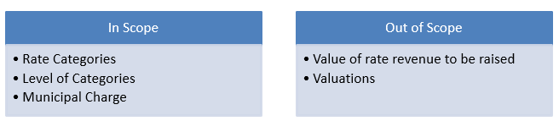

Proposal

The models which were presented to our community were outlined within the proposition paper, but summarised below:

|  |  |
| --- | --- |
| Model/Option | Detail |
| Option 1 | Make no change to the current differential categories and associated rating levels. |
| Option 2 | Decrease the farm land differential from 78% to a range between 70% and 65% and extractive industries from 312% to a range between 280% and 260% of general rates and make no change to the other differential categories. |
| Option 3 | Introduce a municipal charge of between $100 and $200 and make no change to the current differential categories and associated rating levels. |

Feedback sought to understand:

• Where in our community, engagement is coming from (locality);

• What their property is currently rated under and what value of rates they are currently paying;

• Gauge their level of understanding in relation to the framework and tools available from a rating perspective;

• Rank the three different rate model options; and

• Provide an opportunity to provide feedback regarding potential improvements to the structure which should be considered as part of this review.

Community Engagement on the Rate Propositions Paper closed at 5pm 6 March 2022. At the time of closure, the following activity was recorded against Council’s Have your Say page:

Of the 53 completed surveys, the responses came from:

Respondents were also asked to gauge how well they understood the rating framework and tools available from a rating perspective, below are the results of respondents:

Respondents were asked to rank the three model options, of the 53 responses 20 respondents did not respond to this question. Of the remaining respondents the option with the highest ranking was Option 2 (Reduced Farm and Extractive Industry Rate options). Below is the summary of ranking responses:



In addition to the above information, through the survey Council also sought any additional comments of respondents in relation to the survey. Attached to this report is a table which captures written comments from the survey, one of the formal written submissions with the other being an attachment to this report. From the survey and written submissions, there are two respondents who have indicated that they wish to speak to their submissions at the April Ordinary Meeting of Council – both of these respondents have been advised how they need to register to participate in this process based on the documented governance process.

Council Plan

The Council Plan 2021-2025 provides as follows:

**Strategic Objective 3: A Council that listens and adapts to the needs of our evolving communities**

**Priority 3.1: Listen, analyse and understand community needs**

The proposal to review Council’s Rate Structure is consistent with the Council Plan 2021-2025.

Financial Implications

The Rate Strategy Review does not have a financial implication as it does not determine the level of rate revenue raised within our annual budget process. However, the failure to adopt an updated structure and associated Revenue and Rating Plan may have a compliance impact with the requirements of the Local Government Act 2020 and the ability to declare a draft budget and generate associated rate revenue to fund future budget processes.

Risk & Occupational Health & Safety Issues

Council, at the end of the Rate Structure Review, will be required to adopt a preferred rate model which will determine how rate revenue will be derived from our community. This model will need to comply with the legislative constraints and utilise the options available to them within the rates tool box. The adopted rate model will then be incorporated into a future version of the Revenue and Rating Plan. Failure to arrive at a final adopted model will have significant impact to Council to generate rate revenue and continue to comply with legislative provisions.

Communications & Consultation Strategy

|  |  |  |  |
| --- | --- | --- | --- |
| **Level of Engagement** | **Stakeholder** | **Activities** | **Awareness** |
| Consult and Collaborate | Property owners and Ratepaying tenants | Written submissions  Online Survey  Virtual Drop In Sessions | Posters at Community Hubs and Customer Service Points  Printed Media – Moorabool News  Social Media – Facebook and LinkedIn  Digital – Council webpage |

Victorian Charter of Human Rights & Responsibilities Act 2006

In developing this report to Council, the officer considered whether the subject matter raised any human rights issues. In particular, whether the scope of any human right established by the Victorian Charter of Human Rights and Responsibilities is in any way limited, restricted or interfered with by the recommendations contained in the report. Iwt is considered that the subject matter does not raise any human rights issues.

Officer’s Declaration of Conflict of Interests

Under section 130 of the *Local Government Act 2020*, officers providing advice to Council must disclose any interests, including the type of interest.

*General Manager – Caroline Buisson*

In providing this advice to Council as the General Manager, I have no interests to disclose in this report.

*Author – Jacinta Erdody*

In providing this advice to Council as the Author, I have no interests to disclose in this report.

Conclusion

That Council adopt the community engagement feedback and determine the preferred model for incorporation into the next reiteration of the Revenue and Rating Plan and incorporation into the 2022/23 budget.

14 Community Assets & Infrastructure Reports

14.1 Notice of Motion 298 & 299 - Hard Waste Collection & Transfer Station Vouchers

**Author: Caroline Rantall, Coordinator Sustainable Environment**

**Authoriser: Phil Jeffrey, General Manager Community Assets & Infrastructure**

**Attachments: Nil**

Purpose

This combined report is in response to Notice of Motion 298 Hard Waste Collection and 299 Transfer Station Vouchers. Research has been undertaken into hard waste models, indicative costings as well as advantages and disadvantages. A cost analysis has been completed to investigate the issuing of Transfer Station vouchers to ratepayers with annual rates notices.

Executive Summary

• Research has been undertaken into hard waste collection models including indicative costs, benchmarking, advantages and disadvantages.

• A cost analysis has been prepared to issue residents with one 1m3 transfer station voucher with annual rates notices, with the cost being recovered through an increase to the Waste Service Management Charge.

• This report includes community feedback regarding hard waste collection that was collected through the development of the draft Waste and Resource Recovery Strategy.

|  |
| --- |
| **Resolution**  **Moved:** Cr Rod Ward  **Seconded:** Cr Tonia Dudzik  **That Council:**   1. **Endorses, in principle:**    1. **The issuing of one 1m3 transfer station voucher with each annual rates notice commencing in the 2022/23 financial year.**    2. **The introduction of free greenwaste month and half price mattress month at transfer stations commencing in the 2022/23 financial year.** 2. **Includes the following in the 2022/23 draft budget to allow feedback as part of the budget process:**    1. **A $19 increase per tenement of the Waste Management Charge for the provision of 1 X 1m3 transfer station voucher.**    2. **A $7 increase per tenement of the Waste Management Charge for the provision of free greenwaste and half price mattress month at transfer stations.** 3. **That the issuing of one 1m3 transfer station voucher with each annual rates notice, and the introduction of free greenwaste month and half price mattress month at transfer stations be conducted for a three (3) year trial to measure ratepayer usage and assess the ongoing demand for the services before considering the permanent introduction of either or both services for the residents of the Moorabool Shire Council.** 4. **Incorporate the final decision on implementation of the above as part of the final adoption of the 2022/23 budget.**   **Carried**  **Cr Dudzik called for a Division:**  In Favour: Crs Tonia Dudzik, David Edwards, Ally Munari and Rod Ward  Against: Crs Tom Sullivan, Moira Berry and Paul Tatchell  **The Mayor declared the motion CARRIED** |

Background

At the 2 May 2018 Ordinary Meeting of Council, Officers presented a report to determine if Council should implement a Hard Waste collection. Council resolved not to proceed with the implementation of a full hard waste service at that time and, as a part of the resolution, requested that a further report be prepared to investigate the merits of introducing transfer station vouchers with rates notices prior to the consideration of the 2019/20 budget.

A subsequent report was prepared and presented to Council at the 3 April 2019 Ordinary Meeting of Council recommending that a 1m3 waste voucher (equitable to a slightly heaped 6ft x 4ft trailer), to be used at Council’s transfer stations, be issued with annual rates notices commencing from 2019/20, and that the proposal be included in the draft budget to allow submissions prior to final adoption. Council resolved not to proceed and to continue the practice of enabling residents to dispose of their hard waste at Council’s transfer stations for prescribed gate fees.

Currently, transfer station vouchers are available for residents, who are not eligible for a kerbside garbage and recycling service, to purchase and use at any of the three Council transfer stations within the Shire. A sheet of 26 vouchers cost residents $92.00, as per the 2021/22 adopted budget. One voucher equals same volume as a 240L bin.

Draft Waste and resource recovery strategy 2030

As per the Council Plan, the 2014 Waste and Resource Recovery Strategy was due for review in the 2020/2021 financial year. The draft strategy has been developed and was endorsed at the February 2022 Ordinary Meeting of Council to go out to public consultation for 4 weeks.

The new strategy explores innovative, circular and local approaches to waste and resource recovery and will undertake community engagement to gauge levels of appetite for implementing creative and cost-effective ways to tackle the waste challenges we all face.

Strategic actions have been developed for delivery over the next 10 years. An action within this strategy is to complete a detailed cost analysis to investigate options to assist ratepayers with hard waste disposal either via a hard waste collection service or through the use of a voucher system. The Strategy will also look at the operations of transfer stations and opportunities to maximise resource recovery and usage at the sites.

community consultation

In developing the draft Waste and Resource Recovery Strategy, a detailed survey was open to residents to gather feedback regarding current and proposed waste services, including hard waste.

743 responses were received from a combination of online and postal surveys. There was a significantly larger number of responses from our rural community with 699 responses compared to 44 responses from our urban community.

The survey included the following questions relating to hard waste:

• If approximately $20 was added to your rates notice (and all rateable properties within the Shire) to drop off one trailer load of items to our Transfer Stations annually, would you support this?

• If Council offered an 'on call booking' service for hard waste to be picked up from your house, would you be interested? Expected cost $60-$90 per collection.

The results from both urban and rural areas show that the majority of participants would be willing to drop materials at the transfer station if they were provided with annual transfer station vouchers. The below graphs depict the results.

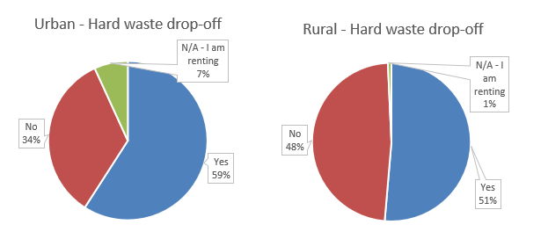

Figure 1: Hard Waste Drop-off – Community Consultation Waste and Resource Recovery Strategy

This contrasts with the responses received for a ‘on call’ hard waste service where most rural respondents did not want an on call booking service compared to the urban participants where the majority of participants selected maybe.

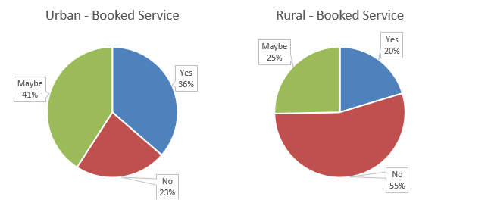Figure 2: Booked Hard Waste Service – Community Consultation Waste and Resource Recovery Strategy

illegal dumping snapshot

Sustainability Victoria has developed an online portal allowing Councils to record illegal dumping data. Moorabool have been inputting data into the program since 2019. This has enabled the identification of hotspots throughout the Shire, and a further understanding of the composition of the materials that are regularly dumped.

In the 2021 financial year, there has been 582 incidents of illegal dumping. 499 incidents contain residential/domestic materials, and 83 incidents originate from the Construction and Demolition (C&D) and Commercial and Industrial (C&I) industries.

Figure 3 provides an analysis of the composition of illegal dumping collected during the above period.

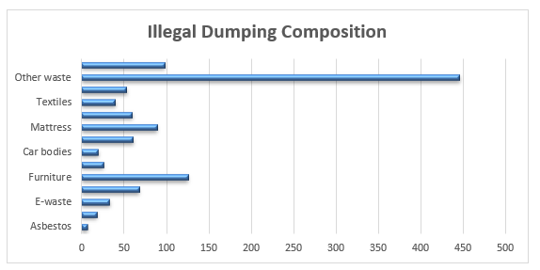

Figure 3: Illegal Dumping – Composition of Materials (2021 financial year)

Observations from this data include:

• 25% of the materials include ‘paper and cardboard, E-waste, whitegoods and metal’ which can be deposited at Council’s transfer stations at no cost.

• 8% of the materials was ‘garden organics’ which can be deposited at the transfer station at half the cost of the general waste gate fee or via our green waste urban kerbside collection.

• 8% of the materials originate from the Construction and Demolition (C&D) and Commercial and Industrial (C&I) industries.

• 4% of the materials are mattresses.

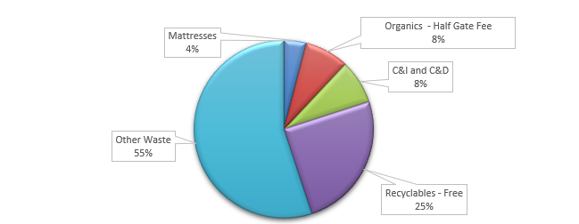

Figure 4: Illegal Dumping – Composition and Percentages of Materials

Illegal dumping requests received by Council are allocated to our internal Litter and Graffiti crew to inspect and collect. Occasionally, some jobs are outside the scope of the internal crew and are referred to an external contractor. The crew also undertake proactive inspections on identified hotspots within the Shire, these hotspots are inspected on a weekly basis.

The following map displays the locations of all illegal dumping jobs performed in 2021.

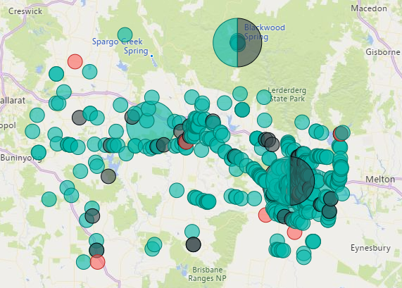



Figure 5: Locations of illegal dumping within the Shire (2021 financial year)

This financial year there have been 13 incidents (out of 572 illegal dumping collections) where identifiable materials were found, and Council issued notices under the Environment Protection Act. In only two of these incidents the offender resided within Moorabool Shire.

Sustainability Victoria does not collect state-wide statistics on correlations between hard waste services and illegal dumping. However, Councils we benchmarked with, have reported that offering vouchers and hard waste collection has not reduced the volume of dumping within their Shire. This instead requires a holistic approach including:

• A Transfer Station education program informing what items are free at the transfer station and the best way to “Sort your load” to ensure recoverable materials are diverted from landfill and to ensure a lower gate fee for the visitor.

• Subsidised green waste and mattress months at the transfer stations, e.g., ‘half price mattress month’ and ‘free green waste month’ leading up to fire season.

• Inspection and enforcement of illegal dumping incidents.

• Investigating funding opportunities to install deterrent measures including signage and cameras at hotspots.

Part A – Notice of Motion 298 - Hard Waste collection

What is hard waste?

Hard waste collections provide households with the opportunity to dispose of items not normally accepted or possible to fit into a kerbside garbage, comingled recycling or green waste bin.

The definition of ‘hard waste’ varies across the state as each Council defines what materials they will accept in their hard waste collection. The common materials accepted include:

• Whitegoods

• Timber

• Mattresses

• Metals

• E-waste

• General household goods and furniture

It is common for Councils to place restrictions on the types of materials that residents can place out for collection as hard waste, either due to health and safety concerns or for financial reasons. Restrictions are imposed through the exclusion of items, volume caps and/or size limitations on individual items.

The following items are generally excluded from hard waste:

• Asbestos

• Gas bottles

• Paint

• Tyres

• Chemicals

hard waste models

The two common approaches Councils offer to residents to enable disposal of hard waste items include a kerbside hard waste collection or a drop-off service where hard waste items are brought to the closest Council Transfer Station.

Kerbside hard waste collection

Kerbside hard waste models allow residents to place materials on the verge of their property, and these are collected by Council and taken away to be sorted, processed and/or disposed.

There are three variations to the kerbside hard waste models offered by Councils.

• Blanket collection.

This is a ‘one size fits all’ approach, offering a hard waste service to all residents at least once each year at a scheduled time. Blanket collections are generally charged through Council general rates or as part of the municipal waste service charge placed on all residential properties. The time and day of a household’s hard waste collection is determined by the Council in consultation with the contractor.

• Booked collections.

This model gives residents the option of arranging a collection at any point throughout the year. Residents have access to a limited number of booked collections annually. Some Councils allow residents to book additional collections for a fee.

• Combination services.

This service is normally offered as a blanket service, with a subsidised booked service as needed.

Drop-off service

This service is where residents transport their hard waste to a Transfer Station and either pay the gate fee or annual Transfer Station vouchers are distributed to ratepayers enabling them to bring hard waste items to their closest Council Transfer Station. Further detail on this model has been prepared in response to the Notice of Motion 299 - Transfer Station Vouchers and is presented in Part B of this report.

The design of a hard waste service should reflect the constraints and opportunities that exist within particular neighbourhoods. For a Council such as Moorabool Shire, with a mix of rural and urban localities, this may mean using a combination of collection and drop-off methods in different areas.

There are several factors that need to be considered when designing a service such as:

• The property mix within the Council area.

• The road and footpath infrastructure.

• Traffic including vehicles, cyclists and pedestrians.

• Local events and/or seasonal influx of visitors to an area that may restrict access to properties.

It is also important to ensure that any hard waste/drop-off service introduced effectively aligns with current and planned collection services offered within the municipality.

There is a strategic imperative to design hard waste collections to be cost effective, to increase the amount of material that can be recovered and support residents to reduce hard waste generation.

state-wide hard waste services

In 2019/20 forty-four local governments provided either a kerbside hard waste collection or a drop-off service. Out of the forty-four Councils, 31 were metropolitan and 13 were non-metro.

All 31 Melbourne metropolitan Councils provide their residents with a form of kerbside hard waste service. Booked collections is the most popular model with 20 of the regions 31 Councils providing this option. Seven of the 31 metropolitan Councils offer blanket collection services. Four metropolitan Councils offer a combined blanket and booked service. One metropolitan Council, City of Melton, offered a hybrid model giving residents the choice of one booked collection from their property or up to two drop-offs at the Melton Recycling Facility.

The non-metro Councils offered services through a combination of kerbside hard waste and drop-off.

Table 1 demonstrates the models used by the forty-four Councils providing a service.

|  |  |  |
| --- | --- | --- |
| Service Model | Metropolitan Council | Regional/Rural Council |
| Kerbside - Blanket collection | 7 | 5 |
| Kerbside - Booked collection | 19 | 5 |
| Kerbside - Combination service | 4 |  |
| Hybrid – Booked or Drop-off | 1 | 3 |
| Alternative – Drop-off service | 0 | 3 |

There are advantages and disadvantages to both kerbside and drop-off approaches to hard waste. These are outlined in Table 2 as follows.

|  |  |
| --- | --- |
| Blanket Collection | |
| Advantages | Disadvantages |
| - Encourages participation as residents respond to visual signals | - Large volumes may reduce ability for collectors to source separate and recover materials  - Scavenging is higher due to volume of materials on kerbsides  - Increased cost with more materials to collect |

|  |  |
| --- | --- |
| Booked Collection | |
| Advantages | Disadvantages |
| - Reduced number of collections and volumes allows collectors to better source separate  - Greater flexibility to fit within schedules of residents | - Requires more effort from resident to book and arrange collection  - Unpredictable uptake with seasonal high demand |

|  |  |
| --- | --- |
| Drop-off Services | |
| Advantages | Disadvantages |
| - Avoids public safety issues associated with kerbside services  - Scavengers cannot access materials | - Users need access to vehicle/trailer  - Black market trading of vouchers  - Voucher provided to property owner not tenant  - Reduce revenue at the transfer stations |

estimated costs and benchmarking

Information provided by Sustainability Victoria suggests that the costs of providing kerbside hard waste service vary considerably and there is not a clear distinction between the costs of the different models.

Indicative costing extracted from *Sustainability Victoria - Local government Waste Services Report 2019/20* show that 44 Councils in Victoria were spending approximately $40 million to collect about 112,000 tonnes of hard waste at a rate of $353 per tonne. Collection costs per household averaged $41 per service, with costs across all households (users and non-users) of approximately $20 per household.

*It should be noted that increases in the State Landfill Levy, that came into effect on 1 July 2021 as per the Recycling Victoria: a new economy policy, would increase costs.*

The mix of urban, semi-rural and rural areas within Moorabool Shire adds further complexity and finding a contractor willing to service the Shire will present financial challenges.

Additional costs will be incurred in the initial establishment and commissioning of the service and ensuring that adequate resources are available within the Waste team to support the rollout and ongoing administration associated with the service.

Benchmarking was undertaken with City of Melton, where the current cost per hard waste collection is approximately $35, plus disposal costs. These costs are recovered through the Waste Service Charge applied on rateable properties.

Within the Grampians Central West Waste and Resource Recovery Group of Councils, Horsham and Hepburn offer a drop-off service and Central Goldfields offers a direct booking system with the contractor. No other Councils within the region offer hard waste options however a number provide transfer stations with their rates notices including Ballarat.

It is reported that about 20-25% of households offered the services use them per year. If a system is introduced, it might get very high levels of use in the first years (as people clean out sheds and yards to take advantage of the new service) but this is likely to fall over time. Costs may therefore be higher initially than they will be in the long term.

Part B – Notice of Motion 299 – Transfer station vouchers

issuing transfer station vouchers with rates notices

A cost analysis has been undertaken to investigate the option of providing a 1m3 (equitable to a slightly heaped 6ft x 4ft trailer) voucher with rates notices. The following was considered within the cost analysis:

• Waste disposal and transportation costs.

• Uptake rate.

• Waste composition.

• Increase in Waste Management Charge to fund the program.

• Possible reduction in transfer station revenue.

• Printing of vouchers.

There are approximately 19,000 rateable properties within the Shire. The disposal costs have been calculated using the per cubic metre volumes of each load, converted into tonnes and multiplied by the current number of rateable properties within the Shire.

To commence a transfer station voucher program, it is estimated that it would require approximately 10-12 months, this would include the following considerations:

• Review waste charges.

• Benchmarking.

• Logistics (e.g. distribution of vouchers, processing of vouchers received, minimising potential of fraud etc.).

• Discussions with Transfer Station operators.

A gate fee per tonne at the processing facilities (Maddingley Brown Coal – Maddingley, and Pinegro – Mt Wallace) has been applied. The transportation costs have been calculated using the per tonne fee charged by the transfer station operators, to transport the waste/green waste to the processing facilities.

It is not possible to estimate the types of waste that will be deposited using the vouchers, therefore assumptions have been made in the modelling that 75% of the waste deposited will be putrescible or mixed waste and 25% will be green waste.

An information request to Grampians Central West Waste & Resource Recovery Group (GCWWRRG) Councils was sent with the aim to gather current information about current provision of transfer station vouchers by member Councils.

Melton City Council and City of Ballarat are the only two Councils who continue to provide annual transfer station vouchers to ratepayers. Ararat City Council and Pyrenees Shire Council historically offered vouchers but have ceased the program due to the low uptake. All Councils have reported that offering vouchers has not reduced the volume of illegal dumping within the Shire.

Annually, City of Ballarat issue two transfer station vouchers to each rateable property, however only 22% of the vouchers are utilised each year. Similarly, Melton has a 25% uptake.

Table 1 (below) shows a range of costs depending on the uptake percentage from residents.

|  |  |  |  |
| --- | --- | --- | --- |
| Charge per Rate of Uptake | | | |
| Uptake Rate | **Tonnages** | **Annual Total Cost** | **Per Tenement Charge** |
| 100% | 9250 | $1,070,440.88 | $63.00 |
| 80% | 7400 | $856,352.71 | $51.00 |
| 60% | 5550 | $642,264.53 | $38.00 |
| 40% | 3700 | $428,176.35 | $26.00 |
| 30% | 2775 | $321,132.26 | $19.00 |
| 20% | 1850 | $214,088.18 | $13.00 |

If Moorabool were to assume a similar uptake to Ballarat and Melton, this would result in an additional $19.00 per tenement increase to the Waste Management Service Charge.

If a system is introduced, it may have high levels of use in the first years (as people clean out sheds and yards to take advantage of the new service) but this is likely to fall over time. Costs may therefore be higher initially than they will be in the long term.

Council Plan

The Council Plan 2021-2025 provides as follows:

**Strategic Objective 2: Liveable and thriving environments**

**Priority 2.3: Enhance our natural environments**

The proposal is consistent with the Council Plan 2021-2025.

Financial Implications

The funds and resources required to enable implementation of the Transfer Stations Vouchers system will be proposed as part of the 2023/24 budget process.

Risk & Occupational Health & Safety Issues

|  |  |  |  |  |
| --- | --- | --- | --- | --- |
| **Risk Identifier** | **Detail of Risk** | **Risk Rating** | | **Control/s** |
| Financial - Future  resource  requirements may  not be approved  within future  budget processes. | There are not enough  resources to implement  the Plan in its entirety. | Medium | Staff implementing the strategy will monitor the  resource requirements  and report to Council  where issues arise. | |
| Reputation –  A negative  perception of the  chosen transfer station voucher model | Negative feedback is received from the community | Medium | Extensive public consultation and communication will be undertaken to communicate the program to the community. | |

Communications & Consultation Strategy

|  |  |  |  |  |  |
| --- | --- | --- | --- | --- | --- |
| **Level of Engagement** | **Stakeholder** | **Activities** | **Location** | **Date** | **Outcome** |
| Engage | Public Survey – online and postal survey as part of the draft Waste and Resource Recovery Strategy development | A survey was published on Moorabool’s ‘Have Your Say’ Engagement portal | Have Your  Say  Moorabool  web page | June – July 2021 | 743 surveys were received, and responses collated |

Victorian Charter of Human Rights & Responsibilities Act 2006

In developing this report to Council, the officer considered whether the subject matter raised any human rights issues. In particular, whether the scope of any human right established by the Victorian Charter of Human Rights and Responsibilities is in any way limited, restricted or interfered with by the recommendations contained in the report. It is considered that the subject matter does not raise any human rights issues.

Officer’s Declaration of Conflict of Interests

Under section 130 of the *Local Government Act 2020*, officers providing advice to Council must disclose any interests, including the type of interest.

*General Manager – Phil Jeffrey*

In providing this advice to Council as the General Manager, I have no interests to disclose in this report.

*Author – Caroline Rantall*

In providing this advice to Council as the Author, I have no interests to disclose in this report.

Conclusion

This Council report outlines previous reports that have been brought to Council regarding hard waste and the issuing of transfer station vouchers.

The draft Waste and Resource Recovery Strategy 2030 is currently out for public consultation, and the new strategy will investigate options regarding hard waste, illegal dumping, and transfer station vouchers.

A snapshot of illegal dumping within the Shire has been provided including the composition of materials and enforcement efforts.

Research has been undertaken on hard waste models, indicative costings as well as advantages and disadvantages. A cost analysis has been undertaken into providing one 1m3 vouchers to ratepayers with annual rates notices.

A snapshot of illegal dumping within the Shire has been provided including the composition of materials and enforcement efforts.

15 Other Reports

Nil

16 Notices of Motion

16.1 Notice of Motion - Bacchus Marsh-Geelong Road

**Attachments: Nil**

I, Councillor Rod Ward, give notice that at the next Ordinary Meeting of Council to be held on 6 April 2022, I intend to move the following motion:

|  |
| --- |
| Resolution  **Moved:** Cr Rod Ward  **Seconded:** Cr Tonia Dudzik  **That Council:**  **1. Requests the Chief Executive officer write to Regional Roads Victoria, Transport Victoria and the local Member for Melton Mr Steve McGhie expressing concerns of Moorabool Shire Council residents at the delays that have plagued the road works on the Bacchus Marsh-Geelong Road, which commenced in October 2018.**  **2. Notes that in addition to freight, this road connects 5,900 vehicles per day with the towns of Lara, Bacchus Marsh and Geelong and after nearly four years of being patient with these roadworks, ratepayers and road users are entitled to know when this project will be complete.**  **Carried** |

I commend this Notice of Motion to Council.

16.2 Notice of Motion - Mountain Bike Jump Park, Telford Park

**Attachments: Nil**

I, Councillor Rod Ward, give notice that at the next Ordinary Meeting of Council to be held on 6 April 2022, I intend to move the following motion:

|  |
| --- |
| **Resolution**  **Moved:** Cr Rod Ward  **Seconded:** Cr Tonia Dudzik  **That Council:**  **1. Requests the Chief Executive Officer prepares a report on the consideration of an introductory mountain bike/BMX jump park in Telford Park, Darley.**  **2. Requests that the report investigates the costs and possible options for this bicycle jump park as part of the Bald Hill redevelopment precinct.**  **LOST** |

Rationale

A map of the Rogers Reserve and the surrounding area is provided below, with the proposed location of the introductory mountain bike/BMX jump park highlighted in red.

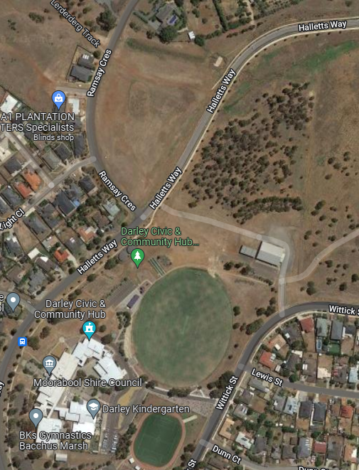

It should be noted that there already exists a number of jumps and paths in this area that the youth of Bacchus Marsh and Darley have built themselves.

If built, this would form an ideal ‘introductory’ mountain bike jump park where the youth could learn to ride downhill and ‘jump’ prior to the establishment of the proposed mountain bike tracks within the Bald Hill precinct for more advanced riders.

This is similar to the Black Hill Mountain Bike precinct in Ballarat where ‘introductory paths’ exist for the youth to learn and develop skills prior to tackling the more advanced downhill sections.

As an example I include photos below of the newly established downhill mountain bike trail which is designed with varying challenges to cater for novices through to advanced riders, and which has been created in the Warralily Grange Estate in Armstrong Creek, Geelong.

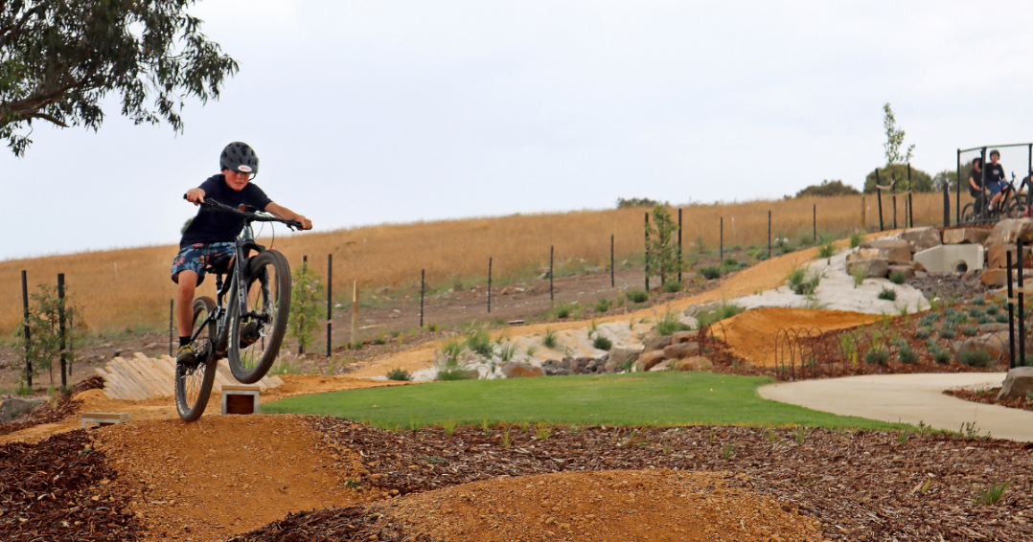

In my opinion the benefits of providing this jump park would lead to an increase in resident satisfaction and provide an increase in tourism and visitor satisfaction.

I commend this Notice of Motion to Council.

17 Notices of Rescission

Nil

18 Mayor’s Report

18.1 Mayor's Report

**Author: Dianne Elshaug, Co-ordinator CEOs Office**

**Authoriser: Derek Madden, Chief Executive Officer**

**Attachments: Nil**

Purpose

To provide details to the community on the meetings and events attended by the Mayor since the last Ordinary Meeting of Council.

Executive Summary

That the Mayor’s Report be tabled for consideration at the Ordinary Meeting of Council.

|  |  |
| --- | --- |
| **Cr Tom Sullivan – Mayor’s Report** | |
| ***Date:*** *6 April 2022* | |
| 4 March | * Central Highlands Councils Victoria Mayors & CEOs Meeting |
| 9 March | * Councillor Briefings: Advocacy Workshop; Renaming of North Section of Duncan Street, Ballan; Review of the DAC Agenda; General Business |
| 10 March | * Circular Economy Leadership Course Live Webinar (Circular Business) |
| 16 March | * Councillor Briefings – Youth Forum Presentation; Draft Public Art & Collections Policy; Review of the OMC Agenda; General Business * Development Assessment Committee |
| 17 March | * Circular Economy Leadership Course Live Webinar (Circular Cities) |
| 23 March | * Councillor Briefings: NoM 298 & 299 – Hard Waste Collection and Transfer Station Vouchers; General Business |
| 24 March | * Circular Economy Leadership Course Live Webinar (Sustainable Lifestyles) * Elaine Mechanics Institute Committee Meeting, Elaine Mechanics Hall |
| 30 March | * Councillor Briefings: MADE Energy Update; Revenue & Rating Plan – Rate Strategy Review Community Consultation; Budget Planning: Capital Improvement Program, General Business |
| 31 March | * Circular Economy Leadership Course Live Webinar (Mainstreaming Circularity) |
| 6 April | * Councillor Briefings – Audit & Risk Committee: Chair Presentation to Council; Council Plan Actions 2022/23 * Economic Development Taskforce Meeting * Ordinary Meeting of Council |

|  |
| --- |
| Resolution  **Moved:** Cr Ally Munari  **Seconded:** Cr Paul Tatchell  **That Council receives the Mayor’s Report.**  **Carried** |

19 Councillors’ Reports

|  |  |
| --- | --- |
| **Cr Moira Berry** | |
| ***Date:*** *6 April 2022* | |
| 9 March & 11 March | * Peri Urban Councils Victoria meetings with various Ministers and Shadow Ministers advocating for various issues |
| 18 March | * VLGA Fast Track 2022 Councillor Leadership Development Program |
| 20 March | * Harvest Festival |
| 24 March | * VLGA Global Panel Forum on local government reform |

|  |  |
| --- | --- |
| **Cr Tonia Dudzik** | |
| ***Date:*** *6 April 2022* | |
| 4 April | * Bacchus Marsh Public Hall Committee Meeting |

|  |
| --- |
| **Resolution**  **Moved:** Cr Ally Munari  **Seconded:** Cr Moira Berry  **RESOLUTION**  **That Council receives the Councillors’ Reports.**  **Carried** |

20 Urgent Business

Cr Ward raised an Item of Urgent Business in relation to the Bacchus Marsh Eastern Link Road.

|  |
| --- |
| 20.1 Bacchus Marsh Eastern Link Road |
| Resolution  **Moved:** Cr David Edwards  **Seconded:** Cr Paul Tatchell  **That Council resolves to admit the item of Urgent Business in relation to the Bacchus Marsh Eastern Link Road.**  **Carried** |

|  |
| --- |
| 20.2 Bacchus Marsh Eastern Link Road |
| Resolution  **Moved:** Cr David Edwards  **Seconded:** Cr Paul Tatchell  **That Council:**  **1. Request the Chief Executive Officer to write to the relevant Minister and seek an urgent meeting to:**  **(a) seek clarification on why the Woolpack Road option was not shortlisted for the Bacchus Marsh Eastlink Road project; and**  **(b) clarify the implications to traffic improvements and land acquisition in excluding the Woolpack Road as a shortlisted option.**  **Carried** |

Cr Berry raised an Item of Urgent Business in relation to the Bacchus Marsh Racecourse Recreation Reserve – Stage 1 Works.

|  |
| --- |
| 20.3 Bacchus Marsh Racecourse Recreation Reserve - Stage 1 Works |
| Resolution  **Moved:** Cr Moira Berry  **Seconded:** Cr Paul Tatchell  **That Council resolves to admit the item of Urgent Business in relation to the Bacchus Marsh Racecourse Recreation Reserve Stage 1 works.**  **LOST** |

Cr Berry raised an Item of Urgent Business in relation to the Equine Club at Bacchus Marsh Racecourse Recreation Reserve exploring the feasibility of becoming a training facility for the Commonwealth Games.

|  |
| --- |
| 20.4 Feasibility of a Training Facility at the Equine Club at the Bacchus Marsh Racecourse Recreation Reserve for the Commonwealth Games |
| Resolution  Moved: Cr Moira Berry  Seconded: Cr Paul Tatchell  **That Council resolves to admit the item of Urgent Business in relation to the feasibility of a training facility at the Equine Club at the Bacchus Marsh Racecourse Recreation Reserve for the Commonwealth Games.**  **Carried** |

|  |
| --- |
| 20.5 FeaSibility of a Training Facility at the Equine Club at Bacchus Marsh Racecourse Recreation Reserve for the Commonwealth Games |
| Resolution  **Moved:** Cr Moira Berry  **Seconded:** Cr Paul Tatchell  **That Council:**   1. **Prepare a report on the Equine Cub at Bacchus Marsh Racecourse Recreation Reserve to bring up the facility to a standard that the Commonwealth Games Committee would expect as a training facility before and during the Commonwealth Games proposed for Melbourne in 2026.** 2. **Write a letter to the Commonweath Games Committee to show an expression of interest in opening up the Equine Club at Bacchus Marsh Racecourse Recreation Reserve as a training facility before and during the Commonwealth Games proposed for Melbourne in 2026 and it be included that we apply for funding for this project.**   **Carried** |

Cr Dudzik raised an Item of Urgent Business in relation to the Bacchus Marsh Racecourse Recreation Reserve Project Scope and Budget Shortfalls.

|  |
| --- |
| 20.6 Update Report on the Bacchus Marsh Racecourse Recreation Reserve Project Scope and Budget Shortfalls |
| **Motion**  **Moved:** Cr Tonia Dudzik  **Seconder:**  **That Council resolves to admit the item of Urgent Business in relation to the provision of an update report on the Bacchus Marsh Racecourse Recreation Reserve project scope and budget shortfalls.**  **Cr Dudzik withdrew the urgent item.** |

21 Closed Session of the Meeting to the Public

Nil

22 Meeting Closure

**The Meeting closed at 8.15pm.**

**...................................................**

**CHAIRPERSON**