|  |  |
| --- | --- |
|  | |
| **AGENDA**    **Ordinary Council Meeting**  **Wednesday, 2 February 2022**  **In accordance with s.395 of the *Local Government Act 2020*, this meeting will not**  **be available for public attendance, however will be streamed live via accessing the**  **Council Internet site.** | |
| **I hereby give notice that an Ordinary Meeting of Council will be held on:** | |
| **Date:** | **Wednesday, 2 February 2022** |
| **Time:** | **6.00pm** |
| **Location:** | **Online** |
| **Derek Madden**  **Chief Executive Officer** | |

**Order Of Business**

1 Opening of Meeting and Prayer 5

2 Acknowledgement of Country 5

3 Recording of Meeting 5

4 Present 5

5 Apologies 5

6 Confirmation of Minutes 5

7 Disclosure of Conflicts of Interest 5

8 Public Question Time 6

9 Petitions 7

Nil

10 Presentations/Deputations 7

11 Chief Executive Officer Reports 8

11.1 Advisory Committees of Council - Reports 8

12 Community Planning and Economic Development Reports 9

12.1 Planning Scheme Amendment C101moor - Browns Lane - Authorisation 9

13 Customer Care and Advocacy Reports 15

13.1 2021-2025 Moorabool Shire Council Plan - Second Quarter Progress for October - December 2021 15

13.2 2017-2021 Moorabool Shire Council Plan - Outstanding Actions Progress Report 18

14 Community Assets & Infrastructure Reports 20

14.1 Development of the Waste and Resource Recovery Strategy 20

15 Other Reports 27

Nil

16 Notices of Motion 28

16.1 Notice of Motion - Rogers Reserve 28

17 Notices of Rescission 30

17.1 Notice of Rescission - Revenue & Rating Plan 30

18 Mayor’s Report 31

18.1 Mayor's Report 31

19 Councillors’ Reports 32

20 Urgent Business 32

21 Closed Session of the Meeting to the Public 32

Nil

22 Meeting Closure 32

1 Opening of Meeting and Prayer

Almighty God be with us as we work for the people of the Shire of Moorabool. Grant us wisdom that we may care for the Shire as true stewards of your creation. May we be aware of the great responsibilities placed upon us. Help us to be just in all our dealings and may our work prosper for the good of all. Amen.

2 Acknowledgement of Country

I acknowledge the Traditional Owners of the land on which we are meeting. I pay my respects to their Elders, past and present, and the Aboriginal Elders of other communities who may be here today.

3 Recording of Meeting

In accordance with Moorabool Shire Council’s Governance Rules, the meeting will be livestreamed.

4 Present

5 Apologies

6 Confirmation of Minutes

Ordinary Council Meeting - Wednesday 1 December 2021

Special Council Meeting - Wednesday 22 December 2021

Special Council Meeting - Thursday 27 January 2022

7 Disclosure of Conflicts of Interest

Conflict of interest laws are prescribed under the *Local Government Act 2020* (the Act) and in the Local Government (Governance and Integrity) Regulations 2020 (the Regulations). Managing conflicts of interest is about ensuring the integrity and transparency of decision-making.

The conflict of interest provisions under the Act have been simplified so that they are more easily understood and more easily applied. The new conflict of interest provisions are designed to ensure relevant persons proactively consider a broader range of interests and consider those interests from the viewpoint of an impartial, fair-minded person.

Section 126 of the Act states that a Councillor has a conflict of interest if they have a general conflict of interest or a material conflict of interest. These are explained below:

* A Councillor has a general conflict of interest in a matter if an impartial, fair-minded person would consider that the member’s private interests could result in them acting in a manner that is contrary to their public duty as a Councillor.
* A Councillor has a material conflict of interest in a matter if an affected person would gain a benefit or suffer a loss depending on the outcome of the matter.

A relevant person with a conflict of interest must disclose the interest in accordance with Council’s Governance Rules and not participate in the decision-making process on the matter. This means the relevant person must exclude themselves from any discussion or vote on the matter at any Council meeting, delegated committee meeting, community asset committee meeting or, if a Councillor, any other meeting conducted under the auspices of the Council. The relevant person must also exclude themselves from any action in relation to the matter, including an action taken to implement a council decision, for example, issuing a planning permit.

8 Public Question Time

The aim of Public Question Time is to provide an opportunity for the public to ask general questions at Council Meetings requiring routine responses. Public Question Time is conducted in accordance with section 3.7.1 of the Council’s Governance Rules.

* 1. Question time will take place during the Council Meeting as provided for in the agenda.
  2. Questions in writing in the form prescribed by the Chief Executive Officer will be accepted up to 5pm on the day before the Meeting.
  3. A person must not submit more than two (2) individual questions at a meeting, inclusive of all parts and variants as interpreted by the Chairperson or other person authorised for this purpose by the Chairperson.
  4. A question will only be read to the meeting if the Chairperson or other person authorised for this purpose by the Chairperson has determined that the:
     1. person directing the question is present in the gallery;
     2. question does not relate to a confidential matter;
     3. question does not relate to a matter in respect of which Council has no power to act;
     4. question is not defamatory, indecent, abusive or objectionable in language or substance;
     5. question is not a repetition of a question already asked or answered (whether at the same or an earlier meeting); and
     6. question is not asked to embarrass a Councillor, member of Council staff or member of the public.
  5. Persons submitting questions must be present in the public gallery. If they are not present in the Gallery, the question will be held over to the next meeting only.
  6. The Chief Executive Officer will read out each question and the Chairperson shall decide who will answer each question.

A Councillor or Council officer may:

* + 1. immediately answer the question asked; or
    2. elect to have the question taken on notice until the next Ordinary meeting of Council; at which time the question must be answered and incorporated in the Agenda of the meeting under Public Question Time; or
    3. elect to submit a written answer to the person asking the question within 10 working days.

Responses to public questions answered at the meeting, will be general in nature, provided in good faith and should not exceed two minutes. These responses will be summarised in the minutes of the meeting.

9 Petitions

Nil

10 Presentations/Deputations

The Council has made provision in the business of the Ordinary Meetings of the Council for the making of presentations or deputations to Council in relation to matters presented on the agenda for Council consideration.

Persons wishing to make a presentation or deputation to Council on a matter included in the agenda shall inform Council prior to the meeting by contacting the Chief Executive Officer’s office and registering their name and agenda item being spoken to.

At the meeting the Mayor will invite the persons wishing to make a presentation or delegation to address the Council on the agenda item.

The person making the presentation or deputation is to stand and address Council on the item.

No debate on the item is permitted between the person making the presentation or delegation and the Council.

A maximum of three minutes per presentation or delegation will be allocated. An extension of time may be granted at the discretion of the Mayor.

Councillors, through the Mayor, may ask the person making the presentation or delegation for clarification of matters presented.

The Mayor may direct that a member of the gallery ceases speaking if the above procedure is not followed.

11 Chief Executive Officer Reports

11.1 Advisory Committees of Council - Reports

**Author: Phillip Howard, Executive Manager Governance & Corporate Compliance**

**Authoriser: Derek Madden, Chief Executive Officer**

**Attachments: 1. Local Business Advisory Committee Meeting Minutes 140921 (under separate cover)**

**2. Local Business Advisory Committee Meeting Minutes 121021 (under separate cover)**

**3. Heritage Advisory Committee Meeting Minutes 180821 (under separate cover)**

**Purpose**

Advisory Committees are established to assist Council with executing specific functions or duties.

Advisory Committees of Council currently have no delegated powers to act on behalf of Council or commit Council to any expenditure unless resolved explicitly by Council following recommendation from the Committee. Their function is purely advisory.

Advisory Committees are required to report to Council at intervals determined by the Council.

**Executive Summary**

• Councillors, as representatives of the following Advisory Committees of Council, present the reports of the Committee Meetings for Council consideration.

|  |  |  |
| --- | --- | --- |
| Committee | Meeting Date | Council Representatives |
| Local Business Advisory Committee | Tuesday 14 September 2021 | Cr Paul Tatchell  Cr Tonia Dudzik |
| Local Business Advisory Committee | Tuesday 12 October 2021 | Cr Paul Tatchell  Cr Tonia Dudzik |
| Heritage Advisory Committee | Wednesday 18 August 2021 | Cr Paul Tatchell |

|  |
| --- |
| **Recommendation**  **That Council receive the Local Business Advisory Committee meetings summaries of minutes, Tuesday 14 September 2021 and Tuesday 12 October 2021, and the Heritage Advisory Committee meeting summary of minutes, Wednesday 18 August 2021.** |

12 Community Planning and Economic Development Reports

12.1 Planning Scheme Amendment C101moor - Browns Lane - Authorisation

**Author: Sarah Kernohan, Manager Growth & Development**

**Authoriser: Henry Bezuidenhout, Executive Manager Community Planning & Economic Development**

**Attachments: 1. C101moor Amendment Documents Authorisation (under separate cover)**

Purpose

The purpose of this report is to consider Amendment C101moor to the Moorabool Planning Scheme.

Executive Summary

• The Heritage Overlay (HO194) is incorrectly applied to 75 Browns Lane, Parwan, instead of 81 Browns Lane, Parwan.

• The property at 81 Browns Lane, Parwan, has been assessed as being of local heritage significance.

• It is proposed to delete the existing heritage overlay from 75 Browns Lane, Parwan, and to apply the heritage overlay to 81 Browns Lane, Parwan.

|  |
| --- |
| Recommendation  **That Council resolves to:**   1. **Request authorisation from the Minister for Planning to prepare and exhibit Moorabool Planning Scheme Amendment C101moor under Section 8A(2) of the *Planning and Environment Act 1987*.** 2. **Exhibit Moorabool Planning Scheme Amendment C101moor, in accordance with Section 17, 18, and 19 of the *Planning and Environment Act 1987*, for a period of one calendar month subject to receiving authorisation from the Minister for Planning.** 3. **Authorise the Executive Manager Community Planning and Economic Development and Manager Growth & Development to negotiate and resolve any issues that are raised by submitters during the exhibition process prior to the amendment being reported back to Council for referral to a Planning Panel or adoption of the Amendment.** |

Background

The Victorian Planning Authority (VPA), who are the Planning Authority for the Parwan Station Precinct Structure Plan engaged Archaeology At TARDIS to undertake a Historical Cultural Heritage Assessment (HCHA) for the Parwan Station Precinct in order to inform the preparation of the Precinct Structure Plan.

The HCHA identifies and assesses historic sites in the Parwan Station Precinct. It also makes recommendations on historic sites in the Parwan Station Precinct. Two properties included in this assessment are 75 and 81 Browns Lane, Parwan. 75 Browns Lane is subject to an existing Heritage Overlay HO194 as shown in **Figure 1**.

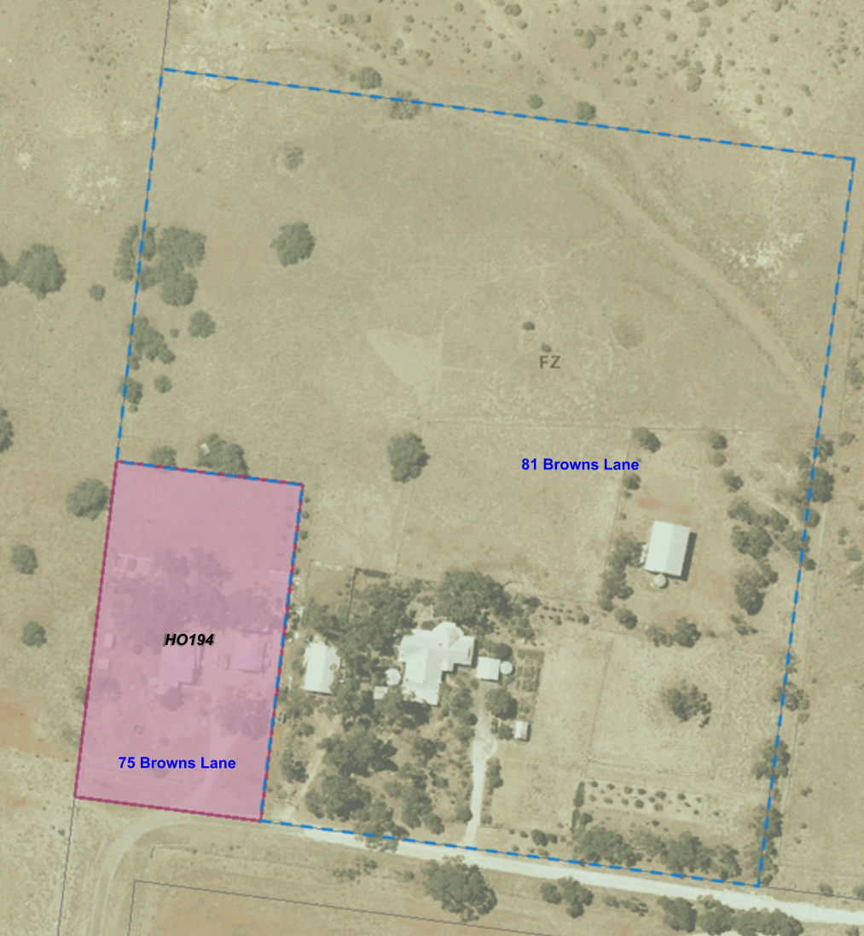**Figure 1:** The subject sites at 75 and 81 Browns Lane, Parwan.

Separate to the VPA engaging a consultant to undertake the HCHA, the landowner at 75 Browns Lane had also contacted Council directly to raise the concerns that the Heritage Overlay is on the incorrect property.

Officers and Council’s heritage advisor visited the properties at 75 and 81 Browns Lane in January 2020, to investigate if the landowner’s claims could be supported. The heritage advisor noted that both dwellings had been altered, and that further assessment was needed on the properties.

Heritage Significance of 75 and 81 Browns Lane, Parwan

As part of the HCHA, Archaeology At TARDIS appointed a Heritage Architect to conduct a heritage assessment at 75 Browns Lane and 81 Browns Lane, Parwan. The aim of this assessment was to identify the original Browns homestead ‘Hill Farm’ which is described in the current heritage citation.

The Heritage Architect’s assessment confirmed that the dwelling described in the current heritage citation for the HO194 is actually the dwelling at 81 Browns Lane, Parwan. The property subject to the HO194 at 75 Browns Lane is noted as built after 1922 and is not the original Browns homestead. The Heritage Overlay is therefore applied to the incorrect property.

The recommendation by Archaeology At TARDIS in the HCHA states that the existing Heritage Overlay should be deleted from 75 Browns Lane, and applied to 81 Browns Lane, Parwan.

Council engaged a heritage consultant Plan Heritage, to prepare a new curtilage for the Heritage Overlay, heritage citation and Statement of Significance. Plan Heritage supports the Heritage Overlay being applied to 81 Browns Lane, Parwan (see **Attachment 1**). The Statement of Significant notes that the Hill Farm is considered a rare surviving example of an 1860s farming complex with later nineteenth century developments, including the brick house (c.1863), brick outbuilding and well (c.1860s), weatherboard outbuildings and wells (c.1880-1900). There are only a small number of farming complexes from the nineteenth century which survive in the former Parwan Agricultural district, and the retained complex of buildings is particularly unusual in the locality.

Proposal

The Amendment seeks to correct an error in the Planning Scheme by deleting the Heritage Overlay applied to 75 Browns Lane, Parwan, and applying the Heritage Overlay to 81 Browns Lane, Parwan. The proposed changes are shown in **Figure 2.**

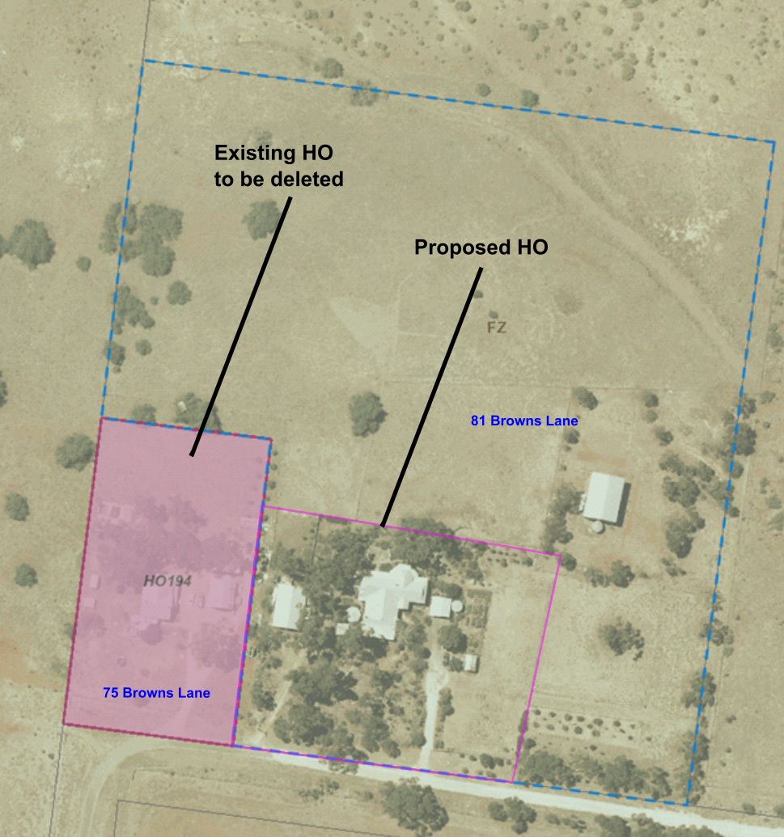**Figure 2: The proposed change in HO extent.**

The Amendment proposes to:

• Amend the Schedule to Clause 43.01 Heritage Overlay to change the name of the site from ‘Dwelling’ to ‘Hill Farm’ and the address of the property from 75 Browns Lane to 81 Browns Lane.

• Make structural changes to the Schedule to Clause 43.01 Heritage Overlay to ensure consistency with the Ministerial Directions on Form and Content.

• Insert a reference to the Statement of Significance into the Schedule to Clause 43.01, and to insert the Statement of Significance as an Incorporated Document into the Schedule to Clause 72.04. A new citation for the heritage place has also been created.

• Amend Planning Scheme Map 46HO, as per **Figure 2**.

The Amendment will also correct an error in the Planning Scheme where the incorrect property is identified as being subject to the Heritage Overlay.

Ministerial Direction No. 11: Strategic Assessment of the Amendment

The Amendment is strategically justified as it seeks to correct an error in the Planning Scheme whilst seeking to apply the Heritage Overlay to the significant heritage place. This will ensure the heritage protection for the place of local heritage significance at 81 Browns Lane, Parwan. The proposed changes are supported by the research conducted by heritage consultants and are in accordance with the VPP Planning Practice Note No. 1 ‘Applying the Heritage Overlay’, August 2018.

The proposed Amendment is generally consistent with the relevant policy objectives of the Planning Policy Framework and the Local Planning Policy Framework.

The Amendment is consistent with Clause 15.03-1S Heritage conservation, which has the objective of ensuring the conservation of places of heritage significance.

The Amendment is also consistent with Local policy Clause 21.06-2 Enhance and Preserve Cultural Heritage that has the objective to preserve, promote, and enhance places of heritage significance including those of historical, aesthetic, architectural, scientific, and/or social value.

Council Plan

The Council Plan 2021-2025 provides as follows:

**Strategic Objective 2: Liveable and thriving environments**

**Priority 2.1: Develop planning mechanisms to enhance liveability in the Shire**

The proposal to apply the Heritage Overlay to the property of heritage significance is consistent with the Council Plan 2021-2025, as it is aligned with priority 1 ‘Develop planning mechanisms to enhance liveability in the Shire’.

Financial Implications

The costs associated with the Amendment including statutory fees, mail outs, advertising, and (if required) panel hearing costs. There will be a cost to Council in terms of staff time. These costs are minimal.

Risk & Occupational Health & Safety Issues

There are no direct risk or occupation health and safety issues associated with the recommendation within this report. If Council chooses not to seek authorisation to prepare a Planning Scheme Amendment, it would prevent the protection of significant heritage place from future development. Council would also risk not meeting its obligations under the *Planning and Environment Act 1987* regarding the conservation and enhancement of heritage places.

Communications & Consultation Strategy

If the Amendment is authorised, a notice of the Amendment will be given in accordance with the requirements of the *Planning and Environment Act* *1987*. The community, State Government authorities and prescribed ministers that may be materially affected by the Amendment will be consulted in accordance with these requirements. This includes notifying nearby landowners and advertising in local newspapers and the Victorian Government Gazette. The community will have the opportunity to make a submission on the Amendment and if a Planning Panel is appointed, the community will have the opportunity to make a submission to the Planning Panel as well.

Victorian Charter of Human Rights & Responsibilities Act 2006

In developing this report to Council, the officer considered whether the subject matter raised any human rights issues. In particular, whether the scope of any human right established by the Victorian Charter of Human Rights and Responsibilities is in any way limited, restricted or interfered with by the recommendations contained in the report. It is considered that the subject matter does not raise any human rights issues.

Officer’s Declaration of Conflict of Interests

Under Section 130 of the *Local Government Act 2020*, officers providing advice to Council must disclose any interests, including the type of interest.

*Executive Manager – Henry Bezuidenhout*

In providing this advice to Council as the Executive Manager, I have no interests to disclose in this report.

*Author – Ana Mitrov*

In providing this advice to Council as the Author, I have no interests to disclose in this report.

Conclusion

The Amendment will provide statutory heritage protection to a property of local heritage significance whilst correcting an error in the Moorabool Planning Scheme by removing the Heritage Overlay that has been incorrectly applied to the neighbouring property.

13 Customer Care and Advocacy Reports

13.1 2021-2025 Moorabool Shire Council Plan - Second Quarter Progress for October - December 2021

**Author: Troy Watson, Senior Corporate Planning Lead**

**Authoriser: Caroline Buisson, General Manager Customer Care & Advocacy**

**Attachments: 1. 2021-2025 Moorabool Shire Council Plan Second Quarter Progress Report for October - December 2021 (under separate cover)**

Purpose

The 2021–2025 Moorabool Shire Council Plan (“Council Plan”) sits within the Council’s planning framework and identifies the main priorities and expectations over a four-year period.

This report provides an update on the status of actions in the second quarter of this year, October-December 2021.

Executive Summary

• Overall, there are 55 Strategic Actions to be achieved this financial year.

• Progress is being made on all required actions of the Council Plan for the second quarter of the 2021/22 financial year.

|  |
| --- |
| Recommendation  **That Council receives the 2021-2025 Moorabool Shire Council Plan – Second Quarter Progress Report for October to December 2021, including Attachment 1 of this report.** |

Background

The three strategic objectives outlined in the Council Plan that guide new initiatives and continuing services are:

1. Healthy, inclusive and connected neighbourhoods

2. Liveable and thriving environments

3. A Council that listens and adapts to the needs of our evolving communities

Each objective has a set of priorities, or desired outcomes, which set out strategic actions to be undertaken over the planned four years to achieve the objectives.

Quarterly performance reporting allows Council to effectively measure, monitor, review and report on its performance, while providing open and transparent reporting to the community. This report presents the second quarter progress performance against the actions set for the   
2021/22 financial year.

Proposal

The 2021–2025 Moorabool Shire Council Plan – Second Quarter Progress Report October-December 2021 is provided as **Attachment 1** to this report.

Overall there are 55 actions to be achieved this financial year. Of these actions for the first quarter period, 52 actions have reached 90% or greater of their target for the period, one action has achieved between 60% and 90% of its target and two actions are at less than 60% of their target. Seven actions are now fully complete, an increase of five from the previous quarter.

The following table summarises the status of those actions set to be achieved in the 2021/22 financial year:

|  |  |  |  |  |  |
| --- | --- | --- | --- | --- | --- |
| **Strategic Objective** | **Completed** | **In Progress** | **Deferred** | **Not Started** | **Total** |
| Healthy, inclusive and connected neighbourhoods | 4 | 15 | 0 | 0 | 19 |
| Liveable and thriving environments | 0 | 18 | 0 | 0 | 18 |
| A Council that listens and adapts to the needs of our evolving communities | 3 | 14 | 0 | 1 | 18 |
| Totals | 7 | 47 | 0 | 1* | 55 |

*The one action that has not yet started is due to commence in Quarter Three.

Further to the first quarterly report presented at the Ordinary Meeting of Council on 1 December 2021, the number of actions to be achieved this financial year has been amended from 56 actions to 55 actions. The action to ‘Develop a set of guiding principles to facilitate placemaking’ has been removed from annual reporting for 2021-22. This action should not have been included in first quarter reporting as it is scheduled to take place from 2022-25, per the timeline in the adopted Council Plan.

Council Plan

The Council Plan 2021-2025 provides as follows:

**Strategic Objective 3: A Council that listens and adapts to the needs of our evolving communities**

**Priority 3.4: Measure performance, communicate our results and continue to improve our services every day**

The proposal to receive the 2021-2025 Moorabool Shire Council Plan – Second Quarter Progress Report for October-December 2021, is consistent with the Council Plan 2021-2025.

Financial Implications

The implementation of Council Plan actions is resourced by Council’s adopted annual budget.

Risk & Occupational Health & Safety Issues

There are no Risk or Occupational Health & Safety issues in relation to this report.

Communications & Consultation Strategy

The online Council Performance Dashboard has recently been updated to include the structure of the 2021-25 Council Plan. This new dashboard was made live on Council’s website in January 2022 and provides the ability to view performance of each of the Council Plan Priorities, together with the second quarter progress comments and performance for each action, as of 31 December 2021.

Specific projects are the subject of their own communications strategy, nevertheless this report will be displayed on Council’s website and the end of year progress will be reported in Council’s Annual Report.

Victorian Charter of Human Rights & Responsibilities Act 2006

In developing this report to Council, the officer considered whether the subject matter raised any human rights issues. In particular, whether the scope of any human right established by the Victorian Charter of Human Rights and Responsibilities is in any way limited, restricted or interfered with by the recommendations contained in the report. It is considered that the subject matter does not raise any human rights issues.

Officer’s Declaration of Conflict of Interests

Under section 80C of the *Local Government Act 2020*, officers providing advice to Council must disclose any interests, including the type of interest.

*General Manager - Caroline Buisson*

In providing this advice to Council as the General Manager, I have no interests to disclose in this report.

*Author – Troy Watson*

In providing this advice to Council as the Author, I have no interests to disclose in this report.

Conclusion

Overall, there are 55 actions being reported on for 2021/22. Progress is being made on all of the required actions of the Council Plan for the second quarter of the 2021/22 financial year.

13.2 2017-2021 Moorabool Shire Council Plan - Outstanding Actions Progress Report

**Author: Troy Watson, Senior Corporate Planning Lead**

**Authoriser: Caroline Buisson, General Manager Customer Care & Advocacy**

**Attachments: 1. 2017-2021 Outstanding Council Plan Actions - December 2021 (under separate cover)**

Purpose

This report provides an update on the progress of outstanding actions from the 2017-2021 Moorabool Shire Council Plan.

Executive Summary

• 10 Strategic Actions were carried over from the 2017-2021 Council Plan. Five actions have now been completed and five remain ‘In Progress’.

• Progress is being made on the remaining actions which will continue to be reported on until completion.

|  |
| --- |
| Recommendation  **That Council receives the 2017-2021 Moorabool Shire Council Plan – Outstanding Actions Progress Report, including Attachment 1 of this report.** |

Background

Of the strategic actions identified for completion in the final year of the 2017-2021 Moorabool Shire Council Plan, 10 were incomplete at 30 June 2021 and were not captured in Council’s new 2021-2025 Council Plan. Accordingly, reporting will continue for these outstanding Council Plan actions until all actions are complete.

A full report including commentary against these actions is also provided in **Attachment 1**.

**Impacts of COVID-19**

Various outstanding actions can be attributed to the continual impacts of the COVID-19 pandemic. Since March 2020, Council officers have been required to re-prioritise activities, particularly those activities directly associated with community contact. For example there were requirements and restrictions on Council services and operations to meet social distancing requirements and periods of extended isolation. This has resulted in significant increase in workload due to the unexpected and shifting impacts of COVID-19. Importantly, those projects requiring community engagement had been heavily affected by the pandemic, resulting in delays in community engagement to ensure appropriate and meaningful engagement can be undertaken.

Proposal

Of the 10 outstanding Strategic Actions, regular progress is being made, and five actions have now been completed with five remaining ‘In Progress’. These actions will continue to be reported on until completion. A progress report including commentary on the status of these actions is provided in **Attachment 1**.

Council Plan

The Council Plan 2021-2025 provides as follows:

**Strategic Objective 3: A Council that listens and adapts to the needs of our evolving communities**

**Priority 3.4: Measure performance, communicate our results and continue to improve our services every day**

The proposal to receive the 2017-2021 Moorabool Shire Council Plan – Outstanding Actions Progress Report is consistent with the Council Plan 2021-2025.

Financial Implications

The implementation of outstanding Council Plan actions is resourced by Council’s adopted annual budget.

Risk & Occupational Health & Safety Issues

There are no Risk or Occupational Health & Safety issues in relation to this report.

Communications & Consultation Strategy

Specific projects are the subject of their own communications strategy.

Victorian Charter of Human Rights & Responsibilities Act 2006

In developing this report to Council, the officer considered whether the subject matter raised any human rights issues. In particular, whether the scope of any human right established by the Victorian Charter of Human Rights and Responsibilities is in any way limited, restricted or interfered with by the recommendations contained in the report. It is considered that the subject matter does not raise any human rights issues.

Officer’s Declaration of Conflict of Interests

Under section 80C of the *Local Government Act 2020*, officers providing advice to Council must disclose any interests, including the type of interest.

*General Manager – Caroline Buisson*

In providing this advice to Council as the General Manager, I have no interests to disclose in this report.

*Author – Troy Watson*

In providing this advice to Council as the Author, I have no interests to disclose in this report.

Conclusion

Council is committed to completing the outstanding actions from the 2017-2021 Moorabool Shire Council Plan, with continued reporting providing for good governance, in line with the overarching governance principles and supporting public transparency principles of the *Local Government Act 2020*.

Of the 10 outstanding Strategic Actions, five have now been completed and five remain in progress. These actions will continue to be reported on until completion.

14 Community Assets & Infrastructure Reports

14.1 Development of the Waste and Resource Recovery Strategy

**Author: Caroline Rantall, Coordinator Sustainable Environment**

**Authoriser: Phil Jeffrey, General Manager Community Assets & Infrastructure**

**Attachments: 1. Draft Waste and Resource Recovery Strategy 2030 (under separate cover)**

Purpose

To seek approval to release the proposed Moorabool Waste and Resource Recovery Strategy 2030 for public exhibition and feedback for a four week period.To seek approval to release the proposed Moorabool Waste and Resource Recovery Strategy 2030 for public exhibition and feedback for a four week period.

Executive Summary

• Council engaged external consultant Urban EP to assist with the review and development of the draft Waste and Resource Recovery Strategy 2030.

• Council has undertaken an extensive community engagement process between March and July 2021 to identify current challenges, issues and strengths pertaining to waste and resource recovery within the Shire.

• The development of the draft Waste and Resource Recovery Strategy 2030 (provided as **Attachment 1** to this report) has considered and responded to national and state policies relating to waste and resource recovery.

• The development of the draft Waste and Resource Recovery Strategy 2030 has been informed by the recently adopted Community Vision 2030 and Council Plan 2021 – 2025 in addition to a review of data, feedback from stakeholder consultations and community feedback and contains the measures required to deliver the strategic objectives over the next ten years.

|  |
| --- |
| Recommendation  **That Council:**  **1. Place the draft Moorabool Waste and Resource Recovery Strategy 2030 (provided as Attachment 1 to this report) on public exhibition for four weeks in February and March 2022 and invites community feedback during the exhibition period.**  **2. Receive a further report at a future Meeting of Council following the exhibition period to consider the adoption of the final Moorabool Waste and Resource Recovery Strategy 2030.** |

Background

As per the Council Plan, the 2014 Waste and Resource Recovery Strategy was due for review in the 2020/2021 financial year. A request for quote was circulated in September 2020 and consultant Urban EP were engaged to complete the review.

The new strategy explores innovative, circular and local approaches to waste and resource recovery and will undertake community engagement to gauge levels of appetite for implementing creative and cost-effective ways to tackle the waste challenges we all face.

The project objectives include:

• Provide clarity and direction for Council regarding operational responsibilities and the broader community’s expectations on waste management services.

• Include realistic targets and KPIs for a diverse range of waste streams to be recovered/diverted from landfill.

• Provide recommendations that encourage an ‘avoid, reuse and recycle’ culture through education and behaviour change programs for the residential, business and community service offerings.

• Address the impact of state and federal legislation e.g. Recycling Victoria, EPA legislation on Council operations.

An internal project control group was established to meet regularly and discuss the deliverables and to ensure the project stayed on track to meet required milestones.

DELIVERABLES OF REVIEW

There are five deliverables within the strategy review:

1. Strategy and Draft Kerbside Transition Plan Review.

2. Operational review on Council services.

3. Community engagement.

4. Policy work.

5. Delivery of the 2030 Waste and Resource Recovery Strategy.

why we need a strategy

As Moorabool’s population grows, and the waste system in Australia transforms, we need to find better ways to manage our resources to ensure our community is protected for generations to come.

The Moorabool population is expected to grow to 72,000 by 2041 and this will put pressure on existing services and infrastructure. Therefore, we need to plan to manage costs effectively and to meet community expectations.

The strategy recognises a shared responsibility between council and the community, and all members of the community play a vital role in the management of waste. Council needs to provide ongoing education and behaviour change campaigns that empower the community to make informed decisions that avoid unnecessary waste.

ACTS, REGULATIONS AND POLICIES

Waste and resource recovery within Moorabool Shire is governed by National, State and Local Government Acts such as the National Waste Policy 2018 and State Recycling Victoria: A New Economy Policy.

The Recycling Victoria policy mandates services councils need to offer their communities and sets standards within the industry. Our Strategy has been developed to respond to this broader regulatory and policy environment and this informs our decision making and compliance obligations.

It is also essential that the strategy aligns with Council’s internal policies and plans such as the Council Plan, Community Vision and Health and Wellbeing Plan.

communications strategy

A Community Engagement Plan was prepared and used as a guide for online community engagement and contained information relating to an engagement timeline and methodology.

A Councillor workshop was held on 8 April 2021 to enable discussion around the proposed themes within the Strategy and to seek feedback.

A community survey was open to residents and businesses to gather feedback regarding proposed waste service. Moorabool’s ‘Have Your Say’ page hosted the online survey for six weeks in June and July 2021. A physical survey was posted to more than 4,000 households in the Shire including areas with a historically low online engagement with Council.

An in-person consultation session was held with the Moorabool Environment and Sustainability Advisory Committee (MESAC) in April 2021 and an online community consultation session was held in June 2021, where the invitation was extended to 36 community members who had previously expressed interest in waste and recycling matters.

The next stage of community engagement is proposed to be undertaken during the public exhibition period. The draft strategy will be placed on Council’s “Have Your Say” engagement platform where feedback from the community will be sought. This feedback will be used to inform and update the final version of the strategy.

Vision and Goals

The feedback and themes from the community consultation were used to formulate the strategy vision and goals. It is the vision of the Strategy *“to transform Moorabool Shire into a low waste municipality by embracing sustainable practices that increase resource recovery, encourage a circular economy and protect the environment”.*

Three overarching goals have been identified to guide the delivery of the Waste and Resource Recovery Strategy 2030 including:

• AVOID waste creation through education initiatives and improved management practices.

• RECOVERmore materials by viewing waste as a resource.

• PROTECTour community and environment from the impact of waste.

targets to 2030

Performance against this strategy will be measured against high-level targets that reflect state and federal government targets presented within the National Waste Policy 2018 and the State Recycling Victoria: A New Economy Policy.

These targets include:

• Aim for 80% of all household waste diverted from landfill.

• Reduce recycling contamination rate to less than 10%.

• Reduce overall amount of illegal dumped rubbish requests by 15%.

Measurables have been identified that Council will use to monitor our progress and ensure we are on track to achieving our targets.

strategic actions

Strategic actions have been developed to achieve the targets under the three identified goals. There are 25 actions within the strategy to be delivered over the next 10 years. Actions will be delivered during a single year (financial), a group of years, or on an ongoing basis as required.

Examples of actions within the strategy include:

• Undertake options and cost analysis of mandated services (separate FOGO and glass) to inform preferred options / timing / bin configurations and associated transition plan for implementation.

• Investigate options to assist ratepayers with hard waste disposal e.g., hard-waste collection service or voucher for disposal.

• Review operational model of Transfer Stations. Explore social enterprise opportunities, resale / repair shop feasibility, increase resource recovery (FOGO, concrete, glass, gas bottles, furniture, clothing, soft plastic etc.).

• Prepare integrated Waste and Resource Recovery / Litter and Illegal Dumping Education Plan for delivery.

Council Plan

The Council Plan 2021-2025 provides as follows:

**Strategic Objective 2: Liveable and thriving environments**

**Priority 2.3: Enhance our natural environments**

The recommendation to place Moorabool’s Waste and Resource Recovery Strategy 2030 for public exhibition is consistent with the Council Plan 2021-2025.

Financial Implications

The proposed Moorabool Waste and Resource Recovery Strategy 2030 has been produced with funds allocated within the 2020/21 budget. Further resources to enable implementation of the strategy will be proposed as part of the 2022/23 budget process.

Risk & Occupational Health & Safety Issues

|  |  |  |  |
| --- | --- | --- | --- |
| **Risk Identifier** | **Detail of Risk** | **Risk Rating** | **Control/s** |
| Strategy is not adopted by Council. | Community expectations will remain unmet. Council will not meet legislative requirements which are proposed within the strategy. | High | Adoption of the Waste and Resource Recovery Strategy 2030. |
| Reputation –  A negative  perception of the  Moorabool Waste and Resource Recovery Strategy 2030 and it’s delivery. | The draft plan receives negative feedback during public exhibition. | Medium | Extensive public consultation and communication has been undertaken to ensure the strategy meets community expectations. |
| Financial - Future  resource  requirements may  not be approved  within future  budget processes. | There are not enough  resources to implement  the Plan in its entirety. | Medium | Staff implementing the strategy will monitor the resource requirements and report to Council where issues arise. |

Communications & Consultation Strategy

| **Level of Engagement** | **Stakeholder** | **Activities** | **Location** | **Date** | **Outcome** |
| --- | --- | --- | --- | --- | --- |
| Inform | Moorabool Community | Promotion and  Communication  • Social Media  • Posts  • Posters  • Flyers  • Newsletters  • Newspaper  • advertising  • Direct Emails  • Have Your Say  • Portal  • Feedback | Across the Shire | April – July 2021 | Engagement opportunity promoted broadly to the Moorabool  Community.  Moorabool  Social Media  Posts |
|  | Councillor Workshop | Workshop to enable discussion around the proposed themes within the Strategy and to seek feedback | Darley Civic Centre | 8 April 2021 | Feedback provided for inclusion in the development of the Waste and Resource Recovery Strategy 2030 |

| **Level of Engagement** | **Stakeholder** | **Activities** | **Location** | **Date** | **Outcome** |
| --- | --- | --- | --- | --- | --- |
| Engage | Consultations with key stakeholders | Stakeholder Consultations undertaken | 8 online sessions  1 face to face workshop held | 18 March 2021  19 March 2021  22 March 2021  23 March 2021  24 March 2021 | 26 internal stakeholder participants  15 external stakeholder participants |
|  | Public Survey – online and postal survey | A survey was published on Moorabool’s ‘Have Your Say’ Engagement portal | Have Your  Say  Moorabool  web page | June – July 2021 | 743 surveys were received, and responses collated to inform the plan |
|  | Councillor Workshop | Workshop to enable discussion around the proposed themes within the Strategy and to seek feedback | Darley Civic Centre | 8 April 2021 | Feedback provided for inclusion in the development of the Waste and Resource Recovery Strategy 2030 |

Victorian Charter of Human Rights & Responsibilities Act 2006

In developing this report to Council, the officer considered whether the subject matter raised any human rights issues. In particular, whether the scope of any human right established by the Victorian Charter of Human Rights and Responsibilities is in any way limited, restricted or interfered with by the recommendations contained in the report. It is considered that the subject matter does not raise any human rights issues.

Officer’s Declaration of Conflict of Interests

Under section 130 of the *Local Government Act 2020*, officers providing advice to Council must disclose any interests, including the type of interest.

*General Manager – Phil Jeffrey*

In providing this advice to Council as the General Manager, I have no interests to disclose in this report.

*Author – Caroline Rantall*

In providing this advice to Council as the Author, I have no interests to disclose in this report.

Conclusion

Delivering on the Moorabool Waste and Resource Recovery Strategy 2030 will support the Shire to explore innovative, circular and local approaches to waste and resource recovery, respond to national and state legislation and implement creative and cost-effective ways to tackle the waste challenges we all face.

Community feedback received during the public exhibition period will further inform and strengthen Council’s waste and resource recovery operations and strategy.

15 Other Reports

Nil

16 Notices of Motion

16.1 Notice of Motion - No. 301 - Rogers Reserve

**Attachments: Nil**

I, Councillor Rod Ward give notice, in accordance with Council’s Governance Rules – Part 3.4.4(d) – Notices of Motion, that at the next Ordinary Meeting of Council to be held on 2 February 2022, I intend to move the following motion:

|  |
| --- |
| Motion  **That Council:**  **1. Requests the Chief Executive Officer prepare a report on Rogers Reserve, Darley which considers opportunities to provide improved open space for passive recreational use.**  **2. Requests consideration in the report the feasibility of:**  **(a) Improvements to the public space to incorporate a ½ wicket cricket pitch capable of being used by neighbourhood children and picnic goers for recreation use**  **(b) Installation of a ½ court basketball court similar to that which has been installed in other open space reserves**  **(c) Play equipment upgrade**  **(d) BBQ area and shelter**  **(e) Public toilets** |

Rationale

A map of the Rogers Reserve and the surrounding area follows:



Due to the proximity of Rogers Reserve to the Lerderderg River, I present that this would be one of the most utilised public parks in Bacchus Marsh. On weekends, and despite its very basic facilities, it is extremely popular with a large number of family groups and visitors utilising the space.

In my opinion the benefits of providing this upgrade would lead to an increase in resident satisfaction and provide an increase in tourism and visitor satisfaction.

I commend this Notice of Motion to Council.

17 Notices of Rescission

17.1 Notice of Rescission - Revenue & Rating Plan

**Attachments: Nil**

I, Councillor Paul Tatchell give notice, in accordance with Council’s Governance Rules – Part 3.6 –Recission Notification, that at the next Ordinary Meeting of Council to be held on 2 February 2022, I intend to move the following rescission motion:

|  |
| --- |
| Motion  **That the resolution 14.2 entitled Revenue and Rating Plan – Rate Strategy Review – Community Engagement that was passed at the meeting of Council on 1 December 2021, be rescinded.** |

Rationale

The rescission is based on the changes to land taxes and the recent ‘Windfall Tax’ being introduced. I also believe that the Strategy being sent to the public is too narrow in its terms and does not include the current situation with COVID-19 and local business in terms of the differential rate.

I also believe there needs to be an open discussion about the soaring land values in the rural sector and the unintended consequences of rate values based on valuations being driven by extraordinary circumstances.

I commend this Notice of Rescission to Council.

18 Mayor’s Report

18.1 Mayor's Report

**Author: Dianne Elshaug, Co-ordinator CEOs Office**

**Authoriser: Derek Madden, Chief Executive Officer**

**Attachments: Nil**

Purpose

To provide details to the community on the meetings and events attended by the Mayor since the last Ordinary Meeting of Council.

Executive Summary

• That the Mayor’s Report be tabled for consideration at the Ordinary Meeting of Council.

|  |
| --- |
| Recommendation  **That Council receives the Mayor’s Report.** |

19 Councillors’ Reports

20 Urgent Business

21 Closed Session of the Meeting to the Public

Nil

22 Meeting Closure