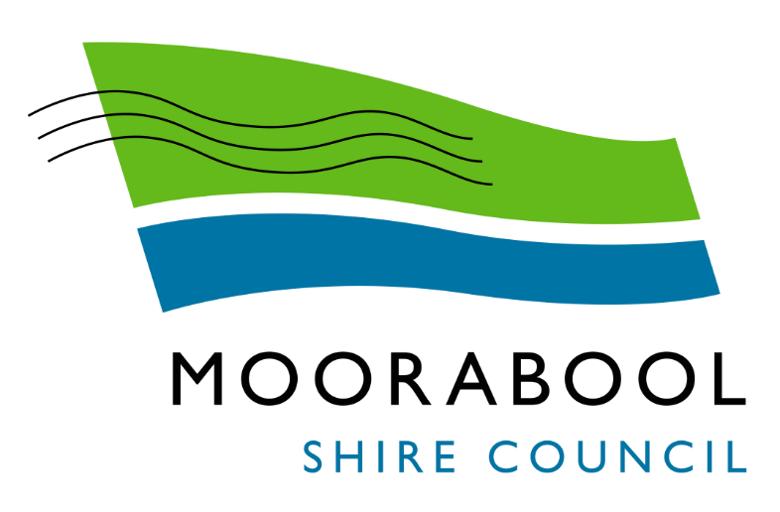
ATTACHMENTS

Ordinary Council Meeting
Under Separate Cover
Wednesday, 2 June 2021

Table of Contents

11.2 Councillor Gift Policy
Attachment 1
Councillor Gift Policy 4
11.3 Audit and Risk Committee - Chairperson's Report
Attachment 1
Audit and Risk Committee - Report by the Chair 10
12.1 Tourism Events Grants Program 2021
Attachment 1
Tourism Event Grant Application - Summary Assessment 14
Attachment 2
Tourism Events Grants Program Guidelines 2021 15
13.1 Arts and Culture Strategy
Attachment 1
Draft Arts and Culture Strategy 21
13.2 Moorabool Shire Community Grants - March 2021
Attachment 1
Community Grants Assessment - March 2021 37
14.2 Advisory Committees of Council - Reports
Attachment 1
Minutes - Lal Lal Falls Advisory Committee - 8 April 2021 42
Attachment 2
Minutes - Audit and Risk Committee - 10 February 2021 46
15.1 Draft Road Management Plan 2021-25
Attachment 1
Final Draft Road Management Plan 2021-25 57
15.2 Local Area Traffic Management Study (Stage 4) Darley
Attachment 1
Existing Conditions Report (Stage 4) 30 April 2021 175
Attachment 2
Draft LATM Plan 30 April 2021 201

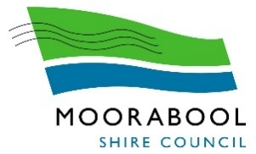

Councillor Gift Policy

Policy Type: | COUNCIL
Version: | 1.0
Date Adopted:
Service Unit | Governance & Risk
Directorate: | Chief Executive Officer
Review Date: | April 2025

1. Purpose
Moorabool Shire Council is committed to ensuring that Councillors act with integrity and honesty when performing their duties as Council representatives.

The acceptance of gifts can create perceptions that a Councillors integrity has been compromised. Therefore, this policy is intended to support Councillors to avoid conflicts of interest and maintain high levels of integrity and public trust.

2. Definitions
For the purposes of this policy, Council adopts the following definitions:
Benefits | Examples include:  • Preferential Treatment  • Discounts  • Employment offers
Ceremonial Gifts | Ceremonial gifts are official gifts provided to Council in accordance with the cultural practices of other communities and/or organisations. Ceremonial gifts are usually provided when meeting with official delegates or representatives from another organisation, community.  Ceremonial gifts are the property of Moorabool Shire Council, irrespective of value.
Conflict of Interest | The Local Government Act 2020 requires Councillors to declare General or Material Conflicts of Interest.  A conflict of interest is a conflict between a Councillor’s public duty to act in the best interest of the Council and their private interests (financial or non-financial). A conflict may exist whether it is:  • Real – it currently exists  • Potential – it may arise, given the circumstances  • Perceived – members of the public could reasonably form the view that a conflict exists, or could arise, that may improperly influence the person’s performance of their duty to the Council, now or in the future.

Gift | As defined in the Local Government Act 2020, means:  Any disposition of property otherwise than by will made by a person to another person without consideration in money or money's worth or with inadequate consideration, including—  (a) the provision of a service (other than volunteer labour); and  (b) the payment of an amount in respect of a guarantee; and  (c) the making of a payment or contribution at a fundraising  Note: A gift is anything of value which is offered to a Councillor as a result of the role as a Councillor. This includes free or discounted goods services, hospitality or other benefits that exceed common courtesy. Some examples include:  • Bottles of wine or alcohol  • Christmas Hampers  • Tickets to sporting events or theatre shows  • Gift vouchers  • Free or discounted accommodation and/or travel
Gift Disclosure Threshold | As defined in the Local Government Act 2020, means:  In the case of a Council other than the Melbourne City Council, $500 or a higher amount or value prescribed by the regulations
Hospitality | Unless the hospitality is reasonable and you are attending the function or event in an official Council capacity, the hospitality will be considered a gift.  Reasonableness test: the hospitality must be of a standard and type that an independent observer would consider appropriate and not excessive.  Official capacity test: it must clearly be part of your duty as a Councillor to attend the relevant function or event.  Hospitality that is not deemed a gift includes:  • Sandwiches and savouries at a lunchtime meeting.  • A non-alcoholic beverage at another organisations premises.  • A cup of coffee at a café (unless there is a conflict of interest).  Hospitality that would be deemed a gift includes:  • An offer of fine dining  • An offer to pay for a working lunch
Value | Value means the actual value or estimated retail value.

3. Scope
This policy applies to all elected Councillors of Moorabool Shire Council.

4. Non-Compliance
Non-compliance of this policy may be deemed to be in contravention the Moorabool Shire Councillor Code of Conduct and subject to appropriate action under that Code and/or action initiated by the relevant regulatory authorities.

5. Policy
Councillors have a responsibility to act with integrity and transparency in their dealings and associations with the community. Councillors should at all times be aware of the Local Government Act provisions regarding the acceptance of gifts especially in relation to conflict of interest, election donations and personal interest returns.
This policy sets out Councils standards and procedures for responding to gift offers, and aims to ensure that Councillors are not compromised in the performance of their duties by accepting gifts which may result in a sense of obligation or could be interpreted as an attempt to influence. This helps to protect and promote the integrity of the Council.

5.1. No Soliciting of Gifts
Councillors must not solicit gifts for themselves or anyone else, in any form. To do so may constitute misuse of their position. It may also constitute corruption and lead to criminal prosecution.

5.2. Gift Offers
5.2.1. Gifts under $50 in value
Councillors may accept token gift offers and hospitality, but all gifts whether accepted or declined, must be declared. and submitted to the Governance Unit for inclusion in the Gifts Register. This is to ensure that the combined total of offers made from a single source in the last 12 months, does not exceed $500.

5.2.2. Gift offers over $50 in value
Councillors are to refuse gift offers that:
      - Are likely to influence them, or can be perceived to influence them in the course of their duties;
- Are likely to raise a conflict of interest, whether actual, potential or perceived;
- Consist of money, gift cards or vouchers;
- Could bring the individual or Council into disrepute;
- Are made in secret; or
- Are likely to be a bribe.
5.2.3. Hospitality
Gift offers of hospitality that exceed common courtesy must be avoided are often inconsistent with community expectations and have a high risk of creating a conflict of interest. Examples of gift offers of hospitality that exceed common courtesy include:
- Attending as a guest in a corporate box at the tennis or football
- Attending as a guest at a concert or theatre event
- Being ‘shouted’ a meal at a restaurant
- Accepting discounted or complimentary tickets for a family member to attend a sporting event
Reasonable hospitality as defined in this policy does not need to be declared.

5.2.4. Conferences
Gift offers in relation to conferences (such as sponsored attendance, participation, travel or accommodation) must be declined unless there is clear justification, such as where the invitation is issued by a government department or the offeror is a peak industry body.
Door prizes at conferences are not considered a gift if the individual has personally paid for their attendance.

5.2.5. The G.I.F.T Test
When deciding whether to accept a Gift, Councillors should first consider if the offer could be perceived as influencing them in performing their duties or lead to reputational damage. The more valuable the offer, the more likely that a conflict of interest or reputational risk may arise.

Developed by the Victorian State Services Commission, the GIFT test is a good example of what to think about when deciding whether to accept or decline a gift, benefit or hospitality.

G | Giver | Who is providing the gift, benefit or hospitality and what is their relationship to me?  Does my role require me to select contractors, award grants, regulate industries or determine government policies? Could the person or organisation benefit from a decision I make?
I | Influence | Are they seeking to gain an advantage or influence my decisions or actions?  Has the gift, benefit or hospitality been offered to me publicly or privately? Is it a courtesy or a token of appreciation or valuable non-token offer? Does its timing coincide with a decision I am about to make?
F | Favour | Are they seeking a favour in return for the gift, benefit or hospitality?  Has the gift, benefit or hospitality been offered honestly? Has the person or organisation made several offers over the last 12 months? Would accepting it create an obligation to return a favour?
T | Trust | Would accepting the gift, benefit or hospitality diminish public trust?  How would the public view acceptance of this gift, benefit or hospitality? What would my colleagues, family, friends or associates think?

5.3. Prohibited Gifts
Any Gifts that are inconsistent with community expectations and could bring a Councillor’s integrity, or that of the Council into question or disrepute must be declined. Accepting a prohibited gift may constitute misuse of a Councillor’s position, or a breach of this policy, which may result in serious misconduct allegations for Councillors.

In addition, if a gift is offered with the expectation of something in return, such as preferential treatment, accepting it may constitute a bribe or other form of corruption and lead to criminal prosecution. Therefore, all Councillors must refuse the following gift offers:

5.3.1. Monetary Gifts (or equivalent)
This includes gift cards, vouchers or items easily converted into money such as shares.

5.3.2. Conflict of Interest
Councillors are prohibited from accepting a gift that creates a General or Material conflict of interest.

5.3.3. Gift Disclosure Threshold
Under section 137 of the Local Government Act 2020, Councillors are prohibited from accepting gifts that are equal to or exceed the gift disclosure threshold, unless they know the name and address of the person making the gift.

If for any reason a Councillor receives a gift and they don’t know the name and address of the person who gave the gift, the Councillor may give the gift to the Council within 30 days to avoid committing an offence under the Act.

5.3.4. Reporting Prohibited Gift Offers
Where offers of prohibited gifts are received, Councillors must lodge a gift declaration form within 7 days, so their refusal/action can be properly recorded in the Gift Register.

5.4. Gift Register
The Governance Unit maintains the Gift Register for all Councillor gift declarations.

All Gifts accepted or declined will be included in the register. The Register contains:
• A description of the gift and its estimated value
• The name of the gift giver/offeror
• What was done with the gift (was it retained by the Councillor, handed to Council, etc.)
• Gifts Declined

The Manager Governance, Risk & Corporate Planning will monitor the Gifts Register and report any identified pattern of gifts offered and accepted, to the Executive Team. Further to this, a report on the Gift Register will also be presented to the Audit & Risk Committee annually.

5.5. Other Gift Disclosure Requirements

5.5.1. A Councillor who has a conflict of interest as a result of receiving a gift, must disclose the conflict of interest in accordance with the procedures outlined in Council’s Governance Rules.
5.5.2. A Councillor must disclose any gift valued at $500 or more in their biannual personal interest return, unless the gift is from a family member.
6. Related Legislation

6.1 Legislation:
• Local Government Act (Victoria) 2020

6.2 Council’s Policies:
• Councillor Code of Conduct
• Fraud Prevention Policy
• Public Transparency Policy

7. Council Plan Reference

Objectives: Providing Good Governance and Leadership
Context: Our business & Systems

8. Review

This policy will be reviewed every 4 years, or as required to reflect changes to organisational or legislative requirements.

Audit and Risk Committee
Report by the Chair
12 May 2021
Introduction
The purpose of the Audit and Risk Committee is to support Council by providing oversight of its financial and performance reporting, risk management, fraud prevention systems and control, internal control environment, internal and external audit, and Council’s performance with regard to compliance with its policies and legislative and regulatory requirements.
The provisions of the Local Government Act 2020 (the Act) relating to the Audit and Risk Committee were proclaimed on 1 May 2020 and required Council to prepare and approve a new Audit and Risk Committee Charter (the Charter) by 1 September 2020.
As such, at its meeting held 26 August 2020, Council adopted the Audit & Risk Committee Charter.
The adopted Charter has been prepared based on the Local Government Victoria model which has been aligned to current local government industry best practice and is fully compliant with Councils obligations under sections 54 of the Act.
The Charter must specify the functions and responsibilities of the committee, including the following:
• monitor the compliance of Council policies and procedures with the overarching governance principles and the Act and any regulations and Ministerial directions
• monitor Council financial and performance reporting
• monitor and provide advice on risk management and fraud prevention systems and controls
• oversee internal and external audit functions.
Section 54 of the Act also describes the work an Audit and Risk committee must undertake and various administrative instructions.
The key elements incorporated into the Audit and Risk Committee Charter include:
• A requirement that there must be a greater number of Independent Members than Councillor members;
• Requirements that take account of the expanded role of the committee pursuant to Sections 53 and 54 of the Act;
• A stronger emphasis on the key role that the internal control environment plays and how the committee can monitor this area of Council’s performance more effectively. This change includes references to the impact of the new Governing Principles on Councils’ policies and procedures; and
• An Appendix that provides guidance to committee members on their regulatory responsibilities with regard to confidentiality, use of information and managing and reporting conflicts of interest.
Membership
The appointment of independent members to the Committee as outlined in the Charter enables the Committee to provide advice to Council on matters related to its responsibilities based on broader skills and experience than might otherwise be the case and in so doing bring additional benefits to Council.
Council, at its meeting held 26 August 2020, appointed the following Independent Members to the Audit & Risk Committee:
• Mike Said (for the period from 27 August 2020 to 30 September 2021);
• Linda MacRae (for the period from 27 August 2020 to 30 September 2022); and
• Simon Dalli (for the period 27 August 2020 to 30 September 2023).
The appointment of Councillors as representatives on advisory committees plays an integral part in Councillors exercising their representation and advocacy responsibilities on behalf of the Moorabool community. Council, at its meeting held 2 December 2020, appointed the following Councillors to the Audit & Risk Committee:
• Councillor Tonia Dudzik;
• Councillor Ally Munari; and
• Councillor Paul Tatchell (Sub).
The Audit and Risk Committee, in alignment with the Local Government Act 2020, requires the chairperson to prepare a report to Council, on the Committee’s activities twice per annum.
The committee has agreed that a report on activities will be prepared for the period 1 July to the 31 December and a full year report will be prepared to outline how the Committee has discharged its responsibilities outlined in the Audit & Risk Committee Charter.
This is the first half yearly report to be presented to Council. The Committee reviewed the half yearly report at its meeting held on 12 May 2021 and confirmed it is an accurate reflection of the Committee’s activities.
Audit and Risk Committee Activities
During the reporting period, the Audit and Risk Committee met on three occasions:
• 12 August 2020
• 2 September 2020
• 9 December 2020.
The Committee considered the following matters at these Meetings:
Financial and Performance Reporting
• 2 September 2020
The Committee reviewed the Annual Financial Statements and Performance Statement for the 2019/20 financial year. The review included presentation and discussion of the Victorian Auditor General’s Office drafts of the Management Letter, Closing Report and Management Representation Letter. After review and consideration of all the matters raised, the Committee recommended to Council that the Annual Financial Statements Performance Statements be signed.
The Financial and Performance Statements subsequently received unqualified Audit Reports from the Auditor General.
• 9 December 2020
Reviewed the Quarterly Financial Report for the period ending 30 September 2020.
Internal Control Environment
• 12 August 2020
A significant internal control mechanism for Council is adherence to Council’s Procurement Policy. The annual Procurement report was provided to the Committee regarding compliance with spend thresholds and associated requirements. (refer Compliance Section)
Risk Management
• 12 August 2020
The Committee considered the activities undertaken by the OHS and Risk Team during Quarter 4, for the period ending 30 June 2020. To understand any emerging risk trends, the Committee reviews the statistics of public liability and internal incidents raised during the quarter.
• 9 December 2020
The Committee considered the activities undertaken by the OHS and Risk Team during Quarter 1, for the period ending 30 September 2020.
Internal Audit
• 12 August 2020
Reviewed the status of all Internal Audit Actions that are to be implemented from previous completed Internal Audit reviews. The review also included an additional comprehensive update on the 18 Recommendations from the Events Management Audit.
Reviewed the outcomes of two Internal Audits completed by the Internal Auditors:
• Enforcement Activities (planning, building and wastewater permits) - Final Report. There were no extreme or high risks identified. Several improvement recommendations were made and Management agreed to implement all such recommendations
• Review of Strategic Financial Planning - Final Report (incl. changes to Local Government Act 2020). There were no extreme or high risks identified. Management agreed with the recommendations made which will improve Council’s Strategic Financial Planning practices
• 9 December 2020
Reviewed the status of all Internal Audit Actions that are to be implemented from previous completed Internal Audit reviews.
The outcome of the Internal Audit Tender was considered with the Contract to be awarded to Pitcher Partners for a three year period with two further one year options.

External Audit
• 2 September 2020
Reviewed the Closing Report and Management Letter issued by the Victorian Auditor general’s Office and management’s plan to address the points raised within these documents in readiness for the next audit (Interim and Final).
Compliance Management
• 12 August 2020
The Committee received its Annual Procurement Audit Outcomes update in relation to the various auditing processes that are undertaken to ensure compliance with legislative and adopted procurement policy provisions.
The Audit and Risk Committee Charter Matrix 2019 - 2020 states the following requirement under Item ii of the Compliance Duty and Responsibility:
‘Review the process for communicating the Councillor Code of Conduct to the Moorabool Shire Council and the Staff Code of Conduct to Moorabool Shire Council staff; and for monitoring compliance with these Codes.’
The Committee noted that there have been no reportable incidences of non-compliance.
• 2 September 2020
Reviewed the Governance Checklist for inclusion in the 2019 – 20 Annual Report.
Review of Charter
The provisions of the Local Government Act 2020 (the Act) relating to the Audit and Risk Committee were proclaimed on 1 May 2020 and required Council to prepare and approve a new Audit and Risk Committee Charter (the Charter) by 1 September 2020.
As such, at its meeting held 26 August 2020, Council adopted the Audit & Risk Committee Charter.
The Audit & Risk Committee received the Council approved Charter at its meeting held 9 December 2020.
Other Matters
At each Meeting the Committee monitors the progress of any major lawsuits the Council is a party to.
As the Audit & Risk Committee meeting of the 9 December 2020 was the first meeting under the new Charter and, in accordance with Council’s Governance Rules, nominations for a Chairperson were called with Ms Linda MacRae declared the new Chairperson.
Ms Linda MacRae thanked Mr Mike Said for his leadership and professionalism during his extensive period as the outgoing Chairperson of the Committee.
The Annual Work Plan of the Committee is reviewed and updated at each Meeting.
At the Meeting on 12 December 2020, the Committee welcomed Councils new Internal Auditors, Pitcher Partners who will provide the Internal Audit Services for the next three (3) years.
The Committee also discussed the Indicative Draft Internal Audit Plan which is subject to the conduct of the Business Function Risk Assurance Map (BFRAM).

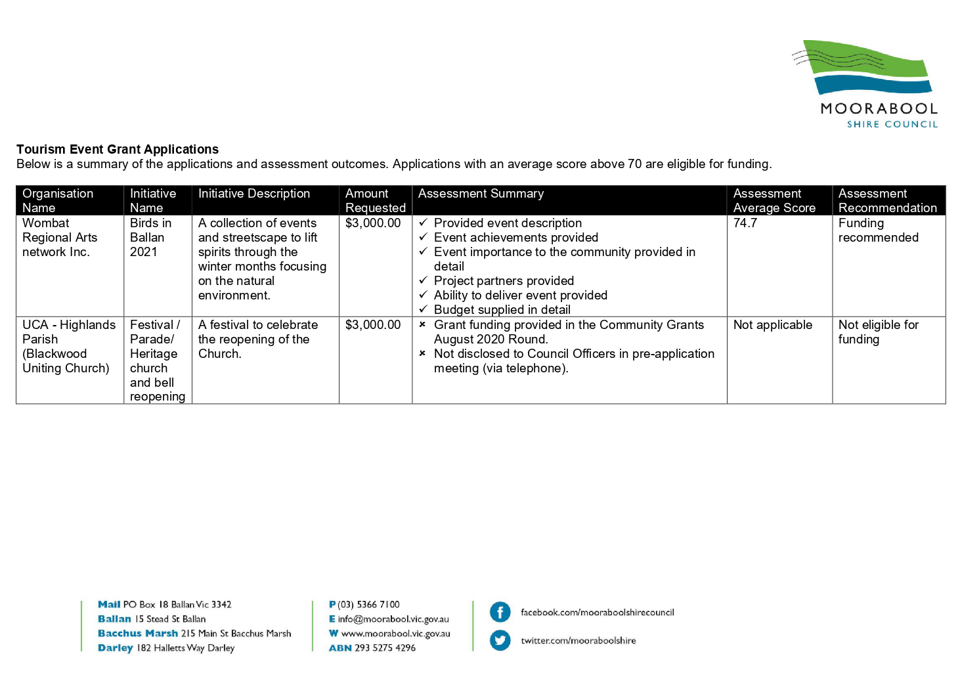
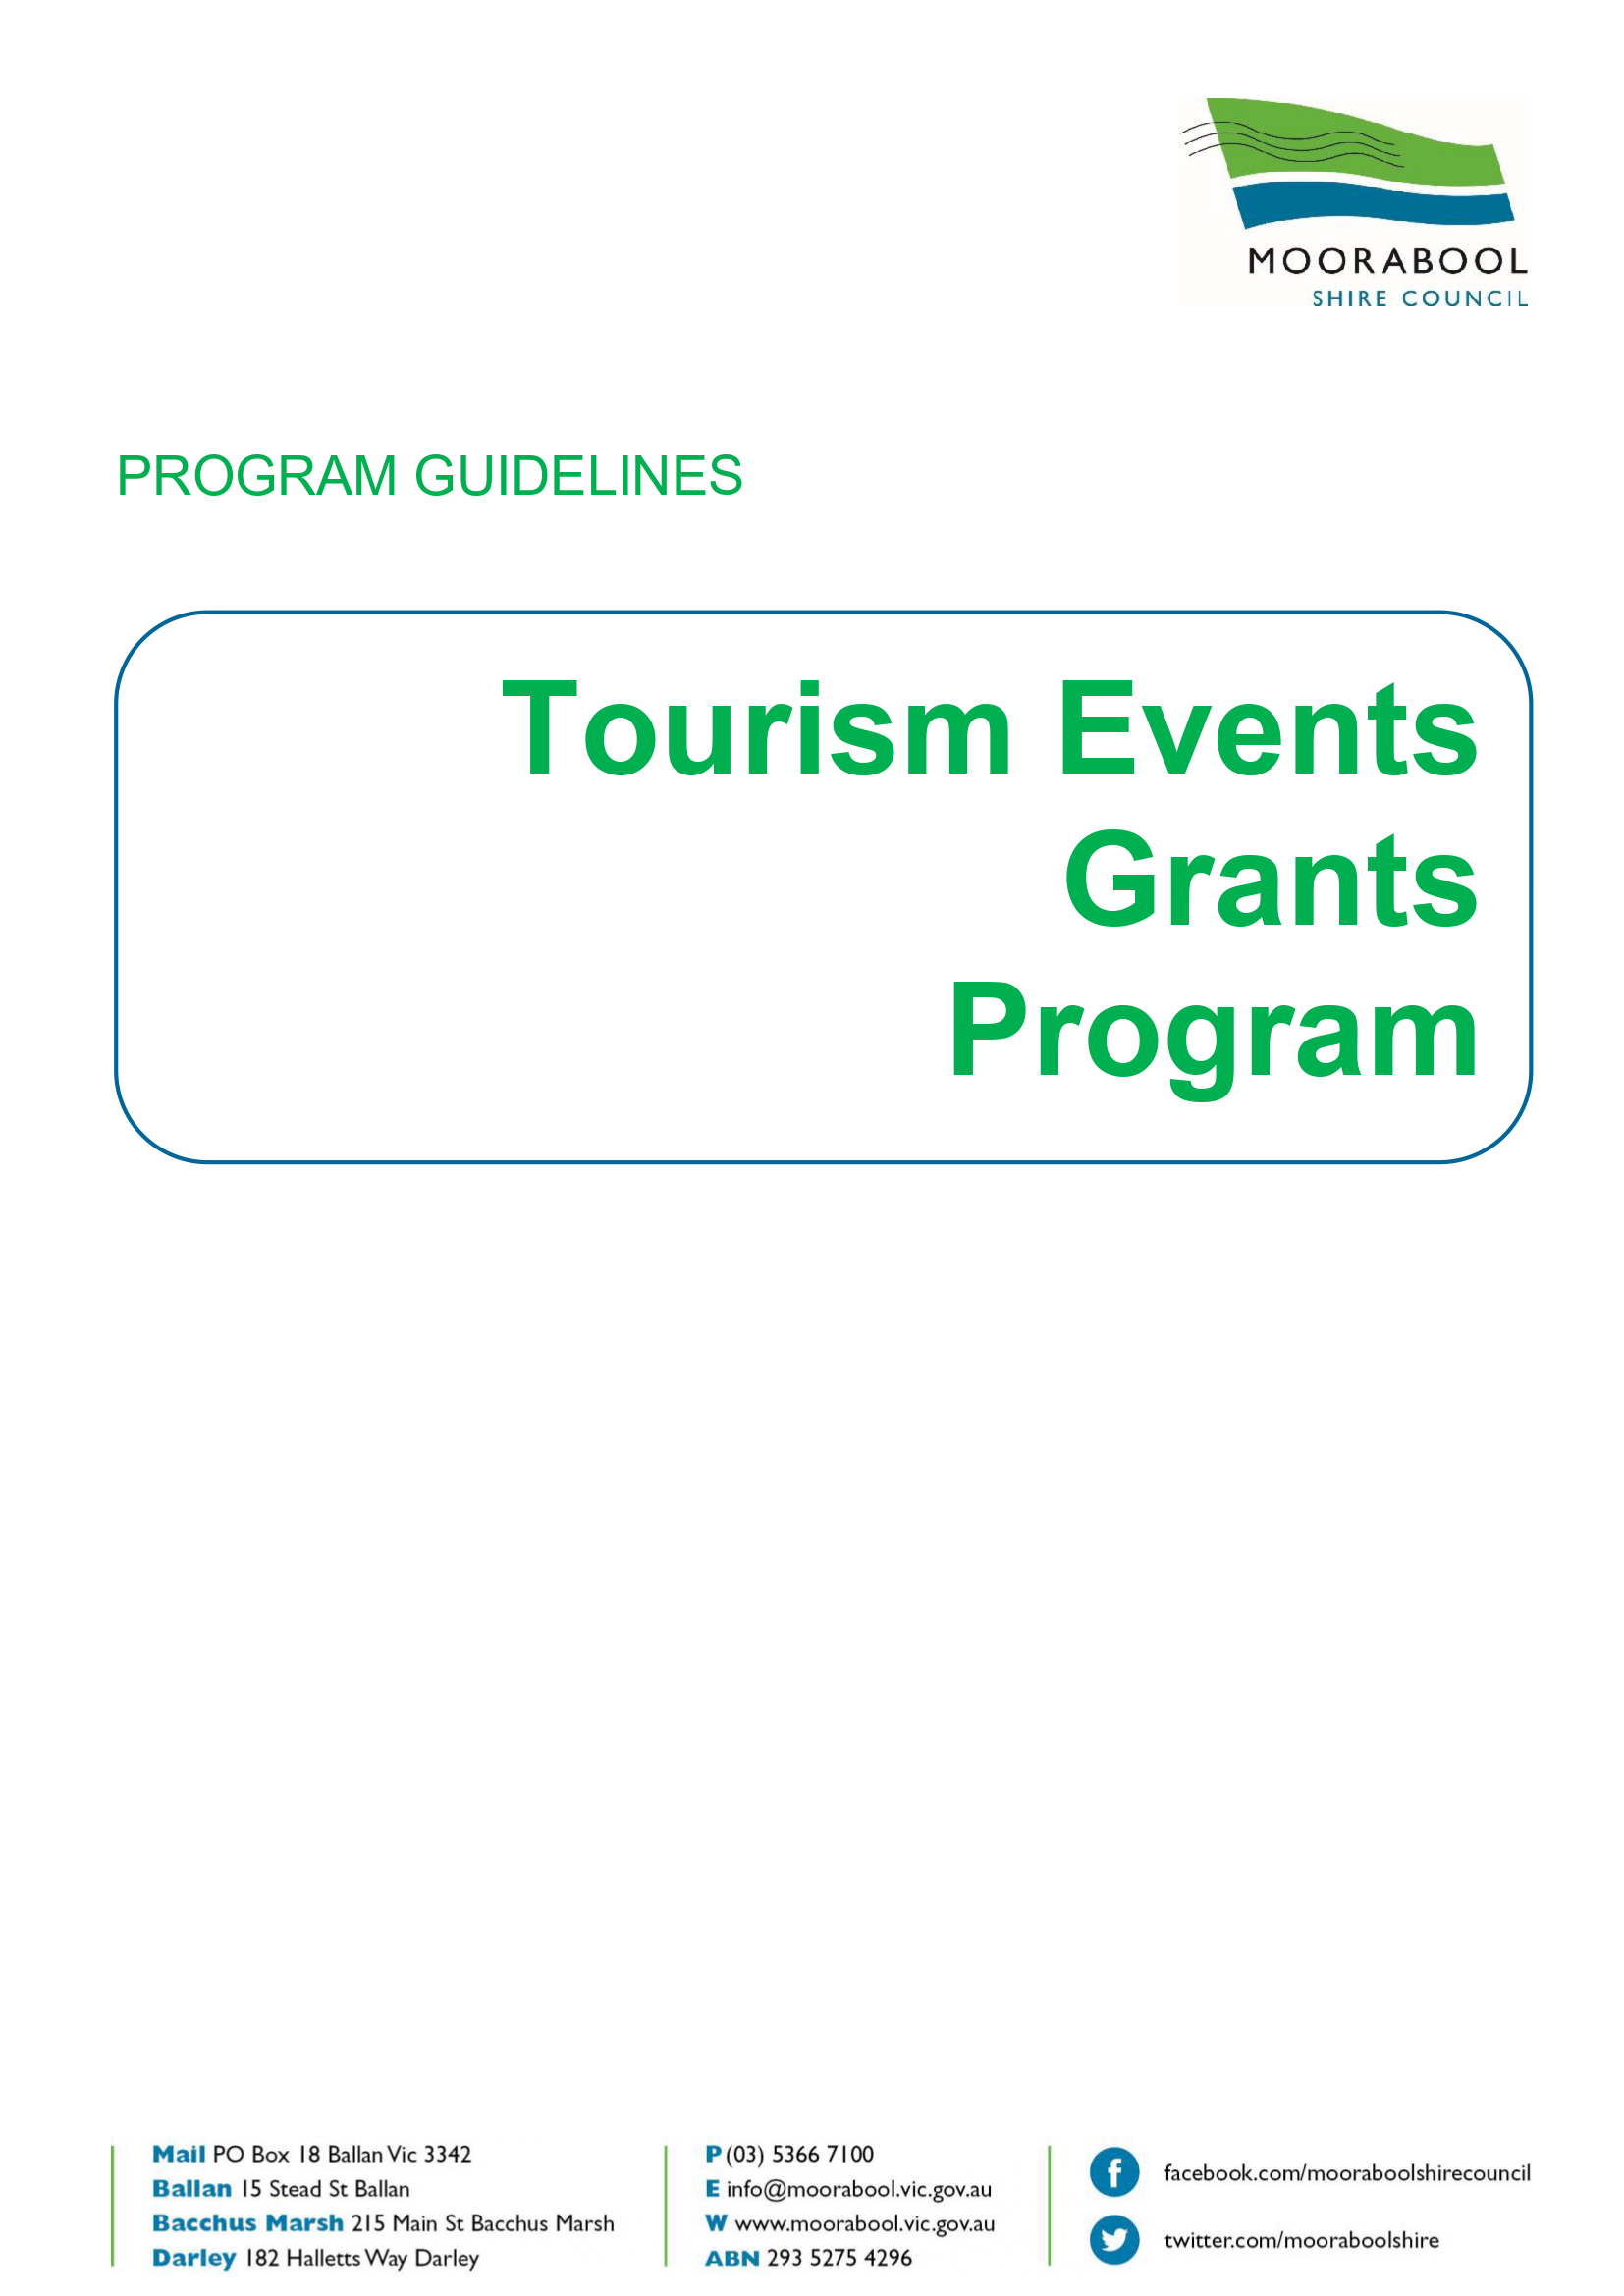

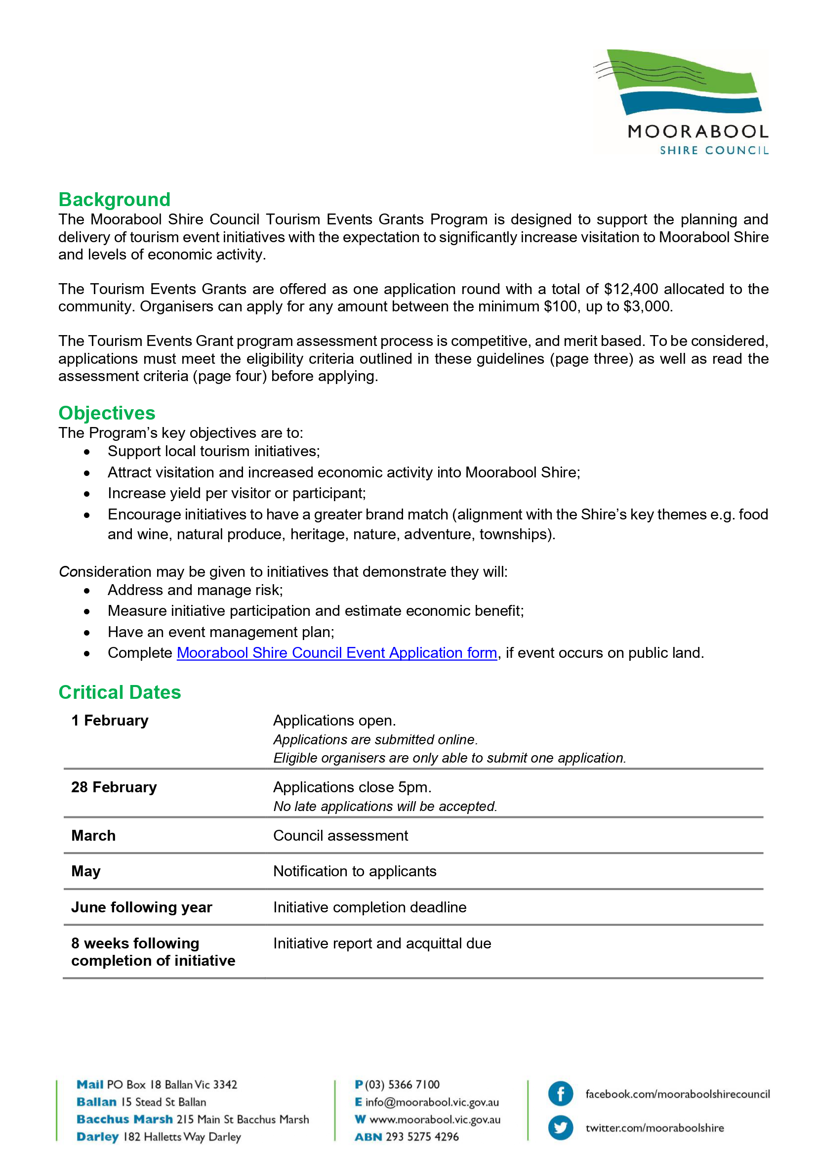

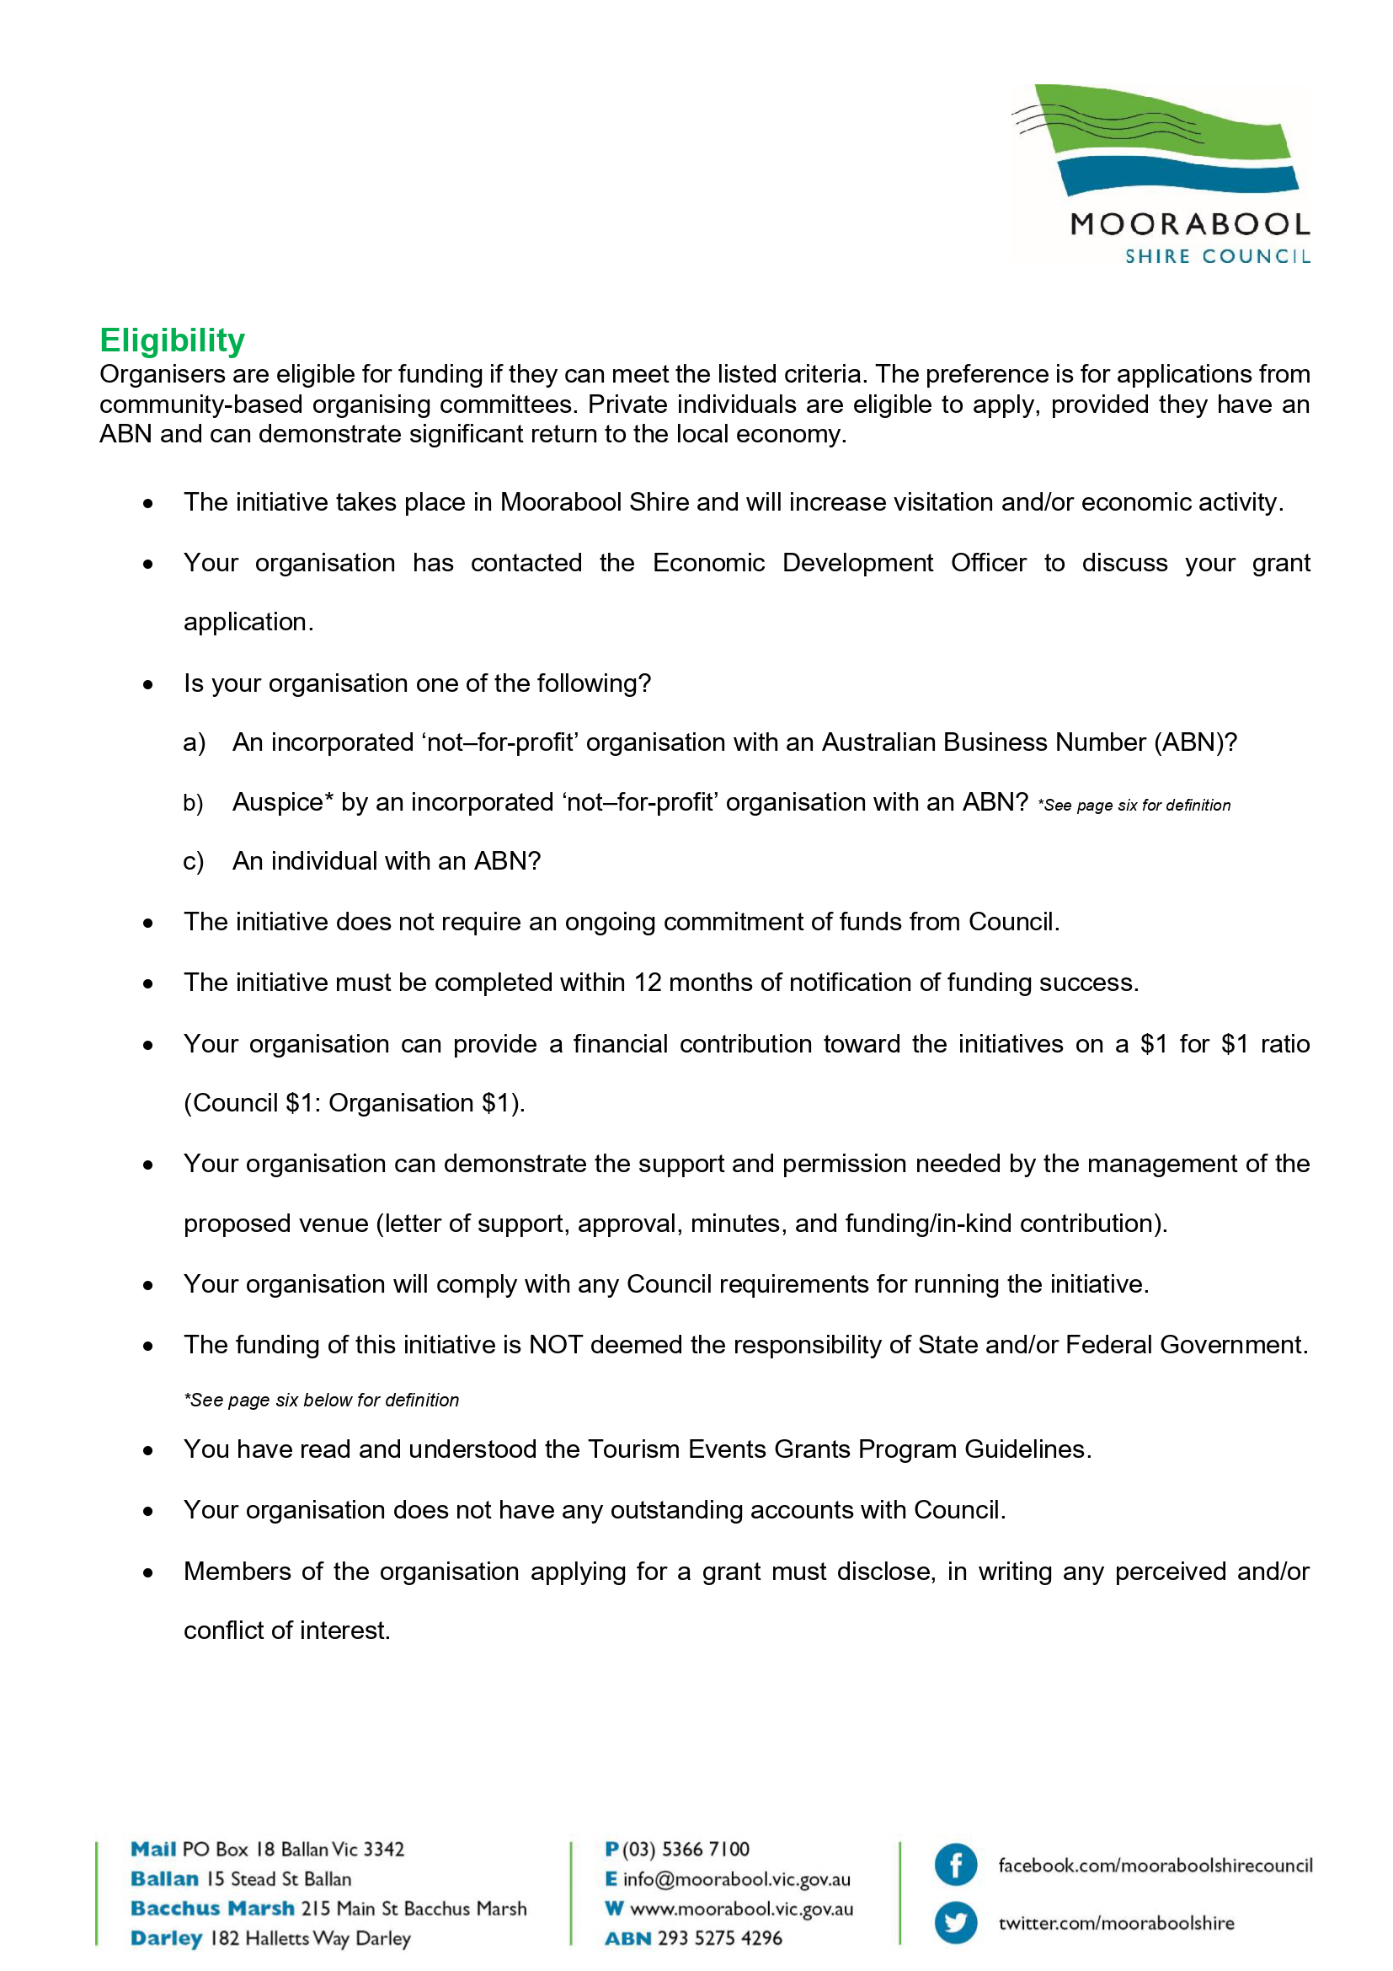

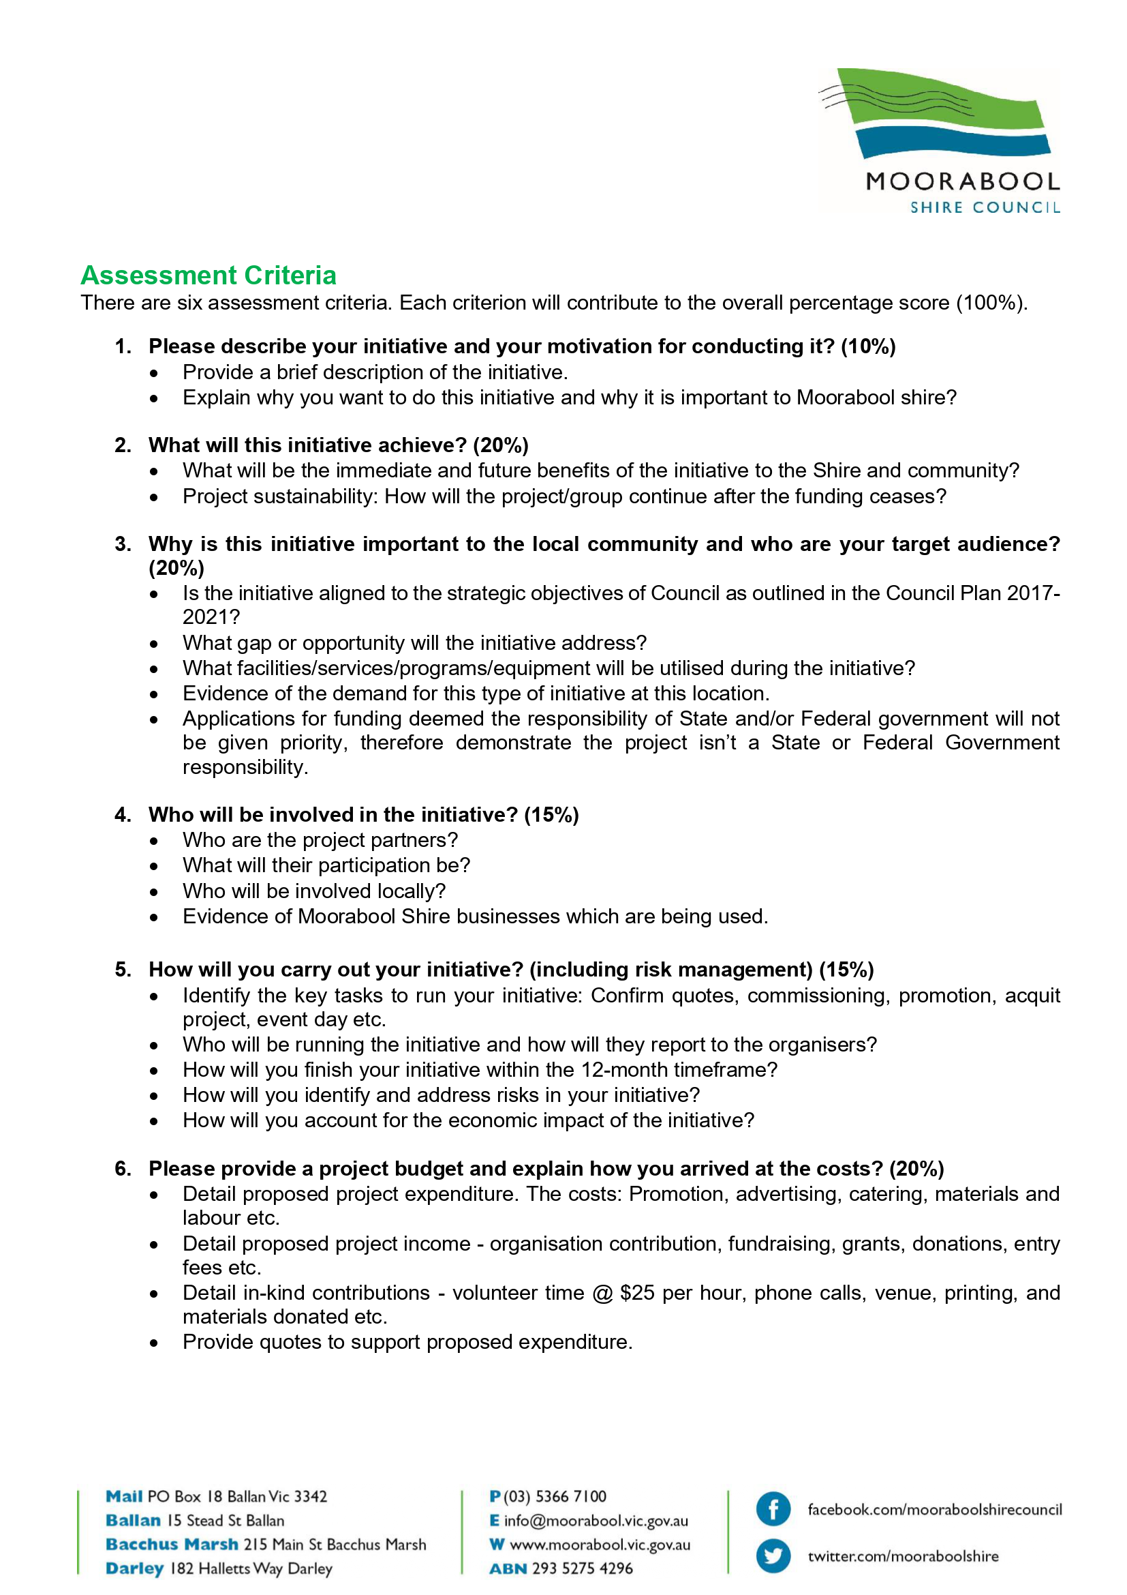

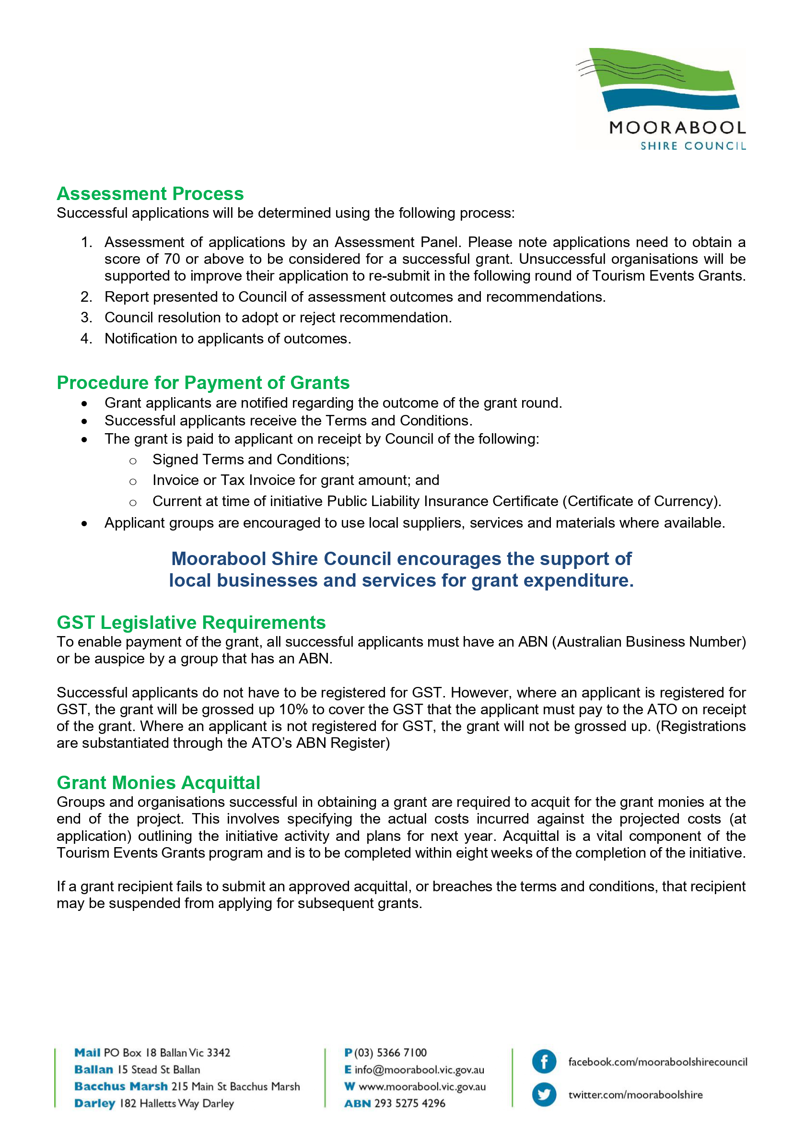

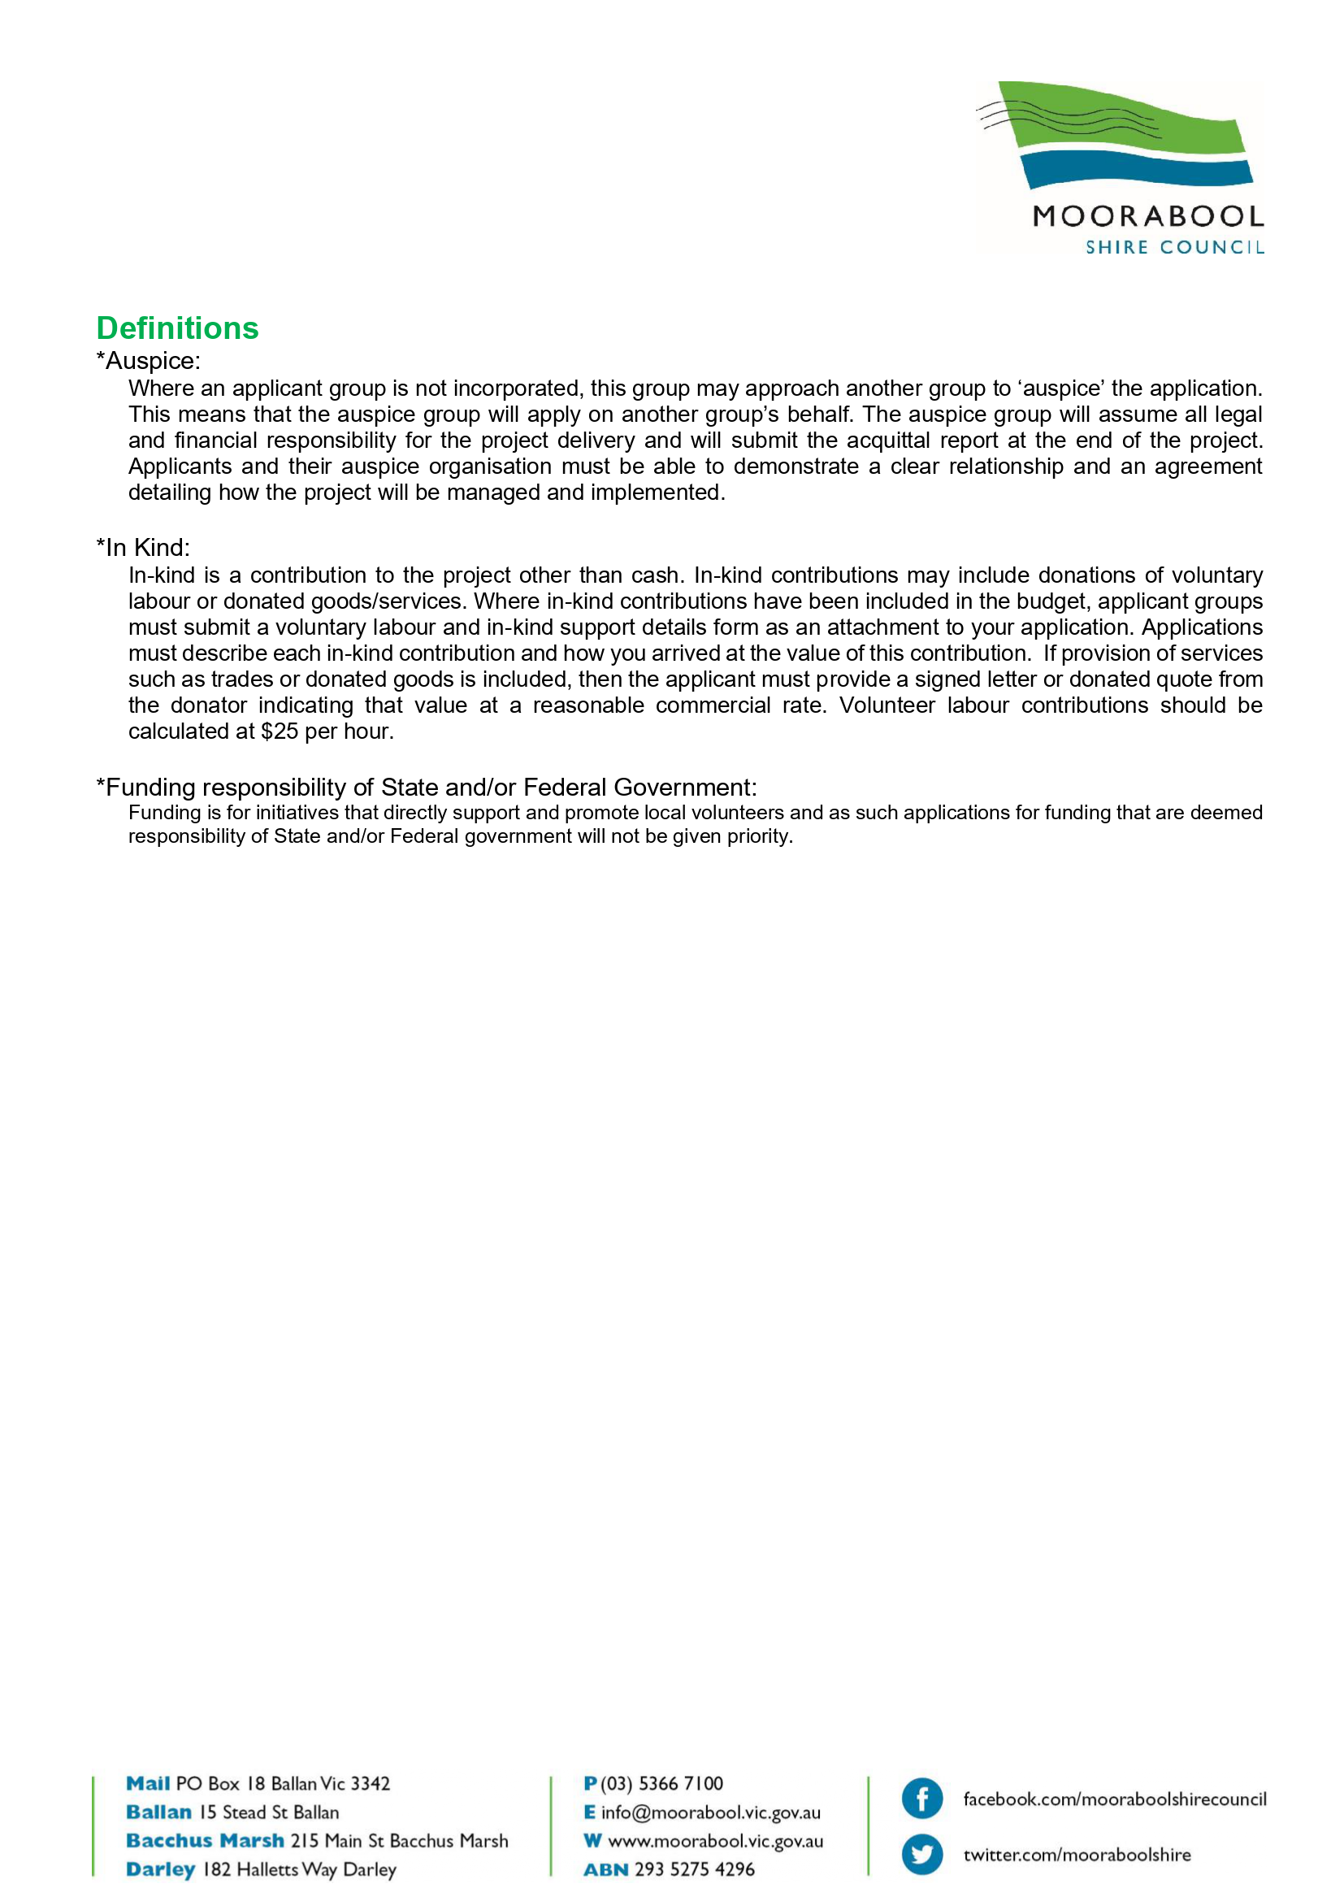

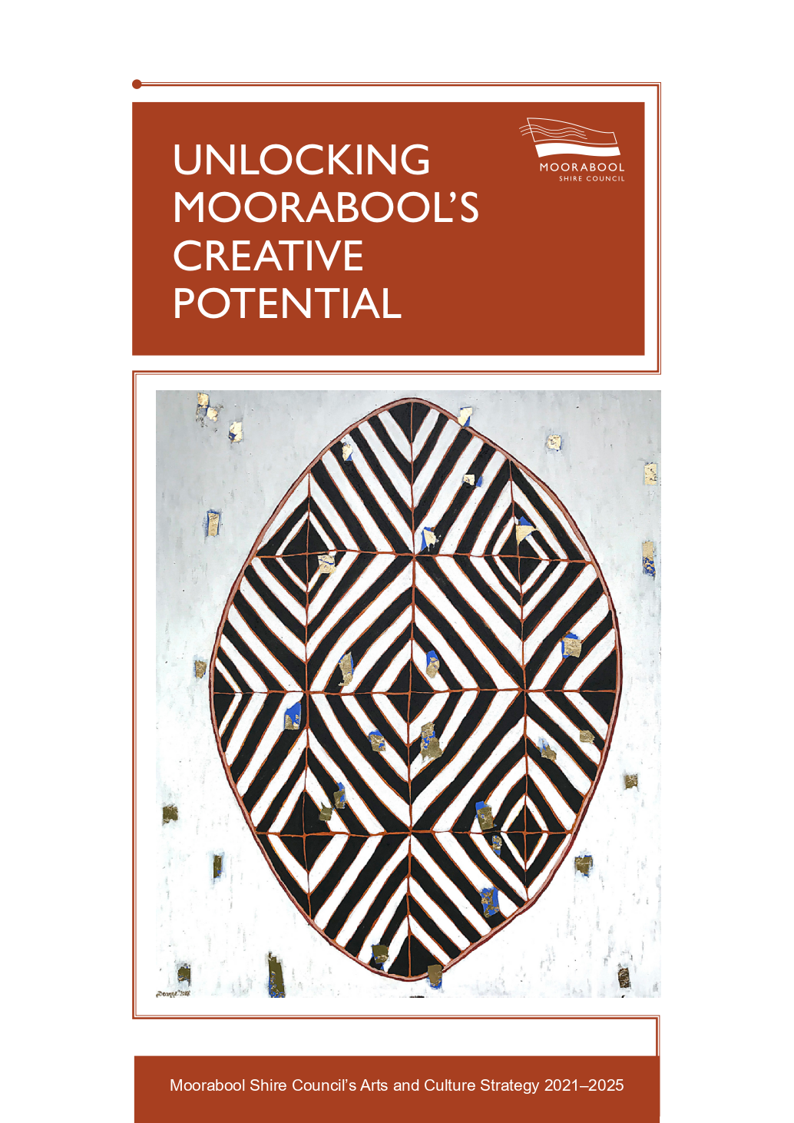

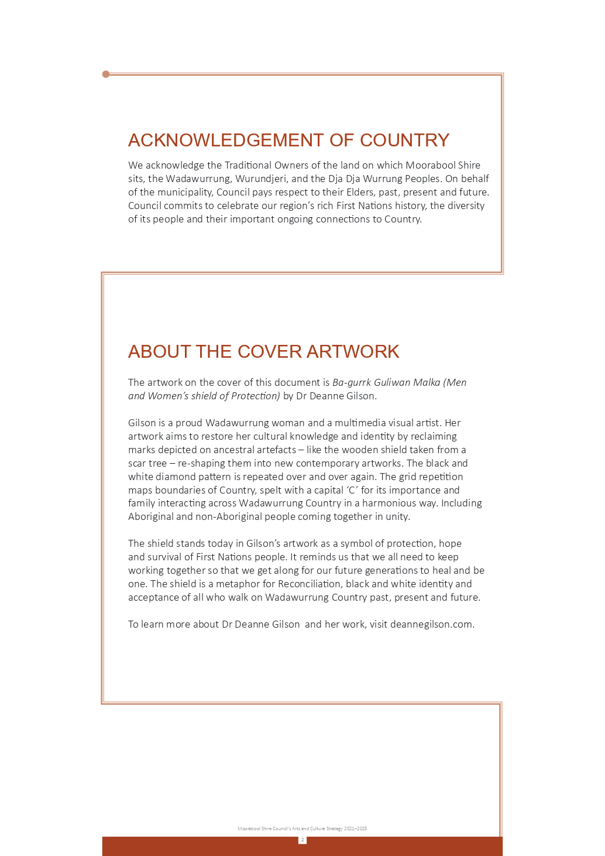

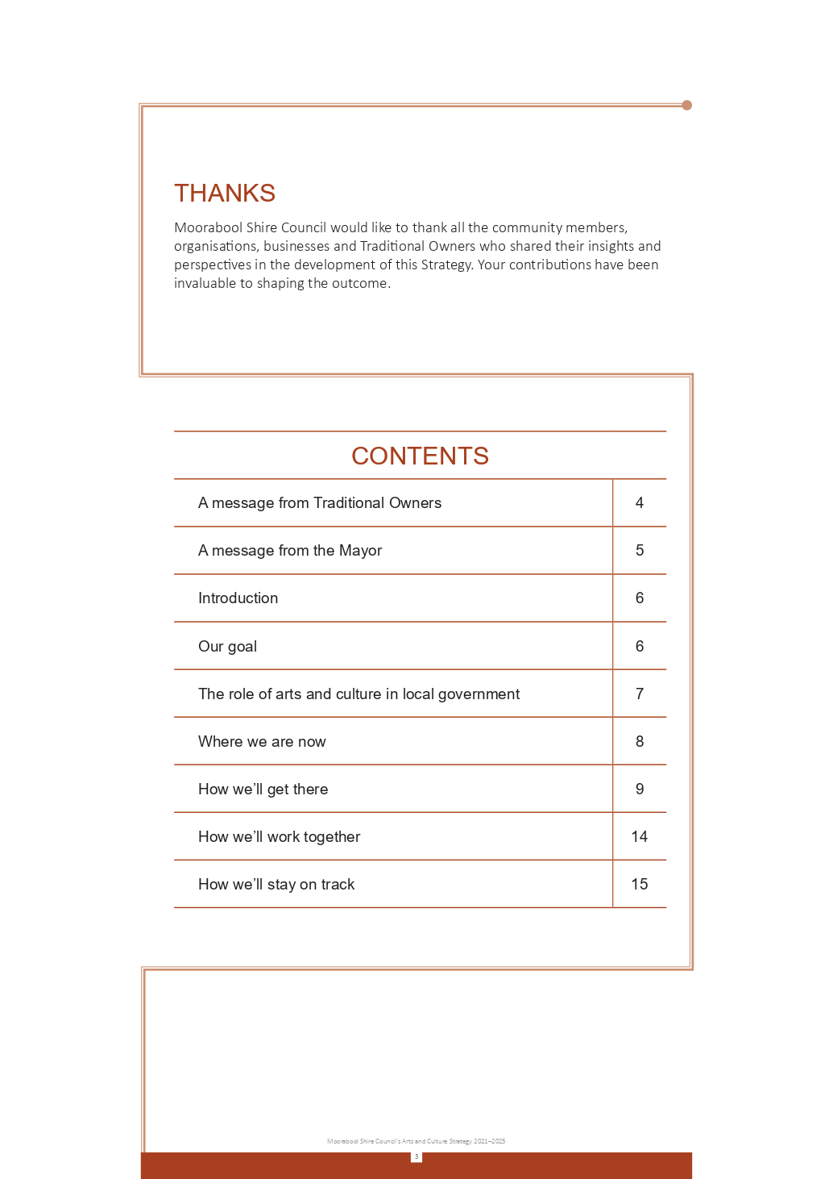

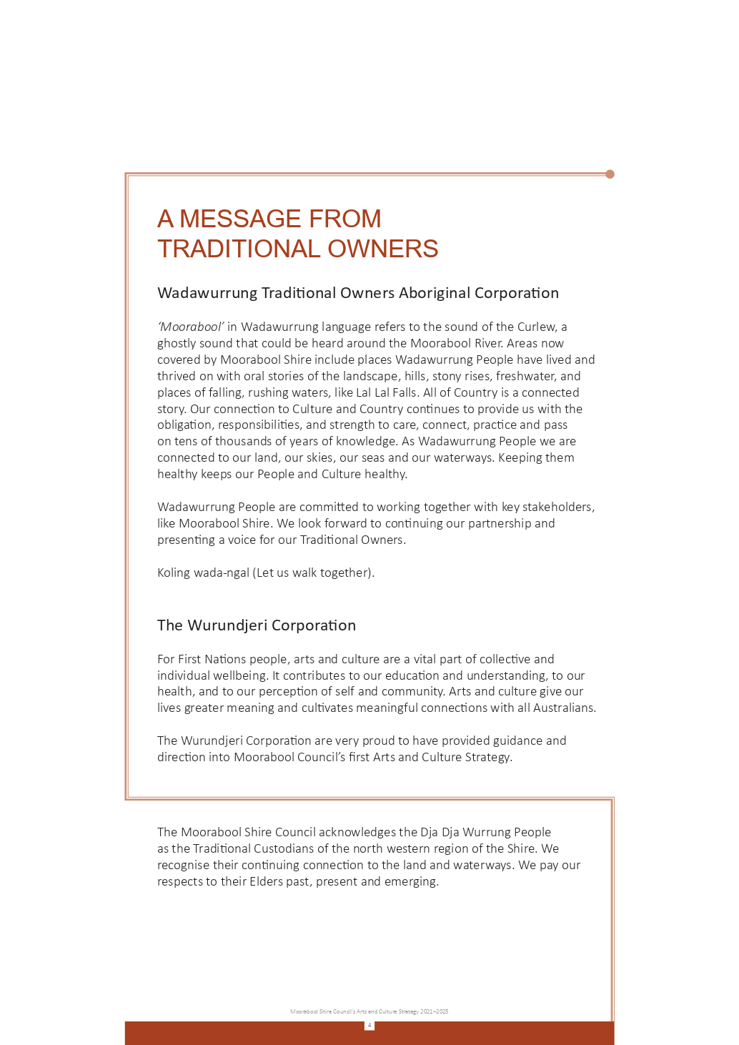

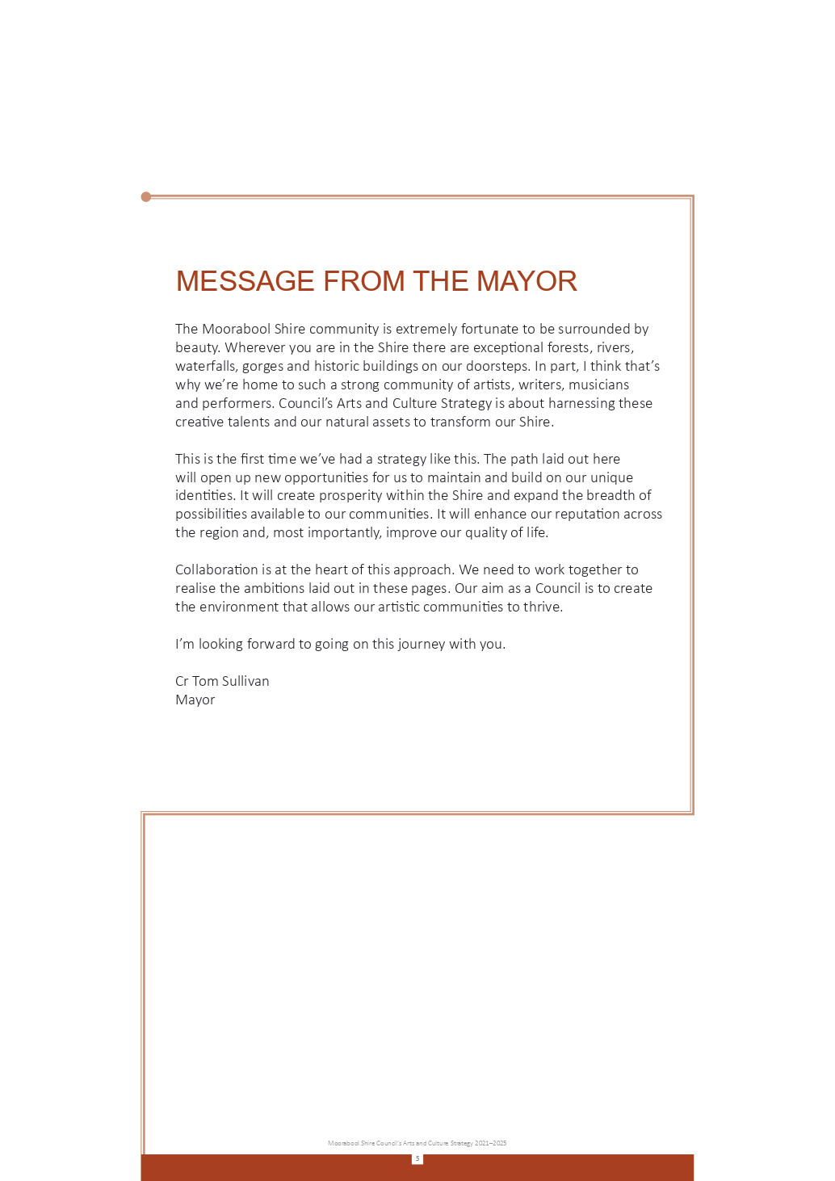

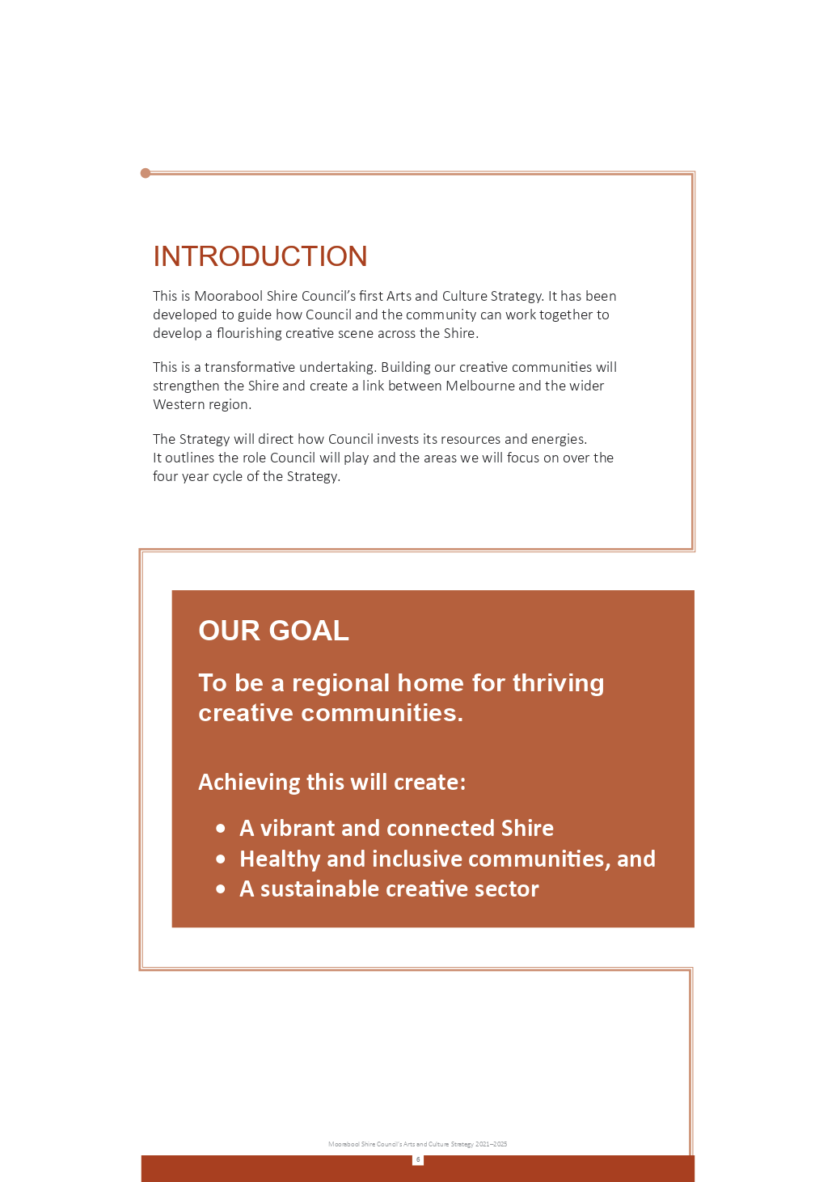

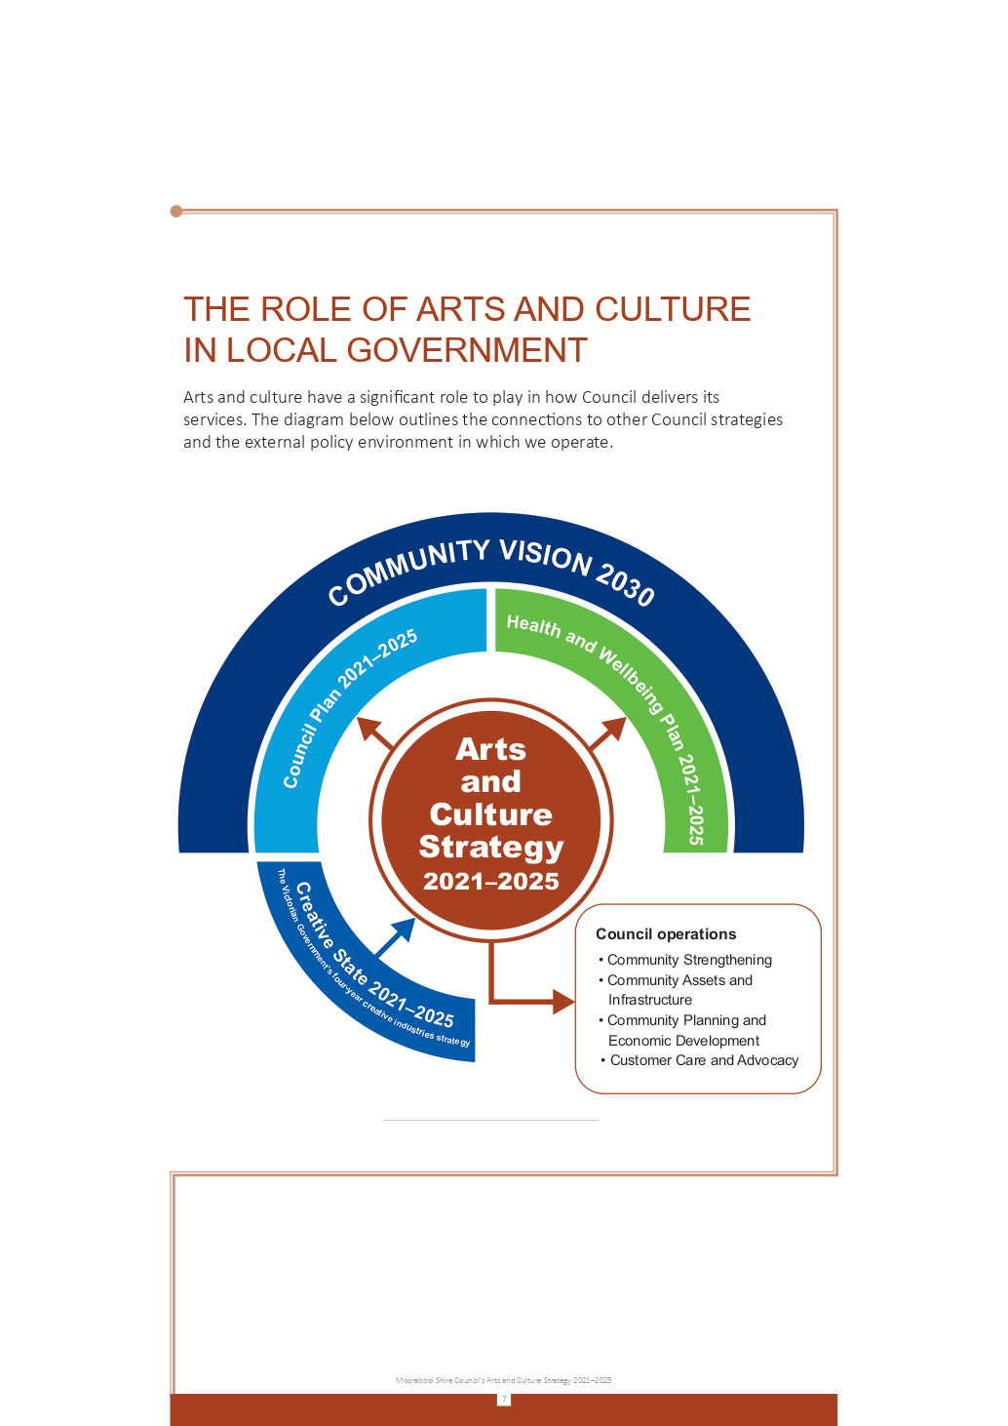

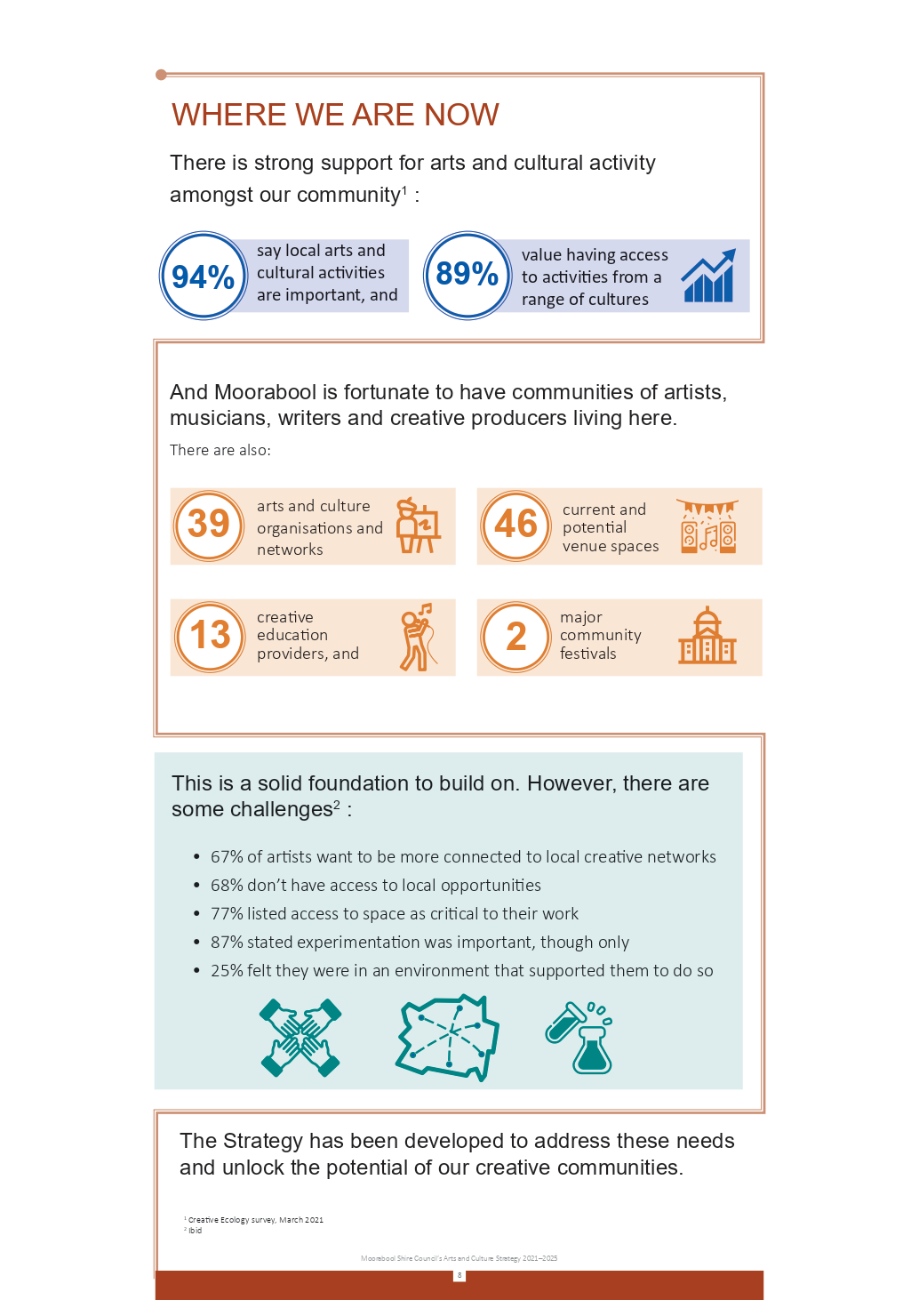

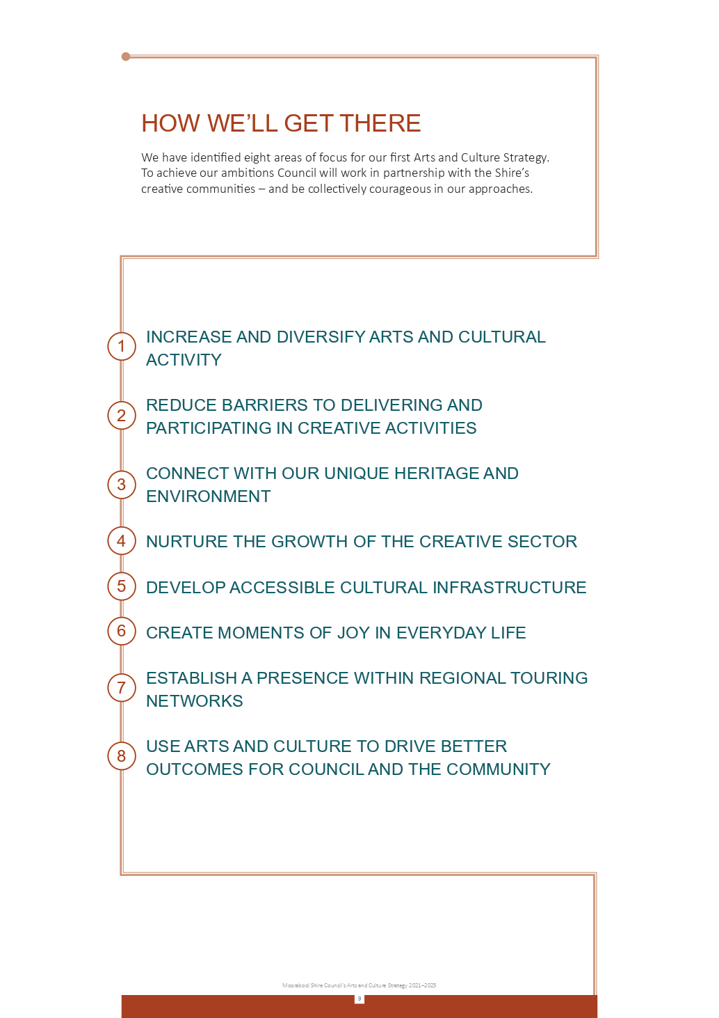

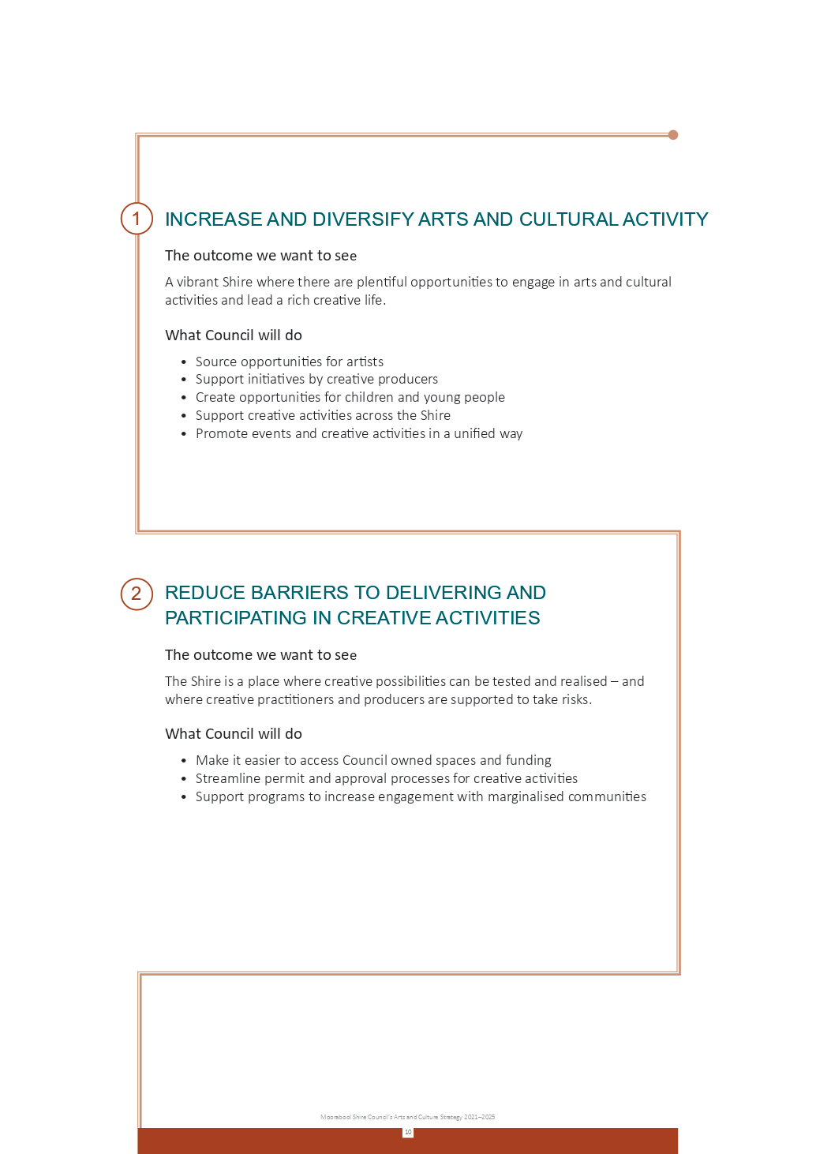

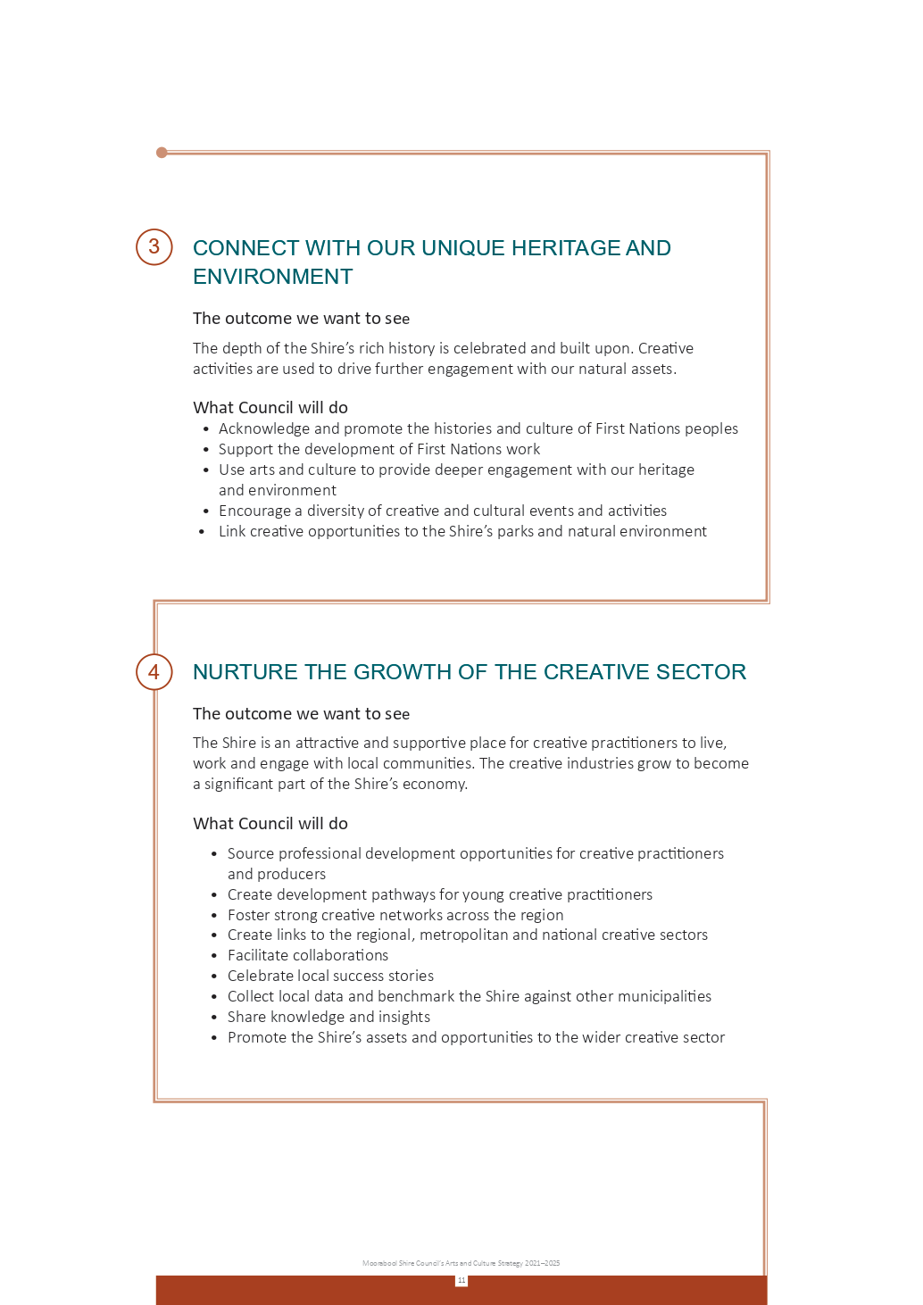

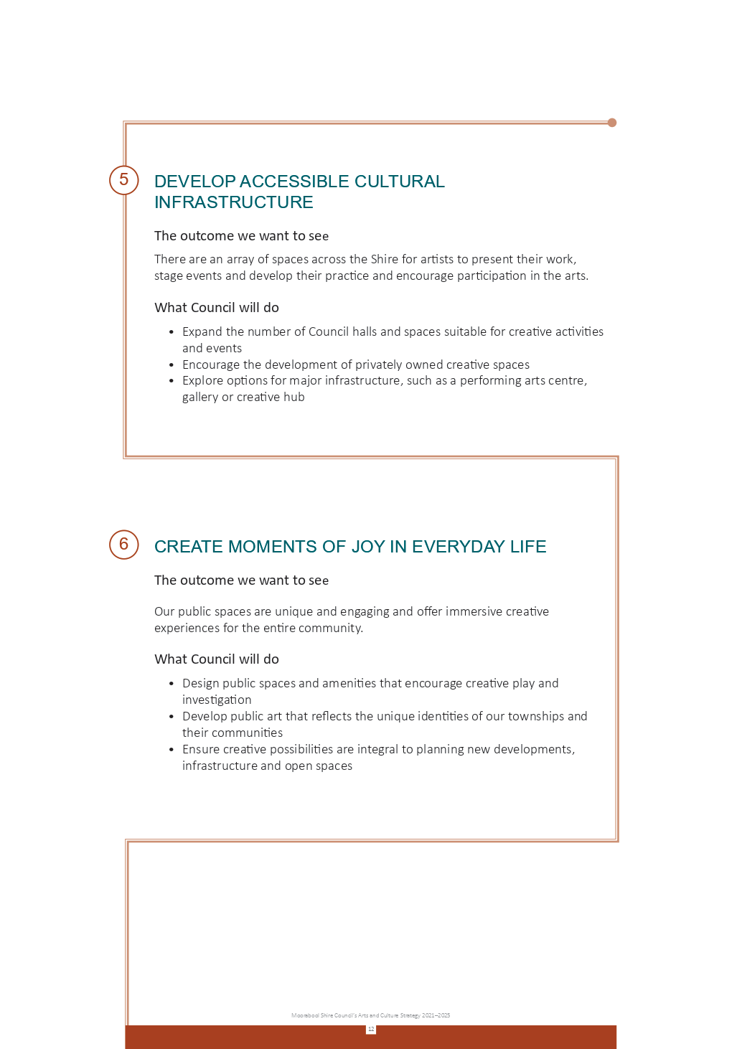

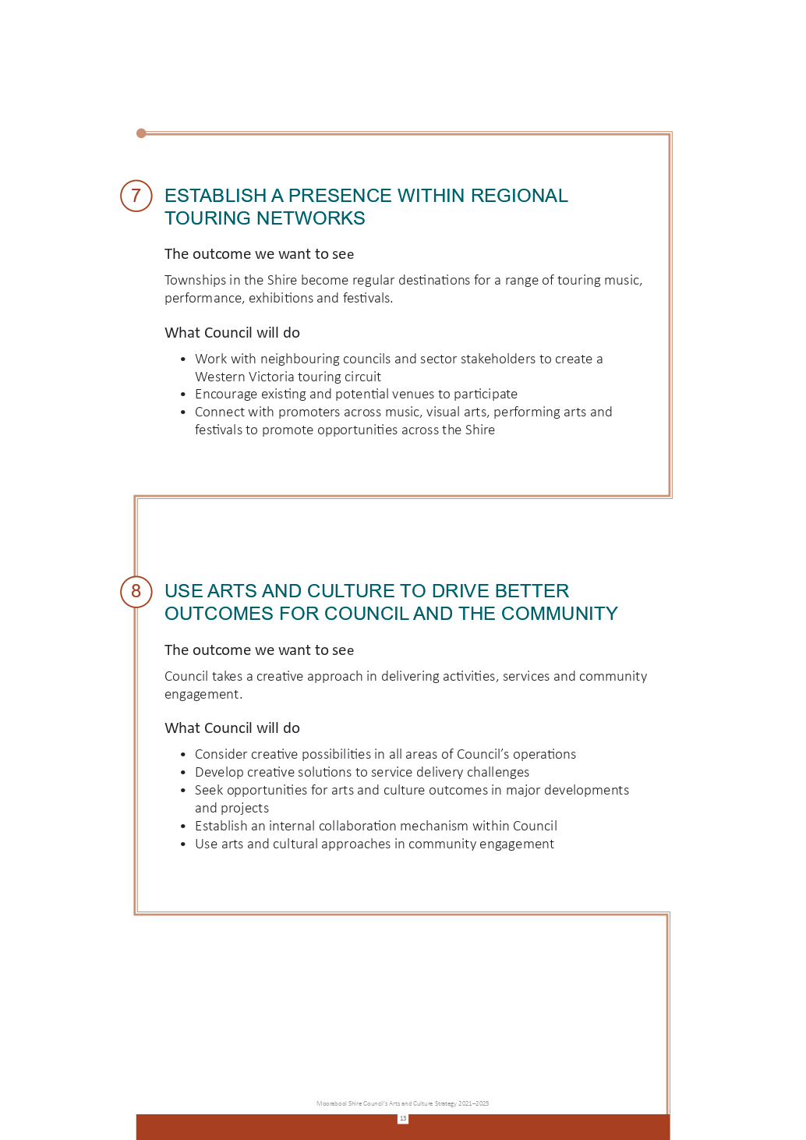

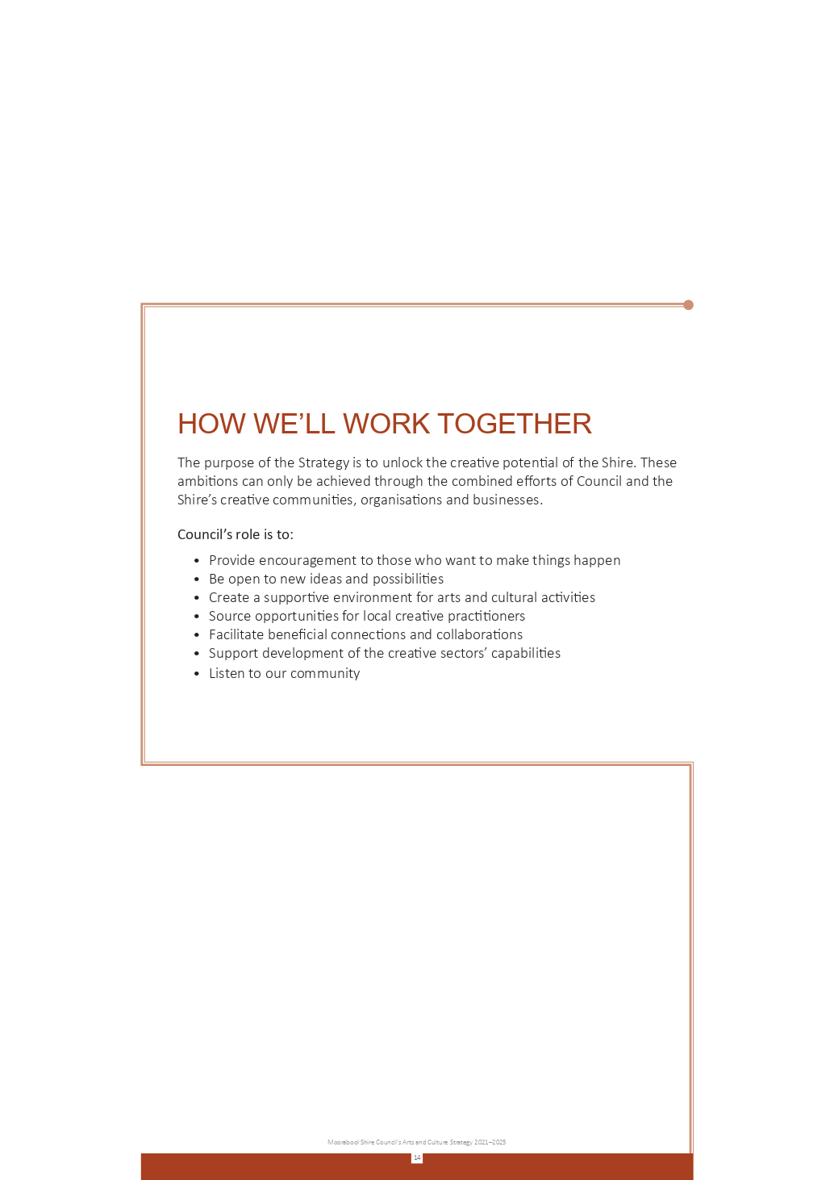

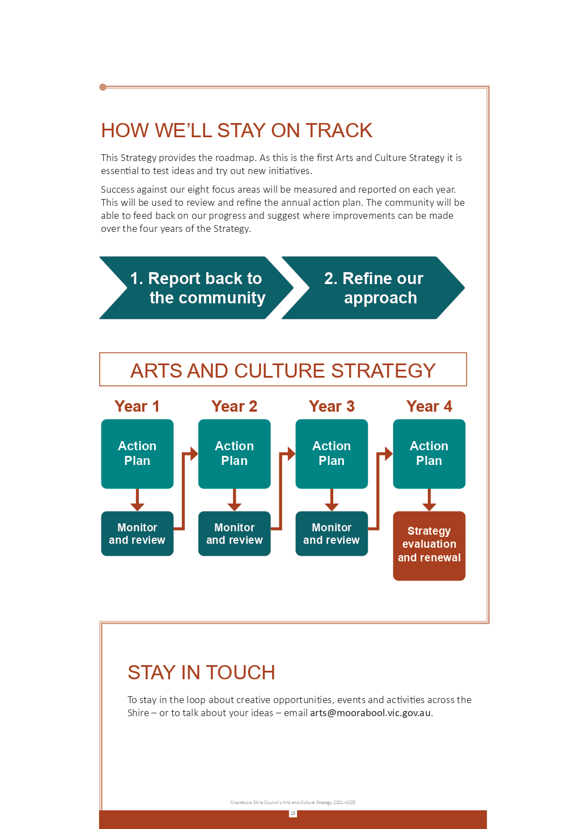

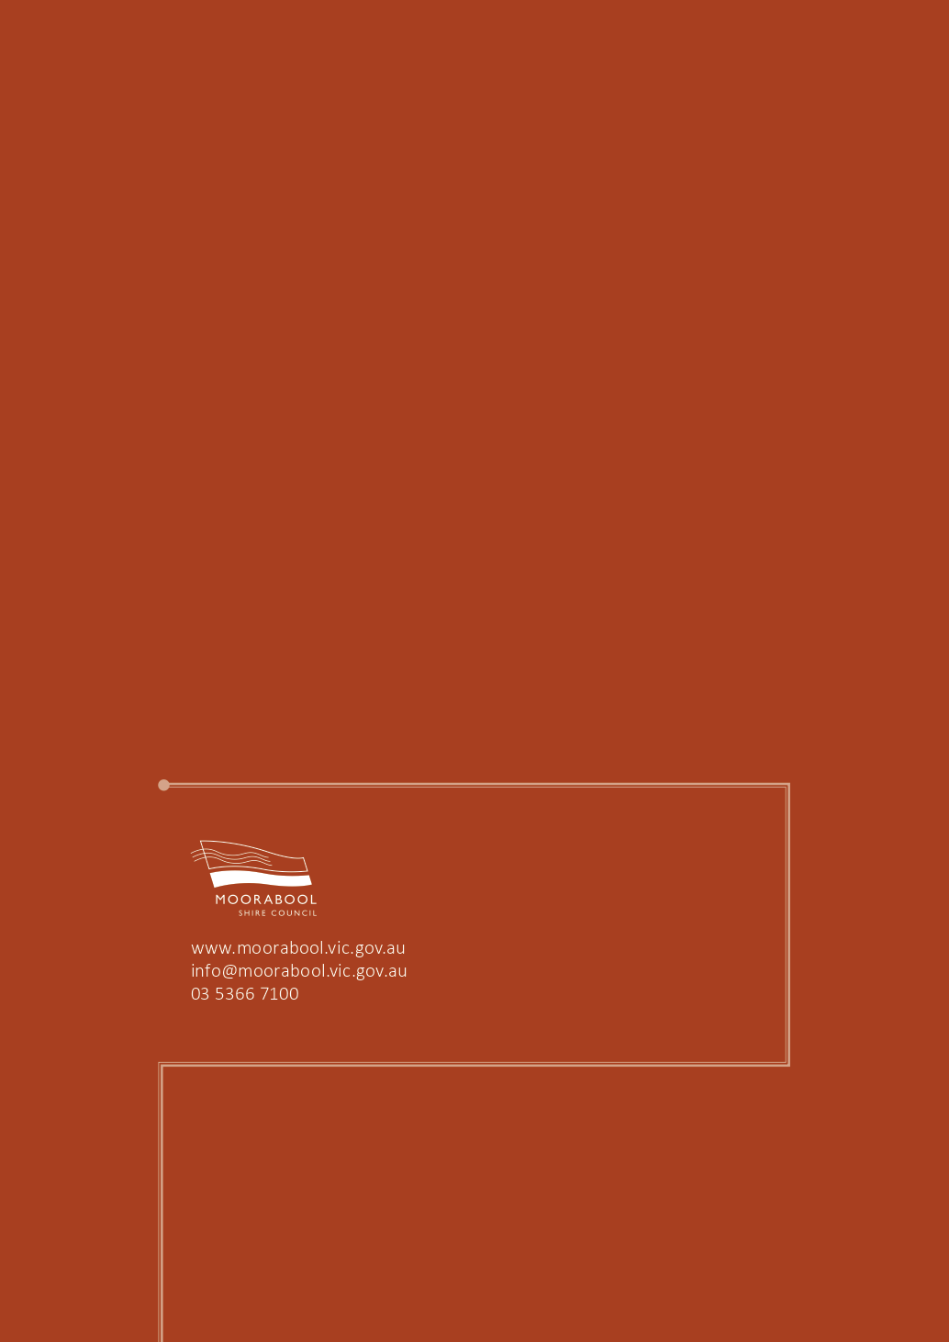

Proposal
Based on the application assessment process and funding criteria, it is proposed that the Council allocates funding for grants for the Moorabool Shire Round 1 March 2021 Community Grants Program as detailed in the tables below:

RECOMMENDED
COMMUNITY ARTS AND CULTURE GRANTS:
Groups demonstrating a score of 70 or above may be provided with funding if Council so determine.

Group Name | Group Project | Project Description | Community Grant Requested | Total Project Value | Policy Score
Moorabool Light Orchestra Inc | September 2021 Concert | To hold a music concert at the Bacchus Marsh Public Hall | $2,000.00 | $5,500.00 | 75.3
Miranda Brockman | Birds in Ballan Concert | To hold a classical music concert at the Ballan Mechanics Institute | $3,000.00 | $7,275.00 | 78.7
Totals |  |  | $5,000.00 | $12,775.00

RECOMMENDED
COMMUNITY STRENGTHENING GRANTS:
Groups demonstrating a score of 70 or above may be provided with funding if Council so determine.

Group Name | Group Project | Project Description | Community Grant Requested | Total Project Value | Policy Score
Lal Lal Moorabool Photographic Group Inc | Lal Lal Photo Group Website | To establish a website to promote the group’s art | $3,000.00 | $6,000.00 | 70.65
Darley Cricket Club | Darley CC Flexipitch Project | To purchase a Flexipitch to increase playing capacity | $2,442.02 | $4,884.04 | 74.6
Ballan Old Racecourse Reserve Committee | Power Upgrade | To upgrade the power supply to the Tom Mullane Pavilion | $5,000.00 | $10,000.00 | 74.6
Bacchus Marsh Lawn Tennis Club Inc | Book-a-Court Instillation and Configuration | To install the Book-a-Court system to allow more use of the courts | $5,000.00 | $22,000.00 | 80.39
Gordon Farmgate Inc | Supporting Local Food through the Gordon Farmgate | To purchase a freezer to support their operations | $1,000.00 | $1,000.00 | 72.75
Totals |  |  | $16,442.02 | $43,884.04

NOT RECOMMENDED
COMMUNITY STRENGTHENING GRANTS:

Group Name | Group Project | Project Description | Community Grant Requested | Total Project Value | Rationale
Wallace Recreation Reserve | Wallace Recreation Reserve Defibrillator | To install a defibrillator at the Wallace Recreation Reserve | $1995.00 | $1995.00 | Ineligible due to not matching 1:1 funds  Beneficiary user group successful last round
Ballan Golf Club Inc. | Primer seal walking tracks in Werribee Valley Reserve | Primer seal walking tracks in Werribee Valley Reserve | $5,000.00 | $13,200.00 | Scored below 70 (60.13)
Totals |  |  | $6,995.00 | $15,195.00

RECOMMENDED
COMMUNITY SUSTAINABILITY AND ENVIRONMENTAL ENGAGEMENT GRANTS:
Groups demonstrating a score of 70 or above may be provided with funding if Council so determine.

Group Name | Group Project | Project Description | Community Grant Requested | Total Project Value | Policy Score
Blackwood and Barry’s Reef Landcare Group | Ultra-Weed-a-thon | To encourage weeding and environmental preservation | $1,000.00 | $2,000.00 | 74.45
 |  | Totals | $1,000.00 | $2,000.00

RECOMMENDED
COMMUNITY DEVELOPMENT GRANTS:

Group Name | Group Project | Project Description | Community Grant Requested | Total Project Value | Policy Score
Friends of Werribee Gorge and Long Forrest Mallee Inc | Meikles Point Discovery Trail | To create interpretive signage and install seating at the Werribee Gorge | $10,959.00 | $27,659.00 | 84.25
 |  | Totals | $10,959.00 | $27,659.00

NOT RECOMMENDED
COMMUNITY DEVELOPMENT GRANTS:

Group Name | Group Project | Project Description | Community Grant Requested | Total Project Value | Rationale
Gordon Recreation Reserve Committee Inc | Master Plan 2021-2031 | Engage a Masterplan consultant, architect and engineer to facilitate the upgrade of Gordon Recreation Reserve | $31,486.00 | $62,972.00 | Ineligible due to being successful in last grant round (August 2020)
Keeley’s Cause Limited | Keeley’s Cause Foodbank Shed | To build a shed to support the Foodbank in Ballan | $15,524.00 | $31,048.00 | Ineligible due to not providing a Certificate of Currency
Totals |  |  | $47,010.00 | $94,020.00

