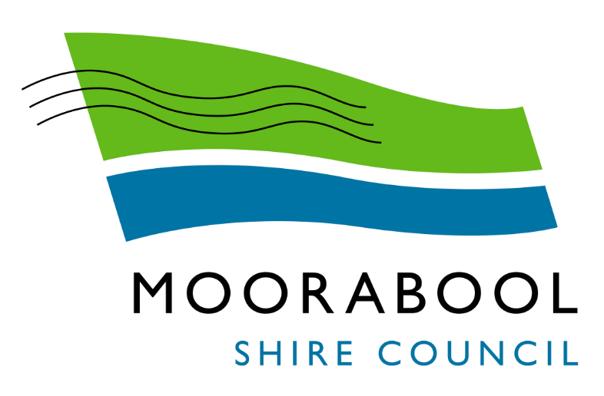
ATTACHMENTS

Ordinary Council Meeting
Under Separate Cover
Wednesday, 1 September 2021

Table of Contents

11.1 2017-2021 Moorabool Shire Council Plan - Year 4 Final Report
Attachment 1 Summary of Outcomes of 2017-2021 Council Plan Final Year Actions 4
Attachment 2 2017-2021 Council Plan Actions Progress - Year 4 Final Report 10
11.2 Instrument of Delegation from Council to the Chief Executive Officer
Attachment 1 Instrument of Delegation from Council to the Chief Executive Officer 40
11.3 Instrument of Appointment and Authorisation and Sub-Delegation from Council to Staff under the Environment Protection Act 2017
Attachment 1 Instrument of Delegation from EPA to Council 44
Attachment 2 Instrument of Direction from EPA to Council 48
Attachment 3 Instrument of Appointment and Authorisation (Environment Protection Act 2017) 51
Attachment 4 Instrument of Sub-Delegation from Council to Members of Staff (Environment Protection Act 2017 only) 53
11.4 Adoption "In principle" of the 2020/21 Performance Statement for Submission to the Victorian Auditor-General for Certification
Attachment 1 2020-21 Performance Statement 57
11.5 2020/21 Governance & Management Checklist
Attachment 1 2020-21 Governance and Management Checklist 75
11.6 Advisory Committees of Council - Reports
Attachment 1 Local Business Advisory Committee Minutes 13 July 2021 79
13.1 Draft Health and Wellbeing Plan 2021-2025
Attachment 1 Draft Health and Wellbeing Plan 2021 - 2025 103
13.2 Bacchus Marsh Racecourse Recreation Reserve Stages 2 and 3 Master Plan
Attachment 1 BMRRR Stages 2 and 3 Master Plan 143
13.3 Darley Park Master Plan
Attachment 1 Draft Darley Park Master Plan 144
14.2 10-Year Financial Plan 2021-2031
Attachment 1 Draft Long Term Financial Plan 2021-2031 204
14.3 Adoption "in principle" of the 2020/21 Financial Statements for Submission to the Victorian Auditor-General for Certification
Attachment 1 2020/2021 Financial Statements 231

Attachment 1 – Summary of Outcomes of 2017-2021 Council Plan (2020 - 2021 Review)
Strategic Objective 1: Providing Good Governance & Leadership
Strategic Context | Strategic Action | Outcome
1A Our Assets and Infrastructure | Deliver Annual Capital Improvement Programs (2017-2021) | Completed
 | Develop and implement a Fleet and Plant Strategy | Completed
 | Develop a framework for asset handover (2019-2021) | Completed
 | Develop Infrastructure Policy for Nature Strips | Completed
1B Our People | Councillor Development – induction and ongoing professional development (2017-2021) | Completed
 | Prepare an Organisational Development Strategy | Completed
 | Revise the Community Engagement Policy and Framework | In Progress (90%)  The Community Engagement Policy has been developed and adopted by Council at the February 24 SMC.  Since this time work has been undertaken relating to the development of the framework to support the policy. There is currently internal staff engagement being undertaken in the form of service unit & individual surveys. The data and information collected through this process will support the final stages of development of the frameworks. It is intended that the framework would be finalised and implemented in August 2021.
 | Develop and implement the Action Plan of the Customer Service Policy and Strategy | Completed
 | Develop a Project Management Framework | Completed
 | Enhance our OHS systems and procedures for the organisation (2017-2021) | Completed

Strategic Context | Strategic Action | Outcome
1C Our Business and Systems | Review the Municipal Planning Scheme | Completed
 | Develop an Enforcement Policy | In progress (75%)  30/6/21 Presentation of draft enforcement policy provided to Exec. Exec confirmed content however prior to further progress and discussion with Council need to undertake a GIA on the plan. Training in GIA only completed in June 2021 and currently gathering group together to discuss best way to tackle GIA on this policy .  23/7/21 Confirmation that a Council wide corporate process for GIA will not be introduced in the coming weeks as such confirmed that the GIA for this policy will be undertaken using the base documentation from State Gov contained within their guide. Group to be formed form those who have undertaken the training in GIA to assess the policy .
 | Facilitate the development of Service Plans for all Business Units (2020-2023) | Completed
 | Undertake Service Reviews as determined by Council | Completed
 | Annually review the Long Term Financial Plan (2017-2021) | Completed
 | Annually review the need to make a rate cap variation for 2020/21 year | Completed
 | Identify and develop shared services with other LG’s, community and private sector organisations (2017-2021) | Completed
 | Seek funding for new, upgrade and renewed community facilities (2017-2021) | Completed

Strategic Objective 2: Minimising Environmental Impact
Strategic Context | Strategic Action | Outcome
2A Built Environment | Develop the Gateways Strategy (2017-2021) | Completed*  *This Action has been marked completed as it is included in the  2021-2025 Council Plan
 | Prepare structure plans for key growth areas | Completed
 | Incorporate flood mapping into the planning scheme (2017-2021) and prepare and exhibit Moorabool Planning Scheme Amendment C91 (2017-2021) | In Progress (95%)  Amendment C91 seeks to introduce flood controls to the Moorabool Planning Scheme. Following the preparation of the flood study and mapping in conjunction with Melbourne Water , a report was presented to the Ordinary Meeting of Council in September 2019, where Councillors endorsed seeking authorisation from the Department of Environment, Land, Water and Planning (DELWP) and exhibiting the Amendment. Conditional authorisation was received from DELWP on 25 November 2019, to prepare and exhibit the amendment. On 13 February 2020, DELWP granted approval to commence exhibition. Exhibition formally commenced on the 12 March 2020 for a period of 8 weeks. Due to COVID-19, the exhibition period was extended until 18 August 2020. The planning scheme amendment was reported to Council on 3 March 2021. At this meeting the amendment was referred to a planning panel. A planning panel has been appointed and a hearing is scheduled for June 2021. A directions hearing was held on 20 April 2021. The panel hearing was held during the week of 15 June.
2B Natural Environment | Finalise and Implement the action plan of the Moorabool Sustainable Environment Strategy (2017-2021) | Completed
 | Review the 2015 Waste Strategy | Completed
 | Develop and implement a policy on allocation, use and trading of water for Council water assets | In progress (90%)  A draft water trading policy has been developed, the policy was been provided to the consultants developing the Bacchus Marsh Integrated Water Management Strategy for inclusion in this document, however due to the scale of the Integrated Water Strategy it was not incorporated .  As a result the policy is still in draft form - it is expected that the policy will be completed in 2021.
 | Complete a waterway and storm water management strategy (2019-2021) | Completed
Strategic Objective 3: Stimulating Economic Development
Strategic Context | Strategic Action | Outcome
3A Land Use Planning | Incorporate strategic documents into the Planning Scheme:  - West Moorabool Heritage Study | In progress (50%)  The consultant undertaking the amendment has completed a review of West Moorabool Heritage Study 2a to ensure the study is consistent with the Planning Practice Note 1: Applying the Heritage Overlay. As a result of this review, a number of changes are required to the statements of significance and heritage curtilages to ensure consistency with the practice note. A consultant was engaged to undertake these changes and progress the planning scheme amendment. The consultant has completed all ground truthing. The heritage citations have been completed and amendment documentation drafted. Heritage overlay mapping has been completed.
 | Include the recommendations from the Planning Scheme Review report into the Planning Scheme | In progress (15%)  This action will commence once the Planning Scheme Review is complete and has been adopted by Council. The planning scheme review stage 1 and stage 2 is complete and was adopted by Council on 3 March 2021. Any further work on this project is on hold as there has been a notice of rescission for this report. The notice of motion was withdrawn. Officers are preparing an implementation plan and will brief the Councillors on the proposed implementation of the planning scheme review. No further update on this action.
 | Develop a program for services and utilities in small towns (2017-2021) | Completed
 | Develop a long term strategy for the Bacchus Marsh Civic Precinct | Completed
 | Review future opportunities for the Darley Civic Precinct (2019-2021) | Completed
3B Investment and Employment | Implement the action plan of the Economic Development Strategy (2017-2021) | Completed
 | Facilitate the Parwan Employment Precinct planning and marketing (2017-2021) | Completed
 | Construct the Ballan Depot (2019-2021) – Stage 1B | Completed
 | Advocate, resource and implement the Bacchus Marsh Integrated Transport Strategy action plans | Completed

Strategic Objective 4: Improving Social Outcome
Strategic Context | Strategic Action | Outcome
4A Health and Wellbeing | Prepare and implement an advocacy and partnership plan to attract investment in government and non- government services in the municipality (2017-2021) | Completed
 | Plan and design the proposed West Maddingley Early Years & Community Hub | Completed
 | Adopt a revised Municipal Early Years Plan | In Progress (5%)  This action is a multi-year action with the bulk of the work be completed in late 2021 -2022 when the current Municipal Early Years plan expires. Late 2021 will see the development of a Project plan and a Community Engagement plan. This action has been funded in the 2021-2022 budget.
 | Implement the Reserve Management Framework (2017-2021) | In Progress (90%)  Connected Communities team in continuing to liaise with local sporting clubs and leagues to ensure the impacts of the pandemic are manageable for local clubs and to ensure their ongoing financial sustainability.  Amendments to the planned outcomes for the final year of the framework have been further reviewed in 2021 to ensure the future of this framework remains relevant and update to date. The review/renewal of this framework in 2021/22 will be informed by real/actual data providing a more robust framework for future years. Once the reviewed document has been developed it will be taken back to Council for future consideration.
 | Design indoor courts in Bacchus Marsh | Completed*  *This Action has been marked completed as it is included in the  2021-2025 Council Plan
 | Prepare and revise a rolling cycle of Reserve Master Plans (2017-2021) | Completed
 | Revise the Recreation and Leisure Strategy (incorporating Hike and Bike Strategy) | Completed*  *This Action has been marked completed as it is included in the  2021-2025 Council Plan
 | Facilitate and support existing and emerging arts and cultural development groups and activities across the municipality (2017-2021) | In Progress (95%)  Following the appointment of Council's first Arts and Culture officer in July 2020, an extensive amount of engagement and consultation has taken place with the Moorabool community to support the development of Council's inaugural Arts & Culture Strategy.  The strategy was developed in two parts, the first of which was to develop a creative ecology map of the shire to determine and understand what existing Arts & Cultural activities existed or were being undertaken. Stage two was development of the draft strategy. This went out for public exhibition in June 2021 and will be taken back to the August 7 OMC for final endorsement by Council.
 | Revise the Community Development Strategy (incorporating the Volunteer Strategy and an Arts and Culture Strategy) | Completed*  *This Action has been marked completed as it is included in the  2021-2025 Council Plan
 | Undertake a Master Plan including concept and cost plan for a youth space at Rotary Park, including the Andy Arnold Facility | In progress (37%)  This is a multi-year project that has been delayed due to COVID-19 lockdowns and restrictions. Council officers have completed a project plan and community engagement plans . The project control group has met and this identified relevant internal and external stakeholders. A request for quote (RFQ) process was completed in February 2021 with four consultants submitting applications, Four18 architects were appointed to the project on the 1 March 2021 and have commenced work on the project, with Community Engagement for the project to commence in August 2021, in line with any COVID-19 restrictions. Due to the delays related to COVID-19 this project will be completed by December 2021.
 | Deliver the Youth Engagement Support (YES) Program to support young people to remain engaged in education or employment | Completed
4B Community Connectedness and Capacity | Develop and deliver a community group capacity building and sustainability program | Completed
 | Deliver community emergency management education program (2017-2021) | Completed

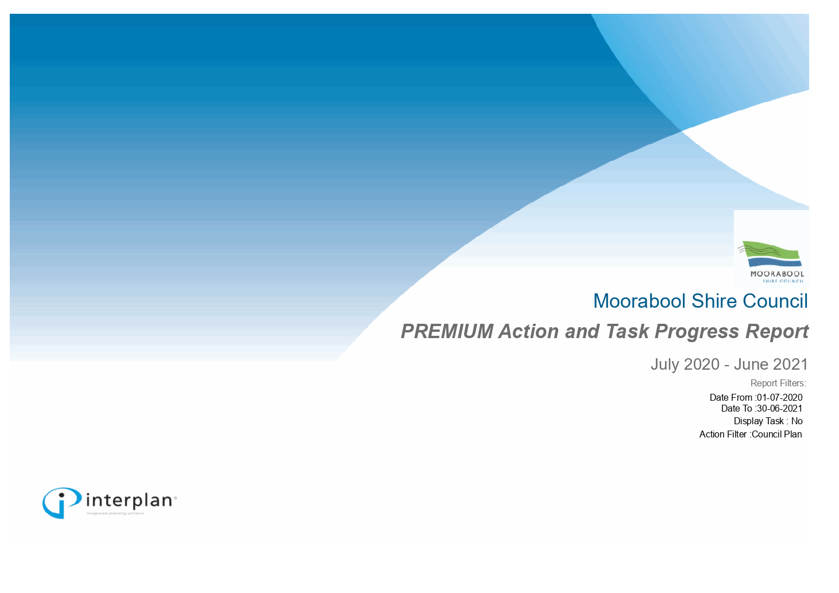

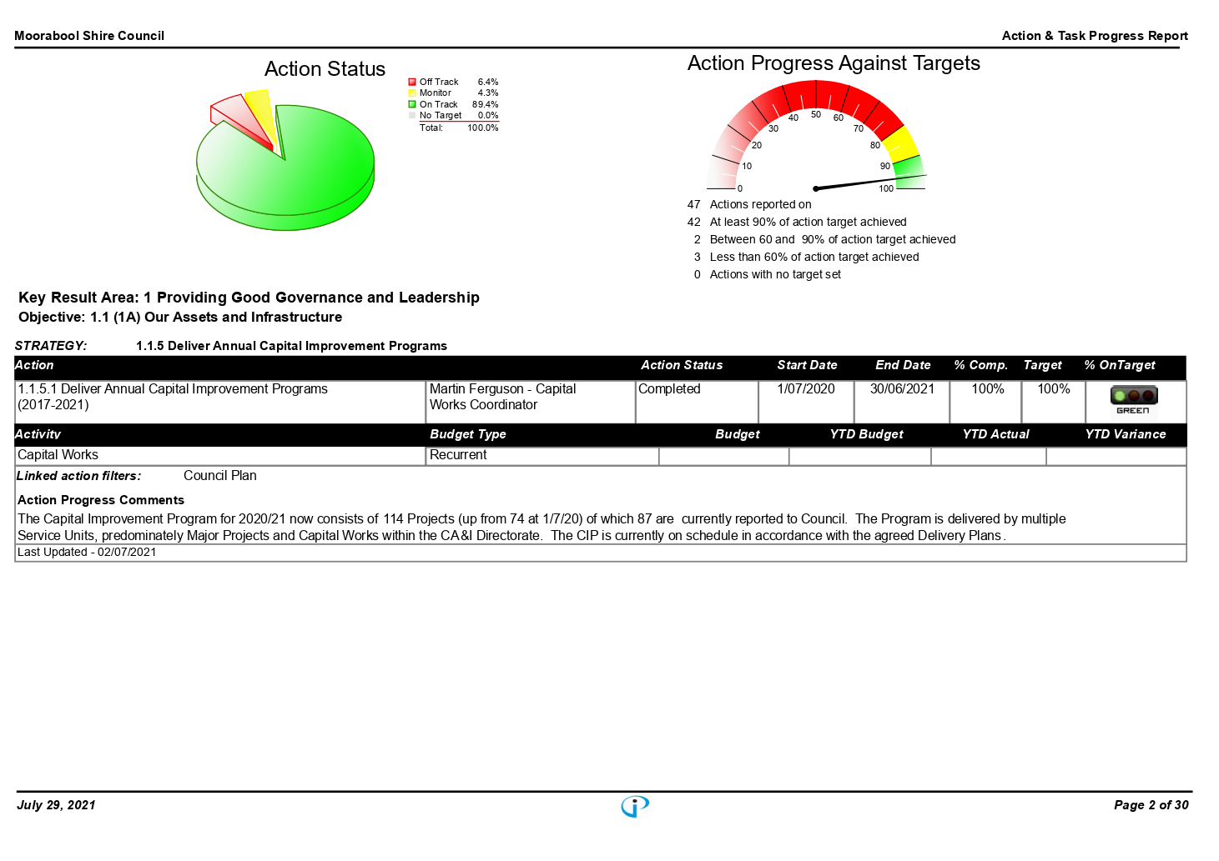

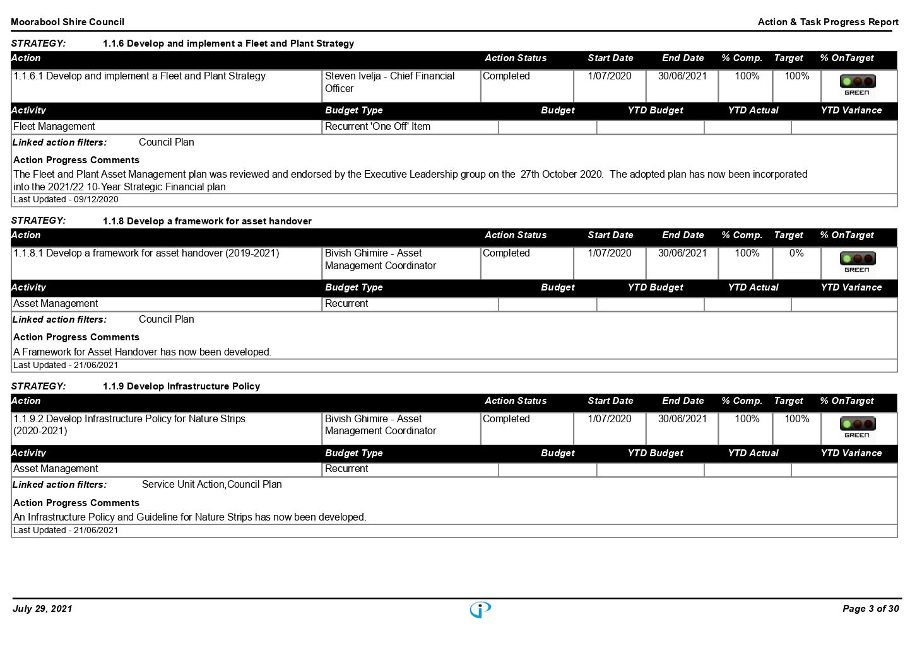

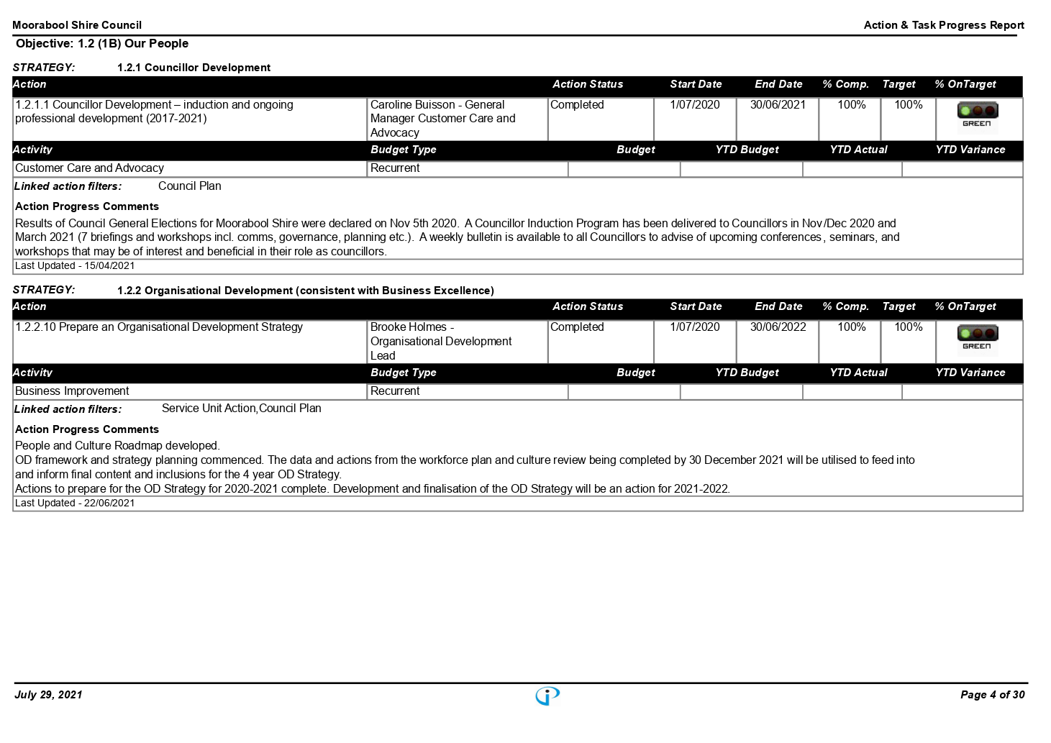

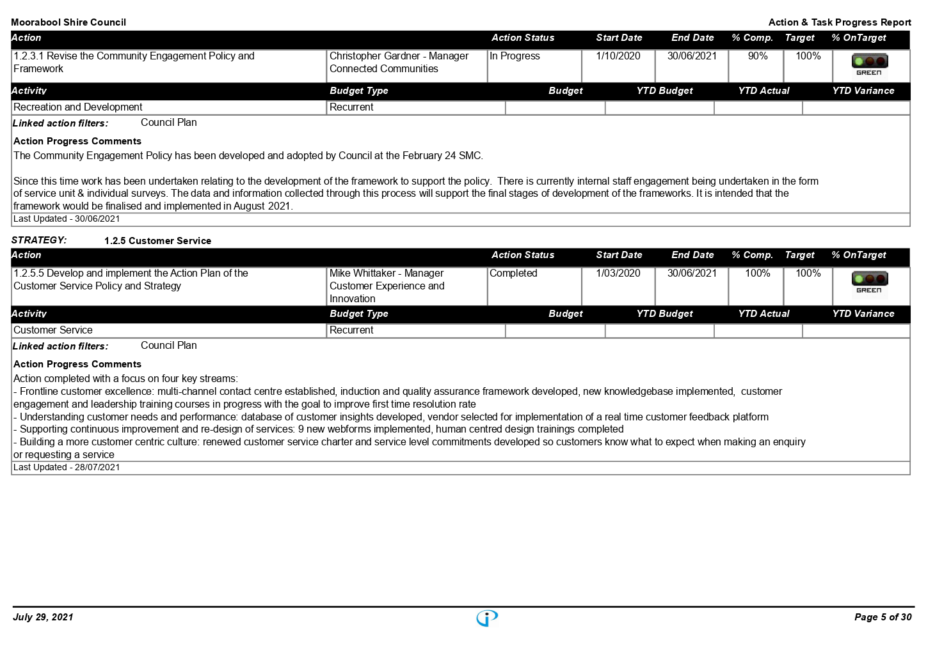

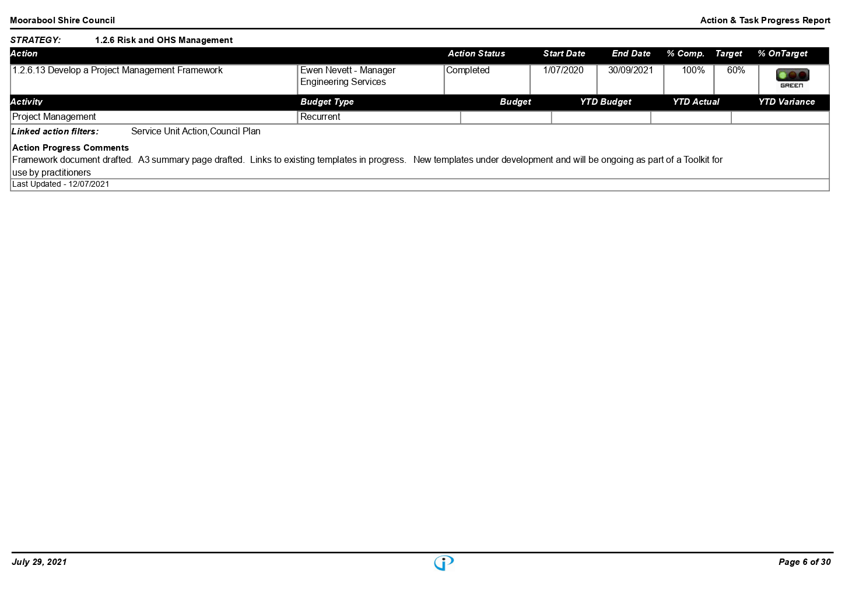

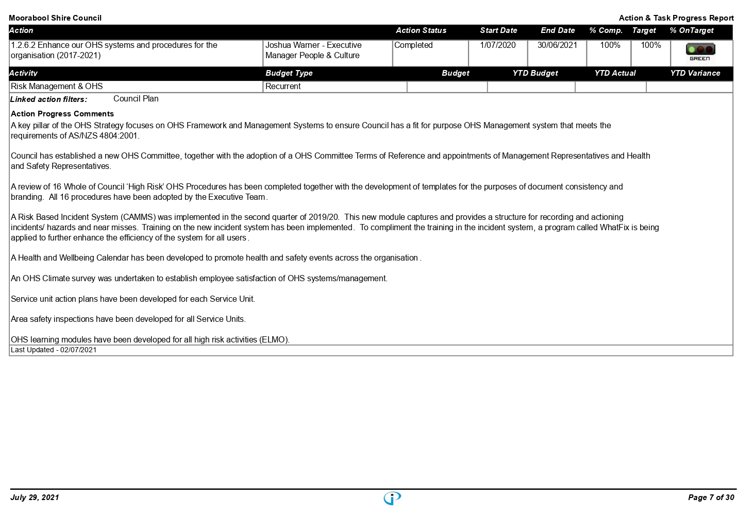

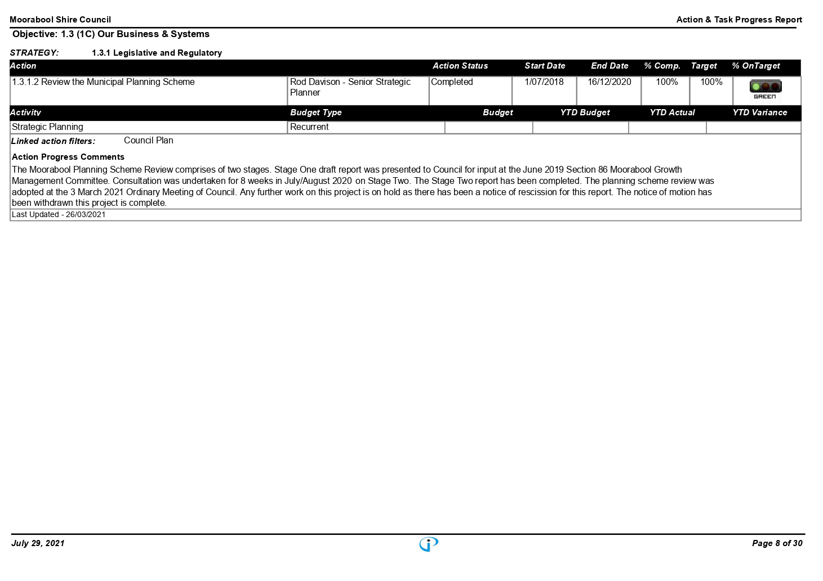

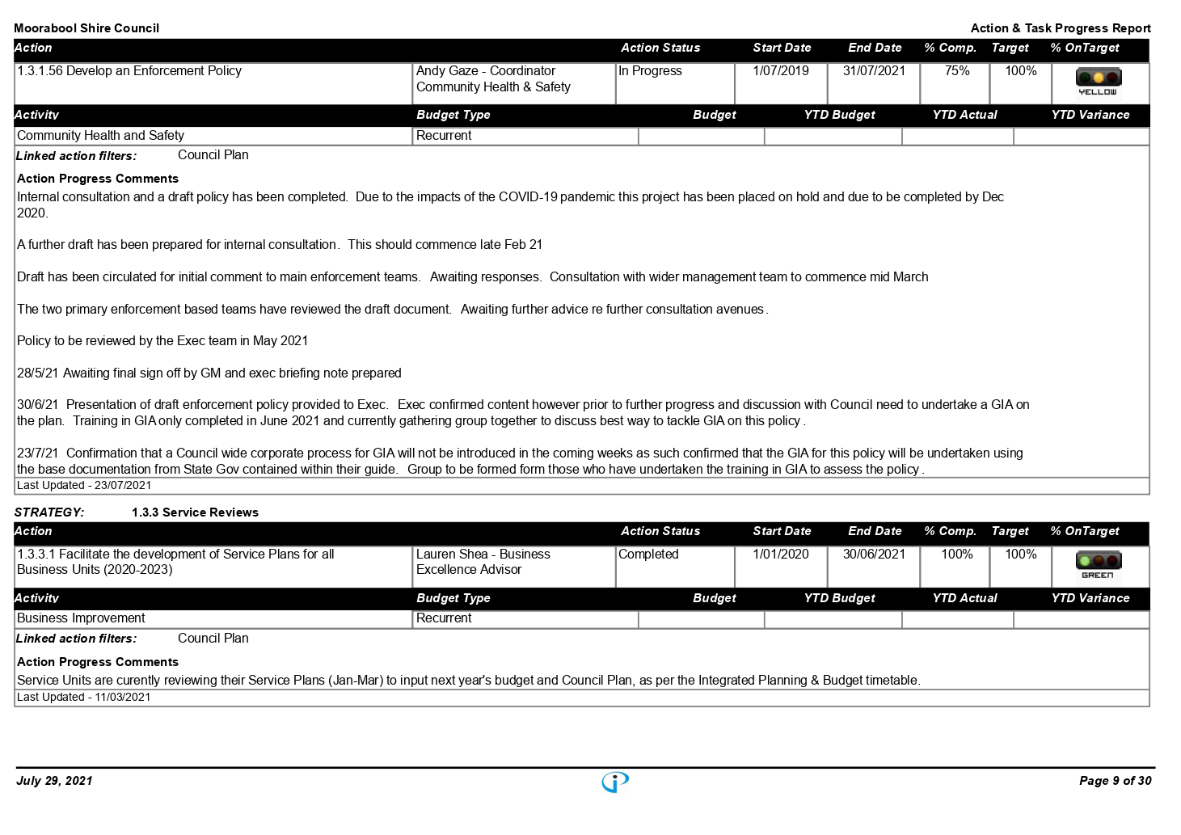

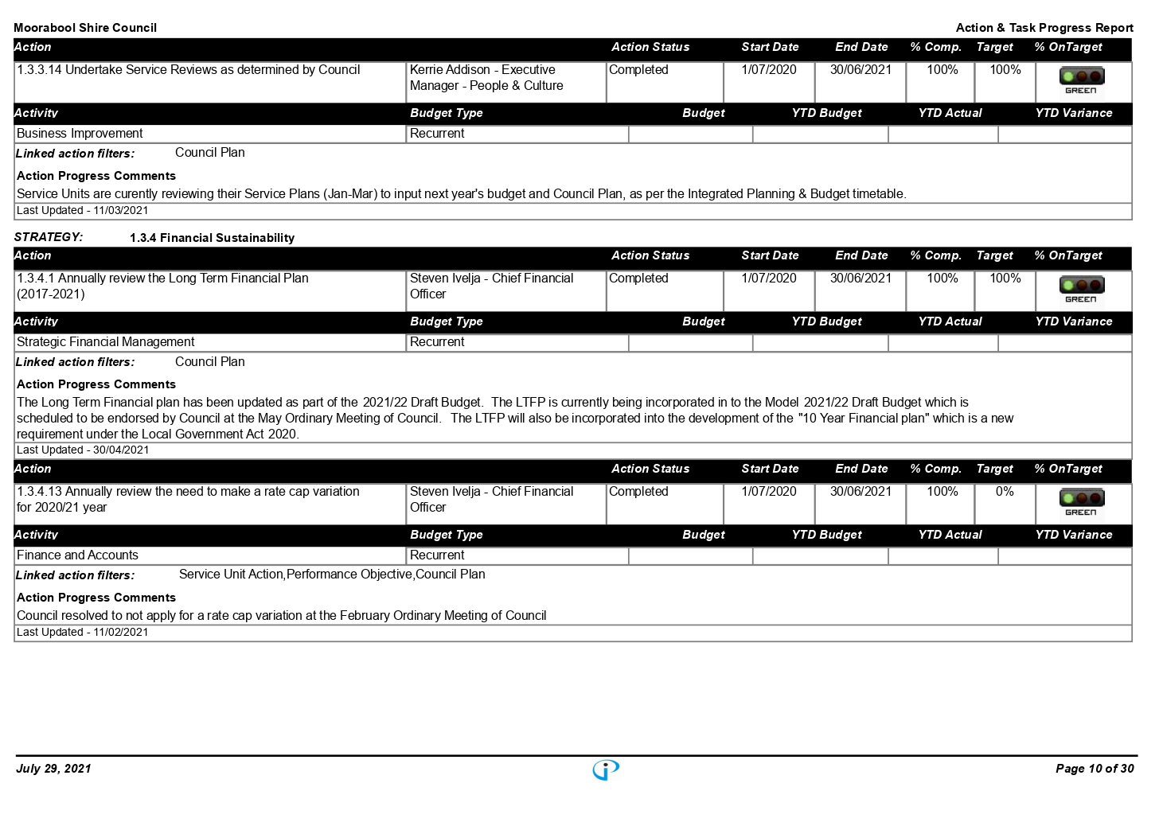

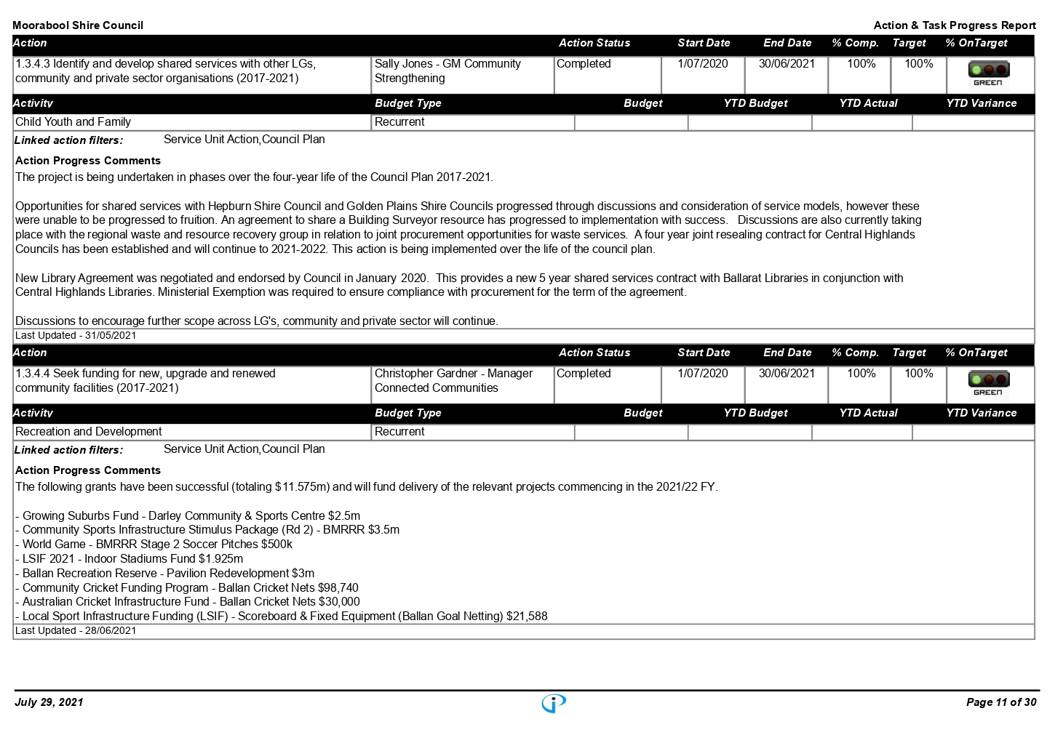

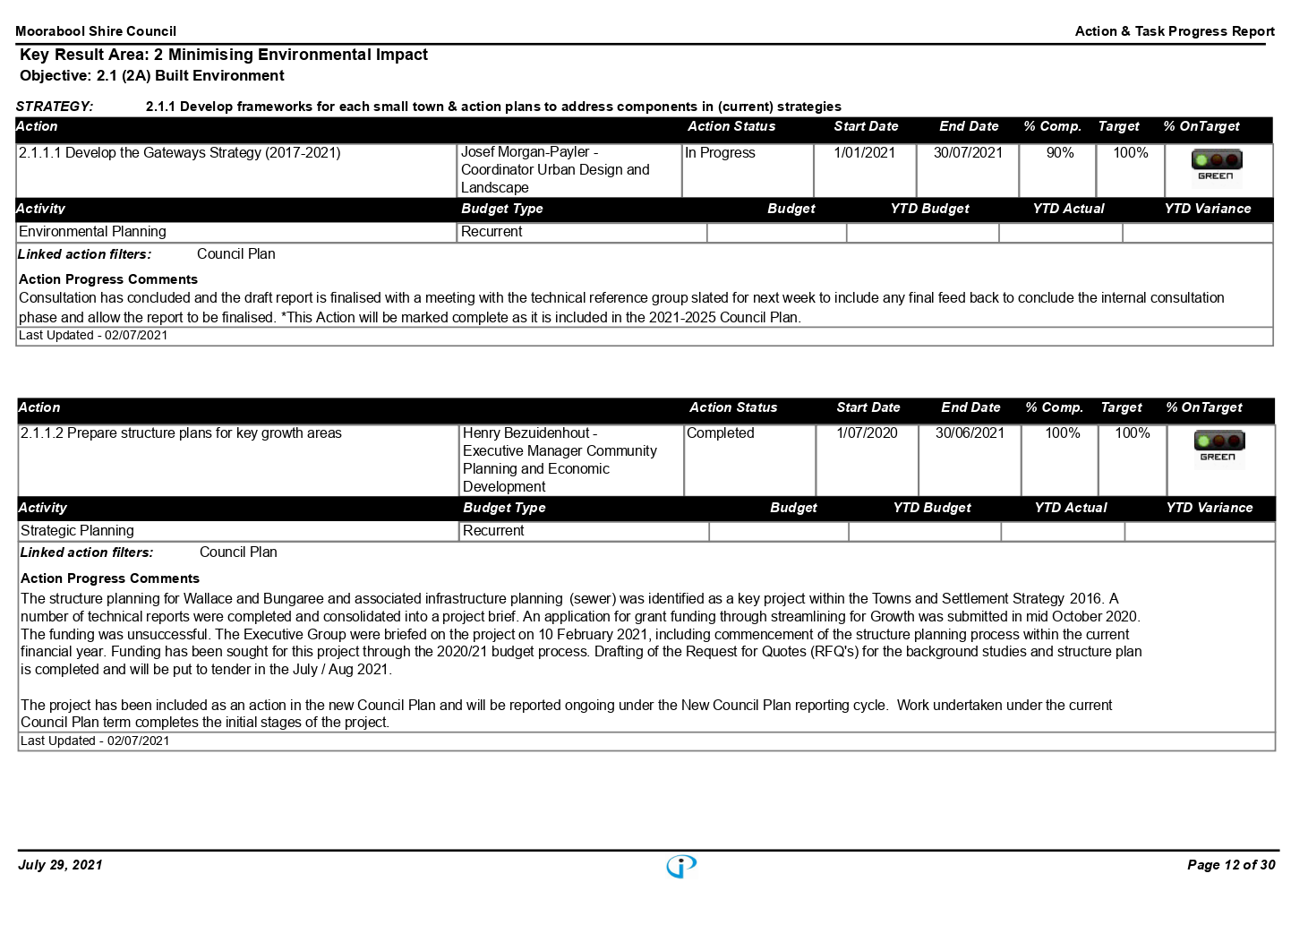

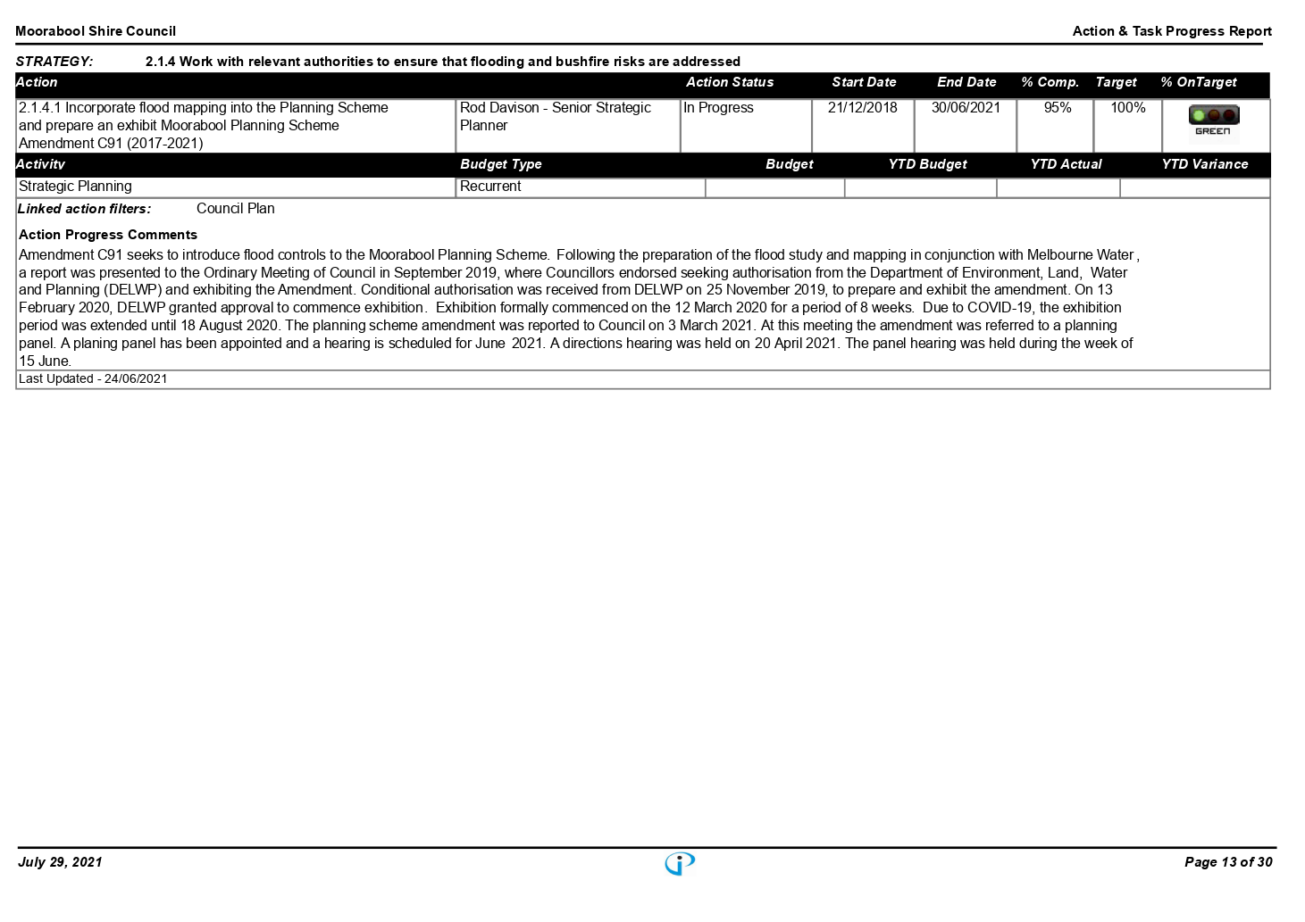

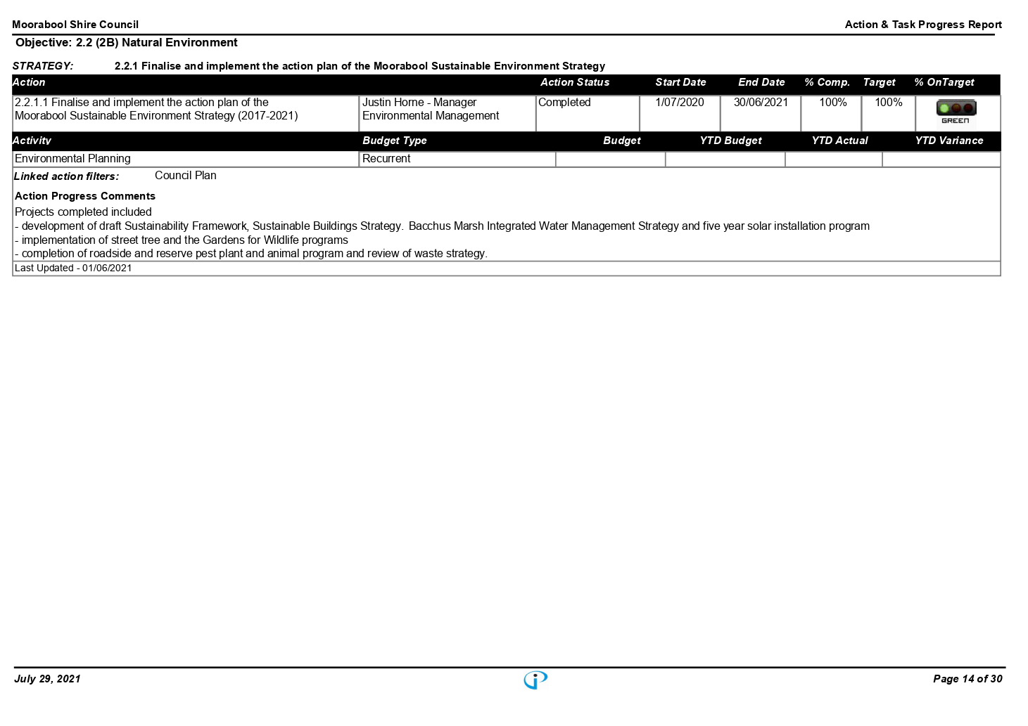

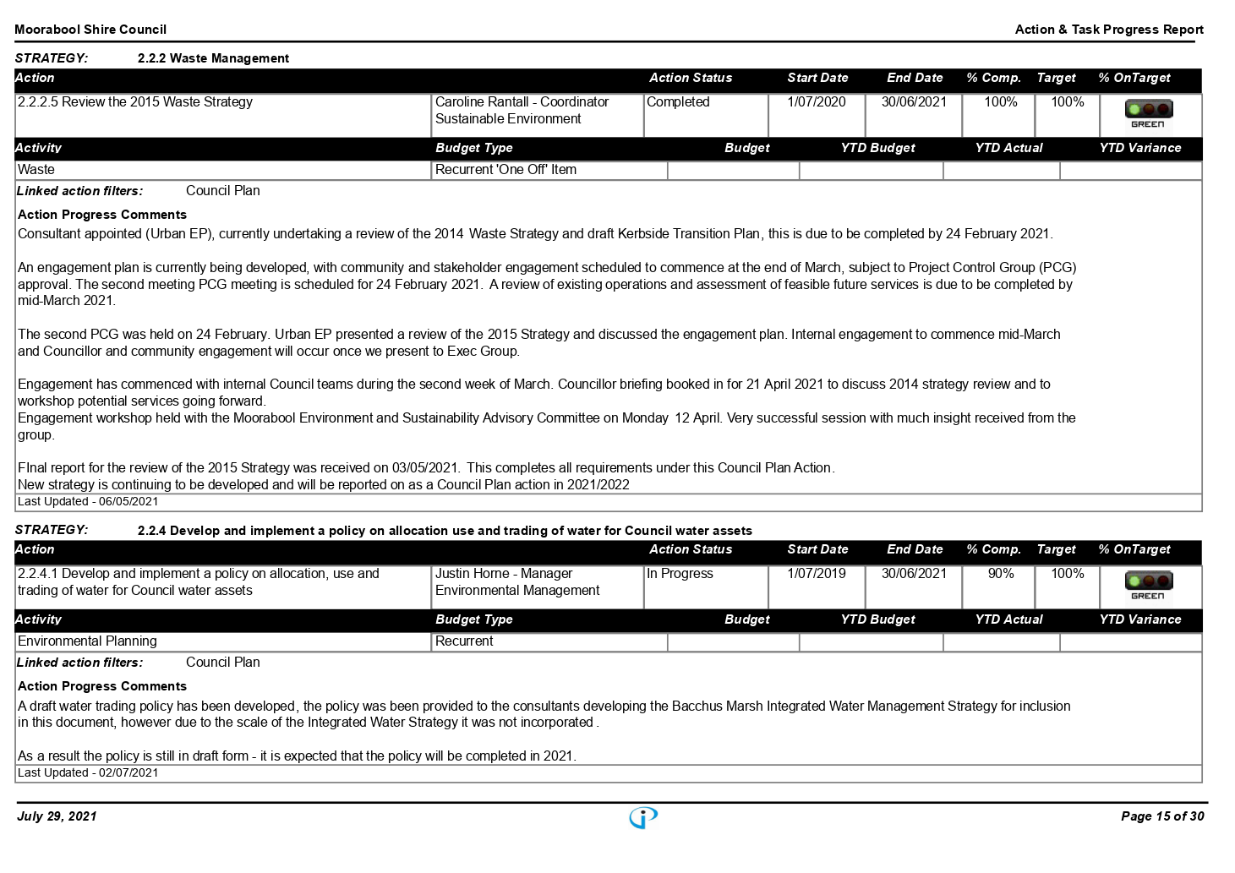

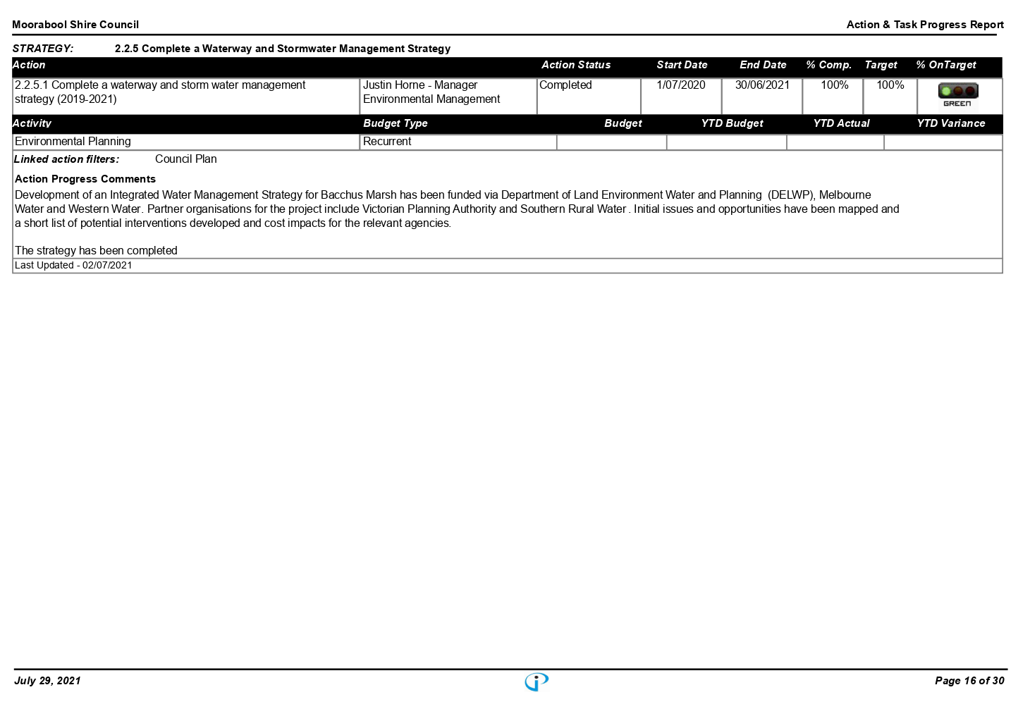

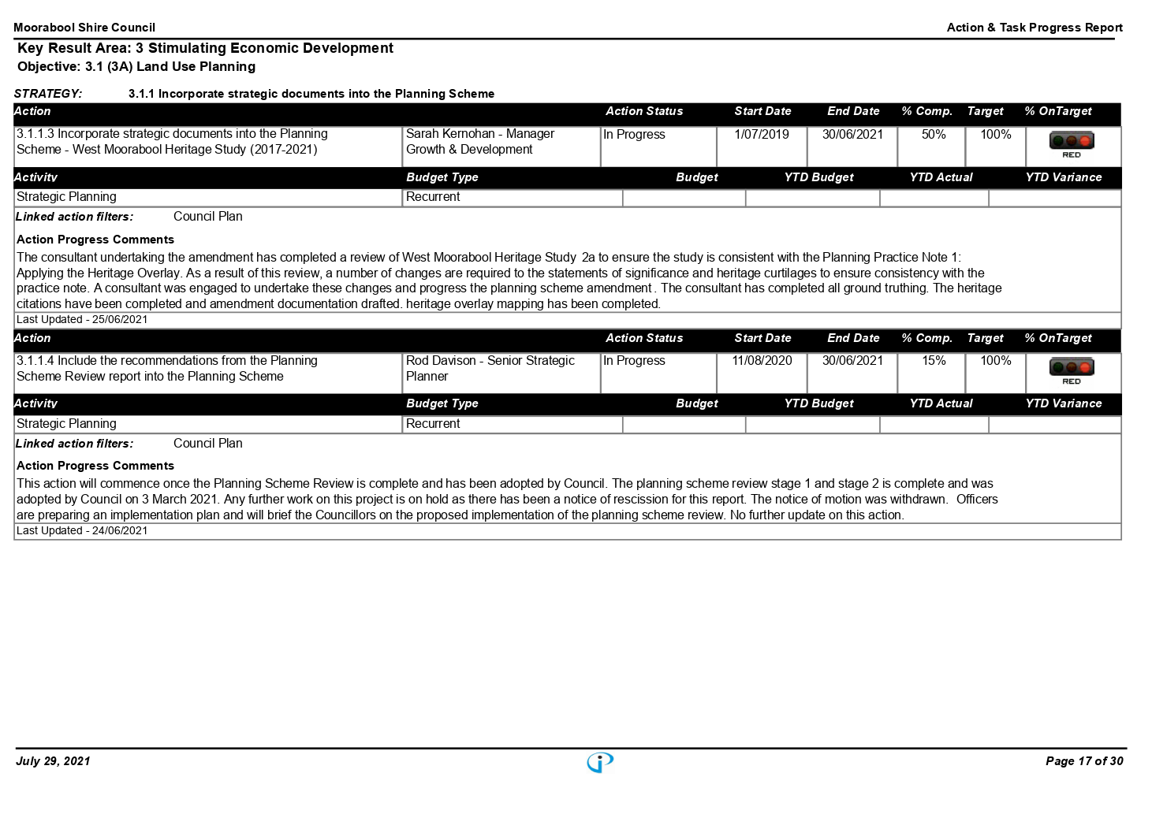

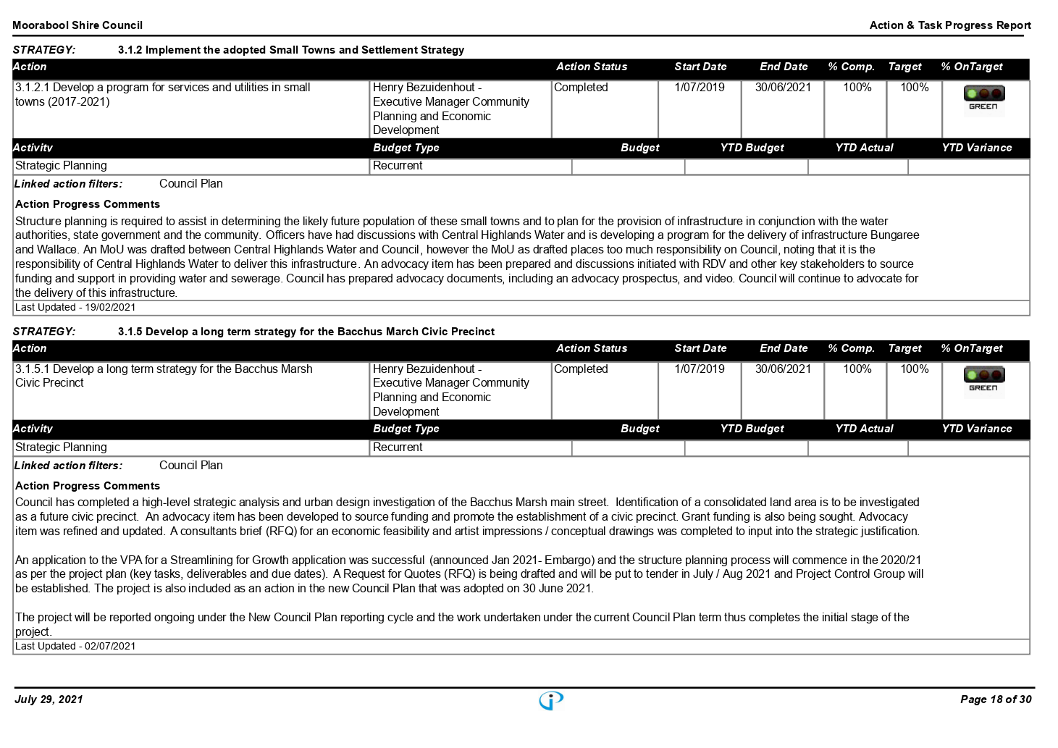

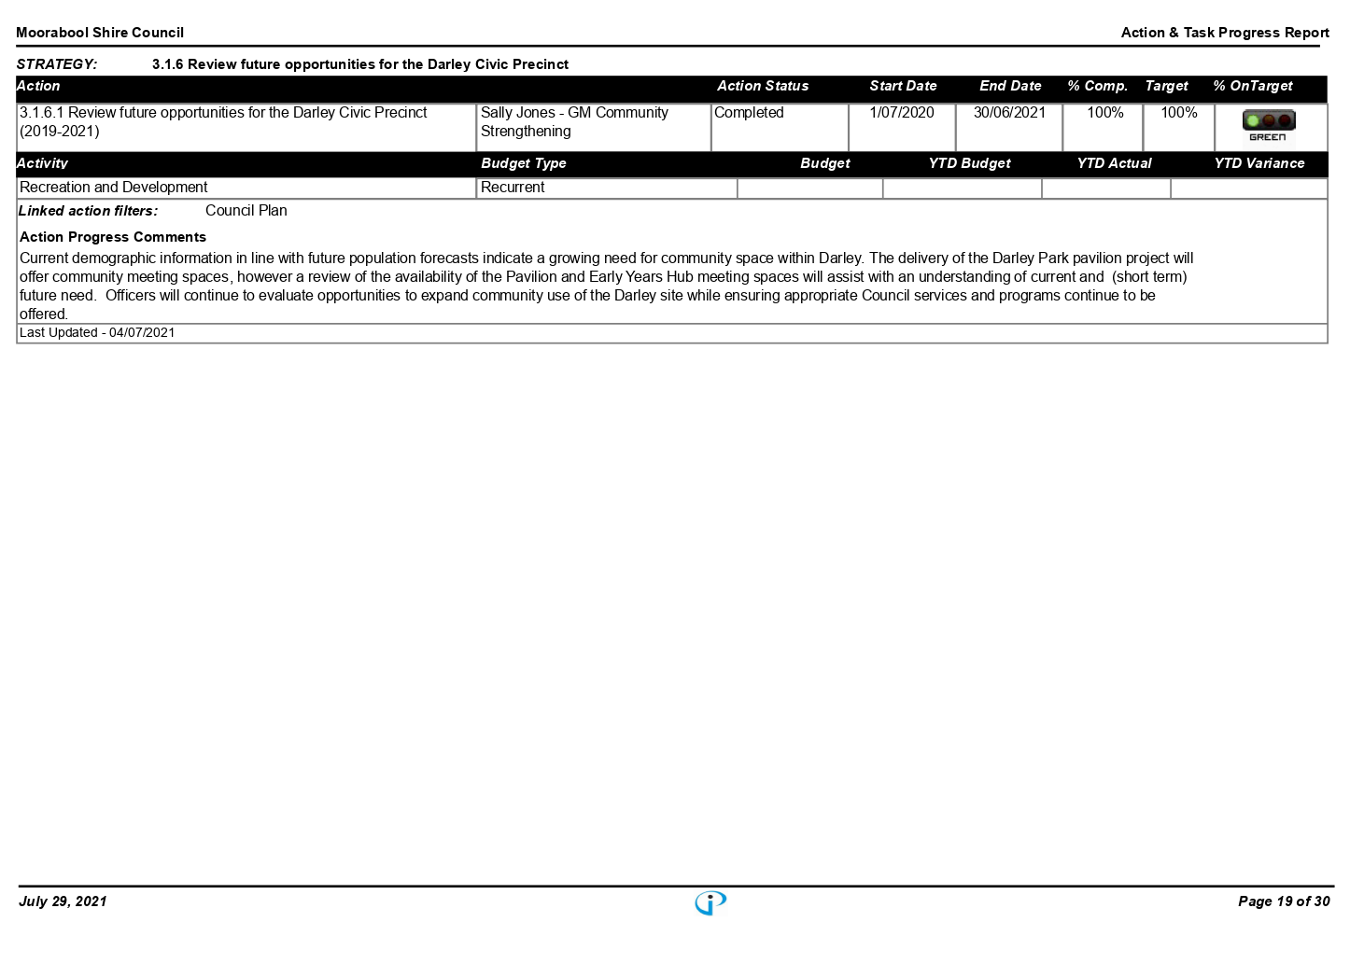

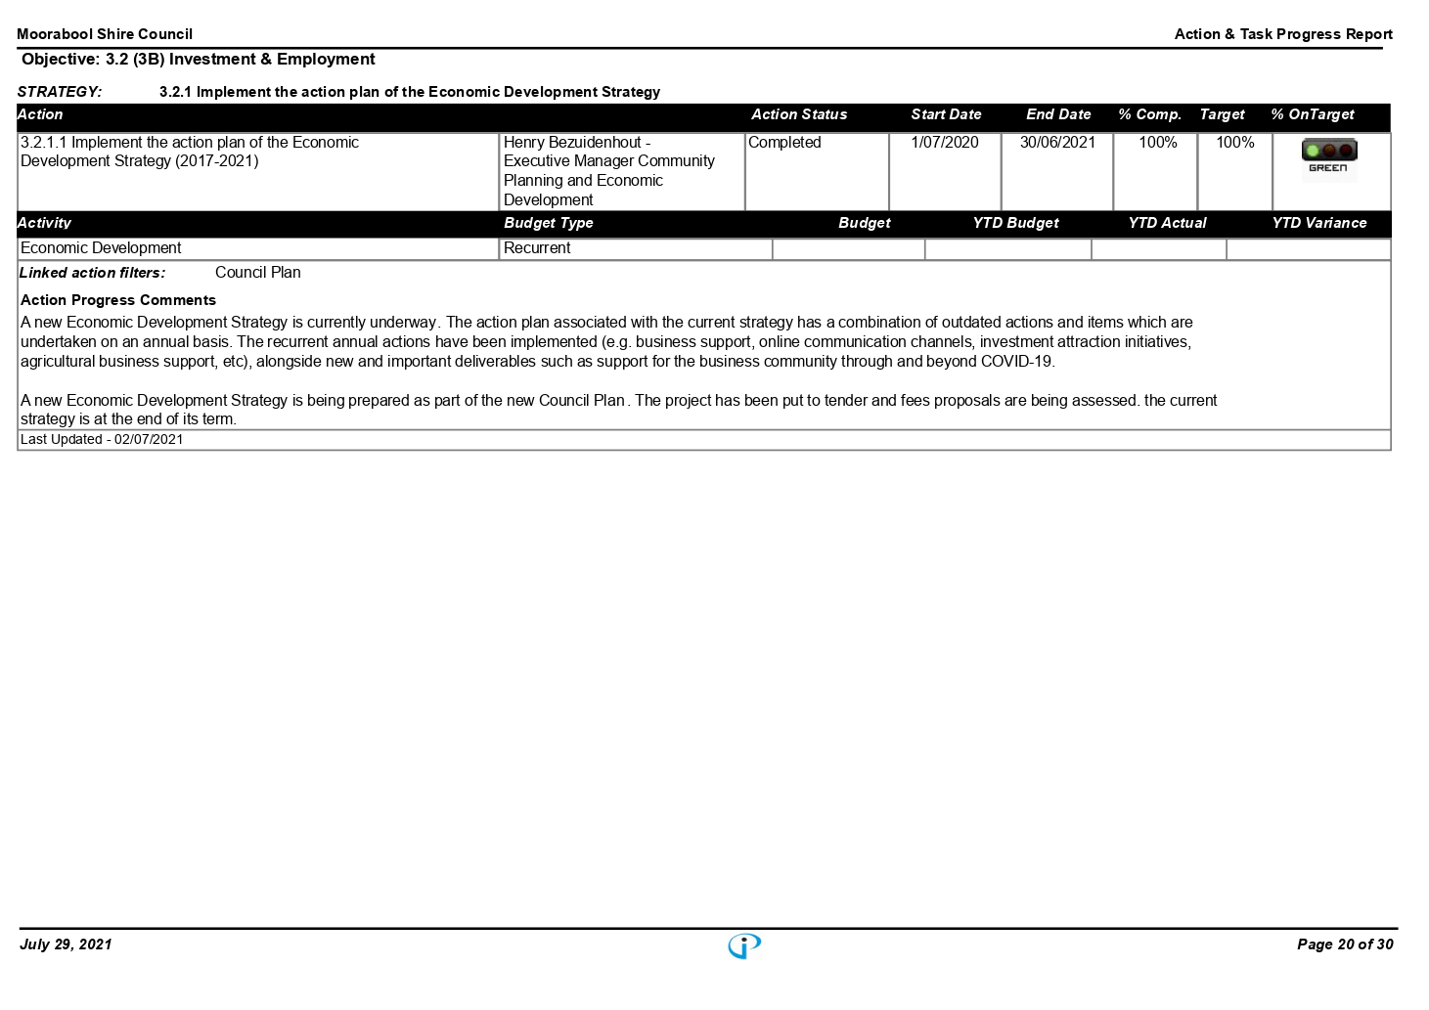

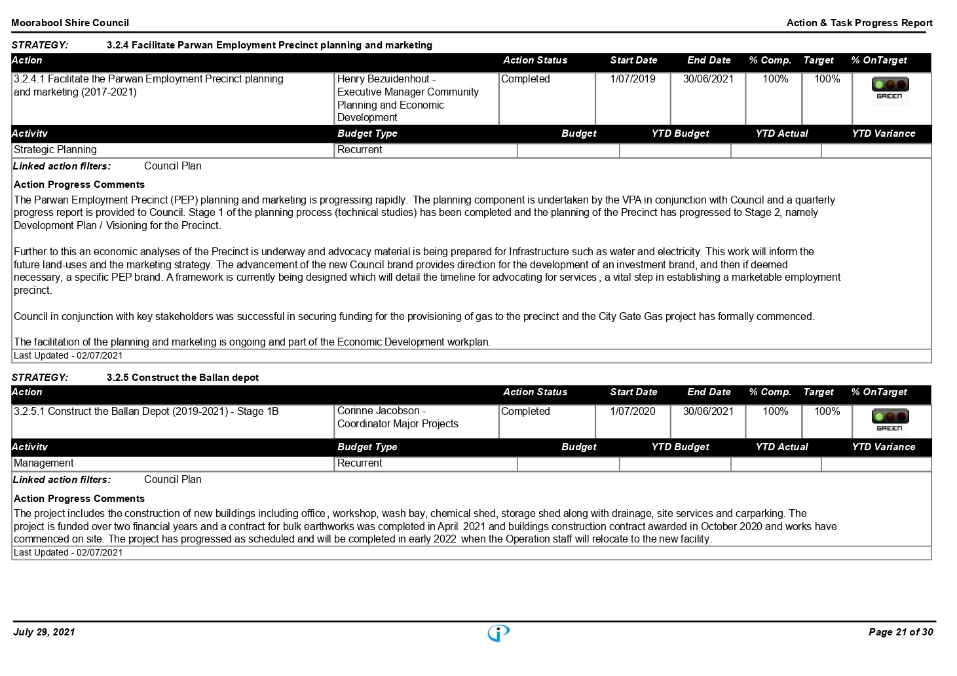

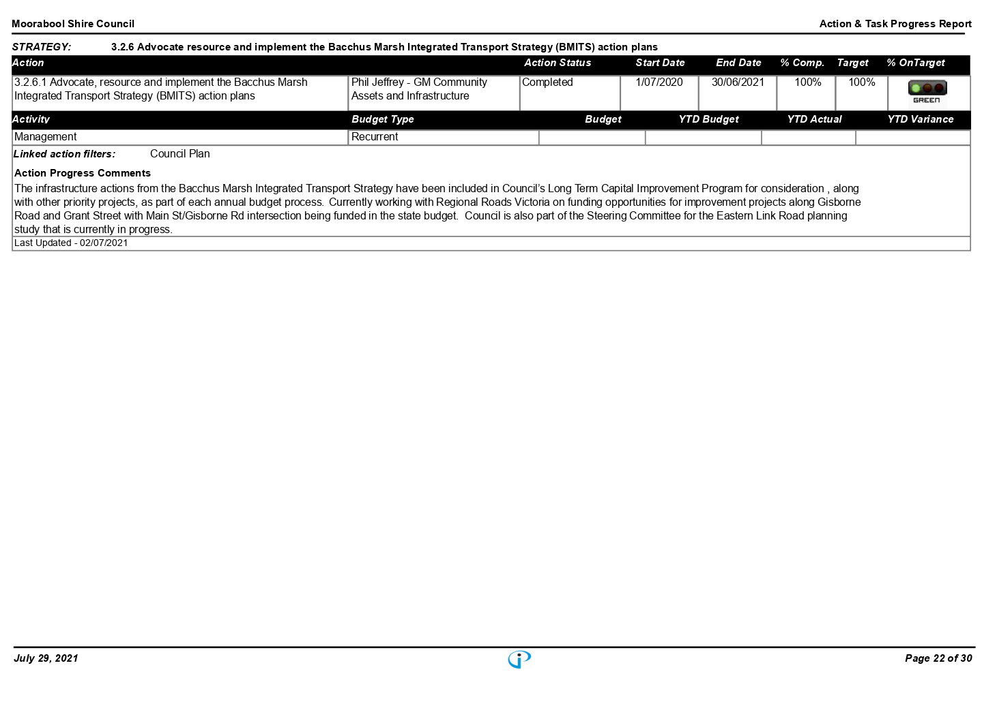

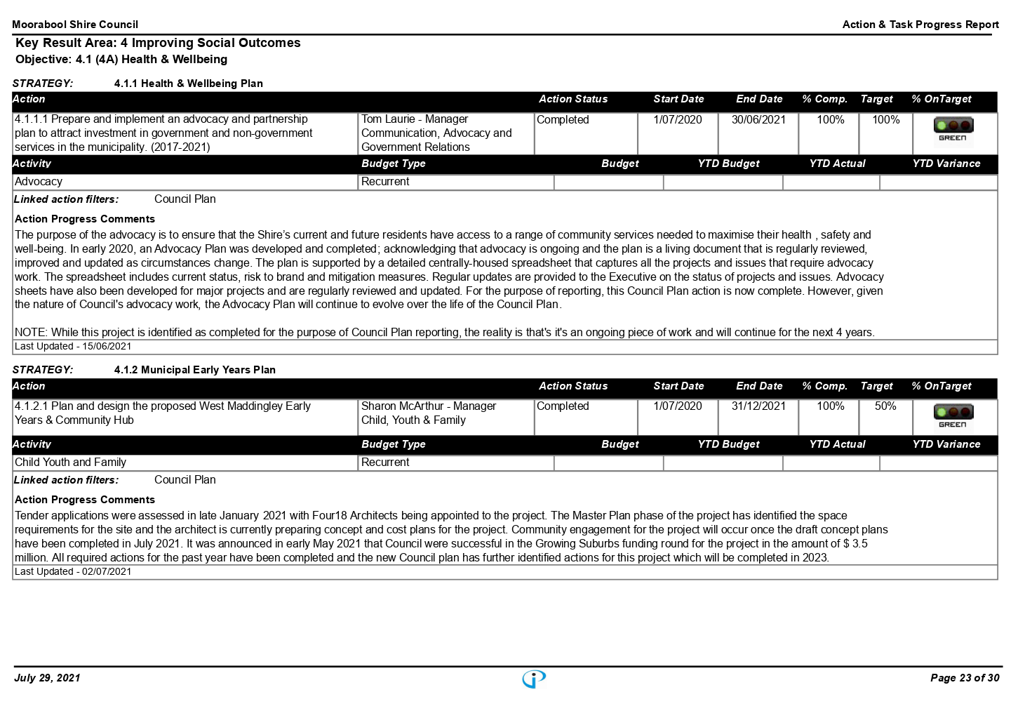

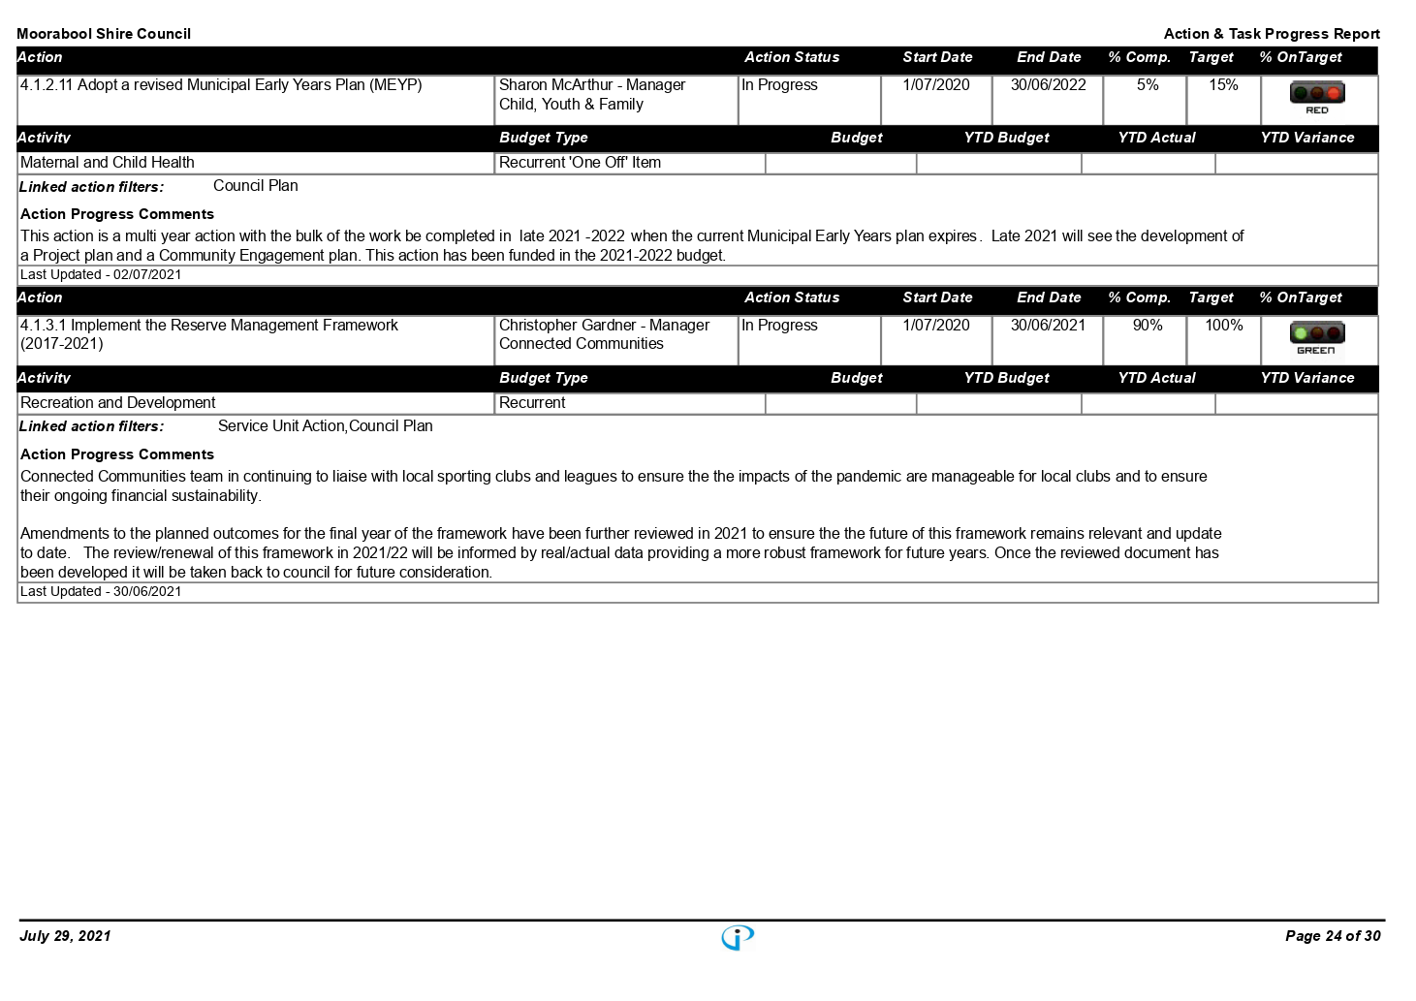

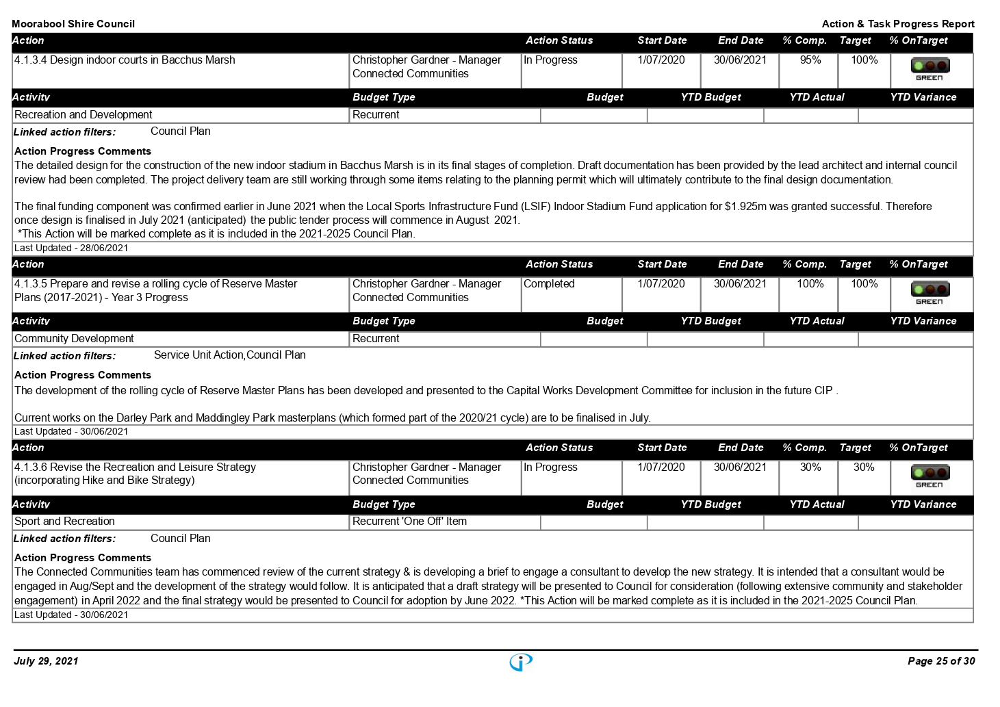

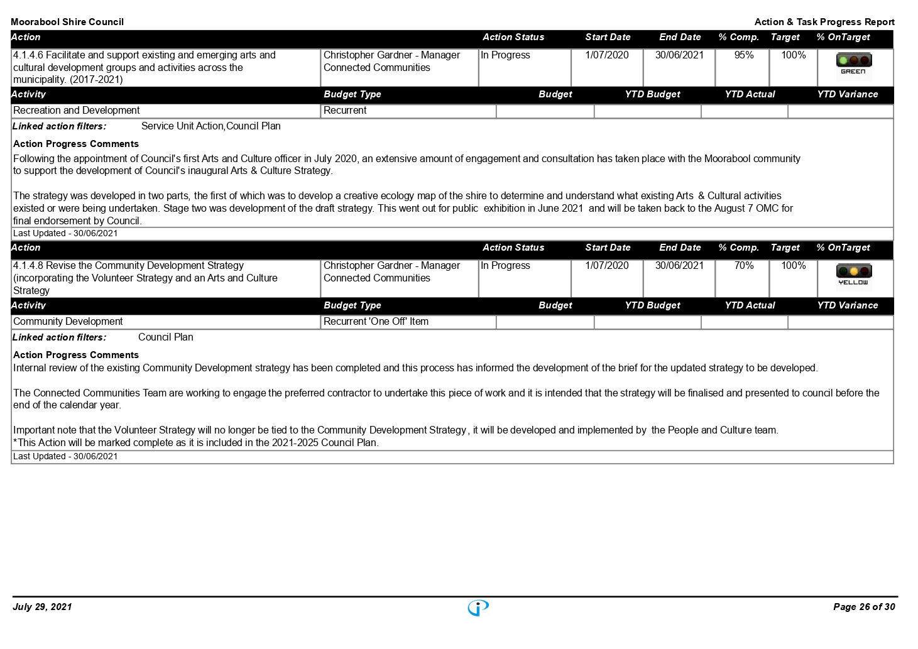

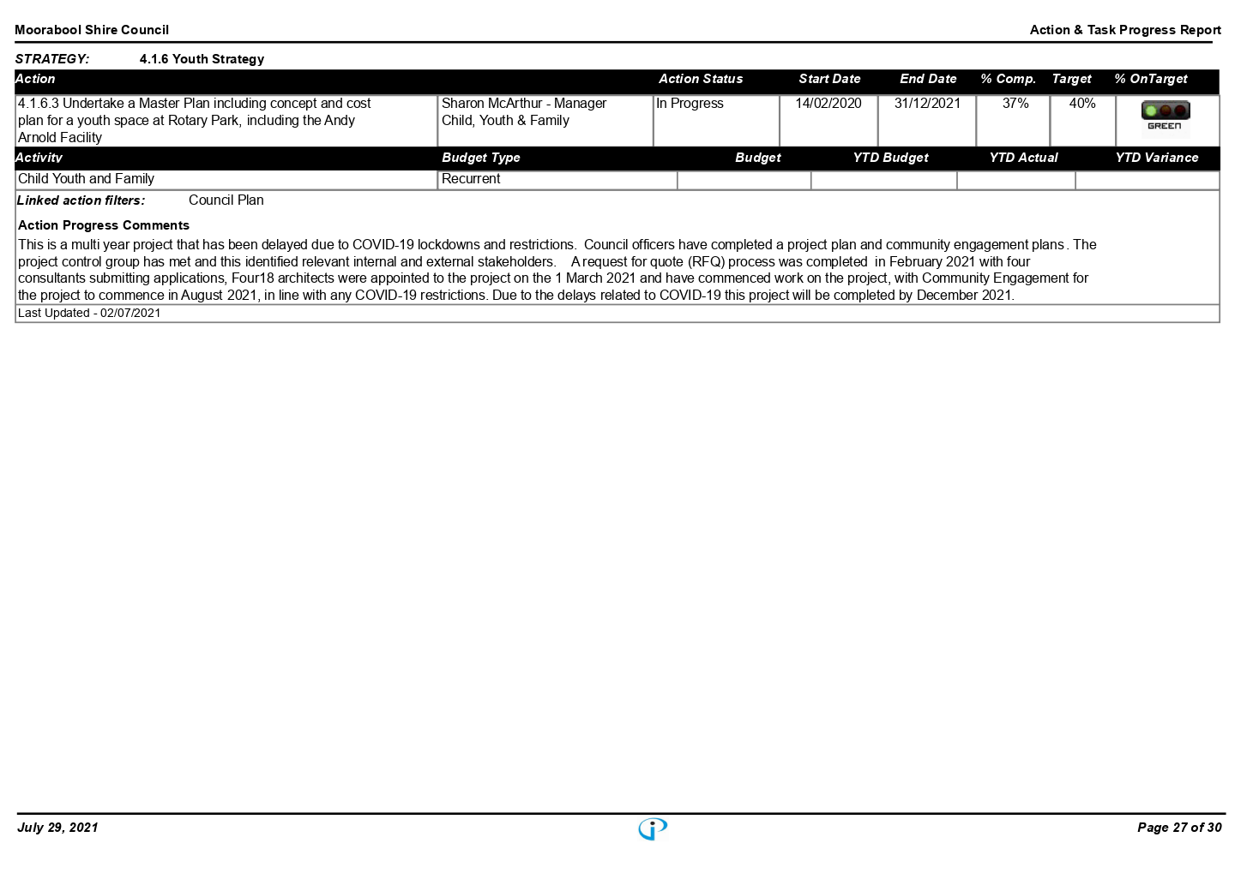

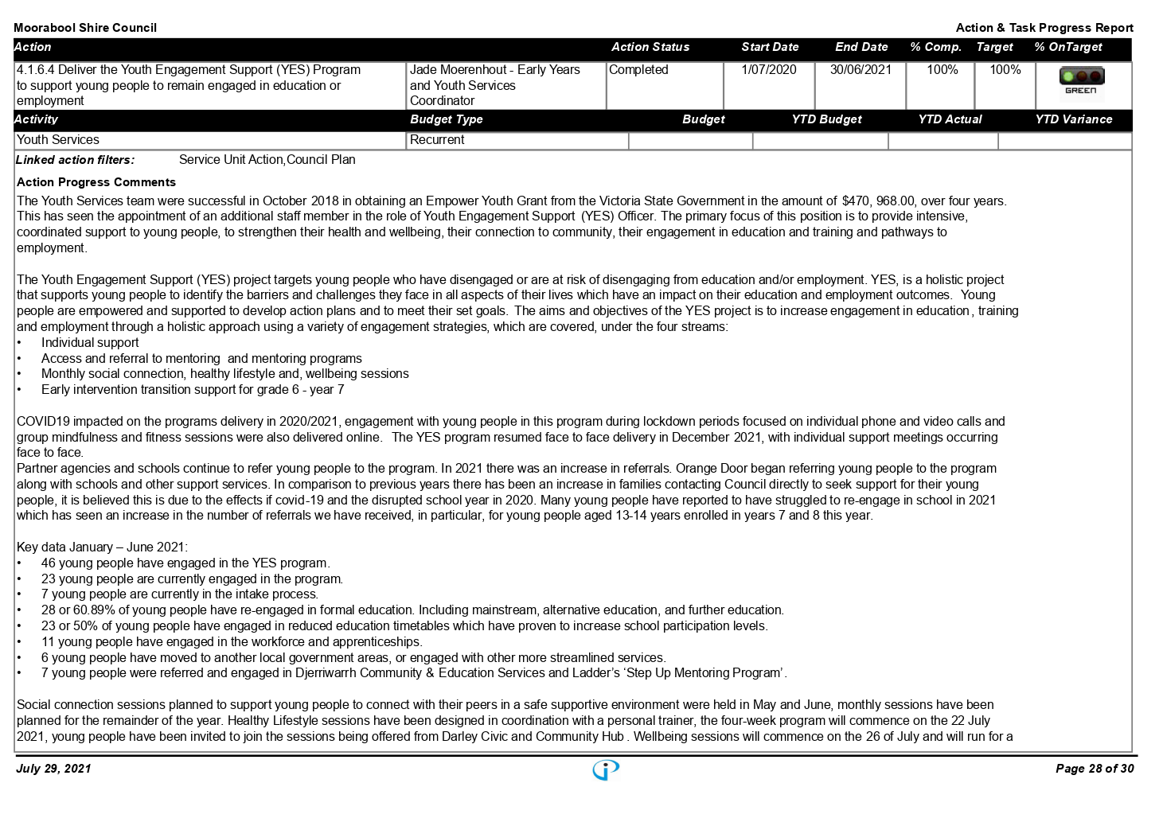

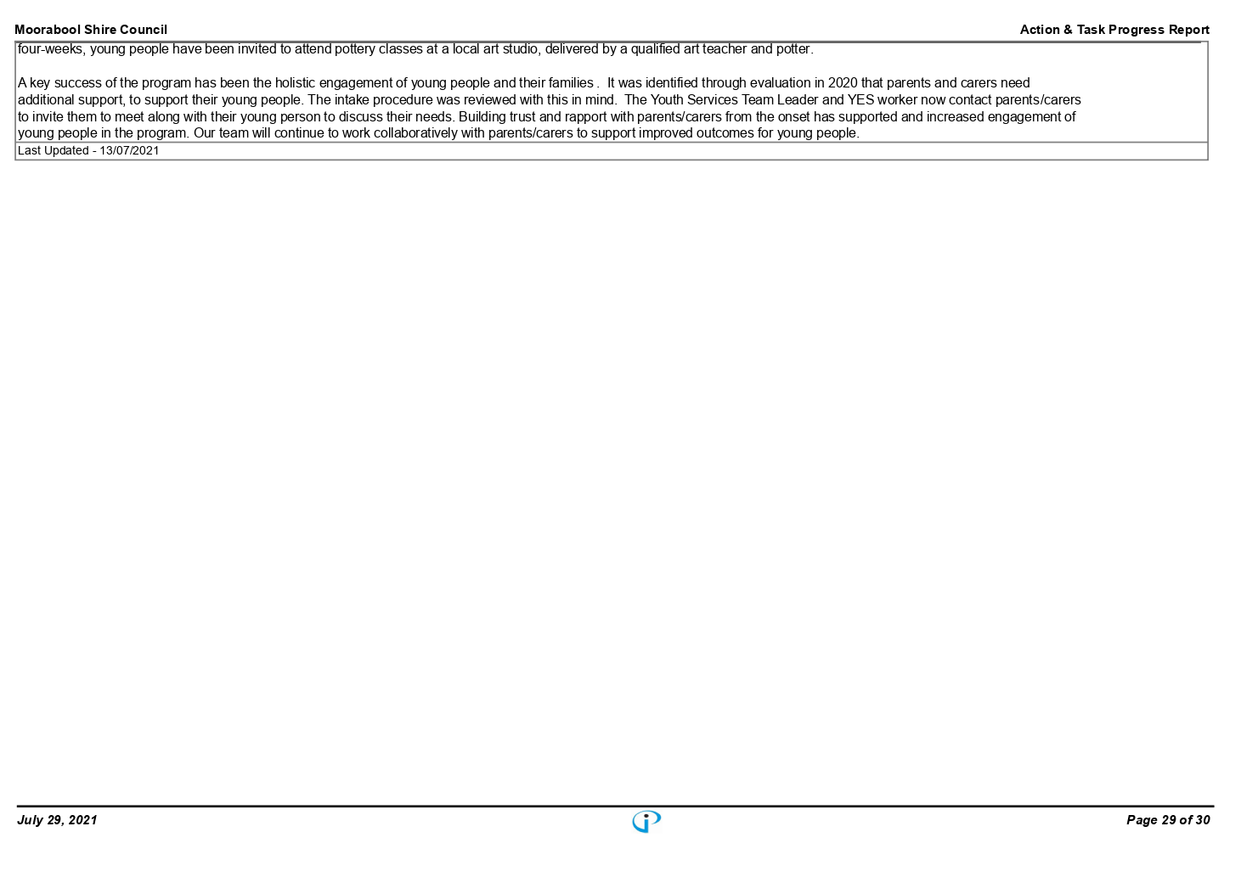

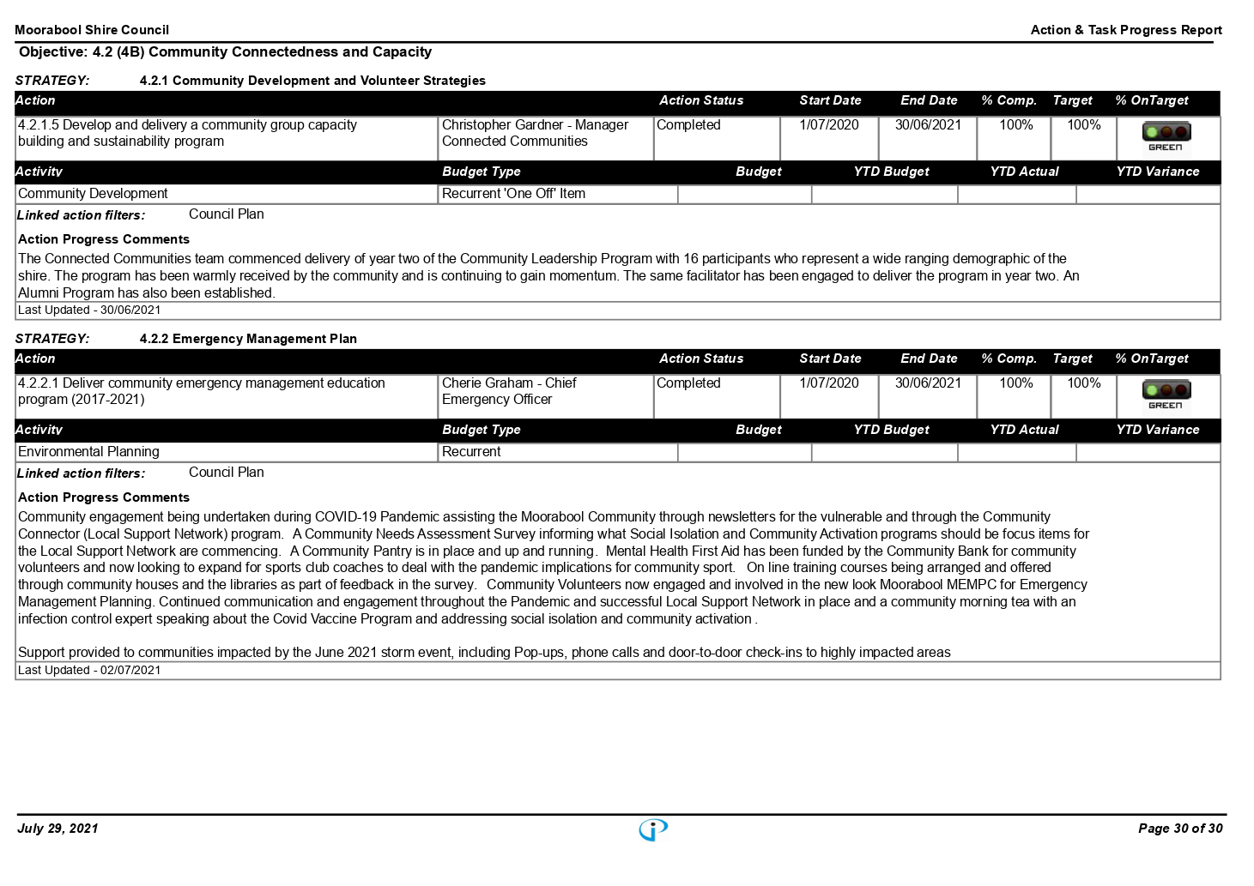

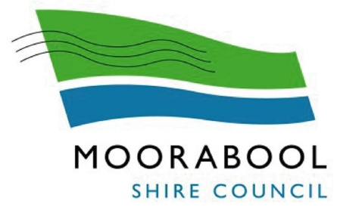

Moorabool Shire Council

Instrument of Delegation

To

The Chief Executive Officer

Instrument of Delegation

In exercise of the power conferred by s 11(1) of the Local Government Act 2020 (the Act) and all other powers enabling it, the Moorabool Shire Council (Council) delegates to the member of Council staff holding, acting in or performing the position of Chief Executive Officer, the powers, duties and functions set out in the Schedule to this Instrument of Delegation,

AND declares that
1. this Instrument of Delegation is authorised by a Resolution of Council passed on 1 September 2021;
2. the delegation
2.1 comes into force immediately the common seal of Council is affixed to this Instrument of Delegation;
2.2 is subject to any conditions and limitations set out in the Schedule;
2.3 must be exercised in accordance with any guidelines or policies which Council from time to time adopts; and
2.4 remains in force until Council resolves to vary or revoke it.
3. The member of Council staff occupying the position or title of or acting in the position of Chief Executive Officer may delegate to a member of Council staff any of the powers (other than the power of delegation conferred by s 47(2) of the Act or any other powers not capable of sub-delegation) which this Instrument of Delegation delegates to him or her.

The COMMON SEAL of the )
MOORABOOL SHIRE COUNCIL )
was affixed by authority of the )
Council in the presence of: )

………………………………………….
Councillor

………………………………………….
Chief Executive Officer

………………………………………….
Date

SCHEDULE

The power to
1. determine any issue;
2. take any action; or
3. do any act or thing
arising out of or connected with any duty imposed, or function or power conferred on Council by or under any Act.
Conditions and Limitations
The delegate must not determine the issue, take the action or do the act or thing
4. if the issue, action, act or thing is an issue, action, act or thing which involves
4.1 awarding a contract exceeding the value of $500,000;
4.2 the appointment of an Acting Chief Executive Officer for a period longer than 28 days;
4.3 adoption of the Auditor's report, Annual Financial Statements, Standard Statements and Performance Statement;
4.4 appointment of councillor or community delegates or representatives to external organisations; or
4.5 the return of the general valuation and any supplementary valuations;
5. if the issue, action, act or thing is an issue, action, act or thing which is required by law to be done by Council resolution;
6. if the issue, action, act or thing is an issue, action or thing which Council has previously designated as an issue, action, act or thing which must be the subject of a Resolution of Council;
7. if the determining of the issue, taking of the action or doing of the act or thing would or would be likely to involve a decision which is inconsistent with a
7.1 policy; or
7.2 strategy
adopted by Council; or
8. if the determining of the issue, the taking of the action or the doing of the act or thing cannot be the subject of a lawful delegation, whether on account of s 11(2)(a)-(n) (inclusive) of the Act or otherwise; or
9. the determining of the issue, the taking of the action or the doing of the act or thing is already the subject of an exclusive delegation to another member of Council staff.
Still further, the Chief Executive Officer has the following delegations:
10. Full details of any contract awarded exceeding $100,000.00 is to be reported to Council within 14 days of the contract being awarded through the Councillor Information Bulletin.
11. The authority to reply to requests by the media and the public to record Council meetings and Special Committee meetings subject to the terms and conditions of any Moorabool Shire Council Local Law or adopted Governance Rules and that the Chief Executive Officer advise Councillors to whom consent to record meetings has been granted or refused.
Business Continuity Exception:
12. Where a state of emergency has been declared under the Public Health and Wellbeing Act 2008, the threshold for awarding a contract up to $500,000, as contained in condition 4.1 of this Instrument, immediately increases to $3,000,000.

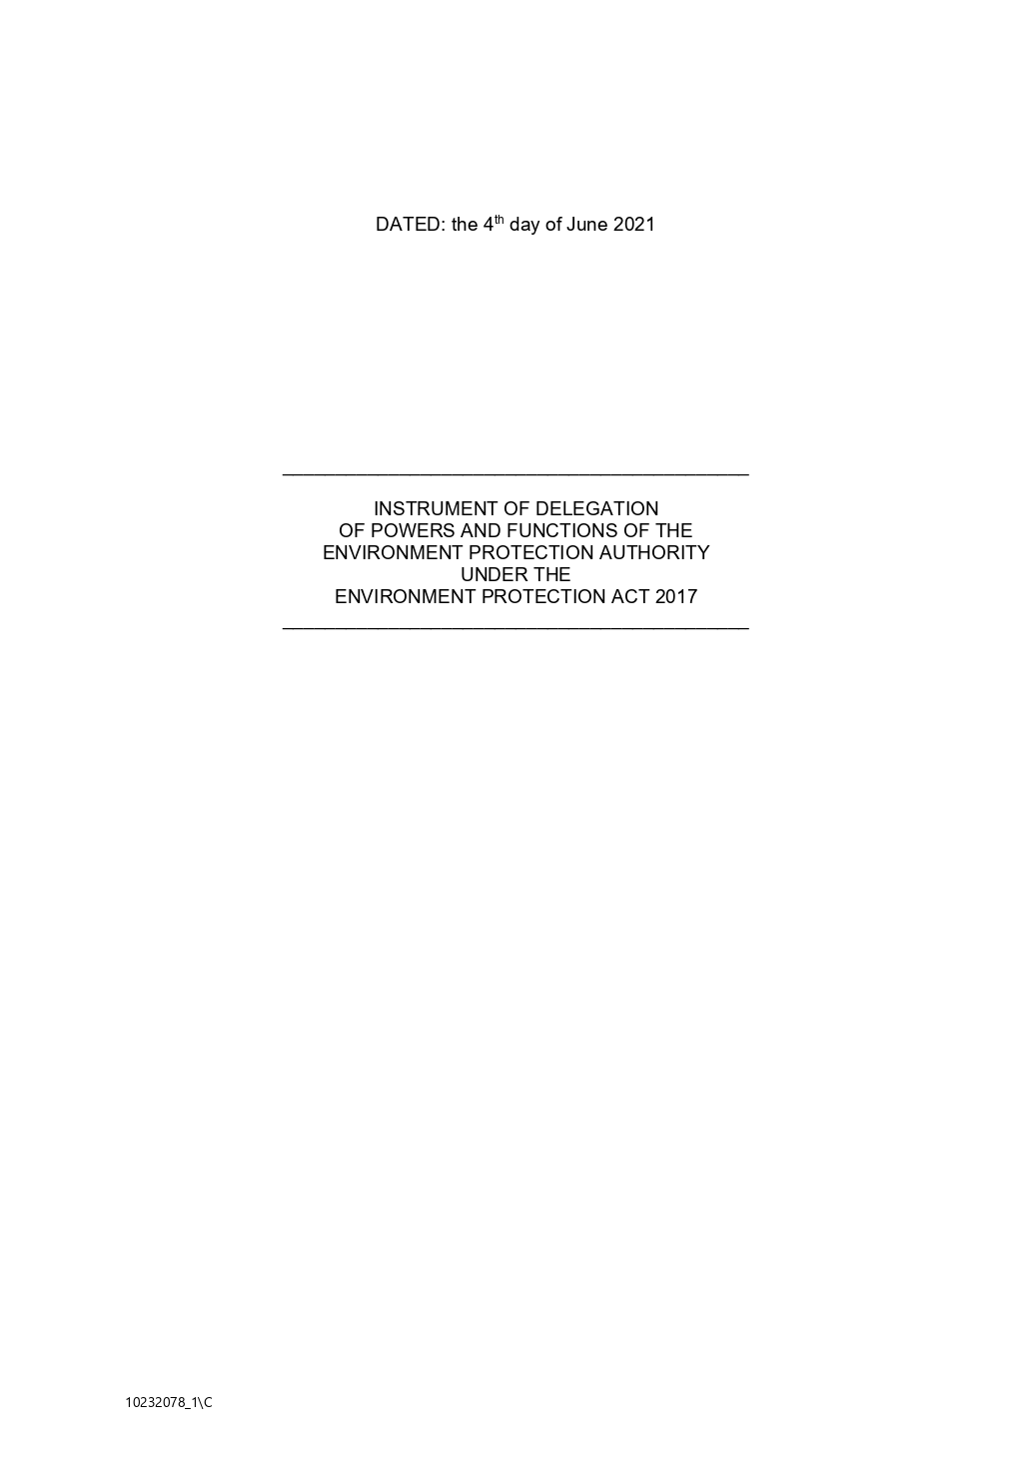

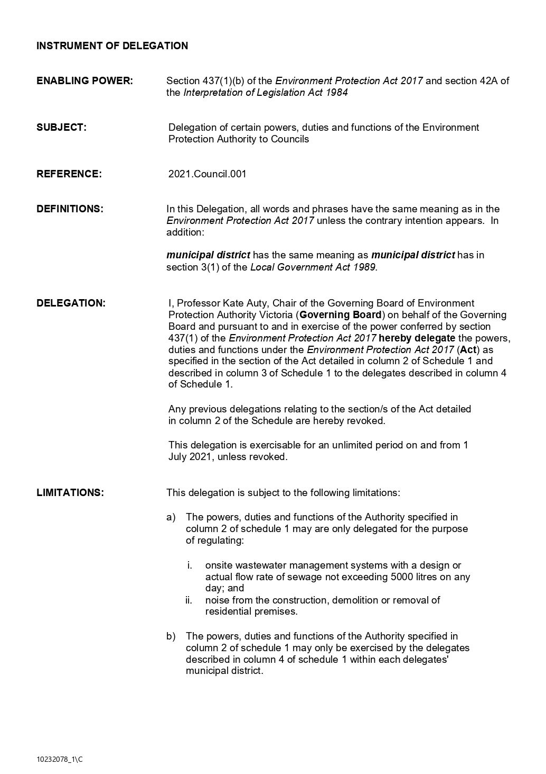

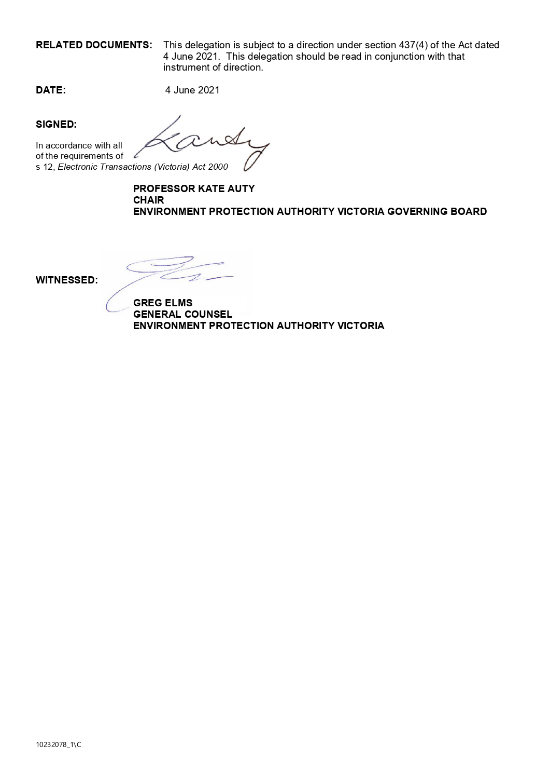

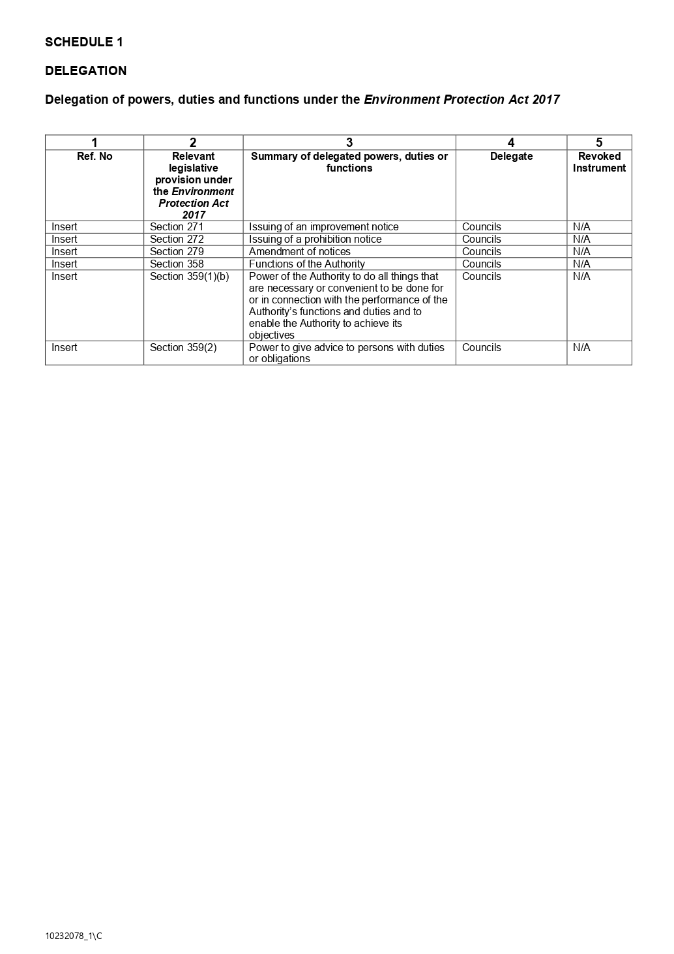

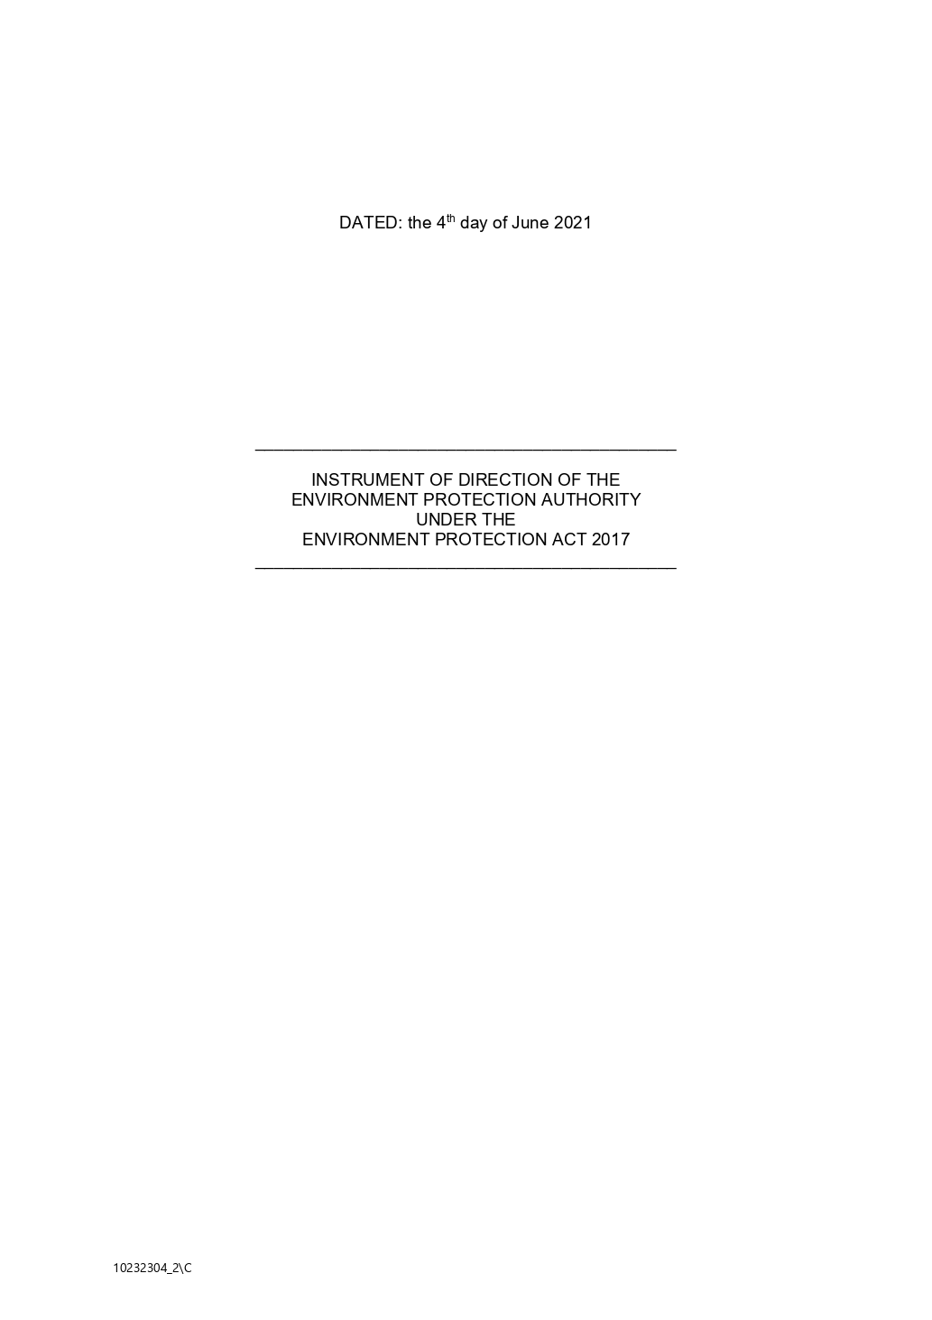

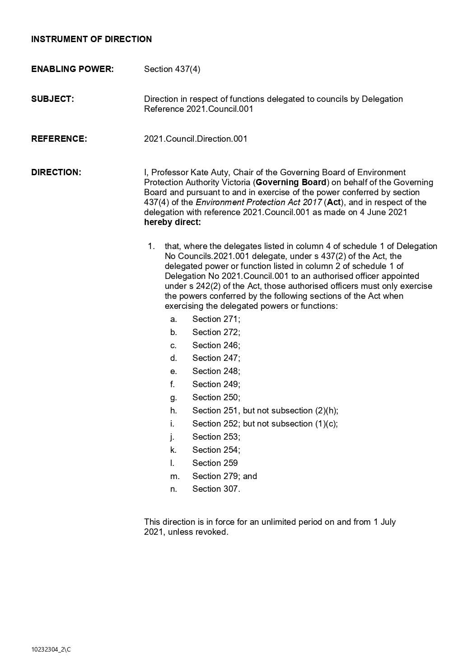

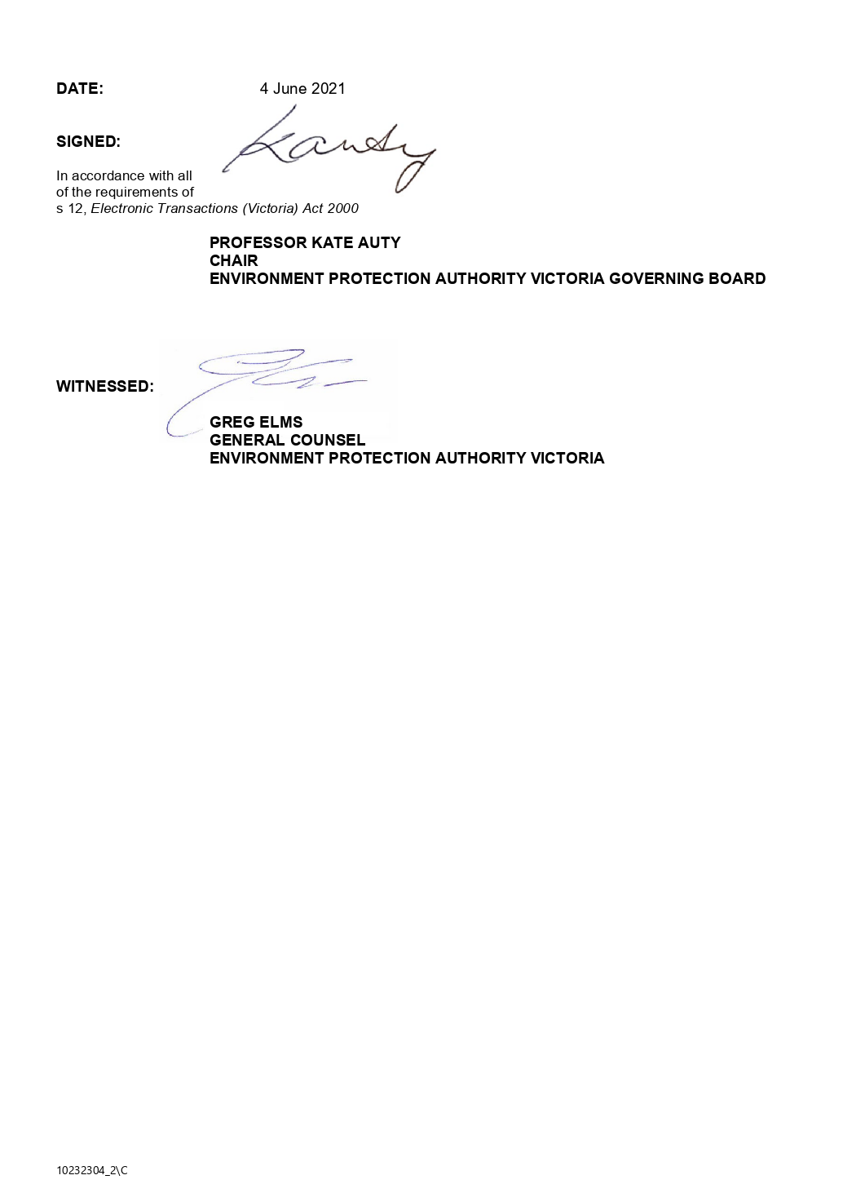

Moorabool Shire Council

Instrument of Appointment and Authorisation

(Environment Protection Act 2017 only)

September 2021

Instrument of Appointment and Authorisation
(Environment Protection Act 2017)

In this instrument ‘officer’ means the members of Council staff as defined in column one of the following table:
Officer | Position | Position Abbreviation
Allan May | Environmental Health Technical Officer | [EHTO]
Andy Gaze | Coordinator Community Health and Safety | [CCHS]
Faye Laskaris | Senior Environmental Health Officer | [SEHO]
Julie Menzies | Senior Environmental Health Officer | [SEHO]
Sally Jones | General Manager Community Strengthening | [GMCS]
Victoria Trembath | Senior Environmental Health Officer | [SEHO]

By this instrument of appointment and authorisation, Moorabool Shire Council -
- under s.242(2) of the Environment Protection Act 2017 (‘Act’) and the Instrument of Delegation of the Environment Protection Authority under the Act dated 4 June 2021 - appoints the abovementioned officers to be authorised officers for the purposes of exercising the powers and functions set out in the Instrument of Direction of the Environment Protection Authority under the Act dated 4 June 2021.
It is declared that this instrument -
• comes into force immediately upon its execution;
• remains in force until varied or revoked.
This instrument is authorised by a resolution of the Moorabool Shire Council on Wednesday
1 September 2021.
The COMMON SEAL of the )
MOORABOOL SHIRE COUNCIL )
was affixed by authority of the )
Council in the presence of: )

………………………………................
Councillor

……...........................…………………
Chief Executive Officer

……...........................…………………
Date

Moorabool Shire Council

Instrument of Sub-Delegation

To

Members of Council Staff

(Environment Protection Act 2017 only)

Instrument of Sub-Delegation

By this Instrument of Sub-Delegation, in exercise of the power conferred by s 437(2) of the Environment Protection Act 2017 (‘Act’) and the Instrument of Delegation of the Environment Protection Authority under the Act dated 4 June 2021, the Council:
1. delegates each duty and/or function and/or power described in column 1 of the Schedule (and summarised in column 2 of the Schedule) to the member of Council staff holding, acting in or performing the duties of the office or position described in column 3 of the Schedule;

2. record that references in the Schedule are as follows

CCHS means Coordinator Community Health and Safety
EHTO means Environmental Health Technical Officer
GMCS means General Manager Community Strengthening
SEHO means Senior Environmental Health Officer

3. this Instrument of Sub-Delegation is authorised by a Resolution of Council passed on Wednesday 1 September 2021 pursuant to a power of sub-delegation conferred by the Instrument of Delegation of the Environment Protection Authority under the Act dated 4 June 2021;

4. the delegation:
4.1 comes into force immediately the common seal of Council is affixed to this Instrument of Sub-Delegation;
4.2 remains in force until varied or revoked;
4.3 is subject to any conditions and limitations set out in sub-paragraph 5, and the Schedule; and
4.4 must be exercised in accordance with any guidelines or policies which Council from time to time adopts; and
5. this Instrument of Sub-Delegation is subject to the following limitations:
5.1 the powers, duties and functions described in column 1 and summarised in column 2 of the Schedule are only delegated for the purpose of regulating:
5.1.1 onsite wastewater management systems with a design or actual flow rate of sewage not exceeding 5000 litres on any day; and
5.1.2 noise from the construction, demolition or removal of residential premises;
6. the delegate must not determine the issue, take the action or do the act or thing:
6.1 if the issue, action, act or thing is an issue, action or thing which Council has previously designated as an issue, action, act or thing which must be the subject of a Resolution of Council;

6.2 if the determining of the issue, taking of the action or doing of the act or thing would or would be likely to involve a decision which is inconsistent with a:
(a) policy; or
(b) strategy
adopted by Council;
6.3 if the determining of the issue, the taking of the action or the doing of the act or thing cannot be the subject of a lawful delegation; or
6.4 the determining of the issue, the taking of the action or the doing of the act or thing is already the subject of an exclusive delegation to another member of Council staff.

The COMMON SEAL of the )
MOORABOOL SHIRE COUNCIL )
was affixed by authority of the )
Council in the presence of: )

………………………………………….
Councillor

………………………………………….
Chief Executive Officer

………………………………………….
Date

Schedule
ENVIRONMENT PROTECTION ACT 2017
Column 1 | Column 2 | Column 3 | Column 4
PROVISION | THING DELEGATED | DELEGATE | CONDITIONS & LIMITATIONS
s 271 | Power to issue improvement notice | EHTO, SEHO, CCHS | EHTO only for Onsite Wastewater Management System
s 272 | Power to issue prohibition notice | CCHS, GMCS
s 279 | Power to amend a notice | CCHS, GMCS
s 358 | Functions of the Environment Protection Authority | EHTO, SEHO, CCHS | EHTO only for Onsite Wastewater Management System
s 359(1)(b) | Power to do all things that are necessary or convenient to be done for or in connection with the performance of the Environment Protection Authority's functions and duties and to enable the Authority to achieve its objective. | EHTO SEHO, CCHS | EHTO only for Onsite Wastewater Management System
s 359(2) | Power to give advice to persons with duties or obligations | EHTO SEHO, CCHS | EHTO only for Onsite Wastewater Management System

2020-21 Performance Statement

Description of Municipality

Moorabool Shire is a fast growing semi-rural municipality nestled between Melbourne, Geelong and Ballarat. Moorabool’s eastern boundary is located just 40km west of Melbourne’s CBD and extends westwards to the City of Ballarat municipal boundary. The Shire straddles Victoria’s Western Highway and has excellent transport access to Melbourne, Ballarat and Geelong.

Spanning more than 2,111 square kilometres, Moorabool is made up of 64 localities, hamlets and towns. More than 74% of the Shire comprises of water catchments, state forests and national parks.

The estimated resident population of Moorabool Shire in 2020/21 is 36,013 and is forecast to double in the next 20 years.

Sustainable Capacity Indicators - for the year ended 30 June 2021
LGV  Ref | Indicator / measure and [formula] | Results  2018 | Results  2019 | Results  2020 | Results  2021 | Comments
 | Population
C1 | Expenses per head of municipal population  [Total expenses / Municipal population] | $1,423.25 | $1,439.25 | $1,563.47 | $1,679.57 | The increase in 2020/21 is mainly due to an increase in employee costs and depreciation. Employee costs have increased significantly in 2020/21 due to the Working for Victoria Program. Council received funding to employee 50.6 FTE for a 6 month period in a State Government COVID initiative. Expenses per property assessment are predicted to increase over the next 4 years fuelled by rapid growth and infrastructure investment. However, in comparative terms, expenses per property assessment are significantly lower in Moorabool Shire than both the state average and that of similar Councils.
C2 | Infrastructure per head of municipal population  [Value of infrastructure / Municipal population] | $13,226.44 | $15,065.11 | $15,257.41 | $15,300.85 | The value of Infrastructure has increased mainly due to the revaluation of Buildings in 2020/21, the completion of the capital works program, and the addition of gifted assets from developers. In addition to this, population growth is fuelling community demand for infrastructure investment. As a result, this ratio is projected to steadily increase over time.
C3 | Population density per length of road  [Municipal population / Kilometres of local roads] | 23.34 | 23.28 | 24.34 | 24.84
 | Own-source revenue
C4 | Own-source revenue per head of municipal population  [Own-source revenue / Municipal population] | $1,178.67 | $1,230.74 | $1,240.94 | $1,222.01
 | Recurrent grants
C5 | Recurrent grants per head of municipal population  [Recurrent grants / Municipal population] | $329.96 | $301.76 | $328.11 | $315.81 | Moorabool Shire receives significantly less grants per head of municipal population than similar Councils and the Victorian average. To overcome this structural disadvantage, Moorabool Shire has a higher reliance on other sources of funding such as loan borrowings.
 | Disadvantage
C6 | Relative Socio-Economic Disadvantage  [Index of Relative Socio-Economic Disadvantage by decile] | 7.00 | 7.00 | 7.00 | 7.00
 | Workforce turnover
C7 | Percentage of staff turnover | 12.90% | 10.20% | 12.43% | 15.78% | There was an increase in permanent staff turnover in 2020/21. There were 10 more staff leave the organisation than the year before. This is not a consistent trend.

Sustainable Capacity Indicators – Definitions

"Adjusted underlying revenue" means total income other than:
(a) non-recurrent grants used to fund capital expenditure; and
(b) non-monetary asset contributions; and
(c) contributions to fund capital expenditure from sources other than those referred to above
“Infrastructure” means non-current property, plant and equipment excluding land
"Local road" means a sealed or unsealed road for which the council is the responsible road authority under the Road Management Act 2004
"Population" means the resident population estimated by council
"Own-source revenue" means adjusted underlying revenue other than revenue that is not under the control of council (including government grants)
"Relative socio-economic disadvantage", in relation to a municipality, means the relative socio-economic disadvantage, expressed as a decile for the relevant financial year, of the area in which the municipality is located according to the Index of Relative Socio-Economic Disadvantage (Catalogue Number 2033.0.55.001) of SEIFA
"SEIFA" means the Socio-Economic Indexes for Areas published from time to time by the Australian Bureau of Statistics on its Internet website
"Unrestricted cash" means all cash and cash equivalents other than restricted cash.

2020-21 Performance Statement

Service Performance Indicators – for the year ended 30 June 2021
LGV  Ref | Service Indicator / measure and [formula] | Results  2018 | Results  2019 | Results  2020 | Results  2021 | Comments
 | Aquatic Facilities
AF6 | Utilisation  Utilisation of aquatic facilities  [Number of visits to aquatic facilities / Municipal population] | 0.26 | 0.30 | 0.20 | 0.18 | Similar rate to the past financial year.
 | Animal Management
AM7 | Health and safety  Animal management prosecutions  [Number of successful animal management prosecutions] | New in 2020 | New in 2020 | 0.00% | 50.00% | Two (2) prosecutions were undertaken in 2020/21. One (1) was successful, the other was withdrawn before Court.
 | Food Safety
FS4 | Health and safety  Critical and major non-compliance outcome notifications  [Number of critical non-compliance outcome notifications and major non-compliance notifications about a food premises followed up/Number of critical non-compliance outcome notifications and major non-compliance notifications about a food premises] x 100 | 100.00% | 100.00% | 100.00% | 100.00% | All businesses where critical or major outcomes were identified were reinspected to ensure compliance.
 | Governance
G5 | Satisfaction  Satisfaction with council decisions  [Community satisfaction rating out of 100 with how council has performed in making decisions in the interest of the community] | 51.00 | 49.00 | 47.00 | 49.00 | Council is committed to taking into account the different views and interests in the municipality to reach a majority position on what is in the best interests of the whole community, and how it can be achieved.
 | Libraries
LB4 | Participation  Active library borrowers in municipality  [Number of active library borrowers in the last three years / The sum of the population for the last three years] x 100 | 9.51% | 9.64% | 8.35% | 7.37% | COVID19 pandemic has resulted in several closures to the library so limited physical access for the community.
 | Maternal and Child Health (MCH)
MC4 | Participation  Participation in the MCH service  [Number of children who attend the MCH service at least once (in the year)/Number of children enrolled in the MCH service] x 100 | 77.92% | 76.17% | 74.14% | 71.43% | Impacts of COVID19 on alternative service models and staff leave due to needing to quarantine or isolated has affected service delivery.
MC5 | Participation  Participation in the MCH service by Aboriginal children  [Number of Aboriginal children who attend the MCH service at least once (in the year)/Number of Aboriginal children enrolled in the MCH service] x 100 | 81.97% | 90.24% | 75.00% | 63.10% | Impacts of COVID19 on alternative service models and staff leave due to needing to quarantine or isolated has affected service delivery.
 | Roads
R5 | Satisfaction  Satisfaction with sealed local roads  [Community satisfaction rating out of 100 with how Council has performed on the condition of sealed local roads} | 46.00 | 48.00 | 42.00 | 45.00 | Council provided additional funding for the road maintenance program.
 | Statutory Planning
SP4 | Decision making  Council planning decisions upheld at VCAT  [Number of VCAT decisions that did not set aside Council’s decision in relation to a planning application / Number of VCAT decisions in relation to planning applications] x 100 | 66.67% | 33.33% | 50.00% | 9.09% | More applications ended up at VCAT this year with a low number of one (1) overturned. Last year two (2) cases overturned.
 | Waste Collection
WC5 | Waste diversion  Kerbside collection waste diverted from landfill  [Weight of recyclables and green organics collected from kerbside bins / Weight of garbage, recyclables and green organics collected from kerbside bins] x 100 | 37.56% | 38.49% | 38.38% | 39.88% | Resulting from the COVID19 pandemic there was an increase in households opting into the Green waste service which has seen an increase in the materials diverted from landfill.

Service Performance Indicators - Definitions

"Aboriginal child" means a child who is an Aboriginal person
"Aboriginal person" has the same meaning as in the Aboriginal Heritage Act 2006
"Active library member" means a member of a library who has borrowed a book from the library
"Annual report" means an annual report prepared by a council under sections 131, 132 and 133 of the Act
“Class 1 food premises” means food premises, within the meaning of the Food Act 1984, that have been declared as class 1 food premises under section 19C of that Act
“Class 2 food premises” means food premises, within the meaning of the Food Act 1984, that have been declared as class 2 food premises under section 19C of that Act
"Critical non-compliance outcome notification" means a notification received by council under section 19N(3) or (4) of the Food Act 1984 , or advice given to council by an authorised officer under that Act, of a deficiency that poses an immediate serious threat to public health
"Food premises" has the same meaning as in the Food Act 1984
"Local road" means a sealed or unsealed road for which the council is the responsible road authority under the Road Management Act 2004
"Major non-compliance outcome notification" means a notification received by a council under section 19N(3) or (4) of the Food Act 1984, or advice given to council by an authorized officer under that Act, of a deficiency that does not pose an immediate serious threat to public health but may do so if no remedial action is taken
"MCH" means the Maternal and Child Health Service provided by a council to support the health and development of children within the municipality from birth until school age
"Population" means the resident population estimated by council
"WorkSafe reportable aquatic facility safety incident" means an incident relating to a council aquatic facility that is required to be notified to the Victorian WorkCover Authority under Part 5 of the Occupational Health and Safety Act 2004.
2020-21 Performance Statement
Financial Performance Indicators – for the year ended 30 June 2021
 |  |  |  |  |  | Forecasts
LGV Ref | Dimension/indicator/measure | Results 2018 | Results 2019 | Results 2020 | Results 2021 | 2022 | 2023 | 2024 | 2025 | Material Variations and Comments
 | Efficiency
E2 | Expenditure level  Expenses per property assessment  [Total expenses / Number of property assessments] | $2,867.61 | $2,876.48 | $3,105.22 | $3,339.93 | $3,134.98 | $3,172.92 | $3,227.71 | $3,307.58 | Expenses per property assessment are predicted to increase over the next 4 years fuelled by rapid population and infrastructure investment. In comparative terms, expenses per property assessment are significantly lower in Moorabool Shire than both the state average and that of similar Councils. This reflects a high degree of resource efficiency and responsible financial stewardship over Council resources, but also reflects the ongoing challenge that Moorabool Shire faces in receiving its fair share of recurrent funding from state and federal governments. It is currently noted that Moorabool Shire receives significantly less in recurrent grants than the state average which in turn, reduces the level of investment and expenditure that Council can put back in the community. As a result, Moorabool Shire is compelled to manage its resources efficiently in the face of these strategic challenges.
E4 | Revenue level  Average rate per property assessment  [General rates and Municipal charges / Number of property assessments] | New in 2020 | New in 2020 | $1,763.45 | $1,785.26 | $1,799.73 | $1,860.17 | $1,915.14 | $1,977.34
 | Liquidity
L1 | Working capital  Current assets compared to current liabilities  [Current assets / Current liabilities] x100 | 192.64% | 226.49% | 277.07% | 135.95% | 265.22% | 226.28% | 209.75% | 161.97% | Movement is due to a significant increase in current liabilities due to a large amount of capital grants received in advance. There is also the full repayment of an interest only loan in 2021/22.
L2 | Unrestricted cash  Unrestricted cash compared to current liabilities  [Unrestricted cash / Current liabilities] x100 | 76.70% | 91.13% | 27.51% | 13.21% | 175.69% | 143.27% | 129.67% | 100.20% | The decrease is primarily due to a significant increase in current liabilities in 2020/21. This is due to a large amount of capital grants received in advance during the 2020/21 financial year. There is also the full repayment of an interest only loan in 2021/22. This ratio is forecast to improve significantly over the next few years.
 | Obligations
O2 | Loans and borrowings  Loans and borrowings compared to rates  [Interest bearing loans and borrowings / Rate revenue] x100 | 37.85% | 32.59% | 50.90% | 44.88% | 58.82% | 66.51% | 83.69% | 77.83% | The decrease is due to loan redemption and scheduled new borrowings for 2020/21 being deferred to 2021/22.
O3 | Loans and borrowings repayments compared to rates  [Interest and principal repayments on interest bearing loans and borrowings / Rate revenue] x100 | 6.33% | 4.99% | 4.46% | 4.67% | 15.88% | 5.89% | 7.81% | 9.12% | This ratio is forecast to remain high in the medium term. In comparative terms, this ratio is likely to be higher than the state average in the future. Moorabool Shire is compelled to fund infrastructure growth through loan borrowings in lieu of large scale funding support from state and federal governments.
O4 | Indebtedness  Non-current liabilities compared to own source revenue  [Non-current liabilities / Own source revenue] x100 | 29.49% | 25.72% | 43.06% | 30.00% | 49.06% | 53.72% | 67.54% | 54.01% | The improvement is due to a large portion of non current interest-bearing liabilities moving to current. An interest only loan Council took up in 2014/15 matures early in the 2021/22 financial year.
O5 | Asset renewal and upgrade  Asset renewal and upgrade compared to depreciation  [Asset renewal and asset upgrade expense / Asset depreciation] x100 | New in 2020 | New in 2020 | 173.84% | 128.61% | 222.71% | 118.92% | 107.58% | 107.22% | Renewal spend was less in 2020/21 due to timing issues with the plant replacement program and also the 2019/20 capital program containing a large amount of local roads renewal projects (compared to 2020/21). Depreciation expense has also increased in 2020/21 due to revaluations on infrastructure assets in the past two years. It is forecast that this ratio will improve significantly in the next two financial years.
 | Operating position
OP1 | Adjusted underlying result  Adjusted underlying surplus (or deficit)  [Adjusted underlying surplus (deficit)/ Adjusted underlying revenue] x 100 | 6.37% | 7.96% | 0.92% | -2.80% | 0.02% | 0.17% | 0.32% | 0.01% | Council has moved into a small underlying deficit in 2020/21 after years of operating on an underlying surplus. The main reasons for this are increases in depreciation, and the net loss on disposal of property, infrastructure, plant and equipment. Depreciation has increased due to the revaluation of infrastructure assets over the past two years, a significant amount of capital works completed, and gifted assets from developers.  Going forward, Councils Strategic Financial Plan forecasts underlying surpluses for the next three years.
 | Stability
S1 | Rates concentration  Rates compared to adjusted underlying revenue  [Rate revenue / Adjusted underlying revenue] x100 | 63.71% | 63.91% | 66.13% | 65.50% | 69.14% | 69.92% | 70.17% | 70.42% | Moorabool Shire has a higher level of reliance on rate revenue than other Victorian Councils. This is driven by two main factors. Firstly, as previously mentioned, Moorabool Shire receives significantly lower levels of recurrent funding from state and federal governments on average compared to other Victorian Councils. In addition to this, factors such as geographical size and low population density significantly limit its ability to generate alternative income streams outside of rates and grants.
S2 | Rates effort  Rates compared to property values  [Rate revenue / Capital improved value of rateable properties in the municipality] x100 | 0.50% | 0.47% | 0.42% | 0.40% | 0.41% | 0.42% | 0.43% | 0.44% | The decline in this ratio is attributed to significant property price growth in the municipality.

Financial Performance Indicators – Definitions

"Adjusted underlying revenue" means total income other than:
(a) non-recurrent grants used to fund capital expenditure; and
(b) non-monetary asset contributions; and
(c) contributions to fund capital expenditure from sources other than those referred to above
"Adjusted underlying surplus (or deficit)" means adjusted underlying revenue less total expenditure
"Asset renewal expenditure" means expenditure on an existing asset or on replacing an existing asset that returns the service capability of the asset to its original capability
“Current assets” has the same meaning as in the AAS
"Current liabilities" has the same meaning as in the AAS
“Non-current assets” means all assets other than current assets
"Non-current liabilities" means all liabilities other than current liabilities
“Non-recurrent grant” means a grant obtained on the condition that it be expended in a specified manner and is not expected to be received again during the period covered by a council's Strategic Resource Plan
"Own-source revenue" means adjusted underlying revenue other than revenue that is not under the control of council (including government grants
"Population "means the resident population estimated by council
“Rate revenue” means revenue from general rates, municipal charges, service rates and service charges
"Recurrent grant "means a grant other than a non-recurrent grant
"Residential rates" means revenue from general rates, municipal charges, service rates and service charges levied on residential properties
"Restricted cash" means cash and cash equivalents, within the meaning of the AAS, that are not available for use other than for a purpose for which it is restricted, and includes cash to be used to fund capital works expenditure from the previous financial year
"Unrestricted cash" means all cash and cash equivalents other than restricted cash.
Other Information - Basis of preparation

Council is required to prepare and include a performance statement within its annual report. The performance statement includes the results of the prescribed sustainable capacity, service performance and financial performance indicators and measures together with a description of the municipal district and an explanation of material variations in the results. This statement has been prepared to meet the requirements of the Local Government Act 2020 and Local Government (Planning and Reporting) Regulations 2020.

Where applicable the results in the performance statement have been prepared on accounting bases consistent with those reported in the Financial Statements. The other results are based on information drawn from council information systems or from third parties (e.g. Australian Bureau of Statistics).

The performance statement presents the actual results for the current year and for the prescribed financial performance indicators and measures, the results forecast by the council’s strategic resource plan. The Local Government (Planning and Reporting) Regulations 2020 requires explanation of any material variations in the results contained in the performance statement. Council has adopted materiality thresholds relevant to each indicator and measure and explanations have not been provided for variations below the materiality thresholds unless the variance is considered to be material because of its nature.

The forecast figures included in the performance statement are those adopted by Council in its Strategic Resource Plan on 15 July 2020 and which forms part of the Council Plan. The Strategic Resource Plan includes estimates based on key assumptions about the future that were relevant at the time of adoption and aimed at achieving sustainability over the long term. Detailed information on the actual financial results is contained in the General Purpose Financial Statements. The Strategic Resource Plan can be obtained by contacting Council.

2019-20 Performance Statement

Retired – for the year ended 30 June 2020
The following indicators were retired in 2020:
 | Service / indicator / measure | Results 2017 | Results 2018 | Results 2019 |  |  |  |  |  | Comments
 | Animal Management
AM4 | Animal management prosecutions  [Number of successful animal management prosecutions] | 2.00 | 0.00 | 0.00 | Retired in 2020 |  |  |  |  | This measure was replaced by AM7 from 1 July 2019.
 | Efficiency
E1 | Revenue level  Average residential rate per residential property assessment  [Residential rate revenue / Number of residential property assessments] | $1,512.85 | $1,543.84 | $1,580.05 | Retired in 2020 |  |  |  |  | This measure was replaced by E4 from 1 July 2019.
 | Obligations
O1 | Asset renewal  Asset renewal compared to depreciation  [Asset renewal expense / Asset depreciation] x100 | 104.74% | 90.25% | 124.41% | Retired in 2020 |  |  |  |  | This measure was replaced by O5 in 1 July 2019.

2020-21 Performance Statement

Certification of the performance statement

In my opinion, the accompanying performance statement has been prepared in accordance with the Local Government Act 2020 and the Local Government (Planning and Reporting) Regulations 2020.

Peter Smith CPA
Principal Accounting Officer
Dated: September 2021

In our opinion, the accompanying performance statement of the (council name) for the year ended 30 June 2021 presents fairly the results of council’s performance in accordance with the Local Government Act 2020 and the Local Government (Planning and Reporting) Regulations 2020.

The performance statement contains the relevant performance indicators, measures and results in relation to service performance, financial performance and sustainable capacity.

At the date of signing, we are not aware of any circumstances that would render any particulars in the performance statement to be misleading or inaccurate.

We have been authorised by the Council and by the Local Government (Planning and Reporting) Regulations 2020 to certify this performance statement in its final form.

Cr. Tonia Dudzik
Councillor
Dated: 2 September 2021

Cr. Ally Munari
Councillor
Dated: 2 September 2021

Derek Madden
Chief Executive Officer
Dated: 2 September 2021

2020-21 Performance Statement

Independent Auditor’s Report

2020/2021 GOVERNANCE AND MANAGEMENT CHECKLIST
Requirement |  | Assessment | Date implemented/Effective date
Community Engagement Policy (policy outlining Council's commitment to engaging with the community on matters of public interest) | Adopted in accordance with section 55 of the Act | YES | 24/02/2021
Community Engagement Guidelines (guidelines to assist staff to determine when and how to engage with the community) | Current guidelines in operation | YES | 24/02/2021
Financial Plan (plan under section 91 of the Act outlining the financial and non-financial resources required for at least the next 10 financial years) | Adopted in accordance with section 91 of the Act | YES | 15/07/2020
Asset Plan (plan that set out the asset maintenance and renewal needs for key infrastructure asset classes for at least the next 10 years) | Adopted in accordance with section 92 of the Act | YES | Part A General 30/04/2013  Part B Transport 30/04/2013  Part C Buildings 03/12/2014  Part D Drainage 03/12/2014  Part E Recreation 03/12/2014
Revenue and Rating Plan (plan setting out the rating structure of Council to levy rates and charges) | Adopted in accordance with section 93 of the Act | NO | 07/07/2021
Annual Budget (plan setting out the services to be provided and initiatives to be undertaken over the next 12 months and the funding and other resources required) | Adopted in accordance with section 94 of the Act | YES | 30/06/2021
Risk Policy (policy outlining Council's commitment and approach to minimising the risks to Council's operations) | Current policy in operation | YES | 21/01/2019
Fraud Policy (policy outlining Council's commitment and approach to minimising the risk of fraud) | Current policy in operation | YES | 30/10/2019
Municipal Emergency Management Plan (plan under section 20 of the Emergency Management Act 1986 for emergency prevention, response and recovery) | Prepared and maintained in accordance with section 20 of the Emergency Management Act 1986 | YES | 03/06/2020
Procurement Policy (policy outlining the principles, processes and procedures that will apply to all purchases of goods and services by the Council) | Adopted in accordance with section 108 of the Act | YES | 05/05/2021
Business Continuity Plan (plan setting out the actions that will be taken to ensure that key services continue to operate in the event of a disaster) | Current plan in operation | YES | 24/10/2017
Disaster Recovery Plan (plan setting out the actions that will be undertaken to recover and restore business capability in the event of a disaster) | Current plan in operation | YES | 11/11/2019
Risk Management Framework (framework outlining Council's approach to managing risks to the Council's operations) | Current framework in operation | YES | 22/06/2021
Audit and Risk Committee (advisory committee of Council under section 53 and 54 of the Act) | Established in accordance with section 53 of the Act | YES | 26/08/2020
Internal Audit (independent accounting professionals engaged by the Council to provide analyses and recommendations aimed at improving Council's governance, risk and management controls) | Internal auditor engaged | YES | 24/11/2020
Performance Reporting Framework (a set of indicators measuring financial and non-financial performance, including the performance indicators referred to in section 131 of the Local Government Act 1989) | Current framework in operation | YES | 02/12/2020
Council Plan Reporting (report reviewing the performance of the Council against the Council Plan, including the results in relation to the strategic indicators, for the first six months of the financial year) | Current report | YES | 1st Quarter 02/12/2020  2nd Quarter 03/03/2021  3rd Quarter 05/05/2021
Financial Reporting (quarterly statements to Council under section 138(1) of the Local Government Act 1989 comparing budgeted revenue and expenditure with actual revenue and expenditure) | Quarterly statements presented to Council in accordance with section 138(1) of the 1989 Act | YES | 1st Quarter 02/12/2020  2nd Quarter 03/03/2021  3rd Quarter 05/05/2021
Risk Reporting (six-monthly reports of strategic risks to Council's operations, their likelihood and consequences of occurring and risk minimisation strategies) | Reports prepared and presented | YES | 12/08/2020  09/12/2020
Performance Reporting (six-monthly reports of indicators measuring the results against financial and non-financial performance, including performance indicators referred to in section 131 of the 1989 Act) | Reports prepared and presented | YES | 03/03/2021
Annual Report (annual report under sections 131, 132 and 133 of the Local Government Act 1989 to the community containing a report of operations and audited financial performance statements) | Annual report considered at a meeting of Council in accordance with section 134 of the 1989 Act | YES | 02/12/2020
Councillor Code of Conduct (Code setting out the standards of conduct to be followed by Councillors and other matters) | Code of conduct reviewed and adopted in accordance with section 139 of the Act | YES | 24/02/2021
Delegations (a document setting out the powers, duties and functions of Council and the Chief Executive Officer that have been delegated to members of staff) | Delegations reviewed in accordance with section 11(7) of the Act and a register kept in accordance with sections 11(8) and 47(7) of the Act | YES | 26/08/2020
Meeting procedures (Governance Rules governing the conduct of meetings of Council and delegated committees) | Governance Rules adopted in accordance with section 60 of the Act | YES | 26/08/2020

I certify that this information presents fairly the status of Council’s governance and management arrangements.

____________________________  Derek Madden  Chief Executive Officer  Dated: ______________ | ____________________________  Cr Tom Sullivan  Mayor  Dated: _____________

