MINUTES
Special Council Meeting
Wednesday, 22 December 2021
Date: | Wednesday, 22 December 2021
Time: | 6.00pm
Location: | Online

Order Of Business
1 Opening of Meeting and Prayer 3
2 Acknowledgement of Country 3
3 Recording of the Meeting 3
4 Present 3
5 Apologies 3
6 Disclosure of Conflicts of Interest 4
7 Presentations/Deputations 4
8 Chief Executive Officer Reports 5
8.1 High Voltage Transmission Line Setback Policy 5
9 Community Planning and Economic Development Reports 8
9.1 PA2020294 - Staged Use and Development of the Land for Leisure and Recreation (Sports and Aquatic Centre) at 21 Taverner Street, Maddingley 8
10 Closed Session of the Meeting to the Public 31
11 Meeting Closure 32

1 Opening of Meeting and Prayer
Almighty God be with us as we work for the people of the Shire of Moorabool. Grant us wisdom that we may care for the Shire as true stewards of your creation. May we be aware of the great responsibilities placed upon us. Help us to be just in all our dealings and may our work prosper for the good of all. Amen.

2 Acknowledgement of Country
We respectfully acknowledge the traditional owners of this land, their spirits and ancestors.

3 Recording of the Meeting
The Mayor advised that the meeting is being livestreamed via Council’s website.

4 Present
Cr Tom Sullivan (Mayor) West Moorabool Ward
Cr Tonia Dudzik (Deputy Mayor) East Moorabool Ward
Cr Moira Berry East Moorabool Ward
Cr David Edwards East Moorabool Ward
Cr Ally Munari Woodlands Ward
Cr Paul Tatchell Central Moorabool Ward
Cr Rod Ward East Moorabool Ward

IN ATTENDANCE
Mr Derek Madden Chief Executive Officer
Mr Phil Jeffrey General Manager Community Assets & Infrastructure
Mr Henry Bezuidenhout Executive Manager Community Planning & Economic Development
Mr Rob Fillisch Manager Statutory Planning & Building Services
Ms Dianne Elshaug Coordinator Office of the CEO
Mr Troy Delia Coordinator Governance & Risk

5 Apologies
Nil.

6 Disclosure of Conflicts of Interest
Nil.

7 Presentations/Deputations
Nil.

8 Chief Executive Officer Reports

8.1 High Voltage Transmission Line Setback Policy
Author: Vanessa Osborn, Coordinator Major Developments
Authoriser: Derek Madden, Chief Executive Officer
Attachments: 1. High Voltage Transmission Line Setback Policy (under separate cover)

Purpose
The purpose of this report is to define the acceptable setback distance from high-voltage transmission lines to dwellings and other sensitive receptors. The policy provides guidance and information for energy infrastructure proponents, operators, community members and other relevant stakeholders.

Executive Summary
• The proposed policy (the policy) has been developed using the most recent energy infrastructure setback recommendations handed down in the Australian Energy Infrastructure Commissioner’s 2020 Annual Report.
• It is recommended that Council adopts the proposed High Voltage Transmission Line Setback Policy.

Resolution
Moved: Cr Rod Ward
Seconded: Cr Tonia Dudzik
That Council adopts the High Voltage Transmission Line Setback Policy provided as Attachment 1 to this report.
Carried

Background
Moorabool Shire currently houses three wind farms with almost 200 turbines between them. The renewable energy facilities were constructed between 2018 to 2021. Moorabool also forms part of the Department of Environment, Land, Water and Planning (DELWP’s) Western Victoria Renewable Energy Zone (REZ). It is one of six zones in their REZ Development Plan (Directions Paper published February 2021), which earmarks potential projects across the State to achieve Victoria’s renewable energy transformation. The existing and prospective renewable energy infrastructure projects highlight a requirement for Council to adopt a policy position on transmission infrastructure.
This policy will be actively considered when determining and making submissions to projects that involve high voltage transmission lines. The consequential actions of Council in response to a non-compliance with this policy will be considered on a project-by-project basis.

Proposal
Moorabool Shire acknowledges the importance of renewable energy projects and is supportive of the transition to renewable energy. However, there are justifiable concerns regarding the impacts of the infrastructure on Moorabool communities. Moorabool also has a strong local identity connected to the environment, and unsightly transmission lines crossing the landscape directly conflicts with the visual amenity and liveability for our communities. There are also impacts on private land due to transmission line easements and access tracks that may restrict current and future growth and land use, particularly for the agricultural properties in our Shire.
The proposed policy has been developed in response to the current lack of government sanctioned and peer reviewed research regarding appropriate setback distances from high-voltage transmission lines.
A number of recommendations have been made by the Australian Energy Infrastructure Commissioner (AEIC) to address the differences in design and governance of renewable energy projects across Australian states and territories, which include high voltage transmission lines, on human health, visual amenity and peaceful enjoyment of private property. The AEIC recommendations provide a framework for a consistent approach and expectations for governments, industry, and the community, towards achieving more equitable community outcomes and driving technological improvements across the energy market, which the policy is based on.

Council Plan
The Council Plan 2021-2025 provides as follows:
Strategic Objective 2: Liveable and thriving environments
Priority 2.1: Develop planning mechanisms to enhance liveability in the Shire
The proposal to adopt the High Voltage Transmission Line Setback Policy is consistent with the Council Plan 2021-2025.

Financial Implications
There are no financial implications in adopting this policy.

Risk & Occupational Health & Safety Issues
There are no risk or occupational health and safety issues identified in this report.

Communications & Consultation Strategy
There is no communications or consultation strategy required for this report.

Victorian Charter of Human Rights & Responsibilities Act 2006
In developing this report to Council, the officer considered whether the subject matter raised any human rights issues. In particular, whether the scope of any human right established by the Victorian Charter of Human Rights and Responsibilities is in any way limited, restricted or interfered with by the recommendations contained in the report. It is considered that the subject matter does not raise any human rights issues.

Officer’s Declaration of Conflict of Interests
Under section 130 of the Local Government Act 2020, officers providing advice to Council must disclose any interests, including the type of interest.
Chief Executive Officer – Derek Madden
In providing this advice to Council as the General Manager, I have no interests to disclose in this report.
Author – Vanessa Osborn
In providing this advice to Council as the Author, I have no interests to disclose in this report.

Conclusion
The current and future renewable energy infrastructure projects highlight a requirement for Council to adopt a policy position on transmission infrastructure. It is proposed to actively consider this policy when determining and making submissions to projects that involve high voltage transmission lines.

9 Community Planning and Economic Development Reports

9.1 PA2020294 - Staged Use and Development of the Land for Leisure and Recreation (Sports and Aquatic Centre) at 21 Taverner Street, Maddingley
Author: Jyoti Makan, Senior Statutory Planner
Authoriser: Henry Bezuidenhout, Executive Manager Community Planning & Economic Development
Attachments: 1. Site, floor and elevation plans (under separate cover)

Application Summary
Permit No: PA2020294
Lodgement Date: 24 December 2020
Planning Officer: Jyoti Makan
Address of the land: 21 Taverner Street, Maddingley or Lot 1 on TP883701C and Lot 1 on PS326264W
Proposal: Staged Use and Development of the Land for Leisure and Recreation (Sports & Aquatic Centre)
Lot size: 3.8ha
Why is a permit required? Clause 35.07-1 and Clause 36.02-1 to use the land for leisure and recreation purposes, Clause 35.07-4 and Clause 36.02-2 for development of the land for Section 2 use (Leisure and Recreation),
Clause 43.02-2 to construct a building or construct or carry out works where not all external walls and roof areas are clad with non-reflective materials.

Resolution
Moved: Cr David Edwards
Seconded: Cr Tonia Dudzik
That Council, having considered all matters as prescribed by the Planning and Environment Act 1987, issue Planning Permit PA2020294 for the Staged Use and Development of the Land for Leisure and Recreation (Sports and Aquatic Centre) at 21 Taverner Street Maddingley, subject to the following conditions:
Amended Plans:
1. Before the use and development starts, amended plans to the satisfaction of the Responsible Authority must be submitted to and approved by the Responsible Authority. When approved, the plans will be endorsed and will then form part of the permit. The plans must be drawn to scale with dimensions and be generally in accordance with the plans (Town Planning Drawings dated April 2021 drafted by Peddle Thorp Project No.: 3-19-0102) submitted with the application but modified to show:
(a) Clearly identify staging of the development and its associated use and development.

(b) Location and design of, pedestrian paths, external lighting, external waste bins and signage. Pedestrian paths towards public transport must be adequately lit to ensure safety.
(c) Location and design of car parking in accordance with Condition 36.
(d) Show the location of the bicycle spaces in accordance with the requirements pursuant to Clause 52.34 of the Planning Scheme.
(e) Floor, elevation and landscaping plans addressing Melbourne Water’s flood modelling requirements contained herein.
(f) A schedule and sample board of all external building finishes and colours. The schedule must show the colour and finish of all external walls, fascia, trim, window frames, glazing types, entry doors, fencing and architectural features including pathway treatments.
Unless otherwise approved in writing by the Responsible Authority, all buildings and works are to be constructed and or undertaken in accordance with the endorsed plans to the satisfaction of the Responsible Authority prior to the commencement of the use.
Operational:
2. Prior to the commencement of works, a Construction Management Plan must be submitted to and approved by the Responsible Authority. The Management Plan must show:
(a) Measures to control erosion and sediment and sediment laden water runoff including the design details of structures.
(b) Dust control.
(c) Where any construction wastes, equipment, machinery and/or earth is to be stored/stockpiled during construction.
(d) Where access to the site for construction vehicle traffic will occur.
(e) The location and details of a sign to be erected at the entrance(s) of the site advising contractors that they are entering a ‘sensitive site’ with prescribed tree protection zones and fences.
(f) The location of any temporary buildings or yards. Development works on the land must be undertaken in accordance with the endorsed Construction Management Plan to the satisfaction of the Responsible Authority.
3. All operational and management tasks of the use and development must be conducted in accordance with the approved Waste Management Plan (Prepared by Leigh Design, dated 9 December 2020).
4. The hours of operation are to be determined by the Responsible Authority.
5. Unless otherwise approved by written consent from the Responsible Authority, all refuse waste and recycling bins and storage must:
(a) be stored inside the building, except for purposes of refuse waste and recycling collection pick-up. The nominated storage area must be screened from public view to the satisfaction of the Responsible Authority;
(b) be regularly emptied and content removed from the site;
(c) the storage, removal and disposal of such/garbage refuse must be undertaken in such a manner so as to avoid any nuisance, pollution or loss amenity to the surrounding area;
(d) all waste collection (including empty glass bottles) shall be bagged during operation times and shall not be emptied into any external refuse bins between the hours of 11.00pm and 8.00am; and
all to the satisfaction of the Responsible Authority.
6. Unless otherwise agreed in writing by the Responsible Authority, all waste must be managed in accordance with the Waste Management Plan dated 9 December 2020 prepared by Leigh Design.
7. The car park must remain open at all times during the use of the operations.
8. The site must be maintained at all times to the satisfaction of the Responsible Authority.
Buildings and Works:
9. The amenity of the area must not be detrimentally affected by the use or development, through the:
(a) transport of materials, goods or commodities to or from the land;
(b) appearance of any building, works or materials;
(c) emission of noise, artificial light, vibration, smell, fumes, smoke, vapour, steam, soot, ash, dust, waste water, waste products, grit or oil;
(d) presence of vermin; and
(e) any other way.
10. Noise emanating from the subject land must not exceed the permissible noise levels when determined in accordance with State Environment Protection Policy No, N-1, (Control of Noise from Commerce, Industry and Trade) and No. N-2 (Control of Music from Public Places) to the satisfaction of the Responsible Authority and no public address system is to be used.
11. Associated mechanical plant or equipment (air conditioning etc.) must be located or screened so as to not be visible from the Street, and must not affect the amenity by operation, and any screening must be to the satisfaction of the Responsible Authority.
12. Exterior lighting must be provided with suitable baffles and/or located, directed, so as to minimise any detriment by emission of light, to neighbouring properties, or traffic, to the satisfaction of the Responsible Authority.
13. All staging must be provided in numerical sequence, unless otherwise agreed in writing by the Responsible Authority.
14. All Infrastructure must be constructed in sequence and as identified for construction in the endorsed plan under Permit PA2020294, unless otherwise agreed in writing by the Responsible Authority.
15. Any clearing or construction activity associated with development on the land, should be carried out in accordance with "Construction Techniques for Sediment Pollution Control" EPA publication No. 275.

16. Development staging must provide for the timely provision and delivery of:
(a) Connector streets.
(b) Street links between properties, constructed to the property boundary.
(c) Connection of the on-road and off-road pedestrian and bicycle network.
17. Before the use commences, the areas set aside for the parking of vehicles, together with the associated access ways/driveways as delineated on the endorsed plans must:
(a) Be provided and completed to the satisfaction of the Responsible Authority prior to the commencement of the use hereby permitted.
(b) Thereafter be maintained to the satisfaction of the Responsible Authority.
(c) Be made available for such use at all times and not used for any other purpose.
(d) Be properly formed to such levels that it can be used in accordance with the endorsed plan.
(e) Be drained and sealed with an all-weather seal coat to the satisfaction of the Responsible Authority.
(f) Have the boundaries of all vehicle spaces clearly indicated on the ground in conformity with the endorsed plan.
18. The loading and unloading of vehicles and the delivery of goods to and from the premises shall at all times be carried on entirely within the site and be so conducted as to cause minimum interference with other vehicular traffic.
Materials and Colour:
19. All finishes and surfaces of all external buildings and works including materials and colours must be in conformity with the approved schedule and sample board to the satisfaction of the Responsible Authority. Any variation of the approved external treatment will be subject to the written consent of the Responsible Authority.
Landscaping:
20. Prior to the commencement of works for each stage of the development, a detailed landscape plan and plant schedule for that stage prepared by a person suitably qualified or experienced in landscape design to the satisfaction of the Responsible Authority must be submitted to and approved by the Responsible Authority.
The plan must show the proposed landscape and plant schedule for all public open space areas, including streetscapes, wetlands, parkland water retention areas, buffer zones, service corridors, areas adjacent to the freeway and community uses and be generally in accordance with the Landscape Master Plan. The plan must be drawn to scale with dimensions, indicating all relevant details, sections/elevations and dimensions and all relevant specifications (including but not limited to):
(a) the details and locations of all landscaping works;
(b) a detailed plant schedule including all proposed tree, shrub, groundcover and climbing plant species, botanical names, common names, pot sizes, sizes at maturity, plant densities and quantities of each plant with reference to the relevant Australian Standards and NATSPECS;
(c) detailed planting and construction drawings including site contours and any proposed changes to existing levels including any structural elements such as retaining walls;
(d) additional supporting information, such as certified structural designs or building forms;
(e) details and locations of the proposed surface finishes of pathways and driveways including slip resistance;
(f) existing vegetation that is approved to be retained; and
(g) all planted trees must be specified as 45L pot size advanced tree(s). Plant species selection for the landscaping of the tree reserve must contribute to habitat for indigenous fauna species, animals and birds that use trees as habitat. The plant species selected must be in accordance with the indigenous Ecological Vegetation Class (EVC). All species selected must be to the satisfaction of the Responsible Authority.
21. Landscaping within the development must be provided in accordance with an approved landscape plan, to the satisfaction of the Responsible Authority.
22. Prior to the commencement of the use of the land, all the landscaping works and public features of the public open spaces and shared accessways must be constructed to the satisfaction of the Responsible Authority.
Environmental Health:
23. Prior to the commencement of any construction on site, onsite sound level measurements are to be taken to establish the background levels for day, evening and night times. These measurements are to be then used to ensure that the assumptions and calculations undertaken in the Marshall Day Acoustic report dated 19 Feb 2021 are correct. A new acoustic report taking into account the measured background readings is to be provided to Council. This new acoustic report is to be approved by Council prior to the commencement of works on site. The new report must also address how the facility will ensure that the requirements under the Environmental Protection Act 2017 with regard to the General Environmental Duty are being met.
24. Full details of all plant and machinery for heating, cooling and ventilation proposed for the site are to be provided to Council prior to installation. Details of the equipment proposed must show how the equipment will meet the desired acoustic outcomes of the new Acoustic report. If the plant chosen does not meet the required sound levels required full details of the attenuation measures proposed must be provided and undertaken prior to the commencement of operations on the site.
25. A detailed Noise Complaint Management plan (NCMP) is to be developed and approved by Council prior to the commencement of operations on the site. The NCMP must address how complaints will be handled, including maintaining a register of all complaints received, how they were responded to and the outcome. If complaints are received regarding amplified music, then as a minimum the NCMP will stipulate that the source of the emission is to cease or be at such a level that it is inaudible at the boundary of the property until the complaint is resolved. The NCMP and details of all complaints received, and actions taken must be available on site at all times and available for inspection by Council Officers.
26. Within six to 12 months of commencement of the operation on site (swimming pool and sports courts) a further acoustic assessment is to be undertaken to ensure full compliance with the requirements specified in the Acoustic Report provided under Point 1. If this Acoustic Report identifies any areas of non-compliance then action must be taken, within three months to address the problem and once completed a further noise assessment undertaken.
27. If at any time the Council receives complaints of noise emanating from the site and are not satisfied that the complaints have been satisfactorily managed under the NCMP then Council reserves the right to require a noise assessment report be undertaken at the expense of the facility. This report must be provided within four weeks of the written request by Council. The findings of the Report are to be complied with in full by the facility within time frames specified by Council.
Infrastructure:
28. All proposed vehicle crossings on Taverner Street must be constructed to urban industrial standard to the satisfaction of the Responsible Authority. A vehicle crossing permit must be taken out for the construction of the vehicle crossings.
29. The vehicle crossing on Bond Street to the proposed internal road must be constructed to industrial standard to the satisfaction of the Responsible Authority.
30. Prior to use of each stage of the development commencing, all works on Taverner Street associated with site entry for the relevant stage of the development must be completed to the satisfaction of the Responsible Authority.
31. Prior to the development and use commencing, engineering drainage plans and computations must be submitted to the Responsible Authority for approval and shall incorporate the following:
(a) The development as a whole must be self-draining and must be connected to an approved point of discharge in an approved manner to the satisfaction of the Responsible Authority.
(b) Underground piped drainage for the whole development shall cater for 10% AEP storm.
(c) Overland 1% AEP flow path(s) for the development must be shown on layout plans and shall ensure that no property is subject to inundation by such a storm to the satisfaction of the Responsible Authority.
32. Prior to use of each stage Storm water drainage from the proposed buildings and impervious surfaces must be completed in accordance with the approved detailed plans and must be directed to the legal point of discharge to the satisfaction of the Responsible Authority. A Stormwater Point of Discharge permit must be obtained from the Responsible Authority prior to the commencement of the works associated with the permit.
33. Sediment discharges must be restricted from any construction activities within the property in accordance with relevant Guidelines including Construction Techniques for Sediment Control (EPA 1991).
34. Unless otherwise approved by the Responsible Authority there must be no buildings, structures, or improvements located over proposed drainage pipes and easements on the property.
35. Prior to the commencement of the development and post completion, notification including photographic evidence must be sent to Council’s Asset Services identifying any existing damage to Council assets. Any existing works affected by the development must be fully reinstated at no cost to and to the satisfaction of the Responsible Authority.
36. Prior to the use of each stage of the development commencing, the required number on-site car parks for the relevant stage of the development must be provided as per the submitted Traffic Report (Ref: MGA21041) to the satisfaction of the Responsible Authority. The car park areas must be constructed with a sealed surface, line-marking and drainage to the satisfaction of the Responsible Authority, and shall incorporate the following:
(a) Parking bays and aisle widths of the car park shall comply with Australian Standard AS 2890.1:2004 Off-Street car parking. Disabled Parking bays shall comply with Australian Standard AS2890.1:2009 Off-Street Parking for People with Disabilities.
(b) Designated loading areas shall be shown on layout plans.
(c) The parking areas shall be provided with an asphalt or concrete surface and associated drainage. Moorabool Shire Council Engineering Services.
(d) Concrete kerb of a minimum height of 150mm must be provided between landscaped areas and areas provided for parking and the passage of vehicles.
(e) The car park must provide sufficient space for a service truck to enter and exit the site in a forward direction. The service truck shall comply with the medium rigid vehicle detailed in AS2890.2 section 2.2. Turning templates shall be submitted for approval.
(f) Upon completion of the three stages of the development, a minimum of 306 car parking spaces must be available for car parking at all times.
37. The building shall be provided with disabled access in accordance with the provisions of AS1428 – Design for Access and Mobility. Prior to the works commencing on the development, notification including photographic evidence must be sent to Council’s Infrastructure Services identifying any existing damage to Council assets. Any existing works affected by the development must be fully reinstated at no cost to and to the satisfaction of the Responsible Authority. If photographic evidence cannot be provided, then the damage then the damage must be fully reinstated at no cost to and to the satisfaction of the Responsibility Authority.
38. No work shall commence onsite for each stage until all approvals are obtained by the relevant authority for the relevant stage. The approvals include, but not limited to:
(a) detailed Designs in the form of Stamped for Construction Plans;
(b) approved Environmental Management Plan;
(c) approved Construction Management Plan (which is to include TMP, PMP); and
(d) any other approvals forming part of other planning Certificate conditions. A copy of all approved documents are to be kept onsite at all times and consent from the relevant authority is required for any departure to the approvals.
39. Prior to the use for the relevant stage of the development, after all engineering works pertaining to the stage have been completed in accordance with the approved plans and the following “as constructed” details must be submitted in the specified format and approved by the Responsible Authority:
(a) Drainage construction details in “D-Spec” format.
(b) Roadworks construction details in “R-Spec” format.
(c) As built plans clearing detailing any changes from the as approved drawings
(d) All relevant test results, including but not limited to, compaction test of each road layer, compaction test of earthworks and certificates for the soil used.

Upon the completion of all works as approved by the relevant authority, a minimum of seven days’ notice is to be provided to the relevant authority for the purpose of organising an on-maintenance inspection.
Melbourne Water:
40. Prior to the endorsement of plans for each stage of the development, Melbourne Water requires detailed designs and flood modelling including flood mitigation works (bunds, road works etc), to be submitted and approved to Melbourne Water’s satisfaction.
41. Finished floor levels are to meet appropriate freeboard above the applicable 1% AEP flood level at the location of each building, as agreed by Melbourne Water in the approval of the detailed design and hydraulic assessment of each stage of the development.
42. The underside (soffit) of the basketball stadium floor must be constructed with a minimum clearance of 300mm above the 1% AEP flood level, in accordance with the hydraulic assessment results, for allowance of flood storage and flow conveyance beneath the basketball stadium.
43. Prior to the completion of Stage 3 works, an earthen bund must be constructed, from the south-western side to the north-western corner of the aquatic centre with a 300mm freeboard allowance above the 1% AEP flood level, in accordance with flood modelling results, to Melbourne Water's satisfaction.
44. The surface levels of the service road along the southern boundary commencing from the rear of the basketball stadium must be maintained in accordance with the hydraulic assessment results, to allow overland flows from a west to east direction.
45. The surface levels of the newly constructed car park area must be maintained in accordance with the hydraulic assessment results, to allow overland flows through the site.
46. Prior to the commencement of Taverner Street works, Melbourne Water requires detailed design plans and results of flood modelling demonstrating any on and offsite flooding impacts caused by the proposed roadworks. Any alterations to the ultimate design and associated flood modelling should be submitted to Melbourne Water for approval, from time to time.
47. Prior to the commencement of use as allowed by this Planning Permit, a certified survey plan including elevation/section detail, showing finished floor, road, bund and underside of the basketball stadium levels (as constructed) reduced to the AHD, must be submitted to Melbourne Water to demonstrate that the specified floor and surface levels have been constructed in accordance with Melbourne Water's requirements.
48. Within six months of the issue of this planning permit for Phase 1 works occurring on site, the owner of the subject site must enter into an agreement under Section 173 of the Planning & Environment Act 1987 with Melbourne Water. The agreement must be fully executed prior to the occupation and commencement of use of the buildings and must be registered on Title and run with the land, and provide for:
(a) Informing current, prospective and future land owners that the site will be subject to flooding to depths that exceed the ‘Guidelines for Development in Flood Affected Areas’ relating to Site and Access Safety Criteria.
(b) Identify the use of the Flood Risk Management Plan (FRMP).

(c) The use and maintenance of any and all flood mitigation works/assets being created (including all works on the future Council Reserve on the north side of Taverner Road, bunds and section of Taverner Street which is being lowered).
(d) Indemnify Melbourne Water of the risk associated with flood damage of the buildings and its contents.
The costs of the preparation, peer review and registration of the agreement must be paid by the owner of the subject site.
49. Prior to the commencement of use, a Flood Risk Management Plan (FRMP) prepared by an accredited risk management professional must be provided to Melbourne Water for our review, to the satisfaction of Melbourne Water and the Responsible Authority. The FRMP must be binding to successors in title to provide for ongoing effective management of flood risks. The FRMP is to include, but not be limited to:
(a) site specific flood risks associated with flooding from Maddingley Park Drain and the Werribee River;
(b) identify and list organisations associated with flood/weather warnings;
(c) identify the management of a flood emergency response, eg. Evacuation procedures/clearly defined plan of evacuation including people's roles and staff training etc;
(d) notification and contacts of people to be alerted in the event of a flood;
(e) ongoing staff training & periodic review of these procedures;
(f) use of evacuation signage and guides etc;
(g) identify the maintenance of all flood mitigation works/assets into the future; and
(h) ongoing use, periodic review and update of the FRMP (undertaken by suitably qualified person).
Greater Western Water:
50. Payment of new customer contributions for the additional demand created by the development, such amount being determined by Greater Western Water at the time of payment.
51. The existing sewer main traversing the development site must be relocated at the owners/developer’s expense and to the satisfaction of Greater Western Water.
52. A sewerage easement in favour of Greater Western Water must be created over the relocated sewer main at the owners/developer’s expense and to the satisfaction of Greater Western Water.
53. The operator under this permit must enter into an Agreement with Greater Western Water relating to the design and construction of any sewerage or water works required. The form of such Agreement shall be to the satisfaction of Greater Western Water. The owner/applicant shall make a written request to Greater Western Water for the terms and conditions of the agreement.
Permit expiry:
54. This permit will expire if:
(a) the development and use are not started within four years of the date of this permit; and
(b) the development is not completed within eight years of the date of this permit.
Permit notes:
Melbourne Water:
Advice:
The site for the Sports Precinct is subject to flooding from the Werribee River and from underground drainage flooding from the Maddingley Park Drain located to the west of the subject site, along Grant Street. The 1% Average Exceedance Probability (AEP) flood level varies from 100.5 metres to Australian Height Datum (AHD) along the western boundary of the site down to 97.5m to AHD along the eastern boundary (Fisken St frontage).
Further Flood Modelling Requirements:
Prior to the endorsement of plans for each stage of the development, if the detailed design varies from the design adopted in the Engeny Flood Impact Assessment modelling that could likely change the modelling results, new comparative flood modelling and reporting is required to be submitted to Melbourne Water for assessment and approval.

As identified in the Flood Impact Assessment, Melbourne Water has acknowledged and accepted a minor increase in flooding to the existing neighbouring dwelling to the north east of up to 14mm as noted in the fully developed conditions, therefore, any future flood modelling must consider any further impacts to this and surrounding properties, to the satisfaction of Melbourne Water.

Basketball Stadium Floor/Underside - Melbourne Water understands that the basketball stadium floor will comprise a 19mm suspended timber floor, supported on piers/joists and designed in such a way to allow conveyance of floodwaters and flood storage beneath the structure. The plans as submitted indicate that this has been satisfactorily addressed, in accordance with flood modelling of the 1% AEP event.

Phased Development:
Interim Developed Conditions - Stages 1 and 2
This phase of the development, referred to in the report as ‘interim development conditions’ consists of the construction of Stages 1 and 2 including the indoor basketball building, lawn bowls building, outdoor greening bowls and carpark area fronting Taverner Street. This first stage also proposes to maintain the existing sports oval on the western side of the site and incorporate proposed road works along Taverner Street.

Fully Developed Conditions – Stages 1 to 3
This phase of the development consists of the construction of all Stages 1 to 3 with the replacement of the existing sports oval with an outdoor aquatic garden, aquatic centre and additional carpark area fronting Taverner Street. This phase also assumes the northern property at 21-26 Taverner Street will become developed and the 50m wide reserve along the southern boundary of this property would be utilised for flood conveyance and storage.

Flood Impacts
Flood flows and Flood Storage – Based upon Melbourne Water’s earlier concerns regarding the effects the development will have on overland flood flows and flood storage, results of the aforementioned report have demonstrated that the flood mitigation works as proposed in the interim developed conditions of Stages 1 and 2 will not cause any obstructions to flood flows and flood storage capacity will be maintained.
Carried

Public Consultation
Was the application advertised? | Yes.
Notices on site: | Yes, two notices.
Notice in Moorabool Newspaper: | No.
Number of objections: | None.
Consultation meeting: | Nil.

Policy Implications
The Council Plan 2021-2025 provides as follows:
Strategic Objective 1: Healthy, inclusive and connected neighbourhoods
Priority 1.1: Improve the health and wellbeing of our community

Victorian Charter of Human Rights & Responsibilities Act 2006
In developing this report to Council, the officer considered whether the subject matter raised any human rights issues. In particular, whether the scope of any human right established by the Victorian Charter of Human Rights and Responsibilities is in any way limited, restricted or interfered with by the recommendations contained in the report. It is considered that the subject matter does not raise any human rights issues.

Officer’s Declaration of Conflict of Interests
Under section 130 of the Local Government Act 2020, officers providing advice to Council must disclose any interests, including the type of interest.
Executive Manager – Henry Bezuidenhout
In providing this advice to Council as the Executive Manager, I have no interests to disclose in this report.
Author – Jyoti Makan
In providing this advice to Council as the Author, I have no interests to disclose in this report.

Executive Summary
Application referred? | Council’s Infrastructure, Strategic Planning, Environmental Management, Environmental Health, Economic Development, Community Health and Safety, Major Developments, Connected Communities. Melbourne Water, Greater Western Water and Transport for Victoria.
Any issues raised in referral responses? | Nil.
Preliminary concerns? | Planning raised concerns over excessive car parking provision, rear laneway access, visual bulk, staging of the development, internal arrangements, and potential traffic issues.
Any discussions with applicant regarding concerns? | Several meetings occurred with Council’s Major Projects, applicant and referral agencies.
Any changes made to the application since being lodged? | The footprint was changed for practicality and efficiency reasons.
Brief history | The site is vacant land.
Previous applications for the site? | Nil.
General summary | The proposal is to use and develop the land for a leisure and aquatic centre consisting of a bowls club, swimming pools, and sports hall to be constructed in three stages with 306 car parking spaces available and associated bicycle bays. The application was advertised, and no objections were received. The proposal is a major recreational asset for the local community and is consistent with the Council Plan 2021-2025 to supports the health and wellbeing of the community.  The applicant has resolved flood concerns and plans will be revised to mitigate the flood risk in accordance with the requirements of Melbourne Water.  It is recommended for approval with conditions protecting amenity of the surrounding area.
Summary of Officer’s Recommendation
That the Council, having considered all matters as prescribed by the Planning and Environment Act 1987, Council issue Planning Permit PA2020294 for the Staged Use and Development of the Land for Leisure and Recreation (Sports and Aquatic Centre) at 21 Taverner Street, Maddingley, subject to the recommended conditions.

Site Description
The subject site is known as 21 Taverner Street, Maddingley and is located in the south-west corner at the intersection of Taverner Street and Fisken Street. The site comprises two lots. These properties are titled as Lot 1 on Plan of Subdivision 326264, Volume 10159 Folio 688 and Lot 1 on Title Plan 993701, Volume 3824 Folio 703. The site has a primary frontage to Taverner Street to the north of 385m and a secondary frontage to Fisken Street to the east of 100m. The site has an overall area of approximately 3.8ha and is rectangular in shape and has a fall of approximately 3m from the west to east. A drainage easement runs along the western boundary of Lot 1 and a water supply easement runs along the northern boundary of the subject site.
The land at 21 Taverner Street is comprised a cricket pitch, four light poles, and goal posts allowing for recreational use. There is no vegetation onsite. The land at Lot 1 on Plan of Subdivision 326264 is vacant land and comprises a holding pond in the north-west corner. Three trees are located along the southern boundary of this site. No formal vehicle access is currently afforded to the site. Both lots are owned by Moorabool Shire Council.
There are mixed land uses adjacent to the site with industrial building to the south, a recently approved residential subdivision to the north and farming properties to the north-west and north-east.

Proposal
The application proposed to construct the Moorabool Aquatic Recreation Centre (the Facility) that comprises three stages.
The site is 3.8ha in extent and the proposal will cover 10,900sqm of the land. The building will be 13.7m in height.
306 car parking spaces are provided on site with associated 80 bike spaces (12 for staff and 68 for visitors).
Stage 1 – Sports Hall/Basketball Stadium. Consisting of one first aid room, four multi-purpose courts, one group fitness/function room and change rooms.
Stage 2 – Lawn Bowls. Consisting of three outdoor greens, car parking drop off and pick up area, 1,050sqm pavilion to facilitate a club and dining room, bar, bowls shop, public gallery, change rooms, offices and storage.
Stage 3 – Aquatic Centre. Consisting of a central café, wellness garden, outdoor aquatic garden, 25m swimming pool, learn to swimming pool, leisure play pool, toddlers pool, program pool, spa, steam room, splash play area, 610sqm gym, three group fitness rooms, one party room, lounge, wellness suites, change amenities, first aid rooms, bike spaces, car parks, loading and emergency services access, drop-off/pick up area.

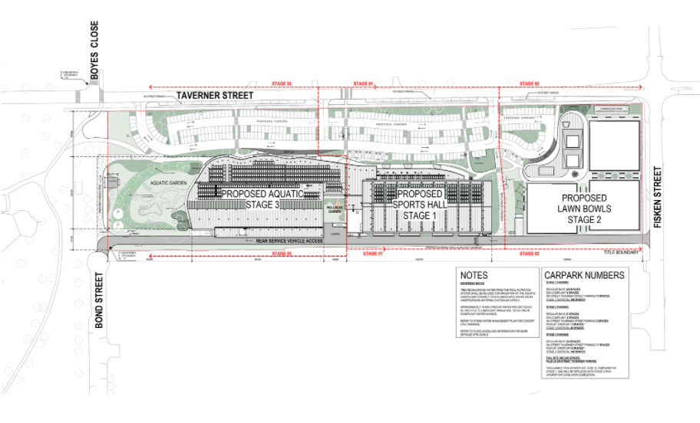
Figure 1: Stage plan with associated car parking.
Vehicle access to the site is proposed via three separate connections to Taverner Street to distribute traffic throughout the main car park for the centre, A separate road is located at the rear of the site connecting from Bond Street to Fisken Street for chemical truck delivery, maintenance vehicles and loading vehicles access only.
The existing footpath and nature strip on the southern side of Taverner Street will be removed and replaced with a new footpath and the parallel parking bays.

History
No previous planning permits were sought for this site.

Public Notice
The application was notified to adjoining and surrounding landowners and with signs on the site.
No objections were received.
One submission was received stating they did not object to the application but wanted the following issues to be considered by officers:
• No connecting footpath along Taverner Street (from Grant Street end) for pedestrians. Links are made to Maddingley Park only. Not all users to the site will do so via Maddingley Park or a vehicle.
• Inadequate carparking area for Maddingley Park.
• The carparking area proposed should be extended or make a connection to the existing carpark to allow proper off street carparking for those visiting Maddingley Park.
• The "Aquatic Garden" area and connecting land would be better utilized as recreation land rather than a proposed large garden area.
• More external rubbish bins need to be provided especially at the front of the subject property and along Taverner Street.
The submission was sent to the relevant Council Departments who stated that works along Taverner Street will be considered as part of a future Capital Works Program.

Locality Map
The map below indicates the location of the subject site and the zoning of the surrounding area.
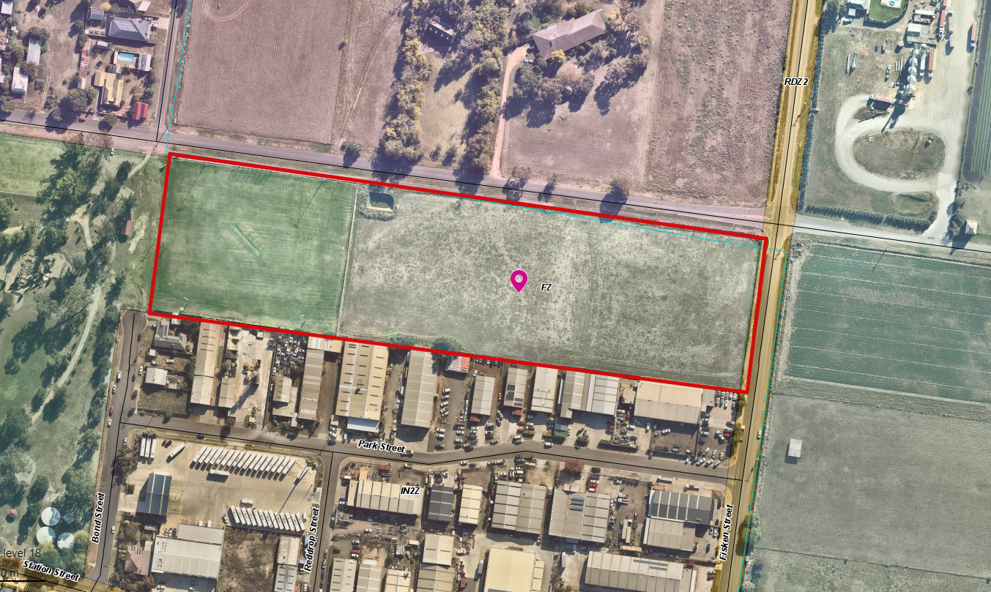
Figure 2: Aerial site map (site highlighted in red boundary)
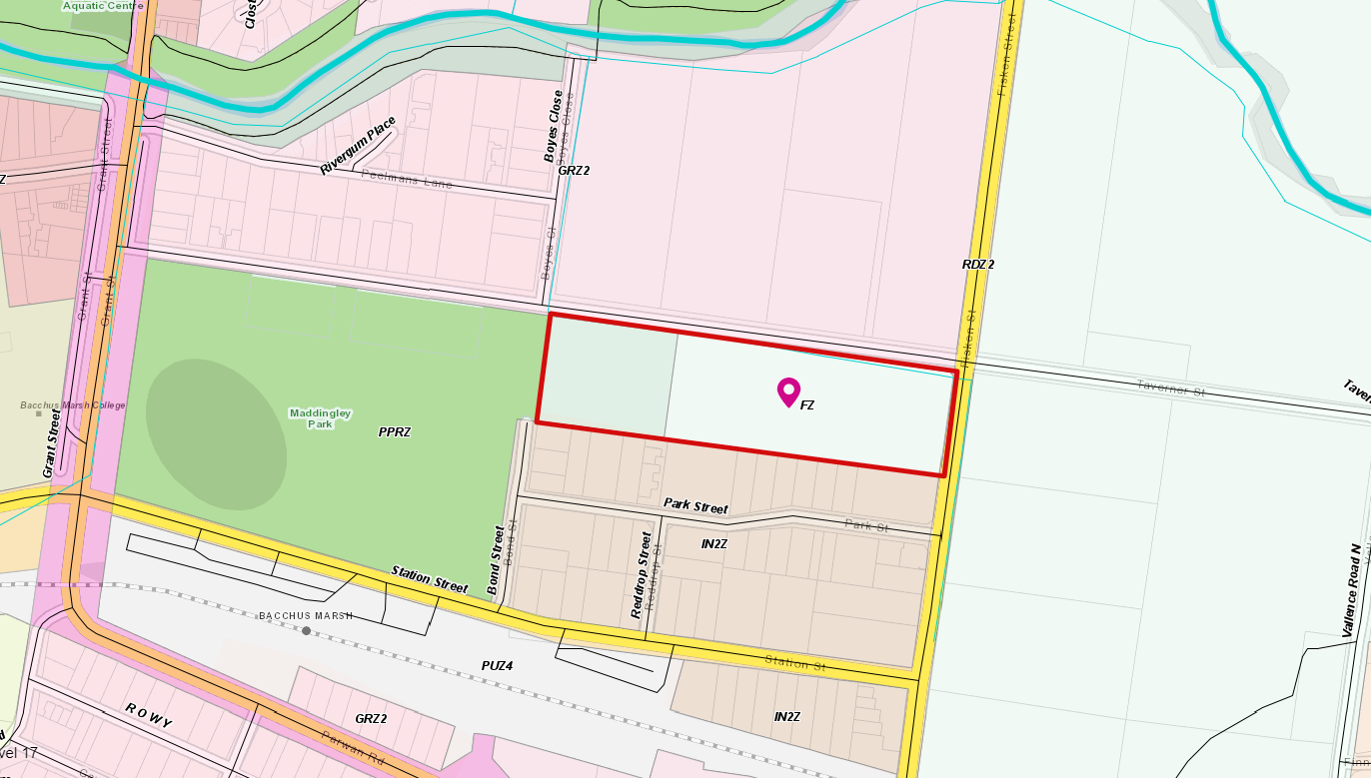
Figure 3: Zoning Map (site boundary highlighted in red)
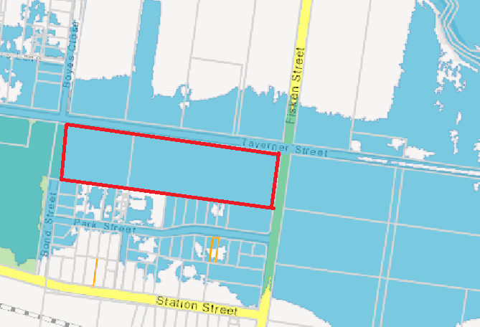
Figure 4: Flood extent coloured blue (site highlighted in red boundary)

Planning Scheme Provisions
Council is required to consider the Victoria Planning Provisions and give particular attention to the Planning Policy Framework (PPF), the Local Planning Policy Framework (LPPF) and the Municipal Strategic Statement (MSS).
The relevant clauses are:
• Clauses 11.01-1S (Settlement)
• Clause 11.02-1S (Supply of urban land)
• Clause 11.03-3S (Sequencing of development)
• Clause 13.05-1S (Noise abatement)
• Clauses 15.01-1S (Urban design)
• Clause 15.01-2S (Building Design)
• Clause 15.01-5S (Neighbourhood Character)
• Clause 15.02-1S (Energy and resource efficiency)
• Clause 17.01-1S (Diversified economy)
• Clause 18.02-1S (Sustainable personal transport)
• Clause 18.02-2S (Public Transport)
• Clause 18.02-4S (Car parking)
• Clause 19.02-4S, (Social and cultural infrastructure)
• Clauses 21.02 (Natural Environment)
• Clause 21.04 (Economic Development and Employment)
• Clause 21.05 (Development and Community Infrastructure)
• Clause 21.07 (Bacchus Marsh)

Zone
This is covered by two zones, the Farming Zone and the Public Park and Recreation Zone.
Clause 35.07 – Farming Zone
The purpose of the Farming Zone includes:
• To implement the Municipal Planning Strategy and the Planning Policy Framework.
• To provide for the use of land for agriculture.
• To encourage the retention of productive agricultural land.
• To ensure that non-agricultural uses, including dwellings, do not adversely affect the use of land for agriculture.
• To encourage the retention of employment and population to support rural communities.
• To encourage use and development of land based on comprehensive and sustainable land management practices and infrastructure provision.
• To provide for the use and development of land for specific purposes identified in a schedule to this zone.
Pursuant to Clause 35.07-1 a permit is required to use the land for the purposes of a
leisure and recreation facility. Pursuant to Clause 35.07-4 a planning permit is required to construct a building or construct or carry out works associated with a Section 2 use.
No maximum building height is specified.
Clause 36.02 – Public Park and Recreation Zone
The purpose of the Public Parking and Recreation Zone includes:
• To implement the Municipal Planning Strategy and the Planning Policy Framework.
• To recognise areas for public recreation and open space.
• To protect and conserve areas of significance where appropriate.
• To provide for commercial uses where appropriate.
Pursuant to Clause 36.02-1 a permit is required to use the land for the purposes of a
leisure and recreation facility. Pursuant to Clause 36.02-2 a planning permit is required to construct a building or construct or carry out works.

Overlays
Design and Development Overlay Schedule 2
The Design and Development Overlay affects the land at Lot 1 on Plan of Subdivision 326264.
DDO2 relates to ‘Visual amenity and building design’ which seeks to enhance the visual amenity in rural, township and vegetated areas of the shire, encourages the use of external cladding, such as non-reflective materials for building construction and discourages the use of materials such as reflective cladding for building construction, which could have a detrimental effect on amenity.
Pursuant to Part 2 of DDO2 a permit is required to construct a building or construct or carry out works where external walls and roof areas are clad with non-reflective materials.
Environmental Significance Overlay Schedule 8
The ES affects a minor portion of 21 Taverner Street in the south-west corner.
ESO8 relates to ‘River Red Gums in the Bacchus Marsh Valley’.
Pursuant to Part 3 of Schedule 8 to the ESO a planning permit is required to remove, destroy, lop or prune River Red Gum native vegetation, and to construct a building or construct or carry out works in the tree protection zone of a River Red Gum.
The site does not contain any vegetation therefore there are no permit triggers under ESO8.

Relevant Policies
Moorabool Industrial Areas Strategy (2015)
This strategy states that the site is within the Maddingley 1 precinct and occupied by a combination of low impact industrial and service industries. The precinct also contains a number of dwellings and non-industrial businesses.
Clause 21.07 of the Shire’s Local Planning Policy Framework also discusses the broader area in and around the precinct as providing opportunities for “planned residential and mixed-use urban development”. The Strategic Planning Department commented that “all of the features of the area combined would suggest that the precinct’s current status more closely resembles an Industrial 3 Zoned area (as opposed an Industrial 1 or 2 Zoned area). That said, the potential for residential or mixed-use redevelopment of the area requires a broader consideration of the precinct’s long term role.”
Close proximity of residential properties to the site limits use of the land for manufacturing purposes more usual to an Industrial 2 Zone. Maddingley 1 precinct requires further strategic planning investigation and review.
Nearby industrial activity is not expected to affect the operation of this sports and aquatic centre.
Bacchus Marsh Urban Growth Framework (2018)
This framework identifies area of growth, Merrimu residential growth precinct, Parwan employment growth precinct, Parwan Station residential and commercial growth precinct, Hopetoun Park North residential growth precinct, investigation and transition areas and implements the Urban Growth Framework actions.
Strategic planning commented that potential investigations are required on rezoning the Park Street, Maddingley industrial precinct from Industrial 2 Zone to Industrial 3 Zone or Mixed-Use Zone, to limit manufacturing and facilitate service industry and other compatible uses.

Particular Provisions
Clause 52.06 – Car Parking:
This clause applies to a new use and an increase in the floor area or site area of an existing use and seeks to ensure the provision of an appropriate number of car parking spaces. A permit may be issued to vary, reduce or waive the statutory car parking requirements.
Table 1 to Clause 52.06 does not provide a statutory car parking requirement for a sports and recreation facility, therefore, pursuant to Clause 52.06-6 car parking is to be provided to the satisfaction of the Responsible Authority.
The proposed car parking provision of 306 spaces is considered adequate and meets the design standard of Clause 52.06-9.
Clause 52.34 – Bicycle Facilities:
This clause applies to a new use or an increase in the floor area of an existing use and seeks to ensure new developments provide an appropriate number of bike spaces for staff and visitors and that the appropriate end-of-trip facilities are provide for staff. A permit may be issued to vary, reduce or waive the statutory bike requirements.
Pursuant to Clause 52.34 a sports and recreation facilities have a requirement to provide one bike space per four staff members for employees and one bike space per 200sqm of net floor area for visitors.
The proposal provides 80 bicycle spaces.
Clause 53.18 – Stormwater Management in Urban Development:
This clause seeks to ensure that stormwater in urban development is managed to mitigate the impacts of stormwater on the environment, property and public safety, and to provide cooling, local habitat and amenity benefits. This clause does not apply to the part of the subject site in the FZ, as specified at Clause 53.18-1.
A stormwater management plan was submitted and referred to Melbourne Water and Council’s Infrastructure.

Discussion
A planning permit application is submitted to use and develop the land for leisure and recreation purposes which is triggered by both the Farming Zone and the Public Park and Recreation Zone.
Traffic and Accessibility
The TIA states that additional traffic generated by the proposal will not compromise the safety or function of the surrounding road network. The application was referred to Transport for Victoria who had no objection to the proposal. Peak vehicle movements could be expected to be adequately catered for between the three access points and that additional traffic and vehicle movement are catered for at the Taverner Street/Grant Street and Taverner Street/Fisken Street intersections. Traffic will be further dispersed at Station Street/Griffith Street, Geelong-Bacchus Marsh Road and Main Street. The service road was found to provide satisfactory access for 12.5m long vehicle to service the site, with an 8.8m truck able to reverse perpendicular to the accessway.
The Bacchus Marsh Railway Station is located 400m from the site and bus routes are available along Station Street and Grant Street which are a walking distance from the site. Sustainable transport modes are also available via the on-road bicycle lanes along Grant Street.
Car parking is assessed against Clause 52.06 of the planning scheme and is considered to be more than adequate to cater for the development. A Traffic Impact Assessment (TIA) provided in the application confirms that the proposed onsite car spaces are expected to satisfy the anticipated peak demands even when a show court event is being held.

The proposal has a requirement to provide a minimum of eight bike spaces for staff and 54 for visitors. These will be provided in individual stages and conditioned as part of the permit to ensure that all bicycle spaces are clearly annotated on the plans. The applicant has advised they will provide 80 spaces which exceeds this requirement.
The proposal states that the rear service lane can accommodate buses for site related group trips if required. The pickup and drop off spaces to the building frontage in the main car park can accommodate minibuses if required.
Taverner and Fisken Street Upgrades
Noting the recommendations of the traffic reports on the Taverner Street and Fisken Street upgrades, these will be appropriately staged as part of future developments and subject to budget allocation.
A concept streetscape design will be addressed with Council officers to ensure that street trees, carriageways, footpaths and drainage are all adequate.
Waste Management
The Waste Management Plan states that waste will be stored within the development and hidden from external view. Collection bins are allocated to ensure that users dispose of waste correctly. Waste collection will be collected within the onsite loading bay and the private collection contractor will transfer bins between the waste area and the truck. Conditions are placed on the permit to ensure that the waste management plan is complied with and also poses conditions to ensure that waste is adequately controlled and screened.
Design Response
The surrounding land is of mixed-use nature and includes residential, agricultural, industrial and open space uses. However, surrounding land including Maddingley Park will not be overshadowed by the development as demonstrated by shadow diagrams provided with the application. The development is setback for 34m from Taverner Street therefore achieving adequate separation from any residential development and in consideration that residential development is to occur directly north of the site with an approval issued for multi lot subdivision.
Windows located at Level 1 are setback a minimum of 30m from the southern boundary.
Landscaping is proposed within the 16m setback from the ground floor. A detailed landscape plan was prepared by Urbis for all on-site landscaping. Three trees are proposed for removal however the development proposes an adequate level of new landscaping treatments to soften the appearance of the built form and create defined visual interest.
Melbourne Water and Flooding
Several discussions took place between Melbourne Water and the Major Projects to ensure that all flood risks are mitigated through other methods of retarding water or changing the rate of flow.
Melbourne Water provided conditions for the planning permit which are recommended in this report. Melbourne Water further stated that the site is subject to flooding from the Werribee River and from underground drainage flooding from the Maddingley Park Drain located west of the subject site along Grant Street. Melbourne Water advised that the 1% Average Exceedance Probability (AEP) flood level varies from 100.5m to Australian Height Datum (AHD) along the western boundary of the site down to 97.5m to AHD along the eastern boundary (Fisken Street frontage). Subsequently, the Condition 1 requirements stipulate that Melbourne Water flood modelling requirements must be met prior to the endorsement of the plans.
Decision guidelines
The proposal is designed to minimise noise impacts with all plant and equipment located away from sensitive land uses. The development is well setback and heavily landscaped to soften the large built form appearance. Material and finishes proposed are designed to create visual interest and allow for sustainable design principles to be achieved. While some of the materials are considered reflective it has been assessed as appropriate for the proposed land use. The setbacks, proposed landscaping and location of the building ensures that limited visual impact from the reflective materials. All areas in the development are proposed with consideration towards surveillance to allow for safe pedestrian and cycle paths and car parking.
The proposal was assessed against the general provisions of the scheme and meets the relevant State and Local Planning Policy. The site is located within a peri-urban growth area and provides a sustainable development to service existing and future population demands at a convenient location. It will provide employment opportunities, during the construction of the facility and will encourage employment in various skill sets to sustain the operation of the centre.

GEneral Provisions
Clause 65 - Decision Guidelines have been considered by officers in evaluating this application.
Clause 66 - Stipulates all the relevant referral authorities to which the application must be referred.
Clause 63.12 – Decision Guidelines - specifies a range of general guidelines that the Responsible Authority must consider prior to deciding an application.

Referrals
Authority | Response
Section 55 – Determining
Western Water | No objection subject to conditions.
Melbourne Water | No objection subject to conditions.
Transport for Victoria (TfV) | No conditions.
Section 52 – Recommending
Infrastructure | Support subject to conditions.
Strategic Planning | No objection.
Connected Communities | No conditions.
Environmental Health | Consent with conditions.
Major Developments | No conditions.
Community Health and Safety | No conditions.
Building Inspector | No conditions.
Economic Development | Consent.
Environmental Management | No comment.

Financial Implications
There are no financial implications other than the project being listed within budgets and as part of the Council’s Action Plan. The draft 2021-2022 Capital Improvement Plan identifies the project.

Risk & Occupational Health & Safety Issues
The recommendation of application does not implicate any risk or OH&S issues to Council.

Communications Strategy
Notice was undertaken for the application, in accordance with s.52 of the Planning and Environment Act 1987, and further correspondence is required to all interested parties to the application as a result of a decision in this matter. All submitters and the applicant were invited to attend this meeting and invited to address Council if required.

Options
Council could consider the following options:
• issue a permit in accordance with the recommendations of this report; or
• issue a notice of refusal outside of the recommendations of this report and provide rounds for the proposal not complying with the Moorabool Planning Scheme.

Conclusion
The proposal is consistent with Moorabool Planning Scheme, Action Plan and strategic plans to achieve the objectives set out in the Recreation and Leisure Strategy. The site is located in the heart of mixed land uses with ease of access to the Bacchus Marsh town centre and abundant residential developments existing and emerging within close proximity. Public Transport is available within a convenient location near the train station with adequate nearby bus stops facilitated by pedestrian paths. The development will become the highlight of Bacchus Marsh and surrounds with Maddingley included to cater for the rapidly growing population. The development will provide a high-quality indoor aquatic and sports hall as well as a lawn bowls facility available to the community in an easy to access location. The development will also provide various employment opportunities and activate the community to engage in leisure and health related activities.
The built form is contemporary in outlook and provides an overall positive urban design outcome with landscaping to soften the development.
The recommendations contained in this report address mechanisms to ensure the site is well maintained, landscaping is maintained, built according to the staging sequence, include adequate infrastructure and services, include noise barriers, include environmentally sustainable design and adequate onsite parking.
It is recommended the use and development be supported subject to the recommendations set out in this report.

10 Closed Session of the Meeting to the Public

Resolution
Moved: Cr Moira Berry
Seconded: Cr Ally Munari
That Council considers the confidential report(s) listed below in a meeting closed to the public in accordance with Section 66(2)(a) of the Local Government Act 2020:
10.1 C21-2021/2022 Culvert Rehabilitation Yendon-Egerton Rd Millbrook
This matter is considered to be confidential under Section 3(1) confidential information - (g) of the Local Government Act, and the Council is satisfied that discussion of this matter in an open meeting would, on balance, be contrary to the public interest as it deals with private commercial information, being information provided by a business, commercial or financial undertaking that
(i) relates to trade secrets; or
(ii) if released, would unreasonably expose the business, commercial or financial undertaking to disadvantage.
10.2 Australia Day Award Selection Panel Recommendations
This matter is considered to be confidential under Section 3(1) confidential information - (f) of the Local Government Act, and the Council is satisfied that discussion of this matter in an open meeting would, on balance, be contrary to the public interest as it deals with personal information, being information which if released would result in the unreasonable disclosure of information about any person or their personal affairs.
Carried

11 Meeting Closure

The Meeting closed at 6.10pm.

The minutes of this meeting were confirmed at the Ordinary Meeting of the Moorabool Shire Council held on 2 February 2022.

...................................................
CHAIRPERSON

