MINUTES
Ordinary Council Meeting
Wednesday, 4 August 2021
Date: | Wednesday, 4 August 2021
Time: | 6.00pm
Location: | Online

Order Of Business
1 Opening of Meeting and Prayer 4
2 Acknowledgement of Country 4
3 Recording of Meeting 4
4 Present 4
5 Apologies 4
6 Confirmation of Minutes 5
7 Disclosure of Conflicts of Interest 5
8 Public Question Time 5
9 Petitions 6
9.1 Petition - Claret Ash Tree, Fisken Street, Ballan 6
10 Presentations/Deputations 7
11 Chief Executive Officer Reports 8
11.1 Advisory Committees of Council - Reports 8
12 Community Planning and Economic Development Reports 9
12.1 PA2020044 - Development of a Second Dwelling behind an existing Dwelling at 13 Clarinda Street, Bacchus Marsh 9
12.2 PA2011338-3 - Amendment to Operating Hours to Use and Development of the Land for a Landfill, Production of Soil and Soil Products (including Composting) and Works Associated with those Uses; Use and Development of the Land for the Purpose of Materials Recycling (Metals and Construction and Demolition Waste); and Construction of a Treatment Plant for Leachate Management 21
13 Community Strengthening Reports 37
13.1 Arts and Culture Strategy 2021 - 2025 37
14 Customer Care and Advocacy Reports 44
Nil 44
15 Community Assets & Infrastructure Reports 45
15.1 Capital Improvement Program - Quarterly Report June 2021 45
16 Other Reports 53
Nil 53
17 Notices of Motion 54
17.1 Notice of Motion 296 - Population Growth and Needs of the Dales Creek Community 54
18 Notices of Rescission 55
Nil 55
19 Mayor’s Report 56
19.1 Mayor's Report 56
20 Councillors’ Reports 58
20.1 Councillors' Reports 58
21 Urgent Business 59
Nil 59
22 Closed Session of the Meeting to the Public 59
22.1 Reciept of Kerbside and Transfer Station Recyclables - Contract Extension 59
22.2 CEO Performance Review 59
23 Meeting Closure 59

1 Opening of Meeting and Prayer
The Mayor opened the meeting with the Council Prayer at 6.00pm.

2 Acknowledgement of Country
I acknowledge the Traditional Owners of the land on which we are meeting. I pay my respects to their Elders, past and present, and the Aboriginal Elders of other communities who may be here today.

3 Recording of Meeting
In accordance with Moorabool Shire Council’s Governance Rules, the meeting is livestreamed.

4 Present
Cr Tom Sullivan, Mayor West Moorabool Ward
Cr Rod Ward, Deputy Mayor East Moorabool Ward
Cr Moira Berry East Moorabool Ward
Cr Tonia Dudzik East Moorabool Ward
Cr David Edwards East Moorabool Ward
Cr Ally Munari Woodlands Ward
Cr Paul Tatchell Central Moorabool Ward
Officers:
Mr Derek Madden Chief Executive Officer
Ms Caroline Buisson General Manager Customer Care & Advocacy
Mr Phil Jeffrey General Manager Community Assets & Infrastructure
Ms Sally Jones General Manager Community Strengthening
Mr Henry Bezuidenhout Executive Manager Community Planning & Economic Development
Mr Robert Fillisch Manager Statutory Planning & Building Services
Mr Anthony Smith Manager Governance Risk & Corporate Planning
Mr Chris Gardner Manager Connected Communities
Mr Mark Lovell Coordinator Statutory Planning
Ms Vanessa Osborn Coordinator Major Developments
Mr Troy Delia Coordinator Governance & Risk

5 Apologies
Nil

6 Confirmation of Minutes
Resolution
Moved: Cr Paul Tatchell
Seconded: Cr David Edwards
That the minutes of the Ordinary Council Meeting held on Wednesday 7 July 2021 be confirmed.
Carried

7 Disclosure of Conflicts of Interest
Nil

8 Public Question Time
Clarification Response regarding question received at Ordinary Meeting of Council 7 July 2021
Sally Jones, General Manager Community Strengthening
Firstly, I would like to issue a point of clarification in relation to a question put to Council by Mr Kowarsky at the Ordinary Council Meeting held Wednesday, 7 July 2021.
I can confirm that there is a $450,000 allocation for the Ballan Library Facility project in Council’s 2021/22 Adopted Budget. In addition to the $450,000 allocation in the Adopted Budget, there will be a carried forward amount of $100,000 from the 2020/21 Adopted Budget. Therefore, the total available for the Ballan Library Facility will be $550,000 for the 2021/22 financial year.
I would like to apologise for the provision of the capital funding advice of $300,000 for the Ballan Library Facility project. This information was taken from a draft document.

Name | Question/Response | CEO/GM/EM | Read at Meeting  (Yes/No) | Taken on Notice  Yes/No
Mr. John Kowarsky | Question:  Please provide details of timing and scope of Public Consultation for the Ballan Library Major Priority Project. | Sally Jones General Manager Community Strengthening | Yes | No
Response:
Officers are currently developing a project plan inclusive of deliberative engagement commitments. The concept design for the community facility will be undertaken in collaboration and consultation with the Moorabool community. Engagement will begin in the 2021-2022 financial year and continue throughout the further design of the facility.

9 Petitions

9.1 Petition - Claret Ash Tree, Fisken Street, Ballan
Author: Anthony Smith, Manager Governance, Risk & Corporate Planning
Authoriser: Derek Madden, Chief Executive Officer
Attachments: Nil

Purpose
Council has received a petition containing 159 signatures from residents and visitors of Ballan.

Executive Summary
The petition states:
We, the undersigned concerned citizens, hereby petition the Moorabool Shire Council to save the mature Claret Ash tree at 22 Fisken St opposite the CFA in BaIlan. There is a permit application (PA 2021042) by Council engineers to remove/cut down this tree in order to redo concrete curbing and guttering. The decision has NOT YET been made. We ask the Council to refuse this application and NOT remove this beautiful, mature tree and to use some other way to fix the guttering eg. box the tree as done in the main street. This is a significant and magnificent, mature (40 years plus) deciduous tree. It provides shade in summer, glorious Autumn colour, bird habitat and generally enhances the beauty of Ballan which is known as an Autumn Town.
This petition meets the requirements of Clause 3.7.2 of Council’s Governance Rules, and only those signatories that met the requirements of Part 3.7.2 of Council’s Governance Rules were included in the total.

Resolution
Moved: Cr Paul Tatchell
Seconded: Cr Tonia Dudzik
That the petition containing 159 signatures in relation to saving the mature Claret Ash tree at 22 Fisken Street, Ballan, be received by Council and considered as part of the process for determining planning application PA2021042.
Carried

10 Presentations/Deputations
Nil

11 Chief Executive Officer Reports

11.1 Advisory Committees of Council - Reports
Author: Anthony Smith, Manager Governance, Risk and Corporate Planning
Authoriser: Derek Madden, Chief Executive Officer
Attachments: 1. Heritage Advisory Committee Minutes - April 2021 (under separate cover)
2. Heritage Advisory Committee Minutes - June 2021 (under separate cover)
3. Local Business Advisory Committee Minutes - June 2021 (under separate cover)

Purpose
Advisory Committees are established to assist Council with executing specific functions or duties.
Advisory Committees of Council currently have no delegated powers to act on behalf of Council or commit Council to any expenditure unless resolved explicitly by Council following recommendation from the Committee. Their function is purely advisory.
Advisory Committees are required to report to Council at intervals determined by the Council.

Executive Summary
Councillors, as representatives of the following Advisory Committees of Council, present the reports of the Committee Meetings for Council consideration.
Committee | Meeting Date | Council Representatives
Heritage Advisory Committee | Wednesday 21 April 2021 | Cr Paul Tatchell
Heritage Advisory Committee | Wednesday 16 June 2021 | Cr Paul Tatchell
Local Business Advisory Committee | Tuesday 8 June 2021 | Cr Paul Tatchell

Resolution
Moved: Cr David Edwards
Seconded: Cr Paul Tatchell
That Council receive the following Advisory Committee reports:
1. Heritage Advisory Committee Meeting Minutes for Wednesday 21 April 2021 and Wednesday 16 June 2021.
2. Local Business Advisory Committee Meeting Minutes for Tuesday 8 June 2021.
Carried

12 Community Planning and Economic Development Reports

12.1 PA2020044 - Development of a Second Dwelling behind an existing Dwelling at 13 Clarinda Street, Bacchus Marsh
Author: Victoria Mack, Statutory Planner
Authoriser: Henry Bezuidenhout, Executive Manager Community Planning & Economic Development
Attachments: 1. Site layout and dwelling plans including landscape plan (under separate cover)

Application Summary
Permit No: PA2020044
Lodgement Date: 2 March 2020. Amended application lodged on 10 February 2021
Planning Officer: Victoria Mack
Address of the land: 13 Clarinda Street, Bacchus Marsh Lot 1 on TP 098690G
Proposal: Development of a second dwelling behind an existing dwelling
Lot size: 714.72sqm
Why is a permit required? Clause 32.08 General Residential Zone – Two dwellings on a lot.

Resolution
Moved: Cr David Edwards
Seconded: Cr Paul Tatchell
That Council, having considered all matters for PA2020044 as prescribed by the Planning and Environment Act 1987, issue a refusal to grant a permit for the Development of a Second Dwelling behind an existing Dwelling at 13 Clarinda Street, Bacchus Marsh, based on the following grounds:
- The development does not accord with the existing or preferred neighbourhood character for the precinct.
- The proposed crossover and side driveway does not allow for enhancement of the front garden character, including increased canopy tree plantings.
- The siting of buildings, driveways and private open space represents an overdevelopment of the site.
Carried

Public Consultation
Was the application advertised? | Yes.
Notices on site: | Yes.
Notice in Moorabool Newspaper: | No.
Number of objections: | 13 objections.
Consultation meeting: | Not held. All objectors were advised in writing of the reduction from three dwellings to two, but only two objectors withdrew their objections.

Policy Implications
The Council Plan 2017-2021 provides as follows:
Strategic Objective 3: Stimulating Economic Development
Context 2A: Built Environment
The proposal is not provided for in the Council Plan 2017-2021 and can be actioned by utilising existing resources.

Victorian Charter of Human Rights & Responsibilities Act 2006
In developing this report to Council, the officer considered whether the subject matter raised any human rights issues. In particular, whether the scope of any human right established by the Victorian Charter of Human Rights and Responsibilities is in any way limited, restricted or interfered with by the recommendations contained in the report. It is considered that the subject matter does not raise any human rights issues.

Officer’s Declaration of Conflict of Interests
Under section 130 of the Local Government Act 2020, officers providing advice to Council must disclose any interests, including the type of interest.
Executive Manager – Henry Bezuidenhout
In providing this advice to Council as the Executive Manager, I have no interests to disclose in this report.
Author – Victoria Mack
In providing this advice to Council as the Author, I have no interests to disclose in this report.

Executive Summary
Application referred? | Yes, to the Department of Human Services and Council’s Infrastructure.
Any issues raised in referral responses? | No issues were raised.
Preliminary concerns? | The original application was for three new dwellings on the lot with the existing dwelling to be demolished. The application did not comply with a number of ResCode requirements.
Any discussions with applicant regarding concerns? | There was regular communication with the applicant.
Any changes made to the application since being lodged? | The applicant decided to amend the application in process and the proposal was changed to a new dwelling behind the existing dwelling.
Brief history. | The site has an existing single storey weatherboard dwelling constructed possibly in the 1970s.
Previous applications for the site? | No previous applications are recorded on the site.
General summary. | The application is for a second dwelling on the lot which has an area of 714.72sqm. The existing dwelling would be retained, and which would maintain the streetscape character of Clarinda Street. The proposal is generally compliant with ResCode and the Neighbourhood Character Precinct 24.  The original application was for three dwellings which drew 15 objections. Two objections were withdrawn when the application was altered to remove one dwelling.  The current two dwelling proposal is an appropriate design response.  It is recommended that the application is supported.
Summary of Officer’s Recommendation
That Council, having considered all matters as prescribed by the Planning and Environment Act 1987, issue a Notice of Decision to Grant Planning Permit PA2020044 for the Development of a second dwelling behind an existing dwelling on Lot 1 on TP 098690G otherwise known as 13 Clarinda Street, Bacchus Marsh, subject to conditions.

Site Description
The site is located on the west side of Clarinda Street, Bacchus Marsh. It is rectangular in shape, has an area of 714.72sqm and has a gradual slope from the rear of the site to the front. The site is directly opposite the intersection of Clarinda Street with Millbank Street where there is a large traffic island located within Millbank Street.
There is an existing single storey weatherboard dwelling on the site without any substantial garden setting. The existing driveway is located on the north side of the site.
The rear of the site contains a small shed and lawn with one small tree.
Neighbouring dwellings are of a similar vintage and present a similar façade to the street.
The site is located approximately 140m north of the Bacchus Marsh Hospital’s Clarinda Street entrance, and approximately 130m south of the intersection with Main Street. The site is located approximately 440m from the Bacchus Marsh town centre and approximately 1.7km north of the Bacchus Marsh Railway Station.
The land is within the Neighbourhood Character Precinct No. 24.
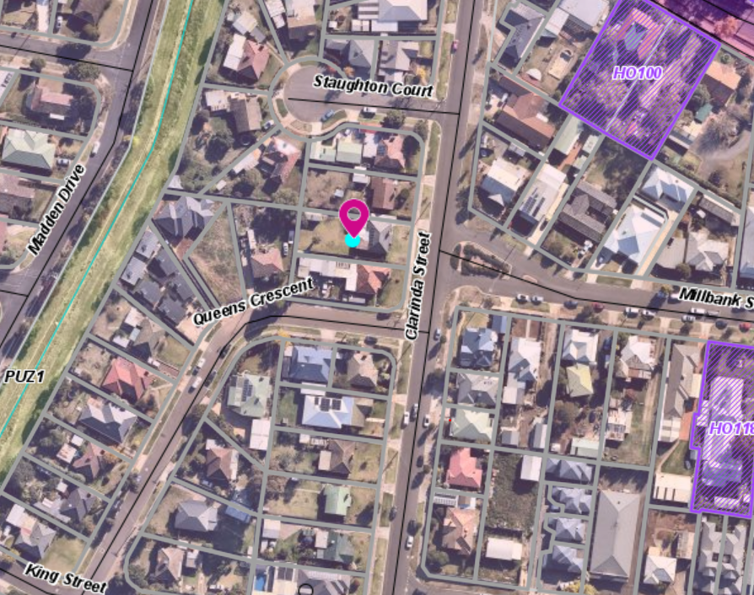
Figure 1: Aerial Map

PROPOSAL
It is proposed to construct a second single storey dwelling behind an existing dwelling. The development would have the following details:
Dwelling 1: The existing dwelling has:
• Two bedrooms.
• Bathroom with separate WC.
• Living room with a fireplace.
• Kitchen meals area with a door to an external concrete courtyard.
• laundry with external access.
The secluded private open space would be 71.93sqm and would contain a storage shed and clothesline.
Dwelling 2: The new dwelling would be constructed with face brick cladding and concrete tiled roof. The windows would be aluminium. Access would be via a driveway on the south side of the lot with an attached single car garage and a tandem space in front of the garage. A reversing turning bay has been included within the site plan for this dwelling to enable exiting the site in a forward direction.
Dwelling 2 will contain:
• Three bedrooms.
• Open plan kitchen, meals and living area with a northerly orientation.
• Master bedroom with WIR and ensuite.
• Two other bedrooms would share a family bathroom and separate WC.
• A covered alfresco dinging area in the north-west corner of the dwelling.
• 90.31sqm of secluded private open space which has a north south orientation.
• Six cubic metres of external storage and a clothesline with access to the garage via a roller door.
In terms of the overall development, the dwellings would be separated by a 1.8m high internal wooden paling fence and 1.9m high boundary fence. The total garden area for the development would comprise of 35.36% of the site. Both dwelling colours would be charcoal, surf mist, monument and earth tones.
The landscape plan submitted with the application meets the requirements of the planning scheme.
The construction of the new dwelling requires limited site works towards the rear of the site as identified in the Figure: 3: Elevations Plan.

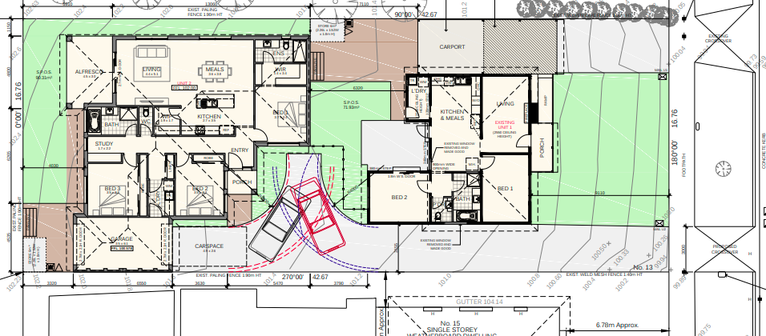

Figure 2: Site Layout Plan including the Floor plan

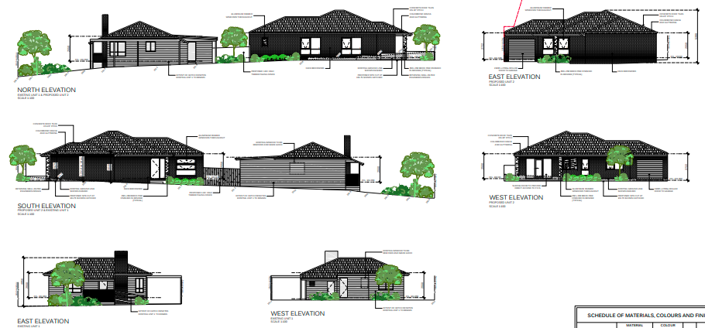

Figure 3: Elevation plans

Background to Current Proposal
The application was initially for three new dwellings on the lot with the existing dwelling to be demolished. The layout and design did not meet all of the ResCode standards and planning scheme requirements. Considerable discussions were held with the applicant to meet these requirements.
The application was advertised, and 15 objections were received. An assessment of the objections and the final plans resulted in the officer advising the applicant that the application would proceed to an Ordinary Meeting of Council with a recommendation for refusal.
After further discussions with the applicant and the owner, it was decided to amend the application to one new dwelling behind the existing dwelling which was to be retained. New plans were provided.

Public Notice
The initial application was notified to adjoining and surrounding landowners and 15 objections were received. The amended application was readvertised, and two objections were withdrawn.

Summary of Objections
The objections received are detailed below with officer’s comments accompanying them.
Objection | Any Relevant Requirement
Parking issues in the immediate area are already a problem. Council needs to undertake a traffic management plan to understand the congestion periods which can be severe.  Nine similar comments received | Clause 52.06-5.
Officer’s Response: The proposed development complies with the requirements of Clause 52.06.
We would prefer that the application was for two dwellings only.  Eight similar comments received | Clause 55 ResCode
Officer’s Response: The applicant has reduced the proposal to two dwellings only.
Traffic congestion in this area of Bacchus Marsh needs to be managed.  Seven similar comments received. | Council’s Infrastructure.
Officer’s Response: This is a wider issue for the precinct and Council notes the concerns. The proposal for one additional dwelling is considered to have minimal impact on the existing traffic flow. Council’s Traffic Engineers raised no objection to the proposal.
Neighbourhood character is important and must be considered when these types of developments are assessed. Just because we live close to services doesn’t mean character should be sacrificed.  Nine similar comments received. | Neighbourhood Character Precinct No. 24
Officer’s Response: The Neighbourhood Character Precinct No. 24 supports increased residential growth, but any development must meet appropriate design and neighbourhood character guidelines. The retention of the existing dwelling ensures the streetscape character is retained.
The application demonstrates poor and cheap design and should not be accepted.
Five similar comments.
Officer’s Response: The applicant has reduced the number of dwellings from three to two which is an improvement in terms of amenity impact and streetscape appearance.

Locality Map
The map below indicates the location of the subject site and the zoning of the surrounding area.
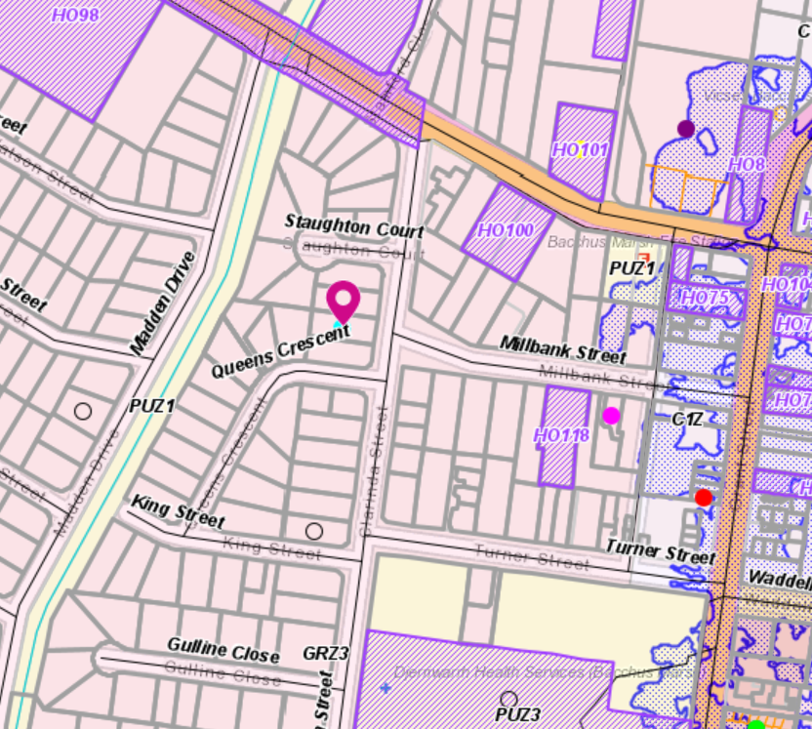
Figure 3: Zoning Map

Planning Scheme Provisions
Council is required to consider the Victoria Planning Provisions and give particular attention to the Planning Policy Framework (PPF), the Local Planning Policy Framework (LPPF) and the Municipal Strategic Statement (MSS).
The relevant clauses are:
• Clause 11.03-2S Growth areas.
• Clause 11.03-3S Peri-urban areas.
• Clause 15.01-1S Urban design.
• Clause 15.01-2S Building design.
• Clause 15.01-5S Neighbourhood character.
• Clause 16.01-1S Integrated housing.
• Clause 16.01-2S Location of residential development.
• Clause 16.01-3S Housing diversity.
• Clause 21.03 Settlement and Housing and Clause 21.03- Key issues and influences.
• Clause 21.03-2 Objectives—Urban growth management.
• Clause 21.03-3 Objectives—Residential development.
• Clause 21.07 Bacchus Marsh and Clause 21.07-2 Objectives - Managing urban growth.
The proposal is generally consistent with the relevant sections of the PPF and LPPF.

Zone
General Residential Zone - Schedule 3
A permit is required under the following clauses of the General Residential Zone:
• Clause 32.08-6 to construct two or more dwellings on a lot. A development must meet the requirements of Clause 55, ResCode.
• In accordance with Clause 32.08-4 an application to construct or extend a dwelling or residential building on a lot must provide a minimum garden area of 35% where the lot area is greater than 650sqm.
Schedule 3 of the General Residential Zone
Schedule 3 applies to areas identified for Increased Residential Growth.
The Neighbourhood character objectives in Schedule 3 include:
• To encourage new development, including innovative and unique development that enhances and responds positively to the existing neighbourhood character.
• To encourage sufficient front setbacks to allow for enhancement of the front garden character including increasing canopy tree plantings.
• To encourage new development to have minimal or low scale front fencing.
• To ensure new garages and carports do not dominate dwellings or streetscapes.

OVERLAYS
Design and Development Overlay Schedule 15
The overlay relates to Bacchus Marsh Hospital Emergency Medical Services Helicopter Flight Path Protection (inner area).
Design objectives:
• To ensure that the height of buildings and works do not encroach on the flight path areas associated with the Bacchus Marsh Hospital helicopter landing site.
• To ensure that the height of development avoids creating a hazard to aircraft using the Bacchus Marsh Hospital helicopter landing site.
The application was required to be referred to the Department of Health and Human Services.

RELEVANT POLICIES
Neighbourhood Character Precinct 24
The preferred neighbourhood character statement for Precinct 24 states the precinct is recommended for Increased Residential Growth.
This recommendation generally, applies to residential land that is well located to services and facilities and has been identified as suitable for infill and increased densities of development. This will include a range of multi units, townhouses and alternative housing options within a walkable catchment of residents’ daily needs.
The preferred character statement includes that:
‘This precinct will allow for increased housing choice over time in a proximate location to several services and facilities. Site coverage will be increased, however new development, including multi dwelling developments should ensure adequate private open space and garden plantings are provided.
Front setbacks will be sufficient to allow for enhancement of the front garden character, including increasing canopy tree plantings. Front fences will be low or absent, allowing for views into front gardens.
New developments will minimise the need for additional crossovers to the street and have a positive street interface to ensure strong passive surveillance is achieved. Building to both side boundaries will generally be avoided, however may be considered where the preferred character of the precinct is not compromised. Garages and carports that do not visually dominate dwellings or streetscapes are encouraged and should be recessed from the front building line or located to the side or rear of the dwelling.
Innovative and unique development that enhances the character of the precinct is encouraged; however new development located in close proximity to dwellings that exhibit historical architectural styles should ensure built form complements these dwellings.
Increasing the diversity in housing products within the precinct is desirable including alternative housing products that allow for a variety of housing choices in areas accessible to services and facilities.’
The proposal generally accords with the preferred neighbourhood character statement.

Particular Provisions
Clause 55 – ResCode – two dwellings on a lot
The proposal generally complies with ResCode (Clause 55). It is noted that neighbourhood character seeks to minimise the number of crossovers. However, the crossovers represent less than 40% of the frontage which meets the standard. Instead of having a consolidated crossover, the development provides for two separate crossovers which allows for on street parking between the crossovers.
Clause 52.06 Car Parking
Under Clause 52.06-5 Table 1 the required car spaces have been provided for both dwellings on the site with both having two car spaces.

Discussion
The applicant reviewed the proposal and amended the concept plan to a new single storey dwelling behind the existing dwelling which would be retained. The amended plan resulted in the layout and design for both dwellings demonstrating a high level of compliance with ResCode objectives and standards.
The application was referred to Council’s Infrastructure which requested that a Stormwater Strategy for the development be provided, as specified in Clause 53.18-3 of the Moorabool Planning Scheme. This was provided and Council’s Infrastructure subsequently consented to the application subject to conditions.
The application was also referred to the Department of Health and Human Services (DHHS) as the land is within the Emergency Medical Services Helicopter Flight Path to the Bacchus Marsh Hospital. DHHS consented with conditions.
The application was advertised to adjoining landowners and occupiers. In the first round of advertising for three dwellings, 15 objections were received. The application was advertised a second time when the proposal was reduced to two dwellings. Two objectors withdrew their objections. No new objections were received.
The issues of most concern to objectors is the current traffic and parking in the immediate vicinity due to the proximity to the hospital and medical services. It was perceived that multi-dwelling developments would add to the parking congestion. The proposal complies with car parking requirement of Clause 52.06 and the reduction of one dwelling further reduces demand for on street parking.
The application complies with Schedule 3 of the General Residential Zone where this area has been identified for increased residential growth. The site is within the Neighbourhood Character Precinct 24 and identified as an area suitable for increased residential growth.
The area has good access to services and public transport that provides access to the Bacchus Marsh town centre and the railway station.
While it is acknowledged that the current neighbourhood character comprises lots of similar size with single dwellings, it is considered that strategic infill development and intensification would not detrimentally impact on the neighbourhood character or the streetscape. This was demonstrated by compliance with the ResCode standards with minimal impact to adjacent properties.

General Provisions
Clause 65 – Decision Guidelines have been considered by officers in evaluating this application.
Clause 66 – Stipulates all the relevant referral authorities to which the application must be referred.

Referrals
Authority | Response
Department of Health and Human Services | Consent with conditions.
Council’s Infrastructure | Consent with conditions.

Financial Implications
There are no financial implications for Council in approving this application.

Risk & Occupational Health & Safety Issues
The recommendation of approval of this development does not implicate any risk or OH&S issues to Council.

Communications Strategy
Notice was undertaken for the application, in accordance with s.52 of the Planning and Environment Act 1987, and further correspondence is required to all interested parties to the application as a result of a decision in this matter. All submitters and the applicant were invited to attend this meeting and invited to address Council if required.

Options
Council could consider the following options:
• issue a Notice of Decision to Grant a permit in accordance with the conditions recommended in this report; or
• issue a Notice of Decision to Grant a permit with varied conditions in this report; or
• issue a Refusal to grant a permit which may result in the applicant seeking Review at VCAT.

Conclusion
The application is for an additional dwelling on the lot with the retention of the existing dwelling. The site is located in a precinct identified as suitable for increased residential growth. Both the proposed dwelling and the existing dwelling generally comply with the ResCode standards and objectives. The application received 15 objections with only two being withdrawn when the application was amended to two dwellings. Car parking to both dwellings complies with the minimum requirements of Clause 52.06.
It is considered that one additional dwelling behind an existing dwelling would not create a detriment to the existing neighbourhood character. This is a development in an area that offers increased opportunity for housing choice, access to services and affordability. The proposed development is supported by Council’s strategic objectives for growth where it is to be concentrated close to services. The application should be supported.

12.2 PA2011338-3 - Amendment to Operating Hours to Use and Development of the Land for a Landfill, Production of Soil and Soil Products (including Composting) and Works Associated with those Uses; Use and Development of the Land for the Purpose of Materials Recycling (Metals and Construction and Demolition Waste); and Construction of a Treatment Plant for Leachate Management
Author: Jyoti Makan, Senior Statutory Planner
Authoriser: Henry Bezuidenhout, Executive Manager Community Planning & Economic Development
Attachments: Nil

Application Summary
Permit No: PA2011338-3
Lodgement Date: 25 November 2020
Planning Officer: Jyoti Makan
Address of the land: 11 Tilleys Road, Maddingley
Proposal: Amendment to allow for vehicle queuing from 5am Monday - Saturday
Lot size: 278.7ha
Why is a permit required? No new permit trigger
Section 72 amendment of Condition 11 – to allow for vehicle queuing at the gates at 5am – 1 hour earlier.

Resolution
Moved: Cr Rod Ward
Seconded: Cr David Edwards
That Council, having considered all matters as prescribed by the Planning and Environment Act 1987, issues a Notice of Decision to Grant Amended Planning Permit PA2011338 to Operating Hours to Use and Development of the land for a Landfill, Production of soil and soil products (including composting) and Works associated with those Uses; Use and Development of the land for the purpose of Materials Recycling) Metals and Construction and Demolition Waste); and Construction of a Treatment for Leachate Management at 11 Tilleys Road, Maddingley as follows:
1. Add Condition 1e:
Install gate at the weigh bridge (Gate 2) that will not be opened until 6am.
Include additional signage to inform drivers lights and engines are to be turned off and restrict passing at weighbridge prior to 6am in locations to the satisfaction of the Responsible Authority.
Annotate gates with numbers i.e. Gate 1 opens at 5am and Gate 2 cannot open until 6am.

2. Amend Condition 11:
Except with the consent of the Responsible Authority in writing, the hours of operation of the uses hereby permitted shall be limited to the following times:
Gate 1 at Tilleys Road to be opened to allow for vehicles to queue past the first gate and stop at Gate 2 from 5:00am to 6:30pm Monday to Saturday and 7:00am to 12:00pm Sunday (except for emergency vehicles).
Gate 2 must not be opened prior to 6:00am Monday to Saturday and 7:00am on Sunday (except for emergency vehicles).
Landfill seven days (except public holidays as listed) 6:00am – 6:30pm
Materials recycling and production of soil and soil products:
Monday to Friday 6:00am – 6:30pm
Saturday 6:00am – 1:00pm
Sunday 7:00am – 12:00pm
Public Holidays – no activities are to be undertaken on the site on Good Friday, Easter Sunday or Christmas Day.
Carried

Public Consultation
Was the application advertised? | Yes, letters to surrounding properties, and newspaper advertisement.
Notices on site: | Nil.
Notice in Moorabool Newspaper: | Yes.
Number of objections: | 46.
Consultation meeting: | No consultation meeting undertaken.

Policy Implications
The Council Plan 2017-2021 provides as follows:
Strategic Objective 3: Stimulating Economic Development
Context 3A: Land Use Planning
The proposal is not provided for in the Council Plan 2017-2021.

Victorian Charter of Human Rights & Responsibilities Act 2006
In developing this report to Council, the officer considered whether the subject matter raised any human rights issues. In particular, whether the scope of any human right established by the Victorian Charter of Human Rights and Responsibilities is in any way limited, restricted or interfered with by the recommendations contained in the report. It is considered that the subject matter does not raise any human rights issues.

Officer’s Declaration of Conflict of Interests
Under section 130 of the Local Government Act 2020, officers providing advice to Council must disclose any interests, including the type of interest.
Executive Manager – Henry Bezuidenhout
In providing this advice to Council as the Executive Manager, I have no interests to disclose in this report.
Author – Jyoti Makan
In providing this advice to Council as the Author, I have no interests to disclose in this report.

Executive Summary
Application referred? | Referred to Council’s Infrastructure, Connected Communities, Environmental Management, Strategic Planning, Major Developments, Department of Transport, Department of Jobs, Precincts and Regions (DJPR), Environmental Protection Authority (EPA), Melbourne Water and Sustainability Victoria.
Any issues raised in referral responses? | Vehicle queuing concerns, enforcements orders, uncovered trucks.
Preliminary concerns? | Vehicle queuing and uncovered trucks – impact on amenity.
Any discussions with applicant regarding concerns? | A Request for Further Information (RFI) was sent to the applicant.
Any changes made to the application since being lodged? | The RFI response provided that only Condition 11 be amended to change the times on the permit to allow the vehicles to queue from 5:00am to avoid traffic congestion and vehicle queuing overflows onto the main road. The planning permit allows for a 6:00am start however the applicant has requested to queue one hour earlier Monday to Saturday.  The initial application also included an amendment to Condition 15 relating to allowing uncovered trucks. This request was removed from the application upon receipt of the further information response.

Brief history. | In 1949 the Maddingley site was opened for mining of brown coal. In 1978 the Commission of Public Health issued a permit to dispose waste on the site.  Various applications have been applied for since which has resulted in the site being identified as a hub of State Significance based on its ability to accept shredder flock.  In 2014 an application to amend existing permits on site and to add green composting was issued – PA2011338 -01.
Previous applications for the site? | Historically the site was operating under a number of separate permits:  a) PA70/78  b) PA79/82  c) PA36/86  d) PA02/93  e) PA92/97  Condition 16 of the current permit requires these separate permits to be cancelled and the site be managed under the one permit.  In 2011 an application was made to operate as a multi-use land fill. In February 2013 Council resolved to issue PA2011338, subject to conditions. This was appealed through VCAT.  The formal determination to grant this permit was determined at VCAT and subsequently issued in November 2014 for the following:  • Use and development of the land for a landfill and production of soil and soil products (including composting) and works associated with those uses.  • Use and Development of the land for the purpose of Materials Recycling (metals and construction and demolition waste) and construction of a treatment plant for leachate waste.  In 2019, Council received an application to accept putrescible waste at the landfill site. This application was withdrawn.
General summary. | An application is submitted to amend Condition 11 to allow vehicle queuing at the gates from 5:00am rather than 6:00am.
Summary of Officer’s Recommendation
That, having considered all relevant matters as required by the Planning and Environment Act 1987, Council issue a Notice to Grant a Section 72 amendment to the Planning Permit PA2011338.

Site Description
The subject site is located approximately 2km south of the Bacchus Marsh Main Street, approximately 55km northwest of Melbourne CBD and 500m away from the nearest General Residential Zone in Maddingley. The train station is less than 1km away from the site. The site is bounded by Tilleys Road to the north, Cummings Road to the east, Parwan Creek to the south and Gullines and East Maddingley Roads to the west. Access to the site is gained via Tilleys Road, via Bacchus Marsh Geelong Road and Woolpack Road. A rear entrance to the site also exists from East Maddingley Road.
Farming land surrounds the site towards the south and east. General residential and industrial zones exist north and west of the site.
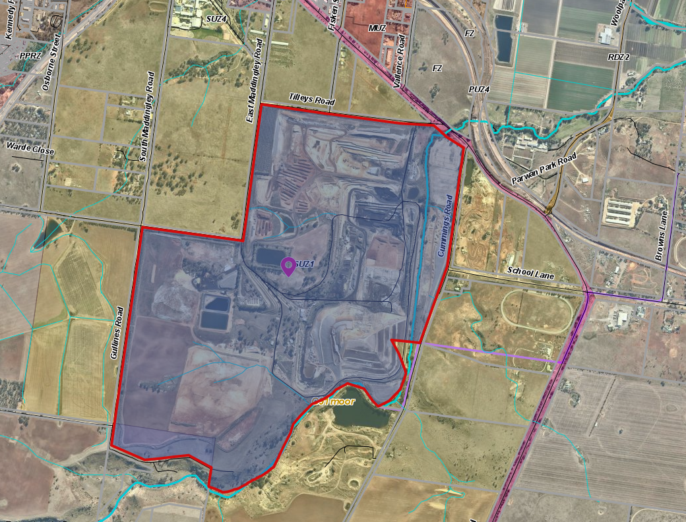
Figure 1: Site plan

Proposal
It is proposed to amend Permit PA2011338 Condition 11 to allow for the front gate on Tilleys Road to open from 5:00am to allow any trucks currently arriving before 6:00am to queue within the site, rather than on Tilleys Road.
Condition 11 reads as follows:
Except with the consent of the Responsible Authority in writing, the hours of operation of the uses hereby permitted shall be limited to the following times: Landfill seven days (except public holidays as listed) 6:00am – 6:30pm, Materials recycling and production of soil and soil products: Monday to Friday 6:00am – 6:30pm Saturday 6:00am – 1:00pm Sunday 7:00am – 12:00pm Public Holidays – no activities are to be undertaken on the site on Good Friday, Easter Sunday or Christmas Day.

Background to Current Proposal
Original Application
Planning Permit No. PA2011338 was issued on 7 November 2014 and specifically allows for:
• Use and development of the land for a landfill, production of soil and soil products (including composting) and works associated with those uses;
• Use and development of the land for the purpose of materials recycling (metals and construction and demolition waste); and
• Construction of a treatment plant for leachate management.
Plans were endorsed in accordance with Condition 1 of the permit on 4 December 2015.
The Planning Permit was amended on the 5 December 2016 pursuant to Section 72 of the Planning and Environment Act 1987. The amendment allowed for a new coal crushing plant with new DEDJTR conditions.

History
In 1989 the site was acquired by a land developer who subdivided the land and sold the component that contained the open cut mine to the applicant in 1990. Since then the applicant has redirected mining activities towards alternative coal uses such as organic fertilisers, soil conditioners and topsoils, as well as continuing the landfilling.
The site is currently used for the following activities:
• Mining – since 1948 and currently operates on site and under Mining Licence No. 4701.
• Refuse disposal by landfilling – Landfilling has been occurring at the site since at least 1978 within the area mined for coal. The landfill currently accepts soil inert waste materials, such as paper pulp and non-prescribed foundry sands. Acid sulphate soils, biosolids and Category C contaminated soils.
• Materials recycling including materials recovery, composting and soils blending – the applicant undertakes composting and soils blending at the site under EPA Licence ES90. These activities involve composting imported organic waste materials and blending them with brown coal sourced from active mining areas to form a soil improver. In addition, the applicant also undertakes materials recovery processes onsite including paper pulp blending and the recycling of metals and other materials i.e. concrete.
• Treatment plant for leachate management.

Public Notice
The application was notified to adjoining and surrounding landowners and via a newspaper advertisement.

Summary of Objections
The objections received are detailed below with officer’s comments accompanying them.
Objection | Any Relevant Requirement
Noise.
Officer’s Response
The EPA was one of the referral agencies who had no objection to allowing trucks to arrive at the gate between 5:00am – 6:00am. Council officers have considered this and requested further information from the applicant. A risk assessment was supplied which detailed the noise risks and other amenity risks. Trucks queuing internally would increase the buffer distances to the relevant sensitive receptors.
Objection | Any Relevant Requirement
Amenity, Dust.
Officer’s Response
The applicant responded that 10km maximum speed zones with signage is applicable within the site. Watercarts are used as required to avoid dust. Trucks arriving at 5:00am are only those that arrive ahead of the weighbridge hours due to reduced traffic to the site. The risk assessment states that there is a low residual impact.
Objection | Any Relevant Requirement
Contaminating land and waterways.
Officer’s Response
The application is made to allow for truck queueing only and will not amend the provision for dumping of soil, waste or other materials. The site is an approved coal mine coupled with activities related to a waste hub and materials recycling. Conditions are imposed on the permit to ensure that waterways are not to be contaminated and waste is treated accordingly.
Objection | Any Relevant Requirement
Light spill.
Officer’s Response
Trucks will be queuing away from the Geelong Bacchus Marsh Road within the site and will be instructed to turn off engines and lights prior to 6:00am.
Objection | Any Relevant Requirement
Impact on flora and fauna, local farming.
Officer’s Response
The application is made for truck queuing between 5:00am and 6:00am only. The intent is to reduce the trucks queuing on Geelong Bacchus Marsh Road and does not include any other additional activities. Therefore, it is not expected to increase the impact to the local farms or flora and fauna.
Objection | Any Relevant Requirement
Safety concerns.
Officer’s Response
The applicant has informed Council that opening the front gate from 5:00am will not increase the number of trucks arriving at the subject site, rather it will reduce the number of trucks along Tilleys Road and Geelong Bacchus Marsh/Tilleys Road intersection.
Objection | Any Relevant Requirement
Questions relating to truck movement and times – no closing times mentioned.
Officer’s Response:
The application does not include a change to the closing times.

Objection | Any Relevant Requirement
Toxic soil dumping from West Gate Tunnel project.
Officer’s Response:
The application is not made for the dumping of the West Gate Tunnel soil.
Objection | Any Relevant Requirement
Unsealed Roads.
Officer’s Response:
The number of trucks entering the site is not anticipated to increase. Opening the front gate at 5:00am rather than 6:00am is not expected to increase dust emissions.

Locality Map
The map below indicates the location of the subject site and the zoning of the surrounding area.
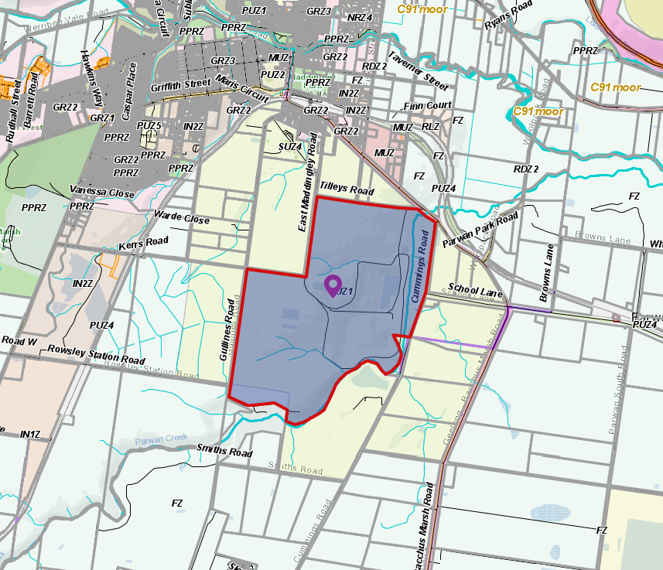
Figure 2: Zone Map

Planning Scheme Provisions
Council is required to consider the Victoria Planning Provisions and give particular attention to the Planning Policy Framework (PPF), the Local Planning Policy Framework (LPPF) and the Municipal Strategic Statement (MSS).
The relevant clauses are:
• Clause 13.06-1S – Air Quality management
• Clause 13.07-1S – Land Use Compatibility
• Clause 14.02-1S – Catchment planning and management
• Clause 17.03-1S – Industrial land supply

Zone
Special Use Zone (Schedule 1) and the Management Plan and Development Plan
The subject land is located within the Moorabool Planning Scheme Clause 37.01 Special Use Zone – Schedule 1 (SUZ1). The purpose of the zone is:
• To recognise and provide for the use and development of land for coal mining.
• To provide for use of the land compatible with the primary purpose of the zone.
• To ensure that mining operations are carried out in an orderly manner and with due regard to the surrounding environment and adjacent land uses.
• To encourage land management practice and rehabilitation that minimises adverse impact on the use and development of nearby land.
• To ensure that use and development occurs in accordance with any endorsed Management Plan and Development Plan.

Overlays
Environmental Significance Overlay – Schedule 2
Parwan Creek which runs along the southern boundary of the site is impacted by the Environmental Significance Overlay – Schedule 2 (Waterway Protection). Under the requirements of this overlay, a planning permit is required to construct a building or construct or carry out works or to remove, destroy or lop any vegetation including dead vegetation. The controls in this overlay are not applicable to the proposal.
Design and Development – Schedule 2
A visual amenity and building design schedule towards design and development controls cover the southern portion of the site. The controls in this overlay are not applicable to the proposal.

Relevant Policies
Planning Scheme Amendment C81 - Bacchus Marsh Urban Growth Framework
The Bacchus Marsh Urban Growth Framework (UGF) was implemented via amendment C81 to the Moorabool Planning Scheme which was gazetted on 6 December 2018.
Amendment C81 resulted in:
• The Maddingley Waste and Resource Recovery Hub being identified on the Bacchus Marsh Urban Growth Framework Plan in Clause 21.07 (see figure 3).
• Clause 21.04 (Economic development and employment) being updated to:
• Recognise the Maddingley Hub as one of three state-significant natural resources and export-based industries that make significant employment and economic contributions to Bacchus Marsh.
• Include the following relevant objectives and strategies:
Objectives:
• To provide for a range of industrial development and activities in proximity to transport networks and existing infrastructure and avoid off-site impacts on residential amenity, environmental quality, or agricultural values.
• To protect the ongoing operation of the Maddingley Waste and Resource Recovery Hub (including coal mine, landfill and associated activities).
Strategies:
• Support best practice management of industrial uses, to minimise offsite amenity impacts.
• Manage off-site impacts and avoid conflict with sensitive uses to realise economic development opportunities.
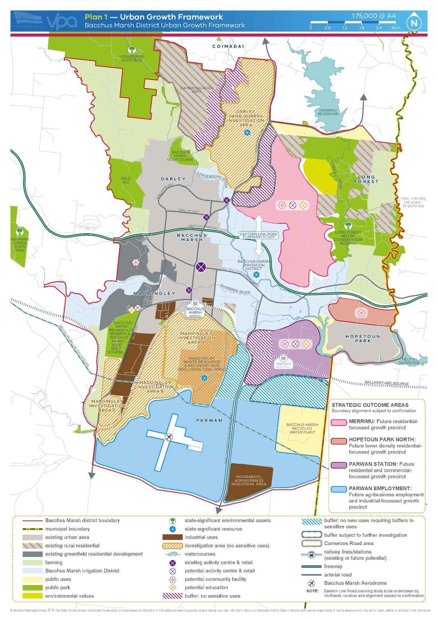
Figure 3: Bacchus Marsh Urban Growth Framework

Particular Provisions
Clause 53.10 Uses with Adverse Amenity Potential
The purpose of this provision is to identify those types of uses and activities, which if not appropriately designed and located, may cause offence or unacceptable risk to the neighbourhood.
The application is made to alter the truck queuing times to avoid negative impacts toward the Geelong Bacchus Marsh Road. Though this provision makes reference to landfills and waste storage and treatment including materials recycling, it does not particularly guide truck movements and noise impacts. The application was assessed for amenity impacts and Council received a risk assessment table highlighting the residual risks and control measures for the following potential hazards (further elaborated in the Discussion section of this report).
• Adverse noise impacts – low
• Traffic increase – low
• Dust increase – low
• Visual impact – low
Clause 52.45 Resource Recovery
The purpose of this Clause is to facilitate the establishment and expansion of a Transfer Station and/or a materials recycling facility in appropriate locations with minimal impact on the environment and amenity of the area.

Discussion
The proposal is for an amendment to the Permit Condition 11 to allow for the front gate on Tilleys Road to open from 5:00am to allow any trucks currently arriving before 6:00am to queue within the site, rather than on Tilleys Road. One of the most significant considerations of this proposal was related to amenity. The application was referred to the relevant authorities who found no issues with the amendment.
Amenity Impacts
Acoustic Assessment
The application was accompanied by an Acoustic Assessment conducted by Enfield Acoustics assessment which indicated that the applicant’s proposal to open gates from 5:00am and allow trucks to queue on the internal access road will not result in adverse noise impacts. The assessment states:
“Observations and testing carried out indicate that there are already other commercial uses nearby operating with trucks prior to 6:00am which are closer to relevant sensitive receptors. General traffic on Geelong Bacchus Marsh Road already dominates ambient noise levels from 5:00am at sensitive receptors, meaning that proposed use of the subject land before 5:00am would likely be inaudible.”
It was also stated that trucks queuing on the internal access road would increase the buffer distances to the sensitive receptors which will result in a better outcome than what is being conducted on the site presently with trucks overflowing towards Geelong Bacchus Marsh Road.
The applicant states that there is a significant proportion of trucks, unrelated to the subject land use, using Geelong Bacchus Marsh Road prior to 6:00am. These vehicles travel directly past the sensitive receptors.
Traffic Assessment
Traffix Group prepared an assessment which states that:
“although truck drivers are aware of the operation commencement time of the site, several trucks typically arrive at the site prior to the 6:00am opening time each day and form a queue along Tilleys Road…it is not uncommon for queues to sometimes extend along Tilleys Road to near the Geelong Bacchus Marsh Road. Truck arrival times can vary depending on original, traffic conditions and weather conditions. It is considered to be reasonably practical for truck operators to schedule trucks to arrive exactly at but not prior to the current site opening time of 6:00am.”
The proposal requires consent to open the gate at the Tilleys Road site access at 5:00am (one hour earlier), Monday to Saturday for both the landfill and material recycling trucks. This results in queuing of trucks within the internal access roads between the weigh bridge and the gate, rather than queuing along Tilleys Road externally.
No changes to the operating hours of the site are proposed, the operating hours will remain as detailed in the Permit. Trucks are not permitted to pass the weighbridge or unload until 6:00am. A condition is placed on the permit to ensure that the trucks do not pass the weighbridge by requesting amended plans and the construction of additional gates and signage at the weighbridge and at the first gate. The signage must state that trucks must turn off engine and lights and cannot move past the weighbridge before opening hours. Figure 5 below shows the possibility of queuing within the 220m length and 160m length and possibly limit the number of trucks queuing together with gate locations in addition to restriction access past the weighbridge.
The amended plans must identify gates with numbers, open Gate 1 at 5:00am and allow for queuing but add gates at the weighbridge to limit access.
A survey was conducted between 2 September 2020 and 19 September 2020, excluding Sundays by the applicant to gather the number and types of trucks queuing at the Tilleys Road site access at 6:00am when gates open. Eight trucks were captured, and length was calculated with 2m gaps between trucks which resulted in the longest queue length of 184m. Traffix Group also suggested that by allowing gates to open at 5:00am will allow internal queuing to significantly improve traffic flows on Tilleys Road and at the Geelong-Bacchus Marsh Road/Tilleys Road intersection, reducing risks of accidents or extended queuing. Queuing of trucks will be fully accommodated within the boundary of the site and would not extend along Tilleys Road which is a more logical traffic outcome.
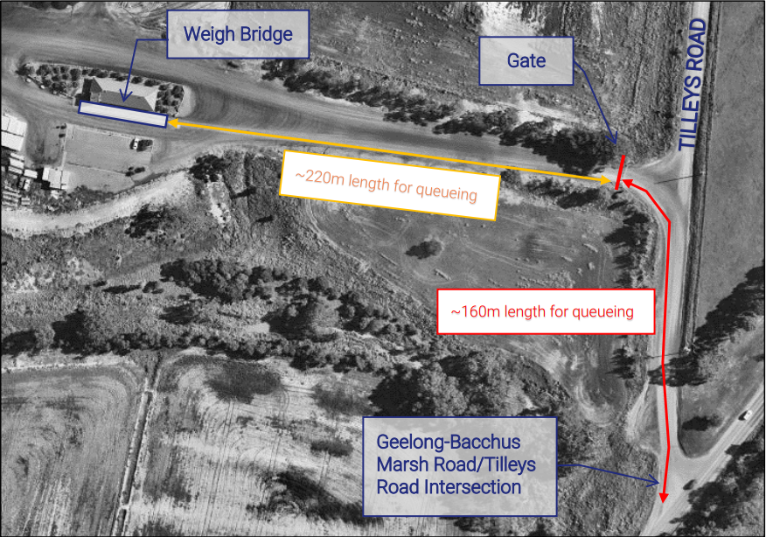
Figure 5: Tilleys Road Access
Risk Assessment
The submitted risk assessment which gathered data from the acoustic and traffic assessment derived at control measures which determined that there is a low risk of adverse noise, traffic, dust and visual impacts because of the following:
• There are already other commercial uses nearby operating with trucks prior to 6:00am which are closer to the relevant sensitive receptors.
• Traffic along Geelong Bacchus Marsh Road dominates ambient noise levels from 5:00am at sensitive receptors hence no material difference in overall noise emissions regardless of the operation.
• A significant proportion of trucks, unrelated to the subject land using Geelong Bacchus Marsh Road prior to 6:00am passing the sensitive receptors.
• Trucks queuing on internal access roads would increase the buffer distances to relevant sensitive receptors resulting in a better overall outcome.
• Queuing internally will result in overall operational improvements and road safety.
• Opening gates from 5:00am does not increase the number of trucks nor changes the operating times.
• The maximum speed is 10km.
• Watercarts are used as required to mitigate dust.
• Trucks arriving from 5:00am are only those that arrive ahead of weighbridge hours due to reduced traffic to the site.
• Visually, trucks will be queuing further away from the Geelong Bacchus Marsh Road on the site.

General Provisions
Clause 65 - Decision Guidelines have been considered by officers in evaluating this application.
Clause 66 - Stipulates all the relevant referral authorities to which the application must be referred.
Decision Guidelines | Officer Comments
The contribution of the proposal to achieving resource recovery targets established by the Victorian Government. | The site will continue to be operated as a waste facility – accordingly, it will make a contribution to helping reduce landfill waste by separating and recycling materials and only delivering the residual waste to landfill.
The impact of the proposal on the amenity of the surrounding area. | The submitted risk assessment which gathered data from the acoustic and traffic assessment derived at control measures which determined that there is a low risk of adverse noise, traffic, dust and visual impacts.
Assessment against the Towards Zero Waste Strategy (DSE, 2005) and Metropolitan Waste and Resource Recovery Strategic Plan (Sustainability Victoria, 2009). | The site has been identified in the Metropolitan Waste and Resource Recovery Strategic Plan as a cross regional disposal site. Accordingly, the current proposal is consistent with the provisions of the Plan as it allows for the continuation of waste and resource recovery operations at the site.

REFERRALS
Authority | Response
Council’s Connected Communities | No comment.
Council’s Infrastructure and Environmental Management | No objection.
Major Developments | No comment.
Council’s Strategic Planning | Consent.
EPA | Consent.
Transport for Victoria, DJPR | No comment.
Melbourne Water | Consent.
Sustainability Victoria | Supports the continued operation of the site subject of compliance to Council’s satisfaction.

Financial Implications
The recommendation of approval of this amendment does not implicate any financial risks.

Risk & Occupational Health & Safety Issues
The recommendation of approval of this amendment does not implicate any risk or OH&S issues to Council.

Communications Strategy
Notice was undertaken for the application, in accordance with s.52 of the Planning and Environment Act 1987, and further correspondence is required to all interested parties to the application as a result of a decision in this matter. All submitters and the applicant were invited to attend this meeting and invited to address Council if required.

Options
Council could consider the following options:
• issue a notice to grant an amended permit in accordance with the conditions recommended in this report; or
• issue an amended permit with conditions outside of the recommendation of this report; or
• should Council wish to consider a refusal to grant an amendment to the permit, Councillors must consider the Planning Scheme assessment and the relevant referral responses.

Conclusion
The proposal to allow for truck queuing at the gates was assessed against the potential amenity impacts and associated risks. After full assessment of the application against the planning scheme and further information provided, it was considered that conditions can be placed on the amended permit to mitigate all concerns. The amendment is therefore recommended for approval subject to planning permit conditions to request for amended plans, adding additional gates to ensure that trucks do not pass the weighbridge and queue only for the maximum length of the site internally without spilling truck queuing on the external road.

13 Community Strengthening Reports

13.1 Arts and Culture Strategy 2021 - 2025
Author: Bec Carey-Grieve, Arts, Culture and Events Officer
Authoriser: Sally Jones, General Manager Community Strengthening
Attachments: 1. Moorabool Shire Council Arts and Culture Strategy 2021 - 2025 (under separate cover)

Purpose
The purpose of this report is to provide Councillors with the Moorabool Arts and Culture Strategy 2021-2025 for adoption following public exhibition. It has been developed by Future Tense Consultancy in consultation with Council Officers. We are seeking Council adoption of the Strategy.

Executive Summary
• In July 2020 through a Councillor led initiative, Moorabool engaged an Arts, Culture and Events Officer with a priority to develop and deliver the first Moorabool Arts and Culture Strategy.
• Through a request for quote process, Future Tense Consultancy were engaged in December 2020 to assist in the development of the Strategy. Widespread consultations were conducted across the Shire in conjunction with the Arts, Culture and Events Officer.
• This report provides key findings from broad community consultation, industry benchmarking and an environmental scan conducted by Future Tense Consultancy and the Arts, Culture and Events Officer.
• Informed by consultations and research conducted, a draft Arts and Culture Strategy has been developed and reviewed by the Executive Group for endorsement for public exhibition in June 2021.
• Following Council endorsement at the June 2 meeting, the Draft Arts and Culture strategy went to public exhibition and feedback have been considered in the final Strategy Document.

Resolution
Moved: Cr Tonia Dudzik
Seconded: Cr Moira Berry
That Council adopts the Moorabool Arts and Culture Strategy 2021 – 2025 provided as Attachment 1 to this report.
Carried

Background
Council is seeking to establish Moorabool’s first Arts and Culture Strategy in collaboration with artists and communities and to support projects that encourage participation in Arts and Culture activity. The four-year Strategy will provide a guiding critical strategic direction.
Arts and Culture play a vital role in the Shire in connecting communities, telling stories and expressing what it means to live in Moorabool. According to the 2019 National Arts Participation Survey conducted by the Australia Council, almost all Australians (98%) engage with arts and culture and recognise the positive impacts the arts has on their lives and their communities. Arts and Culture allows us to celebrate our communities.
The development of the Strategy has enabled Council to undertake broad industry research and to identify initiatives, programs and infrastructure that will support arts and cultural development within the Shire, positively contributing to the health and wellbeing of the Moorabool Shire community.
This will be Moorabool Shire Council’s (MSC) first Arts and Culture Strategy, seeking to establish and deepen the Shire’s relationship with artists and arts organisations in the region and raising the profile of Moorabool as an Arts and Cultural destination.
In July 2020 Council introduced a new Arts, Culture and Events officer position. A key responsibility for this position is to develop Council’s Arts and Culture Strategy and engage with the community to deliver the recommendations identified in the Strategy.

Proposal
It is proposed the Arts and Culture Strategy 2021-2025 is endorsed by Council. Following public exhibition and incorporating public feedback obtained during exhibition period, the Strategy has been finalised for Council adoption.
The Moorabool Arts and Culture Strategy is a guiding document to inform Council’s direction over the next four years. It sets out Council’s role, the role of the community and the eight key pillars Council will focus on over the next four years. The following pillars will be addressed in partnership with the community:
1. Increase and diversify arts and cultural activity;
2. Reduce barriers to delivering and participating in creative activities;
3. Connect with our unique heritage and environment;
4. Foster the growth of the creative sector;
5. Develop accessible cultural infrastructure;
6. Create moments of joy in everyday life;
7. Establish a presence within regional touring networks;
8. Use Arts and Culture to drive better outcomes for Council and the community.
Development of the Strategy
In developing this Strategy, consultation with internal and external stakeholders was conducted throughout February and March including:
• Three community forums attracting between 30 – 50 in attendance at each;
• Drop-in sessions at local arts activities;
• Over 70 one to one interviews with key staff and local artists and businesses, Traditional Owners, local student Councils;
• A community survey with 124 respondents;
• June 2021 public exhibition of the draft Strategy with overwhelmingly positive feedback.
Extensive Traditional Owner engagement was an important part of the process. This included:
• Consultations with Dja Dja Wurrung, Wadawurrung and Wurundjeri;
• One to one interviews with local Wadawurrung artists providing key insights into the Shire’s cultural heritage and what support is needed for First Nation’s elders and artists within the Shire;
• Reviewing the draft Strategy to provide advice from a Traditional Owner perspective.
Key findings from the surveys and consultations show:
• 94% said having local acts and cultural activities was important;
• 89% valued having access to activities from a range of cultures;
• 67% of artists are not as connected as they would like locally;
• 68% do not have access to local opportunities;
• 77% listed access to space as critical to their work.
Future Tense Consultancy performed the following:
• A review of the strategies and priorities of surrounding Councils, as well as state and federal government policies;
• Benchmarking against target municipalities;
• Analysis of data from local, state, and federal agencies;
• Mapping of the current creative sector actors, activities, and assets across the Shire.
Research and findings from Future Tense’s creative ecology report show that within the Shire we have:
• 39 Arts and Culture organisations and networks;
• 46 current and potential venue spaces;
• 13 creative education providers;
• 2 major community festivals;
• Visual arts, craft and music are our dominant creative industries;
• Most creative activity is focused around Bacchus Marsh, Ballan, Gordon, and Blackwood and encouragingly there are green shoots spread across the Shire.
The Strategy seeks to work with our creative industries to grow the sector over the next four years, increase the number or creatives living and working in the Shire and to increase the number of organisations and creative producers providing Arts and Cultural activity across the Shire. By building the capacity of the sector, especially organisations and creative producers, we can create a more sustainable arts and culture sector within Moorabool.
Council’s role in delivering the Strategy is to:
• Provide encouragement to those who want to make things happen within Arts and Culture;
• Be open to new ideas and possibilities;
• Create a supportive environment for creative activities;
• Source opportunities for local creative practitioners;
• Facilitate beneficial connections and collaborations;
• Support development of the creative sectors capabilities.
To ensure Council achieves the goals presented in the Strategy, an annual action plan will be developed, inclusive of a practical evaluation framework

Council Plan
The Council Plan 2017-2021 provides as follows:
Strategic Objective 4: Improve Social Outcomes
Context 4B: Community Connectedness and Capacity
The proposal to endorse Moorabool’s Art and Culture Strategy is consistent with the Council Plan 2017 – 2021.

Financial Implications
The Strategy has been produced with funds allocated within the 2020/21 budget. A further allocation of $30,000 has been requested as part of the 2021/22 budget process to support Strategy implementation. The Strategy, Investment Logic Map and internal investment will be leveraged to secure external funding opportunities and partnerships to further support delivery of the Strategy.

Risk & Occupational Health & Safety Issues
Risk Identifier | Detail of Risk | Risk Rating | Control/s
Strategy is not adopted by Council | Community expectations will remain unmet. Missed opportunities to leverage arts and culture as a tool to achieve Council and community goals. | High | Adoption of the Arts and Culture Strategy.
Reputation –  A negative perception of the Moorabool Arts and Culture Strategy and it’s delivery | The Arts and Culture Strategy receives negative feedback once adopted. | Medium | Public exhibition of the draft Strategy seeking feedback. All feedback received was positive.  A Monitoring, Evaluation and Learning Framework has been developed to ensure the Strategy delivery meets its objectives.
Financial - The development of the Strategy is in excess of the allocated budget | There are not enough resources to complete the Strategy development. | Medium | An annual plan developed including budget allocation request. Further funding will also be sort from State, Federal and other funding sources.

Communications & Consultation Strategy
Level of Engagement | Stakeholder | Activities | Location | Date | Outcome
Inform | Moorabool Community | Promotion and Communication  Social Media Posts  Posters  Flyers  Newsletters  Newspaper advertising  Direct Emails  Have Your Say Page | Across the Shire | February – March 2021 | Engagement opportunity promoted broadly to the Moorabool Community.  2,790 page views on Council Have Your Say digital engagement platform  2 Moorabool News Ads  2 mentions on Apple FM
 | Councillor Briefing | An overview of key findings from the survey and research were presented  The draft strategy was presented to Council before public exhibition and the final version presented prior to adoption at the August OMC | Online | March 2021  June 2021  July 2021 | Councillor’s provided insights and feedback
Consultation | Local Artists  Residents  Local Businesses  Creative Industry | Forums with Community representatives. | Bacchus Marsh, Ballan, Online | February - April March 2021 | Over 100 participants across all forums
 | Consultations with key staff | 1-1 interviews  Online forum  Internal Teams Group |  | February – March 2021 | Over 40 interviews conducted by Future Tense and the Arts, Culture
 | Public Survey | A survey was published on Moorabool’s ‘Have Your Say’ Engagement hub | Have Your Say Moorabool web page. | March 2021 | 124 surveys were received, and responses were collated to inform the Strategy.  Over 50 new subscribers to the Arts, Culture and Libraries eNews.  Baseline data collected on creative practitioners within the shire.
 | Drop in Consultations | Future Tense consultancy and Moorabool’s Arts, Culture and Events officer attended key arts and cultural events in the Shire | Bacchus Marsh Arts Council exhibition opening, a BM Music Bowl concert, St. Anne’s Vineyard pizza and music afternoon, Studio 22 youth space | March 2021 | In depth data was collected from respondents who may not have seen the survey or who were tourists who lived outside the Shire.
Consultation | Traditional Owner Consultations | Online consultations were conducted with Wurundjeri, Wadawurrung and Dja Dja Wurrung (including local artists). | Online | March April | Key insights gathered from Traditional Owners (TO) including Elders and Artists residing in the Shire  3 TO Recognised Aboriginal Parties (RAP) interviews  3 TO reviews of the Strategy  6 Wadawurrung local artist interviews
 | Public Exhibition of Draft Arts and Culture Strategy | The Strategy went to public exhibition in June 2021 | Online | June | All feedback received was positive and very supportive of the strategy

Victorian Charter of Human Rights & Responsibilities Act 2006
In developing this report to Council, the officer considered whether the subject matter raised any human rights issues. In particular, whether the scope of any human right established by the Victorian Charter of Human Rights and Responsibilities is in any way limited, restricted or interfered with by the recommendations contained in the report. It is considered that the subject matter does not raise any human rights issues.

Officer’s Declaration of Conflict of Interests
Under section 130 of the Local Government Act 2020, officers providing advice to Council must disclose any interests, including the type of interest.
General Manager – Sally Jones
In providing this advice to Council as the General Manager, I have no interests to disclose in this report.
Author – Bec Carey-Grieve
In providing this advice to Council as the Author, I have no interests to disclose in this report.

Conclusion
Establishing an Arts and Culture Strategy will support the Shire to become a thriving and vibrant place with healthy and inclusive communities and a sustainable creative sector. It will demonstrate Council’s commitment to creative practitioners within the Shire and establish Moorabool as a home for creative communities.
Building our creative communities will strengthen the Shire and create an Arts and Culture link between Melbourne and the wider Western region.
The Strategy will direct how Council best invests its resources and capabilities, outlining the role Council will play and the areas to focus on over the four years of the Strategy.

14 Customer Care and Advocacy Reports

Nil

15 Community Assets & Infrastructure Reports

15.1 Capital Improvement Program - Quarterly Report June 2021
Author: Ewen Nevett, Manager Engineering Services
Authoriser: Phil Jeffrey, General Manager Community Assets & Infrastructure
Attachments: 1. 2020-2021 Project Status Report (under separate cover)

Purpose
This quarterly report provides Council with an overview of the progress of Council’s 2020-2021 Capital Improvement Program (CIP) to 30 June 2021.

Executive Summary
The delivery of the 2020-2021 CIP progressed with:
• The Original budget approved by Council in June 2020 increased by almost 20% during the year, principally through government pandemic stimulus funding
• CIP expenditure in 2020-2021 was $17.7M, being with 0.01% of budget for completed projects
• 80.3% of the possible CIP Projects completed.
• 6.9% of the CIP projects are deferred and On-Hold.
• 23.0% of the CIP projects are Multi Year projects continuous into the 2021-2022 CIP.

Resolution
Moved: Cr Ally Munari
Seconded: Cr Paul Tatchell
That Council receive the Capital Improvement Program quarterly report to 30 June 2021, provided as Attachment 1 to this report.
Carried

Background
The delivery of the CIP is an important function of Council’s operations and represents a significant portion of Council’s overall expenditure. Accordingly, the status of the overall program is reported to Council every quarter.

Proposal
This quarterly report provides Council with an overview of the outcome of Council’s 2020-2021 CIP to 30 June 2021.
Implementation of the 2020-2021 CIP
The 2020-2021 CIP consisted of 87 projects (up from 73 at the start of the year), of which six (6) remained On-Hold during the year due to unsuccessful grant applications. Of the 81 projects underway during the year, 20 represent Multi Year Projects that are ongoing with carry forward into the 2021-2022 CIP.
This list incorporates projects from various sources including but not limited to the following:
• Projects carried forward from 2019-2020 program
• 2020-2021 Council budgeted projects
• Grant funded projects
• Roads to Recovery
• Local Road Community Infrastructure Program (LRCIP)
• Heavy Vehicle Safety and Productivity Program – Round 7 (HVSPP-7)
• Bridge Renewal Program – Round 5 (BRP-5)
• Agrilinks
• Department of Transport (DoT)
A number of highlights include:
• $2.1M Werribee Vale Road upgrade, providing improved connectivity and safety for all road users and increased amenity along the Werribee River corridor.
• $1.6M Heavy vehicle corridor improvements from Dunnstown Quarries to the Midland Highway, Clarendon, including three new channelised intersection treatments and 2kms of road reconstruction to improve the condition and safety along the corridor.
• $1.4M new Sports Pavilion at Bacchus Marsh Racecourse Reserve.
• $640,000 project at Lidgett Street Reserve, for Stage 1 & 2 works to provide new facilities including playground, shade sails, paths and seats, together with improved landscaping and irrigation.
• 460 metres of new solar lighting along the pedestrian connection from Holts Lane to Grey Street, Darley and incorporating the Jonathan Drive Reserve.
The Engineering Services Unit nominates 7 key stages of the project delivery process and will report with reference to these stages regarding the overall program status.
The table below summarises the overall program status as at 30 June 2021:
CIP Program Delivery Stage | Actuals as of 30 June 2021
 | No. of Projects | %
Inactive/On-Hold & Multi Year Projects | 6 | 6.9
Not Commenced | 0 | 0.0
Documentation / Design Preparation | 13 | 14.9
Tender / Quote Stage | 2 | 2.3
Project Awarded – Awaiting Commencement | 3 | 3.4
In Progress / Under Construction | 14 | 16.1
Complete | 49 | 56.3
Total | 87 | 100.0

The attached report details the status, including specific comments in relation to the progress, of each individual project for 2020-2021.
Program Status and Financial Year Performance
Of the 87 projects, there are 37 projects that will be carried forward into the 2021-2022 CIP, including the 6 projects currently On Hold and 20 Multi Year projects.
Of the 11 projects incomplete at 30 June 2020, the table below outlines each of these projects and their status:
Project Description | Project Status
Woolpack Road, Bacchus Marsh Road Rehabilitation and Rail Containment Barriers | The final component of this project, the rail bridge containment barrier strengthening and deck overlay, is due to be completed by the end of July 2021. Only a final seal remains to be completed on the early road component completed in 2019-2020.
Griffith Street, Maddingley – Design of Upgrades | Design commencement was delayed due to high tender prices and a retendering process. A concept design was out for community engagement in early July. The final design is scheduled to be completed by 31 December 2021.
Fisken Street, Ballan – Kerb | Project was delayed due to an issue obtaining a tree removal permit. Design is progressing; however, any construction works are on hold pending the tree removal permit issue.
Werribee Vale Road - Design and Construction (Drainage) | The project is being redesigned to secure more competitive tender submissions.
Woolpack Road, Bacchus Marsh – Parwan Creek and Werribee River Bridge Works | Works were placed on hold pending the West Gate contaminated soil haulage route discussions. Works have now been awarded to Enoch Civil P/L with a scheduled commence date in August 2021.
Masons Lane - Western Pavilion Extension | Contract has been awarded to SC Homes with construction pending confirmation of the shed location which is under review in consultation with the user groups.
Ballan Civic Centre - Renovations | A design and construct contract was awarded to Simbuilt Pty Ltd in June 2020 with design underway and construction scheduled to commence in September 2021.
Darley Civic Centre - Renovations | A design and construct contract was awarded to Simbuilt Pty Ltd in June 2020 with design underway and construction scheduled to commence in September 2021.
Ballan-Egerton Road Bridge | This project was funded mid-year through the Bridge Strengthening Program with work expected to conclude by the end of July 2021.
Egans Reserve - Implementation of Masterplan Recommendations | Basketball Court upgrades are complete with shade sails over the playground to be completed by September 2021.
Mill Park, Ballan - Pedestrian Connections | This project has been combined with two other projects at Mill Park following the additional funding provided from the LRCIP-R2 program.
Considering projects either “On Hold” or “Multi Year”, 49 projects out of a possible 61 projects were completed resulting in 80.3% of the program being completed in the financial year.
Key aspects of the 2020-2021 CIP delivered projects include:
• 7.9 kms of gravel roads resheeted (9 projects).
• 2.3 kms of shoulder resheeting (2 projects).
• 10.6 kms of sealed roads reconstructed (14 projects).
• 5 major intersections upgraded.
• 3 unsealed intersections upgraded to sealed.
• 4 bridges upgraded.
• 34.4 kms of sealed roads resurfaced.
• 5.6 kms of new footpaths (across 5 projects).
• Upgrades of 8 Community Facilities or Reserves.

‘On-Hold’ or Multi Year Projects
Of the 6 projects that are currently ‘on-hold’, the following table provides an update to these projects:
On-Hold Projects
Project Description | Project Status
Maddingley Park - Resheet and Seal of Pathways | Masterplan for Maddingley Park is being prepared with project on hold until the masterplan is finalised.
Darley Park Recreation Reserve - Playground | Masterplan for Darley Park is being prepared with project on hold until the masterplan is finalised.
SRV Female Friendly Facilities Grant - Dunnstown Recreation Reserve | Dunnstown Recreation Reserve Pavilion upgrade project is on hold until matching grant funding is obtained.
SRV Female Friendly Facilities Grant - Netball Courts | Netball Court upgrade project is on hold until matching grant funding is obtained.
SRV Cricket Facilities Grant | A grant has been successful for cricket nets at Ballan Recreation Reserve. Once a funding application is signed, the project will be delivered though the 2021/22 CIP.
Maddingley Park – Preplanning Public Toilet | A masterplan for Maddingley Park is being developed. Preplanning for the project is on hold until the masterplan is finalised.

Of the 20 projects that are currently Multi Year Projects, the following table provides an update to these projects:
Multi-Year Projects
Project Description | Project Status
Local Area Traffic Management Implementation | Design of 5 treatments is close to completion with procurement for construction due to commence August 2021. Design of the 2021/2022 projects has commenced.
Peppertree Park, Bacchus Marsh - Master Plan Upgrades | Project funded early 2021 through LRCIP-2 with project to be completed by 31 December 2021.
Jonathan Drive, Bacchus Marsh - New Footpath and Speed humps | Project funded early 2021 through LRCIP-2 with project to be completed by 31 December 2021.  Project is currently being designed with procurement scheduled for July 2021 and delivery in September / October 2021.
Bald Hill - 1,000+ Steps - Design & Construction | Construction tenders for the project are currently being evaluated.
Mill Park Road, Ballan - Road Widening & Parking | Project funded early 2021 through LRCIP-2 with project to be completed by 31 December 2021.
Mill Park Upgrades - Community Facilities Grant | Project funded early 2021 through LRCIP-2, with project to be completed by 31 December 2021.
Gordon Public Park Upgrades - Community Facilities Grant | Project funded early 2021 through LRCIP-2, with project to be completed by 31 December 2021.
Bacchus Marsh Racecourse Reserve - Stage 2 Design | The design contract was awarded to Brand Architects in October 2020. Construction works will be staged with Design and documentation for the initial contract anticipated for completion in October 2021.
Bacchus Marsh Indoor Recreation Facility - Preplanning | The design contract was awarded to Peddle Thorp Architects in December 2019. Design and documentation for Stage 1 (Indoor Sports) is scheduled for completion in August 2021. Tender for the construction of Stage 1 is scheduled for September 2021.
Ballan Recreation Reserve Pavilion | Project is currently in consultation and design phase with design scheduled for completion by October 2021. Construction is scheduled to commence in early 2022.
Ballan Library Facility - Feasibility and Design | Feasibility Report prepared with Design documentation to be developed by December 2021.
Bacchus Marsh and Ballan Splash Parks - Design Works | Masterplans for Peppertree Park, Bacchus Marsh and Mill Park, Ballan were adopted by Council in December 2020. Design of splash parks is underway and scheduled for completion in October 2021.
Open Space Improvement Plan | Submissions for works at Guy Place, Maddingley are currently being evaluated with works scheduled to commence September 2021.
Small Town Improvement Program /  Dunnstown Township | Consultation is underway with the Dunnstown community over landscape improvement options for the township.
West Maddingley Early Years Facility - Design/Transfer Land | Project is currently in concept design phase. Construction is scheduled to commence in mid-2022.
Ballan Depot Relocation | Construction contract has been awarded to WP Contractors. Bulk Earthworks are complete on site with building and civil works commencing in July 2021. Project completion is scheduled for April 2022.
Dunnstown Township - Roundabout upgrades, new pedestrian connections and landscaping | This project was allocated in the LCRIP-2 program for completion by Dec 2021. Works are scheduled to commence in August on the Roundabout upgrade and footpath connections.
Bradys Lane, Greendale - Carpark construction and footpath connection | Project funded early 2021 through LRCIP-2 with project to be commence in September 2021 and to be completed by 31 December 2021.
Egans Reserve, Greendale - Implementation of masterplan priorities (irrigation) | Project funded early 2021 through LRCIP-2 with project to commence in September 2021 and to be completed by 31 December 2021.
Aqualink Stage 1 - Strategic Cycle Corridor | The construction of the shared path has been tendered in Stages. 4 Tenders for construction have been awarded including footpath construction and road crossings. 2 design contracts have been awarded for landscaping and design of Route 2 works between Main St and Masons Lane. Construction on Route 3 commenced in April 2021. Route 1 works will commence following agreement with SRW.
Program Financial Status
A review of the financial aspect of the program has been completed through comparison of expenditure against the available budget. The final expenditure has been confirmed and the Capital Works and Major Projects component of the CIP has come in under budget by $16,000 representing a 0.07% underspend.
The Original budget of $25.9M (excluding carryover of $8.4M), approved by Council in June 2020, increased by $6.6M during the year with grants from Federal and State Governments, mainly as stimulus funding in response to the current pandemic. This represented almost 20% increase in funding.
Projects completed with a whole of life expenditure greater than 10% above approved expenditure are discussed below:
Werribee Vale Road, Maddingley – Road Rehabilitation
The Project was budgeted in 2019/2020 and approved by Council for award in December 2019 for $466,130.30 above the available construction budget. Additional funding was to be allocated from Developer Contributions and $33,277.32 to cover irrigation pipe upgrades. The overspend is attributed to numerous variations. The most significant variation being stabilisation of the embankment above the retaining wall and variations to the drainage allowing eight large gum trees to be retained.

Lidgett Street Reservation
Lidgett Street Reserve has had numerous elements funded over the 2018/2019 ($105,000), 2019/ 2020 ($175,000) and 2020/2021 ($250,000) financial years for a total budget of $530,000. The final expenditure for the funded elements at the Lidgett Street Reserve is forecast to be $638,832.58. This is $108,832.58 (20.5%) over budget. The over expenditure has been incurred following community consultation and feedback of which lead to additional elements from future stages being delivered as part of the initial stage of works.

Council Plan
The Council Plan 2017-2021 provides as follows:
Strategic Objective 1: Providing Good Governance and Leadership
Context 1A: Our Assets and Infrastructure
The proposal, Implementation of the 2020-2021 CIP, was consistent with the Council Plan 2017 – 2021.

Financial Implications
There are no additional financial implications.

Risk & Occupational Health & Safety Issues
There are no irregular Risk and Occupational Health and Safety issues identified in this report. Specific risk elements are analysed and monitored by the allocated project manager as part of the delivery of each individual project.

Communications & Consultation Strategy
Progress on the Capital Improvement Program will be reported in the following formats:
• Infrastructure update on active projects weekly.
• Update on major projects monthly.
• Moorabool Matters quarterly.
• Moorabool News as required.
• Report to Council quarterly.

Specific projects are communicated to the community and affected residents as required through a range of methods including but not limited to advertisements, mail outs, letter drops and door knocking.

Victorian Charter of Human Rights & Responsibilities Act 2006
In developing this report to Council, the officer considered whether the subject matter raised any human rights issues. In particular, whether the scope of any human right established by the Victorian Charter of Human Rights and Responsibilities is in any way limited, restricted, or interfered with by the recommendations contained in the report. It is considered that the subject matter does not raise any human rights issues.

Officer’s Declaration of Conflict of Interests
Under section 130 of the Local Government Act 2020, officers providing advice to Council must disclose any interests, including the type of interest.
General Manager – Phil Jeffrey
In providing this advice to Council as the General Manager, I have no interests to disclose in this report.
Author – Ewen Nevett
In providing this advice to Council as the Author, I have no interests to disclose in this report.

Conclusion
This report provides a summary of the 2020-2021 Capital Improvement Program delivery for the full year to 30 June 2021 for the information of Councillors.

16 Other Reports

Nil

17 Notices of Motion

17.1 Notice of Motion 296 - Population Growth and Needs of the Dales Creek Community
Attachments: Nil
I, Councillor Ally Munari, give notice that at the next Ordinary Meeting of Council to be held on 4 August 2021, I intend to move the following motion:

Resolution
Moved: Cr Ally Munari
Seconded: Cr Paul Tatchell
That Council:
1. Request the Chief Executive Officer prepare a report into the population growth and needs of the Dales Creek community.
2. Request consideration in the report of:
(a) An active recreation space to cater for children of the area.
(b) Picnic area and seating to encourage community relationships.
(c) Gathering point during high bushfire danger periods.
(d) Central location for residents to walk or bike ride to.
(e) Installation of climbing frames and appropriate play equipment to promote active play.
(f) Consideration and respect for the native character.
Carried

Rationale
The Dales Creek township nestled in bushland between Greendale and Blackwood has notably grown in population over the last 10 years due to an abundance of homes being built on vacant lots.
With so many families building in the area and with the 2016 Census data quite outdated, I would like to request a report into the population growth and needs of the Dales Creek community which will complement and help with plans for this area into the future.
Points to consider:
• An active recreation space to cater for children of the area.
• Picnic area and seating to encourage community relationships.
• Gathering point during high bushfire danger periods.
• Central location for residents to walk or bike ride to.
• Installation of climbing frames and appropriate play equipment to promote active play.
• Consideration and respect for the native character.
I commend this Notice of Motion to Council.

18 Notices of Rescission

Nil

19 Mayor’s Report

19.1 Mayor's Report
Author: Dianne Elshaug, Co-ordinator CEOs Office
Authoriser: Derek Madden, Chief Executive Officer
Attachments: Nil

Purpose
To provide details to the community on the meetings and events attended by the Mayor since the last Ordinary Meeting of Council.

Executive Summary
• That the Mayor’s Report be tabled for consideration at the Ordinary Meeting of Council.
Cr Tom Sullivan – Mayor’s Report
Date: 4 August 2021
8 July | - NAIDOC Week 2021 Welcome to Country and Smoking Ceremony – Lerderderg Library, Bacchus Marsh
9 July | - NAIDOC Week 2021 Welcome to Country and Smoking Ceremony – Ballan Mechanics Institute, Ballan
14 July | - Councillor Briefings: Health & Wellbeing Plan Workshop; Arts & Culture Strategy and Arts & Culture Action Plan and Evaluation Framework; PA2020044 – 13 Clarinda Street, Bacchus Marsh; Review of the DAC Agenda; General Business
21 July | - Councillor Briefings: Footpath Trading & Activities Guidelines; Review of the OMC Agenda; General Business  - Development Assessment Committee
28 July | - Councillor Briefings: Gender Equality 2021; Bacchus Marsh Strategic Cycling Corridor (Aqualink); PA2011338-3 Amendment to Operating Hours to Use and Development of the Land for a Landfill, Production of Soil and Soil Products (including composting) and Works Associated with those Uses, Use and Development of the Land for the purpose of Materials Recycling (Metals and Construction and Demolition Waste), and Construction of a Treatment Plant for Leachate Management
4 August | - Councillor Briefings: CIP Quarterly Report Update; 10 Year Financial Plan 2021-2031  - Economic Development Taskforce Meeting  - Ordinary Meeting of Council

Resolution
Moved: Cr Paul Tatchell
Seconded: Cr David Edwards
That Council resolves to receive the Mayor’s Report.
Carried

20 Councillors’ Reports

20.1 Councillors' Reports
Councillor | Activity
Cr Munari | - NAIDOC Week 2021 Events at Ballan & Gordon  - Attended MAV Councillor Training
Cr Ward | - Bacchus Marsh Aerodrome Management Committee Meeting
Cr Tatchell | - The first Recovery Meeting for the Storm Event  - Thanked the people of Ballan for how they responded to Ballan COVID Outbreak and Hotspot situation recently
Cr Dudzik | - NAIDOC Week 2021 Welcome to Country and Smoking Ceremony –Lerderderg Library, Bacchus Marsh  - Thanked the people of Bacchus Marsh Grammar for how they responded to COVID Outbreak and Hotspot situation recently
Cr Berry | - NAIDOC Week 2021 Welcome to Country and Smoking Ceremony –Lerderderg Library, Bacchus Marsh

Resolution
Moved: Cr Ally Munari
Seconded: Cr Moira Berry
That Council receives the Councillors’ Reports.
Carried

21 Urgent Business

Nil

22 Closed Session of the Meeting to the Public

Resolution
Moved: Cr Paul Tatchell
Seconded: Cr Rod Ward
That Council considers the confidential reports listed below in a meeting closed to the public in accordance with Section 66(2)(a) of the Local Government Act 2020:

22.1 Reciept of Kerbside and Transfer Station Recyclables - Contract Extension
The Council is satisfied that, pursuant to Section 3(1)(g) confidential information of the Local Government Act 2020, the information to be received, discussed or considered in relation to this agenda item is private commercial information, being information provided by a business, commercial or financial undertaking that if released, would unreasonably expose the business, commercial or financial undertaking to disadvantage.

22.2 CEO Performance Review
The Council is satisfied that, pursuant to Section 3(1)(f) confidential information of the Local Government Act 2020, the information to be received, discussed or considered in relation to this agenda item is personal information, being information which if released would result in the unreasonable disclosure of information about any person or their personal affairs.
Carried

23 Meeting Closure
The Meeting closed at 6.25pm.

...................................................
CHAIRPERSON

