ATTACHMENTS

Ordinary Council Meeting
Under Separate Cover
Wednesday, 7 July 2021

Table of Contents

11.3 Advisory Committees of Council - Reports
Attachment 1 Minutes - Local Business Advisory Committee - 9 March 2021 4
Attachment 2 Minutes - Local Business Advisory Committee - 13 April 2021 7
Attachment 3 Minutes - Local Business Advisory Committee - 11 May 2021 10
14.1 Revenue and Rating Plan
Attachment 1 Revenue and Rating Plan 13
15.1 Draft Naturestrip Policy and Naturestrip Guidelines
Attachment 1 Draft Naturestrip Policy 57
Attachment 2 Draft Naturestrip Guidelines 60

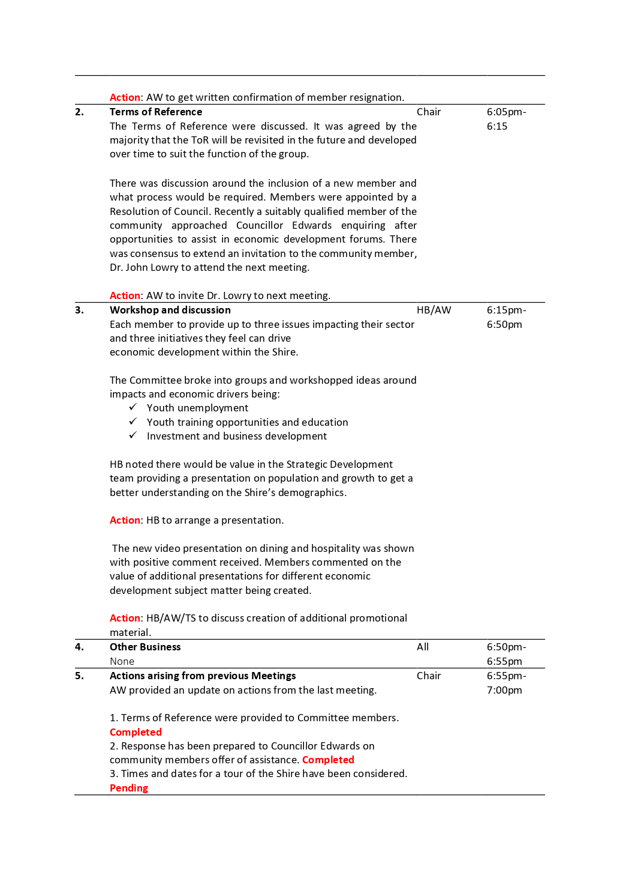

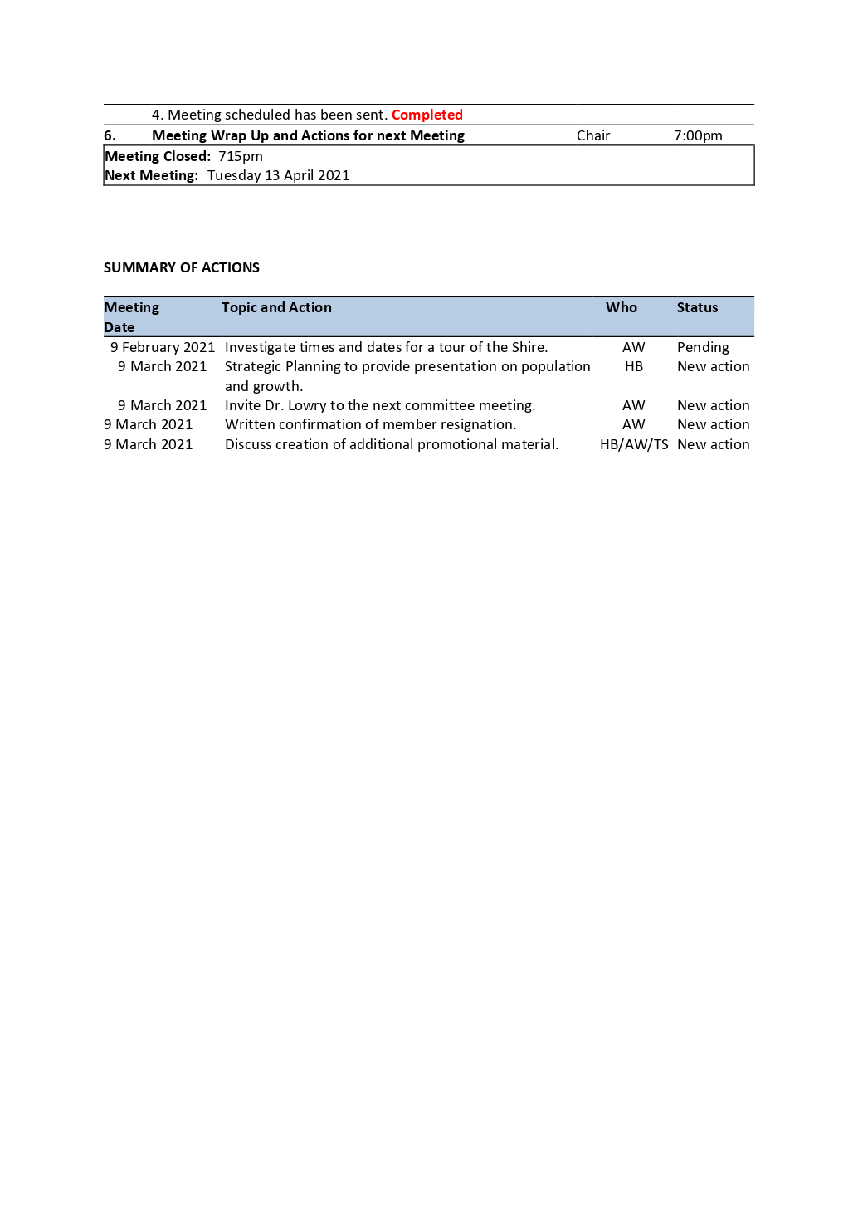

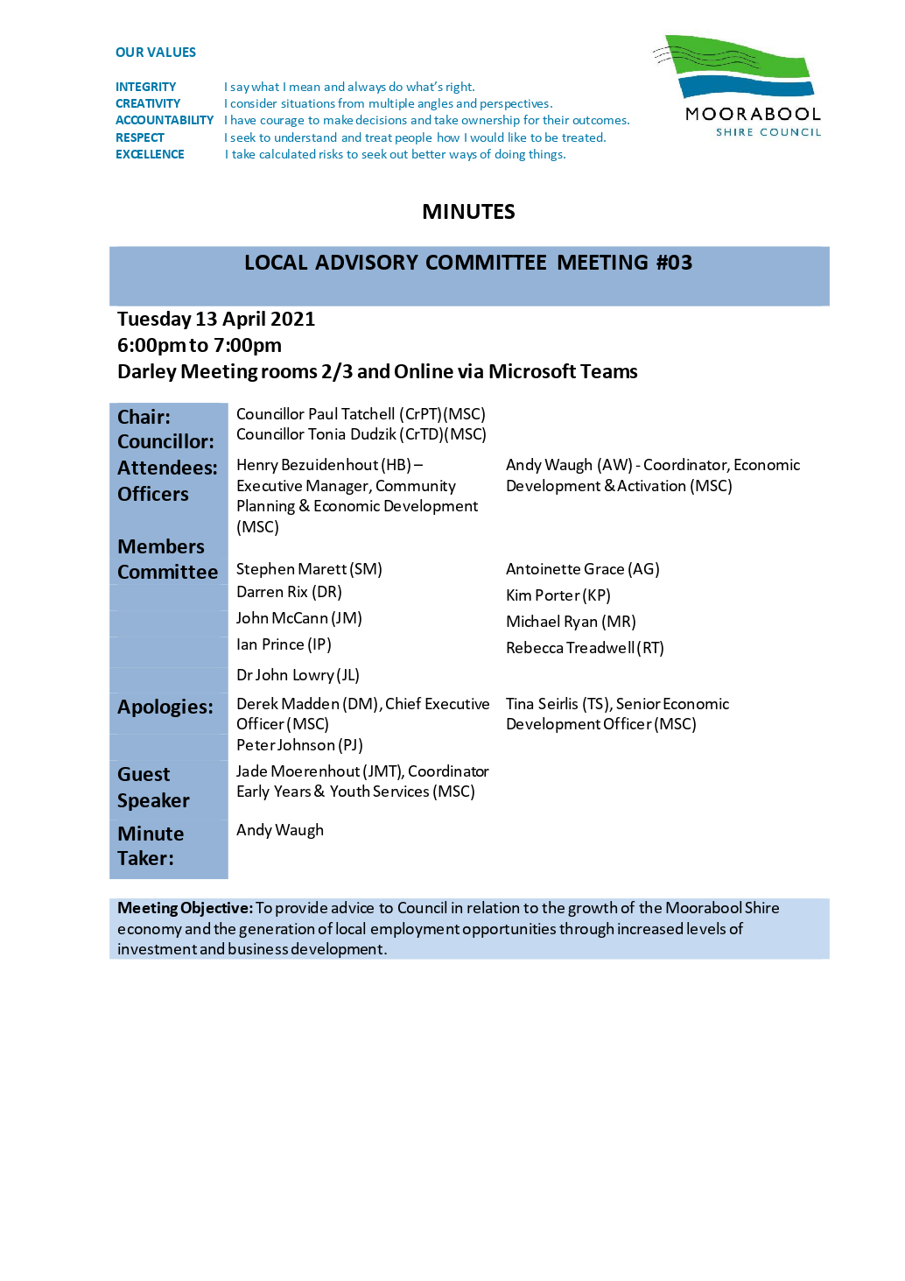

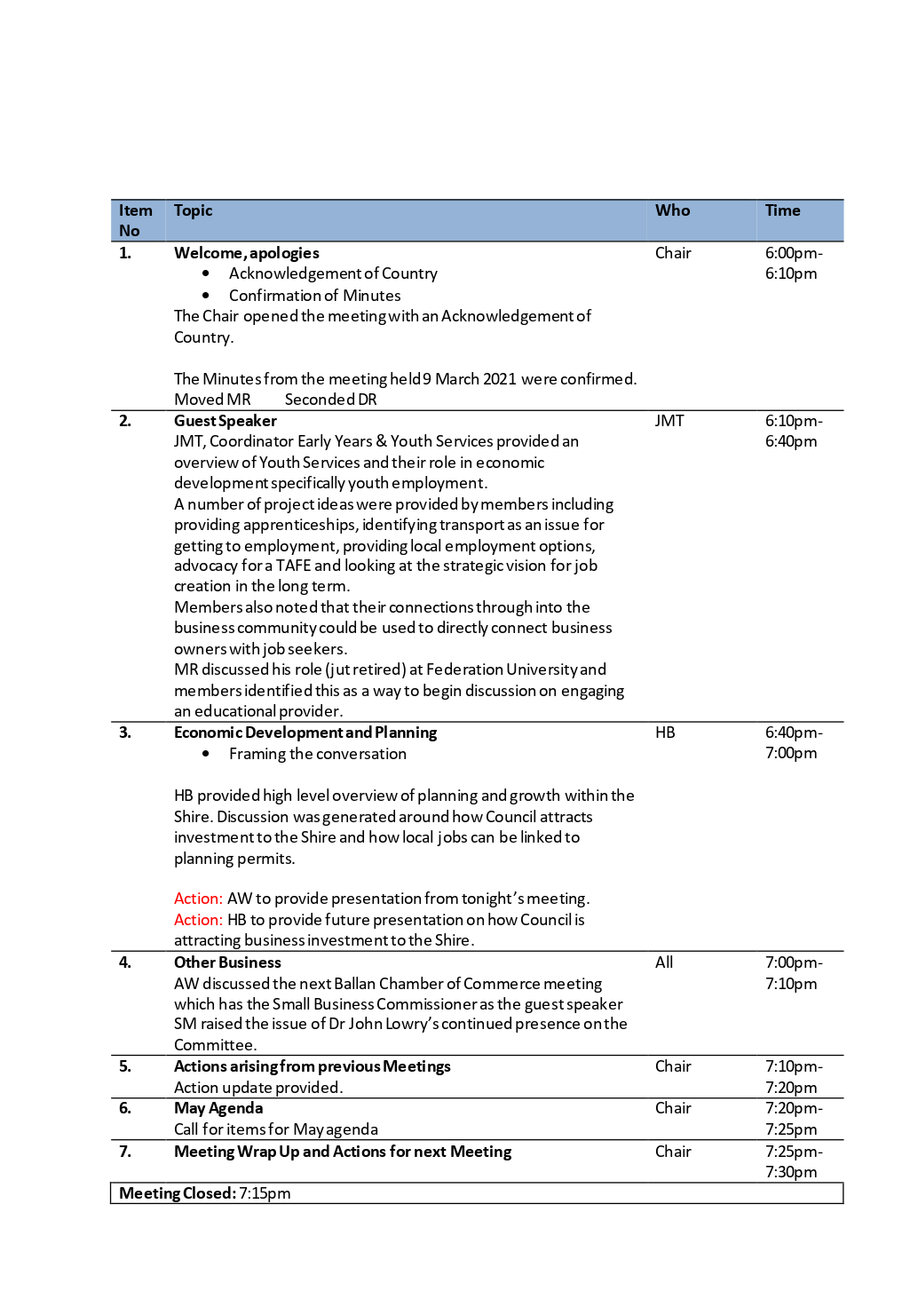

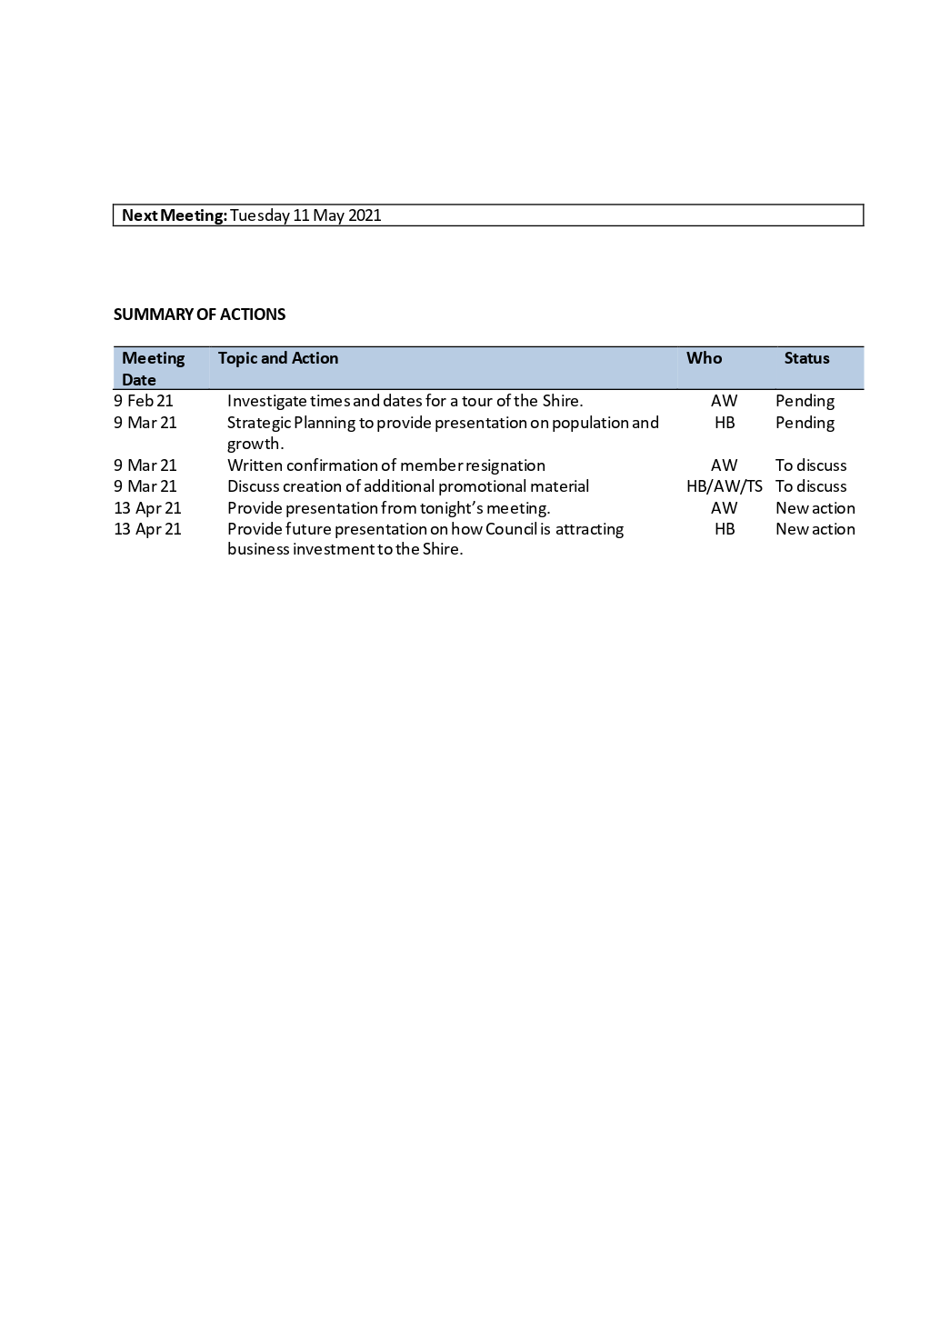

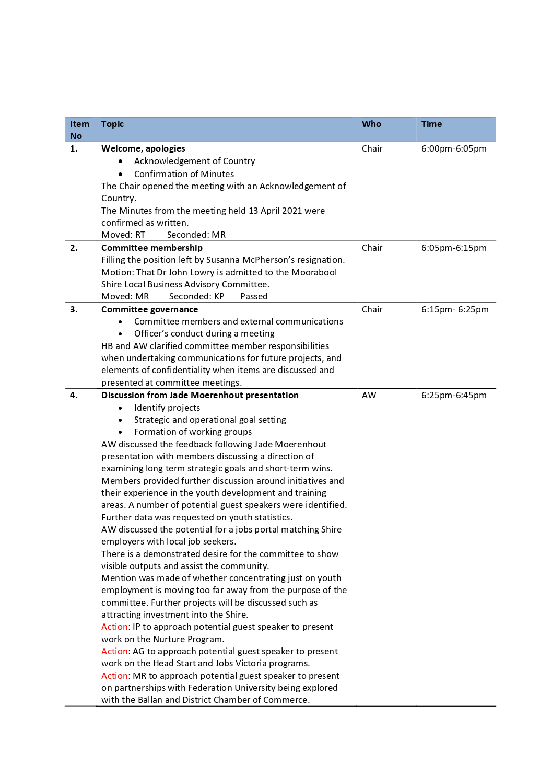

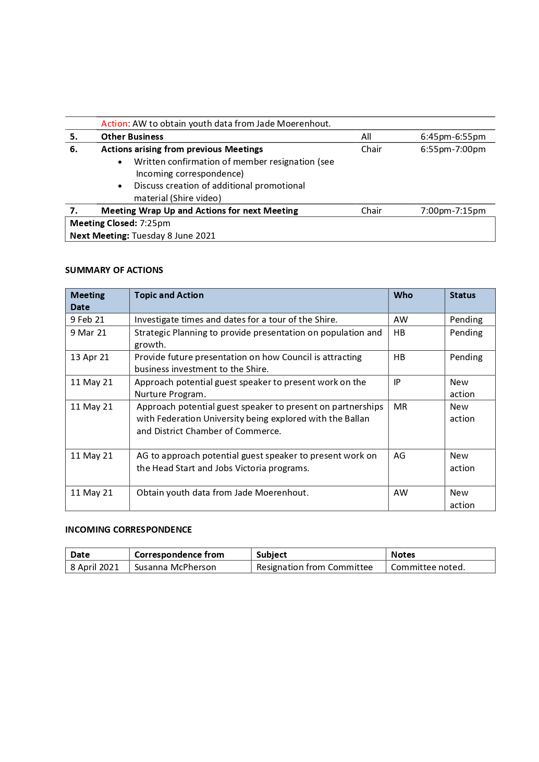

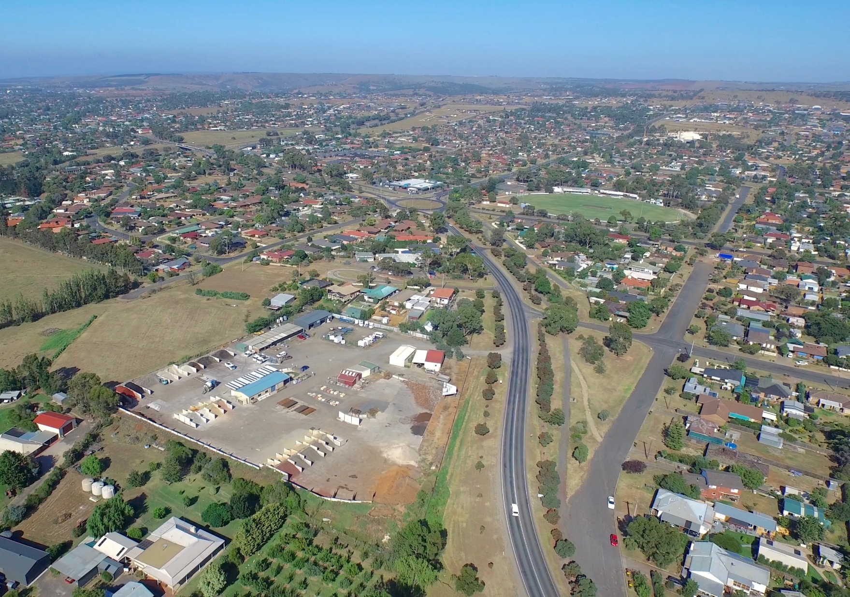
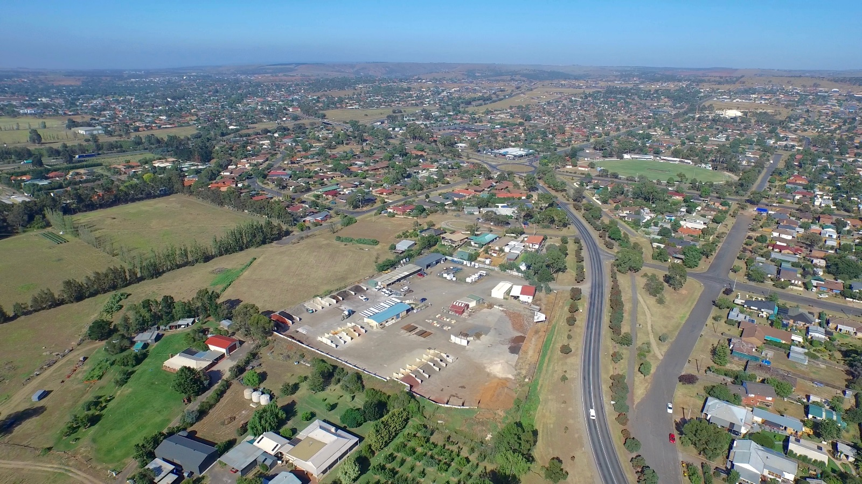
MOORABOOL SHIRE COUNCIL
REVENUE AND
RATING PLAN

Pursuant to the Local Government Act 2020

Contents

SECTION 1 6
Introduction 6
Purpose 6
Introduction 7
SECTION 2 8
Alignment with Existing Plans and Strategies 8
Community Engagement 8
SECTION 3 10
The Legislative and Rating Framework 10
The Legislative Framework 10
Rating Legislation 10
Essential Services Commission (ESC) – Rate Cap (Part 8A) 11
Valuation of Land Act 1960 (VLA) 11
Supplementary Valuations 11
Valuation Objections 12
Fire Services Property Levy Act 2012 (FSPL) 12
SECTION 4 13
Non-Rate Revenue 13
Other Revenue Sources 13
User Fees and Charges 13
Pricing Methods 14
Statutory Fees and Charges 15
Grants 16
Contributions 17
Interest on Investments 18
Borrowings 19
SECTION 5 20
The Rating Provisions 20
Rating Framework 20
Determining which Valuation (Section 157) 20
General Rates (Section 158) 22
Municipal Charge (Section 159) 22
Uniform or Differential Rates (Section 160 and 161) 22
Ministerial Differential Rate Guidelines (Section 161 (2A) and 2(B)) 23
Service Rates and Charges (Section 162) 23
Special Rates and Charges (Section 163) 24
Rebates and Concessions (Section 169 and 171) 24
The Rate Calculation 25
Rate Notice Components 26
Cultural and Recreational Lands Consideration 26
SECTION 6 27
The Collection of Rates 27
Payment Options 27
Legislative and Council Offered options 27
Special Payment Arrangements 27
Payment Channels 27
Non-Payment of Rates by Required Dates 28
Penalty Interest (Section 172 of the LGA) 28
Debt Recovery 28
Deferrals and Waivers 29
Financial Hardship 29
SECTION 7 30
Council’s Rate Overview and Definitions 30
Rates and Charges Overview 30
The Rate Definitions 31
General Land 32
Residential Retirement Land 33
Commercial/Industrial Land 34
Vacant Commercial/Industrial Land 35
Extractive Industry Land 36
Farm Land 37
Vacant General Land 38
Vacant FZ or RCZ Land 39
Vacant GRZ Land 40
SECTION 8 41
The Decision Making Process 41
Review Factors 41
Principle Considerations 41
Model Considerations 42
The proposed Rate Structure 43
The adopted Rate Structure 43
Document Control

VERSION | ADOPTED BY | DATE ADOPTED
1.0 | Moorabool Shire Council | May 2021
2.0 | Moorabool Shire Council – Update per Better Practice Guide 2021 and changed legislative framework

SECTION 1
Introduction

Purpose

The Local Government Act 2020 requires each council to prepare a Revenue and Rating Plan to cover a minimum period of four years following each Council election. The Revenue and Rating Plan establishes the revenue raising framework within which the Council proposes to work.

The purpose of the Revenue and Rating Plan is to determine the most appropriate and affordable revenue and rating approach for Moorabool Shire Council which in conjunction with other income sources, will adequately finance the objectives in the council plan.

One of the key strategies which underpins Council’s Strategic Financial Plan is the Revenue and Rating Plan. The objectives and legislative requirements of the Revenue and Rating Plan (section 93) are to align with:
• Council Plan and Strategic Financial Plan and associated Financial Management Principles (section 101);
• Service Performance Principles (section 106); and
• Strategic Planning Principles (section 89).

Fundamentally the plan will:
• Consider the structure and distribution of rates but not the overall amount of rates to be levied;
• Define the rate categories and rationale behind the differential rate structures;
• Consider any fixed service charges that might be applied on services such as waste or recycling;
• Consider the mix of funding sources and how they will complement the rate model including any fees and charges for services and programs;
• Consider and recognise developer contributions and other revenue including use or allocation of Council assets;
• Explain how Council calculates rates, the valuation basis of rate calculations and how it will collect rates and charges; and
• Will differentiate between recurrent and non-recurrent operational and capital grants from other levels of government.

It is important to note that this plan does not set revenue targets for Council bur rather outlines the strategic framework and decisions that inform how Council will go about calculating and collecting its revenue.

Introduction

Council provides a breadth of services to the community and collects revenue from a range of sources to enable the delivery of these services.

Below is an image providing an overview of the various funding sources:

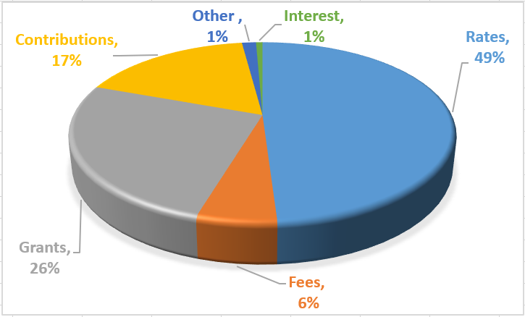
Rates are the most significant revenue service for Council and make up roughly 49% of its annual revenue income.

The introduction of rate capping under the Victorian Government’s Fair Go Rates System (FGRS) has brought a renewed focus to Council’s long-term financial sustainability.

The FGRS continues to restrict Council’s ability to raise revenue above the rate cap unless application is made to the Essential Services Commission (ESC) for a variation. Maintaining service delivery levels and investing in community assets remain key priorities for Council.

Council provides a wide range of services to the community, often for a fee or charge. The nature of these fees and charges generally depends on whether they relate to statutory or discretionary services. Some of these, such as statutory planning fees are set by State Government statute and are commonly known as ` Regulatory Fees’. In these cases, councils usually have no control over service pricing. However, in relation to other services, Council can set a fee or charge and will set that fee based on the principles outlined in this Revenue and Rating Plan.

Council revenue can also be adversely affected by changes to funding from other levels of government. Some grants are tied to the delivery of council services, whilst many are tied directly to the delivery of new community assets, such as roads or sports pavilions. It is important for Council to be clear about what grants it intends to apply for, and the obligations that grants create in the delivery of services or infrastructure.

SECTION 2
Alignment with Existing Plans and Strategies

This plan is an important part of Council’s integrated planning framework, all of which is created to help Council achieve its Community vision.

The strategies outlined in this plan align with the objectives contained in the Council Plan and will feed into our budgeting and long-term financial planning documents, as well as other strategic planning documents under our Council’s strategic planning framework.

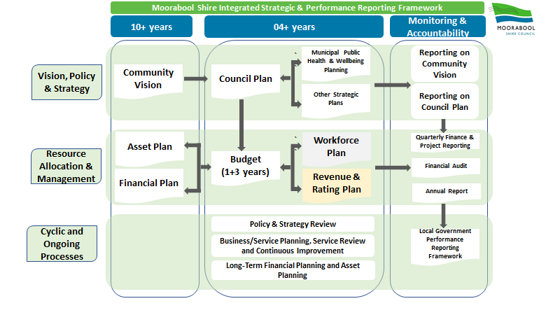

Community Engagement

The Revenue and Rating Plan outlines Council’s decision-making process on how revenues are calculated and collected.

Council is undertaking extensive engagement in the development of the Community Vision and Council Plan and has conducted past engagement on the Budget, Strategic Resource Plan, Rating Strategy and other strategies and plans and outcomes from these engagements have informed the development of this plan.

Deliberative community engagement is not prescribed for a Revenue and Rating Plan in either the Local Government Act 2020, or the Local Government (Planning and Reporting) Regulations 2020. However, community engagement on the Revenue and Rating Plan can be an effective way to better involve and educate ratepayers, customers and other stakeholders about council’s rating and revenue systems, how income is collected, and how policies are created and applied.

Community engagement may be undertaken in several different ways from, simple public exhibitions calling for submissions, to appointing committees or panels of interested stakeholders to inform council decisions.

The following public consultation process is proposed to ensure due consideration and feedback is received from relevant stakeholders.

Revenue and Rating Plan community engagement process:
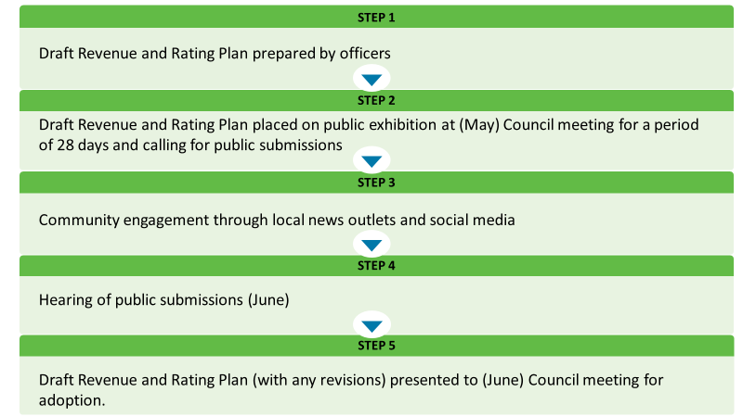

SECTION 3
The Legislative and Rating Framework

The Legislative Framework

The legislative framework for Council is primarily set within the Local Government Act 2020 (LGA) and outlines Council’s requirement to develop a Revenue and Rating Plan that establishes the revenue raising framework within which Council proposes to operate. However, the Rating legislative framework and process is set within the Local Government Act 1989 (LGA Old).

The purpose of the Revenue and Rating Plan is to determine the most appropriate and equitable revenue and rating approach which considers all income sources to finance the objectives of the Council Plan, which includes some of the following key provisions:
• Strategic Planning Principles (Section 89);
• Revenue and Rating Plan (Section 93);
• Financial Management Principles (Section 101); and
• Service Performance Principles (Section 106).

Section 94(2) of the Local Government Act 2020 states that Council must adopt a budget by 30 June each year (or at another time fixed by the Minister) to include:
• The total amount that Council intends to raise by rates and charges;
• A statement as to whether the rates will be raised by the application of a uniform rate or a differential rate;
• A description of any fixed component of the rates, if applicable;
• If Council proposes to declare a uniform rate, the matters specified in section 160 of the Local Government Act 1989;
• If Council proposes to declare a differential rate for any land, the matters specified in section 161(2) of the Local Government Act 1989.

Section 94(3) of the Local Government Act 2020 also states that Council must ensure that, if applicable, the budget also contains a statement –
• That the Council intends to apply for a special order to increase the Council’s average rate cap for the financial year or any other financial year; or
• That the Council has made an application to the Essential Services Commission for a special order and is waiting for the outcome of the application; or
• that a special order has been made in respect of the Council and specifying the average rate cap that applies for the financial year or any other financial year.

Rating Legislation

The LGA (Old) framework provides Council with significant flexibility to tailor a system to suit its requirements, with various sections of the LGA providing the guidelines to the types of rates and charges that can be levied and how they are levied, which are summarised in Section 155 of the LGA (Old), as follows:
• Determining which Valuation (Section 157);
• General Rates (Section 158);
• Municipal Charges (Section 159);
• Service Rates and Charges (Section 162); and
• Special Rates and Charges (Section 163).

The recommended strategy in relation to municipal charges, service rates and charges and special rates and charges are discussed later in this document. Whilst this document outlines Council’s strategy regarding rate revenue, rate data will be contained in the Council’s Annual Budget as required by the LGA.

This plan outlines the principles and strategic framework that Moorabool Shire Council will utilise in calculating and distributing the rating burden to property owners, however, the quantum of rate revenue and rating differential amounts will be determined in the annual Moorabool Shire Council budget.

In 2019 the Victorian State Government conducted a Local Government Rating System Review. The Local Government Rating System Review Panel presented their final report and a list of 56 recommendations to the Victorian Government in March 2020. The Victorian Government subsequently published a response to the recommendations of the Panel’s report. However, at the time of publication, the recommended changes have not yet been implemented, and timelines to make these changes have not been announced.

Essential Services Commission (ESC) – Rate Cap (Part 8A)

Although the Rating Strategy does not consider how much Council raises from rates, Part 8A of the LGA stipulates what a Council’s annual rate increase will be, the provisions for applying for a variation above the stipulated cap and the calculation for determining annual rate revenue. It is important to note that the rate cap only applies to General Rates and Municipal Charges. Service Rates/Charges and Special Rates/Charges are not subject to the rate capping restrictions.

Valuation of Land Act 1960 (VLA)

Currently under the VLA, the Victorian Valuer-General conducts property valuations on an annual basis. Council then applies a Capital Improved Value (CIV) to all properties within the municipality. As a result of annual property valuations, there are often varying levels of valuation movements across the municipality, which results in shifts in the rate burden.

There is a common misconception that as property values increase, Council receives additional revenue – this is not the case. Total rates revenue is determined by Council on an annual basis and must comply with the ESC Rate Cap.

The rate cap determines the overall percentage increase that Council is permitted to apply to its total rate revenue. Due to the impact of annual property valuations, some properties will experience a rate increase greater than the annual rate cap, while other properties will experience a rate increase lower than the rate cap (or even a rate decrease). But from a Council perspective, the total revenue it generates remains unaffected by property valuations.

Supplementary Valuations

Additional to general revaluations of all properties, Council also conducts regular supplementary valuations to recognise changes within properties. Supplementary Valuations can be undertaken for a range of reasons including but not limited to:
• A new home or factory built on vacant land;
• Sale of parcel from development property;
• Extensions to existing buildings;
• Fire Damage to building; or
• Acquisition of adjoining land or disposition of a portion of land.

The Victorian Valuer-General is tasked with undertaking supplementary valuations and advises Council monthly of valuation and Australian Valuation Property Classification Code (AVPCC) changes.

Valuation Objections

Part 3 of the Valuation of Land Act 1960 provides that a property owner may lodge an objection against the valuation of a property or the Australian Valuation Property Classification Code (AVPCC) within two months of the issue of the original or amended (supplementary) Rates and Valuation Charges Notice (Rates Notice), or within four months if the notice was not originally issued to the occupier of the land.

Fire Services Property Levy Act 2012 (FSPL)

The State Government passed legislation following the Bushfire Royal Commission to have the Fire Services Levy charged via council rates notices, rather than added to home insurance policies. The State Government utilises the funding from the FSPL raised and collected by Victorian Councils to fund Victoria’s Fire and Emergency Services.

Council is often tasked with the responsibility of being a collection agency for other tiers of government. The FSPL is not subject to the rate cap and the State Government is unrestricted in its ability to increase the FSPL on an annual basis at amounts greater than the rate cap.

SECTION 4
Non-Rate Revenue

Other Revenue Sources

Whilst rate revenue is the largest contributor (49% of total Revenue), rates are one part of the overall revenue story with fees and charges, grants and other contributions making up the total revenue picture.

Council over recent years has identified a range of savings that have not impacted on services provided to our communities and have applied a “user-pays” model which is cost reflective and inclusive of indirect costs, whilst ensuring delivery of high quality, responsive and accessible services to our communities.

Through already identified savings and ongoing reviews, Council’s long-term financial sustainability will provide significant long-term benefits to our communities in the form of improved infrastructure and expanded services.

User Fees and Charges

Fees and charges are an important component of Councils’ revenue raising strategy and represent 6% of Councils’ budgeted recurrent revenue.

Section 77 of the Local Government Act 2020 provides some guidance on the pricing of Council’s services and facilities. In addressing the Local Government Act, Council must ensure that resources are used effectively and efficiently, and that services and facilities provided by Council are accessible and equitable.

National Competition Policy (Federal Government) and Competitive Neutrality Policy (State Government) also provide requirements regarding pricing for significant business activities that Council provides and adjust Council’s service prices to neutralise any competitive advantages when competing with the private sector.

Some services are required due to statutory obligation, while other services Council chooses to provide as part of its social objectives.

Fees and charges are therefore raised by Council for several reasons:
• To increase revenue available to Council to support the cost of service delivery;
• To support Council’s medium to long term service delivery objectives; and
• To help users of Council service understand the value and benefits they obtain when accessing those services.

Examples of user fees and charges include:
• Kindergarten and Childcare fees;
• Leisure Centre, Gym, and Pool visitation and membership fees;
• Waste Management fees (Transfer Stations);
• Aged and Health Care service fees; and
• Leases and facility hire fees.

In setting Fees and Charges, Council is guided by the following principles:
• Efficiency - the fees are simple to understand and administer.
• Equity - the fees are fairly applied across a range of users and consider users’ capability to pay.
• Effectiveness - the fees provide appropriate signals to users, value for money and ensure that everyone contributes appropriately to the delivery of services.
• Transparency - the method of determining pricing is consistent.

Additionally, in determining fees and charges not regulated by statute, Council will consider the following factors in selecting the pricing method to meet its objectives for the service:
• Balancing individual and community benefit;
• Users’ ability to pay;
• Market pricing - the pricing of comparable services offered by other providers;
• Competitive neutrality (where relevant); and
• Budget implications.

Pricing Methods

As part of the Revenue and Rating Plan, Council has developed a draft Fees and Charges Policy to guide Council’s future approach in setting levels of fees and charges.

It is proposed as part of the overall fee setting process that Council’s Services are provided based on one of the following pricing methods:
• Private Benefit Pricing;
• Accessible Pricing;
• Incentive Pricing; and
• Full Cost-Plus Margin Pricing (Market Pricing).

Private Benefit Pricing
(Price to cover direct and overhead cost).

The aim of this pricing method is to recover the direct and overhead costs associated with providing such services that benefit individual customers specifically.

Examples: Services include Council giving access to information, subject to compliance with information privacy and freedom of information, and damage to Council’s property.

Assessable Pricing
(Price set between Full Council Subsidy (no charge) and Full Cost Pricing (covering direct and overhead costs)).

Accessible Pricing may be used where there are benefits to the overall community, including making a service accessible to low-income or disadvantaged users.

Fees and charges for this pricing method are subsidised by Council, and fees and charges are set to recover only part of the direct cost, for example a service may be provided with fees set to recover 75% of direct costs.

Example: Recreation facilities fees and charges.

Incentive Pricing
(Price set above Full Cost Recovery (covering direct and overhead costs at a minimum)).

This pricing regime will be adopted where the Council have an applicable policy objective that supports disincentive pricing or where the Council performs the role to regulate and restrict certain behavior.
Example: Charging more for late health premise registration.

Full Cost-Plus Margin Pricing
(Market Pricing): Price set above Full Cost Recovery (covering direct and overhead costs at a minimum) in line with benchmarked market prices.

This category includes services that provide discretionary activities without strong social policy objectives. The aim of this pricing method is to set fees and charges based on benchmarking of similar services offered by other service providers or based on current market pricing. Ideally, the price should be greater than Full Cost Recovery and a Market-Based price.

The reason for selecting this method of fee setting is that if fees are out of alignment with market, it may result in a loss of patronage or sales that would reduce the overall level of income for the service.

Examples: Sale of goods through retail outlets, e.g. Visitor Information Centre, Art Gallery.

Fees and Charges Schedule

Council will develop a table of fees and charges as part of its annual budget each year. Proposed pricing changes will be included in this table and will be communicated to stakeholders before the budget is adopted, giving them the chance to review and provide valuable feedback before the fees are locked in.

Statutory Fees and Charges

Under the direction of legislation or other government directives, for some fees and charges or fines, Council’s role is to administer services and apply fees set or controlled under statute or funding agreement. These fees may only provide a partial recovery of the cost of providing the service.

Example: Specified Environmental Health and Statutory Planning Fees.

In addition, there are a range of conditions Council must consider when setting fees for certain purposes, for example under Funding and Service Agreements or Grant Agreements. In these cases, Council must comply with the relevant terms of the agreement, for example there may be an upper limit on the fee Council may charge.

Examples: Home and Community Care service charges.

Penalty and fee units are used in Victoria’s Acts and Regulations to describe the amount of a fine or a fee.

Penalty units

Penalty units are used to define the amount payable for fines for many offences. For example, the fine for selling a tobacco product to a person aged under 18 is four penalty units.

One penalty unit is currently $165.22, from 1 July 2020 to 30 June 2021.

The rate for penalty units is indexed each financial year so that it is raised in line with inflation. Any change to the value of a penalty unit will happen on 1 July each year.

Fee units

Fee units are used to calculate the cost of a certificate, registration or license that is set out in an Act or Regulation. For example, the cost of depositing a Will with the supreme court registrar of probates is 1.6 fee units.

The value of one fee unit is currently $14.81, from 1 July 2020 to 30 June 2021. This value may increase at the beginning of a financial year, at the same time as penalty units.

The cost of fees and penalties is calculated by multiplying the number of units by the current value of the fee or unit. The exact cost may be rounded up or down.

Grants

Grant revenue represents income usually received from other levels of government. Some grants are singular and attached to the delivery of specific projects, whilst others can be of a recurrent nature and may or may not be linked to the delivery of projects.

Council will pro-actively advocate to other levels of government for grant funding support to deliver important infrastructure and service outcomes for the community. Council may use its own funds to leverage higher grant funding and maximise external funding opportunities.

When preparing its financial plan, Council considers its project plans, advocacy priorities, upcoming grant program opportunities, and co-funding options to determine what grants to apply for within the context of the Council Plan and other management plans. Council will only apply for and accept external funding if it is consistent with the Community Vision and does not lead to the distortion of Council Plan priorities.

Grant assumptions are then clearly detailed in council’s annual budget document. No project that is reliant on grant funding will proceed until a signed funding agreement is in place.

Financial Assistance Grants

Financial Assistance Grants are provided by the Commonwealth Government to Council. The grant comprises of general-purpose grants and local roads funding. A small portion for natural disasters is taken from the general-purpose allocation.

General purpose grants are one of the two components of the financial assistance grants (along with local roads grants) provided by the Commonwealth Government to Council. The Local Government (Financial Assistance) Act 1995 provides that the grants are untied; that is, the Victorian Local Government Grants Commission is unable to direct councils as to how the allocated funds are to be spent.
Local Roads Grants

Local roads grants are the second of the two components of the financial assistance grants provided by the Commonwealth Government to Council. Although local roads grants are allocated based on the relative needs of each council for roads expenditure, the Local Government (Financial Assistance) Act 1995 provides that the grants are untied.

Allocation is made based on a set of nationally agreed principles that require local roads grants be ‘allocated to councils as far as practicable on the basis of the relative needs of each council for roads expenditure and to preserve its road assets.

Contributions

Councils are subject to legislative regulation and monitoring of development contribution levies in their roles as a Collecting Agency through the Local Government Act.

Contributions represent funds received by council, usually from non-government sources, and are usually linked to projects and can be made to council in the form of either cash payments or asset handovers.

Types of Contributions Council receive include:
• Contributions from developers under planning and development agreements;
• Contributions made under developer contribution plans and infrastructure contribution plans; and
• Assets handed over to council from developers at the completion of a subdivision, such as roads, drainage, and streetlights.

Development contributions are payments or in-kind works, facilities or services provided by developers towards the supply of infrastructure required to meet the future needs of the community.
Development contributions help fund the higher order, basic and essential works and services required by new communities including roads, intersections, shared paths, parks, local sporting and community facilities. The various infrastructure requirements are identified and justified through a strategic plan/document such as the Precinct Structure Plan (PSP) process. The infrastructure (land and construction) is in addition to general ` developer provided’ infrastructure which includes local estate infrastructure I.e., local roads, local drainage, services and improvements to local parks.
There are a range of mechanisms for collecting development contributions, including Section 173 agreements, development contributions plans, infrastructure contribution plans, and shared funding arrangements.

Contribution from developers under planning and development agreements

At the time of development proposal, landowners, Council, and other parties can freely negotiate agreements for the provision of infrastructure. The agreement can be used to place an obligation on the parties to:
• provide infrastructure;
• Provide land; and/or
• pay for infrastructure.

Section 173 of the Planning and Environment Act 1987 provides a mechanism for formalising a voluntary agreement between the responsible authority, a landowner, and other parties and can provide for:
• the costs and standard of infrastructure provision;
• the timing of the provision of infrastructure;
• the parties’ obligation to provide the infrastructure;
• timing of payments towards infrastructure;
• the refund of cash contributions if infrastructure is not provided;
• the upfront provision of infrastructure by one landowner and the reimbursement of the cost by other landowners as they develop; or
• works-in-kind in lieu of a cash contribution.

Contributions made under developer contribution plans (DCP) and infrastructure contribution plans (ICP)

A DCP is a mechanism used to levy new development for contributions to planned infrastructure needed by a future community as allowed for under the Planning and Environment Act. It sets out the justification for infrastructure and the calculations of cost and apportionment, allows Council to collect Development Contributions and specifies the infrastructure that is to be provided.

The Planning and Environment Act identifies two types of infrastructure which can be levied and collected through a DCP:
• Development and Community Infrastructure, the levies for which are referred to as the Development Infrastructure Levy (DIL); and
• The Community Infrastructure Levy (CIL).

The Development Contribution Levy (DIL) is generally paid when land is subdivided. If a development is proposed without the subdivision of land, the payment is triggered prior to the issue of a building permit. The DIL collected from developers forms most of the funding for projects within a DCP.

The Community Infrastructure Levy (CIL) is paid by homeowners prior to the issue of a building permit for the construction of a dwelling.

The ICP system is based on standard levies that are pre-set for particular development settings and land uses, to fund the provision of essential infrastructure that will support new or growing communities.

DCPs require payment of development contributions in cash, however, section 46P of the Planning and Environment Act provides the option for developers to deliver infrastructure works or provide land, a credit is then applied against the DIL liability for the developer.

These types of contributions are referred to as ‘Works in Kind’ or ‘Land in Kind’.

Interest on Investments

Division 4 Section 103 of The Local Government Act 2020 provides local Councils in Victoria with guidelines and restrictions as to the types of investments that they can make.

There are two types of investments Council invests in accordance with the Investment Guidelines below:
• At Call Investment - whereby Council maintains a cash reserve account for day-to-day funding requirements. This Investment Account is facilitated through Council’s contracted Bank – currently the CBA; and
• General Investment – this is the investment of excess funds from day-to-day operations for a short-term period.

Council receives interest on funds managed as part of its investment portfolio, where funds are held in advance of expenditure, or for special purposes such as to fund capital projects. The investment portfolio is managed per the following principles:
• Preservation of capital - where funds are to be invested in a way that seeks to ensure continual security of the investment portfolio. This includes managing credit and interest rate risk within approved thresholds and parameters;
• Liquidity - where the investment portfolio is maintained in a manner that will ensure adequate liquidity to meet all MSC anticipated cashflow needs for ongoing operational commitments;
• Risk - where Investment decisions are based on the security of funds by limiting unnecessary exposure to risk by applying effective internal controls and adherence to applicable legislative and Council requirements whilst achieving a prudent rate of return through investments in AAA to AA- credit rated Financial Institutions.

Council’s Investment Policy prohibits any investment carried out for speculative purposes, including the following:
• Derivative based investments;
• Principal only investments or securities that provide nil or negative cash flow;
• The use of leveraging (borrowing to invest);
• Standalone securities issued that have underlying futures, options, forward contracts, and swaps of any kind;
• Any securities issued in non-Australian currency; and
• ‘Enhanced cash Funds’ or similar products that fall within the definition of a CDO.

Authority and Delegation

The Chief Financial Officer has responsibility for managing and reviewing Council’s cash balances and investment decisions and is responsible for presenting investment information to the Executive Leadership Team and council on a periodic basis.

Borrowings

Whilst not a source of income, borrowings can be an important cash management tool in appropriate circumstances. Loans can only be approved by council resolution.

New borrowings by Council are identified as part of the annual budget process and may be subject to public tender.

A council report specifying the length of loan, type of interest rate (fixed/variable) and delegation to Chief Executive Officer is required prior to commencing the procurement process.

The public tender process will be in accordance with Moorabool Shire Council’s Procurement Policy and the Act. This procurement process will be undertaken by the finance department.

The following financial sustainability principles will be adhered to with new borrowings:
• Borrowings must only be applied for where it can be proven that repayments can be met in the Long-Term Financial Plan;
• Borrowings must not be used to fund ongoing operations;
• Borrowings are appropriate for funding large capital works where the benefits are provided to future generations; and
• Council will maintain its debt at levels which are sustainable.

SECTION 5
The Rating Provisions

Rating Framework

Rates and charges are required by the Act and the Regulations to be disclosed in Council’s annual budget.

Rates are property taxes that allow Council to raise revenue to fund essential public services to cater to our municipal population. Importantly, it is a taxation system that includes flexibility for council to utilise different tools in its rating structure to accommodate issues of equity and to ensure fairness in rating for all ratepayers.

The Act provides Council with a number of choices in how rates are spread across the community.

Determining which Valuation (Section 157)

Currently, Council can use one of three valuations for the purpose of levying their declared rates and charges:

Valuation Type | Acronym | Definition
Site Value | SV | Value of land only
Capital Improved Value | CIV | Value of land and improvements upon the land
Net Annual Value | NAV | Rental valuation based on CIV*

* For residential and farm properties, NAV is calculated at 5% of the CIV. For commercial and industrial properties, NAV is calculated as the greater of the estimated annual rental value or 5% of the CIV.

Section 161 of the LGA Old framework, allows Council’s to levy rates by way of differential rates if it uses the CIV valuation base and it considers that a differential rate will contribute to the equitable and efficient carrying out of its functions. CIV is the most commonly used valuation base by local government, with over 90% of Victorian councils applying this methodology. The levying of rates on SV or NAV, would only allow rating under Uniform (Section 160) or Limited Differential Rates (Section 161A).

Below is over overview of the Advantages and Disadvantages of rating on each of the available valuation bases:

Valuation Base | Advantage | Disadvantage
Site Value (SV) | • A uniform rate would promote development of land, particularly commercial and industrial developments. There is, however, little evidence to prove that this is the case.  • Scope for possible concessions for urban farmland and residential use land. | • There will be a significant shift from the industrial/commercial sector onto the residential sector of council. The percentage increases in many cases would be in the extreme range.  • SV is a major burden on property owners that have large areas of land. Some of these owners may have much smaller/older dwellings compared to those who have smaller land areas but well-developed dwellings - but will pay more in rates. A typical example is flats, units, or townhouses which will all pay low rates compared to traditional housing styles.  • The use of SV can place pressure on council to give concessions to categories of landowners on whom the rating burden is seen to fall disproportionately (e.g. Farmland and residential use properties). Large landowners, such as farmers for example, are disadvantaged using site value.  • SV will reduce Council’s rating flexibility and options to deal with any rating inequities due to the removal of the ability to levy differential rates.
Capital Improved Value (CIV) | • Includes all property improvements, and hence is often supported on the basis that it more closely reflects “capacity to pay”.  • The CIV rating method considers the full development value of the property, and hence better meets the equity criteria than Site Value and NAV.  • With the increased frequency of valuations, the market values are more predictable and has reduced the level of objections resulting from valuations.  • The concept of the market value of property is more easily understood with CIV rather than NAV or SV making it easier to compare relative movements in rates and valuations across councils.  • The use of CIV allows council to apply differential rates which greatly adds to council’s ability to equitably distribute the rating burden based on ability to afford council rates. CIV also allows council to apply higher rating differentials to the commercial and industrial sector that offset residential rates. | • The main disadvantage with CIV is the fact that rates are based on the total property value which may not necessarily reflect the income level of the property owner as with pensioners and low-income earners.
Net Annual Value (NAV) | • Represents the annual rental value of a property. However, in practice, NAV is loosely linked to capital improved value for residential and farm properties. Valuers derive the NAV directly as 5 per cent of CIV.  • In contrast to the treatment of residential and farm properties, NAV for commercial and industrial properties are assessed with regard to actual market rental. This differing treatment of commercial versus residential and farm properties has led to some suggestions that all properties should be valued on a rental basis.  • Overall, the use of NAV is not largely supported. For residential and farm ratepayers, actual rental values pose some problems. The artificial rental estimate used may not represent actual market value, and means the base is the same as CIV but is harder to understand.

Moorabool Shire Council applies the Capital Improved Value (CIV) to all properties within the municipality to take into account the fully developed value of the property. This basis of valuation takes into account the total market value of the land plus buildings and other improvements which subsequently allows council to levy rates by way of differential rates which is detailed within this document.

General Rates (Section 158)

At least once within each financial year (by 30 June) a Council must declare:
• The amount which the Council intends to raise by general rates, municipal charges, service rates and charges; and
• Whether the general rates will be raised by the application of:
o A uniform rate (Section 160); or
o Differential rates (Section 161); or
o Urban farm rates, farm rates or residential use rates (Section 161A).

Municipal Charge (Section 159)

A municipal charge may be levied on all rateable properties within a municipality “to cover some of the administrative costs of the Council”. The legislation is not definitive on what comprises administrative costs and does not require Council to specify what is covered by the charge.

Under the Local Government Act 1989, a council’s total revenue from a municipal charge in a financial year must not exceed 20 per cent of the combined sum total of the Council’s total revenue from the municipal charge and the revenue from general rates (total rates).

The application of a municipal charge represents a choice to raise a portion of the rates by a flat fee for all properties, rather than sole use of the CIV valuation method.

The municipal charge applies equally to all properties and is based upon the recovery of a fixed cost of providing administrative services irrespective of valuation. The same contribution amount per assessment to cover a portion of Councils administrative costs is an equitable method of recovering these costs.

Moorabool Shire Council does not currently levy a Municipal Charge.

Uniform or Differential Rates (Section 160 and 161)

Council can declare that general rates will be raised by the application of a uniform rate by specifying the percentage as the uniform rate and applying that to any rateable land by multiplying the percentage against the valuation of the land.

On the other hand, differential rates allow Council to apply different rates in the dollar for different types of property as long as Council “considers that the differential rate will contribute to the equitable and efficient carrying out of its functions”.

By declaring differential rates, Council must specify the objectives of each rate which must remain consistent with equitable and efficient carrying out of Council’s functions. When declaring differential rates, Council must ensure that the highest differential rate is no more than four (4) times higher than the lowest differential rate in the municipal district.
The advantages and disadvantages of differential rate approach are as follows:

Advantage | Disadvantage
• There is greater flexibility to distribute the rate burden between all classes of property, and therefore link rates with the ability to pay and reflecting the tax deductibility of rates for commercial and industrial premises.  • Differential rating allows Council to better reflect the investment required by Council to establish infrastructure to meet the needs of the commercial and industrial sector.  • Allows Council to reflect the unique circumstances of some rating categories where the application of a uniform rate may create an inequitable outcome (e.g. Farming enterprises).  • Allows Council discretion in the imposition of rates to facilitate and encourage appropriate development of its municipal district in the best interest of the community. (i.e. Vacant Commercial properties still attract the commercial differential rate) | • The justification of the differential rate can at times be difficult for the various groups to accept giving rise to queries and complaints where the differentials may seem to be excessive.  • Differential rates can be confusing to ratepayers, as they may have difficulty understanding the system. Some rating categories may feel they are unfavorably treated because they are paying a higher level of rates than other ratepayer groups.  • Differential rating involves a degree of administrative complexity as properties continually shift from one type to another (e.g. residential to commercial,) requiring Council to update its records. Ensuring the accuracy/integrity of Council’s data base is critical to ensure that properties are correctly classified into their right category.  • Council may not achieve the objectives it aims for through differential rating. For example, Council may set its differential rate objectives to levy a higher rate on land not developed, however it may be difficult to prove whether the rate achieves those objectives.

Moorabool Shire Council levies general rates via Differential Rates to recognise the diversity of the property and uses across the municipality.

Ministerial Differential Rate Guidelines (Section 161 (2A) and 2(B))

This section provides that the Minister may, by notice published in the Government Gazette, make guidelines for or with respect to:
• The objectives of differential rating;
• Suitable uses of differential rating powers;
• The types or classes of land that are appropriate for differential rating.

Further, by reason of section 161(2A) a Council must have regard to any Ministerial guideline made under subsection (2B) before declaring a differential rate for any land.

Service Rates and Charges (Section 162)

Enables the Council to declare and raise a service rate or an annual service charge for the following services:
• The provision of water supply;
• The collection and disposal of refuse;
• The provision of sewerage services;
• Any other prescribed service.

The charge may be declared on the basis of any criteria specified by the Council but should be relative to the total cost of the service.

Currently, Council levies the following charges under this section of the Act:
• Waste Management Service Charge;
• State Landfill Levy;
• Roadside Garbage (residential and commercial), Recycling and Green waste Services (compulsory and non-compulsory).

Council retains the objective of setting the service charge for waste at a level that fully recovers the cost of the waste services.

Special Rates and Charges (Section 163)

A Council can declare a special rate or charge for the purpose of:
• Defraying any expenses; or
• Repaying (with interest) any advance made to or debt incurred, or loan raised by the Council.

The Local Government Act 1989 recognises that councils need help to provide improved infrastructure for their local communities. The Act allows councils to pass on the cost of capital infrastructure to the owner of a property that generally receives a unique benefit from the construction works.

The purposes for which special rates and special charges may be used include road construction, kerb and channelling, footpath provision, drainage, and other capital improvement projects.

The special rate or special charges may be declared based on any criteria specified by the council in the rate (Section 163 (2)). In accordance with Section 163 (3), council must specify:
• The wards, groups, uses or areas for which the special rate or charge is declared, and
• The land in relation to which the special rate or special charge is declared,
• The way the special rate or special charge will be assessed and levied, and
• Details of the period for which the special rate or special charge remains in force.

The special rates and charges provisions are flexible and can be used to achieve a wide range of community objectives. The fundamental principle of special rates and charges is proof “special benefit” applies to those being levied. For example, they could be used to fund co-operative fire prevention schemes. This would ensure that there were no ‘free-riders’ reaping the benefits but not contributing to fire prevention.

Further information regarding the purpose and scope of Special Rates and Charges can be obtained via Council’s adopted Policy.

Rebates and Concessions (Section 169 and 171)

Council may offer rebates or concessions for a number of reasons as described in Section 169, primarily “to assist the proper development of the municipal district” or to assist in the “preservation and/or restoration of places of historical or environmental interest”.

Additional to Council declared rebates, Section 171 provides for concessions applicable under the State Concessions Act 1986. Concessions under this provision are for the primary place of residence for eligible pensioners. This rebate is determined and funded by the State Government, with the administration and application of the rebate administered by Council.
With regards to new applicants, after being granted a Pensioner Concession Card (PCC), pensioners can then apply for the rebate at any time throughout the rating year. Retrospective claims up to a maximum of one previous financial year can be approved by Council on verification of eligibility criteria, for periods prior to this claim may be approved by the relevant government department.

The Health Care Card, certain Seniors cards and certain Department of Veteran Affairs (DVA) cards are not eligible cards. Application forms are available from Council’s customer service office or website.

The Rate Calculation

Part 8 of the LGA (old Act) outlines and describes the options of Council to determine, declare, levy, and collect rates and charges.

The formula for determining a Council’s rate revenue is:
• The identification of rateable land (Section 154);
• What rates and charges may be declared (Section 155);
• Determining the valuation to be used for the levying of rates (Section 157);
• Multiplied by the rate declared by Council (Sections 158-163).

After the determination of what rates are to be declared, the calculation then looks at each properties Capital Improved Value multiplied by the rate in the dollar for a particular category, equals the total differential rate charge.

Total rates for the municipality |  |  |  |  |  | What you pay
Total Council Rates to be raised |  | Combined value of all rateable properties |  |  | The rate in the dollar |  |  | Market value of each property |  | Your General Rate charge

It needs to be understood that Council does not generate more money if and when property valuations increase. The total combined differential rates collected by Council remains the same irrespective of each individual property’s valuations.

Rate Notice Components

There are a number of charges on each properties annual Rate and Valuation Notice, below is a summary of the charge type, the charges origin and whether the rate cap applies to the charge:

Charge Type | Council Charge | State Government Charge | Does a Rate Cap apply?
Differential Rate | ü |  | ü
Garbage, Recycling and Greenwaste | ü
Waste Management Service Charge | ü
State Landfill Levy |  | ü
Fire Service Property Levy |  | ü

Cultural and Recreational Lands Consideration

Council has an adopted Cultural and Recreational Lands Policy which provides for eligible properties within the definition of ‘recreational land’ per the Cultural and Recreational Lands Act 1963 a partial waiver of their general differential rate component.

SECTION 6
The Collection of Rates

This section is to provide the high-level framework of Moorabool Shire Council’s approach to the rate payment options, the escalation process and the recognition and provisions for those community members who may be experiencing changed financial circumstances. Further details and specifics of the operational process regarding these processes can be found within Council’s Property Rate Debt Management Policy.

Payment Options

Annual Rate and Valuation notices are generally issued towards the end of August or start of September in accordance with adopted budget and approved General Valuations being applied. The legislative framework (LGA 1989 Section 167) requires Council to allow payment via the four instalments or via lump sum with dates fixed by the Minister.

In addition to the legislative provisions, Council also offer a 10 Alternative instalment option for the payment of annual rates and charges.

Legislative and Council Offered options

Option | Legislative or Council | Payment Dates | Expectations and Requirements
Full Payment | Legislative | 15 February each year | Annual Notice issued
4 Instalments | Legislative | 30 September  30 November  28 February  31 May | First instalment must be paid in full by first day and reminder notices will then be issued for remaining three instalments
10 Alternative Instalments | Council | 15th of each month between September and June | Annual Notice issued

Special Payment Arrangements

Those ratepayers experiencing financial difficulties or require payments outside of the Legislative and Council offered, options may via discussion with Council’s Revenue Services Team negotiate a special payment arrangement which would entail regular weekly, fortnightly or monthly payments. Further details of special payment arrangements can be found within Council’s Property Rate Debt Management Policy.

Payment Channels

Council offers a range of payment options including:

• In-store at any Australia Post outlet
• By phoning Australia Post on 13 18 16
• On line at auspost.com.au/postbillpay
• Participating banks or financial institutions
• Transaction via cheque, savings or credit accounts
• Biller Code and Reference Numbers must be entered as referenced on accounts
 | • Phone 5366 7100
• All cheques should be sent to:
• PO Box 18, Ballan, Victoria, 3342
 | • 15 Stead Street, Ballan  • 182 Halletts Way, Darley  • 215 Main Street, Bacchus Marsh | • 8.30am – 5.00pm Mon – Fri  • 8.30am – 5.00pm Mon – Fri  • 8.30am – 5.00 pm Mon – Fri and 9.00am – 2.00pm Saturday
• Direct debits for special arrangements are processed every Friday
• Direct debits can be set up for legislated payment dates and are the only payment channel option for 10 Alternative instalments
• A ratepayer cannot amend or cancel a direct debit without a written request and must provide at least 7 days notice

Non-Payment of Rates by Required Dates

Where a ratepayer fails to meet their obligation to pay rates and charges in accordance with the legislative or Council offered payment dates, penalty interest may be applied in accordance with the legislative framework and an account may referred to Council’s appointed Debt Collection Agency.

Further information regarding the actions Council will take to collect outstanding Rates and Charges can be found in Council’s Property Rate Debt Management Policy.

Penalty Interest (Section 172 of the LGA)

Section 172 of the Local Government Act 1989 enables Council to charge interest on unpaid rates and charges.

The interest rate applied is fixed under Section 2 of the Penalty Interest Rates Act 1983, which is determined by the Minister and published by notice in the Government Gazette.

Debt Recovery

Council makes every effort to contact ratepayers at their correct registered mail address, but it is the ratepayers’ responsibility to properly advise Council of their contact details. The Local Government Act 1989 Section 230 and 231 requires both the vendor and buyer of property, or their agents (e.g. solicitors and or conveyancers), to notify Council by way of notice of acquisition of an interest in land.

In the event that an account becomes overdue, Council will issue reminder notices in accordance with details outlined in the Council’s Property Rate Debt Management Policy.

If an amount payable by way of rates in respect to land has been in arrears for three years or more, Council may take action to sell the property in accordance with the Local Government Act 1989 Section 181.

Deferrals and Waivers

Section 170 of the Local Government Act 1989 enables Council to defer the payment for rates, charges, and interest.

Section 171 of the Local Government Act 1989 enables Council to waive the whole or part of any rate, charge, or interest for classes of ratepayers e.g. pensioners.

Section 171A of the Local Government Act 1989 enables Council to waive rates and charges, based on financial hardship, upon application from the ratepayer.

Further information regarding these provisions of the legislative framework can be located in Council’s Property Rate Debt Management Policy.

Financial Hardship

It is acknowledged at the outset that various ratepayers may experience financial hardship for a whole range of issues and that meeting rate obligations constitutes just one element of a number of difficulties that may be faced which is why Council further defines the Financial Hardship provisions available to our ratepaying community and are documented within the Property Rate Debt Management Policy.

Ratepayers experiencing short term financial difficulties who are unable to pay outstanding rates and charges via the legislated full payment, four instalment or 10 alternative instalment options may apply to Council’s Revenue Services Team to pay via special payment arrangement. Ratepayers experiencing longer term financial hardship may apply for financial hardship and be referred to a financial counsellor who will work with the ratepayer to review their whole financial situation and make a recommendation to Council as to their capacity to maintain an arrangement or recommend a deferral.

SECTION 7
Council’s Rate Overview and Definitions

Rates and Charges Overview

Rates are property taxes that allow Council to raise revenue to fund essential public services to cater to their municipal population. Importantly, it is a taxation system that includes flexibility for councils to utilise different tools in its rating structure to accommodate issues of equity and to ensure fairness in rating for all ratepayers.

Council has established a rating structure comprised of two key elements. These are:

General Rates | Service Charges
Based on property values (using the Capital Improved Valuation methodology), which are indicative of capacity to pay and form the central basis of rating under the Local Government Act 1989 | A ‘user pays’ component for council services to reflect benefits provided by Council to ratepayers who benefit from a service

Striking a balance between these elements will help to improve equity in the distribution of the rate burden across residents.

Council makes a further distinction when administering general rates by applying rating differentials based on the purpose for which the property is used. That is, whether the property is used for residential, commercial/industrial, or farming purposes. This distinction is based on the concept that different property categories should pay a fair and equitable contribution, considering the benefits those properties derive from the local community.

Moorabool Shire Council rating structure comprises of nine differential rates. These rates are structured in accordance with the requirements of Section 161 ‘Differential Rates’ of the Local Government Act 1989, and the Ministerial Guidelines for Differential Rating 2013.

The differential rates are currently proposed as follows:

Differential Rate Category | Rate Category Ratio (Level)
General | 1.00
Residential Retirement | 0.90
Commercial/Industrial | 1.50
Vacant Land Commercial/Industrial | 2.00
Extractive Industry | 3.12
Farm | 0.78
Vacant Land General | 2.00
Vacant Land GRZ | 2.00
Vacant Land FZ or RCZ | 1.00

Currently, Council does not levy a municipal charge. The municipal charge is a minimum rate per property and declared for the purpose of covering some of the administrative costs of Council. As part of future Rating Strategy reviews, Council will consider all options to achieve the most equitable distribution of the rates burden, including the option of a municipal charge.

Rates and charges are an important source of revenue, accounting for 49% of operating revenue received by Council. The collection of rates is an important factor in funding Council services.

Planning for future rate increases is therefore an essential component of the long-term financial planning process and plays a significant role in funding both additional service delivery and the increasing costs related to providing Council services.

Council is aware of the balance between rate revenue (as an important income source) and community sensitivity to rate increases. With the introduction of the State Government’s Fair Go Rates System, all rate increases are capped to a rate declared by the Minister for Local Government, which is announced in December for the following financial year.

In addition to levying general rates, Council levies the following service charges to fully recover the cost of waste services:
• Waste Management Service Charge,
• State Landfill Levy,
• Roadside Garbage (residential and commercial), Recycling and Green waste Services (compulsory and non-compulsory).

These service charges are not capped under the Fair Go Rates System.

The Rate Definitions

Council believes each differential rate will contribute to the equitable and efficient delivery of council functions. Details of the objectives of each differential rate, the classes of land which are subject to each differential rate and the uses of each differential rate are set out below.

General Land

Definition:
General Land is any land:
• on which a dwelling is lawfully erected and occupied for the principal purpose of physically accommodating persons; and
• which does not have the characteristics of:
o Commercial/Industrial Land;
o Vacant Commercial/Industrial Land;
o Extractive Industry Land;
o Farm Land;
o Residential Retirement Land;
o Vacant General Land;
o Vacant Farm Zone or Rural Conservation Zone Land; or
o Vacant General Residential Zone Land within the Moorabool Planning Scheme.

Objective:
To ensure that all rateable land makes an equitable financial contribution to the cost of carrying out the functions of Council, including the –
• Construction and maintenance of public infrastructure; and
• Development and provision of health and community services; and
• Provision of general support services.

Use and Level of Differential Rate:
The differential rate will be used to fund some of those items of expenditure described in the Budget adopted by Council.

The level of the differential rate is the level which council considers is necessary to achieve the objectives specified above.

Geographic Location:
Wherever located within the municipal district.

Use of Land:
Any use permitted under the Moorabool Planning Scheme.

Planning Scheme Zoning:
The zoning applicable to each rateable land within this category, as determined by consulting maps referred to in the Moorabool Planning Scheme.

Types and Classes:
Rateable land having the relevant characteristics described in the above definition.

Types of Buildings:
All dwellings which are lawfully erected on the land.

Residential Retirement Land

Definition:
Residential Retirement Land is any land:
• within the meaning of ‘retirement village land’ under section 3 the Retirement Villages Act 1986.

Objective:
To ensure that all rateable land makes an equitable financial contribution to the cost of carrying out the functions of Council, including the –
• Construction and maintenance of public infrastructure; and
• Development and provision of health and community services; and
• Provision of general support services.

To ensure that the Residential Retirement Land rate is lower than the General Land Rate in recognition of the services and infrastructure undertaken by the retirement village sector.

Use and Level of Differential Rate:
The differential rate will be used to fund some of those items of expenditure described in the Budget adopted by Council.

The level of the differential rate is the level which council considers is necessary to achieve the objectives specified above.

Geographic Location:
Wherever located within the municipal district.

Use of Land:
Any use permitted under the Moorabool Planning Scheme.

Planning Scheme Zoning:
The zoning applicable to each rateable land within this category, as determined by consulting maps referred to in the Moorabool Planning Scheme.

Types and Classes:
Rateable land having the relevant characteristics described in the above definition.

Types of Buildings:
All buildings which are now lawfully constructed on the land or which are constructed lawfully prior to the end of the Financial Year.

Commercial/Industrial Land

Definition:
Commercial/Industrial Land is any land which is lawfully used:
• for the principal purpose of carrying out the manufacturing or productions of goods; or
• for the principal purpose of carrying out trade in goods or services.

Objective:
To ensure that all rateable land makes an equitable financial contribution to the cost of carrying out the functions of Council, including the –
• Construction and maintenance of public infrastructure; and
• Development and provision of health and community services; and
• Provision of general support services.

To ensure that such rateable land makes an equitable financial contribution to the cost of carrying out the functions of Council, having regard to the capacity of such land to be used to yield income and the demands such land make on Council’s infrastructure. The differential rate also recognises that Council rates and charges may be claimed as a tax deduction.

Types and Classes:
Rateable land having the relevant characteristics described in the above definition.

Use and Level of Differential Rate:
The differential rate will be used to fund some of those items of expenditure described in the Budged adopted by Council.

The level of the differential rate is the level which council considers is necessary to achieve the objectives specified above.

Geographic Location:
Wherever located within the municipal district.

Use of Land:
Any use permitted under the Moorabool Planning Scheme.

Planning Scheme Zoning:
The zoning applicable to each rateable land within this category, as determined by consulting maps referred to in the Moorabool Planning Scheme.

Types of Buildings:
All buildings which are lawfully erected on the land.

Vacant Commercial/Industrial Land

Definition:
Vacant Commercial/Industrial Land is any land:
• located within an Industrial or Business zone under the Moorabool Planning scheme; and
• which is vacant; or
o not lawfully developed for the principal purpose of carrying out the manufacturing or production of goods or trade in goods or services; and
o which does not have the characteristics of Vacant General Developed Land, Vacant Farm Zone or Rural Conservation Zone Land or General Residential Zone Land.

Objective:
To ensure that all rateable land makes an equitable financial contribution to the cost of carrying out the functions of Council, including the –
• Construction and maintenance of public infrastructure; and
• Development and provision of health and community services; and
• Provision of general support services.

To encourage the development of land for commercial and industrial purposes.

To discourage land banking and ensure an adequate supply of Commercial and Industrial zoned land to meet market demand.

Types and Classes:
Rateable land having the relevant characteristics described in the above definition.

Use and Level of Differential Rate:
The differential rate will be used to fund some of those items of expenditure described in the Budged adopted by Council.

The level of the differential rate is the level which Council considers is necessary to achieve the objectives specified above.

Geographic Location:
Wherever located within the municipal district.

Use of Land:
Any use permitted under the Moorabool Planning Scheme.

Planning Scheme Zoning:
The zoning applicable to each rateable land within this category, as determined by consulting maps referred to in the Moorabool Planning Scheme.

Types of Buildings:
Any buildings that are not lawfully erected on the land.

Extractive Industry Land

Definition:
Extractive Industry Land is any land;
• which is used primarily for the extraction, removal of minerals, earth or stone including the treatment of minerals, earth or stone; or
• on which activities for the extraction or removal of minerals, earth or stone including the treatment of minerals earth or stone have been discontinued but which has not yet been rehabilitated to environmental standards as required by a work authority issued under the Mineral Resources (Sustainable Development) Act 1990 for the land by reason of:
o an approved rehabilitation plan for the site; or
o the requirements of the Code for Small Quarries;
whichever is applicable.

Objective:
To ensure that all rateable land makes an equitable financial contribution to the cost of carrying out the functions of Council, including the –
• Construction and maintenance of public infrastructure; and
• Development and provision of health and community services; and
• Provision of general support services.

To ensure that such rateable land makes an equitable financial contribution to the cost of carrying out the functions of Council, having regard to the capacity of such land to be used to yield income and the demands such land make on Council’s infrastructure. The differential rate also recognises that Council rates and charges may be claimed as a tax deduction.

Beyond operation, the rate is to ensure that the land is rehabilitated to prevent adverse effects on amenity and encourage former extractive land to be repurposed and put to another use.

Types and Classes:
Rateable land having the relevant characteristics described in the above definition.

Use and Level of Differential Rate:
The differential rate will be used to fund some of those items of expenditure described in the Budged adopted by Council.

The level of the differential rate is set at the level which council considers is necessary to achieve the objectives specified above.

Geographic Location:
Wherever located within the municipal district.

Use of Land:
Any use permitted under the Moorabool Planning Scheme.

Planning Scheme Zoning:
The zoning applicable to each rateable land within this category, as determined by consulting maps referred to in the Moorabool Planning Scheme.

Types of Buildings:
All buildings which are now lawfully constructed on the land or which are lawfully constructed prior to the end of the Financial Year.

Farm Land

Definition:
Farm Land is any land;
• within the meaning of ‘farm land’ as defined by section 2(1) of the Valuation of Land Act 1960.

Objective:
To ensure that all rateable land makes an equitable financial contribution to the cost of carrying out the functions of Council, including the –
• Construction and maintenance of public infrastructure; and
• Development and provision of health and community services; and
• Provision of general support services.

To encourage further development and appropriate use of Farm Land, as defined under the Valuation of Land Act 1960.

To encourage persons engaged in farming activities (as referred to in the definition of ‘farm land’ in the Act) to further develop farm land and value-add to their products in the local community to create more employment opportunities in the industry.

Types and Classes:
Rateable land having the relevant characteristics described in the above definition.

Use and Level of Differential Rate:
The differential rate will be used to fund some of those items of expenditure described in the Budged adopted by Council.

The level of the differential rate is set at the level which council considers is necessary to achieve the objectives specified above.

Geographic Location:
Wherever located within the municipal district.

Use of Land:
Any use permitted under the Moorabool Planning Scheme.

Planning Scheme Zoning:
The zoning applicable to each rateable land within this category, as determined by consulting maps referred to in the Moorabool Planning Scheme.

Types of Buildings:
All buildings which are now lawfully constructed on the land or which are lawfully constructed prior to the end of the Financial Year.

Vacant General Land

Definition:
Vacant General Land is any land;
• on which no dwelling is lawfully erected or occupied; and
• which does not have the characteristics of;
o Vacant Commercial/Industrial Land; or
o Vacant Farm Zone or Rural Conservation Zone Land; or
o Vacant General Residential Zone Land in the Moorabool Planning Scheme; or
o Extractive Industry Land.

Objective:
To ensure that all rateable land makes an equitable financial contribution to the cost of carrying out the functions of Council, including the –
• Construction and maintenance of public infrastructure; and
• Development and provision of health and community services; and
• Provision of general support services.

To encourage development of Vacant General Land.

To discourage land banking and ensure an adequate supply of appropriately zoned land to meet market demand.

Types and Classes:
Rateable land having the relevant characteristics described in the above definition.

Use and Level of Differential Rate:
The differential rate will be used to fund some of those items of expenditure described in the Budged adopted by Council.

The level of the differential rate is the level which council considers is necessary to achieve the objectives specified above.

Geographic Location:
Wherever located within the municipal district.

Use of Land:
Any use permitted under the Moorabool Planning Scheme.

Planning Scheme Zoning:
The zoning applicable to each rateable land within this category, as determined by consulting maps referred to in the Moorabool Planning Scheme.

Types of Buildings:
Any buildings that are not lawfully erected on the land or not for the principal purpose of physically accommodating persons.

Vacant Farm Zone or Rural Conservation Zone Land

Definition:
Vacant Farm Zone or Rural Conservation Zone Land is any land;
• on which no dwelling is lawfully erected or occupied; and
• which is located within the Farm Zone or Rural Conservation Zone under the Moorabool Planning Scheme; and
• which does not have the characteristics of Farm Land.

Objective:
To ensure that all rateable land makes an equitable financial contribution to the cost of carrying out the functions of Council, including the –
• Construction and maintenance of public infrastructure; and
• Development and provision of health and community services; and
• Provision of general support services.

Specifically, the objective of the Vacant Farm Zone or Rural Conservation Zone Land rate category is to recognise the lower likelihood of development on this type of land as a result of planning and development restrictions or other encumbrances which limit the development opportunities and use of the land.

Types and Classes:
Rateable land having the relevant characteristics described in the above definition.

Use and Level of Differential Rate:
The differential rate will be used to fund some of those items of expenditure described in the Budged adopted by Council.

The level of the differential rate is set at the level which council considers is necessary to achieve the objectives specified above.

Geographic Location:
Wherever located within the municipal district.

Use of Land:
Any use permitted under the Moorabool Planning Scheme.

Planning Scheme Zoning:
The zoning applicable to each rateable land within this category, as determined by consulting maps referred to in the Moorabool Planning Scheme.

Types of Buildings:
Any buildings that are not lawfully erected on the land or not for the principal purpose of physically accommodating persons.
Vacant General Residential Zone Land

Definition:
Vacant General Residential Zone Land is any land;
• on which no dwelling is lawfully erected and occupied; and
• which is located within the General Residential Zone under the Moorabool Planning Scheme.

Objective:
To ensure that all rateable land makes an equitable financial contribution to the cost of carrying out the functions of Council, including the –
• Construction and maintenance of public infrastructure; and
• Development and provision of health and community services; and
• Provision of general support services.

To encourage the development of land for residential purposes.

To discourage land banking and ensure an adequate supply of residential zoned land to meet the market demand.

Types and Classes:
Rateable land having the relevant characteristics described in the above definition.

Use and Level of Differential Rate:
The differential rate will be used to fund some of those items of expenditure described in the Budged adopted by Council.

The level of the differential rate is set at the level which council considers is necessary to achieve the objectives specified above.

Geographic Location:
Wherever located within the municipal district.

Use of Land:
Any use permitted under the Moorabool Planning Scheme.

Planning Scheme Zoning:
The zoning applicable to each rateable land within this category, as determined by consulting maps referred to in the Moorabool Planning Scheme.

Types of Buildings:
Any buildings that are not lawfully erected on the land or not for the principal purpose of physically accommodating persons.

SECTION 8
The Decision-Making Process

The following is a summary of some of the key considerations formulated by the Council as a result of its rating strategy review which forms the basis of the Revenue and Rating Plan, for which Council has previously sought feedback on.

Review Factors

• Updated benchmarking was completed to check the relativity of existing rate categories and levels against the same Council’s which were benchmarked during the establishment of the previous Rate Strategy.

• A review of the shifts in the valuation and property base were conducted and reviewed to understand what growth had occurred since the previous Rate Strategy.

• A review of the intent and objectives of existing differential rate categories and associated rate levels was completed – did they still align with Council’s intent and provide for an equitable rate base?

Principle Considerations

In developing this strategy, the Council has formed a view that it wants to:

• Ensure a firm and consistent basis of rating vacant land which ensured all vacant land categories were considered on an equal footing. As a first order principle, Council wishes to continue to rate vacant land assessments at a higher rate to continue to promote the development of vacant land within the municipal district and deter land banking;

• Explore the option of the imposition of a municipal charge at a rate of up to 10% of total Rate Revenue to seek to ensure that all properties in the municipal district pay an equal amount to cover the governance costs of the Council;

• Provide support to our ageing and vulnerable community members and choose to achieve this through advocating to the Government to increase the pensioner concession rebate and services to this sector of our communities. Additional to this advocacy, they will continue to consider and review targeted programs to support this sector of our community via the annual budget process; and

• Recognise the benefit and importance of the farming sector to Moorabool Shire Council. Further, it also recognises historical rating issues which has resulted in some properties receiving the benefit of the farm rate who may not presently be entitled to receive the farm rate as per the Valuation of Land Act definition.

Through recognising this anomaly, Council will continue to explore and accelerate the review of farm rate properties moving into the future to ensure that only eligible properties received the benefit of the reduced differential rate.

Model Considerations

Through this rate strategy review, Council considered four different rate models which took into consideration the principle considerations detailed within this document. Below is a summary of the model structure, what changes were applied and the results of the models.

Model | Structure Changes | Model Results
1 | • There were no structure changes to this model | • Retains 9 rate categories and associated levels
2 | • Implementation of a Municipal Charge – progressive % of total revenue over four-year plan (5% -10%)  • Reduces the Residential Retirement rate level from 0.90 to 0.85 | • Minor rate increase (1.34%) to greater community (General)  • Vacant Land and Residential Retirement categories experience biggest rate increases*  • Reductions for Commercial / Industrial, Vacant Commercial / Industrial, Extractive Industry, Farm and Vacant Land GRZ rate categories
3 | • Consolidation and reduction of some vacant land categories  • Commercial / Industrial rate level progressively reduces from 1.6 to 1.5  • Residential Retirement rate level progressively reduces from 0.90 to 0.82 | • Reductions to the consolidated vacant land categories including Commercial / Industrial  • Minor increases to the General (1.88%), Farm (1.88% and Vacant Land FZ or RCZ (1.88%) categories  • Reductions to the Residential Retirement (-7.39%), Vacant Land General (-2.91%) and Vacant Land GRZ (-19.71%) categories  • Largest increase to the lower value, lower level vacant FZ or RCZ category (7.38%)
4 | • Implementation of a Municipal Charge – progressive % of total revenue over four-year plan (1.25% - 5%)  • Consolidation and increase of some vacant land categories  • Reduced rate level for vacant land properties with approved building permit  • Commercial / Industrial rate level progressively reduces from 1.6 to 1.55 | • Minor reductions to Commercial / Industrial, Extractive Industry and Farm categories  • Significant increases to some vacant land categories where the property does not have an approved building permit  • Significant reductions to vacant land properties with approved building permit  • Minor increase (0.07%) to greater community (General)  • Moderate increase to Residential Retirement and Vacant Land FZ or RCZ categories  • This model has significant administration challenges and goes against benchmarking results for vacant land categories
* Generally lower value properties and by applying a fixed charge increases overall rate burden

The impact of each differential rate category in terms of rate level shift and rate revenue shift were considered for each of the above models.

The proposed Rate Structure

After a series of workshops and deliberative engagement sessions with Council, the Council determined Rate Model 3 as being the proposed rate structure which achieved many of the Rate Strategy objectives, including;
• Consolidation of categories (Vacant Land General, GRZ and Commercial/Industrial);
• Progressive reduction of rate levels associated with vacant land categories; and
• Progressive reduction of Commercial/Industrial rate level.

Below is a summary of the model and the changes that occur over the proposed four-year plan of the Rate Strategy;

Model # | Summary of model | Change from existing
3 | Consolidation of some vacant land categories and change in levels of some categories | Over a four-year plan transition to the consolidation of vacant land categories with lower levels and reduce levels of other existing categories (Commercial / Industrial and Residential Retirement).  Summary of Key Features  1. Consolidation and reduction of some vacant land categories being;  a. Vacant land General progressively reduced from 2.1 to 2.0  b. Vacant land GRZ progressively reduces from 2.5 to 2.0  c. Vacant land Commercial / Industrial progressively reduces from 2.6 to 2.0  2. Commercial / Industrial progressively reduces from 1.6 to 1.5  3. Reduce the Residential Retirement level progressively from 0.90 to 0.82

Community feedback was sought on the proposed differential rating structure. Feedback was sought in the form of a prepared survey as well as providing an opportunity for the community to prepare a stand-alone written submission. Both options also allowed for community members to speak to their submissions at a Council Meeting.

The adopted Rate Structure

The below table demonstrates the rate categories and level of each category for the adopted four-year period of the Rate Strategy:

Differential Rate Category | Current  2017/18 | Year 1  2018/19 | Year 2  2019/20 | Year 3  2020/21 | Year 4  2021/22 | Total proposed change
General | 1.00 | 1.00 | 1.00 | 1.00 | 1.00 | 0.00
Residential Retirement | 0.90 | 0.90 | 0.90 | 0.90 | 0.90 | 0.00
Commercial/Industrial | 1.60 | 1.58 | 1.55 | 1.53 | 1.50 | -0.10
Vacant Land Commercial/Industrial* | 2.60 | 2.50 | 2.30 | 2.10 | 2.00 | -0.60
Extractive Industry | 3.12 | 3.12 | 3.12 | 3.12 | 3.12 | 0.00
Farm | 0.78 | 0.78 | 0.78 | 0.78 | 0.78 | 0.00
Vacant Land General* | 2.10 | 2.10 | 2.10 | 2.10 | 2.00 | -0.10
Vacant Land GRZ* | 2.50 | 2.50 | 2.30 | 2.10 | 2.00 | -0.50
Vacant Land FZ or RCZ | 1.00 | 1.00 | 1.00 | 1.00 | 1.00 | 0.00

As a result of the community consultation, Council decided not to progressively reduce the Residential Retirement differential rate from the existing level of 0.90 for the next four-year period. No further changes were made to the proposed rate categories and associated levels.

Moorabool Shire Council
15 Stead Street, Ballan VIC 3342
P: 03 5366 7100

Version: 2.00
June 2021

