ATTACHMENTS

Ordinary Council Meeting
Under Separate Cover
Wednesday, 3 November 2021

Table of Contents

13.1 Community Grants Report- August 2021
Attachment 1 Community Grants August 2021 round 4
13.2 Age Well Live Well Strategy
Attachment 1 Age Well Live Well Strategy and Disability Access and Inclusion Plan 2019-2022 (Phase 2) Achievements Report 9
14.1 Procurement Policy
Attachment 1 Draft Procurement Policy 26
15.1 Draft Naturestrip Policy and Naturestrip Guidelines
Attachment 1 Draft Naturestrip Guidelines 38
Attachment 2 Draft Naturestrip Policy 46
15.2 Capital Improvement Quarterly Report - September 2021
Attachment 1 CIP Attachment - 30 September 2021 49

Proposal
Based on the application assessment process and funding criteria, it is proposed that the Council allocates funding for grants for the Moorabool Shire August 2021 Round of the Community Grants Program as detailed in the tables below:

RECOMMENDED
COMMUNITY ARTS AND CULTURE GRANTS:
Groups demonstrating a score of 70 or above may be provided with funding if Council so determine.

Group Name | Group Project | Community Grant Requested | Total Project Value
Bacchus Marsh Platypus Alliance Inc | Beginning the Platypus Trail: Public Art Mural | $3,000.00 | $8,025.00
The Stage is Yours | The Stage is Yours- Central Highlands | $3,000.00 | $6,000.00
Turramurra Folk Music Bush Camp | Wadawurrung Welcome to Country | $1,500.00 | $3,525.00
 |  | $7,500.00 | $17,550.00

RECOMMENDED
COMMUNITY STRENGTHENING GRANTS:
Groups demonstrating a score of 70 or above may be provided with funding if Council so determine.

Group Name | Group Project | Community Grant Requested | Total Project Value
Bacchus Marsh and Melton District Community Theatre | Moonlite Theatre Stages | $1,600.00 | $3,242.00
Ballan District Vintage Machinery and Vehicle Club | Set in Stone | $2,935.00 | $5870.00
Bacchus Marsh U3A | Quilts 4 Kids | $999.00 | $2,474.00
Soul Foods Program | Covid Booster Recovery Program | $5,000.00 | $14,262.50
Darley Community Art Garden | Community Engagement Improvement Project | $2,440.00 | $4,890.00
Pentland Calisthenics College | Community Engagement Project 2021 | $3,475.00 | $7,485.00
Bacchus Marsh Basketball Association | Basketball Beginners Program | $2,465.00 | $5,325.50
Totals |  | $18,914.00 | $43,549.00

NOT RECOMMENDED
COMMUNITY STRENGTHENING GRANTS:

Group Name | Group Project | Community Grant Requested | Total Project Value
Yendon Recreation Reserve | Continuous Building Improvement Program | $5,000.00 | $17,412.00
Mount Wallace Model Aircraft Association | Driveway Fix | $2,900.00 | $5,800.00
Greendale Pub and Sporting Club | Moorabool Maze and Graze | $5,000.00 | $15,000.00
St Martins Chapel Community Committee | St Martin’s Chapel Community Strengthening project- A Case Study | $5,000.00 | $10,000.00
Totals |  | $17,900.00 | $48,212.00
RECOMMENDED
COMMUNITY SUSTAINABILITY AND ENVIRONMENTAL ENGAGEMENT GRANTS:
Groups demonstrating a score of 70 or above may be provided with funding if Council so determine.

Group Name | Group Project | Community Grant Requested | Total Project Value
Friends of Hopetoun Park and Parwan Gorge | Hopetoun Habitat | $2,000.00 | $4,000.00
Totals |  | $2,000.00 | $4,000.00
RECOMMENDED
COMMUNITY DEVELOPMENT GRANTS:
Group Name | Group Project | Community Grant Requested | Total Project Value
1st Ballan Scouts | Ballan Scout and Community Centre | $100,000.00 | $1,150,000.00
Ballan Recreation Reserve Committee of Management | Community Room Extension | $90,000.00 | $180,000.00
Totals |  | $190,000.00 | $1,330,000.00

NOT RECOMMENDED
COMMUNITY DEVELOPMENT GRANTS:

Group Name | Group Project | Community Grant Requested | Total Project Value
Bacchus Marsh BMX Club | BM BMX Start Hill Cover | $21,057.00 | $24,057.00
Totals |  | $21,057.00 | $24,057.00

RECOMMENDED
COMMUNITY EVENTS GRANTS:
Groups demonstrating a score of 70 or above may be provided with funding if Council so determine.
Group Name | Group Project |  | Community Grant Requested | Total Project Value
Ballan Uniting Church | Community Arts Day |  | $3,000.00 | $8,150.00
Community Leadership Program Group | Wadawurrung Cultural Walk with Barry Gilson |  | $2,500.00 | $5,950.00
Totals |  | T | $5,500.00 | $14,100.00

NOT RECOMMENDED
COMMUNITY EVENTS GRANTS:

Group Name | Group Project | Community Grant Requested | Total Project Value
Bacchus Marsh Alive | Bring Back Pioneer Day | $3,000.00 | $6,300.00
Bacchus Marsh EasterFest | Bacchus Marsh Easter Fest: Covid Safe Practices | $3,000.00 | $32,050.00
Totals |  | $6,000.00 | $38,350.00

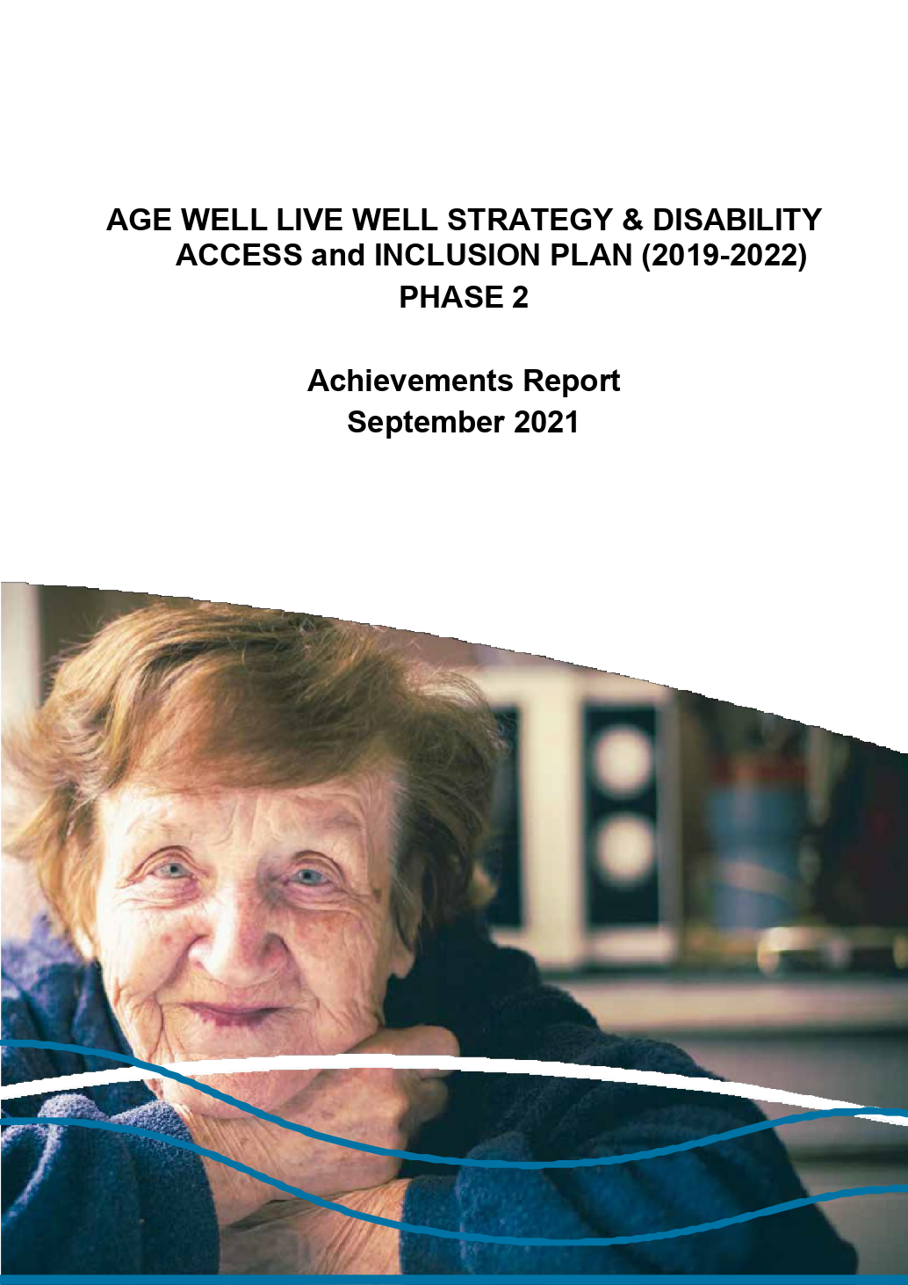

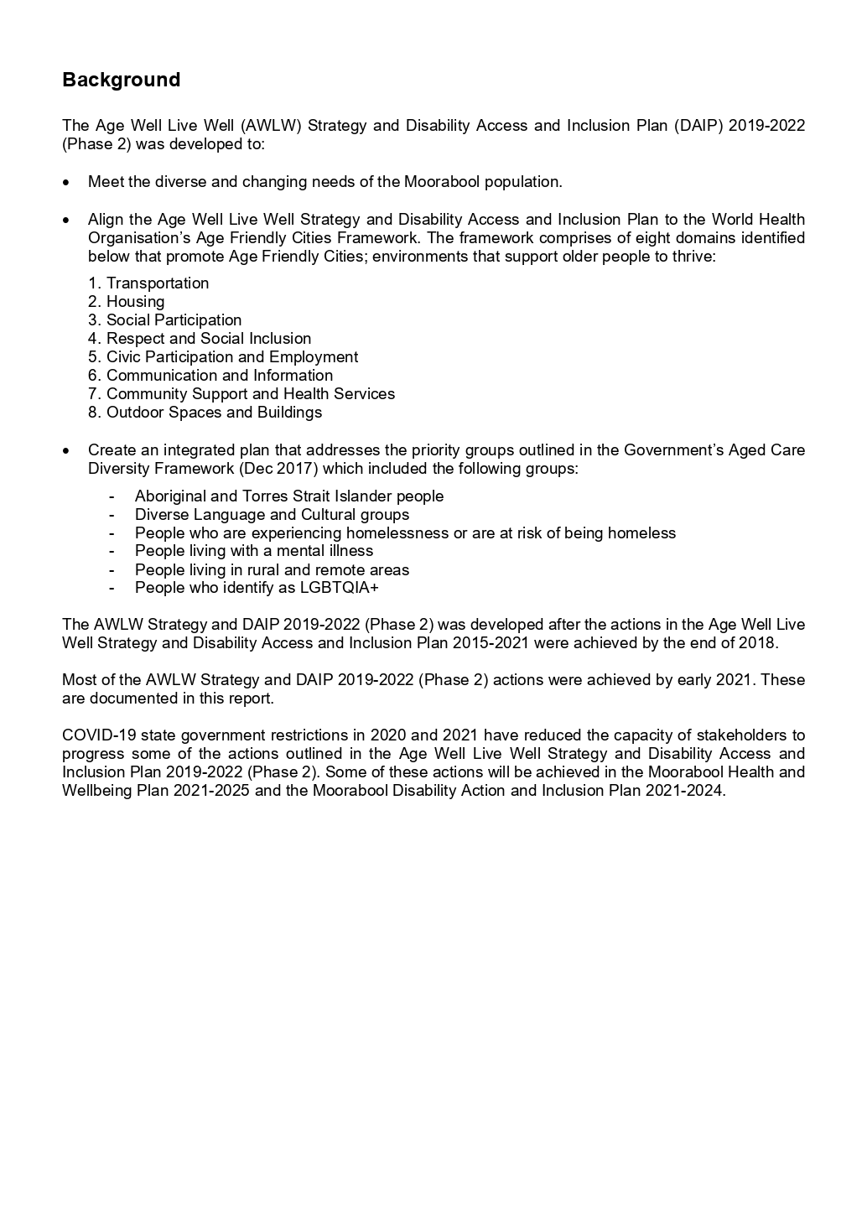
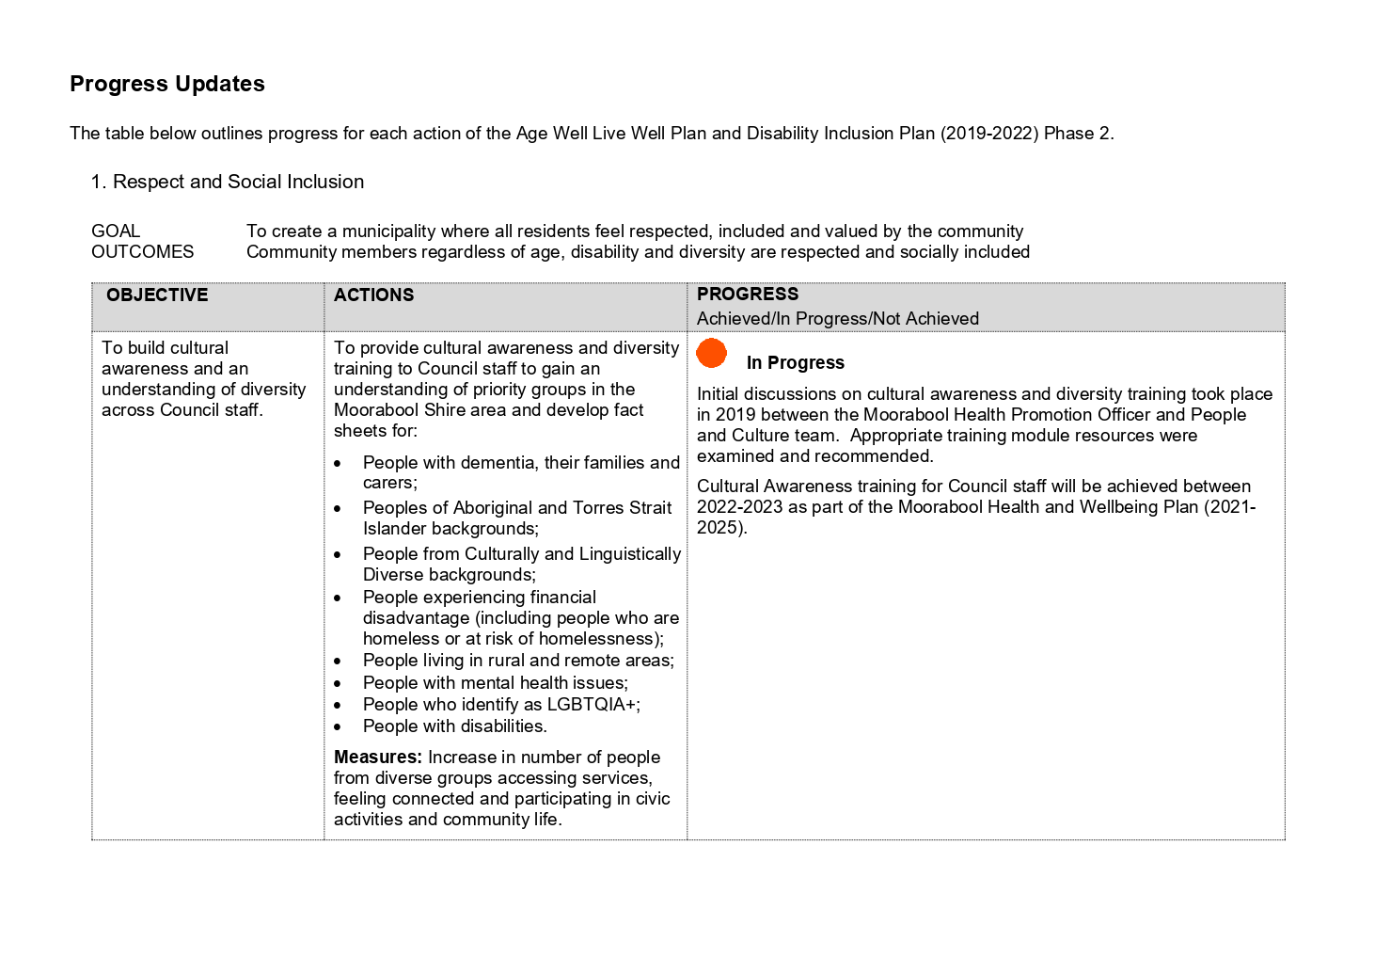

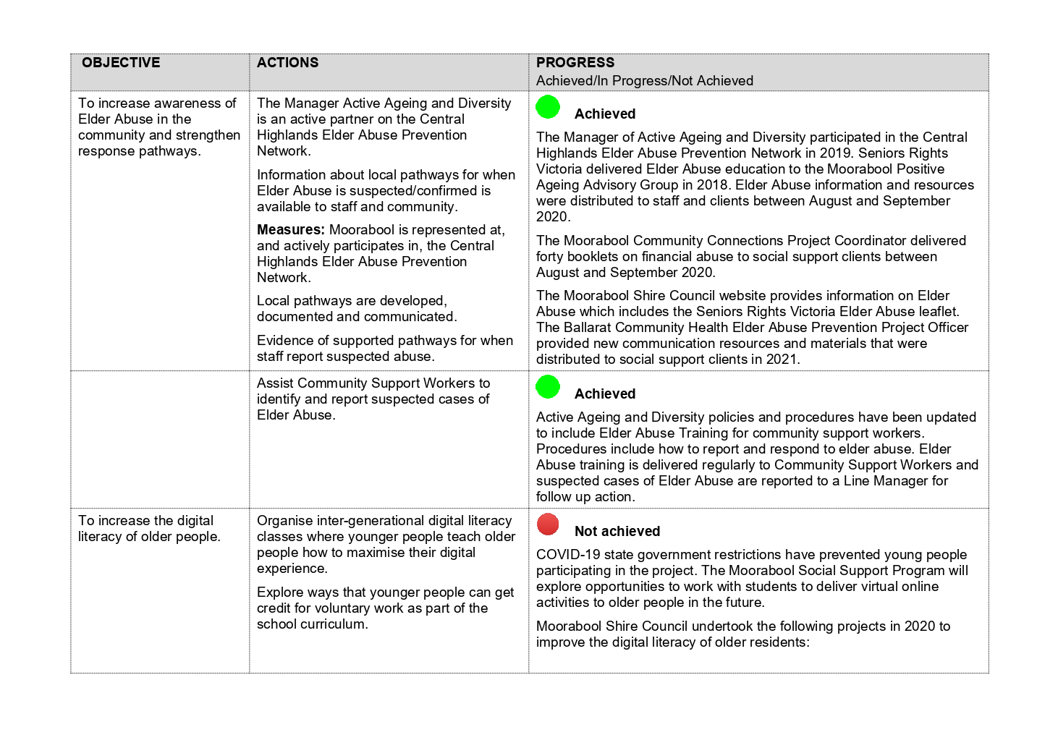

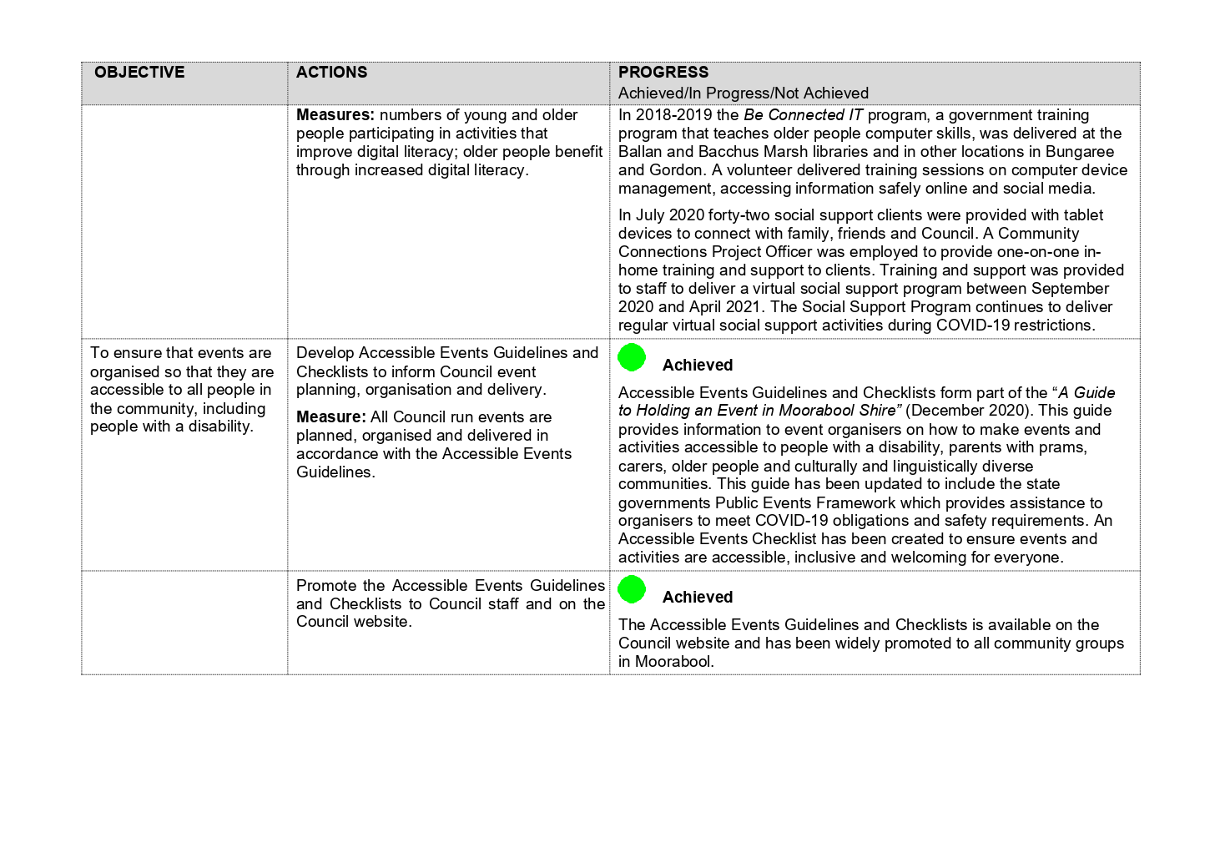

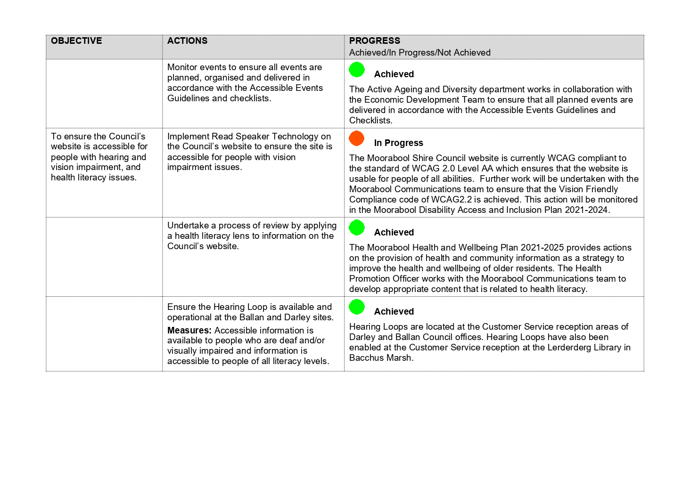

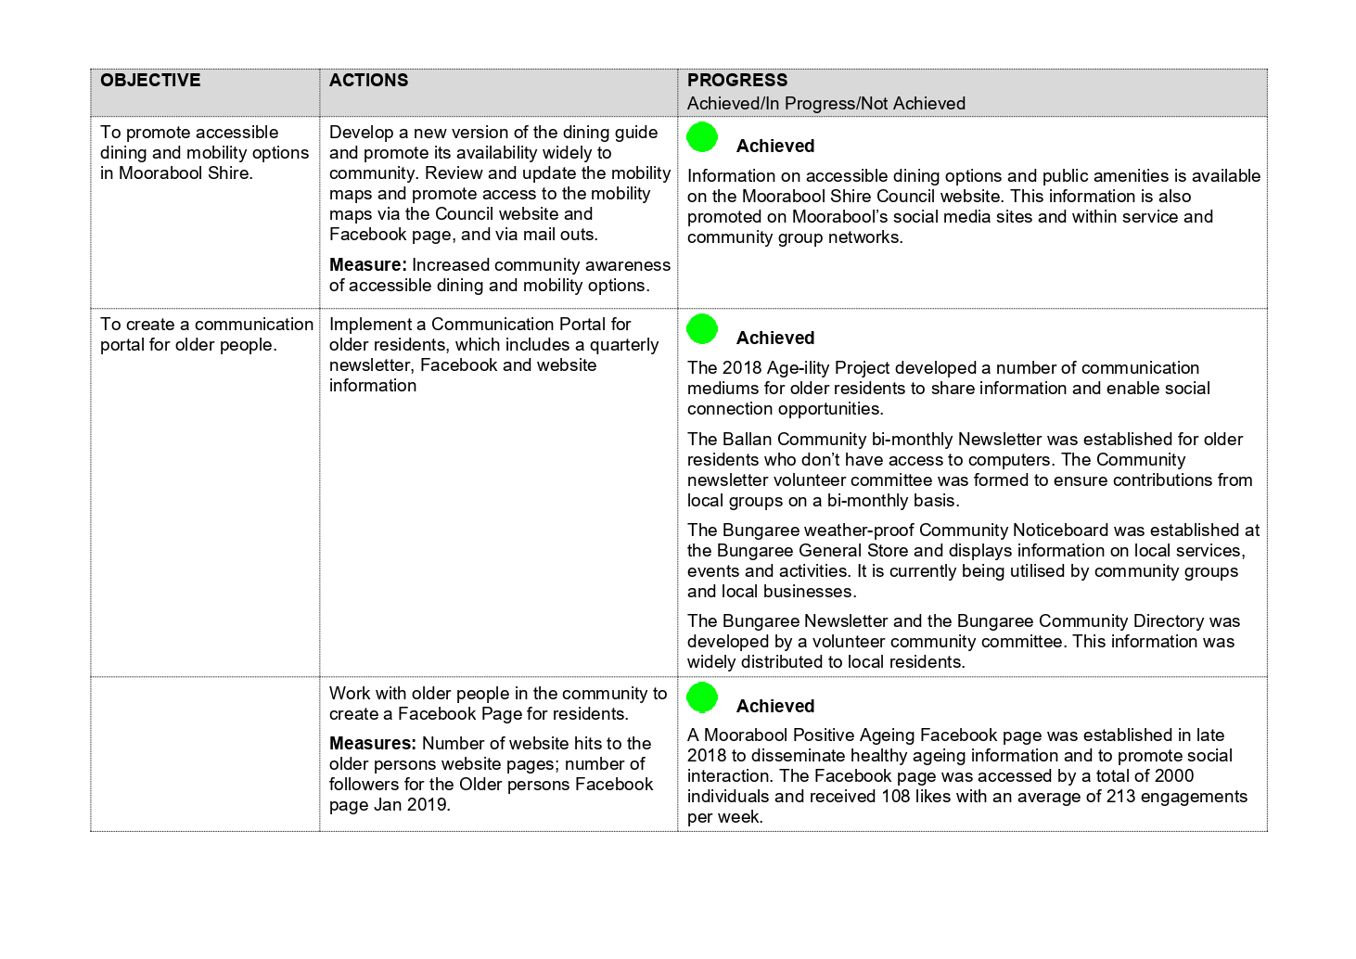

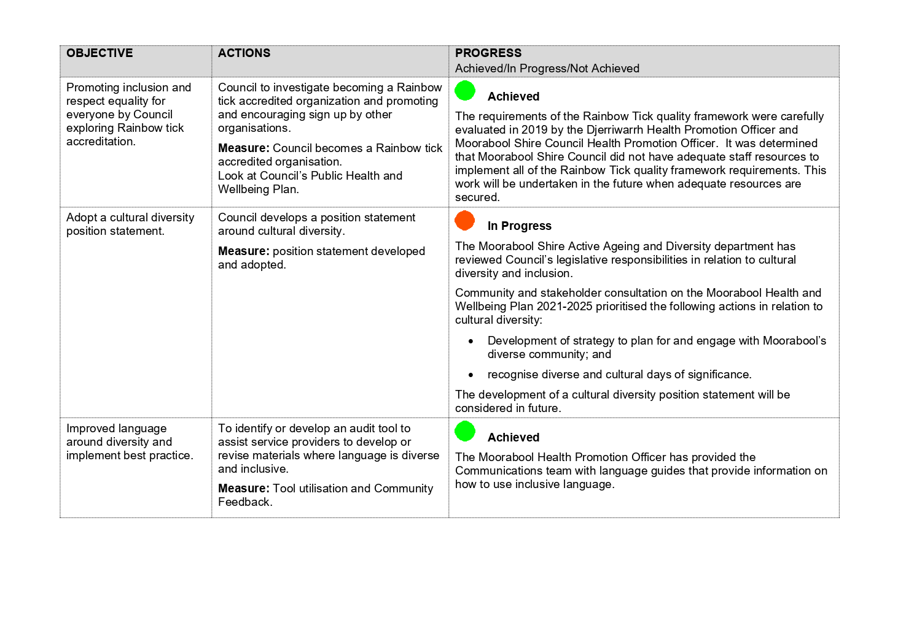

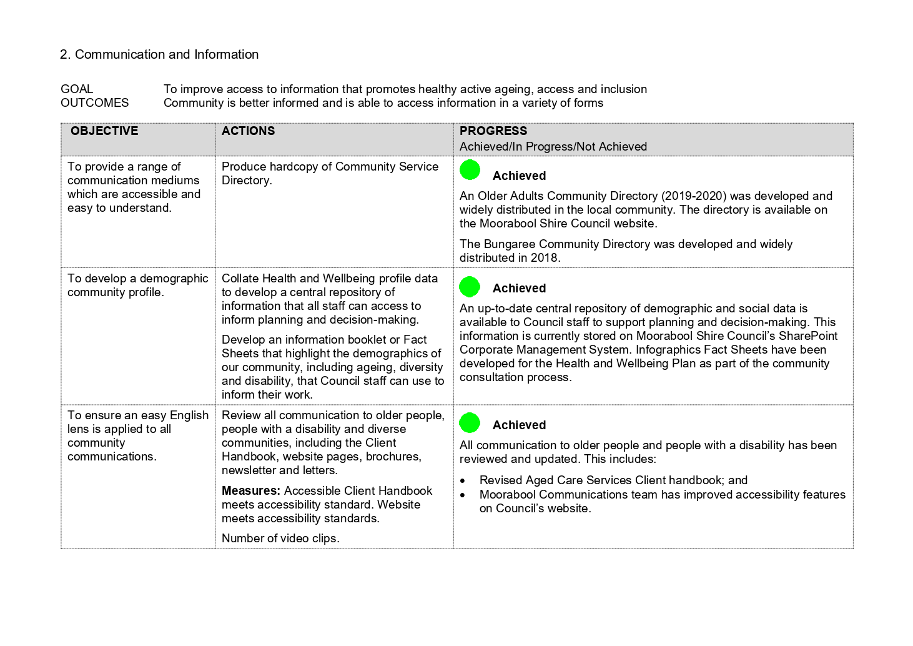

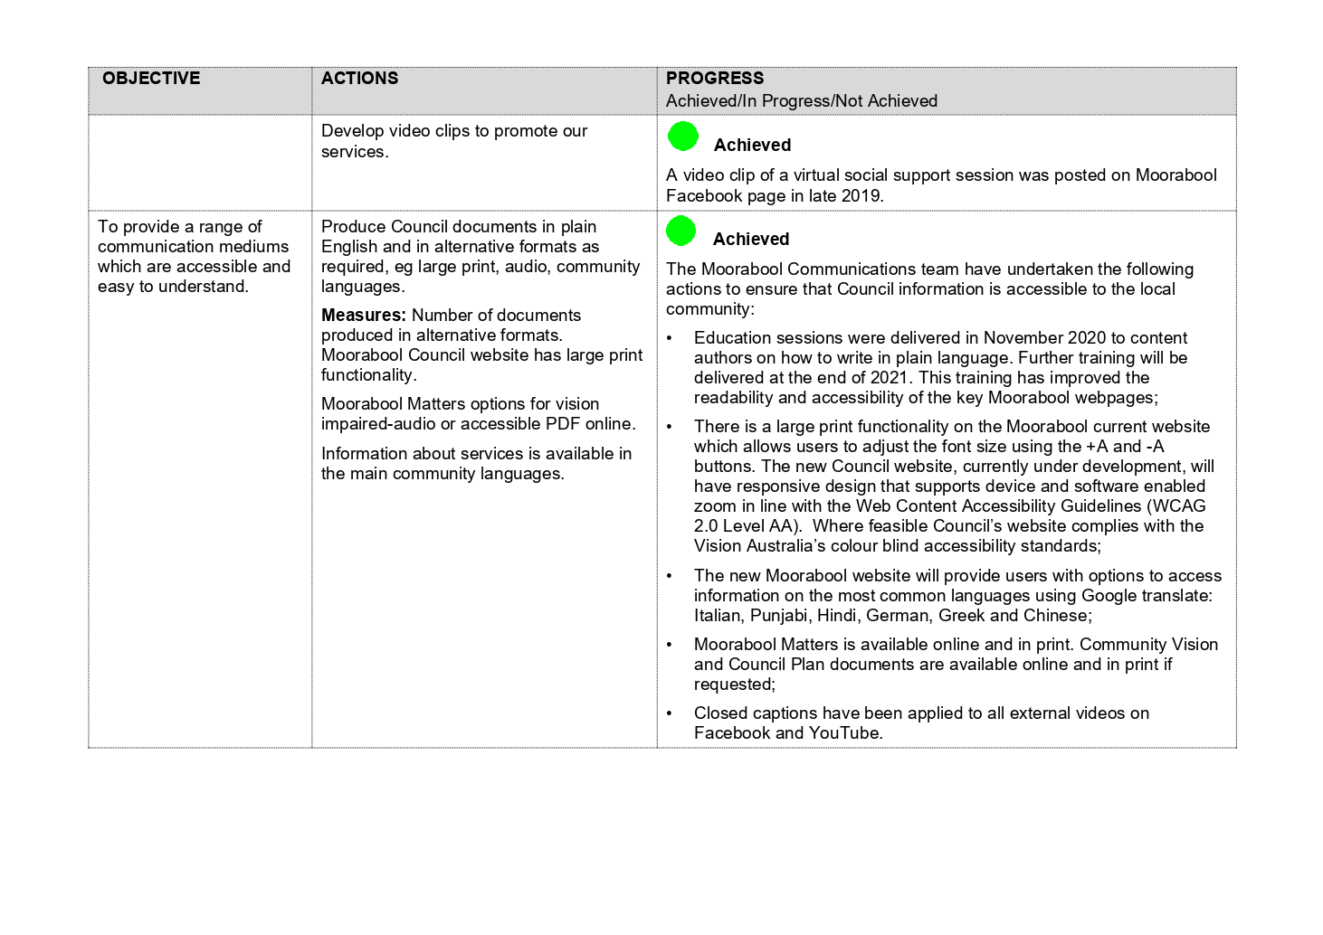

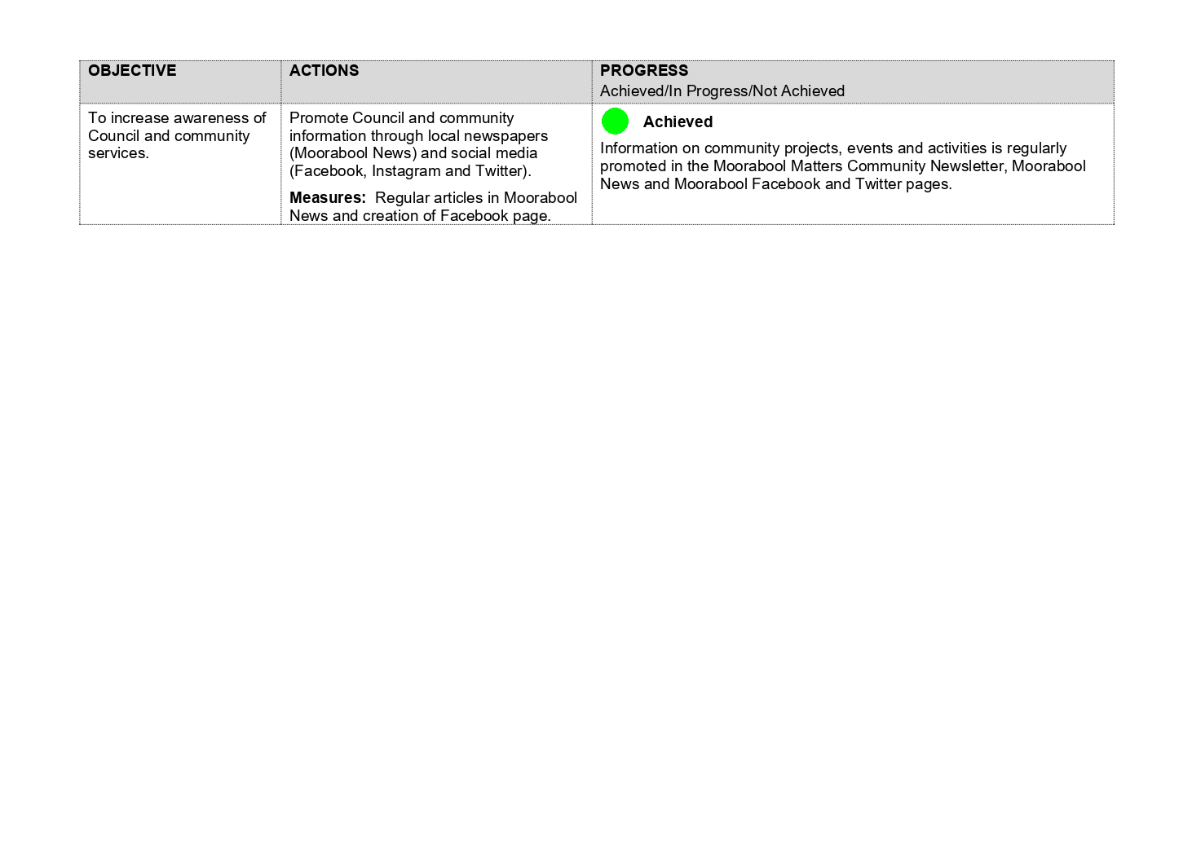
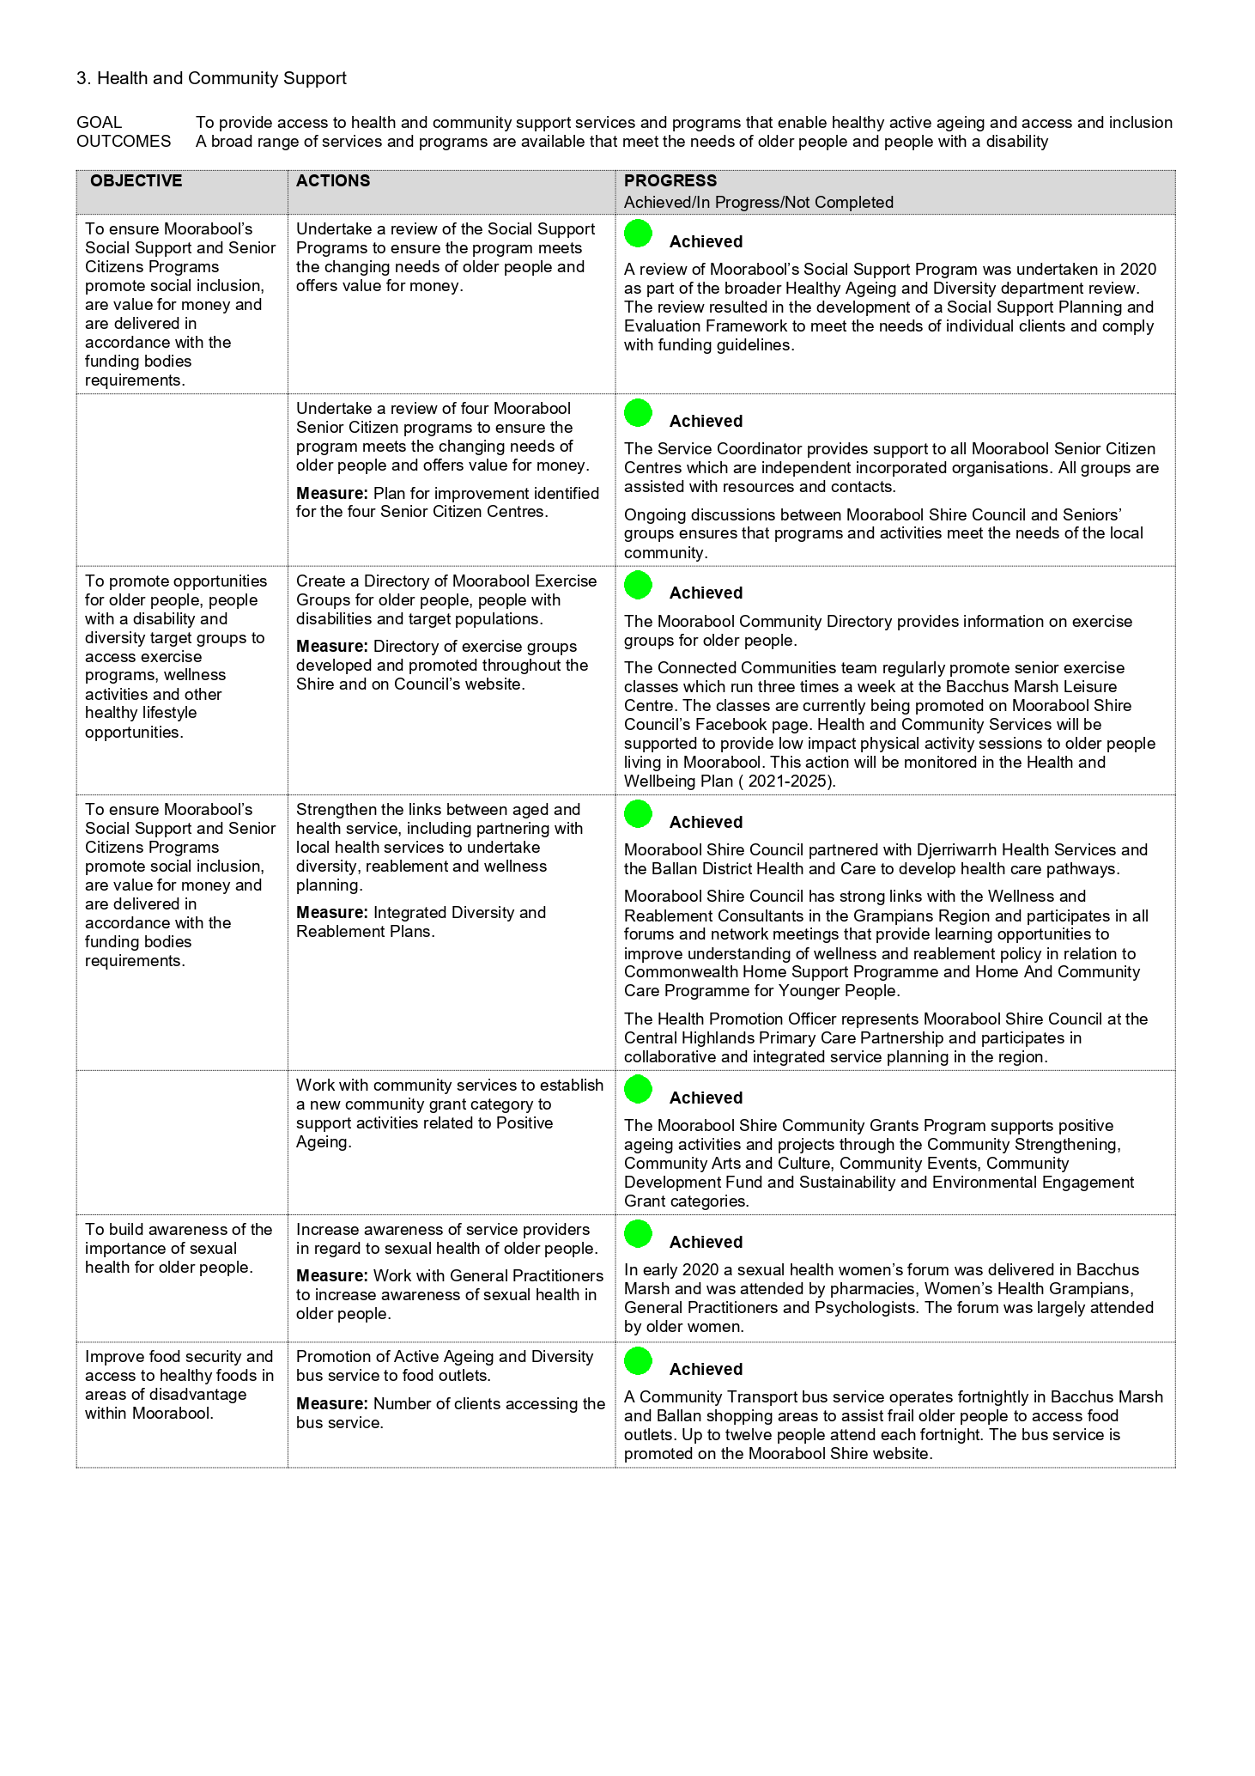

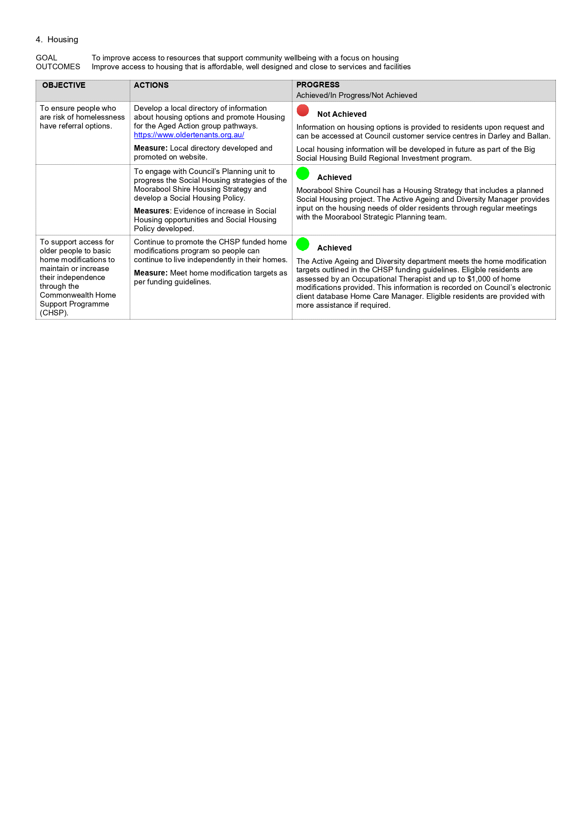

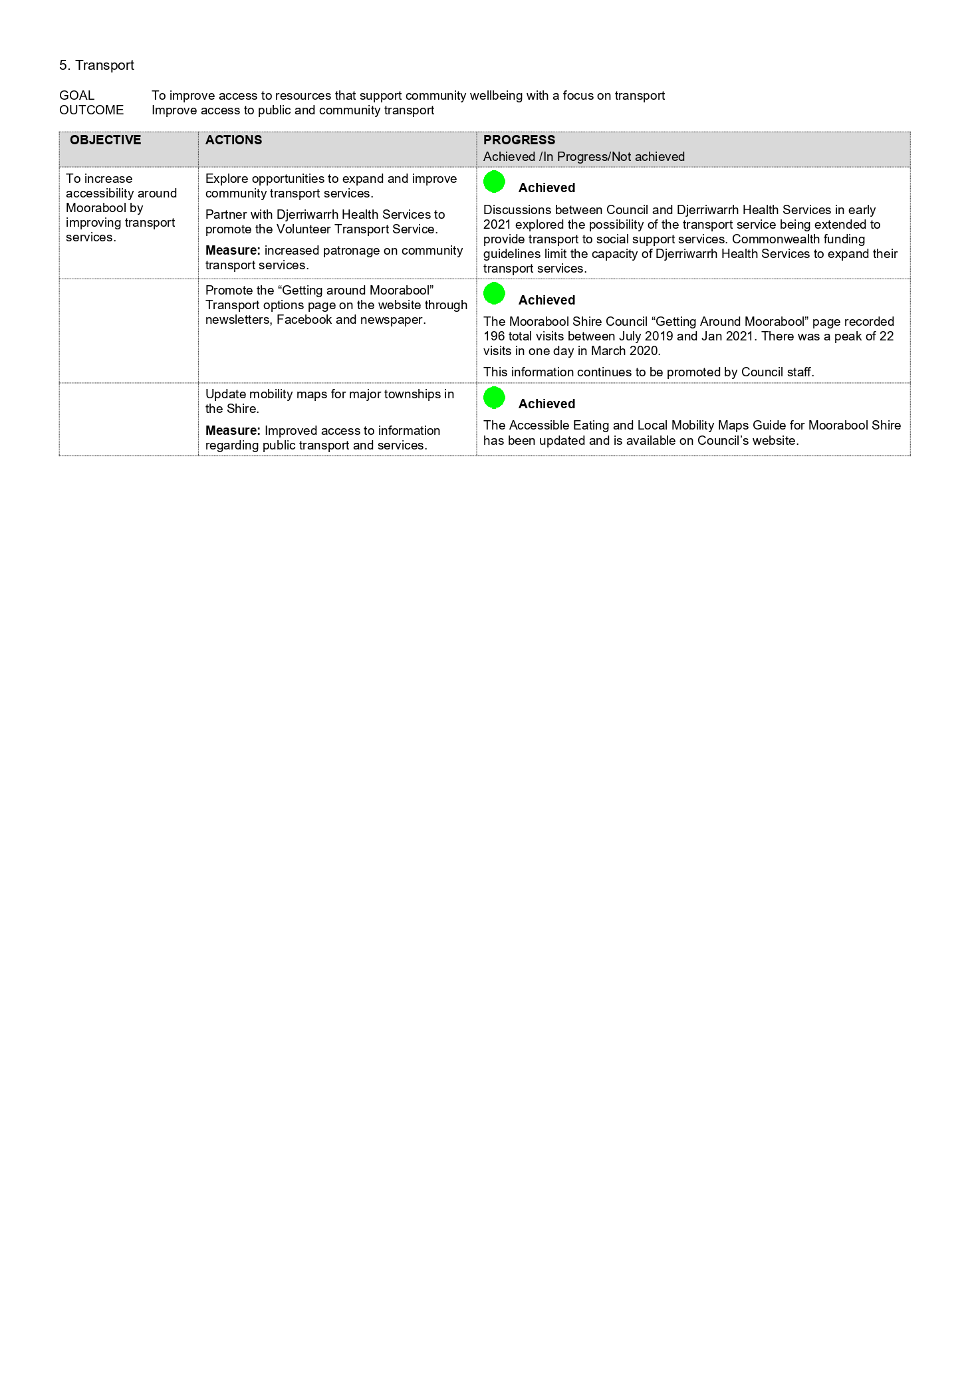

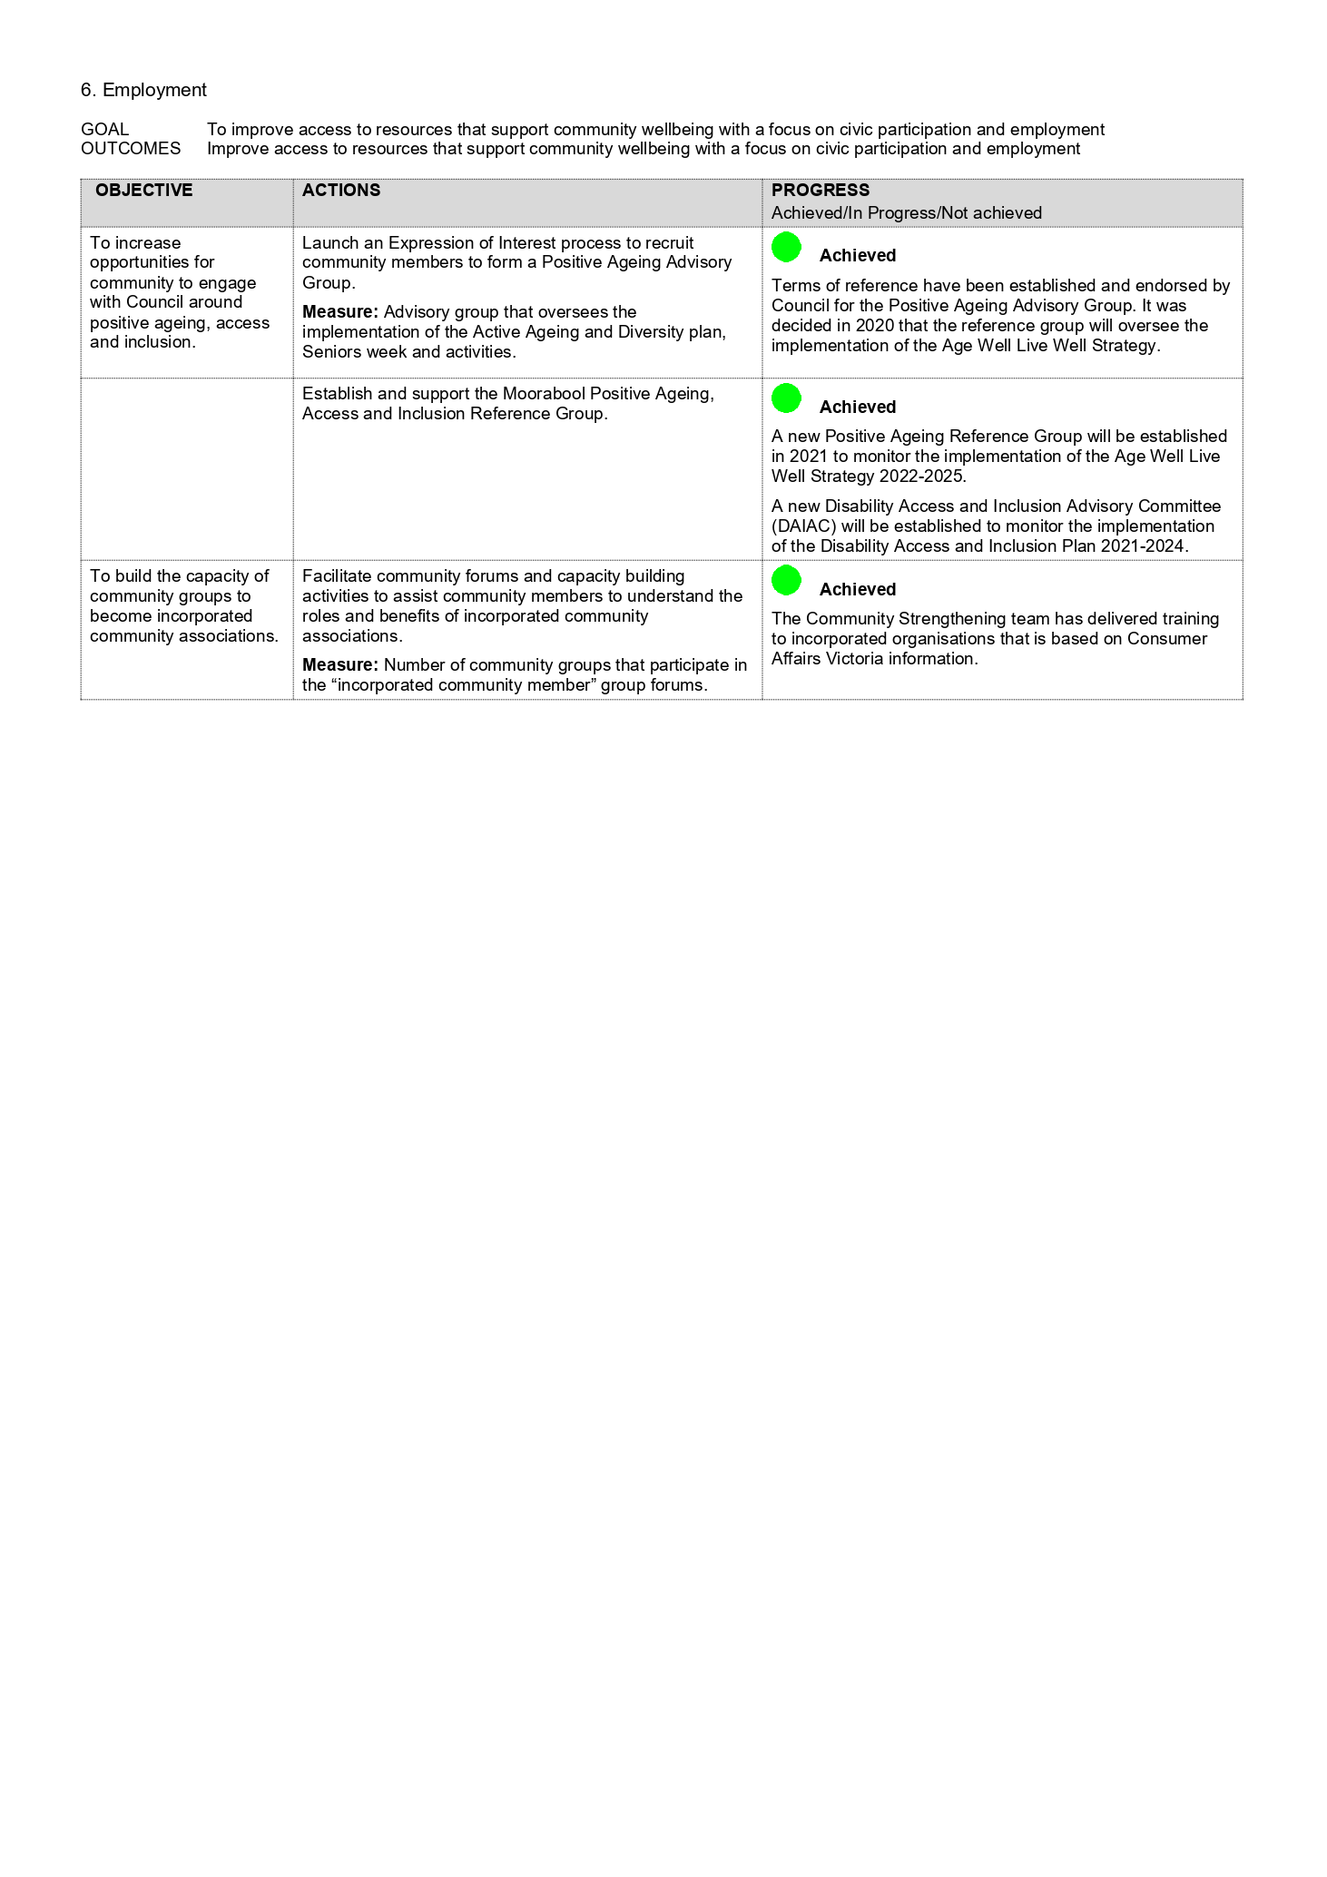

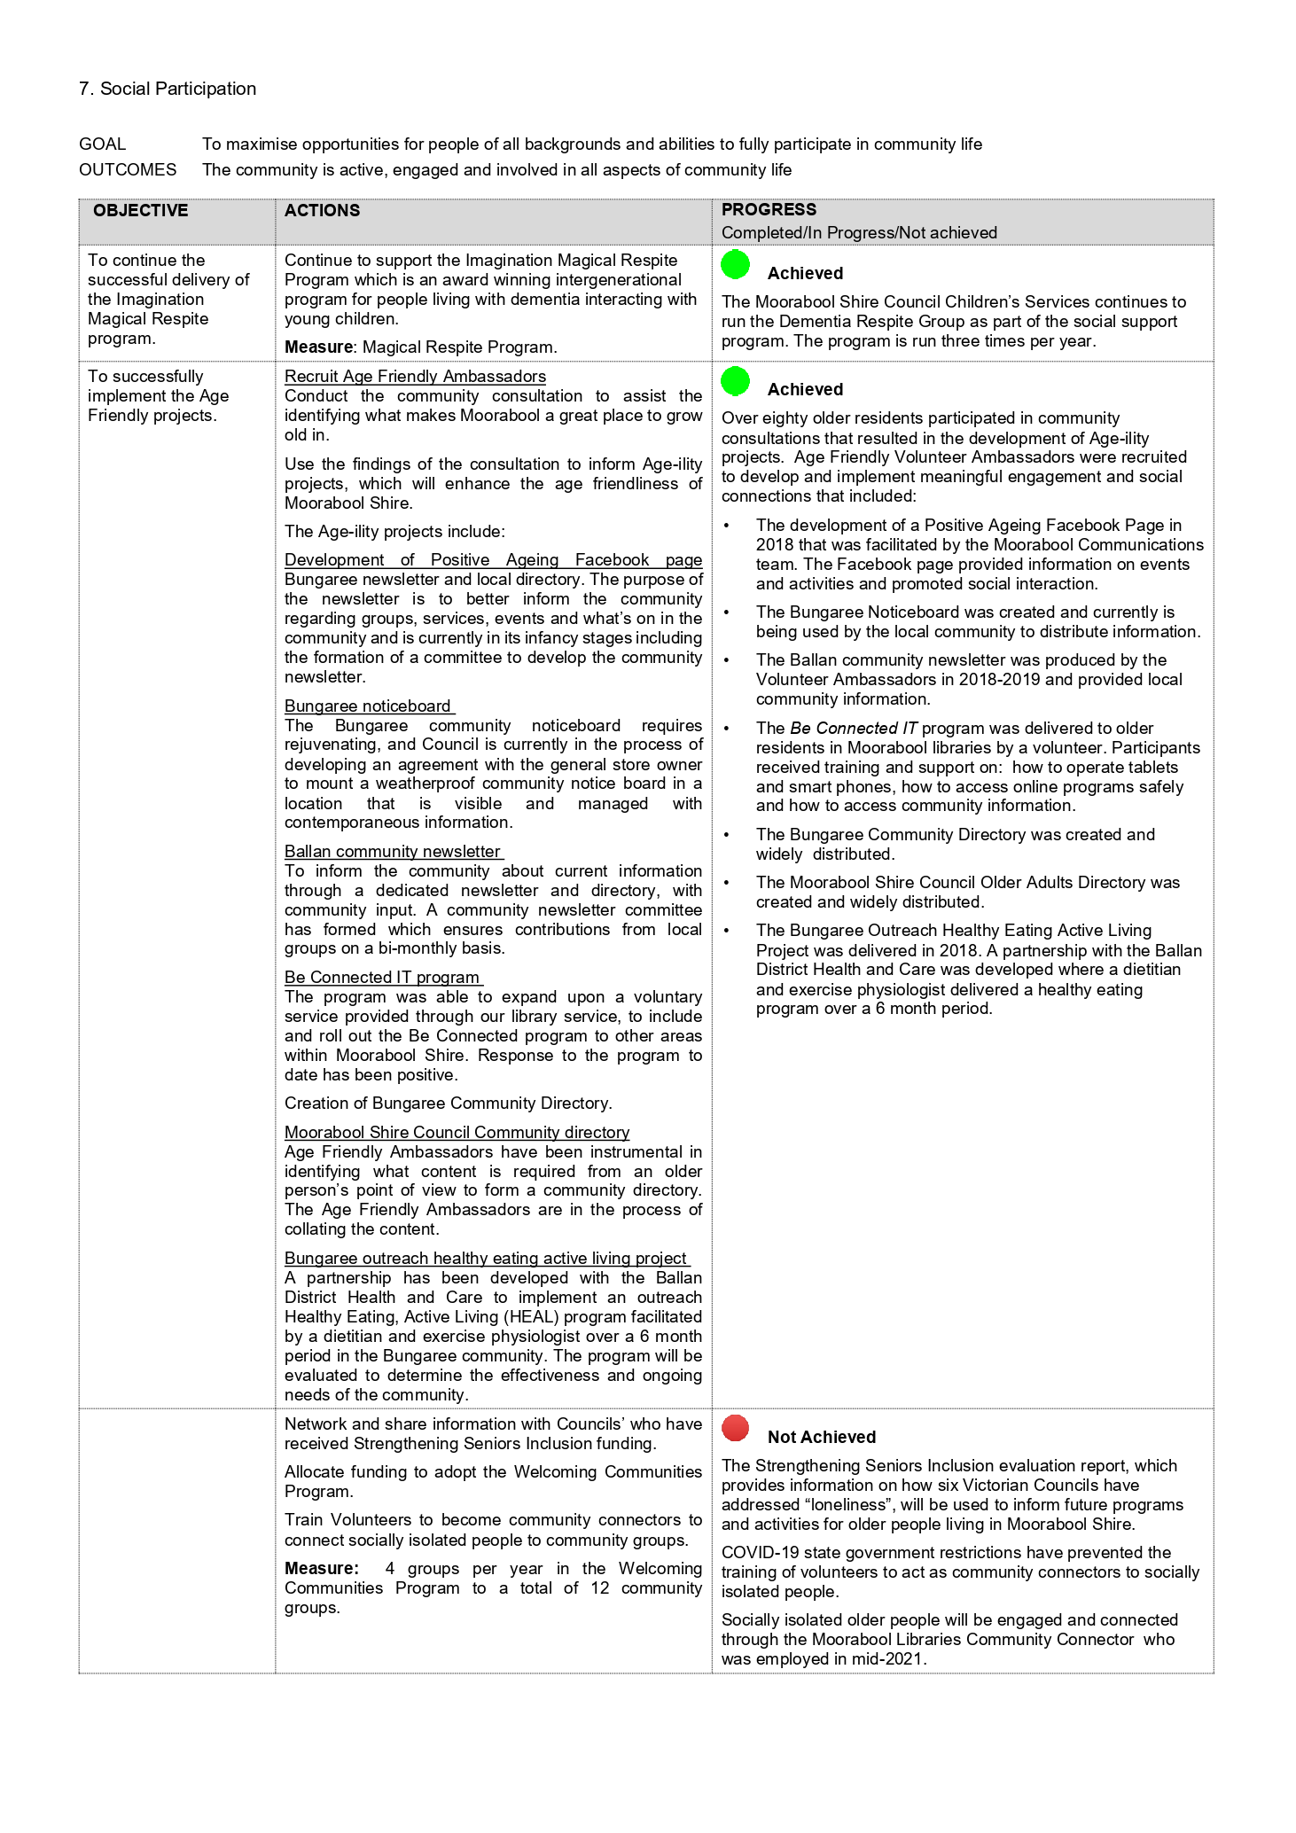

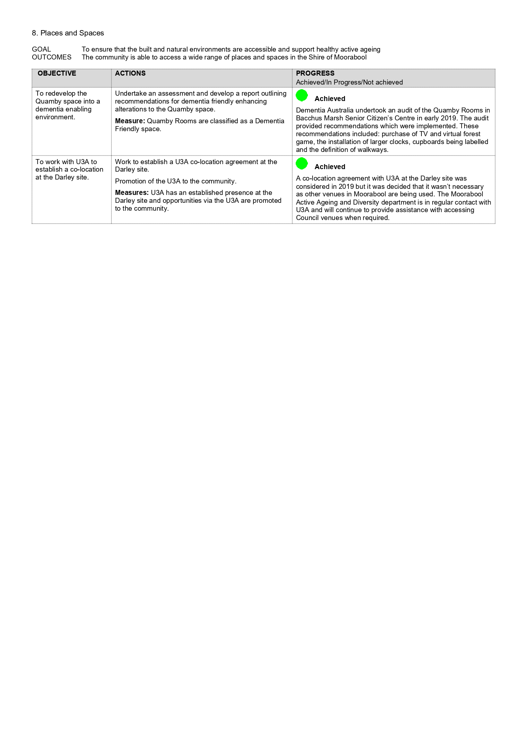

Policy Type: | COUNCIL
Version: | Add in the Version Number e.g. 1.0, 2.0 etc.
Date Adopted:
Service Unit | Revenue Services and Procurement
Directorate: | Customer Care and Advocacy
Review Date: | 4 years from adoption

Purpose | The purpose of this Policy is to:  • Provide a policy framework and guidance to Council to allow consistent application of Procurement activities in a controlled environment;  • To develop sound and ethical procurement practices and systems;  • To manage risk associated with each stage of the procurement process;  • Demonstrate transparency and accountability to ratepayers; and  • Demonstrate the application of elements of best practice procurement.  This policy should support Council in all Procurement activities by ensuring:  • The framework aligns with corporate strategies, aims and objectives including, but not limited to those related to sustainability, protection of the environment, and corporate social responsibility;  • Procurement activities span the whole life cycle of an acquisition from initial concept to the end of the useful life of an asset, including its disposal, or the end of a service contract;  • A robust and transparent audit trail which ensures that procurement projects are delivered on time, within cost constraints and that the needs of end users are fully met;  • Risks are identified throughout the sourcing, transition, delivery and finalisation stages of procurement and ensure appropriate risk avoidance and mitigation strategies are applied whenever practicable and appropriate;  • Council achieve value for money and quality in the acquisition of goods, services and works by Council;  • Council can demonstrate that public money has been well spent;  • Procurement is conducted in an impartial, fair and ethical manner;  • Council seeks continual improvement including the embracement of innovative and technological initiatives such as electronic tendering processes to reduce activity cost;  • Council supports business in the local community; and  • Council complies with legislation, corporate policies or other requirements, ensuring that all staff responsible for procurement and contract management are aware of and adhere to the legislative requirements, Council standards and best practice.
Council Plan | Objective: A Council that listens and adapts to the needs of our evolving communities  Context: Measure performance, communicate our results and continue to improve our services every day
Definitions | Australian Business Number (ABN) | A unique 11 digit identifier for businesses. An enterprise must have an ABN to register for GST
 | Act | Local Government Act 2020
 | Commercial in Confidence | Information that, if released, may prejudice the business dealings or commercial interests of Council or another party e.g. prices, discounts, rebates, profits, methodologies and process information, etc
 | Contract Management | The process that ensures both parties to a contract that fully meet their respective obligations as efficiently and effectively as possible, in order to deliver the business and operational objectives required from the contract and in particular, to provide value for money
 | Council Staff/Officer | Includes full-time and part-time Council officers, and temporary employees, agency staff, contractors and consultants while engaged by Council
 | Cumulative Spend | The spend with a supplier for like type goods, services or works over a rolling period of three years.
 | Expression of Interest (EOI) | A probing procurement process which seeks to understand opportunities to undertake required service or project
 | Financial Delegation | The authority to purchase goods and services on behalf of Council
 | Goods and Services Tax (GST) | A 10% consumption tax on most goods and services. An enterprise must have an ABN and be registered for GST before GST can be applied.  All monetary values stated in this policy include GST, except where specifically stated otherwise.
 | Local Content | Includes the purchases of works, goods and/or services and/or labour from a business that is based within the boundaries of MSC
 | Local Supplier | A supplier whose registered business is within the boundaries of MSC. For large organisations, this definition of local supplier is limited to the section or unit of the organisation that is submitting the tender
 | MSC | Moorabool Shire Council
 | Panel of Suppliers | A contract that appoints multiple suppliers to facilitate the needs of Council operations that have been validated as an approved provider via the public tender process
 | Probity | The dictionary definition of probity refers to uprightness, honesty, proper and ethical conduct and propriety in dealings. Within government, the word "probity" is often used in a general sense to mean "good process." A Procurement process that conforms to the expected standards of probity is one in which clear procedures that are consistent with Council’s policies and legislation are established, understood and followed from the outset. These procedures need to consider the legitimate interests of suppliers and ensure that all potential suppliers are treated equitably
 | Procurement | Procurement is the whole process of acquisition of external goods, services and works. This process spans the whole life cycle from initial concept through to the end of the useful life of an asset (including disposal) or the end of a service contract
 | Quotation | A written and/or verbal offer to Council to carry out works, provide services or supply goods at a stated price
 | Standing Offer Arrangements (SOA) | A contract that sets out rates for goods and services which are available for the term of the agreement. However, no commitment is made under the agreement to purchase a specified value or quantity of goods or services
 | Sustainability | Activities that meet the needs of the present without compromising the ability of future generations to meet their needs
 | Tender Process | The process of inviting parties from either a select list or via public advertisement to submit an offer by tender, followed by evaluation of submissions and selection of a successful bidder or tenderer in accordance with pre-determined evaluation criteria
 | Value for Money | Value for Money in Procurement is about selecting the supply of goods, services and works taking into account both cost and non-cost factors including:  • contribution to the advancement of Council’s priorities;  • non-cost factors such as fitness for purpose, quality, service and support; and  • cost related factors including whole-of-life costs and transaction costs associated with acquiring, using, holding, maintaining and disposing of the goods, services or works
 | Variation | Means any change to the contract or agreed to by the Superintendent and contractor resulting from a direction to undertake Goods, Services or Works that differ from those in the contract
Scope | This procurement Policy is made under Section 108 of the Local Government Act 2020 (Act).  This section of the Act requires Council to prepare and adopt a Procurement Policy which specifies the principles, process and procedure for applying in respect of the purchase of goods and services by Council (including the carrying out of works), which includes the following provisions:  • Seeks to promote open and fair competition and provide value for money;  • The contract value above which the Council will invite a tender or seek an expression of interest;  • A description of the criteria to be used by the Council to evaluate whether a proposed contract provides value for money;  • A description of how the Council will seek collaboration with other councils and public bodies in the procurement of goods or services;  • The conditions under which Council may purchase goods or services without inviting a public tender or expression of interest;  • A description of the process to be undertaken in inviting a public tender or expression of interest.  Council must review its Procurement Policy at least once during each 4 year term of the Council.  This policy should be read in conjunction with Council’s “Staff Code of Conduct” and applies to all contracting and procurement activities at Council and is binding upon Councillors, Council staff and temporary employees, agency staff, contractors and consultants while engaged by the Council.  Any breach of this policy will be addressed in accordance with the “Counselling and Disciplinary Action Policy”.
Values and Principles | Ethics and Probity | Council’s procurement activities will be performed with integrity and in a manner able to withstand the closest possible audit scrutiny.  Councillors and Council staff shall at all times conduct themselves in ways that are, and are seen to be, ethical and of the highest integrity and will:  • treat potential and existing suppliers with equality and fairness;  • not seek or receive personal gain;  • maintain confidentiality of Commercial in Confidence information such as contract prices and other sensitive information;  • present the highest standards of professionalism and probity;  • deal with suppliers in an honest and impartial manner that does not allow conflicts of interest;  • provide all suppliers and tenderers with the same information and equal opportunity; and  • be able to account for all decisions and provide feedback on them.  Council staff who are responsible for managing or supervising contracts are prohibited from performing any works under the contract they are supervising
 | Fair and Honest Dealing | All prospective contractors and suppliers must be afforded an equal opportunity to tender or quote.  Impartiality must be maintained throughout the procurement process so it can withstand public scrutiny.  The commercial interests of existing and potential suppliers must be protected.  Confidentiality of information provided by existing and prospective suppliers must be maintained at all times, particularly commercially sensitive material such as, but not limited to prices, discounts, rebates, profit, manufacturing and product information.
 | Accountability and Transparency | Accountability in procurement means being able to explain and provide evidence on the process followed. The test of accountability is that an independent third party must be able to see clearly that a process has been followed and that the process is fair and reasonable.  Therefore, the processes by which all procurement activities are conducted will be in accordance with Council’s procurement policies and procedures as set out in this policy and other related, relevant Council policies and procedures.  Additionally:  • all Council staff must be able to account for all procurement decisions made over the lifecycle of all goods, services and works purchased by Council and provide feedback on them; and  • all procurement activities are to provide for an audit trail for monitoring and reporting purposes
 | Disclosure of Information | Commercial in Confidence information received by Council must not be disclosed and is to be stored in a secure location.  Councillors and Council officers are to protect, by refusing to release or discuss the following:  • Allocated Council budgets for proposed tenders that have not otherwise been disclosed in the adopted annual Council budget;  • information disclosed by organisations in tenders, quotation or during tender negotiations;  • all information that is Commercial in Confidence information; and  • pre contract information including but not limited to information provided in quotes and tenders or subsequently provided in pre-contract negotiations.  Councillors and Council officers are to avoid references to current or proposed contracts in discussion with acquaintances or outside interests.  Discussion with potential suppliers during tender evaluations should not go beyond the extent necessary to resolve doubt on what is being offered by that supplier.  At no stage should any discussion be entered into which could have potential contractual implications prior to the contract approval process being finalised other than authorised pre contract negotiations.
 | Responsible Financial Management | The principle of responsible financial management shall be applied to all procurement activities.  Accordingly, to give effect to this principle, the availability of existing funds within an approved budget, or external source of funds, shall be established prior to the commencement of any procurement action for the supply of goods, services or works.  Council officers must not authorise the expenditure of funds in excess of their financial delegations.  Council funds must be used efficiently and effectively to procure goods, services and works and every attempt must be made to contain the costs of the procurement process without compromising any of the procurement principles set out in this Policy.  All Council Officers have a responsibility to ensure that this Procurement Policy and associated procedures are adhered to.
 | Continuous Improvement | Council has established ongoing procurement internal audits which are regularly reported to the Executive Group which have a focus on the education of staff and ongoing improvement to daily procurement activities. These audits ensure compliance with various components of the Procurement Policy and relevant provisions of associated legislative requirements. Periodic reporting of procurement audit outcomes will be provided to Council’s Audit and Risk Committee and Council.
 | Sustainable Procurement | Sustainable procurement involves decision making that has the most positive environmental, social and economic impacts possible across the entire lifecycle of goods, services and works.
Operational Requirements | Conflict of Interest  Councillors and Council staff shall at all times avoid situations in which private interest’s conflict, or might reasonably be thought to conflict, or have the potential to conflict, with their Council duties.  The Act defines and provides definitions of Conflict of Interest (Section 126) and then further expands between General Conflict of Interest (Section 127) and Material Conflicts of Interest (Section 128) and then further defines Exemptions (Section 129) and goes on to define the requirement to Disclose a Conflict of Interest (Section 130).  Councillors and Council staff shall not participate in any action or matter associated with the arrangement of a contract (i.e. specification development, evaluation, negotiation, recommendation, or approval), where that person or any member of their immediate family has a significant interest, or holds a position of influence or power in a business undertaking tendering for the work.  The onus is on the Councillor and the Council Officer involved being alert to and promptly declaring any actual or potential conflict of interest to Council in accordance with the legislative provisions.  Where a conflict is identified (General or Material), the Conflict of Interest declaration form from Council’s Document Hub must be completed and submitted to Council’s Governance and Procurement Teams and will be held on a central register.  Achieving Value for Money  Requirement Approach  Council’s procurement activities will be carried out on the basis of obtaining Value for Money. This means minimising the total cost of ownership over the lifetime of the requirement consistent with acceptable quality, reliability, accessibility and delivery considerations. Lowest price is not the sole determinate of value for money, and Council is not required to accept the lowest tender. Achieving best value also requires challenging the need for the procurement and the way in which the service may be reconfigured to achieve improvements in service delivery, comparing service provision options against all those available, consulting with key stakeholders and ensuring competition in the open market. Achieving best value for money must be the basis of all procurement decisions within Council. This will be facilitated by: • developing, implementing and managing procurement approaches that support the co-ordination and streamlining of activities throughout the lifecycle; • effective use of competition; • considering collaborative opportunities and using aggregated contracts and SOAs where appropriate; • identifying and rectifying inefficiencies in procurement processes; • developing cost efficient tender processes including appropriate use of e-solutions; • Council staff responsible for providing procurement services or assistance within Council providing competent advice in terms of available approaches and agreements; and • working with suppliers to create relationships that are professional and productive, and are appropriate to the value and importance of the goods, services and works being acquired.  Internal Controls  Council have a framework of internal controls over procurement processes that ensure:  • more than one person is involved in and responsible for a transaction end to end;  • transparency in the procurement process;  • a clearly documented audit trail exists for procurement activities;  • appropriate authorisations are obtained and documented; and  • systems are in place for appropriate monitoring and performance measurement.  Purchase Orders  Purchase orders (electronic) must be raised prior to delivery of goods or services or commencement of works. A copy of the purchase order must be provided to the supplier and the purchase order number has to be quoted on their invoice. This ensures that invoices received by Accounts Payable are easily identified and directed to the appropriate authorising Council Officer and approved for payment in a timely manner.  Further details regarding the exemptions and authorisations required for purchase orders is contained within Council’s Accounts Payable Policy and Procedure.  Collaborative Procurement  Council officers will seek to use collaborative procurement opportunities when procuring goods, services and works in order to take advantage of economies of scale in accordance with Act Section 108(3)(c) by considering aggregated purchasing arrangements with:  • other Councils and/or Agencies;  • Municipal Association Victoria Procurement (MAV);  • Procurement Australia (PA – formerly known as MAPS Group and Strategic Purchasing); or  • Victorian State Purchasing Board (whole of Government Contracts).  When a report for a procurement is presented to Council for approval, it will include information relating to any collaborative arrangement opportunities that were explored as part of the procurement process.  Exemptions and Exceptions from Market Engagement  It is recognised and understood that in some circumstances quotations and public tender processes will be impractical to seek, obtain and undertake. Some of these circumstances include:  • Utilities Infrastructure (Power Network providers, Water Authorities, etc);  • Other Government Entities or third parties;  • Extension of contracts while Council is at market;  • Operating Leases;  • Emergency works and circumstances;  • Existing IT hardware and software (Annual Support Fees, development, upgrade);  • Exempt payments and professional services unsuitable for tendering (statutory insurance premiums (inc workcover, stamp duty, etc), legal services, Councillor Allowance, Community Grants, Trust,etc);  • Statutory and Operational Compliance (MAV, DELWP, Vehicle Registration, Postage, Payroll, Levies (FSPL));  • Plant and Equipment Servicing and Spare Parts (To maintain warranty, genuine parts/service by recognised manufacturers required);  • Critical/Essential service coverage (Eg: roadside waste)  • Developer procured infrastructure works that includes a council contribution for the upgrade or renewal of a council asset;  • Other extraordinary circumstances as approved by CEO.  Exemptions outside those listed above, the employee responsible must obtain approval from the relevant General Manager or Executive Manager in the form of the attached application form which outlines why the officer is seeking requirement to not obtain quotes. This process must have the relevant General Manager’s or Executive Manager’s approval before the procurement for service/goods is acquired. This clause doesn't apply to the requirement to tender in accordance with the tender thresholds outlined within this Policy. The Exemption approval form must be signed in accordance with that Manager’s financial delegation.  Software  If new software is being considered as part of any procurement process, the MSC vendor security assessment process must be followed including the completion of an information security assessment. In addition, any systems being implemented must consider:  • SSO - Single Sign On;  • SaaS – Software as a Service (not on premise);  • Victorian Protective Data Security Framework (VPDSF); and  • Australian Standard ISO 27001 – Information Security Management.  Cumulative Spend  Officers should take procurement thresholds into consideration where significant sums are spent in aggregate with one supplier or on one service, it is necessary to structure procurement proposals in order to achieve greatest value and supplier performance by leveraging cumulative spend, rather than treating each discrete arrangement as a separate procurement process. Council has determined that the cumulative expenditure to a supplier or for a specific good/service for a period up to three years is to be considered.  Support of Local Business  Council is committed to generating, supporting and buying:  • from local suppliers;  • from businesses outside the boundaries of MSC, who purchase goods and/or services from local suppliers and/or who use local labour;  • has a preference for Australian made products and goods.  Support to Local Business and Australian made products and goods will be achieved through local price preferencing of 5% to obviate additional fees and charges (E.g.: cartage, transport, postage and handling). Every reasonable effort will be given to seek local quotations and to ensure that local suppliers are aware of current and upcoming tenders.  In addition to the price preferencing, responsible officers may apply a scored evaluation criteria to recognize suppliers who are local, utilizing local product/service or employing locals through detail submitted on a Local Content Response schedule.  Contract Management  • Successful tenderers name and contract value will be posted on Council’s web page after each Council meeting unless Council believes that this will pose a breach of commercial in confidence  • Where a panel of contractors are appointed Council will utilise appointed Suppliers for the purpose in which the panel was established but reserves the right to seek quotes for more significant project work outside of the panel  • Contract Managers will regularly monitor the spend with each supplier to ensure balanced allocation of work  Payment Terms  Council’s standard payment terms are 28 days from the date of the invoice and 14 days for local suppliers. Council’s payment terms override supplier’s terms and the supplier should be informed of this at the time of engagement. Alternative arrangements may be made within contract documents.  Council’s preferred method of payment is Electronic Funds Transfer.  Delegation of Authority  Delegations define the limitations within which Council Officers are permitted to function. Delegation of procurement authority allows specified Council Officers to approve certain purchases, quotation, tender and contractual processes without prior referral to Council. This enables the Council to conduct procurement activities in an efficient and timely manner whilst maintaining transparency and integrity.  Procurement delegations ensure accountability and provide confidence to Council and the public that procurement activities are dealt with at the appropriate level.  As such, Council has delegated responsibilities as detailed below relating to the expenditure of funds for the purchase of goods, services and works, the acceptance of quotes and tenders and for Contract Management activities.  Officers Council  Council shall maintain a documented scheme of procurement delegations, identifying Council Officers authorised to make such procurement commitments in respect of goods, services and works on behalf of Council and their respective delegations contained in Financial Delegations policies for: • acceptance of tenders • acceptance of quotes • contract term extensions (within authorised delegation limit) • contract amendment (non-financial) • contract amendment (financial) • appointment to register of pre-qualified suppliers • credit card purchases procedural exceptions Commitments and processes which exceed the CEOs delegation and which must be approved by Council are: • signing and sealing of contract documents (unless provided for in a Council resolution); • tender recommendations and contract approval for all expenditure in excess of the CEOs Financial Delegation; and contract term extensions in excess of the CEOs Financial Delegation
Process | Spend Thresholds and Engagement Methods  Spend Value (Inc GST) Market Engagement Payment Method Evaluation Panel  $0 <$100 No quotation required • **MSC Purchase Card • Petty Cash (Employee Reimbursement Form) • Purchase Order • Request for Payment Responsible Officer  >$100 <$7,500 1 verbal quote or via appointed panel providers • **MSC Purchase Card (<$2,500) • Purchase Order • Request for Payment  >$7,500 <$75,000 3 written quotes or via appointed panel providers • **Purchase Order • Request for Payment 2 Officers  >$75,000 <$150,000 3 written quotes and project brief or via appointed panel providers • **Purchase Order • Request for Payment  >$150,000 < $250,000 RFQ and Project brief posted on Tenderlink • **Purchase Order • Contract Management System Purchase Order • Request for Payment 3 Officers  >$250,000 Public Tender on Tenderlink • **Contract Management System Purchase Order  **Denotes Council’s preferred method of procurement  The use of a MSC Purchase Card must be in accordance with the Purchase Card Policy.  Tender Process  All public tender processes shall be conducted in accordance with the requirements of this policy and any associated procedures, relevant legislation, relevant Australian Standards and the Act.  Specifically, tenders will be made available via the following channels:  • Advertised on Tenderlink  • Local print media generally circulating in the Shire of Moorabool  • Corporate social media platform(s)  Tender Period  • Tender advertising periods will be no shorter than 14 days  Tender Evaluation  A tender evaluation panel will be established to evaluate each tender submission against the tender’s evaluation criteria (mandatory and scored). Tender evaluation panels can include external personnel in order to ensure the best outcome for a procurement activity and must comprise of number of persons described within threshold section of this policy.  Shortlisting and Negotiations  Council may conduct a shortlisting process during EOI, tender and quotation processes. Shortlisting can be based on any criterion or criteria but only in pursuit of Council’s compliance to the legislative framework and provisions of this Policy.  Shortlisted tenderers may be invited by the Council to submit a best and final offer in relation to all or certain aspects of their respective submissions.  Contract Approvals  • Contracts can be approved by the CEO in accordance with the endorsed Financial delegations  • Approval of contracts above CEO financial delegation will be via Council meeting decisions  • Contracts associated with core operation can be approved by CEO (Eg: Microsoft Licencing, Telstra (Phone/Internet));  • Where possible all contracts will be signed utilsing DocuSign  Contract Variations  All contract variations must be assessed to determine whether they are properly charactised as variations, or whether they are in effect a new contract. This will depend on factors like:  • The monetary value of the proposed variation; and  • The subject matter of the proposed variation, and whether it is consistent with the scope of the original contract.  Contract variations must be approved by officers with appropriate delegation taking into account total value of variation and are to be verified by relevant General Manager or Executive Manager.  Record Keeping  Council Officers need to ensure that all records relating to procurements are stored in the corporate document management system. This is to ensure that:  a) The processes followed and any decisions made during the procurement can be substantiated; and  b) There are adequate records to support contract matters, audits or disputes.  The structure and extent of records kept will depend on the value and complexity of the procurement. Records will be kept in accordance with the Public Records Act 1973 – Public Record Standard PROS 09/05 (Retention and Disposal Authority for Records of Local Government Functions).
Reference and Relevance | MSC Staff Code of Conduct  MSC Counselling and Disciplinary Action Policy  Competition and Consumer Act 2010  Australian Competition and Consumer Commission (ACCC)  A New Tax System (Goods and Services Tax) Act 1999  Local Government Act 2020  MSC Councillors Code of Conduct  MSC Purchase Card Policy  MSC Accounts Payable Policy and Procedure  MSC Fraud Prevention Plan  MSC Counselling & Disciplinary Action Policy  MSC Employee, Volunteer & Contractor Code of Conduct  MSC Finance 1 Procedures  MSC OH&S Policy  Trade Practices Act 1974
Complaints and Review | Complaints  Any complaints in relation to procurement activities at Moorabool Shire Council are to be directed to the General Manager Customer Care and Advocacy as follows:  Phone: (03) 5366 7100  Fax: (03) 5368 1757  Email: info@moorabool.vic.gov.au  Council is committed to continuous improvement and will regularly review this Policy to ensure it continues to meet its objectives.  Review  The Chief Executive Officer/Executive Team shall review compliance with this policy on an ongoing basis.  The Procurement Policy shall be reviewed every four years in accordance with legislative requirements.
Approval | This policy came into effect once adopted by Council at the XXXXXX 20XX Ordinary Meeting of Council

APPLICATION TO APPLY FOR QUOTE EXEMPTION
File Number:

Date
To | Executive Manager/General Manager
From | Officer Name and Position
Subject | Seeking approval for Quote Exemption

In accordance with Council’s adopted Procurement Policy, I am seeking approval for the exemption of the requirement to seek required quotes for the following matter:

I am unable to seek required quotes due to the following reasons:

I confirm that total cumulative spend over the next three years will not exceed the tender threshold documented with Council’s adopted Procurement Policy.

Officer Name and Title
Officer Signature |  | Date

Comments from Executive Manager/General Manager

Based on the above information, I approve the requesting officers application to not seek required quotes in accordance with Council’s adopted Procurement Policy.

Executive/GM Name and Title
Executive/GM Signature |  | Date

