MINUTES
Development Assessment Committee Meeting
Wednesday, 16 March 2022
Date: | Wednesday, 16 March 2022
Time: | 6.00pm
Location: | Council Chambers, 15 Stead Street, Ballan & Online

Order Of Business
1 Opening 3
2 Present and Apologies 3
3 Recording of Meeting 3
4 Confirmation of Minutes 3
5 Matters Arising from Previous Minutes 4
6 Disclosure of Conflicts of Interests 4
7 Community Planning Reports 5
7.1 PA2021210 Use and Development of a Dwelling at Hopgoods Road, Clarendon 5
7.2 Notice of Rescission - PA2021196 Building and Works Associated with Existing Industrial Premises (Abattoir) at 6 Woolpack Road, Bacchus Marsh 19
8 Update on Trends, Issues and Other Matters 20
9 Process Forward and Work Program 20
10 Update on VCAT Decisions 20
11 Other Business 20
12 Date of Next Meeting 20
13 Meeting Close 20

1 Opening
The Mayor opened the meeting with the Council Prayer at 6.01pm

2 Present and Apologies
Cr Tom Sullivan, Mayor West Moorabool Ward
Cr Tonia Dudzik, Deputy Mayor East Moorabool Ward
Cr Moira Berry East Moorabool Ward
Cr Ally Munari Woodlands Ward
Cr Paul Tatchell Central Moorabool Ward

IN ATTENDANCE:
Mr Derek Madden Chief Executive Officer
Mr Henry Bezuidenhout Executive Manager Community Planning & Economic Development
Mr Rob Fillisch Manager Statutory Planning & Building Services
Mr Mark Lovell Coordinator Statutory Planning

APOLOGIES:
Cr David Edwards East Moorabool Ward
Cr Rod Ward East Moorabool Ward

3 Recording of Meeting
In accordance with Moorabool Shire Council’s Governance Rules, the meeting is livestreamed.

4 Confirmation of Minutes
Committee Resolution
Moved: Cr Tonia Dudzik
Seconded: Cr Paul Tatchell
That the minutes of the Development Assessment Committee Meeting held on Wednesday 16 February 2022 be confirmed.
Carried

5 Matters Arising from Previous Minutes
Nil.

6 Disclosure of Conflicts of Interests
Nil.

Presentation/Deputations
Item | Community Planning & Economic Development | Speaker/s | Position
7.1 | PA2021120 – Use and Development of a Dwelling at Hopgoods Road, Clarendon | Ms Leah Clarke | Representing the Applicant
7.1 | PA2021120 – Use and Development of a Dwelling at Hopgoods Road, Clarendon | Mr Tim Spicer | Applicant

7 Community Planning Reports

7.1 PA2021210 Use and Development of a Dwelling at Hopgoods Road, Clarendon
Author: Thomas Tonkin, Statutory Planner
Authoriser: Henry Bezuidenhout, Executive Manager Community Planning & Economic Development
Attachments: 1. Proposed plans (under separate cover)

Application Summary
Permit No: PA2021210
Lodgement Date: 13 September 2021
Planning Officer: Tom Tonkin
Address of the land: Hopgoods Road, Clarendon
Proposal: Use and Development of a Dwelling
Lot size: 1.82ha
Why is a permit required? Clause 35.07 Farming Zone – Use and Development of a Dwelling

Committee Resolution
Moved: Cr Tonia Dudzik
Seconded: Cr Paul Tatchell
That the Council, having considered all matters as prescribed by the Planning and Environment Act 1987, issue Planning Permit PA2021210 for the Use and Development of a Dwelling at Lot 2 on LP 219662W known as Hopgoods Road, Clarendon, subject to the following conditions:

Endorsed Plans:
- Before the development starts, amended plans to the satisfaction of the Responsible Authority must be submitted to and approved by the Responsible Authority. When approved, the plans will be endorsed and will then form part of the permit. The plans must be drawn to scale with dimensions and must be generally in accordance with the plans identified as Drawing No. 20197 dated 21 July 2021, Sheet no.’s 3 to 7 of 7 prepared by Lee B De Jong and the Land Management Plan prepared by Inception Planning but modified to show:
  - Updates to the Land Management Plan prepared by Inception Planning as follows:
- All photographs correctly labelled.
- Under ‘Pest Animals/Fauna’, the reference to a pine plantation and pine trees be removed as it is a cleared site.
- Under ‘Land Management Practices, Revegetation and Pasture Management’ provide details of soil enhancement and soil management.
- A legible copy of the Land Management Plan diagram prepared by Lee B De Jong.
Unless otherwise approved in writing by the Responsible Authority, all buildings and works are to be constructed or undertaken in accordance with the endorsed plans to the satisfaction of the Responsible Authority.
Land Management Plan:
- A Land Management Plan to the satisfaction of the Responsible Authority must be endorsed as part of this Permit and cannot be varied without the written consent of the Responsible Authority.
s173 Agreement:
- Before the issue of a Building Permit the owner must enter into an agreement with the Responsible Authority made pursuant to Section 173 of the Planning and Environment Act 1987 to the satisfaction of the Responsible Authority:
(a) The owner of the land must acknowledge that while the land remains zoned as Farming Zone, or its equivalent successor the surrounding land’s primary use is for agricultural activities which may be detrimental to residential amenity.
(b) Environmental management identified in the endorsed Land Management Plan must be undertaken on the land and must be in accordance with the Land Management Plan endorsed under Condition 2 of the Planning Permit and cannot be varied without the written consent of the Responsible Authority.
(c) Before a Building Permit is issued for the dwelling, application must be made to the Registrar of Titles to register the Section 173 Agreement on the title to the land under Section 181 of the Planning and Environment Act 1987 and the owner must provide evidence of that registration of the Agreement to the Responsible Authority.
(d) The owner must pay the reasonable costs for the preparation, execution, and registration of the Section 173 Agreement.
Dwelling Requirements:
- The dwelling must be connected to a reticulated sewerage system or if not available, the wastewater must be treated and retained on-site in accordance with the State Environment Protection Policy (Waters of Victoria) under the Environment Protection Act 1970.
- The dwelling must be connected to a reticulated potable water supply or have an alternative potable water supply with adequate storage for domestic use as well as for firefighting purposes.
- The dwelling must be connected to a reticulated electricity supply or have an alternative energy source.
- Access to the dwelling must be provided via an all-weather road with dimensions adequate to accommodate emergency vehicles.
Materials and Colour:
- All external walls and roof areas of the proposed building are to be clad with non-reflective materials (zincalume prohibited) to the satisfaction of the Responsible Authority.

Infrastructure:
- A standard rural vehicle crossing must be provided on Hopgoods Road to the satisfaction of the Responsible Authority. A vehicle crossing permit must be taken out for the construction of the vehicle crossing.
- Storm water drainage from the proposed buildings and impervious surfaces must be retained and disposed of within the boundaries of the subject land to the satisfaction of the Responsible Authority. Overflows from on-site storage systems must be directed away from any wastewater disposal areas.
- Sediment discharges must be restricted from any construction activities within the property in accordance with relevant Guidelines including Construction Techniques for Sediment Control (EPA 1991).
- Unless otherwise approved by the Responsible Authority there must be no buildings, structures, or improvements located over proposed drainage pipes and easements on the property.
- Prior to the commencement of the development and post completion, notification including photographic evidence must be sent to Council’s Asset Services identifying any existing damage to council assets. Any existing works affected by the development must be fully reinstated at no cost to and to the satisfaction of the Responsible Authority.
Environmental Health:
- The land application area and all conditions must be in accordance with the Land Capability Assessment prepared by McClellands Consulting Engineers, report number 201190 LCA01 dated 30 July 2021 or any approved amendment.
- An onsite wastewater management system with the capacity to treat effluent to a minimum of 20mg/L BOD and 30mg/L Suspended Solids must be installed.
- Effluent disposal must be undertaken via subsurface irrigation system designed and installed by a wastewater irrigation expert in accordance with the EPA Code of Practice for Onsite Wastewater.
- The approved dwelling’s wastewater treatment and management system must be contained within the property boundaries in accordance with the current EPA Code of Practice; Onsite Wastewater Management: Guidelines for Environmental Management, Australian Standard 1547 and Council requirements.
- The effluent disposal area must be kept free of buildings, driveways, vehicular traffic, and services trenching.
- All setback distances must be adhered to as dictated by Table 5 of the Code of Practice, Onsite Wastewater Management, EPA Publication Number 891.4.
- A shallow surface water cut off drain or surface water diversion mound should be provided on the high side of the disposal areas to divert any surface water flows around the effluent fields.
- The subsurface irrigation system must be installed to a depth of 150mm in situ, or if the soil is of poor quality, imported good quality topsoil may be required with a 1m spacing between lines.
- The owner will always maintain all drainage lines to divert surface water and subsurface water clear of the effluent disposal field.
Permit Expiry:
- This permit will expire if:
  - The development and the use are not started within two years of the date of this permit; or
  - The development is not completed within four years of the date of this permit.
Carried

Public Consultation
Was the application advertised? | Yes.
Notices on site: | Yes, one.
Notice in Moorabool Newspaper: | No.
Number of objections: | None.
Consultation meeting: | Not required.

Policy Implications
The Council Plan 2021-2025 provides as follows:
Strategic Objective 1: Healthy, inclusive and connected neighbourhoods
Priority 1.4: Develop a vision and provide opportunities for rural communities

Victorian Charter of Human Rights & Responsibilities Act 2006
In developing this report to Council, the officer considered whether the subject matter raised any human rights issues. In particular, whether the scope of any human right established by the Victorian Charter of Human Rights and Responsibilities is in any way limited, restricted or interfered with by the recommendations contained in the report. It is considered that the subject matter does not raise any human rights issues.

Officer’s Declaration of Conflict of Interests
Under section 130 of the Local Government Act 2020, officers providing advice to Council must disclose any interests, including the type of interest.
Executive Manager – Henry Bezuidenhout
In providing this advice to Council as the Executive Manager, I have no interests to disclose in this report.
Author – Tom Tonkin
In providing this advice to Council as the Author, I have no interests to disclose in this report.

Executive Summary
Application referred? | Yes, to Council’s Infrastructure and Environmental Health.
Any issues raised in referral responses? | No.
Preliminary concerns? | At the time of submitting the application, Council advised the applicant that the proposal would be unlikely to be supported given the lack of appropriate justification for a proposed dwelling in the Farming Zone.
Any discussions with applicant regarding concerns? | Post advertising the applicant was advised in writing that Council officers would be unlikely to support the application.
Any changes made to the application since being lodged? | No.
Brief history. | Not applicable.
Previous applications for the site? | None.
General summary. | It is proposed to use and develop the vacant, cleared site for a dwelling. A basic land management plan was provided but no farming activity is proposed. The proposal does not accord with relevant planning policies for the use and development of farming land and there is insufficient justification to permit a dwelling on the land. The application was advertised. No objections were received.
Summary of Officer’s Recommendation
That, having considered all relevant matters as required by the Planning and Environment Act 1987, the Development Assessment Committee issue a Refusal to Grant to Planning Permit PA2021210 for the Use and Development of a Dwelling at Lot 2 on LP 219662W known as Hopgoods Road, Clarendon, on the grounds included in this report.

Site Description
The subject site, identified as Lot 2 on LP 219662W and known as Hopgoods Road, Clarendon, is a 1.82ha rectangular shaped vacant lot with a 90.52m width and 202m length. The site is located on the northwest side of Hopgoods Road, approximately 86m southeast of the Midland Highway. The site is cleared of vegetation and has a gradual fall, generally from the northeast to the southwest. There is no formal vehicle access to the site.
The subject site and surrounding land to the northeast, northwest and southwest is in the Farming Zone and comprises lots varying is size, although generally larger than the subject site. Some landholdings comprise only single lots whilst others comprise numerous lots. Lots to the southeast, across Hopgoods Road, are in either the Farming Zone or Township Zone, with land in the latter zone extending further to the south-east along the Midland Highway corridor. Adjoining lots to the northeast and northwest are developed with single dwellings, whilst other adjoining lots are vacant.
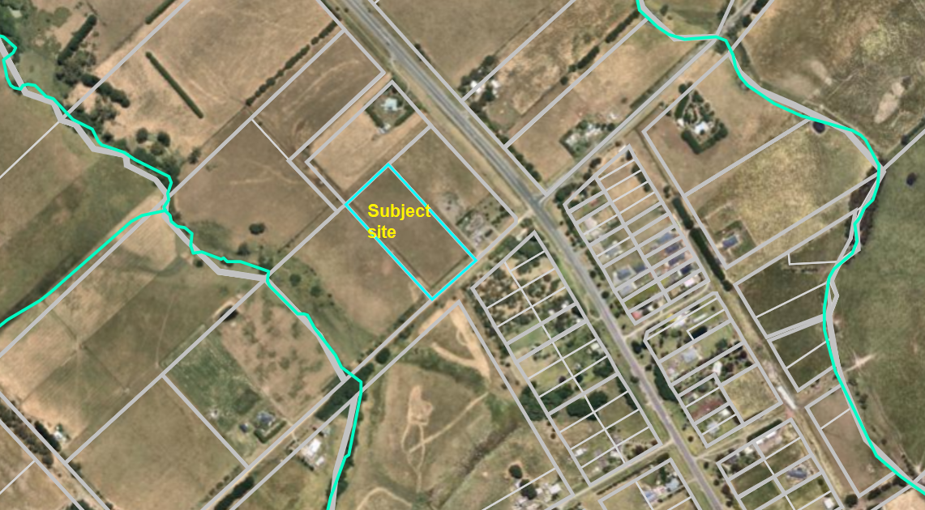
Figure 1: Aerial photograph.

Proposal
It is proposed to use and develop the land for a single storey dwelling. The dwelling would include:
• attached double garage;
• four bedrooms;
• two bathrooms;
• powder room;
• laundry;
• study;
• rumpus;
• living room;
• open plan kitchen, meals and family area;
• alfresco area to the rear.
The total floor area would be 342.59sqm.
The dwelling would be clad with weatherboard and brick, incorporate rendered surfaces, and have a low pitched hipped and gabled Colorbond roof. The dwelling would be centrally located on the lot with a setback 105m from the front title boundary and 24.9m and 34.3m from the respective side boundaries.
Vehicle access would be via a proposed crossover to Hopgoods Road.
The site is unsewered and an onsite treatment system to treat wastewater to a secondary level is proposed. The effluent treatment area would be located in the proposed dwelling’s front setback.
There is no existing or proposed farming enterprise in support of the proposed dwelling. A basic land management plan was provided, which includes control of pest animals and weeds and revegetation of parts of the site with native trees and shrubs. The revegetation is limited to border plantings and is similar in arrangement to a landscape plan for a residential dwelling.
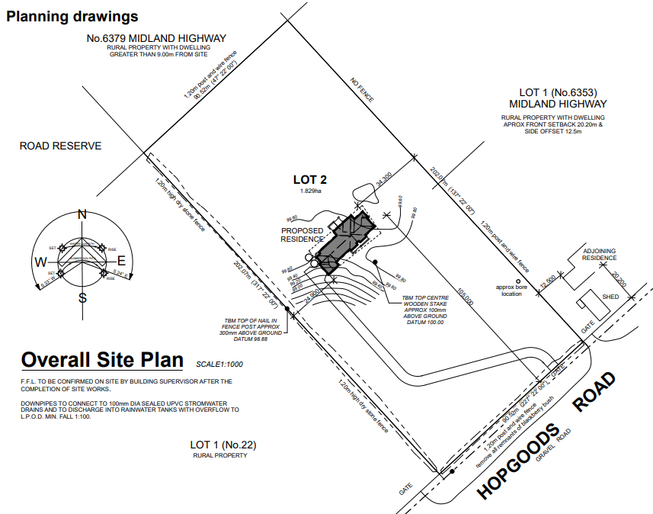
Figure 2: Proposed site plan.
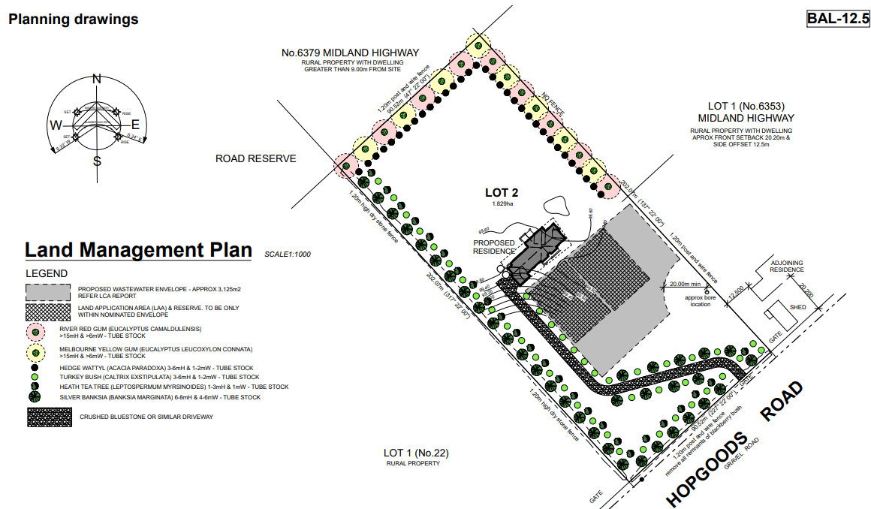
Figure 3: Land management plan.

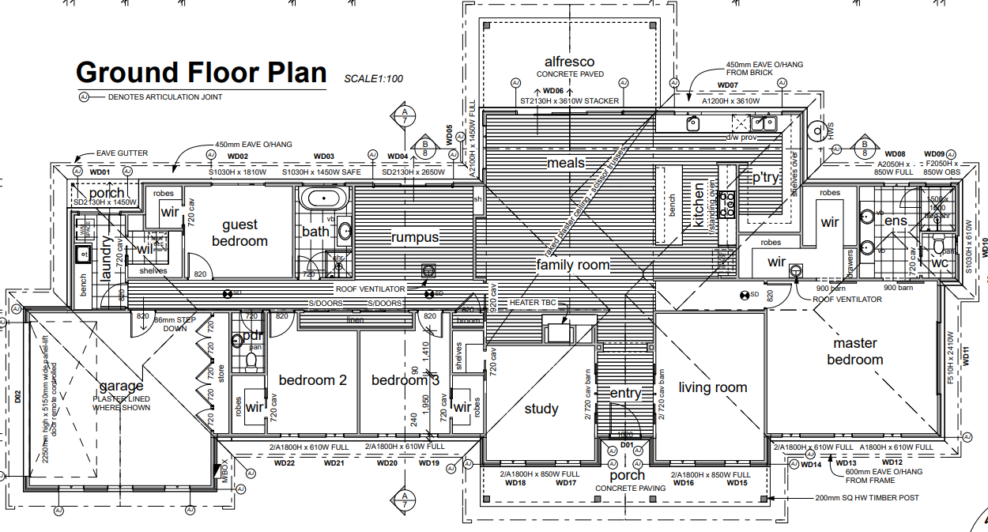
Figure 4: Proposed floor plan.
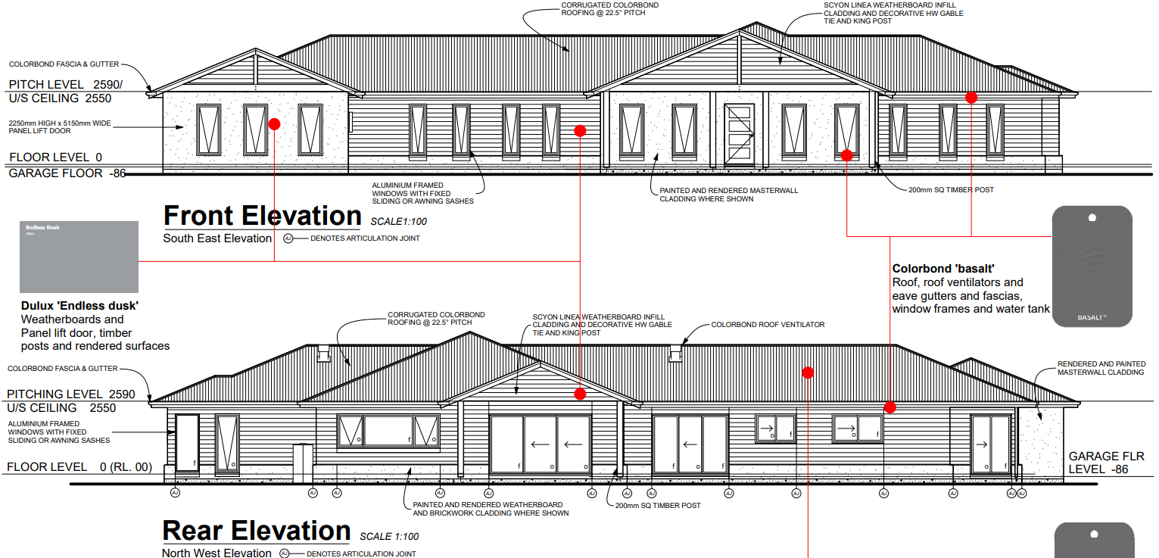
Figure 5: Elevations.
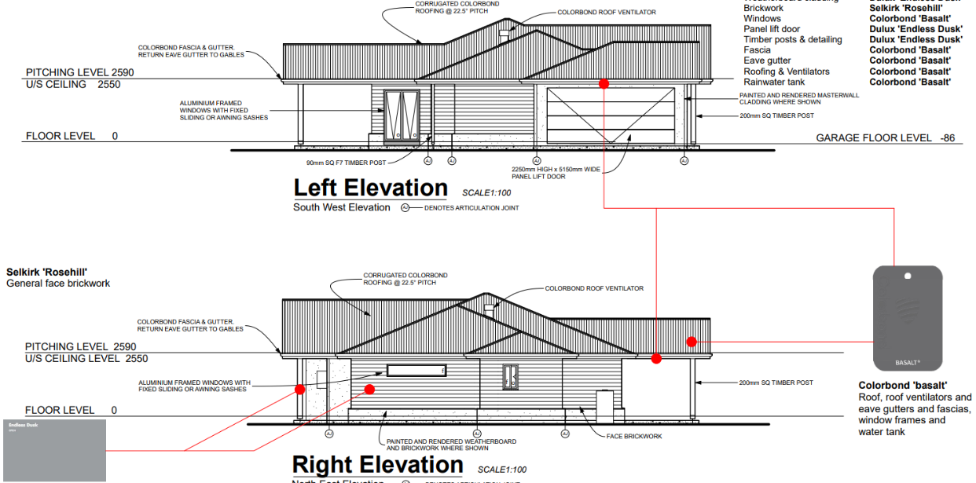
Figure 6: Elevations.

Background to Current Proposal
Not applicable.

History
Not applicable.

Public Notice
Notice of the application was given by way of a sign erected on site and letters posted to adjoining and nearby landowners and occupiers. No objections were received.
Locality Map
The map below indicates the location of the subject site and the zoning of the surrounding area.
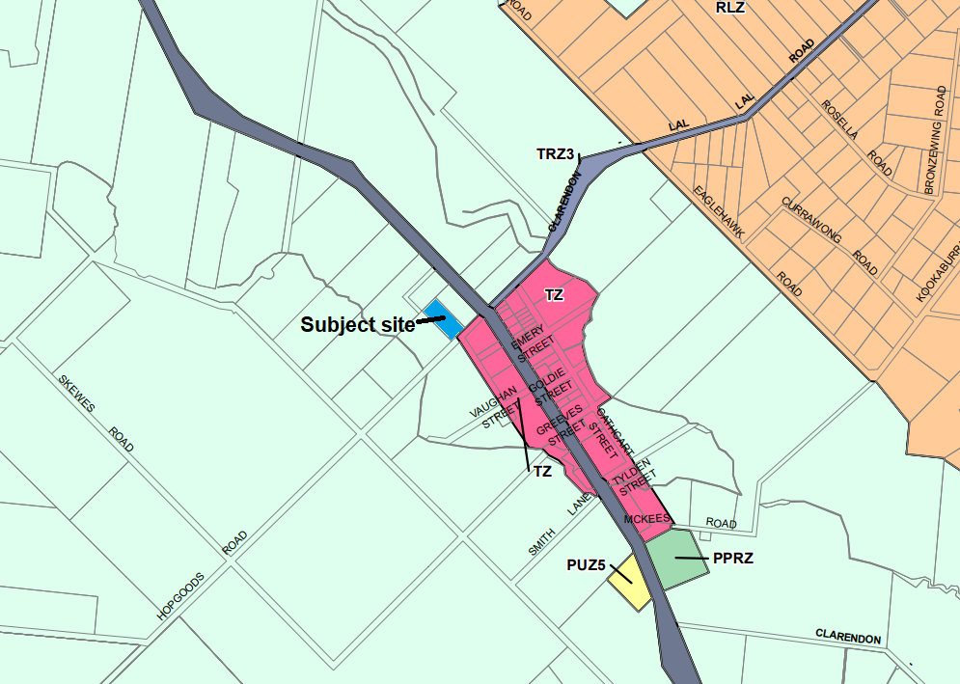
Figure 7: Zone map.

Planning Scheme Provisions
Council is required to consider the Victoria Planning Provisions and give particular attention to the Planning Policy Framework (PPF), the Local Planning Policy Framework (LPPF) and the Municipal Strategic Statement (MSS).
The relevant clauses are:
• Clause 11.01-1R Settlement - Central Highlands
• Clause 11.03-3S Peri-urban areas
• Clause 13.02-1S Bushfire planning
• Clause 14.01-1S Protection of agricultural land
• Clause 15.01-6S Design for rural areas
• Clause 16.01-3S Rural residential development
• Clause 21.02-2 Non-urban landscapes
• Clause 21.03-4 Landscape and neighbourhood character
• Clause 21.03-6 Rural lifestyle opportunities
• Clause 21.04-2 Agriculture
• Clause 21.09-1 Small towns and settlements
• Clause 22.03 Houses and House Lot Excisions in Rural Areas
The proposal does not comply with the relevant PPF and LPPF clauses outlined in the table below:
PPF | Title | Response
Clause 11.03-3S | Peri-urban areas | The proposal would contribute to dispersed settlement beyond the Township Zone in Clarendon which is not supported by this policy.
Clause 14.01-1S | Protection of agricultural land | The use of a small rural lot for a dwelling with no nexus to farming is not supported by this policy.
Clause 16.01-3S | Rural residential development | The proposal lacks strategic justification consistent with this policy.
LPPF

Clause 21.09-1 | Small towns and settlements | This policy discourages residential development located outside of the Clarendon Township Zone.
Clause 22.03 | Houses and house lot excisions in rural areas | The proposed dwelling is unrelated to any farming activity and is inconsistent with this policy.

Zone
The subject site is in the Farming Zone (FZ). The purpose of the FZ is:
• To implement the Municipal Planning Strategy and the Planning Policy Framework.
• To provide for the use of land for agriculture.
• To encourage the retention of productive agricultural land.
• To ensure that non-agricultural uses, including dwellings, do not adversely affect the use of land for agriculture.
• To encourage the retention of employment and population to support rural communities.
• To encourage use and development of land based on comprehensive and sustainable land management practices and infrastructure provision.
• To provide for the use and development of land for the specific purposes identified in a schedule to this zone.
Under Clause 35.07-1 a dwelling is a Section 2 use on a lot of less than 40ha.
Overall, the proposal is inconsistent with the purpose of the zone – see ‘Discussion’ below.

Overlays
The site is affected by Design and Development Overlay, Schedule 2 (DDO2).

Design and Development Overlay, Schedule 2

Under Clause 43.02-3 (DDO) a permit is required to construct buildings and works. Under Schedule 2 there is an exemption where non-reflective external building cladding is proposed, as in this instance. Therefore, a permit is not required under this overlay.

Relevant Policies
Council’s Rural Growth Policy
Council’s Rural Growth Policy Statement was adopted by Council on 19 September 2012. The document applies to all land in Farming Zone.
The policy states:
• Encourage dwellings in areas nominated in Map 1 of Council Rural Growth Policy Statement.
• Ensure the siting of any dwellings is designed to have a minimal impact on any existing or future agricultural activities on the site and on surrounding land.
• Ensure it is clear whether the dwelling is required for agricultural operation, use or to maintain rural communities.
• Ensure sufficient infrastructure is available or that alternative methods are available which do not require normal infrastructure.
• Encourage development of dwellings, to support communities, on land which is unlikely to support agricultural (use) while still considering any other overlays which may impact the land. This is land which is constrained for use as agriculture by other environmental factors such as vegetation, slope, soil quality, etc.
The site is not located within Map 1 of the Council Rural Growth Policy Statement. The policy requires justification for the dwelling based on the proposed agricultural activity. The proposal does not include any agricultural activity and is not considered to sufficiently justify the use of a dwelling.
Council’s Rural Housing Policy
Council’s Rural Housing Policy 2012 was adopted by Council on 19 September 2012 and has been developed to provide direction for how limited farming potential rural dwellings should be considered, and more broadly, rural settlement patterns. This Policy is not incorporated into the Moorabool Planning Scheme.

The principles of the policy relevant to this application include to:
• Support the agricultural sector so that it can be more productive, diverse, resilient, and adaptive to changing agricultural trends, including supporting agricultural activities that recognise Moorabool’s advantageous proximity to market.
• Protect agricultural land use from loss and allow development that increases agricultural productivity.
• Focus growth opportunities in settlements along major transport corridors, in particular where there is physical and social infrastructure and services.
• Recognise that there are substantial existing lots under 40ha capable of supporting the viable operation of agricultural enterprises.
• Promote a rural housing market that meets the needs of the Shire’s rural communities.
• Land parcels for the proposed on-farm living dwellings are to have a minimum lot size of 8ha as identified in Map 1.
The proposed development and use do not align with the above principles. Specifically, the proposal does not accord with the principle to support the agricultural sector so that it can be more productive, diverse, resilient, and adaptive to changing agricultural trends. The land is not being proposed to be used for a productive agricultural purpose which justifies the presence of a dwelling.

Particular Provisions
Not applicable.

Discussion
Overall, the proposed use and development for a dwelling is inconsistent with the relevant provisions of the Moorabool Planning Scheme, in particular state and local planning policies and the Farming Zone.
Relevant planning policies address a range of considerations including rural landscape values, land capability, protection of productive agricultural land and assets, and the location of rural residential development. These policies are outlined above and the proposal’s non-compliance with several of these policies is also noted.
The subject site is a vacant 1.82ha lot on the north-west side of Clarendon’s Township Zone. Given its relatively small size the site’s agricultural value appears limited. Adjoining landholdings are separately owned and similar or slightly larger in size than the subject site and are either vacant or developed with single dwellings. Agricultural uses appear to be generally confined to grazing animals. Notwithstanding the site’s limited opportunity for agricultural use, there is a lack of policy support in the Moorabool Planning Scheme for the use of the land for a dwelling and the policy framework does not encourage dispersal of residential development beyond the boundaries of small towns such as Clarendon.
The proposal does not align with the purpose of the Farming Zone, considering that the proposal would not support any agricultural activity. Although a land management plan was submitted by the applicant providing for native vegetation plantings and pest animal, and weed control, this is not sufficient justification for a dwelling on this property. Conversely, the proposed dwelling would permanently remove the land from any potential agricultural use and contribute to fragmentation of farming land by reducing the potential for consolidation with adjoining vacant lots which could enhance agricultural production.
The proposal is characteristic of the demand for rural residential development on lots which due to their size, have limited potential for viable agricultural use. The proposal represents the ad hoc nature of such development, which without sufficient strategic justification pose a potentially detrimental outcome for the Shire’s rural landscape character and the intended social, economic, and environmental values. The site lies just outside the existing northwest boundary of Clarendon’s Township Zone where the bulk of housing growth in the area is expected to occur on the numerous existing vacant lots zoned for residential use. The development of dwellings outside of the Township Zone, such as that proposed, contributes to a dispersal of scattered residential development beyond the township boundary. This threatens the rural landscape character which is typified by a generally undulating landscape of open paddocks with planted windbreaks and stands of established trees with only occasional dwellings which are visually unobtrusive in the landscape. Furthermore, the proposal also undermines the potential for new agricultural ventures to develop and prosper on such landholdings and reducing opportunities for contiguous land parcels to be consolidated to increase potential productivity.

General Provisions
Clause 65 - Decision Guidelines have been considered by officers in evaluating this application.
Clause 66 - Stipulates all the relevant referral authorities to which the application must be referred.

Referrals
Authority | Response
Council’s  Infrastructure  Environmental Health | Consent with conditions.  Consent with conditions.

Financial Implications
The recommendation to refuse this application has no financial implications for Council.

Risk & Occupational Health & Safety Issues
The recommendation to refuse this application does not have any risk or OH&S implications for Council.

Communications Strategy
Notice was undertaken for the application, in accordance with s.52 of the Planning and Environment Act 1987, and further correspondence is required to all interested parties to the application as a result of a decision in this matter. The applicant was invited to attend this meeting and address the Development Assessment Committee if required.

Options
• Issue a Refusal to Grant a Permit in accordance with the grounds in the recommendation of this report; or
• should the Development Assessment Committee wish to support the application, issue a Planning Permit with conditions.

Conclusion
There is insufficient policy support in the Moorabool Planning Scheme to approve the proposed use and development of the subject site for a dwelling. The proposed dwelling on a cleared lot of 1.82ha would not be used in conjunction with any agricultural land use, with only a proposed land management plan for partial revegetation and pest and weed control. The proposal represents the loss of farming land to residential use without adequate policy support and does not support the orderly planning of the area.

7.2 Notice of Rescission - PA2021196 Building and Works Associated with Existing Industrial Premises (Abattoir) at 6 Woolpack Road, Bacchus Marsh
Author: Dianne Elshaug, Co-ordinator CEOs Office
Authoriser: Derek Madden, Chief Executive Officer
Attachments: Nil

I, Councillor Moira Berry, give notice that at the next Development Assessment Committee meeting to be held on 16 March 2022, I intend to move the following rescission motion:

RECOMMENDATION
1. That the Resolution for Item 7.6 from the Development Assessment Committee held on 16 February 2022 be rescinded.
2. That the original recommendation as proposed by Officers be put back to Council for consideration, with an amendment to Condition 4 (operational) as follows:
(a) The proposed building must be removed from the site within seven years of the completion of the development unless otherwise agreed to by Council.
DEFERRED

RATIONALE
The timeframe of five years as proposed in the original recommendation is of insufficient time; seven years is a more reasonable timeframe.
I commend this Notice of Rescission to Council.

8 Update on Trends, Issues and Other Matters
Nil.

9 Process Forward and Work Program
Nil.

10 Update on VCAT Decisions
Two new appeals lodged with VCAT.
- 58 Griffith Street, Maddingley appeal against conditions.
- 70 Parkers Lane, Lal Lal appeal against refusal as a result of Central Highlands Water being a s55 determining referral authority objecting to the application.
Hearings are likely to be conducted at VCAT in September 2022.

11 Other Business
In relation to Item 7.2, the Chief Exectutive Officer explore options to bring the Notice of Recission Motion to an earlier meeting for Council consideration.

12 Date of Next Meeting
Wednesday 20 April 2022.

13 Meeting Close
The Meeting closed at 6:15pm.

...................................................
CHAIRPERSON

