AGENDA

Development Assessment Committee Meeting
Wednesday, 16 February 2022

In accordance with s.395 of the Local Government Act 2020, this meeting will not
be available for public attendance, however will be streamed live via accessing the Council Internet site.
I hereby give notice that a Development Assessment Committee Meeting will be held on:
Date: | Wednesday, 16 February 2022
Time: | 6.00pm
Location: | Online
Derek Madden
Chief Executive Officer

Order Of Business
1 Opening 5
2 Present and Apologies 5
3 Recording of Meeting 5
4 Confirmation of Minutes 5
5 Matters Arising from Previous Minutes 5
6 Disclosure of Conflicts of Interests 5
7 Community Planning Reports 6
7.1 PA2021195 Use and Development of Three Warehouses and a Reduction of Car Parking (Three Car Spaces) at 1/2A Station Street, Maddingley 6
7.2 PA2021028 - Development of Two Dwellings at 2 Alexander Drive, Ballan 20
7.3 PA2021029 - Development of Two Dwellings at 16 Alexander Drive, Ballan 33
7.4 PA2021030 - Development of Two Dwellings at 1 Alexander Drive, Ballan 46
7.5 PA2021245 - Two Lot Subdivision (Boundary Realignment) and Creation of Easement on Lot 12 and Lot 23 Streeton Drive, Merrimu 61
7.6 PA2021196 - Buildings and Works Associated with Existing Industrial Premises (Abattoir) at 6 Woolpack Road, Bacchus Marsh 71
8 Update on Trends, Issues and Other Matters 87
9 Process Forward and Work Program 87
10 Update on VCAT Decisions 87
11 Other Business 87
12 Date of Next Meeting 87
13 Meeting Close 87

1 Opening

2 Present and Apologies

3 Recording of Meeting
In accordance with Moorabool Shire Council’s Governance Rules, the meeting will be livestreamed.

4 Confirmation of Minutes
Development Assessment Committee Meeting – Wednesday 15 December 2021.

5 Matters Arising from Previous Minutes

6 Disclosure of Conflicts of Interests
Conflict of interest laws are prescribed under the Local Government Act 2020 (the Act) and in the Local Government (Governance and Integrity) Regulations 2020 (the Regulations). Managing conflicts of interest is about ensuring the integrity and transparency of decision-making.
The conflict of interest provisions under the Act have been simplified so that they are more easily understood and more easily applied. The new conflict of interest provisions are designed to ensure relevant persons proactively consider a broader range of interests and consider those interests from the viewpoint of an impartial, fair-minded person.
Section 126 of the Act states that a Councillor has a conflict of interest if they have a general conflict of interest or a material conflict of interest. These are explained below:
- A Councillor has a general conflict of interest in a matter if an impartial, fair-minded person would consider that the member’s private interests could result in them acting in a manner that is contrary to their public duty as a Councillor.
- A Councillor has a material conflict of interest in a matter if an affected person would gain a benefit or suffer a loss depending on the outcome of the matter.
A relevant person with a conflict of interest must disclose the interest in accordance with Council’s Governance Rules and not participate in the decision-making process on the matter. This means the relevant person must exclude themselves from any discussion or vote on the matter at any Council meeting, delegated committee meeting, community asset committee meeting or, if a Councillor, any other meeting conducted under the auspices of the Council. The relevant person must also exclude themselves from any action in relation to the matter, including an action taken to implement a Council decision, for example, issuing a planning permit.

7 Community Planning Reports

7.1 PA2021195 Use and Development of Three Warehouses and a Reduction of Car Parking (Three Car Spaces) at 1/2A Station Street, Maddingley
Author: Thomas Tonkin, Statutory Planner
Authoriser: Robert Fillisch, Manager Statutory Planning & Building Services
Attachments: 1. Proposed plans (under separate cover)

Application Summary
Permit No: PA2021195
Lodgement Date: 26 August 2021
Planning Officer: Tom Tonkin
Address of the land: 1/2A Station Street, Maddingley
Proposal: Use and Development of Three Warehouses and a Reduction of Car Parking (Three Car Spaces)
Lot size: 862sqm
Why is a permit required? Clause 33.02 Industrial 2 Zone – Use and development for warehouses
Clause 52.06 Car Parking – Reduction of car parking

Recommendation
That the Development Assessment Committee, having considered all matters as prescribed by the Planning and Environment Act 1987, issues Planning Permit PA2021195 for Use and Development of Three Warehouses and a Reduction of Car Parking (Three Car Spaces) at Lot 1 on PS 831757E known as 1/2A Station Street, Maddingley, 3340, subject to the following conditions:
Endorsed Plans:
1. Before the use and development starts, amended plans to the satisfaction of the Responsible Authority must be submitted to and approved by the Responsible Authority. When approved, the plans will be endorsed and will then form part of the permit. The plans must be drawn to scale with dimensions and must be generally in accordance with the plans identified as Job No. 21301, Sheet No.’s TP02 rev. A, TP03, TP04 rev. A & TP05 dated 27 July 2021 and prepared by Draft Comps Services but modified to show:
(a) A landscape plan in accordance with Condition 10.
(b) Clearly identify six car parking spaces in accordance with Condition 20.
(c) Details of any front fencing and vehicle gates.
(d) Clearly identifiable numbering to each warehouse on the western façade of the building.
(e) The building’s northern façade treated to improve the building’s presentation to the street.
Use:
2. The use of the site must comply with the requirements of Clause 53.10 (Uses with Adverse Amenity Potential) of the Moorabool Planning Scheme or separate planning approval obtained.
Operational:
3. The loading and unloading of goods and materials from vehicles must only be carried out on the land.
4. Provision must be made within each warehouse for the storage and collection of garbage and other solid waste. Skip bins must not be located external to the building.
Amenity:
5. The amenity of the area must not be detrimentally affected by the use or development, through the:
(a) transport of materials, goods or commodities to or from the land;
(b) appearance of any building, works or materials;
(c) emission of noise, artificial light, vibration, smell, fumes, smoke, vapour, steam, soot, ash, dust, waste water, waste products, grit or oil;
(d) presence of vermin; and
(e) any other way.
6. Effective noise levels from the use of the premises must not exceed the recommended levels as set out in the Noise from Industry in Regional Victoria (NIRV; EPA Publication 1411, 2011) or as amended.
7. External lighting must be provided with suitable baffles and located so that no direct light is emitted outside the site.
8. Any security alarm or similar device installed must be of a silent type.
9. Goods, equipment or machinery must not be stored or left exposed in a position that can be seen from the street.
Landscape Plans:
10. Before the use and development starts, a landscape plan to the satisfaction of the Responsible Authority must be submitted to and approved by the Responsible Authority. When approved, the plan will be endorsed and will then form part of the permit. The plan must be drawn to scale with dimensions. The plan must show:
(a) Details of surface finishes of the accessway.
(b) A planting schedule of all proposed trees, shrubs and ground covers, including botanical names, common names, pot sizes, sizes at maturity, and quantities of each plant.
(c) Landscaping and planting within all open areas of the site.
Species selection shall be to the satisfaction of the Responsible Authority.
11. Before the occupation of the development starts or by such later date as is approved by the Responsible Authority in writing, the landscaping works shown on the endorsed plans must be carried out and completed to the satisfaction of the Responsible Authority.
12. The landscaping shown on the endorsed plans must be maintained to the satisfaction of the Responsible Authority, including that any dead, diseased or damaged plants are to be replaced.
Signage:
13. Except where exempt under the Moorabool Planning Scheme, advertising signage must not be constructed or displayed without separate planning approval.
Infrastructure:
14. A standard urban industrial vehicle crossing must be provided on Station Street to the satisfaction of the Responsible Authority. A vehicle crossing permit must be taken out for the construction of the vehicle crossing.
15. Prior to the development and use commencing, engineering drainage plans and computations must be submitted to the Responsible Authority for approval and shall incorporate the following:
  - The development as a whole must be self draining and must be connected to an approved point of discharge in an approved manner to the satisfaction of the Responsible Authority.
  - Underground piped drainage for the whole development shall cater for 10% AEP storm.
  - Overland 1% AEP flow path(s) for the development must be shown on layout plans and shall ensure that no property is subject to inundation by such a storm to the satisfaction of the Responsible Authority.
16. Storm water drainage from the proposed buildings and impervious surfaces must be directed to the legal point of discharge to the satisfaction of the Responsible Authority. A Stormwater Point of Discharge permit must be obtained from the Responsible Authority prior to the commencement of the works associated with the permit.
17. Sediment discharges must be restricted from any construction activities within the property in accordance with relevant Guidelines including Construction Techniques for Sediment Control (EPA 1991).
18. Unless otherwise approved by the Responsible Authority there must be no buildings, structures, or improvements located over proposed drainage pipes and easements on the property.
19. Prior to the commencement of the development and post completion, notification including photographic evidence must be sent to Council’s Asset Services department identifying any existing damage to council assets. Any existing works affected by the development must be fully reinstated at no cost to and to the satisfaction of the Responsible Authority.
20. Prior to the use commencing, the car park areas must be constructed with a sealed surface, line-marking and drainage to the satisfaction of the responsible authority, and shall incorporate the following:
(a) Parking bays and aisle widths of the car park shall comply with Australian Standard AS 2890.1:2004 Off-Street car parking. Disabled Parking bays shall comply with Australian Standard AS2890.1:2009 Off-Street Parking for People with Disabilities.
(b) Designated loading areas shall be shown on layout plans.
(c) The parking areas shall be provided with an asphalt or concrete surface and associated drainage.
(d) Concrete kerb of a minimum height of 150mm must be provided between landscaped areas and areas provided for parking and the passage of vehicles.
(e) The site must provide sufficient space for a service truck to enter and exit the site in a forward motion in accordance with AS2890.2 section 2.2.
(f) A minimum of six car parking spaces must be available for use at all times.
21. The building shall be provided with disabled access in accordance with the provisions of AS1428 – Design for Access and Mobility.
Environmental Health:
22. Noise must be adequately controlled and must comply with the Environment Protection Act 2017 and publication 1411: Noise from industry in regional Victoria.
Permit Expiry:
23. This permit will expire if:
(a) The development and the use are not started within two years of the date of this permit; or
(b) The development is not completed within four years of the date of this permit.

Public Consultation
Was the application advertised? | No. The application is exempt from notice requirements under the applicable zone and car parking provisions.
Notices on site: | Not applicable.
Notice in Moorabool Newspaper: | Not applicable.
Number of objections: | None.
Consultation meeting: | Not applicable.

Policy Implications
The Council Plan 2021-2025 provides as follows:
Strategic Objective 2: Liveable and thriving environments
Priority 2.4: Grow local employment and business investment

Victorian Charter of Human Rights & Responsibilities Act 2006
In developing this report to Council, the officer considered whether the subject matter raised any human rights issues. In particular, whether the scope of any human right established by the Victorian Charter of Human Rights and Responsibilities is in any way limited, restricted or interfered with by the recommendations contained in the report. It is considered that the subject matter does not raise any human rights issues.

Officer’s Declaration of Conflict of Interests
Under section 130 of the Local Government Act 2020, officers providing advice to Council must disclose any interests, including the type of interest.
Acting Executive Manager – Robert Fillisch
In providing this advice to Council as the Acting Executive Manager, I have no interests to disclose in this report.
Author – Tom Tonkin
In providing this advice to Council as the Author, I have no interests to disclose in this report.

Executive Summary
Application referred? | Yes, the Department of Transport and Council’s Infrastructure, Environmental Health and Strategic Planning.
Any issues raised in referral responses? | Infrastructure requested that the applicant provide a stormwater management strategy and traffic impact assessment.
Preliminary concerns? | The 1m landscape strip at the rear of the building would not be readily maintainable. Minor plan details and clarifications were requested.
Any discussions with applicant regarding concerns? | Council wrote to the applicant regarding the abovementioned matters.
Any changes made to the application since being lodged? | The abovementioned landscape strip was widened to 1.2m.
Brief history. | Not applicable.
Previous applications for the site? | None.
General summary. | It is proposed to construct three warehouses and reduce the car parking requirement by three spaces. Overall, the proposal is generally in accordance with all relevant planning policies. Subject to conditions, the proposed use and development is appropriate for the site and the reduction of car parking would be acceptable considering the scale of the proposed use.
Summary of Officer’s Recommendation
That, having considered all relevant matters as required by the Planning and Environment Act 1987, the Development Assessment Committee issues Planning Permit PA2021195 for Use and Development of Three Warehouses and a Reduction of Car Parking (Three Car Spaces) at 1/2A Station Street Maddingley in accordance with Section 61 of the Planning and Environment Act 1987, subject to the conditions included in this report.

Site Description
The subject site, identified as Lot 1 on PS 831757E and known as 1/2A Station Street, Maddingley. The lot is rectangular shaped and 862sqm in area located on the south side of Station Street, directly east of Bacchus Marsh railway station. The site has a 17.15m wide frontage, variable depth of 49.49m-51.93m and rear boundary width of 17.03m. The lot is currently vacant with no significant vegetation. The site falls by approximately 1.75m generally from the southwest to northeast. The site is not encumbered by any easements and there are no restrictions registered on title. Vehicle access to the site is currently via a single width crossover to Station Street positioned towards the western title boundary.
The subject site and surrounding land to the east, and across Station Street to the north, is in the Industrial 2 Zone and generally developed with sheds of varying sizes used mostly for a range of warehouse and industrial uses. Land to the south and west is in the Public Use Zone and occupied by the Melbourne-Ballarat rail corridor including the Bacchus Marsh railway station and car park to the immediate west of the site. Further to the south is land within the General Residential Zone developed with dwellings.
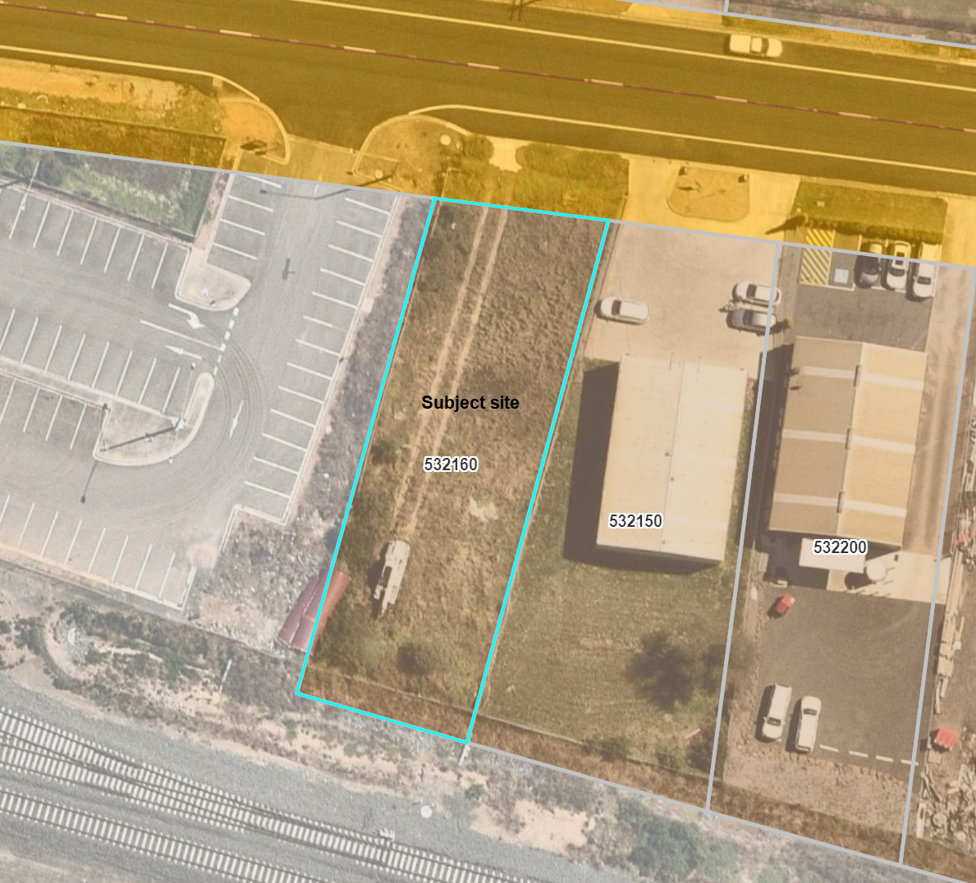
Figure 1: Aerial photograph

Proposal
It is proposed to use and develop the site for three warehouses and to reduce the required car parking provision by three car spaces. The nature of the proposal is speculative so there are no details as to the specific use of each warehouse, such as the type of goods to be stored.
The proposed development would comprise construction of a 300sqm (10m x 30m) shed, divided into three 100sqm warehouses. The building would have a 20.72m front setback, 6.8m west side setback, 1.2m rear south setback and be bult to within 200mm of the east side setback. The building would have a 5m wall height and low pitched hipped roof with an overall height of 6.49m and be clad with Colorbond ‘Night Sky’.
Each warehouse would have a roller door for vehicle access and separate pedestrian door on the west side of the building, accessed via a common accessway and a modified crossover to Station Street.
Loading facilities for each warehouse would comprise internal loading bays of 3.6m width x 6.4m length. Six car spaces would be provided in the building’s front setback and landscape strips provided along sections of all the title boundaries. The car space closest to the building is designed as an accessible space.

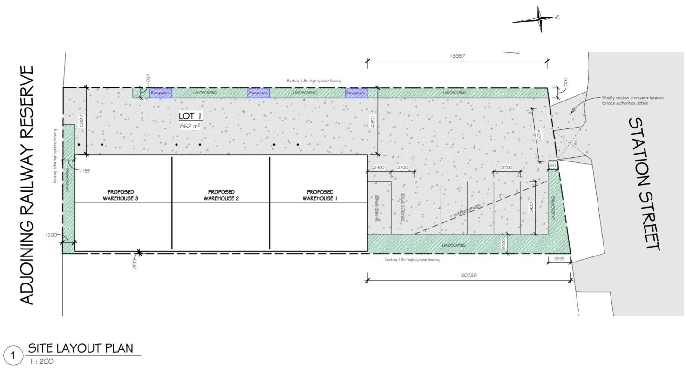
Figure 2: Site plan
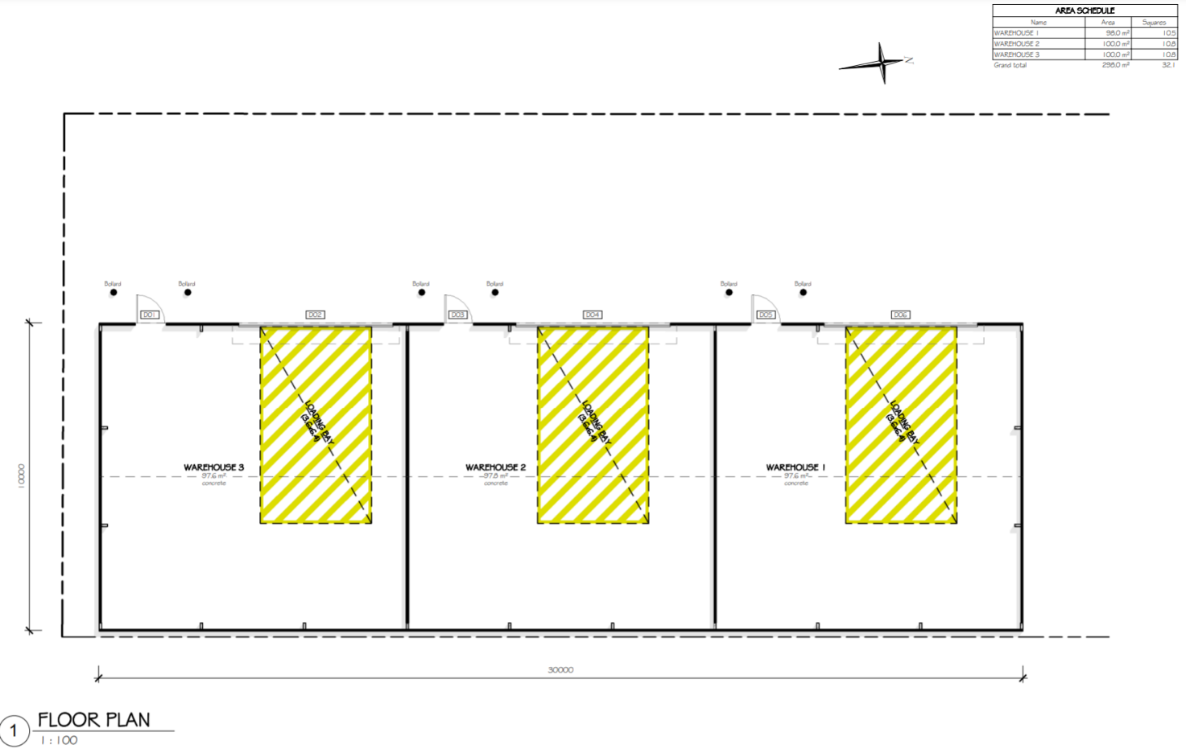
Figure 3: Floor plan
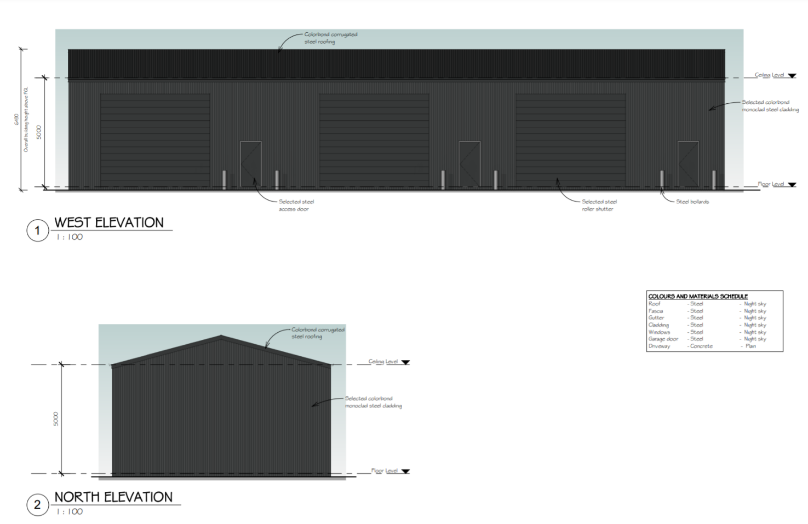
Figure 4: Building elevations

Public Notice
Pursuant to S.52(4) of the Planning and Environment Act 1987 the application is exempt from notice under Clauses 33.02-2, 33.02-4 and 52.06-4 of the Moorabool Planning Scheme.

Summary of Objections
Not applicable.

Locality Map
The map below indicates the location of the subject site and the zoning of the surrounding area.
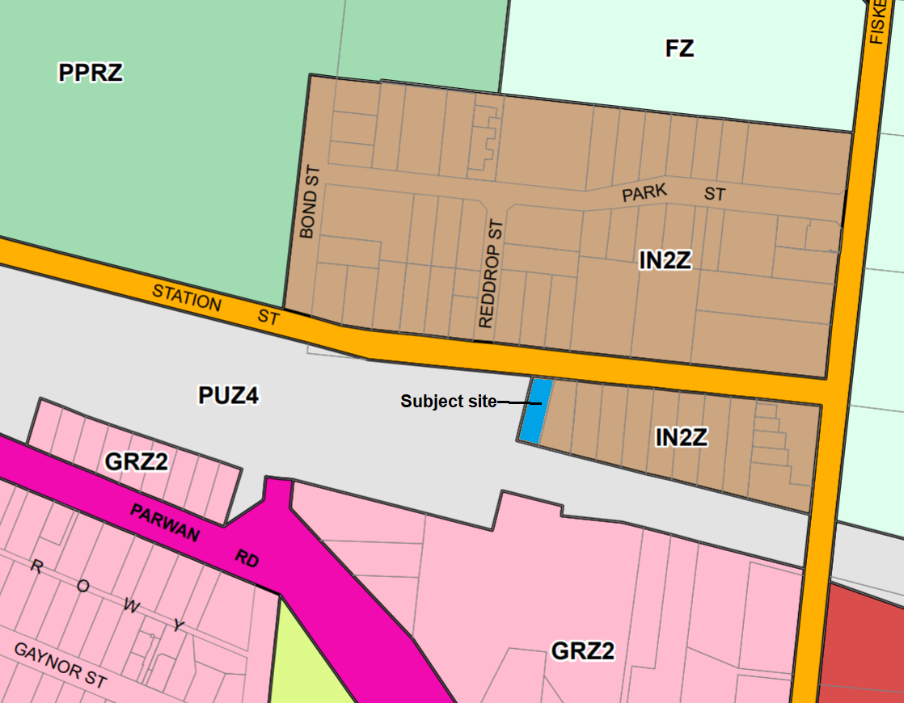
Figure 5: Zone map

Planning Scheme Provisions
Council is required to consider the Victoria Planning Provisions and give particular attention to the Planning Policy Framework (PPF), the Local Planning Policy Framework (LPPF) and the Municipal Strategic Statement (MSS).
The relevant clauses are:
• Clause 11.01-1R Settlement – Central Highlands
• Clause 11.03-3S Peri-urban areas
• Clause 15.01-1S Urban design
• Clause 15.01-2S Building design
• Clause 15.02-1S Energy and resource efficiency
• Clause 17.01-1R Diversified economy – Central Highlands
• Clause 21.03-2 Urban growth management
• Clause 21.03-4 Landscape and neighbourhood character
• Clause 21.04-3 Commercial
• Clause 21.04-5 Local employment
• Clause 21.07-6 Urban design
• Clause 22.05 Presentation of Industrial Areas
Subject to conditions, the proposal is generally consistent with the relevant sections of the PPF and LPPF.

Zone
The subject site is in the Industrial 2 Zone (IN2Z). The purpose of the IN2Z is:
• To implement the Municipal Planning Strategy and the Planning Policy Framework.
• To provide for manufacturing industry, the storage and distribution of goods and associated facilities in a manner which does not affect the safety and amenity of local communities.
• To promote manufacturing industries and storage facilities that require a substantial threshold distance within the core of the zone.
• To keep the core of the zone free of uses which are suitable for location elsewhere so as to be available for manufacturing industries and storage facilities that require a substantial threshold distance as the need for these arises.
Under Clause 33.02-1 a permit is required to use land for warehouses.
Under Clause 33.02-4 a permit is required for building and works.

Overlays

The subject site is not affected by any Overlays.

Relevant Policies
The Moorabool Industrial Areas Strategy, 2015 is a reference document in the Moorabool Planning Scheme. The strategy’s key recommendations are not directly relevant to the current proposal, and the proposal would not prejudice the implementation of any of the recommendations.

Particular Provisions
Clause 52.06 Car Parking
Under Clause 52.06-5 each of the three Warehouses require three car spaces – two per premises plus 1.5 spaces for each 100sqm of net floor area, noting that this excludes the loading bays - equalling a total of nine car spaces. Six car spaces are proposed, therefore a reduction of three car spaces is required.
The proposed car space dimensions, crossover and accessway dimensions meet the design standards of Clause 52.06-9.
Clause 52.34 Bicycle Facilities
There is no specified requirement for the provision of bicycle facilities for a Warehouse.
Clause 53.10 Uses with Adverse Amenity Potential
Detailed information about the use of the proposed warehouses is not available but given the size of the proposed premises it is unlikely the subject site would be used for any storage purposes identified in this clause. Nonetheless, it is recommended that a condition of approval specify this to prevent any adverse amenity impacts on residential zoned land in the local area.
Clause 53.18 Stormwater Management in Urban Development
Subject to conditions the proposal meets the provisions of this clause.

Discussion
Overall, the proposal is generally in accordance with the applicable provisions of the Moorabool Planning Scheme.
The subject site is in an established industrial precinct in Maddingley with all utilities available and the proposed use for warehouses is generally consistent with the surrounding mix of uses. The proposed building would be conventional in appearance and generally in keeping with the surrounding built form, providing facilities able to accommodate small-scale warehouse uses. The proposal supports consolidated growth of the Shire’s largest township and would contribute to local economic growth, in particular catering to the local demand for warehouse facilities.
Clause 22.05 Presentation of Industrial Areas
The proposed development is generally consistent with Council’s policy for industrial development at Clause 22.05 of the Moorabool Planning Scheme. The building footprint would be 34.8%, less than the maximum preferred 60% site coverage. The landscaping would comprise 13%, more than the minimum preferred 10%. The 18.35m front setback exceeds the minimum preferred 7.5m setback and incorporates access, car parking and landscaping. The proposed building materials and finishes comply with the policy. It is recommended that a condition of approval require a landscape plan to be submitted for endorsement.
Clause 33.02 Industrial 2 Zone
The proposal is generally consistent with the Industrial 2 Zone provisions. Whilst the specific future warehouse uses are unknown at this stage, subject to conditions there would be no detrimental amenity impacts. Station Street and the surrounding road network can readily accommodate traffic associated with the development. The proposed streetscape presentation would provide for landscaped areas in the front setback of typically 1-2m width, capable of being planted to soften to some extent the appearance of the car park and the built form more generally. The proposed shed form and appearance would be generally consistent with surrounding buildings in Station Street. Detailed stormwater treatment would be managed by way of permit conditions.
Clause 52.06 Car Parking
Under the car parking provisions at Clause 52.06-5 of the Moorabool Planning Scheme, the proposal requires nine car spaces to be provided. Six car spaces are proposed and therefore a reduction of three car spaces is required.

Overall, the proposed parking provision is deemed to be adequately responsive to the proposed use and the site features and context. A car parking assessment was submitted with the application, including an empirical study of car parking requirements for warehouses based on floor area. For warehouses of less than 500sqm in total area, as proposed in this instance, a maximum of three car spaces would likely be required by future users. The proposal for six car spaces exceeds this and therefore the proposed car parking provision is expected to be sufficient. It must be acknowledged the small floor area of each warehouse and the internal layout without an office space or reception area would likely be utilised by sole operators rather than businesses with employees or activities attracting visitors to the site. The proposed floor areas indicate that small-scale warehouse uses are intended and expected to generate a minimal car parking demand. The assessment also included a survey of on-street car parking conducted on dates from 2018-2021. The assessment indicated a vacancy rate of between 26-65 car spaces in Reddrop Street and that section of Station Street between Bond and Fisken Streets. The assessment provides sufficient evidence to demonstrate the availability of on-street parking to cater for overflow parking from the proposed development, in the unlikely event it is required. The site is also within cycling and walking distance of residential areas and adjoins the Bacchus Marsh railway station, providing opportunities for alternative modes of transport.
There is sufficient justification for a reduction of the three car spaces under Clause 52.06.

General Provisions
Clause 65 - Decision Guidelines have been considered by officers in evaluating this application.
Clause 66 - Stipulates all the relevant referral authorities to which the application must be referred.

Referrals
Authority | Response
Department of Transport | No response.
Council’s  • Infrastructure  • Environmental Health  • Strategic Planning | Consent with conditions.  Consent with conditions.  Consent.

Financial Implications
There are no financial implications for Council in approving the application.

Risk & Occupational Health & Safety Issues
The recommendation to approve this application does not have any risk or OH&S implications for Council.

Communications Strategy
Pursuant to s52(4) of the Planning and Environment Act 1987 the application is exempt from notice under Clauses 33.02-2, 33.02-3, 33.02-4 and 52.06-4 of the Moorabool Planning Scheme. The applicant was invited to attend this meeting and address Council if required.

OPTIONS
• Issue a Planning Permit in accordance with the conditions in the recommendation of this report; or
• issue a Planning Permit with amendments to the conditions contained in the recommendation of this report; or
• issue a Refusal to Grant a Permit on grounds. Council would need to consider what reasonable grounds there would be to refuse the application. This option may result in the applicant appealing Council’s decision to VCAT.

CONCLUSION
The proposal is generally in accordance with the relevant planning policy, particularly the Industrial 2 Zone provisions and Clauses 22.05 and 52.06. The proposed warehouses would contribute to the growth of the local economy and be located and designed to avoid any detrimental amenity impacts. The proposed car parking reduction of three car spaces is deemed to be acceptable, with sufficient onsite parking provided. The layout of car parking and access would provide for safe and functional vehicle access and parking. It is recommended that the application be approved, subject to conditions.

7.2 PA2021028 - Development of Two Dwellings at 2 Alexander Drive, Ballan
Author: Thomas Tonkin, Statutory Planner
Authoriser: Robert Fillisch, Manager Statutory Planning & Building Services
Attachments: 1. Proposed plans (under separate cover)

Application Summary
Permit No: PA2021028
Lodgement Date: 3 February 2021
Planning Officer: Tom Tonkin
Address of the land: 2 Alexander Drive, Ballan 3340
Proposal: Development of Two Dwellings
Lot size: 780sqm
Why is a permit required? Clause 32.09 Neighbourhood Residential Zone, Schedule 7 – Development of Two Dwellings on a Lot.

Recommendation
That the Development Assessment Committee, having considered all matters as prescribed by the Planning and Environment Act 1987, issues a Refusal to Grant Planning Permit PA2021028 for the Development of Two Dwellings at Lot 1 on PS 713325V known as 2 Alexander Drive, Ballan 3342, on the following grounds:
1. The application is not supported by relevant State and local planning policy in the Moorabool Planning Scheme.
2. The application does not meet the neighbourhood character objectives of Neighbourhood Residential Zone, Schedule 7 (Ballan Traditional Residential Area) to Clause 32.09 of the Moorabool Planning Scheme.
3. The proposal does not respect the spacious character of the area and the rhythm of spacing between dwellings.
4. The proposed building setbacks do not provide adequate space for the growth of new canopy trees consistent with the decision guidelines of the Neighbourhood Residential Zone, Schedule 7.
5. The application does not meet all of the relevant objectives of ResCode, Clause 55 of the Moorabool Planning Scheme.

Public Consultation
Was the application advertised? | Yes.
Notices on site: | Yes, one sign.
Notice in Moorabool Newspaper: | No.
Number of objections: | None.
Consultation meeting: | Not applicable.

Policy Implications
The Council Plan 2021-2025 provides as follows:
Strategic Objective 2: Liveable and thriving environments
Priority 2.1: Develop planning mechanisms to enhance liveability in the Shire

Victorian Charter of Human Rights & Responsibilities Act 2006
In developing this report to Council, the officer considered whether the subject matter raised any human rights issues. In particular, whether the scope of any human right established by the Victorian Charter of Human Rights and Responsibilities is in any way limited, restricted or interfered with by the recommendations contained in the report. It is considered that the subject matter does not raise any human rights issues.

Officer’s Declaration of Conflict of Interests
Under section 130 of the Local Government Act 2020, officers providing advice to Council must disclose any interests, including the type of interest.
Acting Executive Manager – Robert Fillisch
In providing this advice to Council as the Acting Executive Manager, I have no interests to disclose in this report.
Author – Tom Tonkin
In providing this advice to Council as the Author, I have no interests to disclose in this report.

Executive Summary
Application referred? | Yes, Greater Western Water and Council’s Infrastructure and Strategic Planning.
Any issues raised in referral responses? | Yes, Strategic Planning objected to the proposal.
Preliminary concerns? | Inconsistency with relevant planning policies regarding neighbourhood character. Additionally, further information was requested regarding landscaping, energy efficiency, compliance with neighbourhood character and the covenant attached to title.

Any discussions with applicant regarding concerns? | Council wrote to the applicant regarding the abovementioned matters.
Any changes made to the application since being lodged? | Changes were made to Unit 1’s floor plan to address solar access to living spaces, Unit 2’s external cladding was amended to comply with the covenant and a landscape plan was submitted.
Brief history. | See ‘History’ below.
Previous applications for the site? | PA2019282 for a two lot subdivision was refused by Council on 20 May 2020.
General summary. | It is proposed to develop the site for two detached single storey four bedroom dwellings. The application was advertised, and no objections were received. The proposal does not comply with the relevant requirements of the Moorabool Planning Scheme for medium density housing, particularly in relation to the preferred neighbourhood character objectives for the precinct or energy efficiency.
Summary of Officer’s Recommendation
That, having considered all relevant matters as required by the Planning and Environment Act 1987, the Development Assessment Committee issue a Refusal to Grant Planning Permit PA2021028 for the development of Two Dwellings at Lot 1 on PS 713325V known as 2 Alexander Drive, Ballan, on the grounds included in this report.

Site Description
The site, identified as Lot 1 on PS 713325V and known as 2 Alexander Drive, Ballan, is located on the north-west corner of Crook Court and Alexander Drive. The site is an irregular shaped lot with an area of 780sqm. The site is vacant with no significant vegetation and falls by approximately 800mm generally from the northwest to the southeast. There are no easements on title.
The subject site and surrounding land to the north, south and west is in the Neighbourhood Residential Zone whilst land to the east, across Crook Court, is in the General Residential Zone. Development is characterised by mostly single storey dwellings on a range of lot sizes, with some vacant lots which mostly reflect the incremental subdivision of larger lots in the area.
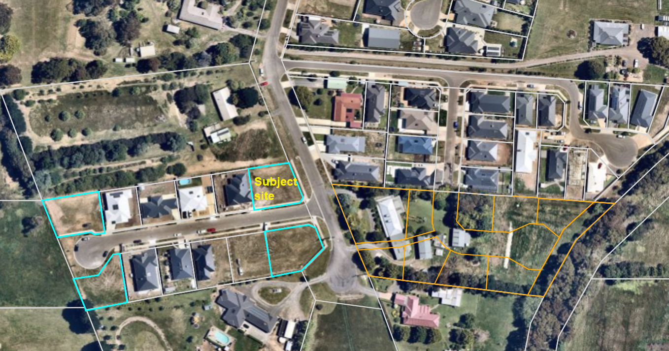
Figure 1: Aerial image

Proposal
It is proposed to develop the site with two single storey dwellings. Both dwellings would comprise four bedrooms, two bathrooms and the usual amenities, with car parking provided in attached double garages. Units 1 and 2 would have respective floor areas of 183.3sqm and 196.7sqm. Both dwellings would front Alexander Drive and be accessed via separate 4m wide crossovers, with Unit 2 benefiting from the existing crossover parallel to the west title boundary which is proposed to be widened by 1m. The dwellings would be of brick construction and conventional in appearance, with low pitched hipped Colorbond roofs with eaves on the front façades and maximum heights of 4.6m. Minimum front setbacks would be 4.12m and 4m respectively. No front fencing is proposed.

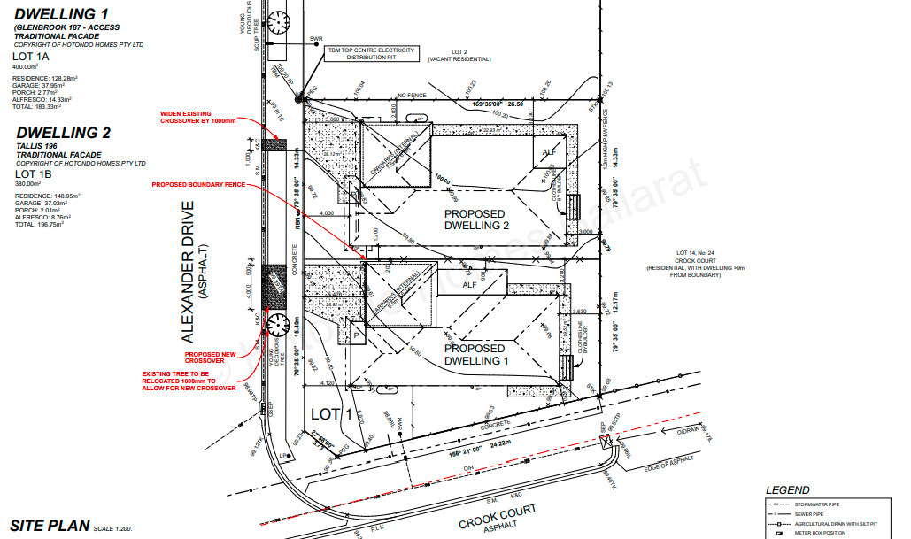
Figure 2: Proposed site plan.
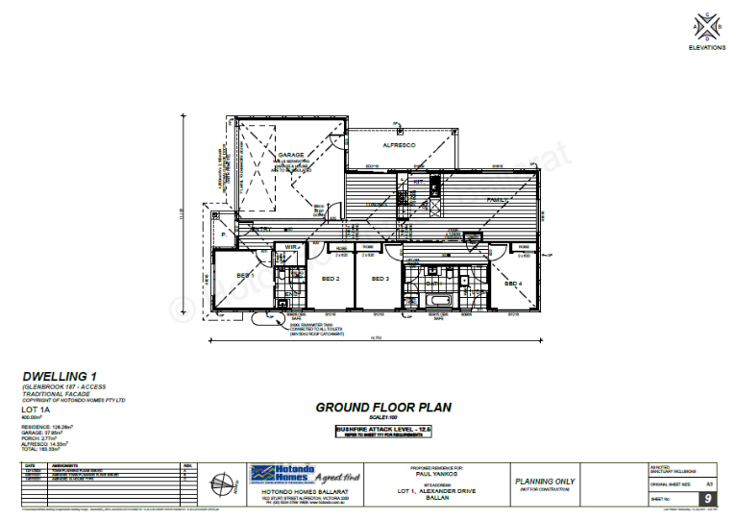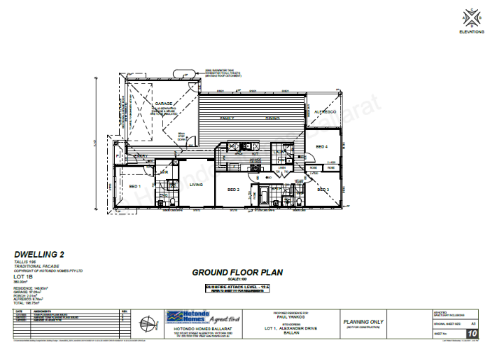
Figure 3: Unit 1 and Unit 2 floor plan.

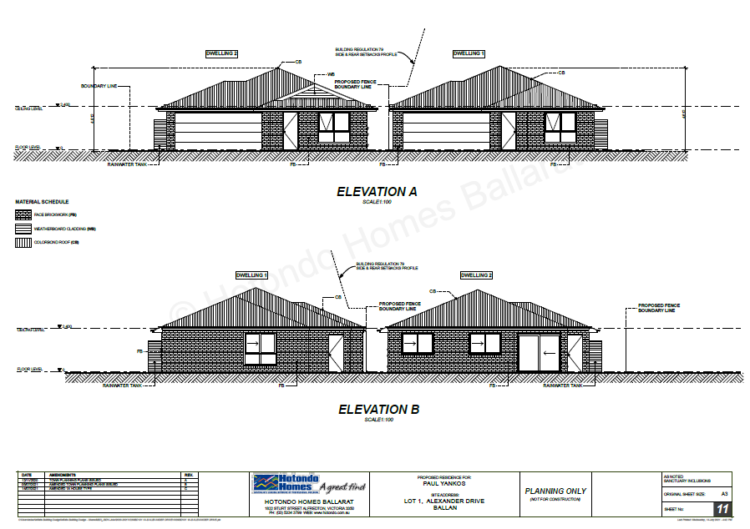
Figure 4: Front and rear elevations.
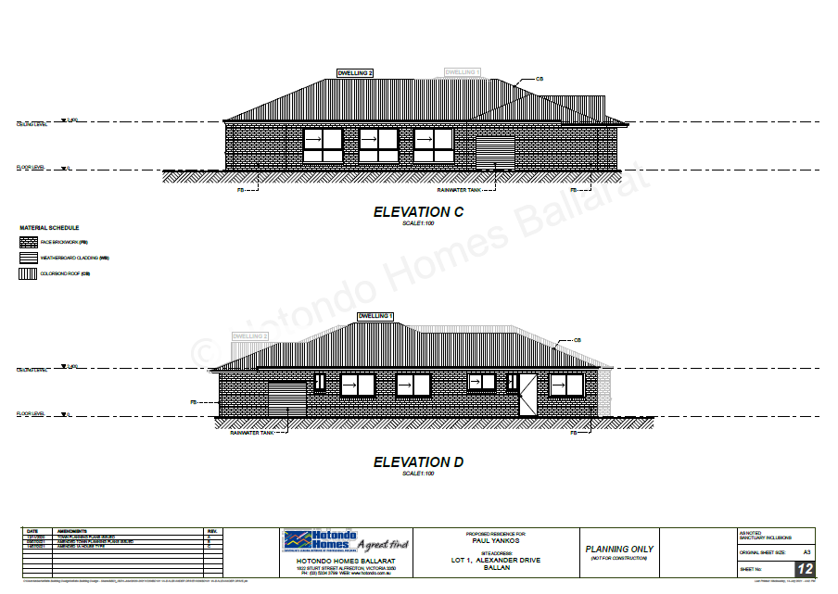
Figure 5: Side elevations.

Background to Current Proposal
Not applicable.

History
Planning permit application PA2019282 for a two lot subdivision was determined at the Development Assessment Committee held in May 2020. It was determined to refuse the application consistent with the officer’s recommendation and the refusal notice was issued on 20 May 2020. There was no subsequent appeal by the applicant against this decision.
The grounds of refusal were as follows:
1. The proposed lot sizes do not meet the minimum allowable lot sizes specified in the Neighbourhood Residential Zone, Schedule 7, of the Moorabool Planning Scheme.
2. The proposal is inconsistent with relevant state and local planning policy in the Moorabool Planning Scheme for residential land subdivision in this location
3. The proposal does not meet all relevant provisions of Clause 56 (ResCode) of the Moorabool Planning Scheme.

Public Notice
Notice of the application was given to adjoining and surrounding landowners and occupiers by mail and a sign erected on site.
No objections were received.

Locality Map
The map below indicates the location of the subject site and the zoning of the surrounding area.
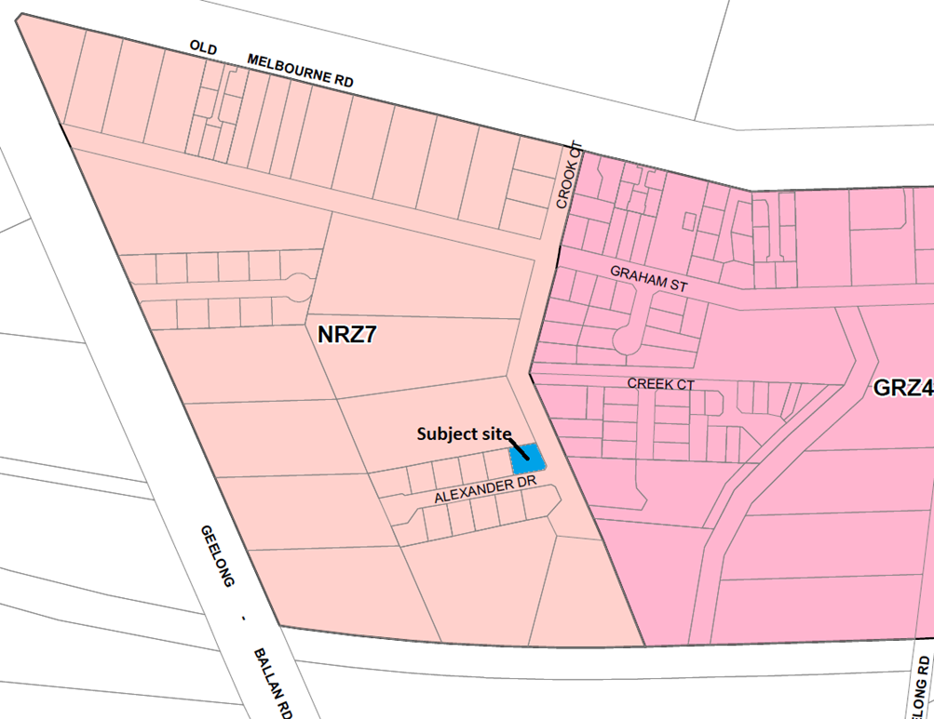
Figure 6: Zone map.

Planning Scheme Provisions
Council is required to consider the Victoria Planning Provisions and give particular attention to the Planning Policy Framework (PPF), Local Planning Policy Framework (LPPF) and the Municipal Strategic Statement (MSS).
The relevant clauses are:
• Clause 11.03-3S – Peri-urban areas
• Clause 14.02 – Water
• Clause 15.01-5S – Neighbourhood character
• Clause 15.02-1S – Energy and resource efficiency
• Clause 16.01-1S – Housing supply
• Clause 16.01-2S – Housing affordability
• Clause 21.02-3 – Water and catchment management
• Clause 21.03-2 – Urban Growth Management
• Clause 21.03-3 – Residential Development
• Clause 21.03-4 – Landscape and Neighbourhood Character
• Clause 21.08 – Ballan
• Clause 22.02 – Special Water Supply Catchments
In assessing it against the relevant sections of the PPF and LPPF, the following significant non-compliances were identified:
PPF and LPPF assessment
PPF | Title | Response
Clause 15.01-5S | Neighbourhood character | The proposal does not respond positively to the preferred neighbourhood character, which encourages detached dwellings with conventional front and side setbacks and garages which do not visually dominate dwellings or streetscapes.
Clause 15.02-1S | Energy and resource efficiency | The proposed design detail is not suitably responsive to the objective of this Clause.
LPPF
Clause 21.03-2 | Urban Growth Management | The proposal would facilitate residential growth in an area of Ballan where limited growth is encouraged.
Clause 21.03-3 | Residential development | The design detail does not adequately respond to the objectives or strategies which encourage environmentally sustainable design.

Clause 21.03-4 | Landscape and Neighbourhood Character | The proposal does not respond appropriately to the preferred neighbourhood character.
Clause 21.08-7 | Strategies for Residential Development | The proposal is inconsistent with the preferred development outcomes for Ballan’s Minimal Growth Areas.

Zone
The subject site is in the Neighbourhood Residential Zone, Schedule 7 (NRZ7). The purpose of the Neighbourhood Residential Zone is:
• To implement the Municipal Planning Strategy and the Planning Policy Framework.
• To recognise areas of predominantly single and double storey residential development.
• To manage and ensure that development respects the identified neighbourhood character, heritage, environmental or landscape characteristics.
• To allow educational, recreational, religious, community and a limited range of other non-residential uses to serve local community needs in appropriate locations.
Schedule 7 specifies the following neighbourhood character objectives to be achieved in this area:
• To protect the character and identity of the town by maintaining the open and spacious character, and transition from rural to residential areas, along Old Melbourne Road.
• To maintain a streetscape rhythm of detached dwellings with conventional front and side setbacks.
• To ensure garages and carports do not visually dominate dwellings or streetscapes.
• To encourage low, open front fencing, combined with landscaped front gardens to emphasise the country ‘feel’ of the township.
Under Clause 32.09-6 a permit is required to construct two or more dwellings on a lot. A development must meet the requirements of Clause 55.
The proposed development is inconsistent with the neighbourhood character objectives for Schedule 7 that seek an open and spacious character.

Overlays
The site is affected by Environmental Significance Overlay, Schedule 1 (ES01).
Under Clause 42.01-2 a permit is required to construct buildings and works. However, there is an applicable exemption under Schedule 1 for the construction of a dwelling in the Neighbourhood Residential Zone which is connected to reticulated sewerage, and no stormwater is discharged less than 100m from a waterway unless into an approved drainage system.
The subject site is connected to reticulated sewerage and stormwater drains to a Council drainage system. Also, no tree removal is proposed.
No permit is required under this overlay control.

Relevant Policies
Ballan Strategic Directions
Ballan Strategic Directions (‘the Strategy’) sets out objectives, strategies and actions for the long-term planning of Ballan. The Strategy informed Council’s preparation of Planning Scheme Amendment C88 which proposed changes to local planning policy and the rezoning of land in Ballan, including the subject site. Council adopted C88 on 2 October 2019 after extensive public consultation and a review by an independent planning panel and the amendment was gazetted on 6 March 2020. Under Amendment C88 the subject site was rezoned from the General Residential Zone to Neighbourhood Residential Zone Schedule 7.

Particular Provisions
Clause 52.06 Car Parking
Under Clause 52.06-5 each dwelling with more than three bedrooms requires two car spaces. Both proposed dwellings are provided with two car spaces in a double garage. The garage and accessway dimensions meet the standards of Clause 52.06-9.
Clause 55 Two or More Dwellings on a Lot and Residential Buildings
The proposal does not comply with the following ResCode (Clause 55) clauses:
Clause ResCode | Title | Response
Clause 55.02-1 | Neighbourhood character | The proposed development does not respect the preferred neighbourhood character.
Clause 55.03-1 | Street setback | Unit 1’s 1.63m setback from Crook Court frontage does not comply with the minimum 2m requirement.
Clause 55.03-5 | Energy efficiency | Unit 2’s living areas are oriented to the east and west and do not take acceptable advantage of the northern aspect available. Although the living area has north facing glazing the position of the alfresco would prevent any north solar access and does not comply with this standard.
Clause 55.03-8 | Landscaping | Unit 2’s boundary setbacks do not provide adequate space for the planting of suitable canopy trees in accordance with the preferred neighbourhood character.
Clause 55.04-1 | Side and rear setbacks | The proposed side setbacks do not respect the preferred neighbourhood character.
Clause 55.06-1 | Design detail | The proposed garages’ visual dominance in the streetscape is inconsistent with the preferred neighbourhood character.

Discussion
Overall, the proposed development is inconsistent with relevant state and local planning policy, the Neighbourhood Residential Zone, Clause 55 and the decision guidelines at Clause 65 of the Moorabool Planning Scheme.
The subject site and surrounding land west of the Crook Court road reserve is in the Neighbourhood Residential Zone, Schedule 7 (NRZ7). Existing nearby development reflects the growth of Ballan over the past few decades, typified by the incremental subdivision of land in Crook Court into smaller residential lots. The gazettal of Planning Scheme Amendment C88 on 6 March 2020 rezoned land in Crook Court to give guidance to Council’s preferred pattern of development for the area. It is important to note that land on the east side of Crook Court remained as General Residential Zone but with a new Schedule 4, compared to the rezoning of land west of Crook Court, which includes the subject site, to the Neighbourhood Residential Zone, Schedule 7.
The key issues with the proposal are assessed as follows:
• Non-compliance with the preferred neighbourhood character as set out in the NRZ7 and supported by State and local planning policies and various sections of Clause 55.
• Non-compliance with the principles of energy efficiency, as set out in State and local planning policies and Clause 55.03-5, in relation to dwelling floor plans which do not take sufficient advantage of passive solar energy.

Neighbourhood character

The subject site is in the Neighbourhood Residential Zone, Schedule 7, which sets out the following neighbourhood character objectives for new development relevant to the current proposal:
• To maintain a streetscape rhythm of detached dwellings with conventional front and side setbacks.
• To ensure garages and carports do not visually dominate dwellings or streetscapes.
• To encourage low, open front fencing, combined with landscaped front gardens to emphasise the country ‘feel’ of the township.
State and local planning policies in the Moorabool Planning Scheme, including at Clause 55, give support to development which responds to the preferred neighbourhood character, as set out above, as part of a suite of policies relevant to assessing medium density housing developments. Local policy at Clause 21.08 of the Moorabool Planning Scheme recognises Ballan’s role in providing for residential growth, with neighbourhoods more sparsely developed and further away from the town centre to generally accommodate less growth than those more readily accessible to services and infrastructure. Clause 21.08 and the zone schedules guide where housing growth should occur and what valued neighbourhood character attributes should be enhanced or created. The proposed development does not respond appropriately to this policy context.
The proposed dwellings, and in particular the side boundary setbacks, do not create the sense of spaciousness consistent with the neighbourhood character objectives. Alexander Drive comprises seven recently constructed dwellings on regular shaped lots 22 to 25m wide with an average size of 670sqm. Six of these dwellings are constructed either on or within approximately 1.2m of one side boundary but set back from the other side boundary by approximately 6m to 10m. The neighbourhood character objectives above refer to ‘conventional front and side setbacks.’ Considering that the area west of Crook Court to which these objectives relate is undergoing incremental subdivision the future character of the area will emerge with less intensive development compared those in the General Residential Zone. It is noted that since the Alexander Drive subdivision was created, the surrounding land west of Crook Court was rezoned to NRZ7, as outlined above, and a minimum 800sqm lot size requirement imposed for new subdivisions. This is relevant because the larger lot sizes create potential for larger more spacious side and rear setbacks and consequently establishing a convention in this regard for this area of Ballan.
The proposed west side boundary setback is 2m, whilst the east side setback would taper, due to the shape of the lot, from 5.92m at the front corner of the dwelling to 1.63m at the rear corner of the dwelling. The proposed dwellings would be set back a minimum of 1.2m from each other. Furthermore, the proposed double garages would be a dominant feature of the property frontages and inconsistent with the preferred neighbourhood character. Whilst the proposed garages are generally consistent with the size and street setbacks of existing garages in Alexander Drive, both would occupy a greater proportion of the dwellings’ front façades which would be compounded by there being two double garages rather than only one double or single garage as is the case for other properties.
The NRZ7 includes the following decision guideline, in addition to the other relevant policy considerations:
• Whether adequate sized open space and setbacks are provided for the retention and growth of existing and new canopy trees.
As outlined above, the application does not comply with Clause 55.03-8 (Landscaping), in particular due to the limited opportunities to landscape Unit 2’s side and rear setbacks. Tree planting is proposed but the proposed setbacks only allow for small trees, not canopy trees as is preferred. The inadequate open spaces available for landscaping further reflects how the design response fails to respond appropriately to the relevant planning provisions, in particular as they relate to neighbourhood character

Energy efficiency policy
Planning policies in the PPF and LPPF encourage new development to adopt the principles of energy efficiency. Clause 55.03-5 sets out the following objectives:
• To achieve and protect energy efficient dwellings and residential buildings.
• To ensure the orientation and layout of development reduce fossil fuel energy use and make appropriate use of daylight and solar energy.
The corresponding Rescode standard B10 sets out the following requirements:
• Buildings should be:
• Oriented to make appropriate use of solar energy.
• Sited and designed to ensure that the energy efficiency of existing dwellings on adjoining lots is not unreasonably reduced.
• Sited and designed to ensure that the performance of existing rooftop solar energy systems on dwellings on adjoining lots are not unreasonably reduced. The existing rooftop solar energy system must exist at the date the application is lodged.
• Living areas and private open space should be located on the north side of the development, if practicable.
• Developments should be designed so that solar access to north-facing windows is maximised.
The key concern with the proposal is that Unit 2’s layout does not maximise solar access to its north-facing living room. The location of the proposed alfresco area would prevent solar access in winter, limiting it to west-facing windows. This significantly reduces opportunities for passive solar heating, forcing occupants to rely on other heat sources resulting in higher costs for heating. The proposed design is not sufficiently site responsive and does not satisfy the applicable requirements of the Moorabool Planning Scheme, in particular Clause 55.03-5.

General Provisions
Clause 65 - Decision Guidelines have been considered by officers in evaluating this application.
Clause 66 - Stipulates all the relevant referral authorities to which the application must be referred.

Referrals
Authority | Response
Council’s  Infrastructure  Strategic Planning | Consent with conditions.  Refusal.

Financial Implications
There are no financial implications for Council in refusing this development application.

Risk & Occupational Health & Safety Issues
The recommendation to refuse this development application does not have any risk or OH&S implications for Council.

Communications Strategy
Notice was undertaken for the application, in accordance with s.52 of the Planning and Environment Act 1987, and further correspondence is required to all interested parties to the application as a result of a decision in this matter. The applicant was invited to attend this meeting and address Council if required.

Options
• Issue a Refusal to Grant a Permit in accordance with the grounds in the recommendation of this report; or
• should Council wish to support the application, issue a Planning Permit with conditions.

Conclusion
Overall, the proposed development is not suitably responsive to the relevant planning controls or policies in the Moorabool Planning Scheme, particularly relating to energy efficient design and the preferred neighbourhood character for this area of Ballan. It is recommended that the application be refused on the specified grounds.

7.3 PA2021029 - Development of Two Dwellings at 16 Alexander Drive, Ballan
Author: Thomas Tonkin, Statutory Planner
Authoriser: Robert Fillisch, Manager Statutory Planning & Building Services
Attachments: 1. Proposed plans (under separate cover)

Application Summary
Permit No: PA2021029
Lodgement Date: 3 February 2021
Planning Officer: Tom Tonkin
Address of the land: 16 Alexander Drive, Ballan, 3342
Proposal: Development of Two Dwellings
Lot size: 844sqm
Why is a permit required? Clause 32.09 Neighbourhood Residential Zone, Schedule 7 – Development of Two Dwellings on a Lot.

Recommendation
That the Development Assessment Committee, having considered all matters as prescribed by the Planning and Environment Act 1987, issues a Refusal to Grant Planning Permit PA2021029 for the Development of Two Dwellings at Lot 6 on PS 713325V known as 16 Alexander Drive, Ballan 3342, on the following grounds:
1. The application is not supported by relevant State and local planning policy in the Moorabool Planning Scheme.
2. The application does not meet the neighbourhood character objectives of Neighbourhood Residential Zone, Schedule 7 (Ballan Traditional Residential Area) to Clause 32.09 of the Moorabool Planning Scheme.
3. The proposal does not respect the spacious character of the area and the rhythm of spacing between dwellings.
4. The proposed building setbacks do not provide adequate space for the growth of new canopy trees consistent with the decision guidelines of the Neighbourhood Residential Zone, Schedule 7.
5. The application does not meet all of the relevant objectives of ResCode, Clause 55 of the Moorabool Planning Scheme.

Public Consultation
Was the application advertised? | Yes.
Notices on site: | Yes, one sign.
Notice in Moorabool Newspaper: | No.
Number of objections: | None.
Consultation meeting: | Not applicable.

Policy Implications
The Council Plan 2021-2025 provides as follows:
Strategic Objective 2: Liveable and thriving environments
Priority 2.1: Develop planning mechanisms to enhance liveability in the Shire

Victorian Charter of Human Rights & Responsibilities Act 2006
In developing this report to Council, the officer considered whether the subject matter raised any human rights issues. In particular, whether the scope of any human right established by the Victorian Charter of Human Rights and Responsibilities is in any way limited, restricted or interfered with by the recommendations contained in the report. It is considered that the subject matter does not raise any human rights issues.

Officer’s Declaration of Conflict of Interests
Under section 130 of the Local Government Act 2020, officers providing advice to Council must disclose any interests, including the type of interest.
Acting Executive Manager – Robert Fillisch
In providing this advice to Council as the Acting Executive Manager, I have no interests to disclose in this report.
Author – Tom Tonkin
In providing this advice to Council as the Author, I have no interests to disclose in this report.

Executive Summary
Application referred? | Yes, to Greater Western Water and Council’s Infrastructure and Strategic Planning.
Any issues raised in referral responses? | Yes, Strategic Planning objected to the proposal.
Preliminary concerns? | Inconsistency with relevant planning policies for neighbourhood character. Additionally, further information was requested regarding landscaping, compliance with neighbourhood character and the covenant attached to title.
Any discussions with applicant regarding concerns? | Council wrote to the applicant regarding the abovementioned matters.

Any changes made to the application since being lodged? | Changes were made to Unit 1’s roof form and front façade to comply with the covenant and a landscape plan was submitted.
Brief history. | See ‘History’ below.
Previous applications for the site? | See ‘History’ below.
General summary. | It is proposed to develop the site for two detached single storey four bedroom dwellings. The application was advertised, and no objections were received. The proposal does not comply with the relevant requirements of the Moorabool Planning Scheme for medium density housing, particularly in relation to the preferred neighbourhood character objectives for the precinct or energy efficiency.
Summary of Officer’s Recommendation
That, having considered all relevant matters as required by the Planning and Environment Act 1987, the Development Assessment Committee issues a Refusal to Grant Planning Permit PA2021029 for the development of Two Dwellings at Lot 6 on PS 713325V known as 16 Alexander Drive, Ballan, on the grounds included in this report.

Site Description
The site, identified as Lot 6 on PS 713325V and known as 16 Alexander Drive, Ballan, is located on the north side of Alexander Drive at the end of the cul-de-sac. The site is an irregular shaped lot with an area of 844sqm, vacant with no significant vegetation and falls by approximately 800mm generally from the northwest to the southeast. The site is not encumbered by any easements.
The subject site and surrounding land is in the Neighbourhood Residential Zone and characterised by mostly single storey dwellings on a range of lot sizes, with some vacant lots which mostly reflect the incremental subdivision of larger lots in the area.
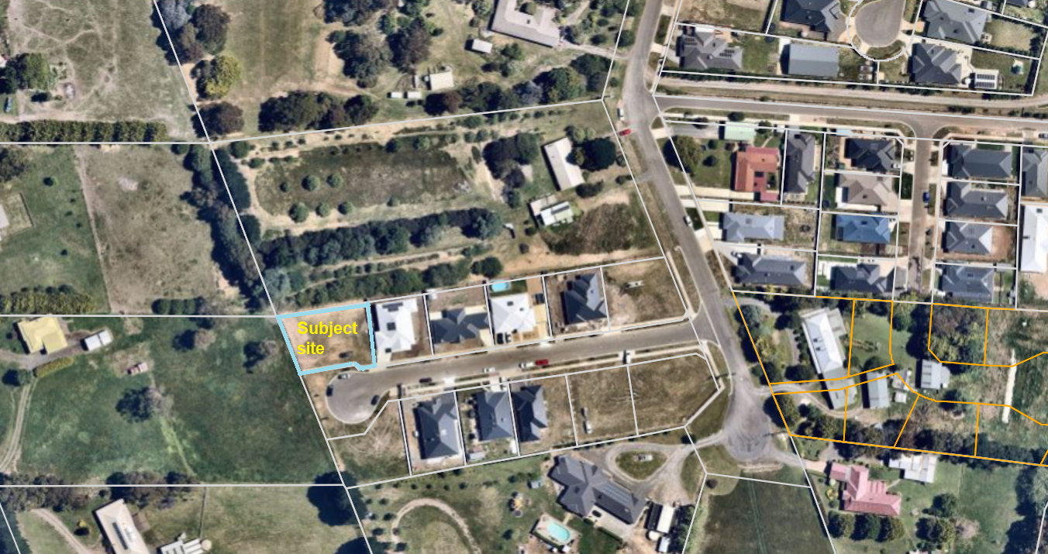
Figure 1: Aerial photograph.

Proposal
It is proposed to develop the site with two single storey dwellings. Both dwellings would comprise four bedrooms, two bathrooms and the usual amenities, with car parking provided in attached double garages. Units 1 and 2 would have respective floor areas of 207.6sqm and 184.9sqm. Both dwellings would front Alexander Drive and be accessed via single width crossovers, with Unit 1 benefiting from the existing crossover parallel to the east title boundary and Unit 2 served by a proposed 3.5m wide crossover. The dwellings would be of brick construction and conventional in appearance, with low pitched hipped Colorbond roofs with eaves on the front façades and maximum heights of 4.99m (Unit 1) and 4.76m (Unit 2). Minimum front setbacks would be 4m. No front fencing is proposed.
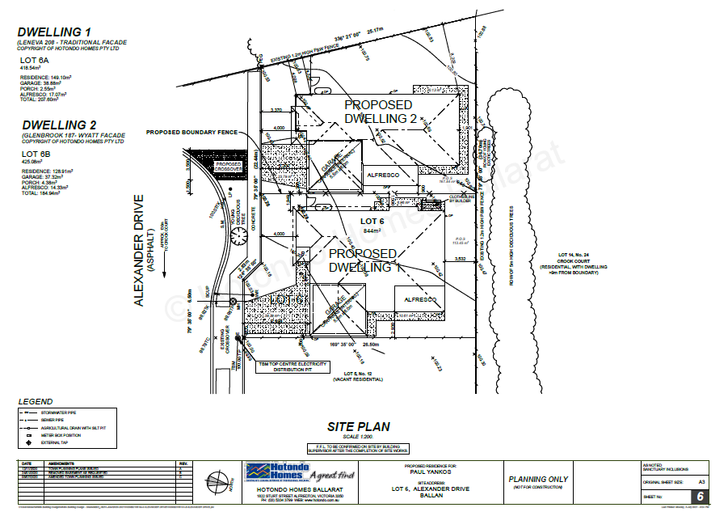
Figure 2: Proposed site plan.
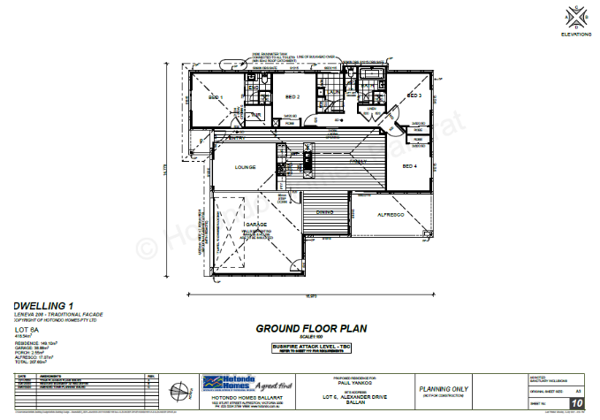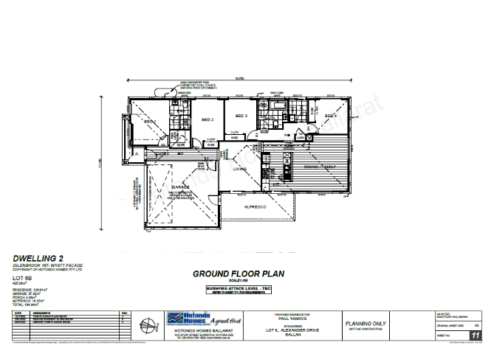
Figure 3: Unit 1 and 2 floor plans.
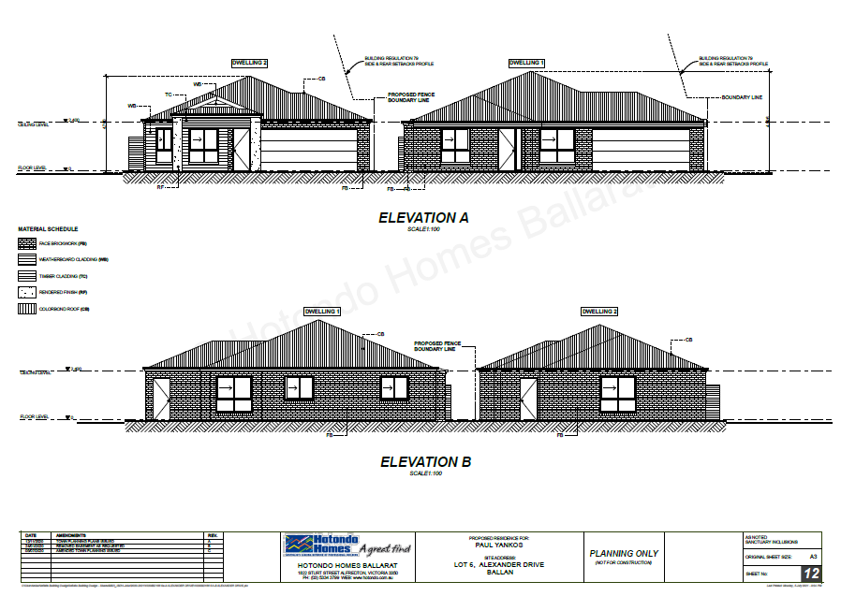
Figure 4: Front and rear elevations.
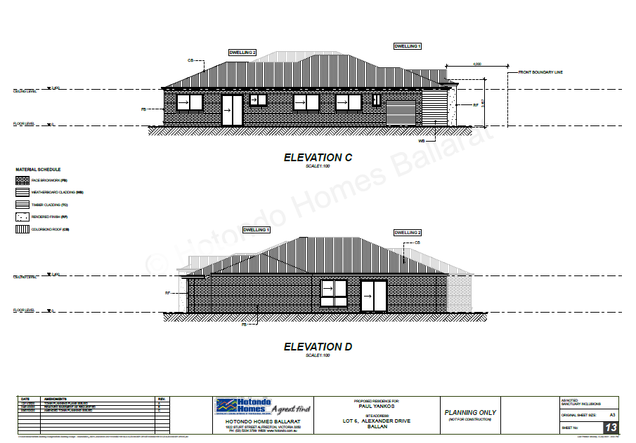
Figure 5: Side elevations.

Background to Current Proposal
Not applicable.

History
Planning permit application PA2019126 for removal of an easement was approved by Council on 8 November 2019. The permit was acted upon and the easement removed.
Planning permit application PA2019286 for a two lot subdivision was determined at the Development Assessment Committee held in May 2020. It was determined to refuse the application consistent with the officer’s recommendation and the refusal notice was issued on 20 May 2020. There was no subsequent appeal by the applicant against this decision.
The grounds of refusal were as follows:
1. The proposed lot sizes do not meet the minimum allowable lot sizes specified in the Neighbourhood Residential Zone, Schedule 7, of the Moorabool Planning Scheme.
2. The proposal is inconsistent with relevant state and local planning policy in the Moorabool Planning Scheme for residential land subdivision in this location.
3. The proposal does not meet all relevant provisions of Clause 56 (ResCode) of the Moorabool Planning Scheme.

Public Notice
Notice of the application was given to adjoining and surrounding landowners and occupiers by mail and a sign erected on site. No objections were received.

Locality Map
The map below indicates the location of the subject site and the zoning of the surrounding area.
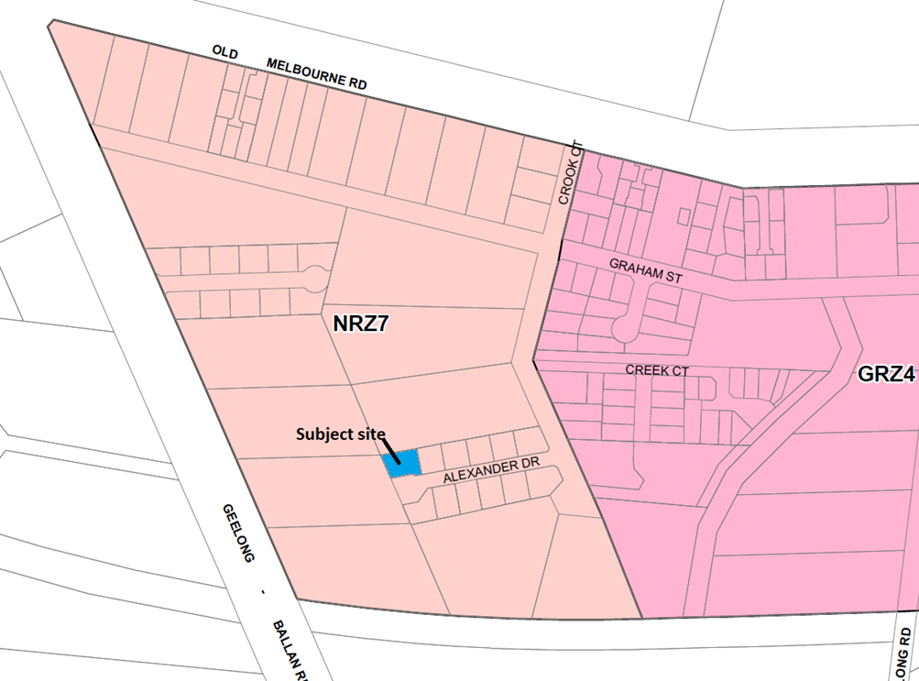
Figure 6: Zone map.

Planning Scheme Provisions
Council is required to consider the Victoria Planning Provisions and give particular attention to the Planning Policy Framework (PPF), Local Planning Policy Framework (LPPF) and the Municipal Strategic Statement (MSS).
The relevant clauses are:
• Clause 11.03-3S – Peri-urban areas
• Clause 14.02 – Water
• Clause 15.01-5S – Neighbourhood character
• Clause 15.02-1S – Energy and resource efficiency
• Clause 16.01-1S – Housing supply
• Clause 16.01-2S – Housing affordability
• Clause 21.02-3 – Water and catchment management
• Clause 21.03-2 – Urban Growth Management
• Clause 21.03-3 – Residential Development
• Clause 21.03-4 – Landscape and Neighbourhood Character
• Clause 21.08 – Ballan
• Clause 22.02 – Special Water Supply Catchments
In assessing it against the relevant sections of the PPF and LPPF, the following significant non-compliances were identified:
PPF and LPPF assessment
PPF | Title | Response
Clause 15.01-5S | Neighbourhood character | The proposal does not respond positively to the preferred neighbourhood character, which encourages detached dwellings with conventional front and side setbacks and garages which do not visually dominate dwellings or streetscapes.
Clause 15.02-1S | Energy and resource efficiency | The proposed design detail is not suitably responsive to the objective of this Clause.
LPPF
Clause 21.03-2 | Urban Growth Management | The proposal would facilitate residential growth in an area of Ballan where limited growth is encouraged.
Clause 21.03-3 | Residential development | The design detail does not adequately respond to the objectives or strategies which encourage environmentally sustainable design.

Clause 21.03-4 | Landscape and Neighbourhood Character | The proposal does not respond appropriately to the preferred neighbourhood character.
Clause 21.08-7 | Strategies for Residential Development | The proposal is inconsistent with the preferred development outcomes for Ballan’s Minimal Growth Areas.

Zone
The subject site is in the Neighbourhood Residential Zone, Schedule 7 (NRZ7). The purpose of the Neighbourhood Residential Zone is:
• To implement the Municipal Planning Strategy and the Planning Policy Framework.
• To recognise areas of predominantly single and double storey residential development.
• To manage and ensure that development respects the identified neighbourhood character, heritage, environmental or landscape characteristics.
• To allow educational, recreational, religious, community and a limited range of other non-residential uses to serve local community needs in appropriate locations.
Schedule 7 specifies the following neighbourhood character objectives to be achieved in this area:
• To protect the character and identity of the town by maintaining the open and spacious character, and transition from rural to residential areas, along Old Melbourne Road.
• To maintain a streetscape rhythm of detached dwellings with conventional front and side setbacks.
• To ensure garages and carports do not visually dominate dwellings or streetscapes.
• To encourage low, open front fencing, combined with landscaped front gardens to emphasise the country ‘feel’ of the township.
Under Clause 32.09-6 a permit is required to construct two or more dwellings on a lot. A development must meet the requirements of Clause 55. Pursuant to Clause 32.09-7, Schedule 7 varies the requirements of Clause 55, in particular Standards B18 and B32. Standard B18 relates to walls on boundaries, and it is noted that the proposed development does not comply with the specified variation to Standard B18.
The proposed development is inconsistent with the neighbourhood character objectives for Schedule 7 and does not comply with the requirements for Clause 55, Standard B18 specified in the Schedule to the zone.

Overlays
The site is affected by Environmental Significance Overlay, Schedule 1 (ES01).
Under Clause 42.01 -2 a permit is required to construct buildings and works. However, there is an applicable exemption under Schedule 1 for the construction of a dwelling in the Neighbourhood Residential Zone which is connected to reticulated sewerage, and no stormwater is discharged less than 100m from a waterway unless into an approved drainage system.
The subject site is connected to reticulated sewerage and stormwater drains to a Council drainage system. Also, no tree removal is proposed.
No permit is required under this overlay control.
Relevant PoliciesBallan Strategic Directions
Ballan Strategic Directions (‘the Strategy’) sets out objectives, strategies, and actions for the long-term planning of Ballan. The Strategy informed Council’s preparation of Planning Scheme Amendment C88 which proposed changes to local planning policy and the rezoning of land in Ballan, including the subject site. Council adopted C88 on 2 October 2019 after extensive public consultation and a review by an independent planning panel and the amendment was gazetted on 6 March 2020. Under Amendment C88 the subject site was rezoned from the General Residential Zone to Neighbourhood Residential Zone Schedule 7.

Particular Provisions
Clause 52.06 Car Parking
Under Clause 52.06-5 each dwelling with three or more bedrooms requires two car spaces. Both proposed dwellings are provided with two car spaces in a double garage. The garage and accessway dimensions meet the standards of Clause 52.06-9.
Clause 55 Two or More Dwellings on a Lot and Residential Buildings
The proposal does not comply with the following ResCode (Clause 55) clauses:
Clause ResCode | Title | Response
Clause 55.02-1 | Neighbourhood character | The proposed development does not respect the preferred neighbourhood character.
Clause 55.03-5 | Energy efficiency | Unit 1’s living areas are oriented to the south and east and do not take acceptable advantage of the northern aspect available. Although the living area has north facing glazing the position of the alfresco would prevent any north solar access and does not comply with this standard.
Clause 55.03-8 | Landscaping | Overall, the proposed boundary setbacks do not provide adequate space for the planting of suitable canopy trees in accordance with the preferred neighbourhood character.
Clause 55.04-1 | Side and rear setbacks | Overall, the proposed side and rear setbacks do not respect the preferred neighbourhood character.
Clause 55.04-2 | Walls on boundaries | The location of Unit 2’s boundary wall does not comply with this standard, as varied by the NRZ7 and is inconsistent with the preferred neighbourhood character.
Clause 55.05-4 | Private open space | Unit 2’s living areas are poorly integrated with the principal area of secluded private open space on the west side of the dwelling.
Clause 55.06-1 | Design detail | The proposed garages’ visual dominance in the streetscape is inconsistent with the preferred neighbourhood character.

Discussion
Overall, the proposed development is inconsistent with relevant state and local planning policy, the Neighbourhood Residential Zone, Clause 55 and the decision guidelines at Clause 65 of the Moorabool Planning Scheme.
The subject site and surrounding land west of the Crook Court road reserve is in the Neighbourhood Residential Zone, Schedule 7 (NRZ7). Existing nearby development reflects the growth of Ballan over the past few decades, typified by the incremental subdivision of land in Crook Court into smaller residential lots. The gazettal of Planning Scheme Amendment C88 on 6 March 2020 rezoned land in Crook Court to give guidance to Council’s preferred pattern of development for the area. It is important to note that land on the east side of Crook Court remained as General Residential Zone but with a new Schedule 4, compared to the rezoning of land west of Crook Court, which includes the subject site, to the Neighbourhood Residential Zone, Schedule 7.
The key issues with the proposal are assessed as follows:
• Non-compliance with the preferred neighbourhood character as set out in the NRZ7 and supported by State and local planning policies and various sections of Clause 55.
• Non-compliance with the principles of energy efficiency, as set out in State and local planning policies and Clause 55.03-5, in relation to dwelling floor plans which do not take sufficient advantage of passive solar energy.
Neighbourhood character
The subject site is in the Neighbourhood Residential Zone, Schedule 7, which sets out the following neighbourhood character objectives for new development relevant to the current proposal:
• To maintain a streetscape rhythm of detached dwellings with conventional front and side setbacks.
• To ensure garages and carports do not visually dominate dwellings or streetscapes.
• To encourage low, open front fencing, combined with landscaped front gardens to emphasise the country ‘feel’ of the township.
State and local planning policies in the Moorabool Planning Scheme, including at Clause 55, give support to development which responds to the preferred neighbourhood character, as set out above, as part of a suite of policies relevant to assessing medium density housing developments. Local policy at Clause 21.08 of the Moorabool Planning Scheme recognises Ballan’s role in providing for residential growth, with neighbourhoods more sparsely developed and further away from the town centre to generally accommodate less growth than those more readily accessible to services and infrastructure. Clause 21.08 and the zone schedules guide where housing growth should occur and what valued neighbourhood character attributes should be enhanced or created. The proposed development does not respond appropriately to this policy context.
The proposed dwellings, and in particular the side boundary setbacks, do not create the sense of spaciousness consistent with the neighbourhood character objectives. Alexander Drive comprises seven recently constructed dwellings on regular shaped lots 22 to 25m wide with an average size of 670sqm. Six of these dwellings are constructed either on or within approximately 1.2m of one side boundary but set back from the other side boundary by approximately 6m to 10m. The neighbourhood character objectives above refer to ‘conventional front and side setbacks.’ Considering that the area west of Crook Court to which these objectives relate is undergoing incremental subdivision the future character of the area will emerge with less intensive development compared those in the General Residential Zone. It is noted that since the Alexander Drive subdivision was created, the surrounding land west of Crook Court was rezoned to NRZ7, as outlined above, and a minimum 800sqm lot size requirement imposed for new subdivisions. This is relevant because the larger lot sizes create potential for larger more spacious side and rear setbacks and consequently establishing a convention in this regard for this area of Ballan.
However, given the emerging pattern of development in Alexander Drive described above it is considered reasonable to assess that this is currently ‘conventional’ in this neighbourhood. The proposed west side boundary setback would taper, due to the shape of the lot, from 4m at the front corner of the dwelling to 8.2m at the rear corner of the dwelling, however the east side setback is 0.2m which is technically deemed to be a wall on boundary. The proposed dwellings would be set back a minimum of 1.9m from each other. The proposed east boundary wall to Unit 1’s garage is a key concern with the proposal, and as previously noted, does not comply with the varied Standard B18 under the NRZ7. The varied standard requires that this wall be set back a minimum of 5.0m from Unit 1’s front wall, which would require a substantial redesign of the proposal.
Further to the concerns regarding the location of the proposed boundary wall, the double garages would be a dominant feature of the property frontages and inconsistent with the preferred neighbourhood character. Whilst the proposed garages are generally consistent with the size and street setbacks of existing garages in Alexander Drive, Unit 2’s garage would occupy a greater proportion of the dwelling’s front façade which would be compounded by there being two double garages rather than only one single or double garage as is the case for other properties. The visual dominance of Unit 1’s garage in the streetscape is largely a result of its location in contravention of Standard B18 as discussed above and does not respect the preferred neighbourhood character.
The NRZ7 includes the following decision guideline, in addition to the other relevant policy considerations:
• Whether adequate sized open space and setbacks are provided for the retention and growth of existing and new canopy trees.
As outlined above, the application does not comply with Clause 55.03-8 (Landscaping), in particular due to the limited opportunities, apart from Unit 2’s west side setback, to landscape either dwelling’s other setbacks. Tree planting is proposed but the proposed setbacks only allow for small trees, not canopy trees as is preferred. Unit 2’s rear setback makes no provision for any tree planting. The inadequate space available for canopy tree planting further reflects how the design response fails to respond appropriately to the relevant planning provisions, in particular as they relate to neighbourhood character.
Energy efficiency policy
Planning policies in the PPF and LPPF encourage new development to adopt the principles of energy efficiency. Clause 55.03-5 sets out the following objectives:
• To achieve and protect energy efficient dwellings and residential buildings.
• To ensure the orientation and layout of development reduce fossil fuel energy use and make appropriate use of daylight and solar energy.

The corresponding ResCode standard B10 sets out the following requirements:
• Buildings should be:
• Oriented to make appropriate use of solar energy.
• Sited and designed to ensure that the energy efficiency of existing dwellings on adjoining lots is not unreasonably reduced.
• Sited and designed to ensure that the performance of existing rooftop solar energy systems on dwellings on adjoining lots are not unreasonably reduced. The existing rooftop solar energy system must exist at the date the application is lodged.
• Living areas and private open space should be located on the north side of the development, if practicable.
• Developments should be designed so that solar access to north-facing windows is maximised.
The key concern with the proposal is that Unit 1’s layout does not maximise solar access to its north-facing living room glazing. The location of the proposed alfresco area would prevent solar access in winter, limiting it to south and east-facing windows. This significantly reduces opportunities for passive solar heating, forcing occupants to rely on other heat sources resulting in higher costs for heating. The proposed design is not sufficiently site responsive and does not satisfy the applicable requirements of the Moorabool Planning Scheme, in particular Clause 55.03-5.

General Provisions
Clause 65 - Decision Guidelines have been considered by officers in evaluating this application.
Clause 66 - Stipulates all the relevant referral authorities to which the application must be referred.

Referrals
Authority | Response
Council’s  Infrastructure  Strategic Planning | Consent with conditions.  Refusal.

Financial Implications
There are no financial implications for Council in refusing this development application.

Risk & Occupational Health & Safety Issues
The recommendation to refuse this development application does not have any risk or OH&S implications for Council.

Communications Strategy
Notice was undertaken for the application, in accordance with s.52 of the Planning and Environment Act 1987, and further correspondence is required to all interested parties to the application as a result of a decision in this matter. The applicant was invited to attend this meeting and address Council if required.

Options
• Issue a Refusal to Grant a Permit in accordance with the grounds in the recommendation of this report; or
• should Council wish to support the application, issue a Planning Permit with conditions.

Conclusion
Overall, the proposed development is not suitably responsive to the relevant planning controls or policies in the Moorabool Planning Scheme, particularly relating to energy efficient design and the preferred neighbourhood character for this area of Ballan. It is recommended that the application be refused on the specified grounds.

7.4 PA2021030 - Development of Two Dwellings at 1 Alexander Drive, Ballan
Author: Thomas Tonkin, Statutory Planner
Authoriser: Robert Fillisch, Manager Statutory Planning & Building Services
Attachments: 1. Proposed plans (under separate cover)

Application Summary
Permit No: PA2021030
Lodgement Date: 3 February 2021
Planning Officer: Tom Tonkin
Address of the land: 1 Alexander Drive, Ballan, 3342
Proposal: Development of Two Dwellings
Lot size: 885sqm
Why is a permit required? Clause 32.09 Neighbourhood Residential Zone, Schedule 7 – Development of Two Dwellings on a Lot.

Recommendation
That the Development Assessment Committee, having considered all matters as prescribed by the Planning and Environment Act 1987, issues a Refusal to Grant Planning Permit PA2021030 for the Development of Two Dwellings at Lot 12 on PS 713325V known as 1 Alexander Drive, Ballan 3342, on the following grounds:
1. The application is not supported by relevant State and local planning policy in the Moorabool Planning Scheme.
2. The application does not meet the neighbourhood character objectives of Neighbourhood Residential Zone, Schedule 7 (Ballan Traditional Residential Area) to Clause 32.09 of the Moorabool Planning Scheme.
3. The proposal does not respect the spacious character of the area and the rhythm of spacing between dwellings.
4. The application does not meet all of the relevant objectives of ResCode, Clause 55 of the Moorabool Planning Scheme.

Public Consultation
Was the application advertised? | Yes.
Notices on site: | Yes.
Notice in Moorabool Newspaper: | No.
Number of objections: | Two.
Consultation meeting: | No.

Policy Implications
The Council Plan 2021-2025 provides as follows:
Strategic Objective 2: Liveable and thriving environments
Priority 2.1: Develop planning mechanisms to enhance liveability in the Shire

Victorian Charter of Human Rights & Responsibilities Act 2006
In developing this report to Council, the officer considered whether the subject matter raised any human rights issues. In particular, whether the scope of any human right established by the Victorian Charter of Human Rights and Responsibilities is in any way limited, restricted or interfered with by the recommendations contained in the report. It is considered that the subject matter does not raise any human rights issues.

Officer’s Declaration of Conflict of Interests
Under section 130 of the Local Government Act 2020, officers providing advice to Council must disclose any interests, including the type of interest.
Acting Executive Manager – Robert Fillisch
In providing this advice to Council as the Acting Executive Manager, I have no interests to disclose in this report.
Author – Tom Tonkin
In providing this advice to Council as the Author, I have no interests to disclose in this report.

Executive Summary
Application referred? | Yes, to Greater Western Water and Council’s Infrastructure and Strategic Planning.
Any issues raised in referral responses? | Yes, Strategic Planning objected to the proposal.
Preliminary concerns? | Inconsistency with relevant planning policies regarding neighbourhood character. Additionally, further information was requested regarding landscaping, compliance with neighbourhood character and the covenant attached to title.
Any discussions with applicant regarding concerns? | Council wrote to the applicant regarding the abovementioned matters.
Any changes made to the application since being lodged? | A landscape plan was submitted. No other changes were made to the plans.
Brief history. | See ‘History’ below.
Previous applications for the site? | PA2019283 for a Two Lot Subdivision was refused by Council on 20 May 2020.

General summary. | It is proposed to develop the site for two semi-detached single storey three and four bedroom dwellings. The application was advertised, and two objections were received, generally relating to neighbourhood character and drainage infrastructure. The proposal does not comply with the relevant requirements of the Moorabool Planning Scheme for medium density housing, particularly in relation to the preferred neighbourhood character objectives for the precinct, energy efficiency or vehicle access.
Summary of Officer’s Recommendation
That, having considered all relevant matters as required by the Planning and Environment Act 1987, the Development Assessment Committee issues a Refusal to Grant Planning Permit PA2021030 for the Development of Two Dwellings at Lot 12 on PS 713325V known as 1 Alexander Drive, Ballan, on the grounds included in this report.

Site Description
The site, identified as Lot 12 on PS 713325V and known as 1 Alexander Drive, Ballan, is located on the south-west corner of Crook Court and Alexander Drive. The site is an irregular shape with an area of 885sqm encumbered by a 2m wide drainage easement parallel to the south and south-eastern boundaries. The site is vacant with no significant vegetation and relatively flat topography. Access to the site is via a crossover to Alexander Drive, parallel to the west title boundary.
The subject site and surrounding land to the north, south and west is in the Neighbourhood Residential Zone whilst land to the east, across Crook Court, is in the General Residential Zone. Development is characterised by mostly single storey dwellings on a range of lot sizes, with some vacant lots which mostly reflect the incremental subdivision of larger lots in the area.
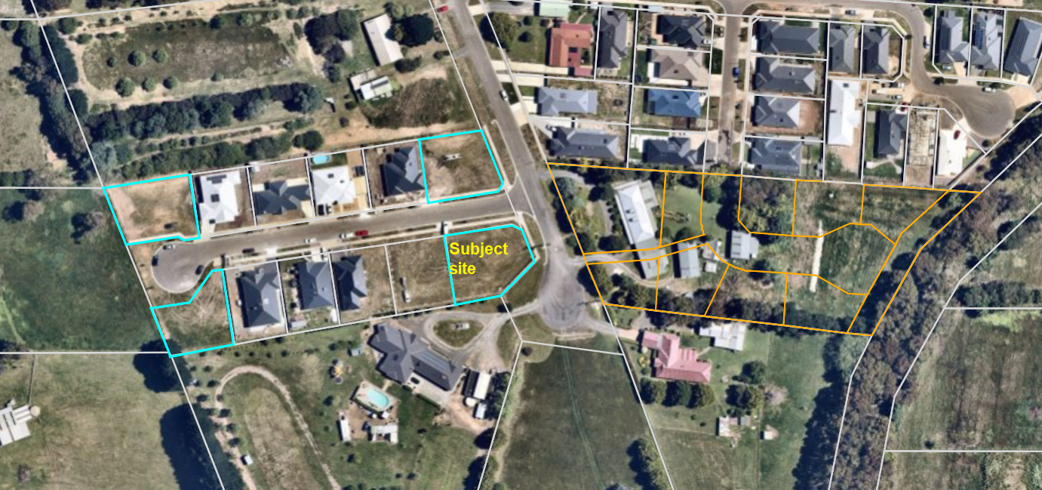
Figure 1: Aerial photograph.

Proposal
It is proposed to develop the site with two single storey dwellings. Units 1 and 2 would comprise, respectively, four and three bedrooms, two bathrooms and the usual amenities, with car parking provided in attached double garages. Units 1 and 2 would have respective floor areas of 207.6sqm and 184.9sqm. Both dwellings would front Alexander Drive and be accessed via double width crossovers. The dwellings would be of brick construction and conventional in appearance. Both dwellings would have a low pitched hipped Colorbond roof whilst Unit 2’s roof form would also incorporate a pitched roof with half gable above the front façade with an eave. Both dwellings would have minimum front setbacks of 4.2m. No front fencing is proposed.
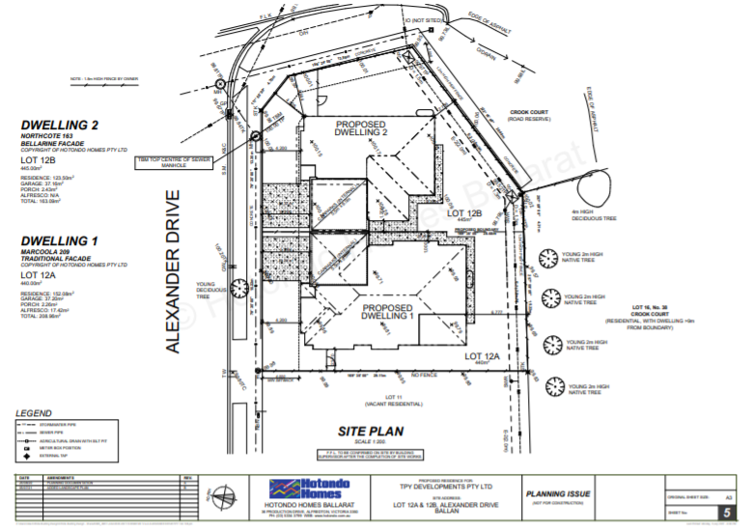
Figure 2: Site plan.
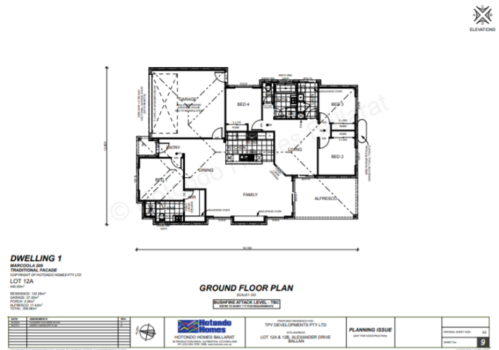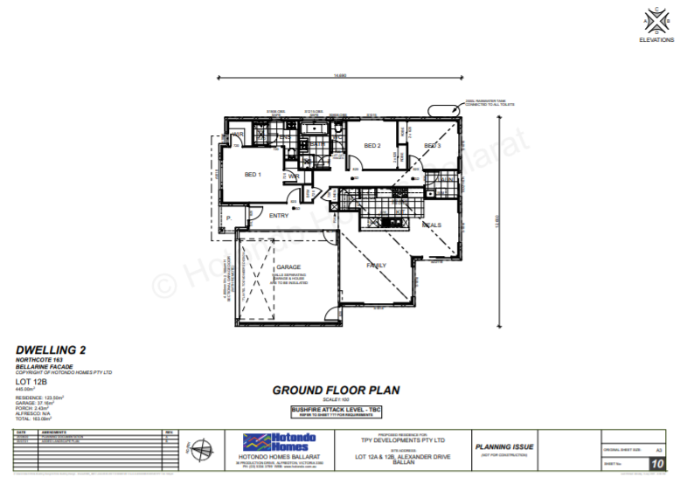
Figure 3: Proposed floor plans.
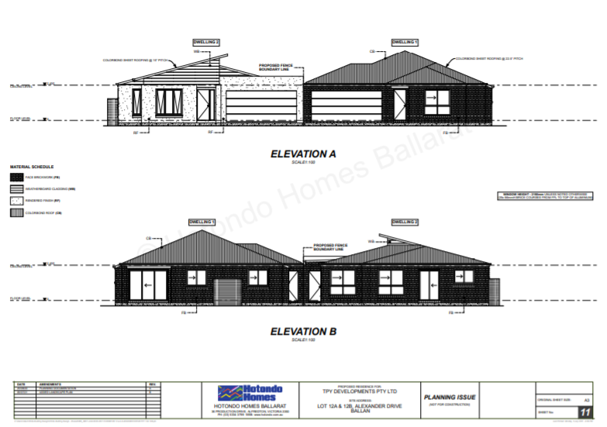
Figure 4: Proposed front and rear setbacks.
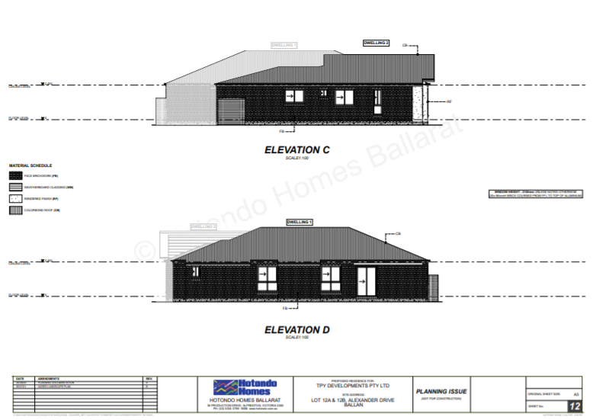
Figure 5: Proposed side setbacks.
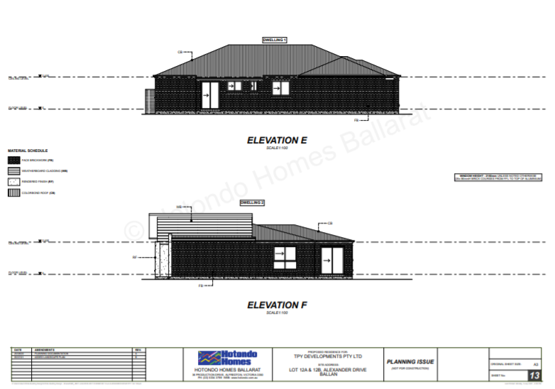
Figure 6: Proposed side setbacks.

Background to Current Proposal
None applicable.

History
Planning permit application PA2019283 for a two lot subdivision was determined at the Development Assessment Committee held in May 2020. It was determined to refuse the application consistent with the officer’s recommendation and the refusal notice was issued on 20 May 2020. There was no subsequent appeal by the applicant against this decision.
The grounds of refusal were as follows:
1. The proposed lot sizes do not meet the minimum allowable lot sizes specified in the Neighbourhood Residential Zone, Schedule 7, of the Moorabool Planning Scheme.
2. The proposal is inconsistent with relevant state and local planning policy in the Moorabool Planning Scheme for residential land subdivision in this location
3. The proposal does not meet all relevant provisions of Clause 56 (ResCode) of the Moorabool Planning Scheme.

Public Notice
Notice of the application was given to adjoining and surrounding landowners and occupiers by mail and a sign erected on site.
Two objections were received.

Summary of Objections
The objections received are detailed below with officer’s comments accompanying them:
Objection | Any Relevant Requirement
The impact on neighbourhood character created by reduced boundary setbacks. | Clauses 15.01-5S, 21.03-4, 21.08-7, 32.09 and 55.02-1.
Officer’s Response:
The proposal is inconsistent with the preferred neighbourhood character. See ‘Discussion’ below.
The existing 2m wide drainage easement is a constraint on the amount of developable land and reduces the amount of spacing between dwellings. | Clauses 55.03-8 and 55.06-1.
Officer’s Response:
The proposal is inconsistent with the preferred neighbourhood character and does not match the rhythm of spacing between dwellings. See ‘Discussion’ below.
The area is unsuited to multi-unit development which is identified for limited growth. | Clauses 21.08-7 and 32.09.
Officer’s Response:
The proposal is not suitably site responsive and does not comply with the relevant provisions for the assessment of two or more dwellings on a lot. See ‘Discussion’ below.
The proposal provides limited opportunity to landscape the building setbacks. | Clauses 21.08-7, 32.09 and 55.03-8.
Officer’s Response:
The proposal is inconsistent with the preferred neighbourhood character and has minimal landscaping opportunities. See ‘Discussion’ below.
Council previously refused an application to subdivide the subject site into two lots because it would have created lots of less than 800sqm which is required under the NRZ7. If the current application is approved, it would defeat the purpose of having refused the previous application. | Clause 32.09.
Officer’s Response:
As per the previous subdivision application (see ‘History’ above), the current proposal is inconsistent with the preferred neighbourhood character. It is noted that, if the proposed development is approved and constructed, the land is currently unable to be subdivided.

There are no other multi-unit developments on land in the NRZ7 and the proposal would not be in keeping with the existing or preferred character. | Clauses 15.01-5S, 21.03-4, 21.08-7, 32.09 and 55.02-1.
Officer’s Response:
The proposal is not suitably site responsive and does not comply with the relevant neighbourhood character provisions of the Moorabool Planning Scheme. See ‘Discussion’ below.
All properties in the NRZ7 comprise single dwellings, allowing residents to enjoy their backyard with room to grow with their family. This allows a better neighbourhood environment that people enjoy coming home to. | Clauses 15.01-5S, 21.03-4, 21.08-7, 32.09, 55.02-1 and 65.01.
Officer’s Response:
The proposal is inconsistent with the preferred neighbourhood character. See ‘Discussion’ below.
Inadequate drainage in the area. Existing works related to this developer have caused flooding of my property. Infrastructure conditions will be inadequate to mitigate flooding. Kerb and channelling is required in Crook Court. | Clause 55.02-4.
Officer’s Response:
If approved, drainage would be required to Council’s satisfaction.
The need for repairs or upgrades to existing roads is usually addressed through Council’s road maintenance program.
Additional traffic and noise pollution. The lack of car parking resulting in cars being parked on the road verge creates a traffic hazard. | Clause 52.06.
Officer’s Response:
The proposal provides for car parking in accordance with the Moorabool Planning Scheme. No formal visitor car parking is required to be provided on site; however it is noted that informal visitor car parking may be accommodated in the driveways. It is not considered that the proposal would impose an unreasonable burden on parking provision in the immediate area.

Locality Map
The map below indicates the location of the subject site and the zoning of the surrounding area.
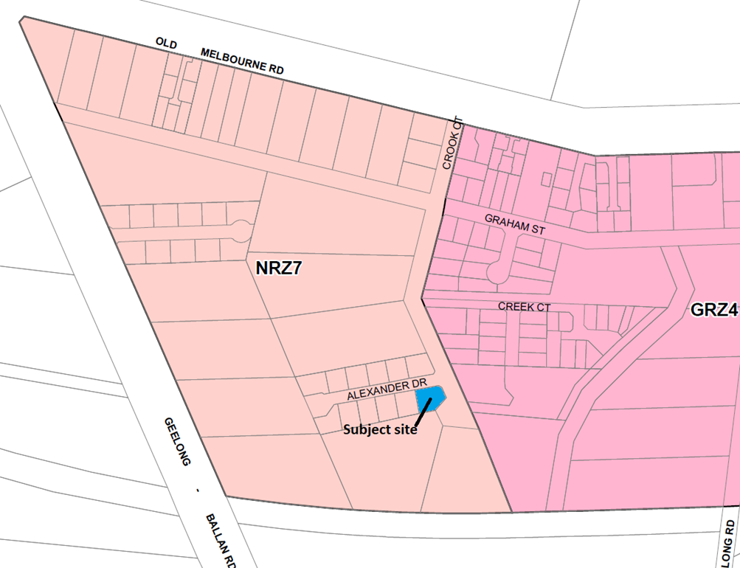
Figure 7: Zone map.

Planning Scheme Provisions
Council is required to consider the Victoria Planning Provisions and give particular attention to the Planning Policy Framework (PPF), Local Planning Policy Framework (LPPF) and the Municipal Strategic Statement (MSS).
The relevant clauses are:
• Clause 11.03-3S – Peri-urban areas
• Clause 14.02 – Water
• Clause 15.01-5S – Neighbourhood character
• Clause 15.02-1S – Energy and resource efficiency
• Clause 16.01-1S – Housing supply
• Clause 16.01-2S – Housing affordability
• Clause 21.02-3 – Water and catchment management
• Clause 21.03-2 – Urban Growth Management
• Clause 21.03-3 – Residential Development
• Clause 21.03-4 – Landscape and Neighbourhood Character
• Clause 21.08 – Ballan
• Clause 22.02 – Special Water Supply Catchments
In assessing it against the relevant sections of the PPF and LPPF, the following significant non-compliances were identified:
PPF and LPPF assessment
PPF | Title | Response
Clause 15.01-5S | Neighbourhood character | The proposal does not respond positively to the preferred neighbourhood character, which encourages detached dwellings with conventional front and side setbacks and garages which do not visually dominate dwellings or streetscapes.
Clause 15.02-1S | Energy and resource efficiency | The proposed design detail is not suitably responsive to the objective of this Clause.
LPPF
Clause 21.03-2 | Urban Growth Management | The proposal would facilitate residential growth in an area of Ballan where limited growth is encouraged.
Clause 21.03-3 | Residential development | The design detail does not adequately respond to the objectives or strategies which encourage environmentally sustainable design.
Clause 21.03-4 | Landscape and Neighbourhood Character | The proposal does not respond appropriately to the preferred neighbourhood character.
Clause 21.08-7 | Strategies for Residential Development | The proposal is inconsistent with the preferred development outcomes for Ballan’s Minimal Growth Areas.

Zone
The subject site is in the Neighbourhood Residential Zone, Schedule 7 (NRZ7). The purpose of the Neighbourhood Residential Zone is:
• To implement the Municipal Planning Strategy and the Planning Policy Framework.
• To recognise areas of predominantly single and double storey residential development.
• To manage and ensure that development respects the identified neighbourhood character, heritage, environmental or landscape characteristics.
• To allow educational, recreational, religious, community and a limited range of other non-residential uses to serve local community needs in appropriate locations.

Schedule 7 specifies the following neighbourhood character objectives to be achieved in this area:
• To protect the character and identity of the town by maintaining the open and spacious character, and transition from rural to residential areas, along Old Melbourne Road.
• To maintain a streetscape rhythm of detached dwellings with conventional front and side setbacks.
• To ensure garages and carports do not visually dominate dwellings or streetscapes.
• To encourage low, open front fencing, combined with landscaped front gardens to emphasise the country ‘feel’ of the township.
Under Clause 32.09-6 a permit is required to construct two or more dwellings on a lot. A development must meet the requirements of Clause 55.
The proposed development is inconsistent with the neighbourhood character objectives for Schedule 7 that seek an open and spacious character.

Overlays
The site is affected by Environmental Significance Overlay, Schedule 1 (ES01).
Under Clause 42.01-2 a permit is required to construct buildings and works. However, there is an applicable exemption under Schedule 1 for the construction of a dwelling in the Neighbourhood Residential Zone which is connected to reticulated sewerage, and no stormwater is discharged less than 100m from a waterway unless into an approved drainage system.
The subject site is connected to reticulated sewerage and stormwater drains to a Council drainage system. Also, no tree removal is proposed.
No permit is required under this overlay control.

Relevant Policies
Ballan Strategic Directions
Ballan Strategic Directions (‘the Strategy’) sets out objectives, strategies and actions for the long-term planning of Ballan. The Strategy informed Council’s preparation of Planning Scheme Amendment C88 which proposed changes to local planning policy and the rezoning of land in Ballan, including the subject site. Council adopted C88 on 2 October 2019 after extensive public consultation and a review by an independent planning panel and the amendment was gazetted on 6 March 2020. Under Amendment C88 the subject site was rezoned from the General Residential Zone to Neighbourhood Residential Zone Schedule 7.

Particular Provisions
Clause 52.06 Car Parking
Under Clause 52.06-5 each dwelling with more than three bedrooms requires two car spaces. Both proposed dwellings are provided with two car spaces in a double garage. The garage and accessway dimensions meet the standards of Clause 52.06-9.

Clause 55 Two or More Dwellings on a Lot and Residential Buildings
The proposal does not comply with the following ResCode (Clause 55) clauses:
Clause ResCode | Title | Response
Clause 55.02-1 | Neighbourhood character | The proposed development does not respect the preferred neighbourhood character.
Clause 55.03-5 | Energy efficiency | Neither dwelling takes acceptable advantage of the site’s northern aspect, with both dwellings’ living areas oriented to the south and west. The proposal does not comply with this standard.
Clause 55.03-9 | Access | The proposed double width crossovers exceed 33% of the street frontage which does not meet the standard and is inconsistent with the preferred neighbourhood character.
Clause 55.06-1 | Design detail | The proposed dwellings’ semi-detached construction and the attached double garages’ visual dominance in the streetscape is inconsistent with the preferred neighbourhood character.

Discussion
Overall, the proposed development is inconsistent with relevant state and local planning policy, the Neighbourhood Residential Zone, Clause 55 and the decision guidelines at Clause 65 of the Moorabool Planning Scheme.
The subject site and surrounding land west of the Crook Court road reserve is in the Neighbourhood Residential Zone, Schedule 7 (NRZ7). Existing nearby development reflects the growth of Ballan over the past few decades, typified by the incremental subdivision of land in Crook Court into smaller residential lots. The gazettal of Planning Scheme Amendment C88 on 6 March 2020 rezoned land in Crook Court to give guidance to Council’s preferred pattern of development for the area. It is important to note that land on the east side of Crook Court remained as General Residential Zone but with a new Schedule 4, compared to the rezoning of land west of Crook Court, which includes the subject site, to the Neighbourhood Residential Zone, Schedule 7.
The key issues with the proposal are assessed as follows:
• Non-compliance with the preferred neighbourhood character as set out in the NRZ7 and supported by state and local planning policies and various sections of Clause 55.
• Non-compliance with the principles of energy efficiency, as set out in state and local planning policies and Clause 55.03-5, in relation to dwelling floor plans which do not take sufficient advantage of passive solar energy.

Neighbourhood character
The subject site is in the Neighbourhood Residential Zone, Schedule 7, which sets out the following neighbourhood character objectives for new development relevant to the current proposal:
• To maintain a streetscape rhythm of detached dwellings with conventional front and side setbacks.
• To ensure garages and carports do not visually dominate dwellings or streetscapes.
• To encourage low, open front fencing, combined with landscaped front gardens to emphasise the country ‘feel’ of the township.
State and local planning policies in the Moorabool Planning Scheme, including at Clause 55, give support to development which responds to the preferred neighbourhood character, as set out above, as part of a suite of policies relevant to assessing medium density housing developments. Local policy at Clause 21.08 of the Moorabool Planning Scheme recognises Ballan’s role in providing for residential growth, with neighbourhoods more sparsely developed and further away from the town centre to generally accommodate less growth than those more readily accessible to services and infrastructure. Clause 21.08 and the zone schedules guide where housing growth should occur and what valued neighbourhood character attributes should be enhanced or created. The proposed development does not respond appropriately to this policy context.
The proposed dwellings’ semi-detached construction does not create the sense of spaciousness consistent with the neighbourhood character objectives. Alexander Drive comprises seven recently constructed dwellings on regular shaped lots 22 to 25m wide with an average size of 670sqm. Six of these dwellings are constructed either on or within approximately 1.2m of one side boundary but set back from the other side boundary by approximately 6m to 10m. The neighbourhood character objectives above refer to ‘conventional front and side setbacks.’ Considering that the area west of Crook Court to which these objectives relate is undergoing incremental subdivision the future character of the area will emerge with less intensive development compared those in the General Residential Zone. It is noted that since the Alexander Drive subdivision was created, the surrounding land west of Crook Court was rezoned to NRZ7, as outlined above, and a minimum 800sqm lot size requirement imposed for new subdivisions. This is relevant because the larger lot sizes create potential for larger more spacious side and rear setbacks and consequently establishing a convention in this regard for this area of Ballan.
Whilst the proposed dwellings’ side setbacks are generally consistent with the preferred neighbourhood character, this is compromised by their semi-detached construction resulting in a building scale and bulk which is inconsistent with the preferred neighbourhood character which specifies a ‘a streetscape rhythm of detached dwellings with conventional front and side setbacks’. Furthermore, the proposed double garages would be a dominant feature of the property frontages and inconsistent with the preferred neighbourhood character which seeks ‘to ensure garages and carports do not visually dominate dwellings or streetscapes.’ This visual dominance would be compounded by the garages being joined to each other and with parallel driveways served by double width crossovers. The combined width of the crossovers would exceed 33% of the site frontage which is non-compliant with the relevant ResCode standard. The proposed landscaping between the driveways would not sufficiently soften the appearance of the garages or driveways. Whilst the proposed garages are generally consistent with the size and street setbacks of existing garages in Alexander Drive, both would occupy a greater proportion of the dwellings’ front façades which would be compounded by there being two double garages rather than only one double or single garage as is the case for other properties.
The NRZ7 includes the following decision guideline, in addition to the other relevant policy considerations:
• Whether adequate sized open space and setbacks are provided for the retention and growth of existing and new canopy trees.
Notwithstanding the constraints imposed by the easement located parallel to the rear boundary, the proposed boundary setbacks overall provide reasonable opportunities for landscaping, including canopy trees, consistent with the preferred neighbourhood character.
Energy efficiency policy
Planning policies in the PPF and LPPF encourage new development to adopt the principles of energy efficiency. Clause 55.03-5 sets out the following objectives:
• To achieve and protect energy efficient dwellings and residential buildings.
• To ensure the orientation and layout of development reduce fossil fuel energy use and make appropriate use of daylight and solar energy.
The corresponding ResCode standard B10 sets out the following requirements:
• Buildings should be:
• Oriented to make appropriate use of solar energy.
• Sited and designed to ensure that the energy efficiency of existing dwellings on adjoining lots is not unreasonably reduced.
• Sited and designed to ensure that the performance of existing rooftop solar energy systems on dwellings on adjoining lots are not unreasonably reduced. The existing rooftop solar energy system must exist at the date the application is lodged.
• Living areas and private open space should be located on the north side of the development, if practicable.
• Developments should be designed so that solar access to north-facing windows is maximised.
The key concern with the proposal is that neither dwelling provides any north-facing living spaces. Notwithstanding that the site is located on the south side of Alexander Drive, its generous width of 28.57m to 35m provides acceptable opportunities to achieve a site responsive design. The current design, which provides only south and west-facing living spaces would provide for extremely limited solar access, significantly reducing opportunities for passive solar heating and forcing occupants to rely on other heat sources resulting in higher costs for heating. The proposed design is not sufficiently site responsive and does not satisfy the applicable requirements of the Moorabool Planning Scheme, in particular Clause 55.03-5.

General Provisions
Clause 65 - Decision Guidelines have been considered by officers in evaluating this application.
Clause 66 - Stipulates all the relevant referral authorities to which the application must be referred.

Referrals
Authority | Response
Greater Western Water  Council’s  Infrastructure  Strategic Planning | No response.  Consent with conditions.  Refusal.

Financial Implications
There are no financial implications for Council in refusing this development application.

Risk & Occupational Health & Safety Issues
The recommendation to refuse this development application does not have any risk or OH&S implications for Council.

Communications Strategy
Notice was undertaken for the application, in accordance with s.52 of the Planning and Environment Act 1987, and further correspondence is required to all interested parties to the application as a result of a decision in this matter. All submitters and the applicant were invited to attend this meeting and address Council if required.

Options
• Issue a Refusal to Grant a Permit in accordance with the grounds in the recommendation of this report; or
• should Council wish to support the application, issue a Notice of Decision to Grant a Permit with conditions.

Conclusion
Overall, the proposed development is not suitably responsive to the relevant planning controls or policies in the Moorabool Planning Scheme, particularly relating to energy efficient design, vehicle access and the preferred neighbourhood character for this area of Ballan. It is recommended that the application be refused on the specified grounds.

7.5 PA2021245 - Two Lot Subdivision (Boundary Realignment) and Creation of Easement on Lot 12 and Lot 23 Streeton Drive, Merrimu
Author: Jyoti Makan, Senior Statutory Planner
Authoriser: Henry Bezuidenhout, Executive Manager Community Planning & Economic Development
Attachments: 1. Proposed Boundary realignment plan (under separate cover)
2. Proposed Subdivision plan (under separate cover)

Application Summary
Permit No: PA2021245
Lodgement Date: 25 October 2021
Planning Officer: Jyoti Makan
Address of the land: Lot 12 and Lot 23 Streeton Drive on PS318904G
Proposal: Two Lot Subdivision (Boundary Realignment) and Creation of Easement
Lot size: Lot 12 - 3.182ha and Lot 23 17 - 0.48ha
Why is a permit required? Clause 35.07-3 (Farming Zone) and Clause 42.01 (Environmental Significance Overlay) – a permit is required to subdivide land.

Recommendation
That the Development Assessment Committee, having considered all matters as prescribed by the Planning and Environment Act 1987, issues a Refusal to grant Planning Permit PA2021245 for a Two Lot Subdivision (Boundary realignment) and Creation of Easement on Lot 12 and Lot 23 on Plan of Subdivision PS318904G subject to the following grounds:
1. The proposed realignment is inconsistent with the objectives of Clause 11.02-2S – Structure Planning.
2. The proposed realignment results in a premature application which will prejudice the preparation of the Merrimu Precinct Structure Plan.
3. The proposed realignment of boundaries does not represent orderly planning of the area.

Public Consultation
Was the application advertised? | Yes, the application was advertised to adjoining property owners and occupiers and with one sign at the end of Streeton Drive and one at the end of Tipperary Flats.
Notices on site: | Yes, two signs were placed at each road entry on site.
Notice in Moorabool Newspaper: | No notices in the newspaper.
Number of objections: | No objections were received.
Consultation meeting: | No public consultation meeting took place.

Policy Implications
The Council Plan 2021-2025 provides as follows:
Strategic Objective 1: Healthy, inclusive and connected neighbourhoods
Priority 1.5: Provide access to services to improve community connection in the Shire

Victorian Charter of Human Rights & Responsibilities Act 2006
In developing this report to Council, the officer considered whether the subject matter raised any human rights issues. In particular, whether the scope of any human right established by the Victorian Charter of Human Rights and Responsibilities is in any way limited, restricted or interfered with by the recommendations contained in the report. It is considered that the subject matter does not raise any human rights issues.

Officer’s Declaration of Conflict of Interests
Under section 130 of the Local Government Act 2020, officers providing advice to Council must disclose any interests, including the type of interest.
Executive Manager – Henry Bezuidenhout
In providing this advice to Council as the Executive Manager, I have no interests to disclose in this report.
Author – Jyoti Makan
In providing this advice to Council as the Author, I have no interests to disclose in this report.

Executive Summary
Application referred? | The application was referred to Melbourne Water, Greater Western Water, Victorian Planning Authority and Council’s Infrastructure and Strategic Planning.
Any issues raised in referral responses? | Impacts of the realignment on the future of the Merrimu Precinct Structure Plan boundary. Future split zoning.
Preliminary concerns? | Lack of clarity of reasoning for realigning the boundary and future split zoning
Any discussions with applicant regarding concerns? | Several discussions, meetings and email communication with the applicant. The applicant provided information and confirmed application reasoning.
Any changes made to the application since being lodged? | None.
Brief history. | None applicable.
Previous applications for the site? | PA2012122 – Use and Development of a Dwelling – permit issued 12 September 2012, extended to be completed by 21 September 2018.
General summary. | The application proposes a Two Lot Subdivision (Boundary Realignment) and Creation of Easement on Lot 12 and Lot 23 on Plan of Subdivision PS318904G. The proposal does not comply with the provisions of the planning scheme and future precinct structure plan boundaries therefore recommended for refusal.
Summary of Officer’s Recommendation
That, having considered all relevant matters as required by the Planning and Environment Act 1987, the Development Assessment Committee issues a Refusal to grant Planning Permit PA2021245 for a Two lot Subdivision (Boundary realignment) and Creation of Easement on Lot 12 and Lot 23 on Plan of Subdivision PS318904G subject to the grounds recommended in this report.

Site Description
The site is located along the Coimadai Creek River Frontage access from Tipperary Flats and Streeton Drive in Merrimu. Tipperary Flats is accessed from the Western Freeway 387m south of Lot 23 on PS318904G. The site is also about 550m east from Flanagans Drive. The site and surrounding sites are restricted by a Section 173 Agreement AE068310W. The Rural Conservation Zone, Farming Zone and Public Use and Recreation Zones surround the site.
Both lots are partially covered by the Cultural Heritage Significance area.

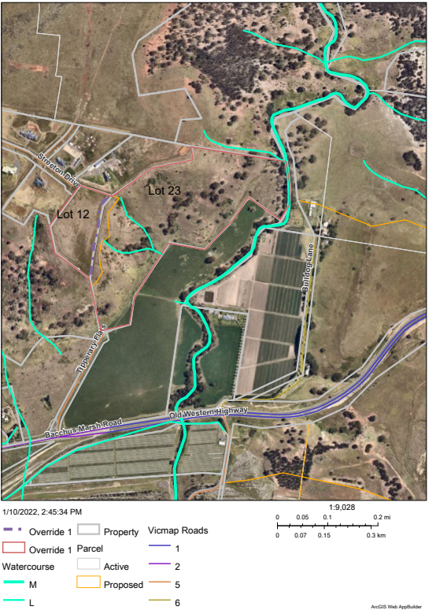
Figure 1: Aerial Site Map

Proposal
The application proposes to realign the boundaries of Lots 12 and 23 on PA318904G and create a carriageway easement identified as E-6 on the proposed plans. The boundary realignment between the two lots as shown in Figure 1 above which shows an orange irregular alignment between Lot 12 and Lot 23. The purple dashed line is the existing boundary. It is proposed that Lot 12 be increased from 3.182ha to 3.913ha (0.73ha increase) and Lot 23 be decreased in area from 17.48ha to 16.76ha (0.73ha). The proposal also consists of a creation of a 12m carriageway easement in favour of Lot 23 (proposed Lot 2). The proposed plan of subdivision and boundary realignment plan is attached herewith.

Background and History to Current Proposal
The site is covered by a Section 173 Agreement (AE068310W) shown on the Certificate of Titles being:
• Volume 10928 Folio 506 – Lot 23 PS318904G
• Volume 10928 Folio 487 – Lot 12 PS318904G
This Agreement relates to the permit issued in 2006 for the subdivision of lots and on previous planning permits: Nos. 55/93, 008/97, 083/99, 2000-056, 030/00, 2001- 203 and 2002-345. The obligations required were mainly based on fencing, access to western freeway and Bacchus Marsh Roads, dwellings, soil extraction, outbuildings, vegetation, no further subdivision, environmental and construction activities.
The relevant restriction applying for the proposal is that “no further subdivision” is permitted. However, considering that from an assessment perspective the proposed application is classified as a two lot subdivision as it creates two new lots, but it does not create a further additional lot therefore it is not classified as further subdivision from what is already subdivided.

Public Notice
The application was notified to adjoining and surrounding landowners. No objections were received.

Locality Map
The map below indicates the location of the subject site and the zoning of the surrounding area.
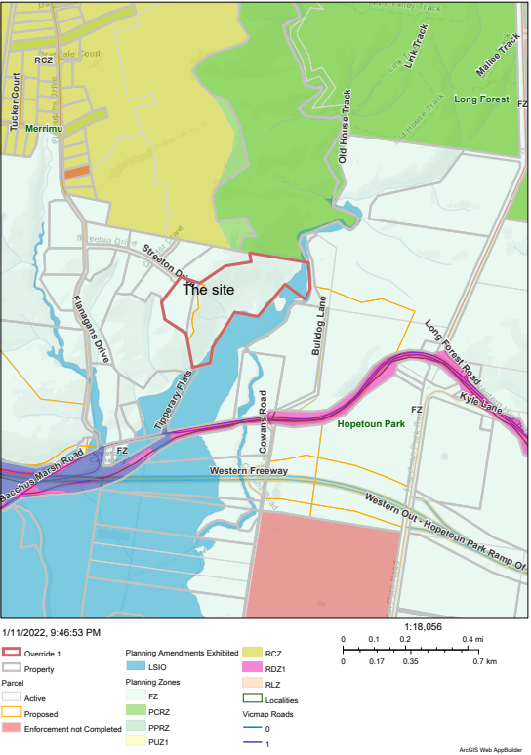
Figure 2: Locality Map

Planning Scheme Provisions
Council is required to consider the Victoria Planning Provisions and give particular attention to the Planning Policy Framework (PPF), the Local Planning Policy Framework (LPPF) and the Municipal Strategic Statement (MSS).
The relevant clauses are:
• Clause 11 – Settlement
• Clause 11.02 – Managing Growth
• Clause 11.02-1S – Supply of urban land
• Clause 11.02-3S – Structure Planning
• Clause 11.03-2S – Growth areas
• Clause 21.03 – Settlement and Housing (Objective urban Growth Management)
• Clause 14.01-1S – Protection of Agricultural Land.

Zone
Farming Zone
The purpose of the Zone is to:
• Implement the Municipal Planning Strategy and the PPF.
• Provide for the use of land for agriculture.
• Encourage the retention of productive agricultural land.
• Ensure that non-agricultural uses, including dwellings, do not adversely affect the use of land for agriculture.
• Encourage the retention of employment and population to support rural communities.
• Encourage use and development of land based on comprehensive and sustainable land management practices and infrastructure provision.
• Provide for the use and development of land for the specific purposes identified in a schedule to this zone.
Pursuant to Clause 35.07-3, a permit is required to subdivide land. A permit may be granted to create smaller lots if the subdivision is the re-subdivision of existing lots and the number of lots is not increased.

Overlays
Environmental Significance Overlay- Schedule 3 (ESO3)
The Environmental Significance Overlay (ESO) has the purpose to:
• To implement the Municipal Planning Strategy and the Planning Policy Framework.
• To identify areas where the development of land may be affected by environmental constraints.
• To ensure that development is compatible with identified environmental values.
ESO 3 is related to the protection of Long Forest and Werribee Gorge.
No vegetation is proposed for removal, but the proposal is not exempt from permit requirements as the ESO 3 does not specifically state a permit is not required for subdivision.

Relevant Policies
Council’s Rural Growth Policy
Council’s Rural Growth Policy Statement was adopted by Council on 19 September 2012. The document applies to all land in Farming Zone.
The policy states:
• Encourage dwellings in areas nominated in Map 1 of Council Rural Growth Policy Statement.
• Ensure the siting of any dwellings is designed to have a minimal impact on any existing or future agricultural activities on the site and on surrounding land.
• Ensure it is clear whether the dwelling is required for agricultural operation, use or to maintain rural communities.
• Ensure sufficient infrastructure is available or that alternative methods are available which do not require normal infrastructure.
• Encourage development of dwellings, to support communities, on land which is unlikely to support agricultural (use) while still considering any other overlays which may impact the land. This is land which is constrained for use as agriculture by other environmental factors such as vegetation, slope, soil quality, etc.

Particular Provisions
Clause 53.01 – Public Open Space Contribution and Subdivision
A person who proposes to subdivide land must make a contribution to the Council for public open space in an amount specified in the schedule to this clause (being a percentage of the land intended to be used for residential, industrial, or commercial purposes, or a percentage of the site value of such land, or a combination of both). If no amount is specified, a contribution for public open space may still be required under section 18 of the Subdivision Act 1988.
An exemption applies from public open space contributions (in part) if it subdivides land into two lots and the Council considers it unlikely that each lot will be further subdivided.

Discussion
The application proposes a realignment of boundaries and no further subdivision. The proposed Lots 12 and 23 are covered by the Farming Zone which requires a planning permit for the subdivision of land. The two lot realignment of boundaries is considered as a subdivision and assessed against the planning scheme’s zoning, overlays, particular provisions, and decision guidelines including the planning and local policy provisions.
The Farming Zone states that the minimum subdivision area is 15ha according to the mapping provided in the schedule to the zone.
The proposal results in an increase in the proposed Lot 1 area to increase the developable area of the proposed Lot 1. The proposed Lot 2 (existing Lot 23) is relatively steep land and will be difficult to develop. Flatter parts of the land are highlighted in Figure 3 below.
The land is also partially covered by the Cultural Heritage sensitive area, but the proposed activity is not classified as a high impact activity according to the Aboriginal Heritage Regulations 2018.
The proposed carriageway easement (E-6) is proposed to provide access to the proposed Lot 2 because there are difficulties accessing the lot due to steep topography.
The proposal compromises land required for future urban expansion pursuant to Clause 11.01 – Settlement.
The Merrimu PSP is currently at the stage of finalising background technical studies which were based on lots within the approved PSP boundary which includes the existing Lot 12 but excludes. Lot 23. By realigning the boundaries, the subdivision results in future split zoning and impacts on the technical studies already conducted by the Victorian Planning Authority (VPA). This has further implications on the neighbouring properties which could potentially request to be included with significant impacts and possible delays on the process. The applicant was requested to discuss the boundary realignment with the VPA and then revisit the realignment of boundaries however the applicant decided to continue with the realignment of boundaries with Council.
Clause 11.02-2S of the planning scheme is based on structure planning which facilitates the hierarchy of structure plans or precinct structure plans for the orderly planning of urban areas. Considering that the urban growth framework has been defined and realigning the lots at this stage will not be in accordance with that defined boundary.
Both Council’s Strategic Planning and the VPA confirmed in its referral advice that this proposal at this late stage of the approved PSP boundary cannot be supported for reasons outlined above.
Further to this, the proposed realignment results in Lot 23 being considered as undevelopable for both farming practices and residential development due to its steep slopes and should not be re-subdivided to remove majority of available flatter land on this parcel as it compromises its future viability. The proposed Lot 1 will also result in future split zoning which is undesirable.
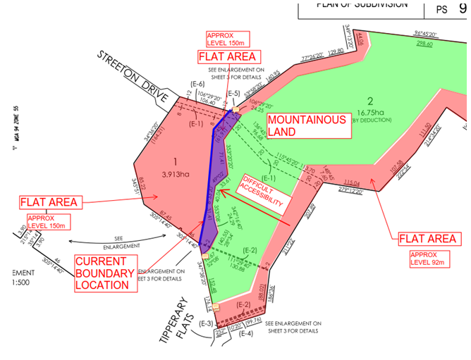
Figure 3: Proposed realignment of lots

General Provisions
Clause 65 - Decision Guidelines have been considered by officers in evaluating this application.
Clause 66 - Stipulates all the relevant referral authorities to which the application must be referred.

Referrals
Authority | Response
Greater Western Water | Consent with conditions.
Melbourne Water | Consent.
Victorian Planning Authority | Consultation meetings provided verbal advice that tat this late stage of the approved PSP boundary, the application is not supported.
Council’s  Infrastructure  Strategic Planning | Consent with conditions.  Refusal.

Financial Implications
There are no financial implications known from the proposal.

Risk & Occupational Health & Safety Issues
The recommendation of approval of this development does not implicate any risk or OH&S issues to Council.

Communications Strategy
Notice was undertaken for the application, in accordance with s.52 of the Planning and Environment Act 1987, and further correspondence is required to all interested parties to the application as a result of a decision in this matter. All submitters and the applicant were invited to attend this meeting and invited to address Council if required.

Options
• Issue a Refusal to grant a permit in accordance with the recommendation of this report; or
• issue an approval to the application for a planning permit outside of the recommendations of this report. However, should Council wish to consider approving of the application, Councillor’s will need to explore reasons why the proposal complies with the Moorabool Planning Scheme.

Conclusion
The application is assessed against the planning scheme and is considered as unsuitable for subdivision as it has detrimental impacts of the future Merrimu Precinct Structure Plan boundaries, background technical studies and results in a future split zoning of the land.
It results in an irregular shaped lot and sits outside the Merrimu Precinct Structure Plan boundary and is recommended for refusal on the grounds mentioned above.

7.6 PA2021196 - Buildings and Works Associated with Existing Industrial Premises (Abattoir) at 6 Woolpack Road, Bacchus Marsh
Author: Jyoti Makan, Senior Statutory Planner
Authoriser: Henry Bezuidenhout, Executive Manager Community Planning & Economic Development
Attachments: 1. Development Plans (under separate cover)

Application Summary
Permit No: PA2021196
Lodgement Date: 26 August 2021
Planning Officer: Jyoti Makan
Address of the land: 6 Woolpack Road, Bacchus Marsh
Proposal: Buildings and Works Associated with existing Industrial Premises (Abattoir)
Lot size: 2.73ha
Why is a permit required? Farming Zone – Construct or carry out building and works pursuant
to Clause 35.07-4

Recommendation
That the Development Assessment Committee, having considered all matters as prescribed by the Planning and Environment Act 1987, issues Planning Permit PA2021196 for Buildings and Works associated with Existing Industrial Premises (Abattoir) at 6 Woolpack Road, Bacchus Marsh, subject to the following conditions:
Endorsed Plans:
1. Before the use and development starts, amended plans to the satisfaction of the Responsible Authority must be submitted to and approved by the Responsible Authority. When approved, the plans will be endorsed and will then form part of the permit. The plans must be drawn to scale with dimensions and must be generally in accordance with the plans dated 17 May 2021 and prepared by NIRAS Australia, but modified to show:
(a) Show construction details of the demountable parts of the building, cool room, and equipment to allow transfer to the new facility to Parwan.
(b) Annotate that there is no increase in the capacity of the manufacturing operations and no increase in employee numbers.
(c) Dimensioned elevation plans.
(d) Non-reflective materials and colour scheme schedule shown on the elevation plans.
(e) Specify the location of any waste storage areas.
(f) Finished floor levels and fencing in accordance with Melbourne Water’s conditions.
(g) Show the location of any landscaping treatments surrounding the proposed building.
(h) Submission of a Site Environmental Management Plan in accordance with the requirements of Melbourne Water.
Car parking:
2. Car spaces, access lanes and driveways shown on the endorsed plan must not be used for any other purpose other than the parking of vehicles, to the satisfaction of the Responsible Authority.
Materials:
3. All external walls and roof areas of the proposed building/s are to be clad with non-reflective materials (zincalume prohibited) to the satisfaction of the Responsible Authority.
Operational:
4. The proposed building must be removed from the site within five years of the completion of the development unless otherwise agreed to by Council.
Amenity:
5. Effective noise levels from the use of the new building must not exceed the recommended levels as set out in the Noise from Industry in Regional Victoria (NIRV; EPA Publication 1411, 2011) or as amended.
6. External lighting must be provided with suitable baffles and located so that no direct light is emitted outside the site.
7. Any security alarm or similar device installed must be of a silent type.
8. Goods, equipment, or machinery must not be stored or left exposed in a position that can be seen from the street.
9. All construction vehicles for the works are to access the site without detrimental amenity impacts to neighbouring properties.
Signage:
10. Except where exempt under the Moorabool Planning Scheme, advertising signage must not be constructed or displayed without separate planning approval.
Infrastructure:
11. Storm water drainage from the proposed building and impervious surfaces must be retained and disposed of within the boundaries of the subject land to the satisfaction of the Responsible Authority. Overflows from onsite storage system must be directed away from any waste water disposal areas.
12. Sediment discharges must be restricted from any construction activities within the property in accordance with relevant Guidelines including Construction Techniques for Sediment Control (EPA 1991).
13. Unless otherwise approved by the Responsible Authority there must be no buildings, structures, or improvements located over any drainage pipes and easements on the property.
14. Prior to the commencement of the development and post completion, notification including photographic evidence must be sent to Council’s Asset Services identifying any existing damage to Council assets. Any existing works affected by the development must be fully reinstated at no cost to and to the satisfaction of the Responsible Authority.

Melbourne Water:
15. Finished floor levels of the building must be constructed to a minimum of 300mm above the applicable flood level of 92.48m to the Australian Height Datum (AHD). This is the flood level that has a 1% Annual Exceedance Probability (AEP), that is, a 1% probability of being equalled or exceeded in any one year.
16. Any fencing and gates (including internal fencing) should be designed as 50% open style or standard timber paling style of design.
17. No filing is permitted outside of the building envelope, with the exception of achieving minimal ramping into the proposed building.
18. Layout of buildings and works as shown on the plans must not be altered without prior written consent from Melbourne Water.
19. Prior to commencement of construction, a Site Environmental Management Plan (SEMP) must be produced and adopted on-site. The SEMP must address the following:
(a) Sediment and silt management controls.
(b) Vegetation management techniques.
(c) Access tracks.
(d) Spoil stockpiling.
(e) Machinery/Plant locations.
(f) Exclusion fencing around native vegetation/habitat.
20. Any new or modified stormwater connection to Melbourne Water’s drainage system must obtain separate approval from Melbourne Water. Please apply online at: https://www.melbournewater.com.au/building-and-works/apply-to-build-or-develop/stormwater-connection
Permit Expiry:
21. This permit will expire if:
(a) the development is not started within two years of the date of this permit; or
(b) the development is not completed within four years of the date of this permit.
Melbourne Water Note:
Flood Information – This property is subject to flooding from the Werribee River. The applicable flood level for this building is 92.48m to the Australian Height Datum (AHD).

Public Consultation
Was the application advertised? | Yes, the application was advertised by means of signs placed on site and letters being sent to adjoining owners and occupiers.
Notices on site: | Yes, against each street frontage.
Notice in Moorabool Newspaper: | No.
Number of objections: | No objections received.
Consultation meeting: | Nil.
The Council Plan 2021-2025 provides as follows:
Strategic Objective 2: Liveable and thriving environments
Priority 2.4: Grow local employment and business investment

Victorian Charter of Human Rights & Responsibilities Act 2006
In developing this report to Council, the officer considered whether the subject matter raised any human rights issues. In particular, whether the scope of any human right established by the Victorian Charter of Human Rights and Responsibilities is in any way limited, restricted or interfered with by the recommendations contained in the report. It is considered that the subject matter does not raise any human rights issues.

Officer’s Declaration of Conflict of Interests
Under section 130 of the Local Government Act 2020, officers providing advice to Council must disclose any interests, including the type of interest.
Executive Manager – Henry Bezuidenhout
In providing this advice to Council as the Executive Manager, I have no interests to disclose in this report.
Author – Jyoti Makan
In providing this advice to Council as the Author, I have no interests to disclose in this report.

Executive Summary
Application referred? | The application was referred to Melbourne Water, the Department of Transport and Council’s Infrastructure, Strategic Planning, Economic Development, and Environmental Health.
Any issues raised in referral responses? | The strategic issue is that the proposal leads to the expansion and modernisation of the abattoir in terms of its buildings and works that can delay the relocation to 3922 Geelong-Bacchus Marsh Road, Parwan. This business is expected to be a keystone occupant of the new Pawan Industrial precinct.

Preliminary concerns? | Expansion of the use and buildings and works, clarity on proposed structures being temporary or permanent, reasoning behind the increased floor area, car parking.
Any discussions with applicant regarding concerns? | Discussions took place with the applicant.
Any changes made to the application since being lodged? | No changes were made to the application.
Brief history. | The site was previously known as the Woolpack Inn and is now used as an Abattoir.
Previous applications for the site? | PA2014159 - Buildings and Works Associated with an Existing Abattoir and Removal of Vegetation (two non-native trees). PA2010292 - Buildings and Works Associated with an Existing Abattoir (Loading Facility and Holding Room).  PA2011179 - Buildings and Works Associated with an Existing Abattoir (Additions to Office).
General summary. | The proposal relates to the addition of 1,300sqm of building area to allow for a reconfiguration of existing operations to meet the physical distancing requirements caused by Coronavirus based on the COVID Safe Workplace rules released by Victorian State Government. The business/landowner has an obligation to ensure that all health and safety requirements of employees are met and that operations can continue at its 100% capacity therefore resulting in an increase in building footprint to allow for sufficient spacing of operations which will result in the spacing of employees. No increase in output or employees are proposed therefore there are no impacts on car parking on the site. The application has been assessed against the planning scheme and is recommended for approval subject to planning permit conditions. A condition is placed in the recommendations of this report to allow a temporary structure it to be relocated to their facility in Parwan.
Summary of Officer’s Recommendation
That, having considered all relevant matters as required by the Planning and Environment Act 1987, the Development Assessment Committee issues Planning Permit PA2021196 for Buildings and Works associated with Existing Industrial Premises (Abattoir) at 6 Woolpack Road Bacchus Marsh, subject to the recommendations contained in this report.

Site Description
The site is situated at the south western corner of Bacchus Marsh Road and Woolpack Road, Bacchus Marsh.
The site is in the Farming Zone and covered by the Design and Development Overlay – Schedule 2, Heritage Overlay – Schedule 57 (refer to Figure 5 below). The Werribee River is located south of the site.
The subject land currently accommodates an existing abattoir and primary processing facility operated by the Failli Family through L&G Meats Pty Ltd. A number of existing trees are planted along the site boundaries.
The subject site is located within the Bacchus Marsh Irrigation District (BMID), which is a declared irrigation district under Part 6A of the Water Act 1989.
The site is surrounded by the Farming Zone and bounded by Transport Road Zone 2 and Transport Road Zone 3. The Avenue of Honour exists along Bacchus Marsh Road fronting the site.
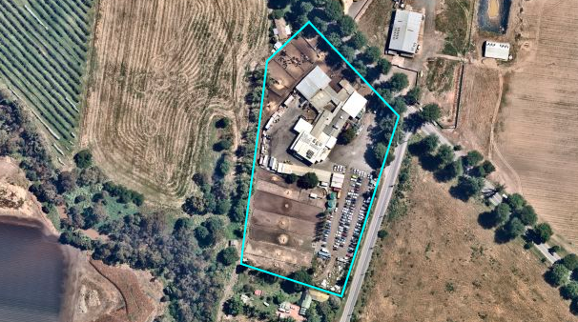
Figure 1: Aerial image of the subject site

Proposal
The proposed building will be located directly south of the existing building and will be obscured by existing buildings and from the Avenue of Honour. Proposed setbacks and existing vegetation will limit visual impacts from Woolpack Road
The rationale for the proposed works is to continue for the facility to operate safely under the new state government requirements pertaining to COVID-19.
The existing floor area of 2,153sqm houses the boning room, chillers, load out, palletising area, freezer, carton room, slaughter areas.
Currently the boning room, palletising area and loadout area has a combined floor area of 284sqm and requires approximately 65 employees for these areas to operate at full capacity. In order to comply with the state government requirements (due to COVID-19) 4sqm of workable area per employee and space for equipment, the applicant proposes to relocate the palletising and loadout operations (and 15 employees) to the proposed building. This will allow the boning room to expand to provide adequate social distancing between the 50 employees to work in the boning room.
There will be no increase in employee numbers as a result of this proposal. However, it will allow for the operations to return to full capacity and the opportunity to retain all employees. The employee numbers below apply to the current operations and the operations after the proposed works are complete:

Area | Number of Employees
Slaughter Floor | 30
Boning Room | 50
Load and Palletising | 15
Total | 95

The Loadout and Palletising operations to be relocated under this proposal will be as per the table below:

Building | Area | Number of Employees
Existing Building | Slaughter Floor | 30
 | Boning Room | 50
Proposed Building | Loadout and Palleting | 15
Total |  | 95

The proposed building is to meet the state government’s social distancing requirements, calculated on space requirements for the abattoir operations.
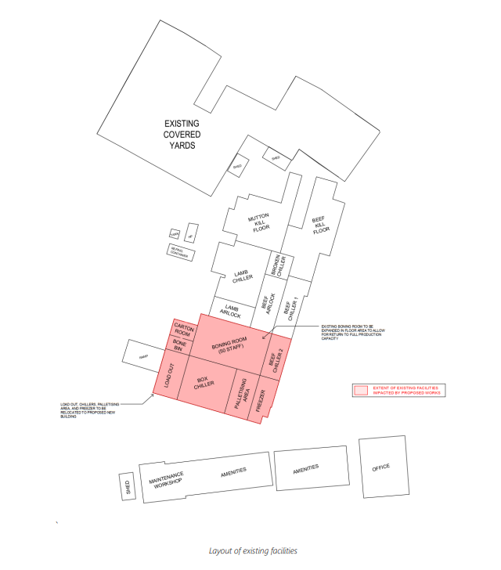
Figure 2: Exsiting facilities layout (area coloured red affected by employee density)
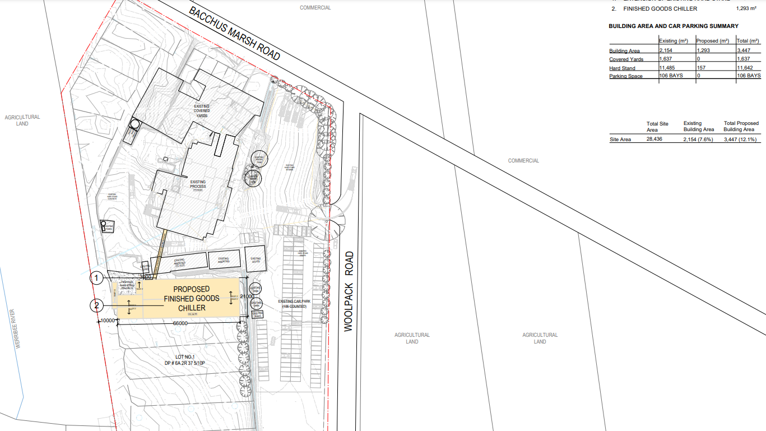
Figure 3: Proposed site plan

The site was historically known as a Woolpack Inn with part of a wall to the original building still standing.
The existing site was built as a multi species Abattoir facility. It is an ovine and bovine processing plant, with the ability to slaughter, chill, bone and package beef and lamb. Planning permits were approved for the buildings and works of associated with an existing abattoir with native vegetation removal.
Further information on the history is provided in the Discussion section of this report.

Public Notice
The application was notified to adjoining and surrounding landowners and signs placed on site.
No objections were received.

Locality Map
The map below indicates the location of the subject site and the zoning and overlays of the surrounding area.
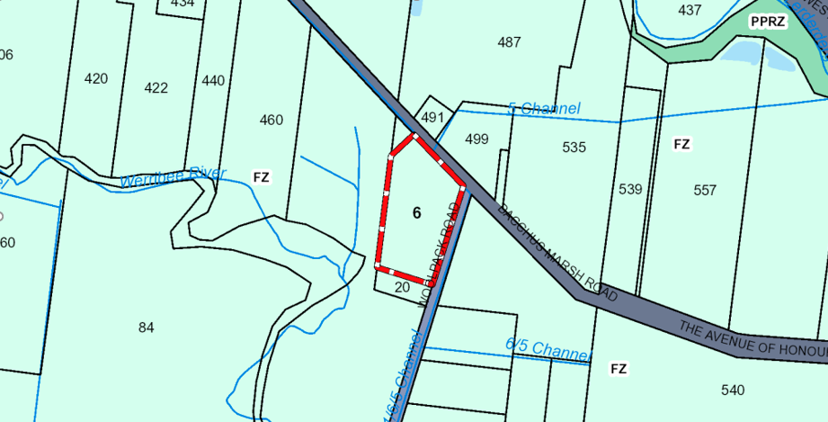
Figure 4: Zone Map with Farming Zone coloured light green
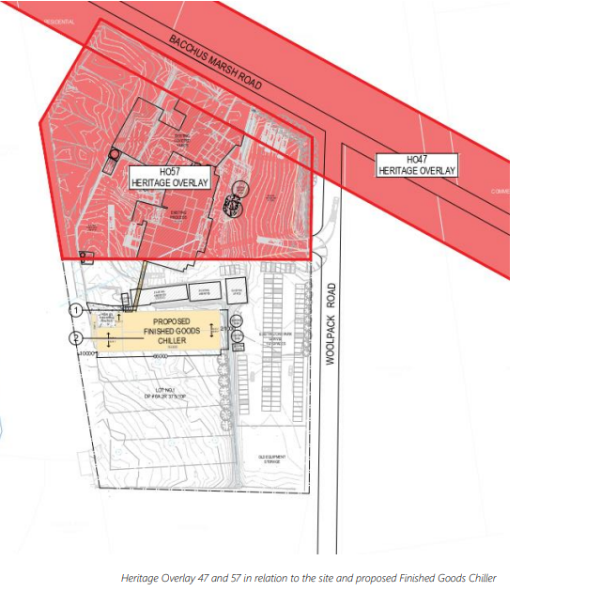
Figure 5: Extent of the Heritage Overlays (coloured red)

Planning Scheme Provisions
Council is required to consider the Victoria Planning Provisions and give particular attention to the Planning Policy Framework (PPF), the Local Planning Policy Framework (LPPF) and the Municipal Strategic Statement (MSS).
The relevant clauses are:
• Clause 13.07 – Land Use Compatibility
• Clause 14.02-3S – Protection of declared irrigation districts
• Clause 15 – Built environment and heritage
• Clause 15.03 – Heritage
• Clause 17 – Economic Development
• Clause 17.03 – Industry
• Clause 21.02-2 – Non-urban landscapes
• Clause 21.04-04 – Agricultural

Zone
Farming Zone
Purpose:
• To implement the Municipal Planning Strategy and the Planning Policy Framework.
• To provide for the use of land for agriculture.
• To encourage the retention of productive agricultural land.
• To ensure that non-agricultural uses, including dwellings, do not adversely affect the use of land for agriculture.
• To encourage the retention of employment and population to support rural communities.
• To encourage use and development of land based on comprehensive and sustainable land management practices and infrastructure provision.
• To provide for the use and development of land for the specific purposes identified in a schedule to this zone.
A permit is required to construct or carry out buildings and works associated with a Section 2 use under Clause 35.07-4.

Overlays
Design and Development Overlay – Schedule 2
Design Objectives of this overlay are:
• To enhance visual amenity in rural, township and vegetated areas of the Moorabool Shire.
• To encourage the use of external cladding, such as non-reflective materials for building construction.
• To discourage the use of materials, such as reflective cladding for building construction, which could have a detrimental effect on amenity.
The applicant is not proposing any reflective materials.
Environmental Significance Overlay – Schedule 8
This overlay is located at the south western corner of the site and not impacted by the proposal. It seeks to protect River red Gums in the Bacchus Marsh Valley.
Heritage Overlay – Schedule 57 and 47
Schedule 4 of this overlay is along the Bacchus Marsh Road protecting the Avenue of Honour trees and Schedule 57 is related to the former Woolpack Inn. Both overlays are not impacted by the proposed buildings and works.
Public Acquisition Overlay (PAO)
This overlay has the purpose to:
• To implement the Municipal Planning Strategy and the Planning Policy Framework.
• To identify land which is proposed to be acquired by a Minister, public authority, or municipal Council.
• To reserve land for a public purpose and to ensure that changes to the use or development of the land do not prejudice the purpose for which the land is to be acquired.
• To designate a Minister, public authority or municipal council as an acquiring authority for land reserved for a public purpose.
This overlay exists at the north eastern corner of the site and is not impacted by the proposal.

Relevant Policies
Amendment C76 – Parwan Industrial Precinct
Moorabool Planning Scheme Amendment C76 (gazetted on 21 Dec 2017) effectively swapped the IN1Z from PC362391Y Geelong-Bacchus Marsh Road Parwan to 3922 Geelong-Bacchus Marsh Road Parwan, resulting in a net increase of 74ha of industrial zoned land. A key reason for the proponents (L & G Failli) seeking to rezone the land was to facilitate the relocation of their existing abattoir from 6 Woolpack Road to 3922 Geelong-Bacchus Marsh Road, Parwan.
Amendment C76 also resulted in DPO1 being applied to 3922 Geelong-Bacchus Marsh Road and a Development Plan – Parwan Industrial Precinct was approved by Council on 18 December 2019.

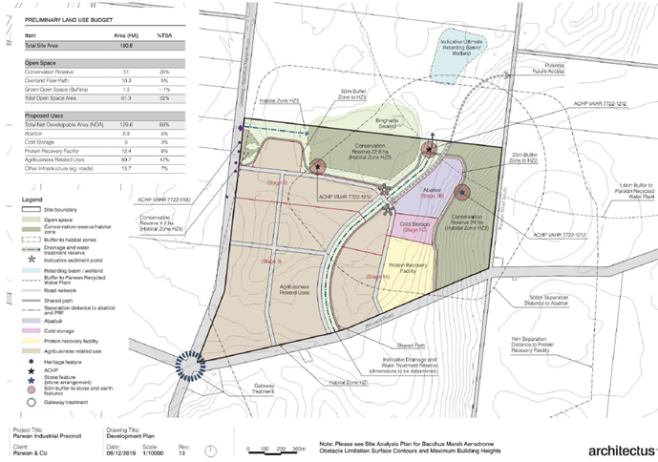
Figure 6: Parwan Industrial Precinct Development Plan. The proposed abattoir site shaded purple.

Particular Provisions
Clause 52.06 – Car Parking
• Ensure that car parking is provided in accordance with the Municipal Planning Strategy and the Planning Policy Framework.
• Ensure provision of an appropriate number of car parking spaces having regard to the demand likely to be generated, the activities on the land and the nature of the locality.
• Support sustainable transport alternatives to the motor car.
• Promote the efficient use of car parking spaces through the consolidation of car parking facilities.
• Ensure that car parking does not adversely affect the amenity of the locality.
• Ensure that the design and location of car parking is of a high standard, creates a safe environment for users and enables easy and efficient use.
This provision does not make reference to an abattoir however car parking assessment provided separates each land use to inform the car parking for the site.

Discussion
Zoning and Overlays
The site is zoned for agricultural activity and the abattoir use is existing. An Abattoir is defined as land used to slaughter animals, including birds. It may include the processing of animals. An Abattoir is in the classification of a Rural Industry. The proposal is made for the buildings and works to allow for additional floor space to meet COVID-19 state government requirements on employee social distancing.
The operations at the facility identify the need for additional 1,300sqm to meet the state government COVID-19 restrictions and for the business to continue to operate at full capacity. The proposed increase to the floor area provides sufficient space for social distancing and to ensure that health and safety requirements are met for all employees.
The proposal is to increase the floor area and reconfigure areas of communal work spaces, use of floor markings, realign workstations and screening, providing each area with its own equipment to minimise build-up of employees.
The proposal does not impact the overlays covering the land and conditions are placed on the permit to ensure that the proposed building does not contain any reflective materials in accordance with the Design and Development Overlay – Schedule 2. The site is subject to flooding and Melbourne Water proposed conditions on the permit to ensure that all flood impacts mitigated with raised finished floor levels.
A portion of the subject site is a designated area of aboriginal cultural heritage. The applicant submitted that, “with reference to the Aboriginal Heritage Regulations 2018 – SR No 59 of 2018 – Reg 46, the proposed works, while subject to designated area of cultural heritage sensitivity, is not deemed to be a High Impact Activity in accordance Part 2, Division 5, 1 (a) does not significantly disturb ground and 1 (b) the activities are not scheduled activities, nor a linear project. Therefore, does not require a Cultural Heritage Management Plan”.
Strategic and Policy Framework
A key consideration with this proposal is to ensure building and works do not prevent or delay a future relocation of the use as approved through the recent planning scheme amendment C76. Proposed permit conditions will make sure the building is removable so that the expansion does not continue once the coronavirus pandemic restrictions are lifted.
Building and Works
The proposed building is located behind the existing building avoiding adverse impacts on the streetscape. The proposed structure is designed to allow existing operations to continue, therefore it does not anticipate any increase in traffic and vehicle movements.
Although the proposal does not meet the strategic and policy framework, the reason for the expansion is related to existing practices on the site for the purpose of meeting the state government’s COVID-19 restrictions in the workplace. An additional building in the Bacchus Marsh Irrigation District is considered justified on an interim to medium term basis subject to the conditions related to the movability of the proposed building included in the Permit.
The proposed building footprint is 1,300sqm and 16m high which requires a significant investment to the subject site and its existing practices. The site is located in the Bacchus Marsh Irrigation District which seeks to protect agricultural land uses including its objectives. The site holds the strategic intention to be used for agricultural practices and not for industrial activity. It also seeks to maintain and enhance the natural environment and the Shire’s rural identity and character as well as to protect the sites surrounding and existing overlays including the Werribee Creek.
Amendment C76 was gazetted on 21 December 2017 which swapped the Industrial 1 Zone from PC36239Y Geelong Bacchus Marsh Road Parwan to 3922 Geelong Bacchus Marsh Road, in Parwan which resulted in an increase of 74ha of industrial zoned land. The current landowners of the abattoir rezoned the land to facilitate the relocation of the existing abattoir from 6 Woolpack Road to 3922 Geelong Bacchus Marsh Road, Parwan. The Development Plan overlay – Schedule 1 was applied because of amendment C76, and the Development Plan for the Parwan Industrial Precinct was approved by Council on 18 December 2019.
The proposed building is intended to be constructed as a temporary structure and to allow for the building and the equipment to be relocated to the new facility in Parwan.
Car parking:
An assessment of car parking provided shows that abundant space is provided for employees and delivery vehicles. The site provides 107 car parking bays. Council’s Infrastructure had no objections to the proposal as there is no increase in the number of employees, therefore no change in car parking. The existing car parking remains on the site.

General Provisions
Clause 65 - Decision Guidelines have been considered by officers in evaluating this application.
Clause 66 - Stipulates all the relevant referral authorities to which the application must be referred.

Referrals
Authority | Response
Melbourne Water | Consent with conditions.
Dept of Transport | Consent, no conditions.
Council’ s  Infrastructure  Strategic Planning  Economic Development  Environmental Health  Heritage Advisor | Consent with conditions.  Refusal – considerations for Amendment C76 – Parwan Industrial Precinct.  No objections.  No objections.  Consent.

Financial Implications
The recommendation of approval of this development does not implicate any financial risks.

Risk & Occupational Health & Safety Issues
The recommendation of approval of this development does not implicate any risk or OH&S issues to Council.

Communications Strategy
Notice was undertaken for the application, in accordance with s.52 of the Planning and Environment Act 1987, and further correspondence is required to all interested parties to the application as a result of a decision in this matter. The applicant was invited to attend this meeting and invited to address Council if required.

Options
• Issue a grant to a permit in accordance with the conditions recommended in this report; or
• should Council wish to consider a refusal to grant a permit, Councillor’s must consider how the proposal does not comply with the Moorabool Planning Scheme.

Conclusion
The proposal was assessed against the planning scheme and is recommended for approval subject to the planning permit conditions. The proposal includes the buildings and works of a 1,300sqm building footprint consisting of a finished goods chiller to allow for existing operations to expand in floor area for social distancing measures for existing employees due to the COVID-19 pandemic. Conditions on the permit will require the buildings to be temporary to allow for its removal and parts of the building relocation to Parwan.

8 Update on Trends, Issues and Other Matters

9 Process Forward and Work Program

10 Update on VCAT Decisions

11 Other Business

12 Date of Next Meeting
Wednesday 16 March 2022.

13 Meeting Close

