AGENDA

Development Assessment Committee Meeting
Wednesday, 17 August 2022
I hereby give notice that a Development Assessment Committee Meeting will be held on:
Date: | Wednesday, 17 August 2022
Time: | 6.00pm
Location: | Council Chambers, 15 Stead Street, Ballan & Online
Henry Bezuidenhout
Executive Manager, Community Planning & Development

Order Of Business
1 Opening 5
2 Present and Apologies 5
3 Recording of Meeting 5
4 Confirmation of Minutes 5
5 Matters Arising from Previous Minutes 5
6 Disclosure of Conflicts of Interests 5
7 Community Planning Reports 6
7.1 PA2022064 - Use of the Existing Dwelling for a Retail Premise (Pharmacy) and a Reduction in Car Parking (two car spaces) at 56 Urquhart Street, Gordon 6
7.2 PA2021224 - Development and Use of a Dwelling at 493 Swans Road Darley 19
7.3 PA2021240 Variation of Restrictive Covenant AD159230W at 10 Parkside Drive, Hopetoun Park 33
8 Update on VCAT Decisions 43
9 Other Business 43
10 Date of Next Meeting 43
11 Meeting Close 43

1 Opening

2 Present and Apologies

3 Recording of Meeting
In accordance with Moorabool Shire Council’s Governance Rules, the meeting will be livestreamed.

4 Confirmation of Minutes
Wednesday 20 July 2022.

5 Matters Arising from Previous Minutes

6 Disclosure of Conflicts of Interests
Conflict of interest laws are prescribed under the Local Government Act 2020 (the Act) and in the Local Government (Governance and Integrity) Regulations 2020 (the Regulations). Managing conflicts of interest is about ensuring the integrity and transparency of decision-making.
The conflict of interest provisions under the Act have been simplified so that they are more easily understood and more easily applied. The new conflict of interest provisions are designed to ensure relevant persons proactively consider a broader range of interests and consider those interests from the viewpoint of an impartial, fair-minded person.
Section 126 of the Act states that a Councillor has a conflict of interest if they have a general conflict of interest or a material conflict of interest. These are explained below:
- A Councillor has a general conflict of interest in a matter if an impartial, fair-minded person would consider that the member’s private interests could result in them acting in a manner that is contrary to their public duty as a Councillor.
- A Councillor has a material conflict of interest in a matter if an affected person would gain a benefit or suffer a loss depending on the outcome of the matter.
A relevant person with a conflict of interest must disclose the interest in accordance with Council’s Governance Rules and not participate in the decision-making process on the matter. This means the relevant person must exclude themselves from any discussion or vote on the matter at any Council meeting, delegated committee meeting, community asset committee meeting or, if a Councillor, any other meeting conducted under the auspices of the Council. The relevant person must also exclude themselves from any action in relation to the matter, including an action taken to implement a Council decision, for example, issuing a planning permit.

7 Community Planning Reports

7.1 PA2022064 - Use of the Existing Dwelling for a Retail Premise (Pharmacy) and a Reduction in Car Parking (two car spaces) at 56 Urquhart Street, Gordon
Author: Jyoti Makan, Senior Statutory Planner
Authoriser: Henry Bezuidenhout, Executive Manager Community Planning & Economic Development
Attachments: 1. Proposed Plans (under separate cover)

Application Summary
Permit No: PA2022064
Lodgement Date: Lodged on 13 April 2022
Planning Officer: Jyoti Makan
Address of the land: 56 Urquhart Street, Gordon
Proposal: Use of the existing dwelling for a retail premise (pharmacy) and a reduction in car parking (two car spaces)
Lot size: 527sqm
Why is a permit required? Clause 32.05 – Use the land for Retail Premises (pharmacy)
Clause 52.06 Car Parking – Reduction in car parking

Recommendation
That the Development Assessment Committee, having considered all matters as prescribed by the Planning and Environment Act 1987, issue Planning Permit PA2022064 for the Use of an Existing Dwelling as a Retail Premise (Pharmacy) and a Reduction of Car Parking (two car spaces) at 56 Urquhart Street, subject to the following conditions:
Endorsed Plans:
1. Before the use and development starts, amended plans to the satisfaction of the Responsible Authority must be submitted to and approved by the Responsible Authority. When approved, the plans will be endorsed and will then form part of the permit. The plans must be generally in accordance with the drafted by Eskander Design and Management Services, dated February 2022, Drawing No.: A02 21-07-03, Rev B but modified to show:
(a) Waste collection points.
(b) Dimensioned landscape plan in accordance with Condition 2.
(c) Remove signage details, notes and annotation which are not part of this planning permit application.
Unless otherwise approved in writing by the Responsible Authority, all buildings and works are to be constructed and or undertaken in accordance with the endorsed plans to the satisfaction of the Responsible Authority prior to the commencement of the use.
Landscaping:
2. Before the development starts, a landscape plan to the satisfaction of the Responsible Authority must be submitted to and approved by the Responsible Authority. When approved, the plan will be endorsed and will then form part of the permit. The plan must be drawn to scale and be generally in accordance with the landscape concept plan dated February 2022 drafted by Eskander Design and Management Services, except that the plan must show:
(a) A survey (including botanical names) of all existing vegetation to be retained and/or removed.
(b) Buildings and trees (including botanical names) on neighbouring properties within 3m of the boundary.
(c) Details of surface finishes of pathways and driveways.
(d) A planting schedule of all proposed trees, shrubs and ground covers, including botanical names, common names, pot sizes, sizes at maturity, and quantities of each plant.
(e) No shrubs or trees are placed over existing or proposed drainage infrastructure and easements.
(f) Landscaping and planting within all open areas of the site.
(g) Canopy trees (if any).
All species selected must be to the satisfaction of the Responsible Authority.
3. Before the use/occupation of the development starts or by such later date as is approved by the Responsible Authority in writing, the landscaping works shown on the endorsed plans must be carried out and completed to the satisfaction of the Responsible Authority.
4. The landscaping shown on the endorsed plans must be maintained to the satisfaction of the Responsible Authority, including that any dead, diseased or damaged plants are to be replaced.
Operational:
5. The hours of operation are restricted to the following and cannot be varied without the written consent of the Responsible Authority:
(a) Monday to Friday – 8:30am to 5:30pm.
(b) Saturday – 9am – 12pm.
6. The floor area of the Pharmacy cannot be altered unless with the written consent of the Responsible Authority.
7. Loading and unloading of vehicles for deliveries must be within the car parking area via the Russell Street crossover outside of business hours.
Amenity:
8. The owner, the occupier and the manager of the premises must make reasonable endeavours to ensure that people associated with the site do not create a nuisance and annoyance to neighbours or otherwise disturb the amenity of the area.

9. The amenity of the area must not be detrimentally affected by the use or development, through the:
(a) Transport of materials, goods or commodities to or from the land.
(b) Appearance of any building works or materials.
(c) Emission of noise, artificial light, vibration, smell, fumes, smoke, vapour, steam, soot, ash, dust, waste water, waste products, grit or oil.
(d) Presence of vermin.
(e) Any other way.
Waste Storage and Collection:
10. All waste must be stored within the premises at all times unless required for waste collection.
Barwon Water:
11. The development must be connected to a reticulated sewerage system.
12. No stormwater is to be discharged less than 100m from a waterway unless into an approved drainage system.
13. Appropriate measures should be used to restrict sediment discharges from the construction site in accordance with Construction Techniques for Sediment Pollution Control, Environment Protection Authority 1991.
Infrastructure:
14. The proposed vehicle crossings must be constructed to urban residential standard to the satisfaction of the Responsible Authority. Any redundant vehicle crossings must be removed, and the kerb and channel and nature strip reinstated to the satisfaction of the Responsible Authority. A vehicle crossing permit must be taken out for the construction of the vehicle crossing.
15. Unless otherwise approved by the Responsible Authority there must be no buildings, structures, or improvements located over proposed drainage pipes and easements on the property.
16. Sediment discharges must be restricted from any construction activities within the property in accordance with the relevant Guidelines including “Construction Techniques for Sediment Control” (EPA 1991) and “Environmental Guidelines for Major Construction Sites” (EPA 1995).
17. Prior to the commencement of the development, notification including photographic evidence must be sent to Council’s Asset Services identifying any existing change to Council assets. Any existing works affected by the development must be fully reinstated at no cost to and to the satisfaction of the Responsible Authority.
18. Prior to the use commencing, the car park areas must be constructed with a sealed surface, line-marking and drainage to the satisfaction of the Responsible Authority, and shall incorporate the following:
(a) Parking bays shall comply with Australian Standard AS 2890.1:2004 Off-Street Car Parking. Disabled Parking bays shall comply with Australian Standard AS2890.1:2009 Off-Street Parking for People with Disabilities.
(b) Designated loading areas shall be shown on layout plans.
(c) Minimum of six car spaces must be provided on site at all times.
Permit Expiry:
19. This permit will expire if the use is not started within two years of the date of this permit.

Public Consultation
Was the application advertised? | Yes.
Notices on site: | Yes.
Notice in Moorabool Newspaper: | No.
Number of objections: | No objections received.
Consultation meeting: | Nil.

Policy Implications
The Council Plan 2021-2025 provides as follows:
Strategic Objective 2: Liveable and thriving environments
Priority 2.4: Grow local employment and business investment
The proposal is consistent with the Council Plan 2021 – 2025.

Victorian Charter of Human Rights & Responsibilities Act 2006
In developing this report to Council, the officer considered whether the subject matter raised any human rights issues. In particular, whether the scope of any human right established by the Victorian Charter of Human Rights and Responsibilities is in any way limited, restricted or interfered with by the recommendations contained in the report. It is considered that the subject matter does not raise any human rights issues.

Officer’s Declaration of Conflict of Interests
Under section 130 of the Local Government Act 2020, officers providing advice to Council must disclose any interests, including the type of interest.
Executive Manager – Henry Bezuidenhout
In providing this advice to Council as the Executive Manager, I have no interests to disclose in this report.
Author – Jyoti Makan
In providing this advice to Council as the Author, I have no interests to disclose in this report.

Executive Summary
Application referred? | The application was referred to Barwon Water and Council’s Infrastructure.
Any issues raised in referral responses? | Vehicle swept paths and landscaping.
Preliminary concerns? | Car parking and landscaping.
Any discussions with applicant regarding concerns? | Several meetings and discussions took place to help the applicant understand the requirements and to provide adequate vehicle turning areas.

Any changes made to the application since being lodged? | The original application proved that car parking locations would not allow for enough space to exit the site in a forward direction. The applicant revised their application on 12 May 2022 for a reduction in car parking and to provide adequate vehicle turning area.
Brief history. | An application was originally lodged for a medical centre and pharmacy and further information was required on loading and unloading, vehicle movements and amendment to the Traffic Report. An amendment in process was lodged on 12 May 2022 to use the existing dwelling for a retail premise (pharmacy) and reduction in car parking requirements associated with the medical centre and pharmacy.
Previous applications for the site? | See ‘HISTORY’ below.
General summary. | It is proposed to change the land use of the site from a Dwelling to a Retail Premise to incorporate a pharmacy and medical centre. The proposed pharmacy is considered as a shop under the land use as “Retail Premises”. The medical centre component does not require planning approval in the township zone as it occupies a building with less than 250sqm of floor space. The medical centre will incorporate one practitioner and the proposed pharmacy includes a floor area of 93sqm. A reduction in car parking (two car spaces) is sought on the site. A Traffic Report was provided together with plans which was deemed satisfactory to Council Officers. The proposal is considered to add value to the Gordon community and increases access and provision of services and retail to the community. The application was assessed against the Moorabool Planning Scheme and is recommended for approval subject to conditions.
Summary of Officer’s Recommendation
That, having considered all relevant matters as required by the Planning and Environment Act 1987, the Development Assessment Committee issue Planning Permit PA2022064 for the Use of an Existing Dwelling as a Retail Premise (Pharmacy) and a Reduction of Car Parking (two car spaces) at 56 Urquhart Street Gordon, subject to the conditions contained within this report.

Site Description
The site is located within the centre of Gordon at the corner of Urquhart Street and Russell Street, one block away from existing retail premises such as Australian Post, Café, Public Hall, Gordon Boot Shop and Farm gate. Several new lots were recently created within 1km of the site. The site is in a Township Zone and is covered by several overlays being the Environmental Significance Overlay – Schedule 1, Design and Development Overlay – Schedule 2 and 5.
The subject site is rectangular in shape 42.6m in length along Russell Street and the 13m side boundary along Urquhart Street.
The site is formerly described at Lot 2 on Plan of Subdivision 723398K and is 525sqm in area.
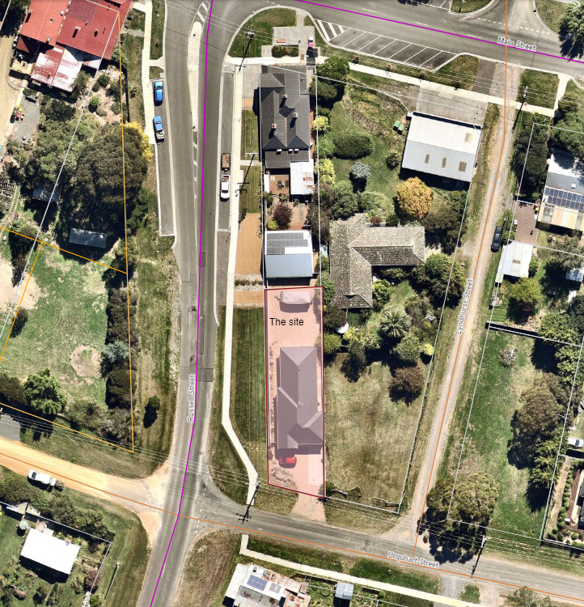
Figure 1: The site (aerial view)

Proposal
The proposal incorporates the use of the existing dwelling as a “Retail Premise” (pharmacy) and a reduction in car parking associated with the medical centre and pharmacy. The operation includes a 93sqm pharmacy (one staff member), and a reduction in two car parking spaces.
A total of six car parking spaces will be provided of which four of these spaces (inclusive of the accessible space) will be accessed via Russell Street for public use and two of the spaces are allocated towards staff parking from Urquhart Street. The car parking spaces will facilitate the medical centre for one practitioner and a 93sqm pharmacy. Eight car parking spaces are required under the planning scheme and six are proposed.
The proposed hours of operation are 8:30am to 5:30pm Monday to Friday and 9am to 12pm on Saturday.

Background to Current Proposal
An application was originally lodged for a medical centre and pharmacy and further information was required on loading and unloading, vehicle movements and amendment to the Traffic Report. An amendment in process was lodged for use of the dwelling as a “Retail Premise” (pharmacy) and a reduction in car parking. The original application proved that car parking locations would not allow for enough space to exit the site in a forward motion. The applicant revised their application on 12 May 2022 to apply for a reduction in two car parking spaces and provided a traffic assessment with a car parking demand assessment.

History
A previous application PA2021254 for same proposal was lodged on 8 November 2021 and lapsed as further information was not provided within the required timeframe. The applicant then re-applied as the current application.

Public Notice
The application was notified to adjoining and surrounding landowners. No objections were received.

Locality Map
The map below indicates the location of the subject site and the zoning of the surrounding area.
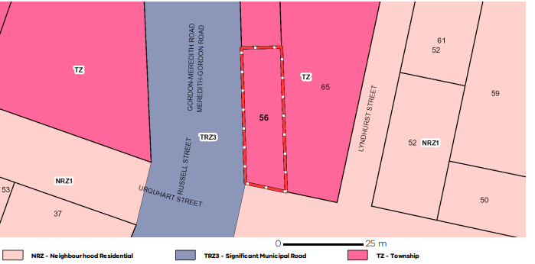
Figure 2: Zone Map

Planning Scheme Provisions
Council is required to consider the Victoria Planning Provisions and give particular attention to the Planning Policy Framework (PPF), the Local Planning Policy Framework (LPPF) and the Municipal Strategic Statement (MSS).
The relevant clauses are:
• Clause 11 – Settlement
• Clause 13.07-1S – Land Use Compatibility
• Clause 14.02-1S – Catchment planning and management
• Clause 17.02-1S – Business
• Clause 21.05 – Development and Community Infrastructure
• Clause 21.09 – Small Towns and Settlements
Pursuant to Clause 21.09-1 of the Moorabool Planning Scheme:
“Gordon is the third largest town in the Shire and characterised by two residential areas and a denser central core with larger lots on its outskirts that provide a distinctly rural character. The recent sewering of the town provides capacity for residential growth.”
This clearly denotes that Gordon has and is capable of a growing population which requires supporting land uses to sustain the neighbourhood. Considering that the existing building is being used to cater for the proposed land uses, the rural character will not be compromised.
Pursuant to Clause 17.02-1S (Business), the proposal provides a net community benefit in relation to its accessibility and efficient use of the existing building. The proposal ensures that health services provision moves closer towards matching forecasted demands, pursuant to Clause 21.05-4 (Community facilities and infrastructure).

Zone
The site is within the Township Zone (TZ) which has the purposes to:
• To implement the Municipal Planning Strategy and the Planning Policy Framework.
• To provide for residential development and a range of commercial, industrial and other uses in small towns.
• To encourage development that respects the neighbourhood character of the area.
• To allow educational, recreational, religious, community and a limited range of other non-residential uses to serve local community needs in appropriate locations.
A medical centre is permitted within the Township Zone if the gross floor area does not exceed 250sqm. The total building floor area is approximately 170sqm.
A planning permit is required to use the site as a “Retail Premise”- sale of goods and services (Pharmacy) pursuant to Clause 32.05-2 of the Township Zone.

Overlays
Design and Development Overlay - Schedule 2 (Visual Amenity)
• The Overlay schedule has the following design objectives.
• To enhance visual amenity in rural, township and vegetated areas of the Moorabool Shire.
• To encourage the use of external cladding, such as non-reflective materials for building construction.
• To discourage the use of materials, such as reflective cladding for building construction, which could have a detrimental effect on amenity. A permit is not required to construct a building or to carry out works where all external walls and roof areas are clad with non-reflective materials.
No works are proposed to the buildings; therefore, no permit is required under this overlay.
Environmental Significance Overlay – Schedule 1 (Proclaimed Water Catchment Areas)
Objective:
• To protect the quality and quantity of water produced within proclaimed water catchments.
• To provide for appropriate development of land within proclaimed water catchments.
There are no building works proposed under this application.

Relevant Policies
Moorabool Retail Strategy
According to the Retail Strategy 2041, potentially 3,000-4,000sqm of retail/various supporting land uses floor area could be provided in Gordon toward supporting the population growth rates and expanding the Township in Small Towns. The forecasted population in Gordon is estimated at 2,690 by 2041.

Particular Provisions
Clause 52.06 – Car parking
The purpose of this particular provision is:
• To ensure that car parking is provided in accordance with the Municipal Planning Strategy and the Planning Policy Framework.
• To ensure the provision of an appropriate number of car parking spaces having regard to the demand likely to be generated, the activities on the land and the nature of the locality.
• To support sustainable transport alternatives to the motor car.
• To promote the efficient use of car parking spaces through the consolidation of car parking facilities.
• To ensure that car parking does not adversely affect the amenity of the locality.
• To ensure that the design and location of car parking is of a high standard, creates a safe environment for users and enables easy and efficient use.

The required car parking spaces for a medical centre is five spaces for every person providing health services plus three to every other person providing health services. One practitioner is proposed therefore five car parking spaces are required for the medical centre component.
The pharmacy component is considered as “Retail Premise”/Shop” and requires four spaces for every 100sqm. The pharmacy makes up 93sqm and requires 3.72 spaces, the planning scheme rounds this down to three car parking spaces.
Overall, eight spaces are required, and six spaces are provided including the accessible car park. Therefore, a reduction in two car parking spaces is sought. A traffic report was submitted. See discussion section of this report.

Discussion
The site is located within the Township Zone in Gordon, close to the Main Street and in close proximity to local shops, parks and services. The site is located at the corner therefore accessible on both street frontages facing Urquhart Street and Russel Street. The surrounding area is present of residential development and other supporting land uses.
The proposal incorporates a Retail Premise (pharmacy) and a reduction in car parking to facilitate the medical centre (one practitioner).
A pharmacy is not listed as a land use in the planning scheme but is considered as “retail premise” because it is defined as land used to sell goods and services. The pharmacy floor area will be 93sqm and the medical floor area will be 68.46sqm. A planning permit is required to use the land for the retail premises in the Township Zone.
The Design and Development Overlay – Schedule 5 (DDO5) specifies some strategies to ensure that development providing for retail must have windows facing main roads and even though and existing residential building is being used, the windows are facing the street and a 1.2m post and wire fence would be used. Another overlay, protecting water catchments (Environmental Significance Overlay – Schedule 1) also covers the land. The application was referred to Barwon Water who had no objections to the proposal however imposed conditions which must ensure that the site be connected to reticulated sewerage, no stormwater to be discharged 100m from a waterway and to restrict sediment discharges in accordance with Environmental Protection Authority (EPA) regulations.
Deliveries are proposed to occur on the site outside of business hours, via the crossover to Russell Street. Swept paths for loading and unloading of vehicles shows that it will perform efficiently
The reduction in car parking is sought of two spaces based on the car parking requirements eight car spaces are required and six are provided. Five car spaces are required for the medical centre with one practitioner. A further three car spaces for the pharmacy, in accordance with Clause 52.06.
The reduction of car parking is sought to ensure that the swept path movements would function to allow vehicles to exit the site in a forward direction. The original application provided eight car parking spaces however four car spaces were provided fronting Urquhart Street did not achieve swept path movements to reverse and exist the site in a forward motion without being blocked by other vehicles.
According, to EDJ Consulting Engineers: “It is anticipated that 14 trips in any hour (one trip every four minutes on average) would have minimal impact on the current operation and safety of the surrounding road network”.
A reduction of parking is appropriate in this location due to the short term stay of customers and proposal is servicing a local community and supports access to people using alternative modes of transport such as walking to the site.
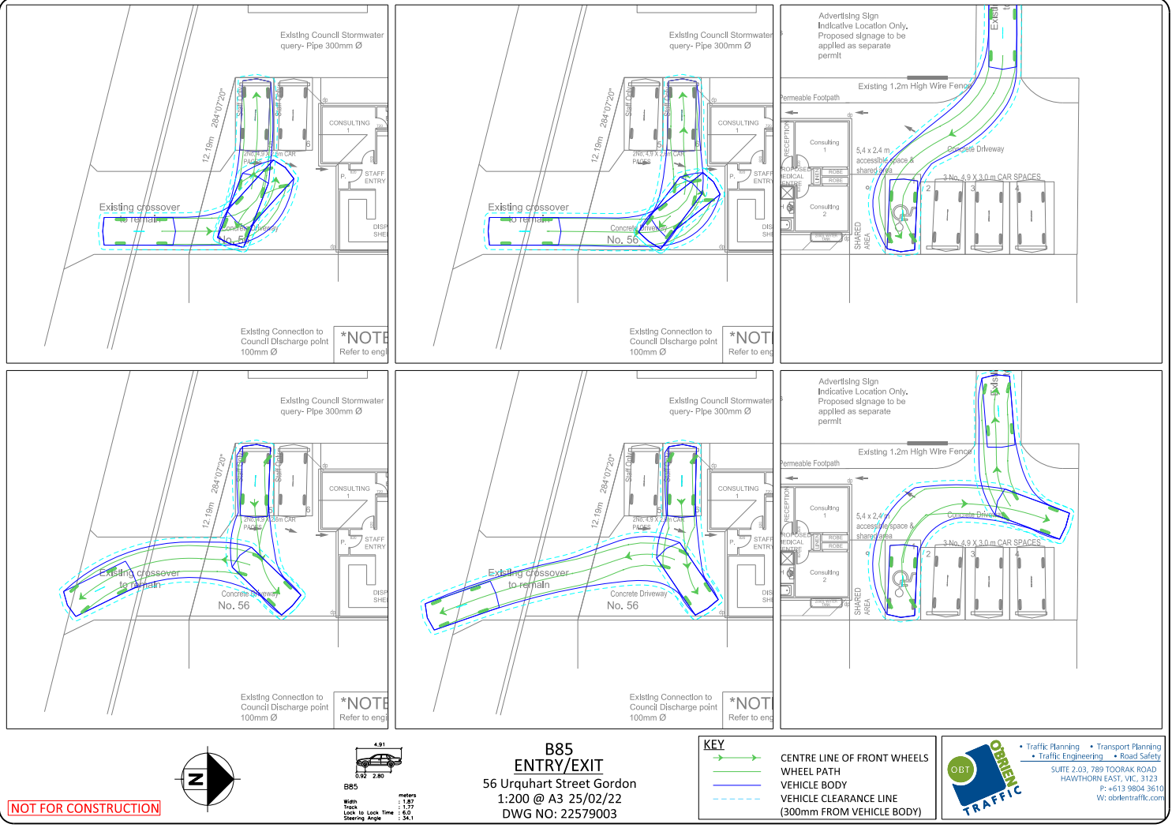
Figure 3: Swept paths after reduction in car parking

General Provisions
Clause 65 – Decision Guidelines have been considered by officers in evaluating this application.
Clause 66 – Stipulates all the relevant referral authorities to which the application must be referred.

Referrals
Authority | Response
Barwon Water | Consent with conditions.
Council’s Infrastructure | Consent with conditions.

Financial Implications
The recommendation of approval of this application has no financial implications to Council.

Risk & Occupational Health & Safety Issues
The recommendation of approval/refusal of this application does not implicate any risk or OH&S issues to Council.

Communications Strategy
Notice was undertaken for the application, in accordance with s.52 of the Planning and Environment Act 1987, and further correspondence is required to all interested parties to the application as a result of a decision in this matter. All submitters and the applicant were invited to attend this meeting and invited to address the Development Assessment Committee if required.
OPTIONS:
The Development Assessment Committee consider the following options:
• issue a permit in accordance with the recommendations of this report; or
• issue a refusal to grant a permit outside of the recommendations of this report.

Conclusion
The application for “Retail Premise” (pharmacy) and reduction in car parking (two car parking spaces) has been assessed against the planning scheme and is recommended for approval as it meets the state and local planning policy framework. The proposed use adds a net community benefit to a projected growing community and is located at the heart of the Gordon township.
The proposal shows no negative or cumulative impacts on traffic, environment, human health and amenity of the area. An existing building is being utilised by the change of use and six car parking spaces are provided on site. All swept paths provided in the traffic report are satisfactory. The Township Zone permits a medical centre as the floor area is less than 250sqm. The pharmacy component meets the projected population demands for additional retail floor space in Gordon. The reduction in car parking of two spaces was required to allow for efficient swept path movements and to avoid internal traffic conflicts. The proposal is close to both residential and various supporting land uses such as retail, food and drink and services, as well as parks and open spaces and meets the general and particular provisions of the scheme and is recommended for approval subject to conditions.

7.2 PA2021224 - Development and Use of a Dwelling at 493 Swans Road Darley
Author: Victoria Mack, Statutory Planner
Authoriser: Henry Bezuidenhout, Executive Manager Community Planning & Economic Development
Attachments: 1. Dwelling Plans (under separate cover)
2. Farm Management Plan (under separate cover)

Application Summary
Permit No: PA2021224
Lodgement Date: 28 September 2021
Planning Officer: Victoria Mack
Address of the land: 493 Swans Road, Darley
Lot 2 on LP 204222L
Proposal: Development and Use of a Dwelling
Lot size: 25.94ha
Why is a permit required? Development and Use of a dwelling in the Farming Zone on a lot less than 40ha.

Recommendation
That the Development Assessment Committee, having considered all matters as prescribed by the Planning and Environment Act 1987, issue a Notice of Decision to Grant Planning Permit PA2021224 for the Development and Use of a Dwelling at 493 Swans Road, Darley, otherwise known as Lot 2 on LP 204222L subject to the following conditions:
Endorsed Plans:
1. Before the use and development starts, amended plans to the satisfaction of the Responsible Authority must be submitted to and approved by the Responsible Authority. When approved, the plans will be endorsed and will then form part of the permit. The plans must be generally in accordance with the plans submitted with the application but modified to show:
(a) A Land Management Plan relating to a revegetation and rehabilitation zone along the eastern boundary of the Korkuperrimul Creek with a width of 100m to accord with the Environmental Significance Overlay, Schedule 2. The plan should include but not limited to:
i. Rehabilitation and revegetation work along the full length of the riparian/river zone that applies to the property.
ii. A replanting plan with suitable native species including grasses, ground covers, shrubs and trees including number of each species to be planted.
iii. Fencing off the area and protection methods for the plants until they are established.
iv. Removal of all motorcycle tracks within the exclusion area.
v. Erosion mitigation works for the whole of the site.
vi. Works schedule which states construction of the dwelling can only occur once the revegetation works have formally commenced and progressed to the satisfaction of the Responsible Authority.
Farm and Land Management Plan:
2. A combined Farm and Land Management Plan to the satisfaction of the Responsible Authority must be endorsed as part of this Permit and cannot be varied without the written consent of the Responsible Authority.
3. Before the issue of a Building Permit the owner must enter into an agreement with the Responsible Authority made pursuant to Section 173 of the Planning and Environment Act 1987 to the satisfaction of the Responsible Authority:
(a) The owner of the land must acknowledge that while the land remains zoned as Farming Zone or its equivalent successor the primary use of the land is for agricultural and land management activities and the use of the dwelling must be in conjunction with an approved agricultural and land management activity.
(b) Agricultural activities and environmental management identified in the endorsed Farm and Land Management Plan must be undertaken on the land and be in accordance with the endorsed plans under Condition 2 and cannot be varied without the written consent of the Responsible Authority.
(c) Before a Building Permit is issued for the dwelling, application must be made to the Register of Titles to register the Section 173 Agreement on the title to the land under Section 181 of the Act and the owner must provide evidence of that registration of the Agreement to the Responsible Authority.
(d) The owner must pay the reasonable costs for the preparation, execution and registration of the Section 173 Agreement.
Dwelling Requirements:
4. The dwelling must be connected to a reticulated sewerage system if available. If reticulated sewerage is not available all wastewater from each dwelling must be treated and retained within the lot in accordance with the requirements of the Environment Protection Regulations under the Environment Protection Act 2017 for an on-site wastewater management system.
5. The dwelling must be connected to a reticulated potable water supply or have an alternative potable water supply with adequate storage for domestic use as well as for firefighting purposes.
6. The dwelling must be connected to a reticulated electricity supply or have an alternative energy source.
7. Access to the dwelling must be provided via an all-weather road with dimensions adequate to accommodate emergency vehicles.
Materials:
8. All external walls and roof areas of the proposed building/s are to be clad with non-reflective materials (zincalume prohibited) to the satisfaction of the Responsible Authority.
Tree Protection:
9. Unless exempt under Clause 52.17 or any other relevant provision of the Moorabool Planning Scheme, native vegetation must not be removed, destroyed or lopped without further planning approval.
Infrastructure:
10. A standard rural vehicle crossing must be provided on Swans Road to the satisfaction of the Responsible Authority. A vehicle crossing permit must be taken out for the construction of the vehicle crossing.
11. Storm water drainage from the proposed buildings and impervious surfaces must be retained and disposed of with a legal point of discharge issued by the Responsible Authority. If applicable, overflows from on-site storage systems must be directed away from any wastewater disposal areas.
12. Sediment discharges must be restricted from any construction activities within the property in accordance with relevant Guidelines including Construction Techniques for Sediment Control (EPA 1991) and civil construction, building and demolition guide (EPA 2020).
13. Unless otherwise approved by the Responsible Authority there must be no buildings, structures, or improvements located over proposed drainage pipes and easements on the property.
14. Prior to the commencement of the development and post completion, notification including photographic evidence must be sent to Council’s Asset Services identifying any existing damage to Council assets. Any existing works affected by the development must be fully reinstated at no cost to and to the satisfaction of the Responsible Authority.
15. The property access and the internal driveways must be constructed in accordance with the requirements specified in Table 5 of Clause 52.47-3 of the Moorabool Planning Scheme, to the satisfaction of the Responsible Authority.
Environmental Health:
16. The land application area and all conditions must be in accordance with the Land Capability Assessment prepared by Provincial geotechnical Pty Ltd, Reference number 18470K dated 11 January 2022 or any approved amendment are to be strictly adhered to.
17. An onsite wastewater management system with the capacity to treat effluent to a minimum of 20mg/L BOD and 30mg/L Suspended Solids must be installed.
18. An onsite wastewater management system with the capacity to treat effluent to a primary standard i.e., standard septic tank must be installed in accordance with the requirements of the Environment Protection Act 1970, the Guidelines for Environmental Management: Code of Practice – Onsite Wastewater Management 891. 4 (2016) and the Responsible Authority.
19. Effluent disposal must be undertaken via subsurface irrigation system designed and installed by a wastewater irrigation expert in accordance with the EPA Code of Practice for Onsite Wastewater.
20. The wastewater management system from proposed dwelling/lots must be treated and contained within the property boundaries in accordance with the current EPA Code of Practice – Onsite Wastewater Management: Guidelines for Environmental Management, Australian Standards 1547 and Council requirements.
21. The effluent disposal area must be kept free of buildings, driveways, vehicular traffic and services trenching.
22. All setback distances must be adhered to as dictated by Table 5 of the Code of Practice, Onsite Wastewater Management, EPA Publication Number 891.4.
23. A shallow surface water cut off drain or surface water diversion mound, should be provided on the high side of the disposal areas to divert any surface water flows around the effluent fields.
24. Subsurface Irrigation system needs to be installed to a depth of 150mm in situ or if the soil is of poor quality, imported good quality topsoil may be required, with a 1m spacing in between lines.
25. The owner will maintain all drainage lines at all times to divert surface water and subsurface water clear of the effluent disposal field.
Permit Expiry:
26. The permit will expiry if:
(a) the development and use are not started within two years of the date of this permit, or
(b) the development is not completed within four years of the date of this permit.
Permit Note:
Prior to installation of works commencing on the wastewater system, a permit to install an onsite wastewater management system must be submitted to Environmental Health.

Public Consultation
Was the application advertised? | Yes.
Notices on site: | One notice.
Notice in Moorabool Newspaper: | No.
Number of objections: | One objector and one supporter.
Consultation meeting: | Not held as issues could not be resolved.

Policy Implications
The Council Plan 2021-2025 provides as follows:
Strategic Objective 2: Liveable and thriving environments
Priority 1.4: Develop a vision and provide opportunities for rural communities
The proposal is consistent with the Council Plan 2021 – 2025.

Victorian Charter of Human Rights & Responsibilities Act 2006
In developing this report to Council, the officer considered whether the subject matter raised any human rights issues. In particular, whether the scope of any human right established by the Victorian Charter of Human Rights and Responsibilities is in any way limited, restricted or interfered with by the recommendations contained in the report. It is considered that the subject matter does not raise any human rights issues.

Officer’s Declaration of Conflict of Interests
Under section 130 of the Local Government Act 2020, officers providing advice to Council must disclose any interests, including the type of interest.
Executive Manager – Henry Bezuidenhout
In providing this advice to Council as the Executive Manager, I have no interests to disclose in this report.
Author – Victoria Mack
In providing this advice to Council as the Author, I have no interests to disclose in this report.

Executive Summary
Application referred? | The application was referred to Melbourne Water and Council’s Environmental Health and Infrastructure Services.
Any issues raised in referral responses? | Environmental Health requested a Land Capability Assessment be provided.
Preliminary concerns? | The Farm Management Plan needed to be expanded with information sought. Additionally, a Land Management Plan was identified as a requirement during the assessment process.
Any discussions with applicant regarding concerns? | Yes, in relation to the further information requested.
Any changes made to the application since being lodged? | An updated Farm Management Plan was provided which met the requirements.
Brief history. | A permit was issued in 2016 for a shed (rural store).  Earthworks have been constructed to create a motorcycle track without a permit (Note that proposed Condition 1(a) iv requires most of the track to be removed for remediation works under the Land Management Plan).  Horse yards and a horse arena have been constructed on the site.  The land is located 650m north of the area mapped as being the future location for part of the Western Victorian Transmission Network Project.
Previous applications for the site? | PA2006143 - Works Associated with the Development of a Dam more than 10 cubic metres in capacity – There are currently two dams on the site.  PA2016177 - Development and Use of a Shed (Rural Store). The shed has been constructed in accordance with this Permit.
General summary. | The application is for the Development and Use of a Dwelling in association with a horse breeding and training enterprise.  The site is generally steep and undulating and the soils are shallow and prone to erosion and weed infestation. The site would not support an intensive farming enterprise and the proposal to breed eight horses on the site is acceptable in association of dwelling on the land.  It is recommended that a 100m wide buffer aligned with the Environmental Significance Overlay, Schedule 2 is required along the Korkuperrimul Creek to protect the waterway. Improving the creek environs will reduce sediment runoff and increase biodiversity value.  Subject to a detailed Land Management Plan being provided to compliment the submitted Farm Management Plan, the proposal can be supported.
Summary of Officer’s Recommendation
That the Development Assessment Committee, having considered all matters as prescribed by the Planning and Environment Act 1987, issue a Notice of Decision to Grant Planning Permit PA2021224 for the Development and Use of a Dwelling at 493 Swans Road, Darley, otherwise known as Lot 2 on LP 204222L subject to the conditions contained within this report.

Site Description
The site is located on the western side of Swans Road and is in the Farming Zone. It is irregular in shape and has an area of 25.94ha.
The topography is undulating, sloping from Swans Road at 340 Australian Height Datum (AHD) down to the western boundary that abuts the Korkuperrimul Creek at 298 AHD, a difference of 42m.
The site contains a shed, water tanks, a horse riding menage, stock yards, fenced horse paddocks, two dams and a private motorcycle track. There is a small amount of scattered vegetation across the site, with a patch of bushland located on the southwest corner and riparian vegetation along the Korkuperrimul Creek.
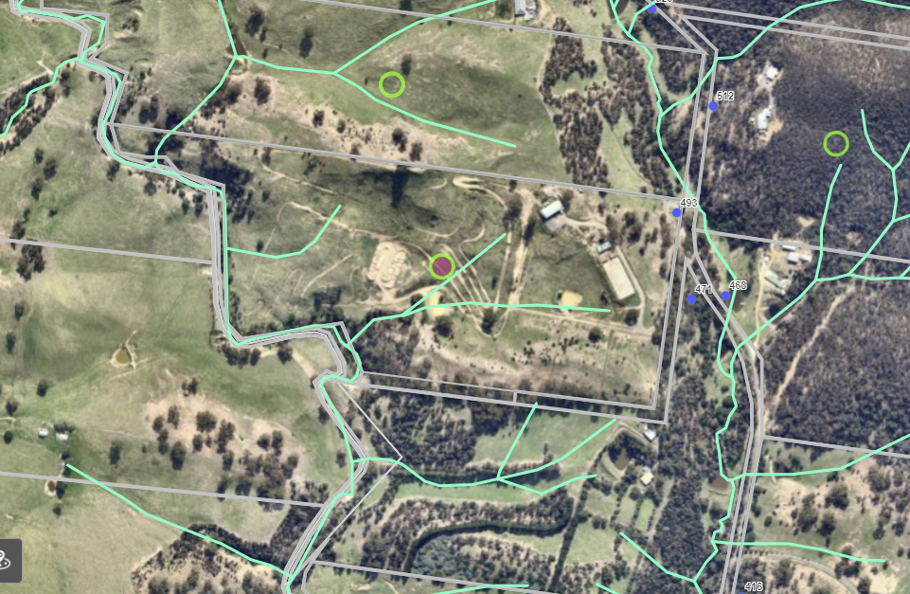
SUBJECT SITE
Figure 1: Aerial photo of the site
The immediate surrounding area along Swans Road and south of the site are in the Farming Zone and contain similar sized lots, many of which contain dwellings and sheds. Approximately 900m to the north of the site is the Lerderderg State Park. To the west across the Korkuperrimul Creek are larger farming lots with areas ranging between 70ha to more than 100ha.
The site has limited services. It is approximately 9km northeast of the Darley shops on Gisborne Road and the Western Freeway interchange.

Proposal
It is proposed to construct a dwelling over three floor levels. It would be located approximately south of the existing shed site and setback 107m from the north boundary, and 152m from the east front boundary abutting Swans Road.
The dwelling would have at the lower ground level a kitchen, bathroom and WC, kids retreat, two car garage and storeroom for wood and pool equipment. An outdoor deck would service a lap pool. At the ground floor will be an open plan kitchen, dining and living, large walk-in pantry, three bedrooms, separate bathroom, separate laundry/mud room, study and powder room and balcony on two sides. The upper level will contain a master bedroom, ensuite with access to an external deck with spa. All floors would be connected via stairs and a lift.
The external cladding of the dwelling would be a mix of Black standing seam metal cladding, toughened glass, stone cladding, rendered cladding and would have a flat Colorbond steel roof. There would be toughened glass balustrades on the decks and balconies. The dwelling would be constructed to complement the natural slope of the land.
A Farm Management Plan was provided. The enterprise proposed is horse breeding of up to eight horses.
A four stable horse complex with exercise yard has been built and the existing exercise track has been formed and gravelled. Culverts have been installed to direct water to the dams and for erosion mitigation.
The Farm Management plan noted due to the steep nature of the property, cultivation will be kept to a minimum to prevent erosion in the event of heavy rainfall. Rotational grazing will reduce the rate by which a paddock becomes "horse-sick".
A gross margin analysis was provided with the application showing that by year five up to 10 two-year-old geldings and fillies would be broken in and sold as future performance horses.
The owners currently own four mares – being a mix of Connemara, Warmblood and Friesian bloodlines. External stallions would be used. A five-year timetable was also provided detailing actions required to establish the enterprise including pastures, fences, infrastructure, pest plant and animal control and erosion mitigation.

Background to Current Proposal
Planning Permits PA2006143 and PA2016177 have been issued for works associated with the development of a dam and the development of a shed (rural store) on the site. These building and works are completed.

History
The construction of a private motorcycle track did not obtain a permit with associated earthworks and has been subject to planning enforcement.

Public Notice
The application was notified to adjoining and surrounding landowners. One objection was received and one submission in support of the application was also received.

Summary of Objections
The objection received is detailed below with officer’s comments accompanying it:
Objection | Any Relevant Requirement
The applicant has demonstrated a complete lack of respect for the municipal laws.  The property has been lived in continuously by the applicant for more than three years without permits and an extensive motorbike track constructed without the required permit. The applicant regularly hosts ride days often with several dozen people in attendance. I have made complaints to the Council regarding these issues.  The house site will impact on the visual amenity of our property adding to the landscape degradation caused by the motorcycle track which has destroyed the fragile landscape.  We have had to change our farming practices adjacent to the property due to the motorbikes, which causes mismothering of lambs.  The Meridian Agriculture report fails to identify the most significant weed in our landscape, Serrated Tussock, and have failed to provide a plan on how to meet the applicants’ Catchment and Land Protection Act responsibilities regarding this declared weed.  The Farm Management Plan identifies erosion as a major issue which it is considering the large amount of motorcycle tracks on the property which are very like to impact the Myrniong Biolink Project and the Korkuperrimul Creek.  Our farm is a generational farm, and we enjoy living here, we appreciate that others will too, however we would appreciate that the development be sympathetic to the landscape, agriculture, and the environment, we do not believe that this application meets these requirements. | Clause 35.07, Farming Zone, of the Moorabool Planning Scheme.

Officer’s Response: The land degradation from a motorcycle track, weed infestation, erosion risk and other related environmental considerations on the site will be addressed in combination with the Farm Management Plan and Land Management Plan (LMP). The LMP includes remediation of the site and revegetation, which will be enforced via a Section 173 Agreement on Title.
Submission in support of the application:
I fully support this proposal. As their neighbour I have seen the work done on the property to date and believe it to be to an excellent standard. The owners are very involved with the Swans Road community and are always there to lend a hand when required. I believe this development will be an asset to the area.

Locality Map
The map below indicates the location of the subject site and the zoning of the surrounding area.
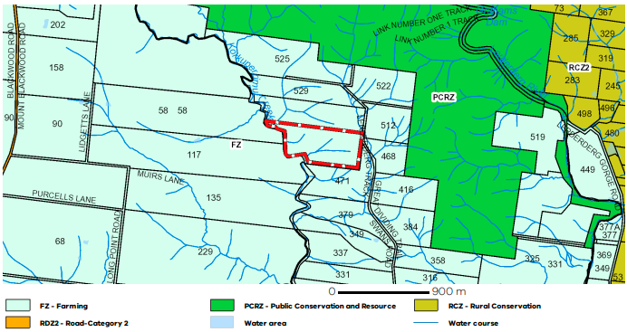
Figure 2: Zoning of the site and the surrounding area.

Planning Scheme Provisions
Council is required to consider the Victoria Planning Provisions and give particular attention to the Planning Policy Framework (PPF), the Local Planning Policy Framework (LPPF) and the Municipal Strategic Statement (MSS).
The relevant clauses are:
• Clause 11.01-1R – Settlement - Central Highlands
• Clause 11.03-3S – Peri-urban areas
• Clause 12.01-1S – Protection of biodiversity
• Clause 12.03-1S – River corridors, waterways, lakes and wetlands
• Clause 13.04-2S – Erosion and landslip
• Clause 14.01-1S – Protection of agricultural land
• Clause 14.01-2S – Sustainable agricultural land use
• Clause 14.02-1S – Catchment planning and management
• Clause 14.02-2S – Water quality
• Clause 15.01-6S – Design for rural areas
• Clause 16.01-3S – Rural residential development
• Clause 22.02 – Special Water Supply Catchments
• Clause 22.03 – Houses and House Lot Excisions in Rural Areas
• Clause 21.02-1 – Key issues and influences
• Clause 21.03-4 – Objective - Landscape and neighbourhood character
The proposal generally complies with the relevant sections of the PPF and LPPF.

Zone
In accordance with Clause 35.07 of the Moorabool Planning Scheme a permit is required for the development and use of a dwelling where the lot size of less than 40ha.
The relevant purposes of the zone are:
• To provide for the use of land for agriculture.
• To encourage the retention of productive agricultural land.
• To ensure that non-agricultural uses, including dwellings, do not adversely affect the use of land for agriculture.
• To encourage the retention of employment and population to support rural communities.
• To encourage use and development of land based on comprehensive and sustainable land management practices and infrastructure provision.
The land is not suited to any intensive agricultural use due to the fragile soils and steep and dissected landscape. The application was accompanied by a Farm Management Plan which addressed in part how the land could be repaired with careful pasture re-seeding, soil testing, fertiliser use, and erosion, pest, plant and animal controls.
It is recommended that a dedicated Land Management Plan is also provided for this site to protect the creek environs and improve local biodiversity.

Overlays
Environmental Significance Overlay – Schedule 2 (ESO2)
In accordance with Clause 42.01-2 of the Moorabool Planning Scheme a permit is required under for buildings and works. However, the dwelling and ancillary shed are not located in the area covered by ES02.
The environmental objectives to be achieved include to:
• Protect the habitat significance of vegetation.
• Provide for appropriate development of land within 100m of either side of a waterway.
• Prevent pollution and increased turbidity of water in natural waterways.
• Prevent increased surface runoff or concentration of surface water runoff leading to erosion or siltation of waterways.
• Conserve existing flora and fauna habitats close to waterways and to encourage generation and regeneration of habitats.
Design and Development Overlay – Schedule 2 (DDO2)
In accordance with Clause 43.02 of the Moorabool Planning Scheme, and Schedule 1 a permit is not required under the overlay and schedule where all external cladding would be with non-reflective materials. In this instance as no reflective materials would be used a permit is not required under the DDO2.
Bushfire Management Overlay (BMO)
In accordance with Clause 44.06 of the Moorabool Planning Scheme, a permit is required for buildings and works associated with the use of land for accommodation.
However, as only a small portion of the site in the northeast corner is covered by the BMO and the proposed dwelling is not located within this area, a planning permit is not required.

Particular Provisions
Clause 52.17 Native vegetation:
No native vegetation would be removed as part of the development and a permit is therefore no planning permit is required under Clause 52.17 of the Moorabool Planning Scheme.

Council Policies
Rural Housing Policy
Council’s Rural Housing Policy 2012 was adopted by Council on 19 September 2012 and has been developed to provide direction for how limited farming potential rural dwellings should be considered, and more broadly, rural settlement patterns.
The principles of the policy relevant to this application include to:
• Support the agricultural sector so that it can be more productive, diverse, resilient and adaptive to changing agricultural trends, including supporting agricultural activities that recognise Moorabool’s advantageous proximity to market.
• Protect agricultural land use from loss and allow development that increases agricultural productivity.
• Focus growth opportunities in settlements along major transport corridors, in particular where there is physical and social infrastructure and services.
• Recognise that there are substantial existing lots under 40ha capable of supporting the viable operation of agricultural enterprises.
• Promote a rural housing market that meets the needs of the Shire’s rural communities.
The proposal generally accords with the assessment principles contained within the Rural Housing Policy for lots between 20ha and 40ha. However, the land is not suited to intensive agricultural practices due to the fragile soils, and the erosion risk is high if not carefully managed.

Discussion
The site is located in the Farming Zone but has limited agricultural potential due to the steep topography and undulating terrain with a creek forming the rear property boundary.
The land along the Korkuperrimul Creek, as well as the central section of the property, is generally degraded and prone to weeds, pest animals and erosion. This is to be addressed through the proposed Land Management Plan, which allows support of the application.
Furthermore, the Farm Management Plan allows for a controlled farming activity and horse enterprise to ensure it does not overstock the capacity of the land. The Farm Management Plan recommended that a rotational grazing system was employed so that grass cover could be sustained all year round.
The Environmental Significance Overlay Schedule 2 covers the Korkuperrimul Creek for 100m on each side. An environmental buffer is to be established on the east side of the creek along the property boundary with a width of 100m. The Land Management Plan compliments and augment the submitted Farm Management Plan.
This would ensure that the fragile riparian area of the creek is fenced off from stock, rehabilitated and revegetated to enhance the creek frontage as a wildlife and biodiversity corridor.
In this instance it is considered that the land would benefit from owners being present on the site to attend to the improvement of the property and sustainable land management outcomes.
The siting of the dwelling is suitably located at the front eastern boundary of the property close to Swans Road. It is not considered that the site for the dwelling would have adverse impacts on neighbouring dwellings and three floor levels will effectively utilise the steep topography.
In the case of degraded land expressed by the objector, the Land Management Plan in association with the submitted Farm Management Plan will provide for measures to rectify existing erosion concerns and make significant improvements to the creek environment. The Land Management Plan will be recommended to be placed on title via a Section 173 Agreement under the Planning and Environment Act 1987 to ensure ongoing protection of the land.
The objector concerns in relation to the motorbike track, it is to be noted proposed Condition 1(a) iv requires most of the track to be removed for remediation works under the Land Management Plan. This will address earthworks undertaken with the motorbike track and degraded land.
The construction of the dwelling can only occur once the revegetation works have formally commenced and progressed to the satisfaction of the Responsible Authority and is a proposed condition.
The application was referred to Council’s Infrastructure Services and Environmental Health, both of which consented to the application with conditions.
It is recommended that the application is supported with conditions.

General Provisions
Clause 65 – Decision Guidelines have been considered by officers in evaluating this application.
Clause 66 – Stipulates all the relevant referral authorities to which the application must be

Referrals
Authority | Response
Melbourne Water | No response after nine months
Council’s Infrastructure  Council’s Environmental Health | Consent with conditions.  Consent with conditions.

Financial Implications
The recommendation of approval of this application has no financial implications to Council.

Risk & Occupational Health & Safety Issues
The recommendation of approval of this development does not implicate any risk or OH&S issues to Council.

Communications Strategy
Notice was undertaken for the application, in accordance with s.52 of the Planning and Environment Act 1987, and further correspondence is required to all interested parties to the application as a result of a decision in this matter. All submitters and the applicant were invited to attend this meeting and invited to address Development Assessment Committee if required.

Options
The Development Assessment Committee consider the following options:
• issue a Notice of Decision to Grant a Planning Permit in accordance with the recommendations of this report; or
• issue a refusal to grant a Planning Permit with specific grounds. The grounds would need to demonstrate how the proposal does not comply with the Moorabool Planning Scheme.

Conclusion
Dwellings in the Farming Zone are generally not supported where the use of the land for agricultural purposes would be compromised by dwellings. The applicant has provided a Farm Management Plan which identifies that a proportion of the land will be used for farming purposes. The balance of the and will be improved under a Land Management Plan. It is considered that the land would benefit from owners being present on the site to attend to the improvement of the property and sustainable land management outcomes in conjunction with a small horse breeding operation.
The application should be supported in accordance with an approved Farm Management Plan and approved Land Management Plan.

7.3 PA2021240 Variation of Restrictive Covenant AD159230W at 10 Parkside Drive, Hopetoun Park
Author: Thomas Tonkin, Statutory Planner
Authoriser: Henry Bezuidenhout, Executive Manager Community Planning & Economic Development
Attachments: 1. Proposed plans (under separate cover)

Application Summary
Permit No: PA2021240
Lodgement Date: 12 October 2021
Planning Officer: Tom Tonkin
Address of the land: 10 Parkside Drive, Hopetoun Park
Proposal: Variation of Restrictive Covenant AD159230W
Lot size: 5,197sqm
Why is a permit required? Clause 52.02 Easements, Restrictions and Reserves

Recommendation
That the Development Assessment Committee, having considered all matters as prescribed by the Planning and Environment Act 1987, issue a Refusal to Grant Planning Permit PA2021240 for Variation of Restrictive Covenant AD159230W at Lot 64 on PS 518686Y known as 10 Parkside Drive, Hopetoun Park 3340, on the following grounds:
1. The proposed variation of covenant does not satisfy the tests in Section 60(5) of the Planning and Environment Act 1987.
2. The proposed variation of covenant will likely cause owners benefiting from the restriction to suffer detriment including perceived determent.

Public Consultation
Was the application advertised? | Yes.
Notices on site: | Yes.
Notice in Moorabool Newspaper: | Yes.
Number of objections: | One.
Consultation meeting: | No. The Council officer liaised separately with the applicant and objector and the application was subsequently amended but the objection was not withdrawn.

Policy Implications
The Council Plan 2021-2025 provides as follows:
Strategic Objective 2: Liveable and thriving environments
Priority 2.1: Develop planning mechanisms to enhance liveability in the Shire

Victorian Charter of Human Rights & Responsibilities Act 2006
In developing this report to Council, the officer considered whether the subject matter raised any human rights issues. In particular, whether the scope of any human right established by the Victorian Charter of Human Rights and Responsibilities is in any way limited, restricted or interfered with by the recommendations contained in the report. It is considered that the subject matter does not raise any human rights issues.

Officer’s Declaration of Conflict of Interests
Under section 130 of the Local Government Act 2020, officers providing advice to Council must disclose any interests, including the type of interest.
Executive Manager – Henry Bezuidenhout
In providing this advice to Council as the Executive Manager, I have no interests to disclose in this report.
Author – Thomas Tonkin
In providing this advice to Council as the Author, I have no interests to disclose in this report.

Executive Summary
Application referred? | No.
Any issues raised in referral responses? | Not applicable.
Preliminary concerns? | Further information was requested of the applicant regarding the intended use of the proposed shed and the intended location of fencing.
Any discussions with applicant regarding concerns? | The applicant was advised in writing of the preliminary concerns.

Any changes made to the application since being lodged? | Yes, the application was amended on 18 May 2022 to reduce the proposed wall height of the shed from 5.2m to 5m, in response to the objection. The objection was not withdrawn.
Brief history. | Not applicable.
Previous applications for the site? | None.
General summary. | It is proposed to vary covenant AD159230W items (b) and (k) which respectively relate to fencing and size and height of an ancillary outbuilding to an existing dwelling. The proposed variation would expand the range of allowable fencing styles/materials and increase the allowable size of outbuildings.  The application was advertised, and one objection received, which raised amenity and neighbourhood character concerns due to the increase in the allowable outbuilding height. The application was amended to reduce the height of the outbuilding but did not result in withdrawal of objection.  With a beneficiary objection, the proposal is deemed to be inconsistent with the relevant provisions of the Moorabool Planning Scheme for the protection of residential amenity and neighbourhood character and thereby fails to meet the tests of Section 60(5) of Planning and Environment Act 1987.
Summary of Officer’s Recommendation
That, having considered all relevant matters as required by the Planning and Environment Act 1987, the Development Assessment Committee issue a Refusal to Grant Planning Permit PA2021240 for the Variation of Restrictive Covenant AD159230W at Lot 64 on PS 518686Y known as 10 Parkside Drive, Hopetoun Park, on the grounds included in this report.

Site Description
The subject site.
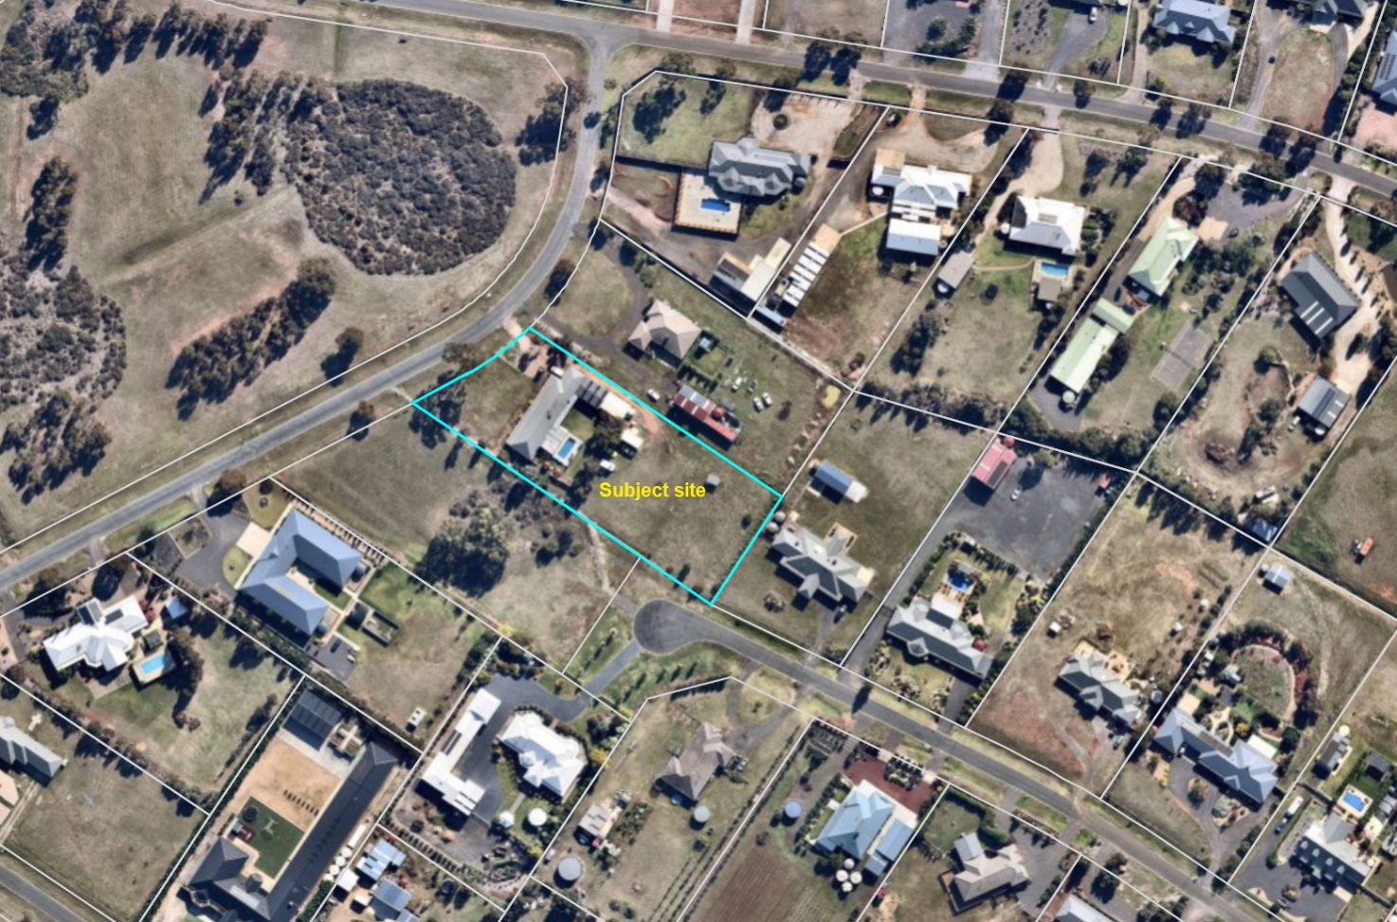
Figure 1: Aerial photograph

Proposal
It is proposed to vary Covenant number AD159230W, items (b) and (k).
Covenant AD159230W states that “the Transferee with the intent that the benefit of this covenant shall be attached to and run at law and in equity with every lot on Plan of Subdivision No. 518686Y other than the Lot hereby transferred and that the burden of this covenant shall be annexed to and run at law and in equity with the said Lot hereby transferred does hereby covenant from himself/herself, their heirs, executors, administrators and transferee and the registered proprietor or proprietors for the time being of every lot described in the said Plan of Subdivision (other than the Lot hereby transferred) that the Transferee, his/her executors, administrators and transferees will not…(b) erect or construct on the Lot hereby transferred any boundary or internal fence other than a standard post and wire type fence; (k) site any outbuildings on the Lot other than towards the rear of the Lot and behind any dwelling house and generally in such a manner as to minimise visual impact from the streetscape. No such outbuilding shall be of a size greater than 13 metres in length, 7 metres in width and 4 metres in height to the eaves nor shall they be constructed prior to the erection of a dwelling house on the Lot.”
The proposed variation of item (b) is to allow for the construction of Colorbond or picket style fencing as partitions on or across the property but not forward of the existing dwelling.
The proposed variation of item (k) is to allow construction of an outbuilding up to 35m long x 18m wide x 5m in height to the eaves. This variation is required to facilitate the storage of a motor home, work car, two tandem trailers, two family cars, a box trailer, five hobby cars, two boats, a tandem truck, an excavator, a float trailer and three motor bikes.

Background to Current Proposal
Not applicable.

History
Not applicable.

Public Notice
Notice of the application was given all beneficiaries of the covenant which included adjoining and surrounding landowners by way of letters to landowners and occupiers and notices on site and in the Moorabool News, a newspaper circulating in the local area.
One objection was received from a beneficiary of the covenant.

Summary of Objections
The objection received is detailed below with officer’s comments accompanying them:
Objection | Any Relevant Requirement
The proposed 5.2m wall height would have a significant impact on the streetscape and make it look like an industrial area. A shed with a 5.2m wall height would also be visible from my backyard. The use of the proposed shed and associated noise is also a concern. | Clause 52.02.
Officer’s Response:
It is noted that following receipt of the objection the application was amended to reduce the proposed wall height to 5m. See ‘Discussion’ below.

Locality Map
The map below indicates the location of the subject site and the zoning of the surrounding area.
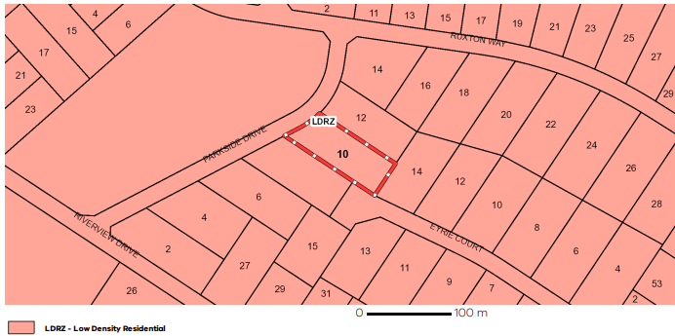
Figure 2: Zone map

Planning Scheme Provisions
Council is required to consider the Victoria Planning Provisions and give particular attention to the Planning Policy Framework (PPF), the Local Planning Policy Framework (LPPF) and the Municipal Strategic Statement (MSS).
The relevant clauses are:
• Clause 11.03-3S – Peri-urban areas
• Clause 15.01-5S – Neighbourhood character
• Clause 21.03-4 – Landscape and Neighbourhood Character
The proposal does not comply with the relevant section of the PPF and the LPPF clauses outlined in the table below:
PPF | Title | Response
Clause 15.01-5S | Neighbourhood character | Based on the assessment against the provisions of section 60(5) of the Planning and Environment Act 1987 the proposal is deemed to be inconsistent with the neighbourhood character of immediate adjacent properties.

LPPF

Clause 21.03-4 | Landscape and Neighbourhood Character | Based on the assessment against the provisions of section 60(5) of the Planning and Environment Act 1987 the proposal is deemed to be inconsistent with the neighbourhood character.

Zone
The subject site is in the Low Density Residential Zone (LDRZ). The purpose of the Zone is:
• To implement the Municipal Planning Strategy and the Planning Policy Framework.
• To provide for low-density residential development on lots which, in the absence of reticulated sewerage, can treat and retain all wastewater.
There is no permit requirement under the zone to vary a restrictive covenant.

Overlays

The subject site is affected by Development Plan Overlay, Schedule 2.

No permit is required under the overlay provisions to vary a covenant.

Relevant Policies
There are no Council policies applicable to the assessment of this application.

Particular Provisions
Clause 52.02 Easements, Restrictions and Reserves
A permit is required before a person proceeds under Section 23 of the Subdivision Act 1988 to vary or remove a restriction.
The decision guidelines state before deciding on an application, in addition to the decision guidelines in Clause 65, the responsible authority must consider the interests of affected people.

Discussion
Pursuant to subsection (4) of the Planning and Environment Act 1987, the relevant consideration for assessment of this application are the provisions of Section 60(5) of this Act. Subsection (4) states the following:
Subsection (2) does not apply to any restriction which was—
        - registered under the Subdivision Act 1988; or
        - lodged for registration or recording under the Transfer of Land Act 1958; or
        - created before 25 June 1991.
In this instance, subsection (4)(b) above applies to covenant AD159230W that was registered under the Transfer of Land Act 1958.
Pursuant to this, subsection 60(5) of the Planning and Environment Act 1987 states the following:
The Responsible Authority must not grant a permit which allows the removal or variation of a restriction referred to in subsection (4) unless it is satisfied that—
(a) the owner of any land benefited by the restriction (other than an owner who, before or after the making of the application for the permit but not more than three months before its making, has consented in writing to the grant of the permit) will be unlikely to suffer any detriment of any kind (including any perceived detriment) as a consequence of the removal or variation of the restriction; and
(b) if that owner has objected to the grant of the permit, the objection is vexatious or not made in good faith.
As outlined above, an objection was received to the application from a beneficiary of the covenant, primarily relating to the potential impact on the neighbourhood character and amenity of the area if the covenant was varied. In consideration of the objection received and the provisions of section 60(5)(a) and (b) it is deemed that Council is unable to satisfy itself that any of the beneficiaries would be unlikely to suffer any detriment of any kind, including perceived detriment, because of the proposed variation of the covenant.
The beneficiary has outlined what they believe the actual or perceived negative consequences of the covenant variation to be. Furthermore, there is nothing in the beneficiary’s objection to suggest that it is vexatious or not made in good faith. The interests of non-beneficiaries also need to be considered under Clause 52.02. It is considered that the application cannot be approved based on the objection received.
The covenant currently allows for the development of outbuildings a maximum of 13m long x 7m wide x 4m height to the eaves. The proponent seeks approval to vary the covenant to allow an outbuilding up to 35m long x 18m wide x 5m in height to the eaves.
The site and surrounding land is zoned for low density residential purposes and the area is typified by generally large single storey dwellings on spacious allotments with generous boundary setbacks. Ancillary outbuildings are not uncommon but vary in size, with some outbuildings similar in size to what the proposed variation of item (k) would enable, although such outbuildings are not a prominent feature of this area of Hopetoun Park.
In the context of the subject site and surrounding neighbourhood, it is considered that the proposed variation of item (k) may result in a loss of amenity. The scale and bulk of an outbuilding facilitated by the proposed variation would be visually prominent as viewed from adjoining and nearby properties, Eyrie Court and the adjoining public reserve to such an extent that the general visual amenity of the neighbourhood would be unreasonably compromised. The objector has raised concerns that the outbuilding height facilitated by the proposed variation to item (k) would be visible from their backyard and create an industrial aesthetic in a residential area.
Additionally, the objector has raised concerns about the potential use of an outbuilding of the size facilitated by the proposed variation to item (k). The proponent provided detailed plans of the intended use of a future outbuilding, indicating the storage of a range of vehicles and equipment for work, household and recreational purposes. If a permit was to issue Council officers would recommend the imposition of a legal agreement on title to require that the use of a future outbuilding only be for purposes ancillary to the dwelling on the site and not for commercial purposes. This is in recognition of the potential for an outbuilding of the size facilitated by the proposed variation of item (k) to be used for uses inconsistent with the amenity of the area.
The proposed variation to item (b) would allow for Colorbond or picket style fencing within the property boundaries and behind the front wall of the dwelling, in addition to the allowable post and wire type fencing. The potential for covenant beneficiaries to suffer detriment as a result of this variation would be likely to rest on the height, colour, particular style and extent of such fencing. Depending on these factors, there is the potential for detriment. Notwithstanding surrounding dwellings being either well set back from the rear part of the subject site or otherwise oriented to face away from the site, it is difficult to argue that the covenant beneficiaries would be unlikely to suffer any perceived detriment as a consequence of the variation to item (b). This is due in large part to the visibility of the subject site from properties in Eyrie Court and adjoining public reserve and the spacious character of the area created in part by the absence of prominent solid fencing, particularly in streetscape views. Non-post and wire type fencing such as Colorbond panel fencing, where present, is generally not disruptive to the neighbourhood character. This is particularly the case where the fencing is not readily visible from the street.
With regard to neighbourhood character, the area is defined by single dwellings on lots of roughly 4,000sqm to 6,000sqm in size. Dwellings are predominantly single storey with spacious boundary setbacks. The area is characterised by its lot sizes and configuration, general low-rise scale of development and views of the distant landscape in some areas. Whilst there are examples of large bulky sheds in Hopetoun Park which are visually dominant, these are not characteristic of the area surrounding the subject site. Outbuildings, where present, generally blend with the scale of dwellings and are not visually dominant. The subject site and surrounding lots, including the objector’s property, are affected by a covenant which allows for development of outbuildings up to 13m long x 7m wide x 4m high to the eaves.
As discussed above, outbuildings in the surrounding area vary in size but typically are substantially smaller than what the proposed variation of item (k) would facilitate. Smaller outbuildings consistent with item (k) exemplify the contribution that outbuildings make to the existing neighbourhood character of this area of Hopetoun Park. Council must satisfy itself that the covenant’s beneficiaries will be unlikely to suffer any detriment of any kind (including perceived detriment) if the maximum outbuilding dimensions are increased to 35m length x 18m width x 5m height to the eaves. The development of an outbuilding matching those dimensions would not be in keeping with the neighbourhood character, as described above. The objector has expressed concerns that the variation of item (k) would facilitate development inconsistent with the streetscape character, which is a key element when assessing neighbourhood character. Furthermore, the objector has identified that such development would be akin to that found in an industrial area. It is deemed that the character of the area would change as a result of the proposed variation of the covenant. Based on this, and on observations of the site and surrounding area, it is deemed that a beneficiary of the covenant would suffer detriment (including perceived detriment).
GENERAL PROVISIONS
Clause 65 – Decision Guidelines have been considered by officers in evaluating this application.
Pursuant to Clause 65 of the Moorabool Planning Scheme, the Responsible Authority must consider, among other things, the matters set out in Section 60 of the Planning and Environment Act 1987, as per the ‘Discussion’ above.
Clause 66 – Stipulates all the relevant referral authorities to which the application must be referred.

Referrals

The application was not required to be referred.

Financial Implications
There are no financial implications for Council in refusing this application.

Risk & Occupational Health & Safety Issues
The recommendation to refuse this application does not have any risk or OH&S implications for Council.

Communications Strategy
Notice was undertaken for the application, in accordance with s.52 of the Planning and Environment Act 1987, and further correspondence is required to all interested parties to the application because of a decision on this matter. The submitter and the applicant were invited to attend this meeting and address Council if required.

Options
- Issue a Refusal to Grant a Permit on the grounds listed in the recommendation of this report; or
• issue a Notice of Decision to Grant a Permit with conditions. The Development Assessment Committee would need to satisfy itself that the covenant beneficiaries would be unlikely to suffer any detriment of any kind (including any perceived detriment) consistent with the provisions of Section 60(5) of the Planning and Environment Act 1987 because of the covenant variation. This option may result in the objector appealing the Committee’s decision to VCAT.

Conclusion
The proposed variation to covenant AD159230W items (b) and (k) respectively relate to fencing and outbuilding dimensions. The proposed variation would expand the range of allowable fencing styles and materials and increase the allowable size of an outbuilding.
The application was advertised, and one objection received, which raised amenity and neighbourhood character concerns related to the proposed increase in the allowable outbuilding height. Based on objection received, the proposal is deemed to be inconsistent with the relevant provisions of the Moorabool Planning Scheme and Section 60(5) of the Planning and Environment Act 1987 for the protection of residential amenity and neighbourhood character.

8 Update on VCAT Decisions

9 Other Business

10 Date of Next Meeting

11 Meeting Close

