AGENDA

Development Assessment Committee Meeting
Wednesday, 18 May 2022
I hereby give notice that a Development Assessment Committee Meeting will be held on:
Date: | Wednesday, 18 May 2022
Time: | 6.00pm
Location: | Council Chambers, 15 Stead Street, Ballan & Online
Henry Bezuidenhout
Executive Manager, Community Planning & Economic Development

Order Of Business
1 Opening 3
2 Present and Apologies 3
3 Recording of Meeting 3
4 Confirmation of Minutes 3
5 Matters Arising from Previous Minutes 3
6 Disclosure of Conflicts of Interests 3
7 Community Planning Reports 4
7.1 PA2021241 Two Lot Subdivision at 151 Camerons Road, Darley 4
7.2 PA2021237 - Removal of Native Vegetation (Two Trees) Associated with a Minor Utility Installation at Cartons Road, Gordon 15
8 Update on VCAT Decisions 26
9 Other Business 26
10 Date of Next Meeting 26
11 Meeting Close 26

1 Opening

2 Present and Apologies

3 Recording of Meeting
In accordance with Moorabool Shire Council’s Governance Rules, the meeting will be livestreamed.

4 Confirmation of Minutes
Wednesday 20 April 2022.

5 Matters Arising from Previous Minutes

6 Disclosure of Conflicts of Interests
Conflict of interest laws are prescribed under the Local Government Act 2020 (the Act) and in the Local Government (Governance and Integrity) Regulations 2020 (the Regulations). Managing conflicts of interest is about ensuring the integrity and transparency of decision-making.
The conflict of interest provisions under the Act have been simplified so that they are more easily understood and more easily applied. The new conflict of interest provisions are designed to ensure relevant persons proactively consider a broader range of interests and consider those interests from the viewpoint of an impartial, fair-minded person.
Section 126 of the Act states that a Councillor has a conflict of interest if they have a general conflict of interest or a material conflict of interest. These are explained below:
- A Councillor has a general conflict of interest in a matter if an impartial, fair-minded person would consider that the member’s private interests could result in them acting in a manner that is contrary to their public duty as a Councillor.
- A Councillor has a material conflict of interest in a matter if an affected person would gain a benefit or suffer a loss depending on the outcome of the matter.
A relevant person with a conflict of interest must disclose the interest in accordance with Council’s Governance Rules and not participate in the decision-making process on the matter. This means the relevant person must exclude themselves from any discussion or vote on the matter at any Council meeting, delegated committee meeting, community asset committee meeting or, if a Councillor, any other meeting conducted under the auspices of the Council. The relevant person must also exclude themselves from any action in relation to the matter, including an action taken to implement a Council decision, for example, issuing a planning permit.

7 Community Planning Reports

7.1 PA2021241 Two Lot Subdivision at 151 Camerons Road, Darley
Author: Thomas Tonkin, Statutory Planner
Authoriser: Robert Fillisch, Manager Statutory Planning & Building Services
Attachments: 1. Proposed plan of subdivision (under separate cover)

Application Summary
Permit No: PA2021241
Lodgement Date: 13 October 2021
Planning Officer: Tom Tonkin
Address of the land: 151 Camerons Road, Darley
Proposal: Two lot subdivision
Lot size: 28.44ha
Why is a permit required? Clause 35.06 Rural Conservation Zone, Schedule 2 - Subdivision
Clause 43.02 Design and Development Overlay, Schedule 14 - Subdivision
Clause 44.06 Bushfire Management Overlay, Schedule 1 - Subdivision

Recommendation
That the Development Assessment Committee, having considered all matters as prescribed by the Planning and Environment Act 1987, refuse to grant Planning Permit PA2021241 for a Two Lot Subdivision at Lot 1 on TP 066538T known as 151 Camerons Road, Darley 3340, on the following grounds:
1. The proposed subdivision does not comply with Clause 21.07-5 of the Moorabool Planning Scheme.
2. The proposed subdivision does not comply with Clause 43.02, Design and Development Overlay, Schedule 14 of the Moorabool Planning Scheme.
3. The proposed subdivision represents an overdevelopment of the site.

Public Consultation
Was the application advertised? | Yes.
Notices on site: | Yes.
Notice in Moorabool Newspaper: | No.
Number of objections: | None.
Consultation meeting: | Not applicable.

Policy Implications
The Council Plan 2021-2025 provides as follows:
Strategic Objective 2: Liveable and thriving environments
Priority 2.1: Develop planning mechanisms to enhance liveability in the Shire

Victorian Charter of Human Rights & Responsibilities Act 2006
In developing this report to Council, the officer considered whether the subject matter raised any human rights issues. In particular, whether the scope of any human right established by the Victorian Charter of Human Rights and Responsibilities is in any way limited, restricted or interfered with by the recommendations contained in the report. It is considered that the subject matter does not raise any human rights issues.

Officer’s Declaration of Conflict of Interests
Under section 130 of the Local Government Act 2020, officers providing advice to Council must disclose any interests, including the type of interest.
A/g Executive Manager – Robert Fillisch
In providing this advice to Council as the A/g Executive Manager, I have no interests to disclose in this report.
Author – Tom Tonkin
In providing this advice to Council as the Author, I have no interests to disclose in this report.

Executive Summary
Application referred? | Yes, to Country Fire Authority, Melbourne Water, Greater Western Water and Council’s Infrastructure and Environmental Health.
Any issues raised in referral responses? | No.
Preliminary concerns? | Non-compliance with the provisions of Clause 43.02 and Clause 44.06.  Specifically, these provisions do not provide for the development of more than one dwelling on the site. The proposed subdivision and creation of two building envelopes does not meet the planning scheme requirements. Additionally, the Bushfire Management Statement contained factual errors.
Any discussions with applicant regarding concerns? | Prior to the application being accepted for processing, the applicant was advised by Council officers that the proposed subdivision does not comply with the Moorabool Planning Scheme. The applicant requested the application be accepted and a decision made. This concern was also reiterated after advertising of the application.

Any changes made to the application since being lodged? | The Bushfire Management Statement was corrected.
Brief history. | See ‘Background to Current Proposal’ below.
Previous applications for the site? | None.
General summary. | The proposed subdivision would create two vacant lots – 16.4ha and 12.04ha to facilitate the future development of two dwellings. The proposal does not comply with the relevant provisions of the Moorabool Planning Scheme, in particular Design and Development Overlay, Schedule 14, which designates only one dwelling envelope for the site. The proposed subdivision is non-compliant and is not supported.
Summary of Officer’s Recommendation
That, having considered all relevant matters as required by the Planning and Environment Act 1987, the Development Assessment Committee refuse to grant Planning Permit PA2021241 for a Two Lot Subdivision at Lot 1 on TP 066538T known as 151 Camerons Road, Darley, in accordance with Section 61 of the Planning and Environment Act 1987, subject on the grounds contained within this report.

Site Description
The subject site, identified as Lot 1 on TP 066538T and known as 151 Camerons Road, Darley, is a vacant 28.44ha lot located on the west side of Camerons Road, approximately 880m north of the intersection with Lerderderg Gorge Road. The site is generally heavily vegetated but more sparsely so towards the central and southeast parts of the site. The site falls by up to 48m from the northeast generally to the south, west and northwest.
The subject site and surrounding land to the north, west and south is in the Rural Conservation Zone and typified by lots of varying sizes, either vacant or developed with single dwellings, with mixed vegetation cover although in general the area is heavily vegetated. To the east, across Camerons Road, is land in the Rural Living Zone, comprising lots generally smaller in size, substantially cleared of vegetation and mostly developed with single dwellings.
Camerons Road generally aligns with a ridgeline, falling westwards to the Lerderderg River and eastwards to Goodmans Creek.

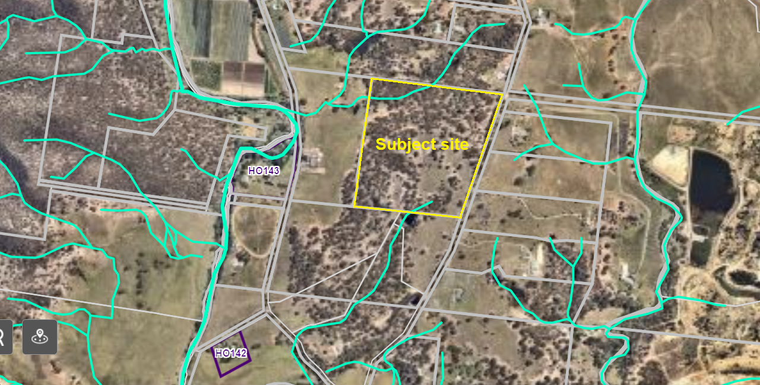
Figure 1: Aerial photograph.

Proposal
It is proposed to subdivide the site into two lots.
Lot 1 would be 16.4ha in size, with a 566.49m wide frontage to Camerons Road and would occupy the northern part of the site. A 30m x 40m building envelope would be sited towards the southeast corner of the lot, set back 90m from the front title boundary.
Lot 2 would be 12.04ha in size, with a 203.13m wide frontage to Camerons Road and would occupy the balance of the site. A 30m x 40m building envelope would be sited towards the centre of the lot, set back 146.48m from the front title boundary.
No common property is proposed, and no vegetation removal is proposed as part of the subdivision. Access to both lots would be via future crossovers to Camerons Road.
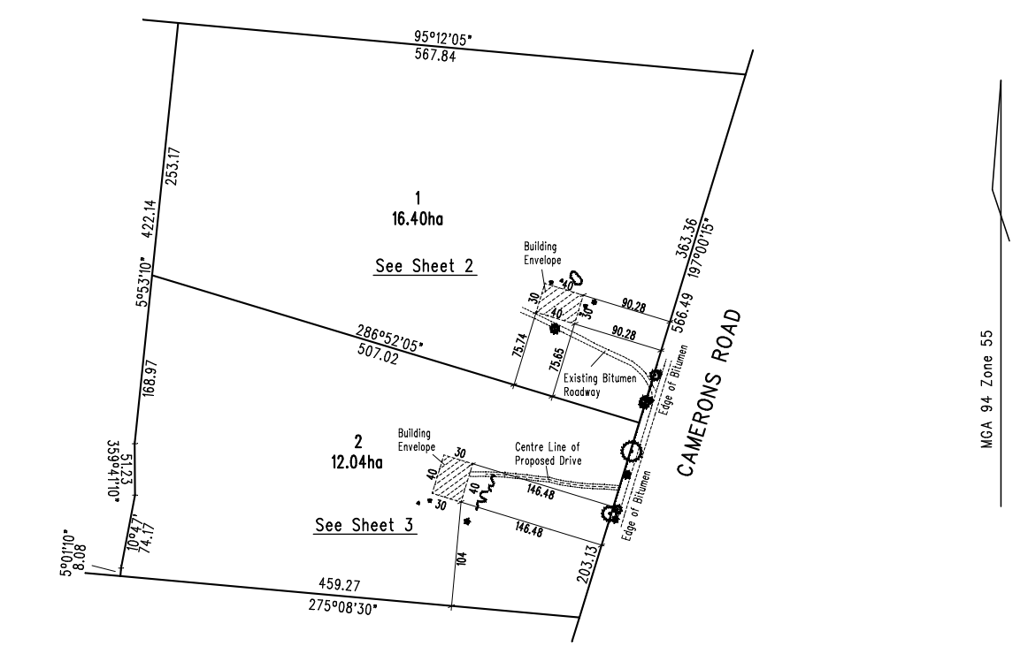
Figure 2: Proposed plan of subdivision

Background to Current Proposal
Amendment C58 to the Moorabool Planning Scheme was gazetted on 4 May 2017, rezoned the subject site from the Farming Zone to the Rural Conservation Zone and introduced Design and Development Overlay, Schedule 14 (DDO14) and Bushfire Management Overlay, Schedule 1 (BMO1). The DDO14 identified preferred dwelling envelopes, including on the subject site, and the BMO1 identified the required bushfire hazard mitigation measures consistent with those identified dwelling envelopes. Submissions made to Amendment C58 were considered by an independently appointed Planning Panel.
As part of the current permit application the applicant stated that Amendment C58 included a mapping error in the DDO14 arising from an error made as part of the Planning Panel process. The DDO14 map relates to the preferred location and permissible number of dwelling envelopes on the subject site and identifies only one dwelling envelope, as opposed to the two sought by the applicant.
Council’s Strategic Planning advised that the plan excerpt submitted by the applicant showing two dwelling envelopes is from the plan exhibited as part of Amendment C58. The subsequent Planning Panel process resulted in changes to this plan, and in particular a reduction in the number of dwelling envelopes on the subject site from two to one. This is reflected in the DDO14 in the Moorabool Planning Scheme as approved by the Minister. There is no appeal process once a planning scheme amendment is introduced into a planning scheme. A Planning Panel has considered all submissions received and this cannot be re-visited as part of a planning permit process.

History
None applicable.

Public Notice
Notice of the application was given to adjoining and surrounding landowners and occupiers by mail and a sign erected on site.
No objections were received.

Locality Map
The map below indicates the location of the subject site and the zoning of the surrounding area.
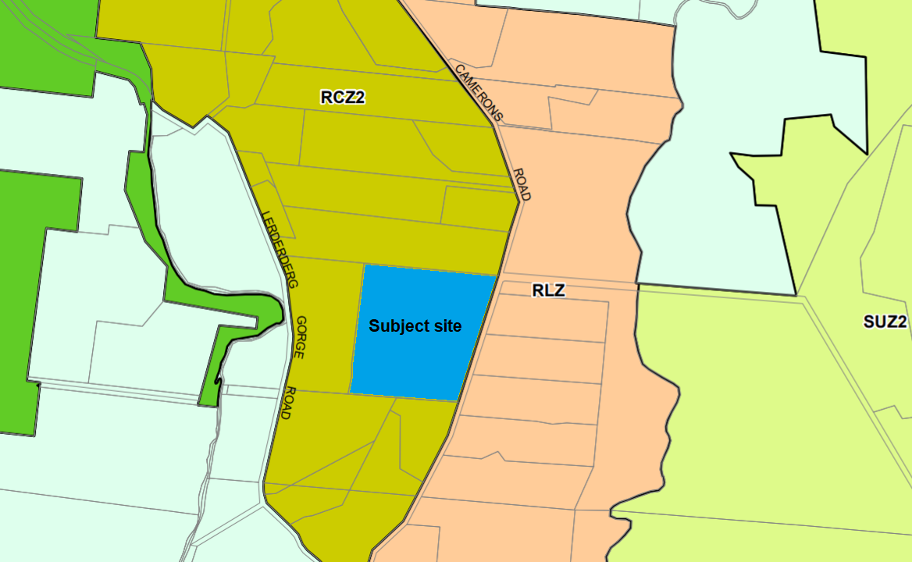
Figure 3: Zone map.

Planning Scheme Provisions
Council is required to consider the Victoria Planning Provisions and give particular attention to the Planning Policy Framework (PPF), the Local Planning Policy Framework (LPPF) and the Municipal Strategic Statement (MSS).
The relevant clauses are:
• Clause 11.01-1R Settlement - Central Highlands
• Clause 11.03-3S Peri-urban areas
• Clause 12.01-1S Protection of biodiversity
• Clause 13.02-1S Bushfire planning
• Clause 16.01-3S Rural residential development
• Clause 21.02-2 Non-urban landscapes
• Clause 21.03-4 Landscape and neighbourhood character
• Clause 21.07-5 Camerons Road Area limited rural living
The proposal does not comply with the relevant section of the PPF and the LPPF clauses outlined in the table below:
PPF | Title | Response
Clause 21.07-5 | Camerons Road Area limited rural living | The proposal includes more than one dwelling envelope that is not in accordance with the requirements of the DDO14.

Zone
The subject site is in the Rural Conservation Zone, Schedule 2. The purpose of the Rural Conservation Zone is:
• To implement the Municipal Planning Strategy and the Planning Policy Framework.
• To conserve the values specified in a schedule to this zone.
• To protect and enhance the natural environment and natural processes for their historic, archaeological and scientific interest, landscape, faunal habitat and cultural values.
• To protect and enhance natural resources and the biodiversity of the area.
• To encourage development and use of land which is consistent with sustainable land management and land capability practices, and which takes into account the conservation values and environmental sensitivity of the locality.
• To provide for agricultural use consistent with the conservation of environmental and landscape values of the area.
• To conserve and enhance the cultural significance and character of open rural and scenic non-urban landscapes.
Schedule 2 specifies the following conservation values identified for the area on the west side of Camerons Road:
• To protect the treed landscape values of the land.
• To retain and protect remnant native vegetation and wildlife habitat of the land.
• To protect the nature conservation values and habitat values of the adjacent Lerderderg State Park.
• To protect the water quality of Goodmans Creek and the Lerderderg River.
• To ensure that the location, siting and design of any development does not adversely impact upon nearby sensitive environments.
• To ensure buildings are sited where appropriate bushfire protection measures can be readily implemented without adverse impacts on environmental values or sustainable land management.
Under Clause 35.06-3 a permit is required to subdivide land and each lot must be at least 6ha as specified in Schedule 2.
The proposed subdivision is generally consistent with the applicable zone provisions.

Overlays
The site is affected by several planning overlays.
Design and Development Overlay, Schedules 2 and 14 (DDO2 & DD014)
Under Clause 43.02-3 a permit is required to subdivide land.
The DDO2 applies to development using reflective exterior cladding and is not applicable to this application.
The DDO14 applies to the Camerons Road area of Darley and Coimadai.
Overall, the proposal does not meet the relevant design objectives and subdivision requirements of the DDO14.
Bushfire Management Overlay, Schedule 1 (BMO1)
The BMO1 applies to land in the Camerons Road area. Under Clause 44.06-2 a permit is required to subdivide land.
The proposal does not meet the provisions of the BMO1.

Particular Provisions
Clause 53.01 Public Open Space Contribution and Subdivision
A person who proposes to subdivide land must contribute to Council for public open space (being a percentage of the land intended to be used for residential, industrial or commercial purposes, or a percentage of the site value of such land, or a combination of both). This does not apply to a two lot subdivision where Council considers it unlikely that each lot will be further subdivided. Considering the planning controls applicable to the subject site it is not considered that either lot would be further subdivided. If a permit was to issue, it is recommended that no contribution be required.
Clause 53.02 Bushfire Planning
The application meets the applicable requirements of Clause 53.02-4 of the Moorabool Planning Scheme.

Discussion
The proposed subdivision does not satisfy the relevant provisions of the Moorabool Planning Scheme, in particular the Design and Development Overlay, Schedule 14 (DDO14).
The subject site is a mostly heavily vegetated lot in the Rural Conservation Zone, Schedule 2 (RCZ2) in Darley. The proposed subdivision generally satisfies the zone provisions, notably protecting the identified conservation values of the area and providing for appropriate effluent treatment, subject to conditions.
The site is affected by Bushfire Management Overlay, Schedule 1 (BMO1), and the application was accordingly submitted to the CFA.
It is noted that any future dwelling development on the site would be subject to separate planning approval under the RCZ2 and BMO1 provisions and would require referral to the relevant bushfire management authority.
The site is affected by Design and DDO14. The DDO14 specifies requirements which a subdivision proposal must meet, including that a lot must contain an existing dwelling, or a dwelling envelope located in accordance with Map 1 to this schedule.
The map at Figure 4 below is an excerpt of Map 1 with the subject site highlighted and clearly showing only one designated dwelling envelope, which accords with the dwelling envelope location for Lot 2 on the proposed plan of subdivision.
The DDO14 also states the following:
• The dwelling envelope locations shown in Map 1 indicates the preferred number and location of new dwellings in the area. The dwelling envelopes are sited to minimise the impacts of environmental constraints, comply with the extractive industry buffer and to mitigate bushfire risk from the site, the immediate area and the broader landscape.

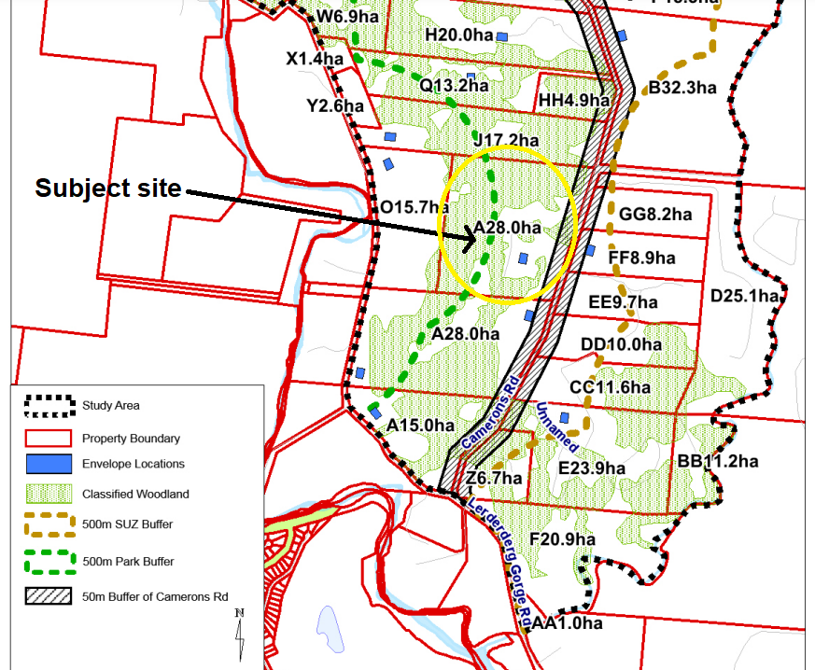
Figure 4: Excerpt of the dwelling envelope plan (Map 1) from DDO14 in the Moorabool Planning Scheme.

The DDO14 provisions provide clear guidance as to the preferred location and number of dwellings and explicitly address any potential ambiguity regarding its interpretation. The DDO14 provisions did not provide discretion to increase the number of building envelopes shown on Map 1. The proposed two lot subdivision of the site, with two dwelling envelopes, does not comply with the DDO14 provisions. The Planning Panel’s recommendations in this regard were informed by the permit applicant’s own expert evidence at the Panel hearing and in a post-Panel hearing report. A planning permit application is not appropriate mechanism to change the outcome of Planning Scheme Amendment.

General Provisions
Clause 65 - Decision Guidelines have been considered by officers in evaluating this application.
Clause 66 - Stipulates all the relevant referral authorities to which the application must be referred.

Referrals
Authority | Response
Melbourne Water  Greater Western Water  CFA | Consent.  Consent.  Consent.
Council’s  Infrastructure  Environmental Health  Strategic Planning | Consent with conditions.  Consent with conditions.  Refusal.

Financial Implications
The recommendation to refuse this application has no financial implications for Council.

Risk & Occupational Health & Safety Issues
The recommendation to refuse this application does not have any risk or OH&S implications for Council.

Communications Strategy
Notice was undertaken for the application, in accordance with s.52 of the Planning and Environment Act 1987, and further correspondence is required to all interested parties to the application as a result of a decision in this matter. The applicant was invited to attend this meeting and address the Development Assessment Committee if required.

Options
• Issue a Refusal to Grant a Permit in accordance with the grounds in the recommendation of this report; or
• should the Committee wish to support the application, issue a Permit with conditions.

Conclusion
The proposed two lot subdivision does not satisfy the applicable provisions of the Moorabool Planning Scheme, in particular the Design and Development Overlay, Schedule 14 (DDO14) and Schedule 1 of the Bushfire Management Overlay. The proposed subdivision would necessitate two dwelling envelopes, exceeding the one allowable envelope specified in DDO14. The proposed subdivision is contrary to the controls introduced through a recent planning scheme amendment process. The proposed subdivision is recommended to be refused.

7.2 PA2021237 - Removal of Native Vegetation (Two Trees) Associated with a Minor Utility Installation at Cartons Road, Gordon
Author: Jyoti Makan, Senior Statutory Planner
Authoriser: Robert Fillisch, Manager Statutory Planning & Building Services
Attachments: Nil

Application Summary
Permit No: PA2021237
Lodgement Date: 7 October 2021
Planning Officer: Jyoti Makan
Address of the land: Part Lots 1D & 1E, Section 6, Parish of Moorabool West
Cartons Road Gordon
Proposal: Removal of native vegetation (two trees) associated with a minor utility installation
Lot size: 40.60ha
Why is a permit required? Clause 42.01-3 Environmental Significance Overlay
Schedule 1 – Removal of Vegetation
Clause 52.17 – Removal of native vegetation

Recommendation
That the Development Assessment Committee, having considered all matters as prescribed by the Planning and Environment Act 1987, issue a Notice of Decision to Grant Planning Permit PA2021237, for the removal of native vegetation (two trees) associated with a minor utility installation at Cartons Road, Gordon, subject to the following recommendations:
Endorsed Plans:
1. The development as shown on the endorsed plans must not be altered without the written consent of the Responsible Authority. All buildings and works must be constructed and or undertaken in accordance with the endorsed plans to the satisfaction of the Responsible Authority. All buildings and works must be located clear of any easements or water and sewer mains or septic tank and effluent lines unless written approval is provided by the relevant authority.
Vegetation:
2. No further native vegetation including dead standing native vegetation other than approved in PA2021237 is to be removed from the land.
3. To offset the removal of 0.112ha of native vegetation, the permit holder must secure a native vegetation offset in accordance with Guidelines for the removal, destruction or lopping of native vegetation (DELWP 2017), the permit holder must secure the following offsets:
(a) A general offset of 0.032 general habitat units.
(b) Located within the Corangamite Catchment Management Authority boundary or Moorabool Shire Council municipal area.
(c) With a minimum strategic biodiversity value of at least 0.268.
4. Before the commencement of works, evidence that the required offset under this permit has been secured must be provided to the satisfaction of the Responsible Authority. This evidence must be one of the following:
(a) an established first party offset site including a security agreement signed by both parties, and a management plan detailing the 10-year management actions and ongoing management of the site; or
(b) credit extract(s) allocated to the permit from the Native Vegetation Credit Register.
A copy of the offset evidence will be endorsed by the Responsible Authority and form part of this permit. Within 30 days of endorsement of the offset evidence, a copy of the endorsed offset evidence must be provided to Planning Approvals at Department of Environment, Land, Water and Planning (DELWP) via email grampians.planning@delwp.vic.gov.au.
5. Before works start, the permit holder must advise all persons undertaking the vegetation removal or works on site of all relevant permit conditions and associated statutory requirements or approvals.
Infrastructure:
6. Sediment discharges must be restricted from any construction activities within the property in accordance with relevant Guidelines including Construction Techniques for Sediment Control (EPA 1991).
Corangamite Catchment Management Authority:
7. The irrigation area should maintain a minimum buffer of at least 20m (preferably 30m) from the top of the waterway bank, or greater if specified by EPA or State Environment Protection Policy regulatory requirements.
Permit Expiry:
8. This permit will expire if:
(a) the development is started within two years of the date of this permit; or
(b) the development is not completed within four years of the date of this permit.

Public Consultation
Was the application advertised? | Yes.
Notices on site: | Yes.
Notice in Moorabool Newspaper: | Not applicable.
Number of objections: | Six.
Consultation meeting: | A consultation meeting took place to ensure that residents are aware of the application, its current process and the planning permit triggers and requirements. There were no withdrawals of objections with several objectors concerned about tree removal not associated with this planning application.

Policy Implications
The Council Plan 2021-2025 provides as follows:
Strategic Objective 2: Liveable and thriving environments
Priority 1.5: Provide access to services to improve community connection in the Shire
The proposal is consistent with the Council Plan 2021 – 2025.

Victorian Charter of Human Rights & Responsibilities Act 2006
In developing this report to Council, the officer considered whether the subject matter raised any human rights issues. In particular, whether the scope of any human right established by the Victorian Charter of Human Rights and Responsibilities is in any way limited, restricted or interfered with by the recommendations contained in the report. It is considered that the subject matter does not raise any human rights issues.

Officer’s Declaration of Conflict of Interests
Under section 130 of the Local Government Act 2020, officers providing advice to Council must disclose any interests, including the type of interest.
A/g Executive Manager – Robert Fillisch
In providing this advice to Council as the A/g Executive Manager, I have no interests to disclose in this report.
Author – Jyoti Makan
In providing this advice to Council as the Author, I have no interests to disclose in this report.

Executive Summary
Application referred? | Barwon Water, Central Highlands Water, Corangamite Catchment Management Authority, Department of Environment, Land, Water and Planning and Council’s Infrastructure.

Any issues raised in referral responses? | No issues raised.
Preliminary concerns? | No concerns.
Any discussions with applicant regarding concerns? | Nil.
Any changes made to the application since being lodged? | No changes were required.
Brief history. | The application was lodged on 7 October 2021 for works associated with an existing sewerage treatment plant (minor utility installation) and removal two trees. The applicant was notified that exemptions on minor utility works apply to the land and that the application needed to be corrected to reflect its relevant permit requirements which is to remove native vegetation.
Previous applications for the site? | Creation of a reserve PA2012080.
General summary. | An application for a permit which proposes to remove two native trees, associated with the existing sewerage treatment plant.  Minor Utility Works is exempt from requiring a planning permit pursuant to Clause 62.02 of the Planning Scheme therefore, the permit is for the removal of the vegetation to allow for the expansion of the treatment plant. Six objections were received mainly about koala habitat at the blue gum plantation not related to this planning application.
Summary of Officer’s Recommendation
That, having considered all relevant matters as required by the Planning and Environment Act 1987, the Development Assessment Committee issue a Notice of Decision to Grant Planning Permit PA2021237 for the removal of native vegetation (two trees) associated with a minor utility installation at Cartons Road, Gordon, subject to the conditions contained within this report.

Site Description
The site is adjoining the site of the current sewerage treatment plant which was installed in Gordon in 2013. The existing site is identified as Reserve No.1 (45.48ha) on Plan of Subdivision PA704622Q. The land in which the proposed works is expanding into is known as Lot 1 (40.60ha) on the same plan of subdivision. The existing site contains, an existing pivot irrigation, blue gum leased plantation and the existing dam. Beyond the blue gum plantation, the site contains some scattered vegetation outside of the proposed irrigation system.

Proposal
The application relates to the removal of native vegetation to facilitate the alteration to the existing wastewater irrigation facility managed by Central Highlands Water (CHW) and the backfilling of an existing dam. The irrigation facility is considered to be a minor utility installation. It includes the expansion of the irrigation loading of recycled wastewater within the subject property with the installation of an addition central pivot, thereby extending the irrigation system.
The proposal for the works related to the minor utility installation is exempt from requiring a permit in accordance with Clause 62.02 of the Moorabool Planning Scheme. The works that require planning approval is the removal of vegetation being one dead tree and one large tree.
The site identified as Reserve No.1 is currently used by CHW to treat and irrigate wastewater from the township of Gordon and as a result of increased loads, there is a need for additional land and expansion of the existing half pivot system to a full pivot system that would allow for effective wastewater management.

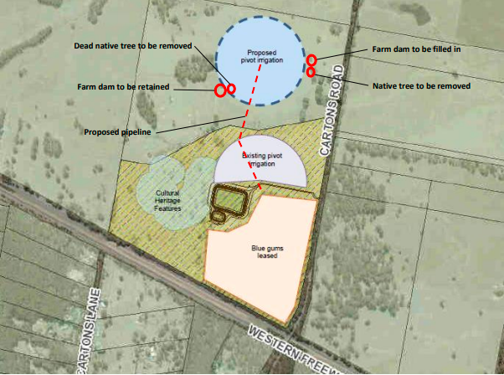
Figure 1: Works area with two trees to be removed

Public Notice
The application was notified to adjoining and surrounding landowners by letter and a sign placed on site.

Summary of Objections
The objections received are detailed below with officer’s comments accompanying them:
Objection
The removal of native vegetation serves as koala and other species habitat and not supported by the Planning Scheme.
Officer’s Response:
The vegetation being removed is one large tree and one dead tree. The koala habitat is outside of the permit area within the Bluegum plantation southwest of the subject site where trees are being removed. The permit application is not related to the Bluegum planation. A native vegetation management report was submitted, and offsets have been provided which would facilitate the expansion of the existing minor utility installation.
Objection
Increased irrigation to cause further runoff into the drinking water catchment.
Officer’s Response:
The proposed increased in the minor utility installation is not a permit requirement. The proposal was assessed for tree removal in the Environmental Significance Overlay Schedule 1 and the Farming Zone. Barwon Water, Central Highlands Water (CHW) and the Corangamite Catchment Management Authority (CCMA) had no objections to the proposal. CCMA states that the irrigation area should maintain a minimum buffer of at least 20m (preferably 30m) from the top of the waterway bank, or greater if specified by EPA or State Environment Protection Policy regulatory requirements. This has been placed as a condition within the recommendations section of this report.

Locality Map
The map below indicates the location of the subject site and the zoning of the surrounding area.
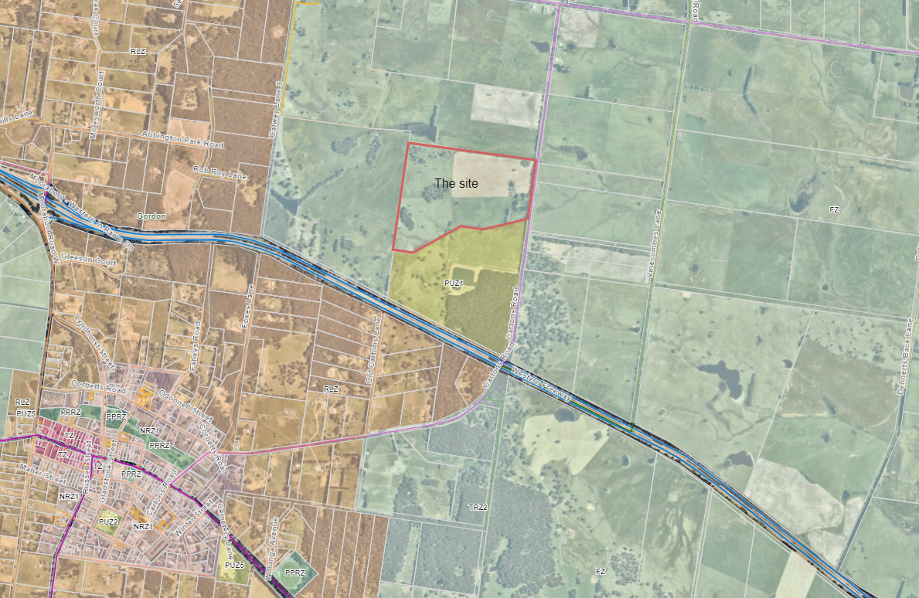
Figure 2: Locality plan

Planning Scheme Provisions
Council is required to consider the Victoria Planning Provisions and give particular attention to the Planning Policy Framework (PPF), the Local Planning Policy Framework (LPPF) and the Municipal Strategic Statement (MSS).
The relevant clauses are:
• Clause 12.01-1S Protection of Biodiversity
• Clause 12.01-2S Native Vegetation Management
• Clause 14.01-1S Protection of Agricultural Land
• Clause 14.02-1S Catchment Planning and Management
• Clause 14.02-2S Water Quality
• Clause 21.02-3 Objective – Water and Catchment Management
• Clause 21.02-4 Objective - Biodiversity
• Clause 21.02-6 Objective – Environmentally Sustainable Development
• Clause 22.02 Special Water Supply Catchments

Zone
Farming Zone
• To implement the Municipal Planning Strategy and the Planning Policy Framework.
• To provide for the use of land for agriculture.
• To encourage the retention of productive agricultural land.
• To ensure that non-agricultural uses, including dwellings, do not adversely affect the use of land for agriculture.
• To encourage the retention of employment and population to support rural communities.
• To encourage use and development of land based on comprehensive and sustainable land management practices and infrastructure provision.
• To provide for the use and development of land for the specific purposes identified in a schedule to this zone.
A permit is required to carry out earthworks in the Farming Zone - Clause 35.07-4, however a minor utility installation is exempt under Clause 62.02.

Overlays
Design and Development Overlay - Schedule 2
Design objectives:
• To enhance visual amenity in rural, township and vegetated areas of the Moorabool Shire.
• To encourage the use of external cladding, such as non-reflective materials for building construction.
To discourage the use of materials, such as reflective cladding for building construction, which could have a detrimental effect on amenity.
A permit is not required to construct a building or to carry out works where all external walls and roof areas are clad with non-reflective materials. There is no requirement for planning permit under this overlay.
Environmental Significance Overlay – Schedule 1
Environmental objective to be achieved:
• To protect the habitat significance of vegetation.
• To provide for appropriate development of land within 100m of either side of a waterway.
• To prevent pollution and increased turbidity of water in natural waterways.
• To prevent increased surface runoff or concentration of surface water runoff leading to erosion or siltation of waterways.
• To conserve existing flora and fauna habitats close to waterways and to encourage generation and regeneration of habitats.
Tree removal requires a planning permit under this overlay.

Particular Provisions
Clause 52.29 Land Adjacent to a Road Zone, Category 1
The proposed removal of vegetation has no impact on the Transport Zones.
Clause 52.17 – Native Vegetation
Purpose:
To ensure that there is no net loss to biodiversity as a result of the removal, destruction or lopping of native vegetation. This is achieved by applying the following three step approach in accordance with the Guidelines for the removal, destruction or lopping of native vegetation (Department of Environment, Land, Water and Planning, 2017) (the Guidelines):
• Avoid the removal, destruction or lopping of native vegetation.
• Minimise impacts from the removal, destruction or lopping of native vegetation that cannot be avoided.
• Provide an offset to compensate for the biodiversity impact if a permit is granted to remove, destroy or lop native vegetation.
To manage the removal, destruction or lopping of native vegetation to minimise land and water degradation.
A permit is required to remove the dead tree and one large tree. A Native Vegetation Report was submitted and states that offsets are required which is provided for within the conditions set in this report. The applicant must fulfill these obligations by providing offset evidence prior to the commencement of works.

DISCUSSION
The proposal is made to expand the irrigation system for the Gordon Wastewater Treatment Plant (Gordon WWTP) A minor utility installation is defined a land used for a utility installation comprising in part of sewerage and water mains, and a sewerage treatment plant to serve the neighborhood. The use and development is exempt from permit requirements. The removal of two trees require a planning permit under the Native Vegetation Removal (Clause 52.17) and the Environmental Significance Overlay - Schedule 1.
The Gordon WWTP is located on Cartons Road and was constructed in 2013. It includes a treatment lagoon, pump shed and irrigation infrastructure servicing 6.2ha of land using a pivot irrigation system. Approximately 25 megalitres of recycled water is produced at the Gordon WWTP each year. Additional land is now required to accommodate the the growth of Gordon and limited water absorbtion based on the soil type, topography and rainfall patterns.
Native vegetation:
The native vegetation reports provided an intermediate assessment pathway with an extent of 0.112ha, inlcuding one large tree. It also states that removal of less than 0.5ha will not have a significant impact on any habitat for a rare or threatended species. An offset amount of 0.032 general habitat units applies in the vinicity of the Corangamite Catchment Management Auhtority or Moorabool Shire Council.

Cultural Heritage Significance
Due dilligence was submitted on cultural heritage matters which states that the western section of the land (Reserve No. 1 on the plan of subdivision) is unsuitable for recycled water irrigations until further investigations occur. A Cultural Heritage Management Plan is not required for the proposed works as the proposal is outside an area of cultual heritage significance.
Titles
A plan of consolidation was not required as part of this recommendation and the minor utility installation requires both parcels to allow for complete operation of the wastewater facility.

General Provisions
Clause 62 – General Exemptions: Minor utility works is exempt from requiring a planning permit for both use and buildings and works.
Clause 65 - Decision Guidelines have been considered by officers in evaluating this application and assessed as discussed in the discussion section of this report.
Clause 66 - Stipulates all the relevant referral authorities to which the application must be referred.

Operational Provisions
Pursuant to Clause 73.03 – Land Use Terms, “minor utility installation” is defined as “Land used for a utility installation comprising of a sewerage treatment plant and associated disposal works required to serve a neighbourhood”

Referrals
Authority | Response
Corangamite Management Catchment Authority | Consent with conditions.
Barwon Water | Consent, no conditions.
Central Highlands Water | Consent, no conditions.
Council’s Infrastructure | Consent with conditions.

Financial ImplicatioNS
The recommendation of approval of this application has no financial implications to Council.

Risk & Occupational Health & Safety Issues
The recommendation of approval of this application does not implicate any risk or OH&S issues to Council.

Communications Strategy
Notice was undertaken for the application, in accordance with s.52 of the Planning and Environment Act 1987, and further correspondence is required to all interested parties to the application as a result of a decision in this matter. All submitters and the applicant were invited to attend this meeting and invited to address the Development Assessment Committee if required.

Options
Council could consider the following options:
• Issue a Notice of Decision to grant a Planning Permit in accordance with the recommendations of this report; or
• issue a refusal to grant a planning permit with specific grounds. The grounds would need to demonstrate how the proposal does not comply with the Moorabool Planning Scheme.

Conclusion
The proposal is made for the removal of two native trees to facilitate minor utility works for the expansion of the existing irrigation faciality used by Central Highlands Water. A minor utility work is exempt from requiring a planning permit to use and conduct works on the site pursuant to Clause 62.01 and 62.02 of the Moorabool Planning Scheme. The removal of one large tree and one dead tree was assessed against the planning scheme. Native vegetation offsets provided within the Native Vegetation Information Management Report will address the native vegetation lost. The offsets have been accounted for within the proposed conditions stated in this report. The proposed works appropriate and facilitate the operation of a minor utility installation.

8 Update on VCAT Decisions

9 Other Business

10 Date of Next Meeting

Wednesday 15 June 2022.

11 Meeting Close

