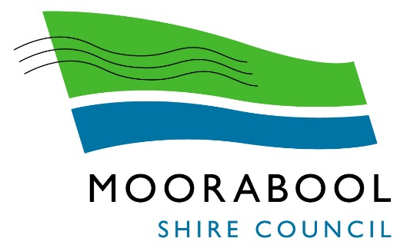

MARVELOO
HIRE INFORMATION KIT

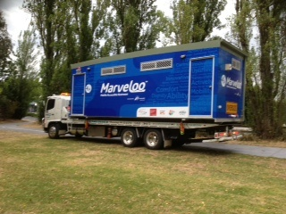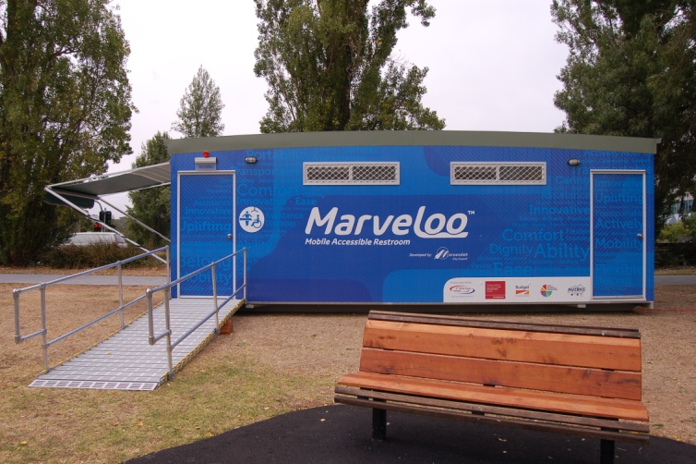

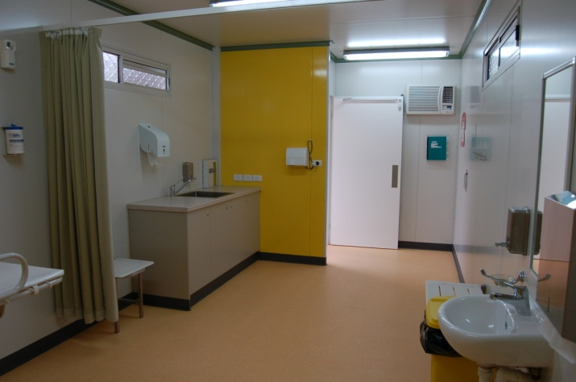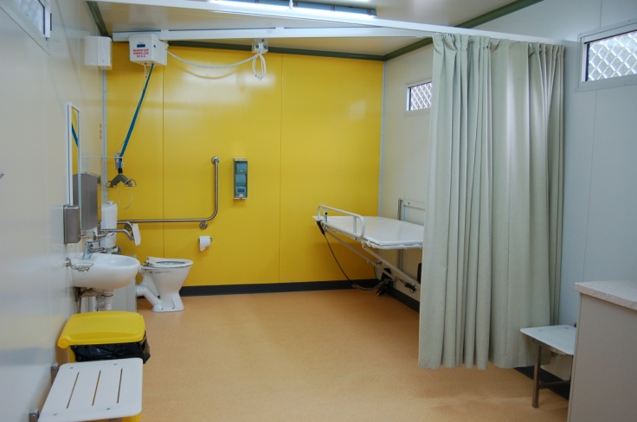

Table of Contents

1. Introduction 3
2. Hire Requirements 5
3. Hire Booking Form 6
4. Standard Terms and Conditions 8
4.1 Definitions and Explanations 8
4.2 Binding Agreement 8
4.3 Terms of Payment 8
4.4 Cancellations and Cancellation Fee 8
4.5 Insurance 9
4.6 Condition and Damage Responsibility 9
4.7 Cleaning 9
4.8 Consumables 10
4.9 Logistics 10
4.10 Delivery and Pick-up 10
4.11 No Sale and Acknowledgement of Ownership 10
4.12 Limitation of Liability 11
5. Acceptance of Hire Agreement 12
5.1 Acknowledgement 12
5.2 Agreement 12
6. Set Up and Pack Up Instructions 13
6.1 Set Up Instructions 13
6.2 Pack Up Instructions 13
7. Public Notice 14
8. Equipment Operating Instructions Reference Guide 15

1. INTRODUCTION

One Mobile Accessible Restrooms (Marveloo 6) is available for hire from Moorabool Shire Council for use at community activities and events.

Marveloo has been designed to meet the needs of people with profound and multiple learning disabilities, their carers, and the many other disabled people who are unable to use standard accessible toilets.

Marveloo is purpose built and is the sixth of its kind in Australia, which is attributed to its many special features including; a fully accessible toilet, overhead ceiling hoist, height adjustable adult change table, modesty curtain, additional seating, heating and cooling, a safe and clean environment, adequate space, an automatic door, access ramp and an external sun shade.

All users are required to provide their own sling for use of the overhead ceiling hoist and advised to check that their sling is compatible with the ceiling hoist provided in each Marveloo, prior to use. Marveloo 6 is fitted with an Eclipse 100 Series Ceiling Hoist. If compatibility has not been checked or there is some uncertainty, the user should not use the ceiling hoist.

All hirers and users of Marveloo are required to read and understand the operating instructions for use of the overhead ceiling hoist, height adjustable adult change table, heating and cooling unit, access ramp, automated door and external sun shade. The operating instructions can be accessed on Moorabool Shire Council's website at Marveloo and in each Marveloo.

Marveloo is available for hire 7 days per week. To book you must complete and submit a Marveloo Hire Booking Form (refer to section 3 page 6), and a schematic drawing that demonstrates where on the event site Marveloo will be located. For an example of how to do the schematic drawing and hints for using Marveloo at your event, refer section 10 page 15.

The hirer must also read and agree to comply with the Terms and Conditions of Hire by signing a Hire Agreement Form (refer to section 5 page 12).

The Marveloo Hire Booking Form and Hire Agreement Form are also available on Moorabool Shire Council's website at Marveloo or call 5366 7100 to obtain copies and further information.

Commercial businesses are required to pay a hire fee for the cost of transport (refer to Council for current quote) and includes set up. The hire fee includes the use of Marveloo for the required hire period, delivery and pick up and consumables such as toilet paper, paper towels, hand soap, disinfectant wipes and garbage bags.

For Moorabool community groups, events and not for profit organisations Moorabool Shire Council will sponsor the cost up to a certain number per year. Please contact Council for more information.

Marveloo will be delivered to you and picked up from the event/activity site via a tandem drive tilt tray truck between the hours of 9.00am and 5.00pm, Monday to Friday only. If delivery is required outside these hours the hirer is liable for any additional costs such as contractor penalty rates. Council will be able to provide quote.

All cancellations made within 30 days of the hire date will incur a cancellation fee of $100.00.

The hirer is responsible for booking and paying all costs associated with emptying the effluent tank which has a storage capacity of 1000 litres. The effluent tank must be emptied at the end of each event day and prior to pick up of Marveloo (refer to section 9 page 15 for a list of effluent tank service providers).

Transportation of Marveloo can only be undertaken by Moorabool Shire Council's nominated contractor and under no circumstances is Marveloo permitted to be transported by anyone else.

An authorised person must be available on site to oversee the delivery and pick up process including site access and allocation, set up and pack up, and completion of a pre and post condition audit.

Marveloo must remain locked when not in use. It is also expected that Marveloo is monitored by event security staff throughout the event, including during event set up and pack up.

In the unlikely event that a Marveloo is not available for use for a scheduled booking, Moorabool Shire Council will not be able to provide a substitute facility.

PLEASE NOTE

Marveloo has been purpose built to meet the needs of people who require an accessible toilet with an overhead ceiling hoist and height adjustable adult change table.

It would be greatly appreciated if Marveloo remains available to those who need it most.

In addition to Marveloo, standard accessible toilets will also need to be made available at your event.

2. HIRE REQUIREMENTS

The following hire requirements apply to ensure Marveloo operates in a safe and functional manner:

- Marveloo’s size is 8m length x 3m width x 3.1m height, and is transported by a tandem drive tilt tray truck which will require access to the event/activity site.

- The truck requires a height clearance of 4.6 metres to avoid overhead services, a tipping clearance of 5.6 metres and a minimum of 30 metres distance to off load Marveloo.

- The truck is 12 metres in length, requires a minimum road width of 4.5 metres to access the site, and sharp corners can be problematic.

- The weight of the truck is 9,840 KG and the weight of Marveloo is 3,500 KG. Total weight = 13,340 KG.

- Marveloo must be positioned on a footprint of flat ground to a minimum of 10 metres long x 10 metres wide (100²m) including the accessible ramp which extends 4.5 metres out from Marveloo.

- To supply power, 2 power leads of 15 amps each from an adequate power supply must be used or a 10 KVA generator. Marveloo also needs to be in close proximity to a power source to ensure adequate power is available. The hirer must use their own lead at length suitable for the event.

- 2 x 15 amp caravan inlets are installed for power connection, and standard single phase power is sufficient.

- Marveloo has an internal hot water unit. To access the onsite cold water supply, the hirer is required to supply a 3/4 inch hose with a nut and tail, or snap on fitting.

- Marveloo has been designed to operate in open parklands without any services, however this key feature compromises the capacity of storing effluent. Therefore, the effluent tank, which has a storage capacity of 1000 litres needs to be emptied at the end of each event day and prior to transporting. This will ensure that the effluent storage system is not overloaded, and will also eliminate the need to shut down Marveloo during an event. The costs and arrangements associated with emptying the effluent tank is the responsibility of the hirer.

- Due to the limited storage capacity of the effluent tank which is 1000 litres, the Marveloo must not be used as a standard accessible toilet and must only be used by people with profound and multiple learning disabilities, their carers, and the many other disabled people who are unable to use standard accessible toilets.

- All consumables e.g. toilet paper, paper towels, hand soap, disinfectant wipes and garbage bags are supplied and stored in the cupboard under the wash basin/trough. An internal waste bin is also supplied.

- The hirer must clean and sanitise Marveloo prior to pick up. Marveloo must also be returned to the same level of cleanliness it was received.

- A schematic drawing which demonstrates where on site Marveloo will be located, must be submitted
with the Marveloo Hire Booking Form.

To obtain further information please refer to Moorabool Shire Council's Website Marveloo or call 5366 7100.

NOTE: THIS FORM MUST BE RETURNED PRIOR TO HIRE


MARVELOO-HIRE BOOKING FORM

CARTAGE CONTRACTOR:

CONTACT DETAILS

Contact name

Organisations name

Position:

Phone Number: B/H

Mobile

Email

Postal Address:

Postcode

HIRE DETAILS

Day of Hire Contact Person:
Name
Phone No
Purpose of Hire:

Day of Hire-Name of Location and Address

Date/s of Hire: From and To
Date of Hire Setup
Time of Hire Setup
Date of Hire Pick up
Time of Hire Pickup

3. MARVELOO-HIRE BOOKING FORM (Continued)

PAYMENT DETAILS FOR COMMERCIAL BUSINESS

Hire Fee for commercial business: $TBA
GST: $TBA
Total Standard Hire Fee: $TBA

Weekend Delivery / Pick Up (Extra Cartage Fee) TBA
Over 50km Delivery / Pick Up (Extra Cartage Fee as quoted) TBA

Up to a maximum of 5 days hire. Longer periods of hire may be negotiated, however will be dependent upon availability of Marveloo.

All hire fees are payable on receipt of a booking confirmation letter and invoice.

Please note that for Moorabool Shire community groups, community events and not for profit organisations Moorabool Shire Council will sponsor the cost up to a certain number per year. Please contact Council for more information.

BOOKING CONFIRMATION

Bookings will only be confirmed once the following documentation has been received:

A completed Marveloo Hire Booking Form.
A schematic drawing of where Marveloo will be located on the event/activity site, taking into consideration hire requirements (refer section 10 page 15).
A signed Marveloo Hire Agreement (Page 12)
Payment of the hire fee (if applicable) on receipt of the invoice following the Event.
I have read and understand the operating instructions for all Marveloo equipment.

Signed: Name

Office Use Only

Notifications

Depot Customer Service

Transport Documentation and Keys

Cleaning

Depot Store Access

Other

4. MARVELOO STANDARD TERMS AND CONDITIONS OF HIRE

4.1 DEFINITIONS AND EXPLANATIONS

In these Standard Terms and Conditions these words and phrases have the following meanings:

"Acceptance" and "Accepted" means acceptance of the Hire Agreement by the hirer.
"Agreement" means the Agreement between Moorabool Shire Council and the hirer for the hiring of Marveloo, the terms of which are fully set out in these Standard Terms and Conditions of Hire.
"Cancellation" means the cancellation by the Hirer of this Agreement, which must be communicated to Moorabool Shire Council in writing via email or mail.
"Cancellation Fee" means a payment of $300.00 is payable to Moorabool Shire Council when a cancellation for the hire of Marveloo is received within 30 days of the anticipated delivery date to the required location.
"Marveloo" means Mobile Accessible Restroom.
"Effective Control" means actual physical control and use of Marveloo.
"Hire Fee" means the fee exclusive of GST that the hirer has by the Hire Agreement agreed to pay to Moorabool Shire Council for the hire of Marveloo for the period of hire. Any fees or charges related to damage of the unit or additional cleaning requirements will be separately invoiced to the hirer and will be additional to the Hire Fee.
"Hirer" means the organisation or person described in the Hire Agreement Form as the "hirer" and where applicable its lawful successors and assignees.
"Site" means the designated place, venue or location at which Marveloo is to be delivered to and at which place the hirer is to take possession of the unit.

4.2 BINDING AGREEMENT

4.2.1 This Agreement is binding on Moorabool Shire Council and the hirer accepting and signing the Hire Agreement Form, for the hire period stated on the Hire Agreement Form.
4.2.2 Until the Hirer has accepted the offer and signed the Hire Agreement Form, Moorabool Shire Council may at any time withdraw the offer in writing, via email or mail.
4.2.3 The hirer for the purpose of this Agreement is deemed to have accepted the Hire Agreement on these Standard Terms and Conditions.
4.2.4 The Hire Agreement can only be signed by the hirer.

4.3 TERMS OF PAYMENT

4.3.1 The hirer will pay the applicable hire fee (if applicable) plus GST to Moorabool Shire Council on the hire fee due date stated on the invoice.
4.3.2 Moorabool Shire Council will provide a Tax Invoice to the hirer for the hire fee upon request.

4.4 CANCELLATION AND CANCELLATION FEE

4.4.1 The hirer has the right to cancel the Hire Agreement provided that a cancellation notice is sent in writing, via email or mail to Moorabool Shire Council. Upon receipt of the cancellation Moorabool Shire Council has no such obligation to deliver Marveloo.
4.4.2 Moorabool Shire Council will invoice the hirer a cancellation fee of $100.00 for all cancellations made within 30 days of the agreed hire date.

4.5 INSURANCE

4.5.1 Insurance of Marveloo during the period of hire for loss or damage is the responsibility of the hirer. The hirer will be charged for the loss of Marveloo or any part thereof at a replacement rate. The cost for repair of any damage to Marveloo or part thereof will be charged at trade rates current at the time the repairs are carried out.
4.5.2 Moorabool Shire Council is only responsible for Marveloo until it is delivered to the hirer on site.

4.6 CONDITION AND DAMAGE RESPONSIBILITY

4.6.1 Marveloo will remain at all times the property of Moorabool Shire Council. The hirer has no legal or equitable interest in Marveloo or any part thereof.
4.6.2 Upon delivery, a condition audit of Marveloo will be conducted by the delivery company upon which will be noted the general condition and particulars of any existing damage (i.e. scratches, dents, abrasions etc). It is the hirers’ responsibility to notify Moorabool Shire Council of any variance as to comments on the condition audit upon delivery to the site.
4.6.3 Any defects or malfunctions must be reported to Moorabool Shire Council as soon as possible. If Marveloo is unable to be used for part or all of the hire period due to a defect or malfunction, with the exception of damage or misuse, Moorabool Shire Council will refund a portion of the hire fee.
4.6.4 Where the hirer is in effective control of Marveloo, the hirer will;

(a) At all times exercise all reasonable care and diligence in the use of Marveloo in accordance with the manufactures specifications, operational instructions and Standard Terms and Conditions of the Hire Agreement;
(b) Due to the limited storage capacity of the effluent tank, ensure that Marveloo is not used as a standard accessible toilet and must only be used by people with profound and multiple learning disabilities, their carers, and the many other disabled people who cannot use standard accessible toilets.
(c) The hirer must make Marveloo available for collection in good working order and condition on expiration of the hire period;
(d) Not tamper or in any way interfere with, or repair or attempt to repair Marveloo;
(e) Be responsible for all accidental damage and all loss or damage to Marveloo occasioned by theft, malicious damage or other unlawful act, and will be liable to pay any costs associated with the repair or replacement of Marveloo and/or its fittings and fixtures due to such loss or damage;
(f) Ensure that the Marveloo is monitored by security staff at all times while on the event/activity site for the duration of the hire period, including after hours;
(g) Ensure that Marveloo is locked at all times when not in use (a key will be provided)
(h) Not remove or deface any labels, instructions, manufacturer’s serial numbers or other marks identifying Marveloo or Moorabool Shire Council's ownership of it;
(i) Not permit any person to improperly use Marveloo.

4.7 CLEANING

4.7.1 Marveloo will be delivered in a clean condition, the hirer must clean Marveloo and return it after use to the same level of cleanliness it was received.
4.7.2 The effluent tank, which has limited storage capacity needs to be emptied at the end of each event day and prior to transporting. For Multiple day events, the level can be monitored, the trigger to empty the tank is 56.2 Capacity as per sign adjacent to the gauge. The costs and arrangements associated with emptying the effluent tank is the responsibility of the hirer.
4.7.3 The hirer may be charged for any additional cleaning costs incurred by Moorabool Shire Council as a result of the hirer failing to return Marveloo to the same level of cleanliness it was received.

4.8 CONSUMABLES

4.8.1 All consumables required for the use of Marveloo are supplied which includes toilet paper, paper towels, hand soap, disinfectant wipes and garbage bags.

4.9 LOGISTICS

4.9.1 To supply power, 2 power leads of 15 amps each from an adequate power supply must be used or a 10 KVA generator. Marveloo also needs to be in close proximity to a power source to ensure adequate power is available. The hirer must use their own lead at a length suitable for their event.
4.9.2 2 x 15 amp caravan inlets are supplied and standard single phase power is required;
4.9.3 Marveloo has an internal hot water unit. To access the onsite cold water supply, the hirer is required to supply a 3/4 inch hose with a nut and tail, or snap on fitting.
4.9.4 The accessible ramp extends 4.5 metres out from the Marveloo.
4.9.5 Marveloo must be positioned on a footprint of flat ground, to a minimum of 10 metres x 10 metres (100²m).

4.10 DELIVERY AND PICK UP

4.10.1 Moorabool Shire Council provides a contractor to deliver and pick up Marveloo, which is 8m long x 3m wide x 3m high metres in size, and is transported by a tandem drive tilt tray truck. Under no circumstances is Marveloo permitted to be transported by anyone else.

4.10.2 Marveloo will be delivered and picked up from the event/activity site between 9.00am and 3.00pm, Monday to Friday only. If delivery is required outside these hours the hirer is liable for any additional costs associated, such as contractor penalty rates which are $100 plus GST per visit.

4.10.3 All deliveries beyond Moorabool Shire Council's landing place in Bennet Street, Bacchus Marsh, will incur an additional fee, which will be quoted upon booking Marveloo.

4.10.4 The hirer must ensure that;

- The truck has a height clearance of 4.6 metres available to avoid overhead services, a tipping clearance of 5.6 metres and a minimum of 30 metres distance to off load Marveloo.
- The truck has a minimum road width of 4.5 metres available to access the site.
- The site is suitable for the weight of the truck which is 9,840 KG and the weight of Marveloo which is 3,500 KG i.e. a total weight of 13,340 KG.
- Access to the site is available at the required times.
- Marveloo is not located where it has the potential to be damaged.
- The site is safe for the delivery contractor to carry out their duties and locate Marveloo on the identified site.
- Marveloo is positioned on a footprint of flat ground, to a minimum of 10 metres x 10 metres (100²m).

4.11 NO SALE AND ACKNOWLEDGEMENT OF OWNERSHIP

4.11.1 This is a Hire Agreement only and does not constitute or give rise to any sale of Marveloo to the hirer, any hire purchase agreement or arrangement with the hirer, or any leasing agreement that contains an option to purchase Marveloo.

4.11.2 The hirer acknowledges that Moorabool Shire Council is the sole, exclusive owner of Marveloo.
4.11.3 Nothing in this Hire Agreement confers any option on the hirer to purchase Marveloo.

4.12 LIMITATION OF LIABILITY

4.12.1 Indemnity-The hirer shall indemnify and keep indemnified and hold harmless Moorabool Shire Council, its servants and agents from all damages suits, actions, claims and demands of every description whatsoever and howsoever arising either directly or indirectly from the use, maintenance, transport, operation of Marveloo or otherwise and whether resulting from the negligence of Moorabool Shire Council its servants or agents or otherwise.

4.12.2 Exclusion of Liability-Moorabool Shire Council shall not be liable to the hirer or the hirers servants or agents from all damages suits, actions, claims and demands of every description whatsoever and howsoever arising either directly or indirectly from representation, warranties, terms and conditions express or implied (except in so far as statutory conditions and warranties cannot be excluded under part V Division 2A of the Trade Practices Act (1974), or relevant State legislation, use, maintenance, transport, or operation of the Marveloo or otherwise, and whether resulting from the negligence of Moorabool Shire Council its servants or agents or otherwise.

5. MARVELOO ACCEPTANCE OF HIRE AGREEMENT

5.1 ACKNOWLEDGEMENT

In signing this Hire Agreement I expressly acknowledge and agree that:

- I have fully read and understand the Standard Hire Terms and Conditions;
- I am over the age of 18 years;
- In creating this Acceptance of Hire Agreement Moorabool Shire Council does so in good faith relying upon the information contained in the Hire Booking Form and any additional information provided by the hirer entering into this Agreement;
- I have been provided with adequate opportunity to seek legal or other advice in relation to the Marveloo Standard Terms and Conditions of Hire and this Hire Agreement;
- In accepting this Hire Agreement I will, in accordance with the Standard Terms and Conditions of Hire, without derogating from any other obligations of the hirer, under the Standard Terms and Conditions of Hire;

(a) Indemnify Moorabool Shire Council against and hold Moorabool Shire Council harmless from any and all claims in relation to the hire of Marveloo, where applicable within the provision of the Standard Terms and Conditions of Hire, and any relevant Acts, Legislation or documentation.

(b) Put in place and maintain the insurance arrangements required for the agreed period of hire, in accordance with Part 4.5 of the Standard Terms and Conditions of Hire; and

(c) Promptly pay all Hire Fees in accordance with Part 4.3 of the Standard Terms and Conditions of Hire and to pay on demand any additional money properly claimed by Moorabool Shire Council under the Standard Terms and Conditions of Hire.

(d) Adjustments to this Agreement without prior consent from Moorabool Shire Council will deem this Agreement invalid.

- Privacy Collection Statement: Moorabool Shire Council is collecting the information on this Agreement for the purpose of registering and administering your booking. The information will not otherwise be disclosed except as required by law. In particular, the information will not be disclosed to others for marketing purposes.

- If you fail to sign and return this Agreement your booking will not be confirmed.

5.2 AGREEMENT

Hirer's Name:

Name of Organisation:

Signature:

Date:

Please return the signed Marveloo Acceptance of Hire Agreement to:
Moorabool Shire Council PO BOX 18, Ballan VIC 3342 or email a scanned copy to: info@moorabool.vic.gov.au For enquiries please call 5366 7100

6. MARVELOO-SET UP AND PACK UP INSTRUCTIONS

6.1 SET UP INSTRUCTIONS

The hirer must ensure the following is undertaken:

- Upon receiving Marveloo, conduct a pre-hire condition audit with the delivery driver.
- A height clearance of 4.6 metres is available to avoid overhead services.
- Marveloo is positioned on a footprint of flat ground, to a minimum of 10 metres x 10 metres (100²m).
- Marveloo is unloaded and stabilised.
- The water and electricity supply is connected.
- The circuit breakers in the fuse box service duct are turned on.
- The automated door is activated.
- The main entrance door is locked in the open position whilst the Marveloo unit is in use.
- The access ramp is set up and secured by the Transport company/Council on delivery.
- Activate and test all equipment e.g. water supply, flushing units, hot water unit, air conditioning/heating, ceiling hoist, height adjustable change table, air deodoriser.
- Consumables are available and adequate.
- Unhook sling from transport lockdown hooks.
- Unlock sun shade locking mechanism.
- Set up external sun shade, as required.

6.2 PACK UP INSTRUCTIONS

The hirer must ensure the following is undertaken:

- A post-hire condition audit is conducted with the delivery driver, upon returning Marveloo.
- The circuit breakers in the fuse box service duct are turned off.
- The automated door is deactivated.
- The internal equipment is decommissioned e.g. hot water unit, air conditioning/heating, ceiling hoist, height adjustable change table, air deodoriser.
- Connect sling into lockdown hooks for transportation.
- Remove and store access ramp, Transport company/Council will complete this.
- Ensure effluent tank is empty-capacity 1,000 litres.
- Pack up sun shade, as required.
- Engage sun shade locking mechanism for transportation.
- Load and secure Marveloo.
- Note: Do not disconnect services i.e. power and water until the internal cleaning of Marveloo has been completed.

7. MARVELOO-EQUIPMENT OPERATING INSTRUCTIONS REFERENCE GUIDE

All hirers and users of Marveloo are required to read and understand the Equipment Operating Instructions of the following equipment prior to use:

- Awning Operating Instructions-A & E Sunchaser Patio Awnings User Guide
- Overhead Hoist User Guide
- Mobility Plus Change table -Operating, Maintenance and Cleaning Manual
- Air Conditioner Owner's Manual
- Ramp Installation Guide
- Automated Access Door Operating Instructions

Marveloo Equipment Operating Instructions are available on Moorabool Shire Council's website Marveloo and are located in Marveloo 6.

8. EFFLUENT TANK SERVICE PROVIDERS (INFORMATION ONLY)

- Local Septic Tank Servicing Contractors-“Turd Burglar” -the cost to empty the size capacity of the Marveloo effluent would be around $60.00.
0418 363 030 226 Lerderderg Park rd, Bacchus Marsh

- Portable Toilet Hire Companies

9. Supply of Tanked Potable water (INFORMATION ONLY)

Alternative Water Supply (if required)

- Phil’s Water 0417 318 831 – philswater@gmail.com

10. MARVELOO SITE PLAN (EXAMPLE)

