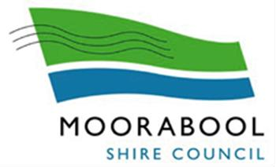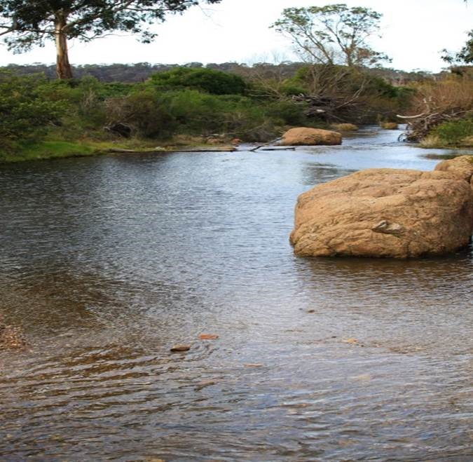
Moorabool
Shire Council
Domestic
Wastewater
Management
Plan
2021

CONTENTS

EXECUTIVE SUMMARY |  | 1
SECTION 1 – PURPOSE
1.1 INTRODUCTION |  | 3
1.2 BACKGROUND |  | 5
1.3 PLANS, POLICIES, LEGISLATION, REGULATONS, STANDARDS & GUIDELINES |  | 6
 | ST1.4 STAKEHOLDERS | 6
1.5 SEPTIC TANK SYSTEMS INSTALLATIONS |  | 7
SECTION 2 – OPERATIONAL PLAN
2.1 OVERVIEW |  | 8
2.2 IDENTIFIED GROWTH & IMPROVEMENT AREAS |  | 8
2.3 INFORMATION MANAGEMENT & REPORTING |  | 11
2.3.1 INFORMATION MANAGEMENT |  | 11
2.3.2 REPORTING |  | 12
2.4 APPROVALS |  | 12
2.4.1 PLANNING |  | 12
2.4.1.1 DENSITY OF DWELLINGS |  | 12
2.4.1.2 INDIVIDUAL & CUMULATIVE IMPACT |  | 13
2.4.1.3 SECTION 173 AGREEMENTS |  | 14
2.4.2 PERMITS |  | 14
2.4.3 LAND CAPABILITY ASSESSMENTS |  | 15
2.4.4 TREATMENT STANDARDS |  | 16
2.4.5 FUTURE DEVELOPMENTS |  | 17

2.5 INSPECTION AND COMPLIANCE MONITORING | 18
2.5.1 COMPLETED INSPECTIONS | 18
2.5.2 INSPECTON AND COMPLIANCE MONITORING | 18
2.5.2.1 INSPECTION & MONITORING MODEL | 18
2.5.2.2 INSPECTION & MONITORING PROGRAM | 19
2.5.3 WASTEWATER SAMPLING | 20
2.5.4 WATER QUALITY SAMPLING | 20
2.6 SEWERED TOWNSHIPS WITH SEPTIC TANK SYSTEMS | 20
2.7. RESOURCING AND FUNDING | 20
2.7.1 SEWERED TOWNSHIPS WITH SEPTIC TANK SYSTEMS | 20
2.7.2 FUNDING SOURCES | 20
2.7.3 FUNDING COMMITMENT | 20
2.8 COMMUNITY EDUCATION & AWARENESS | 22
2.8.1 COUNCIL WEB SITE | 22
2.8.2 DIRECT COMMUNICATION | 22
2.8.2.1 LCA ASSESSORS | 22
2.8.2.2 OWNERS/OCCUPIERS | 22
2.8.2.3 CONVEYANCING PRACTITIONERS | 23
2.8.2.4 SERVICE AGENTS, INSTALLERS AND MAINTAINERS | 23
2.9 AUDIT AND REVIEW | 24
2.10 DWMP - ACTION PLAN | 25

Prepared by Neil Dunbar
Managing Director
Email neil@wdms.com.au
Tel. 0411 040 032

Adopted by Council 3rd March 2021

List of attachments
Attachment 1 Location of Septic Tank Systems by Township 27
Attachment 2 Extract from SEPP Implementation Plan 30
Attachment 3 DWMP requirements for relaxation of dwelling density 32

List of figures
Figure 1: Treatment System Installation Example……………………………………………………………………………..7
Figure 2: Map of townships identified for potential growth of Dunnstown, Wallace and Bungaree….9
Figure 3: Map of township of Myrniong identified for future growth……………………………………………..10
Figure 4: Land subject to inundation not suitable for development…………………………………………………16
Figure 5: Lal Lal Falls……………………………………………………………………………………….……………………………..22
Figure 6: Map showing high risk locations for wastewater assessment…………………………………………..29

Acronyms and abbreviations

AWTS Aerated Wastewater Treatment System
BOD Biological Oxygen Demand
BW Barwon Water
CMA Catchment Management Authorities
CoP code of practice
CHW Central Highlands Water
DELWP Department of Environment, Land, Water and Planning
DWM Domestic Wastewater Management
DMMP Domestic Wastewater Management Plan
LCA Land Capability Assessment
MSC Moorabool Shire Council
EPA Environmental Protection Authority
SEPP (WoV) State environment protection policy (Waters of Victoria)
SS Suspended solids
VAG Victorian Auditor-General
VAGO Victorian Auditor-General’s Office
WW Western Water

Executive Summary
Moorabool Shire Council (the “Council” or “Shire”) is committed to improving the management of onsite wastewater systems within the Shire.
Under the provisions of the State Environment Protection Policy (Waters of Victoria) 2018 (SEPP WoV), Councils need to develop a Domestic Wastewater Management Plan (DWMP) in conjunction with relevant water authorities and the community.
This is the third DWMP that has been prepared, the first of which was in in 2006. The issues associated with poor domestic wastewater management and resulting risk to public and environmental health are well documented in previous DWMPs, the SEPP (WoV) and Victorian Auditor-General’s (VAG) Reports of 2006 and 2018.
The 2018 VAG Report concluded that “Risks from poorly treated and managed domestic wastewater fall into three categories:
- public health—drinking water and recreational water bodies contaminated with human pathogens from mismanaged wastewater
- environmental—polluted surface waters and groundwater which can cause significant harm to aquatic fauna and indigenous vegetation
- amenity—smell, unsightly discharges and seepage leading to reduced amenity and reduction in property values.”
The development of this DWMP has involved considerable consultation with key stakeholders, which has resulted in valuable input to the final document and action strategies.
A review of the Environment Protection Regulations has occurred during the development period of this DWMP. The review of the legislation governing septic tanks is likely to impact on the DWMP based on the draft regulations.
The DWMP is a dynamic planning tool and will be reviewed at such time that legislative changes are enacted.
There are currently around 4,800 septic tank systems recorded as operating in the Shire, ranging from new to 50+ years in age.
A focus of this DWMP is to develop and implement strategies that will:
- Achieve the objectives of the SEPP (WoV);
- Minimise potential risk to public and environmental health from septic tank wastewater; and
- Provide for continued growth within the Shire in areas that rely on septic tank systems for sewerage treatment and disposal.
A key strategy for improving onsite wastewater management practices is the implementation of an effective risk-based inspection and monitoring program for all septic tank systems within the Shire. The inspection and monitoring program will apply to all domestic septic tank system installations.
An initial “township” risk classification of High, Medium or Low has been assigned to each township within the Shire.
The two main factors that have been used to determine the township classification are soil suitability for septic tank systems and previously evidenced problems with wastewater treatment, disposal and containment within property boundaries.
The inspection and monitoring risk classification model will be expanded to incorporate other factors that have been identified as potential risk that need to be evaluated and managed in the monitoring program model. Identification and evaluation of risks for the expanded model will be developed in compliance with ISO 31000 Risk Management.
The inspection program will provide valuable data to support information already obtained from previous audits and property inspections. Collection of data, such as a property not being able to retain its wastewater within the property boundary, is integral to implementing strategies to prevent this occurring.
In addition to the inspection and monitoring requirements, the DWMP also defines wastewater treatment standards that will be required for the development of allotments that have been deemed to be High Risk. Using a risk-based approach will mean that:
- A secondary level of treatment with disinfection to achieve a minimum standard of 20 milligrams per litre (mg/L) biochemical oxygen demand (BOD), 30mg/L suspended solids (SS) and 10 E.coli organisms per 100 millilitres chlorination will be required for all septic tank systems that are located on properties:
- less than 4,000m² in area and located within a potable water supply catchment; and
- less than 2,000m² in area but located outside a potable water supply catchment.
- A secondary level of treatment that can achieve a minimum standard of 20mg/L BOD and 30mg/L SS will be required for all septic tank systems that are located on properties less than 4,000m² and outside a potable water supply catchment.
The inspection program and new treatment standards will be supported by a comprehensive community education and awareness package targeting existing and new owners explaining their responsibilities for proper management of their septic tank system. The package will also target professionals who are involved in the permit approval process and contractors involved in installation, maintenance and servicing of septic tank systems.
The DWMP comprises of two sections; the first section outlines the purpose of the DWMP and background information and the second section contains the operational plan which incorporates a set of actions that Council will undertake. These actions are designed to ensure that future development within the Shire is sustainable, protects the sensitive waterways and potable drinking water catchments and protect public and environmental health.
The strategies and actions detailed in this DWMP are considered practical and deliverable within the stated timeframes and will require co-operation and support of stakeholders.
Section 1 - Purpose
1.1 Introduction
The Shire covers an area of 2,112km² and has a 2020 population forecast of 35,203 which is expected to increase to 63,838 by 2041 (forecast.id November 2019). This increase is being driven by the Shire’s proximity to Melbourne and its semi-rural lifestyle.
The Shire is characterised by many small towns, rural residential development, farming, national parks and forests; it also includes large areas delineated as potable water catchments (over 70% of the Shire).
More than half of the population lives in Bacchus Marsh (17,303, ABS 2016) and surrounds. The Shire’s second largest population can be found in and around Ballan (2,985). The remaining population is distributed throughout the large number of small towns, hamlets and farming areas.
The Shire is identified as a growth area in the Plan Melbourne and Central Highlands Regional Growth Strategy.
There are approximately 4,800 septic tank systems within the Shire. Attachment 1 details the recorded locations of these septic tank systems by township. A risk classification has been attached to each township for use in the new Inspection and Monitoring Program.
Poorly managed and failing septic tank systems have the potential to adversely impact public and environmental health and community amenities.
Risks associated with domestic wastewater can have an impact on public and environmental health and amenities, causing economic loss. Although not exhaustive the following risks require managing.
- Public health can be impacted by untreated sewerage which can carry pathogens, including bacteria and viruses. These pathogens can cause human diseases such as gastroenteritis and hepatitis. Exposure to these diseases can come from contaminated drinking water, recreational activities in contaminated water bodies or eating food such as shellfish from contaminated sources.
Overflows from septic tank systems can cause pooling of wastewater on the ground surface that can provide an ideal breeding source for mosquitoes, which also carry disease.
- Septic tank effluent can also impact the environment through contamination of groundwater and surface water runoff that provides added nitrogen and phosphorus that aides algal blooms and weed growth. Effluent can also affect fish and aquatic plants and cause further pollution to waterways.
- The public health and environmental impacts also carry an economic cost. Reduction in amenities, whether real or perceived, will influence tourism decisions that impact on revenue to a community. Contaminated water bodies can impact on businesses, such as aquiculture and agriculture, and recreational activities which generate revenue sources.
The management of wastewater within the Shire is undertaken to protect public and environmental health, community amenities and support water agencies that manage potable water supplies, groundwater, rivers and streams.
This DWMP covers the management of all onsite domestic wastewater management systems within the Shire.
The protection of surface waters, groundwater and human health are all requirements of the Environment Protection Act 1970. The SEPP (WoV) requires all Councils with onsite domestic wastewater management systems to develop and implement a DWMP that:
- Identifies the public health and environmental risks associated with the onsite domestic wastewater management systems; and
- Sets out strategies to minimise those risks
The key focus of this DWMP is to develop and implement strategies that will achieve the objectives of the SEPP (WoV) and provide for continued growth within the Shire of areas that rely on septic tank systems for sewerage treatment and disposal.
These strategies include:
- Prioritisation of areas where the risk to public and environmental health or community amenity is currently adversely impacted by existing Domestic Wastewater Management (DWM) systems and to recommend actions;
- Identification of properties that are subject to inundation (pooling of surface water as distinct from land that is in a defined flood plain) that could adversely impact on the operation of a septic tank system drainage field;
- Identification of properties that discharge wastewater beyond their property boundary and the implementation of a remedial programs;
- Assessment of individual and cumulative impacts on groundwater and surface water beneficial uses;
- Connection of properties that have reticulated sewerage service available;
- Identification of properties that are being occupied illegally and discharging domestic wastewater without the necessary approvals;
- Implementation of a compliance monitoring program to:
- Ensure owner compliance with permit conditions;
- Ensure owners of land upon which a septic tank system is installed and used which does not require, or is not the subject of a permit under the Environmental Protection Act 1970 comply with Council’s Community Local Law No.1 2019;
- Manage future development to minimise risks from any cumulative effect of onsite domestic wastewater that may have potential to discharge offsite or adversely impact groundwater; and
- Demonstrate Council’s capability to manage DWM systems within potable water catchments on allotments where the density is less than 1 dwelling per 40 hectares;
- Implementation of an awareness program for:
- Residents on their responsibilities for proper maintenance and management of their septic tank system;
- LCA Assessors and Conveyancing Practitioners; and
- Septic tank system Service Agents, Installers and Maintainers
The DWMP comprises:
- Section 1 which outlines the background behind the DWMP and its status as a strategic management document of which its application is designed to deliver sustainable on-site wastewater management within the Shire; and
- Section 2 which contains the Operational Plan which details the management strategies and actions that Council intends to follow to progress achievement of sustainable on-site wastewater management.
1.2 Background
The Council’s first DWMP was prepared in 2006 pursuant to EPA State Environment Protection Policy (Waters of Victoria) June 2003. It was substantially revised in 2014. This legislation was repealed in 2018 and replaced by the SEPP 2018 which came into operation on the 19th October.
The new Policy was supported by an Implementation Plan. The Department of Environment, Land, Water and Planning (DELWP) is the lead agency responsible for the overarching coordination of the Implementation Plan.
The SEPP Implementation Plan 2018 lists actions for managing onsite domestic wastewater, with one of these actions being the establishment of a working group to scope the revision of current guidelines/code. This working group has been established. It should be noted that some of the issues identified in this DWMP have been listed for review in the Implementation Plan.
Attachment 2 contains an extract from the Implementation Plan regarding the above. This DWMP builds upon the work undertaken in earlier DWMP’s, implementation experience, studies and investigations completed since October 2014 and the DWMP Audit undertaken in December 2017.
This is the third DWMP that has been produced and contains information of both a strategic and operational nature to support Council’s objectives for population and economic growth and sustainable onsite wastewater management within the Shire.
The DWMP considers the likely risks posed by existing septic tank systems and the potential risks to be managed when developing unsewered lots within the Shire. It also considers measures for encouraging owners of developed lots to connect to reticulated sewer when it is available and ensuring people who are residing in sheds and other outbuildings have approved onsite wastewater disposal.

1.3 Plans, Policies, Legislation, Regulations, Standards and Guidelines
The following lists the various documents which have been considered in development of the DWMP:
Shire of Moorabool documents
- Small Towns and Settlements Strategy Part A & B September 2016
- Small Town Sewer Investigations Task 2: Review of Options for Bungaree and Wallace June 2017
- Council Plan 2017-2021;
- Council Budget;
- Domestic Wastewater Management Plan - Audit Report 14th December 2017;
- Community Local Law No.1 2019;
- Ballan Strategic Directions 2017 Document (Updated June 2018);
- Bacchus Marsh Urban Growth Framework 2017 (BMUGF).
Other documents
- Environment Protection Act 1970;
- Local Government Act 1989;
- Planning and Environment Act 1987;
- Public Health and Wellbeing Act 2008;
- Water Act 1989;
- EPA Victoria “Code of Practice Onsite Wastewater Management” - Publication 891.4 July 2016;
- Department of Sustainability and Environment Ministerial Guidelines 2012: Planning Permit Applications in open, potable water supply catchment areas;
- ISO 31000 Risk Management;
- State Environment Protection Policy (Waters) 2018;
- Victorian Auditor General’s Report - Protecting our environment and community from failing septic tanks – 2006;
- Victorian Auditor General’s Report - Managing the Environmental Impacts of Domestic Wastewater September 2018; and
- Victorian Land Capability Assessment Framework - January 2014.
1.4 Stakeholders
Development and implementation of the DWMP has involved extensive consultation with other regulatory agencies (noted below) and the wider community through Council’s ‘Have Your Say’ portal. Comments from all stakeholders have been considered and endeavoured to be accommodated in this DWMP.
- Water Corporations (Central Highlands Water, Barwon Water, Western Water Southern Rural Water and Melbourne Water);
- Environment Protection Authority Victoria (EPA);
- Department of Environment, Land, Water and Planning (DELWP); and
- Catchment Management Authorities (CMA): Corangamite, Port Phillip and Westernport, and North Central CMAs.
The consultation process has occurred over the past 9 months and involved joint meetings and individual communications to ascertain stakeholder views and obtain their professional input.
1.5 Septic Tank System installations
The installation, operation and maintenance of onsite wastewater management systems are required to meet and/or comply with the:
- EPA Code of Practice - Onsite Wastewater Management, Publication 891.4 (2016) (the “Code”);
- Land Capability Assessment - Onsite Wastewater Management, Publication 746.1 (2003);
- AS/NZS Standard 1547:2012 On-site Domestic Wastewater Management; and
- AS/NZS Standard 3500:2003 Plumbing and Drainage.

Figure 1: Treatment System Installation Example
Fresh water tap
for cleaning
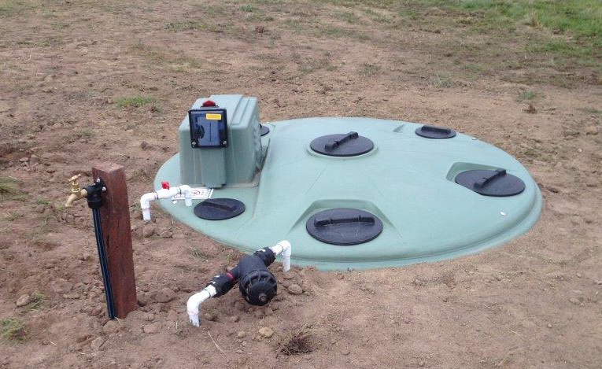
Filter

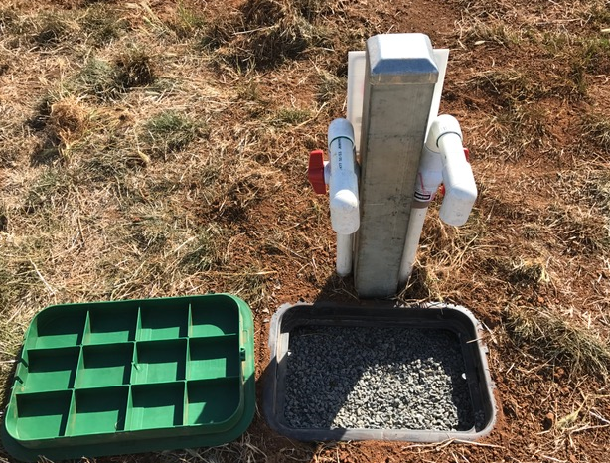
Flush valves and Pit
Section 2 – Operational Plan
2.1 Overview
The operational plan outlines the management strategies and actions that Council intends to implement for effective management of DWM systems within the Shire to achieve:
- sustainable on-site wastewater management; and
- support for continued growth in areas where reticulated sewer is not available
The management strategies and actions are detailed under the following categories:
- Identified Growth and Improvement Areas;
- Information Management and Reporting;
- Approvals;
- Inspection and Compliance Monitoring;
- Funding and Resourcing; and
- Community Education & Awareness
- Audit and Review
A review of the previous DWMP deliverables was conducted in 2017 by way of an independent audit review. This operational plan incorporates the relevant recommendations that were presented in that audit.
2.2 Identified Growth and Improvement Areas
The Moorabool Shire Small Towns and Settlements Strategy September 2016 (STS) was adopted by Council. It provides an overarching vision as to how the Council will manage the future of its small towns and settlements.
The STS identified the towns of Bungaree, Dunnstown, Myrniong and Wallace as having long-term potential to accommodate some population growth. Development was contingent on reticulated sewer to Bungaree, Dunnstown and Wallace and a localised wastewater management solution for Myrniong.
The STS also states that Elaine “has the potential to become a provider of a wider range of community services to residents in the south-western part of the Shire. Limited growth, if it occurs, will rely upon Council’s domestic wastewater policy and suitable sites being identified for housing”.
In 2014 Council engaged consultants to prepare a report for Central Highlands Water on options for the provision of sewerage services to the townships of Bungaree and Wallace. A further report was provided in June 2017 and included actions to be taken to progress a reticulated wastewater solution for the towns.
The STS reinforces the overriding reliance for sustainable onsite wastewater to support the large number of towns and hamlets within the Council.
In addition to the many small towns that will continue to rely on septic tank systems for treatment and disposal of wastewater, the townships of Ballan and Bacchus Marsh are expected to grow significantly.
Extensions to existing reticulated sewers into unsewered areas will result in a reduction in septic tanks as properties connect to sewer. Development outside extended sewered areas will continue to require septic tank systems.
The Ballan Strategic Directions 2018 (BSD) document projects the town’s population to increase by over 94% to approximately 5,910 people by 2041 while the Bacchus Marsh Urban Growth Framework 2017 (BMUGF) forecasts the population to double over the next two decades to around 40,000 residents.
The strategies outlined in this DWMP will provide a framework and certainty for the responsible management of all septic tank systems within the Shire.
Figure 2: Map of townships identified for potential growth of Dunnstown, Wallace and Bungaree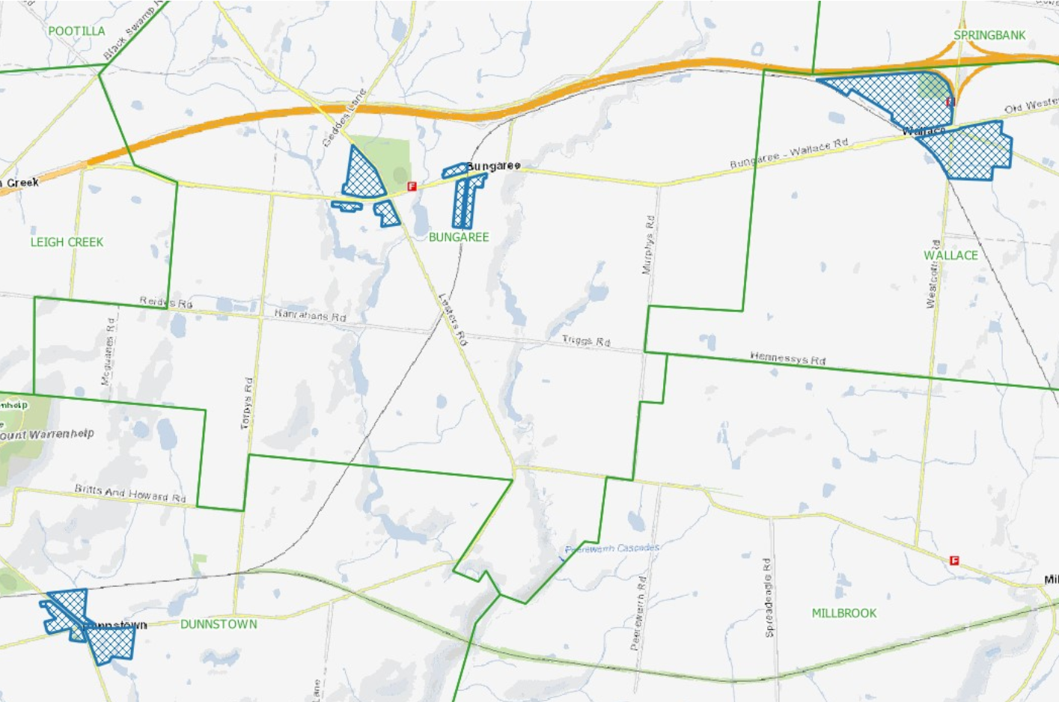
Figure 3: Map of township of Myrniong identified for future growth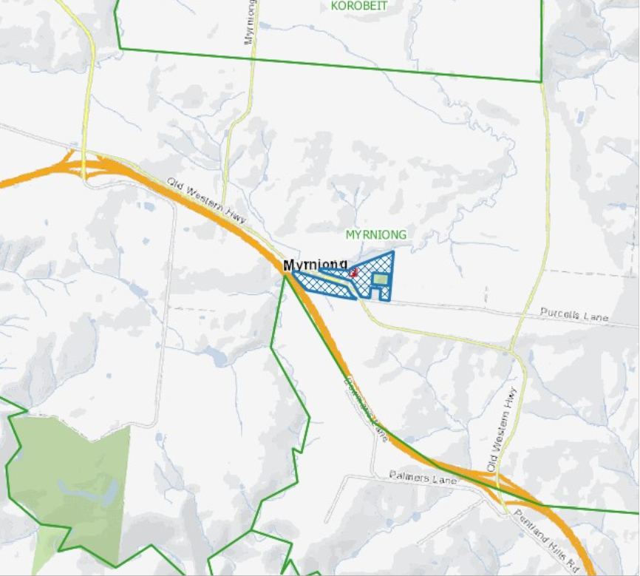

2.3 Information Management & Reporting
The 2017 audit review recommended actions for improving data management and internal/external reporting. The “Wastewater Manager” module of Open Office is currently the primary data repository for septic tank permit and compliance information.
It will be the data source for managing compliance monitoring, system inspections and reporting. It was also identified that there needed to be a process for validation of property information between the corporate rating/property system and Wastewater Manager to ensure data is correct.
2.3.1 Information Management
The data contained in Wastewater Manager is a work in progress database with information being populated as it becomes available. There is minimal data available on septic tank systems that were installed prior to 2000. Resources need to be allocated to improving the accuracy and completeness of the data in this Registry.
Implementation of the compliance monitoring and inspection program proposed in this DWMP will require adequate resources to be provided to ensure all information gathered is recorded and reported against.
A cost-effective system to manage this additional data in a timely manner will need to be developed and implemented to maintain up to date information for inspections and monitoring.
Protocols will also need to be in place for periodic update of properties that connect to sewer to avoid unnecessary letters and inspections. For example, a review of the township of Gordon identified that 32 properties had been connected to sewer but appeared in Council’s Wastewater Manager, as still operating a DWMS.
A snapshot of the Ballan township indicates that a substantial number of properties may be recorded as operating a septic tank system but are in fact connected to sewer. Ballan is a High Risk Township and the removal of these properties from the inspection and monitoring program will reduce the number of inspections under the program.
The same will apply for other sewered townships where records of septic tank systems in Wastewater Manager have not been decommissioned. The aim will be to improve communication with the water corporations for supply of data on sewer connections.
The importance of establishing the accuracy of the base information used for decision making must be a priority and will involve collaboration with Central Highland Water, Barwon Water and Western Water for determining those properties that have connected to sewer.
Other information, external to the Council’s data records, will be needed for further development and implementation of some of the DWMP strategies. For example, the DWMP strategy to prevent individual and cumulative impacts on groundwater and surface water beneficial uses will require data on bore water extraction licences within the Shire.
2.3.2 Reporting
Reporting to stakeholders will be in the form of a written report on a least an annual basis and integral to Council demonstrating confidence that it is effectively managing the potential risk to public and environmental health from poorly managed septic tank systems. In consultation with key stakeholders a reporting mechanism will be developed. It is proposed as a minimum to include the number of:
- Septic tank systems in use within the municipality;
- Permits issued for septic tank systems;
- Septic tank systems decommissioned;
- Septic tank systems inspected by Council and service agents; and
- Septic tank systems that have passed or failed during inspections.
- Actions taken to require rectification of faults

2.4 Approvals
2.4.1 Planning
The State Planning Policy Framework for Victoria includes provisions for protection of agricultural land. Development of a dwelling or subdivision of land, without requiring a planning permit in the Farming Zone, requires a minimum allotment size of 40 hectares and 100 hectares respectively, unless specific areas are designated otherwise within the Council’s planning scheme. Council’s planning scheme does not require a planning permit for development of land for subdivision and construction of a dwelling on an allotment of greater than 15 hectares if the land is within the areas shown in Map 1 to the Schedule to the Farming Zone. These specified areas are in proximity to the Bacchus Marsh township.
The minimum allotment size is reflected in Local Planning Schemes and more generally in the Ministerial Guidelines for Planning Permit Applications in open, potable water supply catchment areas (“Ministerial Guidelines”). Councils are required to refer planning applications in these water supply catchment areas to the relevant water corporation for consideration.
There are two key factors under the Ministerial Guidelines that continue to restrict development of land within these potable water supply catchments. They are the minimum density requirements for dwellings and implementation of strategies to prevent individual and cumulative impacts on groundwater and surface water beneficial uses.
2.4.1.1 Density of Dwellings
Guideline 1 provides that:
“Where a planning permit is required to use land for a dwelling or to subdivide land or where a planning permit to develop land is required pursuant to a schedule to the Environmental Significance Overlay that has catchment or water quality protection as an objective:
- the density of dwellings should be no greater than one dwelling per 40 hectares (1:40 ha); and
- each lot created in the subdivision should be at least 40 hectares in area.”
The dwelling density is calculated by applying a one-kilometre radius from the building envelope of the proposed new dwelling. If there are seven existing dwellings within that radius, the current practice is that the planning permit application may be refused by the referring water corporation.
A water corporation has the discretion to allow a higher density of development than would otherwise be permitted by Guideline 1, where all the conditions listed in Category 4 of the Ministerial Guidelines are met.
One of the conditions requires the water corporation to be satisfied that the relevant Council has prepared, adopted and is implementing a DWMP in accordance with the DWMP Requirements as set out in the Ministerial Guidelines.
Relaxation of Guideline 1 (Density of dwellings) will only be considered acceptable, if Council’s DWMP can demonstrate that it also satisfies ALL the DWMP requirements that are listed in the Ministerial Guidelines. The details of all the conditions to be satisfied are listed in Attachment 3.
2.4.1.2 Individual and Cumulative Impacts
Through the application of the SEPP, Councils are required to apply the “precautionary principle” to guide decisions about the protection and management of Victoria’s surface waters when considering a permit for septic tank system.
The SEPP requires the cumulative risk of the adverse impact of septic tank systems on water quality, in open potable water supply catchments, resulting from increased dwelling density.
Further to the SEPP, a condition of the Domestic Wastewater Management Plan Requirements as set out in the Ministerial Guidelines is that the DWMP must comprise a strategy, including timelines and priorities, to prevent individual and cumulative impacts on groundwater and surface water beneficial uses.
The individual and cumulative impact of treated septic tank wastewater on groundwater and surface water beneficial uses should consider both positive and negative impacts in the assessment process.
The work undertaken by Council in ensuring that older systems are properly maintained, repaired and replaced has a positive effect on the cumulative impact. Subsequently, Council ensures that all new systems are of the highest standard and do not contaminate off site, to reduce any negative cumulative impacts.
Council’s DWMP all considers all elements of each given site and reduces negative impact by ensuring the best and most appropriate wastewater system is installed.
Council’s DWMP implements a risk-based inspection and monitoring program of septic tank systems within the Shire. The inspection program will support previous inspection work to enable identification of properties that are not containing wastewater within the property boundary for further remedial action.
The DWMP also introduces a requirement for a higher standard of wastewater treatment for allotments less than 4,000m² in area, located within a potable water supply catchment.
The implementation of these initiatives will improve septic tank system performance and the quality of treated wastewater, which will have a positive impact on groundwater and surface water beneficial uses.
The completion of Council’s strategy to prevent individual and cumulative impacts on groundwater and surface water beneficial uses is a work in progress and will require input from and partnering with stakeholders. Monitoring to assess impacts on ground and surface waters needs to be undertaken and there is an action plan item for all stakeholders to work on this together.
The implementation of this strategy and action program when finalised will then satisfy the Ministerial Guidelines condition for relaxation of Guideline 1 (Density of dwellings) which will assist further development within the Shire.
2.4.1.3 Section 173 Agreements
Water corporations have been requiring Council to enter into Section 173 Agreements under the Planning and Environment Act with property owners to register on title the existence of a septic tank system. It is unknown if registration of these Agreements contributes to improved onsite wastewater management practices and protection of the potable water supply. A review of this practice should be conducted with water corporations, as it appears an unnecessary requirement.
The DWMP includes a comprehensive and ongoing awareness program for owners of properties with septic tanks. Existing Council communication processes will also be strengthened to create awareness of a septic tank at the time of transfer of a property.

2.4.2 Permits
Septic tank systems do have a limited lifespan even with proper maintenance. The current permit process issues the owner a right to use their system for an indefinite period. This approval system is out-dated. It severely restricts the ability of councils to amend permit conditions so that the septic systems are required to meet performance standards that are consistent with improved public and environmental health standards.
The current State system for permits should be subjected to an industry review and a system of operational licensing be investigated for sustainable onsite wastewater and source of ongoing funding for compliance monitoring programs.
However, recognising the present constraint, strengthening the process for determining the initial septic tank system installation will ensure that the most suitable septic tank system is installed based on current technology. This will in-turn minimise risk of a potential system failure.
2.4.3 Land Capability Assessments
A Land Capability Assessment (LCA) may be required to accompany a planning permit application involving the installation of a new septic tank system. An LCA may also be required for installation of a septic tank system that does not require planning approval if deemed necessary by Council.
The Municipal Association of Victoria (MAV) has developed a model LCA report and procedures to assist LCA assessors and regulators. LCAs should follow the 12 stage best practice model as detailed within the EPA Code of Practice (2013) and Victorian Model LCA Framework (MAV 2014).
The specific LCA requirements for the determined operational risk classes (High, Moderate and Low) are detailed in Tables 6 – 8 and should be conducted in accordance with the EPA Code of Practice (2013) and AS/NZS 1547:2012.
The EPA requires that LCA Assessors be independent and have:
- Significant experience in onsite surveying, measuring hydraulic conductivity, performing water and nutrient balance calculations;
- Tertiary-level scientific qualification (in geotechnical engineering, soil science, agricultural science, environmental science etc.) including scientific knowledge of soil, and the hydrological and chemical processes within soils; and
- Appropriate Professional Indemnity Insurance
It is imperative that Council’s permit application process provides for the LCA to be completed and consistent from assessors.
A key consideration in determining water balance modelling for an LCA is rainfall data. Defining what will be the accepted source of data for determining rainfall for LCAs within areas of the Shire will prevent the most favourable data being selected. It is expected that LCA providers will use the closest rainfall data available for the specific site that they are assessing.
All LCAs should include calculations of the technical sizing of the effluent field supporting the proposed wastewater treatment system and any alternative system offered e.g. conventional primary treatment system or alternate secondary treatment system.
It must be noted that notwithstanding the LCA, some selected sites will need to have a secondary system installed as a minimum to comply with the requirements of this DWMP.
All LCAs must consider the wastewater quality treatment standards required under this DWMP so that any recommended system meets the minimum effluent standard requirements.
2.4.4 Treatment Standards
The level of wastewater treatment has a direct correlation to risk minimisation. All properties that have a High-Risk classification will require the septic tank system to treat the wastewater to a secondary standard.
The level of treatment required for septic tank systems on properties that are classified as High Risk will be assessed on allotment size and whether they are located in a potable water supply catchment.
A secondary level of treatment that can achieve a minimum standard of 20mg/L BOD, 30mg/L SS and 10orgs/100ml chlorination will be required for all septic tank systems that are located on properties:
- less than 4,000m² in area and located within a potable water supply catchment; and
- less than 2,000m² in area but located outside a potable water supply catchment.
A secondary level of treatment that can achieve a minimum standard of 20mg/L BOD and 30mg/L SS will be required for all septic tank systems that are located on properties less than 4,000 m² and outside a potable water supply catchment
Allotments of less than 2,000m² are limited in their ability to treat and retain wastewater onsite and provide for any future reserve effluent area if needed. Empirical evidence supports this decision and the leading practice solution is to minimise potential risks by requiring a safer quality of treated effluent.
Similarly, the risk minimisation approach has been adopted for allotments within a potable water catchment. The inclusion of these requirements will provide owners seeking to develop existing allotments with certainty as to the standard of treatment required for a septic tank system installation and what is required for the ongoing maintenance of their system.
The level of required treatment for other allotments will be considered on a case by case basis. As with any proposed development, the LCA will still need to demonstrate that all wastewater can be retained on site and the septic tank system installation complies with the Code and any other required conditions.
This new requirement for secondary treatment should be included as part of the information provided to applicants and LCA assessors.
The strengthening of wastewater quality standards for small blocks and allotments within the Shire will further protect the water catchments areas.
2.4.5 Future Developments
This DWMP establishes the framework and intended actions for managing potential risks from septic tank installations with a key focus on the ongoing protection of the potable water supply catchments.
Development of sites that are currently constrained for development by application of the 1:40 density requirement as set out in the Ministerial Guidelines, should be permitted to be developed if wastewater risks can be effectively managed and new and innovative solutions applied.
An innovative solution that could be applied to constrained blocks are allowing recirculating evapotranspiration systems as acceptable effluent dispersal and recycling systems. A Rhizopod system is an example of this, which is an onsite wastewater treatment technology that takes advantage of evapotranspiration, the use of water from the soil by evaporation and by transpiration from plants.
The relaxation of this condition requires Council’s DWMP to satisfy certain requirements which have been previously detailed in Section 2.4.1. and Attachment 3.
An outcome of this DWMP is to reach an agreement with the water corporations for the relaxation of the density level where wastewater risks can be effectively managed.
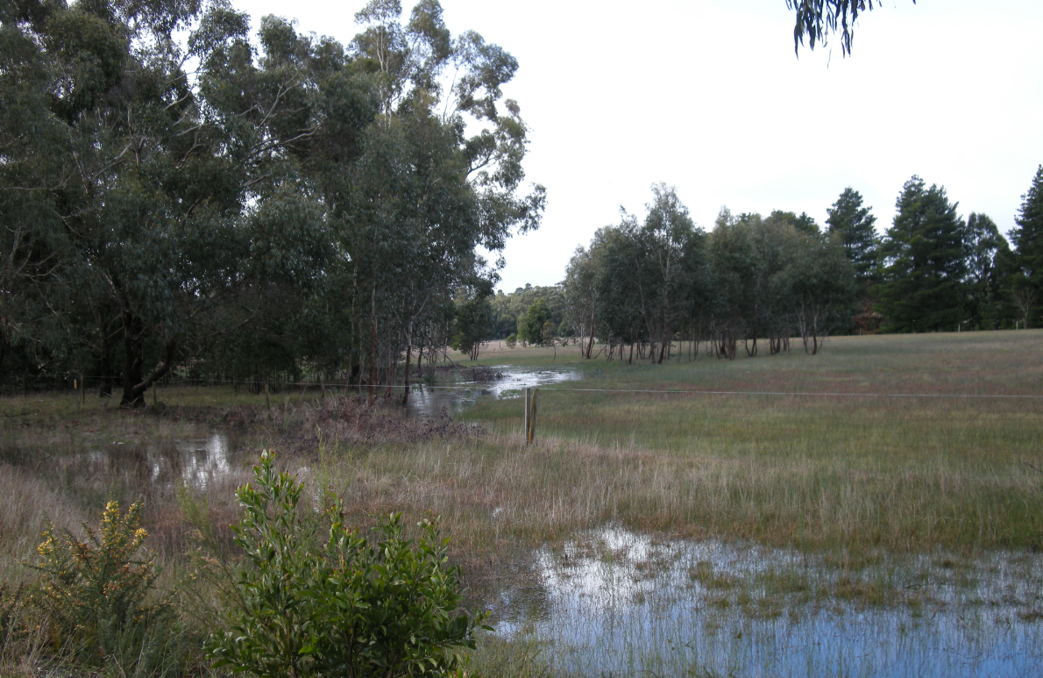
Figure 4: Land subject to inundation not suitable for development.
2.5 Inspection and Compliance Monitoring
2.5.1 Completed Inspections
Approximately 2,900 system inspections were conducted during the period 2014-2019 in accordance with the previous DWMP requirements.
More recently Council has completed inspection of septic tank systems on 570 properties within the townships of Greendale (237) and Mount Egerton (333) and a further inspection of some 60 previously identified “High Risk” properties were also completed in several other townships.
The result of these inspections was 84.3% of systems that were passed and less than 3.65% failed. The failed systems were either severe or moderate. Severe is defined as a failing system with evidence of potential public and/or environmental health risk e.g. wastewater not being retained on site, while moderate was the potential for onsite risk.
The 2017 Audit Review recommended establishing a “risk-based” inspection program to monitor owner compliance and septic system performance within the whole of the Shire.
2.5.2 Inspection and Monitoring
2.5.2.1 Inspection and Monitoring Model
A three-tier risk classification (High, Medium & Low) Model (“the Model”) has been developed upon which to undertake inspections and monitoring of septic tank systems within the 62 townships and hamlets in the Shire.
It also determines that allotments less than 2,000m² in area not located within a potable water supply catchment and allotments less than 4,000m² in area that are located within a potable water supply catchment will be classified as High Risk.
The Model uses available data on:
- Septic tank system locations (including whether within a potable water catchment);
- System type;
- Soil characteristics;
- Allotment size;
- Results of onsite inspections; and
- Knowledge gained by Council’s professional officers that are responsible for septic tank permitting, complaint handling and enforcement
The Model will be “fine-tuned” in the first year of the DWMP to reflect additional risk parameters that may be applicable to a particular property such as allotment slope, proximity to waterways, flood prone land and groundwater extraction, building use, and other environmental and public health considerations.
The effect of this fine-tuning will be to shift some properties within the three classifications to either higher or lower risk classifications and this will affect the Inspection and Monitoring Program.
A classification of High Risk will generate a greater level of inspection and monitoring to ensure compliance and protection of public and environmental health. It will also provide assurance to the relevant authorities that their water supplies are being monitored against potential contamination from onsite wastewater discharges.
2.5.2.2 Inspection and Monitoring Program
The Inspection and Monitoring Program (“the Program”) that will be carried out under the Model will provide for:
- 100% audit of owner compliance with the need to have their Aerated Wastewater Treatment System (AWTS) serviced quarterly
- 5% annual inspection of AWTS’s;
- 25% annual inspection of conventional and other systems classified as High Risk;
- 15% annual inspection of conventional and other systems classified Medium Risk and
- 5% annual inspection of conventional and other systems classified Low Risk.
It is expected that this will result in approximately 550-600 planned inspections (additional to the audit of AWTS service reports per year) which will need to be resourced and funded.
The Program needs to include the identification of properties that are being occupied illegally. These properties include sheds, caravans and tiny houses that are being used for habitation without any permits.
Enforcement of compliance will require liaison between Council’s Planning and Environmental Health departments to achieve satisfactory outcomes. The level of enforcement will depend on the offence and its risk. The legislative enforcement tools available to Council are contained in its Local Law, the Public Health and Well Being Act 2008, the Building Act 1993, the Planning and Environment Act 1987 and Environment Protection Act Regulations.
2.5.3 Wastewater Sampling
Sampling of the wastewater quality of AWTS and other secondary treatment septic systems is required to be undertaken as it is critical to monitor potential health risks from failing systems. The sampling by owners is a requirement for the operation of their septic system, as required by the planning permit.
It would assist owners if Council produced an information sheet on what is required and how to comply with the testing requirements. This could be incorporated in the community education program.
2.5.4 Water Quality Sampling
It is imperative that the benefits that are expected to be delivered from the Inspection and Monitoring Program are measured. Similarly, it is also important to document any perceived risk from wastewater not being retained within the property boundary.
Therefore, ambient water quality benchmarks need to be established at sampling points to enable changes in water quality that can be identified from the impact of domestic wastewater on waterways and reservoirs within the Catchment. Implementing a sampling, monitoring and reporting regime should be a priority for relevant agencies.
2.6 Sewered Townships with Septic Tank Systems
A strategy should be implemented to progress the connection of properties with septic systems to the sewer when it becomes available. The reason small towns were provided with reticulated sewer under subsidised local schemes was based on risk.
The strategy will need to allow for the requirements of Clause 3.12. of the Code regarding existing primary and secondary treatment systems.
Owners with septic tank systems will be paying to operate and maintain their system and also paying rates for the sewer availability. The uncertainty about which properties have connected to sewer needs to be addressed jointly with Central Highlands Water.
2.7. Resourcing and Funding
The Council Budget provides resources and funding for permitting and general onsite domestic wastewater management.
The implementation of a comprehensive inspection and monitoring program will require additional budgetary support.
2.7.1 Inspection and Monitoring Program Costs
The question of cost recovery and who should pay is one for further consideration by management and Council. A budget allocation is required for implementation of the Inspection and Monitoring Program.
There will be an establishment cost and ongoing annual cost of administering the Program. It is estimated that an allowance of $10K-$15K for setup to cover the purchase of a hand-held device and management software to download and upload data to Wastewater Manager is required. An additional ongoing estimated operational cost of between $100K – $120K per year will be required for site inspections and auditing compliance. This is based on an estimated cost of $180 per inspection, plus a 10% initial follow-up of inspections and audit of quarterly service reports of treatment plants.

2.7.2 Funding Sources
The options for levying a special service fee that only charges owners of septic tank systems may be difficult under the existing legislation and would rely on the Special Charges provisions of the Local Government Act 1989.
Council has previously obtained legal advice regarding this and other revenue raising options under the Local Government Act 1989.
Council’s ability to use the Local Law provisions of the Local Government Act 1989 to make a local law for septic tank system inspections and monitoring would as it stands still not allow a charge to be applied for recovery of costs for the inspection and monitoring program.
The Environment Protection Act 1970, which is currently under review would need to be amended to provide for a charge to be levied by a council for such purpose.
If a full cost recovery from owners of septic tank systems was able to be implemented, then an initial charge of $20-$25 per property would be required. This estimate includes septics on “community” properties e.g. Council recreation reserves has been included.
The inspection and monitoring program will reduce public and environmental health risk from failing septic tank systems through improved onsite wastewater management. This will deliver a community wide benefit and therefore another option would be to apply the cost over the rate base.
The Council does not currently levy a Municipal Charge which could provide an alternative for cost recovery, with equal contributions as distinct from the rate system based on Capital Improved Value rating.
Another possible funding source worth exploring is whether the water authorities within the Shire are able/prepared to include a levy in their septic tank waste disposal fee to fund the sampling component of the monitoring and inspection program as part of its responsibility for the protection of their drinking water supply.
2.7.3 Funding Commitment
By adopting this DWMP Council commits to funding its obligations. It is also acknowledged that achieving the strategies within the DWMP will require co-operation with stakeholders and in some instances financial or Community support for the identified programs and actions.

2.8 Community Education & Awareness
A multi-dimensional campaign is required to raise public awareness about septic tank systems on properties and the potential liabilities attached to the owner or occupier.
Section 53N of the Environment Protection Act 1970 states:
“An occupier of premises on which a septic tank is located must maintain it in accordance with the requirements specified in the permit issued by the municipal council for that septic tank system.”
In many instances older septic tank systems have no definable permit or have conditions on its permit that don’t meet today’s standards and community expectations.
Property owners and/or occupiers are also often unaware of their responsibilities and in the absence of any enforced inspection and monitoring program, do not undertake the required maintenance.
The following tools can be used to create and maintain awareness for existing and future owners/occupiers of premises with septic tank systems.
2.8.1 Council Website
The Council’s website provides residents with easily accessible information on what is required when applying for a septic tank system, together with fact sheets on the various system types and their maintenance requirements.
The proposed Inspection and Monitoring Program should be added to the website. This will assist in alerting owners and/occupiers as to their responsibilities and raise an expectation of enforcement that may require remedial work to be undertaken.
Similarly, information to LCA assessors on new requirements including secondary treatment for High and Medium Risk properties can also be included.
2.8.2 Direct Communication
2.8.2.1 LCA Assessors
It would be worthwhile notifying the “known” companies and individuals that have been submitting LCAs as to new information requirements and secondary treatment for High and Medium Risk classifications.
2.8.2.2 Owners/Occupiers
Letters should be sent to property owners and occupiers advising them of the introduction of the Inspection and Monitoring Program and the impact on them regarding permit compliance, system maintenance and reporting. The letters will need to be customised to the relevant owner and occupier group, having regard to septic system type, age and permit requirements (if any).
Advice can also be sent to new owners of properties with a septic system (maybe in a welcome package) advising of their responsibilities for care and maintenance of their system and details of Council’s monitoring and inspection program.

2.8.2.3 Conveyancing Practitioners
There is currently no requirement for the recording of a septic tank system on the Section 32 Statement provided under the Sale of Land Act 1962. The statement merely states whether sewerage is connected to the land.
As such the purchaser will most likely have signed a contract before they become aware that they have a septic tank system on the property or may even take occupancy before they become aware. At present Council’s ability to inform prospective owners in advance of executing a contract of sale is very limited.
The statement should be provided to conveyancers acting for the purchaser advising that a septic tank system is located on the property and that the purchasers should satisfy themselves as to the operational performance of the system to avoid potential liability for remedial works.
A longer-term solution would be to seek support for amending legislation to require a vendor to disclose that the property has a septic tank system and that permit conditions have been complied with.
The sale of the property may well create the catalyst necessary for a vendor to make sure that the septic tank system is in order to sell their property.
2.8.2.4 Service Agents, Installers and Maintainers
The introduction of the Inspection and Monitoring Program will increase business for service providers as owners comply with their responsibilities. The aim should be to work with service providers to establish an efficient system for reporting to Council of completed periodic maintenance, including any wastewater sampling results. The potential for an electronic based notification system that service agents can utilise should be investigated to reduce the burden placed on service agents and Council regarding the notification requirements.
The random audit component of the Inspection and Monitoring Program should also be clearly explained including potential impact if service reports are found to be deficient or inaccurate.
It may also be an opportunity to indicate to waste carriers that a system for tracking waste collection and disposal is being considered at a State level.

2.9 Audit and Review
It is acknowledged that the legislative framework governing septic tanks is expected to be amended in 2021 and that if this occurs may require an early internal review of the DWMP to accommodate such changes.
Notwithstanding the above, the DWMP will be independently audited after Year 3 and the results of the audit reported to stakeholders as soon as practical following completion. The Council and stakeholders will jointly review the results of the audit and progress of the action items.
A review of the DWMP is scheduled during Year 5 and stakeholder input will be sought prior to the review commencement.

Figure 5: Lal Lal Falls
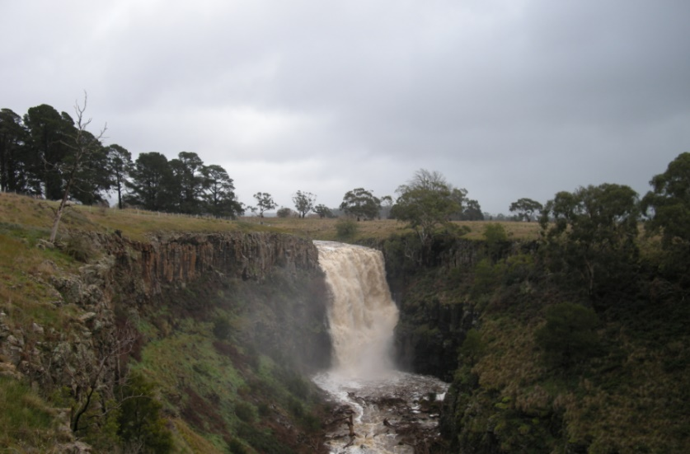

2.10 DWMP - Action Plan
Strategy | Item Description | Year
 |  | 1 | 2 | 3 | 4 | 5
Identified Growth and Improvement Areas | Undertake DWMP inspections within the township of Gordon, Bungaree, Dunnstown, Wallace and Myrniong. | X | X | X | X
 | Undertake sampling within Myrniong to demonstrate evidence of failing septic tank systems. |  | X | X
 | Investigate options for creating awareness to new owners that their property is located within a potable water catchment area and contains a septic tank system. This may be an alternative to the current request by the water authorities for conditions to be recorded on Section 173 Agreements. | X
 | Develop an agreed statement or memorandum of understanding with the water authorities in respect to relaxation of the 1:40ha density within potable water supply catchments and removal of septic tank conditions from Section 173 Agreements. |  | X
Information Management and Reporting | Complete register of septic tank systems to ensure all properties are included and available data populated. | X
 | Undertake an audit of sewered townships in conjunction with Central Highlands Water to determine septic tank systems that have been connected to sewer and update Wastewater Manager. | X | X
 | Obtain information on location of groundwater bores within the unsewered areas of the Shire for use in Council’s strategy, to prevent individual and cumulative impacts on groundwater and surface water beneficial uses. | X
 | Establish portal to allow owners and/or contractors to register pump-outs and maintenance on-line. |  | X
 | Implement the use a hand-held device for inspections that can download and upload data to the system. |  | X
 | Implement a formal reporting arrangement between water authorities and Council for the provision of information on connections of septic tank systems to sewer. | X

Strategy | Item Description | Year
 |  | 1 | 2 | 3 | 4 | 5
Information Management and Reporting | Develop a reporting mechanism following discussion with stakeholders to demonstrate the implementation of the DWMP and progress in achieving the action items, this can be undertaken in a written report on a least an annual basis. | X
Approvals | Develop actions and timelines additional to the permit inspections and monitoring program in partnership with the water corporations for preventing discharge of wastewater beyond property boundaries and individual and cumulative impact on groundwater and surface water beneficial uses. | X
 | Review standard conditions on septic tank system permits as part of a continuous improvement process to maintain relevance with changing community and environmental health expectations and standards. | X
Inspection and Monitoring | Refine the Inspection and Monitoring Risk Classifications for individual properties using additional criteria. | X | X
 | Implement process for monitoring AWTS permit compliance. | X
 | Trial Inspection and Monitoring Program. | X
 | Implement Inspection and Monitoring Program. | X | X | X | X | X
 | Review water sampling program with stakeholders to determine the potential impact of sewage effluent from septic tank systems on waterways and the catchments. | X
 | Establish a process for auditing septic tank system pump-outs with septic tank waste disposal. |  |  | X
 | Implement audit process for wastewater collection and disposal. |  |  | X
 | Identify and action properties that are subject to occupancy but have no approved septic tank system. | X | X
 | Identify properties that are subject to flooding and make a note against the property record in the corporate registry and, where applicable, against the permit record in Wastewater Manager. | X | X

Strategy | Item Description | Year
 |  | 1 | 2 | 3 | 4 | 5
Inspection and Monitoring | Identify properties that are failing to retain wastewater within the property boundary for use in Council’s strategy to prevent discharge of wastewater beyond property boundaries. | X | X | X | X | X
Sewered Townships with septic tank systems | Implement a strategy to achieve connection of properties from septic to sewer in the townships of Gordon, Ballan & Bacchus Marsh. |  | X | X
Funding & Resources | Determine the funding method for financing the cost of implementing the Inspection and Monitoring Program and budget allocation | X
Community Education and Awareness | Seek Industry support for inclusion of septic tank system compliance to be added to the Section 32 Statement under the Sale of Land Act | X
 | Produce a wastewater check list information sheet for owners and occupiers | X
 | Produce a guide or template for service agents of septic tank systems | X
 | Meet with LCA assessors to explain the information within this DWMP and the new requirements for secondary treatment and to discuss what data should be used as base data for LCA assessment e.g. rainfall figures | X
 | Develop a welcome package and process to inform new owners of properties with a septic tank system of their responsibilities for care and maintenance of their system and details of Council’s inspection and monitoring program | X
 | Organise a meeting with service providers every two years to discuss the DWMP new initiatives and any issues the industry or Council are facing | X |  | X |  | X
 | Update Council’s website with details of the inspection and monitoring program information for owners and the new secondary treatment requirements for information of LCA Assessors. | X

Strategy | Item Description | Year
 |  | 1 | 2 | 3 | 4 | 5
DWMP Audit and Review | A performance audit of the DWMP will be conducted in Year 4 of the Plan and the results circulated to stakeholders as soon as practical after the audit. The DWMP will be reviewed at the expiration of Year 5 |  |  |  | X | X

Attachment 1 Septic Tank System Locations and Town Risk Classification

Locality | DWMS | Risk Classification
Bacchus Marsh | 121 | Low
Ballan | 401 | High
Ballarto South | 8 | Low
Balliang | 32 | Low
Balliang East | 48 | Low
Barkstead | 223 | Medium
Barrys Reef | 38 | High
Beremboke | 61 | Low
Blackwood | 343 | High
Blakeville | 20 | Medium
Bolwarrah | 15 | Low
Bullarook | 30 | Low
Bunding | 24 | Low
Bungal | 19 | Low
Bungaree | 118 | Medium
Buninyong | 46 | Low
Cargerie | 10 | Low
Clarendon | 58 | Low
Claretown | 16 | Low
Clarkes Hill | 21 | Low
Coimadai | 150 | High
Colbrook | 21 | Low
Dales Creek | 162 | High
Darley | 72 | High
Dunnstown | 92 | Medium
Durham Lead | 13 | Low
Elaine | 107 | Medium
Fiskville | 15 | Low
Glen Park | 12 | Low
Glenmore | 19 | Low
Gordon | 456 | High
Greendale | 233 | High
Grenville | 3 | Low
Hopetoun Park | 10 | Medium
Ingliston | 25 | Low
Korobeit | 26 | Low
Korweinguboora | 102 | Low
Lal Lal | 229 | High
Leigh Creek | 26 | Low

Attachment 1 Septic Tank System Locations and Town Risk Classification (Cont’d)
Locality | DWMS | Risk Classification
Lerderderg | 1 | Low
Long Forest | 113 | High
Maddingley | 71 | Medium
Meredith | 1 | Low
Merrimu | 74 | High
Millbrook | 59 | Low
Mollongghip | 11 | Low
Morrisons | 59 | Medium
Mount Clear | 2 | Low
Mount Doran | 53 | Medium
Mount Egerton | 301 | High
Mount Wallace | 49 | Low
Myrniong | 174 | High
Navigators | 90 | Low
Parwan | 72 | Medium
Pentland Hills | 56 | Medium
Pootilla | 31 | Low
Rowsley | 73 | Low
Scotsburn | 27 | Low
Spargo Creek | 20 | Low
Springbank | 51 | Low
Wallace | 88 | Medium
Warrenheip | 45 | Low
Wattle Flat | 10 | Low
Yendon | 110 | High
Total | 4,866

Figure 6: Map showing high risk locations for wastewater assessment

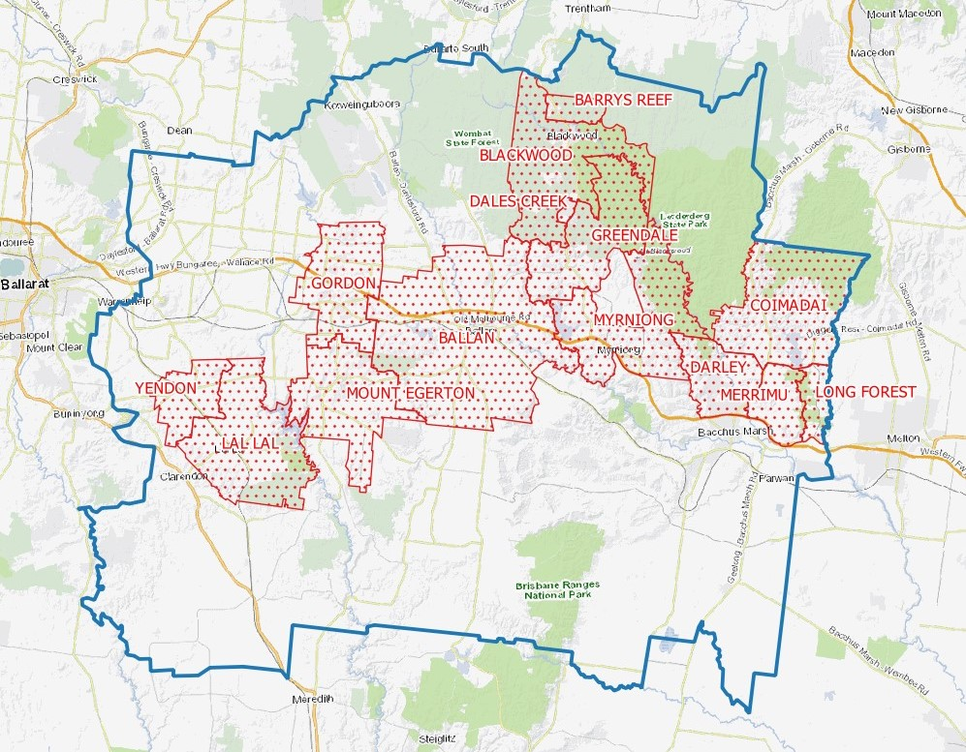

Attachment 2 Extract from SEPP Implementation Plan 2018

Action | Details
Action 5.1 Set up a Local Government/water corporation working group to scope the revision of current guidance/code | Scoping to include:  • Review of the Land Capability Assessment Framework;  • Review of the Code of Practice – Onsite Domestic Wastewater Management 2016 (areas for review include community schemes, standard permitting conditions; feasibility of a generic technique for determining where septic have failed);  • Development of a risk assessment framework for both land capability and landholder capacity;  • Development of a best practice model for maintenance of onsite domestic wastewater management systems ;  • Review of the Ministerial guidance: planning permit applications in open, potable water supply catchment areas  • Review of the 2006 MAV DWMP guidance .  • Development of EPA guidance on the process to conduct audits for DWMPs.  • Consider developing a service agreement between local government and water corporations to clarify arrangements for the use of existing powers to require a property owner to connect to a sewerage system
Action 5.2 Update the VPP ‘Particular Provisions’ clause 56.07 -3. | VPPs will need to be amended to reflect new clauses in the policy.
Action 5.3 Work with Local Government to identify support material required to assist with onsite domestic wastewater management. | Develop materials to assist Local Government inform rate payers about septics and the need to manage.  Local Government requested support for materials for ratepayers; this would involve facilitation of sharing information between Local Government as opposed to developing new material.
Action 5.4 Work with Local Government to determine the feasibility of developing a system to accredit Land Capability Assessment providers (to ensure the standard of LCA). | 2006 Victorian Auditor General’s Office report recommended the establishment of a suitable mechanism to assure the quality of land capability assessments. The working group in action 5.1 could scope this task.

Attachment 2 Extract from SEPP Implementation Plan 2018 (Cont’d)

Action | Details
Action 5.5 Work with Local Government to facilitate information exchange on alternative solutions to reticulated sewerage (e.g. Park Orchards trial), including preparation of a variety of case studies to highlight how current and legacy issues have been dealt with. | Set up forums to discuss what new and innovative pilot projects are underway to share information and build confidence in alternative systems
Action 5.6 Work with water corporations and Local Government to determine options for where sewerage cannot be provided. | Use existing water corporation forums to develop a shared understanding of when the provision of sewerage services is possible practicable and share this with Local Government.
Action 5.7 Secure funding to assist local government to undertake domestic wastewater management planning. | Prepare a funding bid to support Local Government to undertake domestic wastewater management planning
Action 5.8 Establish a Land Capability Assessment (LCA) Review Panel | Expert panel to assess LCA provider accreditation and provide advice on development of LCAs.

Attachment 3 DWMP Requirements for Relaxation of Dwelling Density
Requirements for a DWMP to be an acceptable basis for relaxation of Guideline 1 of Ministerial Guidelines 2012: Planning Permit Applications in open, potable water supply catchment areas.
DWMP Requirement
Consultation with all relevant stakeholders including,
- other local governments with which catchment/s are shared,
- EPA; and
- local water corporation/s.
A strategy, including timelines and priorities, to:
- prevent discharge of wastewater beyond property boundaries; and
- prevent individual and cumulative impacts on groundwater and surface water beneficial uses.
Provision for:
- the effective monitoring of the condition and management of onsite treatment systems, including but not limited to compliance by permit holders with permit conditions and the Code;
- the results of monitoring being provided to stakeholders as agreed by the relevant stakeholders;
- enforcement action where non-compliance is identified;
- a process of review and updating (if necessary) of the DWMP every 5 years;
- independent audit by an accredited auditor (water corporation approved) of implementation of the DWMP, including of monitoring and enforcement, every 3 years;
- the results of audit being provided to stakeholders as soon as possible after the relevant assessment; and
- Council’s demonstration that suitable resourcing for implementation, including monitoring, enforcement, review and audit, is in place.

