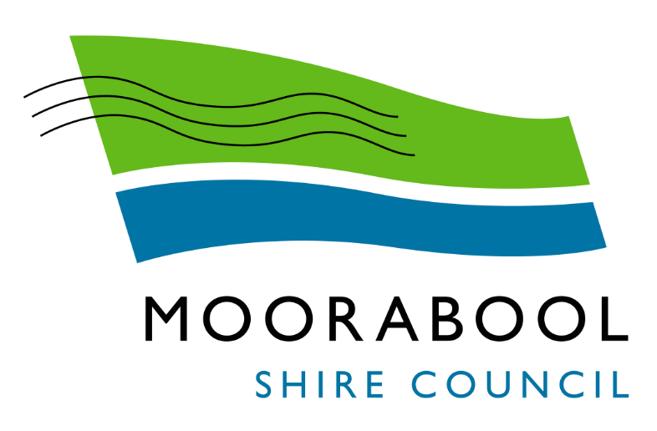
MINUTES
Moorabool Growth Management Committee Meeting
Wednesday, 2 June 2021
Date: | Wednesday, 2 June 2021
Time: | 3.30pm
Location: | Online

Order Of Business
1 Opening 3
2 Present and Apologies 3
3 Recording of Meeting 3
4 Confirmation of Minutes 3
5 Matters Arising from Previous Minutes 4
6 Disclosure of Conflicts of Interests 4
7 Community Planning Reports 5
7.1 Crook Court Concept Plan 5
7.2 Local Planning Policy Framework Translation 12
8 Update on Trends, Issues and Other Matters 16
8.1 Major Developments Update 16
9 Process Forward and Work Program 17
10 Update on VCAT Decisions 17
11 Other Business 17
12 Date of Next Meeting 17
13 Closed Session of the Meeting to the Public 17
8.1 Major Developments Update 17
13.1 Ballan Growth Area Update 17
13.2 Bacchus Marsh Growth Area Update 17
14 Meeting Close 17

1 Opening
The Mayor opened the meeting at 3.31 pm.

2 Present and Apologies
Cr Tom Sullivan, Mayor West Moorabool Ward
Cr Moira Berry East Moorabool Ward
Cr Tonia Dudzik East Moorabool Ward
Cr David Edwards East Moorabool Ward
Cr Ally Munari Woodlands Ward
Cr Paul Tatchell Central Moorabool Ward
APOLOGIES:
Cr Rod Ward, Deputy Mayor East Moorabool Ward
Officers
Mr Derek Madden Chief Executive Officer
Ms Caroline Buisson General Manager Customer Care & Advocacy
Mr Phil Jeffrey General Manager Community Assets & Infrastructure
Ms Sally Jones General Manager Community Strengthening
Mr Henry Bezuidenhout Executive Manager Community Planning & Economic Development
Mr Anthony Smith Acting Manager Governance, Risk & Corporate Planning
Ms Sarah Kernohan Manager Growth & Development
Ms Vanessa Osborn Acting Manager Statutory Planning & Building Services
Mr Mark Lovell Coordinator Statutory Planning
Mr Troy Delia Coordinator Governance & Risk

3 Recording of Meeting
In accordance with Moorabool Shire Council’s Governance Rules, the meeting will be livestreamed.

4 Confirmation of Minutes
Committee Resolution
Moved: Cr Moira Berry
Seconded: Cr Ally Munari
That the minutes of the Moorabool Growth Management Committee Meeting held on Wednesday 3 March 2021 be confirmed.
Carried

5 Matters Arising from Previous Minutes
Nil

6 Disclosure of Conflicts of Interests
Nil

7 Community Planning Reports

7.1 Crook Court Concept Plan
Author: Robert Fillisch, Manager Statutory Planning & Building Services
Authoriser: Henry Bezuidenhout, Executive Manager Community Planning & Economic Development
Attachments: 1. Crook Court Concept Plan
2. Crook Court Concept Plan including lot layout

Purpose
Provide an informal Concept Plan to ensure the development in this area is facilitated in an orderly manner. The Concept Plan addresses issues of traffic, servicing, and general amenity. This Plan will assist in providing certainty to potential developers when applying to subdivide land.

Executive Summary
• A number of subdivisions have been approved/proposed in the Crook Court area. These subdivisions are being undertaken in an ad hoc manner as a series of individual court bowls without consideration of connectively to adjoining sites.
• A Concept Plan for the Crook Court area has been prepared that provides an overall framework for the development of the area and provides for vehicle and pedestrian connectivity.
• The Concept Plan will provide additional guidance on the development of the Crook Court area. The Concept Plan would be used in pre-application and permit discussions with applicants.
• It is considered that the Concept Plan is an appropriate tool to communicate Council’s desired outcomes for this area and drive improved urban form outcomes. Is it not proposed to adopt the Concept Plan, accordingly the Plan would not hold statutory weight in any formal decision making review at VCAT.

Committee Resolution
Moved: Cr David Edwards
Seconded: Cr Moira Berry
That the Moorabool Growth Management Committee:
1. Notes the preparation of the Crook Court Concept Plan as provided as Attachment 1 and 2, to this report; and
2. Notes that Officers will use the Plan as the basis for discussions with applicants.
.Carried

Background
The Ballan Strategic Directions is a long‐term strategic document that provides guidance for the future growth of Ballan through to 2041. The Ballan Strategic Directions was adopted by Council on 1 November 2017 and amended by Council on 6 June 2018. Amendment C88 which implemented the Ballan Strategic Directions was gazetted on the 6 March 2020.
There is an area of land (Figure 1) that is bounded Crook Court, the railway line, Geelong-Ballan Road, and an unconstructed road reserve (Graham Street). This land is located on the south west of Ballan approximately 1.2km from the commercial centre.
The existing land parcels in the area are typically around 1ha (10,000sqm in size) and previously zoned as General Residential without the requirement for minimum lots sizes. The Concept Plan also provides guidance on subdivision on several larger lots bounded by the unconstructed road reserve (Graham Street) and Old Melbourne Road.
The area to the east of Crook Court has been subject to various subdivision applications with lots sizes averaging 500sqm in size. The size of the lots has been problematic and did not meet the general neighbourhood character. Lot sizes have predominately been addressed as most of the land is now zoned Neighbourhood Residential Zone – Schedule 7 (NRZ7). There is one parcel of undeveloped land which is in the General Residential Zone – Schedule 4 (GRZ4). The NRZ7 has a minimum lot size of 800sqm and the GRZ4 has no minimum lot size. The rezoning does not address movement within the area and without an appropriate development plan there is a high risk of the area identified in this report of being developed into a series of court bowls.
For the purposes of this report, this land will be referred to as the Crook Court area. However, it is noted that not all properties are located on Crook Court. Approximately half are located and accessed off Ballan-Geelong Road. The Crook Court area as described above, largely consists of large rural residential style lots varying between 7,800sqm to 15,100sqm, with a single dwelling. One of these larger lots does not contain a dwelling. Two lots have subdivision permits, for an 11-lot and a 12-lot subdivision. The 11-lot subdivision was approved in December 2014. Works have commenced and the subdivision is yet to be completed. The 12-lot subdivision was approved in August 2012 and is completed with individual titles issued. Planning officers required the 12-lot subdivision to be designed in a manner to facilitate the future extension of Alexandra Drive.
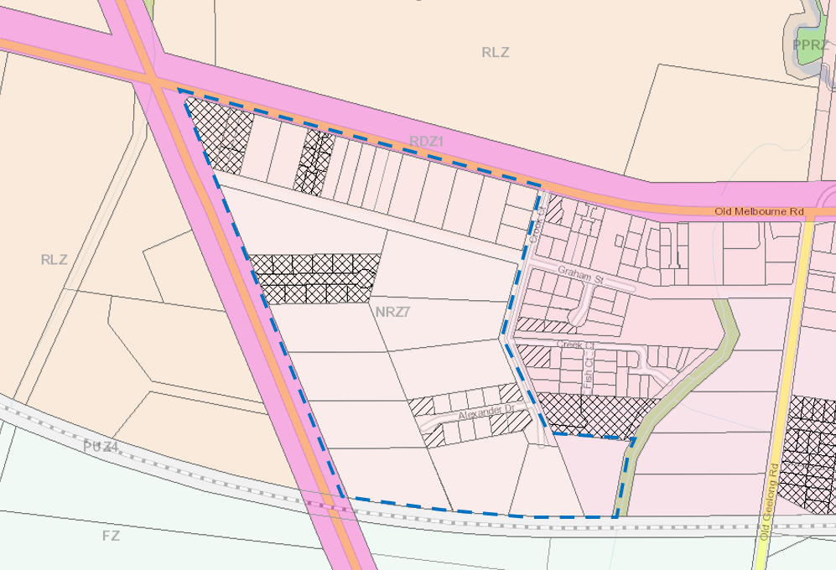
Figure 1: Crook Court Area

Proposal
Officers have received an application for 10 lot subdivision at 5486 Geelong-Ballan Road, Ballan (PA2020071). This property is located within the Crook Court area immediately to the west of the existing Alexander Drive subdivision. The application seeks a subdivision layout that would result in the extension of Alexander Drive to access seven lots, with the remaining three lots to be accessed off Geelong-Ballan Road (Figure 2).
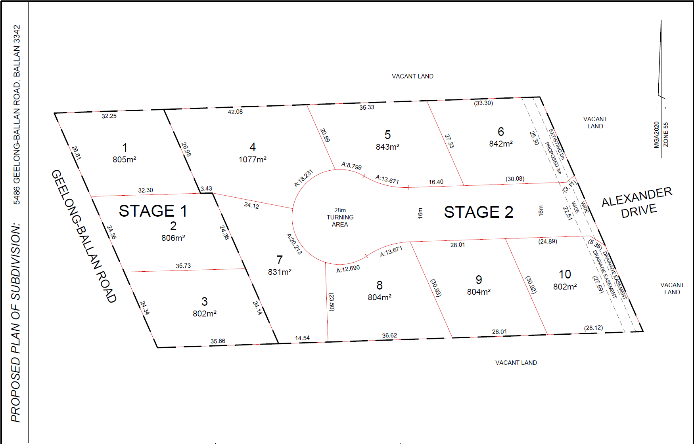
Figure 2: Original Proposed 10 lot subdivision, 5486 Geelong-Ballan Road, Ballan
The receipt of this application and the proposed subdivision layout has raised a number of concerns with both the development proposal itself, but also the fragmented and piecemeal nature of development within of the wider Crook Court area.
Noting the size of existing lots, general undeveloped nature, proximity of the land within Ballan, and zoning which allows subdivision down to 800sqm, it is considered likely that future subdivision applications will be received for the remaining sites in the near future.
The existing approved, and proposed subdivision layouts consist of court bowl layouts with no consideration of the broader road network. Without intervention by Council, it is considered likely that the development of the Crook Court area will continue in this pattern with a series of unconnected court bowls, noting that all properties within the Crook Court area are under separate ownership. This would create poor vehicle and pedestrian movement within this area.
Officers engaged the services of Mesh Planning to prepare a Concept Plan for the Crook Court area to provide an overall framework for the development of this area that provides for vehicle and pedestrian connectivity. (Attachment 1). The Concept Plan has also been prepared showing an indicative lot layout (Attachment 2)
The Concept Plan provides for a logical vehicular and pedestrian layout while limiting access through to Geelong – Ballan Road. It takes into consideration the minimum lot size of the NRZ and provides for larger lots adjoining the railway reserve.
The development of the Concept Plan has been an iterative and collaborative process, with Officers from Statutory Planning, Strategic Planning and Engineering working closely together to prepare and refine the plan. Comment was also sought from Regional Roads Victoria as to the Geelong-Ballan Road interface. Regional Roads Victoria advised that it was their preference to limit access to Geelong-Ballan Road, with preferably no new access points provided.
Officers have provided the Concept Plan to the developer for the current application who was resistant as they believed compliance would reduce the lot yield. It was made clear to the applicant that the minimum lot size of 800sqm did not mean that Council would necessarily accept the minimum. The applicant has now amended the lot layout to accord with the Concept Plan as detailed in Figure 3 below.
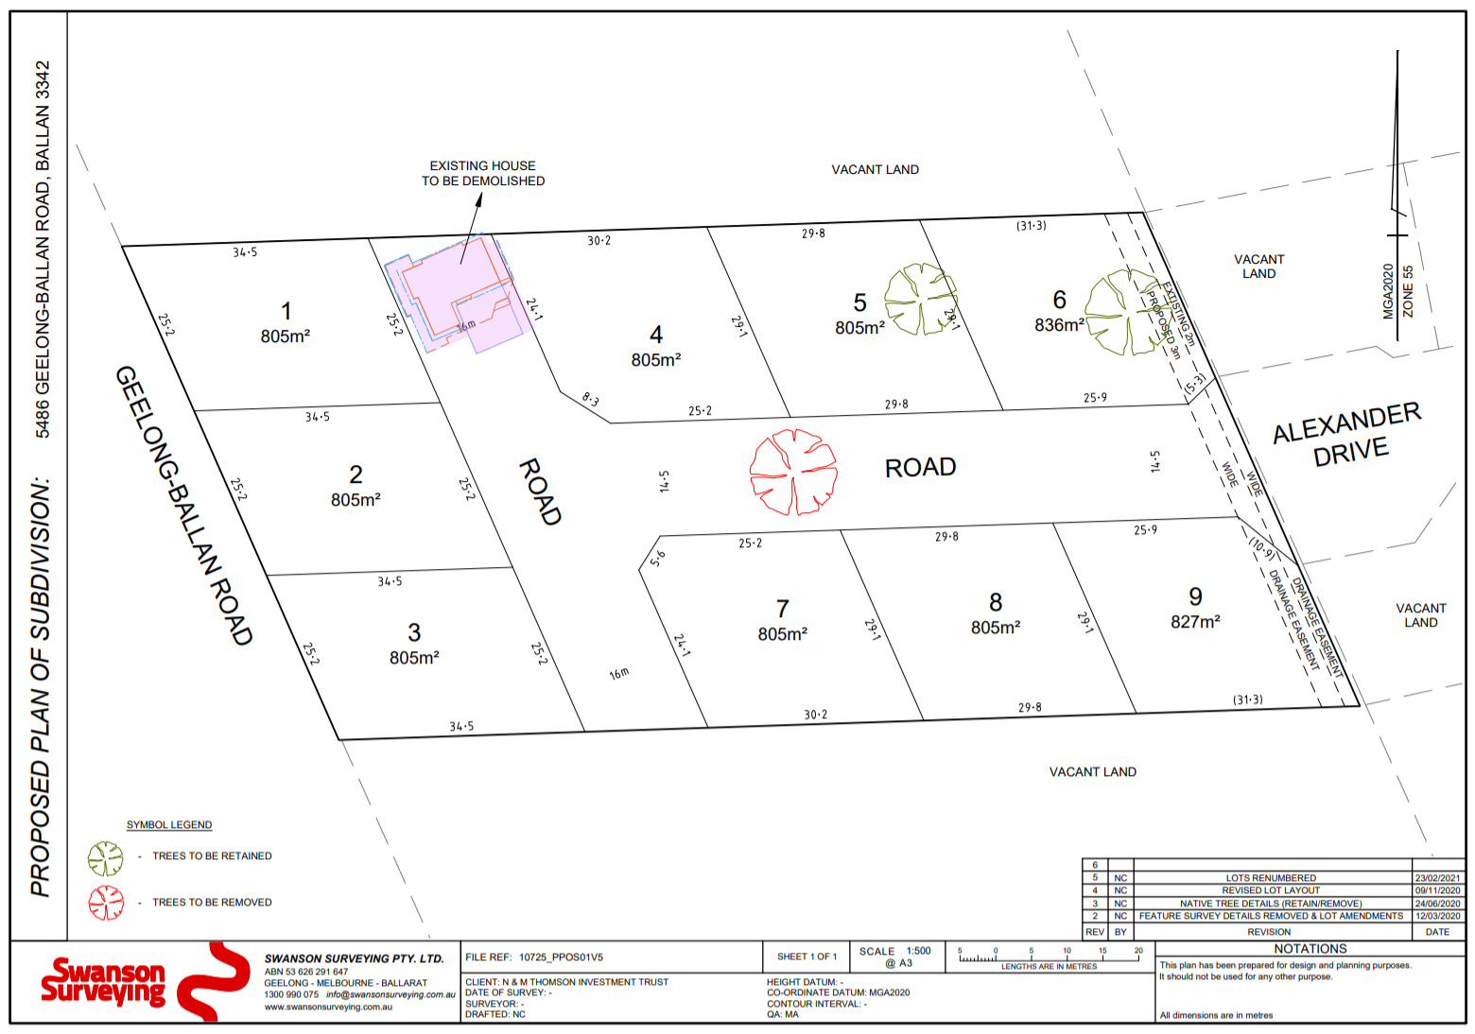
Figure 3: Final Proposed 9 lot subdivision, 5486 Geelong-Ballan Road, Ballan
The Concept Plan has been tested in discussions with several other pre application meetings for land in this area. Discussions have generally been positive with developers accepting the purpose of the Plan will be to provide for an improved outcome of the area. The only negative comments have come from developers who may need to wait on other properties to develop to provide access. In most cases staging of subdivision can overcome this issue.
The Concept Plan is proposed to build on the work done through the Ballan Strategic Directions by providing additional guidance on the development on this infill growth area. The Concept Plan would be used in preapplication and permit discussions with applicants. It is considered that the Concept Plan is an appropriate tool to communicate Council’s desired outcomes for this area and drive improved urban form outcomes. Is it not proposed to adopt the Concept Plan, accordingly the Plan would not hold statutory weight in any formal decision making review at VCAT. Albeit VCAT would see that the Concept Plan is based on good design outcomes, which are an appropriate consideration in decision making.
Due the lack of consolidated land ownership, any consideration of connectivity and the wider road network is unlikely without the use of this Concept Plan to drive the outcomes described by Council.

Council Plan
The Council Plan 2017-2021 provides as follows:
Strategic Objective 3: Stimulating Economic Development
Context 3A: Land Use Planning
The Crook Court Concept Plan is consistent with the Council Plan 2017 – 2021 in that it seeks to provide for improved land use planning outcomes.

Financial Implications
The preparation of a Concept Plan can provide benefits of defining outcomes when applicants contact Council regarding subdivision. The other benefit is when developers have clear direction there is a reduced likelihood of VCAT appeals.

Risk & Occupational Health & Safety Issues
There are no risks and occupational health and safety issues related to this proposal.

Communications & Consultation Strategy
The Concept Plan will be provided to applicants, consultants and developers, and used in pre application discussions. As it is not proposed to adopt the Concept Plan, it is not proposed to undertake any formal consultation of the Concept Plan.

Victorian Charter of Human Rights & Responsibilities Act 2006
In developing this report to Council, the officer considered whether the subject matter raised any human rights issues. In particular, whether the scope of any human right established by the Victorian Charter of Human Rights and Responsibilities is in any way limited, restricted or interfered with by the recommendations contained in the report. It is considered that the subject matter does not raise any human rights issues.

Officer’s Declaration of Conflict of Interests
Under section 130 of the Local Government Act 2020, officers providing advice to Council must disclose any interests, including the type of interest.
Executive Manager – Henry Bezuidenhout
In providing this advice to Council as the Executive Manager, I have no interests to disclose in this report.
Author – Rob Fillisch
In providing this advice to Council as the Author, I have no interests to disclose in this report.

Conclusion
Subdivision of land in the area known as Crook Court has traditionally led to poor planning outcomes particularly in terms of lot size due to the previous zoning of the land as General Residential. This issue has been resolved to some extent with the recent adoption of the Ballan Strategic Directions, which has rezoned the land with appropriate minimum lot sizes. Further guidance is required to ensure the layout of lots is appropriate particularly in terms of movement both vehicular and pedestrian.
The Concept Plan will provide such guidance both to developers and officers accessing future subdivision applications in this area. The Concept Plan does not need to be formally adopted, however officers are seeking Council support to provide additional weight in discussion with applicants.
The Concept Plan is considered to provide for an appropriate subdivision outcome in the Crook Court area taking into account existing limitations.

7.2 Local Planning Policy Framework Translation
Author: Rod Davison, Senior Strategic Planner
Authoriser: Henry Bezuidenhout, Executive Manager Community Planning & Economic Development
Attachments: Nil

Purpose

To update Council on the translation of the Local Planning Policy Framework within the Moorabool Planning Scheme into a new Planning Policy Framework.

Executive Summary
• The existing Local Planning Policy Framework in all Victorian planning schemes is being translated to the new Planning Policy Framework structure introduced by State Government.
• The translation process is policy neutral and does not seek to introduce new policy or change the intent of existing policy.
• The State Government project team commenced the translation of the Moorabool Planning Scheme to the new Planning Policy Framework structure in August 2020 and a first draft of the new Planning Policy Framework has recently been completed.
• It is anticipated that the Planning Policy Framework translation process will be completed by approximately mid-2021.

Committee Resolution
Moved: Cr Moira Berry
Seconded: Cr Tonia Dudzik
That the Moorabool Growth Management Committee:
1. Notes the translation of the Moorabool Planning Scheme to the new Planning Policy Framework structure is currently underway; and
2. Notes that further updates on the progression of this project will be provided at the next Growth Management Committee meeting.
Carried

Background
Planning Scheme Amendment VC148 was prepared by the Minister for Planning and gazetted on 31 July 2018. The amendment introduced a new Planning Policy Framework (PPF) to the Victoria Planning Provisions (VPP) and applies to all planning schemes across Victoria.
The new PPF seeks to combine the existing state, regional and local policy in one location, however Amendment VC148 only restructured state and regional policy content. It did not translate each Councils’ local policy content into the new structure.
The intent of the new PPF structure is to strengthen planning policy and to better align and integrate state and local planning policy. It also seeks to make policy easier to navigate and use, and to ensure that State government and Council (local) policy is consistent and concise.
Following the gazettal of Amendment VC148, the Department of Environment, Land, Water and Planning (the Department) with the assistance of Tract Planning (planning consultants), has been working with Councils to progress individual translations of each planning scheme into the new PPF structure. For the majority of Councils, the planning scheme translation process has either been completed or is currently in progress.
The PPF translation process only translates existing local policy (Clauses 21 and 22 within the Moorabool Planning Scheme). It does not make any changes to any other local content provisions of the planning scheme (e.g. zones or overlays).
Where existing local policy content is relevant, up to date and consistent with state policy and the planning scheme ‘rules’, it can be translated to the new structure. Existing content must be translated in a manner that is ‘policy neutral’, to ensure that the policy intent isn’t changed. In the process of translation, policy elements may be rearranged, and wording may need to be changed to ensure that it suits its new location. However, the general intent of the policy must remain the same. No new policy can be added.
Some local policy content has potential to be located under more than one PPF theme, with no right or wrong approach. The PPF translation is therefore an iterative process and two or more drafts will be required before a draft of the translated PPF can be finalised.
Whilst the intent is to translate all existing content into the new structure, the planning scheme rules mean that some existing content is not able to be translated (e.g. content that conflicts with state policy, advocacy content, duplicated content, outdated content or unclear content).
The Moorabool Planning Scheme translation process commenced on 11 August 2020, when an inception meeting was held with the Department and Tract consultants. In order to assist with the translation, officers are required to review existing local policy content and advise of any content that duplicates state policy or is redundant /outdated.

Proposal
Current Status of Moorabool Planning Scheme Translation
The Department recently prepared an initial draft of the translated PPF, consisting of two sets of documents:
• A track changed version of the PPF showing where the content was translated from.
• Annotated existing local policy showing where content has been moved to in the new PPF structure, where any content has been deleted, and if so, why it’s been deleted.
Officers have reviewed the initial draft and provided feedback to the Department. Officers are generally supportive of the initial draft, subject to some changes being made. Changes include:
• Relocating some local policy content to a different PPF theme;
• Refining or clarifying the intent of wording;
• Updating statistics such as population projections; and
• Updating the schedule relating to Council’s further strategic work over the next four years.

Next Steps
The Department will prepare a second draft for Councils review.
The Department has advised that the whole translation process should be completed by mid-2021. The translation once completed will need to be implemented via a planning scheme amendment. The Department will seek Council’s endorsement of the final draft, including the planning scheme amendment documents. The Department will undertake the amendment, including the preparation of all amendment documents. The Department has advised that the amendment will be undertaken as a ministerial amendment under section 20(4) of the Planning and Environment Act 1987, as the translation process is policy neutral and does not seek to introduce new policy or change existing policy intent.

Council Plan
The proposal is not provided for in the Council Plan 2017-2021 and will be actioned by the Department of Environment, Land, Water and Planning.

Financial Implications
There are no financial implications to Council, as the translation is undertaken by the Department of Environment, Land, Water and Planning.

Risk & Occupational Health & Safety Issues
There are no risks and occupational health and safety issues related to this proposal.

Communications & Consultation Strategy
The Department of Environment, Land, Water and Planning has been informing Council about the translation process through a Smart Planning newsletter and updates on its website.
The PPF translation will be undertaken as a 20(4) amendment which does not allow for public consultation. The PPF translation is policy neutral and does not seek to introduce new policy for change the intent of existing policy.

Victorian Charter of Human Rights & Responsibilities Act 2006
In developing this report to Council, the officer considered whether the subject matter raised any human rights issues. In particular, whether the scope of any human right established by the Victorian Charter of Human Rights and Responsibilities is in any way limited, restricted or interfered with by the recommendations contained in the report. It is considered that the subject matter does not raise any human rights issues.

Officer’s Declaration of Conflict of Interests
Under section 130 of the Local Government Act 2020, officers providing advice to Council must disclose any interests, including the type of interest.
Executive Manager – Henry Bezuidenhout
In providing this advice to Council as the Executive Manager, I have no interests to disclose in this report.
Author – Rod Davison
In providing this advice to Council as the Author, I have no interests to disclose in this report.

Conclusion
The PPF translation will enable a planning scheme structure that improves the operation of planning policy in all Victorian planning schemes. The translation process will only translate the existing local policies and will not change any other local content provisions of the Moorabool Planning Scheme such as zones or overlays.
The translation is policy neutral and will be implemented via a 20(4) amendment that will be undertaken by the Department. Before undertaking the amendment, the Department will seek Council’s endorsement of the final draft of PPF and all amendment documents.

8 Update on Trends, Issues and Other Matters

8.1 Major Developments Update
Author: Vanessa Osborn, Coordinator Major Developments
Authoriser: Henry Bezuidenhout, Executive Manager Community Planning & Economic Development
Attachments: Nil

PURPOSE
The purpose of this report is to provide the Moorabool Growth Management Committee with an update on Major Developments within the Shire.
The Coordinator, Major Developments has prepared a presentation which will be presented at the meeting and will include updates on:
• Maddingley Brown Coal
• Western Victoria Transmission Network
• Parwan
• Eastern Link Road Project
• Bacchus Marsh Aerodrome
• Quarries
• Wind Farms
• Strategic Projects
Given the dynamic nature of these projects and mostly subject to external influences, it is not feasible to provide the presentation well in advance to the meeting.

Committee ReSOLUTION
Moved: Cr David Edwards
Seconded: Cr Tonia Dudzik
That the Moorabool Growth Management Committee discuss the Major Developments Update in the closed session of the meeting.
CARRIED

9 Process Forward and Work Program
Mr Henry Bezuidenhout provided an update to Council in relation to C191 Flood Amendment, Amendment VC194 and the Carparking Study Consultation.

10 Update on VCAT Decisions
Nil

11 Other Business
Nil

12 Date of Next Meeting
1 September 2021

13 Closed Session of the Meeting to the Public

Committee Resolution
Moved: Cr Moira Berry
Seconded: Cr Tonia Dudzik
That the Committee considers the confidential reports listed below in a meeting closed to the public in accordance with Section 66(2)(a) of the Local Government Act 2020:

8.1 Major Developments Update
This matter is considered to be confidential under Section 3(1) confidential information (c) of the Local Government Act 2020, as it contains land use planning information and the Council is satisfied that discussion of this matter in an open meeting would, on balance, be contrary to the public interest as it deals with proposed developments.

13.1 Ballan Growth Area Update
This matter is considered to be confidential under Section 3(1) confidential information (c) of the Local Government Act 2020, as it contains land use planning information and the Council is satisfied that discussion of this matter in an open meeting would, on balance, be contrary to the public interest as it deals with proposed developments.

13.2 Bacchus Marsh Growth Area Update
This matter is considered to be confidential under Section 3(1) confidential information (c) of the Local Government Act 2020, as it contains land use planning information and the Council is satisfied that discussion of this matter in an open meeting would, on balance, be contrary to the public interest as it deals with proposed developments.
Carried

14 Meeting Close
The Meeting closed at 5.04pm.

