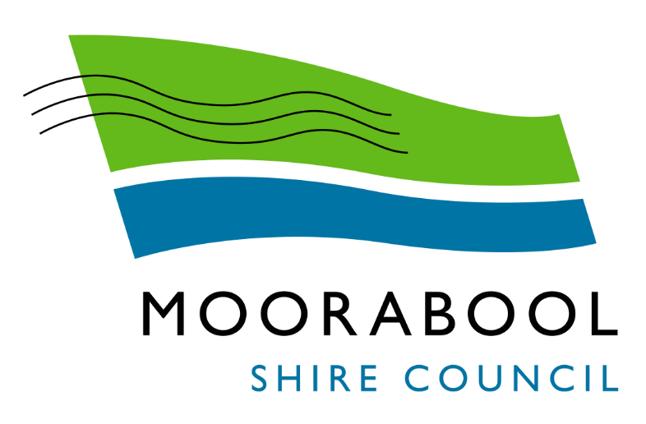
MINUTES
Moorabool Growth Management Committee Meeting
Wednesday, 1 September 2021
Date: | Wednesday, 1 September 2021
Time: | 3.30pm
Location: | Online

Order Of Business
1 Opening 3
2 Present and Apologies 3
3 Recording of Meeting 3
4 Confirmation of Minutes 3
5 Matters Arising from Previous Minutes 4
6 Disclosure of Conflicts of Interests 4
7 Community Planning Reports 4
8 Update on Trends, Issues and Other Matters 4
9 Process Forward and Work Program 5
10 Update on VCAT Decisions 5
11 Other Business 5
12 Date of Next Meeting 5
13 Closed Session of the Meeting to the Public 6
13.1 Bacchus Marsh Growth Area Update 6
13.2 Ballan Growth Area Update 6
13.3 Major Developments Update 6
14 Meeting Close 6

1 Opening
The Mayor opened the meeting at 3.34 pm.

2 Present and Apologies
Cr Tom Sullivan, Mayor West Moorabool Ward
Cr Rod Ward, Deputy Mayor East Moorabool Ward
Cr Moira Berry East Moorabool Ward
Cr David Edwards East Moorabool Ward
Cr Ally Munari Woodlands Ward
Cr Paul Tatchell Central Moorabool Ward

IN ATTENDANCE:
Mr Derek Madden Chief Executive Officer
Ms Caroline Buisson General Manager Customer Care & Advocacy
Mr Henry Bezuidenhout Executive Manager Community Planning & Economic Development
Mr Anthony Smith Acting Manager Governance, Risk & Corporate Planning
Ms Sarah Kernohan Manager Growth & Development
Ms Vanessa Osborn Coordinator Major Developments
Ms Kate Barclay Coordinator Strategic Planning
Mr Troy Delia Coordinator Governance & Risk

APOLOGIES:
Cr Tonia Dudzik East Moorabool Ward

3 Recording of Meeting
In accordance with Moorabool Shire Council’s Governance Rules, the meeting is livestreamed.

4 Confirmation of Minutes
Committee Resolution
Moved: Cr Moira Berry
Seconded: Cr Ally Munari
That the minutes of the Moorabool Growth Management Committee Meeting held on Wednesday 2 June 2021 be confirmed.
Carried

5 Matters Arising from Previous Minutes
Nil

6 Disclosure of Conflicts of Interests
Nil

7 Community Planning Reports
Nil

8 Update on Trends, Issues and Other Matters
Mr Henry Bezuidenhout provided an update to the Committee on the following matters.
C91 Flood Controls
- Panel Hearing Report received 30 July 2021.
- Briefing Note circulated to Councillors with Councillor Iinformation Bulletin 6 August 2021 advising of Panel Report release and included a copy of the Panel Report.
- Briefing scheduled 8 September 2021.
- Council meeting proposed October to consider panel report and adopt amendment.
Planning Policy Framework Update
- The Planning Policy Framework (PPF) translation process is being undertaken by DELWP and seeks to translate local policy content from Clauses 21 and 22 of the Moorabool Planning Scheme to the new PPF structure.
- Officers have reviewed the second draft and provided feedback to DELWP. Officers are generally supportive of the second draft, subject to some further refinements being made.
- Over the coming months, DELWP will prepare a final draft of the PPF translation documents. When officers are happy with the PPF translation documents, a letter for CEO endorsement will be prepared.
- DELWP will then prepare a ministerial amendment to update the Moorabool Planning Scheme.
Melbourne Airport Environs Safeguarding Standing Advisory Committee Interim Issues and Options Paper Submission
- The Committee has been appointed to advise the Minister for Planning on the effectiveness of the planning provisions safeguarding Melbourne Airports ongoing curfew free operations.
- In April 2021 the Committee released an issues and options paper that discussed applying restrictions on development under long term flight paths of the airport, including limiting rezoning of rural areas to urban zones, or building requirements for dwellings in those areas in accordance with the National Airports Safeguarding Framework.
- This has the potential to impact on large areas of land around Melbourne, including existing and future PSP’s in Melton, and a section of the Moorabool PSP’s (Merrimu and a small portion of Parwan Station and Parwan Employment Precinct).
- Councils submission outlined the Bacchus Marsh Urban Growth Framework and associated planning scheme amendment had been approved by the Minister, that planning was underway for these growth precincts, and that any proposal to protect flight paths needed to recognise existing identified growth areas.
- A number of other Councils, and the VPA have made submissions.
- The Committee will provide their recommendations to the Minister by the end of October 2021.

9 Process Forward and Work Program
Nil

10 Update on VCAT Decisions
Nil

11 Other Business
Nil

12 Date of Next Meeting
Wednesday 1 December 2021

13 Closed Session of the Meeting to the Public

Committee Resolution
Moved: Cr Rod Ward
Seconded: Cr Moira Berry
That Council considers the confidential report(s) listed below in a meeting closed to the public in accordance with Section 66(2)(a) of the Local Government Act 2020:

13.1 Bacchus Marsh Growth Area Update
This matter is considered to be confidential under Section 3(1) confidential information - (c) of the Local Government Act 2020, and the Council is satisfied that discussion of this matter in an open meeting would, on balance, be contrary to the public interest as it deals with land use planning information, being information that if prematurely released is likely to encourage speculation in land values.

13.2 Ballan Growth Area Update
This matter is considered to be confidential under Section 3(1) confidential information - (c) of the Local Government Act 2020, and the Council is satisfied that discussion of this matter in an open meeting would, on balance, be contrary to the public interest as it deals with land use planning information, being information that if prematurely released is likely to encourage speculation in land values.

13.3 Major Developments Update
This matter is considered to be confidential under Section 3(1) confidential information - (a), (c) and (e) of the Local Government Act 2020, and the Council is satisfied that discussion of this matter in an open meeting would, on balance, be contrary to the public interest as it deals with Council business information, being information that would prejudice the Council's position in commercial negotiations if prematurely released, land use planning information, being information that if prematurely released is likely to encourage speculation in land values, and legal privileged information, being information to which legal professional privilege or client legal privilege applies.
Carried

14 Meeting Close

The Meeting closed at 4.30 pm.

...................................................
CHAIRPERSON

