MINUTES
Development Assessment Committee Meeting
Wednesday, 21 July 2021
Date: | Wednesday, 21 July 2021
Time: | 6.03pm
Location: | Online

Order Of Business
1 Opening 3
2 Present and Apologies 3
3 Recording of Meeting 3
4 Confirmation of Minutes 3
5 Matters Arising from Previous Minutes 4
6 Disclosure of Conflicts of Interests 4
7 Community Planning Reports 5
7.1 PA2020283 - Two Lot Subdivision at 410 Moorabool West Road, Gordon 5
7.2 PA2020150 - Two lot subdivision at 246 Camerons Road Coimadai 17
8 Update on Trends, Issues and Other Matters 29
9 Process Forward and Work Program 29
10 Update on VCAT Decisions 29
11 Other Business 29
12 Date of Next Meeting 29
13 Closed Session of the Meeting to the Public 30
13.1 PA2014010 - Five lot subdivision, creation of easement and reduction in car parking (10 Spaces) at 151-155 Main Street Bacchus Marsh 30
14 Meeting Close 31

1 Opening
The Mayor opened the meeting at 6:03pm

2 Present and Apologies
Cr Tom Sullivan, Mayor West Moorabool Ward
Cr Tonia Dudzik East Moorabool Ward
Cr David Edwards East Moorabool Ward
Cr Moira Berry East Moorabool Ward
Cr Ally Munari Woodlands Ward
Cr Paul Tatchell Central Moorabool Ward
Officers:
Mr Derek Madden Chief Executive Officer
Mr Henry Bezuidenhout Executive Manager Community Planning & Economic Development
Mr Rob Fillisch Manager Statutory Planning & Building Services
Mr Anthony Smith Manager Governance, Risk & Corporate Planning
Mr Mark Lovell Coordinator Statutory Planning

APOLOGIES:
Cr Rod Ward, Deputy Mayor East Moorabool Ward

3 Recording of Meeting
The Mayor advised that the meeting is being livestreamed via Council’s website.

4 Confirmation of Minutes
Committee Resolution
Moved: Cr Tonia Dudzik
Seconded: Cr Paul Tatchell
That the minutes of the Development Assessment Committee Meeting held on Wednesday 16 June 2021 be confirmed.
Carried

5 Matters Arising from Previous Minutes
Nil

6 Disclosure of Conflicts of Interests
Cr Ally Munari declared a Conflict of Interest in Item 7.1 - PA2020283 - Two Lot Subdivision at 410 Moorabool West Road, Gordon, as the owner of the land and applicant.
Cr David Edwards declared a Conflict of Interest in Item 7.2 - PA2020150 - Two lot subdivision at 246 Camerons Road Coimadai, due to a close association with the applicants.
Cr Tom Sullivan declared a Conflict of Interest in Item 7.2 - PA2020150 - Two lot subdivision at 246 Camerons Road Coimadai, due to working on the matter in a professional capacity as a surveyor.
Cr Tom Sullivan also declared a Conflict of Interest in Item 13.1 - PA2014010 - Five lot subdivision, creation of easement and reduction in car parking (10 Spaces) at 151-155 Main Street Bacchus Marsh, due to working on the matter in a professional capacity as a surveyor.

Presentation/Deputations
Item | Community Planning & Economic Development | Speaker/s | Position | Attendance
7.2 | PA2020150 - Two lot subdivision at 246 Camerons Road Coimadai | Mr Steve Bourke | On behalf of applicant | Online

At 6.05pm Cr Ally Munari, having declared a Conflict of Interest in Item 7.1, left the meeting.

7 Community Planning Reports

7.1 PA2020283 - Two Lot Subdivision at 410 Moorabool West Road, Gordon
Author: Thomas Tonkin, Statutory Planner
Authoriser: Henry Bezuidenhout, Executive Manager Community Planning & Economic Development
Attachments: 1. Proposed plan of subdivision (under separate cover)
2. Proposed plan of subdivision overlaid on aerial photograph (under separate cover)

Application Summary
Permit No: PA2020283
Lodgement Date: 15 December 2020
Planning Officer: Tom Tonkin
Address of the land: 410 Moorabool West Road, Gordon
Proposal: Two Lot Subdivision
Lot size: 48.52ha
Why is a permit required? Clause 35.07 Farming Zone – Subdivision
Clause 42.01 Environmental Significance Overlay – Subdivision
Clause 44.06 Bushfire Management Overlay – Subdivision

Committee Resolution
Moved: Cr Paul Tatchell
Seconded: Cr Tonia Dudzik
That the Development Assessment Committee, having considered all matters as prescribed by the Planning and Environment Act 1987, issue Planning Permit PA2020283 for a Two Lot Subdivision (house lot excision) at 410 Moorabool West Road, Gordon with the following conditions:
Endorsed Plans:
- The formal plan of subdivision lodged for certification must be generally in accordance with the endorsed plan and must not be modified except to comply with statutory requirements or with the written consent of the Responsible Authority.
Servicing:
- The owner of the land must enter into agreements with the relevant authorities for the provision of water supply, drainage, sewerage facilities, electricity and gas services to each lot shown on the endorsed plan in accordance with the authority’s requirements and relevant legislation at the time.
- All existing and proposed easements and sites for existing or required utility services and roads on the land must be set aside in the plan of subdivision submitted for certification in favour of the relevant authority for which the easement or site is to be created.
- The plan of subdivision submitted for certification under the Subdivision Act 1988 must be referred to the relevant authority in accordance with Section 8 of that Act.
Environmental Health:
- The standard septic tank and the land application area must be all within Lot 1 with the existing dwelling.
Infrastructure:
- Prior to the issue of a Statement of Compliance for the subdivision, Lot 2 must be provided with rural standard vehicle crossing to the satisfaction of the Responsible Authority. Any redundant vehicle crossings must be removed, nature strip reinstated to the satisfaction of the Responsible Authority. A vehicle crossing permit must be taken out for the construction of the vehicle crossing.
- Sediment discharges must be restricted from any construction activities within the property in accordance with relevant Guidelines including Construction Techniques for Sediment Control (EPA 1991).
- Unless otherwise approved by the Responsible Authority there must be no buildings, structures, or improvements located over proposed drainage pipes and easements on the property.
- Prior to the commencement of the development and post completion, notification including photographic evidence must be sent to Council’s Asset Services identifying any existing damage to council assets. Any existing works affected by the development must be fully reinstated at no cost to and to the satisfaction of the Responsible Authority.
Barwon Water:
- The issue of a planning permit for the subdivision does not convey in any way ensuing approval for development of a dwelling on either lot. Any future proposals for development of a dwelling will be subject to relevant planning approvals and assessed separately in relation to potential impacts on catchment water quality.
- Prior to a certificate of compliance being issued for the subdivision the owner shall enter into an Agreement with the Responsible Authority and Barwon Water under Sections 173 of the Planning and Environment Act 1987, requiring that:
- Each lot created cannot be further subdivided.
- The Owner and the Responsible Authority agree to do all things necessary to register a memorandum of this Agreement on the title of the land pursuant to Section 181 of the Planning and Environment Act 1987.
- The Owner shall meet all costs of the Responsible Authority in relation to stamping and registration of this Agreement.
- The Owner shall not sell or enter into any contract to sell the land until this Agreement has been registered pursuant to Clause (b) herein.
- Barwon Water require the Section 173 to be signed by the Managing Director and Company Secretary and to state the following: THE COMMON SEAL of the BARWON REGION WATER CORPORATION was hereunto affixed in the presence of.
Country Fire Authority:
- Before the statement of compliance is issued under the Subdivision Act 1988 the owner must enter into an agreement with the responsible authority under Section 173 of the Planning and Environment Act 1987. The agreement must:
- State that it has been prepared for the purpose of an exemption from a planning permit under Clause 44.06-2 of the Moorabool Planning Scheme.
- Incorporate the plan prepared in accordance with Clause 53.02-4.4 of this planning scheme and approved under this permit.
- State that if a dwelling is constructed on the land without a planning permit that the bushfire protection measures set out in the plan incorporated into the agreement must be implemented and maintained to the satisfaction of the responsible authority on a continuing basis.
- The landowner must pay the reasonable costs of the preparation, execution and registration of the Section 173 Agreement.
Permit Expiry:
- This permit will expire if the plan of subdivision is not certified within two years of the date of issue of the permit.
Permit Note:
Statement of Compliance must be achieved and certified plans registered at Titles office within five years from the date of certification.
Carried

Public Consultation
Was the application advertised? | Yes.
Notices on site: | Two.
Notice in Moorabool Newspaper: | No.
Number of objections: | None.
Consultation meeting: | Not applicable.

Policy Implications
The Council Plan 2017-2021 provides as follows:
Strategic Objective 2: Minimising Environmental Impact
Context 2B: Natural Environment
The proposal does not conflict with the Council Plan 2017 – 2021.

Victorian Charter of Human Rights & Responsibilities Act 2006
In developing this report to Council, the officer considered whether the subject matter raised any human rights issues. In particular, whether the scope of any human right established by the Victorian Charter of Human Rights and Responsibilities is in any way limited, restricted or interfered with by the recommendations contained in the report. It is considered that the subject matter does not raise any human rights issues.

Officer’s Declaration of Conflict of Interests
Under section 130 of the Local Government Act 2020, officers providing advice to Council must disclose any interests, including the type of interest.
Executive Manager – Henry Bezuidenhout
In providing this advice to Council as the Executive Manager, I have no interests to disclose in this report.
Author – Tom Tonkin
In providing this advice to Council as the Author, I have no interests to disclose in this report.

Executive Summary
Application referred? | Yes, to Barwon Water, Country Fire Authority and Council’s Infrastructure and Environmental Health.
Any issues raised in referral responses? | No.
Preliminary concerns? | Native vegetation may be impacted by the proposed boundary between Lots 1 and 2.  Other preliminary concerns were the purpose of the subdivision, how does the proposal meet the objective of Clause 22.03 which is to ensure that subdivision and dwellings in rural areas are required to increase agricultural productivity.
Any discussions with applicant regarding concerns? | Council wrote to the applicant regarding the abovementioned concerns.
Any changes made to the application since being lodged? | Yes, the proposed boundary between Lots 1 and 2 was amended to address the preliminary concerns about vegetation.
Brief history. | See ‘History’ below.
Previous applications for the site? | PA2010086 for Two Lot Subdivision was issued by Council on 4 October 2010.  See ‘History’ below for further details.
General summary. | The proposed subdivision does not align with relevant state and local planning policy for the protection or enhancement of agricultural land. The proposal would fragment land, creating an ‘as of right’ opportunity for the development of a dwelling on proposed Lot 2 without sufficient justification that subdivision would benefit agricultural productivity.
Summary of Officer’s Recommendation
That, having considered all relevant matters as required by the Planning and Environment Act 1987, Council issue a Refusal to Grant a Permit for a two lot subdivision at Lot 1 on PS PS060146 known as 410 Moorabool West Road, Gordon, on the grounds included in this report.

Site Description
The subject site, identified as Lot 1 on PS060146 and known as 410 Moorabool West Road, Gordon, is a 48.52ha lot located on the southeast corner of Moorabool West Road and Calway Lane South, Gordon. The site is an irregular shape with a 502.92m frontage to Moorabool West Road and 896.3m frontage to Calway Lane South. The site is not encumbered by any easements or restrictions registered on title and has generally gently undulating topography, falling generally to the south, east and southeast by up to 30m. The site is developed with a single storey brick dwelling and ancillary outbuildings located close to the northwest corner of the site, accessed from Moorabool West Road via two crossovers. A small number of sheep, alpacas and donkeys are grazed on the site.
The subject site and surrounding land to the east, south and north is in the Farming Zone and characterised by mostly cleared grazing land. Lot sizes are variable, with some landholdings comprising numerous titles. The area is sparsely developed with dwellings. To the east of the site are three landholdings comprising lots of 4.2ha, 21.27ha and 39.0ha, the smaller two of which are developed with single dwellings. To the south is another landholding comprising a lot of 71.71ha. To the north, across Moorabool West Road, is a landholding comprising seven lots totalling 47.14ha and developed with a dwelling.
Land to the west is in the Rural Living Zone, and immediately opposite the subject site is heavily forested, although further to the west are more substantially cleared areas. Lot sizes are typically are between 2ha and 6ha and most lots are developed with single dwellings. Directly opposite the site on Calway Lane South are two lots, one of which is developed with a dwelling.

Proposal
It is proposed to subdivide the property into two lots. Lot 1 would contain the existing dwelling and ancillary outbuildings on a lot of 2.46ha, approximately rectangular in shape with a maximum width of 129.08m and maximum length of 193.34m. The southern boundary of Lot 1 would align with an existing fence line and partly with an existing fence line on its east boundary. Lot 1 would be located on the southeast corner of Moorabool West Road and Calway Lane South with existing vehicle access to Moorabool West Road maintained. Lot 2 would occupy the balance of the land, being 46.06ha of vacant land containing two dams and predominantly cleared land with only scattered trees. Lot 2 would have a 373.92m frontage to Moorabool West Road and 702.93m frontage to Calway Lane South. No common property is proposed, and no vegetation is proposed for removal.
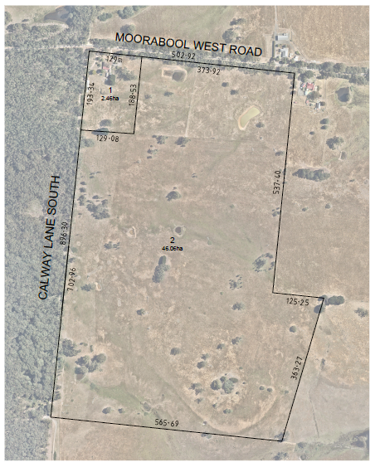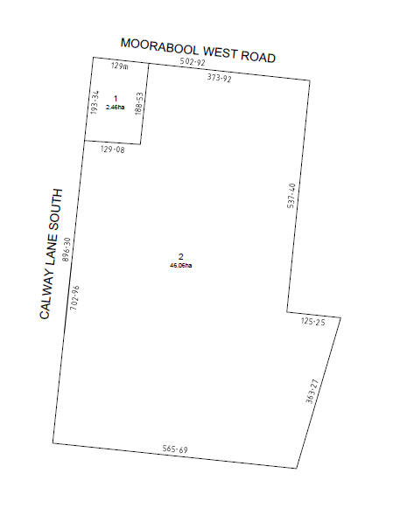
Figure 1: Proposed subdivision.

Background to Current Proposal
Not applicable.

History
PA2010086 for two Lot Subdivision was issued by Council on 4 October 2010 but was not acted upon and has since expired. The approved subdivision was almost identical to the current proposal and the permit included conditions imposed by Council and Barwon Water requiring the landowner to enter into a Section 173 Agreement to prevent the development of any further dwellings or any further subdivision to create additional lots. The applicant appealed against Barwon Water’s condition to VCAT. On 24 June 2011 VCAT upheld Council’s decision with no change to the permit condition.
Barwon Water is the relevant water board for the Special Water Supply Catchment in which the subject site is located. Key matters raised by the Tribunal are as follows:
• The Guidelines for Planning Permit Applications in Open Potable Water Supply Catchments (2009) (“the Guidelines”) is the key guiding policy document, requiring consideration under the Planning and Environment Act 1987 and Environmental Significance Overlay, Schedule 1 in the Moorabool Planning Scheme.
• The Guidelines included a policy that dwelling density be 1:40ha, with 40ha minimum lot sizes to negate the cumulative risk of adverse impacts posed by onsite wastewater/septic tank systems on water quality in open potable water supply catchments resulting from increased dwelling density.
• The proposal to create a vacant lot of >40ha which, subject to meeting siting specific requirements, would not require a planning permit to construct a dwelling contrary to principles of orderly and proper planning and to the principles of sound catchment management.
• Clause 65 decision guidelines in the Moorabool Planning Scheme when assessing a subdivision application require consideration of the existing use and possible future development of land and nearby land.
• Information submitted by the permit applicant indicated no intention to develop the proposed vacant lot for a dwelling in future and that the vacant lot would be used for rural/agricultural purposes.
The current application was referred to Barwon Water who consented, subject to the landowner entering into a Section 173 Agreement which includes no further subdivision of either lot. See ‘Discussion’ below.

Public Notice
Notice of the application was given to adjoining and surrounding landowners and occupiers by way of direct letters and signs erected on site. No objections were received.

Summary of Objections
Not applicable.

Locality Map
The map below indicates the location of the subject site and the zoning of the surrounding area.
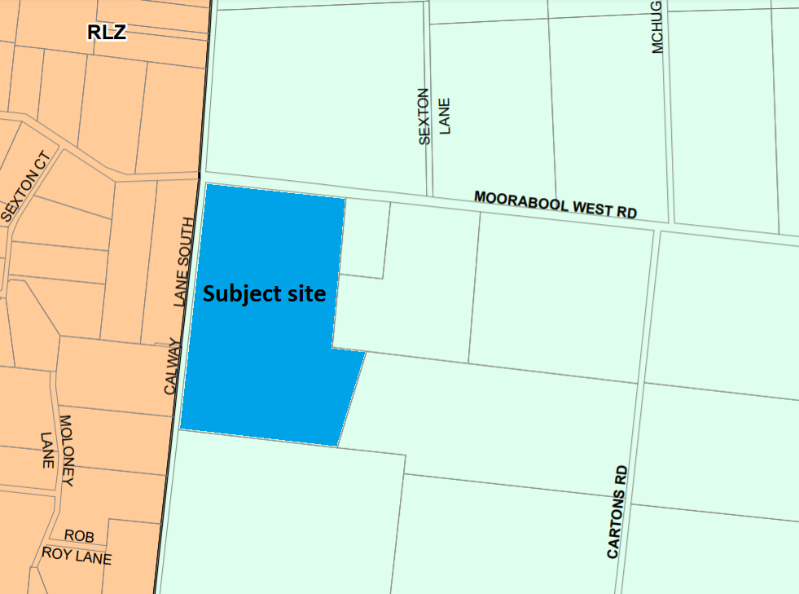
Figure 2: Zone map

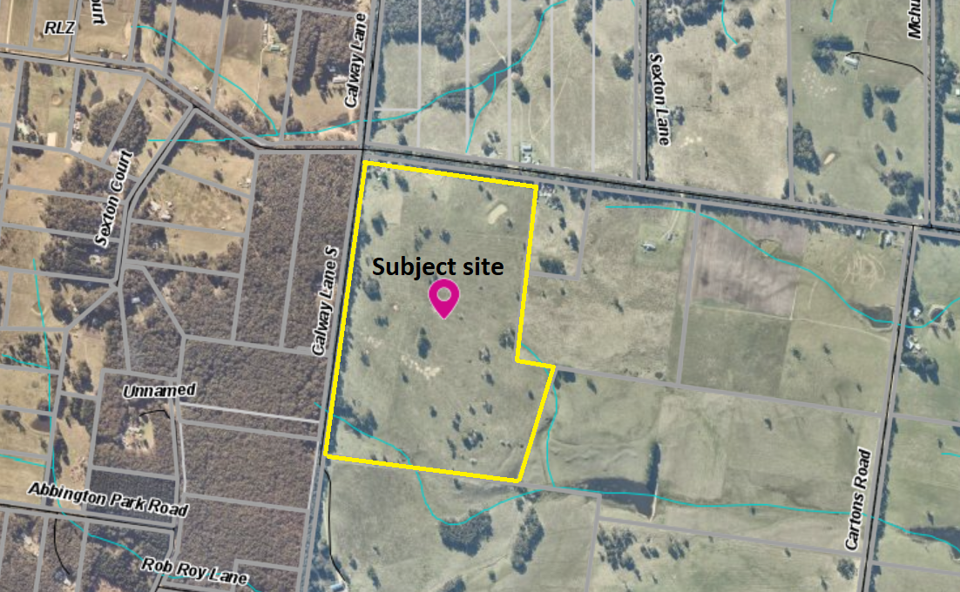
Figure 3: Aerial Photograph

Planning Scheme Provisions
Council is required to consider the Victoria Planning Provisions and give particular attention to the Planning Policy Framework (PPF), the Local Planning Policy Framework (LPPF) and the Municipal Strategic Statement (MSS).
The relevant clauses are:
• Clause 11.01-1R Settlement - Central Highlands
• Clause 11.03-3S Peri-urban areas
• Clause 13.02-1S Bushfire planning
• Clause 14.01-1S Protection of agricultural land
• Clause 14.01-2S Sustainable agricultural land use
• Clause 14.02-1S Catchment planning and management
• Clause 14.02-2S Water quality
• Clause 21.02-2 Non-urban landscapes
• Clause 21.02-3 Water and catchment management
• Clause 21.02-5 Bushfire
• Clause 21.03-4 Landscape and neighbourhood character
• Clause 21.03-6 Rural lifestyle opportunities
• Clause 21.04-2 Agriculture
• Clause 22.02 Special Water Supply Catchments
• Clause 22.03 Houses and House Lot Excisions in Rural Areas
In assessing it against the relevant sections of the PPF and LPPF, the following significant non-compliances were identified:
PPF | Title | Response
Clause 14.01-1S | Protection of agricultural land | There is insufficient justification that the proposed subdivision is required to enable tangible benefits to agricultural productivity on the property. Furthermore, the proposal would create an ‘as of right’ use of Lot 2 for a future dwelling which, based on the current proposal, is not considered beneficial to farming the property.
Clause 14.01-2S | Sustainable agricultural land use | There is insufficient justification that the proposed subdivision would improve the site’s capacity to sustain productive farming compared to the current site conditions.

LPPF

Clause 21.03-4 | Landscape and neighbourhood character | The proposed subdivision would create a vacant lot of 46ha and ‘as of right’ use for a dwelling. The proposal provides insufficient justification that the subdivision would meaningfully benefit farming and conflicts with the strategy to discourage residential development in the farming areas unless it is required for the agricultural use of the land.
Clause 21.03-6 | Rural lifestyle opportunities | The proposed subdivision creates a 46ha lot enabling ‘as of right’ use for a dwelling without sufficient justification that farming would benefit. The proposal does not align with strategies to prevent the fragmentation of farming land through inappropriate subdivisions or limit rural lifestyle developments to prevent adverse impacts on farm production.
Clause 21.04-2 | Agriculture | The proposed subdivision does not maintain productive farm sizes, with proposed Lot 1 being 2.46ha in size, fragments land without sufficient justification and creates a 46ha enabling ‘as of right’ use for a dwelling.
Clause 22.02 | Special Water Supply Catchments | The proposal does not align with the policy to strongly discourage the subdivision of land in proclaimed water catchment areas.
Clause 22.03 | Houses and house lot excisions in rural areas | The proposal provides insufficient justification that it meets the policy objective to ensure that subdivision and dwellings in rural areas are required to increase agricultural productivity.

Zone
The subject site is in the Farming Zone (FZ). The purpose of the FZ is:
• To implement the Municipal Planning Strategy and the Planning Policy Framework.
• To provide for the use of land for agriculture.
• To encourage the retention of productive agricultural land.
• To ensure that non-agricultural uses, including dwellings, do not adversely affect the use of land for agriculture.
• To encourage the retention of employment and population to support rural communities.
• To encourage use and development of land based on comprehensive and sustainable land management practices and infrastructure provision.
• To provide for the use and development of land for the specific purposes identified in a schedule to this zone.
Under Clause 35.07-3 a permit is required to subdivide land. Each lot must be at least the area specified for the land in a schedule to this zone, which is 100ha. A permit may be granted to create smaller lots if the subdivision is to create a lot for an existing dwelling. The subdivision must be a two lot subdivision. The proposal meets this requirement.
Overall, the proposal is inconsistent with the purpose of the zone – see ‘Discussion’ below.

Overlays
The site is affected by Environmental Significance Overlay, Schedule 1 (ESO1), Design and Development Overlay, Schedule 2 (DDO2) and partly by the Bushfire Management Overlay (BMO).

Environmental Significance Overlay, Schedule 1
Under Clause 42.01-2 (ESO) a permit is required to subdivide land. There are no applicable exemptions under Schedule 1 therefore a permit is required under this overlay.

Design and Development Overlay, Schedule 2
Under Clause 43.02-3 (DDO) a permit is required to subdivide land. Under Schedule 2 there is an exemption for subdivision, therefore a permit is not required under this overlay.

Bushfire Management Overlay
Under Clause 44.06-2 (BMO) a permit is required to subdivide land.

Relevant Policies
There are no relevant adopted Council policies or draft policies.

Particular Provisions
Clause 53.02 Bushfire Planning
The proposal meets the relevant objectives of Clause 53.02-4. The size and dimensions of Lot 1 retain acceptable defendable space for the existing dwelling within its lot boundaries. Lot 2 is partially affected by the BMO and the proposed lot size enables sufficient opportunity to locate any future dwelling to mitigate the bushfire hazard to an acceptable extent.

Discussion
Overall, the proposed subdivision does not align with relevant state and local planning policy, the Farming Zone or decision guidelines at Clause 65 of the Moorabool Planning Scheme.
State and local planning policy recognises the importance of Melbourne’s peri-urban areas for their diverse values – the environmental qualities, scenic landscapes and townships, contribution to the tourist economy and agricultural and natural resource sectors. The assessment of land use and development is typically subject to an assessment of competing policy demands.
The subject site is in the Farming Zone and the proposal seeks to subdivide the site into two lots, excising the existing dwelling on a lot of 2.46ha and creating a vacant 46.06ha lot. In support of the application the applicant advises that the current hobby farm will be expanded to sheep grazing on both proposed lots, relying heavily on the farming experience of older family members living on the property. The applicant also advises that a key aspect of the proposal is that the existing dwelling is unsuited to accommodating the family into the future, implying that Lot 2 would be developed for a future dwelling, being an ‘as of right’ land use on a lot >40ha.
Planning policy at the state and local levels consistently prioritises the use and enhancement of Farming Zone land for mainly agricultural purposes. The development and subdivision of Farming Zone land should, where applicable, support the role of agriculture for its economic, environmental and social benefits. The purpose of the Farming Zone, stated above, also supports the retention of employment and population to support rural communities.
Council’s local policy at Clause 22.03 of the Moorabool Planning Scheme relates to houses and house lot excisions in rural areas, directly applicable to this application. Clause 22.03 has the following objectives:
• To ensure that subdivision and dwellings in rural areas are required to increase agricultural productivity.
• To minimise the potential for adverse impacts on farm production through land use conflicts.
The subject site, on a single title of 48.52ha, contains a dwelling, enabling the owner to reside on the property and undertake a farming enterprise. The proposed subdivision would excise the existing dwelling on a lot of 2.46ha, unsuited to any significant farming activity and able to be separately disposed of at any time, effectively removing it from any direct connection to a farming enterprise. Whilst proposed Lot 2’s 46.06ha size and dimensions retains potential for viable farming, the subdivision nonetheless contributes to the fragmentation of agricultural land. The application does not provide a clear demonstration that any benefit to farming productivity would outweigh the risk of creating an ‘as of right’ opportunity for a second dwelling on the land, nor that excising the existing dwelling from the bulk of the landholding would lead to a better farming outcome.
As per ‘History’ above, Barwon Water have provided conditional consent to the current application. Conditions include that the landowner enter into a Section 173 Agreement which includes no further subdivision of either lot. Barwon Water have also included the following condition:
‘The issue of a planning permit for the subdivision does not convey in any way ensuing approval for development of a dwelling on either lot. Any future proposals for development of a dwelling will be subject to relevant planning approvals and assessed separately in relation to potential impacts on catchment water quality.’
However, in respect of this it should be noted that subject to the design and siting of a future dwelling on the proposed vacant Lot 2, a planning permit may not be required meaning Barwon Water would not be required to consent to any future development plans.

General Provisions
Clause 65 - Decision Guidelines have been considered by officers in evaluating this application.
Clause 66 - Stipulates all the relevant referral authorities to which the application must be referred.

Referrals
Authority | Response
Barwon Water  CFA | Consent with conditions.  Consent.
Infrastructure  Environmental Health | Consent with conditions.  Consent with conditions.

Financial Implications
There are no financial implications for Council in refusing this subdivision application.

Risk & Occupational Health & Safety Issues
The recommendation to refuse this subdivision application does not have any risk or OH&S implications for Council.

Communications Strategy
Notice was undertaken for the application, in accordance with s.52 of the Planning and Environment Act 1987, and further correspondence is required to all interested parties to the application as a result of a decision in this matter. The applicant was invited to attend this meeting and address Council if required.

Options
• Issue a Refusal to Grant a Permit in accordance with the grounds in the recommendation of this report; or
• issue a Refusal to Grant a Permit with amendments to the grounds in the recommendation of this report. Either option to refuse the application may result in the applicant appealing Council’s decision at VCAT; or
• should Council wish to support the application, issue a Planning Permit with conditions.

Conclusion
Overall, the proposed subdivision does not align with relevant state and local planning policy for the protection and enhancement of agricultural land. There is insufficient justification that the subdivision is required to improve agricultural productivity, results in further fragmentation of farming land and creates an as ‘as of right’ opportunity for additional residential growth in a location where planning policy gives priority to agriculture.

At 6.10 pm Cr Ally Munari returned to the meeting, Cr Tom Sullivan, having declared a Conflict of Interest in Item 7.2, vacated the Chair and left the meeting, and Cr David Edwards, having also declared a Conflict of Interest in Item 7.2, left the meeting. Cr. Paul Tatchell assumed the Chair.
Suspension of Standing Orders 6.11pm

Committee Resolution
Moved: Cr Ally Munari
Seconded: Cr Moira Berry
That Standing Orders be suspended to facilitate a discussion on Item 7.2.
Carried

Resumption of Standing Orders 6.33pm

Committee Resolution
Moved: Cr Moira Berry
Seconded: Cr Tonia Dudzik
That Standing Orders now be resumed to facilitate a return to the business of the Agenda.
Carried

Mr Steve Bourke addressed the Committee on behalf of the applicant associated with Item 7.2.

7.2 PA2020150 - Two lot subdivision at 246 Camerons Road Coimadai
Author: Mark Lovell, Coordinator Statutory Planning
Authoriser: Henry Bezuidenhout, Executive Manager Community Planning & Economic Development
Attachments: 1. Subdivison Plan (under separate cover)

Application Summary
Permit No: PA2020170
Lodgement Date: 29 July 2020
Planning Officer: Mark Lovell
Address of the land: Lot 2 on PS818727P, 246 Camerons Road Coimadai
Proposal: Two lot subdivision
Lot size: 24.06 ha
Why is a permit required? Rural Living Zone – Subdivide land
Design & Development Overlay Schedule 14 – Subdivide land
Environmental Significance Overlay Schedule 2 – Subdivide land
Bushfire Management Overlay Schedule 1 – Subdivide land

Committee Resolution
Moved: Cr Tonia Dudzik
Seconded: Cr Moira Berry
That the Development Assessment Committee, defer the matter of PA2020150 - Two lot subdivision at 246 Camerons Road Coimadai to a future Development Assessment Committee meeting, to enable a further briefing for Councillors on the C58 amendment and implications.
Carried

Public Consultation
Was the application advertised? | Yes.
Notices on site: | Yes.
Notice in Moorabool Newspaper: | No.
Number of objections: | No objections.
Consultation meeting: | Nil.

Policy Implications
The Council Plan 2017-2021 provides as follows:
Strategic Objective 2: Minimising Environmental Impact
Context 2A: Built Environment
The proposal is consistent with the Council Plan 2017 – 2021.

Victorian Charter of Human Rights & Responsibilities Act 2006
In developing this report to Council, the officer considered whether the subject matter raised any human rights issues. In particular, whether the scope of any human right established by the Victorian Charter of Human Rights and Responsibilities is in any way limited, restricted or interfered with by the recommendations contained in the report. It is considered that the subject matter does not raise any human rights issues.

Officer’s Declaration of Conflict of Interests
Under section 130 of the Local Government Act 2020, officers providing advice to Council must disclose any interests, including the type of interest.
Executive Manager - Henry Bezuidenhout
In providing this advice to Council as the Executive Manager, I have no interests to disclose in this report.
Author – Mark Lovell
In providing this advice to Council as the Author, I have no interests to disclose in this report.

Executive Summary
Application referred? | Powercor Australia, Western Water, Melbourne Water, Country Fire Authority, Council’s Infrastructure and Council’s Environmental Health.
Any issues raised in referral responses? | Nil.
Preliminary concerns? | The owner was advised the application does not comply with the planning scheme controls.
Any discussions with applicant regarding concerns? | Yes, the applicant disagrees with Council’s interpretation of the planning scheme controls and believes the planning scheme allows for a further subdivision of land. The applicant did not want to withdraw the application.
Any changes made to the application since being lodged? | Nil.
Brief history. | Camerons Road was rezoned from Farming Zone to part Rural Living Zone to facilitate limited rural living lots under Planning Scheme Amendment C58 gazetted on 4 May 2017.  The lot originated from a prior two lot subdivision of land in 2017.
Previous applications for the site? | PA2017133 was issued on 5 November 2017 authorising a two lot subdivision of the land creating the current lot, Lot 2.
General summary. | The rezoning and new planning controls introduced in 2017 were designed for the purpose of creating limited rural living lots within designated building envelopes.  While not prohibited in undertaking a further subdivision of the land, the proposed subdivision is inconsistent with the Design and Development Overlay Schedule 14 and the Bushfire Management Overlay Schedule 1.  The proposal would undermine all the strategic work that was undertaken in rezoning the land and would result in a higher residential density that was not envisaged when the controls were formed.
Summary of Officer’s Recommendation
That, having considered all relevant matters as required by the Planning and Environment Act 1987, Council issue a refusal to grant a planning permit for a two lot subdivision at Lot 2 on PS818727P, 246 Camerons Road, Coimadai.

SITE DESCRITION
The current Lot 2 has an area of 24.06ha and contain the existing dwelling and outbuildings. It has 83.90m frontage to Camerons Road and the existing vehicle access is maintained. There are two 15m wide powerline easements, with one near the front property boundary connecting into former Lot 1 and the other cutting though the south-east corner of the site. The land is undulating with a low point running through the centre of the site in a west to east direction and a further low point adjacent to the eastern property boundary which forms Goodmans Creek. The land is largely cleared with some scattered trees concentrated along the northern property boundary
PROPOSAL
It is proposed to subdivide the land into two lots. Lot 1 is irregular in shape, with a proposed narrower frontage width to Camerons Road at 67.39m and a total area of 11.5 ha. Lot 1 contains the existing dwelling, shedding and existing driveway. Lot 2 is located to the rear of the site and will be accessed by 16.51m new driveway running parallel with the southern property boundary. Lot 2 is vacant and has an area of 12.56ha. The applicant has shown a building envelope area of 40m x 30m and separate effluent envelope area of 9m x 40m. The envelopes are located close to its primary western lot boundary and near the southern property boundary.

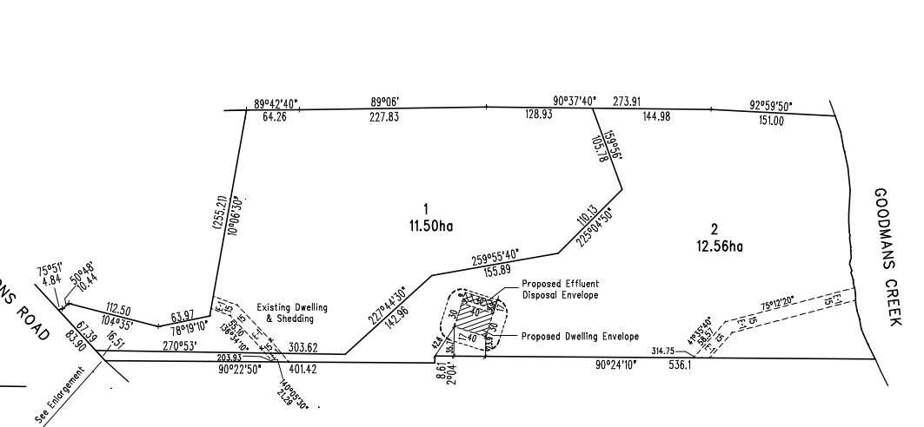
Figure 1: Proposed Plan of Subdivision

HISTORY
Planning permit PA2017133 was issued 5 November 2017 authorising a two lot subdivision of land from the parent lot at 246 Camerons Road, Coimadai. The application was advertised, and no objections were received. Titles were released on 27 July 2018. The subject land that is part of this current application is known as Lot 2 on PS818727P.
Planning permit PA2018301 was issued on 15 January 2019 for Lot 1 on PS818727P authorising a development of a relocatable dwelling and ancillary outbuilding (shed). The application was advertised, and no objections were received. The dwelling, shed and associated driveways are complete.

Public Notice
The application was notified to adjoining and surrounding landowners and placing a large notice on site. No objections were received as a result of the advertising.

Locality Map
The map below indicates the location of the subject site and the zoning of the surrounding area.
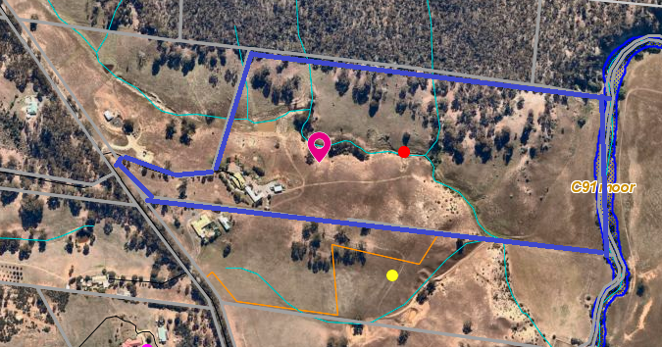
Figure 2: Aerial Photography

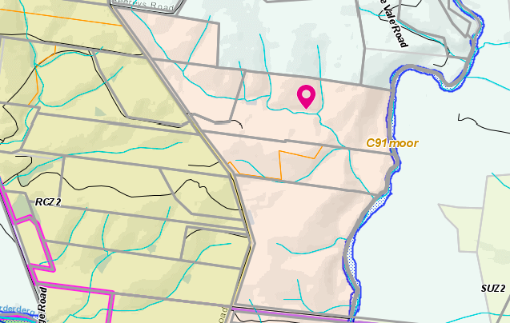
Figure 3: Zone Map
Key:
Pink – Rural Living Zone
Brown – Rural Conservation Zone Schedule 2
Light Green – Farming Zone

Planning Scheme Provisions
Council is required to consider the Victoria Planning Provisions and give particular attention to the Planning Policy Framework (PPF), the Local Planning Policy Framework (LPPF) and the Municipal Strategic Statement (MSS).
The relevant clauses are:
• Clause 11.03-3S Peri-Urban Areas
• Clause 13.02-1S Bushfire Planning
• Clause 15.01-3S – Subdivision Design
• Clause 15.01-5S Neighbourhood Character
• Clause 21.02 Natural Environment
• Clause 21.02-2 Objective—Non-Urban Landscapes
• Clause 21.02-3 Objective—Water and Catchment Management
• Clause 21.02-4 Objective—Biodiversity
• Clause 21.02-5 Objective—Bushfire
• Clause 21.02-6 Objective—Environmentally Sustainable Development
• Clause 21.07-5 Objective—Cameron’s Road Area Limited Rural Living
The proposal does not comply with the relevant sections of the PPF and LPPF clauses outlined in the table below:
LPPF | Title | Response
Clause 21.07-5 | Cameron’s Road Area limited rural living | The objective of this clause is to provide limited high amenity rural lifestyle opportunities while protecting human life from bushfire risk, avoiding fragmenting agricultural land, protecting extractive industry from accommodation development and protecting significant flora and fauna values. A strategy to achieve the objective is to specify subdivision requirements to limit development and site buildings appropriate to the environmental constraints of the land.  With this site a building envelope was designated and has address in prior subdivision of land. An additional building envelope was not designated for this lot consistent with the objective of providing limited rural living opportunities.

Zone
The subject site is located within a Rural Living Zone.
The purpose of the zone is:
• To implement the SPPF and the LPPF, including the MSS and local planning policies.
• To provide for residential use in a rural environment.
• To provide for agricultural land uses which do not adversely affect the amenity of surrounding land uses.
• To protect and enhance the natural resources, biodiversity and landscape and heritage values of the area.
• To encourage use and development of land based on comprehensive and sustainable land management practices and infrastructure provision.
Under Clause 35.03-3 a permit is required to subdivide land. Under the schedule to the zone the minimum subdivision area is 6ha. Decision guidelines are listed under Clause 35.03-5.

Overlays
Design & Development Overlay Schedule 2 & 14 (DD02 and DD014)
The site is affected by the Design and Development Overlay Schedule 2 - Visual amenity and building design, and Schedule 14 – Camerons Road area.
Under Clause 43.02-3, a permit is required to subdivide land. Schedule 2 provides an exemption from this requirement. There are no exemptions under Schedule 14, therefore a permit is required.
Part 3.0 of Schedule 14 states a lot must contain an existing dwelling, or a dwelling envelope located in accordance with Map 1 to Schedule 14 to Clause 43.02. Decision guidelines are listed under Part 4.0.
The design objectives for Schedule 14 are:
• To provide for limited rural living development in locations that protect the treed landscape values and land capability of the area.
• To ensure a building is sited to protect and retain remnant native vegetation and wildlife habitat and the treed landscape values of the land.
• To ensure a building is sited to protect the nature conservation values and habitat values of the Lerderderg State Park and the water quality of Goodmans Creek and the Lerderderg River.
• To ensure a building used for accommodation is separated by an appropriate distance from a quarry to avoid adverse impacts on the operation of existing extractive industries.
• To ensure a building used for accommodation is sited where bushfire risk associated with the site, the immediate area and the broader landscape is mitigated to an acceptable level without adverse impacts on environmental values.

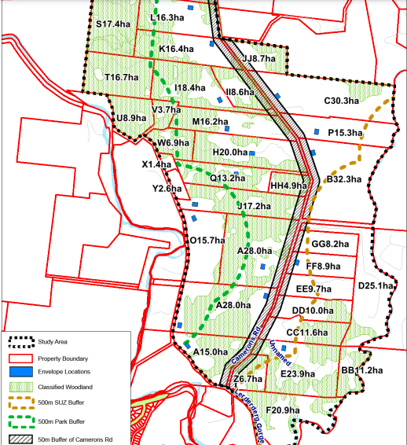
Figure 4: is part of the Design & Development Overlay Schedule 14.
Under DD014, the property is identified as Lot C with a building envelope located at the front of the site (now known as Lot 1 associated with the previous subdivision land that is completed).
Environmental Significance Overlay – Schedule 2
The site is partly affected by the Environmental Significance Overlay – Schedule 2 – Waterway Protection. Under Clause 42.01-2, a permit is required to subdivide land. There are no relevant exemptions under Schedule 2. Decision guidelines are listed under Part 4.0.
The Environmental Objectives for Schedule 2 are:
• To protect the habitat significance of vegetation.
• To provide for appropriate development of land within 100m of either side of a waterway.
• To prevent pollution and increased turbidity of water in natural waterways.
• To prevent increased surface runoff or concentration of surface water runoff leading to erosion or siltation of waterways.
• To conserve existing flora and fauna habitats close to waterways and to encourage generation and regeneration of habitats.
Bushire Management Overlay
The property is affected by the Bushfire Management Overlay Schedule 1 – Camerons Road Area. Under Clause 44.06-2, a permit is required to subdivide land. There are no exemptions under Schedule 1.
Schedule 1 to Clause 44.06, item 2.0 states as follows:
This schedule applies to all applications for building and works associated with a dwelling (including an extension or alteration to a dwelling) or a dependant persons unit or to subdivide land for a dwelling on land described in Table 1 to this schedule. Clause 52.47 applies to all other applications.
Map 1 to Schedule 1 of Clause 44.06 includes:
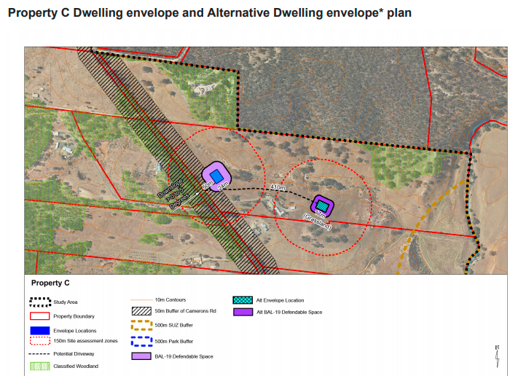
Figure 5: is part of the Bushfire Management Overlay Schedule 1.

The note added to bottom of this plan within Map 1 of Clause 44.06 states
An alternative dwelling envelope also satisfies AM2.1 and is an alternative location for the dwelling envelope. It is not an additional dwelling envelope.

Discussion
The prior subdivision of land under Planning Permit PA2017133 was completed in accordance with the planning scheme controls and titles have subsequently been issued. The Design and Development Overlay and Bushfire Management Overlay Schedule 1 were designed to consider the best location for new dwellings in terms of impact upon natural features, bushfire risk and proximity to the nearby sand quarries. There was a large body of strategic planning documents that were reviewed by a State Government planning panel to ensure future dwelling were well sited. Building envelopes were created with some lots having an alternative building envelope or specific design criteria if a future owner wanted to build in a different location. The entire purpose of the new controls was to allow each owner the ability to undertake a two lot subdivision and construct a new dwelling in the vacant lot. Camerons Road Area is being developed in accordance with the planning scheme controls and several planning permits have been issued for subdivisions and construction of single dwellings on single lots.
The applicant in this instance is seeking to undertake a further subdivision of land and has provided a Land Capability Assessment to demonstrate wastewater can be managed on site and has provided a Bushfire Management Statement demonstrating adequate bushfire mitigation measure can be utilised. The applicant has interpretated Schedule 1 of the Bushfire Management Overlay which specified an alternative building envelope as allowing for two dwellings on the land in addition to retention of the existing dwelling, thereby allowing a total of three dwellings on the one parent lot. The note included with Schedule 1 of the Bushfire Management Overlay at Clause 44.06 of the Moorabool Planning Scheme clearly states the alterative building envelope is not an additional building envelope. The owner disagrees with this notation in the planning scheme and believes the rezoning was designed to allow for two additional dwellings on their land.
The planning scheme controls through the Design and Development Overlay Schedule 14 and the Bushfire Management Overlay Schedule 1 are clear in their intent and any subdivision must meet these requirements. This is further reinforced through the Local Planning Policy, Clause 21.07-5 of the Moorabool Planning Scheme which states it is policy to require all dwellings to be located within a dwelling envelope.
Without these overlay provisions, applicants could subdivide land in multiple lots achieving the minimum lot area specified by the Rural Living Zone which is 6ha. The orderly planning of the area was correctly considered during C58 Planning Scheme Amendment (C58) process. C58 sort to restrict subdivision of these large parent titles into two lots that would protect conservation values of the area, protect future occupant from bushfire risk and protect the area from over development. There is no planning justification based on the current planning controls to support this further two lot subdivision of the land.

General Provisions
Clause 65 - Decision Guidelines have been considered by officers in evaluating this application.
Clause 66 - Stipulates all the relevant referral authorities to which the application must be referred.

Referrals
Authority | Response
Western Water  Melbourne Water  Powercor  Country Fire Authority | Consent.  Consent, with two conditions including a requirement to provide waterways easement.  Consent, with five conditions.  Consent with two conditions.
Council’s Infrastructure  Council’s Environmental Health | Consent, with four conditions.  Consent, with eight conditions.

Financial Implications
There are no financial implication in recommending refusal to this subdivision application.

Risk & Occupational Health & Safety Issues
The recommendation of refusal of this subdivision does not implicate any risk or OH&S issues to Council.
COMMUNICATIONS STRATEGY
Notice was undertaken for the application, in accordance with s.52 of the Planning and Environment Act 1987, and further correspondence is required to all interested parties to the application as a result of a decision in this matter. The applicant was invited to attend this meeting and invited to address Council if required.

Options
• Issue a refusal to grant a permit in accordance with the recommendation of this report; or
• should Council wish to support the application, issue a planning permit contrary to the planning scheme provisions

Conclusion
The proposed subdivision is inconsistent with the planning controls including the local planning policy as contained within the Moorabool Planning Scheme. The Camerons Road Area has been properly planned through a planning scheme amendment process. This application proposes a subdivision contrary to the planning controls and would not represent the orderly planning of the area. The application is recommended to be refused with specified grounds.

At 6.42pm Cr Tom Sullivan returned to the meeting and assumed the Chair.
At 6.46pm Cr David Edwards returned to the meeting.

8 Update on Trends, Issues and Other Matters
Nil.

9 Process Forward and Work Program
Nil.

10 Update on VCAT Decisions
A report will be provided at the next Development Assessment Committee meeting outlining an overview of VCAT decisions from the previous 12 months and a summary of the implications of those decisions.

11 Other Business
Nil.

12 Date of Next Meeting
Wednesday 18 August 2021

13 Closed Session of the Meeting to the Public
This matter is considered to be confidential under Section 3(1) confidential information - (e) and (f) of the Local Government Act 2020, and the Development Assessment Committee is satisfied that discussion of this matter in an open meeting would, on balance, be contrary to the public interest as it deals with legal privileged information, being information to which legal professional privilege or client legal privilege applies and personal information, being information which if released would result in the unreasonable disclosure of information about any person or their personal affairs.

Committee Resolution
Moved: Cr Paul Tatchell
Seconded: Cr Ally Munari
That the Development Assessment Committee considers the confidential report listed below in a meeting closed to the public in accordance with Section 66(2)(a) of the Local Government Act 2020:
13.1 PA2014010 - Five lot subdivision, creation of easement and reduction in car parking (10 Spaces) at 151-155 Main Street Bacchus Marsh.
Carried

14 Meeting Close
The Meeting closed at 7.24pm.

...................................................
CHAIRPERSON

