MINUTES
Development Assessment Committee Meeting
Wednesday, 21 April 2021
Date: | Wednesday, 21 April 2021
Time: | 6.00pm
Location: | Pavilion Room, Darley Civic and Community Hub

Order Of Business
1 Opening 3
2 Present and Apologies 3
3 Recording of Meeting 3
4 Confirmation of Minutes 3
5 Matters Arising from Previous Minutes 3
6 Disclosure of Conflicts of Interests 3
7 Community Planning Reports 5
7.1 PA2020063 Development and Use of a Dwelling and Resubdivision of Three Lots to Two Lots at 10 Donnellys Road East, Navigators 5
7.2 PA2015131-1 - Use and Development for a Postal Agency, Food and Drink Premises (Cafe) and Shop (Convenience Goods, Giftware and Clothing). Reduction of Car Parking, Display of Business Identification Signage and Vegetation Removal at 23 Martin Street, Blackwood 20
7.3 PA2020105 - 629 Mount Doran Road, Mount Doran - Variation of a Restrictive Covenant to move and enlarge the building envelope 32
7.4 PA2019260 - Development of Three Dwellings at 46 McCullagh Street Bacchus Marsh 46
7.5 PA2019140 - Use and Development for Dog Breeding (10 Breeding Dogs) and Vegetation Removal at 104 Mount Doran-Egerton Road, Mount Doran 61
8 Update on Trends, Issues and Other Matters 75
9 Process Forward and Work Program 75
10 Update on VCAT Decisions 75
11 Other Business 75
12 Date of Next Meeting 75
13 Meeting Close 75

1 Opening
The Mayor opened the meeting at 6.00pm

2 Present and Apologies
Cr Tom Sullivan, Mayor West Moorabool Ward
Cr Rod Ward, Deputy Mayor East Moorabool Ward
Cr Tonia Dudzik East Moorabool Ward
Cr David Edwards East Moorabool Ward
Cr Ally Munari Woodlands Ward
Cr Paul Tatchell Central Moorabool Ward
Officers:
Mr Derek Madden Chief Executive Officer
Mr Henry Bezuidenhout Executive Manager Community Planning & Economic Development
Mr Rob Fillisch Manager Statutory Planning & Building Services
Mr Anthony Smith Manager Governance, Risk & Corporate Planning
Mr Mark Lovell Coordinator Statutory Planning

APOLOGIES:
Cr Moira Berry East Moorabool Ward

3 Recording of Meeting
The Mayor advised that the meeting is being livestreamed via Council’s website.

4 Confirmation of Minutes
Committee Resolution
Moved: Cr Paul Tatchell
Seconded: Cr David Edwards
That the minutes of the Development Assessment Committee Meeting held on Wednesday 17 March 2021 be confirmed.
Carried

5 Matters Arising from Previous Minutes
Nil

6 Disclosure of Conflicts of Interests
Nil

Presentation/Deputations
Item | Community Planning and Economic Development | Speaker/s | Position | Attendance
7.1 | PA2020063 Development and Use of a Dwelling and Resubdivision of Three Lots to Two Lots at 10 Donnellys Road East, Navigators | Mr. Mark Mullane  Applicant | Objector | Online
7.1 | PA2020063 Development and Use of a Dwelling and Resubdivision of Three Lots to Two Lots at 10 Donnellys Road East, Navigators | Mr. James Robson EDQ Town Planning Applicants Representative | Objector | Online
7.2 | PA2015131-1 - Use and Development for a Postal Agency, Food and Drink Premises (Cafe) and Shop (Convenience Goods, Giftware and Clothing). Reduction of Car Parking, Display of Business Identification Signage and Vegetation Removal at 23 Martin Street, Blackwood | Mr. Richard Blake ARCIworx Design  Applicants Representative | Seeking Deferral | Online
7.2 | PA2015131-1 - Use and Development for a Postal Agency, Food and Drink Premises (Cafe) and Shop (Convenience Goods, Giftware and Clothing). Reduction of Car Parking, Display of Business Identification Signage and Vegetation Removal at 23 Martin Street, Blackwood | Mr. Martyn Blake Applicant | Seeking Deferral | Online
7.2 | PA2015131-1 - Use and Development for a Postal Agency, Food and Drink Premises (Cafe) and Shop (Convenience Goods, Giftware and Clothing). Reduction of Car Parking, Display of Business Identification Signage and Vegetation Removal at 23 Martin Street, Blackwood | Ms. Carol Guthrie Applicant | Seeking Deferral | Online
7.3 | PA2020105 - 629 Mount Doran Road, Mount Doran - Variation of a Restrictive Covenant to move and enlarge the building envelope | Mr. Dale Wright and Ms. Marnie Campbell | Supporter | Online
7.4 | PA2019260 - Development of Three Dwellings at 46 McCullagh Street Bacchus Marsh | Mrs. Rachel Buehler | Supporter | Online

7 Community Planning Reports
Mr. Mark Mullane addressed Council as the applicant associated with Item 7.1.

Mr. James Robson addressed Council as the representative of the applicant associated with Item 7.1.

7.1 PA2020063 Development and Use of a Dwelling and Resubdivision of Three Lots to Two Lots at 10 Donnellys Road East, Navigators
Author: Mark Lovell, Coordinator Statutory Planning
Authoriser: Henry Bezuidenhout, Executive Manager Community Planning & Economic Development
Attachments: 1. Dwelling and Shed Plans (under separate cover)
2. Plan of Subdivision (under separate cover)

Application Summary
Permit No: PA2020063
Lodgement Date: 30 March 2020
Planning Officer: Mark Lovell
Address of the land: Land in Plan of Consolidation PC 170302K, Lot 1 on TP 120214X (formerly ptCA2, S19, Parish of Warrenheip) and Lot 1 on TP 259312W (formerly CA2, S19, Parish of Warrenheip), located at 10 Donnellys Road East, Navigators
Proposal: Development and Use of a Dwelling and re-subdivision of three lots to two lots
Lot size: 23.8ha
Why is a permit required? Clause 35.07 – Development and Use of a dwelling on a lot
Clause 35.07 – Subdivision in the Farming Zone
Clause 42.01 – Buildings and Works in the Environmental Significance Overlay.

Recommendation
Moved: Cr Paul Tatchell
Seconded: Cr Rod Ward
That the Development Assessment Committee
  - Notes that all parts of the report including maps that make reference to the eight lots or eight titles are incorrect and do not form part of the recommendation or decision made within this application, and
  - having considered all matters as prescribed by the Planning and Environment Act 1987, issues a planning permit PA2020063 for the Development and Use of a Dwelling and Resubdivision of Three Lots into Two Lots at 10 Donnelley Road, Navigators, with the following conditions:

Endorsed Plans:
- Before the use and/or development starts, amended plans to the satisfaction of the Responsible Authority must be submitted to and approved by the Responsible Authority. When approved, the plans will be endorsed and will then form part of the permit. The plans must be drawn to scale with dimensions and three copies must be provided. The plans must be generally in accordance with the plans submitted with the application or some other specified plans but modified to show:
  - Site plan to show all dwelling setbacks to the nearest property boundaries.
  - Complete dimension plans of the proposed dwelling.
  - Show the driveway location between the street frontage and the horse stables.
Unless otherwise approved in writing by the Responsible Authority, all buildings and works are to be constructed and or undertaken in accordance with the endorsed plans to the satisfaction of the Responsible Authority prior to the commencement of the use.
Subdivision:
- The plan of subdivision submitted for certification under the Subdivision Act 1988 must be referred to the Relevant Authority in accordance with Section 8 of that Act.
- The owner of the land must enter into agreements with the Relevant Authorities for the provision of water supply, drainage, sewerage facilities, electricity and gas services to each lot shown on the endorsed plan in accordance with the Authority’s requirements and relevant legislation at the time.
- All existing and proposed easements and sites for existing or required utility services and roads on the land must be set aside in the plan of subdivision submitted for certification in favour of the Relevant Authority for which the easement or site is to be created.
Farm Management Plan
- A Farm Management Plan to the satisfaction of the Responsible Authority must be endorsed as part of this permit and cannot be varied without the written consent of the Responsible Authority.
- Prior to the issue of a building permit, sufficient work must have occurred in accordance with the five year plan of the Farm Management Plan to the satisfaction of the Responsible Authority.
Section 173 Agreements:
- Before the issue of a Building Permit the owner must enter into an agreement with the Responsible Authority made pursuant to Section 173 of the Planning and Environment Act 1987 to the satisfaction of the Responsible Authority:
  - The owner of the land must acknowledge that while the land remains zoned as Farming Zone or its equivalent successor the primary use of the land is for agricultural activities and the use of the dwelling must be in conjunction with an approved agricultural activity.
  - Agricultural activities and environmental management identified in the endorsed Farm and Land Management Plan must be undertaken on the land and must be in accordance with the Farm Management Plan endorsed under Condition 5 of the Planning Permit and cannot be varied without the written consent of the Responsible Authority.
  - Before a Building Permit is issued for the dwelling, application must be made to the Register of Titles to register the Section 173 Agreement on the title to the land under Section 181 of that Act and the owner must provide evidence of that registration of the Agreement to the Responsible Authority.
  - The owner must pay the reasonable costs for the preparation, execution, and registration of the Section 173 Agreement.
Dwelling Requirements:
- The dwelling must be connected to a reticulated sewerage system or if not available, the wastewater must be treated and retained on-site in accordance with the State Environment Protection Policy (Waters of Victoria) under the Environment Protection Act 1970.
- The dwelling must be connected to a reticulated potable water supply or have an alternative potable water supply with adequate storage for domestic use as well as for firefighting purposes.
- The dwelling must be connected to a reticulated electricity supply or have an alternative energy source.
- Access to the dwelling must be provided via an all-weather road with dimensions adequate to accommodate emergency vehicles.
Materials and Colour:
- All external walls and roof areas of the proposed building/s are to be clad with non-reflective materials (zincalume prohibited) to the satisfaction of the Responsible Authority.
Environmental Health:
- An onsite wastewater management system with the capacity to treat effluent to a minimum of 20mg/L BOD and 30mg/L Suspended Solids must be installed for the proposed dwelling.
- A subsurface Irrigation system needs to be installed for the land application area to a depth of 150mm in situ or if the soil is of poor quality, imported good quality topsoil may be required, with a 1m spacing in between lines.
- The land application area must be in accordance to the Land Capability Assessment prepared by Provincial Geotechnical Pty Ltd, ref number 132221 dated 24th October 2019, or any approved amendment are to be strictly adhered to.
- Prior to any developments a new site plan needs to be submitted showing the land application area to be on the flat land behind the dwelling to the west of the property.
- Any proposed plumbing fixtures in the shed for the animals need to be connected to the onsite wastewater management system.
- The wastewater management system including all effluent must be wholly contained within the property boundaries at all times.
- The effluent disposal area must be kept free of buildings, driveways, vehicular traffic, and services trenching.

- All setback distances must be adhered to as dictated by Table 5 of the Code of Practice, Onsite Wastewater Management, EPA Publication Number 891.4
- The owner will maintain all drainage lines at all times to divert surface water and subsurface water clear of the effluent disposal field.
Infrastructure:
- Storm water drainage from the proposed buildings and impervious surfaces must be disposed of to the satisfaction of the Responsible Authority. Overflows from on-site storage systems must be directed away from any wastewater disposal areas.
- Sediment discharges must be restricted from any construction activities within the property in accordance with relevant Guidelines including Construction Techniques for Sediment Control (EPA 1991).
- Unless otherwise approved by the Responsible Authority there must be no buildings, structures, or improvements located over any drainage pipes and easements on the property.
- Prior to the commencement of the development and post completion, notification including photographic evidence must be sent to Council’s Asset Services department identifying any existing damage to Council assets. Any existing works affected by the development must be fully reinstated at no cost to and to the satisfaction of the Responsible Authority
Central Highlands Water:
- The dwelling and effluent disposal system must be located in accordance with the Land Capability Assessment by Provincial Geotechnical Pty Ltd dated 24th October 2019 Reference 132221.
- The owner must install a wastewater management system that provides a secondary level of treatment of wastewater.
- Prior to a Building Permit being issued for a dwelling the owner must enter into an agreement with Central Highlands Region Water Corporation (CHW) and the responsible authority under Sections 173 and 174 of the Planning and Environment Act 1987, requiring that:
  - The owner must have any wastewater treatment facility and effluent disposal system for the dwelling inspected annually by a qualified environmental health officer (“the EHO”) and must provide annually to both the Council and to CHW a written report from the EHO on the condition of the wastewater treatment and effluent disposal system.
  - The Owner must have the wastewater treatment facility desludged at least once every three years or as otherwise determined by the EHO and evidence of this desludging must be provided in the EHO report referred to in Clause (a) herein.
  - The Owner must carry out any works considered necessary by the EHO to ensure the satisfactory operation of the wastewater treatment facility and effluent disposal system.
  - The owner will maintain all drainage lines at all times to divert surface water and subsurface water clear of the effluent disposal field.
  - The Owner and the Council agree to do all things necessary to register a memorandum of this Agreement on the title of the land pursuant to Section 181 of the Planning and Environment Act 1987.
  - The Owner must meet all costs of inspections, reports, and works referred to in Clauses (a), (b), (c) and (d) herein and all costs of the Council in relation to stamping and registration of this Agreement.
  - The Owner must not sell or enter into any contract to sell the land until this Agreement has been registered pursuant to Clause (e) herein.
- The landowners must meet all costs of preparing and recording this agreement
Permit Expiry:
- This permit will expire if one of the following circumstances applies:
  - the development and the use are not started within two years of the date of this permit; or
  - the development is not completed within four years of the date of this permit; or
  - the plan of subdivision is not certified within two years of the date of the permit.
Permit Note:
A permit to install an onsite wastewater management system must be submitted to Environmental Health.
CARRIED
A Division was called:
For: Councillors Ally Munari, Paul Tatchell, Rod Ward and Tom Sullivan.
Against: Councillors David Edwards, Tonia Dudzik.
The motion was carried

Public Consultation
Was the application advertised? | Yes.
Notices on site: | Yes.
Notice in Moorabool Newspaper: | No.
Number of objections: | Nil.
Consultation meeting: | None required.

Policy Implications
The Council Plan 2017-2021 provides as follows:
Strategic Objective 3: Stimulating Economic Development
Context 3A: Land Use Planning
The proposal to develop and use the land for a dwelling and the associated re-subdivision of three lots to two lots is consistent with the Council Plan 2017 – 2021.

Victorian Charter of Human Rights & Responsibilities Act 2006
In developing this report to Council, the officer considered whether the subject matter raised any human rights issues. In particular, whether the scope of any human right established by the Victorian Charter of Human Rights and Responsibilities is in any way limited, restricted or interfered with by the recommendations contained in the report. It is considered that the subject matter does not raise any human rights issues.

Officer’s Declaration of Conflict of Interests
Under section 130 of the Local Government Act 2020, officers providing advice to Council must disclose any interests, including the type of interest.
Executive Manager – Henry Bezuidenhout
In providing this advice to Council as the Executive Manager, I have no interests to disclose in this report.
Author – Mark Lovell
In providing this advice to Council as the Author, I have no interests to disclose in this report.

Executive Summary
Application referred? | Yes, Central Highlands Water, Corangamite Catchment Management Authority, Councils Environmental Health and Council’s Infrastructure.
Any issues raised in referral responses? | No.
Preliminary concerns? | The land in question is three of eight parcels in common ownership. The eight parcels in total equate to an area of approximately 63ha. Two of these parcels contain existing dwellings.  This application relates to the three eastern most lots, which equate to an area of approximately 23.8ha. One of these lots is already developed with an existing dwelling, which is proposed to be excised from the bulk of the land and not used for any agricultural purpose. The proposed agricultural use is for an equestrian use that would include breeding, agistment and convalescing (healing and recovery) on the land.
Any discussions with applicant regarding concerns? | Yes, the applicant was advised of the planning concerns in the early stages of the application.
Any changes made to the application since being lodged? | No.
Brief history. | See Assessment section.
Previous applications for the site? | There are two previous planning applications associated with the site.  PA2001-353 – Three Lot Subdivision (Re-subdivision of existing three lots).  PA2003-037 – Development of a Pergola.
General summary. | The application is seeking approval for the development of a new dwelling and a re-subdivision from three lots into two lots.  The land is approximately 23.8ha and is comprised of three parcels of land, with an existing dwelling located on the south eastern portion of the land. The boundaries are proposed to be realigned to contain the existing dwelling and its associated outbuilding.  It is proposed to develop a new dwelling on the remaining land, as well as an ancillary outbuilding. The proposed new dwelling would have four bedrooms and two bathrooms.  The Farm Management Plan (FMP) is proposed to be used for the purposes of equine breeding and training and have up to 36 horses on the land plus foals as part of the proposed farming operation.  This farming activity could be conducted utilising the existing dwelling on the land and that the development and use of another dwelling would contribute to the continued fragmentation of agricultural land.
Summary of Officer’s Recommendation
That, having considered all relevant matters as required by the Planning and Environment Act 1987, Council issue a Refusal to grant a planning permit for development and use of a dwelling and re-subdivision of three lots to two lots at 10 Donnellys Road East, Navigators.
Site Description
The three parcels for this application are the eastern most parcels, identified as Plan of Consolidation PC 170302K, Lot 1 on TP 120214X (formerly ptCA2, S19, Parish of Warrenheip) and Lot 1 on TP 259312W (formerly CA2, S19, Parish of Warrenheip). The site is defined by four roads, a private road to the west, Mullanes Road to the North, Navigators Road to the West and Donnellys Road East to the South.
Lot 1 on Title Plan TP120214 contains an existing dwelling and dam and is going to be largely unchanged by the proposal. The other two lots that comprise the development are largely cleared of vegetation and predominately flat, with a slight fall down to the east of the property. The land has a dam on to the eastern boundary facing Navigators Road and two other dams towards the internal private road.
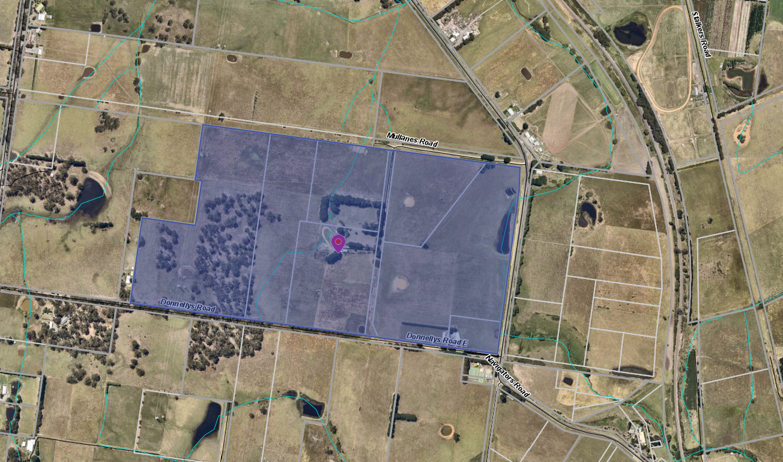
The site is a portion of a larger farming operation that has historically been used for the purposes of cattle breeding on the land. The larger farming operation comprises of eight parcels of land in common ownership comprising a total of 63.9ha in area, three of which are the subject to this planning application.
Figure 1: Map showing the extent of the land in common ownership.

Proposal
The proposal is the seeking approval for the development and use of a dwelling as well as a re-subdivision from three lots down to two lots.
The three parcels of land subject to this application equate to approximately 23.8ha. The resubdivision would see the lot containing the existing dwelling increase from 1.6ha to 2ha with the balance of the land of 21.8ha being the land for the proposed new dwelling and the equestrian use.
The proposed new dwelling is a four-bedroom, two-bathroom home with a simple internal layout of a lounge/family room that leads out to a courtyard/alfresco area. The dwelling would have an ancillary outbuilding, which is proposed to be a 12m x 20m (240sqm). The shed will be used for horse husbandry. The proposed agricultural use to justify the use and development of the dwelling is an equestrian business.
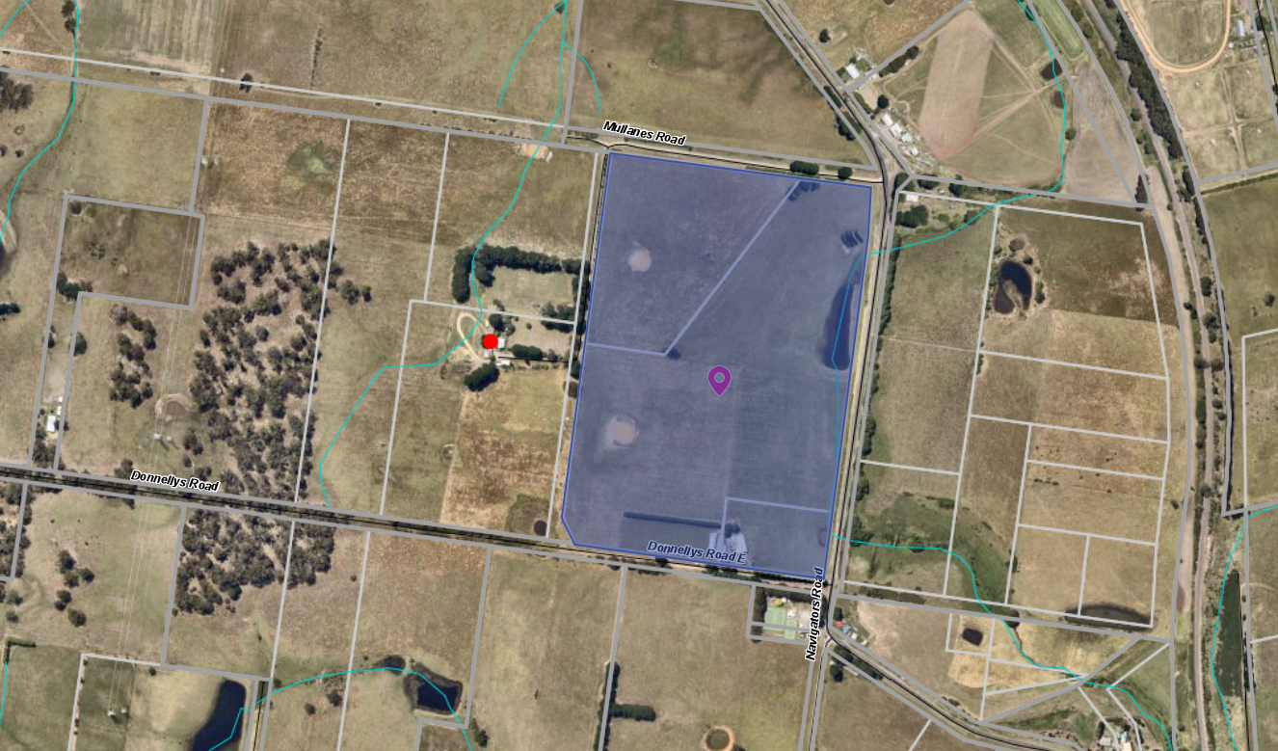
Figure 2: Map showing the three parcels of land that is subject to this application.

History
There are two previous planning permit applications that are associated with the land.
PA2001-353 - Three Lot Subdivision (Re-subdivision of existing three lots).
PA2003-037 - Development of a Pergola.

Public Notice
The application was notified to adjoining and surrounding landowners.

Summary of Objections
There were no objections received by Council in relation to the development and use of a dwelling and associated re-subdivision of the land from three lots to two lots.

Locality Map
The map below indicates the location of the subject site and the zoning of the surrounding area.
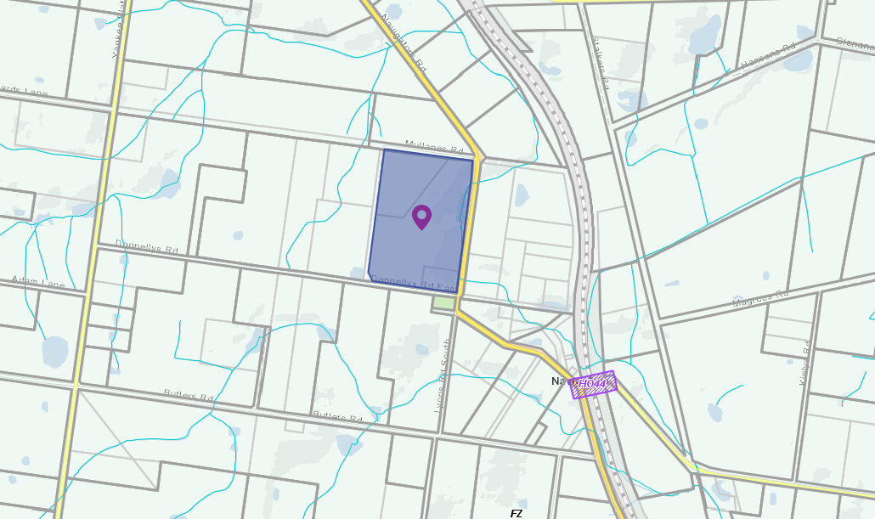
Figure 3: Map showing the zoning of the subject land and surrounding area
The land surrounding the site contains many examples of properties that contain multiple titles. It is not common for a property in same ownership to have more than one dwelling.

Planning Scheme Provisions
Council is required to consider the Victoria Planning Provisions and give particular attention to the Planning Policy Framework (PPF), the Local Planning Policy Framework (LPPF) and the Municipal Strategic Statement (MSS).
The relevant clauses are:
• Clause 11.01 - Victoria Settlement
• Clause 11.03 – Planning for Places
• Clause 12.05 – Significant Environments and Landscapes
• Clause 14.01 – Agriculture
• Clause 14.02 – Water
• Clause 15.01 – Built Environment
• Clause 16.01 – Housing
• Clause 21.02 – Natural Environment
• Clause 21.03 – Settlement and Housing
• Clause 21.09 – Small Towns and Settlements
• Clause 22.02 – Special Water Supply Catchments
• Clause 22.03 – Houses and House Lot Excisions in rural areas
The proposal does not comply with the clauses outlined in the table below:
PPF | Title | Response
Clause 14.01 | Agriculture | Clause 14.01-1S speaks to protect the Victoria’s agricultural base by preserving productive farmland. The cumulative impact of approving dwellings in the farming zone imposes constraints on the farming operations both on this site and to the surrounding land users. The direction from the State Government also says to direct growth into existing settlements to avoid subdivision and development that diminishes long-term productive capacity of the land.
Clause 16.01 | Housing, specifically Clause 16.01-3S | The first strategy under Clause 16.01-3S is for the Responsible Authority to manage development in rural areas to protect agriculture and avoid inappropriate rural residential development.
LPPF | Title | Response
Clause 21.03 | Settlement and Housing | This local strategy aims to prevent the fragmentation of farmland through inappropriate subdivisions and to focus rural living development in areas close to urban centres
Clause 21.09 | Small Towns and Settlements | The Small Towns and Settlement Strategy identifies the towns that limited growth is to be directed. Navigators is not one of the towns identified for growth.

Zone
The site is within the Farming Zone. The purpose of the zone is:
• To implement the Municipal Planning Strategy and the Planning Policy Framework.
• To provide for the use of land for agriculture.
• To encourage the retention of productive agricultural land.
• To ensure that non-agricultural uses, including dwellings, do not adversely affect the use of land for agriculture.
• To encourage the retention of employment and population to support rural communities.
• To encourage use and development of land based on comprehensive and sustainable land management practices and infrastructure provision.
• To provide for the use and development of land for the specific purposes identified in a schedule to this zone.

Pursuant to Clause 35.07-1, a planning permit is required for the development of a dwelling on a lot less than 40ha. A planning permit is also required for the proposed subdivision.

Overlays
Clause 42.01 Environmental Significance Overlay, Schedule 1
The land is within the Environmental Significance Overlay, Schedule 1. The purpose of the Environmental Significance Overlay is:
• To implement the Municipal Planning Strategy and the Planning Policy Framework.
• To identify areas where the development of land may be affected by environmental constraints.
• To ensure that development is compatible with identified environmental values.
Further to the purpose of the overlay, the following environmental objectives are to be achieved under the schedule to the overlay:
• To protect the quality and quantity of water produced within proclaimed water catchments.
• To provide for appropriate development of land within proclaimed water catchments.
Clause 43.02 Design and Development Overlay, Schedule 2
The land is within the Design and Development Overlay, Schedule 2. The purpose of the Design and Development Overlay is:
• To implement the Municipal Planning Strategy and the Planning Policy Framework.
• To identify areas which are affected by specific requirements relating to the design and built form of new development.
Further to the purpose of the overlay, the following design objectives are to be achieved under this schedule to the overlay:

Relevant Policies
Council’s Rural Housing Policy, adopted on 19 September 2012, gives direction for assessing planning permit applications which propose new residential development of land in the Farming Zone. An application needs to satisfy the purpose of the Farming Zone and supports agricultural opportunities. Whilst the conflict with surrounding farming activity may not be readily apparent, the policy identifies that a dwelling on a parcel of land to raise land value should not be supported. There is already a dwelling on this site. This application is a situation where the development is not seeking to maximise the agricultural potential of the land, which is against the intent of the Planning Scheme and would encourage further fragmentation of farming land. In addition, the Small Towns and Settlements Strategy provides clear direction for the areas of growth in the rural communities. This Strategy highlights that certain towns are designated for growth. Navigators is not identified as a town within the study area as the residential growth potential of this area is limited.

Particular Provisions
There are no relevant Particular Provisions to this application.

Discussion
There are two aspects to this application, the dwelling and the re-subdivision of three lots into two lots. The landowner and proponent have eight parcels of land in common ownership and the applicant is seeking approval for a dwelling, which would be the second dwelling over the three parcels of land. It would also be the third dwelling in common ownership over the entire eight parcels of land of which five parcels are not part of this application.
The Moorabool Planning Scheme provides discretion for a permit to be granted to use and develop land for the purposes of a dwelling on a lot less than 40ha. Where a permit is required, the decision guidelines of the Farming Zone require that consideration be given to a range of matters before deciding on an application. Having considered these matters, if the application is to be approved, it could result in an unacceptable precedent being set as well as see the further fragmentation of productive farming land. An outcome of approval of the application is not supported by the local and state planning policies.
This was explored in detail by VCAT in Strachan v LaTrobe CC (2012) Member Tracey Bilston-McGillen stated that:
‘In considering applications for dwellings in the Farming Zone, the Tribunal has on a number of occasions commented on the adverse impact on agricultural production associated with the intrusion of dwellings on small lots in the Farming Zone. In particular the Tribunal has commented that the impact of permitting dwellings in small rural lots in the Farming Zone is incremental in nature and that care must be exercised not to lose sight of the cumulative impact of each dwelling when considering applications for individual proposals. The failure to do so lead inevitably to the circumstances where the proliferation of dwellings on small lots changes the character of a locality to rural residential and productive agricultural land is lost forever’.
This application and the current ownership arrangement where dwellings already exist, will result in the proliferation of dwellings and fragmentation of land. The farming activity proposed does not need an additional dwelling covering the eight existing parcels in common ownership.
The ability to develop land in the Farming Zone restricts the ability for farming operations to expand due to the economic consequences. This cumulative impact would also undermine both the state and local policies that relate to growth in rural areas.
The proposed farming activity could be appropriate for the land, however the Farm Management Plan (FMP) submitted does not adequately justify the need for a dwelling and excising an existing dwelling as part of a re-subdivision of land. It is considered that the stocking rate of horses identified in the planning report of “up to 36 mature horses plus foals at foot would be kept (breeding and agistment) on the subject land under capacity” cannot be achieved. The FMP in the five-year plan identifies that a total of 30 horses, comprised of a mix of breeding, agistment and convalescence would be kept on site, which is still too high based on the land area available. Reducing the number of horses to approximately 20 does not change the fundamental issue that there is no requirement for an additional dwelling on the land. The proposed agricultural activity could be conducted from the dwelling that already exists on the land within the scope of this application or from the other dwelling that is in common ownership.
While the FMP states the land could support 36 horses, it also requires paddock rotation in order to ensure correct pasture management. The FMP does not demonstrate how this rotation could be achieved with a full stocking rate of 36 horses.

While the development is one aspect of the application, the second is the re-subdivision. The re-subdivision would see an overall reduction in the number of lots that are currently available and would make the existing dwelling self-contained with its own ancillary outbuilding and wastewater treatment system. There were no objections from any of the catchment authorities regarding the re-subdivision of land.
The re-subdivision to create a lot with dwelling that is 2ha in area is consistent with parts of the local policy, Clause 22.03 - Houses and House lot Excision in Rural Areas. However, it should also be noted under this clause of the Planning Scheme there is a requirement for the owner to enter Section 173 Agreement to ensure that there are no dwellings to be developed on the balance of the land after an existing dwelling has been excised. In this situation, the applicant is requesting planning permission for a dwelling on the proposed vacant/balance lot. There is a high risk that creating this lot would create the ability to dispose of this dwelling to separate ownership without any agricultural activity. In this case the dwelling would be used for residential purposes which is not the intent of the farming zone.

General Provisions
Clause 65 – Decision Guidelines have been considered by officers in evaluating this application.
Clause 66 – Stipulates all the relevant referral authorities to which the application must be referred.

Referrals
Authority | Response
Central Highlands Water  Corangamite Catchment Management Authority | Consent with Conditions.  No response.
Environmental Health  Infrastructure | Consent with Conditions.  Consent with Conditions.

Financial Implications
There are no financial implications to Council for the recommendation to refuse.

Risk & Occupational Health & Safety Issues
The recommendation of refusal to this development and re-subdivision application does not implicate any risk or OH&S issues to Council.

Communications Strategy
Notice was undertaken for the application, in accordance with s.52 of the Planning and Environment Act 1987, and further correspondence is required to all interested parties to the application as a result of a decision in this matter. The applicant was invited to attend this meeting and invited to address Council if required.

Options
• Issue a Refusal to grant a permit in accordance with the recommendation of this report; or
• should Council wish to approve the application, issue a Planning Permit with conditions outside the recommendation of this report. Councillors need to explore reasons based on the proposal complying with the Moorabool Planning Scheme.

Conclusion
In conclusion, this application is seeking to develop the land for an additional dwelling while excising off a lot for the existing dwelling on the land is not an appropriate planning outcome in the Farming Zone. The dwelling that exists on the land could be used to operate the farming activity. The proposed dwelling and retention of the existing dwelling does not support the long term agricultural use of farming land. This is not supported by a range of policy guidelines as well as the legislation that governs planning decisions. If the owners were genuine in their attempt to start an equestrian husbandry and agistment operation, it could be started utilising the dwelling that is already owned and occupied on the either the whole site in common ownership (all eight titles) or the dwelling that is on one of the three titles that comprises this planning permit application. As such, it is recommended that the application is refused for the reasons outlined within this report.

Mr. Richard Blake addressed Council as the representative of the applicant associated with Item 7.2 and requested this matter be deferred.

7.2 PA2015131-1 - Use and Development for a Postal Agency, Food and Drink Premises (Cafe) and Shop (Convenience Goods, Giftware and Clothing). Reduction of Car Parking, Display of Business Identification Signage and Vegetation Removal at 23 Martin Street, Blackwood
Author: Thomas Tonkin, Statutory Planner
Authoriser: Henry Bezuidenhout, Executive Manager Community Planning & Economic Development
Attachments: 1. Existing and proposed plans (under separate cover)

Application Summary
Permit No: PA2015131-1
Lodgement Date: 24 March 2020
Planning Officer: Tom Tonkin
Address of the land: 23 Martin Street, Blackwood
Proposal: Amendment to PA2015131
Lot size: 809sqm
Why is a permit required? Clause 32.05 Township Zone – Use and development for a Shop (Convenience Goods, Giftware and Clothing) and Food and Drink Premises (Café)
Clause 42.01 Environmental Significance Overlay, Schedule 1 – Buildings and works and removal of vegetation
Clause 44.06 Bushfire Management Overlay – Buildings and works associated with a Retail Premises
Clause 52.06 Car Parking – Reduction of car parking

Committee Resolution
Moved: Cr Paul Tatchell
Seconded: Cr Tonia Dudzik
That the Development Assessment Committee defer PA2015131-1 for Use and Development for a Postal Agency, Food and Drink Premises (Café) and Shop (Convenience Goods, Giftware and Clothing), Reduction of Car Parking, Display of Business Identification Signage and Vegetation Removal to the Committee Meeting of 19 May 2021 at the request of the applicant.
Carried

Public Consultation
Was the application advertised? | Yes.
Notices on site: | Yes.
Notice in Moorabool Newspaper: | No.
Number of objections: | Two, later withdrawn. 15 submissions in support of the proposal were also received.
Consultation meeting: | No. The Council officer and landowner separately consulted with the objectors.

Policy Implications
The Council Plan 2017-2021 provides as follows:
Strategic Objective 3: Stimulating Economic Development
Context 2A: Built Environment
The proposal does not conflict with the Council Plan 2017 – 2021.

Victorian Charter of Human Rights & Responsibilities Act 2006
In developing this report to Council, the officer considered whether the subject matter raised any human rights issues. In particular, whether the scope of any human right established by the Victorian Charter of Human Rights and Responsibilities is in any way limited, restricted or interfered with by the recommendations contained in the report. It is considered that the subject matter does not raise any human rights issues.

Officer’s Declaration of Conflict of Interests
Under section 130 of the Local Government Act 2020, officers providing advice to Council must disclose any interests, including the type of interest.
Executive Manager – Henry Bezuidenhout
In providing this advice to Council as the Executive Manager, I have no interests to disclose in this report.
Author – Tom Tonkin
In providing this advice to Council as the Author, I have no interests to disclose in this report.

Executive Summary
Application referred? | Yes, to Southern Rural Water, Western Water and CFA, Council’s Infrastructure and Council’s Environmental Health.
Any issues raised in referral responses? | No.
Preliminary concerns? | The site is identified in the West Moorabool Heritage Study Stage 2A as part of the Martin Street Heritage Precinct which recommends future coverage by a Heritage Overlay in the Moorabool Planning Scheme. Advice from Council’s Heritage Advisor recommended changes to the proposed building design to minimise its visual impact on the streetscape and to protect a future heritage streetscape.
Any discussions with applicant regarding concerns? | Yes, applicant advised of concerns, but no changes were made to the design.
Any changes made to the application since being lodged? | Yes. Initially the application was to amend the permit to also allow for use of a shop and take away food premises and associated development to expand the existing premises. After advertising and the receipt of objections, the application was changed to allow for a café instead of the takeaway food premises, with associated changes to the development aspect.
Brief history. | See ‘History’ below.
Previous applications for the site? | PA2015131 was issued for the Use of an Existing Building as a Post Office (with Ancillary Retail Component) and Business Identification Signage was on 27 September 2017.
General summary. | It is proposed to amend PA2015131 to expand the range of retail uses and extend the building footprint. Subject to conditions, the proposal would be generally consistent with the relevant planning controls and would not have any detrimental amenity impacts. The site is identified as being of heritage significance and recommended plan changes would ensure the proposal would respect the heritage features.
Summary of Officer’s Recommendation
That, having considered all relevant matters as required by the Planning and Environment Act 1987, Council issue an Amendment to Planning Permit PA2015131 to allow for Use and Development for a Postal Agency, Food and Drink Premises (Café) and Shop (Convenience Goods, Giftware and Clothing), Reduction of Car Parking, Display of Business Identification Signage and Vegetation Removal at 23 Martin Street, Blackwood, in accordance with Section 61 of the Planning and Environment Act 1987, subject to the conditions included in this report.

Site Description
The subject site, identified as Crown Allotment 2, Section B, Parish of Blackwood and known as 23 Martin Street, Blackwood, is a rectangular shaped parcel of 809sqm located on the west side of the street diagonally opposite Blackwood Hotel. The site is encumbered by a 2.44m wide carriageway easement parallel to the north side boundary which connects to a laneway at the rear of the land leading to Shaw Street and is aligned with the existing crossover and accessway to Martin Street which accommodates two informal tandem car spaces. The site is developed with a timber building with a hipped pitched roof directly adjoining the street frontage used as a post office with planning approval to sell coffee, pies, pastries and pre-made/packaged food. In addition, convenience goods, giftware and clothing and takeaway food is also sold, for which retrospective approval is sought as part of this current application.
The current opening hours are as follows: Monday-Friday, 8.00am-5.00pm, Saturday 8.00am-3.00pm and Sunday, 8.00am-12.00pm. The post office boxes are located at the front of the building. Apart from a shed abutting the north side title boundary, the rear of the site is undeveloped and there are various established trees in the rear setback area. The front of the site is relatively flat but then falls to the west by approximately 5m.
The site and surrounding land is in the Township Zone, with this section of Martin Street performing a main street function for Blackwood’s limited commercial activity comprising a hotel and several small businesses. There are several dwellings in close proximity, including to the immediate north and west of the site.
The site has connections to reticulated water and power.

Proposal
It is proposed to amend planning permit PA2015131 to expand the permitted use of the land to include a café and shop selling convenience goods, giftware and clothing and to construct alterations and additions to the existing building, reduce car parking and remove vegetation. It is also proposed to amend permit Conditions 1, 3 and 4 which relate to, respectively, endorsed plan details, increased hours of operation and expansion to the range of goods offered for sale.
A skillion roofed extension to the north side of the building would be constructed, abutting the front property boundary in keeping with the existing building and set back 2.7m from the north side boundary. This extension would expand the retail floor space and provide for a new kitchen and storage area. A skillion roofed extension to the south side of the building would be constructed, set back approximately 2.1m from the front boundary to accommodate the relocated post office boxes and constructed to the south side boundary with a masonry wall to accommodate additional retail floor space. There would be consequential changes to the location of the toilet, to be accessible to both staff and customers, the service area would be expanded and a fireplace relocated. A bin storage area with 1.8m high screening on its north and west sides, and a staff entrance, would be provided at the rear of the kitchen and a timber deck constructed at the rear of the building, accessible to customers via the existing doors to the rear of the building. The deck would be provided with 2.1m high screening on its south and south-west edge to limit overlooking of the property to the south. Seating for 20 café patrons would be provided inside and outside on the deck. Further to the rear of the deck and towards the southern side boundary a freestanding 22.6sqm building is proposed as an additional retail space. This retail space would be of a contemporary design, with a flat roof and external cladding including recycled galvanised iron painted in muted tones on its south façade. The building would be 3.3m in height above the finished floor level.
Alterations to the building’s front façade would comprise removing the post office boxes, installing two new windows on either side of the front doorway and extending the verandah roof over the public footpath to the north and south in line with the proposed building extensions. In addition to the extensions the rear building façade would be altered by removing a window. The building extensions’ roofing would be corrugated horizontal sheeting to match the existing building and wall cladding to be corrugated metal sheet cladding.
Two birch trees at the rear of the building would be removed to accommodate the rear extensions.
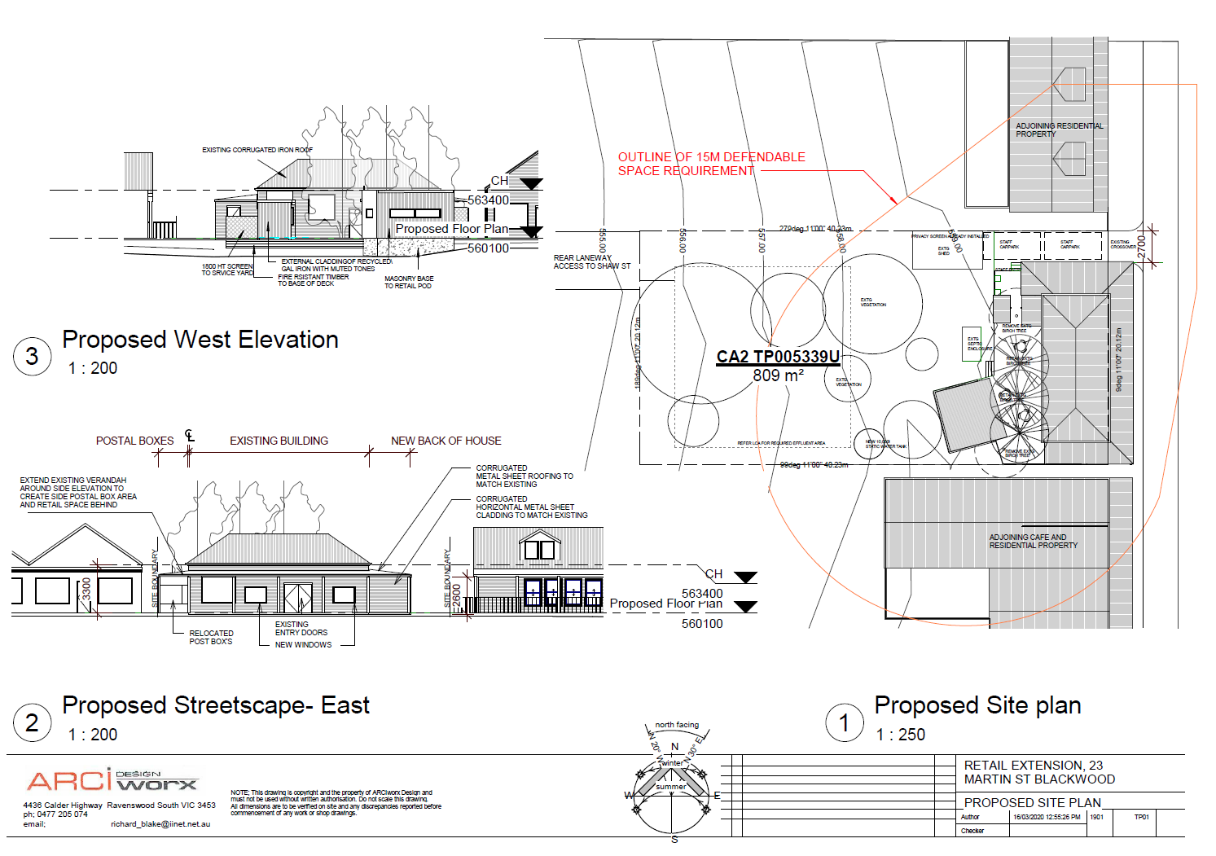
Figure 1: Proposed site plan, roof plan and elevations.
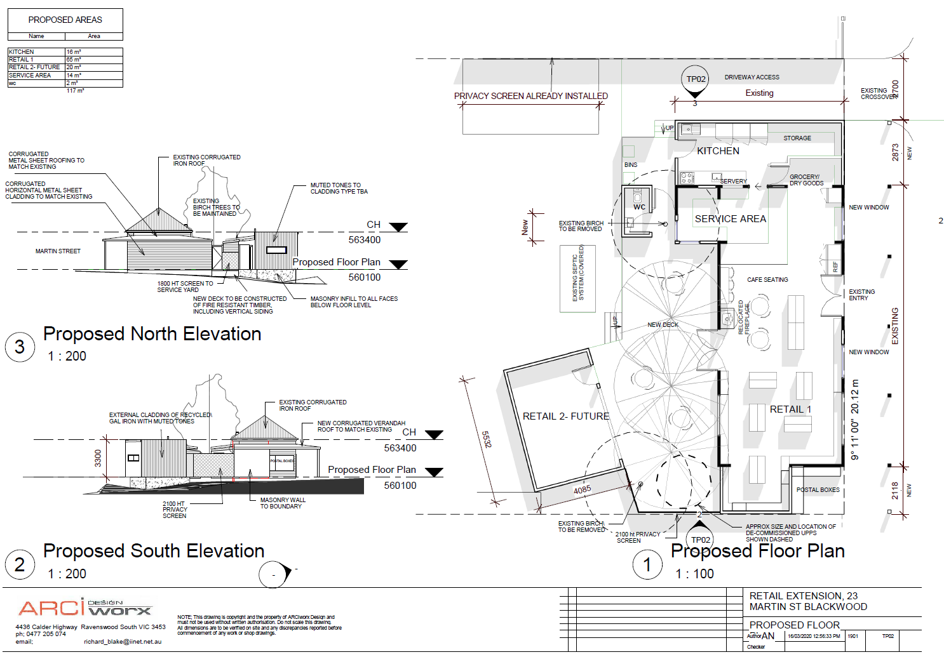
Figure 2: Proposed floor plan and elevations

Background to Current Proposal
See ‘History’ below.

History
Planning permit PA2015131 for Use of an Existing Building as a Post Office (with Ancillary Retail Component) and Business Identification Signage was issued by Council on 27 September 2017. Condition 1 plans were required to be endorsed but were never submitted to Council. The property was subsequently sold in late 2017 to the current proprietors who, in addition to the permitted use, have been operating an expanded retail offering and takeaway food premises and associated buildings and works, which the current amendment application seeks to bring into compliance with the Moorabool Planning Scheme.

Public Notice
Notice of the application was given to adjoining and surrounding landowners and occupiers. Two objections were received but the proposal was amended in part to address the objector concerns and the objections subsequently withdrawn. The application received 15 submissions in support of the application.

Locality Map
The map below indicates the location of the subject site and the zoning of the surrounding area.
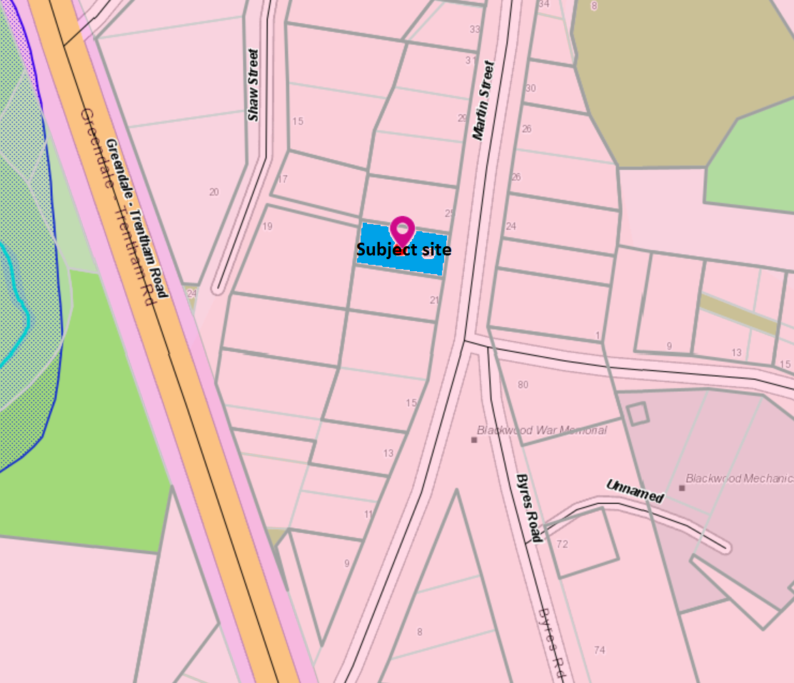
Figure 3: Zone map
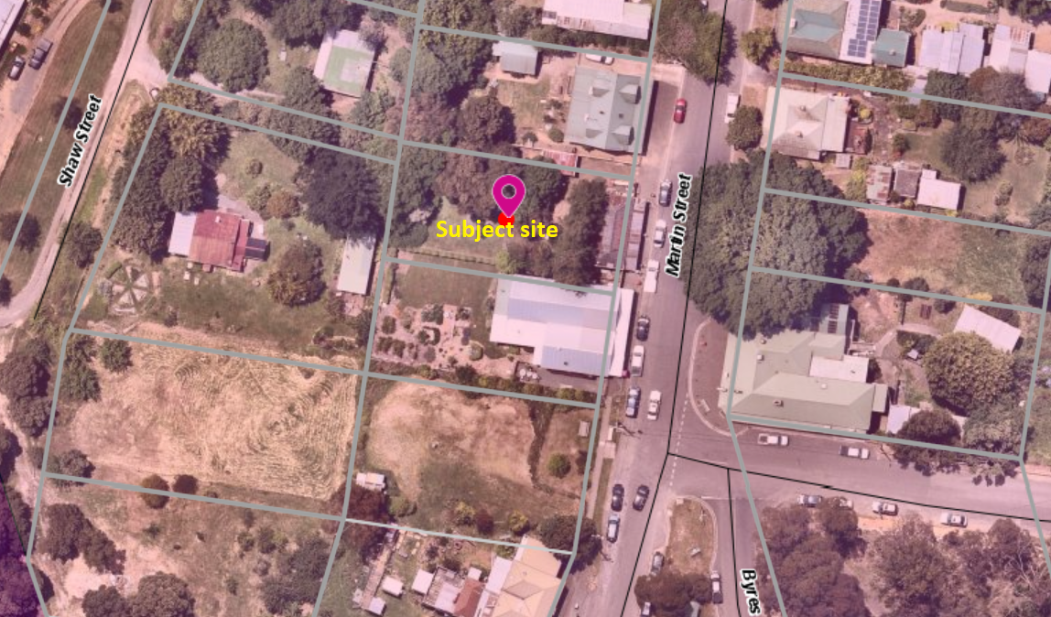
Figure 4: Aerial photograph

Planning Scheme Provisions
Council is required to consider the Victoria Planning Provisions and give particular attention to the Planning Policy Framework (PPF), the Local Planning Policy Framework (LPPF) and the Municipal Strategic Statement (MSS).
The relevant clauses are:
• Clause 11.03-3S Peri-urban areas
• Clause 13.02-1S Bushfire planning
• Clause 13.07-1S Land use compatibility
• Clause 14.02-1S Catchment planning and management
• Clause 14.02-2S Water quality
• Clause 15.01-2S Building design
• Clause 15.01-5S Neighbourhood character
• Clause 17.02-1S Business
• Clause 21.02-3 Water and catchment management
• Clause 21.03-4 Landscape and neighbourhood character
• Clause 21.03-5 Small town development
• Clause 21.09 Small Towns and Settlements
• Clause 22.02 Special Water Supply Catchments
Subject to conditions, the proposal is generally consistent with the relevant sections of the PPF and LPPF.

Zone
The subject site is in the Township Zone (TZ). The purpose of the TZ is:
• To implement the Municipal Planning Strategy and the Planning Policy Framework.
• To provide for residential development and a range of commercial, industrial and other uses in small towns.
• To encourage development that respects the neighbourhood character of the area. To allow educational, recreational, religious, community and a limited range of other non-residential uses to serve local community needs in appropriate locations.
Under Clause 32.05-2, the proposed new uses for a café and shop are Section 2 uses which require a permit and under Clause 32.05-10 a permit is required for the associated buildings and works.
Overall, the proposal is generally consistent with the purpose of the TZ taking account of the applicable decision guidelines under Clause 32.05-13.

Overlays
The site is affected by the following overlays: Environmental Significance Overlay, Schedule 1 (ESO1), Vegetation Protection Overlay, Schedule 1 (VPO1), Design and Development Overlay, Schedule 2 (DDO2) and Bushfire Management Overlay (BMO).
Under Clause 42.01-2 (ESO) a permit is required to construct buildings and works and remove vegetation. There are no relevant exemptions under Schedule 1.
Subject to conditions, the proposal would be generally consistent with the ESO1 provisions. Western Water and Southern Rural Water, the relevant catchment authorities, were notified of the application and have no objections, subject to conditions.
Under Clause 42.02-2 a permit is required to remove, destroy or lop vegetation specified in Schedule 1, which relates only to native vegetation. In this instance a permit is not required.
Under Clause 43.02-2 (DDO2) a permit is required to construct buildings and works. Under Schedule 2 there is an exemption for use of non-reflective building cladding. In this instance a permit is not required.
Under Clause 44.06-2 (BMO) a permit is required to construct buildings and works associated with a retail premises.
Subject to conditions, the proposal would be generally consistent with the BMO provisions. Country Fire Authority, being the relevant fire authority, was notified of the application and has no objection, subject to conditions.

Relevant Policies
There are no Council policies applicable to this application.

Particular Provisions
Clause 52.06 Car Parking
A total of 11 car spaces are required for the proposal. Under Clause 52.06-5, a postal agency and a shop each require four car spaces per 100sqm of leasable floor area.
A café is not a defined use in the Victoria Planning Provisions but is similar to a restaurant which is listed under this clause as requiring 0.4 spaces per seated patron.
The internal floor area would be 115sqm, with the deck providing additional floor space for café patrons. Given the mix of uses proposed to occupy the premises and differing rates of parking required, the following is noted:
• Most, but not all, of the internal floor space would be dedicated to the postal agency and shop, with only the kitchen and some café seating occupying this space. Based on a calculation of the internal floor space area this equates to three car spaces for the postal agency and shop combined.
• 20 patron seats inside and outside are proposed for the café which, based on the abovementioned restaurant rate, equates to eight car spaces.
• Two existing car spaces are provided in a tandem arrangement in the north side setback, however their proposed 2.7m width does not meet the 3.2m width specified for car spaces constrained by buildings or fences. The useability of these spaces is compromised, therefore the applicant proposes to replace these car spaces with two tandem spaces accessible from Shaw Street via a laneway adjoining the rear of the site. This arrangement is considered acceptable.
Clause 52.34 Bicycle Facilities
The proposed floor area does not meet the minimum thresholds under Clause 52.34-5 for the provision of bicycle parking or cyclist facilities.
Clause 53.02 Bushfire Planning
Clause 53.02-4 applies to this application.

Discussion
Overall, the proposed amendment to the planning permit is generally consistent with relevant state and local planning policy, the Township Zone, applicable Overlays and Particular Provisions and the decision guidelines at Clause 65.01 of the Moorabool Planning Scheme.
The proposal to expand the range of uses, and construct the associated development, would support commercial activity in Blackwood on a scale appropriate to the site and serve both the local community and visitors. The proposed uses are generally complementary to the existing postal agency and to existing commercial and community uses nearby. The proposed development respects the form, scale and appearance of the host building and the streetscape and is generally in keeping with the surrounding neighbourhood character. The existing verandah over the adjoining public footpath would be extended in line with the existing verandah and proposed building extension which would also improve pedestrian amenity. The proposed removal of two trees at the rear of the existing building would not detrimentally impact on the character of the area, noting the presence of other large established trees on the site and adjoining properties ensuring the landscape character would be maintained.
The amenity of adjoining and nearby residents would not be detrimentally affected, and the applicant has modified the proposal to resolve previous concerns raised by neighbours. The existing single storey built form would be maintained, limiting overlooking and overshadowing and maintaining acceptable solar access, and noise and other emissions would be limited to an acceptable extent, subject to conditions.
The site and surrounding land is in a Special Water Supply Catchment and is unsewered. The applicant submitted a Land Capability Assessment in support of the proposed expansion of the premises and the application was referred to the relevant water boards and Council’s Environmental Health Officer. Conditional consent was given, subject to which there would be no detriment to potable water quality or supply.
The subject site is within a Bushfire Management Overlay and accordingly due to the expansion of retail activity proposed a Bushfire Management Statement was submitted by the applicant and referred to the CFA. All approved or allowable alternate measures under Clause 53.02-4 are met and CFA consent to the proposal, subject to conditions including that a Bushfire Management Plan be submitted for endorsement.
The proposed reduction of car parking is considered acceptable for the following reasons:
• Parking provision for customers on the site is impractical due to the constraints imposed by the building footprint and established trees which contribute to the character of the township.
• The site is within the core of Blackwood’s small commercial area with associated amenities and proposes multiple functions on the premises which would be likely to generate multi-purpose trips, resulting in reduced car trips to the site.
• The site is within walking distance of numerous dwellings and accessible to a local pedestrian catchment.
• The postal agency serves a community function and the applicant advises that its viability relies on the proposed additional retail activities.
The West Moorabool Heritage Study Stage 2A (‘the Study’), adopted by Council in September 2017, identifies the subject site as part of the Martin Street Heritage Precinct (‘the precinct’). The precinct is a legacy of the commercial hub of an area formerly known as Red Hill, established in 1855 at the height of the gold rush, with surviving building fabric dating from between 1868 and c.1910, including the subject site. The precinct is historically significant for its associations with the rise and decline of the Blackwood goldfields district from 1855, and particularly the evolution and development of the commercial hub from late 1860s and early 1870s. The building on the subject site dates from the early 20th century. The front verandah is substantially unchanged, and whilst the building has been compromised by alterations to the front and north side façades the original character and appearance is readily apparent. The Study recommends the site and precinct’s inclusion in a future Heritage Overlay in the Moorabool Planning Scheme, which would be subject to a future planning scheme amendment.
The application was referred to Council’s Heritage Advisor who raised concerns with aspects of the proposed design. In particular, the heritage advice required:
• Set back the proposed northern extension from the street to behind the existing building’s roof pitch and in line with the main rear wall of the existing building.
• Retain the front verandah above the Martin Street footpath in its current form with no extensions.
• Minimise the roof coverage above the post boxes using a lightweight material.
• Use unobtrusive external wall and roof cladding such as weatherboards and galvanised iron.
The proposed changes outlined above would ensure that the existing building’s heritage features are appropriately maintained and distinguishable from any new substantial alterations or additions. Unless the recommended design changes are made, the proposal is in its current form would compromise not only the building’s heritage fabric and significance but likely also that of the precinct. The negative impact on the site and precinct’s heritage significance may also compromise the potential for Blackwood’s inclusion within a region of possible world heritage significance associated with Victoria’s historic gold rush. The proposed changes on heritage grounds can be resolved through a new condition 1 requirement for amended plans.
The proposed increase in opening hours, in particular on weekends, is supported and it is not considered that there would be any unreasonable amenity impacts considering the nature of the proposed use. Utilising on-street parking for loading and unloading of goods for delivery to the premises is considered reasonable, noting the site constraints, the scale of the proposed use, types of goods being delivered, demand for on street parking and traffic flows in Martin Street.

General Provisions
Clause 65 – Decision Guidelines have been considered by officers in evaluating this application.
Clause 66 – Stipulates all the relevant referral authorities to which the application must be referred.

Referrals
Authority | Response
Western Water  Southern Rural Water  CFA | Consent with conditions  Consent with conditions  Consent with conditions
Infrastructure  Environmental Health | Consent with conditions  Consent with conditions

Financial Implications
There are no financial implications for Council in approving this amendment application.

Risk & Occupational Health & Safety Issues
The recommendation to approve this amendment application does not have any risk or OH&S implications for Council.

Communications Strategy
Notice was undertaken for the application, in accordance with s.52 of the Planning and Environment Act 1987, and further correspondence is required to all interested parties to the application as a result of a decision in this matter. The applicant was invited to attend this meeting and address Council if required.

Options
• Issue an Amendment to the Planning Permit in accordance with the conditions in the recommendation of this report; or
• issue an Amendment to the Planning Permit with further amendments to the conditions in the recommendation of this report; or
• should Council wish to refuse the application, issue a Refusal to Grant an Amended Permit on relevant grounds. This option may result in the applicant appealing Council’s decision at VCAT.

Conclusion
Subject to conditions, the proposal is generally in accordance with relevant planning policies. The proposed expansion of the premises to provide additional retail activity would contribute to the local economy and amenity of residents and visitors to Blackwood. Subject to conditions, there would be no detrimental amenity or environmental impacts. Further changes to the plans as recommended by Council’s Heritage Adviser would protect the site’s heritage features. It is recommended the amendment by supported.

Ms. Marnie Campbell addressed Council as a supporter to the recommendation associated with Item 7.3.

Mr. Dale Wright addressed Council as a supporter to the recommendation associated with Item 7.3.

7.3 PA2020105 - 629 Mount Doran Road, Mount Doran - Variation of a Restrictive Covenant to move and enlarge the building envelope
Author: Victoria Mack, Statutory Planner
Authoriser: Henry Bezuidenhout, Executive Manager Community Planning & Economic Development
Attachments: Nil

Application Summary
Permit No: PA2020105
Lodgement Date: 5 June 2020
Planning Officer: Victoria Mack
Address of the land: 629 Mount Doran Road, Mount Doran
Lot 6 on PS 803476W
Proposal: Variation of a Restrictive Covenant to move and enlarge the building envelope
Lot size: 4.568ha
Why is a permit required? Clause 52.02 - Under Section 23 of the Subdivision Act 1988 to create, vary or remove an easement or restriction

Committee Resolution
Moved: Cr Paul Tatchell
Seconded: Cr Tonia Dudzik
That the Development Assessment Committee, having considered all matters as prescribed by the Planning and Environment Act 1987, advise VCAT it would not support PA2020105 for a Variation of a Restrictive Covenant to move and enlarge the building envelope at 629 Mount Doran Road, otherwise known as Lot 6 on PS 803476W on the following grounds:
1. The building envelopes were located on each of the lots in the subdivision to enhance rural residential amenity and the separation of dwellings from each other approved under Planning Permit PA2016255, and it is not considered that moving the building envelope is consistent with this intent.
2. The proposal does not support the orderly planning of the area.
Carried

Public Consultation
Was the application advertised? | Yes.
Notices on site: | Yes.
Notice in Moorabool Newspaper: | Yes.
Number of objections: | Eight.
Consultation meeting: | Not held; several discussions with one objector by phone.

Policy Implications
The Council Plan 2017-2021 provides as follows:
Strategic Objective 2: Minimising Environmental Impact
Context 2B: Natural Environment
The proposal is not provided for in the Council Plan 2017-2021 and can be actioned by utilising existing resources.

Victorian Charter of Human Rights & Responsibilities Act 2006
In developing this report to Council, the officer considered whether the subject matter raised any human rights issues. In particular, whether the scope of any human right established by the Victorian Charter of Human Rights and Responsibilities is in any way limited, restricted or interfered with by the recommendations contained in the report. It is considered that the subject matter does not raise any human rights issues.

Officer’s Declaration of Conflict of Interests
Under section 130 of the Local Government Act 2020, officers providing advice to Council must disclose any interests, including the type of interest.
Executive Manager – Henry Bezuidenhout
In providing this advice to Council as the Executive Manager, I have no interests to disclose in this report.
Author – Victoria Mack
In providing this advice to Council as the Author, I have no interests to disclose in this report.

Executive Summary
Application referred? | Yes, to Country Fire Authority (CFA).
Any issues raised in referral responses? | Yes, the CFA requested that the application and documents were clarified. They requested an amended Bushfire Management Plan.
Preliminary concerns? | Moving the building envelope would require all restrictive covenants registered on title to be amended if the application was approved.

Any discussions with applicant regarding concerns? | Yes, the applicant agreed to provide amended restrictive covenants to be registered on title if the application was approved.
Any changes made to the application since being lodged? | A Bushfire Management Plan was provided with an amended building envelope as requested by the CFA.
Brief history. | The site was vacant land and generally used for farming in the Rural Living Zone prior to an 11 lot staged subdivision.  The applicant has lodged an appeal for a failure to determine the application within the prescribed time. The VCAT appeal date is set for 16 September 2021.
Previous applications for the site? | PA2016255 being for an 11 lot staged subdivision issued on 4 June 2017.
General summary. | The application is to move and enlarge a building envelope restriction registered on the title to Lot 6 of this subdivision.  There are 11 lots in the subdivision all of which, bar Lot 3, are beneficiaries of the restriction and also burdened by it.  The application received eight objections all of which are beneficiaries of the restriction.  Enlargement of the building envelope is not the major issue with this application but changing the location does not accord with the original intention of the building envelope on each of the lots.  The building envelopes were located to prevent dwellings being constructed too close to each other, to enhance the rural amenity and residential privacy, for native vegetation protection and to protect landscape values.  Moving the building envelope on the subject site would significantly detract from this intention.  It is recommended that the application is refused.
Summary of Officer’s Recommendation
That, having considered all relevant matters as required by the Planning and Environment Act 1987, Council advises VCAT that it would not support the application for a Variation of a Restrictive Covenant to move and enlarge the building envelope on land at 629 Mount Doran Road, Mount Doran otherwise known as Lot 6 on PS 803476W.

Site Description
The site is Lot 6 of an 11 lot staged subdivision PA2016255 approved on 4 June 2017. It is vacant land with an area of 4.568ha and is approximately square in shape. The land is zoned Rural Living.
The land is undulating and predominantly cleared with a large dam located in the northeast corner of the site which contains a waterway running north to south. The land on the west side of the dam is elevated compared to the balance of the property. There are patches of native vegetation located in the north west corner, along the west boundary, along the east boundary and two patches of native vegetation within the site.
The land has access from Mount Doran Road on the eastern boundary. It is located approximately 3.9km south east of the Lal Lal township.
The location of the existing building envelope is in an area that is lower in the landscape than the proposed relocated building envelope.
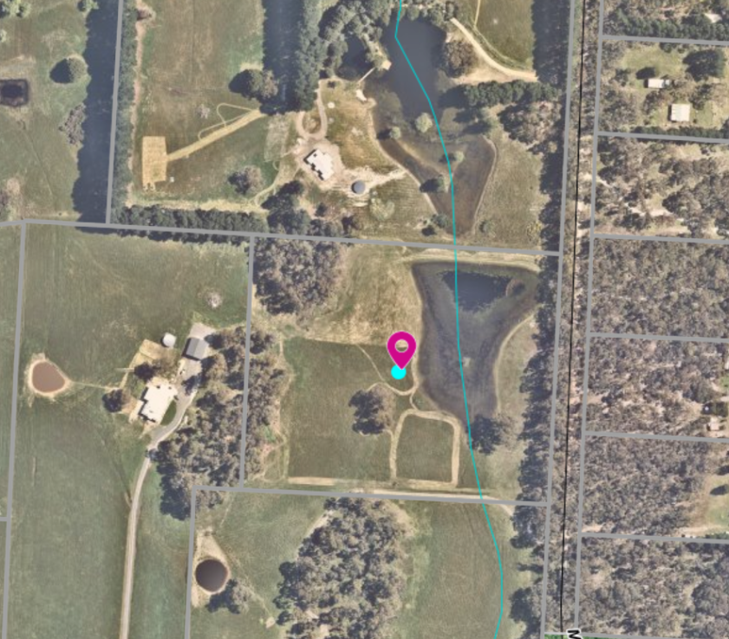
Subject site
Figure 1: Aerial photo of the site
Figure 2 below shows the plan of subdivision for the 11 lots, the building envelopes for each and the surrounding defendable space envelope.
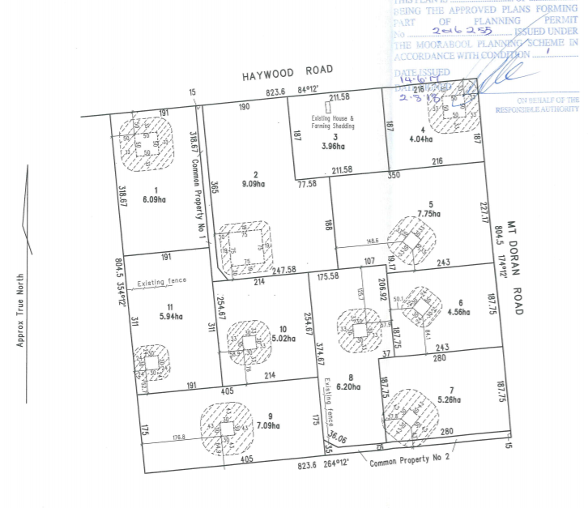
Subject site
Figure 2: Building envelopes on the 11 lot subdivision approved by PA2016255

Proposal
The application requests that the building envelope is moved approximately 50m to the north east and enlarged.
Figure 3 below shows:
1. The existing envelope marked in pink with dimensions 30m x 30m which is in a “valley” or hollow that is lower in the landscape than the proposed building envelope marked in orange with dimensions 30m x 50m.
2. The relocation of the building envelope is requested to provide the owners:
(a) improved surveillance of the whole of the property and improved view of the dam.
(b) Move the dwelling site out of a depression, or hollow, which is a wetter area, part of a drainage line to the dam and less suitable for a dwelling.

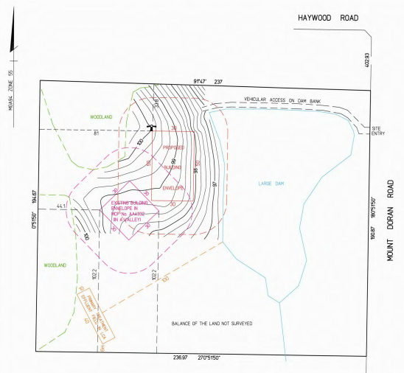
Existing building envelope (pink) surrounded by defendable space envelope
Proposed building envelope (orange)
surrounded by defendable space envelope
Figure 3: Existing and proposed change to the building envelope
3. The application, if approved, would require the following restrictions that are registered on title to be amended:
(a) Covenant PS803476W registered on title on 12 October 2018
The description of the restriction applies to all lots in the subdivision except Lot 3. The relevant clause states that:
‘Except with the written consent of the registered proprietors and in all other instances with the consent of each and every registered proprietor of the benefiting Lot on Plan of Subdivision the registered proprietor or proprietors for the time being of any burdened Lot on the Plan of Subdivision shall not:
1.7 allow buildings to be constructed outside the building envelopes shown hatched on MCP No AA4332.

The MCP No AA4332 is a Memorandum of Common Provisions and which is dated 29 August 2018 and states:
Building Envelope Any building on the lots contained within plan of subdivision PS803476W must be contained within the building envelopes shown on the attached plan and defined by the associated setback profiles. the building envelopes are part of the planning permit No. PA2016255, issued by Moorabool Shire Council on 9 August 2017, being created as a condition of that permit.’
(b) Section 173 Agreement AR434458K registered on 10 September 2018
The agreement relates to storm water management and bushfire mitigation measures.
The agreement includes a Bushfire Management Plan as an annexure to the agreement which shows the building envelopes on the Plan of Subdivision. The relevant part of the agreement states that:
‘the Owner acknowledges and agrees that the Bushfire Management Plan must not be altered unless with the prior written consent of Council and the CFA.’

History
Council determined PA2016255 at its Development Assessment Committee (DAC) n 14 June 2017 and decided to issue a Notice of Decision to grant a permit for 11 lot subdivision for the parent property known as 82 Haywood Road, Lal Lal. The permit was issued on 8 August 2017. All the lots have been sold with the exception of Lot 3 which is still owned by the developer/owners of the original subdivision.
The current applicant has lodged an appeal for a failure to determine the application within the prescribed time on 3 March 2021. The VCT appeal date is set for 16 September 2021. Council is required to notify VCAT of its position.

Public Notice
The application was notified to adjoining and surrounding landowners including the former owners and developers of the land who remain the owners of Lot 3 and are named in the restrictive covenant. Eight objections were received. No objection was received from the original owners and developers of the land.

Summary of Objections
The objections received are detailed below with officer’s comments accompanying them:
Objection | Any Relevant Requirement
The restrictive covenants imposed on this subdivision were to ensure that each property would not overlook any others in the subdivision. Other purchasers of these properties have adhered to these restrictions.  The purchasers of this land were well aware of the restrictions on this land and if it was not suited to their purpose, they should not have purchased it in the first place. They should comply with the original building envelope as have all other owners within this sub-division.  Three similar comments. | Restrictive covenant, MCP and Bushfire Management Plan all registered on title.
Officer’s Response: The original Council Report for PA2016255 noted that the building envelopes were located across the 11 lots with the intention of separating dwellings from each other to enhance amenity and protect native vegetation and landscape values.
The building envelope has also been increased in size by 600sqm from 900sqm to 1,500sqm which implies that the owners wish to build a much larger structure than was originally intended by the original building envelope.  Two similar comments. | Building envelope registered on title.
Officer’s Response: Of the 11 lots one lot has an existing dwelling, there is one building envelope of 5,625sqm on Lot 2, two building envelopes each of 1,000sqm on Lots 1 and 4, with the balance of the lots having building envelopes of 900sqm. The size of the building envelope is not necessarily the issue, so much as its location.
We are sure that a lot of thought and design went into the original layout of this subdivision and the reasons for restricting construction to those envelopes were genuine and legitimate.  Three similar comments. | Building envelopes registered on title.
Officer’s Response: The building envelope locations were specifically designed to avoid dwellings being constructed close to each other, and to protect rural amenity, native vegetation and landscape values. Moving the building envelope to the north east, as requested, would have a direct impact on the amenity of the adjoining landowner to the north on Lot 5, where each dwelling would come into full view of the other. This was not the intention of the developers when they selected the building envelope locations.
Approval would create a legal precedent for current, and/or future owners within PS803476W to further amend the Restrictive Covenant for this, and a variety of other reasons.  Three similar comments. | Clause 52.02 Easements, restrictions, and reserves
Officer’s Response: An application to vary the restriction would require a planning permit.
Changes to the restrictive covenant require the approval of the owners of all lots.
Officer’s Response: All lots in this subdivision are burdened and also benefit from the Restrictive Covenant PS803476W and MCP No. AA4332 except for Lot 3. Enforcement of a covenant is not a Council responsibility, however, an application to vary a covenant does involve Council through the planning permit process. The view of beneficiaries of the restrictions must be considered to have weight in such an application.

The applicant’s building envelope is located on the other side of a hill on our shared boundary. As a result of this careful placement, future development on the lot would not be visible from our lot. The proposed amendment would move the applicants building envelope onto the top of the hill on our shared boundary. Not only has the elevation increased substantially, the building envelope has moved considerably closer to our shared boundary. As a result, any future development would become highly visible from our lot. We purchased our lot, safe in the knowledge that our bush views could not be compromised by future development. | Restrictive covenant, MCP and Bushfire Management plan all registered on title.
Officer’s Response: A site visit showed that the proposed building envelope location would enable a dwelling to be in line of site from the neighbouring dwelling that has been constructed on Lot 5.
The applicant’s building envelope is behind a hill. The proposed amendment would allow future developments to be constructed on top of a hill on our shared boundary. The proposed location of the new building envelope would allow the applicant to remove vegetation from a woodland on our shared boundary (and the boundary with Lot 9) as part of their amended bushfire management plan as shown on the amended plan. | Clause 52.12-5 Exemption to create defendable space for a dwelling under Clause 44.06 of this planning scheme
Officer’s Response: The relocated defendable space envelope as shown on the amended Bushfire Management Plan would permit any native vegetation within that envelope to be removed without a permit. A small area of vegetation would be potentially impacted if the envelope was moved.
The building envelopes were selected to provide privacy to all lot owners – changing the building envelope is a huge privacy issue and detrimental to the rural setting.  One similar comment. | PA2016255: 11 lot subdivision
Officer’s Response: The original Council Report for the subdivision indicated that the building envelopes were located to keep dwellings separate from each other and to protect rural amenity, native vegetation and landscape values.

Locality Map
The map below indicates the location of the subject site and the zoning of the surrounding area.
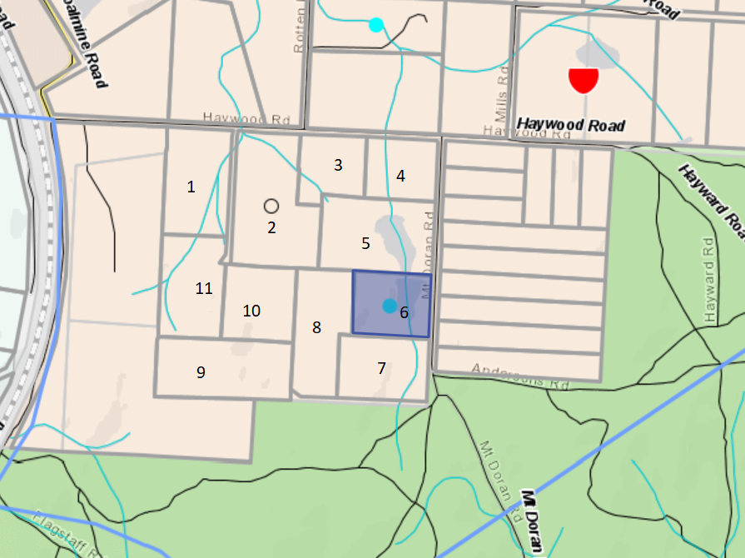
Subject site
Figure 4: Zoning map

Planning Scheme Provisions
Council is required to consider the Victoria Planning Provisions and give particular attention to the Planning Policy Framework (PPF), the Local Planning Policy Framework (LPPF) and the Municipal Strategic Statement (MSS).
The relevant clauses are:
• Clause 15.01-5S Neighbourhood character
• Clause 15.01-6S Design for rural areas
• Clause 21.03-4 Objective—Landscape and neighbourhood character
• Clause 21.03-6 Objective—Rural lifestyle opportunities

The proposal does not demonstrate compliance with the relevant sections of the PPF and LPPF outlined in the table below:
PPF | Title | Response
Clause 15.01-5S | Neighbourhood character | Objective: To recognise, support and protect neighbourhood character, cultural identity, and sense of place.  The character of the immediate area has been shaped by the location of the building envelopes on each of the 11 lots. The objective was to ensure dwellings were discreetly screened from each other for increased privacy and enhanced rural amenity.
Clause 15.01-6S | Design for rural areas | Objective: To ensure development respects valued areas of rural character.  This application is not for development but, if approved, would enable a future development application to site a dwelling where the privacy and rural amenity is compromised.
LPPF
Clause 21.03-4 | Landscape and neighbourhood character | To ensure new development in all zones respects the existing character, landscape setting and amenity of the local area.  It is considered, if approved, that the application would not respect the existing character or landscape setting envisaged by the original designers of the subdivision and secured by a restrictive covenant.

Zone
Rural Living Zone
In accordance with Clause 35.03 of the Moorabool Planning Scheme a permit is not required to vary a restriction.

Overlays

Bushfire Management Overlay
In accordance with Clause 44.06 of the Moorabool Planning Scheme a permit is not required to vary a restriction.

Environmental Significance Overlay, Schedule 1
In accordance with Clause 42.01 and Schedule 1 of the Moorabool Planning Scheme a permit is not required to vary a restriction.

Design and Development Overlay, Schedule 2
In accordance with Clause 43.02 of the Moorabool Planning Scheme a permit is not required to vary a restriction.

Relevant Policies
There is no relevant policy in relation to this application to vary a restriction.

Particular Provisions
Clause 52.02 Easements, restrictions, and reserves
Under Section 23 of the Subdivision Act 1988 a permit is required to vary a restriction registered on title.

Discussion
The lot was created as part of an 11 lot subdivision approved by PA2016255 in June 2017. Building envelopes were added to each lot to ensure dwellings were not located too close together for resident privacy, to protect native vegetation and landscape values.
The application requests that the restrictions registered on title are amended to allow for the building envelope to be moved approximately 50m to the north east and enlarged from 900sqm to 1,500sqm. The amended location would elevate a dwelling to a prominent part of the landscape where it would not be screened by trees or topography from the neighbouring dwelling. The application has failed to acknowledge the site constraints of a relocated building envelope in an exposed location that would be visible from adjacent dwellings.
The original Council Report for the subdivision stated that:
‘The building envelopes proposed by the applicant are designed to ensure the dwellings are well separated from each other and do not impact existing vegetation and natural features.’
The assessment section of the Council Report expanded on the use of the building envelopes as follows:
“Typically, on large rural living zoned properties, building envelopes are not required. The applicant has purposefully decided to ensure the amenity of new residents is not negatively impacted upon with poor dwelling siting or dwellings located too close together.
This has led to a scattered building envelope arrangement which has also been designed to retain existing landscape features. There will be a requirement for the submission of revised plans to show all existing trees to be retained as this provides for some screening of dwellings especially when viewed from the existing residences in Mt Doran Road”.
The location of building envelopes on each of the 11 lots was specifically designed to protect the amenity of new residents and prevent the siting of dwellings too close together. It is understood that the building envelope locations were carefully considered to achieve this objective.
This application does not respect this intent and, if approved, would allow a future dwelling to be constructed in clear view of other dwellings and particularly a newly constructed dwelling to the north on Lot 5. It is considered that this is an unacceptable outcome for the dwelling on Lot 5. Even a single storey dwelling on the subject lot would be prominent on this elevated site compared to the site of the current building envelope. The reasons provided for the amended location include improved surveillance of the whole of the property, views of the dam and that the current site was wetter as part of a drainage line to the dam.
The application was advertised with eight objections received. A strong theme in objector comments was that the building envelope restrictions were clear to all purchasers of the lots in the sales documentation. The Purchasers were aware of the restrictions on this land and they should comply with them, as have all other landowners within the sub-division.
It is considered that the objector’s concerns have weight.
Section 60(2) of the Planning and Environment Act 1987 states that:
The responsible authority must not grant a permit which allows the removal or variation of a restriction (within the meaning of the Subdivision Act 1988 ) unless it is satisfied that the owner of any land benefited by the restriction (other than an owner who, before or after the making of the application for the permit but not more than three months before its making, has consented in writing to the grant of the permit) will be unlikely to suffer:
(a) financial loss; or
(b) loss of amenity; or
(c) loss arising from change to the character of the neighbourhood; or
(d) any other material detriment—
as a consequence of the removal or variation of the restriction.
It is considered that if approved the variation to the restriction would create a loss of amenity to neighbours who would have purchased the land understanding that the building envelopes were registered restrictions on title.
The application was referred to the Country Fire Authority who consented to the application subject to one condition that an amended Bushfire Management Plan (BMP) is endorsed and forms part of the permit. However, it is noted that if this application was approved, an amended BMP would need to be registered on title which would require the Section 173 Agreement to be amended.
The purchaser of the subject lot would have known of the building envelope restriction at the time of purchase. Due to the objections relating to loss of amenity from other beneficiaries of the restriction it is considered that the application should be recommended for refusal.
General Provisions
Clause 65 – Decision Guidelines have been considered by officers in evaluating this application.
Clause 66 – Stipulates all the relevant referral authorities to which the application must be referred.

Referrals
Authority | Response
CFA | Consent with one condition

The CFA condition required that:
1. Bushfire Management Plan
The Bushfire Management Plan prepared by Timothy J Steele, Steele Surveying Pty Ltd (for 629 Mount Doran Road, Lal Lal (Lot 6, PS803476W) – Version No: 1, dated 22 September 2020) must be endorsed to form part of the permit and must not be altered unless otherwise agreed in writing by the CFA and the Responsible Authority.

Financial Implications
There is no financial implication associated with this refusal to grant a permit for a variation of a restriction.

Risk & Occupational Health & Safety Issues
The recommendation of approval of this development does not implicate any risk or OH&S issues to Council.

Communications Strategy
Notice was undertaken for the application, in accordance with s.52 of the Planning and Environment Act 1987, and further correspondence is required to all interested parties to the application as a result of a decision in this matter. All submitters and the applicant were invited to attend this meeting and invited to address Council if required.

Options
Council could consider the following options:
• Issue a refusal to grant a permit in accordance with the recommendations of this report; or
• issue a permit with conditions outside of the recommendations of this report.

Conclusion
The building envelope restrictions on each lot, except Lot 3 which has an existing dwelling, were designed to avoid dwellings being constructed too close to each other, to enhance rural amenity, privacy, protection of native vegetation and landscape values. The proposed new location of the building envelope on Lot 6 does not achieve these objectives and if approved a future dwelling site on this lot would create a loss of rural residential amenity which was not the intent of the original subdividers.

Mrs. Rachel Buehler addressed Council as a supporter to the recommendation associated with Item 7.4.

7.4 PA2019260 - Development of Three Dwellings at 46 McCullagh Street Bacchus Marsh
Author: Mark Lovell, Coordinator Statutory Planning
Authoriser: Henry Bezuidenhout, Executive Manager Community Planning & Economic Development
Attachments: 1. Floor Plans (under separate cover)
2. Elevations, Shadow Diagrams, Landscape Plan and Proposed Plan of Subdivision (under separate cover)

Application Summary
Permit No: PA2019260
Lodgement Date: 7 November 2019
Planning Officer: Mark Lovell
Address of the land: Lot 21 on PS442194S located at 46 McCullagh Street, Bacchus Marsh
Proposal: Development of Three Dwellings
Lot size: 1684.4sqm
Why is a permit required? General Residential Zone, Development of two or more dwellings on a lot

Committee Resolution
Moved: Cr Tonia Dudzik
Seconded: Cr Paul Tatchell
That the Development Assessment Committee, having considered all matters as prescribed by the Planning and Environment Act 1987, issue a Refusal to Grant a Planning permit for the Development of three dwellings at 46 McCullagh Street, Bacchus Marsh, otherwise known as Lot 21 on PS 442194S subject to the following grounds:
1. The proposed development does not respect the existing and preferred neighbourhood character characterised by generous open spaces and setbacks.
2. The proposed development does not comply the objectives of Clause 21.07 and does not represent modest housing growth characterised for Natural Residential Growth Areas.
3. The proposed three dwellings represent an over development of the site.
Carried

Public Consultation
Was the application advertised? | Yes.
Notices on site: | Yes.
Notice in Moorabool Newspaper: | No.
Number of objections: | Four objections, one objection was signed by six other neighbours.
Consultation meeting: | Held on 12 March 2020. Issues discussed but not a complete resolution.

Policy Implications
The Council Plan 2017-2021 provides as follows:
Strategic Objective 2: Minimising Environmental Impact
Context 2A: Built Environment
The proposal is not provided for in the Council Plan 2017-2021 and can be actioned by utilising existing resources.

Victorian Charter of Human Rights & Responsibilities Act 2006
In developing this report to Council, the officer considered whether the subject matter raised any human rights issues. In particular, whether the scope of any human right established by the Victorian Charter of Human Rights and Responsibilities is in any way limited, restricted or interfered with by the recommendations contained in the report. It is considered that the subject matter does not raise any human rights issues.

Officer’s Declaration of Conflict of Interests
Under section 130 of the Local Government Act 2020, officers providing advice to Council must disclose any interests, including the type of interest.
Executive Manager – Henry Bezuidenhout
In providing this advice to Council as the Executive Manager, I have no interests to disclose in this report.
Author – Mark Lovell
In providing this advice to Council as the Author, I have no interests to disclose in this report.

Executive Summary
Application referred? | Yes, to Council’s Infrastructure Department and the Department of Transport.
Any issues raised in referral responses? | Council’s Infrastructure requested a Stormwater Management Strategy in accordance with Clause 53.18 of the Moorabool Planning Scheme.

Preliminary concerns? | ResCode requirements and plan changes including bin and recycling enclosures, mailboxes, lighting along the driveway, and the location of air conditioning units.  The shadow diagrams were incorrectly labelled, and a landscape plan requested. The applicant was further advised of neighbourhood character concerns at the assessment stage.
Any discussions with applicant regarding concerns? | Yes, changes were made to the plans and a landscape plan was provided. There were no changes made with reference to the neighbourhood character concerns.
Any changes made to the application since being lodged? | Minor changes addressing the preliminary concerns and a Stormwater Management Plan was provided.
Brief history. | The land is vacant.
Previous applications for the site? | Nil.
General summary. | The land is an irregular shaped allotment with an area of 1,684.4sqm and slopes from the McCullagh Street frontage downwards to the north.  The dwellings will be constructed in tandem and have side open space areas and onsite car parking. There were no changes made with reference to the neighbourhood character concerns.  The proposal does not accord with the relevant policies of the Moorabool Planning Scheme and Clause 55, ResCode regarding neighbourhood character and is proposing a greater intensification of dwellings in area designated for Natural Residential Growth.  The proposed development is not site responsive to a generally intact streetscape with a distinctive open garden character.
Summary of Officer’s Recommendation
That, having considered all relevant matters as required by the Planning and Environment Act 1987, Council issue a Refusal to Grant a Planning permit for the development of three dwellings at 46 McCullagh Street, Bacchus Marsh, otherwise known as Lot 21 on PS 442194S subject to conditions.

Site Description
The irregular shaped site has an area of 1,684.4sqm and slopes from the McCullagh Street frontage down to the north boundary, from 153 AHD to 147 AHD, a fall of 6m over the site. The site is vacant and without any vegetation.
The site is located at the western end of McCullagh Street and the southern boundary wraps around a court bowl at the end of the street with a frontage width to the street of approximately 41m.

There is a vacant lot on the south-west side boundary. The north boundary abuts the newly constructed Western Freeway off ramp. The east side boundary contains a double storey dwelling on a lot with an area of approximately 1,600sqm. The surrounding area generally comprises single storey dwellings on a mix of lots sizes with a few undeveloped vacant lots in the immediate vicinity.
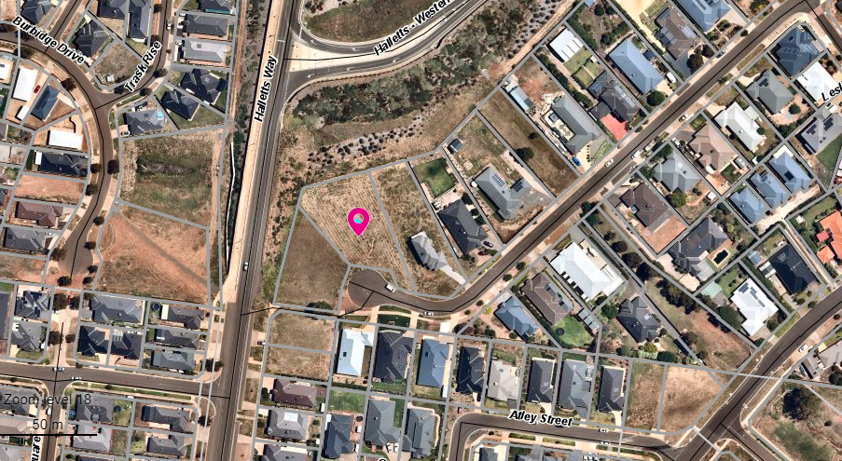
Figure 1: Aerial photograph
The land is within Neighbourhood Character Precinct 15 which is recommended for Natural Residential Growth with the exception of the north-east corner, 101 Gisborne Road, which is identified for Increased Residential Growth. The area is surrounded by large lot sizes and an open garden character (refer Precinct 15).

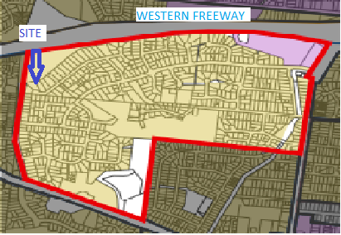
Figure 2: The boundaries of Neighbourhood Character Precinct 15 (south of Western Freeway, west of Gisborne Road, north of Main Street and east of Halletts Way)
McCullagh Street is located approximately 1.4km west of Gisborne Road via Clifton Drive and approximately 2.5km north-west of the Bacchus March township.
The nearest public bus service is located approximately 100m from the subject site via a dedicated pedestrian walkway to the west in Halletts Way.
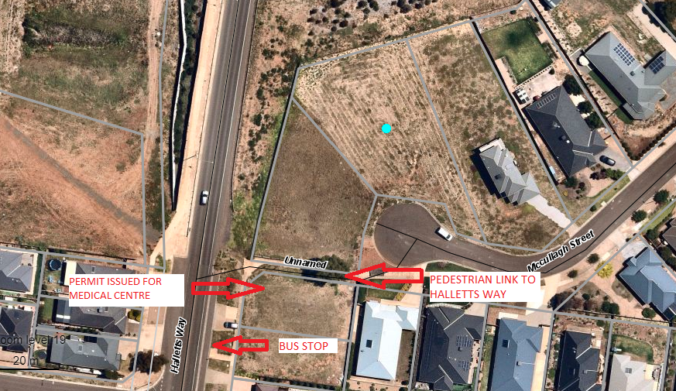
Figure 3: Proximity to services

Proposal
It is proposed to construct three dwellings on the lot. The applicant has submitted a proposed plan of subdivision to only demonstrate the total lot area and the extent of common property. The slope of the land requires a tiered development to be constructed down the slope to the northern boundary.
The dwellings would have the following specifications and details.
Dwelling 1 would be located at the front of the of the lot facing to McCullagh Street. Due to the slope of the land a basement and garage would be located under the residence. Dwelling 1 would have a total floor area, including living, porch, basement and garage, of 204.21sqm.
Dwelling 1 would contain three bedrooms, the master bedroom with ensuite, and a separate family bathroom. The front porch and entrance lead to an open plan kitchen, dining and living area. Steps down from the kitchen to the west would open onto a concreted area of private open space. Further steps from this area would lead down to additional private open space at the basement and garage level. The basement level would contain the laundry, a storage area and an attached two car space garage. The site for Dwelling 1 would require retaining walls, batters and steps. The total area of private open space for Dwelling 1 would be 129.86sqm.
Dwelling 2 and Dwelling 3 would be located on the north side of Dwelling 1 and lower on the site. Both dwellings would be constructed on a modest slope with cut and fill required in some sections. Each would contain three bedrooms, the master with ensuite, and a separate family bathroom. There would be an open plan kitchen, pantry, dining and living area with access from the front porch and an entrance hallway. Each would have a laundry and an attached two car-space garage with a rear roller door opening to the private open space. The dwellings would require retaining walls, batters and steps in some places.
Dwelling 2 would be provided with 98.6sqm of private open space made up of lawn, gravel and concreted areas. Dwelling 3 would be provided with 303.65sqm of private open space made up of lawn, gravel and concreted areas.
Overall development
All dwellings would be constructed with brick cladding, selected weatherboard (Dwelling 1) and stone and rendered features and they would have tiled roofing. The porches would have rendered columns. Colours would be a mixture of earth tones: dark and slate grey, brown and light brown.
There would be no front fencing.
A common property concrete driveway, with a minimum width of 3m, would provide vehicle access to the three dwellings.
The total site coverage would be 32.31%; total permeable area would be 40.41%; and the available garden areas would be at least 43.74%.
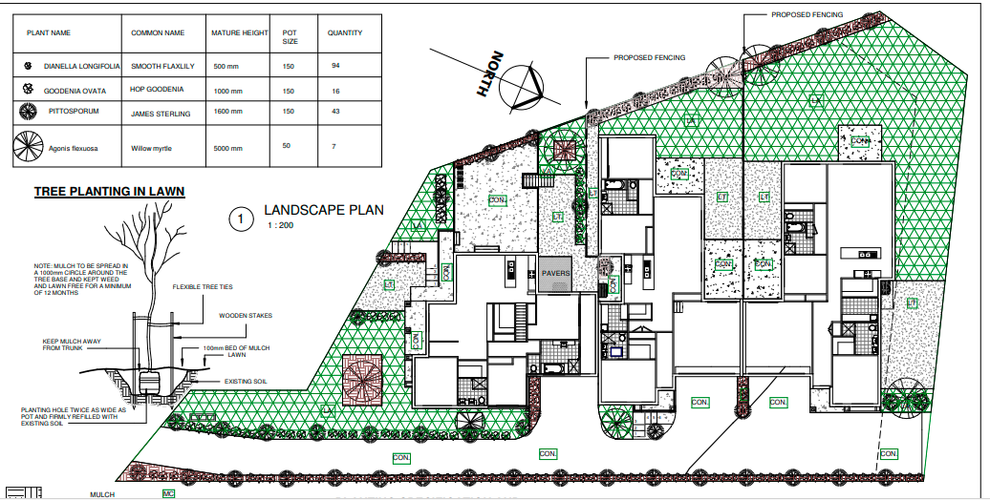
Figure 4: Landscape plan
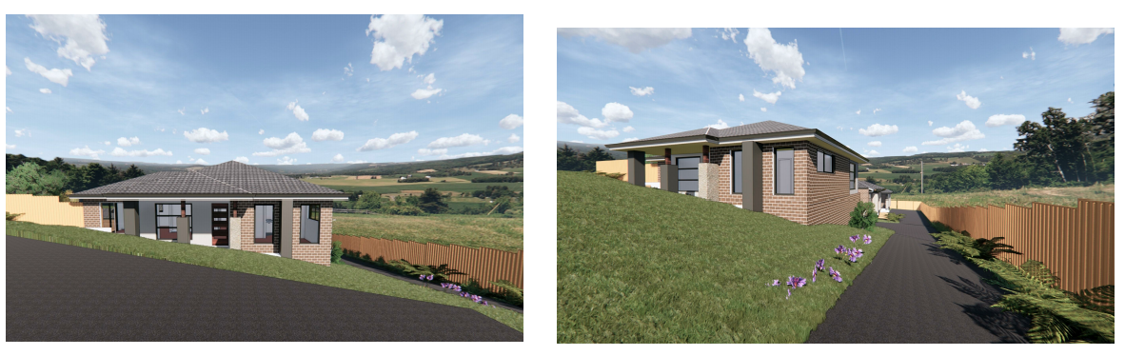
Figure 5: Photo representation of Dwelling 1

Background to Current Proposal
The land has been vacant since the lot was created in 2006.

History
The land has no relevant history.

Public Notice
The application was notified to adjoining and surrounding landowners and a sign was placed on the site for a minimum period of 14 days. Four objections were received from three households. One objection was signed by six other neighbouring landowners.

Summary of Objections
The objections received are detailed below with officer’s comments accompanying them:
Objection | Any Relevant Requirement
Objectors all raised concern about stormwater and drainage. The northern rear end of the site, and the rear of dwellings on the same side of the street to the east, have experienced flooding and drainage issues in the past with sheds inundated, fences damaged, and sewer pipes impacted especially on 14 December 2018.  They expressed the view that further development in the area will make matters worse, especially for the proposed northern dwelling. They claimed that drainage had become worse since the Western Freeway off ramp was completed, but also flooding from Halletts Way and from southern developments. | Infrastructure Design Manual
Officer’s Response: Council’s Infrastructure Department raised no specific concerns about drainage management in this area and was satisfied that the submitted Stormwater Management Plan would address drainage within the site. The site is not identified as subject to flooding on Melbourne Water’s flood mapping.
The site is not suitable for three dwellings. It is located on the court bowl with limited on street parking for visitors, and there is limited room for a garbage truck to turn if there are cars parked around the court bowl.  The proposed 5.5m x 6m garages are insufficient to adequately park two average vehicles. There will be increased on-street parking. Overflow street parking from residents will be compounded by visitor parking to these properties causing traffic congestion around the court resulting in more on-street parking outside other neighbouring properties.  There is a limited area for bin storage for collection in front of this site which will just add to the congestion of this area. | Requirement under ResCode and also the Infrastructure Design Manual.
Officer’s Response: The car parking provided on site meets the objectives and standards of Clause 55 ResCode of the Moorabool Planning Scheme. The garage dimensions comply with the minimum design standards under Clause 52.06. A concern is the court bowl roadway restricts the amount of on street visitor parking in McCullagh Street.

If this development is approved, it will create a precedent. We purchased in McCullagh Street because of the large lots with single owner-occupied dwellings, not rentals. The proposal does not accord with the neighbourhood character of the precinct at all. | Neighbourhood Character Precinct 15 and ResCode.
Officer’s Response: There are few undeveloped lots in McCullagh Street. Most are fully developed with single dwellings. This intact streetscape creates a distinctive neighbourhood character of generous open spaces and an open garden setting. Lots sizes are large which contributes to the openness of the streetscape. Approval of this proposal could adversely alter the preferred neighbourhood character and create significant smaller lots sizes not in keeping with the prevailing lot sizes for this immediate area.
The length of the proposed driveway will create issues as water will pour down it and add to the flood risk at the bottom. | Infrastructure Design Manual.
Officer’s Response: Council’s Infrastructure raised no specific concerns about stormwater in this area and was satisfied that the submitted Stormwater Management Plan would address drainage within the site. The development cannot discharge stormwater onto adjacent properties.
The proposed build is excessive, not in keeping with the other lots in the street and would set a precedent for the neighbouring vacant lot to also subdivide. What  should be a lot for one average house, with one average family, would be tripled. | Requirement under ResCode.
Officer’s Response: The proposed development does not meet the key objectives and standards of Clause 55 ResCode of the Moorabool Planning Scheme, such as neighbourhood character and detailed design.
We moved to Bacchus Marsh to get away from dense housing establishments. This will take away from the charm that Bacchus Marsh and McCullagh Street has shown us. We also feel that these premises will more than likely be rentals/investment properties leaving existing residents to deal with the impact that results. | Bacchus Marsh Housing Strategy.
Officer’s Response: The proposal does not represent modest change reflected by the intent of a Natural Residential Growth Area.
Concerned that three dwellings all using one access way. This will result is excessive noise as six to eight cars navigate the sloping driveway, which will impact on the amenity of the east side neighbouring dwelling. | Clause 52.06 Car parking

Officer’s Response: The accessway dimensions are satisfactory with acceptable turning templates. ResCode standards cover the impact of noise generated within a property.

Locality Map
The map below indicates the location of the subject site and the zoning of the surrounding area.
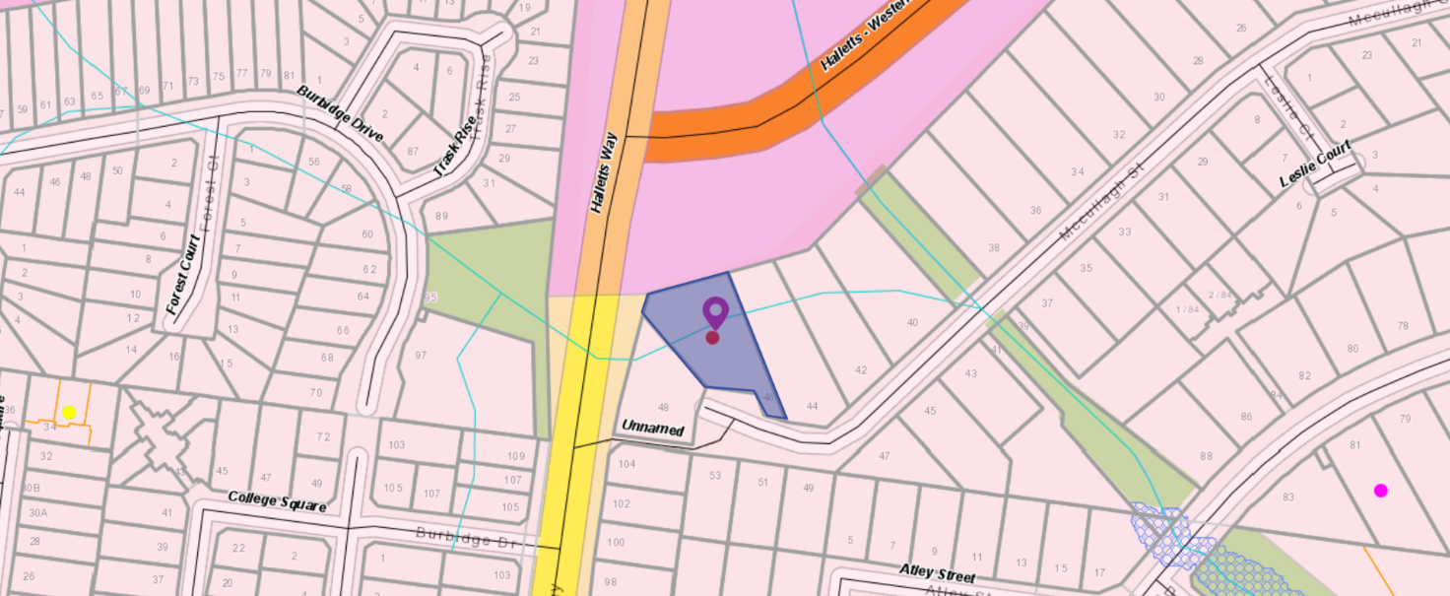
Figure 6: Zone map

Planning Scheme Provisions
Council is required to consider the Victoria Planning Provisions and give particular attention to the Planning Policy Framework (PPF), the Local Planning Policy Framework (LPPF) and the Municipal Strategic Statement (MSS).
The relevant clauses are:
• Clause 11.03-3S Peri-urban areas
• Clause 15 Built Environment and Heritage
• Clause 15.01-3S Subdivision design
• Clause 15.01-5S Neighbourhood character
• Clause 16.01-2S Location of residential development
• Clause 16.01-3S – Housing diversity
• Clause 21.02-6 – Environmentally Sustainable Development
• Clause 21.03-2 – Urban Growth Management
• Clause 21.03-3 – Residential Development
• Clause 21.03-4 – Landscape and Neighbourhood Character
• Clause 21.06-2 – Heritage – Enhance and preserve cultural heritage
• Clause 21.06-2 – Objective: Enhance and preserve cultural heritage
• Clause 21.07-2 – Managing Urban Growth
The proposal complies with the relevant sections of the PPF and LPPF.

Zone
General Residential Zone – Schedule 2
In accordance with Clause 32.08-6 of the Moorabool Planning Scheme a permit is required to construct two or more dwellings on a lot.
In accordance with Clause 32.08-4 of the Moorabool Planning Scheme the minimum area to be set aside for garden area on a lot of more than 650sqm is 35%.
The purpose of the General Residential Zone is to:
• Implement the Municipal Planning Strategy and the Planning Policy Framework.
• Encourage development that respects the neighbourhood character of the area.
• Encourage a diversity of housing types and housing growth particularly in locations offering good access to services and transport.
Schedule 2 of the General Residential Zone applies to Natural and greenfield residential growth areas. The Neighbourhood character objectives include to:
• Encourage new development, including innovative and unique development that enhances and responds positively to the existing neighbourhood character.
• Encourage an increase in landscaping within the public and private realm.
• Encourage new development to respect existing setbacks within the streetscape.
• Encourage new development to have minimal or low scale front fencing.
• Ensure garages, carports, and second storey development do not visually dominate dwellings or streetscapes.
A landscape plan must be provided with an application in accordance with the application requirements of Schedule 2.

Overlays
No overlays apply to the site.

Relevant Policies
Housing Bacchus Marsh to 2041 is Council’s adopted housing strategy to guide residential growth in Bacchus Marsh to suitable locations. The subject site is in Precinct 15 which is identified for ‘natural residential growth’ which applies to residential land that has been identified for natural change over time. Appropriate well designed, infill development, including multi-unit developments that complement the preferred character of the area, while providing for a variety of housing options will be encouraged in suitable locations.
The Preferred Neighbourhood Character statement includes the following:
• This precinct will generally maintain a streetscape rhythm of detached dwellings with conventional front and side setbacks. Built form to one boundary may be appropriate where the preferred character of the precinct is not compromised. Boundary to boundary development should be avoided.

• Built form will be of a modest scale and be sympathetic to the existing character of the precinct, however innovative and unique built form, that enhances the character of the precinct will be encouraged. Multi-dwelling developments should minimise the need for additional crossovers to the street, be located on lots within the precinct that are within a walkable distance of some services and facilities and have minimal impact on the streetscape rhythm and pattern. Therefore, some lots within the precinct may not be suitable for further intensification.
• Open front gardens will blend into the public realm, with minimal front fencing. Built form will not dominate the lot which will allow for generous private open space and garden plantings. Increasing canopy tree cover will assist in improving the landscape within the precinct, while also achieving a balance between open space and built form.

Particular Provisions
Clause 52.06 Car Parking
In accordance with Clause 52.96-5 and Table 1, two car spaces are required for each three, or more, bedroom dwelling. The proposal meets the requirement with two car spaces being provided for each dwelling.
Clause 53.18 – Stormwater Management in Urban Development
The proposal complies with standards W1, W2 and W3 of this provision.
Clause 55 - ResCode
The proposal does not comply with the following ResCode (Clause 55) as outlined in the table below:
Clause ResCode | Title | Response
55.02-1 | Neighbourhood Character | The proposal does not reflect the existing character and does not respond to the preferred neighbourhood character of generous open spaces and setbacks.
55.03-5 | Energy Efficiency objectives  Standard B10 | The design of Dwelling 1 has not attempted to maximise energy efficiency.
55.03-10 | Parking location objectives Standard B15 | The standard state shared accessways or car parks of other dwellings and residential buildings should be located at least 1.5m from the windows of habitable rooms. This setback may be reduced to 1m where there is a fence at least 1.5m high or where window sills are at least 1.4m above the accessway.  The window sill heights of the master bedrooms for Dwelling 2 and Dwelling 3 do not meet this standard.

Discussion
The site has a fall from the front of the lot to the rear of approximately 6m. The proposal is to create a multi-level tiered development of three dwellings to accommodate the topography of the site. The three dwellings would therefore be constructed on the slope with some cutting and filling required.
Design Response
The site is located at the edge of Neighbourhood Character Number 15 with Neighbourhood Character Precinct 16 located on the western side of Halletts Way and Neighbourhood Character Precinct 11 located on the northern side of Western Freeway. In this locality, there is an intact streetscape with a distinctive character. Any design response in this locality with have to be modest form with generous open spaces, generous setback and break up the built form. A higher level of density of development consisting of three dwellings on one lot that has a total area of 1,684sqm or a density ratio of 1:561sqm is an inappropriate design response.
Neighbourhood Character/ Streetscape
The front dwelling is partly obscured by the topography of the site and presents as a single dwelling to the street. The two rear dwellings would not be visible from the street and will be single storey dwellings. The dwellings are exposed from Halletts Way due to the location of the roadway well above natural ground level.
The detailed design and layout of the proposed dwellings is compatible with neighbouring dwellings, with similar roof form, materials and low horizontal scale. The problem with the layout is the attached form and continuous building mass across a lot when viewed from the side elevation. This precinct and immediate site context do not have attached buildings across an individual lot.
The rear two dwellings are single storey in height to minimise visual impacts to the adjacent dwelling to the east. The design has a simple building form. The garages are setback from the east side walls and are not fronting the street to further improve the streetscape presentation.
The tandem arrangement with three dwellings across the lot does not maintain a sense of openness which is a key character element of the area. A modest scale development could be achieved by a two dwellings development with a requirement to have large setbacks and a detached building form. The lot does not have sufficient area for three dwellings in a tandem arrangement.
The proposal meets the car parking requirement for the site, with a double garage space being provided for each dwelling with no reduction in car parking requested. The vehicle turning templates provided demonstrate that the shared driveway can readily allow vehicles to exit in a forward direction, however, it is considered that the visitor car spaces should be removed from the plans to facilitate reversing for vehicles from Dwelling 3.
The secluded private open spaces comply with the minimum area specified under ResCode however they do not reflect the character of the area with large open spaces. These large open spaces create a sense of openness and rear landscaped corridors. The proposed development needs large open space to match the prevailing streetscape pattern in McCullagh Street. This has not been achieved with the proposed development.

Policy Response
The site is located in Neighbourhood Character Precinct 15 of the Housing Bacchus Marsh to 2041 Strategy. It is considered that the proposal does not generally meet the preferred neighbourhood character of Precinct 15, where ‘open front gardens will blend into the public realm, with minimal front fencing. Built form will not dominate the lot which will allow for generous private open space and garden plantings. Increasing canopy tree cover will assist in improving the landscape within the precinct, while also achieving a balance between open space and built form’.
The built form does dominate the lots by building across the lot and the open spaces areas are minimal and will not allow for active spaces. The proposed development cannot be described as consistent with the preferred neighbourhood character. The land is vacant that provides an opportunity for more than one dwelling, but the lack of property depth and the orientation of the lot does not allow for three dwellings to be consistent with Housing Bacchus to 2041 Strategy
It is considered that the application for three dwellings on one allotment should not be supported.

General Provisions
Clause 65 – Decision Guidelines have been considered by officers in evaluating this application.
Clause 66 – Stipulates all the relevant referral authorities to which the application must be referred.

Referrals
Authority | Response
Department of Transport | No comment.
Council’s Infrastructure | Consent with conditions.

Financial Implications
It is not considered that the recommendation of approval represents any financial risk or implications to Council.

Risk & Occupational Health & Safety Issues
The recommendation of approval of this development does not implicate any risk or OH&S issues to Council.

Communications Strategy
Notice was undertaken for the application, in accordance with s.52 of the Planning and Environment Act 1987, and further correspondence is required to all interested parties to the application as a result of a decision in this matter. All submitters and the applicant were invited to attend this meeting and invited to address Council if required.

Options
• Issue a Refusal to Grant a Planning Permit in accordance with the recommendations of this report; or
• should Council wish to consider an approval of the application, Councillor’s need to explore reasons based on the proposal not complying with the Moorabool Planning Scheme.

Conclusion
The proposal is to construct three dwellings on a vacant lot with an area of 1,684.4sqm. It is considered to be an unacceptable design response on the sloping land with a distinctive neighbourhood character precinct that contains generous open spaces. The design does not accord with the policies, objectives and standards contained within the Moorabool Planning Scheme, in particular the neighbourhood character standards. It is considered that the application should be refused with specified grounds.

7.5 PA2019140 - Use and Development for Dog Breeding (10 Breeding Dogs) and Vegetation Removal at 104 Mount Doran-Egerton Road, Mount Doran
Author: Thomas Tonkin, Statutory Planner
Authoriser: Henry Bezuidenhout, Executive Manager Community Planning & Economic Development
Attachments: 1. Proposed site plan (under separate cover)
2. Proposed shed plans (under separate cover)

Application Summary
Permit No: PA2019140
Lodgement Date: 21 June 2019
Planning Officer: Tom Tonkin
Address of the land: 104 Mount Doran-Egerton Road, Mount Doran
Proposal: Use and Development for Dog Breeding (10 Breeding Dogs) and Vegetation Removal
Lot size: 4.0ha
Why is a permit required? Clause 35.07 Farming Zone – Use and development for Dog Breeding
Clause 42.01 Environmental Significance Overlay – Buildings and works

Committee Resolution
Moved: Cr Paul Tatchell
Seconded: Cr Tonia Dudzik
That the Development Assessment Committee, having considered all matters as prescribed by the Planning and Environment Act 1987, advises VCAT that it would not support PA2020140 for Use and Development for Dog Breeding (10 Breeding Dogs) and Vegetation Removal at Lot 10 on PS 098699 known as 104 Mount Doran-Egerton Road, Mount Doran 3334, on the following grounds:
1. The proposal would result in land use conflicts inconsistent with relevant State and local planning policy.
2. The proposal does not comply with Clause 22.04 of the Moorabool Planning Scheme.
3. The proposal does not meet the purpose of Clause 35.07 of the Moorabool Planning Scheme.
4. There is insufficient information provided by the applicant to assess whether the proposed enterprise can be managed to an acceptable standard to limit off site amenity impacts.
Carried

Public Consultation
Was the application advertised? | Yes.
Notices on site: | Yes.
Notice in Moorabool Newspaper: | No.
Number of objections: | One.
Consultation meeting: | No, but the officer spoke to the objector about the concerns raised.

Policy Implications
The Council Plan 2017-2021 provides as follows:
Strategic Objective 2: Minimising Environmental Impact
Context 2B: Natural Environment
The proposal does not conflict with the Council Plan 2017 – 2021.

Victorian Charter of Human Rights & Responsibilities Act 2006
In developing this report to Council, the officer considered whether the subject matter raised any human rights issues. In particular, whether the scope of any human right established by the Victorian Charter of Human Rights and Responsibilities is in any way limited, restricted or interfered with by the recommendations contained in the report. It is considered that the subject matter does not raise any human rights issues.

Officer’s Declaration of Conflict of Interests
Under section 130 of the Local Government Act 2020, officers providing advice to Council must disclose any interests, including the type of interest.
Executive Manager – Henry Bezuidenhout
In providing this advice to Council as the Executive Manager, I have no interests to disclose in this report.
Author – Tom Tonkin
In providing this advice to Council as the Author, I have no interests to disclose in this report.

Executive Summary
Application referred? | Yes, to Barwon Water and Council’s Infrastructure, Environmental Health and Community Safety.
Any issues raised in referral responses? | Barwon Water and Council’s Environmental Health both requested further information regarding waste management and the associated treatment of wastewater from the premises. Additionally, Environmental Health requested information regarding noise management.

Preliminary concerns? | Information regarding likely noise emissions and mitigation measures was requested of the applicant.
Any discussions with applicant regarding concerns? | Yes, applicant advised of concerns.
Any changes made to the application since being lodged? | No.
Brief history. | The proprietor is currently operating a dog breeding establishment with one female dog, which is allowed for under the Moorabool Planning Scheme. See ‘History’ below. The applicant has lodged an appeal for a failure to determine the application within the prescribed time. The VCAT appeal date is set for 29 October 2021.
Previous applications for the site? | PA2003051 Development and Use of a Shed was approved by Council on 24 April 2003.
General summary. | It is proposed to expand an existing dog breeding facility to accommodate up to 10 entire female Huskies and to construct an associated 280sqm shed to facilitate the enterprise.  One objection was received which raised concerns regarding noise from barking dogs and increased traffic.  There are 12 dwellings within 500m of the proposed facility and accordingly there is unacceptable potential for land use conflicts due to noise from barking dogs. Whilst measures proposed by the applicant are likely to reduce some noise there is clear policy guidance in the Moorabool Planning Scheme that the proposed use is inappropriate in this location.  Furthermore, there are currently 26 dogs being kept on site and therefore an assessment of animal keeping in addition to breeding is required. However, the applicant has not addressed this in the application.
Summary of Officer’s Recommendation
That, having considered all relevant matters as required by the Planning and Environment Act 1987, Council advises VCAT that it would not support the application on the grounds included in this report.

Site Description
The subject site, identified as Lot 10 on PS 098699 and known as 104 Mount Doran-Egerton Road, Mount Doran, is a roughly rectangular shaped lot of 4ha located on the south side of the road approximately 980m east of Settlement Road and 1.45km west of Mount Doran Road. The site is relatively flat and is developed with a single storey dwelling, ancillary sheds and an existing dog breeding facility comprising of kennels and yards. The southern half of the site is heavily treed with a plantation of trees whilst the balance of the site is substantially cleared apart from scattered trees. There are two dams on the property, near the south and east property boundaries. The site and surrounding land is generally flat to gently undulating, with most surrounding land substantially cleared of vegetation.
The subject site and surrounding land is in the Farming Zone, with many properties along a 2.5km stretch of Mount Doran-Egerton Road east and west of the site being of a similar size to the subject site, mostly developed with single dwellings.

Proposal
Approval is sought for the use and development of the land for a dog breeding facility. It is proposed to keep up to 10 breeding Husky bitches. Associated buildings and works would comprise a 28m x 10m shed designed to house the dogs in 16 sleeping pens with attached outdoor pens along with areas for feeding preparation, first aid, bathing area and whelping area. Two 40,000L water tanks are proposed and a septic system to cater for wastewater. The shed would be clad with Colorbond and have a low pitched hipped roof with an overall height of 5m. There would be outdoor play areas on the north and south sides of the shed, with 1.8m high metal fencing surrounding the building and outdoor areas. The wastewater effluent field would be located on the south-east side of the shed. The shed would be set back approximately 65m from the rear of the dwelling and would require removal of several planted trees. Boundary setbacks would be between approximately 44-65m from the east side boundary, 10-20m from the west side boundary and approximately 185m from the south side boundary.
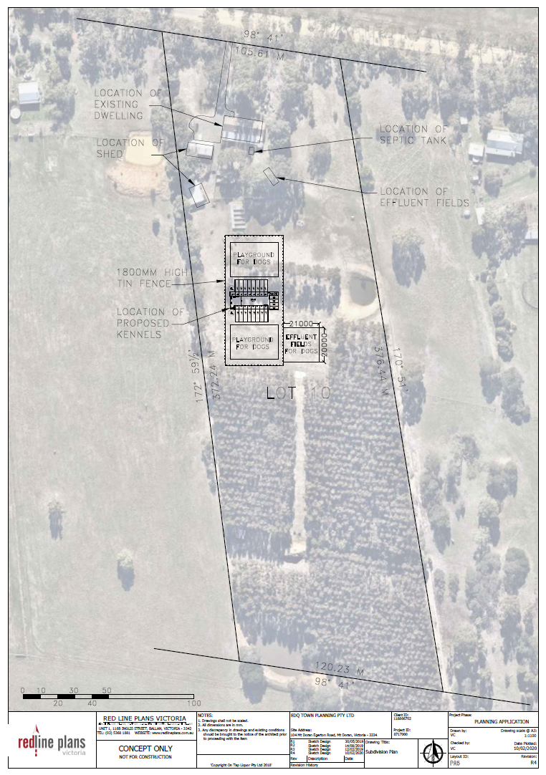
Figure 1: Proposed site plan
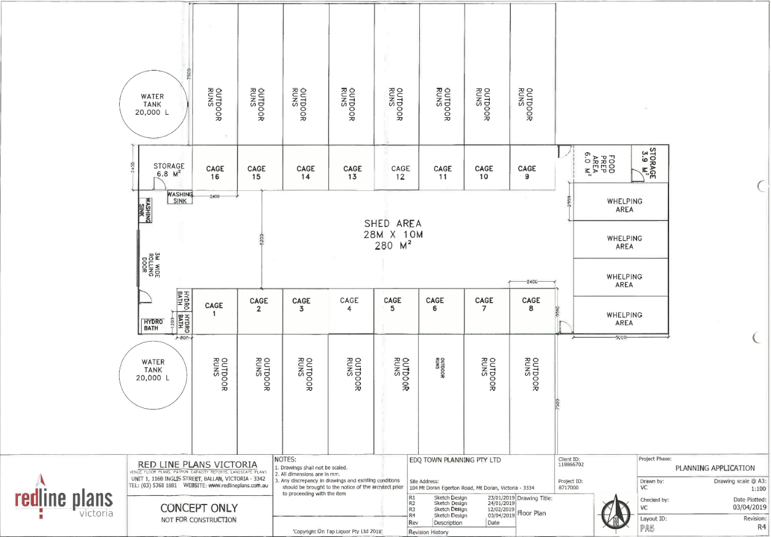
Figure 2: Proposed floor plan
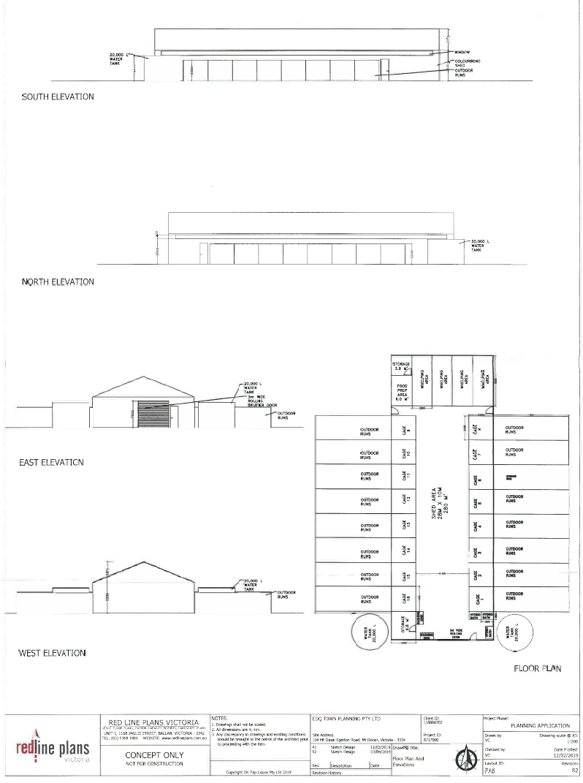
Figure 3: Proposed building plan and elevations

Background to Current Proposal
Noting that the Farming Zone provisions allow for breeding of up to five female dogs without a planning permit, the proponent is currently running a dog breeding establishment from the premises with one female dog, with associated basic infrastructure. It should be noted that since the application was submitted in 2019 dog numbers on site have fluctuated and previously there have been more than one female dog than are currently present.

History
In 2019, several dogs from the property escaped and killed a large number of chickens at a nearby property. This incident brought to Council’s attention that the proprietor was breeding in excess of the allowable five dogs and was advised to obtain the required permissions from Council.
There are currently 26 dogs kept on the property, of which there are six entire males and one entire female which is within the allowable limit to operate without a planning permit. The proprietor is currently in the process of gaining the required animal registrations from Council’s Community Safety, with registration of the animal breeding business subject to a decision on the current permit application. It should be noted that the current application does not address the keeping of additional animals on the site.
The applicant has lodged an appeal for a failure to determine the application within the prescribed time on 26 March 2021. The VCAT appeal date is set for 29 October 2021. Council is required to notify VCAT of its position.

Public Notice
Notice of the application was given by mail to adjoining and surrounding landowners and occupiers within 500m of the subject site and a sign erected on site. One objection was received.

Summary of Objections
The objection received is detailed below with officer’s accompanying comments:
Objection | Any Relevant Requirement
The noise from four to five dogs currently on the premises howl and bark at different hours of the day and night. | Clauses 13.05-1S, 13.07-1S, 14.01-2S & 22.04.
Officer’s Response:
The objector verbally advised that feeding times which occur in the morning and evening for approximately 10 minutes each time are of particular concern. See ‘’Discussion’ below.
The design of Mt. Doran-Egerton Road, with a large camber in the middle and deep gutters on either side, requires careful driving for the safety of all drivers. Drivers unfamiliar with the road tend to drive unsafely. | None applicable.
Officer’s Response:
This concern is not directly related to the permit application but in any case, the proposal would not be expected to generate traffic to such an extent that any measures specific to this application are required.

Locality Map
The map below indicates the location of the subject site and the zoning of the surrounding area.
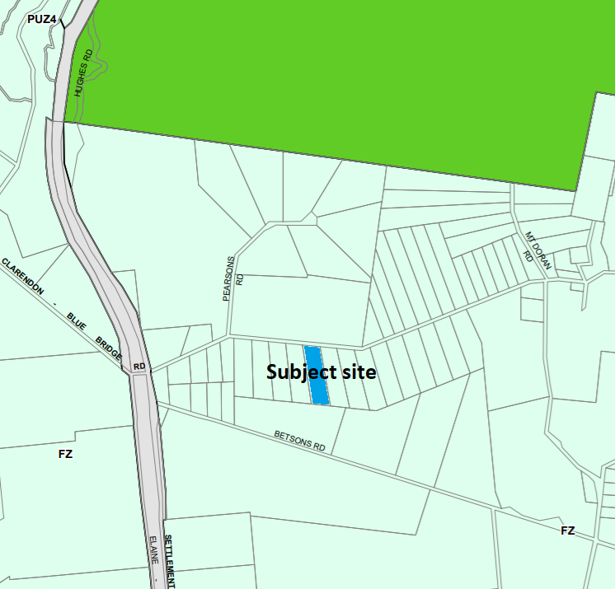
Figure 4: Zone map
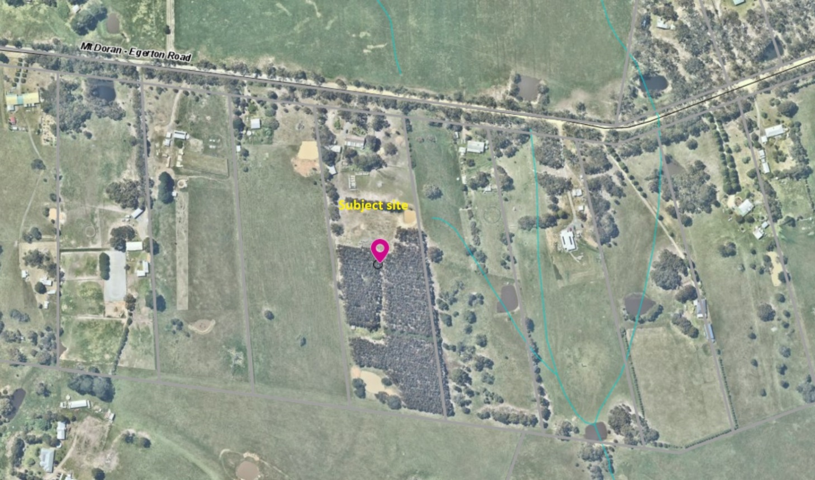
Figure 5: Aerial photograph

Planning Scheme Provisions
Council is required to consider the Victoria Planning Provisions and give particular attention to the Planning Policy Framework (PPF), the Local Planning Policy Framework (LPPF) and the Municipal Strategic Statement (MSS).
The relevant clauses are:
• Clause 11.03-3S Peri-urban areas
• Clause 13.05-1S Noise abatement
• Clause 13.07-1S Land use compatibility
• Clause 14.01-1S Protection of agricultural land
• Clause 14.01-2S Sustainable agricultural land use
• Clause 14.02-1S Catchment planning and management
• Clause 14.02-2S Water quality
• Clause 15.01-6S Design for rural areas
• Clause 21.02-3 Water and catchment management
• Clause 22.02 Special Water Supply Catchments
• Clause 22.04 Animal Keeping

The proposal does not comply with sections of the PPF and LPPF outlined in the table below:
PPF | Title | Response
Clause 13.05-1S | Noise abatement | The noise impacts from barking dogs would be best managed by way of land use separation, however the subject site’s proximity to numerous dwellings prevents this.
Clause 13.07-1S | Land use compatibility | The noise impacts from barking dogs associated with the proposed use is generally incompatible with the amenity of surrounding residential uses.
Clause 14.01-2S | Sustainable agricultural land use | The proposal is inconsistent with the policy due to the site’s proximity to numerous dwellings and the associated amenity impacts on nearby residents.
LPPF
Clause 22.04 | Animal Keeping | The proposal is inconsistent with the policy due to its proximity to numerous dwellings and the associated amenity impacts on nearby residents.

Zone
The subject site is in the Farming Zone (FZ). The purpose of the FZ is:
• To implement the Municipal Planning Strategy and the Planning Policy Framework.
• To provide for the use of land for agriculture.
• To encourage the retention of productive agricultural land.
• To ensure that non-agricultural uses, including dwellings, do not adversely affect the use of land for agriculture.
• To encourage the retention of employment and population to support rural communities.
• To encourage use and development of land based on comprehensive and sustainable land management practices and infrastructure provision.
• To provide for the use and development of land for the specific purposes identified in a schedule to this zone.
Under Clause 35.07-1, dog breeding is a Section 1 use not requiring a permit on the condition there be a maximum of five animals. For more than five animals, as proposed in this application, a permit is required for the use and for any associated buildings and works.

Overlays
The site is affected by the following overlays: Environmental Significance Overlay, Schedule 1 (ESO1), Design and Development Overlay, Schedule 2 (DDO2) and Bushfire Management Overlay (BMO) (part).
Under Clause 42.01-2 (ESO) a permit is required to construct buildings and works. There are no relevant exemptions under Schedule 1.
Subject to conditions, the proposal would be generally consistent with the overlay provisions. Barwon Water, the relevant catchment authority, were notified of the application and have no objections, subject to conditions.
Under Clause 43.02-2 (DDO) a permit is required to construct buildings and works. Under Schedule 2 there is an exemption for use of non-reflective building cladding. In this instance a permit is not required.
Under Clause 44.06-2 (BMO) a permit is not required to construct buildings and works associated with dog breeding.

Relevant Policies
There are no Council policies relevant to this application.

Particular Provisions
There are no Particular Provisions applicable to this application.

Discussion
Overall, the proposed use and development is not considered to align with relevant State and local planning policy, the Farming Zone or relevant decision guidelines at Clause 65.01 of the Moorabool Planning Scheme.
Planning policies at both the State and local level relevant to this application require consideration of a range of matters, particularly relating to the proposal’s compatibility with surrounding land uses. The subject site is located in the Farming Zone, in an area of Mount Doran which comprises numerous properties approximately 4.0ha in size, many of which are developed with single dwellings and used for rural lifestyle properties rather than for bona fide agricultural uses. There are also several larger properties to the north and south which appear to be used predominantly for animal grazing. Figure 6 below shows that there are 12 properties with dwellings located within 500 metres of the proposed dog breeding establishment. The objective of Council’s policy for animal keeping at Clause 22.04 of the Moorabool Planning Scheme is ‘to ensure that animal keeping establishments are appropriately located, sited, designed, and managed so they will not have an adverse effect on the environment, the amenity of nearby residents, and the operation of surrounding animal husbandry enterprises.’ The related policies of particular note are to:
• Discourage the keeping and breeding of dogs in areas that are:
o predominantly used for extensive animal husbandry;
o have a significant number of dwellings in close proximity; and
o adjacent to significant wildlife habitats.
• Require the following measures to be applied in the siting and design of dog keeping and breeding establishments:
o facilities should be located at least 500 metres away from residential areas and a substantial proportion of this buffer must be provided within the boundary of the subject site;
o facilities should be sited to use the surrounding topography to reduce noise;
o facilities should be fully contained by appropriate fencing including a fully enclosed or acoustically baffled area to house particularly noisy animals at a ratio of 1:15;
o facilities should be constructed or landscaped as appropriate to visually screen stimuli from other dogs, animals, traffic or passers-by; and
o kennels should be constructed in materials that reduce the emission of noise.
In the context of land in the Farming Zone within Moorabool Shire, the area within 500m of the site is developed relatively densely with dwellings which poses greater potential for amenity impacts due largely to the noise of barking dogs. The applicant has advised that the following measures or features would mitigate noise impacts:
• Insulation of the shed structure with Foamcell multipurpose RO.2 made by Fletcher Insulation to baffle noise. The enclosure of all pens within the shed and a row of trees on its north side would further baffle noise. Barking collars would be worn by dogs as deemed necessary.
• Visual stimuli would be controlled by 1.8m high solid fencing surrounding the dogs’ compound to prevent views of animals outside the enclosure. Full enclosure of pens within the shed would prevent dogs from seeing each other.
• Fully supervised exercising of dogs between 2.00-4.00pm and feeding prior to 6.00pm would occur in accordance with EPA guidelines. Feeding time is expected to generate the most excitement for the dogs, generally occurring between 3.00-6.00pm daily.
• Access to the dogs’ compound would be restricted to staff only.
• Huskies are non-territorial and generally not prone to barking.
It is acknowledged that the above proposed measures are positive, however there is not sufficient information to assess whether management of the proposed operation would be adequate to prevent unreasonable amenity impacts from occurring. Without this information there can be no certainty to enable the granting of the permit. The proximity to numerous dwellings means that the site is considered unsuited to a dog breeding facility on the scale proposed. Council’s policy recognises the potential for amenity issues to arise in residential areas and whilst mitigation measures are proposed they do not satisfactorily resolve concerns that amenity impacts due to noise are to some extent unavoidable due to the proximity of existing dwellings. Based on the application in its current form, it is considered that greater separation from dwellings is required and whilst the site is in the Farming Zone where such dog breeding establishments are generally encouraged to locate, the constraints on this particular site are so significant as to warrant refusal of the application.

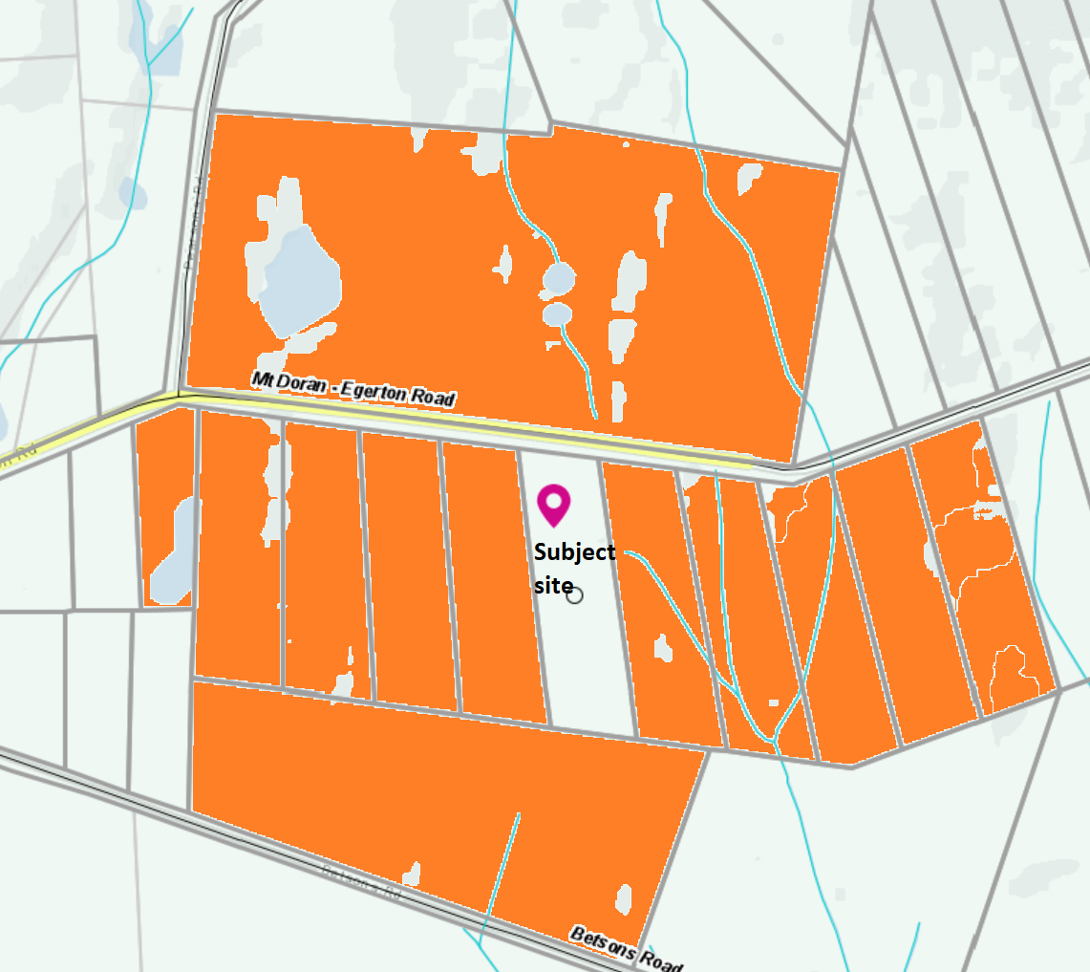
Figure 6: properties with Dwellings within 500 metres of the proposed dog breeding establishment highlighted in orange.
Separately, it is noted that the site is located in a Special Water Supply Catchment and is unsewered. Accordingly, the application was referred to Barwon Water and Council’s Environmental Health, both of whom consented to the proposal subject to conditions. It is not considered that the proposal would pose any unreasonable detriment to potable water quality or supply. The nearest waterway is approximately 80m to the south-east which is a tributary of Tea Tree Creek.

General Provisions
Clause 65 – Decision Guidelines have been considered by officers in evaluating this application.
Clause 66 – Stipulates all the relevant referral authorities to which the application must be referred.

Referrals
Authority | Response
Barwon Water | Consent with conditions
Infrastructure  Environmental Health  Community Safety | Consent with conditions.  Consent with conditions.  Consent with conditions.

Financial Implications
There are no financial implications for Council in refusing this application.

Risk & Occupational Health & Safety Issues
The recommendation to refuse this application does not have any risk or OH&S implications for Council.

Communications Strategy
Notice was undertaken for the application, in accordance with s.52 of the Planning and Environment Act 1987, and further correspondence is required to all interested parties to the application as a result of a decision in this matter. The objector and applicant were invited to attend this meeting and address Council if required.

Options
• Inform VCAT that Council would not support the application in accordance with the grounds in the recommendation of this report; or
• inform VCAT that Council would not support the application with amendments to the grounds in the recommendation of this report; or
• should Council wish to support the application, include appropriate recommended permit conditions and notify VCAT accordingly.

Conclusion
The proposed use and development for dog breeding of up to 10 female Huskies is not considered to be appropriate in this location. The site’s proximity to numerous dwellings poses an acceptable risk of land use conflicts due to impacts on existing residential amenity from noise associated with the proposed use. State and local planning policy recognises the potential for such conflicts to occur and accordingly there is clear policy guidance to discourage the proposed use in this location. Furthermore, there is insufficient information to assess whether the proposed operation could be managed to adequately avoid any detrimental amenity impacts on surrounding properties.

8 Update on Trends, Issues and Other Matters
Nil

9 Process Forward and Work Program
Nil

10 Update on VCAT Decisions
Nil

11 Other Business
Nil

12 Date of Next Meeting
Wednesday 19 May 2021

13 Meeting Close
The Meeting closed at 6.35pm.

