MINUTES
Development Assessment Committee Meeting
Wednesday, 16 June 2021
Date: | Wednesday, 16 June 2021
Time: | 6.00pm
Location: | Online

Order Of Business
1 Opening 3
2 Present and Apologies 3
3 Recording of Meeting 3
4 Confirmation of Minutes 3
5 Matters Arising from Previous Minutes 4
Nil.
6 Disclosure of Conflicts of Interests 4
Nil.
7 Community Planning Reports 6
7.1 PA2015131-1 - Use and Development for a Postal Agency, Food and Drink Premises (Cafe) and Shop (Convenience Goods, Giftware and Clothing). Reduction of Car Parking, Display of Business Identification Signage and Vegetation Removal at 23 Martin Street, Blackwood 6
7.2 PA2020116 - Development of Two Dwellings on a Lot and Subdivision of Land into Two Lots at 9 Boyes Close Maddingley 24
7.3 PA2020250 - Use and Development of a Dwelling and Ancillary Outbuilding at 821 Greenhills Road, Blackwood 42
7.4 PA2020257 - Use and Development of a Dwelling and Ancillary Outbuiding at Corries Lane Mount Egerton 60
7.5 PA2020284 - Use of the Land for a Licensed Premise, Building and Works, Signage and Reduction in the Standard Car Parking Rate at 60B Grant Street Bacchus Marsh 74
8 Update on Trends, Issues and Other Matters 92
Nil.
9 Process Forward and Work Program 92
Nil.
10 Update on VCAT Decisions 92
11 Other Business 92
Nil.
12 Date of Next Meeting 92
13 Meeting Close 92

1 Opening
The Mayor opened the meeting at 6:01pm

2 Present and Apologies
Cr Tom Sullivan, Mayor West Moorabool Ward
Cr Tonia Dudzik East Moorabool Ward
Cr Moira Berry East Moorabool Ward
Cr Ally Munari Woodlands Ward
Cr Paul Tatchell Central Moorabool Ward
Officers:
Mr Derek Madden Chief Executive Officer
Mr Henry Bezuidenhout Executive Manager Community Planning & Economic Development
Ms Vanessa Osborn Acting Manager Statutory Planning & Building Services
Mr Anthony Smith Manager Governance, Risk & Corporate Planning
Mr Ewen Nevett Manager Engineering Services
Mr Mark Lovell Coordinator Statutory Planning

APOLOGIES:
Cr David Edwards East Moorabool Ward
Cr Rod Ward East Moorabool Ward - Approved leave of absence until 27 June 2021.

3 Recording of Meeting
The Mayor advised that the meeting is being livestreamed via Council’s website.

4 Confirmation of Minutes
Committee Resolution
Moved: Cr Moira Berry
Seconded: Cr Tonia Dudzik
That the minutes of the Development Assessment Committee Meeting held on Wednesday 19 May 2021 be confirmed.
Carried

5 Matters Arising from Previous Minutes
Nil.

6 Disclosure of Conflicts of Interests
Nil.

Presentation/Deputations
Item | Community Planning & Economic Development | Speaker/s | Position | Attendance
7.1 | PA2015131-1 - Use and Development for a Postal Agency, Food and Drink Premises (Cafe) and Shop (Convenience Goods, Giftware and Clothing). Reduction of Car Parking, Display of Business Identification Signage and Vegetation Removal at 23 Martin Street, Blackwood | Mrs. Sue Donnelly | Supporter of Recommendation | Online
7.1 | PA2015131-1 - Use and Development for a Postal Agency, Food and Drink Premises (Cafe) and Shop (Convenience Goods, Giftware and Clothing). Reduction of Car Parking, Display of Business Identification Signage and Vegetation Removal at 23 Martin Street, Blackwood | Mrs. Carol Guthrie | Applicant | Online
7.1 | PA2015131-1 - Use and Development for a Postal Agency, Food and Drink Premises (Cafe) and Shop (Convenience Goods, Giftware and Clothing). Reduction of Car Parking, Display of Business Identification Signage and Vegetation Removal at 23 Martin Street, Blackwood | Mr. Richard Blake | Applicant’s Representative | Online
7.2 | PA2020116 - Development of Two Dwellings on a Lot and Subdivision of Land into Two Lots at 9 Boyes Close Maddingley | Mr. Michael Tudball | Supporter of Recommendation | Online
7.2 | PA2020116 - Development of Two Dwellings on a Lot and Subdivision of Land into Two Lots at 9 Boyes Close Maddingley | Mr. Stuart Robertson | Objector of Recommendation | Online
7.2 | PA2020116 - Development of Two Dwellings on a Lot and Subdivision of Land into Two Lots at 9 Boyes Close Maddingley | Mr. Trevor Crawford  and  Ms. Ashlea Lorensini | Objectors of Recommendation | Online
7.3 | PA2020250 - Use and Development of a Dwelling and Ancillary Outbuilding at 821 Greenhills Road, Blackwood | Mr. Joshua Trowell | Applicant’s Representative | Online
7.3 | PA2020250 - Use and Development of a Dwelling and Ancillary Outbuilding at 821 Greenhills Road, Blackwood | Mr. Daniel Sullivan | Objector of Recommendation | Online
7.5 | PA2020284 - Use of the Land for a Licensed Premise, Building and Works, Signage and Reduction in the Standard Car Parking Rate at 60B Grant Street Bacchus Marsh | Ms. Carly Meyers | Applicant | Online

7 Community Planning Reports
Mrs. Sue Donnelly addressed the Committee in support of the recommendation associated with Item 7.1.
Mrs. Carol Guthrie addressed the Committee as the applicant associated with Item 7.1.
Mr. Richard Blake addressed the Committee as the applicant’s representative associated with Item 7.1.

7.1 PA2015131-1 - Use and Development for a Postal Agency, Food and Drink Premises (Cafe) and Shop (Convenience Goods, Giftware and Clothing). Reduction of Car Parking, Display of Business Identification Signage and Vegetation Removal at 23 Martin Street, Blackwood
Author: Thomas Tonkin, Statutory Planner
Authoriser: Henry Bezuidenhout, Executive Manager Community Planning & Economic Development
Attachments: 1. Existing and previously proposed plans (under separate cover)
2. Amended proposed plans 21 May 2021 (under separate cover)

Application Summary
Permit No: PA2015131-1
Lodgement Date: 24 March 2020. Amended plans lodged on 21 May 2021
Planning Officer: Tom Tonkin
Address of the land: 23 Martin Street, Blackwood
Proposal: Amendment to PA2015131
Lot size: 809sqm
Why is a permit required? Clause 32.05 Township Zone – Use and development for a Shop (Convenience Goods, Giftware and Clothing) and Food and Drink Premises (Café)
Clause 42.01 Environmental Significance Overlay, Schedule 1 – Buildings and works and removal of vegetation
Clause 44.06 Bushfire Management Overlay – Buildings and works associated with a Retail Premises
Clause 52.06 Car Parking – Reduction of car parking

Committee Resolution
Moved: Cr Paul Tatchell
Seconded: Cr Tonia Dudzik
That the Development Assessment Committee, having considered all matters as prescribed by the Planning and Environment Act 1987, issues Amended Permit PA2015131 for Use and Development for a Postal Agency, Food and Drink Premises (Café) and Shop (Convenience Goods, Giftware and Clothing), Reduction of Car Parking, Display of Business Identification Signage and Vegetation Removal, subject to the following conditions:
Endorsed Plans:
1. Before the use and development starts, amended plans to the satisfaction of the Responsible Authority must be submitted to and approved by the Responsible Authority. Any supplementary amendments may be approved under delegation. When approved, the plans will be endorsed and will then form part of the permit. The plans must be generally in accordance with the plans submitted to Council dated 9 September 2020 prepared by Arciworx Design subject to mutually agreed changes and the Bushfire Management Statement prepared by Richard Blake of Arciworx Design dated 26 May 2019 but modified to show:
(a) A bushfire management plan in accordance with Condition no. 37.
(b) Vehicle access and the provision of two car spaces, with one being an accessible car parking space.
(c) The south extension to the front verandah above the Martin Street footpath deleted.
(d) A schedule of colours, materials and finishes.
(e) The sketched additions formally drawn to scale and with dimensions.
2. The use and development as shown on the endorsed plans must not be altered without the written approval of the Responsible Authority.
General Conditions:
3. The hours of operation are restricted to the following and cannot be varied without the consent of the Responsible Authority:
(a) Monday to Sunday: 8.30am-6.00pm.
Amenity:
4. ‘Deleted’.
Environmental Health:
5. The food premises must be connected to a wastewater system and a triple stage grease trap installed, sized to effectively dispose of all sewage and waste water in accordance with the Food Act 1984 and the Guidelines for Environmental Management: Code of Practice for Onsite Wastewater Management 891.4 (2016).
6. A 2,000L load-balance tank must be installed.
7. The land application area and all conditions must be in accordance with the Land Capability Assessment prepared by Paul Williams and Associates, report no. A191008 dated November 2019 or any approved amendment.
8. The owner will maintain all drainage lines at all times to divert surface water and subsurface water clear of the effluent disposal field.
9. An onsite wastewater management system with the capacity to treat effluent to a minimum of 20/30/10 must be installed.
10. The wastewater management system including all effluent must be wholly contained within the property boundaries at all times.
11. The effluent disposal area must be kept free of buildings, driveways, vehicular traffic and services trenching.
12. The subsurface irrigation system must be installed to a depth of 150mm in situ, or if the soil is of poor quality, imported good quality topsoil may be required, with a 1m spacing in between lines.
Infrastructure:
13. Unless otherwise approved by the Responsible Authority there must be no buildings, structures, or improvements located over proposed drainage pipes and easements on the property.
14. The property access and the internal driveways must be constructed in accordance with the requirements specified in Table 5 of Clause 53.02-5 of the Moorabool Planning Scheme, to the satisfaction of the Responsible Authority.
15. Prior to the works commencing on the development, notification including photographic evidence must be sent to Council’s Infrastructure Services identifying any existing damage to Council assets. Any existing works affected by the development must be fully reinstated at no cost to and to the satisfaction of the Responsible Authority. If photographic evidence cannot be provided, then the damage must be fully reinstated at no cost to and to the satisfaction of the Responsibility Authority.
16. Stormwater drainage from the development must be directed to a legal point of discharge to the satisfaction of the Responsible Authority. A Stormwater Point of Discharge permit must be obtained from the Responsible Authority prior to the commencement of the works associated with the permit
17. Sediment discharges must be restricted from any construction activities within the property in accordance with relevant Guidelines including Construction Techniques for Sediment Control (EPA 1991).
Materials and Colour:
18. All external walls and roof areas of the proposed buildings are to be clad with non-reflective materials (zincalume prohibited) to the satisfaction of the Responsible Authority.
Vegetation Removal:
19. Except where no permit is required under the Moorabool Planning Scheme or where permitted to be removed as shown on the plans endorsed as part of this planning permit, vegetation including dead standing vegetation must not be removed without further planning permission.
Southern Rural Water:
20. Wastewater must be dispersed via an appropriate method and the onsite wastewater system must be designed, constructed and maintained in line with the Land Capability Assessment undertaken by Paul Williams and Associates (Report #A191008 dated November 2019) and with due consideration to installer recommendations.
21. Wastewater must be treated to a secondary standard prior to dispersal (20/30 BOD/SS Standard).
22. The wastewater disposal system must be installed by a suitably qualified contractor to the satisfaction of Council’s Environmental Health Officer.
23. All buffer distances to waterways, dams and other areas of interest must be met as per EPA Publication 891.4.
24. No building, stock access or vehicle access must be allowed on the Land Application Area to prevent damage to the system. If required, fencing should be installed in order to prevent stock or vehicle access.
25. The owner of the land must keep records of maintenance or works to the onsite wastewater system and must make these records available on request to Council or water authorities.
26. Any failure of the LAA or wastewater treatment system must be immediately reported to Council’s Environmental Health Officer and rectified to the satisfaction of Council.
Western Water:
27. Prior to a building permit being granted for the development, the owner of the land must enter into a Section 173 Agreement with Western Water and the Council agreeing that:
(a) A wastewater treatment system that produces wastewater to a minimum standard of 20/30/10 (BOD/suspended solids/E.coli) must be installed to the satisfaction of the Council's Environmental Health Officer and Western Water to treat all sullage and sewage waste on site.
(b) Wastewater must be dispersed to the satisfaction of Council's Environmental Health Officer and Western Water using methods that will prevent waste and treated waste from discharging from the property at all times.
(c) The effluent system must be maintained by a suitably qualified person in accordance with the manufacturer's specifications and EPA requirements.
(d) The wastewater effluent being released from the treatment facility must be monitored annually to ensure compliance with the 20/30/10 standard.
(e) Reports on water quality and maintenance must be submitted to the Responsible Authority at the completion of each maintenance period. This report must be made available to Western Water on request.
(f) The Owner shall meet the costs of the inspections and reports referred to in Condition (e).
(g) The owner shall carry out such works including replacing effluent treatment, storage pumping and disposal systems within the time specified to do so by the Council's Environmental Health Officer or Western Water to cease and prevent waste and treated waste from discharging from the property.
(h) If the wastewater program proves to be unsustainable, the land holder must immediately rectify the sewerage disposal system.
(i) The owner shall have the wastewater treatment system desludged at least once every three years and evidence of this fact shall be provided in the annual written report referred to in Condition (e).
(j) The effluent disposal field must be protected by being isolated from any building, driveway, livestock, vehicles or permanent recreational area that could render it unavailable in the future and should be planted with suitable grasses that will aid in moisture removal.
(k) No other building works shall be undertaken on the subject land without written approval of Western Water.
28. All recommendations and accompanying management plan contained within the Land Capability Assessment prepared by Paul Williams and Associates dated November 2019 report No. A191008 (or as amended) must be followed and implemented to the satisfaction of Western Water.
29. The load-balance tank must be fitted with a water meter to record all outgoing wastewater flows. Should out going wastewater flows exceed 360 litres a day all operations associated with the café must cease immediately.
30. The load-balance tank must be fitted with an alarm system that alerts the owner when the tank is three quarters full. Should the alarm be activated the load-balance tank must be pumped out within 12 hours. Should the load-balance tank not be pumped out within 12 hours of the alarm being activated then the use must cease immediately.
31. All incoming water and outgoing wastewater must be recorded each day against patronage. All incoming and outgoing meter readings and patronage numbers must be kept in a logbook that can be provided to Western Water or Council on request. The logbook must contain photo evidence of daily meter readings and must also contain a record of all maintenance works.
32. Sediment Pollution Controls shall be employed during construction and maintained until all disturbed areas have regenerated.
33. Stormwater is to be managed in a way to minimise risk to erosion of the surrounding land. No stormwater should be allowed to move into the effluent disposal fields.
34. The obligations under this agreement shall run with the land.
35. The applicant shall pay the Council’s reasonable costs associated with the registration and enforcement of the Section 173 Agreement.
Country Fire Authority:
36. The bushfire protection measures forming part of this permit or shown on the endorsed plans, including those relating to construction standards, defendable space, water supply and access, must be maintained to the satisfaction of the Responsible Authority on a continuing basis. This condition continues to have force and effect after the development authorised by this permit has been completed.
37. Before the development starts, a bushfire management plan must be submitted to and endorsed by the Responsible Authority. The plan must show the following bushfire mitigation measures, unless otherwise agreed in writing by the CFA and the Responsible Authority:
Defendable Space –
(a) Show an area of defendable space to the property boundaries where vegetation (and other flammable materials) will be modified and managed in accordance with the following requirements:
(i) Grass must be short cropped and maintained during the declared fire danger period.
(ii) All leaves and vegetation debris must be removed at regular intervals during the declared fire danger period.

(iii) Within 10m of a building, flammable objects must not be located close to the vulnerable parts of the building.
(iv) Plants greater than 10cm in height must not be placed within 3m of a window or glass feature of the building.
(v) Shrubs must not be located under the canopy of trees.
(vi) Individual and clumps of shrubs must not exceed 5sqm in area and must be separated by at least 5m.
(vii) Trees must not overhang or touch any elements of the building.
(viii) The canopy of trees must be separated by at least 5m.
(ix) There must be a clearance of at least 2m between the lowest tree branches and ground level.
Construction Standard –
(b) Nominate a minimum Bushfire Attack Level of BAL 29 that the building will be designed and constructed.
Water Supply –
(c) Show 5,000 litres of effective water supply for firefighting purposes which meets the following requirements:
(i) Be stored in an above ground water tank constructed of concrete or metal.
(ii) Have all fixed above ground water pipes and fittings required for firefighting purposes must be made of corrosive resistant metal.
(iii) Include a separate outlet for occupant use.
Permit Expiry:
38. This permit will expire if one of the following circumstances apply:
(a) The development and the use are not started within two years of the date of this permit; and
(b) The development is not completed within four years of the date of this permit.
Permit Note:
Prior to any alteration of works commencing on the wastewater system, an application for a permit to alter an onsite wastewater management system must be submitted to Council’s Environmental Health.
Carried

Public Consultation
Was the application advertised? | Yes.
Notices on site: | Yes.
Notice in Moorabool Newspaper: | No.
Number of objections: | Two, later withdrawn. 15 submissions in support of the proposal were also received.
Consultation meeting: | No. The Council officer and landowner separately consulted with the objectors.

Policy Implications
The Council Plan 2017-2021 provides as follows:
Strategic Objective 3: Stimulating Economic Development
Context 2A: Built Environment
The proposal does not conflict with the Council Plan 2017 – 2021.

Victorian Charter of Human Rights & Responsibilities Act 2006
In developing this report to Council, the officer considered whether the subject matter raised any human rights issues. In particular, whether the scope of any human right established by the Victorian Charter of Human Rights and Responsibilities is in any way limited, restricted or interfered with by the recommendations contained in the report. It is considered that the subject matter does not raise any human rights issues.

Officer’s Declaration of Conflict of Interests
Under section 130 of the Local Government Act 2020, officers providing advice to Council must disclose any interests, including the type of interest.
Executive Manager – Henry Bezuidenhout
In providing this advice to Council as the Executive Manager, I have no interests to disclose in this report.
Author – Tom Tonkin
In providing this advice to Council as the Author, I have no interests to disclose in this report.

Executive Summary
Application referred? | Yes, to Southern Rural Water, Western Water and CFA, Council’s Infrastructure and Environmental Health.
Any issues raised in referral responses? | No.
Preliminary concerns? | The site is identified in the West Moorabool Heritage Study Stage 2A as part of the Martin Street Heritage Precinct which recommends future coverage by a Heritage Overlay in the Moorabool Planning Scheme. Advice from Council’s Heritage Advisor recommended changes to the proposed building design to minimise its visual impact on the streetscape and to protect a future heritage streetscape.
Any discussions with applicant regarding concerns? | Yes, applicant advised of concerns. A site meeting was held on 4 May 2021 with the applicant and Council’s heritage advisor where the heritage concerns were discussed.
Any changes made to the application since being lodged? | Yes. Initially the application was to amend the permit to also allow for use of a shop and take away food premises and associated development to expand the existing premises. After advertising and the receipt of objections, the application was changed to allow for a café instead of the takeaway food premises, with associated changes to the development aspect.  0n 10 May 2021 plans were further amended in response to the matters discussed at the 4 May on site meeting.
Brief history. | See ‘History’ below.
Previous applications for the site? | PA2015131 was issued for the Use of an Existing Building as a Post Office (with Ancillary Retail Component) and Business Identification Signage was on 27 September 2017.
General summary. | It is proposed to amend PA2015131 to expand the range of retail uses and extend the building footprint. Subject to conditions, the proposal would be generally consistent with the relevant planning controls and would not have any detrimental amenity impacts. The site is identified as being of heritage significance and recommended conditions would ensure the proposal respects the heritage features.
Summary of Officer’s Recommendation
That, having considered all relevant matters as required by the Planning and Environment Act 1987, Council issue an Amendment to Planning Permit PA2015131 to allow for Use and Development for a Postal Agency, Food and Drink Premises (Café) and Shop (Convenience Goods, Giftware and Clothing), Reduction of Car Parking, Display of Business Identification Signage and Vegetation Removal at 23 Martin Street, Blackwood, in accordance with Section 61 of the Planning and Environment Act 1987, subject to the conditions included in this report.

Site Description
The subject site, identified as Crown Allotment 2, Section B, Parish of Blackwood and known as 23 Martin Street, Blackwood, is a rectangular shaped parcel of 809sqm located on the west side of the street diagonally opposite Blackwood Hotel. The site is encumbered by a 2.44m wide carriageway easement parallel to the north side boundary which connects to a laneway at the rear of the land leading to Shaw Street and is aligned with the existing crossover and accessway to Martin Street which accommodates two informal tandem car spaces. The site is developed with a timber building with a hipped pitched roof directly adjoining the street frontage used as a post office with planning approval to sell coffee, pies, pastries and pre-made/packaged food. In addition, convenience goods, giftware and clothing and takeaway food is also sold, for which retrospective approval is sought as part of this current application.
The current opening hours are as follows: Monday-Friday, 8.00am-5.00pm, Saturday 8.00am-3.00pm and Sunday, 8.00am-12.00pm. The post office boxes are located at the front of the building. Apart from a shed abutting the north side title boundary, the rear of the site is undeveloped and there are various established trees in the rear setback area. The front of the site is relatively flat but then falls to the west by approximately 5m.
The site and surrounding land is in the Township Zone, with this section of Martin Street performing a main street function for Blackwood’s limited commercial activity comprising a hotel and several small businesses. There are several dwellings in close proximity, including to the immediate north and west of the site.
The site has connections to reticulated water and power.

Proposal
It is proposed to amend planning permit PA2015131 to expand the permitted use of the land to include a café and shop selling convenience goods, giftware and clothing and to construct alterations and additions to the existing building, reduce car parking and remove vegetation. It is also proposed to amend permit Conditions 1, 3 and 4 which relate to, respectively, endorsed plan details, increased hours of operation and expansion to the range of goods offered for sale.
A skillion roofed extension to the north side of the building would be constructed, set back 2.7m from the north side boundary, to expand the retail floor space and provide for a new kitchen. A staff entry would be provided to the rear of the kitchen, forming part of a rear west extension to the building which would incorporate changes to the location of the toilet, accessible to staff and customers, and include a storage and postal sorting space. A bin storage area would be provided in the rear setback, screened from the north by an existing privacy screen on the title boundary. A skillion roofed extension to the south side of the building would be constructed, set back 2.5m from the front boundary to accommodate the relocated post office boxes and constructed to the south side boundary with a masonry wall to accommodate additional retail floor space. The service area would be expanded, and a fireplace relocated, and a timber deck constructed at the rear of the building, accessible to customers via the existing doors to the rear of the building. The deck would be provided with 2.1m high screening on its south and south-west edge to limit overlooking of the property to the south. Seating for 20 café patrons would be provided inside and outside on the deck. Further to the rear of the deck and towards the southern side boundary a freestanding 22.6sqm building is proposed as an additional retail space. This retail space would be of a contemporary design, with a flat roof and external cladding to match the north and west building extensions. The building would be 3.3m in height above the finished floor level.
Alterations to the building’s front façade would see the removal of the post office boxes and installing two new windows on either side of the front doorway. In addition to the extensions the rear building façade would be altered by removing a window and the roof of the existing building would be replaced with roof sheeting to match the existing corrugated galvanised iron. The building extensions’ roofing would be corrugated horizontal sheeting to match the existing building and wall cladding to be corrugated metal sheet cladding.
Two birch trees at the rear of the building would be removed to accommodate the rear extensions.
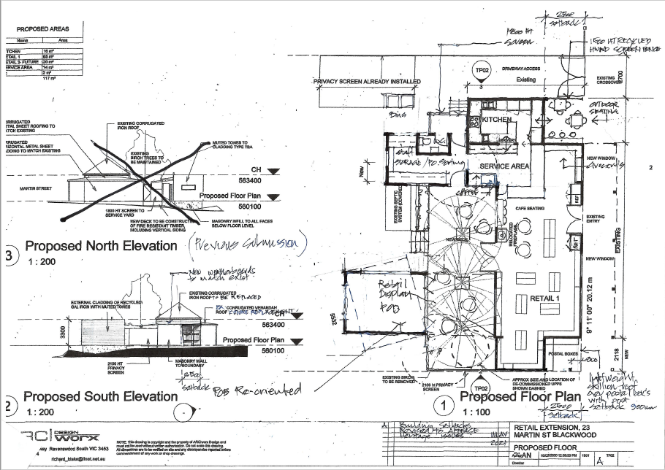
Figure 1: Proposed floor plan and south elevation.
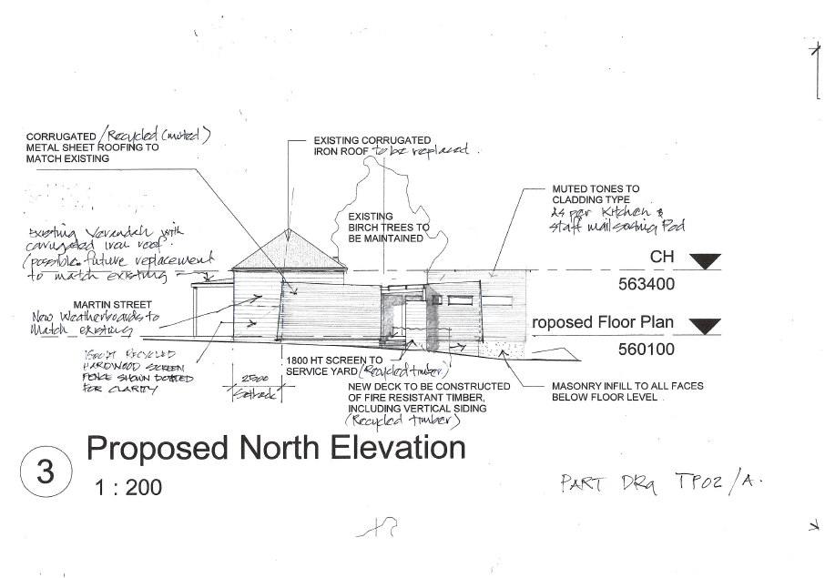
Figure 2: Proposed north elevation.
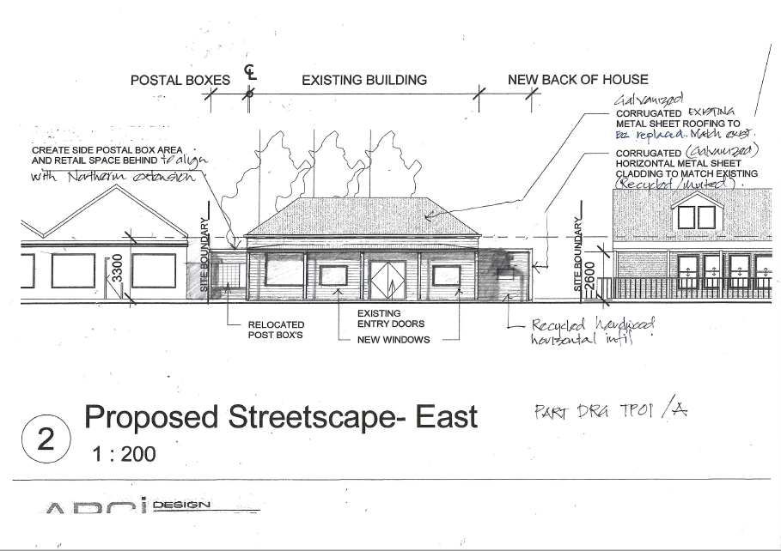
Figure 3: Proposed east elevation

Background to Current Proposal
See ‘History’ below.

History
Planning permit PA2015131 for Use of an Existing Building as a Post Office (with Ancillary Retail Component) and Business Identification Signage was issued by Council on 27 September 2017. Condition 1 plans were required to be endorsed but were never submitted to Council. The property was subsequently sold in late 2017 to the current proprietors who, in addition to the permitted use, have been operating an expanded retail offering and takeaway food premises and associated buildings and works, which the current amendment application seeks to bring into compliance with the Moorabool Planning Scheme.
At its meeting on 21 April 2021 the Development Assessment Committee resolved to defer PA2015131-1 for Use and Development for a Postal Agency, Food and Drink Premises (Café) and Shop (Convenience Goods, Giftware and Clothing), Reduction of Car Parking, Display of Business Identification Signage and Vegetation
The applicant subsequently met onsite with Council’s Heritage Advisor and the Coordinator Statutory Planning to discuss the proposal, after which amended plans were submitted 21 May 2021 to the satisfaction of the Heritage Advisor. These plans now form the basis of the officer’s assessment of this application.

Public Notice
Notice of the original amendment application was given to adjoining and surrounding landowners and occupiers. Two objections were received but the proposal was amended in part to address the objector concerns and the objections subsequently withdrawn. The application received 15 submissions in support of the application.
Notice of the most recent amendments to the plan was not given. The amendments maintain those elements of the design to address the concerns of objectors. The changes in building footprint are relatively minor, with no encroachments closer to common title boundaries and subsequently no issues relating to overlooking, overshadowing or visual bulk.

Locality Map
The map below indicates the location of the subject site and the zoning of the surrounding area.
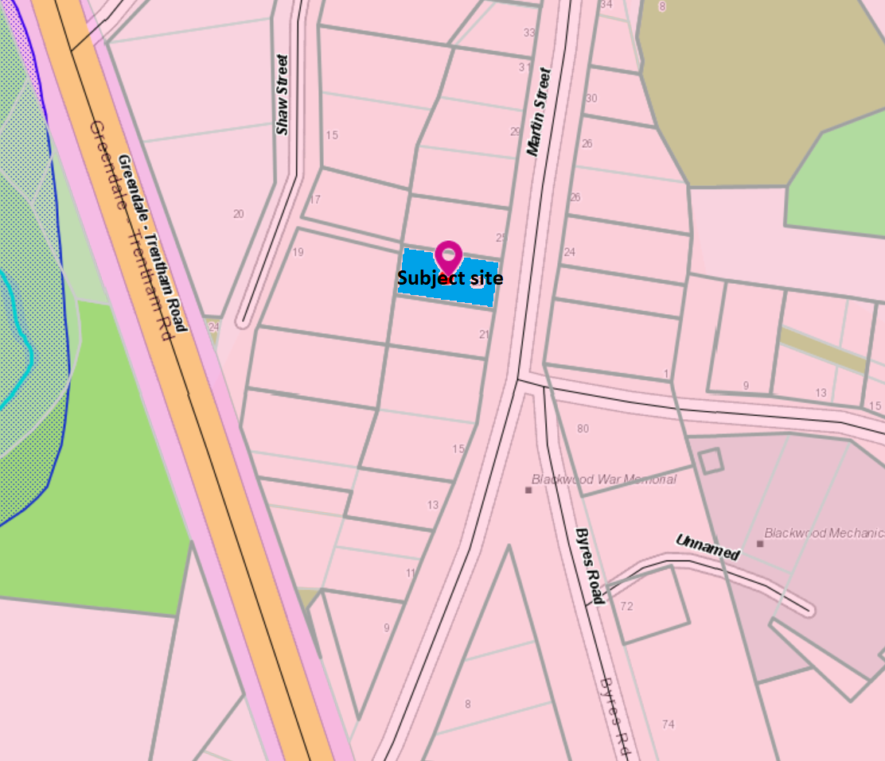
Figure 4: Zone map
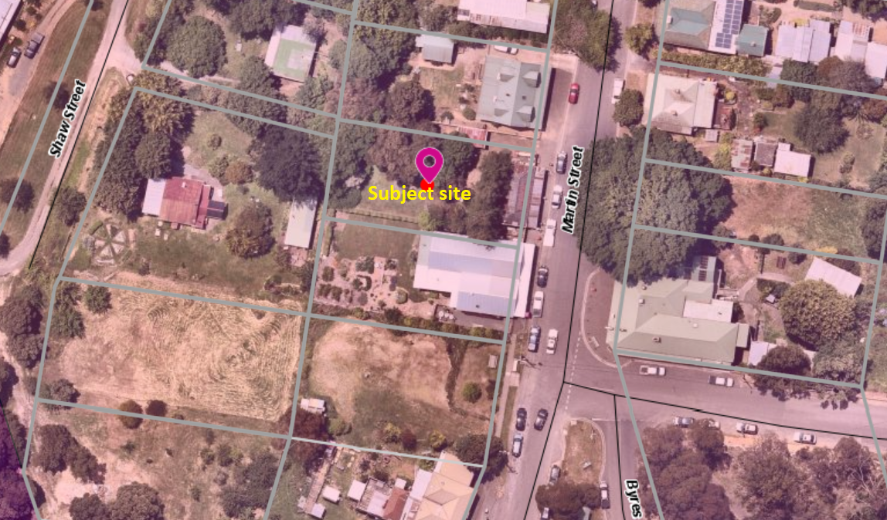
Figure 5: Aerial photograph

Planning Scheme Provisions
Council is required to consider the Victoria Planning Provisions and give particular attention to the Planning Policy Framework (PPF), the Local Planning Policy Framework (LPPF) and the Municipal Strategic Statement (MSS).
The relevant clauses are:
• Clause 11.03-3S Peri-urban areas
• Clause 13.02-1S Bushfire planning
• Clause 13.07-1S Land use compatibility
• Clause 14.02-1S Catchment planning and management
• Clause 14.02-2S Water quality
• Clause 15.01-2S Building design
• Clause 15.01-5S Neighbourhood character
• Clause 17.02-1S Business
• Clause 21.02-3 Water and catchment management
• Clause 21.03-4 Landscape and neighbourhood character
• Clause 21.03-5 Small town development
• Clause 21.09 Small Towns and Settlements
• Clause 22.02 Special Water Supply Catchments
Subject to conditions, the proposal is generally consistent with the relevant sections of the PPF and LPPF.

Zone
The subject site is in the Township Zone (TZ). The purpose of the TZ is:
• To implement the Municipal Planning Strategy and the Planning Policy Framework.
• To provide for residential development and a range of commercial, industrial and other uses in small towns.
• To encourage development that respects the neighbourhood character of the area. To allow educational, recreational, religious, community and a limited range of other non-residential uses to serve local community needs in appropriate locations.
Under Clause 32.05-2, the proposed new uses for a café and shop are Section 2 uses which require a permit and under Clause 32.05-10 a permit is required for the associated buildings and works.
Overall, the proposal is generally consistent with the purpose of the TZ taking account of the applicable decision guidelines under Clause 32.05-13.

Overlays
The site is affected by the following overlays: Environmental Significance Overlay, Schedule 1 (ESO1), Vegetation Protection Overlay, Schedule 1 (VPO1), Design and Development Overlay, Schedule 2 (DDO2) and Bushfire Management Overlay (BMO).
Under Clause 42.01-2 (ESO) a permit is required to construct buildings and works and remove vegetation. There are no relevant exemptions under Schedule 1.
Subject to conditions, the proposal would be generally consistent with the ESO1 provisions. Western Water and Southern Rural Water, the relevant catchment authorities, were notified of the application and have no objections, subject to conditions.
Under Clause 42.02-2 a permit is required to remove, destroy or lop vegetation specified in Schedule 1, which relates only to native vegetation. In this instance a permit is not required.
Under Clause 43.02-2 (DDO2) a permit is required to construct buildings and works. Under Schedule 2 there is an exemption for use of non-reflective building cladding. In this instance a permit is not required.
Under Clause 44.06-2 (BMO) a permit is required to construct buildings and works associated with a retail premises.
Subject to conditions, the proposal would be generally consistent with the BMO provisions. Country Fire Authority, being the relevant fire authority, was notified of the application and has no objection, subject to conditions.

Relevant Policies
There are no Council policies applicable to this application.

Particular Provisions
Clause 52.06 Car Parking
A total of 11 car spaces are required for the proposal. Under Clause 52.06-5, a postal agency and a shop each require four car spaces per 100sqm of leasable floor area.
A café is not a defined use in the Victoria Planning Provisions but is similar to a restaurant which is listed under this clause as requiring 0.4 spaces per seated patron.
The internal floor area would be 115sqm, with the deck providing additional floor space for café patrons. Given the mix of uses proposed to occupy the premises and differing rates of parking required, the following is noted:
• Most, but not all, of the internal floor space would be dedicated to the postal agency and shop, with only the kitchen and some café seating occupying this space. Based on a calculation of the internal floor space area this equates to three car spaces for the postal agency and shop combined.
• 20 patron seats inside and outside are proposed for the café which, based on the abovementioned restaurant rate, equates to eight car spaces.
• Two existing car spaces are provided in a tandem arrangement in the north side setback, however their proposed 2.7m width does not meet the 3.2m width specified for car spaces constrained by buildings or fences. The useability of these spaces is compromised; therefore, the applicant proposes to replace these car spaces with two tandem spaces accessible from Shaw Street via a laneway adjoining the rear of the site. This arrangement is considered acceptable.
Clause 52.34 Bicycle Facilities
The proposed floor area does not meet the minimum thresholds under Clause 52.34-5 for the provision of bicycle parking or cyclist facilities.
Clause 53.02 Bushfire Planning
Clause 53.02-4 applies to this application.

Discussion
Overall, the proposed amendment to the planning permit is generally consistent with relevant state and local planning policy, the Township Zone, applicable Overlays and Particular Provisions and the decision guidelines at Clause 65.01 of the Moorabool Planning Scheme.
The proposal to expand the range of uses, and construct the associated development, would support commercial activity in Blackwood on a scale appropriate to the site and serve both the local community and visitors. The proposed uses are generally complementary to the existing postal agency and to existing commercial and community uses nearby. The proposed development respects the form, scale and appearance of the host building and the streetscape and is generally in keeping with the surrounding neighbourhood character. The proposed removal of two trees at the rear of the existing building would not detrimentally impact on the character of the area, noting the presence of other large established trees on the site and adjoining properties ensuring the landscape character would be maintained.
The amenity of adjoining and nearby residents would not be detrimentally affected, and the applicant has modified the proposal to resolve previous concerns raised by neighbours. The existing single storey built form would be maintained, limiting overlooking and overshadowing and maintaining acceptable solar access, and noise and other emissions would be limited to an acceptable extent, subject to conditions.
The site and surrounding land is in a Special Water Supply Catchment and is unsewered. The applicant submitted a Land Capability Assessment in support of the proposed expansion of the premises and the application was referred to the relevant water boards and Council’s Environmental Health Officer. Conditional consent was given, subject to which there would be no detriment to potable water quality or supply.
The subject site is within a Bushfire Management Overlay and accordingly due to the expansion of retail activity proposed a Bushfire Management Statement was submitted by the applicant and referred to the CFA. All approved or allowable alternate measures under Clause 53.02-4 are met and CFA consent to the proposal, subject to conditions including that a Bushfire Management Plan be submitted for endorsement.
The proposed reduction of car parking is considered acceptable for the following reasons:
• Parking provision for customers on the site is impractical due to the constraints imposed by the building footprint and established trees which contribute to the character of the township.
• The site is within the core of Blackwood’s small commercial area with associated amenities and proposes multiple functions on the premises which would be likely to generate multi-purpose trips, resulting in reduced car trips to the site.
• The site is within walking distance of numerous dwellings and accessible to a local pedestrian catchment.
• The postal agency serves a community function and the applicant advises that its viability relies on the proposed additional retail activities.
The West Moorabool Heritage Study Stage 2A (‘the Study’), adopted by Council in September 2017, identifies the subject site as part of the Martin Street Heritage Precinct (‘the precinct’). The precinct is a legacy of the commercial hub of an area formerly known as Red Hill, established in 1855 at the height of the gold rush, with surviving building fabric dating from between 1868 and c.1910, including the subject site. The precinct is historically significant for its associations with the rise and decline of the Blackwood goldfields district from 1855, and particularly the evolution and development of the commercial hub from late 1860s and early 1870s. The building on the subject site dates from the early 20th century. The front verandah is substantially unchanged, and whilst the building has been compromised by alterations to the front and north side façades the original character and appearance is readily apparent. The Study recommends the site and precinct’s inclusion in a future Heritage Overlay in the Moorabool Planning Scheme, which would be subject to a future planning scheme amendment.
The amended plans submitted 21 May 2021 after the site meeting were provided to Council’s Heritage Advisor for comment, with consent given to the amended sketch plans and approval of the amendment, subject to the submission of formal amended plans for endorsement.
The most recent changes to the plans would ensure that the existing building’s heritage features are appropriately maintained and distinguishable from any new substantial alterations or additions. The proposed plan changes respect the site and precinct’s heritage significance and are not considered to compromise the potential for Blackwood’s inclusion within a region of possible world heritage significance associated with Victoria’s historic gold rush.
The proposed increase in opening hours, in particular on weekends, is supported and it is not considered that there would be any unreasonable amenity impacts considering the nature of the proposed use. Utilising on-street parking for loading and unloading of goods for delivery to the premises is considered reasonable, noting the site constraints, the scale of the proposed use, types of goods being delivered, demand for on street parking and traffic flows in Martin Street.

General Provisions
Clause 65 – Decision Guidelines have been considered by officers in evaluating this application.
Clause 66 – Stipulates all the relevant referral authorities to which the application must be referred.

Referrals
Authority | Response
Western Water  Southern Rural Water  CFA | Consent with conditions.  Consent with conditions.  Consent with conditions.
Infrastructure  Environmental Health | Consent with conditions.  Consent with conditions.

Financial Implications
There are no financial implications for Council in approving this amendment application.

Risk & Occupational Health & Safety Issues
The recommendation to approve this amendment application does not have any risk or OH&S implications for Council.

Communications Strategy
Notice was undertaken for the application, in accordance with s.52 of the Planning and Environment Act 1987, and further correspondence is required to all interested parties to the application as a result of a decision in this matter. The applicant was invited to attend this meeting and address Council if required.

Options
• Issue an Amendment to the Planning Permit in accordance with the conditions in the recommendation of this report; or
• issue an Amendment to the Planning Permit with further amendments to the conditions in the recommendation of this report; or
• should Council wish to refuse the application, issue a Refusal to Grant an Amended Permit on relevant grounds. This option may result in the applicant appealing Council’s decision at VCAT.

Conclusion
Subject to conditions, the proposal is generally in accordance with relevant planning policies. The proposed expansion of the premises to provide additional retail activity would contribute to the local economy and amenity of residents and visitors to Blackwood. Subject to conditions, there would be no detrimental amenity or environmental impacts. The proposal is supported by Council’s Heritage Adviser, and subject to conditions, would protect the site’s heritage features. It is recommended the amendment by supported.

Mr. Michael Tudball addressed the Committee in support of the recommendation associated with Item 7.2.
Mr. Stuart Robertson addressed the Committee as an objector to the recommendation associated with Item 7.2.
Mr. Trevor Crawford & Ms. Ashlea Lorensini addressed the Committee as objectors to the recommendation associated with Item 7.2.

7.2 PA2020116 - Development of Two Dwellings on a Lot and Subdivision of Land into Two Lots at 9 Boyes Close Maddingley
Author: Robert Asquith, Statutory Planner
Authoriser: Henry Bezuidenhout, Executive Manager Community Planning & Economic Development
Attachments: 1. Plans (under separate cover)

Application Summary
Permit No: PA2020116
Lodgement Date: 19 June 2020. Latest amended plans lodged 24 April 2021
Planning Officer: Robert Asquith
Address of the land: 9 Boyes Close, Maddingley
Proposal: Development of Two Dwellings on a Lot and Subdivision of land into 2 Lots
Lot size: 757sqm
Why is a permit required? Clause 32.08-3 GRZ2. Subdivide land
Clause 32.08-6 GRZ2. Construct two dwellings on a lot.
Clause 42.01-2 ESO8. Subdivide land.
Clause 43.02-2 DDO6. Construct a building.
Clause 43.02-3 DDO6. Subdivide land.

Committee Resolution
Moved: Cr Tonia Dudzik
Seconded: Cr Ally Munari
That the Development Assessment Committee, having considered all matters as prescribed by the Planning and Environment Act 1987, issues a Notice of Decision to Grant a Planning Permit PA2020116 for the Development of Two Dwellings on a Lot and Subdivision of land into Two Lots at Lot 1 on PS603092 known as 9 Boyes Close, Maddingley, 3340, subject to the following conditions:
Endorsed Plans:
1. Before the use and development starts, amended plans to the satisfaction of the Responsible Authority must be submitted to and approved by the Responsible Authority. When approved, the plans will be endorsed and will then form part of the permit. The plans must be drawn to scale with dimensions and three copies must be provided. The plans must be generally in accordance with the plans submitted with the application or some other specified plans but modified to show:
(a) The front fence to Boyes Close to be in line with the closest point of the existing northern boundary fence at the same height
(b) Unit 1 first floor ensuite window specified to be obscure glazing to limit overlooking.
(c) The driveway to Unit 1 to be widened to allow for two side by side car spaces in the front of the double garage.
Unless otherwise approved in writing by the Responsible Authority, all buildings and works are to be constructed and or undertaken in accordance with the endorsed plans to the satisfaction of the Responsible Authority prior to the commencement of the use.
Servicing:
2. The owner of the land must enter into agreements with the relevant authorities for the provision of water supply, drainage, sewerage facilities, electricity and gas services to each lot shown on the endorsed plan in accordance with the authority’s requirements and relevant legislation at the time.
3. All existing and proposed easements and sites for existing or required utility services and roads on the land must be set aside in the plan of subdivision submitted for certification in favour of the relevant authority for which the easement or site is to be created.
4. The plan of subdivision submitted for certification under the Subdivision Act 1988 must be referred to the relevant authority in accordance with Section 8 of that Act.
Subdivision:
5. The plan of subdivision submitted for certification must include a creation of restriction. The wording of the creation of restriction shall be as follows:
(a) Land to be Burdened: All lots on this plan.
(b) Land to Benefit: All lots on this plan.
(c) Creation of Restriction: Upon registration of this plan, the following restriction is created.
(d) Description of Restriction: No buildings to be constructed on each lot unless in accordance with the endorsed plans attached to Planning Permit number PA2020116 issued by Moorabool Shire Council.
(e) Variation: The restriction can only be varied with the written consent of Moorabool Shire Council.
Infrastructure:
6. Prior to the issue of a Statement of Compliance for the subdivision, each lot must be provided with a standard urban residential vehicle crossing on Peelmans Lane to the satisfaction of the Responsible Authority. The redundant portion of shared vehicle crossing to Boyes Close must be removed, and the kerb and channel and nature strip reinstated to the satisfaction of the Responsible Authority. A vehicle crossing permit must be taken out for the construction of the vehicle crossings.
7. Prior to the issue of a Statement of Compliance for the subdivision, the development must be provided with a drainage system constructed to a design approved by the Responsible Authority, and must ensure that:
(a) The development as a whole must be self draining.
(b) Volume of water discharging from the development in a 10% AEP storm shall not exceed the 20% AEP storm prior to development. Peak flow must be controlled by the use of a detention system located and constructed to the satisfaction of the Responsible Authority.
(c) Each lot must be provided with a stormwater legal point of discharge at the low point of the lot, to the satisfaction of the Responsible Authority.
(d) Stormwater runoff must meet the “Urban Stormwater Best Practice Environmental Management Guidelines (CSIRO 1999)”.
8. Prior to the commencement of the development design computations for drainage of the whole site must be prepared and submitted to the Responsible Authority for approval.
9. Storm water drainage from the development must be directed to a legal point of discharge to the satisfaction of the Responsible Authority. A Stormwater Point of Discharge permit must be obtained from the responsible authority prior to the commencement of the works associated with the permit.
10. Sediment discharges must be restricted from any construction activities within the property in accordance with relevant Guidelines including Construction Techniques for Sediment Control (EPA 1991).
11. Unless otherwise approved by the Responsible Authority there must be no buildings, structures, or improvements located over proposed drainage pipes and easements on the property.
12. Prior to the commencement of the development and post completion, notification including photographic evidence must be sent to Council’s Asset Services identifying any existing damage to Council assets. Any existing works affected by the development must be fully reinstated at no cost to and to the satisfaction of the Responsible Authority.
13. Prior to the commencement of the development, plans and specifications of all road and drainage works must be prepared and submitted to the Responsible Authority for approval, detailing but not limited to the following:
(a) Location of vehicle crossings.
(b) Details of the underground drainage.
(c) Location of drainage legal points of discharge.
(d) Standard details for vehicle crossings and legal points of discharge.
(e) Civil notes as required to ensure the proper construction of the works to Council
standard.
Telecommunications:
14. The owner of the land must enter into agreements with:
(a) A telecommunications network or service provider for the provision of telecommunication service to each lot shown on the endorsed plan in accordance with the provider’s requirements and relevant legislation at the time; and

A suitably qualified person for the provision of fibre ready telecommunication facilities to each lot shown on the endorsed plan in accordance with any industry specifications or any standards set by the Australian Communications and Media Authority, unless the applicant can demonstrate that the land is in an area where the National Broadband Network will not be provide by optical fibre.
15. Before the issue of Statement of Compliance for any stage of the subdivision under the Subdivision Act 1988, the owner of the land must provide written confirmation from:
(a) A telecommunications network or service provider that all lots are connected to or are ready for connection to telecommunications services in accordance with the provider’s requirements and relevant legislation at the time; and
(b) A suitably qualified person that fibre ready telecommunication facilities have been provided in accordance with any industry specifications or any standards set by the Australian Communications and Media Authority, unless the applicant can demonstrate that the land is an area where the National Broadband Network will not be provided by optical fibre.
Melbourne Water:
16. Finished floor levels of Unit 1 must be set no lower than 101.45m to Australian Height Datum (AHD) which is 600mm above the 1% AEP at the location of 100.85m to AHD.
17. Finished floor levels of Unit 2 must be set no lower than 101.5m to AHD which is 600mm above the 1% AEP at the location of 100.90m to AHD.
18. No earth filling will be permitted outside of the building footprints.
19. All setbacks including 1,150mm gap between the units must be maintained as shown on the submitted plan.
20. Open space areas must be maintained at natural surface levels with no retaining walls or solid raised landscaping.
21. Any proposed fences/gates, must be designed as 50% open style or standard paling style of construction.
22. Proposed alfresco must be constructed with open foundations including open stairs/ risers to allow for passage of flood flow.
Permit Expiry:
23. This permit will expire if:
(a) The development is not started within two years of the date of this permit.
(b) The development is not completed within four years of the date of this permit.
(c) This permit will expire if the plan of subdivision is not certified within two years of the date of issue of the permit.
(d) Statement of Compliance must be achieved and certified plans registered at Titles office within five years from the date of certification.
Carried

Public Consultation
Was the application advertised? | Yes.
Notices on site: | Yes.
Notice in Moorabool Newspaper: | No.
Number of objections: | Three.
Consultation meeting: | No.

Policy Implications
The Council Plan 2017-2021 provides as follows:
Strategic Objective 2: Minimising Environmental Impact
Context 2A: Built Environment
The proposal of development of two dwellings and subdivision is not inconsistent with the Council Plan 2017 – 2021.

Victorian Charter of Human Rights & Responsibilities Act 2006
In developing this report to Council, the officer considered whether the subject matter raised any human rights issues. In particular, whether the scope of any human right established by the Victorian Charter of Human Rights and Responsibilities is in any way limited, restricted or interfered with by the recommendations contained in the report. It is considered that the subject matter does not raise any human rights issues.

Officer’s Declaration of Conflict of Interests
Under section 130 of the Local Government Act 2020, officers providing advice to Council must disclose any interests, including the type of interest.
Executive Manager – Henry Bezuidenhout
In providing this advice to Council as the Executive Manager, I have no interests to disclose in this report.
Author – Robert Asquith
In providing this advice to Council as the Author, I have no interests to disclose in this report.

Executive Summary
Application referred? | Yes. Melbourne Water, Powercor, Downer Utilities, Western Water and Council’s Infrastructure and Strategic Planning.
Any issues raised in referral responses? | No.
Preliminary concerns? | Interface with Boyes Close and access of lots via Peelmans Lane; response to neighbourhood character.
Any discussions with applicant regarding concerns? | Yes, including extensive written detailing of concerns and various discussions/meetings with applicant.
Any changes made to the application since being lodged? | Minor changes to address ResCode requirements
Brief history. | The site is vacant and has no known prior planning permits or applications.  Pre-application advice was sought and provided for the proposed design and layout generally resulting in change from double-attached garages to detached units prior to lodgement.
Previous applications for the site? | Nil.
General summary. | It is proposed to develop two detached double-storey dwellings on the lot and subdivide this lot into two, each to contain one of the proposed dwellings.  Key issues raised include consideration of the most appropriate access arrangement into the site from adjoining roads, neighbourhood character, and the manifestation of ‘country town character’ as sought by the DDO6.  Based on the revised plans, the design and layout allow for a conditional approval.
Summary of Officer’s Recommendation
That, having considered all relevant matters as required by the Planning and Environment Act 1987, Council issue a Notice of Decision to Grant Planning Permit PA2020116 for this application in accordance with Section 61 of the Planning and Environment Act 1987 subject to conditions contained within this report.

Site Description
The subject site is a parcel of land, being Lot 1 on Plan Number 603092G, located at the corner of Peelmans Lane and Boyes Close in Maddingley. The lot is rectangular in shape, oriented on an east-west long axis and comprises an area of 757sqm with frontages of 19.7m to Boyes Close and 38.8m to Peelmans Lane. Generally flat topography. Vegetation on the site is limited to grass while one street tree is located in the nature strip of Boyes Close, centrally to the lot frontage.
Boyes Close terminates only 90m north of the site, south of the Werribee River, while a pedestrian footbridge at this location provides access to the Maddingley Park area and Bacchus Marsh Railway Station. Peelmans Lane is a narrow one-way road connecting Grant Street and Boyes Close in an east to west direction. Exiting only from Peelmans Lane into Boyes Close at the subject site, the permissible entry into the road is from the Grant Street end, approximately 600m travel via Taverner Street.
The site is located within 500m of a variety of services including Bacchus Marsh Railway Station, Maddingley Park and sports facilities, Bacchus Marsh College and Grant Street with access to all local bus routes, shopping centre and major transport links.
Surrounding land is generally residential in use but is highly varied in terms of lot area, dwelling size, and style. Other lots fronting Boyes Close are similar in land area, generally single storey (with elements of double storey), feature hipped or gabled roofs and a range of materials and colours.
Land to the west through Peelmans Lane features typically smaller lots and a greater proportion of site coverage on newer lots and subdivisions. Land to the south and south-west through the Taverner Street block, however, are generally larger than both Boyes Close and Taverner Street with older housing stock, large gardens and some heritage recognition. All these are combined with the neighbourhood character precinct 30 (Grant Street to Fisken Street between Taverner Street and the Werribee River) which recognises this “eclectic” housing style and natural residential growth potential, limited by its low lying position. The eastern portion of this precinct is generally undeveloped.
Land to the east of the site, opposite Boyes Close, is currently undeveloped although may be included in future residential development and subdivision in accordance with the Development Plan Overlay Schedule 4.
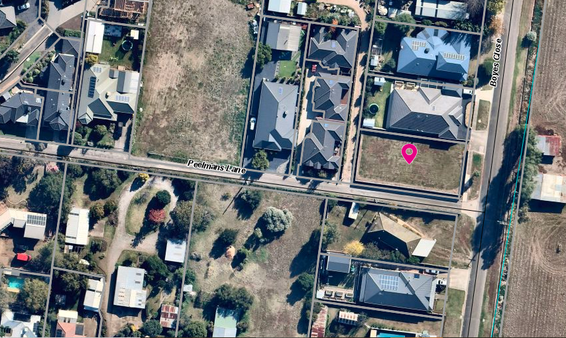
Figure 1: Aerial photograph

Proposal
The current proposal seeks to construct two dwellings on the existing lot and to then subdivide the land into two new lots, each to contain one of the existing dwellings.
Two dwellings in detached form, front-to-back from Boyes Close/side-by-side from Peelmans Lane and generally described as a contemporary style. Unit 1 (front) to have a primary interface with Boyes Close and rear garage access to Peelmans Lane. Unit 2 (rear) to interface and access Peelmans Lane only.
When subdivided, the resultant lots would be as follows: Lot 1, corner of Boyes Close and Peelmans Lane, approx. 403sqm area, 37% site coverage. Lot 2, Peelmans Lane, approx. 364sqm, 53% site coverage.
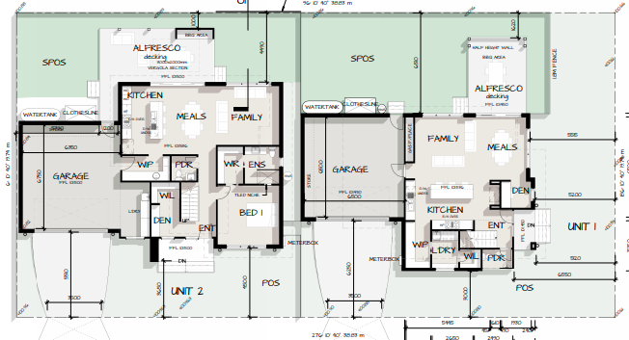
Figure 2: Ground floor plan

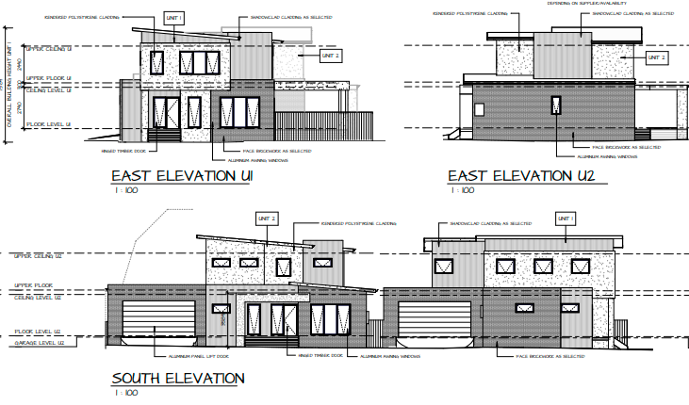
Figure 3: Elevation plans

Background to Current Proposal
Prior to the lodgement of the planning permit application, pre-application advise was informally sought result in some design changes to proposed concept plan. In response to a letter requesting further information, amended plans were received and later after public notice had concluded. The changes made to the plans on both occasions were considered minor. For clarity, the relevant adjoining and nearby neighbours were notified by letter of latest minor changes to plans being received and opportunity was afforded to consider and comment. No objector withdrew their objections.

History
There is no known or recorded history of previous planning permits or applications on the site.

Public Notice
The application was notified to adjoining and surrounding landowners. Letters were distributed and a sign was erected and maintained on site for at least 14 days.

Summary of Objections
Three objections were received during the public notice period. The objections received are detailed below with officer’s comments accompanying them:
Objection | Any Relevant Requirement
Inappropriate site layout by having both units access Peelmans Lane, increased traffic adding to safety concerns. | Clause 55.02-1, Neighbourhood character, Standard B1.  Clause 55.02-5, Integration with the street, standard B5  Clause 56.06-8, Lot access, Standard C21
Officer’s Response:
It was raised early and consistently during assessment by Council Officers that the preferred site layout, if practicable, would see Unit 1 with a vehicle crossover and access to Boyes Close, while only Unit 2 would be accessed by Peelmans Lane. Council Infrastructure determined that there was nothing in the Infrastructure Design Manual which gives affect to this issue and that the proposed layout is acceptable. An alternate layout with access to Unit 1 from Boyes Close would likely incur other detrimental consequences such as energy efficiency, side and rear setbacks, daylight to open space.
Inappropriate response to neighbourhood character in terms of:  a) dwelling style (design detail); and  b) double storey which may contribute to privacy concerns. | Clause 55.02-1, Neighbourhood character, Standard B1  Clause 55.04-6, Overlooking objective, Standard B22
Officer’s Response:
The neighbourhood precinct is regarded as eclectic in character and few features are strongly consistent between sites which are themselves diverse in layout, size, and shape. Additionally, the immediate streetscape contains varied architectural styles though dwellings are generally single storey with elements of second stories, and garages prominent to the street.

Facades will be varied with articulation and material. Landscaping around the dwellings will be extensive. There is opportunity to modify the first floor of unit 2, increasing the recession from ground floor walls on the eastern façade. This would further reduce bulk and improve accordance with streetscape and neighbourhood character. This can be addressed through the submission of revised plans.
Overlooking into adjoining properties, private open space and habitable room windows. | Clause 55.04-6, Overlooking objective, Standard B22
Officer’s Response:
The design response fully complies with the overlooking objective and standard B22 of Clause 55.04-6
Overshadowing of adjoining properties and general loss of light. | Clause 55.04-3, Daylight to existing windows objective, Standard B19  Clause 55.04-4, North-facing windows objective, Standard B20  Clause 55.04-5, Overshadowing open space objective, Standard B21
Officer’s Response:
The design response is fully compliant with the daylight to existing windows objective and standard B19 of Clause 55.04-3, B20 is not an issue due to the orientation of the site and the overshadowing open space objective and standard B21 of Clause 55.04-5.

Locality Map
The map below indicates the location of the subject site and the zoning of the surrounding area.

Planning Scheme Provisions
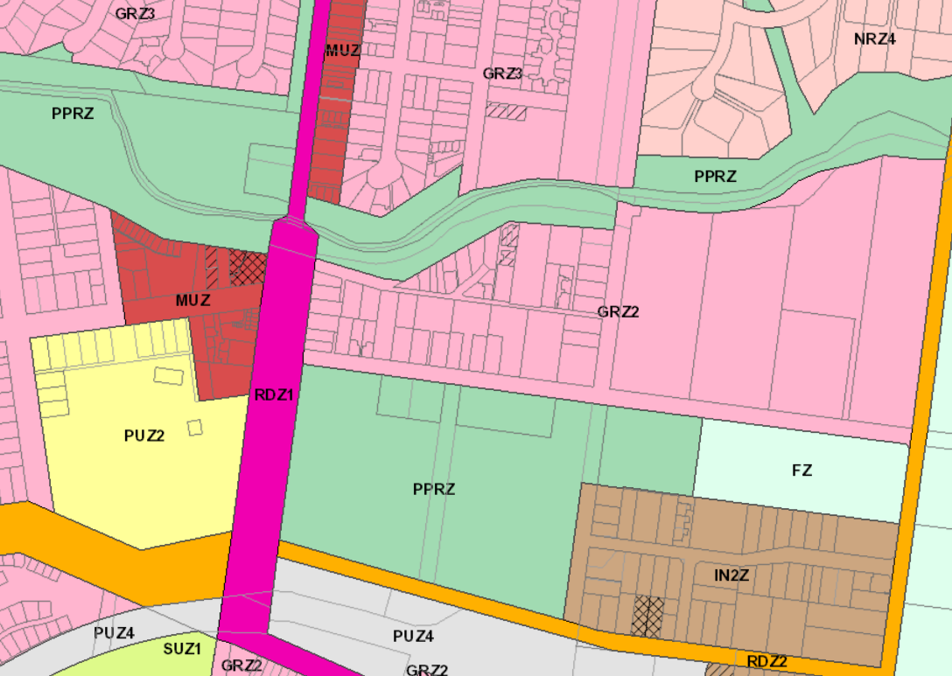Figure 4: The subject site identified within the surrounding context of zones
Council is required to consider the Victoria Planning Provisions and give particular attention to the Planning Policy Framework (PPF) and the Municipal Strategic Statement (MSS).
The relevant clauses are:
• Clause 11.01-1R (Settlement) Settlement – Central Highlands
• Clause 11.02-1S (Settlement) Supply of urban land
• Clause 12.01-1S (Environmental and Landscape Values) Protection of biodiversity
• Clause 13.03-1S (Environmental Risks and Amenity) Floodplain management
• Clause 15.01-1S (Built Environment and Heritage) Urban design
• Clause 15.01-2S (Built Environment and Heritage) Building design
• Clause 15.01-3S (Built Environment and Heritage) Subdivision design
• Clause 15.01-5S (Built Environment and Heritage) Neighbourhood character
• Clause 16.01-1S (Housing) Housing supply
• Clause 16.01-2S (Housing) Housing affordability
• Clause 21.03-2 (Settlement and Housing) Objectives—Urban growth management.
• Clause 21.03-3 (Settlement and Housing) Objectives—Residential development
• Clause 21.03-4 (Settlement and Housing) Objective—Landscape and neighbourhood character
• Clause 21.07-2 (Bacchus Marsh) Objectives—Managing urban growth
• Clause 21.07-6 (Bacchus Marsh) Objectives—Urban design
The proposal is generally consistent with the relevant sections of the PPF and LPPF.

Zone

Clause 32.08 General Residential Zone – Schedule 2 (GRZ2)
Under the provisions of the zone, the proposal requires a planning permit is required for:
• Clause 32.08-3 Subdivide land
• Clause 32.08-6 Construct two dwelling on a lot.
The purpose of the General Residential Zone is to:
• To implement the Municipal Planning Strategy and the Planning Policy Framework.
• To encourage development that respects the neighbourhood character of the area.
• To encourage a diversity of housing types and housing growth particularly in locations offering good access to services and transport.
• To allow educational, recreational, religious, community and a limited range of other non-residential uses to serve local community needs in appropriate locations.
Schedule 2 (natural and greenfield residential growth area) contains the following neighbourhood character objectives:
• To encourage new development, including innovative and unique development that enhances and responds positively to the existing neighbourhood character.
• To encourage an increase in landscaping within the public and private realm.
• To encourage new development to respect existing setbacks within the streetscape.
• To encourage new development to have minimal or low scale front fencing.
• To ensure garages, carports, and second storey development do not visually dominate dwellings or streetscapes.
Schedule 2 requires that a landscape plan be submitted with applications.

Overlays

Clause 42.01 Environmental Significance Overlays – Schedule 8 (ESO8)
The proposal requires a planning permit is required to subdivide land.
Pursuant to Clause 3.0 of Schedule 8 to the Environmental Significance Overlay, no permit is required under the ESO8 for the development of two dwellings because all buildings and works would be located beyond the declared tree protection zone of the nearby river red gum.
The purpose of the Environmental Significance Overlay is:
• To implement the Municipal Planning Strategy and the Planning Policy Framework.
• To identify areas where the development of land may be affected by environmental constraints.
• To ensure that development is compatible with identified environmental values.
Schedule 8 contains the following relevant environmental objectives:
To provide for the long-term preservation and regeneration of the River Red Gum population within the Bacchus Marsh Valley, therefore enhancing biodiversity and landscape quality. Ongoing management practices for River Red Gums should aim to achieve the following:
• Retain all hollow bearing trees.
• Minimisation of disturbance to the Tree Protection Zone for all River Red Gums.
• Support the regeneration of River Red Gums by protecting the growth of young trees.

Clause 43.02 Design and Development Overlay – Schedule 6 (DDO6)
Under the provisions of the DDO6, the proposal requires a planning permit is required for:
• Clause 43.02-2 Construct a building.
• Clause 43.02-3 Subdivide land.
The purpose of the Design and Development Overlay is:
• To implement the Municipal Planning Strategy and the Planning Policy Framework.
• To identify areas which are affected by specific requirements relating to the design and built form of new development.
Schedule 6 contains the following relevant design objectives:
• To encourage medium density residential development provided that such development respects and responds to the character of the neighbourhood.
• To encourage the development and subdivision of land which concentrates on the retention of the openness of the streetscapes, created by generous nature strips and spacious garden settings to the dwellings.
• To encourage the development of a built form character that responds to the existing site characteristics including creating appropriate interfaces with Boyes Close to the east and the Werribee River to the north.
• To encourage new development which provides for and maintains a country town character.
• To ensure new residential development is oriented towards the Werribee River corridor and Boyes Close to promote public safety in the public and private realm.
• To ensure residential development abutting public frontages is appropriately set back to allow for canopy tree planting to maintain the country town character.
• To encourage retention and establishment of vegetation that contributes to the character of the precinct.
• To consider a variety of building heights across the precinct, to a maximum of 9m.
• To ensure that development is orientated to provide public frontages.

Particular Provisions

Clause 52.06 Car Parking
In accordance with Clause 52.06-5 and Table 1, two car spaces are required for each three, or more, bedroom dwelling. The proposal meets the requirement with two car spaces being provided for each dwelling.

Clause 53.01 Public Open Space Contribution and Subdivision
It is considered unlikely that either of the two lots would be further subdivided due to relatively small lot size and very limited availability of future additional street access. The proposal is not required to make a public open space contribution.

Clause 55 Two or more dwellings on a lot and residential buildings
The application is for the development of two dwellings on a lot and thus must be assessed against relevant objectives of Clause 55. The proposal must meet the objectives and should meet the standards of all of Clause 55 except Clause 55.07-1 to 55.07-15 (inclusive).

Clause 56 Residential Subdivision
The application is for a subdivision of two lots of vacant land and thus must be assessed against relevant objectives of Clause 56. The proposal must meet the objectives, and should meet the standards, of the following Clauses: 56.03-5, 56.04-2, 56.04-3, 56.04-5, 56.06-8 to 56.09-2.
The proposal generally complies with ResCode (Clause 55/56), with the exception of the following:
Clause | Title | Response
Clause 55 Two or more dwellings on a lot
55.02-1 | Neighbourhood character | The facades and walls of both dwellings are generally well recessed and setback, except for the first-floor front wall of Unit 2, facing Close. The design detail of this key and prominent interface overhangs the ground floor walls: this does not accord with the streetscape neighbourhood character (where upper levels are recessed) nor Council’s urban design guidelines which encourage that ”the second storey and upper levels of a dwelling should be setback or forward from the ground level to provide increased built form articulation.”  This element can be addressed by increasing the recession of the upper eastern front wall such that it clearly sits behind the line of the front wall at ground level.  A condition on any approved permit which requires plans to be amended showing a recession as described of at least 0.5m is recommended.
55.06-1 | Design detail

Relevant Policies

Housing Bacchus Marsh to 2041, 2016
These two policies have been implemented into local policy through Clause 21.07 of the Moorabool Planning Scheme and the demarcation of the residential precincts, of which the subject site is in Precinct 30. These policies provide guidance of residential urban growth and development within Bacchus Marsh.
Precinct 30 has been identified as being appropriate for natural residential growth, suitable for “well designed, infill development, including multi-unit developments that complement the preferred character of the area, while providing for a variety of housing options.”
Precinct 30 has an existing character defined as within close proximity to the Bacchus Marsh Train Station, Maddingley Park, Grant Street shopping strip and the Werribee River. The precinct has a flat topography and is a modified grid layout. The precinct has a limited footpath network and ranges from some streets having no footpath to others having one sided footpath. A narrow, one way street (Peelmans Lane) with no kerb and channel, is unique to the Precinct, and contains both older development and contemporary single and double storey dwellings, including multi dwelling developments which all contribute to the eclectic style of the precinct. The eastern portion of the precinct is yet to be developed for residential purposes.
Precinct 30 has a preferred character defined as a Natural Residential Growth Area. Some intensification may be appropriate; however, this will need to be considered on a site by site basis. Where new development is considered appropriate, front setbacks will be sufficient to allow for enhancement of the front garden character, including increased canopy tree cover. Front fences will continue to be of a low scale, allowing for views into front gardens. New developments will minimise the need for additional crossovers to the street and have a positive street interface to ensure strong passive surveillance is achieved. Building to both side boundaries will generally be avoided, however may be considered where an innovative and unique development is proposed that enhances the character of the precinct. Multi-dwelling developments should minimise the need for additional crossovers to the street, be located on lots within the precinct that are within a walkable distance of some services and facilities and have minimal impact on the streetscape rhythm and pattern. Garages and carports that do not visually dominate dwellings or streetscapes are encouraged and should be recessed from the front building line or located to the side or rear of the dwelling.

Discussion
Overall, it is considered that, with some minor changes to the built form outcomes proposed, the proposed development of two dwellings and subdivision of two lots are generally in accordance with the relevant zone, overlays, particular and general provisions of the Moorabool Planning Scheme. A permit should be approved accordingly for the reasons set out below:

Neighbourhood character and design detail
As identified by the Precinct 30 existing character statement, the precinct and existing character is unique for its eclectic style, varied lot size and layouts and setbacks, and limited access opportunities through Peelmans Lane.
Development on Boyes Close (the immediate streetscape) is generally single storey with elements of double storey building form, varied material and architectural style (brick, render and weatherboard; gable and hip roof faces) and ages. Further, the streetscape at the Taverner Street intersection is dominated by the long side boundary of 18 Taverner Street (a property in the Heritage Overlay) and interfacing via the side walls of two sheds, canopy trees, and a high timber paling fence. Meanwhile, the eastern side of Boyes Close comprises vacant undeveloped land in common ownership. This land is subject to an approved Development Plan (guiding future subdivision and development) though is not currently subject to any approved subdivision or development.

There are still key elements of the existing and preferred character to be maintained and delivered. The proposal is considered to generally respond to the neighbourhood character in this regard. The built form setback to both streets at least the Standard requirement (Clause 55.03-1) and landscaping redesigned to incorporate a considerable number of plantings and trees that will improve on existing and surrounding conditions. Boundary-to-boundary development has been avoided and by incorporating spacing between both dwellings they are detached in each streetscape aspect. The landscaping design, including lack of front fencing, also helps contribute to the spacious and open garden setting. The use of side access from Peelmans Lane, notwithstanding any other concerns, does mitigate additional visual bulk and sheer wall dominance in the Boyes Close streetscape. To Peelmans Lane, the two garages are separated, partially visually broken with landscaping, and considerably recessed from main walls (3.2m to Unit 1 and 1m to Unit 2). These elements ensure that Peelmans Lane is also not further dominated by the presence of garages.
The proposed landscaping is considered appropriate to maintain a country town character, and physical and visual connections to both Boyes Close and Peelmans Lane will ensure suitable interfacing and surveillance opportunities. These design outcomes are considered appropriate to the DDO6 design requirements, excepting two elements which can be rectified by way of condition to any approved permit:
It is noted that a 1.8m timber paling front fence to Boyes Close is included in the design. This section of fencing can be considered a return fence which encloses the northern secluded private open space of Unit 1. To ensure the consistency of dwelling and public frontages primarily interfacing the streetscape and minimal front fencing, a condition on any approved permit to further recess to this fence in order not to protrude past the adjoining building wall is recommended as a part of the submission of revised plans.
In accordance with other buildings with second storey elements in the streetscape, the upper level of Unit 1 facing Boyes Close should be recessed so as to not protrude forward of the ground level front wall. This design outcome is consistent with the neighbourhood character and the urban design guidelines.

Access
It was expressed by Council early during the assessment process that the proposed site layout of Unit 1 achieving crossing access from Peelmans Lane is not ideal if Boyes Close is otherwise practicably possible. Peelmans Lane is an abnormally narrow one-way access without full kerb and channel or footpaths and pedestrians and vehicles must share the roadway. Furthermore, the legal entry into Peelmans Lane, from Grant Street, is 620m away by road
Thus, the concern of development and access onto this site is whether the design has appropriately sought to minimise additional traffic into Peelmans Lane and discourage illegal entry into Peelmans Lane from the wrong direction.
It was acknowledged that the subdivision being generally acceptable and Lot 2 having no practicable access to Boyes Close, its own Peelmans Lane access is acceptable. Lot 1, however, could be accessed from Boyes Close and indeed does have an existing crossover. Council Infrastructure were requested to specifically consider and respond to this concern and suggested that there are no infrastructure or engineering standards including the Infrastructure Design Manual which would recommend against the access and layout proposal. Council must consider the potential increased traffic imposed and examine the benefits and impacts of an alternate design response.
Other design responses were considered, including maintaining the existing crossover into Boyes Close (on the north-east corner of the property), or a south-eastern crossover adjacent to the Peelmans Lane exit. The former option would substantially impact ResCode Objectives relating to northern solar access to open space, walls on boundary, design detail and neighbourhood character regarding visual bulk and garages to the streetscape. The latter option may incur similar design detail and neighbourhood character concerns, overlooking or overshadowing concerns, and incur new safety concerns by mixing traffic exiting Peelmans Lane with that accessing the site.
Given the findings above, the presently proposed layout with access to Peelmans Lane for both units is therefore considered the most acceptable outcome and accords with orderly planning and seeks the best design response.

Subdivision
The subdivision design as laid out is generally consistent with the objectives of Clause 56 and the requirements of DDO6.

General Provisions
Clause 65 – Decision Guidelines have been considered by officers in evaluating this application.
Clause 66 – Stipulates all the relevant referral authorities to which the application must be referred.

Referrals
Authority | Response
External referrals
Western Water | Consent with conditions.
Melbourne Water | Consent with conditions.
Powercor | Consent with conditions.
Downer Utilities | Consent with conditions.
Internal referrals
Infrastructure | Consent with conditions.
Strategic Planning | Consent with conditions.

Financial Implications
There are no known financial implications arising from approval of this development and subdivision.

Risk & Occupational Health & Safety Issues
The recommendation for approval this proposal does not implicate any risk or OH&S issues to Council.

Communications Strategy
Notice was undertaken for the application, in accordance with s.52 of the Planning and Environment Act 1987, and further correspondence is required to all interested parties to the application as a result of a decision in this matter. All submitters and the applicant were invited to attend this meeting and invited to address Council if required.

Options
• Issue a Notice of Decision to grant a permit in accordance with the recommendation of this report; or
• issue a Notice of Decision to grant a permit with amendments to the conditions in the recommendation of this report; or
• should Council wish to refuse the application, issue a Refusal to Grant a Permit on relevant grounds. This option may result in the applicant appealing Council’s decision at VCAT.

Conclusion
The proposed construction of two dwellings on the lot and associated subdivision into two lots is considered, with some relatively minor modifications by condition as recommended, to be generally in accordance with the relevant planning policies of the Moorabool Planning Scheme, including those relating to neighbourhood character and lot access, and a planning permit should be granted accordingly. The applicant has made changes from the originally submitted plan to adequately satisfy Council’s initial concerns. The objector concerns regarding neighbourhood character and the use of Peelmans Lane cannot be mediated. It is recommended the application be supported.

Mr. Joshua Trowell addressed the Committee as the applicant’s representative associated with Item 7.3.
Mr. Daniel Sullivan addressed the Committee as an objector to the recommendation associated with Item 7.3.

7.3 PA2020250 - Use and Development of a Dwelling and Ancillary Outbuilding at 821 Greenhills Road, Blackwood
Author: Victoria Mack, Statutory Planner
Authoriser: Henry Bezuidenhout, Executive Manager Community Planning & Economic Development
Attachments: 1. Site plan and dwelling floor plan and elevations (under separate cover)
2. Land Management Plan (under separate cover)

Application Summary
Permit No: PA2020250
Lodgement Date: 06 November 2020
Planning Officer: Victoria Mack
Address of the land: 821 Greenhills Road, Blackwood
Proposal: Development and Use of a Dwelling and ancillary outbuilding
Lot size: 3.035ha
Why is a permit required? Rural Conservation Zone - Use and Development of a Dwelling Bushfire Management Overlay - Buildings and works associated with the use of accommodation.

Committee Resolution
Moved: Cr Tonia Dudzik
Seconded: Cr Moira Berry
That the Development Assessment Committee, having considered all matters as prescribed by the Planning and Environment Act 1987, issues a Notice of Decision to Grant a Planning Permit at Greenhills Road, Blackwood, otherwise known as Crown Allotment 10, Parish of Blackwood subject to the following conditions:
Endorsed Plans:
- Before the use and/or development starts, amended plans to the satisfaction of the Responsible Authority must be submitted to and approved by the Responsible Authority. When approved, the plans will be endorsed and will then form part of the permit. The plans must be drawn to scale with dimensions and three copies must be provided. The plans must be generally in accordance with the plans submitted with the application or some other specified plans but modified to show:
  - An amended Bushfire Management Plan in accordance with the Country Fire Authority’s Condition 24.
  - A colour schedule for all external cladding of the dwelling and shed which must include muted earthy tones to compliment the surrounding environment.
  - The internal dwelling layout must altered to include removal of the western kitchen to prevent two self-contained dwellings on the land.
Unless otherwise approved in writing by the Responsible Authority, all buildings and works are to be constructed and or undertaken in accordance with the endorsed plans to the satisfaction of the Responsible Authority prior to the commencement of the use.
Land Management Plan:
- A Land Management Plan (LMP) to the satisfaction of the Responsible Authority must be endorsed as part of this permit and cannot be varied without the written consent of the Responsible Authority. The land must be managed in accordance with the endorsed LMP.
Dwelling Requirements:
- Access to the dwelling must be provided via an all-weather road with dimensions adequate to accommodate emergency vehicles.
- The dwelling must be connected to a reticulated potable water supply or have an alternative potable water supply with adequate storage for domestic use as well as for firefighting purposes.
- The dwelling must be connected to a reticulated electricity supply or have an alternative energy source.
- The dwelling must be connected to a reticulated sewerage system or if not available, the waste water must be treated and retained on-site in accordance with the State Environment Protection Policy (Waters of Victoria) under the Environment Protection Act 1970.
Materials and Colour:
- All external walls and roof areas of the proposed building/s are to be clad with non-reflective materials (zincalume prohibited) to the satisfaction of the Responsible Authority.
Environmental Health:
- The land application area and all conditions must be in accordance to the Land Capability Assessment prepared by Provincial Geotechnical Pty Ltd, ref number 151781 dated 6 October 2020 or any approved amendment are to be strictly adhered to.
- An onsite wastewater management system with the capacity to treat effluent to a primary standard i.e. standard septic tank must be installed in accordance with the requirements of the Environment Protection Act 1970, the Guidelines for Environmental Management: Code of Practice Onsite Wastewater Management 891. 4 (2016).and the Responsible Authority.
- The wastewater management system from proposed dwelling/lots must be treated and contained within the property boundaries in accordance with the current EPA Code of Practice Onsite Wastewater Management: Guidelines for Environmental Management, Australian Standards 1547 and Council requirements.
- The effluent disposal area must be kept free of buildings, driveways, vehicular traffic and services trenching.
- All setback distances must be adhered to as dictated by Table 5 of the Code of Practice, Onsite Wastewater Management, EPA Publication Number 891.4.
- A shallow surface water cut off drain or surface water diversion mound, should be provided on the high side of the disposal areas to divert any surface water flows around the effluent fields.
- The owner will maintain all drainage lines at all times to divert surface water and subsurface water clear of the effluent disposal field.
Infrastructure:
- A standard rural vehicle crossing must be provided on Greenhills Road and the Unnamed Road to the satisfaction of the Responsible Authority. A vehicle crossing permit must be taken out for the construction of the vehicle crossings.
- The property access and the internal driveways must be constructed in accordance with the requirements specified in Table 5 of Clause 53.02-5 of the Moorabool Planning Scheme, to the satisfaction of the Responsible Authority.
- The property is not covered by a waste collection zone. Private arrangements must be made for waste collection.
- Stormwater drainage from the proposed buildings and impervious surfaces must be retained and disposed of within the boundaries of the subject land to the satisfaction of the Responsible Authority. Overflows from on-site storage systems must be directed away from any waste water disposal areas.
- Sediment discharges must be restricted from any construction activities within the property in accordance with relevant Guidelines including Construction Techniques for Sediment Control (EPA 1991).
- Unless otherwise approved by the responsible authority there must be no buildings, structures, or improvements located over proposed drainage pipes and easements on the property.
- Prior to the commencement of the development and post completion, notification including photographic evidence must be sent to Council’s Asset Services identifying any existing damage to Council assets. Any existing works affected by the development must be fully reinstated at no cost to and to the satisfaction of the Responsible Authority.
- Maintenance of the road access to the site is to be undertaken by the registered landowner to satisfaction of the Responsible Authority.
Country Fire Authority:
- The bushfire mitigation measures forming part of this permit or shown on the endorsed plans, including those relating to construction standards, defendable space, water supply and access, must be maintained to the satisfaction of the Responsible Authority on a continuing basis. This condition continues to have force and effect after the development authorised by this permit has been completed.
- Before the development starts, an amended bushfire management plan which is to be generally in accordance with that prepared by Yarra Valley BAL Assessments (Bushfire Management Statement for Allotment 10, Greenhills Road, Blackwood 3458 – Section 11. Appendices, Page 1 & 2, Version A, dated 29 August 2020) must be submitted to and endorsed by the Responsible Authority. The plan must show the following bushfire mitigation measures, unless otherwise agreed in writing by the Country Fire Authority and the Responsible Authority:
  - Show an area of defendable space for a distance of 35m around the proposed building or to the property boundary where vegetation (and other flammable materials) will be modified and managed in accordance with the following requirements:
    - Grass must be short cropped and maintained during the declared fire danger period.
    - All leaves and vegetation debris must be removed at regular intervals during the declared fire danger period.
    - Within 10m of a building, flammable objects must not be located close to the vulnerable parts of the building.
    - Plants greater than 10cm in height must not be placed within 3m of a window or glass feature of the building.
    - Shrubs must not be located under the canopy of trees.
    - Individual and clumps of shrubs must not exceed 5sqm in area and must be separated by at least 5m.
    - Trees must not overhang or touch any elements of the building.
      - The canopy of trees must be separated by at least 5m.
      - There must be a clearance of at least 2m between the lowest tree branches and ground level.
  - Nominate a minimum Bushfire Attack Level of BAL – 29 that the building will be designed and constructed.
  - Show 10,000 litres of effective water supply for fire fighting purposes which meets the following requirements:
    - Be stored in an above ground water tank constructed of concrete or metal.
    - Have all fixed above ground water pipes and fittings required for firefighting purposes made of corrosive resistant metal.
    - Include a separate outlet for occupant use.
    - Be readily identifiable from the building or appropriate identification signage to the satisfaction of the relevant fire authority.
    - Be located within 60m of the outer edge of the approved building.
    - The outlet/s of the water tank must be within 4m of the accessway and unobstructed.
    - Incorporate a separate ball or gate valve (British Standard Pipe (BSP 65mm) and coupling (64mm CFA 3 thread per inch male fitting).
    - Any pipework and fittings must be a minimum of 65 millimetres (excluding the CFA coupling).
  - Show the access for fire fighting purposes which meets the following requirements:
    - All weather construction.
    - A load limit of at least 15 tonnes.
    - Provide a minimum trafficable width of 3.5m
    - Be clear of encroachments for at least 0.5m on each side and at least 4m vertically.
    - Curves must have a minimum inner radius of 10m.
    - The average grade must be no more than 1 in 7 (14.4%) (8.1 degrees) with a maximum of no more than 1 in 5 (20%) (11.3 degrees) for no more than 50m.
    - Dips must have no more than a 1 in 8 (12.5%) (7.1 degrees) entry and exit angle.
    - Incorporate a turning area for fire fighting vehicles close to the building by one of the following:
      - A turning circle with a minimum radius of 8m.
      - A driveway encircling the dwelling.
      - The provision of vehicle turning heads – such as a T or Y head – which meets the specification of Austroad Design for an 8.8 m Service Vehicle.
Southern Rural Water:
- Cutoff drains should be installed above and below the wastewater Land Application Area (LAA) in order to prevent storm water run-on entering the LAA.
- Wastewater must be dispersed via a suitable method and the onsite wastewater system must be designed, constructed and maintained in line with the Land Capability Assessment undertaken by Provincial Geotechnical (Report #15178I dated 6 October 2020) and with due consideration to installer recommendations.
- Wastewater must be treated to a secondary standard prior to dispersal (20/30 BOD/SS Standard).
- The wastewater disposal system must be designed and installed by a suitably qualified contractor to the satisfaction of Council’s Health Officer.
- Prior to construction, approval from Council’s Health Officer must be sought with respect to the design, size and location of the LAA, consistent with the proposed plans for a five bedroom and two study dwelling, which will require consideration of a maximum occupancy of eight persons.
- Any failure of the LAA or wastewater treatment system must be immediately reported to Council’s Health Officer and rectified to the satisfaction of Council.
- Vegetation must be maintained on the LAA such that evapotranspiration is maximized, including keeping lawns mowed.
- The owner of the land must keep records of maintenance or works to the onsite wastewater system and must make these records available on request to Council or water authorities.
- No building, stock access or vehicle access must be allowed on the LAA to prevent damage to the system. If required, fencing should be installed in order to prevent stock or vehicle access.
- All buffer distances to waterways, dams and other areas of interest must be met as per EPA Publication 891.4.
Western Water:
- Prior to a building permit being granted for the development of a dwelling, the owner of the land must enter into a Section 173 Agreement with Western Water and the Council agreeing that:
  - A wastewater treatment system that produces wastewater to a minimum standard of 20/30 (BOD/suspended solids) must be installed to the satisfaction of the Council's Environmental Health Officer and Western Water to treat all sullage and sewage waste on site.
  - Wastewater must be dispersed to the satisfaction of Council's Environmental Health Officer and Western Water using methods that will always prevent waste and treated waste from discharging from the property.
  - The effluent system must be maintained by a suitably qualified person in accordance with the manufacturer's specifications and EPA requirements.
  - The wastewater effluent being released from the treatment facility must be monitored annually to ensure compliance with the 20/30 standard.
  - Reports on water quality and maintenance must be submitted to the Responsible Authority at the completion of each maintenance period. This report must be made available to Western Water on request.
  - The Owner shall meet the costs of the inspections and reports referred to in Condition 1 e).
  - The owner shall carry out such works including replacing effluent treatment, storage pumping and disposal systems within the time specified to do so by the Council's Environmental Health Officer or Western Water to cease and prevent waste and treated waste from discharging from the property.
  - If the wastewater program proves to be unsustainable, the land holder must immediately rectify the sewerage disposal system.
  - The owner shall have the wastewater treatment system desludged at least once every three years and evidence of this fact shall be provided in the annual written report referred to in Condition 1 e).
  - The effluent disposal field must be protected by being isolated from any building, driveway, livestock, vehicles or permanent recreational area that could render it unavailable in the future and should be planted with suitable grasses that will aid in moisture removal.
  - All recommendations, actions and timelines contained within the Land Management Plan prepared by Central Highlands Environmental Consultancy, Dated: 31 December 2020 must be followed and implemented to the satisfaction of Western Water and Moorabool Shire Council.
- Sediment Pollution Controls shall be employed during construction and maintained until all disturbed areas have regenerated.
- Stormwater is to be managed in a way to minimise risk to erosion of the surrounding land. No stormwater should be allowed to move into the effluent disposal fields.

- Stormwater run-off from the dwelling and surrounding impervious surfaces must be dissipated as normal un-concentrated overland flow.
- Low volume water fittings such as water efficient showerheads, dual flush toilets and tap aerators are to be fitted to all water fixtures.
- The obligations under this agreement shall run with the land.
Permit Expiry:
- This permit will expire if:
  - The development and use are not started within two years of the date of this permit; and
  - The development is not completed within four years of the date of this permit.
Permit Notes:
- Country Fire Authority:
Given the greater landscape risk (Type 4) and the very limited egress options available to the location, CFA are unable to support a construction level less than BAL 29 in this location as the proposed dwelling may be required by the occupants as a last resort shelter during a bushfire event. BAL 12.5 construction would provide minimal protection (i.e. from embers). If you wish to discuss this matter in more detail, please do not hesitate to contact Daniel Faulkner on (03) 5329 5570.
- Environmental Health:
Prior to installation of works commencing on the wastewater system, a permit to install an onsite wastewater management system must be submitted to Environmental Health.
Carried

Public Consultation
Was the application advertised? | Yes.
Notices on site: | Yes.
Notice in Moorabool Newspaper: | No.
Number of objections: | One.
Consultation meeting: | None held. However, the applicant responded to the objection in writing, and the objector in turn responded to applicant’s response.

Policy Implications
The Council Plan 2017-2021 provides as follows:
Strategic Objective 2: Minimising Environmental Impact
Context 2B: Natural Environment
The proposal is not provided for in the Council Plan 2017-2021 and can be actioned by utilising existing resources.

Victorian Charter of Human Rights & Responsibilities Act 2006
In developing this report to Council, the officer considered whether the subject matter raised any human rights issues. In particular, whether the scope of any human right established by the Victorian Charter of Human Rights and Responsibilities is in any way limited, restricted or interfered with by the recommendations contained in the report. It is considered that the subject matter does not raise any human rights issues.

Officer’s Declaration of Conflict of Interests
Under section 130 of the Local Government Act 2020, officers providing advice to Council must disclose any interests, including the type of interest.
Executive Manager – Henry Bezuidenhout
In providing this advice to Council as the Executive Manager, I have no interests to disclose in this report.
Author – Victoria Mack
In providing this advice to Council as the Author, I have no interests to disclose in this report.

Executive Summary
Application referred? | Yes, to Western Water, Southern Rural Water and the Country Fire Authority and Council’s Environmental Health and Infrastructure.
Any issues raised in referral responses? | No.
Preliminary concerns? | Requirement for a Land Management Plan (LMP) including a response to the decision guidelines of the Rural Conservation Zone, and information about the use of the land for agriculture if applicable.  The internal layout could be used as two self-contained dwellings.
Any discussions with applicant regarding concerns? | Requested further information was provided.
Any changes made to the application since being lodged? | A detailed Land Management Plan (LMP) was provided including a revegetation plan, a small wetland area plan and pest plant and animal control. Apart from a pony no livestock would be kept on the property.
Brief history. | The land has been used for grazing. The site is one of several crown allotments that were all in the same ownership over many years. Recently this owner has sold off individual crown allotments to new land owners.
Previous applications for the site? | No applications are recorded for this site.

General summary. | The application is for a dwelling and outbuilding in the Rural Conservation Zone where a permit is required for one dwelling on a lot.  The land is cleared without substantial native vegetation on the site although the surrounding area is native forest and bushland. A LMP was provided with the application which addresses both the protection and enhancement of the site’s environmental values.  It is considered that the LMP should be endorsed as part of the permit and a colour schedule is provided to ensure that the dwelling is constructed with external cladding in muted earthy tones.  The land will not be used for agriculture and it is considered that the use is appropriate in this location.  It is recommended that the application is supported.
Summary of Officer’s Recommendation
That, having considered all relevant matters as required by the Planning and Environment Act 1987, Council issues a Notice of Decision to Grant a Planning Permit at Greenhills Road, Blackwood, otherwise known as Crown Allotment 10, Parish of Blackwood subject to conditions.

Site Description
The site is rectangular in shape and has an area of 3.035ha and is within the Rural Conservation Zone. The site is cleared and pastured. No stock are currently run on the site. There is scattered native vegetation around the boundary of the site, with some of this located in the adjacent road reserve.
The property has access from Greenhills Road and a there is a road on title that runs along the northeast boundary.
The land slopes upwards from Greenhills Road to the rear with a rise of approximately 10m.
It is located approximately 1.4km south-west of the intersection of Greenhills Road with the Greendale Trentham Road, and approximately 4km south west of the Blackwood township.
In the surrounding area are a few scattered dwellings, a plant nursery and open pastured grazing land. A State Forest surrounds a group of Crown lots along Greenhills Road. The surrounding Crown lots are partly cleared of remanent vegetation.
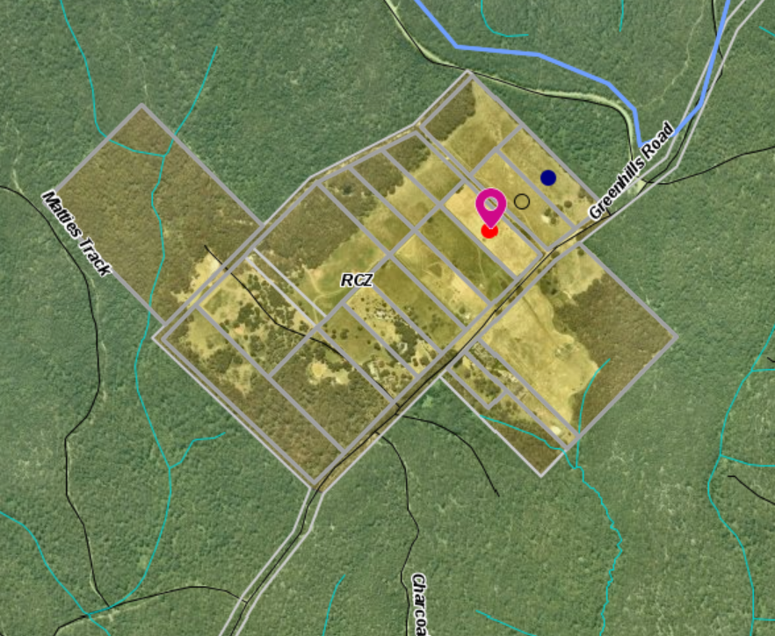
Figure 1: Aerial Photograph

Proposal
It is proposed to develop and use the land for a dwelling and shed. The development would be off the electricity grid as reticulated power is not available to the site.
The main part of the dwelling would be single storey with an open plan kitchen, meals, and family area with access to a covered alfresco area with a small kitchenette for outdoor dining. The kitchen would have access to a laundry.
There would be a porch and entrance area with stairs leading to a 48.7sqm upper loft. The balance of the main dwelling would comprise a long hallway with access to a powder room, master bedroom with ensuite and WIR, two other bedrooms both with access to a family bathroom, a study, a store room and then access to a three car space covered carport. There would be access from the carport to a second powder room and second storage room. On the other side of the carport under the same roofline would be with two bedrooms, a shared bathroom, a study, a kitchenette and a living or retreat area.
The total floor area of the development would be 599sqm.
The dwelling would be constructed with face brick, aluminium windows and a Colorbond roof.
It would be setback 90m from the frontage to Greenhills Road, 27.1m from the northeast boundary and the paper road and 35.4m from the southwest boundary.
A shed would be constructed behind the dwelling. It would be 12m long and 8m wide and setback 30m north of the dwelling and 55m from the southwest boundary.
The LMP site plan is shown below:
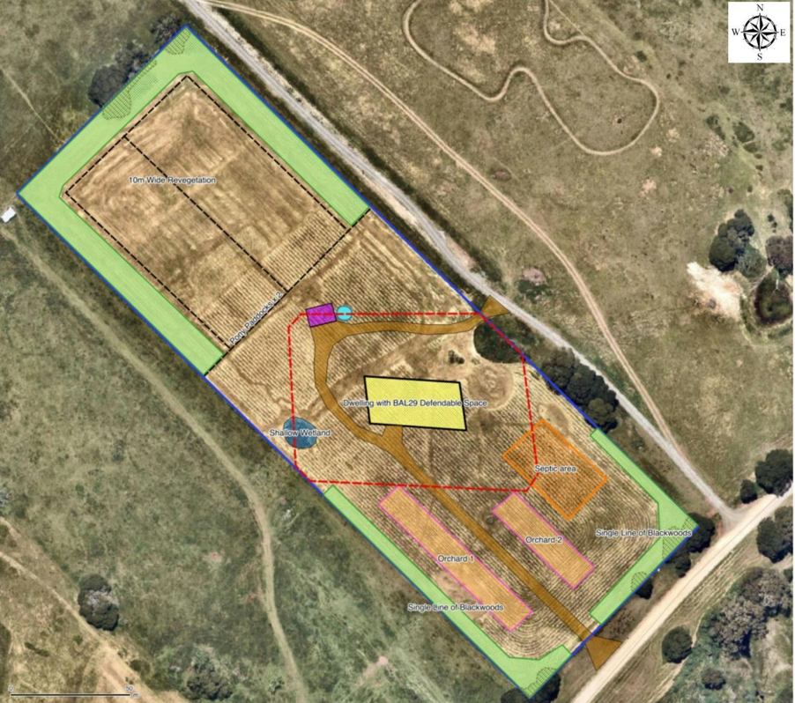
Figure 2: Land Management Plan (LMP) Site Plan

KEY: LMP Site Plan – existing and proposed features of the property
Property boundary | Dark blue outlined
Existing roads
Existing Hydrology | light blue lines (if present)
Other existing native treed vegetation | olive hashed area with dotted outline – mainly on or near property boundaries
proposed dwelling | yellow shaded
small shed | pink shaded
driveway | brown shaded
proposed water tank 20,000lt | blue circle
proposed BAL 29 defendable space – 35m or to property boundary | red dashed outline
proposed septic area | orange hashed
proposed shallow wetland area | dark blue shaded area
proposed shelterbelts | light green shaded areas
proposed Orchard areas | pink outline with light orange shading
proposed internal fence line – for two small pony paddocks | black dashed lines

History
There are no previous applications recorded on the subject site.

Public Notice
The application was notified to adjoining and surrounding landowners.
One objection was received.

Summary of Objections
The objections received are detailed below with officer’s comments accompanying them:
Objection | Any Relevant Requirement
Council has proven they cannot be trusted with administration or management of planning approvals in sensitive environmental areas such as Rural Conservation Zone (RCZ). Including approval and construction of a new easement road (approved by PA2015141) to access the new dwelling through Crown land without any consideration to the impacts on the environment, residents, and other stakeholders in the area.  Any further access granted by the Council in relation to any future planning permits, such as this one, should include mandatory upgrades to the section of easement being accessed to meet minimum standards and specifications for a carriageway construction in accordance with the Council’s own guidelines and it should include the ongoing maintenance requirements of the easement road. | Land Act 1958 - Sect 402  Moorabool Shire Council Policy IS017:  Maintenance of Unmade “Paper” Roads Policy
Officer’s Response: The road in question is an unused “paper” road running parallel to the northeast boundary of the subject site. Previously the applicant for PA2015141-1 was advised that they could use the road for access to the property known as Blackwood Ridge Road or Property No. 59800, but such use was to be constructed and maintained at their expense. Unused roads are Crown land with right of access within the Land Act 1958.
Moorabool Shire Policy in relation to “paper roads” states:
The cost of maintenance of “paper” roads is the responsibility of the landowners who use the road for access to private properties. Where access is only for a single property, the property owners may also choose to upgrade the section of road to a standard lower than Council would accept (akin to a driveway) to access their property at their cost and maintenance responsibility.
The proposed dwelling is a ‘dual occupancy’ residence and the proposed shed is well over 50sqm and requires planning approval and should be properly documented with detailed plans. At best the advertising of this development is false and misleading and at worst deceptive. As a stakeholder with an established agritourism business on land adjacent to the proposed development, these poor planning decisions will ultimately impact the viability of my business.
Officer’s Response: The subject site is located approximately 204m from the plant nursey along Greenhills Road. The internal layout of the dwelling is required to be altered to prevent two self-contained dwellings under the one roof line. Refer to Condition 1.c). The location of a shed was clearly marked on the site plan behind the dwelling.
The proposal to install a primary wastewater system to service such a large home in this environmentally sensitive water catchment area is completely out of touch with contemporary conservation and protection of Victoria’s 134 ‘Declared Special Water Supply Catchment Areas’ such as Greenhills which supplies upland water to Pykes Creek reservoir which supplies drinking water to the town of Myrniong. | Catchment and Land Protection Act 1994  EPA Publication 891.4: Code of practice – onsite wastewater management
Officer’s Response: Southern Rural Water and Western Water both consented to the application. It is their role it is to assess any potential impacts in the Water Catchment areas.
The risks of the proposed primary wastewater treatment system failing with such a large development is extremely high and should not be considered in this area. | Catchment and Land Protection Act 1994  EPA Publication 891.4: Code of practice – onsite wastewater management
Officer’s Response: Southern Rural Water and Western Water both consented to the application. It is their role it is to assess any potential impacts in the Water Catchment areas.
The RCZ encourages the need to minimise adverse impacts of siting, design, bulk, colours and materials, on the landscape, vistas, character and appearance of the area or of natural scenic beauty, to blend into the natural environment and to conserve the values specified in the schedule to this zone.

The use or development of this site for such a large dwelling of approximately 500sqm is completely inappropriate and the site must be protected and enhanced with consideration given to the environmental and landscape qualities and its surrounds in accordance with the planning scheme.
Officer’s Response: One purpose of the schedule to the RCZ is to ‘Ensure that the location, siting and design of any development does not adversely impact upon sensitive environments nearby’. It is not considered that with appropriate landscaping that the dwelling would adversely affect the surrounding sensitive environments.
I operate a well-established agritourism business adjacent to the proposed development with ornamental plant nursery, restaurant, market garden and open gardens. The site for my business was chosen for its pristine naturally scenic and unique rural non-urban surrounds and vistas Inappropriate development in this environmentally sensitive, historic farming area would affect my business which I have been operating successfully for the past 11 years. My customers are looking for a unique experience and would be put off by this type of residential development nearby and wouldn’t bother to visit the area or my business in the future.
Officer’s Response: The subject site is not adjacent to the plant nursery, it is 204m to the east. A dwelling is a permit required use in the Rural Conservation Zone.
The proposed development has an estimated budget of $450,000. On current building costs per square metre the dwelling would cost upwards of $800,000 not including any associated infrastructure costs for this type of off-grid rural living and shed. With such a severely under budgeted development it will most likely never be completed and remain an eyesore in the area for many years.
Officer’s Response: The capacity of an applicant/landowner to pay for a development is not a planning consideration.

Locality Map
The map below indicates the location of the subject site and the zoning of the surrounding area.
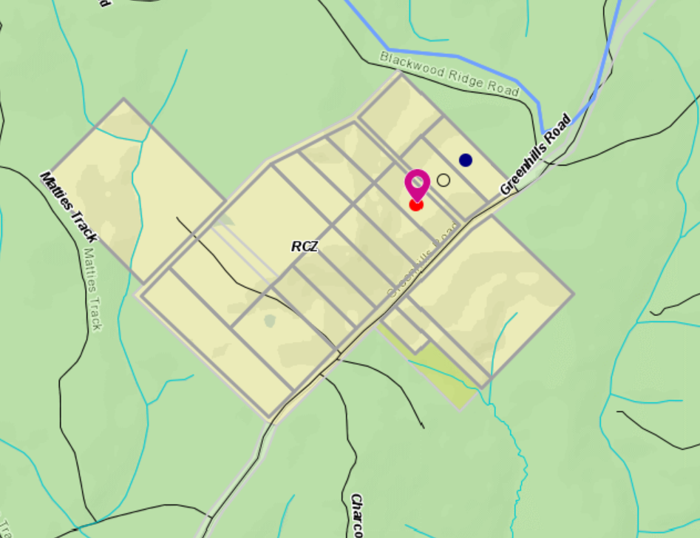
Figure 3: Zone map

Planning Scheme Provisions
Council is required to consider the Victoria Planning Provisions and give particular attention to the Planning Policy Framework (PPF), the Local Planning Policy Framework (LPPF) and the Municipal Strategic Statement (MSS).
The relevant clauses are:
• Clause 12.01-1S - Protection of biodiversity
• Clause 12.01-2S - Native vegetation management
• Clause 12.05-2S - Landscapes
• Clause 13.02-1S - Bushfire planning
• Clause 14.02-1S - Catchment planning and management
• Clause 14.02-2S - Water quality
• Clause 16.01-3S - Rural residential development
• Clause 22.02 - Special Water Supply Catchments
• Clause 21.02 - Natural Environment
• Clause 21.02-1 - Key issues and influences
• Clause 21.09-1 - Small Towns and Settlements
Based on assessment of the supporting documentation including the Land Management Plan and advice from referral agencies, Council is satisfied that the proposal generally complies with the relevant sections of the PPF and LPPF applicable to this application.

Zone
Rural Conservation Zone (RCZ)
In accordance with Clause 35.06-1, Section 2, of the Moorabool Planning Scheme a permit is required to use land for a dwelling. The dwelling must be the only dwelling on the lot.
In accordance with Clause 35.06-5, of the Moorabool Planning Scheme a permit is required to construct or carry out a building or works associated with a use in Section 2 of Clause 35.06-1.
The purpose of the Rural Conservation Zone is to:
• Implement the Municipal Planning Strategy and the Planning Policy Framework.
• Conserve the values specified in a schedule to this zone.
• Protect and enhance the natural environment and natural processes for their historic, archaeological and scientific interest, landscape, faunal habitat and cultural values.
• Protect and enhance natural resources and the biodiversity of the area.
• Encourage development and use of land which is consistent with sustainable land management and land capability practices, and which takes into account the conservation values and environmental sensitivity of the locality.
• Provide for agricultural use consistent with the conservation of environmental and landscape values of the area.
• Conserve and enhance the cultural significance and character of open rural and scenic non-urban landscapes.
The purpose of the Schedule to the Rural Conservation Zone is to:
• Protect land of environmental significance.
• Ensure that the location, siting and design of any development does not adversely impact upon sensitive environments nearby.
The decision guidelines of the RCZ require that the Responsible Authority must consider as appropriate:
- The protection and enhancement of the natural environment of the area, including the retention of vegetation and faunal habitats and the need to revegetate land including riparian buffers along waterways, gullies, ridgelines, property boundaries and saline discharge and recharge areas.
- How the use and development relate to sustainable land management and the need to prepare an integrated land management plan which addresses the protection and enhancement of native vegetation and waterways, stabilisation of soil and pest plant and animal control.
- The capability of the land to accommodate the proposed use or development.
- The need to minimise adverse impacts on the character and appearance of the area or features of archaeological, historic or scientific significance or of natural scenic beauty or importance.

Overlays

Relevant Policies
Design and Development Overlay, Schedule 2 (DDO2) : Visual Amenity and Building Design
The Design objectives are to:
- Enhance visual amenity in rural, township and vegetated areas of the Moorabool Shire.
- Encourage the use of external cladding, such as non-reflective materials for building construction.
- Discourage the use of materials, such as reflective cladding for building construction, which could have a detrimental effect on amenity.
A permit is not required to construct a building or to carry out works where all external walls and roof areas are clad with non-reflective materials.
As the proposed development does not use any reflective materials in the external cladding a permit is not triggered under the DDO2.
Bushfire Management Overlay (BMO)
In accordance with Clause 44.06 a permit is required for buildings and works associated with the use of land for accommodation.
An application must meet the requirements of Clause 53.02 unless the application meets all of the requirements specified in a schedule to this overlay

Particular Provisions
Clause 52.12-5 Bushfire Protection Exemptions
The exemptions to create defendable space for a dwelling under Clause 44.06 of this planning scheme from vegetation removal do not apply to the Rural Conservation Zone.
Clause 53.02 Bushfire Planning:
Clause 53.02-4 Bushfire protection objectives applies to land in the Rural Conservation Zone.

Discussion
The proposal generally complies with the provisions of the PPF and LPPF and the zone, overlay and particular provision of the planning scheme requirements as outlined in the body of the report. Subject to minor changes as outlined below and the implementation of the LMP, the conservation value of the area is not diminished.
The application contains two self-contained living areas under one roof. This can be rectified by changing the internal layout to ensure one self-contained dwelling is situated on the land by removing the second kitchen to western side of the dwelling. Revised plans are being conditioned are per Condition 1.c).
The development is compliant with the rural conservation zone decision guidelines subject to a colour scheme being provided for the external cladding of the dwelling and shed. This is a requirement of Condition 1 of the permit.
The application is supported by all referral agencies subject to conditions.
The application was advertised, and one objection was received. The objection is outlined in this report. A summary of the grounds for the objection are based on the impact of the proposed development on their nursery business particularly from a landscape and vista perspective. The proposed dwelling is over 200m from their property and is not considered that the visual impacts would create a detriment to his plant nursery site.

General Provisions
Clause 65 – Decision Guidelines have been considered by officers in evaluating this application.
Clause 66 – Stipulates all the relevant referral authorities to which the application must be referred.

Referrals
Authority | Response
Western Water  Southern Rural Water | TBA  Consent with conditions.
Environmental Health  Infrastructure  Country Fire Authority (CFA) | Consent with conditions.  Consent with conditions.  Consent with conditions.

Financial Implications
There is no financial implication associated with this approval to grant a permit for this use and development of a dwelling.

Risk & Occupational Health & Safety Issues
The recommendation of approval of this use and development does not implicate any risk or OH&S issues to Council.

Communications Strategy
Notice was undertaken for the application, in accordance with s.52 of the Planning and Environment Act 1987, and further correspondence is required to all interested parties to the application as a result of a decision in this matter. All submitters and the applicant were invited to attend this meeting and invited to address Council if required.

Options
Council could consider the following options:
• issue a Notice of Decision to grant a permit in accordance with the recommendations of this report; or
• issue a refusal to Grant a Permit with specific grounds.

Conclusion
It is considered that the application for a single dwelling on 3.035ha lot in the Rural Conservation Zone is appropriate and consistent with planning scheme provisions. The dwelling would be well setback from the road and neighbouring properties and is an effective use of vacant land. The LMP provided with the application covers both the protection and enhancement of the environmental values of the site in accordance with the objectives of the Rural Conservation Zone.

7.4 PA2020257 - Use and Development of a Dwelling and Ancillary Outbuiding at Corries Lane Mount Egerton
Author: Victoria Mack, Statutory Planner
Authoriser: Henry Bezuidenhout, Executive Manager Community Planning & Economic Development
Attachments: 1. Proposed dwelling and shed plans (under separate cover)
2. Proposed site plan (under separate cover)
3. Farm Management Plan (under separate cover)

Application Summary
Permit No: PA2020257
Lodgement Date: 11 November 2020
Planning Officer: Victoria Mack
Address of the land: Corries Lane Mount Egerton
Lot 2 on PS 425954
Proposal: Use and Development of a Dwelling and Ancillary Outbuilding
Lot size: 21.31ha
Why is a permit required? Farming Zone - Use and development of a dwelling on a lot less than 40ha;
Bushfire Management Overlay - Buildings and works associated with the use of land for accommodation;
Environmental Significance Overlay, Schedule 1 - Buildings and.

Committee Resolution
Moved: Cr Paul Tatchell
Seconded: Cr Tonia Dudzik
That Council, having considered all matters for PA2020257 as prescribed by the Planning and Environment Act 1987, issue a Notice of Decision to grant a Planning permit for the Development of a Dwelling in Association with Use of the Land for Agriculture at Corries Lane Mount Egerton otherwise known as Lot 2 on PS 425954 with the following conditions:
Endorsed Plans:
- The development as shown on the endorsed plans must not be altered without the written consent of the Responsible Authority. All buildings and works must be constructed and or undertaken in accordance with the endorsed plans to the satisfaction of the Responsible Authority. All buildings and works must be located clear of any easements or water and sewer mains or septic tank and effluent lines unless written approval is provided by the relevant authority.
Farm Management Plan:
- A Farm Management Plan to the satisfaction of the Responsible Authority must be endorsed as part of this permit, and cannot be varied without the written consent of the Responsible Authority.
Section 173 Agreements:
- Before the issue of a Building Permit the owner must enter into an agreement with the Responsible Authority made pursuant to Section 173 of the Planning and Environment Act 1987 to the satisfaction of the Responsible Authority:
  - The owner of the land must acknowledge that while the land remains zoned as Farming Zone or its equivalent successor the primary use of the land is for agricultural activities and the use of the dwelling must be in conjunction with an approved agricultural activity.
  - Agricultural activities and environmental management identified in the endorsed Farm and Land Management Plan must be undertaken on the land and must be in accordance with the Farm Management Plan endorsed under Condition 2 of the Planning Permit and cannot be varied without the written consent of the Responsible Authority.
  - Before a Building Permit is issued for the dwelling, application must be made to the Register of Titles to register the Section 173 Agreement on the title to the land under Section 181 of the the Planning and Environment Act 1987 and the owner must provide evidence of that registration of the Agreement to the Responsible Authority.
  - The owner must pay the reasonable costs for the preparation, execution and registration of the Section 173 Agreement.
Dwelling Requirements:
- Access to the dwelling must be provided via an all-weather road with dimensions adequate to accommodate emergency vehicles.
- The dwelling must be connected to a reticulated potable water supply or have an alternative potable water supply with adequate storage for domestic use as well as for firefighting purposes.
- The dwelling must be connected to a reticulated electricity supply or have an alternative energy source.
- The dwelling must be connected to a reticulated sewerage system or if not available, the waste water must be treated and retained on-site in accordance with the State Environment Protection Policy (Waters of Victoria) under the Environment Protection Act 1970.
Materials and Colour:
- All external walls and roof areas of the proposed building/s are to be clad with non-reflective materials (zincalume prohibited) to the satisfaction of the Responsible Authority.
Environmental Health:
- The land application area and all conditions must be in accordance to the Land Capability Assessment prepared by Provincial Geotechnical Pty Ltd, ref number 13895B dated 3rd March 2020 or any approved amendment are to be strictly adhered to.
- An onsite waste water management system with the capacity to treat effluent to a primary standard i.e. standard septic tank must be installed in accordance with the requirements of the Environment Protection Act 1970, the Guidelines for Environmental Management: Code of Practice Onsite Wastewater Management 891. 4 (2016).and the Responsible Authority.
- The wastewater management system from proposed dwelling/lots must be treated and contained within the property boundaries in accordance with the current EPA Code of Practice Onsite Wastewater Management: Guidelines for Environmental Management, Australian Standards 1547 and Council requirements.
- The effluent disposal area must be kept free of buildings, driveways, vehicular traffic and services trenching.
- All setback distances must be adhered to as dictated by Table 5 of the Code of Practice, Onsite Wastewater Management, EPA Publication Number 891.4.
- A shallow surface water cut off drain or surface water diversion mound, should be provided on the high side of the disposal areas to divert any surface water flows around the effluent fields.
- The owner will maintain all drainage lines at all times to divert surface water and subsurface water clear of the effluent disposal field.
Infrastructure:
- A standard rural vehicle crossing be provided on Corries Lane to the satisfaction of the Responsible Authority. A vehicle crossing permit must be taken out for the construction of the vehicle crossing.
- The property access and the internal driveways must be constructed in accordance with the requirements specified in Table 5 of Clause 53.02-5 of the Moorabool Planning Scheme, to the satisfaction of the Responsible Authority.
- Storm water drainage from the proposed buildings and impervious surfaces must be retained and disposed of within the boundaries of the subject land to the satisfaction of the Responsible Authority. Overflows from on-site storage systems must be directed away from any waste water disposal areas.
- Sediment discharges must be restricted from any construction activities within the property in accordance with relevant Guidelines including Construction Techniques for Sediment Control (EPA 1991).
- Unless otherwise approved by the responsible authority there must be no buildings, structures, or improvements located over proposed drainage pipes and easements on the property.
- Prior to the commencement of the development and post completion, notification including photographic evidence must be sent to Council’s Asset Services department identifying any existing damage to council assets. Any existing works affected by the development must be fully reinstated at no cost to and to the satisfaction of the Responsible Authority.
Barwon Water:
- The following shall be undertaken to the requirements of Barwon Water and to the satisfaction of the Responsible Authority:
  - As a minimum, wastewater is to be treated to a primary standard, as recommended in the Provincial Land Capability Assessment - Report No. 13895B dated March 3 2020.
  - The land application area must be located in the area recommended in the Provincial Land Capability Assessment - Report No. 13895B dated March 3 2020 and to the satisfaction of Moorabool Shire Council Environmental Health Officer.
  - Gypsum must be applied to the base of the land application area as recommended in the Provincial Land Capability Assessment - Report No. 13895B dated March 3 2020.
  - All components of the wastewater management system including the effluent disposal area must be located at least 100m from any surface waterway and 60m from any dam.
  - All stormwater must be directed away from the effluent disposal area and roof stormwater must not be disposed to the effluent disposal area.
  - The effluent disposal field must be protected by being isolated from any building, driveway, livestock, and vehicles.
  - Monitoring, Operation and Maintenance must be undertaken in accordance with the Provincial Land Capability Assessment - Report No. 13895B dated March 3 2020 and to the satisfaction of Moorabool Shire Council Environmental Health Officer.
  - Sediment control measures as outlined in the EPA’s publication No 275 Sediment Pollution Control shall be employed during the construction of the dwelling and maintained until the disturbed area has regenerated.
  - The use, storage and disposal of any fuels or chemicals must be managed in accordance with EPA’s publication 1698 Liquid storage and handling guidelines. Chemicals and fuels used on site must be registered by the Australian Pesticides and Veterinary Medicines Authority and must be stored in their own, labelled containers above flood levels to avoid water contamination in flood or overland flow events.
Country Fire Authority:
- The bushfire mitigation measures forming part of this permit or shown on the endorsed plans, including those relating to construction standards, defendable space, water supply and access, must be maintained to the satisfaction of the Responsible Authority on a continuing basis. This condition continues to have force and effect after the development authorised by this permit has been completed.
- The Bushfire Management Plan prepared by Central Highlands Environmental Consultancy (Lot 2, Corries Lane, Mt Egerton, Version 1, dated 20/10/2020) must be endorsed to form part of the permit and must not be altered unless otherwise agreed in writing by the Country Fire Authority and the Responsible Authority.
Permit Expiry:
- This permit will expire if:
  - The development and use are not started within two years of the date of this permit; and
  - The development is not completed within four years of the date of this permit.
Permit Note:
- Prior to installation of works commencing on the wastewater system, a permit to install an onsite wastewater management system must be submitted to Environmental Health.
Carried

Public Consultation
Was the application advertised? | Yes.
Notices on site: | Yes, one sign.
Notice in Moorabool Newspaper: | No.
Number of objections: | No objections.
Consultation meeting: | Not applicable.

Policy Implications
The Council Plan 2017-2021 provides as follows:
Strategic Objective 2: Minimising Environmental Impact
Context 3A: Land Use Planning
The proposal is not provided for in the Council Plan 2017-2021 and can be actioned by utilising existing resources.

Victorian Charter of Human Rights & Responsibilities Act 2006
In developing this report to Council, the officer considered whether the subject matter raised any human rights issues. In particular, whether the scope of any human right established by the Victorian Charter of Human Rights and Responsibilities is in any way limited, restricted or interfered with by the recommendations contained in the report. It is considered that the subject matter does not raise any human rights issues.

Officer’s Declaration of Conflict of Interests
Under section 130 of the Local Government Act 2020, officers providing advice to Council must disclose any interests, including the type of interest.
Executive Manager – Henry Bezuidenhout
In providing this advice to Council as the Executive Manager, I have no interests to disclose in this report.
Author – Victoria Mack
In providing this advice to Council as the Author, I have no interests to disclose in this report.

Executive Summary
Application referred? | Yes, to Barwon Water, the Country Fire Authority and Council’s Environmental Health and Infrastructure.
Any issues raised in referral responses? | Environmental Health requested further information.
Preliminary concerns? | The submitted Farm Management Plan contained incorrect information and incorrect projected yields and financial returns for the various enterprises proposed.

Any discussions with applicant regarding concerns? | A request for further information was made requesting the Farm Management Plan was corrected.
Any changes made to the application since being lodged? | The Farm Management Plan was accepted.
Brief history. | The land was the site of a Blue Gum Plantation which was harvested between 15 October 2017 and 29 November 2017, except for the southern section, of approximately 2.4ha, where the trees have been retained.
Previous applications for the site? | PA2000108 being for the Development and Use of a Dwelling which was refused on 28 February 2001.
General summary. | The application is for a dwelling in the Farming Zone on a 21.31ha lot. The justification for the dwelling is based on a mixed farming proposal including prime lambs, chickens for egg production, olive trees for processing olives and fruit trees to make preserves. All produce would be sold in local markets.  The sheep stocking rates proposed are unachievable, the olive and fruit tree yields are without an adequate water supply would appear difficult to sustain on the land.  It is considered that the proposal does not adequately justify a dwelling. The enterprises proposed are overly optimistic based on land constraints.  Land in the Farming Zone should be retained for productive agriculture use and not for rural residential pursuits or hobby type farms.  It is recommended that the application be refused.
Summary of Officer’s Recommendation
That, having considered all relevant matters as required by the Planning and Environment Act 1987, Council issues a Refusal to Grant a Planning permit for the Development of a Dwelling in Association with Use of the Land for Agriculture at Corries Lane Mt Egerton otherwise known as Lot 2 on PS 425954.

Site Description
The site is 21.31ha and is relatively flat. The allotment is irregular in shape with a section of approximately 2.4ha containing blue gums from a plantation that previously covered the whole of the site and was harvested at the end of 2017.
Signs of the former plantation are evident on the site with remnant timber pieces scattered within the regrowth pasture.
A waterway crosses the northern end of the remnant plantation. There is a small dam in the northeast corner of the site with a surface area of approximately 800sqm.
The land is located on the southern side of Corries Lane approximately 340m west of the intersection with Little Forest Road, and approximately 750m south east of the intersection of Corries Land with Shepherds Lane.
The land is approximately 3km east of the Egerton Ballark Road.
The nearest neighbouring dwelling is located approximately 250m from the eastern boundary of the site.
Below is an aerial photo of the site.
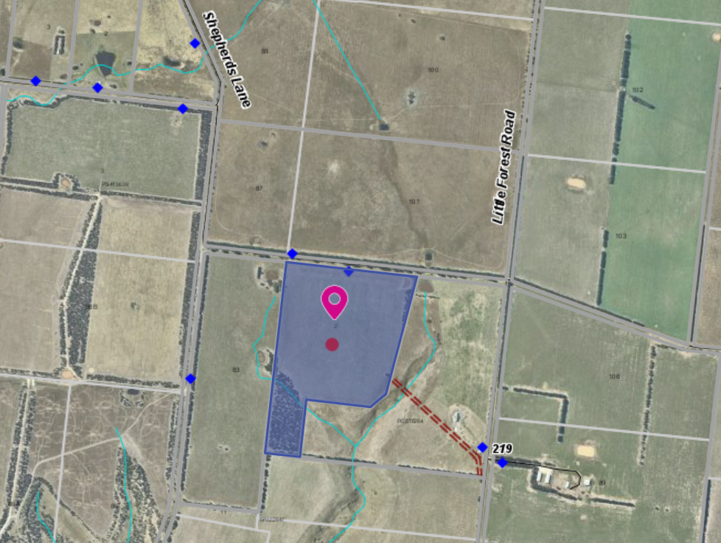
Figure 1: Aerial photograph of the site

Proposal
It is proposed to construct a dwelling and shed on the site in association with the use of the land for agriculture.
The dwelling would have four bedrooms. The master bedroom with ensuite and walk in robe, an open plan kitchen, meals and family room, a separate laundry, separate family bathroom and an attached two car space garage. There would be a verandah along the front of the dwelling and porch leading to an entrance hallway which provides access to a separate study and separate living room. The external cladding of the dwelling would be face brick with a Colorbond roof.
An outbuilding would be setback 20m from Corries Lane. It would 16m long and 9m wide and would have three open bays and one fully enclosed bay with a roller and side access door. The external cladding would be Colorbond steel. The shed would be used to store stock feed, farm equipment and would also be a cool room for egg storage.
Two water tanks would be installed. A 62,000L tank for domestic use and a 22,500L tank for farm use.
The land would be fenced into six paddocks. Five paddocks would be approximately 3.2ha each and the sixth would include the dwelling, shed, driveway, effluent field and a 1.2ha orchard. The dwelling and shed area would be approximately 1ha.
Two native plantations would be planted on the west and south boundaries – each plantation would be three rows and 15m wide.
The farming activities are diverse with different livestock and different food produce.
The Farm Management Plan (FMP) showed that the following enterprises would be run on the property consisting of a sheep flock comprising 200 ewes and 100 egg-laying chickens producing approximately 30,000 eggs per annum.
An olive grove would consist of 100 olive trees. Olive preserving would be done on site and sold to local businesses throughout the region.
The netted 1.2ha orchard would contain approximately 240 fruit trees. Trees would include feijoas, tamarillos, quince, plums, cherries, peaches and apricots. All fruit would be harvested by the farm owner and seasonal staff if required and made into preserves. These would be sold at local farmers markets and businesses.
The remaining 2.4ha of the former blue gum plantation has been allowed to coppice. The plantation would then be allowed to re-coppice. The harvest would go to pulp.
The stocking rate is high with 200 first cross ewes and lambs which require a high-quality pasture on the available 16ha of the site. Assuming each ewe and lamb have a DSE rating of between 2-3 DSE, 200 ewes and lambs require the property to provide between 400 and 600 DSE per annum, or 25-37 DSE/ha. This stocking density is not possible on the current regrowth pasture following a blue gum plantation. Even after substantial pasture improvement, achieving a DSE carrying capacity of 25, let alone 37, would require substantial pasture improvement and irrigation.
However, no pasture improvement has been included in the FMP provided other than the fertiliser provided by the free range chickens.
The FMP states the trees would be mulched to retain moisture. However, to achieve the high level of productivity of fruit from the trees listed in the FMP, watering would be required at least several times in the season especially if the spring is dry. The available water for this enterprise from a 22,500L water tank is not sufficient. In a dry season a minimum of 50L of water may be required per tree, or 12,000L per watering. The tank would not supply the water to trees, as well as providing water for the sheep and chickens. The FMP does not address stocking rate and lack of water supply for the trees.

Background to Current Proposal
The site contained a blue gum plantation which was harvested in late 2017.

History
PA2000108 for the development and use of a dwelling was refused on 28 February 2001. The land is in the same ownership as this previous application.

Public Notice
The application was notified to adjoining and surrounding landowners and no objections were received.

Locality Map
The map below indicates the location of the subject site and the zoning of the surrounding area.
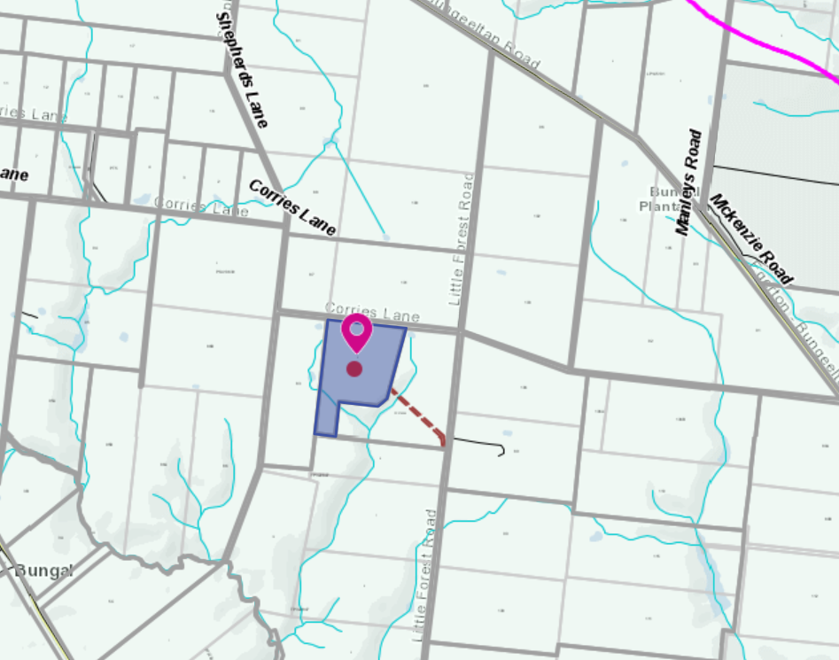
Figure 2: Zone Map – Farming zone

Planning Scheme Provisions
Council is required to consider the Victoria Planning Provisions and give particular attention to the Planning Policy Framework (PPF), the Local Planning Policy Framework (LPPF) and the Municipal Strategic Statement (MSS).
The relevant clauses are:
• Clause 11.03 - Peri Urban Areas
• Clause 13.02-1S - Bushfire planning
• Clause 14 - Natural Resource Management
• Clause 14.01-1S - Protection of agricultural land
• Clause 14.02-1S - Catchment planning and management
• Clause 14.02-2S - Water quality
• Clause 15.01-6S - Design for rural areas
• Clause 16.01-5S - Rural residential development
• Clause 21.02-5 - Objective - Bushfire
• Clause 22.03 - Houses and House Lot Excisions in Rural Areas
• Clause 21.02-3 - Objective - Water and catchment management
• Clause 21.03-4 - Objective - Landscape and neighbourhood character
• Clause 21.03-6 - Objective - Rural lifestyle opportunities
• Clause 21.04 - Economic Development and Employment
• Clause 21.04-1 - Key issues and influences Agriculture and horticulture
• Clause 21.04-2 Objectives - Agriculture
The proposal does not comply with the relevant sections of the PPF and LPPF as outlined in the table below:
PPF | Title | Response
Clause 11.03-3S | Peri-urban areas | The proposal would intensify the rural residential use of the land, resulting in the loss of farming land.
Clause 14.01-1S | Protection of agricultural land  Objective To protect the state’s agricultural base by preserving productive farmland. | The proposal increases residential use of farming land and diminishes the capacity of the site to support agriculture activity.  The FMP has insufficient detail to demonstrate that the livestock and trees can be maintained.
Clause 16.01-5S | Rural residential development  Objective To identify land suitable for rural residential development. | The proposal does not protect high quality agricultural land and is considered to be inappropriate rural residential development located within the Farming Zone.
LPPF
Clause 21.02-2 | Non-Urban Landscapes. | The proposal would increase residential development in a rural location which erodes the rural character of the area and set a precedent for similar applications on small lots.
Clause 21.03-6 | Objective—Rural lifestyle opportunities | The proposal would fragment productive agricultural land and set a precedent for similar applications on small lots.
Clause 21.04-2 | Objectives—Agriculture  To protect good quality agricultural land and support the productivity and sustainability of existing and future agricultural and horticultural activities. | The proposal would not support productive, sustainable farming.
Table 1: Local and State Policy Assessment

Zone
Farming Zone
The purposes of the Zone are to:
• Implement the MPS and the PPF.
• Provide for the use of land for agriculture.
• Encourage the retention of productive agricultural land.
• Ensure that non-agricultural uses, including dwellings, do not adversely affect the use of land for agriculture.
• Encourage the retention of employment and population to support rural communities.
• Encourage use and development of land based on comprehensive and sustainable land management practices and infrastructure provision.
• Provide for the use and development of land for the specific purposes identified in a schedule to this zone.
In accordance with Clause 35.07-1, a permit is required to use land for a dwelling where the land is less than 40ha.
In accordance with Clause 35.07-4 a permit is required for a building or works associated with a use in Section 2 of Clause 35.07-1.

Overlays
Environmental Significance Overlay, Schedule 1
In accordance with Clause 42.01-2 a permit is required for buildings and works.
Design and Development Overlay, Schedule 2
In accordance with Clause 43.02 Schedule 2 of the this overlay a permit is not required where all external cladding of buildings is non-reflective. In this application, there is no reflective materials proposed and therefore a permit is not required under this overlay.
Bushfire Management Overlay
In accordance with Clause 44.06 a permit is required for buildings and works associated with the use of land for accommodation.

Relevant Policies
Council’s Rural Growth Policy Statement
Council’s Rural Growth Policy Statement was adopted by Council on 19 September 2012. The document applies to all land in Farming Zone. This Council policy is not incorporated into the Moorabool Planning Scheme.
The policy states:
• Encourage dwellings in areas nominated in Map 1 of Council Rural Growth Policy Statement.
• Ensure the siting of any dwellings is designed to have a minimal impact on any existing or future agricultural activities on the site and on surrounding land.
• Ensure it is clear whether the dwelling is required for agricultural operation, use or to maintain rural communities.
• Ensure sufficient infrastructure is available or that alternative methods are available which do not require normal infrastructure.
• Encourage development of dwellings, to support communities, on land which is unlikely to support agricultural (use) while still considering any other overlays which may impact the land. This is land which is constrained for use as agriculture by other environmental factors such as vegetation, slope, soil quality, etc.
The subject site is not located on Map 1 of Council’s Rural Growth Policy Statement.
The policy requires justification for the dwelling based on a proposed agricultural activity. The land is good agricultural land, however, as a blue gum plantation was grown on the site for over 10 years, resulting in diminished soil quality.
The proposal is to operate a mixed enterprise including prime lambs, chickens for eggs, olive trees for processing, fruit trees to make preserves while retaining a 2.4ha blue gum plantation.
Council’s Rural Housing Policy
Council’s Rural Housing Policy 2012 was adopted by Council on 19 September 2012 and has been developed to provide direction for how limited farming potential rural dwellings should be considered, and more broadly, rural settlement patterns. This Council policy is not incorporated into the Moorabool Planning Scheme.
The principles of the policy relevant to this application include to:
• Support the agricultural sector so that it can be more productive, diverse, resilient and adaptive to changing agricultural trends, including supporting agricultural activities that recognise Moorabool’s advantageous proximity to market.
• Protect agricultural land use from loss and allow development that increases agricultural productivity.
• Focus growth opportunities in settlements along major transport corridors, in particular where there is physical and social infrastructure and services.
• Recognise that there are substantial existing lots under 40ha capable of supporting the viable operation of agricultural enterprises.
• Promote a rural housing market that meets the needs of the Shire’s rural communities
• Land parcels for the proposed on-farm living dwellings are to have a minimum lot size of 8ha as identified in Figure 1.
The land has an area of 21.31ha. The proposal does not meet the principle of Council’s Rural Housing Policy of having an existing lot less than 40ha capable of supporting a viable operation of an agricultural enterprise based on the FMP submitted.

Particular Provisions
Clause 52.12 - Bushfire protection exemptions
Clause 53.02 - Bushfire planning

Discussion
The application proposes several farming enterprises including prime lambs, chickens for egg production, olives trees for processing and fruit trees for the manufacture of preserves.
There are several notable issues with the submitted FMP as discussed below.
The stocking density proposed for the sheep is not feasible at between 25 to 37 DSE/ha in Mount Egerton. Based on information provided in FMP, it was not demonstrated how the stocking rates can be achieved without irrigation or substantial supplementary feeding.
It was not demonstrated in the FMP that the water supply for the whole operation is sufficient for the productivity goals proposed for the fruit trees and olives. Therefore, the water supply for the operation is considered insufficient in order to maximise the productivity of the olive and fruit trees.
Applicants are asked to justify the use of a dwelling in the context of the agricultural use. In this application, even after being adjusted twice, the amended FMP does not provide sufficient information regarding a viable agricultural operation.
The proposal is inconsistent with the purpose and objectives of the Farming Zone and does not comply with the PPF or the LPPF of the MPS relevant to the development and use of rural land as discussed in Table 1.

General Provisions
Clause 65 - Decision Guidelines have been considered by officers in evaluating this application.
Clause 66 - Stipulates all the relevant referral authorities to which the application must be referred.

Referrals
Authority | Response
Barwon Water  Country Fire Authority | Consent with conditions.  Consent with conditions.
Infrastructure  Environmental Health | Consent with conditions.  Consent with conditions.

Financial Implications
There is no financial implication associated with this refusal to grant a permit for this use and development of a dwelling.

Risk & Occupational Health & Safety Issues
The recommendation of refusal of this use and development does not implicate any risk or OH&S issues to Council.

Communications Strategy
Notice was undertaken for the application, in accordance with s.52 of the Planning and Environment Act 1987, and further correspondence is required to all interested parties to the application as a result of a decision in this matter. All submitters and the applicant were invited to attend this meeting and invited to address Council if required.

Options
Council could consider the following options:
• issue a refusal to grant a permit in accordance with the recommendations of this report; or
• issue a permit with conditions outside of the recommendations of this report.

Conclusion
It is considered that the application for a dwelling on the land is not justified by the agricultural uses proposed. The Farm Management Plan provided with the application does not demonstrate the need for a dwelling on site.
The proposal is inconsistent with the purpose and objectives of the Farming Zone and does not comply with the PPF or the LPPF of the MPS relevant to the development and use of rural land.
It is recommended that the application be refused with specified grounds.

Ms. Carly Meyers addressed the Committee as the applicant associated with Item 7.5.

7.5 PA2020284 - Use of the Land for a Licensed Premise, Building and Works, Signage and Reduction in the Standard Car Parking Rate at 60B Grant Street Bacchus Marsh
Author: Jyoti Makan, Senior Statutory Planner
Authoriser: Henry Bezuidenhout, Executive Manager Community Planning & Economic Development
Attachments: Nil

Application Summary
Permit No: PA2020284
Lodgement Date: 16 December 2020. Amended application lodged 5 March 2021
Planning Officer: Jyoti Makan
Address of the land: 60B Grant Street Bacchus Marsh
Proposal: Liquor Licence, building and works, signage and reduction in the standard car parking rate
Lot size: 342.45sqm
Why is a permit required? Clause 43.01 – Heritage Overlay – Building and Works Clause 52.06 – Reduction in car parking, Clause 52.05 – Business Identification Signage Clause 52.27 – Liquor Licence

Committee Resolution
Moved: Cr Tonia Dudzik
Seconded: Cr Moira Berry
That the Development Assessment Committee, having considered all relevant matters as required by the Planning and Environment Act 1987, issues a Notice of Decision to Grant a Permit for the application number PA2020284, for the use of the land as a Food and Drink Licensed Premises, reduction in car parking and erection of signage at 60B Grant Street, Bacchus Marsh, subject to the following planning permit conditions:
Amended Plans:
1. Before the use and development starts, amended plans to the satisfaction of the Responsible Authority must be submitted to and approved by the Responsible Authority. When approved, the plans will be endorsed and will then form part of the permit. The plans must be drawn to scale with dimensions must be generally in accordance with the plans (Rev A dated 10 February 2021, Job 2053 drafted by Corso Interior Architecture) submitted with the application or some other specified plans but modified to show:
(a) One disabled car parking bay in accordance with the Australian Standard AS2890.1:2009 Off-Street Parking for People with Disabilities.
(b) Show the swept paths and 85th percentile vehicle with the ability to move in a forward’s motion as stated in the proposed Traffic Impact Statement
(c) At least one canopy tree at the rear of the property in accordance with the Moorabool’s Landscape Design Manual (LDM).
(d) Landscaping along the boundaries of the site at the rear of the building.
(e) A schedule of all proposed trees, shrubs and ground covers (including numbers, size at planting, size at maturity and botanical names), as well as sealed and paved surfaces. The flora selection and landscape design should be drought tolerant and based on species selection in accordance with the LDM.
Unless otherwise approved in writing by the Responsible Authority, all buildings and works are to be constructed and or undertaken in accordance with the endorsed plans to the satisfaction of the Responsible Authority prior to the commencement of the use.
Liquor Licensing:
2. The layout of the licensed area on the endorsed plans must not be altered without the written consent of the Responsible Authority.
3. Liquor can be consumed on and off the premises.
4. During all hours (whether or not liquor is served) in which the business is open to the public, there must be present on the premises a person above the age of 18 years, responsible for the good conduct of the premises (“the Manager”).
5. Patrons of the approved uses must only occupy areas within the Endorsed Red-Line Plan on the premise. Areas outside of the Endorsed Red-Line area are reserved for staff use only.
Hours of Operation:
6. Without the prior written consent of the Responsible Authority, the sale and consumption of liquor shall only occur within the licensed area(s) between the following hours:
(a) 11:00am to 11:00pm Monday to Saturday; and
(b) 12:00am to 10:00pm Sunday and Public Holidays.
Signage:
7. No advertising signage must be erected on the land except as allowed for under the Moorabool Planning Scheme.
Music Conditions:
8. At all times, unless otherwise approved by written consent from the Responsible Authority:
(a) No live music is permitted on the premises.
(b) No music or announcements may be audible outside the boundaries of the site.
(c) There must be no amplified (other than background) music provided at the premises at any time. All to the satisfaction of the Responsible Authority.
Waste Storage and Collection:
9. Unless otherwise approved by written consent from the Responsible Authority, all refuse waste and recycling bins and storage must:
(a) Be stored inside the building, except for purposes of refuse waste and recycling collection pick-up. The nominated storage area must be screened from public view to the satisfaction of the Responsible Authority.
(b) Be regularly emptied and content removed from the site.
(c) The storage, removal and disposal of such/garbage refuse must be undertaken in such a manner so as to avoid any nuisance, pollution or loss amenity to the surrounding area.
(d) All bottles (including empty glass bottles) shall be bagged during operation times and shall not be emptied into any external refuse bins between the hours of 11.00pm and 8.00am.
All to the satisfaction of the Responsible Authority.
Heritage:
10. All nominated external paint colours must be strictly in accordance with the endorsed plan and cannot be altered without consent of the Responsible Authority.
11. No paint permitted over the existing brickwork.
12. The external faces of walls on or facing boundaries are to be cleaned and finished to the same standard as such walls within the development site to the satisfaction of the Responsible Authority.
13. No external plant and equipment visible from any street frontage can erected without the written consent of the Responsible Authority.
14. All pipes (except down-pipes), fixtures, fittings and vents servicing any building on the site must be concealed in service ducts or otherwise hidden from external view to the satisfaction of the Responsible Authority.
15. All building and works must be maintained to the satisfaction of the Responsible Authority.
Environmental Health:
16. The food premises located on the property must be connected to a waste water system and grease trap sized accordingly that will effectively dispose of all sewage and waste water in line with the Food Act 1984 and the Guidelines for Environmental Management: Code of Practice; Onsite Wastewater Management 891. 4 (2016).
17. All proposed food premises must be designed in accordance with the requirements of the FSANZ Food Standards Code and Australian Standard 4674:2004. A detailed and to scale floor plan of the proposed food premises in conjunction with any other requested documents must be supplied to Council's Environmental Health prior to any approval of an application for registration.
18. Noise must be adequately controlled. Premises must consider the Environment Protection Act 1970, the State Environment Protection Policy (Control of noise from commerce, industry and trade) No. N-1 and the Public Health & Well-being Act 2008.
Car parking:
19. Car spaces, access lanes and driveways shown on the endorsed plan must not be used for any other purpose other than the parking of vehicles, to the satisfaction of the Responsible Authority.
Amenity:
20. The owner, the occupier and the manager of the premises must make reasonable endeavours to ensure that people associated with the site do not create a nuisance and annoyance to neighbours or otherwise disturb the amenity of the area.
21. The amenity of the area must not be detrimentally affected by the use or development, through the:
(a) Transport of materials, goods or commodities to or from the land.
(b) Appearance of any building works or materials.
(c) Emission of noise, artificial light, vibration, smell, fumes, smoke, vapour, steam, soot, ash, dust, waste water, waste products, grit or oil.
(d) Presence of vermin.
(e) Any other way.
Infrastructure:
22. Unless otherwise approved by the Responsible Authority there must be no buildings, structures, or improvements located over any drainage pipes and easements on the property.
23. Prior to works commencing on the development, the rear laneway abutting the length of the eastern boundary of the property must be constructed with reinforced concrete to a depth of 150mm in accordance with the requirements of the Council’s Infrastructure Design Manual, to the satisfaction of the Responsible Authority.
24. Prior to the commencement of the development, the proponent must submit a plan detailing the construction of the laneway for the approval of the Responsible Authority.
25. Prior to the works commencing on the development, notification including photographic evidence must be sent to Council’s Infrastructure Services identifying any existing damage to Council assets. Any existing works affected by the development must be fully reinstated at no cost to and to the satisfaction of the Responsible Authority. If photographic evidence cannot be provided, then the damage then the damage must be fully reinstated at no cost to and to the satisfaction of the Responsible Authority.
26. Sediment discharges must be restricted from any construction activities within the property in accordance with relevant Guidelines including Construction Techniques for Sediment Control (EPA 1991).
27. Prior to the use commencing, the car park areas must be constructed with an all-weather surface, markings and drainage to the satisfaction of the responsible authority, and shall incorporate the following:
(a) Parking bays and aisle widths of the car park shall comply with Australian Standard AS 2890.1:2004 Off-Street car parking. Disabled Parking bays shall comply with Australian Standard AS2890.1:2009 Off-Street Parking for People with Disabilities.
Permit Expiry:
28. This permit will expire if one of the following circumstances applies:
(a) The development and the use are not started within two years of the date of this permit; and
(b) The development is not completed within four years of the date of this permit.

Permit Notes:
Loading Bays
Prior to the commencement of works, an application must be made for a loading bays to facilitate loading and offloading of goods to the proposed use.
Local Laws
Council’s Local Laws must be contacted for any further permit requirements prior to any sale of alcohol on and off the premises.
Environmental Health
Contact Council's Environmental Health to discuss the plans approval process of the proposed premises prior to becoming registered under the Food Act 1984 with Council.
Carried

Public Consultation
Was the application advertised? | Yes.
Notices on site: | Yes.
Notice in Moorabool Newspaper: | No.
Number of objections: | No objections. There were 51 submissions received in support of the proposal.
Consultation meeting: | Not required.

Policy Implications
The Council Plan 2017-2021 provides as follows:
Strategic Objective 3: Stimulating Economic Development
Context 3A: Land Use Planning
The proposal is consistent with the Council Plan 2017 – 2021.

Victorian Charter of Human Rights & Responsibilities Act 2006
In developing this report to Council, the officer considered whether the subject matter raised any human rights issues. In particular, whether the scope of any human right established by the Victorian Charter of Human Rights and Responsibilities is in any way limited, restricted or interfered with by the recommendations contained in the report. It is considered that the subject matter does not raise any human rights issues.

Officer’s Declaration of Conflict of Interests
Under section 130 of the Local Government Act 2020, officers providing advice to Council must disclose any interests, including the type of interest.
Executive Manager – Henry Bezuidenhout
In providing this advice to Council as the Executive Manager, I have no interests to disclose in this report.
Author – Jyoti Makan
In providing this advice to Council as the Author, I have no interests to disclose in this report.

Executive Summary
Application referred? | Yes.
Any issues raised in referral responses? | Yes, patron numbers, car parking, swept paths, heritage related signage.
Preliminary concerns? | Car parking, suitability of the sale of liquor in the surrounding residential area, swept paths.
Any discussions with applicant regarding concerns? | Yes, several meetings have occurred.
Any changes made to the application since being lodged? | Yes, specifically a reduction in patron numbers and removal of some signage.
Brief history. | The site is currently a vacant commercial premise and has been used as commercial premises for a number of years.
Previous applications for the site? | No previous application for the site.
General summary. | approval is sought for food and drink premises (Hotel) to sell liquor for the consumption on and off the licensed premises, signage and reduction in car parking. No accommodation is proposed on the site.
Summary of Officer’s Recommendation
That, having considered all relevant matters as required by the Planning and Environment Act 1987, Council issue grant a permit for the application number PA2020284, for the use of the land as a Food and Drink Licensed Premises, reduction in car parking and erection of signage at 60B Grant Street, Bacchus Marsh, subject to planning permit conditions.

Site Description
The subject site is situated within a mixed land use pocket east of Grant Street, north of Sydney Street and south of Pilmer Street in Bacchus Marsh. The site fronts Grant Street and gains pedestrian access from Grant Street. An unmade laneway is located directly east of the site where vehicle access is obtained. The site is also known as Lot 2 on Plan of Subdivision 812652C and is approximately 342.45sqm in area, rectangular in shape and has an 8.2m frontage towards Grant Street.
Grant Street serves as a main arterial to service a number of high activity land uses in Bacchus Marsh and connects to the Western Freeway, Main Street (north) and Geelong Bacchus Marsh Road (south). Therefore, considered to be a high usage road within the suburb.
The existing building is vacant but the adjacent building to the north is occupied by a pizza and barber shop and the building directly south of the site is occupied by offices. Residential development is present east of the site and two dwellings were approved above the offices at 62 Grant Street. Below are some site inspection photos to represent the site and adjacent buildings.
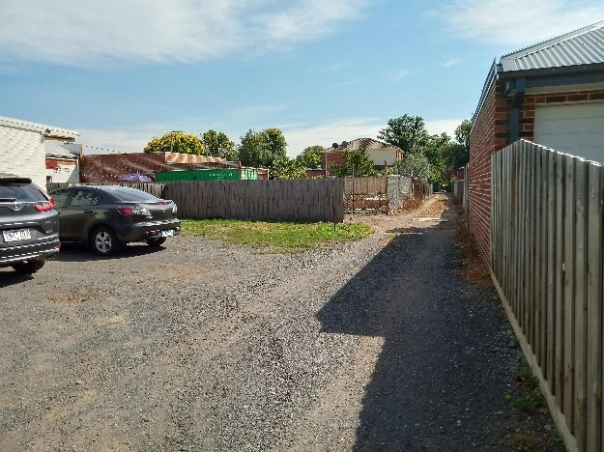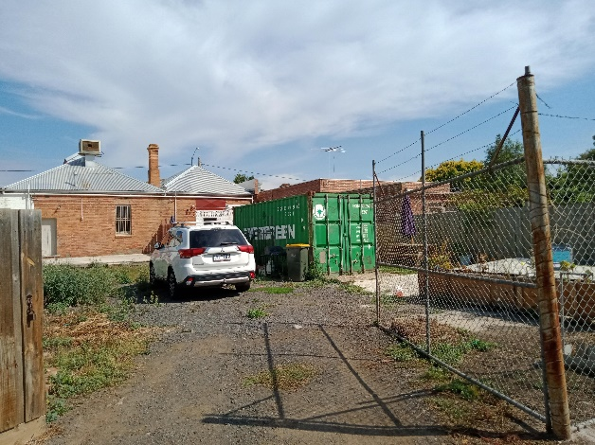
Photo 1: rear laneway Photo 2: rear of the site (proposed car park)
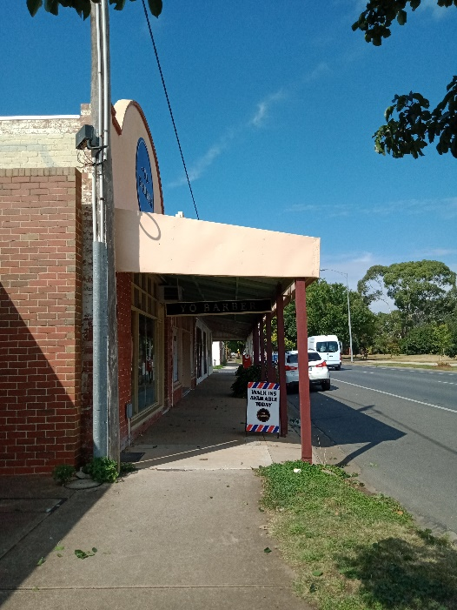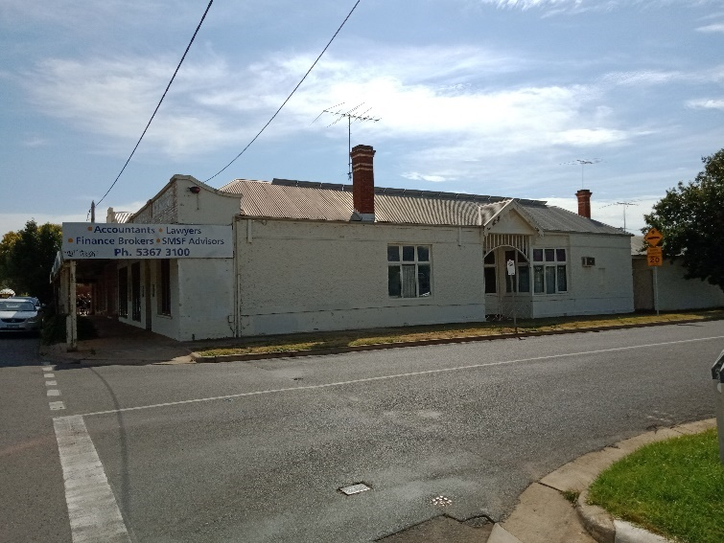
Photo 3: frontage along Grant Street Photo 4: Existing Offices south of the site (Sydney/Grant corner)

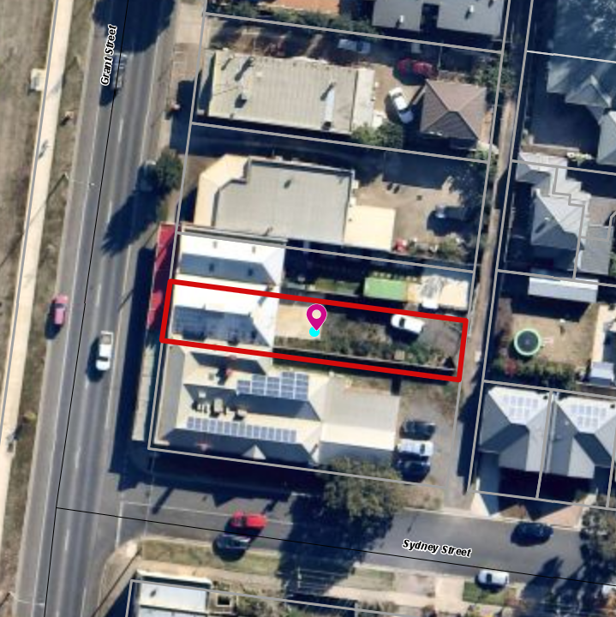
Figure 1: Site plan highlighted in red border

Proposal
An application is made for a Hotel (food and drink licenced premise), reduction in car parking, building and works, and erection of signage.
The premises will have the capacity to cater for 40 patrons. It is proposed to serve craft beer from around Victoria using a 12-tap bar. It will also include the supply of products in a pre-packaged format.
Four car parks and bicycle racks are proposed at the rear, which are catered towards staff parking. The car park will be accessed from the laneway.
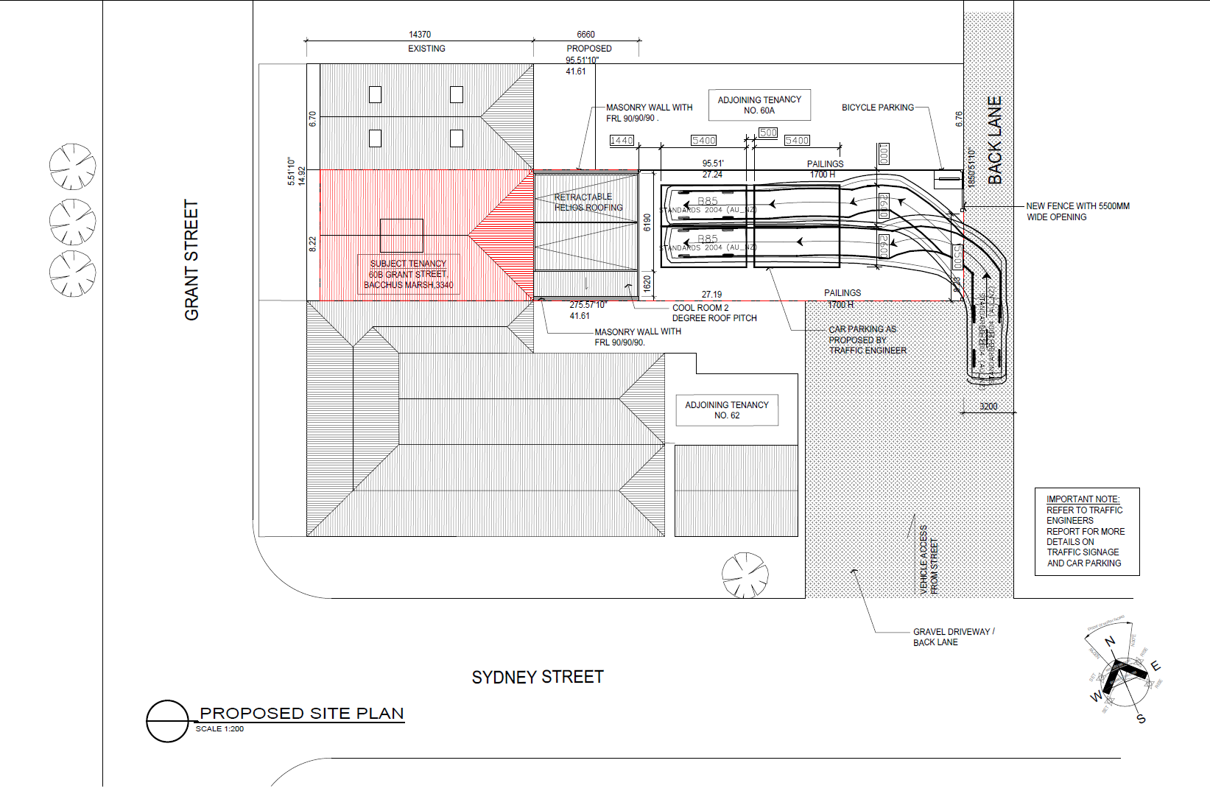
Figure 2: Proposed site plan
The proposed hours of operation are in accordance with the Liquor Control reform Act 1998 and are as follows:
• Monday to Thursday – 9am to 11pm
• Friday to Sunday – 9am to 11pm
• ANZAC Day / Good Friday – 12noon to 11pm
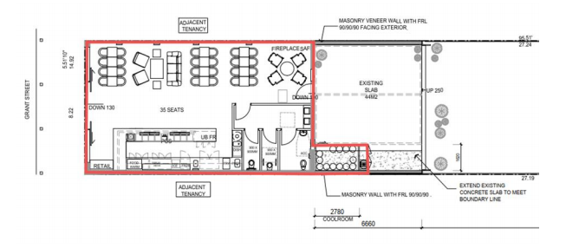
Figure 2: Proposed licensed area highlighted in red

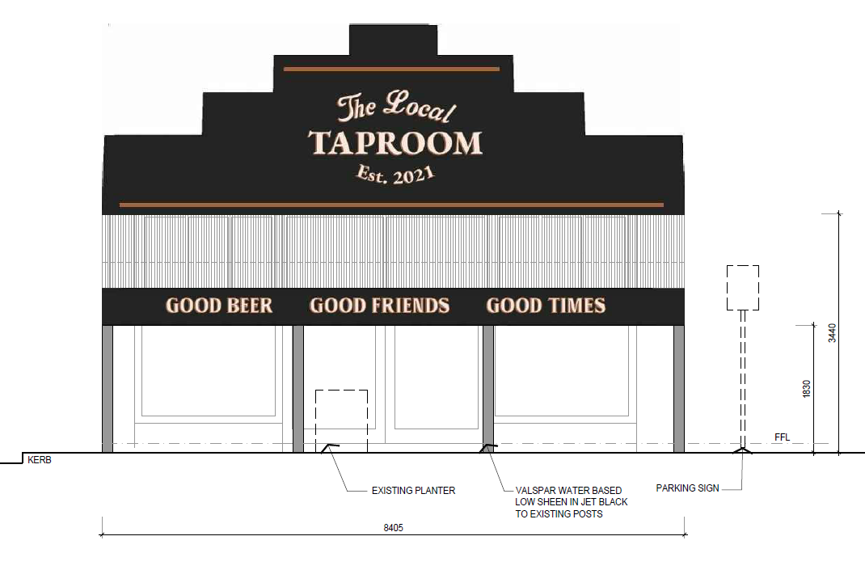
Figure 3: Signage Montage Proposed
The proposal also includes the development of business identification signage in front of the building, a cool room at the rear and a retractable roofing on the east facing rear wall.
The signage proposal includes the following:
• 2.945m wide 1.410m high metal sign on the parapet situated in the centre of the building and fixed (3.5msq).
• 540mm high sign on the front facia of the verandah that extends the width, 8.405m wide. (4.5sqm)
Bins will be situated at the rear of the site and includes one 1,100 litre general waste skip bin and one 1,100 litre recyclable waste skip bin. It also stated that a number of smaller bins will be situated through the site to allow for waste separation and ease of use. Collection of waste is proposed with a private contractor and will be collected once a week between 9:00am and 7:00pm or as required by the venue.

Background to Current Proposal
The original application was submitted on 16 December 2020 requesting a permit for a use of the land to sell liquor inside and outside the premises (food and drink) with a maximum patron capacity of 50 internally and 30 externally. A car parking reduction from 20 bays to 16 bays was proposed, based on the patron numbers. The business identification signage included an under verandah blade sign that was internally illuminated, signage on the parapet in the centre and a sign on the front facia of the verandah which totalled 8.4sqm of signage.
A request for further information was sent to the applicant on 13 January 2021. Requesting information that was required to justify the car parking reduction and proposed land use being a hotel premises to allow for the sale of alcohol both inside and outside the premises.
Other information such as adequate vehicle turning movements, seating arrangements, numbers of patrons, alternative car parking and a car parking demand assessment was also required. Further justification on noise emanating from the premises was required as residential premises reside nearby. A request for information related to signage including amending the under-awning blade signage was required because the heritage overlay applies to the site. The applicant removed the 800mm internally illuminated under verandah blade sign from the proposal which was accepted by the heritage advisor.
The revised application was submitted on 5 March 2021 resulting in patron numbers reduced to 40 and the licenced area was reduced to allow only internal seating. This resulted in the reduction of required car parking requirement from 20 to 16 bays. With the provision of four existing bays, 12 bays are now requested as the car parking reduction. The application was made aware of Council’s concerns related to the proposed use of the land as a hotel which triggers higher car parking bay ratios than a food and drink premises or bar under the Planning Scheme. After numerous internal and external discussions with Infrastructure and VicRoads, Council found that a more informed car parking demand assessment be undertaken to inform the streetcar parking availability surrounding the site. The applicant was also made aware of noise and signage related concerns.
The applicant finalised their plans and submitted a revised application on 7 May 2021 and a revised Transport Impact Assessment was submitted on 13 May 2021. The applicant removed the 800mm internally illuminated under verandah blade sign from the proposal which was accepted by the heritage advisor. The applicant also provided a clearer car parking demand assessment showing on-street car parking availability.

History
No other previous planning permit applications were lodged for this site. The site is covered by the Heritage Overlay – Schedule 81 which includes a shop and office listed as a heritage place and where paint controls apply.

Public Notice
The application was notified to adjoining and surrounding landowners.

Summary of Objections
No objections were received. There were 51 submissions received in support of the application.

Locality Map
The map below indicates the location of the subject site and the zoning of the surrounding area.
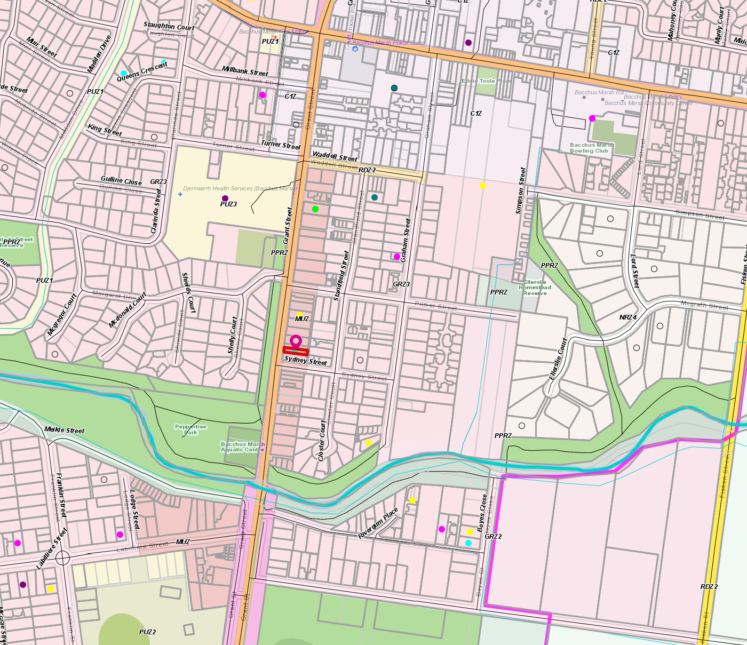Figure 4: Zone map

Planning Scheme Provisions
Council is required to consider the Victoria Planning Provisions and give particular attention to the Planning Policy Framework (PPF), the Local Planning Policy Framework (LPPF) and the Municipal Strategic Statement (MSS).
The relevant clauses are:
• Clause 11.01-1S – Settlement
• Clause 11.03-1S Activity Centres
• Clause 11.03-2S – Growth Areas
• Clause 15.01-1S – Urban Design

Zone
Mixed Use Zone (MUZ).
Under Clause 32.04-2 a permit is not required for Food and Drink premises where the leasable floor area must not exceed 150sqm.
The proposal complies with this requirement.

Overlays
Heritage Overlay (HO81)
Under Clause 43.01-1 a permit is required to erect a sign and paint a building because paint controls apply. Under this clause a permit is required to carry out works, repairs and routine maintenance which change the appearance of a heritage place or which are not undertaken to the same details, specifications, and materials.
Decision guidelines are listed under Clause 43.01-8 of the Moorabool Planning Scheme.
Design and Development Overlay (Schedule 12)
Under Clause 43.02 a permit is required to construct a building or construct or carry out works unless the schedule to the overlay specified otherwise. In this instance, the schedule does not exempt a permit for the works proposed.
Design and Development Overlay (Schedule 15)
Under Clause 43.02 of Schedule 15 a planning permit is not required to construct a building or construct or carry of works that are not higher than ridgeline of the existing building. The proposal complies with this requirement.

Relevant Policies
Nil.

Particular Provisions
Clause 52.06 Car Parking
Under Clause 52.06-4, a Hotel requires 0.4 spaces to each patron permitted. The proposal permits 40 patrons and requires 16 car spaces. Four bays are provided for staff and servicing use only resulting in a reduction of 12 car parking bays. Decision guidelines are listed under Clause 52.06-7.
Clause 52.29 Land Adjacent to Road Zone Category 1
No new access proposed, and a permit is not required under Clause 52.29.-2.
Clause 52.17 – Licenced Premises
A permit is required to sell or consumer liquor for licence required.
Decision guidelines are
• The Municipal Planning Strategy and the Planning Policy Framework.
• The impact of the sale or consumption of liquor permitted by the liquor licence on the amenity of the surrounding area.
• The impact of the hours of operation on the amenity of the surrounding area.
• The impact of the number of patrons on the amenity of the surrounding area.
• The cumulative impact of any existing licensed premises and the proposed licensed premises on the amenity of the surrounding area.

Discussion
The proposed new use contributes to community and cultural life by enhancing the mixed-use character along Grant Street and surrounds and is consistent with the objectives of the Mixed-Use Zone.
Access
The rear laneway will be used to access the proposed car park which are proposed with four bays to be used as staff car parking. Bicycle racks are located at the rear of the premises. Alternative modes of parking were discussed by requesting bicycle racks at the shop front however due to the fact the Grant Street is absent of cycle paths and narrow existing footpaths, this was not possible. The rear access lane will be limited to staff as the car park at the rear is allocated towards staff car parking. Swept paths were provided which Council’s Infrastructure Department was comfortable with and approved subject to conditions on the permit. Officer’s discussed the access to the laneway at length and considering that access to the laneways from Sydney Street is limited to two buildings, it was not a major concern.
Car Parking
The application was referred to VicRoads and Council’s Infrastructure. VicRoads had no objection to the proposal.
Council’s Infrastructure found that the car parking reduction was extensive and required a proper car parking demand assessment.
The applicant submitted to Council a Traffic Impact Statement on 30 March 2021. This Statement stated that based on the 12 bay reduction, a car parking demand assessment was conducted which considered a historical car parking credit of six bays from the formal clothing retail operation (Western Outfitters).
The assessment also included the local on-street parking which is characterised by two-hour parking during day time trading and is unrestricted past 5pm. It states that,
“Such parking arrangements are typical of local business centres and are designed to support and encourage business activity and turnover. In this case, the parkland on the opposite side of Grant Street also means the zone generates only half the parking demand of a typical high street, as businesses are limited to a single side. It is therefore considered that there is adequate and suitable on-street parking to support this business without having negative impacts on the local parking patterns”.
Council evaluated the assessment provided and found that additional information is required to show the availability of on-street car parking around the area and for evidence on the car parking credits to further support the application. The revised Transport Impact Assessment submitted on 13 May 2021 provided information which stated that the historical credit was based on the former operation with a leasable floor area of 150sqm which required 6 car parking abys at the time. A review of aerial imagery from 2010 suggested that no formal parking was allocated to the rear of the site as it was fully grassed, and the land sue was operating with a shortfall of 6 car spaces which is accommodated as on-street car parking.
On street car parking availability was surveyed with 120 bays available on a Friday at peak hour and 143 bays available on a Saturday at peak hours.
The premises proposes to sell liquor inside and outside the premises which is the underlying reason for the car parking reduction and the sale of liquor outside the premises which require short stay car parking on street and on-site sale of liquor will occur at peak times mainly being lunch and dinner.
As stated in the background section of this report, the applicant took on board Council’s initial concerns and reduced their seating area to accommodate 35 seats and number of patrons to 40. However due to the significant number of car space bays being reduced, officer have considered an alternative approach to the proposed operating hours which can include an 11m start to 11pm close from Monday to Saturday and 11:00am to 11:00pm and 12:00am to 10:00pm on Sundays and Public Holidays. This is included as part of recommended permit conditions as unrestricted street car parking is applicable after 5pm.
Pedestrian activity:
Grant Street is a Category 1 Road within the Road Zone classification meaning, it is managed by VicRoads. It is absent of cycle lanes but is currently available as restricted street car parking on both sides of the street.
Council’s Infrastructure was consulted in this process and found that nearby pedestrian paths and traffic lights are available along Grant Street to ensure that safety is not impacted. Council’s Infrastructure also stated that bike lanes would not fit in the current kerb width without eliminating parking or widening the kerb and both these come with significant issues. For additional cyclability, construction activities for a cycle corridor towards the west of Grant Street will promote cyclability in the area to improve overall traffic congestion along Grant Street.
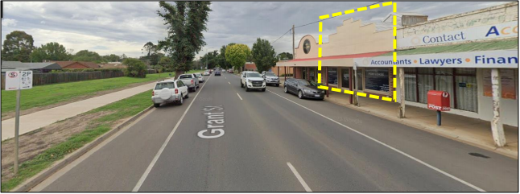
Figure 5: Street View
Design and Development Overlay – DDO12
The external construction will not be visible from the street and not exceed the height of the premises and will complement the current building design and character of the neighbourhood.
Land Use
The land use proposed is for a Hotel due to the definitions laid out in the Planning Scheme which are as follows:
Hotel: “Land used to sell liquor for consumption on and off the premises. It may include Hotel accommodation, food for consumption on the premises, entertainment, dancing, amusement machines, and gambling”.
Food and Drink premises: “Land used to prepare and sell food and drink for immediate consumption on, or off, the premises.”
The applicant stated in their last correspondence dated 20 May 2021 that, “The Term Food and Drink premises in Liquor licensing terms is often associated with that of a Restaurant and Café Liquor Licence where there are restrictions associated with supply of liquor being that the predominate activity must be the preparation and consumption of meals on the premises at all times they are open, basically liquor supply in such venues is a secondary aspect of the business.
In general, people whom consume liquor in a restaurant and café can consume said liquor without a meal, however the licensee MUST satisfy that predominate activity clause related the meals at all times.
In general, liquor is not sold for immediate consumption off the premises, Council Bylaws restrict this along with the Amenity impacts associated with planning controls and that of liquor licence condition.”
A hotel allows for the sale of liquor to occur on and off the premises. It does not stipulate that it has to include accommodation, entertainment, dancing, amusement machines and gambling. The applicant stated that the “Hotel” use most reflects the nature of the business in that it is land primary used to sell liquor for consumption on and off the premise as opposed to the land terms related to food and drink that includes “immediate consumption” on and off the premises, this immediate consumption would have impacts related to regulation.
Food: The venue is not supplying meals but rather supplying foods and snacks such as pies to provide hot food options, rolls, pasties using a pie warmer. They will also have an oil-free fryer for hot chips and wedges and will also service cheese platters, chips, nuts, etc.
Pre-packaged drinks: they are proposing a refrigerated and retail display with capacity for 100 pre-packaged produced, allowing their partners to showcase their packaged offerings to encourage different beers in store and then buy packaged versions of them to take away.
Local beer and wine – 12 taps from five to six core suppliers, pouring pots, schooners and pints will be used to serve house and premium wines by the glass and bottle. A small section of spirits will also be made available but is not a core offering.
Heritage Overlay
The Heritage Overlay (HO81) specifically relates to 60 and 62 Grant Street only where a shop and office is listed as a heritage place. As stated above a permit is required for the signage, the buildings and works to the rear of the venue to erect a small storage area and a retractable roof is also a trigger for building and works. The business identification signage is proposed at the front and the works are proposed at the rear of the building.
The proposal was referred to the Council’s Heritage Advisor who requested the removal of the under-verandah sign and this was removed from the revised plans. The proposal was not considered to adversely affect the natural or cultural significance of the place. No changes in height or built form are proposed other than the signage and paint controls which were considered acceptable for the proposed land use and is in keeping with the appearance of the heritage place.
The proposed building works comply with the provisions of the Heritage Overlay.

Amenity
The applicant provided examples of a Noise and Amenity Action Plan, Operations Management Plan, Acoustic Reports and Management Plan to show Council the level of management approach to ensure that the amenity of the area is not affected as a result of having a licenced premise in close proximity to residential dwellings.
Council’s Environmental Health stipulated conditions for the planning permit which included noise control in accordance with Environment Protection Act 1970, the State Environment Protection Policy (Control of noise from commerce, industry and trade) No. N-1 and the Public Health & Well-being Act 2008.
Officer’s recommend alternative operating hours to reduce any possible negative impacts to local residents. Conditions are also imposed for waste collection and bagging of empty bottles so that noise levels are reduced between 11pm – 8am. To further protect amenity of local residents, external seating areas were removed from plans as was originally proposed and the rear car parking is proposed for staff only.

General Provisions
Clause 65 – Decision Guidelines have been considered by officers in evaluating this application.
Clause 66 – Stipulates all the relevant referral authorities to which the application must be referred.

Referrals
Authority | Response
Transport for Victoria (DOT and PtV combined) | No objection.
Economic Development | No objection - in principle support.
Environmental Health Officer | No objection subject to conditions
Infrastructure | Requested further information related to car parking, swept paths and access. No objection
Strategic Planning | No objection.
Active Ageing and Diversity | No comment.
Environmental Management | No comment.

Financial Implications
There are no financial implications applicable to this works and car parking reduction application.

Risk & Occupational Health & Safety Issues
The recommendation of approval of this development does not implicate any risk or OH&S issues to Council.

Communications Strategy
Notice was undertaken for the application, in accordance with s.52 of the Planning and Environment Act 1987, and further correspondence is required to all interested parties to the application as a result of a decision in this matter. All submitters and the applicant were invited to attend this meeting and invited to address Council if required.

Options
Council could consider the following options:
• issue an approval (in accordance with the recommendations of this report; or
• should Council wish to refuse the application, Councillor’s need to explore reasons for refusing the based on the compliances with the Moorabool Planning Scheme.

Conclusion
The application was assessed against the Moorabool Planning Scheme together with the relevant referral authorities and found that the proposal to reduce car parking, obtain a liquor licence and conduct works associated with the proposed cool room and signage is considered acceptable and will not pose any detrimental impacts to the neighbourhood or the heritage character of the area.
The car parking reduction and amenity levels were an initial concern from Council Officers however this was mitigated through revised plans, traffic reports and planning permit conditions.
A car parking demand assessment was submitted to Council which provided adequate information to support the reduction in car parking.
The application was advertised, and no objections were received. There were 51 separate letters of support suggesting widespread community support for the proposal.
The proposal is recommended for approval subject to planning permit conditions to ensure adequate amenity levels, management hours of operation, noise, and car parking on the site.

8 Update on Trends, Issues and Other Matters
Nil.

9 Process Forward and Work Program
Nil.

10 Update on VCAT Decisions
An update was provided on the residential development at 101 Gisborne Road which is going to compulsory conference tomorrow.
An update was provided on 3 items that went to a VCAT Hearing in June, they are O’Donnell Street, Gordon, Davies Street, Darley and Camerons Road, Coimadai. Council is expecting the decisions on these matters in the coming weeks.

11 Other Business
Nil.

12 Date of Next Meeting
Wednesday 21 July 2021 at 6.00pm.

13 Meeting Close
The Meeting closed at 7.24pm.

...................................................
CHAIRPERSON

