AGENDA

Development Assessment Committee Meeting
Wednesday, 20 October 2021

In accordance with s.395 of the Local Government Act 2020, this meeting will not
be available for public attendance, however will be streamed live via accessing the Council Internet site.
I hereby give notice that a Development Assessment Committee Meeting will be held on:
Date: | Wednesday, 20 October 2021
Time: | 6.00pm
Location: | Online
Derek Madden
Chief Executive Officer

Order Of Business
1 Opening 5
2 Present and Apologies 5
3 Recording of Meeting 5
4 Confirmation of Minutes 5
5 Matters Arising from Previous Minutes 5
6 Disclosure of Conflicts of Interests 5
7 Community Planning Reports 6
7.1 PA2021072 - Development and Use of a Dwelling and a Shed at Lot 11, 821 Greenhills Road, Blackwood 6
7.2 PA2021117 - Removal of Restrictive Covenant 2388443 at 10 and 11 David Court, Darley 21
7.3 PA2021233 - Development of an Agricultural Shed at 410 Moorabool West Road, Gordon 30
8 Update on Trends, Issues and Other Matters 38
9 Process Forward and Work Program 38
10 Update on VCAT Decisions 38
11 Other Business 38
12 Date of Next Meeting 38
13 Meeting Close 38

1 Opening

2 Present and Apologies

3 Recording of Meeting
In accordance with Moorabool Shire Council’s Governance Rules, the meeting will be livestreamed.

4 Confirmation of Minutes
Development Assessment Committee Meeting – Wednesday 15 September 2021

5 Matters Arising from Previous Minutes

6 Disclosure of Conflicts of Interests
Conflict of interest laws are prescribed under the Local Government Act 2020 (the Act) and in the Local Government (Governance and Integrity) Regulations 2020 (the Regulations). Managing conflicts of interest is about ensuring the integrity and transparency of decision-making.
The conflict of interest provisions under the Act have been simplified so that they are more easily understood and more easily applied. The new conflict of interest provisions are designed to ensure relevant persons proactively consider a broader range of interests and consider those interests from the viewpoint of an impartial, fair-minded person.
Section 126 of the Act states that a Councillor has a conflict of interest if they have a general conflict of interest or a material conflict of interest. These are explained below:
- A Councillor has a general conflict of interest in a matter if an impartial, fair-minded person would consider that the member’s private interests could result in them acting in a manner that is contrary to their public duty as a Councillor.
- A Councillor has a material conflict of interest in a matter if an affected person would gain a benefit or suffer a loss depending on the outcome of the matter.
A relevant person with a conflict of interest must disclose the interest in accordance with Council’s Governance Rules and not participate in the decision-making process on the matter. This means the relevant person must exclude themselves from any discussion or vote on the matter at any Council meeting, delegated committee meeting, community asset committee meeting or, if a Councillor, any other meeting conducted under the auspices of the Council. The relevant person must also exclude themselves from any action in relation to the matter, including an action taken to implement a Council decision, for example, issuing a planning permit.

7 Community Planning Reports

7.1 PA2021072 - Development and Use of a Dwelling and a Shed at Lot 11, 821 Greenhills Road, Blackwood
Author: Mark Lovell, Coordinator Statutory Planning
Authoriser: Henry Bezuidenhout, Executive Manager Community Planning & Economic Development
Attachments: 1. Plans (under separate cover)

Application Summary
Permit No: PA2021072
Lodgement Date: 9 April 2021
Planning Officer: Mark Lovell
Address of the land: Lot 11, 821 Greenhills Road, Blackwood
Proposal: Development of Dwelling and Shed
Lot size: 3.132ha
Why is a permit required? Clause 44.06-1 permit for buildings and works in BMO
Clause 35.06-1 permit for use in RCZ
Clause 35.06-5 permit for buildings and works for a Section 2 use

Recommendation
That the Development Assessment Committee, having considered all matters as prescribed by the Planning and Environment Act 1987, issue a Notice of Decision to grant a Planning Permit PA2021072 for the Development and Use of a Dwelling and Shed at Lot 11 Greenhills Road, Blackwood subject to the following conditions:
Endorsed plans:
1. The use and development as shown on the endorsed plans must not be altered without the written consent of the Responsible Authority. All buildings and works must be constructed and or undertaken in accordance with the endorsed plans to the satisfaction of the Responsible Authority.
Land Management
2. A Land Management Plan to the satisfaction of the Responsible Authority must be endorsed as part of this permit and cannot be varied without the written consent of the Responsible Authority.
3. The subject land is to be developed and maintained in accordance with the Integrated Land Management Plan for the site prepared by Natural Resource Link Pty Ltd (Project 2034) dated 17 December 2020.
Materials:
4. All external walls and roof areas of the proposed building/s are to be clad with non-reflective materials (zincalume prohibited) to the satisfaction of the Responsible Authority.
Dwelling Requirements:
5. Access to the dwelling must be provided via an all-weather road with dimensions adequate to accommodate emergency vehicles.
6. The dwelling must be connected to a reticulated potable water supply or have an alternative potable water supply with adequate storage for domestic use as well as for firefighting purposes.
7. The dwelling must be connected to a reticulated electricity supply or have an alternative energy source.
8. The dwelling must be connected to a reticulated sewerage system or if not available, the waste water must be treated and retained on-site in accordance with the State Environment Protection Policy (Waters of Victoria) under the Environment Protection Act 1970.
Infrastructure:
9. A standard rural vehicle crossing must be provided on Greenhills Road to the satisfaction of the Responsible Authority. A vehicle crossing permit must be taken out for the construction of the vehicle crossing.
10. The property access and the internal driveways must be constructed in accordance with the requirements specified in Table 5 of Clause Moorabool Shire Council Engineering Services 53.02-5 of the Moorabool Planning Scheme, to the satisfaction of the Responsible Authority.
11. Storm water drainage from the proposed buildings and impervious surfaces must be retained and disposed of within the boundaries of the subject land to the satisfaction of the Responsible Authority. Overflows from on-site storage systems must be directed away from any waste water disposal areas.
12. Sediment discharges must be restricted from any construction activities within the property in accordance with relevant Guidelines including Construction Techniques for Sediment Control (EPA 1991).
13. Unless otherwise approved by the responsible authority there must be no buildings, structures, or improvements located over proposed drainage pipes and easements on the property.
14. Prior to the commencement of the development and post completion, notification including photographic evidence must be sent to Council’s Asset Services identifying any existing damage to council assets. Any existing works affected by the development must be fully reinstated at no cost to and to the satisfaction of the Responsible Authority.
Environmental Health:
15. The land application area and all conditions must be in accordance with the Land Capability Assessment prepared by Ballarat Soil Testing, ref number NR281020 dated October 2020, or any approved amendment are to be strictly adhered to.
16. An onsite waste water management system with the capacity to treat effluent to a minimum of 20mg/L BOD and 30mg/L Suspended Solids must be installed.
17. Effluent disposal must be undertaken via a subsurface irrigation system designed and installed by a wastewater irrigation expert in accordance with the EPA Code of Practice for Onsite Wastewater.
18. The wastewater management system form proposed dwellings/lots must be treated and contained within the property boundaries in accordance with the current EPA Code of Practice, Onsite Wastewater Management: Guidelines for Environmental Management, Australian Standards 1547 and Council requirements.
19. The effluent disposal area must be kept free of buildings, driveways, vehicular traffic and services trenching. The effluent disposal area must be kept free of buildings, driveways, vehicular traffic and services trenching.
20. All setback distances must be adhered to as dictated by Table 5 of the Code of Practice, Onsite Wastewater Management, EPA Publication Number 891.4
21. A shallow surface water cut off drain or surface water diversion mound, should be provided on the high side of the disposal areas to divert any surface water flows around the effluent fields.
22. The owner will maintain all drainage lines at all times to divert surface water and subsurface water clear of the effluent disposal field.
Country Fire Authority (CFA):
23. The Bushfire Management Plan prepared by Natural Resource Link Pty Ltd (Bushfire Management Report for 821 Greenhills Road, Blackwood - Project: 2034, Appendix Ten (10), dated December 2020) must be endorsed to form part of the permit and must not be altered unless otherwise agreed in writing by the CFA and the Responsible Authority.
24. The bushfire mitigation measures forming part of this permit or shown on the endorsed plans, including those relating to construction standards, defendable space, water supply and access, must be maintained to the satisfaction of the Responsible Authority on a continuing basis. This condition continues to have force and effect after the development authorised by this permit has been completed.
Greater Western Water:
25. Prior to a building permit being granted for the development of a dwelling, the owner of the land must enter into a Section 173 Agreement with Greater Western Water and the Council agreeing that:
a) A wastewater treatment system that produces wastewater to a minimum standard of 20/30(BOD/suspended solids) shall be installed to the satisfaction of the Council's Environmental Health Officer and Greater Western Water to treat all sullage and sewage waste on site.
b) Wastewater is to be dispersed to the satisfaction of Council's Environmental Health Officer and Greater Western Water using methods that will prevent waste and treated waste from discharging from the property at all times.
c) The effluent system must be maintained by a suitably qualified person in accordance with the manufacturer's specifications and EPA requirements.
d) Reports on water quality and maintenance must be submitted to the Responsible Authority at the completion of each maintenance period. This report must be made available to Greater Western Water on request.

e) The wastewater effluent being released from the treatment facility must be monitored annually to ensure compliance with the 20/30 standard.
f) The Owner shall meet the costs of the maintenance, testing and reports referred to in this Condition parts c), d) and e).
g) The owner shall carry out such works including replacing effluent treatment, storage pumping and disposal systems within the time specified to do so by the Council's Environmental Health Officer or Greater Western Water to cease and prevent waste and treated waste from discharging from the property.
h) If the wastewater program proves to be unsustainable, the land holder must immediately rectify the sewerage disposal system.
i) The owner shall have the wastewater treatment system desludged at least once every three years and evidence of this fact shall be provided in the annual written report referred to in this Condition part e).
j) The effluent disposal field must be protected by being isolated from building, driveway. livestock, vehicles or permanent recreation area that could render it unavailable in the future and should be planted with suitable grasses that will aid in moisture removal.
k) All recommendations, actions and timelines contained within the Land Management Plan prepared by NR Links dated: December 2020 must be followed and implemented to the satisfaction of Greater Western Water and Moorabool Shire Council.
26. No other building works to be undertaken on the subject land without written approval Greater Western Water.
27. Any existing or proposed shed must not be used for the purposes of accommodation or contain facilities that result in the discharge of wastewater.
28. Sediment Pollution Controls shall be employed during construction and maintained until the disturbed area has been regenerated.
29. Stormwater is to be managed in a way to minimise risk to erosion of the surrounding land. No stormwater should be allowed to move into the effluent disposal fields.
30. The obligations under this agreement must run with the land.
31. The applicant shall pay the Council’s reasonable costs associated with the registration and enforcement of the Section 173 Agreement.
Permit Expiry:
32. This permit will expire if:
a) The development and use are not started within two years of the date of this permit; or
b) The development is not completed within four years of the date of this permit.

Public Consultation
Was the application advertised? | Yes.
Notices on site: | Yes.
Notice in Moorabool Newspaper: | No.
Number of objections: | One.
Consultation meeting: | No, concerns cannot be addressed.

Policy Implications
The Council Plan 2021-2025 provides as follows:
Strategic Objective 2: Liveable and thriving environments
Priority 1.4: Develop a vision and provide opportunities for rural communities

Victorian Charter of Human Rights & Responsibilities Act 2006
In developing this report to Council, the officer considered whether the subject matter raised any human rights issues. In particular, whether the scope of any human right established by the Victorian Charter of Human Rights and Responsibilities is in any way limited, restricted or interfered with by the recommendations contained in the report. It is considered that the subject matter does not raise any human rights issues.

Officer’s Declaration of Conflict of Interests
Under section 130 of the Local Government Act 2020, officers providing advice to Council must disclose any interests, including the type of interest.
Executive Manager – Henry Bezuidenhout
In providing this advice to Council as the Executive Manager, I have no interests to disclose in this report.
Author – Mark Lovell
In providing this advice to Council as the Author, I have no interests to disclose in this report.

Executive Summary
Application referred? | Yes, Greater Western Water, Southern Rural Water, Country Fire Authority, and Council’s Infrastructure and Environmental Health.
Any issues raised in referral responses? | Nil.
Preliminary concerns? | Nil.
Any discussions with applicant regarding concerns? | No planning concerns.
Any changes made to the application since being lodged? | Nil.

Brief history. | The land has been used for grazing. The site is one of several crown allotments that were all in the same ownership over many years. Recently this owner has sold off individual crown allotments to new land owners.
Previous applications for the site? | Nil
General summary. | The proposed use and development are appropriately sited on a vacant parcel with limited biodiversity value. The wastewater water system achieves the objectives of the Environmental Significance Overlay and the defendable spaces fulfils the bushfire mitigate measures under the Bushfire Management Overlay. The objector concerns cannot be resolved and are primarily concerned with a residential use in the Rural Conservation Zone. The proposed use and development should be supported with conditions.
Summary of Officer’s Recommendation
That, having considered all relevant matters as required by the Planning and Environment Act 1987, Council issue a Notice of Decision to grant a Planning Permit for PA2021072 for the Development and Use of a Dwelling and Shed at Lot 11, 821 Greenhills Road, Blackwood subject to the following conditions contained within this report.

Site Description
The subject site is located with a frontage to Greenhills Road and the locality is a small opening amongst state parks. The site contains a small dam towards the frontage, is largely cleared with only a couple of trees occupying the site.
The site is an old subdivision located within the Wombat State Forest and close to the Lederderg State Park and most allotments are undeveloped and surrounded by crown land. The land has a history of grazing use. The subject site and surrounding lots have been cleared of their original vegetation and are mainly undeveloped. Blackwood has an extreme risk of bushfires and development on existing lots is required to demonstrate a high level of mitigation for ember attack, while bushfire management for the land and buildings is essential.
Land surrounding the site is also zoned Rural Conservation with a surrounding extensive area of forest in all directions. The land is also located within an open potable water supply catchment area for Pykes Creek reservoir and the Werribee River.

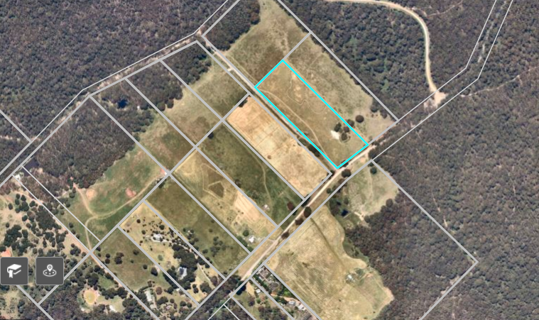
Figure 1: Aerial photograph

Proposal
It is proposed to construct a new single storey dwelling and shed on the subject site. The rectangular shaped lot is located within a small development of mostly vacant lots with frontage to Greenhills Road and is included in the Rural Conservation Zone with a total land area of 3.132ha.
The new dwelling will comprise four bedrooms, two bathrooms and an open plan dining/living/kitchen area together with decks that surround the verandah area. The dwelling will be finished in weatherboard wall cladding and Colorbond roof with aluminium framed windows and doors. It is proposed to site the dwelling with a 118.69m setback to the Greenhills Road frontage, 56.6m to the north-eastern side boundary and 25.04m to the southwestern side boundary. An all-weather driveway will service the dwelling and shed off Greenhills Road.
The proposed shed will be finished in Colorbond cladding and will measure 30m X 10m with an overall building height of 3.75m. The shed will be located 33.8m to the rear of the dwelling with a 51.64m setback to the north-eastern side boundary and 27.07m setback to the south-western side boundary.
An Integrated Land Management Plan has been submitted with the application as advised by Greater Western Water in order to address drainage lines and low-lying wet areas, as well as revegetation and protection of existing remnant vegetation. In addition, the Bushfire Management Statement submitted with the application has indicated a BAL40 construction for the new dwelling.
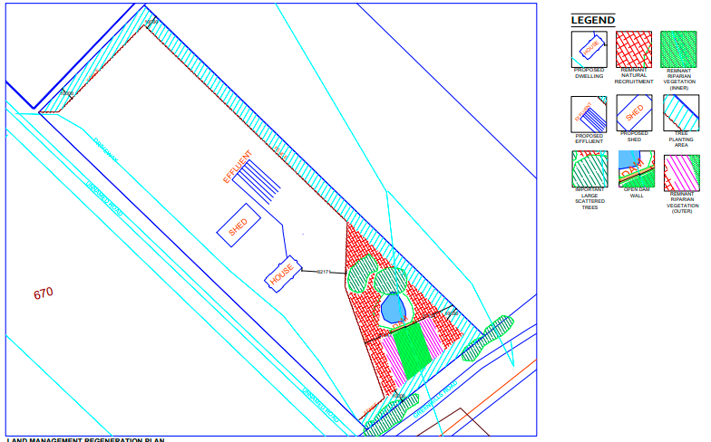
Figure 2: Site plan with location of remnant vegetation

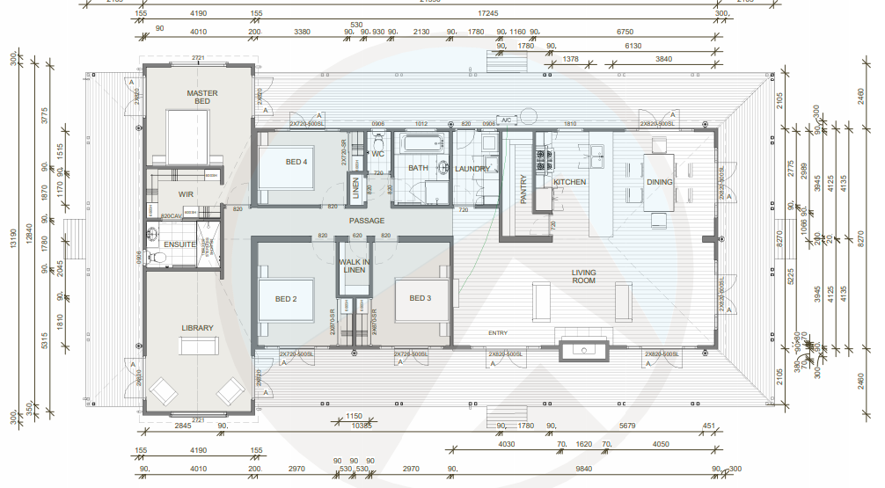
Figure 3: Floor Plan
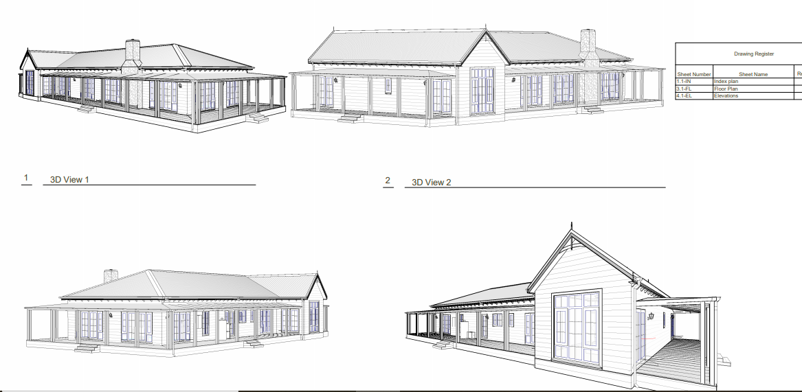
Figure 4: Elevation perspectives

History
There are no previous applications recorded on the subject lot. The property formerly known as 821 Greenhills Road contained several crown lots which were under one ownership. They have recently been sold off and are now are in different land ownerships. A history of planning applications for the property known as 821 Greenhills Road are as follows:
APPLICATION  NUMBER | LOT  NUMBER | PROPOSAL | DECISION DATE | OUTCOME
PA2019269 | Lot 13 | Development and use of a Dwelling | 24/03/20 | Permit issued
PA2020250 | Lot 10 | Development and use of dwelling and ancillary outbuilding | 16/06/21 | VCAT appeal against Notice of Decision
PA2021044 | Lot 12 | Development and use of a dwelling and shed | 25/06/21 | Permit issued
PA2021072 | Lot 11 | Development and use of a dwelling and shed | - | Current active file
PA2021161 | Lot 14 | Development and use of dwelling and ancillary outbuilding | - | On Advertising

Public Notice
The application was notified to adjoining and surrounding landowners. One objection was received.

Summary of Objections
The objections received are detailed below with officer’s comments accompanying them:
Objection | Any Relevant Requirement
State of Greenhills Road.
Officer’s Response: The subject site is part of an old subdivision and while the current state of Greenhills Road is relevant to any further development of the locality, Council’s Infrastructure raised no issue with the road and provided conditions.

Dwelling density in unsewered area and the number of dwellings within the catchment. Domestic Wastewater Management Plan not updated. | Water authority responses.
Officer’s Response: The application was referred to both Greater Western Water and Southern Rural Water with no issues raised. Wastewater is fully contained within the property boundary.
Zoning – the development of dwellings is better suited to rural townships. | Rural Conservation Zone.
Officer’s Response: The Rural Conservation Zone amongst other purposes, ‘encourages development and use of land which is consistent with sustainable land management and land capability practices, and which takes into account the conservation values and environmental sensitivity of the locality.’ It is considered that the proposed development of the new dwelling and shed is compatible to the locality in an acceptable built form that is consistent with the purpose of the zone.
Visual impact and size of the proposed shed | Rural Conservation Zone.
Officer’s Response: It is considered that the overall built form and siting of the proposed shed, to be finished in Colorbond, will not detract from the amenity of the surrounding rural area.
BAL 40 rating of the dwelling. | Bushfire Management Overlay.
Officer’s Response: The proposal has been referred to Country Fire Authority and no issues raised subject to conditions.
Integrated Land Management Plan, issue with Council enforcement being necessary. | Rural Conservation Zone.
Officer’s Response: The Integrated Land Management Plan and its outcomes will be included as a condition of the permit.
Use of land for agricultural and the Rural Conservation Zone is not a rural residential zone. | Rural Conservation Zone.
Officer’s Response: Use of the land for Agriculture is a Section 2, permit required use in the Rural Conservation Zone and the zone does allow for residential activity subject to an appropriate assessment against the decision guidelines.

Locality Map
The map below indicates the location of the subject site and the zoning of the surrounding area.
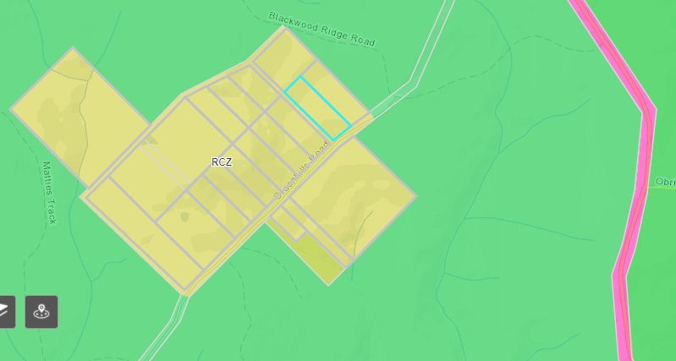
Figure 5: Zone Map

Planning Scheme Provisions
Council is required to consider the Victoria Planning Provisions and give particular attention to the Planning Policy Framework (PPF), the Local Planning Policy Framework (LPPF) and the Municipal Strategic Statement (MSS).
The relevant clauses are:
• Clause 12.01-1S - Protection of biodiversity
• Clause 12.01-2S - Native vegetation management
• Clause 12.05-2S - Landscapes
• Clause 13.02-1S - Bushfire planning
• Clause 14.02-1S - Catchment planning and management
• Clause 14.02-2S - Water quality
• Clause 16.01-3S - Rural residential development
• Clause 22.02 - Special Water Supply Catchments
• Clause 21.02 - Natural Environment
• Clause 21.02-1 - Key issues and influences
• Clause 21.09-1 - Small Towns and Settlements
The proposal complies with the relevant sections of the PPF and LPPF.

Zone
Rural Conservation Zone
The subject site is located in the Rural Conservation Zone. In accordance with Clauses 35.06-1 the proposed use for a dwelling requires a permit. Under Clause 35.06-5, building and works for a Section 2 use requires a permit. Decision guidelines are listed under Clause 35.06-6.
The purpose of the Rural Conservation Zone is:
• To implement the Municipal Planning Strategy and the Planning Policy Framework.
• To conserve the values specified in a schedule to this zone.
• To protect and enhance the natural environment and natural processes for their historic, archaeological and scientific interest, landscape, faunal habitat and cultural values.
• To protect and enhance natural resources and the biodiversity of the area.
• To encourage development and use of land which is consistent with sustainable land management and land capability practices, and which takes into account the conservation values and environmental sensitivity of the locality.
• To provide for agricultural use consistent with the conservation of environmental and landscape values of the area.
• To conserve and enhance the cultural significance and character of open rural and scenic non-urban landscapes.
The purpose of the Schedule to the Rural Conservation Zone is to:
• Protect land of environmental significance.
• Ensure that the location, siting and design of any development does not adversely impact upon sensitive environments nearby.
The decision guidelines of the RCZ require that the Responsible Authority must consider as appropriate:
• The protection and enhancement of the natural environment of the area, including the retention of vegetation and faunal habitats and the need to revegetate land including riparian buffers along waterways, gullies, ridgelines, property boundaries and saline discharge and recharge areas.
• How the use and development relate to sustainable land management and the need to prepare an integrated land management plan which addresses the protection and enhancement of native vegetation and waterways, stabilisation of soil and pest plant and animal control.
• The capability of the land to accommodate the proposed use or development.
• The need to minimise adverse impacts on the character and appearance of the area or features of archaeological, historic or scientific significance or of natural scenic beauty or importance.

Overlays

Relevant Policies
Design and Development Overlay – Schedule 2 (DD02):
The site is included in the Design and Development Overlay – Schedule 2 covering visual amenity and building design.
The relevant design objectives of the DDO2 to be achieved are:
• To enhance visual amenity in rural, township and vegetated areas of the Moorabool Shire.
• To encourage the use of external cladding, such as non-reflective materials for building construction.
• To discourage the use of materials, such as reflective cladding for building construction, which could have a detrimental effect on amenity.
In accordance with Clause 2.0 of Schedule 2, a permit is not required to construct a building or to carry out works where all external walls and roof areas are clad with non-reflective materials.
The proposed dwelling would be externally clad with non-reflective materials and a permit is not required under this overlay.
Bushfire Management Overlay (BMO)
The subject site as affected by the Bushfire Management Overlay. In accordance with Clause 44.06-2 a permit is required to construct a building or construct or carry out works associated with Accommodation.
The relevant purposes of the BMO are:
• To implement the Municipal Planning Strategy and the Planning Policy Framework.
• To ensure that the development of land prioritises the protection of human life and strengthens community resilience to bushfire.
• To ensure that the location, design and construction of development appropriately responds to the bushfire hazard.
• To ensure development is only permitted where the risk to life, property and community infrastructure from bushfire can be reduced to an acceptable level.
• To specify location, design and construction measures for a single dwelling that reduces the bushfire risk to life and property to an acceptable level.
Pursuant to Clause 44.06-6, referral to the relevant fire authority in accordance with Clause 66.03 is required. The application was referred to the Country Fire Authority and a BAL40 was designated for the dwelling construction.

Particular Provisions
Clause 53.02 Bushfire Planning
Subject to Clause 44.06-4, this application must meet the requirements of Clause 53.02 Bushfire Planning.
A Bushfire Management Statement was provided with the application. The purpose of Clause 53.02 is:
• To implement the Municipal Planning Strategy and the Planning Policy Framework.
• To ensure that the development of land prioritises the protection of human life and strengthens community resilience to bushfire.
• To ensure that the location, design and construction of development appropriately responds to the bushfire hazard.
• To ensure development is only permitted where the risk to life, property and community infrastructure from bushfire can be reduced to an acceptable level.
• To specify location, design and construction measures for a single dwelling that reduces the bushfire risk to life and property to an acceptable level.

Clause 52.12-5 Bushfire Protection Exemptions
The exemptions to create defendable space for a dwelling under Clause 44.06 of this planning scheme from vegetation removal do not apply to the Rural Conservation Zone.

Discussion
While the locality is constrained by significant vegetation in the surrounding area, the proposed location of the dwelling and shed is generally acceptable on a vacant lot.
The setbacks proposed are generous with a defendable space in accordance conditions provided by the CFA based on the accompanying Bushfire Management Statement. The Bushfire report estimated that the Bushfire Attack Level for this site was BAL40.
A Land Capability Assessment was submitted with the application and it was referred to Council's Environmental Health as well as Greater Western Water and Southern Rural Water, all of which have consented to the application with conditions. The application was referred to Council's Infrastructure which also consented subject to conditions.
The land is of sufficient size and the proposed dwelling and ancillary shed are positioned appropriately on the land to not cause any adverse impacts to any adjacent properties.
The site is vacant land with limited biodiversity value with some small patches of remanent vegetation near the dam. The site has been grazed as part of previous farming practices which has not preserved native grasses or native trees. The applicant has prepared a comprehensive land management plan which ensues the dwelling and shed location do not affect remanent vegetation and provides a series of management measures specific to new tree plantings and the control of weed species. The land management plan can be endorsed as part of this use and development application which will protect the conservation value of the area. The objector is primarily concerned with dwellings entering the area and believes the area should be protected for agricultural purposes. This is not the intent of the Rural Conservation Zone and there are no environmental constraints to prevent the establishment of a dwelling and detached ancillary shed. The proposal is supported by planning policy and should be approved subject to conditions.

General Provisions
Clause 65 - Decision Guidelines have been considered by officers in evaluating this application.
Clause 66 - Stipulates all the relevant referral authorities to which the application must be referred.

Referrals
Authority | Response
Greater Western Water  Southern Rural Water  Country Fire Authority | Consent with conditions.  Consent.  Consent with conditions.
Council’s Infrastructure  Council’s Environmental Health | Consent with conditions.  Consent with conditions.

Financial Implications
There is no financial implication associated with this approval for this use and development of a dwelling and shed.

Risk & Occupational Health & Safety Issues
The recommendation of approval of this use and development does not implicate any risk or OH&S issues to Council.

Communications Strategy
Notice was undertaken for the application, in accordance with s.52 of the Planning and Environment Act 1987, and further correspondence is required to all interested parties to the application as a result of a decision in this matter. All submitters and the applicant were invited to attend this meeting and invited to address Council if required.

Options
Council could consider the following options:
• issue a Notice of Decision to grant a Planning Permit in accordance with the recommendations of this report; or
• issue a refusal to Grant a Planning Permit with specific grounds. The grounds would need to demonstrate how the proposal does not comply with the Moorabool Planning Scheme.

Conclusion
In summary, based on the information within the Bushfire Management Statement and Land Capability Assessment as well as the Integrated Land Management Plan, it is considered that the overall siting and built form of the dwelling and shed, is an appropriate outcome for the site and considered to be generally acceptable and, therefore, should be supported subject to relevant conditions.

7.2 PA2021117 - Removal of Restrictive Covenant 2388443 at 10 and 11 David Court, Darley
Author: Thomas Tonkin, Statutory Planner
Authoriser: Henry Bezuidenhout, Executive Manager Community Planning & Economic Development
Attachments: 1. Proposed plan of removal of restriction (under separate cover)

Application Summary
Permit No: PA2021117
Lodgement Date: 27 May 2021
Planning Officer: Tom Tonkin
Address of the land: 10 and 11 David Court, Darley
Proposal: Removal of Restrictive Covenant 2388443
Lot size: Each lot is 818.71sqm
Why is a permit required? Clause 52.02 Easements, Restrictions and Reserves – Removal of a restriction.

Recommendation
That the Development Assessment Committee, having considered all matters as prescribed by the Planning and Environment Act 1987, issue a Refusal to Grant Planning Permit PA2021117 for the Removal of Restrictive Covenant 2388443 at Lots 23 and 24 on PS 022114 known as 10 and 11 David Court, Darley, 3340, on the following grounds:
1. The removal of restrictive covenant 2388443 does not satisfy the tests of section 60(5) of the Planning and Environment Act 1987.
2. Beneficiaries and non-beneficiaries of the covenant are likely to suffer detriment including perceived detriment as a result of the removal of the covenant.

Public Consultation
Was the application advertised? | Yes.
Notices on site: | Yes, two.
Notice in Moorabool Newspaper: | Yes.
Number of objections: | Four.
Consultation meeting: | No.

Policy Implications
The Council Plan 2021-2025 provides as follows:
Strategic Objective 1: Healthy, inclusive and connected neighbourhoods
Priority 1.1: Improve the health and wellbeing of our community

Victorian Charter of Human Rights & Responsibilities Act 2006
In developing this report to Council, the officer considered whether the subject matter raised any human rights issues. In particular, whether the scope of any human right established by the Victorian Charter of Human Rights and Responsibilities is in any way limited, restricted or interfered with by the recommendations contained in the report. It is considered that the subject matter does not raise any human rights issues.

Officer’s Declaration of Conflict of Interests
Under section 130 of the Local Government Act 2020, officers providing advice to Council must disclose any interests, including the type of interest.
Executive Manager – Henry Bezuidenhout
In providing this advice to Council as the Executive Manager, I have no interests to disclose in this report.
Author – Tom Tonkin
In providing this advice to Council as the Author, I have no interests to disclose in this report.

Executive Summary
Application referred? | No, not required.
Any issues raised in referral responses? | Not applicable.
Preliminary concerns? | No.
Any discussions with applicant regarding concerns? | Not applicable.
Any changes made to the application since being lodged? | No.
Brief history. | Not applicable.
Previous applications for the site? | None.
General summary. | It is proposed to remove restrictive covenant 2388443 which prohibits the construction of more than one dwelling and the usual outbuildings on either lot. The applicant has advised that the purpose of the proposal is to facilitate the subdivision of two lots to create an additional/third lot, which would be subject to a future planning permit application.  Four objections were received, including from two covenant beneficiaries, raising concerns generally regarding the negative impact on the neighbourhood character and amenity of the area.  Based on the relevant provisions of the Moorabool Planning Scheme and objections in accordance with Section 60(5) of the Planning and Environment Act 1987 it is recommended that the application be refused.
Summary of Officer’s Recommendation
That, having considered all relevant matters as required by the Planning and Environment Act 1987, Council issue a Refusal to Grant a Permit for the Removal of Restrictive Covenant 2388443 at Lots 23 and 24 on PS 022114 known as 10 and 11 David Court, Darley, on the grounds included in this report.

Site Description
The subject sites, identified as Lots 23 and 24 on PS 022114 and known as 10 and 11 David Court, Darley, are adjoining land parcels on the north side of David Court. Both lots are rectangular in shape with identical dimensions, both 818.71sqm in size. Both lots are developed with single dwellings, and on Lot 23 ancillary outbuildings.
The subject site and surrounding land is in the General Residential Zone, Schedule 2, and developed with predominantly single dwellings on lots of an identical or similar size to the subject sites, with only occasional examples of medium density housing development. Most dwellings are single storey, and the pattern and appearance of development is generally uniform.
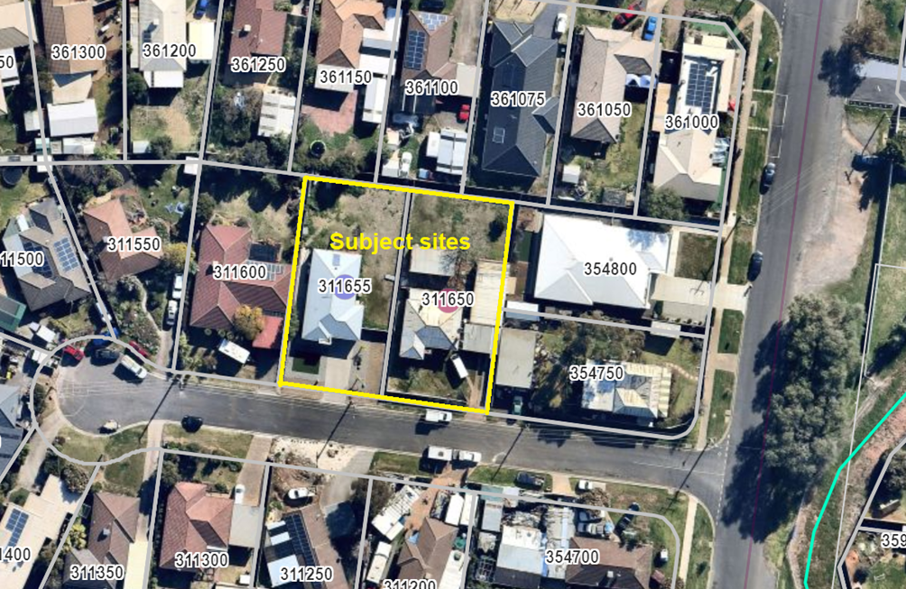
Figure 1: Aerial photograph

Proposal
It is proposed to remove restrictive covenant 2388443 which is registered on the title to both lots. The covenant prohibits the construction of buildings on either lot apart from a single dwelling and ancillary outbuildings. The covenant was created on 14 March 1951 and must be assessed under Section 60(5) rather than Section 60(2) of the Planning & Environment Act 1987.

Background to Current Proposal
The applicant advised that the purpose of removing restrictive covenant 2388443 is to enable the potential subdivision of both lots to create an additional lot. The proposed subdivision is not assessed as part of this application, with the assessment of such a proposal being reliant on the removal of the covenant as proposed by the current application.

History
None applicable.

Public Notice
Notice of the application was given all beneficiaries of the covenant which included adjoining and surrounding landowners by way of letters to landowners and occupiers and notices on site and in the Moorabool News, a newspaper circulating in the local area. Four objections were received, two of which were from beneficiaries of the covenant.

Summary of Objections
The objections received are detailed below with the officer’s accompanying comments:
Objection | Any Relevant Requirement
The purpose of the proposal would create an opportunity for subdivision or unit development which is not appropriate given the neighbourhood character and traffic issues. | Clause 52.02.
Officer’s Response:
See ‘Discussion’ below.
The prevailing lot sizes and single dwelling development in the surrounding neighbourhood allow for generally spacious private open spaces which contribute to the neighbourhood character. The proposed removal of covenant would create an opportunity for land development inconsistent with the neighbourhood character. | Clause 52.02.
Officer’s Response:
See ‘Discussion’ below.
Traffic and parking conditions in David Court are not conducive to increased residential development which could be facilitated by removal of the covenant. | Clause 52.02.
Officer’s Response:
See ‘Discussion’ below.
The subject sites, in terms of lot size and streetscape presentation, currently meet the existing and preferred neighbourhood character, notwithstanding the rundown condition of the dwelling at no. 11. Further development of the sites, facilitated by the removal of the covenant, would not be in keeping with the surrounding dwelling density or neighbourhood character. | Clause 52.02.
Officer’s Response:
See ‘Discussion’ below.
The proposal has the potential to impact on the safety of students and parents walking to the nearby Darley Primary School due to increased traffic. | Clause 52.02.
Officer’s Response:
Whilst it is accepted that approval of the application creates the potential for further development of the subject sites and additional vehicle traffic, this would be subject to an assessment as part of any future development application.
Negative impact on property values. | Clause 52.02.
Officer’s Response:
VCAT have consistently stated that the impact of financial loss cannot be easily determined and would require expert evidence.

Locality Map
The maps below indicate the location of the subject site and the zoning of the surrounding area.

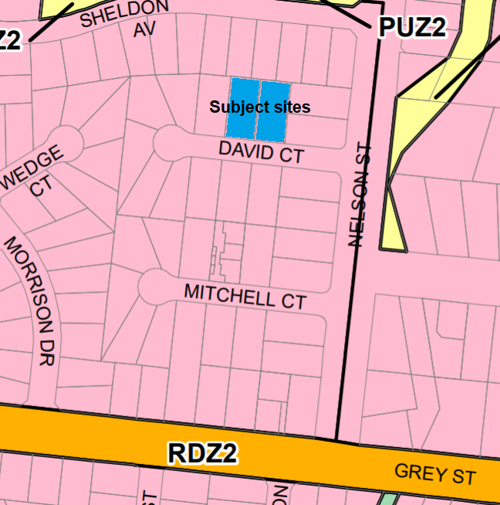
Figure 2: Zone map

Planning Scheme Provisions
Council is required to consider the Victoria Planning Provisions and give particular attention to the Planning Policy Framework (PPF), the Local Planning Policy Framework (LPPF) and the Municipal Strategic Statement (MSS).
The relevant clauses are:
• Clause 11.03-3S Peri-urban areas
• Clause 15.01-5S Neighbourhood character
• Clause 21.03-4 Landscape and Neighbourhood Character
Objections raised include concerns about the negative impacts of the covenant removal on the neighbourhood character and amenity of the area. See ‘Discussion’ below.

Zone
The subject site is in the General Residential Zone, Schedule 2 (GRZ2). The purpose of the Zone is:
• To implement the Municipal Planning Strategy and the Planning Policy Framework.
• To encourage development that respects the neighbourhood character of the area.
• To encourage a diversity of housing types and housing growth particularly in locations offering good access to services and transport.
• To allow educational, recreational, religious, community and a limited range of other non-residential uses to serve local community needs in appropriate locations.
Schedule 2 relates to areas identified for natural residential growth. Whilst there is no permit requirement under the zone to remove a restrictive covenant, the following neighbourhood character objectives for Schedule 2 provide relevant policy context for the objections about neighbourhood character:
• To encourage new development, including innovative and unique development that enhances and responds positively to the existing neighbourhood character.
• To encourage an increase in landscaping within the public and private realm.
• To encourage new development to respect existing setbacks within the streetscape.
• To encourage new development to have minimal or low scale front fencing.
• To ensure garages, carports, and second storey development do not visually dominate dwellings or streetscapes.

Overlays

The subject site is not affected by any Overlays.

Relevant Policies
There are no Council policies applicable to the assessment of this application.

Particular Provisions
Clause 52.02 Easements, Restrictions and Reserves
A permit is required before a person proceeds under Section 23 of the Subdivision Act 1988 to vary or remove a restriction.
The decision guidelines state before deciding on an application, in addition to the decision guidelines in Clause 65, the responsible authority must consider the interests of affected people.

Discussion
The relevant consideration for assessment of this application are the provisions of Section 60, subsections (4) and (5) of the Planning and Environment Act 1987. Subsection (4) makes the relevant distinction between restrictions created before and after 25 June 1991. As previously stated, the restriction in question was created in 1951, thus pursuant to subsection (4), subsection (5) is applicable to this application and states the following:

The responsible authority must not grant a permit which allows the removal or variation of a restriction referred to in subsection (4) unless it is satisfied that—
(a) the owner of any land benefited by the restriction (other than an owner who, before or after the making of the application for the permit but not more than three months before its making, has consented in writing to the grant of the permit) will be unlikely to suffer any detriment of any kind (including any perceived detriment) as a consequence of the removal or variation of the restriction; and
(b) if that owner has objected to the grant of the permit, the objection is vexatious or not made in good faith.
As previously outlined above, objections were received to the application including from beneficiaries of the covenant, primarily relating to the potential impacts on the neighbourhood character and amenity of the area if the covenant was removed. Notwithstanding that the development of additional dwellings or subdivision of either lot would require separate planning approval, in consideration of the objections received and the provisions of section 60(5)(a) and (b) it is deemed that Council is unable to satisfy itself that any of the beneficiaries would be unlikely to suffer any detriment of any kind, including perceived detriment, because of the proposed removal of the covenant.
The beneficiaries have described what they believe the actual or perceived negative consequences of the covenant removal would be. Furthermore, there is nothing in the beneficiaries’ objections to suggest that they are vexatious or not made in good faith. The interests of non-beneficiaries also need to be considered under Section 60(5) and they raised similar concerns as the beneficiaries of the covenant. The application cannot be approved based on these objections.

General Provisions
Clause 65 - Decision Guidelines have been considered by officers in evaluating this application.
Pursuant to Clause 65 of the Moorabool Planning Scheme, the Responsible Authority must consider, among other things, the matters set out in Section 60 of the Planning and Environment Act 1987, as per the ‘Discussion’ above.
Clause 66 - Stipulates all the relevant referral authorities to which the application must be referred.

Referrals

The application was not required to be referred.Financial Implications
There are no financial implications for Council in refusing this application.

Risk & Occupational Health & Safety Issues
The recommendation to refuse this application does not have any risk or OH&S implications for Council.

Communications Strategy
Notice was undertaken for the application, in accordance with s.52 of the Planning and Environment Act 1987, and further correspondence is required to all interested parties to the application because of a decision on this matter. All submitters and the applicant were invited to attend this meeting and address Council if required.

Options
- Issue a Refusal to Grant a Permit on the grounds listed in the recommendation of this report; or
- issue a Notice of Decision to Grant a Permit with conditions. Council would need to satisfy itself that the covenant beneficiaries would be unlikely to suffer any detriment of any kind, including perceived detriment, because of the removal of the covenant. This option may result in the objectors appealing Council’s decision to VCAT and beneficiaries could make a claim for costs.

Conclusion
Based on the assessment of the application against the relevant provisions of the Moorabool Planning Scheme and Section 60(5) Planning and Environment Act 1987 it is recommended that this application to remove restrictive covenant 2388443 be refused. Based on the objections received including from beneficiaries of the covenant, Council would be unable to satisfy itself that they would be unlikely to experience any detriment including perceived detriment if the covenant was to be removed.

7.3 PA2021233 - Development of an Agricultural Shed at 410 Moorabool West Road, Gordon
Author: Justin Rocio, Statutory Planning Officer
Authoriser: Henry Bezuidenhout, Executive Manager Community Planning & Economic Development
Attachments: 1. Site, floor and elevation plans

Application Summary
Permit No: PA2021233
Lodgement Date: 5 October 2021
Planning Officer: Justin Rocio
Address of the land: 410 Moorabool West Road, Gordon
Proposal: Development of an Agricultural Shed
Lot size: 47.2ha
Why is a permit required? Environmental Significance Overlay Schedule 1 – Buildings and works

Recommendation
That the Development Assessment Committee, having considered all matters as prescribed by the Planning and Environment Act 1987, issue Planning Permit PA2021233 for the Development of an Agricultural Shed at 410 Moorabool West Road, Gordon, subject to the following conditions:
1. Endorsed Plans
The development as shown on the endorsed plans must not be altered without the written consent of the Responsible Authority. All buildings and works must be constructed and or undertaken in accordance with the endorsed plans to the satisfaction of the Responsible Authority. All buildings and works must be located clear of any easements or water and sewer mains or septic tank and effluent lines unless written approval is provided by the relevant authority.
Materials and Colour
2. All external walls and roof areas of the proposed building are to be clad with non-reflective materials (include and equivalents prohibited) to the satisfaction of the Responsible Authority.
Infrastructure
3. Storm water drainage from the proposed buildings and impervious surfaces must be retained and disposed of within the boundaries of the subject land to the satisfaction of the Responsible Authority. Overflows from on-site storage systems must be directed away from any waste water disposal areas.
4. Sediment discharges must be restricted from any construction activities within the property in accordance with the relevant Guidelines including Construction techniques for Sediment Control (EPA 1991).
5. Unless otherwise approved by the Responsible Authority there must be no buildings, structures, or improvements located over proposed drainage pipes and easements on the property.
6. Prior to the commencement of the development and post completion, notification including photographic evidence must be sent to Council’s Asset Services identifying any existing damage to Council assets. Any existing works affected by the development must be fully reinstated at no cost to and to the satisfaction of the Responsible Authority.
Barwon Water
7. The permitted building must not be used for any habitable purpose and must not be used for any commercial or industrial purpose except in accordance with the provisions of the Moorabool Planning Scheme.
8. The existing or proposed effluent disposal areas (if applicable) must be kept free from stock, buildings, driveways, and service trenching.
9. Stormwater must not be released directly into any waterway and must be directed away from any existing or approved effluent fields.
10. Sediment control measures outlined in the EPA’s publication No. 275 Sediment Pollution Control, shall be employed during construction, and maintained until the disturbed area has been revegetated.
Permit Expiry
11. This permit will expire if:
(a) the development and use are not started within two years of the date of this permit; or
(b) the development is not completed within four years of the date of this permit.

Public Consultation
Was the application advertised? | No material detriment. The application was not advertised.
Notices on site: | No.
Notice in Moorabool Newspaper: | Not applicable.
Number of objections: | No objections
Consultation meeting: | No.

Policy Implications
The Council Plan 2021-2025 provides as follows:
Strategic Objective 1: Healthy, inclusive and connected neighbourhoods
Priority 1.4: Develop a vision and provide opportunities for rural communities

Victorian Charter of Human Rights & Responsibilities Act 2006
In developing this report to Council, the officer considered whether the subject matter raised any human rights issues. In particular, whether the scope of any human right established by the Victorian Charter of Human Rights and Responsibilities is in any way limited, restricted or interfered with by the recommendations contained in the report. It is considered that the subject matter does not raise any human rights issues.

Officer’s Declaration of Conflict of Interests
Under section 130 of the Local Government Act 2020, officers providing advice to Council must disclose any interests, including the type of interest.
Executive Manager – Henry Bezuidenhout
In providing this advice to Council as the Executive Manager, I have no interests to disclose in this report.
Author – Justin Rocio
In providing this advice to Council as the Author, I have no interests to disclose in this report.
It is noted the permit applicant is a sitting Councillor of Moorabool Shire Council.

Executive Summary
Application referred? | Barwon Water and Council’s Infrastructure.
Any issues raised in referral responses? | No.
Preliminary concerns? | No.
Any discussions with applicant regarding concerns? | No.
Any changes made to the application since being lodged? | Applicant lodged elevation plans of the shed that were absent from plans lodged.
Brief history. | The site contains an existing dwelling associated with farming activities.
Previous applications for the site? | PA2010086 was issued on 4 October 2021 for a Two Lot Subdivision (House Lot Excision).  PA2020283 was issued on 21 July 2021 for a Two Lot Subdivision (House Lot Excision).
General summary. | The proposal is an agricultural shed within the Farming Zone and is consistent with the zoning objectives. The lot is affected by the Environmental Significance Overlay Schedule 1 and subject to conditions will have no impact on the water quality within the catchment area. The proposal is recommended for approval.
Summary of Officer’s Recommendation
That, having considered all relevant matters as required by the Planning and Environment Act 1987, Council issue Planning Permit PA2021233 for the Development of an Agricultural Shed at 410 Moorabool West Road, Gordon subject to the conditions contained within this report.

Site Description
The subject site is an ‘L’ shaped block which has an area of around 47ha. The land is cleared of vegetation with only small patches of trees scattered throughout the property. There are two waterways flowing through the property. One running on the south-western corner of the site and the other towards the east. There are four dams located in the property with two of the dams located towards the centre of the site and the other two towards the frontage. The site has been subject to a previous house lot excision approval on the north western corner of the property. The titles have yet to be released as a result of this approval.
The surrounding properties all have differing land sizes with some lots being 4ha and others being over 70ha. Due to the change in zoning from Farming to Rural Living, the properties to the west of the subject site are noticeably smaller than those on the east. There is also significantly more vegetation found in the properties to the west of the site. Due to this, the Bushfire Management Overlay mainly affects those properties to the west as well as western part of the subject site. The proposed shed is not affected by the Bushfire Management Overlay.

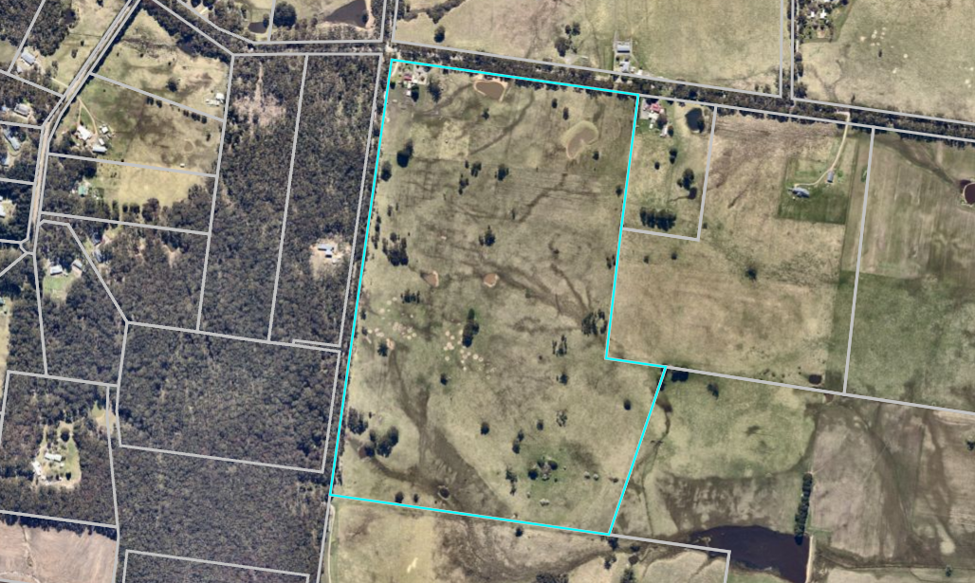
Figure 1: Aerial image of the site

Proposal
The subject site is proposed for the construction of a 24 x 10m farm shed and a 24 x 5m awning with a gutter height of 4m and a ridge height of 4.972m. The shed will have a western side setback of 280m and a rear setback of 356m. The shed will contain vehicle roller doors and internal pedestrian doors and will be clad with Colorbond sheeting ‘Monolith’ colour. No trees or native vegetation is proposed to be removed.

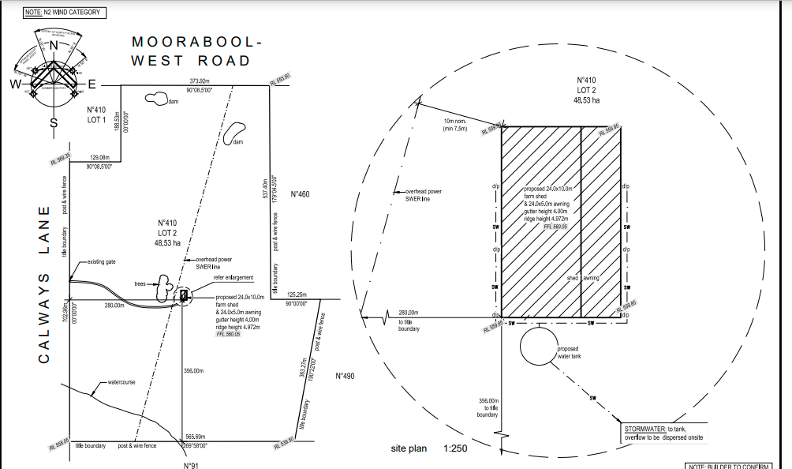
Figure 2: Site plans

History
PA2010086 was issued on 4 October 2021 for a Two Lot Subdivision (House Lot Excision). The permit expired without the titles being released.
PA2020283 was issued on 21 July 2021 for a Two Lot Subdivision (House Lot Excision). The titles are yet to be released as a result of this approval.

Public Notice
The application was not advertised.

Summary of Objections
There are no objections to this application.

Locality Map
The map below indicates the location of the subject site and the zoning of the surrounding area.
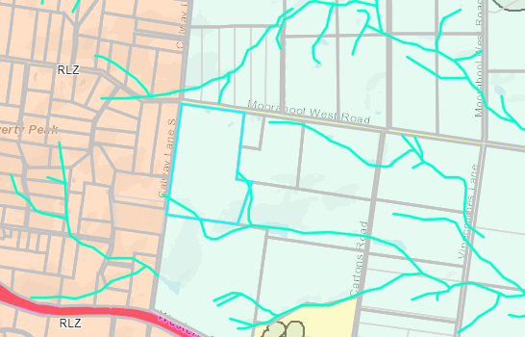
Figure 3: Zone Map.

Planning Scheme Provisions
Council is required to consider the Victoria Planning Provisions and give particular attention to the Planning Policy Framework (PPF), the Local Planning Policy Framework (LPPF) and the Municipal Strategic Statement (MSS).
• Clause 13.02-1S – Bushfire planning
• Clause 14.01-1S – Protection of agricultural land
• Clause 14.02-1S Catchment Planning and Management
• Clause 14.02-2S Water Quality
• Clause 15.01-6S – Design for rural areas
• Clause 21.02-3 Objective – Water and Catchment Management
• Clause 21.02-5 Objective – Bushfire
• Clause 21.03-4 Objective – Landscape and neighbourhood character
• Clause 21.04-2 Objective – Agriculture
• Clause 22.02 Special Water Supply Catchments
The proposal complies fully with the relevant sections of the PPF and LPPF.
Zone
Farming Zone
The subject site is within the Farming Zone. A permit is not required to use a shed for agricultural purposes.

A permit is not required for building and works under Clause 35.07-4 of the Moorabool Planning Scheme.

Overlays
Bushfire Management Overlay

Part of the site is affected by the Bushfire Management Overlay. A permit is not required for a shed under this overlay because the shed is not within the Bushfire Management Overlay area.

Design and Development Overlay Schedule 2

The site is affected by Schedule 2 of the Design and Development Overlay. A planning permit is not needed under this overlay because the proposal will have non-reflective building materials as required by permit conditions.

Environmental Significance Overlay Schedule 1

The site is affected by Schedule 1 of the Environmental Significance Overlay. A permit is required for an agricultural shed under this overlay because the shed does not have any exemptions listed within Schedule 1 to the Environmental Significance Overlay and in accordance with Clause 42.01-2 of the Moorabool Planning Scheme.

The environmental objectives of the Environmental Significance Overlay are:

• To protect the quality and quantity of water produced within proclaimed water catchments.

• To provide for appropriate development of land within proclaimed water catchments.

Particular Provisions
No relevant provisions.

Discussion

The proposal is generally in accordance with the relevant Planning Policy Framework and the Local Planning Policy Framework. Due to this, a permit is recommended to be issued for the following reasons:

• The site meets the Environmental Significance Overlay Schedule 1 requirements. The permit conditions have been added by the relevant catchment authority to ensure the water catchment area is not degraded by the development of a shed.
• The application was also referred to Council’s Infrastructure and it has consented as per conditions.
• The proposed shed is an appropriate use and development in the Farming Zone and will support the continued agricultural use of the land.

General Provisions
Clause 65 - Decision Guidelines have been considered by officers in evaluating this application.
Clause 66 - Stipulates all the relevant referral authorities to which the application must be referred.

Referrals
Authority | Response
Barwon Water | Consent with conditions.
Council’ Infrastructure | Consent with conditions.

Financial Implications
There are no financial implications to Council with the recommendation of approval of this application.

Risk & Occupational Health & Safety Issues
The recommendation for approval of this application does not implicate any risk or OH&S issues to Council.

Communications Strategy
Notice was not undertaken for the application, in accordance with s.52 of the Planning and Environment Act 1987. The applicant was invited to attend the meeting.

Options
Council could consider the following options:
• issue a planning permit in accordance with the recommendations of this report; or
• issue a refusal to grant a planning permit with specific grounds. The grounds would need to demonstrate how the proposal does not comply with the Moorabool Planning Scheme.

Conclusion
It is considered that the overall siting and built form of the agricultural shed is an appropriate outcome for the site and complies with the provision of Moorabool Planning Scheme. The referral authorities have consented to the application in accordance with their requirements. It is recommended that a planning permit be issued with standard conditions.

8 Update on Trends, Issues and Other Matters

9 Process Forward and Work Program

10 Update on VCAT Decisions

11 Other Business

12 Date of Next Meeting
Wednesday 17 November 2021

13 Meeting Close

