AGENDA

Development Assessment Committee Meeting
Wednesday, 15 September 2021
I hereby give notice that a Development Assessment Committee Meeting will be held on:
Date: | Wednesday, 15 September 2021
Time: | 6.00pm
Location: | Online
Derek Madden
Chief Executive Officer

Order Of Business
1 Opening 5
2 Present and Apologies 5
3 Recording of Meeting 5
4 Confirmation of Minutes 5
5 Matters Arising from Previous Minutes 5
6 Disclosure of Conflicts of Interests 5
7 Community Planning Reports 6
7.1 PA2020095 – Development and use of Three Warehouses, Three Lot Subdivision and a Reduction of Car Parking (one car space) at 8 Osborne Street, Maddingley 6
7.2 PA2020150 - Two lot subdivision at 246 Camerons Road Coimadai 20
7.3 PA2021097 Development and Use of a Dwelling and Shed at Lot 1 Kennedys Lane, Bunding 31
7.4 PA2021018 - Development and Use of a Dwelling and Shed at Ralstons Road, Pootilla 43
8 Update on Trends, Issues and Other Matters 56
9 Process Forward and Work Program 56
10 Update on VCAT Decisions 56
11 Other Business 56
12 Date of Next Meeting 56
13 Meeting Close 56

1 Opening

2 Present and Apologies

3 Recording of Meeting
In accordance with Moorabool Shire Council’s Governance Rules, the meeting will be livestreamed.

4 Confirmation of Minutes
Development Assessment Committee Meeting – Wednesday 18 August 2021

5 Matters Arising from Previous Minutes

6 Disclosure of Conflicts of Interests
Conflict of interest laws are prescribed under the Local Government Act 2020 (the Act) and in the Local Government (Governance and Integrity) Regulations 2020 (the Regulations). Managing conflicts of interest is about ensuring the integrity and transparency of decision-making.
The conflict of interest provisions under the Act have been simplified so that they are more easily understood and more easily applied. The new conflict of interest provisions are designed to ensure relevant persons proactively consider a broader range of interests and consider those interests from the viewpoint of an impartial, fair-minded person.
Section 126 of the Act states that a Councillor has a conflict of interest if they have a general conflict of interest or a material conflict of interest. These are explained below:
- A Councillor has a general conflict of interest in a matter if an impartial, fair-minded person would consider that the member’s private interests could result in them acting in a manner that is contrary to their public duty as a Councillor.
- A Councillor has a material conflict of interest in a matter if an affected person would gain a benefit or suffer a loss depending on the outcome of the matter.
A relevant person with a conflict of interest must disclose the interest in accordance with Council’s Governance Rules and not participate in the decision-making process on the matter. This means the relevant person must exclude themselves from any discussion or vote on the matter at any Council meeting, delegated committee meeting, community asset committee meeting or, if a Councillor, any other meeting conducted under the auspices of the Council. The relevant person must also exclude themselves from any action in relation to the matter, including an action taken to implement a Council decision, for example, issuing a planning permit.

7 Community Planning Reports

7.1 PA2020095 – Development and use of Three Warehouses, Three Lot Subdivision and a Reduction of Car Parking (one car space) at 8 Osborne Street, Maddingley
Author: Thomas Tonkin, Statutory Planner
Authoriser: Henry Bezuidenhout, Executive Manager Community Planning & Economic Development
Attachments: 1. Plans of the existing site and proposed development (under separate cover)
2. Proposed subdivision plans (under separate cover)

Application Summary
Permit No: PA2020095
Lodgement Date: 27 May 2020 Amended application lodged 14 May 2021
Planning Officer: Tom Tonkin
Address of the land: 8 Osborne Street, Maddingley
Proposal: Development and Use of Three Warehouses, Three Lot Subdivision and a Reduction of Car Parking (one car space)
Lot size: 2478sqm
Why is a permit required? Clause 33.02 Industrial 2 Zone – Development and use for warehouses and subdivision
Clause 52.06 Car Parking – Reduction of car parking

Recommendation
That the Development Assessment Committee, having considered all matters as prescribed by the Planning and Environment Act 1987, issue Planning Permit PA2020095 for Development and Use of Three Warehouses, Three Lot Subdivision and a Reduction of Car Parking at Lot 2 on PS218916W known as 8 Osborne Street, Maddingley, 3340, subject to the following conditions:
Endorsed Plans:
1. Before the use and development starts or before the subdivision is certified, whichever occurs first, amended plans to the satisfaction of the Responsible Authority must be submitted to and approved by the Responsible Authority. When approved, the plans will be endorsed and will then form part of the permit. The plans must be drawn to scale with dimensions and must be generally in accordance with the plans identified as Plan of Subdivision 841406E, Sheets 1 & 2 v. 3, surveyor’s reference 4571 drawn by Anthony Ford and rev. B of Sheet no.’s TP2, TP3, TP4, TP5, TP6 & TP7, Job no. J19070 dated 12/05/2021 prepared by Briclok Building Design but modified to show:
(a) Details of signage or other identification of the common property car spaces for drivers to distinguish from Lot 1’s car spaces.
(b) The location of external lighting to enhance safety and property security.
(c) The landscape plan amended to clarify the numbers of listed plant species identified in the plant legend.
Subdivision:
2. The formal plan of subdivision lodged for certification must be generally in accordance with the endorsed plan and must not be modified except to comply with statutory requirements or with the written consent of the Responsible Authority.
Telecommunications:
3. The owner of the land must enter into an agreement with:
(a) A telecommunications network or service provider for the provision of telecommunication services to each lot shown on the endorsed plan in accordance with the provider’s requirements and relevant legislation at the time; and
(b) A suitably qualified person for the provision of fibre ready telecommunication facilities to each lot shown on the endorsed plan in accordance with any industry specifications or any standards set by the Australian Communications and Media Authority, unless the applicant can demonstrate that the land is in an area where the National Broadband Network will not be provided by optical fibre.
4. Before the issue of a Statement of Compliance for any stage of the subdivision under the Subdivision Act 1988, the owner of the land must provide written confirmation from:
(a) A telecommunications network or service provider that all lots are connected to or are ready for connection to telecommunications services in accordance with the provider’s requirements and relevant legislation at the time; and
(b) A suitably qualified person that fibre ready telecommunication facilities have been provided in accordance with any industry specifications or any standards set by the Australian Communications and Media Authority, unless the applicant can demonstrate that the land is in an area where the National Broadband Network will not be provided by optical fibre.
Use:
5. The use of the site must comply with the requirements of Clause 53.10 (Uses with Adverse Amenity Potential) of the Moorabool Planning Scheme or separate planning approval obtained.
Operational:
6. The loading and unloading of goods and materials from vehicles must only be carried out on the land.
7. Provision must be made on the land for the storage and collection of garbage and other solid waste. This area must be graded and drained, as appropriate, and screened from public view to the satisfaction of the Responsible Authority.
Amenity:
8. The amenity of the area must not be detrimentally affected by the use or development, through the:
(a) transport of materials, goods or commodities to or from the land;
(b) appearance of any building, works or materials;
(c) emission of noise, artificial light, vibration, smell, fumes, smoke, vapour, steam, soot, ash, dust, waste water, waste products, grit or oil;
(d) presence of vermin; and
(e) any other way.
9. Effective noise levels from the use of the premises must not exceed the recommended levels as set out in the Noise from Industry in Regional Victoria (NIRV; EPA Publication 1411, 2011) or as amended.
10. External lighting must be provided with suitable baffles and located so that no direct light is emitted outside the site.
11. Any security alarm or similar device installed must be of a silent type.
12. Goods, equipment or machinery must not be stored or left exposed in a position that can be seen from the street.
Landscape Plans:
13. Before the occupation of the development starts or by such later date as is approved by the Responsible Authority in writing, the landscaping works shown on the endorsed plans must be carried out and completed to the satisfaction of the Responsible Authority.
14. The landscaping shown on the endorsed plans must be maintained to the satisfaction of the Responsible Authority, including that any dead, diseased or damaged plants are to be replaced.
Infrastructure:
15. A standard urban industrial vehicle crossing must be provided on Osborne Street to the satisfaction of the Responsible Authority. A vehicle crossing permit must be taken out for the construction of the vehicle crossing.
16. Prior to the development and use commencing, engineering drainage plans and computations must be submitted to the Responsible Authority for approval and shall incorporate the following:
(a) The development as a whole must be self draining and must be connected to an approved point of discharge in an approved manner to the satisfaction of the Responsible Authority.
(b) Underground piped drainage for the whole development shall cater for 10% AEP storm.
(c) Overland 1% AEP flow path(s) for the development must be shown on layout plans and shall ensure that no property is subject to inundation by such a storm to the satisfaction of the Responsible Authority.
17. Storm water drainage from the proposed buildings and impervious surfaces must be directed to the legal point of discharge to the satisfaction of the Responsible Authority. A Stormwater Point of Discharge permit must be obtained from the Responsible Authority prior to the commencement of the works associated with the permit.
18. Sediment discharges must be restricted from any construction activities within the property in accordance with relevant Guidelines including Construction Techniques for Sediment Control (EPA 1991).
19. Unless otherwise approved by the Responsible Authority there must be no buildings, structures, or improvements located over proposed drainage pipes and easements on the property.
20. Prior to the commencement of the development and post completion, notification including photographic evidence must be sent to Council’s Asset Services identifying any existing damage to council assets. Any existing works affected by the development must be fully reinstated at no cost to and to the satisfaction of the Responsible Authority.
21. Prior to the use commencing, the car park areas must be constructed with a sealed surface, line-marking and drainage to the satisfaction of the responsible authority, and shall incorporate the following:
(a) Parking bays and aisle widths of the car park shall comply with Australian Standard AS 2890.1:2004 Off-Street car parking. Disabled Parking bays shall comply with Australian Standard AS2890.1:2009 Off-Street Parking for People with Disabilities.
(b) Designated loading areas shall be shown on layout plans.
(c) The parking areas shall be provided with an asphalt or concrete surface and associated drainage.
(d) Concrete kerb of a minimum height of 150mm must be provided between landscaped areas and areas provided for parking and the passage of vehicles.
(e) The car park must provide sufficient space for a service truck to enter and exit the site in a forward direction. The service truck shall comply with the medium rigid vehicle detailed in AS2890.2 section 2.2. Turning templates shall be submitted for approval.
22. The buildings shall be provided with disabled access in accordance with the provisions of AS1428 – Design for Access and Mobility.
Powercor:
23. The plan of subdivision submitted for certification under the Subdivision Act 1988 shall be referred to the Distributor in accordance with Section 8 of that Act.
24. The applicant shall provide an electricity supply to all lots in the subdivision in accordance with the Distributor’s requirements and standards.
Notes: Extension, augmentation or rearrangement of the Distributor’s electrical assets may be required to make such supplies available, with the cost of such works generally borne by the applicant.
25. The applicant shall ensure that existing and proposed buildings and electrical installations on the subject land are compliant with the Victorian Service and Installation Rules (VSIR). Notes: Where electrical works are required to achieve VSIR compliance, a registered electrical contractor must be engaged to undertake such works.
26. The applicant shall establish easements on the subdivision, for all existing Distributor electric lines where easements have not been otherwise provided on the land and for any new powerlines to service the lots or adjust the positioning existing easements.
Notes: Existing easements may need to be amended to meet the Distributor’s requirements; Easements required by the Distributor shall be specified on the subdivision and show the Purpose, Origin and the In Favour of party as follows: Easement Reference; Purpose – Power Line; Width (Metres); Origin – Section 88 – Electricity Industry Act 2000; Land Benefitted/In Favour Of – Powercor Australia Ltd.

Downer Utilities:
27. The plan of subdivision submitted for certification must be referred to AusNet Gas Services in accordance with Section 8 of the Subdivision Act 1988.
Greater Western Water:
28. Payment of new customer contributions for each lot created by the development, such amount being determined by Greater Western Water at the time of payment.
29. Provision of reticulated water and associated construction works to each allotment within the development, at the developer's expense and to the satisfaction of Greater Western Water.
30. Provision of reticulated sewerage and associated construction works to each allotment within the development, at the developer's expense and to the satisfaction of Greater Western Water.
31. The operator under this permit shall be obliged to enter into an Agreement with Greater Western Water relating to the design and construction of any sewerage or water works required. The form of such Agreement shall be to the satisfaction of Greater Western Water. The owner/applicant shall make a written request to Greater Western Water for the terms and conditions of the agreement.
32. The owner/developer must confirm that the development can drain to the Greater Western Water sewer main by gravity flow prior to entering into an agreement with Greater Western Water.
Permit Expiry:
33. This permit will expire if:
(a) The development and the use are not started within two years of the date of this permit; or
(b) The development is not completed within four years of the date of this permit; or
(c) The plan of subdivision is not certified within two years of the date of this permit.
Statement of Compliance must be achieved, and certified plans registered at Titles office within five years from the date of certification.
Permit Note:
Powercor: It is recommended that applications for electricity supply to each lot be submitted at the earliest opportunity so that the precise requirements of the Distributor can then be determined and accommodated. Applications for electricity supply shall be submitted via the Distributor’s web portal, “mySupply” which can be accessed via the following link: https://customer.portal.powercor.com.au/mysupply/CIAWQuickCalculator
Melbourne Water: Information available at Melbourne Water indicates that the above property is not subject to flooding from a Melbourne Water drain or waterway for a storm event with a 1% chance of occurrence in any one year. The area may be subject to flooding from the local drainage system, you are advised to Consult with the local Council to determine an applicable flood level.

Public Consultation
Was the application advertised? | No. The application is exempt from notice requirements under the applicable zone and car parking provisions.
Notices on site: | Not applicable.
Notice in Moorabool Newspaper: | Not applicable.
Number of objections: | None.
Consultation meeting: | Not applicable.

Policy Implications
The Council Plan 2021-2025 provides as follows:
Strategic Objective 2: Liveable and thriving environments
Priority 2.4: Grow local employment and business investment

Victorian Charter of Human Rights & Responsibilities Act 2006
In developing this report to Council, the officer considered whether the subject matter raised any human rights issues. In particular, whether the scope of any human right established by the Victorian Charter of Human Rights and Responsibilities is in any way limited, restricted or interfered with by the recommendations contained in the report. It is considered that the subject matter does not raise any human rights issues.

Officer’s Declaration of Conflict of Interests
Under section 130 of the Local Government Act 2020, officers providing advice to Council must disclose any interests, including the type of interest.
Executive Manager – Henry Bezuidenhout
In providing this advice to Council as the Executive Manager, I have no interests to disclose in this report.
Author – Tom Tonkin
In providing this advice to Council as the Author, I have no interests to disclose in this report.

Executive Summary
Application referred? | Yes, to Council’s Infrastructure, Environmental Health and Strategic Planning, Greater Western Water, Melbourne Water, Powercor, and Downer Utilities.
Any issues raised in referral responses? | Infrastructure raised concerns about the proposed parking reduction and requested the proposal be redesigned to enable all parking to be provided on site.
Preliminary concerns? | As per the Infrastructure concerns stated above.
Any discussions with applicant regarding concerns? | Council wrote to the applicant regarding the abovementioned concerns.
Any changes made to the application since being lodged? | Yes, after extensive consultation with Council officers the application was formally amended on 14 May 2021 in response to the concerns raised by Council.
Brief history. | Not applicable.
Previous applications for the site? | PA2003165 for Development and Use of a Factory (Machinery and Timber Storage) was approved by Council on 6 June 2003. It is understood the existing warehouse building onsite was constructed in accordance with the permit. It is considered that this permit has expired
General summary. | It is proposed to construct three warehouses, subdivide the site into three lots and reduce the car parking requirement by one car space. Overall, the proposal is generally in accordance with all relevant planning policies. The proposed use and development is appropriate for the site and the reduction of one car space would not have any negative impacts on parking availability in this location. Council officers have engaged extensively with the applicant to achieve an acceptable proposal, subject to conditions.
Summary of Officer’s Recommendation
That, having considered all relevant matters as required by the Planning and Environment Act 1987, the Development Assessment Committee issue Planning Permit PA2020095 for Development and Use of Three Warehouses, Three Lot Subdivision and a Reduction of Car Parking (one car space) at 8 Osborne Street Maddingley in accordance with Section 61 of the Planning and Environment Act 1987, subject to the conditions included in this report.

Site Description
The subject site, identified as Lot 2 on PS218916W and known as 8 Osborne Street, Maddingley, is a rectangular shaped lot with a 21.33m width, 116.25m length and overall area of 2478sqm. The site is located on the eastern side of Osborne Street, approximately 110m south of Griffith Street.
The site is developed with a galvanised iron shed, approximately 150sqm in size setback approximately 70m from the site frontage, with vehicle access via a single width gravel crossover parallel to the north title boundary. A concrete retaining wall is constructed parallel to the south title boundary for approximately two thirds of the site length. The site falls by up to 4.0m generally from the southwest to the northeast and is encumbered by a 1.83m wide sewerage and drainage easement parallel to the rear boundary.
The subject site and surrounding land is in the Industrial 2 Zone and characterised by numerous lots approximately 950sqm in size. Surrounding land to the north, and across Osborne Street to the west, is mostly developed for a mix of uses, with several dwellings in the nearby area interspersed with mostly small scale manufacturing, storage and service uses, such as tyre fitters and motor mechanics. Land to the east and south of the subject site comprises substantially larger industrial lots which are mostly undeveloped. To the south is a 2.0ha vacant lot. To the east is a 3.25ha lot developed with a dwelling and ancillary outbuildings towards the Griffith Street frontage. The nearest residential zoned land is approximately 105m to the east and 170m to the north.
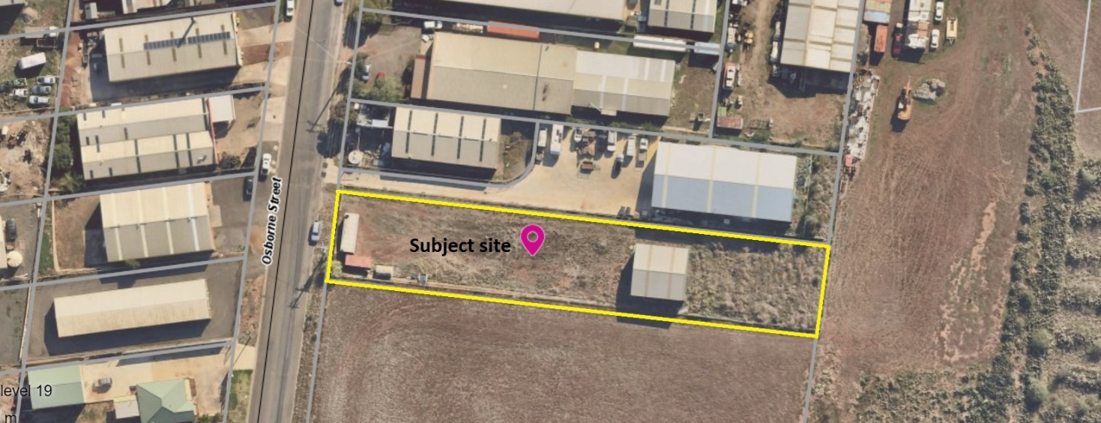
Figure 1: Aerial photograph

Proposal
It is proposed to use and develop the subject site for three warehouses, subdivide the site into three lots and reduce the car parking requirement. The existing buildings and works would be demolished, and three warehouses constructed. The nature of the proposal is speculative so there are no details as to the specific use of each warehouse, such as the type of goods to be stored.
Warehouse 1 and Warehouse 2 would be contained within a single building and Warehouse 3 in a separate building further to the rear of the site.
Warehouse 1, with a ground floor area of 339sqm, would have a ground floor front setback of 23.06m occupied by 10 car spaces and landscaped areas. Warehouse 1 would also have a 72sqm upper level partially projecting 6.4m above the car park and set back 16.66m from Osborne Street. Warehouse 2 would have a 334sqm floor area and Warehouse 3 a 495sqm floor area and rear setback of 2.0-2.52m. All warehouses would be built to the south title boundary and Warehouse 3 would also adjoin the north title boundary. Each warehouse would comprise a foyer/showroom, two separate toilets including an accessible toilet and shower, an internal 8.0m x 4.0m loading bay and internal waste storage areas. Warehouse 1 would also include an office and additional toilet. Owing to the site topography the proposed warehouses would have varied wall heights of 8.0-9.79m above finished ground level. The Warehouses would be of concrete panel construction in ‘Ironstone’ colour incorporating rolled texture/rendered feature sections and steel fascia canopies above the foyer entries in ‘Monument’ colour. Warehouse 1’s second storey would be clad with Colorbond ‘Standing Seam’ in ‘Monument’ colour.
No front fence is proposed. Business identification signage is not included as part of this application.
Vehicle access to the site would be via a proposed 6.1m wide crossover parallel to the north title boundary, leading to a common accessway and 10 car spaces in the front setback and 10 car spaces towards the rear of the site between Warehouse 2 and Warehouse 3.
The proposed subdivision would create three lots and common property. Lots 1, 2 and 3 would respectively contain Warehouses 1, 2 and 3 and the car parking allocation to each lot would be as follows:

Lot no. | No. of car spaces | Location of car spaces
1 | 5 | Front setback of Warehouse 1
2 | 5 | Rear setback of Warehouse 2
3 | 5 | Front setback of Warehouse 3
Common property | 5 | Front setback of Warehouse 1
Table 1: Car parking provision per proposed lot and common property

Common property would comprise the accessway, landscaped areas and five car spaces, including an accessible car space, numbered on the site plan 1, 2, 3, 6 and 10.
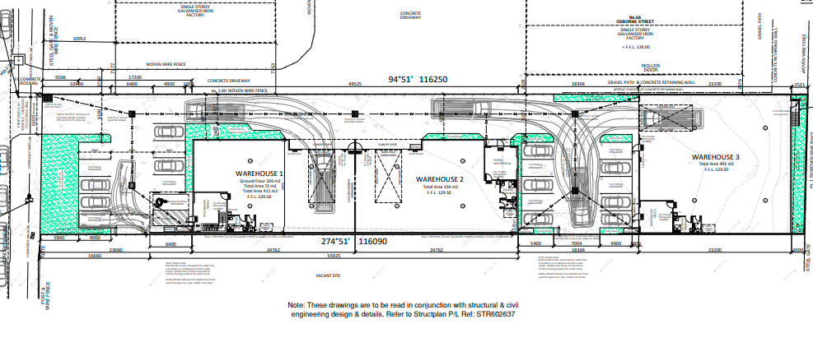
Figure 2: Site Plan

Public Notice
Pursuant to S.52(4) of the Planning and Environment Act 1987 the application is exempt from notice under Clauses 33.02-2, 33.02-3, 33.02-4 and 52.06-4 of the Moorabool Planning Scheme.

Summary of Objections
Not applicable.

Locality Map
The map below indicates the location of the subject site and the zoning of the surrounding area.
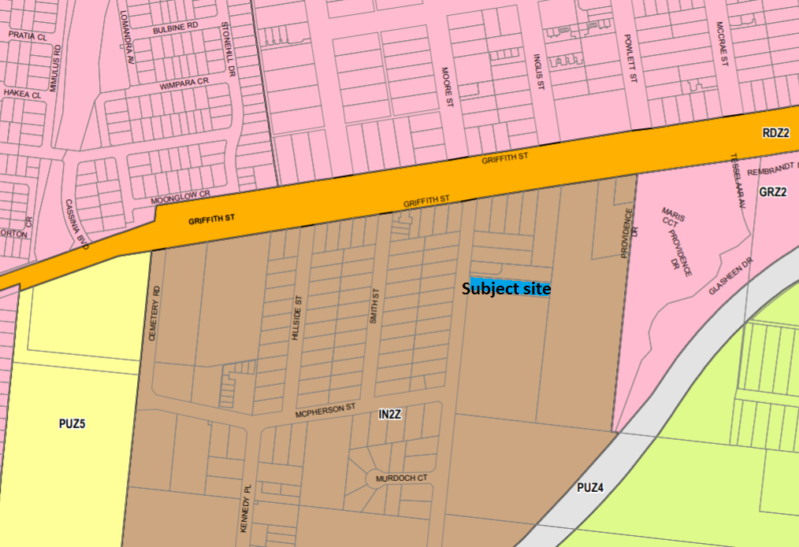
Figure 3: Zone map

Planning Scheme Provisions
Council is required to consider the Victoria Planning Provisions and give particular attention to the Planning Policy Framework (PPF), the Local Planning Policy Framework (LPPF) and the Municipal Strategic Statement (MSS).
The relevant clauses are:
• Clause 11.01-1R Settlement – Central Highlands
• Clause 11.03-3S Peri-urban areas
• Clause 15.01-1S Urban design
• Clause 15.01-2S Building design
• Clause 15.01-3S Subdivision design
• Clause 15.02-1S Energy and resource efficiency
• Clause 17.01-1R Diversified economy – Central Highlands
• Clause 21.03-2 Urban growth management
• Clause 21.03-4 Landscape and neighbourhood character
• Clause 21.04-3 Commercial
• Clause 21.04-5 Local employment
• Clause 21.07-6 Urban design
• Clause 22.05 Presentation of Industrial Areas
Subject to conditions, the proposal is generally consistent with the relevant sections of the PPF and LPPF.

Zone
The subject site is in the Industrial 2 Zone (IN2Z). The purpose of the IN2Z is:
• To implement the Municipal Planning Strategy and the Planning Policy Framework.
• To provide for manufacturing industry, the storage and distribution of goods and associated facilities in a manner which does not affect the safety and amenity of local communities.
• To promote manufacturing industries and storage facilities that require a substantial threshold distance within the core of the zone.
• To keep the core of the zone free of uses which are suitable for location elsewhere so as to be available for manufacturing industries and storage facilities that require a substantial threshold distance as the need for these arises.
Under Clause 33.02-1 a permit is required for use land for warehouses.
Under Clause 33.02-4 a permit is required for building and works.
Under Clause 33.03-2 a permit is required for subdivision.

Overlays

The subject site is not affected by any Overlays.

Relevant Policies
The Moorabool Industrial Areas Strategy, 2015 is a reference document in the Moorabool Planning Scheme. The strategy’s key recommendations are not directly relevant to the current proposal, and the proposal would not prejudice the implementation of any of the recommendations.

Particular Provisions
Clause 52.06 Car Parking
Under Clause 52.06-5 the three Warehouses require a total of 21 car spaces. The applicant is providing 20 car spaces, therefore a reduction of one car space is required.
The proposed car space dimensions, crossover and accessway dimensions meet the design standards of Clause 52.06-9.
Clause 52.34 Bicycle Facilities
There is no specified requirement for the provision of bicycle facilities for a Warehouse. In any case, four external bicycle parking spaces are proposed and each premises include shower and change room facilities.
Clause 53.01 Public Open Space Contribution and Subdivision
A person who proposes to subdivide land, including for industrial purposes, must contribute to Council for public open space if specified in a schedule to this clause. There is no amount specified in the applicable schedule in the Moorabool Planning Scheme, but a contribution may still be required under section 18 of the Subdivision Act 1988. It is understood that no prior contribution to public open space has been made for this land.
The proposed development does not incorporate any public open space and it is not considered that the proposal would generate a demand for public open space. It is therefore recommended that a contribution not be imposed.
Clause 53.10 Uses with Adverse Amenity Potential
Detailed information about the use of the proposed warehouses is not available but given the size of the proposed premises it is unlikely the subject site would be used for any storage purposes identified in this clause. Nonetheless, it is recommended that a condition of approval specify this to prevent any adverse amenity impacts on residential zoned land in the local area.
Clause 53.18 Stormwater Management in Urban Development
Subject to conditions the proposal meets the provisions of this clause.

Discussion
Overall, the proposal is generally in accordance with the applicable provisions of the Moorabool Planning Scheme.
The subject site is in an established industrial precinct in Maddingley with all utilities available and the proposed use for warehouses is generally consistent with the surrounding mix of uses. The proposed buildings would be modern in appearance, offering facilities able to accommodate a range of small to medium-scale warehouse uses. The proposal supports consolidated growth of the Shire’s largest township and would contribute to local economic growth, in particular catering to the local demand for warehouse facilities.
Clause 22.05 Presentation of Industrial Areas
The proposed development is generally consistent with Council’s policy for industrial development at Clause 22.05 of the Moorabool Planning Scheme. The building footprint is 50%, less than the maximum preferred 60%. The landscaping would comprise 9.3%, being slightly less than the minimum preferred 10%. The 23m ground floor front setback exceeds the minimum preferred 7.5m and incorporates a substantial landscaped area to be planted with native species. The proposed building materials and finishes comply with the policy. It is recommended that a condition of approval require the landscape plan to be amended to clarify the number of plantings proposed.
Clause 33.02 Industrial 2 Zone
The proposal is generally consistent with the Industrial 2 Zone provisions. Whilst the specific future warehouse uses are unknown at this stage, subject to conditions there would be no detrimental amenity impacts. Osborne Street and the surrounding road network can readily accommodate traffic associated with the development. The layout of the proposed development, particularly relating to car parking provision and vehicle access and manoeuvrability has been subject to extensive negotiation between Council officers and the applicant to reach an acceptable design outcome. The proposed streetscape presentation would provide for a minimum 5.5m wide landscaped area in the front setback, capable of being planted to soften the appearance of the adjoining car park and the built form more generally. The two storey, flat roofed built form, incorporating concrete panel and steel elements would complement the surrounding built form. Detailed stormwater treatment would be managed by way of permit conditions. It is recommended that a condition of approval require details of external lighting of the common areas to improve safety and property security after dark.
The subdivision layout accords with the development plans and the common driveway and landscaped areas can be maintained through an owner’s corporation. All service authorities consented to the subdivision application.
Clause 52.06 Car Parking
Under the car parking provisions at Clause 52.06-5 of the Moorabool Planning Scheme, the proposal requires 21 car spaces to be provided, 20 car spaces are proposed and therefore a reduction of one car space is required.
Overall, the proposed parking provision is deemed to be adequately responsive to the site features and context and the proposed use. The site constraints, in particular its narrow width, the need to accommodate adequate turning areas for cars and medium rigid vehicles and provide sufficient floor space to cater for a range of potential warehouse uses, mean that the site cannot practically contain all car parking. It is noted that there is sufficient on-street parking capacity to accommodate the potential parking overflow. The site is also within cycling and walking distance of residential areas of Maddingley, creating opportunities for alternative modes of transport and the site is approximately 1km from Bacchus Marsh railway station. The allocation of five car spaces to each warehouse plus an additional five spaces provided within common property is deemed to be an acceptable allocation. The provision of five common property car spaces in the front setback, including an accessible car space, provides for overflow parking in a suitable location. It is recommended that a condition of approval require details of signage or marking to clearly demarcate the common property car spaces for future users.

General Provisions
Clause 65 - Decision Guidelines have been considered by officers in evaluating this application.
Clause 66 - Stipulates all the relevant referral authorities to which the application must be referred.

Referrals
Authority | Response
Melbourne Water  Greater Western Water  Powercor  Downer Utilities | Consent.  Consent with conditions.  Consent with conditions.  Consent with conditions.
Infrastructure  Environmental Health  Strategic Planning | Consent with conditions.  Consent.  Consent.

Financial Implications
There are no financial implications for Council in approving the application.

Risk & Occupational Health & Safety Issues
The recommendation to approve this application does not have any risk or OH&S implications for Council.

Communications Strategy
Pursuant to s.52(4) of the Planning and Environment Act 1987 the application is exempt from notice under Clauses 33.02-2, 33.02-3, 33.02-4 and 52.06-4 of the Moorabool Planning Scheme. The applicant was invited to attend this meeting and address Council if required.

Options
- Issue a Planning Permit in accordance with the conditions in the recommendation of this report; or
- issue a Planning Permit with amendments to the conditions in the recommendation of this report; or
- issue a Refusal to Grant a Permit on grounds. Council would need to consider what reasonable grounds there would be to refuse the application. This option may result in the applicant appealing Council’s decision to VCAT.

Conclusion
The proposal is generally in accordance with relevant planning policy, particularly the Industrial 2 Zone provisions and Clauses 22.05 and 52.06. The proposed warehouses would contribute to the growth of the local economy and be located and designed to avoid any detrimental amenity impacts. The proposed car parking reduction of one car space is deemed to be acceptable, with sufficient onsite parking provided. The layout of car parking and access would provide for safe and functional vehicle access and parking. It is recommended that the application be approved, subject to conditions.

7.2 PA2020150 - Two lot subdivision at 246 Camerons Road Coimadai
Author: Mark Lovell, Coordinator Statutory Planning
Authoriser: Henry Bezuidenhout, Executive Manager Community Planning & Economic Development
Attachments: 1. Subdivison Plan (under separate cover)

Application Summary
Permit No: PA2020170
Lodgement Date: 29 July 2020
Planning Officer: Mark Lovell
Address of the land: Lot 2 on PS818727P, 246 Camerons Road Coimadai
Proposal: Two lot subdivision
Lot size: 24.06ha
Why is a permit required? Rural Living Zone – Subdivide land
Design & Development Overlay Schedule 14 – Subdivide land
Environmental Significance Overlay Schedule 2 – Subdivide land
Bushfire Management Overlay Schedule 1 – Subdivide land

Recommendation
That the Development Assessment Committee, having considered all matters as prescribed by the Planning and Environment Act 1987, issues a Refusal to grant a permit for a Two Lot Subdivision at Lot 2 on PS818727P, known as 246 Camerons Road, Coimadai on the following grounds:
1. The proposed subdivision does not comply with Clause 21.07-5 of the Moorabool Planning Scheme to allow for limited rural living lots.
2. The proposed subdivision does not comply with the subdivision requirements of Clause 43.02-3 Design and Development Overlay.
3. The proposed subdivision does not comply with the mandatory requirements of Section 3.0 - Subdivision of the Design and Development Overlay Schedule 14.
4. The proposed subdivision does not represent the orderly planning of the area.

Public Consultation
Was the application advertised? | Yes.
Notices on site: | Yes.
Notice in Moorabool Newspaper: | No.
Number of objections: | No objections.
Consultation meeting: | Nil.

Policy Implications
The Council Plan 2021-2025 provides as follows:
Strategic Objective 1: Healthy, inclusive and connected neighbourhoods
Priority 1.4: Develop a vision and provide opportunities for rural communities

Victorian Charter of Human Rights & Responsibilities Act 2006
In developing this report to Council, the officer considered whether the subject matter raised any human rights issues. In particular, whether the scope of any human right established by the Victorian Charter of Human Rights and Responsibilities is in any way limited, restricted or interfered with by the recommendations contained in the report. It is considered that the subject matter does not raise any human rights issues.

Officer’s Declaration of Conflict of Interests
Under section 130 of the Local Government Act 2020, officers providing advice to Council must disclose any interests, including the type of interest.
Executive Manager - Henry Bezuidenhout
In providing this advice to Council as the Executive Manager, I have no interests to disclose in this report.
Author – Mark Lovell
In providing this advice to Council as the Author, I have no interests to disclose in this report.

Executive Summary
Application referred? | Powercor Australia, Greater Western Water, Melbourne Water, Country Fire Authority, Council’s Infrastructure and Environmental Health.
Any issues raised in referral responses? | Nil.
Preliminary concerns? | The owner was advised the application does not comply with the planning scheme controls.
Any discussions with applicant regarding concerns? | Yes, the applicant disagrees with Council’s interpretation of the planning scheme controls and believes the planning scheme allows for a further subdivision of land. The applicant did not want to withdraw the application.
Any changes made to the application since being lodged? | Nil.
Brief history. | Camerons Road was rezoned from Farming Zone to part Rural Living Zone to facilitate limited rural living lots under Planning Scheme Amendment C58 gazetted on 4 May 2017.  The lot originated from a prior two lot subdivision of land in 2017.

Previous applications for the site? | PA2017133 was issued on 5 November 2017 authorising a two lot subdivision of the land creating the current lot, Lot 2.
General summary. | The rezoning and new planning controls introduced in 2017 were designed for the purpose of creating limited rural living lots within designated building envelopes of land previously zoned for farming purposes.  The proposal does not meet the mandatory subdivision requirements of the Design and Development Overlay Schedule 14 and is therefore prohibited.  The proposal would undermine all the strategic work that was undertaken in rezoning the land and would result in a higher residential density that was not envisaged when the controls were formed.
Summary of Officer’s Recommendation
That, having considered all relevant matters as required by the Planning and Environment Act 1987, Council issue a Refusal to grant a planning permit for a Two Lot Subdivision at Lot 2 on PS818727P, 246 Camerons Road, Coimadai.

SITE DESCRITION
The current Lot 2 has an area of 24.06ha and contain the existing dwelling and outbuildings. It has 83.90m frontage to Camerons Road and the existing vehicle access is maintained. There are two 15m wide powerline easements, with one near the front property boundary connecting into former Lot 1 and the other cutting though the south-east corner of the site. The land is undulating with a low point running through the centre of the site in a west to east direction and a further low point adjacent to the eastern property boundary which forms Goodmans Creek. The land is largely cleared with some scattered trees concentrated along the northern property boundary

PROPOSAL
It is proposed to subdivide the land into two lots. Lot 1 is irregular in shape, with a proposed narrower frontage width to Camerons Road at 67.39m and a total area of 11.5 ha. Lot 1 contains the existing dwelling, shedding and existing driveway. Lot 2 is located to the rear of the site and would be accessed by 16.51m new driveway running parallel with the southern property boundary. Lot 2 is vacant and has an area of 12.56ha. The applicant has shown a building envelope area of 40m x 30m and separate effluent envelope area of 9m x 40m. The envelopes are located close to its primary western lot boundary and near the southern property boundary.

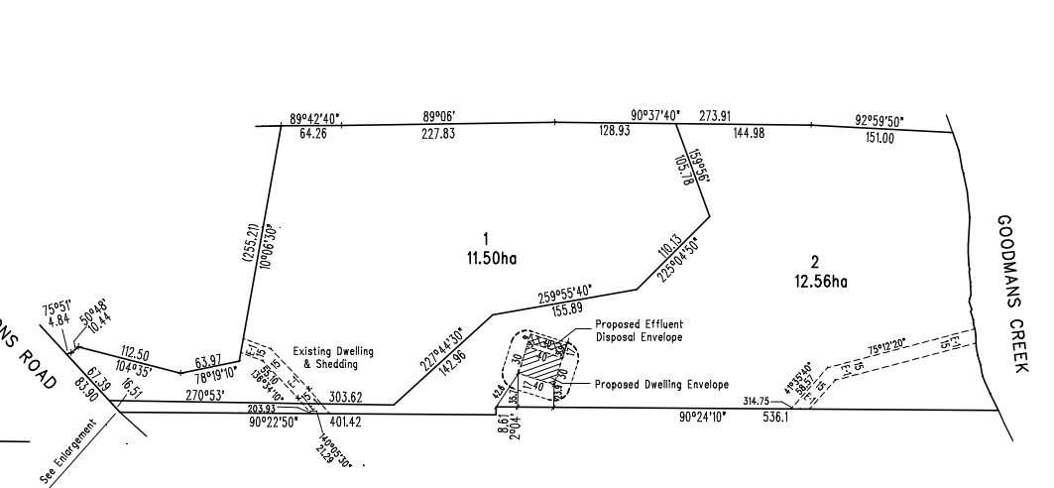
Figure 1: Proposed Plan of Subdivision

HISTORY
Planning permit PA2017133 was issued 5 November 2017 authorising a two lot subdivision of land from the parent lot at 246 Camerons Road, Coimadai. The application was advertised, and no objections were received. Titles were released on 27 July 2018. The subject land that is part of this current application is known as Lot 2 on PS818727P.
Planning permit PA2018301 was issued on 15 January 2019 for Lot 1 on PS818727P authorising a development of a relocatable dwelling and ancillary outbuilding (shed). The application was advertised, and no objections were received. The dwelling, shed and associated driveways are complete.
BACKGROUND
Council at its Development Assessment Committee Meeting held on 21 July 2021 determined to defer the application in order to review Planning Scheme Amendment C58 that rezoned the subject land on 4 May 2017.

Public Notice
The application was notified to adjoining and surrounding landowners and placing a large notice on site. No objections were received as a result of the advertising.

Locality Map
The map below indicates the location of the subject site and the zoning of the surrounding area.
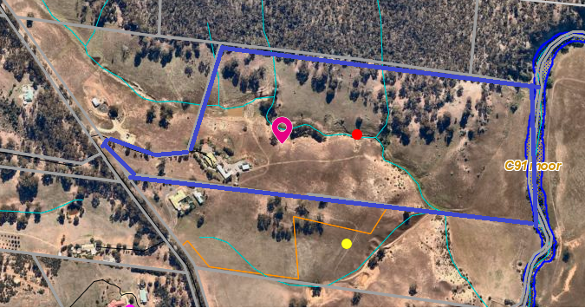
Figure 2: Aerial Photography

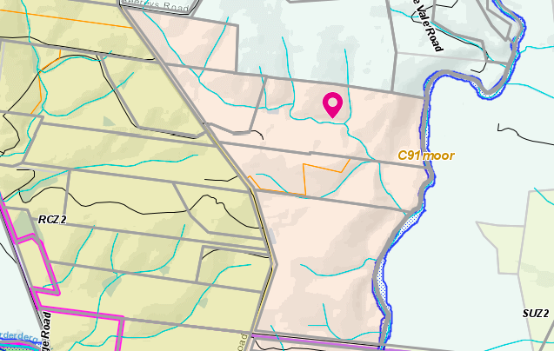
Figure 3: Zone Map
Key:
Pink – Rural Living Zone
Brown – Rural Conservation Zone Schedule 2
Light Green – Farming Zone

Planning Scheme Provisions
Council is required to consider the Victoria Planning Provisions and give particular attention to the Planning Policy Framework (PPF), the Local Planning Policy Framework (LPPF) and the Municipal Strategic Statement (MSS).
The relevant clauses are:
• Clause 11.03-3S Peri-Urban Areas
• Clause 13.02-1S Bushfire Planning
• Clause 15.01-3S – Subdivision Design
• Clause 15.01-5S Neighbourhood Character
• Clause 21.02 Natural Environment
• Clause 21.02-2 Objective—Non-Urban Landscapes
• Clause 21.02-3 Objective—Water and Catchment Management
• Clause 21.02-4 Objective—Biodiversity
• Clause 21.02-5 Objective—Bushfire
• Clause 21.02-6 Objective—Environmentally Sustainable Development
• Clause 21.07-5 Objective—Cameron’s Road Area Limited Rural Living
The proposal does not comply with the relevant sections of the PPF and LPPF clauses outlined in the table below:
LPPF | Title | Response
Clause 21.07-5 | Cameron’s Road Area limited rural living | The objective of this clause is to provide limited high amenity rural lifestyle opportunities while protecting human life from bushfire risk, avoiding fragmenting agricultural land, protecting extractive industry from accommodation development and protecting significant flora and fauna values. A strategy to achieve the objective is to specify subdivision requirements to limit development and site buildings appropriate to the environmental constraints of the land.  An additional building envelope was not designated for this lot consistent with the objective of providing limited rural living opportunities.

Zone
The subject site is located within a Rural Living Zone.
The purpose of the zone is:
• To implement the PPF and the LPPF, including the MSS and local planning policies.
• To provide for residential use in a rural environment.
• To provide for agricultural land uses which do not adversely affect the amenity of surrounding land uses.
• To protect and enhance the natural resources, biodiversity and landscape and heritage values of the area.
• To encourage use and development of land based on comprehensive and sustainable land management practices and infrastructure provision.
Under Clause 35.03-3 a permit is required to subdivide land. Under the schedule to the zone the minimum subdivision area is 6ha. Decision guidelines are listed under Clause 35.03-5.

Overlays
Design & Development Overlay Schedule 2 & 14 (DD02 and DD014)
The site is affected by the Design and Development Overlay Schedule 2 - Visual amenity and building design, and Schedule 14 – Camerons Road area.
Under Clause 43.02-3, a permit is required to subdivide land. Schedule 2 provides an exemption from this requirement. There are no exemptions under Schedule 14, therefore a permit is required.
Part 3.0 of Schedule 14 states a lot must contain an existing dwelling, or a dwelling envelope located in accordance with Map 1 to Schedule 14 to Clause 43.02. Decision guidelines are listed under Part 4.0.
The design objectives for Schedule 14 are:
• To provide for limited rural living development in locations that protect the treed landscape values and land capability of the area.
• To ensure a building is sited to protect and retain remnant native vegetation and wildlife habitat and the treed landscape values of the land.
• To ensure a building is sited to protect the nature conservation values and habitat values of the Lerderderg State Park and the water quality of Goodmans Creek and the Lerderderg River.
• To ensure a building used for accommodation is separated by an appropriate distance from a quarry to avoid adverse impacts on the operation of existing extractive industries.
• To ensure a building used for accommodation is sited where bushfire risk associated with the site, the immediate area and the broader landscape is mitigated to an acceptable level without adverse impacts on environmental values.

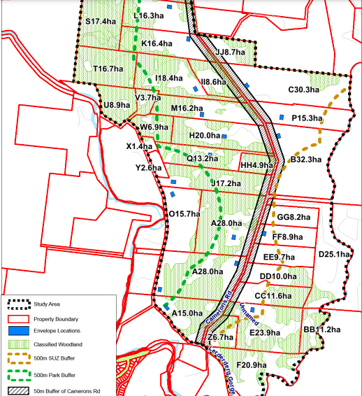
Figure 4: is part of the Design & Development Overlay Schedule 14.
Under DD014, the property is identified as Lot C with a building envelope located at the front of the site (now known as Lot 1 associated with the previous subdivision land that is completed).
Environmental Significance Overlay – Schedule 2
The site is partly affected by the Environmental Significance Overlay – Schedule 2 – Waterway Protection. Under Clause 42.01-2, a permit is required to subdivide land. There are no relevant exemptions under Schedule 2. Decision guidelines are listed under Part 4.0.
The Environmental Objectives for Schedule 2 are:
• To protect the habitat significance of vegetation.
• To provide for appropriate development of land within 100m of either side of a waterway.
• To prevent pollution and increased turbidity of water in natural waterways.
• To prevent increased surface runoff or concentration of surface water runoff leading to erosion or siltation of waterways.
• To conserve existing flora and fauna habitats close to waterways and to encourage generation and regeneration of habitats.
Bushire Management Overlay
The property is affected by the Bushfire Management Overlay Schedule 1 – Camerons Road Area. Under Clause 44.06-2, a permit is required to subdivide land. There are no exemptions under Schedule 1.
Schedule 1 to Clause 44.06, item 2.0 states as follows:
This schedule applies to all applications for building and works associated with a dwelling (including an extension or alteration to a dwelling) or a dependant persons unit or to subdivide land for a dwelling on land described in Table 1 to this schedule. Clause 52.47 applies to all other applications.
Map 1 to Schedule 1 of Clause 44.06 includes:
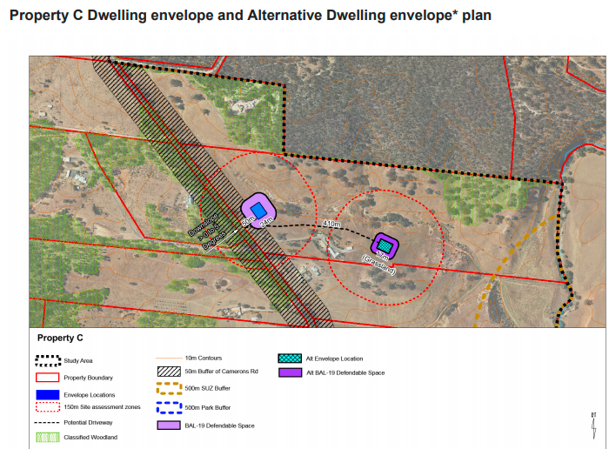
Figure 5: is part of the Bushfire Management Overlay Schedule 1.

The note added to bottom of this plan within Map 1 of Clause 44.06 states
An alternative dwelling envelope is an alternative location for the dwelling envelope. It is not an additional dwelling envelope.

Discussion
The prior subdivision of land under Planning Permit PA2017133 was completed in accordance with the planning scheme controls and titles have subsequently been issued. The Design and Development Overlay and Bushfire Management Overlay Schedule 1 were designed to consider the best location for new dwellings in terms of impact upon natural features, bushfire risk and proximity to the nearby sand quarries. There was a large body of strategic planning documents that were reviewed by a State Government planning panel to ensure future dwelling were well sited. Building envelopes were created with some lots having an alternative building envelope or specific design criteria if a future owner wanted to build in a different location. The entire purpose of the new controls was to allow each owner the ability to undertake a two lot subdivision and construct a new dwelling in the vacant lot. Camerons Road Area is being developed in accordance with the planning scheme controls and several planning permits have been issued for subdivisions and construction of single dwellings on single lots.
The important consideration of this application relates to the subdivision requirements of the Design and Development Overlay. In this case Clause 43.02-3 Subdivision of the Design and Development Overlay clearly states “subdivision must occur in accordance with any lot size or other requirement specified in a schedule to this overlay”.
Schedule 14 of the Design and Development Overlay applies to this site and Section 3.0 Subdivision states “A lot must contain an existing dwelling, or a dwelling envelope located in accordance with Map 1 to this schedule”. Map 1 of the schedule clearly identifies a single building envelope which was subject to the previously approved subdivision. This is further reinforced through the Local Planning Policy, Clause 21.07-5 of the Moorabool Planning Scheme which states it is policy to require all dwellings to be located within a dwelling envelope.
The applicant in this instance is seeking to undertake a further subdivision of land and has provided a Land Capability Assessment to demonstrate wastewater can be managed on site and has provided a Bushfire Management Statement demonstrating adequate bushfire mitigation measure can be utilised. The applicant has interpretated Schedule 1 of the Bushfire Management Overlay which specified an alternative building envelope as allowing for two dwellings on the land in addition to retention of the existing dwelling, thereby allowing a total of three dwellings on the one parent lot. The note included with Schedule 1 of the Bushfire Management Overlay at Clause 44.06 of the Moorabool Planning Scheme clearly states the alterative building envelope is not an additional building envelope. The owner disagrees with this notation in the planning scheme and believes the rezoning was designed to allow for two additional dwellings on their land.
Without these overlay provisions, applicants could subdivide land in multiple lots achieving the minimum lot area specified by the Rural Living Zone which is 6ha. The orderly planning of the area was correctly considered during C58 Planning Scheme Amendment (C58) process. C58 sort to restrict subdivision of these large parent titles into two lots that would protect conservation values of the area, protect future occupant from bushfire risk and protect the area from over development. There is no planning justification based on the current planning controls to support this further two lot subdivision of the land.
It is important that an assessment of a planning application meets all the requirements of the scheme. While this application meets some of the requirements particularly with regard to the Rural Living Zone it does not meet the mandatory requirements of Schedule 14 of the Design and Development Overlay.

General Provisions
Clause 65 - Decision Guidelines have been considered by officers in evaluating this application.
Clause 66 - Stipulates all the relevant referral authorities to which the application must be referred.

Referrals
Authority | Response
Greater Western Water  Melbourne Water  Powercor  Country Fire Authority | Consent.  Consent, with two conditions including a requirement to provide waterways easement.  Consent, with five conditions.  Consent with two conditions.
Council’s Infrastructure  Council’s Environmental Health | Consent, with four conditions.  Consent, with eight conditions.

Financial Implications
There are no financial implication in recommending refusal to this application.

Risk & Occupational Health & Safety Issues
The recommendation of refusal of this application does not implicate any risk or OH&S issues to Council.
COMMUNICATIONS STRATEGY
Notice was undertaken for the application, in accordance with s.52 of the Planning and Environment Act 1987, and further correspondence is required to all interested parties to the application as a result of a decision in this matter. The applicant was invited to attend this meeting and invited to address Council if required.

Options
Issue a refusal to grant a permit in accordance with the recommendation of this report.

Conclusion
The proposed subdivision is inconsistent with the planning controls including the local planning policy as contained within the Moorabool Planning Scheme. The Camerons Road Area has been properly planned through a planning scheme amendment process. This application proposes a subdivision which is prohibited under the provisions of the Moorabool Planning Scheme and would not represent the orderly planning of the area. The application is recommended to be refused with specified grounds.

7.3 PA2021097 Development and Use of a Dwelling and Shed at Lot 1 Kennedys Lane, Bunding
Author: Victoria Mack, Statutory Planner
Authoriser: Henry Bezuidenhout, Executive Manager Community Planning & Economic Development
Attachments: 1. Development plans (under separate cover)
2. Farm Management Plan (under separate cover)

Application Summary
Permit No: PA2021097
Lodgement Date: 4 May 2021
Planning Officer: Victoria Mack
Address of the land: Kennedys Lane Bunding
Lot 1 on TP 221966J (formerly part CA10D, S13, Parish of Moorabool West)
Proposal: Development and Use of a Dwelling and Shed
Lot size: 5.656ha
Why is a permit required? Clause 35.07-1, Section 2, Use of a dwelling on a lot less than 40ha in Farming Zone;
Clause 35.07-4 Buildings and works for a use in Section 2 in the Farming Zone;
Clause 42.01-2 Building and Works in the Environmental Significance Overlay, Schedule 1.

Recommendation
That the Development Assessment Committee, having considered all matters as prescribed by the Planning and Environment Act 1987, issue a Refusal to Grant a Planning Permit for the Development and Use of a Dwelling and Shed at Kennedys Lane Bunding, otherwise known as Lot 1 on TP 221966J (formerly part CA10D, S13, Parish of Moorabool West) on the following grounds:
1. The proposal is inconsistent with the purpose and objectives of the Farming Zone.
2. The proposal does not comply with the Planning Policy Framework or the Local Planning Policy Framework of the Moorabool Planning Scheme relevant to the development and use of rural land.
3. The proposed dwelling would result in the fragmentation of productive agricultural land.
4. The Farm Management Plan does not adequately demonstrate a dwelling is reasonably required for an agriculture purpose.
5. The proposed use and development do not represent orderly planning of the area.

Public Consultation
Was the application advertised? | Yes, to neighbouring landowners and occupiers.
Notices on site: | Not required.
Notice in Moorabool Newspaper: | Not applicable.
Number of objections: | Two.
Consultation meeting: | The applicant responded to the objector’s concerns in writing. One objector declined to take part in a consultation meeting. The objectors were provided with the applicant’s contact details to further discuss their concerns if they wished.

Policy Implications
The Council Plan 2021-2025 provides as follows:
Strategic Objective 2: Liveable and thriving environments
Priority 1.4: Develop a vision and provide opportunities for rural communities

Victorian Charter of Human Rights & Responsibilities Act 2006
In developing this report to Council, the officer considered whether the subject matter raised any human rights issues. In particular, whether the scope of any human right established by the Victorian Charter of Human Rights and Responsibilities is in any way limited, restricted, or interfered with by the recommendations contained in the report. It is considered that the subject matter does not raise any human rights issues.

Officer’s Declaration of Conflict of Interests
Under section 130 of the Local Government Act 2020, officers providing advice to Council must disclose any interests, including the type of interest.
Executive Manager – Henry Bezuidenhout
In providing this advice to Council as the Executive Manager, I have no interests to disclose in this report.
Author – Victoria Mack
In providing this advice to Council as the Author, I have no interests to disclose in this report.

Executive Summary
Application referred? | Yes, to Barwon Water and Council’s Environmental Health and Infrastructure.
Any issues raised in referral responses? | No.
Preliminary concerns? | Small parcel of land for a dwelling to operate a small-scale horse enterprise.
Any discussions with applicant regarding concerns? | Yes, the justification for the dwelling was a concern on the small site based on a small horse enterprise. The Farm Management Plan needed to be more detailed.
Any changes made to the application since being lodged? | The site plan was amended to correct the location of the driveway. The Farm Management Plan was amended with more details provided.
Brief history. | No relevant history.
Previous applications for the site? | The site is vacant with no previous permit history.
General summary. | The proposed use and development of a dwelling on a small parcel of land with an area of 5.65ha does not demonstrate that the land can be used for productive purpose. The total livestock at any one time would be two horses in work, two to four horses spelling ready to be started, and four head of cattle (two cows and two calves). Such a small number of horses and cattle does not warrant support for a dwelling on the land. The proposal will result in the fragmentation of agricultural land. It is recommended the application be refused.
Summary of Officer’s Recommendation
That, having considered all relevant matters as required by the Planning and Environment Act 1987, the Development Assessment Committee issue a Refusal to Grant a Planning Permit for the Development and Use of a Dwelling and Shed at Kennedys Lane, Bunding otherwise known as Lot 1 on TP 221966J (formerly part CA10D, S13, Parish of Moorabool West) on grounds contained within this report.

Site Description
The site is a long rectangular lot, up to 81.09m in width and up to 980.6m in length for total area of 5.656ha. It has an existing older style shed towards the front of the lot and a dam. The site for the dwelling slopes down from north to south with a fall of about 4m.
A waterway runs north-south across the property located approximately 372m from the front boundary where there is also a medium sized dam. Beyond the rear west boundary is a large waterbody, known as Railway Weir, which is in private ownership with a surface area of approximately 3.6ha.
The site is approximately 1.9kms west of the Ballan-Daylesford Road and approximately 8.3kms north-west of the Western Freeway.
Surrounding land has a few similar sized allotments, but most are larger and generally used for animal grazing industries.
There are three neighbouring dwellings located within 100m of the property boundaries of the subject site.
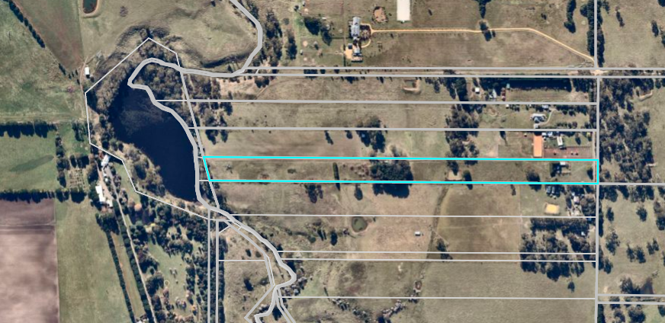
Figure 1: Aerial Photo of the subject site

Proposal
It is proposed to construct a four bedroom single storey dwelling on the site in association with a small horse enterprise.
The dwelling would be located approximately 126m west of the front boundary, 16m from the north boundary and 21.5m from the south boundary. It would be located to the west of the existing shed which would be retained. The dwelling would be constructed with brick and the roof comprised of Colourbond sheeting.
A new shed would be constructed. It would be 7.5m wide and 6m long with Colorbond steel cladding. The new shed would be located on the east side of the existing shed.
An equestrian arena would be constructed south of the new shed in the south east corner of the site. It would be 30m x 60m and constructed with an all-weather surface in accordance with horse arena requirements.
Farm Management Plan
The site would be used to retrain and re-home off the track racehorses focusing on Standardbreds. The Standardbred is an American horse breed best known for its ability in harness racing but is used for a variety of equestrian activities, including horse shows and pleasure riding.
The following activities would be run on the property:
• Four to six horses per year to be retrained and then rehomed. Depending on each horse’s history they would need at least four weeks to “let down” from racing, then 8 to 12 weeks of training under saddle (flat work, poles, road work/trails).
• Horse agistment for up to four horses.
• Cattle would be incorporated into the overall management with two cows in calf yearly, with the calves to be sold at a suitable age.
A replanting program will be introduced within the areas close to the dams to ensure the erosion and health of the dams and wetlands is maintained. Replanting will focus on indigenous species native to the Moorabool Shire.
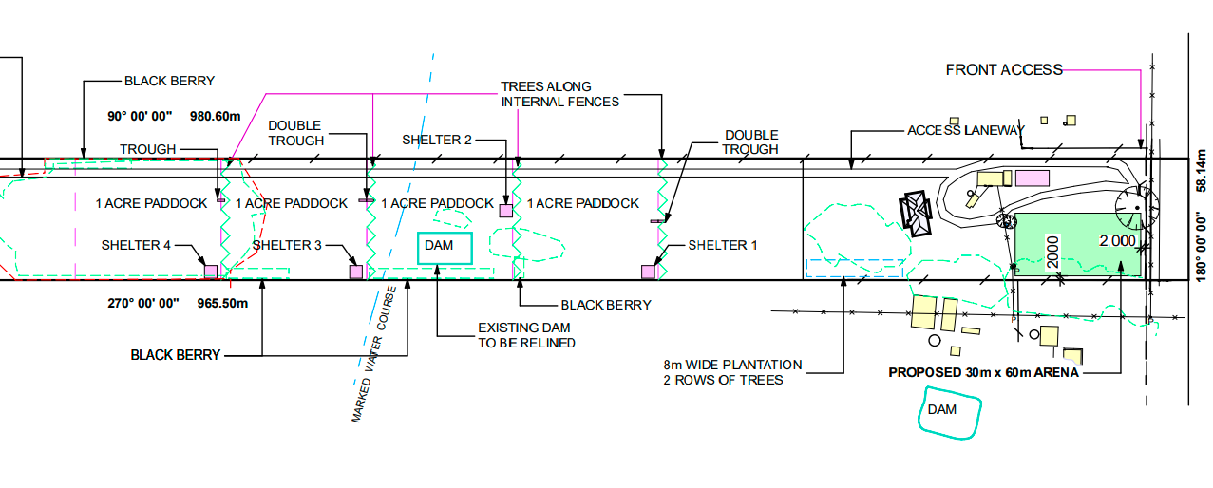
Figure 2: Part Site Plan

History
There is no relevant permit history on the site.

Public Notice
The application was notified to adjoining and surrounding landowners. Two objections were received.

Summary of Objections
The objections received are detailed below with officer’s comments accompanying them:
Objection | Any Relevant Requirement
I object to the cutting down of many large trees on the property due to the impact on our native wildlife habitat. The very large conifer trees also provide privacy between our blocks and shade/shelter for our horse paddocks. | Environmental Significance Overlay, Schedule 1
Officer’s Response: A permit is required to remove any vegetation under the Environmental Significance Overlay, Schedule 1. A few cypress pines would be removed but they have limited biodiversity value. The proponents intend to plant replacement native vegetation with improved biodiversity potential.

The close proximity of the proposed residence to our enclosed dressage arena which is utilised daily to train our horses safely in a quiet private area of our property. Horses can react dangerously to loud noises, unexpected movements of people and construction machinery. There is a risk that they can run through fences in their paddock and injure themselves when they are close to frightening stimuli. | Farming Zone
Officer’s Response: It would not be expected that a residential property will affect horses on an adjacent property.
The location of the proposed arena near our dwelling, from both horse riding and harrowing, will result in dust entering our house and our water tanks.
Officer’s Response: Dust could be controlled by permit conditions.
The direction of fall from the effluent field will impact on the catchment area for our dam which is used to water vegetable gardens and provide drinking water to livestock. In winter, the ground water in this area rises to the surface. Relocation of the house and septic system would resolve this issue. | Environmental Significance Overlay, Schedule 1 and EPA publication No. 891.4: Code of practice – onsite wastewater management
Officer’s Response: Wastewater must be retained within property boundaries in accordance with the EPA’s Code of practice – onsite wastewater management. The application was referred to Barwon Water and Environmental Health both of which consented to the application with conditions.
Kennedys Lane is already in poor condition with potholes and corrugations. The road should be upgraded for construction vehicles. | Farming Zone
Officer’s Response: The application was referred to Council’s Infrastructure which consented to the application with conditions.
The land has rocks and rocky land is not suitable for cutting hay due to damaging equipment. There is also limited useful (pasture) growth on the property. We are concerned that the proposed plan has not considered this and may not be successful. | Farming Zone
Officer’s Response: The Farm Management Plan provided with the application does not address rocky ground but does include a pasture improvement plan over time.

Locality Map
The map below indicates the location of the subject site and the zoning of the surrounding area.
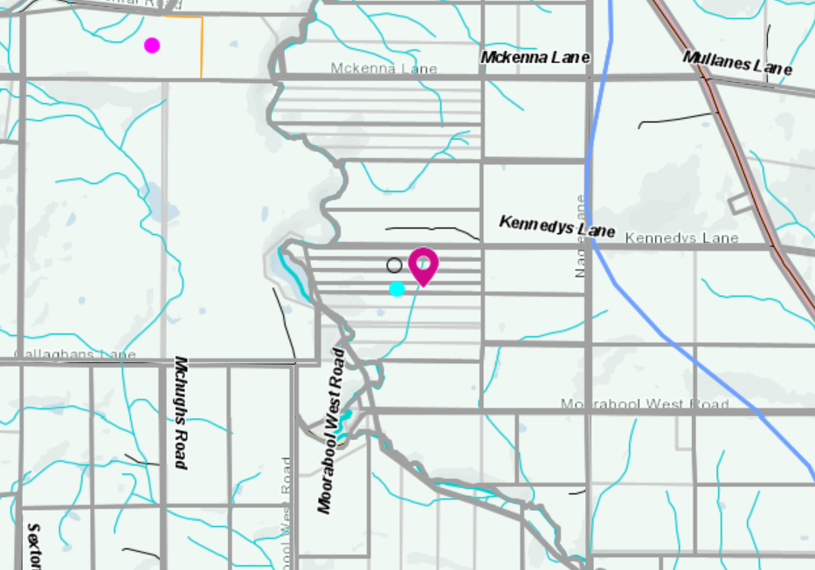
Figure 3: Zone Map

Planning Scheme Provisions
Council is required to consider the Victoria Planning Provisions and give particular attention to the Planning Policy Framework (PPF), the Local Planning Policy Framework (LPPF) and the Municipal Strategic Statement (MSS).
The relevant clauses are:
• Clause 11.03—Peri Urban Areas
• Clause 14.01-1S—Protection of agricultural land
• Clause 14.02-1S—Catchment planning and management
• Clause 14.02-2S—Water quality
• Clause 15.01-6S—Design for rural areas
• Clause 16.01-5S—Rural residential development
• Clause 21.02-3 Objective—Water and catchment management
• Clause 21.03-4 Objective—Landscape and neighbourhood character
• Clause 21.03-6 Objective—Rural lifestyle opportunities
• Clause 21.04-Economic Development and Employment
• Clause 21.04-1—Key issues and influences Agriculture and horticulture
• Clause 21.04-2 Objectives—Agriculture
• Clause 22.03—Houses and House Lot Excisions in Rural Areas
• Clause 21.04-2 Objectives—Agriculture
The proposal does not comply with the relevant sections of the PPF and LPPF clauses outlined in the table below:
PPF | Title | Response
Clause 11.03-3S | Peri-urban areas  Strategies: Establish growth boundaries for peri-urban towns to avoid urban sprawl and protect agricultural land and environmental assets. | Approval of a rural residential use of the land in a productive agricultural district sets a precedent that may create expectations for future land use applications in the Farming Zone.
Clause 14.01-1S | Protection of agricultural land  Objective: To protect the state’s agricultural base by preserving productive farmland.  Strategies include to protect productive farmland of strategic significance in the local or regional context; protect productive agricultural land from unplanned loss due to permanent changes in land use; protect strategically important agricultural and primary production land from incompatible uses; and limit new housing development in rural areas by discouraging development of isolated small lots in the rural zones from use for dwellings or other incompatible uses. | It is policy to limit new housing development in rural areas by discouraging development of isolated small lots in the rural zones from use for dwellings or other incompatible uses.  The policy does not support rural residential development on small lots on productive agricultural land.  The subject site is an isolated lot in a productive agricultural district.  It is not considered that such a small horse and cattle enterprise justifies the use of a dwelling in the Farming Zone or protects agricultural land from permanent land use change.
Clause 16.01-3 | Rural residential development  Objective To identify land suitable for rural residential development.  Strategy: Manage development in rural areas to protect agriculture and avoid inappropriate rural residential development. | The application for a dwelling is on 5.656ha is the Farming Zone.

LPPF
Clause 21.04-2 | Objectives—Agriculture  To protect good quality agricultural land and support the productivity and sustainability of existing and future agricultural and horticultural activities.  Strategies: Maintain productive farm sizes by discouraging fragmentation of land for non-rural use and development.  Direct rural residential and rural living developments to strategic growth areas where they will not impact on agricultural and horticultural production. | The proposed development would not protect surrounding farming land from future encroachment by rural residential and lifestyle development applications.

Zone
Farming Zone
The purpose of the Zone is to:
• Implement the Municipal Planning Strategy and the PPF.
• Provide for the use of land for agriculture.
• Encourage the retention of productive agricultural land.
• Ensure that non-agricultural uses, including dwellings, do not adversely affect the use of land for agriculture.
• Encourage the retention of employment and population to support rural communities.
• Encourage use and development of land based on comprehensive and sustainable land management practices and infrastructure provision.
• Provide for the use and development of land for the specific purposes identified in a schedule to this zone.
In accordance with Clause 35.07-1, a permit is required to use land for a dwelling where the land is less than 40ha.
In accordance with Clause 35.07-4 a permit is required for a building or works associated with a use in Section 2 of Clause 35.07-1, and where a building or works is within 100m of a dwelling not in the same ownership. There are three neighbouring dwellings located within 100m of the property boundaries of the subject site.

Overlays
Environmental Significance Overlay, Schedule 1
In accordance with Clause 42.01-2 a permit is required for buildings and works and for the removal of vegetation.
Design and Development Overlay, Schedule 2
In accordance with Clause 43.02 Schedule 2 of the this overlay a permit is not required where all external cladding of buildings is non-reflective. In this application, there is no reflective materials proposed and therefore a permit is not required under this overlay.

Relevant Policies
Council’s Rural Growth Policy
Council’s Rural Growth Policy Statement was adopted by Council on 19 September 2012. The document applies to all land in Farming Zone.
The policy states:
• Encourage dwellings in areas nominated in Map 1 of Council Rural Growth Policy Statement.
• Ensure the siting of any dwellings is designed to have a minimal impact on any existing or future agricultural activities on the site and on surrounding land.
• Ensure it is clear whether the dwelling is required for agricultural operation, use or to maintain rural communities.
• Ensure sufficient infrastructure is available or that alternative methods are available which do not require normal infrastructure.
• Encourage development of dwellings, to support communities, on land which is unlikely to support agricultural (use) while still considering any other overlays which may impact the land. This is land which is constrained for use as agriculture by other environmental factors such as vegetation, slope, soil quality, etc.
The site is not located within Map 1 of the Council Rural Growth Policy Statement. The policy requires justification for the dwelling based on the proposed agricultural activity. The proposal is to run 2-4 horses and 2 cows with calves on this site is not considered to sufficiently justify the use of a dwelling.
Council’s Rural Housing Policy
Council’s Rural Housing Policy 2012 was adopted by Council on 19 September 2012 and has been developed to provide direction for how limited farming potential rural dwellings should be considered, and more broadly, rural settlement patterns. This Policy is not incorporated into the Moorabool Planning Scheme.
The principles of the policy relevant to this application include to:
• Support the agricultural sector so that it can be more productive, diverse, resilient, and adaptive to changing agricultural trends, including supporting agricultural activities that recognise Moorabool’s advantageous proximity to market.
• Protect agricultural land use from loss and allow development that increases agricultural productivity.
• Focus growth opportunities in settlements along major transport corridors, in particular where there is physical and social infrastructure and services.
• Recognise that there are substantial existing lots under 40ha capable of supporting the viable operation of agricultural enterprises.
• Promote a rural housing market that meets the needs of the Shire’s rural communities
• Land parcels for the proposed on-farm living dwellings are to have a minimum lot size of 8ha as identified in Map 1.
The proposed development and use align with some of the above principles.
However, the proposal does not accord with the principle to support the agricultural sector so that it can be more productive, diverse, resilient, and adaptive to changing agricultural trends. The land is not proposed to be used for a productive agricultural purpose which justifies the presence of a dwelling.
The Rural Housing Policy for high quality agricultural land parcels of less than 8ha requires that dwellings are not located next to adjoining property boundaries if there could be a land use conflict with the adjoining activities. The policy also requires that land used for the dwelling and associated infrastructure should not exceed more than 4,000sqm of the land, and these applications must include a Farm Management Plan to ensure that the obligations of the land owner/manager are met and the agricultural practice is effective. This Plan should include how the agricultural activities will be carried out and how the integrity of the site for agricultural uses will be maintained and enhanced.
It is not considered that the proposal accords with these principles in their entirety.

Discussion
The application is for a very small horse and cattle enterprise on a very small lot in the Farming Zone,
The lot is narrow and long. There are a nine lots in the immediate locality that are of a similar configuration. Four of these lots have dwellings and five are in the same ownership being farmed as a large parcel of 45ha. The planning scheme has not designated this as an area for Rural Living and a further additional dwelling in close proximity to other dwellings is against the objectives of the Farming Zone.
The justification for the dwelling on the land is based on retraining and then selling four to six retired racehorses per year, with agistment of horses and running two cows with calves. Such a small number of horses and cattle does not support the requirement for a dwelling on the land. The horses and cattle can be managed by a farmer who does not reside on the site.
The application has not demonstrated that it meets the purpose of the Farming Zone with particular regard for the use of the land for agricultural purposes. The proposed agricultural activities are limited and do not justify a dwelling is reasonably require to ensure they can be undertaken.
The proposed dwelling will further reduce the available land for agricultural purposes and further fragments land in a locality already comprised of small sized farming lots. A dwelling in this location will create a residential enclave without sufficient access to services and rely on rural infrastructure that is designed to assist farming rather than residential activity. The proposed dwelling is not supported by planning policies and does not protect or enhance agricultural land.

General Provisions
Clause 65 - Decision Guidelines have been considered by officers in evaluating this application.
Clause 66 - Stipulates all the relevant referral authorities to which the application must be referred.

Referrals
Authority | Response
Barwon Water | Consent with conditions.
Infrastructure  Environmental Health | Consent with conditions.  Consent with conditions.

Financial Implications
There is no financial implications associated with this refusal of this application. However, the applicant may seek review at VCAT with associated cost to Council.

Risk & Occupational Health & Safety Issues
The recommendation of refusal of this application does not implicate any risk or OH&S issues to Council.

Communications Strategy
Notice was undertaken for the application, in accordance with s.52 of the Planning and Environment Act 1987, and further correspondence is required to all interested parties to the application as a result of a decision in this matter. All submitters and the applicant were invited to attend this meeting and invited to address Council if required.

Options
That the Development Assessment Committee could consider the following options:
• issue a Refusal to grant a permit in accordance with the recommendations of this report; or
• issue a Notice of Decision to Grant a Permit with conditions
CONCLUSION
It is proposed to run a small horse and cattle enterprise on the site of 5.65ha with a dwelling. The proposed use and development of a dwelling will contribute to the fragmentation of agricultural land for rural residential pursuits. The surrounding area does contain dwellings on small sized lots and further development of an additional dwelling will undermine the intent of Farming Zone to the retain sufficient land for agricultural purposes. On this basis it is recommended that the application is not supported.

7.4 PA2021018 - Development and Use of a Dwelling and Shed at Ralstons Road, Pootilla
Author: Victoria Mack, Statutory Planner
Authoriser: Henry Bezuidenhout, Executive Manager Community Planning & Economic Development
Attachments: Nil

Application Summary
Permit No: PA2021018
Lodgement Date: 20 January 2021
Planning Officer: Victoria Mack
Address of the land: Ralstons Road, Pootilla being Lot 1 on TP 860879M
Proposal: Development and Use of a Dwelling and Shed
Lot size: 30.15ha
Why is a permit required? Farming Zone – Development and Use of a Dwelling on land less than 40ha, Environmental Significance Overlay, Schedule 1 – Buildings and works

Recommendation
That the Development Assessment Committee, having considered all matters as prescribed by the Planning and Environment Act 1987, issues a Notice of Decision to Grant Planning Permit PA2021018 for the Development and Use of a Dwelling and Shed at Ralstons Road, Pootilla, otherwise known as Lot 1 on TP 860879M, subject to the following conditions:
Endorsed Plans:
1. Before the use and/or development starts, amended plans to the satisfaction of the Responsible Authority must be submitted to and approved by the Responsible Authority. When approved, the plans will be endorsed and will then form part of the permit. The plans must be drawn to scale with dimensions and must be generally in accordance with the plans submitted with the application or some other specified plans but modified to show:
(a) A plan showing how the dams and native bushland will be fenced of from damage by cattle in accordance with Condition 10.
(b) A species list of native trees and shrubs to be planted internally as shown on the submitted site plan in accordance with Condition 11.
Unless otherwise approved in writing by the Responsible Authority, all buildings and works are to be constructed and or undertaken in accordance with the endorsed plans to the satisfaction of the Responsible Authority prior to the commencement of the use.
Farm Mangement Plan:
2. A Farm Management Plan to the satisfaction of the Responsible Authority must be endorsed as part of this permit, and cannot be varied without the written consent of the Responsible Authority.
Section 173 Agreement:
3. Before the issue of a Building Permit the owner must enter into an agreement with the Responsible Authority made pursuant to Section 173 of the Planning and Environment Act 1987 to the satisfaction of the Responsible Authority:
(a) The owner of the land must acknowledge that while the land remains zoned as Farming Zone or its equivalent successor the primary use of the land is for agricultural activities and the use of the dwelling must be in conjunction with an approved agricultural activity.
(b) Agricultural activities and environmental management identified in the endorsed Farm Management Plan must be undertaken on the land and must be in accordance with the Farm Management Plan endorsed under Condition 2 of the Planning Permit and cannot be varied without the written consent of the Responsible Authority.
(c) Before a Building Permit is issued for the dwelling, application must be made to the Register of Titles to register the Section 173 Agreement on the title to the land under Section 181 of the Planning and Environment Act 1987 and the owner must provide evidence of that registration of the Agreement to the Responsible Authority.
(d) The owner must pay the reasonable costs for the preparation, execution and registration of the Section 173 Agreement.
Dwelling Requirements:
4. Access to the dwelling must be provided via an all-weather road with dimensions adequate to accommodate emergency vehicles.
5. The dwelling must be connected to a reticulated potable water supply or have an alternative potable water supply with adequate storage for domestic use as well as for firefighting purposes.
6. The dwelling must be connected to a reticulated electricity supply or have an alternative energy source.
7. The dwelling must be connected to a reticulated sewerage system or if not available, the waste water must be treated and retained on-site in accordance with the State Environment Protection Policy (Waters of Victoria) under the Environment Protection Act 1970.
Materials and colour:
8. All external walls and roof areas of the proposed building/s are to be clad with non-reflective materials (zincalume prohibited) to the satisfaction of the Responsible Authority.
Native Vegetation:
9. Unless exempt under Clause 52.17 or any other relevant provision of the Moorabool Planning Scheme, native vegetation must not be removed, destroyed or lopped without further planning approval.

Dams:
10. Prior to any cattle being kept on the property, the two large dams and the bushland in the northwest corner of the property, must be fenced off from any cattle grazing that would damage the water quality of the waterway or the integrity of the bushland to the satisfaction of the Responsible Authority.
General conditions:
11. A minimum of two rows of native plantations must be planted in accordance with the site plan submitted with the application. A species list must be provided.
Infrastructure:
12. Stormwater drainage from the proposed buildings and impervious surfaces must be retained and disposed of within the boundaries of the subject land to the satisfaction of the Responsible Authority. Overflows from on-site storage systems must be directed away from any waste water disposal areas.
13. Sediment discharges must be restricted from any construction activities within the property in accordance with relevant Guidelines including Construction Techniques for Sediment Control (EPA 1991).
14. Unless otherwise approved by the responsible authority there must be no buildings, structures, or improvements located over proposed drainage pipes and easements on the property.
15. Prior to the commencement of the development and post completion, notification including photographic evidence must be sent to Council’s Asset Services identifying any existing damage to Council assets. Any existing works affected by the development must be fully reinstated at no cost to and to the satisfaction of the Responsible Authority.
Environmental Health:
16. The land application area and all conditions must be in accordance to the Land Capability Assessment prepared by Paul Williams and Associates Pty Ltd, Report number A201201 dated December 2020 or any approved amendment are to be strictly adhered to.
17. An onsite wastewater management system with the capacity to treat effluent to a minimum of 20mg/L BOD and 30mg/L Suspended Solids must be installed.
18. Effluent disposal must be undertaken via subsurface irrigation system designed and installed by a wastewater irrigation expert in accordance with the EPA Code of Practice for Onsite Waste Water.
19. The wastewater management system from proposed dwelling/lots must be treated and contained within the property boundaries in accordance with the current EPA Code of Practice Onsite Wastewater Management: Guidelines for Environmental Management, Australian Standards 1547 and Council requirements.
20. The effluent disposal area must be kept free of buildings, driveways, vehicular traffic and services trenching.
21. All setback distances must be adhered to as dictated by Table 5 of the Code of Practice, Onsite Wastewater Management, EPA Publication Number 891.4

22. A shallow surface water cut off drain or surface water diversion mound, should be provided on the high side of the disposal areas to divert any surface water flows around the effluent fields.
23. Subsurface Irrigation system needs to be installed to a depth of 150mm in situ or if the soil is of poor quality, imported good quality topsoil may be required, with a 1m spacing in between lines.
24. The owner will maintain all drainage lines at all times to divert surface water and subsurface water clear of the effluent disposal field.
Central Highlands Water:
25. The dwelling and effluent disposal system must be located in accordance with the Land Capability Assessment by Paul Williams and Associates Report No A201201 dated December 2020.
26. The owner must install a wastewater management system that provides a secondary level of treatment of wastewater, in accordance with the recommendations of Land Capability Assessment by Paul Williams and Associates Report No A201201 dated December 2020.
27. Prior to a Building Permit being issued for a dwelling the owner must enter into an agreement with Central Highlands Region Water Corporation (CHW) and the Responsible Authority under Sections 173 and 174 of the Planning and Environment Act 1987, requiring that:
(a) The owner must have any wastewater treatment facility and effluent disposal system for the dwelling inspected annually by a qualified environmental health officer (“the EHO”) and must provide annually to both the Council and to CHW a written report from the EHO on the condition of the wastewater treatment and effluent disposal system.
(b) The Owner must have the wastewater treatment facility desludged at least once every three years or as otherwise determined by the EHO and evidence of this desludging must be provided in the EHO report referred to in Clause (a) herein.
(c) The Owner must carry out any works considered necessary by the EHO to ensure the satisfactory operation of the wastewater treatment facility and effluent disposal system.
(d) The owner will maintain all drainage lines at all times to divert surface water and subsurface water clear of the effluent disposal field.
(e) The Owner and the Council agree to do all things necessary to register a memorandum of this Agreement on the title of the land pursuant to Section 181 of the Planning and Environment Act 1987.
(f) The Owner must meet all costs of inspections, reports and works referred to in Clauses (a), (b), (c) and (d) herein and all costs of the Council in relation to stamping and registration of this Agreement.
(g) The Owner must not sell or enter into any contract to sell the land until this Agreement has been registered pursuant to Clause (e) herein.
28. The landowner must meet all costs of preparing and recording this Agreement.

Permit Expiry:
29. This permit will expire if:
(a) The development and use are not started within two years of the date of this permit; or
(b) the development is not completed within four years of the date of this permit

Public Consultation
Was the application advertised? | Yes.
Notices on site: | Yes, one notice.
Notice in Moorabool Newspaper: | No.
Number of objections: | Two.
Consultation meeting: | Not held, both objectors declined.

Policy Implications
The Council Plan 2021-2025 provides as follows:
Strategic Objective 2: Liveable and thriving environments
Priority 2.1: Develop planning mechanisms to enhance liveability in the Shire

Victorian Charter of Human Rights & Responsibilities Act 2006
In developing this report to Council, the officer considered whether the subject matter raised any human rights issues. In particular, whether the scope of any human right established by the Victorian Charter of Human Rights and Responsibilities is in any way limited, restricted or interfered with by the recommendations contained in the report. It is considered that the subject matter does not raise any human rights issues.

Officer’s Declaration of Conflict of Interests
Under section 130 of the Local Government Act 2020, officers providing advice to Council must disclose any interests, including the type of interest.
Executive Manager – Henry Bezuidenhout
In providing this advice to Council as the Executive Manager, I have no interests to disclose in this report.
Author – Victoria Mack
In providing this advice to Council as the Author, I have no interests to disclose in this report.

Executive Summary
Application referred? | Yes, to Central Highlands Water and Council’s Environmental Health and Infrastructure.
Any issues raised in referral responses? | No concerns raised.
Preliminary concerns? | Information was requested about the management of the native bushland area in the northwest corner, as well as the large dams on the western side of the property, and how these areas will be protected from impact by cattle. Additional information was also requested regarding the Farm Management Plan.
Any discussions with applicant regarding concerns? | The applicant responded in writing to the request.
Any changes made to the application since being lodged? | Minor changes were made to the proposal.
Brief history. | The land has been improved including new fencing, the central laneway and pasture improvement.
Previous applications for the site? | None recorded.
General summary. | The application is for a dwelling and shed in association with a commercial Angus cattle breeding enterprise.  The use of a dwelling on highly productive agricultural in the Pootilla agricultural district would remove a small area of the land from productive use but the balance of the farm land would be retained for agriculture and cattle production.
Summary of Officer’s Recommendation
That the Development Assessment Committee, having considered all matters as prescribed by the Planning and Environment Act 1987, issue a Notice of Decision to Grant a Planning Permit PA2021018 for the Development and Use of a Dwelling and Shed at Ralstons Road, Pootilla, otherwise known as Lot 1 on TP 860879M subject to conditions.

Site Description
The land is rectangular in shape with a total area of 30.15ha and is relatively flat. There is an intact patch of native bushland in the north west corner of the site with an area of approximately 1.3ha. There are two large dams also on the western side of the site with combined surface areas of approximately 2.5ha. These dams are connected by a waterway. There are two other small dams in the eastern paddocks, one of which is also linked to a waterway. The property is currently serviced by a water tank and solar pump connected to water troughs and has a 50ML water licence.
The site has been used for grazing livestock. It has been improved by fencing into six paddocks all connected by a relatively new central laneway. Double gates provide access to the laneway from Kierces Road. The pastures appear to have been improved over recent years. There are no buildings on the site.
The land is in the Farming Zone. Surrounding properties are similar, or larger, in size but the general allotment picture is mixed. Surrounding land is used for mixed farming including livestock (sheep and cattle grazing), cereal cropping, commercial forestry, and horticultural crops, predominantly potatoes, and irrigated summer crops. The area is generally known for its rich red soils, clean underground water, and high agricultural productivity.
The site is located approximately 5km north of the Western Freeway; approximately 9kms north west of Bungaree and approximately 11km north east of Ballarat.
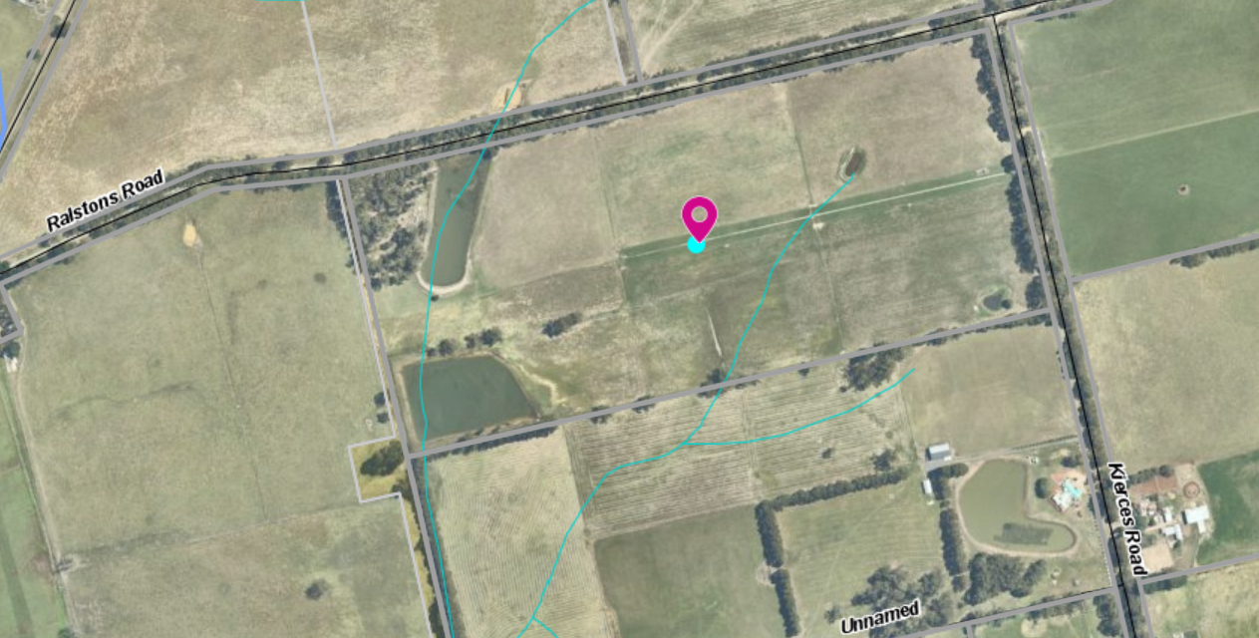
Figure 1: Aerial Map

Proposal
It is proposed to construct a single storey dwelling and shed on the site.
Power would be provided to the property off grid: with a 16.1 kW Fronius/Selectronic Off Grid Solar with 21 kWh SimpliPhi battery and LG Panels, combined with a fully maintained back-up generator.
Water would be by roof collection to tanks from both the dwelling and shed.
The dwelling would be constructed with brick external cladding and it would have a Colorbond roof. The Verandah would be constructed on all four sides of the dwelling. It would have a total floor area of 210.79sqm.
The dwelling would have:
- four bedrooms
- master with a WIR and ensuite
- second bathroom
- laundry
- separate WC; and
- an open plan kitchen, dining, family and living area.
The dwelling would be setback 204m from the west boundary and 85m from the north boundary abutting Ralstons Road. Access would be via an existing farm style crossover and a new driveway would be constructed to the dwelling and shed.
The area around the dwelling would be fenced into smaller paddocks.
The dwelling would be approximately 100m west of the waterway that runs through the dam but only 63m from the dam.
The shed would be 14m wide and 24m long and 4.8m high to the top of the roof. The shed would have a floor area of 336sqm and be constructed with Colourbond sheeting. It would be used for the farming enterprise. It would be located behind and to the south east of the dwelling. Stockyards would be constructed on the east side of the shed.
The effluent field would be located approximately 105m from the dam.
No vegetation would be removed to construct the dwelling or shed.
A Land Capability Assessment and Farm Management Plan were provided with the application.
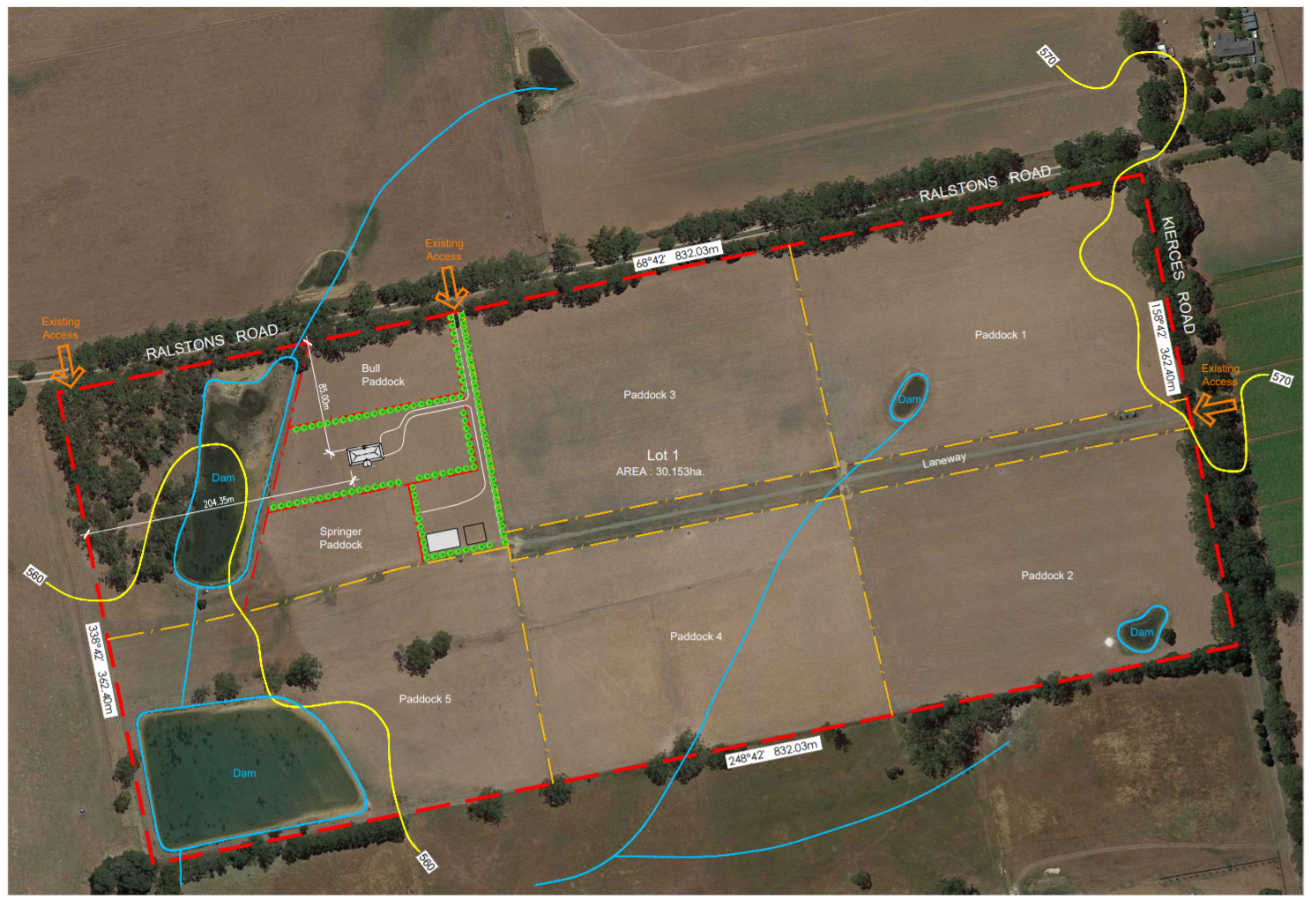
Figure 2: Site plan
The Farm Management Plan
The Farm Management Plan (FMP) relates to the operation of an Angus cattle enterprise.
It is proposed that 40 head of cattle (breeding cows) would be run on the site of 30.15ha less approximately 1ha for the dwelling and shed area and 2.5ha that is taken up by the dams.
Therefore approximately 26.65ha would be available for the breeding cattle which have a DSE/ha rating range of between 9 and 25 DSE/ha depending on the weight of the cow and whether pregnant or carrying a calf at foot. The average DSE rating for a cow and calf over the breeding cycle would be approximately 15 DSE/ha.
Hence the property needs to be able to provide for 600 DSE per annum, requiring a pasture capability of 22.5 DSE/ha. The target of 40 breeding cows may have to be reduced to 35-36 cows without use of irrigation on the pastures. The site has two large dams and a 50ML water licence to allow for pasture irrigation.

History
No permit applications or compliance issues are recorded on the site.

Public Notice
The application was notified to adjoining and surrounding landowners.
Two objections were received.

Summary of Objections
The objections received are detailed below with officer’s comments accompanying them:
Objection | Any Relevant Requirement
The dwelling site is too close to the watercourse. | Code of Practice for Onsite wastewater Management
Officer’s Response: The location of the dwelling and effluent field meets the minimum setback requirements and there were no objections from the water authority.
The dwelling proposal doesn’t meet the Moorabool Shire requirements in the Farming Zone and the acreage is too small. | Clause 35.07 Farming Zone
Officer’s Response: The land is less than 40ha and therefore a permit is required to use land for a dwelling in the Farming Zone. Any dwelling in the Farming Zone needs to be assessed against the impact of the productivity of agricultural land and type of farming practice to be undertaken.
I am concerned that a new dwelling could impact my primary production business by complaints about noise and dust etc from irrigation and farm equipment. | Clause 14.01-1S  Protection of agricultural land
Officer’s Response: The Planning Scheme recognises the right of farmers to farm their land in the Farming Zone without impact from rural residential uses.

Locality Map
The map below indicates the location of the subject site and the zoning of the surrounding area.
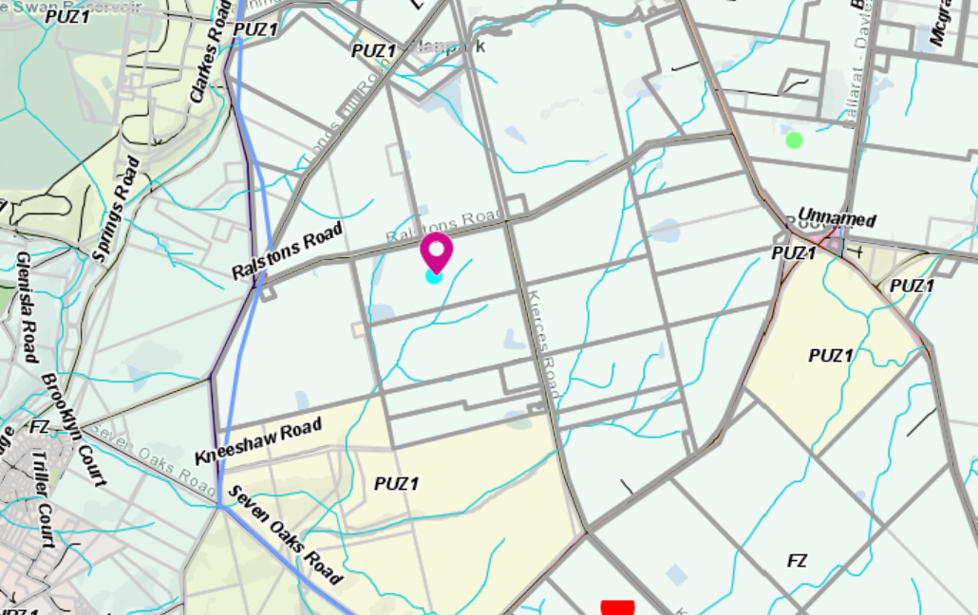
Figure 2: Zone Map

Planning Scheme Provisions
Council is required to consider the Victoria Planning Provisions and give particular attention to the Planning Policy Framework (PPF), the Local Planning Policy Framework (LPPF) and the Municipal Strategic Statement (MSS).
The relevant clauses are:
• Clause 11.03—Peri Urban Areas
• Clause 14.01-1S—Protection of agricultural land
• Clause 14.02-1S—Catchment planning and management
• Clause 14.02-2S—Water quality
• Clause 15.01-6S—Design for rural areas
• Clause 16.01-5S—Rural residential development
• Clause 21.02-3 Objective—Water and catchment management
• Clause 21.03-4 Objective—Landscape and neighbourhood character
• Clause 21.03-6 Objective—Rural lifestyle opportunities
• Clause 21.04-Economic Development and Employment
• Clause 21.04-1—Key issues and influences Agriculture and horticulture
• Clause 21.04-2 Objectives—Agriculture
• Clause 22.03—Houses and House Lot Excisions in Rural Areas
• Clause 21.04-2 Objectives—Agriculture
The proposal complies with the relevant policies of the PPF and LPPF.
Zone
Farming Zone
The purpose of the Zone is to:
• Implement the Municipal Planning Strategy and the PPF.
• Provide for the use of land for agriculture.
• Encourage the retention of productive agricultural land.
• Ensure that non-agricultural uses, including dwellings, do not adversely affect the use of land for agriculture.
• Encourage the retention of employment and population to support rural communities.
• Encourage use and development of land based on comprehensive and sustainable land management practices and infrastructure provision.
• Provide for the use and development of land for the specific purposes identified in a schedule to this zone.
In accordance with Clause 35.07-1, Section 2, a permit is required to use land for a dwelling where the land is less than 40ha.
In accordance with Clause 35.07-4 a permit is required for a building or works associated with a use in Section 2 of Clause 35.07-1.

Overlays
Environmental Significance Overlay, Schedule 1
In accordance with Clause 42.01-2 a permit is required for buildings and works.
Design and Development Overlay, Schedule 2
In accordance with Clause 43.02 Schedule 2 of the this overlay a permit is not required where all external cladding of buildings is non-reflective. In this application, there is no reflective materials proposed and therefore a permit is not required under this overlay.

Relevant Policies
Council’s Rural Housing Policy
Council’s Rural Housing Policy 2012 was adopted by Council on 19 September 2012 and has been developed to provide direction for how limited farming potential rural dwellings should be considered, and more broadly, rural settlement patterns. This Council policy is not incorporated into the Moorabool Planning Scheme.
The policy relevant to this application include to:
• Support the agricultural sector so that it can be more productive, diverse, resilient, and adaptive to changing agricultural trends, including supporting agricultural activities that recognise Moorabool’s advantageous proximity to market.
• Protect agricultural land use from loss and allow development that increases agricultural productivity.
• Focus growth opportunities in settlements along major transport corridors, in particular where there is physical and social infrastructure and services.
• Recognise that there are substantial existing lots under 40ha capable of supporting the viable operation of agricultural enterprises.
• Promote a rural housing market that meets the needs of the Shire’s rural communities
• Land parcels for the proposed on-farm living dwellings are to have a minimum lot size of 8ha as identified in Map 1.
The guiding principles for lots between 20ha and 40ha aim to ensure that the location of the dwelling does not compromise the existing agricultural practices or agricultural opportunities on this site, and minimise area taken up by dwelling, septic, shed and driveways in areas of high agriculture quality. The application generally accords with these principles.
The policy requires justification for the dwelling based on the proposed agricultural activity. The proposal is to run 40 breeding cows and calves on this site with approximately 26.65ha of available farming land (less the area taken up by the dwelling, shed and dams). It is considered that the site would sustainably run 35-36 cows provided the pastures are maintained in excellent condition year-round.

Discussion
The application was accompanied by a Farm Management Plan relating to running 40 Angus breeding cows on the site.
The Pootilla district is known for rich productive soils and excellent underground water. The subject property also has a 50ML water licence.
The land has two large dams and two smaller dams. The large dams are both located on a waterway and it is considered that they should be fenced off from livestock. There is also a patch of quality native bushland in the north west corner of the property which should also be protected from cattle and this should be made a condition of the permit.
The application has been considered against Council’s Rural Housing Policy and is located in one of the areas nominated for increased growth. The application fully accords with the principles of this policy.
The estimated stocking density may have to be reduced to 35-36 breeding cows if irrigation is not installed when removing the area of the dams and dwelling site. This would reduce the available land for the cattle to approximately 26.65ha.
The application was referred to Central Highlands Water and Council’s Environmental Health both of which consented to the application with conditions.
The application was referred to Council’s Infrastructure who also consented to the application with standard conditions.
The application was advertised, and two objections were received. Generally, the objectors were concerned that if the land could be used for rural residential purposes complaints may be received about their normal farming operations, such as irrigation pumps and farm machinery.
It is not considered that this application would be detrimental to the rural and agricultural character of the area. The land has been running cattle and sheep and has been well maintained and improved by the current owner with fencing, a central laneway and good water infrastructure.
It is recommended that this application is approved.
General Provisions
Clause 65 – Decision Guidelines have been considered by officers in evaluating this application.
Clause 66 – Stipulates all the relevant referral authorities to which the application must be referred.

Referrals
Authority | Response
Central Highlands Water | Consent with conditions.
Infrastructure  Environmental Health | Consent with conditions.  Consent with conditions.

Financial Implications
There is no financial implication associated with approval for this application. However, the objectors may seek review at VCAT with associated cost to Council.

Risk & Occupational Health & Safety Issues
The recommendation of approval of this application does not implicate any risk or OH&S issues to Council.

Communications Strategy
Notice was undertaken for the application, in accordance with s.52 of the Planning and Environment Act 1987, and further correspondence is required to all interested parties to the application as a result of a decision in this matter. All submitters and the applicant were invited to attend this meeting and invited to address Council if required.

Options
The Development Assessment Committee could consider the following options:
• issue a Notice of Decision to grant a permit in accordance with the recommendations of this report; or
• issue a refusal to Grant a Permit with specific grounds.

Conclusion
It is proposed to run a commercial Angus cattle enterprise on the site. The land is 30.15ha and the proposed stocking densities are achievable provided the pastures maintained in top condition.
The application generally accords with the assessment principles of the Rural Housing Policy for land between 20ha and 40ha.
It is recommended that the application is supported.

8 Update on Trends, Issues and Other Matters

9 Process Forward and Work Program

10 Update on VCAT Decisions

11 Other Business

12 Date of Next Meeting
Wednesday 20 October 2021

13 Meeting Close

