AGENDA

Development Assessment Committee Meeting
Wednesday, 20 April 2022

In accordance with s.395 of the Local Government Act 2020, this meeting will not
be available for public attendance, however will be streamed live via accessing the Council Internet site.
I hereby give notice that a Development Assessment Committee Meeting will be held on:
Date: | Wednesday, 20 April 2022
Time: | 6.00pm
Location: | Council Chambers, 15 Stead Street, Ballan  & Online
Derek Madden
Chief Executive Officer

Order Of Business
1 Opening 5
2 Present and Apologies 5
3 Recording of Meeting 5
4 Confirmation of Minutes 5
5 Matters Arising from Previous Minutes 5
6 Disclosure of Conflicts of Interests 5
7 Community Planning Reports 6
7.1 PA2020118-1 - Four Lot Subdivision at 6 Lyndhurst Street, Gordon 6
7.2 PA2021168 - Use and Development of a Childcare Centre, Removal of Vegetation and Reduction in the standard car parking rate at 14 Stead Street, Ballan 14
8 Update on Trends, Issues and Other Matters 31
9 Process Forward and Work Program 31
10 Update on VCAT Decisions 31
11 Other Business 31
12 Date of Next Meeting 31
13 Meeting Close 31

1 Opening

2 Present and Apologies

3 Recording of Meeting
In accordance with Moorabool Shire Council’s Governance Rules, the meeting will be livestreamed.

4 Confirmation of Minutes
Development Assessment Committee Minutes – Wednesday 16 March 2022.

5 Matters Arising from Previous Minutes

6 Disclosure of Conflicts of Interests
Conflict of interest laws are prescribed under the Local Government Act 2020 (the Act) and in the Local Government (Governance and Integrity) Regulations 2020 (the Regulations). Managing conflicts of interest is about ensuring the integrity and transparency of decision-making.
The conflict of interest provisions under the Act have been simplified so that they are more easily understood and more easily applied. The new conflict of interest provisions are designed to ensure relevant persons proactively consider a broader range of interests and consider those interests from the viewpoint of an impartial, fair-minded person.
Section 126 of the Act states that a Councillor has a conflict of interest if they have a general conflict of interest or a material conflict of interest. These are explained below:
- A Councillor has a general conflict of interest in a matter if an impartial, fair-minded person would consider that the member’s private interests could result in them acting in a manner that is contrary to their public duty as a Councillor.
- A Councillor has a material conflict of interest in a matter if an affected person would gain a benefit or suffer a loss depending on the outcome of the matter.
A relevant person with a conflict of interest must disclose the interest in accordance with Council’s Governance Rules and not participate in the decision-making process on the matter. This means the relevant person must exclude themselves from any discussion or vote on the matter at any Council meeting, delegated committee meeting, community asset committee meeting or, if a Councillor, any other meeting conducted under the auspices of the Council. The relevant person must also exclude themselves from any action in relation to the matter, including an action taken to implement a Council decision, for example, issuing a planning permit.

7 Community Planning Reports

7.1 PA2020118-1 - Four Lot Subdivision at 6 Lyndhurst Street, Gordon
Author: Thomas Tonkin, Statutory Planner
Authoriser: Henry Bezuidenhout, Executive Manager Community Planning & Economic Development
Attachments: Nil

Application Summary
Permit No: PA2020118-1
Lodgement Date: 7 December 2021
Planning Officer: Tom Tonkin
Address of the land: 6 Lyndhurst Street, Gordon
Proposal: Amendment to PA2020118
Lot size: 3,215sqm
Why is a permit required? Clause 32.09 Neighbourhood Residential Zone - Subdivision
Clause 42.01 Environmental Significance Overlay - Subdivision
Clause 43.02 Design and Development Overlay - Subdivision

Recommendation
That the Development Assessment Committee, having considered all matters as prescribed by the Planning and Environment Act 1987, issue a Refusal to grant Amended Planning Permit PA2020118-1 for a Four Lot Subdivision at Crown Allotments 1 and 2, Section 2, Parish of Kerrit Bareet known as 6 Lyndhurst Street, Gordon, on the following grounds:
1. The proposed amendment is inconsistent with the relevant provisions of Moorabool Planning Scheme for the contribution to public open space.
2. The applicant has failed to demonstrate there will not be an increased population density or increased demand for existing public open space use and has not reviewed the provision of public open space in the immediate area to warrant a reduction in the public open space requirement.

Public Consultation
Was the application advertised? | No.
Notices on site: | Not applicable.
Notice in Moorabool Newspaper: | Not applicable.
Number of objections: | Not applicable.
Consultation meeting: | Not applicable. The applicant is seeking a change to a permit condition.

Policy Implications
The Council Plan 2021-2025 provides as follows:
Strategic Objective 1: Healthy, inclusive and connected neighbourhoods
Priority 2.1: Develop planning mechanisms to enhance liveability in the Shire

Victorian Charter of Human Rights & Responsibilities Act 2006
In developing this report to Council, the officer considered whether the subject matter raised any human rights issues. In particular, whether the scope of any human right established by the Victorian Charter of Human Rights and Responsibilities is in any way limited, restricted or interfered with by the recommendations contained in the report. It is considered that the subject matter does not raise any human rights issues.

Officer’s Declaration of Conflict of Interests
Under section 130 of the Local Government Act 2020, officers providing advice to Council must disclose any interests, including the type of interest.
Executive Manager – Henry Bezuidenhout
In providing this advice to Council as the Executive Manager, I have no interests to disclose in this report.
Author – Tom Tonkin
In providing this advice to Council as the Author, I have no interests to disclose in this report.

Executive Summary
Application referred? | No.
Any issues raised in referral responses? | Not applicable.
Preliminary concerns? | Lack of sufficient justification for the proposed amendment.
Any discussions with applicant regarding concerns? | Council wrote to the applicant regarding the abovementioned matters.
Any changes made to the application since being lodged? | No.
Brief history. | Planning permit PA2020118 for a four lot subdivision was approved by Council under delegation on 28 September 2020. There was no appeal against any permit condition with the 60 day appeal period completed on 28 November 2020.
Previous applications for the site? | None.
General summary. | It is proposed to amend PA2020118 to reduce the public open space contribution from 5% to 2.5%. The applicant’s justification for the amendment does not have sufficient policy support in the Moorabool Planning Scheme or the Subdivision Act 1988 and will reduce the amount spent on improving existing public open spaces in the Gordon area. There is no strategic basis for a reduced public open space requirement.
Summary of Officer’s Recommendation
That, having considered all relevant matters as required by the Planning and Environment Act 1987, the Development Assessment Committee issue a Refusal to Grant Amended Planning Permit PA2020118-1 for the Four Lot Subdivision of Crown Allotments 1 and 2, Section 2, Parish of Kerrit Bareet known as 6 Lyndhurst Street, Gordon, on the grounds within this report.

Site Description
The site comprises two contiguous Crown allotments: Allotment 1 being the northern half covering approximately 1,700sqm between Lyndhurst and Gladstone Streets, abutting the unmade Tennyson St along the northern boundary; and Allotment 2 being the southern half covering approximately 1,500sqm between Lyndhurst and Gladstone Streets, abutting properties to the south at 29 Gladstone Street and 2 Lyndhurst Street.
The land slopes down evenly to the northeast, falling nearly 8m from southwest to northeast corners. The subject site is cleared of vegetation, although there are three small trees on the road reserves of Lyndhurst and Tennyson Streets. The land is located within the Moorabool River Special Water Supply Catchment managed by Barwon Water. The nearest waterway of this catchment is the Paddock Creek approximately 150m downhill to the north.
The area is serviced by reticulated water, sewerage and electricity.
Surrounding land uses are all residential in nature, although the property opposite on Gladstone St and one of the two north against Tennyson Street are undeveloped. Immediately surrounding lots are generally regular in shape and range in size from 544sqm to 1,497sqm. It is noted that the subject site immediately abuts the Township Zone to the west.
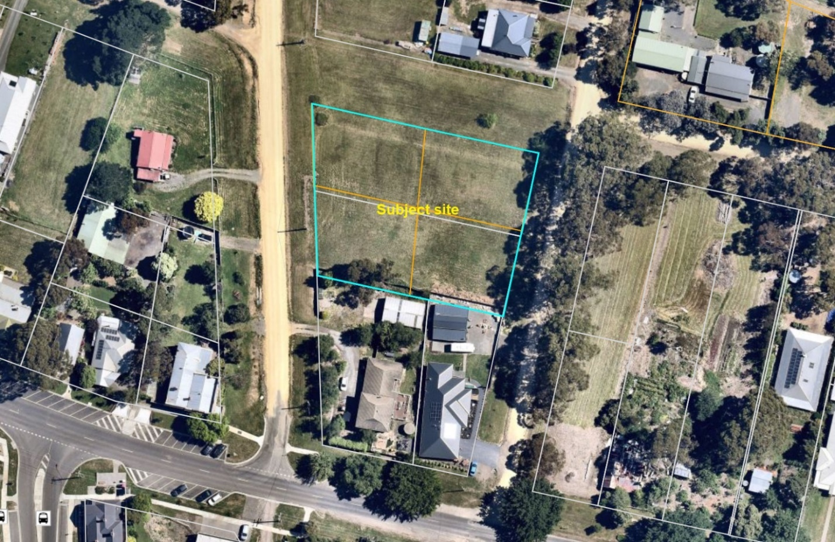
Figure 1: Aerial photograph

Proposal
It is proposed to amend Condition 5 of PA2020118 to reduce the public open space contribution from 5% to 2.5% of the site value.
Condition 5 stated ‘Before the statement of compliance is issued under the Subdivision Act 1988, the applicant or owner must pay to the responsible authority a sum equivalent to 5% of the site value of all the land in the subdivision for public open space purposes. The permit holder/developer must pay the reasonable costs of Council in having the land valued for this purpose’.

Background to Current Proposal
The applicant did not exercise their right pursuant to Section 80 of the Planning and Environment Act 1987 to appeal the permit condition to VCAT within 60 days of the permit being granted on 28 September 2020.

History
None applicable.

Public Notice
Notice of the application was not required in this instance as the proposed amendment would not directly cause material detriment to any person.

Locality Map
The map below indicates the location of the subject site and the zoning of the surrounding area.
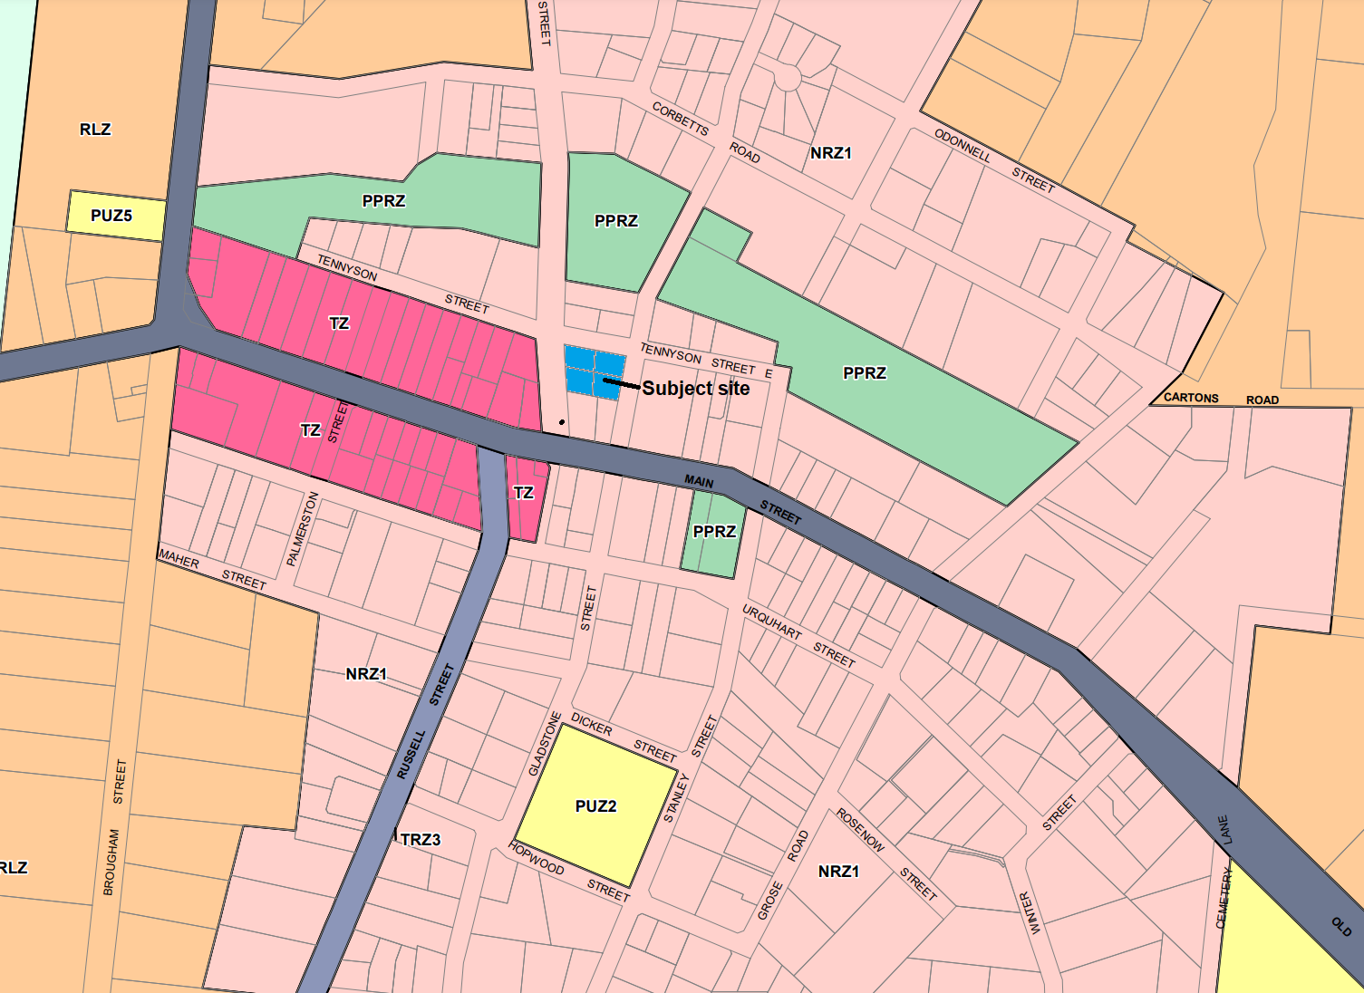
Figure 2: Zone map

Planning Scheme Provisions
Council is required to consider the Victoria Planning Provisions and give particular attention to the Planning Policy Framework (PPF), the Local Planning Policy Framework (LPPF) and the Municipal Strategic Statement (MSS).
The clauses relevant to the assessment of the proposed amendment are:
• Clause 11.01-1R Settlement Central Highlands
• Clause 19.02-6S Open space
• Clause 21.03-5 Small town development
• Clause 21.05-2 Open space and recreation
• Clause 21.05-4 Community facilities and infrastructure
• Clause 21.05-7 Further strategic work
• Clause 21.09-2 Gordon

In assessing it against the relevant sections of the PPF and LPPF, the following significant non-compliances were identified:
PPF and LPPF assessment
PPF | Title | Response
Clause 19.02-6S | Open space | The proposed amendment does not meet the objective to establish, manage and improve a diverse and integrated network of public open space that meets the needs of the community.
LPPF
Clause 21.03-2 | Urban Growth Management | The proposed amendment does not adequately support the objective to improve social and physical infrastructure in the Shire to support the growing population.
Clause 21.03-5 | Small town development | The proposed amendment does not align with the relevant strategy to plan for population growth, service delivery and investment on a cluster basis, rather than a town specific basis having regard for the social and economic linkages between towns.
Clause 21.05-2 | Open space and recreation | The proposed amendment does not adequately support the objective to provide high quality, equitable and integrated open space, and recreation facilities.
Clause 21.09-2 | Gordon | The proposed amendment does not adequately support the policy to provide for the progressive development of a linked series of parks to serve township and local needs.

Zone
The subject site is in the Neighbourhood Residential Zone, Schedule 1 (NRZ1). The Zone does not have any bearing on a decision on the proposed amendment to Permit Condition 5.

Overlays
The subject site is affected by the following planning overlays:
• Clause 42.01 Environmental Significance Overlay, Schedule 1.
• Clause 42.03 Significant Landscape Overlay, Schedule 2.
• Clause 43.02 Design and Development Overlay, Schedules 2 and 5.
None of the Overlays have any bearing on a decision on the proposed amendment to Permit Condition 5.
Relevant Policies
There are no Council policies applicable to this application.

Particular Provisions
Clause 53.01 Public Open Space Contribution and Subdivision
A person who proposes to subdivide land must contribute to the Council for public open space in an amount specified in the schedule to this clause (being a percentage of the land intended to be used for residential, industrial or commercial purposes, or a percentage of the site value of such land, or a combination of both). If no amount is specified, as in this instance, a contribution for public open space may still be required under section 18 of the Subdivision Act 1988.
Condition 5 of PA2020118 required a 5% contribution equivalent to the site value.
There would be increased population and a greater demand to utilise existing public open space as a result of the subdivision.
Subdivision Act 1988
Section 18(1A) of the Subdivision Act 1988 (the Act) state that Council may only make a public open space requirement if it considers that, as a result of the subdivision, there will be a need for more open space, having regard to the following:
a) the existing and proposed use or development of the land;
b) any likelihood that existing open space will be more intensively used after than before the subdivision;
c) any existing or likely population density in the area of the subdivision and the effect of the subdivision on this;
d) whether there are existing places of public resort or recreation in the neighbourhood of the subdivision, and the adequacy of these;
e) how much of the land in the subdivision is likely to be used for places of resort and recreation for lot owners;
f) any policies of the Council concerning the provision of places of public resort and recreation.
In accordance with the Act, any contribution made under Section 18 must only be used for public open space or improvements to open space.

Discussion
Overall, it is considered that the proposed amendment to the permit, reducing the public open space contribution from 5% to 2.5%, is not acceptable having regard for the site context and the orderly planning of the area.
Gordon is the Shire’s third largest township and the largest town in the western part of the Shire (west of Ballan). State and local planning policies support the provision of appropriate public open space and associated infrastructure to meet a range of needs. Accordingly, Council would impose a 5% public open space contribution for subdivisions which create more than two lots, when no previous contribution has been made and there is greater demand to utilise existing public open spaces.
With regard to Section 18 of the Subdivision Act, it is reasonable to expect that existing public open space will be more intensively used as the subdivision of residential zoned land in Gordon and the surrounding smaller towns as further settlements occurs. Whilst there is existing public open space in Gordon, notably Paddock Creek Reserve, Gordon Public Park and the Gordon Recreation Reserve located southeast of the township, there is a need to ensure that investment in public open space is maintained and improved to ensure that the diverse recreational needs of future residents are met. It is noted that Paddock Creek Reserve is crown land and parts of it are privately leased. The contribution required will be utilised to improve the existing open spaces within the Gordon Township.
The applicant submits that given the subject site comprises two lots which PA2020118 enables to be re-subdivided to create four lots, a reduction in the standard public open space contribution is appropriate, given this would result in a less intensive use of public open space than if the four lots were being created from only one lot. The applicant’s request however does not sufficiently account for policy directives which require a more holistic assessment of public open space requirements to meet the varied needs of the community. There is insufficient justification to reduce the Council requirement for a 5% contribution to 2.5%. There was no detailed analysis to determine how the 2.5% figure was calculated and is what not based on the demand for public open space in Gordon.

General Provisions
Clause 65 - Decision Guidelines have been considered by officers in evaluating this application.
Clause 66 - Stipulates all the relevant referral authorities to which the application must be referred.

Financial Implications
The recommendation to refuse this application has no financial implications for Council.

Risk & Occupational Health & Safety Issues
The recommendation to refuse this application does not have any risk or OH&S implications for Council.

Options
• Issue a Refusal to Grant an Amended Permit in accordance with the grounds in the recommendation of this report; or
• should the Development Assessment Committee wish to support the application, issue an Amended Planning Permit with Condition 5 amended from 5% to 2.5%.

Conclusion
The proposed amendment to PA2020118 to reduce the public open space contribution from 5% to 2.5% does not have sufficient policy support in the Moorabool Planning Scheme, which includes consideration of Section 18(1A) of the Subdivision Act 1988. The requirement for a 5% contribution reflects Council’s consistent approach to facilitating appropriate public open space provision in areas where there is an increased population density.

7.2 PA2021168 - Use and Development of a Childcare Centre, Removal of Vegetation and Reduction in the standard car parking rate at 14 Stead Street, Ballan
Author: Victoria Mack, Statutory Planner
Authoriser: Henry Bezuidenhout, Executive Manager Community Planning & Economic Development
Attachments: 1. PA2021168 - Final Development Plans (under separate cover)
2. PA2021168 - On Street Car Parking Plan (under separate cover)

Application Summary
Permit No: PA2021168
Lodgement Date: 5 August 2021
Planning Officer: Victoria Mack
Address of the land: 14 Stead Street, Ballan or otherwise known as Crown Allotment 2, Section 11, Parish of Ballan
Proposal: Use and Development of a Childcare Centre, Removal of Vegetation and a Reduction of the standard car parking rate (five spaces)
Lot size: 2,057.39sqm
Why is a permit required? Clause 32.08-2 - Section 2, Use of land for a Childcare Centre. Clause 32.08-9 - Buildings and works associated with a Section 2 use; Clause 42.01-2 - Removal of vegetation Clause 52.06-3 - Reduction to the standard car parking rate

Recommendation
That the Development Assessment Committee, having considered all matters as prescribed by the Planning and Environment Act 1987, issue a Notice of Decision to Grant Planning Permit PA2021168 for Use and Development of a Childcare Centre, Removal of Vegetation and Reduction to the standard car parking rate (five spaces) at 14 Stead Street, Ballan or otherwise known as Crown allotment 2, Section 11, Parish of Ballan, subject to the following conditions:
1. Before the use and development starts, amended plans to the satisfaction of the Responsible Authority must be submitted to and approved by the Responsible Authority. When approved, the plans will be endorsed and will then form part of the permit. The plans must be drawn to scale with dimensions and three copies must be provided. The plans must be generally in accordance with the plans submitted with the application or some other specified plans but modified to show:
(a) Landscape plans in accordance with Condition 2 and detailing tree protection areas for all trees on the northern boundary within the neighbouring property.
(b) Acoustic fencing on the north and east boundaries to meet the required standards in accordance with Condition 6.
(c) Details of fencing along the western boundary to Council’s satisfaction.
(d) Provide Entry and Exit signage to the one way internal accessway near the respective street frontages.
Unless otherwise approved in writing by the Responsible Authority, all buildings and works are to be constructed and or undertaken in accordance with the endorsed plans to the satisfaction of the Responsible Authority prior to the commencement of the use.
Landscape Plans:
2. Before commencement of the use landscape plans to the satisfaction of the Responsible Authority must be submitted and approved by the Responsible Authority. When approved, the plans will be endorsed and will then form part of the permit. The plans must be drawn to scale with dimensions and electronic copies must be provided.
3. The landscape plans submitted must include two stages of landscaping to the satisfaction of the Responsible Authority.
(a) Prior to commencement of works an external landscaping plan of the land surrounding the Childcare to include street trees in Steiglitz Street and Stead Street to the satisfaction of Council’s Parks and Gardens to be planted and maintained for a minimum of 2 years at the developer’s cost.
(b) Prior to commencement of the use of the Childcare Centre all internal landscaping relating to the Childcare Centre operation areas to include:
i. Landscaping and planting within all open outdoor play areas of the site.
ii. Canopy trees (minimum 2m tall when planted) in all outdoor play areas. All species selected must be to the satisfaction of the Responsible Authority.
iii. Surface finishes of the outdoor play areas and pathways.
iv. Fixed play equipment.
4. Before the use/occupation of the development starts or by such later date as is approved by the Responsible Authority in writing, the landscaping works shown on the endorsed plans must be carried out and completed to the satisfaction of the Responsible Authority.
5. The landscaping shown on the endorsed plans must be maintained to the satisfaction of the Responsible Authority, including that any dead, diseased or damaged plants are to be replaced.
General conditions:
6. Acoustic fencing at least 1.9m high must be provided on the north and east boundaries of the site. Details of materials must be provided to the satisfaction of the Responsible Authority.
Infrastructure:
7. The proposed vehicle crossing must be constructed to urban residential standard to the satisfaction of the Responsible Authority. Any redundant vehicle crossings must be removed, and the kerb and channel and nature strip reinstated to the satisfaction of the Responsible Authority. A vehicle crossing permit must be taken out for the construction of the vehicle crossing.
8. The development must be provided with a drainage system constructed to a design approved by the Responsible Authority, and must ensure that:
(a) The development as a whole must be self draining.
(b) Volume of water discharging from the development in a 10% AEP storm shall not exceed the 20% AEP storm prior to development. Peak flow must be controlled by the use of a detention system located and constructed to the satisfaction of the Responsible Authority.
(c) The site must be provided with a stormwater legal point of discharge at the low point of each potential lot, to the satisfaction of the Responsible Authority.
(d) Stormwater runoff must meet the “Urban Stormwater Best Practice Environmental Management Guidelines (CSIRO 1999)”.
9. Prior to the commencement of the development, design computations for drainage of the whole site must be prepared and submitted to the Responsible Authority for approval.
10. Unless otherwise approved by the Responsible Authority there must be no buildings, structures, or improvements located over proposed drainage pipes and easements on the property.
11. Sediment discharges must be restricted from any construction activities within the property in accordance with the relevant Guidelines including “Construction Techniques for Sediment Control” (EPA 1991) and “Environmental Guidelines for Major Construction Sites” (EPA 1995).
12. Prior to the commencement of the development, notification including photographic evidence must be sent to Council’s Asset Services identifying any existing change to council assets. Any existing works affected by the development must be fully reinstated at no cost to and to the satisfaction of the Responsible Authority.
13. Prior to the commencement of the development, plans and specifications of all road and drainage works must be prepared and submitted to the Responsible Authority for approval, detailing but not limited to the following:
(a) Location of vehicle crossings.
(b) Details of the underground drainage.
(c) Location of drainage legal points of discharge.
(d) Standard details for vehicle crossing and legal point of discharge.
(e) Civil notes as required to ensure the proper construction of the works to the satisfaction of the Responsible Authority.
14. Prior to the use commencing, the car park areas must be constructed with a sealed surface, line-marking and drainage to the satisfaction of the Responsible Authority, and shall incorporate the following:
(a) Parking bays and aisle widths of the car park shall comply with Australian Standard AS 2890.1:2004 Off-Street car parking. Disabled Parking bays shall comply with Australian Standard AS2890.1:2009 Off-Street Parking for People with Disabilities.
(b) Designated loading areas shall be shown on layout plans.
(c) A minimum of 18 car spaces on site must be available at all times for vehicle parking only.
(d) The parking areas shall be provided with an asphalt or concrete surface and associated drainage.
(e) Concrete kerb of a minimum height of 150mm must be provided between landscaped areas and areas provided for parking and the passage of vehicles.
(f) The car park must provide sufficient space for a service truck to enter and exit the site in a forward direction. The service truck shall comply with the medium rigid vehicle detailed in AS2890.2 section 2.2. Turning templates shall be submitted for approval.
15. Prior to the construction commencing, engineering road and drainage plans, and detailed computations must be submitted and approved by the Responsible Authority. The plans are to be in line with plans by Drysdale Engineering Services Pty Ltd 6981-6983 Revision B designed by J.Barker (Jan 2022). The works are to include, but not limited to, road widening, street car park line marking, footpath across the full frontage of Stead Street and Stiglitz Streets (establishing the connective links between Stead Street and Steiglitz Street) and all other works as required by the Responsible Authority. All works are to be completed to the satisfaction of the Responsible Authority prior to use commencing.
16. Prior to the use commencing, the developer must pay:
(a) 0.75 % of the total estimated cost of works for the checking of engineering plans associated with that stage of the development.
(b) 2.5% of the total estimated cost of works for the supervision of works associated with that stage of the development.
(c) The fees are to be determined based on the requirements as specified within the Infrastructure Design Manual and the Subdivision Act.
17. Prior to the use and after all engineering works have been completed in accordance with the approved plans and the following “as constructed” details must be submitted in the specified format and approved by the Responsible Authority:
(a) Roadworks construction details in “R-Spec” format.
(b) As built plans clearing detailing any changes from the as approved drawings All relevant test results, including but not limited to, compaction test of each road layer, compaction test of earthworks and certificates for the soil used.
18. Upon the completion of all works as approved by the relevant authority, a minimum of seven days’ notice is to be provided to the relevant authority for the purpose of organising an on maintenance inspection.
19. All road, drainage and infrastructure works must be maintained in good condition and repair for a minimum of three months after completion of the works, to the satisfaction of the Responsible Authority.
20. Prior to the use of the development, a security deposit of 5% of the total value of engineering works for that stage as approved by the Responsible Authority must be lodged with the Responsible Authority, to cover the maintenance of all works. The deposit will be returned after the final inspection of works, three months after the completion of works, subject to the satisfactory completion of all required maintenance and rectification works.

Environmental Health:
21. All proposed food premises must be designed in accordance with the requirements of the FSANZ Food Standards Code and Australian Standard 4674:2004. A detailed and to scale floor plan of the proposed food premises in conjunction with any other requested documents must be supplied to Council’s Environmental Health prior to any approval of an application for registration.
22. Industrial/Commercial waste collection times are to be restricted to: 7:00am to 8:00pm Monday to Saturday, and 9:00am to 8:00pm Sunday and Public Holidays.
General Conditions:
23. The hours of operation are to be from 6:00am to 6:00pm Monday to Friday and cannot be varied unless with the written consent of the Responsible Authority.
24. The maximum number of children permitted at any one time is 102.
25. External lighting must be provided with suitable baffles and located so that no direct light is emitted outside the site.
26. The amenity of the area must not be detrimentally affected by the use or development, through the:
(a) Transport of materials, goods or commodities to or from the land;
(b) Appearance of any building, works or materials;
(c) Emission of noise, artificial light, vibration, smell, fumes, smoke, vapour, steam, soot, ash, dust, waste water, waste products, grit or oil;
(d) Presence of vermin;
(e) Any other way.
27. Any public address system installed must not be audible beyond the boundaries of the site.
28. All recycling, organics and general waste must be collected and stored in accordance with the endorsed waste management plan and to the satisfaction of the Responsible Authority.
29. The on street car parking bays hereby approved must be completed to the satisfaction of Responsible Authority prior to the occupation of the use.
Permit Expiry:
30. This permit will expire if:
(a) The development and use are not started within two years of the date of this permit; or
(b) the development is not completed within four years of the date of this permit.
Permit Note:
Any proposed signage may require separate planning permit approval.

Public Consultation
Was the application advertised? | Yes.  Following receipt of amended plans showing for increased angle car parking to be constructed on-street, the application was re-advertised.
Notices on site: | Yes.
Notice in Moorabool Newspaper: | Not required.
Number of objections: | Three objections received with a fourth objection withdrawn.
Consultation meeting: | Not held.

Policy Implications
The Council Plan 2021-2025 provides as follows:
Strategic Objective 2: Liveable and thriving environments
Priority 2.4: Grow local employment and business investment
The proposal is not provided for in the Council Plan 2021-2025 and can be actioned by utilising existing resources.

Victorian Charter of Human Rights & Responsibilities Act 2006
In developing this report to Council, the officer considered whether the subject matter raised any human rights issues. In particular, whether the scope of any human right established by the Victorian Charter of Human Rights and Responsibilities is in any way limited, restricted or interfered with by the recommendations contained in the report. It is considered that the subject matter does not raise any human rights issues.

Officer’s Declaration of Conflict of Interests
Under section 130 of the Local Government Act 2020, officers providing advice to Council must disclose any interests, including the type of interest.
Executive Manager – Henry Bezuidenhout
In providing this advice to Council as the Executive Manager, I have no interests to disclose in this report.
Author – Victoria Mack
In providing this advice to Council as the Author, I have no interests to disclose in this report.

Executive Summary
Application referred? | The application was referred to Greater Western Water, Southern Rural Water, and Council’s Infrastructure, Environmental Health, Active Ageing and Diversity, Strategic Planning, Connected Communities and Environment, Emergency and Waste Management.
Any issues raised in referral responses? | Infrastructure requested further information and required a Stormwater Management Strategy and Traffic Management Plan. The applicant satisfied the further information requests on 9 March 2022.  Environmental Health requested further information to provide a detailed plan of the proposed kitchen to determine the suitability and safety of the kitchen.
Preliminary concerns? | The applicant was advised of planning concerns including adequacy of the outdoor play space around the site, solar access, landscaping response, lack of sustainable practices and how the building design accord with the Neighbourhood character objectives of the General Residential Zone Schedule 4, to ensure that new development does not compromise the character of the precinct.
Any discussions with applicant regarding concerns? | The applicant arranged for the assessing officer to visit an equivalent Childcare centre in Brown Hill near Ballarat, constructed by the same developer. This was to demonstrate how child centre functions on a small land area in response to the concerns raised.  The applicant also submitted a Traffic Impact Assessment, a Stormwater Management Strategy, an Arborist Report, an amended Landscape Plan and alternative perimeter fence design.  Rather than adding five additional car spaces within the subject site to meet the minimum car parking requirement, the applicant submitted an alternative on-street parking plan for 22 angled car spaces: 17 in Stead Street and five in Steiglitz Street.  Infrastructure accepted this option subject to conditions.
Any changes made to the application since being lodged? | No change to the development plans, but an amended landscape plan was provided, and an alternative on-street parking plan.
Brief history. | The site contains an old single storey dwelling with outbuildings in a garden setting.
Previous applications for the site? | None recorded.
General summary. | The application is for a 102 place Childcare Centre. The centre has been designed to meet the requirements and design standards of the National Quality Framework (NQF) Australian Children’s Education and Care Quality Authority.  Subject to conditions, it is recommended that the application be supported.
Summary of Officer’s Recommendation
That, having considered all relevant matters as required by the Planning and Environment Act 1987, the Development Assessment Committee issue a Notice of Decision to Grant Planning Permit PA2021168 for the Use and Development of a Childcare Centre, Removal of Vegetation, and Reduction of the Standard Car Parking Rate at 14 Stead Street, Ballan or otherwise known as Crown Allotment 2, Section 11, Parish of Ballan, subject to the conditions contained within this report.

Site Description
The site is located at the north-east corner of the intersection of Stead Street with Steiglitz Street. The site is flat in topography and rectangular in shape. It has an area of approximately 2,057sqm. There is an old single storey dwelling and outbuildings on the site. There are garden plantings on the site including mature trees and shrubs.
The site is in the General Residential Zone Schedule 4 (GRZ4). Surrounding land is also in the GRZ4 and comprises lots of similar size, or smaller, generally containing single story single dwellings within spacious garden settings.
It is obliquely opposite the Moorabool Shire Council offices located in the south-west corner of the intersection.
The site is located approximately 524m north-east of the Ballan railway station and approximately 360m south-east of the Ballan town centre.
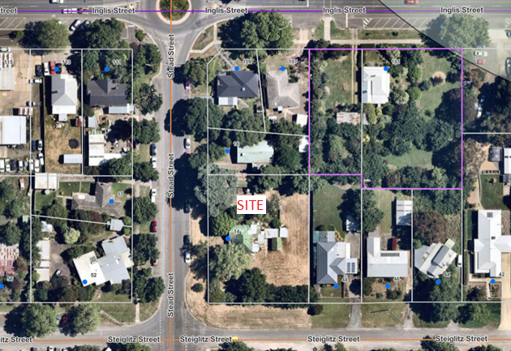
Figure 1: Aerial photo of the subject site

Proposal
The proposal is the use and development a childcare centre on the site that would accommodate up to 102 children. The operating hours would be between 6.00am and 6.00pm Monday to Friday. Staffing would be determined by enrolments.
The proposed building would be single storey and would be constructed with brick veneer walls and a 15 degree pitched Colorbond roof. A prominent front entry point would be highlighted using bold colours.
The building would be setback 12.67m from the Steiglitz Street front boundary and a varying 10m-12m from the Stead Street side boundary.
The building would contain the following activity areas:
• Two 0 to 2 year-old rooms; one 2 to 3 year-old room; one 3 to 5 year-old room; one kinder room; and a cot room.
Each of these rooms would have access to a dedicated washroom with toilets, a kitchenette, and a storeroom. There would be access from each of these activity areas to the outside play spaces via sliding doors onto a covered verandah which surrounds much of the building.
• Administration areas would include a reception area inside the front entrance and foyer, a meeting room, a staff room with bathroom and toilets, a laundry, a separate adult disabled toilet, and office.
• An undercover outdoor bin storage area would be accessed from the laundry.
• There would a centrally located general kitchen with pantry.
In this development 731sqm is provided for outdoor play areas. The majority of play space has been located on the western side of the development - away from adjoining residential dwellings.
Common boundaries with adjoining residential sites will be provided with new 2,100 high acoustic timber paling fencing.
Fencing abutting both street frontages on the south and west boundaries of the land would have 50% closed paling sections interspersed with the balance being transparent vertical steel bar sections.
Carparking would be located on the south side of the building with the entrance from Steiglitz Street and one way internal accessway with an exit to Stead Street. There would be 18 car spaces provided on the site including one disabled space.
An area for waste storage bins and air-conditioning units would be located at the front of the structure with easy access for service vehicles. All external lighting would be baffled.
The landscaping plan provided shows a majority of low and medium height native with one exotic species. Existing trees would be removed from the site.

History
There is no relevant history on the site.

Public Notice
The application was notified to adjoining and surrounding landowners and three objections were received. Following the provision of amended plans showing the provision of on street parking and associated street works, the application was readvertised, and no additional objections were received.

Summary of Objections
The objections received are detailed below with officer’s comments accompanying them:
Objection | Any Relevant Requirement
A commercial use within a General Residential Zone is not in accordance with neighbourhood character.  Generating commercial on street parking, with large amounts of traffic volume/noise is not suitable for this part of Ballan, which should be of a modest scale and be sympathetic to the existing character of the precinct.  Ballan is lucky to have such open residential lots surrounded by trees which makes it special. This proposal doesn’t fit within a Ballan residential area. | Moorabool Planning Scheme  Clause 21.08 Ballan
Officer’s Response: Childcare centres do require a permit in residential zones but are not prohibited. Ballan is the second largest town within the Shire and is a rural service centre and commuter town with many residents travelling to Ballarat, Bacchus Marsh, or Melbourne for work. An industrial estate, local businesses and retail and wholesale trade provide local employment. The proposal would provide a service to families in a growing town where childcare services will be increasing in demand.
The arborist report does not mention neighbouring trees or Council owned street trees. Are the structural root zones of these unrecorded trees being impacted? Concern that a large neighbouring tree could fall onto a child if their root networks are weakened. | Moorabool Planning Scheme  Clause 42.01 – Environmental Significance Overlay, Schedule 1 (ESO1)
Officer’s Response: It is considered that an effective landscape plan including street trees will reduce the impact of the development over time.
The report makes no reference to raised play equipment. The report suggests that acoustic fencing is in place, does this mean that all raised play equipment will be along Stead Street to avoid noise impacts to neighbouring properties? | EPA Noise Guidelines
Officer’s Response: Appropriate acoustic fencing to mitigate noise will be made a condition of the permit.
My concern is five carparking dispensations. I am aware of Council’s view of carparking dispensations, and fear that this will open the floodgates for future developments to call on dispensations. It is clear that this site is being overdeveloped if a car space dispensation is required.  The report doesn’t account for the impact of waste collection on parking and amenity.  Staff levels not nominated. With a five carpark reduction, what is to say that the carpark will not be occupied by staff alone? | Moorabool Planning Scheme  Clause 52.06 Car Parking
Officer’s Response: Initially Council was not supportive of a reduction of five car spaces, however with 22 car spaces to be constructed on street at the expense of the developer, connected by crossovers, footpaths and the required engineering infrastructure. It is considered that this is an acceptable car parking outcome. The on street parking bays can be utilised by any residents at any time.
The waste management plan doesn’t specify how much waste this development is estimated to produce, or the size of the bins required. This would determine how often the bins are collected. I would assume that multiple collections would impact car park flow which already calls for dispensation of five car spaces.
Officer’s Response: Waste collection hours will be controlled by permit conditions.
A commercial use should be kept to the commercial hub of Ballan where any amenity impacts are catered for and where a Childcare centre belongs.
Officer’s Response: Childcare centres are located in residential which supports nearby residents with young families and reduce car parking generation.
Steiglitz Street is a quiet residential street. The possibility of a Childcare centre was never considered but worse the likelihood of a carpark for 18 cars accessed from Steiglitz Street over a period of 12 hours is a disgrace. This would greatly impact on the amenity to enjoy the quiet of our home as there would be constant cars, noise and people, an also not good for those that work night shift.
Officer’s Response: Car parking is considered appropriate with the applicant providing constructed, on street, car parking bays.
Steiglitz Street is in poor condition for such additional traffic and people. The only footpath is on the south side of the street therefore all foot traffic comes along that side of the street.  The road is in poor condition. Traffic moving along the street must travel half on and half off the bitumen as there isn’t enough room for all cars and the bitumen, on both sides is rough.  Cars and people picking up children from the Ballan Primary School cluster along the south side of the street adding to the congestion and the need to move off and on the bitumen. We feel that there is enough activity in the street without trying to add traffic movements by the parents of 102 children. | Infrastructure
Officer’s Response: Strategic Planning is ongoing in Ballan and overtime will address Infrastructure upgrades for the growing township. The proposed use can operate within an established residential area.

Locality Map
The map below indicates the location of the subject site and the zoning of the surrounding area.
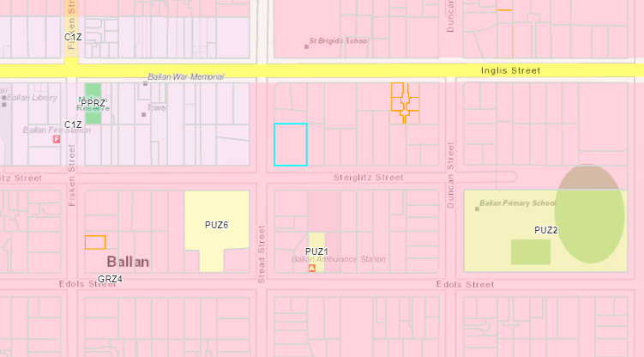
Figure 2: Zoning map of te site and surrounding area (site outlined in blue)

Planning Scheme Provisions
Council is required to consider the Victoria Planning Provisions and give particular attention to the Planning Policy Framework (PPF), the Local Planning Policy Framework (LPPF) and the Municipal Strategic Statement (MSS).
The relevant clauses are:
• Clause 17.01-1S Diversified economy
• Clause 17.01-1R Diversified economy – Central Highlands Strategies
• Clause 19.02-2S Education facilities
• Clause 21.05-4 Objective – Community facilities and infrastructure
• Clause 21.08-09 Ballan
• Clause 21.08-1 Key Issues and Influences
The proposal complies with the relevant sections of the PPF and LPPF.

Zone
General Residential Zone – Schedule 4 (GRZ4)
In accordance with Clause 32.08-2, section 2 of the Moorabool Planning Scheme a permit is required to use land for a childcare centre.
In accordance with Clause 32.08-9 of the Moorabool Planning Scheme a permit is required a to construct a building or construct or carry out works for a use in Section 2 of clause 32.08-2.

The purpose of the General Residential Zone is to:

• Implement the municipal planning strategy and the planning policy framework.

• Encourage development that respects the neighbourhood character of the area.

• Encourage a diversity of housing types and housing growth particularly in locations offering good access to services and transport.

• Allow educational, recreational, religious, community and a limited range of other non-residential uses to serve local community needs in appropriate locations.

The Neighbourhood Character Objectives of Schedule 4 include to:
• Maintain a streetscape rhythm of detached dwellings with conventional front and side setbacks.
• Provide for built form that does not dominate the lot and allows for generous private open space and garden plantings, with minimal or low scale front fencing.
• Ensure that new development does not compromise the heritage values and character of precinct.
The proposal is generally consistent with the General Residential Zone. It provides for community facility in the growing township of Ballan with a single storey form that generally accords with surrounding buildings and neighbourhood character.

Overlays

Environmental Significance Overlay - Schedule 1 (ESO1)

In accordance with Clause 42.01-2 of the Moorabool Planning Scheme a permit is required to remove, destroy or lop any vegetation, including dead vegetation.

PARTICULAR PROVISIONS

Clause 52.05 Advertising signs
In accordance with Clause 32.08-14 of the General Residential Zone signage requirements are in Category 3 of Clause 52.05.
Clause 52.05-13 Category 3 is for high amenity areas requires a permit for business identification in the GRZ4. No restriction to total overall signage area is specified.
The applicant has not provided any details of signage.
Clause 52.06 Car parking.
In accordance with Clause 52.06-5, Table 1 of the Moorabool planning Scheme the car parking requirement for a childcare centre is 0.22 car spaces per child.
As there would be a maximum of 102 children enrolled in the centre, 23 car spaces are required on the site.
The application has provided for 18 spaces on the site, including one disabled space, with a request for a reduction of five car spaces.
Application requirements and decision guidelines for a reduction to the standard car parking rate are listed in Clause 52.06-7.
During the assessment of the application an alternative car parking option was provided by the applicant which would include 22 angled on street parking spaces. This would result in five spaces in Steiglitz Street, and 18 in Stead Street on both sides of the road. The works would include asphalt surfaces and 1.5m wide footpaths along both street frontages extending to street crossovers with appropriate grading.

Discussion
The application is for a childcare centre to accommodate up to 102 children aged from 0-5 years of age. The centre would be in a residential area perpendicular to the Moorabool Shire Council office in Stead Street.
Childcare centres provide essential services for young families and can be located within residential zoned land provided the amenity of surrounding residents is adequately protected.
The objections to the application related largely to the unsuitability of this site for the proposed use. These concerns included that the development was not in accordance with neighbourhood character of the precinct and noise of the development. The other major concern was the traffic and related activity likely to be generated by up to 102 children being dropped off and picked up from the centre daily in what is currently a relatively quiet street.
It is noted that the Council offices perpendicular to this site generates substantial traffic from both business hours and after-hours usage. The site is in close proximity to the commercial centre of Ballan.
The proposed building provides acceptable setbacks from Stead Street and Steiglitz Street being in the order of 10m to 13m. The proposed building would be centrally located on the site which will afford landscaping around all boundaries. It would be constructed with a mixture of building materials predominantly face brick in keeping with the existing character of the area. The roof has been designed with a pitch of 15 degrees which is in keeping with the existing pitched roofs on the existing buildings/dwellings in the immediate area. Effective landscaping of the site will soften its final appearance from both streets.
The hours of operation proposed are 6:00am to 6:00pm Monday to Friday, and this will be made a condition of the permit.
In relation to Waste collection Council’s Environmental Health recommended a condition on the permit that Industrial/Commercial waste collection time should be restricted to: 7:00am - 8:00pm Monday to Saturday and 9:00am - 8:00pm Sunday and Public Holidays. It is recommended that this condition is included.
In accordance with the Guide to the National Quality Framework (NQF), Australian Children’s Education and Care Quality Authority for early childhood centres, there are specific building standards relating to:
• Egress (including escape routes)
• Fall prevention barriers
• Area per person (in sqm)
• Window safety and sill height
• Natural light
• Fencing and barriers
• Kitchen and laundry facilities
• Toilet and washbasin numbers
It is considered that the design of the proposed building will meet the standards required under the NQF subject to landscaping in the outdoor spaces.
On site car parking was an initial planning concern as only 18 spaces being provided on the site from required minimum of 23 spaces with the applicant seeking a reduction of five car spaces. However, the applicant in response the initial planning concerns has proposed that 22 car spaces would be constructed in Stead Street and Steiglitz Street road reserves with required surface treatments, foot paths, pedestrian crossovers, and other engineering requirements. Safety features also need to be built into the final design of these car spaces.
Council’s Infrastructure has supported this option and consented to the application subject to conditions. These constructed car spaces can be utilised by residents as well as the childcare centre use.
The car parking layout within the site given the small land area does not allow all spaces to be assessed by vehicles in one forward motion and either requires a three point turn or vehicles reversing into the space. The spaces will be occupied for limited times during pick up and drop periods and this should not present difficulties with the accessway only one way reducing potential internal traffic conflicts. Signage indicating the correct entry and exit points can be satisfied by a permit condition.
The application was referred to Council’s Landscape architect for comment with comments providing useful landscaping concepts.
It is recommended that the submitted landscape plan should be improved to further soften the development. It is recommended that a revised landscape plan is made a condition of the permit.
The trigger for vegetation removal relates to the water catchment area. The relevant water authority has not objected on the vegetation removal as it will not impact on the quality of water.
The proposal generally accords with the state and local planning policies and conditions on the permit including hours of operations and acoustic fencing to minimise off site impacts.

General Provisions
Clause 65 - Decision Guidelines have been considered by officers in evaluating this application.
Clause 66 - Stipulates all the relevant referral authorities to which the application must be referred.
REFERRALS
Authority | Response
Greater Western Water  Southern Rural Water | No objection, no conditions.  No comment.
Council’s:  Infrastructure  Environmental Health  Strategic Planning  Active Aging and Diversity  Connected Communities  Environment, Emergency & Waste Management | Consent with conditions.  Consent with conditions.  No comment.  No comment.  No comment.  No comment.

Financial Implications
There are no financial implications for Council in approving the application.

Risk & Occupational Health & Safety Issues
The recommendation of approval of this application does not implicate any risk or OH&S issues to Council.

Communications Strategy
Notice was undertaken for the application, in accordance with s.52 of the Planning and Environment Act 1987, and further correspondence is required to all interested parties to the application as a result of a decision in this matter. All submitters and the applicant were invited to attend this meeting and invited to address the Development Assessment Committee if required.

Options
• Issue a Notice of Decision to Grant Planning Permit in accordance with the conditions in the recommendation of this report; or
• issue a Notice of Decision to Grant a Planning Permit with amendments to the conditions contained in the recommendation of this report; or
• issue a Refusal to Grant a Permit on grounds. The Development Assessment Committee would need to consider what reasonable grounds there would be to refuse the application. This option may result in the applicant appealing the decision to VCAT.

Conclusion
The proposal for the development and use of a childcare centre on the site makes appropriate use of the land providing a service for young families in a growing township.
The design, layout and functionality of the proposal is appropriate and will be softened over time with appropriate landscaping to accord with the surrounding neighbourhood character. The reduction of the standard car parking rate is acceptable with the on street parking bays provided by the applicant.
It is recommended that the application is supported.

8 Update on Trends, Issues and Other Matters

9 Process Forward and Work Program

10 Update on VCAT Decisions

11 Other Business

12 Date of Next Meeting
Wednesday 18 May 2022.

13 Meeting Close

