AGENDA

Development Assessment Committee Meeting
Wednesday, 16 March 2022

In accordance with s.395 of the Local Government Act 2020, this meeting will not
be available for public attendance, however will be streamed live via accessing the Council Internet site.
I hereby give notice that a Development Assessment Committee Meeting will be held on:
Date: | Wednesday, 16 March 2022
Time: | 6.00pm
Location: | Council Chambers, 15 Stead Street, Ballan & Online
Derek Madden
Chief Executive Officer

Order Of Business
1 Opening 5
2 Present and Apologies 5
3 Recording of Meeting 5
4 Confirmation of Minutes 5
5 Matters Arising from Previous Minutes 5
6 Disclosure of Conflicts of Interests 5
7 Community Planning Reports 6
7.1 PA2021210 Use and Development of a Dwelling at Hopgoods Road, Clarendon 6
7.2 Notice of Rescission - PA2021196 Building and Works Associated with Existing Industrial Premises (Abattoir) at 6 Woolpack Road, Bacchus Marsh 18
8 Update on Trends, Issues and Other Matters 19
9 Process Forward and Work Program 19
10 Update on VCAT Decisions 19
11 Other Business 19
12 Date of Next Meeting 19
13 Meeting Close 19

1 Opening

2 Present and Apologies

3 Recording of Meeting
In accordance with Moorabool Shire Council’s Governance Rules, the meeting will be livestreamed.

4 Confirmation of Minutes
Development Assessment Committee Meeting Minutes – Wednesday 16 February 2022.

5 Matters Arising from Previous Minutes

6 Disclosure of Conflicts of Interests
Conflict of interest laws are prescribed under the Local Government Act 2020 (the Act) and in the Local Government (Governance and Integrity) Regulations 2020 (the Regulations). Managing conflicts of interest is about ensuring the integrity and transparency of decision-making.
The conflict of interest provisions under the Act have been simplified so that they are more easily understood and more easily applied. The new conflict of interest provisions are designed to ensure relevant persons proactively consider a broader range of interests and consider those interests from the viewpoint of an impartial, fair-minded person.
Section 126 of the Act states that a Councillor has a conflict of interest if they have a general conflict of interest or a material conflict of interest. These are explained below:
- A Councillor has a general conflict of interest in a matter if an impartial, fair-minded person would consider that the member’s private interests could result in them acting in a manner that is contrary to their public duty as a Councillor.
- A Councillor has a material conflict of interest in a matter if an affected person would gain a benefit or suffer a loss depending on the outcome of the matter.
A relevant person with a conflict of interest must disclose the interest in accordance with Council’s Governance Rules and not participate in the decision-making process on the matter. This means the relevant person must exclude themselves from any discussion or vote on the matter at any Council meeting, delegated committee meeting, community asset committee meeting or, if a Councillor, any other meeting conducted under the auspices of the Council. The relevant person must also exclude themselves from any action in relation to the matter, including an action taken to implement a Council decision, for example, issuing a planning permit.

7 Community Planning Reports

7.1 PA2021210 Use and Development of a Dwelling at Hopgoods Road, Clarendon
Author: Thomas Tonkin, Statutory Planner
Authoriser: Henry Bezuidenhout, Executive Manager Community Planning & Economic Development
Attachments: 1. Proposed plans (under separate cover)

Application Summary
Permit No: PA2021210
Lodgement Date: 13 September 2021
Planning Officer: Tom Tonkin
Address of the land: Hopgoods Road, Clarendon
Proposal: Use and Development of a Dwelling
Lot size: 1.82ha
Why is a permit required? Clause 35.07 Farming Zone – Use and Development of a Dwelling

Recommendation
That the Development Assessment Committee, having considered all matters as prescribed by the Planning and Environment Act 1987, issue a Refusal to Grant Planning Permit PA2021210 for the Use and Development of a Dwelling at Lot 2 on LP 219662W known as Hopgoods Road, Clarendon 3352, on the following grounds:
1. The proposal is inconsistent with the purpose of the Farming Zone.
2. The proposal does not comply with the relevant provisions of the Planning Policy Framework and Local Planning Policy Framework of the Moorabool Planning Scheme for the use and development of rural land, in particular for residential purposes.
3. The application provides insufficient justification for the use of the land for a dwelling.
4. The site is adjacent to land in the Township Zone and this proposal undermines the zone delineation between land set aside for farming and land set aside for residential activity.
5. The proposed use is not consistent with the purpose of Clause 21.09-1 (Small Towns and Settlements) of the Moorabool Planning Scheme that discourages residential development beyond the township of Clarendon.

Public Consultation
Was the application advertised? | Yes.
Notices on site: | Yes, one.
Notice in Moorabool Newspaper: | No.
Number of objections: | None.
Consultation meeting: | Not required.

Policy Implications
The Council Plan 2021-2025 provides as follows:
Strategic Objective 1: Healthy, inclusive and connected neighbourhoods
Priority 1.4: Develop a vision and provide opportunities for rural communities

Victorian Charter of Human Rights & Responsibilities Act 2006
In developing this report to Council, the officer considered whether the subject matter raised any human rights issues. In particular, whether the scope of any human right established by the Victorian Charter of Human Rights and Responsibilities is in any way limited, restricted or interfered with by the recommendations contained in the report. It is considered that the subject matter does not raise any human rights issues.

Officer’s Declaration of Conflict of Interests
Under section 130 of the Local Government Act 2020, officers providing advice to Council must disclose any interests, including the type of interest.
Executive Manager – Henry Bezuidenhout
In providing this advice to Council as the Executive Manager, I have no interests to disclose in this report.
Author – Tom Tonkin
In providing this advice to Council as the Author, I have no interests to disclose in this report.

Executive Summary
Application referred? | Yes, to Council’s Infrastructure and Environmental Health.
Any issues raised in referral responses? | No.
Preliminary concerns? | At the time of submitting the application, Council advised the applicant that the proposal would be unlikely to be supported given the lack of appropriate justification for a proposed dwelling in the Farming Zone.
Any discussions with applicant regarding concerns? | Post advertising the applicant was advised in writing that Council officers would be unlikely to support the application.
Any changes made to the application since being lodged? | No.
Brief history. | Not applicable.
Previous applications for the site? | None.
General summary. | It is proposed to use and develop the vacant, cleared site for a dwelling. A basic land management plan was provided but no farming activity is proposed. The proposal does not accord with relevant planning policies for the use and development of farming land and there is insufficient justification to permit a dwelling on the land. The application was advertised. No objections were received.
Summary of Officer’s Recommendation
That, having considered all relevant matters as required by the Planning and Environment Act 1987, the Development Assessment Committee issue a Refusal to Grant to Planning Permit PA2021210 for the Use and Development of a Dwelling at Lot 2 on LP 219662W known as Hopgoods Road, Clarendon, on the grounds included in this report.

Site Description
The subject site, identified as Lot 2 on LP 219662W and known as Hopgoods Road, Clarendon, is a 1.82ha rectangular shaped vacant lot with a 90.52m width and 202m length. The site is located on the northwest side of Hopgoods Road, approximately 86m southeast of the Midland Highway. The site is cleared of vegetation and has a gradual fall, generally from the northeast to the southwest. There is no formal vehicle access to the site.
The subject site and surrounding land to the northeast, northwest and southwest is in the Farming Zone and comprises lots varying is size, although generally larger than the subject site. Some landholdings comprise only single lots whilst others comprise numerous lots. Lots to the southeast, across Hopgoods Road, are in either the Farming Zone or Township Zone, with land in the latter zone extending further to the south-east along the Midland Highway corridor. Adjoining lots to the northeast and northwest are developed with single dwellings, whilst other adjoining lots are vacant.
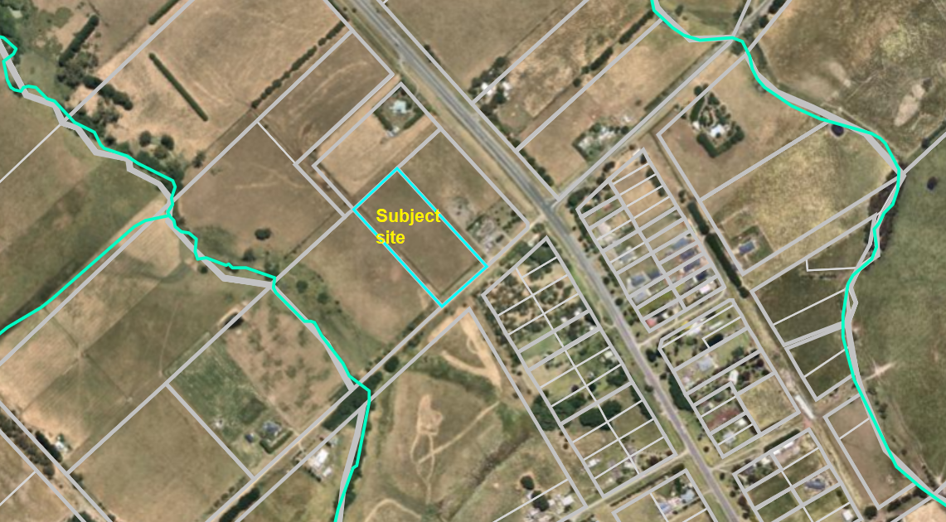
Figure 1: Aerial photograph.

Proposal
It is proposed to use and develop the land for a single storey dwelling. The dwelling would include:
• attached double garage;
• four bedrooms;
• two bathrooms;
• powder room;
• laundry;
• study;
• rumpus;
• living room;
• open plan kitchen, meals and family area;
• alfresco area to the rear.
The total floor area would be 342.59sqm.
The dwelling would be clad with weatherboard and brick, incorporate rendered surfaces, and have a low pitched hipped and gabled Colorbond roof. The dwelling would be centrally located on the lot with a setback 105m from the front title boundary and 24.9m and 34.3m from the respective side boundaries.
Vehicle access would be via a proposed crossover to Hopgoods Road.
The site is unsewered and an onsite treatment system to treat wastewater to a secondary level is proposed. The effluent treatment area would be located in the proposed dwelling’s front setback.

There is no existing or proposed farming enterprise in support of the proposed dwelling. A basic land management plan was provided, which includes control of pest animals and weeds and revegetation of parts of the site with native trees and shrubs. The revegetation is limited to border plantings and is similar in arrangement to a landscape plan for a residential dwelling.
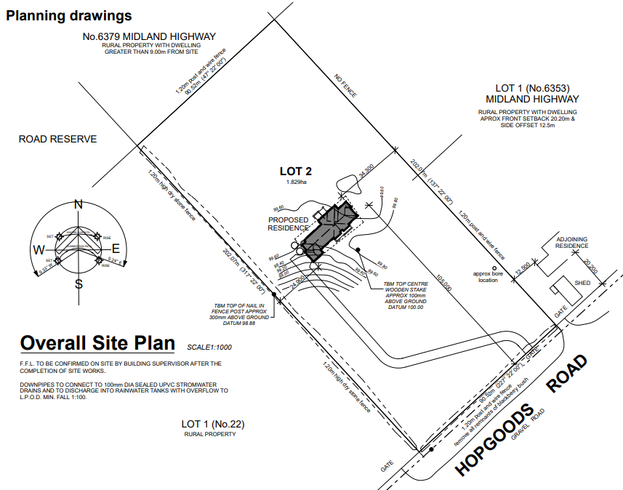
Figure 2: Proposed site plan.
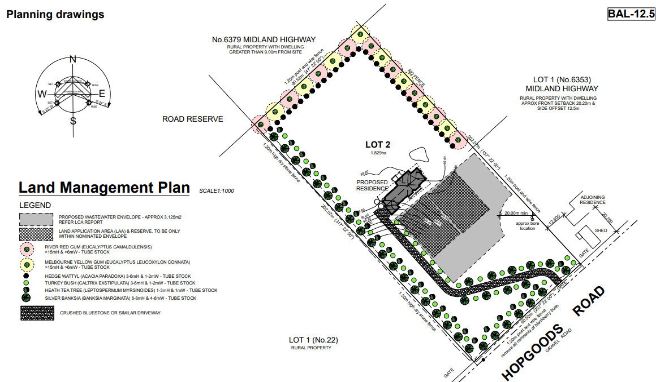
Figure 3: Land management plan.
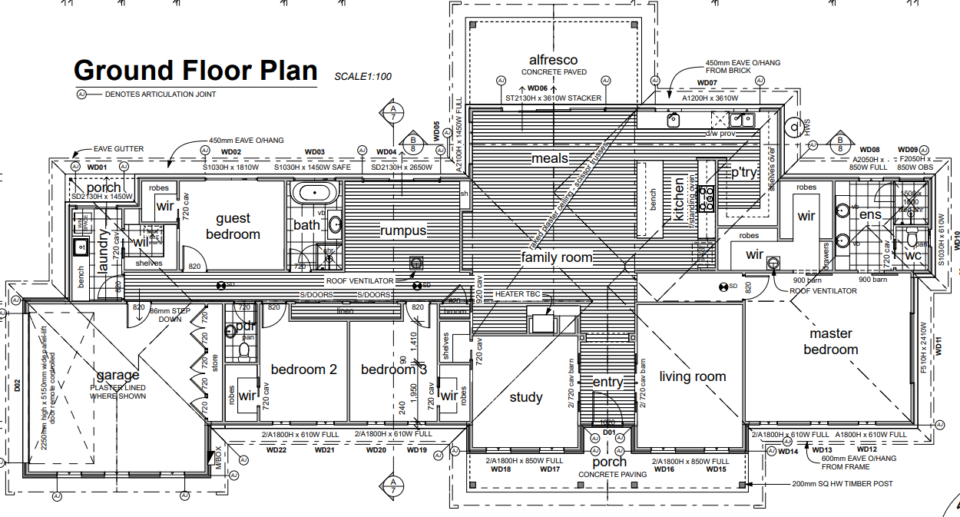
Figure 4: Proposed floor plan.
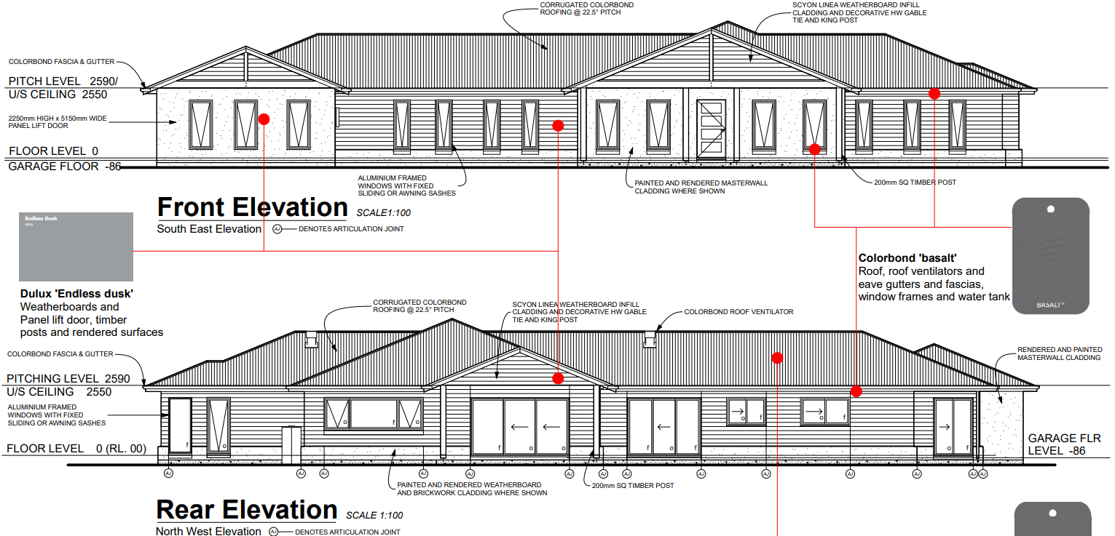
Figure 5: Elevations.
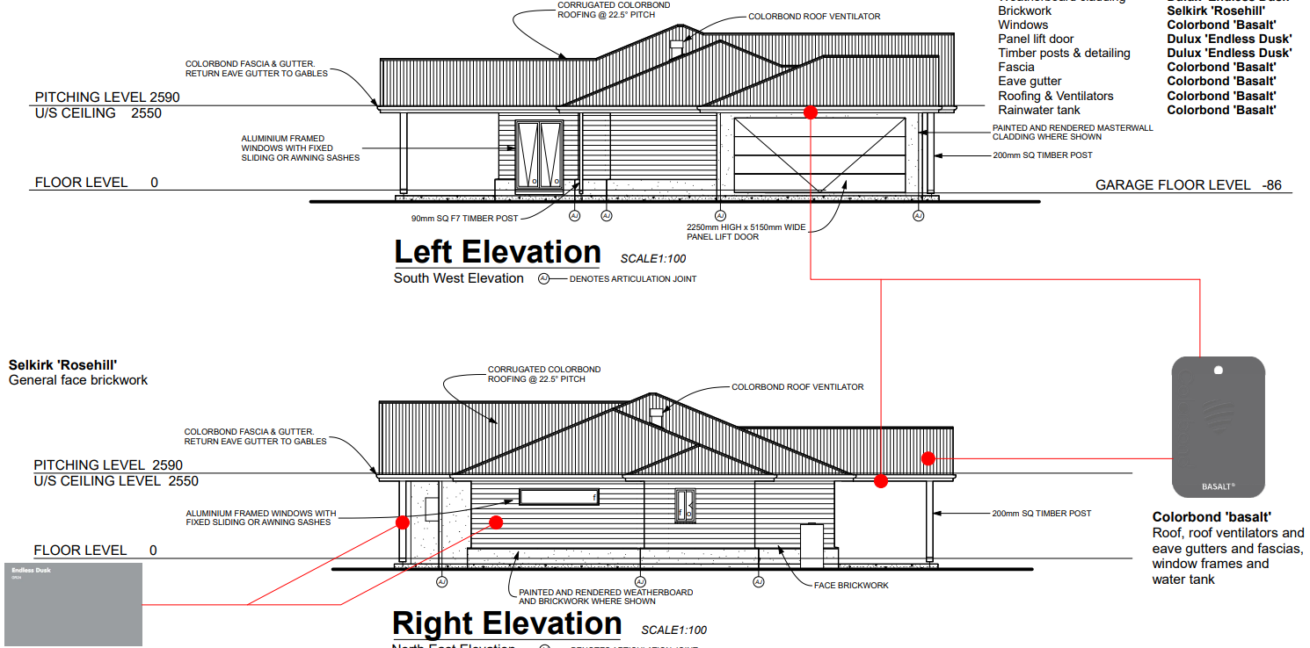
Figure 6: Elevations.

Background to Current Proposal
Not applicable.

History
Not applicable.

Public Notice
Notice of the application was given by way of a sign erected on site and letters posted to adjoining and nearby landowners and occupiers. No objections were received.

Locality Map
The map below indicates the location of the subject site and the zoning of the surrounding area.
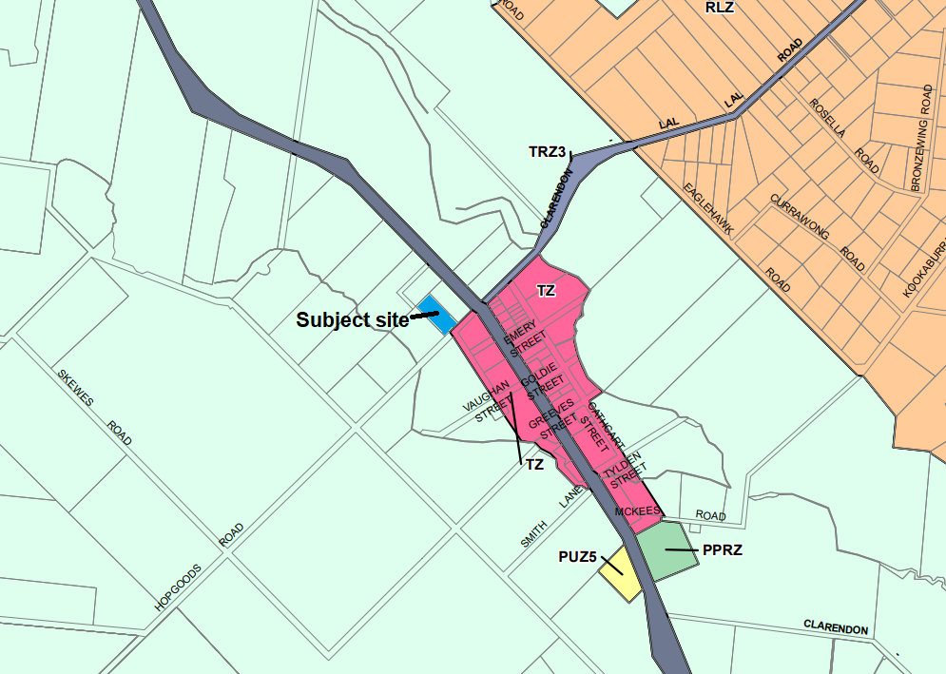
Figure 7: Zone map.

Planning Scheme Provisions
Council is required to consider the Victoria Planning Provisions and give particular attention to the Planning Policy Framework (PPF), the Local Planning Policy Framework (LPPF) and the Municipal Strategic Statement (MSS).
The relevant clauses are:
• Clause 11.01-1R Settlement - Central Highlands
• Clause 11.03-3S Peri-urban areas
• Clause 13.02-1S Bushfire planning
• Clause 14.01-1S Protection of agricultural land
• Clause 15.01-6S Design for rural areas
• Clause 16.01-3S Rural residential development
• Clause 21.02-2 Non-urban landscapes
• Clause 21.03-4 Landscape and neighbourhood character
• Clause 21.03-6 Rural lifestyle opportunities
• Clause 21.04-2 Agriculture
• Clause 21.09-1 Small towns and settlements
• Clause 22.03 Houses and House Lot Excisions in Rural Areas
The proposal does not comply with the relevant PPF and LPPF clauses outlined in the table below:
PPF | Title | Response
Clause 11.03-3S | Peri-urban areas | The proposal would contribute to dispersed settlement beyond the Township Zone in Clarendon which is not supported by this policy.
Clause 14.01-1S | Protection of agricultural land | The use of a small rural lot for a dwelling with no nexus to farming is not supported by this policy.
Clause 16.01-3S | Rural residential development | The proposal lacks strategic justification consistent with this policy.
LPPF

Clause 21.09-1 | Small towns and settlements | This policy discourages residential development located outside of the Clarendon Township Zone.
Clause 22.03 | Houses and house lot excisions in rural areas | The proposed dwelling is unrelated to any farming activity and is inconsistent with this policy.

Zone
The subject site is in the Farming Zone (FZ). The purpose of the FZ is:
• To implement the Municipal Planning Strategy and the Planning Policy Framework.
• To provide for the use of land for agriculture.
• To encourage the retention of productive agricultural land.
• To ensure that non-agricultural uses, including dwellings, do not adversely affect the use of land for agriculture.
• To encourage the retention of employment and population to support rural communities.
• To encourage use and development of land based on comprehensive and sustainable land management practices and infrastructure provision.
• To provide for the use and development of land for the specific purposes identified in a schedule to this zone.
Under Clause 35.07-1 a dwelling is a Section 2 use on a lot of less than 40ha.
Overall, the proposal is inconsistent with the purpose of the zone – see ‘Discussion’ below.

Overlays
The site is affected by Design and Development Overlay, Schedule 2 (DDO2).

Design and Development Overlay, Schedule 2

Under Clause 43.02-3 (DDO) a permit is required to construct buildings and works. Under Schedule 2 there is an exemption where non-reflective external building cladding is proposed, as in this instance. Therefore, a permit is not required under this overlay.

Relevant Policies
Council’s Rural Growth Policy
Council’s Rural Growth Policy Statement was adopted by Council on 19 September 2012. The document applies to all land in Farming Zone.
The policy states:
• Encourage dwellings in areas nominated in Map 1 of Council Rural Growth Policy Statement.
• Ensure the siting of any dwellings is designed to have a minimal impact on any existing or future agricultural activities on the site and on surrounding land.
• Ensure it is clear whether the dwelling is required for agricultural operation, use or to maintain rural communities.
• Ensure sufficient infrastructure is available or that alternative methods are available which do not require normal infrastructure.
• Encourage development of dwellings, to support communities, on land which is unlikely to support agricultural (use) while still considering any other overlays which may impact the land. This is land which is constrained for use as agriculture by other environmental factors such as vegetation, slope, soil quality, etc.
The site is not located within Map 1 of the Council Rural Growth Policy Statement. The policy requires justification for the dwelling based on the proposed agricultural activity. The proposal does not include any agricultural activity and is not considered to sufficiently justify the use of a dwelling.
Council’s Rural Housing Policy
Council’s Rural Housing Policy 2012 was adopted by Council on 19 September 2012 and has been developed to provide direction for how limited farming potential rural dwellings should be considered, and more broadly, rural settlement patterns. This Policy is not incorporated into the Moorabool Planning Scheme.

The principles of the policy relevant to this application include to:
• Support the agricultural sector so that it can be more productive, diverse, resilient, and adaptive to changing agricultural trends, including supporting agricultural activities that recognise Moorabool’s advantageous proximity to market.
• Protect agricultural land use from loss and allow development that increases agricultural productivity.
• Focus growth opportunities in settlements along major transport corridors, in particular where there is physical and social infrastructure and services.
• Recognise that there are substantial existing lots under 40ha capable of supporting the viable operation of agricultural enterprises.
• Promote a rural housing market that meets the needs of the Shire’s rural communities.
• Land parcels for the proposed on-farm living dwellings are to have a minimum lot size of 8ha as identified in Map 1.
The proposed development and use do not align with the above principles. Specifically, the proposal does not accord with the principle to support the agricultural sector so that it can be more productive, diverse, resilient, and adaptive to changing agricultural trends. The land is not being proposed to be used for a productive agricultural purpose which justifies the presence of a dwelling.

Particular Provisions
Not applicable.

Discussion
Overall, the proposed use and development for a dwelling is inconsistent with the relevant provisions of the Moorabool Planning Scheme, in particular state and local planning policies and the Farming Zone.
Relevant planning policies address a range of considerations including rural landscape values, land capability, protection of productive agricultural land and assets, and the location of rural residential development. These policies are outlined above and the proposal’s non-compliance with several of these policies is also noted.
The subject site is a vacant 1.82ha lot on the north-west side of Clarendon’s Township Zone. Given its relatively small size the site’s agricultural value appears limited. Adjoining landholdings are separately owned and similar or slightly larger in size than the subject site and are either vacant or developed with single dwellings. Agricultural uses appear to be generally confined to grazing animals. Notwithstanding the site’s limited opportunity for agricultural use, there is a lack of policy support in the Moorabool Planning Scheme for the use of the land for a dwelling and the policy framework does not encourage dispersal of residential development beyond the boundaries of small towns such as Clarendon.
The proposal does not algin with the purpose of the Farming Zone, considering that the proposal would not support any agricultural activity. Although a land management plan was submitted by the applicant providing for native vegetation plantings and pest animal, and weed control, this is not sufficient justification for a dwelling on this property. Conversely, the proposed dwelling would permanently remove the land from any potential agricultural use and contribute to fragmentation of farming land by reducing the potential for consolidation with adjoining vacant lots which could enhance agricultural production.
The proposal is characteristic of the demand for rural residential development on lots which due to their size, have limited potential for viable agricultural use. The proposal represents the ad hoc nature of such development, which without sufficient strategic justification pose a potentially detrimental outcome for the Shire’s rural landscape character and the intended social, economic, and environmental values. The site lies just outside the existing northwest boundary of Clarendon’s Township Zone where the bulk of housing growth in the area is expected to occur on the numerous existing vacant lots zoned for residential use. The development of dwellings outside of the Township Zone, such as that proposed, contributes to a dispersal of scattered residential development beyond the township boundary. This threatens the rural landscape character which is typified by a generally undulating landscape of open paddocks with planted windbreaks and stands of established trees with only occasional dwellings which are visually unobtrusive in the landscape. Furthermore, the proposal also undermines the potential for new agricultural ventures to develop and prosper on such landholdings and reducing opportunities for contiguous land parcels to be consolidated to increase potential productivity.

General Provisions
Clause 65 - Decision Guidelines have been considered by officers in evaluating this application.
Clause 66 - Stipulates all the relevant referral authorities to which the application must be referred.

Referrals
Authority | Response
Council’s  Infrastructure  Environmental Health | Consent with conditions.  Consent with conditions.

Financial Implications
The recommendation to refuse this application has no financial implications for Council.

Risk & Occupational Health & Safety Issues
The recommendation to refuse this application does not have any risk or OH&S implications for Council.

Communications Strategy
Notice was undertaken for the application, in accordance with s.52 of the Planning and Environment Act 1987, and further correspondence is required to all interested parties to the application as a result of a decision in this matter. The applicant was invited to attend this meeting and address the Development Assessment Committee if required.

Options
• Issue a Refusal to Grant a Permit in accordance with the grounds in the recommendation of this report; or
• should the Development Assessment Committee wish to support the application, issue a Planning Permit with conditions.

Conclusion
There is insufficient policy support in the Moorabool Planning Scheme to approve the proposed use and development of the subject site for a dwelling. The proposed dwelling on a cleared lot of 1.82ha would not be used in conjunction with any agricultural land use, with only a proposed land management plan for partial revegetation and pest and weed control. The proposal represents the loss of farming land to residential use without adequate policy support and does not support the orderly planning of the area.

7.2 Notice of Rescission - PA2021196 Building and Works Associated with Existing Industrial Premises (Abattoir) at 6 Woolpack Road, Bacchus Marsh
Author: Dianne Elshaug, Co-ordinator CEOs Office
Authoriser: Derek Madden, Chief Executive Officer
Attachments: Nil

I, Councillor Moira Berry, give notice that at the next Development Assessment Committee meeting to be held on 16 March 2022, I intend to move the following rescission motion:

MOTION
1. That the Resolution for Item 7.6 from the Development Assessment Committee held on 16 February 2022 be rescinded.
2. That the original recommendation as proposed by Officers be put back to Council for consideration, with an amendment to Condition 4 (operational) as follows:
(a) The proposed building must be removed from the site within seven years of the completion of the development unless otherwise agreed to by Council.

RATIONALE
The timeframe of five years as proposed in the original recommendation is of insufficient time; seven years is a more reasonable timeframe.
I commend this Notice of Rescission to Council.

8 Update on Trends, Issues and Other Matters

9 Process Forward and Work Program

10 Update on VCAT Decisions

11 Other Business

12 Date of Next Meeting
Wednesday 20 April 2022.

13 Meeting Close

