MINUTES
Development Assessment Committee Meeting
Wednesday, 19 May 2021
Date: | Wednesday, 19 May 2021
Time: | 6.00pm
Location: | Pavilion Room, Darley Civic and Community Hub

Order Of Business
1 Opening 3
2 Present and Apologies 3
3 Recording of Meeting 3
4 Confirmation of Minutes 3
5 Matters Arising from Previous Minutes 3
Nil
6 Disclosure of Conflicts of Interests 3
7 Community Planning Reports 5
7.1 PA2020245 Development and Use of a Dwelling at Lot 106 Thynes Road, Mount Egerton 5
7.2 PA2020158 - Multi-lot Subdivision at 174 Mortons Road, Pentland Hills (Underbank Estate) 19
7.3 PA2020251 Development and Use of a dwelling at 1124 Old Melbourne Road, Ballan 52
7.4 PA2020101 - Use and Development of a Dwelling and Dependent Persons Unit and ancillary shed at 187 Camerons Road Coimadai 71
7.5 PA2003472, PA2003473, PA2003474, PA2003475 - Sixth extension of time for use and development of a single dwelling at Conroys Lane Wallace 85
7.6 PA2020275 - Use and Development of a Second Dwelling for Short Term Accommodation, Use of Land for Agriculture and works in an ESO1 98
7.7 PA2019142 - Use of the Land for Domestic Animal Husbandry at 29 Evergreen Way Gordon 115
7.8 PA2020218 Development of a Dwelling and Use of an existing building for a Residential Building (Short-Term Tourist Accommodation) at 278 Moorabool West Road, Gordon 129
8 Update on Trends, Issues and Other Matters 148
Nil
9 Process Forward and Work Program 148
Nil
10 Update on VCAT Decisions 148
11 Other Business 148
12 Date of Next Meeting 148
13 Meeting Close 148

1 Opening
The Mayor opened the meeting at 6:00pm

2 Present and Apologies
Cr Tom Sullivan, Mayor West Moorabool Ward
Cr Tonia Dudzik East Moorabool Ward
Cr David Edwards East Moorabool Ward
Cr Moira Berry East Moorabool Ward
Cr Ally Munari Woodlands Ward
Cr Paul Tatchell Central Moorabool Ward
Officers:
Mr Derek Madden Chief Executive Officer
Mr Henry Bezuidenhout Executive Manager Community Planning & Economic Development
Ms Vanessa Osborn Acting Manager Statutory Planning & Building Services
Mr Anthony Smith Acting Manager Governance, Risk & Corporate Planning
Mr Mark Lovell Coordinator Statutory Planning
APOLOGIES:
Nil

3 Recording of Meeting
The Mayor advised that the meeting is being livestreamed via Council’s website.

4 Confirmation of Minutes
Committee Resolution
Moved: Cr Paul Tatchell
Seconded: Cr Ally Munari
That the minutes of the Development Assessment Committee Meeting held on Wednesday 21 April 2021 be confirmed.
Carried

5 Matters Arising from Previous Minutes
Nil

6 Disclosure of Conflicts of Interests
Cr Tom Sullivan declared a Conflict of Interest due to a close association with an Objector in Item 7.8.

Presentation/Deputations
Item | Community Planning and Economic Development | Speaker/s | Position | Attendance
7.1 | PA2020245 Development and Use of a Dwelling at Lot 106 Thynes Road, Mount Egerton | Ms. Janine Ryan | Applicant | In person
7.3 | PA2020251 Development and Use of a dwelling at 1124 Old Melbourne Road, Ballan | Ms. Laura Clark | Applicant | In Person
7.3 | PA2020251 Development and Use of a dwelling at 1124 Old Melbourne Road, Ballan | Mr. Warren Meiss | Owner | In Person
7.5 | PA2003472, PA2003473, PA2003474, PA2003475 - Sixth extension of time for use and development of a single dwelling at Conroys Lane, Wallace | Mr. Ramon Jimenez & Mrs. Elma Jimenez | Applicant | In Person
7.7 | PA2019142 - Use of the Land for Domestic Animal Husbandry at 29 Evergreen Way, Gordon | Mrs. Bridget Clow | Applicant | In Person
7.7 | PA2019142 - Use of the Land for Domestic Animal Husbandry at 29 Evergreen Way, Gordon | Mr. & Mrs. Kris | Supporter to Recommendation | Written
7.7 | PA2019142 - Use of the Land for Domestic Animal Husbandry at 29 Evergreen Way, Gordon | Mr. & Mrs. Westoby | Supporter to Recommendation | Written
7.8 | PA2020218 Development of a Dwelling and Use of an existing building for a Residential Building (Short-Term Tourist Accommodation) at 278 Moorabool West Road, Gordon | Mrs. Elise Jreige | Applicant | In Person

7 Community Planning Reports
Ms. Janine Ryan addressed Council as the applicant associated with Item 7.1.

7.1 PA2020245 Development and Use of a Dwelling at Lot 106 Thynes Road, Mount Egerton
Author: Victoria Mack, Statutory Planner
Authoriser: Henry Bezuidenhout, Executive Manager Community Planning & Economic Development
Attachments: 1. Dwelling floor plan (under separate cover)
2. Dwelling Elevations (under separate cover)
3. Original site plan (under separate cover)

Application Summary
Permit No: PA2020245
Lodgement Date: 29 October 2020
Planning Officer: Victoria Mack
Address of the land: Thynes Road, Mount Egerton
Lot 106 on PC 353819M
Proposal: Development and Use of a Dwelling
Lot size: 10.96ha
Why is a permit required? Farming Zone - use and development of a dwelling on lot less than 40ha
Environmental Significance Overlay, Schedule 1 – Buildings and works

Committee Resolution
Moved: Cr Paul Tatchell
Seconded: Cr Ally Munari

That the Development Assessment Committee, having considered all matters as prescribed by the Planning and Environment Act 1987, issues planning permit PA2020245 for the Development and Use of a Dwelling at Thynes Road, Mount Egerton, otherwise known as Lot 106 on PC 353819M, with the following conditions:

Endorsed Plans:
- Before the use and/or development starts, amended plans to the satisfaction of the Responsible Authority must be submitted to and approved by the Responsible Authority. When approved, the plans will be endorsed and will then form part of the permit. The plans must be drawn to scale with dimensions. The plans must be generally in accordance with the plans submitted with the application but modified to show a detailed site plan to include:
  - The dwelling located in the northwest corner of the site and the location of the shed.
  - The setback distances of both the dwelling and shed from the road and west side boundary, as well as from each other.
  - The farm site plan including fenced paddock plan, laneways, yards and water supply.
  - The revegetation areas and/or new plantations including width, number of rows and the species to be planted and number of each species.
Unless otherwise approved in writing by the Responsible Authority, all buildings and works are to be constructed and or undertaken in accordance with the endorsed plans to the satisfaction of the Responsible Authority prior to the commencement of the use.

Farm Management Plan:
- A Farm Management Plan to the satisfaction of the Responsible Authority must be endorsed as part of this permit and cannot be varied without the written consent of the Responsible Authority.

Section 173 Agreements:
- Before the issue of a Building Permit the owner must enter into an agreement with the Responsible Authority made pursuant to Section 173 of the Planning and Environment Act 1987 to the satisfaction of the Responsible Authority:
  - The owner of the land must acknowledge that while the land remains zoned as Farming Zone or its equivalent successor the primary use of the land is for agricultural activities and the use of the dwelling must be in conjunction with an approved agricultural activity.
  - Agricultural activities and environmental management identified in the endorsed Farm and Land Management Plan must be undertaken on the land and must be in accordance with the Farm Management Plan endorsed under Condition 2 of the Planning Permit and cannot be varied without the written consent of the Responsible Authority.
  - Before a Building Permit is issued for the dwelling, application must be made to the Register of Titles to register the Section 173 Agreement on the title to the land under Section 181 of the Planning and Environment Act 1987 and the owner must provide evidence of that registration of the Agreement to the Responsible Authority.
  - The owner must pay the reasonable costs for the preparation, execution and registration of the Section 173 Agreement.

Materials and Colour:
- All external walls and roof areas of the proposed building/s are to be clad with non-reflective materials (zincalume prohibited) to the satisfaction of the Responsible Authority.

Dwelling Requirements:
- Access to the dwelling must be provided via an all-weather road with dimensions adequate to accommodate emergency vehicles.
- The dwelling must be connected to a reticulated potable water supply or have an alternative potable water supply with adequate storage for domestic use as well as for firefighting purposes.
- The dwelling must be connected to a reticulated electricity supply or have an alternative energy source.
- The dwelling must be connected to a reticulated sewerage system or if not available, the wastewater must be treated and retained on-site in accordance with State Environment Protection Policy (Waters of Victoria) under the Environment Protection Act 1970.

Native Vegetation:
- Unless exempt under Clause 52.17 or any other relevant provision of the Moorabool Planning Scheme, native vegetation must not be removed, destroyed or lopped without further planning approval.
- The land application area and all conditions must be in accordance to the Land Capability Assessment prepared by Ballarat Soil Testing, ref number JR221020 dated 23 October 2020 or any approved amendment are to be strictly adhered to.
- An onsite waste water management system with the capacity to treat effluent to a minimum of 20mg/L BOD, 30mg/L SS and 10orgs/100ml with chlorination, i.e. secondary treatment via an aerated wastewater treatment system must be installed.
- Effluent disposal must be undertaken via subsurface irrigation system designed and installed by a wastewater irrigation expert in accordance with the EPA Code of Practice for Onsite Waste Water.
- The wastewater management system from proposed dwelling/lots must be treated and contained within the property boundaries in accordance with the current EPA Code of Practice Onsite Wastewater Management: Guidelines for Environmental Management, Australian Standards 1547 and Council requirements.
- The effluent disposal area must be kept free of buildings, driveways, vehicular traffic and services trenching.
- All setback distances must be adhered to as dictated by Table 5 of the Code of Practice, Onsite Wastewater Management, EPA Publication Number 891.4.
- A shallow surface water cut off drain or surface water diversion mound, should be provided on the high side of the disposal areas to divert any surface water flows around the effluent fields.
- Subsurface Irrigation system needs to be installed to a depth of 150mm in situ or if the soil is of poor quality, imported good quality topsoil may be required, with a 1m spacing in between lines.

Infrastructure:
- A standard rural vehicle crossing must be provided on Thynes Road to the satisfaction of the Responsible Authority. A vehicle crossing permit must be taken out for the construction of the vehicle crossing.
- Stormwater drainage from the proposed buildings and impervious surfaces must be retained and disposed of within the boundaries of the subject land to the satisfaction of the Responsible Authority. Overflows from on-site storage systems must be directed away from any waste water disposal areas.
- Sediment discharges must be restricted from any construction activities within the property in accordance with relevant Guidelines including Construction Techniques for Sediment Control (EPA 1991).
- Unless otherwise approved by the responsible authority there must be no buildings, structures, or improvements located over proposed drainage pipes and easements on the property.

- Prior to the commencement of the development and post completion, notification including photographic evidence must be sent to Council’s Asset Services department identifying any existing damage to council assets. Any existing works affected by the development must be fully reinstated at no cost to and to the satisfaction of the Responsible Authority.

Barwon Water:
- Wastewater treatment is to achieve a minimum water quality standard of 20mg/L BOD, 30mg/L SS and 10 orgs/100ml, i.e. secondary treatment, via an EPA approved all wastewater treatment system.
- Effluent disposal must be undertaken via a subsurface irrigation system designed and installed by a wastewater irrigation expert as recommended in the Ballarat Soil Testing Land Capability Assessment – Report No. JR221020 dated 23 October 2020 and to the satisfaction of Moorabool Shire Environmental Health Officers.
- All components of the wastewater management system including the effluent disposal area must be located at least 100m from any surface waterway.
- All stormwater must be directed away from the effluent disposal area and roof stormwater must not be disposed to the effluent disposal area.
- Monitoring, Operation and Maintenance must be undertaken in accordance with Ballarat Soil Testing Land Capability Assessment – Report No. JR221020 dated 23 October 2020 and to the satisfaction of Moorabool Shire Environmental Health Officers.
- The effluent disposal field must be protected by being isolated from any building, driveway, livestock, and vehicles.
- Sediment control measures as outlined in the EPA’s publication No 275 Sediment Pollution Control shall be employed during the construction of the dwelling and maintained until the disturbed area has regenerated.
- Prior to a certificate of occupancy being issued for the dwelling the owner must enter into an agreement with the Responsible Authority and Barwon Water in accordance with Section 173 of the Planning and Environment Act 1987 requiring that:
  - The Owner is to enter into a service contract to have any wastewater treatment facility and effluent disposal system for the dwelling inspected and maintained in accordance with the EPA Certificate of Approval for the installed system.
  - The Owner must provide to Barwon Water and the Responsible Authority an annual report on the condition and operation of the wastewater treatment system which documents the effluent quality achieved and provides laboratory, inspection and maintenance reports for the preceding 12 months.
  - The Owner shall have the wastewater treatment facility desludged at least once every three years or as otherwise determined by Council’s Environmental Health Officer. Evidence of this desludging shall be provided in the annual report referred to in Clause (b) here in.
  - The Owner shall carry out any works considered necessary by the service contractor to ensure the satisfactory operation of the wastewater treatment facility and effluent disposal system.

  - The Owner will maintain all drainage lines at all times to divert surface water and subsurface water clear of the effluent disposal field.
  - The Owner and the Responsible Authority agree to do all things necessary to register a memorandum of this Agreement on the title of the land pursuant to Section 181 of the Planning and Environment Act 1987.
  - The Owner shall meet all costs of inspections, reports and works referred to in Clauses (a), (b), (c), (d), and (e) herein and all costs of the Responsible Authority in relation to stamping and registration of this Agreement.
- The Owner shall not sell or enter into any contract to sell the land until this Agreement has been registered pursuant to Clause (f) herein. Barwon Water
require the Section 173 to be signed by the Managing Director and Company Secretary and to state the following: THE COMMON SEAL of the BARWON REGION WATER CORPORATION was hereunto affixed in the presence of.

Permit Expiry:
- This permit will expire if:
  - The development and use are not started within two years of the date of this permit; and
  - The development is not completed within four years of the date of this permit.

Permit Note:
Prior to installation of works commencing on the wastewater system, a permit to install an onsite wastewater management system must be submitted to Environmental Health.
Carried

Public Consultation
Was the application advertised? | Yes.
Notices on site: | Yes, one notice on Thynes Road.
Notice in Moorabool Newspaper: | No.
Number of objections: | Nil.
Consultation meeting: | Not applicable.

Policy Implications
The Council Plan 2017-2021 provides as follows:
Strategic Objective 2: Minimising Environmental Impact
Context 3A: Land Use Planning
The proposal is not provided for in the Council Plan 2017-2021 and can be actioned by utilising existing resources.

Victorian Charter of Human Rights & Responsibilities Act 2006
In developing this report to Council, the officer considered whether the subject matter raised any human rights issues. In particular, whether the scope of any human right established by the Victorian Charter of Human Rights and Responsibilities is in any way limited, restricted or interfered with by the recommendations contained in the report. It is considered that the subject matter does not raise any human rights issues.

Officer’s Declaration of Conflict of Interests
Under section 130 of the Local Government Act 2020, officers providing advice to Council must disclose any interests, including the type of interest.
Executive Manager – Henry Bezuidenhout
In providing this advice to Council as the Executive Manager, I have no interests to disclose in this report.
Author – Victoria Mack
In providing this advice to Council as the Author, I have no interests to disclose in this report.

Executive Summary
Application referred? | Yes, to Barwon Water, Council’s Environmental Health and Infrastructure.
Any issues raised in referral responses? | No.
Preliminary concerns? | Proposal to run cattle on 10.9ha did not sufficiently justify the need for a dwelling on the land.
Any discussions with applicant regarding concerns? | A request for further information was sent to the applicant requesting a site plan for the property with dimensions showing the proposed dwelling and shed, including setback distances from at least two property boundaries, the crossover and driveway access, proposed paddocks, water supply and dam/s, location of the cattle infrastructure such as yards and the proposed shelter belt/s. This was provided but in rudimentary format.  It was also requested that the Farm Management Plan (FMP) was upgraded to provide more detailed information in relation to the proposed farming enterprises.
Any changes made to the application since being lodged? | A more detailed Farm Management Plan was provided in relation to the cattle enterprise. In year one, eight Angus steers weighing approximately 350- 400kgs would be purchased and grown on and after approximately nine months would be sold with an estimated weight gain of 150-200kgs. Hay would also be cut with round bales produced and approximately half of the bales would be sold. Following a pasture improvement program, six Angus stud cows would be run with calves each year.  The farm plan covered the costs and financial returns in detail, but less detail was provided on the operational actions to develop the farm.
Brief history. | The land has been used for predominantly grazing and hay production. Two crown allotments, CA 105 and CA 106, were consolidated in 1993 to make up the current Plan of Consolidation.
Previous applications for the site? | PA2010087 being for the development and use of a dwelling which was withdrawn in 2010.
General summary. | The land is 10.9ha. The owner/applicant would run cattle on the site, specifically six stud angus cows and calves and a bull. These number might increase over time; and male calves may be grown on to be sold as stud bulls.  The proposal does not overstock the property, and it is understood that the owner/applicant is a committed beef producer. However, it is not considered that running six cows justifies the use of a dwelling on the site.  However, it is considered that approval of this application would set a precedent in the Farming Zone in the Moorabool Shire that would encourage more rural residential development applications at the expense of protecting agricultural land for agriculture.
Summary of Officer’s Recommendation
That, having considered all relevant matters as required by the Planning and Environment Act 1987, Council issues a Refusal to Grant a Planning Permit for Development and Use of a Dwelling at Lot 106 Thynes Road, Mount Egerton otherwise known as Lot 106 on PC 353819M.

Site Description
The site is 10.9ha and is undeveloped farming land located on the south side of Thynes Road. The site is relatively flat and square in shape. Access from Thynes Road is via a rural gateway located approximately centrally on the north side boundary.
The site is generally pastured grazing land with a few scattered trees and a dam located at the rear of the property in the south-west corner. There is a plantation on the neighbouring property on the south boundary and the north boundary road verge has native vegetation.
The pastures at the time of inspection appeared to be reasonably productive with dominant stands of clover and fescue or rye grass.
The site is approximately 250m west of the intersection of Thynes Road with the Egerton-Ballark Road, and approximately 900m east of the Lal Reservoir.
The immediate surrounding area is predominantly vacant farming lots of similar or larger size. A number of these lots are in the same ownership. There are scattered dwellings on the Egerton-Ballark Road and also on Corries Lane to the southeast of Thynes Road.
An electricity supply is available on Thynes Road.
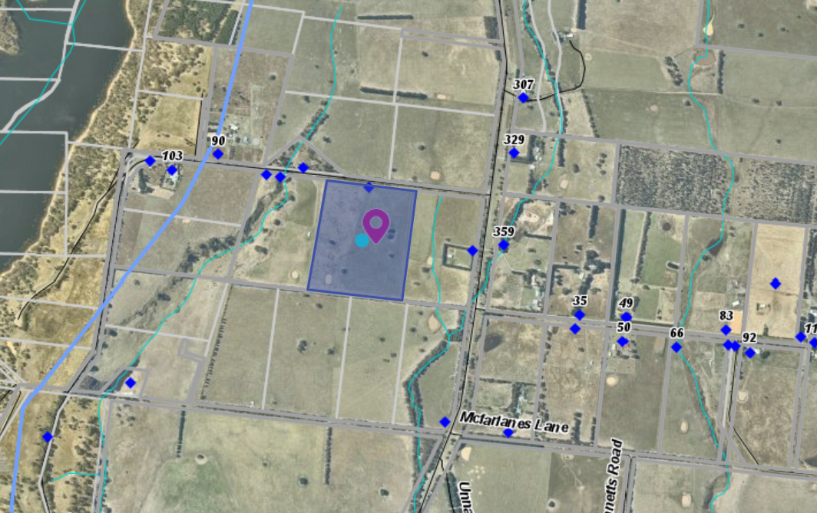
Figure 1: Aerial photograph of site

Proposal
It is proposed to develop the land for a dwelling and farm infrastructure.
The single storey dwelling was to be located centrally on the lot but was changed to a location in the northwest corner of the site, setback 100m from Thynes Road and 50m from the west side boundary. A shed would be located southwest of the dwelling setback 15m from the west boundary. The shed would have a floor area of 106.58sqm. No shed plans were provided.
The dwelling would contain four bedrooms, two bathrooms, an open plan kitchen, meals and family room, a separate Lounge room, an entrance hallway, a laundry with large store and separate toilet, and an attached two car garage. There would be a covered alfresco area and an 8.5m x 3.8m proposed pool. A verandah will be constructed on all four sides of the dwelling.
The dwelling would be constructed with face brick cladding and would have a Colorbond roof. The floor area of the dwelling would be approximately 250sqm.
Access would be from a new crossover in the northwest corner of the site to Thynes Road.
It is proposed to develop the land including fencing, water supply, cattle yards and pastures to run cattle.
Initially there would be eight steers purchased for fattening and sale, and then six stud angus cows would be purchased and a stud angus bull as back up. The breeding operation would produce six calves produced each year. Hay would be cut each spring. Pastures would be renovated, and fertiliser applied regularly including lime to increase the soil pH level.
A plantation would be constructed in the south-west corner of the site comprising 150 trees in March 2021 and a further 150 trees in the winter 2021. The plantation would be 6m wide.
The family farm is located approximately 650m to the northeast of the subject site. The applicant’s active cattle production involvement on the family farm will continue.

History
Two crown allotments were consolidated in approximately 1993. The subject site is titled as a Plan of Consolidation.

Public Notice
The application was notified to adjoining and surrounding landowners. No objections were received.

Locality Map
The map below indicates the location of the subject site and the zoning of the surrounding area.
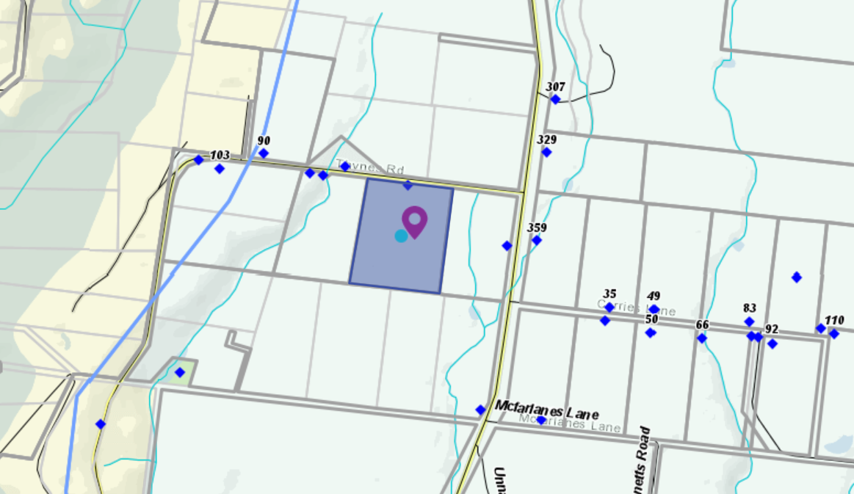
Figure 2: Zone Map

Planning Scheme Provisions
Council is required to consider the Victoria Planning Provisions and give particular attention to the Planning Policy Framework (PPF), the Local Planning Policy Framework (LPPF) and the Municipal Strategic Statement (MSS).
The relevant clauses are:
• Clause 11.03—Peri Urban Areas
• Clause 14—Natural Resource Management
• Clause 14.01-1S—Protection of agricultural land
• Clause 14.02-1S—Catchment planning and management
• Clause 14.02-2S—Water quality
• Clause 15.01-6S—Design for rural areas
• Clause 16.01-5S—Rural residential development
• Clause 22.03 Houses and House Lot Excisions in Rural Areas
• Clause 21.02-3 Objective—Water and catchment management
• Clause 21.03-4 Objective—Landscape and neighbourhood character
• Clause 21.03-6 Objective—Rural lifestyle opportunities
• Clause 21.04-Economic Development and Employment
• Clause 21.04-1—Key issues and influences Agriculture and horticulture
• Clause 21.04-2 Objectives—Agriculture
The proposal does not comply with the relevant sections of the PPF and LPPF, outlined in the table below:
PPF | Title | Response
Clause 11.03-3S | Peri-urban areas | The proposal would intensify the rural residential use of the land, resulting in the loss of farming land.
Clause 14.01-1S | Protection of agricultural land  Objective To protect the state’s agricultural base by preserving productive farmland. | The proposal increases residential use of farming land and diminishes the capacity of the site to support agriculture activity.  Running six stud cows and calves does not demonstrate a need for the development and use of a dwelling for agricultural purposes.
Clause 16.01-5S | Rural residential development  Objective To identify land suitable for rural residential development. | The proposal does not protect high quality agricultural land and is considered to be inappropriate rural residential development located within Farming Zone.
LPPF
Clause 21.02-2 | Non-Urban Landscapes. | The proposal would increase residential development in a rural location which erodes the rural character of the area and set a precedent for similar applications on small lots.
Clause 21.03-4 | Landscape and Neighbourhood Character | The proposed dwelling’s benefit to agriculture is not sufficiently justified.
Clause 21.03-6 | Objective—Rural lifestyle opportunities | The proposal would fragment productive agricultural land and set a precedent for similar applications on small lots.

Clause 21.04-2 | Objectives—Agriculture  To protect good quality agricultural land and support the productivity and sustainability of existing and future agricultural and horticultural activities. | The proposal would not support productive, sustainable farming, as it removes productive land from farming purposes

Zone
Farming Zone
The purposes of the Zone is:
• To implement the Municipal Planning Strategy and the PPF.
• To provide for the use of land for agriculture.
• To encourage the retention of productive agricultural land.
• To ensure that non-agricultural uses, including dwellings, do not adversely affect the use of land for agriculture.
• To encourage the retention of employment and population to support rural communities.
• To encourage use and development of land based on comprehensive and sustainable land management practices and infrastructure provision.
• To provide for the use and development of land for the specific purposes identified in a schedule to this zone.
In accordance with Clause 35.07-1, a permit is required to use land for a dwelling where the land is less than 40ha.
In accordance with Clause 35.07-4 a permit is required for a building or works associated with a use in Section 2 of Clause 35.07-1, and where a building or works is within 100m of a dwelling not in the same ownership.
The nearest neighbouring dwelling is located within 350m of the site; therefore, this permit trigger does not apply. There is no neighbouring dwelling within 100m of the site. However, as the development is a Section 2 use a permit is required for buildings and works.

Overlays
Environmental Significance Overlay, Schedule 1
In accordance with Clause 42.01-2 a permit is required for buildings and works.
Design and Development Overlay, Schedule 2
In accordance with Clause 43.02 Schedule 2 of the this overlay a permit is not required where all external cladding of buildings is non-reflective. In this application, there is no reflective materials proposed and therefore a permit is not required under this overlay.

Relevant Policies
Council’s Rural Growth Policy Statement
Council’s Rural Growth Policy Statement was adopted by Council on 19 September 2012. The document applies to all land in Farming Zone. This Council policy is not incorporated into the Moorabool Planning Scheme.
The policy states:
• Encourage dwellings in areas nominated in Map 1 of Council Rural Growth Policy Statement.
• Ensure the siting of any dwellings is designed to have a minimal impact on any existing or future agricultural activities on the site and on surrounding land.
• Ensure it is clear whether the dwelling is required for agricultural operation, use or to maintain rural communities.
• Ensure sufficient infrastructure is available or that alternative methods are available which do not require normal infrastructure.
• Encourage development of dwellings, to support communities, on land which is unlikely to support agricultural (use) while still considering any other overlays which may impact the land. This is land which is constrained for use as agriculture by other environmental factors such as vegetation, slope, soil quality, etc.
The policy requires justification for the dwelling based on the proposed agricultural activity. The proposal is to run six stud breeding cows and calves on this site with approximately 9.9ha of available farming land (less the dwelling and shed site). The site would sustainably run six cows. However, such a small enterprise does not justify the use of a dwelling on the site to manage its operation.
Council’s Rural Housing Policy
Council’s Rural Housing Policy 2012 was adopted by Council on 19 September 2012 and has been developed to provide direction for how limited farming potential rural dwellings should be considered, and more broadly, rural settlement patterns. This Council policy is not incorporated into the Moorabool Planning Scheme.
The principles of the policy relevant to this application include to:
• Support the agricultural sector so that it can be more productive, diverse, resilient and adaptive to changing agricultural trends, including supporting agricultural activities that recognise Moorabool’s advantageous proximity to market.
• Protect agricultural land use from loss and allow development that increases agricultural productivity.
• Focus growth opportunities in settlements along major transport corridors, in particular where there is physical and social infrastructure and services.
• Recognise that there are substantial existing lots under 40ha capable of supporting the viable operation of agricultural enterprises.
• Promote a rural housing market that meets the needs of the Shire’s rural communities
• Land parcels for the proposed on-farm living dwellings are to have a minimum lot size of 8ha as identified in Map 1.
The proposed development and use of a dwelling does not align with the above principles and furthermore it is considered to undermine the agricultural potential of the land that is highly productive.
The lot is small in area and with the land taken by the dwelling and it associated effluent field, leaving less area for a productive agricultural use that can be sustained in the long term. The proposal does not meet the principle of Council’s Rural Housing Policy of having an existing lot less than 40ha capable of supporting a viable operation of an agricultural enterprise.

Discussion
The Moorabool Planning Scheme provides discretion for a permit to be granted to use and develop land for a dwelling on a lot less than 40ha. Where a permit is required, the decision guidelines of the Farming Zone require a range of matters be considered.
The application does not accord with the purposes of the Farming Zone. The proposal does not support the retention of productive agricultural land. It does not encourage the use and development of land based on comprehensive and sustainable land management practices and infrastructure provision. While the applicant has stated commitment to sustainable agriculture this was not documented in the Farm Management Plan. It is considered that this application does not encourage the retention of highly productive agricultural land.
In relation to dwellings in the Farming Zone, the decision guidelines require that the Responsible Authority to consider whether a dwelling will result in the loss or fragmentation of productive agricultural land.
Based on an assessment against the Prograze Manual which assesses Dry Sheep Equivalent (DSE) values for different classes of Cattle, a breeding cow is rated between 10-22 DSE depending on the weight of the cow and assuming calves are weaned at eight months with an average DSE over the year of 15DSE/Ha. It is estimated that the site would support between six and seven cows. The application also provides for supplementary feeding on an “as needs” basis. There is no clear need for a dwelling to support six to seven cows on this property.
The proposal is not supported by either the PPF or the LPPF which includes protection of the state’s agricultural base by preserving productive farmland (Clause 14.01-1S.) and maintaining and enhancing the natural environment and the Shire’s rural identity and character. (Clause 21.02-2).
It is considered that the proposal would adversely affect high quality agricultural land from being used for a wholly productive purpose with the introduction of rural residential use. A dwelling on such a small holding is not justified in the context of a small herd of cows.
Overall, the proposed use and development for a dwelling is considered to be inconsistent with the PPF and LPPF, the Farming Zone objectives and the relevant decision guidelines at Clause 65 of the Moorabool Planning Scheme.

General Provisions
Clause 65 – Decision Guidelines have been considered by officers in evaluating this application.
Clause 66 – Stipulates all the relevant referral authorities to which the application must be referred.

Referrals
The application was referred to the following authorities:
Authority | Response
Barwon Water | Consent with conditions.
Infrastructure  Environmental Health | Consent with conditions.  Consent with conditions.

Financial Implications
There is no financial implication associated with this refusal to grant a permit for this use and development of a dwelling.

Risk & Occupational Health & Safety Issues
The recommendation of refusal of this use and development does not implicate any risk or OH&S issues to Council.

Communications Strategy
Notice was undertaken for the application, in accordance with s.52 of the Planning and Environment Act 1987, and further correspondence is required to all interested parties to the application as a result of a decision in this matter. The applicant was invited to attend this meeting and address Council if required.

Options
Council could consider the following options:
• Issue a refusal to grant a permit in accordance with the recommendations of this report; or
• issue a permit with conditions outside of the recommendations of this report.

Conclusion
The site is located in an agricultural district that has productive agricultural soils and good water. The planning policies and Farming Zone provisions seek to prevent the loss or fragmentation of agricultural land with dwellings. The Farm Management Plan submitted did not demonstrate the need for a dwelling to support such a small number of breeding cows. It is unlikely a productive farming use of the land in the long term can be sustained due to the small land area and the type of farming activity. Additional residential development on prime agricultural land does not accord with the planning policies of the Moorabool Planning Scheme. It is recommended the application be refused with specified grounds.

7.2 PA2020158 - Multi-lot Subdivision at 174 Mortons Road, Pentland Hills (Underbank Estate)
Author: Jyoti Makan, Senior Statutory Planner
Authoriser: Henry Bezuidenhout, Executive Manager Community Planning & Economic Development
Attachments: Nil

Application Summary
Permit No: PA2020158
Lodgement Date: 6 September 2020
Planning Officer: Jyoti Makan
Address of the land: 174 Mortons Road, Pentland Hills - Lot S7 (Part) in Plan of
Subdivision 725408Y in Volume 11939 and Folio 012 (Underbank Estate)
Proposal: Multi-lot Subdivision and Removal and Creation of Easements
Lot size: 136.90 hectares – Lot S7
Proposed Development Area – 12.77 hectares
Why is a permit required? Clause 32.08-3 - Subdivide land
Clause 42.01-2 - Building and works within
Environmental Significance Overlay Schedule 2
Clause 42.01-2 - Subdivide land
Clause 52.02- Create or vary an easement
Clause 52.17 - Remove native vegetation
Committee Resolution
Moved: Cr Moira Berry
Seconded: Cr David Edwards
That the Development Assessment Committee, having considered all matters as prescribed by the Planning and Environment Act 1987, supports the application PA2020158 to issue a planning permit subject to the following conditions:
1. Prior to certification of a plan of subdivision, amended plans to the satisfaction of the Responsible Authority must be submitted to and approved by the Responsible Authority. When approved the plans will be endorsed and will then form part of the permit. The plans must be generally in accordance with the Subdivision Masterplan Package (Revision 15) prepared by Taylors Development Strategists Pty Ltd but amended to show:
(a) Cut and fill depths and heights.
(b) Location, heights and details of retaining walls.

Endorsed plans
2. The formal plan of subdivision lodged for certification must be generally in accordance with the endorsed plan and must not be modified except to comply with statutory requirements or with the written consent of the Responsible Authority.
Subdivision
3. The plan of subdivision submitted for certification under the Subdivision Act 1988 must be referred to the relevant authority in accordance with Section 8 of that Act.
4. All staging must be provided in numerical sequence, unless otherwise agreed in writing by the Responsible Authority.
5. All Infrastructure must be constructed in sequence and as identified for construction in the approved Underbank Development Plan, unless otherwise agreed in writing by the Responsible Authority.
6. Development staging must provide for the timely provision and delivery of:
(a) Connector streets.
(b) Street links between properties, constructed to the property boundary.
(c) Connection of the on-road and off-road pedestrian and bicycle network.
7. Utility service substations, kiosk sites and the like must not be located on any land identified as public open space or land to be used for any municipal purpose unless otherwise agreed by the Responsible Authority.

Contributions
8. Prior to the issue of a Statement of Compliance for each stage of the subdivision, development contributions for that stage of the subdivision must be paid to Moorabool Shire Council in accordance with Section 173 Agreement AQ206447X registered on title.
9. Prior to the Statement of Compliance being issued under the Subdivision Act 1988, the applicant or owner must pay to the Responsible Authority a sum equivalent to 5% of the site value of all the land in the subdivision for public open space purposes. The permit holder/developer must pay the reasonable costs of Council in having the land valued for this purpose.

Telecommunications
10. The owner of the land must enter into agreements with:
(a) a telecommunications network or service provider for the provision of telecommunication service to each lot shown on the endorsed plan in accordance with the provider’s requirements and relevant legislation at the time; and
(b) a suitably qualified person for the provision of fibre ready telecommunication facilities to each lot shown on the endorsed plan in accordance with any industry specifications or any standards set by the Australian Communications and Media Authority, unless the applicant can demonstrate that the land is in an area where the National Broadband Network will not be provided by optical fibre.
11. Before the issue of Statement of Compliance for any stage of the subdivision under the Subdivision Act 1988, the owner of the land must provide written confirmation from:

(a) a telecommunications network or service provider that all lots are connected to or are ready for connection to telecommunications services in accordance with the provider’s requirements and relevant legislation at the time; and
(b) a suitably qualified person that fibre ready telecommunication facilities have been provided in accordance with any industry specifications or any standards set by the Australian Communications and Media Authority, unless the applicant can demonstrate that the land is an area where the National Broadband Network will not be provided by optical fibre.

Landscaping
12. Prior to the certification of the first stage in the subdivision, a landscape masterplan for the permit area must be prepared by an experienced landscape architect, landscape designer or suitably qualified person, in accordance with the endorsed plans and the Underbank Development Plan and Environmental Management Plan. The landscape master plan must be drawn to scale, indicating all relevant concept layouts and sections/elevations, including but not limited to the following:
(a) A Landscape Design Statement addressing issues such as design intent; design principles; response to heritage and environment.
(b) A Landscaping Theming Document consisting of graphical concepts depicting the landscape character including the surface finishes and materials, fencing, retaining walls and planting palette.
(c) Tree protection plan showing all tree protection zones, critical root zones, heights and dimensions relevant to the protected trees.
(d) Tree removal plan showing all trees to be removed and its associated information.
(e) The location of open space.
(f) Entrance treatments and signage if applicable.
(g) Site connectivity and relationship to existing context i.e. pedestrian paths, pram crossings, and any other infrastructure associated with the landscaping. These works must be set away from protected species including the recommended retention of Tree #74 (Mugga) identified in the ABZECO Biodiversity Report Ver 1.2 March 2021.
(h) Provides specific detail relating to the recommended number of each species for revegetation, density of plantings, and location of the species (including the creeks).
(i) Identify locations where seeds collected from all remaining Melbourne Yellow-gum and Fragrant Saltbush are planted, in accordance with the recommendations in the Abzeco Biodiversity Assessment Ver. 1.2 dated March 2021.
(j) Identify all hollows being retained or relocated which support habitats to retain and encourage wildlife.
When approved, the plan will be endorsed and will then form part of the permit.

13. Prior to the certification for the relevant stage, a detailed streetscape plan must be submitted for all stages and approved to the satisfaction of the Responsible Authority. The landscape plan must show public open space reserves including the location of playground equipment; any site services such as toilets/drinking fountains/lighting; footpath location, width, material, and associated safety signage; bike path location, width, materials and associated safety signage; and any landscape features and irrigation systems.
14. Landscaping within the development must be provided in accordance with an approved landscape plan, to the satisfaction of the Responsible Authority.
15. Prior to the issue of a Statement of Compliance for the relevant stage, all the landscaping works and public features of the public open spaces with the shared accessway adjacent to the creek must be located and constructed to the satisfaction of the Responsible Authority.
Landscape Completion
16. Before the issue of a Statement of Compliance for any stage of the subdivision under the Subdivision Act 1988, or by any later date that is approved in writing by the Responsible Authority, the landscape works shown on the endorsed landscape plans must be carried out and completed to the satisfaction of the Responsible Authority.
Tree Protection Zones and Fencing
17. Prior to the commencement of works, tree protection fencing must be erected around the Tree Protection Zone of all trees to be retained on or adjacent to works (including street trees) prior to the commencement of works. The fence must remain in place until all works are completed to the satisfaction of the Responsible Authority.
18. All tree protection zones, and fencing must comply with AS 4970-2009 Protection Trees on Development Sites and Moorabool Shire Tree Protection Guidelines to the satisfaction of the Responsible Authority.
19. The retained vegetation within the fenced area must be established as a No-Go-Zone with appropriate signage, to prohibit the following, except with the written consent of the Responsible Authority:
(a) vehicular or pedestrian access;
(b) trenching or soil excavation;
(c) storage or dumping of any soils, materials, equipment, vehicles, machinery or waste products;
(d) entry and exit pits for underground services; and
(e) any other actions or activities that may result in adverse impacts to retained native vegetation.
20. Any encroachment into the Tree Protection Zone will condition a requirement to submit a Tree Management Plan as per AS4970-2009 to the satisfaction of the Responsible Authority.
Landscape Maintenance
21. All landscaping and open space reserves created as part of any subdivision, must be maintained to the satisfaction of the Responsible Authority, as per the Landscape Design Manual, before the Council takes over maintenance responsibilities.

Open Space Transfer
22. Land required for open space as a local or district park as set out in the approved Taverner Street Development Plan must be transferred to or vested in Council at no cost to Council and to the satisfaction of Council.
Open Space Delivery
23. Prior to the issue of a Statement of Compliance of the relevant stage, all Open Space must be finished to a standard that satisfies the requirements of the Responsible Authority as per the adopted Landscape Design Manual prior to the transfer of the open space to Council.
Biodiversity
24. Prior to the issue of a Statement of Compliance for the first stage of the subdivision, an Eastern Grey Kangaroo Management Plan (EGKMP) must be prepared and approved by the Responsible Authority.
25. The Mugga Tree identified as Habitat Tree#74 in Figure 2 of the ABZECO Biodivserity Assessment must be protected and fenced of as a No-Go Zone and must not be impacted by the shared path trial.
26. Prior to commencement of works on the site, plant seeds collected from all remaining Melbourne Yellow-gum and Fragrant Saltbush within the subject site, in accordance with the recommendations in the Abzeco Biodiversity Assessment Ver. 1.2 dated March 2021.
Tree Removal Works
27. Prior to any trees being removed on the site, all trees must be inspected and supervised by a qualified zoologist to ensure that any wildlife encountered is appropriately handled and relocated, in accordance with the ABZECO Biodiversity Assessment Ver. 1.2 dated March 2021.
28. Prior to any works commencing, the tree removal works, erosion conduction, tree protection zones, weed management, vehicle hygiene, fauna salvage and relocation must be conducted in accordance with approved landscape plans and to the satisfaction of the Responsible Authority.
Site Environmental Management Plan
29. Prior to commencement of any works associated with a permit, a Site Environmental Management Plan (SEMP), in accordance with the Landscape Plans, must be prepared approved by the Responsible Authority and will then form part of the permit. The SEMP applies to all land works approved in this Permit up to where public land is handed over (and accepted) by the relevant authority and the remainder is completely in private ownership. This SEMP must include but not limited to the following:
(a) Access to the site must always be made available for Council representatives to monitor the implementation of the SEMP.
(b) Prior to the commencement of works, contractors must be inducted into the SEMP and all flora and fauna conservation requirements.
(c) Prior to commencement of works, the works zone must be enclosed by secure and obvious temporary fencing. The work zone fence must remain in place until works are completed. Fill machinery and building materials must not be placed outside of the works zone.
(d) All litter and building waste must be contained on the site and must not be allowed to leave the site until the time it is correctly disposed of.
(e) Remnant trees that are being retained in public open space and reserves must have bollards placed around the Tree Protection Zone (as defined by Australian Standard AS4970). The area under the tree must be mulched and planted with appropriate ground cover species to the satisfaction of the Responsible Authority.
(f) Protection and Management conditions of the Cultural Heritage Management Plan (CHMP) 15876 approved by Wurundjeri Woi-wurrung.
(g) Identify locations where seeds collected from all remaining Melbourne Yellow-gum and Fragrant Saltbush are planted, in accordance with the recommendations in the Abzeco Biodiversity Assessment Ver. 1.2 dated March 2021.
Weed Control
30. Any weed infestations resulting from soil disturbance and/or the importation of sand, gravel and other material must be controlled during the construction period to ensure that there is no weed spread outside of the subject site to the satisfaction of the Responsible Authority.
31. Prior to the issue of a Statement of Compliance of the relevant stage, all noxious weeds and mulch on the land must be eradicated to the satisfaction of the Responsible Authority.
Infrastructure
32. Prior to the issue of a Statement of Compliance for the first stage (Stage 21) of the subdivision, the infrastructure to the existing Randwick Avenue must be constructed to the satisfaction of the Responsible Authority. The infrastructure includes the completion of Randwick Drive connecting to both the south and north and the construction of the bridge/creek crossing.
33. The subdivision must be provided with drainage system to a design approved by the Responsible Authority and must ensure that:
(a) The subdivision as a whole must be self draining.
(b) All drainage courses within the subdivision must pass through easements or reserves shown on the plan of subdivision.
(c) All outfall drainage passing through other land must be provided at the cost of the developer and be constructed within easements shown on the plan of subdivision.
(d) Volume of water discharging from the subdivision in a 10% AEP storm shall not exceed the 20% AEP storm prior to development. Peak flow must be controlled by the use of retardation basin(s) located and constructed to the satisfaction of the Responsible Authority.
(e) Flow paths of the 1% AEP storm must be determined, and the subdivision designed so that no property is inundated by such a storm. The flow paths must be indicated on the engineering plans.
(f) The drainage system must be designed to include provision to intercept litter. vii. All lots must be provided with a stormwater legal point of discharge at the low point of the lot, to the satisfaction of the Responsible Authority.

(g) The drainage design must take into account any applicable drainage or flood management strategy. If required, the layout of the subdivision must be modified based on the approved stormwater design.
34. Design computations for drainage of the whole site must be prepared and submitted to the Responsible Authority for approval, and must include analysis of the existing stormwater drainage system in the area to determine:
(a) the requirements for drainage of the whole site.
(b) if the existing drainage network has sufficient capacity to cater for the additional runoff from the ultimate development.
(c) If additional outfall drainage or upgrading of the existing drainage network is required.
35. The internal road network layout must be designed and constructed to the standards detailed in the Infrastructure Design Manual, to the satisfaction of the Responsible Authority.
36. Design computations for all road pavement construction, based on a geotechnical investigation of the site, must be prepared and submitted to the Responsible Authority for approval.
37. Prior to the certification of the plan of subdivision for each stage, Functional Layout Plans in accordance with the Infrastructure Design Manual and approved Underbank Development Plan, are required to be submitted to the satisfaction of the Responsible Authority.
38. Plans and specifications of all road, traffic and drainage works must be prepared and submitted to the responsible authority for approval prior to the commencement of such works and all such works must be carried out in accordance with the approved plans to the satisfaction of the Responsible Authority.
39. Unless otherwise approved by the Responsible Authority there must be no buildings, structures, or improvements located over proposed drainage pipes and easements on the property.
40. Prior to the commencement of works, an Environmental Management Plan/Construction Management Plan for the road construction works must be submitted to the Responsible Authority for approval. All works must be performed in accordance with the approved Environmental Management Plan/Construction Management Plan:
(a) how the land is to be accessed during the construction period;
(b) all measures to be introduced to ensure that construction on the land does not impact on any vegetation to be retained;
(c) all measures to be introduced to minimise soil erosion and runoff;
(d) details relating to the storage of all plant and equipment during the construction period; and
(e) measures to be implemented to ensure the containment of dust, dirt and mud within the site and method and frequency of clean up procedures in the event of build-up of matter outside of the site.
41. All activities demonstrated in the endorsed Construction Management Plan must be complied with for the duration of all construction activities on the site.

42. Prior to the commencement of works, a Traffic Management Plan for the road construction works and delivery of material must be submitted to the Responsible Authority for approval. All works must be performed in accordance with the approved Traffic Management Plan.
43. Sediment discharges must be restricted from any construction activities within the property in accordance with the relevant Guidelines including “Construction Techniques for Sediment Control” (EPA 1991) and “Environmental Guidelines for Major Construction Sites” (EPA 1995).
44. Traffic management treatments must be provided in the form of linemarking, signage and pavement markers at intersections and vehicle turning areas, to the satisfaction of the Responsible Authority.
45. Prior to the issue of Statement of Compliance for each stage, street lighting must be provided in accordance with the requirements of AS1158 – Lighting for Roads and Public Places, to the satisfaction of the Responsible Authority. All lighting fittings must be “Standard” fittings maintained by the electricity network provider at no additional cost to Council. All lights must utilise LED type luminaires where available.
46. Street names and street signs must be provided to the satisfaction of the responsible authority.
47. Permanent survey marks must be provided at a maximum spacing of 200M and registered, to the satisfaction of the Responsible Authority.
48. Prior to landscaping works being undertaken and prior to the issue of Statement of Compliance a landscaping plan must be submitted to the satisfaction of the Responsible Authority.
49. Landscaping within the development must be provided in accordance with this approved landscape plan, to the satisfaction of the responsible authority. All landscape plans and associated works must comply with Moorabool Shire’s Landscape Design Manual.
50. Street trees must be provided at approved locations in all internal roads of the subdivision at a rate of one tree per lot frontage and one tree per lot sideage, with an approved species to the satisfaction of the responsible authority. All street trees must be installed as per the guidelines identified within Moorabool Shire’s Landscape Design Manual.
51. Street trees and Landscaping must be maintained for a minimum period of 24 months including watering, mulching, weeding and formative pruning, to the satisfaction of the Responsible Authority.
52. A security deposit equal to 150% of the cost of planting street trees and Landscaping must be lodged with the Council. The deposit will be returned after the final inspection of street trees, 24 months after the completion of planting of the trees, only if Council requires no further maintenance of the trees to be undertaken.
53. Prior to the issue of a Statement of compliance for each stage of the subdivision, the developer must pay:
(a) 0.75 % of the total estimated cost of works for the checking of engineering plans associated with that stage of the development.
(b) 2.50 % of the total estimated cost of works for the supervision of works associated with that stage of the development. Moorabool Shire Council Engineering Services

(c) The fees are to be determined based on the requirements as specified within the Infrastructure Design Manual and the Subdivision Act 1988.
54. Prior to the issue of a Statement of Compliance for the relevant stage of the subdivision, after all engineering and Landscape works pertaining to the stage have been completed, the following “as constructed” details must be submitted in the specified format to the Responsible Authority:
(a) Drainage construction details in “D-Spec” format.
(b) Roadworks construction details in “R-Spec” format.
(c) Landscape construction details in “O-Spec” format. Subject to the consent of the responsible authority, the data may be provided prior to the end of the maintenance period for the relevant stage of the subdivision.
(d) All road and drainage works must be maintained in good condition and repair for a minimum of three months after completion of the works, to the satisfaction of the Responsible Authority.
55. Prior to the issue of a Statement of compliance for each stage of the subdivision, a security deposit of 5% of the total value of engineering works for that stage as approved by the Responsible Authority must be lodged with the Responsible Authority, to cover the maintenance of all works. The deposit will be returned after the final inspection of works, three months after the completion of works, subject to the satisfactory completion of all required maintenance and rectification works.
56. Prior to the commencement of the development and post completion, notification including photographic evidence must be sent to Council’s Asset Services department identifying any existing damage to Council assets. Any existing works affected by the development must be fully reinstated at no cost to and to the satisfaction of the Responsible Authority.
Risk Assessment – Geotechnical Recommendations
57. Prior to works commencing for any stage, all recommendations contained in the Geotechnical Assessment prepared by Tonkin and Taylor Pty Ltd dated June 2020 must be complied with.
Cultural Heritage Management Plans
58. Prior to works commencing on any stage in the subdivision, the Cultural Heritage Management Conditions stipulated in Section of the approved Cultural Heritage Management Plan (CHMP) 15876 prepared by Heritage Insight, dated June 14, 2019 must be complied with. Failure to comply with the CHMP conditions is an offence under Section 67A of the Aboriginal Heritage Act 2006.
59. A copy of the CHMP must be held on site at all times. Section 2.6 – Compliance checklist of the CHMP AV Management Plan Number: 15876 must be verified by the site manager.
Western Water
60. Payment of new customer contributions for each lot created by the development, such amount being determined by Western Water at the time of payment.
61. Provision of reticulated water mains and associated construction works to front each allotment within the development, at the developer's expense, in accordance with standards of construction adopted by and to the satisfaction of Western Water.
62. Any existing water service which crosses any of the proposed allotment boundaries within the proposed development must be disconnected and relocated at the developer’s expense, to be wholly within one allotment only and to the satisfaction of Western Water.
63. Provision of reticulated sewerage and associated construction works to each allotment within the development, at the developer’s expense, in accordance with standards of construction adopted by and to the satisfaction of Western Water.
64. The owners shall reach an agreement with Western Water regarding the construction of any Shared Assets (potable water mains that are greater than 150mm diameter and gravity sewerage mains that are greater than 225mm diameter), required to service the subdivision/development. The construction of Shared Assets reimbursable by Western Water shall comply with Western Water’s Procurement Procedure and Guide to New Customer Contributions.
65. Provision of easements in favour of Western Water over all existing and proposed sewer mains located within private property. The easement shall be 3m wide for combined sewer and drainage easements and 2.5m wide for dedicated sewerage easement.
66. Pursuant to Section 36 of the Subdivision Act 1988, Western Water considers that for the economical and efficient subdivision and servicing of the land covered by the Application for Permit it requires the owner of the land to acquire an easement over other land in the vicinity, namely, any land not owned by the Developer through which sewerage extension servicing the development is to be located. The easements created shall be in favour of Western Water.
67. The developer must produce for approval by Western Water an Integrated Water Management Plan (IWMP) that incorporates water efficiency measures and water- sensitive urban design techniques that reduce reliance on potable water by increasing utilisation of fit for-purpose alternative water supplies.
68. The IWMP must set out subdivision outcomes that appropriately respond to the site and its context for integrated water management to the satisfaction of Western Water. When approved by Western Water, the IWMP must be endorsed and form part of the permit.
69. Prior to Certification of the Plan of Subdivision Developer Design Guidelines must be submitted to Council for approval and endorsement. Any requirement for a rainwater tank at an individual lot level must be included and mandated within the endorsed Developer Design Guidelines.
70. The operator under this permit must enter into an Agreement with Western Water relating to the design and construction of any sewerage or water works required. The form of such Agreement shall be to the satisfaction of Western. Water. The owner/applicant shall make a written request to Western Water for the terms and conditions of the agreement.
71. All contractors engaged on construction of the Subdivision Infrastructure obtain a Water Carters Permit from Western Water and comply with that permit at all times. The permit will include a requirement for the Water Carter Permit holder to:
(a) own a metered hydrant approved by Western Water
(b) meter and pay for all water taken;
(c) display a Western Water Permit Number Sticker on the tanker;
(d) only take water from nominated hydrants or standpipes;
(e) only use water for the purpose approved in the Water Carters Permit;
(f) Avoid wastage of water on site; and
(g) Comply with any water restrictions imposed by Western Water at the time water is used
For the purpose of this condition, Subdivision Infrastructure includes new and alterations to existing: roads; drains; water mains, sewer mains; power supply; telephone; gas; and any other services infrastructure required by this permit and dust suppression during construction of the same.
Notwithstanding the above, a Water Carters Permit is not required if the permit holder and contractors engaged by the permit holder can demonstrate to the satisfaction of Western Water that water is not required from Western Water's town water supply systems to construct Subdivision Infrastructure as defined above.
PowerCor
72. The plan of subdivision submitted for certification under the Subdivision Act 1988 shall be referred to the Distributor in accordance with Section 8 of that Act.
73. The applicant shall provide an electricity supply to all lots in the subdivision in accordance with the Distributor’s requirements and standards. Notes: Extension, augmentation or rearrangement of the Distributor’s electrical assets may be required to make such supplies available, with the cost of such works generally borne by the applicant.
74. The applicant shall ensure that existing and proposed buildings and electrical installations on the subject land are compliant with the Victorian Service and Installation Rules (VSIR). Notes: Where electrical works are required to achieve VSIR compliance, a registered electrical contractor must be engaged to undertake such works.
75. The applicant shall, when required by the Distributor, set aside areas with the subdivision for the purposes of establishing a substation or substations. Notes: Areas set aside for substations will be formalised to the Distributor’s requirements under one of the following arrangements: RESERVES established by the applicant in favour of the Distributor. SUBSTATION LEASE at nominal rental for a period of 30 years with rights to extend the lease for a further 30 years. The Distributor will register such leases on title by way of a caveat prior to the registration of the plan of subdivision.
76. The applicant shall establish easements on the subdivision, for all existing Distributor electric lines where easements have not been otherwise provided on the land and for any new powerlines to service the lots or adjust the positioning existing easements.
Notes: Existing easements may need to be amended to meet the Distributor’s requirements
Easements required by the Distributor shall be specified on the subdivision and show the Purpose, Origin and the In Favour of party as follows: Easement Reference Purpose Width (Metres) Origin Land Benefited / In Favour Of Power Line Section 88 - Electricity Industry Act 2000 Powercor Australia Ltd.

Transport for Victoria
77. Cross Sections for roads identified as potential bus routes must be in accordance with the approved cross sections within the Underbank Development Plan. Any alteration to the approved cross sections in the Underbank Development Plan must be referred to the Head, Transport for Victoria for approval.
78. Any roundabouts constructed on roads designated a future public transport route within the subdivision, must be designed to accommodate ultra-low floor buses, to the satisfaction of the Head, Transport for Victoria.
79. Intersections, slow points, splitter islands and any other local area traffic management treatments must be designed and constructed in accordance with the Public Transport Guidelines for Land Use and Development. The use of speed humps, raised platforms, one-way road narrowing and ‘weave points’ must not be constructed on any portion of a road identified as a potential bus route.
Downer
80. The plan of subdivision submitted for certification must be referred to AusNet Gas Services in accordance with Section 8 of the Subdivision Act 1988.
Department of Environment Land Water and Planning
81. Before works start, the permit holder must advise all persons undertaking the vegetation removal or works on site of all relevant permit conditions and associated statutory requirements or approvals
82. The native vegetation permitted to be removed, destroyed or lopped under this permit is comprised of
(a) 1.642 hectares of native vegetation.
(b) including 15 large trees.
83. Before works start, a plan to the satisfaction of the responsible authority identifying all native vegetation to be retained and describing the measures to be used to protect the identified vegetation during construction, must be prepared and submitted to and approved by the responsible authority. When approved, the plan will be endorsed and will form part of this permit. All works constructed or carried out must be in accordance with the endorsed plan.
84. Except with the written consent of the responsible authority, within the area of native vegetation to be retained and any tree or vegetation protection zone associated with the permitted use and/or development, the following is prohibited:
(a) vehicular or pedestrian access
(b) trenching or soil excavation
(c) storage or dumping of any soils, materials, equipment, vehicles, machinery or waste products
(d) entry and exit pits for the provision of underground services
(e) any other actions or activities that may result in adverse impacts to retained native vegetation.

85. To offset the removal of 1.642 hectares of native vegetation, the permit holder must secure a native vegetation offset in accordance with Guidelines for the removal, destruction or lopping of native vegetation (DELWP 2017), as specified below:
A general offset of 0.485 general habitat units must meet the following criteria:
(a) located within the Port Phillip and Westernport Catchment Management Authority
(b) boundary or Moorabool Shire Council municipal area
(c) with a minimum strategic biodiversity score of at least 0.415, and
(d) The offset(s) secured must also protect fifteen (15) large trees.
86. Before the commencement of works approved by this permit, evidence that the required offset by this permit has been secured must be provided to the satisfaction of the responsible authority. This evidence must be one or both of the following:
(a) a) an established first party offset site including a security agreement signed by both parties, and a management plan detailing the 10-year management actions and ongoing management of the site, and/or
(b) credit extract(s) allocated to the permit from the Native Vegetation Credit Register.
87. A copy of the offset evidence will be endorsed by the responsible authority and form part of this permit. Within 30 days of endorsement of the offset evidence, a copy of the endorsed offset evidence must be provided to Planning Approvals at the Department of Environment, Land, Water and Planning - Grampians regional office via email:
grampians.planning@delwp.vic.gov.au.
88. No polluted or sediment-laden runoff is to be discharged directly or indirectly into the Crown land.
89. No vehicle or machinery access, or material storage, is allowed via the adjoining Crown land.
90. No structures are to encroach upon the adjoining Crown land.
91. No effluent or run-off is to be discharged onto Crown land.
92. Crown land is not to be utilised as defendable space to satisfy a Bushfire or Wildfire Management Overlay (BMO or WMO).
93. Crown land is not to be utilised as an easement or as legal access.
94. Crown land is not to be used for temporary access or storage associated with the proposal.
Country Fire Authority (CFA)
95. The subdivision as shown on the Plan of Subdivision prepared Taylors (Ref. 02111- COMP-8A, Version 1) must not be altered without the consent of CFA.
96. Prior to the issue of a Statement of Compliance under the Subdivision Act 1988 the following requirements must be met to the satisfaction of the CFA:
(a) Above or below ground operable hydrants must be provided. The maximum distance between these hydrants and the rear of all building envelopes (or in the absence of building envelopes, the rear of the lots) must be 120m and the hydrants must be no more than 200m apart. These distances must be measured around lot boundaries.

(b) The hydrants must be identified with marker posts and road reflectors as applicable to the satisfaction of the Country Fire Authority. Note –CFA’s requirements for identification of hydrants are specified in ‘Identification of Street Hydrants for Firefighting Purposes’ available under publications on the CFA web site (www.cfa.vic.gov.au)
97. Roads must be constructed to a standard so that they are accessible in all weather conditions and capable of accommodating a vehicle of 15 tonnes for the trafficable road width.
(a) The average grade must be no more than 1 in 7 (14.4%) (8.1 degrees) with a maximum of no more than 1 in 5 (20%) (11.3 degrees) for no more than 50m. Dips must have no more than a 1 in 8 (12%) (7.1 degree) entry and exit angle.
(b) Curves must have a minimum inner radius of 10m.
(c) Have a minimum trafficable width of 3.5m and be clear of encroachments for at least 0.5 metres on each side and 4m above the access way.
(d) Roads more than 60m in length from the nearest intersection must have a turning circle with a minimum radius of 8m (including roll-over kerbs if they are provided) T or Y heads of dimensions specified by the CFA may be used as alternatives.
Operational
98. Appropriate sediment controls to the satisfaction of the Responsible Authority must be in place during the entire construction phase to prevent sediment runoff into the creek.
99. All construction vehicles for the subdivision works are to access these stages from south via Adelong Way and Halletts Way with no access permitted via Randwick Avenue or Mortons Road
100. All filling on the site must be carried out, supervised, completed and recorded in accordance with AS 3798 (Guidelines on earthworks for commercial and residential developments) to specifications to the satisfaction of the Responsible Authority.
Permit Expiry
101. This permit will expire if:
(a) the first stage of the plan of subdivision is not certified within two years of the date of issue of the permit; and
(b) each subsequent stage is not certified within two years of the date of certification of the previous stage.
Statement of Compliance must be achieved, and certified plans registered at Titles office within five years from the date of certification of each stage.
Permit Notes:
Western Water:
(i) Where the land is to be developed in stages, Western water conditions apply to any subsequent stage of the estate development. However, as any future stages of the development will be connected to Western Water’s water supply and sewerage systems independently of this stage, Western Water reserves the right to revise any conditions applicable to any subsequent stages lodged.
DELWP
(i) Please note before any works on public land start, a permit to take protected flora under the Flora and Fauna Guarantee (FFG) Act 1988 may be required. To obtain an FFG permit or further information, please contact a Natural Environment Program officer at the Grampians regional office of the Department of Environment, Land, Water and Planning on grampians.environment@delwp.vic.gov.au.
(ii) Before any works on public land start, the applicant must comply with applicable commonwealth, State and local legislation, regulations and permits.
Carried

Public Consultation
Was the application advertised? | No, exempt from advertising in accordance with the DPO6.
Notices on site: | No.
Notice in Moorabool Newspaper: | No.
Number of objections: | None
Consultation meeting: | Yes, there have been meetings with the permit applicant advising of various concerns.

Policy Implications
The Council Plan 2017-2021 provides as follows:
Strategic Objective 3: Stimulating Economic Development
Context 3A: Land Use Planning
The proposal is consistent with the Council Plan 2017 – 2021.

Victorian Charter of Human Rights & Responsibilities Act 2006
In developing this report to Council, the officer considered whether the subject matter raised any human rights issues. In particular, whether the scope of any human right established by the Victorian Charter of Human Rights and Responsibilities is in any way limited, restricted or interfered with by the recommendations contained in the report. It is considered that the subject matter does not raise any human rights issues.

Officer’s Declaration of Conflict of Interests
Under section 130 of the Local Government Act 2020, officers providing advice to Council must disclose any interests, including the type of interest.
Executive Manager – Henry Bezuidenhout
In providing this advice to Council as the Executive Manager, I have no interests to disclose in this report.
Author – Jyoti Makan
In providing this advice to Council as the Author, I have no interests to disclose in this report.

Executive Summary
Application referred? | Southern Rural Water, Western Water, Melbourne Water, Transport Victoria, Powercor Australia, Country Fire Authority, Downer Utilities, DELWP, Council’s Infrastructure, Strategic Planning, Connected Communities, Environmental Management.
Any issues raised in referral responses? | Yes, density and lot sizes. All other matters related to infrastructure and environmental management were addressed through permit conditions.
Preliminary concerns? | Yes, concerns were raised with the layout being inconsistent with the development plan this included road layout variations, staging of infrastructure works and lot sizes.
Any discussions with applicant regarding concerns? | Yes, a number of meetings were held between Council officers and the applicants.
Any changes made to the application since being lodged? | Yes, there have been number of changes made to the plans.
Brief history. | This super lot was created as 8 December 2017 known as Lot S7 and comprises of the remaining land within Underbank Estate. The current subdivision will create new lots within part of the super lot.
Previous applications for the site? | Yes, there have been previous subdivisions associated with the earlier stages of Underbank Estate
General summary. | Council has been mainly concerned with the proposed lot sizes based on the topography of the site and the staging of infrastructure to access Stage 21. Overall, the outcome is reasonable to accept the varied reduction in lot sizes and frontages in the flatter areas of the lot. The road widths and bus routes are resolved as part of Traffic Impact Assessments and referral advice. All issues related to native vegetation removal have been supplied to DELWP who have consented to the application. The site gains access from Randwick Avenue and from the infrastructure south of the land. The developer stated that all construction vehicles will utilise the infrastructure south of the site, to construct the subdivision, rather than Mortons Road (unmade) and Randwick Avenue (undulating).
Summary of Officer’s Recommendation
That, having considered all relevant matters as required by the Planning and Environment Act 1987, Council issue a Planning Permit in accordance with revised plans, dated 26.02.2021, Version 04 drafted by Beveridge Williams, for planning application PA2020158 at 174 Mortons Road, Pentland Hills subject to permit conditions.

Site Description
The proposed development area is 12.77ha and is located south of the Western Freeway along the unconstructed section of Mortons Road in Pentland Hills. The site sits between the Werribee River and Korkuperrimul Creek. The site is also known as S7 (Part) in Plan of Subdivision 725408Y in Volume 11939 and Folio 012, which also comprises the balance land yet to be subdivided in Underbank Estate. An easement for water supply and drainage crosses the Lot from east to west, impacting the area of the proposed subdivision.
Currently, several outbuildings are existing and used for agricultural purposes. The site is closely linked to access from Randwick Avenue east of the site. Also, east of the site rests the Korkuperrimul Creek, which is heavily vegetated. The land is undulating with steep slopes of up to 20% along ridgelines but mostly at 15% within the permit area. Lots below the 125m contour are in the flatter parts of the land.

Proposal
The proposal seeks to subdivide 12.77ha of land into 97 lots in three stages. It is also proposed to allow for the removal, variation and creation of easements.
The original proposal consisted of smaller lots ranging from 256sqm to 648sqm. The amended proposal shows lots all above 312sqm in the flatter parts of the site and up to 833sqm on the steeper slopes. The net developable area of the site is 8.2ha is used to facilitate the residential allotments resulting in a density of 12.1 lots per hectare.
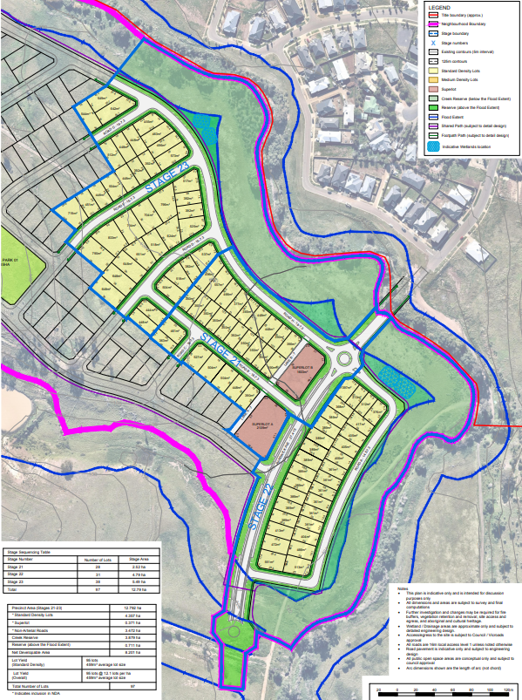
Figure 1 – Proposed subdivision layout

Currently, easements E-16 and E-18 traverse the subject site. These easements will be removed and/or varied at the Certification of the relevant Plan of Subdivision. Additionally, easements may be required in the future as part of servicing connection and development of the site. Any easements required will be shown on Plans of Subdivision submitted for certification.
The movement network comprises of predominantly 16m road widths and an 18m road width along the Korkuperrimal Creek and a 27m road width along the public transport route being Randwick Avenue.
A geotechnical assessment accompanied the application prepared by Tonkin and Taylor providing detailed contours and the application plan demonstrated the topography of the land showing that land is flatter, generally at a 2-5% slope which is where smaller lots are proposed. Land area highlighted in blue and purple in Figure 2 below identify flatter slopes at 5% and less.
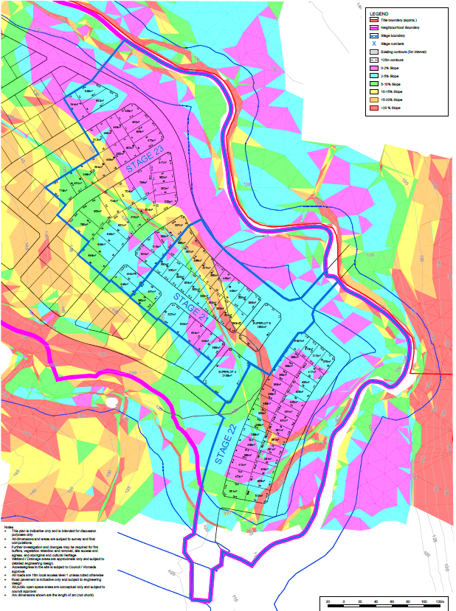
Figure 2 – Slope Analysis Plan

Table 1 below shows the stage numbers and overall lot sizes. Lots are all above 300sqm and more than 50% of the lots are above 400sqm.
Stage number | Lots less than 300sqm | Lots between 300-399sqm | Lots between 400-499sqm | Lots above 500 (excluding superlots) | Superlots | Total
21 | 0 | 16 | 6 | 4 | 0 | 26
22 | 0 | 21 | 8 | 2 | 2 | 33
23 | 0 | 5 | 10 | 23 | 0 | 38
Total | 0 | 42 | 24 | 29 | 2 | 97

Background to Current Proposal
Further information was received on 05 November 2020 and was not considered sufficient as it still proposed smaller lots on steeper slopes, an 18m connector road (Mortons’s Road), lack of pedestrian connectivity and footpaths shown along local roads, inadequate street species proposed and lack of information to assist with the DELWP (native vegetation and biodiversity) requirements.
After numerous consultation meetings with the applicant, more information was provided in November 2021 to finalise the agreed lot sizes. Discussions on the lot sizes took place after site visits to the site prior to the lodgement of the application to understand the topography of the land.
Discussions also took place on the flexibility of the Development Plan to allow for smaller lots in flatter areas of the site.

History
PA2011170 was issued 11 May 2012 for staged subdivision of land in accordance with the endorsed plans. This subdivision consisting 106 lots.
PA2016266 was issued on 31 August 2017 for land sales signage.
PA2017043 was issued 26 September 2017 for a staged subdivision, variation of an easement and associated works. This subdivision consisted of 110 lots and was known as Stages 5 to 8 of Underbank Estate. The permit was amended on 9 August 2018 to amend the permit preamble from stages subdivision, variation of an easement and associated works and building and works with ES02. The plans were amended under the secondary consent provisions on 24 August. 2018 altering the staging plan.
PA2018137 was issued on 09 October 2019 for a Staged Subdivision, Removal and Vegetation, Removal, Variation and Creation of Easements, Buildings and Works within the Environmental Significance Overlay – Schedule 2.

Public Notice
The application was considered exempt from the notice provisions in accordance with Development Plan Overlay Schedule 6, as the proposal is generally in accordance with the approved Development Plan.

Locality Map
The map below indicates the location of the subject site and the zoning of the surrounding area.
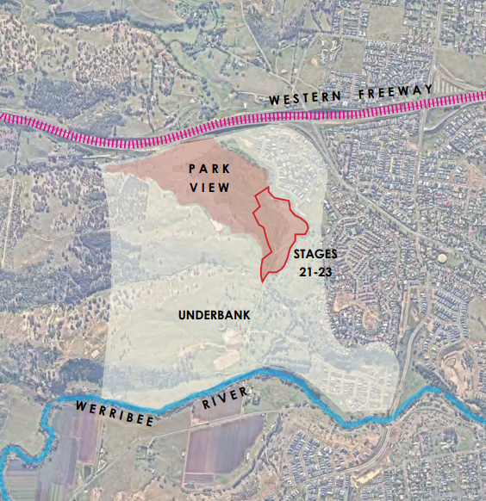
Figure 3 – the site and surrounds

Planning Scheme Provisions
Council is required to consider the Victoria Planning Provisions and give particular attention to the Planning Policy Framework (PPF), the Local Planning Policy Framework (LPPF) and the Municipal Strategic Statement (MSS).
The relevant clauses are:
• Clause 11.01-1R Settlement Central Highlands.
• Clause 11.02-1S Supply of urban land.
• Clause 11.03-3S Peri-urban areas.
• Clause 12.01-2S Native Vegetation Management
• Clause 12.05-2R Landscapes Central Highlands.
• Clause 15.01-3S Subdivision Design.
• Clause 15.01-5S Neighbourhood Character.
• Clause 16.01-2S Locational of Residential Development
• Clause 18.02-2S Public Transport
• Clause 19.03-2S Infrastructure Design and Provision
• Clause 19.03-3S Integrated Water Management
• Clause 21.03-2 Urban Growth Management.
• Clause 21.03-3 Residential Development.
• Clause 21.03-4 Landscape and Neighbourhood Character.
• Clause 21.07-2 Bacchus Marsh

Zone
The subject site is in the General Residential Zone, Schedule 2 (GRZ2).
The purpose of the Zone is:
• To implement the Municipal Planning Strategy and the Planning Policy Framework.
• To encourage development that respects the neighbourhood character of the area.
• To encourage a diversity of housing types and housing growth particularly in locations offering good access to services and transport.
• To allow educational, recreational, religious, community and a limited range of other non-residential uses to serve local community needs in appropriate locations.
Under Clause 32.08-3, a permit is required to subdivide land. An application to subdivide land must meet the relevant requirements of Clause 56 for a residential subdivision.
Clause 32.08-3 states an application to subdivide land that would create a lots less than 400sqm capable of a development for a dwelling must ensure the vacant lot contains at least 25% as garden space. This does not apply to a lot created where a Development Plan has been approved. in accordance with an approved development plan. With an approved development plan under the Development Plan Overlay Schedule 6, the garden space provisions do not apply.
Decision guidelines are listed under Clause 32.08-12. Under the subdivision section has the following decision guidelines:
• The pattern of subdivision and its effect on the spacing of buildings.
• For subdivision of land for residential development, the objectives and standards of Clause 56.
With reference to Schedule 2, the neighbourhood character objectives are:
• To encourage new development, including innovative and unique development that enhances and responds positively to the existing neighbourhood character.
• To encourage an increase in landscaping within the public and private realm.
• To encourage new development to respect existing setbacks within the streetscape.
• To encourage new development to have minimal or low scale front fencing.
• To ensure garages, carports, and second storey development do not visually dominate dwellings or streetscapes

Overlays
Development Plan Overlay Schedule 6
Pursuant to Clause 43.04-1 of the Moorabool Planning Scheme a permit must not be granted to use or subdivide land, construct a building or construct or carry out works until a development plan has been prepared to the satisfaction of the Responsible Authority. This does not apply if a schedule to this overlay specifically states that a permit may be granted before a development plan has been prepared to the satisfaction of the Responsible Authority.
A permit granted must:
• Be generally in accordance with the development plan.
• Include any conditions or requirements specified in a schedule to this overlay in accordance with the Development Plan.
The objectives of Schedule 6 of the Development Plan Overlay are:
• Planning for residential and associated development in a logical, cost effective and sequential manner.
• Efficient use of infrastructure, and land, and management of any impacts on the environment and amenity.
• Identification and effective management of sites of environmental, heritage and landscape significance.
• Co-ordinated provision of utility services and drainage.
• Co-ordinated provision of physical and community infrastructure and public open space that enhances the amenity, safety and liveability of the precinct and surrounds.
• Preparation of an integrated development plan generally in accordance with the Underbank Farm Concept Plan shown in Clause 5.0 of this Schedule.
Environmental Significance Overlay Schedule 2
This overlay covers waterways protection. The objectives under Part 2.0 are
• To protect the habitat significance of vegetation.
• To provide for appropriate development of land within 100 metres of either side of a waterway.
• To prevent pollution and increased turbidity of water in natural waterways.
• To prevent increased surface runoff or concentration of surface water runoff leading to erosion or siltation of waterways.
• To conserve existing flora and fauna habitats close to waterways and to encourage generation and regeneration of habitats.
A permit is required under Clause 42.01-2 to subdivide land. Decision guidelines are listed Schedule 2 Part 4.0
Relevant Policies
Housing Bacchus Marsh to 2041 – This policy addresses the management of growth, housing and guides neighbourhood character in Bacchus Marsh and surrounds. Maddingley is one of the three suburbs within close proximity to Bacchus Marsh in terms of both physical proximity as well as significant natural features and distance with the Western Freeway warranting the adoption of planning and housing strategies to support sustainable neighbourhoods. This policy guides development towards sustainable principles such as:
• Environmentally Sustainable Design,
• Compact Neighbourhoods,
• Walkable and Pedestrian Scale,
• Mixed Land Uses;
• Diverse Housing, Streets and Public Spaces;
• Interconnected Streets;
• Variety of Transport Options; and
• Range of green spaces as features
Open Space Framework to 2041
The Bacchus Marsh & Ballan Open Space Framework 2041 includes the following objectives which have been considered in the design and provision of open space:
• Be designed for maximum community benefit and consider all potential opportunities and activities to facilitate the development of the site (e.g. funding, community involvement and social engagement).
• Provide quality and accessible open space for all residents.
• Be a connected and safe network for all the community to use.
• In existing areas of Bacchus Marsh & Ballan all residents should be within:
• 400m of an area of open space.
• New greenfield developments must provide publicly accessible open space within a 400m walkable catchment.
• Reflect the landscape and Indigenous and European cultural heritage of Moorabool.
• Identify and budget for future maintenance and staff resourcing requirements

Particular Provisions
Clause 52.17 Native Vegetation
Under Clause 52.17-2 a permit is required to remove, destroy or lop native vegetation, including dead native vegetation. Decision guidelines are listed under Clause 52.17-5. DELWP had no objection to vegetation removal subject to offset conditions.

Clause 53.01 Public Open Space Contribution and Subdivision
A person who proposes to subdivide land must contribute to Council for public open space in an amount specified in the schedule to this clause (being a percentage of the land intended to be used for residential, industrial or commercial purposes, or a percentage of the site value of such land, or a combination of both). If no amount is specified, a contribution for public open space will be required under section 18 of the Subdivision Act 1988. A condition is recommended to provide 5% of the land value towards public open space. Some infrastructure works will take place to provide fitness and seating nodes south of Stage 22, other seating areas and footpaths will be constructed as part of the three stages within the permit area however no pockets parks are proposed within this permit area. It will be proposed as part of future subdivision applications north of the proposed Stages as shown in Figure 6 below.
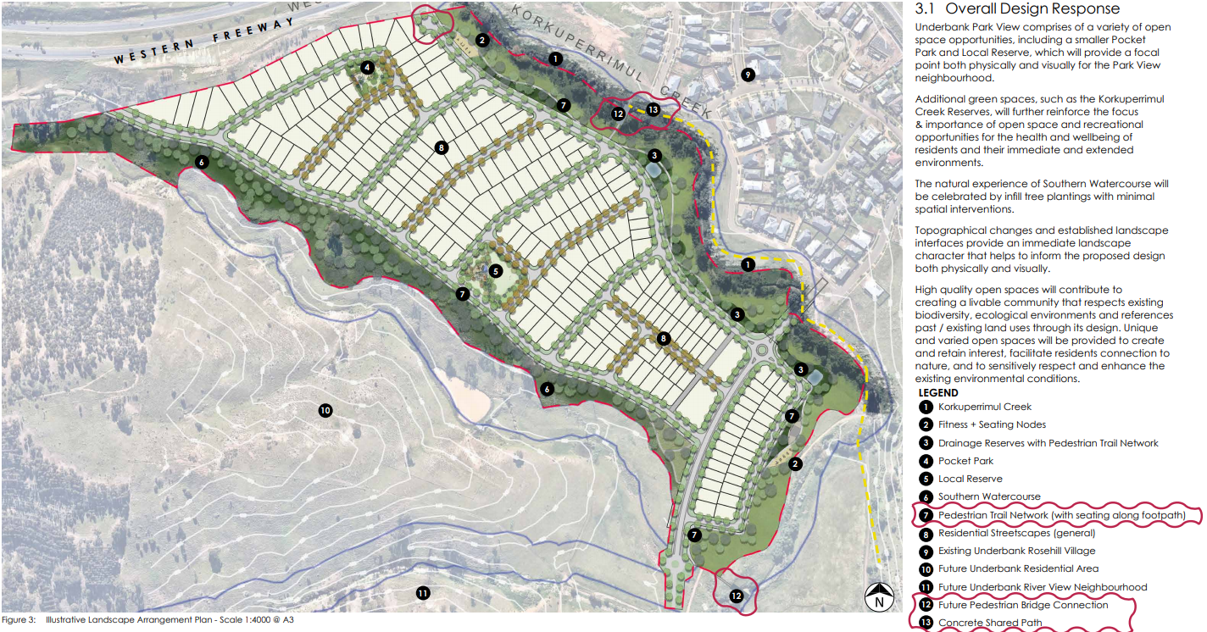
Figure 4 – Overall landscape master plan for the Park View precinct (this is layout shows more than the proposed subdivision)
Clause 56 – Residential Subdivision
Clause 56 has the purpose to create liveable and sustainable neighbourhoods and urban places with character and identify and achieve residents subdivision outcomes that appropriately respond to the site and its context to provide for policy implementation, liveable and sustainable communities, residential lot design, urban landscape, access and mobility management, integrated water management, site management and utilities. An assessment against Clause 56 has been conducted and the development complies with the standards and objectives with slight variations as discussed in the discussion section of this report.

Discussion
Neighbourhood Character:
The site is identified in precinct 26 (Greenfield Residential Growth Area) of the Neighbourhood Character Broachers informed by the Housing Bacchus Marsh to 2041 Strategy. This identifies “land located on the fringe that has been identified as land suitable for future residential development or is in the process of being developed for residential purposes, often over a number of years”. With this said, the preferred character guides developments towards diverse housing choice, while ensuring a sense of place and encouraging landscaping, canopy tree cover and avoid excessive site disturbance. The subdivision is proposed with diverse lot widths and orientation to increase housing choice in the area. Each lot has the opportunity to provide canopy tree planting and additional landscaping to enhance its future built form. The conditions on the permit ensure that all management conditions in the Cultural Heritage Management plan is complied with prior to any works taking place on the site. Further conditions for streetscape plans are also required to ensure that street trees are planted in accordance with the Street Tree Strategy and in line with detailed engineering plans.
Density and Lot Design
The density levels and lot design are based on the topography of the site. It includes a diverse range of lot sizes to facilitate diverse housing products. Generally, lots ranging from 300sqm – 500sqm are located on slopes at 20% and below (flatter parts of the site). The superlots for medium density development are proposed along a future Bus Route (Randwick Avenue) which is closely linked to the future Activity Centre.
As shown in Figures 1 of this report, and after numerous consultation meetings with the applicant and landowner, alternative outcomes were achieved resulting in an increase in lot frontages and lot sizes. The negotiations with the developer and applicant were based on achieving better outcomes towards the rural interface and transition from the Creek to accord with the intention of the approved Underbank Development Plan.
Lots above Korkuperrimal Creek above Randwick Avenue are in range of 500-800sqm with some smaller lot frontages along the creek. The same principles have been applied for the proposed subdivision to allow for activation of open spaces, walkability and deliver a sense of place. Lot frontages of around 12.5m are provided along the Creek interface and larger frontages are proposed on steeper slopes.
Underbank Development Plan - Generally in Accordance Test
The approved Underbank Development Plan dated 2017 nominated the subject site as Neighbourhood C to provide two lot typologies namely: Conventional and Rural Interface Lots.
The approved development plan provides guidance on the two lot typologies (in part) as follows:
• Conventional Lots: Minimum lot sizes generally in the order of 700sqm, except where the land has a gradient of less than approximately 1:10 (Neighbourhood C);
• Rural Interface Lots: Larger blocks at sensitive interfaces and on steeper land for a less urban experience (Neighbourhood C).
Victorian Planning Authority projected a guidance note in April 2020 to assist decision makers to test the concept of “generally in accordance” against a plan or proposal, as part of their Streamlining for Growth project.
“General accordance is a question of fact to be judged on the facts and circumstances of each case; and The less detail and precision there is in the primary document or documents, the more flexibility is given by the phrase ‘generally in accordance with… There is a difference between ‘in accordance’ and ‘generally in accordance’. While ‘in accordance’ allows for some minor (insignificant) differences, ‘generally in accordance’ will allow for greater latitude when assessing an application.”
In this case, the approved development plan provides flexibility to allow for smaller lots where the land has a gradient of less that approximately 1:10. Flexibility can then be given to the statutory planning application related to the size of the lots. Considering this guidance, the applicant provided a slope analysis plan and geotechnical assessments to support smaller lots on flatter parts of the land.
Therefore, where the land is less than a 1:10 gradient, larger lots are proposed with the largest lot being 833sqm. Lots in the flatter parts of the site range from 312sqm.
Though changes have been made to the road widths internal to the subdivision, the functionality of the Traffic Impact Assessment was assessed by Council’s Infrastructure Department and Transport for Victoria who had no objections subject to conditions recommended for the planning permit.
This information was the driver towards negotiations with all parties to determine the best outcome for the site and yet stipulate the strategic objective for economic development in the growth areas and to cater for future town centre and justify future community facilities to establish a self-sustaining neighbourhood.
Biodiversity and Native Vegetation
The applicant submitted a Biodiversity Assessment prepared by ABZECO (Report 11028_8, Version 1.2, March 2021) to inform the proposed subdivision. The recommendations listed in the biodiversity assessment are related the presence of two rare tree species namely, Melbourne Yellow-gum Eucalyptus leucoxylon subsp. connata and Fragrant Saltbush Rhagodia parabolica. Seeds from these trees are recommended for ongoing nursery propagation and eventual replanting throughout the residential estate and escarpment.
The assessment also recommended that all trees be inspected and supervised prior to and during the removal by a qualified zoologist to ensure that any wildlife encountered is appropriately handled and relocated. These recommendations have been addressed as part of planning permit conditions.
The application was referred to DELWP and Council’s Environmental Management Department. DELWP provided conditions which will be recommended for a planning permit in order to ensure that the required offsets are provided, protect endangered wildlife, and remove noxious weeds from the site.
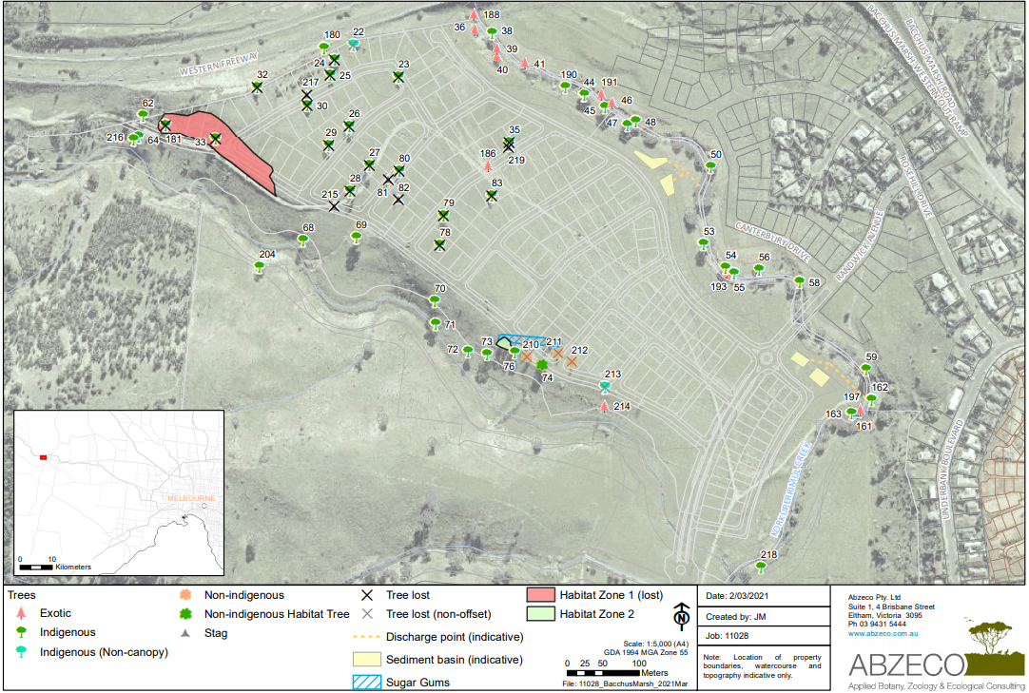Figure 5 – ABZECO biodiversity plan
Clause 56 – Residential Subdivision Assessment
Design Response
The design response plan submitted identifies the whole precinct and not only the permit area. This gives Council a good indication on possible future surrounding layout. It also focusses heavily on the topography of the site providing information on the 125m contours based on the percentage of slope. The Underbank Development Plan identifies land for the potential community, sporting and local town centre uses to the south of the proposed subdivision. These land uses are within 700m away from the proposed subdivision. Randwick Avenue which is proposed to be extended through the proposed subdivision is a bus capable route and anticipated that public transport will be regularly made available for ease of public access. The Development Plan does however provide for road network upgrades to facilities road access to nearby services. The intention from the approved Development Plan is to use the existing Stables building for community facilities. At this stage, this is out of the permit area but will be facilitated in the future planning permit applications.
Zone and Overlays
The subdivision is within the General Residential Zone Schedule 2 identified for natural and greenfield residential growth which encourages landscaping, respectful setbacks and streetscape and appropriate front interfaces of future built form which must not be dominated by garages and carports nor second storey developments. However, in areas where public transport is available to link towards the future town centre, provision has been made for 2 superlots which are subject to separate planning permit applications to ensure that the zoning and overlay requirements are met. This permit area provides lots large enough to allow for ample secluded and private open spaces, increased landscaping and respectful setbacks.
Schedule 6 of the Development Plan Overlay provides mandatory conditions which are required under a permit issued for subdivision within the Underbank Estate. One of which is a Construction Management Plan which is placed within the Infrastructure conditions so that all construction works are managed appropriately to the satisfaction of the Responsible Authority.
Conditions related to contributions under the Section 173 Agreement are also recommended as part of permit conditions for this subdivision.
Schedule 2 of the Environmental Significance Overlay protects and ensures that the waterway is protected in all its significant habitats and flora and fauna where habitat regeneration is encouraged and prevention is taken towards surface runoff which may lead to erosion and siltation of waterways. The applicant engaged consultant to provide assessment of the biodiversity and geotechnical aspects of the site. All recommendations contained in these assessments must be complied with ensuring the construction activities and offsets are required for vegetation being removed from the site. DELWP provided conditions which are recommended as permit conditions.
Public Transport and Movement Network:
The road network is permeable in the permit area and the layout provides for a sense of place and cultural identify activating the Werribee River and the Kokuperrimul Creek reserve which will improve the overall amenity of the residents.
The approved Underbank Development plan identified proposed bus routes which are highlighted in figure 3 below. Transport for Victoria (TfV) initially questioned the suitability of Mortons Road becoming a future bus route but after acknowledging the overall strategic land use basis of the area and in keeping with the approved development plan, Transport for Victoria provided conditions for the permit based on Randwick Avenue being constructed as a future bus route.
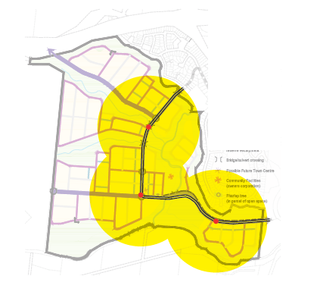Figure 6 – Future bus routes (Approved Underbank Development Plan, 2017)
Council’s Environmental Management (Urban Design) had concerns over the walkability across the site however continued footpaths are now shown on the plans and the Functional Layout Plans and Detailed Landscape plans are recommended as conditions for the permit will determine the continued footpaths, pram crossings and the relevant information to ensure continuity in footpaths. Streetscape plans are also part of planning permit conditions.

General Provisions
Clause 65 – Decision Guidelines have been considered by officers in evaluating this application.
Clause 66 – Stipulates all the relevant referral authorities to which the application must be referred.

Referrals
Authority | Response
Western Water  Melbourne Water  CFA  Downer  Powercor  Transport for Victoria  DELWP | Consented.  No conditions.  Consented.  Consented  Consented.  Consented.  Consented
Infrastructure | Consented subject to permit conditions.
Strategic Planning | In process.
Environmental Management | No objection subject to connected footpaths and adequate streetscaping.

Financial Implications
There are no financial implications in approving the subdivision application.

Risk & Occupational Health & Safety Issues
The recommendation of approval of this development does not implicate any risk or OH&S issues to Council.

Communications Strategy
Notice was not undertaken in accordance with s.52 of the Planning and Environment Act 1987. The applicant has been invited to attend this meeting and invited to address Council if required.

Options
Council could consider the following options:
• Issue an approval in accordance with the recommendations of this report; or
• should Council wish to refuse the application, Councillor’s need to explore reasons for refusing the subdivision based on non-compliances with the Moorabool Planning Scheme.

Conclusion
An application for a multi-lot subdivision was submitted to Council showing 103 lots (inclusive of two superlots) in two stages namely Stages 21, 22 and 23 between the Korkuperrimul Creek and the Werribee River. After submission of revised plans reducing the number of lots to 97 and several consultations with the applicant, all parties agreed that the density levels and road layout is generally in accordance with the approved Underbank Development Plan and recommends approval of the subdivision. The land is highly undulating towards the Werribee River and the northern parts of the site. The southern parts of the site are generally flatter, and allowances have bene made to facilitate diverse lot sizes catering between 300-400sqm. All referral authorities have consented to the subdivision subject to conditions. The application was assessed against the planning scheme and considered to be acceptable to align to the previous stages within the Underbank Estate.

Ms. Laura Clark addressed Council as the applicant associated with Item 7.3.
Mr. Warren Meiss addressed Council as the property owner associated with Item 7.3.

7.3 PA2020251 Development and Use of a dwelling at 1124 Old Melbourne Road, Ballan
Author: Victoria Mack, Statutory Planner
Authoriser: Henry Bezuidenhout, Executive Manager Community Planning & Economic Development
Attachments: 1. Site plan (under separate cover)
2. Shed plans - two shed and horse shelters (under separate cover)
3. Dwelling plans and elevations (under separate cover)
4. Farm Management Plan (under separate cover)
5. Farm Management Plan - Supplementary information (under separate cover)
6. Budgets and forecast - equine enterprise (under separate cover)

Application Summary
Permit No: PA2020251
Lodgement Date: 6 November 2020
Planning Officer: Victoria Mack
Address of the land: 1124 Old Melbourne Road, Ballan
Crown Allotment B5, Section 9, Parish of Moorabool West
Proposal: Development and Use of a Dwelling
Lot size: 7.547ha
Why is a permit required? Development and use of a dwelling on less than 40ha;
Buildings and works in the Environmental Significance Overlay, Schedule 1.
Committee Resolution
Moved: Cr Paul Tatchell
Seconded: Cr Tonia Dudzik
That the Development Assessment Committee, having considered all matters as prescribed by the Planning and Environment Act 1987, issues Notice of Decision to grant a permit for the Development and Use of a Dwelling at 1124 Old Melbourne Road, Ballan, otherwise known as Crown Allotment B5, Section 9, Parish of Moorabool West with the following conditions:
Endorsed Plans:
- Before the use and/or development starts, amended plans to the satisfaction of the Responsible Authority must be submitted to and approved by the Responsible Authority. When approved, the plans will be endorsed and will then form part of the permit. The plans must be drawn to scale with dimensions.
The plans must be generally in accordance with the plans submitted with the application but modified to show an amended farm management plan with:
  - Details of the revegetation areas and/or new plantations including width, number of rows and the native species to be planted and number of each species. The trees marked in the road reserve to be removed should be deleted.
  - An amended site plan showing all the revegetation areas on the plan.
  - Planting and management, including fencing, of the riparian area in the north west corner of the site.
Unless otherwise approved in writing by the Responsible Authority, all buildings and works are to be constructed and or undertaken in accordance with the endorsed plans to the satisfaction of the Responsible Authority prior to the commencement of the use.
Farm Management Plan:
- A Farm Management Plan to the satisfaction of the Responsible Authority must be endorsed as part of this permit, and cannot be varied without the written consent of the Responsible Authority.
Section 173 Agreements:
- Before the issue of a Building Permit the owner must enter into an agreement with the Responsible Authority made pursuant to Section 173 of the Planning and Environment Act 1987 to the satisfaction of the Responsible Authority:
  - The owner of the land must acknowledge that while the land remains zoned as Farming Zone or its equivalent successor the primary use of the land is for agricultural activities and the use of the dwelling must be in conjunction with an approved agricultural activity.
  - Agricultural activities and environmental management identified in the endorsed Farm and Land Management Plan must be undertaken on the land and must be in accordance with the Farm Management Plan endorsed under Condition 2 of the Planning Permit and cannot be varied without the written consent of the Responsible Authority.
  - Before a Building Permit is issued for the dwelling, application must be made to the Register of Titles to register the Section 173 Agreement on the title to the land under Section 181 of the Act and the owner must provide evidence of that registration of the Agreement to the Responsible Authority.
  - The owner must pay the reasonable costs for the preparation, execution and registration of the Section 173 Agreement.
Native Vegetation:
- Unless exempt under Clause 52.17 or any other relevant provision of the Moorabool Planning Scheme, native vegetation must not be removed, destroyed or lopped without further planning approval.
Dwelling Requirements:
- Access to the dwelling must be provided via an all-weather road with dimensions adequate to accommodate emergency vehicles.

- The dwelling must be connected to a reticulated potable water supply or have an alternative potable water supply with adequate storage for domestic use as well as for firefighting purposes.
- The dwelling must be connected to a reticulated electricity supply or have an alternative energy source.
- The dwelling must be connected to a reticulated sewerage system or if not available, the waste water must be treated and retained on-site in accordance with the State Environment Protection Policy (Waters of Victoria) under the Environment Protection Act 1970.
Materials and Colour:
- All external walls and roof areas of the proposed building/s are to be clad with non-reflective materials (zincalume prohibited) to the satisfaction of the Responsible Authority.
Infrastructure:
- A standard rural vehicle crossing must be provided on Old Melbourne Road to the satisfaction of the Responsible Authority. A vehicle crossing permit must be taken out for the construction of the vehicle crossing.
- Storm water drainage from the proposed buildings and impervious surfaces must be retained and disposed of within the boundaries of the subject land to the satisfaction of the Responsible Authority. Overflows from on-site storage systems must be directed away from any waste water disposal areas.
- Sediment discharges must be restricted from any construction activities within the property in accordance with relevant Guidelines including Construction Techniques for Sediment Control (EPA 1991).
- Unless otherwise approved by the responsible authority there must be no buildings, structures, or improvements located over proposed drainage pipes and easements on the property.
- Prior to the commencement of the development and post completion, notification including photographic evidence must be sent to Council’s Asset Services department identifying any existing damage to council assets. Any existing works affected by the development must be fully reinstated at no cost to and to the satisfaction of the Responsible Authority.
Environmental Health:
- The land application area and all conditions must be in accordance to the Land Capability Assessment prepared by Ballarat Soil Testing, ref number LCA281020 dated 29 October 2020 or any approved amendment are to be strictly adhered to.
- An onsite waste water management system with the capacity to treat effluent to a primary standard i.e. standard septic tank must be installed in accordance with the requirements of the Environment Protection Act 1970, the Guidelines for Environmental Management: Code of Practice Onsite Wastewater Management 891. 4 (2016).and the Responsible Authority.
- The wastewater management system from proposed dwelling/lots must be treated and contained within the property boundaries in accordance with the current EPA Code of Practice Onsite Wastewater Management: Guidelines for Environmental Management, Australian Standards 1547 and Council requirements.

- The effluent disposal area must be kept free of buildings, driveways, vehicular traffic and services trenching.
- All setback distances must be adhered to as dictated by Table 5 of the Code of Practice, Onsite Wastewater Management, EPA Publication Number 891.4.
- A shallow surface water cut off drain or surface water diversion mound, should be provided on the high side of the disposal areas to divert any surface water flows around the effluent fields.
Barwon Water:
- Wastewater treatment is to achieve a minimum water quality standard of 20mg/L BOD, 30mg/L SS and 10 orgs/100ml, i.e. secondary treatment, via an EPA approved all wastewater treatment system.
- Effluent disposal must be undertaken via a subsurface irrigation system designed and installed by a wastewater irrigation expert to the satisfaction of Moorabool Shire Council Environmental Health Officers.
- All components of the wastewater management system including the effluent disposal area must be located at least 100m from any surface waterway.
- All stormwater must be directed away from the effluent disposal area and roof stormwater must not be disposed to the effluent disposal area.
- Monitoring, Operation and Maintenance must be undertaken in accordance with RPA Code of Practice for Onsite Wastewater Management, Ballarat Soil and Testing Land Capability Assessment – Report No. LC281020 dated 29 October 2020 and to the satisfaction of Moorabool Shire Council Environmental Health Officers.
- The effluent disposal field must be protected by being isolated from any building, driveway, livestock, and vehicles.
- Sediment control measures as outlined in the EPA’s publication No 275 Sediment Pollution Control shall be employed during the construction of the dwelling and maintained until the disturbed area has regenerated.
- The creek must be fenced off in accordance with Section 3.3 and as detailed in Figure 7 Paddock Layout Plan of the Farm Management Plan.
- Prior to a certificate of occupancy being issued for the dwelling the owner must enter into an
agreement with the Responsible Authority and Barwon Water in accordance with Section
173 of the Planning and Environment Act 1987 requiring that:
  - The Owner is to enter into a service contract to have any wastewater treatment facility and effluent disposal system for the dwelling inspected and maintained in accordance with the EPA Certificate of Approval for the installed system.
  - The Owner must provide to Barwon Water and the Responsible Authority an annual report on the condition and operation of the wastewater treatment system which documents the effluent quality achieved and provides laboratory, inspection and maintenance reports for the preceding 12 months.

  - The Owner shall have the wastewater treatment facility desludged at least once every 3 years or as otherwise determined by Council’s Environmental Health Officer. Evidence of this desludging shall be provided in the annual report referred to in Clause (b) here in.
  - The Owner shall carry out any works considered necessary by the service contractor to ensure the satisfactory operation of the wastewater treatment facility and effluent disposal system.
  - The Owner will maintain all drainage lines at all times to divert surface water and subsurface water clear of the effluent disposal field.
  - The Owner and the Responsible Authority agree to do all things necessary to register a memorandum of this Agreement on the title of the land pursuant to Section 181 of the Planning and Environment Act 1987.
  - The Owner shall meet all costs of inspections, reports and works referred to in Clauses (a), (b), (c), (d), and (e) herein and all costs of the Responsible Authority in relation to stamping and registration of this Agreement.
  - The Owner shall not sell or enter into any contract to sell the land until this Agreement has been registered pursuant to Clause (f) herein.
- Barwon Water require the Section 173 to be signed by the Managing Director and Company Secretary and to state the following: THE COMMON SEAL of the BARWON REGION WATER CORPORATION was hereunto affixed in the presence of.
Permit Expiry:
- This permit will expire if:
  - The development and use are not started within two years of the date of this permit; and
  - The development is not completed within four years of the date of this permit.
Carried

Public Consultation
Was the application advertised? | Yes.
Notices on site: | Yes.
Notice in Moorabool Newspaper: | Not required.
Number of objections: | One.
Consultation meeting: | Not held. There was however discussions with the objector.

Policy Implications
The Council Plan 2017-2021 provides as follows:
Strategic Objective 3: Stimulating Economic Development
Context 3A: Land Use Planning
The proposal is not provided for in the Council Plan 2017-2021 and can be actioned by utilising existing resources.

Victorian Charter of Human Rights & Responsibilities Act 2006
In developing this report to Council, the officer considered whether the subject matter raised any human rights issues. In particular, whether the scope of any human right established by the Victorian Charter of Human Rights and Responsibilities is in any way limited, restricted or interfered with by the recommendations contained in the report. It is considered that the subject matter does not raise any human rights issues.

Officer’s Declaration of Conflict of Interests
Under section 130 of the Local Government Act 2020, officers providing advice to Council must disclose any interests, including the type of interest.
Executive Manager – Henry Bezuidenhout
In providing this advice to Council as the Executive Manager, I have no interests to disclose in this report.
Author – Victoria Mack
In providing this advice to Council as the Author, I have no interests to disclose in this report.

Executive Summary
Application referred? | Yes, Barwon Water, Corangamite Catchment Management Authority, Council’s Environmental Health Department and Council’s Infrastructure Department.
Any issues raised in referral responses? | No issues raised.
Preliminary concerns? | Development and use of a dwelling on a 7.457ha lot in the Farming Zone which is an unfenced crown allotment and part of an existing 185.09ha farm.
Any discussions with applicant regarding concerns? | Yes, a Request for Further Information was sent to the applicant requesting clarification of some aspects of the Farm Management Plan including: fencing; shelterbelt plantation design; proposed driveway tree species; protection and maintenance of the creek area in the northwest corner of the site from stock; and an amended site plan showing horse shelters and water troughs.  The applicant was also asked to provide details of how the proposed horse enterprise would operate on the site. The intention to rehome 24 horses each year, or 8 horses to be re-educated and rehomed each 4 months. A five-year timeline was requested showing when the target of 24 horses per year could be achieved and how the venture would cover costs.
Any changes made to the application since being lodged? | The applicant responded to the further information request by providing the required additional information including a capital expenditure list and a profit and loss statement and an estimated costing per horse.
Brief history. | The land is a crown allotment of 7.457ha located in the south-east corner of an existing 185.09ha farm. The allotment is unfenced and has been used for grazing and general farming.
Previous applications for the site? | PA2002-044 being for Development and Use of a Dwelling issued on 3 April 2002.  PA2004368 being for Development and Use of a Dwelling and Garage within a Wildfire Management Overlay issued on 14 February 2005.  This dwelling has been constructed and is centrally positioned on the 185ha site.
General summary. | The proposal is to retrain and rehome retired thoroughbred racehorses. The number of horses to be processed per year is 24, with 8 horses to be on the property at any one time. The letdown time for each horse would be 2 months and the retraining time allowed per horse would also be 2 months.  It is understood that the applicants have the qualifications and experience to run the enterprise, and that they will both continue with full time employment as well as operate the equine business.  The concern is with the intensification of a use on a small parcel of land which otherwise is part of an existing large farm.  The application, if approved, may set a negative precedent across the Shire if small crown allotments can be sold off for rural residential and lifestyle related activities.  While horses are considered to be an agricultural use, it is considered that this parcel is too small for such an intensive activity. It is considered that the site is unsuitable for this use.
Summary of Officer’s Recommendation
That, having considered all relevant matters as required by the Planning and Environment Act 1987, Council issues a Refusal to Grant a Planning Permit for the Development and Use of a Dwelling at 1124 Old Melbourne Road, Ballan otherwise known as Crown Allotment B5, Section 9, Parish of Moorabool West.

Site Description
The site is one crown allotment of 4 allotments that make up the current farm of 185.09ha. There is an existing large homestead styled dwelling that has been constructed on the site approved under Planning Permit PA2004368. The lot with the homestead is approximately 135ha with the north boundary abutting the Western Freeway and access from Cartons Road. The other two lots that are not part of this application are vacant, one of approximately 34ha in the north-east corner of the site and the other along the south boundary with a creek frontage of approximately 9ha. The farm is used for cattle production, general grazing, hay production and more recently horticulture, specifically potatoes.
The land is very good quality grazing land evidenced by the size of the property with substantial annual hay production and the cattle enterprise. The undulating nature of the property with creek flats affords a variety of agricultural options including summer crops.
The subject crown lot abuts the Old Melbourne Road and is 7.547ha in area. Access would be constructed from the Old Melbourne Road. The land slopes to the north-west corner where there is a creek frontage and a wetland area of approximately 1ha. In this area of the larger farm there are two marked waterways which traverse the southern end of the property. The larger farm has scattered vegetation as well as a large bushland area on the west side of the existing dwelling.
The subject site has no established trees or understorey vegetation.
There is a 10m wide gas supply easement along the length of the southern boundary abutting Old Melbourne Road.
Below is an aerial photo of the whole of the farm with the subject site marked in the lower right corner.
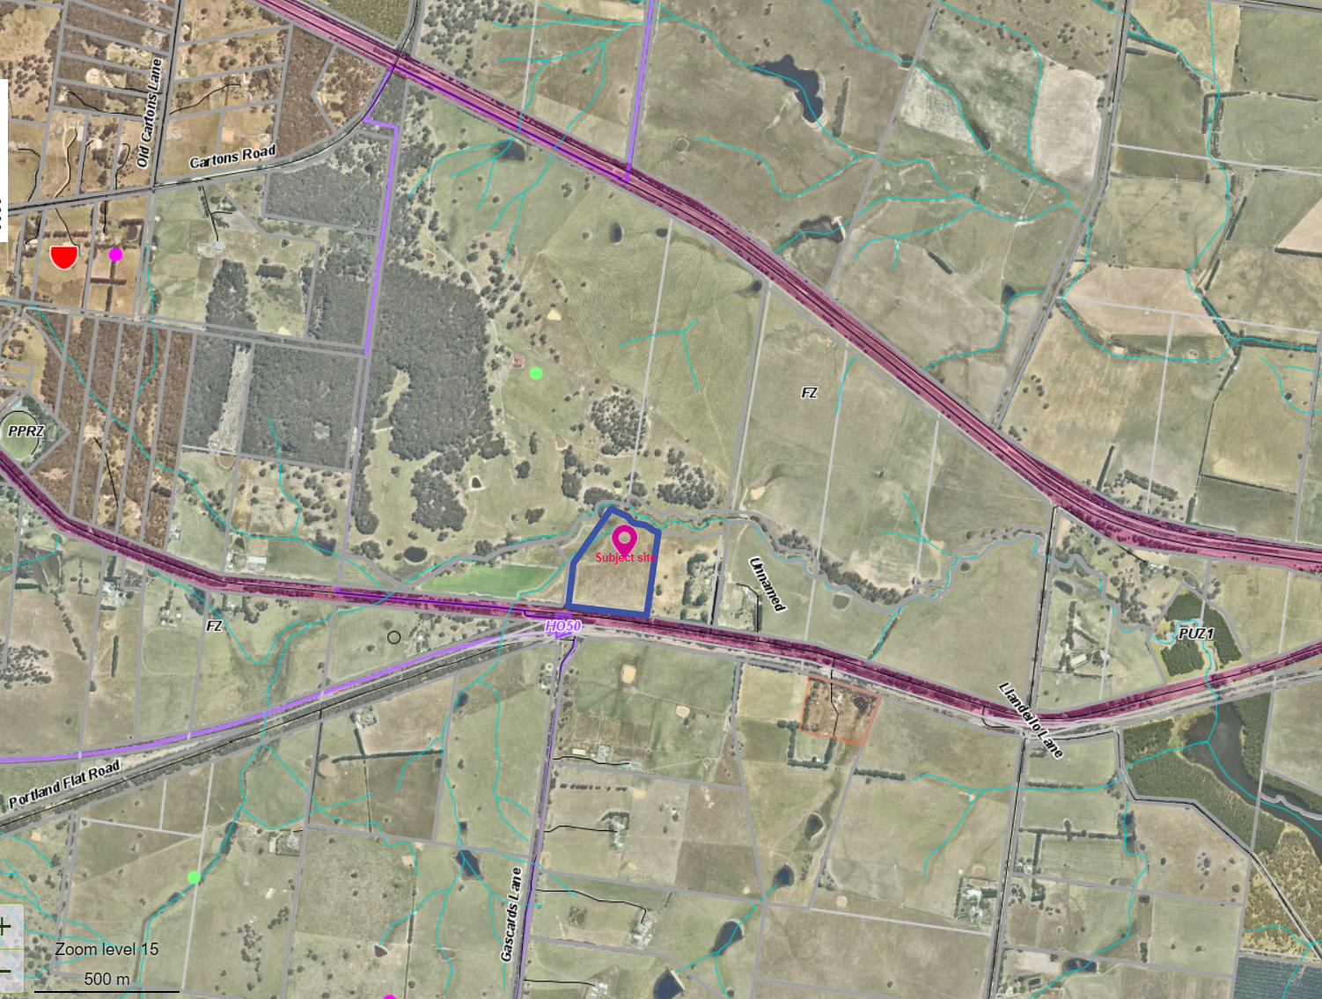
Figure 1: Aerial photo of the site and surrounds.

Proposal
It is proposed to construct a dwelling on the site in conjunction with an equine enterprise.
The dwelling would be located approximately centrally on the site and would have the following details: three bedrooms, two bathrooms, an entrance hallway, an open plan kitchen, meals and living area with access to an alfresco, a separate lounge and an attached two car space garage. There would be no verandas and no eaves. The total floor area including residence, garage and alfresco would be 201.90sqm. Three 50,000L water tanks would be installed.
The dwelling would be clad with face brick walls in sandstone colouring with a Colorbond deep blue roof.
There would be two sheds and 8 horse shelters:
1. Open Bay Stable Shed: 17.5m long, 6m wide and 3m high to the eaves with an overall height of 4.14m and a 22º pitched roof. The shed would contain 3 stables, a lock up equipment and horse feed room and an undercover float storage area. It would be clad with smooth cream Colourbond wall cladding and deep blue Colourbond roofing.
2. Equipment Shed Plans: 10m long, 6m wide and 2.7m high to the eaves with an overall height of 3.28m and a 11º pitched roof. The shed would contain 3 bays, two end wall roller doors, a side wall access door and two end wall windows would be clad with smooth cream Colourbond wall cladding and deep blue Colourbond roofing.
3. Horse shelters x 8 (one in each paddock): 3.5m long, 3.5m wide and 2.6m high with a 5º skillion roof. The horse shelters would be clad with deep blue Colorbond cladding.
An equestrian arena would be constructed on the east side of the proposed dwelling and sheds 20m from the east side boundary. The arena would be 60m long and 30m wide surfaced with river sand. The arena would be used by the owners as part of the equestrian proposal.
The equestrian proposal states that the objective is to:
“develop a first-class Thoroughbred rehoming and retraining facility within an already established horse community, in which we will take off the track Thoroughbreds for rehabilitation, retraining, and rehoming. Each horse’s individual strengths and weaknesses will be assessed to determine their suitability for different disciplines during their time in training with us and will be found a home suitable to what we believe they will excel in”.
It is proposed to have eight horses on the property at any one time, four in the spelling paddock having a break or ‘let down’ after finishing their racing careers, and four in work for re-training. Each individual horse differs in the time taken but most horses can be re-homed around two months after beginning training following their break.
Assuming on average eight horses on the property at any one time the applicants’ estimate that a minimum of 25 hours per week would be required to care and train the horses, with additional time required for pasture/fence/arena maintenance and other related activities.
Based on the above two-month timeline and having four horses in training at any one time, the applicant’s estimate they can re-train and re-home upwards of 24 horses per year.
Figure 2: Site plan with the dwelling located in a central part of the lot accessed from a driveway connecting to Old Melbourne Road
The application also stated that mares with exceptional qualities may be retained and joined to a Warmblood stallion and foaled down on the property. These have not been included in the stocking rate proposed for the retraining and rehoming enterprise.
The Farm Management plan provided adequate detail of the proposal covering a range of matters including: construction details of the equestrian arena, water management, fencing, revegetation, pest plant and animal management, soil quality and conservation, stocking rate, rotational grazing, pasture development, fire management, and a 5 year timetable of development actions. The applicants would appear to have the qualifications and experience to run the enterprise. A weekly workplan timetable was also provided. Both the applicants plan to retain their full-time employment while running the horse enterprise before and after work.
The applicant response to the further information requested included the following additional information: a capital expenditure statement, profit and loss statement and cost per horse breakdown; details of proposed plantations including one row width and species; additional plans showing water supply and double fencing; treatment and planting proposed to protect the creek riparian area; and justification of the estimated two month timeline to retrain a racehorse. It is proposed to plant 80 birch trees along the driveway which would require a water supply in summer.

History
Planning Permit PA2004368 was issued in 2005. The applicant/owner has had numerous extensions of time approved after the development stalled past lock up stage to enable him to complete the finer details especially to the internal works of the large homestead style dwelling.

Public Notice
The application was notified to adjoining and surrounding landowners. One objection was received.

Summary of Objection
The objection received is detailed below with officer’s comments accompanying them:
Objection | Any Relevant Requirement
The proposal shouldn't be allowed to proceed because the land size, 7.547ha, is smaller than the minimum (area for a dwelling) as stated in the Moorabool Planning Scheme (40 hectares). | Clause 35.07-1, Section 2 – use of a dwelling on land less than 40ha.
Officer’s Response: It is considered that a small holding of 7.457ha is too small to justify a dwelling and an overly ambitious equine enterprise which would be better suited on a larger area of land.
I believe the proposal is an overly intensive use of the land and brings urban fringe development thinking to a Farming Zone. I am a strong supporter of the Council's strategy to preserve the rural character of farming zones. | Clause 35.07 – Farming Zone.
Officer’s Response: Selling off individual crown allotments from large farming holdings would fragment agricultural land for rural residential pursuits and should be discouraged.
The proposal divides an already small parcel of land into numerous smaller paddocks. Apart from the unpleasant visual amenity, this would bring attendant dust and odour problems if stocked with 8 horses. On my property, I am directly affected by a prevailing westerly wind. | Clause 35.07 – Farming Zone and use of the land for agriculture.
Officer’s Response: The stocking density proposed would potentially have an adverse impact on the land, particularly in very wet and very dry seasons. This is discussed further in this report.
The Farm Plan indicates rotating paddocks which through the dry summer/autumn period would have absolutely no effect on dust as there would quickly be no grass in the smaller paddocks. The proposed 60 x 30 metre outdoor arena and 20 x 80 metre cross-country jumping area to the east would generate dust. Horses they are very harsh on land and generate a considerable amount of odorous manure.
Officer’s Response: The proposal appears to be intensive for this sized parcel of land.
While I think the concept is worthy, I believe the proposal is better suited to a much larger parcel of land.
Officer’s Response: Running 24 horses over each 12 months would appear to be excessive stocking on this sized parcel of land. This is discussed further in this report.

Locality Map
The map below indicates the location of the subject site and the zoning of the surrounding area.
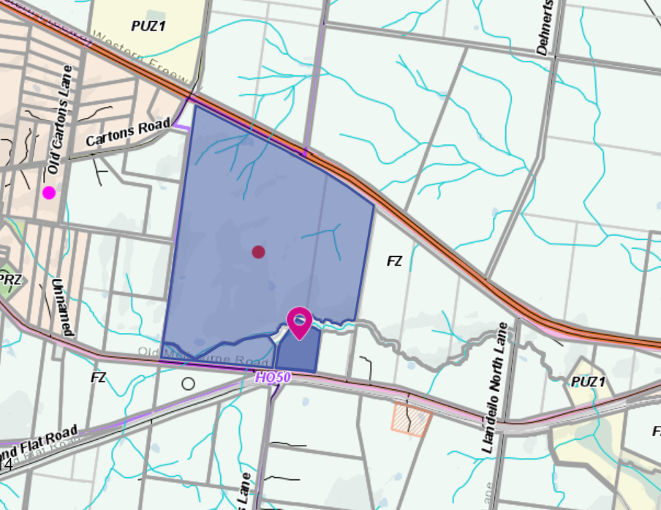
Subject site
Figure 3: Zone map showing the whole of the farm and the subject site.

Planning Scheme Provisions
Council is required to consider the Victoria Planning Provisions and give particular attention to the Planning Policy Framework (PPF), the Local Planning Policy Framework (LPPF) and the Municipal Strategic Statement (MSS).
The relevant clauses are:
• Clause 11.03 Peri Urban Areas
• Clause 14 Natural Resource Management
• Clause 14.01-1S Protection of agricultural land
• Clause 14.02-1S Catchment planning and management
• Clause 14.02-2S Water quality
• Clause 15.01-6S Design for rural areas
• Clause 16.01-5S Rural residential development
• Clause 22.03 Houses and House Lot Excisions in Rural Areas
• Clause 21.02-3 Objective—Water and catchment management
• Clause 21.03-4 Objective—Landscape and neighbourhood character
• Clause 21.03-6 Objective—Rural lifestyle opportunities
• Clause 21.04-Economic Development and Employment
• Clause 21.04-1 Key issues and influences Agriculture and horticulture
• Clause 21.04-2 Objectives—Agriculture
The proposal does not comply with the relevant sections of the PPF and LPPF, outlined in the table below:
PPF | Title | Response
Clause 11.03-3S | Peri-urban areas | The proposal would intensify the rural residential use of the land, resulting in the loss of agricultural and farming land.
Clause 14.01-1S | Protection of agricultural land  Objective To protect the state’s agricultural base by preserving productive farmland. | The proposal increases residential use of farming land and diminishes the capacity of the area to support agriculture activity.  Running a large equine enterprise on 7.457ha, and the development and use of a dwelling, is considered to be an over development of farming zoned land.
Clause 16.01-5S | Rural residential development  Objective To identify land suitable for rural residential development. | The proposal does not protect high quality agricultural land and is considered to be an inappropriate rural residential development application located within the Farming Zone.
LPPF
Clause 21.02-2 | Non-Urban Landscapes. | The proposal would increase residential development in a rural location which erodes the rural character of the area and set a precedent for similar intensive applications on small sized lots.
Clause 21.03-4 | Landscape and Neighbourhood Character | The proposed dwelling’s benefit to agriculture is not sufficiently justified.
Clause 21.03-6 | Objective—Rural lifestyle opportunities | The proposal would fragment productive agricultural land and set a precedent for similar applications on small sized lots.
Clause 21.04-2 | Objectives—Agriculture  To protect good quality agricultural land and support the productivity and sustainability of existing and future agricultural and horticultural activities. | The proposal would not support productive, sustainable farming.

Zone
Farming Zone
The purposes of the Zone is:
• To implement the Municipal Planning Strategy and the PPF.
• To provide for the use of land for agriculture.
• To encourage the retention of productive agricultural land.
• To ensure that non-agricultural uses, including dwellings, do not adversely affect the use of land for agriculture.
• To encourage the retention of employment and population to support rural communities.
• To encourage use and development of land based on comprehensive and sustainable land management practices and infrastructure provision.
• To provide for the use and development of land for the specific purposes identified in a schedule to this zone.
In accordance with Clause 35.07-1, Section 2, a permit is required to use land for a dwelling where the land is less than 40ha.
In accordance with Clause 35.07-4 a permit is required for a building or works associated with a use in Section 2 of Clause 35.07-1, and where a building or works is within 100m of a dwelling not in the same ownership.
The nearest neighbouring dwelling is located within 182m of the site; therefore, this permit trigger does not apply.
A permit is required for buildings and works associated with a Section 2 Use.

Overlays
Environmental Significance Overlay, Schedule 1
In accordance with Clause 42.01-2 a permit is required for buildings and works.
Design and Development Overlay, Schedule 2
In accordance with Clause 43.02 Schedule 2 of the this overlay a permit is not required where all external cladding of buildings is non-reflective. In this application, there is no reflective materials proposed and therefore a permit is not required under this overlay.

Relevant Policies
Council’s Rural Growth Policy Statement
Council’s Rural Growth Policy Statement was adopted by Council on 19 September 2012. The document applies to all land in Farming Zone. This Council policy is not incorporated into the Moorabool Planning Scheme.
The policy states:
• Encourage dwellings in areas nominated in Map 1 of Council Rural Growth Policy Statement.
• Ensure the siting of any dwellings is designed to have a minimal impact on any existing or future agricultural activities on the site and on surrounding land.
• Ensure it is clear whether the dwelling is required for agricultural operation, use or to maintain rural communities.
• Ensure sufficient infrastructure is available or that alternative methods are available which do not require normal infrastructure.
• Encourage development of dwellings, to support communities, on land which is unlikely to support agricultural (use) while still considering any other overlays which may impact the land. This is land which is constrained for use as agriculture by other environmental factors such as vegetation, slope, soil quality, etc.
The land is not within Map 1 of Council’s Rural Growth policy. The policy requires justification for the dwelling based on the proposed agricultural activity.
The proposal is to run 8 horses on this site with 5.4ha of available farming land (net of the land set aside for the dwelling, shed, equestrian arena and the creek riparian area). The site could only run 8 horses on the site with supplementary feeding. Such an intensive enterprise on a small land area does not accord with the intent of the policy. It is considered that an intensive horse grazing enterprise would create environmental risk, including dust in summer months and pasture damage and pugging in the winter months.
It is not considered that the number of horses proposed to be run on the property over 12 months is sustainable on such a small parcel without causing significant risk to the land.
Council’s Rural Housing Policy
Council’s Rural Housing Policy 2012 was adopted by Council on 19 September 2012 and has been developed to provide direction for how limited farming potential rural dwellings should be considered, and more broadly, rural settlement patterns. This Council policy is not incorporated into the Moorabool Planning Scheme.
The principles of the policy relevant to this application include to:
• Support the agricultural sector so that it can be more productive, diverse, resilient and adaptive to changing agricultural trends, including supporting agricultural activities that recognise Moorabool’s advantageous proximity to market.
• Protect agricultural land use from loss and allow development that increases agricultural productivity.
• Focus growth opportunities in settlements along major transport corridors, in particular where there is physical and social infrastructure and services.
• Recognise that there are substantial existing lots under 40ha capable of supporting the viable operation of agricultural enterprises.
• Promote a rural housing market that meets the needs of the Shire’s rural communities
• Land parcels for the proposed on-farm living dwellings are to have a minimum lot size of 8ha as identified in Map 1.
The proposed development and use of a dwelling on the site does not align with the above principles and furthermore it is considered to undermine the existing agricultural productivity of farming land.

The lot is small in area and taking into consideration the land excluded, due to the dwelling and associated effluent field, the two sheds, the equestrian area and the paddock creek exclusion zone, there is even less area for a productive agricultural use that can be sustained in the long term. The site is less than 8ha. The policy for lots less than 8ha states that for High Agricultural value land the smaller the land parcel the greater the potential to erode the lands capabilities for agricultural practices. The objective of the dwelling on this size parcel of land should be to ensure that the viability of the agricultural practice or opportunities is not compromised as a result of the dwelling.
It also states that landowners have an obligation to maintain their land to a certain standard and not encourage any adverse amenity impacts on adjoining or surrounding property owners. There is an opportunity, through the planning permit process, for Moorabool to be proactive when it comes to land management practices and advocating for effective land management strategies.
The dwelling and associated sheds on a lot that contains exclusion area for creek corridor will be too small for a productive agricultural purpose and the horse activity will instead lead to further degradation of the land.

Discussion
The Moorabool Planning Scheme provides discretion for a permit to be granted to use and develop land for a dwelling on a lot less than 40ha. Where a permit is required, the decision guidelines of the Farming Zone require a range of matters be considered.
The application does not accord with the purposes of the Farming Zone. The proposal does not support the retention of productive agricultural land. It does not encourage the use and development of land based on comprehensive and sustainable land management practices and infrastructure provision. While the applicant has provided a competent Farm Management Plan, it is considered that the use of the land for retraining up to 24 racehorses per annum will be an intensive use and an overuse of a small parcel of land.
The property is effectively 5.4ha taking into consideration the land excluded, due to the dwelling and associated effluent field, the two sheds, the equestrian area and the exclusion zone.
The Dry Sheep Equivalent (DSE) rating for horses is included in the following table (Reference: NSW DPI Primefacts Pastures for Horses February 2007):
Light horse | 10.0
Draught horse | 14.0
Pony | 6.0
Horse - light work | 13.5
Horse - heavy work | 18.7
To keep 8 horses in light work over 3 cycles in each 12 month period, the farm would be required to support a total carrying capacity of 108DSE per annum. The land area of 5.4ha (available grazing area) would require pasture with an average DSE rating of 20DSE/ha. This would be an exceptional pasture to carry this stocking level over 12 months.
Obviously, the horses would require supplementary feeding to maintain performance and body weight.

The proposal would also put pressure on the land as horses are known for being harsh on pasture quality. According NSW DPI document ‘Primefacts Pastures for Horses February 2007’ horses are wasteful grazers. They selectively graze pastures, damaging parts of the pasture by overgrazing and leaving other parts of the pasture tall and rank and relatively unacceptable.
It is not considered that the proposal justifies the use of a dwelling on the land.
In relation to dwellings in the Farming Zone, the decision guidelines require that the Responsible Authority to consider whether a dwelling will result in the loss or fragmentation of productive agricultural land. As this lot is currently part of an existing 185ha farm, if approved, the sale of the crown allotment would set a precedent for future applications for dwellings on small crown allotments across the Shire.
It is considered that this use of the land for the spelling then retraining of up to 24 thoroughbred former racehorses per annum, as well as potentially one or more brood mares to be retained on 7.457ha parcel of land, is an intensive horse enterprise and an over development of this farming land.
When considering the land removed from the enterprise for the dwelling, effluent field, two sheds, the driveway, equestrian arena and a creek protection zone, the available land to run the horses is closer to 5.457ha. The proponents claim they can retrain 24 horses per annum (needing a minimum of 25 hours per week for the horse care and training component) while both maintaining full time employment off the farm during the day.
While the applicant’s competence to retrain the horses is not questioned, the scale of the project may likely create seasonal environmental impacts: mud and runoff in the winter and dust and topsoil loss in the summer.
The proposal is not supported by either the PPF or the LPPF which includes protection of the state’s agricultural base by preserving productive farmland. (Clause 14.01-1S.) and maintaining and enhancing the natural environment and the Shire’s rural identity and character. (Clause 21.02-2).
It is considered that the proposal would adversely affect very good quality agricultural land based on soil type and access to water from being used for a wholly productive purpose with the introduction of rural residential use. A dwelling on such a small land holding and the equine retraining plan proposed would appear to be too intensive for this site and is an overuse of the available agricultural land.
Overall, the proposed use and development for a dwelling is inconsistent with the PPF and LPPF, the Farming Zone objectives and the relevant decision guidelines at Clause 65 of the Moorabool Planning Scheme.

General Provisions
Clause 65 – Decision Guidelines have been considered by officers in evaluating this application.
Clause 66 – Stipulates all the relevant referral authorities to which the application must be referred.

Referrals
Authority | Response
Barwon Water  Corangamite Catchment Management Authority | Consent with conditions  Consent
Infrastructure  Environmental Health | Consent with conditions  Consent with conditions

Financial Implications
There is no financial implication associated with this refusal to grant a permit for this use and development of a dwelling.

Risk & Occupational Health & Safety Issues
The recommendation of refusing of this development does not implicate any risk or OH&S issues to Council.

Communications Strategy
Notice was undertaken for the application, in accordance with s.52 of the Planning and Environment Act 1987, and further correspondence is required to all interested parties to the application as a result of a decision in this matter. All submitters and the applicant were invited to attend this meeting and invited to address Council if required.

Options
Council could consider the following options:
• Issue a refusal to grant a permit in accordance with the recommendations of this report; or
• issue a permit with conditions outside of the recommendations of this report.

Conclusion
The site is located in an agricultural district with productive agricultural soils and good water sources. The planning policies and Farming Zone provisions seek to prevent the loss or fragmentation of agricultural land with dwellings. The Farm Management Plan submitted detailed the intensive utilisation of the land based on a high turnover of horses each 12 months, while the owners maintain full time employment. It is unlikely a productive farming use of the land in the long term can be sustained due to the small land area available and the type of farming activity proposed. Additional residential development on land zoned for productive farming purposes does not accord with the planning policies of the Moorabool Planning Scheme. It is recommended the application be refused with specified grounds.

7.4 PA2020101 - Use and Development of a Dwelling and Dependent Persons Unit and ancillary shed at 187 Camerons Road Coimadai
Author: Mark Lovell, Coordinator Statutory Planning
Authoriser: Henry Bezuidenhout, Executive Manager Community Planning & Economic Development
Attachments: 1. Site plan (under separate cover)
2. Floor plan (under separate cover)
3. Elevation plan (under separate cover)
4. Shed floor plan (under separate cover)
5. Shed elevation plan (under separate cover)

Application Summary
Permit No: PA2020101
Lodgement Date: 3 June 2020
Planning Officer: Mark Lovell
Address of the land: 187 Camerons Road Coimadai
Proposal: Use and Development of a Dwelling and Dependant Persons Unit and Ancillary Shed
Lot size: 14.375 ha
Why is a permit required? Rural Conservation Zone - Clause 35.06-1 and 35.06-5 – Use & Building and Work
Bushfire Management Overlay - Clause 44.06 Works associated with use of land for accommodation

Committee Resolution
Moved: Cr Tonia Dudzik
Seconded: Cr Paul Tatchell
That the Development Assessment Committee, having considered all matters as prescribed by the Planning and Environment Act 1987, issue a Notice of Decision to Grant a permit for use and development of a dwelling, dependant persons unit and ancillary shed at 187 Camerons Road, Coimadai with the following conditions
1. Before the use and/or development starts, amended plans to the satisfaction of the Responsible Authority must be submitted to and approved by the Responsible Authority. When approved, the plans will be endorsed and will then form part of the permit. The plans must be drawn to scale with dimensions and three copies must be provided. The plans must be generally in accordance with the plans submitted with the application or some other specified plans but modified to show:
(a) Site plan to show location of DPU and shed including exact setbacks of the dwelling to the DPU and to the ancillary shed
(b) Elevation plans of the Dependant Persons Unit.

Unless otherwise approved in writing by the Responsible Authority, all buildings and works are to be constructed and or undertaken in accordance with the endorsed plans to the satisfaction of the Responsible Authority prior to the commencement of the use.
Use:
2. The DPU must be removed from the site to the satisfaction of the Responsible Authority when there is no longer a dependant persons reliant on the primary residence.
3. The permitted outbuilding must not be used for any habitable, commercial or industrial purposes except in accordance with the provisions of the Moorabool Planning Scheme.
Materials
4. All external walls and roof areas of the proposed building/s are to be clad with non-reflective materials (zincalume prohibited) to the satisfaction of the Responsible Authority.
Environmental Health
5. The land application area and all conditions must be in accordance to the Land Capability Assessment prepared by Ballarat Soil Testing, ref number DE150720 dated 15 July 2020 or any approved amendment are to be strictly adhered to.
6. An onsite wastewater management system with the capacity to treat effluent to a primary standard i.e. standard septic tank must be installed in accordance with the requirements of the Environment Protection Act 1970, the Guidelines for Environmental Management: Code of Practice & Onsite Wastewater Management 891. 4 (2016).and the Responsible Authority
7. The wastewater management system from proposed dwelling/lots must be treated and contained within the property boundaries in accordance with the current EPA Code of Practice & Onsite Wastewater Management: Guidelines for Environmental Management, Australian Standards 1547 and Council requirements.
8. The effluent disposal area must be kept free of buildings, driveways, vehicular traffic and services trenches
9. All setback distances must be adhered to as dictated by Table 5 of the Code of Practice, Onsite Wastewater Management, EPA Publication Number 891.4
10. The owner will maintain all drainage lines at all times to divert surface water and subsurface water clear of the effluent disposal field.
Infrastructure
11. The property access and the internal driveways must be constructed in accordance with the requirements specified in Table 5 of Clause 53.02-5 of the Moorabool Planning Scheme, to the satisfaction of the responsible authority
12. Storm water drainage from the proposed buildings and impervious surfaces must be retained and disposed of within the boundaries of the subject land to the satisfaction of the Responsible Authority. Overflows from on-site storage systems must be directed away from any wastewater disposal areas.
13. Sediment discharges must be restricted from any construction activities within the property in accordance with relevant Guidelines including Construction Techniques for Sediment Control (EPA 1991).

14. Unless otherwise approved by the Responsible Authority there must be no buildings, structures, or improvements located over proposed drainage pipes and easements on the property.
15. Prior to the commencement of the development and post completion, notification including photographic evidence must be sent to Council’s Asset Services department identifying any existing damage to Council assets. Any existing works affected by the development must be fully reinstated at no cost to and to the satisfaction of the Responsible Authority
Country Fire Authority (CFA)
16. The bushfire protection measures forming part of this permit or shown on the endorsed plans, including those relating to construction standards, defendable space, water supply and access, must be maintained to the satisfaction of the responsible authority on a continuing basis. This condition continues to have force and effect after the development authorised by this permit has been completed.
17. The Bushfire Management Plan prepared by Terramatrix (Bushfire Management Statement for the construction of a dwelling at 195 Camerons Road, Coimadai VIC 3340 – Version 1.0, Map 1, Page 7, dated 13 November 2019 must be endorsed to form part of the permit and must not be altered unless otherwise agreed in writing by the CFA and the Responsible Authority
Native Vegetation
18. No native vegetation may be removed, destroyed or lopped unless where specifically exempt under the provisions of the Moorabool Planning Scheme.
Permit Expiry
19. This permit will expire if:
(a) the development is not started within two years of the date of this permit; and
(b) the development is not completed within four years of the date of this permit.
Carried

Public Consultation
Was the application advertised? | Yes.
Notices on site: | Yes.
Notice in Moorabool Newspaper: | No.
Number of objections: | One.
Consultation meeting: | Nil. Several attempts made to contact the objector without success

Policy Implications
The Council Plan 2017-2021 provides as follows:
Strategic Objective 2: Minimising Environmental Impact
Context 2A: Built Environment
The proposal is consistent with the Council Plan 2017 – 2021.

Victorian Charter of Human Rights & Responsibilities Act 2006
In developing this report to Council, the officer considered whether the subject matter raised any human rights issues. In particular, whether the scope of any human right established by the Victorian Charter of Human Rights and Responsibilities is in any way limited, restricted or interfered with by the recommendations contained in the report. It is considered that the subject matter does not raise any human rights issues.

Officer’s Declaration of Conflict of Interests
Under section 130 of the Local Government Act 2020, officers providing advice to Council must disclose any interests, including the type of interest.
Executive Manager – Henry Bezuidenhout
In providing this advice to Council as the Executive Manager, I have no interests to disclose in this report.
Author – Mark Lovell
In providing this advice to Council as the Author, I have no interests to disclose in this report.

Executive Summary
Application referred? | Yes, Council Infrastructure, Environmental Health and Country Fire Authority.
Any issues raised in referral responses? | Nil.
Preliminary concerns? | None.
Any discussions with applicant regarding concerns? | None.
Any changes made to the application since being lodged? | Nil.
Brief history. | Vacant land
Previous applications for the site? | PA2017129 approved a two lot subdivision, creating two lots greater than 6ha in area and in accordance with the Design and Development Overlay Schedule 14 controls.
General summary. | The development of the dwelling and DPU are located on a large lot that is well separated from the property boundaries and watercourses. The proposal complies with the planning scheme provisions and is recommended for approval.
Summary of Officer’s Recommendation
That, having considered all relevant matters as required by the Planning and Environment Act 1987, Council issue a Notice of Decision to Grant a Permit for the Use and Development of a Dwelling and Dependant Persons Unit with an Ancillary Shed at 187 Camerons Road, Coimadai.

Site Description
The subject site is located on the western side of Camerons Road, north of Bonnie Vale Road, Coimadai. The lot is irregular in shape with a narrow street frontage width of 50 metres extending to the rear boundary width of 241.07m. The lot has a total area of 14.075ha. There is some remanent vegetation at the front of the site and towards the rear boundary and the southern side boundary. The dwelling site is within a cleared section of land. There is a 15m wide powerline easement that is adjacent to the front property boundary. The site slopes from an east to west direction.

Proposal
It is proposed to construct a single storey dwelling consisting of five bedrooms with the master bedroom having an ensuite, media room, home office, rumpus room, activity room, family/meals, kitchen and associated amenities. There will be an attached triple car space garage. The dwelling will be comprised of face brickwork walls, aluminium framed windows and Colorbond roofing. The dwelling will have a BAL level of 29.
The dwelling is setback approximately 350m from the street frontage, 50m from the northern side boundary, 100m from the southern side boundary and well setback from the rear property boundary.
It is also proposed to construct a two bedroom Dependant Persons Unit (DPU) that will be 12m in length and 5m in width. There were no elevation plans lodged at this stage. The DPU is located about 15m to the north of the dwelling and will also have a BAL level of 29. No vegetation removal proposed.
It is also proposed to construct a detached shed that will be 25m in length and 10m in width and will consist of three roller doors and two open bay areas. The shed will have an external wall height of 3.6m and be comprised of Colorbond walls and roofing. The shed is located about 60m to the north-west of the dwelling and about 40m to the west of the DPU.
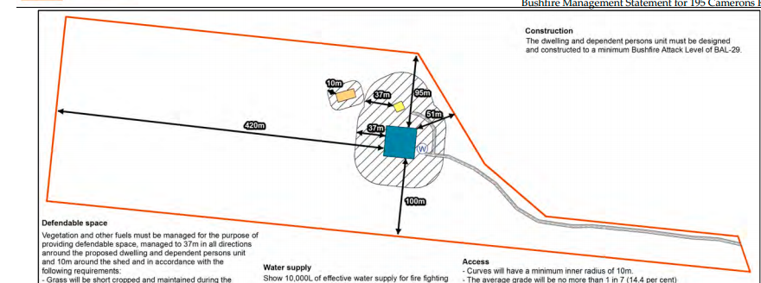
KEY: Blue – Dwelling, Yellow – DPU, Orange – Shed, Hatched Area- Defendable Space
Figure 1: Site plan

History
Planning permit PA2017129 was issued 13 November 2017 authorising a two lot subdivision of land from the parent lot, known as 195 Camerons Road, Coimadai. The application was advertised, and no objections were received.

Public Notice
The application was notified to adjoining and surrounding landowners.

Summary of Objections
The objections received are detailed below with officer’s comments accompanying them:
Objection | Any Relevant Requirement
The applicants carved up the land on the hillside for a motorbike racing track - facing my property. The noise from their motorbike racing events virtually every weekend has been extremely loud due to the topography, which creates a natural megaphone. I like to be outdoors every afternoon (eg. working on the ecological restoration of my property) but was prevented from being outdoors on weekends due to the noise. I offered to purchase that portion of their land by email, but they did not answer. Later, I asked the Shire planning department if there was anything I could do. A planner told me the motorbike track was against the planning code as bulldozing the bush and terraforming without a permit in this zone was prohibited. The planning enforcement officer spoke to them, but they continued to ride loud motorbikes almost weekend (revving constantly). | Noise Impacts.
Officer’s Response: Not relevant to a planning application for a dwelling and shed
I recently called the Shire’s Community Safety people as I was told that people cannot ride motorcycles on properties of that size without a permit. The track is not just for family use, as they have had as many as seven caravans, and other cars, when guests were attending these presumably just social racing events. I was promised that, if they applied for a permit, I would receive notice. There has been little motorcycling lately and no indication of a permit application (fingers crossed).
Officer’s Response: Not relevant to a planning application for a dwelling and shed

Nonetheless, the north facing slope is subject to extreme erosion. I have the same conditions on a north slope on my property where an old, abandoned road is eroding dramatically. I learned that we cannot lop trees unless their trunk is within 10 metres of the house (this impedes my roof solar cells). Since I did not initially know that, and neighbours were felling trees, I asked the Shire to advise people in the zone of their rights and obligations via letterbox (so I would not be blamed). Instead, they called in another neighbour who I assume just got a warning - but who was furious at me and apparently no longer speaks to me. The problem is not the complainant but the breach of rules, so the complainant should not be the only one to pay a price.
Officer’s Response: The dwelling would need to comply with any geotechnical requirements during the building phase. The site is not subject to an erosion overlay.
I notice the applicants are building a dam where water from their property used to run into my dam. They told me it is to feed sheep to ‘eat all the grass’, but there is no grass on that property yet, so sheep may damage the bush and further erode the hillside. It is a tiny dam that fills up when it rains, and then goes dry again. This does not do me much harm since so little water is involved. However, in a conservation zone having sheep running around will conflict with the wildlife and damage the native vegetation. I realize this is none of my business, but the Shire should consider biodiversity in a conservation zone. | Animal Keeping
Officer’s Response: If more than two animals are proposed, then a permit is required for animal keeping
They also were shooting across my property very frequently. The local police said I could not do anything about it because I would be unable to prove it. They said I could not photograph them as it would violate their privacy, so I should just ‘not go outdoors’. Although they denied that they shot over my property, I had (frightened) witnesses. Mr. Elcoat then told me he only shoots skeet. This may be so, as I have sheltered behind a large tree when the shooting started and had litter from the tree (and/or the skeet) fall all around me (5 times) - definitely on my property. I finally had other police talk to them and they appear to have greatly reduced or stopped this activity. I do not think shooting should be allowed in residential areas in conservation zones as people make the assumption no one is in the bush - and they cannot if people are there. | Noise Impacts
Officer’s Response: Not relevant to a planning application for a dwelling and shed
The noise from shooting and motorcycling must also be harmful to the wildlife. Our two properties are in a conservation zone very near Lerderderg Gorge State Park. I have put in over 40 nesting boxes on my property, but the noise, shooting and unpenned sheep from their ‘non-residential activities’ would certainly disturb biodiversity. Both shooting and motorbiking have died down lately, perhaps due to my complaints, but I cannot be sure if they are just on holiday.  I wonder if they have a bush regeneration plan or will do something to prevent erosion? | Noise Impacts
Officer’s Response: Not relevant to a planning application for a dwelling and shed

Locality Map
The map below indicates the location of the subject site and the zoning of the surrounding area.
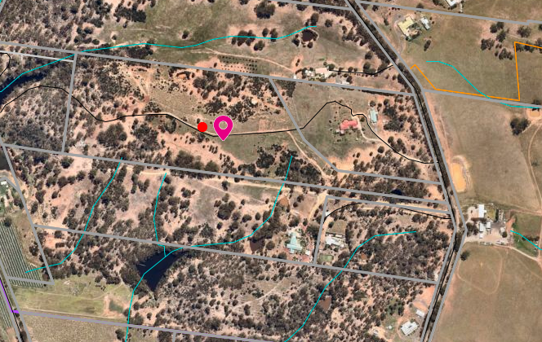
Figure 2: Aerial Photograph
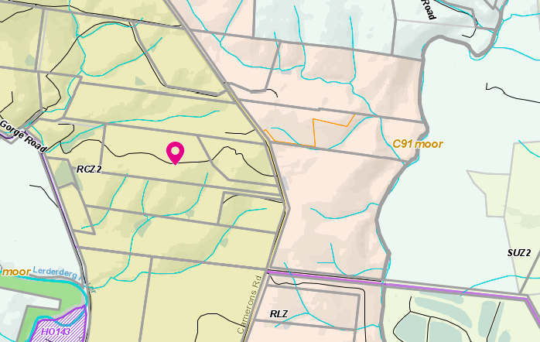
Figure 3: Zone Map

Planning Scheme Provisions
Council is required to consider the Victoria Planning Provisions and give particular attention to the Planning Policy Framework (PPF), the Local Planning Policy Framework (LPPF) and the Municipal Strategic Statement (MSS).
The relevant clauses are:
• Clause 11.03-3S Peri-urban areas
• Clause 13.02-1S Bushfire planning
• Clause 15.01-5S Neighbourhood character Clause 21.02 Natural Environment
• Clause 21.02-2 Objective—Non-urban landscapes
• Clause 21.02-3 Objective—Water and catchment management
• Clause 21.02-4 Objective—Biodiversity
• Clause 21.02-5 Objective—Bushfire
• Clause 21.02-6 Objective—Environmentally sustainable development
• Clause 21.07-5 Objective—Cameron’s Road Area limited rural living
The proposal complies with all of the relevant sections of the PPF and LPPF.

Zone
The subject site is located within a Rural Conservation Zone Schedule 2 (RCZ2)
The purpose of the zone is:
• To implement the State Planning Policy Framework and the Local Planning Policy Framework, including the Municipal Strategic Statement and local planning policies.
• To conserve the values specified in a schedule to this zone.
• To protect and enhance the natural environment and natural processes for their historic, archaeological and scientific interest, landscape, faunal habitat and cultural values.
• To protect and enhance natural resources and the biodiversity of the area. To encourage development and use of land which is consistent with sustainable land management and land capability practices, and which takes into account the conservation values and environmental sensitivity of the locality.
• To provide for agricultural use consistent with the conservation of environmental and landscape values of the area.
• To conserve and enhance the cultural significance and character of open rural and scenic non urban landscapes
Under Clause 35.06-1 the use of the land does require a planning permit on the condition that it meets the requirements of Clause 35.06-2.
Clause 35.06-2 states a lot used for a dwelling must meet the following requirements:
• Access to the dwelling must be provided via an all-weather road with dimensions adequate to accommodate emergency vehicles.
• The dwelling must be connected to a reticulated sewerage system or if not available, the wastewater must be treated and retained on-site in accordance with the State Environment Protection Policy (Waters of Victoria) under the Environment Protection Act 1970.
• The dwelling must be connected to a reticulated potable water supply or have an alternative potable water supply with adequate storage for domestic use as well as for firefighting purposes.
• The dwelling must be connected to a reticulated electricity supply or have an alternative energy source
Under Clause 35.06-5 a planning permit is required to construct a building or carry out works associated with a Section 2 use. Decision guidelines are listed Clause 35.05-6.

Overlays
Design & Development Overlay Schedule 14 (DD14)
In accordance with Clause 43.02 a planning permit is not required for the following buildings and works:
• Any buildings or works associated with the use of an existing dwelling.
• Any buildings or works associated with the existing use of the land for agriculture.

All new buildings must be sited:
• At least 500m from the extractive industries as defined by the Special Use Zone Schedule 2. A permit cannot be granted to vary this requirement.
• Within a dwelling envelope, for a building used for a dwelling or dependent person’s unit, generally located in accordance with Map 1 to Schedule 14 to Clause 43.02. An alternative dwelling envelope location other than shown in Map 1 to Schedule 14 to Clause 43.02 should meet all of the siting requirements of this clause and be capable of accommodating a defendable space in accordance with Clause 52.47 and Schedule 1 to Clause 44.06 (BMO1).
• At least 100m from Goodmans Creek or the Lerderderg River.
• At least 500m from the Lerderderg State Park except that a building used for a dwelling or dependent person’s units located on Properties A, O and J shown on Map 1 to Schedule 14 to Clause 43.02 may be located within the 500m setback to the Lerderderg State Park with the written consent of the Department of Environment, Land, Water and Planning.
• At least 30m for a building used for a dwelling or dependent person’s unit.
• At least 50m for buildings other than those used for a dwelling or dependent person’s unit from a road boundary.
• At least 10m from other boundaries, and
• To avoid slopes of greater than 20% (11 degrees) where possible.
The proposed development complies with these requirements.
Bushire Management Overlay
In accordance with Clause 44.06 a permit is not required for a use associated with accommodation where:
A building or works consistent with an agreement under Section 173 of the Planning and Environment Act 1987 prepared in accordance with a condition of permit issued under the requirements of Clause 44.06-5.
Schedule 1 to Clause 44.06, item 2.0 states as follows:
This schedule applies to all applications for building and works associated with a dwelling (including an extension or alteration to a dwelling) or a dependant persons unit or to subdivide land for a dwelling on land described in Table 1 to this schedule. Clause 52.47 applies to all other applications.
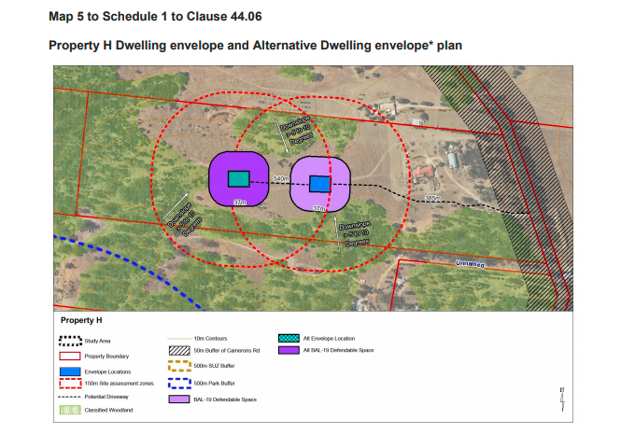
Figure 5: BMO for Property H (the former parent title to 195 Cameron Road).
The shed is located outside the defendable space and needs to be accessed as works ancillary to the use of the land for accommodation.

Discussion
The proposed dwelling complies with the objectives of the zone and are located within the designated envelope areas as defined by the DD014 controls. The dwelling complies with the setbacks requirements and is located on part of the site that is well away from the street frontage. The dwelling is located in a cleared part of the site with trees located to the rear and southern sides to be retained thereby preserving the conservation values of the area. The DPU is a moveable dwelling and will need to be removed from the land when the dependant persons are no longer present. This can be enforced by a permit condition.
The large lot size ensures that the effluent field can be contained with the property boundaries and is well setback from the nearest watercourses. The effluent field can be managed in accordance with the requirement of Council’s Environmental Health. The one effluent field will be shared between the dwelling and DPU.
The Bushfire Management Plan has been examined by the CFA who have consented to the application in accordance with the requirement of the Bushfire Management Overlay.
The objector has expressed concerns about the current activity on vacant land such as the use of motorbikes, shooting and sheep on the land. These are not related to the planning application.

The objector only provided an email address and several emails sent over a four month period requesting consultation or discussion have been unsuccessful. Despite the lack of contact, conditions will still be in place to ensure the dwelling, the DPU and the ancillary shed operate only for their intended uses. Noise issues can be dealt separately through Council’s Environmental Health rather than through this planning application for a dwelling use.

General Provisions
Clause 65 – Decision Guidelines have been considered by officers in evaluating this application.
Clause 66 – Stipulates all the relevant referral authorities to which the application must be referred.

Referrals
Authority | Response
Infrastructure  Environmental Health  CFA | Consent with conditions  Consent with conditions  Consent with conditions.

Financial Implications
There are no financial implication in recommending approval of this use and development.

Risk & Occupational Health & Safety Issues
The recommendation of approval of this use and development does not implicate any risk or OH&S issues to Council.

Communications Strategy
Notice was undertaken for the application, in accordance with s.52 of the Planning and Environment Act 1987, and further correspondence is required to all interested parties to the application as a result of a decision in this matter. All submitters and the applicant were invited to attend this meeting and invited to address Council if required.

Options
• Issue a Notice of Decision to grant a permit in accordance with the recommendation of this report; or
• issue a Notice of Decision to grant a permit with amendments to the conditions in the recommendation of this report; or
• should Council wish to refuse the application, issue a Refusal to Grant a Permit on relevant grounds. This option may result in the applicant appealing Council’s decision at VCAT.

Conclusion
The proposed development of a dwelling and Dependant Persons Unit on a recently subdivided parcel of land that was created to comply with the Design and Development Overlay Schedule 14 requirement is acceptable and does not create any off site impacts. The dwelling is appropriately positioned on the land with regards to the approved defendable space under the DD014. The area was re-zoned to a Rural Conservation Zone Schedule 2 with a Design and Development Schedule 14 and this proposed dwelling is following the intended pattern of development for this area. The objection grounds are concentrated on non-related amenity issues that can addressed by Council’s Environmental Health. It is recommended that a Notice of Decision to grant a permit be issued.

Mr. Ramon Jimenez addressed Council as the applicant associated with Item 7.5.
Mrs. Elma Jimenez addressed Council as the applicant associated with Item 7.5.

7.5 PA2003472, PA2003473, PA2003474, PA2003475 - Sixth extension of time for use and development of a single dwelling at Conroys Lane Wallace
Author: Mark Lovell, Coordinator Statutory Planning
Authoriser: Henry Bezuidenhout, Executive Manager Community Planning & Economic Development
Attachments: Nil

Application Summary
Permit No: PA2003472, PA2003473, PA2003474 and PA2003475
Lodgement Date: 27 October, 2020
Planning Officer: Mark Lovell
Address of the land: Lots 1 & 2 on PS503064U; Crown Allotments 11-15 in PC365342W; Crown Allotments 15-20 in PC365343U; Conroys Lane, Wallace
Proposal: Sixth extension of time
Lot size: 9.7ha
Why is a permit required? The permit has expired as the development was not commenced by 27 April 2020. An extension of time is required to commence the development

Committee Resolution
Moved: Cr Paul Tatchell
Seconded: Cr Ally Munari
That the Development Assessment Committee, having considered all matters as prescribed by the Planning and Environment Act 1987, issues a Refusal to extend the permit expiry dates based on the following grounds:
- The application does not meet the Kantor tests including no substantial commencement of the development has been undertaken.
- There has been insufficient progress in the intervening period to commence works on site.
- The request for a sixth extension of time to commence is beyond a reasonable amount of time given since the issue of the permit 15 years ago.
Carried

Public Consultation
Was the application advertised? | A request for an extension of time is not required to be advertised under Section 69 of the Planning and Environment Act 1987.
Notices on site: | No.
Notice in Moorabool Newspaper: | No.
Number of objections: | Nil.
Consultation meeting: | No

Policy Implications
The Council Plan 2017-2021 provides as follows:
Strategic Objective 3: Stimulating Economic Development
Context 3A: Land Use Planning
The proposal is consistent with the Council Plan 2017 – 2021.

Victorian Charter of Human Rights & Responsibilities Act 2006
In developing this report to Council, the officer considered whether the subject matter raised any human rights issues. In particular, whether the scope of any human right established by the Victorian Charter of Human Rights and Responsibilities is in any way limited, restricted or interfered with by the recommendations contained in the report. It is considered that the subject matter does not raise any human rights issues.

Officer’s Declaration of Conflict of Interests
Under section 130 of the Local Government Act 2020, officers providing advice to Council must disclose any interests, including the type of interest.
Executive Manager – Henry Bezuidenhout
In providing this advice to Council as the Executive Manager, I have no interests to disclose in this report.
Author – Mark Lovell
In providing this advice to Council as the Author, I have no interests to disclose in this report.

Executive Summary
Application referred? | No.
Any issues raised in referral responses? | Nil.
Preliminary concerns? | No.
Any discussions with applicant regarding concerns? | Nil.
Any changes made to the application since being lodged? | None.
Brief history. | The permit was issued at the direction of VCAT on 27 April 2006 which set aside Council’s Refusal to grant a planning permit for a single dwelling on a single lot for four separate planning applications. VCAT resolved to issue one permit for one dwelling over four lots provided they were consolidated into a single lot.
Previous applications for the site? | Nil.
General summary. | The application is for a sixth extension of time of an approved development which has not commenced. The applicant has provided a timeline from 1998 onwards detailing the difficulties in first obtaining the initial permit and then with ongoing difficulties. The timeline in the initial approval for five years to commence and seven to complete was reasonable for a small scale development consisting of one dwelling.  Officers have recommended Refusal to three previous extension of time requests were overturned by Council in 2016, 2017 and 2019.  To allow beyond 15 years for commencement is completely contrary to the Planning and Environment Act 1987.
Summary of Officer’s Recommendation
That, having considered all relevant matters as required by the Planning and Environment Act 1987, Council issue a refusal to extend the permit expiry dates for the use and development of a single storey dwelling at Conroys Lane, Wallace

Site Description
The subject site is located on the western side of Conroys Lane, north of the Western Freeway, Wallace. The lots do not have an abuttal to Conroys Lane but can be assessed from their southern boundary which is adjacent to Spargo Creek Road. Spargo Creek Road runs parallel with the Western Freeway. The subject site is comprised of open farming land without any building structures. There are only a small scattering of border trees and internal dividing fences separating each of the four lots. The site has a slight sloped topography in an east to west direction with the Moorabool River (Western Branch) located one further property to the west.

Proposal
An application for a single dwelling on a single lot covering four lots under four separate planning applications were lodged on 15 December 2003. The applications were advertised, and objections were received including from a Section 55 referral authority - Central Highlands Water. All four planning permit applications were refused on 25 May 2005.
The applicant appealed against each of these decisions to VCAT who determined all four applications together and resolved to issue one planning permit for one dwelling covering four lots on 27 April 2006. The permit numbers for this single permit is PA2003-472, PA2003-473, PA2003-474 and PA2003-475.
Condition 15 of the Permit contained a five year commencement date and seven year completion date with the following expiry dates:
• The development and use is started by 27 April 2011.
• The development and use is completed by 27 April 2013.
There have been five previous extension of time requests granted as detailed below.
First Extension of time
A first extension of time (E1) of two years was granted on 28 September 2010. The reasons given for the request were:
• Adversely affected by the Global Financial Crisis with tightening of the credit markets.
• The applicant was unable to raise funds to take any steps to advance the development.
The expiry conditions were extended to:
• The development and use is started by 27 April 2013.
• The development and use is completed by 27 April 2015.
The applicant was advised in a cover letter to the approval dated 6 October 2010 that is unlikely that Council will grant any further application for an extension of time and the applicant should endeavour to commence development and comply with the conditions of the permit.
Second Extension of Time
A second extension of time (E2) of three years was granted on 25 July 2013.
The reason given for the request was:
• Lack of availability of finance for the project.
• The ongoing global financial instability that started in 2008 has resulted in tightening of credit markets and impacted on the financial position of the applicant.
The expiry conditions were extended to:
• The development and use is started by 27 April 2016.
• The development and use is completed by 27 April 2018.
During the assessment of the second extension of time application, discussions were held with the applicant who was advised at that time that Council officers were considering refusing the application. The proposed grounds of refusal were to be warehousing the permit given the length of time passing since approval. A report was being prepared for Council to consider a refusal recommendation. The applicant offered to provide an assurance that the development would commence within a three year period and they would not seek any further extensions to the commencement date.
The applicant then confirmed in a written correspondence dated 18 June, 2013: “I confirm that our application for an extension of time is to be resolved on the basis that you will approve extensions of three and two years respectively to the start and completion dates…you will not give a further extension to the start date, however you may grant an extension to the completion date if more time is needed to complete the building and other works.”
With this written assurance, the permit was extended under delegation beyond the normal 12 months’ timeframe to three years, on the understanding there would no further requests to the commencement date.
Third Extension of Time
A third extension of time (E3) was granted on 6 July 2016.
Council officers recommended refusal to the third of extension of time. Council determined at its Ordinary Meeting of Council (OMC) held on 6 July 2017 to allow another 12 months to the commencement and completion dates.
The reason given for the request was:
• The applicant stated as a result of funds becoming available in late 2015 the applicant has begun discussions with builders including Porter Davis and has taken the necessary steps to progress the project including updated reports.
The expiry conditions were extended to:
• The development and use is started by 27 April 2017.
• The development and use is completed by 27 April 2019.
Council by approving this extension advised they would not support any further extensions of time as the applicant was about to commence construction.
Fourth Extension of Time
A fourth extension of time (E4) was approved on 2 August 2017.
Council officers recommended refusal to the fourth of extension of time. Council determined at its Ordinary Meeting of Council (OMC) held 2 August 2017 to allow another 12 months to the commencement and completion dates.
The reason given for the request was:
• Hampered by financial difficulties.
• Commencement of preparation of fully dimensioned plans to be submitted to Council for endorsement.
The expiry conditions were extended to:
• The development and use is started by 27 April 2018.
• The development and use is completed by 27 April 2020.
Fifth Extension of Time
A fifth extension of time (E5) was granted on 6 February 2019.
Council officers recommended refusal to the fifth of extension of time. Council determined at its Ordinary Meeting of Council (OMC) held on 6 February 2019 to allow another 24 months rather than the standard 12 months to the commencement and completion dates. This was done as by the time the application was made (six months after the expiry) and the application was determined it would have only allowed an effective two month extension from the decision date.
The reasons given for the request was:
• Hampered by financial difficulties.
The expiry conditions were extended to:
• The development and use is started by 27 April 2020.
• The development and use is completed by 29 April 2022.
Sixth Extension of Time (current request)
A sixth extension of time (E6) was lodged by the applicant, Ramon Jimenez on 27 October 2020. The application was again made after the expiry of the permit but within the six months grace period after expiry to apply for an extension of time. The grace period to apply for an extension of time ended on 27 October,2020. The applicant lodged the extension of time on the last possible day to apply.
The reasons given for the request
• Serious motor vehicle accident and ability to work severely affected.
• Covid-19.
The applicant is seeking a further two years to the commencement date and a further two years to the completion date.

History
All four planning permit applications were refused on 25 May 2005. The applicant appealed against each of these decisions to VCAT who determined all four applications together and resolved to issue a planning permit for one dwelling covering four lots on 27 April 2006.
The permit numbers for this single permit is PA2003-472, PA2003-473, PA2003-474 and PA2003-475

Public Notice
Application for an extension of time do not require notification.

Locality Map
The map below indicates the location of the subject site and the zoning of the surrounding area.
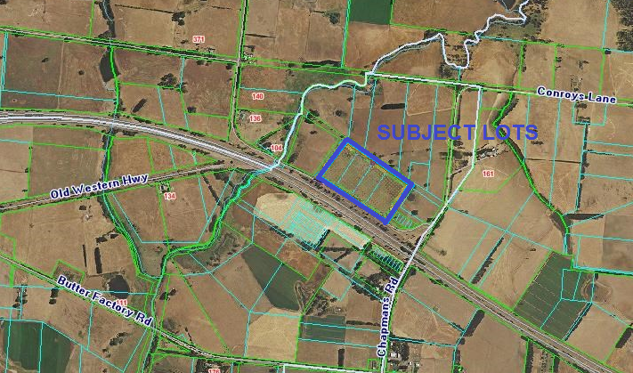
Figure 1: Aerial photograph
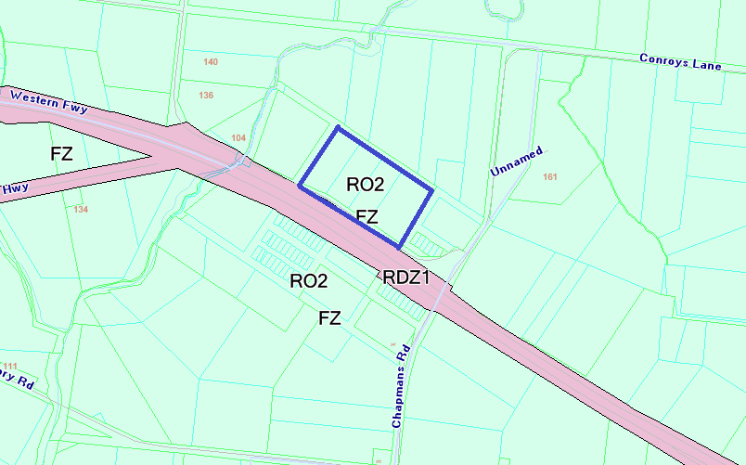
Figure 2: Zone Map

Planning Scheme Provisions
Assessment of Extension of time applications – Kantor test
There are no specific controls in the Planning Scheme relating to the assessment of an extension of time of a permit. However, there are some general guidelines or “tests” that can be applied to guide an assessment of an extension of time application. Such guidance was provided by His Honour Mr. Justice Ashley in considering a number of Tribunal decisions in Kantor v. Murrindindi Shire Council 18 AATR 285 where His Honour stated that a Responsible Authority “may rightly consider” the following:
• Whether there had been change in planning policy.
• Whether the landowner is seeking to “warehouse” the permit.
• Intervening circumstances as bearing upon grant or refusal.
• The total elapse of time.
• Whether the time limit originally imposed was adequate.
• The economic burden imposed on the landowner by the permit.
• The probability of a permit issuing should a fresh application be made.
It is important to note that most of the above decisions do not necessarily provide clear direction on the “weighting” that should be applied to the various criteria and it is important that each proposal be assessed on the merits of the individual circumstances.
The applicant disagrees with the Kantor decision based on a Supreme Court decision in 2015. Subsequent to the Supreme Court decision, VCAT legal members have advised the Kantor tests are the appropriate mechanism to access extension of time requests.
The Kantor tests are generally used by the Moorabool Shire Planning Department to assess extension of time applications.

Zone
Farming Zone
The land is in the Farming Zone (FZ) where a permit is required to a single dwelling on a lot less than 40ha.
The purpose of the zone is to:
• To implement the Municipal Planning Strategy and Planning Policy Framework.
• To provide for the use of land for agriculture.
• To encourage the retention of productive agricultural land.
• To ensure that non-agricultural uses, including dwellings, do not adversely affect the use of land for agriculture.
• To encourage the retention of employment and population to support rural communities.
• To encourage use and development of land based on comprehensive and sustainable land management practices and infrastructure provision.
OVERLAYS
Environmental Significance Overlay – Schedule 1 (ESO1)

In Environmental Significance Overlay, a permit is required for buildings and works.
• To implement the Municipal Planning Strategy and the Local Planning Policy Framework.
• To identify areas where the development of land may be affected by environmental constraints.
• To ensure that development is compatible with identified environmental values. The environmental objective to be achieved.
• To protect the quality and quantity of water produced within proclaimed water catchments.
• To provide for appropriate development of land within proclaimed water catchments

Design & Development Overlay Schedule 2
The land is also covered by a Design & Design & Development Overlay - Schedule 2 (DD02). A permit is not required for building and works provided the materials are non reflective.
Design & Design & Development Overlay - Schedule 3
The land is also covered in part by a Design & Design & Development Overlay - Schedule 3 (DD03). A permit is required to construct a dwelling.

The purpose of the overlay is to:
• To ensure that the development of land or the display of advertising signs near the alignment of the Western Freeway does not prejudice the levels of service, safety and amenity of the Western Freeway/Highway.
• To minimise any adverse effects of noise on noise sensitive uses from traffic using the Western Freeway/Highway.

Restructure Overlay (RO)
The land is also covered by a Restructure Overlay. A permit is required to construct a dwelling and must be in accordance with the restructure plan for the land listed in the schedule.
The purpose of this overlay is:
• To implement the Municipal Planning Strategy and the Local Planning Policy Framework.
• To identify old and inappropriate subdivisions which are to be restructured.
• To preserve and enhance the amenity of the area and reduce the environmental impacts of dwellings and other development.

Road Closure (RXO)
The land is also covered by a Road Closure Overlay (RXO).
The purpose of this overlay is:
• To implement the and the Municipal Planning Strategy and the Planning Policy Framework.
• To identify a road that is closed by an amendment to this planning scheme.
A road included in this overlay is closed on the date notice of approval of the amendment is published in the Government Gazette.

Relevant Policies
No relevant policies

Particular Provisions
No relevant particular provisions.

Discussion
Kantor tests
1. Whether there has been change in Planning Policy
When the application was determined the land was zoned in a Rural Zone. Amendment the C50 came into operation on 2 August 2007 and was subsequently incorporated into the Moorabool Shire Planning Scheme. The amendment introduced the Farming Zone into the Scheme and rezoned the subject land from a Rural Zone to a Farming Zone. Following C50 amendment, various amendments were introduced to Moorabool Planning Scheme to ensure the better and consistent planning outcome for assessing applications within the Farming Zone.
The application would now need to be assessed in light of the objectives of the Farming Zone whereby the applicant would now need to demonstrate how an agricultural activity is linked to the proposed dwelling and would require the submission of a comprehensive Farm Management Plan.
No Farm Management Plan was submitted with the initial approved development.
This change to planning controls could in Council in not supporting a future planning application for use and development of a dwelling.
2. Whether the landowner is seeking to “warehouse” the permit.
Based on a recent VCAT decision, the applicant is not warehousing the permit, applicant has stated they unable to commence works due to a serious motor accident that has affected their ability to work.
3. Intervening circumstances as bearing upon grant or refusal.
There have been no intervening circumstances that would have a bearing on this decision. The major reforms to the planning scheme as part of VC148 have not changed the intent or purpose of the Farming Zone which is the primary considerations in assessing a new development proposal. There has been no relaxing of the Farming Zone controls which discourage residential activity.
4. The total elapse of time since the permit was issued.
The permit was issued on 27 April 2006, which is 15 years ago. The project is for a single dwelling over four lots rather the intended development project which was lodged as four dwellings over four lots. It would not be expected that a development project of this small scale would take more than 15 years to commence.
The applicant could have started the clock by beginning the development to the foundation stage, while not having all of the funds available thereby allowing an additional two year window to complete the works.
The start has been delayed by the actions of the applicant who has not lodged plans for endorsement as required by conditions of the permit and has not received a Building Permit with endorsed Working Drawings from a Building Surveyor. These tasks could have been completed several years ago and may have assisted in obtaining finance for the project. At this stage, only a planning permit has been granted which was issued in 2006.
The applicant has decided to pursue other aspects of the development that would normally be completed after endorsement of plans such as a crossover permit approval despite the absence of an endorsed site plan showing a crossover location and updating the Land Capability Assessment (LCA) despite no floor plan of the dwelling that would identify the total number of bedrooms and no site plan to determine where the dwelling will be located on site. The endorsement of plans is a simple task to undertake and it is not reasonable to take more than 15 years to make changes to town planning drawings. The applicant advised in their Extension of Time 4 application in 2017 that they were preparing fully dimensioned plans however these plans have never been submitted.
In the current circumstances with the applicant’s health, it is unlikely that development will commence within the next year and the applicant will likely need to apply for further extensions of time into the future.
VCAT decisions in relation extension of time request, look at likelihood of works commencing if an extension of time is granted. In this situation, it is more than likely that the development will not commence any time soon. If the responsible authority believe it is unlikely to commence, then extension of time should not be granted.

This extension is not the first request, but the sixth request and Council officers have recommended refusal back in 2016, 2017 and 2019. Council decided to give this applicant further opportunities to commence works. In the last request, Council extended the timelines beyond the normal 12 months extension to 24 months in order to further assist the applicant. This applicant has encountered numerous financial hardships and personal health issues which demonstrate that the applicant may not be able to ever commence this development. Permits are not to remain open with unlimited timelines. The applicant can re-apply for a permit when their personal circumstances improve. To continually allow further extensions to a 2006 issued planning permit is contrary to the Planning an Environment Act 1987 and there is no known example of a single dwelling development taking more than 15 years to commence works.
Under this Kantor test, 15 years has lapsed since the permit was issued, that is completely unacceptable and fails to be considered as a reasonable length of time.

General Provisions
Clause 65 – Decision Guidelines have been considered by officers in evaluating this application.
Clause 66 – Stipulates all the relevant referral authorities to which the application must be referred.

Financial Implications
There are no financial implication in recommending refusal of this extension of time request

Risk & Occupational Health & Safety Issues
The recommendation of refusal does not implicate any risk or OH&S issues to Council.

Communications Strategy
Notice was not undertaken for the application, in accordance with s.52 of the Planning and Environment Act 1987. The applicant is invited to attend this meeting and invited to address Council if required.

Options
• Issue a refusal to extend the time limits in accordance with the recommendation of this report; or
• should Council wish to consider approving the extension of time request they need to explore justifications for the extension of time that is contrary to the Planning and Environment Act 1987.

Conclusion
Council has been exceptionally generous over a long period of time in granting previous extension of time approvals well beyond the usual 12 month extensions, to enable the applicant to commence works on site. Council has accepted the problems encountered by the applicant and has wanted to provide this applicant with opportunities to commence works on site.
Council has approved five previous extensions of time requests and has allowed the applicant 15 years to commence the development for one dwelling on the land. Permits are not issued to be left open or remain open until such time an applicant has the capacity to commence, as this is contrary to the provisions of the Planning and Environment Act 1987. The applicant can re-apply when their circumstances change for the better.
The proposal cannot be supported based on the well-established tests for an extension of time application. It is recommended that the extension of time request be refused.

7.6 PA2020275 - Use and Development of a Second Dwelling for Short Term Accommodation, Use of Land for Agriculture and works in an ESO1
Author: Robert Fillisch, Manager Statutory Planning & Building Services
Authoriser: Henry Bezuidenhout, Executive Manager Community Planning & Economic Development
Attachments: Nil

Application Summary
Permit No: PA2020275
Lodgement Date: 11 December 2020
Planning Officer: Robert Fillisch
Address of the land: 19 Faheys Road, Gordon
Proposal: Use and Development of a Second Dwelling for Short Term Accommodation, Use of Land for Agriculture and Works in an ESO1.
Lot size: 16.19ha
Why is a permit required? Clause 35.03-1 – Rural Living Zone – Second Dwelling (Short Term Accommodation)
Clause 35.03-1 – Rural Living Zone - Agriculture
Clause 42.01-2 – Environmental Significance Overlay - Works

Committee Resolution
Moved: Cr Tonia Dudzik
Seconded: Cr Ally Munari
That the Development Assessment Committee, having considered all matters as prescribed by the Planning and Environment Act 1987, issue a Planning Permit for the Use and Development of a Second Dwelling for Short Term Accommodation, Use of Land for Agriculture and Works in the Environmental Significance Overlay Schedule 1 at 19 Faheys Road Gordon, otherwise known as Lot 1 on TP015455L, subject to the following conditions:
Amended Plans:
1. Before the use and/or development starts, plans to the satisfaction of the Responsible Authority must be submitted to and approved by the Responsible Authority. When approved, the plans will be endorsed and will then form part of the permit. The plans must be drawn to scale with dimensions and two copies must be provided. The plans must show:
(a) a plan showing the extent of decommissioning of the existing dwelling; and
(b) floor and elevation plans of the proposed new shed.
2. Unless otherwise approved in writing by the Responsible Authority, all buildings and works are to be constructed and or undertaken in accordance with the endorsed plans to the satisfaction of the Responsible Authority prior to the commencement of the use.

Replacement Dwelling and Short Term Accommodation Building Requirements:
3. The replacement dwelling and short term accommodation building must be connected to a reticulated sewerage system or if not available, the wastewater must be treated and retained on-site in accordance with the State Environment Protection Policy (Waters of Victoria) under the Environment Protection Act 1970.
4. The replacement dwelling and the short term accommodation building must be connected to a reticulated potable water supply or have an alternative potable water supply with adequate storage for domestic use as well as for firefighting purposes.
5. The replacement dwelling and the short term accommodation building must be connected to a reticulated electricity supply or have an alternative energy source.
6. Access to the replacement dwelling and short term accommodation building must be provided via an all-weather road with dimensions adequate to accommodate emergency vehicles.
Materials and Colour:
7. All external walls and roof areas of the proposed building/s are to be clad with non-reflective materials (zincalume prohibited) to the satisfaction of the Responsible Authority.
Farm Management Plan:
8. A Farm Management Plan to the satisfaction of the Responsible Authority must be endorsed as part of this permit and cannot be varied without the written consent of the Responsible Authority.
Earthworks and Extension to the Dam:
9. The earthworks and the extension to the existing dam must be in accordance with the endorsed plans. The following must be met:
(a) the wall of the dam to have a suitable foundation and be constructed of compacted clay material so as to be completely stable and watertight; and
(b) the spillway of the dam constructed of rock or similar non-erodible material.
Infrastructure:
10. The property access and the internal driveways must be constructed in accordance with the requirements specified in Table 5 of Clause 53.02-5 of the Moorabool Planning Scheme, to the satisfaction of the Responsible Authority
11. Stormwater drainage from the proposed building/s and impervious surfaces must be retained and disposed of within the boundaries of the subject land to the satisfaction of the Responsible Authority. Overflows from on-site storage systems must be directed away from any wastewater disposal areas.
12. Sediment discharges must be restricted from any construction activities within the property in accordance with relevant Guidelines including Construction Techniques for Sediment Control (EPA 1991).
13. Unless otherwise approved by the Responsible Authority there must be no buildings, structures, or improvements located over proposed drainage pipes and easements on the property.

14. Prior to the commencement of the development and post completion, notification including photographic evidence must be sent to Council’s Asset Services department identifying any existing damage to Council assets. Any existing works affected by the development must be fully reinstated at no cost to and to the satisfaction of the Responsible Authority.
Environmental Health:
15. The land application area and all conditions must be in accordance to the Land Capability Assessment prepared by Provincial Geotechnical, ref number 15154I dated 2 October 2020 or any approved amendment are to be strictly adhered to.
16. An onsite wastewater management system with the capacity to treat effluent to a minimum of 20mg/L BOD and 30mg/L Suspended Solids must be installed
17. Effluent disposal must be undertaken via subsurface irrigation system designed and installed by a wastewater irrigation expert in accordance with the EPA Code of Practice for Onsite Waste Water.
18. The wastewater management system from proposed dwelling/lots must be treated and contained within the property boundaries in accordance with the current EPA Code of Practice; Onsite Wastewater Management: Guidelines for Environmental Management, Australian Standards 1547 and Council requirements.
19. The effluent disposal area must be kept free of buildings, driveways, vehicular traffic and services trenching.
20. All setback distances must be adhered to as dictated by Table 5 of the Code of Practice, Onsite Wastewater Management, EPA Publication Number 891.4
21. A shallow surface water cut off drain or surface water diversion mound, should be provided on the high side of the disposal areas to divert any surface water flows around the effluent fields.
22. Subsurface Irrigation system needs to be installed to a depth of 150mm in situ or if the soil is of poor quality, imported good quality topsoil may be required, with a 1m spacing in between lines.
23. The owner will maintain all drainage lines at all times to divert surface water and subsurface water clear of the effluent disposal field.
Corangamite Catchment Management Authority:
24. Excavated sediment is to be removed from site or placed on higher ground outside of the 1% AEP flood extent and in a position where it can’t wash into the waterway.
25. Sediment controls such as sediment fences are to be suitably placed and maintained for the duration of the works to protect the waterway from sediment input.
26. Works are to occur during dry periods.
Barwon Water:
27. The following shall be undertaken to the requirements of Barwon Water and to the satisfaction of the Responsible Authority:
28. Wastewater treatment is to achieve a minimum water quality standard of 20mg/L BOD, 30mg/L SS and 10 orgs/100ml, i.e. secondary treatment, via an EPA approved all wastewater treatment system.
29. Effluent disposal must be designed and installed by a wastewater irrigation to the satisfaction of Moorabool Shire Council’s Environmental Health Officer.
30. All components of the wastewater management system including the effluent disposal area must be located at least 60m from any surface waterway and 20m from any groundwater bore.
31. All stormwater must be directed away from the effluent disposal area and roof stormwater must not be disposed to the effluent disposal area.
32. Monitoring, Operation and Maintenance must be undertaken in accordance with Provincial Land Capability Assessment Report No. 15154I dated 2 October 2020 and to the satisfaction of Moorabool Shire Council’s Environmental Health Officer.
33. The effluent disposal field must be protected by being isolated from any building, driveway, livestock, and vehicles.
34. Sediment control measures as outlined in the EPA’s publication No 275 Sediment Pollution Control shall be employed during the construction of the dwelling and maintained until the disturbed area has regenerated.
35. The existing septic tank must be decommissioned in accordance with the EPA Code of Practice – onsite wastewater management.
36. Prior to a certificate of occupancy being issued for the dwelling the owner must enter into an agreement with the Responsible Authority and Barwon Water in accordance with Section 173 of the Planning and Environment Act 1987 requiring that:
(a) The Owner is to enter into a service contract to have any wastewater treatment facility and effluent disposal system for the dwelling inspected and maintained in accordance with the EPA Certificate of Approval for the installed system.
(b) The Owner must provide to Barwon Water and the Responsible Authority an annual report on the condition and operation of the wastewater treatment system which documents the effluent quality achieved and provides laboratory, inspection and maintenance reports for the preceding 12 months.
(c) The Owner shall have the wastewater treatment facility desludged at least once every three years or as otherwise determined by Council’s Environmental Health Officer. Evidence of this desludging shall be provided in the annual report referred to in Clause (b) here in.
(d) The Owner shall carry out any works considered necessary by the service contractor to ensure the satisfactory operation of the wastewater treatment facility and effluent disposal system.
(e) The Owner will maintain all drainage lines at all times to divert surface water and subsurface water clear of the effluent disposal field.
(f) The Owner and the Responsible Authority agree to do all things necessary to register a memorandum of this Agreement on the title of the land pursuant to Section 181 of the Planning and Environment Act 1987.
(g) The Owner shall meet all costs of inspections, reports and works referred to in Clauses (a), (b), (c), (d), and (e) herein and all costs of the Responsible Authority in relation to stamping and registration of this Agreement.
(h) The Owner shall not sell or enter into any contract to sell the land until this Agreement has been registered pursuant to Clause (f) herein.
37. Barwon Water require the Section 173 to be signed by the Managing Director and Company Secretary and to state the following: THE COMMON SEAL of the BARWON REGION WATER CORPORATION was hereunto affixed in the presence of.
Permit Expiry:
38. This permit will expire if one of the following circumstances applies:
(a) The development is not started within two years of the date of this permit;
(b) The development is not completed within four years of the date of this permit.
Permit Notes:
Environmental Health
Prior to installation of works commencing on the wastewater system, a permit to install an onsite wastewater management system must be submitted to Environmental Health.
.Carried

Public Consultation
Was the application advertised? | Yes.
Notices on site: | Yes.
Notice in Moorabool Newspaper: | No.
Number of objections: | Nil.
Consultation meeting: | Not applicable.

Policy Implications
The Council Plan 2017-2021 provides as follows:
Strategic Objective 2: Minimising Environmental Impact
Context 3A: Land Use Planning
The proposal is not provided for in the Council Plan 2017-2021 and can be actioned by utilising existing resources.

Victorian Charter of Human Rights & Responsibilities Act 2006
In developing this report to Council, the officer considered whether the subject matter raised any human rights issues. In particular, whether the scope of any human right established by the Victorian Charter of Human Rights and Responsibilities is in any way limited, restricted or interfered with by the recommendations contained in the report. It is considered that the subject matter does not raise any human rights issues.

Officer’s Declaration of Conflict of Interests
Under section 130 of the Local Government Act 2020, officers providing advice to Council must disclose any interests, including the type of interest.
Executive Manager – Henry Bezuidenhout
In providing this advice to Council as the Executive Manager, I have no interests to disclose in this report.
Author – Robert Fillisch
In providing this advice to Council as the Author, I have no interests to disclose in this report. However, Statutory Planner, Victoria Mack declared a Direct Conflict of Interest in relation to PA2020275 due to being the partner of the applicant and as a consequence was not involved in any preparation or deliberations of this report for Council’s consideration. The report was therefore assessed and prepared by an external consultant on behalf of the Manager, Statutory Planning and Building Services for review and authorisation.

Executive Summary
Application referred? | Yes.
Any issues raised in referral responses? | No.
Preliminary concerns? | An additional dwelling on a one parcel of land in a Rural Living Zone.
Any discussions with applicant regarding concerns? | No.
Any changes made to the application since being lodged? | No.
Brief history. | N/A.
Previous applications for the site? | PA2020136 was a planning application for the development of an outbuilding and Water Tank Ancillary to an existing dwelling.  PA2019264 was a planning application for the removal of vegetation.
General summary. | The site will continue to be used for rural living purposes and will allow for a replacement dwelling to be built on the site and allow a new building for short term accommodation (second dwelling). The existing dwelling will be decommissioned, and new septic tanks installed. The land will be used for agricultural purposes. The proposal is not out of character with the area.

Summary of Officer’s Recommendation
That, having considered all relevant matters as required by the Planning and Environment Act 1987, Council issue a Planning Permit for the Use and Development of a Second Dwelling for Short Term Accommodation, Use of Land for Agriculture and Works in the Environmental Significance Overlay Schedule 1on land at Lot 1 TP015455L otherwise known as 19 Faheys Road, Gordon.

Site Description
The subject site fronts onto Faheys Road which is an all-weather gravel surface road with open drains on both sides and some existing native vegetation in the nature strips. The subject site is regular in shape with a frontage of 156.51m to Faheys Road, a western boundary of 402.34m, a northern boundary of 201.17m and an eastern boundary of 402.33m for a total area of 7.2ha. The subject site has a sloped topography from RL621 in the northeast corner down to RL 583 in the southwest corner a difference of 38m. There are no designated easements on the site.
The site is largely cleared of vegetation with grassland covering most of the land with a scattering of some existing trees. There are established trees within the road reserve of Faheys Road. The subject site comprises an existing single storey weatherboard dwelling which comprises two bedrooms, kitchen, bathroom and living area and is situated towards the middle of the site. It currently has power, a water tank and a septic system. An existing gravel driveway provides access to the dwelling from Faheys Road. There is an existing small dam situated on the eastern side of the gravel driveway which captures overflow runoff from the site.
The surrounding area reflects a spacious low density residential character on the northern side of Faheys Road with a more compact residential character on the south side. Detached storey dwellings on larger lots and have generous front, side and rear setbacks and generally occupying lots with mixed landscape treatments that includes native and non-native trees.

Proposal
It is proposed that the land is to include a replacement dwelling (decommissioning of the existing dwelling), a second dwelling that will be used for short accommodation, construction of an outbuilding, earthworks, increasing the surface area of the existing dam with the remainder of the site used for agricultural purposes.
The existing dwelling will be decommissioned once the replacement dwelling has been completed and will be converted into an outbuilding that will be used for storage as part of the ongoing use of the land for agricultural purposes.
The replacement dwelling will comprise three bedrooms with one being used as a study/bedroom, open kitchen plan, meals and living area with a small den accessed by double doors on the north side of the living room. An ensuite and walk-in-robe to master bedroom and a separate bathroom and separate toilet. Outside there is a covered alfresco area at the rear and a verandah that runs along the south and western elevation. The replacement dwelling will have a total floor area of approximately 300sqm. The dwelling will be setback approximately 67m from the western boundary and 73m from the northern boundary.

The detached accommodation (short term accommodation) will comprise two bedrooms with an open plan kitchen, living room and an ensuite to both bedrooms. An alfresco area is located on the northern side with a verandah located along the southern side. The short term accommodation building will have a floor area of approximately 120sqm. The proposed building will be setback approximately 30m from the western boundary and 68m from the northern boundary.
This building will be used for family and for short stay tourist accommodation at other times to provide an experience of farm life.
Both new buildings will clad in Cement weatherboard and painted in dark grey tones with timber features and a Colorbond roof in a black colour. Windows will be aluminium double glazed with black surrounds.
A new septic system will be installed to treat and dispose of all wastewater from both the new dwelling and the short term accommodation building. The treatment will comprise a conventional septic tank system with primary treated waste distribution by absorption trenches. A location of the new system has been provided on the plans.
The proposed new outbuilding (garage) will be located between the replacement dwelling and the short term accommodation building and will have a floor area of approximately 84sqm. It will comprise two open vehicle bays and an enclosed storage section for tools and the solar battery. The roof and walls of the outbuilding will be black.
The existing dam is to be enlarged and will hold up to 2 megalitres which will be used for stock and domestic purposes. The surface area of the dam will be increased from 415sqm to 1,300sqm.
The balance of the land will be used for agricultural purposes such as growing of Oak and Stone Pines for truffle production, garlic production and animal grazing.

Background to Current Proposal
Nil.

History
PA2020136 was a planning application for the development of an outbuilding and Water Tank Ancillary to an existing dwelling.
PA2019264 was a planning application for the removal of vegetation.

Public Notice
The application was notified to adjoining and surrounding landowners by mail and placing an on-site sign for a period of fourteen days. A statutory declaration verifying display of the notice was received on 18 March 2021. There were no objections to the proposal.

Summary of Objections
No objections were received at the time of writing this report.

Locality Map
The map below indicates the location of the subject site.
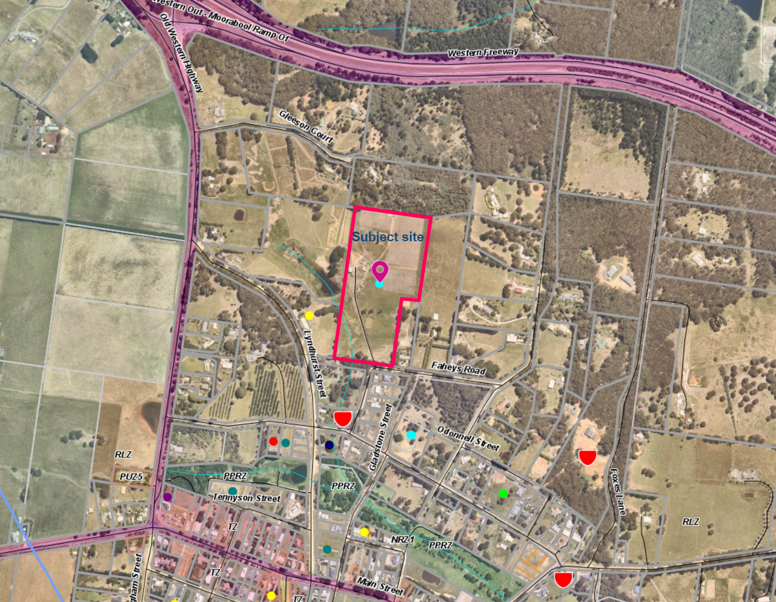
Figure 1: Aerial photograph of site

Planning Scheme Provisions
Council is required to consider the Victoria Planning Provisions and give particular attention to the Planning Policy Framework (PPF), the Local Planning Policy Framework (LPPF) and the Municipal Strategic Statement (MSS).
The relevant clauses are:
• Clause 11.01-1R – Settlement Central Highlands
• Clause 11.03-3S – Peri-urban areas
• Clause 12.05-2R – Landscapes Central Highlands
• Clause 14.02-1S – Catchment Planning and Management
• Clause 15.02-6S – Design for Rural Areas
• Clause 16.01-3S – Rural Residential Development
• Clause 17.04-1S – Facilitating Tourism
• Clause 19.03-3S – Integrated Water Management
• Clause 21.02-3 – Water and Catchment Management.
• Clause 21.03-4 – Landscape and Neighbourhood Character
• Clause 21.03-6 – Rural Lifestyle Opportunities.
• Clause 21.04-5 – Local Employment
• Clause 21.09-2 – Gordon
• Clause 22.02 – Special Water Supply Catchments
The proposal complies with the relevant sections of the PPF and LPPF.

Zone

The map below indicates the zoning of the subject site

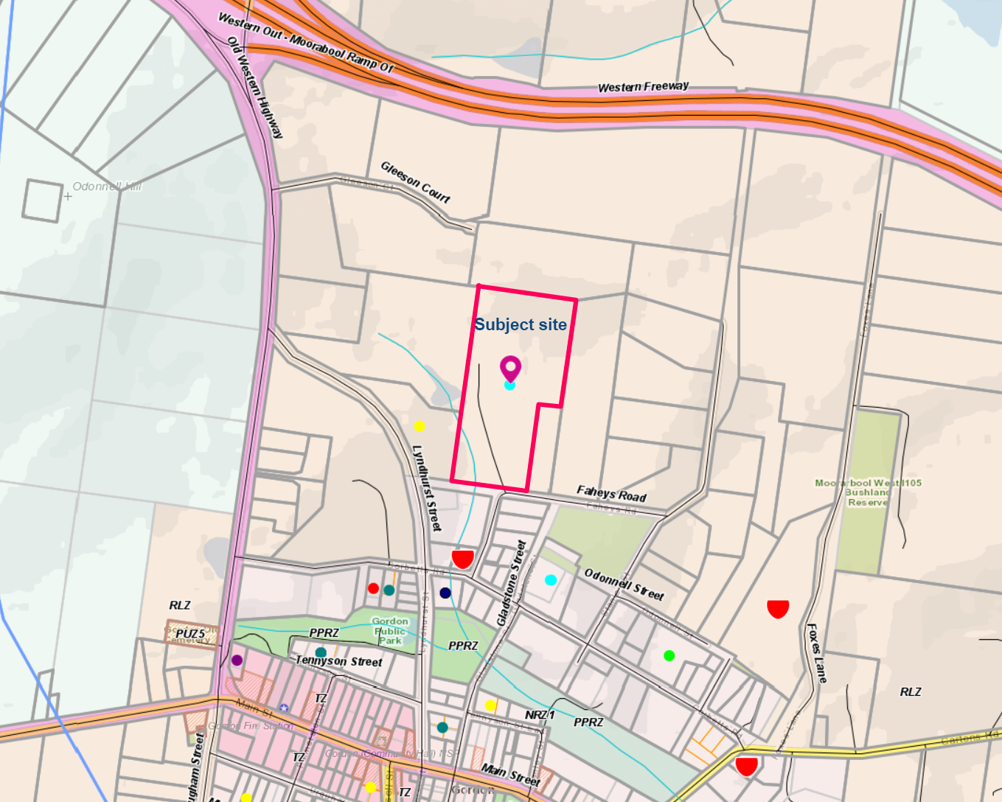

Figure 2: Map of zoning
The subject site is in the Rural Living Zone.
The purpose of the Zone is:
• To implement the Municipal Planning Strategy and the Planning Policy Framework.
• To provide for residential use in a rural environment.
• To provide for agricultural land uses which do not adversely affect the amenity of surrounding land uses.
• To protect and enhance the natural resources, biodiversity and landscape and heritage values of the area.
• To encourage use and development of land based on comprehensive and sustainable land management practices and infrastructure provision.
Under Clause 35.03-4 a permit is required to construct or carry out any of the following:
• A building or works associated with a use in Section 2 of Clause 35.03-1
Decision guidelines are listed under Clause 35.03-6 and the following decision guidelines are:
General issues
• The Municipal Planning Strategy and the Planning Policy Framework.
• Any Regional Catchment Strategy and associated plan applying to the land.
• The capability of the land to accommodate the proposed use or development.
• Whether the site is suitable for the use or development and whether the proposal is compatible with adjoining and nearby land uses.
Agricultural issues
• The capacity of the site to sustain the agricultural use.
• Any integrated land management plan prepared for the site.
• The potential for the future expansion of the use or development and the impact of this on adjoining and nearby agricultural and other land uses.
Environmental issues
• The impact on the natural physical features and resources of the area and in particular any impact caused by the proposal on soil and water quality and by the emission of noise, dust and odours.
• The impact of the use or development on the flora, fauna and landscape features of the locality.
• The need to protect and enhance the biodiversity of the area, including the need to retain vegetation and faunal habitat and the need to revegetate land including riparian buffers along waterways, gullies, ridgelines, property boundaries and saline discharge and recharge area.
• The location of on-site effluent disposal areas to minimise the impact of nutrient loads on waterways and native vegetation.
Design and siting issues
• The impact of the siting, design, height, bulk, colours and materials to be used, on the natural environment, major roads, vistas and water features and the measures to be undertaken to minimise any adverse impacts.
• The impact on the character and appearance of the area or features of architectural, historic or scientific significance or of natural scenic beauty or importance.
• The location and design of existing and proposed infrastructure including roads, gas, water, drainage, telecommunications and sewerage facilities.
• Whether the use or development will require traffic management measures.

Overlays

Relevant Policies
Environmental Significance Overlay (ESO1)
The subject site is in the Environmental Significance Overlay Schedule 1 and the provisions of Clause 42.01 apply.
The purpose of the overlay is:
• To implement the State Planning Policy Framework and the Local Planning Policy Framework, including the Municipal Strategic Statement and local planning policies.
• To identify areas where the development of land may be affected by environmental constraints.
• To ensure that development is compatible with identified environmental values.
Under Part 2 of Schedule 1 of the overlay has the following environmental objectives to be achieved:
• To protect the quality and quantity of water produced within proclaimed water catchments.
• To provide for appropriate development of land within proclaimed water catchments.
Under Clause 42.01-2 a planning permit is not required for:
• The construction of a dam under 3ML capacity that is not on a waterway.
• The construction of a dwelling in the any of the General Residential Zone, Neighbourhood Residential Zone, Low Density Residential Zone, Township Zone or Rural Living Zone where the dwelling is not connected to reticulated sewerage, but the proposal complies with the following:
o it has been demonstrated to the satisfaction of the responsible authority and the relevant water authority that the lot can contain effluent in accordance with the requirements and provisions of the State Environment Protection Policy (Waters of Victoria) and the provisions of the “Septic Tanks Code of Practice”, and
o the building and its septic tank effluent absorption area are not located within 100m of a waterway or upstream of a dam or wetland, and
o no stormwater is discharged less than 100m from a waterway unless into an approved drainage system
• The construction or carrying out of works if all of the following conditions are met:
o any site cut required is less than 1m in depth and less than 300sqm in area.
Decision guidelines are listed under Part 5 of Schedule 1.
Design & Development Overlay Schedule 2 and 5 (DD02 and DD05)
The subject site is in the Design and Development Overlay Schedules 2 and 5 and provisions of Clause 43.02 apply.
Under Schedule 2, a permit is not required to construct a building or to carry out works where all external walls and roof areas are clad with non-reflective materials.

Under Schedule 5, a permit is required for buildings and works that meet the following requirements:
• Buildings or extensions to existing buildings with a minimum side setback of 2ms from either boundary and a minimum rear setback of 5m.
• The site area covered by buildings does not exceed 40%.
• Total floor area of all buildings does not exceed 300sqm in floor area.
• Buildings under 9m in height from natural ground level.
• Earthworks under 1m in depth or height.
• Where all external walls and roof areas are clad with non-reflective materials.
Under Clause 5 of Schedule 5, it states:
• Whether the development responds to the design objectives of the overlay.
• The contribution that the development makes to the preferred character of the area.
• Whether the development has addressed stormwater drainage issues.
• The impact of the development on visual amenity both from adjoining properties and from within the township of Gordon.
• The impact of the landscaping and scale of new development, particularly in open areas and locations on exposed hill tops and slopes.
• Whether the proposed buildings and works would have any adverse impact on the landscape and the visual amenity of the surrounding area.
• Whether the materials proposed to be used, and the form of development proposed would avoid or reduce any adverse impact on the landscape and the visual amenity of the surrounding area.
• Whether the setbacks of the proposed building and works from adjoining roads and properties will ensure that the development would avoid or reduce any adverse impact on the landscape and the visual amenity of the surrounding area.
• Whether any proposed landscaping around the buildings and works would reduce any adverse visual impacts on the landscape and the visual amenity of the surrounding area.
Significant Landscape Overlay Schedule 2 (SLO2)
The subject site is in Significant Landscape Overlay and the provisions of Clause 42.03 apply.
Under the Significant Landscape Overlay Schedule 2, a permit is not required to construct a building or construct or carry out works which are at least 4 metres from the base of a tree having a single trunk circumference of 40 centimetres or less at a height of 1.3m above ground level.

Particular Provisions
Gordon Structure Plan 2013
Back in 2011, The Gordon Structure Plan identified that the construction of a sewerage treatment plant and the sewering of the core township area by Central Highlands Water would boost demand for further residential development and provide opportunities for different forms of residential and other development in the town such as more intensive residential development, infill development and increased densities of residential and other development in the area to be sewered.

The Structure Plan therefore sets out requirements for the form and scale of future development. Consultation with the community had indicated a very strong community expression to retain the small township village feel and the quality of the rural setting.
The landscape character of the town was also acknowledged as quite complex and made up of a diverse range of elements, natural, introduced and built. It required considerable care to be taken to ensure that the location, scale and form of new development reinforces the qualities and character of that landscape. It acknowledged there are considerable opportunities to reinforce the landscape and character of the town particularly through further carefully selected and sited planting associated with new development and along key roads and routes.
It was noted that future development based on higher density and smaller lot residential development should be focused in the area bounded by Urquhart, Lyndhurst, Tennyson Streets and the western edge of the built up township area.
An identified principle of the Structure Plan was ‘the retention of the rural character of the township area and surrounds is paramount to retaining the lower density scale residential and vegetated areas in the surrounds and the wider rural living setting of the township’.
The Gordon Structure Plan would only see limited development that is site responsive in the locality of the current application due to its unique landscape character.

Discussion
Zone Requirements:
The site is within a Rural Living Zone and the character of the area comprises large lots usually with a single dwelling, outbuildings and vegetation. The proposal is to allow for a new dwelling to be built on the site as the existing dwelling has come to the end of its life and that the landowners are wanting to live in more modern facilities. The decommissioning of the existing dwelling and converting it to an outbuilding will provide extra storage area for the agricultural use of the land. The inclusion of a short term accommodation building will provide additional accommodation for family as well as providing accommodation for visitors who wish to experience rural life.
The purpose of the zone is to allow a residential use in a rural environment and to allow agricultural land uses which do not adversely affect the amenity of surrounding land uses. The proposal provides a residential use where an agricultural use can operate without having any impact on the surrounding land uses. The Farm Management Plan sets out how the agricultural use of the land will occur, and the decision guidelines have been adequately addressed.
The general character of the area is for rural residential living where land is occupied by a dwelling and some shedding. There is some evidence of land being used for agricultural purposes but on a very small scale. It is proposed that the land is to be used for the growing of trees to produce truffles and garlic as well as grazing of animals. The growing of trees for truffles and garlic will have very little impact on the adjoining properties as these areas are located in the northern section of the site away from adjoining dwellings.
Overlay Requirements:
Environmental Significance Overlay
The proposed new septic tank triggers a planning permit under the Overlay as the site is not connected to reticulated sewerage. A Land Capability Assessment recommends that a primary treatment system with trenches be used to treat and dispose of the wastewater on site. Both Council’s Environmental Health Department and Barwon Water have no objection and request conditions on the planning permit.
The proposed works in creating a flat surface for the replacement dwelling and short term accommodation will require a greater area of 300sqm and 1m in depth therefore triggers a planning permit. The spoil from the cut will be reused on site to create a flat surface. Appropriate sediment control measures will be required to be put in place to reduce any sediment from entering any waterway.
The proposed increase in the dam will is also triggered under this Overlay as the extension is within 100m of an existing waterway.
Design and Development Overlay
The design of the new dwelling complies with the Design and Development Overlay in non-reflective materials being used for the external cladding. These materials will blend in with the existing landscape and will be appropriately screened in time by the new plantings on the site.
The proposed earthworks are triggered under this Overlay. The location of the earthworks are located on the higher section of the site, but are located at the rear of the new buildings. Further landscaping of the area around the dwelling would help with any potential impact on adjoining properties and the Gordon Township proper.
Further landscaping of the site will only further enhance the existing vegetated hilltops that surround the township of Gordon.
Significant Landscape Overlay
The proposed location of the new buildings are toward the higher section of the site, however they have been located so they are not at the top of the ridgeline so that it can’t be seen from the Gordon township. It is proposed that none of the existing vegetation on the site is to be removed and that the landowner intends to plant a mixture of native and exotic species on the site to further enhance the existing important landscape.
The proposed building materials will have no impact on the landscape due to the low scale single storey construction and the use of non-reflective colours on the exterior will help blend them into the surrounding landscape.
Local Planning Policies
Clause 21.02-3 - Water and Catchment Management.
The replacement dwelling and the short term accommodation building will be connected to an approved wastewater disposal system which meets the current requirements of Council and Barwon Water. All stormwater will be depicted into the 100,000L tank and any overflow will be directed to the existing dam on site. The water in the dam is used to water the trees and garlic.
Clause 21.03-4 - Landscape and Neighbourhood Character
The new development has been appropriately sited, designed and constructed so it will blend in with the existing landscape values of Gordon.
Clause 21.03-6 - Rural Lifestyle Opportunities
The replacement dwelling and the short term accommodation building will allow the landowners to live in a semi-rural setting and to use the land for agricultural purposes, will only further enhance the specialty of Gordon as being in a small township that provides a rural lifestyle that is close to Melbourne and Ballarat.

Clause 21.04-5 - Local Employment.
The proposed short term accommodation building will provide accommodation for tourists who wish to visit Gordon as well as surrounding areas. The accommodation will provide opportunity to experience farming practices and to explore other areas of the Shire.
Clause 21.09-2 - Gordon
The proposal responds to the protection of the landscape elements by low level buildings and the enhancement of further landscaping of the site.
Clause 22.02 - Special Water Supply Catchments
The Land Capability Assessment demonstrates that the land is capable of treating and disposing of wastewater on site in accordance with the Septic Tank Code of Practice. The new system is at least 100m from the existing waterway and the existing dam.

General Provisions
Clause 65 – Decision Guidelines have been considered by officers in evaluating this application.
Clause 66 – Stipulates all the relevant referral authorities to which the application must be referred.
These include:
• The matters set out in section 60 of the Planning and Environment Act 1987.
• The Municipal Planning Strategy and the Planning Policy Framework.
• The purpose of the zone overlay or other provision.
• Any matter required to be considered in the zone, overlay or other provision.
• The orderly planning of the area.
• The effect on the amenity of the area.
• The proximity of the land to any public land.
• Factors likely to cause or contribute to land degradation, salinity or reduce water quality.
• Whether the proposed development is designed to maintain or improve the quality of stormwater within and exiting the site.
• The extent and character of native vegetation and the likelihood of its destruction.
• Whether native vegetation is to be or can be protected, planted or allowed to regenerate.
• The degree of flood, erosion or fire hazard associated with the location of the land and the use, development or management of the land so as to minimise any such hazard.
• The adequacy of loading and unloading facilities and any associated amenity, traffic flow and road safety impacts.

Referrals
Authority | Response
Corangamite Catchment Management Authority  Barwon Water | Consent subject to conditions  Consent subject to conditions
Infrastructure  Environmental Health | Consent subject to conditions  Consent subject to conditions

Financial Implications
The recommendation of approval of this development application would not represent any financial implications for Council.

Risk & Occupational Health & Safety Issues
The recommendation of approval of this development does not implicate any risk or OH&S issues to Council.

Communications Strategy
Notice was undertaken for the application, in accordance with s.52 of the Planning and Environment Act 1987, and no further correspondence is required as no objections were received.

Options
Council could consider the following options:
• Issue a permit in accordance with the recommendation of this report; or
• issue a permit with amendments to conditions within the recommendation of this report; or
• should Council wish to consider refusal of the application, Councillors need to explore reasons based on the proposal not complying with the Moorabool Planning Scheme.

Conclusion
The application for short term accommodation and use of the land for agriculture has been assessed against the requirement of the Moorabool Planning Scheme and is considered to be an appropriate use of the land.

Mrs. Bridget Clow addressed Council as the applicant associated with Item 7.7.
Mr. and Mrs. Kris addressed Council in writing as a supporter to the recommendation associated with Item 7.7.
Mr. and Mrs. Westoby addressed Council in writing as a supporter to the recommendation associated with Item 7.7.

7.7 PA2019142 - Use of the Land for Domestic Animal Husbandry at 29 Evergreen Way Gordon
Author: Mark Lovell, Coordinator Statutory Planning
Authoriser: Henry Bezuidenhout, Executive Manager Community Planning & Economic Development
Attachments: 1. Dog Breeding Operation Site Management Plan (under separate cover)

Application Summary
Permit No: PA2019142
Lodgement Date: 24 June 2019
Planning Officer: Mark Lovell
Address of the land: Lot 15 on PS213123M located at 29 Evergreen Way, Gordon
Proposal: Use of the Land for Domestic Animal Husbandry
Lot size: 4.16ha
Why is a permit required? Clause 35.03-1 – Rural Living Zone – Use of land for Domestic Animal Husbandry

Committee Resolution
Moved: Cr Tonia Dudzik
Seconded: Cr Paul Tatchell
That the Development Assessment Committee, having considered all matters as prescribed by the Planning and Environment Act 1987, issue a Refusal to Grant a Planning Permit for the Use of the land for Domestic Animal Husbandry:
1. The proposal would result in land use conflicts inconsistent with relevant State and local planning policy.
2. The proposal does not comply with Clause 22.04 of the Moorabool Planning Scheme.
3. The proposal does not meet the purpose of Clause 35.03 of the Moorabool Planning Scheme to provide for agricultural land uses which do not adversely affect the amenity of surrounding land uses.
- The proposal use will result in unreasonable amenity impacts to surrounding residents.
Carried

Public Consultation
Was the application advertised? | The application was advertised by a notice on the site and by letters to adjoining landowners.
Notices on site: | Yes.
Notice in Moorabool Newspaper: | Nil.
Number of objections: | Three objections.
Consultation meeting: | Officers met the applicant and objectors at their place of residences. Objectors were also contacted to confirm any changes in the operation since the lodgement of the application.

Policy Implications
The Council Plan 2017-2021 provides as follows:
Strategic Objective 3: Stimulating Economic Development
Context 3A: Land Use Planning
The proposal of the Use of the Land for Domestic Animal Husbandry is consistent with the Council Plan 2017 – 2021.

Victorian Charter of Human Rights & Responsibilities Act 2006
In developing this report to Council, the officer considered whether the subject matter raised any human rights issues. In particular, whether the scope of any human right established by the Victorian Charter of Human Rights and Responsibilities is in any way limited, restricted or interfered with by the recommendations contained in the report. It is considered that the subject matter does not raise any human rights issues.

Officer’s Declaration of Conflict of Interests
Under section 130 of the Local Government Act 2020, officers providing advice to Council must disclose any interests, including the type of interest.
Executive Manager – Henry Bezuidenhout
In providing this advice to Council as the Executive Manager, I have no interests to disclose in this report.
Author – Mark Lovell
In providing this advice to Council as the Author, I have no interests to disclose in this report.

Executive Summary
Application referred? | Yes, the application was referred to Council’s Environmental Health, Community Safety and Infrastructure and Barwon Water.
Any issues raised in referral responses? | The issue of how waste was to be managed required further information, however the relevant catchment authority and Environmental Health have since consented to the application.
Preliminary concerns? | Aside from the above, there were concerns with the impacts of noise on the amenity of the wider area.
Any discussions with applicant regarding concerns? | On site meeting owner explained some of the mitigation measures that have been undertaken to date, including the planting of vegetation for the purpose of creating a visual screen around the area housing the animals.
Any changes made to the application since being lodged? | Lodgement of Dog Breeding Operation Site Management Plan.
Brief history. | An application was lodged for the use of keeping of animals after an audit by Council’s Community Safety.  The owners have stated that they have been breeding dogs for 25 years and lived on site for 21 years.
Previous applications for the site? | A search of Council records shows that there is one previous planning permit for the site, which allowed the development of an outbuilding in 2004.
General summary. | The application is seeking approval for the use of the land for Domestic Animal Husbandry. Dog breeding has occurred on site without planning approval. The site is 4.2ha in the Rural Living Zone. The closest dwelling (not in common ownership) is approximately 120m away from where the animal husbandry use is primarily undertaken.  The applicant has made a series of changes on site to reduce noise impacts that have concerned adjacent and nearby neighbours. The proper management of site is difficult to maintain due to the number of dogs present and in consideration of animal welfare that the dogs need to be located in the exposed run areas and do at times create noise disturbances due to stimuli and the presence of people from the surrounding properties. The proposed presents unacceptable land use conflict in a Rural Living Area that is designated for residential use.

Summary of Officer’s Recommendation
That, having considered all relevant matters as required by the Planning and Environment Act 1987, Council issue a Refusal to grant a Planning Permit for the Use of the land for Domestic Animal Husbandry at 29 Evergreen Way, Gordon.

Site Description
The subject site is an irregular shaped parcel of land to the south of the Gordon township in the Rural Living Zone. The land is developed with a dwelling and several outbuildings which are used for a variety of purposes, including for the proposed use, bird keeping and domestic uses. The land is gently sloping with the frontage onto Evergreen Way with a highpoint to the rear of the site.
The dwelling is surrounded by vegetation and the outbuildings. There is a dam to the south-east of the dwelling. The rear of the site is largely vacant.
The surrounding area is of similar sized lots used and developed for rural residential purposes. The Public Use Zone to the south is the Ballarat – Melbourne Train Line. The closest dwelling from where the dogs are kept on site is approximately 120m away. From the aerial photograph there are 16 dwellings within 500m of the main activity on the subject land.
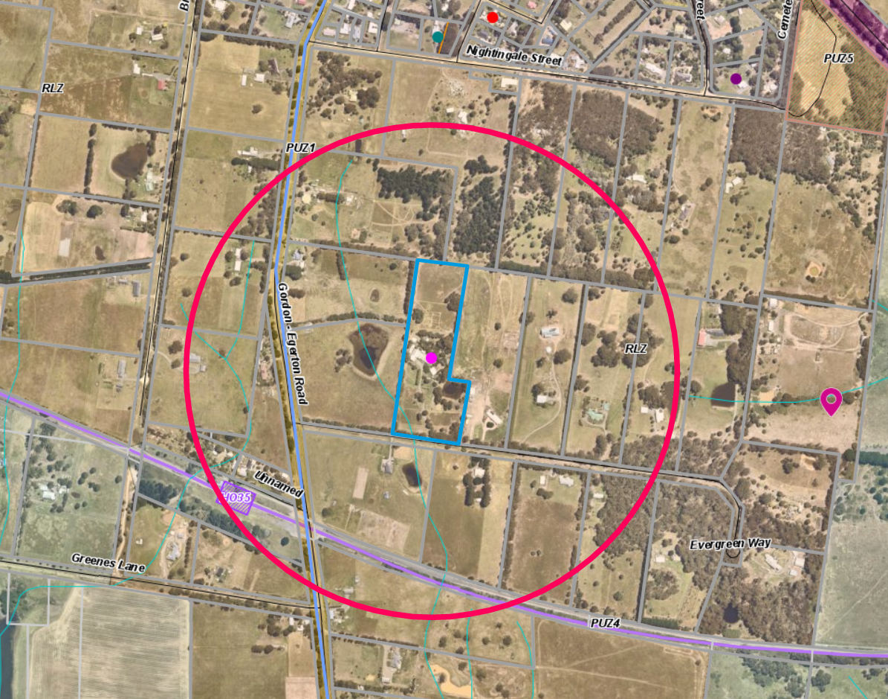Figure 1: with property boundary marked with the blue outline and red circle representing 500m radius from the shed housing the dogs.

Proposal
The applicant is seeking approval for the use of the site for the purpose of domestic animal husbandry. The species that have been bred on site and is proposed to continue to be bred on site is Hungarian Vizsla, a breed of dog that typically ranges from 18kg-29kg in weight and 53-64cm in height.
The use would continue to utilise an existing outbuilding for the purpose of housing the animals, which is connected to the external pens. The shed is divided into 10 internal pens of 10sqm each and the external pens range from 50-100sqm.
The shed is insulated and has windows to allow natural light into the shed.
Under the Code of Practice for the Operation of Breeding and Rearing Businesses, updated June 2018, the following definitions for classifying dogs of various ages:
Puppy – a dog under 16 weeks of age
Adolescent - between 16 Weeks - 12 months of age
Adult – 12 months of age or older
Retired and/or Desexed – A dog of any age that has been desexed and cannot breed
The applicant has applied for 18 dogs which include three visiting dogs, although they currently have 15 dogs in total that live on site, mixture of breeding and non-breeding dogs. The breakdown of the animals that are currently kept on site is listed within the table below:
Male |  | Female
Desexed Male | 1 | Desexed Female | 1
Adolescent (Under 12 months in age) | 1 | Adolescent (Under 12 months in age) | 1
Between 1-12 Years (whole animals) | 4 | Between 1-12 Years (whole animals) | 6
Over 12 years in age | 1 | Over 12 Years in age | 0
TOTAL: 7 Males |  | TOTAL: 8 Females
TOTAL 15 Dogs
The above list contains a total of 10 breeding dogs and five non-breeding dogs. The applicant wants to increase the total number of existing dogs from 15 to 18, with the three additional dogs being dogs that do not regularly live on site. There is no existing planning permit for the 15 dogs currently on site. The applicant has advised that most puppies are sold before birth, meaning that the majority of puppies are removed from the site as early as eight weeks of age. It should be noted that some pups can remain for up to four months.
Under the Domestic Animals Act 1994, all cats and dogs over the age of three months are required to be registered. The Australian Vizslas Health Registry identifies that Vizsla bitches must be a minimum of 18 months prior to being bred and are only classified as breeding animals after this age. Litters range per dog, has a minimum requirement of 18 months between each, with each litter ranging between four to 11 pups. A bitch may whelp six litters but may have others with Veterinary certification.
A Dog Breeding Operation Site Management Plan was submitted to Council in January 2021 and provides a description of the cleaning, feeding and other necessary information of how the operation is to be managed. The management arrangement was further revised in March 2021 to limit the time duration and the number of dogs within the run areas. The Management Plan has been put together by the applicant and it is unclear if any expertise from an appropriately qualified person was provided.
The applicant has also advised Council Officers that there are birds on site contained within aviaries that do not require planning approval.
Under the Domestic Animals Act 1994, the operation is defined as a Recreational Breeder, as there is 10 or less fertile female dogs.
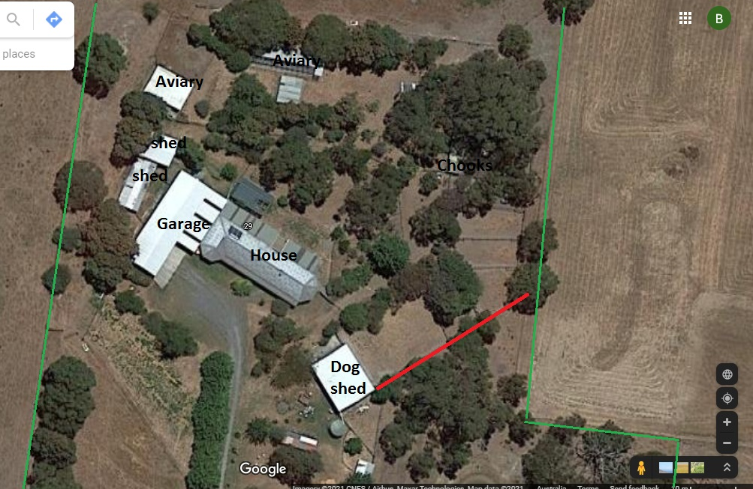
Figure 2: Site Plan. The red line shows shade cloth placed over existing fence to block sightline of dogs

Background to Current Proposal
The current owners of the land have lived on site for 21 years, with 10 dogs registered on site between 1999 – 2015, although have been breeding for 25 years. This lapse in registration and a lack of evidence suggests that existing use rights may not apply to the proposed 15 dogs currently on site. Currently 15 dogs reside on the subject land that are older than three months of age, but the applicants requested to increase this number to 18 dogs.

History
A search of Council records shows that there is one planning permit that was previously approved for the subject site. This application, PA2004238, sought approval for buildings and works associated with the construction of a garage within an Environmental Significance Overlay.

Public Notice
The application was notified to adjoining and surrounding landowners. As a result of the public notification, three objections were received.

Summary of Objections
The objections received are detailed below with officer’s comments accompanying them:
Objection | Any Relevant Requirement
Noise impacts.  Increase to existing noise made from the dogs.  Location of Dog Pens.  Impact on wildlife.  Amenity concerns. | Domestic Animal Management Plan  Clause 13.02 – Noise  Clause 22.04 – Animal Keeping
Officer’s Response:
Based on objector experiences the dogs have created noise impacts to an unreasonable over long period of time.
The applicant has changed the way they manage the site and decided to utilise their Dog Breeding Operation Site Management Plan, dated January 2021 (revised March 2021). There has been a reduction in noise impacts. However, based on the number of dogs proposed and proximity to nearby residents, the proposed is considered to continue as an unacceptable land use conflict.
Street Noise impacts.  The proposed land use is not consistent with the purpose of the Rural Living Zone.  Local laws in the Rural Living Zone s are too narrow. | Domestic Animal Management Plan.
Officer’s Response:
Discussion on the consistency of the proposal with the purpose of the Rural Living Zone and the impact is contained within the Discussion Section of this report. There is some improvement since the lodgement of the application however the residential amenity is still affected.

Locality Map
The map below indicates the location of the subject site and the zoning of the surrounding area.
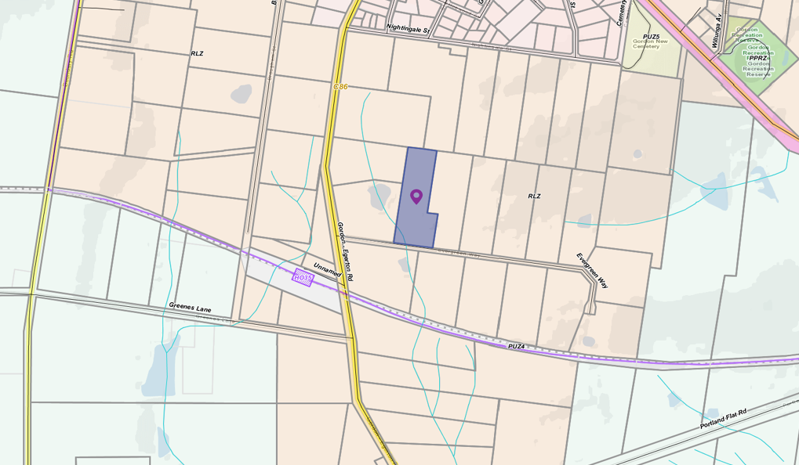
Figure 3: Zoning Map. Orange: Rural Living Zone. Light Green to the south-east and south-west: Farming Zone. Pink to the north: Neighbourhood Residential Zone

Planning Scheme Provisions
Council is required to consider the Victoria Planning Provisions and give particular attention to the Planning Policy Framework (PPF), the Local Planning Policy Framework (LPPF) and the Municipal Strategic Statement (MSS).
The relevant clauses are:
• Clause 11.03 – Planning for Places
• Clause 12.05 – Significant Environments and Landscapes
• Clause 13.05 – Noise
• Clause 13.07 – Amenity and Safety
• Clause 14.02 – Water
• Clause 21.03 – Settlement and Housing
• Clause 21.09 – Small Towns and Settlements
• Clause 22.04 – Animal Keeping

The proposal does not comply with the relevant sections of the PPF and LPPF, of the clauses outlined in the table below:
PPF | Title | Response
Clause 13.05-1S | Noise Abatement | The objective to “… control… noise effects on sensitive land uses”. Noise has been unacceptable for quite a period of time.
Clause 13.07-1 | Land use compatibility | The objective of this clause is to safeguard community amenity while facilitating appropriate other uses with potential off-site effects, the ability of this site to limit all adverse amenity impacts are managed on site. The proposed use create conflict with the surrounding residential land use.
LPPF
Clause 22.04 | Animal Keeping | This local policy seeks to implement requirements for the design of animal keeping facilities. Further commentary on the requirements of Clause 22.04 is included in the discussion section.

Zone
Clause 35.03 Rural Living Zone
The land is within the Rural Living Zone, where the purpose of the zone is:
• To implement the Municipal Planning Strategy and the Planning Policy Framework.
• To provide for residential use in a rural environment.
• To provide for agricultural land uses which do not adversely affect the amenity of surrounding land uses.
• To protect and enhance the natural resources, biodiversity and landscape and heritage values of the area.
• To encourage use and development of land based on comprehensive and sustainable land management practices and infrastructure provision.
There is a planning permit trigger under the zone as the application is seeking a land use under Section 2 that is Domestic Animal Husbandry of more than two animals.

Overlays

Relevant Policies
Clause 42.01 Environmental Significance Overlay, Schedule 1
The Environmental Significance Overlay, Schedule 1 that applies to the land is for the Proclaimed Water Catchment Areas of Moorabool Shire. The environmental objectives to be achieved under this overlay are:
• To protect the quality and quantity of water produced within proclaimed water catchments.
• To provide for appropriate development of land within proclaimed water catchments.
The proposed land use, which can generate waste, was referred to relevant catchment authority for comment.
Clause 43.02 Design and Development Overlay, Schedule 2
The Design and Development Overlay, Schedule 2 that applies to the land is to maintain Visual Amenity and Building Design for rural environments of Moorabool Shire. The design objectives to be achieved under this overlay are:
• To enhance visual amenity in rural, township and vegetated areas of the Moorabool Shire.
• To encourage the use of external cladding, such as non-reflective materials for building construction.
• To discourage the use of materials, such as reflective cladding for building construction, which could have a detrimental effect on amenity.
No permit is required under the provisions of this overlay for this application.

RELEVANT POLICIES
In addition to Councils own policies, there are several state requirements, that must be met, these include:
• The Domestic Animals Act 1994.
• Code of Practice for the Operation of Breeding and Rearing Businesses 2014.

PARTICULAR PROVISIONS
There are no relevant particular provisions to this application.

Discussion
The application for the domestic animal husbandry of 18 dogs requires a planning permit for the use of the land under the Rural living Zone.
As part of the further information requirements and in order to ensure compliance with the relevant legislation and policies, Council requested a Dog Breeding Operation Site Management Plan (the Plan) be submitted. This Plan contains information about the procedures that are required to operate an animal husbandry business including staffing, emergency management, waste management, dog management and complaints register. The plan was prepared by permit applicant and was not by an animal welfare specialist.
The plan has assisted in the applicant in attempting to operate a better managed facility and take into consideration the impact of dogs on neighbouring properties. While there has been some improvement in the management of the site, they have not adequately mitigated all adverse impacts including noise.
Zoning
Dog breeding and Animal Husbandry are nested under agricultural uses in Clause 75 of the Planning Scheme and is a Section 2 Use in the Rural Living Zone for any more dogs, other than for two breeding animals. In the Rural Living Zone, where residents have a high amenity expectation, one of the primary purposes of the zone is “to provide for agricultural land uses which do not adversely affect the amenity of the surrounding land uses”.
In this instance, due to the number of dogs currently on site and proposal to increase the number to 18 dogs will result in land use conflicts. The residential amenity of residents living in Rural Living Zone must be protected and the proposal has not demonstrated any evidence that there will negligible noise impacts generated from 18 dogs.
Local Planning Policy
Within Council’s Local Planning Policy, Clause 22.04 of the Planning Scheme (Animal Keeping), certain requirements have been set out. Under this local policy, the following are requirements for the siting and design of dog keeping and breeding establishments are to be met:
• facilities should be located at least 500 metres away from residential areas and a substantial proportion of this buffer must be provided within the boundary of the subject site;
• facilities should be sited to use the surrounding topography to reduce noise;
• facilities should be fully contained by appropriate fencing including a fully enclosed or acoustically baffled area to house particularly noisy animals at a ratio of 1:15;
• facilities should be constructed or landscaped as appropriate to visually screen stimuli from other dogs, animals, traffic or passers-by; and;
• kennels should be constructed in materials that reduce the emission of noise.
Clause 22.04 also seeks to discourage the keeping and breeding of dogs in areas that are:
• predominantly used for extensive animal husbandry;
• have a significant number of dwellings in close proximity; and
• adjacent to significant wildlife habitats.
The application is seeking approval for the use and not all of the requirements of Clause 22.04 can be achieved due to presence of at least 16 dwellings within 500m of the site. Despite this, the applicant has attempted to change the operation and reduce noise impacts especially from dogs within the exposed run areas. The key problem presented for this applicant, is there are several existing dwellings including a new dwelling in close proximity. The dwellings are a permitted land use within the Rural Living Zone subject to conditions.
Given that the land is within a Rural Living Zone, there is minimal separation between the proposed operation and nearby dwellings.
Objectors have clearly expressed concerns with noise impacts from the subject land. The applicant previously had no management plan in place to reduce noise impacts. Through the course of this planning application which was lodged in 2019 the applicant has been given opportunities to control noise impacts. They have taken some time to implement management practices on the site and the Dog Breeding Operation Site Management Plan was only produced in January 2021 and further revised in March 2021. While some improvement has been made, the sheer number of proposed 18 dogs in close proximity to residential properties that requires residential protection cannot be achieved through further management practices or permit condition controls.
VCAT decisions
An example of a similar operation outside of Moorabool Shire was reviewed at the Victorian Civil and Administrative Tribunal (VCAT), Duval v Macedon Ranges SC (2019). This VCAT decision examined the Policy and Zone provisions, amenity impacts, including the visual and noise impacts, waste management and the capacity of the existing operators.
The decision was to grant permit subject to conditions for a small dog breeding business in a Rural Living Zone. The member stated, ‘The conclusion of all the above is that in a policy context, dog breeding as proposed in this application is a permitted use within an RLZ provided the amenity impacts on the surrounding residents is acceptable and that the proposed use can be appropriately managed’.
The above VCAT case and the more recent VCAT decision Bentley v Macedon Ranges SC (2020), established clear guidance for a Responsible Authority that can limit the number of dogs, even including limits on the numbers of fertile female or male dogs. Both VCAT cases have included limitations on the number of puppies that can be kept on site and the number of litters per year.
However, there were no local planning policies unlike the Moorabool Planning Scheme which are deliberately designed to protect residential amenity. Clause 22.04 sets a 500m radius to existing dwellings. In this instance, 16 dwellings will be adversely affected by the proposed use.
This is a retrospective planning permit application. As per the Supreme Court Case of Victoria, Knox City Council V Tulcany PTY LTD 2004, ‘…the paradox that unlawful commencement of a use (or construction of a development) may enable a better appreciation of its impact on its context and plans or other descriptions of a proposal ever could…’. It is understood that this land use, currently operating without a planning permit, is causing amenity concerns, which according to the objectors, is the noise generated from the animals when they bark.
Visual Impact
Based on the existing site conditions and the experiences of objectors, the facilities could be visually screened with acoustic styled boundary fencing to prevent stimuli, this could be appropriately conditioned. The area where the dog kennels are located is within a shed, well away from the street frontage, this does not appear to have any undue streetscape impact to Evergreen Way. The applicant has recently added shade cloth to fencing in the front run to reduce visual stimuli.
Amenity Impact (Noise and Waste)
The biggest amenity impact of the proposed use would be noise impacts that the animals would have on the neighbouring landowners. The proposal is to increase the number of dogs from 15 dogs, which do not have planning permission, to a maximum of 18 dogs. This increase is going to reduce the amenity beyond what is already occurring.
It is considered that retrospective approval should not be given to current operation and the applicant’s proposal to increase the current number to 18 dogs to allow three dogs external to the site being bought in for the purposes of breeding. The aspect of introducing outside dogs for breeding is likely to contribute to additional noise as they are away from their normal place of residence.
Noise attenuation measures such as the acoustic fencing can reduce the ability for the dogs to see stimuli. These measures can have an effect of reducing the existing noise generated from the site. The degradation of residential amenity as experienced by surrounding residents demonstrates an obvious land use conflict. Further noise attenuation measures will not solve or rectify the existing amenity impacts. Consideration must be given that while noise is limited within the enclosed shed building, dogs are required to out in the open and enter run area for appropriate exercise. There are state requirements regarding animal welfare. Noise from 18 dogs that are at times located outside in run area due brief stays and in certain numbers does not adequately protect the residential amenity simply due to the location within a residential area. The activity would be appropriate on large lot within the Farming Zone that is well away from existing dwellings.
It is acknowledged the site was poorly managed without consideration of the neighbouring properties. The submitted Dog Breeding Operation Site Management Plan covers all operational aspects and has been the first attempt to start managing the dogs and reducing noise impacts.
The plan alone is insufficient to protect residential amenity in a Rural Living Zone.

General Provisions
Clause 65 – Decision Guidelines have been considered by officers in evaluating this application.
Clause 66 – Stipulates all the relevant referral authorities to which the application must be referred.

Referrals
Authority | Response
Barwon Water | Consent with conditions.
Infrastructure | Consent.
Environmental Health | Consent with conditions.

Financial Implications
It is thought that the recommendation of refusal is not thought to have any financial risk to Council.

Risk & Occupational Health & Safety Issues
The recommendation of refusal of this use does not implicate any risk or OH&S issues to Council.

Communications Strategy
Notice was undertaken for the application, in accordance with s.52 of the Planning and Environment Act 1987, and further correspondence is required to all interested parties to the application as a result of a decision in this matter. All submitters and the applicant were invited to attend this meeting and invited to address Council if required.

Options
Council could consider the following options:
• Issue a Refusal to grant a permit in accordance within the recommendation of this report; or
• issue an approval to the application for a planning permit outside of the recommendations of this report. However, should Council wish to consider approving of the application, Councillor’s need to explore reasons based on the proposal complying with the Moorabool Planning Scheme.

Conclusion
The application for animal husbandry use has been assessed on its merits within the context of the site, zones and overlay provisions and planning policy. From this assessment, it is recommended that the application be refused due to land use conflict within a zone that seeks to provide residential use in a rural environment. The applicant has failed to demonstrate that with the site constraints of 16 dwellings within 500m of the proposed development can be mitigated through management plans or further noise attenuation measures. The site’s proximity to numerous dwellings poses an unacceptable risk. The proposed use should be refused with specified grounds.

At 6.59 pm Cr Tom Sullivan having declared a Conflict of Interest, vacated the Chair and left the meeting. Cr. Paul Tatchell assumed the Chair.
Mrs. Elise Jreige addressed Council as the applicant associated with Item 7.8.
Mrs. Liane Wordie addressed Council as an objector to the recommendation associated with Item 7.8.
Mr. Lahey addressed Council as an objector to the recommendation associated with Item 7.8.

7.8 PA2020218 Development of a Dwelling and Use of an existing building for a Residential Building (Short-Term Tourist Accommodation) at 278 Moorabool West Road, Gordon
Author: Thomas Tonkin, Statutory Planner
Authoriser: Henry Bezuidenhout, Executive Manager Community Planning & Economic Development
Attachments: 1. Proposed plans (under separate cover)
2. Draft amended site plan recommended for approval (under separate cover)

Application Summary
Permit No: PA2020218
Lodgement Date: 9 October 2020
Planning Officer: Tom Tonkin
Address of the land: 278 Moorabool West Road, Gordon
Proposal: Development of a Dwelling and Use of an existing building for a Residential Building (Short-term Tourist Accommodation)
Lot size: 4.05ha
Why is a permit required? Clause 35.03 Rural Living Zone – Development of a Dwelling and Use for a Residential Building (Short-term Tourist Accommodation)
Clause 42.01 Environmental Significance Overlay, Schedule 1 – Buildings and works

Committee Resolution
Moved: Cr Tonia Dudzik
Seconded: Cr Ally Munari
That the Development Assessment Committee, having considered all matters as prescribed by the Planning and Environment Act 1987, issues a Notice of Decision to Grant Planning Permit PA2020218 for Development of a Dwelling and Use of an existing building for a Residential Building (Short-term Tourist Accommodation) at Lot 2 on PS217023 known as 278 Moorabool West Road, Gordon, 3345, subject to the following conditions:

Endorsed Plans:
1. Before the use and development starts, amended plans to the satisfaction of the Responsible Authority must be submitted to and approved by the Responsible Authority. When approved, the plans will be endorsed and will then form part of the permit. The plans must be drawn to scale with dimensions and must be generally in accordance with the plans identified as Job no. 19295, Sheet no.'s A01, A02 and A03 dated 9 December 2020 prepared by Draft Comps Services but modified to show:
(a) The proposed dwelling set back a minimum of 30m from the south title boundary and a minimum of 40m from the west title boundary.
(b) A colour schedule for the exterior of the proposed dwelling, with a muted colour palette to generally blend with the surroundings.
(c) The gravelled area on the northwest side of the proposed dwelling deleted from the plans.
Unless otherwise approved in writing by the Responsible Authority, all buildings and works are to be constructed or undertaken in accordance with the endorsed plans to the satisfaction of the Responsible Authority.
Dwelling requirements:
2. Access to the dwelling must be provided via an all-weather road with dimensions adequate to accommodate emergency vehicles.
3. The dwelling must be connected to a reticulated potable water supply or have an alternative potable water supply with adequate storage for domestic use as well as for firefighting purposes.
4. The dwelling must be connected to a reticulated electricity supply or have an alternative energy source.
5. The dwelling must be connected to a reticulated sewerage system or if not available, the wastewater must be treated and retained on-site in accordance with the State Environment Protection Policy (Waters of Victoria) under the Environment Protection Act 1970.
6. Within one month of a Certificate of Occupancy being issued for the approved dwelling, the existing dwelling must be vacated and used only for short-term tourist accommodation, to the satisfaction of the Responsible Authority.
Use:
7. Except with the written consent of the Responsible Authority no more than six persons shall be accommodated in the approved tourist accommodation at any time.
8. Except with the written consent of the Responsible Authority the maximum duration of stay at any time in the approved tourist accommodation shall be 14 nights.
9. Sufficient evidence of compliance with Condition no.’s 7 and 8 must be provided at the request and to the satisfaction of the Responsible Authority.
10. The building approved for use for tourist accommodation must be demolished or removed from the subject site if no longer required for the permitted use.

Amenity:
11. The amenity of the area must not be detrimentally affected by the use for short-term tourist accommodation, through the:
(a) Transport of materials, goods or commodities to or from the land;
(b) Appearance of any building, works or materials;
(c) Emission of noise, artificial light, vibration, smell, fumes, smoke, vapour, steam, soot, ash, dust, wastewater, waste products, grit or oil;
(d) Presence of vermin;
(e) Any other way.
12. External lighting must be provided with suitable baffles and located so that no direct light is emitted outside the site.
13. Any security alarm or similar device installed must be of a silent type.
Materials and Colour:
14. All external walls and roof areas of the proposed building are to be clad with non-reflective materials (zincalume prohibited) to the satisfaction of the Responsible Authority.
Environmental Health:
15. The land application area and all conditions must be in accordance with the Land Capability Assessment prepared by Ballarat Soil Testing, ref. no. BJ240920 dated 25 September 2020 or any approved amendment.
16. An onsite wastewater management system with the capacity to treat effluent to a minimum of 20mg/L BOD, 30mg/L SS and 10orgs/100ml with chlorination, i.e. secondary treatment via an aerated wastewater treatment system must be installed.
17. Effluent disposal must be undertaken via a subsurface irrigation system designed and installed by a wastewater irrigation expert in accordance with the EPA Code of Practice for Onsite Waste Water.
18. The wastewater management system for the proposed dwelling and tourist accommodation must be treated and contained within the property boundaries in accordance with the current EPA Code of Practice for Onsite Wastewater Management: Guidelines for Environmental Management, Australian Standard 1547 and Council requirements.
19. The effluent disposal area must be kept free of buildings, driveways, vehicular traffic and services trenching.
20. All setback distances must be adhered to as dictated by Table 5 of the Code of Practice, Onsite Wastewater Management, EPA Publication No. 891.4.
21. A shallow surface water cut off drain or surface water diversion mound should be provided on the high side of the disposal areas to divert any surface water flows around the effluent fields.
22. The subsurface irrigation system must be installed to a depth of 150mm in situ. If the soil is of poor quality, imported good quality topsoil may be required with a 1.0m spacing in between lines.

23. The owner will maintain all drainage lines at all times to divert surface water and subsurface water clear of the effluent disposal field.
24. Prior to commencement of the use for tourist accommodation, the existing standard septic tank must be repaired, the tank exposed to the ground and be pumped out to the satisfaction of the Responsible Authority.
Infrastructure:
25. A standard rural vehicle crossing must be provided on Poverty Peak Court to the satisfaction of the Responsible Authority. A vehicle crossing permit must be taken out for the construction of the vehicle crossing.
26. The property access and the internal driveways must be constructed in accordance with the requirements specified in Table 5 of Clause 53.02-5 of the Moorabool Planning Scheme, to the satisfaction of the Responsible Authority.
27. Storm water drainage from the proposed buildings and impervious surfaces must be retained and disposed of within the boundaries of the subject land to the satisfaction of the Responsible Authority. Overflows from on-site storage systems must be directed away from any wastewater disposal areas.
28. Sediment discharges must be restricted from any construction activities within the property in accordance with relevant Guidelines including Construction Techniques for Sediment Control (EPA 1991).
29. Unless otherwise approved by the Responsible Authority there must be no buildings, structures, or improvements located over proposed drainage pipes and easements on the property.
30. Prior to the commencement of the development and post completion, notification including photographic evidence must be sent to Council’s Asset Services department identifying any existing damage to Council assets. Any existing works affected by the development must be fully reinstated at no cost to and to the satisfaction of the Responsible Authority.
Barwon Water:
31. The following shall be undertaken to the requirements of Barwon Water and to the satisfaction of the Responsible Authority:
(a) Wastewater treatment is to achieve a minimum water quality standard of 20mg/L BOD, 30mg/L SS and 10 orgs/100ml, i.e. secondary treatment, via an EPA approved all wastewater treatment system.
(b) Effluent disposal must be undertaken via a subsurface irrigation system, designed and installed by a wastewater irrigation expert and located as recommended in the Ballarat Soil Testing Land Capability Assessment – Report No. BJ240920 Dated 25 September 2020 and to the satisfaction of Moorabool Shire Council Environmental Health Officers.
(c) All components of the wastewater management system including the effluent disposal area must be located at least 100m from any surface waterway.
(d) All stormwater must be directed away from the effluent disposal areas and roof stormwater must not be disposed to the effluent disposal areas.

(e) Monitoring, Operation and Maintenance must be undertaken in accordance with Ballarat Soil Testing Land Capability Assessment – Report No. BJ240920 Dated 25 September 2020 and to the satisfaction of Moorabool Shire Council Environmental Health Officers.
(f) The effluent disposal fields must be protected by being isolated from any building, driveway, livestock, and vehicles.
(g) Sediment control measures as outlined in the EPA’s publication No 275 Sediment Pollution Control shall be employed during the construction of the dwelling and maintained until the disturbed area has regenerated.
(h) Prior to a certificate of occupancy being issued for the dwelling the owner must enter into an agreement with the Responsible Authority and Barwon Water in accordance with Section 173 of the Planning and Environment Act 1987 requiring that:
(i) The Owner is to enter into a service contract to have any wastewater treatment facility and effluent disposal system for the dwelling inspected and maintained in accordance with the EPA Certificate of Approval for the installed system.
(ii) The Owner must provide to Barwon Water and the Responsible Authority an annual report on the condition and operation of the wastewater treatment system which documents the effluent quality achieved and provides laboratory, inspection and maintenance reports for the preceding 12 months.
(iii) The Owner shall have the wastewater treatment facility desludged at least once every three years or as otherwise determined by Council’s Environmental Health Officer. Evidence of this desludging shall be provided in the annual report referred to in Clause (ii) here in.
(iv) The Owner shall carry out any works considered necessary by the service contractor to ensure the satisfactory operation of the wastewater treatment facility and effluent disposal system.
(v) The Owner will maintain all drainage lines at all times to divert surface water and subsurface water clear of the effluent disposal field.
(vi) The Owner and the Responsible Authority agree to do all things necessary to register a memorandum of this Agreement on the title of the land pursuant to Section 181 of the Planning and Environment Act 1987.
(vii) The Owner shall meet all costs of inspections, reports and works referred to in Clauses (i), (ii), (iii), (iv), and (v) herein and all costs of the Responsible Authority in relation to stamping and registration of this Agreement.
(viii) The Owner shall not sell or enter into any contract to sell the land until this Agreement has been registered pursuant to Clause (vi) herein.
32. Barwon Water require the Section 173 to be signed by the Managing Director and Company Secretary and to state the following: THE COMMON SEAL of the BARWON REGION WATER CORPORATION was hereunto affixed in the presence of.
Permit Expiry:
33. This permit will expire if:
(a) the development is not started within two years of the date of this permit;
(b) the development is not completed within four years of the date of this permit; and
(c) the use for tourist accommodation is not started within three months of the completion of the development.
Permit Notes:
Prior to installation of works commencing on the wastewater system, an application for a permit to install an onsite wastewater management system must be submitted to Environmental Health.
A Building Permit may be required from a Registered Building Surveyor for a different class of building and/or to create self-contained tourist accommodation in accordance with the Building Regulations.
Carried

Public Consultation
Was the application advertised? | Yes.
Notices on site: | Yes.
Notice in Moorabool Newspaper: | No.
Number of objections: | Two.
Consultation meeting: | No, but Council and the proponent both separately consulted with the objectors.

Policy Implications
The Council Plan 2017-2021 provides as follows:
Strategic Objective 2: Minimising Environmental Impact
Context 2A: Built Environment
The proposal does not conflict with the Council Plan 2017 – 2021.

Victorian Charter of Human Rights & Responsibilities Act 2006
In developing this report to Council, the officer considered whether the subject matter raised any human rights issues. In particular, whether the scope of any human right established by the Victorian Charter of Human Rights and Responsibilities is in any way limited, restricted or interfered with by the recommendations contained in the report. It is considered that the subject matter does not raise any human rights issues.

Officer’s Declaration of Conflict of Interests
Under section 130 of the Local Government Act 2020, officers providing advice to Council must disclose any interests, including the type of interest.
Executive Manager – Henry Bezuidenhout
In providing this advice to Council as the Executive Manager, I have no interests to disclose in this report.
Author – Tom Tonkin
In providing this advice to Council as the Author, I have no interests to disclose in this report.

Executive Summary
Application referred? | Yes, to Barwon Water and CFA and Council’s Infrastructure and Environmental Health.
Any issues raised in referral responses? | Yes, Barwon Water requested information on the functioning of the existing onsite wastewater management system to be used for the proposed tourist accommodation.
Preliminary concerns? | Clarification requested on whether a proposed shed shown on the plans was to be assessed as part of this application.
Any discussions with applicant regarding concerns? | Council wrote to the applicant regarding the abovementioned concerns.
Any changes made to the application since being lodged? | The proposed shed was deleted from the plans.
Brief history. | Not applicable.
Previous applications for the site? | None.
General summary. | It is proposed to use the existing three bedroom dwelling for short-term tourist accommodation and to construct a new single storey dwelling on the south part of the site. The application was advertised, and two objections received, raising concerns including loss of privacy, noise, the visual impact of development, impact on future development plans, flooding and contamination of groundwater. Subject to conditions, the proposal meets the relevant requirements of the Moorabool Planning Scheme and it is not considered that the amenity of the area would be unreasonably affected. Recommended conditions would control the use the tourist accommodation to limit guest numbers and duration of stays.

Summary of Officer’s Recommendation
That, having considered all relevant matters as required by the Planning and Environment Act 1987, Council issue a Notice of Decision to Grant a Permit for this application for development of a dwelling and use of an existing building for a residential building (short-term tourist accommodation) in accordance with Section 61 of the Planning and Environment Act 1987, subject to the conditions included in this report.

Site Description
The subject site, identified as Lot 2 on PS217023 and known as 278 Moorabool West Road, Gordon, is a rectangular shaped lot on the southwest corner of Moorabool West Road and Poverty Peak Court. The site has a 121.31m wide frontage to Moorabool West Road and a 334.14m wide frontage to Poverty Peak Court, yielding an area of 4.05ha. The site has a slight fall from the southwest to the northeast and is occupied by a single storey weatherboard dwelling and ancillary outbuildings located near the west title boundary and set back approximately 150m from Moorabool West Road. Existing vehicle access is via a crossover to Moorabool West Road located parallel to the west title boundary. The site is sparsely vegetated with various native and exotic trees, generally clustered around the existing buildings apart from a row of trees planted across the middle of the site in an east-west direction. There is a dam located towards the Poverty Peak frontage.
The subject site and surrounding land is in the Rural Living Zone and characterised by lots similar in size to the subject site, many of which are developed with single dwellings and ancillary outbuildings set in spacious surroundings. The topography of the area is varied, with several small peaks nearby allowing for views of the surrounding and distant landscape from many properties. Whilst vegetation cover is varied, with most lots substantially cleared, trees are a significant feature of the area and within 1.0km to the northeast and southeast there are heavily treed properties. There are dwellings located on all immediately adjoining properties, including opposite both road frontages.

Proposal
It is proposed to use the existing dwelling for tourist accommodation and to construct a new dwelling on the site. The proposed dwelling would be sited towards the south side of the site, set back a minimum 15m from the south title boundary, 30m from the west boundary and 71m from Poverty Peak Court. Vehicle access to the proposed dwelling would be via a proposed crossover to Poverty Peak Court. The proposed dwelling would comprise four bedrooms, main with en suite, a study, theatre, gym, retreat, laundry, powder room, bathroom, separate toilet, open plan living, kitchen and dining area leading to an alfresco area to the rear and a double garage, yielding an overall floor area of 501.3sqm. The dwelling would be conventional in appearance, clad with face brick and incorporating feature stone, weatherboard and rendered elements with a low pitched hipped Colorbond roof. Up to approximately 1.5m cut and fill would be required. A 100,000L water tank is proposed in the south side setback and a 50,000L water tank in the northwest setback in a proposed gravelled area of approximately 2500sqm. No vegetation removal would be required.
The existing dwelling proposed for tourist accommodation comprises three bedrooms, bathroom, laundry and open plan kitchen, meals and living area leading to a covered deck. Existing vehicle access would be maintained to serve occupants. No signage is proposed for the tourist accommodation.
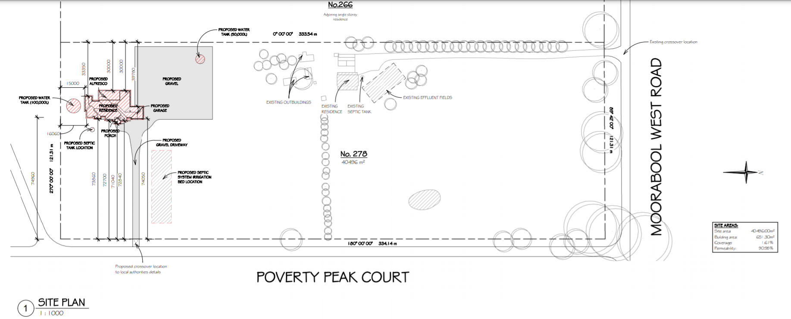
Figure 1: Proposed site plan
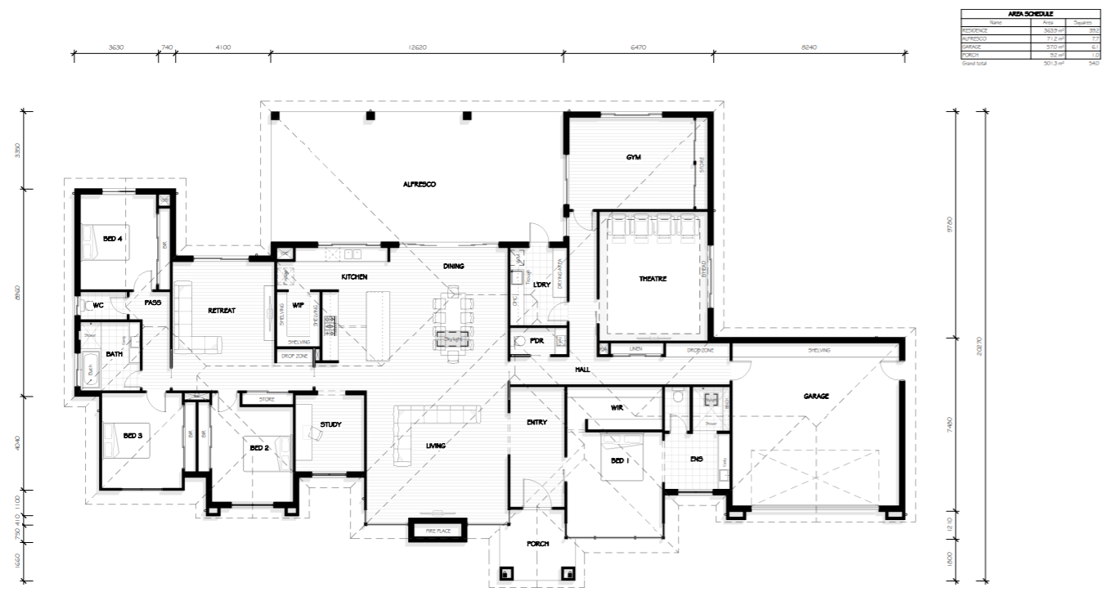
Figure 2: Proposed dwelling floor plan
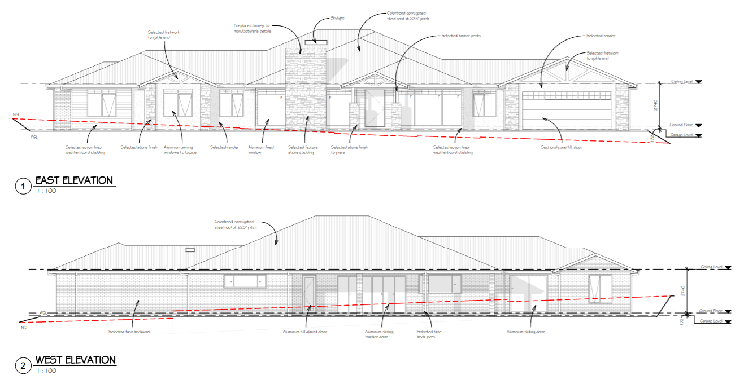
Figure 3: Proposed dwelling east and west elevations
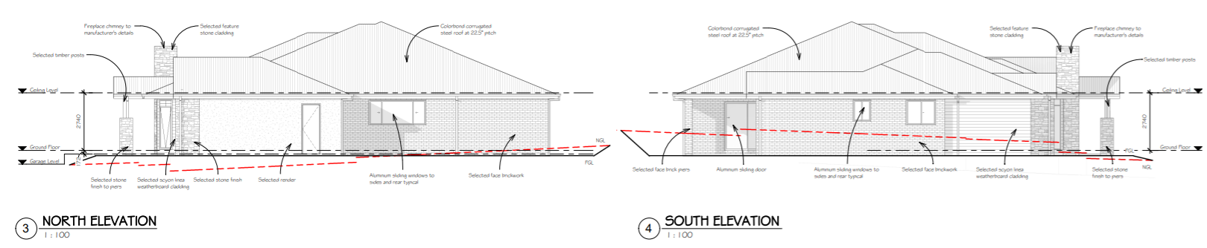
Figure 4: Proposed dwelling north and south elevations

Background to Current Proposal
Not applicable.

History
There is no known record of a planning permit for the existing dwelling, however the dwelling appears to be at least 15 years old.

Public Notice
Notice of the application was given to adjoining and surrounding landowners and occupiers by way of direct letters and a sign erected on site. Two objections were received.

Summary of Objections
The objections received are detailed below with officer’s comments accompanying them:
Objection | Any Relevant Requirement
Location of proposed dwelling will ruin magnificent view from almost every room in our house which was designed to take advantage of views and would negatively impact property values. | Clauses 11.03-3S, 15.01-6S, 21.03-4, 21.03-6, 35.03 & 65.01.
Officer’s Response:
According to Council’s contour maps, the objector’s dwelling is elevated approximately 20m above the location of the proposed single storey dwelling and whilst the dwelling would be within view it is considered that the views of the surrounding landscape would be largely maintained due to the existing dwelling’s elevated location.
Property values are not a planning consideration.
We bought the property with the intent of operating a plant nursery in future and are concerned that the location of the proposed dwelling would compromise this due to its proximity to the intended location of the nursery and the associated land use conflicts. | Clause 35.03.
Officer’s Response:
A plant nursery would be subject to future planning approval. The current permit application is subject to an assessment against the relevant planning scheme provisions and the existing site context. It is not considered reasonable to base the assessment on possible future land uses which are subject to a separate assessment.
Our privacy would be impacted as we are in an elevated position with large full length windows, meaning future residents would be able to see into our living areas and bedrooms. | Clause 65.01.
Officer’s Response:
The proposed dwelling would be set back approximately 180m from the objector’s dwelling at its nearest point and at a lower elevation. Whilst it appears that both dwellings would be readily visible to each other it is not considered that overlooking from 180m away would present a detrimental amenity impact.
The application specifies that the subject site and surrounding properties do not have bores which is incorrect. There are concerns that effluent generated by the proposal would contaminate potable water supply. | Clauses 14.02-1S, 14.02-2S, 21.02-3, 22.02 & 65.01.

Officer’s Response:
The Council officer verified with Barwon Water that this was addressed in their assessment. Barwon Water advised that the data relied upon indicated the nearest known bore to be on a property approximately 200m away, as per the register of bores on the ‘Visualising Victoria’s Groundwater’ website. The EPA Code of Practice for onsite wastewater management stipulates that a 20m setback is required from a groundwater bore to the onsite wastewater system and effluent field.
The location of the proposed dwelling may be subject to overflows from a dam on the adjoining property which has come close to overflowing on many occasions. | Clause 65.01.
Officer’s Response:
Subject to conditions, the proposed dwelling would be setback approximately 65m from the existing dam and it appears would be located in the general flow path of runoff. It is unclear what the risk of overflows or flooding might be, but it is expected that mitigation measures which the proponent could implement in future would reduce the potential for flooding of the dwelling.
The proposal sets a precedent for everyone to build a second dwelling on their property for any purpose, which may change the landscape and lifestyle of the area and strain the existing infrastructure. | Clause 35.03.
Officer’s Response:
Most types of accommodation on land in the Rural Living Zone, including the proposed use of the existing dwelling for tourist accommodation, are subject to planning approval and each application is assessed on its merits. Recommended permit conditions will restrict the use of the proposed tourist accommodation to short term use for persons away from their normal place of residence.
The location of the proposed dwelling 30m from the west property boundary, including associated noise impacts, would compromise the space, peace and quiet which we moved to our property to enjoy. | Clauses 11.03-3S, 15.01-6S, 21.03-4, 21.03-6, 35.03 & 65.01.
Officer’s Response:
The proposed dwelling would be set back approximately 105m from the dwelling on the objector’s property and partially obscured by vegetation on the objector’s property. It is acknowledged that compared to the location of the existing dwelling approximately 160m away that residential noise would be emitted closer to the objector’s dwelling. However, subject to recommended Condition 1 plan changes for the proposed dwelling, it is not considered that the proposal presents an unreasonable impact on the rural residential character and amenity of the area.

Obstruction of views. | Clauses 11.03-3S, 15.01-6S, 21.03-4, 21.03-6, 35.03 & 65.01.
Officer’s Response:
According to Council’s contour maps, the objector’s dwelling is elevated approximately 5.0m above the location of the proposed single storey dwelling and whilst the dwelling would be within view it is considered that the views of the surrounding landscape would be substantially maintained. In any case, based on the applicable planning controls the loss of particular views or vistas is not a relevant planning consideration.
Proximity of horse agistment area to proposed tourist accommodation raises concerns about guests unknowingly feeding the horses toxic food. | Clause 65.01.
Officer’s Response:
Whilst it is acknowledged that this is a legitimate concern of the objector, it is beyond the scope of the assessment of this application. Overall, the nature of the proposed tourist accommodation is not considered to be at odds with the horse agistment and it is considered that either landowner could put simple measures in place to reasonably prevent horses being fed by guests.

Locality Map
The map below indicates the location of the subject site and the zoning of the surrounding area.
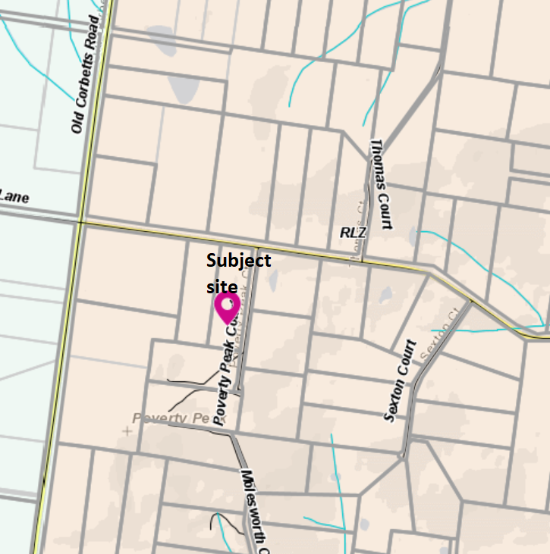
Figure 5: Zone map
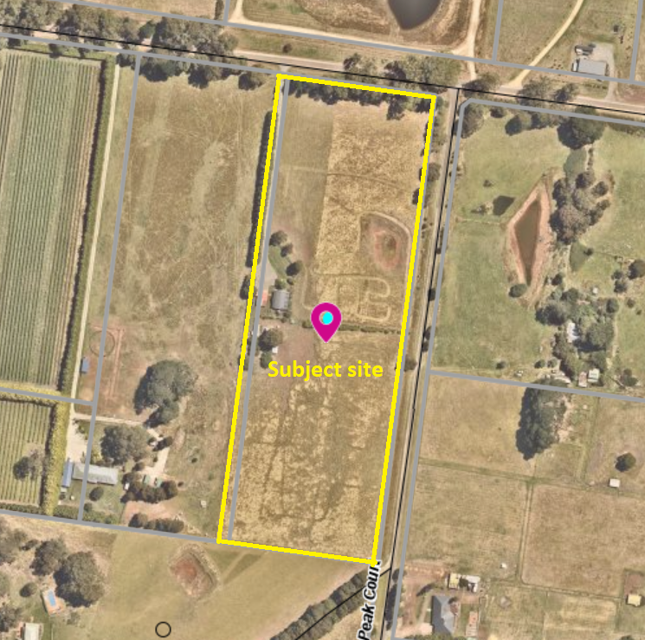
Figure 6: Aerial photograph

Planning Scheme Provisions
Council is required to consider the Victoria Planning Provisions and give particular attention to the Planning Policy Framework (PPF), the Local Planning Policy Framework (LPPF) and the Municipal Strategic Statement (MSS).
The relevant clauses are:
• Clause 11.03-3S Peri-urban areas
• Clause 13.02-1S Bushfire planning
• Clause 14.01-1S Protection of agricultural land
• Clause 14.02-1S Catchment planning and management
• Clause 14.02-2S Water quality
• Clause 15.01-6S Design for rural areas
• Clause 16.01-3S Rural residential development
• Clause 17.01-1R Diversified economy – Central Highlands
• Clause 17.04-1S Facilitating tourism
• Clause 21.02-2 Non-urban landscapes
• Clause 21.02-3 Water and catchment management
• Clause 21.03-4 Landscape and neighbourhood character
• Clause 21.03-6 Rural lifestyle opportunities
• Clause 22.02 Special Water Supply Catchments
Subject to conditions, the proposal is generally consistent with the relevant sections of the PPF and LPPF.

Zone
The subject site is in the Rural Living Zone (RLZ). The purpose of the RLZ is:
• To implement the Municipal Planning Strategy and the Planning Policy Framework.
• To provide for residential use in a rural environment.
• To provide for agricultural land uses which do not adversely affect the amenity of surrounding land uses.
• To protect and enhance the natural resources, biodiversity and landscape and heritage values of the area.
• To encourage use and development of land based on comprehensive and sustainable land management practices and infrastructure provision.
The use of the land for a dwelling is established by way of the existing dwelling. The proposed dwelling would maintain this existing use but due to the site being less than 6ha in size a dwelling is a Section 2 use and thus the proposed buildings and works require a permit under Clause 35.03-4.
Most types of accommodation are a Section 2 use and require a permit for use, as in this instance where the existing dwelling is proposed to be used for tourist accommodation. No buildings and works are proposed.
Overall, the proposal is generally consistent with the purpose of the zone.

Overlays
The site is affected by Environmental Significance Overlay, Schedule 1 (ESO1), Design and Development Overlay, Schedule 2 (DDO2) and partly by the Bushfire Management Overlay (BMO).
Environmental Significance Overlay, Schedule 1
Under Clause 42.01-2 (ESO) a permit is required to construct buildings and works. There are no applicable exemptions under Schedule 1 therefore a permit is required under this overlay.

Design and Development Overlay, Schedule 2
Under Clause 43.02-2 (DDO) a permit is required to construct buildings and works. Under Schedule 2 there is an exemption for buildings clad with non-reflective materials. The proposal meets the exemption and therefore a permit is not required under this overlay.
Bushfire Management Overlay
Under Clause 44.06-2 (BMO) a permit is required to construct buildings and works associated with accommodation. The BMO covers the northern part of the site, approximately two fifths of the site area, but no construction is proposed on this part of the site therefore a permit is not required under this overlay.
Relevant Policies

Particular Provisions
The are no Particular Provisions relevant to this application.

Discussion
Overall, the proposed use and development is considered to be generally in accordance with relevant State and local planning policy, the Rural Living Zone, Environmental Significance Overlay and the decision guidelines at Clause 65.01 of the Moorabool Planning Scheme.
Relevant planning policy at the State and local level requires consideration of a range of policy directions which generally support the valued character of Melbourne’s peri-urban settlements whilst ensuring growth is consolidated in suitable locations to ensure no detrimental impacts to the environment, rural land uses or landscape values.
The use of the subject site for a dwelling is already established. The intensification of the site’s use for accommodation purposes, specifically for small-scale tourist accommodation, is considered to be acceptable, subject to conditions. The proposed short-term tourist accommodation would make use of a modest self-contained three bedrooms building in an area with currently limited accommodation options for tourists. A key consideration in assessing the suitability for the proposed use is to ensure that the amenity of the surrounding rural residential area is not unreasonably affected. The relatively small scale of the proposal, substantial setback distances from existing dwellings and recommended permit conditions to address amenity and control the maximum number of guests and duration of stay would ensure that the proposed use can be appropriately managed to be compatible with surrounding uses.
Overall, the proposed dwelling and tourist accommodation are consistent with the purpose of the Rural Living Zone. There would be no detrimental impacts to farming activities, and the general scale and form of the proposed single storey dwelling would be in keeping with the site features and surrounding development. There would be no loss of vegetation or identified fauna or flora habitat.
The subject site and surrounding land is in a Special Water Supply Catchment and is unsewered. Accordingly, a land capability assessment was submitted with the application and referred to Barwon Water as the relevant water board and Council’s Environmental Health officer, both of whom consent to the proposal, subject to conditions. The subject site is not proximate to any waterways and it is considered that there would be no detriment to potable water quality or supply in the Moorabool Special Water Supply Catchment area.

A key concern raised by objectors relates to the location of the proposed dwelling on the site, relative to their own dwellings. During the course of the application, the objectors were consulted and through the process the applicant informally proposed an amendment to the location of the dwelling to increase the setbacks from the south and west title boundaries by, respectively, 15m and 10m increasing the minimum boundary setbacks to, respectively, 30m and 40m. Whilst this change was not sufficient to resolve the objections, it is considered to be an appropriate change to extend the distance from the nearest site boundaries without any detriment to other neighbours or the applicant. It is recommended that this change to the plans be formalized as a condition of approval, which would result in approximate minimum setbacks from dwellings to the south and west by, respectively 180m and 115m. Furthermore, it is recommended that a condition of approval require a colour schedule to be approved for the proposed dwelling to ensure that the colours chosen generally blend with the surrounding landscape to limit the visual impact, particularly on the property to the south which overlooks the site. A further recommended standard condition would prohibit the use of any external reflective building cladding.
Additionally, the applicant advises that the proposed graveled area on the northwest side of the proposed dwelling relates to the shed which formed part of the original application but which was later deleted from the plans, The shed would be subject to separate planning approval and it is therefore considered appropriate that the approximately 2500sqm gravelled area be deleted from the current proposal and considered as part of a future planning permit. It is also noted that a large graveled surface may create issues with sediment runoff from the site.

General Provisions
Clause 65 – Decision Guidelines have been considered by officers in evaluating this application.
Clause 66 – Stipulates all the relevant referral authorities to which the application must be referred.

Referrals
Authority | Response
Barwon Water  CFA | Consent with conditions  Consent
Infrastructure  Environmental Health | Consent with conditions  Consent with conditions

Financial Implications
There are no financial implications for Council in approving the application for use and development of the land for accommodation.

Risk & Occupational Health & Safety Issues
The recommendation to approve this application for use and development of the land for accommodation does not have any risk or OH&S implications for Council.

Communications Strategy
Notice was undertaken for the application, in accordance with s.52 of the Planning and Environment Act 1987, and further correspondence is required to all interested parties to the application as a result of a decision in this matter. All submitters and the applicant were invited to attend this meeting and address Council if required.

Options
- Issue a Notice of Decision to Grant a Permit in accordance with the conditions in the recommendation of this report; or
- issue a Notice of Decision to Grant a Permit with amendments to the conditions in the recommendation of this report. Either of these options may result in the objectors appealing Council’s decision to VCAT; or
- issue a Refusal to Grant a Permit on grounds. Council would need to consider what reasonable grounds there would be to refuse the application. This option may result in the applicant appealing Council’s decision to VCAT.

Conclusion
Overall, the proposed development of a dwelling and use of the existing dwelling for short-term tourist accommodation is considered to be generally in accordance with the relevant provisions of the Moorabool Planning Scheme. Subject to conditions, the proposal makes a modest contribution to tourist related facilities in the Shire whilst ensuring that the amenity of the surrounding area is not unreasonably impacted. Subject to conditions, the proposed single storey dwelling would be sited and designed to respect the amenity and character of the surrounding rural residential area without any unreasonable detriment to the amenity or landscape values of the area.

At 7.24pm, Cr Tom Sullivan returned to the meeting and assumed the Chair.

8 Update on Trends, Issues and Other Matters
Nil

9 Process Forward and Work Program
Nil

10 Update on VCAT Decisions
Mr Henry Bezuidenhout provided an update on VCAT Decisions in relation to Change of use to a Motel (Appeal against refusal to grant a permit) and Two (2) Lot Subdivision (Appeal against a condition)​.

11 Other Business
Cr Tatchell sought clarification from Mr Bezuidenhout if people with planning permits in the area which could be affected by the Transmission lines project would have to pay additional fees to have their permits extended.
Cr Munari requested an update on the Blackwood Post Office application which was subject to a deferral at the April DAC meeting.
Cr Sullivan requested that consideration be given to the development of guidelines or criteria for the assessment of applications for Kennel Breeding facilities.

12 Date of Next Meeting
Wednesday 16 June 2021

13 Meeting Close
The Meeting closed at 7.30pm

Net developable area is defined as land within a precinct available for development. This excludes encumbered land, arterial roads, railway corridors, significant heritage, schools and community facilities and public open space. It includes lots, local streets and connector streets.

