MINUTES
Development Assessment Committee Meeting
Wednesday, 17 November 2021
Date: | Wednesday, 17 November 2021
Time: | 6.01pm
Location: | Council Chambers, 15 Stead Street, Ballan & Online

Order Of Business
1 Opening 3
2 Present and Apologies 3
3 Recording of Meeting 3
4 Confirmation of Minutes 3
5 Matters Arising from Previous Minutes 3
6 Disclosure of Conflicts of Interests 4
7 Community Planning Reports 5
7.1 PA2021161 Development and Use of a Dwelling and Ancillary Outbuilding at Lot 14, 821 Greenhills Road, Blackwood 5
7.2 PA2021005 - Development and Use of a Dwelling and Ancillary Shed at Lots 1 and 3, Chapmans Road, Gordon. 22
7.3 PA2021083 - 29 Lot Subdivision, Multi-Unit Development and Reduction in all Visitor Car Parking at Lot S7 of PS725408Y at Rosehill Drive, Bacchus Marsh 37
8 Update on Trends, Issues and Other Matters 62
9 Process Forward and Work Program 62
10 Update on VCAT Decisions 62
11 Other Business 62
12 Date of Next Meeting 62
13 Meeting Close 62

1 Opening
The Mayor opened the meeting with the Council Prayer at 6.01pm

2 Present and Apologies
Cr Tom Sullivan, Mayor West Moorabool Ward
Cr Rod Ward, Deputy Mayor East Moorabool Ward
Cr Tonia Dudzik East Moorabool Ward
Cr David Edwards East Moorabool Ward
Cr Moira Berry East Moorabool Ward
Cr Ally Munari Woodlands Ward
OFFICERS:
Mr Derek Madden Chief Executive Officer
Mr Henry Bezuidenhout Executive Manager Community Planning & Economic Development
Mr Rob Fillisch Manager Statutory Planning & Building Services
Mr Phillip Howard Executive Manager Governance & Corporate Compliance
Mr Mark Lovell Coordinator Statutory Planning
Mr Troy Delia Coordinator Governance & Risk
APOLOGIES:
Cr Paul Tatchell Central Moorabool Ward

3 Recording of Meeting
In accordance with Moorabool Shire Council’s Governance Rules, the meeting is livestreamed.

4 Confirmation of Minutes
Committee Resolution
Moved: Cr David Edwards
Seconded: Cr Moira Berry
That the minutes of the Development Assessment Committee Meeting held on Wednesday 20 October 2021 be confirmed.
Carried

5 Matters Arising from Previous Minutes
Nil.

6 Disclosure of Conflicts of Interests
Nil.
PRESENTATIONS AND DEPUTATIONS
Item | Community Planning & Economic Development | Speaker/s | Position
7.1 | PA 2021161 - Development and Use of a Dwelling and Ancillary Outbuilding at Lot 14, 821 Greenhills Road, Blackwood | Mr Saul Pavitt | Applicant
7.1 | PA 2021161 - Development and Use of a Dwelling and Ancillary Outbuilding at Lot 14, 821 Greenhills Road, Blackwood | Ms Kimberly Vause | Objector
7.2 | PA 2021005 - Development and Use of a Dwelling and Ancillary Shed at Lots 1 & 3 Chapmans Road, Gordon | Ms Pauline Alabakis | Applicant
7.2 | PA 2021005 - Development and Use of a Dwelling and Ancillary Shed at Lots 1 & 3 Chapmans Road, Gordon | Mr Mark Weigall | Objector
7.3 | PA2021083 - 29 Lot Subdivision, Multi-Unit Development and Reduction in all Visitor Car Parking at Lot S7 of PS725408Y at Rosehill Drive, Bacchus Marsh | Ms Hayley Down | Representative of the Applicant

7 Community Planning Reports
Mr Saul Pavitt addressed the Committee as the applicant associated with Item 7.1.
Ms Kimberly Vause addressed the Committee as an objector associated with Item 7.1.

7.1 PA2021161 Development and Use of a Dwelling and Ancillary Outbuilding at Lot 14, 821 Greenhills Road, Blackwood
Author: Mark Lovell, Coordinator Statutory Planning
Authoriser: Henry Bezuidenhout, Executive Manager Community Planning & Economic Development
Attachments: 1. Dwelling and Ancillary Outbuilding Plans (under separate cover)

Application Summary
Permit No: PA2021161
Lodgement Date: 27 July 2021
Planning Officer: Mark Lovell
Address of the land: Lot 14, 821 Greenhills Road, Blackwood
Proposal: Development and Use of a Dwelling and Ancillary Outbuilding
Lot size: 2.19ha
Why is a permit required? Clause 35.06-1 permit for use in RCZ
Clause 35.06-5 permit for buildings and works for a Section 2 use
Clause 44.06-1 permit for building and works in Bushfire Management Overlay

Committee Resolution
Moved: Cr David Edwards
Seconded: Cr Rod Ward
That the Development Assessment Committee, having considered all matters as prescribed by the Planning and Environment Act 1987, issue a Notice of Decision to grant Planning Permit PA2021161 for the Development and Use of a Dwelling and Ancillary Outbuilding at Lot 14, 821 Greenhills Road, Blackwood subject to the following conditions:
Endorsed plans:
1. Before the use and/or development starts, amended plans to the satisfaction of the Responsible Authority must be submitted to and approved by the Responsible Authority. When approved, the plans will be endorsed and will then form part of the permit. The plans must be generally in accordance with the plans submitted with the application or some other specified plans but modified to show:
(a) Colour scheme of the ancillary outbuilding and the dwelling roof to contain muted tones to satisfaction of the Responsible Authority to blend with a natural environment.

2. Unless otherwise approved in writing by the Responsible Authority, all buildings and works are to be constructed and or undertaken in accordance with the endorsed plans to the satisfaction of the Responsible Authority prior to the commencement of the use.
Land Management:
3. A Land Management Plan to the satisfaction of the Responsible Authority must be endorsed as part of this permit and cannot be varied without the written consent of the Responsible Authority.
4. The subject land is to be maintained in accordance with the Land Management Plan for the site prepared by Central Highlands Environmental Consultancy dated June 2021.
Materials:
5. All external walls and roof areas of the proposed building/s are to be clad with non-reflective materials (zincalume prohibited) to the satisfaction of the Responsible Authority.
Dwelling Requirements:
6. Access to the dwelling must be provided via an all-weather road with dimensions adequate to accommodate emergency vehicles.
7. The dwelling must be connected to a reticulated potable water supply or have an alternative potable water supply with adequate storage for domestic use as well as for firefighting purposes.
8. The dwelling must be connected to a reticulated electricity supply or have an alternative energy source.
9. The dwelling must be connected to a reticulated sewerage system or if not available, the waste water must be treated and retained on-site in accordance with the State Environment Protection Policy (Waters of Victoria) under the Environment Protection Act 1970.
Infrastructure:
10. The unnamed road abutting the subject site is an unconstructed road, which is not included in the Moorabool Shire Council Register of Public Roads. Council does not carry out any construction or maintenance works on this road. The Council documents “Moorabool Shire Council Road Management Plan 2017- 2021” and “ISO17 Maintenance of Unmade (Paper) Roads Policy” set out the requirements which must be satisfied for a road to be included in the Register of Public Roads. These documents are available on Council’s Public Website at any time, or at Council’s Offices during business hours.
11. The subject site should be provided with rural standard vehicle crossing to the satisfaction of the Responsible Authority. A vehicle crossing permit must be taken out for the construction of the vehicle crossing.
12. The property access and the internal driveways must be constructed in accordance with the requirements specified in Table 5 of Clause 53.02-5 of the Moorabool Planning Scheme, to the satisfaction of the Responsible Authority.
13. Storm water drainage from the proposed buildings and impervious surfaces must be retained and disposed of within the boundaries of the subject land to the satisfaction of the Responsible Authority. Overflows from on-site storage systems must be directed away from any wastewater disposal areas.
14. Sediment discharges must be restricted from any construction activities within the property in accordance with relevant Guidelines including Construction Techniques for Sediment Control (EPA 1991).
15. Unless otherwise approved by the Responsible Authority there must be no buildings, structures, or improvements located over proposed drainage pipes and easements on the property.
16. Prior to the commencement of the development and post completion, notification including photographic evidence must be sent to Council’s Asset Services identifying any existing damage to Council assets. Any existing works affected by the development must be fully reinstated at no cost to and to the satisfaction of the Responsible Authority.
Environmental Health:
17. An onsite waste water management system with the capacity to treat effluent to a minimum of 20mg/L BOD and 30mg/L Suspended Solids must be installed
18. Effluent disposal must be undertaken via subsurface irrigation system designed and installed by a wastewater irrigation expert in accordance with the EPA Code of Practice for Onsite Waste Water.
19. The wastewater management system from proposed dwelling/lots must be treated and contained within the property boundaries in accordance with the current EPA Code of Practice and Onsite Wastewater Management: Guidelines for Environmental Management, Australian Standards 1547 and Council requirements.
20. The effluent disposal area must be kept free of buildings, driveways, vehicular traffic and services trenching.
21. All setback distances must be adhered to as dictated by Table 5 of the Code of Practice, Onsite Wastewater Management, EPA Publication Number 891.4.
22. A shallow surface water cut off drain or surface water diversion mound, should be provided on the high side of the disposal areas to divert any surface water flows around the effluent fields.
23. Subsurface irrigation system needs to be installed to a depth of 150mm in situ or if the soil is of poor quality, imported good quality topsoil may be required, with a 1m spacing in between lines.
24. The owner will maintain all drainage lines at all times to divert surface water and subsurface water clear of the effluent disposal field.
Greater Western Water:
25. Prior to a building permit being granted for the development of a dwelling, the owner of the land must enter into a Section 173 Agreement with Greater Western Water and the Council agreeing that:
(a) A wastewater treatment system that produces wastewater to a minimum standard of 20/30/10 (BOD/suspended solids/E.Coli) shall be installed to the satisfaction of the Council's Environmental Health Officer and Greater Western Water to treat all sullage and sewage waste on site.

(b) Wastewater is to be dispersed to the satisfaction of Council's Environmental Health Officer and Greater Western Water using methods that will prevent waste and treated waste from discharging from the property at all times.
(c) The effluent system must be maintained by a suitably qualified person in accordance with the manufacturer's specifications and EPA requirements.
(d) The wastewater effluent being released from the treatment facility must be monitored annually to ensure compliance with the 20/30/10 standard.
(e) Reports on water quality and maintenance must be submitted to the Responsible Authority at the completion of each maintenance period. This report must be made available to Greater Western Water on request.
(f) The Owner must meet the costs of the inspections and reports referred to in Conditions c), d) e) and g)
(g) The owner must carry out such works including replacing effluent treatment, storage pumping and disposal systems within the time specified to do so by the Council's Environmental Health Officer or Greater Western Water to cease and prevent waste and treated waste from discharging from the property.
(h) If the wastewater program proves to be unsustainable, the landholder must immediately rectify the sewerage disposal system.
(i) The owner must have the wastewater treatment system desludged at least once every three years and evidence of this fact must be provided in the annual written report referred to in Condition e).
(j) The effluent disposal field must be fenced and protected by being isolated from any building, driveway, livestock, vehicles or permanent recreational area that could render it unavailable in the future and should be planted with suitable grasses that will aid in moisture removal.
(k) All recommendations, actions and timelines contained within the Land Management Plan prepared by Central Highlands Consultancy Dated: 8 July 2021 must be followed and implemented to the satisfaction of Greater Western Water and Moorabool Shire Council.
26. No other building works to be undertaken on the subject land without written approval of Greater Western Water.
27. Any existing or proposed outbuilding must not be used for the purposes of accommodation or contain facilities that result in the discharge of wastewater.
28. Sediment Pollution Controls must be employed during construction and maintained until the disturbed area has been regenerated.
29. Stormwater must be managed in a way to minimise risk to erosion of the surrounding land. Stormwater must not be allowed to move into the effluent disposal fields.
30. The obligations under this Agreement must run with the land.
31. The applicant must pay the Council’s reasonable costs associated with the registration and enforcement of the Section 173 Agreement.

Southern Rural Water:
32. Wastewater must be dispersed, and the onsite wastewater system must be designed, constructed and maintained in line with the Land Capability Assessment undertaken by Ballarat Soil Testing (Stephen O’Loughlin, Report NB031220 dated December 7, 2020) and with due consideration to installer recommendations and the following conditions:
(a) Wastewater must be treated to a secondary standard prior to dispersal (20/30 BOD/SS Standard).
(b) The wastewater disposal system must be installed by a suitably qualified contractor to the satisfaction of Council’s Health Officer.
(c) Cut off drains should be installed above and below the wastewater Land Application Area (LAA) in order to prevent storm water run-on entering the LAA.
(d) Vegetation must be maintained on the LAA such that evapotranspiration is maximized, including keeping lawns mowed.
(e) All buffer distances to waterways, dams and other areas of interest must be met as per EPA Publication 891.4.
Country Fire Authority:
33. The bushfire mitigation measures forming part of this permit or shown on the endorsed plans, including those relating to construction standards, defendable space, water supply and access, must be maintained to the satisfaction of the Responsible Authority on a continuing basis. This condition continues to have force and effect after the development authorised by this permit has been completed.
34. The Bushfire Management Plan prepared by Regional Planning and Design Pty Ltd (Version B dated 23/10/20) must be endorsed to form part of the permit and must not be altered unless otherwise agreed in writing by the CFA and the Responsible Authority.
Permit Expiry:
35. This permit will expire if:
(a) the development and use are not started within two years of the date of this permit; or
(b) the development is not completed within four years of the date of this permit.
Carried

Public Consultation
Was the application advertised? | Yes.
Notices on site: | Yes.
Notice in Moorabool Newspaper: | No.
Number of objections: | Two.
Consultation meeting: | No, concerns cannot be addressed fully. The colour scheme of the ancillary shed can be altered through the submission of revised plans to a muted tone.

Policy Implications
The Council Plan 2021-2025 provides as follows:
Strategic Objective 1: Healthy, inclusive and connected neighbourhoods
Priority 1.4: Develop a vision and provide opportunities for rural communities

Victorian Charter of Human Rights & Responsibilities Act 2006
In developing this report to Council, the officer considered whether the subject matter raised any human rights issues. In particular, whether the scope of any human right established by the Victorian Charter of Human Rights and Responsibilities is in any way limited, restricted or interfered with by the recommendations contained in the report. It is considered that the subject matter does not raise any human rights issues.

Officer’s Declaration of Conflict of Interests
Under section 130 of the Local Government Act 2020, officers providing advice to Council must disclose any interests, including the type of interest.
Executive Manager – Henry Bezuidenhout
In providing this advice to Council as the Executive Manager, I have no interests to disclose in this report.
Author – Mark Lovell
In providing this advice to Council as the Author, I have no interests to disclose in this report.

Executive Summary
Application referred? | Yes, Greater Western Water, Southern Rural Water, Country Fire Authority, and Council’s Infrastructure and Environmental Health.
Any issues raised in referral responses? | Nil.
Preliminary concerns? | Nil.
Any discussions with applicant regarding concerns? | No planning concerns.
Any changes made to the application since being lodged? | Nil.
Brief history. | The land has been used for grazing. This lot is one of several crown lots that were in the same ownership for many years. Recently this owner has sold off the individual lots to new landowners.
Previous applications for the site? | No planning application for this lot (Lot 14).

General summary. | The proposed use and development are appropriately sited on a vacant parcel with its biodiversity value comprised tree canopy in the northern half of lot. The applicant proposes to plant 120 trees/shrubs in accordance with a comprehensive Land Management Plan. The wastewater water system achieves the objectives of the Environmental Significance Overlay and the defendable spaces fulfils the bushfire mitigation measures under the Bushfire Management Overlay. The objector concerns could not be resolved. The proposed use and development should be supported with conditions.
Summary of Officer’s Recommendation
That, having considered all relevant matters as required by the Planning and Environment Act 1987, Council issue a Notice of Decision to grant Planning Permit PA2021161 for the Development and Use of a Dwelling and Ancillary Outbuilding at Lot 14, 821 Greenhills Road, Blackwood subject to the conditions contained within this report.

Site Description
The subject site is located on the southern side of an unamed road reserve which is a single lane gravel track that intersects with Greenhills Road to the east. There is also a road reserve on title adjacent to the western property boundary. The lot has a frontage width of 201.37m and a depth of 100.56m for a total area of 2.192ha. The lot is mostly comprised of vacant land with concentration of native trees adjacent to the western boundary. The site has a moderate sloped topography.
The surrounding area is comprised of similar sized crown lots with a mixutre of completed cleared lots and some partly cleared with pockets of tree canopies. Beyond the crown lots is a forest area with fire access tracks and undulating terrain.
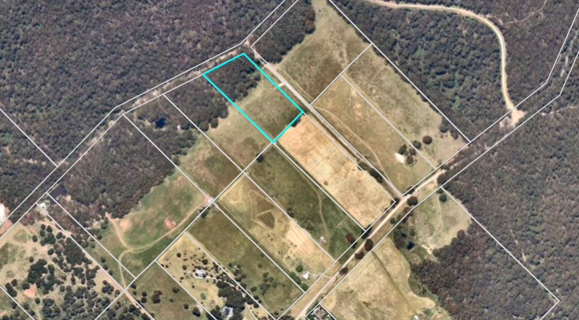
Figure 1: Aerial image of the site

Proposal
It is proposed to construct a single storey dwelling and detached ancillary outbuilding. The dwelling will consist of four bedrooms, purpose built study, lounge, combined kitchen/living/meals area, laundry and bathroom. The dwelling will be comprised of weatherboard wall cladding, aluminium framed windows and Colorbond roofing without stipulating the colour. The dwelling will be setback 65m from the road frontage, 59m from the eastern side boundary and 13m from the rear southern boundary. A detached ancillary outbuilding is proposed approximately 25m to the north-west dwelling and will be 150sqm in area with an overall heigh of 5.85m and comprised of Colorbond materials with proposed colour of Monolith for the roof and Surmist for the walls.
The applicant has submitted a detailed Land Management Plan which proposes retention of the tree canopy area adjacent to the western property boundary and proposes additional planting in a partially cleared section of this area. Additional trees and shrubs are also proposed along part of the front property boundary and eastern side boundary, a total planting of 120 trees/schrubs.

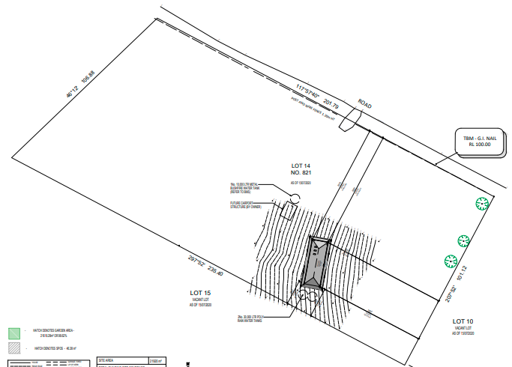
Figure 2: Site plan

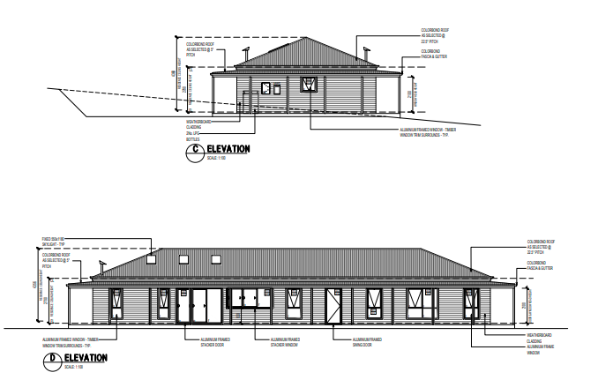
Figure 3: Dwelling Elevation plans

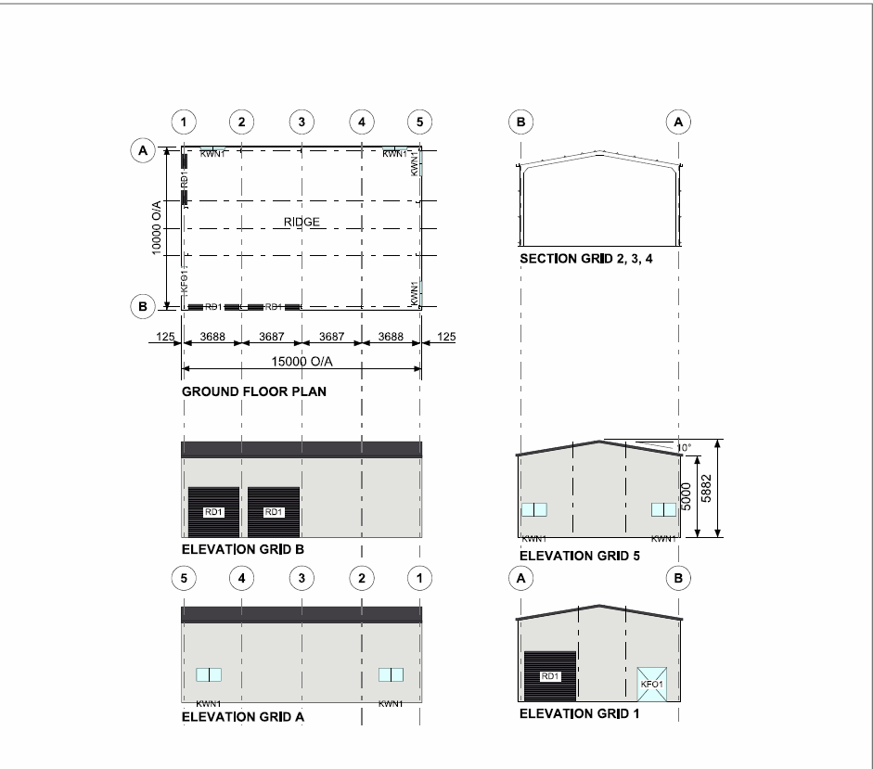
Figure 4: Shed plans

The Land Management Plan shows the location of a chicken shed, garden shed, pool space and pergola which are not part of this current application and can be subject to future planning permission.

History
The property formerly known as 821 Greenhills Road contained several Crown lots which were under one ownership. They have recently been sold off and are now in different land ownerships. A history of planning applications for the property known as 821 Greenhills Road are as follows:
APPLICATION  NUMBER | LOT  NUMBER | PROPOSAL | DECISION DATE | OUTCOME
PA2019269 | Lot 13 | Development and Use of a Dwelling | 24/03/20 | Permit issued
PA2020250 | Lot 10 | Development and Use of a Dwelling and Ancillary Outbuilding | 16/06/21 | VCAT appeal against Notice of Decision
PA2021044-1 | Lot 12 | Development and Use of a Dwelling and Shed | 25/06/21 | Permit issued
PA2021072 | Lot 11 | Development and Use of a Dwelling and Shed | 20/10/21 | Notice of Decision
PA2021161 | Lot 14 | Development and Use of a Dwelling and Ancillary Outbuilding | - | Current application
PA2021212 | Lot 16 | Development and Use a Dwelling and Ancillary Outbuilding | - | Request for further information

Public Notice
The application was notified to adjoining and surrounding landowners.
Two objections were received as a result of the advertising.

Summary of Objections
The objections received are detailed below with officer’s comments accompanying them:
Objection | Any Relevant Requirement
Proximity of dwelling (privacy, noise and air quality, water tanks) to a shared boundary | Rural Conservation Zone.
Officer’s Response: The dwelling is setback from all property boundaries. Constructing close to a rear southern boundary adjacent to a vacant lot does not create amenity concerns. The dwelling achieves the required minimum 5m setback that would trigger a permit for building and works under Clause 35.06-5.
Off Grid details and considerations  Wood fire burning | Rural Conservation Zone.
Officer’s Response: Electricity supply must be in accordance with the dwelling requirements of Clause 35.06-2. Details of the panels are not required by a planning assessment and are defined as works normal to a dwelling. Any wood burning fire has to comply with any EPA and CFA requirements.
Shed size, height, materials and colours | Rural Conservation Zone.
Officer’s Response: The ancillary outbuilding to the proposed dwelling and cannot be used for habitable purposes. It is appropriately sized and located on the land. Altered colour schemes of the outbuilding rather than Colorbond ‘Surfmist’ can be requested as part of the submission of revised plans to better adapt to a natural environment.
Paper Road condition/unsafe access | Council’s Infrastructure
Officer’s Response: Council’s Infrastructure have placed conditions with regard to access to the existing road reserve. The applicant is required formalise the paper road as required by a permit condition.
Risk to the Open Portable Supply Catchment / area has reached its density limits. | Catchment Authority referral responses
Officer’s Response: There are no density limits within catchment areas and each application is assessed against a specific Land Capability Assessment. The responsible water catchment authorities have consented to the application with conditions managing the onsite wastewater system. The wastewater field is contained wholly within the subject land and Greater Western Water have requested the owner enter into a Section 173 Agreement for the management of the wastewater system.
Own Agri-tourism business / affect the future success of the business | Rural Conservation Zone
Officer’s Response: The proposed dwelling is a permitted use within Rural Conservation Zone. The area is not zoned for commercial activities which are restricted to certain uses.
Reference to a refusal recommendation for a dwelling in Kennedy Lane Bunding / Proposal results in fragmentation of agricultural land. | Rural Conservation Zone
Officer’s Response: Kennedy Lane planning application PA2021097 was located in the Farming Zone and the Development Assessment Committee (DAC) determined to issue a Notice of Decision to Grant a permit. Agriculture is a Section 2 use in the Rural Conservation Zone and can have negative impact upon the biodiversity value of the land. The primary objectives of the Rural Conservation Zone is to protect biodiversity value of the area. This has been achieved with the applicant’s Land Management Plan.

Locality Map
The map below indicates the location of the subject site and the zoning of the surrounding area.
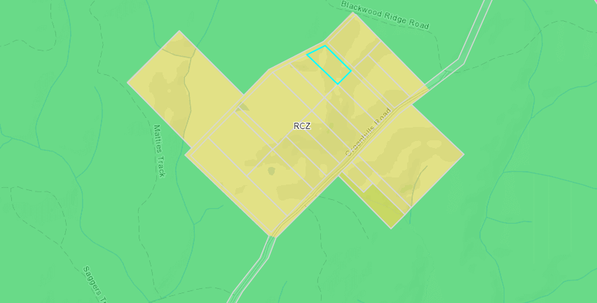
Figure 5: Zone Map

Planning Scheme Provisions
Council is required to consider the Victoria Planning Provisions and give particular attention to the Planning Policy Framework (PPF), the Local Planning Policy Framework (LPPF) and the Municipal Strategic Statement (MSS).
The relevant clauses are:
• Clause 12.01-1S - Protection of biodiversity
• Clause 12.01-2S - Native vegetation management
• Clause 12.05-2S - Landscapes
• Clause 13.02-1S - Bushfire planning
• Clause 14.02-1S - Catchment planning and management
• Clause 14.02-2S - Water quality
• Clause 16.01-3S - Rural residential development
• Clause 22.02 - Special Water Supply Catchments
• Clause 21.02 - Natural Environment
• Clause 21.02-1 - Key issues and influences
• Clause 21.09-1 - Small Towns and Settlements
The proposal complies with the relevant sections of the PPF and LPPF.

Zone
Rural Conservation Zone
The subject site is located in the Rural Conservation Zone. In accordance with Clauses 35.06-1 the proposed use for a dwelling requires a permit. Under Clause 35.06-5, building and works for a Section 2 use requires a permit. Decision guidelines are listed under Clause 35.06-6.
The purpose of the Rural Conservation Zone is:
• To implement the Municipal Planning Strategy and the Planning Policy Framework.
• To conserve the values specified in a schedule to this zone.
• To protect and enhance the natural environment and natural processes for their historic, archaeological and scientific interest, landscape, faunal habitat and cultural values.
• To protect and enhance natural resources and the biodiversity of the area.
• To encourage development and use of land which is consistent with sustainable land management and land capability practices, and which takes into account the conservation values and environmental sensitivity of the locality.
• To provide for agricultural use consistent with the conservation of environmental and landscape values of the area.
• To conserve and enhance the cultural significance and character of open rural and scenic non-urban landscapes.

Overlays

Relevant Policies
Design and Development Overlay – Schedule 2 (DD02)
The site is included in the Design and Development Overlay – Schedule 2 covering visual amenity and building design.
The relevant design objectives of the DDO2 to be achieved are:
• To enhance visual amenity in rural, township and vegetated areas of the Moorabool Shire.
• To encourage the use of external cladding, such as non-reflective materials for building construction.
• To discourage the use of materials, such as reflective cladding for building construction, which could have a detrimental effect on amenity.

In accordance with Clause 2.0 of Schedule 2, a permit is not required to construct a building or to carry out works where all external walls and roof areas are clad with non-reflective materials.
The proposed dwelling and ancillary outbuilding would be externally clad with non-reflective materials and therefore a permit is not required under this overlay.
Bushfire Management Overlay
The subject site as affected by the Bushfire Management Overlay (BMO). In accordance with Clause 44.06-2 a permit is required to construct a building or construct or carry out works associated with Accommodation.
The relevant purposes of the BMO are:
• To implement the Municipal Planning Strategy and the Planning Policy Framework.
• To ensure that the development of land prioritises the protection of human life and strengthens community resilience to bushfire.
• To ensure that the location, design and construction of development appropriately responds to the bushfire hazard.
• To ensure development is only permitted where the risk to life, property and community infrastructure from bushfire can be reduced to an acceptable level.
• To specify location, design and construction measures for a single dwelling that reduces the bushfire risk to life and property to an acceptable level.
Pursuant to Clause 44.06-6, referral to the relevant fire authority in accordance with Clause 66.03 is required. The application was referred to the Country Fire Authority and a BAL29 was designated for the dwelling construction.
Particular Provisions
Clause 53.02 Bushfire Planning
Subject to Clause 44.06-4, this application must meet the requirements of Clause 53.02 Bushfire Planning.

A Bushfire Management Statement was provided with the application. The purpose of Clause 53.02 is:
• To implement the Municipal Planning Strategy and the Planning Policy Framework.
• To ensure that the development of land prioritises the protection of human life and strengthens community resilience to bushfire.
• To ensure that the location, design and construction of development appropriately responds to the bushfire hazard.
• To ensure development is only permitted where the risk to life, property and community infrastructure from bushfire can be reduced to an acceptable level.
• To specify location, design and construction measures for a single dwelling that reduces the bushfire risk to life and property to an acceptable level.

Discussion
While the locality is constrained by significant vegetation in the surrounding area, the proposed location of the dwelling and the ancillary outbuilding is generally acceptable in a cleared section of the land. The dwelling and ancillary outbuilding location have avoided the native tree canopy to the western side of the lot.
The setbacks proposed are suitable with a defendable space in accordance with the conditions provided by the CFA based on the accompanying Bushfire Management Statement. The Bushfire report estimated that the Bushfire Attack Level for this site was BAL29. The defendable space does not encroach into the tree canopy area which is a positive deign approach.
A Land Capability Assessment was submitted with the application and it was referred to Council's Environmental Health as well as Greater Western Water and Southern Rural Water, all of which have consented to the application with conditions.
The application was referred to Council's Infrastructure which also consented subject to conditions. The issue for this lot is access from an unconstructed roadway which connects into Greenhills Road. This road will need to be formalised in accordance with Council’s requirements and constructed to a minimum standard at the owner’s expense.
The land is of sufficient size and the proposed dwelling and ancillary outbuilding are positioned appropriately on the land to not cause any adverse impacts to any adjacent properties. The Colorbond roof of the outbuilding is proposed to be ‘Surfmist’ a white colour. The applicant has not provided colours for the dwelling roof. There have been some concerns raised on whether ‘Surfmist’ colour is deemed as reflective. Therefore, amended plans are required to clarify the colour of the dwelling roof and the outbuilding to Council’s satisfaction to ensure the material is non-reflective.
The site is vacant land with retention of its western half of the lot containing a tree canopy area that protects the biodiversity value of the site. The dwelling and outbuilding are well clear of this treed area. The applicant also proposes in addition to retaining existing native trees on site, to plant 120 trees and shrubs including a small section of the cleared tree area and along parts of the front and side properties boundaries. This will improve the biodiversity of the area and the applicant has provided extensive details of new planting and how to maintain these new vegetation areas. New vegetation will improve the visual aspect of the site and achieve the objectives of the Rural Conservation Zone.
The applicant’s Land Management Plan ensues the dwelling and outbuilding location do not affect remanent vegetation and provides a series of management measure including the control of weed species. The Land Management Plan can be endorsed as part of this use and development application which will protect the conservation value of the area. The objector concerns with dwellings entering the area and not protecting land for agricultural purposes is not the intent of the Rural Conservation Zone and there are no environmental constraints to prevent the establishment of a dwelling and detached ancillary outbuilding. Another objector consideration has been setback to their shared boundary and scale of the ancillary outbuilding. The setbacks are appropriate and are designed to allow for new tree plantings while maintaining a bushfire defendable space in accordance with CFA’s requirements. The ancillary outbuilding is appropriate in a rural setting and its central location on the lot minimises off site impacts. However, the colour scheme of the outbuilding should be altered to be sympathetic to the tree canopy backdrop that will be addressed through the submission of revised plans.
The proposal is supported by planning policy and should be approved subject to conditions.

General Provisions
Clause 65 - Decision Guidelines have been considered by officers in evaluating this application.
Clause 66 - Stipulates all the relevant referral authorities to which the application must be referred.

Referrals
Authority | Response
Greater Western Water  Southern Rural Water  CFA | Consent with conditions.  Consent with conditions.  Consent with conditions.
Infrastructure  Environmental Health | Consent with conditions.  Consent with conditions.

Financial Implications
The recommendation of approval of does not implicate any financial risk to Council.

Risk & Occupational Health & Safety Issues
The recommendation of approval of does not implicate any risk or OH&S issues to Council.

Communications Strategy
Notice was undertaken for the application, in accordance with s.52 of the Planning and Environment Act 1987, and further correspondence is required to all interested parties to the application as a result of a decision in this matter. All submitters and the applicant were invited to attend this meeting and invited to address Council if required.

Options
Council could consider the following options:
• issue a Notice of Decision to grant a Planning Permit in accordance with the recommendations of this report; or
• issue a refusal to Grant a Planning Permit with specific grounds. The grounds would need to demonstrate how the proposal does not comply with the Moorabool Planning Scheme.

Conclusion
In summary, based on the information within the Bushfire Management Statement and Land Capability Assessment as well as the comprehensive Land Management Plan, it is considered that the overall siting and built form of the dwelling and the ancillary outbuilding, is an appropriate outcome for the site and considered to be generally acceptable and, therefore, should be supported subject to relevant conditions.

Ms Pauline Alabakis addressed the Committee as the applicant associated with Item 7.2.
Mr Mark Weigall addressed the Committee as an objector associated with Item 7.2.

7.2 PA2021005 - Development and Use of a Dwelling and Ancillary Shed at Lots 1 and 3, Chapmans Road, Gordon.
Author: Jyoti Makan, Senior Statutory Planner
Authoriser: Henry Bezuidenhout, Executive Manager Community Planning & Economic Development
Attachments: 1. PA2021005 - Planning Report, Farm Management Plan, Titles and Plans (under separate cover)

Application Summary
Permit No: PA2021005
Lodgement Date: 04 January 2021
Planning Officer: Jyoti Makan
Address of the land: Lots 1 and 3 Chapmans Road, Gordon
Lot 1 of TP 124327M and Lot 3 on PS330386H
Proposal: Development and Use of a Dwelling and Ancillary Shed.
Lot size: Lot 1 of TP 124327M (1.376ha) and Lot 3 on PS330386H (11.80ha)
Why is a permit required? Development and Use of a Dwelling and Ancillary Shed on land less than 40ha in the Farming Zone;
Buildings and works within the Environmental Significance Overlay, Schedule 1

MOTION
Moved: Cr Rod Ward
Seconded: Cr Ally Munari
That the Development Assessment Committee, having considered all matters as prescribed by the Planning and Environment Act 1987, issue a Notice of Decision to grant Planning Permit PA2021005 for the Development and Use of a Dwelling and Ancillary Shed on Lot 1 of TP 124327M and Lot 3 of PS330386H, Chapmans Road, Gordon, subject to the following conditions:
Endorsed Plans:
1. Before the use and development starts, amended plans to the satisfaction of the Responsible Authority must be submitted to and approved by the Responsible Authority. When approved, the plans will be endorsed and will then form part of the permit. The plans must be drawn to scale with dimensions and three copies must be provided. The plans must be generally in accordance with the plans submitted with the application or some other specified plans but modified to show:
(a) Development plans:
(i) Fully dimensioned plans of the dwelling, including floor and elevations with a material and colour schedule to ensure the materials are non-reflective.
(ii) Update site plan to detail the location of the effluent field.
(b) Additional detailing, to sustain the agricultural productivity proposed in the Farm Management Plan V3 completed 7 June 2021 drafted by Central Vic Planning Consultants pertaining to the following:
(i) Landscaping and revegetation works across the site.
(ii) Update the five-year plan with the contingency on availability and adequacy of ongoing water supply.
Dwelling Requirements:
2. The dwelling must be connected to a reticulated sewerage system or if not available, the wastewater must be treated and retained on-site in accordance with the State Environment Protection Policy (Waters of Victoria) under the Environment Protection Act 1970.
3. The dwelling must be connected to a reticulated potable water supply or have an alternative potable water supply with adequate storage for domestic use as well as for firefighting purposes.
4. The dwelling must be connected to a reticulated electricity supply or have an alternative energy source.
5. Access to the dwelling must be provided via an all-weather road with dimensions adequate to accommodate emergency vehicles.
General:
6. Prior to the occupancy of the dwelling, proposed works identified in the five-year management plan within the Farm Management Plan approved under Permit PA2021005 must be sufficiently undertaken to the satisfaction of the responsible authority.
Subdivision:
7. Prior to the occupancy of the dwelling, Lot 1 of TP 124327M and Lot 3 on PS330386H on Chapmans Road must be consolidated.
Operational:
8. The permitted outbuilding must not be used for any habitable, commercial or industrial purposes except in accordance with the provisions of the Moorabool Planning Scheme.
9. Unless with the written consent of the Responsible Authority the agricultural activities required to justify the use of a dwelling must be in accordance with the endorsed Farm Management Plan.
Section 173 Agreement:
10. Before the issue of a Building Permit the owner must enter into an Agreement with the Responsible Authority made pursuant to Section 173 of the Planning and Environment Act 1987 to the satisfaction of the Responsible Authority:
(a) The owner of the land must acknowledge that while the land remains zoned as Farming Zone or its equivalent successor the primary use of the land is for agricultural activities and the use of the dwelling must be in conjunction with an approved agricultural activity.

(b) Agricultural activities and environmental management identified in the endorsed Farm Management Plan under Permit PA2021005.
11. Before a Certificate of Occupancy is issued for the dwelling, application must be made to the Register of Titles to register the Section 173 Agreement on the title to the land under Section 181 of the Act and the owner must provide evidence of that registration of the Agreement to the Responsible Authority.
12. The owner must pay the reasonable costs for the preparation, execution and registration of the Section 173 Agreement.
Materials and Colour:
13. All external walls and roof areas of the proposed buildings are to be clad with non-reflective materials (zincalume prohibited) to the satisfaction of the Responsible Authority.
Native Vegetation:
14. No native vegetation may be removed, destroyed or lopped unless where specifically exempt under the provisions of the Moorabool Planning Scheme.
Environmental Health:
15. The land application area and all conditions must be in accordance with the Land Capability Assessment prepared by Ballarat Soil Testing, ref number PA071020 dated 12 October 2020 or any approved amendment which are to be strictly adhered to.
16. An onsite waste water management system with the capacity to treat effluent to a minimum of 20mg/L BOD, 30mg/L SS and 10orgs/100ml with chlorination, i.e., secondary treatment via an aerated wastewater treatment system must be installed.
17. Effluent disposal must be undertaken via subsurface irrigation system designed and installed by a wastewater irrigation expert in accordance with the EPA Code of Practice for Onsite Waste Water.
18. The wastewater management system from proposed dwelling/lots must be treated and contained within the property boundaries in accordance with the current EPA Code of Practice and Onsite Wastewater Management: Guidelines for Environmental Management, Australian Standards 1547 and Council requirements.
19. The effluent disposal area must be kept free of buildings, driveways, vehicular traffic and services trenching.
20. All setback distances must be adhered to as dictated by Table 5 of the Code of Practice, Onsite Wastewater Management, EPA Publication Number 891.4
21. A shallow surface water cut off drain or surface water diversion mound, should be provided on the high side of the disposal areas to divert any surface water flows around the effluent fields.
22. Subsurface Irrigation system needs to be installed to a depth of 150mm in situ or if the soil is of poor quality, imported good quality topsoil may be required, with a 1m spacing in between lines.
23. The owner will maintain all drainage lines at all times to divert surface water and subsurface water clear of the effluent disposal field.
Infrastructure:
24. A standard rural residential vehicle crossing must be provided on Chapmans Road to the satisfaction of the Responsible Authority. Any redundant vehicle crossings must be removed, and the kerb and channel and nature strip reinstated to the satisfaction of the Responsible Authority. A vehicle crossing permit must be taken out for the construction of the vehicle crossing.
25. Stormwater runoff must meet the “Urban Stormwater Best Practice Environmental Management Guidelines (CSIRO 1999)”.
26. Unless otherwise approved by the Responsible Authority there must be no buildings, structures, or improvements located over proposed drainage pipes and easements on the property.
27. Sediment discharges must be restricted from any construction activities within the property in accordance with the relevant Guidelines including “Construction Techniques for Sediment Control” (EPA 1991) and “Environmental Guidelines for Major Construction Sites” (EPA 1995).
28. Prior to the commencement of the development, notification including photographic evidence must be sent to Council’s Asset Services identifying any existing change to council assets. Any existing works affected by the development must be fully reinstated at no cost to and to the satisfaction of the Responsible Authority.
29. Prior to the commencement of the development, plans and specifications of all road and drainage works must be prepared and submitted to the responsible authority for approval, detailing but not limited to the following:
(a) location of vehicle crossings.
30. Storm water drainage from the proposed buildings and impervious surfaces must be disposed of to the satisfaction of the Responsible Authority. Overflows from on-site storage systems must be directed away from any waste water disposal areas. A Stormwater Point of Discharge permit must be obtained from the Assets Unit of the Responsible Authority prior to the commencement of the works associated with the permit.
Corangamite Catchment Management Authority:
31. Prior to the commencement of works, appropriate silt control measures must be installed to prevent sediment laden runoff from entering the wetland and waterway. The silt control measures must be maintained throughout the construction period.
Central Highlands Water:
32. The dwelling and effluent disposal system must be located in accordance with the Land Capability Assessment by Ballarat Soil Testing Reference PA071020 dated 12 October 2020.
33. The owner must install a wastewater management system that provides a secondary level of treatment of wastewater, in accordance with the recommendations in Section 5 of Land Capability Assessment by Reference PA071020 dated 12 October 2020.
34. Prior to a building permit being issued for a new dwelling on the land:
(a) the land known as Lot 3 PS330386H Certificate of Title Vol. 10160 Fol. 614 and Lot 1 TP 124327M Certificate of Title Vol. 9961 Fol. 178 must have been consolidated and the plan registered to the satisfaction of Central Highlands Water;
(b) the owner must enter into an Agreement with Central Highlands Region Water Corporation (CHW) and the responsible authority under Sections 173 and 174 of the Planning and Environment Act 1987, requiring that:
(i) The owner must have any wastewater treatment facility and effluent disposal system for the dwelling inspected annually by a qualified environmental health officer (“the EHO”) and must provide annually to both the Council and to Central Highlands Water’s a written report from the EHO on the condition of the wastewater treatment and effluent disposal system.
(ii) The Owner must have the wastewater treatment facility desludged at least once every three years or as otherwise determined by the EHO and evidence of this desludging must be provided in the EHO report referred to in Clause (a) herein.
(iii) The Owner must carry out any works considered necessary by the EHO to ensure the satisfactory operation of the wastewater treatment facility and effluent disposal system.
(iv) The owner will maintain all drainage lines at all times to divert surface water and subsurface water clear of the effluent disposal field.
(v) The Owner and the Council agree to do all things necessary to register a memorandum of this Agreement on the title of the land pursuant to Section 181 of the Planning and Environment Act 1987.
(vi) The Owner must meet all costs of inspections, reports and works referred to in Clauses (a), (b), (c) and (d) herein and all costs of the Council in relation to stamping and registration of this Agreement.
(vii) The Owner must not sell or enter into any contract to sell the land until this Agreement has been registered pursuant to Clause (e) herein.
(c) The landowners must meet all costs of preparing and recording this Agreement.
(d) Any plan lodged for certification will be referred to the Central Highlands Region Water Corporation pursuant to Section 8(1)(a) of the Subdivision Act 1988.
Permit expiry:
35. This permit will expire if one of the following circumstances applies:
(a) The development and the use is not started within two years of the date of this permit; and
(b) The development is not completed within four years of the date of this permit.
Permit notes:
Please contact the Council’s Statutory Planning prior to any works being conducted on the dams across the site (other than maintenance) since planning permits may be required for the works associated with the dams.
All buildings and works must be located clear of any easements or water and sewer mains or septic tank and effluent lines unless written approval is provided by the relevant authority.
LOST ON THE CASTING VOTE OF THE MAYOR

Committee Resolution
Moved: Cr Tonia Dudzik
Seconded: Cr Moira Berry
That the Development Assessment Committee, having considered all matters for PA2021005 as prescribed by the Planning and Environment Act 1987, issues a Refusal to grant a permit for the Development and Use of a Dwelling and Ancillary Shed at Lots 1 and 3 Chapmans Road, Gordon with the following grounds of refusal:

- The applicant has not provided sufficient evidence that there is adequate, ongoing water supply for the market garden, orchard and olive grove.
- The proposed agricultural use will adversely affect surrounding and existing farming uses.
- The proposal does not represent the orderly planning of the area.
Carried ON THE CASTING VOTE OF THE MAYOR

Public Consultation
Was the application advertised? | Yes
Notices on site: | Yes.
Notice in Moorabool Newspaper: | None
Number of objections: | Four objections were received.
Consultation meeting: | Applicant responded to the objections; no consultation meeting was undertaken.

Policy Implications
The Council Plan 2021-2025 provides as follows:
Strategic Objective 1: Healthy, inclusive and connected neighbourhoods
Priority 1.4: Develop a vision and provide opportunities for rural communities

Victorian Charter of Human Rights & Responsibilities Act 2006
In developing this report to Council, the officer considered whether the subject matter raised any human rights issues. In particular, whether the scope of any human right established by the Victorian Charter of Human Rights and Responsibilities is in any way limited, restricted or interfered with by the recommendations contained in the report. It is considered that the subject matter does not raise any human rights issues.

Officer’s Declaration of Conflict of Interests
Under section 130 of the Local Government Act 2020, officers providing advice to Council must disclose any interests, including the type of interest.
Executive Manager – Henry Bezuidenhout
In providing this advice to Council as the Executive Manager, I have no interests to disclose in this report.
Author – Jyoti Makan
In providing this advice to Council as the Author, I have no interests to disclose in this report.

Executive Summary
Application referred? | The application was referred to Central Highlands Water, Corangamite Catchment Management Authority, Council’s Environmental Health Officer, Infrastructure, Strategic Planning, and Environmental Management.
Any issues raised in referral responses? | No issues raised.
Preliminary concerns? | The sustainability of the agricultural practice, mainly:  adequate water supply, sufficient land area to sustain the market garden orchard, egg and sheep farm on a 13ha property.  The need for a dwelling, ancillary shed to sustain the agricultural livelihood of the land.
Any discussions with applicant regarding concerns? | Several discussions took place with the applicant to ensure that the Farm Management Plan must be realistic, show that the farming practices can be sustained on the land to be able to allow for a dwelling on the property.
Any changes made to the application since being lodged? | No changes were made to the application however the Farm Management Plan and Site Plan was updated to clarify some of the concerns.
Brief history. | No relevant history.
Previous applications for the site? | None.
General summary. | An application is made for the use and development of a dwelling, ancillary shed, and pool on land within the Farming Zone.  The objections cannot be resolved however some additional details within the Farm Management Plan can be addressed through revised plans.  The application was assessed against the decision guidelines of the planning scheme, the Municipal and Planning Policy Framework which has resulted a recommendation to approve the application subject to the recommendations contained in this report.
Summary of Officer’s Recommendation
That, having considered all relevant matters as required by the Planning and Environment Act 1987, Council issue a Notice of Decision to grant Planning Permit PA2021005 for the Development and Use of a Dwelling and Ancillary Shed on Lot 1 of TP 124327M and Lot 3 on PS330386H, Chapmans Road, Gordon, subject to conditions contained within this report.

Site Description
The site is located at the corner of Chapmans and Clohesy Roads. The site is relatively flat with a fall towards the northwest and southeast. The site is made up of two lots titled as Lot 1 of TP 124327M and Lot 3 on PS330386H.
The site is currently used for grazing of cattle. There is a large dam to the west which is shared with the neighbouring property. The property has no access to reticulated water or sewerage. The Rural Living Zone and Township Zone is located about 1.5km east of the site. The Western Freeway runs north of the site and can be accessed within 3km of the site. The properties in the immediate surrounds are within the Farming Zone and range from approximately 2ha to 400ha. The Farming Zone in this area is highly compromised by fragmented lots showing irregular slopes and shapes. The site is within close proximity to several linkages such as Old Melbourne Road and the Freeway which leads towards several nearby towns, Ballarat to west and Bacchus Marsh to the east.
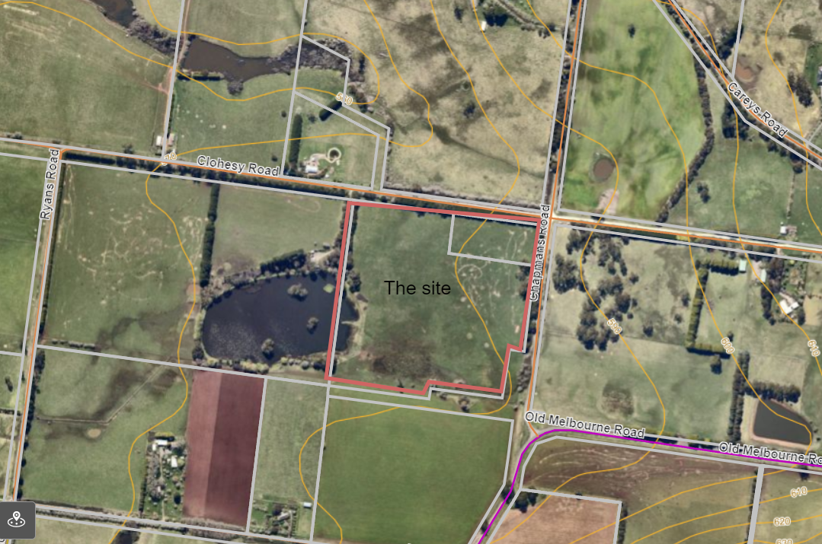
Figure 1: Aerial Map

Proposal
It is proposed to build a five-bedroom single storey dwelling with attached double garage, ancillary shed in north-east corner of the lots. The dwelling is setback 20m from Chapmans Road where vehicle access will be obtained and is setback 20m from the Clohsey Road frontage. The ancillary shed is 15m long and 15m wide with an overall height of 4.92m and will have two roller doors. The shed is located 20m from Clohsey Road frontage. The applicant also proposes a domestic pool located to the south of the dwelling. The farm will consist of an olive grove focusing on preserved olives, fruit and nut orchard, market garden, egg and sheep farming.

Summary of the Farm Management Plan:
Orchard
• 200 trees to produce olives, fruits and nuts – 100 olive trees and 100 fruit and nut trees.
- Fruit - Varieties include apples, pears, apricots, peach, nectarine, plum, pomegranate, cherry, fig, cumquat, lemon, lime, mulberry, chestnuts and almonds.
- 3-5 year yield for full crop to start commercial activity. Different varieties are planted at different seasons.
Market Garden
• To include following: tomatoes, zucchini, green beans, broad beans, onions, garlic, chives, spinach, cucumber, lettuce, kale, silverbeet, cabbage and broccoli, rosemary, basil, dill, parsley, oregano, coriander and thyme.
Sheep and egg Farming
• The flock will consist of 20 merino ewes, one white Suffolk Ram for grazing, wool and meat production. Ewes will produce 20-30 lambs per year. Grazing will be by rotation.
Eggs
• 100 egg laying chickens onsite producing 30,000 eggs per annum.

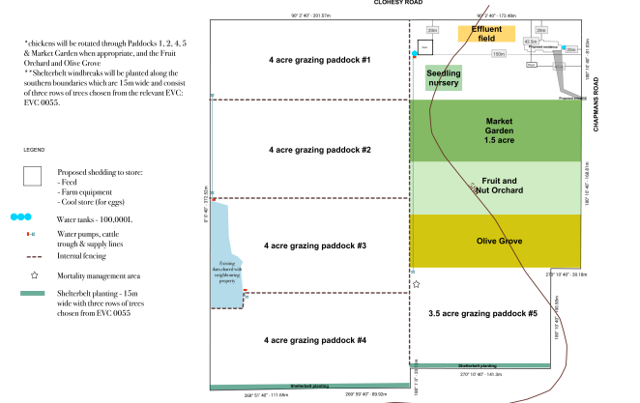
Figure 2: Site Plan/ Farm Management Plan

Public Notice
The application was notified to adjoining and surrounding landowners and four objections were received which are summarised below.

Summary of Objections
The objections received are detailed below with officer’s comments accompanying them:
Objection | Any Relevant Requirement
The objector has concerns relating to the gentlemen’s agreement in regard to irrigating the dam and the level of water available from the dam on an ongoing basis to cater for the proposed farming activities.
Officer’s Response: The application provided evidence stating that rainwater tanks (two 100,000 litre), growing in swales and the shared dam will be used for water supply. If water supply were to be inadequate, water cartages and the construction of a bore can be used.
Objection | Any Relevant Requirement
The objector has concerns on the water quality due to the location of the shed, house and market garden, and the disposal of dead animals. | Farm Management Plan  Environmental Significance Overlay Schedule 1
Officer’s Response: The proposal accompanied a Land Capability Assessment (LCA) addressing septic system proposed to cater for the dwelling on the property. This was referred to Environmental Health, Corangamite CMA and Central Highlands Water who had no objections subject to permit conditions.
Objection | Any Relevant Requirement
Farming Zone requirements:  • Change to the rural nature of the area. Farm Zones must be protected, the land is not in a Rural Living Zone.  • Site is less than 40ha and dwellings on small lots will lead to proliferation of new dwellings in the immediate area. Impacts of the dwelling in the Farm Zone will result in a loss or fragmentation of productive agricultural land by adversely affecting the expansion of adjoining properties. A dwelling permanently alters the use of the land. | Clause 35.07
Officer’s Response: The planning scheme makes provision for a permit application to be made for a dwelling in the Farming Zone for a lot less than 40ha together with the decision guidelines set out in the zone to allow for the assessment of the application. It is considered the proposal allows for productive use of agricultural land.

Locality Map
The map below indicates the location of the subject site and the zoning of the surrounding area.
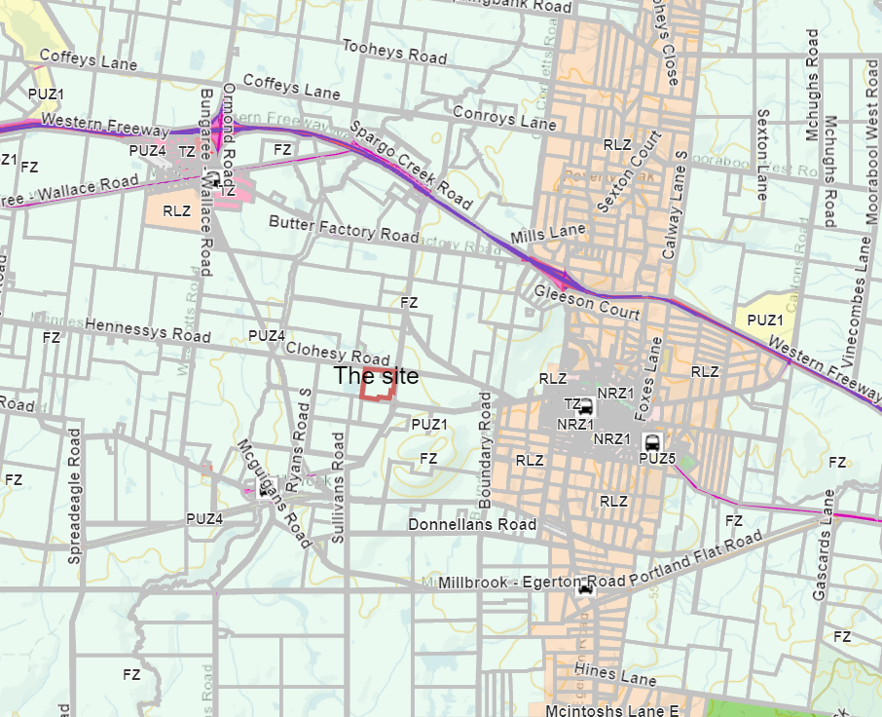
Figure 3: Zone and Locality Map
Gordon Township

Planning Scheme Provisions
Council is required to consider the Victoria Planning Provisions and give particular attention to the Planning Policy Framework (PPF), the Local Planning Policy Framework (LPPF) and the Municipal Strategic Statement (MSS).
The relevant clauses are:
• Clause 14.01-1S - Protection of agricultural land
• Clause 14.02-1S - Catchment planning and management
• Clause 14.02-2S - Water quality
• Clause 15.01-6S - Design for rural areas
• Clause 16.01-5S - Rural residential development
• Clause 17.01-1S – Diversified Economy
• Clause 21.02-1 - Objective - Water and catchment management
• Clause 21.03-4 - Objective - Landscape and neighbourhood character
• Clause 21.03-6 - Objective - Rural lifestyle opportunities
• Clause 21.04-1 - Key issues and influences Agriculture and horticulture
• Clause 21.04-2 Objectives - Agriculture

Zone
Farming Zone
The purposes of the Zone are to:
• Implement the MSS and the PPF.
• Provide for the use of land for agriculture.
• Encourage the retention of productive agricultural land.
• Ensure that non-agricultural uses, including dwellings, do not adversely affect the use of land for agriculture.
• Encourage the retention of employment and population to support rural communities.
• Encourage use and development of land based on comprehensive and sustainable land management practices and infrastructure provision.
• Provide for the use and development of land for the specific purposes identified in a schedule to this zone.
In accordance with Clause 35.07-1, a permit is required to use land for a dwelling where the land is less than 40ha.
In accordance with Clause 35.07-4 a permit is required for a building or works associated with a use in Section 2 of Clause 35.07-1.

Overlays
Environmental Significance Overlay, Schedule 1
In accordance with Clause 42.01-2 a permit is required for buildings and works.
Design and Development Overlay, Schedule 2
In accordance with Clause 43.02 Schedule 2 of the this overlay a permit is not required where all external cladding of buildings is non-reflective. In this application, there is no reflective materials proposed and therefore a permit is not required under this overlay.

Relevant Policies
Council’s Rural Growth Policy Statement
Council’s Rural Growth Policy Statement was adopted by Council on 19 September 2012. The document applies to all land in Farming Zone. This Council policy is not incorporated into the Moorabool Planning Scheme.
The policy states:
• Encourage dwellings in areas nominated in Map 1 of Council Rural Growth Policy Statement (Map 1 is highlighted in Figure 3 in the discussion section of this report).
• Ensure the siting of any dwellings is designed to have a minimal impact on any existing or future agricultural activities on the site and on surrounding land.
• Ensure it is clear whether the dwelling is required for agricultural operation, use or to maintain rural communities.
• Ensure sufficient infrastructure is available or that alternative methods are available which do not require normal infrastructure.
• Encourage development of dwellings, to support communities, on land which is unlikely to support agricultural (use) while still considering any other overlays which may impact the land. This is land which is constrained for use as agriculture by other environmental factors such as vegetation, slope, soil quality, etc.

The proposal is located in close proximity to freeway which can support dwelling in the Farming Zone.

Particular Provisions
Clause 53.09 – Poultry Farm - To facilitate the establishment and expansion of poultry farms, including broiler farms, in a manner that is consistent with orderly and proper planning and the protection of the environment.
The application accompanied an assessment against the Victorian Low Density Mobile Outdoor Poultry Farm Planning Permit Guidelines (June 2018) which is considered satisfactory for the proposed 100 egg laying chickens.

DiscussioN
A proposal is made for the use and development of the land for a dwelling and ancillary shed on two lots, namely Lot 1 on TP124327M and Lot 3 on Plan of Subdivision PS330386H which are proposed for a consolidation. Both lots total to a 13ha site.
The land is covered by the Farming Zone. When reviewing state provision, Clause 14.01-1S seeks the protection of agricultural land, which allows planners to assess the proposal to avoid permanent removal of productive agricultural land for the state’s agricultural base without considering the economic viability, to direct housing growth into existing settlements, discourage development of isolated small lots in rural zones and protect agricultural land from unplanned loss due to permanent changes in land use.
As stated above, most of the built form is clustered in a corner of the property leaving available land to manage agricultural practices. The property is 13ha and has the potential to be sustainably farmed by the use of the land for a dwelling to assist in the agricultural practices on the land. The proposal is accompanied by a Farm Management Plan and Land Capability Assessment which states that the land is capable to sustain an agricultural livelihood by improving pastures and soil quality with supplements during the coming months.
The proposal provides information to show that the rural activities proposed are innovative and managed to maintain the long-term sustainable use and management of existing natural resources. This provision assists to facilitate ongoing productivity and investment in high value agriculture including the establishment of animal farms whilst protecting the environment meeting the objectives of Clause 14.01-2 S to sustain agricultural land use.

In this instance, the proposal must encourage diversification and value-adding agriculture through effective agricultural production and processing, rural industry and farm-related retailing. It should assist genuine farming enterprises to embrace opportunities and adjust flexibility to market changes and climate change. The applicant stated that the market garden will be grown from seed in an on-farm nursery and planted out. The growth rate depends on the weather, nutrients in the soil, pesticides and largely trial and error. Permaculture principles are proposed for the orchard and paddocks to ensure that water needs are easily met, water is further sourced from the proposed rainwater tanks or the existing shared dam. Biodynamic mulching and spraying including keyline ploughing is proposed to enhance the quality of the soil and its long-term viability. It is also proposed to re-vegetate the farm with a windbreak of Grey Box, Buloke and Golden wattle which include approximately 300 shelterbelt trees.
A Land Capability Assessment was submitted and considered satisfactory to both the Environmental Health Department and Central Highlands Water. Authorities had no objections subject to conditions recommended in this report. The septic system is located away from the farming practices and between the shed and dwelling.
To ensure that water quality is addressed, the application was referred to the Corangamite CMA who had no objections but required as part of a condition to ensure that silt control measures must be installed to prevent sediment laden runoff from entering the wetland and waterway. This will need to be maintained through the construction period.
Rural Housing Policy
The site is in close to the Ballarat-Melbourne corridor. The policy being similar to the provisions in the scheme, sets out assessment principles related to site size, slope of land, access, environmental assets/liabilities, area of agricultural activities, adjoining or strategic context.
When assessing the application for a dwelling in the farming zone, one of the main considerations is how a dwelling supports and enhances the agricultural production on the land as considered in Another main consideration is determinising whether the productive agricultural land is viable or not. In response to sustaining the agricultural practices proposed, the proposal has consideration for the site context in terms of slope, location, vegetation and access and considered climate change which is also shown in the Five-Year Plan for Operation and management of the land.
Overall, the dwelling is not considered to result in the loss or fragmentation of productive agricultural land. The dwelling is setback 20m from the road reserve and a reasonable distance from adjoining agricultural properties. The immediate surrounds are all within the Farming Zone but large-scale farms which need opportunities for expansion are absent, therefore the dwelling will not adversely affect the operation and expansion of adjoining and nearby agricultural uses. The proposal is also made to consolidate Lot 1 with Lot 3 therefore promoting the objectives of the planning scheme provisions to assist in expanding agricultural functionality for the land.
Conditions are also recommended to ensure that the activities shown on the Farm Management Plan are viable such as more evidence required on ongoing water supply, landscaping and revegetation works to ensure that additional measures on agricultural viability is required to allow for sustainable agricultural activities on the land.
Subject to the conditions proposed, the proposal should be supported and will allow for the continued agricultural use of the land while supporting a dwelling.

General Provisions
Clause 65 - Decision Guidelines have been considered by officers in evaluating this application.
Clause 66 - Stipulates all the relevant referral authorities to which the application must be referred.

Referrals
Authority | Response
Central Highlands Water  Corangamite CMA | No objection subject to conditions.  No objection subject to a condition.
Council’s:  Infrastructure  Environmental Health  Strategic Planning | No objections subject to conditions.  No objections subject to conditions.  No objection.

Financial Implications
There are no financial implications associated with this grant to a permit for this application.

Risk & Occupational Health & Safety Issues
The recommendation of approval of this application does not implicate any risk or OH&S issues to Council.

Communications Strategy
Notice was undertaken for the application, in accordance with s.52 of the Planning and Environment Act 1987, and further correspondence is required to all interested parties to the application as a result of a decision in this matter. All submitters and the applicant were invited to attend this meeting and invited to address Council if required.

Options
Council could consider the following options:
• issue a Notice of Decision to grant a permit in accordance with the recommendations of this report; or
• issue a refusal to grant a permit with conditions outside of the recommendations of this report.

Conclusion
The application is for the development and use of the land for a dwelling and ancillary shed. It is accompanied by a Farm Management Plan detailing information of the agricultural activities proposed on the land and the need for a dwelling on the land to sustain the farming practices. The application was assessed against the Planning and Local Policy Framework, particular provisions, general provisions, and decision guidelines of the zone and overlays covering the property. The proposal can provide a sustainable farming practice to achieve a net community benefit and has balanced the objectives of the planning scheme. The applicant has demonstrated they will use the land for productive purpose consistent with the objectives of the Farming Zone. It is recommended the applicant be supported and a Notice of Decision to grant a permit be issued.

Ms Hayley Down addressed the Committee as the representative of the applicant associated with Item 7.3.

7.3 PA2021083 - 29 Lot Subdivision, Multi-Unit Development and Reduction in all Visitor Car Parking at Lot S7 of PS725408Y at Rosehill Drive, Bacchus Marsh
Author: Jyoti Makan, Senior Statutory Planner
Authoriser: Henry Bezuidenhout, Executive Manager Community Planning & Economic Development
Attachments: 1. Plan of Subdivision (under separate cover)
2. Traffic Engineering Assessment (under separate cover)

Application Summary
Permit No: PA2021083
Lodgement Date: 29 March 2021
Planning Officer: Jyoti Makan
Address of the land: Rosehill Drive Bacchus Marsh – Lot S7 of PS725408Y
Proposal: 29 Lot Subdivision, Multi-Unit Development and a Reduction in all Visitor Car Parking
Lot size: 7,738sqm
Why is a permit required? Clause 32.08.3 Subdivision, Clause 32.08-6 Two or more Dwellings on a Lot and Clause 52.06 – Reduction in Car Parking

Committee Resolution
Moved: Cr Rod Ward
Seconded: Cr Tonia Dudzik
That the Development Assessment Committee, having considered all matters as prescribed by the Planning and Environment Act 1987, issues Planning Permit PA2021083 for a 29 Lot Subdivision, Multi-Unit Development and a Reduction in all Visitor Car Parking at Rosehill Drive, Bacchus Marsh subject to the following conditions:
1. Prior to the certification of the plan of subdivision and before the commencement of any works, amended plans to the satisfaction of Responsible Authority must be submitted to and approved by the Responsible Authority. When approved, the plans will be endorsed and will then form part of the permit. The plans must be drawn to scale with dimensions and must be generally in accordance with the subdivision and unit development plans submitted and the application but modified to show:
(a) Unit Development Plans:
(i) Relocate the fence of Unit 29 to increase the landscaping interface towards Adelong Way to the satisfaction of the Responsible Authority.
(ii) Annotate low scale (no higher than 0.5m) 50% transparent fencing for at least 50% of its length which abuts a footpath or landscaped reserve, for the following corner properties: Lots 1, 12, 13, 17, 18, 23, 24 and 29 to the satisfaction of the Responsible Authority.
(iii) Detailed design measures such as façade treatments, front balconies and architectural features are required for the Dwellings in Lots 1, 12, 13, 17, 18, 23, 24 and 29 to address both the main street frontage and the second street frontage or public reserve frontage.
(iv) All waste collection points.
(v) Bin storage areas for recycling, organics and general waste.
(vi) Heights, location and details of retaining walls.
(vii) Cut and fill depths and heights.
(viii) Additional lighting along the footpaths to ensure safety or pedestrians.
(ix) Landscaping along the internal laneway be removed.
(x) Include all garden area with green hatching.
(b) Landscape Plans:
(i) At least one mature canopy tree per lot frontage of each dwelling in accordance with Moorabool Shire Council Landscape Design Manual.
(ii) A detailed plant schedule including all proposed tree, shrub, groundcover and climbing plant species, botanical names, common names, pot sizes, sizes at maturity, plant densities and quantities of each plant with reference to the relevant Australia Standards and NATSPECS.
(iii) Tree protection zones and tree protection fencing.
(iv) Impervious and pervious surfaces.
2. Unless otherwise approved in writing by the Responsible Authority, all buildings and works are to be constructed and or undertaken in accordance with the endorsed plans to the satisfaction of the Responsible Authority prior to the commencement of the use.
Endorsed Plans:
3. The formal plan of subdivision lodged for certification must be generally in accordance with the endorsed plan and must not be modified except to comply with statutory requirements or with the written consent of the Responsible Authority.
Subdivision:
4. The plan of subdivision submitted for certification must include a creation of restriction. The wording of the creation of restriction shall be as follows:
(a) Land to be Burdened: All lots on this Plan.
(b) Land to Benefit: All lots on this Plan.
(c) Creation of restriction: Upon registration of this Plan, the following restriction is created:
Description of Restriction:
(i) No front boundary fencing permitted other than 50% permeable fencing that does not exceed 1.2m in height.

(ii) No buildings, roofed structures, driveways, and car spaces are permitted within the garden area (hatched in green) as shown on the endorsed plans attached to Planning Permit No. PA2021083 issued by Moorabool Shire Council. Variation:
The restriction can only be varied with the written consent of Moorabool Shire Council.
5. The plan of subdivision submitted for certification under the Subdivision Act 1988 must be referred to the relevant authority in accordance with Section 8 of that Act.
Telecommunications:
6. The owner of the land must enter into agreements with:
(a) a telecommunications network or service provider for the provision of telecommunication service to each lot shown on the endorsed plan in accordance with the provider’s requirement and relevant legislation at the time; and
(b) a suitably qualified person for the provision of fibre ready telecommunication facilities to each lot shown on the endorsed plan in accordance with any industry specifications or any standards set by the Australian Communications and Media Authority, unless the applicant can demonstrate that the land is in an area where the National Broadband Network will not be provided by optic fibre.
7. Before the issue of Statement of Compliance for any stage of the subdivision under the Subdivision Act 1988, the owner of the land must provide written confirmation from:
(a) a telecommunications network or service provider that all lots are connected to or are ready for connection to telecommunication services in accordance with the provider’s requirements and relevant legislation at the time; and
(b) a suitably qualified person that fibre ready telecommunication facilities have been provided in accordance with any industry specifications or any standards set by the Australian Communications and Media Authority, unless the applicant can demonstrate that the land is in an area where the National Broadband Network will not be provided by optical fibre.
Landscape Plans:
8. Landscaping within the development must be provided in accordance with an approved landscape plan and Moorabool’s Landscape Design Manual, to the satisfaction of the Responsible Authority.
9. Prior to occupation of any dwelling, all the landscape works shown on the endorsed plans must be carried out and completed to the satisfaction of the Responsible Authority.
Car Parking:
10. Car spaces, access lanes and driveways shown on the endorsed plan must not be used for any other purpose other than the parking of vehicles, to the satisfaction of the Responsible Authority.
Amenity:
11. All pipes, fixtures, fittings and vents servicing any building on the site, other than stormwater down pipes, must be concealed in service ducts or otherwise hidden from view to the satisfaction of the Responsible Authority.
Waste Management:
12. Prior to the commencement of the development, a Waste Management Plan must be submitted and approved to the satisfaction of the Responsible Authority. The Plan must include, but not limited to the following:
(a) Calculations showing that all occupiers will be sufficiently catered for with the proposed number of garbage and recycling bins.
(b) The size and location for the storage of general waste and recyclables on the ground/basement floor and details of screening from view.
(c) Design details of the built-in waste/recycling system for the building indicating the provision made for the separate disposal of garbage and recycling streams.
(d) The consideration of the ease of taking the fully laden bins to the collection point(s).
13. When submitted and approved to the satisfaction of the Responsible Authority, the Waste Management Plan and associated notated plans will form part of this Permit.
14. The Waste Management Plan approved under this permit must be implemented and complied with at all times to the satisfaction of the Responsible Authority unless with the further written approval of the Responsible Authority.
Infrastructure:
15. Prior to the issue of a Statement of Compliance for the subdivision, each lot must be provided with urban residential standard vehicle crossing to the satisfaction of the Responsible Authority.
16. The subdivision must be provided with drainage system to a design approved by the Responsible Authority and must ensure that:
(a) The subdivision as a whole must be self-draining.
(b) All drainage courses within the subdivision must pass through easements or reserves shown on the plan of subdivision.
(c) All outfall drainage passing through other land must be provided at the cost of the developer and be constructed within easements shown on the plan of subdivision.
(d) Volume of water discharging from the subdivision in a 10% AEP storm shall not exceed the 20% AEP storm prior to development. Peak flow must be controlled by the use of retardation basin(s) located and constructed to the satisfaction of the Responsible Authority.
(e) Flow paths of the 1% AEP storm must be determined, and the subdivision designed so that no property is inundated by such a storm. The flow paths must be indicated on the engineering plans.
(f) The drainage system must be designed to include provision to intercept litter.
(g) All lots must be provided with a stormwater legal point of discharge at the low point of the lot, to the satisfaction of the Responsible Authority.
(h) The drainage design must take into account any applicable drainage or flood management strategy.
If required, the layout of the subdivision must be modified based on the approved stormwater design.
17. Design computations for drainage of the whole site must be prepared and submitted to the Responsible Authority for approval, and must include analysis of the existing stormwater drainage system in the area to determine:
(a) The requirements for drainage of the whole site.
(b) If the existing drainage network has sufficient capacity to cater for the additional runoff from the ultimate development.
(c) If additional outfall drainage or upgrading of the existing drainage network is required.
18. The internal road network layout must be designed and constructed to the standards detailed in the Infrastructure Design manual, to the satisfaction of the Responsible Authority.
19. Design computations for all road pavement construction, based on a geotechnical investigation of the site, must be prepared and submitted to the Responsible Authority for approval.
20. Plans and specifications of all road, traffic, drainage and any other external works required by the endorsed plans must be prepared and submitted to the Responsible Authority for approval prior to the commencement of such woks and all such works must be carried out in accordance with the approved plans to the satisfaction of the Responsible Authority.
21. Unless otherwise approved by the Responsible Authority there must be no buildings, structures or improvements located over proposed drainage pipes and easements on the property.
22. An Environmental Management Plan (EMP) for the road construction works must be submitted to the Responsible Authority for approval prior to the commencement of construction. All works must be performed in accordance with the approved EMP. The EMP must also include but not limited to the protection and management conditions of the Cultural Heritage Management Plan (CHMP) 15254 approved by the Wurundjeri Tribe Land and Compensation Cultural Heritage Council.
23. Sediment discharges must be restricted from any construction activities within the property in accordance with the relevant Guidelines including “Construction Techniques for Sediment Control” (EPA 1991) and Environmental Guidelines for Major Construction Site” (EPA 1995).
24. Prior to the issue of Statement of Compliance for the subdivision, street lighting must be provided in accordance with the requirements of AS1158 – Lighting for Roads and Public Places, to the satisfaction of the Responsible Authority. All lighting fittings must be “Standard” fittings maintained by the electricity network provider at no additional cost to Council. All lights must utilise LED type luminaires where available.
25. Landscaping within the development must be provided in accordance with an approved landscape plan, to the satisfaction of the Responsible Authority.
26. Landscaping must be maintained for a minimum period of 18 months including watering, mulching, weeding and formative pruning, to the satisfaction of the Responsible Authority.
27. A security deposit equal to 150% of the cost of the landscaping must be lodged with the Council. The deposit will be returned after the final inspection of landscaping, 18 months after the completion of the landscaping, only if Council requires no further maintenance of the landscaping to be undertaken.
28. Prior to the issue of a Statement of Compliance for the subdivision, after all engineering works pertaining to the subdivision have been completed, the following “as constructed” details must be submitted in the specified format to the Responsible Authority:
(a) Drainage construction details in “D-Spec” format.
(b) Roadworks construction details in “R-Spec” format.
29. All road and drainage works must be maintained in good condition and repair for a minimum of three months after completion of the works, to the satisfaction of the Responsible Authority.
30. Prior to the issue of a Statement of Compliance for the subdivision, a security deposit of 5% of the total value of engineering works for the subdivision as approved by the Responsible Authority must be lodged with the Responsible Authority, to cover the maintenance of all works. The deposit will be returned after the final inspection of works, three months after the completion of works, subject to the satisfactory completion of all required maintenance and rectification works.
31. Prior to the commencement of the development and post completion, notification including photographic evidence must be sent to Council’s Asset Services identifying any existing damage to Council assets. Any existing works affected by the development must be fully reinstated at no cost to and to the Moorabool Shire Council Engineering Services satisfaction of the Responsible Authority.
Greater Western Water:
32. The operator under this permit shall be obliged to enter into an Agreement with Greater Western Water relating to the design and construction of any sewerage or water works required. The form of such Agreement shall be to the satisfaction of Greater Western Water. The owner/applicant shall make a written request to Greater Western Water for the terms and conditions of the Agreement.
Melbourne Water:
33. Prior to the commencement of works, the owner shall enter into and comply with an agreement with Melbourne Water Corporation for the acceptance of surface and storm water from the subject land directly or indirectly into Melbourne Water’s drainage systems and waterways, the provision of drainage works and other matters in accordance with the statutory powers of Melbourne Water Corporation.
34. Prior to the commencement of works a separate application direct to Melbourne Water must be made and approved of any new or modified storm water connection to Melbourne Water’s drains or watercourses.
Country Fire Authority (CFA):
35. Hydrants prior to the issue of a Statement of Compliance under the Subdivision Act 1988 the following requirements must be met to the satisfaction of the CFA:
36. Roads must be constructed to a standard so that they are accessible in all weather conditions and capable of accommodating a vehicle of 15 tonnes for the trafficable road width:
(a) Have a minimum trafficable width of 3.45m and be clear of encroachments for at least 0.5m on each side and 4m above the access way.
PowerCor:
37. The plan of subdivision submitted for certification under the Subdivision Act 1988 shall be referred to the Distributor in accordance with Section 8 of that Act.
38. The applicant shall provide an electricity supply to all lots in the subdivision in accordance with the Distributor’s requirements and standards.
39. The applicant shall ensure that existing and proposed buildings and electrical installations on the subject land are compliant with the Victorian Service and Installation Rules (VSIR).
40. The applicant shall, when required by the Distributor, set aside areas with the subdivision for the purposes of establishing a substation or substations.
Permit Expiry:
41. The permit will expire if one of the following circumstances applies:
(a) The development is not started within two years of the date of this permit;
(b) the development is not completed within four years of the date of this permit; and
(c) the subdivision is not certified within two years of the date of issue of the permit.
Statement of compliance must be achieved, and certified plan registered at the Titles Office within five years from the date of certification.
Permit Notes:
CFA’s requirements for identification of hydrants are specified in ‘Identification of Street Hydrants for Firefighting Purposes’ available under publications of the CFA web site (www.cfa.vic.gov.au).
Carried

Public Consultation
Was the application advertised? | Not required as the development is generally in accordance with the approved Underbank Development Plan.
Notices on site: | No.
Notice in Moorabool Newspaper: | No.
Number of objections: | No objections.
Consultation meeting: | Nil.

Policy Implications
The Council Plan 2021-2025 provides as follows:
Strategic Objective 1: Healthy, inclusive and connected neighbourhoods
Priority 2.1: Develop planning mechanisms to enhance liveability in the Shire

Victorian Charter of Human Rights & Responsibilities Act 2006
In developing this report to Council, the officer considered whether the subject matter raised any human rights issues. In particular, whether the scope of any human right established by the Victorian Charter of Human Rights and Responsibilities is in any way limited, restricted or interfered with by the recommendations contained in the report. It is considered that the subject matter does not raise any human rights issues.

Officer’s Declaration of Conflict of Interests
Under section 130 of the Local Government Act 2020, officers providing advice to Council must disclose any interests, including the type of interest.
Executive Manager – Henry Bezuidenhout
In providing this advice to Council as the Executive Manager, I have no interests to disclose in this report.
Author – Jyoti Makan
In providing this advice to Council as the Author, I have no interests to disclose in this report.

Executive Summary
Application referred? | The application was referred to Melbourne Water, PowerCor, Downer, the CFA, Greater Western Water, Council’s Infrastructure, Strategic Planning, Environmental Management and Connected Communities.
Any issues raised in referral responses? | Mid-lane internal access, reduction in visitor car parking, traffic impacts, housing typologies to meet demographic demands.
Preliminary concerns? | Dwelling typologies, shadowing of secluded private open space, interface towards Adelong Way and the reserve. Dominance of garages in the internal laneway. Limited room for landscaping internally. Fencing treatments at corner properties and along all interfaces.
Any discussions with applicant regarding concerns? | A number of consultation meetings took place with the applicant about the abovementioned concerns.
Any changes made to the application since being lodged? | No changes have been made to the application, however, upon discussions with the applicant, agreed outcomes for dwellings to front Adelong Way in the form of a pedestrian path, low lying fencing including more landscaping treatments fronting Adelong Way rather than 1.8m high fencing fronting the road.
Brief history. | The site is located in the Underbank Development Plan and was identified as a Superlot in the approved Planning Permit PA2018137 (Riverview Precinct). This site was allocated towards residential development and is close to the future Town Centre and sports field and is alongside the Korkuperrimul Creek.
Previous applications for the site? | A Planning Permit was issued under PA2018137 for a Multi-Lot staged Subdivision and removal of vegetation in Underbank Estate also known as the Riverview Precinct. This included the subject site as a Superlot which was subject to a future planning permit.
General summary | The proposed 29 lot subdivision and multi-unit development is generally in accordance with the Underbank Development Plan. It is located along Adelong Way and has access to transport and within a walkable catchment towards the future town centre, creek and future sports field.  The development activates the creek as pedestrian paths and habitable room windows overlook the creek and the future oval. Adelong Way will be fully streetscaped with mature vegetation. No access is proposed along Fulham Circuit which avoids congestion and improves on safety of road users and residents.  All onsite visitor car parking is reduced to ensure that sufficient areas are set aside for landscaping and pedestrian footpaths to allow ease walkability towards Fulham Circuit, Adelong Way and nearby recreation activities and shopping facilities.  The units are present of secluded private open spaces between each of the garages and dwellings. Garages will be accessed via the internal 9m laneway.  The proposal meets the relevant planning scheme provisions and policy framework in the planning scheme and is recommended for approval subject to conditions.
Summary of Officer’s Recommendation
That, having considered all relevant matters as required by the Planning and Environment Act 1987, Council issue a Planning Permit PA2020023 for a 29 lot subdivision, multi lot development and reduction in all visitor car parking at Rosehill Drive, Bacchus Marsh subject to the conditions contained within the report.

Site Description
The subject site is a vacant superlot within Underbank Estate. The site has an area of 7,738sqm, with a frontage of approximately 133m to Fulham Circuit, and a secondary frontage of 54.58m to Adelong Way. The site is located immediately east of the developing residential land associated with the Riverview Precinct of the Underbank Estate.

This site is part of the approved multi-lot subdivision PA2018137 which created this lot as part of Stage 9 in the Riverview Precinct. The land will form its own parcel once registered and show no easements or restrictions other than the current requirements under the Section 173 Agreement related to Development Contributions. The future of this site will have a prominent interface towards the future Town Centre to the immediate north-east, Korkuperrimul Creek to its immediate east and further east and the future sports field. Adelong Way is identified as a future bus route and links towards Halletts Way further east of the site.
Underbank estate is located approximately 2km west of the Bacchus Marsh town centre. As shown in Figure 2, a number of bus stops are evident along Underbank Boulevard and clear movement networks identify ease of access towards the Western Freeway and Main Street. The surrounding area is an establishing greenfield residential precinct evolving from the approved Underbank Development Plan.
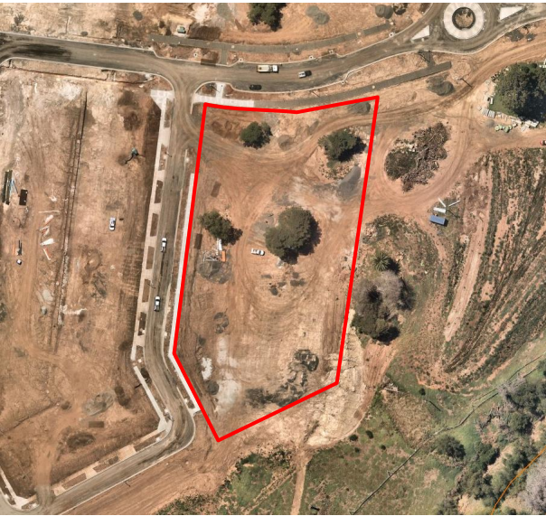
Figure 1: Aerial image of the subject site

Proposal
It is proposed to subdivide and develop the land into 29 lots with each lot containing a dwelling, double garage and no provision for visitor car parking on site.
Proposed lot frontages range from 6m to 17.2m in width and have an average size of 203sqm with lots ranging from 168sqm to 348sqm.
The proposal includes all rear-loaded housing typologies which are designed mainly to avoid crossovers towards Fulham Circuit and towards the Korkuperrimul Creek reserve. All dwellings will be accessed via the internal 9m laneway which consists of a 6m carriageway.
Each lot is proposed to have their pedestrian access and dwelling frontage towards the public realm. The laneway serves as a two-way vehicle access which is also proposed to cater for waste collection.
All dwellings are double storey and consist of three and four-bedroom dwellings. Each dwelling has:
• kitchen facilities;
• living/dining areas;
• ensuite and regular bathrooms; and
• a laundry room.
Each dwelling is provided with a double car garage, which is accessible via the laneway. A footpath is provided around the development, which will provide pedestrian access to each dwelling.

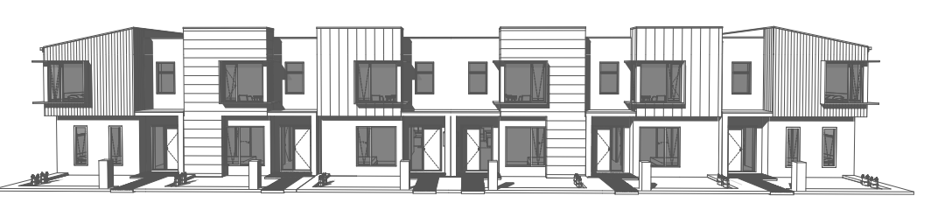
Streetscape elevation of Dwellings 7-12
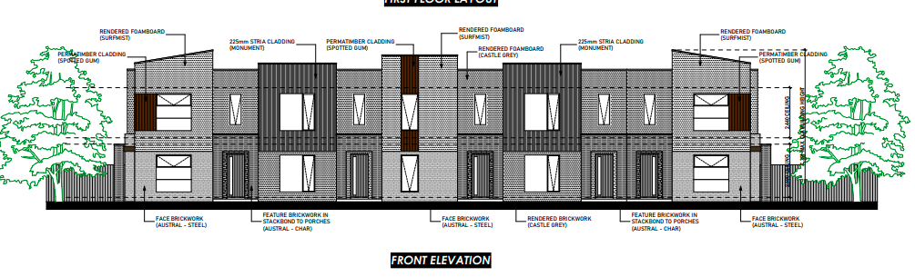
Streetscape elevation of Dwelling 13-17
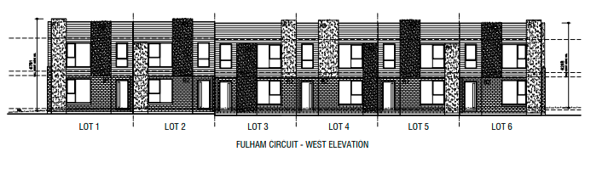
Typical streetscape plan of 1-7 and 18-29
Figure 2: Elevation Plans

Background/HISTORY
The subject site was created as part of the subdivision associated with the Riverview Precinct of the Underbank Estate. Planning permit PA2018137 for the Riverview Precinct, which included the creation of the subject superlot and was issued on 9 October 2019. The subsequently endorsed subdivision layout plans provided for the creation of the subject site, referred to as Lot S901. Additionally, the Underbank Design Guidelines apply to the site as referenced in Restriction G on PS725408Y/S9.

Public Notice
The application was not advertised as it is in accordance with the previous permit identifying the land as Medium Density Housing. The proposed development is generally in accordance with the approved Development Plan for Underbank Estate.

LOCALITY MAP

The map below indicates the location of the subject site and the zoning of the surrounding area.
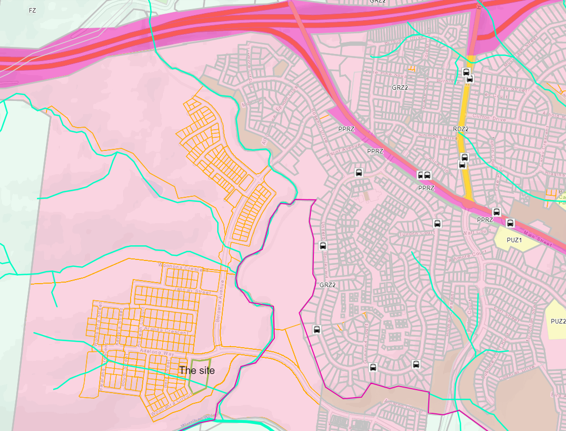

Figure 3: Locality Map

Planning Scheme Provisions
Council is required to consider the Victoria Planning Provisions and give particular attention to the Planning Policy Framework (PPF), the Local Planning Policy Framework (LPPF) and the Municipal Strategic Statement (MSS).
The relevant clauses are:
• Clause 11.01-1R Settlement – Central Highlands
• Clause 11.02-1S – Supply of urban land
• Clause 11.02-3S – Sequencing of development
• Clause 11.03-2S – Growth Areas
• Clause 15.01-1S – Urban Design
• Clause 15.01-2S – Building Design
• Clause 15.01-3S – Subdivision Design
• Clause 15.01-5S – Neighbourhood Character
• Clause 15.02-1S – Energy and resource efficiency
• Clause 16.01-1S – Housing Supply
• Clause 18.02-4S – Car parking
• Clause 19.02-5S – Emergency services
• Clause 19.02-6S – Open Space
• Clause 21.03 – Settlement and Housing
• Clause 21.07 – Bacchus Marsh

zone
The site is zoned as General Residential Zone Schedule 2 (GRZ2).
The purpose of the Zone is:
• To implement the Municipal Planning Strategy and the Planning Policy Framework.
• To encourage development that respects the neighbourhood character of the area.
• To encourage a diversity of housing types and housing growth particularly in locations offering good access to services and transport.
• To allow educational, recreational, religious, community and a limited range of other non-residential uses to serve local community needs in appropriate locations.
Part 1 of Schedule 2 has the following neighbourhood character objectives:
• Innovative and unique development that enhances and responds positively to the existing neighbourhood character.
• Increase in landscaping within the public and private realm.
• Respect existing setbacks within the streetscape.
• Minimal or low scale front fencing.
• Garages, carports and second storey development do not visually dominate dwellings or streetscapes.
A planning permit is required for two or more dwelling units under Clause 32.08-6. Under Clause 32.08-3, a permit is required to subdivide land. An application to subdivide land must meet the relevant requirements of Clause 56 for a residential subdivision.
Decision guidelines are listed under Clause 32.08-12. Under the subdivision section has the following decision guidelines:
- The pattern of subdivision and its effect on the spacing of buildings.
- For subdivision of land for residential development, the objectives and standards of Clause 56.
Under the dwellings and residential buildings section, the following decision guidelines apply:
- For the construction and extension of two or more dwellings on a lot, dwellings on common property and residential buildings, the objectives, standards and decision guidelines of Clause 55.

Overlays
Environmental Significance Overlay Schedule 2
The site is partially located within Environmental Significance Overlay Schedule 2.
The environmental objectives under Part 2 of Schedule 2:
- To protect the habitat significance of vegetation.
- To provide for appropriate development of land within 100m of either side of a waterway.
- To prevent pollution and increased turbidity of water in natural waterways.
- To prevent increased surface runoff or concentration of surface water runoff leading to erosion or siltation of waterways.
- To conserve existing flora and fauna habitats close to waterways and to encourage generation and regeneration of habitats.
Clause 42.01-2 states a permit is required for buildings and works and subdivision. Decision guidelines are listed Schedule 2 Part 4.0.
Development Plan Overlay Schedule 6
The site is also located within the Development Plan Overlay Schedule 6.
Pursuant to Clause 43.04-1 of the Moorabool Planning Scheme a permit must not be granted to use or subdivide land, construct a building or construct or carry out works until a development plan has been prepared to the satisfaction of the Responsible Authority. This does not apply if a schedule to this overlay specifically states that a permit may be granted before a development plan has been prepared to the satisfaction of the Responsible Authority.
A permit granted must:
• Be generally in accordance with the development plan.
• Include any conditions or requirements specified in a schedule to this overlay in accordance with the Development Plan.
The objectives of Schedule 6 of the Development Plan Overlay are:
• Planning for residential and associated development in a logical, cost effective and sequential manner.
• Efficient use of infrastructure, and land, and management of any impacts on the environment and amenity.
• Identification and effective management of sites of environmental, heritage and landscape significance.
• Co-ordinated provision of utility services and drainage.
• Co-ordinated provision of physical and community infrastructure and public open space that enhances the amenity, safety and liveability of the precinct and surrounds.
• Preparation of an integrated development plan generally in accordance with the Underbank Farm Concept Plan shown in Clause 5.0 of this Schedule.

Relevant Policies
Housing Bacchus Marsh to 2041

One of the objectives of the Strategy is to provide a clear direction and policy guidance to enable orderly growth, manage change and retention of key elements of character including neighbourhood character mapping and character precinct brochures. This policy addresses the management of growth, housing and guides neighbourhood character in Bacchus Marsh and surrounds. Maddingley is one of the three suburbs within close proximity to Bacchus Marsh in terms of both physical proximity as well as significant natural features and distance with the Western Freeway warranting the adoption of planning and housing strategies to support sustainable neighbourhoods. This policy guides development towards sustainable principles such as:
• Environmentally Sustainable Design
• Compact Neighbourhoods
• Walkable and Pedestrian Scale
• Mixed Land Uses
• Diverse Housing, Streets and Public Spaces
• Interconnected Streets
• Variety of Transport Options
• Range of green spaces as features

The site is contained within Precinct 26 of the Bacchus Marsh Housing Strategy. The preferred character statement contains the following relevant guidance this precinct will generally maintain to be generally in accordance with the Underbank Development Plan and in accordance with Schedule 6 of the Development Plan Overlay. However apart from this, this precinct should also allow for the following:
• A diverse range of housing choice, whilst ensuring a sense of place and character.
• Multi-dwelling developments should be encouraged in locations that provide high levels of amenity.
• Future development is encouraged to be sympathetic to the landscape and should avoid excessive site disturbance.
• Open front gardens should blend into the public realm, with minimal front fencing.
• Strong street tree plantings will be encouraged to ensure the precinct, in time, provides a high level of landscaping, including canopy tree cover.

Open Space Framework to 2041
The Bacchus Marsh and Ballan Open Space Framework 2041 includes the following objectives which have been considered in the design and provision of open space:
• Be designed for maximum community benefit and consider all potential opportunities and activities to facilitate the development of the site (e.g., funding, community involvement and social engagement).
• Provide quality and accessible open space for all residents.
• Be a connected and safe network for all the community to use.
• In existing areas of Bacchus Marsh and Ballan all residences should be within:
  - 400m of an area of open space.
  - New greenfield developments must provide publicly accessible open space within a 400m walkable catchment.
  - Reflect the landscape and Indigenous and European cultural heritage of Moorabool.
• Identify and budget for future maintenance and staff resourcing requirements.

Particular Provisions
Clause 52.06 - Car Parking
The purpose of this particular provision is:
• To ensure that car parking is provided in accordance with the Municipal Planning Strategy and the Planning Policy Framework.
• To ensure the provision of an appropriate number of car parking spaces having regard to the demand likely to be generated, the activities on the land and the nature of the locality.
• To support sustainable transport alternatives to the motor car.
• To promote the efficient use of car parking spaces through the consolidation of car parking facilities.
• To ensure that car parking does not adversely affect the amenity of the locality.
• To ensure that the design and location of car parking is of a high standard, creates a safe environment for users and enables easy and efficient use.
Two car parking spaces are required for every three or more bedroom dwelling. One visitor car parking space is required for every five dwellings. The application is proposed with double garages to each unit and no dedicated visitor car parking. Therefore, a reduction in all visitor car parking is requested. Car parking is further considered in the discussion section of this report.
Clause 56 – Residential Subdivision
Clause 56 has the purpose to create liveable and sustainable neighbourhoods and urban places with character and identify and achieve residential subdivision outcomes that appropriately respond to the site and its context to provide for policy implementation, liveable and sustainable communities, residential lot design, urban landscape, access and mobility management, integrated water management, site management and utilities. An assessment against Clause 56 has been conducted and the development complies with the standards and objectives.
Clause 55 – Multi Unit Residential Development (ResCode)
Clause 55 provides the opportunity to assess the development to meet the following purpose:
• To implement the Municipal Planning Strategy and the Planning Policy Framework.
• To achieve residential development that respects the existing neighbourhood character, or which contributes to a preferred neighbourhood character.
• To encourage residential development that provides reasonable standards of amenity for existing and new residents.
• To encourage residential development that is responsive to the site and the neighbourhood.
Overall, the proposal complies with ResCode but also accepts slight variations which is assessed against the decision guidelines of the standards.
Clause 52.17 Native Vegetation
Under Clause 52.17-2 a permit is required to remove, destroy or lop native vegetation, including dead native vegetation. Decision guidelines are listed under Clause 52.17-5. All vegetation was assessed during the planning permit processing as part of PA2018137 for the Multi-lot Subdivision also known as the Riverview Precinct.
Clause 53.01 Public Open Space Contribution and Subdivision
A person who proposes to subdivide land must contribute to Council for public open space in an amount specified in the schedule to this clause (being a percentage of the land intended to be used for residential, industrial or commercial purposes, or a percentage of the site value of such land, or a combination of both). If no amount is specified, a contribution for public open space will be required under section 18 of the Subdivision Act 1988.

Discussion
Access
Access is received internally via a 9m wide laneway where all double garages will be accessed. Pedestrian access will be formed to each unit from the footpaths which will be located along the creek interface, Fulham Circuit and Adelong Way. The internal vehicle accessed laneway will provide two-way vehicle access to the development. Both footpaths will connect pedestrians to the public realm serving access to the creek on the east and Fulham Circuit to the west. All footpaths and access will be in accordance with the Infrastructure Design Manual making this development compliant with Clause 56.06 (access and mobility management) and Clause 18 (Transport – Planning Policy), where walking, cycling, convenient car parking and vehicle access objectives will be met.
It will achieve integrated mobility objectives that supports compaction of neighbourhoods and encourages walkability which in turn reduces carbon emissions and car dependence. Adelong Way will also serve as a bus route in accordance with the Underbank Development Plan.
Car parking:
Car parking is regulated by Clause 52.06 of the Planning Scheme that seeks two spaces for every three or more bedroom dwellings and one visitor space for every five dwellings.

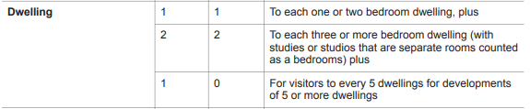

The proposal seeks to develop twenty-nine three to four bed dwellings. For these twenty-nine, townhouses, 58 spaces are required plus five spaces are required for visitors. A reduction in all visitor car parking is sought so that additional landscaping in between the development and better design outcomes were able to be provided to soften the townhouse development with its surrounding urban landscape. Justification for the reduction in car parking is also based on the design having rear loaded garages, which in effect increases car parking on the public realm of Fulham Circuit as crossovers are not required. It has also been taken into consideration that indented car parking is available along Adelong Way. The proposal provides for double garages with two spaces to each dwelling however does not provide dedicated visitor car parking as required by Clause 52.06. The Planning Scheme makes provision for car parking to be reduced and must include a car parking demand assessment. The submitted Traffic Report included a car parking demand assessment which stated that the subject site is located immediately to the west of the standard density residential subdivision associated with the Riverview Precinct of the Underbank Estate. The road network within this subdivision area is capable of accommodating on street parking within close proximity to the medium density site. Immediately adjacent to the site, along Fulham Circuit, Council has recommended that 4hr parking limits be applied. This will reduce reliance on on-street parking for convenience and encourage residents to utilise garages for car parking.
Fulham Circuit is a 16m road reserve which caters for a 7.7m wide carriageway. The road reserve allows for car parking on both sides of the street. The Traffic Impact Assessment states that no crossovers are proposed along Fulham Circuit and the road reserves are wide enough to accommodate on-site car parking without affecting the traffic flows. This was one of the main reasons for the rear loaded design because the dwellings would be able to activate the future reserve and the creek as well as limit any impacts on traffic flows along Fulham Circuit and Adelong Way.
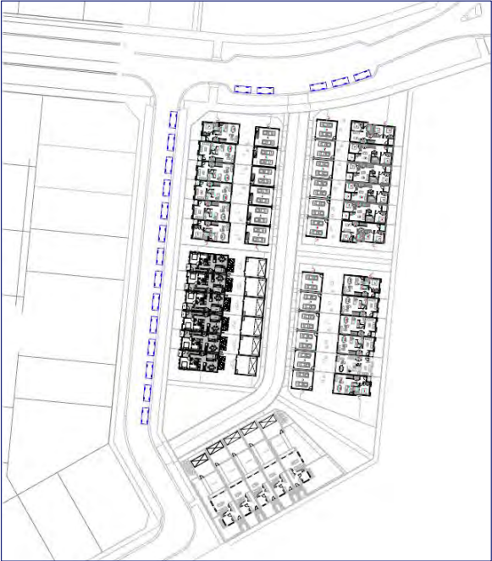
Figure 5 – Indicative On-street car parking (Excerpt from the Traffic Report, Traffix Group, 2021)
The application was reviewed by Council’s Infrastructure who had no objections to the development overall as it met access requirements to the proposed dwellings and the submitted Traffic Report prepared by Traffix Group (July 2021, Ref G30099R-01A) satisfactory demonstrated the appropriate sight distances at the intersections of the laneway with Adelong Way and Fulham Circuit, fire hydrants, car parking and stormwater drainage. It also included turning templates of a 10.2m waste truck entering and existing the site to adequately demonstrate safe waste collection. Council’s Infrastructure ensured that conditions were placed on the permit so that each lot is provided with urban residential vehicle access to the satisfaction of the Responsible Authority, apart from other conditions to ensure that all Council’s standards are met. Council’s Infrastructure noted that due to the nature of the development and the availability of the on street car parking in the immediate vicinity, there are no objections with the way that the development has been designed.
Neighbourhood Character
The proposal meets the objectives of the General Residential Zone 2 which also includes the design statements as part of the Housing Bacchus Marsh to 2041 Strategy-Precinct 26.
The development is respectful to the neighbourhood character of the area considering that the preferred character statements guide multi-dwellings developments in areas where high levels of amenity are abundant. The site is across from the future town centre and also located west of the Korkuperrimul Creek and the future sports field. Planning Permit PA2018137 which approved a multi-lot staged subdivision and removal of vegetation included superlots and the boundaries of the sports oval and town centre as shown in Figure 6 below.

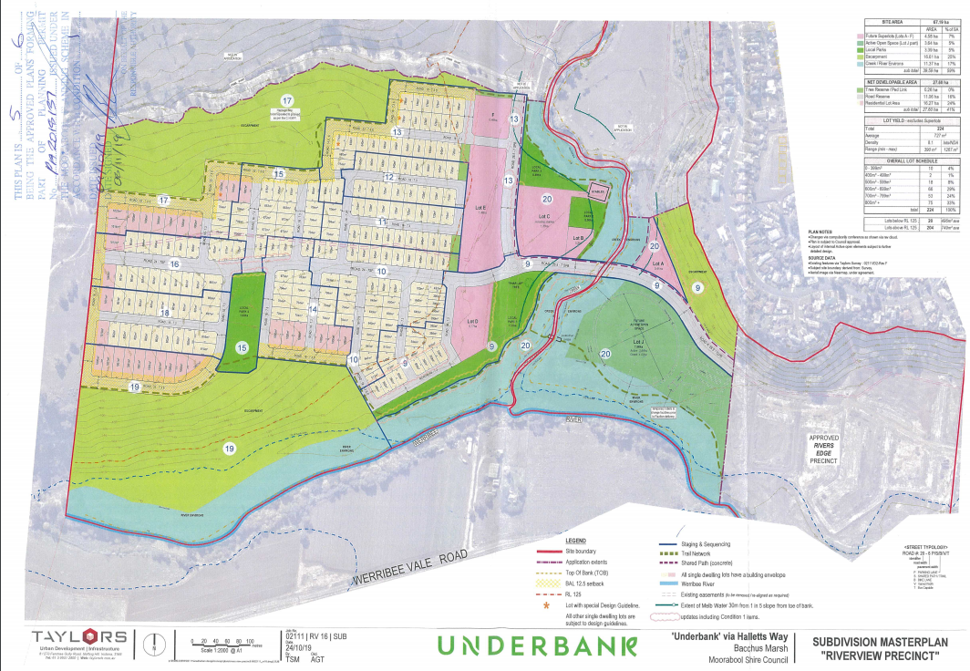

Figure 6: Approved subdivision plan PA218137 (Riverview Precinct)

Underbank Development Plan
The site falls within Neighbourhood A in the Development Plan (DP), which is described as:
“Generally located on flatter land, Neighbourhood A represents areas of higher amenity, with access to community facilities, public transport and open space areas. As such, this area will seek to provide for a higher density, with lot frontages generally ranging between 10m - 12.5m” The DP states that buildings should be sited and designed to:
• Contribute to the streetscape character through addressing road frontages and integrating landscaping within the front yard;
• Maximise opportunities for passive surveillance to streets, escarpments, gullies, waterways and open space corridors;
• Exhibiting a contemporary built form outcome that is responsive to the existing rural setting of Bacchus Marsh;
• Ensure that built form in prominent locations and corners provide a positive address to both street frontages;
• Respond to site levels to avoid excessive amounts of retaining; and
• Define boundaries between public and private spaces and restrict access to private spaces necessary.
The proposed development accords with these objectives.
Clause 55 – Multi-Unit Residential Development (ResCode)
The proposal meets the relevant standards of ResCode as it proposes diverse housing typologies which are designed by three different home builders. Lots 1-6 and 18-29 are designed by Nostra Homes, Lots 7-12 are designed by Creation Homes, Lots 13-17 are designed by Hermitage Homes.
To resolve the integration with the street objectives, discussions took place to ensure that units facing the street are well integrated by means of additional landscaping, corner balconies, low fencing, dwelling entry and pedestrian pathways from the dwellings. Dwellings 13-29 will front the footpath along the Korkuperrimul Creek and the future sports field. Dwellings 1-12 will front Fulham Circuit along the western boundary. Dwellings 12,13, 17, 18, 21, 23, 24 and 29 are corner properties and are recommended to be revised to ensure that low fencing, corner balconies, and additional landscaping be developed. This will be addressed through amended plans.
The street setback from Fulham Circuit is at minimum 3m from the wall to the boundary. Balconies are a minimum of 2.7m from this street. The highest overall building height does not exceed 7.6m, the double storey dwellings improve the surrounding interface and provide surveillance around the development. The overall site coverage does not exceed 60% with Dwellings 1-6 at the highest covered properties in the development at 58.95%. The level of permeability proposed to increase the impact of increased stormwater run-off on the drainage system is more than 30% therefore meeting the 20% requirement.
Due to the orientation of the site, some of the dwellings were unable to incorporate the living areas to the north of each dwelling but corner allotments allow for more energy efficiency towards living rooms. The rest of the proposed dwellings are designed to make most efficient use of the site by providing north facing windows and solar access to the private open spaces.
To ensure ease of access, the swept paths submitted show that a waste collection vehicle can run through the internal laneway. Additional lighting is requested to ensure safety along footpaths and the internal laneway.
The proposed development accords with these objectives.
Clause 55 – Multi-Unit Residential Development (ResCode)
The proposal meets the relevant standards of ResCode as it proposes diverse housing typologies which are designed by three different home builders. Lots 1-6 and 18-29 are designed by Nostra Homes, Lots 7-12 are designed by Creation Homes, Lots 13-17 are designed by Hermitage Homes.
To resolve the integration with the street objectives, discussions took place to ensure that units facing the street are well integrated by means of additional landscaping, corner balconies, low fencing, dwelling entry and pedestrian pathways from the dwellings. Dwellings 13-29 will front the footpath along the Korkuperrimul Creek and the future sports field. Dwellings 1-12 will front Fulham Circuit along the western boundary. Dwellings 12,13, 17, 18, 21, 23, 24 and 29 are corner properties and are recommended to be revised to ensure that low fencing, corner balconies, and additional landscaping be developed. This will be addressed through amended plans.
The street setback from Fulham Circuit is at minimum 3m from the wall to the boundary. Balconies are a minimum of 2.7m from this street. The highest overall building height does not exceed 7.6m, the double storey dwellings improve the surrounding interface and provide surveillance around the development. The overall site coverage does not exceed 60% with Dwellings 1-6 at the highest covered properties in the development at 58.95%. The level of permeability proposed to increase the impact of increased stormwater run-off on the drainage system is more than 30% therefore meeting the 20% requirement.
Due to the orientation of the site, some of the dwellings were unable to incorporate the living areas to the north of each dwelling but corner allotments allow for more energy efficiency towards living rooms. The rest of the proposed dwellings are designed to make most efficient use of the site by providing north facing windows and solar access to the private open spaces.
To ensure ease of access, the swept paths submitted show that a waste collection vehicle can run through the internal laneway. Additional lighting is requested to ensure safety along footpaths and the internal laneway.
Overall, the development meets the garden area requirement to provide 35% of the site towards garden area. As additional safety measures the 1.8m fencing along footpaths is requested to be reduced for at least 50% of its length to avoid high fences along footpaths.
The side and rear setbacks are acceptable. The side setback to Lot 13 and 24 propose a minimum of 2.34m and 1.8m respectively and requires 2.9m, however, considering the design of the dwellings and overall wall height, the design is led by functionality.
All windows that impact internal views to neighbouring secluded private open space are glazed or located to limit views to private open spaces. Each dwelling has a kitchen and living areas and a laundry which are accessible on the ground floor with the exception of proposed dwellings on lots 24-29. All dwellings contain 25sqm of secluded private open space with adequate levels of sunlight due to the separation between the dwelling and the garage (5m). Materials and colours proposed are of muted tones and low reflective colours. Mailboxes will be located at the street frontage of each property and waste collection is proposed from the rear laneway.

Clause 56 – Residential Subdivision Provisions
The proposal is generally in accordance with the approved Riverview Precinct and the Underbank Development Plan. The internal roadways proposed meets the minimum requirements of Clause 56.
Public transport is available in the form of a bus route along Adelong Way.
Overall, the proposal will encourage diversity of housing when compared to the residential subdivision proposed in the surrounds. The standard housing typology has been proposed in past subdivisions which are all single dwellings per lot. Row type townhouses create diverse housing choice and also provide urban compaction towards the centres of activity. This area will become a centralised activity node which should encourage medium to higher density living environments.
The proposal meets these character provisions as no front fencing is proposed, the dwelling entries and footpaths lead towards the street scape and the creek interface. The future town centre will be approximately 250m away from the site. All lots face east west however the living and open spaces all receive adequate solar access.
The proposed lot arrangement accords with the intent of the approved Underbank Development Plan.

General Provisions
Clause 65 - Decision Guidelines have been considered by officers in evaluating this application.
Clause 66 - Stipulates all the relevant referral authorities to which the application must be referred.

Referrals
Authority | Response
External:
Greater Western Water | No objection subject to conditions.
Melbourne Water | No objection subject to conditions.
Powercor | No objection subject to conditions.
CFA | No objection subject to conditions.
Downer | No comment.
Transport for Victoria | No response after repeated requests.
Internal:
Infrastructure | No objection subject to conditions.
Strategic Planning | No objection.
Connected Communities | Request for more one and two bedroom housing typologies.
Environmental Management | No objection. No conditions however comments made during consultations to encourage more landscaping.

Financial Implications
There are no financial implications resulting from this proposal.

Risk & Occupational Health & Safety Issues
The recommendation of approval of this application does not implicate any risk or OH&S issues to Council.

Communications Strategy
Notice was undertaken for the application, in accordance with s.52 of the Planning and Environment Act 1987, and further correspondence is required to all interested parties to the application as a result of a decision in this matter. The applicant was invited to attend this meeting and invited to address Council if required.

Options
• Issue a permit in accordance with the conditions recommended in this report; or
• should Council refuse to grant a permit, consideration must be given to how the proposal does not comply with the Moorabool Planning Scheme.

Conclusion
The proposal was assessed against the general and operational provision of the scheme where all matters related to orderly planning, zoning, overlays, planning and local policy frameworks as well as the impacts on the environment, and amenity of the area and is considered to comply.
The location and neighbourhood character objectives of the site allow for increased housing growth to drive the future land uses in the area. The site is located within the part of Underbank which will hold its node of activity with the future town centre and sports field located within its walkable catchment.
Considering the availability of on street parking within close proximity, the reduction in all visitor car parking is considered to be acceptable
The development proposes effective activation of the public realm with the articulation of pedestrian paths and habitable room windows towards the creek and surrounding streets.
Conditions are placed on the permit to ensure that all obligations towards landscaping and architectural design elements are met together with requirements as part of the Infrastructure Design Manual, site services, waste management and contributions.
It is recommended for approval subject to planning permit conditions.

8 Update on Trends, Issues and Other Matters
Nil.

9 Process Forward and Work Program
Nil.

10 Update on VCAT Decisions
Nil.

11 Other Business
Nil.

12 Date of Next Meeting
Wednesday 15 December 2021.

13 Meeting Close
The Meeting closed at 7.00pm.

...................................................
CHAIRPERSON

