MINUTES
Development Assessment Committee Meeting
Wednesday, 15 December 2021
Date: | Wednesday, 15 December 2021
Time: | 6.00pm
Location: | Council Chambers, 15 Stead Street, Ballan & Online

Order Of Business
1 Opening 3
2 Present and Apologies 3
3 Recording of Meeting 3
4 Confirmation of Minutes 3
5 Matters Arising from Previous Minutes 3
6 Disclosure of Conflicts of Interests 4
7 Community Planning Reports 5
7.1 PA2020209 - Three Lot Subdivision and Vegetation Removal at 18 Lyndhurst Street, Gordon 5
7.2 PA2020246 - Use of the Land for Domestic Animal Husbandry (8 Dogs) at 30 Maddisons Lane Greendale 22
7.3 PA2021154 - Development and Use of a Childcare Centre at 101 Gisborne Road Bacchus Marsh 35
8 Update on Trends, Issues and Other Matters 50
9 Process Forward and Work Program 50
10 Update on VCAT Decisions 50
11 Other Business 50
12 Date of Next Meeting 50
13 Meeting Close 50

1 Opening
The Mayor opened the meeting with the Council Prayer at 6.00pm

2 Present and Apologies
Cr Tom Sullivan, Mayor West Moorabool Ward
Cr Tonia Dudzik, Deputy Mayor East Moorabool Ward
Cr Moira Berry East Moorabool Ward
Cr Ally Munari Woodlands Ward
Cr Paul Tatchell Central Moorabool Ward
Cr Rod Ward East Moorabool Ward
IN ATTENDANCE:
Mr Derek Madden Chief Executive Officer
Mr Henry Bezuidenhout Executive Manager Community Planning & Economic Development
Mr Phillip Howard Executive Manager Governance & Corporate Compliance
Mr Rob Fillisch Manager Statutory Planning & Building Services
Mr Mark Lovell Coordinator Statutory Planning
Mr Troy Delia Coordinator Governance & Risk
APOLOGIES:
Cr David Edwards East Moorabool Ward

3 Recording of Meeting
In accordance with Moorabool Shire Council’s Governance Rules, the meeting is livestreamed.

4 Confirmation of Minutes
Committee Resolution
Moved: Cr Moira Berry
Seconded: Cr Paul Tatchell
That the minutes of the Development Assessment Committee Meeting held on Wednesday 17 November 2021 be confirmed.
Carried

5 Matters Arising from Previous Minutes
Nil.

6 Disclosure of Conflicts of Interests
Cr Tom Sullivan declared a Conflict of Interest in Item 7.1 - PA2020209 - Three Lot Subdivision and Vegetation Removal at 18 Lyndhurst Street, Gordon, due to working on the matter in a professional capacity as a surveyor.

Presentation/Deputations
Item | Community Planning & Economic Development | Speaker/s | Position | Attendance
7.2 | PA2020246 - Use of the Land for Domestic Animal Husbandry (8 Dogs) at 30 Maddisons Lane Greendale | Mr Warrick Boyle | Applicant | Online
7.2 | PA2020246 - Use of the Land for Domestic Animal Husbandry (8 Dogs) at 30 Maddisons Lane Greendale | Ms Lori Giles | Representative of the Applicant | Online
7.2 | PA2020246 - Use of the Land for Domestic Animal Husbandry (8 Dogs) at 30 Maddisons Lane Greendale | Mr Steven Norman | Objector | Online
7.2 | PA2020246 - Use of the Land for Domestic Animal Husbandry (8 Dogs) at 30 Maddisons Lane Greendale | Ms Carol Guthrie;  Mr Martyn Blake; and  Mr Gary Matheson. | Objectors | Online
7.3 | PA2021154 - Development and Use of a Childcare Centre at 101 Gisborne Road Bacchus Marsh | Ms Tonia Chatterjee | Representative of the Applicant | Online
7.3 | PA2021154 - Development and Use of a Childcare Centre at 101 Gisborne Road Bacchus Marsh | Mr Andrew Ferguson | Applicant | Online

7 Community Planning Reports
6.01pm Cr Tom Sullivan, having declared a Conflict of Interest in Item 7.1, vacated the Chair and left the meeting. Cr Tonia Dudzik assumed the Chair.

7.1 PA2020209 - Three Lot Subdivision and Vegetation Removal at 18 Lyndhurst Street, Gordon
Author: Thomas Tonkin, Statutory Planner
Authoriser: Henry Bezuidenhout, Executive Manager Community Planning & Economic Development
Attachments: 1. Plan of Proposed Subdivision and Landscape Plan 26 July 2021 (under separate cover)
2. Flood Plan (under separate cover)

Application Summary
Permit No: PA2020209
Lodgement Date: 21 September 2020. Amended application lodged 12 June 2021
Planning Officer: Tom Tonkin
Address of the land: 18 Lyndhurst Street, Gordon
Proposal: Three Lot Subdivision and Vegetation Removal
Lot size: 3,702sqm
Why is a permit required? Clause 32.09 Neighbourhood Residential Zone, Schedule 1 - Subdivision
Clause 42.01 Environmental Significance Overlay, Schedule 1 – Subdivision and vegetation removal
Clause 42.03 Significant Landscape Overlay, Schedule 2 – Vegetation removal
Clause 43.02 Design and Development Overlay, Schedule 5 – Subdivision

Committee Resolution
Moved: Cr Paul Tatchell
Seconded: Cr Ally Munari
That the Development Assessment Committee, having considered all matters as prescribed by the Planning and Environment Act 1987, issues a Notice of Decision to Grant Planning Permit PA2020209 for Three Lot Subdivision and Vegetation Removal at Crown Allotment 1, Section 12, Township of Gordon, Parish of Kerrit Bareet, known as 18 Lyndhurst Street, Gordon, subject to the following conditions:
Endorsed Plans:
1. Before the plan of subdivision is certified, amended plans to the satisfaction of the Responsible Authority must be submitted to and approved by the Responsible Authority. When approved, the plans will be endorsed and will then form part of the permit. The plans must be drawn to scale with dimensions and must be generally in accordance with the plans identified as Plan of Proposed Subdivision and Landscaping Plan, Surveyor’s reference 1524, dated July 2021 and prepared by TG Sullivan & Associates P/L but modified to show:
(a) The proposed drainage easement on Lot 3 amended to a drainage reserve in favour of Moorabool Shire Council.
(b) The requirements of Corangamite Catchment Management Authority as contained herein including the plans must clearly demonstrate that the building envelopes for dwellings are wholly located within the area of ‘H1’ as identified in the Flood Impact Assessment Report submitted as part of the application.
(c) Each building envelope with a minimum street frontage setback of 6m.
(d) The location of proposed tree plantings on Lot 3 to enable vehicle access to the site in accordance with Condition no. 4(c).
2. The formal plan of subdivision lodged for certification, and the plan for vegetation removal, must be generally in accordance with the endorsed plan and must not be modified except to comply with statutory requirements or with the written consent of the Responsible Authority.
Subdivision:
3. Before the Statement of Compliance is issued under the Subdivision Act 1988, the applicant or owner must pay to the Responsible Authority a sum equivalent to 5% of the site value of all the land in the subdivision for public open space purposes. The permit holder/developer must pay the reasonable costs of Council in having the land valued for this purpose.
4. The plan of subdivision submitted for certification must include a creation of restriction. The wording of the creation of restriction shall be as follows:
a) Land to be Burdened: All lots on this plan.
b) Land to Benefit: All lots on this plan.
c) Description of Restriction:
i. No fencing within any lot or along any lot boundary, apart from Lot 3’s eastern title boundary, shall be of any type other than post and wire.
ii. Vehicle access to Lot 3 from Corbetts Road shall not be in any other location than generally parallel to the east title boundary.
iii. No building shall be constructed within 6m of any street frontage.
iv. No tree as shown on the endorsed Landscape Plan shall be removed, destroyed or lopped without separate planning approval.
d) Variation: The restriction can only be varied with the written consent of Moorabool Shire Council.
Telecommunications:
5. The owner of the land must enter into an agreement with:
a) A telecommunications network or service provider for the provision of telecommunication services to each lot shown on the endorsed plan in accordance with the provider’s requirements and relevant legislation at the time; and
b) A suitably qualified person for the provision of fibre ready telecommunication facilities to each lot shown on the endorsed plan in accordance with any industry specifications or any standards set by the Australian Communications and Media Authority, unless the applicant can demonstrate that the land is in an area where the National Broadband Network will not be provided by optical fibre.
6. Before the issue of Statement of Compliance for any stage of the subdivision under the Subdivision Act 1988, the owner of the land must provide written confirmation from:
a) A telecommunications network or service provider that all lots are connected to or are ready for connection to telecommunications services in accordance with the provider’s requirements and relevant legislation at the time; and
b) A suitably qualified person that fibre ready telecommunication facilities have been provided in accordance with any industry specifications or any standards set by the Australian Communications and Media Authority, unless the applicant can demonstrate that the land is an area where the National Broadband Network will not be provided by optical fibre.
Landscape Plans:
7. Prior to the issue of a Statement of Compliance for the subdivision, the trees identified on the endorsed landscape plan must be planted to the satisfaction of the Responsible Authority. All trees must have an existing height of 1.5m upon planting, must be planted to an approved standard incorporating two hardwood stakes, tree ties, Ag pipe, water crystals, 100mm of mulch and initial watering, to the satisfaction of the Responsible Authority.
Vegetation Removal:
8. Except where exempt under the Moorabool Planning Scheme or as allowed for under this planning permit, existing vegetation must not be removed, destroyed or lopped without further planning approval.
Infrastructure:
9. Prior to the issue of a Statement of Compliance for the subdivision, each lot must be provided with a standard rural residential vehicle crossing to the satisfaction of the Responsible Authority. Any redundant vehicle crossings must be removed, and the roadside reinstated to the satisfaction of the Responsible Authority. A vehicle crossing permit must be taken out for the construction of the vehicle crossing.
10. Prior to the issue of a Statement of Compliance for the subdivision, the development must be provided with a drainage system constructed to a design approved by the Responsible Authority, and must ensure that:
a) The development as a whole must be self-draining.
b) All drainage courses within the development must pass through easements or reserves shown on the plan of subdivision.
c) Volume of water discharging from the development in a 10% AEP storm shall not exceed the 20% AEP storm prior to development. Peak flow must be controlled by the use of a detention system located and constructed to the satisfaction of the Responsible Authority.
d) Each lot must be provided with a stormwater legal point of discharge at the low point of the lot, to the satisfaction of the Responsible Authority.
e) Stormwater runoff must meet the “Urban Stormwater Best Practice Environmental Management Guidelines (CSIRO 1999)”.

11. Prior to the commencement of the development design computations for drainage of the whole site must be prepared and submitted to the Responsible Authority for approval.
12. Storm water drainage from the development must be directed to a legal point of discharge to the satisfaction of the Responsible Authority. A legal point of discharge permit must be taken out prior to the construction of the stormwater drainage system.
13. Prior to the issue of a Statement of Compliance for the subdivision, the following works must be undertaken to the satisfaction of the Responsible Authority:
a) The boundaries of the drainage reserve must be provided with post and wire type fences to a standard to be determined by the Responsible Authority.
b) The water course within the drainage reserve and the outfall through the reserve to the south must be shaped to a trapezoidal profile and be satisfactory sized to the satisfaction of the Responsible Authority.
14. Prior to the issue of Statement of Compliance for the subdivision, street lighting must be provided in accordance with the requirements of AS1158 – Lighting for Roads and Public Places, to the satisfaction of the Responsible Authority. All lighting fittings must be “Standard” fittings maintained by the electricity network provider at no additional cost to Council. All lights must utilise LED type luminaires where available.
15. Sediment discharges must be restricted from any construction activities within the property in accordance with relevant Guidelines including Construction Techniques for Sediment Control (EPA 1991).
16. Unless otherwise approved by the Responsible Authority there must be no buildings, structures, or improvements located over proposed drainage pipes and easements on the property.
17. Prior to the commencement of the development and post completion, notification including photographic evidence must be sent to Council’s Asset Services department identifying any existing damage to council assets. Any existing works affected by the development must be fully reinstated at no cost to and to the satisfaction of the Responsible Authority.
18. Prior to the commencement of the development, plans and specifications of all road and drainage works must be prepared and submitted to the responsible authority for approval, detailing but not limited to the following:
a) Location of vehicle crossings.
b) Details of the underground drainage.
c) Location of drainage legal points of discharge.
d) Standard details for vehicle crossings and legal points of discharge.
e) Civil notes as required to ensure the proper construction of the works to Council standard.
Corangamite Catchment Management Authority:
19. Prior to the certification of a plan of subdivision, amended plans must be submitted to and approved by the Responsible Authority. The plans must show a building envelope, outside of which no habitable building can be constructed. The building envelope must be entirely within the area of hazard category “H1” as identified in the Flood Impact Assessment Report submitted with the application.
Barwon Water:
20. Each lot created in the development must be connected to a reticulated sewerage system.
21. No stormwater is to be discharged less than 100 metres from a waterway unless into an approved drainage system.
Central Highlands Water:
22. Any plan lodged for certification will be referred to the Central Highlands Region Water Corporation pursuant to Section 8(1)(a) of the Subdivision Act 1988.
23. Reticulated sewerage facilities must be provided to each lot by the owner of the land (or applicant, in anticipation of becoming the owner) to the satisfaction of the Central Highlands Region Water Corporation. This will include the construction of works and the payment of major works contributions by the applicant.
24. A reticulated water supply must be provided to each lot by the owner of the land (or applicant, in anticipation of becoming the owner) to the satisfaction of the Central Highlands Region Water Corporation. This will include the construction of works and the payment of major works contributions by the applicant.
25. The owner will provide easements to the satisfaction of the Central Highlands Region Water Corporation, which will include easements for pipelines or ancillary purposes in favour of the Central Highlands Region Water Corporation, over all existing and proposed sewerage facilities within the proposal.
26. If the land is developed in stages, the above conditions will apply to any subsequent stage of the subdivision.
Powercor:
27. The plan of subdivision submitted for certification under the Subdivision Act 1988 shall be referred to the Distributor in accordance with Section 8 of that Act.
28. The applicant shall provide an electricity supply to all lots in the subdivision in accordance with the Distributor’s requirements and standards. Notes: Extension, augmentation or rearrangement of the Distributor’s electrical assets may be required to make such supplies available, with the cost of such works generally borne by the applicant.
29. The applicant shall ensure that existing and proposed buildings and electrical installations on the subject land are compliant with the Victorian Service and Installation Rules (VSIR). Notes: Where electrical works are required to achieve VSIR compliance, a registered electrical contractor must be engaged to undertake such works.
30. The applicant shall, when required by the Distributor, set aside areas with the subdivision for the purposes of establishing a substation or substations. Notes: Areas set aside for substations will be formalised to the Distributor’s requirements under one of the following arrangements: • RESERVES established by the applicant in favour of the Distributor. • SUBSTATION LEASE at nominal rental for a period of 30 years with rights to extend the lease for a further 30 years. The Distributor will register such leases on title by way of a caveat prior to the registration of the plan of subdivision.
31. The applicant shall establish easements on the subdivision, for all existing Distributor electric lines where easements have not been otherwise provided on the land and for any new powerlines to service the lots or adjust the positioning existing easements. Notes: • Existing easements may need to be amended to meet the Distributor’s requirements • Easements required by the Distributor shall be specified on the subdivision and show the Purpose, Origin and the In Favour of party as follows: Easement Reference; Purpose – Power Line; Width (Metres); Origin – Section 88 – Electricity Industry Act 2000; Land Benefitted/In Favour Of – Powercor Australia Ltd.
Permit Expiry:
32. This permit will expire if the plan of subdivision is not certified within two (2) years of the date of issue of the permit.
Statement of Compliance must be achieved, and certified plans registered at Titles office within five years from the date of certification.
Carried

Public Consultation
Was the application advertised? | Yes.
Notices on site: | Yes, two signs.
Notice in Moorabool Newspaper: | No.
Number of objections: | Two.
Consultation meeting: | No.

Policy Implications
The Council Plan 2021-2025 provides as follows:
Strategic Objective 1: Healthy, inclusive and connected neighbourhoods
Priority 1.1: Improve the health and wellbeing of our community

Victorian Charter of Human Rights & Responsibilities Act 2006
In developing this report to Council, the officer considered whether the subject matter raised any human rights issues. In particular, whether the scope of any human right established by the Victorian Charter of Human Rights and Responsibilities is in any way limited, restricted or interfered with by the recommendations contained in the report. It is considered that the subject matter does not raise any human rights issues.

Officer’s Declaration of Conflict of Interests
Under section 130 of the Local Government Act 2020, officers providing advice to Council must disclose any interests, including the type of interest.
Executive Manager – Henry Bezuidenhout
In providing this advice to Council as the Executive Manager, I have no interests to disclose in this report.
Author – Tom Tonkin
In providing this advice to Council as the Author, I have no interests to disclose in this report.

Executive Summary
Application referred? | Yes, Barwon Water, Central Highlands Water, Powercor, Downer Utilities, Corangamite Catchment Management Authority (CCMA) and Council’s Infrastructure.
Any issues raised in referral responses? | CCMA requested the applicant provide a flood impact assessment considering the property’s identified flood risk.
Preliminary concerns? | No information was provided as to whether the proposed subdivision would require the removal of vegetation.  After amendment in process was lodged, Council subsequently wrote to the applicant to request a landscape concept plan showing replacement planting. Council also raised concerns regarding Lot 3’s building envelope 4m setback from the street. The applicant responded by amending the proposed plan of subdivision to show the location and species of replacement planting and increased Lot 3’s building envelope street setback to 6m.
Any discussions with applicant regarding concerns? | Council wrote to the applicant regarding the abovementioned matters.
Any changes made to the application since being lodged? | On 12 June 2021 the application was amended in process to include vegetation removal.
Brief history. | Not applicable.
Previous applications for the site? | PA2011106 for Development of a Dwelling and Removal of Vegetation was issued on 29 July 2011. The permit was not acted on and has since expired.  PA2011341 for Two Lot Subdivision was issued on 15 June 2012. The permit was not acted on and has since expired.  PA2017086 for Development of a Replacement Dwelling and Removal of Vegetation was issued on 23 October 2017.  The permit was extended three times however the permit with last approval requiring commencement of development by 23 October 2021. A further extension of time maybe applied for within the six months grace period that expires on 23 April 2022.
General summary. | It is proposed to subdivide the site into three lots and to remove three exotic trees. The proposed lots – 953sqm, 954sqm and 1,795sqm would each have a frontage to either Lyndhurst Street or Corbetts Road. Trees are proposed to be removed from proposed Lot 2 and from the road reserve.  The application was advertised, and two objections received, raising concerns regarding neighbourhood character, vegetation removal and the impact of the flood hazard on future development.  The application was referred to all relevant authorities, including the floodway management authority, with conditional consent provided.  On balance, the proposal is considered to be appropriate and generally in accordance with the relevant provisions of the Moorabool Planning Scheme.
Summary of Officer’s Recommendation
That, having considered all relevant matters as required by the Planning and Environment Act 1987, Council issue a Notice of Decision to Grant Planning Permit PA2020209 for Three Lot Subdivision and Vegetation Removal at Crown Allotment 1, Section 12, Township of Gordon, Parish of Kerrit Bareet, known as 18 Lyndhurst Street, Gordon subject to the conditions included in this Report.

Site Description
The subject site is identified as Crown Allotment 1, Section 12, Township of Gordon, Parish of Kerrit Bareet and known as 18 Lyndhurst Street, Gordon. The lot is located on the south-east corner of Lyndhurst Street and Corbetts Road. The site is a trapezoid shape, with a 65.9m frontage to Lyndhurst Street, 66.39m frontage to Corbetts Road, 51.25m southern boundary, 61.12m eastern boundary for an overall area of 3,702sqm.
The site falls by approximately 4m generally from north to south but with a depression towards the middle of the site through which a drainage flow path drains into Paddock Creek to the south of the site. The site is developed with a single storey dwelling and ancillary outbuildings located adjacent to Lyndhurst Street. Vegetation comprises several scattered medium to large exotic canopy trees. Informal access to the site is gained via Lyndhurst Street.
The subject site and surrounding land to the north, east and west are located within the Neighbourhood Residential Zone and characterised by single dwelling development on lots generally ranging in size from 809sqm to 2,400sqm. Land to the south of the site is in the Public Park and Recreation Zone (PPRZ) and used as a linear public open space reserve aligned with Paddock Creek. Land to the north-west is in the Rural Living Zone.

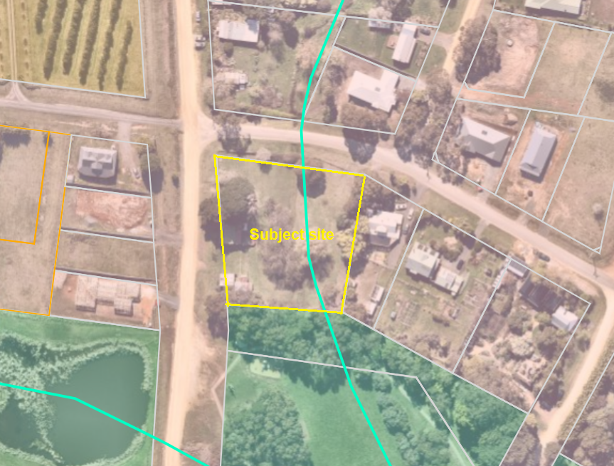
Figure 1: Aerial Photograph with green lines representing waterways

Proposal
It is proposed to subdivide the site into three lots and to remove three trees. The existing buildings on the site would be demolished to enable future development.
• Lot 1, with an area of 954sqm, would occupy the southwest corner of the site and be a trapezoid shape with a 33.19m wide frontage to Lyndhurst Street and a varied depth of 28.25m-29.71m.
• Lot 2, with an area of 953sqm, would occupy the northwest corner of the site and be a trapezoid shape with a 32.71m wide frontage to Lyndhurst Street and secondary frontage to Corbetts Road of 31.39m.
• Lot 3, with an area of 1,795sqm, would occupy the eastern half of the site and also be a trapezoid shape, with a 35m frontage to Corbetts Road and varied depth of 61.12m-63.4m.
A 5m wide drainage easement is proposed parallel to and directly abutting the west title boundary. A 2m wide sewerage easement is proposed approximately parallel to the west title boundary and offset from the drainage easement by between 1.66m and 3.81m.
Three large trees – a poplar and two pine trees, one of the latter being in the Lyndhurst Street road reserve – are proposed to be removed from Lot 2. Replacement planting of 12 native trees – six medium and six large – is proposed.
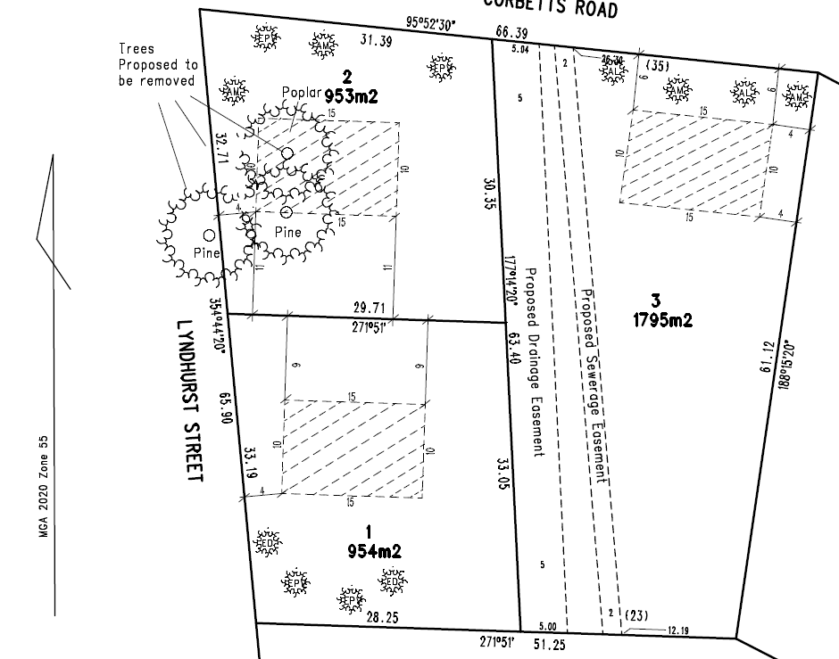
Figure 2: Proposed plan with building envelopes

Background to Current Proposal
Not applicable.

History
PA2011106 for Development of a Dwelling and Removal of Vegetation was issued on 29 July 2011. The permit was not acted on and has since expired.
PA2011341 for Two Lot Subdivision was issued on 15 June 2012. The permit was not acted on and has since expired.
PA2017086 for Development of a Replacement Dwelling and Removal of Vegetation was issued on 23 October 2017. The permit was extended three times however the permit with last approval requiring commencement of development by 23 October 2021. A further extension of time maybe applied for within the 6 months grace period that expires on 23 April 2022.If a further extension is sought, the current subdivision proposal would be taken into consideration in Council’s decision.

Public Notice
Notice of the application was given to adjoining and nearby landowners and occupiers by post and signs erected on both street frontages from 16 August 2021 until 6 September 2021. Two objections were received.

Summary of Objections
The objections received are detailed below with officer’s accompanying comments:
Objection | Any Relevant Requirement
Removal of vegetation which contributes to neighbourhood character and Gordon’s scenic landscape. | Clauses 21.09-2 & 42.03.  Significant Landscape Overlay Schedule 2
Officer’s Response:
Vegetation removal would be confined to three exotic trees, including one within the Lyndhurst Street road reserve.
The plans do not accurately show all existing vegetation on the site. | Clause 42.03.  Significant Landscape Overlay Schedule 2
Officer’s Response:
The key requirement is that vegetation proposed for removal is clearly identified. A recommended condition of approval would require that no other vegetation be removed without the required planning approval.
No landscape plan or arborist report was provided. | Clause 42.03.  Significant Landscape Overlay Schedule 2
Officer’s Response:
A landscape plan was submitted, overlaid on the proposed plan of subdivision. The matter of tree health or viability was not in question and therefore an arborist report was not requested by Council.
The 10m x 15m (150sqm) building envelopes would not accommodate a contemporary sized dwelling. How will outbuildings be accommodated? Will the envelopes be registered as a restriction on title? | Clause 56.04-2.
Officer’s Response:
It is understood that the building envelope dimensions are indicative, although their dimensions demonstrate that the minimum required size can be achieved. A recommended condition of approval would require that building envelopes, with dimensions to be determined by the applicant, be shown registered on the titles created and in accordance with the Corangamite Catchment Management Authority (CCMA) requirements to locate within those parts of the site mapped as subject to ‘relatively benign flow conditions’ with ‘no vulnerability constraints.’ This can allow for larger building envelopes.
Non-habitable outbuildings may be located outside the building envelopes, subject to future planning or building approval.
The site is subject to inundation and floods in a storm event or in winter. Approval of this application will leave Council open to litigation when dwellings are inundated in peak rainfall and storm events. | Clauses 13.03-1S & 65.01.
Officer’s Response:
The application, including a flood impact assessment, was referred to CCMA who consented to the proposal, subject to the condition for the development of habitable buildings to be contained within building envelopes on those parts of the site mapped as subject to ‘relatively benign flow conditions’ with ‘no vulnerability constraints.’ The flood impact assessment recommends that where possible building envelopes should be located outside the mapped flood extent and that any dwelling be constructed with finished floor levels at least 300mm above the application 1% AEP flood level at the location of the proposed dwelling.
This part of Gordon has already been impacted by poor planning decisions with small urban lots which would be exacerbated by approval of this application. The concept of spacious garden areas capable of containing canopy trees and protecting existing vegetation is not supported by this application. | Clauses 21.09-2, 32.09, 42.03 and 43.02.
Officer’s Response:
The proposed lot dimensions and sizes are considered capable of accommodating tree plantings and landscaping consistent with the surrounding neighbourhood. The proposed vegetation removal is considered to be acceptable, subject to conditions.
The site is physically unsuited to subdivision and development of dwellings due to the waterway running through the site and the associated flooding. | Clauses 13.03-1S & 65.01.
Officer’s Response:
The waterway and associated flooding have been addressed in the application, as outlined above, which was referred to CCMA who consented to the proposal, subject to conditions, which are recommended for inclusion on the permit.
It is considered that the risk associated with the flood hazard can be managed to an acceptable extent to ensure that development of the site is not unreasonably impacted by flooding.
The proposed building envelope siting and tree removal do not ‘sit well’ with the Gordon Structure Plan. | Clauses 32.09, 42.03 and 43.02.
Officer’s Response:
The Gordon Structure Plan was translated into the Moorabool Planning Scheme as part of Amendment C53 by rezoning land and applying the Design and Development Overlay, Schedule 5 and Significant Landscape Overlay, Schedule 2. The application has been assessed as generally in accordance with these provisions.

Locality Map
The map below indicates the location of the subject site and the zoning of the surrounding area.
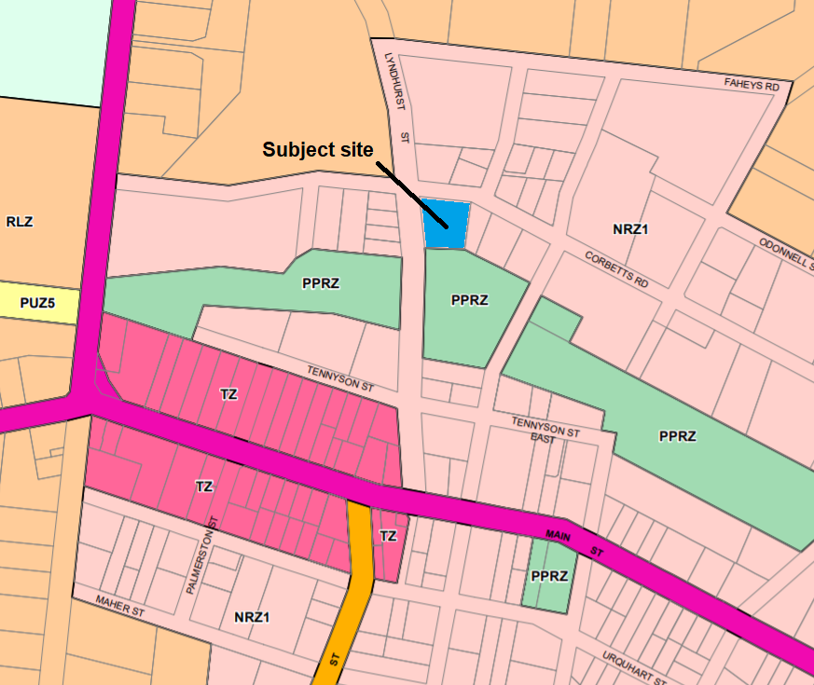
Figure 3: Zone Map

Planning Scheme Provisions
Council is required to consider the Victoria Planning Provisions which includes the Planning Policy Framework (PPF), the Local Planning Policy Framework (LPPF) and the Municipal Strategic Statement (MSS).
The relevant clauses are:
• Clause 11.03-3S Peri-urban areas
• Clause 13.03-1S Floodplain management
• Clause 14.02-2S Water quality
• Clause 15.01-3S Subdivision design
• Clause 15.01-5S Neighbourhood character
• Clause 16.01-2S Location of residential development
• Clause 21.02-3 Water and Catchment Management
• Clause 21.02-6 Environmentally sustainable development
• Clause 21.03-2 Urban growth management
• Clause 21.03-3 Residential development
• Clause 21.03-4 Landscape and Neighbourhood Character
• Clause 21.09-2 Gordon
• Clause 22.02 Special Water Supply Catchments
The proposal generally complies with the relevant sections of the PPF and LPPF.

Zone
The subject site is in the Neighbourhood Residential Zone, Schedule 1 (NRZ1).
Under Clause 32.09-3 a permit is required to subdivide land. An application to subdivide land must meet the relevant requirements of Clause 56 for residential subdivision.
Schedule 1 to the zone specifies a minimum lot size of 800sqm.
The purpose of the Zone is:
• To implement the Municipal Planning Strategy and the Planning Policy Framework.
• To recognise areas of predominantly single and double storey residential development.
• To manage and ensure that development respects the identified neighbourhood character, heritage environmental or landscape characteristics.
• To allow educational, recreational, religious, community and a limited range of other non-residential uses to serve local community needs in appropriate locations.
The proposed lot sizes exceed the minimum lot size requirement and the proposal generally meets the purpose of the zone.

Overlays
The site is affected by several planning overlays.
Environmental Significance Overlay, Schedule 1 (ESO1)
The ESO1 applies to land in a Special Water Supply Catchment. Under Clause 42.01-2 a permit is required to subdivide land and remove vegetation. The site is in the Special Water Supply Catchment and has access to reticulated sewer.
Subject to conditions the proposal would satisfy the provisions of the ESO1.
Design and Development Overlay, Schedules 2 and 5 (DDO2 & DD05)
The DDO2 applies to development using reflective exterior cladding and is not applicable to this proposal.
The DDO5 applies to the Gordon township and rural surrounds.
Under Clause 43.02-3 a permit is required to subdivide land, with a minimum lot size requirement of 800sqm. All proposed lots are above the minimum 800sqm stipulated under the NRZ1 and DDO5 generally in keeping with the characteristically larger lots in this area of the town. Overall, the proposal meets the relevant design objectives and subdivision requirements of the DDO5 and is an acceptable design response to the surrounding neighbourhood character.
Significant Landscape Overlay, Schedule 2 (SLO2)
Under the SLO2 there is no permit requirement for subdivision, but a permit is required to remove vegetation.
The landscape objectives under Part 2 of Schedule 2:
• To retain and protect significant trees, vegetation and windbreaks that are significant component of local identity and landscape of the township character of Gordon.
• To protect vegetation and trees of special significance, natural beauty, interest and importance.
• To retain trees where they have high amenity value, unless identified as an environmental weed. To support the retention and planting of further exotic and indigenous trees.
Overall, the proposed vegetation removal and replacement tree planting is considered to be generally consistent with the SLO2 provisions.

Particular Provisions
Clause 53.01 Public Open Space Contribution and Subdivision
A person who proposes to subdivide land must make a contribution to the Council for public open space in an amount specified in the schedule to this clause (being a percentage of the land intended to be used for residential, industrial or commercial purposes, or a percentage of the site value of such land, or a combination of both). If no amount is specified, a contribution for public open space may still be required under section 18 of the Subdivision Act 1988.
It is recommended that if a permit were granted a condition that a contribution to be made equivalent to 5% of the site value is required. There would be increased population as a result of the subdivision and a greater demand to utilise existing public open spaces.
Clause 56 Residential Subdivision
The proposal complies with the relevant provisions of Clause 56.

Discussion
Overall, the proposed subdivision is generally in accordance with relevant State and local planning policy, the Zone, Overlays, relevant Particular Provisions and the decision guidelines at Clause 65 of the Moorabool Planning Scheme.
Planning policy supports consolidation of housing in established areas whilst ensuring that new development respects neighbourhood character. The subject site is within Gordon township, located proximate to local facilities and with utilities readily available.
Lot Size
The proposal meets the minimum 800sqm lot size requirements under NRZ1 & DDO5, with proposed lot sizes between 953sqm and 1,795sqm. The lot shapes and sizes would be generally uniform and generally consistent with the surrounding subdivision pattern of the area.
Flooding
A waterway flows through the site and is subject to flooding. The flood impact assessment submitted by the applicant has modelled the existing flood extent, depth, velocity, and hazard for the 1% annual exceedance probability (AEP) flood event in line with Australian Rainfall and Runoff 2019 guidelines. The assessment provides a hazard classification which shows that the flood risk varies across the site.
The proposed plan of subdivision shows building envelopes for each proposed lot, each located within the hazard category ‘H1’, land described in the flood impact assessment as subject to ‘relatively benign flow’ or ‘no vulnerability constraints.’ The application was referred to the Corangamite Catchment Management Authority (CCMA) as the relevant flood authority, who consented to the proposal subject to conditions that any habitable building must be contained within a building envelope located only on land covered by the hazard category ‘H1’, as described above. It is recommended that this condition be included on the permit.
Additionally, in accordance with advice from Council’s Infrastructure, it is recommended that the proposed drainage easement revert to the originally proposed drainage reserve which is generally consistent with Council’s adopted Infrastructure Design Manual (IDM). It is deemed prudent that maintenance of this area of land, which accommodates a substantial portion of the most flood prone part of the site, be maintained by Council rather than by the owner of Lot 3 given the appropriate management of this area benefits all of the lots proposed. Retaining this section of easement may not allow for proper maintenance.
The proposal meets the relevant standards of Clause 56 for residential subdivision. The proposed lot sizes and configuration generally respond to the surrounding neighbourhood character. Each lot would readily accommodate a 10m x 15m dwelling envelope, as shown on the proposed plans, which is the minimum requirement of Rescode. It is noted that the proposed envelopes shown are indicative in size and, subject to meeting the CCMA requirements and additional recommendations for siting, may be increased in size at the permit applicant’s discretion. Each lot would be oriented to receive solar access in accordance with the standard. No common property is proposed. The adjoining streets are of sufficient width to accommodate the additional traffic generated by the proposal. Recommended permit conditions would provide for on site management measures during subdivision construction.
It is proposed to remove three large exotic trees, two within the property and one within the Lyndhurst Street road reserve, to accommodate the future development of Lot 2. Although the trees are large and readily visible from the north and south along Lyndhurst Street they are not deemed to be of particular landscape or habitat significance. Proposed replacement planting of 12 native trees across the site is considered to be acceptable compensatory planting, with improved opportunities for native fauna habitat. Given the site characteristics, in particular the flood hazard, the retention of the trees as part of a three lot subdivision is not considered best landscaping response. On balance, considering the applicable planning policies, the proposed tree removal is considered acceptable, subject to the recommended conditions for replacement planting.
Catchment issues
The subject site is in a Special Water Supply Catchment and accordingly the application was referred to Barwon Water, the relevant water board, who consented to the proposal subject to conditions. Reticulated sewerage is available for connection and subject to each lot being connected to sewer there would be no detriment to the potable water quality or supply. Stormwater runoff will be managed by standard infrastructure conditions.

General Provisions
Clause 65 - Decision Guidelines have been considered by officers in evaluating this application.
Clause 66 - Stipulates all the relevant referral authorities to which the application must be referred.

Referrals
Authority | Response
Barwon Water  Central Highlands Water  Powercor  Downer Utilities  Corangamite Catchment Management Authority | Consent with conditions.  Consent with conditions.  Consent with conditions.  Consent.  Consent with conditions.
Council’s Infrastructure | Consent with conditions.

FINANCIAL IMPLICATIONS
There are no financial implications for Council in approving this application.

Risk & Occupational Health & Safety Issues
The recommendation to approve this application does not have any risk or OH&S implications for Council.

Communications Strategy
Notice was undertaken for the application, in accordance with s.52 of the Planning and Environment Act 1987, and further correspondence is required to all interested parties to the application as a result of a decision in this matter. All submitters and the applicant were invited to attend this meeting and invited to address Council if required.

Options
• Issue a Notice of Decision to Grant a Permit in accordance subject to the conditions in the recommendation of this report; or
• issue a Notice of Decision to Grant a Permit with amendments to the conditions in the recommendation of this report. Either option for approval may result in the objectors appealing Council’s decision at VCAT; or
• issue a Refusal to Grant a Permit on grounds. This option may result in applicant appealing Council’s decision at VCAT.

Conclusion
Overall, the proposed subdivision and vegetation removal is considered to be generally in accordance with the relevant provisions of the Moorabool Planning Scheme as discussed within this report. The proposed subdivision consolidates residential growth within the Gordon township in a location proximate to local services and in keeping with the preferred neighbourhood character. Subject to conditions, the proposal responds appropriately to the flood hazard associated with the site and the proposed vegetation removal would not have any detrimental impacts on the landscape character. The subdivision should be supported.

6.02pm Cr Tom Sullivan returned to the meeting and assumed the Chair.
Mr Warrick Boyle addressed the Committee as the applicant associated with Item 7.2.
Ms Lori Giles addressed the Committee on behalf of the applicant associated with Item 7.2.
Mr Steven Norman, Ms Carol Guthrie, Mr Martyn Blake and Mr Gary Matheson addressed the Committee as objectors associated with Item 7.2.

7.2 PA2020246 - Use of the Land for Domestic Animal Husbandry (8 Dogs) at 30 Maddisons Lane Greendale
Author: Mark Lovell, Coordinator Statutory Planning
Authoriser: Henry Bezuidenhout, Executive Manager Community Planning & Economic Development
Attachments: 1. Proposed Management Plan (under separate cover)

Application Summary
Permit No: PA2020246
Lodgement Date: 27 October 2020. Amendment in Process lodged on 3 August 2021
Planning Officer: Mark Lovell
Address of the land: Lot 3 on Plan of Subdivision 093404
30 Maddisons Lane, Greendale
Proposal: Use of the Land for Domestic Animal Husbandry (8 dogs)
Lot size: 7.8ha
Why is a permit required? Clause 35.03-1 – Rural Living Zone – Use of land for Domestic Animal Husbandry

Committee Recommendation
Moved: Cr Paul Tatchell
Seconded: Cr Ally Munari
That the Development Assessment Committee, having considered all matters as prescribed by the Planning and Environment Act 1987, issue a refusal to grant a permit for the use of the land for domestic animal husbandry (8 dogs) at Lot 3 on Plan of Subdivision 093404 otherwise known as 30 Maddisons Lane, Greendale.
1. The proposal would result in land use conflicts inconsistent with relevant State and local planning policy.
2. The proposal does not comply with Clause 22.04 of the Moorabool Planning Scheme.
3. The proposal does not meet the purpose of Clause 35.03 of the Moorabool Planning Scheme to provide for agricultural land uses which do not adversely affect the amenity of surrounding land uses.
4. The proposal will result in unreasonable amenity impacts to surrounding residents.
A division was called:
In Favour: Crs Paul Tatchell, Tom Sullivan, Ally Munari and Moira Berry
Against: Crs Tonia Dudzik and Rod Ward
The motion was carried

Public Consultation
Was the application advertised? | Yes, the application was advertised by a notice on the site and by letters to adjoining landowners.
Notices on site: | Yes.
Notice in Moorabool Newspaper: | Nil.
Number of objections: | Six objections.
Consultation meeting: | The applicant did revise their planning report, which detailed management measures to address objector’s concerns to reduce the number of breeding dogs by two. The application was re-advertised but no objections were withdrawn.

Policy Implications
The Council Plan 2021-2025 provides as follows:
Strategic Objective 1: Healthy, inclusive and connected neighbourhoods
Priority 1.4: Develop a vision and provide opportunities for rural communities

Victorian Charter of Human Rights & Responsibilities Act 2006
In developing this report to Council, the officer considered whether the subject matter raised any human rights issues. In particular, whether the scope of any human right established by the Victorian Charter of Human Rights and Responsibilities is in any way limited, restricted or interfered with by the recommendations contained in the report. It is considered that the subject matter does not raise any human rights issues.

Officer’s Declaration of Conflict of Interests
Under section 130 of the Local Government Act 2020, officers providing advice to Council must disclose any interests, including the type of interest.
Executive Manager – Henry Bezuidenhout
In providing this advice to Council as the Executive Manager, I have no interests to disclose in this report.
Author – Mark Lovell
In providing this advice to Council as the Author, I have no interests to disclose in this report.

Executive Summary
Application referred? | Greater Western Water and Southern Rural Water and Council’s Environment Health
Any issues raised in referral responses? | Both Environmental Health and Greater Western Water required further information. The information and referral consents were received by 26 October 2021.
Preliminary concerns? | Management of the dog breeding in close proximity to residential dwellings.
Any discussions with applicant regarding concerns? | Yes.
Any changes made to the application since being lodged? | The applicant provided a more detailed management report as part of the amendment in process.
Brief history. | The site has operated as a dog breeding operation since 2019. In early 2020, Dogs Victoria advised the owner of changes to the Domestic Animals Act 2017, which now requires recreational breeders to ensure relevant permits are obtained from Council to regulate the sale of puppies and reduce the likelihood of puppy farms being established in Victoria. The applicant then applied for planning approval.  The applicant reduced the number of breeding dogs by two.
Previous applications for the site? | Nil.
General summary. | The application is seeking approval for the use of the land for Domestic Animal Husbandry. The site has operated since 2019. A total of six breeding dogs and two domesticated dogs will occupy the site. The land is in the Rural Living Zone and the closest dwelling is approximately 141m away from where the animal husbandry use is primarily undertaken.  The site is located where there are numerous dwellings in the surrounding area. The applicant proposes to mitigate off site impacts by provided including fencing to reduce stimuli.  The proposed presents unacceptable land use conflict in a rural living area that is designated for residential living. It is recommended the application be refused.
Summary of Officer’s Recommendation
That, having considered all relevant matters as required by the Planning and Environment Act 1987, Council issue a refusal to grant a permit for the use of the land for domestic animal husbandry (8 dogs) at Lot 3 on Plan of Subdivision 093404 otherwise known as 30 Maddisons Lane, Greendale.

Site Description
The site is located on the southern side of Maddisons Lane, Greendale. The lot is irregular and triangular in shape with a narrow street frontage and wide rear boundary. The total land area is 7.8ha. There is a centrally located dwelling approximately 200m from the Maddisons Lane frontage. The site is predominately cleared with a dam located within the front setback area. There is an extensive forest area with a waterway adjacent to the southern rear property boundary.
The peak of Greendale Hill is located on the immediate adjacent property to the east. This lot is large compared to most of the surrounding lots which are small sized containing single storey dwellings located within the Rural Living Zone. The subject lot is surrounded by residential areas in all directions. The nearest dwelling is located 141m to the east.

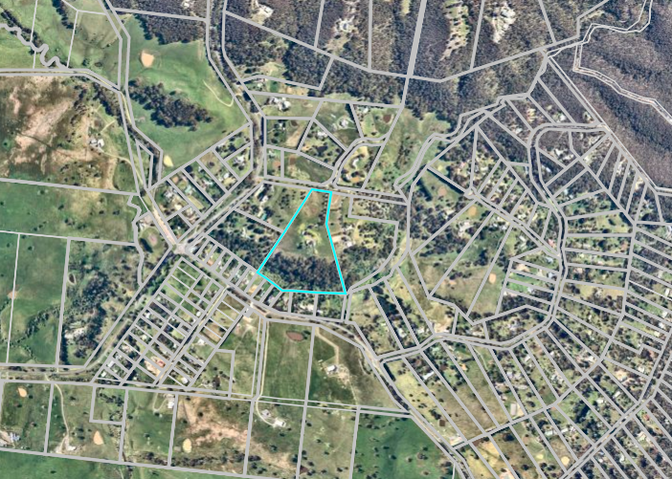
Figure 1: Aerial Photograph

Proposal
To keep a total of six Tibetan Mastiffs Dogs at the subject site for the purposes of breeding. Within any 12 month period it is anticipated that two litters will be born with the puppies being sold at 8-12 weeks of age. There are also two domesticated Tibetan Mastiffs located on the property that are desexed and domesticated.

Each entire female at the property will have a maximum of five litters at the property over their breeding lifetime. The total development to be used for the purpose of breeding, including the night kennel, whelping kennel, day yard areas and communal yard is approximately 6,000sqm. The applicant has also advised the owners intend to propose the use of ultra-sonic barking devices to control unwanted barking and the night kennel and whelping kennel will be fitted out internally to reduce the emission of noise.

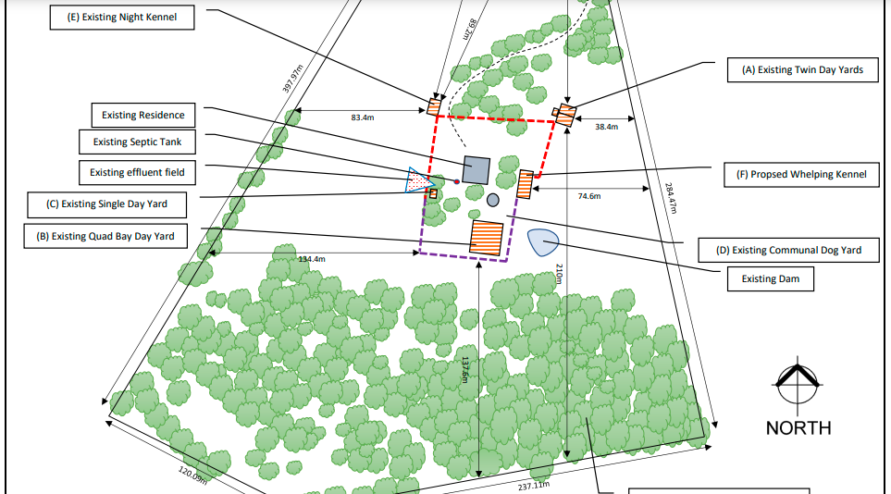
Figure 2: Existing site plan with proposed new fencing (dashed red line)

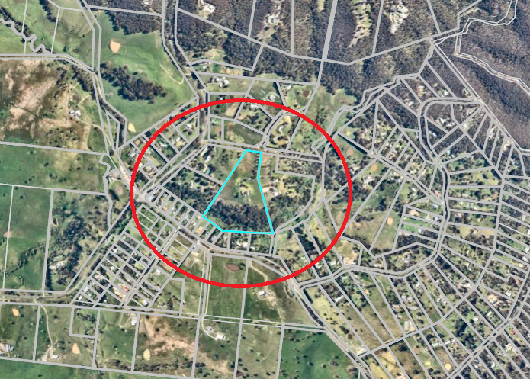
Figure 3: Red line area of 500m radius from the dog area.

Background to Current Proposal

Public Notice
The application was notified to adjoining and surrounding landowners.

Summary of Objections
The objections received are detailed below with officer’s comments accompanying them:
Objection | Any Relevant Requirement
Existing problems with animals escaping/ poor fencing / inadequate fencing.
Officer’s Response: This could be addressed by the applicant to secure animals in enclosures and external fencing of suitable height and material to prevent livestock escapes.
Problems with sheep / goats / pigs and cattle from this site.
Officer’s Response: The proposal is for dog breeding and other animals causing nuisances to neighbours could be addressed through local laws if there are animal breaches.
Excessive barking /constant barking
Officer’s Response: The existing amenity needs to be maintained and dog breeding according to the objectors has created off site impacts. There has been absence of measures such as acoustic fencing or other noise mitigation measures to address this concern in the current operation.
Rural Living Zone, not consistent with residential area. | Clause 35.03
Officer’s Response: A purpose of the Rural Living Zone is to provide for residential use in a rural environment. The site and surrounding area are located in a Rural Living Zone and contain established housing stock. The proposal does involve dog breeding with eight breeding dogs and litters kept to 12 weeks of age. The dogs require a minimal living standard including dog yards to allow for exercise. The proposal does introduce a land use that is incompatible with a residential area containing residential dwellings. The amenity of existing residents must not be compromised through a new land use.
Dogs do not comply with comply current legislation / inconsistent with local laws approval.
Officer’s Response: The proposal is assessed as a planning application and against the planning scheme provisions. Other statutory requirements would also require compliance in the event a permit is granted.
Inadequate advertising of the planning application / notice requirement different to local laws application. | Planning and Environment Act 1987
Officer’s Response: The planning application was advertised in accordance with the notice requirements under Section 52 of the Planning and Environment Act 1987 including a large notice on site displayed for 14 days.

Locality Map
The map below indicates the location of the subject site and the zoning of the surrounding area.
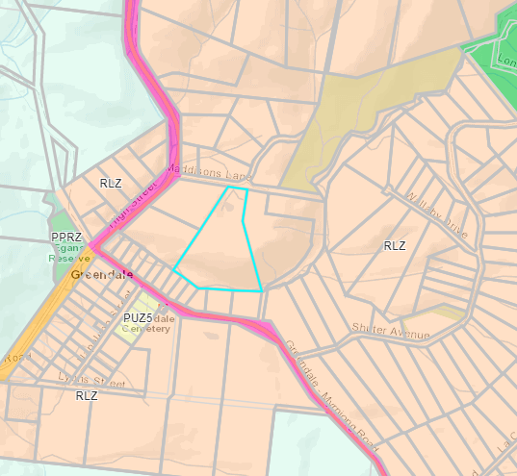
Figure 4: Zone Map

Planning Scheme Provisions
Council is required to consider the Victoria Planning Provisions and give particular attention to the Planning Policy Framework (PPF), the Local Planning Policy Framework (LPPF) and the Municipal Strategic Statement (MSS).
The relevant clauses are:
• Clause 11.03 – Planning for Places
• Clause 12.05 – Significant Environments and Landscapes
• Clause 13.05 – Noise
• Clause 13.07 – Amenity and Safety
• Clause 14.02 – Water
• Clause 21.03 – Settlement and Housing
• Clause 21.09 – Small Towns and Settlements
• Clause 22.04 – Animal Keeping
The proposal does not comply with the following relevant sections of the PPF and LPPF, as outlined in the table below:
PPF | Title | Response
Clause 13.05-1S | Noise Abatement | The objective to “… control… noise effects on sensitive land uses”. Noise can cause concern to adjacent properties.
Clause 13.07-1 | Land use compatibility | The objective of this clause is to safeguard community amenity while facilitating appropriate other uses with potential off-site effects, the ability of this site to limit all adverse amenity impacts are managed on site. The proposed use can create conflict with the surrounding residential land use.
LPPF | Title | Response
Clause 22.04 | Animal Keeping | This local policy seeks to implement requirements for the design of animal keeping facilities. Further commentary on the requirements of Clause 22.04 is included in the discussion section.

Zone
Rural Living Zone (Clause 35.03)
The land is within the Rural Living Zone, where the purpose of the zone is:
• To implement the Municipal Planning Strategy and the Planning Policy Framework.
• To provide for residential use in a rural environment.
• To provide for agricultural land uses which do not adversely affect the amenity of surrounding land uses.
• To protect and enhance the natural resources, biodiversity and landscape and heritage values of the area.
• To encourage use and development of land based on comprehensive and sustainable land management practices and infrastructure provision.
There is a planning permit trigger under the zone as the application is seeking a land use under Section 2 that is Domestic Animal Husbandry of more than two animals.

Overlays
Environmental Significance Overlay, Schedule 1 (Clause 42.01)
The Environmental Significance Overlay, Schedule 1 that applies to the land is for the Proclaimed Water Catchment Areas of Moorabool Shire. The environmental objectives to be achieved under this overlay are:
• To protect the quality and quantity of water produced within proclaimed water catchments.
• To provide for appropriate development of land within proclaimed water catchments.
The proposed land use, which can generate waste, was referred to the relevant catchment authorities under section 55 of the Planning and Environment Act 1987 for comment and have consented to the application.
Design and Development Overlay, Schedule 2 (Clause 43.02)
The Design and Development Overlay, Schedule 2 that applies to the land is to maintain Visual Amenity and Building Design for rural environments of Moorabool Shire.
The design objectives to be achieved under this overlay are:
• To enhance visual amenity in rural, township and vegetated areas of the Moorabool Shire.
• To encourage the use of external cladding, such as non-reflective materials for building construction.
• To discourage the use of materials, such as reflective cladding for building construction, which could have a detrimental effect on amenity.
No permit is required under the provisions of this overlay for this application.
Bushfire Management Overlay (Clause 44.06)

The site is within the Bushfire Management Overlay,

The purpose of the overlay is

• To implement the Municipal Planning Strategy and the Planning Policy Framework.

• To ensure that the development of land prioritises the protection of human life and strengthens community resilience to bushfire.

• To identify areas where the bushfire hazard warrants bushfire protection measures to be implemented.

• To ensure development is only permitted where the risk to life and property from bushfire can be reduced to an acceptable level.
No permit is required under the provisions of this overlay for this application.

Relevant Policies
In addition to Council’s own policies, there are several state requirements, that must be met, these include:
• The Domestic Animals Act 1994.
• The Domestic Animal Amendment Act 2017
• Code of Practice for the Operation of Breeding and Rearing Businesses 2014

Particular Provisions
There are no relevant particular provisions to this application.

Discussion
The application for the domestic animal husbandry of six breeding dogs along with retaining two domestic dogs requires a planning permit for the use of the land under the Rural living Zone.
As part of the further information requirements and in order to ensure compliance with the relevant legislation and policies, a management schedule and details were submitted. The applicant updated their report in response to the objections received. The management measures cover information about noise controls, ultrasonic bark control system, visual amenity and security including fencing and security cameras, kennel and facility management including waste management and on site management including feeding times and a mating program.
These measures could assist the applicant in attempting to operate a better managed facility and to take into consideration the impact of dogs on neighbouring properties. The applicant is willing to change their existing operation in response to the objections received which have highlighted existing amenity concerns. The proposal requires stringent management practices in relation to proximity to nearby dwellings. The applicant has not provided sufficient evidence of how noise will be reduced, or dogs prevented from causing a nuisance.
Zoning
Dog breeding and Animal Husbandry are nested under agricultural uses in Clause 75 of the Planning Scheme and is a Section 2 Use in the Rural Living Zone for any more dogs, other than for two breeding animals. In the Rural Living Zone, where residents have a high amenity expectation, one of the primary purposes of the zone is “to provide for agricultural land uses which do not adversely affect the amenity of the surrounding land uses”.
In this instance, due to the current number of dogs currently on site (licensed for seven dogs) and existing concerns expressed by several surrounding residents, the applicant has not demonstrated that the current operation in this location is not causing off site impacts.
Local Planning Policy
Within Council’s Local Planning Policy, Clause 22.04 of the Planning Scheme (Animal Keeping), certain requirements have been set out. Under this local policy, the following are requirements for the siting and design of dog keeping and breeding establishments are to be met:
• facilities should be located at least 500m away from residential areas and a substantial proportion of this buffer must be provided within the boundary of the subject site;
• facilities should be sited to use the surrounding topography to reduce noise;
• facilities should be fully contained by appropriate fencing including a fully enclosed or acoustically baffled area to house particularly noisy animals at a ratio of 1:15;
• facilities should be constructed or landscaped as appropriate to visually screen stimuli from other dogs, animals, traffic or passers-by; and;
• kennels should be constructed in materials that reduce the emission of noise.
Clause 22.04 also seeks to discourage the keeping and breeding of dogs in areas that are:
• predominantly used for extensive animal husbandry;
• have a significant number of dwellings in close proximity; and
• adjacent to significant wildlife habitats.
The application is seeking approval for the use and not all of the requirements of Clause 22.04 can be achieved due to presence of a several dwellings within 500m of the site. Despite this, the applicant has contemplated changing their operation and reducing noise impacts especially by establishing new internal fencing and improved management practices. The key problem presented for this applicant, is there are several existing dwellings in close proximity with the site and surrounded by all dwellings of all sides. This was clearly presented when viewing the locality map. There are likely to be more dwellings established as there are some vacant lots within 500m of the dog area. Dwellings are a permitted land use within the Rural Living Zone subject to conditions. The lot sizes especially to the south-west and south-east are small and this site does not have the locational advantage of generous lot sizes, physical barriers or good separation of nearby dwellings to minimise off site impacts.
Given that the land is within a Rural Living Zone, there is minimal separation between the proposed operation and nearby dwellings. The site does allow for support dog breeding activity.

General Provisions
Clause 65 - Decision Guidelines have been considered by officers in evaluating this application.
Clause 66 - Stipulates all the relevant referral authorities to which the application must be referred.

Referrals
Authority | Response
Greater Western Water  Southern Rural Water | No objection subject to eleven conditions  No objection.
Environmental Health | No objection subject to six conditions. Requirement to upgrade the existing septic system.

Financial Implications
There are no financial implications in recommending refusal to this application.

Risk & Occupational Health & Safety Issues
The recommendation of refusal of this application does not implicate any risk or OH&S issues to Council.

Communications Strategy
Notice was undertaken for the application, in accordance with s.52 of the Planning and Environment Act 1987, and further correspondence is required to all interested parties to the application as a result of a decision in this matter. All submitters and the applicant were invited to attend this meeting and invited to address Council if required.

Options
• Issue a Refusal to grant a permit in accordance with the recommendation of this report; or
• issue an approval to the application for a planning permit outside of the recommendations of this report. However, should Council wish to consider approving of the application, Councillor’s will need to explore reasons why the proposal complies with the Moorabool Planning Scheme.

Conclusion
The application for a domestic animal husbandry use has been assessed on its merits within the context of the site, zones and overlay provisions and local planning policy. From this assessment, it is recommended that the application be refused due to land use conflict within a zone that seeks to provide residential use in a rural environment. The applicant has failed to demonstrate that with the site constraints of several dwellings within 500m of the proposed use, and how they can be mitigated through management practices or further noise attenuation measures. The site’s proximity to numerous dwellings poses an unacceptable risk. The application should not be supported.

Ms Tonia Chatterjee addressed the Committee on behalf of the applicant associated with Item 7.3.
Mr Andrew Ferguson addressed the Committee as the applicant associated with Item 7.3.

7.3 PA2021154 - Development and Use of a Childcare Centre at 101 Gisborne Road Bacchus Marsh
Author: Jyoti Makan, Senior Statutory Planner
Authoriser: Henry Bezuidenhout, Executive Manager Community Planning & Economic Development
Attachments: 1. Childcare Centre Plans (under separate cover)

Application Summary
Permit No: PA2021154
Lodgement Date: 20 July 2021
Planning Officer: Jyoti Makan
Address of the land: Lots 401 & 403 on LP 212230R3
101 Gisborne Road, Bacchus Marsh
Proposal: Development and Use of a Childcare Centre
Lot size: 2665sqm
Why is a permit required? Clause 32.08-2 – a permit is required to use the land for a childcare centre.
Clause 32.08-9 – a permit is required to construct a building or carry out works.

Committee Resolution
Moved: Cr Rod Ward
Seconded: Cr Paul Tatchell
That the Development Assessment Committee, having considered all matters as prescribed by the Planning and Environment Act 1987, issue a Notice of Decision for PA2021154 for the Development and Use of a Childcare Centre at 101 Gisborne Road, Bacchus Marsh, subject to the following conditions:
1. Before the use and development starts, amended plans to the satisfaction of the Responsible Authority must be submitted to and approved by the Responsible Authority. When approved, the plans will be endorsed and will then form part of the permit. The plans must be drawn to scale with dimensions and three copies must be provided. The plans must be generally in accordance with the plans submitted with the application but modified to show:
(a) A landscape plan in accordance with Condition No. 2.
(b) Heights, colours, materials and details of the acoustic fence in accordance with the Acoustic Report dated 25 May 2021 (Report R01 21045) prepared by Clarity Acoustics for Lots 3 (Childcare Centre) at 101 Gisborne Road.
(c) Heights, colours and materials of all fencing.
(d) Waste management plan revised to include recycling, general waste and organic waste storage, bins sizes and collection.
(e) Drainage layout plan in accordance with Condition 10.
(f) Car parking number 26 removed as it is a dedicated electric vehicle charging station.
(g) Show a pedestrian link between the existing link path on the southern side of the lot 3 and the front entry area which can aid people with prams access to the building.
Unless otherwise approved in writing by the Responsible Authority, all buildings and works are to be constructed and or undertaken in accordance with the endorsed plans to the satisfaction of the Responsible Authority prior to the commencement of the use.
2. Before the development starts, a landscape plan to the satisfaction of the Responsible Authority must be submitted to and approved by the responsible authority. When approved, the plan will be endorsed and will then form part of the permit. The plan must be in accordance with the endorsed plans and Moorabool Landscape Design Manual must show (but not limited to):
(a) A survey (including botanical names) of all existing vegetation to be retained and/or removed.
(b) Building and trees (including botanical names).
(c) Details of surface finishes of pathways and driveways.
(d) A planting schedule of all proposed trees, shrubs and ground covers, including botanical names, common names, pot sizes, sizes at maturity, and quantities of each plant.
(e) Suitable screen planting along the northern and western boundaries, minimum 2.0m high when planted and to grow to a mature height of minimum 2.4m. All species selected must be to the satisfaction of the Responsible Authority.
(f) Inclusion of sustainable practices including worm farms, rainwater tanks and garden beds.
3. Before the use starts or by such later date as is approved by the responsible authority in writing, the landscaping works shown on the endorsed plans must be carried out and completed to the satisfaction of the responsible authority.
4. The landscaping shown on the endorsed plans must be maintained to the satisfaction of the responsible authority, including that any dead, diseased, or damaged plants are to be replaced.
5. Before the building is occupied, an acoustic fence must be erected in accordance with the Acoustic Report dated 25 May 2021 (Report R01 21045) prepared by Clarity Acoustics for Lots 3 (Childcare Centre) at 101 Gisborne Road. The design of the fence must be prepared in consultation with a suitably qualified acoustic engineer. The details of the design and acoustic qualities of the fence must be to the satisfaction of the responsible authority.
6. No more than 110 children may be in care at the facility at any time.
7. The use of the childcare must operate only between the hours of 6:30am to 6:30pm Monday to Friday except with the written consent of the Responsible Authority.
8. The use of the multi-purpose facility must operate only between the hours of 6:30pm to 10:00pm Monday – Sunday except with the written consent of the Responsible Authority.
Amenity:
9. The amenity of the area must not be detrimentally affected by the use or development, through the:
(a) Transport of materials, goods or commodities to or from the land;
(b) Appearance of any building, works or materials;
(c) Emission of noise, artificial light, vibration, smell, fumes, smoke, vapour, steam, soot, ash, dust, waste water, waste products, grit or oil;
(d) Presence of vermin; and
(e) Any other way.
Infrastructure:
10. A drainage layout plan must be submitted to the Responsible Authority for approval, and should incorporate the following:
(a) The development as a whole must be self-draining and must be connected to an approved point of discharge in an approved manner to the satisfaction of the Responsible Authority.
(b) Underground piped drainage for the whole development shall cater for 10% AEP storm.
11. Sediment discharges from any construction activities must be restricted within the construction area in accordance with EPA guidelines.
12. Prior to the use commencing, the vehicle crossing must be constructed in accordance with the requirements of PA2019109 and to the satisfaction of the Responsible Authority.
13. The car park must be designed in accordance with AS2890. Landscaped and trafficable areas should be separated by kerbing or other physical barriers.
14. A minimum of 24 car parking spaces including one disabled space must be available on the site at all times.
15. The surface of all paved areas within the development must be constructed with an all-weather surface and designed to ensure that the areas are properly drained so as to prevent the flooding of any buildings.
16. The building must be provided with disabled access in accordance with AS1428.
17. Unless otherwise approved by the responsible authority there must be no buildings, structures, or improvements located over proposed drainage pipes and easements on the property.
18. Storm water drainage from the proposed buildings and impervious surfaces must be retained and disposed of within the boundaries of the subject land to the satisfaction of the Responsible Authority. Overflows from on-site storage systems must be directed away from any wastewater disposal areas.

19. Prior to the commencement of the development and post completion, notification including photographic evidence must be sent to Council’s Asset Services department identifying any existing damage to council assets. Any existing works affected by the development must be fully reinstated at no cost to and to the satisfaction of the Responsible Authority.
20. Prior to the commencement of the development, design computations for drainage of the whole site must be prepared and submitted to the Responsible Authority for approval.
Waste Management:
21. All recycling, organics and general waste must be collected and stored in accordance with the endorsed waste management plan and to the satisfaction of the Responsible Authority.
Permit expiry:
22. This permit will expire if one of the following circumstances applies:
(a) the development and the use are not started within two years of the date of this permit; or
(b) the development is not completed within four years of the date of this permit.
Permit note:
23. Any proposed signage may require separate planning permit approval.
Carried

Public Consultation
Was the application advertised? | Yes.
Notices on site: | Yes.
Notice in Moorabool Newspaper: | None.
Number of objections: | One objection.
Consultation meeting: | A consultation meeting took place between the applicant and the objector on 25 November 2021. The objection remains unresolved.

Policy Implications
The Council Plan 2021-2025 provides as follows:
Strategic Objective 3: A Council that listens and adapts to the needs of our evolving communities
Priority 3.2: Align services to meet the needs of the community

Victorian Charter of Human Rights & Responsibilities Act 2006
In developing this report to Council, the officer considered whether the subject matter raised any human rights issues. In particular, whether the scope of any human right established by the Victorian Charter of Human Rights and Responsibilities is in any way limited, restricted or interfered with by the recommendations contained in the report. It is considered that the subject matter does not raise any human rights issues.

Officer’s Declaration of Conflict of Interests
Under section 130 of the Local Government Act 2020, officers providing advice to Council must disclose any interests, including the type of interest.
Executive Manager – Henry Bezuidenhout
In providing this advice to Council as the Executive Manager, I have no interests to disclose in this report.
Author – Jyoti Makan
In providing this advice to Council as the Author, I have no interests to disclose in this report.

Executive Summary
Application referred? | The application was referred to the Council’s Connected Communities, Environmental Health, Infrastructure, Strategic Planning, Active Aging and Diversity, Environmental Emergency and Waste Management and the Department of Transport.
Any issues raised in referral responses? | Intention of the multi-purpose area, adequacy of car parking, community health and wellbeing in consideration proximity to fast food restaurant.
Preliminary concerns? | Landscaping, acoustic noise wall heights and location, purpose of the multi-purpose room, pick up and drop off zones, sustainable practices, designing in accordance with the Design guide for Victorian Children’s Services.
Any discussions with applicant regarding concerns? | Discussions were related to the intention of the multi-purpose room, acoustic noise wall, amenity, landscaping, shaded areas, interleading doors, worm farms, waste collection, health and well-being of children, rainwater tanks, materials and colour schedules and environmental sustainability.
Any changes made to the application since being lodged? | Nil.
Previous applications for the site? | PA2019109 approved a service station and convenience restaurant.

General summary. | The site is affected by a Section 173 agreement which details (in part) that Lot 3 must not be used for a convenience restaurant and be developed for a potential community orientated use to the satisfaction of the Responsible Authority. The proposals accompanying reports were referred to the relevant authorities who had no objections subject conditions. Initial concerns on drop off and pick up zones, health and well-being, environmental sustainability, acoustic walls, and the intention of the multi-purpose space were resolved.  The proposal provides the minimum number of car spaces on site.  The proposal has been assessed against the Moorabool Planning Scheme and is a reasonable outcome for a community orientated land use to support the nearby general residential areas. It is recommended for approval.
Summary of Officer’s Recommendation
That, having considered all relevant matters as required by the Planning and Environment Act 1987, Council issue a Notice of Decision for PA2021154 for the Development and Use of a Childcare Centre at 101 Gisborne Road, Bacchus Marsh, subject to the conditions contained within this report.

Site Description
The site is located at the corner of Gisborne Road and the Western Freeway and is currently known as Lots 402 and 403 on Title Plan LP 212230R at 101 Gisborne Road
Part of the site has been developed under Planning Permit PA2019109, which also permitted the subdivision of land into three lots (in part) to create the subject site. Individual land titles are currently being processed for the three lots including the subject site (identified as Lot 3 on PS843738R) in accordance with the Section 173 Agreement registered on the title.
The site is rectangular in shape and gains access from Gisborne Road. Access could also be gained from Clifton Drive via the serve station area and the convenience restaurant. The site is relatively flat with a slight slope towards its north west.
The site is located within the General Residential Zone 3 (Increased Residential Growth) surrounded by General Residential Zone 2 (Natural Growth) as well as pockets of commercial activities across the site along Gisborne Road and the Freeway such as a Veterinary Centre, Car Wash, Chiropractor, and Sports Medicine Clinic and Ambulance Station.
The Western Freeway and Gisborne Road are both Category 1 Roads managed by the Department of Transport. The nearest bus stop is 200m south of the site and the train station is 2.5km south of the site.
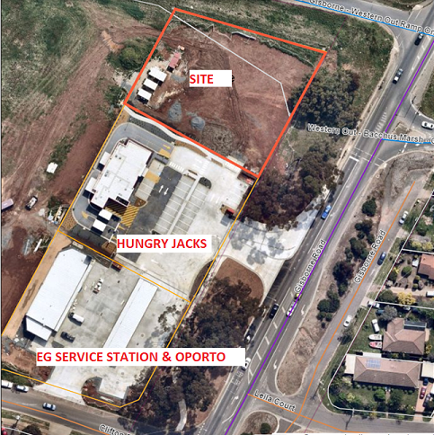
Figure 1: Aerial Photograph

Proposal
It is proposed to use and develop the site for a childcare centre with a capacity of 110 children. The childcare holds a building footprint of 883sqm and 787sqm outdoor play area. The childcare centre provides 25 car parking spaces and six bicycle spaces. It also includes an electric vehicle charging station as this is a requirement of the previous permit PA2019109. A 6.4m wide accessway provides vehicle access via Lot 2 (Hungry Jacks).
Pedestrian access will be adjacent to the northern boundary of the proposed Lot 2 and will provide an east-west linkage through the site connecting with the existing footpath on Gisborne Road and any future residential development to occur at Lot 223 of Clifton Drive directly west of the subject site.
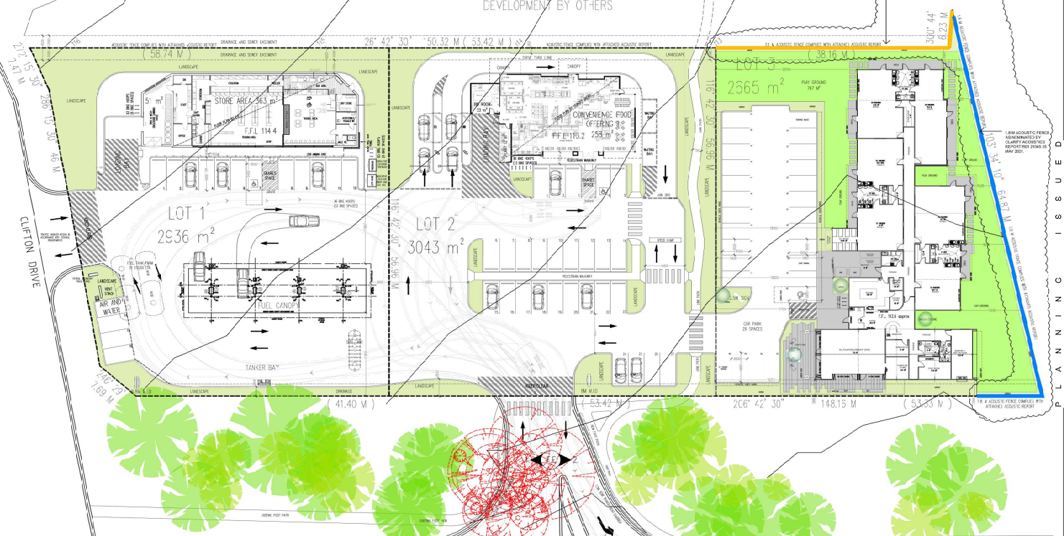
Figure 2 – Proposed development including layout of development of Lots 1 and 2
The building is setback 3.5m from the western boundary, 3.58m from the northern boundary and 2.6m from the eastern boundary. In order to make room for efficient access and car parking areas, the building is setback 16m from the southern boundary.
No business identification signage is proposed with this application and is subject to future planning approval
Internally the childcare will consist of six rooms catering for ages 0-3 years. It will also include kitchen and kitchen store, bathrooms and toilets, cot room, store rooms, laundry, laundry store, office, staff room, interview room and a 77.6sqm multipurpose community space with adjacent furniture storage.
It was further indicated that the multipurpose community space is intended to be ancillary to the operation of the childcare centre. It will be used by carers of child attendees during the day for informal get togethers, or for information sessions on topics such as breast feeding, toilet training and the like with an expected attendance of no more than 15-20 carers, which will be held outside of the normal drop-off or pick up times for the centre. It is also stated that 20-30 attendees could use the room or parent and information meetings could occur at night.
It was further noted that the multi-purpose room will be managed and facilitated by the childcare centre operation.

Background to Current Proposal
There is a Section 173 Agreement registered on title a number of obligations to be fulfilled as follows:
• ‘Lot 3 will be developed for a potential community orientated use to the satisfaction of the Responsible Authority and subject to the required permits and approvals by the relevant authorities.
• Lot 3 will not be used or developed for the purpose of a convenience restaurant’.
• A pedestrian path and associated landscaping will be provided through the land connecting Gisborne Road and the vacant land to the west of the site which will be located and designed to the satisfaction of the Responsible Authority.
• Vehicle access will be provided between Lot 2 and Lot 3 with the location and the design to be to the satisfaction of the Responsible Authority.
• Future development of Lot 3 must be sited and designed to enhance the visual amenity of the land’s prominent gateway location and must demonstrate and innovative and unique design which enhances the character of the precinct and broader area’.

History
Planning permit PA2019109 was issued on 11 March 2020 directly east of the subject site, for the Development and Use of a Service Station, Convenience Restaurant, Three Lot Subdivision, Signage, and Creation of access to a Road Zone, Category 1 (RDZ1) at 101 Gisborne Road, Bacchus Marsh. The development approved under this permit is currently under construction.

Public Notice
The application was notified to adjoining and surrounding landowners.

Summary of Objections
The objections received are detailed below with officer’s comments accompanying them:
Objection | Any Relevant Requirement
Current demand for childcare centres, lack of people to serve the childcare centre, threat to current business close to the site, impact on occupancy and employment opportunities of current staff, traffic impacts on the school bus services | Not applicable.
Officer’s Response:
Commercial considerations of existing child care centre are not valid planning consideration.
The traffic impact assessment provides that the proposal does not impact on the surrounding commercial areas.

Locality Map
The map below indicates the location of the subject site and the zoning of the surrounding area.
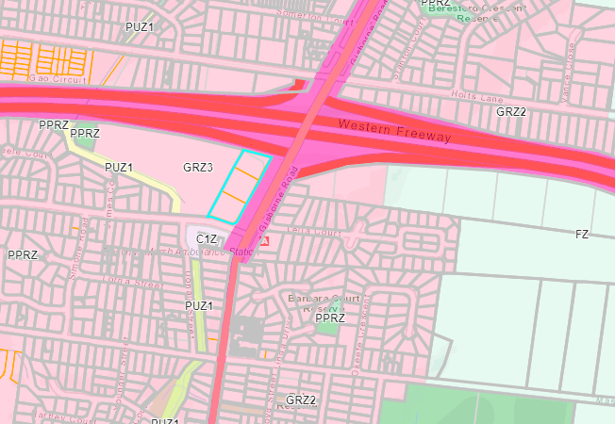
Figure 3: Zone map

Planning Scheme Provisions
Council is required to consider the Victoria Planning Provisions and give particular attention to the Planning Policy Framework (PPF), the Local Planning Policy Framework (LPPF) and the Municipal Strategic Statement (MSS).
The relevant clauses are:
• Clause 15.01-1S-Urban design
• Clause 15.01-2S-Building design
• Clause 15.01-3S-Subdivision design
• Clause 15.01-4S-Healthy neighbourhoods
• Clause 15.01-5S-Neighbourhood character
• Clause 15.02-1S – Energy and resource efficiency
• Clause 18.02-4S – Car parking
• Clause 18-02.1S – Sustainable personal transport
• Clause 17.02-1S – Business
• Clause 17.01 – Employment
• Clause 19 – Infrastructure
• Clause 21.07 Bacchus Marsh
• Clause 21.04 – Economic Development and Employment

Zone
The subject site is zoned General Residential Schedule 3 (GRZ3)
The purpose of the General Residential Zone is:
• To implement the Municipal Planning Strategy and the Planning Policy Framework.
• To encourage development that respects the neighbourhood character of the area.
• To encourage a diversity of housing types and housing growth particularly in locations offering good access to services and transport.
• To allow educational, recreational, religious, community and a limited range of other non-residential uses to serve local community needs in appropriate locations.
The neighbourhood character objectives included in the GRZ3 include:
• To encourage new development, including innovative and unique development that enhances and responds positively to the existing neighbourhood character.
• To encourage sufficient front setbacks to allow for enhancement of the front garden character including increasing canopy tree plantings.
• To encourage new development to have minimal or low scale front fencing.
• To ensure new garages and carports do not dominate dwellings or streetscapes.

Overlays
No overlays apply to the site.

Relevant Policies
Bacchus Marsh Urban Growth Framework
The proposal promoted the identified objectives in this strategy by promoting increase employment growth, servicing populations, supporting residential development, and delivers infrastructure to cater for the service delivery needs of the neighbourhood.

Particular Provisions
Clause 52.29-2 Land Adjacent to a Road Zone
The purpose of this particular provision is:
• To ensure appropriate access to identified roads.
• To ensure appropriate subdivision of land adjacent to identified roads.
Under Clause 52.29-2 a permit is required to create and access to a road in a Road Zone – Category 1.
No new access is proposed as this was previously approved under PA2019109.
Clause 52.06 Car Parking
Under Clause 52.06-5, a childcare centre requires 0.22 spaces to each child. Based on the proposed 110 children, this required for 24 car parking spaces, however the proposal provides for 25 spaces and exceeds minimum requirement. The car spaces and accessways comply with the relevant design standards of Clause 52.06.
Clause 53.18 – Stormwater Management in Urban Development
The purpose of this clause is to ensure that stormwater in urban development, including retention and reuse, is managed to mitigate the impacts of stormwater on the environment, property, public safety, and to provide cooling, local habitat and amenity benefits. As a permit condition, the applicant will be required to provide a drainage plan to the satisfaction of the Responsible Authority.

Discussion
Zoning and Land use
The site is within the General Residential Zone 3 which allows for increased growth and allows for non-residential land uses to serve local community needs in appropriate locations. As stipulated above, a Section 173 Agreement under the Planning and Environment Act 1987 attached to the title requires that the site be used for a community orientated purpose. Resolutions on the land use included the multi-purpose room and 3-4 year old kindergarten consistent with the agreement. The proposed land uses are appropriated sited and well separated from the nearest residential dwellings. Standard amenity conditions are proposed should an approval be granted.
Traffic, Car parking and Access
In terms of traffic movement, the childcare centre and Hungry Jacks have different peak hours and therefore avoid internal traffic conflicts. The wide vehicle entry design caters for all different traffic movements associated with the various uses.
The 25 car parking bays provided on the site meets the requirements of the planning scheme pursuant to Clause 52.06. The remaining space shown on plans as no. 26 is not a car space but the dedicated electric vehicle charging station, which is a requirement under the previous development permit for the Service Station and Convenient Restaurant under PA2019109.
It caters for the childcare centre and ancillary community space as well as anticipated night-time use of the community space. The Traffic Impact Assessment Report (TIAR) was analysed by Council’s Infrastructure Department who were satisfied with the details relating to car parking design, bicycle parking locations and projected traffic volumes. The turning lane provided in the TIAR assessment looks at avoiding congestion, delays and improve safety of traffic movements at intersections and access points (such as the driveaway) to the proposed development. This is determined based on the speed environment and the combination of through and turning traffic volumes. The traffic impact assessment conducted for the service station site under Planning Permit PA2019109 was used as the underlying basis to assess projected movements. The recommendations relating to the turning lane in Gisborne Road remained unchanged from those in previous traffic reports. The analysis shows that a 2.2% per annum growth rate based on the Department of Transport data and therefore the site access intersection at Gisborne Road is expected to operate with excellent levels of service, reducing delays and queues in the right turning lane.

The proposed ancillary multipurpose community space is intended to function as an adjunct to the childcare centre. It is expected to attract minimal additional daytime parking demands generated by the drop-off and pick up movements with other activities of the centre. This is expected to occur mostly outside of peak traffic times as the multipurpose faciality will be operated and managed by the childcare centre and mostly used in evenings not in the same manner as a community centre but primarily used by parents and those associated with the childcare centre.
When considering the peaks demands, operational levels in terms of predominantly evening use for the multi-purpose room together with the required bays for the childcare centre, the proposed 25 bays for the childcare centre and the multi-purpose room is considered acceptable.
One accessible car park is provided in accordance with the standard at the entrance of the premises.
Condition in the planning permit do not limit the use of the multi-purpose room to evenings only because the use should be available to meet the needs of the community without restrictive hours of operations.
Amenity and Pedestrian Activity
Landscaped footpaths are shown on the plans between the convenience restaurant and childcare centre to allow for connectivity to the future development west of the site. Footpaths along the streetscape are subject to detailed design and functional layout plans required under the parent Planning Permit. There should also be dedicated internal footpath connecting the front entry to the approved link footpath on the southern boundary allow for ease of access for people with prams. This has been included as a permit condition.
Six bicycle bays are provided which promotes sustainable methods of personal transport. The site is 200m north from the nearest bus stop and a 2.5km cycle or drive towards the train station.
The proposal has appropriate consideration for each interface to adjacent properties. An acoustic wall will bound the northern and western site boundaries to mitigate noise impacts from the freeway and outside of the childcare centre. Condition recommended reflect screening tree planting along the northern and western site boundaries
The car park, proposed landscaping, and footpath provides as a buffer between the drive through the day care centre. The proposed built from is setback 2.6m from Gisborne Road and clad with INNOWOOD timber composite cladding, light grey brick work and muted paint colours which provide an environmentally friendly entrance to the site. The multipurpose room will be located at the Gisborne Road interface with its courtyard and large bi-fold doors openings to provide additional surveillance to the street.
Conditions are recommended to ensure that the acoustic wall (proposed at 1.8m at the Freeway boundary) design, materials and colour are provided on the plans submitted to the Council for review and approval. This is due to the location of acoustic wall and topography of the site where the acoustic wall would be prominent at the intersection of Gisborne Road and the Freeway.
A 2.1m acoustic fence at the western interface is included in the parent Permit and complies with the acoustic report submitted with the application.
Sustainable Development and Waste
The proposal provides for a positive contribution towards streetscaping and landscaping around the perimeter of the site. The height design and setbacks and material used for the built form are sustainable and will add value to the Gisborne Road interface.
The building includes muted building materials such as vertical INNOWOOD timber composite cladding combined with reclaimed brickwork walls, aesthetically balanced design elements and a number of window and door openings for energy efficiency and provision of adequate solar access within the building. All open spaces are orientated to receive ample solar access.
A condition is placed on permit to ensure that not only recycling and general waste is accounted for but also the inclusion of organic waste collection which should be collected, and this will be addressed through a revised Waste Management Plan.

General Provisions
Clause 65 - Decision Guidelines have been considered by officers in evaluating this application.
Clause 66 - Stipulates all the relevant referral authorities to which the application must be referred.

Referrals
Authority | Response
Department of Transport | No comment
Council’s Infrastructure  Strategic Planning  Connected Communities  Active Aging and Diversity  Environment, Emergency  Waste Management | No objections subject to planning permit conditions.  No objection.  No objection.  No objection.  No objection.  No objection.

Financial Implications
There are no financial implications for Council in supporting the application.

Risk & Occupational Health & Safety Issues
The recommendation of approval does not implicate any risk or OH&S issues to Council.

Communications Strategy
Notice was undertaken for the application, in accordance with s.52 of the Planning and Environment Act 1987, and further correspondence is required to all interested parties to the application as a result of a decision in this matter. All submitters and the applicant were invited to attend this meeting and invited to address Council if required.

Options
Council could consider the following options:
• issue an approval in accordance with the recommendations of this report; or
• should Council wish to refuse the application, Councillor’s need to explore reasons for refusing the based on the compliances with the Moorabool Planning Scheme.

Conclusion
The application was assessed against the Moorabool Planning Scheme together with the relevant referral authorities and found the proposal to use and develop the land for a childcare centre is considered acceptable and will not pose any detrimental impacts to the surrounding neighbourhood. The proposal is considered to serve the growing community needs and is proposed as well-designed built form with landscaping, materials, and colours to provide for positive contribution at the corner of Gisborne Road and the Western Freeway.
The proposal included sustainable development measures, appropriate areas for cooling environmental, play areas, building materials and colours, and landscaping.
The accompanied Traffic Impact assessment concluded that the proposal will not significantly increase the traffic associated with the service station and convenience restaurant nor the current traffic from the residential and commercial developments surrounding the site. The objector concerns are related to commercial considerations not relevant to the planning assessment. The proposal is recommended for approval subject to planning permit conditions.

8 Update on Trends, Issues and Other Matters
Nil.

9 Process Forward and Work Program
Nil.

10 Update on VCAT Decisions
Mr Mark Lovell made a presentation on the VCAT determination to overturn Council’s decision in relation to the Multi-Dwelling Development, Staged Subdivision and Removal of Easements at 101 Gisborne Road, Bacchus Marsh.
An update was provided on the VCAT determination in relation to 278 Moorabool West Road, Gordon. It was advised that the parties had mediated through the process and permit was granted for a 2nd Dwelling to be used as short term accommodation.
An update was provided on the VCAT determination in relation to 821 Greenhills Road, Blackwood. It was advised that a beneficial mediation process had occurred and the next stage is an administrative mention where the parties may be agreeable to a landscape plan being provided, which may address their concerns.

11 Other Business
Nil.

12 Date of Next Meeting
16 February 2022.

13 Meeting Close

The Meeting closed at 7.31pm.

...................................................
CHAIRPERSON

