MINUTES
Ordinary Council Meeting
Wednesday, 2 June 2021
Date: | Wednesday, 2 June 2021
Time: | 6.02pm
Location: | Online

Order Of Business
1 Opening of Meeting and Prayer 4
2 Acknowledgement of Country 4
3 Recording of Meeting 4
4 Present 4
5 Apologies 5
6 Confirmation of Minutes 5
7 Disclosure of Conflicts of Interest 5
Nil.
8 Public Question Time 6
9 Petitions 8
Nil.
10 Presentations/Deputations 9
11 Chief Executive Officer Reports 10
11.1 Mayoral and Councillor Allowances 10
11.2 Councillor Gift Policy 13
11.3 Audit and Risk Committee - Chairperson's Report 16
12 Community Planning and Economic Development Reports 19
12.1 Tourism Events Grants Program 2021 19
12.2 PA2020185 - Multi-Dwelling Development, Staged Subdivision and Removal of Easements at 101 Gisborne Road, Bacchus Marsh 23
13 Community Strengthening Reports 58
13.1 Arts and Culture Strategy 58
13.2 Moorabool Shire Community Grants - March 2021 65
14 Customer Care and Advocacy Reports 71
14.1 Delegated Committees of Council - Reports 71
14.2 Advisory Committees of Council - Reports 72
15 Community Assets & Infrastructure Reports 73
15.1 Draft Road Management Plan 2021-25 73
15.2 Local Area Traffic Management Study (Stage 4) Darley 80
16 Other Reports 86
Nil.
17 Notices of Motion 86
Nil.
18 Notices of Rescission 86
Nil.
19 Mayor’s Report 87
19.1 Mayor's Report 87
20 Councillors’ Reports 88
20.1 Councillors' Reports 88
21 Urgent Business 88
22 Closed Session of the Meeting to the Public 89
22.1 Contract C32 - Major Patching Contract Extensions 89
23 Meeting Closure 89

1 Opening of Meeting and Prayer
The Mayor opened the meeting with the Council Prayer at 6.02pm

2 Acknowledgement of Country
I acknowledge the Traditional Owners of the land on which we are meeting. I pay my respects to their Elders, past and present, and the Aboriginal Elders of other communities who may be here today.

3 Recording of Meeting
In accordance with Moorabool Shire Council’s Governance Rules, the meeting is livestreamed.

4 Present
Cr Tom Sullivan, Mayor West Moorabool Ward
Cr Moira Berry East Moorabool Ward
Cr Tonia Dudzik East Moorabool Ward
Cr David Edwards East Moorabool Ward
Cr Ally Munari Woodlands Ward
Cr Paul Tatchell Central Moorabool Ward
Officers:
Mr Derek Madden Chief Executive Officer
Ms Caroline Buisson General Manager Customer Care & Advocacy
Mr Phil Jeffrey General Manager Community Assets & Infrastructure
Ms Sally Jones General Manager Community Strengthening
Mr Henry Bezuidenhout Executive Manager Community Planning & Economic Development
Mr John Miller Manager Asset Management
Mr Chris Gardner Manager Connected Communities
Mr Anthony Smith Manager Governance Risk & Corporate Planning
Mr Troy Delia Coordinator Governance & Risk

5 Apologies
Cr Rod Ward has submitted a request for a leave of absence until 28 June 2021.
Resolution
Moved: Cr David Edwards
Seconded: Cr Tonia Dudzik
That leave of absence be granted to Cr Ward until 27 June 2021.
Carried

6 Confirmation of Minutes
Resolution
Moved: Cr Tonia Dudzik
Seconded: Cr Moira Berry
That the minutes of the Ordinary Council Meeting held on Wednesday 5 May 2021 be confirmed.
Carried

7 Disclosure of Conflicts of Interest
Nil.

8 Public Question Time
Name | Question/Response | CEO/GM/EM | Read at Meeting  (Yes/No) | Taken on Notice  (Yes/No)
Mr. John Kowarsky | Question 1:  When a vote is taken, can the process be less hurried, and the Councillors be quite clear about their hand raising? | Derek Madden  CEO | Yes | No
Response:
Council’s Governance Rules require that voting be by show of hands and that the Chairperson must be satisfied that they have determined those in favour, those opposed to a motion and those that have abstained from the vote.
However, the Governance Rules do not specify any requirements for matters such as the pace of the vote. Therefore, the Chairperson may at their discretion seek to clarify the vote at any time.
Question 2:
With each Public Question, after the Council Officer has provided their answer, can the Chair specifically ask Councillors if they would like to make any comment or ask the Officer any question about the matter?
Response:
Council’s Governance Rules specify the process for the Conduct of Public Question Time. Any change to this process would need to be considered at the time the Governance Rules are reviewed in September 2021.
Ms. Rose De La Cruz | Question 1:  What is the Council doing to protect significant, mature trees in the Shire in general and in particular, the significant mature tree at 22 Fisken Street, Ballan? | Henry Bezuidenhout Executive Manager Community Planning & Economic Development | Yes | No
Response:
There is a current planning application for the removal of one tree within the road reserve at 22 Fisken Street, Ballan (PA2021042). A decision has not been made on this application and officers are considering a range of issues associated with the infrastructure upgrade and the recommendations from an independent Arborist.

Council has introduced tree controls over large parts of the shire through a range of planning overlays such as the Vegetation Protection Overlay, and /or Heritage Overlay and /or Significant Landscape Overlay and lastly the Environmental Significance Overlay (Schedule 8), which protects Red Gums in the Bacchus Marsh Valley. These overlays can provide protection for significant mature trees. When assessing planning applications Council encourages, where possible, the retention of mature trees on both private properties and Council road reserves consistent with the planning policies of the Moorabool Planning Scheme.
Mr. Simon Lumb – Community Leadership Program 2021 Representative | Question 1:  What is Council’s view on co-working spaces within the Shire? | Henry Bezuidenhout Executive Manager Community Planning & Economic Development | Yes | No
Response:
Recent shifts in work environments as a result of Covid-19, has increased interest and opportunity for innovative workplaces including co-working spaces. Economic Development welcome the opportunity to further explore your concept. It is worth noting that there is currently a co-working space active in the Bacchus Marsh town centre.
Question 2:
Are Council looking into encouraging the development of, or actually investing in the creation of co-working spaces in the Shire?
Response:
The development of coworking spaces is encouraged and Council officers welcome the opportunity to have facilitative conversations with interested parties. The conversation can be further facilitated through Council’s Economic Development Unit.

Name | Question/Response | CEO/GM/EM | Read at Meeting  (Yes/No) | Taken on Notice  (Yes/No)
Ms. Heidi Taylor – Community Leadership Program 2021 Representative | Question 1:  What is Council’s receptivity to public art (street art/graffiti)? | Sally Jones General Manager Community Strengthening | Yes | No
Question 2:
Would Council consider funding murals and public art in Bacchus Marsh and across the municipality?
Response for both questions:
Officers have developed a draft Arts and Culture Strategy which will encourage strong partnerships across the Shire with artists and arts organisations. Without pre-empting a decision of Council, the draft strategy is being presented to Council this evening for consideration to undertake community consultation and request feedback and input into the future of arts across Moorabool.
Ms. Renee Robinson | Question 1:  The Moorabool Shire budget 2020-21 allocated $100,000 from Council cash for the Ballan Library Facility - Feasibility and Concept Design. What amount out of the 2020-21 budget's $100,000 has been spent as at 31 May 2021 and what documents have been produced as a result of this? | Sally Jones General Manager Community Strengthening | Yes | No
Response:
To date Council has expended approx. $3000 on the development of the Draft Ballan Library Infrastructure Review.
Question 2:
If the full $100,000 was not spent as of 31 May 2021, where have the remaining funds been allocated.
Response:
On Council endorsement of the 2021-2022 budget, the balance of the allocated funds will be rolled over to support next stages of the development of the project including concept and detailed design.

9 Petitions
Nil.

10 Presentations/Deputations
Item No | Description | Name | Method | Position
12.2 | PA2020185 - Multi-Dwelling Development, Staged Subdivision and Removal of Easements at 101 Gisborne Road, Bacchus Marsh | Mr. Peter Righetti | Online | Applicant
12.2 | PA2020185 - Multi-Dwelling Development, Staged Subdivision and Removal of Easements at 101 Gisborne Road, Bacchus Marsh | Mr. Phillip Rygl | Online | Applicant’s Representative
12.2 | PA2020185 - Multi-Dwelling Development, Staged Subdivision and Removal of Easements at 101 Gisborne Road, Bacchus Marsh | Mr. and Mrs. Harkom | Written | Supporter of Recommendation

11 Chief Executive Officer Reports

11.1 Mayoral and Councillor Allowances
Author: Anthony Smith, Manager Governance, Risk & Corporate Planning
Authoriser: Derek Madden, Chief Executive Officer
Attachments: Nil

Purpose
The purpose of this report is to commence the formal review process of the Mayoral and Councillor Allowances as required, in accordance with section 74 of the Local Government Act 1989.

Executive Summary
• Sections 74 and 74A of the Local Government Act 1989 make provision for the setting of, and application of increases to Mayoral and Councillor Allowances.
• As a designated Category 2 Council, the current maximum Mayoral and Councillor Allowance are set at $81,204 and $26,245 plus 9.5% (equivalent of superannuation guarantee contribution) respectively.
• Pursuant to Section 73B(2) of the Local Government Act 1989, the Minister must, at least once every year, review the limits and ranges of the Mayoral and Councillor Allowances.
• The Minister has conducted a review and determined that, for this year, no adjustment to allowances will be made in respect of all Councils. The Minister had regard to the Victorian Premier’s recent decision determining a zero per cent adjustment to Victorian Public Service executive remuneration for the 2020/21 financial year.
Resolution
Moved: Cr Paul Tatchell
Seconded: Cr David Edwards
That Council:
1. Notes that the previous Mayoral and Councillor Allowances were set at $81,204 and $26,245 plus 9.5% (equivalent of superannuation guarantee contribution) respectively.
2. In conducting a review of the Mayoral and Councillor Allowances under Section 74(1) of the Local Government Act 1989, proposes that the new Mayoral and Councillor allowances remain unchanged and stay set at $81,204 and $26,245 plus 9.5% (equivalent of superannuation guarantee contribution) respectively.
3. In accordance with sections 74(4) and 223 of the Local Government Act 1989, gives public notice that a review of the Mayoral and Councillor Allowances is being conducted, and submissions will be received on the proposed allowances from 3 June 2021 until 1 July 2021.
4. In accordance with Section 223 of the Local Government Act 1989, provides Submitters with the opportunity to be heard by Council to speak in support of their submission, if they wish to do so, at the Council Meeting of 7 July 2021.
Carried

Background
The Mayor and Councillors are entitled to receive an allowance while performing their duty as an elected official.
Section 39 of the Local Government Act 2020 stipulates that Mayors, Deputy Mayors and Councillors are entitled to receive an allowance in accordance with a Determination of the Victorian Independent Remuneration Tribunal. However, a determination made by the Tribunal at the request of the Minister for Local Government, under section 23A of the Victorian Independent Remuneration Tribunal and Improving Parliamentary Standards Act 2019, has not yet come into effect.
Until such time that a determination is made by the Tribunal at the request of the Minister for Local Government, under section 23A of the Victorian Independent Remuneration Tribunal and Improving Parliamentary Standards Act 201, the review of allowances will continue under s.74(1) of the Local Government Act 1989 after the election.
The Minister has determined that for this year, no adjustment to allowances will be made in respect of all Councils. The Minister had regard to the Victorian Premier’s recent decision determining a zero per cent adjustment to Victorian Public Service executive remuneration for the 2020/21 financial year.

Proposal
Councils are classified as a Category 1, 2 or 3 for the purposes of determining the allowance range and limit. Moorabool Shire Council is a Category 2 Council.
As a designated Category 2 Council, the current Mayoral Allowance is set at $81,204 per annum plus the amount equivalent of the superannuation guarantee contribution 9.5% and Councillor Allowances are set at $26,245 plus 9.5% (equivalent of superannuation guarantee contribution).
The review of the Mayoral and Councillor Allowances has taken into consideration the classification and size of the Council; the complexity of issues brought before it and the ensuing workloads for Councillors. Therefore, it is proposed that Mayoral and Councillor Allowances remain at the maximum amount in the range.

Council Plan
The Council Plan 2017-2021 provides as follows:
Strategic Objective 1: Providing Good Governance and Leadership
Context 1B: Our People
The proposal to review the Mayoral and Councillor allowances is consistent with the Council Plan 2017 – 2021.

Financial Implications
Provision for the application of the Mayoral and Councillors Allowances is included in Council’s Annual Budget.

Risk & Occupational Health & Safety Issues
There are no identified risks or occupational, health & safety implications as a result of presenting this report.

Communications & Consultation Strategy
Level of Engagement | Stakeholder | Activities | Location | Date | Outcome
Consult | Residents and the General Community | Call for Submissions under section 223 of the Local Government Act 1989. | Online and Public Notice | 3 June 2021 | Written submissions will be received until 1 July 2021 and if requested, submitters may be heard in person by Council.

Victorian Charter of Human Rights & Responsibilities Act 2006
In developing this report to Council, the officer considered whether the subject matter raised any human rights issues. In particular, whether the scope of any human right established by the Victorian Charter of Human Rights and Responsibilities is in any way limited, restricted, or interfered with by the recommendations contained in the report. It is considered that the subject matter does not raise any human rights issues.

Officer’s Declaration of Conflict of Interests
Under section 130 of the Local Government Act 2020, officers providing advice to Council must disclose any interests, including the type of interest.
Chief Executive Officer – Derek Madden
In providing this advice to Council as the Chief Executive Officer, I have no interests to disclose in this report.
Author – Anthony Smith
In providing this advice to Council as the Author, I have no interests to disclose in this report.

Conclusion
This report recommends that Council endorses the proposed Mayoral and Councillor Allowances review in accordance with the Local Government Act 1989 and seek community feedback in relation to the Mayoral and Councillor Allowances.

11.2 Councillor Gift Policy
Author: Anthony Smith, Manager Governance, Risk & Corporate Planning
Authoriser: Derek Madden, Chief Executive Officer
Attachments: 1. Councillor Gift Policy (under separate cover)

Purpose
The purpose of this report is to present to Council the Councillor Gift Policy for adoption.

Executive Summary
• The proposed policy (the policy) shown as attachment 1 to this report, is intended to support Councillors to avoid conflicts of interest and maintain high levels of integrity and public trust as the acceptance of gifts can create perceptions that a Councillors integrity has been compromised.
• The policy provides Councillors with the tools required to determine the difference between a gift and genuine hospitality, and whether the acceptance of a gift offer is appropriate. The policy also requires that Councillors make gift declarations whether a gift is accepted or declined.
• It is recommended that Council adopts the proposed Councillor Gift Policy to meet the requirements specified under section 138 of the Local Government Act 2020.

Resolution
Moved: Cr Paul Tatchell
Seconded: Cr Moira Berry
That Council adopts the Councillor Gift Policy provided as Attachment 1 to this report.
Carried

Background
Section 138 of the Local Government Act 2020 requires Council to adopt a Councillor Gift Policy within the period of six (6) months after a general election.
A Councillor Gift Policy must include:
1. Procedures for the maintenance of a gift register, and
2. Any other matters prescribed by the regulations.
The Councillor Gift Policy has been developed to comply with the requirements of the Act and furthermore provides direction to Councillors when responding to the offer of gifts, benefits, and hospitality.

Proposal
Councillors have a responsibility to act with integrity and transparency in their dealings and associations with the community.
The policy sets out Council’s standards and procedures for responding to gift offers, and aims to ensure that Councillors are not compromised in the performance of their duties by accepting gifts which may result in a sense of obligation or could be interpreted as an attempt to influence. This helps to protect and promote the integrity of the Council.
The purpose of the policy is to:
• Define the difference between a gift and acceptable hospitality;
• Set standards and procedures for responding to gift offers;
• Outline the types of gifts that are prohibited;
• Outline the process for maintaining the Councillor Gift Register;
• Detail the ongoing reporting requirements to the Executive Team and Council’s Audit and Risk Committee; and
• Provide Councillors with an overview of other Gift Disclosure requirements.
Under the policy, any Gifts that are inconsistent with community expectations and could bring a Councillor’s integrity, or that of the Council into question or disrepute must be declined.

Council Plan
The Council Plan 2017-2021 provides as follows:
Strategic Objective 1: Providing Good Governance and Leadership
Context 1C: Our Business and Systems
The proposal to adopt the Councillor Gift Policy is consistent with the Council Plan 2017 – 2021.

Financial Implications
There are no additional financial implications associated with the adoption and implementation of the Councillor Gift Policy.

Risk & Occupational Health & Safety Issues
Risk Identifier | Detail of Risk | Risk Rating | Control/s
Legislative requirements | Failure to comply with the requirements of the Local Government Act 2020 or the prescribed Standards of Conduct for Councillors. | Medium | Council to adopt and comply with the Councillor Gift Policy.

Communications & Consultation Strategy
Level of Engagement | Stakeholder | Activities | Location | Date | Outcome
Consult | Councillors | The proposed Policy was discussed at a Councillor briefing | Darley | May 2021 | Councillor input into the Gift Policy was provided.

Victorian Charter of Human Rights & Responsibilities Act 2006
In developing this report to Council, the officer considered whether the subject matter raised any human rights issues. In particular, whether the scope of any human right established by the Victorian Charter of Human Rights and Responsibilities is in any way limited, restricted, or interfered with by the recommendations contained in the report. It is considered that the subject matter does not raise any human rights issues.

Officer’s Declaration of Conflict of Interests
Under section 130 of the Local Government Act 2020, officers providing advice to Council must disclose any interests, including the type of interest.
Chief Executive Officer – Derek Madden
In providing this advice to Council as the Chief Executive Officer, I have no interests to disclose in this report.
Author – Anthony Smith
In providing this advice to Council as the Author, I have no interests to disclose in this report.

Conclusion
The adoption of the Councillor Gift Policy will demonstrate to the Moorabool community the Councillors’ ongoing commitment to good governance whilst ensuring Council’s compliance with the requirements of the Local Government Act 2020.

11.3 Audit and Risk Committee - Chairperson's Report
Author: Anthony Smith, Manager Governance, Risk & Corporate Planning
Authoriser: Derek Madden, Chief Executive Officer
Attachments: 1. Audit and Risk Committee - Report by the Chair (under separate cover)

Purpose
The Audit and Risk Committee, in alignment with the Local Government Act 2020 (Act), requires the Chairperson to prepare a report to Council, on the Committee’s activities twice per annum.
This report is presented to Council to note the first half yearly report (Attachment 1) prepared by the Audit and Risk Committee’s Chairperson, Ms. Linda MacRae.

Executive Summary
• At its meeting of 26 August 2020, Council adopted the Audit and Risk Committee Charter, in accordance with requirements of the Local Government Act 2020.
• In accordance with section 54(5) of the Local Government Act 2020, and the Audit and Risk Committee Charter, the Chairperson of the Audit and Risk Committee is required to prepare a biannual report on the activities of the Committee, including its findings and recommendations, and provide a copy of the report for tabling at a Council meeting.
• This is the first half yearly report to be presented to Council. The Committee reviewed the half yearly report at its meeting held on 12 May 2021 and confirmed it is an accurate reflection of the Committee’s activities.

Resolution
Moved: Cr Tonia Dudzik
Seconded: Cr Ally Munari
That Council notes the Audit and Risk Committee Chairperson’s Report, provided as Attachment 1.
Carried

Background
At the Ordinary Meeting of Council on 26 August 2020, Council adopted the Audit and Risk Committee Charter, in accordance with the requirements of the Local Government Act 2020, and appointed 5 members to its Audit and Risk Committee, consisting of 3 independent members and 2 Councillors.
Ms. Linda MacRae was declared Chairperson of the Audit and Risk Committee at its meeting on 9 December 2020.
In accordance with section 54(5) of the Local Government Act 2020, and the Audit and Risk Committee Charter, the Chairperson of the Audit and Risk Committee is required to prepare a biannual report on the activities of the Committee, including its findings and recommendations, and provide a copy of the report for tabling at a Council meeting.
The committee has agreed that a report on activities will be prepared for the period 1 July to 31 December and a full year report will be prepared to outline how the Committee has discharged its responsibilities outlined in the Audit & Risk Committee Charter.

Proposal
This report seeks Council to note the Audit and Risk Committee Chairperson’s Report, which has been prepared in accordance with the Act, and the Committee’s Charter.
This is the first half yearly report to be presented to Council. The Committee reviewed the half yearly report at its meeting held on 12 May 2021 and confirmed it is an accurate reflection of the Committee’s activities.

Council Plan
The Council Plan 2017-2021 provides as follows:
Strategic Objective 1: Providing Good Governance and Leadership
Context 1C: Our Business and Systems
The proposal to note the Audit and Risk Committee Chairperson’s Report is consistent with the Council Plan 2017 – 2021.

Financial Implications
There are no financial implications associated with noting the Audit and Risk Committee Chairperson’s Bi-annual Report.

Risk & Occupational Health & Safety Issues
Risk Identifier | Detail of Risk | Risk Rating | Control/s
Reputational Risk | Not upholding good governance in Council processes.  Non-compliance with the requirements relating to Audit and Risk Committees under the Local Government Act 2020. | Medium | Noting the Chairperson’s Report, provided in accordance with the Local Government Act 2020 and the Audit and Risk Committee Charter.  Ongoing adherence to the requirements of the Act and the Charter.

Communications & Consultation Strategy
Level of Engagement | Stakeholder | Activities | Location | Date | Outcome
Presentation | Audit and Risk Committee Members | Report presented to the Audit and Risk Committee | Darley Civic Hub | 12 May 2021 | Confirmed accurate report of Committee’s activities
Briefing | Councillors | Chairperson presenting report at Councillor Briefing | Council Chambers, Ballan | 2 June 2021 | Confirmation by Council

Victorian Charter of Human Rights & Responsibilities Act 2006
In developing this report to Council, the officer considered whether the subject matter raised any human rights issues. In particular, whether the scope of any human right established by the Victorian Charter of Human Rights and Responsibilities is in any way limited, restricted, or interfered with by the recommendations contained in the report. It is considered that the subject matter does not raise any human rights issues.

Officer’s Declaration of Conflict of Interests
Under section 130 of the Local Government Act 2020, officers providing advice to Council must disclose any interests, including the type of interest.
Chief Executive Officer – Derek Madden
In providing this advice to Council as the Chief Executive Officer, I have no interests to disclose in this report.
Author – Anthony Smith
In providing this advice to Council as the Author, I have no interests to disclose in this report.

Conclusion
It is proposed that the Audit and Risk Committee Chairperson’s Report (Attachment 1) meets the requirements of s.54 of The Local Government Act 2020, and is in accordance with the Committee’s Charter, and therefore is recommended for noting by Council.

12 Community Planning and Economic Development Reports

12.1 Tourism Events Grants Program 2021
Author: Kat Barbuto, Economic Development Officer
Authoriser: Henry Bezuidenhout, Executive Manager Community Planning & Economic Development
Attachments: 1. Tourism Event Grant Application - Summary Assessment (under separate cover)
2. Tourism Events Grants Program Guidelines 2021 (under separate cover)

Purpose
The purpose of this report is to provide a summary of the grant applications received by Council seeking funding for tourism events under the Tourism Events Grants Program 2021.

Executive Summary
• The Tourism Events Grants Program provides funding to organisations to support the planning and delivery of tourism event initiatives with the expectation to significantly increase visitation to Moorabool Shire and levels of economic activity.
• Council received two applications.
• A total of $6,000.00 was requested with $12,400.00 available.
• The report presents Council with a list of recommended grants for the 2021 funding round prepared by the Tourism Events Grants Assessment Panel (Attachment 1).
• In total, one application is recommended to receive $3,000.00 in funding.
• The allocation of this sum is detailed in the funding recommendation within this report and at Attachment 1.

Resolution
Moved: Cr Tonia Dudzik
Seconded: Cr Paul Tatchell
That Council approves the allocation of the Tourism Events Grants for 2021, provided as Attachment 1 to this report.
Carried

Background
Program purpose
The purpose of this report is to present Council with an assessment of the applications received for the Tourism Events Grants Program 2021. The program is designed to support the planning and delivery of tourism event initiatives with the expectation to significantly increase visitation to Moorabool Shire and levels of economic activity. Opening on 1 February 2021 and closing on 28 February 2021, a total of $12,400.00 was allocated to the community. Applicants could apply for any amount between $100.00 to $3,000.00.
The Tourism Events Grants Program assessment is a competitive, and merit-based process. To be considered, applications had to meet the eligibility criteria as outlined in the program guidelines.
The program’s key objectives are to:
• support local tourism initiatives;
• attract visitation and increased economic activity into Moorabool Shire;
• increase yield per visitor or participant; and
• encourage initiatives to have a greater brand match (alignment with the Shire’s key themes e.g. food and wine, natural produce, heritage, nature, adventure, townships).
Applicants also need to demonstrate a cash or in‐kind contribution toward the cost of their project on a ratio of $1 for $1 (Council $1: Applicant $1).
Applicant support
The Tourism Events Grants Guidelines (Attachment 2) specifies that applicant groups are required to liaise with an Economic Development officer prior to lodging an application to ensure they receive clear guidance on eligibility and how to best present their applications. All applicants received support and advice from Council officers before lodging their application.
Policy assessment criteria
The applications were considered against the criteria outlined in the guidelines (see Attachment 2) contributing to an overall percentage score (100%).
• Initiative description and why the applicant wants to do the project – 10%.
• What will this initiative achieve? – 20%.
• Why is this initiative needed in your community? – 20%.
• Who will be involved in the initiative? – 15%.
• How will you carry out your initiative (including risk management)? – 15%.
• Initiative budget and explanation of how the group arrived at the costs – 20%.
Number of applications and amount requested
In total, two applications were received. A total of $6,000.00 was requested from the $12,400.00 available.

Proposal
Current status
The recommendations provided in Attachment 1 represent 100% of grant applications for 2021.

Council Plan
The Council Plan 2017-2021 provides as follows:
Strategic Objective 3: Stimulating Economic Development
Context 3B: Investment & Employment
The proposal allocation of grants under the Tourism Events Grants Program 2021 is consistent with the Council Plan 2017 – 2021.

Financial Implications
The total of grants being recommended for allocation in the year 2021 is $3,000.00. This is a recurrent item in the Council budget therefore there is no financial implication for this or future financial years

Risk & Occupational Health & Safety Issues
Risk Identifier | Detail of Risk | Risk Rating | Control/s
Initiative timelines | Grant recipient exceeding prescribed timelines | Medium | • Terms and conditions agreements required to be signed by grant recipients  • Scheduled. monitoring of initiatives
Financial | Grant recipient appropriate expenditure of Council funds | High | • Terms and conditions agreements required to be signed by grant recipients  • Grant acquittal required upon completion of initiative.

Communications & Consultation Strategy
Level of Engagement | Stakeholder | Activities | Location | Date | Outcome
Consult | Event Groups | Meetings with applicant groups | Various | 1 February – 28 February 2021 | Applicants groups supported to submit applications
Information on the program was available on Council’s website with the use of social media, Council’s email newsletter and newspaper advertising to inform the community of the opportunity.
Applicants for the Tourism Events Grants Program have been advised they will be notified of the outcome of their grant application in June 2021. Economic Development officers will provide feedback to unsuccessful applicant groups. Feedback will include:
• advice to applicant groups of the relative strengths and areas for improvement in their application;
• options for alternative funding (if applicable); and
• supporting a group to re-lodge their application in the next appropriate round of the Tourism Events Grants Program.

Victorian Charter of Human Rights & Responsibilities Act 2006
In developing this report to Council, the officer considered whether the subject matter raised any human rights issues. In particular, whether the scope of any human right established by the Victorian Charter of Human Rights and Responsibilities is in any way limited, restricted, or interfered with by the recommendations contained in the report. It is considered that the subject matter does not raise any human rights issues.

Officer’s Declaration of Conflict of Interests
Under section 130 of the Local Government Act 2020, officers providing advice to Council must disclose any interests, including the type of interest.
Executive Manager – Henry Bezuidenhout
In providing this advice to Council as the Executive Manager, I have no interests to disclose in this report.
Author – Kat Barbuto
In providing this advice to Council as the Author, I have no interests to disclose in this report.

Conclusion
Applications received under the 2021 Tourism Events Grants Program are designed to support the planning and delivery of tourism event initiatives with the expectation to significantly increase visitation to Moorabool Shire and levels of economic activity. In total, two applications were received. It is recommended that Council allocates funding for the grants based on the tables provided in Attachment 1.

Mr. Peter Righetti addressed Council as the applicant for Item 12.2.
Mr. Phillip Rygl addressed Council as the applicant’s representative for Item 12.2.
Mr. and Mrs. Harkom provided a written statement as supporters to the recommendation for Item 12.2.

12.2 PA2020185 - Multi-Dwelling Development, Staged Subdivision and Removal of Easements at 101 Gisborne Road, Bacchus Marsh
Author: Jyoti Makan, Senior Statutory Planner
Authoriser: Henry Bezuidenhout, Executive Manager Community Planning & Economic Development
Attachments: Nil

Application Summary
Permit No: PA2020185
Lodgement Date: 13 August 2020
Planning Officer: Jyoti Makan
Address of the land: Lot 223 Clifton Drive of PS317067A, at 101 Gisborne Road, Bacchus Marsh
Proposal: Staged Multi-Dwelling Development, Subdivision and Variation of Easements
Lot size: 3.517ha
Why is a permit required? Clause 32.08.3, a planning permit is required to subdivide land
Clause 32.08-6, a planning permit is required to construct two or more dwellings on a lot
Clause 36.01-2, a permit is required for building and works for Section 2 use
Clause 36.01-2, a permit is required to subdivide land
Clause 52.29-2, a is required to subdivide land
Clause 52.01 – a permit is required to vary of an easement

Resolution
Moved: Cr Tonia Dudzik
Seconded: Cr Moira Berry
That Council, having considered all matters as prescribed by the Planning and Environment Act 1987, advises VCAT that it does not support PA2020185 for Staged Multi-Dwelling Development, Subdivision and Variation of Easements at Lot 223 Clifton Drive of PS317067A, 101 Gisborne Road, Bacchus Marsh 3340 on the following grounds (but not limited to):
1. The proposal is inconsistent with the General Residential Zone of the Moorabool Planning Scheme regarding neighbourhood character.

2. The proposal is inconsistent with the planning policy framework and local policy frameworks of the Moorabool Planning Scheme, particularly energy efficiency, urban design, building design, landscape and neighbourhood character, subdivision design, car parking location, emergency services and usable public open space.
3. The proposal does not comply particular provisions of the Moorabool Planning Scheme with regards to stormwater management, car parking, walkability, cyclability, lot design, neighbourhood character, energy efficiency and common property.
4. The poor internal layout affords for low levels of internal amenity and represents an over development of the site.
5. The design of the dwellings fails to provide an innovative or unique design response.
6. The applicant has not demonstrated where functional visitor car parking can be provided on site in accordance with Clause 52.06 when approval has not been obtained to locate visitor car parking over the Southern Rural Water easement.
7. The proposed works does not comply with the purpose of Public Use Zone Schedule 1 and are not appropriately located or designed.
8. The subdivision layout does not match the prevailing pattern of the area.
9. The applicant has provided insufficient information to properly assess stormwater management.
10. The traffic report has not adequately addressed access points to the site and traffic congestion/traffic queuing at the Gisborne Road intersection.
11. Inaccurate plans were provided with regard to floor areas of the dwelling and lot sizes.
12. Insufficient information was provided to competently assess the application.
Carried

Public Consultation
Was the application advertised? | Yes.
Notices on site: | Yes, three notices were placed on Gisborne Road, Clifton Drive, and the Western Freeway.
Notice in Moorabool Newspaper: | No.
Number of objections: | 84.
Consultation meeting: | None.

Policy Implications
The Council Plan 2017-2021 provides as follows:
Strategic Objective 3: Stimulating Economic Development
Context 2A: Built Environment
The proposal does not conflict with the Council Plan 2017 – 2021.

Victorian Charter of Human Rights & Responsibilities Act 2006
In developing this report to Council, the officer considered whether the subject matter raised any human rights issues. In particular, whether the scope of any human right established by the Victorian Charter of Human Rights and Responsibilities is in any way limited, restricted, or interfered with by the recommendations contained in the report. It is considered that the subject matter does not raise any human rights issues.

Officer’s Declaration of Conflict of Interests
Under section 130 of the Local Government Act 2020, officers providing advice to Council must disclose any interests, including the type of interest.
Executive Manager – Henry Bezuidenhout
In providing this advice to Council as the Executive Manager, I have no interests to disclose in this report.
Author – Jyoti Makan
In providing this advice to Council as the Officer, I have no interests to disclose in this report.

Executive Summary
Application referred? | Yes.
Any issues raised in referral responses? | Strategic Planning - Neighbourhood character, density, body corporate arrangement.  Infrastructure - traffic congestion and no use of Infrastructure Design Manual (IDM) standards, acoustic measures, stormwater management, streetscape tree planting, maintenance arrangements, Public Open Space (POS) contributions.  Environmental Planning - Future plans for the Council’s cycle corridor.  Southern Rural Water - Works along Southern Rural Water easement.
Preliminary concerns? | Overall design and layout of the dwellings, transition of the neighbourhood character from the low density housing south of the site, interface treatments from the service station, interface treatment to the freeway, Council’s reserve and future cycle corridor, traffic, narrow streets, court bowl designs, failure to provide footpaths on each side of the roadway.
Any discussions with applicant regarding concerns? | Several consultation meetings were held with the applicant.
Any changes made to the application since being lodged? | Yes.

Brief history. | The site is vacant land. The applicant has lodged an appeal with VCAT for a failure to determine the application within the prescribed time on 15 February 2021. The appeal is set for 18-20 August 2021, with a compulsory conference on 17 June 2021.
Previous applications for the site? | In 2015 this site was proposed to be rezoned to facilitate development of the site for trade supplies and restricted retail premises, with Bunnings Warehouse being the anchor tenant plus four other retail premises. The proposal was exhibited, and 196 submissions received which Council considered in November 2015 and resolved to abandon the proposal. See ‘History’ below.
General summary. | The application is for a staged subdivision and development to accommodate 76 dwellings and includes one super lot for future high density housing. The development is proposed as a body corporate arrangement.  The site is within the General Residential Zone 3 and is currently vacant. The site is encumbered by several easements and is adjacent to a Council reserve.  The application was advertised, and 84 objections were received. Key concerns include, traffic impacts along Clifton Drive and Gisborne Road, car parking, low standard of liveable housing design guidelines, housing types, isolated high density housing, lack of respect for existing neighbourhood character and poor internal amenity.  Some objectors also provided suggestions that the site be used for retail, community, and recreation purposes. It recommended that the application not be supported, on the grounds set out above.
Summary of Officer’s Recommendation
That, having considered all relevant matters as required by the Planning and Environment Act 1987, Council advises VCAT that it would not support the application, on the grounds included in this report.

Site Description
The subject land is highly irregular in shape with a total area of 3.517ha and known as Lot 223 on PS317067A at 101 Gisborne Road, Bacchus Marsh. It is located on the north of Clifton Drive and southern side of the Western Freeway “entry ramp” and western side of Gisborne Road (directly west of the approved service station site currently under construction). The site has frontage to Clifton Drive for approximately 66m. The land is located about 1,200m north of the Bacchus Marsh Activity Centre and 600m south of Darley Plaza. The entry to the site along Clifton Drive is directly across from the Bacchus March Veterinary Centre and adjacent to the Bacchus Marsh Childcare and Kindergarten Centre. Overall, the site is clear of vegetation and the group of trees shown along the Western Freeway are outside of the subject site. The site slopes from west to east for 5m with another 5m fall from north to south.
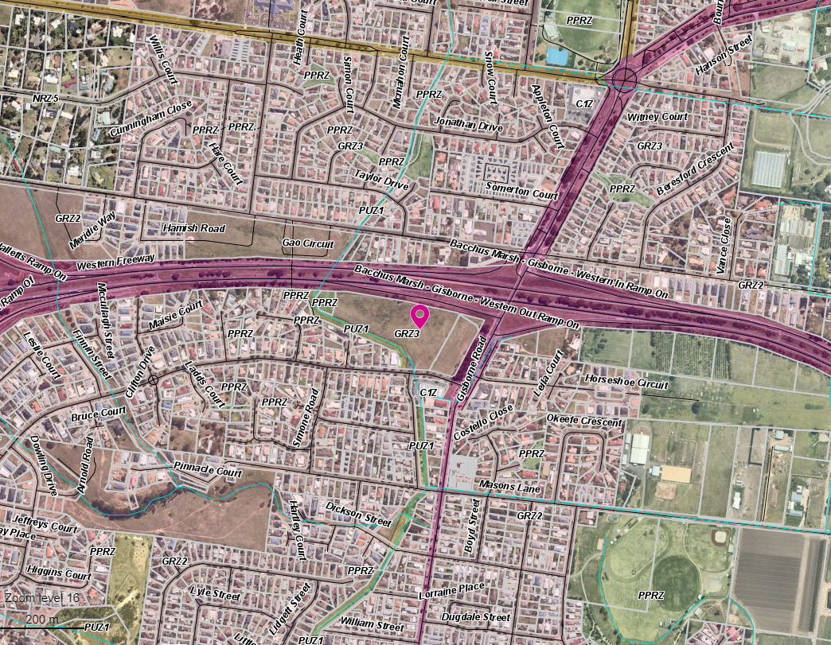
The site
Figure 1: Subject site
The site is encumbered by the following easements
• E-1 (20.19m wide Southern Rural Water (SRW) high pressure drainage and irrigation channel easement),
• E-5 (5m wide Council’s carriageway easement) and
• E-4 (Drainage and sewerage easement 2m along the east and 3m towards the west of the frontage).
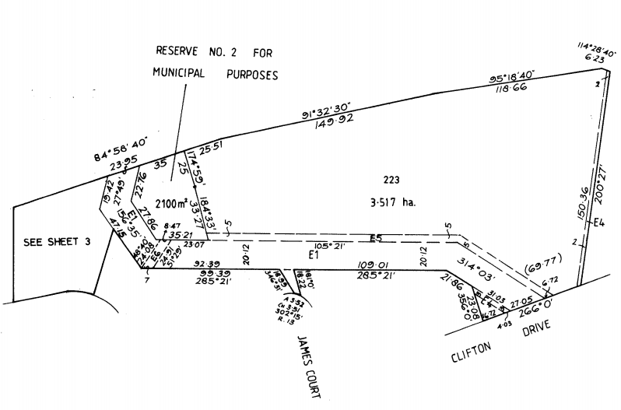
Figure 2: Title Plan PS317067A Easement locations
Two Council reserves at 2,100sqm and 946sqm are located towards the western interface of the site. The reserves are divided by the Southern Rural Water (SRW) easement which is also known as the Lerderderg Track and currently zoned for in the Public Use Zone. These reserves are undeveloped and fully grassed.

Proposal
A proposal is made for a staged multi-lot development of 75 dwellings and subdivision of land comprising of 77 lots which includes a Superlot for future higher density housing. The proposal also includes variations and creation of easements.
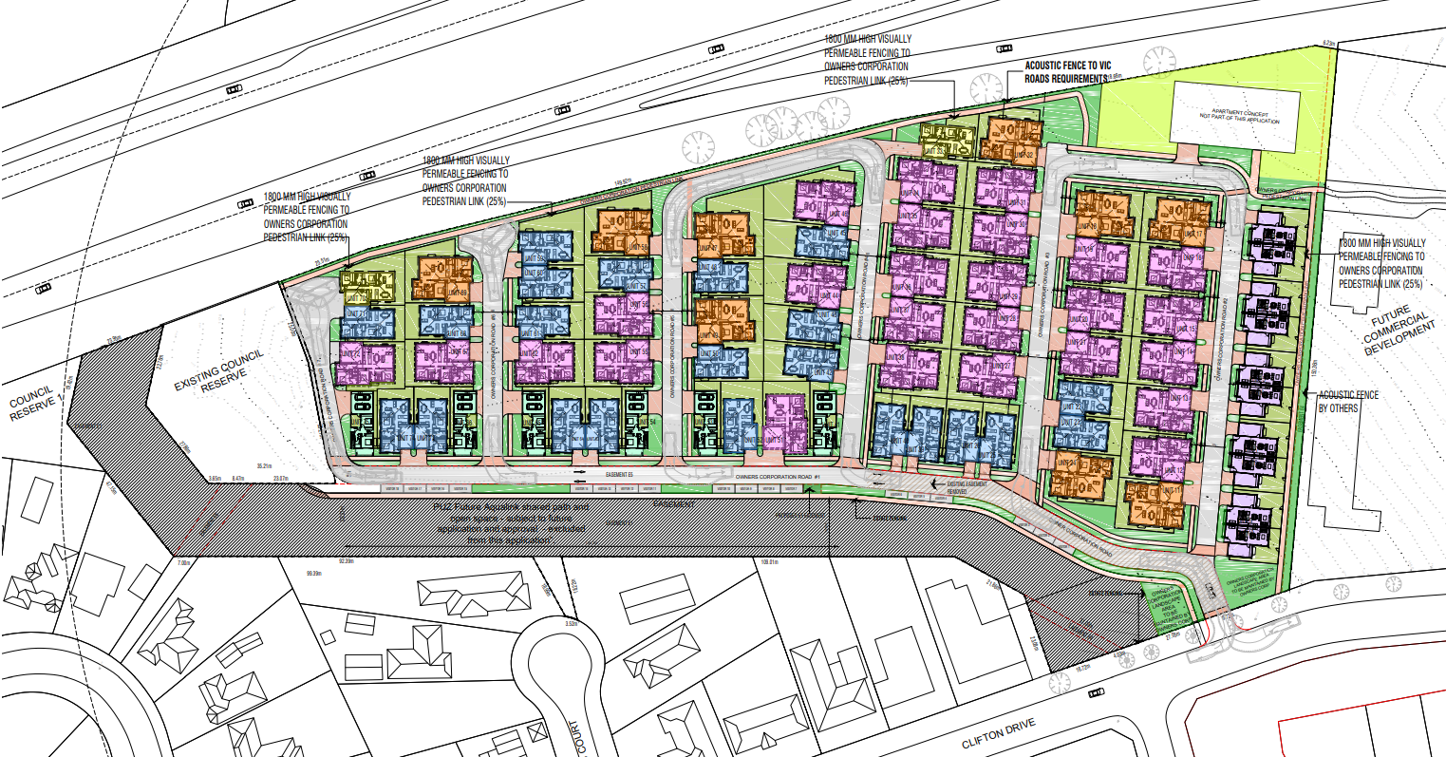
Figure 3: Development plans
The development proposal consists of two bedroom and three bedroom double and single storey housing types, associated onsite car parking within garages. There are 12 dwellings proposed as two bedrooms and sixty-three dwellings proposed to be three bedrooms.
It is proposed that there will be 18 visitor car parking bays located along the Southern Rural Water easement.
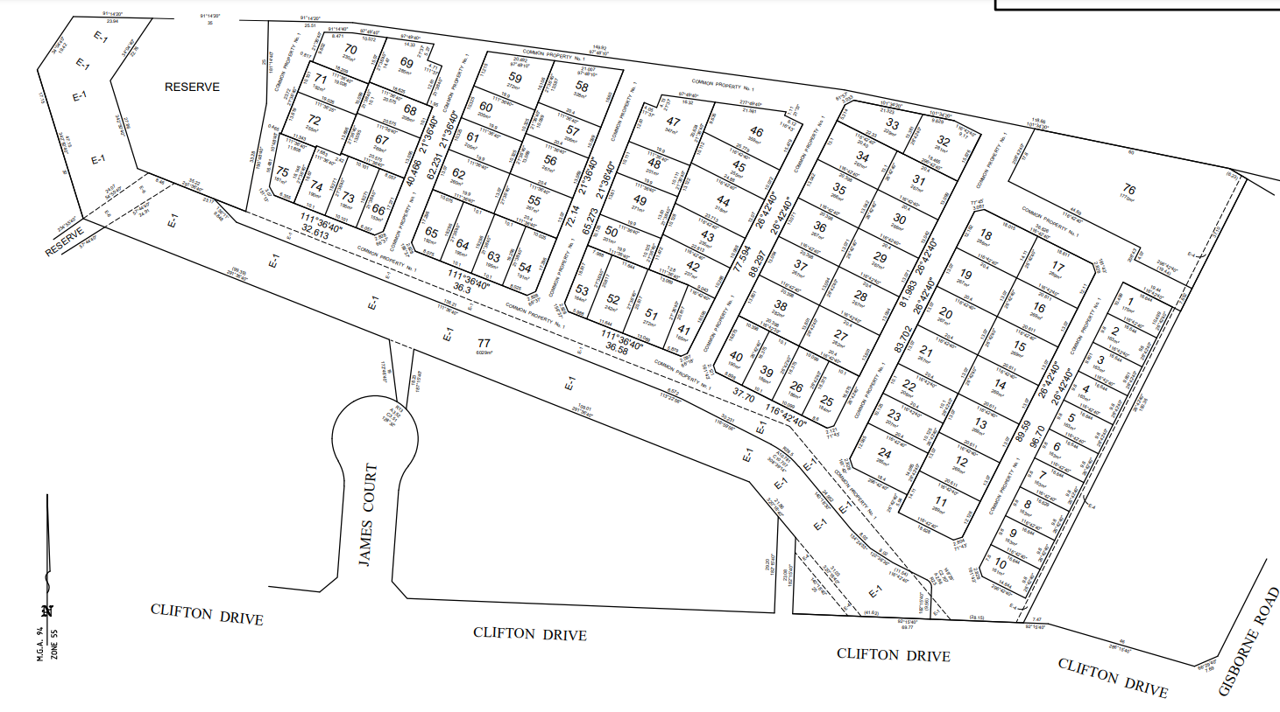
Figure 4: Proposed Subdivision Layout
The subdivision consists of lots ranging from 163sqm to 359sqm to align to the proposed townhouse development shown in Figure 4 above.
The road layout is proposed with 5.5m carriageway widths as shown in the cross-section excerpts below:
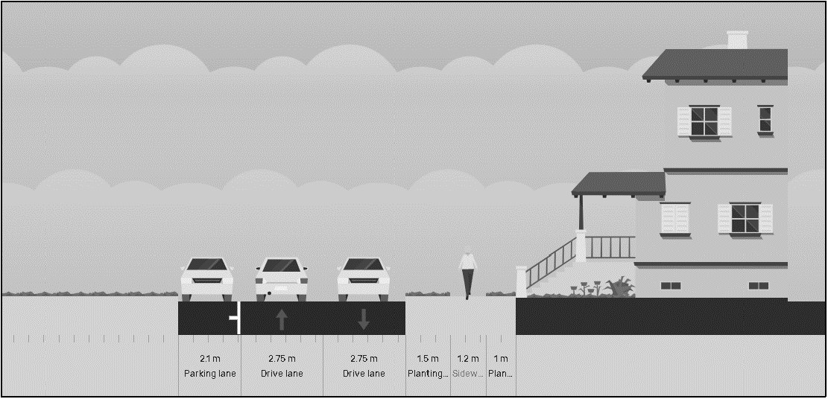
Figure 5: Major road cross section (Excerpt from One Mile Grid TIA, 2020)

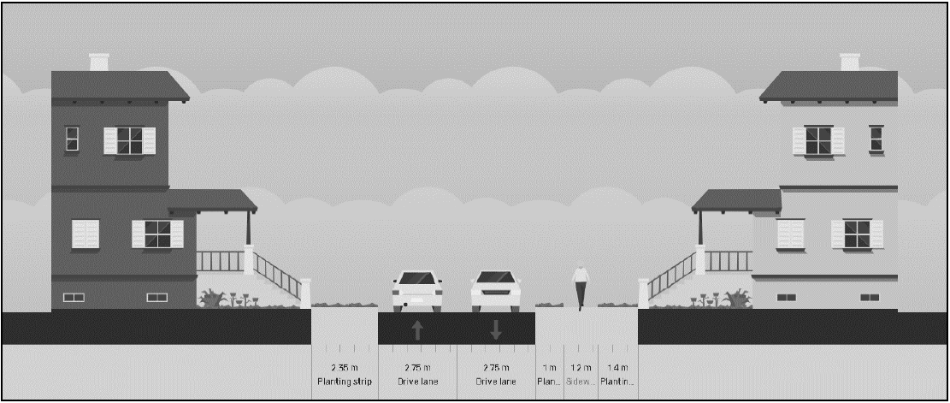
Figure 6: Minor road cross-section (Excerpt from One Mile Grid TIA, 2020)
An owner’s corporation arrangement is proposed to manage the site and the proposal seeks to provide unfettered access to the general public and no gates or restrictions will be imposed. The body corporate roadways will reduce infrastructure costs and the applicant expects that the houses will be able to be delivered at a price achieving affordable housing thresholds and enabling first home buyers and lower income households to purchase in an area that is close to services and the town centre.
A Superlot is proposed at the north east corner of the site is 1.912sqm and adjacent to the Freeway on ramp. The application states that the super lot will be developed for higher density development or a mixed-use outcome.
The submitted application expects that the Superlot can accommodate between 12-13 apartments subject to a future planning permit. An indicative building footprint is shown in Figure 3.
The development is proposed in five stages with Stage 1 consisting of the first 17 units and the super lot adjacent to the approved service station site east of the subject site.
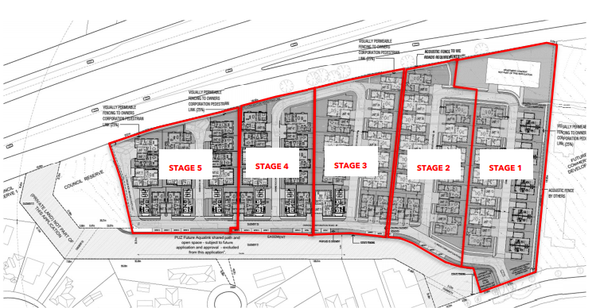
Figure 7: Indicative Staging Plan

Background to Current Proposal
The application was lodged on 13 August 2020 for 46 dwellings and staged subdivision, creation and variation of easements as shown the Figure 8.
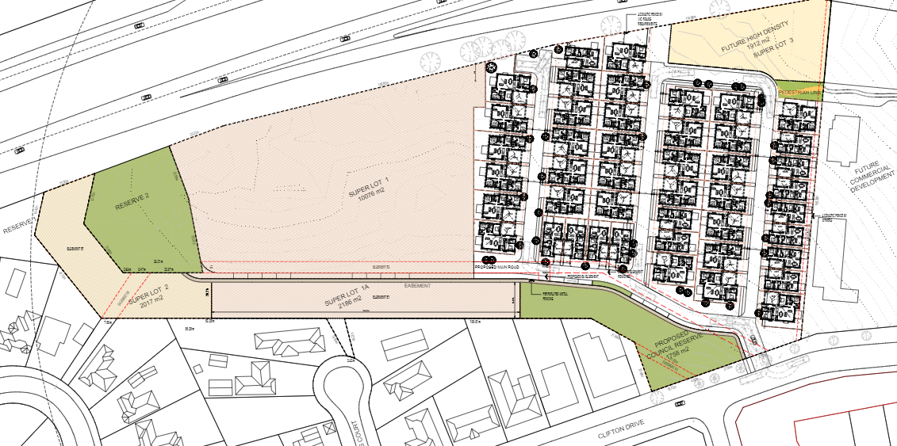
Figure 8: Original proposed development

Further information was requested on 9 September 2020 requesting several items to support the proposal, including:
• Improving housing diversity (to provide a mix of housing typologies), site responsiveness, establish innovative and unique development and enhance the character of the precinct, promote liveable design guidelines.
• The intention of future Superlots were questioned.
• Environmentally Sustainable Design measures.
• Landscape master plan.
• Continuity of shared paths on either side of roads.
• Open space maintenance.
• Questioned improvements towards open space connectivity proposed to the Freeway Underpass (Lerderderg Track).
• Permission from beneficiaries of the various easements covering the site.
• Questioned suitability of the proposed land uses in these areas.
• A plan showing clarity on the ultimate layout of the retained easement E-5 which is benefited by Council.
• Full road reserve cross sections for the internal road network to ensure adequate space is provided for footpaths, streetscaping and the carriageway. The proposed 5.5m carriageway will not support the ingress and egress of vehicles and on-street car parking.
• Stormwater Management Strategy and Signalised and Unsignalized Intersection Design and Research Aids (SIDRA) data being required prior to assessing traffic impacts, clarity on the 2019 values in the Traffic report.
• Clarity on the planned process for generally restricting public from entering the body corporate property. If public is allowed, it would be considered that Council will face maintenance issues. If public is not allowed, then this will impact the use of the Lerderderg Track and Council’s Reserves to the west of the site.
• A plan detailing existing services and utilities on site (especially the SRW irrigation main) so the impact of the development can be accessed.
• Urban Design Guidelines Assessment.
• Clear design response of neighbourhood character and site description including any infrastructure and how the development responds. A design response was submitted but did not provide detail on how the development responds to the surrounding neighbourhood.
• Show integration of dwellings with the streetscape and open spaces to better activate open spaces.
• Orientate dwellings for energy efficiency i.e. more north south facing habitable spaces in dwellings.
• Clarity of variations required in the Clause 55 assessment, the submitted report requests variations to ResCode on site coverage and permeability, however it did not provide any further detail or assessment on it.
• Create a permeable road network limiting court bowls; an access road along the eastern boundary; and provide adequate visitor car parking.
• Meet decision guidelines to show opportunities for adequately sized open space and setbacks for the retention and growth of existing and new canopy trees.
• Amend the Waste Management Plan to consider “Recycling Victoria” policy and transition to four kerbside bins, adequate space on road frontages for each dwelling to place bins 1m apart. Submitted to Council was the Waste Management Plan for Melton City Council A-Z guidelines to Waste and Recycling.
The applicant submitted a response on 7 December 2021 which provided some positive changes and included the provision of dwelling diversity by incorporating 34 two bedroom dwellings and 41 three bedroom dwellings. The revised plans revealed activation of the dwellings towards the internal street network and landscaped areas along the eastern boundary. It also included a loop road towards the northern boundary to allow for further permeability of the street layout.
Additional discussions were held between Council officers and the applicant. At the applicant’s request, the application was sent to advertising, whilst a re-referral to relevant agencies and assessment of the further information response was being conducted by Council officers.
Overall, the planning officer held more than 15 consultation meetings with internal and external agencies and the applicant, along with written communication that was sent to each party involved in the application. Most discussions were based on issues listed above which were included in the request for further information but mainly on the future cycle corridor, public open space contributions, body corporate arrangement and its suitability based on location and access, road network, SRW easement (water pipe) and internal amenity design considerations.
After referral agencies and Council officers assessed the RFI response and after a number of consultation meetings and the applicant’s request for meetings, Council officers requested information from the applicant to support the requests made on provision of public open space, drainage strategy, visitor car parking. However, to date, the applicant has not provided any further formal response or amended documentation other than what was received on 7 December 2020. Therefore, the assessment and all comments from referral agencies below are based on the plans submitted on 7 December 2020.

History
Amendment C71 to the Moorabool Planning Scheme proposed to rezone the subject site and adjoining land to the west from the General Residential Zone and Public Use Zone (Service & Utility) to the Commercial 2 Zone. In conjunction with the rezoning a planning permit application to use and develop the site for a 13,000sqm trade supplies and restricted retail premises including Bunnings Warehouse as the anchor tenant.
The Amendment and permit application were exhibited in August and September 2015 and 196 submissions were made to Council raising key issues including the location/economic impacts, traffic, neighbourhood character, residential amenity, and other strategic considerations. On 25 November 2015, Council considered the submissions and resolved to abandon the Amendment.
Amendment C79 to the Moorabool Planning Scheme was gazetted on 15 November 2018 and
implemented the findings of Housing Bacchus Marsh to 2041 to establish the direction for future residential development in Bacchus Marsh. Council had intended for 101 Gisborne Road to be included within the General Residential Zone, Schedule 2 (Neighbourhood and Greenfield Residential Growth Areas), consistent with surrounding residential land.
However, further to a submission made to the Amendment and discussions between the land owner and Council, it was agreed with the Planning Panel’s support to include the subject site in the General Residential Zone, Schedule 3 (Increased Residential Growth Areas) in recognition of its strategic merits to support diverse housing choices in a location proximate to existing services and infrastructure.
Planning permit PA2019109 was issued on 11 March 2020 directly east of the subject site, for the Development and Use of a Service Station and two Convenience Restaurants, Display of Signage, Three Lot Subdivision and Creation of access to a Road Zone, Category 1 at 101 Gisborne Road, Bacchus Marsh. The development approved under this permit is currently under construction.
The current application was appealed to VCAT on Council’s failure to determine within the prescribed time. VCAT have set an appeal hearing date for 18-20 August 2021.

Public Notice
The application was notified to adjoining and surrounding landowners.

Summary of Objections
At the time of writing the report, Council received 84 submissions objecting to the development. The objections received are summarised below, with the officer’s comments accompanying them:
Objection | Any Relevant Requirement
Traffic Congestion and Infrastructure (multiple submissions received) | Clauses 18.02-3S & 65.01.
Officer’s Response:
The objections about traffic were discussed with Council’s Infrastructure who had several concerns about the proposal and are further discussed further in this report.
Council consulted with VicRoads who stated that based on the conclusions from the TIA, no road upgrades were required to Clifton Drive and Gisborne Road.
Objection | Any relevant requirements
The proposal is not in keeping with the surrounding neighbourhood character and scale of existing development. | Clauses 13.07-1S, 15.01-1S, 15.01-5S, 21.03-4 & 21.07-6.
Officer’s Response:
The proposal does not appropriately respond to the surrounding built form and landscaping existing in this area which is discussed further in the Discussion section of this report. The site is identified towards increased residential housing but not at the expense of limited walkability, cyclability, landscaping and responsiveness towards the surrounding built environment.
Objection | Any relevant requirements
Loss of on street parking spaces in Clifton Drive. | Clauses 52.06 & 65.01.
Officer’s Response:
No information was provided on the loss of parking on Clifton Drive brought upon by the entrance and how this would impact the community and where this offset would be provided.
Objection | Any relevant requirements
Application claims affordable housing will be developed but little information provided to support this statement. The body corporate rates and fees and maintenance will not be considered affordable. | Clause 16.01-2S housing affordability
Officer’s Response:
The applicant discussed that the expectation is that the dwellings will be priced at an affordable level but no formal evidence was provided to state that the housing is appropriate to the needs of a range of very low to moderate households and priced so that these households are able to meet other essential basic living costs.
Objection
The site should be used for community recreational facilities | Clause 21.05-2.
Officer’s Response:
The site is identified for increased residential growth in the Housing Bacchus Marsh to 2041 Strategy.
Objection | Requirements
Car parking | Clause 52.06
Officer’s Response:
Adequate car parking is provided in accordance with the scheme requirements as discussed in the particular provisions section of the report. However, the location of visitor car parking is not permitted and requires amendments which have not yet been proposed to Council other than in consultation meetings. The layout would need to be modified to provide the required visitor car parking.
Objection | Requirements
Overdevelopment of the site
Officer’s Response:
The site is identified for increased residential growth in the Housing Bacchus Marsh to 2041 Strategy. However, it is still considered as an overdevelopment of the site because the of the increased demands on infrastructure and services. It is also considered that it will impact on internal and surrounding amenity levels with limitations around the movement network, decreased liveability, and greater adaptations towards changing neighbourhood character as mentioned in this report.
Objection | Requirements
Safety, social and domestic problems | Clause 11.03-2
Officer’s Response:
Lighting has been provided along the northern landscaped footpath along the Freeway. Where dwellings are proposed, Council cannot predict the social issues that may occur.
Objection | Requirements
Low standard liveable housing design guidelines | Clause 21.06
Officer’s Response:
The applicant did not provide any information which was requested to elaborate further on how liveable standards are achieved based on the guidelines. The development is not considered to be affordable housing. Affordable Housing is normally targeted for those who are part of a very low or moderate income household.
Objection | Requirements
Restricted access for services – waste management and emergency services | Clause 13.02-1S, Clause 56.06-7
Officer’s Response:
Council raised concerns about the movement network and widths of proposed roads to ensure that all emergency, delivery, and waste vehicles can easily access the site. The applicant stated that private vehicles will be used for waste removal. No information was provided on the emergency and delivery vehicles.

Locality Map
The map below indicates the location of the subject site and the surrounding area.

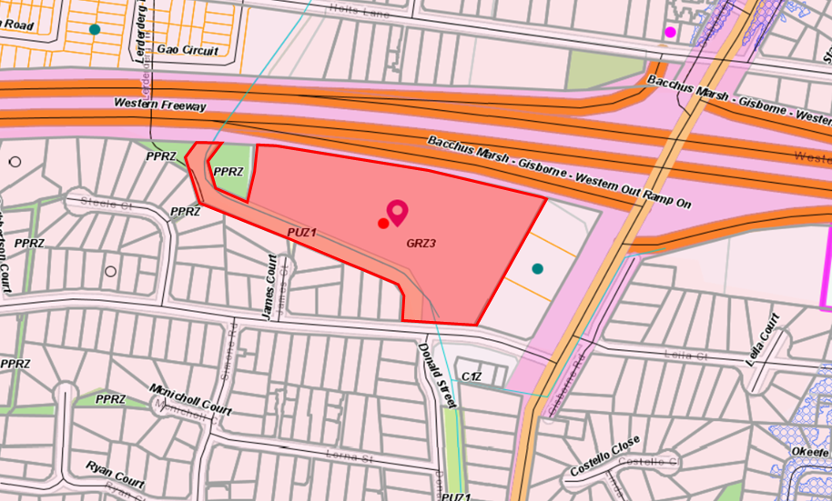
Figure 9: Zone Map

Planning Scheme Provisions
Council is required to consider the Victoria Planning Provisions and give particular attention to the Planning Policy Framework (PPF), the Local Planning Policy Framework (LPPF) and the Municipal Strategic Statement (MSS).
The relevant clauses are:
• Clause 11.01-1R Settlement – Central Highlands
• Clause 11.02-1S – Supply of urban land
• Clause 11.02-3S – Sequencing of development
• Clause 11.03-2S – Growth Areas
• Clause 15.01-1S – Urban Design
• Clause 15.01-2S – Building Design
• Clause 15.01-3S – Subdivision Design
• Clause 15.01-5S – Neighbourhood Character
• Clause 15.02-1S – Energy and resource efficiency.
• Clause 16.01-1S – Housing Supply
• Clause 18.02-4S – Car parking
• Clause 19.02-5S – Emergency services
• Clause 19.02-6S – Open Space
• Clause 19.03-3S – Integrated Water Management.
• Claus 19.03-4S – Telecommunications
• Clause 21.03 – Settlement and Housing
• Clause 21.07 – Bacchus Marsh
The proposal does not comply with the relevant sections of the PPF and LPPF clauses outlined in the table below:
PPF | Title | Response
Clause 15.01-1S | Urban Design | The proposal does not respond to the surrounding neighbourhood character nor facilitate accessibility.  The proposal does not support the public realm amenity and does not promote safe access to walking and cycling environments and public transport.  The publicly accessible private spaces including car parking areas, footpaths do not create a safe environment for users and does not enable easy and efficient use.  The proposed landscaping does not prove longevity of tree planting as narrow streetscapes are proposed and vegetation may not be sustainable with the limited space available for its growth and development.  The site is highly visible from transport corridors and does not promote good urban design principles.
Clause 15.01-2S | Building Design | The development does not respond to the development of neighbouring properties in terms of form, scale, and appearance towards enhancing functionality and increasing amenity for surrounding and future residents of the site. Some dwellings are proposed with no toilets on the ground floor which may not be suitable for those with disabilities. The development does not provide safe access and egress for pedestrians, cyclists, and vehicles.
Clause 15.01-3S | Subdivision Design | The subdivision is proposed with increased traffic movements internally which impose on functionality, safety, and accessibility. Furthermore, this clause makes provision to enable energy efficient utilities and services but no evidence to show energy efficient methods of subdivision development were provided.
Clause 15.01-5S | Neighbourhood Character | The development does not respect the pattern of the local urban structure and surrounding subdivisions.
Clause 15.02-1S | Energy and Resource Efficiency | The development has limited cooling areas across the site considering the site’s net developable area. The urban heat island effect is not adequately addressed through the development.
Clause 18.02-4S | Car parking | The location of the visitor car parking is along a SRW water pipe easement and is not permitted.
Clause 19.02-5S | Emergency Services | The proposed movement network does not provide ample road widths for emergency and service vehicles.
Clause 19.02-6S | Open Space | The proposal does not provide usable public open space integrated within the development or positioned to ensure the best usage by future residents. They cannot rely on the aqualink as they have removed it from this proposal.
Clause 19.03-3S | Integrated Water Management | The proposed drainage plans do not support the current layout proposed and leads to potential flooding risks to the adjacent properties. The proposed Superlot could hold a drainage pit and has the potential to form a functional drainage basin to mitigate flood risks. This lot would need to be removed from the development.

LPPF

Clause 21.03-3 | Settlement and Housing - Residential development | The proposal does not provide evidence of Environmentally Sustainable Design principles to reduce the cost of living and improve liveability.
Clause 21.03-4 | Settlement and Housing -Landscape and neighbourhood character | The development does not enhance the existing built form and does not respects its landscape setting.
Clause 21.07-6 | Urban Design | The design does not allow adequate space in terms of width for new tree plantings to survive.

Zone
The subject site is zoned General Residential Schedule 3 (GRZ3) and Public Use Zone Schedule 1 (PUZ1)
The purpose of the General Residential Zone is:
• To implement the Municipal Planning Strategy and the Planning Policy Framework.
• To encourage development that respects the neighbourhood character of the area.
• To encourage a diversity of housing types and housing growth particularly in locations offering good access to services and transport.
• To allow educational, recreational, religious, community and a limited range of other non-residential uses to serve local community needs in appropriate locations.
The neighbourhood character objectives included in the GRZ3 include:
• To encourage new development, including innovative and unique development that enhances and responds positively to the existing neighbourhood character.
• To encourage sufficient front setbacks to allow for enhancement of the front garden character including increasing canopy tree plantings.
• To encourage new development to have minimal or low scale front fencing.
• To ensure new garages and carports do not dominate dwellings or streetscapes.
The purpose of Public Use Zone
• To implement the Municipal Planning Strategy and the Planning Policy Framework.
• To recognise public land use for public utility and community services and facilities.
• To provide for associated uses that are consistent with the intent of the public land reservation or purpose.
Under Clause 36.01- 6 Schedule 4 is for the purpose of service and utility.

Overlays
There are no overlays affecting the site.

Relevant Policies
Housing Bacchus Marsh to 2041
One of the objectives of the Strategy is to:
‘Provide a clear direction and policy guidance to enable orderly growth, managed change and retention of key elements of character including neighbourhood character mapping and character precinct brochures.’
The site is specifically set aside within Precinct 15 of the Neighbourhood Character Strategy formulated by the Housing Bacchus to 2041 study. Precinct 15 is predominantly identified for “Natural Residential Growth”. A “Natural Residential Growth Area” applies to residential land that has been identified for natural change over time. Appropriate well designed, infill development, including multi-unit developments that complement the preferred character of the area, while providing for a variety of housing options will be encouraged in suitable locations.”
However, the subject site was specially identified by the Planning Panel during the Amendment C79 process, for “Increased Residential Growth” which “generally applies to residential land that is well located to services and facilities and has been identified as suitable for infill and increased densities of development. This will include a range of multi units, townhouses and alternative housing options within a walkable catchment of residents daily needs.”
The Planning Panel considered that the site is a “large undeveloped parcel in a central location that has the potential to be developed with a diverse range of housing products that would assist in providing housing choice in Bacchus Marsh, which is the key objective of the strategy”.
The Preferred Character Statement for this site in Precinct 15 gives direction to the following:
• The site presents a significant opportunity to improve housing diversity in Bacchus Marsh and is recognized as a strategic redevelopment site.
• Innovative and unique development that enhances the character of the precinct and broader area is encouraged.
• Development should be site responsive and ensure aesthetically pleasing interfaces to the Western Freeway, Gisborne Road and Clifton Drive.
Though the proposal is for increased residential housing it is not considered to enhance the existing character of the neighbourhood which are formed with larger blocks that are fully landscaped with ample front setbacks and private open spaces.

Particular Provisions
Clause 52.06 Car Parking
Under Clause 52.06-5 a Dwelling requires one car park to each one or two bedroom dwelling permitted or two bays for every three bedrooms or more (with studies or studios that are separate rooms counted as bedrooms), plus one for visitors for every five dwellings.
The table below represents the car parking requirements for the proposed development i.e. 75 dwellings.
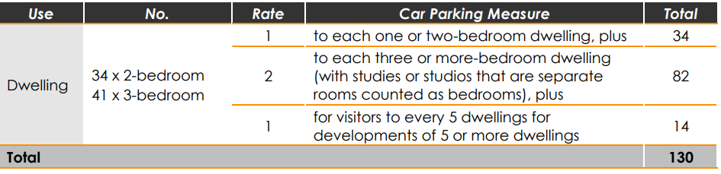
Table 1: Excerpt from One Mile Grid Traffic Impact Assessment dated 7 December 2020.
The car parking rates are adequate however the location of visitor car parking was questioned. The garages attached to the proposed dwellings provide the required car parks.
The visitor car parking is proposed on the SRW easement and is not permitted. The proposed Traffic Impact Assessment shows excess/informal visitor car parking along the carriageway in addition to those provided along the SRW easement. Car parking along the carriageway is not supported by Council officers as it causes additional traffic and congestion including safety issues caused when cars queue to pass the visitor car parking. It will lead to negative impacts on both traffic movement and pedestrian activity.
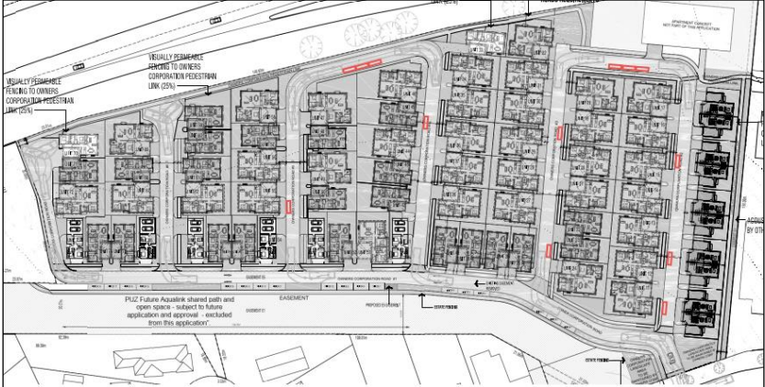
Figure 10: Excess/Informal Visitor car parking (red boxes in common property area) – excerpt from One Mile Grid Traffic Impact Assessment dated 7 December 2020.
The car parking loss on Clifton Drive of two kerbside bays has been assessed by Council’s Infrastructure who had no issue with the loss of on street car parking. The TIA shows additional space along Clifton Drive to allocate car parking.
Clause 52.29-2 Land Adjacent to a Road Zone
The purpose of this particular provision
• To ensure appropriate access to identified roads.
• To ensure appropriate subdivision of land adjacent to identified roads.
Under Clause 52.29-2 a permit is required to subdivide land.
Clause 53.01 Public Open Space Contribution and Subdivision
A person who proposes to subdivide land must make a contribution to the Council for public open space in an amount specified in the schedule to this clause (being a percentage of the land intended to be used for residential, industrial or commercial purposes, or a percentage of the site value of such land, or a combination of both). If no amount is specified, a contribution for public open space may still be required under section 18 of the Subdivision Act 1988.
It is recommended that, if a permit be issued, a contribution equivalent to 5% of the site value be imposed as a condition of approval.
Clause 53.18 Stormwater Management in Urban Development
Any urban development must have the purpose to ensure that stormwater, including retention and reuse is managed to mitigate the impacts of stormwater on the environment, property, and public safety and to provide cooling, local habitat, and amenity benefits. The applicant submitted a Drainage Strategy report dated July 2020 which was referred to the relevant authorities. Council’s Infrastructure Department requested further information to provide evidence to mitigate flood risks to neighbouring properties. For the minor system (10-year event), all the water is collected in the infrastructure and discharges at the legal point of discharge at the north east corner of the site as shown in Figure 12. Anything more than a minor event being 10 years or more, will cumulatively discharge towards the bend of the proposed road at the north east corner leading towards the proposed footpath which links towards the neighbouring property therefore inconsistent with Clause 56.07-4 Stormwater Management as they need to provide safe overflows up to the 1:100 year event.
No additional information was provided to Council, after numerous discussions took place with the applicant about the issues relating to the drainage flows.
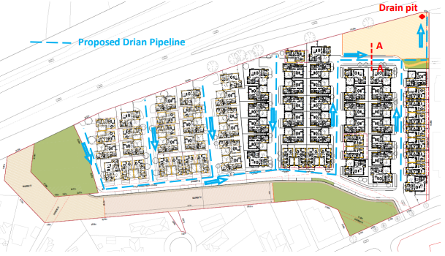
Figure 11: Overland flow path (excerpt from the Drainage Strategy Report dated July 2020)
Council’s Engineering stated that 10% post development flows have to be less than or equal to the 20% predevelopment flows. A safe mechanism to discharge the overtop on site detention has not been provided to manage the overland flows.
During consultations, the applicant and owner of the land stated that they have a channelling system to manage overland flows, but this was not submitted to Council. The applicant proposed, during consultations, that a revised drainage solution was prepared which shows overland flows towards the Western Freeway and stated that VicRoads was already aware of this. Council officers made contact with VicRoads who did not receive any drainage plans other than the Drainage Strategy Report dated July 2020 which was submitted to Council with the applicants RFI response and re-referred to the relevant authorities.
No revised drainage plans were received.
Clause 55:
The proposal does not comply with the clauses outlined in the table below:
Clause ResCode | Title | Response
55.02-1 | Neighbourhood Character | The proposal does not respond to the features of the site and the surrounding area, especially considering the narrow access point from Clifton Drive, sensitive interfaces with spaciously landscaped low density existing residential development south of the site and a future petrol station east of the site. Furthermore, it fails to provide a transition from the existing neighbourhood character to the proposed. The Lerderderg Track/SRW easement provides a buffer between the existing residential developments south of the site and the proposed. However, the proposal fails to respect the existing character from a visual bulk, built form and landscaping perspective. The proposed plans showing the development and landscaping of the site excludes the SRW easement from the permit area, however the proposed plan of subdivision includes this land as the 77th lot within the subdivision.  The existing neighbourhood character is evident showing large setbacks, increased landscaping within the front setbacks and footpaths on both sides of the street.
Clause 55.02-2 | Residential Policy | The proposal partially meets this clause as it is in keeping with the Housing Bacchus Marsh to 2041 Strategy where increased residential growth is preferred but noting that:  ’innovative and unique development is preferred which enhances the character of the precinct and the broader area. The site must be developed with a site appropriate response and ensure aesthetically pleasing interfaces to the Western Freeway, Gisborne Road and Clifton Drive.’  The proposal must be assessed not only on higher density but also how the density enhances the character of the precinct and broader area. This site is limited with the following:  • One access point from Clifton Drive.  • No train station within a walkable catchment (400m) but has one bus stop on Gisborne Road.  • No high activity land uses to support the proposed high-density development within a 400m walkable catchment.  • Located on an irregular shaped site making it difficult to develop housing as proposed.  • The site has a drainage pit and natural fall leading to offsite flood risks that have not been mitigated.  • The site is sensitive to the Freeway (north), Service Station (east), Open Space (west), SRW easement/future cycle corridor/residential development (south).  Based on some of the features the site holds and its surrounding character, the proposal poorly responds to the above. This is also explained further within the report.
Clause 55.02-4 | Infrastructure | The proposal will impose traffic pressures onto Clifton Drive and the Gisborne Road intersections. The development has failed to provide functional drainage solutions to mitigate overland flows. The body corporate arrangement and lack of information limits the assessment of the proposal against the functionality of adequate infrastructure and services to increase the amenity of future residents who will reside in the proposed development.
Clause 55.02-5 | Integration with the street | The intention of this standard is in part, to provide adequate vehicle and pedestrian links that maintain or enhance local accessibility and high fencing in front of dwellings should be avoided. Due to the irregular shape of the land, some of the units along the northern boundary will face the future acoustic fence. The applicant was made aware of this and was requested to setback the dwellings or provide a road towards the north to act as a buffer. However only 2m is provided from the northern boundary Freeway Interface to the closest proposed dwelling, more specially identified on the plan as Dwelling Unit 33.  The proposal should also complement and enhance open space where developments are proposed adjacent to open space. The development is proposed with a court bowl next to the Council’s reserve which will cause ad hoc car parking by residents and visitors especially due to the limitations proposed with visitor car parking. However, the proposed dwellings do front the reserve to activate the reserve.
Clause 55.03-3 and Clause 55.03-4 | Site coverage and permeability | The site coverage identified on the plans is 38.8% however after reviewing the plans, the net developable area and permit area should also be considered when assessing the protection of amenity and character of surrounding neighbourhoods and the intent of this standard. There is limited evidence on the plans to identify that garages and dwellings have been included in the calculation.  Based on the area schedule provided on the plans as shown below, the calculations provided are not seemingly accurate e.g. the Type 2 Dwelling is approximately 191sqm, three bedrooms and single storey and the area schedule on the plans state that the garage and dwelling combined is 183sqm but the lot area as 166sqm, this is not considered to be accurate and therefore the overall site coverage calculation has not been accurately provided.  Similarly, permeability calculations can be questioned as stated above.
Clause 55.03-5 | Energy Efficiency | Though some of the proposed living areas face north, the orientation of most of the dwellings are east west facing therefore not orientated to make appropriate use of solar energy efficiency. The decision guidelines are in part determined by the size, orientation and slope of the lot and the proposed site is considered to have the ability to cater for lots and buildings orientated to receive greater energy efficiency.
Clause 55.03-8 | Landscaping | The proposal provides limited space for landscaping that would enhance and complement the character of the area. The landscape plan shows trees to be planted however the narrow spaces provided for landscaping does not encourage the retention of mature vegetation on the site.
Clause 55.03-10 | Parking location | The proposed visitor car parking is located along the SRW easement without SRW support. This requires other visitor bays to be provided along the road carriageway. With the narrow road reserves proposed, residents will find it inconvenient to queue when visitors are parking along the road reserve.
Clause 55.04-8 | Noise impacts | Dwellings along the eastern and northern interface will face noise impacts from both the service station site and the Western Freeway. It has been partially addressed via conditions in the approved permit for the service station and conditions from VicRoads on the northern boundary.
Clause 55. 05-4 | Private open space | The proposal is inconsistent with the objectives and intent of this Clause. It does not have usable and secluded private open spaces accessible to living areas for all units.  It does not contribute to the existing nor preferred character for this site. Narrow private open space are provided limiting the usage of these spaces for the future residents. The POS to Type 6 Dwelling typologies does not comply with the standard.
Clause 55. 05-5 | Solar access to open space | Type 5 Dwellings require 6.14m setback from the southern boundary of the secluded private open space to the dwellings north of the open space. However, only 4.7m is proposed therefore providing inadequate solar access to open space. For type 6 dwellings, 7.4m setback is required and one 2.1m is proposed.
Clause 55. 05-6 | Storage | A minimum of 6 cubic metres is required. The application did not identify the measurements of each storage area.
Clause 55.06-3 | Common property | The subject site is a fundamental link in that it connects public open spaces in Bacchus Marsh and surrounds and will need to be easily accessible to all surrounding residents and visitors. The proposal however incorporates common property of which will be maintained by a formal body corporate comprising of the future residents within the subject development. This poses several concerns because if public will be regularly utilising the common areas, it will pose burdens on future residents of the subject site. Additionally, the design and layout of the development is likely to lead to issues such as lack of maintained landscaping, internal car parking along the carriageway, traffic congestion, inaccessibility of waste, emergency, and service delivery vehicles.
Clause 55.06-4 | Site services | The proposal does not adequately address the storage of bins. Council questioned the landowner and the applicant on the waste removal however it was proposed that private waste collection will take place on the site in front of each unit as shown in the waste management plan dated December 2020.  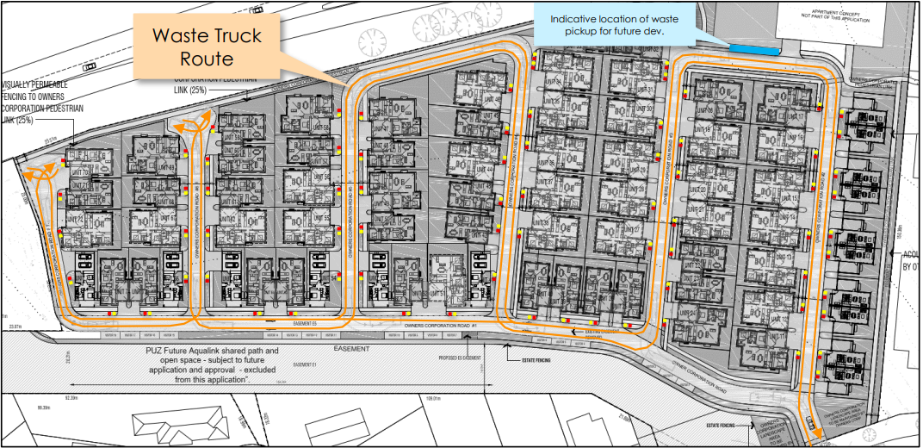  Figure 12: Bin collection spots

The proposal does not comply with the following ResCode Clause 56:
Clause ResCode | Title | Response
Clause 56.04-2 (C8) | Lot area and building envelopes objectives | All Lots are not provided with minimal space to enable adequate solar access, private open spaces, vehicle access and parking, water management, and the retention of significant vegetation for each future resident.
Clause 56.04-3 | Solar orientation of lots | The subdivision is not designed to provide at least 70% of the lots for appropriate solar orientation.
Clause 56.04-5 | Common area objective | The purposes for the proposed common area proposal was not adequately addressed by the applicant. No further management arrangements including maintenance standards for streets and open spaces to be commonly held was provided to the Council. As shown in Figure 16 below, the common area includes roads, pedestrian footpaths and landscaping which will be regularly used by both the body corporate and the general public due to the strategic location of the site which holds a close connection to a future cycle link and Council’s reserve.  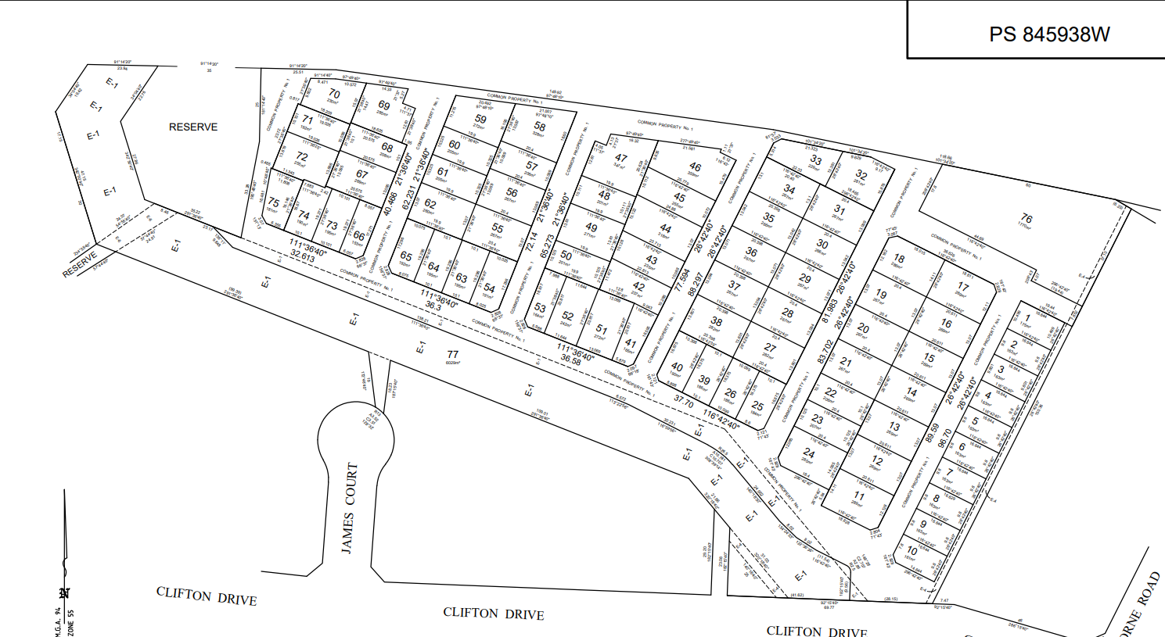  Figure 13: Subdivision Plan (proposed)
Clause 56.06-2 | Walking and cycling network | The proposal does not provide for walkability on both sides of the internal road network, which further limits the accessibility level for people with disabilities.
Clause 56.07 -4 | Integrated Water Management | The proposed drainage plans are not accepted by Council’s Infrastructure. The proposal suggests a wetland or retarding basin at the drainage pit location in the north east corner and a northern road alignment to eliminate the potential flooding risks to the adjacent properties. However, the plan provided incorporates retarding basins within the road reserve, which is not an acceptable outcome.

Clause 56.06-4 | Neighbourhood street network | The proposed TIA, which states that traffic surveys were not conducted but traffic volume surveys were previously undertaken based on the September 2019 nationwide Traffic Survey. This is the only point of reliance to support the traffic impacts, risks, and levels of congestion. Council requested further information on this however based on the evidence provided, the traffic assessment is not considered to be measuring the proposal purposefully and consider the wide impacts to surrounding infrastructure.
Clause 56.06-8 | Lot access | The footpaths in the proposed layout are shown as 1.2m. However, the TIA submitted states that access place requirements for all internal streets should provide for 1.5m footpaths.

Discussion
Neighbourhood Character and Residential Policy
One of the most fundamental discussion points, concerns from referral agencies and resident objectors have been around neighbourhood character. Practice Note 43 developed by the Department of Environment, Land, Water and Planning provides enough guidance to assess applications against neighbourhood character. This including the Bacchus Marsh Housing Strategy to 2041, Amendment C79 and planning scheme provisions were used to assess this application against neighbourhood character.
Amendment C79 was intended to implement the findings of Housing Bacchus Marsh to 2041 in part to rezone various established areas to either Neighbourhood Residential Zone (NRZ) or General Residential Zone (GRZ).
The Housing Strategy was developed with the objective to capture key aspects of housing supply and demand, identify housing stock diversity and how they are achieved, direct orderly growth, manage change and retain neighbourhood character mapping and character precinct broachers, in part of other objectives to meet housing demands close to existing jobs, services and transport and reduce the demand for new infrastructure on the fringe to work towards 20 minute neighbourhoods.
More importantly, this subject site is identified in the Housing Strategy as an increased residential growth area informing the General Residential 3 Zone. The Increased Residential Growth Area is defined as:
“Generally applies to residential land that is well located to services and facilities and has been identified as suitable for infill and increased densities of development. This will include a range of multi-units, townhouses and alternative housing typologies within a walkable catchment of residents daily needs.”
The definition is generalised as it “generally applies to residential land….” and provides flexibility in the assessment of neighbourhood character based on the methodology to determine the locations of Increased Residential Growth Areas by the Housing Strategy. Therefore, it was the intention of the strategy to locate increased residential growth in precincts that are:
• Within walkable catchment of the Bacchus Marsh Railway Station/and/or bus services. Walkable catchment is accepted across all strategic plans in Victoria as 400m. Though the site is close to bus services the railway station is more than 2kms away from the site limiting walkability.
• Precincts that are generally within close proximity to activity centres or where access to some level of services and facilities are within a walkable catchment (i.e. Bacchus Marsh Town Centre, Darley Plaza, the proposed Activity Centre in the Stonehill development, Maddingley and the shopping strip on Grant Street). The Darley Plaza is about 700m away from the site and the Bacchus Marsh activity centre is more than 1km away from the site.
However apart from this the Housing Strategy also provides community engagement feedback which resulted in signifying that, “where increased housing density is proposed the MSS should include strong provision for protection of neighbourhood character and heritage values of the neighbourhood, not just a few select buildings”.
It also provides this Increased Residential Growth Area preferred statements:
• To encourage new development, including innovative and unique development that enhances and responds positively to the existing neighbourhood character.
• To encourage sufficient front setbacks to allow for enhancement of the front garden character including increasing canopy tree plantings.
• To encourage new development to have minimal or low scale front fencing.
• To ensure new garages and carports do not dominate dwellings or streetscapes.
Officer’s assessment of the proposal considers it to be inconsistent with the purpose of the GRZ3, as discussed because of the following:
• The proposed development is not considered to respond positively to the surrounding interfaces including the existing character of the neighbourhood. As suggested in Practice Note 43, neighbourhood character is also assessed against the pattern of development, built form, scale, architectural roof styles and other notable features. It is also determined by the neighbourhood character statement for Precinct 15 relating to both natural and increased residential growth which is also described further in the “relevant policy” section of this report. The discussion below on the interfaces of the site will provide further detail on the suitability of the design approach taken in the proposal.
• The development consists of smaller lots and increased built form adding visual bulk to the internal streetscape, the proposed garages also dominate the streetscape.
• The development does not encourage an increase in canopy tree plantings as it provides lack of front setbacks.
Eastern Interface
The eastern interface is present of an approved service station and restaurant. This development is currently being constructed and has the obligation to include a 2m high acoustic fence adjoining the service station. The applicant was requested to provide a road along the eastern boundary however a 1.5m owners corporation footpath and 2m landscaping strip is proposed along the eastern boundary. The proposed housing development is setback 3m from their proposed site boundaries. The proposed footpath along the eastern boundary provides pedestrian access to Units 1 – 10’s secluded private open spaces. The amenity of the future residents along this interface is comprised considering that their secluded private open spaces and living areas face east.

Southern Interface
Future Cycle Corridor (Aqualink)
Several consultations took place with Council’s Environmental Management and Infrastructure including SRW to discuss the future of the cycle corridor. This section of the future cycle corridor, that rests within the subject site is identified as Route 1 of the Strategic Cycling Corridor Network (SCCN) for Bacchus Marsh.

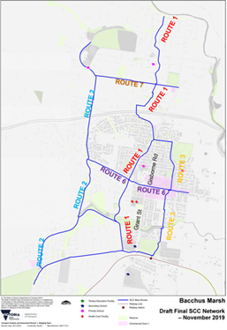
Figure 14: Strategic Cycling Network
The SCCN is a Department of Transport (DoT) identified route and is also supported in the endorsed Council documents – Bacchus Marsh Integrated Transport Strategy, Hike and Bike Strategy, Bacchus Marsh and Ballan Open Space Framework and the Bacchus Marsh Urban Growth Framework. The intention of the future cycle corridor is to provide connectivity of the existing open spaces in Bacchus Marsh and surrounding areas and to formalise the existing Lerderderg Track. This piece of land however is encumbered by a SRW easement (water pipe), owned by the developer of the proposed development and is zoned Public Open Space -Schedule 1. The applicant proposed questions to Council on whether or not the land will be considered as public open space contributions meeting the requirements in Section 18 of the Subdivision Act 1988 if it were to be handed over to Council with no development works. Council hosted several meetings with internal departments and SRW to discuss the matter as Council cannot accept encumbered land for public open space (POS) contributions.

The concept of POS contributions was then dismantled to provide enough grounds that if the land were to provide long term net community benefit towards public open space then considerations towards the land as a POS contribution can be considered by Council. In this instance, the land is encumbered and to ensure that it provides a long term net community benefit, and will need to be developed to deliver the intended strategic purpose of the land i.e. to provide a shared path and associated landscaping to form a cycle corridor that provides the network required to connect existing public open spaces in Bacchus Marsh.
Southern Rural Water Easement (E1)
SRW was consulted throughout the process and stated that no development is permitted over the easement. As discussions evolved on the amount of land required for the future cycle corridor and ownership of the easement, SRW stated that they would not object to the use of their channel reserve (now pipeline) or easement as a cycling corridor subject to a formal agreement with Moorabool Shire Council. SRW do not wish for the easement to be managed and owned by a developer/body corporate and would prefer it was managed by a public authority. Council’s plans for the cycle corridor is currently in progress, but the possible width required for the cycle corridor is 5m to allow for a 3m for the shared path and 1m of landscaping on each side.
Council Carriageway Easement (E5)
Easement E-5 is identified as Council’s carriageway easement. The applicant seeks to vary this easement with slight realignments to accommodate the proposed footpath, visitor car parking and proposed body corporate road. The access, alignment and maintenance of the road was questioned as the site is home to current public open spaces which requires suitable and adequate access to all residents in the surrounding area.
Existing Residential Development and Kindergarten
The existing residential character is predominantly low-density single storey built form on lots of predominantly around 600-900sqm. Small pockets of medium density residential developments exist which results in lots more than 300sqm. Apart from lot sizes, the most important factors is considering the proposed built form resulting in visual bulk, lack of transition from the existing neighbourhood character south of the site.
A kindergarten is located abutting the entrance of the site along Clifton Drive which poses additional burden on the ingress and egress of vehicles and associated car parking on the street. Based on current site visits, the on-street car parking is heavily utilised by the Commercial 1 Zone i.e. Bacchus Marsh Veterinary Centre across the road and the Kindergarten. The proposed crossover will result in loss of on-street car parking and will further impede vehicle movements. The development proposal has the potential for approximately 134 vehicles when calculating the number of vehicle spaces available. This results in safety concerns with the number of vehicles ingressing and egressing from one access point being Clifton Drive, particularly during peak hours.
Western Interface
Two of Council’s reserves are located along in the west also known as Reserve 1 (2,100sqm) and Reserve 2 (946sqm) on the title plan. The reserves are divided by the SRW easement (E-4) which is used as the Lerderderg Track. The preferred method of POS contribution is in the form of land and development of public open space towards achieving a net community benefit.

Northern Interface
The Western Freeway runs along the northern boundary and links to the north south facing Gisborne Road. The application was referred to DoT who provided conditions related to acoustic measures along the northern boundary. Council initially requested a loop road along the northern boundary to appropriately setback the noise and future noise wall from the future housing. Units 32 and 33 are located 2m and 3.5m from its closet point. The height of the noise wall is unknown at this stage. The landscape design proposed shows small canopy trees along the northern boundary to soften the noise wall however the landscaping strip is very narrow and may not sustain the future of canopy trees along this boundary. Two court bowls along the western portion of the north boundary are proposed thus limiting vehicle permeability.
Traffic and Infrastructure
Council’s Planning and Infrastructure provided comments and participated in all ongoing consultation meetings with the applicant and a developer. Based on the current information provided the following issues were still unresolved:
• Stormwater discharging onto neighbouring property without any easement resulting in nuisance water and possible flooding, which is also a concern raised by the neighbouring property.
• Insufficient information provided to validate how the stormwater system will function considering to the existing topography. A meeting was held with the applicant’s Engineer and they did agree to provide additional information due to it being missing from the report, however, this information was not provided. Other supporting information such as Model for Urban Stormwater Improvement Conceptualisation (MUSIC) modelling, on-site stormwater detention volumes, significant reduction in outflow caused by site constraints were not submitted for assessment.
• The road widths do not comply with the Infrastructure Design Manual (IDM) and Clause 56 provisions. No other supporting information was presented to demonstrate the functionality of the internal road layout. Swept paths were provided however this was insufficient to cover emergency and delivery vehicles. The applicant proposed a body corporate arrangement where private waste collection would be conducted, however the applicant was made aware that potential issues related to cars parked on streets, narrowing the roads for emergency and delivery vehicles.
• Traffic count inputs were never provided to validate the model and network upgrades. The report incorrectly concluded that the existing network has no issues with regards to holding times, which is not the case. The applicant agreed that they were going to provide supporting information but was not received to make a clear assessment.
• No acceptable visitor car parking was provided other than those on the SRW easement which is not supported by SRW. Some visitor car parking was discussed at consultation meetings with the applicant and developer where visitor car parking is proposed within the internal carriageway arrangement. Council is not supportive of locating visitor car parking along the proposed 5.5m carriageway as this will result in one way passing traffic internally and again reducing the overall amenity of the future residents and those visiting the site. No information was provided for the development against access, mobility, and overall movement network under Clause 56 of the Moorabool Planning Scheme. – Access Street – 5.5m carriageway with regards to their configuration widths and turning arcs. It is understood that the network would be private, but this shortfall is highlighted.
• Other traffic matters such as inputs to validate the model and network upgrades were not submitted other than a statement that the existing network has no issues with regards to holding times. Traffic model submitted did not satisfactory model the existing situation due to the model conducing the existing road network and intersection operating perfectly where in real like this is far from the care, this means that there are errors in the way the traffic is modelled. The development traffic builds on the existing model, and due to the existing model not being correct it is impossible to review the conclusions of the developments model.
Transport for Victoria (TfV) was consulted during this process and concerns were raised on traffic congestion, drainage, and acoustic barriers. However, conditions were imposed which TfV believe will ensure that the development will not adversely affect the road safety and traffic efficiency of the surrounding road network. TfV also stated that their comments were based on the information provided to them with the application i.e. the TIA and Drainage report that was submitted with the RFI response in December 2020. Swept paths were not provided to validate how the private garbage collection would be possible with the network, especially with consideration to visitor parking spaces
Vehicle queueing was evident to the Planning Officer site visits done at 11am on a weekday confirmed that Clifton Drive and Gisborne Road however the TIA provided did not provide evidence of this.
Public Open Space
Public open space contributions are required from this development in accordance with Section 18 of the Subdivision Act 1988 as the proposal will place pressures on existing public open spaces in the area. This will be recommended as a condition if this development were to be approved.
Owners Corporation/Body Corporate Arrangement
Based on the Planning Scheme, the objectives must be complied with which include the following (in part):
• Reasons why the area should be commonly held.
• Provide common areas that is appropriate and necessary management arrangements.
• Communal open space, car parking, access areas and site facilities are practical, attractive, and easily maintained.
• Avoid future management difficulties in areas of common ownership.
These matters were raised in consultation with the applicant due to Council’s concerns over the maintenance, location, and reasons behind the common property proposal.
The subject site is one that is critical to a public network and is adjacent to a Council Reserve. This Council Reserve can only be accessed through this development which will be in private ownership but will allow for public access. The future of the public link/cycle corridor which is also known as the Lerderderg Track and Council’s Reserves will be inviting public to travel through this site and link towards the open space Corridor in Bacchus Marsh as shown in the Strategic Cycling Network in Figure 14.

Council officers also requested other examples from the applicant so that it could be further assessed and reviewed other sites with a similar design elements and layout. Council officers were provided with the following list of places:
• Sanctuary Lakes, Point Cook.
• The Haig, Haig Street & Bonar Street Heidelberg Heights.
• Paragon (Former Kodak site) – Elizabeth Street, North (you can search using Snapshot Drive Coburg Hill).
• Waverley Park by Mirvac – Wellington Road, Mulgrave (former Waverley Park stadium.
• The Heath by Mirvac – Kingston Road Heatherton (adjacent to Kingston Heath Golf Club)
Council visited a few of these developments however found that the proposal is not similar to the examples provided. A number of observations were made such as:
• Cars parking over landscaping strips.
• Lack of maintenance of landscaped pockets between each property.
• Cars parking along the carriageways making it difficult to pass through for two way traffic.
• Minimal turning areas from garages for vehicles to egress in a forward’s direction.
• Limitations for emergency and delivery vehicles accessing the site.
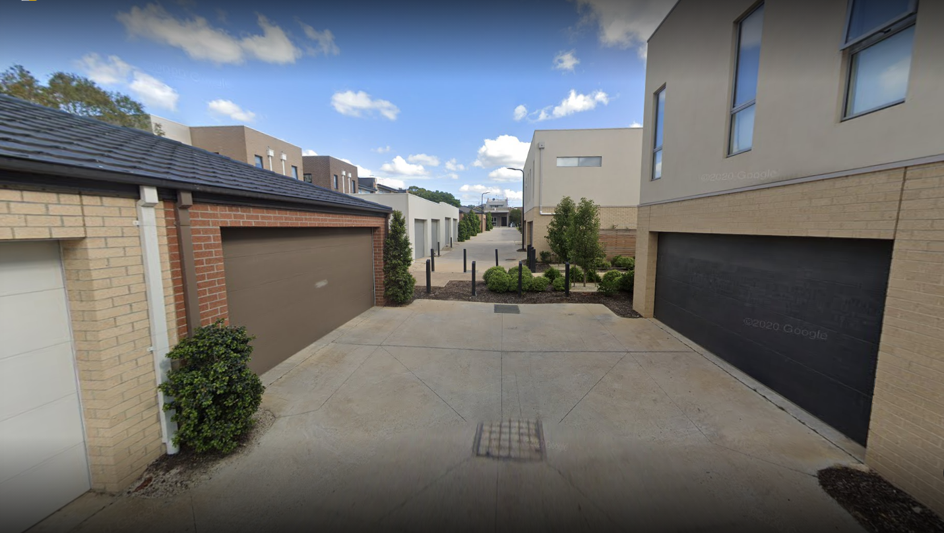
Figure 15: Photograph of the street view of the Haig development
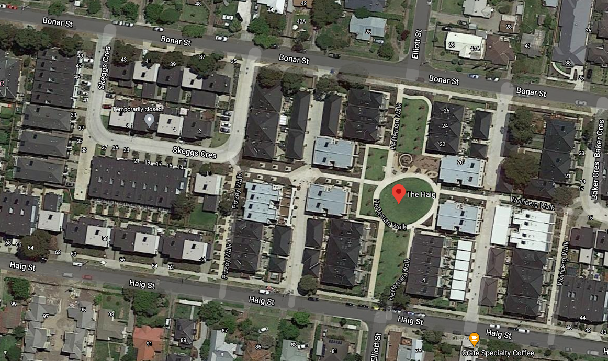
Figure 16: Aerial photo of the Haig development.
Moorabool’s Urban Design Guidelines
An assessment of Council’s urban design guidelines was conducted and concluded that the streetscapes should be in keeping with the surrounding streetscape character to contribute to the continuity, rhythm, and unity of the streetscape. The front setbacks should be landscaped to compliment the streetscape and at least one advanced canopy tree be planted within the front setback. Hard paving, driveways, paths, and car parking should not dominate the streetscape and all communal areas should be landscaped to compliment the streetscape. The internal private access roads or shared driveways should be designed to establish opportunities for internal vistas and landscape nodes within the development. Informal car parking must be avoided on verges, nature strips and footpaths. The development should take into consideration any easements, services, or infrastructure assets requiring protection. Evidently, the proposal is not in accordance with the Urban Design Guidelines.
Sustainable Subdivisions Framework
The applicant was requested to participate in the Sustainable Subdivisions Framework Trial. This trial is based on achieving sustainable outcomes for present and future communities and based on reducing energy, promoting ecology, reducing urban heat, encouraging a circular economy for waste and materials, integrated water management, site layout and liveability and additional consideration for streets and public realm. The applicant declined to participate in the Trail.

General Provisions
Clause 65 – Decision Guidelines
Clause 66 – Stipulates all the relevant referral authorities to which the application must be referred.

Referrals
Section 55 Referrals:
• Department of Transport – consent with conditions
• CFA – consent with conditions
• Downer – Consent with conditions
• Powercor – consent with conditions
• Melbourne Water – consent with conditions
• Southern Rural Water – Refusal
• Western Water – Consent with Conditions
Section 52 Referrals
• Strategic Planning – Request for Further Information
• Infrastructure – Request for Further Information
• Environmental Management – Request for Further Information
• Connected Communities – Request for Further information
• Environmental Protection Authority – No objection but provided information to determine the application – (EPA Publication 1518 and EPA Publication 960)
• Environmental Health – Consent with Conditions

Financial Implications
There are no financial implications for Council in not supporting the application.

Risk & Occupational Health & Safety Issues
The recommendation of not supporting this development and subdivision does not implicate any risk or OH&S issues to Council.

Communications Strategy
Notice was undertaken for the application, in accordance with s.52 of the Planning and Environment Act 1987, and further correspondence is required to all interested parties to the application as a result of a decision in this matter. All submitters and the applicant were invited to attend this meeting and invited to address Council if required.

Options
• Inform VCAT that Council would not support the application, in accordance with the grounds in the recommendation of this report; or
• inform VCAT that Council would not support the application, with amendments to the grounds in the recommendation of this report; or
• should Council wish to support the application, include appropriate recommended permit conditions, and notify VCAT accordingly.

Conclusion
Whilst the proposal is partially consistent with the Bacchus Marsh Housing Strategy to 2041 and Schedule 3 of the General Residential Zone by promoting increased residential growth, it is considered that it would do so at the expense of the objectives and standards of the Planning and Local Policy Framework, Particular and general Provisions and decision guidelines set out in the Moorabool Planning Scheme. More importantly, it will do so at the expense of the neighbourhood character objectives which must encourage sufficient setbacks to allow for enhancement of the front garden character including increased canopy tree plantings and ensure that new garages do not dominate dwellings and streetscapes.
The application displays inadequacies in regard to the surrounding context having insufficient consideration of neighbourhood character, established and emerging built form, scale, design detail, street setbacks, landscaping, open space provision and future amenity outcomes for residents.
The proposal does not provide for functional stormwater management nor provides evidence to mitigate potential traffic congestion caused by the additional cars and potentially 191 future residents that will need to utilise the one access point to Clifton Drive to gain access to either public transport or the Freeway, noting that the nearest train station is approximately 2.7km away from the subject site therefore not within the 400m walkable catchment. The high activity land uses along the Bacchus Marsh Main Street is 1.2km away from the site. This clearly reflects that car dependence will be high. The surrounding character is fully landscaped with large lot frontages, well landscaped gardens, footpaths and both sides, single storey brick veneer housing with pitched roofs. The proposed does not provide for footpaths on both sides of the street and lacks space for adequate tree planting within the front and rear setbacks to each allotment.
The development provides narrow streetscapes limiting the sustainability of the proposed landscaping. Furthermore, internal amenity is inadequately addressed providing narrow private open spaces that are heavily shadowed and lack adequate solar access. The application is absent of sustainable design principles to promote efficiency in both built form and subdivision.
The subject site is a fundamental link in that it connects public open spaces in Bacchus Marsh and surrounds and will need to be easily accessible to all surrounding residents and visitors. The proposal however incorporates common property of which will be maintained by a formal body corporate comprising of the future residents within the subject development. This poses several concerns because if public will be regularly utilising the common areas, it will pose burdens on future residents of the subject site. Additionally, the design and layout of the development is likely to lead to issues such as lack of maintained landscaping, internal car parking along the carriageway, traffic congestion, inaccessibility of waste and service delivery vehicles to name a few.
It is therefore recommended that the application not be supported and VCAT be notified accordingly.

13 Community Strengthening Reports

13.1 Arts and Culture Strategy
Author: Bec Carey-Grieve, Arts, Culture and Events Officer
Authoriser: Sally Jones, General Manager Community Strengthening
Attachments: 1. Draft Arts and Culture Strategy (under separate cover)

Purpose
The purpose of this report is to provide Councillors with a draft of first Moorabool Arts and Culture Strategy 2021-2025. It has been developed by Future Tense Consultancy in consultation with Council Officers. We are seeking Council endorsement to take the draft Strategy to public exhibition in June 2021.

Executive Summary
• In July 2020 through a Councillor led initiative, Moorabool engaged an Arts, Culture and Events Officer with a priority to develop and deliver the first Moorabool Arts and Culture Strategy.
• Through a request for quote process, Future Tense Consultancy were engaged in December 2020 to assist in the development of the Strategy. Widespread consultations were conducted across the Shire in conjunction with the Arts, Culture and Events Officer.
• This report provides key findings from broad community consultation, industry benchmarking and an environmental scan conducted by Future Tense Consultancy and the Arts, Culture and Events Officer.
• Informed by consultations and research conducted, a draft Arts and Culture Strategy has been developed and reviewed by the Executive Group for endorsement for public exhibition in June 2021.

Motion
Moved: Cr Tonia Dudzik
Seconded: Cr Ally Munari
That Council approves the Draft Moorabool Arts and Culture Strategy provided as attachment 1 to this report, for public exhibition in June 2021.
CARRIED

Background
Council is seeking to establish Moorabool’s first Arts and Culture Strategy in collaboration with artists and communities and to support projects that encourage participation in Arts and Culture activity. The four year Strategy will provide a guiding critical strategic direction.
Arts and Culture play a vital role in the Shire in connecting communities, telling stories, and expressing what it means to live in Moorabool. According to the 2019 National Arts Participation Survey conducted by the Australia Council, almost all Australians (98%) engage with arts and culture and recognise the positive impacts the arts has on their lives and their communities. Arts and Culture allows us to celebrate our communities.
The development of the draft Strategy will enable Council to undertake broad industry research and to identify initiatives, programs and infrastructure that will support arts and cultural development within the Shire, positively contributing to the health and wellbeing of the Moorabool Shire community.
This will be Moorabool Shire Council’s (MSC) first Arts and Culture Strategy, seeking to establish and deepen the Shire’s relationship with artists and arts organisations in the region and raising the profile of Moorabool as an Arts and Cultural destination.
In July 2020 Council introduced a new Arts, Culture and Events officer position. A key responsibility for this position is to develop Council’s Arts and Culture Strategy and engage with the community to deliver the recommendations identified in the Strategy.

Proposal
It is proposed the draft Arts and Culture Strategy 2021-2025 is approved for public exhibition. Following public exhibition and incorporating public feedback obtained during exhibition period, the Strategy will be finalised for Council adoption.
The Moorabool Arts and Culture Strategy is a guiding document to inform Council’s direction over the next four years. It sets out Council’s role, the role of the community and the eight key pillars Council will focus on over the next four years. The following pillars will be addressed in partnership with the community:
1. Increase and diversify arts and cultural activity;
2. Reduce barriers to delivering and participating in creative activities;
3. Connect with our unique heritage and environment;
4. Foster the growth of the creative sector;
5. Develop accessible cultural infrastructure;
6. Create moments of joy in everyday life;
7. Establish a presence within regional touring networks;
8. Use Arts and Culture to drive better outcomes for Council and the community.
Development of the Strategy
In developing this Strategy, consultation with internal and external stakeholders was conducted throughout February and March including:
• Three community forums attracting between 30 – 50 in attendance at each;
• Drop-in sessions at local arts activities;
• Over 70 one to one interviews with key staff and local artists and businesses, Traditional Owners, local student Councils; and
• A community survey with 124 respondents.
Extensive Traditional Owner engagement was an important part of the process. This included:
• Consultations with Dja Dja Wurrung, Wadawurrung and Wurundjeri;
• One to one interviews with local Wadawurrung artists providing key insights into the Shire’s cultural heritage and what support is needed for First Nation’s elders and artists within the Shire;
• Reviewing the draft Strategy to provide advice from a Traditional Owner perspective. Key findings from the surveys and consultations show:
• 94% said having local acts and cultural activities was important;
• 89% valued having access to activities from a range of cultures;
• 67% of artists are not as connected as they would like locally;
• 68% do not have access to local opportunities;
• 77% listed access to space as critical to their work.
Future Tense Consultancy performed the following:
• A review of the strategies and priorities of surrounding Councils, as well as state and federal government policies;
• Benchmarking against target municipalities;
• Analysis of data from local, state, and federal agencies;
• Mapping of the current creative sector actors, activities, and assets across the Shire.
Research and findings from Future Tense’s creative ecology report show that within the Shire we have:
• 39 Arts and Culture organisations and networks;
• 46 current and potential venue spaces;
• 13 creative education providers;
• 2 major community festivals;
• Visual arts, craft and music are our dominant creative industries;
• Most creative activity is focused around Bacchus Marsh, Ballan, Gordon, and Blackwood and encouragingly there are green shoots spread across the Shire.
The Strategy seeks to work with our creative industries to grow the sector over the next four years, increase the number or creatives living and working in the Shire and to increase the number of organisations and creative producers providing Arts and Cultural activity across the Shire. By building the capacity of the sector, especially organisations and creative producers, we can create a more sustainable arts and culture sector within Moorabool.
Council’s role in delivering the Strategy is to:
• Provide encouragement to those who want to make things happen within Arts and Culture;
• Be open to new ideas and possibilities;
• Create a supportive environment for creative activities;
• Source opportunities for local creative practitioners;
• Facilitate beneficial connections and collaborations;
• Support development of the creative sectors capabilities.
To ensure Council achieves the goals presented in the Strategy, an annual action plan will be developed, inclusive of a practical evaluation framework.

Council Plan
The Council Plan 2017 – 2021 provides as follows:
Strategic Objective 4: Improve Social Outcomes
Context 4B: Community Connectedness and Capacity
The proposal to develop Moorabool’s draft Arts and Culture Strategy for public exhibition in June 2021 is consistent with the Council Plan 2017 – 2021.

Financial Implications
The Strategy has been produced with funds allocated within the 2020/21 budget. A further allocation of $30,000 has been requested as part of the 2021/22 budget process to support Strategy implementation. The Strategy, Investment Logic Map and internal investment will be leveraged to secure external funding opportunities and partnerships to further support delivery of the Strategy.

Risk & Occupational Health & Safety Issues
Risk Identifier | Detail of Risk | Risk Rating | Control/s
Strategy is not adopted by Council | Community expectations will remain unmet. Missed opportunities to leverage arts and culture as a tool to achieve Council and community goals. | High | Adoption of the Arts and Culture Strategy.
Reputation –  A negative perception of the Moorabool Arts and Culture Strategy | The draft Arts and Culture Strategy receives negative feedback during public exhibition. | Medium | Extensive public consultation and communication has been undertaken to ensure the Strategy meets community expectations.
Financial - The development of the Strategy is in excess of the allocated budget | There are not enough resources to complete the Strategy development. | Medium | A quote has been agreed to with the consultant and a contract has been entered into to complete the works. Weekly Project Control Group meetings have been established to ensure the timelines and budgets are adhered to.

Communications & Consultation Strategy
Level of Engagement | Stakeholder | Activities | Location | Date | Outcome
Inform | Moorabool Community | Promotion and Communication  Social Media Posts  Posters  Flyers  Newsletters  Newspaper advertising  Direct Emails  Have Your Say Page | Across the Shire | February – March 2021 | Engagement opportunity promoted broadly to the Moorabool Community.  2,790 page views on Council Have Your Say digital engagement platform  2 Moorabool News Ads  2 mentions on Apple FM
 | Councillor Briefing | An overview of key findings from the survey and research were presented | Online | March 2021 | Councillor’s provided insights and feedback
Consultation | Local Artists  Residents  Local businesses  Creative Industry | Forums with Community representatives. | Bacchus Marsh, Ballan, Online | February - April March 2021 | Over 100 participants across all forums
 | Consultations with key staff | 1-1 interviews  Online forum  Internal Teams Group |  | February – March 2021 | Over 40 interviews conducted by Future Tense and the Arts, Culture
 | Public Survey | A survey was published on Moorabool’s ‘Have Your Say’ Engagement hub | Have Your Say Moorabool web page. | March 2021 | 124 surveys were received, and responses were collated to inform the Strategy.  Over 50 new subscribers to the Arts, Culture and Libraries eNews.  Baseline data collected on creative practitioners within the shire.
 | Drop in Consultations | Future Tense consultancy and Moorabool’s Arts, Culture and Events officer attended key arts and cultural events in the Shire | Bacchus Marsh Arts Council exhibition opening, a BM Music Bowl concert, St. Anne’s Vineyard pizza and music afternoon, Studio 22 youth space | March 2021 | In depth data was collected from respondents who may not have seen the survey or who were tourists who lived outside the Shire.
 | Traditional Owner Consultations | Online consultations were conducted with Wurundjeri, Wadawurrung and Dja Dja Wurrung (including local artists). | Online | March April | Key insights gathered from Traditional Owners (TO) including Elders and Artists residing in the Shire  3 TO Recognised Aboriginal Parties (RAP) interviews  3 TO reviews of the Strategy  6 Wadawurrung local artist interviews

Victorian Charter of Human Rights & Responsibilities Act 2006
In developing this report to Council, the officer considered whether the subject matter raised any human rights issues. In particular, whether the scope of any human right established by the Victorian Charter of Human Rights and Responsibilities is in any way limited, restricted, or interfered with by the recommendations contained in the report. It is considered that the subject matter does not raise any human rights issues.

Officer’s Declaration of Conflict of Interests
Under section 130 of the Local Government Act 2020, officers providing advice to Council must disclose any interests, including the type of interest.
General Manager – Sally Jones
In providing this advice to Council as the General Manager, I have no interests to disclose in this report.
Author – Arts, Culture and Events Officer - Bec Carey-Grieve
In providing this advice to Council as the Author, I have no interests to disclose in this report.

Conclusion
Establishing an Arts and Culture Strategy will support the Shire to become a thriving and vibrant place with healthy and inclusive communities and a sustainable creative sector. It will demonstrate Council’s commitment to creative practitioners within the Shire and establish Moorabool as a home for creative communities.
Building our creative communities will strengthen the Shire and create an Arts and Culture link between Melbourne and the wider Western region.
The Strategy will direct how Council best invests its resources and capabilities, outlining the role Council will play and the areas to focus on over the four years of the Strategy.

13.2 Moorabool Shire Community Grants - March 2021
Author: Kristian Brudenell, Senior Connected Communities & Engagement Officer
Authoriser: Sally Jones, General Manager Community Strengthening
Attachments: 1. Attachment 1: Community Grants Assessment - March 2021 (under separate cover)

Purpose
The purpose of this report is to make recommendations to Council regarding applications to the Round 1 March 2021 Community Grants Program.

Executive Summary
• To seek Council endorsement of the recommendations for funding for the Round 1 March 2021 Community Grants Program by the Community Grants Assessment Panel.
• The Community Grants Program provides funding to community organisations to deliver programs that build on local strengths to develop active, healthy, connected, and inclusive communities.
• Council received 13 applications across the five program categories: Community Arts and Culture (2), Community Strengthening Grants (7), Community Events Grants (0), Community Development Fund (3) and Sustainability and Environmental Engagement Grant (1).
• A total of $87,406.00 was requested with $187,400.00 available this round.
• Eligible applications were assessed by an Assessment Panel consisting of officers from a diverse range of departments.
• The report presents Council with a list of recommended grants for the Round 1 March 2021 funding round prepared by the Community Grants Assessment Panel (Attachment 1).
• In total, 9 applications from 13 organisations are recommended to receive $33,401.00 in funding.
• The allocation of this sum is detailed in the funding recommendations within this report and at Attachment 1.

Resolution
Moved: Cr David Edwards
Seconded: Cr Paul Tatchell
That Council approves the allocation of the Community Grants as provided in Attachment 1 to this report.
Carried

Background
The purpose of this report is to present Council with an assessment of applications received for the Round 1 March 2021 Community Grants Program, which totals $270,400 per annum. The Round 1 March 2021 Grants Program opened on 1 March 2021 and closed on 31 March 2021. A total of 60% of applications which were commenced via the online portal were submitted for final consideration and feedback was sought from some applicants who ultimately chose not to submit. Some groups are currently dormant, and communication has been challenging during the pandemic.
Council’s Community Grants program enables not for profit community groups to apply for funding under the following five program categories:
• Arts and Culture Grants: Supporting local artists and organisations to use a creative approach to the development of community projects and initiatives ($10,000 available this round).
• Community Strengthening Grants: Community projects, programs, and initiatives with a specific focus on connecting communities and building community capacity ($60,000 available this round).
• Events Grants: Non‐recurrent, seed funding designed to encourage and promote the development of sustainable local events ($10,000 available this round).
• Community Development Fund Grants: Supporting community infrastructure projects which significantly impact on community development. One or more projects may be funded up to $100,000 in this round, with any remaining funding allocated to a second round opening the following August during Round 2 ($100,000 available this round).
• Sustainability and Environment Engagement Grants: Supporting the community in reducing expenditure of gas and electricity, investing in sustainability measures, and providing opportunities to raise awareness of environmental issues to the broader community ($7,400 available this round).
Community groups and organisations can apply for up to $5,000 for Community Strengthening Grants and up to $3,000 for Arts, Events and Sustainability Grants. Groups also need to demonstrate a cash or in‐kind contribution toward the cost of their project on a ratio of $1 for $1 (Council $1: Group $1). Small Community Strengthening projects under $1,000 are not required to demonstrate a contribution.

Proposal
Applicant Support
The Community Grants Guidelines specifies that applicant groups are required to liaise with a Connected Communities officer prior to lodging an application to ensure applicants receive clear guidance on eligibility and how to best present their applications. All applicants received support and advice from Council officers before lodging their application. Additional support was provided after the funding round closed to clarify any ambiguity in applications.
Policy Assessment Criteria
• Project Description and why the applicant wants to complete the project – 10%;
• What will this project achieve? – 20%;
• Why is this project needed in your community? – 20%;
• Who will be involved in the project? – 15%;
• How will you carry out your project? (including risk management) – 15%;
• Project budget and explanation of how the group arrived at the costs? – 20%.
Each criterion is assessed out of 10 and weighted according to the criteria percentage. The maximum possible score for any application is 100.
Scoring Guide
Score each criteria out of 10
0 | Did not address criteria
1‐2 | Minimal
3‐5 | Satisfactory
6‐8 | Good
9‐10 | Excellent

Key Issues

This report is to present recommendations from the assessment panel to Council regarding applications to the Round 1 March 2021 Community Grants Program.

Number of applications and amount requested
In total, 13 applications were received across the five program categories: Community Arts and Culture (2), Community Strengthening Grants (7), Community Events Grants (0), Community Development Fund (3) and Sustainability and Environmental Engagement Grant (1). A total of $87,406.00 was requested with $187,740.00 available this round.
Category | Applications  Received | Amount  Available | Amount  Requested | Amount  Recommended
Community Arts and Culture | 2 | $10,000.00 | $5,000.00 | $5,000.00
Community Strengthening Grant | 7 | $60,000.00 | $23,437.00 | $16,442.00
Community Events Grant | 0 | $10,000.00 | $0.00 | $0.00
Community Development Fund | 3 | $100,000.00 | $57,969.00 | $10,959.00
Sustainability and Environmental  Engagement Grant | 1 | $7,400.00 | $1,000.00 | $1,000.00
Total | 13 | $187,400.00 | $87,406.00.00 | $33,401.00.00
Current Status
The recommendations provided in Attachment 1 represent 100% of community grant applications from Round 1 March 2021 grants.

Council Plan
The Council Plan 2017-2021 provides as follows:
Strategic Objective 4: Improve Social Outcomes
Context 4B: Community Connectedness and Capacity
The proposed allocation of grants under the 2021 March Community Grants Program is consistent with the Council Plan 2017 – 2021.

Financial Implications
Consistent with the Community Grants Policy and 2020/21 budget allocation, a total of $187,400.00 is available for allocation in Round 1 March 2021 Community Grants Program.
The following amounts are recommended:
• $5,000.00 for Arts and Culture Grants;
• $16,442.00 for Community Strengthening Grants;
• $10,959.00 for Community Development Fund;
• $1,000.00 for Sustainability and Environmental Engagement Grants.

Risk & Occupational Health & Safety Issues
Risk Identifier | Detail of Risk | Risk Rating | Control/s
Project timelines | Grant recipients exceeding prescribed timelines | Medium | Terms and conditions agreements required to be signed by grant recipients  Scheduled monitoring of projects
Financial – Inadequate funds to finish project | Grant recipients misappropriate expenditure of Council funds | Medium | Terms and conditions agreements required to be signed by grant recipients  Grant acquittal required upon completion of projects

Communications & Consultation Strategy
Successful applicants:
• Formal notification and congratulations will be provided via email on endorsement of Council report.
Unsuccessful applicants:
• To be advised by telephone and/or email. Guidance and support will be provided to improve opportunities for future grant applications.
• To be offered the opportunity for one on one meetings with officers to discuss their application and request advice.
• Be advised of future Grant Writing Workshop opportunities.
Community Groups
• Are advised when Community Grants become available and requested to further advise their networks via direct telephone calls and email.
• Are requested to advertise the Community Grants across their communications options including social media and newsletters.
Moorabool Residents
• Promotional flyers and information advertising Community Grants Program across the Shire:
o Library notice boards and Library newsletter;
o Economic Development Newsletter;
o AACA Newsletter;
o Community Noticeboards;
o Neighbourhood Houses;
o Darley Early Years Hub;
o Moorabool News;
o Early Years Newsletter;
o Website Events Page and Community Page;
o Youth Facebook Page;
o Moorabool Shire corporate website and social media channels;
o Local businesses.
• New promotional banners at township entrances.
• Grant Writing Workshops:
o Two workshops were held online to improve knowledge of Smartygrants and grant writing requirements;
o Advice and guidance provided to potential applicants.
Applicants for the 2021 Round 1 (March) Community Grants Program have been informed they will be notified of the outcomes of their grant applications in June 2021.
The Connected Communities Team will formally notify groups of the outcome of their applications and provide opportunity for feedback to the unsuccessful applicant.
Feedback will include:
• Advice to applicant groups of the relative strengths and areas for improvement in their application;
• Options for alternative funding (if applicable);
• Supporting a group to amend and re‐lodge their application in the next appropriate round of the Community Grants program.

Victorian Charter of Human Rights & Responsibilities Act 2006
In developing this report to Council, the officer considered whether the subject matter raised any human rights issues. In particular, whether the scope of any human right established by the Victorian Charter of Human Rights and Responsibilities is in any way limited, restricted, or interfered with by the recommendations contained in the report. It is considered that the subject matter does not raise any human rights issues.

Officer’s Declaration of Conflict of Interests
Under section 130 of the Local Government Act 2020, officers providing advice to Council must disclose any interests, including the type of interest.
General Manager – Sally Jones
In providing this advice to Council as the General Manager, I have no interests to disclose in this report.
Authors – Kristian Brudenell and Ashley Malloy
In providing this advice to Council as the Authors, we have no interests to disclose in this report.

Conclusion
Based on the application assessment process and funding criteria, it is proposed that the Council allocates funding for grants for the Moorabool Shire Round 1 March 2021 Community Grants based on the tables provided in Attachment 1.

14 Customer Care and Advocacy Reports

14.1 Delegated Committees of Council - Reports
Author: Anthony Smith, Manager Governance, Risk and Corporate Planning
Authoriser: Caroline Buisson, General Manager Customer Care & Advocacy
Attachments: Nil

Purpose
Delegated Committees are established to assist Council with executing specific functions or duties. By Instrument of delegation, Council may delegate to the committees such functions and powers of the Council that it deems appropriate, utilising provisions of the Local Government Act 1989 and now, Local Government Act 2020. The Council could not delegate certain powers as specifically indicated in Section 86(4) of the Local Government Act 1989 and cannot delegate those powers identified in section 11(2) of the Local Government Act 2020.
Delegated Committees are required to report to Council at intervals determined by the Council.

Executive Summary
Councillors, as representatives of the following Delegated Committees of Council, present the report of the Committee Meetings for Council consideration.
Committee | Meeting Date | Council Representative
Development Assessment Committee Meeting - Minutes | 17 March 2021 | All Councillors

Resolution
Moved: Cr Paul Tatchell
Seconded: Cr Moira Berry
That Council receive the minutes from the Development Assessment Committee meeting 17 March 2021.
Carried

14.2 Advisory Committees of Council - Reports
Author: Anthony Smith, Manager Governance, Risk and Corporate Planning
Authoriser: Caroline Buisson, General Manager Customer Care & Advocacy
Attachments: 1. Minutes - Lal Lal Falls Advisory Committee - 8 April 2021 (under separate cover)
2. Minutes - Audit and Risk Committee - 10 February 2021 (under separate cover)

Purpose
Advisory Committees are established to assist Council with executing specific functions or duties.
Advisory Committees of Council currently have no delegated powers to act on behalf of Council or commit Council to any expenditure unless resolved explicitly by Council following recommendation from the Committee. Their function is purely advisory.
Advisory Committees are required to report to Council at intervals determined by the Council.

Executive Summary
Councillors, as representatives of the following Advisory Committees of Council, present the reports of the Committee Meetings for Council consideration.
Committee | Meeting Date | Council Representatives
Lal Lal Falls Advisory Committee | 8 April 2021 | Cr. Sullivan
Audit and Risk Committee Meeting | 10 February 2021 | Cr. Dudzik, Cr. Munari

Resolution
Moved: Cr David Edwards
Seconded: Cr Ally Munari
That Council receive the following Advisory Committee reports:
1. Lal Lal Falls Advisory Committee Meeting Minutes 8 April 2021.
2. Audit and Risk Committee Meeting Minutes 10 February 2021.
Carried

15 Community Assets & Infrastructure Reports

15.1 Draft Road Management Plan 2021-25
Author: Bivish Ghimire, Asset Management Coordinator
Authoriser: Phil Jeffrey, General Manager Community Assets & Infrastructure
Attachments: 1. Final Draft Road Management Plan 2021-25 (under separate cover)

Purpose
Following initial presentation to the Ordinary Meeting of Council in March 2021 and a subsequent public exhibition process, the purpose of this report is to provide a summary of the submissions received and present the Draft Road Management Plan (2017-21) for formal adoption.

Executive Summary
• Council’s Road Management Plan (RMP) is an operational document that provides an overview of Council’s road management and maintenance practices.
• Under the Road Management (General) Regulations 2005, Council is required to undertake a review of its RMP every four years, with the next version required to be updated by Council by 30 June 2021.
• A review of the current plan has been undertaken by Council staff and updates were recommended based on professional experience and learnings from the current plan, benchmarking against other plans and utilising a range of RMP guidance documentation, as detailed within this report.
• Following initial presentation at the Ordinary Meeting of Council in March 2021 a public exhibition period has been undertaken. During the exhibition period seven submissions were received, and a summary of those submissions as well as recommended amendments to the plan is outlined within this report.
• The draft updated document is now presented to Council for formal adoption to supersede the Road Management Plan 2017-21.

Resolution
Moved: Cr Tonia Dudzik
Seconded: Cr David Edwards
That Council:
1. In accordance with Section 53 of the Road Management Act 2004, adopts the Road Management Plan 2021-25 provided as Attachment 1 to this report;
2. Requests that a copy of the plan be placed on Council’s website; and
3. Notes that a periodic review of the Register of Public Roads and Paths will be undertaken, as delegated to Council’s General Manager Community Assets & Infrastructure.
Carried

Background
Moorabool Shire Council is a Road Authority as defined in Section 37 of the Road Management Act 2004 (RMA) and under this legislation, Road Authorities may choose to develop and publish a Road Management Plan (RMP).
The RMP is an operational document that provides road user with an overview of Council’s road management and maintenance practices. Specifically, the RMP and its appendices define:
• The road assets (roads and paths) which Council manages and maintains on behalf of its community;
• The responsibilities of Council in relation to the management of road assets;
• Levels of service in relation to the maintenance of road assets, considering available resources;
• Policies and procedures in relation to the ongoing risk inspection of Council’s road assets;
• Intervention levels and associated maximum response times for Council to address road defects.
Whilst the development of an RMP is not mandatory, it is commonplace for Councils to have such a document in order to:
• Meet the legislative requirements of the Road Management Act 2004;
• Mitigate risk and manage civil liability;
• Demonstrate that Council is responsibly managing its road assets;
• Manage community expectation in relation to road maintenance works.
Moorabool adopted its first RMP in 2004 and subsequent reviews were undertaken in 2009, 2013 and 2017. Under the Regulations, where Councils elect to develop a plan it is mandatory to undertake a review of the document every four years in line with Council elections and the Council Plan, required to be adopted by 30 June the year following Council elections.

Proposal
The draft revised plan was presented to Council at the Ordinary Meeting on 3 March where it was resolved to proceed with public exhibition, allowing the community to make submissions to the plan for consideration prior to formal adoption.
The public exhibition period was undertaken between 15 March and 16 April 2021 and a total of seven submissions were received. A summary of those submissions and an officer response is outlined in the table below. A copy of the full submissions is attached as an appendix to this report.

Submission 1
Summary:
The submission raises concerns in relation to upgrade of Coal Mine Road, Lal Lal from an unsealed road to a sealed road and a change in speed limit along Coal Mine Road, Lal Lal.
Response:
The RMP outlines Council’s responsibilities, maintenance standards and inspection regimes required to manage its road assets.
The plan does not address upgrades to infrastructure and changes to posted speed limits.
As a result of the submission, a customer request has been logged for investigation and a response will be provided on these specific items once completed. An interim response has been provided to the submitter.
No amendments to the RMP are recommended as a result of this submission.
Submission 2
Summary:
The submission raises concerns in relation to the design and upgrade of Ironmine Road, Lal Lal.
Response:
The RMP outlines Council’s responsibilities, maintenance standards and inspection regimes required to manage its road assets.
The plan does not address upgrades to infrastructure.
As a result of the submission, a customer request has been logged for investigation and a response will be provided on these specific items once completed. An interim response has been provided to the submitter.
No amendments to the RMP are recommended as a result of this submission.
Submission 3
Summary:
The submission raises concerns in relation to footpath renewal along Greendale Myrniong Road, Greendale.
Response:
The RMP outlines Council’s responsibilities, maintenance standards and inspection regimes required to manage its road assets.
The plan does not address renewal of infrastructure.
A response has been provided to the submitter concerning the specific issues raised and noting that the footpath from Greendale-Trentham Road to Shutter Avenue is currently under construction and due for completion by 30 June 2021. The remaining section of footpath from Shutter Avenue to Hasting Road is proposed in the 2021/22 Capital Improvement Program.
No amendments to the RMP are recommended as a result of this submission.
Submission 4
Summary:
The submission raises concerns in relation to upgrading of roads in Ballan township and using the widened seal for additional parking.
Response:
The RMP outlines Council’s responsibilities, maintenance standards and inspection regimes required to manage its road assets.
The plan does not address upgrades to infrastructure.
A response has been provided to the submitter concerning the specific issues raised and noting that there is an additional dedicated parking area in Steiglitz Street with through access to the main street. The request for upgrade and widening of the existing Road network in Ballan township, has been referred to Council’s long-term Capital Improvement Program for consideration.
No amendments to the RMP are recommended as a result of this submission.
Submission 5
Summary:
The submission raises concerns in relation to upgrading of roads, roadside slashing, speed limits and construction of a new roundabout in Pentland Hills.
Response:
The RMP outlines Council’s responsibilities, maintenance standards and inspection regimes required to manage its road assets.
The plan does not address the upgrade of infrastructure, speed limits or construction of new infrastructure.
A response has been provided to the submitter concerning the specific issues raised noting that:
• All roadside slashing is conducted annually on sealed roads. It has been confirmed that it was slashed in December 2020.
• The intersection at Smiths Lane and Pentland Hills Road was graded in March 2021 and will continue to be maintained as per the adopted Road Management Plan. A site investigation will be conducted to assess the specific issues raised with a further response to be provided once completed.
• Regional Roads Victoria (former VicRoads) constructed the roundabout at the intersection of Pentland Hills Road to improve safety at this high-risk high-speed intersection. Prior to the roundabout construction, there were two casualty crashes, including one serious, resulting in five people being injured. The speed limit on each approach to the new roundabout has been reduced to 60km/h to further reduce the risk of an accident. This speed limit is signed, and each leg has advance warning signs of ’60 AHEAD’ to advise drivers that they are approaching a 60km/h speed zone. Additional directional signs have been installed to alert drivers that they are approaching an intersection to further enhance safety at this intersection.

• Incidences of irresponsible driving including speeding can be reported to the Hoon Hotline on 1800 333 000.
No amendments to the RMP are recommended as a result of this submission.
Submission 6
Summary:
The submission raises concerns in relation to additional maintenance and the upgrade of Haywood Road and Rotten Lane in Lal Lal from an unsealed Road to a sealed Road.
Response:
The RMP outlines Council’s responsibilities, maintenance standards and inspection regimes required to manage its road assets.
The plan does not address upgrades to infrastructure.
A customer request has been logged for investigation and a response will be provided on these specific items once completed. An interim response has been provided to the submitter concerning the specific issues raised, noting that these roads will be maintained in accordance with the adopted Road Management Plan.
No amendments to the RMP are recommended as a result of this submission.
Submission 7
Summary:
The submission raises concerns in relation to additional maintenance and the upgrade of Coalmine and Haywood Roads, Lal Lal from an unsealed Road to a sealed Road.
Response:
The RMP outlines Council’s responsibilities, maintenance standards and inspection regimes required to manage its road assets.
The plan does not address upgrades to infrastructure.
A customer request has been logged for investigation and a response will be provided on these specific items once completed. An interim response has been provided to the submitter concerning the specific issues raised, noting that these Roads will be maintained in accordance with the adopted Road Management Plan.
No amendments to the RMP are recommended as a result of this submission.
During the public exhibition period, officers also reviewed the Register of Public Roads and Register of Public Paths and some minor amendments have been made as a result:
• Inclusion of all new gifted assets (roads and paths from subdivisions).
• Inclusion of all off road car parks and reserve roads and paths.
• General health check of spelling, descriptions, naming consistency etc.
The final draft Road Management Plan 2021-25 is now recommended to be formally adopted by Council.

Council Plan
The Council Plan 2017-2021 provides as follows:
Strategic Objective 1: Providing Good Governance and Leadership
Context 1A: Our Assets and Infrastructure
The proposal is consistent with the Council Plan 2017 – 2021.

Financial Implications
There are no financial implications associated with the recommendation within this report.

Risk & Occupational Health & Safety Issues
Risk Identifier | Detail of Risk | Risk Rating | Control/s
Legal – civil liability | Risk to Council’s legal defence where it has not documented the management and maintenance practices achievable within its resources. | Medium | The development and adoption of an RMP.
Legal – civil liability | Risk to Council where it unable to achieve the commitments within its Road Management Plan. | Medium | Reasonable and achievable standards and timeframes outlined within the RMP.

Communications & Consultation Strategy
The review of the Road Management Plan included a public exhibition period and advertising in line with statutory requirements, including the following key activities.
Level of Engagement | Stakeholder | Activities | Date | Outcome
Consult | Council officers | Internal working group meetings to undertake a review of the current RMP. | July 2020 – January 2021 | Updated draft RMP.
Consult | Councillors | Briefing of Councillors to provide an overview of the RMP, review process and recommended amendments. A report to Council seeking endorsement of the public exhibition process. | February & March 2021 | Endorsement of the draft document and proposed public exhibition process.
Consult | Community | Public exhibition of the updated draft document to allow for review and submissions by the community, to be taken into account in finalising the RMP.  Promotions of the exhibition period including advice in the Government Gazette, print media and online platforms. | March/April 2021 | Community feedback on the draft document.
Consult | Councillors | A report to Council outlining the submissions received during the public exhibition process, providing an official response and overview of any resultant amendments. | June 2021 | Final draft document adopted by Council.
Inform | Community | Final adopted document made available to the public on Council’s website and promoted to the community in print and online media. | June 2021 | Final adopted RMP made available and promoted.

Victorian Charter of Human Rights & Responsibilities Act 2006
In developing this report to Council, the officer considered whether the subject matter raised any human rights issues. In particular, whether the scope of any human right established by the Victorian Charter of Human Rights and Responsibilities is in any way limited, restricted, or interfered with by the recommendations contained in the report. It is considered that the subject matter does not raise any human rights issues.

Officer’s Declaration of Conflict of Interests
Under section 130 of the Local Government Act 2020, officers providing advice to Council must disclose any interests, including the type of interest.
General Manager – Phil Jeffrey
In providing this advice to Council as the General Manager, I have no interests to disclose in this report.
Author – Bivish Ghimire
In providing this advice to Council as the Author, I have no interests to disclose in this report.

Conclusion
A review of Council’s existing Road Management Plan has been undertaken and a public exhibition period completed following an initial presentation of the Draft to the Ordinary Meeting of Council in March 2021. Seven submissions were received during the exhibition period, and a summary of those submissions as well as recommended amendments to the plan are outlined within this report.
It is now proposed that the Road Management Plan 2021-25 be adopted to supersede the Road Management Plan 2017-21.

15.2 Local Area Traffic Management Study (Stage 4) Darley
Author: Ohid Morad, Traffic & Transport Engineer
Authoriser: Phil Jeffrey, General Manager Community Assets & Infrastructure
Attachments: 1. Existing Conditions Report (Stage 4) 30 April 2021 (under separate cover)
2. Draft LATM Plan 30 April 2021 (under separate cover)

Purpose
The purpose of this report is to present the Draft Local Area Traffic Management Plan (Stage 4) to Council and to seek in principle endorsement for the purpose of further public consultation.

Executive Summary
• To address the traffic impacts of growth within the Bacchus Marsh township and to help inform planning and management of road space usage, a Bacchus Marsh Local Area Traffic Management Study (Stage 4) has been completed and draft plan developed.
• The purpose of a Local Area Traffic Management (LATM) Study is to view traffic management on a precinct basis rather than individual streets. As Bacchus Marsh continues to grow, there has been a significant increase in the number of traffic related enquiries.
• The study area for Stage 4 is Darley, which extends from the north of Albert Street to Pamela Court and is bounded by the Lerderderg River to the east.
• The development of a LATM Study supports key infrastructure objectives from the 2017-21 Council Plan and Bacchus Marsh Integrated Transport Strategy. ​

Resolution
Moved: Cr Tonia Dudzik
Seconded: Cr David Edwards
That Council:
1. Endorses the Draft Local Area Traffic Management Plan (Stage 4) for the purpose of public consultation over a period of 8 weeks.
2. Requests that a further report be presented to Council on completion of the consultation process.
Carried

Background
The Bacchus Marsh Integrated Transport Strategy (BMITS) presents the vision for the transport network for Bacchus Marsh. One of the key recommendations of the strategy is to ‘introduce the use of Local Area Traffic Management (LATM) studies and refer recommendations to Council’s Capital Improvement Program’.
The preparation of a LATM study within a precinct of Bacchus Marsh aims to improve traffic management and road safety within the area. The LATM study, which has been funded by a grant from the TAC, seeks to view traffic management and associated treatments on a precinct basis rather than by individual street.
At present, Council receives a high volume of traffic related customer enquiries from the community that, due to the lack of such a precinct plan, are considered in isolation. This creates an ad hoc approach to traffic issues and the implementation of traffic management solutions.
The development of a LATM study will assist in providing a consistent approach to traffic related issues in the local area, and also supports key infrastructure objectives from the 2017-21 Council Plan.
The study area for Stage 4 is Darley, which extends from the north of Albert Street to Pamela Court and is bounded by the Lerderderg River to the east.
The Study Objectives
The preparation of a LATM study considers both the technical and community aspects and is intended to meet a number of key objectives, with consideration given to the likely impact on the surrounding network. The key objectives aim to:
• Provide an integrated approach to managing traffic in local areas across all transport modes, through:
o Investigating and addressing connectivity and safety along local travel routes;
o Consideration and integration of local land use and their specific needs;
o Use of appropriate and effective traffic calming measures;
o Making efficient and appropriate use of local on-street car parking provisions;
o Ensuring that future population growth and transport demand are understood and accounted for; and
o Defining the function of local streets as appropriate to their surrounding land uses, pedestrian, cycling and traffic volumes, natural features, and connectivity to surrounding areas.
• Reduce traffic volumes and speeds in local streets;
• Increase amenity and improve safety and access for residents, especially pedestrians and cyclists;
• Provide guidance for planners and engineers associated with the design, development, and management of residential precincts;
• Ensure that transport issues are addressed in a manner that balances amenity, safety, and mobility for all transport modes;
• Improve the environment, economic and social outcomes of the area;
• Identify future priority projects to be considered for inclusion in Council’s Capital Improvement Program; and
• Ensure the local community are engaged and consulted in the identification of issues and the development of treatments to mitigate these issues.
The LATM Area
The township has been divided into three key areas for the purpose of undertaking LATM studies over the coming years:
LATM Area 1 Darley;
LATM Area 2 Bacchus Marsh (completed); and
LATM Area 3 Maddingley.
Area 1 (Darley) forms the focus area for the fourth LATM study to be undertaken. LATM Stage 3 has already dealt with the remaining area of the Darley precinct. The area for the current LATM study (Stage 4) is outlined below.
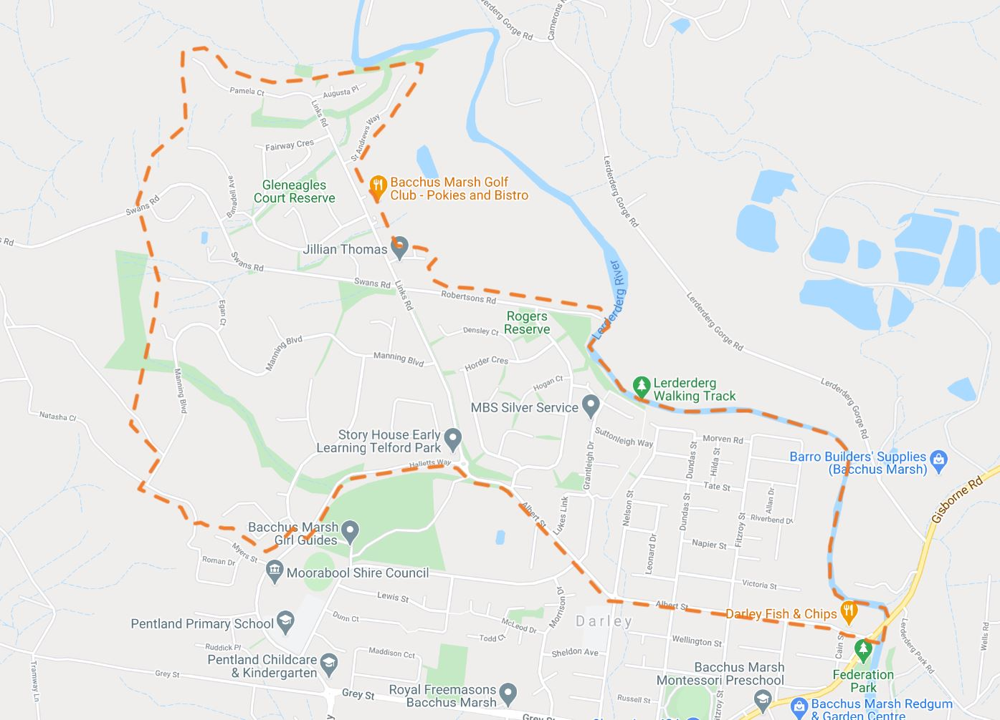

The LATM Process
The following key activities will be undertaken as part of the development of the LATM study:
1. Existing Conditions Assessment
Initial works:  • Review of background information pertaining to the study area and other documents that may have an impact on key decisions.  • Preparation of a Project Management Plan and Community Engagement Plan.  • On-site inspections of the study areas to gain a thorough understanding of the existing conditions. | Complete
Community consultation letter and online survey (electronic and print distribution and use of interactive mapping) relating to traffic issues in the local area. | Complete
Collection and analysis of traffic data. | Complete
Preparation of an Existing Conditions Assessment Report. | Complete
2. Development of Draft LATM Plan
Preparation of draft concept plans and proposed LATM treatments. | Complete
Preparation of a draft LATM plan. | Complete
Community consultation letter and web survey (electronic and print distribution, and interactive map).
Community engagement workshops (2) at Darley.
3. Finalisation of LATM Plan
Collation of results of community engagement.
Final LATM Study Report and Plan.
Presentation to Council for endorsement.
Final community consultation letter.
A copy of the Existing Conditions Assessment (ECA) Report and Draft LATM Plan is attached for Councillors information.
The ECA Report provides an overview of the project and study methodology, and summarises the key themes arising from the site analysis and feedback during phase 1 of the community consultation. This report has been utilised to develop the draft plan and proposed traffic management treatments.

Proposal
The next stage of the project involves presenting the draft plan to the community and providing the opportunity for feedback on the proposed treatments. This phase of consultation will include a second letter to residents within the study area, online engagement including further use of interactive mapping, as well as two face to face community sessions proposed to be held in Bacchus Marsh during June 2021.
It is recommended that Councillors provide in principle endorsement of the attached Draft LATM Plan for phase 2 of the community consultation.

Council Plan
The Council Plan 2017-2021 provides as follows:
Strategic Objective 1: Providing Good Governance and Leadership
Context 1A: Our Assets and Infrastructure
The proposal is consistent with the Council Plan 2017 – 2021.

Financial Implications
The development of this LATM Plan for Darley is a funded project through a TAC grant. As such, there are no financial implications associated with the recommendation within this report.

Risk & Occupational Health & Safety Issues
Risk Identifier | Detail of Risk | Risk Rating | Control/s
Financial | Inadequate financial management resulting in insufficient funds to complete the project | Medium | Adequate project scope and budget, procurement process, ongoing supervision of project financials
Community expectation | Community expectation of key project outcomes outside of the project scope | Medium | Well scoped community consultation process and documentation, clear project objectives documented

Communications & Consultation Strategy
Level of Engagement | Stakeholder | Activities | Location | Date | Outcome
Consult and Involve | Residents within the study area | Direct mail out, online, hardcopy distribution and face to face engagement | Various | March 2021  &  June 2021 | Residents encouraged and supported to provide feedback on key issues and draft documents
Community participation is an important component of the study to assist in understanding the local issues. Significant community consultation will be undertaken throughout the project, including the following:
• Direct mail outs to the study area;
• Community questionnaire;
• Interactive online mapping tool;
• Online engagement (Council website and social media pages);
• Community workshops (2) in Darley; and
• Reports to Council (2).

Victorian Charter of Human Rights & Responsibilities Act 2006
In developing this report to Council, the officer considered whether the subject matter raised any human rights issues. In particular, whether the scope of any human right established by the Victorian Charter of Human Rights and Responsibilities is in any way limited, restricted, or interfered with by the recommendations contained in the report. It is considered that the subject matter does not raise any human rights issues.

Officer’s Declaration of Conflict of Interests
Under section 130 of the Local Government Act 2020, officers providing advice to Council must disclose any interests, including the type of interest.
General Manager – Phil Jeffrey
In providing this advice to Council as the General Manager, I have no interests to disclose in this report.
Author – Ohid Morad
In providing this advice to Council as the Author, I have no interests to disclose in this report.

Conclusion
To address the traffic impacts of growth in the Bacchus Marsh township and help inform planning and management of road space usage, a LATM Study (Stage 4) has been completed and draft plan developed.
It is recommended that Councillors endorse the draft documentation for the purpose of the next phase of community consultation.

16 Other Reports
Nil.

17 Notices of Motion
Nil.

18 Notices of Rescission
Nil.

19 Mayor’s Report

19.1 Mayor's Report
Author: Dianne Elshaug, Co-ordinator CEOs Office
Authoriser: Derek Madden, Chief Executive Officer
Attachments: Nil

Purpose
To provide details to the community on the meetings and events attended by the Mayor since the last Ordinary Meeting of Council.

Executive Summary
• That the Mayor’s Report be tabled for consideration at the Ordinary Meeting of Council.
Cr Tom Sullivan – Mayor’s Report
Date: 2 June, 2021
6 May | - Moorabool Shire Women in Business Luncheon
12 May | - Councillor Briefings – Local Area Traffic Management Study Stage 4; Pandemic Recovery Fund; Presentation by Boral on the outcomes of Community Engagement; Review of the draft DAC Agenda; General Business
14 May | - Funding Announcement – Bacchus Marsh Racecourse & Recreation Reserve
15 May | - Community Leadership Program – Welcome and Overview  - Development Assessment Committee Meeting
19 May | - Meeting with Pat Griffin re Bacchus Marsh Aquatic Centre  - Councillor Briefings – Road Management Plan; Municipal Revaluation 2021/22 Presentation by the Municipal Valuers; Review of the OMC Agenda; General Business
21 May | - MAV State Council Meeting
27 May | - Meeting with Central Highland Water  - Navigators Community Centre Annual General Meeting
2 June | - Councillor Briefings – Update from the Chair of the Audit & Risk Committee  - Moorabool Growth Management Committee Meeting  - Ordinary Meeting of Council

Resolution
Moved: Cr Paul Tatchell
Seconded: Cr Ally Munari
That Council receives the Mayor’s Report.
Carried

20 Councillors’ Reports

20.1 Councillors' Reports
Councillor | Activity
Cr Dudzik | - 6 May – Attended the Moorabool Shire Women in Business Luncheon  - 14 May – Attended the Bacchus Marsh Racecourse and Recreation Reserve funding announcement  - 20 May – Attended a protest on the steps of Parliament in support of residents opposing toxic soil in Bacchus Marsh
Cr Berry | - 6 May – Attended the Moorabool Shire Women in Business Luncheon  - 14 May – Attended the Bacchus Marsh Racecourse and Recreation Reserve funding announcement  - 18 May – Attended the Neighbours House Annual General Meeting at the Holy Trinity Anglican Church Hall  - 26, 27 & 28 May – Attended the Rural Councils Victoria Summit at Mitchelton, Nagambie
Cr Munari | - 6 May – Attended the Moorabool Shire Women in Business Luncheon  - 26, 27 & 28 May – Attended the Rural Councils Victoria Summit at Mitchelton, Nagambie  - Attended as the Guest Speaker at the recent Ballan and District Community House Annual General Meeting  - Attended various training programs for new Councillors  - Cr Munari acknowledged the recent passing of Mr Shane Scanlon, of the Blackwood and Barries Reef Land Care Group and offered her condolences.

Resolution
Moved: Cr Tonia Dudzik
Seconded: Cr Moira Berry
That Council receives the Councillors’ Reports.
Carried

21 Urgent Business
Cr Tatchell acknowledged the recent passing of Mr Frank Sheahan, former MLA of Ballarat and offered his condolences.

22 Closed Session of the Meeting to the Public
Resolution
Moved: Cr Paul Tatchell
Seconded: Cr Moira Berry
That Council considers the confidential report listed below in a meeting closed to the public in accordance with Section 66(2)(a) of the Local Government Act 2020:
22.1 Contract C32 - Major Patching Contract Extensions
Carried

23 Meeting Closure
The Meeting closed at 7.03pm.

