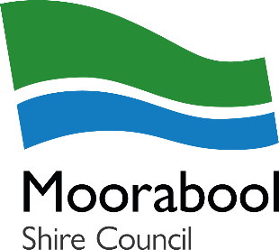
If you are taking over an existing food business, it is recommended that you request a pre-sale inspection with consent from the current proprietor (person or company). This is to ensure the business you are purchasing complies with the Food Act 1984 and the Food Standards Code.

The standard time for this service is 14 working days. Council does offer a priority pre-sale inspection service within 5 working days.

FEES 2026/2027 | Standard Service (14 days) | Priority Service (5 days)
Food Premises Pre-Sale Inspection | ☐ $365.50 | ☐ $510.00

For payments, Council will generate an invoice after receiving your application. Please be aware that invoices can take up to 5 business days to be generated. Once you have received your invoice, payment can be made via the following options:
- Post bill pay
- B-pay
- Cheque
- Over the phone with Council’s Customer Service on 5366 7100
- In person at one of the Council offices (Ballan, Darley, or Lerderderg Library)

CURRENT PROPRIETOR DETAILS
Name of proprietor:

Trading name:
Residential address of current proprietor:
Address of food business:
I HEREBY CONSENT to Moorabool Shire Council disclosing any information, reports or documents relating to the above food premises to the applicant detailed below following the inspection.
Signature of current proprietor

APPLICANT DETAILS
Name of proposed proprietor:
Contact name:
Postal address
Proprietor’s contact details: | Phone: | Mobile:
Proprietor’s contact details: | Email:
Proposed date of settlement:

SOLICITOR DETAILS (if being application being submitted by the solicitor)
Name of solicitor:
Solicitor company:
Contact number:
Email:
By providing your email address you consent to receiving correspondence by email.
DECLARATION
I understand and acknowledge that upon paying fee for this inspection that:
- The information provided in this application is true and complete to the best of my knowledge, and;
- The application forms a legal document and penalties exist for providing false or misleading information.

Applicant signature/s
Name:
Date:

PRIVACY STATEMENT
Your personal information is being collected by Moorabool Shire Council for the purpose of inspecting a food business you are possibly purchasing that is currently registered under the Food Act 1984. Your information will be stored in the Health Manager database and will be used solely by Council for this purpose or a related secondary purpose unless in accordance with the provisions of the Privacy and Data Protection Act 2014. This information will be used to identify you when communicating with Council and for the delivery of services and information. Failure to provide some or all of this information may result in your application not being processed. Requests for access and/or correction should be made to Council’s Privacy Officer. For further information on how your personal information is handled, refer to Council’s Privacy Policy at www.moorabool.vic.gov.au.

