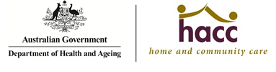
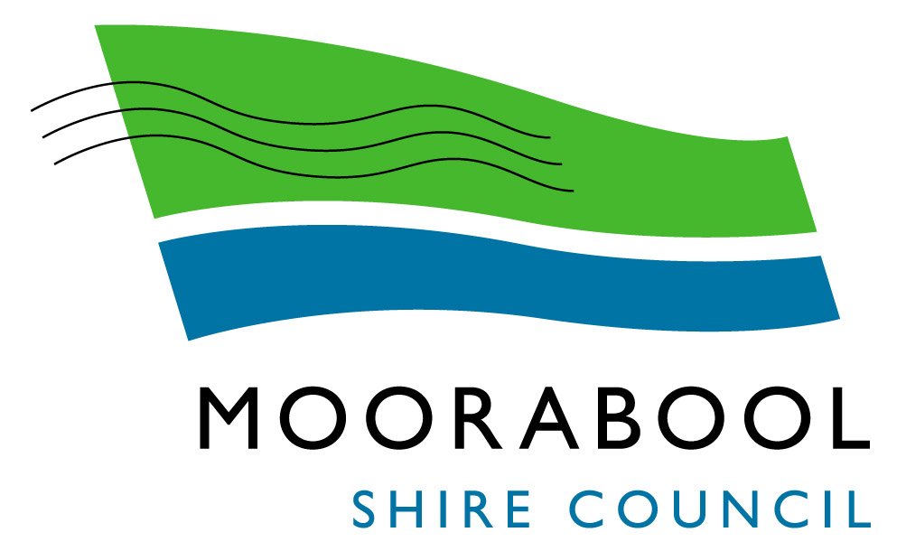
Active Ageing and Community Access Services Compliments, Feedback & Complaints Form

Moorabool Shire Council is keen to receive feedback about the services you receive through the Active Ageing and Community Access Unit. The information you provide assist us to improve our services and provide feedback to staff about the assistance / care they provide. You are welcome to lodge your feedback using this form or alternatively contact the Active Ageing and Community Access Manager on 5366 7100 to discuss your issue.

Date:
Anonymous: [tick here]
Name:

Address:
Telephone:
Feedback

The issue you have raised will be treated confidentially and will not impact upon current or future access to services, but if you wish to remain anonymous there is also an opportunity to do so. You input will be sought in relation to how the issue can be resolved and you will be informed about the action that is taken in response to the issue.
Moorabool Shire Council recognises and supports the client’s choice to use an advocate when dealing directly or raising issues with council officers.
Postal Address: PO Box18, Ballan Victoria 3342, Telephone: 03 5366 7100, Facsimile: 03 5368 1757
Web: www.moorabool.vic.gov.au | Email: info@moorabool.vic.gov.au
Office of the Public Advocate, 1300 309 337 or (03) 9606 9500

If the issue is complex, please contact the Manager Active Ageing & Community Access on 5366 7100 and arrange a time to discuss your issues without feeling rushed. You may also choose to bring an advocate or a family member with you to assist you through the complaints management process.
If your concern is not resolved, you may direct your concerns to any of the following:
- General Manager Social and Organisational Development

Moorabool Shire Council

P.O. Box 18

Ballan Vic 3342
- Ombudsman Victoria
Level 9, 459 Collins Street
Melbourne Vic 3000
1800 806 314 or via
website www.ombudsman.vic.gov.au (link is external)
Alternatively you can contact:
- Aged Care Complaints Commissioner on an open, confidential or anonymous basis by phoning:
1800 550 552 TTY 1800 555 677
www.agedcarecomplaints.gov.au (link is external)
The Complaints Commissioner provides a free service for anyone to raise concerns about the quality of care or services delivered and is independent of the Department of Health.
- Aged Care Information Line
1800 500 853 TTY 1800 555 677

