MINUTES
Special Council Meeting
Wednesday, 17 June 2020
Time: | 6.00pm
Location: | The Pavilion Room, Darley Civic Hub

Order Of Business
1 Opening of Meeting and Prayer 3
2 Acknowledgement of Country 3
3 Present 3
4 Apologies 3
5 Disclosure of Conflicts of Interest 3
6 Presentations/Deputations 4
7 Community Assets & Infrastructure Reports 6
7.1 Bacchus Marsh Indoor Sports and Aquatic Facility 6
8 Closed Session of the Meeting to the Public 13
8.1 Variation to C19-2019/2020 - Bacchus Marsh Sports Precinct, Principal Consultancy 13
9 Meeting Closure 14

1. Opening of Meeting and Prayer
The Mayor opened the meeting with the Council Prayer at 6.00pm.
The Mayor advised that Councillors Borgelt, Keogh, Sullivan and Tatchell are participating in tonight’s meeting via video link and tonight’s meeting is being livestreamed via Council’s website.

2. Acknowledgement of Country
We respectfully acknowledge the traditional owners of this land, their spirits and ancestors.

3. Present
Cr David Edwards, Mayor East Moorabool Ward
Cr Jarrod Bingham East Moorabool Ward
Cr Tonia Dudzik East Moorabool Ward
Cr John Keogh East Moorabool Ward
Cr Lawry Borgelt Woodlands Ward
Cr Tom Sullivan West Moorabool Ward
Cr Paul Tatchell Central Moorabool Ward

Officers:
Mr Derek Madden Chief Executive Officer
Ms Caroline Buisson General Manager Customer Care and Advocacy
Mr Phil Jeffrey General Manager Community Assets & Infrastructure
Ms Sally Jones General Manager Community Strengthening
Mr Henry Bezuidenhout Executive Manager Community Planning & Economic Development
Ms Yvonne Hansen Manager Governance, Risk & Corporate Planning

4. Apologies
Nil.

5. Disclosure of Conflicts of Interest
Nil.

6. Presentations/Deputations
Nil.

7. Community Assets & Infrastructure Reports

7.1 Bacchus Marsh Indoor Sports and Aquatic Facility
Author: Corinne Jacobson, Coordinator Major Projects
Authoriser: Phil Jeffrey, General Manager Community Assets & Infrastructure
Attachments: 1. Business Case
2. Masterplan Options
3. Integrated Facility Masterplan
4. Consultation Summary Report

Purpose
To present three masterplan options for the Bacchus Marsh Sports Precinct (Taverner Street Site) and endorse one option to proceed to detailed design for the Indoor Sports and Aquatic facility.

Executive Summary
• Four masterplan options have been developed for the Bacchus Marsh Indoor Sports and Aquatic Facility on the Taverner Street site.
• Community consultation commenced in March 2020 via the online Community Consultation Platform Social Pinpoint. Relevant stakeholder groups were contacted directly and promotion of the social pinpoint site was undertaken via newspapers, social media and Council’s website.
• A business case has been developed articulating the underlying assumptions for facility patronage, revenue, expenses and operating costs of standalone buildings versus an integrated building.
• Seeking endorsement of one option with approval to proceed to the detailed design phase for the Taverner Street site. Further development of masterplans for Maddingley Park, Peppertree Park and Mill Park are required after consideration of the community feedback.

Resolution
Moved: Cr John Keogh
Seconded: Cr Tonia Dudzik
That Council:
(a) Receives the community feedback from the masterplan consultation period.
(b) Receives the Bacchus Marsh Indoor Sport and Aquatic Centre Business Case.
(c) Endorses the Masterplan Option 1A for the Taverner Street Site providing an integrated facility incorporating the indoor sports stadium, aquatic facility and other community recreation purposes.
(d) Requests officers to proceed to detailed design for Stage 1, indoor stadium component.
(e) Request a further report for Maddingley Park, Peppertree Park and Mill Park on finalisation of the masterplans.
Carried
A Division was called:
In Favour: Crs David Edwards, Jarrod Bingham, Tonia Dudzik, John Keogh, Paul Tatchell and Lawry Borgelt.
Against: Cr Tom Sullivan.
The motion was declared carried

Background
In December 2019 Council awarded a contract to Peddle Thorp Architects as Principal Consultant for the preparation of masterplan options for the Bacchus Marsh Sports Precinct and the preplanning and design for an Indoor Sports and Aquatic Centre in Bacchus Marsh.
The project includes;
a. Masterplans for;
i. Bacchus Marsh Sports Precinct including Maddingley Park, Siberia, Taverner Street and Peppertree Park.
ii. Mill Park, Ballan.
b. Concept Design and Schematic Design of an Indoor Sports Centre (Stage 1) and Aquatic Facility (Stage 2)
c. Detailed design and documentation of Indoor Sports Centre (4 Courts)
d. Contract documentation and contract administration for Indoor Sports Centre
e. Design and documentation of new Splash Parks in Bacchus Marsh and Ballan.
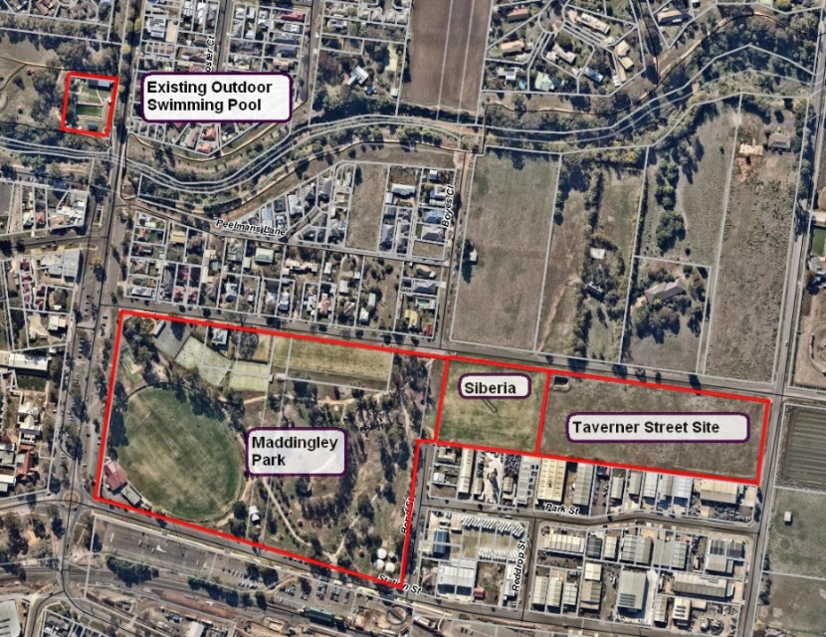

Masterplan Development
Preliminary masterplan work was completed for all sites except for Maddingley Park to go to community consultation. Information and ideas were sought from the community for Maddingley Park and Mill Park and Peppertree Park (beyond the swimming pool) which will be used to develop full masterplans for these parks.

The masterplan development provided for the following options;

Site | Option 1 | Option 2 | Option 3
Taverner Street | Indoor Sports, Aquatic and provision for future bowls relocation. | Indoor Sports and Aquatic | Indoor Sports and Aquatic
Siberia | Redevelop site to accommodate aquatic centre | Retain Siberia shift aquatic and sports to the east | Retain Siberia and shift aquatic and sports to the east.
Peppertree Park | Retain existing pool and provide new splash park | Decommission existing pool and provide new large-scale pool.
Mill Park | Retain existing pool and provide new splash park.  Provide skate park, pump track and half basketball court | Decommission existing pool and provide new large-scale pool.  Provide skate park, pump track and half basketball court

Community Consultation
Following the development of masterplan options for the Bacchus Marsh Sports Precinct covering the 5 sites, the project was presented to project stakeholders and the broader community for feedback and input.
Given the situation relating to COVID-19 and the enforcement of social distancing, face to face consultation was not an option for engagement. User groups and the wider community were consulted with via the online platform, Social Pinpoint.
Social Pinpoint is an online community consultation platform where people can provide feedback which others can then comment on, agree or disagree. The project was advertised for consultation for a week period commencing on Tuesday 31 March 2020 through to Sunday 19 April 2020. This has approach has been very successful having received high levels of engagement with 5,466 visits to the site. The Facebook post reached 17,318 people with 4,486 clicking on the link.
Overall the feedback received is positive. With respect to the Taverner Street site, Option 1 received the most ‘likes’ with Option 3 receiving a similar number.
Common feedback provided included strong support for Option 1 however there was some concern around the loss of Siberia in that scenario. This outcome may have been different if an alternative for Siberia was presented with the masterplans. If Siberia is redeveloped, user groups would be allocated space at Bacchus Marsh Racecourse Recreation Reserve with the design of new soccer, AFL and cricket sports fields included in the draft budget.
The Bacchus Marsh Cricket Club provided feedback including support for Option 1 on the basis an alternative to Siberia can be provided.
Information and ideas were sought from the community for Maddingley Park, Mill Park and Peppertree Park (beyond the swimming pool). These sites require further development of the masterplans following the consultation and these will be brought back to council at a future date.

Taverner Street Site
Endorsement of a masterplan for Taverner Street will allow the project to progress to the detailed design phase.
All 3 options for consideration include a 4 court stadium and indoor aquatic facility with Options 2 and 3 retaining Siberia. Option 1 provides stand along facilities. An additional Option 1A has been developed based on the operating costs in the business case and considers an integrated facility.
Option | Advantages | Disadvantages
1 | • Allows for Indoors Sports, Aquatic and Bowls facilities.  • Provides full integration between open space in Maddingley Park through to the Aquatic Centre.  • Siting of buildings along southern boundary adjacent to industrial buildings provide a clear separation between recreation and industrial land.  • Provides increased car parking.  • Good marketing potential with water play area facing Maddingley Park. | • Requires redevelopment of Siberia  • Undeveloped and isolated land on comer of Fisken Street if bowls club is not relocated.
2 | • Retains Siberia, maintaining existing sporting uses.  • Retains Siberia for future redevelopment  • Buildings are sited towards Fisken St with a strong Basketball Hall building presence close to the roadway | • Indoor sports facility on Fisken street.  • Poor integration between Maddingley Park and indoor sports facility with aquatic centre land potentially vacant long term.  • Siberia does not meet sporting guidelines in terms of size and there is no access to change facilities.
3 | • Retains Siberia, maintaining existing sporting uses.  • Retains Siberia for future redevelopment.  • landscaped garden face to Fisken St and main entry towards the street intersection  • An indoor pool building is more sculptural and transparent than a basketball hall, therefore more inviting and aesthetically pleasing for the streetscape. | • Aquatic outdoor spaces faces Fisken Street adjacent to industrial land uses.  • Sports facility would be adjacent to Siberia overshadowing the playing field.  • Poor integration between Maddingley Park and indoor sports facility.  • Siberia does not meet sporting guidelines in terms of size and there is no access to change facilities.
1A  Integrated Model | • Allows for Indoors Sports, Aquatic and Bowls facilities.  • Provides single entry, kiosk and admin facilities.  • Siting of buildings along southern boundary adjacent to industrial buildings provide a clear separation between recreation and industrial land.  • Provides increased car parking. | • Requires redevelopment of Siberia  • Single entry point which compromises design opportunities with respect the aquatic component.  • Limited integration opportunities with Maddingley Park.  • Undeveloped and isolated land on comer of Fisken Street if bowls club is not relocated.  • Leisure zone will not have outlook  • Café patrons will not have outlook  • Less opportunity for leisure expansion

If an option retaining Siberia as a sportsfield is adopted, the masterplan for Maddingley Park would need to include improvements and upgrades for the sports oval to provide change facilities.
Option 1 provides for the full development of the Taverner Street site including Siberia. The masterplan takes advantage of the long narrow block, integration opportunities with Maddingley Park and will allow for greater parking opportunities which would be essential for a development of this scale.

Business Case
A business case has been prepared by Otium Leisure Planners. The business case provides two separate business scenarios. The first is covers two stand-alone facilities in accordance with the masterplan options and the second an integrated facility.
The draft business case is attached to this report. The modelling presented in the report indicates the base case for two standalone buildings is an operating cost of $116,000 per annum. The optimistic case provides revenue of $286,000. An integrated facility base case indicated an operating revenue of $88,000 and an optimistic case revenue of $445,000. The main difference in the figures is an integrated facility will have a single reception, café and management model.

The model also assumes Council’s estimated maintenance costs. The maintenance costs in the business case are those that have been included in the SFP, that have been developed by Council, and allows for 1.5% of the construction cost per annuum for maintenance. The 1.5% construction cost allocation equates to $210k for the indoor stadium component and $465k for the indoor aquatic component (and then escalated from year to year).
It is noted that the forecast id figures used are those which are available on Council’s website as the standard growth rate. If the high grow rate model which Council has developed with forecast ID is realised the optimistic scenario could be a possible outcome.

Proposal
Endorsement of Option 1A for the Taverner Street site and approval to proceed to detailed design and documentation. Option 1A provides for a four court indoor stadium, aquatic facility and future bowls club. This option requires redevelopment of the Siberia site which will necessitate the relocation of user groups to Bacchus Marsh Racecourse Recreation Reserve.
Further workshops with Peddle Thorp and the landscape architects are required to further develop masterplans for Maddingley Park, Peppertree Park and Mill Park with consideration of the community feedback. These will be brought back to Council at a future meeting for endorsement.

Council Plan
The Council Plan 2017-2021 provides as follows:
Strategic Objective 1: Providing Good Governance and Leadership
Context 1A: Our Assets and Infrastructure
The proposal to endorse the Option 1 Masterplan for the Taverner Street site as part of the Bacchus Marsh Sports Precinct and proceed to detailed design and documentation is consistent with the Council Plan 2017 – 2021.

Financial Implications
If the recommendation to proceed with detailed design and documentation is approved, there will be no further financial implications with a contract awarded to Peddle Thorp which includes detailed design and documentation for masterplanning and design of the indoor sports courts.

Risk & Occupational Health & Safety Issues
Risk Identifier | Detail of Risk | Risk Rating | Control/s
Financial – Inadequate funds to finish project | Inadequate financial management | High | Project Management and Supervision by staff.
Delivery Timeframes | Delayed completion | Medium | Agreed program.  Project management and supervision by Council staff

Communications & Consultation Strategy
Level of Engagement | Stakeholder | Activities | Location | Date | Outcome
Consult | User Groups / Schools / Community | Meetings with user groups seeking feedback on design | Various | During concept design phase | User group input into design
Inform | User Groups / Community | Regular updates to groups and on social media | Various | During construction | Progress reporting

Victorian Charter of Human Rights & Responsibilities Act 2006
In developing this report to Council, the officer considered whether the subject matter raised any human rights issues. In particular, whether the scope of any human right established by the Victorian Charter of Human Rights and Responsibilities is in any way limited, restricted or interfered with by the recommendations contained in the report. It is considered that the subject matter does not raise any human rights issues.

Officer’s Declaration of Conflict of Interests
Under section 80C of the Local Government Act 1989 (as amended), officers providing advice to Council must disclose any interests, including the type of interest.
General Manager – Phil Jeffrey
In providing this advice to Council as the General Manager, I have no interests to disclose in this report.
Author – Corinne Jacobson
In providing this advice to Council as the Author, I have no interests to disclose in this report.

Conclusion
Community consultation for the Bacchus Marsh Sports Precinct masterplans has concluded. Three options have been developed for the Taverner Street site catering for indoor Sports courts, aquatic and bowls facilities. Overall community response to the project has been positive. Endorsement of a masterplan for the Taverner Street site will allow the project to progress to the detailed design phase.
Based on the financial modelling within the business case, an integrated facility incorporating the indoor stadium and aquatic facility offers the best financial outcome.

8. Closed Session of the Meeting to the Public

Resolution
Moved: Cr Jarrod Bingham
Seconded: Cr Tonia Dudzik
That pursuant to the provisions of the Local Government Act 1989, the meeting now be closed to members of the public to enable the meeting to discuss the following matters:
8.1 Variation to C19-2019/2020 - Bacchus Marsh Sports Precinct, Principal Consultancy
Council is satisfied that, pursuant to Section 89(2) of the Local Government Act 1989, the information to be received, discussed or considered relates to a contractual matter.
Carried

Resolution
Moved: Cr Jarrod Bingham
Seconded: Cr Tonia Dudzik
That Council now return to Open Session.
Carried

9. Meeting Closure
The Meeting closed at 6.12pm.

...................................................
CHAIRPERSON

