AGENDA

Statutory Meeting of Council

I hereby give notice that a Statutory Meeting of Council will be held on:
Date: | Monday, 23 November 2020
Time: | 6.00pm
Location: | Council Chamber, 15 Stead Street, Ballan
Derek Madden
Chief Executive Officer

Order of Business

1. Opening of Meeting and Prayer

The Chief Executive Officer welcomes everyone to the Statutory Meeting of Council. As there is no appointed Chairperson, in accordance with Council’s Governance Rules, Council must appoint a Temporary Chair.

1.1 Appointment of Temporary Chair

The Chief Executive Officer invites nominations and a vote is taken.

The Temporary Chairperson will assume the Chair.

2. Prayer and Acknowledgement of Country

2.1 Prayer
Almighty God be with us as we work for the people of the Shire of Moorabool. Grant us wisdom that we may care for the Shire as true stewards of your creation. May we be aware of the great responsibilities placed upon us. Help us to be just in all our dealings and may our work prosper for the good of all. Amen.

2.2 Acknowledgement of Country
We respectfully acknowledge the traditional owners of this land, their spirits and ancestors.

3. Recording of Meeting
In accordance with Moorabool Shire Council’s Governance Rules, the Council will be recording this meeting. The following organisations have also been granted permission to make an audio recording:
- The Moorabool News; and
- The Star Weekly

4. Present

5. Apologies

6. Disclosure of Conflicts of Interest
Section 130 of the Local Government Act 2020 requires a Councillor to disclose a conflict of interest, and in accordance with Clause 6.3 of the Governance Rules, state the Agenda item for which they have a conflict, whether the conflict of interest is general or material, and the circumstances that gives rise to the conflict of interest. At this time of the Meeting and/or before consideration or discussion of the Item, a Councillor must indicate to the meeting the existence of the conflict of interest and leave the meeting.

7. Business

7.1 Former Mayor's Report
The former Mayor, Cr. David Edwards, will present his report on the November 2019 to October 2020 Mayoral term.

Recommendation
That the former Mayor’s Report for the Mayoral term of November 2019 to October 2020 be received.

7.2 Expression of Thanks to the Outgoing Mayor
Prior to calling for nominations for the position of Mayor, the Chief Executive Officer will call upon any Councillors who wish to express appreciation to the outgoing Mayor for his term in Office.

7.3 Determining the Term of Office of Mayor
In accordance with section 26 of the Local Government Act 2020 (the Act), the following applies when a Mayor is to be elected:
- A Mayor is to be elected no later than one month after the date of a general election at a Council meeting open to the public.
- Before the election of the Mayor, a Council must determine by resolution whether the role is to be elected for a 1 year or a 2 year term respectively.
- If the Mayor is elected for a 1 year term, the next election of the Mayor must be held on a day to be determined by the Council that is as close to the end of the 1 year term as is reasonably practicable.
- If the Mayor is to be elected for a 2 year term, the next election of the Mayor must be held on a day to be determined by the Council that is as close to the end of the 2 year term as is reasonably practicable.
- A Mayor is to be elected within one month after any vacancy in the office of Mayor occurs.
- The election of a Mayor after the period specified in this section does not invalidate the election.
- A Councillor elected to fill a vacancy in the office of Mayor caused other than by the expiration of a one year or a 2 year term serves the remaining period of the previous Mayor's term.

Recommendation
That Council, in accordance with section 26(3) of the Local Government Act 2020, appoint the term of office for the Mayor for a period of __ year/s.

Temporary Chair vacates the Chair.

7.4 Election of Mayor
- The Chief Executive Officer, shall conduct the election for the office of Mayor of Moorabool Shire Council for the term of office in accordance with Part 4 of the Governance Rules, and shall invite nominations.
- Following the election, the Mayor will be assisted in being robed as a symbol of taking up the robes of office. The Mayor shall then assume the Chair to deal with the remaining business of the Meeting.
- Once elected, it is customary for the newly elected Mayor to make a short statement of thanks in response to the Councillors’ confidence and an indication of aspirations for the term in office.

The Mayor will assume the role of Chairperson.

7.5 Determination to Elect a Deputy Mayor
    - Section 20A of the Local Government Act 2020 proclaims that a Council may establish an office of Deputy Mayor.
    - As provided for in section 21 of the (the Act), the role of the Deputy Mayor, if resolved by Council to be established, is to perform the role of the Mayor and may exercise any of the powers of the Mayor should the following occur:
    - the Mayor is unable for any reason to attend a Council meeting or part of a Council meeting; or
    - the Mayor is incapable of performing the duties of the office of Mayor for any reason, including illness; or
    - the office of Mayor is vacant.

Recommendation
That Council establish an office of Deputy Mayor for a period of __ year/s.

7.6 Election of Deputy Mayor
The Mayor shall conduct the election for the office of Deputy Mayor of Moorabool Shire Council in accordance with Part 4, Clause 4.3 of the Governance Rules, and shall invite nominations

8. Chief Executive Officer Reports
8.1 Receipt of Oaths of Office 6
8.2 Mayoral and Councillor Allowances 9

9. Meeting Closure

8 Chief Executive Officer Reports

8.1 Receipt of Oaths of Office
Author: Yvonne Hansen, Manager Governance, Risk & Corporate Planning
Authoriser: Caroline Buisson, General Manager Customer Care & Advocacy
Attachments: Oaths of Office

Purpose
The purpose of this report is for Council to receive the oath of office undertaken by the newly elected Councillors and to record the taking of the oath of office in the Minutes of the Council Meeting.

Executive Summary
• The Local Government Act 2020 provides that a person elected to be a Councillor is not capable of acting as a Councillor unless they have taken the Oath or Affirmation of Office
A person elected to be a Councillor is not capable of acting as a Councillor until the person has taken the oath or affirmation of office before the Chief Executive Officer as prescribed.

Recommendation
That Council receives the Oaths of Office taken by Moorabool Shire Councillors duly dated and signed before the Chief Executive Officer on Thursday 5 November 2020 (provided as Attachment 1).

Background
On Thursday 5 November 2020, the newly elected Councillors of Moorabool Shire, took the Oath of Office as administered by the Chief Executive Officer to undertake the duties of the office of Councillor in the best interests of the people in Moorabool Shire.
Section 30 of the Local Government Act 2020 stipulates that a person elected to be a Councillor is not capable of acting as a Councillor until the person has taken the oath or affirmation of office in the manner prescribed by the regulations.
The oath or affirmation of office must be—
        - administered by the Chief Executive Officer; and
        - dated and signed before the Chief Executive Officer; and
        - recorded in the minutes of the Council, whether or not the oath or affirmation was taken at a Council meeting.
Where a Councillor fails to take the Oath or Affirmation of Office within 3 months of the day after he or she was declared elected, the office of that Councillor becomes vacant.

Proposal
It is proposed that Council receive the signed Oaths of Office as provided in Attachment 1 from the following Councillors:
- Cr. Paul Tatchell, Central Moorabool Ward
- Cr. Rodney Ward, East Moorabool Ward
- Cr. Moira Berry, East Moorabool Ward
- Cr. David Charles Edwards, East Moorabool Ward
- Cr. Tonia Dudzik East Moorabool Ward
- Cr. Thomas Gerard Sullivan, West Moorabool Ward
- Cr. Ali Munari, Woodlands Ward

Council Plan
The Council Plan 2017-2021 provides as follows:
Strategic Objective 1: Providing Good Governance and Leadership
Context 1B: Our People

Financial Implications
There are no associated financial implications with Council receiving the signed Oaths of the newly elected Councillors.

Risk & Occupational Health & Safety Issues
There are no identified Risks or OH&S implications as a result of presenting this report.

Communications & Consultation Strategy
As the nature of this report is procedural, there is no requirement to undertake any specific consultation.

Victorian Charter of Human Rights & Responsibilities Act 2006
In developing this report to Council, the officer considered whether the subject matter raised any human rights issues. In particular, whether the scope of any human right established by the Victorian Charter of Human Rights and Responsibilities is in any way limited, restricted or interfered with by the recommendations contained in the report. It is considered that the subject matter does not raise any human rights issues.

Officer’s Declaration of Conflict of Interests
Under section 130 of the Local Government Act 2020 officers providing advice to Council must disclose any interests, including the type of interest.
General Manager – Caroline Buisson
In providing this advice to Council as the General Manager, I have no interests to disclose in this report.
Author – Yvonne Hansen
In providing this advice to Council as the Author, I have no interests to disclose in this report.

Conclusion
It is recommended that Council receives the Oath of Office taken by Moorabool Shire Councillors duly dated and signed before the Chief Executive Officer on Thursday 5 November 2020.

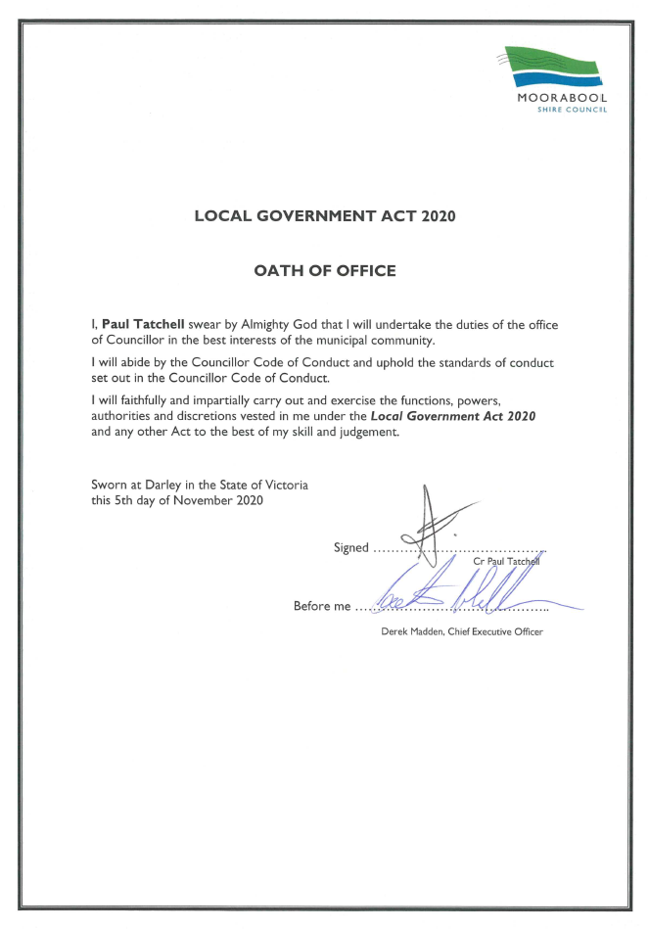
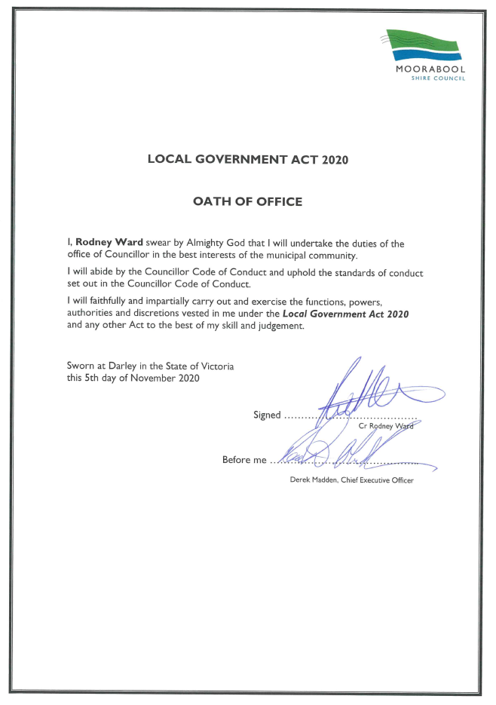
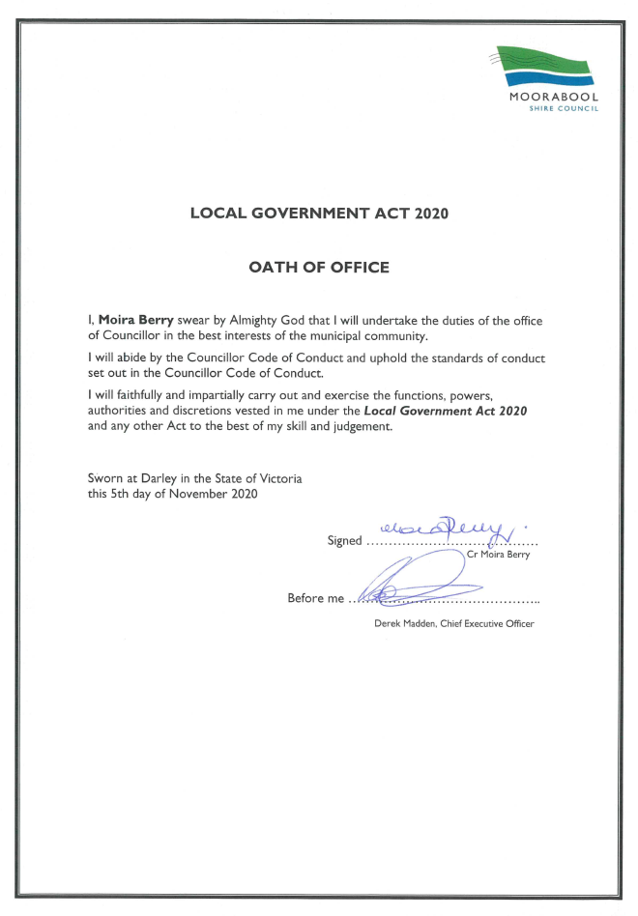
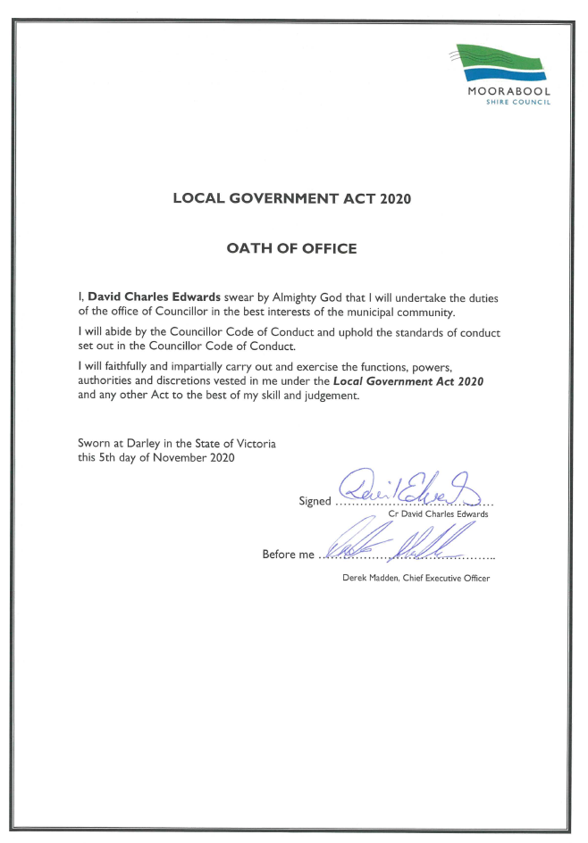
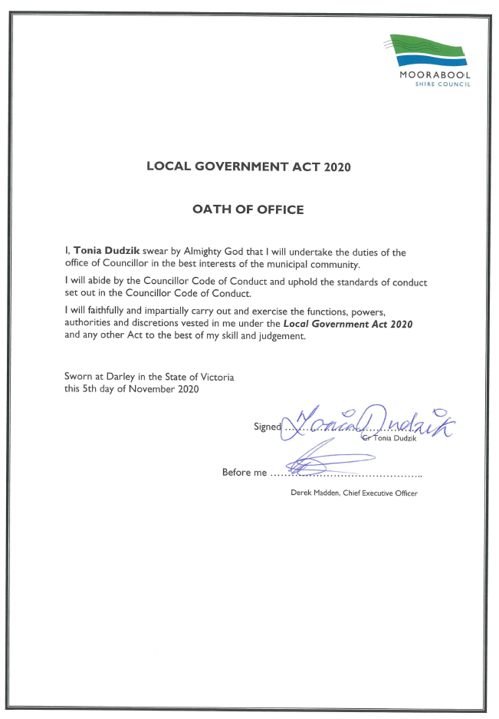
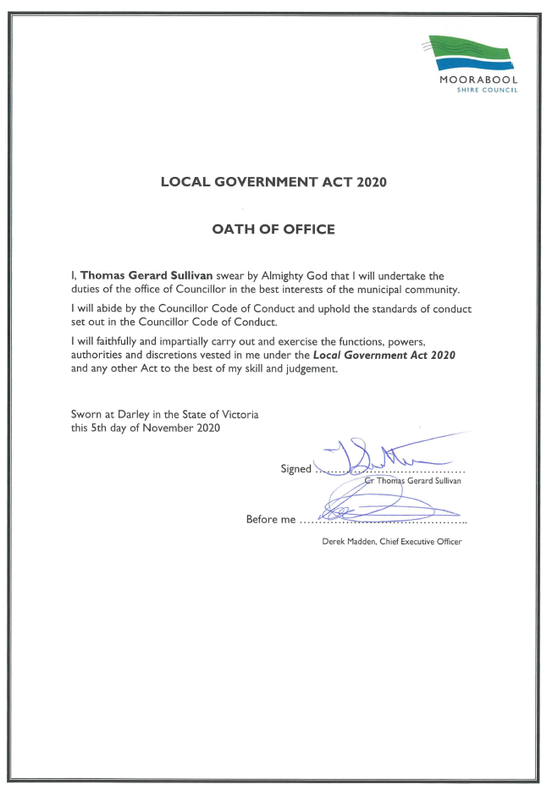
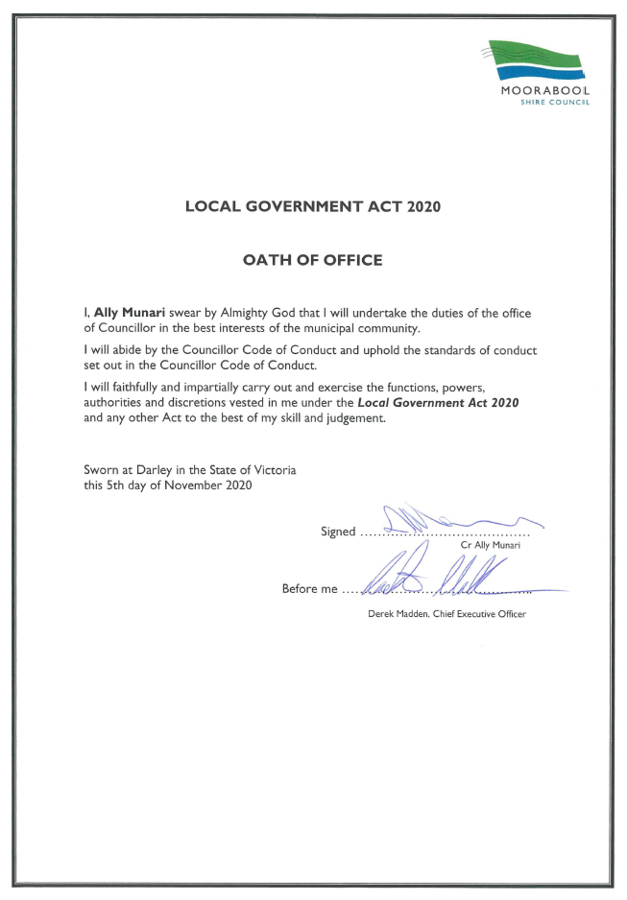

8.2 Mayoral and Councillor Allowances
Author: Yvonne Hansen, Manager Governance, Risk & Corporate Planning
Authoriser: Caroline Buisson, General Manager Customer Care & Advocacy
Attachments: Nil

Purpose
The purpose of this report is for Council to formally note the prevailing Mayoral and Councillor allowances that apply to the elected representatives of Moorabool Shire Council.

Executive Summary
As a designated Category 2 Council, the current maximum Mayoral and Councillor Allowances are set at $81,204 and $26,245 plus 9.5% (equivalent of superannuation guarantee contribution) respectively.
Provisions under the Local Government Act 2020 pertaining to the Mayor, Deputy Mayor and Councillor entitlements to receive an allowance have not yet come into effect.
The review of Mayoral and Councillors allowances will continue under s.74(1) of the Local Government Act 1989.
The Minister for Local Government has not yet published a notice in Government Gazette regarding the review of Councillor Allowances for the 2020-2021 term.

Recommendation
That Council receive the report on Mayoral and Councillor Allowances noting:
1. Current allowances are set at $81,204 pa (Mayoral) and $26,245 pa (Councillors) plus 9.5% (equivalent of superannuation guarantee contribution).
2. The payment of annual allowances is not to exceed more than one month in advance.

Background
Mayor and Councillors are entitled to receive an allowance while performing their duty as an elected official.
Section 39 of the Local Government Act 2020 stipulates that Mayors, Deputy Mayors and Councillors are entitled to receive an allowance in accordance with a Determination of the Victorian Independent Remuneration Tribunal. However, a determination made by the Tribunal at the request of the Minister for Local Government, under section 23A of the Victorian Independent Remuneration Tribunal and Improving Parliamentary Standards Act 2019, has not yet come into effect.
Until such time that a determination is made by the Tribunal at the request of the Minister for Local Government, under section 23A of the Victorian Independent Remuneration Tribunal and Improving Parliamentary Standards Act 2019, the review of allowances will continue under s.74(1) of the Local Government Act 1989 after the election.
In accordance with Section 74(1) of the Local Government Act 1989 Council must review and determine the level of the Councillor allowance and the Mayoral allowance within the period of 6 months after a general election or by the next 30 June, whichever is later.
Additionally, the allowance for Mayor and Councillors may be adjusted accordingly with any increase, as determined by Council as a result of the annual automatic adjustment announced by the Minister for Local Government.
As at 1 December 2019, the Minister for Local Government approved an adjustment factor increase of 2.0% to the Mayoral and Councillor allowances, under section 73B(4) of the Local Government Act 1989.

Proposal
It is proposed that until such time as the Minister for Local Government either publishes a notice in the Government Gazette regarding an adjustment of Councillor Allowances for the 2020-2021 term, or a determination is made by the Tribunal at the request of the Minister for Local Government, under section 23A of the Victorian Independent Remuneration Tribunal and Improving Parliamentary Standards Act 2019, that the Mayoral and Councillor Allowances remain at $81,204 pa (Mayoral) and $26,245 pa (Councillors) plus 9.5% (equivalent of superannuation guarantee contribution).
The manner of payment of allowances will not exceed more than one month in advance.
At the time of preparing this report, the Minister had not yet published a notice in Government Gazette regarding the review of Councillor Allowances for the 2020-2021 term. Therefore, a further report will be presented at a later date.

Council Plan
The Council Plan 2017-2021 provides as follows:
Strategic Objective 1: Providing Good Governance and Leadership
Context 1B: Our People

Financial Implications
Provision for the application of Mayoral and Councillor allowances has been made in Council’s 2020-2021 Annual Budget.

Risk & Occupational Health & Safety Issues
There are no identified Risks or OH&S implications as a result of presenting this report.

Communications & Consultation Strategy
As the nature of this report is procedural, there is no requirement to undertake any specific consultation.

Victorian Charter of Human Rights & Responsibilities Act 2006
In developing this report to Council, the officer considered whether the subject matter raised any human rights issues. In particular, whether the scope of any human right established by the Victorian Charter of Human Rights and Responsibilities is in any way limited, restricted or interfered with by the recommendations contained in the report. It is considered that the subject matter does not raise any human rights issues.

Officer’s Declaration of Conflict of Interests
Under section 130 of the Local Government Act 2020 officers providing advice to Council must disclose any interests, including the type of interest.
General Manager – Caroline Buisson
In providing this advice to Council as the General Manager, I have no interests to disclose in this report.
Author – Yvonne Hansen
In providing this advice to Council as the Author, I have no interests to disclose in this report.

Conclusion
It is recommended that Council note the prevailing Mayoral and Councillor allowances.

