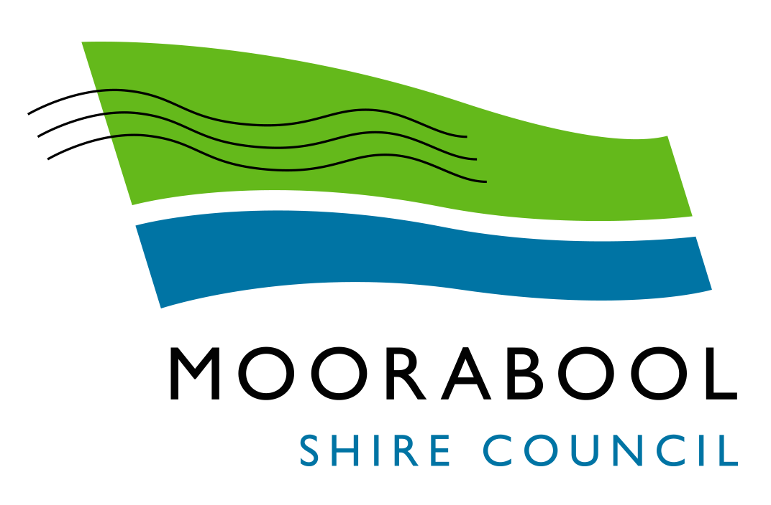
AGENDA

Special Council Meeting
Wednesday, 16 December 2020
I hereby give notice that a Special Meeting of Council will be held on:
Date: | Wednesday, 16 December 2020
Time: | 5.00pm
Location: | The Pavilion Room, Darley Civic Hub
Derek Madden
Chief Executive Officer

Order Of Business
1 Opening of Meeting and Prayer 5
2 Acknowledgement of Country 5
3 Present 5
4 Apologies 5
5 Disclosure of Conflicts of Interest 5
6 Presentations/Deputations 6
7 Community Strengthening Reports 7
7.1 Community Grants Program Round 2 (August) 2020 7
8 Closed Session of the Meeting to the Public 13
8.1 Australia Day Award Selection Panel Recommendations 13
9 Meeting Closure 14

1 Opening of Meeting and Prayer
Almighty God be with us as we work for the people of the Shire of Moorabool. Grant us wisdom that we may care for the Shire as true stewards of your creation. May we be aware of the great responsibilities placed upon us. Help us to be just in all our dealings and may our work prosper for the good of all. Amen.

2 Acknowledgement of Country
We respectfully acknowledge the traditional owners of this land, their spirits and ancestors.

3 Present

4 Apologies

5 Disclosure of Conflicts of Interest
Conflict of interest laws are prescribed under the Local Government Act 2020 (the Act) and in the Local Government (Governance and Integrity) Regulations 2020 (the Regulations). Managing conflicts of interest is about ensuring the integrity and transparency of decision-making.
The conflict of interest provisions under the Act have been simplified so that they are more easily understood and more easily applied. The new conflict of interest provisions are designed to ensure relevant persons proactively consider a broader range of interests and consider those interests from the viewpoint of an impartial, fair-minded person.
Section 126 of the Act states that a Councillor has a conflict of interest if they have a general conflict of interest or a material conflict of interest. These are explained below:
- A Councillor has a general conflict of interest in a matter if an impartial, fair-minded person would consider that the member’s private interests could result in them acting in a manner that is contrary to their public duty as a Councillor.
- A Councillor has a material conflict of interest in a matter if an affected person would gain a benefit or suffer a loss depending on the outcome of the matter.
A relevant person with a conflict of interest must disclose the interest in accordance with Council’s Governance Rules and not participate in the decision-making process on the matter. This means the relevant person must exclude themselves from any discussion or vote on the matter at any Council meeting, delegated committee meeting, community asset committee meeting or, if a councillor, any other meeting conducted under the auspices of the Council. The relevant person must also exclude themselves from any action in relation to the matter, including an action taken to implement a Council decision, for example, issuing a planning permit.

6 Presentations/Deputations
The Council has made provision in the business of the Special Meetings of the Council for the making of presentations or deputations to Council in relation to matters presented on the agenda for Council consideration.
Presentations or deputations are required to be conducted in accordance with the requirements contained within the Presentation/Deputations Protocols and Procedural Guidelines.
Persons wishing to make a presentation or deputation to Council on a matter included in the agenda shall inform Council prior to the meeting by contacting the Chief Executive Officer’s office and registering their name and agenda item being spoken to.
At the meeting the Mayor will invite the persons wishing to make a presentation or delegation to address the Council on the agenda item.
The person making the presentation or deputation is to stand and address Council on the item.
No debate on the item is permitted between the person making the presentation or delegation and the Council.
A maximum of three minutes per presentation or delegation will be allocated. An extension of time may be granted at the discretion of the Mayor.
Councillors, through the Mayor, may ask the person making the presentation or delegation for clarification of matters presented.
The Mayor may direct that a member of the gallery ceases speaking if the above procedure is not followed.

7 Community Strengthening Reports

7.1 Community Grants Program Round 2 (August) 2020
Author: Chris Gardner, Manager Connected Communities
Authoriser: Sally Jones, General Manager Community Strengthening
Attachments: 1. Community Grants Program Attachment 1 - Closed (under separate cover)

Purpose
The purpose of this report is to seek endorsement for the recommendations for funding Round 2 (August) 2020 of the Community Grants Program.

Executive Summary
- To seek Council endorsement of the recommendations for funding for the 2019-2020 Community Grants Program by the Community Grants Assessment Panel.
- The Community Grants Program provides funding to community organisations to deliver programs that build on local strengths to develop active, healthy, connected and inclusive communities.
- Council received 14 applications across the five program categories: Community Arts and Culture (3), Community Strengthening Grants (10), Community Events Grants (0), Community Development Fund (0) and Sustainability and Environmental Engagement Grant (1).
- A total of $51,754.00 was requested with $187,400.00 available this round.
- Eligible applications were assessed by an Assessment Panel consisting of officers from a diverse range of departments.
- The report presents Council with a list of recommended grants for the August 2020 funding round prepared by the Community Grants Assessment Panel (Attachment 1).
- In total, 13 applications from 12 organisations are recommended to receive $46,754 in funding.
- The allocation of this sum is detailed in the funding recommendations within this report and at Attachment 1.

Recommendation
That Council approves the allocation of the Community Grants as provided in Attachment 1.

Background
The purpose of this report is to present Council with an assessment of applications received for the 2020 Round 2 (August) Community Grants Program, which total $270,400 per annum. Round 2 (August) of the Community Grants Program opened on 1 August 2020 and closed on 31 August 2020. Assessors commented that the overall calibre of applications in this round was high. A total of 50% of applications which were commenced via the online portal were submitted for final consideration and feedback was sought from applicants who ultimately chose not to submit. The majority of feedback received indicated the impact of COVID affected the ability for community groups to finalise submissions. Many groups are currently dormant, and communication has been challenging during the pandemic.
Council’s Community Grants program enables not for profit community groups to apply for funding under the following five program categories:
- Arts and Culture Grants: Supporting local artists and organisations to use a creative approach to the development of community projects and initiatives ($10,000 available this round).
- Community Strengthening Grants: Community projects, programs and initiatives with a specific focus on connecting communities and building community capacity ($60,000 available this round).
- Events Grants: Non‐recurrent, seed funding designed to encourage and promote the development of sustainable local events ($10,000 available this round).
- Community Development Fund Grants: Supporting community infrastructure projects which significantly impact on community development. One or more projects may be funded up to $100,000 in this round, with any remaining funding allocated to a second round opening the following August during Round 2 ($70,000 available in this round).
- Sustainability and Environment Engagement Grants: Supporting the community in reducing expenditure of gas and electricity, investing in sustainability measures and providing opportunities to raise awareness of environmental issues to the broader community ($7,400 in this round).
Community groups and organisations can apply for up to $5,000 for Community Strengthening Grants and up to $3,000 for Arts, Events and Sustainability Grants. Groups also need to demonstrate a cash or in‐kind contribution toward the cost of their project on a ratio of $1 for $1 (Council $1: Group $1). Small Community Strengthening projects under $1,000 are not required to demonstrate a contribution.

Proposal
Applicant Support
The Community Grants Guidelines specifies that applicant groups are required to liaise with a Connected Communities officer prior to lodging an application to ensure applicants receive clear guidance on eligibility and how to best present their applications. All applicants received support and advice from Council officers before lodging their application. Additional support was provided after the funding round closed to clarify any ambiguity in applications.

Policy Assessment Criteria
- Project Description and why the applicant wants to do the project – 10%
- What will this project achieve? – 20%
- Why is this project needed in your community? – 20%
- Who will be involved in the project? – 15%
- How will you carry out your project? (including risk management) – 15%
- Project budget and explanation of how the group arrived at the costs? – 20%
Each criterion is assessed out of 10 and weighted according to the criteria percentage. The maximum possible score for any application is 100.
Scoring Guide
Score each criteria out of 10
0 | Did not address criteria
1‐2 | Minimal
3‐5 | Satisfactory
6‐8 | Good
9‐10 | Excellent

Key Issues

This report is to present recommendations from the assessment panel to Council regarding applications to the Round 2 (August) 2020 Community Grants Program.

Number of applications and amount requested
In total, 14 applications were received across the five program categories: Community Arts and Culture (3), Community Strengthening Grants (10), Community Events Grants (0), Community Development Fund (0) and Sustainability and Environmental Engagement Grant (1). A total of $51,754.00 was requested with $187,400.00 available this round.
Category | Applications  Received | Amount  Available | Amount  Requested | Amount  Recommended
Community Arts and Culture | 3 | $10,000 | $6,450 | $6,450
Community Strengthening Grant | 10 | $60,000 | $42,304.00 | $37,304.00
Community Events Grant | 0 | $10,000 | $0.00 | $0.00
Community Development Fund | 0 | $100,000 | $0.00 | $0.00
Sustainability and Environmental  Engagement Grant | 1 | $7,400 | $3,000.00 | $3,000.00
Total | 14 | $187,400.00 | $51,754.00 | $46,754.00

Current Status
The recommendations provided in Attachment 1 represent 100% of community grant applications from Round 2, August 2020 grants.

Council Plan
The Council Plan 2017–2021 provides as follows:
Strategic Objective 4: Improve Social Outcomes
Context 4B: Community Connectedness and Capacity
The proposed allocation of grants under the 2020 Round 2 August Community Grants Program is consistent with the Council Plan 2017–2021.

Financial Implications
Consistent with the Community Grants Policy and 2019/20 budget allocation, a total of $187,400.00 is available for allocation in Round 2 August 2020 Community Grants Program.
The following amounts are recommended:
- $6,450.00 for Arts and Culture Grants
- $37,304.00 for Community Strengthening Grants
- $3,000.00 for Sustainability and Environmental Engagement Grants

Risk & Occupational Health & Safety Issues
Risk Identifier | Detail of Risk | Risk Rating | Control/s
Project timelines | Grant recipients exceeding prescribed timelines | Medium | • Terms and conditions agreements required to be signed by grant recipients  • Scheduled monitoring of projects
Financial | Grant recipients misappropriate expenditure of Council funds | Medium | • Terms and conditions agreements required to be signed by grant recipients  • Grant acquittal required upon completion of projects

Communications & Consultation Strategy
Successful applicants:
- Formal notification and congratulations will be provided via email on endorsement of Council report.
Unsuccessful applicants:
- To be advised by telephone and/or email. Guidance and support will be provided to improve opportunities for future grant applications.
- To be offered the opportunity for one on one meetings with officers to discuss their application and request advice.
- Be advised of future Grant Writing Workshop opportunities.

Community Groups
- Are advised when Community Grants become available and requested to further advise their networks via direct telephone calls and email.
- Are requested to advertise the Community Grants across their communications options including social media and newsletters.
Moorabool Residents
- Promotional flyers advertising Community Grants Program across the Shire:
  - Libraries notice board and Library newsletter
  - Economic Development Newsletter
  - Community Noticeboards
  - Bacchus Marsh Leisure Centre
  - Darley Neighbourhood House, Ballan & District Community House
  - Darley Early Years Hub
  - Visitors Centre
  - Moorabool News
  - Early Years Newsletter
  - Website Events Page and Community Page
  - Youth Facebook Page
  - Moorabool Shire corporate website and Facebook page
  - Apple FM
- Grant Writing Workshops
  - Four Workshops were held across Bacchus Marsh and Ballan to improve knowledge of Smartygrants and grant writing requirements.
  - Advice and guidance provided to potential applicants.
Applicants for the 2020 Round 2 (August) Community Grants Program have been informed they will be notified of the outcomes of their grant applications in December 2020.
The Community Connections Team will formally notify groups of the outcome of their applications and provide opportunity for feedback to the unsuccessful applicant.
Feedback will include:
- Advice to applicant groups of the relative strengths and areas for improvement in their application;
- Options for alternative funding (if applicable);
- Supporting a group to amend and re‐lodge their application in the next appropriate round of the Community Grants program.

Victorian Charter of Human Rights & Responsibilities Act 2006
In developing this report to Council, the officer considered whether the subject matter raised any human rights issues. In particular, whether the scope of any human right established by the Victorian Charter of Human Rights and Responsibilities is in any way limited, restricted or interfered with by the recommendations contained in the report. It is considered that the subject matter does not raise any human rights issues.

Officer’s Declaration of Conflict of Interests
Under section 130 of the Local Government Act 2020, officers providing advice to Council must disclose any interests, including the type of interest.
General Manager – Sally Jones
In providing this advice to Council as the General Manager, I have no interests to disclose in this report.
Author – Chris Gardner
In providing this advice to Council as the Author, I have no interests to disclose in this report.

Conclusion
Based on the application assessment process and funding criteria, it is proposed that the Council allocates funding for grants for the Moorabool Shire Round 2 (August) 2020 Community Grants based on the tables provided in Attachment 1.

8 Closed Session of the Meeting to the Public

Recommendation
That Council considers the confidential report listed below in a meeting closed to the public in accordance with Section 66(2)(a) of the Local Government Act 2020:
8.1 Australia Day Award Selection Panel Recommendations

9 Meeting Closure

