|  |  |
| --- | --- |
|  | |
| **MINUTES**  **Ordinary Council Meeting**  **Wednesday, 3 June 2020**  In accordance with s. 395 of the COVID-19 Omnibus (Emergency Measures) Bill 2020,  this meeting was closed for public attendance, however, a livestream via Council’s Internet site was made available. | |
| **Time:** | **6.00pm** |
| **Location:** | **The Pavilion Room, Darley Civic Hub** |

**Order Of Business**

1. Opening of Meeting and Prayer 4

2. Acknowledgement of Country 4

3 Recording of Meeting 4

4. Present 4

5. Apologies 4

6. Confirmation of Minutes 5

7. Disclosure of Conflicts of Interest 5

8. Public Question Time 5

9. Petitions 5

10. Presentations/Deputations 5

11. Chief Executive Officer Reports 5

12 Community Planning and Economic Development Reports 6

12.1 Revocation of Urban Growth Policy Statement 2012 6

13 Community Strengthening Reports 14

13.1 Reserve Funds - Community Seed Funding Reserve 14

13.2 Community Grants Program: Round 1 (March) 2020 20

14. Customer Care and Advocacy Reports 26

14.1 Procurement Policy Review 26

15. Community Assets & Infrastructure Reports 30

15.1 Municipal Emergency Management Plan 2020-2023 30

15.2 Draft Bores/Standpipes Policy 34

16 Other Reports 39

17 Notices of Motion 39

18. Mayor’s Report 39

18.1 Mayor's Report 39

19. Councillors Report 40

20. Urgent Business 40

21 Closed Session of the Meeting to the Public 40

19 Meeting Closure 40

1. Opening of Meeting and Prayer

The Mayor opened the meeting with the Council Prayer at 6.00pm.

The Mayor advised that Councillors Tatchell and Keogh are participating in tonight’s meeting via video link and tonight’s meeting is being livestreamed via Council’s website.

2. Acknowledgement of Country

We respectfully acknowledge the traditional owners of this land, their spirits and ancestors.

3 Recording of Meeting

In accordance with Moorabool Shire Council’s Meeting Procedure Local Law, the Council has recorded this meeting.

4. Present

Cr David Edwards (Mayor) East Moorabool Ward

Cr Jarrod Bingham East Moorabool Ward

Cr Tonia Dudzik East Moorabool Ward

Cr John Keogh East Moorabool Ward

Cr Lawry Borgelt Woodlands Ward

Cr Tom Sullivan West Moorabool Ward

Cr Paul Tatchell Central Moorabool Ward

**Officers:**

Mr Derek Madden Chief Executive Officer

Mr Phil Jeffrey General Manager Community Assets & Infrastructure

Ms Caroline Buisson General Manager Customer Care and Advocacy

Ms Sally Jones General Manager Community Strengthening

Mr Henry Bezuidenhout Executive Manager Community Planning & Economic Development

Ms Yvonne Hansen Manager Governance, Risk & Corporate Planning

5. Apologies

Nil.

6. Confirmation of Minutes

|  |
| --- |
| **Resolution**  **Moved:** Cr Jarrod Bingham  **Seconded:** Cr Lawry Borgelt  That the Minutes of the Ordinary Council Meeting held on Wednesday 6 May 2020 and the Special Council Meeting held on Wednesday 20 May 2020 be confirmed.  **Carried** |

7. Disclosure of Conflicts of Interest

Nil.

8. Public Question Time

|  |  |
| --- | --- |
| **Name** | **Question** |
| Judy Haarburger, Bacchus Marsh | The Moorabool community are concerned about the State government proposal to dump the toxic soil from the West gate Tunnel Project in our region and are adamant that they do not want the toxic soil in their beautiful Shire.   1. What is Council’s position? 2. What feedback have Council got back from the state government regarding a transparent process? 3. Given the 1 year delay for the project, how does that effect the planning and decision-making processes regarding the soil discussion? |
|  | **Response:**  Thank you for taking the time to submit your concerns about the proposal to receive, store and potentially dispose of unclassified soil from the Westgate Tunnel Project at Bacchus Marsh. We understand that this is a sensitive issue for many in the community.  It is understood that the proposal was submitted to the Minister for Planning for consideration under section 20(4) of the Planning and Environment Act on 5 May 2020.  Council received a copy of the application and the associated technical documents from the Planning Minister on the 20 May 2020.  We are in the process of reviewing these documents to provide a response to the Minister by 10 June 2020.  In response to the specific questions, we can provide the following responses:  Council has not had a chance to review the documents in full at this stage and has therefore not  formed position.  However, Council has expressed its concerns about the proposal and the lack of consultation to relevant Ministers since December 2019, and we will continue to do so.  Council has not received feedback from the Minister’s office regarding the transparency of the proposal.  It is acknowledged that the West Gate Tunnel Project is under a lot of pressure, however the Planning Minister has an obligation to adhere to the correct planning and decision-making processes regardless of project delays.  As best we can, Council will continue to keep the community up-to-date on the Moorabool Shire Council website and Facebook pages. |
| Phaedra Morris, Barrys Reef | 1. What involvement/influence does Council have in the decision-making processes regarding the VEAC recommendations for the Wombat-Lerderderg National Park? 2. Can council advise if they are aware of the State’s response? 3. Where can we as local stakeholders get information about this process or get involved? |
|  | **Response:**  This is a State Government process relating to a review of Crown Land within the Central West Region - Council provided a response to the Central West Investigation Proposal Paper in late 2018 in relation to the Lerderderg State Park, Wombat State Forest and Bungal State Forest – no further engagement was undertaken with Council in the development of the final report.  The State Government was scheduled to respond to the recommendations by late February 2020. Council was advised that the significant summer bush fire season and COVID-19 impacted the initial timeline for the State Government response – at this time a revised timeline is not yet known.  The final report, fact sheets and other information  relating to the investigation can be found at http://www.veac.vic.gov.au/investigation/central-west-investigation |

|  |  |
| --- | --- |
| Nishka Bernadine Gawalski, Ballan | Is Council involved in any advocacy to the State government urging them to plan and budget for a secondary state school in Ballan? If not why not, when this issue has been of great community concern over the past 2 council cycles? |
|  | **Response:**  Council has not undertaken any formal advocacy to the State Government regarding the planning and budgeting for a state secondary school in Ballan.  Acknowledging the projected high growth, Council will continue to monitor the annual rate of growth in Ballan and threshold figures.  Provision standards for state secondary schools are 1 per 9,000-10,000 dwellings. There are currently approx. 1,112 dwellings (2,564 people) in Ballan, with this projected to increase to 2,901 dwellings (6,714 people) by 2041. Council will furthermore factor in the rural catchment area in its annual calculations.  As mentioned above, we will continue to monitor the growth to proactively plan and advocate for the provisioning of community infrastructure in a timely manner. |

9. Petitions

Nil.

10. Presentations/Deputations

Nil.

11. Chief Executive Officer Reports

Nil.

12 Community Planning and Economic Development Reports

12.1 Revocation of Urban Growth Policy Statement 2012

**Author: Rod Davison, Senior Strategic Planner**

**Authoriser: Henry Bezuidenhout, Executive Manager Community Planning & Economic Development**

**Attachments: 1. Urban Growth Policy Statement 2012**

**2. Audit of Urban Growth Policy Statement**

Purpose

This purpose of this report is to revoke Council’s *Urban Growth Policy Statement* *2012* (policy #GD008/01).

Executive Summary

• On 19 September 2012, Council adopted the Urban Growth Policy Statement 2012 (policy #GD008/01) as part of Phase 1 of the Moorabool 2041 strategic planning project. The purpose of this policy was to provide interim direction for future development in the Shire and to provide guidance for Phase 2 of the Moorabool 2041 project.

• Phase 2 of the Moorabool 2041 project has now been completed and involved the preparation and implementation of the following key strategies, via amendments to the Moorabool Planning Scheme:

• Housing Bacchus Marsh to 2041 (2018)

• Bacchus Marsh Urban Growth Framework 2018

• Ballan Strategic Directions 2018

• Small Towns and Settlements Strategy 2016

• The Moorabool Planning Scheme now provides the current urban growth policy direction for the Shire, based on the above strategies.

• This report includes a full audit of the Urban Growth Policy Statement 2012 against the various key Moorabool 2041 strategies and the Moorabool Planning Scheme. The audit demonstrates that the policy statement is now reflected in the above strategies and the Moorabool Planning Scheme and can be revoked.

|  |
| --- |
| Resolution  **Moved:** Cr Tonia Dudzik  **Seconded:** Cr Lawry Borgelt  That Council resolves to revoke Urban Growth Policy Statement 2012 (policy #GD008/01).  **Carried** |

Background

On 19 September 2012, Council adopted the Urban Growth Policy Statement 2012 (policy #GD008/01) together with a Rural Growth Policy Statement 2012 (policy #GD007/01), as part of Phase 1 of the Moorabool 2041 strategic planning project. On 7 May 2014, Council adopted the Rural Housing Policy (policy #GD011/01) which built upon the Rural Growth Policy Statement 2012 by providing guidance for assessment of applications for single dwellings in the Farming Zone. The purpose of these policy statements was to provide interim direction for future development in the Shire and to provide guidance for Phase 2 of the Moorabool 2041 project.

**Moorabool 2041**

‘Moorabool 2041’ is a strategic planning project which commenced in 2012 to guide the growth and development of the Shire through to 2041.

The aim of Moorabool 2041 was to develop a vision and provide a strategic framework to guide future sustainable development in appropriate locations in the Shire, addressing land use, amenity and lifestyle opportunities while matching growth with the provision of physical and social infrastructure. There is no overarching document titled Moorabool 2041; it is an umbrella term used to refer to Council’s key strategic documents that guide growth and change until 2041 across the Shire.

The Moorabool 2041 project was delivered in two phases as follows:

• Phase 1 involved the preparation of the abovementioned urban and rural growth policies, to provide interim policy direction and to provide guidance for Phase 2 of the project.

• Phase 2 of the Moorabool 2041 project involved extensive community consultation (during 2014/15) and the preparation of a number of strategies which were implemented via amendments to the Moorabool Planning Scheme.

Phase 2 of the Moorabool 2041 project has now been completed. Key strategies that form part of Moorabool 2041 include Housing Bacchus Marsh to 2041, the Small Towns and Settlements Strategy, Ballan Strategic Directions and the Bacchus Marsh Urban Growth Framework. These strategies provide the current urban growth policy direction, having been adopted by Council and included in the Moorabool Planning Scheme via series of planning scheme amendments as outlined in Table 1 below.

|  |  |  |
| --- | --- | --- |
| **Strategy** | **Amendment to the Moorabool Planning Scheme** | **Amendment Gazettal Date** |
| Housing Bacchus Marsh to 2041 (2018) | Amendment C79 | 15 November 2018 |
| Bacchus Marsh Urban Growth Framework 2018 | Amendment C81 | 6 December 2018 |
| Ballan Strategic Directions 2018 | Amendment C88 | 6 March 2020 |
| Small Towns and Settlements Strategy 2016 | Amendment C78 | 31 May 2018 |

Table 1: Moorabool 2041 strategies and their respective planning scheme amendments

In addition to the Moorabool 2041 strategies, planning scheme amendment C58 (gazetted on 4 May 2017) is also considered relevant to the Urban Growth Policy Statement 2012*.* This is due to the fact that amendment C58 rezoned land in the Camerons Road area of Darley/Coimadai (to facilitate limited rural residential development) and the policy statement includes place‑based specific policy principles relating to this area.

**Urban Growth Policy Statement 2012 (policy #GD008/01):**

The Urban Growth Policy Statement 2012 (Attachment 1) was developed to provide interim direction for future development in the Shire and to provide guidance for Phase 2 of the Moorabool 2041 project.

The policy statement aims to provide an urban growth vision for the municipality up to the year 2041. The policy anticipates that outward growth pressure from metropolitan Melbourne will continue to reinforce the advantages of the Shire as a place in which to live and invest.

The policy statement doesn’t specify exactly which towns it applies to, however, it focuses largely on Bacchus Marsh and Ballan. The policy acknowledges that Bacchus Marsh will likely absorb most of this growth pressure, but that the urban area is constrained by topography, and mineral and agricultural/horticultural resources. As unconstrained land in Bacchus Marsh becomes scarce, Ballan and Gordon have the potential to accommodate further growth.

The policy statement comprises a suite of general policy principles, together with a number of place-based specific policy principles.

**Relevant Amendments to the Moorabool Planning Scheme:**

Amendment C79 - Bacchus Marsh Housing Strategy:

Amendment C79 (gazetted on 15 November 2018) implemented the Bacchus Marsh housing strategy (Housing Bacchus Marsh to 2041), thereby providing policy direction for infill development of existing urban zoned land. C79 updated various local planning policy clauses, rezoned various land and applied new schedules to land in the General Residential Zone, Neighbourhood Residential Zone and Low-Density Residential Zone throughout Bacchus Marsh, Darley and Maddingley. The amendment also inserted Housing Bacchus Marsh to 2041 as a reference document in the planning scheme.

Amendment C81- Bacchus Marsh Urban Growth Framework:

Amendment C81 (gazetted on 6 December 2018) implemented the Bacchus Marsh Urban Growth Framework 2018 (UGF) which provides direction for the growth of the town to 2041. C81 updated various local planning policy clauses and inserted the UGF as a reference document. The updated local planning policy clauses include the Bacchus Marsh UGF Plan (see Figure 1), which identifies urban growth investigation areas at Merrimu, Parwan Station and Hopetoun Park North, together with the Parwan Employment Precinct (which includes the aerodrome environs).

Future planning scheme amendments will be required to rezone land and implement Precinct Structure Plans or Development Plans for each of these precincts.

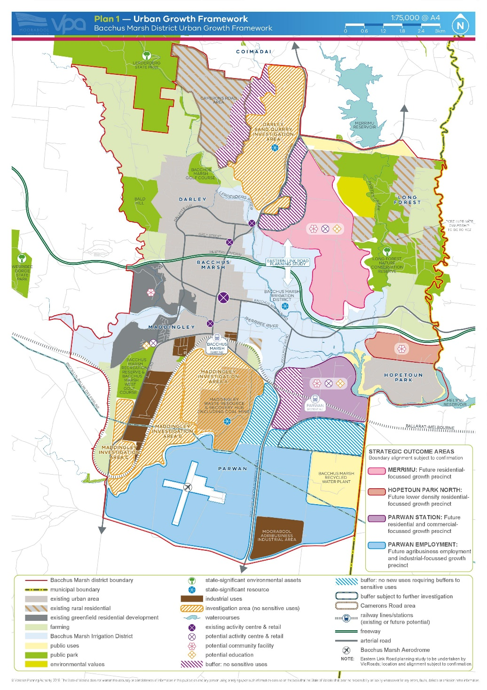

Figure 1: Bacchus Marsh Urban Growth FrameworkPlan

Amendment C88 - Ballan Strategic Directions:

Amendment C88 (gazetted on 6 March 2020) implemented Ballan Strategic Directions 2018, which provides direction for the growth of the town to 2041. C88 updated local planning policy clauses and inserted Ballan Strategic Directionsas a reference document. C88 also rezoned land, applied existing zone schedules, and introduced new schedules to certain residential zones. The updated local planning policy clauses include an updated Ballan Framework Plan, which identifies land for natural, greenfield and minimal growth and also identifies seven future residential growth precincts (see Figure 2).

Future planning scheme amendments will be required to rezone land and (in most cases) apply a Development Plan Overlay Schedule to the new growth precincts.

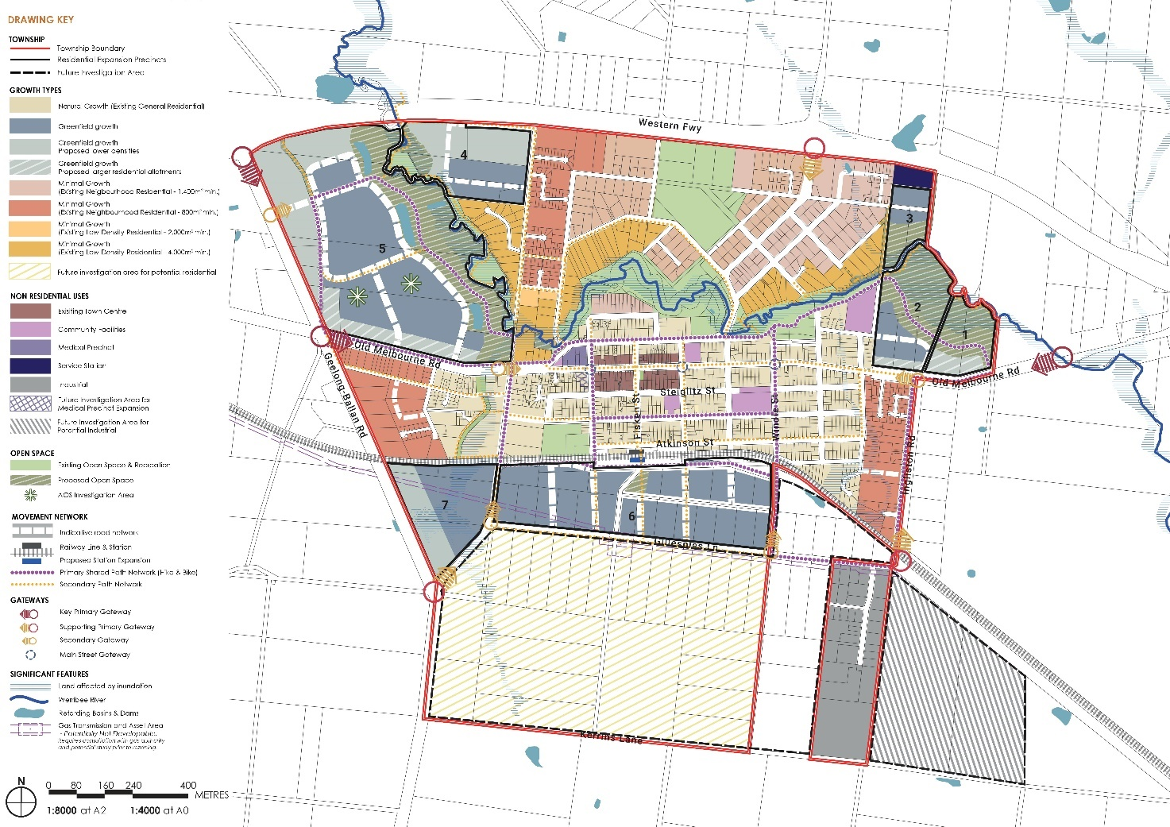

Figure 2: Ballan Framework Plan

Amendment C78 – Small Towns and Settlements:

Amendment C78 (gazetted on 31 May 2018) implemented the recommendations of the Small Towns and Settlements Strategy 2016, by updating various local planning policy clauses.

The updated Clause 21.09 (Small Towns and Settlements) provides the following policy direction in relation to residential development:

• Provide for limited growth in Bungaree, Dunnstown, Gordon Myrniong and Wallace and restrict residential development to within existing urban areas of the Shire’s other small towns and settlements.

• Limit residential growth in small towns subject to severe bushfire risk and other serious constraints.

• Protect viable agricultural land from residential fragmentation, to preserve its use for farming purposes.

• Blackwood - Identify where lot consolidation of vacant land may enable limited new development, or more appropriately sized lots.

Amendment C58 – Camerons Road Area:

Amendment C58 (gazetted on 4 May 2017) rezoned 550 hectares of land in the Camerons Road area of Darley/Coimadai from Farming Zone to part Rural Conservation Zone (RCZ) Schedule 2 and part Rural Living Zone (RLZ) (see Figure 3), to facilitate limited rural residential development.

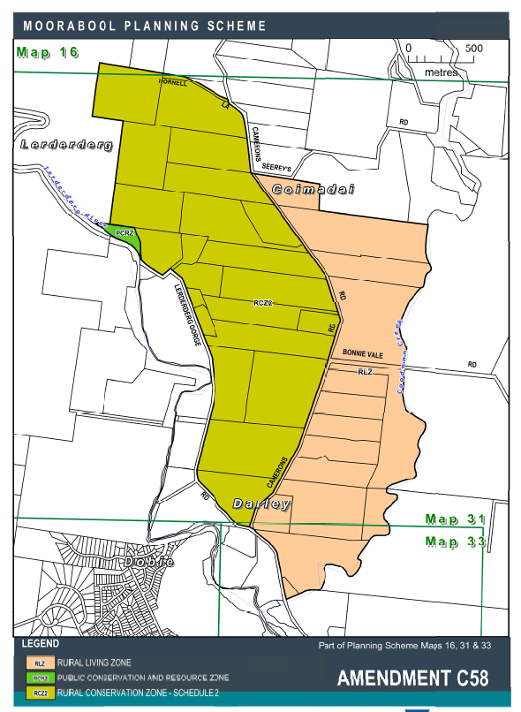

Figure 3: Land affected by Amendment C58

Proposal

Given that the Moorabool 2041 strategic planning project has been completed, it is now considered appropriate to revoke the Urban Growth Policy Statement 2012, noting that the purpose of the policy statement was to provide interim policy direction and guidance for the preparation of the various key Moorabool 2041 strategies. Consideration has been given to the policy principles identified in the policy statement, and whether they have been reflected in the key Moorabool 2041 strategies and also in the Moorabool Planning Scheme.

Attachment 2 includes a full audit of the Urban Growth Policy Statement 2012 against the various key Moorabool 2041 strategies and the Moorabool Planning Scheme*.* The audit demonstrates the following:

• That recent strategic work and amendments to the Moorabool Planning Scheme have comprehensively addressed the Moorabool 2041 implementation tasks identified in the Urban Growth Policy Statement 2012, consistent with the general policy principles.

• That all of the place-based specific policy principles identified in the Urban Growth Policy Statement 2012 are superseded, as they have been addressed in recent strategic work and amendments to the Moorabool Planning Scheme.

Overall, the audit demonstrates that the Urban Growth Policy Statement 2012 has served its purpose, as it has informed the development of the Moorabool 2041 strategies, which are now reflected in the Moorabool Planning Scheme. It is considered that the policy statement is therefore no longer required*.*

Consideration has also been given to the Rural Growth Policy Statement 2012 (policy #GD007/01) and the Rural Housing Policy (policy #GD011/01). Whilst the Small Towns and Settlements Strategy 2016 provides direction for some rural areas of the Shire, there remains a significant policy gap in regard to rural areas more generally. It is noted that the 2019/20 Council Budget includes an allocation for a new Rural Land Use Strategy and the Strategic Planning team has commenced this important project. It is considered appropriate to await completion of the new Rural Land Use Strategy before reviewing the Rural Growth Policy Statement and the Rural Housing Policy.

Council Plan

The Council Plan 2017-2021 provides as follows:

**Strategic Objective 3: Stimulating Economic Development**

**Context 3A: Land Use Planning**

The proposal revocation of the Urban Growth Policy Statement 2012 is broadly consistent with the Council Plan 2017 – 2021.

Financial Implications

There are no financial implications associated with the proposed revocation of Council’s Urban Growth Policy Statement 2012.

Risk & Occupational Health & Safety Issues

There are no risk or occupational health and safety issues associated with the proposed revocation of Council’s Urban Growth Policy Statement 2012.

Communications & Consultation Strategy

No consultation is proposed prior to revoking the Urban Growth Policy Statement 2012. As noted above, the policy is considered to be superseded by various Moorabool 2041 strategies. Council undertook extensive community and stakeholder consultation during the preparation of the various strategies and during the exhibition of the associated planning scheme amendments.

Victorian Charter of Human Rights & Responsibilities Act 2006

In developing this report to Council, the officer considered whether the subject matter raised any human rights issues. In particular, whether the scope of any human right established by the Victorian Charter of Human Rights and Responsibilities is in any way limited, restricted or interfered with by the recommendations contained in the report. It is considered that the subject matter does not raise any human rights issues.

Officer’s Declaration of Conflict of Interests

Under section 80C of the *Local Government Act 1989* (as amended), officers providing advice to Council must disclose any interests, including the type of interest.

*Executive Manager – Henry Bezuidenhout*

In providing this advice to Council as the Executive Manager, I have no interests to disclose in this report.

*Author – Rod Davison*

In providing this advice to Council as the Author, I have no interests to disclose in this report.

Conclusion

The purpose of Council’s Urban Growth Policy Statement 2012 (policy #GD008/01) was to provide interim policy direction for future development in the Shire and to provide guidance for Phase 2 of the Moorabool 2041 strategic planning project. Phase 2 of the Moorabool 2041 project has now been completed and involved the preparation and implementation of a substantial body of strategic work, via various amendments to the Moorabool Planning Scheme.

The audit of the Urban Growth Policy Statement 2012 demonstrates that the policy statement has served its purpose, as it has informed the development of the Moorabool 2041 strategies, which are now reflected in the Moorabool Planning Scheme. It is considered that the policy statement has been superseded and should therefore be revoked.

13 Community Strengthening Reports

13.1 Reserve Funds - Community Seed Funding Reserve

**Author: Sally Jones, General Manager Community Strengthening**

**Authoriser: Derek Madden, Chief Executive Officer**

**Attachments: 1. Agenda and Minutes Community Seed Funding Reserve**

Purpose

This report presents two community recreation projects requiring financial support to ensure completion. The projects align with the intended purpose of the Community Seed Funding Reserve and are presented for consideration.

Executive Summary

• Council Officers have become aware of two recreation projects requiring additional funding to enable completion. These projects align with the intended purpose of the Community Seed Funding Reserve.

• The projects requiring financial support are:

• Gordon Football Netball Club – Female Friendly Facility Project

• Darley Football Netball Club – Netball Court Resurfacing

|  |
| --- |
| Resolution  **Moved:** Cr Tonia Dudzik  **Seconded:** Cr John Keogh  That Council approves:  1. The required shortfall funding of $36,643 for the Female Friendly Facility Program project being delivered by Gordon Football Netball Club is funded from the Community Seed Funding Reserve; and  2. The required shortfall funding of $15,000 for the netball court resurfacing project at Darley Park, inclusive of the line marking requirements for multiple tennis courts, is funded from the Community Seed Funding Reserve.  **Carried** |

Background

• At the Ordinary Meeting of Council of 2 May 2018, the following Urgent Business item was raised by two Councillors:

• That a report to Council be presented to the next meeting that addresses guidelines for utilising ward funds and whether they should continue going forward.

• At the Ordinary Meeting of Council of 6 June 2018, (Attachment 1) a report addressing the use of Council Reserve/Ward funds was presented to Council. In order to provide a source of funds for urgent or opportunistic projects, outside of the community grants process, it was concluded that a new Shire wide funding reserve was required.

• The resolution of Council (Attachment 1) consisted of eight points. Points six and seven resolved:

• 6. That the Capital Works Seed Funding Reserve be renamed the Community Seed Funding Reserve and continue post the next State and Federal election and that the Council continues to contribute 0.25% of rate revenue to the Reserve annually.

• 7. That the purpose of the Community Seed Funding Reserve be to respond to urgent and opportunistic requests from the community and government on a Shire wide basis. Expenditure from the Reserve will be by Council resolution after considering a report from officers based on the Community Grants policy and guidelines.

In response to the resolution at point seven, the Objective as stated in the introduction of the Community Grants Program Guidelines states:

*The key objective of Community Grants is to support the development and improvement of local projects, programs, events and initiatives, increasing resources and opportunities for local groups who have limited avenues of support, but wish to undertake activities that engage the wider community.*

Both groups requesting shortfall funding meet the eligibility criteria within the Community Grants policy and qualify within the Community Development Fund Grant stream. The current round of Community Grants opened in March, however the panel decisions are not made until June. This timeframe does not support the timeframes of the following project funding requests.

**Gordon Football Netball Club**

Female Friendly Facility Program

The Gordon Football Netball Club are currently undertaking the Gordon Netball Facility Upgrade project. The project has a current shortfall of $36,643, placing the project at risk of remaining incomplete.

The secured funding for this project consists of:

|  |  |  |
| --- | --- | --- |
| Moorabool Shire | $75,000 | 2019-2020 CIP Budget |
| Sport and Rec Victoria | $250,000 | 2018-2019 Female Friendly Facilities Fund |
| Gordon Football Netball | $25,000 | Club fundraising, cash contribution |
| Gordon Football Netball | $15,000 (in kind) | Court works provided by Carey Civil Contractors |
| Gordon Rec Reserve Committee of Management | $10,000 | Cash Contribution |
| **SHORTFALL** | $36,643 | Request through Community Seed Funding |

In 2018 an agreement for the project to be delivered within a total of $375,000 was signed by Moorabool Shire and the Gordon Recreation Reserve Committee of Management inclusive of the reporting and acquittal requirements of Sport and Recreation Victoria (SRV).

Officers have now received information related to a shortfall of $36,643 funding required to complete the initial building improvement project.

During preparation of the estimate for the project the proposed netball changeroom was designed to be a simple building without heating, cooling, windows or floor coverings. All netball facility projects require approval from Netball Victoria in order to qualify for the Female Friendly Facility Program. The initial design plans did not correspond to minimum facility requirements of Netball Victoria which led to some required design changes from the original scope.

On receipt of notification of a successful funding application, Gordon Committee of Management applied for a building permit and were informed that while they had satisfied Netball Victoria from a design aspect, changes to building code requirements necessitated changes to the toilets and showers to meet disabled, ambulant, gender neutral, male and female requirements in each room. This also led to the original concrete slab needing redesign as the building was no longer classified as a shed but a pavilion with toilets, showers, air conditioning etc. As the building size changed, the netball court required additional fill to be slightly relocated. The increased scope of the project has resulted in a shortfall for the above changes in design and construction of $26,643.

Drainage

The table drain on site is also considered to require additional works to support best outcomes for this project. The table drain runs between trees and is regularly blocked by falling tree debris reducing the capacity to take water. Ongoing clearing and maintenance are required to keep the table drain functional, and this requirement is currently not able to be met.

The Committee of Management has proposed to pipe the whole length of the table drain to capture water from Willunga Avenue per the diagram below:

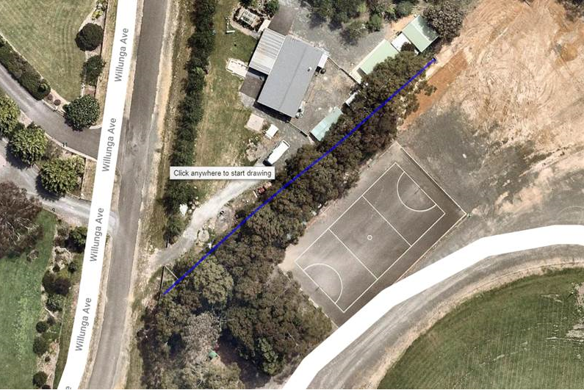

This will eliminate overflowing of the table drain and the need for regular maintenance. The estimate for supply and installation of the above is approx. $10,000.

**Darley Football Netball Club**

Netball Court Resurfacing

The second project for consideration is the resurfacing of two netball courts at Darley Oval. The project is not within Council’s 2019-2020 capital works projects list so is not currently resourced or scheduled. Darley Football Netball Club have secured external funding to support their project however are requesting an additional $15,000 to enable the project to be completed within a timeframe ahead of where these works will be considered within Council’s capital works program.

The secured funding for this project consists of:

|  |  |  |
| --- | --- | --- |
| Bendigo Bank | $25,000 | Community Bank sponsorship |
| Darley Football Netball Club | $5,000 | Club Fundraising |
| **SHORTFALL** | $15,000 | Request through Community Seed Funding |

The club has requested financial support to allow the improvement works to be carried out during the first part of the netball season, allowing for the courts to be available for finals games. Currently there exists two netball courts overlayed with line marking for three tennis courts. The club has requested removal of two tennis courts to allow for one designated netball only court and the second netball court overlayed with line marking for one tennis court.

There is no formal allocation of tennis court usage for organised training or games and no requests have been received for formalised allocation or organised use. Anecdotal evidence indicates casual usage by local residents, mainly children and teenagers, however community consultation has not taken place to establish this. The removal of two tennis courts will require the relocation of net posts which may extend the cost and time required to complete the project. In order to deliver the scope of works preferred by the club, it is anticipated Council will need to engage an external organisation to project manage and deliver this within the timeframes required.

A project which only resurfaces the netball courts and returns the line marking to the current status quo of two netball courts overlayed with three tennis courts is likely to be completed in a shorter time frame, however may also require the engagement of an external project management resource. A masterplan is due to be developed for Darley Park in the current financial year and we will shortly commence engagement. The request for shortfall funding to undertake these works has been received ahead of the masterplan process as the club has access to sponsorship of $25,000 and can currently offer another $5,000 to cover a significant amount of the total project cost.

Proposal

It is proposed that Council consider utilisation of the Community Seed Funding Reserve to support the recreation projects identified in this report.

Council Plan

The proposal is not provided for in the Council Plan 2017-2021 and can be actioned by utilising existing resources.

Financial Implications

The immediate financial implications associated with the identified projects are listed:

Gordon Football Netball Club – Female Friendly Facility $36,643

Darley Football Netball Club – Netball Resurfacing Project $15,000

**TOTAL $51,643**

Risk & Occupational Health & Safety Issues

In the absence of securing funding for the completion of the recreation projects within the report will result in:

**Gordon Football Netball Club**

The inability to deliver on guaranteed infrastructure outcomes as identified in funding agreements with Sport and Recreation Victoria and Moorabool Shire.

**Darley Football Netball Club**

The project if not completed within the current financial year, is expected be identified within the development of the Darley Park Masterplan. The delay will not impede the ability of the netball club to compete in the current season, however the games will continue to be played on a surface requiring improvement works.

|  |  |  |  |
| --- | --- | --- | --- |
| **Risk Identifier** | **Detail of Risk** | **Risk Rating** | **Control/s** |
| Inadequate engagement and consultation | Consultation with casual users of Darley Park tennis courts has not been undertaken | Medium | Returning line markings to status quo (three tennis courts) will ensure current use will be interrupted only for duration of the works |

Communications & Consultation Strategy

|  |  |  |  |  |  |
| --- | --- | --- | --- | --- | --- |
| **Level of Engagement** | **Stakeholder** | **Activities** | **Location** | **Date** | **Outcome** |
| Advise | Committees of Management, Sporting Clubs, Funding bodies | Meetings with applicant groups | Various | February 2020 | Applicants groups supported to submit applications |

Victorian Charter of Human Rights & Responsibilities Act 2006

In developing this report to Council, the officer considered whether the subject matter raised any human rights issues. In particular, whether the scope of any human right established by the Victorian Charter of Human Rights and Responsibilities is in any way limited, restricted or interfered with by the recommendations contained in the report. It is considered that the subject matter does not raise any human rights issues.

Officer’s Declaration of Conflict of Interests

Under section 80C of the *Local Government Act 1989* (as amended), officers providing advice to Council must disclose any interests, including the type of interest.

*CEO – Derek Madden*

In providing this advice to Council as the CEO, I have no interests to disclose in this report.

*Author – Sally Jones*

In providing this advice to Council as the Author, I have no interests to disclose in this report.

Conclusion

The Moorabool Community Seed Funding Reserve was endorsed by Council in 2018. The purpose of the Community Seed Funding Reserve is to respond to urgent and opportunistic requests from the community and government on a Shire wide basis. Expenditure from the Reserve must be by Council resolution after considering a report from officers based on the Community Grants Policy and Guidelines.

The projects presented for consideration of shortfall funding within the report meet the criteria as required within the Community Grants Policy and Guidelines.

13.2 Community Grants Program: Round 1 (March) 2020

**Author: Stephanie Lewin, Community & Recreation Liaison Officer**

**Authoriser: Sally Jones, General Manager Community Strengthening**

**Attachments: 1. Community Grants Program: Attachment 1**

**Purpose**

The purpose of this report is to seek endorsement for the recommendations for funding Round 1 (March) 2020 of the Community Grants Program.

**Executive Summary**

• To seek Council endorsement of the recommendations for funding for the 2019-2020 Community Grants Program by the Community Grants Assessment Panel.

• The Community Grants Program provides funding to community organisations to deliver programs that build on local strengths to develop active, healthy, connected and inclusive communities.

• Council received 16 applications across the five program categories: Community Arts and Culture (1), Community Strengthening Grants (14), Community Events Grants (1). No applications were received within the Community Development Fund or the Sustainability and Environmental Engagement Grant criteria.

• A total of $45,062.00 was requested with $158,020.75available this round.

• Eligible applications were assessed by an Assessment Panel consisting of officers from a diverse range of departments

• The report presents Council with a list of recommended grants for the March 2020 funding round prepared by the Community Grants Assessment Panel (Attachment 1).

• In total, 10 applications from 8 organisations are recommended to receive $15,461.40 in funding.

• The allocation of this sum is detailed in the funding recommendations within this report and at Attachment 1.

|  |
| --- |
| **Resolution**  **Moved:** Cr Tom Sullivan  **Seconded:** Cr Lawry Borgelt  That Council approves the allocation of the Community Grants as provided in Attachment 1.  **Carried** |

**Background**

The purpose of this report is to present Council with an assessment of applications received for the 2020 Round 1 (March) Community Grants Program, which totals $270,400 per annum. Round 1 (March) of the Community Grants Program opened on 1 March 2020 and closed on 6 April 2020. The extended closing date was due to multiple requests from community groups for extensions to submit their application due to the COVID-19 pandemic.

All applications were received via the SmartyGrants portal, equating to 100% of applications now being received online.

Council’s Community Grants program enables not for profit community groups to apply for funding under the following five program categories:

• **Arts and Culture Grants: $10,000 available**

Supporting local artists and organisations to use a creative approach to the development of community projects and initiatives).

• **Community Strengthening Grants: $60,000 available**

Community projects, programs and initiatives with a specific focus on connecting communities and building community capacity

• **Events Grants: $10,000 available**

Non‐recurrent, seed funding designed to encourage and promote the development of sustainable local events

• **Community Development Fund Grants: $70,620.75 available this round**

Supporting community infrastructure projects which significantly impact on community development. One or more projects may be funded up to $100,000 in Round 2 (August), with any remaining funding allocated to the following round in March (current round).

• **Sustainability and Environment Engagement Grants: $7,400 available**

Supporting the community in reducing expenditure of gas and electricity, investing in sustainability measures and providing opportunities to raise awareness of environmental issues to the broader community ($7,400 in this round).

**APPLICANT SUPPORT**

The Community Grants Guidelines specify that applicant groups are required to liaise with a Community and Recreation Development officer prior to lodging an application to ensure applicants receive clear guidance on eligibility and how to best present their applications. All applicants received support and advice from Council Officers before lodging their application. Additional support was provided after the funding round closed to clarify any ambiguity in applications.

**POLICY ASSESSMENT CRITERIA**

• Project Description and why the applicant wants to do the project – 10%

• What will this project achieve? – 20%

• Why is this project needed in your community? – 20%

• Who will be involved in the project? – 15%

• How will you carry out your project? (including risk management) – 15%

• Project budget and explanation of how the group arrived at the costs? – 20%

Each criterion is assessed out of 10 and weighted according to the criteria percentage. The maximum possible score for any application is 100.

|  |  |
| --- | --- |
| Scoring Guide | |
| Score each criteria out of 10 | |
| 0 | Did not address criteria |
| 1‐2 | Minimal |
| 3‐5 | Satisfactory |
| 6‐8 | Good |
| 9‐10 | Excellent |

**NUMBER OF APPLICATIONS AND AMOUNT REQUESTED**

In total, 16 applications were received across the five program categories: Community Arts and Culture (1), Community Strengthening Grants (14), Community Events Grants (1). No applications were received for either the Community Development Fund or the Sustainability and Environmental Engagement Grant.

A total of **$45,062.00** was requested with **$158,020.75** available this round.

|  |  |  |  |  |
| --- | --- | --- | --- | --- |
| **Category** | **Applications**  **Received** | **Amount**  **Available** | **Amount**  **Requested** | **Amount**  **Recommended** |
| Community Arts and Culture | 1 | $10,000.00 | $3,000.00 | $3,000.00 |
| Community Strengthening Grant | 14 | $60,000.00 | $40,957.30 | $11,355.90 |
| Community Events Grant | 1 | $10,000.00 | $1,105.50 | $1,105.50 |
| Community Development Fund | 0 | $70,620.75 | $0.00 | $0.00 |
| Sustainability and Environmental Engagement Grant | 0 | $7,400.00 | $0.00 | $0.00 |
| **Total:** | **16** | **$158,020.75** | **$45,062.80** | **$15,461.40** |

**ASSESSMENT**

Applications were individually assessed by a diverse panel of officers from across Council units against the extent to which the application addressed the policy assessment criteria. Groups demonstrating a score of 70 or above may be provided with funding if Council so determine.

**Proposal**

Based on the application assessment process and funding criteria, it is proposed that the Council allocates funding for grants for the Moorabool Shire Round 1 (March) 2020 Community Grants Program as detailed in Appendix A.

**Council Plan**

The Council Plan 2017-2021 provides as follows:

**Strategic Objective 4: Improve Social Outcomes**

**Context 4B: Community Connectedness and Capacity**

The proposed allocation of grants under the 2020 *Round 1 March* Community Grants Program is consistent with the Council Plan 2017 – 2021.

**Financial Implications**

Consistent with the Community Grants Policy and 2019/20 budget allocation, a total of **$158,020.75** is available for allocation in *Round 1 March 2020* Community Grants Program.

The following amounts are recommended:

• $3,000.00 for Arts and Culture Grants

• $11,355.90 for Community Strengthening Grants

• $1,105.50 for Community Events Grants

**Risk & Occupational Health & Safety Issues**

|  |  |  |  |
| --- | --- | --- | --- |
| **Risk Identifier** | **Detail of Risk** | **Risk Rating** | **Control/s** |
| Project timelines | Grant recipients exceeding prescribed timelines | Medium | • Terms and conditions agreements required to be signed by grant recipients  • Scheduled monitoring of projects |
| Financial | Grant recipients misappropriate expenditure of Council funds | Medium | • Terms and conditions agreements required to be signed by grant recipients  • Grant acquittal required upon completion of projects |

**Communications & Consultation Strategy**

**Successful applicants:**

- Formal notification and congratulations will be provided via email on endorsement of Council report.

**Unsuccessful applicants:**

- To be advised by telephone and/or email. Guidance and support will be provided to improve opportunities for future grant applications.

- To be offered the opportunity for one on one meetings with officers to discuss their application and request advice.

- Be advised of future Grant Writing Workshop opportunities.

**Community Groups**

- Are advised when Community Grants become available and requested to further advise their networks via direct telephone calls and email.

- Are requested to advertise the Community Grants across their communications options including social media and newsletters.

**Moorabool Residents**

- Promotional flyers advertising Community Grants Program across the Shire:

• Libraries notice board and Library newsletter

• Economic Development Newsletter

• Community Noticeboards

• Bacchus Marsh Leisure Centre

• Darley Neighbourhood House, Ballan & District Community House

• Darley Early Years Hub

• Visitors Centre

• Moorabool News

• Early Years Newsletter

• Website Events Page and Community Page

• Youth Facebook Page

• Moorabool Shire corporate website and Facebook page

• Apple FM

- Grant Writing Workshops

• Four Workshops were held across Bacchus Marsh and Ballan to improve knowledge of Smartygrants and grant writing requirements.

• Advice and guidance provided to potential applicants.

Applicants for the 2020 Round 1 (March) Community Grants Program have been informed they will be notified of the outcomes of their grant applications in June 2020.

The Community Strengthening Liaison Advisor will formally notify groups of the outcome of their applications and provide opportunity for feedback to unsuccessful applicant groups.

Feedback will include:

• Advice to applicant groups of the relative strengths and areas for improvement in their application;

• Options for alternative funding (if applicable);

• Supporting a group to amend and re‐lodge their application in the next appropriate round of the Community Grants program.

**Victorian Charter of Human Rights & Responsibilities Act 2006**

In developing this report to Council, the officer considered whether the subject matter raised any human rights issues. In particular, whether the scope of any human right established by the Victorian Charter of Human Rights and Responsibilities is in any way limited, restricted or interfered with by the recommendations contained in the report. It is considered that the subject matter does not raise any human rights issues.

**Officer’s Declaration of Conflict of Interests**

Under section 80C of the *Local Government Act 1989* (as amended), officers providing advice to Council must disclose any interests, including the type of interest.

*General Manager – Sally Jones*

In providing this advice to Council as the General Manager, I have no interests to disclose in this report.

*Author – Stephanie Lewin*

In providing this advice to Council as the Author, I have no interests to disclose in this report.

**Conclusion**

Applications received under the 2020 March Round of Community Grants are reflective of the diverse range of activities that community groups are engaged in and the areas in need of financial support from Council. In total, 16 applications were received across the five program categories: Community Strengthening Grants (14), Community Events Grants (1), Arts and Culture Grants (1). No applications were received for the Development Fund Grant or the Sustainability and Environmental Engagement Grant.

14. Customer Care and Advocacy Reports

14.1 Procurement Policy Review

**Author: Jacinta Erdody, Co-ordinator Revenue and Procurement**

**Authoriser: Caroline Buisson, General Manager Customer Care & Advocacy**

**Attachments: 1. Procurement Policy**

Purpose

The *Local Government Act 1989* requires Council to formally review and adopt a Procurement Policy in accordance with Section 186A at least once every financial year.

Executive Summary

• The existing LGA requires an annual review of Council’s Procurement Policy – the last adopted Procurement Policy was April 2019

• The new LGA will require a significant review of the Procurement Policy with this section of the new LGA becoming effective from 1 July 2021

|  |
| --- |
| **Resolution**  **Moved:** Cr Tom Sullivan  **Seconded:** Cr Lawry Borgelt  That Council resolves to lay on the table in accordance with the Moorabool Shire Council Policy Protocol ‘Consideration of items which affect beyond the current year’ the attached procurement policy for further consideration at the next Ordinary Meeting of Council.  **Carried** |

Background

The *Local Government Act 1989* requires Council to review and formally adopt a Procurement Policy on annual basis. The last time Council adopted our Procurement Policy was in April 2019. The following report is a necessary step required to comply with the provisions of S186A of the Local Government Act.

Whilst the current procurement policy has served Council well over many years, the new *Local Government Act 2020* will result in several major changes to long-established procurement practices within local government. The new legislative provisions will come into force on 1 July 2021. This means Council must continue to comply with the provisions in the Local Government Act 1989 for a further 12 months.

With significant legislative changes foreshadowed in the next 12 months and considering the limited remaining life of the current procurement policy, Officers are recommending no changes to the procurement policy.

Proposal

With the pending implementation of the new Local Government Act 2020 and associated Procurement provisions, there are no changes being recommended to the existing policy. A more extensive review of the procurement policy is being proposed in the 2020/21 financial year in preparation for the new legislative commencement date. Under the new legislative framework, the Procurement Policy will need to:

• Seek to promote open and fair competition and provide value for money;

• Council will be responsible for setting their own tender thresholds - this is currently pre-determined under the existing LGA, but under the new legislative provisions each Council will have the flexibility to determine appropriate tender thresholds;

• A description of the criteria to be used by the Council to evaluate whether a proposed contract provides value for money – Council currently advertise this within all tenders to create an open and transparent approach to our tenders and associated evaluations but it is not currently a requirement under the existing LGA;

• A description of how Council will seek collaboration with other Councils and public bodies in the Procurement of goods or services – this will be something that the sector will work with Local Government Victoria and MAV to determine the best path forward;

• The conditions under which the Council may purchase goods or services without inviting a public tender or expression of interest – Council may wish to exclude essential services from public tender e.g.: works required to be undertaken by Powercor, etc.

• Be reviewed at least once during each 4 year term of the Council with the first re-iteration of the policy to be reviewed within six months of the commencement of this section of the new LGA

• The CEO must ensure that any report to the Council that recommends entering into a procurement agreement includes information in relation to any opportunities for collaboration with other Councils or public bodies which may be available.

**Procurement Thresholds**

In recent years, Council made significant changes to the procurement thresholds resulting in the current established threshold categories. The procurement thresholds aim to balance efficiency, compliance and value for money. Whilst there is a likelihood that procurement thresholds may change once the new legislative provisions come into force, no changes are being recommended as part of this policy review.

A review of accounts payable transactions for the most recent audited financial year based on the current procurement thresholds, indicates that the majority of our transactions (86%) are within the spend range that either does not require any quotes or only requires one verbal quote – however these transactions only form 15.1% of the total spend for the same period. Conversely, 52.4% of spend is within procurement thresholds which requires three quotes, whilst the remaining spend (32.4%) is within public tender thresholds.

Based on this analysis we are confident that procurement thresholds continue to allow for efficient operation whilst ensuring value for money outcomes. As a result, there are no changes recommended to the current established procurement thresholds.



Council Plan

The Council Plan 2017-2021 provides as follows:

**Strategic Objective 1: Providing Good Governance and Leadership**

**Context 1C: Our Business and Systems**

The proposal for the review of the Procurement Policy is consistent with the Council Plan 2017 – 2021.

Financial Implications

The adoption of the revised Procurement Policy has no additional known financial implications to Council. In more general terms, the Procurement policy aims to balance efficiency, compliance and value for money.

Risk & Occupational Health & Safety Issues

As the annual review of this policy is a legislative requirement, there is a risk of non-compliance with the Local Government Act if this policy is not reviewed on an annual basis.

Communications & Consultation Strategy

Once Council has reviewed and adopted the revised Procurement Policy, the updated document will be communicated to all staff, committees required to adhere to provisions of the policy and placed on Council’s website.

Victorian Charter of Human Rights & Responsibilities Act 2006

In developing this report to Council, the officer considered whether the subject matter raised any human rights issues. In particular, whether the scope of any human right established by the Victorian Charter of Human Rights and Responsibilities is in any way limited, restricted or interfered with by the recommendations contained in the report. It is considered that the subject matter does not raise any human rights issues.

Officer’s Declaration of Conflict of Interests

Under section 80C of the *Local Government Act 1989* (as amended), officers providing advice to Council must disclose any interests, including the type of interest.

*General Manager – Caroline Buisson*

In providing this advice to Council as the General Manager, I have no interests to disclose in this report.

*Author – Jacinta Erdody*

In providing this advice to Council as the Author, I have no interests to disclose in this report.

Conclusion

The policy protocol relation to consideration of items which affect beyond the current year is applied for consideration of matters whose impact of influence will extend to directly affect the activities and/or financial planning of Council for a period beyond the term of the current Council Budget and therefore seek Council to review and lay on the table the attached Procurement Policy for review and adoption at a future meeting of Council.

15. Community Assets & Infrastructure Reports

15.1 Municipal Emergency Management Plan 2020-2023

**Author: Cherie Graham, Chief Emergency Officer**

**Authoriser: Phil Jeffrey, General Manager Community Assets & Infrastructure**

**Attachments: 1. Municipal Emergency Management Plan**

Purpose

To seek approval from Council to endorse the Municipal Emergency Management Plan version 8, dated 19 May 2020.

Executive Summary

• It is a legislative requirement for Council to appoint a Municipal Emergency Management Planning Committee (MEMPC) and to maintain a MEMPlan under the *Emergency Management Act 1986* Part 4 Section 20 and 21, and the *Emergency Management Act 2013*.

• Emergency Management is considered an important and necessary function to ensure that the safety interests of our community are maintained. Council officers assist lead agencies to respond to a variety of incidents such as fires, floods, storms, single incident house fires, and other miscellaneous incidents.

• Emergency management requires the collaboration from many agencies. Council facilitates regular planning meetings to enhance communication and review plans. The MEMPC has broad representation and is made up of the following member agencies:

• Moorabool Shire Council

• Victoria Police

• VICSES

• CFA

• DELWP

• Department of Jobs, Precincts and Regions

• Ambulance Victoria

• Health Services

• Australian Red Cross

• VCC Emergency Ministries

• Department of Health and Human Services

• Water Authorities

• WICEN

• VicRoads

• For the Council’s MEMP to remain current it has been continually reviewed and updated by the Municipal Emergency Management Planning Committee (MEMPC) and is a standard agenda item for discussion.

• The Plan has been reviewed and revised in line with the EMMV (Emergency Management Manual Victoria) being used as the guide and to ensure that it meets all audit requirements. It was presented to the Municipal Emergency Management Planning Committee (MEMPC) and recommended to be presented to Council for consideration and adoption.

• In July 2020 Victorian State Emergency Service, Victorian Police and Department Health and Human Services are scheduled to coordinate the latest three-yearly audit of the MEMPlan. The last audit was conducted in 2017. In preparation, a requirement for this audit is for Council to review and endorse the latest MEMPlan. The Plan then needs to be assessed by guidelines and a criteria specified in the Audit Tool and Evidence Guide which is provided by the Victoria State Emergency Service (VicSES).

• The latest version of the MEMPlan will be listed on Council’s website following Council endorsement and before the audit process. The purpose of the plan is to guide Council’s service response to municipal emergencies.

|  |
| --- |
| Resolution  **Moved:** Cr John Keogh  **Seconded:** Cr Tonia Dudzik  That Council:  1. Endorses the Municipal Emergency Management Plan 2017-2020 Version 8 and that it be signed and sealed by Council.  2. Endorses the appointment of the MEMP Committee for Moorabool Shire Council as listed on page 25 of the Municipal Emergency Management Plan.  3. Notes that the three yearly audit will be conducted in July 2020 and will be coordinated by Victorian State Emergency Services, Victoria Police and the Department of Health and Human Services.  **Carried** |

Background

The MEMPlan :

• Is maintained and managed on behalf of the MEMPC by the Municipal Emergency Resource Officer (MERO).

• Guides Council actions during municipal emergencies for mobilising resources (personnel and equipment) and providing support to lead emergency response and recovery agencies.

• Is an internal document used by members of the Municipal Emergency Management Planning Committee (MEMPC) to prepare, respond to and provide relief and recovery for emergencies experienced within our municipality.

• Is reviewed and revised by the MEMPC annually. It is audited on a three-yearly basis by external emergency management agencies to ensure due diligence for industry best practice is maintained.

Proposal

The MEMPlan has undergone a full review of the entire document. All organisations and agency names have been reviewed and updated where applicable, and changes have been made in line with current legislation. The Plan has been recommended by the Municipal Emergency Management Planning Committee (MEMPC) for adoption by Council as included in the Emergency Management Act 1986 and the Emergency Management Act 2013.

The plan provides clear guidance on Council’s response to emergency incidents. Council’s officers have responded to numerous events in each calendar year, this has included fires, flooding, bush fire assistance, storm events, structure fires, building damage, traffic incidents, pandemics and search and rescue incidents. Officers provide a twenty four-hour seven day a week response service.

Council Plan

The Council Plan 2017-2021 provides as follows:

**Strategic Objective 4: Improve Social Outcomes**

**Context 4B: Community Connectedness and Capacity**

The proposal to endorse the Municipal Emergency Management Plan is consistent with the Council Plan 2017 – 2021.

Financial Implications

The provision of the municipal emergency management resource funds is already accounted for within existing Council budgets.

Risk & Occupational Health & Safety Issues

Failure to provide an adopted Municipal Emergency Management Plan may mean that Council does not meet legislation and audit requirements

Communications & Consultation Strategy

|  |  |  |  |  |  |
| --- | --- | --- | --- | --- | --- |
| **Level of Engagement** | **Stakeholder** | **Activities** | **Location** | **Date** | **Outcome** |
| Engage | Community | Feedback | Website | June / July 2020 | Community comments welcomed. |

Victorian Charter of Human Rights & Responsibilities Act 2006

In developing this report to Council, the officer considered whether the subject matter raised any human rights issues. In particular, whether the scope of any human right established by the Victorian Charter of Human Rights and Responsibilities is in any way limited, restricted or interfered with by the recommendations contained in the report. It is considered that the subject matter does not raise any human rights issues.

Officer’s Declaration of Conflict of Interests

Under section 80C of the *Local Government Act 1989* (as amended), officers providing advice to Council must disclose any interests, including the type of interest.

*General Manager – Phil Jeffrey*

In providing this advice to Council as the General Manager, I have no interests to disclose in this report.

*Author – Cherie Graham*

In providing this advice to Council as the Author, I have no interests to disclose in this report.

Conclusion

Emergencies can detrimentally affect our community. Council is tasked with ensuring the MEMPlan is up to date and relevant to ensure the MEMPC are prepared to respond to municipal emergencies. The latest revision of the MEMPlan considers community impact from future emergencies and aims to achieve the required level of preparedness and response for our community.

15.2 Draft Bores/Standpipes Policy

**Author: John Miller, Manager Asset Management**

**Authoriser: Phil Jeffrey, General Manager Community Assets & Infrastructure**

**Attachments: 1. Draft Bores and Standpipes Policy**

Purpose

Moorabool Shire Council (MSC) is responsible for providing a number of Bores and Standpipes across the Shire and acknowledges the importance of this service to the local farming community and emergency services by providing a vital alternative water supply for stock, domestic use and firefighting. This is particularly evident during summer and drought conditions.

The purpose of this policy is to provide a framework for the provision, management and maintenance of Council owned and managed bores/standpipes, including their administration and conditions of public use.

Executive Summary

• MSC provides seven (7) standpipes within the municipality. This policy outlines the organisation’s approach to the management of the Council owned and managed standpipes in Road Reserves.

|  |
| --- |
| Resolution  **Moved:** Cr Tom Sullivan  **Seconded:** Cr Lawry Borgelt  That Council, in accordance with Moorabool Shire Council Policy Protocol, Consideration of items which affect beyond the current year, now lay on the table the draft Bores/Standpipes Policy for further consideration at the next Ordinary Meeting of Council.  **Carried** |

Background

Council currently provides and maintains several Bores and Standpipes located at various locations within the Shire that provide water for stock, domestic and firefighting purposes. The water provided is either treated potable (drinking) water or untreated river or bore water which contains varying salinity levels and is generally only suitable for stock use.

Proposal

This draft policy outlines the organisation’s approach to the management of Council owned and managed standpipes in Road Reserves for provision of water to all residents within Moorabool Shire Council (MSC) and applies to all users of these facilities. The policy does not address the use of fire hydrants provided by the water authorities or bores located within reserves.

Assets owned and maintained

MSC provides seven (7) standpipes within the municipality, as outlined in the table below. All standpipes are free except for assets at Maddingley and Ballan. This is primarily due to being located within more urban environments.

|  |  |  |  |  |  |  |
| --- | --- | --- | --- | --- | --- | --- |
| **Street** | **Suburb** | **Location** | **Ward** | **Description** | **Fee Type** | **Quality** |
| Grant Street | Maddingley | Between Taverner and Station Streets | East Moorabool | Dual Standpipe | Chargeable (Both potable and untreated) | Potable and untreated river water. High volume facility. |
| Bacchus Marsh-Geelong Road | Balliang East | South of School Road | East Moorabool | Standpipe, bore and tank | Free | Brackish water can be used for stock purposes. High volume facility. |
| Cowie Street | Ballan | Opposite Atkinson Street | Central Moorabool | Standpipe, bore and tank | Chargeable (Bore water only) | Bore water low salt content. Low volume facility and supply. |
| Cargerie-Bamgamie Road | Cargerie | 200m north-west of Doyles Road | West Moorabool | Standpipe, bore and tank | Free | Bore water low salt content. Low volume facility and supply. |
| Millbrook-Egerton Road | Millbrook | 100m east of Donnellans Road | West Moorabool | Standpipe and spring fed tank | Free | Spring fed very low salt content. Low volume facility and supply. |
| Ti Tree Road | Dunnstown | 60m west of Tierneys Road | West Moorabool | Standpipe, bore and tank | Free | Bore water low salt content. Low volume facility and supply that can run dry over summer. |
| Ballan-Greendale Road | Greendale | 300m south of Greendale Myrniong Road | Woodlands | Standpipe, bore and tanks | Free | Spring fed low salt content. Low volume facility and supply. |

Options for managing these Assets

There are several options for managing these assets;

Making all sites chargeable

• Could put extra strain on farmers during drought

• May see water use decline (reduce the ability to recover upgrade costs)

• Water quality generally only suitable for stock purposes (except for Maddingley)

• Cost to install additional infrastructure to allow usage to be measured would be cost prohibitive.

• Higher administrative costs

• No guarantee of water availability

• Ability to monitor and restrict use to residents

Making all sites free

• Additional cost to rate payers

• Water carting businesses would be able to take advantage of free water and profiteer from this

• Higher usage may impact water supply (potential for bores to dry out)

• May encourage users from outside the Shire

• No guarantee of water availability

Status Quo with managed access

• No additional cost to rate payers

• Provides free water to most farmers for stock purposes

• Existing processes remain in place

• Additional administration costs (keys, invoicing)

• Cost to install additional infrastructure to allow usage to be measured and restricted

would be cost prohibitive

• Ability to restrict use to residents

Status Quo

• No additional cost to rate payers

• Provides free water to most farmers for stock purposes

• Existing processes remain in place

• No need to install additional costly infrastructure

• Reduced administrative costs

• No ability to restrict use to residents

Usage

Council utilises the services of AVDATA to conduct meter readings and provide usage information. The water usage for Maddingley and Ballan varies from year to year depending on weather and drought conditions. For 2019 the usage at Ballan standpipe was 35,000 Litres and for Maddingley standpipe 2,524,200 Litres. The total income received by Council in providing this service was $6,453.48 after fees and charges.

Maintenance and Renewal

Council has an annual allocation for the maintenance of the 7 seven standpipes and any major and/or renewal works are referred to Council’s Long-Term Capital Works Improvement Program for consideration. Two of the facilities have been upgraded in the last 5 years.

Conditions of Use

• Property owners within MSC who do not have access to a reticulated water supply and may require water by necessity because of prevailing drought conditions.

• Persons whose principal place of residence is within an urban area (and therefore have access to reticulated water) will not have access to the use of the untreated standpipe water unless that person provides evidence to the satisfaction of the Council that:

• the use of the standpipe water is for stock and domestic use necessitated by prevailing drought conditions, and that

• no use will be made of such standpipe water supplied which is inconsistent with the prevailing water restrictions that apply within the urban area.

• A statutory declaration will be required to support an application for the supply of untreated water to urban residents.

• Untreated water is not recommended for human consumption.

• Emergency services are except from these conditions.

• It should be noted that at times some of these locations can run dry, in which case Officers will install signage at the location and publish information on Social Media.

Benchmarking

Officers sought additional information through the Super 11 group of Councils in relation to how other municipalities operate and manage their standpipe assets. Unfortunately, no Council’s that provided a response to the Super 11 request have policies in place and most had handed back responsibility of their standpipes to the local Water Authority. It should be noted that discussions with the relevant Water Authorities in the past has been that if Council wanted to hand back responsibility of the standpipes, the Authorities may have them removed, leaving local property owners and farmers with no alternative water supply.

Council Plan

The Council Plan 2017-2021 provides as follows:

**Strategic Objective 1: Providing Good Governance and Leadership**

**Context 1A: Our Assets and Infrastructure**

The proposal to adopt the draft Bores and Standpipes Policy is consistent with the Council Plan 2017 – 2021.

Financial Implications

There are no financial implications associated with the recommendation within this report.

However, should there be a change to the existing fee structure or availability of free water then there may be additional costs to provide this service.

Risk & Occupational Health & Safety Issues

There are no risk or occupational health and safety implications associated with the recommendation within this report.

Communications & Consultation Strategy

|  |  |  |  |  |  |
| --- | --- | --- | --- | --- | --- |
| **Level of Engagement** | **Stakeholder** | **Activities** | **Location** | **Date** | **Outcome** |
| Inform | Community | Place a copy of the adopted Policy on Council’s website | N/A | July 2020 | Policy accessible to wider community |

Victorian Charter of Human Rights & Responsibilities Act 2006

In developing this report to Council, the officer considered whether the subject matter raised any human rights issues. In particular, whether the scope of any human right established by the Victorian Charter of Human Rights and Responsibilities is in any way limited, restricted or interfered with by the recommendations contained in the report. It is considered that the subject matter does not raise any human rights issues.

Officer’s Declaration of Conflict of Interests

Under section 80C of the *Local Government Act 1989* (as amended), officers providing advice to Council must disclose any interests, including the type of interest.

*General Manager – Phil Jeffrey*

In providing this advice to Council as the General Manager, I have no interests to disclose in this report.

*Author – John Miller*

In providing this advice to Council as the Author, I have no interests to disclose in this report.

Conclusion

The provision of Standpipes provides the local community and emergency services with a vital alternative water supply for stock, domestic use and firefighting purposes. This is particularly evident during dry or drought conditions. The free provision of water in rural locations is a vital resource that helps support our local farming community.

16 Other Reports

Nil.

17 Notices of Motion

Nil.

18. Mayor’s Report

18.1 Mayor's Report

**Author: Dianne Elshaug, Co-ordinator CEOs Office**

**Authoriser: Derek Madden, Chief Executive Officer**

**Attachments: Nil**

Purpose

To provide details to the community on the meetings and events attended by the Mayor since the last Ordinary Meeting of Council.

|  |  |
| --- | --- |
| **Cr David Edwards – Mayor’s Report** | |
| ***Date:*** *3 June, 2020* | |
| 11 May | * Bacchus Marsh Aerodrome Management Board Meeting |
| 13 May | * Councillor Briefing – Review of the DAC Agenda and draft Budget |
| 19 May | * Peri-Urban Teleconference Meeting |
| 20 May | * Special Meeting of Council * S86 Development Assessment Committee Meeting |
| 21 May | * Teleconference with Catherine King, Federal Member for Ballarat |
| 27 May | * Teleconference with Minister Jacinta Allan, Minister for Transport Infrastructure * Councillor Briefing – Indoor Sports Stadium Masterplan * Councillor Briefing – Community grants Program Round 1 March 2020 * Councillor Briefing – Revocation of Urban Growth Policy 2012 |
| 1 June 20 | * Meeting TVSA, Bacchus Marsh Aerodrome Management * Peri- Urban Economic Development Meeting |
| 3 June | * Councillor Briefing – Car Parking Study Update * Councillor Briefing – Maddingley Planning Study * Councillor Briefing – AusNet WestVic Transmission Lines Update * Ordinary Meeting of Council |

|  |
| --- |
| Resolution  **Moved:** Cr Tonia Dudzik  **Seconded:** Cr Lawry Borgelt  That Council resolves to receive the Mayor’s Report.  **Carried** |

|  |
| --- |
| 19. Councillors Report  Councillors Sullivan and Keogh acknowledged the passing of former Councillor and Mayor of Moorabool Shire Council, Ms Del Leggett. |

20. Urgent Business

|  |
| --- |
| 20.1 Review of Employment Processes and Awarding Tenders & Contracts |
| Resolution  **Moved:** Cr Tom Sullivan  **Seconded:** Cr Tonia Dudzik  That, in light of the Ombudsman’s Report into the Ballarat City Council and with regards to the findings of the Report, Moorabool Shire undertake a review of the following:   1. The employment processes, protocols or policies in place in Moorabool Shire. 2. The use of delegated authority in the awarding of tenders and contracts.   **Carried** |

21 Closed Session of the Meeting to the Public

Nil.

19 Meeting Closure

The Meeting closed at 6.21pm.

**...................................................**

**CHAIRPERSON**