ATTACHMENTS

Ordinary Council Meeting
Under Separate Cover
Wednesday, 5 August 2020

Table of Contents

14.1 Public Transparency Policy
Attachment 1 Public Transparency Policy 2020 4
14.2 Council Expenses Policy
Attachment 1 Council Expenses Policy 12
14.3 Customer Experience Strategy
Attachment 1 Customer Experience Strategy 2020-21 21
Attachment 2 Appendix A and B 33
14.4 Section 86 - Delegated Committees of Council - Reports
Attachment 1 s.86 Blacksmith's Cottage and Forge Committee Meeting Minutes 230620 34
Attachment 2 s.86 Bacchus Marsh Public Hall Committee Meeting Minutes 240220 39
15.1 Capital Improvement Program Quarterly Report - 30 June 2020
Attachment 1 CIP Quarterly Report June 2020 47

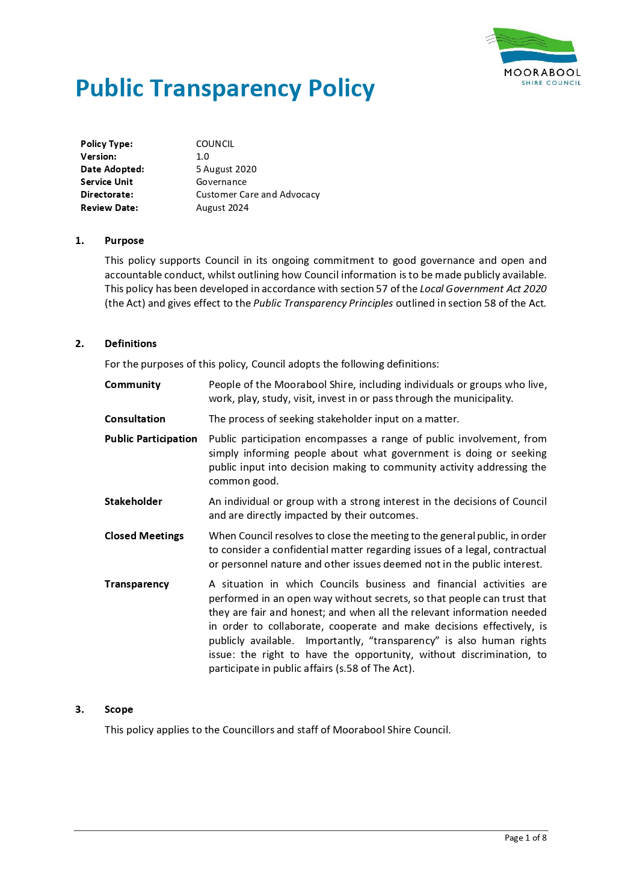

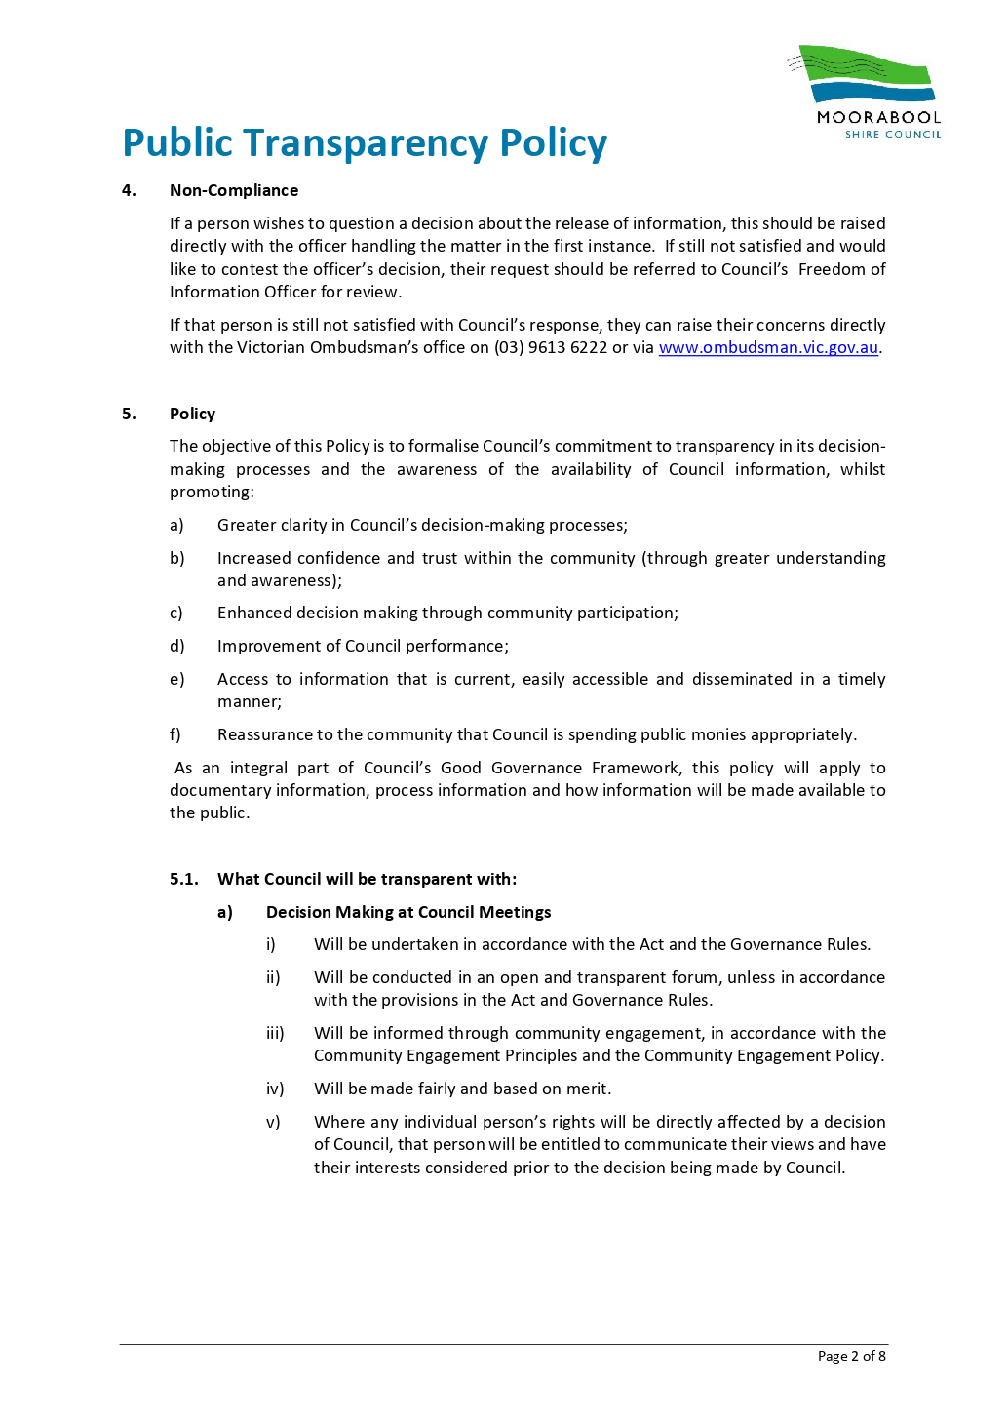

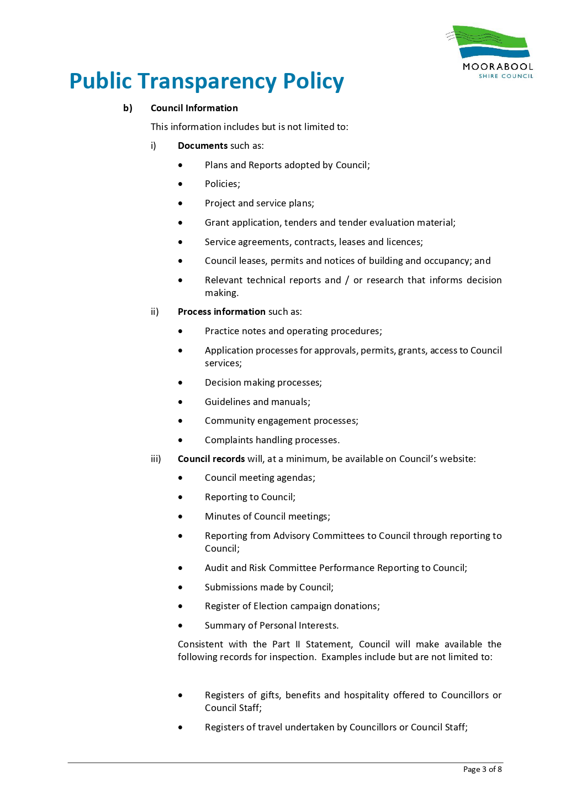

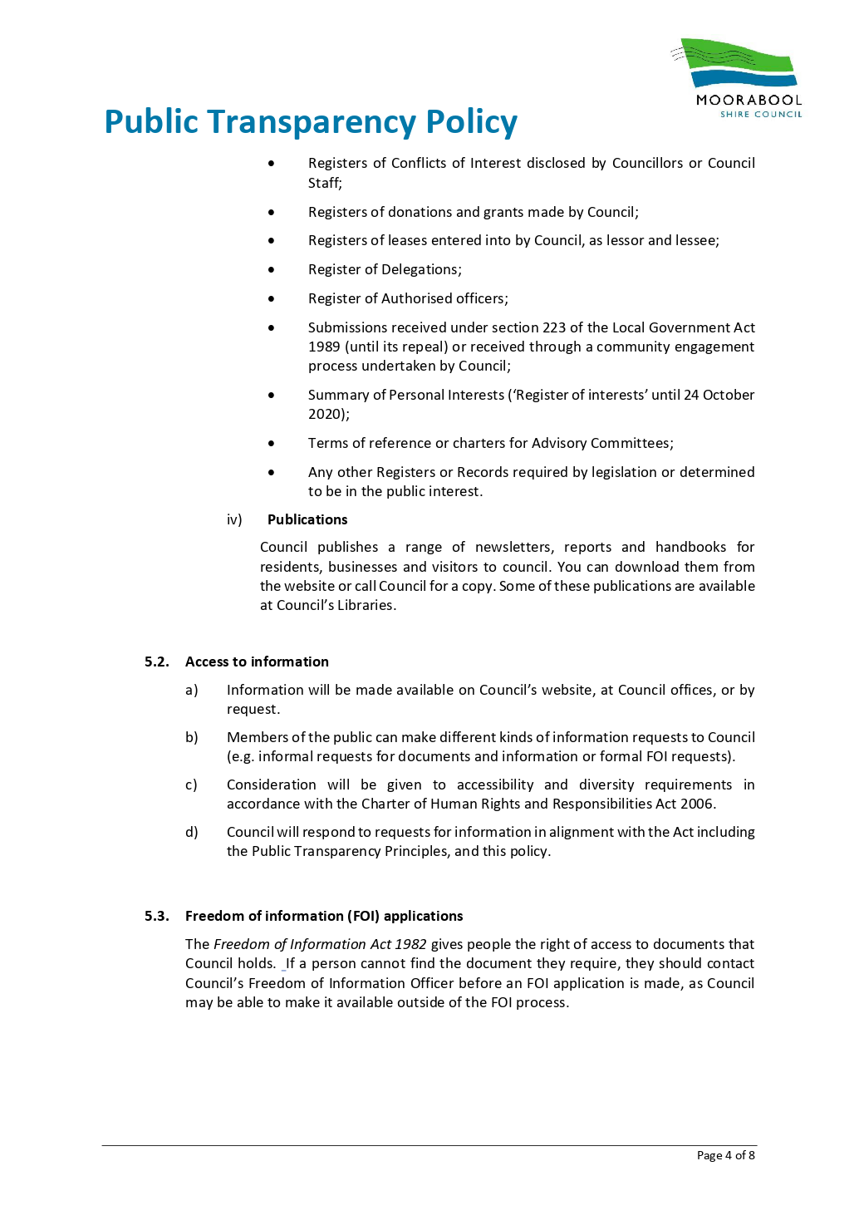

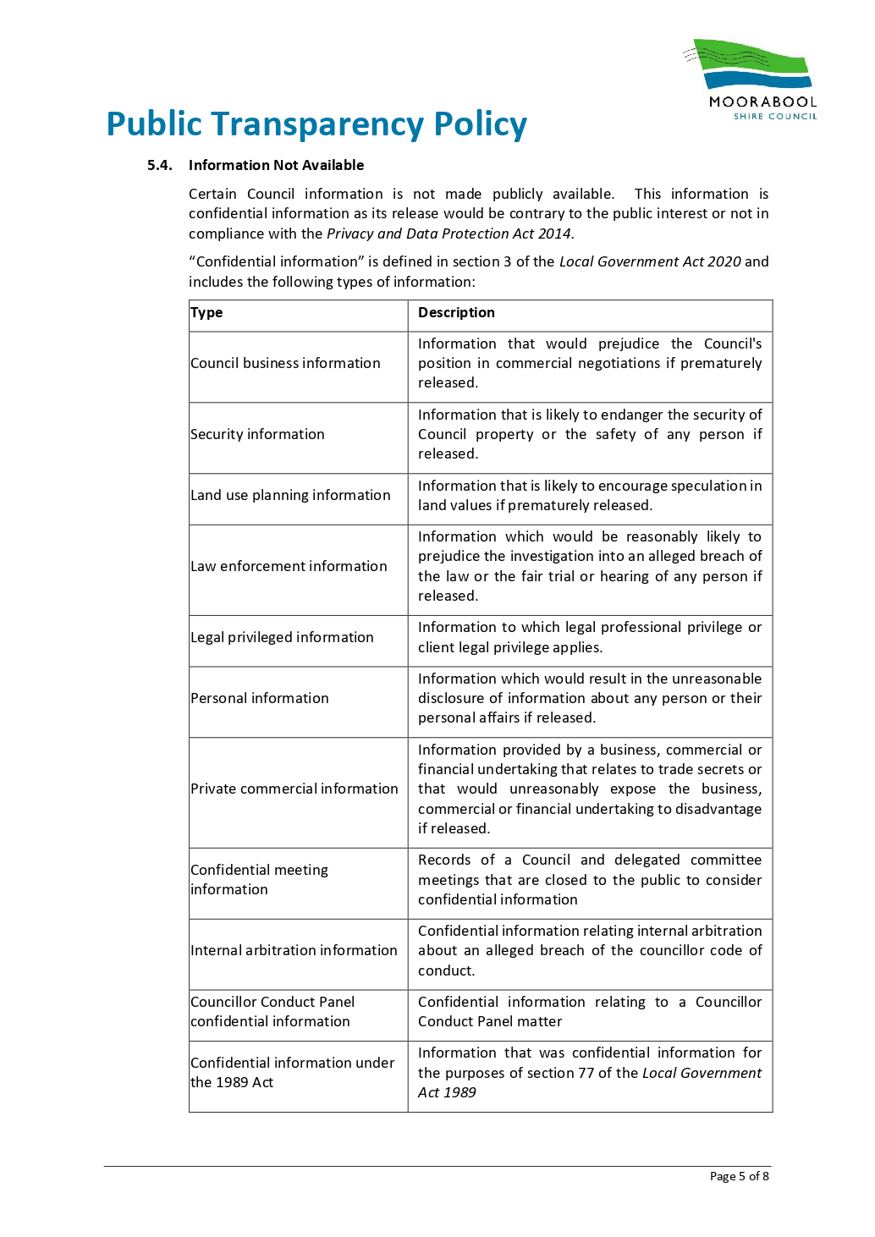

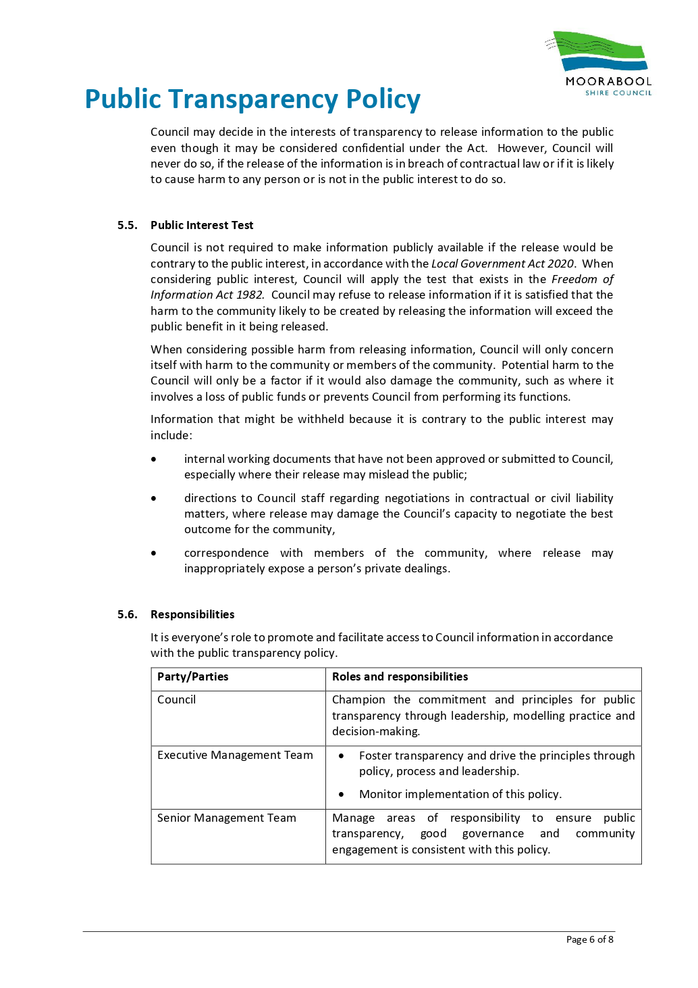

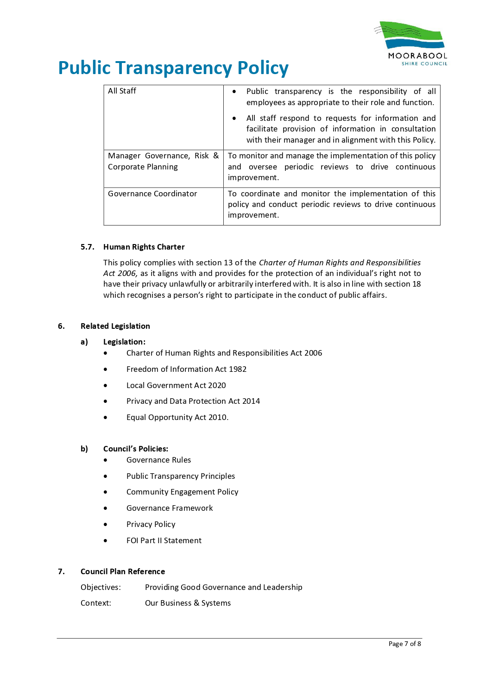

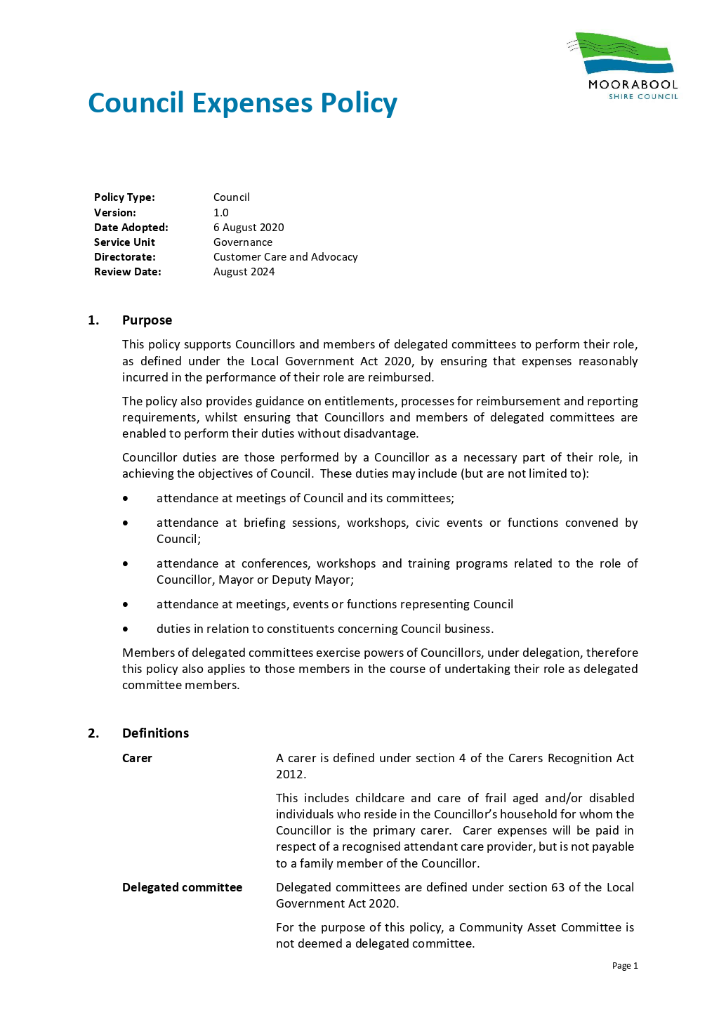

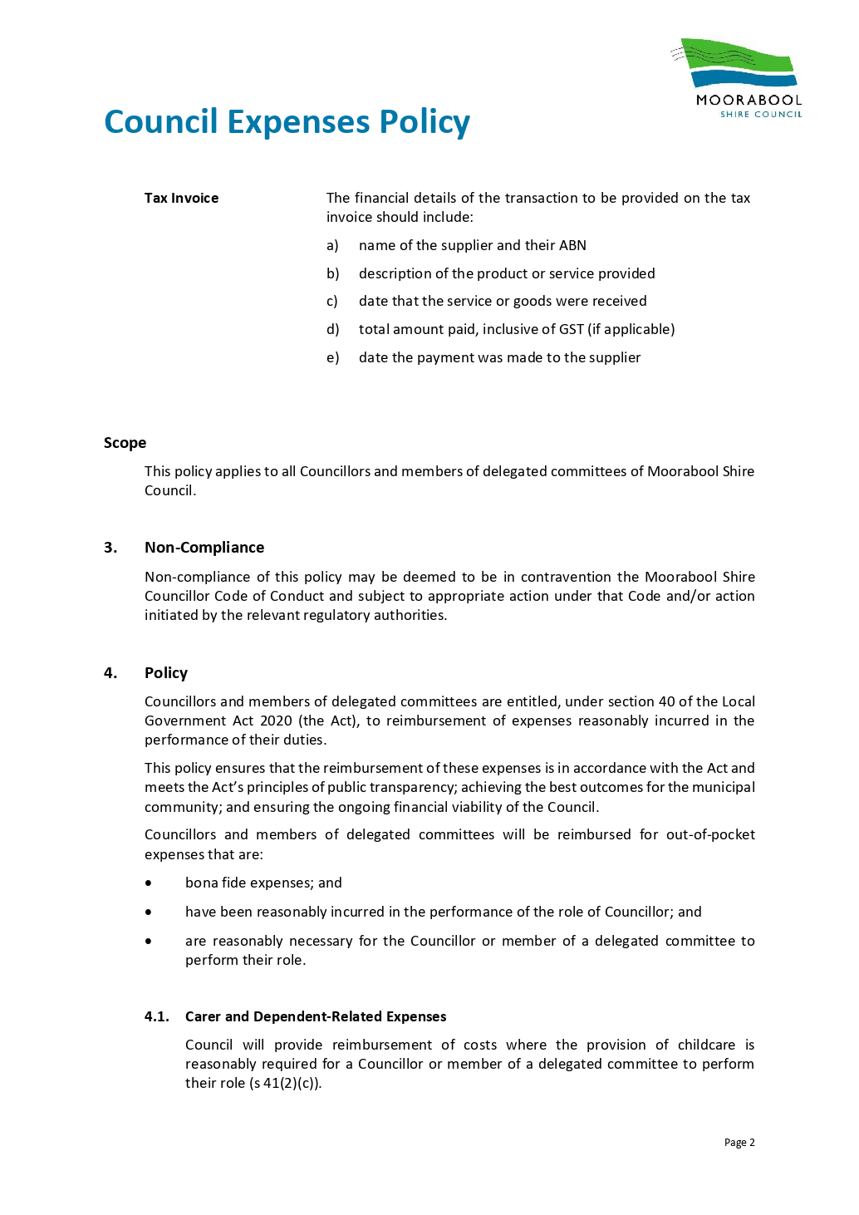

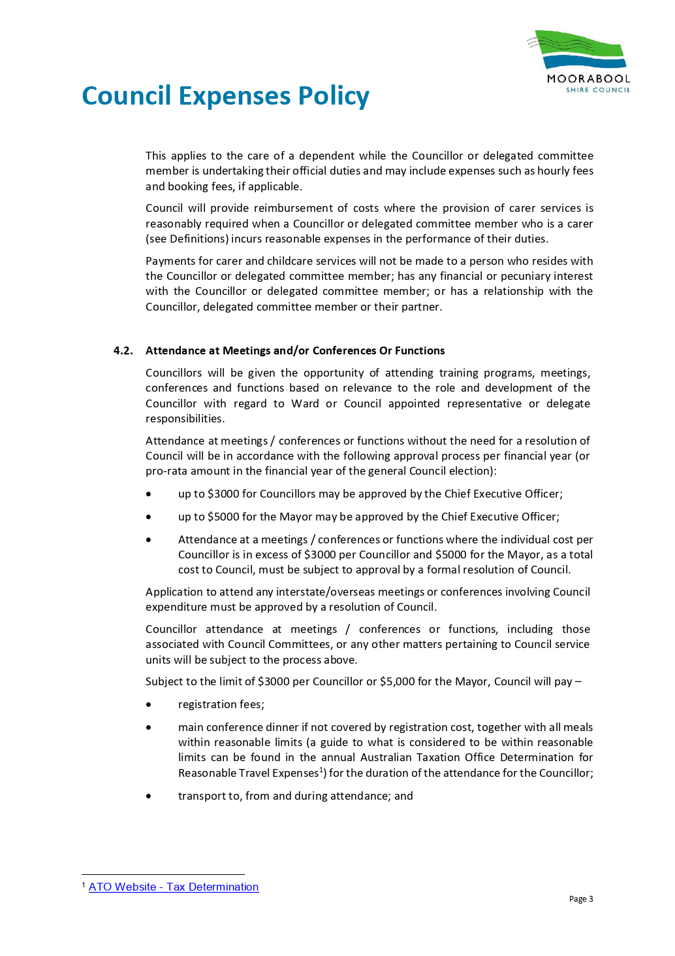

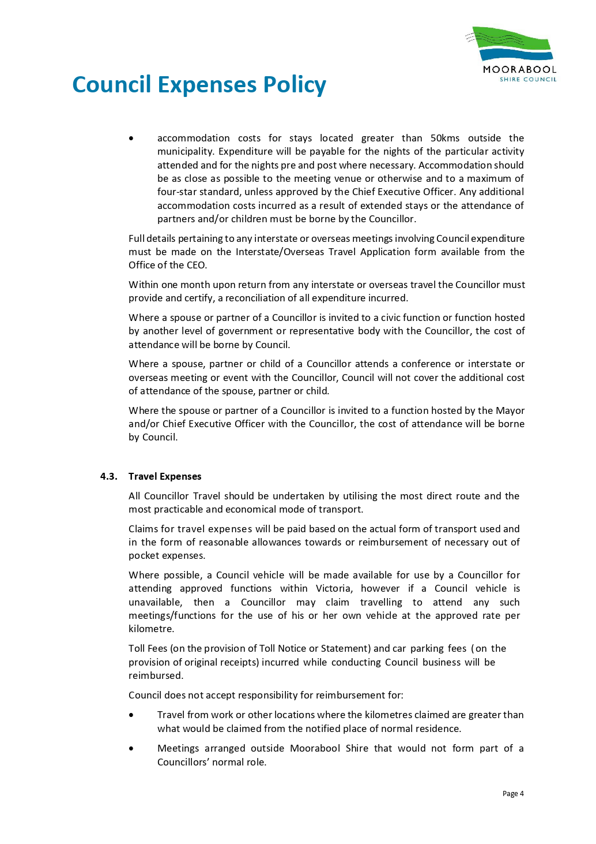

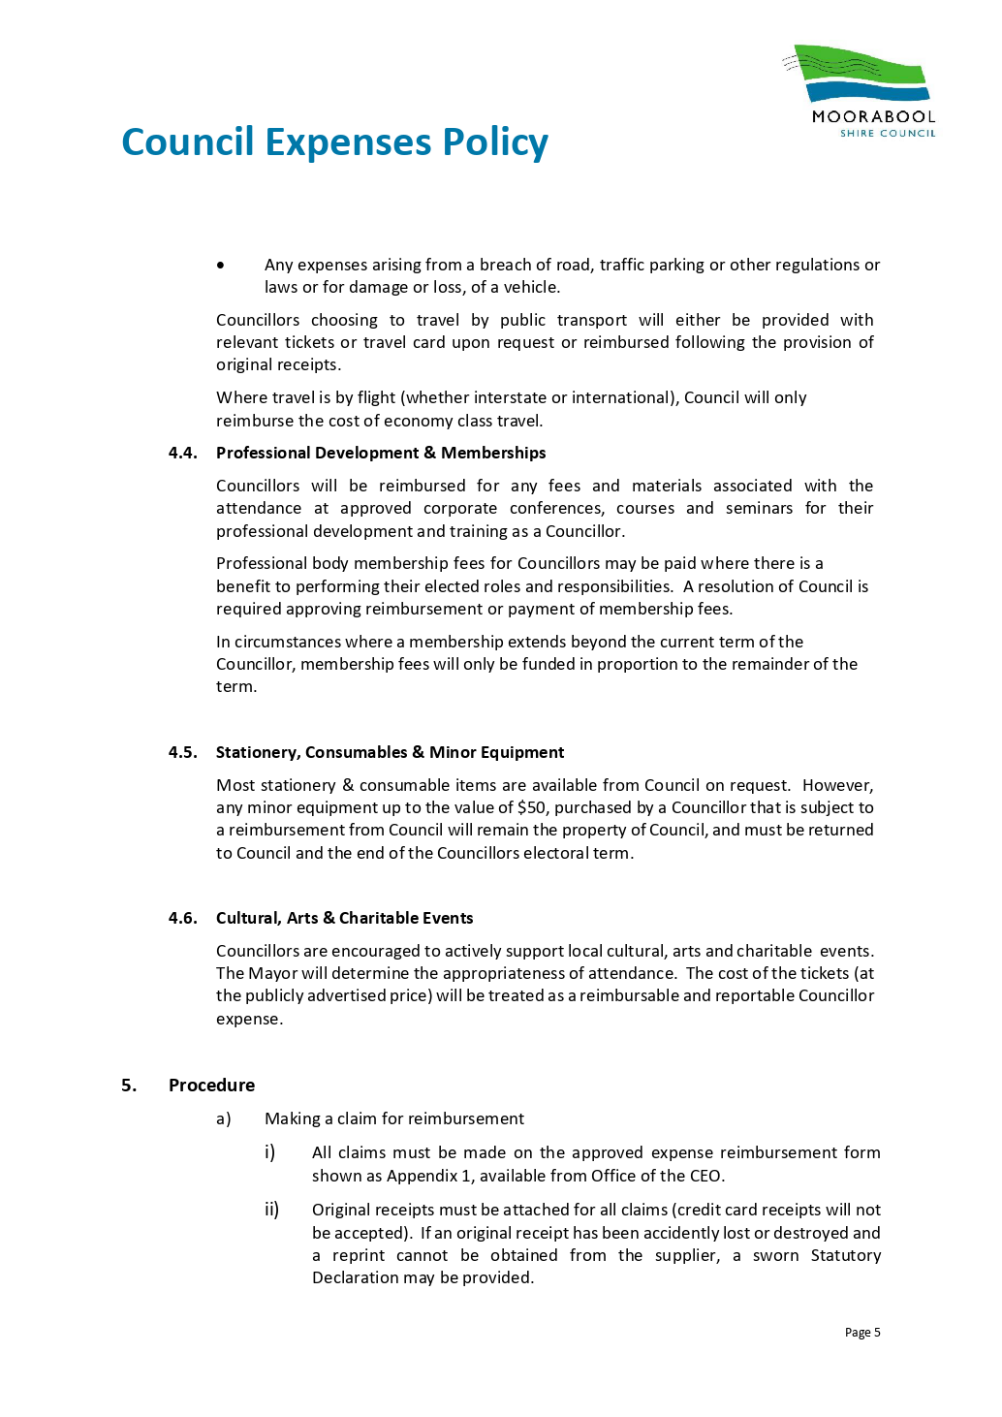

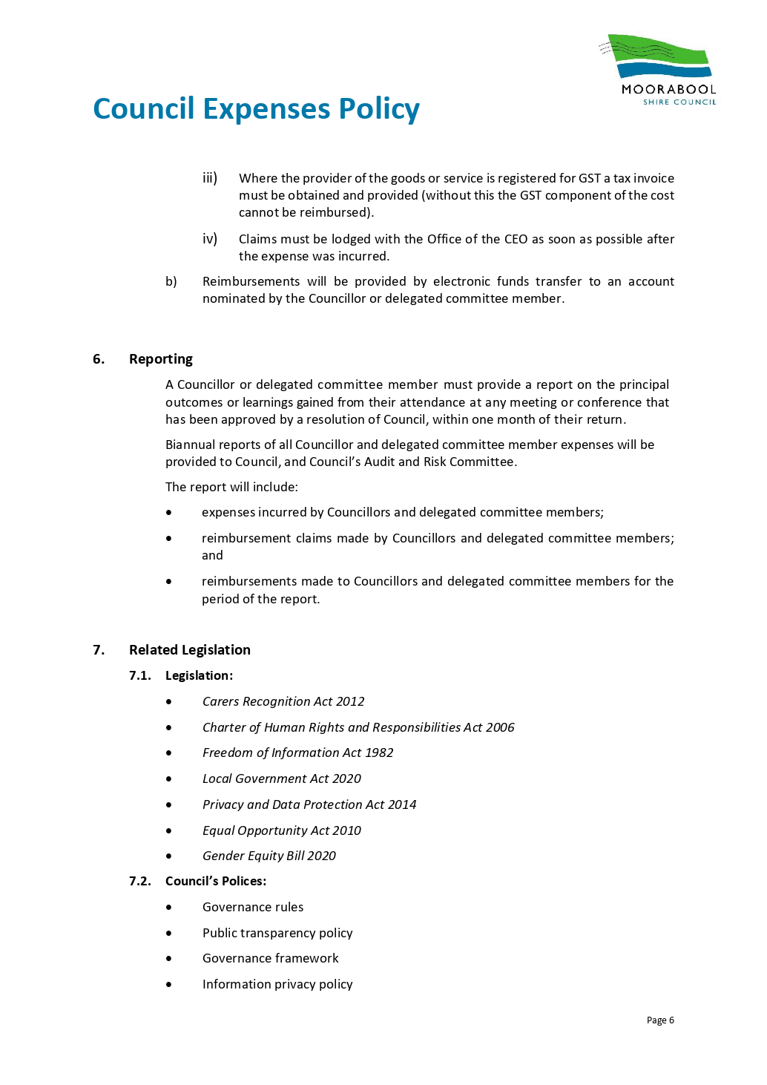

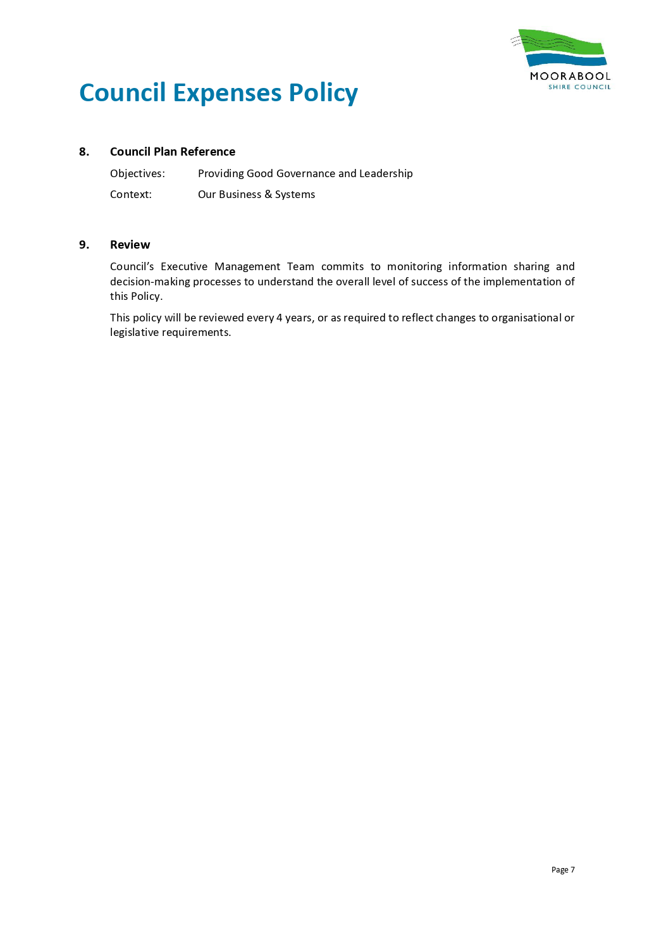

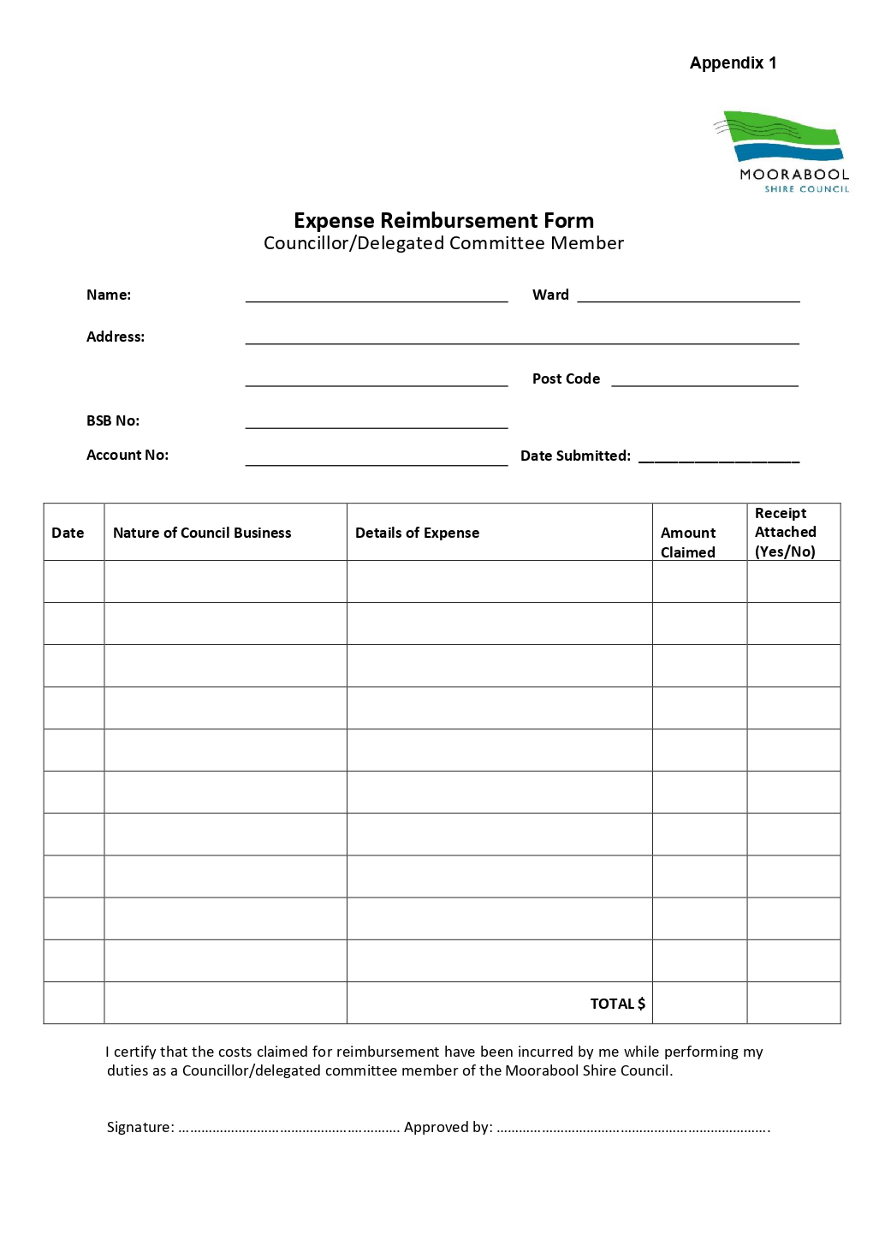

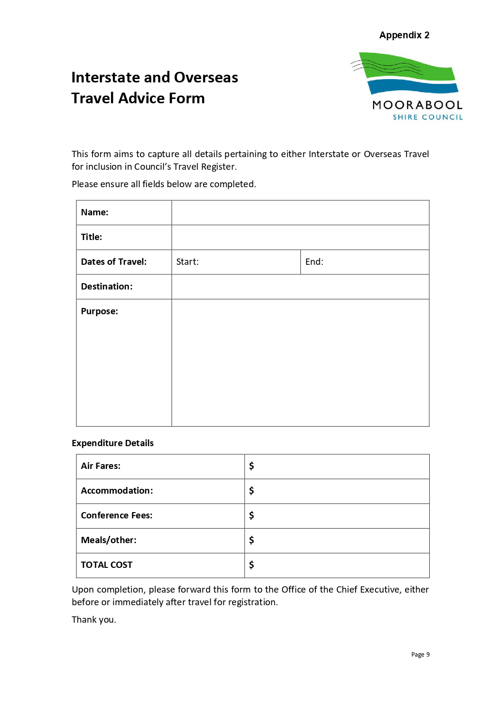

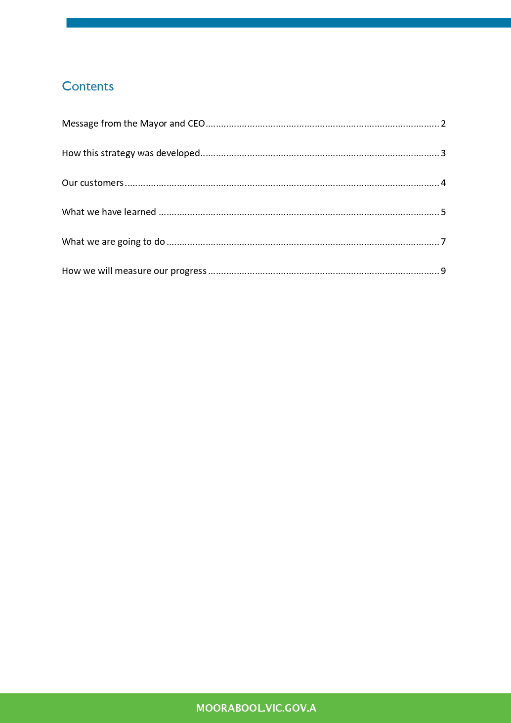

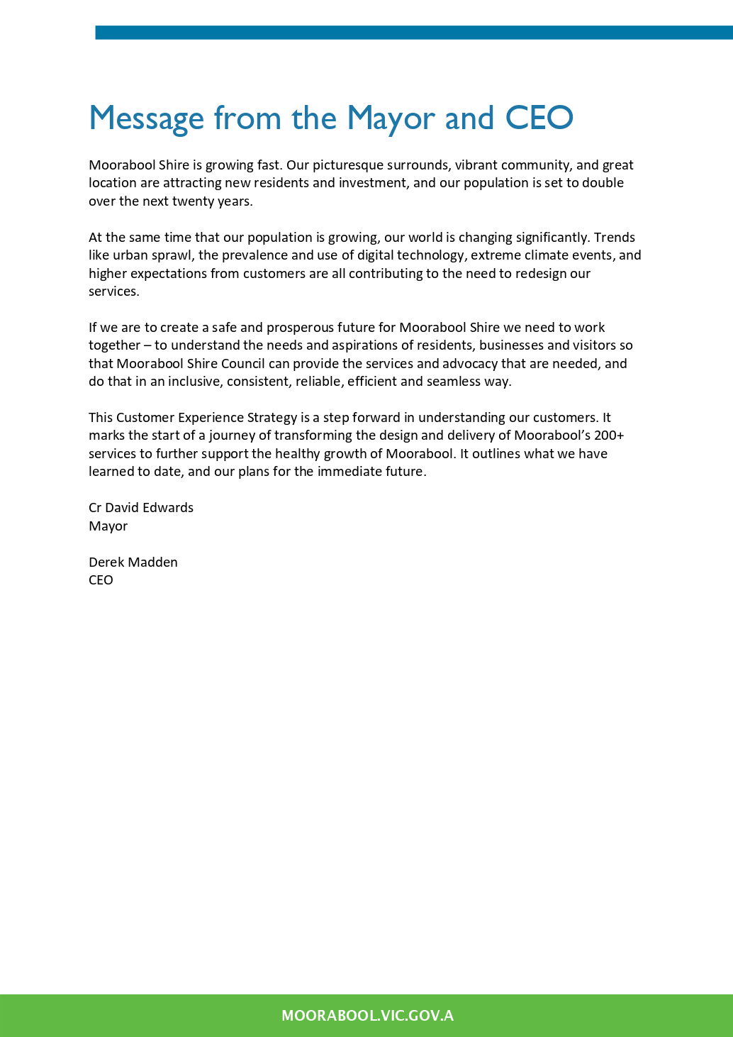

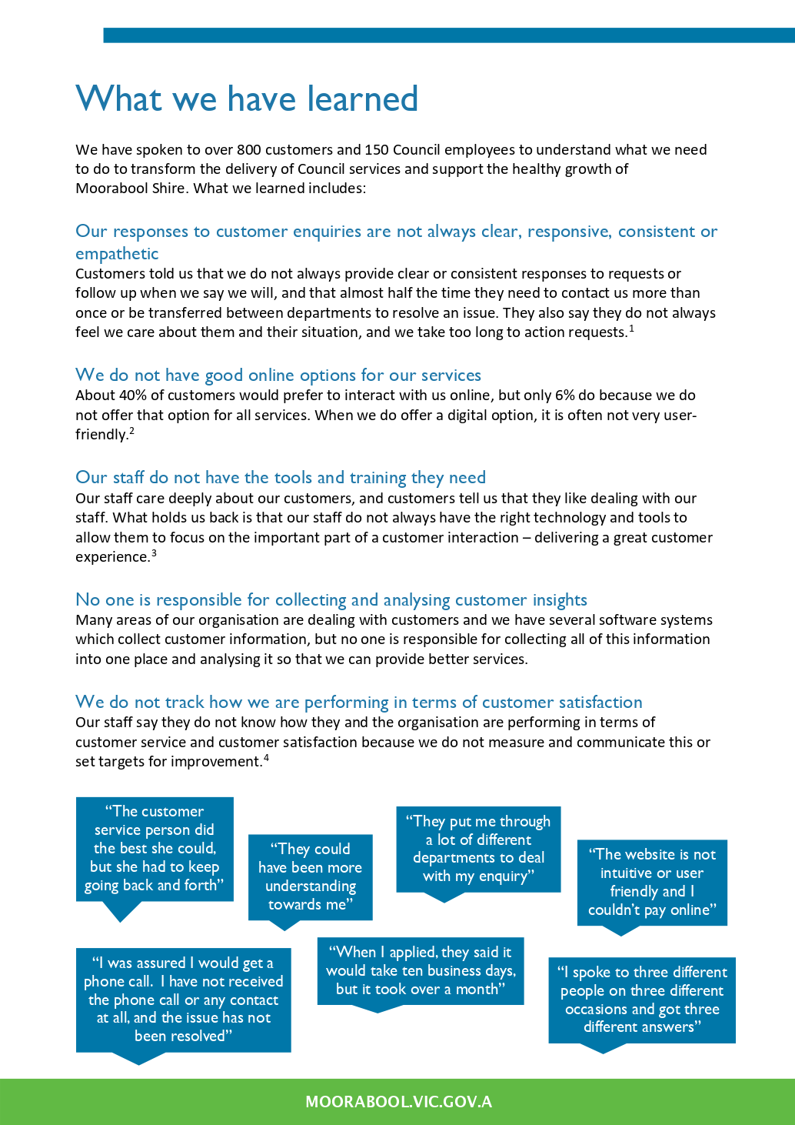

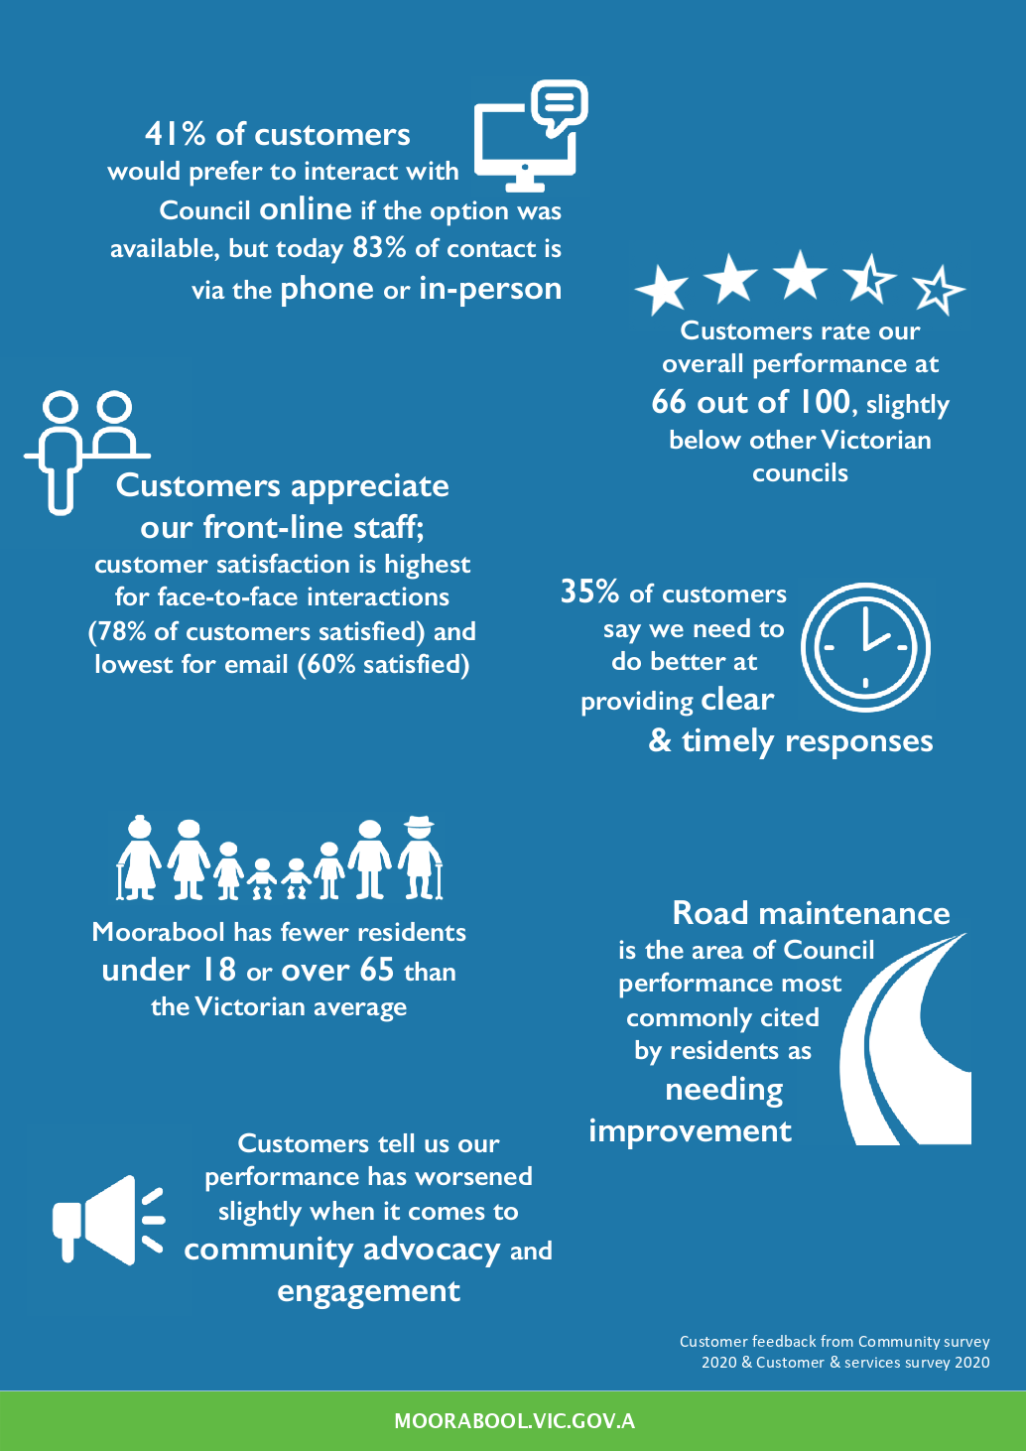

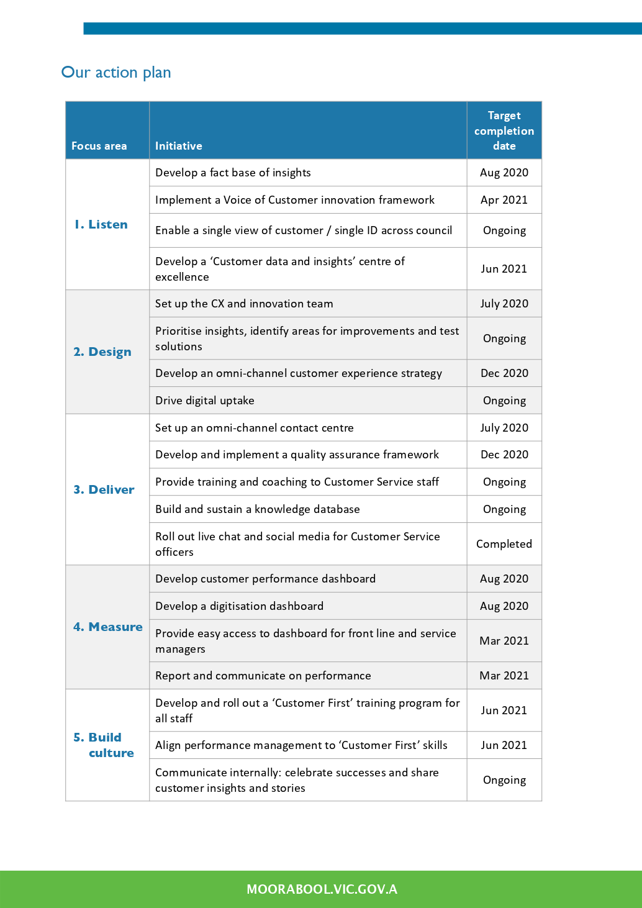

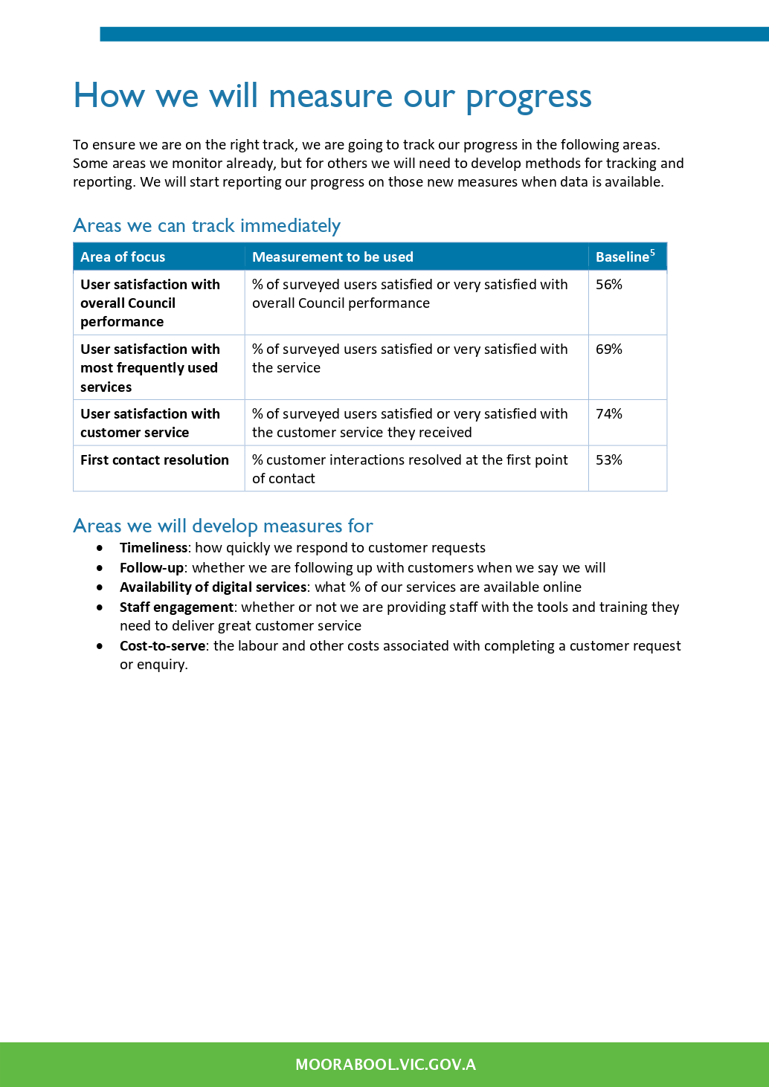

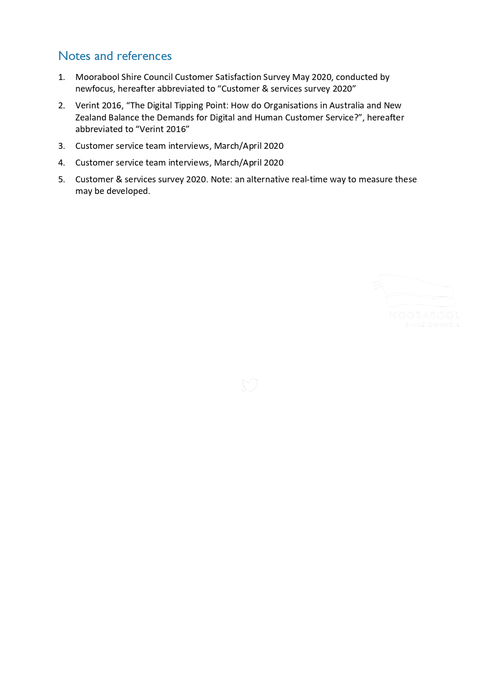

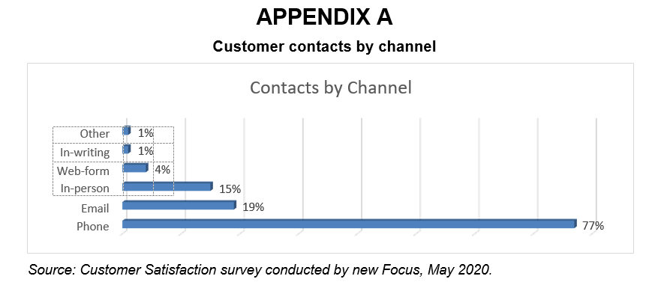
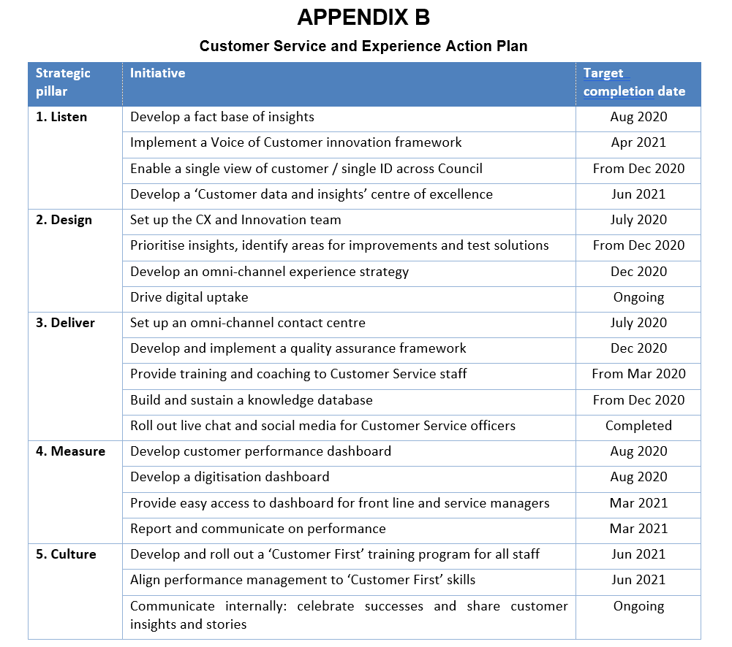

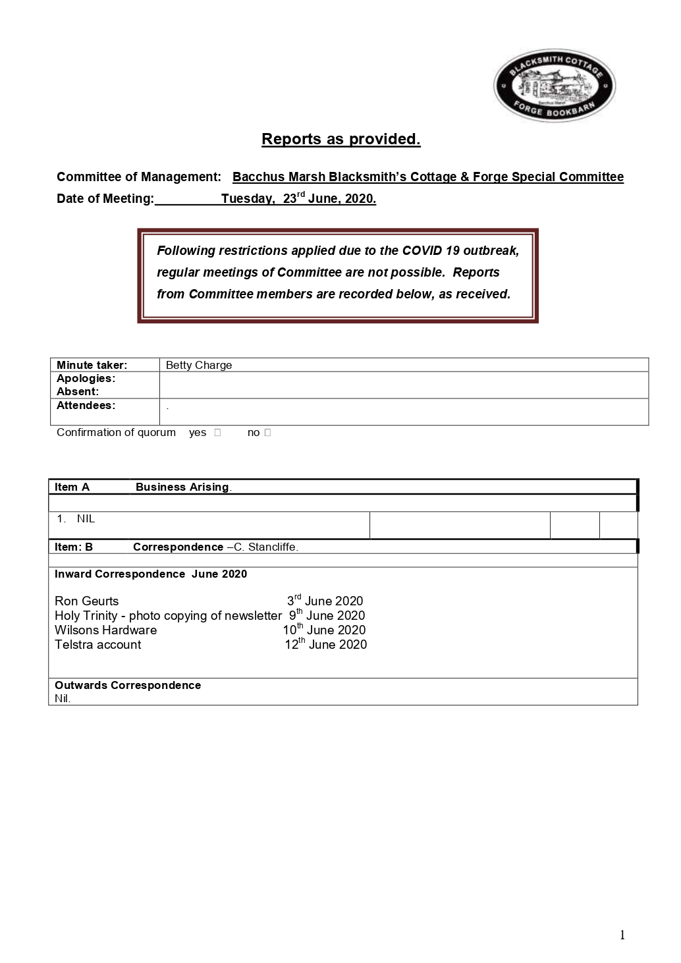

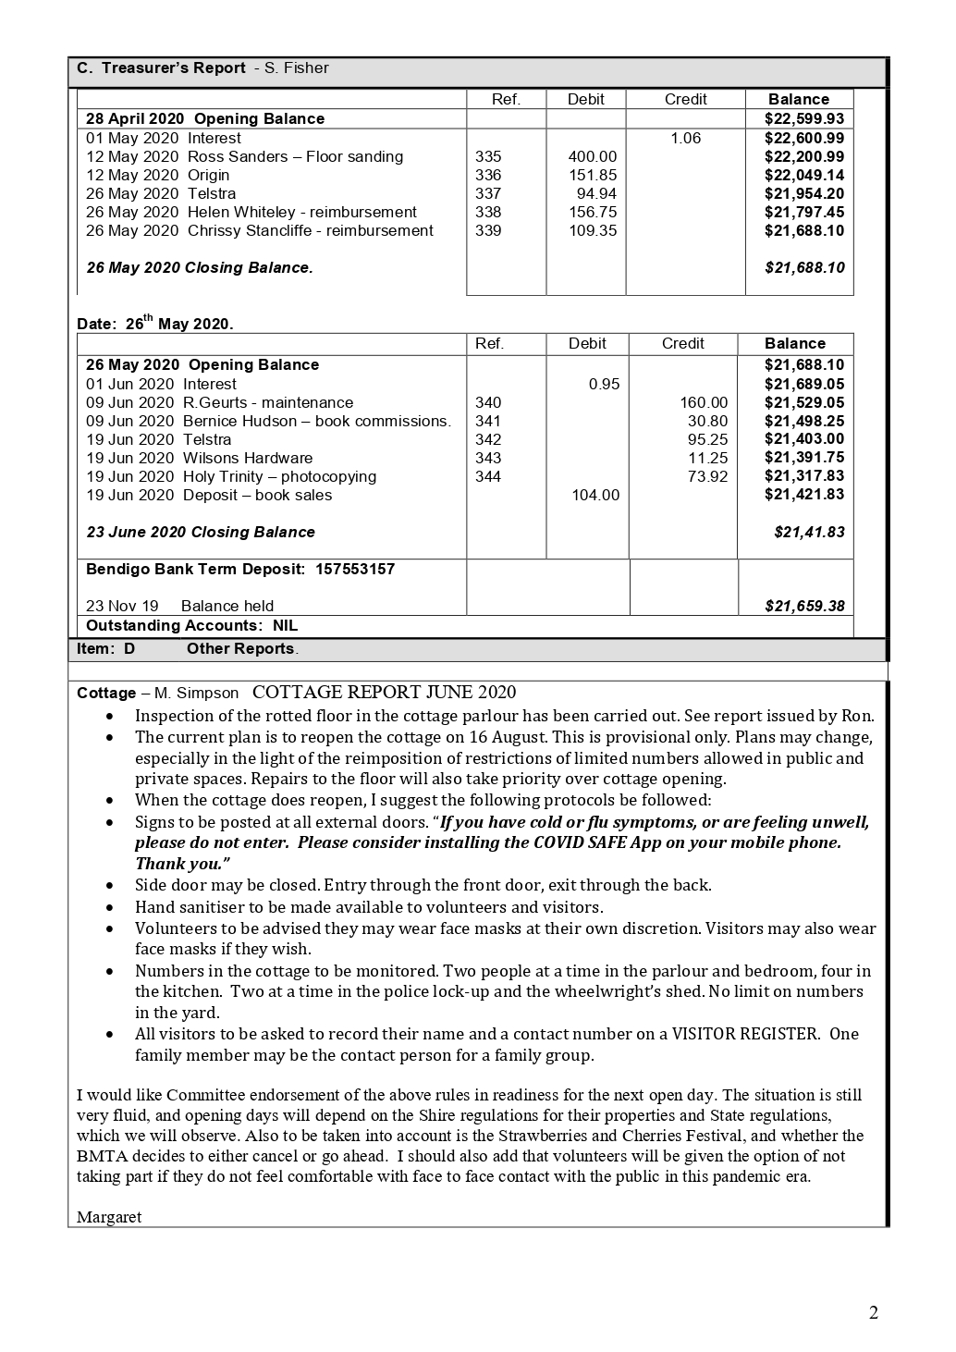

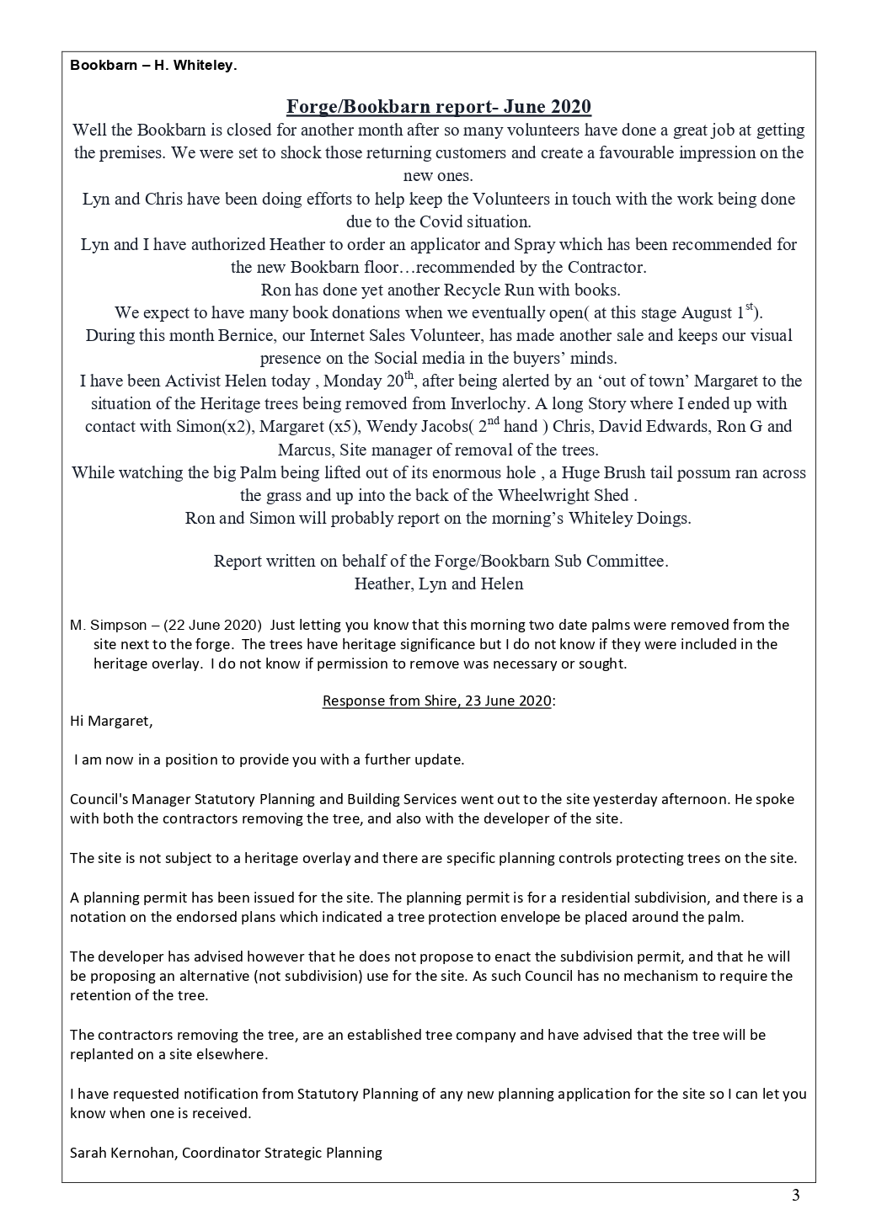

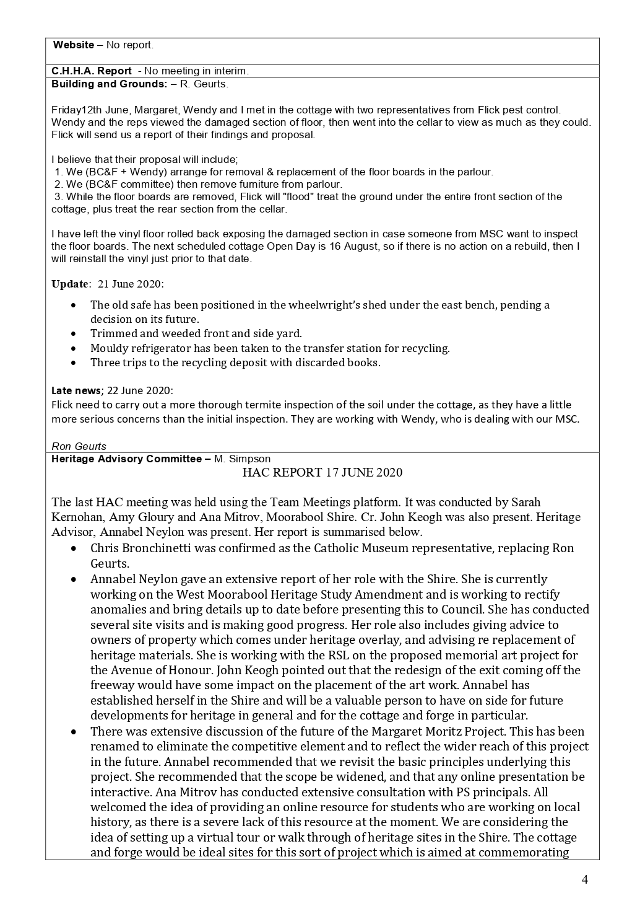

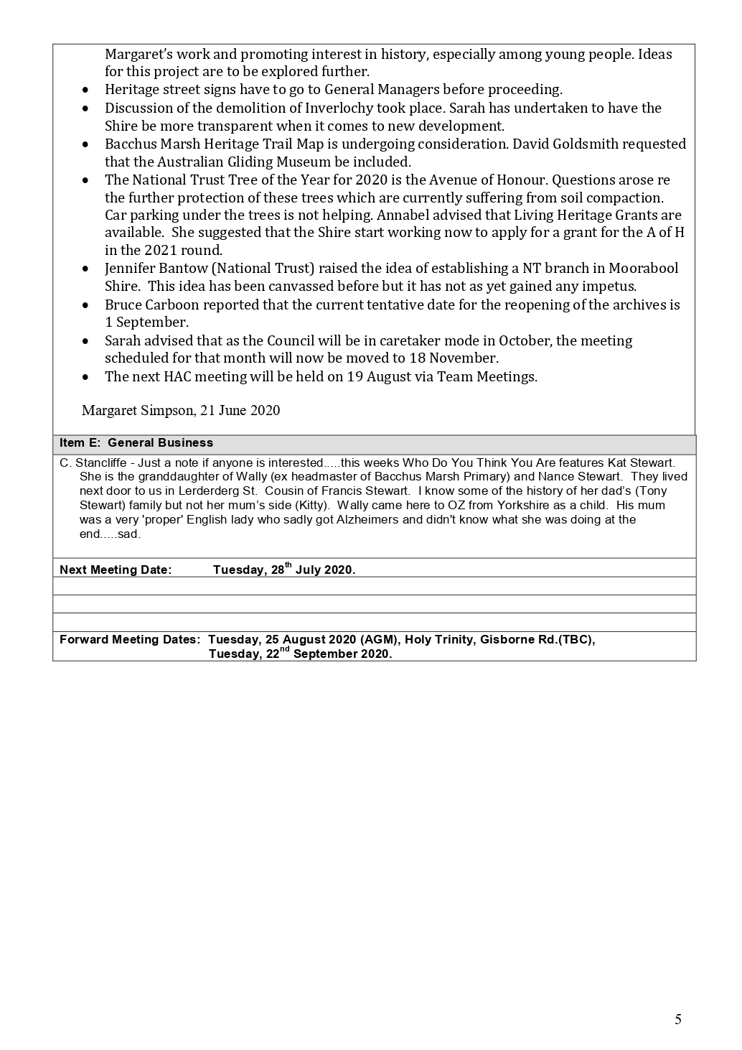

Bacchus Marsh Public Hall Committee of Management

Committee Meeting Monday 24th February 2020

Location: Supper Room, Main Street, Bacchus Marsh

MINUTES OF MEETING
1. | Meeting Opened: 7.05 pm with S Deagan in the Chair.
2. | Members present: S Deagan, D Childs, G Treloar, E Daws, J Faulkner, K Currie, J Ginnane
3. | Apologies received: Nil
4. | Guests: Cr J Bingham, R Geurts and C Young
5. | Disclosure of Conflicts of Interest: Nil
6. | Confirmation of Minutes
Resolution:
That the minutes of the Meeting of 20th January 2020 be confirmed.
Moved: J Faulkner Seconded: G Treloar
Carried
7. | Actions arising from previous meetings
 | 7.1 Disabled Accessibility to Foyer and Stage. Repairs to Stage Ceiling and Replacement Curtains 0816 |  |  |  |  | Shane Cooke has requested why we want the ceiling inspected. J Faulkner to advise him regarding suitability of changing to a vaulted ceiling and the availability to hand curtains from existing beams.  The estimate for works in the Foyer and Stage area is between $138000 to $146000 incl GST. A sub committee of S Deagan, J Faulkner and E Daws to prepare a justification letter for Moorabool Shire Council and report back to next meeting.
 | 7.2 Hall User Manual 1017 |  |  |  |  | This is a work in progress and will be actioned by S Deagan
 | 7.3 Council Maintenance, timing and advice of contracts issued by MSC 0319 |  |  |  |  | MSC - S Lewin has advised if any agenda items need following up, we are to advise her and she will forward the agenda to the personnel concerned.  MSC - S Jones advised previously that a generic email address was being set up and job numbers would be issued against requests. Has this been progressed.
 | 7.4 Committee Issued Contracts 1018 |  |  |  |  | MSC – S Jones has advised we can go ahead with the advertising for a Booking Contractor. This will not be taken over by MSC at this stage. Any amount of $5000 and up to $50000 can be approved by MSC – S Jones.  A panel to interview successful applicants will consist of S Deagan and G Treloar.  The Committee is to consider taking on the Secretarial position.  Programmable Soda have initiated new cloud emails for the  Chairperson, Treasurer, Secretary and Bookings
 | 7.5 Public Hall Front of Stage Lighting, Stage Lighting and Hall Lighting 0717 |  |  |  |  | Long term project carried over until item 7.1 is complete.  Hirers have been turning off the circuit breakers in the switchboard resulting in other hirers being unable to access the sound system and overhead projector. Cr J Bingham will address this issue with the CEO of MSC to see if the switchboard can have some light circuit breakers removed from the switchboard and a lock put on the switchboard.
 | 7.6 Interpretive Signs 0917 |  |  |  |  | MSC – S Lewin has been emailed regarding permits and we are awaiting response. S Deagan to follow up for next meeting
 | 7.7 Masterplan 0618 |  |  |  |  | Awaiting update from MSC S Jones on writing of Masterplan in collaboration between MSC and Hall Committee
 | 7.8 Paintwork 0619 |  |  |  |  | MSC S Lewin has been contacted regarding painting of the dado in the Public Hall.  MSC S Lewin has been contacted re Supper Room paint work completed prior to Christmas. This item has been completed.
 | 7.9 Community Framework Document 0619 |  |  |  |  | Awaiting document from MSC
 | 7.10 Treasurer Absence 1019 |  |  |  |  | The paperwork for S Deagan to be added to the Hall Booking Acc has been signed and will be given to the Bendigo Bank this week.
 | 7.11 Dummy Security Cameras and skip lines 1119 |  |  |  |  | The cameras have been replaced and moved slightly away from the skip bin lid. However they are being turned around by the Public and a new place will have to be investigated.  The skip bin placement lines have been painted onto the concrete.
 | 7.12 Christmas Event on the Village Green 1219 |  |  |  |  | S Deagan to follow up with MSC – S Jones
 | 7.13 Chair Covers for Public Hall 1219 |  |  |  |  | R Geurts to order from Alloyfold 10 Blue covers and 4 olive covers. 50% deposit has to be sent with order. These should arrive in May/June
 | 7.14 Help Phone Number 0120 |  |  |  |  | We are no longer able to purchase a 1300 number outright. It must be leased at a cost of $199/month.  We are able to lease an IBR with the existing 1300 number with a press button 1 for Bookings; button 2 for help. This would cost $79/mth.  This will be carried over until the Booking Contractor is appointed.
 | Cr J Bingham left the meeting
 | 7.15 Masterkey Transfer 0120 |  |  |  |  | S Deagan will pass on his masterkey to J Faulkner
 | 7.16 Steam Cleaning 0120 |  |  |  |  | The Supper Room and Foyer have been steam cleaned by GJK. Some marks in the Supper Room are unable to be removed.
8. | Secretary’s report
 | 8.1 Inwards correspondence |  |  |  |  |  |  | MSC – S Lewin CRMS 20296798 Supper Room repaint  MSC – S Lewin CRMS 20296802 Dado painting  MSC – S Lewin CRMS 20296797 Blocked Drain  GJK Facility Maintenance – Statement and invoice  Ballan News – Invoice  Telstra – Invoice  MSC – Remittance Advice  MSC – K Brudenell – Agenda items  MSC – Community Noticeboard – Grants  BM Christian Church – Thank you and Diary  Bendigo Bank – Term Deposit Certificates  Wilsons Hardware – Statement  Various emails re Bookings
 | 8.2 Outwards correspondence |  |  |  |  |  |  | MSC – S Lewin – repaint of Supper Room wall  MSC – S Lewin – dado painting  MSC – S Lewin – Blocked drain  MSC – S Lewin – Police Incident Report – Defibrillator
 | 8.3 Business arising |  |  |  |  |  |  | Stolen Defibrillator – Cr J Bingham will contact CEO for a replacement defibrillator
Resolution:
That the Secretary’s report be received.
Moved: G Treloar Seconded: John Ginnane
Carried

9. | Treasurer’s report
 | 9.1 Accounts for Payment |  |  |  | AGL Sales $164.75  Elms Bookkeeping $695.85  Suez Waste Management $140.54 inc Rental  Ron’s Maintenance Service $250.00  Wilsons Hardware $7.13  Telstra $43.60  AGL Electricity $950.00  E Daws – Cables $77.94
 | 9.2 Business Arising |  |  |  | The Term Deposit certificates have been received.
Cheque Account
 |  |  |  | Month January 2020 |  | 2019/20 YTD |  | 2018/19 YTD
INCOME
Hall Hire - Public hiring |  |  |  | 2,533.62 |  | 22,335.34 |  | 20,570.42
Hall Hire - Council |  |  |  | 218.18 |  | 4,353.78 |  | 2,790.00
Cleaning/ Other Costs Recouped |  |  |  | - |  | 299.99 |  | 300.44
Hire - Crockery and Cutlery |  |  |  |  |  | - |  | 35.46
Grant Moniesw Received |  |  |  | - |  | - |  | 2,887.50
Operational Grant |  |  |  | - |  | 31,370.37 |  | 31,370.00
Public Liability Amounts Received |  |  |  | - 242.00 |  | 82.00 |  | - 185.50
GST on Income |  |  |  | - 916.80 |  | 257.92 |  | - 1,162.37
Interest Received |  |  |  | - |  | - |  | 31.04
 |  | Total Income |  | 1,593.00 |  | 58,699.40 |  | 56,636.99
EXPENDITURE
Advertising |  |  |  | - |  | - |  | 29.70
Bank Charges |  |  |  | - |  | 1.10 |  | -
Booking & Secretarial Fees |  |  |  | 695.60 |  | 4,845.39 |  | 4,562.92
Cleaning |  |  |  | 700.34 |  | 5,209.41 |  | 3,898.42
Cleaning & Other Recouped |  |  |  | - |  | 213.68 |  | 227.26
Computer Expense |  |  |  | 142.91 |  | 420.84 |  | 475.00
Electricity |  |  |  | - |  | 2,176.55 |  | 2,360.48
Freight |  |  |  | - |  | - |  | 299.00
Gas |  |  |  | - |  | 973.78 |  | 1,276.32
Hallkeeper |  |  |  | - |  | 1,500.00 |  | 1,750.00
Meeting Expense |  |  |  | - |  | 295.74 |  | 243.86
Public Liability Insurance |  |  |  | - |  | 624.63 |  | -
Skip Hire & Rubbish Removal |  |  |  | 20.87 |  | 990.87 |  | 744.02
Stationery & Postage |  |  |  | - |  | 42.54 |  | -
Telephone |  |  |  | 39.57 |  | 311.95 |  | 288.87
Maintenance:- |  |  |  |  |  | 3,914.32 |  | 4,445.59
 |  | building |  | 354.55
Equipment Purchases |  |  |  |  |  | 1,835.00 |  | 27,003.98
 |  | furnishings |  | 135.00
GST on Purchases |  |  |  | - 966.27 |  | 265.33 |  | - 1,810.57
Contra Account - Hall Hire Council |  |  |  | 218.18 |  | 4,353.78 |  | 2,790.00
 |  | Total Expenditure |  | 1,340.75 |  | 27,974.91 |  | 48,584.85
 |  | Surplus/ Deficiency |  | 252.25 |  | 30,724.49 |  | 8,052.14
Transferred to Term Deposit |  |  |  | 50,000.00 |  | 50,000.00 |  | 31.04
Bank Account Balance B/Fwd |  |  |  | 79,835.12 |  | 49,362.88
BANK ACCOUNT BALANCE -31st January 2020 |  |  |  | $ 30,087.37 |  | $ 30,087.37

Resolution:
That the Treasurer’s report be received.
Moved: G Treloar Seconded: D Childs
Carried
10. | Booking Contractor’s report
 | 10.1 Bookings Received |  |  |  |  |  | Kayla Jones – Wedding  MSC – S Lewin  MSC – S Kuypers  C Conlan  The Voice of 7 Angels – Feb Bookings  BM Aquatic Consortium  Michael Crawford Funerals  Aust College of Higher Education – Kitchen  Vic Serrated Tussock – Meeting  Apple Radio  Angelena Kouc – Wedding  MSC – T Dudzik  Moorabool Light Orchestra  Rotary Art Show  RSL Anzac Day  Fidari Jonuzi – Birthday  BM Friendship Quilters – 2021  MSC – K Seketa  The Voice of 7 Angels – March Bookings  BMFNC – Mid Year Ball
 | 10.2 Booking Enquiries |  |  |  |  |  | Dreamtime Entertainment – Trivia Night  Michele Graham – 18th  DELWP – Community Info Session  Vic Serrated Tussock – Meeting  RSL – Funeral  Jean – 18th  Jeannie – 60th  Louise – International Peace Conference  Karen Trask  Kim – 21st
 | 10.3 Hall Viewings |  |  |  |  |  | Karellyn Dangar – Apple Radio  Luke Friedrich – Wedding Caterer  Arbee Real Estate – S Creese  Chelsea – Birthday  Jade – Engagement  Emily – Wedding  Fidari – 1st Birthday  Julie Del Papa – Ovarian Cancer Afternoon Tea
 | 10.4 Business Arising |  |  |  |  |  | Bushido Martial Arts have cancelled their permanent booking as they have secured a permanent booking at St Bernards which they are already hiring on another night and allows them to store equipment on site.  Bookings have increased 7.9% YTD for external bookings and 35.9% YTD for MSC bookings
Resolution:
That the Booking Contractor’s report be received.
Moved: E Daws Seconded: K Currie
Carried
11. | Hall Keeper’s report
 | 11.1. Tasks competed |  |  | Hall inspections  Minor maintenance  Items as listed above
 | 11.2 Business Arising |  | The dummy security camera near the skip is being moved up and down by the Public possibly due to the disposable container for syringes. Another position will be trialled.  The Suez split lid skip bin has arrived and is the same volume as the previous bin and the keys remain the same
Resolution:
That the Hall Keeper’s report be received.
Moved: J Ginnane Seconded: J Faulkner
Carried

13. | General Business
 | 13.1 Theft | 2 Teapots have been removed from the kitchen. G Treloar will order 3 new replacement tea pots  The defibrillator has been stolen and MSC – S Lewin is looking into if this can be replaced by MSC  Cables from the sound system have been taken and new ones purchased. It was suggested that these be marked with coloured tape to stop confusion with hirer’s supplying their own cables.
14. | The next meeting of the Committee will be held at 7pm on Monday 30th March, 2020 in the Supper Room
15. | The meeting closed at 8. 36 pm.

