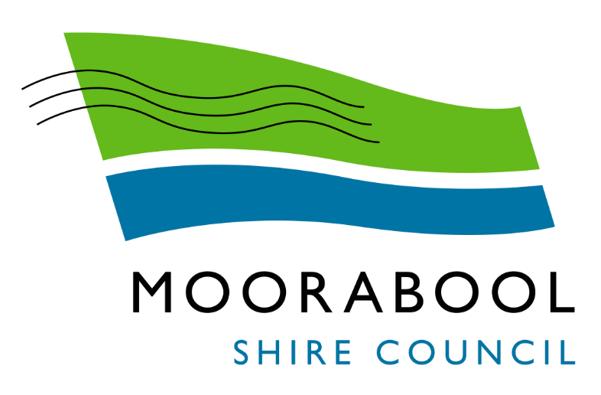
ATTACHMENTS

Ordinary Council Meeting
Under Separate Cover
Wednesday, 3 February 2021

Table of Contents

12.3 Planning for Melbournes Green Wedges and Agricultural Land - Submission
Attachment 1 Council's Submission 4
15.3 Capital Improvement Quarterly Report - December 2020
Attachment 1 2020 - 2021 CIP Quarterly Report December 2020 14

Matt Vincent
Executive Director, Planning Implementation
Department of Environment, Land, Water and Planning | Ref:
Sent via email: planning.implementation@delwp.vic.gov.au | File: | 13/01/023

Dear Mr Vincent

Re: Submission on the Planning for Melbourne’s Green Wedges and Agricultural Land - Consultation Paper

Thank you for providing the opportunity to comment on the Planning for Melbourne’s Green Wedges and Agricultural Land consultation paper. Council is generally supportive of the intent of the project which seeks to protect agricultural land, however wishes to raise concerns with several of the options proposed, and seek clarification or changes to a number of the options.

The submission raises concerns about the blanket approach of applying the reform options to all agricultural land within 100km of Melbourne, concerns at the ‘Melbourne centric’ focus on the consultation paper, lack of options to support to needs of agricultural land owners, and the lack of direction notification of landowners given the nature of the changes proposed.

In making this submission, it is important that the Department is aware of the significant amount of growth and development currently being experienced in the Shire. A number of these projects have been identified in State Policy and are significantly progressed such as the Precinct Structure Plans, while others such as the Western Victoria Transmission Network Project are proposals. These projects all relate to land that currently located within the suite of rural zones. These projects include;
• Bacchus Marsh Irrigation District Planning Study
• Rural Land Use Study
• Bungaree and Wallace Structure Plans
• Ballan Strategic Directions
• Maddingley Planning Study
• Merrimu and Parwan Station Precinct Structure Plans (Victorian Planning Authority)
• Parwan Agribusiness Precinct Development Plan (Victorian Planning Authority)
• Eastern Link Road Planning Study (Regional Roads Victoria)
• Western Victoria Transmission Network Project (AusNet Services)
• Western Irrigation Network (Western Water)

A number of these projects are not led by Council, and where there is the case, the lead Department/Authority is listed above. These projects are discussed further where relevant throughout this submission.

The remainder of this submission is structured to respond to the various sections and proposed options in the consultation paper.

Section 3.1 – Strengthening the Legislative and Policy Framework
Council is generally supportive of the option to strengthen the legislative and policy framework as it relates to agricultural land, however has concerns about the blanket approach to strengthening the framework as it relates to all agricultural land within 100km of Melbourne. Further comments on the specific options are discussed in further detail below.

Regional features of the study area – West
Moorabool Shire Council contains a number of significant points of interests such as Brisbane Ranges National Park, the Lerderderg and Werribee Gorge State Parks, Wombat State Forest, and the Avenue of Honour that are not mentioned in this section. The description of our region should also include a reference to the Special Water Supply Catchments.

A number of specific changes are requested to Map 4 as follows:
• Map 4 identifies the Leonards Hill windfarm, however does not include any other windfarms in the West including a number of windfarms in Moorabool Shire. It is unclear why the Leonards Hill windfarm has been singled out (or other Shires). If windfarms are to be identified in this map, it is requested that the three windfarms (Lal Lal, Moorabool, and Yaloak South) within Moorabool are added to this map.
• A number of symbols are used on the Map but not shown in the legend.
• Brisbane Ranges National Park, Lerderderg and Werribee Gorge State Parks, and Wombat State Forest should be shown on the Map.
• The existing potato farm cluster in Bungaree/Wallace area should be shown on the Map.
• The existing poultry cluster in Parwan should be shown on the Map.
• The existing horticulture cluster in the Bacchus Marsh Irrigation District should be shown on the Map.
• There is a * symbol after the Principal Agricultural Zone. It is unclear to what the * symbol relates to as there is no further explanation provided.

3.1.2 Legislative and policy framework for Melbourne’s agricultural land
It is important that in recognising the significance of agricultural land, recognition is had to land that has been identified for future growth, through State or local planning e.g. Central Highlands Regional Growth Plan (CHRGP), Plan Melbourne, or Council’s Strategic Planning, and that reform options allow for the continued growth and development of these areas. The areas of Bungaree, Wallace, Ballan, Merrimu, and Parwan have all been identified in both State and local policy for further development which will be facilitated by the preparation of structure plans. Any proposed changes to policy or planning controls through this project must recognise the existing strategic direction for these areas, and not seek to remove the development opportunities already identified.

Protecting all agricultural land surrounding Melbourne.
Council does not support the option to protect all agricultural land, noting that not all land currently zoned Farming Zone, is considered to be good quality agricultural land. There are a number of reasons why some land is not suitable or able to be used for productive agricultural land uses, many of which were identified in the Phase 1 of Planning for Melbourne’s Green Wedges and Agricultural Land project. Whilst the importance of protecting agricultural land within 100km of Melbourne is acknowledged and supported, it is of no value to apply protections to land that is not able to be productively used for agricultural purposes. It would also place unrealistic expectations of landowners to farm land that is not viable for farming, and effectively quarantine their land if other non-farming land uses are not supported. The policy should reinforce areas of high value agricultural land based on specific criteria (to be developed by the Department) and be supported by studies that identify productive agricultural land.

It is also noted above that some of this ‘agricultural’ land has already been identified for growth through both State and local policy, as should not be subject to any proposed protections.

Consideration should be given to the blanket application of the Farming Zone, noting that not all land zoned Farming is viable farming land, and whether an additional or alternative rural zone is required to more appropriately reflect ‘non farming’ land that is located in rural and peri urban areas.

Improving regional policy protection of Melbourne’s agricultural land
Council supports the update to the Planning Policy Framework (PPF) to include new regional policy for Melbourne’s agricultural land. One of the options proposed is to encourage opportunities for growth and diversification of other activities complementary to agriculture that leverage the advantages of proximity to the Melbourne and its local markets. However, a better understanding of ‘activities complimentary to agriculture’ is required, including how it will be addressed in the Farming Zone provisions, and whether any guidance will be provided regarding what activities are considered to be ‘complimentary’.

Council requests that there be consideration on how the PPF can strengthen the requirement for a dwelling to be required for a viable agricultural use. Current policy only refers to a dwelling being reasonably required for an agricultural use. The use of the term ‘reasonably’ is vague and is open to interpretation.

Protecting the natural resources that underpin agricultural land use
Council supports an update to PPF to encourage land uses that have limited or negligible reliance on soil as the basis of production, to be located in areas where soil-based agriculture is likely to be constrained. Council requests that this be included in the purpose and decision guidelines for the proposed irrigation district overlay.

Legislating the right to farm
Council supports proposed new right to farm legislation for Melbourne’s agricultural land that seeks to ensure that primary production carried out on a farm does not constitute a nuisance, provided that it is conducted lawfully, and the zoning of the land supports agricultural use as a primary purpose of the zone.

While right to farm legislation is supported, Council is concerned with the ability of other legislation to override this legislation such as Public Health and Wellbeing Act 2008. The right to farm legislation would need to be developed in a way that it prevents the use of other Acts to circumvent the right to farm. It should also be recognised that any right to farm legislation, whilst beneficial, would not resolve matters where breaches with other legislation occur. An example of this is the use of bird scaring cannons which are used for crop protection in the Bacchus Marsh Irrigation District (BMID), some of which are in breach of Environment Protection Authority Victoria noise requirements due to distance from houses.

It is also important that the wording of the right to farm legislation, provides adequate protections for existing agricultural business to expand, without being unfairly constrained by the proximity to existing dwellings or other sensitive uses. An example of this is the number of existing businesses within the BMID that are located within close proximity to residential development. It is also important to note that land use conflict can exist between two agricultural uses.

Council supports the introduction of the ‘agent of change’ principle into legislation to assign responsibility for mitigating impacts of lawful agricultural operations (e.g. dust, noise and odour) to the ‘agent of change’ – the person or organisation who introduces a new use or development in an existing environment. Spray drift should also be included as a potential impact that should be mitigated by the new use or development.

Council supports the PPF update in conjunction with legislative changes above to encourage appropriate sitting, design and scale of sensitive uses and developments within rural areas to avoid conflicts with agricultural uses and to maintain capability to intensify agricultural land uses.

Section 3.2 – Supporting Agricultural Land Use
This section of the consultation paper provides information on the produce produced in the varying regions. For all regions, except the BMID a corresponding statistic is included e.g. the Casey Cardinia region produces almost 90 per cent of Australia’s asparagus. Council requests that information on the productivity of the BMID is included in the consultation paper. The consultation paper only refers to fruit orchards as a product of the BMID, however it is noted that the BMID consists of a diverse range of horticultural land uses, and that a greater area of the BMID is used for growing lettuce than fruit orchards. It is considered that the reference to fruit orchards is outdated and does not reflect the true diversity of production in the BMID. It should be noted that the BMID produces 2% of Victoria’s apples, 1% of Victoria’s vegetables, 5% of Victoria’s nurseries (undercover), 7% of Victoria’s cultivated turf.

Map 8 - Economic output and jobs — agricultural, forestry and fishing sector (2018)
Towns should be added to Map 8 to assist the reader in locating the various output areas on the map.

3.2.1 Managing subdivision and dwelling development in agricultural areas
Council acknowledges that there is a need for some method of controlling subdivision of agricultural land. The option to require parliamentary ratification of proposals to subdivide land into more lots or smaller lots than currently provided for in the planning scheme is supported, subject ensuring that this restriction is not applied to land that is not considered to be good quality agricultural land, or land that has already been identified for State or local policy for growth or development.

Council also requires some guidance from the Department regarding the how the proposed subdivision changes would apply to re-subdivision of lots in common ownership or the consolidation of lots (noting that this is classed as subdivision).

Council supports the option to amend the subdivision provisions of the Farming Zone to prohibit creation of a lot for an existing dwelling that is smaller than the minimum lot size.

In addition, it is requested that there be consideration on how the PFF can strengthen the requirement for a dwelling to be required for a viable agricultural activity. The current policy only refers to a dwelling being reasonably required for an agricultural use.

Dwellings in rural areas

Map 10 – Dwelling approvals during 2011-2018
Towns should be added to Map 10 to assist the reader in locating of the approved dwellings on the Map.

Council does not support the option to remove dwellings as an as-of-right use in the Farming Zone within 100 km of Melbourne. Council suggests retaining dwellings as an as-of-right use in conjunction with the proposed option to not allow subdivision for existing dwellings on lots less that the minimum lot size. This will encourage the consolidation of lots. Council notes that dwellings on the smaller lots are of more concern that dwellings on the lots that are minimum lot size.

3.2.2 Improving decision-making on agricultural land
Council supports the option to provide a planning practice note to guide discretionary decision-making on agricultural land and expert advisory service for peri-urban Councils to support decision-makers and facilitate compliance with the planning scheme. In addition to the matters listed in the consultation paper, it is considered that the following additional matters should be provided within the practice note:
• Clear guidance on assessing whether a dwelling is reasonably required for an agricultural purpose. Including guidance on the term ‘reasonably’
• Direction on what activities are considered ‘complimentary to agriculture’.
• Guidance on the extent to which supporting ancillary buildings and works should be provided for within the irrigation district.

3.2.3 Future proofing Melbourne’s food bowl

Safeguarding agricultural land with potential access to alternative water
Council supports the development of a new regional policy at Clause 14.02-3R of the PPF ‘Preserving opportunities of irrigated agriculture around Melbourne’, which would seek to safeguard land that has potential for future growth in irrigated agriculture, based on alternative water use.

Supporting agricultural land use in Melbourne’s irrigated districts
Moorabool Shire contains both an existing (Bacchus Marsh Irrigation District) and an emerging irrigation district (Western Irrigation District).

Council supports the option to apply a planning overlay to land within declared irrigation districts to protect food producing areas with access to secure water supply and irrigation infrastructure. Council would however caution against the application of any overlay to the proposed Western Irrigation Network, prior to the confirmation of this land as being part of an irrigation district.

It is noted that an option is proposed for the application of a 500m buffer to land around the irrigation district. Clarification is required regarding the application of the 500m buffer. Map 11 states that “Buffer could only be applied where there is still capacity to do so i.e. to areas that are not already built up”. It is unclear if this applies to areas that are not already ‘built up’ but are proposed for development e.g. identified for development within a precinct structure plan. It is also unclear if this buffer only applies to residential land, or all land that is ‘built up’.

It is important to note that not all land currently within the BMID is productive agricultural land, and that some areas of the irrigation district have been rezoned and/or developed for other purposes (Figure 1). For example, parts of the Underbank Estate have since been rezoned and developed for residential purposes, and parts Merrimu Precinct Structure Plan are located within the irrigation district. Council is aware of these and a number of other discrepancies with the declared irrigation district, and is currently reviewing this boundary through the Bacchus Marsh Irrigation District Planning Study. The Bacchus Marsh Irrigation District Planning Study is an action from the Bacchus Marsh Urban Growth Framework and is currently being prepared by Council and RMCG consultants. This study seeks to review of the current and ongoing viability of land within the BMID and will provide direction on the future of the BMID along with planning policy and controls for the protection of and investment in the BMID. A recommendation of this planning study will likely be to amend areas of the declared irrigation district, where development has occurred, or has been identified for development through State or local policy. It is important that the Department consults with Council further on the draft overlay, including the proposed boundary and any controls for the proposed 500m buffer.
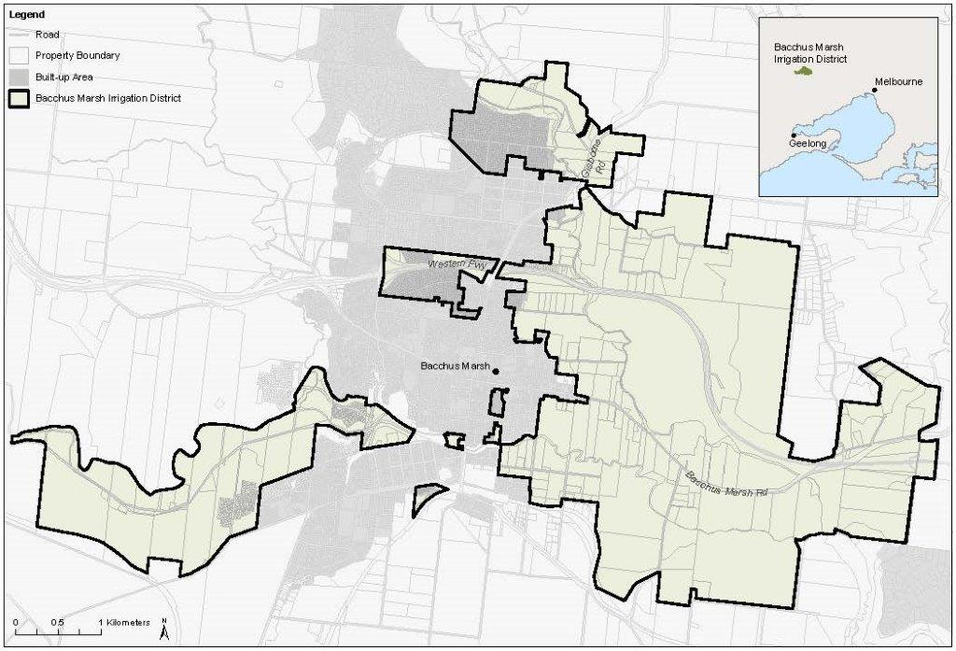
Figure 1: Declared Bacchus Marsh Irrigation District boundary

In conjunction with any option to apply a planning overlay to irrigation districts, it is requested that the Department provides guidance on the extent to which supporting ancillary buildings and works that remove land from productive use should be provided for within the irrigation district, for example, carparking and warehouses.

Map 11 - Water for agriculture — existing infrastructure and future opportunities
A number of comments are provided on Map 11. These are:
• The boundary of the BMID appears differently across several maps, and also appears to be incorrect in a number of maps. As noted above, it is requested that the Department consult with Council regarding the correct boundary, noting that the declared irrigation district boundary is not appropriate for use in the application of any proposed overlay.
• Recycled water and outfall pipes 1km buffer marked on the map are not discussed in the consultation paper. It is unclear if these relate to existing or proposed pipes, and what the purpose/need for the buffer is. This should be clarified.

3.2.4 Strengthening referral and notice requirements
Council supports the option to strengthen referral and notice requirements and supports the relevant water authority being made a determining referral authority for permit applications in the irrigation district.

3.2.5 Supporting agricultural diversification, value-adding and innovation
The option to update the definition of ‘Primary produce sales’ to allow for the sale of ancillary goods, the sale of produce from land held in one ownership to support farms comprising divided holdings in the same ownership, and to allow a percentage of produce sold to be sourced from local producers within 5km of the use is generally supported by Council. However, it is important that any changes to the definition of ‘Primary produce sales’, to allow for the sale of ancillary goods includes a clear definition of ancillary goods. This could be assisted by including by providing for a percentage of ancillary goods by floor area.

In addition, Council considers that the option to ‘allow a percentage of produce sold to be sourced from local producers within 5km of the use’ is unnecessarily restrictive, noting that farmers networks in a large Shire such as Moorabool extend much further than 5km. It is requested that a longer distance would be more appropriate.

Host farms
Council supports the option that suggests amending the definition ‘host farm’ to require a direct link to an ‘operating agricultural property’, however considers that a definition of operating agricultural property, and direct link, should be provided. It is unclear how the requirement of a ‘direct link’ would be assessed.

Council notes the option to make a host farm as an as-of-right use under Section 1. If this option is proposed, there needs to be some additional provisions regarding distance from adjoining dwellings, as some houses in rural areas can be quite close to each other, and 10 people staying in a host farm could impact on a nearby dwelling through noise generated by the guests and particularly privacy if adequate vegetation or other screening is not in place.

It is also noted that host farms may not be appropriate as a Section 1 use in all areas of the Farming Zone. The Parwan Agribusiness Precinct is an employment precinct that will provide for significant agribusiness land uses. Areas of the Parwan Agribusiness Precinct are likely to remain in the Farming Zone and will consist of both existing and proposed land uses that require both significant built infrastructure and amenity buffer distances. It is therefore requested that the Department provide further consideration of the suitably of host farms as a Section 1 use within all areas of Farming zone, noting that Host Farms are unlikely to be appropriate within the Parwan Agribusiness Precinct.

Section 3.3 – Managing use of Green Wedge and Peri-urban Land
3.3.1 Managing the urban-rural interface
Council is supportive of guidance for preferred transitional land uses and zoning for land at the urban-rural interface and urban design guidance that supports a permanent edge and buffer to the urban area.

3.3.3 Managing discretionary uses
Council is supportive of changes to definitions for caravan parks and camping as it would enable Council to have greater opportunity to articulate the types of camping and caravan parks that are appropriate to be on the rural land.

Other Matters
Planning for future infrastructure needs
It is noted that no options are proposed for Section 3.3.2 Planning for future infrastructure needs. Given the importance that the consultation paper places on the protection of agricultural land, it is unclear why no options have been proposed. It is considered essential that the issue of infrastructure projects within agricultural land be addressed, and options proposed.

Due to the Shire being located on the periphery of the metropolitan growth area, it has become a pseudo ‘service centre’ for Melbourne as the host of multiple extractive industries, mines, and a State significant waste hub all being located on the critical entry points of Bacchus Marsh. In addition to this, the encroachment of industrial and residential development on the agricultural land has resulted in a very real challenge for Council to ensure that it is no longer impacted or inhibited by uses that pose further impost on land owners and loss of local identity.

While these large-scale infrastructure projects provide local, regional and State benefits they also have a number of negative implications for the community. There is currently much angst in the Bacchus Marsh community in regard to the potential expansion of the waste facility and quarries, and there is still angst in the community in the west of the Shire in regard to the installation and cumulative effect of the number of wind farms that have been constructed. This issue is further compounded by the proposal for high voltage transmission lines that will go from the eastern edge through to the far western edge, potentially through some of the Shire’s most productive land.

A number of significant infrastructure projects are currently proposed within the agricultural areas of Moorabool Shire, including transmission lines and a proposed Eastern Link Road bypass. These projects on their potential impact on agricultural land are discussed in further detail below.

Eastern Link Road
Regional Roads Victoria are currently undertaking a planning study to determine the alignment of an Eastern Link Road bypass of Bacchus Marsh. The Eastern Link Road is needed not only to address existing traffic congestion, but to accommodate the growth of Bacchus Marsh, providing a connection between these new growth precincts. Securing the alignment of the Eastern Link Road is essential to the timely planning and development of these precincts.

The shortlisted alignments all propose to impact on the BMID to varying degrees. Whilst the consultation paper places a higher level of importance and protection of the irrigation district, the options proposed do not provide for any consideration of the impacts of an infrastructure project of this nature. Depending the alignment chosen, the road bypass has the potential to result in the fragmentation of land the irrigation district and impact on the viability of several farms to continue to operate within the irrigation district.

Western Victoria Transmission Network Project
AusNet Services have been awarded the contract for the Western Victoria Transmission Network Project. This includes 70 km of new 500kV transmission line proposed to traverse the length of Moorabool Shire, and would run through significant areas of land identified through this consultation paper, as being of agricultural importance. This project is of significant concern to Council and the community, for a number of reasons, one of which being the potential impact that the proposal will have on the use of the land for agriculture. It is understood that the easement placement for the transmission lines will impact on the type of farming practices and machinery that can be used in the vicinity of the lines, as well as the potential for impacts of radiation on crop production, including radiation in the harvested crop e.g. potatoes.

It is noted that the transmission lines are proposed to traverse through other municipalities identified within the consultation paper, including City of Ballarat, Hepburn Shire and Melton City Council.

Impact on Landowners
Council also wishes to raise the Melbourne-centric’ focus of the consultation paper, including reference to ‘Melbourne’s food bowl’. Whilst it is recognised that the majority of Victoria’s population is located within metropolitan Melbourne, it is concerned at the continued focus of the State Government on Melbourne’s needs, and lack of importance placed on the needs of agricultural landowners.

Council has concerns about the impacts that the proposed options will have on landowners. While Council does not dispute the need to protect significant agricultural land, it is currently unclear how the proposed options, particularly the planning controls will benefit the owners of this land. At the community consultation session held in Bacchus Marsh on the 27 March 2019, a number of landowners raised concerns with the existing level of controls and restrictions placed on their land and the conditions threatening the viability of farming of this land. The protection of agricultural land is of little value, if the protection does not allow for the continued viability of existing and future farming operations.

It is essential in that seeking to protect agricultural land, due consideration is given to the local community and their needs. It is not appropriate for agricultural land to be protected for Melbourne, to the detriment of agricultural landowners. If this land is of such importance to Melbourne, then it is only appropriate that the State Government provide the necessary support for landowners to continue to farm this land.

Social and Cultural Implications
Farming often has strong cultural, social and intergeneration ties. These ties to the land are a significant element of many successful operational farms. It is important that the consultation paper acknowledges these ties and the importance they play in the continued operation of many farms. Many options proposed such as those related to subdivision and dwellings, are deeply ingrained in the ability of farms to successfully operate. Careful consideration needs to be had to the extent to which these options, may limit the ability of these farms to continue to operate, whether it to be subdivision to assist with financing or to enable land to be passed down to family.

Non-planning matters
The consultation paper notes that a planning response is insufficient to ensure a sustainable food bowl for the long term, stating that non-regulatory measures must also be employed to encourage agricultural use. The paper then goes on to note that a range of options beyond planning were identified during Phase 2 consultation and could be further explored by local and State Government. The Department should clearly outline these options to allow for their consideration by local government. Council is currently undertaking both a Rural Land Use Strategy and Bacchus Marsh Irrigation District Planning Study, the identification of the options would be of both interest and benefit to Council, and this strategic work.

Whilst it is acknowledged as being outside of the scope of this consultation paper, it is considered that the Department also provide these options to the relevant State Government Departments for consideration.

Further Consultation
The project timeline in the consultation paper states that the project is currently in Phase 4 public consultation, and that Phase 5 which is the final phase is to ‘review consultation findings and implement preferred options’. Council is concerned that this timeline does not provide the opportunity to be consulted on or review the specific changes proposed such as the proposed irrigation district overlay, changes to existing zones, and new/amended policy. Whilst the consultation paper talks generally about the changes, the wording of these is particularly important. Council requests the opportunity to review these changes.

Notification of Landowners
Council is concerned with the absence of direct notification of all landowners noting the significant nature of some of the options proposed. Council understands that DELWP is only directly notifying landowners within the existing and emerging irrigation networks. In the case of Moorabool that is landowners within the Bacchus Marsh Irrigation District and the proposed Western Irrigation District. Council requests that given the significant nature of the changes proposed, that all landowners are directly notified.

Mapping
A number of maps in the consultation paper are difficult to read due to their small size and/or resolution. As stated in our previous submission to the Department, it would be beneficial if Council could get access to GIS layers in order to confirm the accuracy of the mapping before the Department implements any of the options proposed.

Thank you again for the opportunity to provide comment on the consultation paper. Please contact Sarah Kernohan, Coordinator Strategic Planning skernohan@moorabool.vic.gov.au if you would like to discuss any aspects of this submission in further detail.

Yours sincerely,

Derek Madden
Chief Executive Officer

