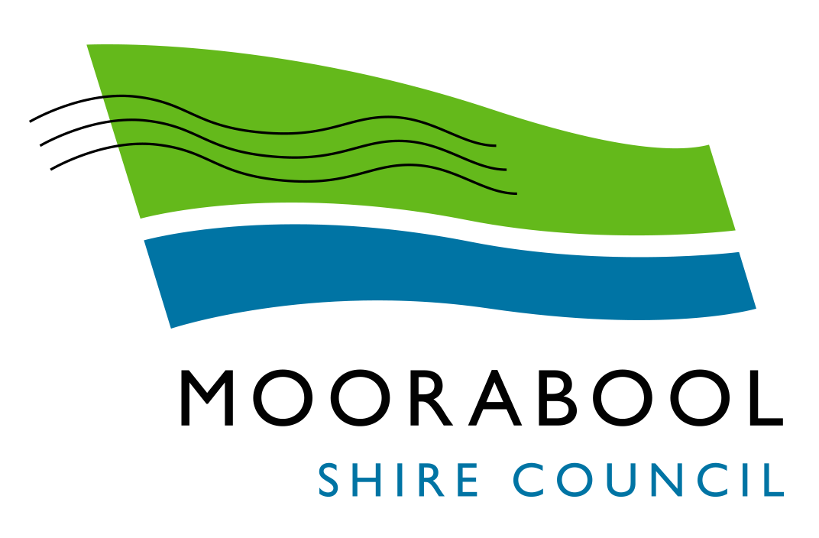
ATTACHMENTS

Ordinary Council Meeting
Under Separate Cover
Wednesday, 2 September 2020

Table of Contents

14.1 Adoption "in principle" of the 2019/20 Financial Statements for Submission to the Victorian Auditor-General for Certification
Attachment 1 2019/20 Financial Statements 4
14.2 Adoption “in principle” of the 2019/20 Performance Statement for submission to the Victorian Auditor-General for certification
Attachment 1 2019/2020 Performance Statement 69
14.3 2019/20 Governance & Management Checklist
Attachment 1 2019/20 Governance & Management Checklist 89
14.4 2017-2021 Moorabool Shire Council Plan - Year 3 Final Report
Attachment 1 Summary of Outcomes of 2017-2021 Council Plan (2019 Review) 93
Attachment 2 Council Plan Actions Progress Report for Year 3 102
15.1 Landscape Design manual
Attachment 1 Attachment 01 - Moorabool Landscape Design Guidelines - Final 131
Attachment 2 Attachment 02 - Consultation Feedback 173

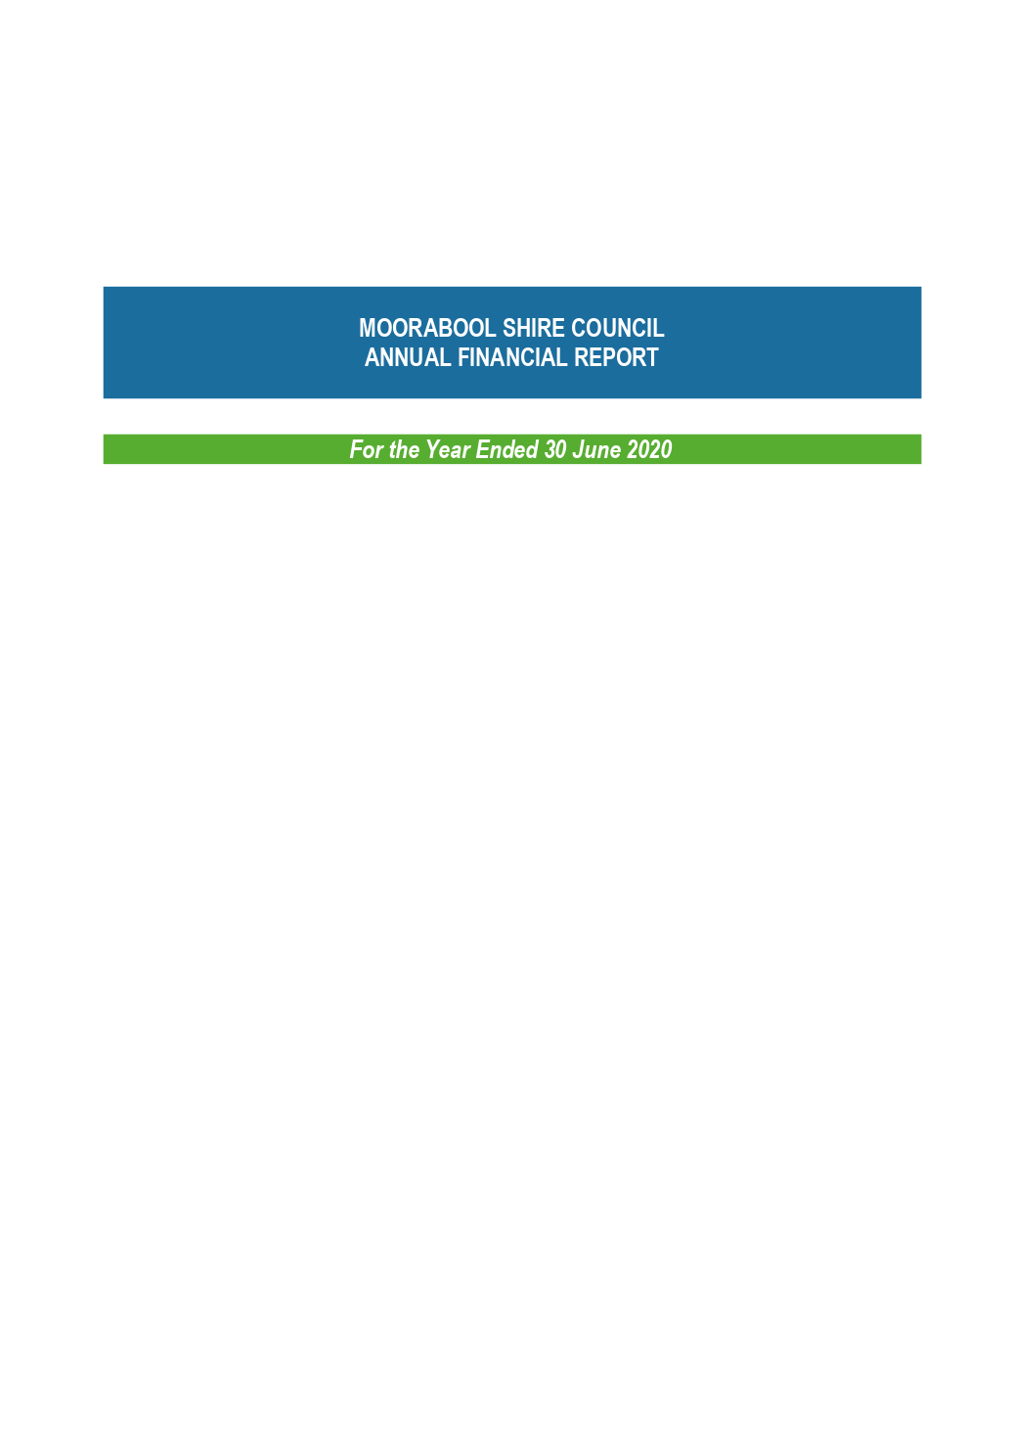

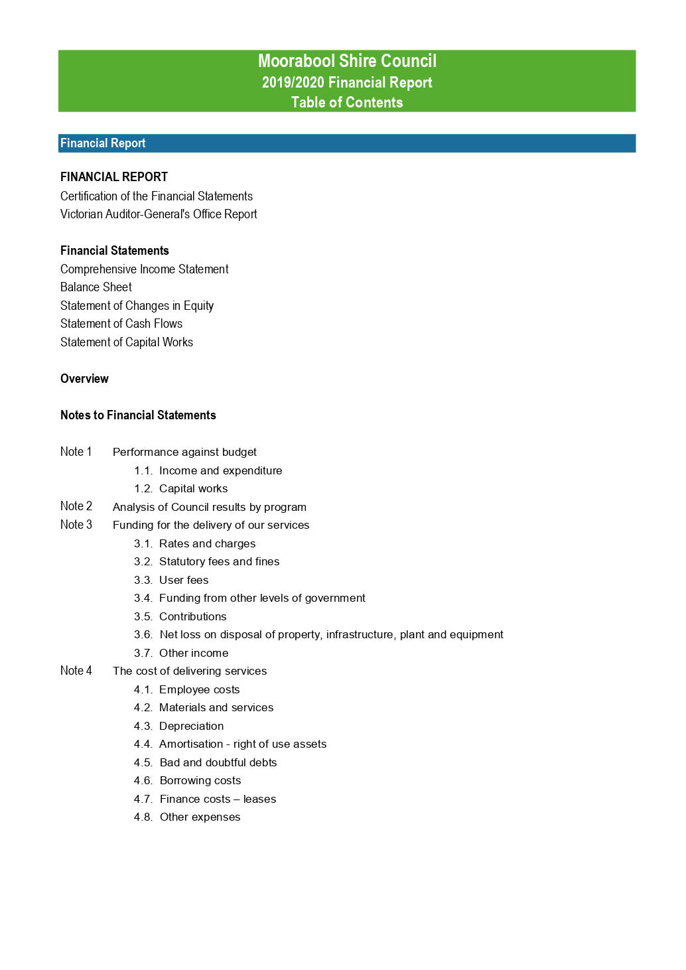

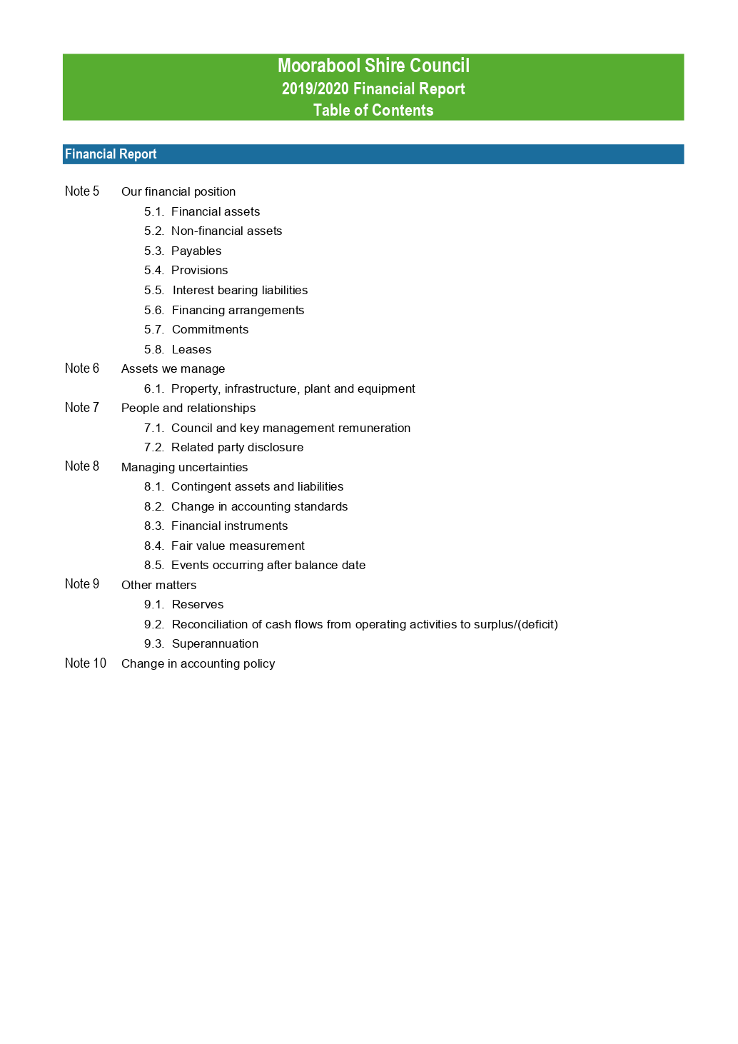

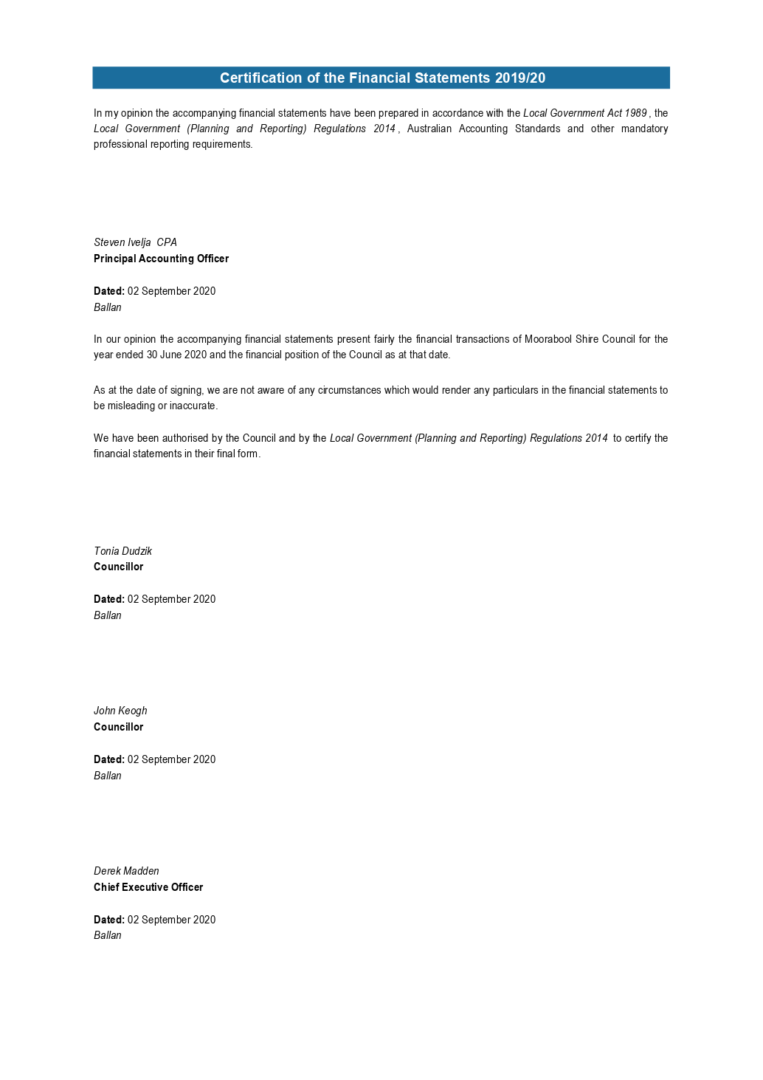

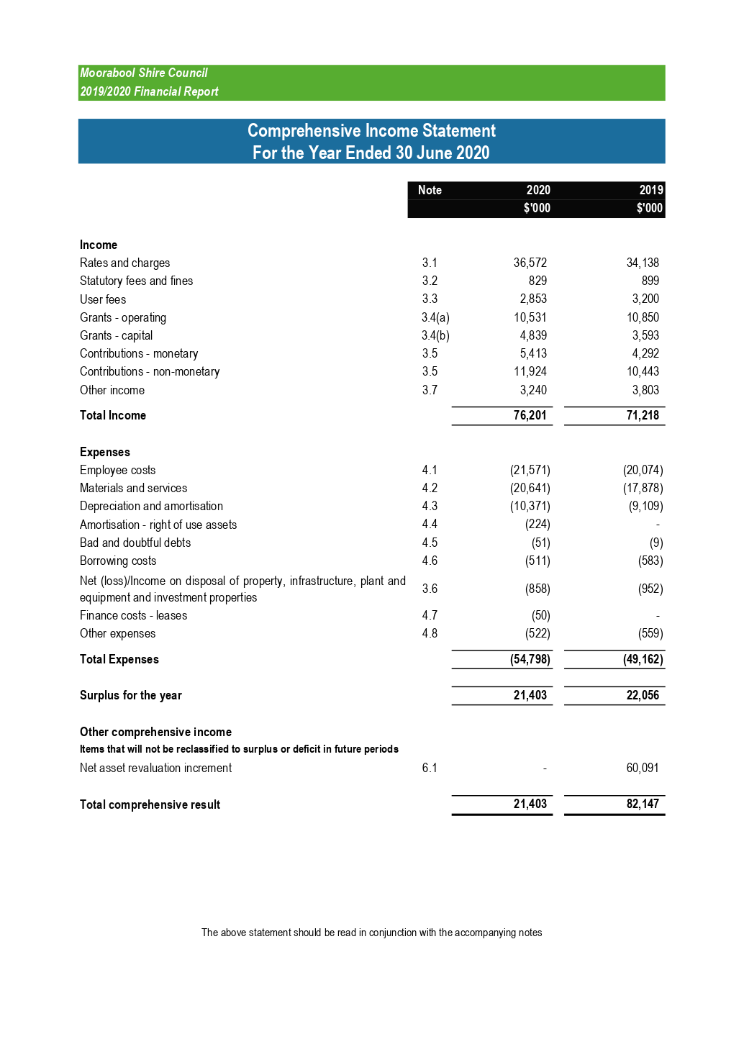

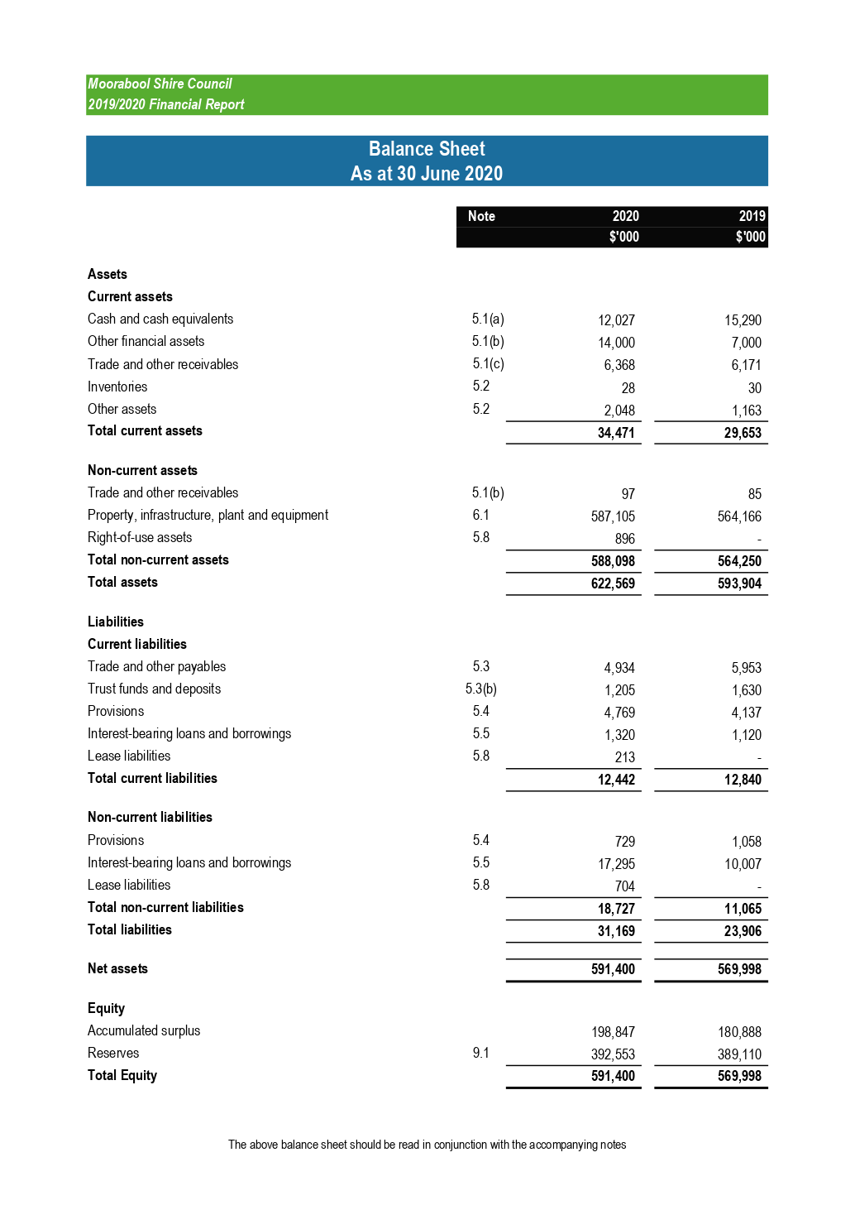

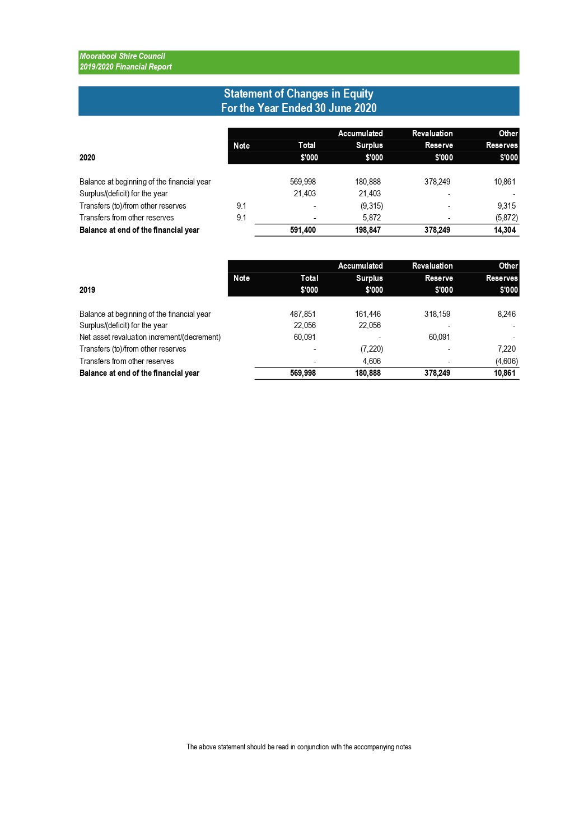

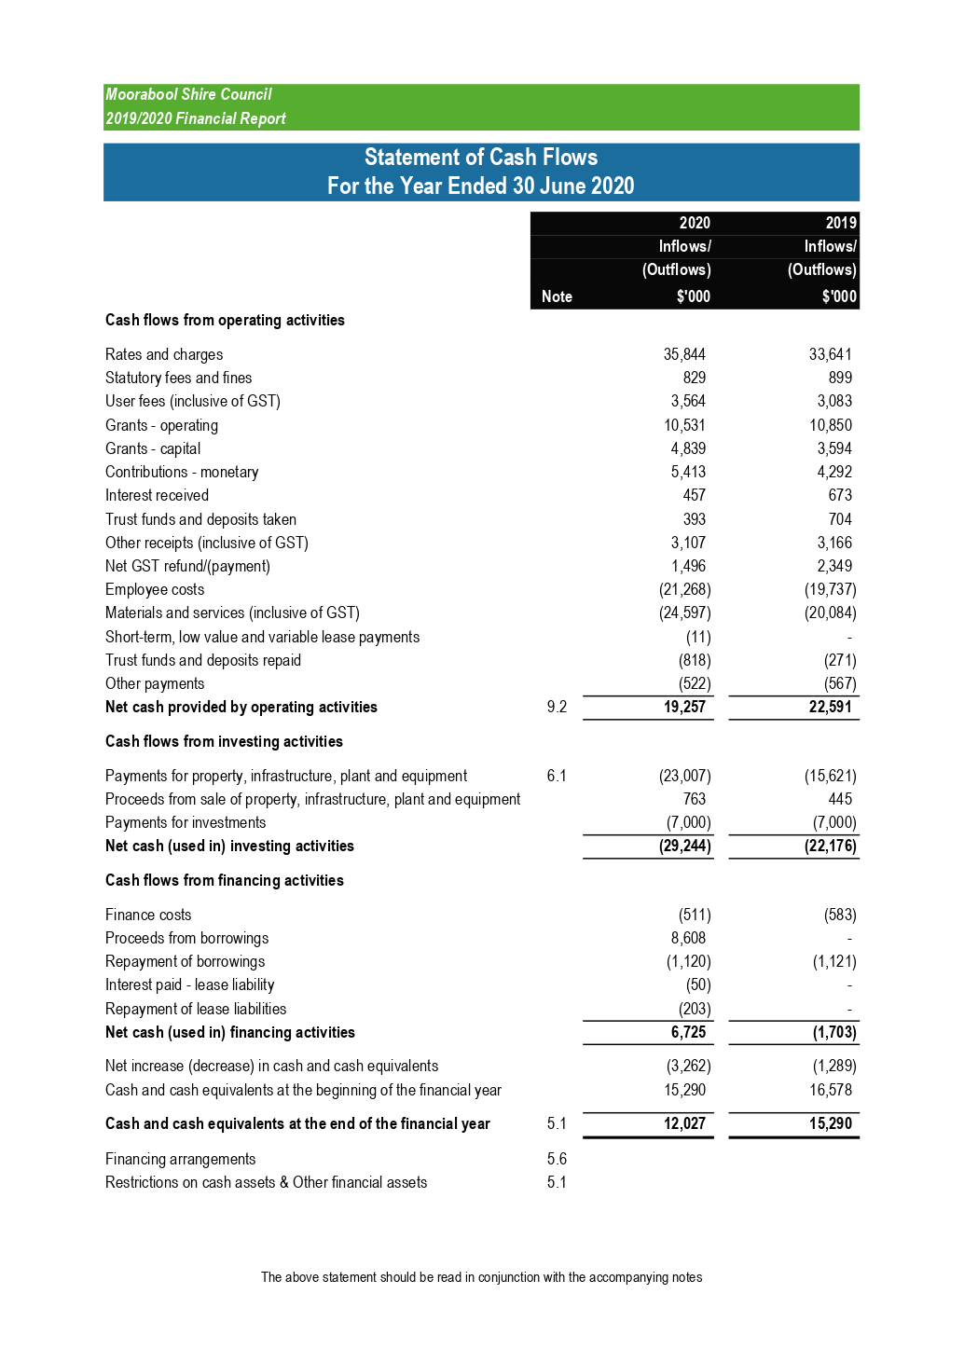

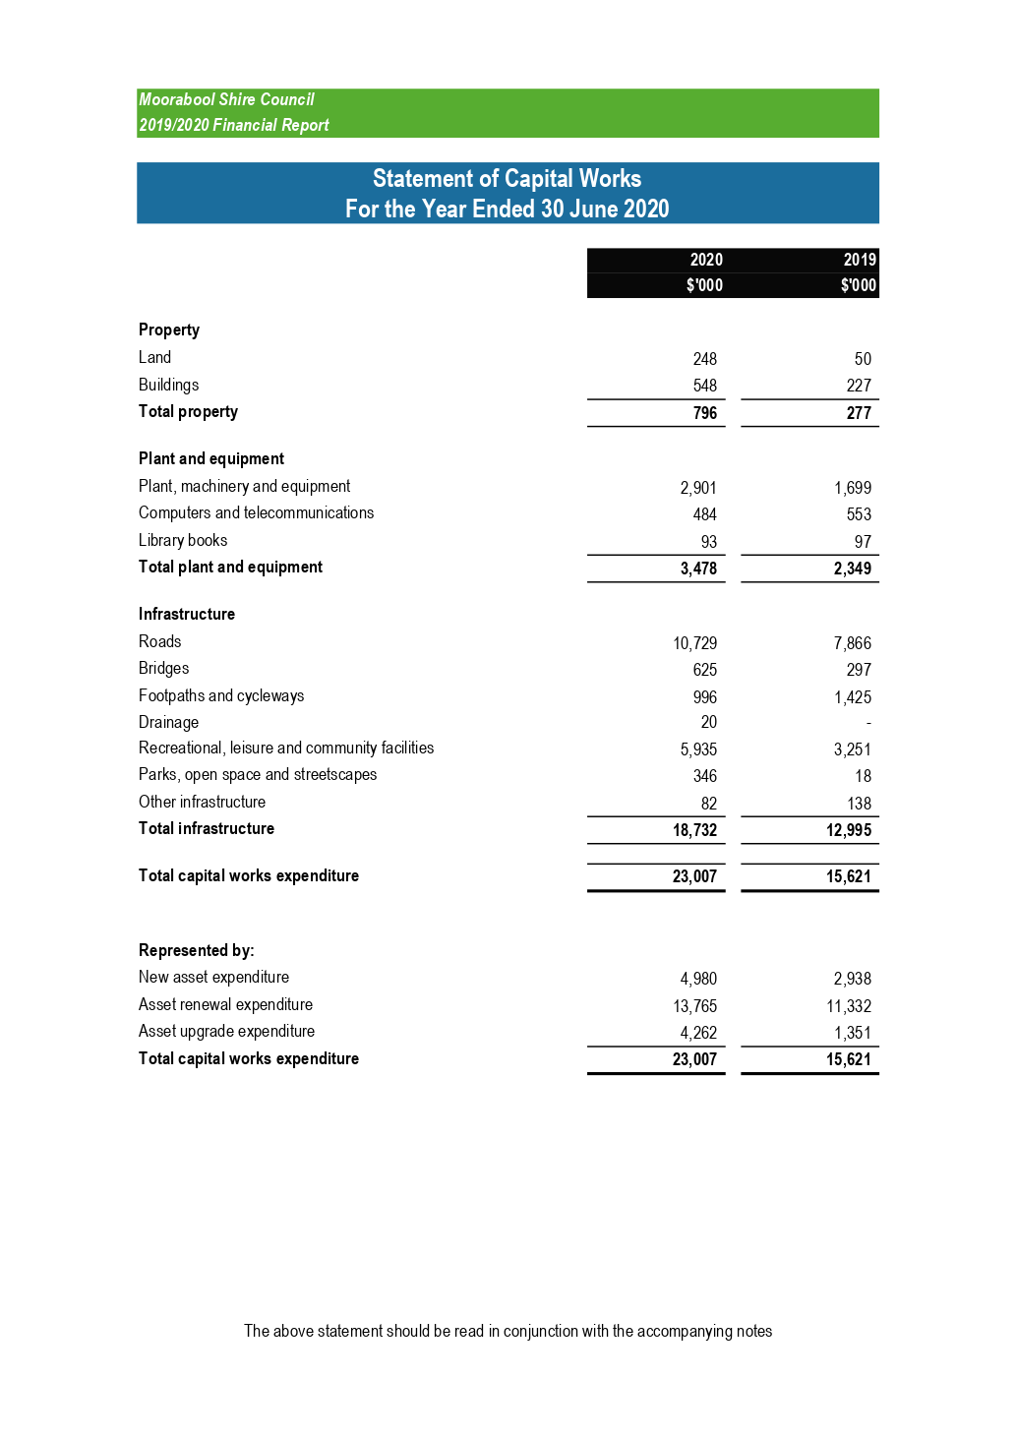

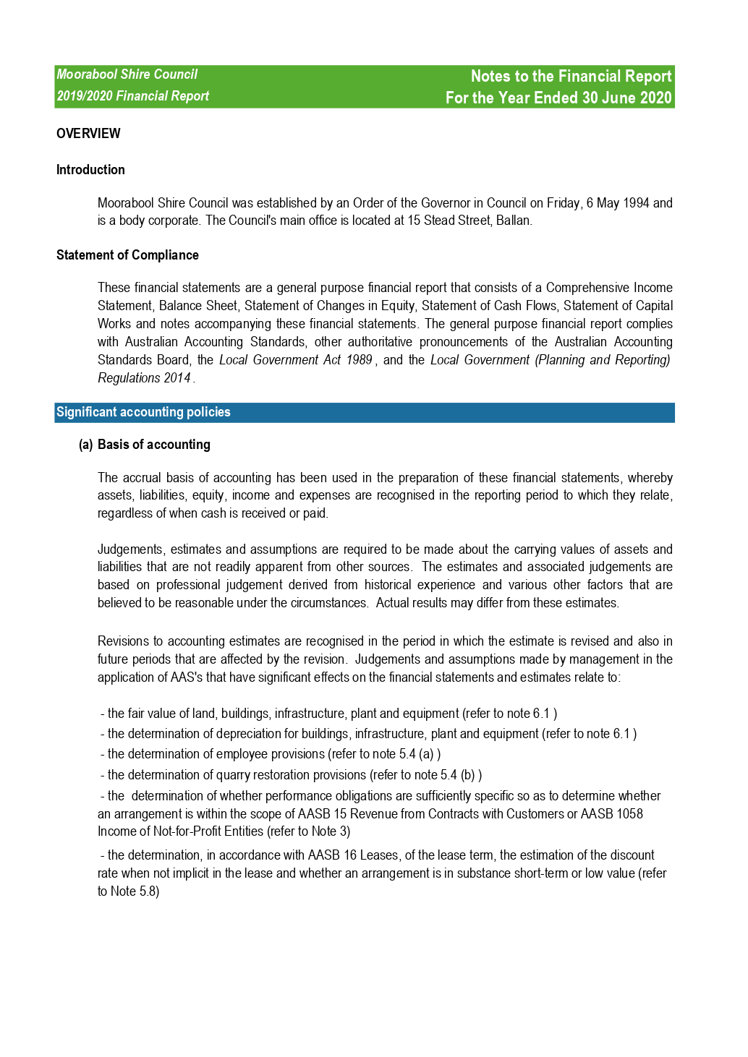

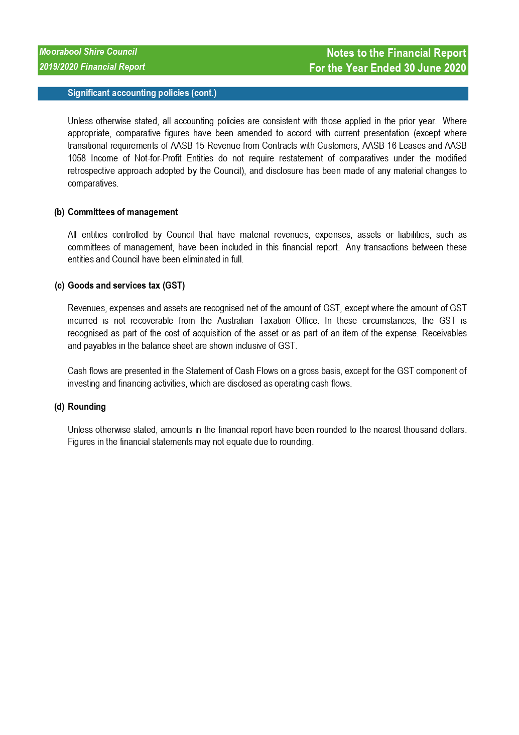

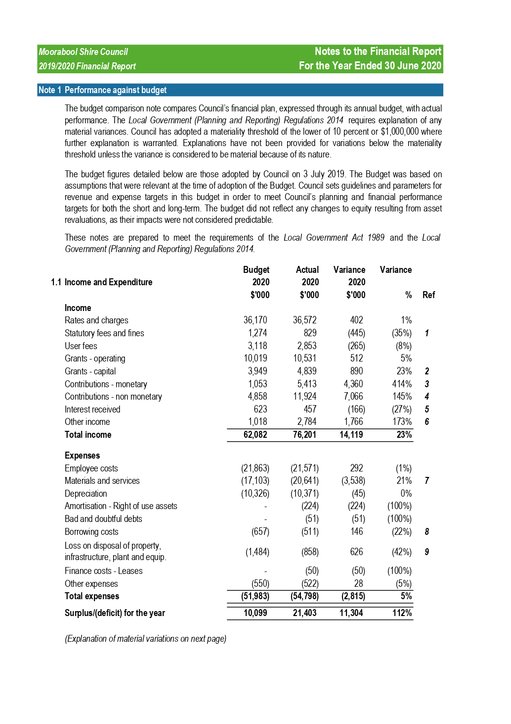

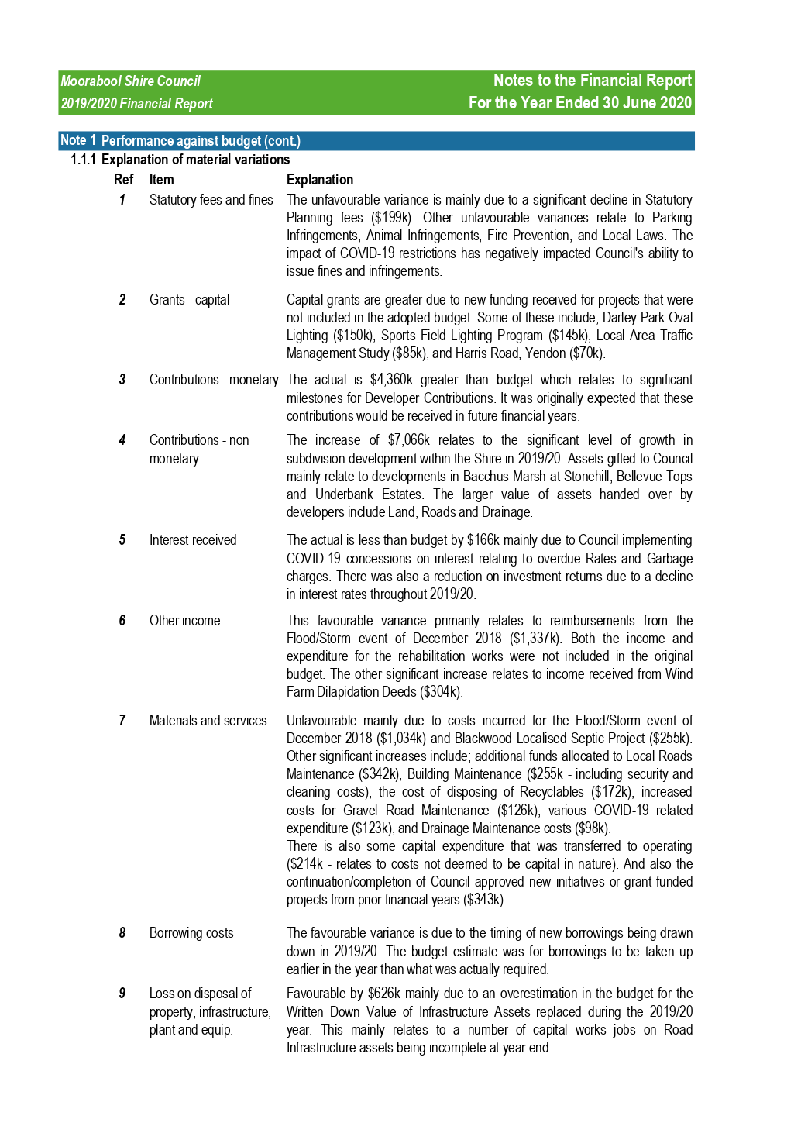

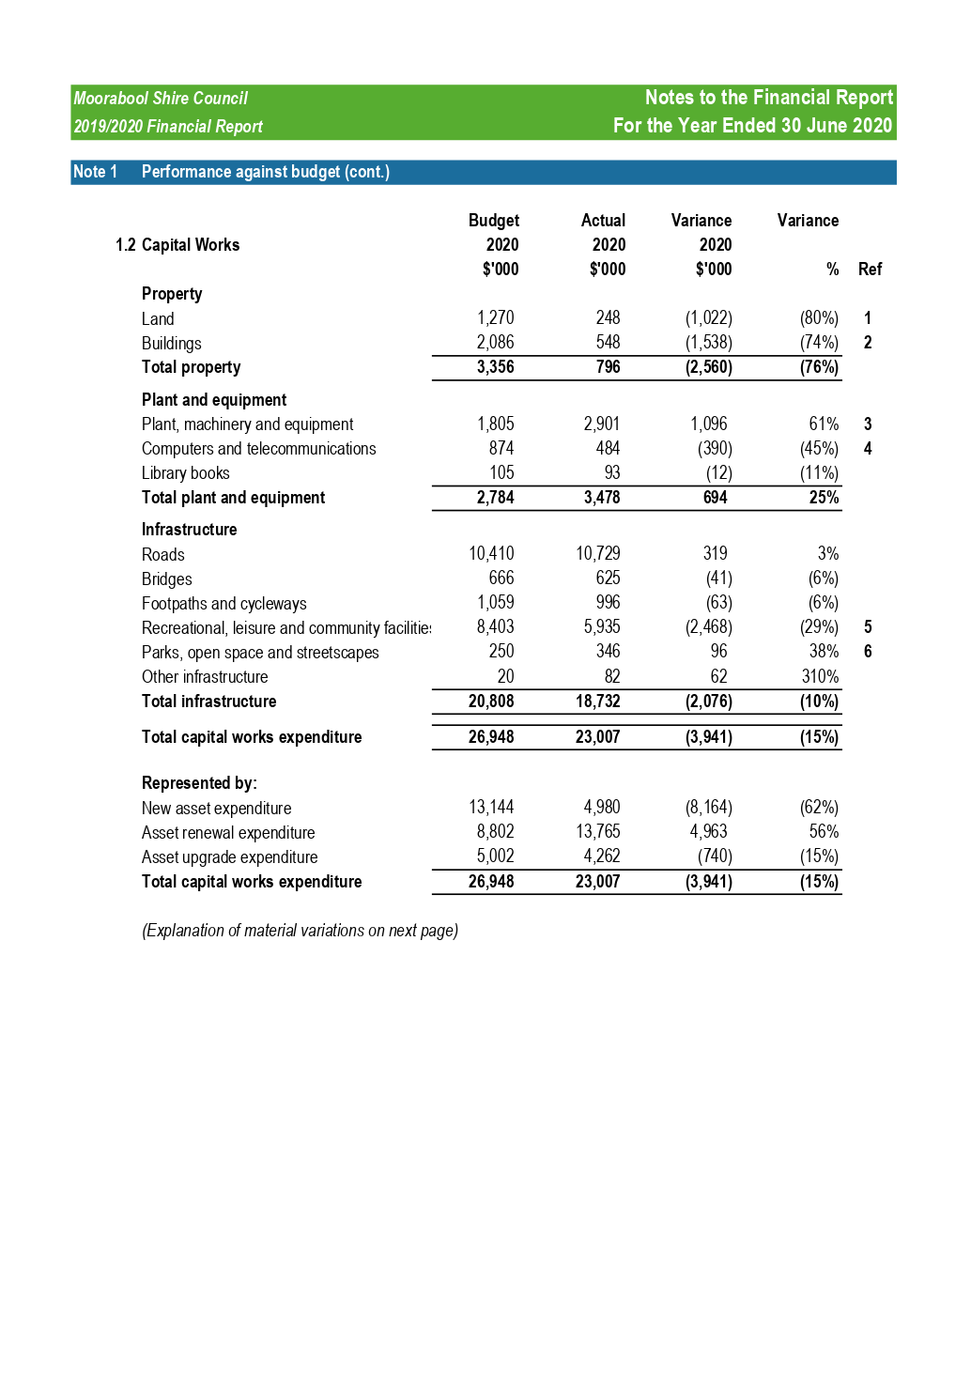

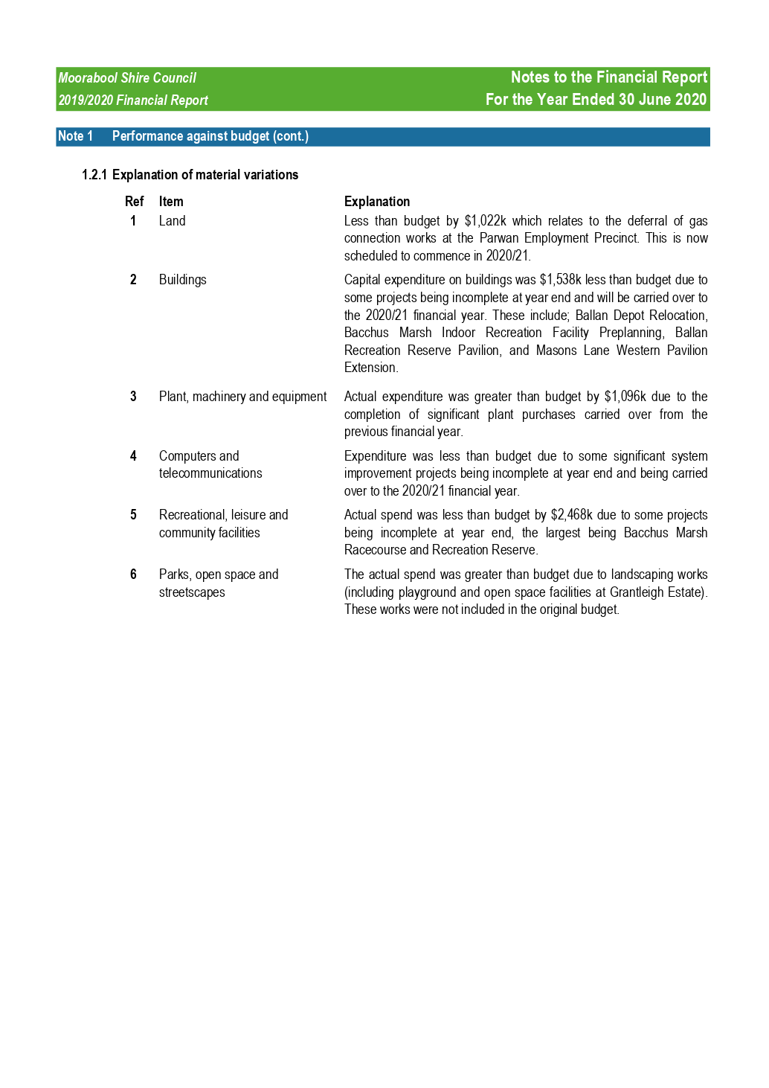

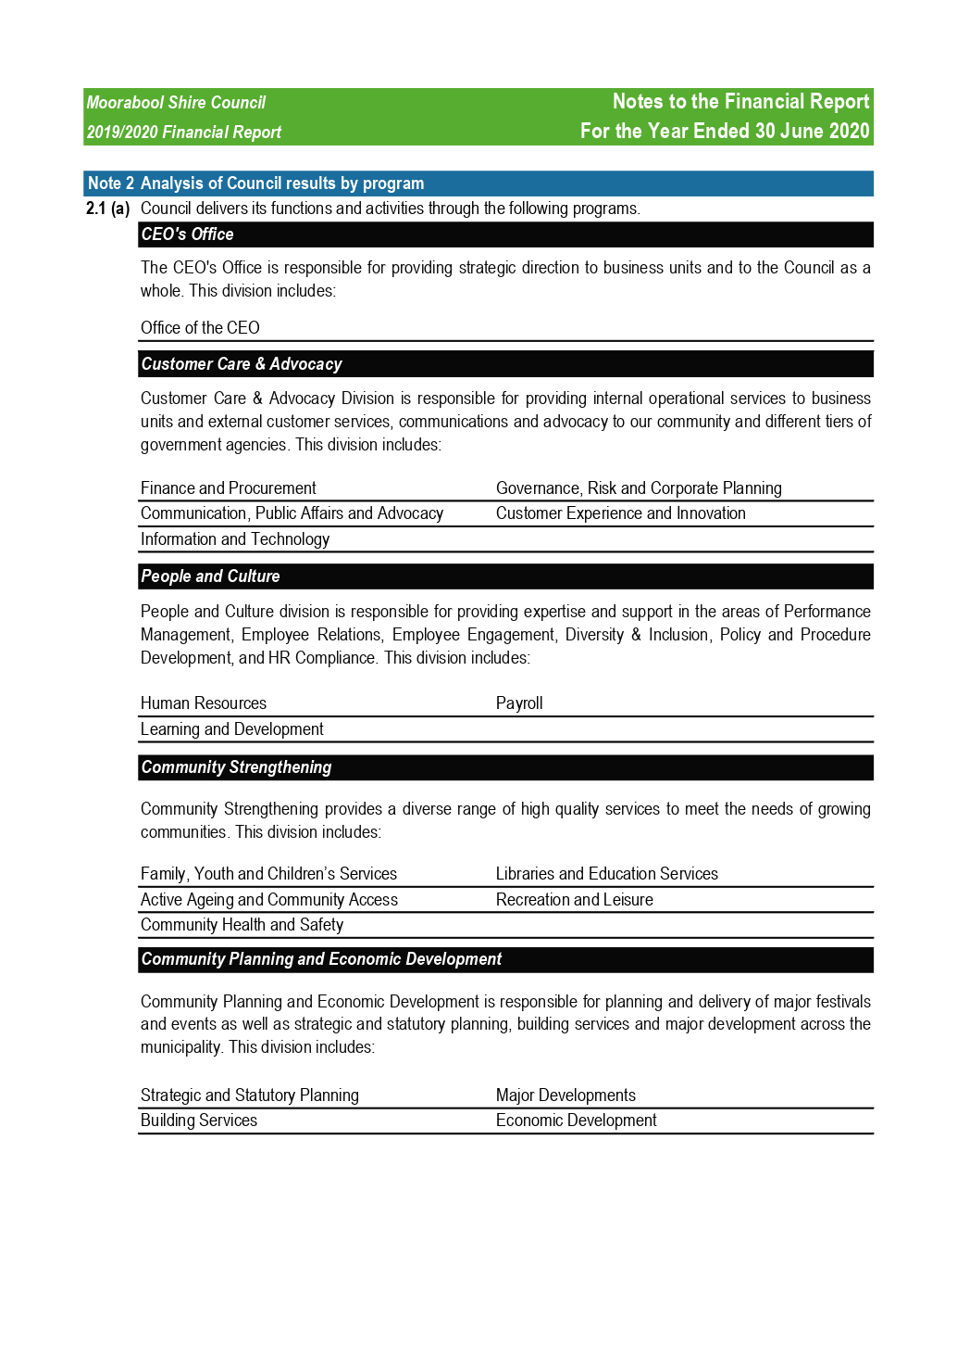

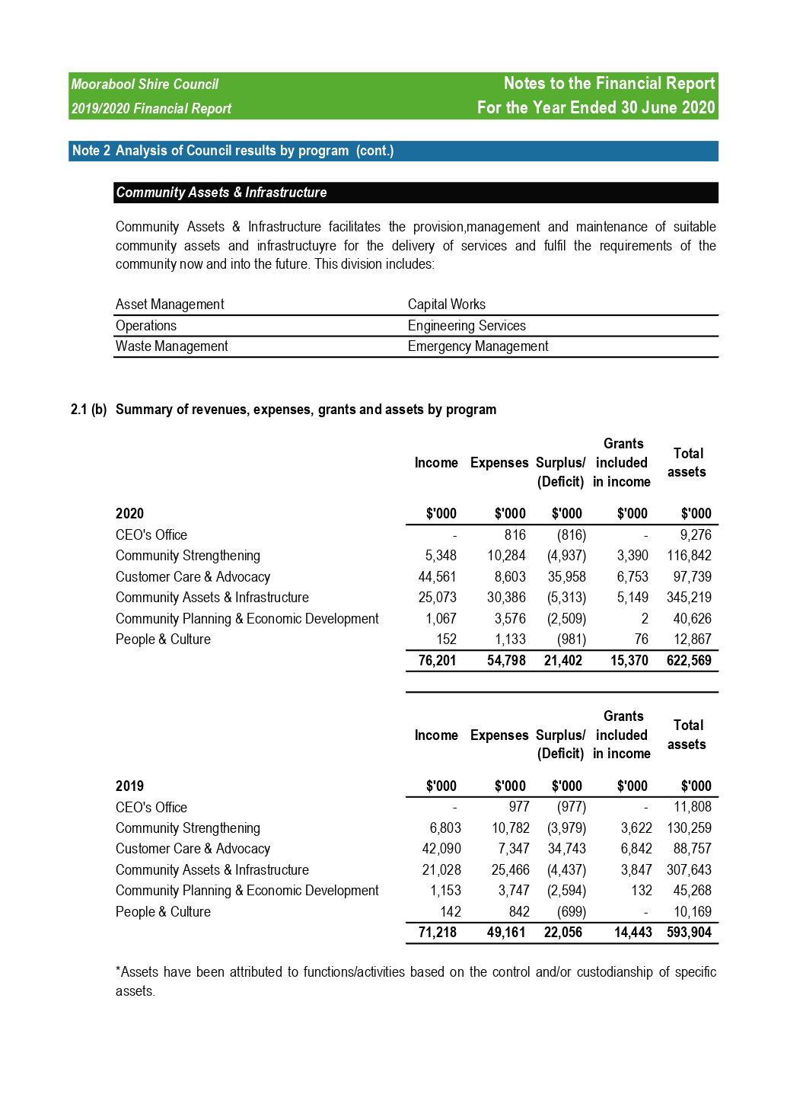

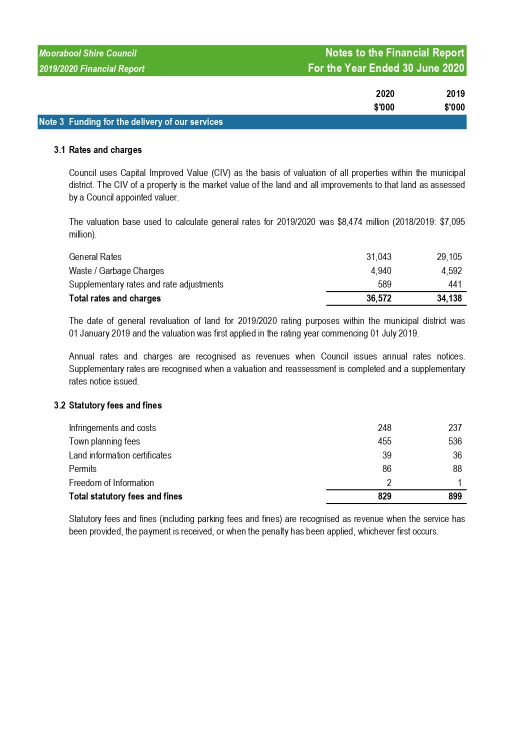

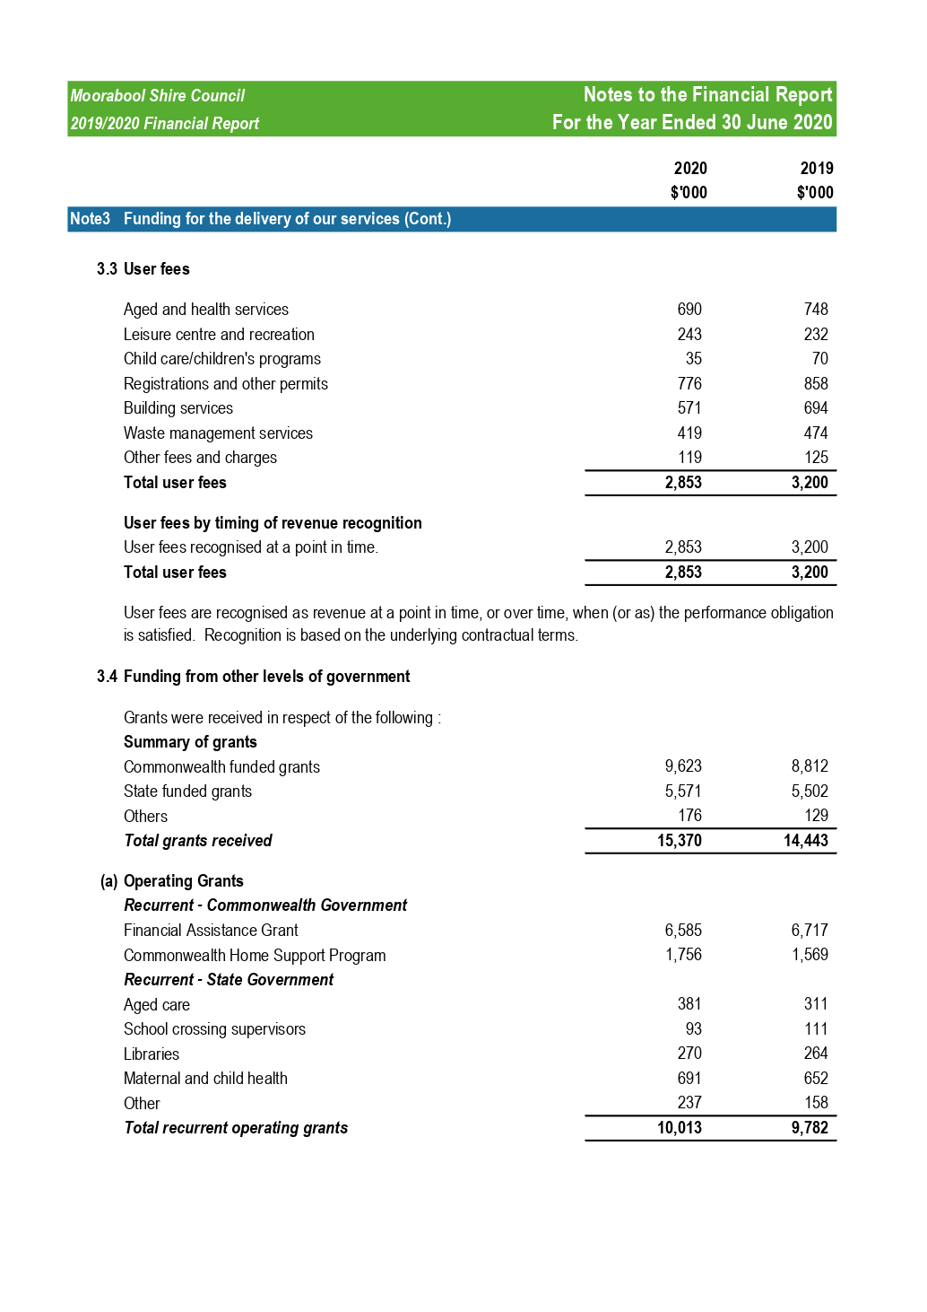

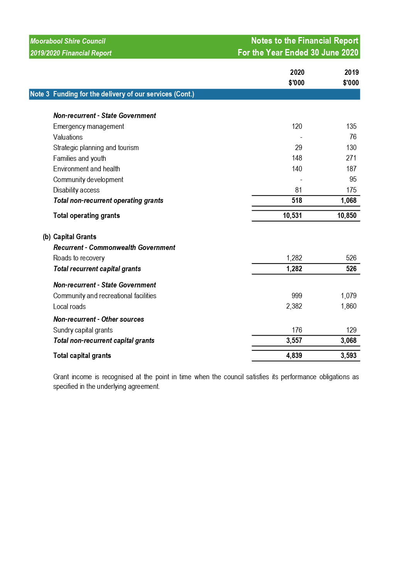

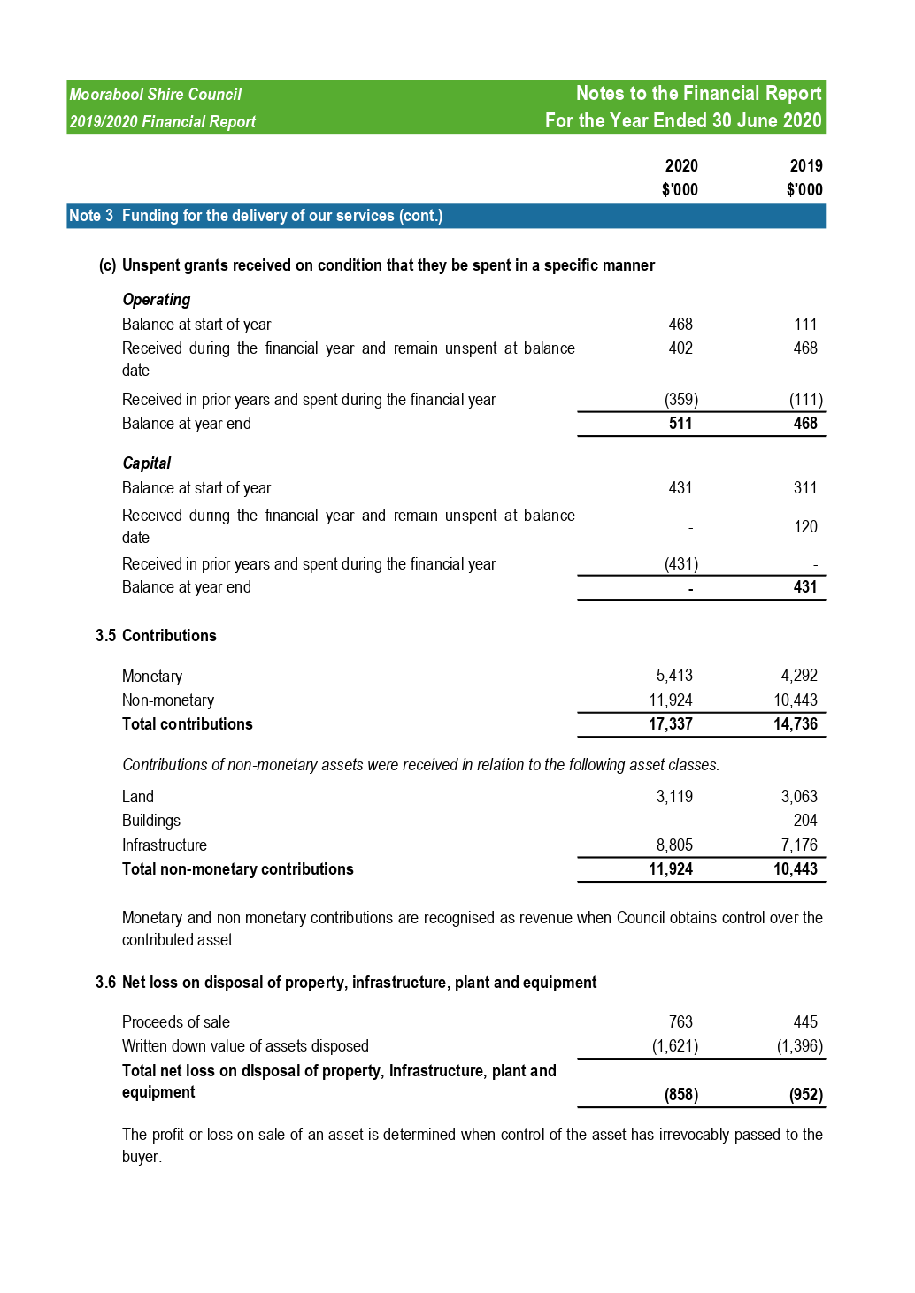

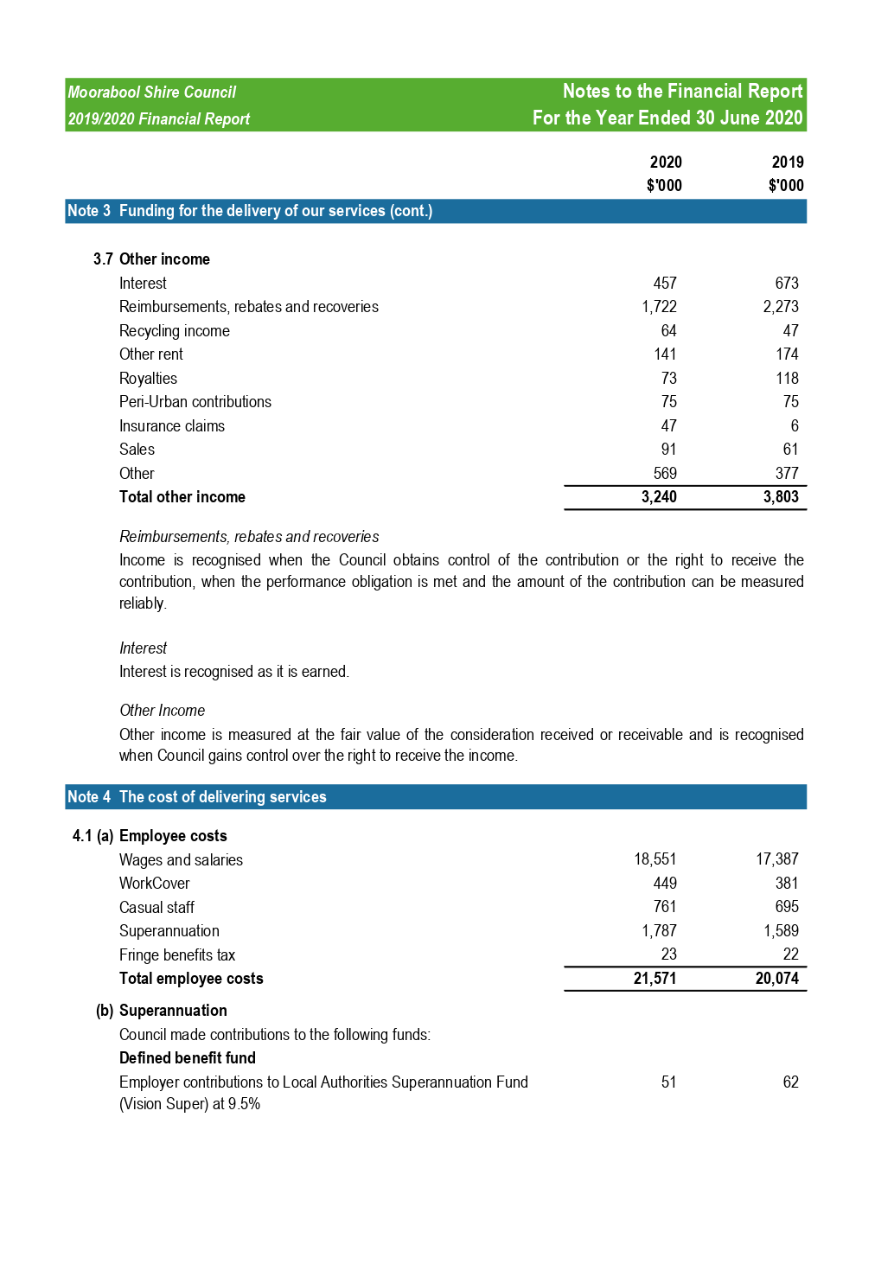

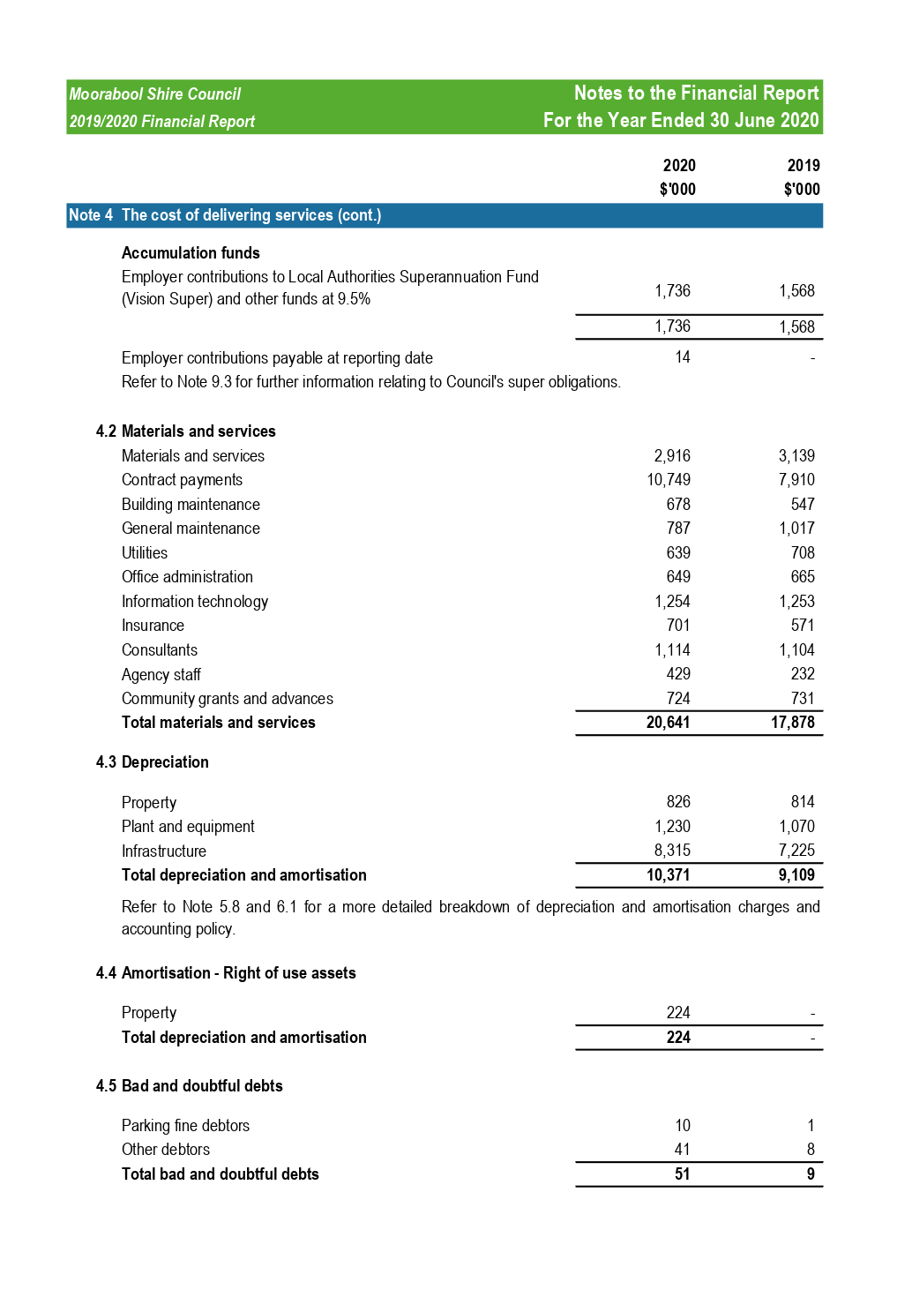

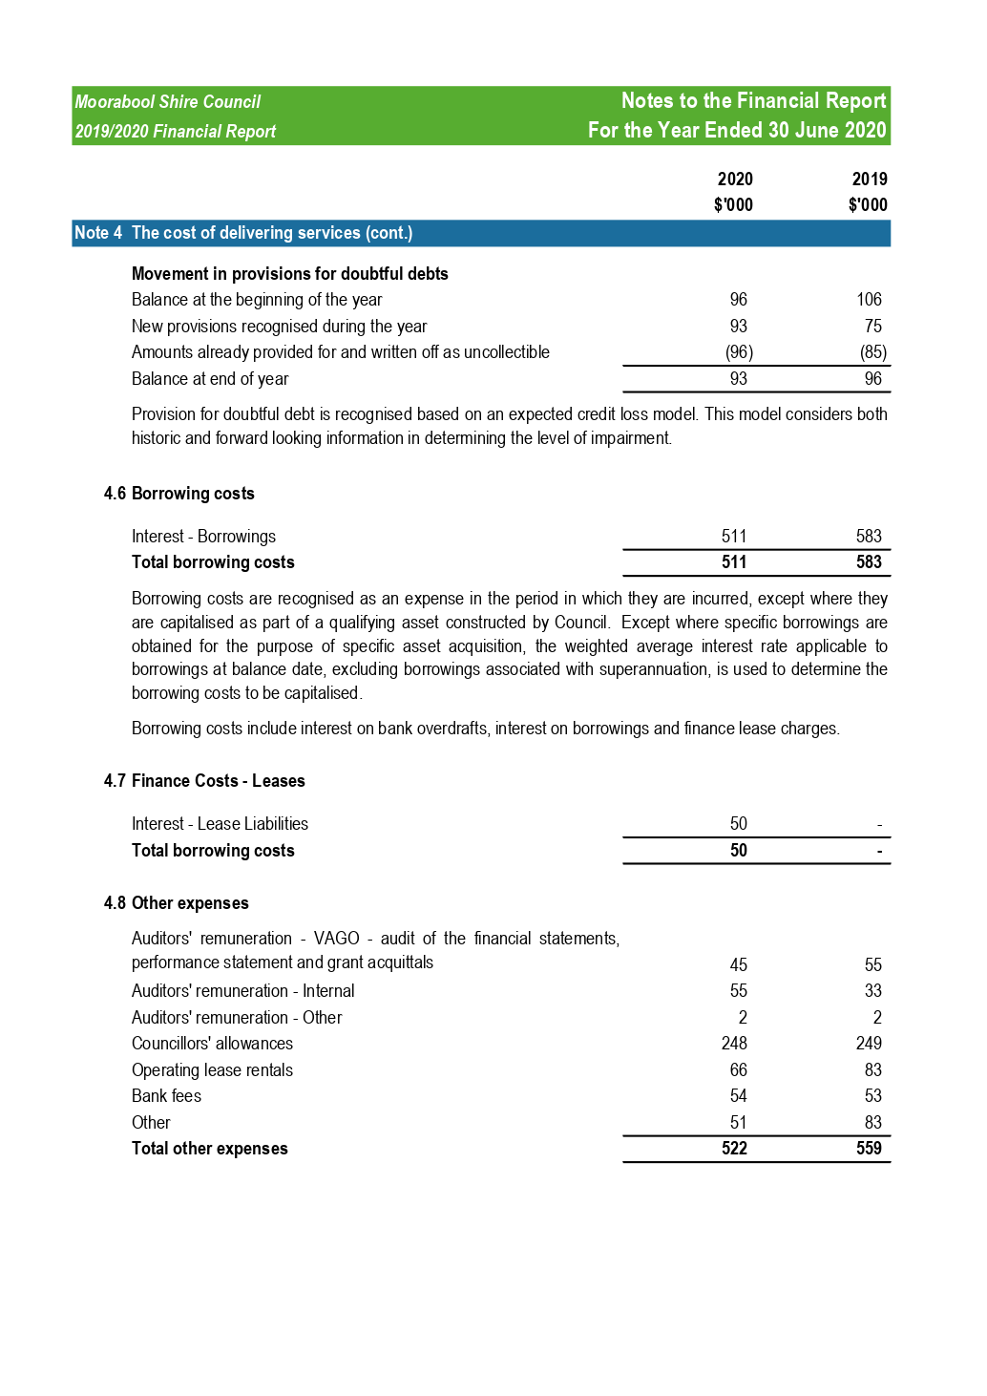

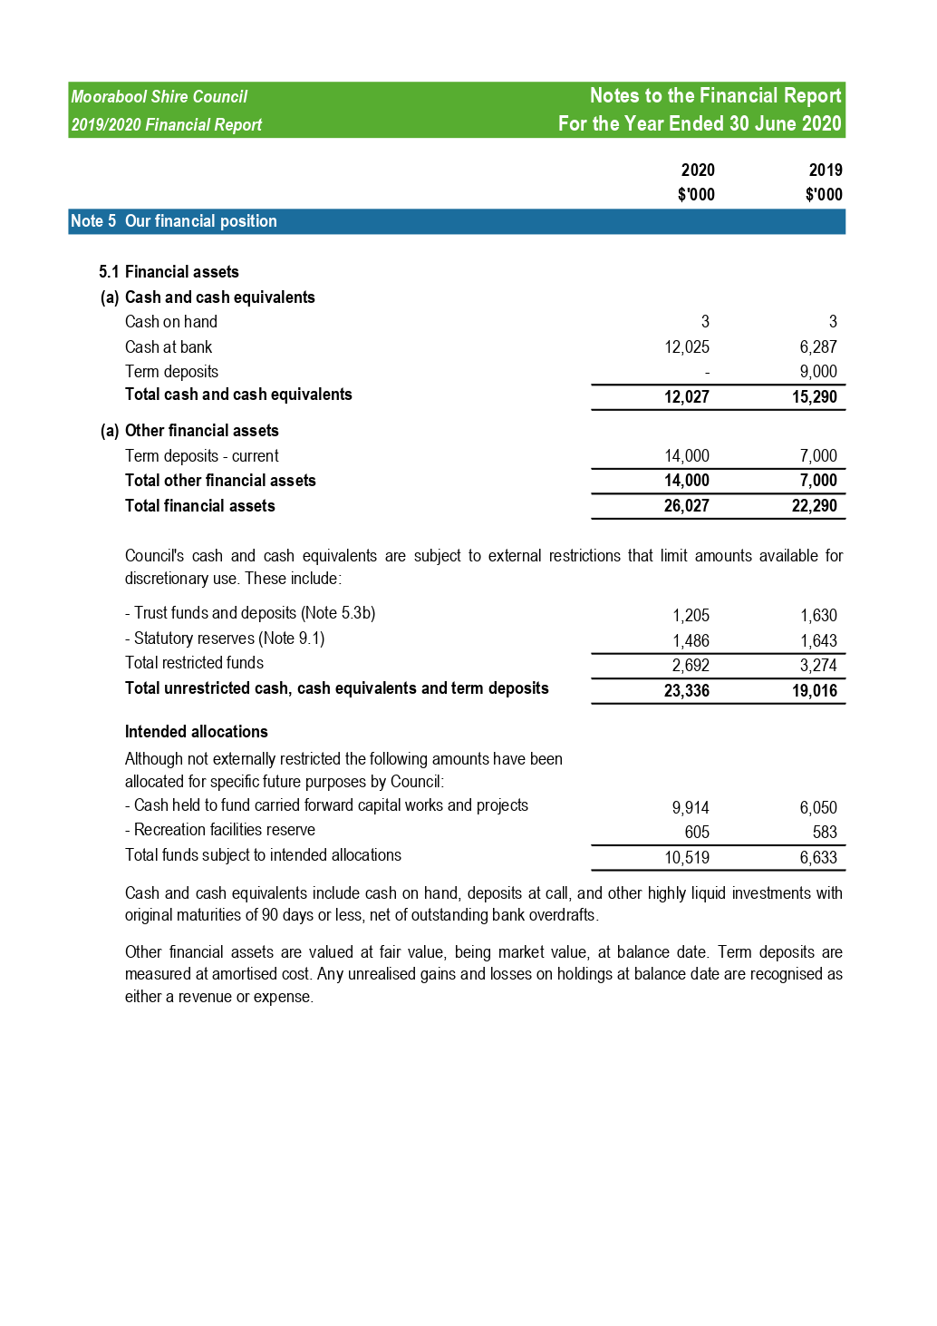

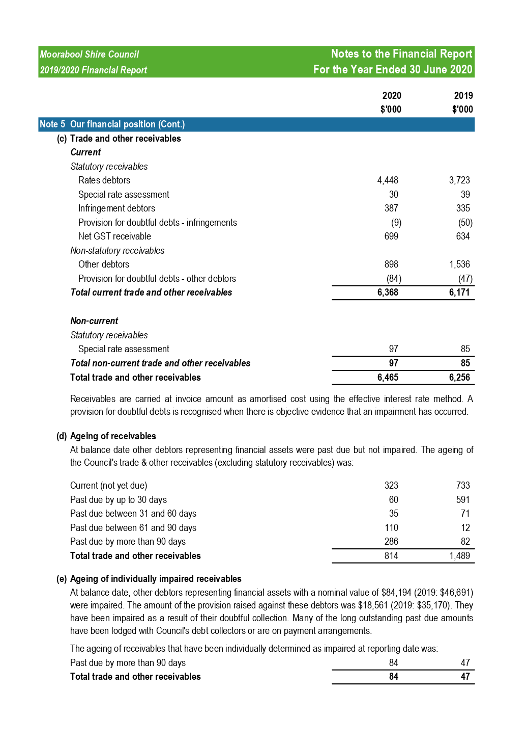

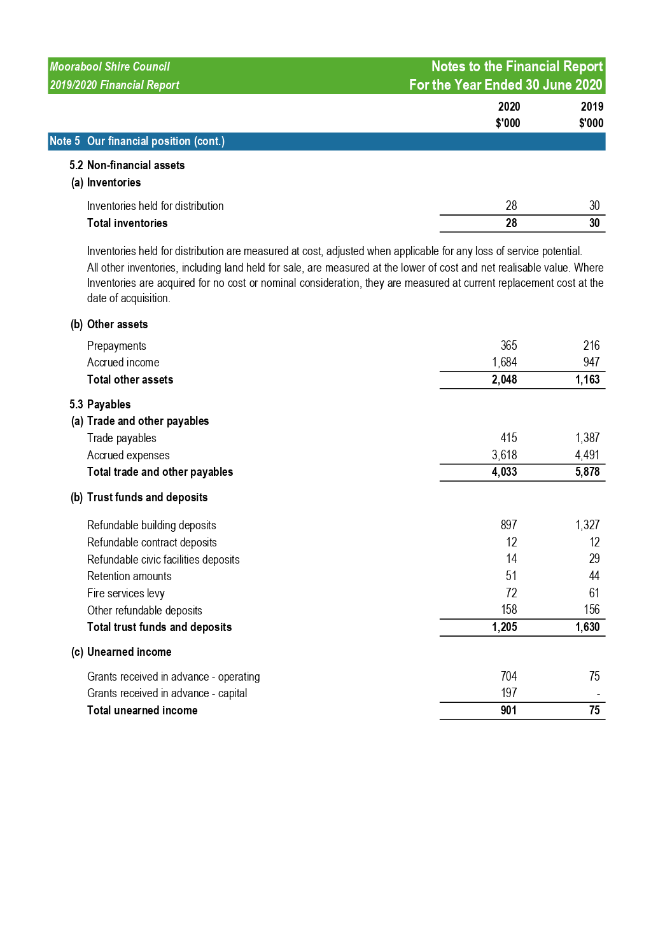

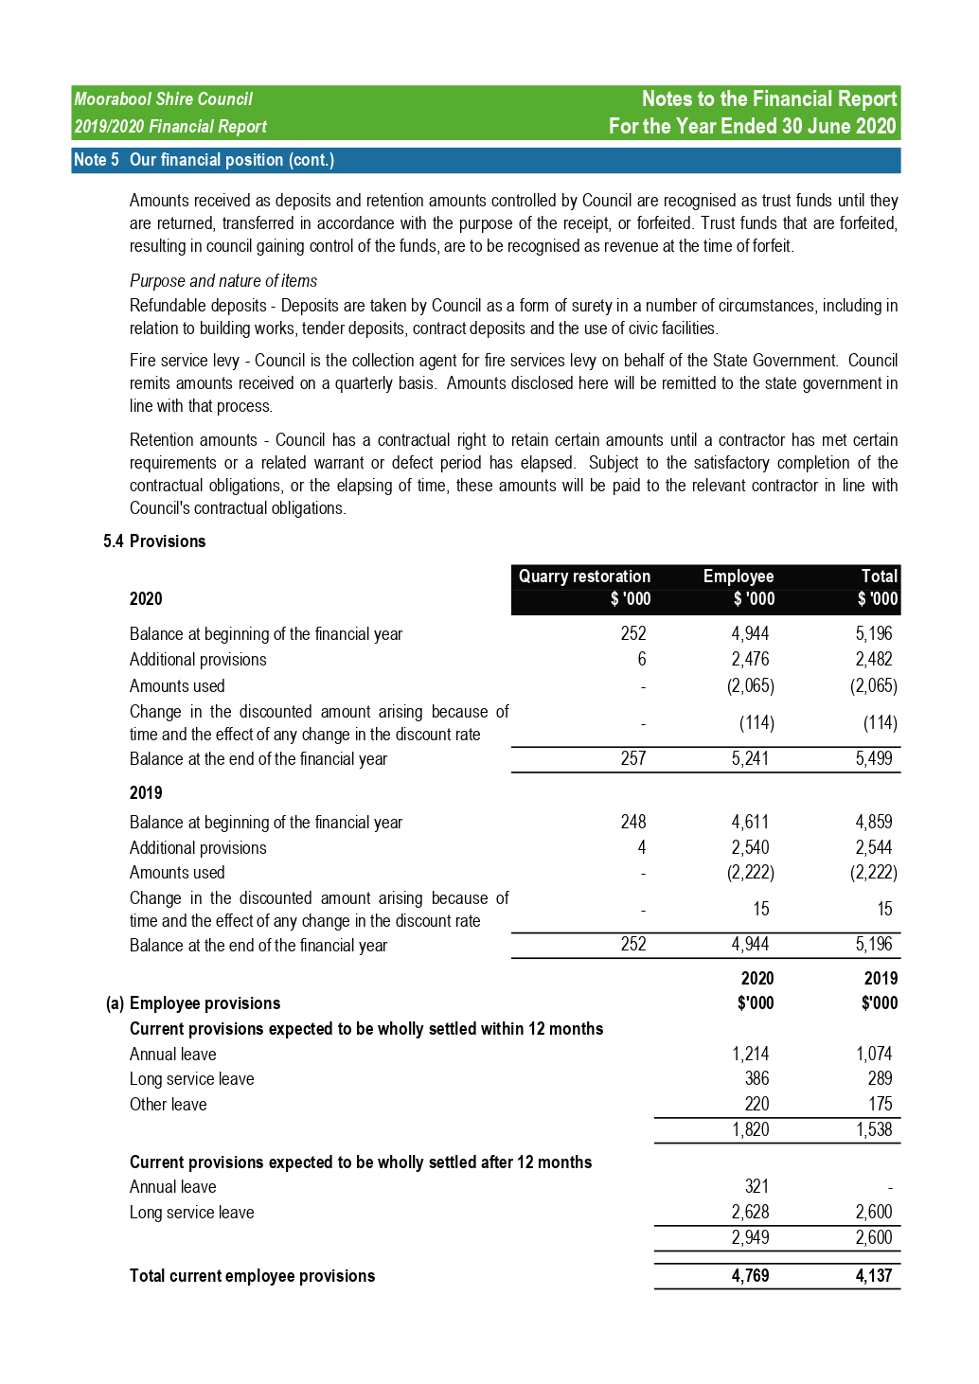

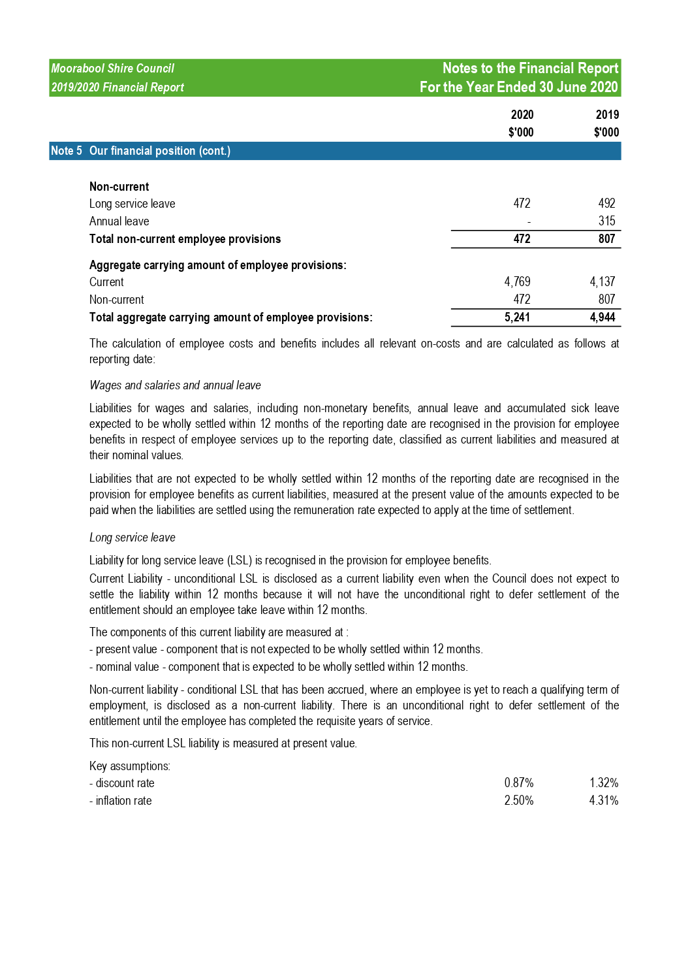

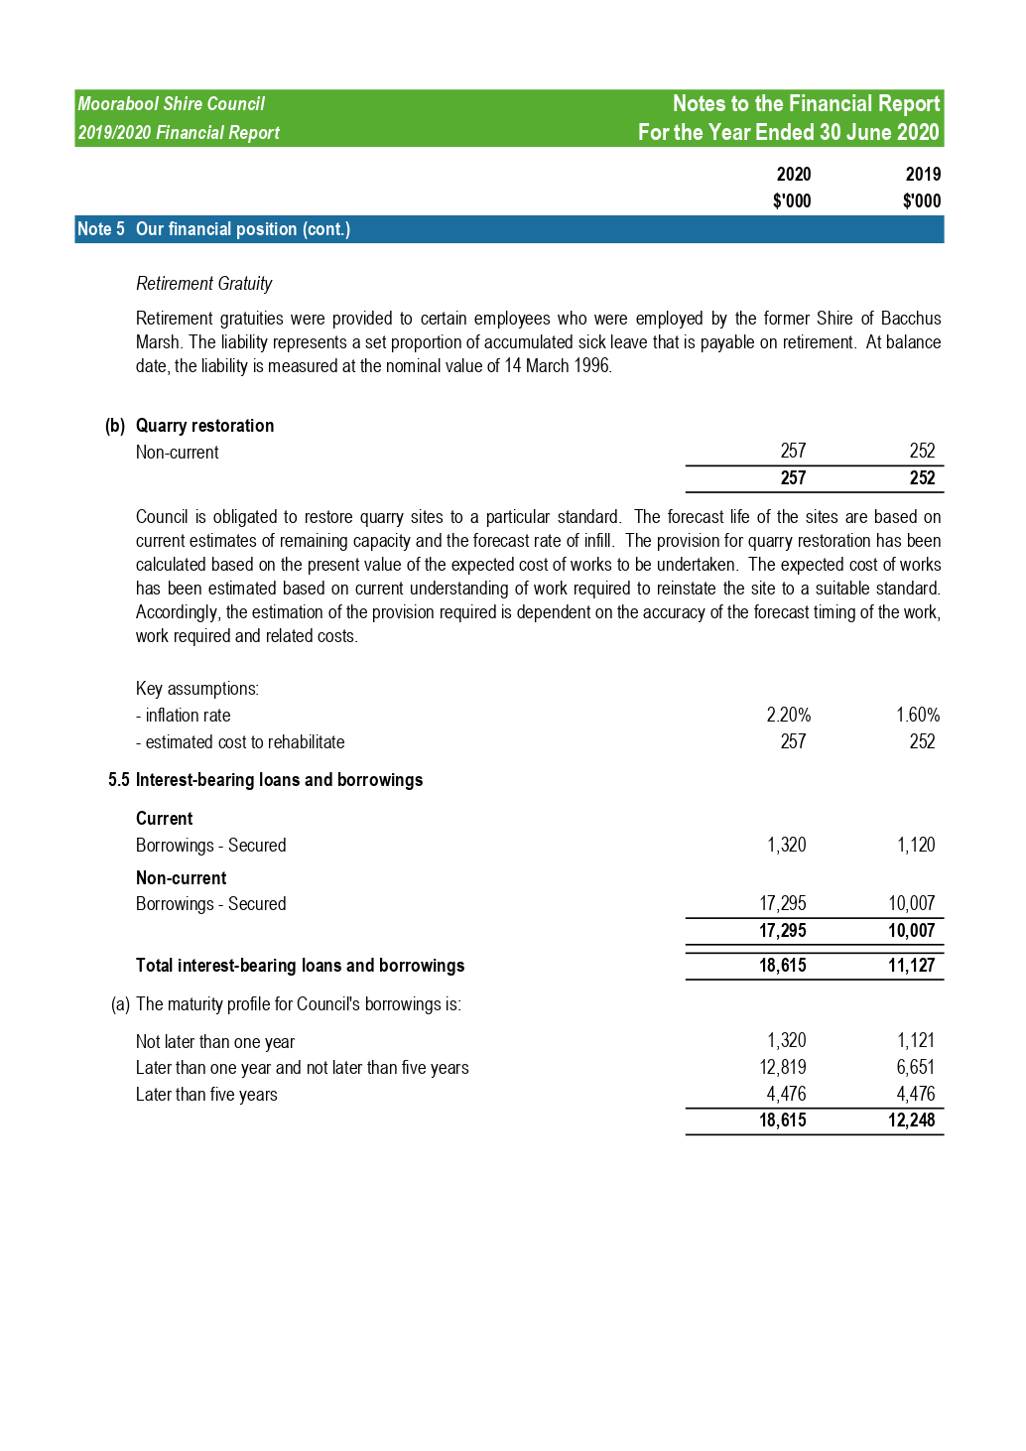

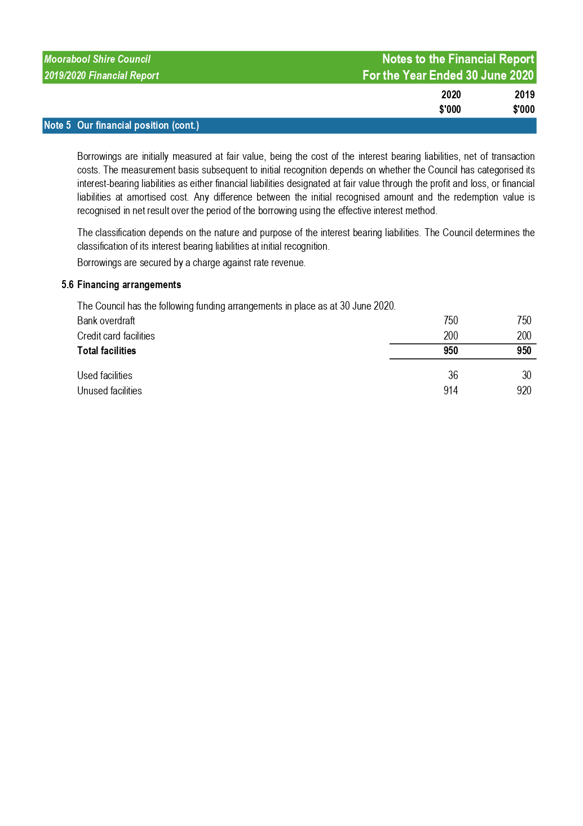
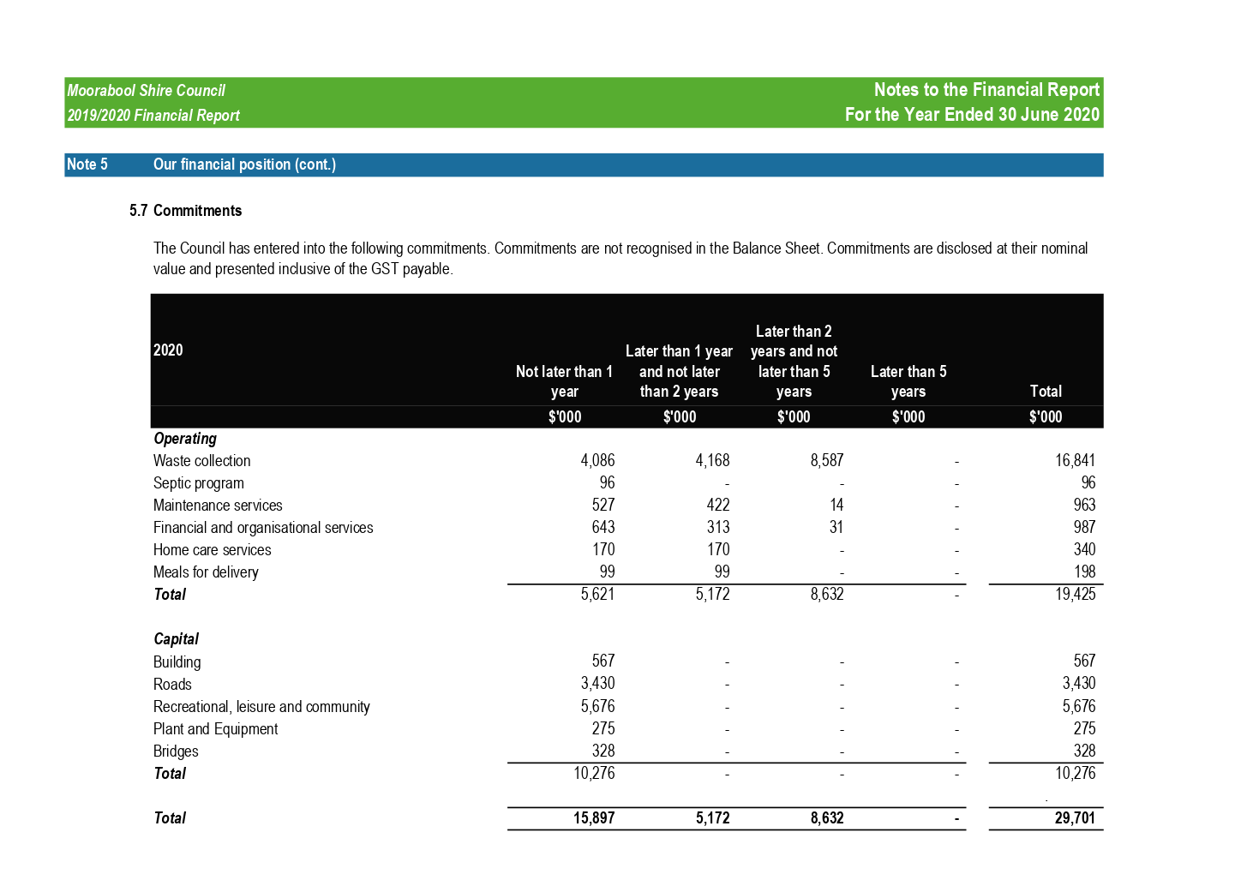

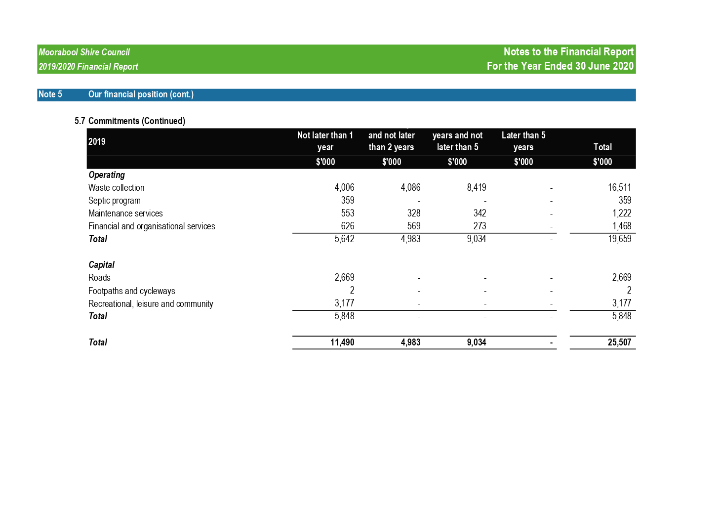
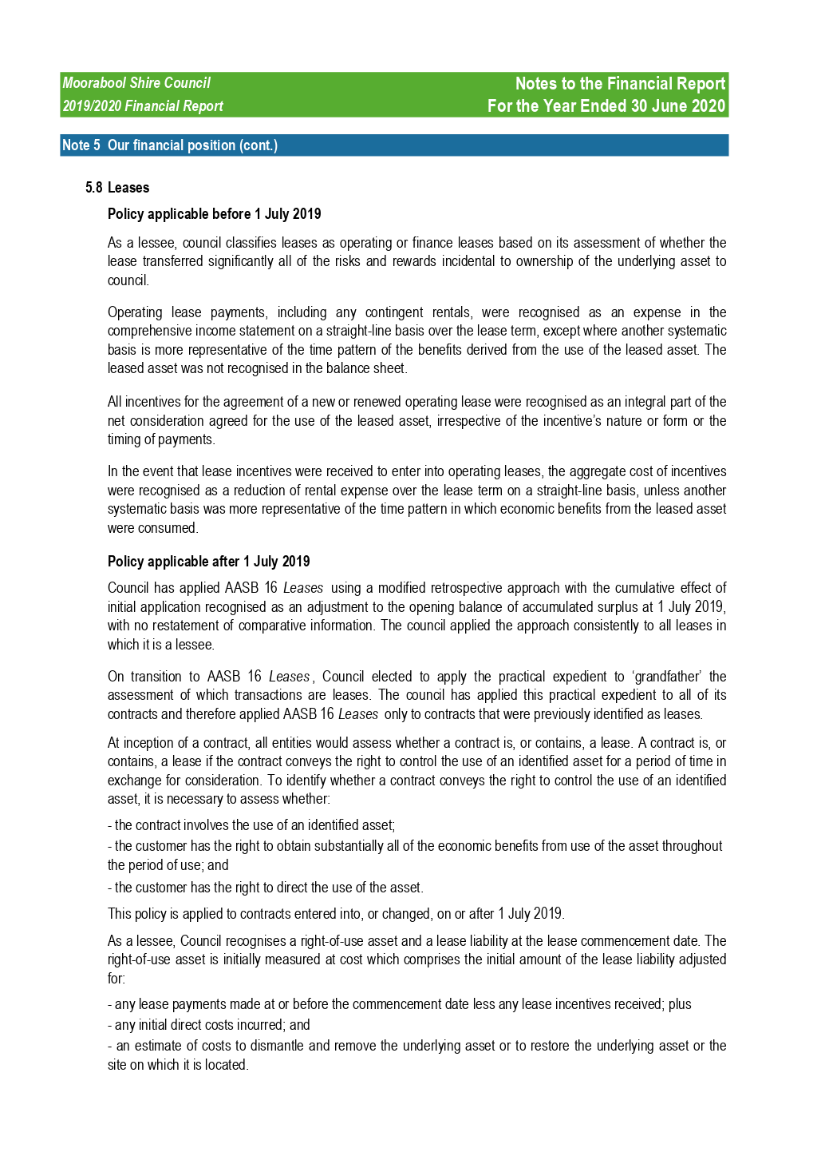

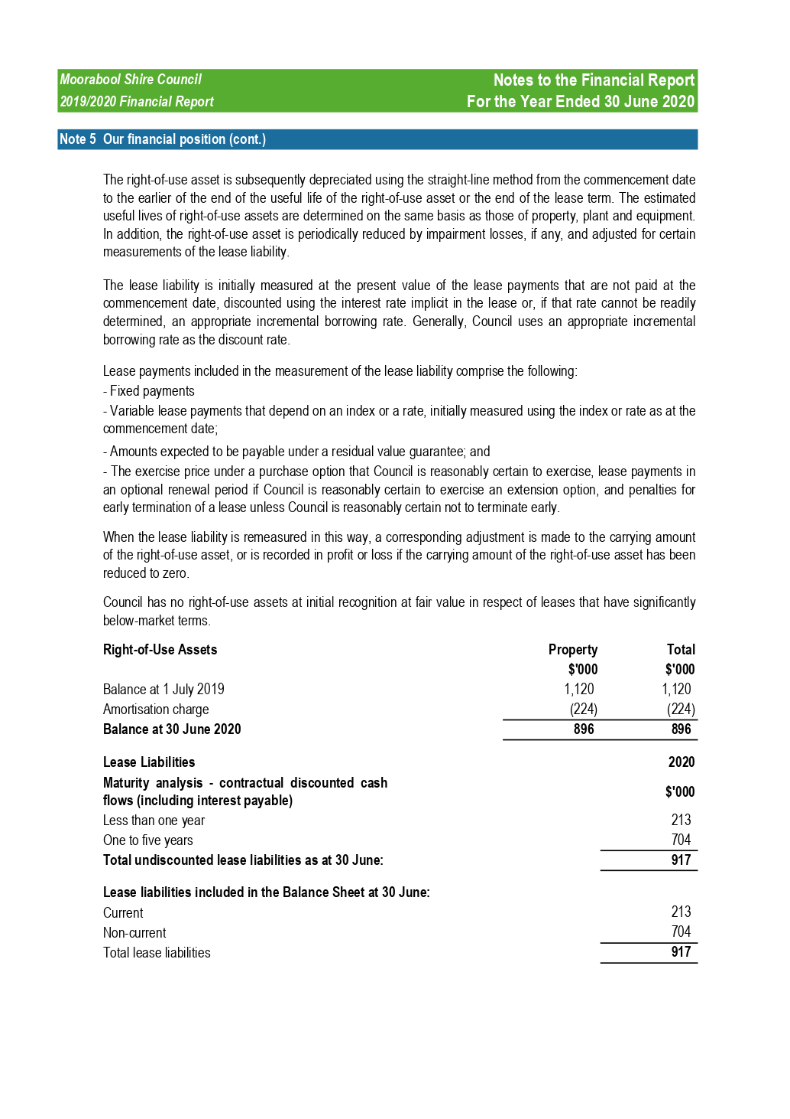

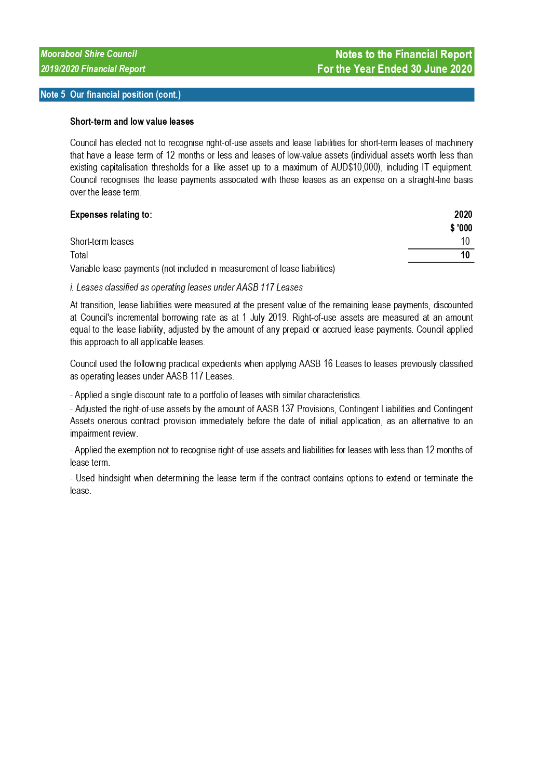

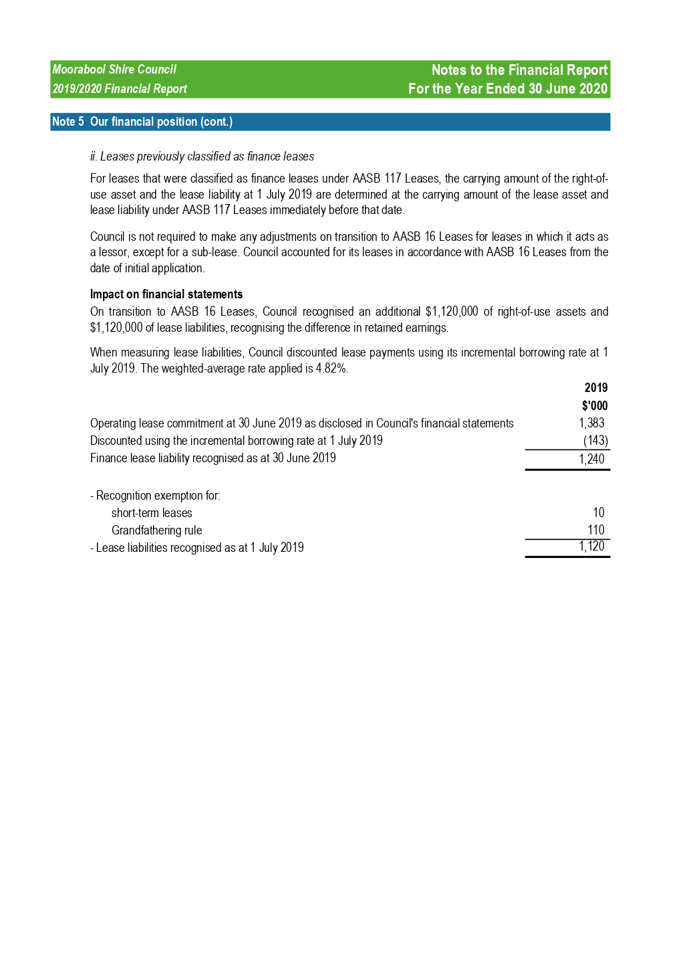
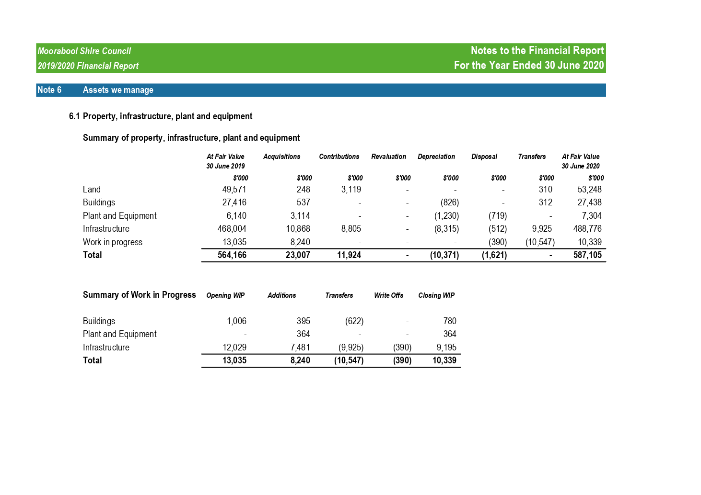

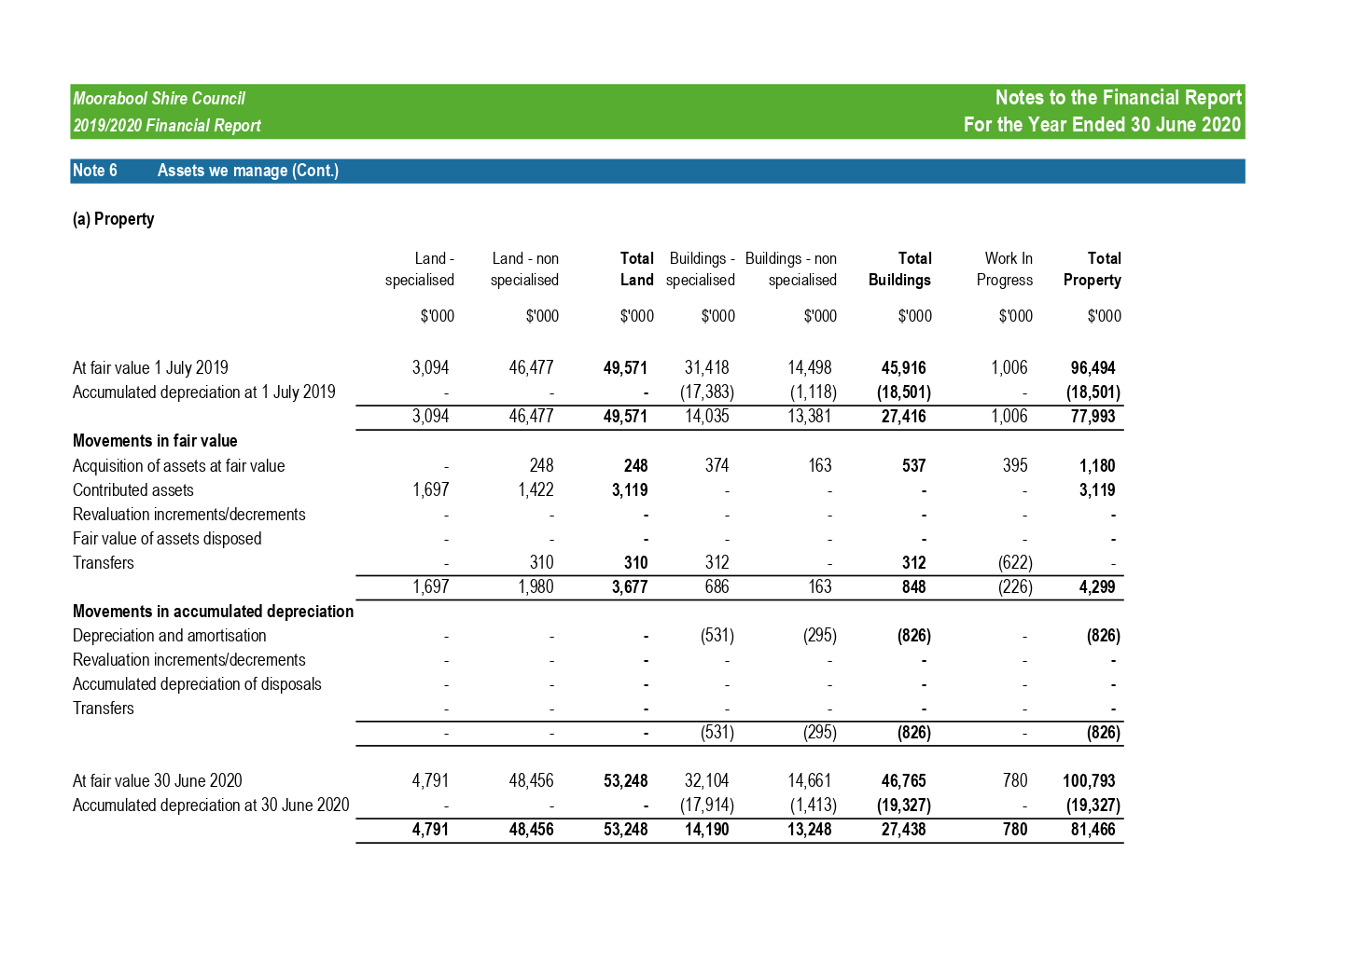

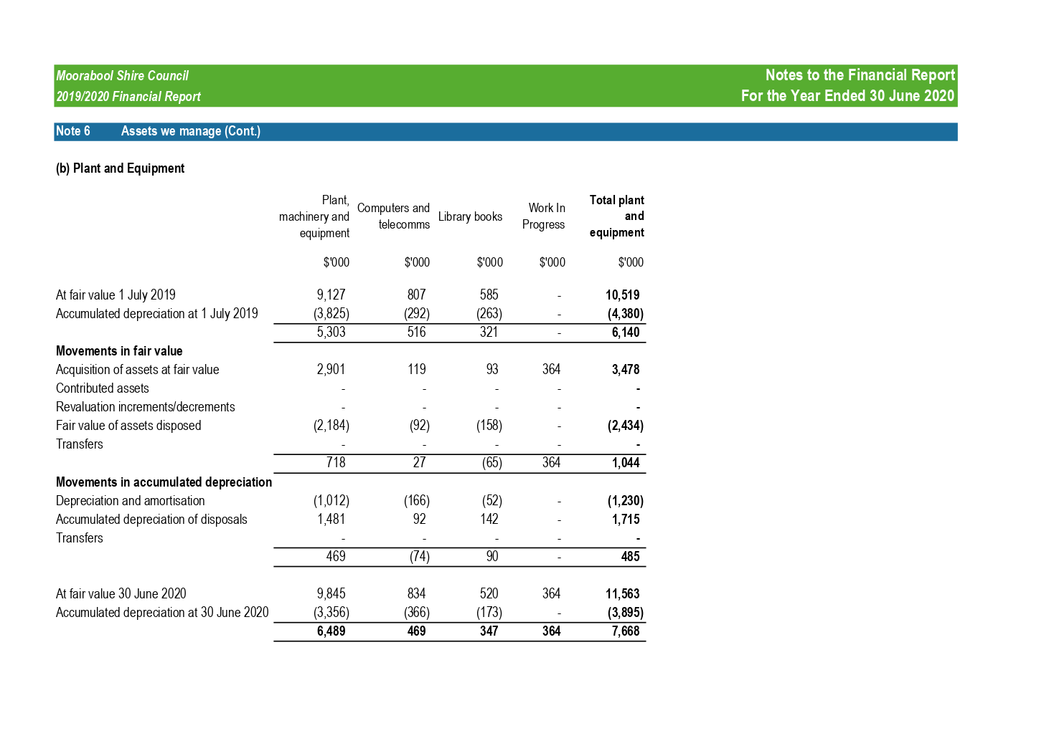

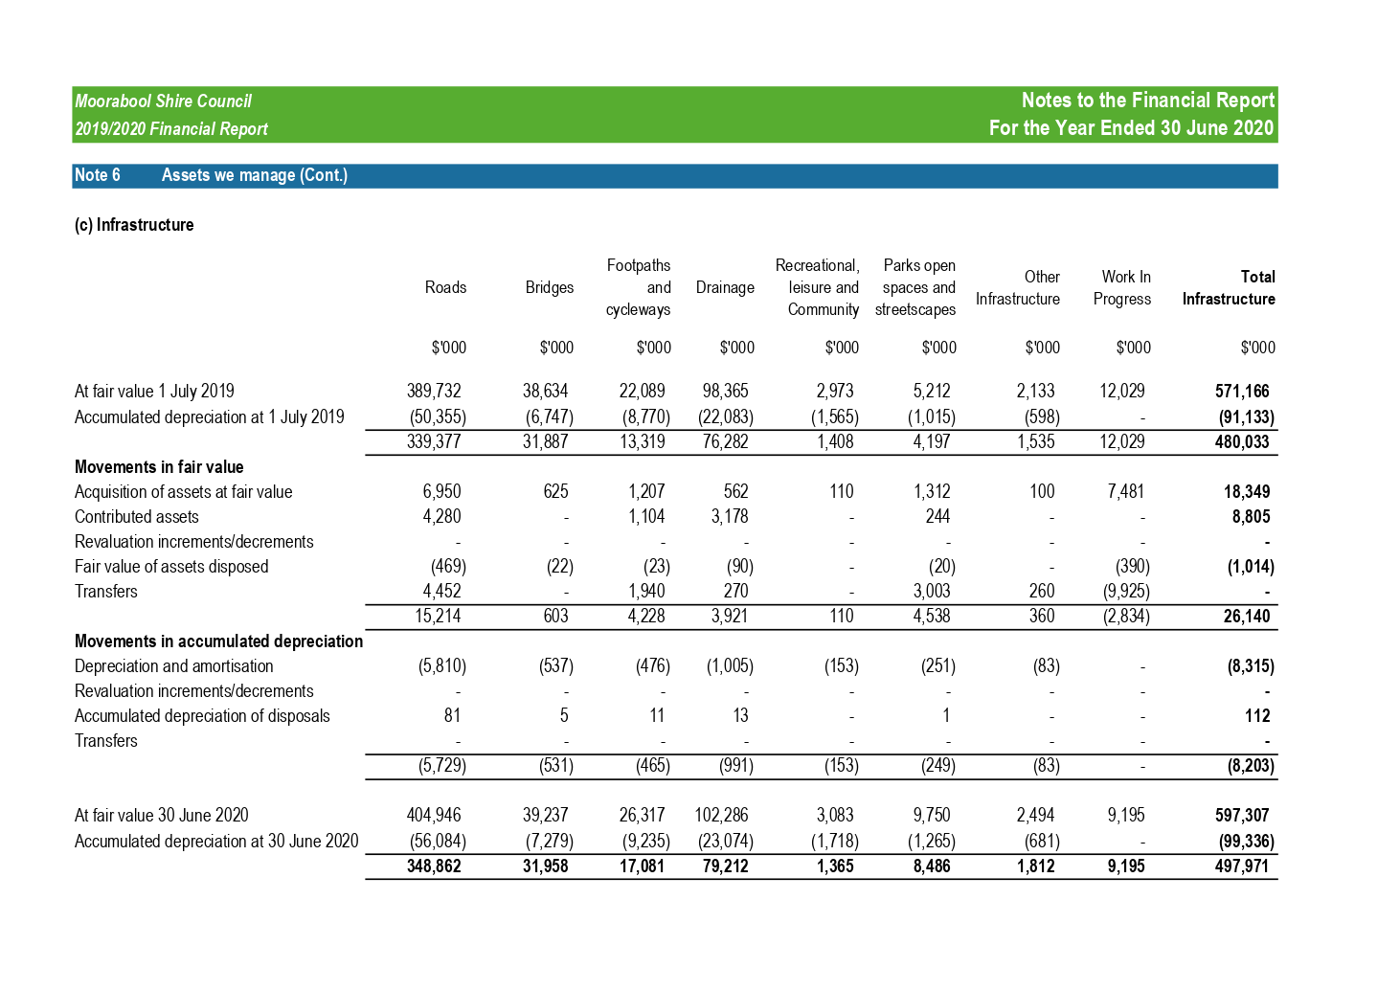
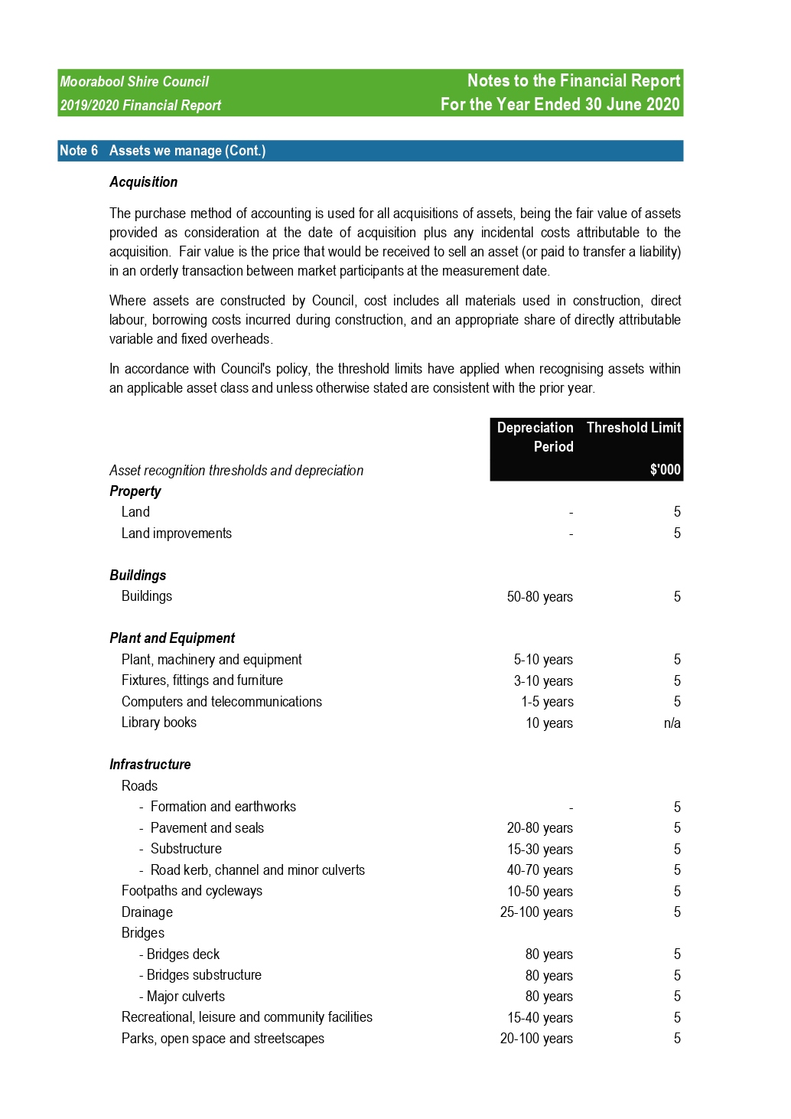

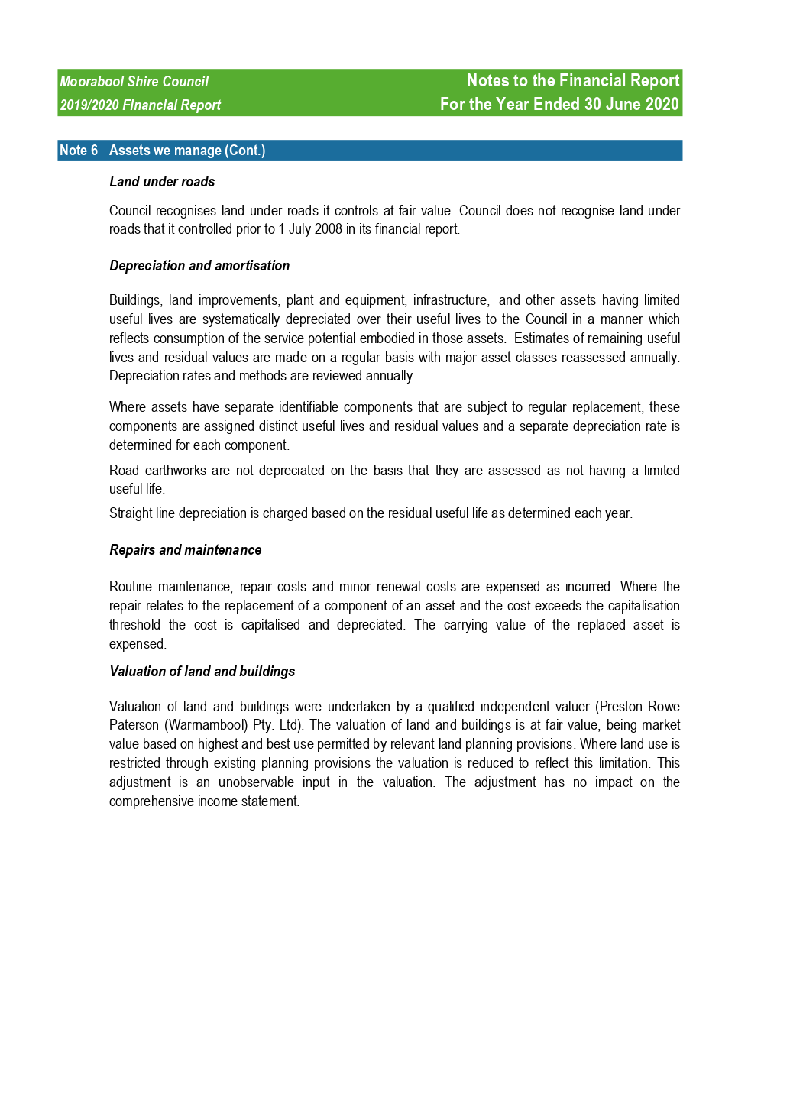

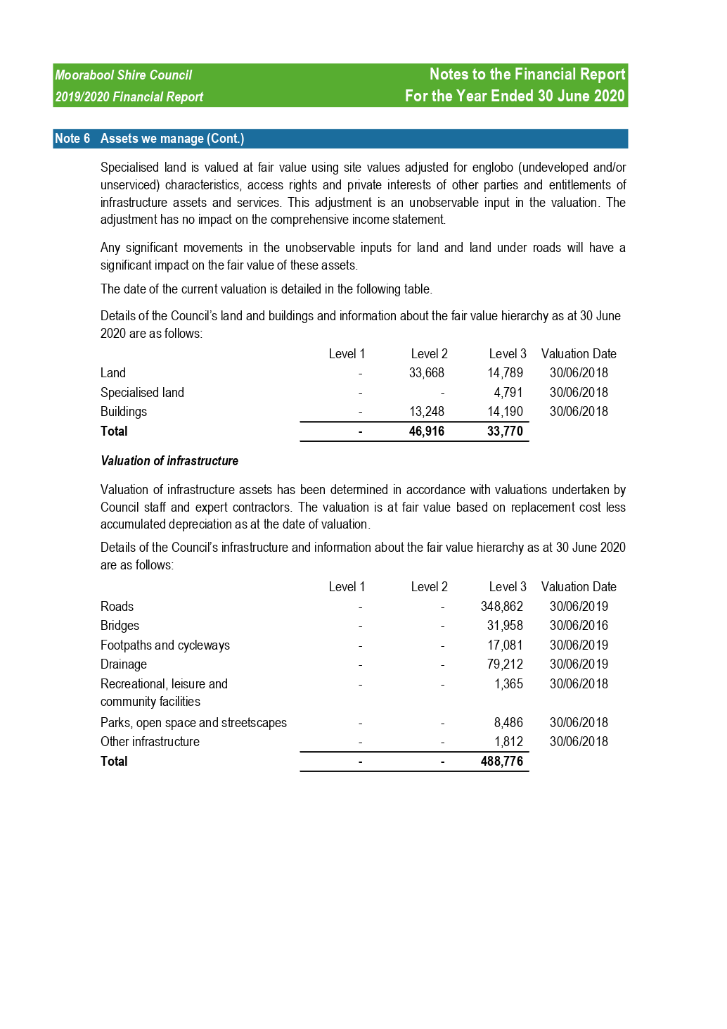

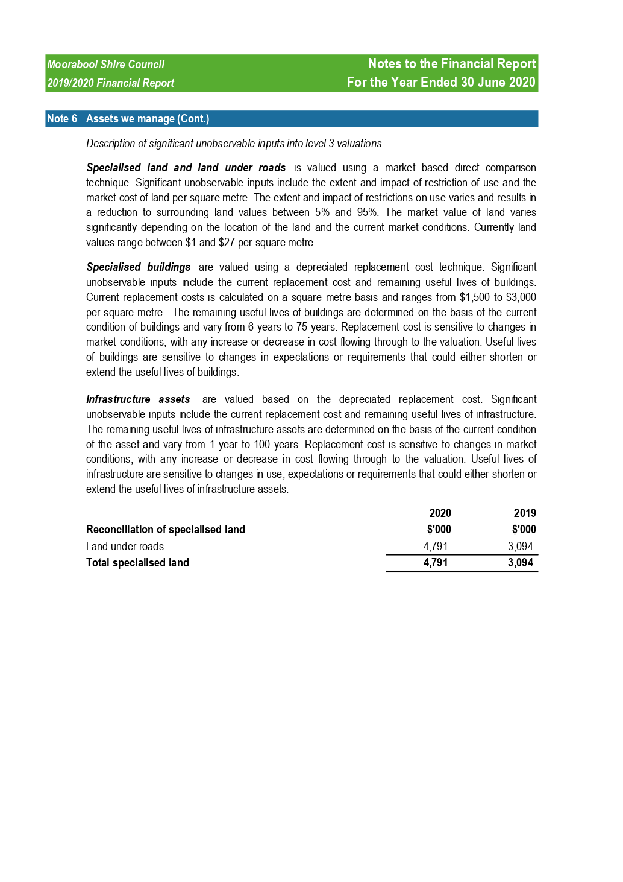

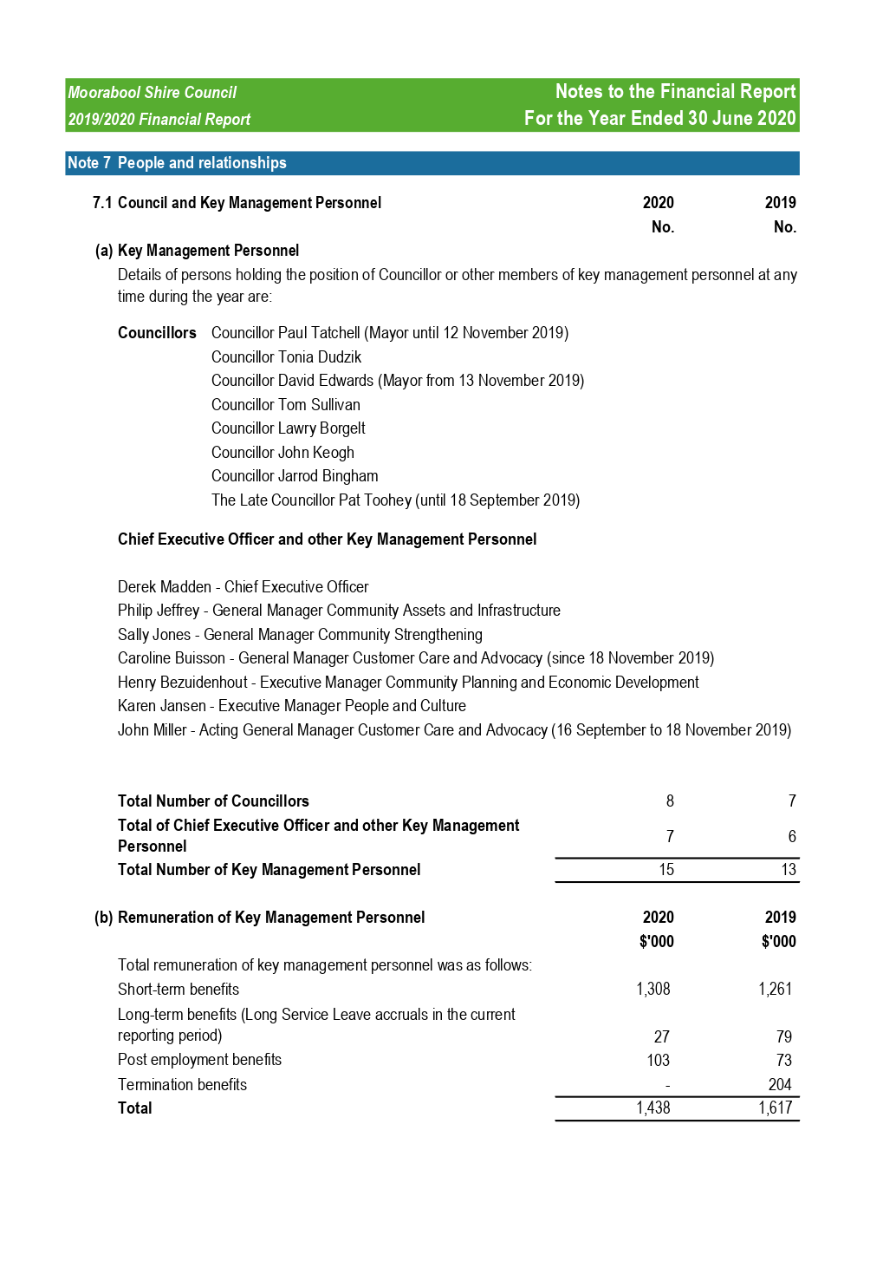

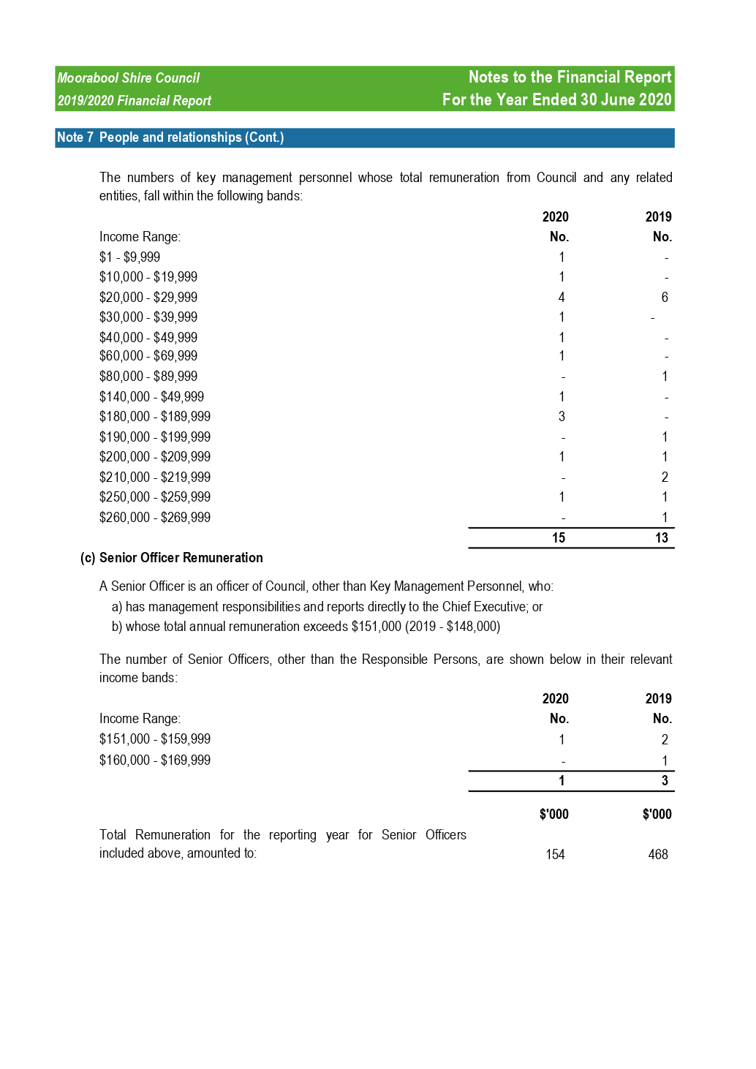

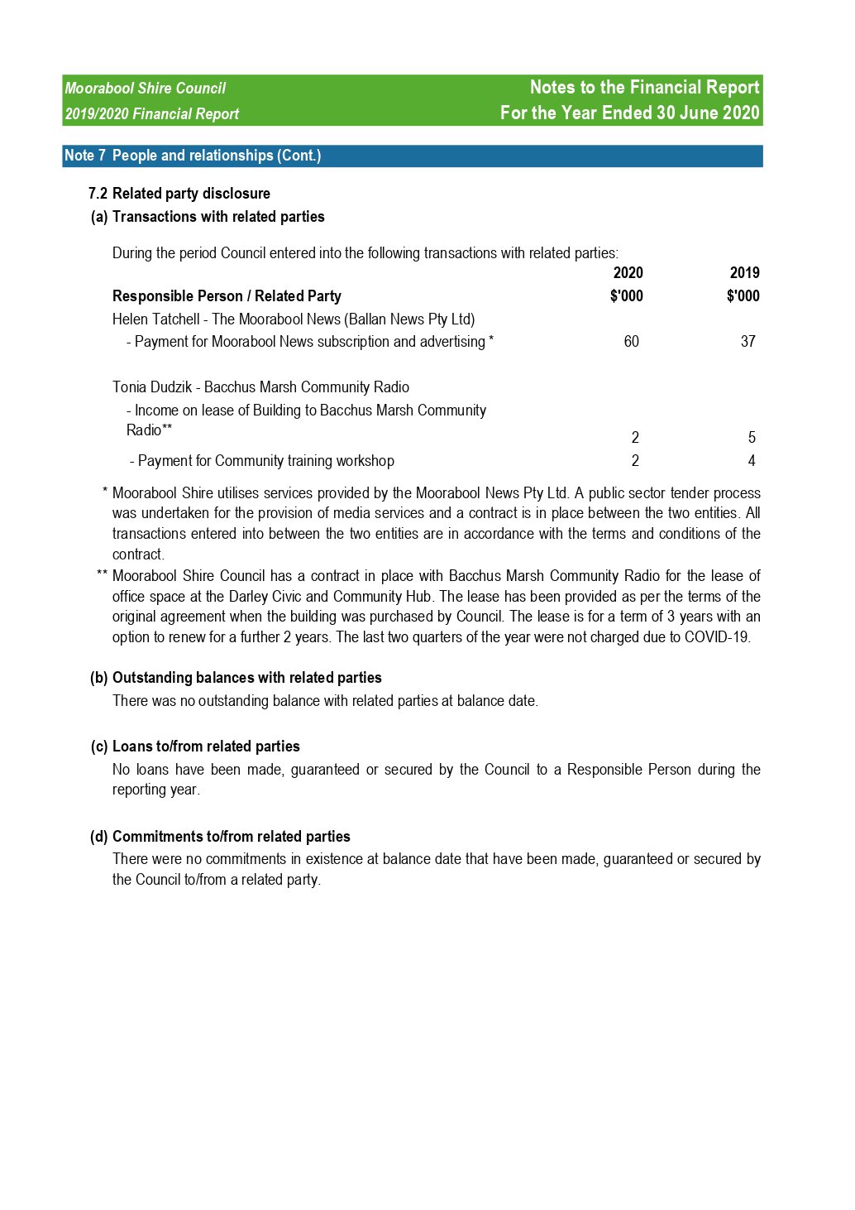

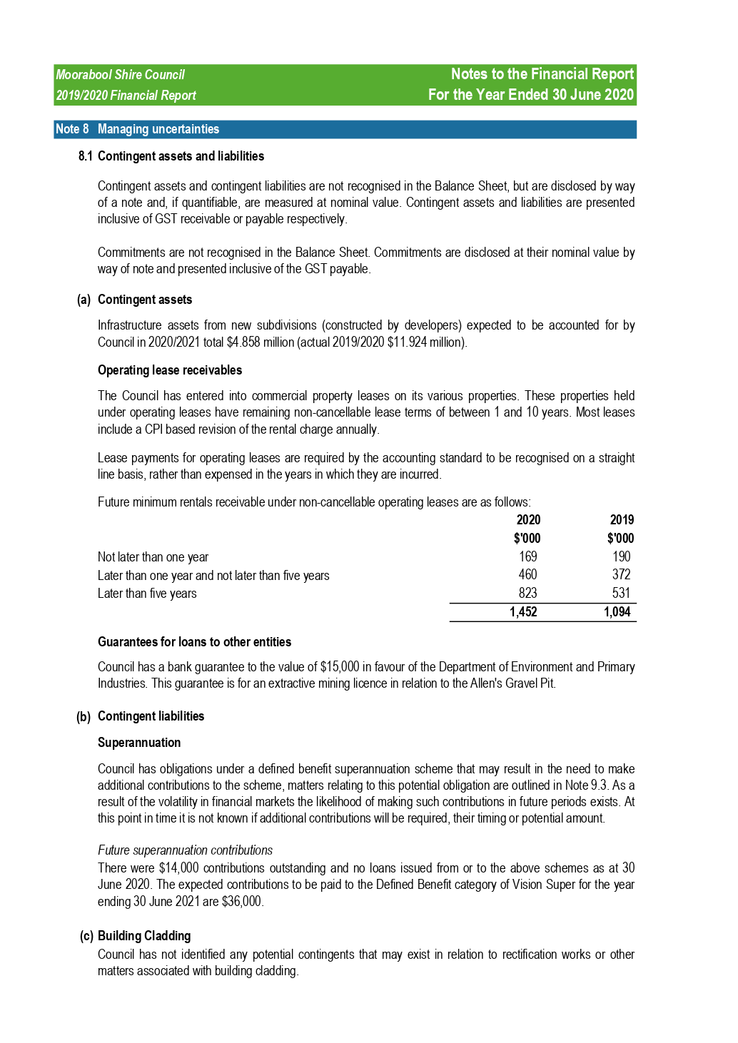

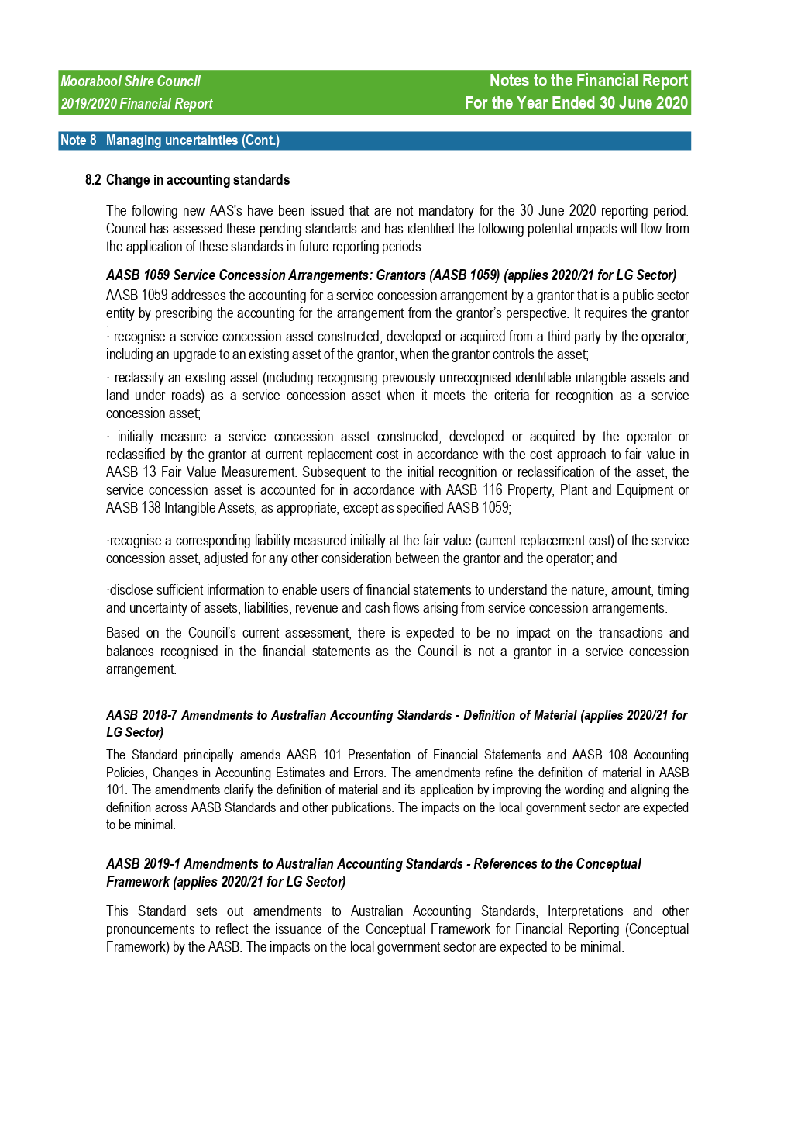

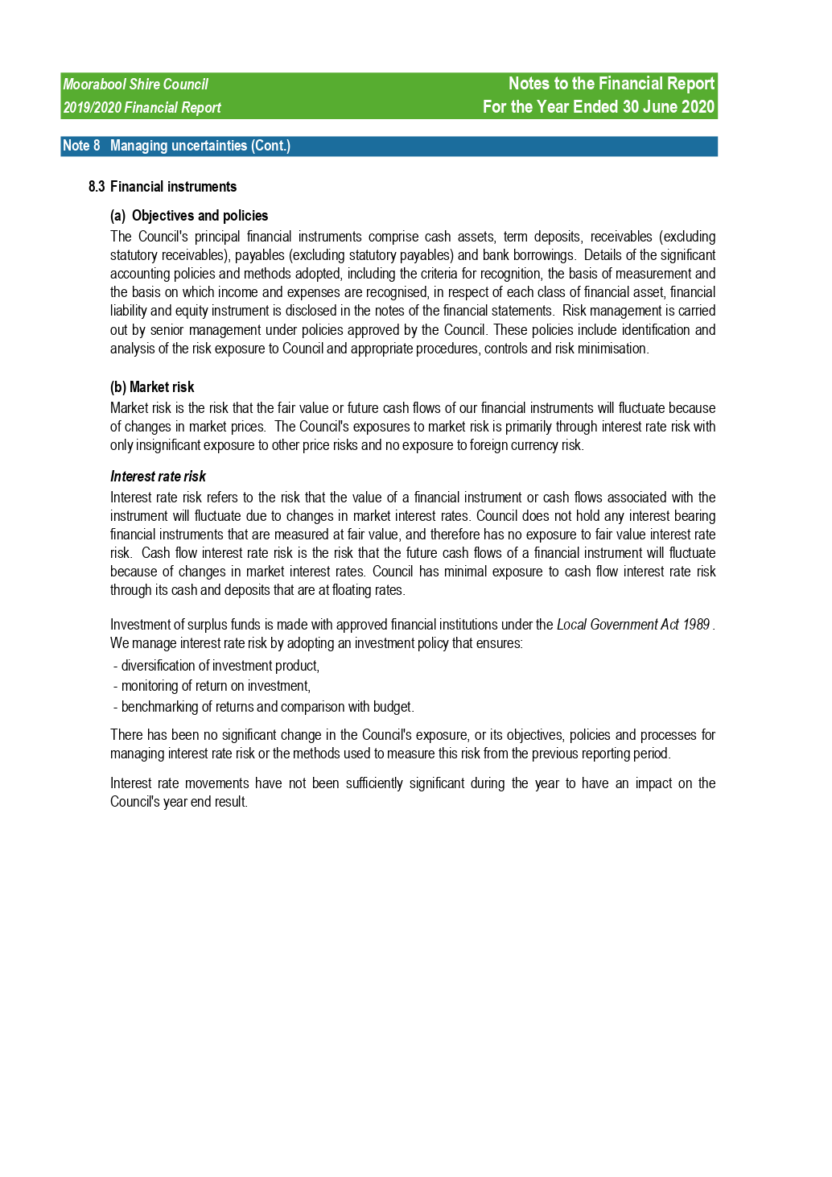

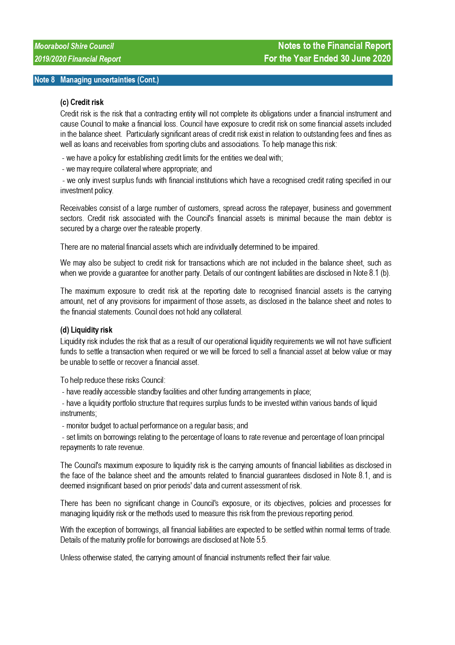

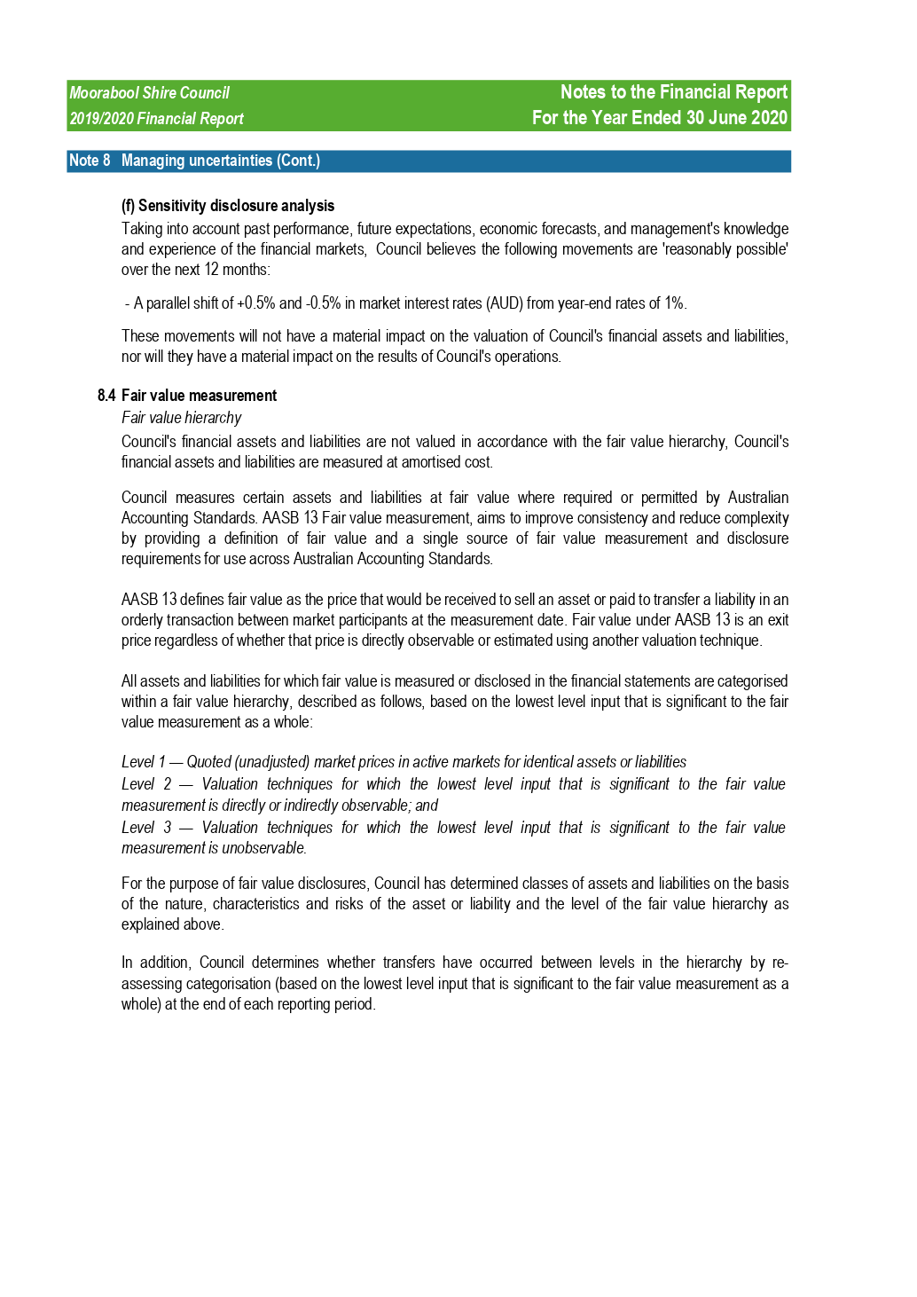

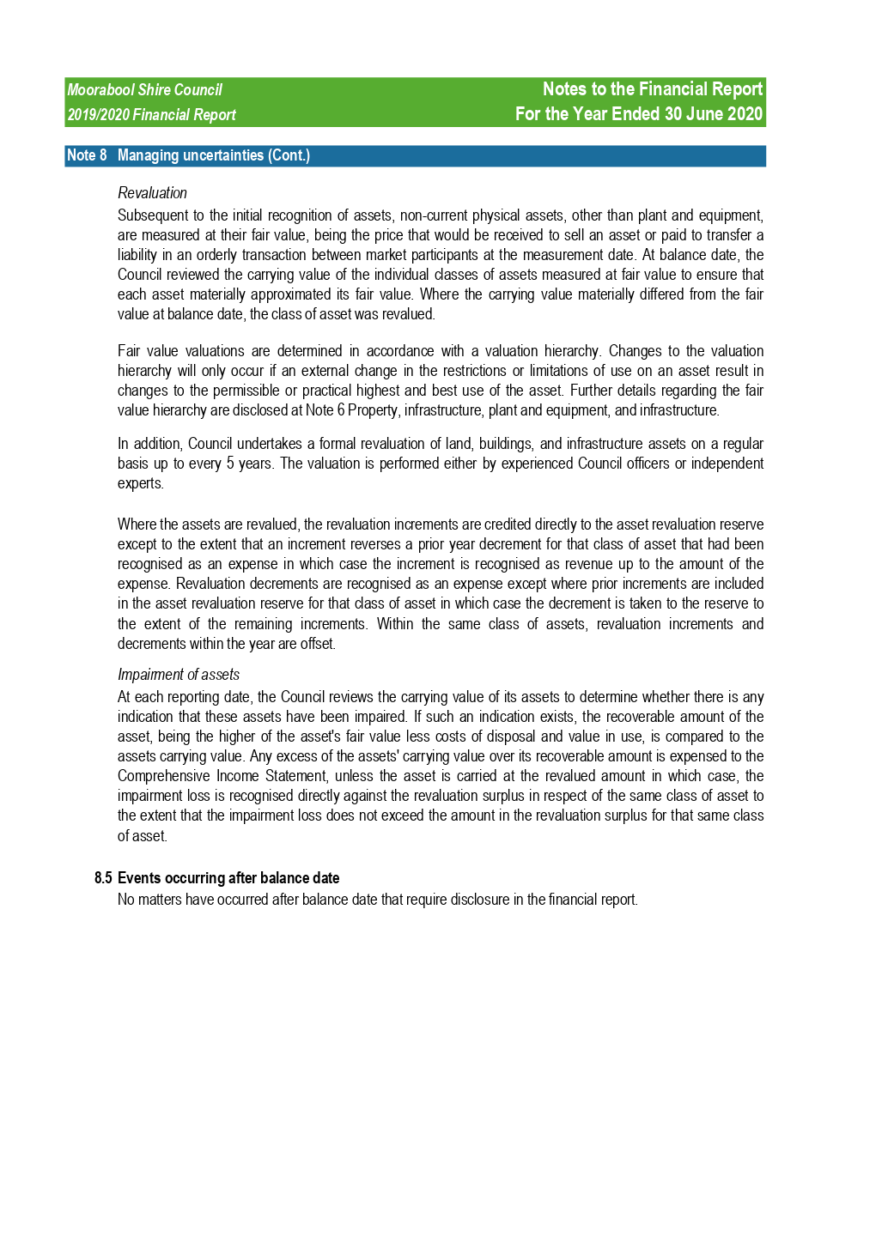

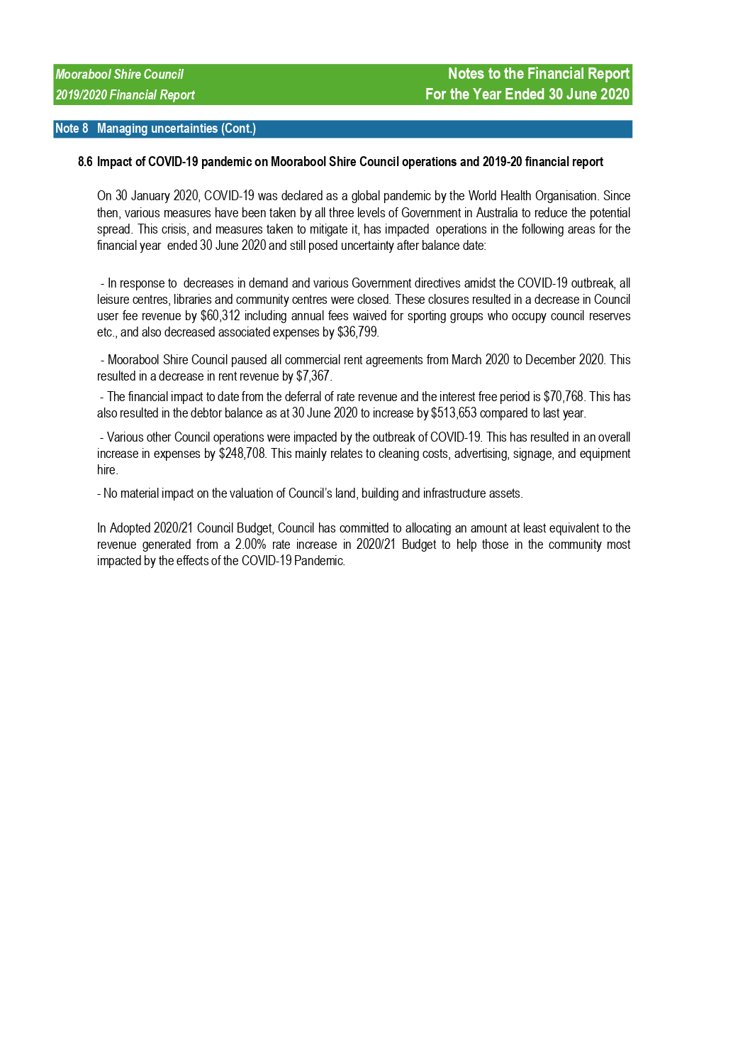

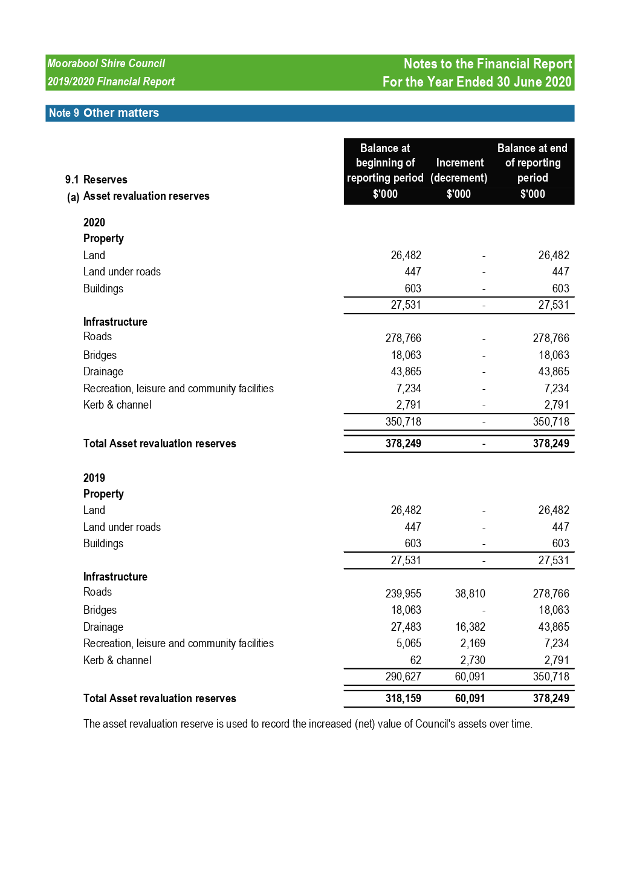

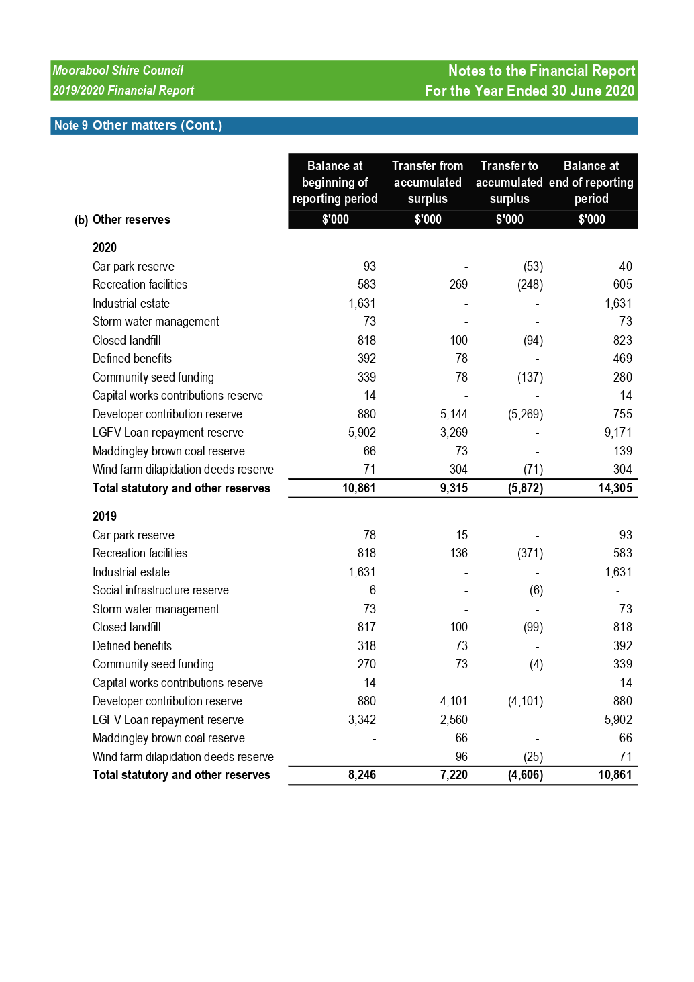

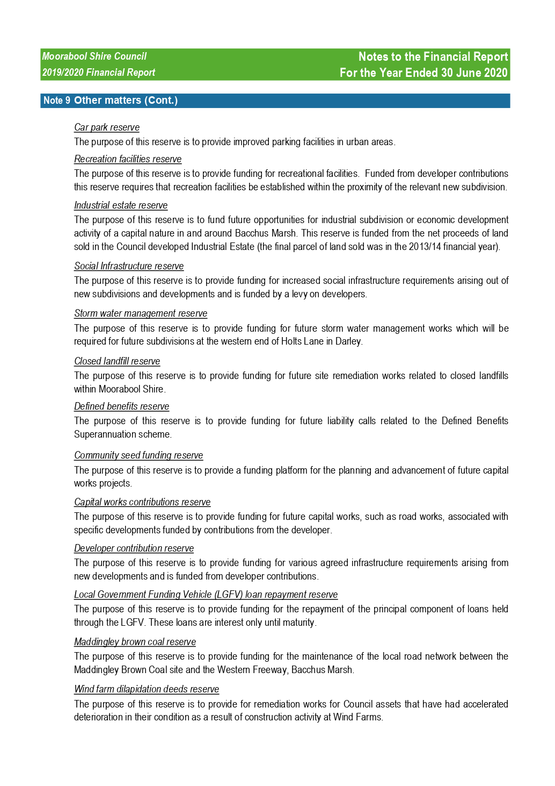

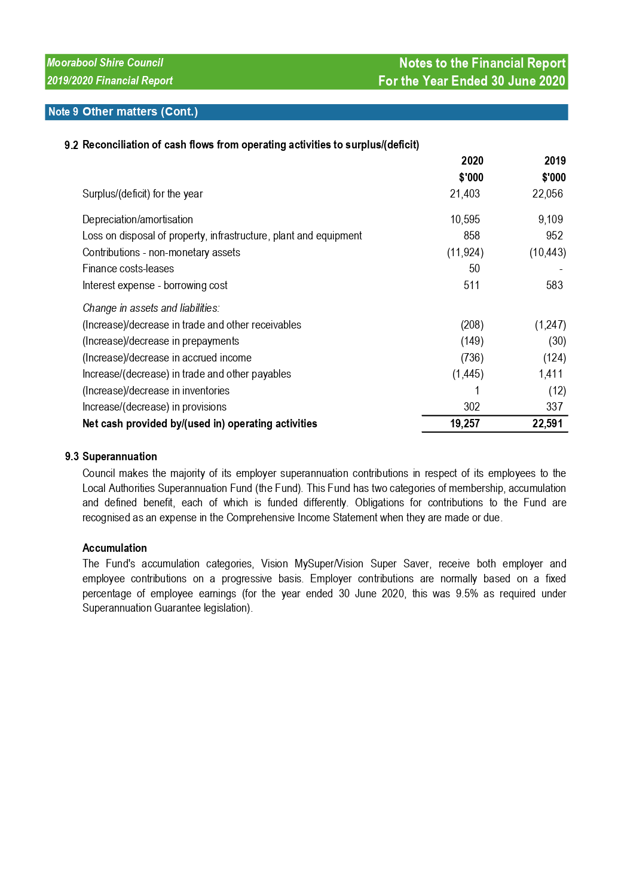

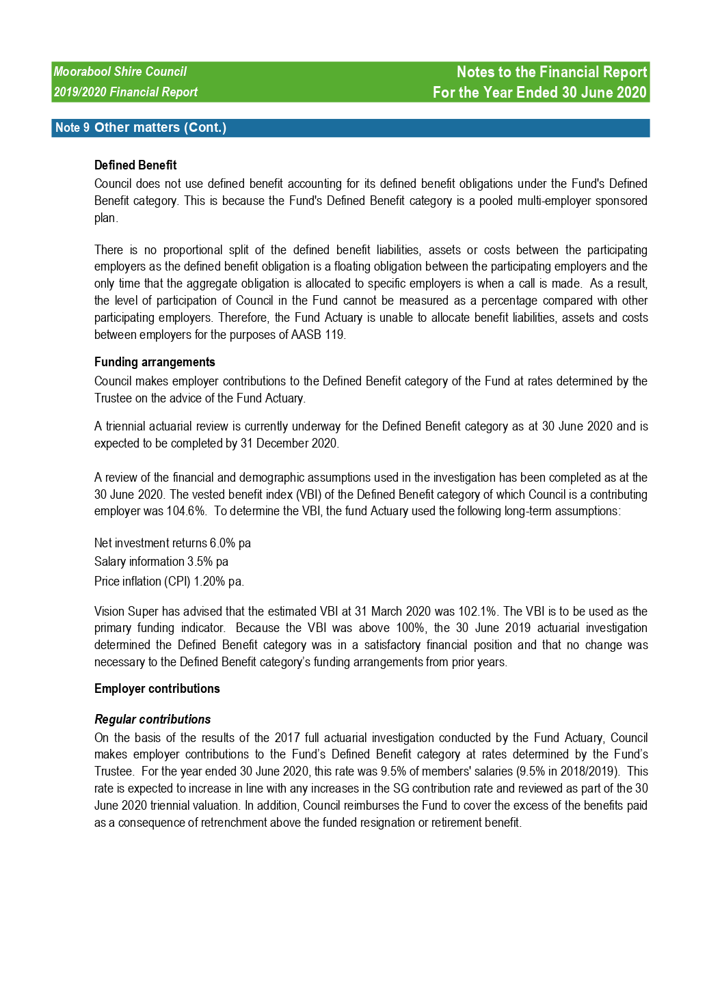

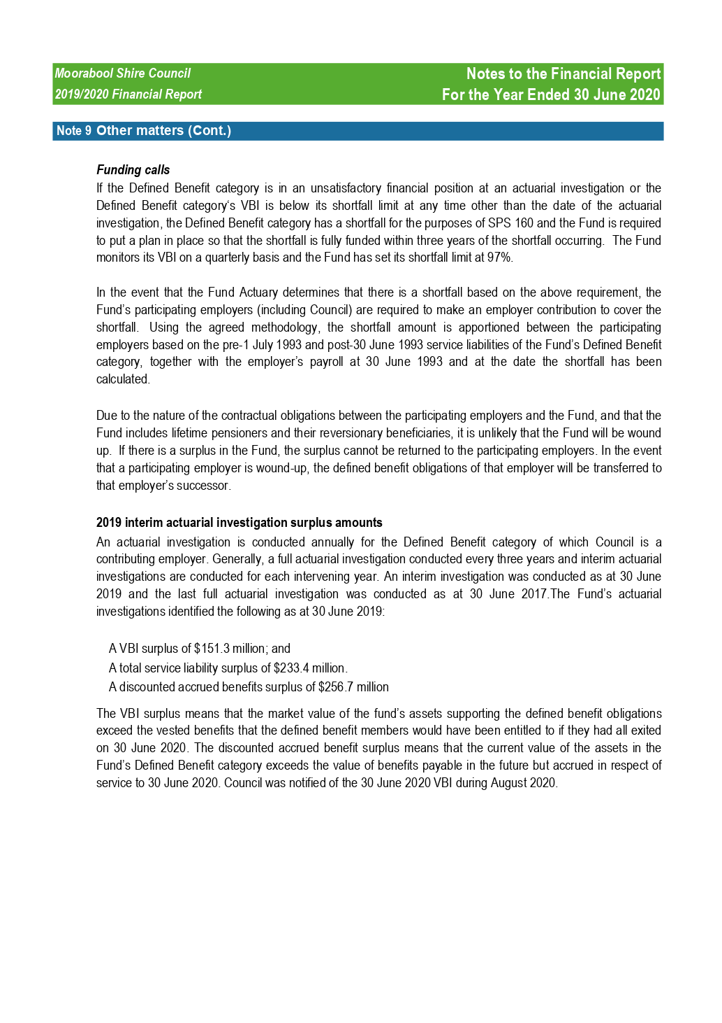

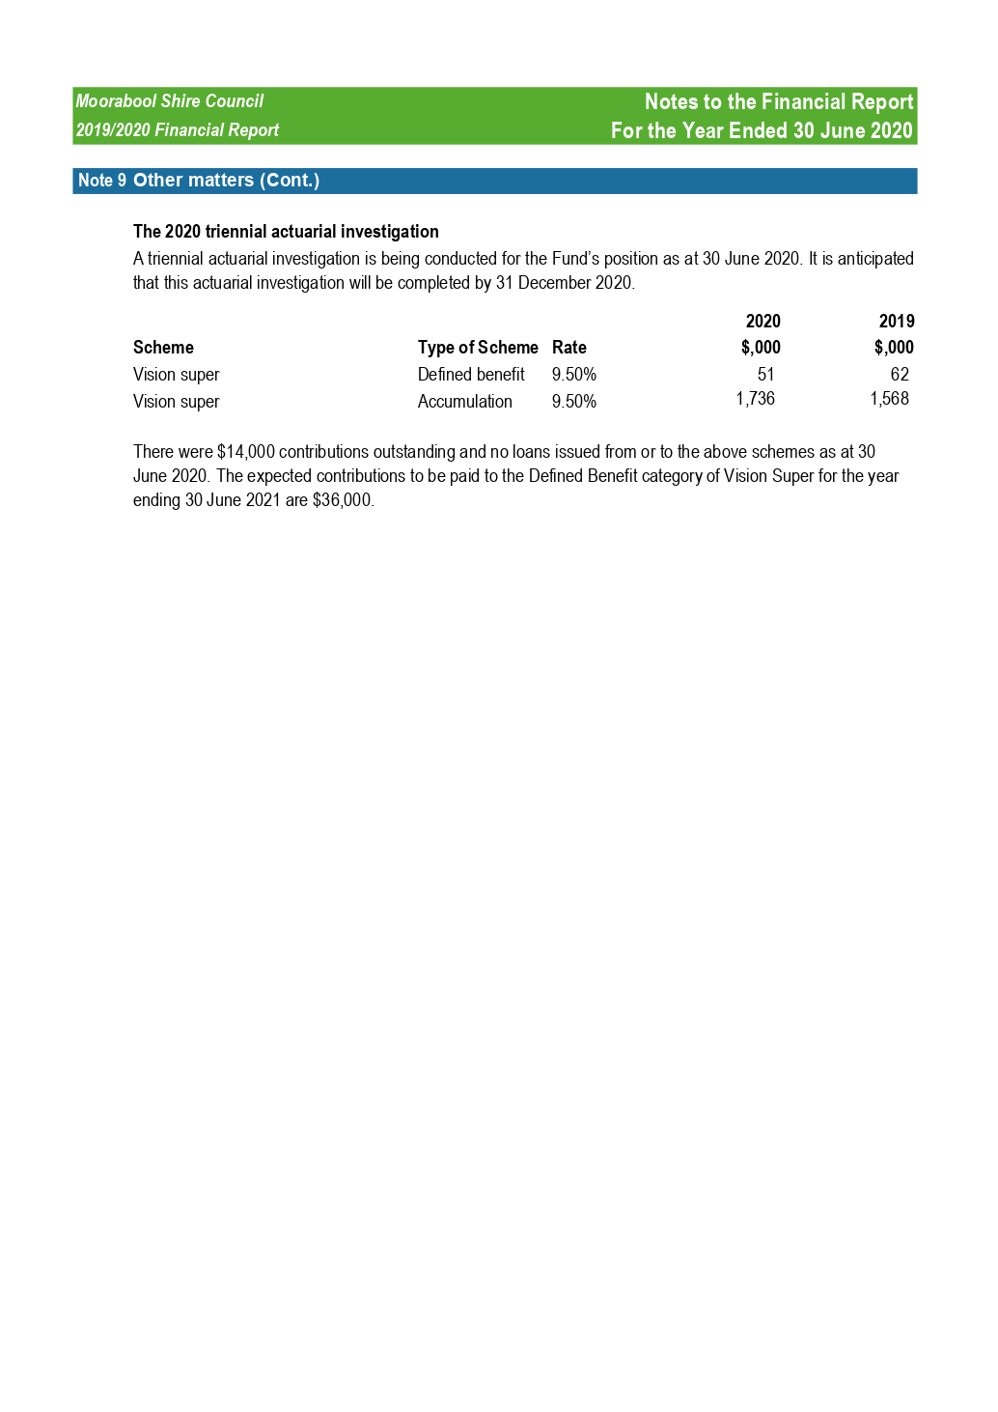

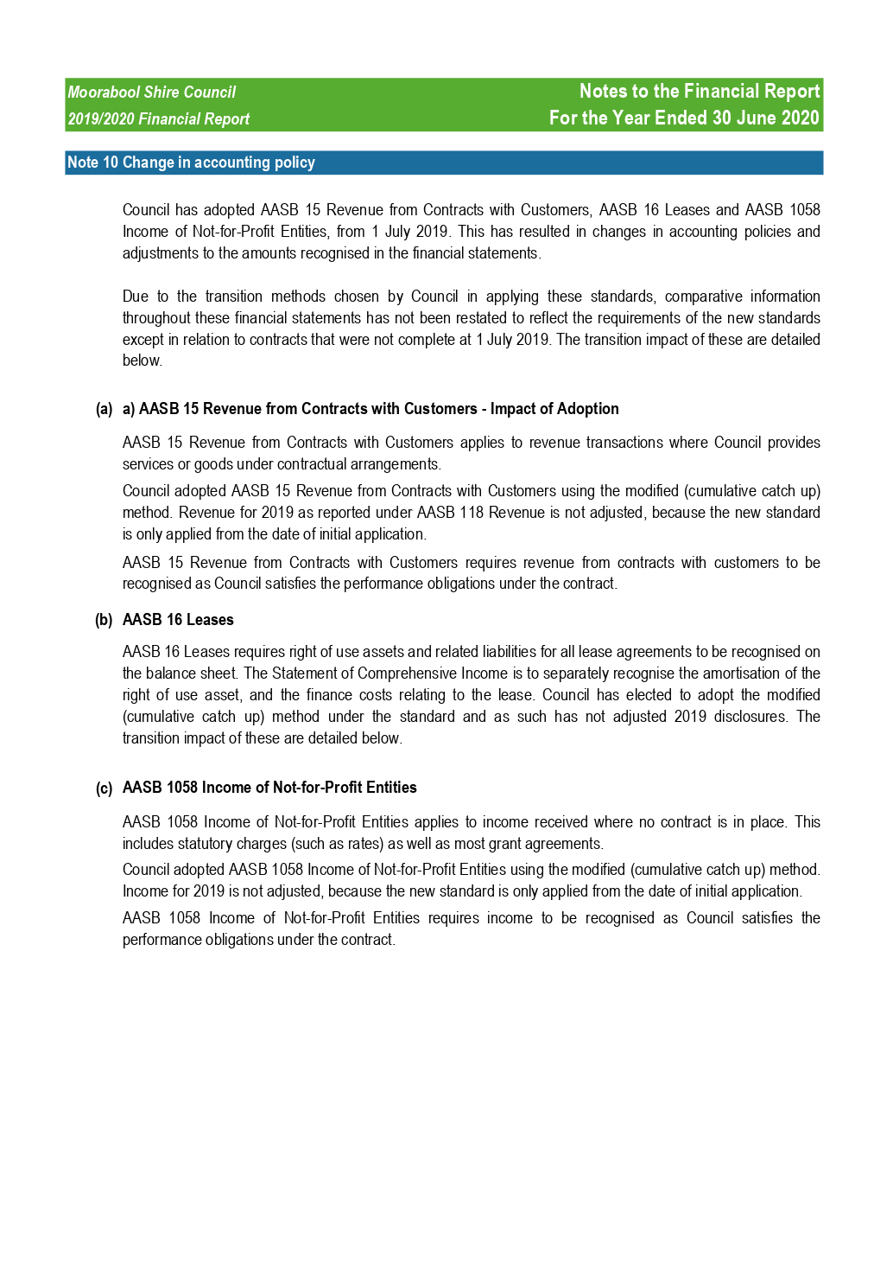

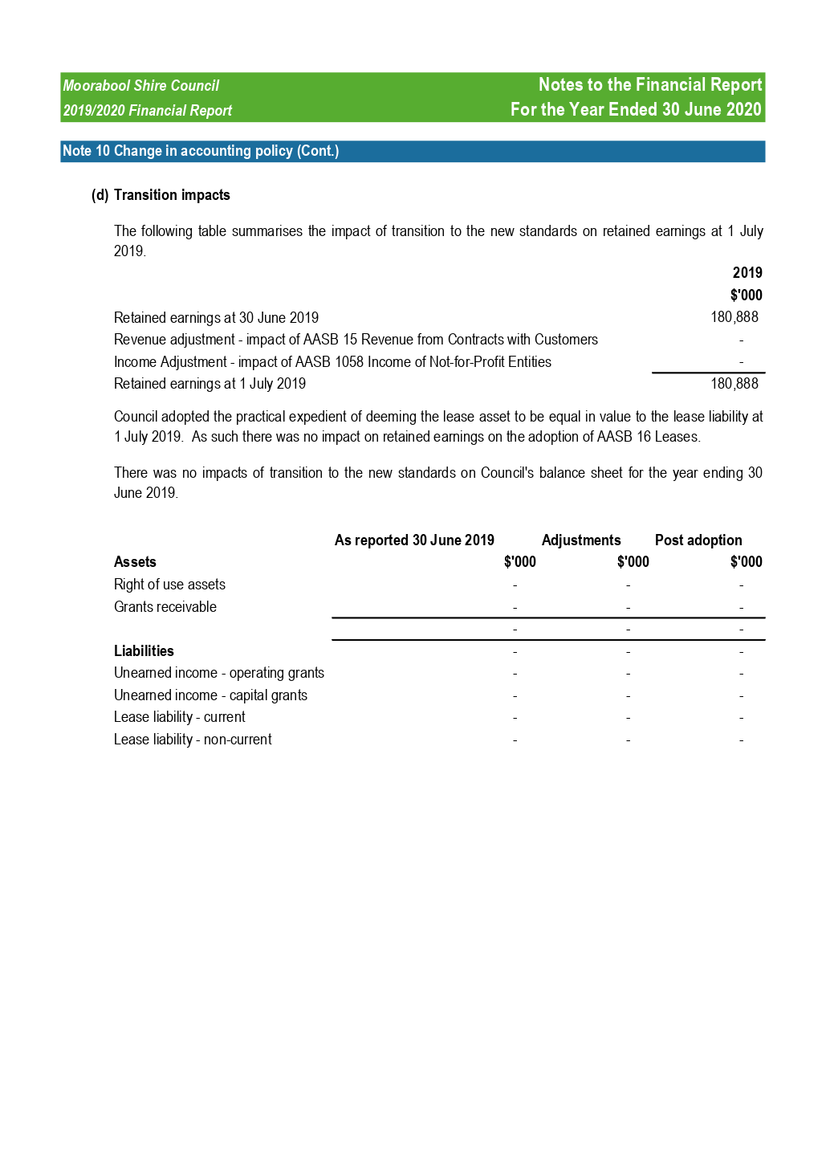

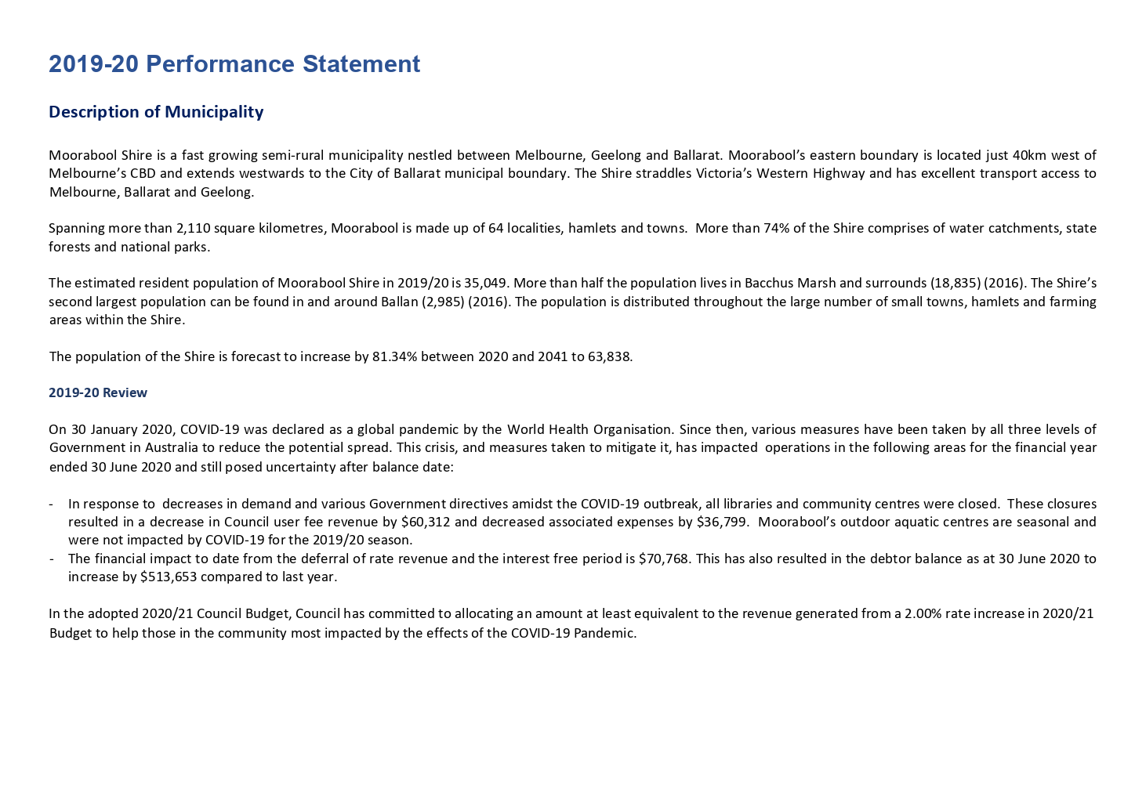

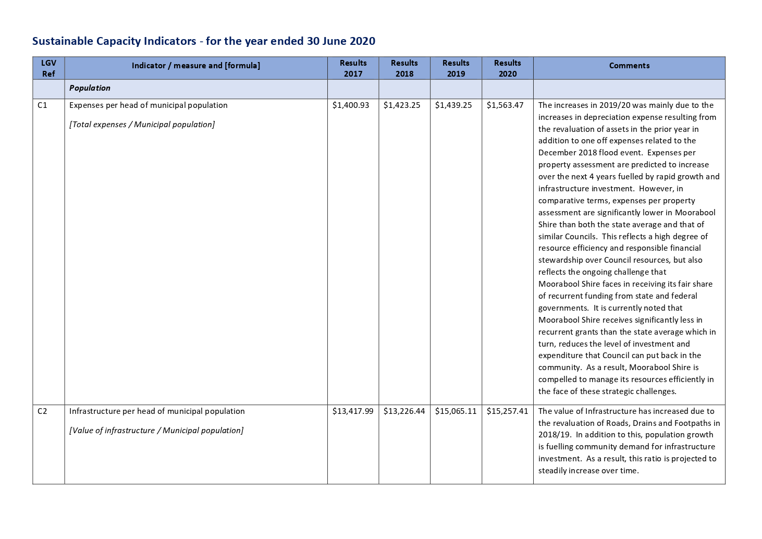

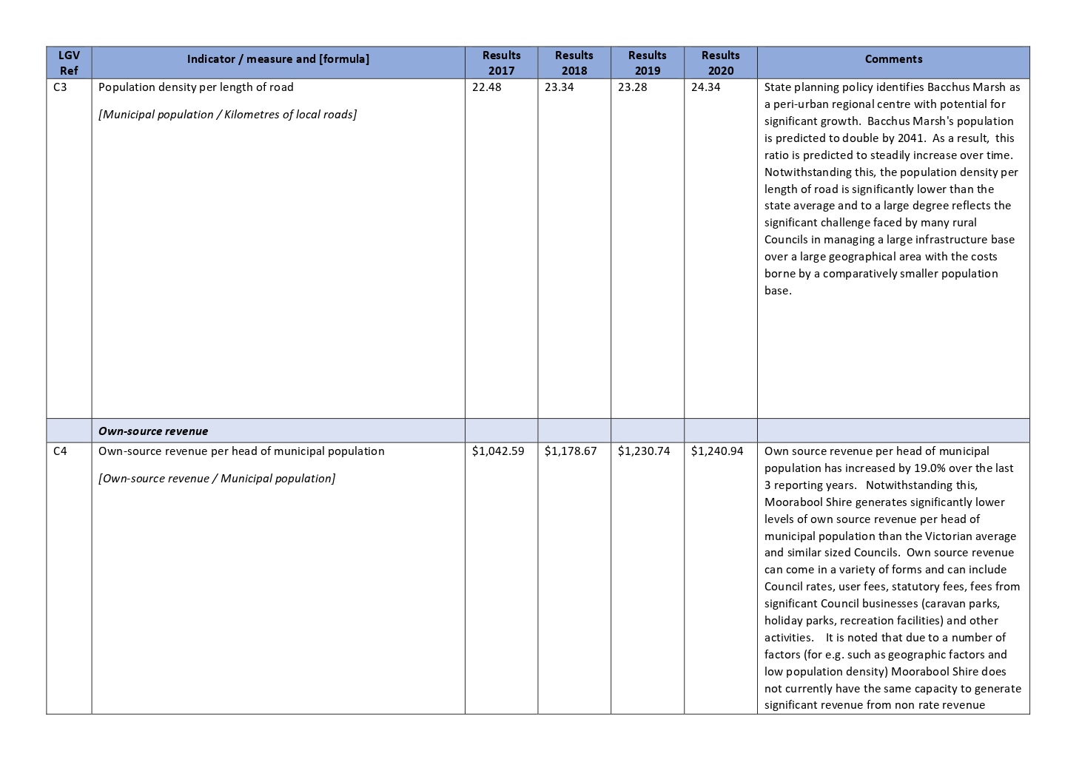

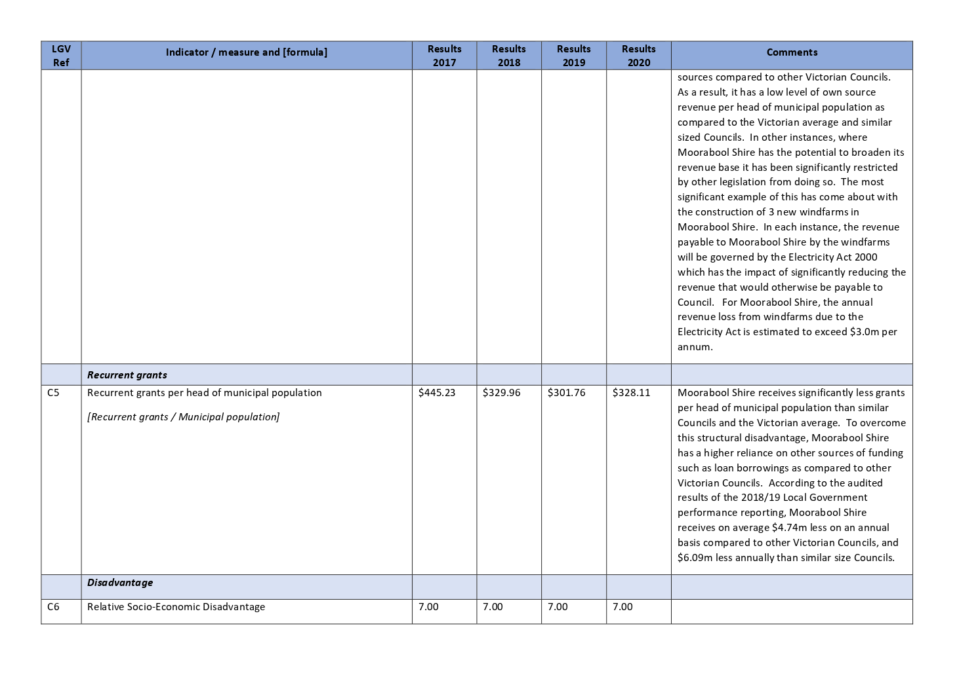

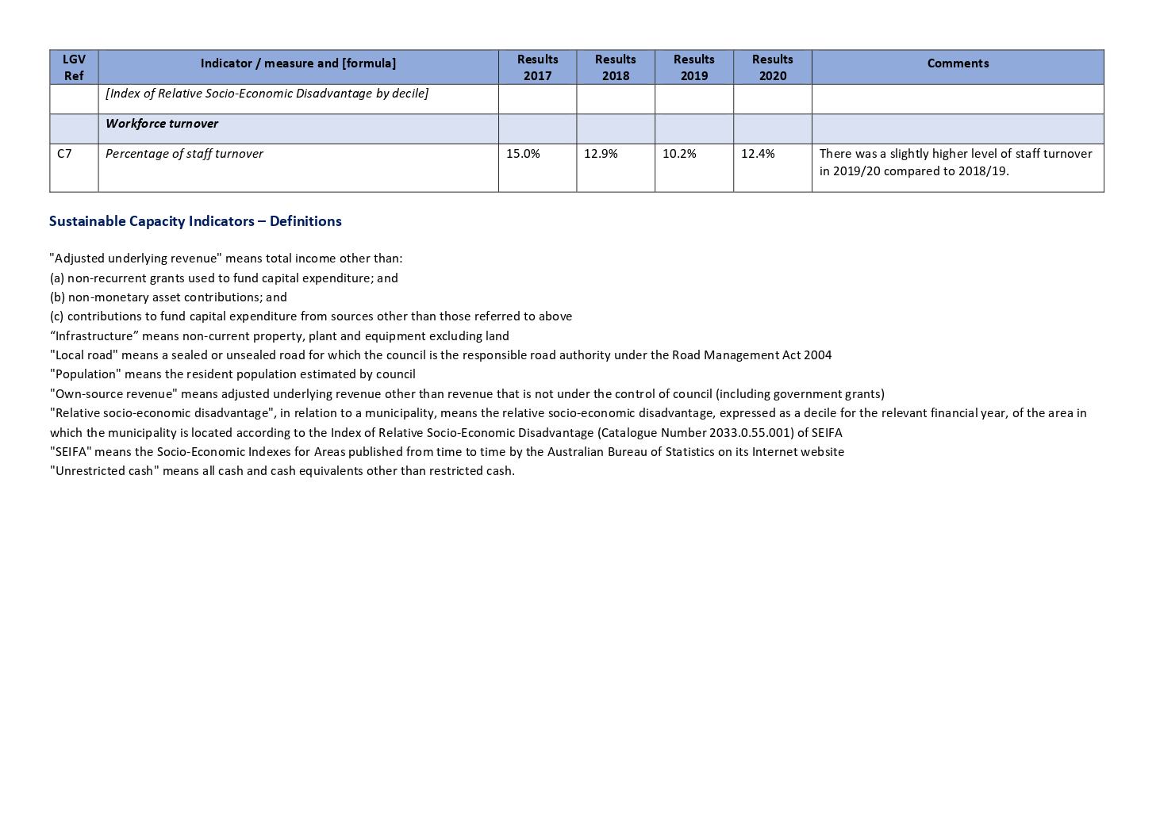

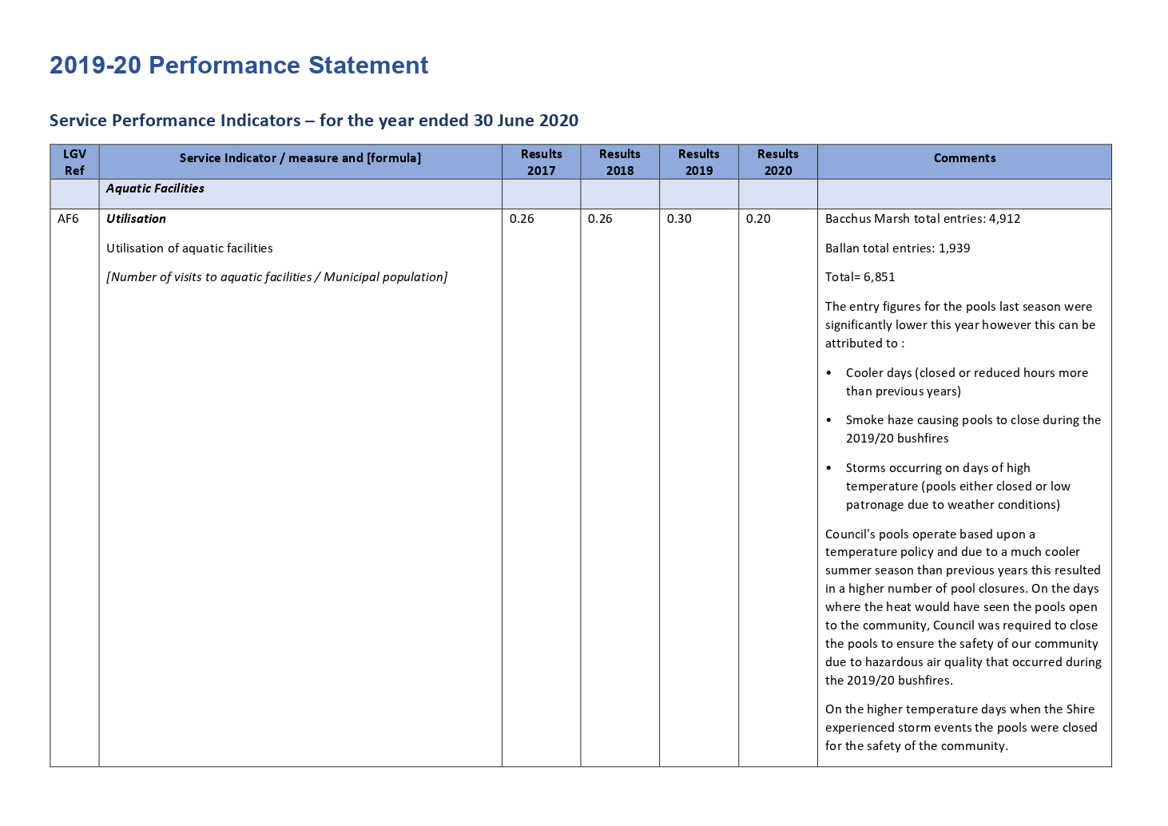

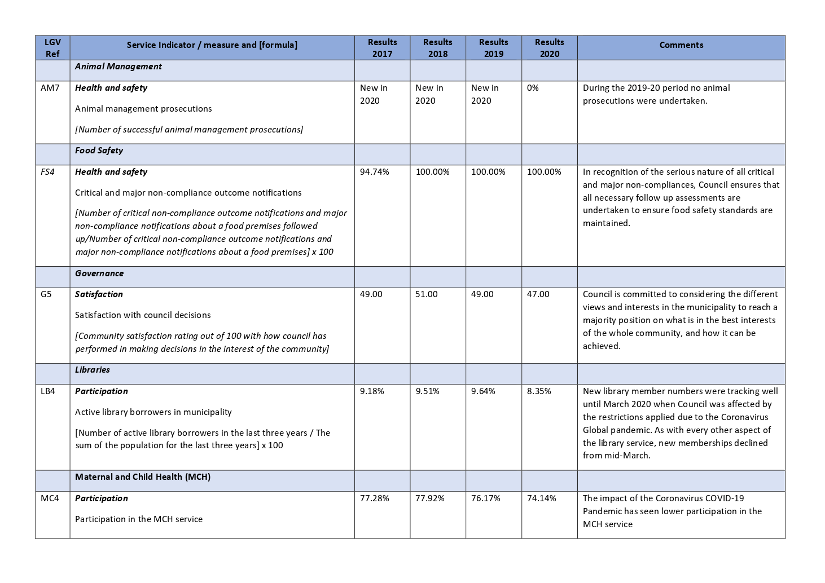

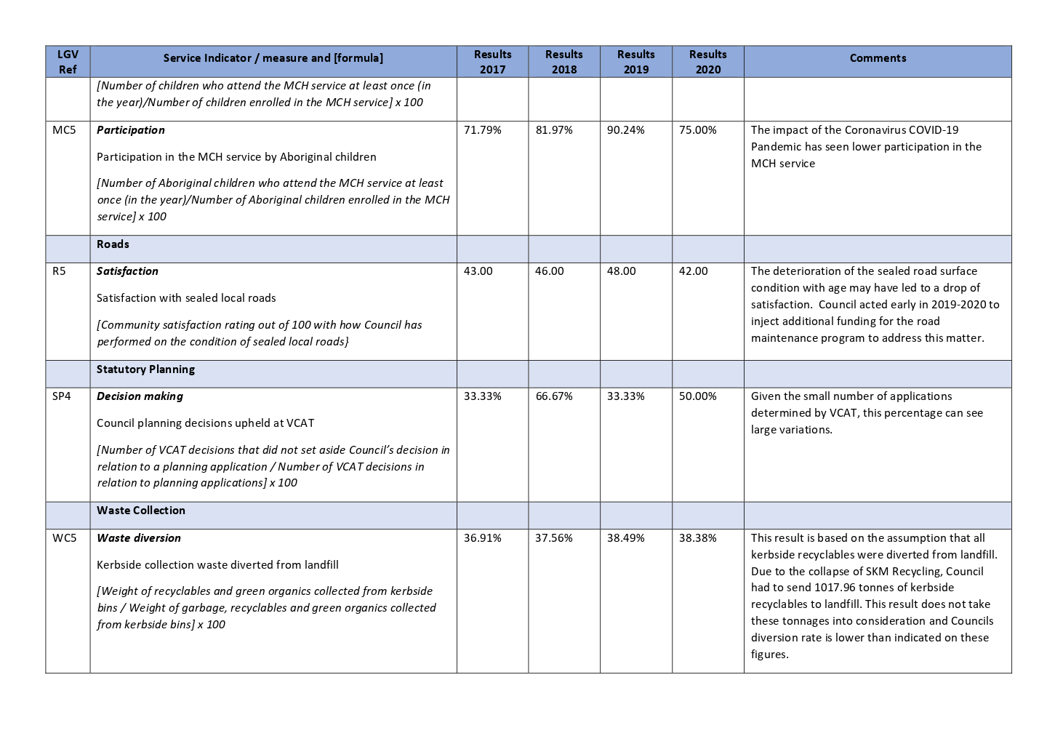

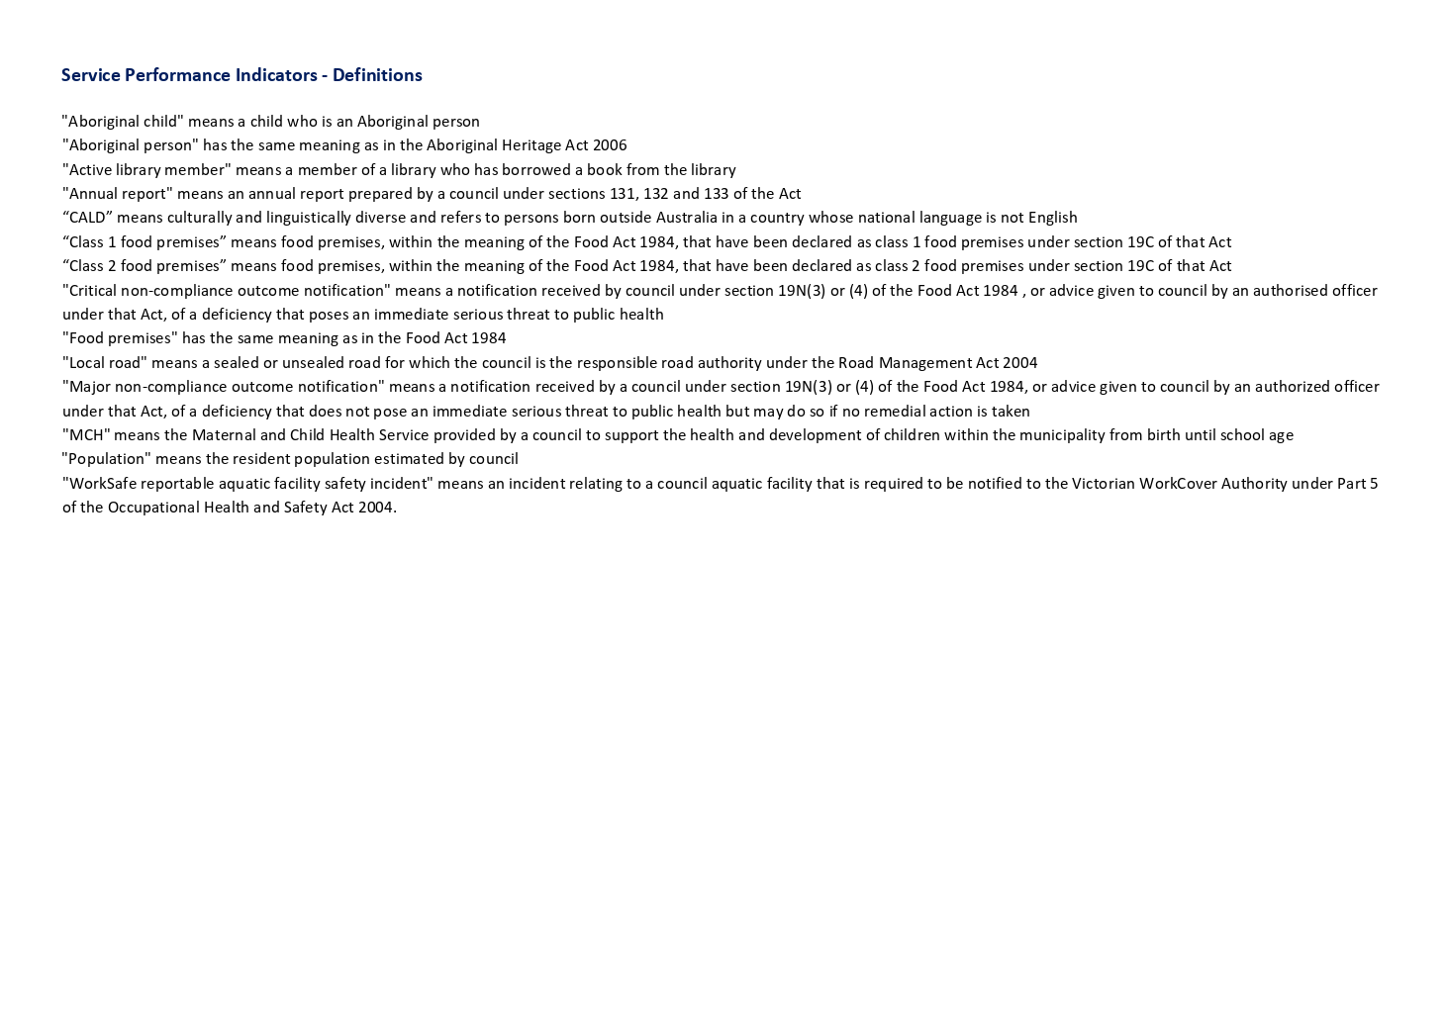

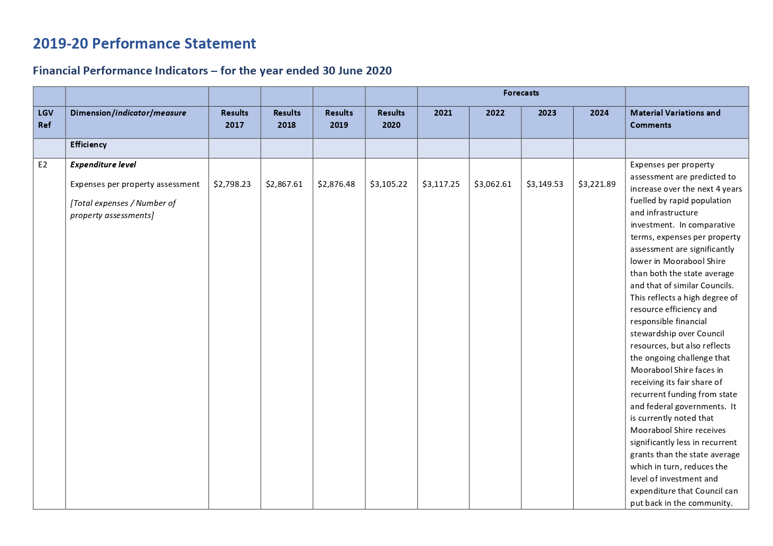

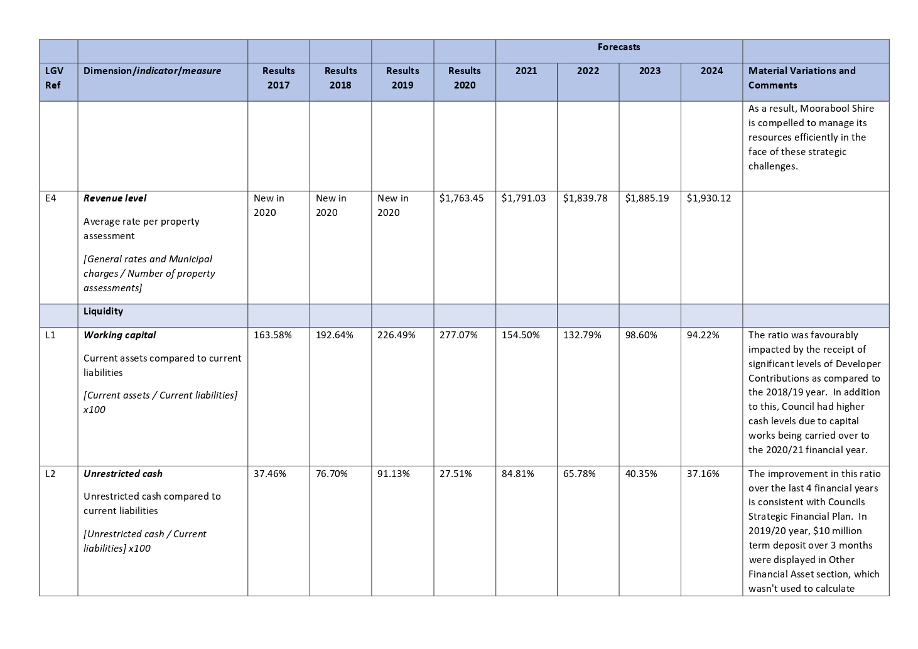

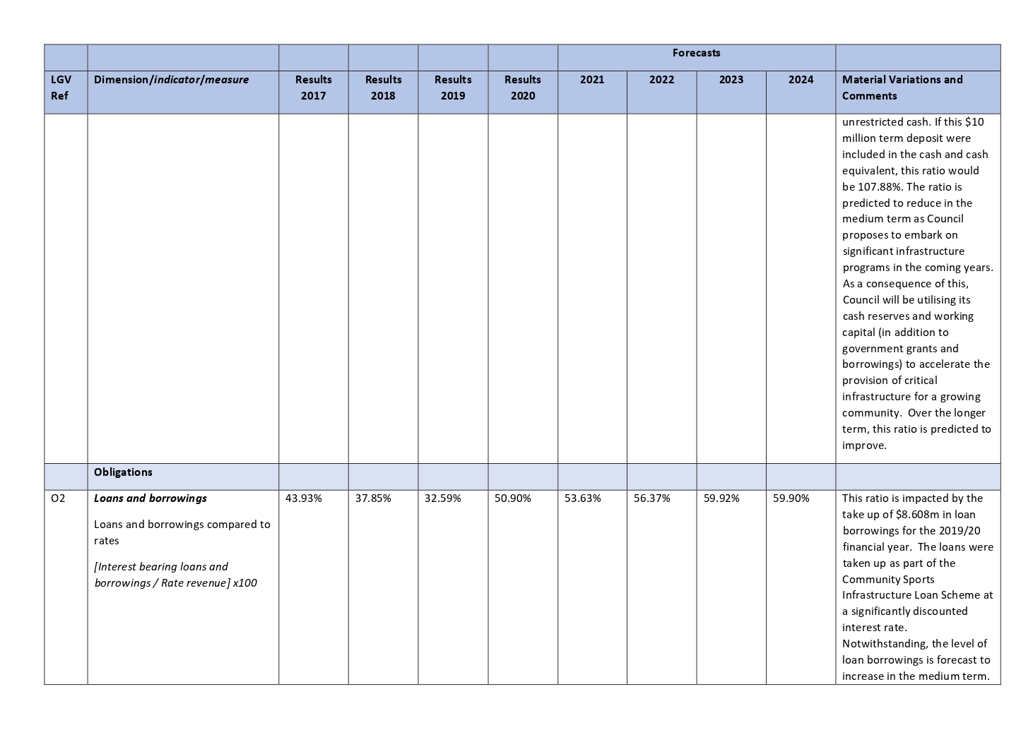

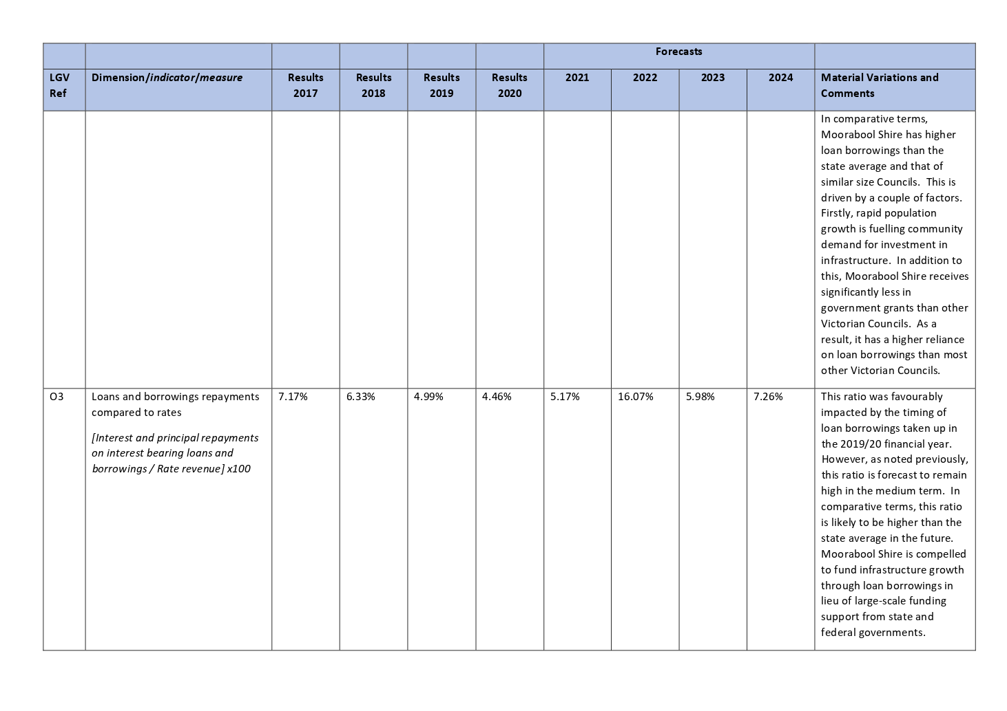

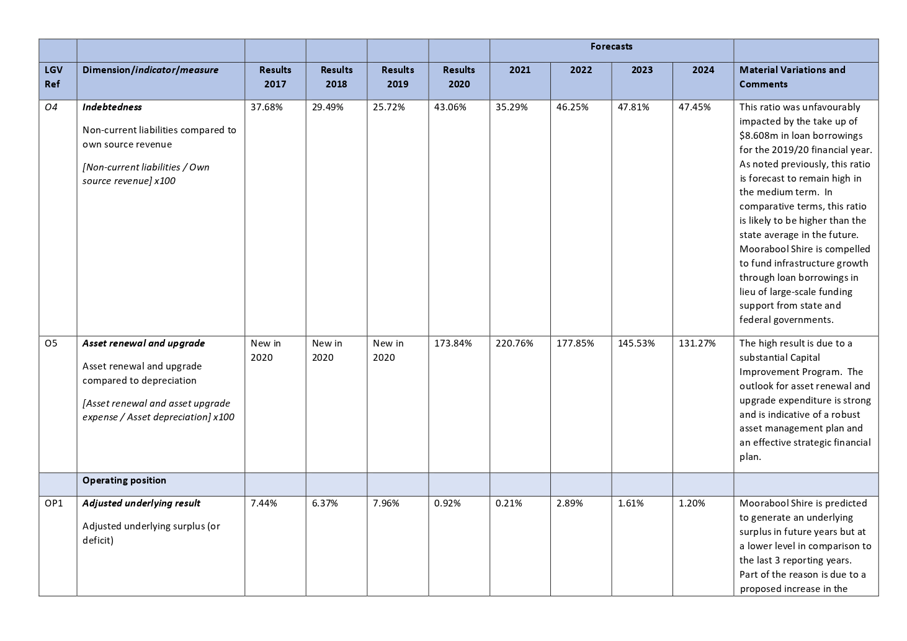

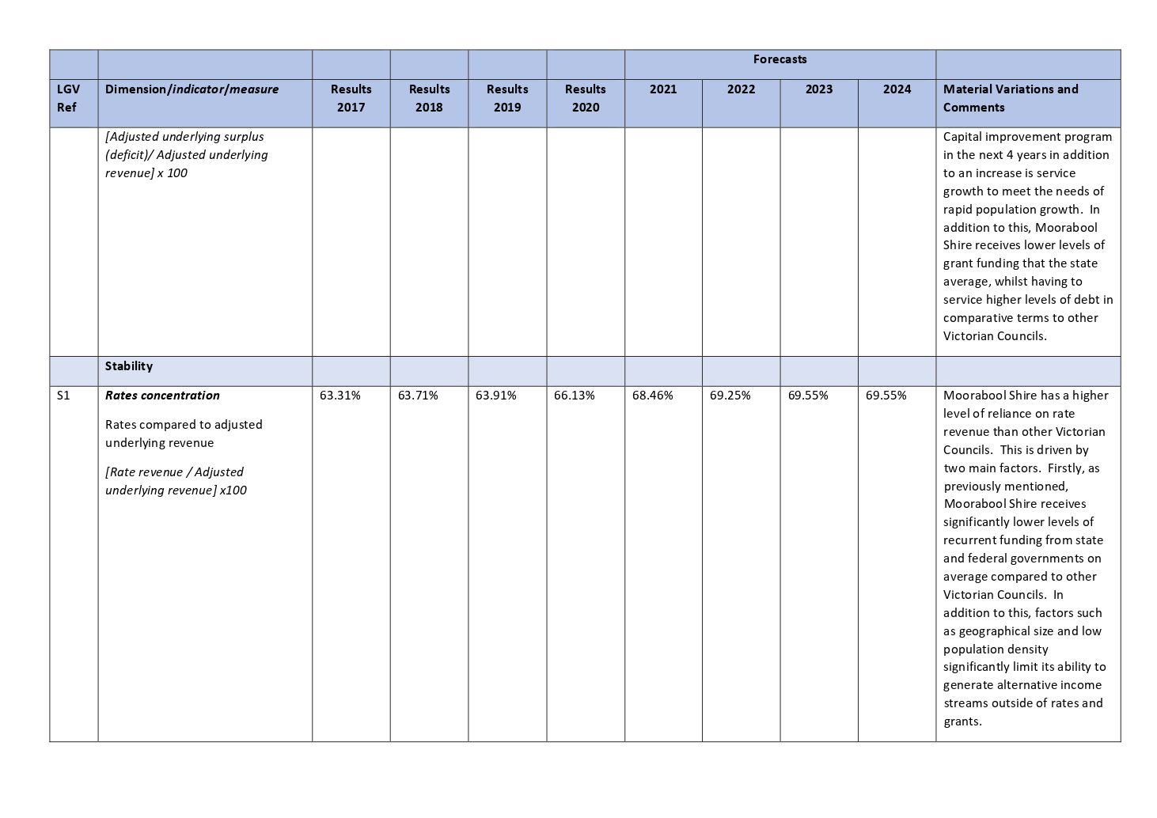

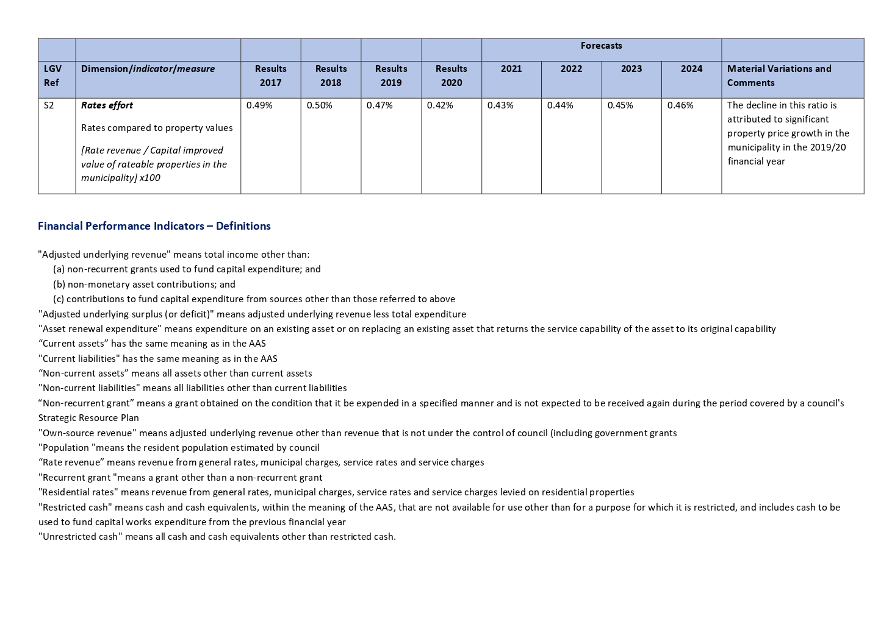

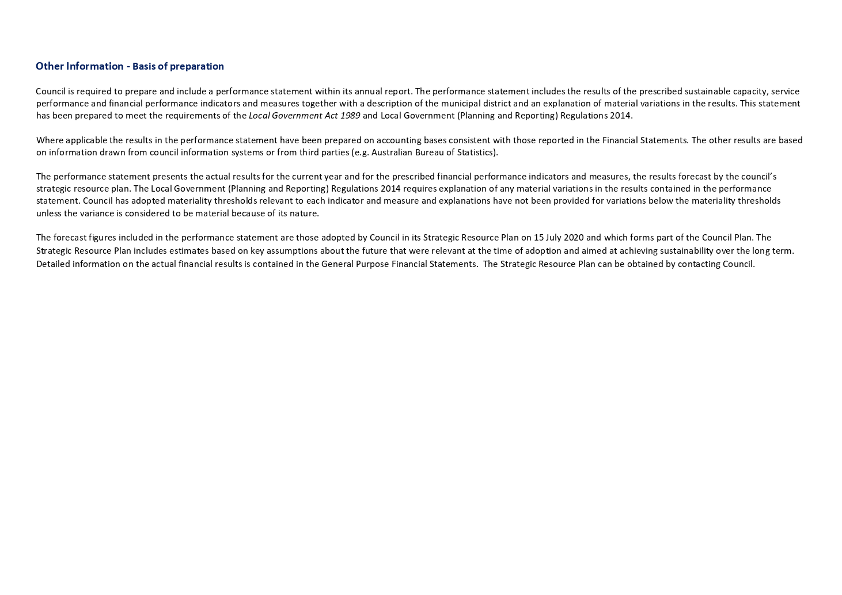

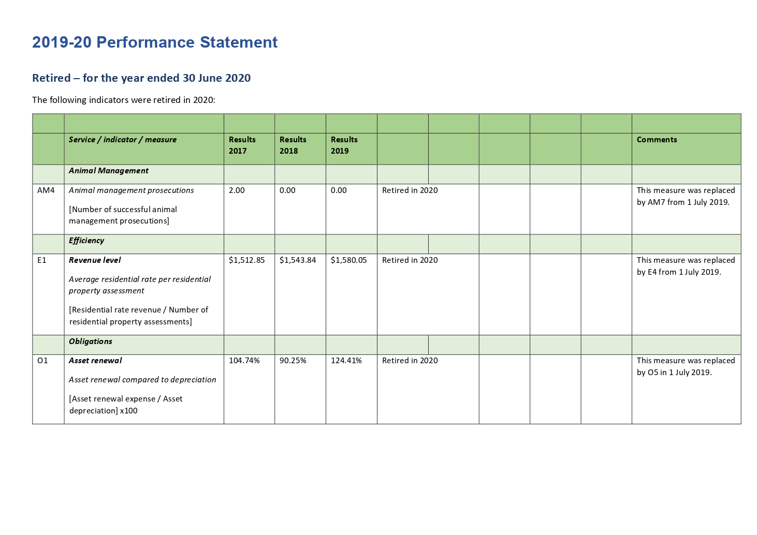
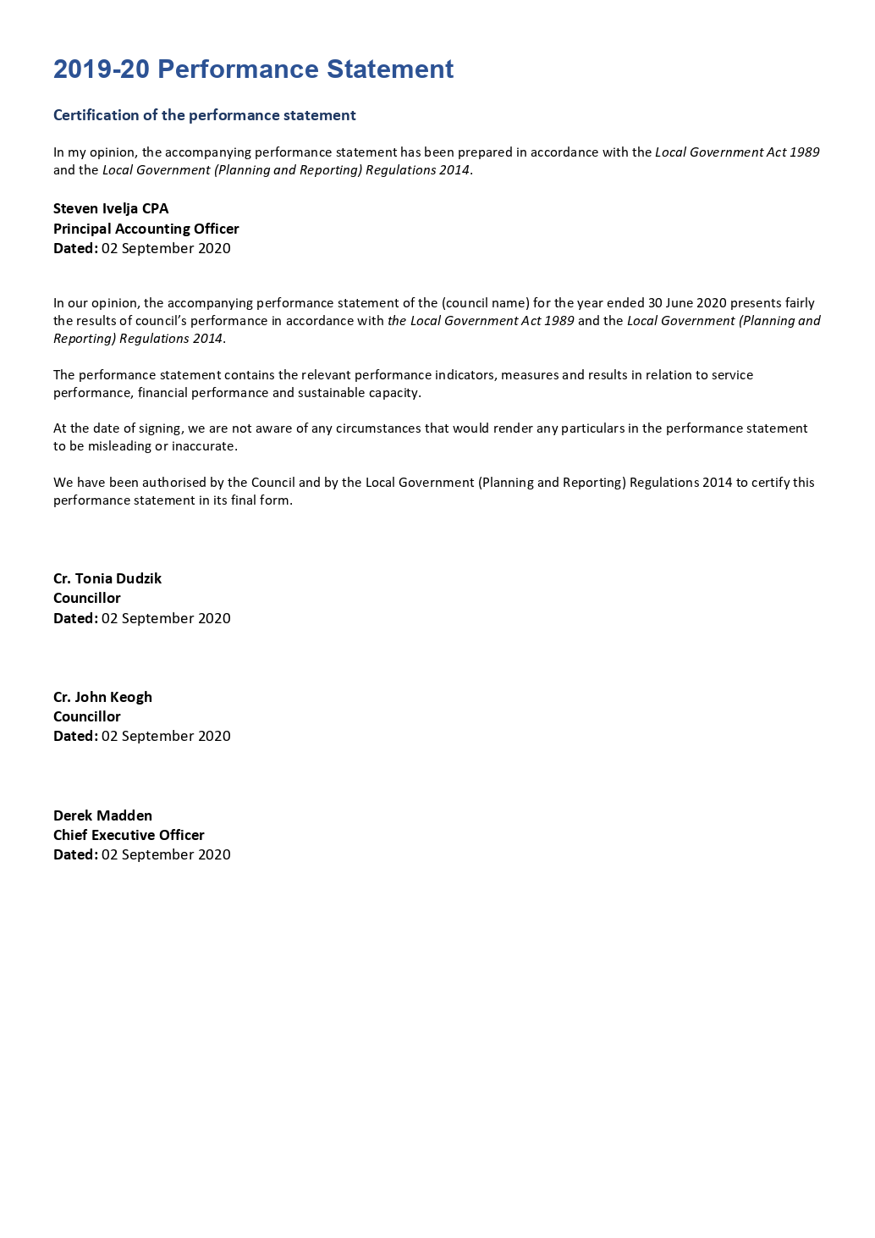

2019/2020 GOVERNANCE AND MANAGEMENT CHECKLIST
Requirement |  | Assessment | Date implemented/Effective date
Community Engagement Policy (policy outlining Council's commitment to engaging with the community on matters of public interest) | Current policy in operation | YES | 2/03/2016
Community Engagement Guidelines (guidelines to assist staff to determine when and how to engage with the community) | Current guidelines in operation | YES | 2/03/2016
Strategic Resource Plan (plan under section 126 of the Act outlining the financial and non-financial resources required for at least the next 4 financial years) | Plan adopted in accordance with section 126 of the Act | YES | 15/07/2020
Annual Budget (plan under section 130 of the Act setting out the services to be provided and initiatives to be undertaken over the next 12 months and the funding and other resources required) | Budget adopted in accordance with section 130 of the Act | YES | 15/07/2020
Asset Management Plans (plans that set out the asset maintenance and renewal needs for key infrastructure asset classes for at least the next 10 years) | Current plans in operation | YES | Part A General 30/4/13  Part B Transport 30/4/13  Part C Buildings 3/12/14  Part D Drainage 3/12/14  Part E Recreation 3/12/14
Rating Strategy (strategy setting out the rating structure of Council to levy rates and charges) | Current strategy in operation | YES | 2/05/2018
Risk Policy (policy outlining Council's commitment and approach to minimising the risks to Council's operations) | Current policy in operation | YES | 13/08/2019
Fraud Policy (policy outlining Council's commitment and approach to minimising the risk of fraud) | Current policy in operation | YES | 30/10/2019
Municipal Emergency Management Plan (plan under section 20 of the Emergency Management Act 1986 for emergency prevention, response and recovery) | Prepared and maintained in accordance with section 20 of the Emergency Management Act 1986 | YES | 3/06/2020
Procurement Policy (policy under section 186A of the Local Government Act 1989 outlining the matters, practices and procedures that will apply to all purchases of goods, services and works) | Prepared and approved in accordance with section 186A of the Local Government Act | YES | 1/7/2020
Business Continuity Plan (plan setting out the actions that will be undertaken to ensure that key services continue to operate in the event of a disaster) | Current plan in operation | YES | 24/10/2017
Disaster Recovery Plan (plan setting out the actions that will be undertaken to recover and restore business capability in the event of a disaster) | Current plan in operation | YES | 11/11/2019
Risk Management Framework (framework outlining Council's approach to managing risks to the Council's operations) | Current framework in operation | YES | 25/03/2015
Audit Committee (advisory committee of Council under section 139 of the Act whose role is to oversee the integrity of a Council's financial reporting, processes to manage risks to the Council's operations and for compliance with applicable legal, ethical, and regulatory requirements) | Committee established in accordance with section 139 of the Act | YES | 23/03/2004
Internal Audit (independent accounting professionals engaged by the Council to provide analyses and recommendations aimed at improving Council's governance, risk and management controls) | Internal auditor engaged | YES | 5/08/2015
Performance Reporting Framework (a set of indicators measuring financial and non-financial performance, including the performance indicators referred to in section 131 of the Act) | Current framework in operation | YES | 1/07/2019
Council Plan Reporting (report reviewing the performance of the Council against the Council Plan, including the results in relation to the strategic indicators, for the first six months of the financial year) | Current report | YES | 1st Quarter 06/11/2019  2nd Quarter 05/02/2020  3rd Quarter 06/05/2020
Financial Reporting (quarterly statements to Council under section 138(1) of the Act comparing budgeted revenue and expenditure with actual revenue and expenditure) | Quarterly statements presented to Council in accordance with section 138(1) of the Act | YES | 1st Quarter 06/11/2019  2nd Quarter 05/02/2020  3rd Quarter 06/05/2020
Risk Reporting (six-monthly reports of strategic risks to Council's operations, their likelihood and consequences of occurring and risk minimisation strategies) | Reports prepared and presented | YES | 3/04/2019
Performance Reporting (six-monthly reports of indicators measuring the results against financial and non-financial performance, including performance indicators referred to in section 131 of the Act) | Reports prepared and presented | YES | 4/09/2019
Annual Report (annual report under sections 131, 132 and 133 of the Act to the community containing a report of operations and audited financial performance statements) | Annual report considered at a meeting of Council in accordance with section 134 of the Act | YES | 2/10/2019
Councillor Code of Conduct (Code under section 76C of the Act setting out the conduct principles and the dispute resolution processes to be followed by Councillors) | Code of conduct reviewed in accordance with section 76C of the Act | YES | 8/02/2017
Delegations (a document setting out the powers, duties and functions of Council and the Chief Executive Officer that have been delegated to members of staff) | Delegations reviewed in accordance with section 98(6) of the Act | YES | 4/09/2019
Meeting procedures (a local law governing the conduct of meetings of Council and special committees) | Meeting procedures local law made in accordance with section 91(1) of the Act | YES | 29/06/2016

I certify that this information presents fairly the status of Council’s governance and management arrangements.

____________________________  Derek Madden  Chief Executive Officer  Dated: ______________ | ____________________________  Cr David Edwards  Mayor  Dated: _____________

Attachment 1 – Summary of Outcomes of 2017-2021 Council Plan (2019 Review)
Strategic Objective 1: Providing Good Governance & Leadership
Strategic Context | Strategic Action | Outcome
1A Our Assets and Infrastructure | Produce 10 Year Capital Improvement Programs | Completed
 | Deliver Annual Capital Improvement Programs | Completed
 | Develop and implement a Fleet & Plant Strategy | In Progress (75%)  The Fleet and Plant Strategy is currently being updated with input from key user departments. It is anticipated that the project will be endorsed by the end of November 2020 and will be incorporated into the 2020/21 Strategic Financial Plan.
 | Finalise the Community Infrastructure Framework | Completed
 | Develop Infrastructure policies for nature strips  (Bores/ standpipes, graffiti, traffic calming and unmade road reserves completed) | Completed
1B Our People | Councillor Development – induction and ongoing professional development | Completed
 | Prepare an Organisational Development Strategy | In progress (54%)  A framework has been developed for consultation.  The framework includes strategies and plans for leadership development, employee engagement, integration of systems and process, future workforce planning including reward and recognition. Stakeholder consultation has been conducted.

Strategic Context | Strategic Action | Outcome
1B Our People | Revise the Community Engagement Policy and Framework | Deferred (65%)  The Engagement Policy and Framework will be revised and updated in 2020/2021 to reflect best practice and will reflect the changes per the updated Act. The timeline for the reviewed policy and framework is per the requirements of the Act.
 | Review the Customer Service Policy & Strategy | Completed
 | Develop and implement the action plan of the Customer Service Policy and Strategy | In progress  (30%)  There is now a detailed action plan to support the new Customer Experience Strategy that has been developed in response to Action 1.2.5.2 (Review the Customer Service Policy & Strategy).  A number of key action items aligned to the new Customer Experience Strategy have already been completed including the appointment of a Customer Experience and Innovation Manager, the establishment of a Customer Experience team, and a re-aligned Customer Service Unit structure to better meet the needs of customers and the organisation. The remaining actions will be completed during the next financial year.
 | Develop an OHS Strategy | Completed
 | Enhance OHS systems and procedures | Completed
 | Review identified corporate, strategic and operational risks | Completed
 | Implement child safety standards across the organisation | Completed

Strategic Context | Strategic Action | Outcome
1C Our Business and Systems | Review the Local Law | Completed
 | Review the Municipal Planning Scheme | In progress  (80%)  The Moorabool Planning Scheme Review comprises of two stages. The first two stages (review and recommendations) will be delivered by a Consultant. Stage One draft report was presented to Council for input at the June 2019 Section 86 Moorabool Growth Management Committee. The consultant has commenced Stage Two which will include community consultation. The planning scheme review is currently on community consultation during June-July 2020.
 | Develop an Enforcement Policy | In progress  (75%)  Internal consultation and a draft policy has been completed. Due to the impacts of the COVID-19 pandemic this project has been placed on hold and due to be completed by Dec 2020.
 | Implement Phases 3 (GIS replacement) of the Digital Strategy | Completed
 | Develop Service Plans for all services | Completed
 | Undertake service reviews as determined by Council
 | - Governance | Completed
 | - Visitor Information Centre | Completed
 | Align the finance system with service plans, systems views and ESC requirements | Completed
 | Annually review the Long-Term Financial Plan | Completed
 | Annually review the need to make a rate cap variation for 2020/21 year. | Completed
 | Identify and develop shared services with other LGs, community and private sector organisations | Completed
 | Seek funding for new, upgrade and renewed community facilities | Completed

Strategic Objective 2: Minimising Environmental Impact
Strategic Context | Strategic Action |  | Outcome
2A Built Environment |  | Develop the Gateway Strategy |  | Completed
 |  | Implement the Gordon Infrastructure Plan - Year 2 Progress |  | Completed
 |  | Incorporate flood mapping into the planning scheme (2017-2021) and prepare and exhibit Moorabool Planning Scheme Amendment (c91) |  | In Progress (90%)  Amendment C91 seeks to introduce flood controls to the Moorabool Planning Scheme. Following the preparation of the flood study and mapping in conjunction with Melbourne Water, a report was presented to the Ordinary Meeting of Council in September 2019, where Councillors endorsed seeking authorisation from the Department of Environment, Land, Water and Planning (DELWP) and exhibiting the Amendment. Conditional authorisation was received from DELWP on 25 November 2019, to prepare and exhibit the amendment. On 13 February 2020, DELWP granted approval to commence exhibition. Exhibition formally commenced on the 12 March 2020 for a period of 8 weeks. Due to COVID-19, Council has written to all affected parties, advising that the exhibition period will now be extended until 4 weeks after government restrictions are either removed or relaxed. A further letter will be sent at a later date, to advise of the new closing date for submissions.
 |  | Review and implement a Bacchus Marsh Avenue of Honour Management Plan |  | Completed
 |  | Implement an Energy Efficient Street Lighting Plan |  | Completed
2B Natural Environment |  | Complete Bald Hill Activation Plan Feasibility Study |  | Completed
 |  | Finalise and Implement the action plan of the Moorabool Sustainable Environment Strategy |  | Completed
 |  | Develop an Open Space Integrated Water Management Plan |  | Completed
 |  | Develop and implement a policy on allocation, use and trading of water for Council water assets – Stage 1 |  | In progress (90%)  A policy has been developed, with internal engagement to be undertaken in July 2020, with the aim for it to be considered by the Executive Group.

Strategic Objective 3: Stimulating Economic Development
Strategic Context | Strategic Action | Outcome
3A Land Use Planning | Incorporate strategic documents into the Planning Scheme:
 | - Ballan Strategic documents | Completed
 | - West Moorabool Heritage Study | In progress  (45%)  The consultant undertaking the amendment has completed a review of West Moorabool Heritage Study 2a to ensure the study is consistent with the Planning Practice Note 1: Applying the Heritage Overlay. As a result of this review, a number of changes are required to the statements of significance and heritage curtilages to ensure consistency with the practice note. A consultant was engaged to undertake these changes and progress the planning scheme amendment. The consultant has completed all ground truthing.
 | Develop a program for services and utilities in small towns | In progress  (50%)  Structure planning is required to assist in determining the likely future population of these small towns and to plan for the provision of infrastructure in conjunction with the water authorities, state government and the community. Officers have had discussions with Central Highlands Water and is developing a program for the delivery of infrastructure to the towns.  An advocacy item was prepared and discussions initiated with RDV and other key stakeholders to source funding and support in providing water and sewerage. The next step is to develop a growth scenario (framework plan) and formalise the MOU. In preparation of a framework plan the following documentation and background studies were reviewed, services analysis report, options report, and flood study. These will inform the framework plan and the update the MOU and a project plan was developed. A briefing note outlining the key issues and next steps will be presented to the Executive Group in July.
Strategic Context | Strategic Action | Outcome
 | Develop a long-term strategy for the Bacchus Marsh Civic Precinct | In Progress  (60%)  Council has completed a high-level strategic analysis and urban design investigation of the Bacchus Marsh main street. Identification of a consolidated land area is to be investigated as a future civic precinct. An advocacy item has been developed to source funding and promote the establishment of a civic precinct. Grant funding is also being sought.
 | Review future opportunities for the Darley Civic Precinct | Completed
3B Investment and Employment | Implement the action plan of the Economic Development Strategy | Completed
 | Facilitate the Parwan Employment Precinct planning and marketing | In progress  (60%)  Council was successful in obtaining funding from the Victorian Planning Authority under Streamlining for Growth. This funding will assist with final background studies and further work on a Precinct Structure Plan.  Council Officers are undertaking investigations of stakeholder engagement of existing and potential businesses in the Parwan Employment Precinct (PEP) with the aim to facilitate economic investment, expansion of current businesses and to inform future planning studies.  Meeting held with the Victorian Planning Association (VPA), Invest Victoria, and Regional Development Victoria (RDV) to strategically plan for the purpose and identification of the Parwan Employment Precinct. This resulted in a vision statement for the Agri Business Precinct, a workshop is planned with Councillors in early 2020 to further enhance this vision. Invest Victoria, in conjunction with Council is preparing a funding proposal under the Federal Government City Deals initiative.  Council is also working closely with Invest Victoria and service providers to secure the upgrade/provision of key infrastructure to facilitate catalyst projects. Next step is to develop a marketing strategy targeted at Agri Business investors. This is currently being prepared.  Project initiated to understand the needs of the PEP and from there identify the potential investors and what an appropriate brand may be. The project commenced in May. This action will carry into the next financial year.
 | Construct the Ballan Depot (Stage 1 completed, Stage 1B to be completed 2020-2021) | Completed
 | Advocate, resource and implement the Bacchus Marsh Integrated Transport Strategy action plans | Completed
 | Advocate for improved Ballarat Rail Line and integrated public transport outcomes | Completed

Strategic Objective 4: Improving Social Outcome
Strategic Context | Strategic Action | Outcome
4A Health and Wellbeing | Prepare and implement an advocacy and partnership plan to attract investment in government and non- government services in the municipality | Completed
 | Facilitate and support existing and emerging arts and cultural development groups and activities across the municipality | Completed
 | Plan and design the proposed West Maddingley Community Facility | Completed
 | Implement the Reserve Management Framework | Completed
 | Design indoor courts in Bacchus Marsh | Completed
 | Prepare and revise a rolling cycle of Reserve Master Plans | Completed
 | Construct stage 1 of the Bacchus Marsh Racecourse Recreation Reserve | Completed
 | Finalise Open Space Framework including beautification and irrigation of neighbourhood parks | Completed
 | Undertake a Master Plan including concept and cost plan for Rotary Park including the Andy Arnold Facility | In progress (40%)  This is a multi year project that has been delayed due to COVID19. The project is currently in its infancy. Council officers have completed a project plan and community engagement plans. Initial meeting on the project with internal stakeholders has occurred and this identified relevant internal and external stakeholders. This project will run over the 19-20 and 20-21 financial years and is to be completed by December 2020.
 | Advocate and support the development of programs and services to increase employment opportunities for young people | Completed
4B Community Connectedness and Capacity | Deliver community emergency management education program | In progress  (91%)  Fire prevention inspections are occurring and a social media campaign to educate and advise the community. Lal Lal was successful for a Safer Together Program for the 2019/2020 year with agency and council involvement as required. Assisted DELWP to provide community education and liaison for planned burning prior to summer season. A social media campaign on home safety, insurance campaigns and house fire incidents was undertaken. Emergency Service Agencies and Council are developing a Search and Rescue Plan for the Werribee Gorge and Lerderderg State Park and then an education program will follow. Blackwood Community Fire Refuge Open Night and Bushfire Planning Scenario Workshop was held in November. Submitted a grant application for a Bushfire Mitigation Education and Engagement Officer. Key engagement with community currently occurring due to COVID-19, newsletters for older residents, key messaging from government agencies being used.  Ongoing liaison with all community agencies to ensure messaging and information on relief provisions being provided. Initial COVID-19 Relief and Recovery Committee Meeting held.

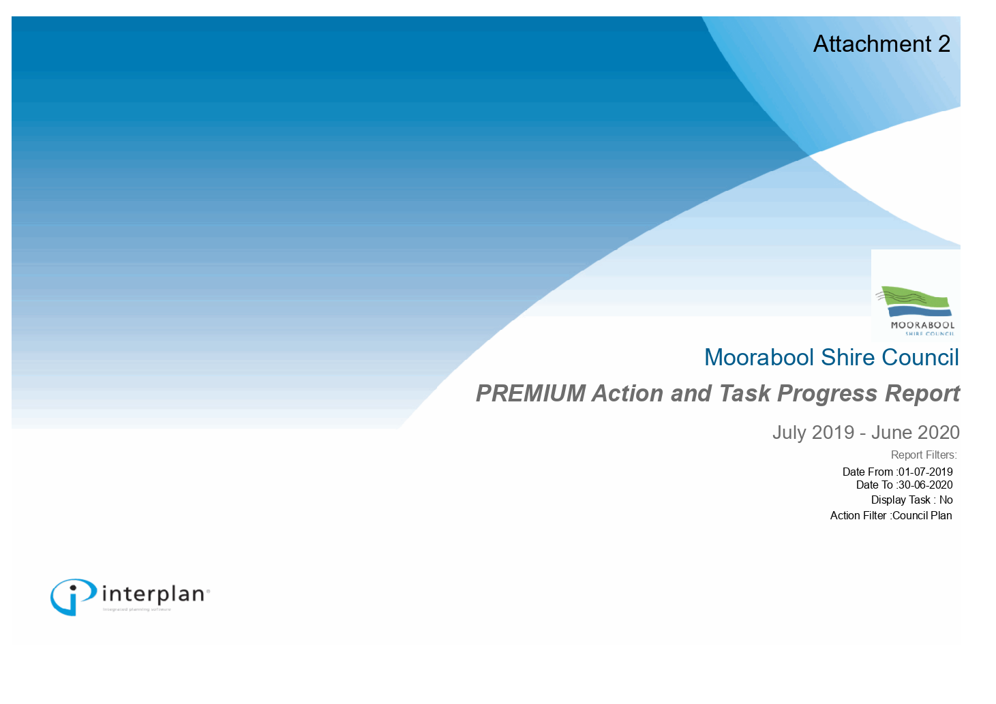

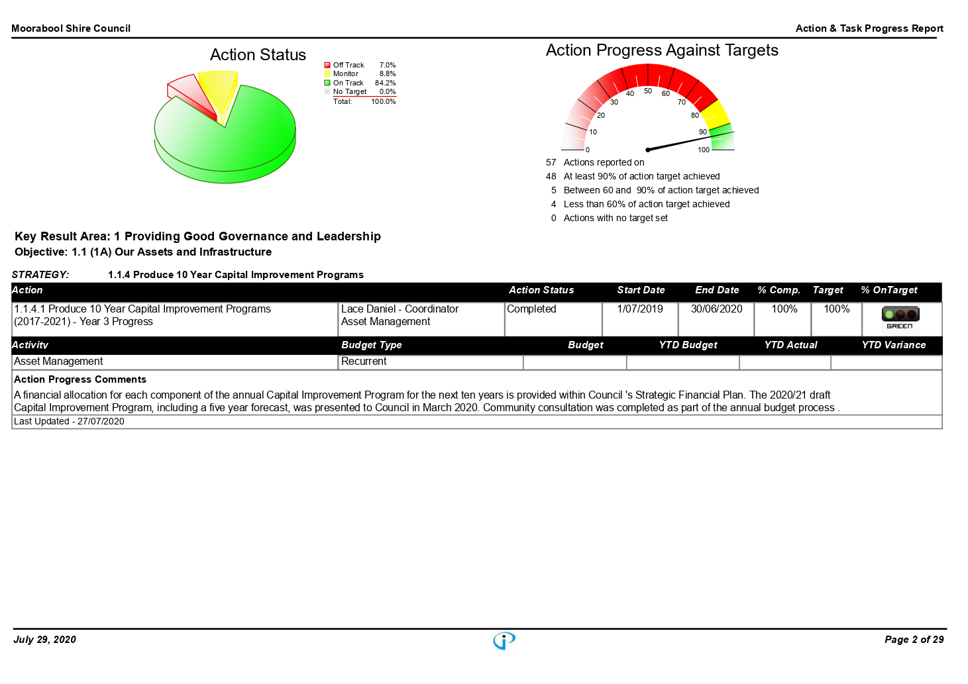

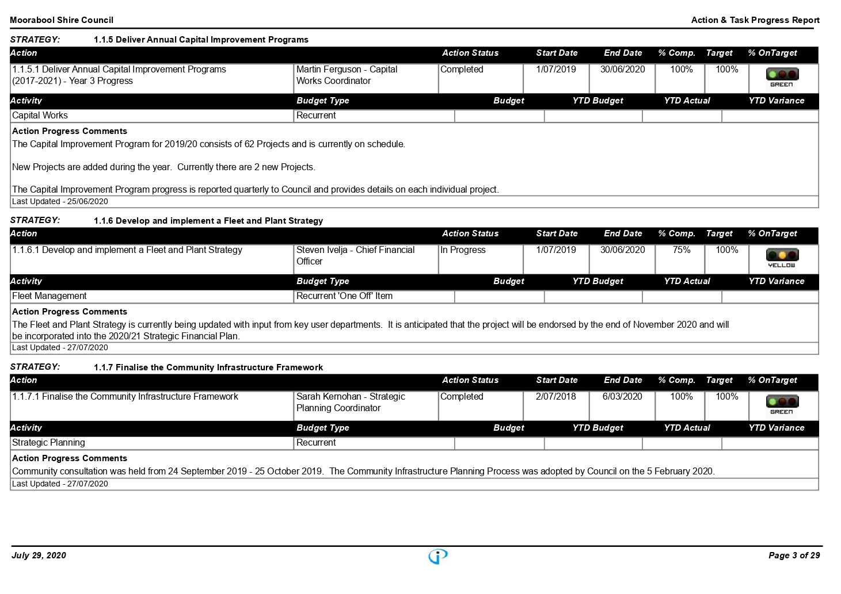

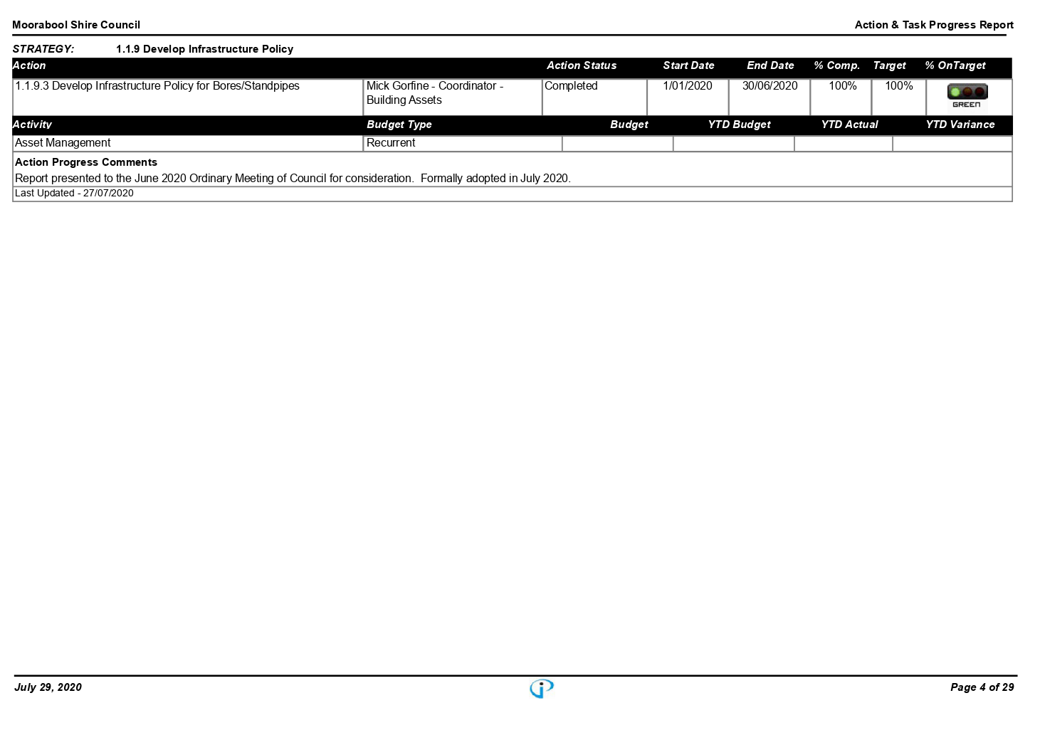

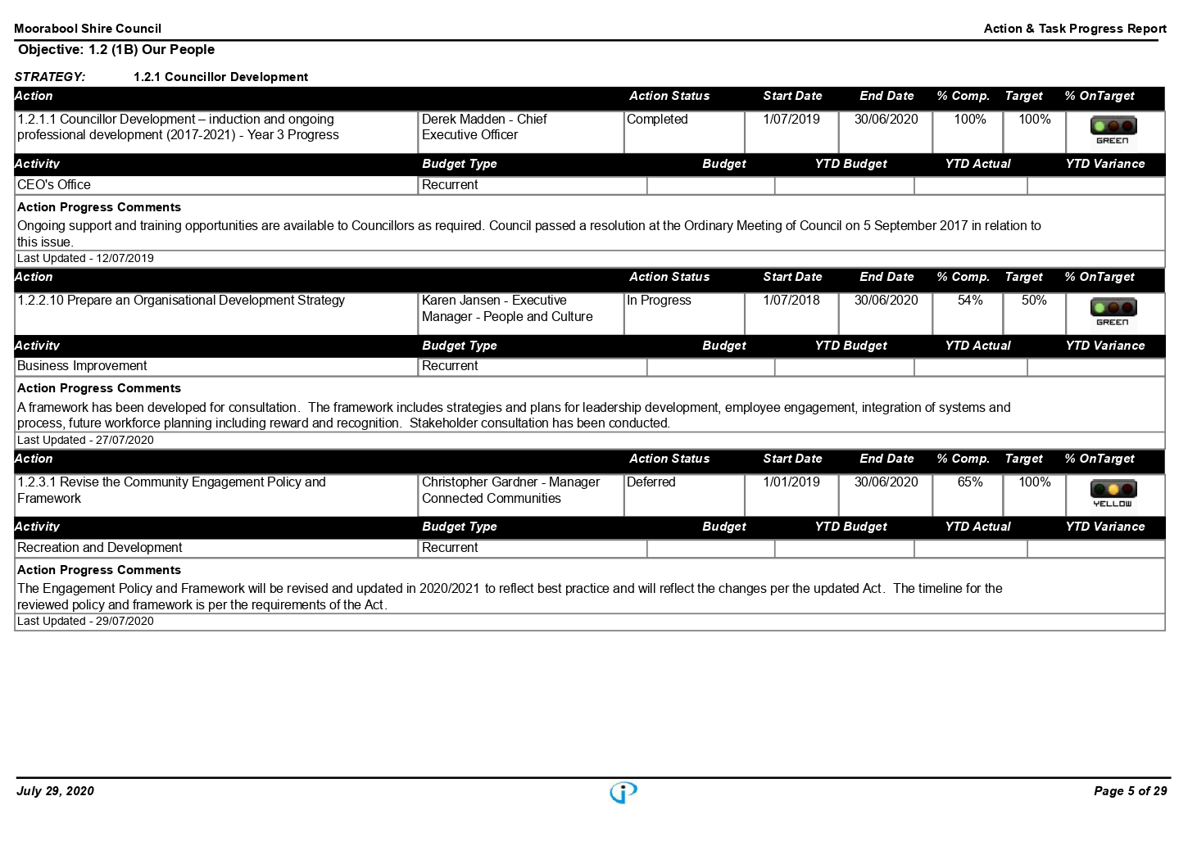

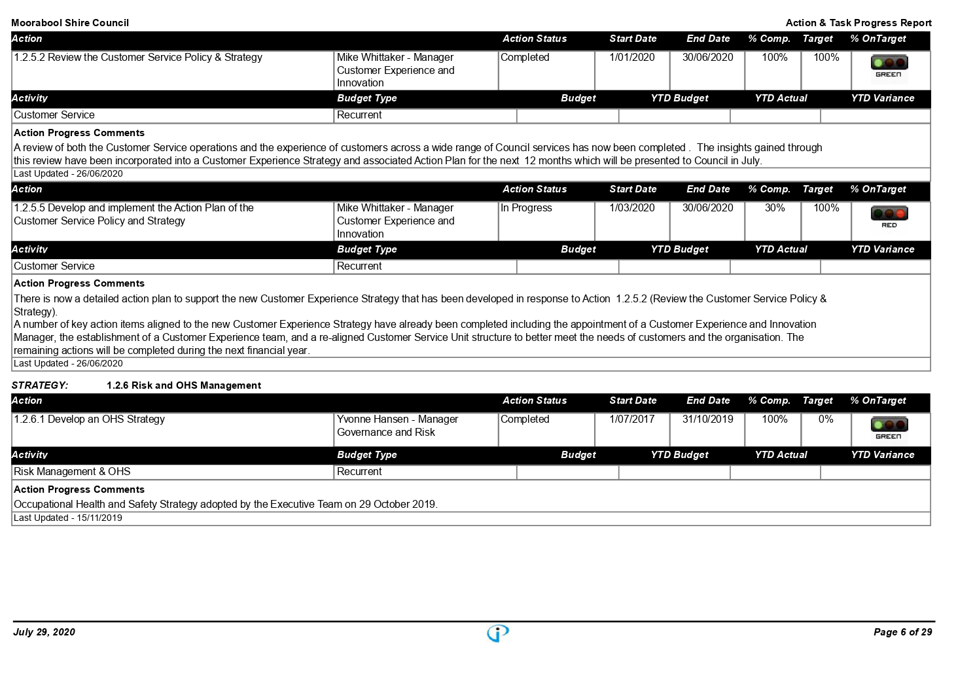

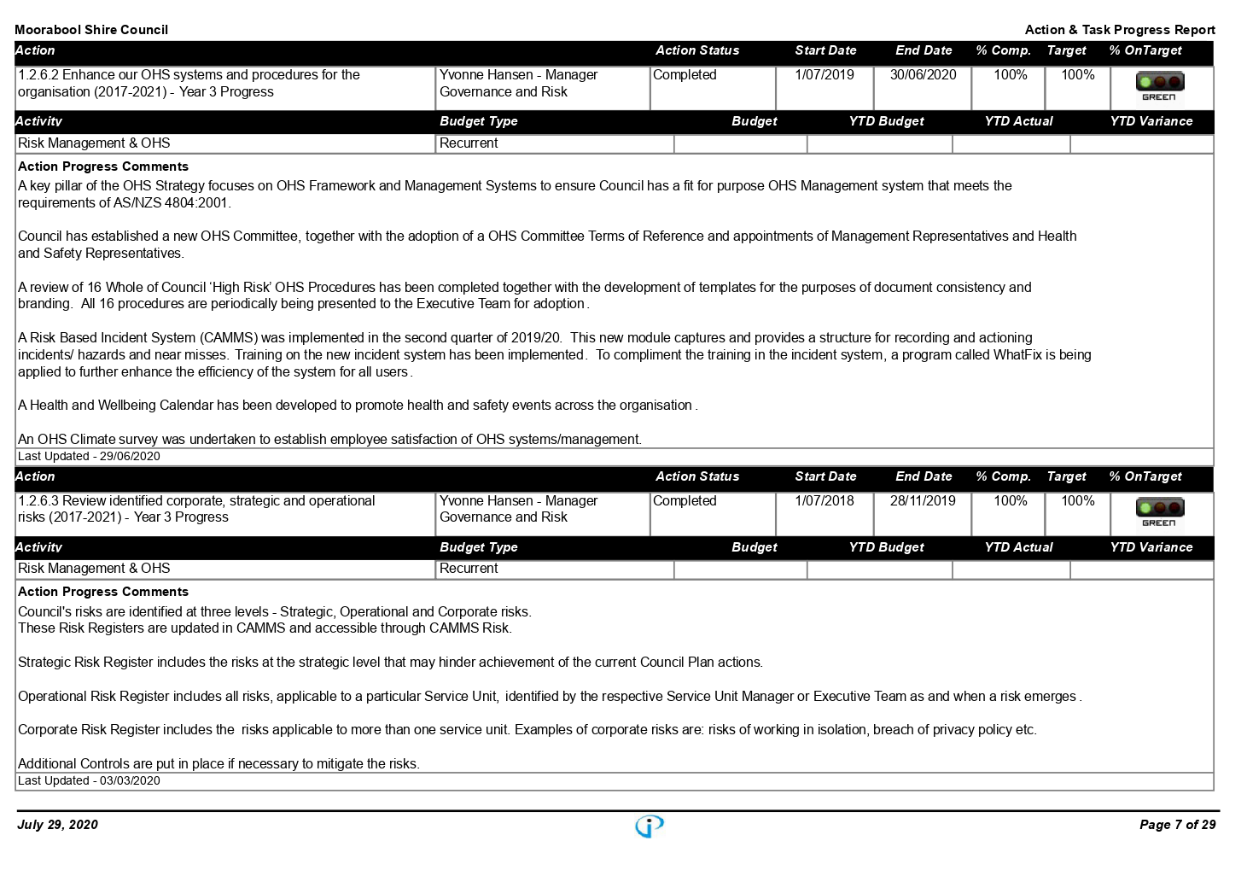

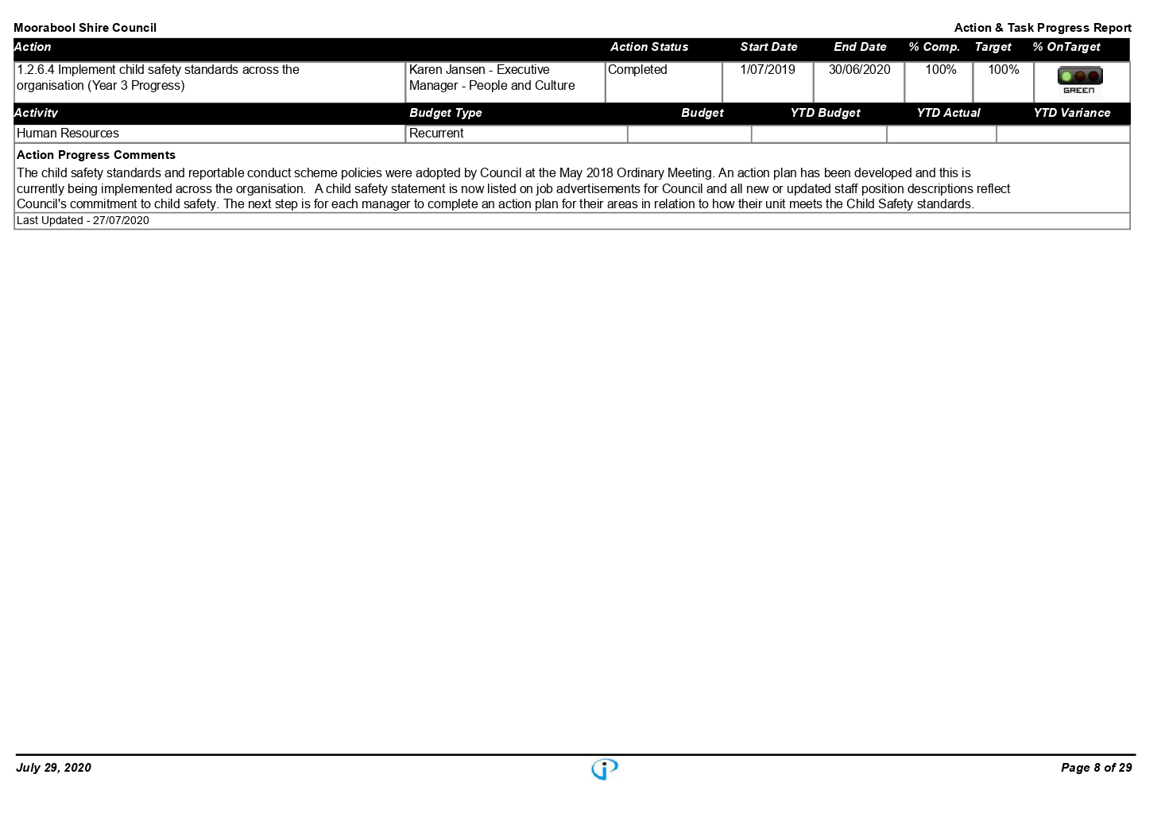

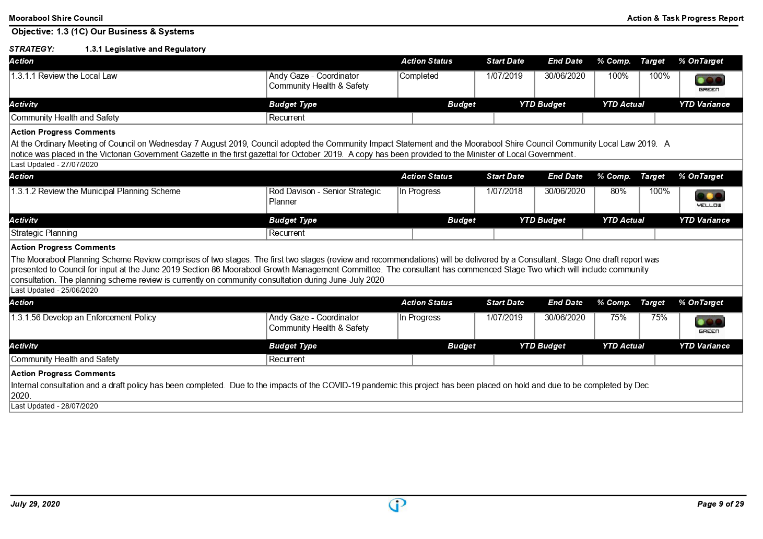

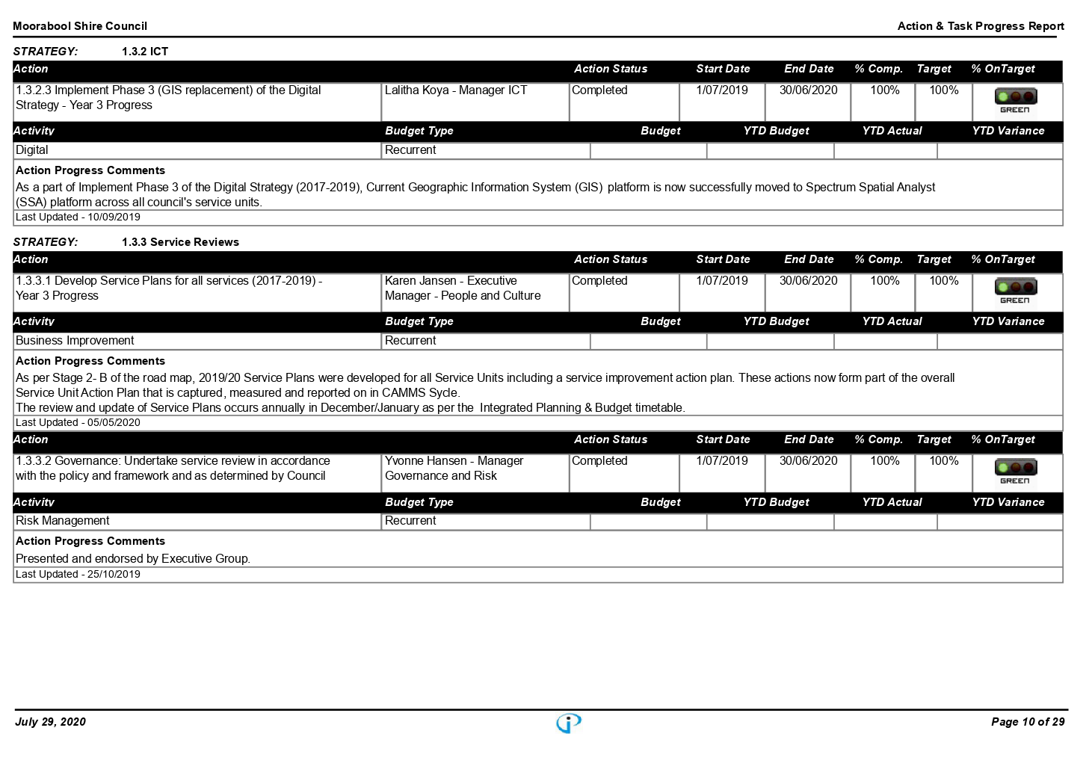

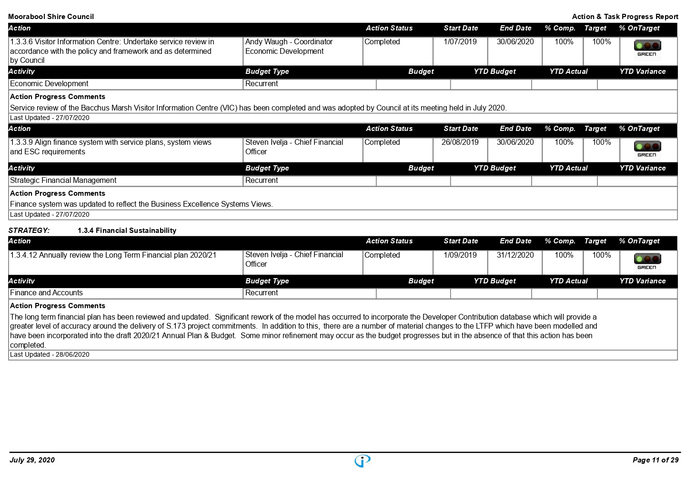

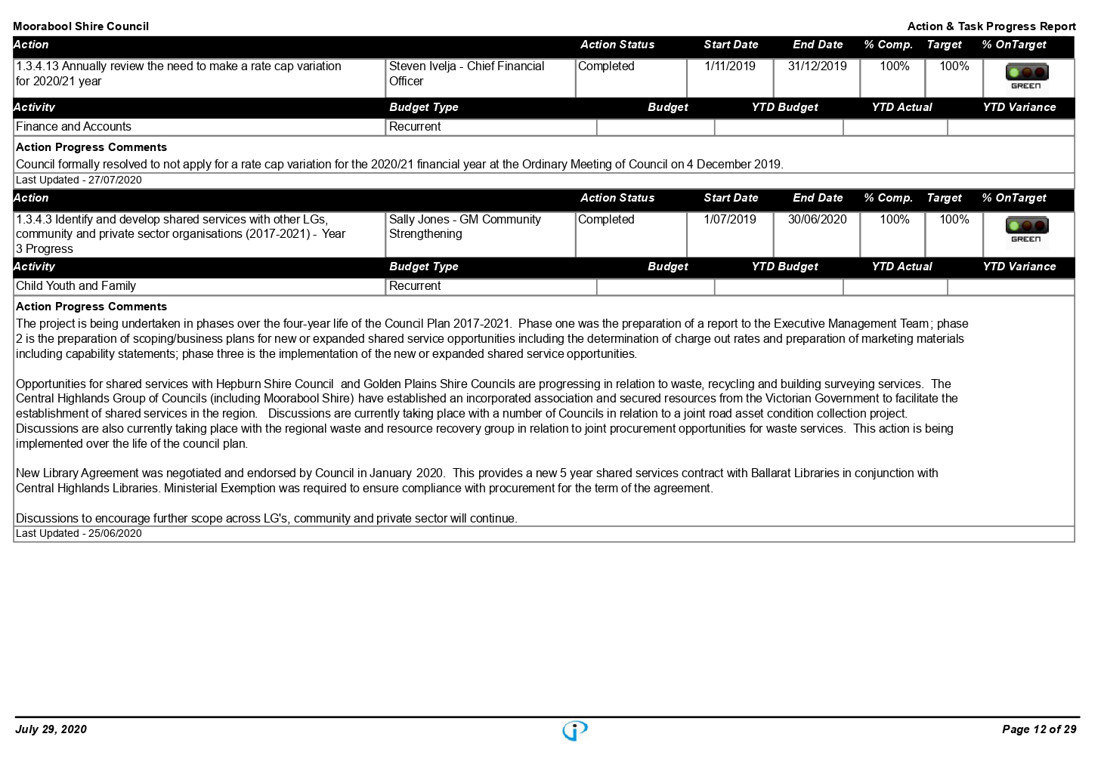

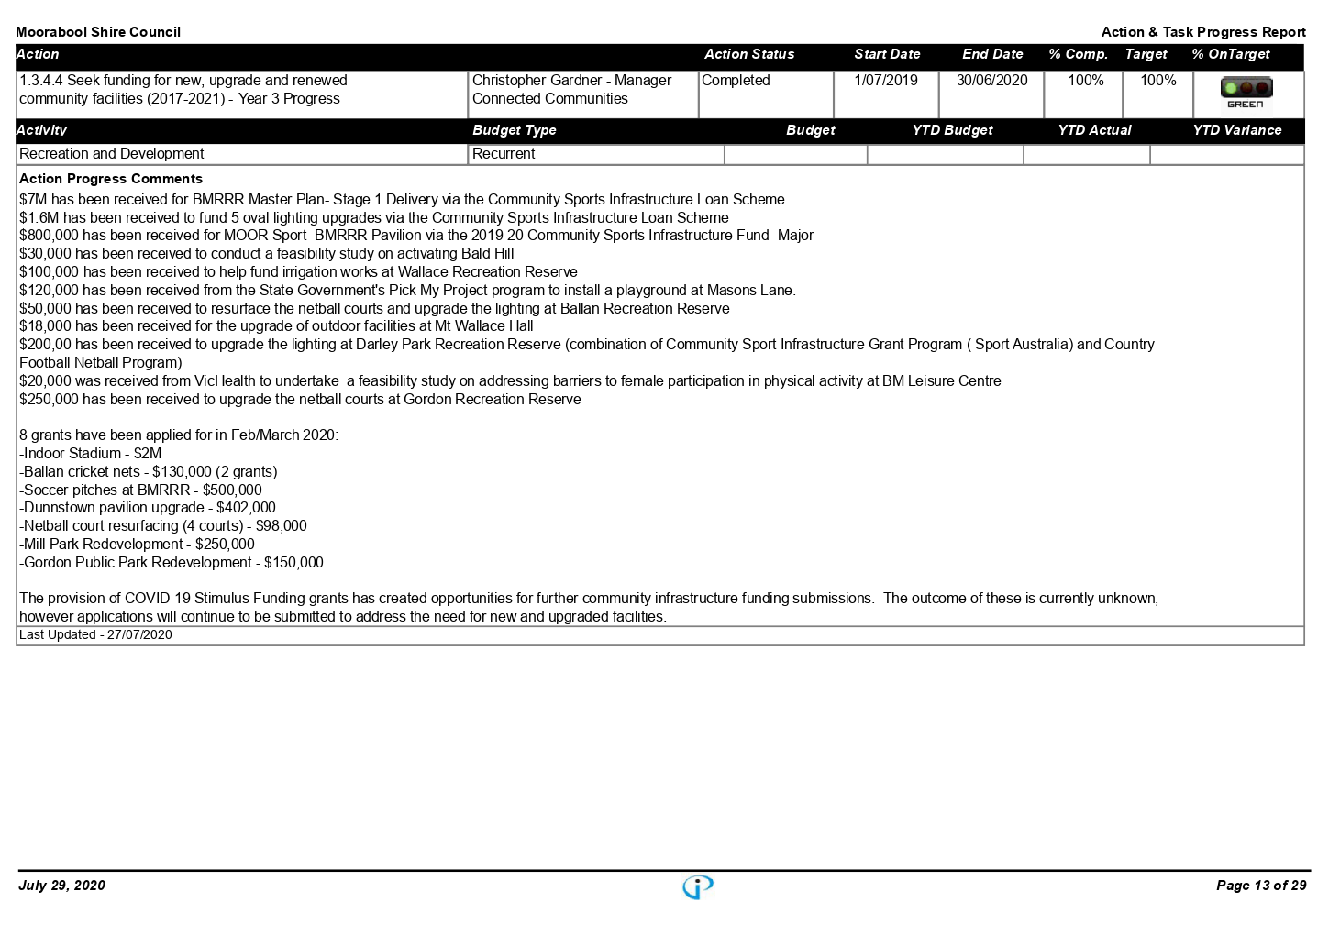

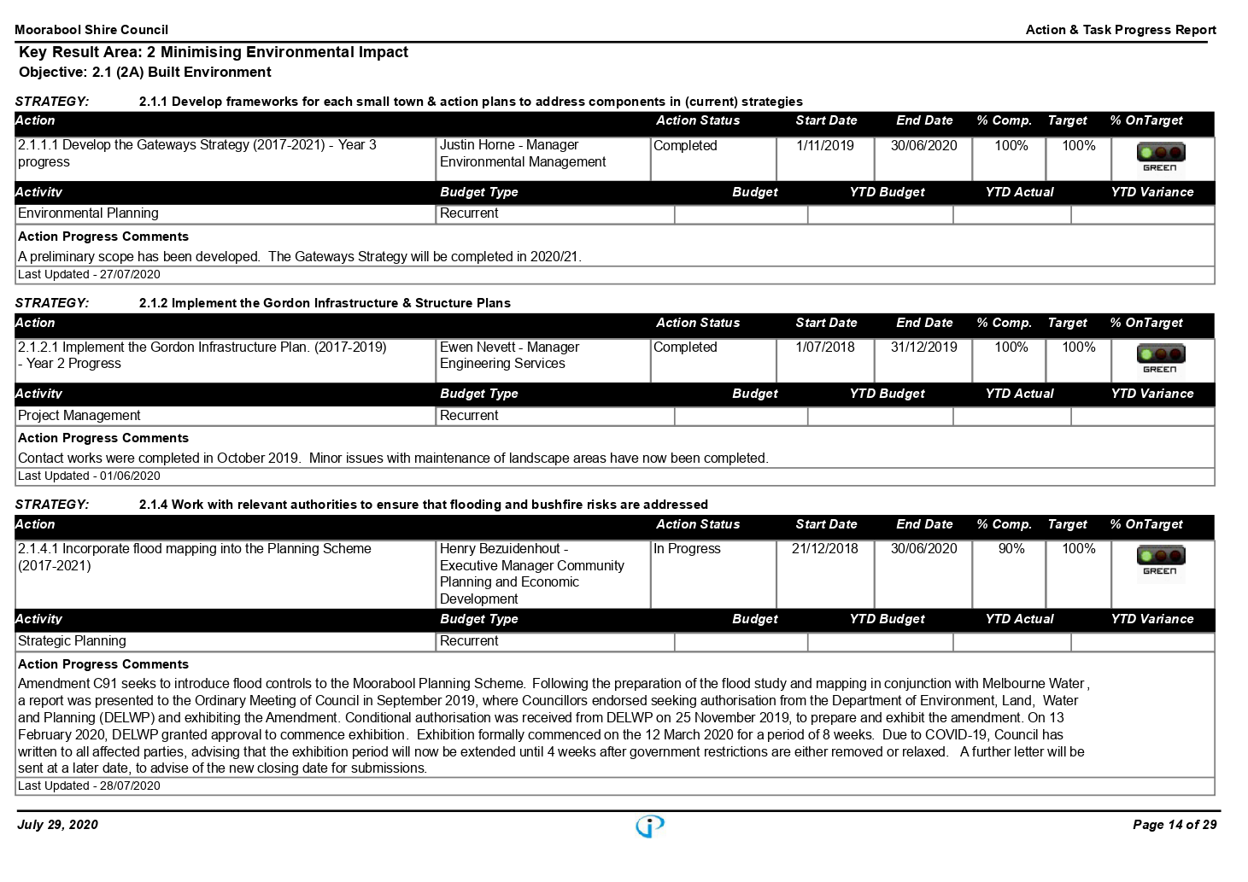

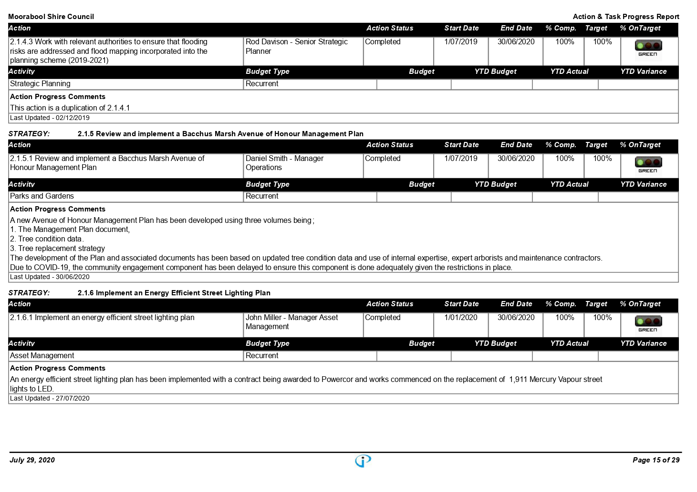

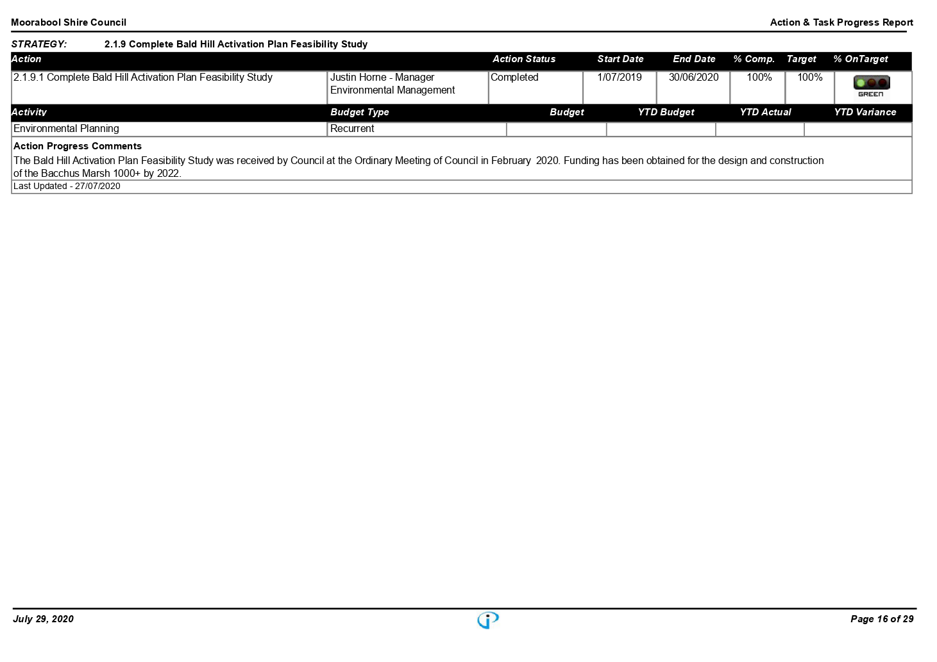

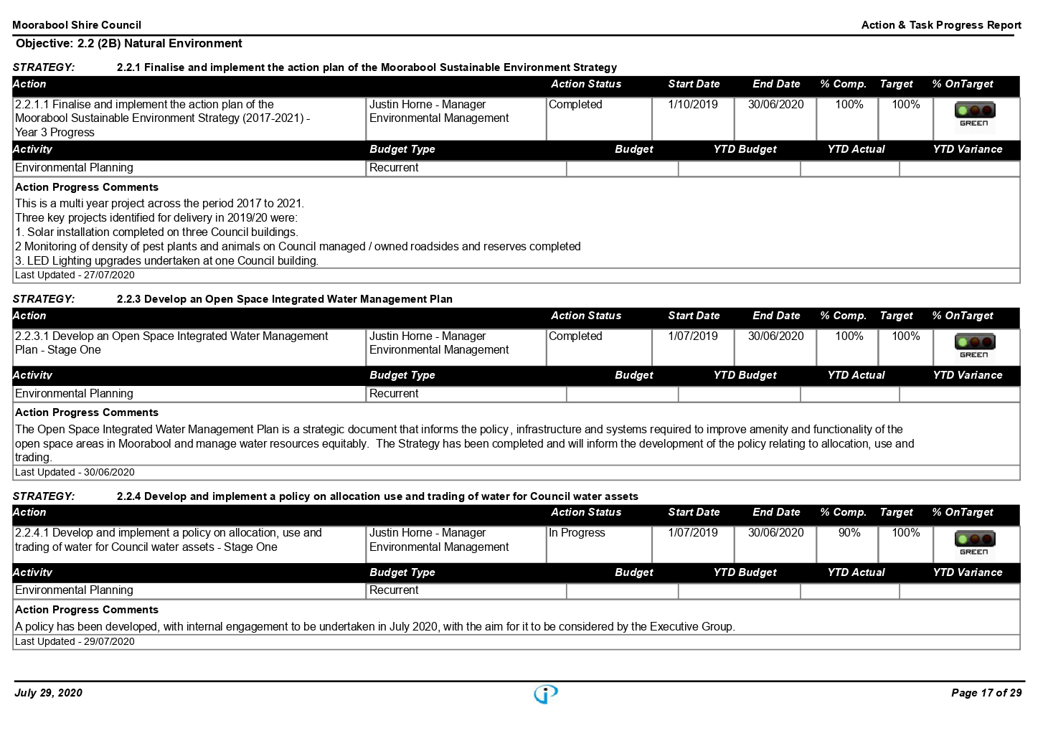

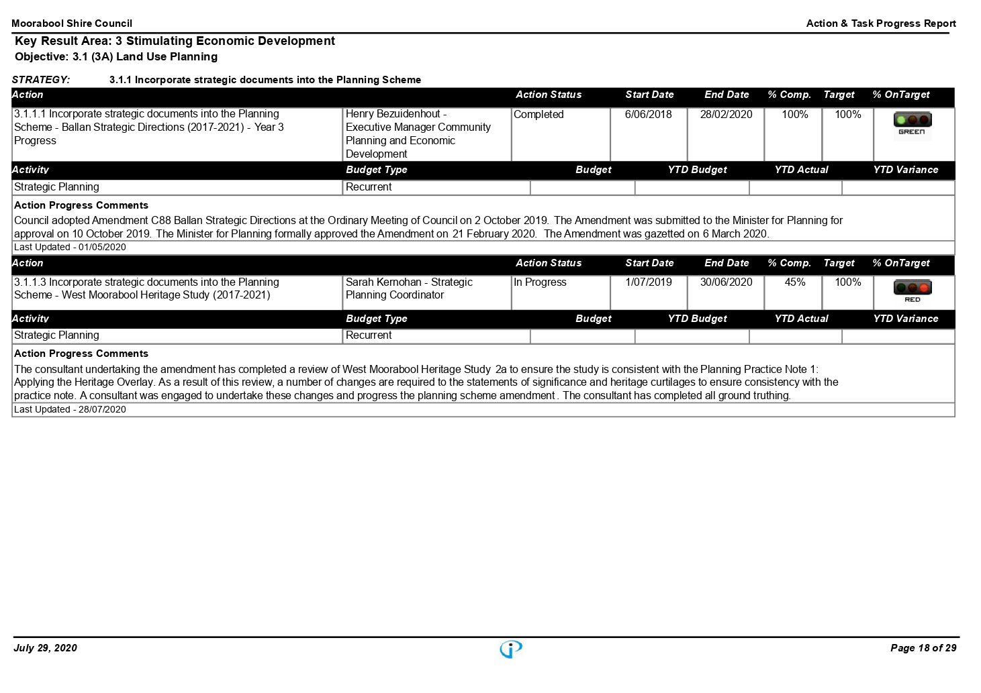

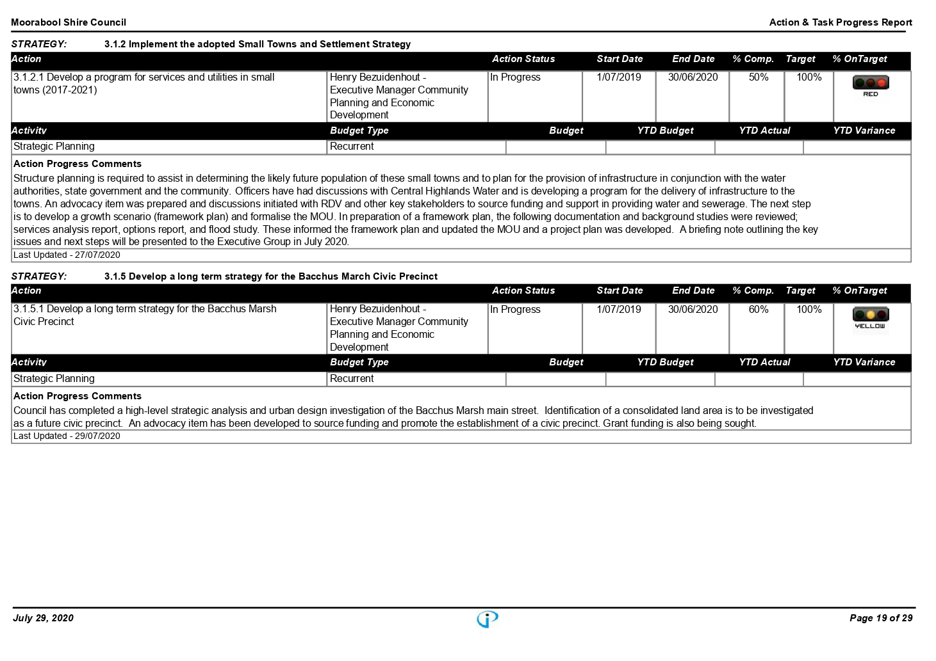

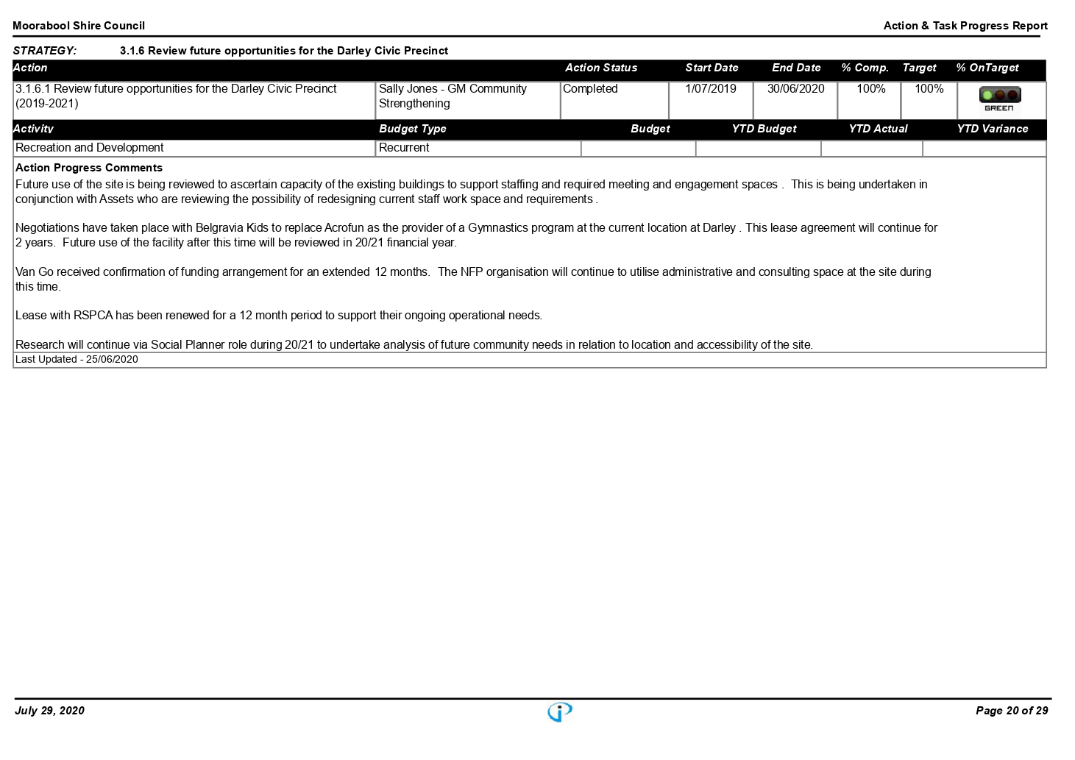

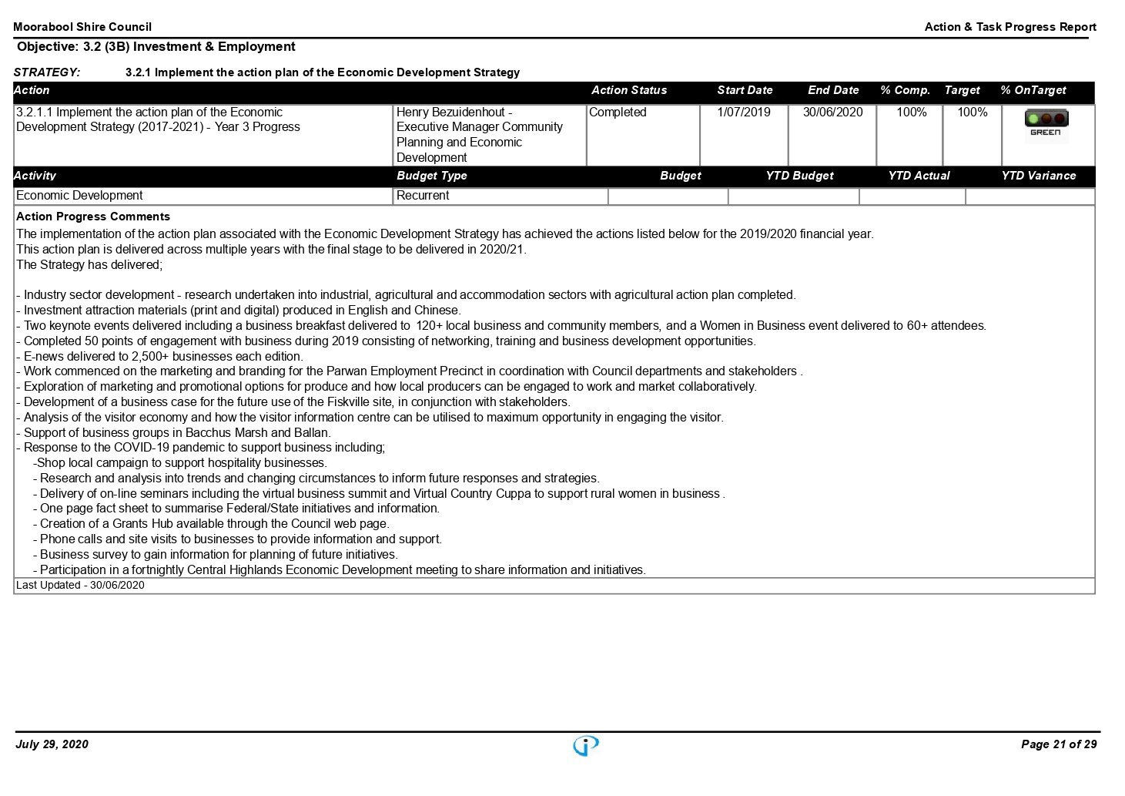

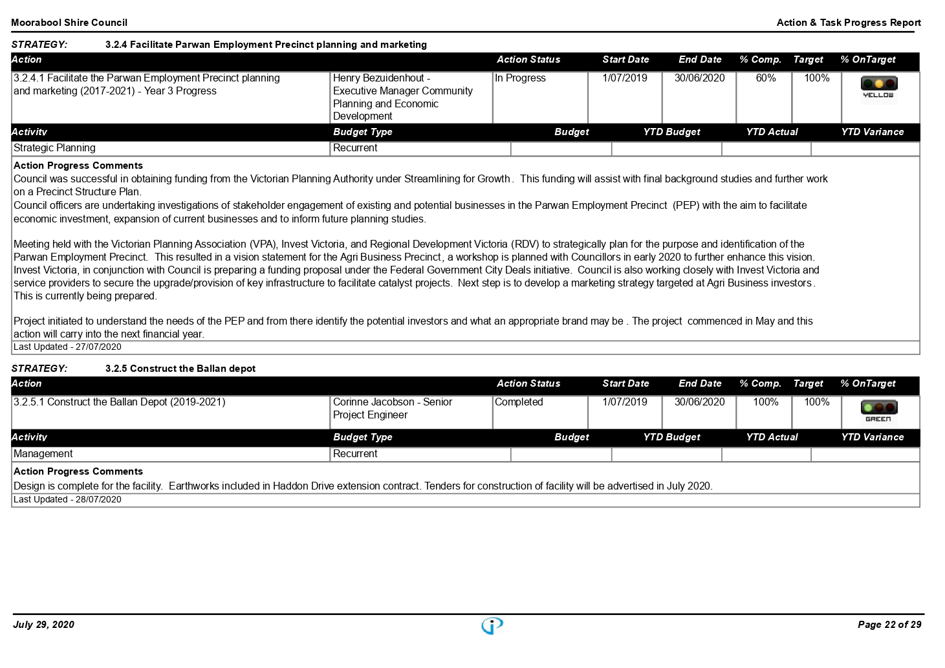

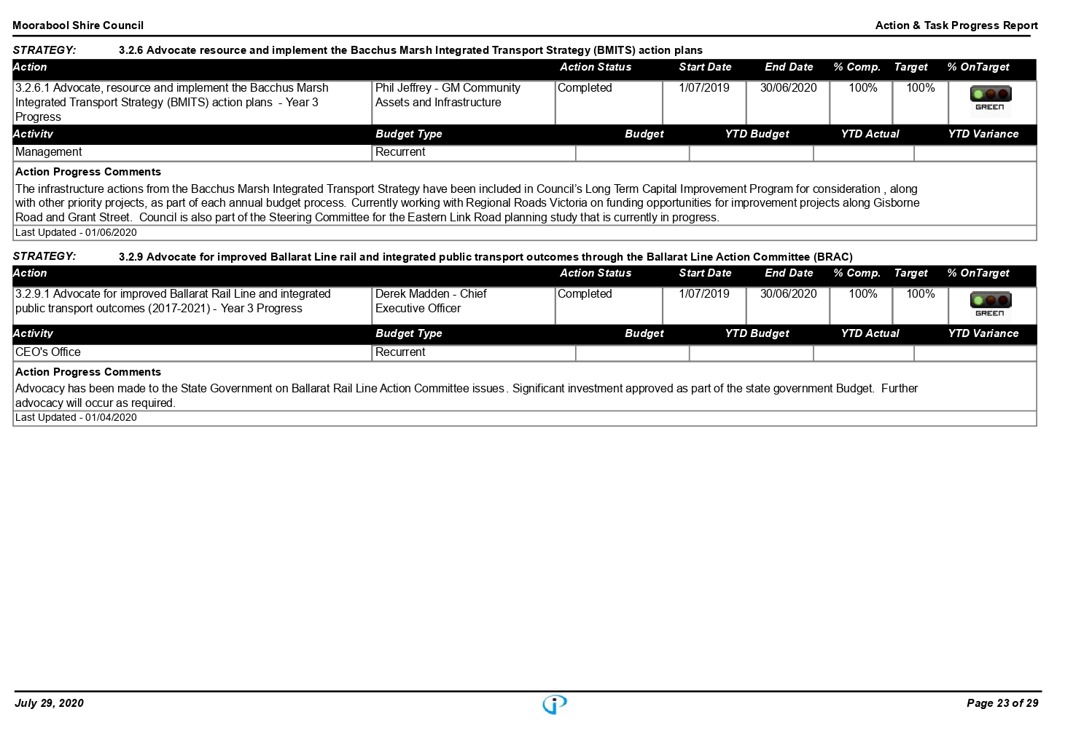

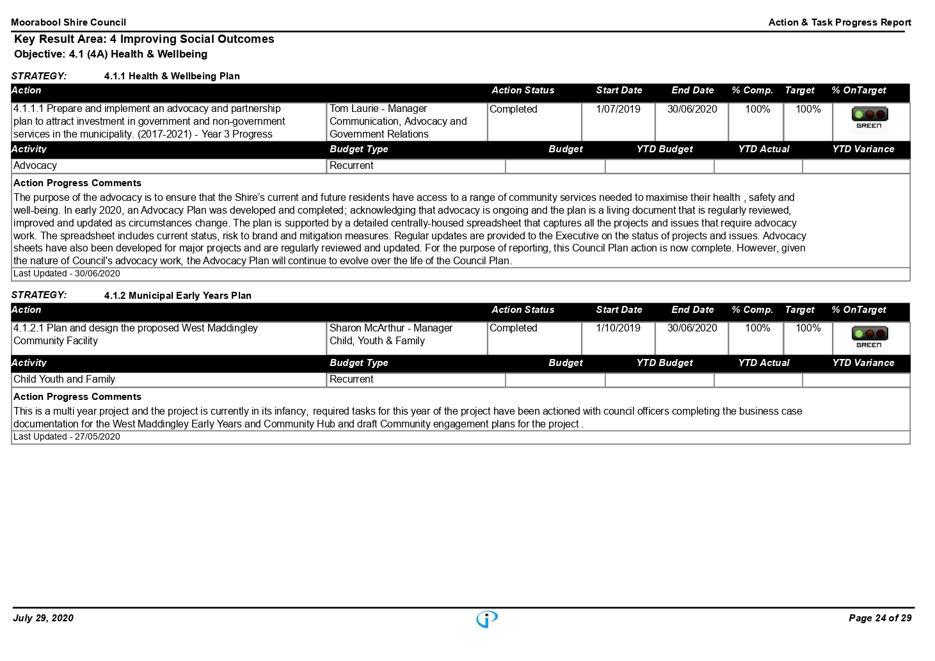

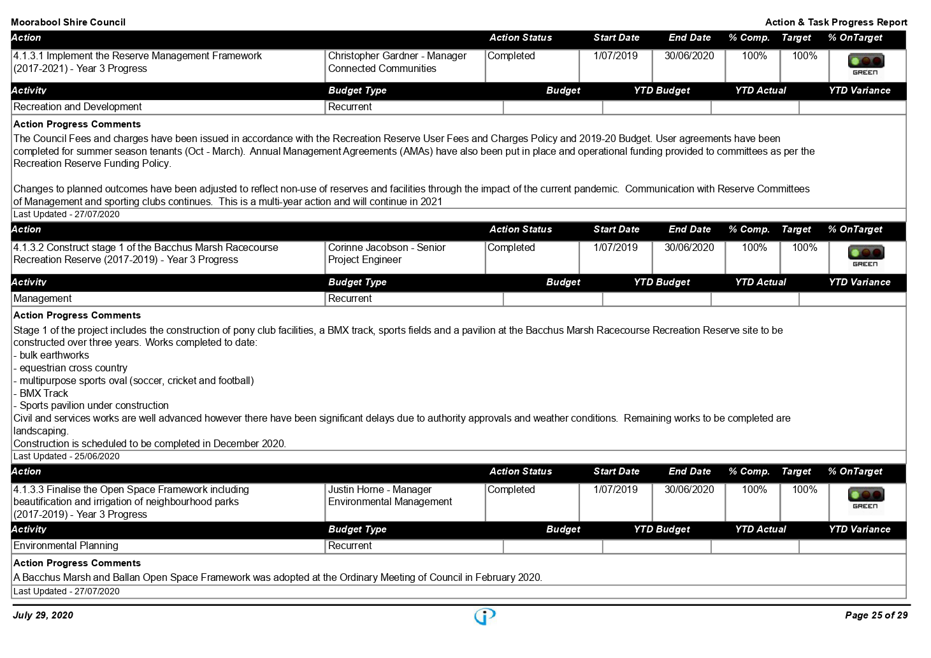

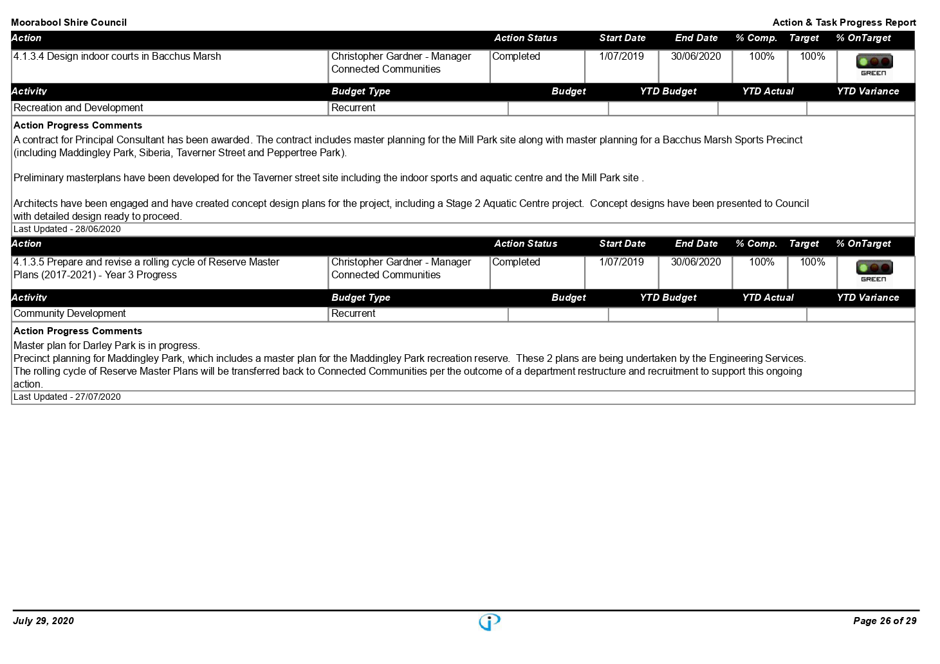

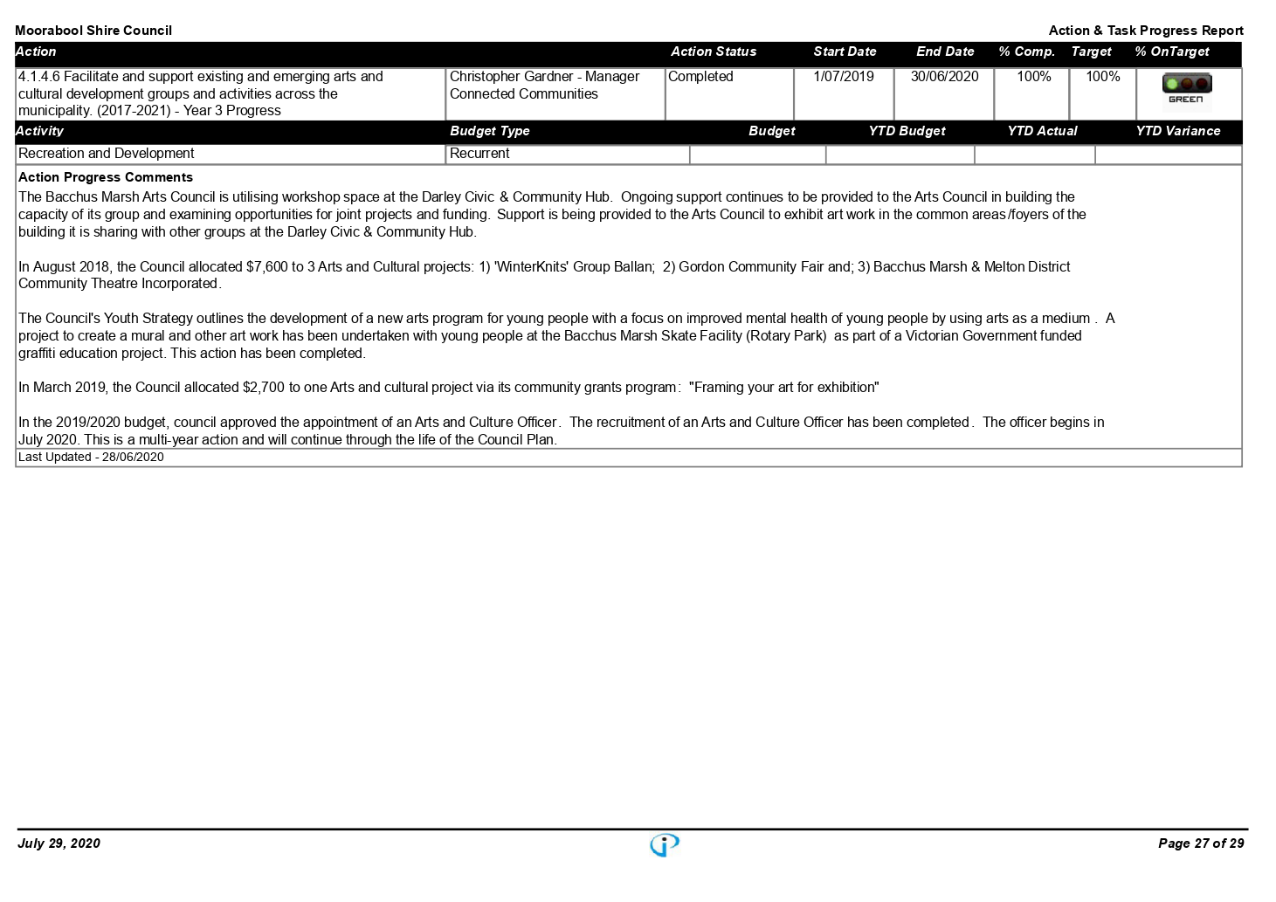

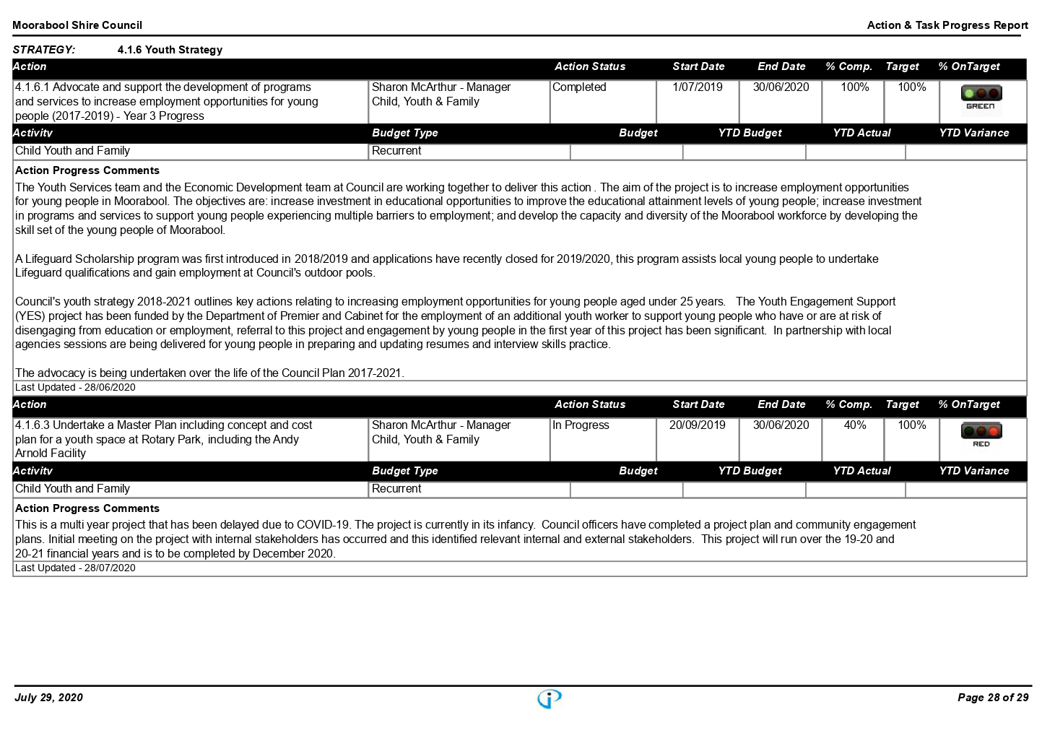

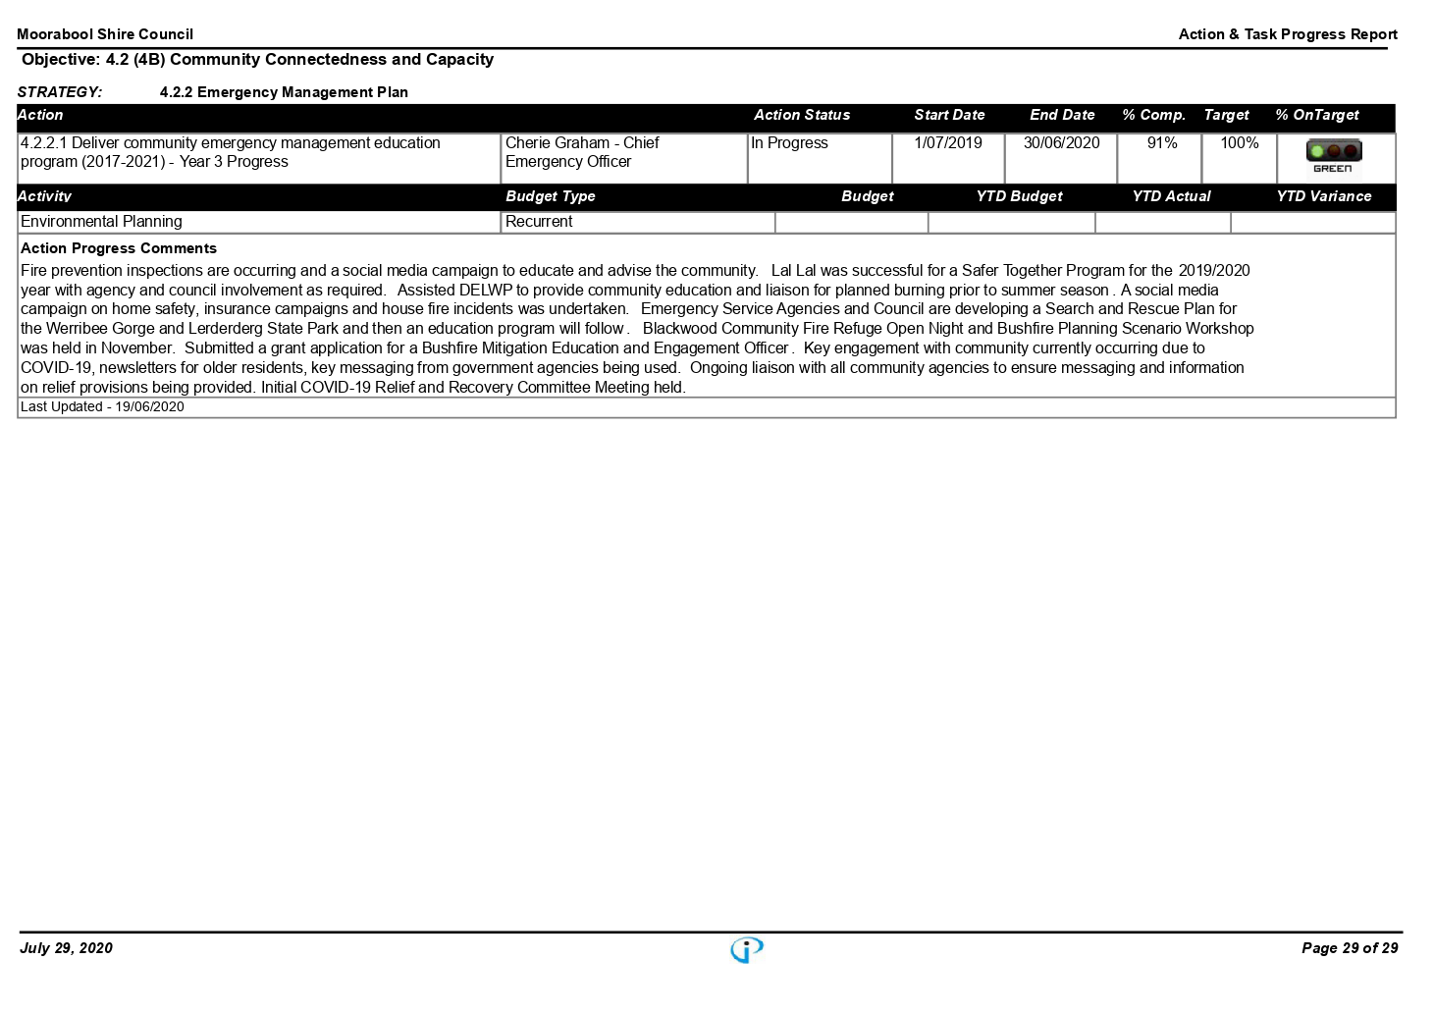

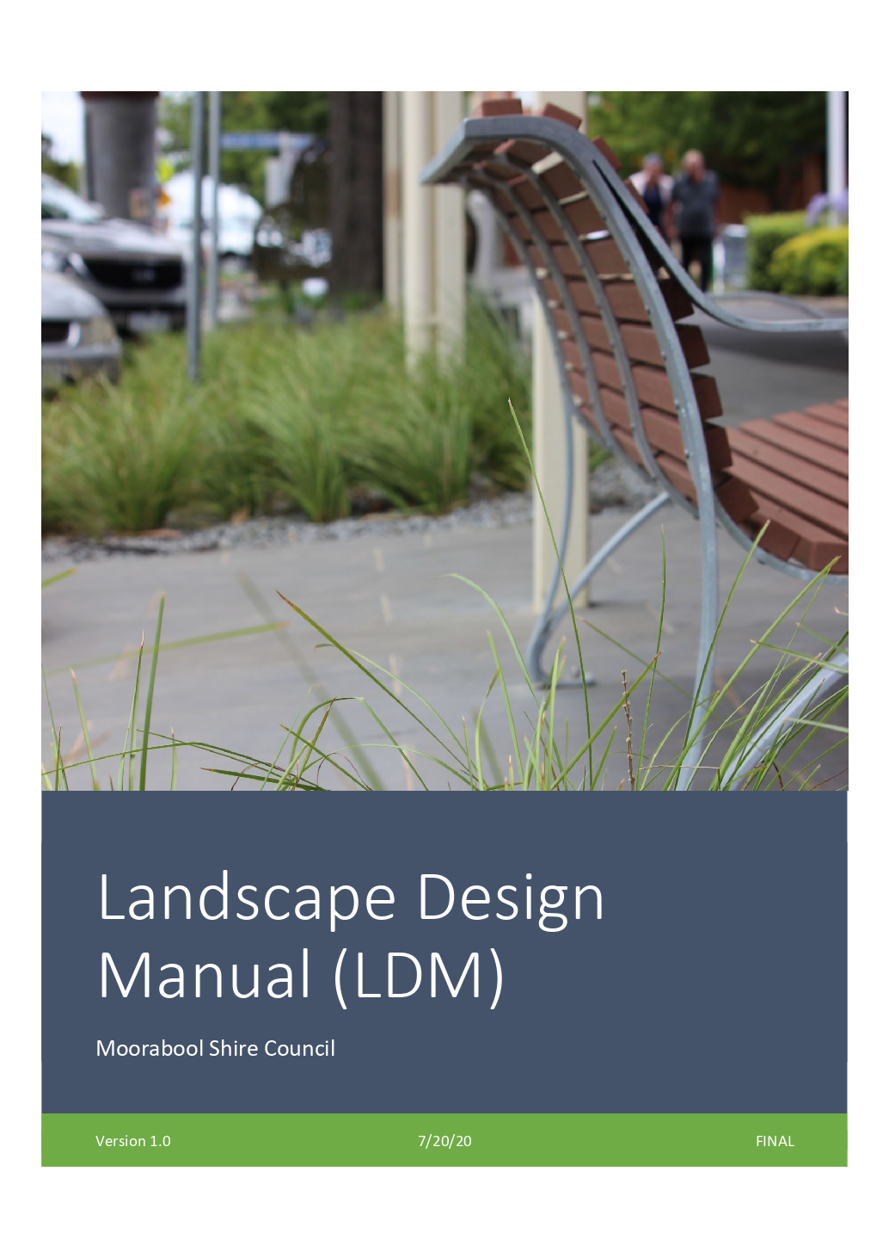

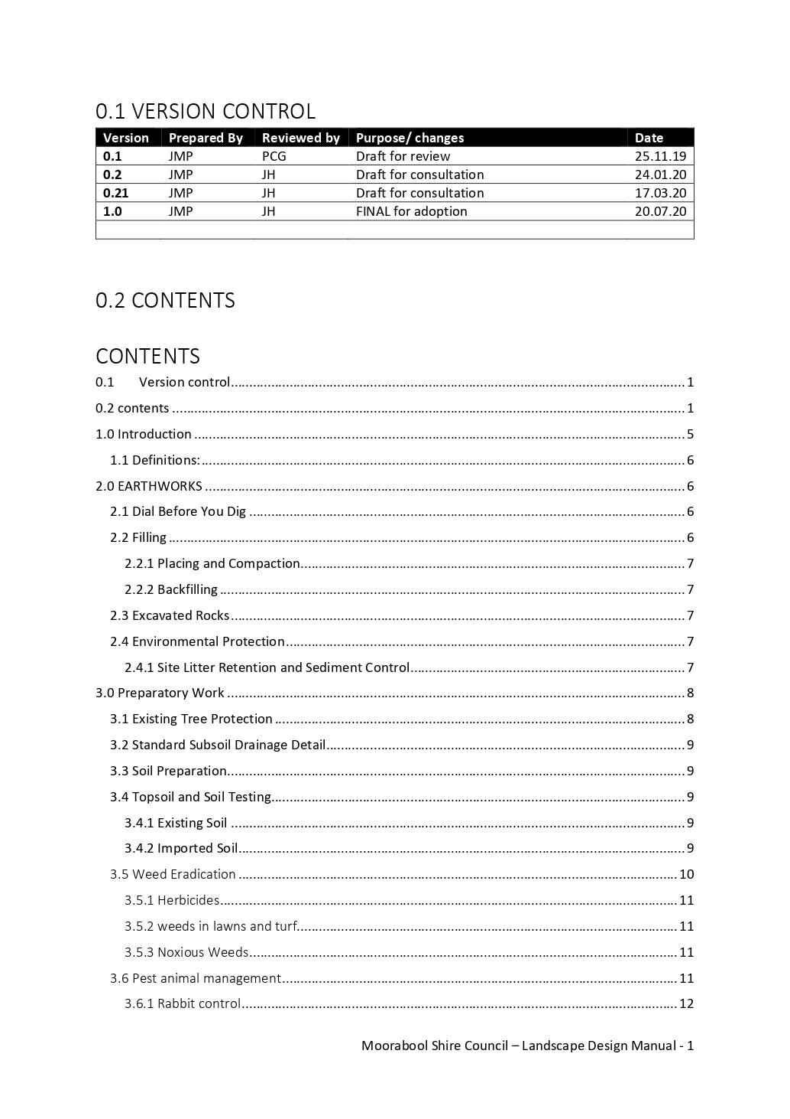

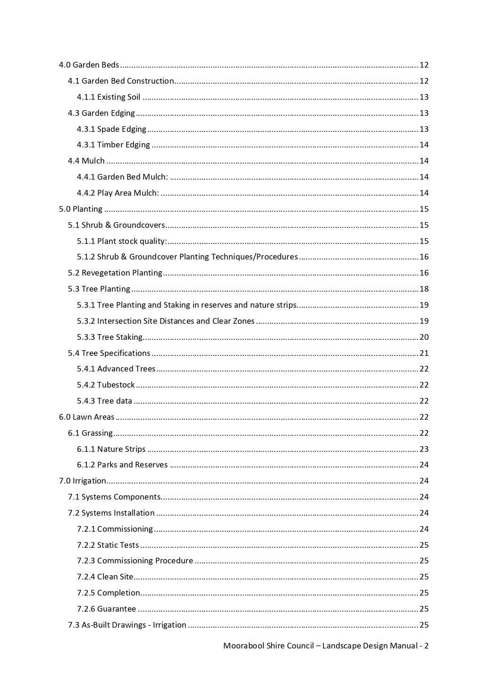

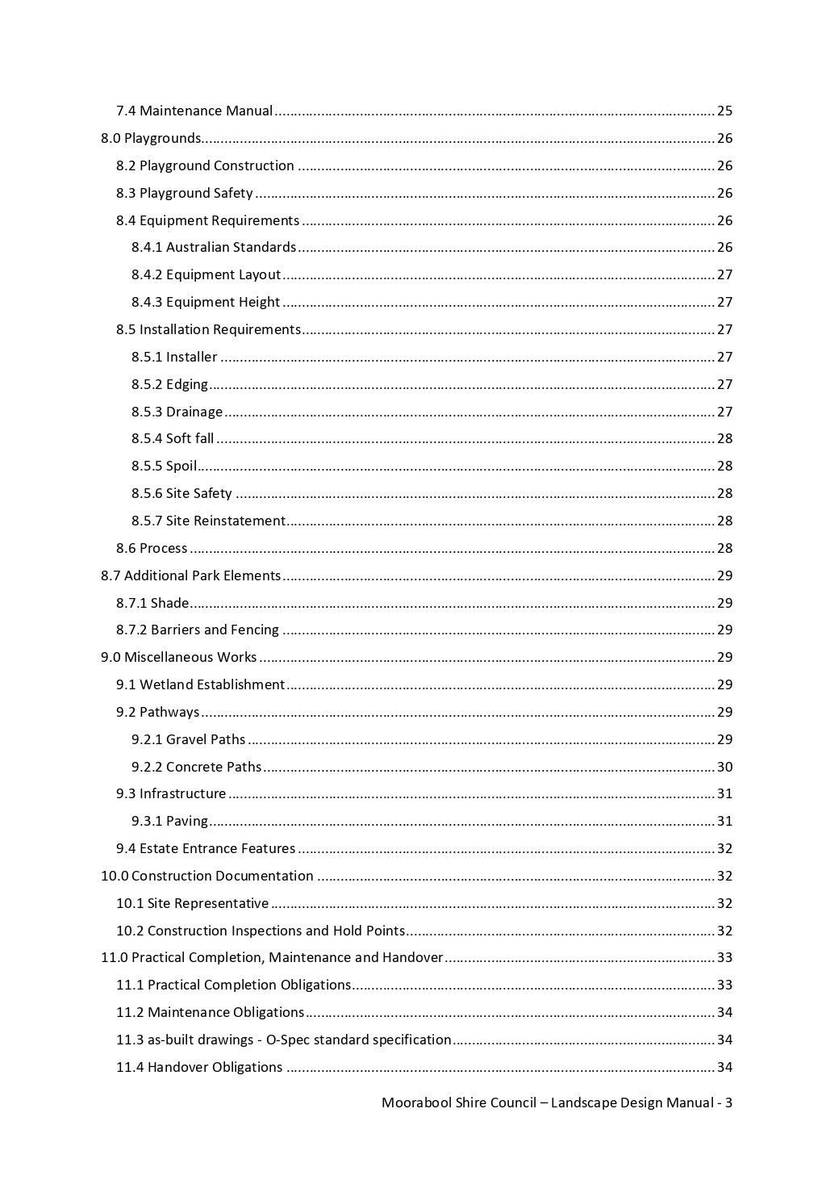

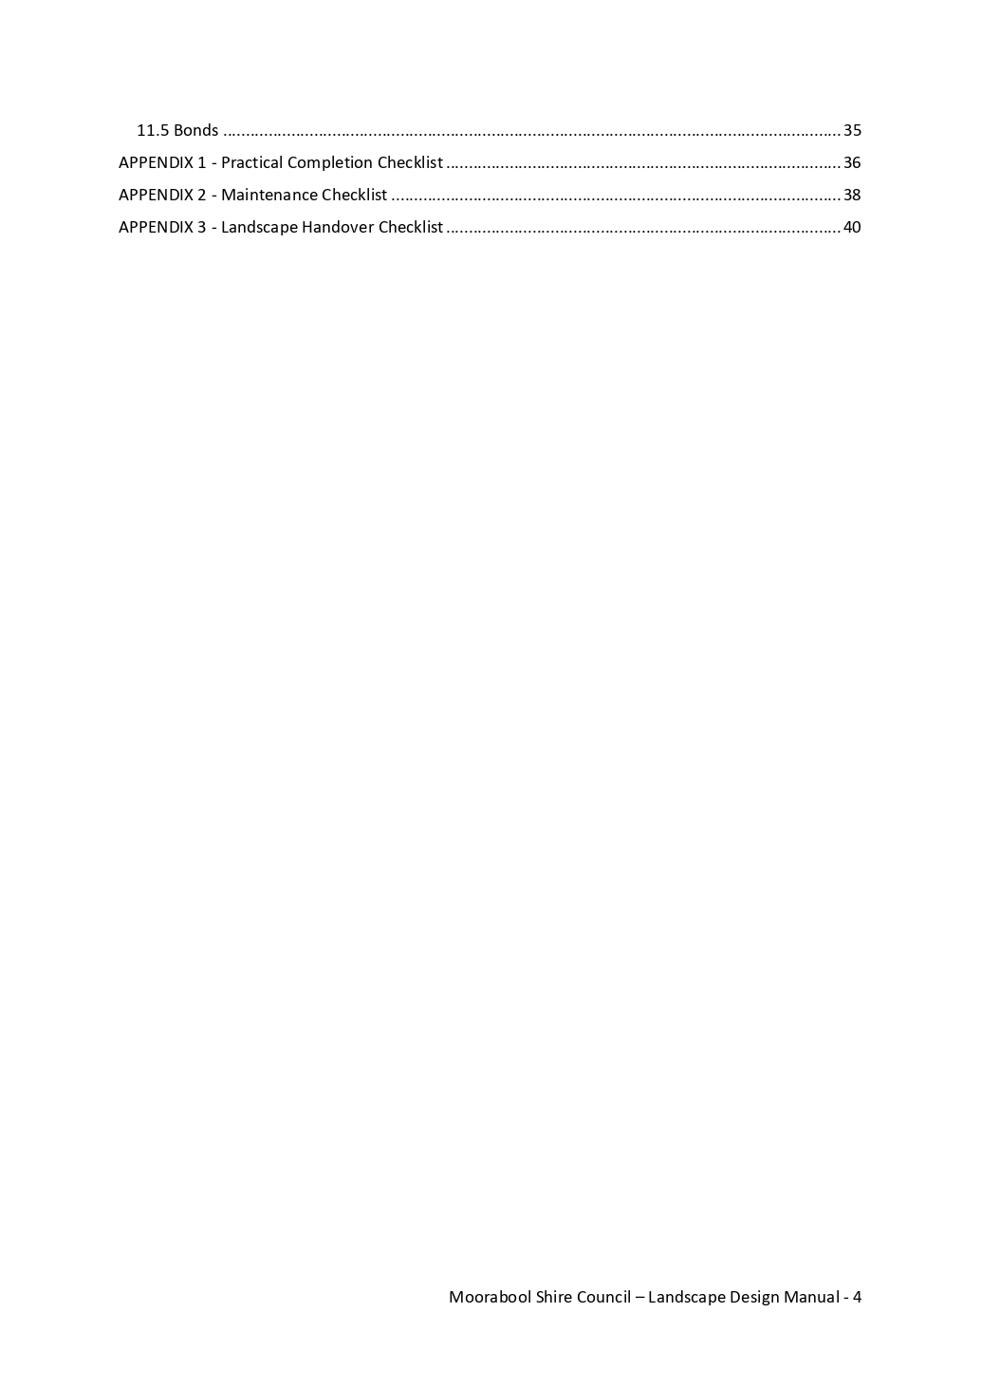

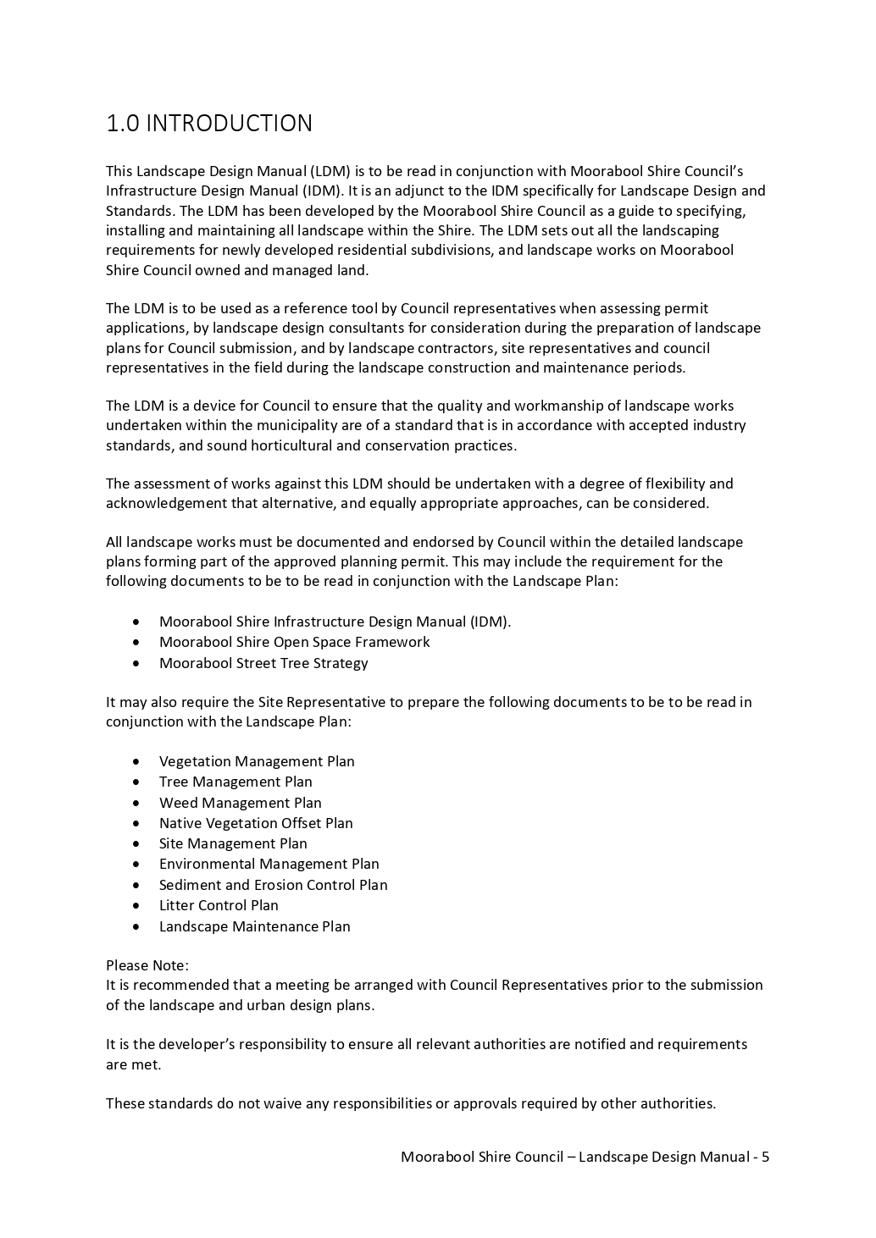

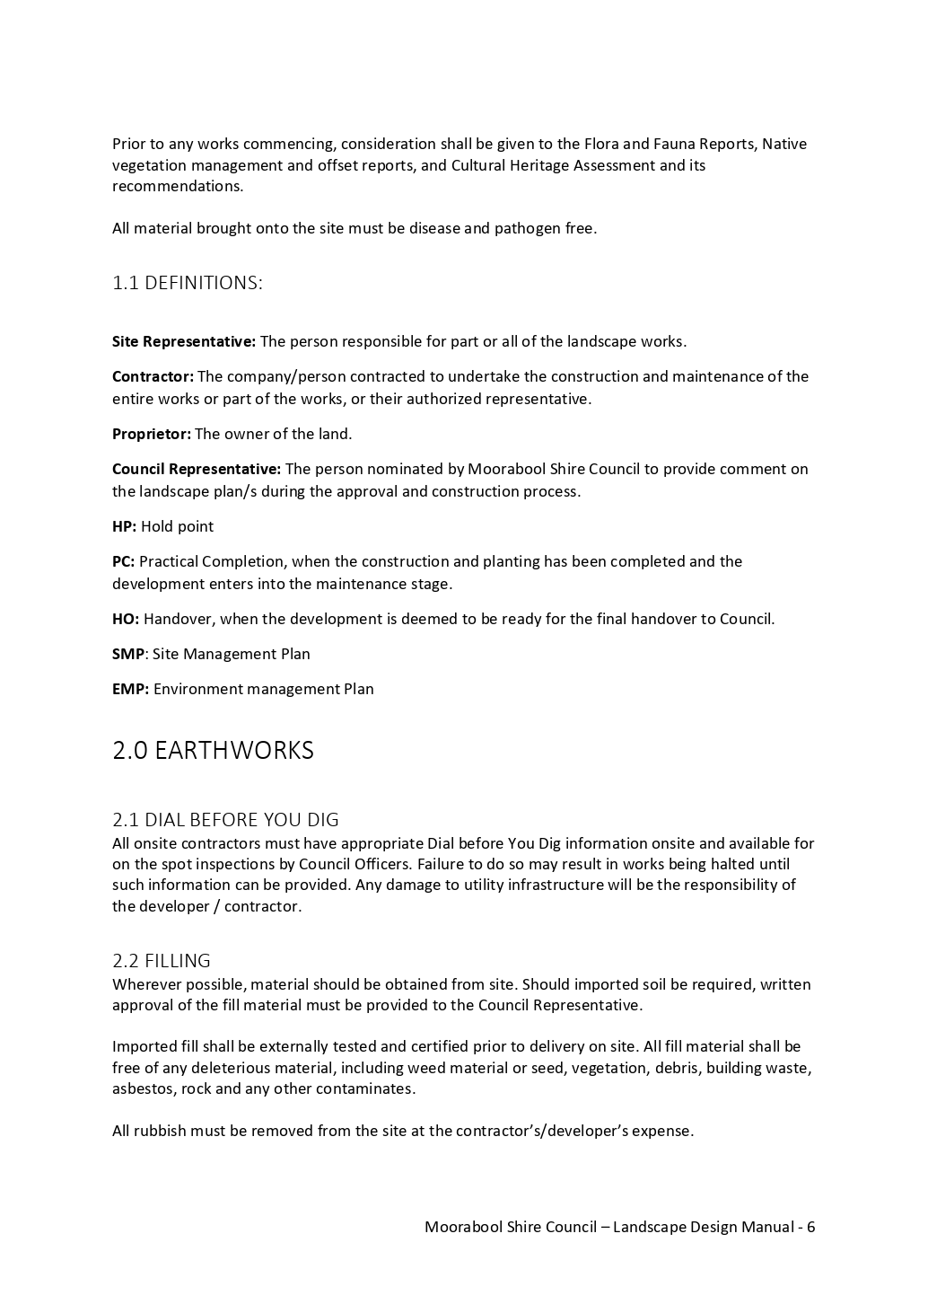

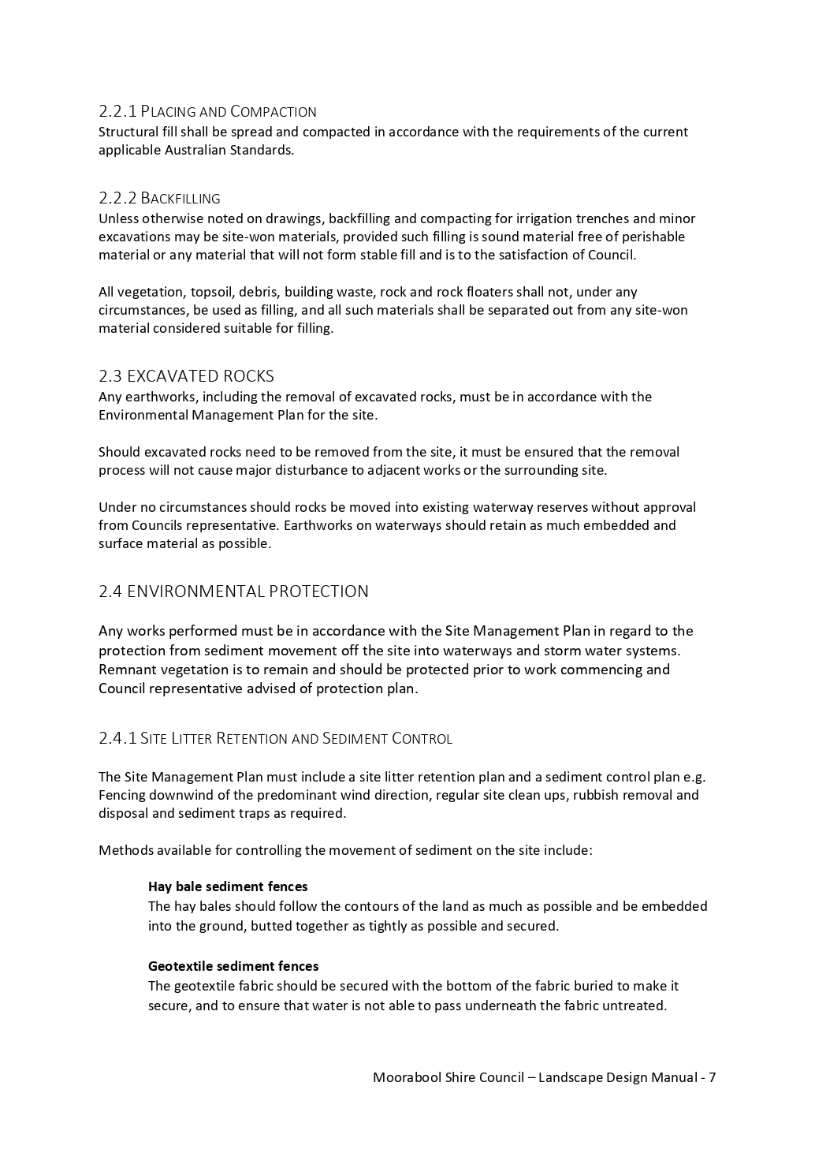

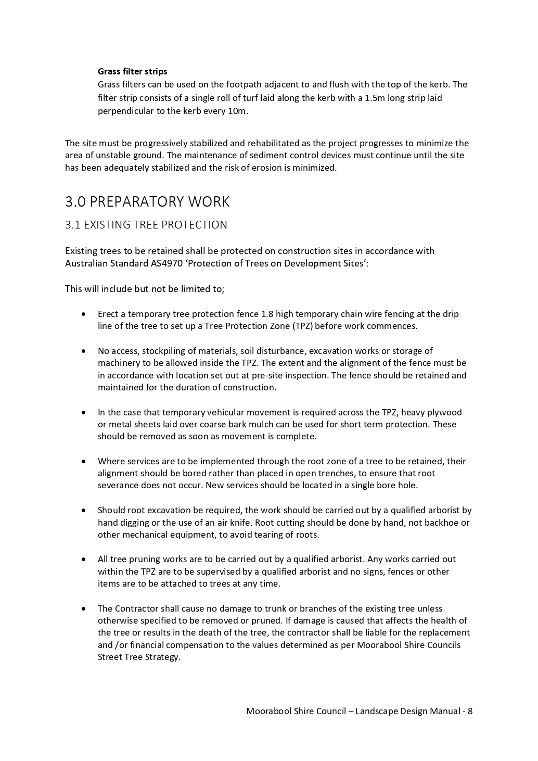

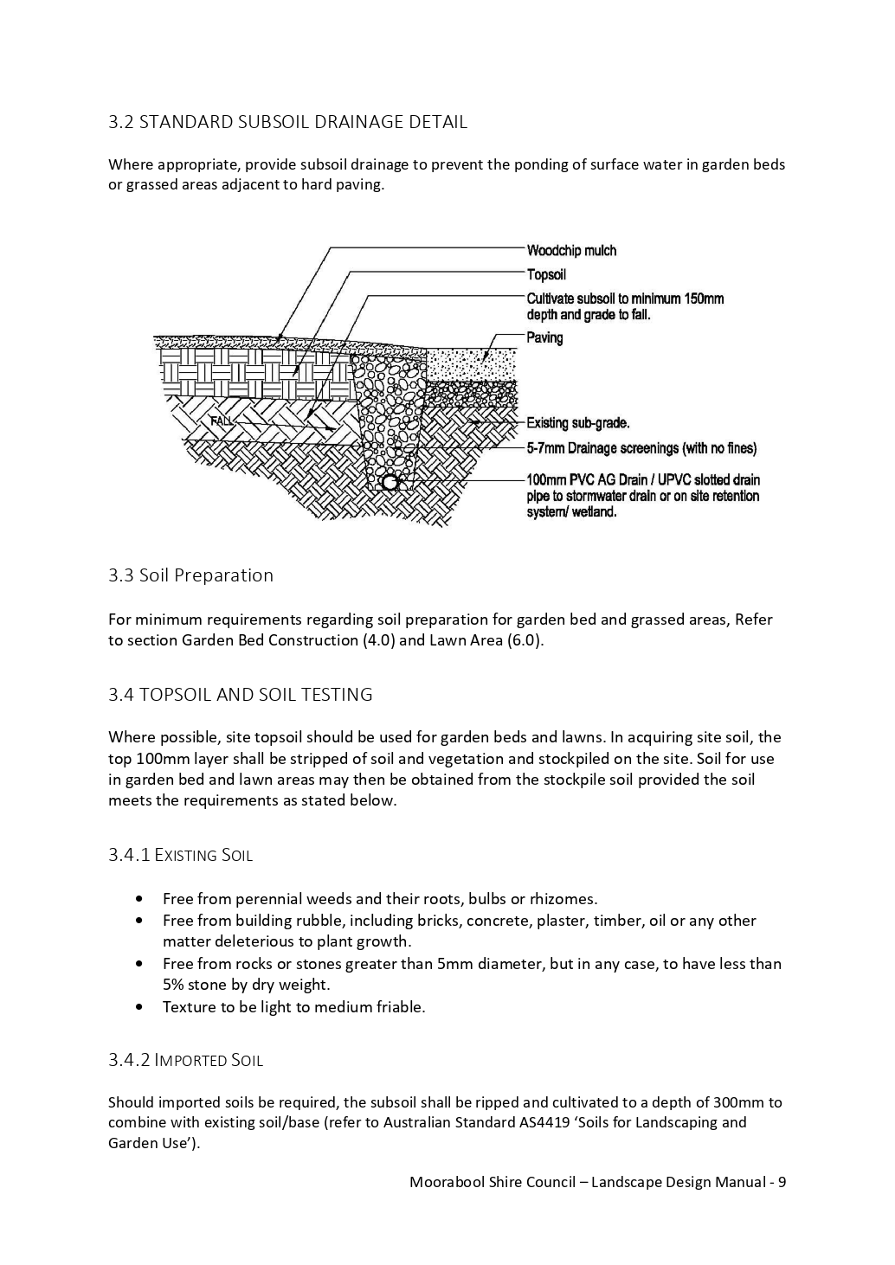

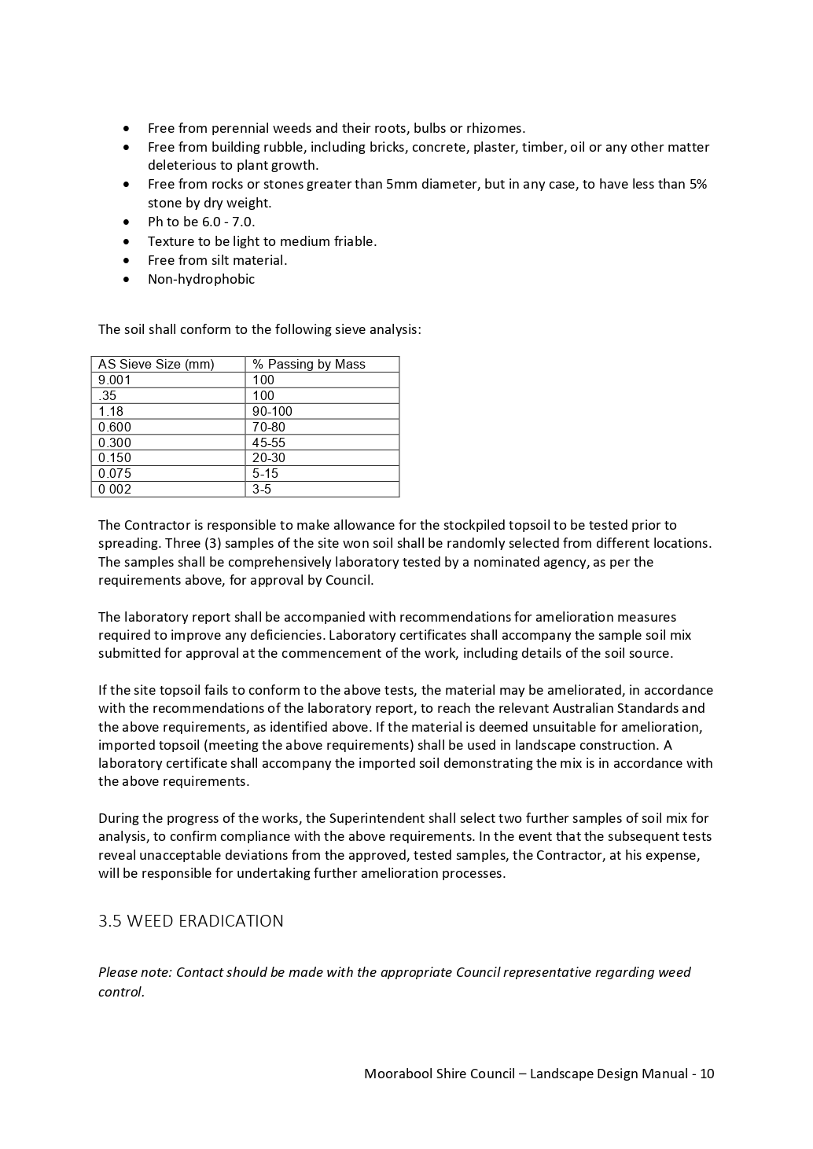

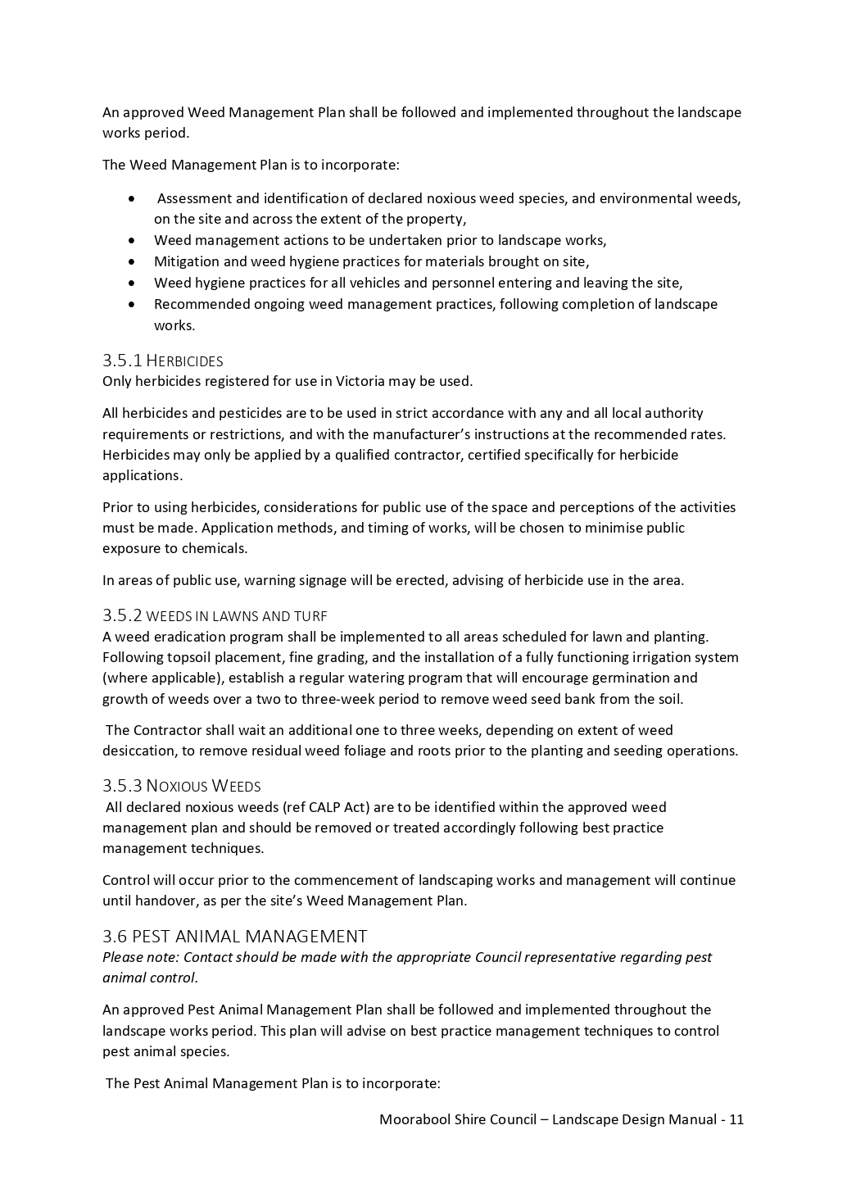

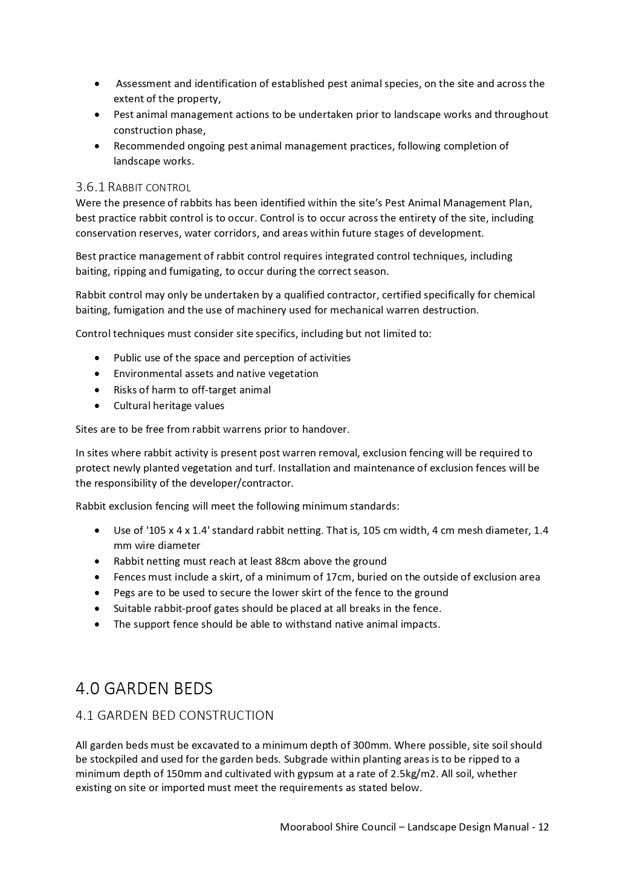

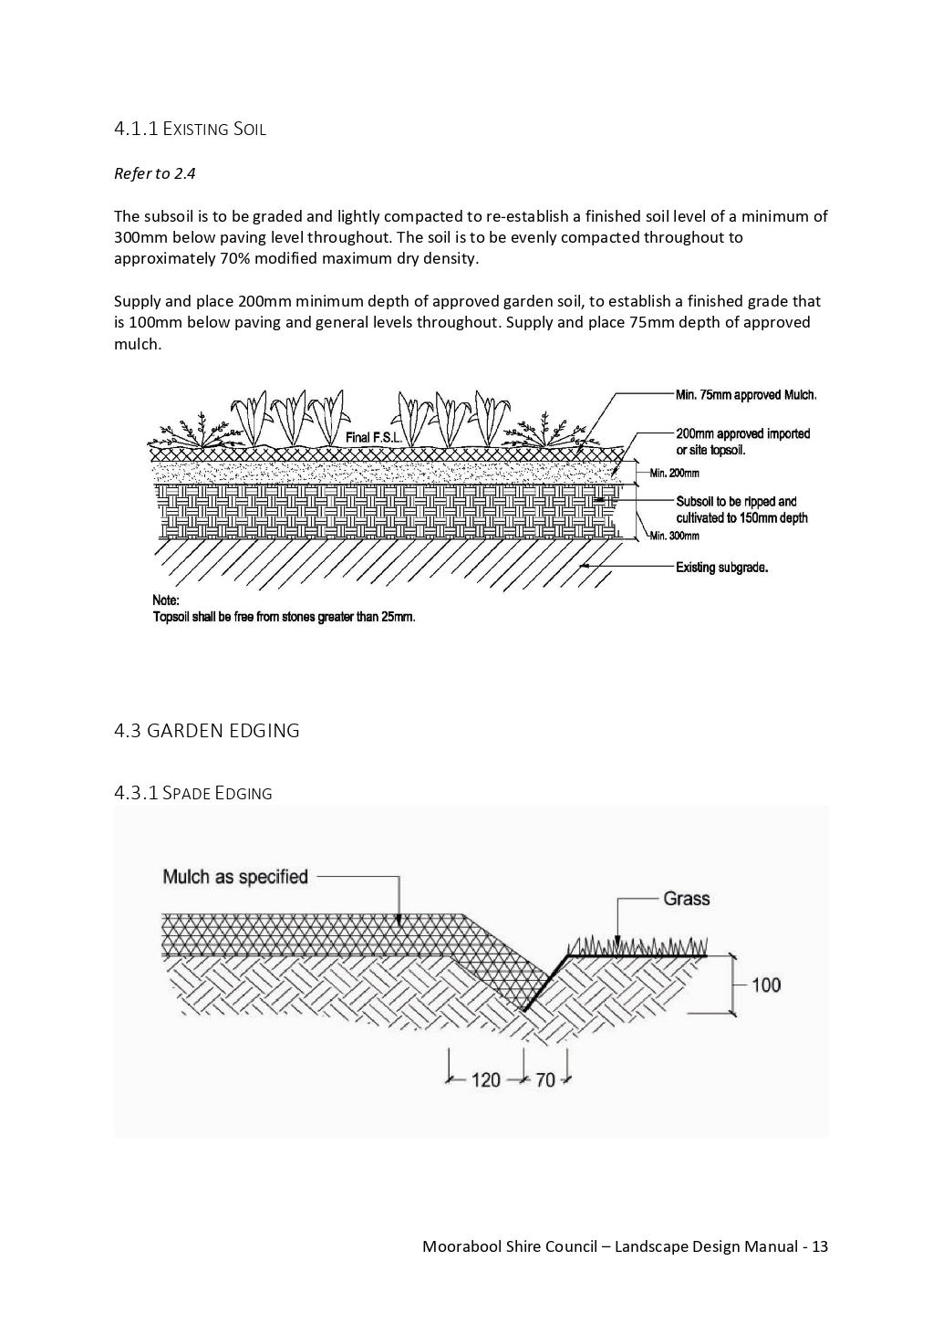

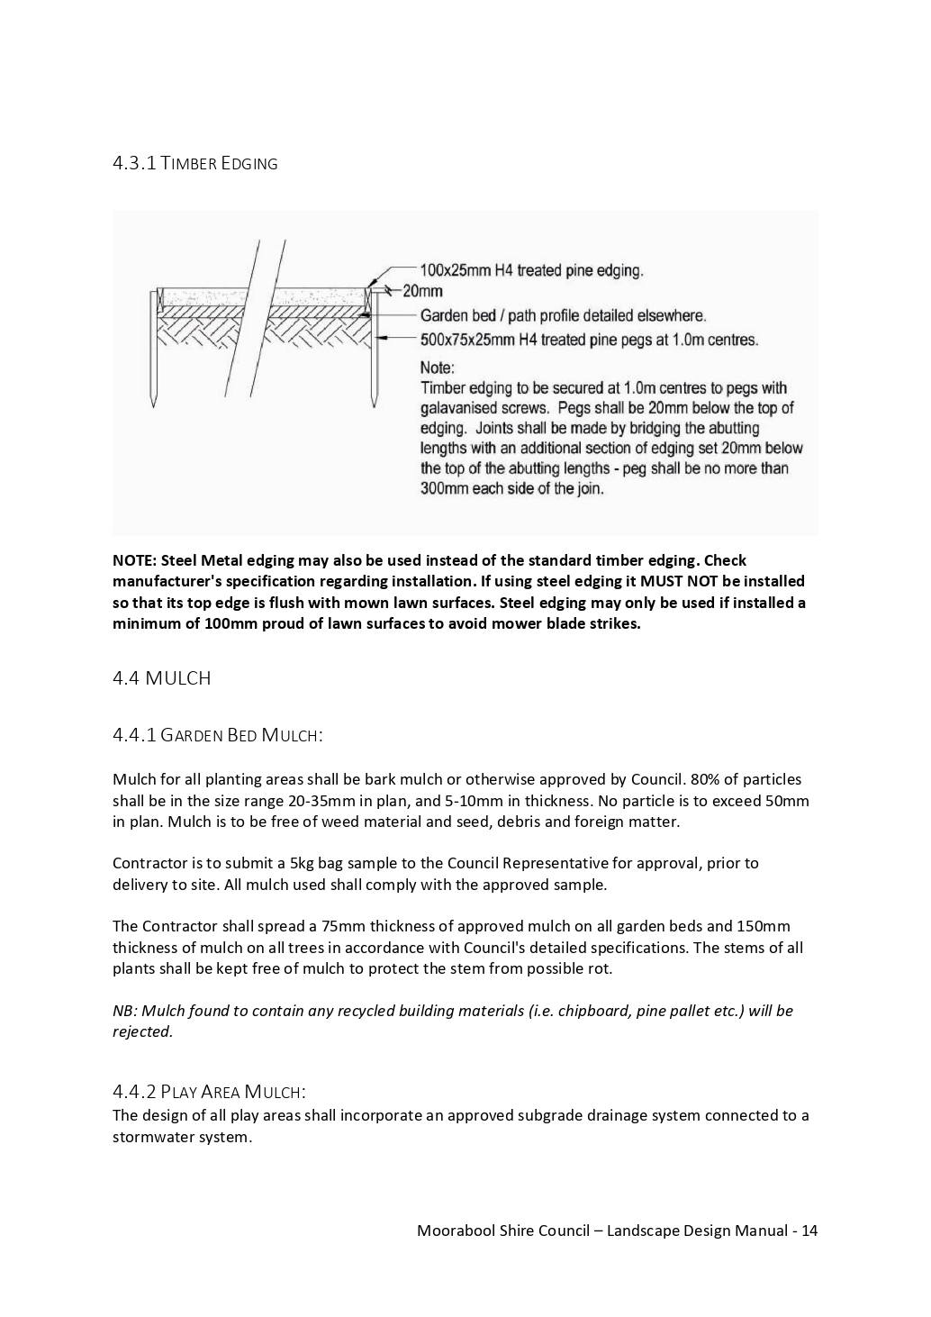

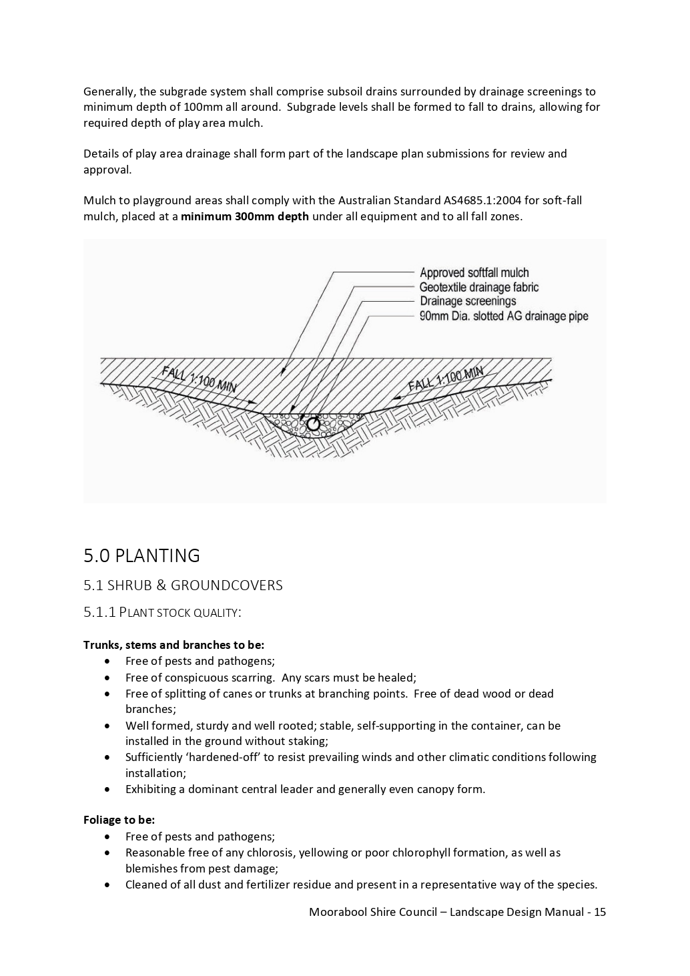

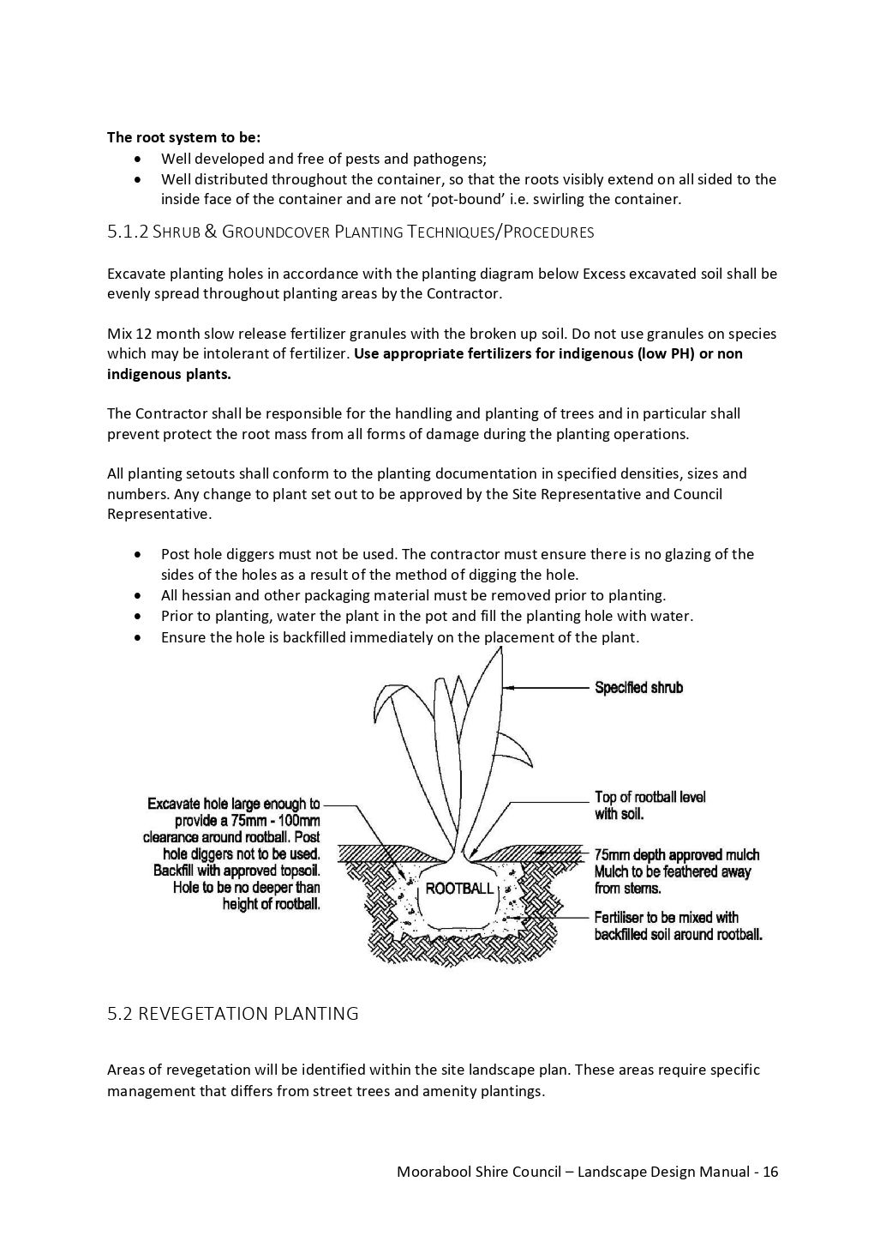

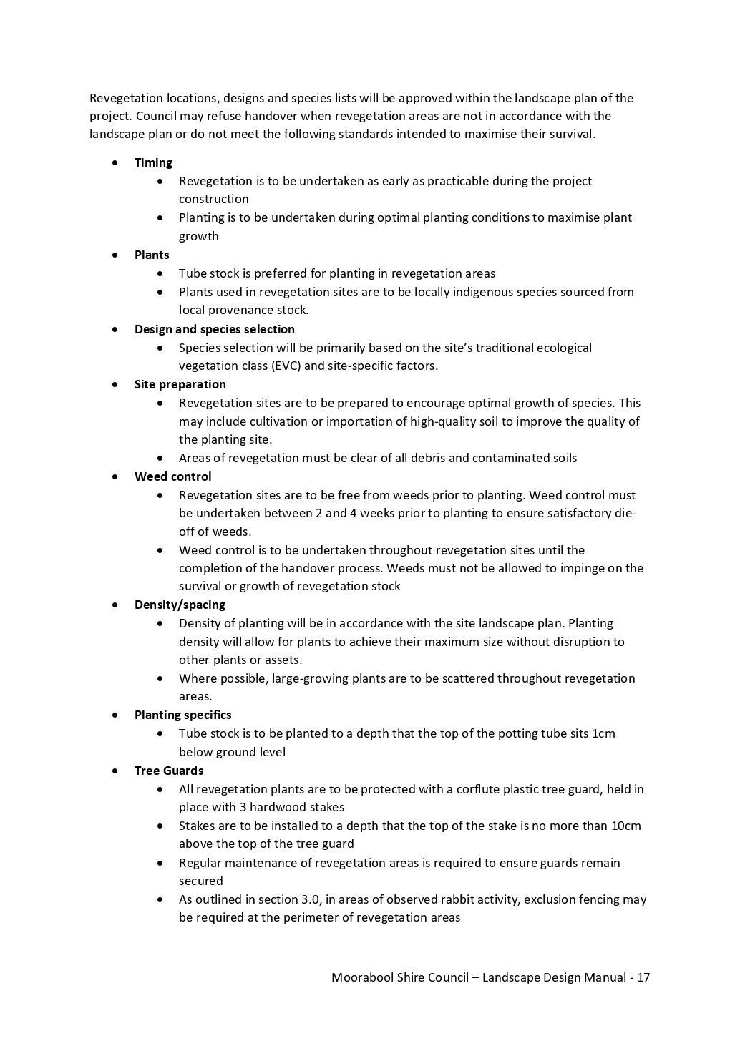

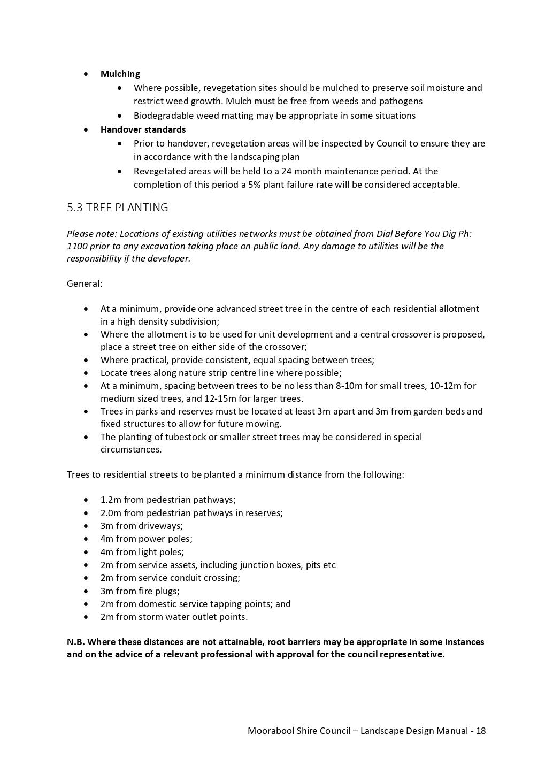

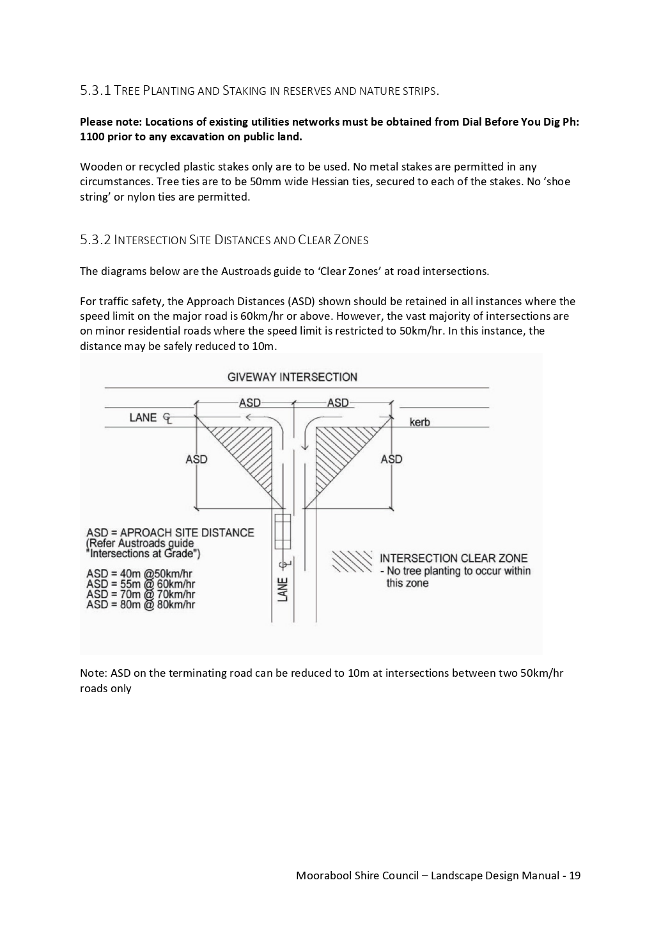

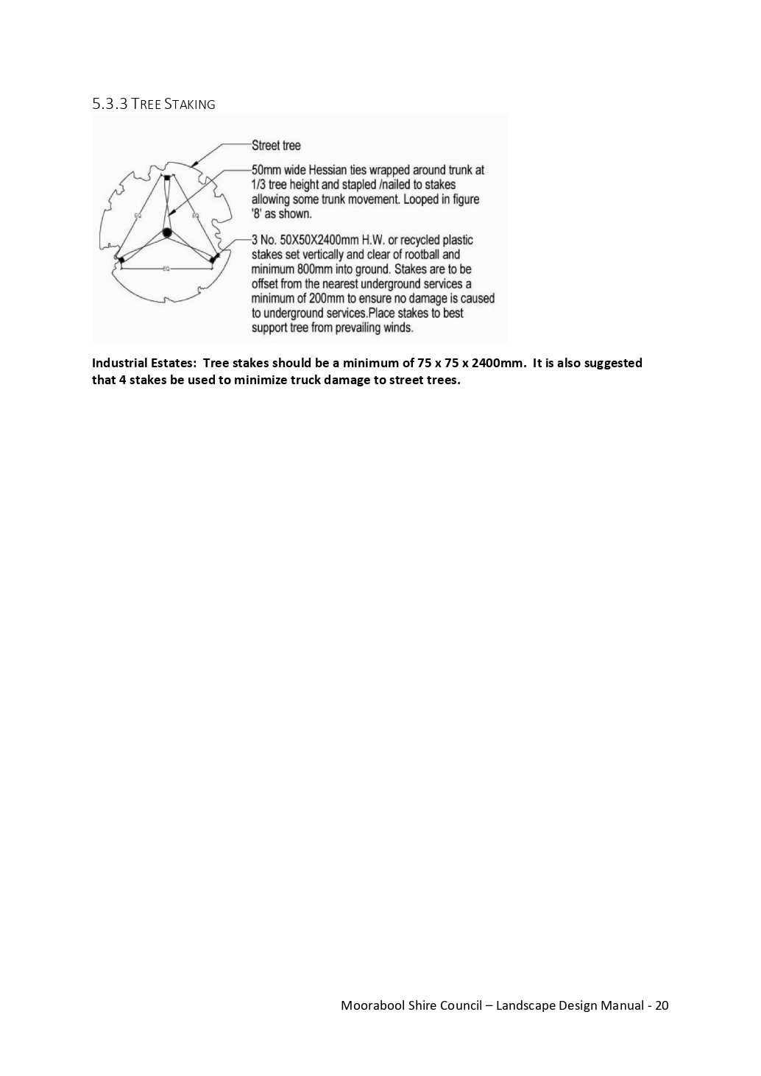

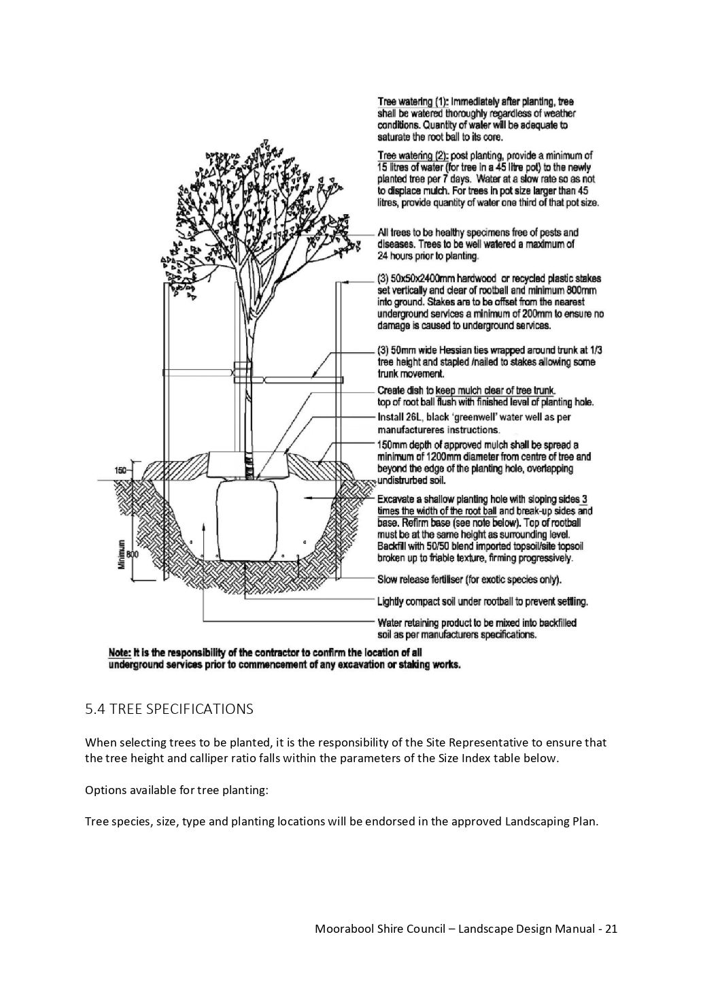

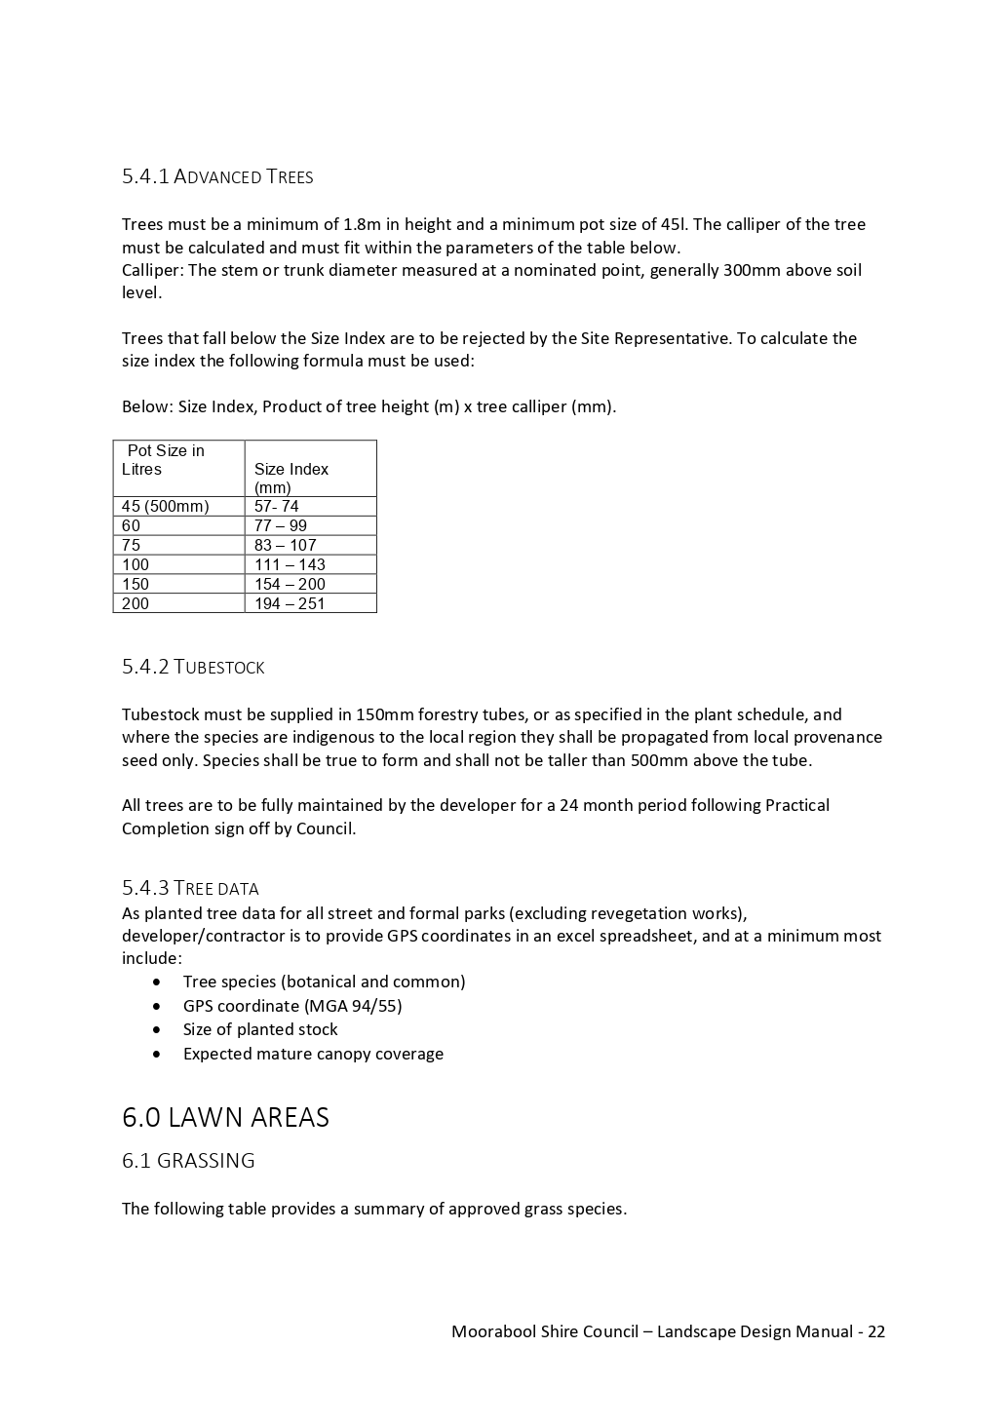

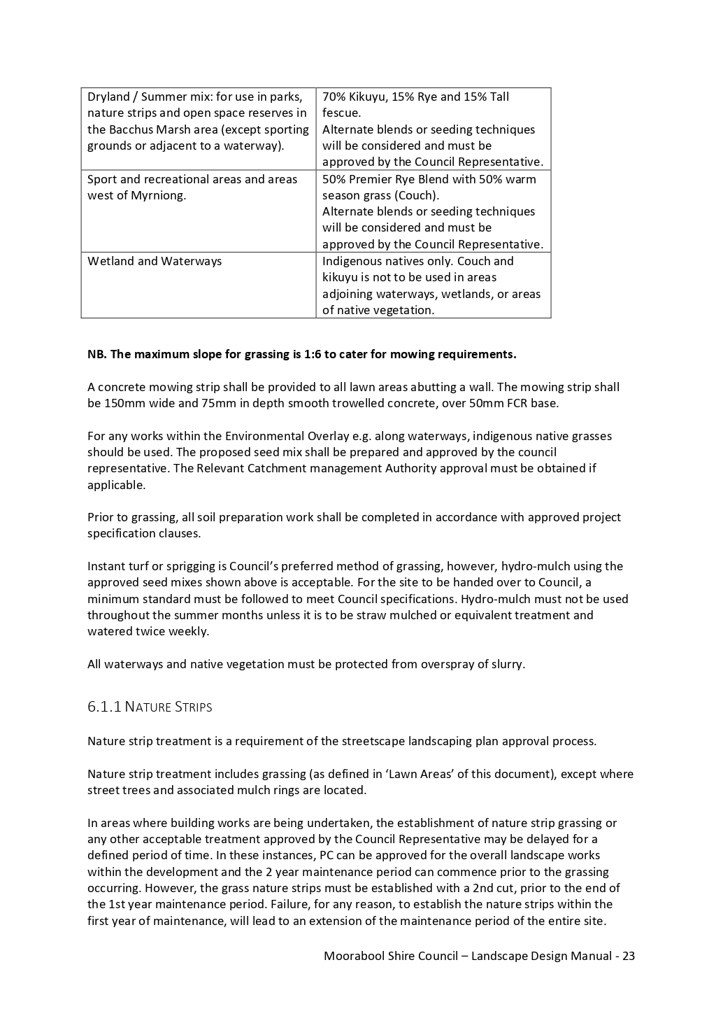

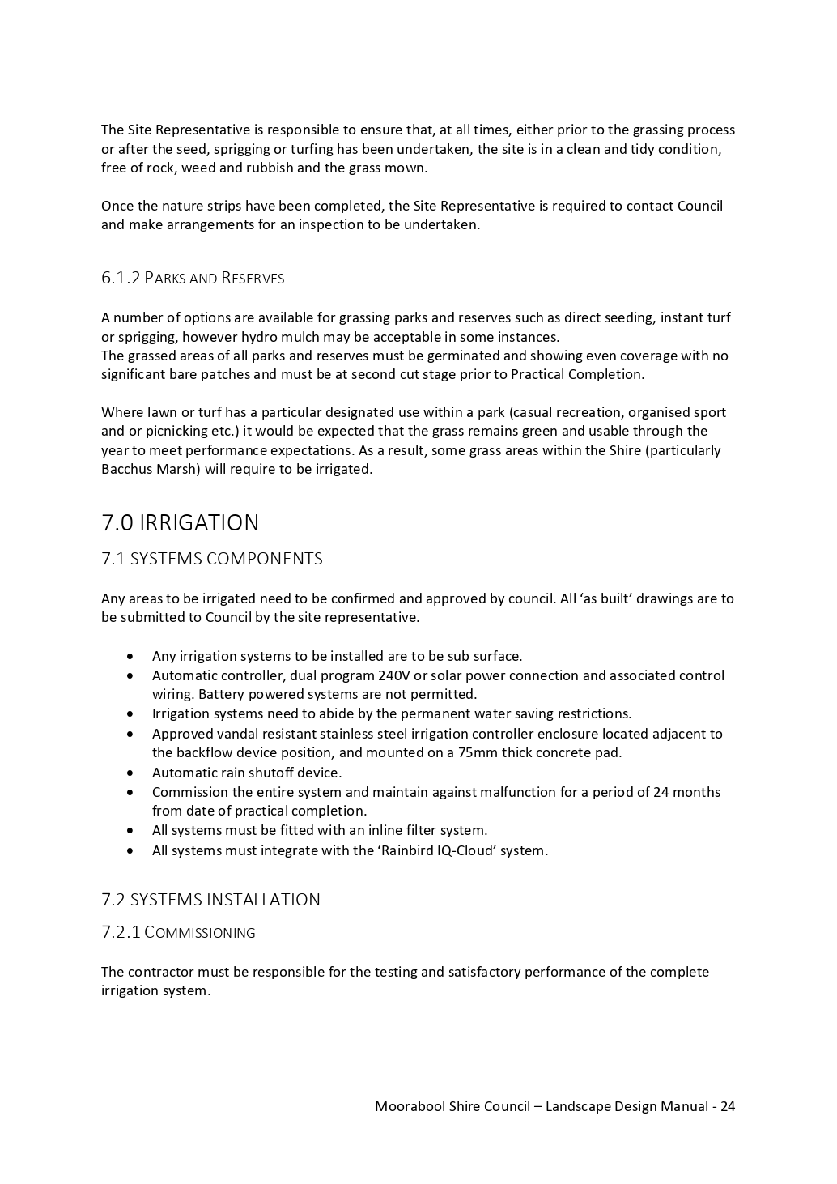

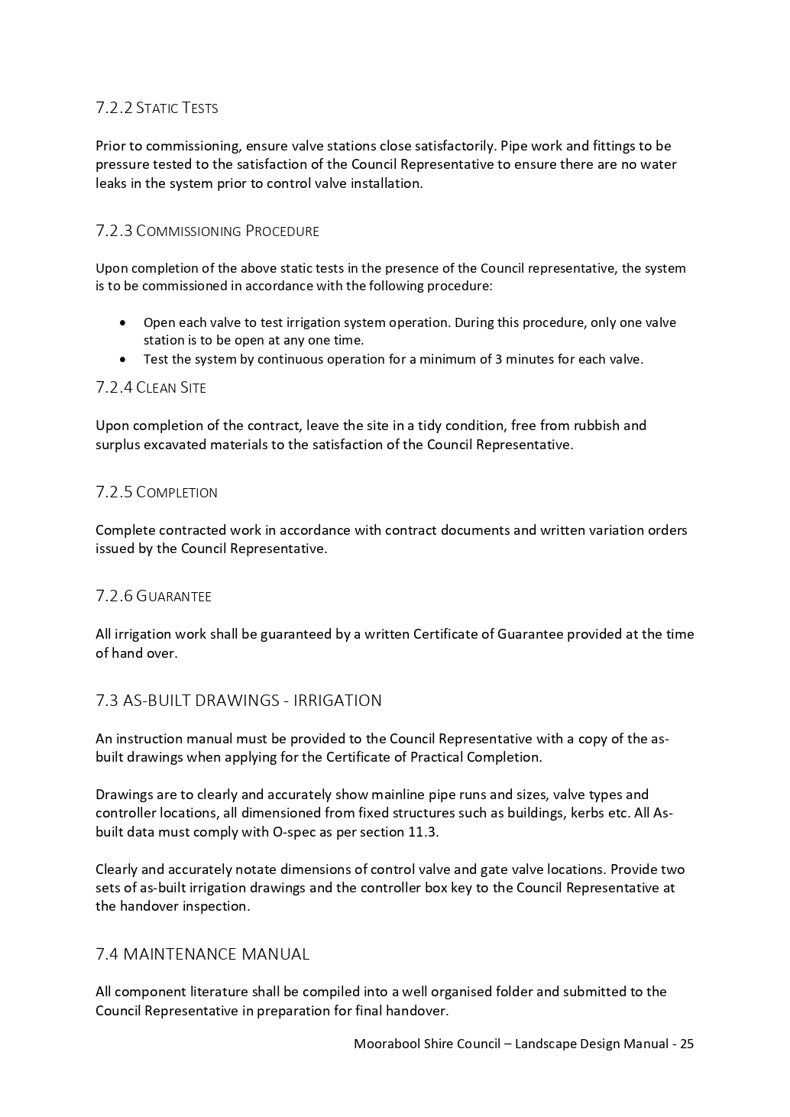

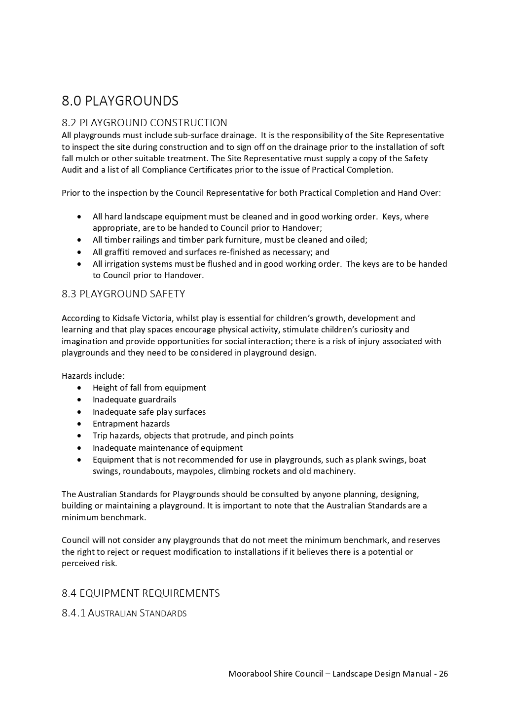

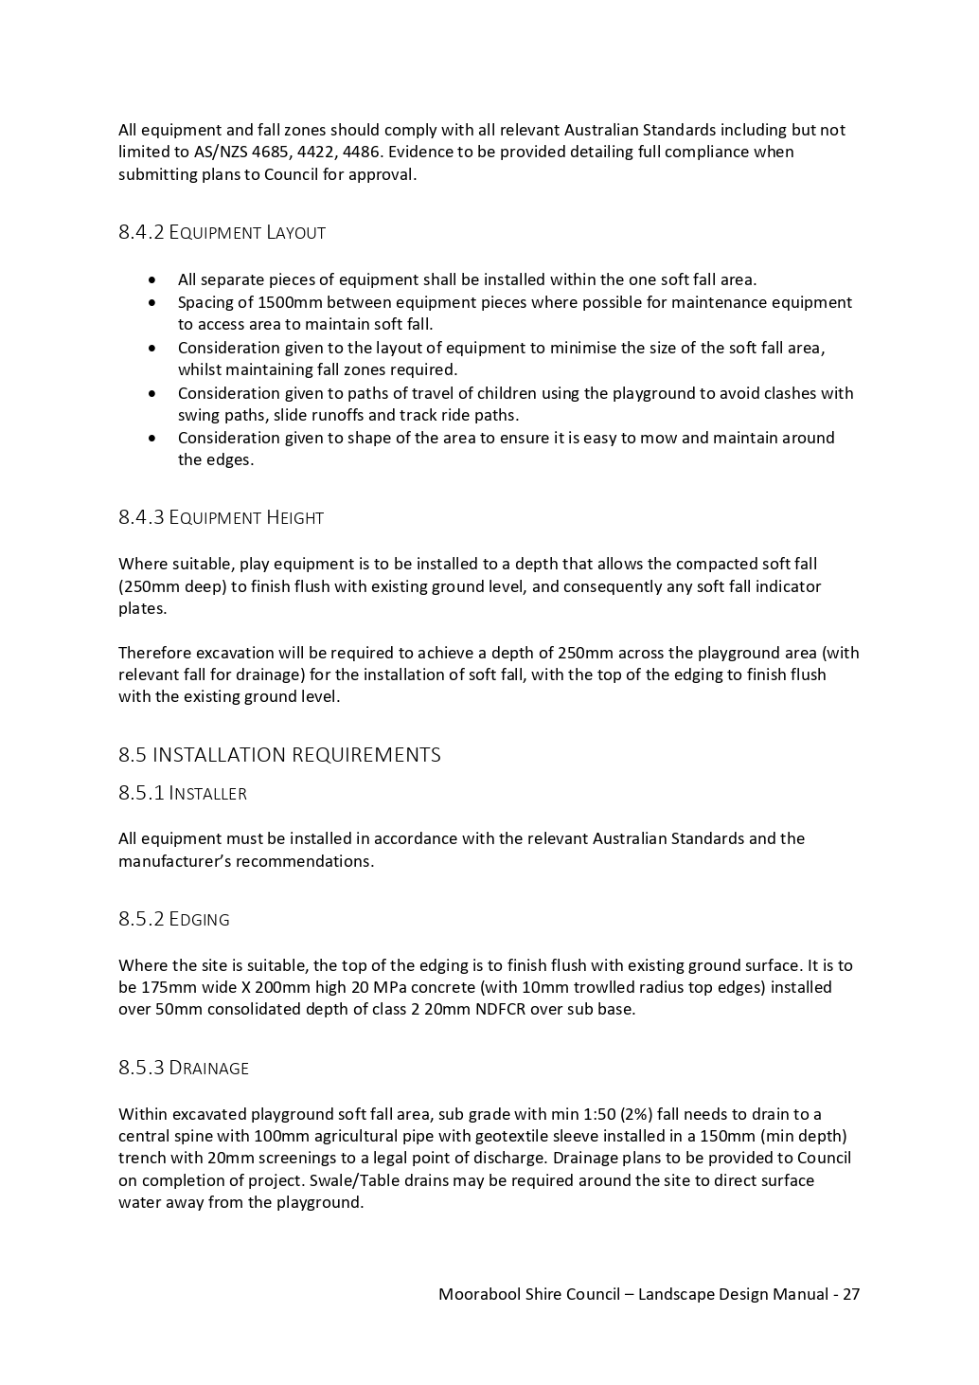

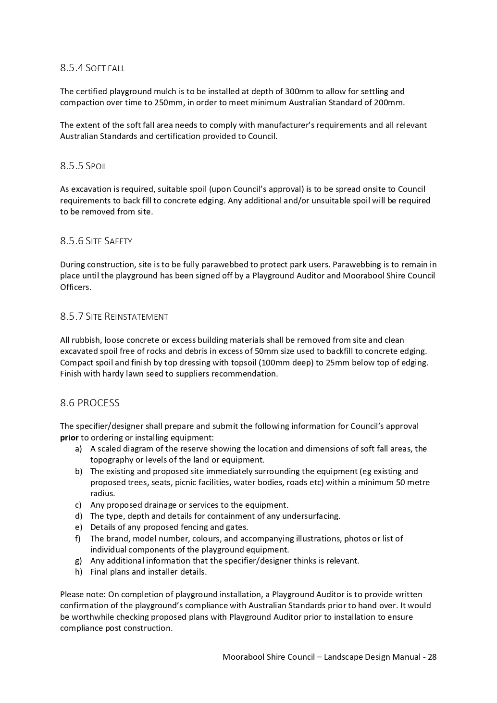

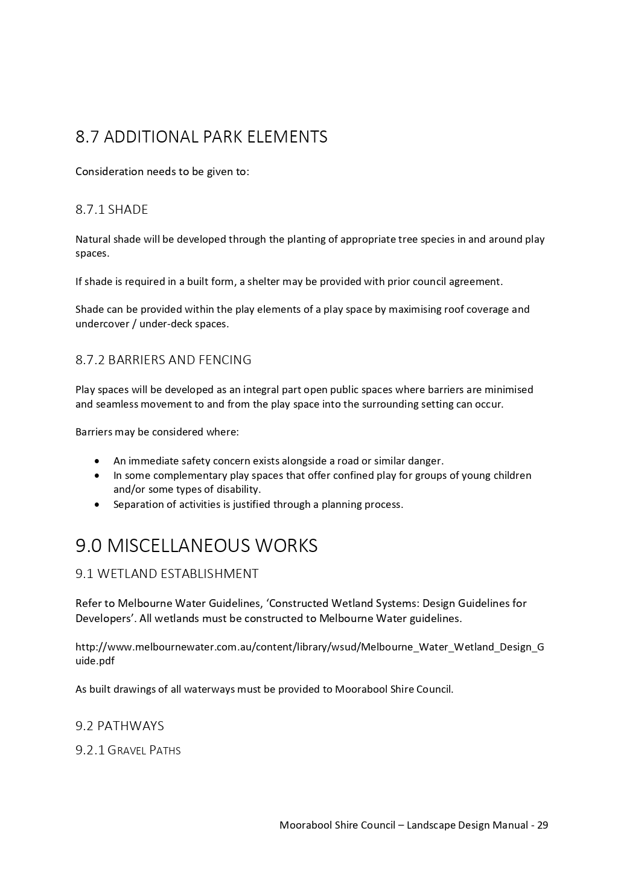

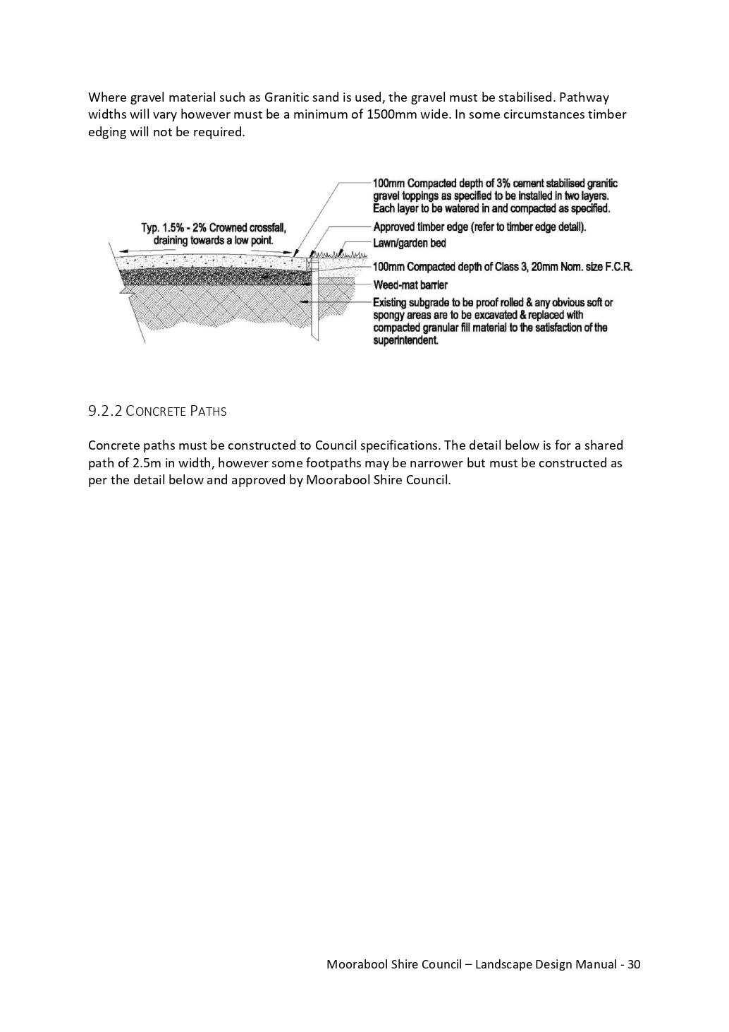

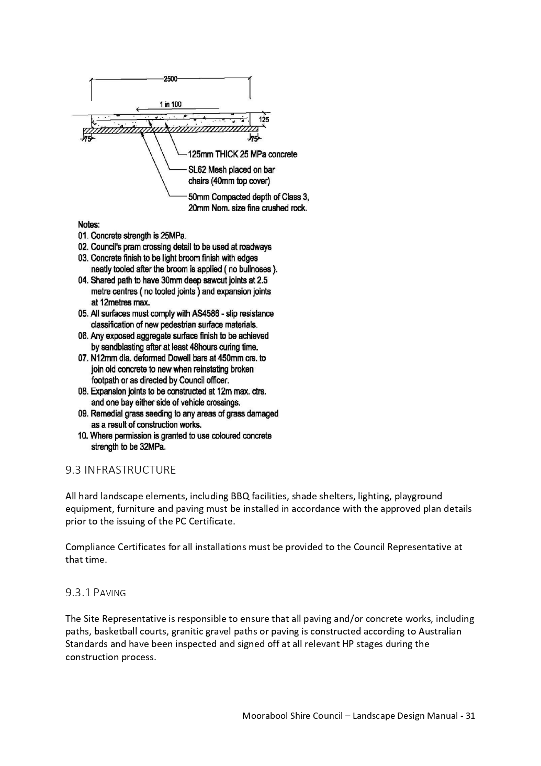

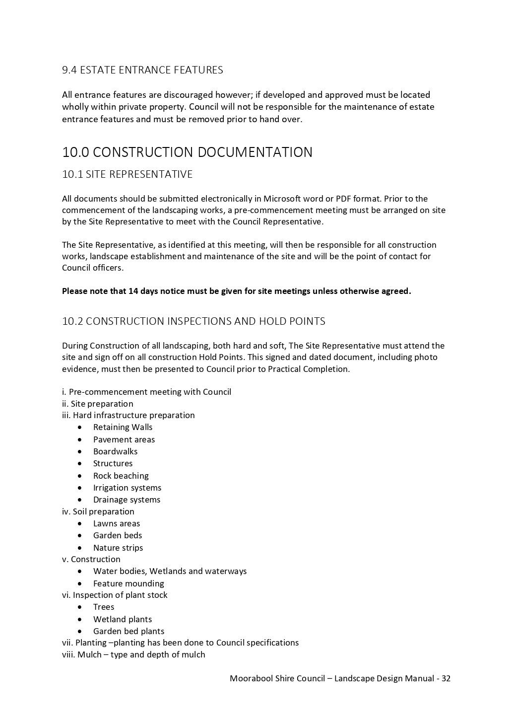

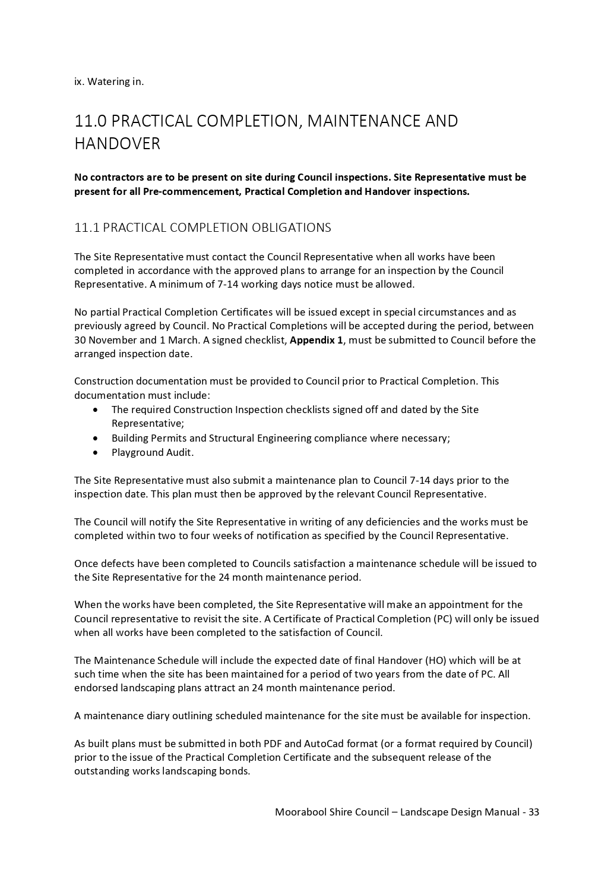

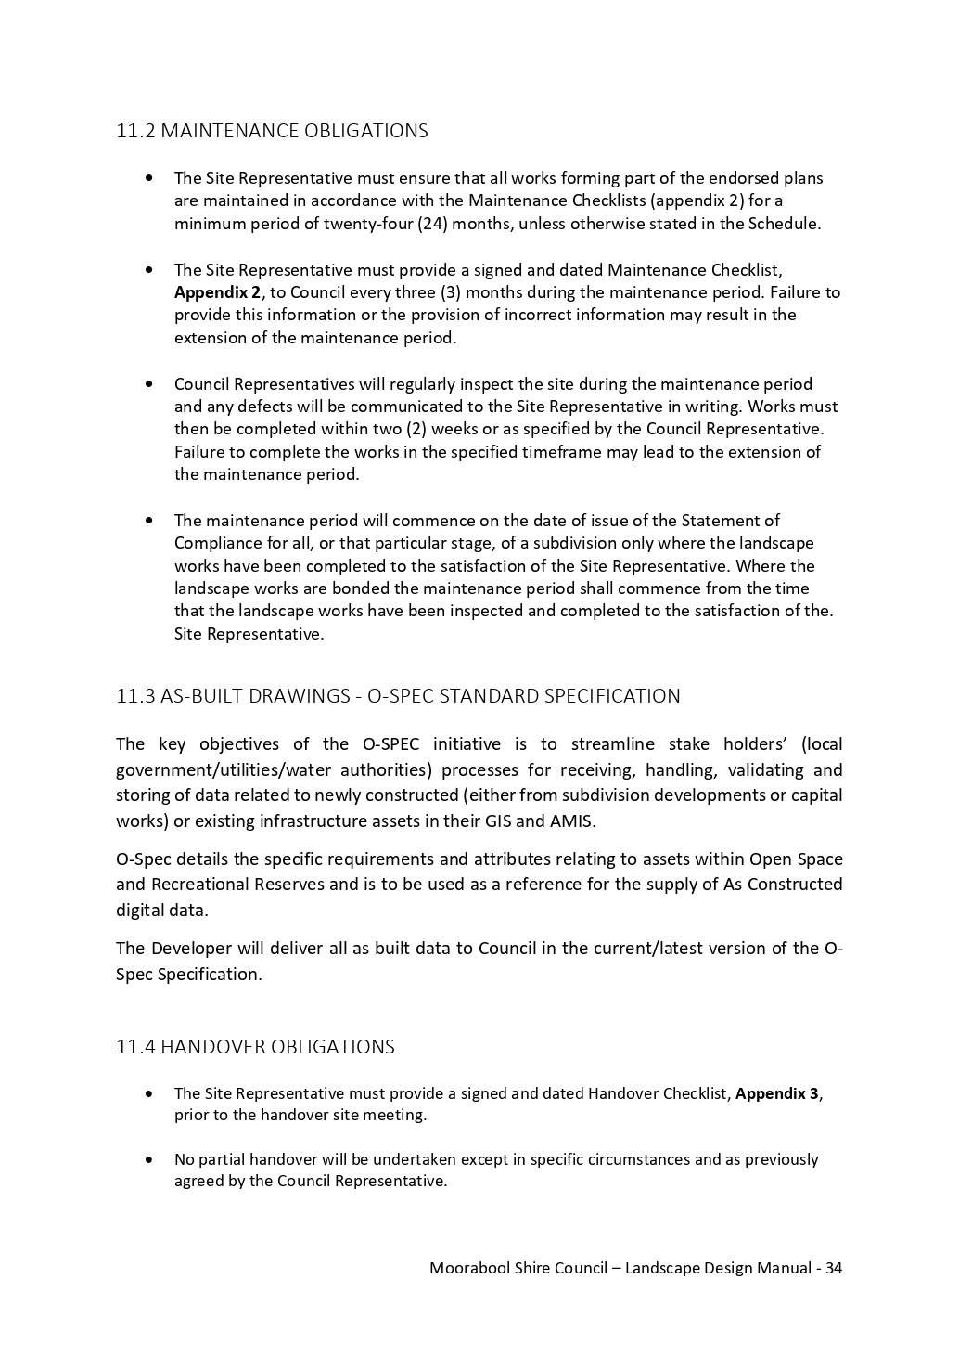

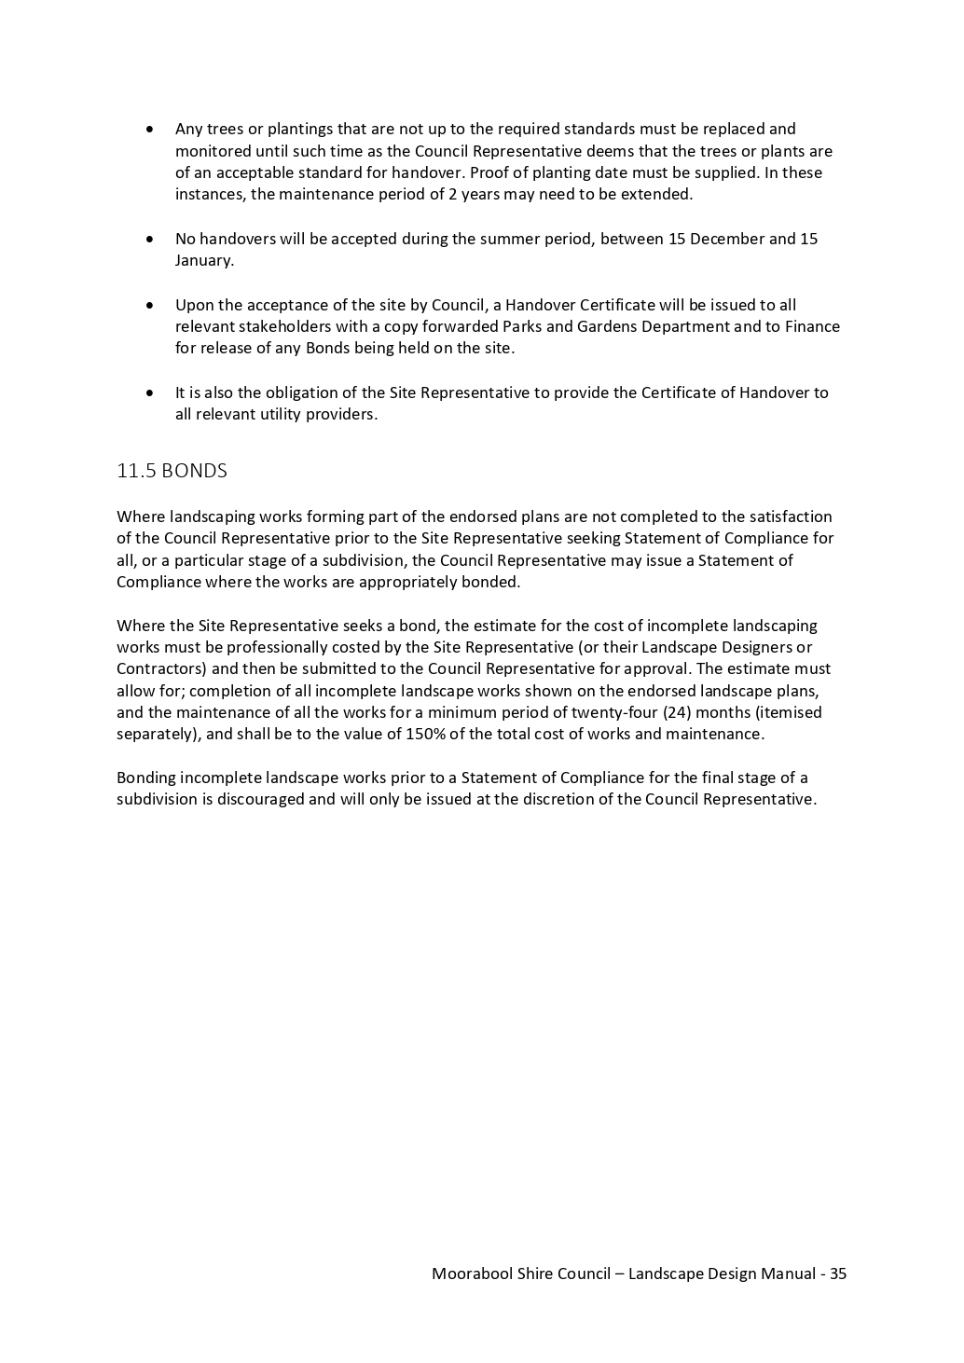

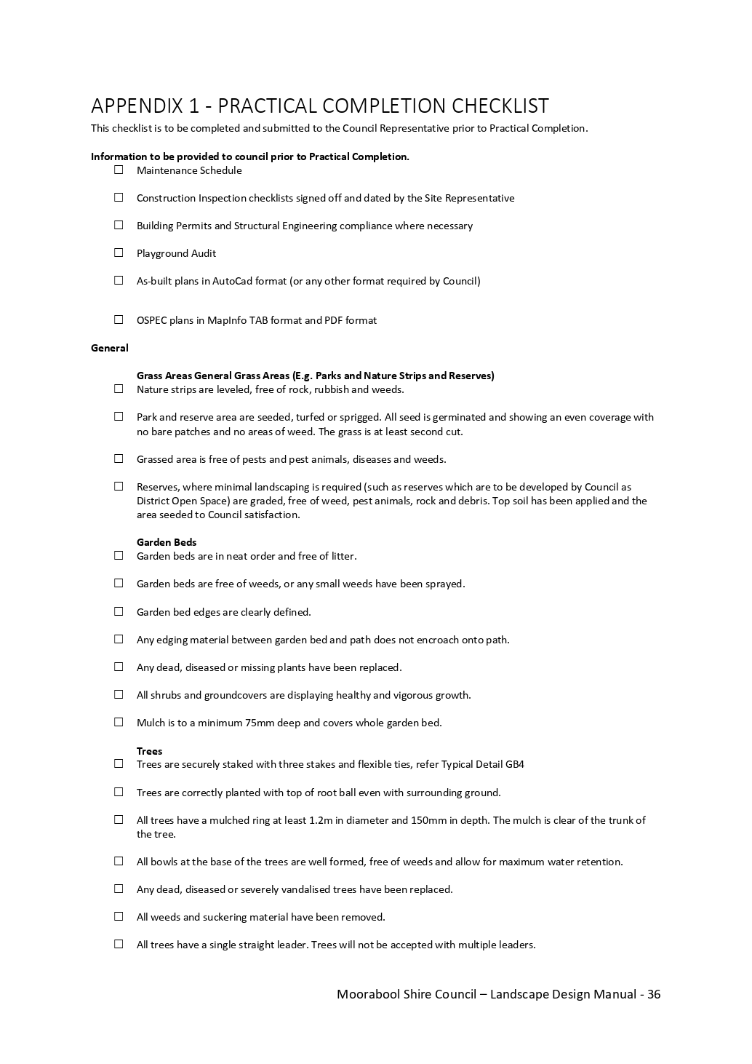

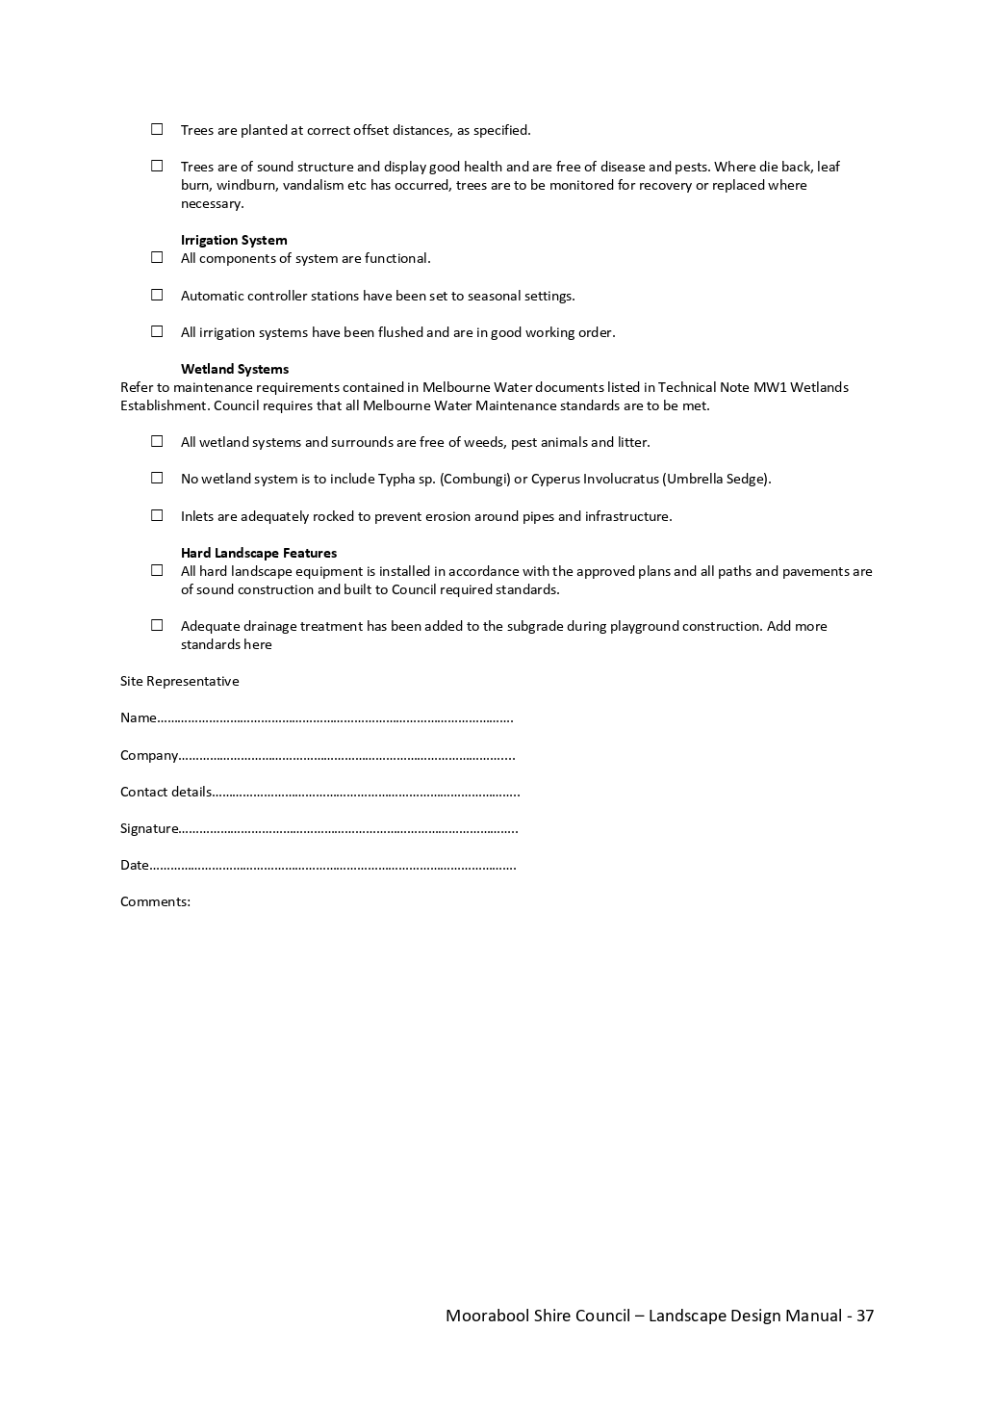

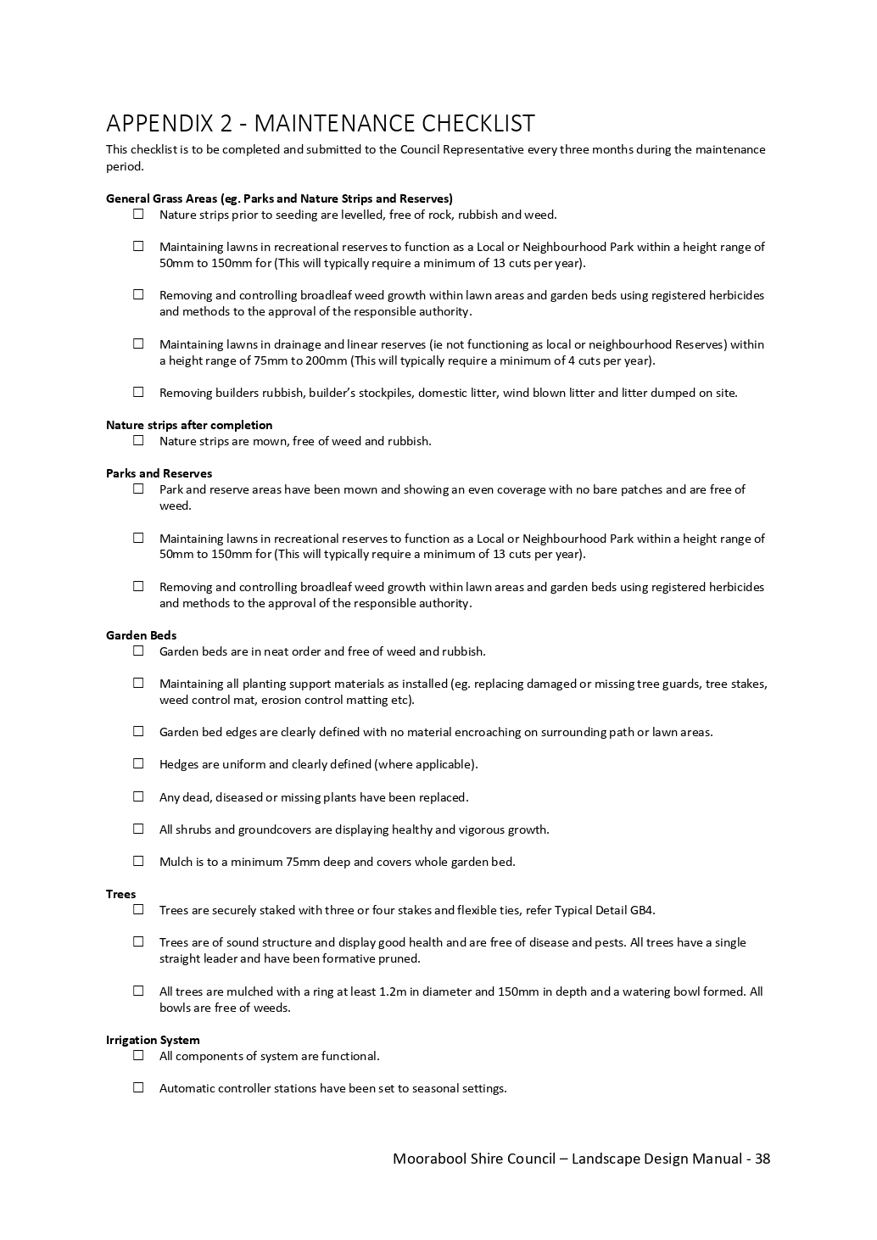

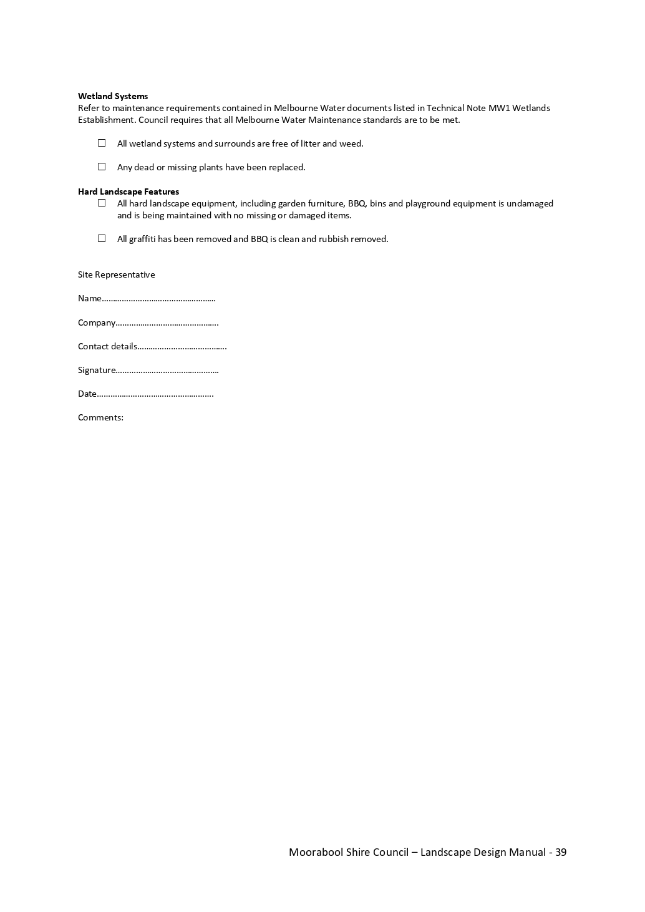

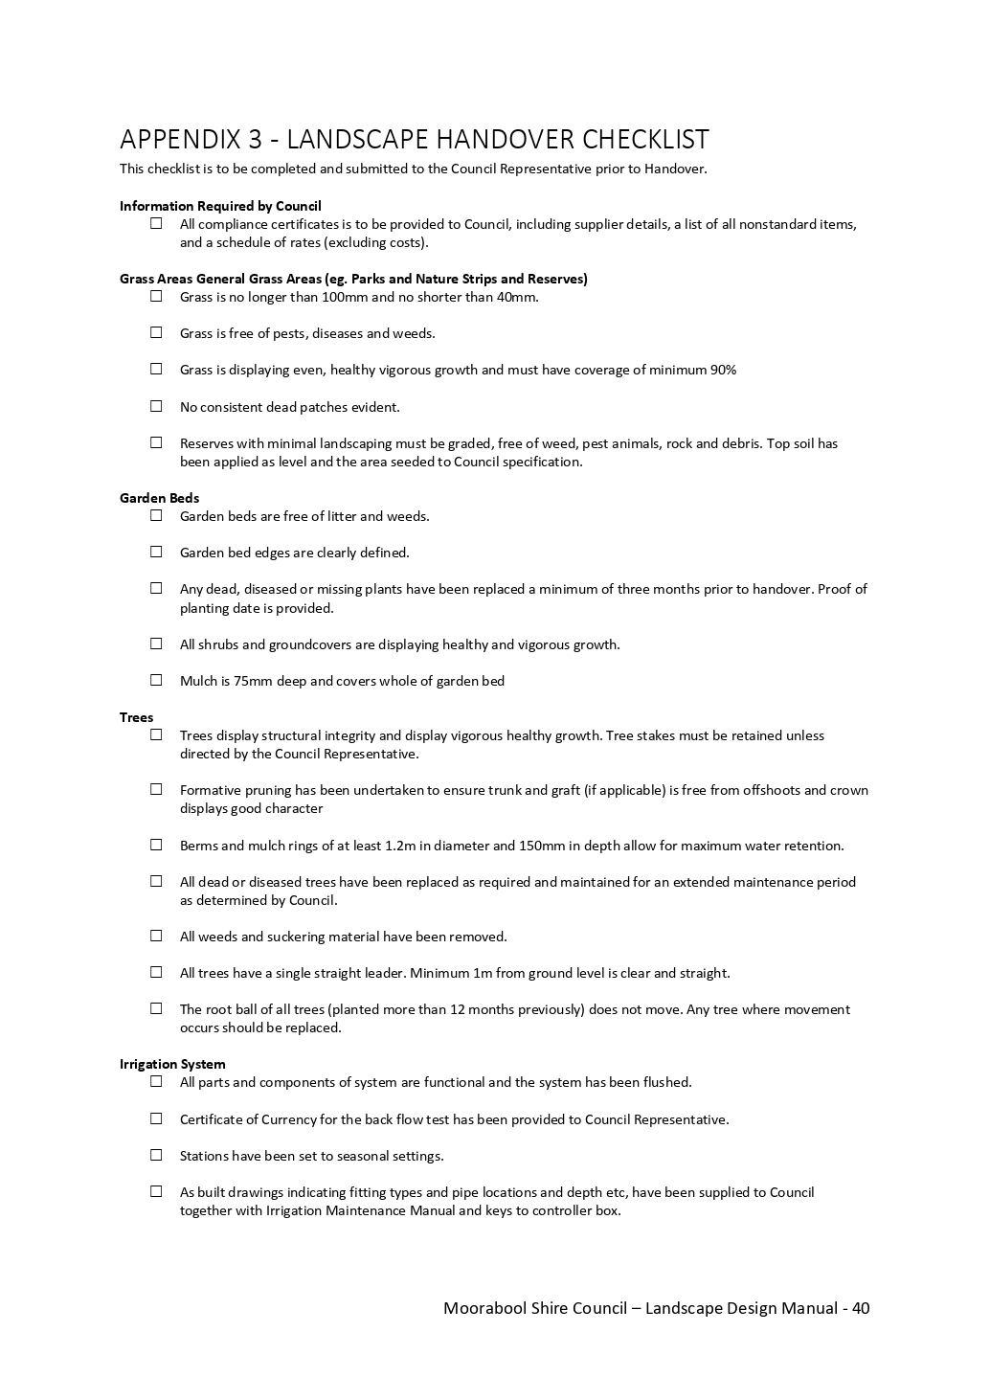

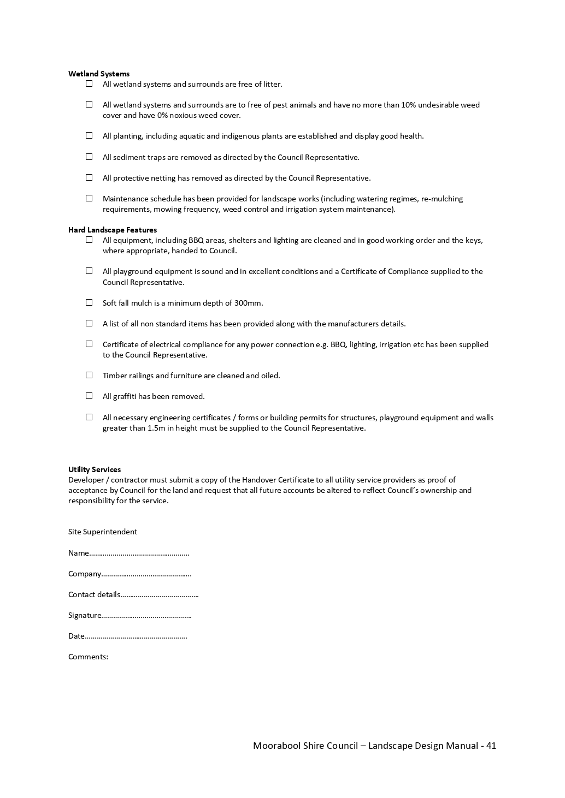

LANDSCAPE DESIGN MANUAL – CONSULTATION FEEDBACK
*NOTE: Some multi-issue comments have been broken into their individual issues/comments for ease of response.
Comment No. | Comment | Action
1 | Does this manual align with the Moorabool Shire Sustainable Environment Strategy 2016 - 26? | The LDM has been developed to ensure that the built form that is delivered in new developments and by Council are constructed and delivered to the highest possible consistent standards. It does not consider the type and or source of materials used.  The environmental considerations of the materials utilised in the public realm will be reviewed in the development of the specific design guideline and design suite documentation that will be undertaken after Council has considered the LDM.  Additional opportunities to address these issues will be flagged as part of the Open Space Strategy and Waste & Resource Recovery Strategies which are due to be completed in 2020/21.
2 | Could reference be made to landscape design with sustainability and maintenance in mind- i.e preferencing drought tolerant and native plants, such as included in Hume City Council/Greater Shepparton City Council Landscaping Guidelines | While this falls outside the scope of the LDM, it is agreed that this has merit.  Council has previously developed a Recommended Street Tree Planting List and is currently developing a supplementary document for gardens and landscaping to define recommended and supported species for open space and the public realm projects. It will likely have a large leaning to low water use and native species.
3 | Could a list of native plants to Moorabool Shire be included, such as lists included in Casey and Hume City Council Landscaping Guidelines | Plant lists, furniture suites etc are intended to be separate reference documents as they are likely to be needed to be updated somewhat regularly and remaining as separate documents will allow for more flexibility in this regard.  See response to response #2
4 | Document provides good over view on Council expectations on landscape design. It would be good to see more of an emphasis on the preferred use of native plants or sustainable landscape practices/design. | See response to #2
5 | There is also little to no consideration of waste management/minimization in the landscape design process. Waste streams should be minimized and the waste hierarchy implemented in the design and building of public landscapes for better environmental and social outcomes. | Response is noted. The Open Space Strategy and Waste & Resource Recovery Strategy which are due to be completed in 2020/21 will explore these opportunities further.
6 | P5. The document states that it also applies to Shire owned and managed land, but its focus reads with a heavy emphasis on developers. While that emphasis on what developers can and can’t do is welcome, I wonder whether rules applying to Shire owned and managed land belong in the same document? Mashing them together leads to some significant confusions. Eg, there is no sensible discussion or guidelines about streetscape plantings. | The LDM covers construction methodology and this should be aligned across developer and council delivered projects to ensure consistency across public open space assets.  Design Guidelines in regard to aesthetics are not intended to be covered within the LDM.  The LDM does not take the place of a design suite and or a design style guide but rather it guides material, installation and construction quality of individual finishes, objects and elements.
7 | At pp16-17 there is discussion about species selection and EVCs are specifically mentioned in relation to “revegetation”. This is a spurious distinction in my view and its all about revegetation as white people denuded the area in recent history. So, whether we are talking about revegetation on Shire lands or private lands, I don’t see the point in having separate rules and guidelines. Species selection should be heavily oriented to the prospective changes in climate – hotter, drier and longer periods of heat. We should be planting with a view to drought tolerance and provision of shade and not be so focused on autumn colour for example. | The performance requirements of plants varies between revegetation of natural reserves (river corridors etc) vs. urban public space.  A good example may be certain gum species that are prone to limb drop are not suitable for a public, high use environment yet are an important part of the ecosystem in natural reserves.  Also see comment to response #2
8 | P11. The discussion about use of herbicides is woefully inadequate. Surely they should mention the need for extra care when using near waterways or in areas where runoff will end up in waterways? Apart from this I find the Shire’s blind acceptance of the safety of Roundup to be foolish and financially risky. With huge payouts happening in the US about users of Roundup and various lawsuits and class actions underway in Australia, Council is exposing themselves, officers, ratepayers and residents to unacceptable risks in my view. Attempting to hide behind the façade of the chemical being currently registered for use in Victoria wont wash when cases get to court. | The comment relating to the issues relating to the use of herbicides is noted.  Section 3.5.1 Relates to overall site preparation and aims to ensure that Council is receiving sites that are free of weeds (environmental and noxious), to increase the success of landscaping projects and reduce the on-going maintenance of sites due to poor site preparation. If sites are being prepared as per the specifications, it is expected that the use of herbicides in landscaped areas will be greatly reduced.
9 | I note there is no mention of the Street Tree Strategy. This seems a significant omission? | Noted. The street tree strategy and street tree species guides have been included in the reference document section (introduction 1.0).
10 | Is there scope in this process to define what may be done in the Main Street of Bacchus Marsh for several (say 3 or 4) interpretive history boards, in the same style as those already in place at the Court House, Church Street open space, the Blacksmith Forge & Cottage and others at Holy Trinity, St Andrews and old Express Office. | The LDM is a technical reference document aimed at construction methodology and interpretation signage is outside of its scope.  This comment has been forwarded to our Heritage Officer within the Strategic Planning team to be considered in their future work.
11 | I think the manual looks comprehensive and the use of native species is covered. My comment is that the use of indigenous natives species should be further encouraged, not just high, medium and small native trees but high, mid and low level native plants, and ground level native species. There are many lovely plants to choose from. In some areas the use of non-indigenous species may also be appropriate. The use of exotic plant species should be discouraged on all public land including road reserves, in new housing estates and in other developments including on industrial land. An education package and native species brochures should be provided to all developers and with all permits issued that require landscaping. The Council should promote a native vegetation policy in the Shire. This can also be linked to the Gardens for Wildlife program, local Landcare group's activities and other authority programs such as Melbourne Water's waterway programs. Local nurseries should be included in the program so they can advise customers on appropriate native species for landscaping. | See comment to response #2

