MINUTES
Ordinary Council Meeting
Wednesday, 6 May 2020

In accordance with s. 395 of the COVID-19 Omnibus (Emergency Measures) Bill 2020,
this meeting was closed for public attendance, however, a livestream via Council’s Internet site was made available.
Date: | Wednesday, 6 May 2020
Time: | 6.00pm
Location: | The Pavilion Room, Darley Civic Hub

Order Of Business
1. Opening of Meeting and Prayer 4
2. Acknowledgement of Country 4
3. Recording of Meeting 4
4. Present 4
5. Apologies 5
6. Confirmation of Minutes 5
7. Disclosure of Conflicts of Interest 5
8. Public Question Time 5
9. Petitions 6
Nil.
10. Presentations/Deputations 6
11 Chief Executive Officer Reports 7
11.1 Instrument of Delegation from Council to the Chief Executive Officer 7
11.2 Instrument of Delegation - Council to Members of Council Staff 11
12. Community Planning and Economic Development Reports 18
Nil.
13. Community Strengthening Reports 18
Nil.
14. Customer Care and Advocacy Reports 18
14.1 Consideration of the Proposed 2020/21 Annual Budget 18
14.2 Instrument of Appointment and Authorisation of Council Officers under Section 147(4) of the Planning and Environment Act 1987 23
14.3 Council Plan 2017-2021 (2020 Review) 26
14.4 March 2020 Quarterly Financial Report 30
14.5 2017-2021 Council Plan Third Quarter Progress for January - March 2020 33
14.6 Section 86 - Delegated Committees of Council - Reports 36
15 Community Assets & Infrastructure Reports 37
15.1 Draft Landscape Design Manual 37
15.2 Speed Zone Change - Inglis Street & Cowie Street (Ballan) and Main Street (Bacchus Marsh) 42
15.3 Moorabool Community Road Safety Strategy 46
15.4 Petition Response; Griffith Street, Maddingley 51
15.5 Capital Improvement Program Quarterly Report - March 2020 60

16 Other Reports 64
16.1 Assembly of Councillors 64
17. Notices of Motion 65
Nil.
18. Mayor’s Report 65
18.1 Mayor's Report 65
19. Councillors’ Reports 66
20. Urgent Business 66
21. Closed Session of the Meeting to the Public 66
22. Meeting Closure 66

1. Opening of Meeting and Prayer
The Mayor opened the meeting with the Council Prayer at 6.03pm.
The Mayor advised that Councillors Tatchell and Keogh are participating in tonight’s meeting via video link and that for the first time in Moorabool Shire Council’s history, tonight’s meeting is being livestreamed via Council’s website.

2. Acknowledgement of Country
We respectfully acknowledge the traditional owners of this land, their spirits and ancestors.

3. Recording of Meeting
In accordance with Moorabool Shire Council’s Meeting Procedure Local Law, the Council has recorded this meeting.

The Mayor acknowledged the recent passing of Mr Satwinder Sandhu, Council’s former General Manager Growth & Development.

4. Present
Cr David Edwards (Mayor) East Moorabool Ward
Cr Jarrod Bingham East Moorabool Ward
Cr Tonia Dudzik East Moorabool Ward
Cr John Keogh East Moorabool Ward
Cr Lawry Borgelt Woodlands Ward
Cr Tom Sullivan West Moorabool Ward
Cr Paul Tatchell Central Moorabool Ward

Officers:
Mr Derek Madden Chief Executive Officer
Mr Phil Jeffrey General Manager Community Assets & Infrastructure
Ms Caroline Buisson General Manager Customer Care and Advocacy
Mr Henry Bezuidenhout Executive Manager Community Planning & Economic Development
Mr Steve Ivelja Chief Financial Officer
Ms Yvonne Hansen Manager Governance, Risk & Corporate Planning

5. Apologies
Nil.

6. Confirmation of Minutes
Resolution
Moved: Cr John Keogh
Seconded: Cr Jarrod Bingham
That the Minutes of the Ordinary Council Meeting held on Wednesday, 4 March 2020 be confirmed.
Carried

7. Disclosure of Conflicts of Interest
Nil.

8. Public Question Time
Name | Question/Response
Mr. Stephen Derrick | Question:  Regarding Agenda Item 11.2, p14, clause 1.2 d.  How will Council justify the proposal to allow officers to determine applications that have less than five unresolved objections?
Response:
The Report being presented to Council contains a justification which is based on the following:
• Improving turn-around times for planning applications where objections are received;
• The Council process generally extends the timeframe for assessing applications beyond the 60 Statutory day obligation under the Planning & Environment Act 1987;
• In 2019 only one application with objections that went to Council for approval had a final outcome which was different to the recommendation;
• A considerable amount of Councillor and officer time is required to determined applications at a Council meeting;
• Streamlining processes to allow for more efficient and customer focus level of decision making whilst maintaining the opportunity for Council to input into decision making on matters of significance and/or with strategic implications;

• These applications would be considered by the internal Planning Determinations Panel which comprises senior / executive level officers and has a higher level of scrutiny;
• Continue to provide Councillors a list of new planning applications and provide a link to planning applications currently on advertising each week;
• Councillors retain the opportunity to call in planning applications.

9. Petitions
Nil.

10. Presentations/Deputations
Nil.

11 Chief Executive Officer Reports

11.1 Instrument of Delegation from Council to the Chief Executive Officer
Author: Yvonne Hansen, Manager Governance, Risk & Corporate Planning
Authoriser: Derek Madden, Chief Executive Officer
Attachments: 1. Instrument of Delegation from Council to Chief Executive Officer (under separate cover)

Purpose
The purpose of this report is to enable Council to revoke the Instrument of Delegation to the Chief Executive Officer that was endorsed at the Council meeting held on 5 July 2017; and to endorse an amended Instrument of Delegation to the Chief Executive Officer (CEO).
The proposed Instrument of Delegation as attached to this report, has been amended to reflect the requirements of the Local Government Act 2020, whilst providing further power to the CEO, to ensure that Council can continue to operate and function for the benefit and welfare of the Moorabool community, during the period of a State of Emergency.

Executive Summary
• It is recommended that Council adopt an amended Instrument of Delegation to the CEO, to enable the ongoing operation of Council during a declared State of Emergency.
• The proposed Instrument of Delegation has been prepared to meet the requirements contained in the Local Government Act 2020, that come into effect on 1 May 2020.
• A provision has been made in the proposed Instrument of Delegation to ensure that the CEO, can exercise greater power in the execution of contracts during the period of a declared State of Emergency.
• A further provision has been made to empower the Chief Executive Officer to appoint an Acting Chief Executive Officer for a period up to 28 days.
Resolution
Moved: Cr Tonia Dudzik
Seconded: Cr Lawry Borgelt
That Council, in the exercise of the powers conferred by section 11(1) of the Local Government Act 2020 (the Act) and the other legislation referred to in the attached Instrument of Delegation, Council resolves that:
1. There be delegated to the person holding the position, acting in or performing the duties of Chief Executive Officer the powers, duties and functions set out in the attached Instrument of Delegation to the Chief Executive Officer, subject to the conditions and limitations specified in that Instrument.
2. The Instrument of Delegation - Council to the Chief Executive Officer be signed under the common seal of the Council.

3. The Instrument comes into force immediately the common seal of Council is affixed to the Instrument.
4. On the coming into force of the Instrument all previous delegations to the Chief Executive Officer are revoked.
5. The duties and functions set out in the Instrument must be performed, and the powers set out in the Instrument must be executed, in accordance with any guidelines or policies of Council that it may from time to time adopt.
6. It is noted that the Instrument includes a power of delegation to members of Council staff, in accordance with section 47(a) of the Act.
Carried
A Division was called:
In Favour: Crs Jarrod Bingham, John Keogh, Lawry Borgelt and Tonia Dudzik.
Against: Crs Tom Sullivan, Paul Tatchell and David Edwards.
The motion was declared carried

Background
Council currently has in place an Instrument of Delegation to the CEO (dated 5 July 2017) that provides the powers to determine any issue; take any action; or do any act or thing arising out of or connected with any duty imposed, or function or power conferred on Council by or under any act.
However, as the provisions relating to delegations contained in the Local Government Act 2020 come into effect as of 1 May 2020, Council cannot amend the existing Instrument. Therefore, any new Instrument of Delegation must be prepared in accordance with the requirements of the new legislation.
In accordance with section 11 of the Local Government Act 2020, a Council may by instrument of delegation delegate to a member of its staff any power, duty or function of a Council under the Act or any other Act. other than:
(a) the power of delegation;
(b) the power to elect a Mayor or Deputy Mayor;
(c) the power to grant a reasonable request for leave;
(d ) the power to appoint the Chief Executive Officer, whether on a permanent or acting basis (for a period greater than 28 days);
(e) the power to make any decision in relation to the employment, dismissal or removal of the Chief Executive Officer;
(f) the power to approve or amend the Council Plan;
(g) the power to adopt or amend any policy that the Council is required to adopt under the Act;
(h) the power to adopt or amend the Governance Rules;
(i) the power to appoint the chair or the members to a delegated committee;
(j) the power to make, amend or revoke a local law;
(k) the power to approve the budget or revised budget;
(l) the power to borrow money;
(m) the power to declare general rates, municipal charges, service rates and charges and special rates and charges;
(n) any power, duty or function prescribed by the regulations.

Proposal
With a current State of Emergency having been declared, together with social distancing requirements and the unknown impacts of COVID -19 on Councillors, Council officers and other individuals, there is a risk that Council and Committee meetings cannot not be held, or meeting quorums cannot be achieved due to Councillor illness or self-isolation.
To ensure that Council can continue to operate and function in a manner that meets the expectations of the community during a declared pandemic, Council must develop and implement measures to ensure its decision-making processes are effective whilst complying with social distancing requirements and the restrictions being put on the size of public gatherings.
Therefore, it is prudent for Council to consider amending its Instrument of Delegation to the Chief Executive Officer to facilitate the making of decisions during the periods of declared State of Emergencies.
As such, a proposed Instrument of Delegation to the CEO (provided as Attachment 1) has been prepared for Council consideration that includes a clause to enhance the CEO’s powers during a State of Emergency, effectively allowing the CEO to enter into contracts on behalf of Council beyond a value that is currently permitted.
Furthermore, the proposed instrument of Delegation provides the CEO with the power to appoint an Acting CEO for a period up to 28 days, should they for any reason be unable to undertake their duties.
The above-mentioned proposals will ensure that Council maintains the transparency of its decision-making and is recommended that registers be developed and made available on Council’s website of all contracts awarded between the value of $500,000 and $3,000,000. In addition, prior to any decision being made, all Councillors will receive a minimum of 72 hours’ notice of the use of this additional delegation. Should Councillors request additional information, this will be supplied, and no decision will be made until this has been actioned and should any Councillor request that the item/s be held until we can arrange a formal meeting, this will be actioned.

Council Plan
The Council Plan 2017-2021 provides as follows:
Strategic Objective 1: Providing Good Governance and Leadership
Context 1B: Our People
The proposed Instrument of Delegation to CEO is consistent with the Council Plan 2017 – 2021.

Financial Implications
Whist there are no direct financial implications associated with the preparation of this report, the amended Instrument of Delegation allows the CEO to award contracts up to the value of $3,000,000 in a declared State of Emergency.

Risk & Occupational Health & Safety Issues
Risk Identifier | Detail of Risk | Risk Rating | Control/s
Council Decision Making | Council not being able to convene | High | Enhanced Delegation to the CEO
Professional Liability | Decision Making | Low | Insurance to cover the decisions of staff and transparency in decision making through the use of public registers of key decisions made under delegation

Communications & Consultation Strategy
Section 11(8) of the Local Government Act 2020 requires Council to keep a register of delegations.

Victorian Charter of Human Rights & Responsibilities Act 2006
In developing this report to Council, the officer considered whether the subject matter raised any human rights issues. In particular, whether the scope of any human right established by the Victorian Charter of Human Rights and Responsibilities is in any way limited, restricted or interfered with by the recommendations contained in the report. It is considered that the subject matter does not raise any human rights issues.

Officer’s Declaration of Conflict of Interests
Under section 80C of the Local Government Act 1989 (in force until 24 October 2020), officers providing advice to Council must disclose any interests, including the type of interest.
Chief Executive Officer – Derek Madden
In providing this advice to Council as the Chief Executive Officer, I have no interests to disclose in this report.
Author – Yvonne Hansen
In providing this advice to Council as the Author, I have no interests to disclose in this report.

Conclusion
In accordance with section 11(1) of the Local Government Act 2020 the Instrument of Delegation – Council to the Chief Executive Officer is placed before Council for consideration. This Instrument grants delegated powers for and on behalf of Council to the Chief Executive Officer under section 11(1) of the Local Government Act 2020 as set out in the Instrument of Delegation.
It is recommended that Council approve and adopt the Instrument of Delegation to the Chief Executive Officer to ensure that the organisation can continue to operate and function for the benefit and welfare of the Moorabool community, during the period of State of Emergency resulting from the COVID-19 Pandemic.

11.2 Instrument of Delegation - Council to Members of Council Staff
Author: Yvonne Hansen, Manager Governance, Risk & Corporate Planning
Authoriser: Derek Madden, Chief Executive Officer
Attachments: 1. Instrument of Delegation from Council to Officers (under separate cover)
2. Planning Determinations Panel Terms of Reference (under separate cover)

Purpose
The purpose of this report is to present for Council adoption, a revised Instrument of Delegation to delegate Council powers, duties and functions to members of Council staff.
Primarily, this report largely reviews delegations relating to planning permit applications with a focus on improving the efficiency of decisions, however several other minor amendments have also been made to meet recent legislative changes.

Executive Summary
• An Instrument of Delegation is a formal document that allows for certain duties, functions and decision-making powers to be delegated to a Council officer or a Special Committee, as a means of reducing the operational and decision-making workload upon the Council.
• Council’s Instruments of Delegation are routinely reviewed and updated to incorporate legislative changes that occur from time to time.
• Primarily, the report also proposes the delegation of additional Council powers, duties and functions relating to Section 61(1) under the Planning & Environment Act 1987 to Council officers, including the ability to determine applications with less than five unresolved objections at an internal assessment Panel. This is extended to include development and uses prohibited under the Moorabool Planning Scheme.
• In this regard, the additional delegations are considered to achieve improved turn-around times and a reduction in the operational and decision-making workload of Councillors without increasing risk to Council or compromising quality decision-making.
• A summary of all the proposed amendments is provided in the body of this report.

Motion
Moved: Cr Tonia Dudzik
Seconded: Cr Jarrod Bingham
That Council, having undertaken a review of its delegations to staff, resolves that:
- There be delegated to the members of Council staff holding, acting in or performing the duties of the offices or positions referred to in the Instrument of Delegation to Members of Council staff (provided as Attachment 1), the powers, duties and functions set out in that Instrument, subject to the conditions and limitations specified in that Instrument.
- The Instrument of Delegation to Members of Council Staff (provided as Attachment 1) comes into force immediately upon the common seal of Council is affixed to the Instrument.

- On the coming into force of the Instrument of Delegation to Members of Council Staff, all previous delegations to members of Council staff (other than the Chief Executive Officer) are revoked.
- The duties and functions set out in the Instrument must be performed, and the powers set out in the Instruments must be executed, in accordance with any guidelines or policies of Council that it may from time to time adopt.

Cr Jarrod Bingham withdrew from seconding the motion.
The Mayor sought a seconder of the motion.
Cr John Keogh seconded the motion.
LOST

Background
Councils have wide-ranging responsibilities and have been given many powers, duties and functions under various pieces of legislation. It is impossible for a Council to exercise all of these powers, duties and functions itself, as Council would be required to pass a resolution each time it wished to act. For day to day operations, Councils need others to make decisions and act on their behalf.
The Chief Executive Officer has an instrument of delegation from Council which contains broad ranging powers that include the power to sub-delegate to Council staff. However, some legislation (such as the Planning and Environment Act 1987) does not allow for the sub-delegation of the powers or responsibilities that are conferred on Council. Therefore, in these instances Council must delegate the power, function or duties directly to Council staff.

Proposal
1. Amendment to Delegations relating to various Acts
The amended Instrument of Delegation from Council to Members of Council Staff has been reviewed due to the:
• Proclamation of Local Government Act 2020;
• Introduction of new legislative requirements or amendments; and
• Acts that have been/repealed or have sunsetted.
Other amendments that have been made include minor typographical errors have been corrected and in instances where the CEO was previously noted as a delegate in this instrument, these references now noted in the conditions and limitations, as the CEO is subject to a separate, all-encompassing Instrument of Delegation.
The following is a summary of the key amendments to assist with interpreting the changes to the attached Instrument of Delegation before Council.
1.1 Local Government Act 2020
a) Removal of references to s98(1) the Local Government Act 1989 in the opening paragraph;
b) Removal of the original clause 3.3.3, as it related to provisions contained in the Local Government Act 1989;
In the above instances, the new Local Government Act 2020 does not contain the provision for Council to make delegations directly to staff (other than the CEO). Council now relies on the powers of delegation provided in each of the enabling Acts.

1.2 Introduction of new legislative requirements or amendments
a) The Residential Tenancies Act 1997 contains new provisions which have been included in this Instrument for completeness. However, they do not come into effect until 1 July 2020 and are not delegated to officers at this time.
b) All references to VicRoads contained in the Road Management Act 2004, have been amended to read “the Head, Transport for Victoria”.
1.3 Acts that have been/repealed or have sunsetted
All previous delegations relating to the Rail Safety (Local operations) Act 2006, have been revoked due the Act being repealed.
2. Delegations specific to the Planning & Environment Act
1.1 Considerations relating to the Planning & Environment Act
The Planning and Environment Act 1987 requires Council to decide planning permit applications within 60 statutory days. Based on recent intervention and operation level systems improvements, the average turn-around time for processing and deciding planning permit applications has increased from an average of 40% decided within the statutory time-frame to around 65%. Further improvement in turn-around times require the consideration of a review of the existing Instrument of Delegation.
Council’s existing delegations require any planning permit application with one or more objection recommended for refusal, reduction in car parking in the Bacchus Marsh central activity area, reduction of car parking as stipulate in Table 1 of Clause 2.05-5 and wind energy facility are to be decided at the Development Assessment Committee (DAC) or at an Ordinary Meeting of Council (OMC). Any planning permit application with 10 or more objections requires a decision by full Council and cannot be determined by the DAC. The above includes VicSmart applications (a fast track process for low impact applications which are exempt from advertising).
Some statistics include:
a) In the 2019 calendar year, 61 planning permit applications went to the DAC. Approximately 50% of the applications went to DAC based on a single objection or having no more than four objections.
b) Of the number of applications which went to DAC for consideration purely on objections with a Council officer recommendation for approval, only one had a final outcome which was different to the officer recommendation.
A considerable amount of additional Councillor and Council officer time and effort is required to determine planning permit applications at the DAC and/or OMC.
In addition to the statutory obligations, there is an opportunity for Council to streamline delegations to allow for a more efficient and customer focused level of decision making whilst maintaining the opportunity for Council to input into decision making on matters of significance and/or with strategic implications.
The opportunity therefore exists to further improve the process through a revision of the Instrument of Delegation to the benefit of not only Council but primarily from a customer perspective by reducing both applicant and objector delays.
Further, it is proposed to transform the Planning Determinations Panel introduced in December 2019, to facilitate and improve decision-making at Council officer level by extending its Terms of Reference and reviewing its protocols.
1.2 Proposal Relating to Planning Delegations
The Instrument of Delegation from Council to Council officers for consideration by Council proposes the following:
a) Senior Statutory Planner and Statutory planner have been added to the list of delegated officers for:
i) s.50(4) Duty to amend application;
ii) s.57(5) Duty to make available copy of all objections; and
iii) s.61(4) Duty to refuse to grant the permit if grant would authorize a breach of a registered restrictive covenant.
b) Statutory Planner has been added to the list of delegated officers for:
i) s.49(2) Duty to make register available for inspection;
ii) s.51 Duty to make copy of application available for inspection;
iii) s.55(1) Duty to give copy application, together with the prescribed information, to every referral authority specified in the planning scheme; and
iv) s.57A(4) Duty to amend application in accordance with applicant's request, subject to s.57A(5) and s.60(1) Duty to consider certain matters.
c) Senior Statutory Planner has been added to the list of delegated officers for s.62(1) Duty to include certain conditions in deciding to grant a permit.
d) It is proposed that the conditions associated with s.61(1) Power to determine permit application, either to decide to grant a permit, to decide to grant a permit with conditions or to refuse a permit application, are retained with an amendment to enable officers to determine applications that have less than 5 unresolved objections.
e) Coordinator Strategic Planning has been added to the list of delegated officers for s.61(1) Power to determine permit application.
f) The following delegations under the Planning and Environment (Fees) Regulations 2016, are also amended to include the Manager Statutory Planning and Building Services in the list of delegated officers for:
i) r.20 Power to waive or rebate a fee other than a fee relating to an amendment to a planning scheme.
ii) r.21 Duty to record matters taken into account and which formed the basis of a decision to waive or rebate a fee under r 19 or 20.
Under the current delegation any planning permit application recommended for refusal (irrespective of objections) is to be presented to the DAC for consideration. This delegation is not recommended to be changed other than a refusal defined as a prohibited use under the Moorabool Planning Scheme. This is very similar to the delegation currently in place where a Council officer is required under the Act to recommend refusal based on advice from a determining referral authority.
By revising the delegation of Council officers, it is expected to reduce the current number of planning permit applications being presented to the DAC or OMC by approximately 75%.
To ensure that Council maintains the open transparency of its decision-making process, it is recommended that the following procedures be implemented:
a) Continue to provide a list of new planning permit applications each week and a link to planning permit applications currently on public notice to Councillors to improve awareness of the number and nature of active planning permit applications.
b) Continue with the established call-in process for Councillors. The call-in process is enacted when one or more Councillors submits a formal request to the CEO, stipulating the reason for the request.
c) Amendment of the Planning Determinations Panel Terms of Reference (Attachment 2) (includes protocols, procedures and representations) to facilitate and improve decision-making at Council officer level by including the additional delegations as requested in this Report.
d) Provide a summary report to Councillors via the weekly CIB from the Planning Determinations Panel which includes planning permit applications being presented and a summary of planning permit application outcomes.
e) The above procedures allow for effective information sharing and reporting processes whereby Councillors can maintain a line of sight of all delegated planning permit applications and the ability to enact the call-in process, if considered appropriate.

1.3 Planning Determinations Panel

The Planning Determinations Panel is primarily tasked with overseeing and streamlining Council officer decision-making, improving timeframes and ensuring effective decision-making, measured against the requirements of the Moorabool Planning Scheme.
An overview of the Terms of Reference of the Planning Determinations Panel is provided below:
a) All recommendations carried out by the Panel must be in accordance with the Planning and Environment Act 1987 and the Planning and Environment Regulations 2015.
b) All recommendations made by the Planning Determinations Panel must give consideration in accordance with provisions of the Council’s Instrument of Delegation to Council Officers, in determining planning applications in accordance with the Planning and Environment Act 1987 and must include as a minimum three senior Council officers. These include:
i) Executive Manager, Community Planning and Economic Development (EMPSED);
ii) Manager, Statutory Planning and Building Services (MSPBS);
iii) Coordinator, Statutory Planning (CSP);
iv) Coordinator, Strategic Planning (CSTP); and
v) Senior Statutory Planner (SSP).
A minimum of three Panel Members must attend each Panel meeting and all decisions must be by clear majority.
Provision is also made for a senior Council officer from the Community Infrastructure and Assets be co-opted as a Panel member.
In terms of logistical arrangements, the following will apply:

a) Meetings will be held fortnightly and set at the start of each calendar year.

b) The Agenda will be drafted and finalised for circulation three business days before each meeting.

c) Late applications will not be considered, unless authorised by the Executive Manager, Community Planning and Economic Development.

d) A Delegate Report must be prepared for the Panel meeting and made available prior to the meeting.

e) Minutes will be drafted, approved, signed and circulated three business days after each meeting.
The Terms of Reference and the Agenda and Minute templates form part of the Terms of Reference.

Council Plan
The Council Plan 2017-2021 provides as follows:
Strategic Objective 1: Providing Good Governance and Leadership
Context 1C: Our Business and Systems

The proposal to grant by Instrument of Delegation from Council to members of Council Officers is consistent with the 2017-2021 Council Plan.

Financial Implications
Whilst there are no direct financial implications associated with the preparation of this report, the amended Instrument of Delegation does facilitate improved turn-around times, reduce risk for failure to determine VCAT appeals and is more effective use of resources and improved service delivery.

Risk & Occupational Health & Safety Issues
No Risk or Occupational Health and Safety issues apply to Council unless the relevant Council officers do not receive the appropriate delegations from Council.

Communications & Consultation Strategy
Section 11(8) of the Local Government Act 2020 requires Council to keep a register of delegations.

Victorian Charter of Human Rights & Responsibilities Act 2006
In developing this report to Council, the officer considered whether the subject matter raised any human rights issues. In particular, whether the scope of any human right established by the Victorian Charter of Human Rights and Responsibilities is in any way limited, restricted or interfered with by the recommendations contained in the report. It is considered that the subject matter does not raise any human rights issues.

Officer’s Declaration of Conflict of Interests
Under section 80C of the Local Government Act 1989 (in force until 24 October 2020), officers providing advice to Council must disclose any interests, including the type of interest.
Chief Executive Officer – Derek Madden
In providing this advice to Council as the Chief Executive Officer, I have no interests to disclose in this report.
Authors – Henry Bezuidenhout and Yvonne Hansen
In providing this advice to Council as the Authors, we have no interests to disclose in this report.

Conclusion
Delegating a Council's powers, duties and functions is essential to fulfilling the responsibilities of local government. When a Council delegates a power, duty or function to a member of staff or to a committee ("the delegate"), the decision of the delegate is deemed to be a decision of the Council.
It is recommended that Council approve and adopt the Instrument of Delegation to Members of Council Staff, to ensure that the organisation is compliant with current legislative requirements and operates for the benefit and welfare of the Moorabool community.

12. Community Planning and Economic Development Reports
Nil.

13. Community Strengthening Reports
Nil.

14. Customer Care and Advocacy Reports

14.1 Consideration of the Proposed 2020/21 Annual Budget
Author: Aaron Light, Senior Accountant
Authoriser: Caroline Buisson, General Manager Customer Care & Advocacy
Attachments: 1. 2020/21 Proposed Annual Budget (under separate cover)

Purpose
This report relates to the commencement of the process for Council to adopt the 2020/21 Annual Budget, in accordance with Section 126,127,129 and 223 of the Local Government Act 1989 (as amended).
The proposed budget recognises the importance of setting a clear direction for the future, achieving measurable objectives, encouraging community input and consultation, and being financially responsible. It is part of a four-year Strategic Financial Plan that aims to secure a viable and sustainable path to achieve the Shire's objectives.

Executive Summary
This report highlights the important points for consideration in the 2020/21 budget. These include;
• Proposed Loan Borrowings and Loan Redemption
• Proposed Rate Increase
• Differential Rate Categories and Cents/$CIV
• Proposed Changes to Annual Waste Service Charges
• 28 Public Consultation Period

Motion
Moved: Cr Tonia Dudzik
That the Consideration of the Proposed 2020/21 Annual Budget be deferred to the next meeting.
The motion LAPSED for want of a seconder.

RESOLUTION
Moved: Cr Tom Sullivan
Seconded: Cr Tonia Dudzik
That Council review the effects of a 0% rate increase prior to consultation.
CARRIED

Background
This report relates to the commencement of the process for Council to adopt the 2020/21 Annual Budget, in accordance with Section 126,127,129 and 223 of the Local Government Act 1989 (as amended).
The proposed budget recognises the importance of setting a clear direction for the future, achieving measurable objectives, encouraging community input and consultation, and being financially responsible. It is part of a four-year Strategic Financial Plan that aims to secure a viable and sustainable path to achieve the Shire's objectives.
The proposed rate increase is 2 per cent, in line with the order by the Minister for Local Government on 13 December 2019 under the Fair Go Rates System. Council resolved to not apply for a rate cap variation for the 2020/21 year and is very aware of cost pressures on individuals and businesses.
The rate increase is to fund the Capital Improvement Program, New Initiatives, service growth and Council operations. The budget document appended to this report (Appendix A) provides detailed information with regard to the major impacts for 2020/21. It also provides details with regard to Council’s financial management principles to ensure a financially sustainable future.
The coronavirus pandemic is posing an unprecedented challenge to communities around the world. As part of the 2020/21 budget, Council is proposing to create a Community Recovery Fund and we will work in close partnership with the community to determine how we allocate these resources. We have also prepared a COVID-19 Financial Hardship policy to provide some targeted relief for parts of the community experiencing financial hardship as a result of the pandemic crisis.

Proposal
• Operating revenue of $57.01 million (excluding developer contributions, non-monetary assets and non-recurrent capital grants);
• Operating expenditure of $55.04 million;
In addition to the planned delivery of recurrent services, the 2020/21 Annual Budget is proposing to fund a number of New Initiatives. Some of these being:
• Implementation of Customer Service Efficiency Improvements ($0.176 million net cost)
• New Capital Works Development Officer ($0.074 million net cost)
• Gateway Strategy – Review and Assessment of Town Entrances ($0.060 million net cost)
• Increase in Sealed Roads Maintenance ($0.050 million net cost)
• Economic Development Strategy Update ($0.050 million net cost)
• Increase in Unsealed Roads Maintenance ($0.048 million net cost)
• Review of the Moorabool Waste Management and Resource Recovery Strategy ($0.040 million net cost)
• Increase in Playgrounds Maintenance ($0.040 million net cost)
• Increase in Footpaths Maintenance ($0.040 million net cost)
• Increase in Local Roads Line Marking ($0.030 million net cost)
• Council Hosted Major Business Events ($0.015 million net cost)
In total, Council will invest $0.924 million in new service initiatives across service areas. The investment in New Initiatives of $0.924 million will be delivered whilst at the same time achieving minimal growth in overall expenditure and ensuring a sustainable operating budget surplus.

Capital Projects
Council’s Capital Works program maintains a mix between the need to maintain existing infrastructure and build new assets to meet community expectations. Included in the 2020/21 budget is $27.609 million (includes $3.579 million in estimated works carried forward from 2019/20) in funds set aside for the delivery of the Capital Improvement Program. Some of the projects proposed as part of the 2020/21 Capital Program include;
• Ballan Recreation Reserve Pavilion ($3.250 million)
• Bacchus Marsh Indoor Recreation Facility ($2.600 million)
• Ballan Depot - Construction Stage 1 ($1.750 million)
• Yendon-Lal Lal Road, Lal Lal - Rehabilitation ($0.897 million)
• West Maddingley Early Years Facility ($0.848 million)
• Yendon-Egerton Road, Mount Egerton - Rehabilitation ($0.693 million)
• Dunnstown Recreation Reserve - Female Friendly Facilities Grant ($0.599 million)
• Mill Park, Ballan - Community Facilities Grant ($0.506 million)
• Bacchus Marsh Racecourse & Recreation Reserve - Design of Stage 2 ($0.550 million)
• Franklin and Labilliere Street, Maddingley - Upgrade ($0.485 million)
• Bald Hill - 1,001 Steps - Design & Construction ($0.375 million)

Waste Service Charges
The Waste Management Service Charge will reduce from $85.00 to $82.00 and the overall Waste Collection Charge will increase from $187.00 to $211.00. The State Landfill Levy will increase from $36.00 to $46.00, and the optional Kerbside Green Waste service will increase from $77.00 to $78.00 for 2020/21.
The cost to Council of delivering waste collection services to the community has been materially impacted by significant increases in the disposal cost for recyclables and the Victorian State Government proposal to increase the State Landfill Levy from $65.90 per tonne in 2019/20 to $85.90 per tonne for 2020/21.

Loan Funding
The 2020/21 budget includes new borrowings of $1.600 million which will be used to fund the Bacchus Marsh Indoor Recreation facility in the 2020/21 CIP Program.
The 2020/21 budget also includes loan principle repayments of $1.608 million.

Cash Management
Overall, total cash and investments of $23.782 million are forecast as at 30 June 2021.

Council Plan
The Council Plan 2017-2021 provides as follows:
Strategic Objective 1: Providing Good Governance and Leadership
Context 1C: Our Business and Systems
The proposal Consideration of the Proposed 2020/21 Annual Budget is consistent with the Council Plan 2017 – 2021.

Financial Implications
The 2020/21 Budget contains details of the financial resources required to deliver the Council Plan.

Risk & Occupational Health & Safety Issues
Risk Identifier | Detail of Risk | Risk Rating | Control/s
OHS –  Manual Handling | Strain to office worker when using equipment | Medium | Ergonomic Assessment, training, equipment

Communications & Consultation Strategy
Subject to Council endorsing the Proposed 2020/21 Budget, an advertisement will be placed in local newspapers. The process includes giving public notice to allow 28 days for submissions to be made by members of the public and such submissions will be heard prior to Council adopting the 2020/21 Annual Budget.
Copies of the Proposed 2020/21 Annual Budget can also be viewed on Council’s website: www.moorabool.vic.gov.au with physical copies mailed out on request.
Residents are invited to make submissions in relation to the Proposed 2020/21 Annual Budget until 5.00pm on Tuesday 9 June, 2020.

Feedback should be made in writing and be addressed to:
The Chief Executive Officer
Budget Submission
Moorabool Shire Council
PO Box 18
Ballan VIC 3342

Alternatively, submissions can be emailed to info@moorabool.vic.gov.au or submitted online at haveyoursaymoorabool.com.au

Any person requesting that he or she be heard in support of a submission is entitled to appear before the Special Meeting of Council either personally or by a person acting on his or her behalf. Any person who wishes to be heard in support of a submission should indicate this request in their written submission. A special meeting to hear submissions is scheduled to occur on Wednesday 17 June, 2020 at 6.00pm, at the Council Chambers, Ballan.

Victorian Charter of Human Rights & Responsibilities Act 2006
In developing this report to Council, the officer considered whether the subject matter raised any human rights issues. In particular, whether the scope of any human right established by the Victorian Charter of Human Rights and Responsibilities is in any way limited, restricted or interfered with by the recommendations contained in the report. It is considered that the subject matter does not raise any human rights issues.

Officer’s Declaration of Conflict of Interests
Under section 80C of the Local Government Act 1989 (as amended), officers providing advice to Council must disclose any interests, including the type of interest.
General Manager – Caroline Buisson
In providing this advice to Council as the General Manager, I have no interests to disclose in this report.
Author – Steve Ivelja
In providing this advice to Council as the Author, I have no interests to disclose in this report.

Conclusion
The Proposed Budget presents Council's immediate and longer-term financial strategy and links the actions set out in the Council Plan. It also identifies the capital works and services the community can expect from Council during the 2020/21 financial year and beyond.

14.2 Instrument of Appointment and Authorisation of Council Officers under Section 147(4) of the Planning and Environment Act 1987
Author: Michelle Morrow, Co-ordinator Governance
Authoriser: Caroline Buisson, General Manager Customer Care & Advocacy
Attachments: 1. Instrument of Appointment and Authorisation (Planning and Environment Act 1987) - 6 May 2020 (under separate cover)

Purpose
The purpose of this report is to update authorisations of Council officers.

Executive Summary
• Under section 147(4) of the Planning and Environment Act 1987 (the Act),
Council must appoint authorised officers for the purposes and regulations made under the Act.
• Only Council can appoint and revoke the appointment of authorised officers under the Planning and Environment Act 1987.

RESOLUTION
Moved: Cr Tom Sullivan
Seconded: Cr John Keogh
That Council:
1. Approves, under the common seal of Council, the attached Instrument of Appointment and Authorisation of Council officers under section 147(4) of the Planning and Environment Act 1987.
2. Revokes the previous Instrument of Appointment and Authorisation under the Planning and Environment Act 1987, which was approved by Council on 2 October 2019, with such revocation to take effect immediately after execution of the Instrument of Appointment and Authorisation referred to in point 1, above.
CARRIED

Background
Section 232 of the Local Government Act 1989 authorises the relevant officers generally to institute proceedings for offences against the Acts and Regulations described within the proposed Instrument of Appointment and Authorisation.

Proposal
In order to comply with the Planning and Environment Act 1987 and the Local Government Act 1989, an Instrument of Appointment and Authorisation is now presented to the Council, as attached, requesting that the officers named in that Instrument be hereby appointed for the purposes of section 147(4) of the Planning and Environment Act 1987 and the regulations made under that Act and section 232 of the Local Government Act 1989 for the purpose generally to institute proceedings for offences against the Acts and regulations described in the instrument.
The attached Instrument of Appointment and Authorisation reflects the following changes:
• Updates to the following staff position titles:
• Vanessa Osborn, from Statutory Planning Project Officer to Coordinator Major Developments
• Narelle Sillitoe, from Community Safety Officer to Acting Senior Community Safety Officer
• Commencement of Anne Wilson, Senior Strategic Planner
• Departure of the following staff:
• Bronwyn Southee, Coordinator Statutory Planning
• Glenn Burns, Senior Community Safety Officer
• Jacobus Hulst, Environmental Health Officer
• Naaz Begum, Statutory Planner

Council Plan
The Council Plan 2017-2021 provides as follows:
Strategic Objective 1: Providing Good Governance and Leadership
Context 1C: Our Business and Systems
The preparation of this Instrument of Appointment and Authorisation of Council Officers under section 147(4) of the Planning and Environment Act 1987 is consistent with the 2017 - 2021 Council Plan.

Financial Implications
No financial implications to Council.

Risk & Occupational Health & Safety Issues
No Risk and Occupational Health and Safety issues apply to Council unless the relevant Council officers do not receive the appropriate appointment and authorisation from Council.

Communications & Consultation Strategy
No communication & consultation strategy is required as this is an internal process only.

Victorian Charter of Human Rights & Responsibilities Act 2006
In developing this report to Council, the officer considered whether the subject matter raised any human rights issues. In particular, whether the scope of any human right established by the Victorian Charter of Human Rights and Responsibilities is in any way limited, restricted or interfered with by the recommendations contained in the report. It is considered that the subject matter does not raise any human rights issues.

Officer’s Declaration of Conflict of Interests
Under section 80C of the Local Government Act 1989 (as amended), officers providing advice to Council must disclose any interests, including the type of interest.
Chief Executive Officer – Derek Madden
In providing this advice to Council as the Chief Executive Officer, I have no interests to disclose in this report.
Author – Michelle Morrow
In providing this advice to Council as the Author, I have no interests to disclose in this report.

Conclusion
Council is obliged to comply with section 147(4) of the Planning and Environment Act 1987, therefore the attached Instrument of Appointment and Authorisation is required to be approved under the Seal of Council.

14.3 Council Plan 2017-2021 (2020 Review)
Author: Michelle Morrow, Co-ordinator Governance
Authoriser: Caroline Buisson, General Manager Customer Care & Advocacy
Attachments: 1. Draft MSC Council Plan 2020 Review (under separate cover)
2. MSC Council Plan 2020 Review - Updates (under separate cover)

Purpose
The purpose of the report is to present the draft 2020 review of the 2017-2021 Council Plan and to seek Council endorsement to place the document on public exhibition for public inspection and inviting submissions for consideration.

Executive Summary
• In accordance with Section 125 of the Local Government Act 1989 (the Act), Council must consider whether the Council Plan requires any adjustment.
• This report does not propose to amend the statutory elements of the Council Plan, however does propose to update statistical information; progress made to date against each strategic progress indicator and updating the Strategic Resource Plan.
• It is recommended that Council give public notice, inviting submissions during the prescribed period under section 223 of the Local Government Act 1989,

resolution
Moved: Cr Tom Sullivan
Seconded: Cr Jarrod Bingham
That the Council Plan 2017-2021 (2020 Review) be deferred.
CARRIED

Background
In accordance with Section 125 of the Local Government Act 1989 (the Act), Council, at least once in each financial year, must consider whether the current Council Plan requires any adjustment in respect of the remaining period of the Council Plan and may make any adjustment it considers necessary to the Council Plan.
In doing so, a person has a right to make a submission under section 223 on a proposed adjustment to a Council Plan which relates to the following aspects:
(a) the strategic objectives of the Council;
(b) the strategies for achieving the objectives; and
(c) the strategic indicators for monitoring the achievement of the objectives.

Proposal
The 2017-2021 Council Plan has been reviewed by Council officers to determine a need to amend strategic objectives, strategies and indicators. As such, officers confirm there are no requirements to amend these components of the Council Plan. However, officers have updated non-prescribed elements of the Plan such as statistical information pertaining to the Shire’s population and business profile (as detailed on pages 4-5); progress made to date against each strategic progress indicator (as they appear on pages 30-35) and the replacement of the Strategic Resource Plan (to reflect the Council’s resolution in relation to the 2020/21 Annual Budget. To assist with navigating progress updates, a summary has been provided as Attachment 2 to this report.

Council Plan
The Council Plan 2017-2021 provides as follows:
Strategic Objective 1: Providing Good Governance and Leadership
Context 1B: Our People

The proposal to review the 2017-2021 Council is consistent with the requirements of the Local Government Act 1989.

Financial Implications
In accordance with Section 126 of the Local Government Act 1989, Council has prepared a draft 2017-2021 Strategic Resource Plan that details the resources required to achieve the 4 strategic objectives outlined in the 2017-2021 Council Plan.
The Strategic Resource Plan includes the standard statements describing the required financial resources in the form and containing the information mandated by the regulations from 1 July 2017 and concluding 30 June 2021.
The standard statements section of the Strategic Resource Plan shows the:
• Comprehensive Income Statement
• Balance Sheet
• Cash Flow Statement; and
• Capital Works
The proposed 2017-2021 Council Plan (2020 Review) will be updated to reflect the Council’s resolution in relation to the 2020/21 Annual Budget.

Risk & Occupational Health & Safety Issues
There are no risk or occupational health and safety issues identified in relation to this report.

Communications & Consultation Strategy
A communications plan has been developed to advise the community via Council’s website, media release, social media, Council’s community consultation website: haveyoursay.com.au and with hard copies available at all Council offices.
Advertisements are being placed in regional and local papers and members of the community will have no less than 28 days to make a submission.
In accordance with the Local Government Act 1989, the draft 2017-2021 Council Plan (2020 Review) and Strategic Resource Plan will progress through the following consultation and adoption process:

Timetable for the consultation and adoption of the 2017-2021 Council Plan (2020 Review) inclusive of the Strategic Resource Plan
Ordinary Meeting of Council - Draft 2017-2021 Council Plan (2020 Review) presented to Council | Wednesday 6 May
Advertise draft 2017-2021 Council Plan (2020 Review), inviting public inspection and submissions according to Section 223 of the Local Government Act 1989, in both regional and local newspapers.  • Ballarat Courier – Saturday 9 May 2020  • Moorabool News – Tuesday 12 May 2020 | By Thursday 7 May 2020
Have your say website (Moorabool) | Friday 8 May to Tuesday 5 June 2020
Statutory advertisement period ends | Tuesday 5 June 2020
Special Meeting of Council – Consideration of Submissions on draft 2017-2021 Council Plan (2020 Review) | Wednesday 17 June 2020
Ordinary Meeting of Council – Adoption of 2017-2021 Council Plan (2020 Review) | Wednesday 1 July 2020
Post-Adoption:  • Notice of Adoption of Council Plan  Ballarat Courier – Saturday 4 July 2020  Moorabool News – Tuesday 7 July 2020  • Copies for Public Inspection at Council Offices  • Submit Council Plan 2017-2021 (2020 Review) to Minister for Local Government | Thursday 2 July 2020  Prior to 31 July 2020

Victorian Charter of Human Rights & Responsibilities Act 2006
In developing this report to Council, the officer considered whether the subject matter raised any human rights issues. In particular, whether the scope of any human right established by the Victorian Charter of Human Rights and Responsibilities is in any way limited, restricted or interfered with by the recommendations contained in the report. It is considered that the subject matter does not raise any human rights issues.

Officer’s Declaration of Conflict of Interests
Under section 80C of the Local Government Act 1989 (as amended), officers providing advice to Council must disclose any interests, including the type of interest.
General Manager – Caroline Buisson
In providing this advice to Council as the General Manager, I have no interests to disclose in this report.
Author – Michelle Morrow
In providing this advice to Council as the Author, I have no interests to disclose in this report.

Conclusion
In accordance with section 125 of the Local Government Act 1989, the 2017-2021 Council Plan (2020 Review) is presented for Council’s consideration.

14.4 March 2020 Quarterly Financial Report
Author: Aaron Light, Senior Accountant
Authoriser: Caroline Buisson, General Manager Customer Care & Advocacy
Attachments: 1. March 2020 Quarterly Report (under separate cover)

Purpose
That Council receives the March 2020 Quarterly Report.

Executive Summary
This Quarterly Report covers the period of 1 July 2019 to 31 March 2020. The report outlines the year to date financial position of Council and forecast projections for the full year results.

As at the end of March 2020, the Operating Budget surplus is forecast to increase by $6.075m compared to the Amended Budget. This surplus can be misinterpreted as it contains income relating to capital grants, developer contributions and other one-off items. After allowing for these adjustments, the Adjusted Operating Budget result is forecast to be $0.132m favourable to the Amended Budget. This result includes an estimated $0.244m in additional costs directly attributed to the Covid-19 pandemic.

The total expenditure forecast for the Capital Improvement Program is $28.505m. After allowing for $3.579m in potential carry forwards into 2020/21 and other adjustments, the overall Capital program is forecasted to be $0.022 unfavourable at year end.

When combining the net adjusted deficit for both the Operating Budget and the Capital Budget, Council is forecast to be $0.110m favourable at year end. This represents a 0.20% favourable variance to the Amended Operating Budget. Officers will continue to monitor the year end forecast as the financial year progresses.

Under section 138 – Quarterly Statements, of the Local Government Act 1989, Council is to receive a quarterly report on progress against the adopted budget.

Resolution
Moved: Cr Tonia Dudzik
Seconded: Cr John Keogh
That Council receives the Quarterly Financial Report – March 2020.
Carried

Background
The attached Quarterly Financial Report provides an explanation of the Income Statement, Balance Sheet, Cash Flow Statement and Capital Works Statement with the year-to-date actuals compared to the year-to-date amended budget, and the amended annual budgets compared to the annual forecasts.
Income Statement

The main changes within the Income Statement are as follows:

• Increase in “Rates and Charges” ($0.620m), which primarily relates to significant growth in property numbers and waste service charges during the first half of 2019/20.
• Favourable in “Contributions - Monetary” ($4.456m) due to the likelihood that milestones on land sales by Developers will be ahead of schedule than originally anticipated. The bulk of the contributions were expected in 2020/21 and beyond.
• Favourable in “Other Income” ($2.395m) mainly due to reimbursements for Flood/Storm Events in December 2018.
• Increase in “Materials and Services” ($3.292m). The bulk of the expected overspend relates to restoration works for Flood/Storm Events. There are also new grants received since the adoption of the budget.

The net effect of these changes and other minor variances causes the total surplus for the year to increase by $6.075m to $15.589m.

Cash

The forecast cash balance at 30 June 2020 has increased by $8.482m to $25.736m in comparison to the amended budget.

Capital Improvement Program (CIP)

The total cash expenditure forecast for the CIP at this stage, has decreased by $2.417m to $28.505m. This is due to the amount of works estimated to be carried over into 2020/21, which is partially offset by new funding received since the adoption of the budget.

Proposal
That Council receives the Quarterly Report – March 2020.

Council Plan
The Council Plan 2017-2021 provides as follows:
Strategic Objective 1: Providing Good Governance and Leadership
Context 1C: Our Business and Systems

The proposal to adopt the Quarterly Report – March 2020 is consistent with the Council Plan 2017 - 2021.

Risk & Occupational Health & Safety Issues
There are no identified risks associated with this process.

Communications & Consultation Strategy
To Council, through the Ordinary Meeting of Council on 6 May 2020, and to the Audit and Risk Committee meeting on 13 May 2020.

Victorian Charter of Human Rights & Responsibilities Act 2006
In developing this report to Council, the officer considered whether the subject matter raised any human rights issues. In particular, whether the scope of any human right established by the Victorian Charter of Human Rights and Responsibilities is in any way limited, restricted or interfered with by the recommendations contained in the report. It is considered that the subject matter does not raise any human rights issues.

Officer’s Declaration of Conflict of Interests
Under section 80C of the Local Government Act 1989 (as amended), officers providing advice to Council must disclose any interests, including the type of interest.
General Manager – Caroline Buisson
In providing this advice to Council as the General Manager, I have no interests to disclose in this report.
Manager – Steve Ivelja
In providing this advice to Council as the Author, I have no interests to disclose in this report.

Conclusion
The Quarterly Report – March 2020 has been prepared in accordance with Section 138 – Quarterly Statements of the Local Government Act 1989 for review and receiving by Council.

14.5 2017-2021 Council Plan Third Quarter Progress for January - March 2020
Author: Michelle Morrow, Co-ordinator Governance
Authoriser: Caroline Buisson, General Manager Customer Care & Advocacy
Attachments: 1. 2017 – 2021 Moorabool Shire Council Plan – Third Quarter Progress Report January – March 2020 (under separate cover)

Purpose
The 2017 – 2021 Moorabool Shire Council Plan (“Council Plan”) sits within the Council’s planning framework and identifies the main priorities and expectations over a four-year period.

Executive Summary
• Overall there are 57 actions to be achieved.
• Three new actions commenced in January 2020 and one in March 2020.
• Progress is being made on all actions that commenced prior to March 2020 of the 2017 - 2021 Council Plan.

Resolution
Moved: Cr Tonia Dudzik
Seconded: Cr Lawry Borgelt
That Council receives and notes the 2017-2021 Moorabool Shire Council Plan – Third Quarter Progress Report for January – March 2020.
Carried

Background
The Four Strategic Objectives outlined in the Council Plan and that guide new initiatives and continuing services are:

1. Providing Good Governance and Leadership
2. Minimising Environmental Impact
3. Stimulating Economic Development
4. Improving Social Outcomes

Each Strategic Objective has a set of contexts, or desired outcomes, which sets out strategic actions to be undertaken over the planned four years to achieve the objectives.
Quarterly performance reporting allows Council to effectively measure, monitor, review and report on its performance, while providing open and transparent reporting to the community. This report presents the third quarter progress performance against the actions set for the
2019/20 financial year.

Proposal
The 2017 – 2021 Moorabool Shire Council Plan – Third Quarter Progress Report January – March 2020 is provided as Attachment 1.

Overall there are 57 actions to be achieved this financial year.
Of these actions for the third quarter period, 36 actions have reached 90% or greater of their target for the period, 14 actions have achieved between 60% and 90% of their target and 7 actions remain at less than 60% of their target.

The following table summarises the status of those actions set to be achieved in the 2019/20 financial year:

Strategic Objective | Completed | In Progress | Deferred | Not Started | Total
Providing Good Governance and Leadership | 12 | 12 | 1 | 1 | 26
Minimising Environmental Impact | 2 | 8 | - | - | 10
Stimulating Economic Development | 2 | 8 | - | - | 10
Improving Social Outcomes | - | 11 | - | - | 11
Totals | 16 | 39 | 1 | 1 | 57

Council Plan
The Council Plan 2017-2021 provides as follows:
Strategic Objective 1: Providing Good Governance and Leadership
Context 1C: Our Business and Systems

The proposal is consistent with the Council Plan 2017 – 2021.

Financial Implications
There are no financial implications from this report.

Risk & Occupational Health & Safety Issues
There are no Risk or Occupational Health & Safety issues in relation to this report.

Communications & Consultation Strategy
Specific projects are the subject of their own communications strategy, nevertheless this report will be displayed on Council’s website and the annual progress will be reported in Council’s Annual Report.

Victorian Charter of Human Rights & Responsibilities Act 2006
In developing this report to Council, the officer considered whether the subject matter raised any human rights issues. In particular, whether the scope of any human right established by the Victorian Charter of Human Rights and Responsibilities is in any way limited, restricted or interfered with by the recommendations contained in the report. It is considered that the subject matter does not raise any human rights issues.

Officer’s Declaration of Conflict of Interests
Under section 80C of the Local Government Act 1989 (as amended), officers providing advice to Council must disclose any interests, including the type of interest.
General Manager – Caroline Buisson
In providing this advice to Council as the General Manager, I have no interests to disclose in this report.
Author – Michelle Morrow
In providing this advice to Council as the Author, I have no interests to disclose in this report.

Conclusion
Overall, there are 57 actions being reported on for 2019/20. Progress is being made on all actions of the Council Plan that commenced prior to March 2020 for the third quarter of the 2019/20 financial year.

14.6 Section 86 - Delegated Committees of Council - Reports
Author: Michelle Morrow, Co-ordinator Governance
Authoriser: Caroline Buisson, General Manager Customer Care & Advocacy
Attachments: 1. s.86 Blacksmith's Cottage and Forge Committee Meeting Minutes - 030320 (under separate cover)

Purpose
Section 86 Delegated Committees are established to assist Council with executing specific functions or duties. By instrument of delegation, Council may delegate to the committees such functions and powers of the Council that it deems appropriate, utilising provisions of the Local Government Act 1989. The Council cannot delegate certain powers as specifically indicated in Section 86(4) of the Act.
Section 86 Delegated Committees are required to report to Council at intervals determined by the Council.

Executive Summary
Councillors, as representatives of the following section 86 – Delegated Committees of Council, present the reports of the Committee Meetings for Council consideration.

Committee | Meeting Date | Council Representative
s.86 Blacksmith’s Cottage and Forge | 3 March 2020 | Cr Edwards
s.86 Development Assessment Committee Meeting - Minutes | 19 February 2020 | All Councillors
s.86 Development Assessment Committee Meeting - Minutes | 18 March 2020 | All Councillors

Resolution
Moved: Cr Tom Sullivan
Seconded: Cr John Keogh
That Council receive the following section 86 Committee of Council reports:
1. Blacksmith’s Cottage and Forge Committee Meeting Minutes from 3 March 2020.
2. Development Assessment Committee Meeting Minutes from 19 February 2020 and
18 March 2020.
Carried

15 Community Assets & Infrastructure Reports

15.1 Draft Landscape Design Manual
Author: Joe Morgan-Payler, Urban Designer
Authoriser: Phil Jeffrey, General Manager Community Assets & Infrastructure
Attachments: 1. Draft Landscape Design Manual (under separate cover)

Purpose
The objective of this report is to consider placing the draft Moorabool Landscape Design Manual on public consultation for a period of 4 weeks.

Executive Summary
• The Landscape Design Manual (LDM) documents minimum acceptable standards for the design and construction of landscape elements for greenfield and infill development and capital works programs.
• It is a guide to specifying, installing and maintaining all landscape assets within Moorabool.
• The LDM sets out all the landscaping requirements for newly developed residential subdivisions, and landscape works on Moorabool Shire Council owned and managed land and will lead to a higher quality of landscape infrastructure.
• The Landscape Design Manual is to be read in conjunction with Moorabool Shire Council’s Infrastructure Design Manual (IDM).

Resolution
Moved: Cr Tom Sullivan
Seconded: Cr Tonia Dudzik
That Council:
1. Endorses, in principle, the Draft Landscape Design Manual for the purpose of public exhibition for a period of 60 days;
2. Includes targeted engagement with key stakeholders such as the Victorian Planning Authority and the development industry; and
3. Requests that a further report be presented to Council on completion of the exhibition period.
Carried

Background
Currently for larger developments and capital works programs, landscape plans are required, however Council does not currently have minimum construction standards which leads to issues such as inconsistency of treatments and variation in quality.

The LDM has been developed to enable staff to provide guidance to developers and contractors to ensure consistency of public realm assets (e.g garden beds, lawn areas) that are delivered in new developments and capital works programs, thus reducing variations in quality and enable improved processes relating to inspection of works.

The Landscape Design Manual is to be read in conjunction with Moorabool Shire Council’s Infrastructure Design Manual (IDM). The LDM is an adjunct to the IDM and specifically focuses on landscape design and standards which are not addressed in the IDM.

The development of the LDM was identified as a key action in the 2019/20 service plan for the Environmental Management team.

Landscape Design Manual

The Landscape Design Manual (LDM) documents minimum acceptable standards for the design and construction of landscape elements. The manual will be used to guide developers, contractors and internal staff on specifications that Council are willing to accept and or approve at handover. The Manual has been developed based on similar documents developed by Wyndham, Melton and Ballarat Councils, and adapted to suit Moorabool’s requirements based on resourcing and local climate and conditions.

The LDM has been developed as a guide to specifying, installing and maintaining all landscape within the Shire. The LDM sets out all the landscaping requirements for newly developed residential subdivisions, and landscape works on Moorabool Shire Council owned and managed land. The primary objectives of the LDM are to:

• To clearly document Council’s requirements for the design and development of Landscape elements that is or will become Council’s Infrastructure.
• To standardise development submissions as much as possible and thus to expedite Council’s approval process.
• To ensure that minimum criteria are met regarding the design and construction of landscape infrastructure for projects being delivered by Council or through development.
• Enable improved inspection and enforcement of public realm landscape elements during the construction and handover process.

The LDM does not take the place of a design suite and or a design style guide but rather it guides material and construction quality of individual finishes, objects and elements.

The manual is to be used by landscape design consultants during the preparation of landscape plans, as a reference tool by Council when assessing permit applications, and by landscape contractors, site representatives and council representatives in the field during the landscape construction and maintenance periods.

The LDM is a device for Council to ensure that the quality and workmanship of landscape works undertaken within the municipality are of a standard that is in accordance with accepted industry standards, and sound horticultural and conservation practices.

The assessment of proposed works against this LDM should be undertaken with a degree of flexibility and acknowledgement that alternative, and equally appropriate approaches, can be considered.

All landscape works must be documented and endorsed by Council within the detailed landscape plans forming part of the approved planning permit. This may include the requirement for the following documents to be to be read in conjunction with the Landscape Plan:

• Moorabool Shire Infrastructure Design Manual (IDM).
• Moorabool Shire Open Space Framework

Internal service units interfacing with and/or receiving responsibility for elements built under the LDM have provided input to ensure that the standards set out in the manual are suitable, achievable and acceptable for Council across these departments.

Landscape Design: New Fees

It is proposed that Council apply fees to the review of drawings and supervision of construction works relating to Landscape elements as per the regulations referenced within the Subdivision Act 1988.
The ‘Subdivision (Fees) Regulations 2016’ outlines two fees that are applicable:
1. Fee for checking engineering drawings. This fee should not exceed 0.75% of the estimated cost of construction works; and
2. Fee for supervision of works. This fee may be up to 2.5% of the estimated cost of construction works.
These two fees allow for a total of 3.25% of the estimated cost of construction works to be charged to cover the internal costs incurred during the review and supervision of Landscape elements within new developments.
These fees are represented in the draft budget and are intended to facilitate a higher level of review of both drawings prior to construction approval being granted and the supervision of works in order to ensure build elements are constructed as per the approved drawings

Proposal
It is proposed that Council considers placing the LDM on exhibition for a period of 4 weeks to receive further feedback from developers, the general community and any remaining stakeholders prior to the LDM becoming an adopted document.

Council Plan
The proposal is not provided for in the Council Plan 2017-2021 and can be actioned by utilising existing resources.

Financial Implications
There are no immediate financial implications associated with the consideration of this report beyond the Officer time spent finalising the LDM Document post consultation.

Risk & Occupational Health & Safety Issues
In absence of an LDM, Council will lack consistent guidance surrounding the design and construction of Landscape infrastructure. This may result in the provision of landscape elements that do not meet the requirements of Council and or may increase maintenance costs, not meet performance standards or require remediation works at Councils cost.

Communications & Consultation Strategy
Subject to Council’s agreeing with proceeding toward exhibition of the Landscape Design Manual, it is proposed that the document is placed on Have your say to reach the community with direct emails to developer entities active within the shire to ensure those involved with the works associate with the LDM are up to date and informed.

Level of Engagement | Stakeholder | Activities | Location | Date | Outcome
Consult | Residents and wider community  Developers active in the shire.  Other stakeholders | Have Your Say. | N/a | March/ April 2020 | Interested parties to provide feedback and or support for the document.

During the development of the Landscape Design Guidelines, Council staff involved and consulted the following internal stakeholders:
• Parks and Gardens
• Capital Works
• Assets
• Strategic Planning
• Environment
• Urban Design

Council staff also consulted directly with staff from both Wyndham and Ballarat city councils to identify where their LDM’s had been successful, and on the lessons learned from implementing the document.

Victorian Charter of Human Rights & Responsibilities Act 2006
In developing this report to Council, the officer considered whether the subject matter raised any human rights issues. In particular, whether the scope of any human right established by the Victorian Charter of Human Rights and Responsibilities is in any way limited, restricted or interfered with by the recommendations contained in the report. It is considered that the subject matter does not raise any human rights issues.

Officer’s Declaration of Conflict of Interests
Under section 80C of the Local Government Act 1989 (as amended), officers providing advice to Council must disclose any interests, including the type of interest.
General Manager – Phil Jeffrey
In providing this advice to Council as the General Manager, I have no interests to disclose in this report.
Author – Joe Morgan-Payler – Urban Designer
In providing this advice to Council as the Author, I have no interests to disclose in this report.

Conclusion
Currently Moorabool Shire Council does not have a document guiding minimum acceptable standards for Landscape construction works.

It is intended that the LDM will lead to a higher quality of landscape infrastructure being inherited by council and as a result a better quality of landscape, open space and public realm for residents and the wider community.

The LDM has been developed based on successfully implemented LDM documents from adjoining Councils. Moorabool’s draft LDM has strong support from the internal departments that inherit responsibility for built landscape works and the document is seen as long needed and welcome addition to Council’s existing guidelines.

15.2 Speed Zone Change - Inglis Street & Cowie Street (Ballan) and Main Street (Bacchus Marsh)
Author: Ewen Nevett, Manager Engineering Services
Authoriser: Phil Jeffrey, General Manager Community Assets & Infrastructure
Attachments: Nil

Purpose
To request endorsement for a speed zone change on Inglis Street and Cowie Street (Ballan), generally between the Catholic Primary School and Ballan Hospital and on Main Street (Bacchus Marsh), between, between Gisborne Road and Young Street.

Executive Summary
• Streetscape works on Inglis Street, Ballan, have recently been completed. Works include an increase in number of on-street parking, minor change in the angle of parking, and slight decrease in width of the through traffic lanes. There is an increase in number of pedestrians and cyclists using this section of the road and the recent works are likely to encourage even greater use.
• Council requested officers seek Regional Roads Victoria (RRV) support for safety improvements on Main Street, Bacchus Marsh. RRV responded on 8 August 2019 that they would support a request for a speed limit reduction only.
• Reducing road trauma is a key priority and reducing the speed limit on Inglis Street, Ballan, generally between the Catholic Primary School and Ballan Hospital and on Main Street, Bacchus Marsh, between Gisborne Road and Young Street, will provide greater safety outcomes for all road users.
• A Speed Zone Change Application is required to be completed and sent to RRV for approval.

Resolution
Moved: Cr Tom Sullivan
Seconded: Cr Tonia Dudzik
That Council requests officers write to Regional Roads Victoria (RRV) requesting:
1. That the current posted speed limit of 50km/hr be decreased to 40km/hr along Inglis Street and Cowie Street, Ballan (generally between the Catholic Primary School and Ballan Hospital); and
2. That the current posted speed limit of 50km/hr be decreased to 40km/hr along Main Street, Bacchus Marsh (between the Gisborne Road and Young Street).
Carried

Background
Inglis Street & Cowie Street, Ballan
Old Melbourne Road (Inglis Street) is a “C” class road maintained by Regional Roads Victoria (RRV).

The section of Inglis Street between Catholic Primary School and Cowie Street has a time-based 40 km/hr school speed zone, a school crossing and two formalised pedestrian crossings. The road has two 3.1m traffic lanes and 1.2m bike lanes. There are several shops, cafes and banks in this section of the road as well as Ballan Hospital located on Cowie Street.
Streetscape upgrade works including minor changes to the number and angle of on-street parking has recently been completed.

As a part of this project, there has been a slight reduction to the width of traffic lanes ensuring that there is adequate width provided for the on-road bicycle path.
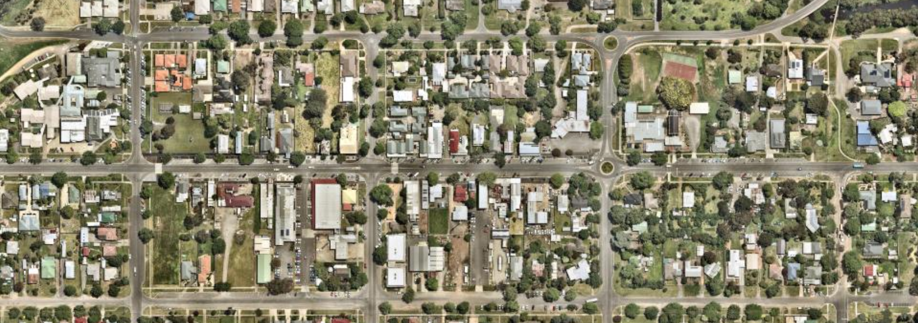
Inglis Street
Cowie Street
Stead Street
Fisken Street
Ballan Hospital
Catholic PS
Proposed 40 km/hr speed zone
Existing 40 km/hr Time-based School speed zone
Existing Pedestrian Crossings
Ballan Township

Crash History
There have been three reported crashes on Inglis Street within the last five years. In two of the crashes, pedestrians were struck. The other crash was recorded as “collision with a fixed object”.

Engagement Summary
Residents, Ballan Police, Ambulance Victoria, CFA and other emergency services have been informed and consulted. An article was posted on Moorabool Shire Council’s facebook page and in the local newspaper (Moorabool News) seeking feedback from community.

Emergency services were supportive of permanent speed reduction, and more than 10 positive comments were received from the community with nil opposed.

Main Street, Bacchus Marsh
Main Street is a “C” class road maintained by Regional Roads Victoria (RRV).

The section of Main Street between, between Gisborne Road and Young Street, currently has a speed limit of 50km/hr with four pedestrian crossings. There is also a pedestrian crossing on the side road entrance to the Village Shopping Centre.

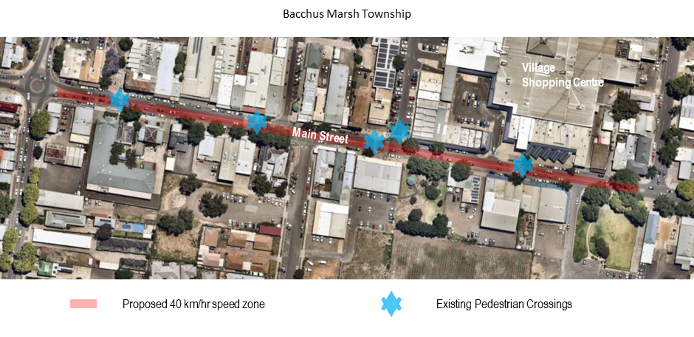

Crash History
There have been six reported crashes on Main Street within the last five years.
Engagement Summary
Council has historically received a number of requests for speed limit amendments within the CBD precinct, on the basis of pedestrian safety, particularly along Main Street between Gisborne and Young Streets.
In addition to this, the development of Local Area Traffic Management Plans (Stages 1 and 2) in Bacchus Marsh involved significant community consultation processes including online interactive surveys, written correspondence to property owners within the area and a number of face-to-face community workshops. Consultation was open to all stakeholders and involvement from the community was substantial across all contribution methods.

Proposal
Inglis Street & Cowie Street, Ballan
Based on the information outlined above, it is viewed that the existing speed limit along Inglis Street and Cowie Street from the Catholic Primary School to Ballan Hospital should be decreased to 40km/hr. Future traffic counts will continue to be monitored and alternative traffic control devices will be investigated. Reducing the speed limit together with other safety measures already in place will increase safety of pedestrians, cyclists and motorists using this road.

Main Street, Bacchus Marsh
Based on the community feedback provided to Councillors, it is viewed that the existing speed limit along Main Street from the Gisborne Road to Young Street should be decreased to 40km/hr. Reducing the speed limit together with other safety measures already in place will increase safety of pedestrians, cyclists and motorists using this road

Council Plan
The Council Plan 2017-2021 provides as follows:
Strategic Objective 1: Providing Good Governance and Leadership
Context 1A: Our Assets and Infrastructure
The proposal is consistent with the Council Plan 2017 – 2021.

Financial Implications
There are no financial implications associated with the recommendation within this report.

Risk & Occupational Health & Safety Issues
The are no risk or occupational health and safety issues associated with the recommendation within this report.

Communications & Consultation Strategy
Level of Engagement | Stakeholder | Activities | Location | Date | Outcome
Consult and Inform | Community and Emergency Services | Email, Press Release, and Facebook | Various | December | Community and Emergency Services were supportive of Speed Zone Change

Victorian Charter of Human Rights & Responsibilities Act 2006
In developing this report to Council, the officer considered whether the subject matter raised any human rights issues. In particular, whether the scope of any human right established by the Victorian Charter of Human Rights and Responsibilities is in any way limited, restricted or interfered with by the recommendations contained in the report. It is considered that the subject matter does not raise any human rights issues.

Officer’s Declaration of Conflict of Interests
Under section 80C of the Local Government Act 1989 (as amended), officers providing advice to Council must disclose any interests, including the type of interest.
General Manager – Phil Jeffrey
In providing this advice to Council as the General Manager, I have no interests to disclose in this report.
Author – Ewen Nevett
In providing this advice to Council as the Author, I have no interests to disclose in this report.

Conclusion
Following an assessment of the road conditions, it has been determined that the existing speed limit along Inglis Street and Cowie Street, generally from the Catholic Primary School to Ballan Hospital and Main Street, Bacchus Marsh, between Gisborne Road and Young Street, should be decreased to 40km/hr.

15.3 Moorabool Community Road Safety Strategy
Author: Jacquie Younger, Asset Systems Officer
Authoriser: Phil Jeffrey, General Manager Community Assets & Infrastructure
Attachments: 1. Moorabool Community Road Safety Strategy (under separate cover)

Purpose
Following extensive consultation with key stakeholders and the community, the draft Moorabool Community Road Safety Strategy was developed and placed on public exhibition during March 2020. The purpose of this report is to present the final strategy to Council for formal adoption.

Executive Summary
• Moorabool Shire Council was successful in obtaining funding for the development of a Community Road Safety Strategy through the Transport Accident Commission (TAC) Towards Zero Grant Program.
• Extensive consultation was undertaken as part of the strategy development, including with key stakeholders/groups as well as the wider community.
• The strategy builds on the positive work already undertaken by Council and sets out a range of improvement actions to be undertaken, to assist in reducing serious injury and fatality crashes within the Shire, in line with Safe System Principles.
• Following the public exhibition process during March, the strategy has now been finalised for formal adoption.

Resolution
Moved: Cr Tom Sullivan
Seconded: Cr Tonia Dudzik
That Council:
1. Adopts the Moorabool Community Road Safety Strategy 2020-24.
2. Requests that a copy of the strategy be made available on Council’s website.
Carried

Background
Moorabool Shire Council plays an important role in providing a safe travel environment for residents and visitors. A key part of this role includes the implementation of activities directed at reducing the likelihood and severity of road accidents and influencing driver behaviour by working in partnership with key road safety bodies and community groups.
Moorabool Shire Council was successful in obtaining funding for the development of a Community Road Safety Strategy through the Transport Accident Commission (TAC) Towards Zero Grant Program. A working group was developed to ensure all road safety factors were considered Shire wide. The working group was made up of key Council staff and representatives from the Victoria Police.
Following significant community and stakeholder consultation (outlined below), a Moorabool Community Road Safety Strategy has been developed. The strategy outlines a four-year action plan in line with Safe System Principles (safe roads, safe speeds, safe people and safe vehicles) to assist in promoting safe travel with the aim of reducing serious injuries and fatalities on local and arterial roads within the municipality and provide a structured approach to guide Council in delivering projects and initiatives that meet the needs of the growing community.
The strategy builds on the positive work already undertaken by Council, acknowledging transport pressures faced, and confirms a commitment to the reduction of casualty accidents in line with Safe System principles of the Victorian Government’s Toward Zero Strategy.

Proposal
It is recommended that Council adopts the final Moorabool Community Road Safety Strategy 2020-24.

Council Plan
The Council Plan 2017-2021 provides as follows:
Strategic Objective 1: Providing Good Governance and Leadership
Context 1A: Our Assets and Infrastructure
The proposal is consistent with the Council Plan 2017 – 2021.

Financial Implications
Moorabool Shire Council was successful in obtaining funding for the development of a Community Road Safety Strategy through the Transport Accident Commission (TAC) Towards Zero Grant Program. As such there are no financial implications associated with the recommendation within this report.

Risk & Occupational Health & Safety Issues
Risk Identifier | Detail of Risk | Risk Rating | Control/s
Financial | Inadequate funds to deliver priority projects | Low | Adequate review of key actions including resource requirements. Referral of infrastructure priorities to Council’s Long Term Capital Improvement Plan.
Community expectation | Community expectation of key project outcomes outside of the project scope | Low | Well scoped community consultation processes and documentation, clear project objectives documented.

Communications & Consultation Strategy
Community participation is an important component of the strategy development, assisting to better understand the local issues. Significant community consultation has been undertaken throughout the project as outlined below.

Level of Engagement | Stakeholder | Activities | Location | Date | Outcome
Collaborate | Key internal MSC staff and Victoria Police | Working Group was formed | MSC | August 2019 | A Working Group was developed to commence the draft strategy process
Consult | Victoria Police, Transport Accident Commission (TAC), Road Safe Central Highlands (RSCH), VicRoads, Victoria State Emergency Service (SES), CFA (Country Fire Authority), Public Transport Victoria (PTV) | Direct phone call - One on one consultation | Various | October 2019 | Stakeholders were asked specific relevant questions and also encouraged to provide general feedback on key road safety issues within Moorabool
Consult | All residents and visitors who live, work and travel in Moorabool | Community survey both online via Have Your Say and hard copy | Various | October 2019 | Encouraged to provide feedback on key road safety issues within Moorabool via Councils Have Your Say
Consult | All residents and visitors who live, work and travel in Moorabool | Media release through local paper, Councils Social Media and local radio station | Various | October 2019 | Encouraged to provide feedback on key road safety issues within Moorabool via Councils Have Your Say

Consult | Various stakeholders, user and community groups (all Council databases) | Direct Emails to inform of Community survey both online via Have Your Say and hard copy | Various | October 2019 | Encouraged to provide feedback on key road safety issues within Moorabool via Councils Have Your Say
Consult | All stakeholders, various user and community groups, residents and visitors who live, work and travel in Moorabool | Open Community Workshops (2) | Lerderderg Library and Ballan Council Chambers | November 2019 | Encouraged to participate in workshops to give feedback and provide potential solutions on key road safety issues within Moorabool. Victoria Police also attended and presented at the workshops.
Inform | Councillors and Executive Team | Councillor Briefing | MSC | January 2020 | A presentation was conducted with Councillors to discuss the draft strategy as well as statistics obtained during the process
Inform | Councillors and community | Council report | MSC | January 2020 | A Council report was completed to present the draft strategy to Councillors requesting endorsement for the draft strategy to go to public exhibition
Consult | All stakeholders, various user and community groups, residents and visitors who live, work and travel in Moorabool | Draft Moorabool Community Road Safety Strategy endorsed for Public Exhibition for a period of 28 days | Various | March 2020 | Encouraged to provide feedback on draft strategy via Councils Have Your Say
Inform | All stakeholders, various user and community groups, residents and visitors who live, work and travel in Moorabool | Present final Moorabool Community Road Safety Strategy to Council for Adoption | MSC | May 2020 | Final strategy will be uploaded to Councils website and promoted via online media channels

Victorian Charter of Human Rights & Responsibilities Act 2006
In developing this report to Council, the officer considered whether the subject matter raised any human rights issues. In particular, whether the scope of any human right established by the Victorian Charter of Human Rights and Responsibilities is in any way limited, restricted or interfered with by the recommendations contained in the report. It is considered that the subject matter does not raise any human rights issues.

Officer’s Declaration of Conflict of Interests
Under section 80C of the Local Government Act 1989 (as amended), officers providing advice to Council must disclose any interests, including the type of interest.
General Manager – Phil Jeffrey
In providing this advice to Council as the General Manager, I have no interests to disclose in this report.
Author – Jacquie Younger
In providing this advice to Council as the Author, I have no interests to disclose in this report.

Conclusion
A Moorabool Community Road Safety Strategy has been developed which sets out a range of improvement actions to be undertaken in line with Safe System Principles to assist in promoting safe travel within Moorabool Shire.
Stakeholders, various user and community groups, residents and visitors were encouraged to participate, provide feedback and potential solutions on key issues within the municipality and it is recommended that Council adopts the final Moorabool Community Road Safety Strategy.

15.4 Petition Response; Griffith Street, Maddingley
Author: Lace Daniel, Coordinator Asset Management
Authoriser: Phil Jeffrey, General Manager Community Assets & Infrastructure
Attachments: 1. Concept Design (under separate cover)

Purpose
The purpose of this report is to provide Councillors with an overview of upgrades proposed on Griffith Street, Maddingley, to cater for future vehicle and pedestrian movements. The report also provides a response to two petitions received in late 2019 in relation to the same issue.

Executive Summary
• Two petitions have been received regarding Griffith Street in Maddingley, particularly highlighting concerns in relation to the service roads and pedestrian crossing points.
• Council’s strategic work identifies the need for upgrades to cater for future traffic and pedestrian movements. A traffic investigation has been undertaken to inform these works and a concept plan developed for proposed interim and ultimate solutions.
• $125,000 is included in the draft 2020/21 Capital Improvement Program for the detailed design and preplanning component of the project with a construction allocation, partly funded by development contributions, proposed in 2021/22 to upgrade the road.
• An interim pedestrian refuge is recommended to be installed in front of Providence Village connecting the bus stops prior to completion of the design and subsequent upgrades.

Resolution
Moved: Cr Tonia Dudzik
Seconded: Cr John Keogh
That Council:
1. Receives the report and acknowledges that the following allocations are included in the draft 2020/21 capital budget:
$125,000 for the detailed design of upgrades along Griffith Street, between Grant Street and Cassinia Boulevard.
$40,000 for the construction of a pedestrian refuge on Griffith Street, at the front of Providence Village connecting the existing bus stop on each side of the road.
2. Requests officers apply to Public Transport Victoria for funding for the installation of a DDA compliant bus stop and shelter at this location.
3. Writes to the convener of each petition to inform them of Council’s decision.
Carried
DIVISION:
In Favour: Crs Tom Sullivan, John Keogh, Lawry Borgelt, Tonia Dudzik and David Edwards.
Against: Crs Jarrod Bingham and Paul Tatchell.
The motion was declared carrIed

Background
At the Ordinary Meeting in August 2019, Council received a petition from residents requesting improvements to the nature strip adjacent to the Griffith Street Service Road on the south side, between Osborne Street and Hillside Street. The petition called specifically for levelling and landscaping, installation of business signage, and sealing and formalisation of parking for the industrial estate.
Further to this, at the Ordinary Meeting in September 2019, Council received a petition from residents requesting the construction of a pedestrian crossing and connection from Providence Village on the south side, to the existing bus stop on the north side, including the installation of a shelter at this location. The petition also requests modification of the existing crossing at the Grant Street roundabout, to improve connectivity and accessibility for prams and scooters.
There are numerous issues and factors to be considered, including the future function and capacity of the road, and thus this report discusses the future arrangement of Griffith Street and seeks to address both petitions outlined above.
Site Assessment (Current Conditions)
Griffith Street is a local road extending approximately 1.8km from Grant Street at the east, to McCormacks Road at the west and provides a key strategic link between the suburbs of Maddingley and Bacchus Marsh. The road is classified as a Trunk Collector and is managed and maintained in accordance with Council’s Road Management Plan.
The carriageway width varies between approximately 7m and 12m, providing a single lane in either direction along the full extent with an additional westbound lane between Franklin Street and Osborne Street.
The existing pedestrian connections along Griffith Street include sections of footpath, highlighted yellow and shared paths highlighted red in the images below. There are no designated on-road bicycle connections on either side of the road.
Land use along Griffith Street is primarily residential on the north side and industrial on the south side, in addition providing access to the Bacchus Marsh College, Providence Retirement Village and Maddingley Cemetery. A combination of sealed and unsealed service roads exists on the north and south side of Griffith Street, between Franklin and Hillside Streets.
Image 1: Grant Street to Osborne Street
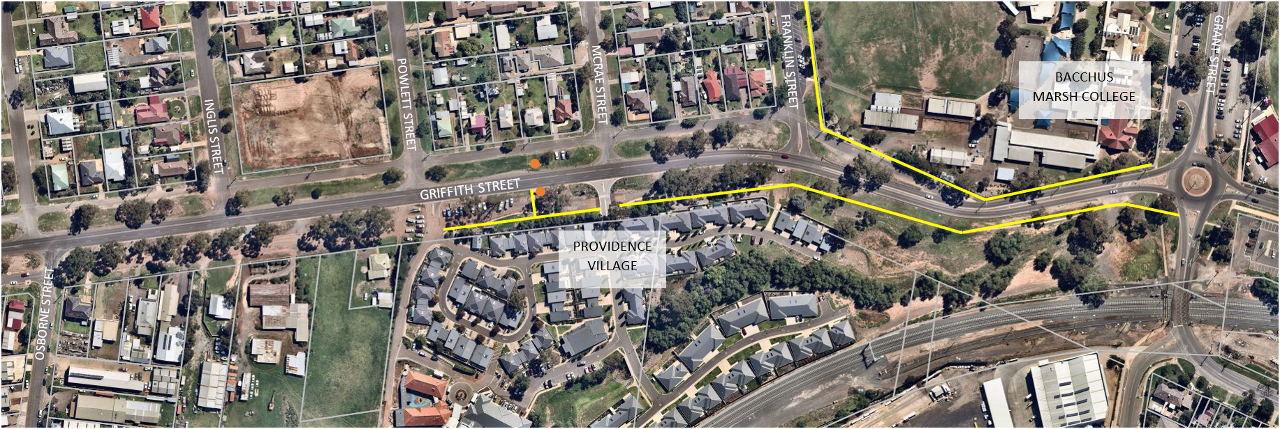

Image 2: Osborne Street to Cassinia Boulevard
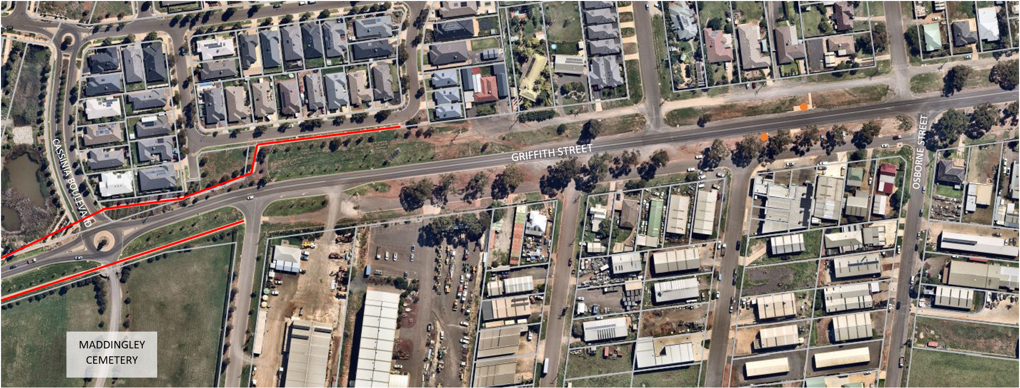
Image 3: Cassinia Boulevard to McCormacks Road
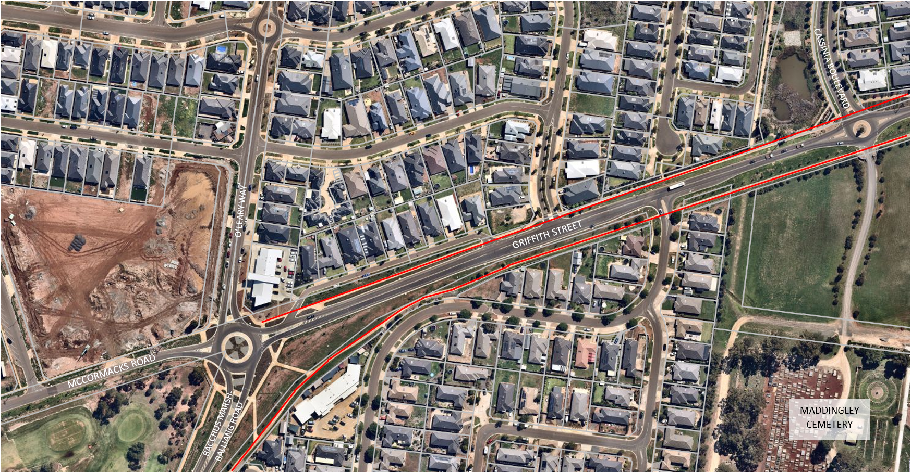
Griffith Street has a posted speed limit of 60km/h, with a timed 40km/h school zone between Grant and Franklin Streets during school pick up/drop off times.
Public bus route 433 operates along Griffith Street, connecting passengers from Maddingley to the Bacchus Marsh Station and CBD. The bus stops along Griffith Street are highlighted orange in the images above.
Future Functionality
A number of future traffic projections and scenarios were investigated and outlined as part of the Bacchus Marsh Integrated Transport Strategy (2015) (BMITS), including modelling of likely daily and peak hour volumes along Griffith Street in 2021, 2031 and 2041. These forecasts were modelled based on growth projections for the town and implementation of various road infrastructure projects.

The strategy identifies the need for capacity improvements to Griffith Street by 2031 and highlights the impacts to the road network in the scenario that no action is undertaken (see below). It also identified the intersection of Grant and Griffith Streets requiring upgrades in the near future which Council is advocating to Regional Roads Victoria to upgrade.
Image 4: By 2031; A ‘Do Nothing’ Approach (BMITS 2015)
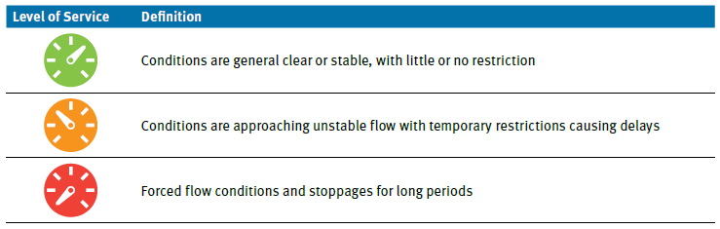
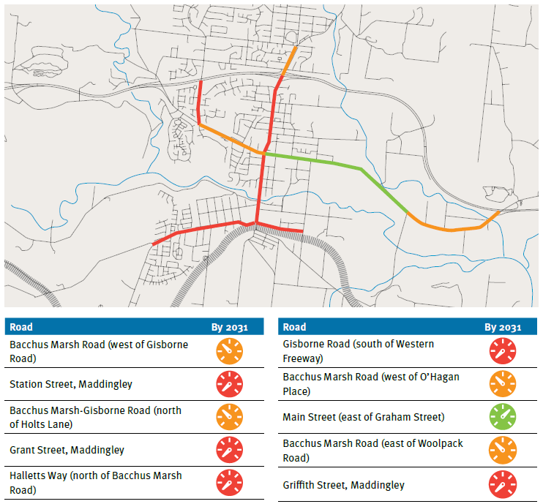
Traffic Investigation
Rather than looking at all the issues raised in isolation, and to ensure future traffic and pedestrian considerations were considered, Traffix Group was engaged by Council to undertake a traffic investigation for the section of Griffith Street, between Grant Street and Cassinia Boulevard (entrance to Stonehill Estate).
The project included the review of existing conditions, site inspection and pedestrian counts during peak times, the assessment of technical data and statistics, and the development of concept plans for interim and ultimate works to facilitate future predicted traffic movements. Traffic count data collected is summarised below.

Location | Direction | AADT | 85th %ile speed
Eastern End  (between McCrae Street and Franklin Street) | Eastbound | 4,020 | 63.0
 | Westbound | 4,223 | 66.9
 | Combined | 8,243 | 64.9
Western End  (between Cemetery Road and Barry Street) | Eastbound | 3,044 | 64.8
 | Westbound | 3,366 | 66.0
 | Combined | 6,410 | 65.4
The transport modelling undertaken as part of the BMITS indicates that the daily traffic volume on Griffith Street will increase to 16,900 and 17,900 in 2031 and 2041 respectively. The recommendations within this report take into account these projections.
Vehicle turning movement surveys and capacity investigations were conducted at a number of key intersections along the route, in addition to a pedestrian count undertaken on site.
A review of available crash statistics was also undertaken, showing four casualty crashes (two serious injury and two other) in the last five years. The two serious injury crashes involved pedestrians crossing Griffith Street during the evening/night.
Petition 1; Service Roads
The first petition received by Council raises concerns in relation to the layout and condition of the service road on the south side of Griffith Street, fronting the industrial estate. The petition requests a number of treatments be considered including sealing and the provision of formal car parking, landscaping and the installation of business signage.
It is noted that a combination of sealed and unsealed service roads exists on both the north and south sides of Griffith Street, generally between Franklin and Hillside Streets. The detailed design for the project will consider the layout and landscaping of all Griffith Street service roads. There are also numerous direct connections to Griffith Street from the service roads on both sides and it is proposed that these connections be formalised and rationalised as part of the detailed design process.
Petition 2; Pedestrian Connections
The second petition received by Council focusses on the lack of pedestrian connections, specifically in the vicinity of Providence Village aged care facility. It requests that consideration be given to the installation of a crossing at this location, in addition to a shelter at the bus stop on the north side.
As shown in the image below, there is an existing bus shelter, including a footpath to the Providence Village entrance, on the south side. There is a bus stop on the north side, however there is no concrete pad or shelter, no crossing at this point and no pedestrian connections provided to the stop from any direction. The current layout presents safety risks and access issues for public transport users and anecdotally, residents are opting to find alternative modes of transport as a result.
Given the immediate need, it is recommended that a short-term option be implemented to facilitate crossing Griffith Street at this location. This is discussed further in the Proposal section below.
Initial discussions with Public Transport Victoria (PTV) also indicate that they would be happy to consider a joint funding proposal for works at this location, once a concept plan has been approved for the crossing. It is recommended that officers pursue this funding opportunity.

Image 5: Griffith Street, between Powlett and McCrae Streets, looking east
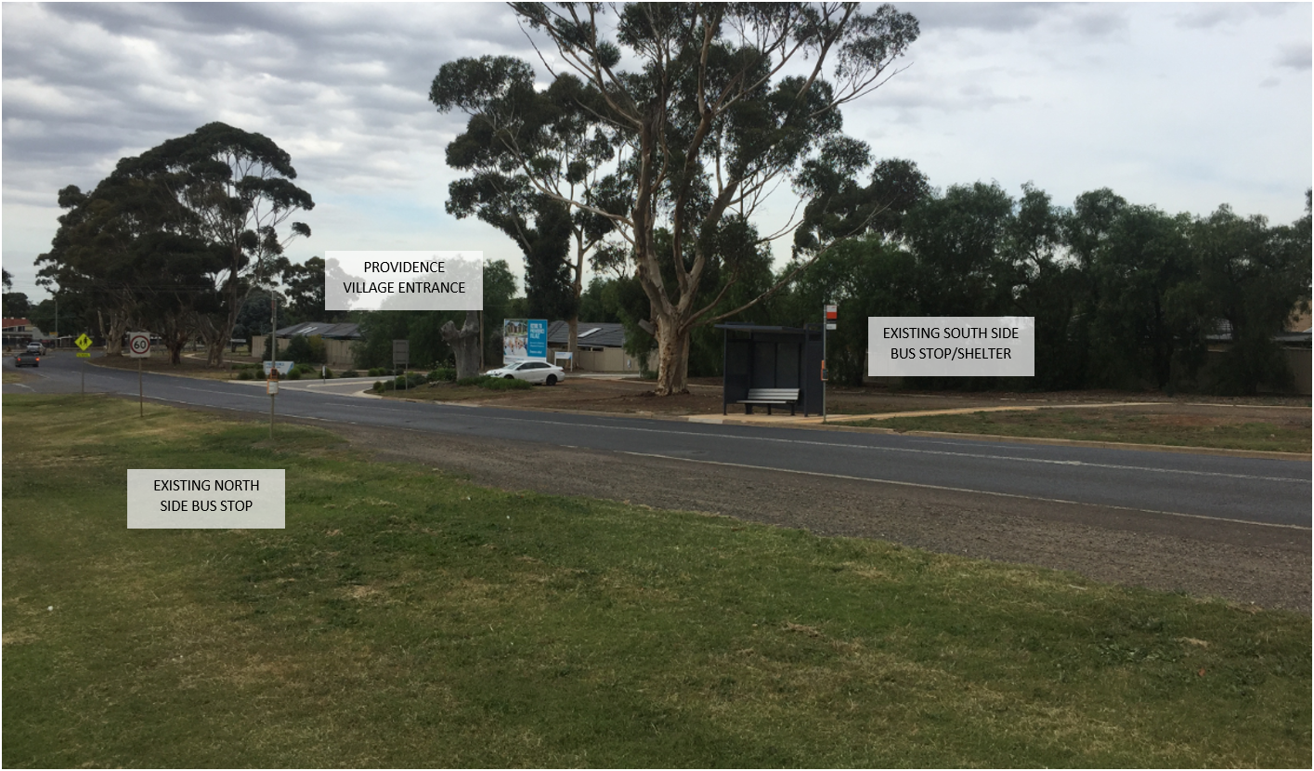
The petition also raises concerns in relation to the crossing point on the western leg of the Grant Street roundabout (Griffith Street) however it is noted that Council is currently in the process of upgrading this crossing, including replacement of the existing ramps and improving the crossing alignment. These works are scheduled to be completed prior to the end of the financial year.
Grant Street Roundabout
Acknowledging the need to improve capacity at the intersection of Griffith and Grant Streets Regional Roads Victoria have prepared a concept design for the conversion from a roundabout to a signalised intersection. These upgrades are subject to future funding and Council continues to advocate to RRV for upgrades.
Image 6: Grant Street / Griffith Street Concept Plan (BECA 2016)
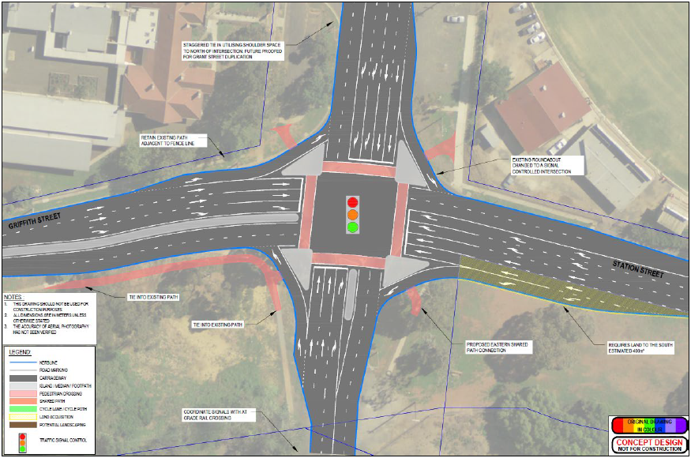

Proposal
The traffic investigation report identifies and recommends both immediate and ultimate upgrades for Griffith Street. These upgrades are supported by the analysis and recommendations within the BMITS.
The immediate recommendations made within the report include the following:
• Intersection upgrades at Grant and Griffith Streets (RRV),
• Installation of a three-lane treatment providing a through lane in each direction and a median lane to provide pedestrian refuges and turning lanes as appropriate,
• A right turn lane treatment into Franklin Street,
• Installation of pedestrian refuges and pram ramps at the following locations:
• Bus stops between Barry and Moore Streets,
• Bus stops and Providence Village between Powlett and McCrae Streets, and
• Installation of a shared path on the north side of Griffith Street, between Moonglow Crescent and Grant Street.
The ultimate recommendations made within the report include the following:
• Upgrade of Griffith Street to provide a divided carriageway with two through-lanes in each direction, with capacity for median storage and turning lanes as required,
• Construction of a footpath on the south side of Griffith Street, between Cemetery Road and Providence Drive, and
• Installation of pedestrian operated signals between Powlett and McCrae Streets, upgrading the pedestrian refuge proposed within the interim recommendations.
A concept design for both scenarios is attached for information and given the need for capacity improvements by 2031, it is recommended the Council proceed with the detailed design of the ultimate arrangements in the first instance. It is noted that an allocation of $125,000 is included in the 2020/21 Capital Improvement Program for this planning project.
The detailed design would incorporate a divided 4 lane road, pedestrian and cycle facilities, signalised pedestrian crossing, sealed service roads on both sides with consideration for parking and landscaping.
Given the current deficiencies in relation to pedestrian and public transport access at the front of Providence Village, it is proposed to provide an interim solution at this location. This includes the provision of a pedestrian refuge in the existing centre climbing lane, thus closing that lane to provide footpath connections between Providence Village and the existing bus stop to the north. It is recommended that this be funded from the 2020/21 capital budget.
Public Transport Victoria have indicated that once a concept is developed and approved, Council may apply to them for supplementary funding toward the installation of a DDA compliant bus stop and shelter at this location.

Council Plan
The Council Plan 2017-2021 provides as follows:
Strategic Objective 1: Providing Good Governance and Leadership
Context 1A: Our Assets and Infrastructure
The proposal is consistent with the Council Plan 2017 – 2021.

Financial Implications
A nominal allocation of $2.5M is included in Council’s Strategic Financial Plan for the road upgrades, including $1.355M in developer contributions from West Maddingley estate. $125,000 is currently included within the draft 2020/21 Capital Improvement Program for the detailed design of road upgrades.
The construction component is a nominal allocation that could vary significantly depending on the detailed design and preplanning for the project to better understand the impact on underground services and other required works to establish a cost estimate for construction with a high confidence rating.
As outlined above, the provision of a crossing refuge from Providence Village to the existing bus stop to the north is proposed to be funded from 2020/21 capital budget.
As a result, pending adoption of the Annual Budget, there are no immediate financial implications associated with the recommendations within this report.

Risk & Occupational Health & Safety Issues
Risk Identifier | Detail of Risk | Risk Rating | Control/s
Occupational Health & Safety | Risk of personal injury (staff, contractors or the public) | Low | Audits ensuring adequate contractor OHS documentation, processes and checks are in place throughout the project.
Financial | Inadequate funds available to complete the full scope of works | Low | Adequate project scoping and procurement processes in place throughout the project. Design providing the ability to stage construction.
Public Liability | Risk of property damage (staff, contractors or the public) | Low | Adequate safety measures and insurances in place throughout the project.

Communications & Consultation Strategy
Level of Engagement | Stakeholder | Activities | Location | Date | Outcome
Inform | Petition convener (2) | Advise the convenor of the outcome of the Report to Council | N/A | May 2020 | Petitioners informed of petition outcome/s
Inform | Residents and road users | Advise of works and changed traffic conditions | N/A | TBC | Residents and road users aware of changes.

Victorian Charter of Human Rights & Responsibilities Act 2006
In developing this report to Council, the officer considered whether the subject matter raised any human rights issues. In particular, whether the scope of any human right established by the Victorian Charter of Human Rights and Responsibilities is in any way limited, restricted or interfered with by the recommendations contained in the report. It is considered that the subject matter does not raise any human rights issues.

Officer’s Declaration of Conflict of Interests
Under section 80C of the Local Government Act 1989 (as amended), officers providing advice to Council must disclose any interests, including the type of interest.
General Manager – Phil Jeffrey
In providing this advice to Council as the General Manager, I have no interests to disclose in this report.
Author – Lace Daniel
In providing this advice to Council as the Author, I have no interests to disclose in this report.

Conclusion
Council’s strategic work identifies the need for upgrades along Griffith Street to cater for future traffic and pedestrian movements, and there is also clear community support for these upgrades to occur as highlighted by the petitions received. To inform the recommendations in this report, a traffic investigation for Griffith Street, between Grant Street and Cassinia Boulevard, has also been undertaken.
To improve safety and better facilitate public transport use, it is proposed that interim works be undertaken to provide a crossing between Powlett and McCrae Streets and that officers proceed with the detailed design of all future works as outlined within this report as part of the 2020/21 Capital Improvement Program.

15.5 Capital Improvement Program Quarterly Report - March 2020
Author: Martin Ferguson, Capital Works Coordinator
Authoriser: Phil Jeffrey, General Manager Community Assets & Infrastructure
Attachments: 1. Capital Improvement Program Quarterly Report - March 2020 (under separate cover)

Purpose
To provide Council with an overview of the progress of Council’s 2019/2020 Capital Improvement Program to 31 March 2020.

Executive Summary
The delivery of the 2019-2020 Capital Improvement Program is on schedule with:
• 50% of the CIP Projects completed.
• 36% of the CIP Projects either commenced or awarded awaiting start.
• 14% of the CIP Projects in the design or tendering stage.

Resolution
Moved: Cr Tom Sullivan
Seconded: Cr Tonia Dudzik
That Council resolves to receive the Capital Improvement Program quarterly report to 31 March 2020.
Carried

Background
The delivery of the Capital Improvement Program (CIP) is an important function of Council’s operations and represents a significant portion of Council’s overall expenditure. Accordingly, the status of the overall program is reported to Council every quarter.

Proposal
This quarterly report provides Council with an overview of the progress of Council’s 2019/2020 Capital Improvement Program to 31 March 2020.
Implementation of the 2019/2020 Capital Improvement Program
The 2019/2020 Capital Improvement Program currently consists of 64 projects. The number of projects may be adjusted throughout the year as other projects become active. This list incorporates projects from various sources including but not limited to the following:
• Projects carried forward from 2018/2019 program.
• 2019/2020 Council budgeted projects.
• Grant funded projects.
For simplicity the reseal and final seal programs have been listed as 2 projects in total rather than listing each individual road under each respective program.

The Engineering Services Unit nominates 6 key stages of the project delivery process and will report with reference to these stages regarding the overall program status.
Program Status
The table below summarises the overall program status as at 31 March 2020:
CIP Program Delivery Stage | Actuals as of 31 March 2020
 | No. of Projects | %
Inactive / On Hold | 0 | 0
Not Commenced | 0 | 0
Documentation / Design Preparation | 3 | 4.7
Tender / Quote Stage | 6 | 9.4
Project Awarded – Awaiting Commencement | 2 | 3.2
In Progress / Under Construction | 21 | 32.8
Complete | 32 | 50.0
Total | 64 | 100
The attached report details specific comments in relation to each project and its status.
The program is relatively on track for delivery. Some project will be carried forward to the 2020/2021 financial year.
• 50% of the CIP Projects completed.
• 36% of the CIP Projects either commenced or awarded awaiting start.
• 14% of the CIP Projects in the design or tendering stage.
Several projects will be carried over to the following financial year due to various constraints.
Carry Over Projects
Ballan Netball Courts Acrylic Surfacing – Issues with the stability of the asphalt surface have delayed the application of the acrylic surfacing. Due to ambient temperature requirements this surfacing will now be applied after Winter.
Ballan Oval Lighting – Installation has been deferred to align with the upgrade of the Ballan Recreation Reserve Oval.
Dunnstown Yendon Road Reseal – Reseal to be completed with the final seal on the 2019/2020 road rehabilitation.
Final Sealing Projects – Woolpack Road, Clarkes Road, Bacchus Marsh – Balliang Road – Projects carried forward due to short length of time between initial seal and proposed final seal.
Fisken Street Reseal – Major patching required, once completed the weather will be unsuitable to complete the reseal.
Harris Road Intersection – Project fully funded by Regional Roads Victoria (RRV). Market capacity to deliver at a reasonable cost and alternatives being explored with RRV.
Wallace Recreation Reserve Irrigation Construction – Initially proposed to carry over due to market capacity to deliver prior to the football season commencing. Now unable to bring forward due to the unsuitable weather conditions for grass to establish after construction is complete despite the postponement of the football season.
Ballan Depot Site Works – Earthworks will not be completed prior to Winter as Contractor will be focussing on completing Haddon Drive component of Contract.
A number of projects are part of multi-year delivery, including Bacchus Marsh Racecourse Reserve; Ballan Recreation Reserve; Bacchus Marsh Indoor Recreation Facility design.

Council Plan
The Council Plan 2017-2021 provides as follows:
Strategic Objective 1: Providing Good Governance and Leadership
Context 1A: Our Assets and Infrastructure
The proposal is consistent with the Council Plan 2017 – 2021.

Financial Implications
Reporting of the Capital Improvement Program has been resourced as part of Council’s budget; accordingly, there are no additional financial implications. At this point in time, there are no significant budget issues to report, with the overall program anticipated to be delivered within 0.5% of the budget allocation (excluding the carryover projects).

Risk & Occupational Health & Safety Issues
There are no irregular Risk and Occupational Health and Safety issues identified in this report. Specific risk elements are analysed and monitored by the allocated project manager as part of the delivery of each individual project.

Communications & Consultation Strategy
Progress on the Capital Improvement Program will be reported in the following formats:
• Infrastructure update on active projects weekly
• Update on major projects monthly
• Moorabool Matters quarterly
• Moorabool News as required
• Report to Council quarterly
Specific projects are communicated to the community and affected residents as required through a range of methods including but not limited to advertisements, mail outs, letter drops and door knocking.

Victorian Charter of Human Rights & Responsibilities Act 2006
In developing this report to Council, the officer considered whether the subject matter raised any human rights issues. In particular, whether the scope of any human right established by the Victorian Charter of Human Rights and Responsibilities is in any way limited, restricted or interfered with by the recommendations contained in the report. It is considered that the subject matter does not raise any human rights issues.

Officer’s Declaration of Conflict of Interests
Under section 80C of the Local Government Act 1989 (as amended), officers providing advice to Council must disclose any interests, including the type of interest.
General Manager – Phil Jeffrey
In providing this advice to Council as the General Manager, I have no interests to disclose in this report.
Author – Ewen Nevett
In providing this advice to Council as the Author, I have no interests to disclose in this report.

Conclusion
This report provides a summary of the progress of the Capital Improvement Program for the third quarter of the 2019/2020 period for the information of Councillors.

16 Other Reports

16.1 Assembly of Councillors
Author: Renee Hodgson, Governance Officer
Authoriser: Caroline Buisson, General Manager Customer Care & Advocacy
Attachments: 1. Assembly of Councillors - 26 February 2020 (under separate cover)
2. Assembly of Councillors - 4 March 2020 (under separate cover)
3. Assembly of Councillors - 11 March 2020 (under separate cover)

Purpose
This record of Assemblies of Councillors is provided in accordance with statutory requirements of the Local Government Act 1989.

Executive Summary
• In accordance with section 80A(2) of the Local Government Act 1989, The Chief Executive Officer must ensure that the written record of an assembly of Councillors is, as soon as practicable, reported at an ordinary meeting of the Council and incorporated in the minutes of that council meeting.
• The Local Government Act 1989 defines the following to be Assemblies of Councillors: a meeting of an advisory committee of the Council, if at least one Councillor is present, or a planned or scheduled meeting of at least half of the Councillors and one member of Council staff which considers matters that are intended or likely to be the subject of a decision of the Council or subject to the exercise of a function, duty or power of the Council that has been delegated to a person or committee.
• It should be noted, an assembly of Councillors does not include a meeting of the Council, a special committee of the Council, an audit committee established under section 139, a club, association, peak body, political party or other organisation.

Resolution
Moved: Cr John Keogh
Seconded: Cr Lawry Borgelt
That Council receive the record of Assemblies of Councillors, as follows:
1. Assembly of Councillors – Wednesday 26 February 2020:
(a) Cat curfew
(b) Moorabool Community Road Safety Strategy
(c) Confidential – Visitor Information Centre Service Review and Local Visitor Economy
2. Assembly of Councillors – Wednesday 4 March 2020:
(a) Western Irrigation Network Update
3. Assembly of Councillors – Wednesday 11 March 2020
(a) MSC Subdivision Review Arrangements
(b) Budget and Council Plan
Carried

17. Notices of Motion
Nil.

18. Mayor’s Report

18.1 Mayor's Report
Author: Dianne Elshaug, Co-ordinator CEOs Office
Authoriser: Derek Madden, Chief Executive Officer
Attachments: Nil

Purpose
To provide details to the community on the meetings and events attended by the Mayor since the last Ordinary Meeting of Council.

Executive Summary
Cr David Edwards – Mayor’s Report
Date: 5 March – 6 May, 2020
11 March | - Meeting with the Hon David Davis, Shadow Minister Transport Infrastructure  - Councillor Briefing – MSC Subdivision Review Arrangements  - Councillor Briefing – Budget and Council Plan  - Women’s Health Forum
13 March | - Meeting with Djerriwarrh Health Services  - Peri-Urban Group of Rural Councils Meeting
16 March | - Meeting with CEO, Western Health
18 March | - S86 Development Assessment Committee Meeting
22 April | - Councillor Briefing - Proposed Financial Assistance Measures re COVID-19 via Teams
29 April | - MSC Community Leadership Program Q&A via Zoom
6 May | - Ordinary Meeting of Council

Resolution
Moved: Cr Tonia Dudzik
Seconded: Cr John Keogh
That Council resolves to receive the Mayor’s Report.
Carried

19. Councillors’ Reports
Councillors noted their limitation to attend various meetings and activities due to the current COVID-19 restrictions in place.
Since the last Ordinary Meeting of Council, Councillors have attended the following meetings and activities:
Cr Tatchell | Meeting with Bendigo Bank regarding Community Funding Project Funding.
Cr Keogh | Attending weekly/fortnightly Municipal Emergency Management Committee Meetings.
Cr Borgelt | Attended the Central Highlands Local Learning and Employment Network.

Resolution
Moved: Cr Tom Sullivan
Seconded: Cr Jarrod Bingham
That Council resolves to receive the Councillors’ Reports’.
CARRIED

20. Urgent Business

Nil.

21. Closed Session of the Meeting to the Public

Nil.

22. Meeting Closure
The Meeting closed at 7.17pm.

...................................................
CHAIRPERSON

