
AGENDA

S86 Development Assessment Committee Meeting
Wednesday, 20 May 2020

I hereby give notice that a S86 Development Assessment Committee Meeting will be held on:
Date: | Wednesday, 20 May 2020
Time: | 6.00pm
Location: | The Pavilion, Darley Civic Hub
Derek Madden
Chief Executive Officer

Order Of Business
1 Opening 5
2 Present and Apologies 5
3 Recording of Meeting 5
4 Confirmation of Minutes 5
5 Matters Arising from Previous Minutes 5
6 Disclosure of Conflicts of Interests 5
7 Community Planning Reports 7
7.1 PA2019156 - Two lot subdivision (house lot excision) at 70 Dunbar Road, Pentland Hills 7
7.2 PA2019282 - Two Lot Subdivision at 2 Alexander Drive, Ballan 23
7.3 PA2019059 - Two Lot Re-Subdivision and Use and Development of a Dwelling at 139 Pound Creek Road Navigators 34
7.4 PA2019286 - Two Lot Subdivision at 16 Alexander Drive, Ballan 80
7.5 PA2019283 - Two Lot Subdivision at 1 Alexander Drive, Ballan 91
7.6 PA2019284 - Two Lot Subdivision at 5 Alexander Drive, Ballan 103
7.7 PA2019285 - Two Lot Subdivision at 15 Alexander Drive, Ballan 114
7.8 PA2019261 - Use of an existing dwelling as a retail premises (cafe) at 15 Martin Street, Blackwood 126
8 Update on Trends, Issues and Other Matters 143
9 Process Forward and Work Program 143
10 Update on VCAT Decisions 143
11 Other Business 143
12 Date of Next Meeting 143
13 Meeting Close 143

1 Opening

2 Present and Apologies

3 Recording of Meeting
As well as the Council for its minute taking purposes, the following organisations have been granted permission to make an audio recording of this meeting:
- The Moorabool News; and
- The Star Weekly.

4 Confirmation of Minutes
S86 Development Assessment Committee Meeting - Wednesday 18 March 2020

5 Matters Arising from Previous Minutes

6 Disclosure of Conflicts of Interests
Under the Local Government Act (1989), the classification of the type of interest giving rise to a conflict is; a direct interest; or an indirect interest (section 77A and 77B). The type of indirect interest specified under Section 78, 78A, 78B, 78C or 78D of the Local Government Act 1989 set out the requirements of a Councillor or member of a Special Committee to disclose any conflicts of interest that the Councillor or member of a Special Committee may have in a matter being or likely to be considered at a meeting of the Council or Committee.
Definitions of the class of the interest are:
- A direct interest (section 77A, 77B)
- An indirect interest (see below)
- indirect interest by close association (section 78)
- indirect financial interest (section 78A)
- indirect interest because of conflicting duty (section 78B)
- indirect interest because of receipt of gift(s) (section 78C)
- indirect interest through civil proceedings (section 78D)
- indirect interest because of impact on residential amenity (section 78E)
Time for Disclosure of Conflicts of Interest
In addition to the Council protocol relating to disclosure at the beginning of the meeting, section 79 of the Local Government Act 1989 (the Act) requires a Councillor to disclose the details, classification and the nature of the conflict of interest immediately at the beginning of the meeting and/or before consideration or discussion of the Item.
Section 79(6) of the Act states:
While the matter is being considered or any vote is taken in relation to the matter, the Councillor or member of a special committee must:
- Leave the room and notify the Mayor or the Chairperson of the special committee that he or she is doing so; and
- Remain outside the room and any gallery or other area in view of hearing of the room.
The Councillor is to be notified by the Mayor or Chairperson of the special committee that he or she may return to the room after consideration of the matter and all votes on the matter.
There are important reasons for requiring this disclosure immediately before the relevant matter is considered.
- Firstly, members of the public might only be in attendance for part of a meeting and should be able to see that all matters are considered in an appropriately transparent manner.
- Secondly, if conflicts of interest are not disclosed immediately before an item there is a risk that a Councillor who arrives late to a meeting may fail to disclose their conflict of interest and be in breach of the Act.

7 Community Planning Reports

7.1 PA2019156 - Two lot subdivision (house lot excision) at 70 Dunbar Road, Pentland Hills
Author: Victoria Mack, Statutory Planner
Authoriser: Henry Bezuidenhout, Executive Manager Community Planning & Economic Development
Attachments: 1. Proposed plan of subdivision (house lot excision)

Application Summary
Permit No: PA2019156
Lodgement Date: 9 July 2019
Planning Officer: Victoria Mack
Address of the land: 70 Dunbar Road, Pentland Hills 3341
Proposal: Two lot subdivision (House lot excision)
Lot size: 18.20 hectares
Why is a permit required? Clause 35.07-3 Subdivide land (House lot excision)

Recommendation
That Council, having considered all matters as prescribed by the Planning and Environment Act 1987, issue a refusal to grant a permit for a two-lot subdivision (house lot excision) on Lot 7 on TP 000918E otherwise known as 70 Dunbar Road, Pentland Hills, on the following grounds:
1. The proposed subdivision results in the fragmentation of agricultural land;
2. The proposal subdivision does not comply with the policies contained in Clause 22.03, House and House Lot Excisions in Rural Areas, of the Moorabool Planning Scheme;
3. The proposed subdivision is not directly related to the agricultural use of the land; and
4. The proposed subdivision does not comply with the objectives of the Farming Zone at Clause 35.07 of the Moorabool Planning Scheme.

Public Consultation
Was the application advertised? | Yes
Notices on site: | Yes
Notice in Moorabool Newspaper: | No.
Number of objections: | 3 objections
Consultation meeting: | Not held.

Policy Implications
The Council Plan 2017-2021 provides as follows:
Strategic Objective 2: Minimising Environmental Impact
Context 3A: Land Use Planning

Victorian Charter of Human Rights & Responsibilities Act 2006
In developing this report to Council, the officer considered whether the subject matter raised any human rights issues. In particular, whether the scope of any human right established by the Victorian Charter of Human Rights and Responsibilities is in any way limited, restricted or interfered with by the recommendations contained in the report. It is considered that the subject matter does not raise any human rights issues.

Officer’s Declaration of Conflict of Interests
Under section 80C of the Local Government Act 1989 (as amended), officers providing advice to Council must disclose any interests, including the type of interest.
General Manager – Henry Bezuidenhout
In providing this advice to Council as the Executive Manager, I have no interests to disclose in this report.
Author – Victoria Mack
In providing this advice to Council as the Author, I have no interests to disclose in this report.

Executive Summary
Application referred? | Melbourne Water and Council’s Environmental Health and Infrastructure Departments.
Any issues raised in referral responses? | No.
Preliminary concerns? | The location of existing dwelling creates an irregular shaped lot in the centre of the property accessed via a long driveway which bisects the land.
Any discussions with applicant regarding concerns? | No.
Any changes made to the application since being lodged? | The proposed lot with the existing dwelling was increased in area from 1.40ha to 1.52ha.
Brief history. | The owners have lived on the subject property for many years. They currently breed dogs on the property, predominantly Welsh Corgis, and have run cattle on the property. They have advised that remaining in the existing dwelling on a smaller land parcel best meets their retirement needs.
Previous applications for the site? | Nil.

General summary. | The proposed house lot excision creates a vacant lot of 16.68ha and a house lot of 1.52ha. Because the dwelling is in the centre of the site, accessed via a long driveway from the north-east corner, the proposed excision dissects the land into two awkward shaped parcels.  The owners also wish to retain access to the dam on the property in the north-west corner of the site and to enable this a water supply easement to the dam has been added to the Plan of Subdivision.  It is not considered that this proposal is an orderly planning outcome for this land.
Summary Recommendation
That Council, having considered all matters as prescribed by the Planning and Environment Act 1987, issue a refusal to grant a permit for a two-lot subdivision (house lot excision) on Lot 7 on TP 000918E otherwise known as 70 Dunbar Road, Pentland Hills.

Site Description
The land is undulating with the existing dwelling located in the centre of the property on an elevated part of the site with prominent views of the surrounding area, particularly to the east. The land generally slopes away from the house site to the west, south and east. To the north the land contains the driveway to Dunbar Road and is generally flat. The driveway is currently fenced on both sides. It is assumed that the current fences accord with the proposed subdivision boundaries.
The Myrniong Creek runs along the whole of the south boundary. The land slopes sharply to the creek with the escarpment width being approximately 100m. This sloped area has scattered vegetation. A tributary of the Myrniong Creek also dissects the north-west corner of the site. There is a dam on this waterway with a surface area of approximately 800sq m. The current owner wishes to retain access to this dam for domestic water supply purposes.
Surrounding land to the south is also steeply dissected and includes a floodplain at the bottom of the escarpment. Further to the south is the Werribee River. Land to the west, north and east is generally grazing land. Land on the north side boundary of the site has been significantly revegetated.
There is another small dam on the site located half-way along, and close to, the west side boundary.
There are trees around the dwelling site, but the balance of the land is pastured land without any plantations or paddock trees.
The single storey dwelling is older in style with several sheds and dog runs to the side and rear of the dwelling. The effluent field is located to the north of the dwelling within the proposed lot 1.
The site has historically been used for grazing cattle. There are cattle yards on the property located near the front entrance at Dunbar Road.
An aerial photograph of the site is shown below.

Figure 1: Aerial map
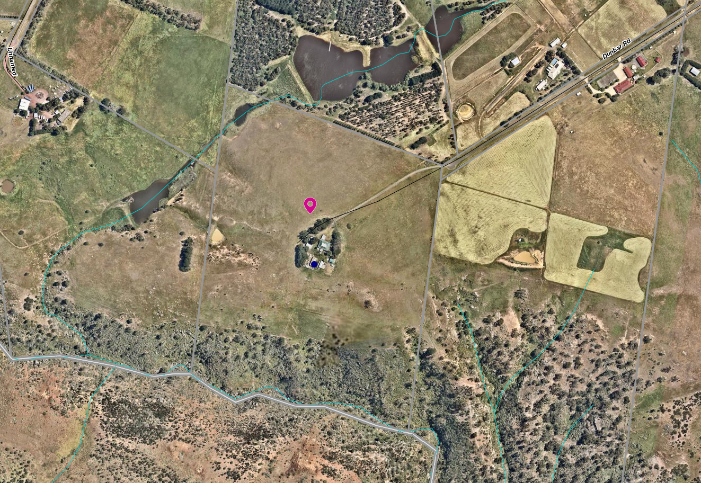

Proposal
It is proposed to subdivide the land into two lots. Under Clause 35.07-3 of the Farming Zone an application can be made for a two-lot subdivision to create a lot for an existing dwelling.
Lot 1 would be 1.52ha and would contain the dwelling, sundry sheds and the driveway to Dunbar Road. The lot would be irregular in shape with a narrow strip of land containing the driveway and then a roughly circular area around the dwelling and sheds.
Lot 2 would be approximately 16.68ha (by deduction) and would contain two dams and the cattle yards. The yards are located close to the entrance of the property at Dunbar Road.
A water supply easement from the dam in the north-east corner of the site is also proposed to supply the dwelling and for domestic purposes.
The proposed Lot 1 is not currently fenced to the proposed new boundary around the dwelling, but the driveway is fenced. It is assumed that the driveway fencing accords with the proposed driveway boundary.
The proposed plan of subdivision is included as an attachment to this report and also below).

Figure 2: plan of subdivision
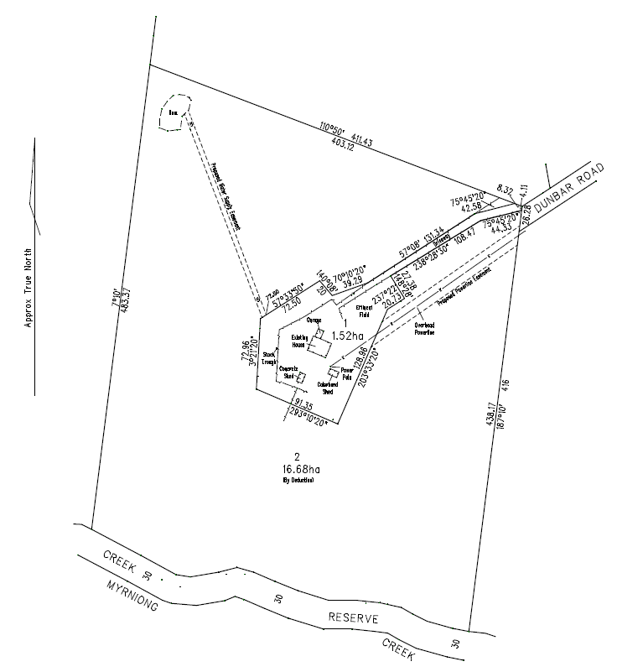

Background to Current Proposal
At a meeting with the owner at the Council office he requested that a Section 173 Agreement is not applied to any future permit to restrict a dwelling on Lot 2. He felt that the larger lot would make a very suitable site for another dwelling as a lifestyle choice. He said that the land cannot be cropped and should only be lightly grazed due it being in a low rainfall area (rain shadow), and that the property was not suitable for highly productive agriculture.

History
A search of Council records revealed that no permits have been issued on the subject site. There are no compliance issues relevant to the site.

RESTRICTIVE COVENANT
There is a covenant registered on the title with number Y000705A dated 19 December 1975. It was applied as part of a subdivision of the land in this area at that time. The covenant restricts various development matters relating to the design, siting and materials to be used for dwellings. It also prohibits the use of the land for pig and poultry farming and boarding kennels.

Public Notice
The application was notified to adjoining and surrounding landowners. Three (3) objections were received.

Summary of Objections
The objections received are detailed below with officer’s comments accompanying them:
Objection | Any Relevant Requirement
The covenants on these lots prohibit subdivision and various farm industries. Yet dog breeding has been allowed by Council which many locals are not happy with it. | Covenant number Y000705A
Officer’s Response: The covenant does not restrict subdivision. It does restrict a boarding kennel; however, dog breeding is not a boarding kennel and is not prevented by the covenant.
The development of a second dwelling on the land following the subdivision would set a precedent for future subdivision and such development in this area would detrimentally affect the landscape values.
Officer’s Response: The application is for subdivision. No dwellings are being applied for.
The subdivision meets the “material detriment” definition and is likely to have an adverse impact on the enjoyment of our property. We share a 400m boundary (north) with the site and have planted 18,000 native and indigenous plants which demonstrates that degraded land can be returned to its natural state. This is compared to the broad scale destruction of land in the surrounding area. Council should ensure the exploitation of land ceases and set an example of how land should be managed in a sustainable manner.  Reducing the size of landholder allotments can only lead to further degradation of the land and negative environmental impact from excess stock loads, additional buildings and houses and increased demands on water supply. | State and local planning policies
Officer’s Response: This concern is addressed further in this report.
The proposed subdivision will have a negative environmental impact on the flora and fauna that rely on the Myrniong Creek and at least one of its tributaries. | State and local policies
Officer’s Response: This concern is addressed further in this report.
The Palmer’s Road area is dominated by 40+ acre properties, most well established. Subdivisions of this nature are inconsistent with the precinct’s agricultural landscape. | Farming Zone subdivision
Officer’s Response: This concern is addressed further in this report.
If a new vacant lot is created, it will lead to another dwelling and sheds being constructed increasing dwelling density in this area. | State and local policies; rural growth policy
Officer’s Response: This concern is addressed further in this report.
If this proposal is approved, it will set a precedent and others may use such decision to subdivide in the future. | Farming Zone
Officer’s Response: This concern is addressed further in this report.
I have no objection to the subdivision provided a condition of the permit is that no dwellings/sheds are permitted, and the agricultural use continues. | Section 173 of the Planning and Environment Act 1987
Officer’s Response: An option would be to recommend approval subject to a Section 173 Agreement to be registered on title preventing the development of a dwelling on the vacant Lot 2. This is addressed further in this report.

Locality Map
The map below indicates the location of the subject site and the zoning of the surrounding area.
Figure 3: Zone map
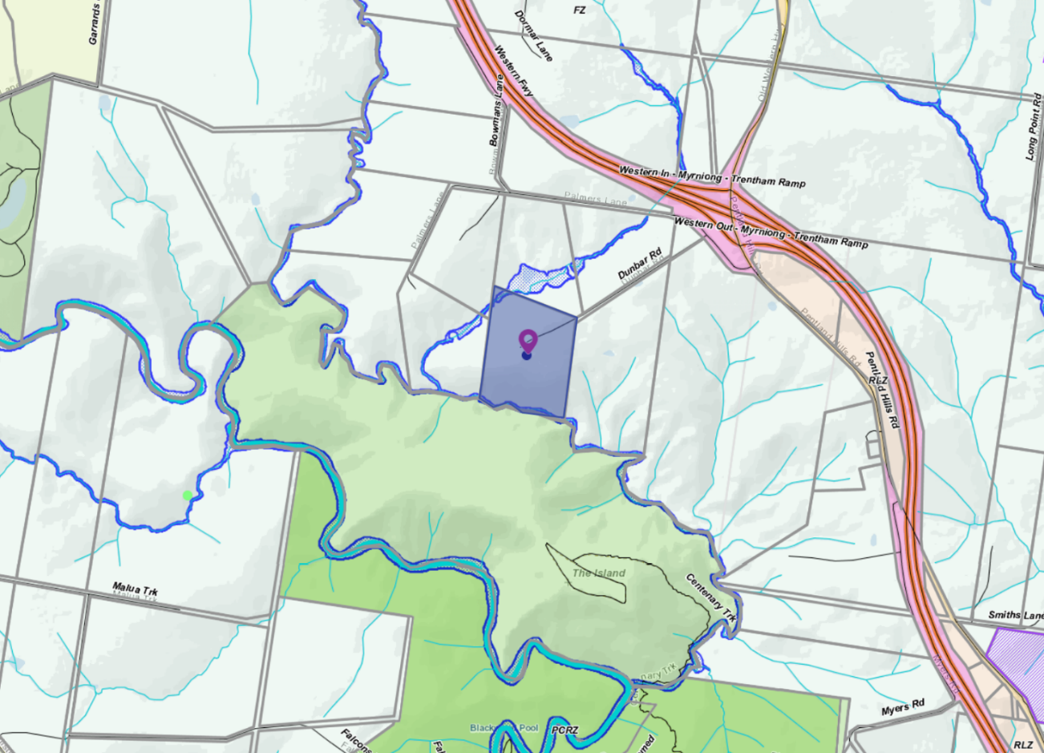

Planning Scheme Provisions
Council is required to consider the Victoria Planning Provisions and give particular attention to the State Planning Policy Framework (SPPF), the Local Planning Policy Framework (LPPF) and the Municipal Strategic Statement (MSS).
The relevant clauses are:
Clause 11.03-3S Peri-urban areas
Clause 12.03-1S River corridors, waterways, lakes and wetlands
Clause 14.01-1S Protection of agricultural land
Clause 15.01-6S Design for rural areas
Clause 16.01-5S Rural residential development
Clause 21.03-6 Objective - Rural lifestyle opportunities
The proposal complies with the relevant sections of the PPF and LPPF, with the exception of the clauses outlined in the table below:

PPF | Title | Response
Clause 14.01-1S | Protection of Agricultural Land | A strategy of this clause is to limit new housing development in rural areas by discouraging development of isolated small lots in the rural zone from use for dwellings or other incompatible uses. The proposal is a small lot subdivision on farming zone land with the resultant balance lot further fragmented and further limiting its agricultural productivity.
Clause 12.03-1S 31 | River corridors, waterways, lakes and wetlands | The objective of this policy is to protect and enhance river corridors, waterways, lakes and wetlands by ensuring that development responds to and respects the significant environmental, conservation, cultural, aesthetic, open space, recreation and tourism assets of water bodies and wetlands.  Intensification of development in this area would potential have a detrimental impact on the environmental values of the precinct over time.
Clause 16.01-5S | Rural residential development | This policy aims to discourage development of small lots in rural zones for residential use or other incompatible uses.
LPPF | Title | Response
Clause 21.03-6 | Objective—Rural lifestyle opportunities | Strategy: Prevent the fragmentation of farm land through inappropriate subdivisions.
Clause 22.03 | House and House Lot Excisions in Rural Areas | See details of this policy below.
Clause 22.03 House and House Lot Excisions in Rural Areas

The objectives of this clause are:

• To ensure that subdivision and dwellings in rural areas are required to increase agricultural productivity.
• To minimise the potential for adverse impacts on farm production through land use conflicts.
Policy
It is policy to:
• Discourage subdivision and dwellings unless they are directly related to the agricultural use of land.
• Discourage non-agricultural use and development in areas of productive agricultural land. Encourage the consolidation of small lots.
• Ensure that lots created under Clause 35.07-3 have a maximum area of 2ha.
• Maintain the right of existing farms to continue their operations without being adversely affected or constrained by residential concerns.
• Include the following requirements on a permit to excise a lot for a dwelling where it is considered this would facilitate ongoing agricultural use of the remaining land:
o Consolidate of the remaining land with the title of an existing farm; or
o If the remainder land is less than 40ha, require the landowner to enter into an agreement under S173 of the Planning and Environment Act that no further applications will be made to erect a dwelling on the balance allotment.
Comment: The proposed Lot 1 would contain the existing dwelling on a lot of less than 2ha. However, its shape and location would fragment the balance of the land. The dwelling would become a lifestyle lot. Such fragmentation of agricultural land should not be supported.
This application is not an orderly planning outcome for the area

Zone
Farming Zone
In accordance with Clause 35.07-3 of the Moorabool Planning Scheme a permit is required to subdivide land. Each lot must be at least the area specified for the land in a schedule to this zone which in the Moorabool Planning Scheme specifies in this locality each lot must be 100ha.
However, this clause also states that a permit may be granted to create smaller lots if:
• The subdivision is to create a lot for an existing dwelling. The subdivision must be a two-lot subdivision.
The purpose of the zone is to:
• Implement the Municipal Planning Strategy and the Planning Policy Framework.
• Provide for the use of land for agriculture.
• Encourage the retention of productive agricultural land.
• Ensure that non-agricultural uses, including dwellings, do not adversely affect the use of land for agriculture.
• Encourage the retention of employment and population to support rural communities.
• Encourage use and development of land based on comprehensive and sustainable land management practices and infrastructure provisions.

The proposal is a two-lot subdivision with one lot containing an existing dwelling.

The proposal is inconsistent with the purposes of the zone as the proposal is unable to demonstrate an outcome that will result in sustainable farming and land management practices and the proposal potentially would adversely affect the use of the balance of the land for agriculture.

Overlays
Environmental Significance Overlay (ESO3)
The purpose of the ESO is to:
• Implement the Municipal Planning Strategy and the Planning Policy Framework.
• Identify areas where the development of land may be affected by environmental constraints.
• Ensure that development is compatible with identified environmental values.
Schedule 3, Environmental Significance Overlay - Long Forest and Werribee Gorge
In accordance with Schedule 3 to the Environmental Significance Overlay a permit is not required under the schedule as no vegetation would be impacted or removed by the proposed subdivision.
Design and Development Overlay and Schedule 2 (DDO2)
In accordance with Schedule 2 to the Design and Development Overlay a permit is not required to subdivide land under this overlay.

RELEVANT POLICIES
Council’s Rural Housing Policy Statement
Council’s Rural Housing Policy Statement was adopted by Council on 19 September 2012. The document applies to all land in Farming Zone under the Moorabool Planning Scheme.
The policy intent is to:
• Encourage dwellings in areas nominated in Map 1 of Council Rural Growth Policy Statement.
• Ensure the siting of any dwellings is designed to have a minimal impact on any existing or future agricultural activities on the site and on surrounding.
• Ensure it is clear whether the dwelling is required for agricultural operation use or to maintain rural communities.
• Ensure sufficient infrastructure is available or that alternative methods are available which do not require normal infrastructure.
• Encourage development of dwellings to support communities on land which is unlikely to support agricultural activity while still considering any other overlays which may impact the land. This is land which is constrained for use as agriculture by other environment factors such as vegetation, slope, soil quality, etc.
• Ensure any subdivision is undertaken in accordance with the scheme in order to discourage fragmentation of agricultural land.
It is considered that the proposed subdivision would further fragment agricultural land.
Council’s Rural Growth Policy statement - 19 September 2012
Council’s Rural Growth Policy has been developed to provide direction for how limited farming potential rural dwellings should be considered, and more broadly, rural settlement patterns. The policy seeks to articulate support for resilient and integrated rural communities and agricultural enterprises, recognising that ‘State Government Planning Policy Framework does not adequately recognise or support agriculture trends and rural settlements in the Moorabool Shire’.

The principles of the policy relevant to this application include:
• support the agriculture sector so that it can be more productive, diverse, resilient and adaptive to changing agricultural trends, including supporting agricultural activities that recognise Moorabool’s advantageous proximity to market;
• protect agricultural land use from loss and allow development that increases agricultural productivity;
• focus growth opportunities in settlements along major transport corridors, in particular where there is physical and social infrastructure and services;
• recognise that there are substantial existing lots under 40 hectares capable of supporting the viable operation of agricultural enterprises;
• promote a rural housing market that meets the needs of the Shire’s rural communities; and
• land parcels for the proposed on farm living dwellings are to have a minimum lot size of 8 hectares as identified in Map 1.
The proposed subdivision is not generally aligned with the above principles of the policy and is furthermore considered to detract from the agricultural productivity of the land.

Particular Provisions
Clause 53.10 Public Open Space Contribution and Subdivision
A person who proposes to subdivide land must make a contribution to the council for public open space in an amount specified in the schedule to this clause (being a percentage of the land intended to be used for residential, industrial or commercial purposes, or a percentage of the site value of such land, or a combination of both). If no amount is specified, a contribution for public open space may still be required under section 18 of the Subdivision Act 1988.
An open space fee can be applied under Section 18(8)(c) of the Subdivision Act for a two-lot subdivision that is likely to be further subdivided.
Comment: As neither lot could be subdivided under the Moorabool Planning Scheme there is no requirement for a public open space contribution.

Discussion
Subdivision design
The proposed subdivision results in a highly irregular shaped Lot 1 which would contain the existing dwelling and sheds. The lot does not have the advantage of direct street access, resulting in a long driveway being required to the dwelling. This design effectively cuts the north-eastern end of the land in two as the driveway is fenced. The owners also want to retain access to the waterway and dam in the north-east corner using existing pipe infrastructure. A water supply easement would therefore be required to cross Lot 2.
The subdivision design has been influenced by the existing dwelling location. It represents a poor longer-term planning outcome.
The surrounding areas reflects a subdivision which was registered in 1975. It appears that there were 8-10 lots in the subdivision each with an area of approximately 20ha which includes a covenant relating to dwelling design and siting issues and also the prohibition of three uses being pig and poultry farming or the operation of a boarding kennel.
In considering that the land is zoned for farming, further dwelling intensification on the balance Lot 2 with an area of 16.68ha would be inappropriate in this location. It is considered that the subdivision would adversely fragment the agricultural land, and potentially create future land use conflicts between neighbouring agricultural activities and a rural residential allotment.
The creation of the vacant 16.68ha lot does not comply with the Farming Zone provisions which seeks to encourage the retention of productive agricultural land. The owner has stated that the land is affected by the Pentland Hills rainfall shadow and is therefore not highly productive grazing land. However, State and local planning policies do not support the creation of lots in the Farming Zone for rural residential or lifestyle uses.
It is considered that the subdivision of the land would create a parcel that would be unviable unless sold to a neighbour for expansion of the neighbour’s holding. The applicant has not provided a farm management plan associated with this subdivision or justification for the ongoing use of the vacant lot. The subdivision arrangement is considered to adversely fragment the agricultural land to an unsustainable level.
Objectors generally felt that this proposal was inappropriate for the land and the wider area. They were concerned about a precedent being created where others could also apply to excise their dwellings. This raised wider concerns about sustainable land management and environmental impact particularly in relation to the waterways as well as the land itself.
It is understood that land in the Pentlands Hills is relatively fragile due to the lower rainfall and lighter and more erodible soils. Such land needs to be managed carefully and not overstocked. It is noted that no native vegetation planting has occurred on the site.
Objector concerns could be addressed by a Section 173 Agreement to prevent a future dwelling or any further subdivision of the land, however, it is considered that the creation of Lot 1 is a poor planning outcome and should not be supported.
Objectors also expressed concern, if the subdivision was approved, that other landholders within the same subdivision could apply for a similar house lot excision. It is noted that each planning application must be assessed on own its individual merit and if such applications were received then a similar assessment would be made against Council policies and the policies contained in the Moorabool Planning Scheme.

Servicing
As this is a two-lot subdivision, all servicing authorities would be notified during the certification stage in accordance with Clause 66.01 and the three mandatory conditions can be included if a permit was to issue. The mandatory telecommunication conditions under Clause 66.01-1 do not apply to subdivide land in a rural zone.

General Provisions
Clause 65 – Decision Guidelines have been considered by officers in evaluating this application.
Clause 66 – Stipulates all the relevant referral authorities to which the application must be referred.

Referrals
Authority | Response
Melbourne Water | Consent with conditions.
Infrastructure  Environmental Health | Consent with conditions.  Consent with conditions.

Financial Implications
There is no financial implication associated with this refusal to grant a permit.

Risk & Occupational Health & Safety Issues
The recommendation of refusal of the planning application does present any OH&S issues to Council.

Communications Strategy
Notice was undertaken for the application, in accordance with s.52 of the Planning and Environment Act 1987, and further correspondence is required to all interested parties to the application as a result of a decision in this matter. All submitters and the applicant were invited to attend this meeting and invited to address Council if required.

Options
Council could consider the following options:
• Issue a refusal to grant a permit in accordance with the recommendations of this report; or
• Issue a permit with conditions outside of the recommendations of this report.

Conclusion
The proposed subdivision of the land into two lots with one containing an existing dwelling and the other to remain vacant is considered inconsistent with the planning provisions and the State and Local Planning Policy Framework.
The house lot is awkwardly shaped which would result in permanent fragmentation of the balance of the agricultural land. It provides an unacceptable subdivision layout.
The proposal is also considered inconsistent with the objectives of the Farming Zone.
While objector concerns could be addressed by permit conditions including that a restriction is registered on the title of the vacant lot to prohibit a future dwelling, the proposal does not address the fundamental concern that creating a small lot in the Farming Zone will not encourage the sustainable agricultural use of the land, not protect the areas environmental and landscape values.
The proposed subdivision of land into two lots is not recommended for the reasons outlined in this report.

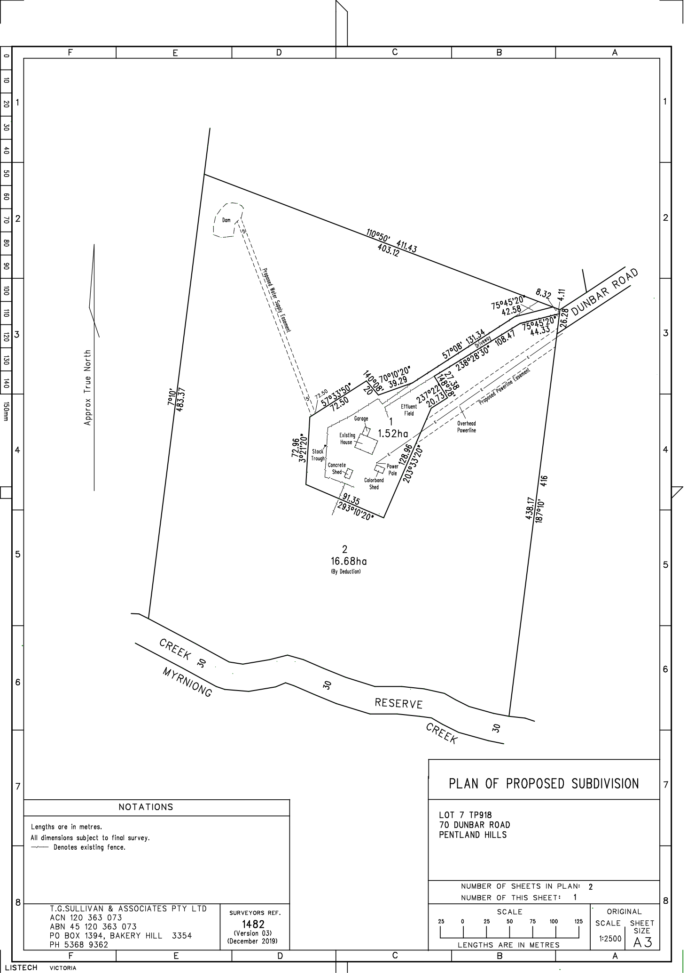

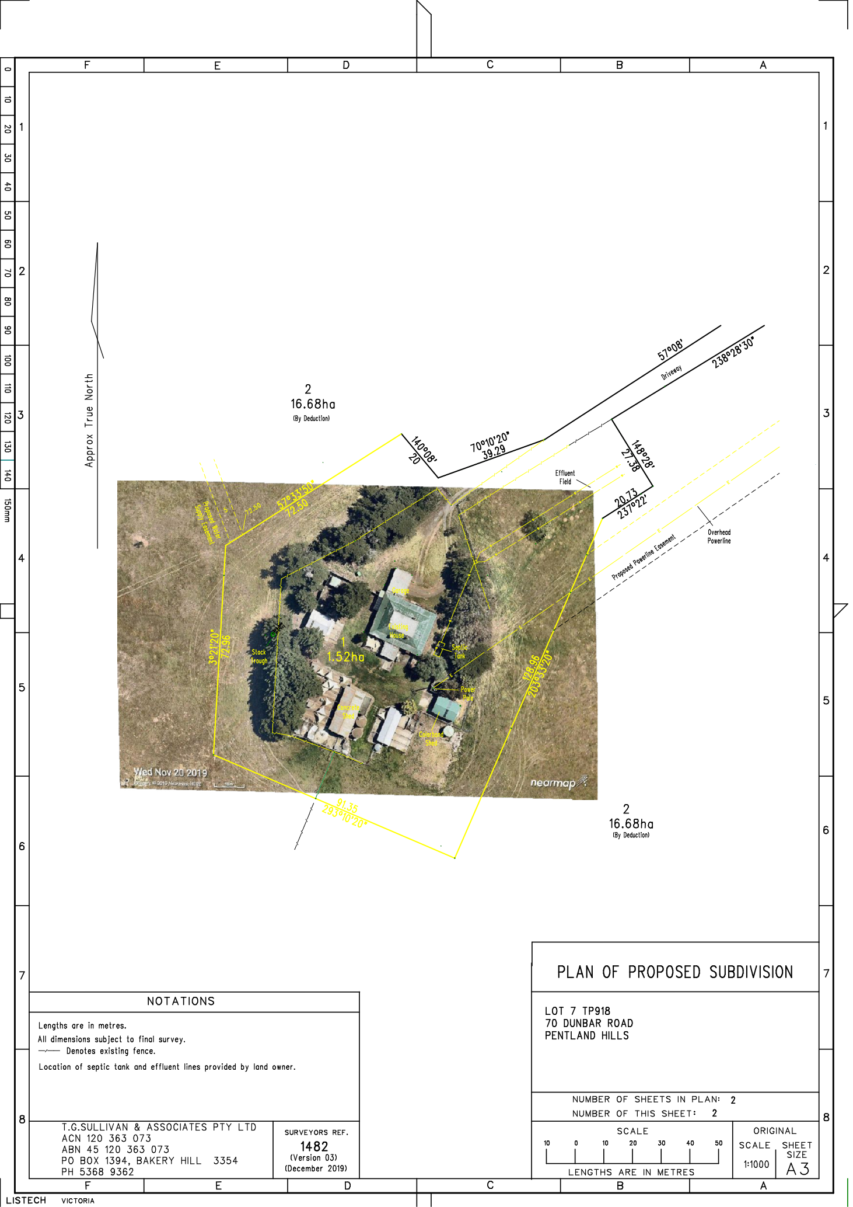

7.2 PA2019282 - Two Lot Subdivision at 2 Alexander Drive, Ballan
Author: Thomas Tonkin, Statutory Planner
Authoriser: Henry Bezuidenhout, Executive Manager Community Planning & Economic Development
Attachments: 1. Proposed plan of subdivision

Application Summary
Permit No: PA2019282
Lodgement Date: 6 December 2019
Planning Officer: Tom Tonkin
Address of the land: 2 Alexander Drive Ballan
Proposal: Two Lot Subdivision
Lot size: 780 sqm
Why is a permit required? Clause 32.09 Neighbourhood Residential Zone, Schedule 7 - Subdivision
Clause 42.01 Environmental Significance Overlay, Schedule 1 - Subdivision

Recommendation
That Council, having considered all matters as prescribed by the Planning and Environment Act 1987, issue a Refusal to Grant Planning Permit PA2019282 for a Two Lot Subdivision at Lot 1 on PS 713325V known as 2 Alexander Drive, Ballan 3342, on the following grounds:
1. The proposed lot sizes do not meet the minimum allowable lot sizes specified in the Neighbourhood Residential Zone, Schedule 7, of the Moorabool Planning Scheme.
2. The proposal is inconsistent with relevant state and local planning policy in the Moorabool Planning Scheme for residential land subdivision in this location.
3. The proposal does not meet all relevant provisions of Clause 56 (Rescode) of the Moorabool Planning Scheme.

Public Consultation
Was the application advertised? | Yes.
Notices on site: | Yes.
Notice in Moorabool Newspaper: | No.
Number of objections: | None.
Consultation meeting: | Not applicable.

Policy Implications
The Council Plan 2017-2021 provides as follows:
Strategic Objective 2: Minimising Environmental Impact
Context 2A: Built Environment
The proposal is consistent with the Council Plan 2017 – 2021.

Victorian Charter of Human Rights & Responsibilities Act 2006
In developing this report to Council, the officer considered whether the subject matter raised any human rights issues. In particular, whether the scope of any human right established by the Victorian Charter of Human Rights and Responsibilities is in any way limited, restricted or interfered with by the recommendations contained in the report. It is considered that the subject matter does not raise any human rights issues.

Officer’s Declaration of Conflict of Interests
Under section 80C of the Local Government Act 1989 (as amended), officers providing advice to Council must disclose any interests, including the type of interest.
Executive Manager – Henry Bezuidenhout
In providing this advice to Council as the Executive Manager, I have no interests to disclose in this report.
Author – Tom Tonkin
In providing this advice to Council as the Author, I have no interests to disclose in this report.

Executive Summary
Application referred? | Yes, to Council’s Infrastructure.
Any issues raised in referral responses? | No.
Preliminary concerns? | Non-compliance with the minimum 800 sqm lot size requirement of NRZ7, which was adopted by Council as part of Amendment C88 before the application was submitted. C88 was gazetted on 6 March 2020.
Any discussions with applicant regarding concerns? | Yes, informally before and after the application was submitted.
Any changes made to the application since being lodged? | No.
Brief history. | The subject site is part of a 12-lot subdivision approved by Council under planning permit PA2011316 issued on 21 August 2012.
Previous applications for the site? | None. This application has been lodged concurrently with four other two lot subdivisions in the same street by the same applicant.

General summary. | The proposed 390 sqm lot sizes do not meet the minimum 800 sqm lot size requirements of the Neighbourhood Residential Zone, Schedule 7 and is therefore in direct contravention of the Moorabool Planning Scheme. Council has no discretion to approve the application due to the minimum lot size requirement of 800 sqm.
Summary Recommendation
That, having considered all relevant matters as required by the Planning and Environment Act 1987, Council issue a Refusal to Grant a Permit for this application in accordance with Section 61 of the Planning and Environment Act 1987, on the grounds included in this report.

Site Description
The site is identified as Lot 1 on PS 713325V and is known as 2 Alexander Drive, Ballan, and is located on the north-west corner of Crook Court and Alexander Drive. The site is an irregular shaped lot with an area of 780 sqm, vacant with no significant vegetation and minimal fall.

Proposal
It is proposed to subdivide the site into two lots. Both lots would be 390 sqm in size, roughly rectangular in shape. Lot 1 would have a 14.25 metre frontage to Crook Court and Lot 2 would occupy the corner of Crook Court and Alexander Drive. Both lots would be encumbered by a building envelope.

Background to Current Proposal
The subject site was rezoned to the Neighbourhood Residential Zone, Schedule 7 (NRZ7) on 6 March 2020 as part of Planning Scheme Amendment C88 which implemented the Ballan Strategic Directions (June 2018) policy in the Moorabool Planning Scheme. The NRZ7 imposes minimum lots sizes of 800 sqm for a subdivision. There are no applicable transitional provisions in the Moorabool Planning Scheme to enable consideration of smaller lot sizes proposed in applications received prior to the Amendment’s gazettal on 6 March 2020.

History
None applicable.

Public Notice
Notice of the application was given to adjoining and surrounding landowners by mail and a sign erected on site from 14-29 January 2020. No objections were received.

Locality Map
The map below indicates the location of the subject site and the zoning of the surrounding area.
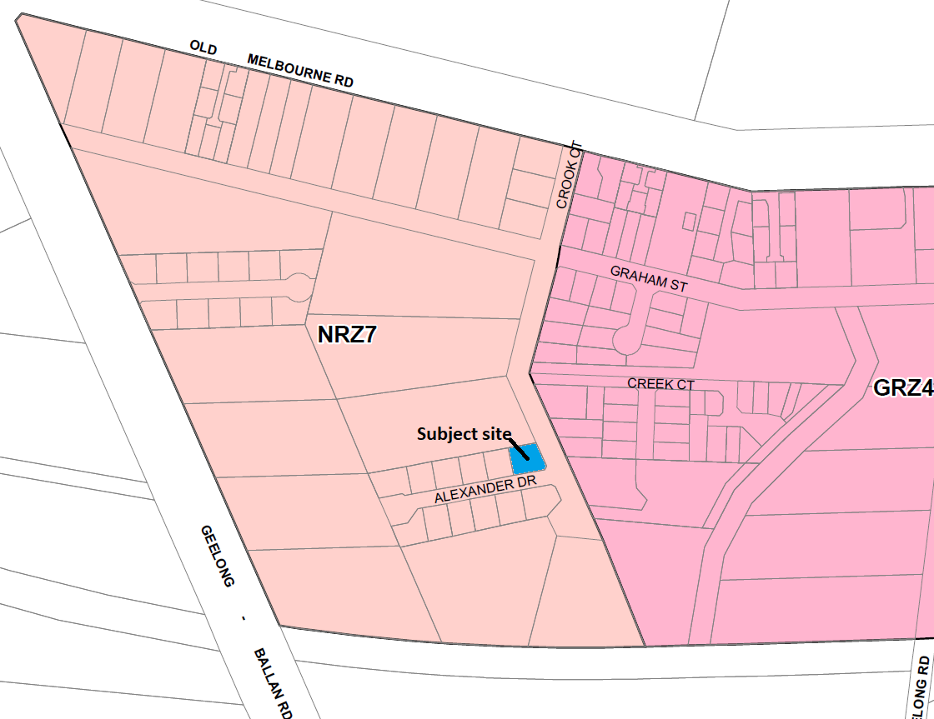

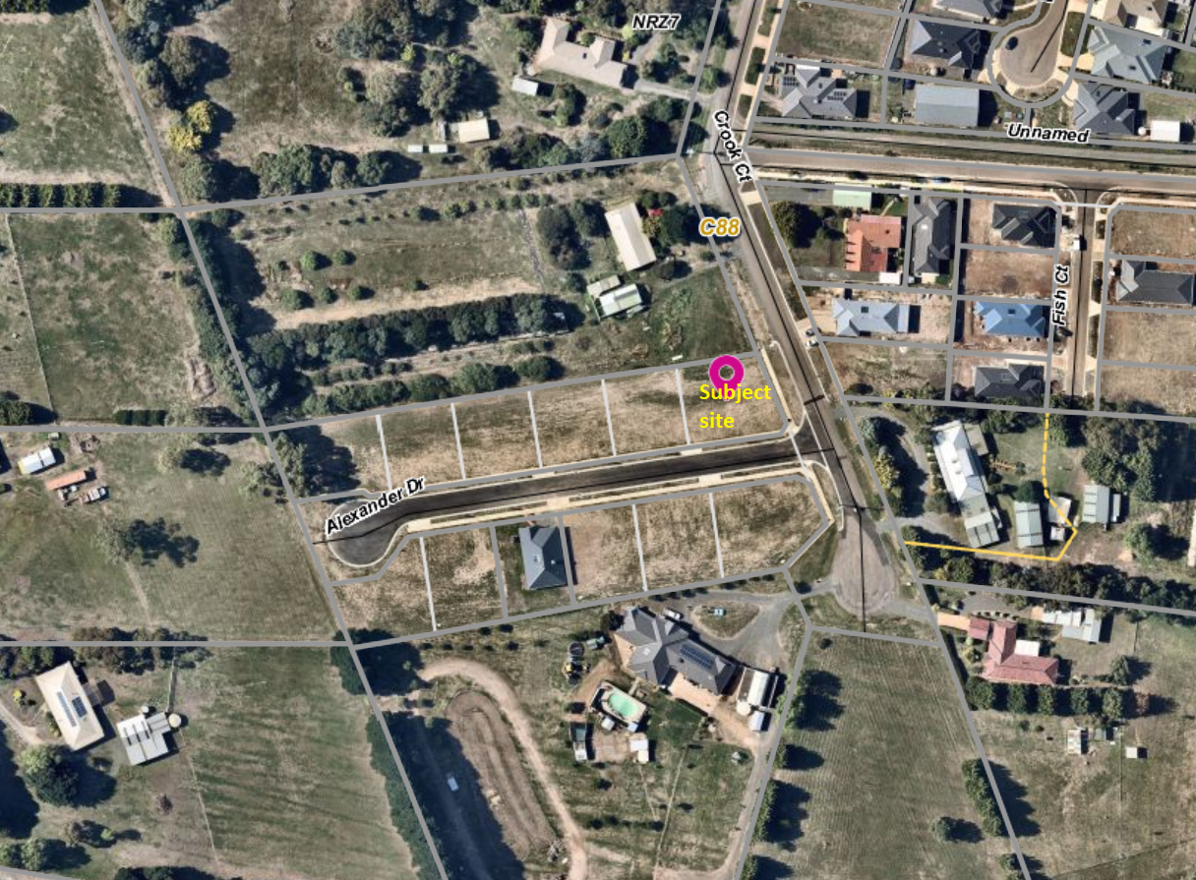

Planning Scheme Provisions
Council is required to consider the Victoria Planning Provisions and give particular attention to the Planning Policy Framework (PPF), the Local Planning Policy Framework (LPPF) and the Municipal Strategic Statement (MSS).
The relevant clauses are:
• Clause 11.03-3S Peri-urban areas
• Clause 14.02 Water
• Clause 15.01-3S Subdivision design
• Clause 15.01-5S Neighbourhood character
• Clause 16.01-2S Location of residential development
• Clause 21.02-3 Water and catchment management
• Clause 12.03-2 Urban Growth Management
• Clause 21.03-3 Residential Development
• Clause 21.03-4 Landscape and Neighbourhood Character
• Clause 21.08 Ballan
• Clause 22.02 Special Water Supply Catchments
In assessing the application against the relevant sections of the PPF and LPPF, the following significant non-compliances were identified:

PPF | Title | Response
Clause 15.01-5S | Neighbourhood character | The proposal does not respond positively to the preferred neighbourhood character, which encourages detached dwellings with conventional front and side setbacks. The proposed subdivision would prejudice such development.
Clause 16.01-2S | Location of residential development | The proposal would facilitate residential growth in an area of Ballan where limited growth is encouraged.
LPPF

Clause 21.03-2 | Urban Growth Management | The proposal would facilitate residential growth in an area of Ballan where limited growth is encouraged.
Clause 21.03-4 | Landscape and Neighbourhood Character | The proposal does not respond appropriately to the preferred neighbourhood character because the proposal would not facilitate site responsive future development.
Clause 21.08-7 | Strategies for Residential Development | The proposed lot sizes would facilitate built form inconsistent with the preferred development outcomes for this area of Ballan, by limiting opportunities for low density housing with boundary setbacks to accommodate landscaping.

Zone
The subject site is in the Neighbourhood Residential Zone, Schedule 7 (NRZ7). The purpose of the Zone is:
• To implement the Municipal Planning Strategy and the Planning Policy Framework.
• To recognise areas of predominantly single and double storey residential development.
• To manage and ensure that development respects the identified neighbourhood character, heritage, environmental or landscape characteristics.
• To allow educational, recreational, religious, community and a limited range of other non-residential uses to serve local community needs in appropriate locations.
Under Clause 32.09-3 a permit is required to subdivide land. A zone schedule may specify a minimum lot size to subdivide land, and each lot must be at least the area specified for the land. Schedule 7 specifies a minimum 800 sqm lot size for a subdivision.
The proposed lot sizes do not meet the minimum lot size requirement; therefore, the proposal is fundamentally inconsistent with the Zone provisions.

Overlays

The site is affected by Environmental Significance Overlay, Schedule 1 (Proclaimed Water Catchment Areas). Under Clause 42.01-2 a permit is required to subdivide land. There are no relevant exemptions under Schedule 1. The subject site is sewered and drains more than 100 metres from the nearest waterway. Subject to conditions the proposal would not cause detriment to potable water quality or supply.

Relevant Policies
The Ballan Strategic Directions (June 2018) policy underpins Planning Scheme Amendment C88 which was recently approved by the Minister for Planning and gazetted on 6 March 2020. The proposed lot sizes less than 800 sqm are inconsistent with Amendment C88 adopted by Council.

Particular Provisions
Clause 53.01 Public Open Space Contribution and Subdivision
A subdivision is exempt from a public open space requirement specified in this scheme if it subdivides land into two lots and the Council considers it unlikely that each lot will be further subdivided. If the application could be considered for approval by Council, it would be unlikely for either lot to be further subdivided and no public open space contribution would be required.
Clause 56 Residential Subdivision
The proposal complies with ResCode (Clause 56), with the exception of the following:
Clause ResCode | Title | Response
56.03-5 | Neighbourhood Character | The proposal does not adequately respond to the key features of the preferred neighbourhood character.

Discussion
Overall, the proposal is inconsistent with relevant state and local planning policy, the Neighbourhood Residential Zone and Clause 56 of the Moorabool Planning Scheme.
The proposed 390 sqm lot sizes are less than the minimum allowable 800 sqm lot sizes specified in Schedule 7 to the Neighbourhood Residential Zone, gazetted on 6 March 2020. It is noted that despite the application being lodged with Council prior to the gazettal date there is no transitional provision in the Moorabool Planning Scheme which would enable Council to consider approving the application. Furthermore, it is noted that when the application was submitted on 6 December 2019, Amendment C88 has already progressed through the Panel Hearing process, been adopted by Council and submitted to the Minister for Planning for approval. The applicant was aware of the Amendment C88’s status when submitting the application. The proposal explicitly contravenes the Moorabool Planning Scheme and is therefore recommended for refusal.

General Provisions
Clause 65 – Decision Guidelines have been considered by officers in evaluating this application.
Clause 66 – Stipulates all the relevant referral authorities to which the application must be referred.

Referrals
Authority | Response
Western Water  Southern Rural Water | Conditions in accordance with Council’s MoU with these authorities.
Infrastructure | Consent with conditions.

Financial Implications
There are no financial implications for Council in refusing the application.

Risk & Occupational Health & Safety Issues
The recommendation to refuse this application does not have any risk or OH&S implications for Council.

Communications Strategy
Notice was undertaken for the application, in accordance with s.52 of the Planning and Environment Act 1987.

Options
• Issue a Refusal to Grant a Permit in accordance with the grounds in the recommendation of this report; or
• Issue a Refusal to Grant a Permit with amendments to the grounds in the recommendation of this report.

Conclusion
Overall, the proposal is inconsistent with the relevant provisions of the Moorabool Planning Scheme, in particular the NRZ7 given that the proposed lot sizes do not meet the minimum 800 sqm lot size requirement.

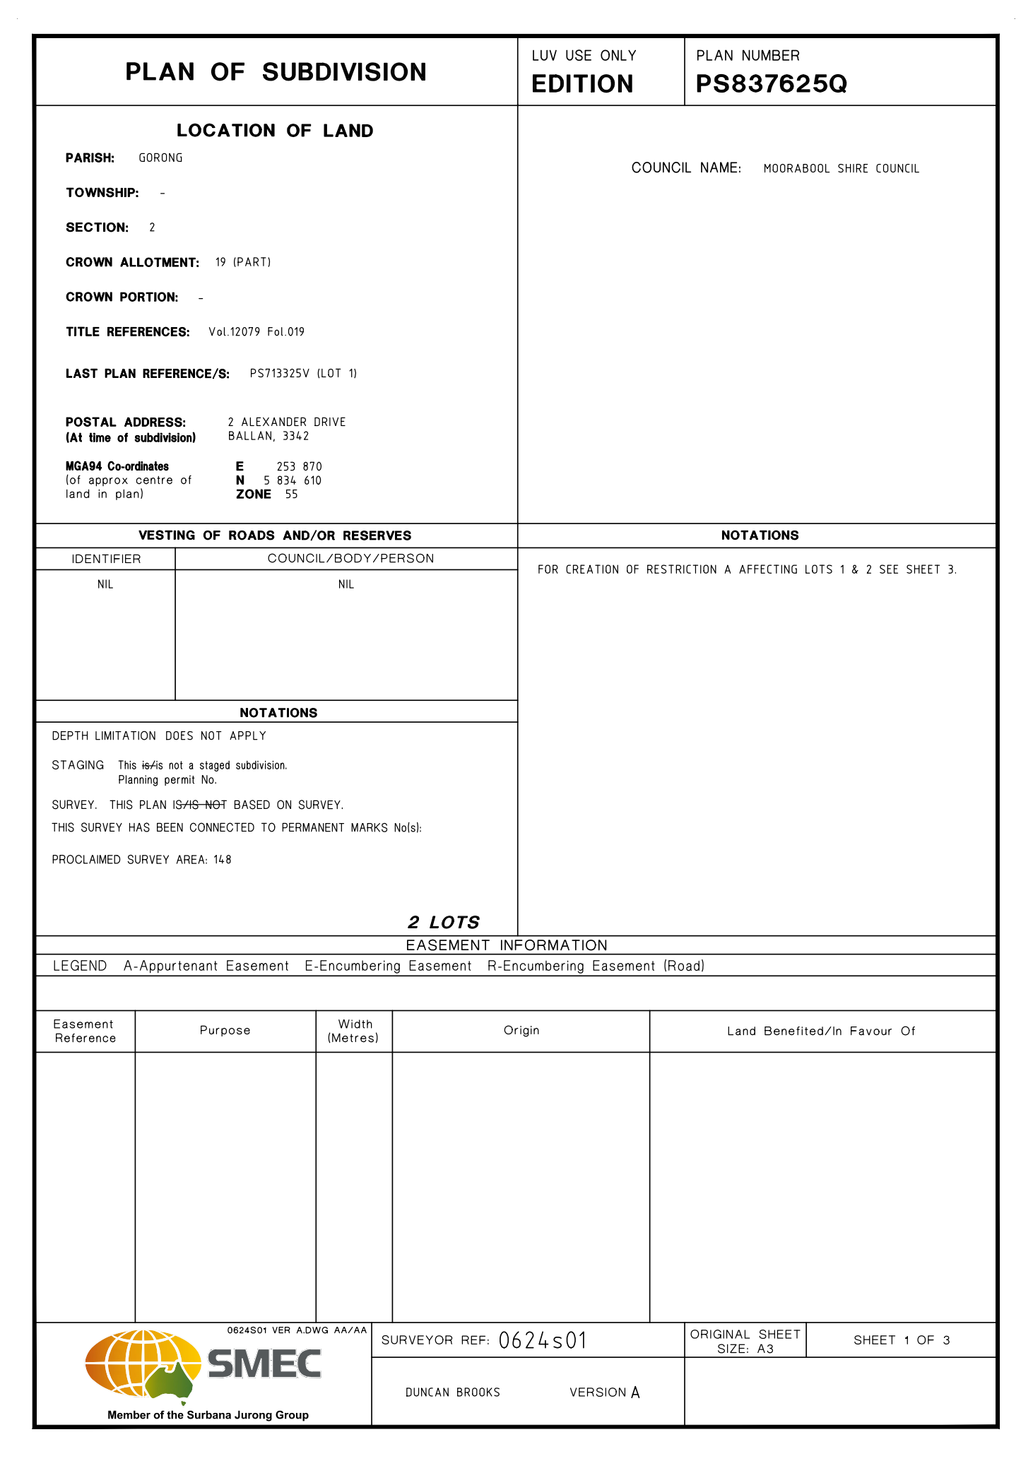
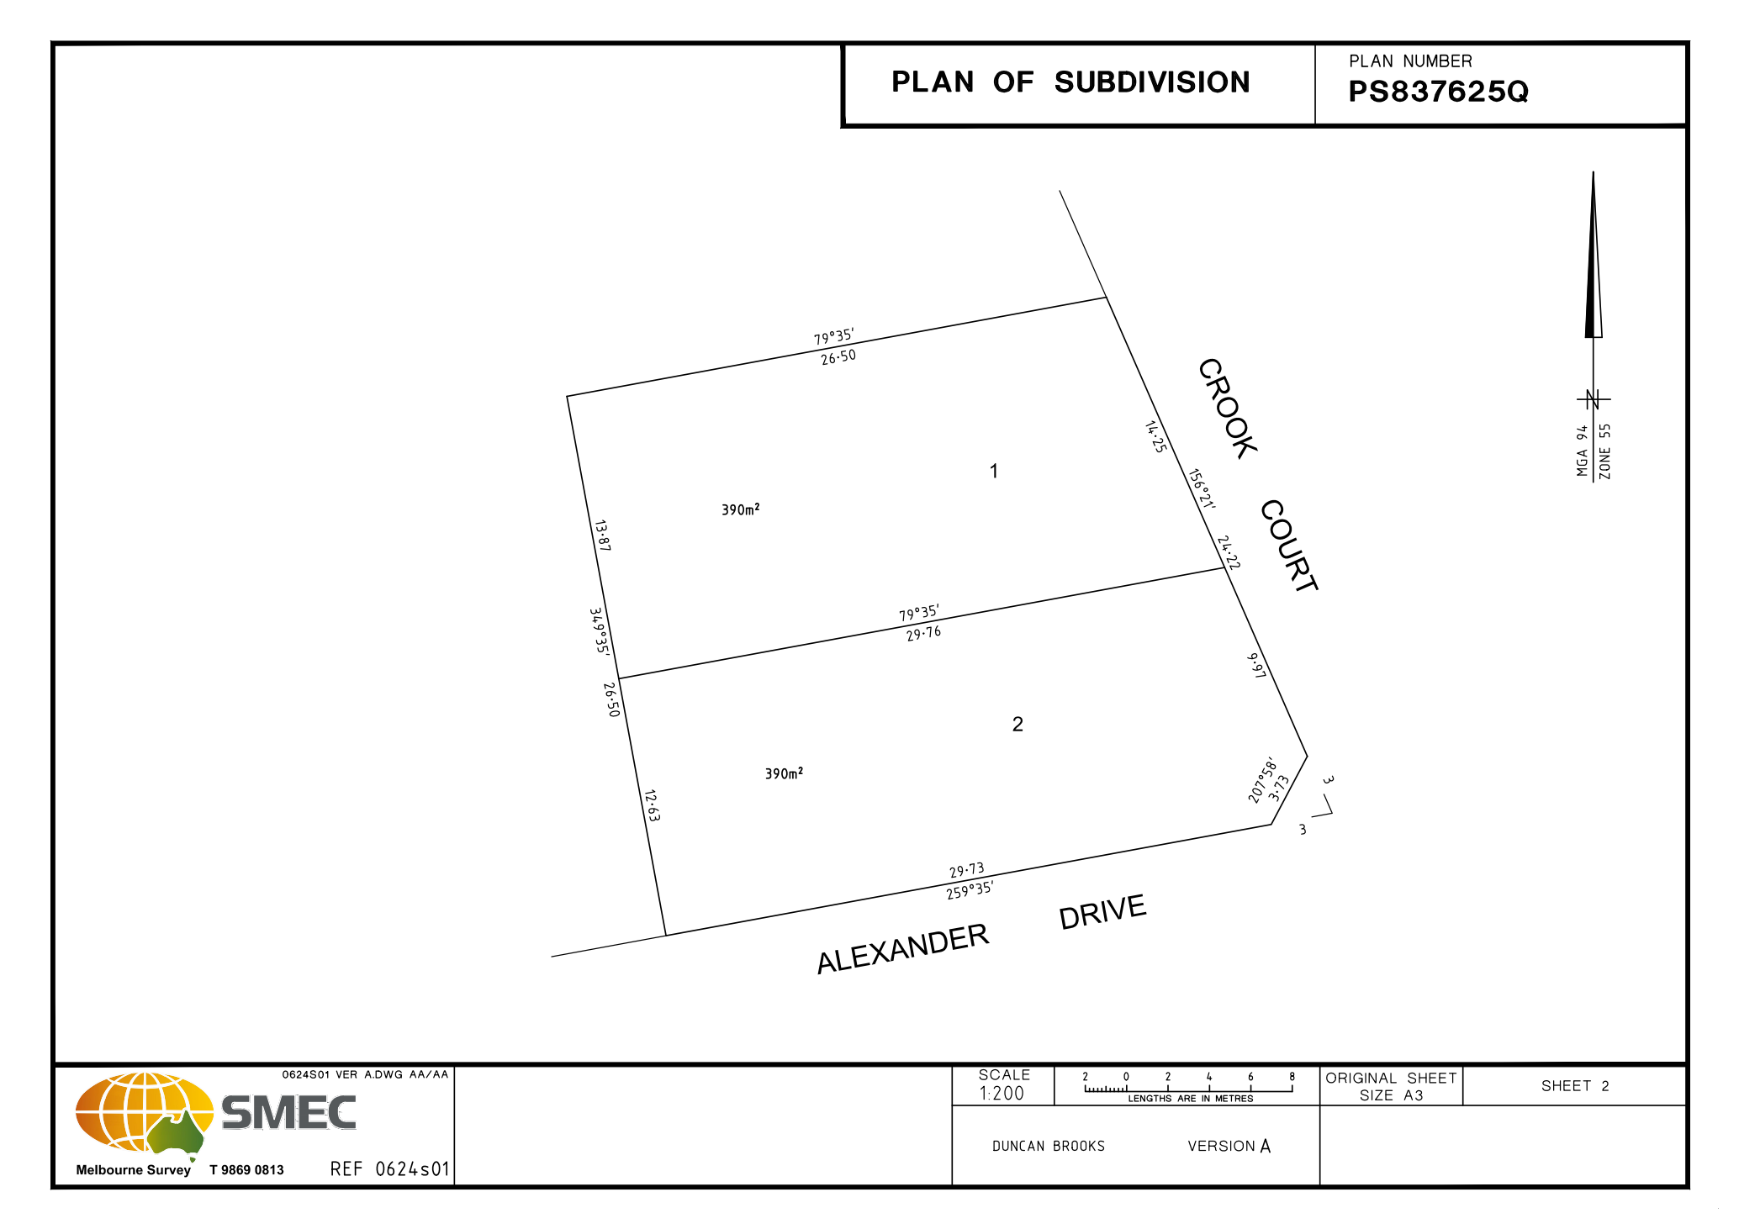
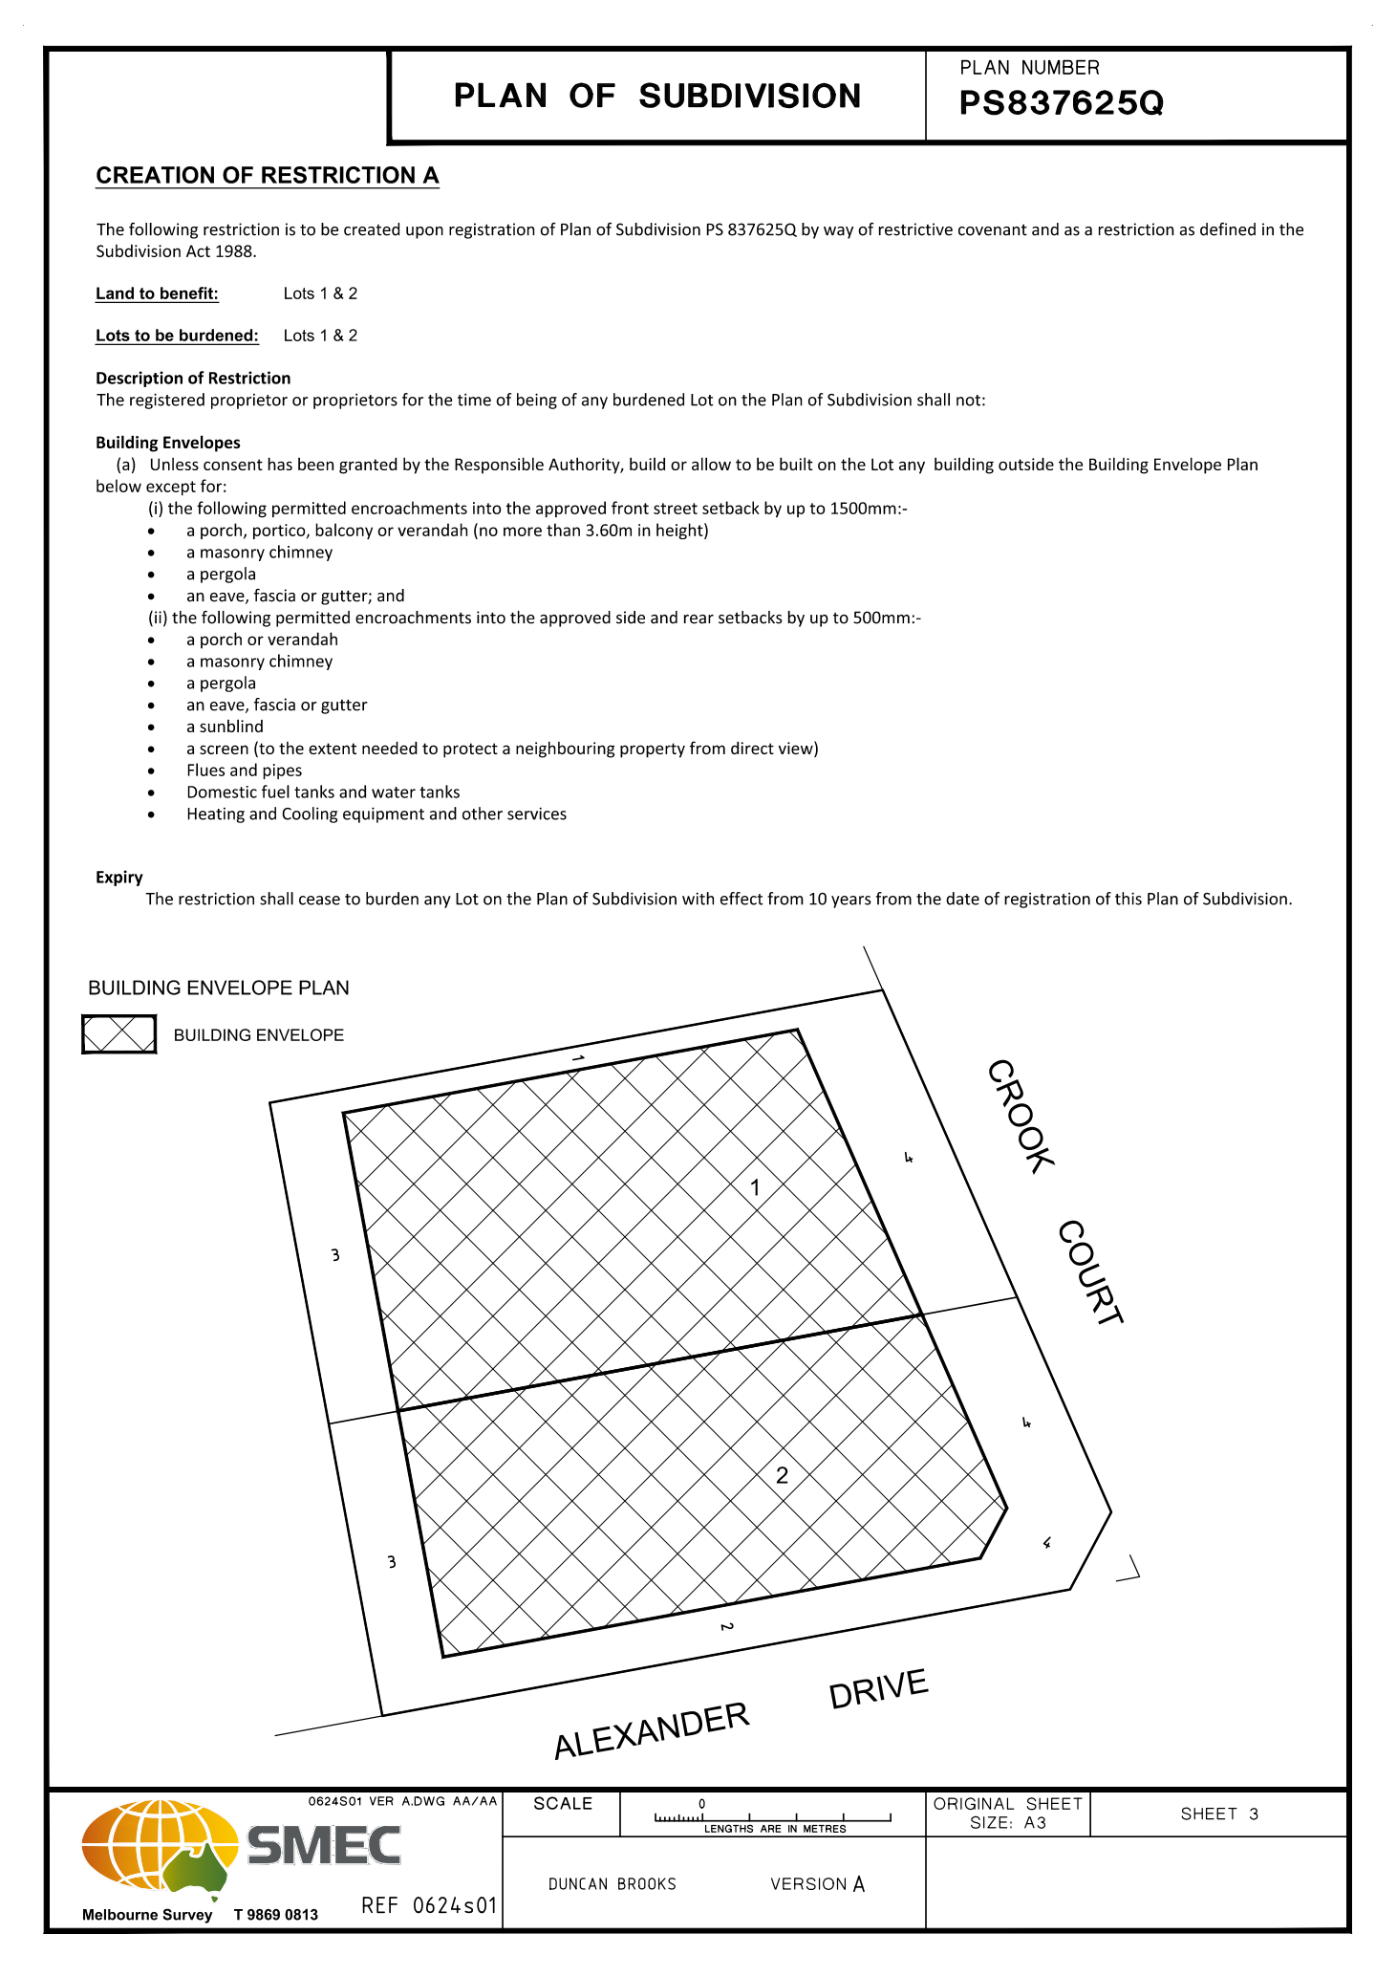

7.3 PA2019059 - Two Lot Re-Subdivision and Use and Development of a Dwelling at 139 Pound Creek Road Navigators
Author: Thomas Tonkin, Statutory Planner
Authoriser: Henry Bezuidenhout, Executive Manager Community Planning & Economic Development
Attachments: 1. Existing subdivision layout
2. Proposed subdivision layout
3. Proposed dwelling
4. Farm Management Plan

Application Summary
Permit No: PA2019059
Lodgement Date: 7 March 2019. Amended in process on 14 August, 2019
Planning Officer: Tom Tonkin
Address of the land: 139 Pound Creek Road Navigators
Proposal: Two Lot Re-Subdivision and Use and Development of a Dwelling
Lot size: 28.02 hectares
Why is a permit required? Clause 35.07 Farming Zone – Subdivision and Use and Development of a Dwelling
Clause 42.01 Environmental Significance Overlay, Schedule 1 – Subdivision and Development of a Dwelling
Clause 44.06 Bushfire Management Overlay - Subdivision

Recommendation
That Council, having considered all matters as prescribed by the Planning and Environment Act 1987, issue a Refusal to Grant Planning Permit PA2019059 for Two Lot Re-Subdivision and Use and Development for a Dwelling at Lot 1 on PS 633637U and Crown Allotment 4A Section 20A Parish of Warrenheip, known as 139 Pound Creek Road, Navigators 3352, on the following grounds:
1. The proposal breaches Section 173 Agreement AD935687W registered on the title to Lot 1 on Plan of Subdivision 633637U.
2. The proposal is inconsistent with the purpose and objectives of the Farming Zone.
3. The proposal does not comply with the Planning Policy Framework or Local Planning Policy Framework of the Moorabool Planning Scheme relevant to the development and use of rural land.
4. The proposed subdivision will result in a fragmentation of agricultural land.
5. There has been insufficient justification provided to support a further dwelling on the land.
6. The proposed agricultural activity can be undertaken utilising the existing dwelling on the land.

Public Consultation
Was the application advertised? | Yes.
Notices on site: | Yes.
Notice in Moorabool Newspaper: | No.
Number of objections: | Two.
Consultation meeting: | The Council officer consulted with one objector. The other objector did not wish to consult because of a fundamental opposition to the proposal. A formal meeting was not conducted as the recommendation is for refusal.

Policy Implications
The Council Plan 2017-2021 provides as follows:
Strategic Objective 2: Minimising Environmental Impact
Context 2B: Natural Environment
The proposal does not conflict with the Council Plan 2017 – 2021.

Victorian Charter of Human Rights & Responsibilities Act 2006
In developing this report to Council, the officer considered whether the subject matter raised any human rights issues. In particular, whether the scope of any human right established by the Victorian Charter of Human Rights and Responsibilities is in any way limited, restricted or interfered with by the recommendations contained in the report. It is considered that the subject matter does not raise any human rights issues.

Officer’s Declaration of Conflict of Interests
Under section 80C of the Local Government Act 1989 (as amended), officers providing advice to Council must disclose any interests, including the type of interest.
Executive Manager – Henry Bezuidenhout
In providing this advice to Council as the Executive Manager, I have no interests to disclose in this report.
Author – Tom Tonkin
In providing this advice to Council as the Author, I have no interests to disclose in this report.

Executive Summary
Application referred? | Yes, to Council’s Infrastructure, Council’s Environmental Health, Central Highlands Water and CFA.
Any issues raised in referral responses? | The original application submitted on 7 March 2019 proposed a two-lot re-subdivision. Central Highlands Water (CHW) raised concerns with the application due to its potential to create a lot capable of accommodating a dwelling in an area where CHW calculate the existing dwelling density per hectare to be 1:19, well in excess of the 1:40 ratio recommended in the catchment authority guidelines.
Preliminary concerns? | No detailed information as to how the proposed subdivision would support and enhance farming the land and concerns that the proposal would fragment agricultural land.
Any discussions with applicant regarding concerns? | Yes, the Council officer wrote to the applicant regarding the abovementioned concerns.
Any changes made to the application since being lodged? | Yes. After notice of the original application (re-subdivision) was given and the CHW referral response was received, the applicant amended the application on 14 August 2019 to include the use and development of a dwelling. The amended application was advertised.
Brief history. | Previous planning approvals relevant to the land are summarised under ‘History’ below.
Previous applications for the site? | PA2010145 for a Two Lot Subdivision (Boundary Realignment) was approved by Council on 1 October 2010.
General summary. | It is proposed to re-subdivide to create two lots and develop the vacant lot for a dwelling, in addition to the existing dwelling on the landholding. The applicant has provided insufficient justification for why the proposal is required to support an agricultural enterprise and how it would avoid further fragmenting of agricultural land. The current farming enterprise does not require two dwellings over two lots to supports its operation. Two objections were received which raised concerns generally consistent with those of the planning officer. Additionally, Council has obtained legal advice that the proposal is in breach of a Section 173 Agreement registered as a restriction on one of the titles.
Summary Recommendation
That, having considered all relevant matters as required by the Planning and Environment Act 1987, Council issue a Refusal to Grant a Permit for this application in accordance with Section 61 of the Planning and Environment Act 1987, on the grounds included in this report.

Site Description
The subject site comprises the following lots:
• Crown Allotment 4A, Section 20A, Parish of Warrenheip which is a 3313 sqm parcel of land, with a maximum 11.53 metres width x 372.32 metres length. The lot is undeveloped and contains no vegetation; and
• Lot 1 on PS633637U, which is an irregular shaped lot of 27.69 ha containing a dwelling and ancillary outbuildings. Other than a few scattered trees the site is cleared of vegetation. This lot is encumbered by a 12-metre-wide powerline easement which crosses the site in an east-west direction. Beyond the residential use the land is used predominantly for cattle grazing. Two Section 173 Agreements are registered on the title to this lot.
A small waterway flows northwards through the site which is otherwise relatively flat.
The site and surrounding land is in the Farming Zone and comprises a range of lot sizes. The surrounding area is typified by a mix of small-scale farming and rural residential properties.

Proposal
It is proposed to re-subdivide the existing lots and to use and develop the new vacant lot for a dwelling. Proposed Lot 1 would be 16.94 ha in size, irregular in shape with a 367.35-metre-wide frontage to Pound Creek Road and contain the existing dwelling and outbuildings with the existing access to Pound Creek Road retained. Proposed Lot 2 would be 11.07 ha in size, irregular in shape and vacant and almost entirely cleared of trees. The existing powerline easement would be contained within Lot 1 but parallel to the common boundary with Lot 2. There is no existing formal vehicle access to Lot 2.
The proposed dwelling on Lot 2 would be set back approximately 30 metres from Pound Creek Road and will be single storey in height and traditional in design with a low-pitched hipped roof, and weatherboard and masonry cladding. The dwelling would comprise of four bedrooms, main with ensuite, bathroom, separate toilet, laundry, study, living room, children’s room and open plan kitchen, meals and family area leading to a rear alfresco area. An attached double garage would be provided for car parking and the building would have an overall floor area of 303.53 sqm.
The application documents state that the proposed dwelling is required for succession planning purposes and that the current landowner would shift from the existing dwelling to the proposed dwelling, with a nephew moving into the existing dwelling to manage farm operations and ultimately inherit the land. The Farm Management Plan provided by the applicant states that the proposed subdivision will allow an increase in overall stocking capacity and hence a significant increase in productivity. The dwelling is stated as being vital for proper functioning of the proposed enterprise including stock monitoring and security.

Background to Current Proposal
Not applicable.

History
The existing dwelling was approved under planning permit PA2004140 issued by Council on 27 September 2004.PA2005007 was issued by Council on 1 June 2005 and re-subdivided the land from five lots to two lots creating parcels of 32.73 ha and 3.671 ha respectively. A condition of this permit required the landowner to enter into a Section 173 Agreement (AD935687W) to not further subdivide the lots created by the permit and not allow more than one dwelling to exist on either lot created by the permit at any one time. Council has obtained recent legal advice that the current permit application is in breach of this Agreement.
Lot 1 on PS633637U, part of the subject site, was created as part of a two-lot re-subdivision approved under planning permit PA2010145 issued by Council on 1 October 2010. The re-subdivision created two lots of 27.69 ha and 8.713 ha, both in separate ownership, derived from parent lots created under PA2005007 of 32.73 hectares and 3.671 ha. The re-subdivision resulted in the smaller lot increasing by 5.04 ha at the expense of the larger lot.

Public Notice
Notice of the original application was given to adjoining and nearby landowners by mail and a sign erected on site. One objection was received. Notice of the amended application was given consistent with the original application and a sign erected on site from 20 January 2020 until 11 February 2020. The previous objector made a further objection and a second objection was received from another person.

Summary of Objections
The objections received are detailed below with officer’s comments accompanying them:
Objection | Any Relevant Requirement
The subdivision is a misguided use of the re-subdivision provision of the Farming Zone. | Clause 35.07.
Officer’s Response:
See ‘Discussion’ below.
The proposal results in the loss and fragmentation of productive farming land and impacts on food security. | Clauses 14.01-1S & 35.07.
Officer’s Response:
See ‘Discussion’ below.
The application documents contain a weak and theoretical agricultural justification which fails to demonstrate a sufficient link between the dwelling and the farming of the land. | Clauses 14.01-1S & 35.07.
Officer’s Response:
See ‘Discussion’ below.
The subdivision is not supported by Council’s Small Towns and Settlements Strategy 2016. | Clause 21.09.
Officer’s Response:
See ‘Discussion’ below.
The proposal is inconsistent with the Rural Planning policy and Special Water Supply Catchment policy. | Clauses 14.02-2S & 22.02.
Officer’s Response:
See ‘Relevant Policies’ and ‘Discussion’ below.
The proposal will result in a risk to adjoining and nearby agricultural operations. | Clause 35.07.
Officer’s Response:
See ‘Discussion’ below.
The capacity of the site to sustain an agricultural use is not demonstrated. | Clause 35.07.
Officer’s Response:
See ‘Discussion’ below.

Locality Map
The map below indicates the location of the subject site and the zoning of the surrounding area.
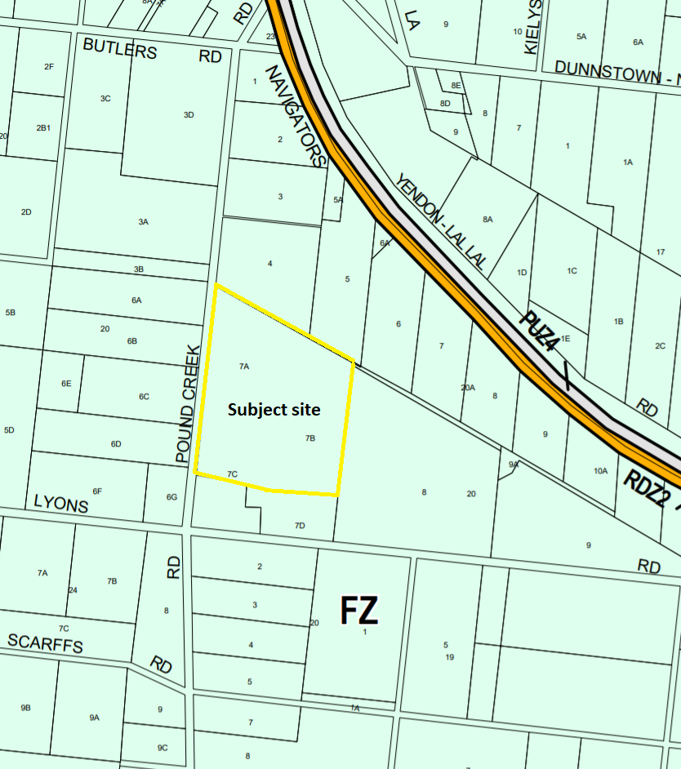
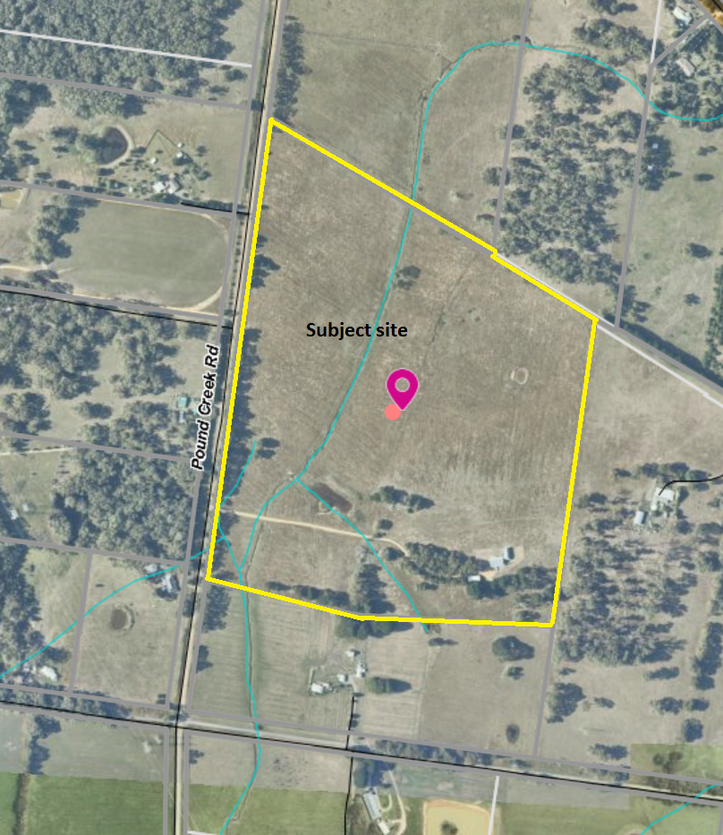

Planning Scheme Provisions
Council is required to consider the Victoria Planning Provisions and give particular attention to the Planning Policy Framework (PPF), the Local Planning Policy Framework (LPPF) and the Municipal Strategic Statement (MSS).
The relevant clauses are:
• Clause 11.03-3S Peri-urban areas
• Clause 14.01-1S Protection of agricultural land
• Clause 14.02 Water
• Clause 15.01-6S Design for rural areas
• Clause 21.02-2 Non-Urban Landscapes
• Clause 21.02-3 Water and Catchment Management
• Clause 21.03-3 Residential Development
• Clause 21.03-4 Landscape and Neighbourhood Character
• Clause 22.02 Special Water Supply Catchments
• Clause 22.03 Houses and House Lot Excisions in Rural Areas
The proposal complies with the relevant sections of the PPF and LPPF, with the exception of the clauses outlined in the table below:

PPF | Title | Response
Clause 11.03-3S | Peri-urban areas | The proposal would intensify residential use of the site, resulting in loss of farm land.
Clause 14.01-1S | Protection of agricultural land | The proposal increases residential use of farm land and diminishes the capacity of the site to support agriculture.
LPPF

Clause 21.02-2 | Non-Urban Landscapes | The proposal would increase residential development in a rural location which erodes the rural character of the area.
Clause 21.03-4 | Landscape and Neighbourhood Character | The proposed dwelling’s benefit to agriculture is not sufficiently justified.
Clause 21.03-6 | Rural Lifestyle Opportunities | The proposal would fragment farm land.
Clause 21.04-2 | Agriculture | The proposal would not support productive, sustainable farming in both the short and longer term.
Clause 22.03 | Houses and House Lot Excisions in Rural Areas | The proposed agricultural activity is not considered sufficient justification for the proposed subdivision and dwelling.

Zone
The subject site is in the Farming Zone. The purpose of the Zone is:
• To implement the Municipal Planning Strategy and the Planning Policy Framework.
• To provide for the use of land for agriculture.
• To encourage the retention of productive agricultural land.
• To ensure that non-agricultural uses, including dwellings, do not adversely affect the use of land for agriculture.
• To encourage the retention of employment and population to support rural communities.
• To encourage use and development of land based on comprehensive and sustainable land management practices and infrastructure provision.
• To provide for the use and development of land for the specific purposes identified in a schedule to this zone.
Under Clause 35.07, a permit is required to subdivide land and to use and develop a lot of less than 40 ha for a dwelling. The default minimum lot size for subdivision is 100 ha, however there is an exemption for the re-subdivision of existing lots where the number of lots is not increased.
Overall, the proposal is inconsistent with the purpose of the zone – see ‘Discussion’ below.

Overlays

The site is affected by Environmental Significance Overlay, Schedule 1, Design and Development Overlay, Schedule 2, and partially by the Bushfire Management Overlay.

Environmental Significance Overlay Schedule 1 (ES01)

Under Clause 42.01 of the Environmental Significance Overlay, a permit is required to subdivide land and construct buildings and works. There are no relevant exemptions under Schedule 1.

Design & Development Overlay Schedule 2 (DD02)

Under Clause 43.02 of the Design and Development Overlay, a permit is required to subdivide land and construct buildings and works. Under Schedule 2 there is an exemption for subdivision and for buildings and works where non-reflective external building cladding is proposed. In this instance a permit is not required.

Bushfire Management Overlay (BMO)

Under Clause 44.06 of the Bushfire Management Overlay, a permit is required to subdivide land and construct buildings and works. As only a portion of the land is affected the BMO a permit is only required for subdivision.

Subject to conditions, the proposal is generally consistent with the applicable overlay provisions.

Relevant Policies
Council’s Rural Growth Policy Statement
Council’s Rural Growth Policy Statement was adopted by Council on 19 September 2012. The document applies to all land in Farming Zone under the Moorabool Planning Scheme.
The policy states:
• Encourage dwellings in areas nominated in Map 1 of Council Rural Growth Policy Statement.
• Ensure the siting of any dwellings is designed to have a minimal impact on any existing or future agricultural activities on the site and on surrounding land.
• Ensure it is clear whether the dwelling is required for agricultural operation use or to maintain rural communities.
• Ensure sufficient infrastructure is available or that alternative methods are available which do not require normal infrastructure.
• Encourage development of dwellings to support communities of land which is unlikely to support agricultural land which still considering any other overlays which may impact the land. This is land which is constrained for use as agriculture by other environment factors such as vegetation, slope, soil quality etc.
• Ensure any subdivision is undertaken in accordance with the scheme in order to discourage fragmentation of agricultural land.
It is noted, that the site is located in an area where dwelling development on lots greater than 8 ha is encouraged, as per the Policy’s Map 1 – Rural Development Areas. However, the proposal only responds to part of this policy for sites of 8-20 ha, noting that the proposed agricultural enterprise gives insufficient justification for the additional dwelling. The proposed re-subdivision would further fragment agricultural land and in this instance, they have not demonstrated that two dwellings are required to support one farming activity.
Council’s Rural Housing Policy
Council’s Rural Housing Policy has been developed to provide direction for how limited farming potential rural dwellings should be considered, and more broadly, rural settlement patterns. The policy seeks to articulate support for resilient and integrated rural communities and agricultural enterprises, asserting that ‘State Government Planning Policy Framework does not adequately recognise or support agriculture trends and rural settlements in the Moorabool Shire’.
The principles of the policy relevant to this application include:
• Support the agricultural sector so that it can be more productive, diverse, resilient and adaptive to changing agricultural trends, including supporting agricultural activities that recognise Moorabool’s advantageous proximity to market.
• Protect agricultural land use from loss and allow development that increases agricultural productivity.
• Focus growth opportunities in settlements along major transport corridors, in particular where there is physical and social infrastructure and services.
• Recognise that there are substantial existing lots under 40 ha capable of supporting the viable operation of agricultural enterprises.
• Promote a rural housing market that meets the needs of the Shire’s rural communities
• Land parcels for the proposed on-farm living dwellings are to have a minimum lot size of 8 ha as identified in Map 1.
The proposed subdivision is not aligned with the above principles of the policy and is furthermore considered to undermine the agricultural potential of the land. The existing single dwelling in support of one farm enterprise should be maintained rather than two dwellings on two re-subdivided lots in support of a single farm enterprise.

Particular Provisions
Clause 53.02 Bushfire Planning
The application was assessed by CFA who consent to the application. The proposed dwelling would be sited outside of the area of BMO coverage.

Discussion
Overall, the proposed subdivision and use and development for a dwelling is considered to be inconsistent with relevant Victorian and local planning policy, the Farming Zone and relevant decision guidelines at Clause 65 of the Moorabool Planning Scheme. Furthermore, the proposal breaches Section 173 Agreement AD935687W registered on the title to one of the existing lots. The intent of the Agreement was to prevent further subdivision of the land and was created to allow the previous planning permit approval.
The Moorabool Planning Scheme provides discretion for a permit to be granted to use and develop land for a dwelling on a lot less than 40 ha. Where a permit is required, the decision guidelines of the Farming Zone require a range of matters be considered.
In relation to dwellings in the Farming Zone the decision guidelines require that the responsible authority consider whether a dwelling:
• Will result in the loss or fragmentation of productive agricultural land.
• Whether the dwelling will be adversely affected by agricultural activities on adjacent and nearby land due to dust, noise, odour, use of chemicals and farm machinery, traffic and hours of operation.
• Whether the dwelling will adversely affect the operation and expansion of adjoining and nearby agricultural uses.
• The potential for the proposal to lead to a concentration or proliferation of dwellings in the area and the impact of this on the use of the land for agriculture.
In relation to agricultural issues in the Farming Zone the decision guidelines require that the responsible authority also consider:
• Whether the use or development will support and enhance agricultural production.
• Whether the use or development will adversely affect soil quality or permanently remove land from agricultural production.
• The potential for the use or development to limit the operation and expansion of adjoining and nearby agricultural uses.
• The capacity of the site to sustain the agricultural use.
• The agricultural qualities of the land, such as soil quality, access to water and access to rural infrastructure.
• Any integrated land management plan prepared for the site.
The proposed dwelling is stated to be in support of a small cow-calf breeding enterprise. The proposed subdivision would re-subdivide the existing landholding to provide two lots of 11.07 ha and 16.94 ha, with the proposed dwelling to be sited on the smaller lot and the larger lot to accommodate an existing dwelling and sheds.
The application includes a detailed farm management plan in support of the proposal. However, whilst the proposed dwelling is purported to benefit the proposed farming enterprise, there is an existing dwelling on the property which could readily serve the function of the proposed dwelling, positioned to visually survey most of the property. The applicant claims that the proposed subdivision would improve the current land fragmentation, but the justification given is insufficient. It is acknowledged that the existing 3313 sqm lot is a particularly small ‘fragment’ of land. However, it is contiguous with the proponent’s adjoining 27.69 ha lot and being in common ownership the fact of being separate titles does not prevent a farming enterprise being carried out on two or more titles. The landholding comprises two titles rather than one is irrelevant to the property’s productivity. The proposition that re-subdividing the property in the manner proposed and constructing an additional dwelling improves the current land fragmentation is refuted. Rather, it is considered that the proposed subdivision and dwelling development will not only fragment the property further without any tangible benefit to agricultural output or sustainable land practices but also result in an additional dwelling in a rural zone, which contributes to inflated land values ultimately hindering the site’s viability for bona fide agricultural uses in the longer term. Victorian and local planning policy seeks to protect viable agricultural land for that purpose, and prevent incompatible land uses from encroaching and permanently removing that land from agricultural use. The proposal represents the incremental loss of land from productive agricultural. Limiting land fragmentation would be best achieved by consolidating the existing titles.
By allowing the proposed dwelling on the land, when the existing dwelling would readily serve the same function in support of the one farming activity, the site’s use for residential purposes is intensified, and its agricultural viability eroded. This is characteristic of incremental fragmentation of farming land. Such an outcome is not supported by either Victorian or local planning policy which includes the following objectives:
• To manage growth in peri-urban areas to protect and enhance their identified valued attributes. (Clause 11.03-3S).
• To protect the state’s agricultural base by preserving productive farmland. (Clause 14.01-1S.)
• To maintain and enhance the natural environment and the Shire’s rural identity and character. (Clause 21.02-2).
Further to these objectives, Victorian and local planning policy includes the following relevant strategies:
• Prevent dispersed settlement and provide for non-urban breaks between urban areas. (Clause 11.03-3S).
• Protect productive agricultural land from unplanned loss due to permanent changes in land use. (Clause 14.01-1S).
• Prevent inappropriately dispersed urban activities in rural areas. (Clause 14.01-1S).
• Limit new housing development in rural areas by directing housing growth into existing settlements. (Clause 14.01-1S).
• In considering a proposal to use, subdivide or develop agricultural land, consider the desirability and impacts of removing the land from primary production, given its agricultural productivity. (Clause 14.01-1S).
• Avoid the subdivision of productive agricultural land from diminishing the long-term productive capacity of the land. (Clause 14.01-1S).
• Focus rural living development in areas close to urban centres with good access to services and facilities where there is minimal impact on productive agriculture and horticulture or areas with environmental values. (Clause 21.03-5).
The site is evidently productive for grazing, in terms of the climate, soil conditions and water supply, and forms part of a larger rural area in the wider Melbourne and Ballarat rural hinterland. The proposal undermines these attributes for the reasons outlined above.

General Provisions
Clause 65 – Decision Guidelines have been considered by officers in evaluating this application.
Clause 66 – Stipulates all the relevant referral authorities to which the application must be referred.

Referrals
Authority | Response
Central Highlands Water  Country Fire Authority | Consent with conditions  Consent
Infrastructure  Environmental Health | Consent with conditions  Consent with conditions

Financial Implications
There are no financial implications for Council in deciding to refuse the application.

Risk & Occupational Health & Safety Issues
The recommendation to refuse the application does not have any risk or OH&S implications for Council.

Communications Strategy
Notice was undertaken for the application, in accordance with s.52 of the Planning and Environment Act 1987, and further correspondence is required to all interested parties to the application as a result of a decision in this matter. All submitters and the applicant were invited to attend this meeting and address Council if required.

Options
• Issue a Refusal to Grant a Permit in accordance with the grounds in the recommendation of this report. This option may result in the applicant appealing Council’s decision at VCAT; or
• issue a Refusal to Grant a Permit with amendments to the grounds in the recommendation of this report.
Support for the proposal would breach the Section 173 Agreement registered on the title to Lot 1 on PS 633637U, therefore approval is not considered to be an option. In any case, issuing a Notice of Decision to Grant a Permit may result in the objectors appealing Council’s decision at VCAT.

Conclusion
Overall, the proposed re-subdivision and use and development for a dwelling is inconsistent with relevant Victorian and local planning policy and the Farming Zone in respect of agricultural land use and rural housing development. The proposal is inconsistent with the orderly planning of rural land, resulting in the loss of agricultural land to rural residential use, detrimental impacts on sustainable agricultural land use and is an example of inappropriate development of rural land to the longer-term detriment of the Shire’s agricultural base. Furthermore, the proposal is in breach of Section 173 Agreement AD935687W registered on the title to Lot 1 on PS 633637U.
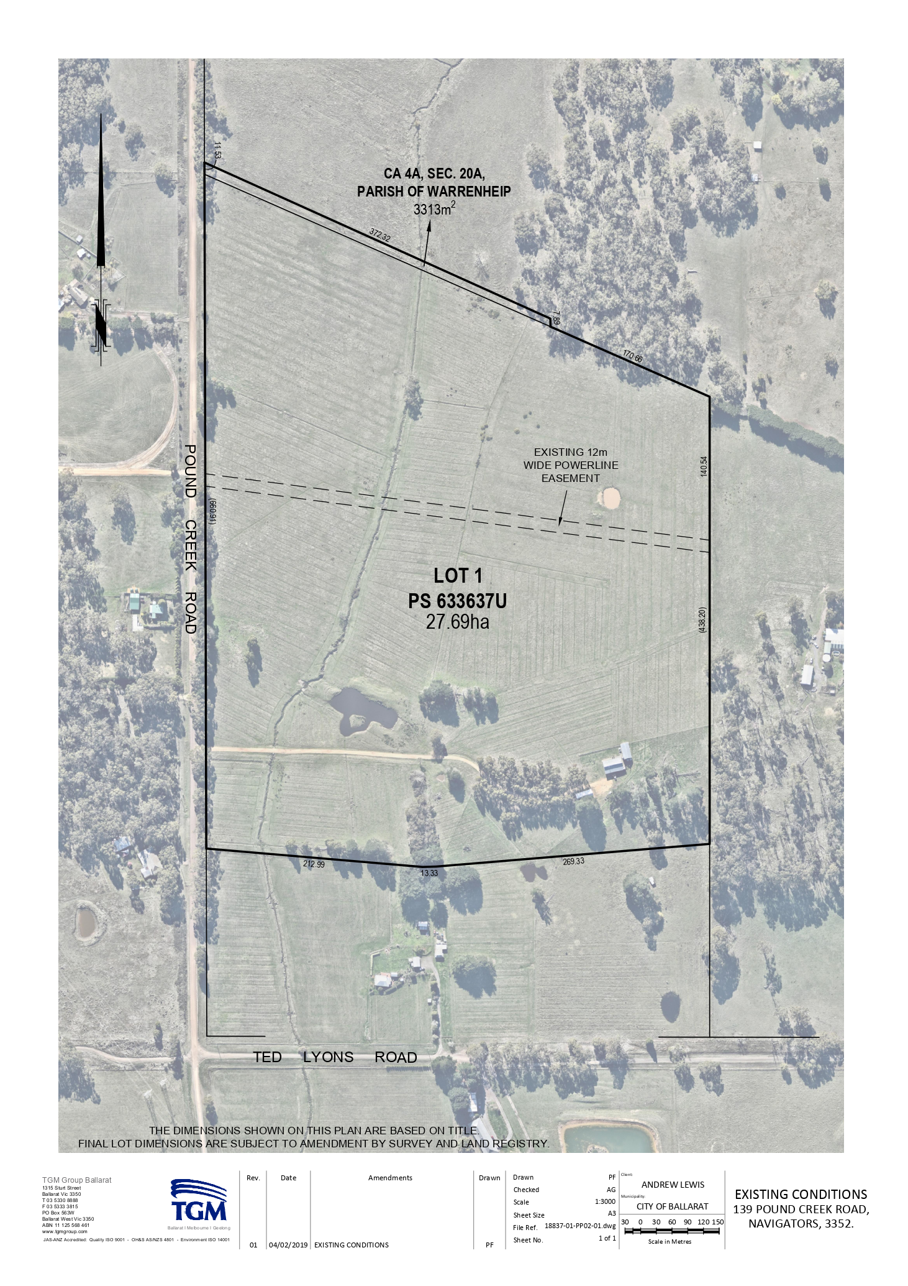
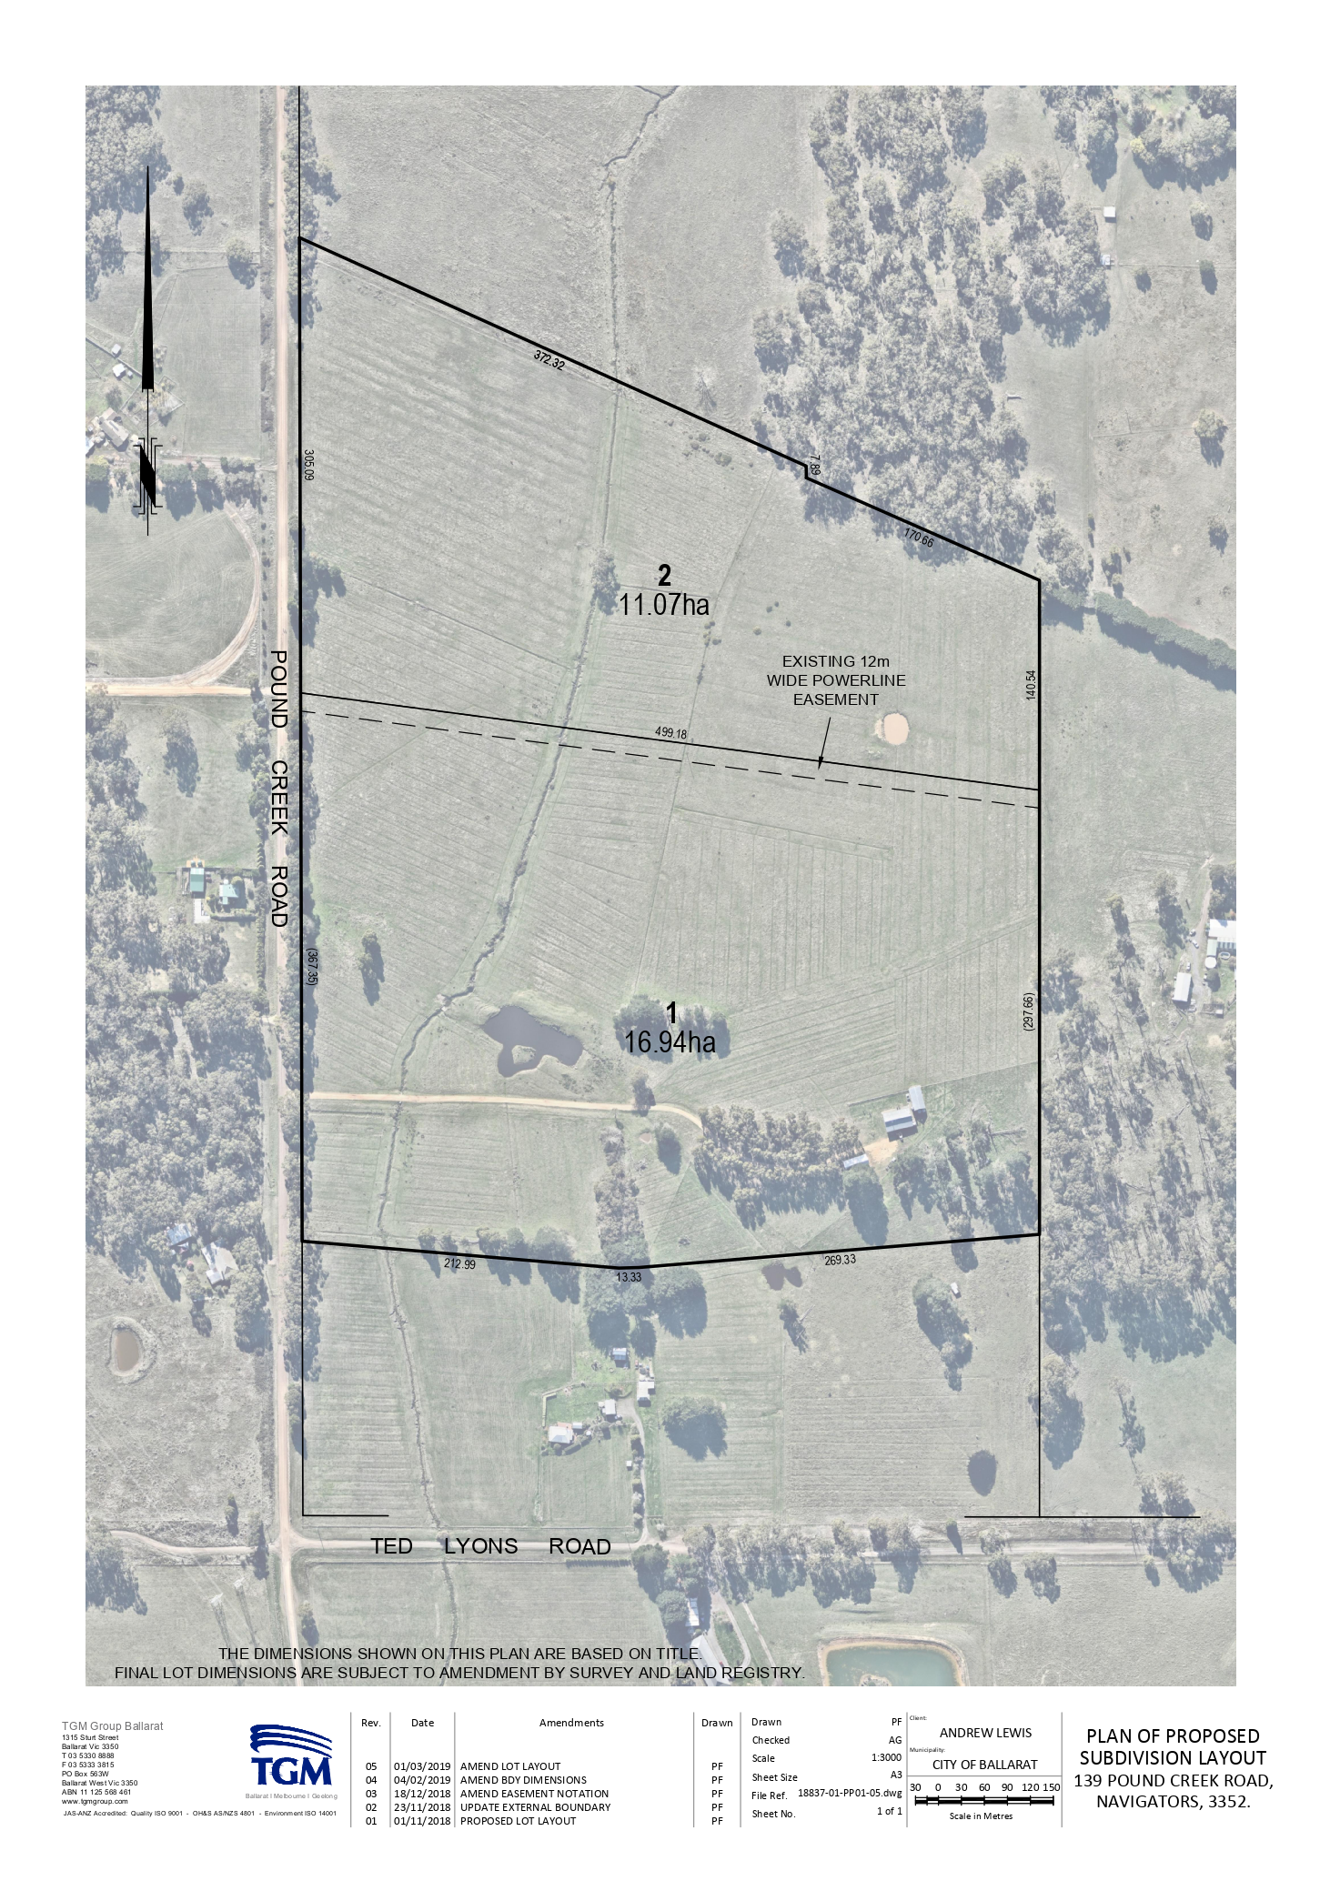
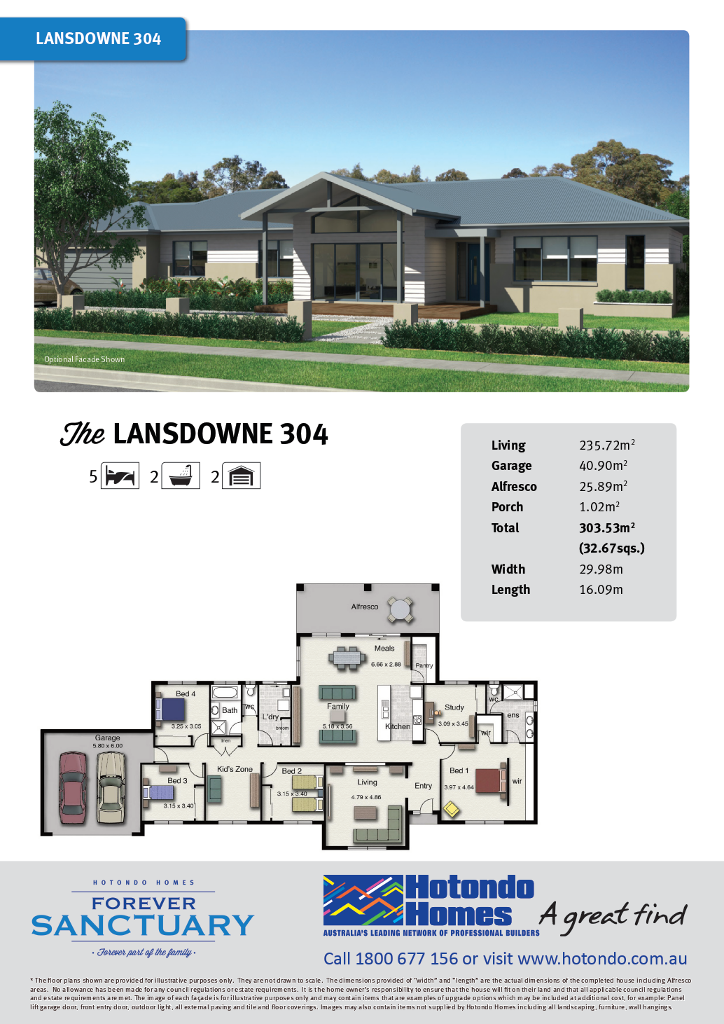
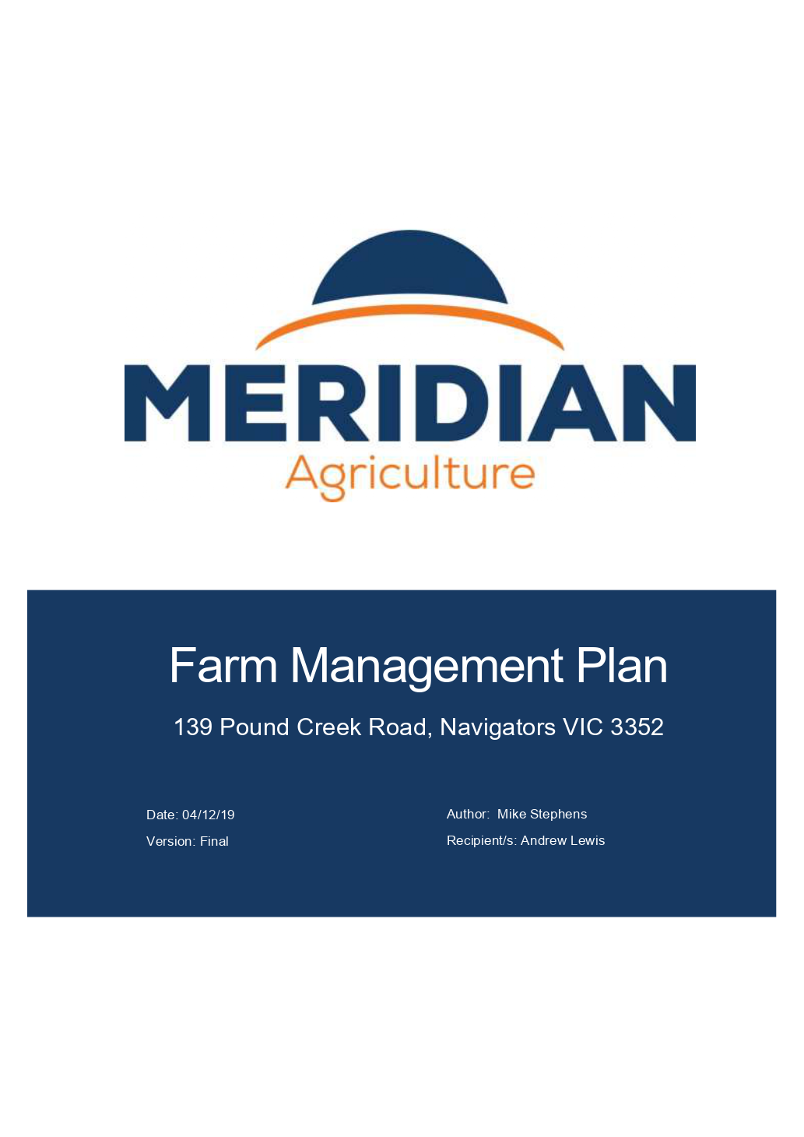

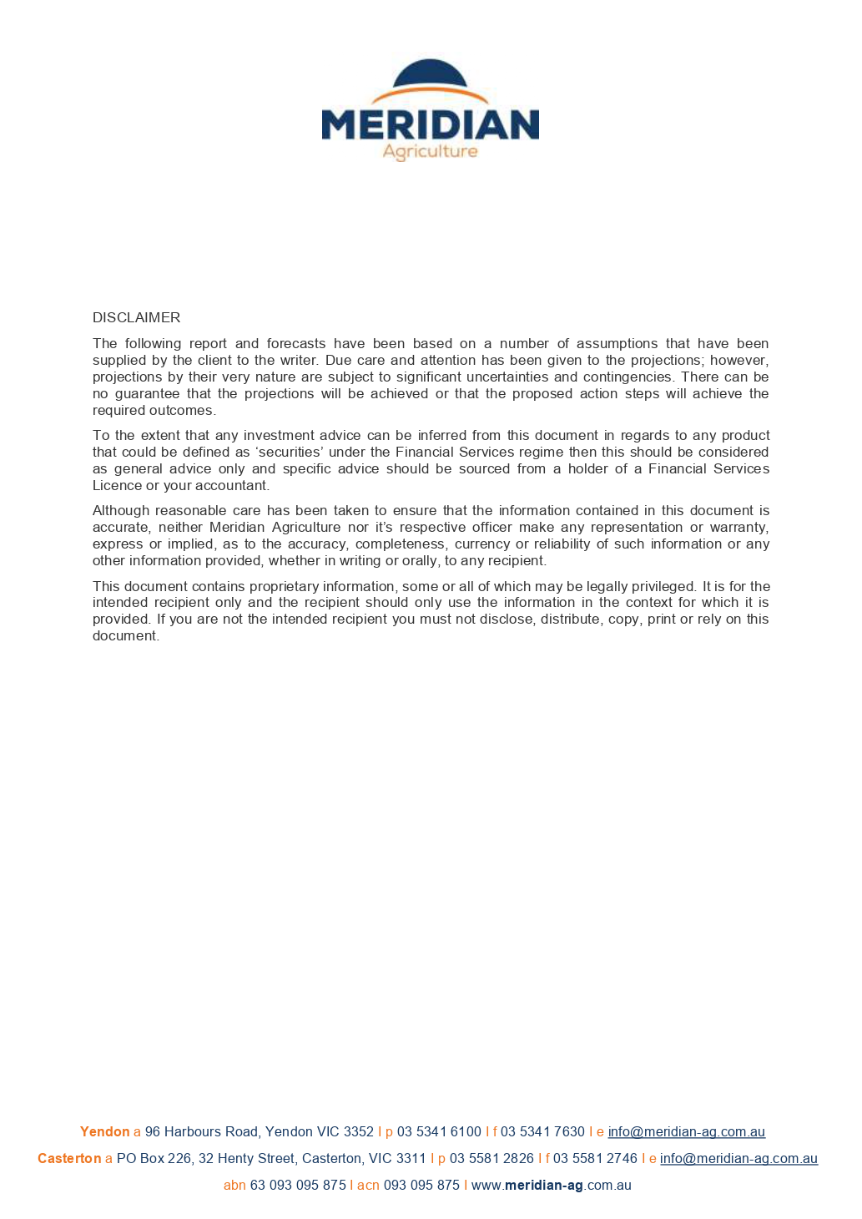

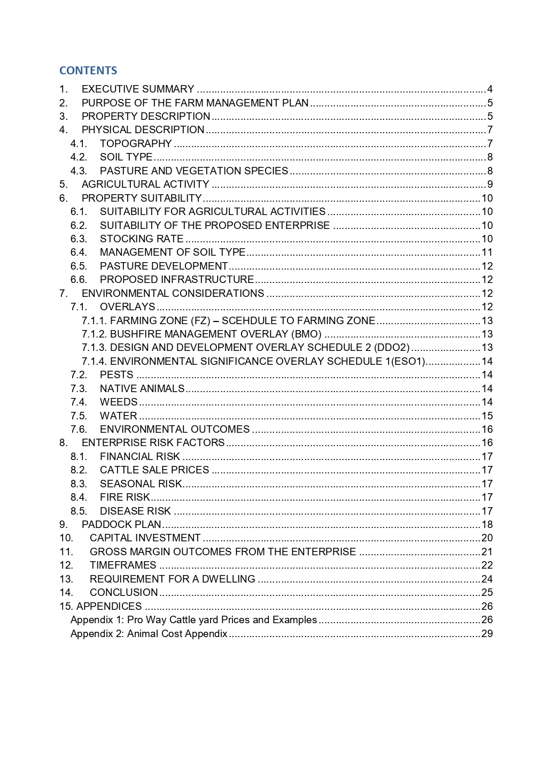

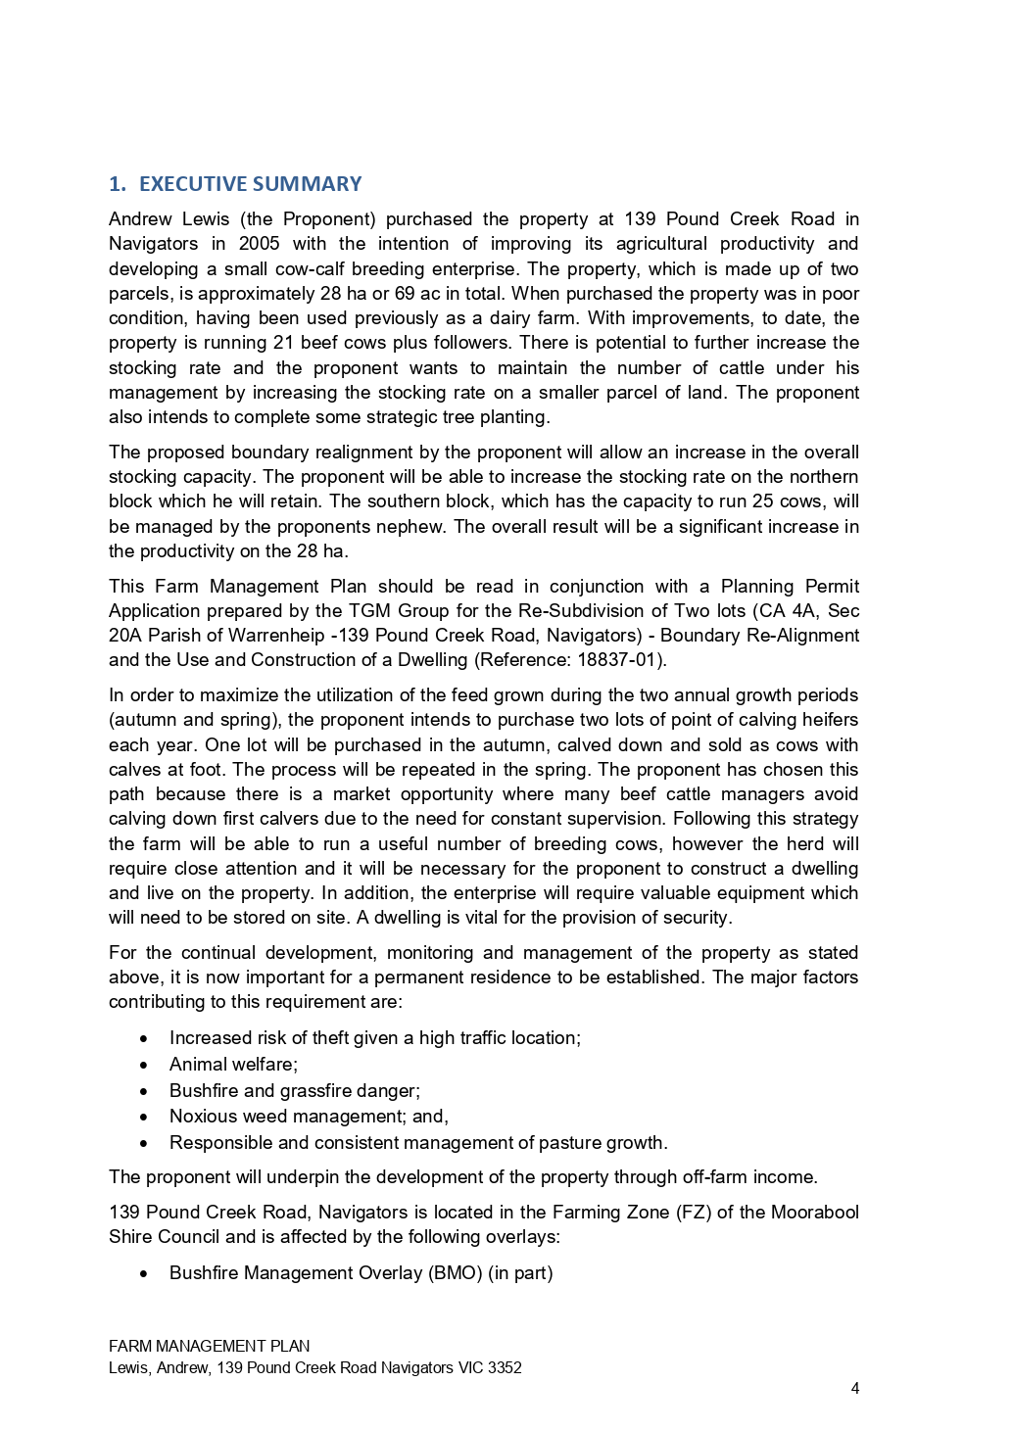

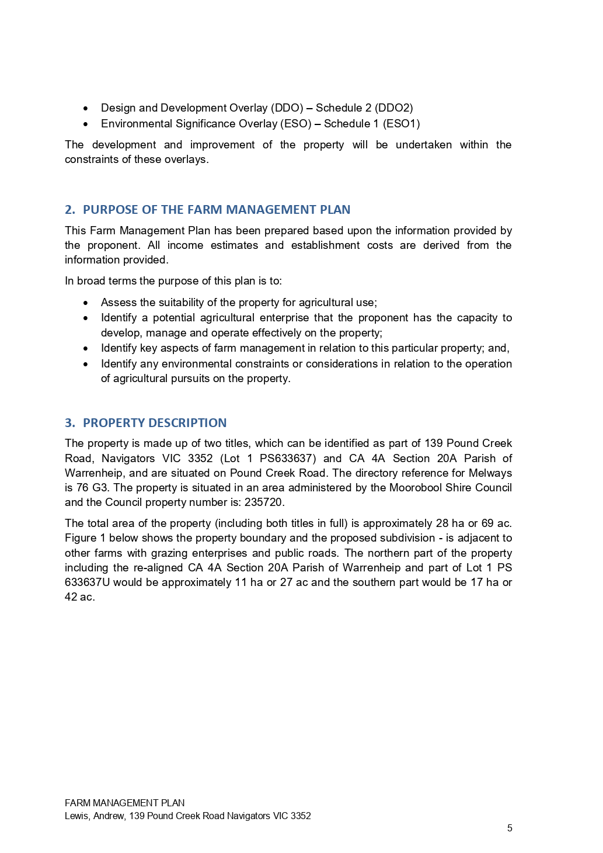

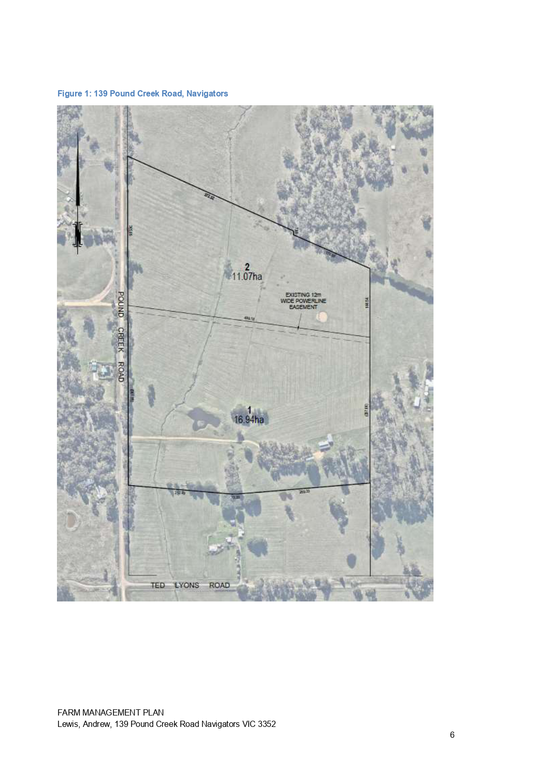

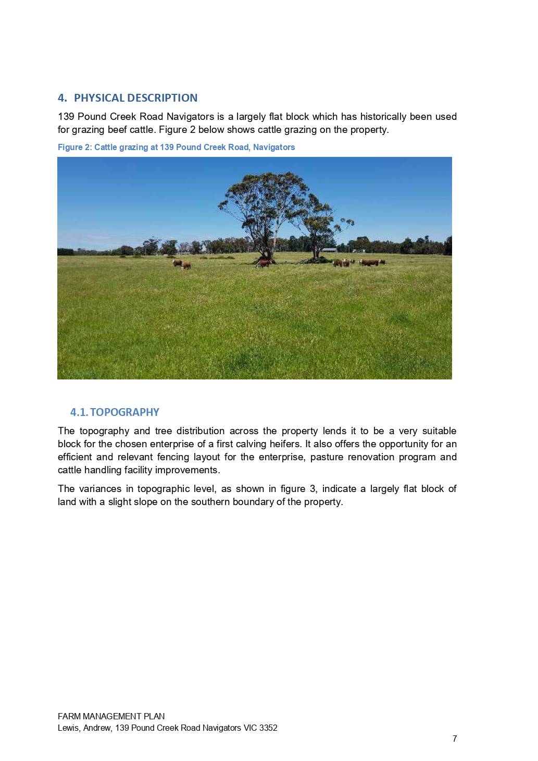

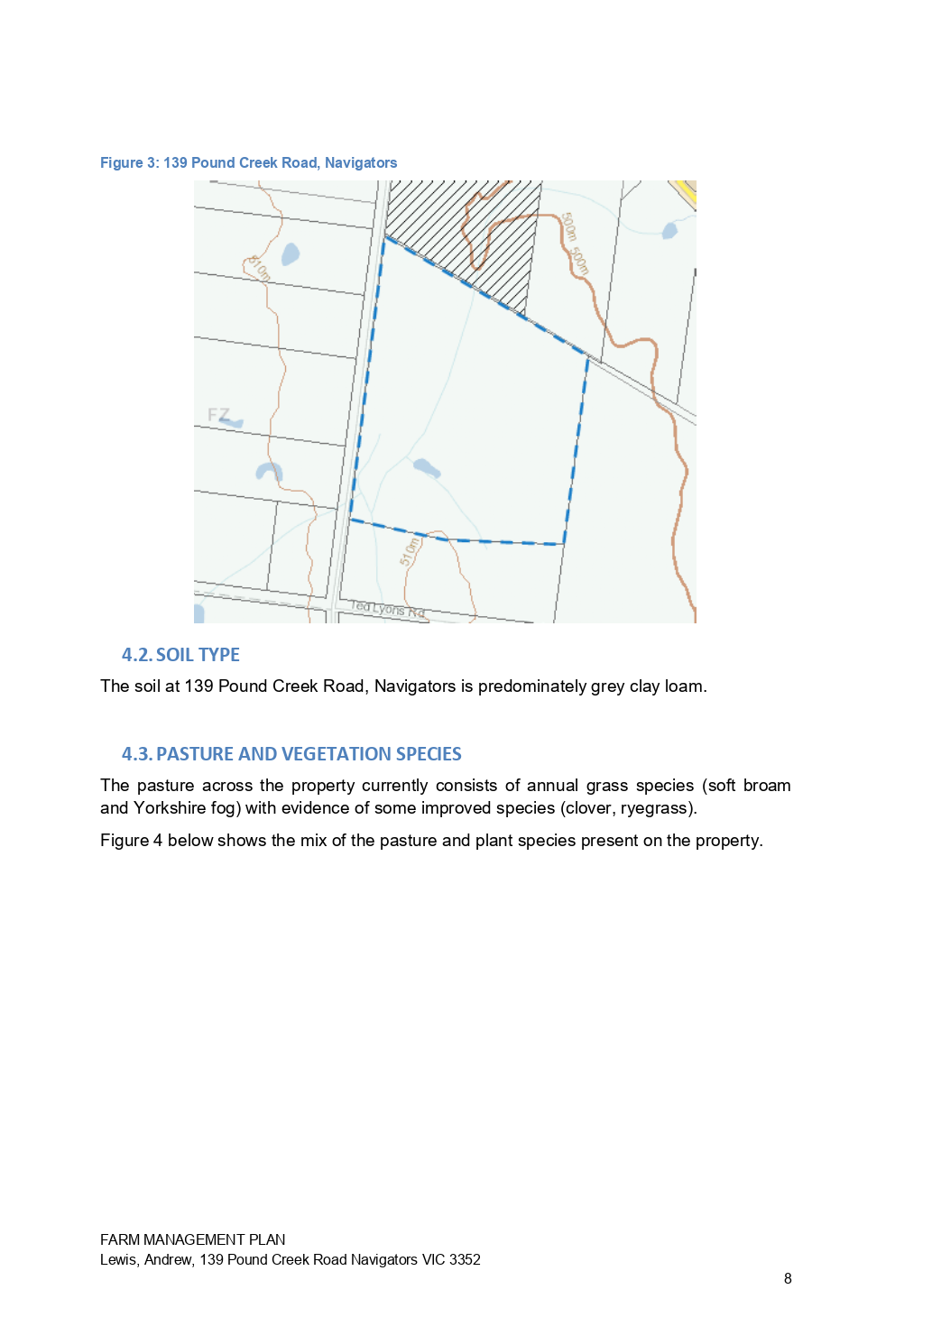

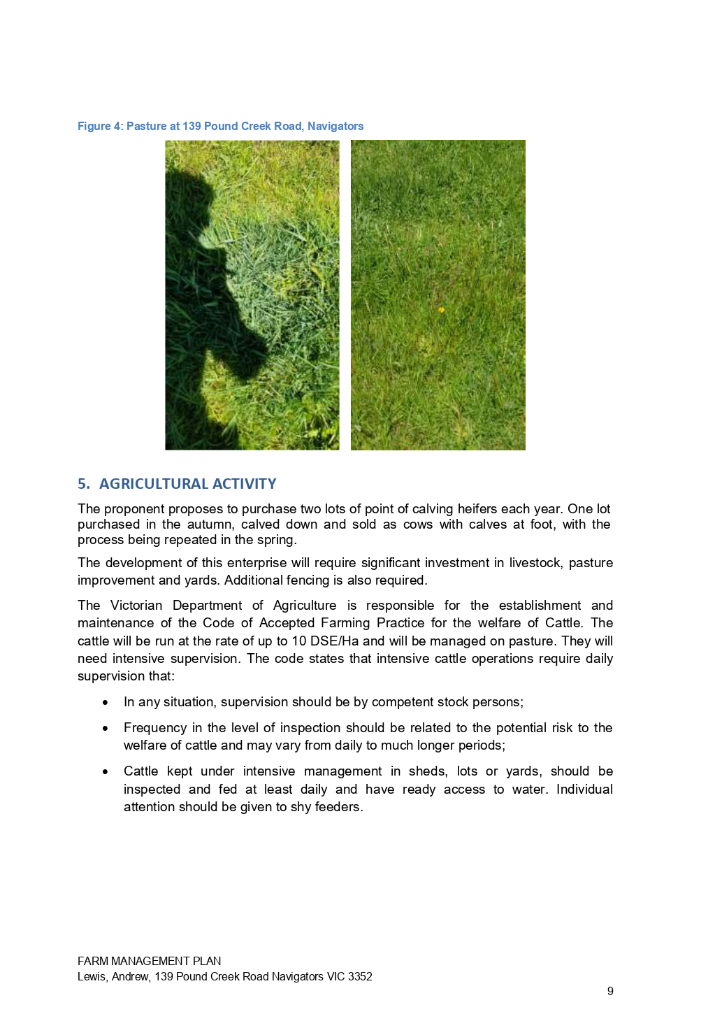

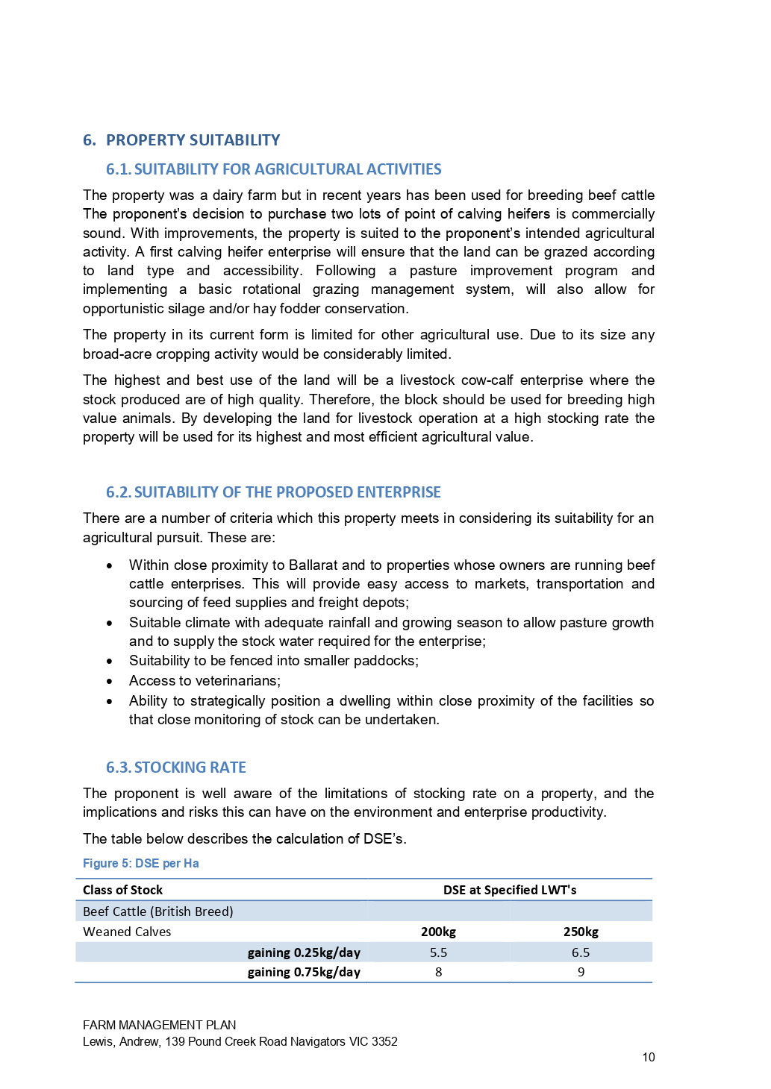

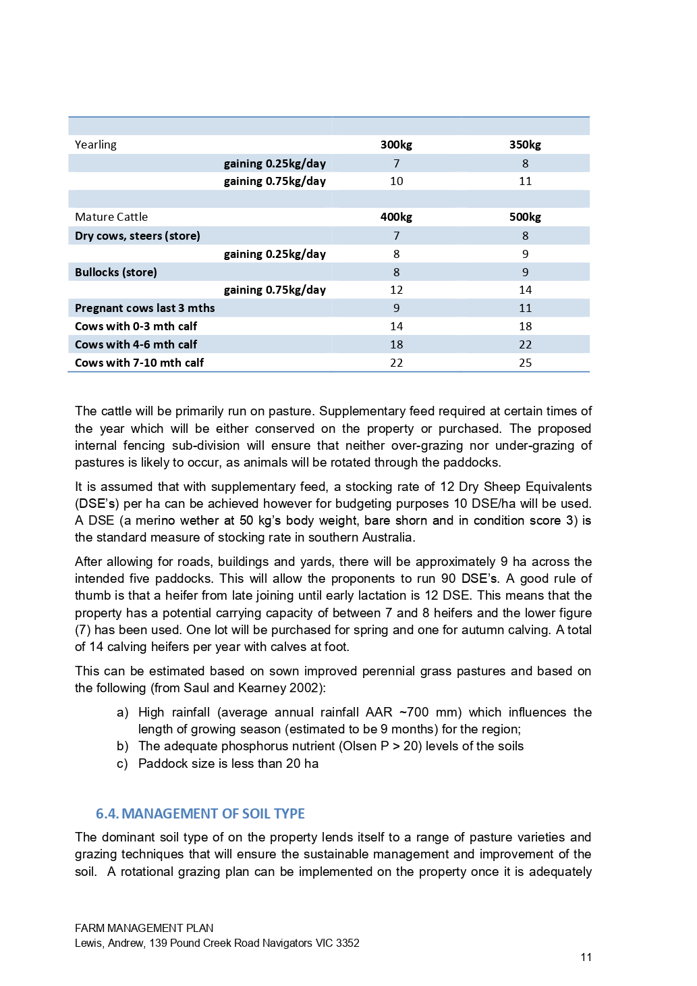

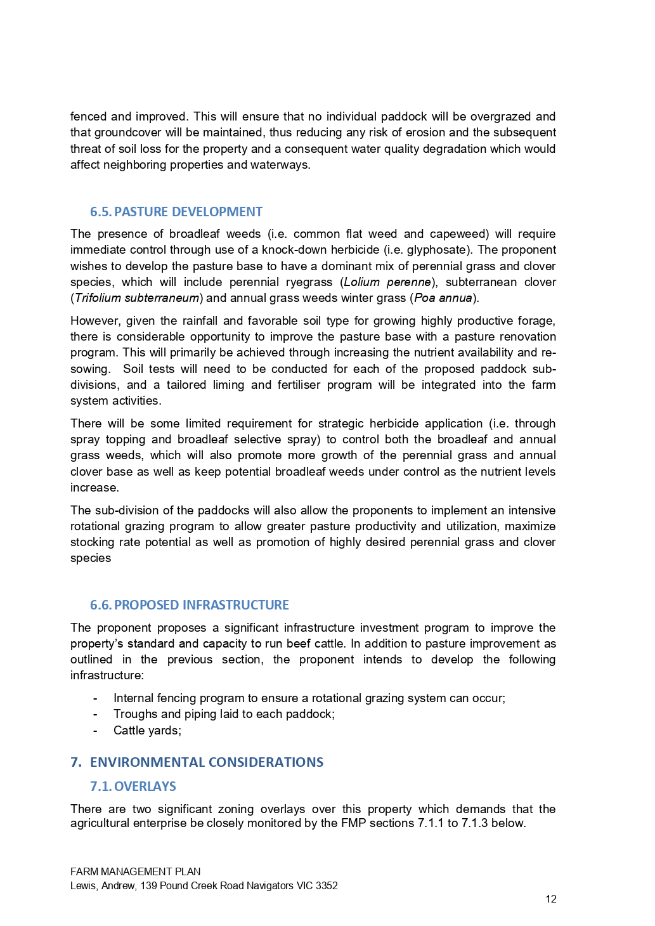

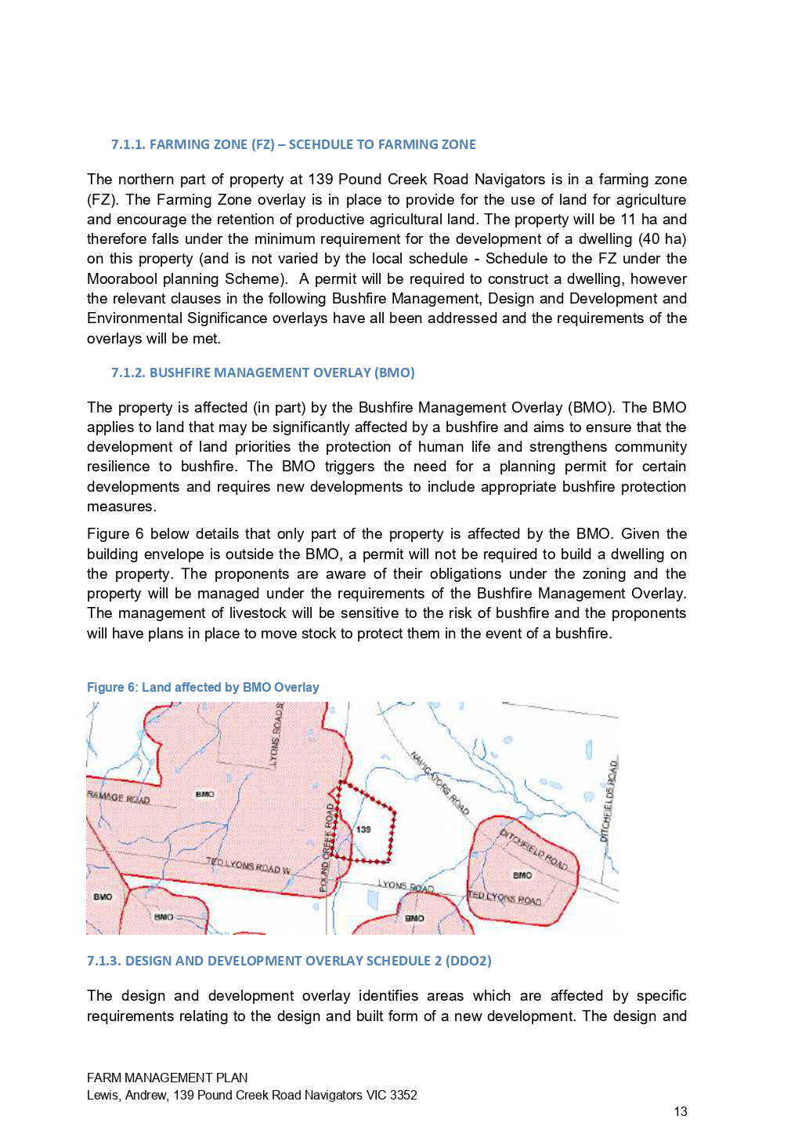

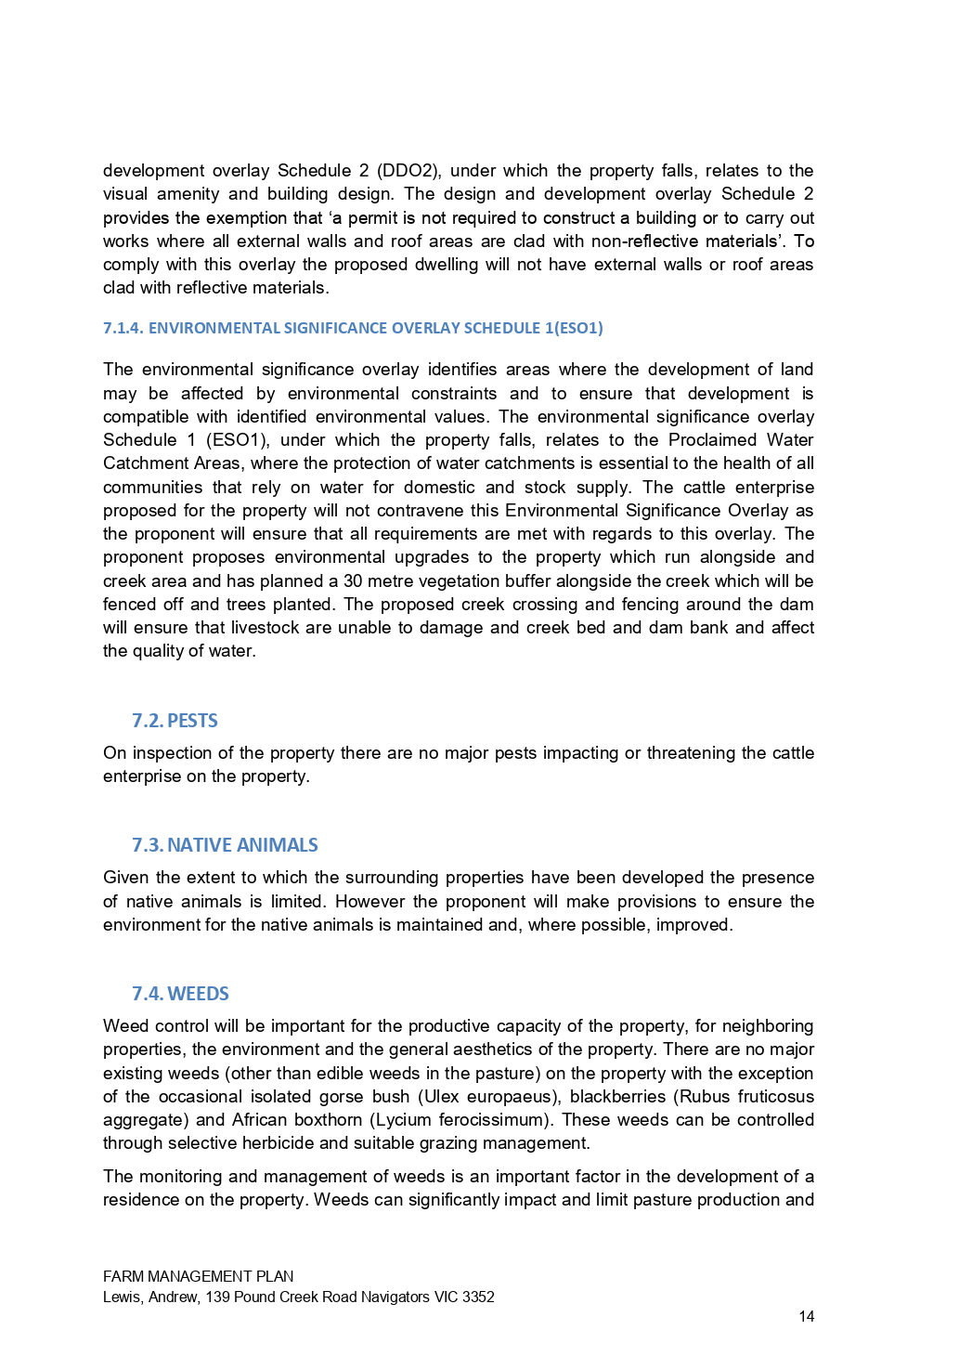

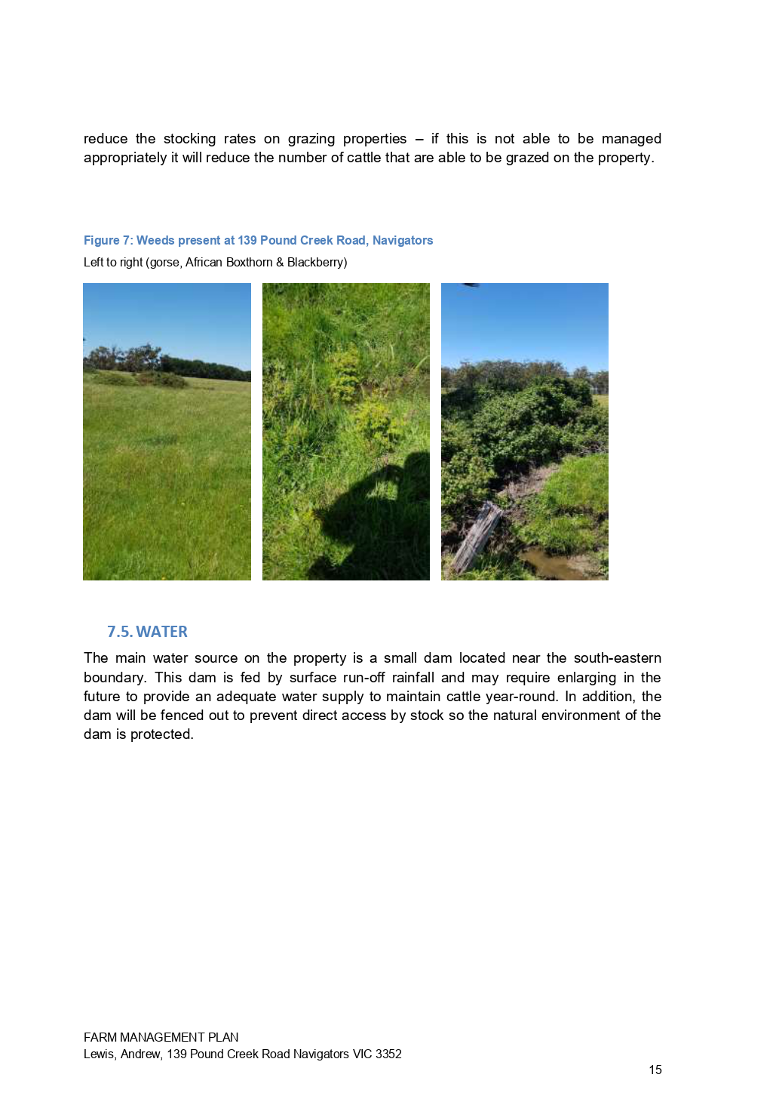

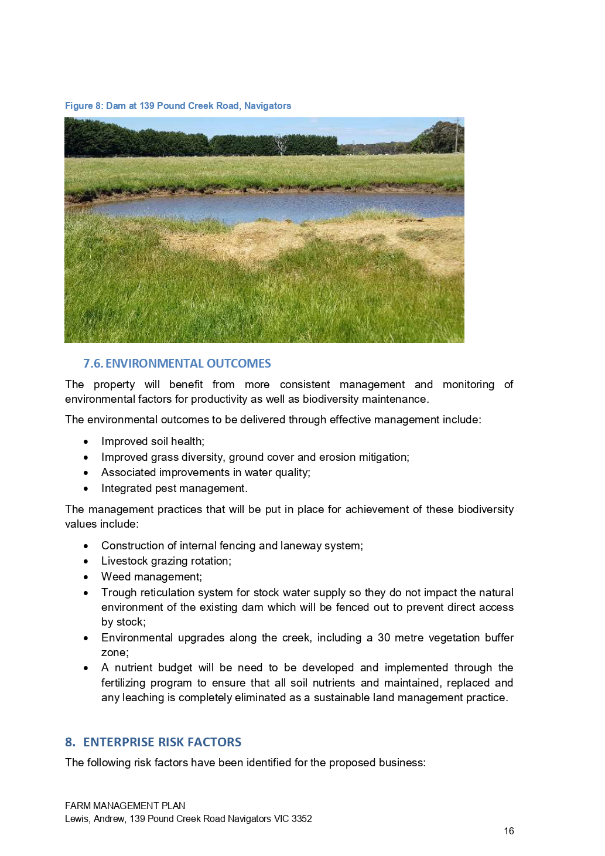

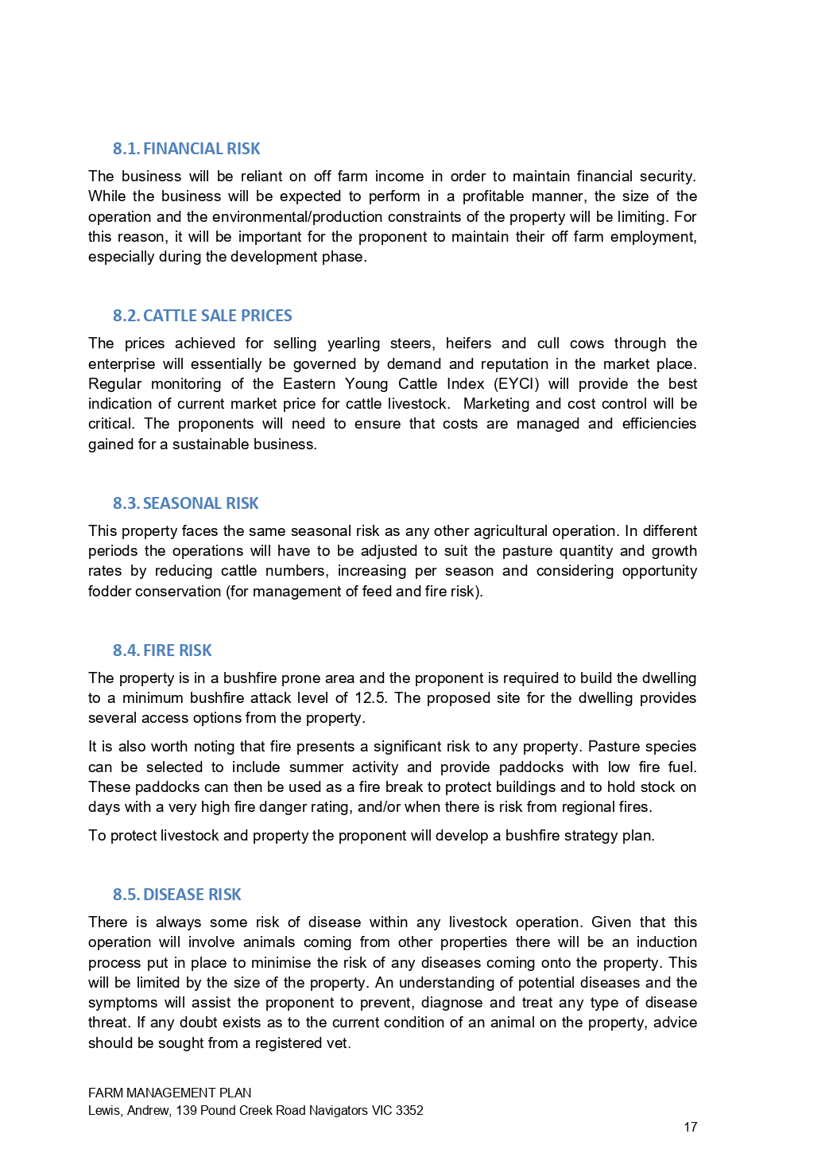

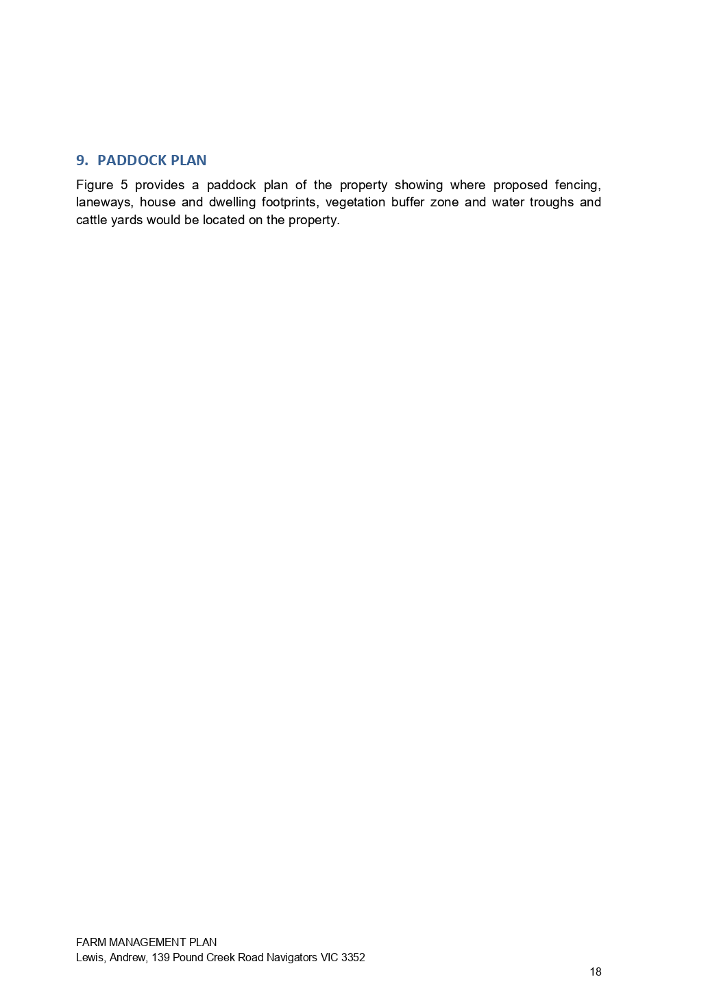
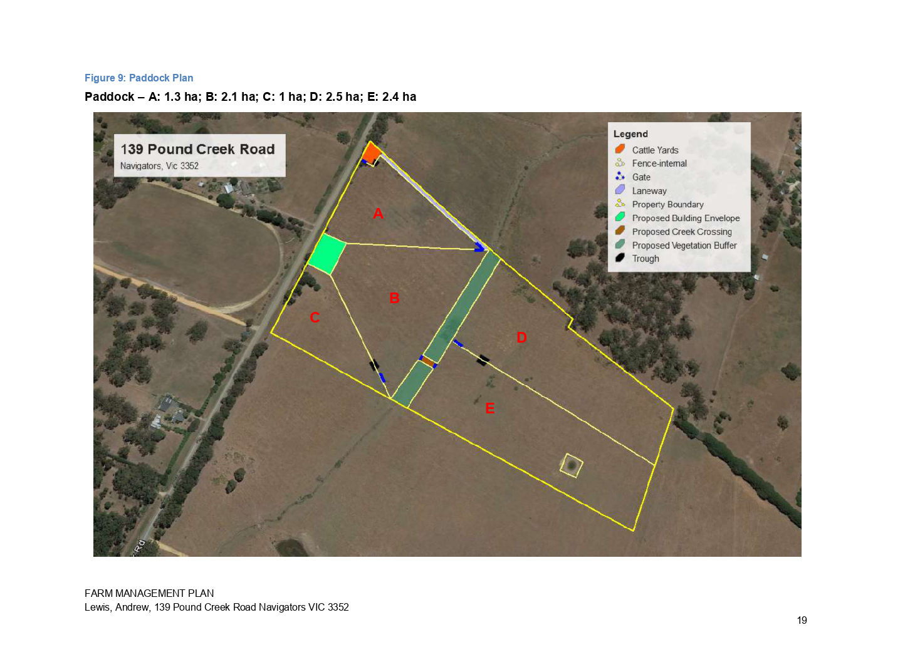
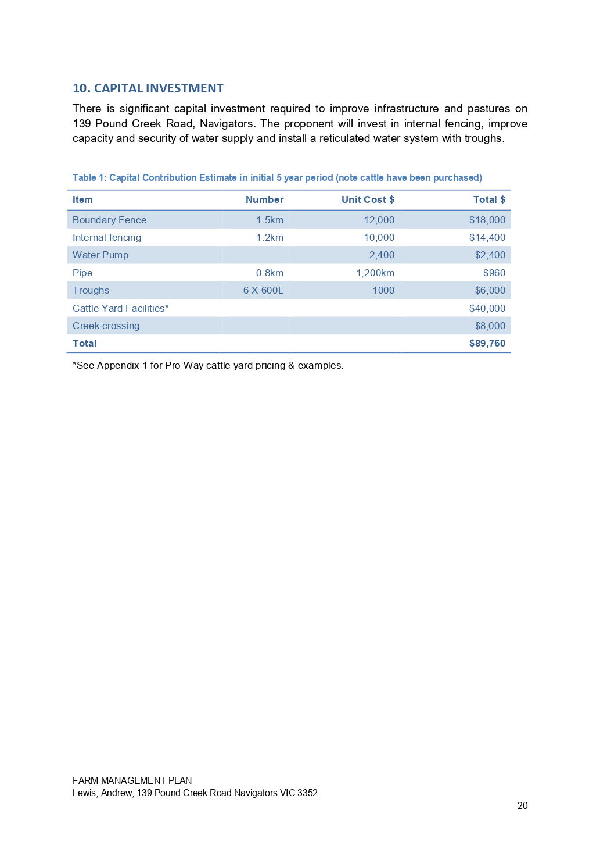
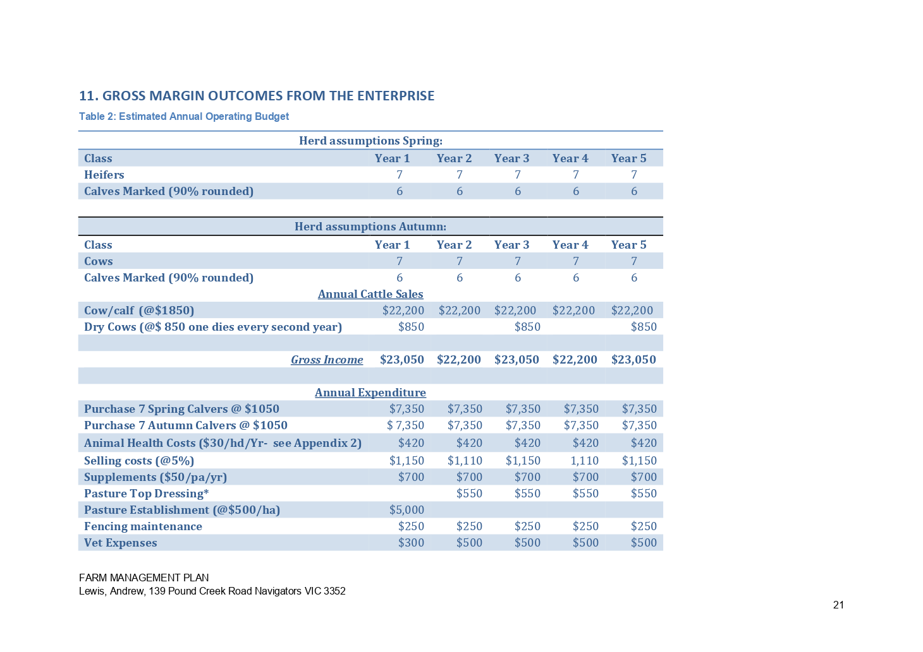

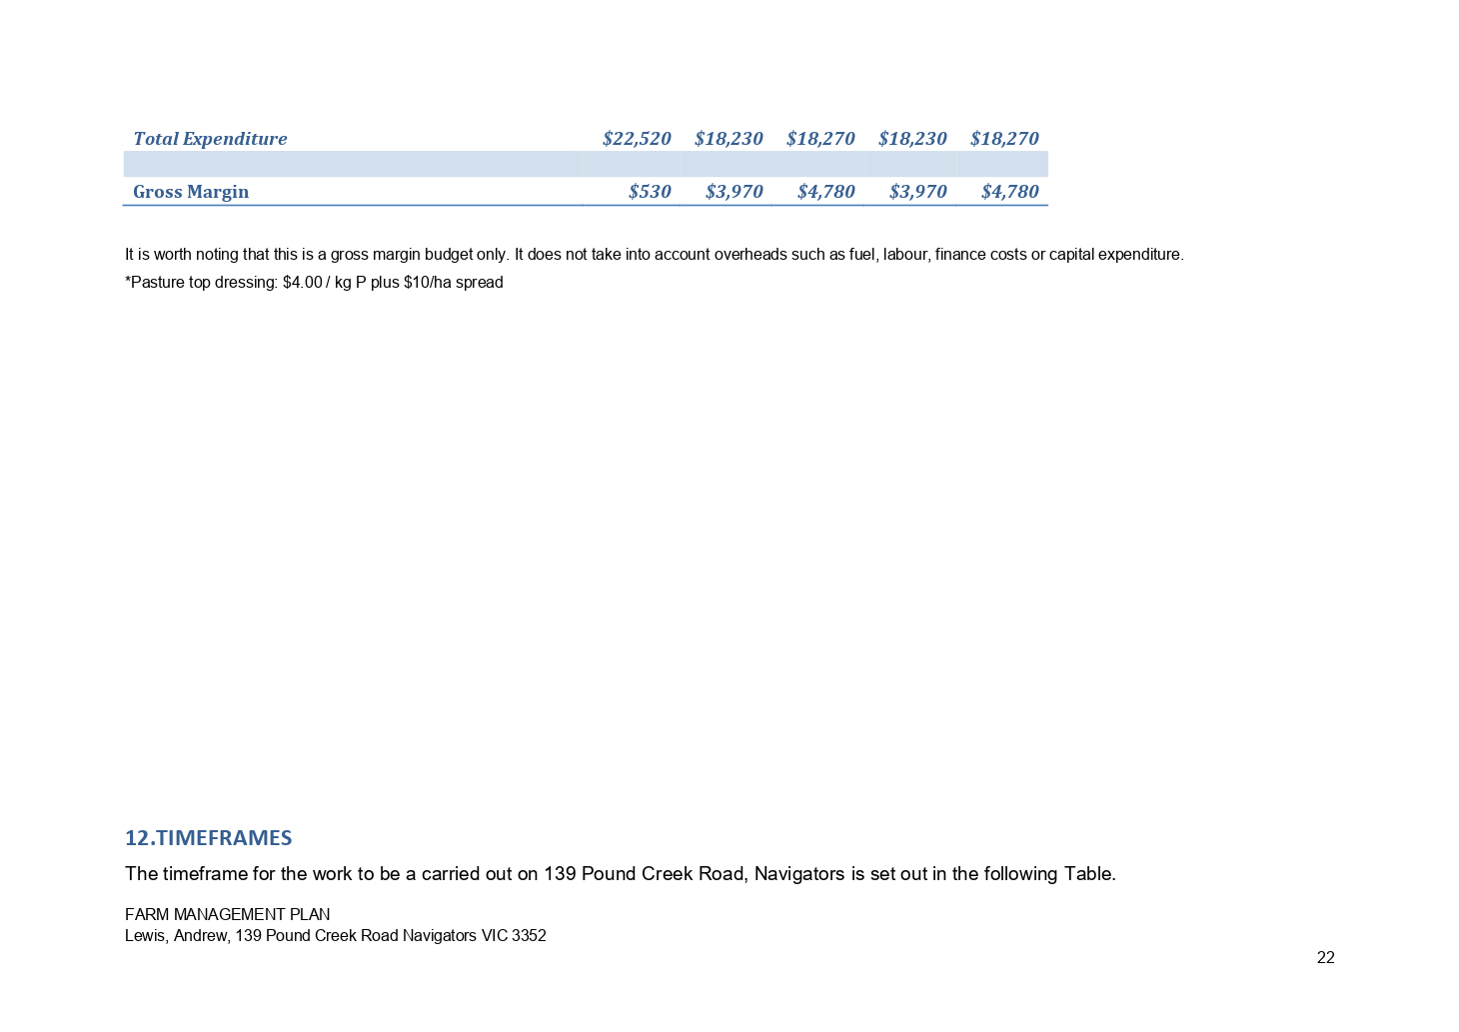

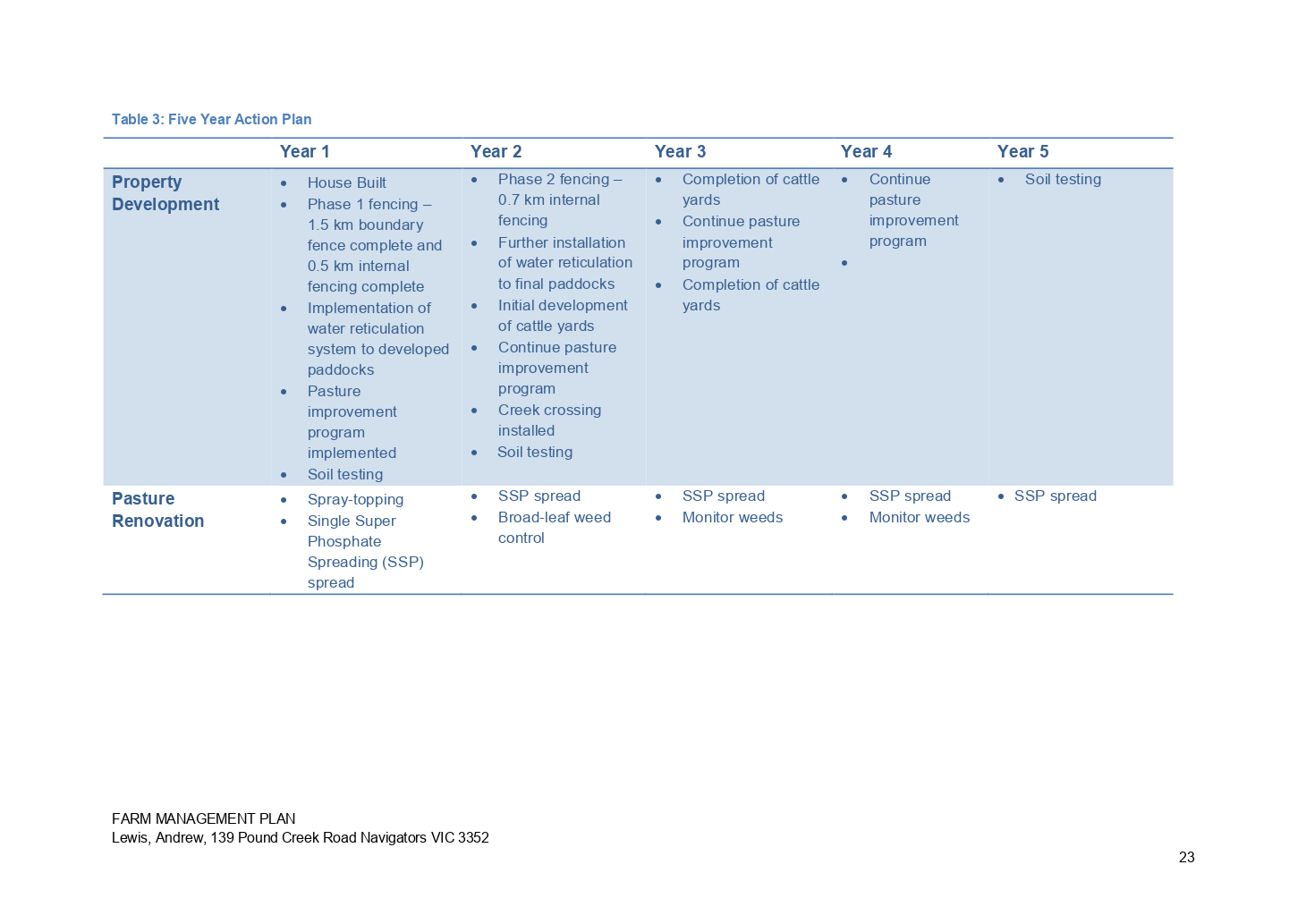
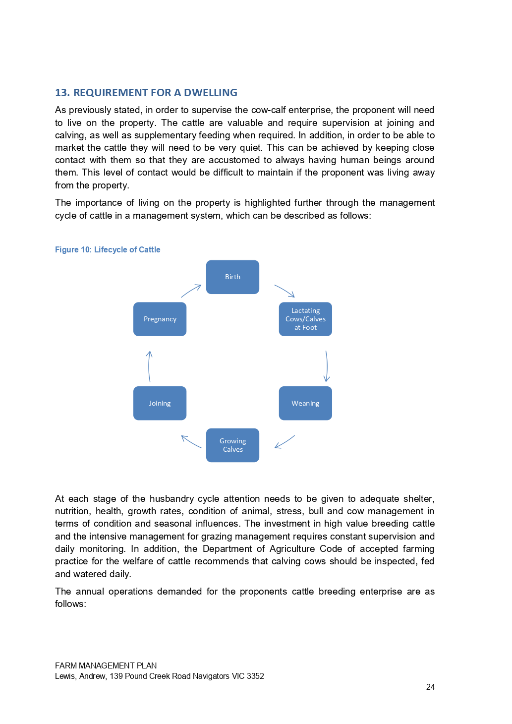

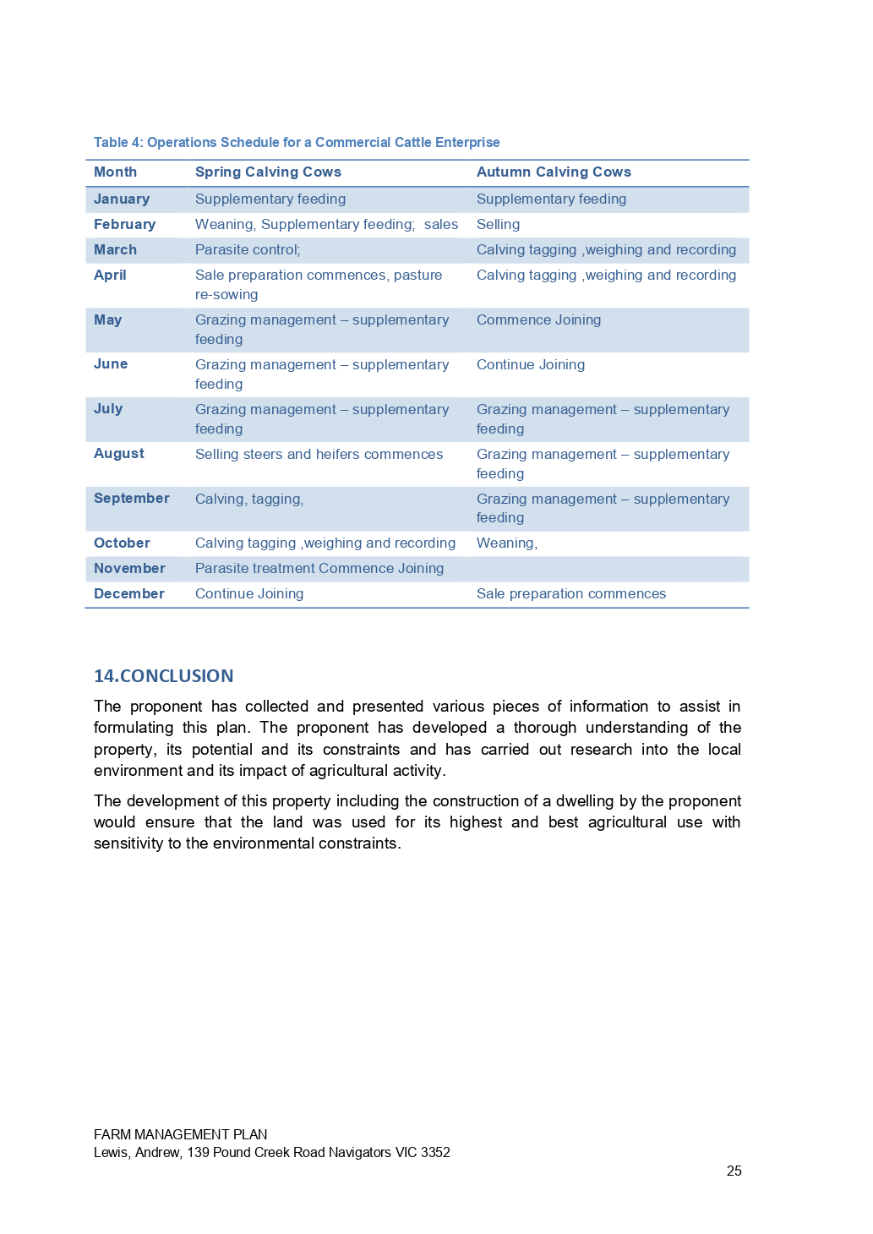

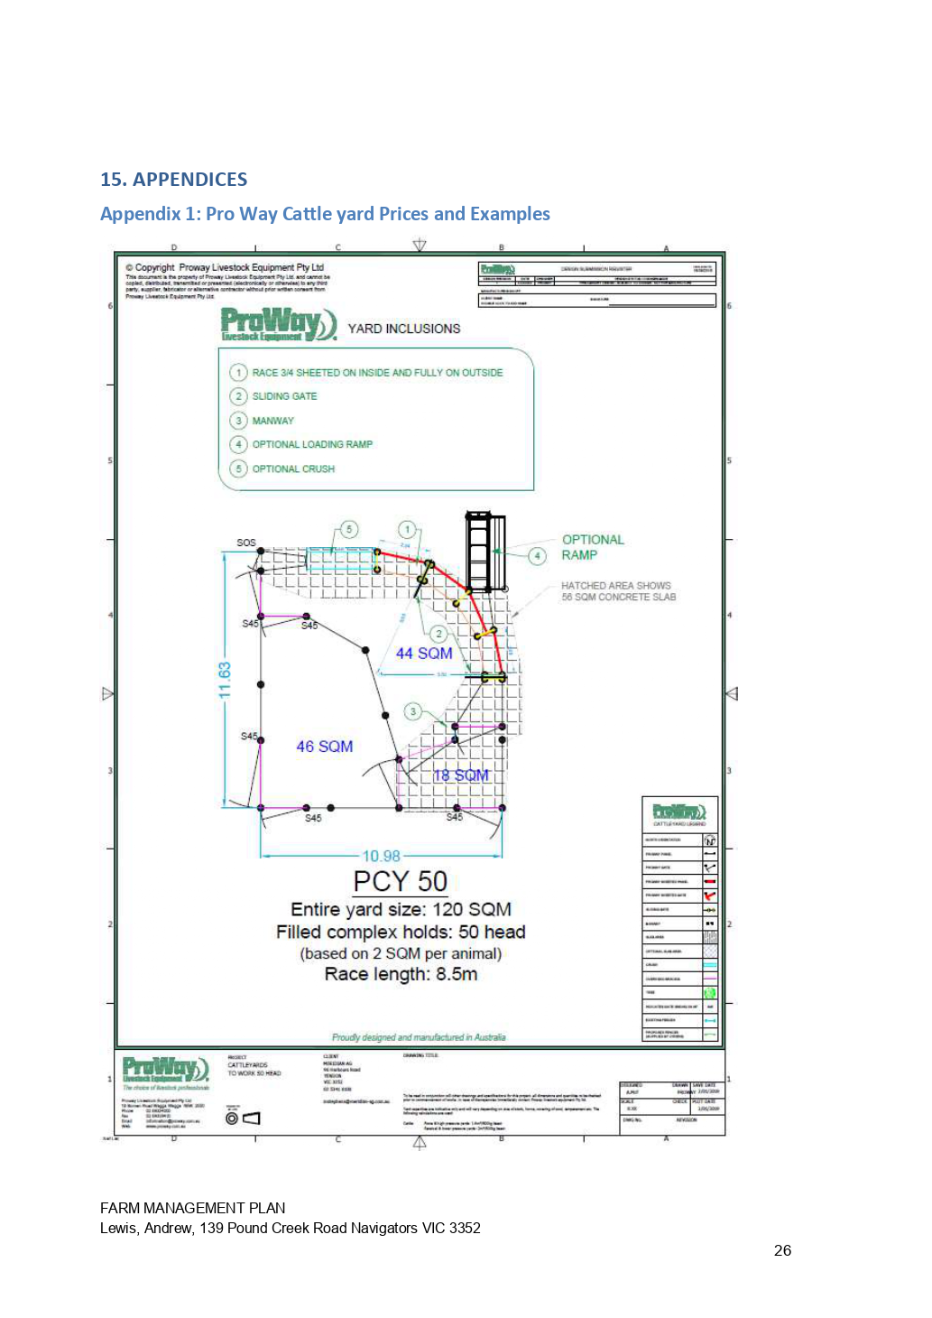

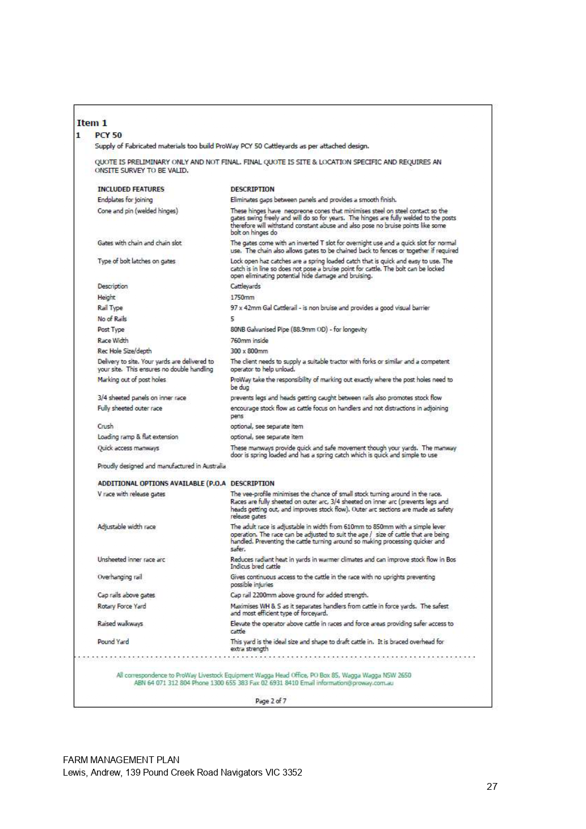

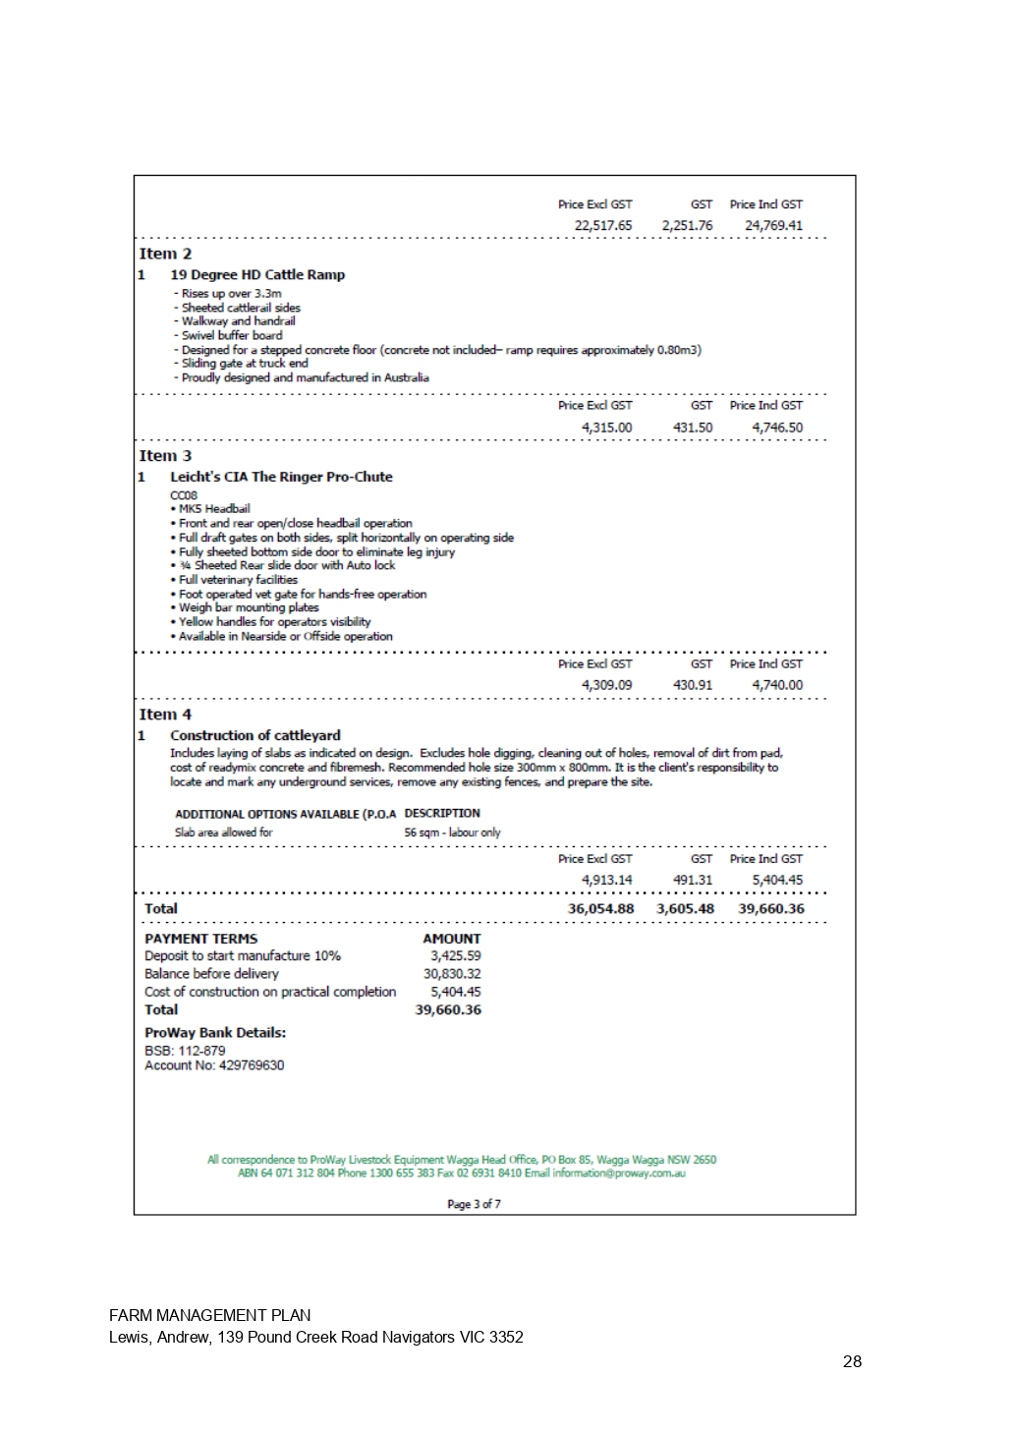

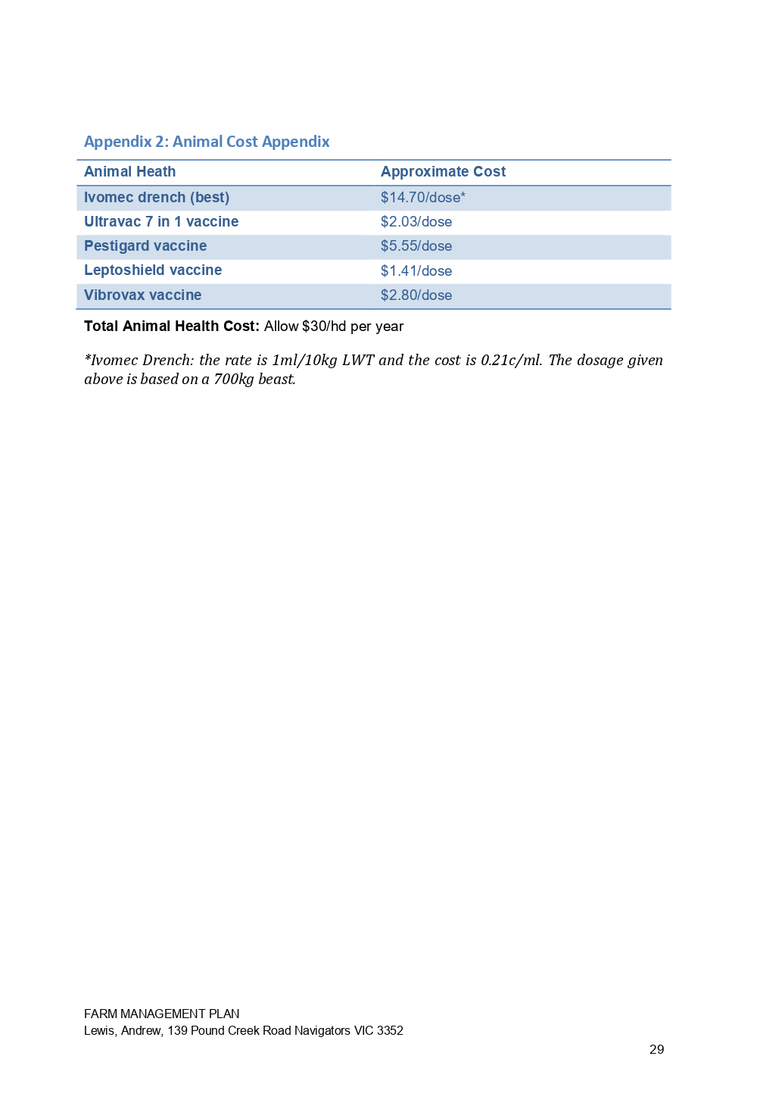



7.4 PA2019286 - Two Lot Subdivision at 16 Alexander Drive, Ballan
Author: Thomas Tonkin, Statutory Planner
Authoriser: Henry Bezuidenhout, Executive Manager Community Planning & Economic Development
Attachments: 1. Proposed plan of subdivision

Application Summary
Permit No: PA2019286
Lodgement Date: 6 December 2019
Planning Officer: Tom Tonkin
Address of the land: 16 Alexander Drive Ballan
Proposal: Two-Lot Subdivision
Lot size: 844 sqm
Why is a permit required? Clause 32.09 Neighbourhood Residential Zone, Schedule 7 - Subdivision
Clause 42.01 Environmental Significance Overlay, Schedule 1 - Subdivision

Recommendation
That Council, having considered all matters as prescribed by the Planning and Environment Act 1987, issue a Refusal to Grant Planning Permit PA2019286 for a Two-Lot Subdivision at Lot 6 on PS 713325V known as 16 Alexander Drive, Ballan 3342, on the following grounds:
1. The proposed lot sizes do not meet the minimum allowable lot sizes specified in the Neighbourhood Residential Zone, Schedule 7, of the Moorabool Planning Scheme.
2. The proposal is inconsistent with relevant state and local planning policy in the Moorabool Planning Scheme for residential land subdivision in this location.
3. The proposal does not meet all relevant provisions of Clause 56 (Rescode) of the Moorabool Planning Scheme.

Public Consultation
Was the application advertised? | Yes.
Notices on site: | Yes.
Notice in Moorabool Newspaper: | No.
Number of objections: | None.
Consultation meeting: | Not applicable.

Policy Implications
The Council Plan 2017-2021 provides as follows:
Strategic Objective 2: Minimising Environmental Impact
Context 2A: Built Environment
The proposal is consistent with the Council Plan 2017 – 2021.

Victorian Charter of Human Rights & Responsibilities Act 2006
In developing this report to Council, the officer considered whether the subject matter raised any human rights issues. In particular, whether the scope of any human right established by the Victorian Charter of Human Rights and Responsibilities is in any way limited, restricted or interfered with by the recommendations contained in the report. It is considered that the subject matter does not raise any human rights issues.

Officer’s Declaration of Conflict of Interests
Under section 80C of the Local Government Act 1989 (as amended), officers providing advice to Council must disclose any interests, including the type of interest.
Executive Manager – Henry Bezuidenhout
In providing this advice to Council as the Executive Manager, I have no interests to disclose in this report.
Author – Tom Tonkin
In providing this advice to Council as the Author, I have no interests to disclose in this report.

Executive Summary
Application referred? | Yes, to Council’s Infrastructure unit.
Any issues raised in referral responses? | No.
Preliminary concerns? | Non-compliance with the minimum 800 sqm lot size requirement of NRZ7, which was adopted by Council as part of Amendment C88 before the application was submitted. Amendment C88 was gazetted on 6 March 2020.
Any discussions with applicant regarding concerns? | Yes, informally before and after the application was submitted.
Any changes made to the application since being lodged? | No.
Brief history. | The subject site is part of a 12-lot subdivision approved by Council under planning permit PA2011316 issued on 21 August 2012.
Previous applications for the site? | None. This application has been lodged concurrently with four other two lot subdivisions in the same street by the same applicant.
General summary. | The proposed 420 sqm and 424 sqm lot sizes do not meet the minimum 800 sqm lot size requirements of the Neighbourhood Residential Zone, Schedule 7 and are therefore in direct contravention of the Moorabool Planning Scheme. Council has no discretion to approve the application due to the minimum lot size requirement of 800 sqm.
Summary Recommendation
That, having considered all relevant matters as required by the Planning and Environment Act 1987, Council issue a Refusal to Grant a Permit for this application in accordance with Section 61 of the Planning and Environment Act 1987, on the grounds included in this report.

Site Description
The site is identified as Lot 6 on PS 713325V and is known as 16 Alexander Drive, Ballan, and is located on the north side of Alexander Drive at the end of the cul-de-sac. The site is an irregular shaped lot with an area of 844 sqm, vacant with no significant vegetation and minimal fall.

Proposal
It is proposed to subdivide the site into two lots. Lot 1 would be 424 sqm in size and Lot 2 would be 420 sqm, both directly fronting Alexander Drive. Both lots would be encumbered by building envelopes.

Background to Current Proposal
The subject site was rezoned to the Neighbourhood Residential Zone, Schedule 7 (NRZ7) on 6 March 2020 as part of Planning Scheme Amendment C88 which implemented the Ballan Strategic Directions (June 2018) policy in the Moorabool Planning Scheme. NRZ7 imposes minimum lots sizes of 800 sqm for subdivision. There are no applicable transitional provisions in the Moorabool Planning Scheme to enable consideration of smaller lot sizes proposed in applications received prior to the Amendment’s gazettal on 6 March 2020.

History
None applicable.

Public Notice
Notice of the application was given to adjoining and surrounding landowners by mail and a sign erected on site from 14-29 January 2020. No objections were received.

Locality Map
The map below indicates the location of the subject site and the zoning of the surrounding area.
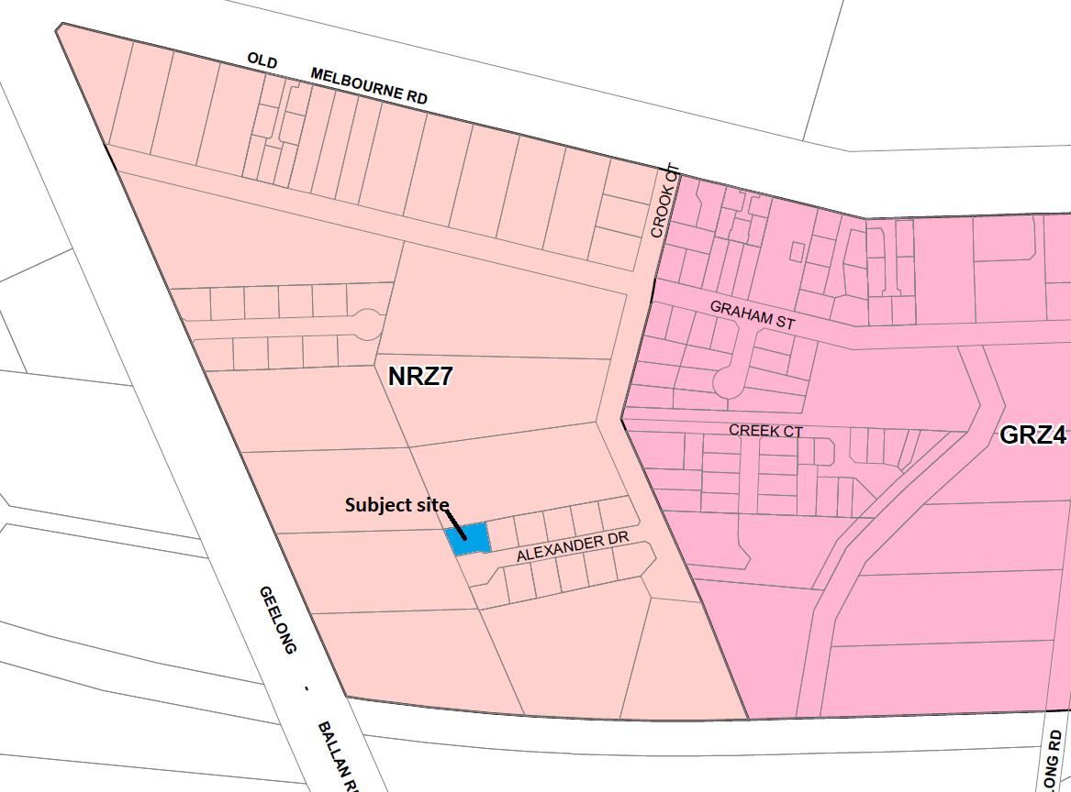
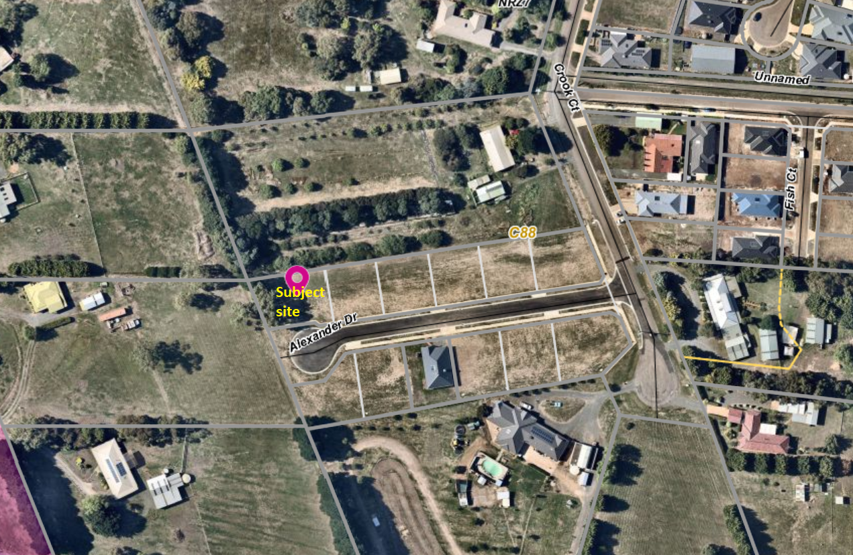

Planning Scheme Provisions
Council is required to consider the Victoria Planning Provisions and give particular attention to the Planning Policy Framework (PPF), the Local Planning Policy Framework (LPPF) and the Municipal Strategic Statement (MSS).
The relevant clauses are:
• Clause 11.03-3S Peri-urban areas
• Clause 14.02 Water
• Clause 15.01-3S Subdivision design
• Clause 15.01-5S Neighbourhood character
• Clause 16.01-2S Location of residential development
• Clause 21.02-3 Water and catchment management
• Clause 12.03-2 Urban Growth Management
• Clause 21.03-3 Residential Development
• Clause 21.03-4 Landscape and Neighbourhood Character
• Clause 21.08 Ballan
• Clause 22.02 Special Water Supply Catchments
In assessing the application against the relevant sections of the PPF and LPPF, the following significant non-compliances were identified:
PPF | Title | Response
Clause 15.01-5S | Neighbourhood character | The proposal does not respond positively to the preferred neighbourhood character, which encourages detached dwellings with conventional front and side setbacks in a garden setting. The proposed subdivision would prejudice such development.
Clause 16.01-2S | Location of residential development | The proposal would facilitate residential growth in an area of Ballan where limited growth is encouraged.
LPPF

Clause 21.03-2 | Urban Growth Management | The proposal would facilitate residential growth in an area of Ballan where limited growth is encouraged.
Clause 21.03-4 | Landscape and Neighbourhood Character | The proposal does not respond appropriately to the preferred neighbourhood character because the proposal would not facilitate site responsive future development.
Clause 21.08-7 | Strategies for Residential Development | The proposal would not facilitate the built form consistent with the preferred development outcomes for this area of Ballan, by limiting opportunities for low density housing with boundary setbacks to accommodate landscaping.

Zone
The subject site is in the Neighbourhood Residential Zone, Schedule 7 (NRZ7). The purpose of the Zone is:
• To implement the Municipal Planning Strategy and the Planning Policy Framework.
• To recognise areas of predominantly single and double storey residential development.
• To manage and ensure that development respects the identified neighbourhood character, heritage, environmental or landscape characteristics.
• To allow educational, recreational, religious, community and a limited range of other non-residential uses to serve local community needs in appropriate locations.
Under Clause 32.09-3 a permit is required to subdivide land. A zone schedule may specify a minimum lot size to subdivide land, and each lot must be at least the area specified for the land. Schedule 7 specifies a minimum 800 sqm lot size for subdivision.
The proposed lot sizes do not meet the minimum lot size requirement; therefore, the proposal is fundamentally inconsistent with the zone provisions.

Overlays

The site is affected by Environmental Significance Overlay, Schedule 1 (Proclaimed Water Catchment Areas). Under Clause 42.01-2 a permit is required to subdivide land. There are no relevant exemptions under Schedule 1. The subject site is sewered and drains more than 100 metres from the nearest waterway. Subject to conditions the proposal would not cause detriment to potable water quality or supply.

Relevant Policies
The Ballan Strategic Directions (June 2018) policy underpins Planning Scheme Amendment C88 which was recently approved by the Minister for Planning and gazetted on 6 March 2020. The proposed lot sizes less than 800 sqm are inconsistent with Amendment C88 adopted by Council.

Particular Provisions
Clause 53.01 Public Open Space Contribution and Subdivision
A subdivision is exempt from a public open space requirement specified in this scheme if it subdivides land into two lots and the council considers it unlikely that each lot will be further subdivided. If the application could be considered for approval by Council, it would be unlikely for either lot to be further subdivided and no public open space contribution would be required.
Clause 56 Residential Subdivision
The proposal complies with ResCode (Clause 56), with the exception of the following:
Clause ResCode | Title | Response
56.03-5 | Neighbourhood Character | The proposal does not adequately respond to the key features of the preferred neighbourhood character.

Discussion
Overall, the proposal is inconsistent with relevant state and local planning policy, the Neighbourhood Residential Zone and Clause 56 of the Moorabool Planning Scheme.
The proposed 420 sqm and 424 sqm lot sizes are less than the minimum allowable 800 sqm lot sizes specified in Schedule 7 to the Neighbourhood Residential Zone, gazetted on 6 March 2020. It is noted that despite the application being lodged with Council prior to the gazettal date there is no transitional provision in the Moorabool Planning Scheme which would enable Council to consider approving the application. Furthermore, it is noted that when the application was submitted on 6 December 2019, Amendment C88 has already progressed through the Panel Hearing process, been adopted by Council and submitted to the Minister for Planning for approval. The applicant was aware of the Amendment C88’s status when submitting the application. The proposal explicitly contravenes the Moorabool Planning Scheme and is therefore recommended for refusal.

General Provisions
Clause 65 – Decision Guidelines have been considered by officers in evaluating this application.
Clause 66 – Stipulates all the relevant referral authorities to which the application must be referred.

Referrals
Authority | Response
Western Water  Southern Rural Water | Conditions in accordance with Council’s MoU with these authorities.
Infrastructure | Consent with conditions.

Financial Implications
There are no financial implications for Council in refusing the application.

Risk & Occupational Health & Safety Issues
The recommendation to refuse this application does not have any risk or OH&S implications for Council.

Communications Strategy
Notice was undertaken for the application, in accordance with s.52 of the Planning and Environment Act 1987. No objections were received.

Options
• Issue a Refusal to Grant a Permit in accordance with the grounds in the recommendation of this report; or
• Issue a Refusal to Grant a Permit with amendments to the grounds in the recommendation of this report.

Conclusion
Overall, the proposal is inconsistent with the relevant provisions of the Moorabool Planning Scheme, in particular the NRZ7 given that the proposed lot sizes do not meet the minimum 800 sqm lot size requirement.

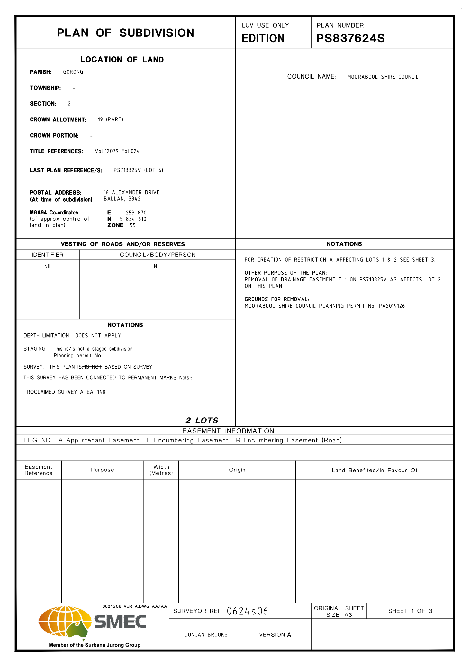
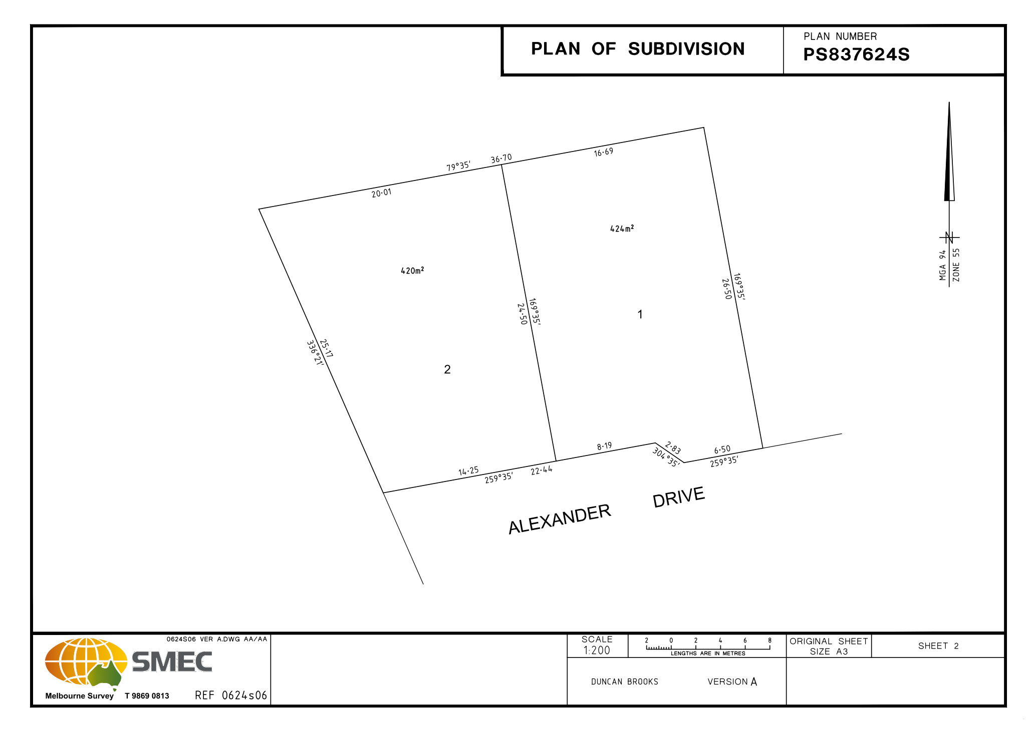
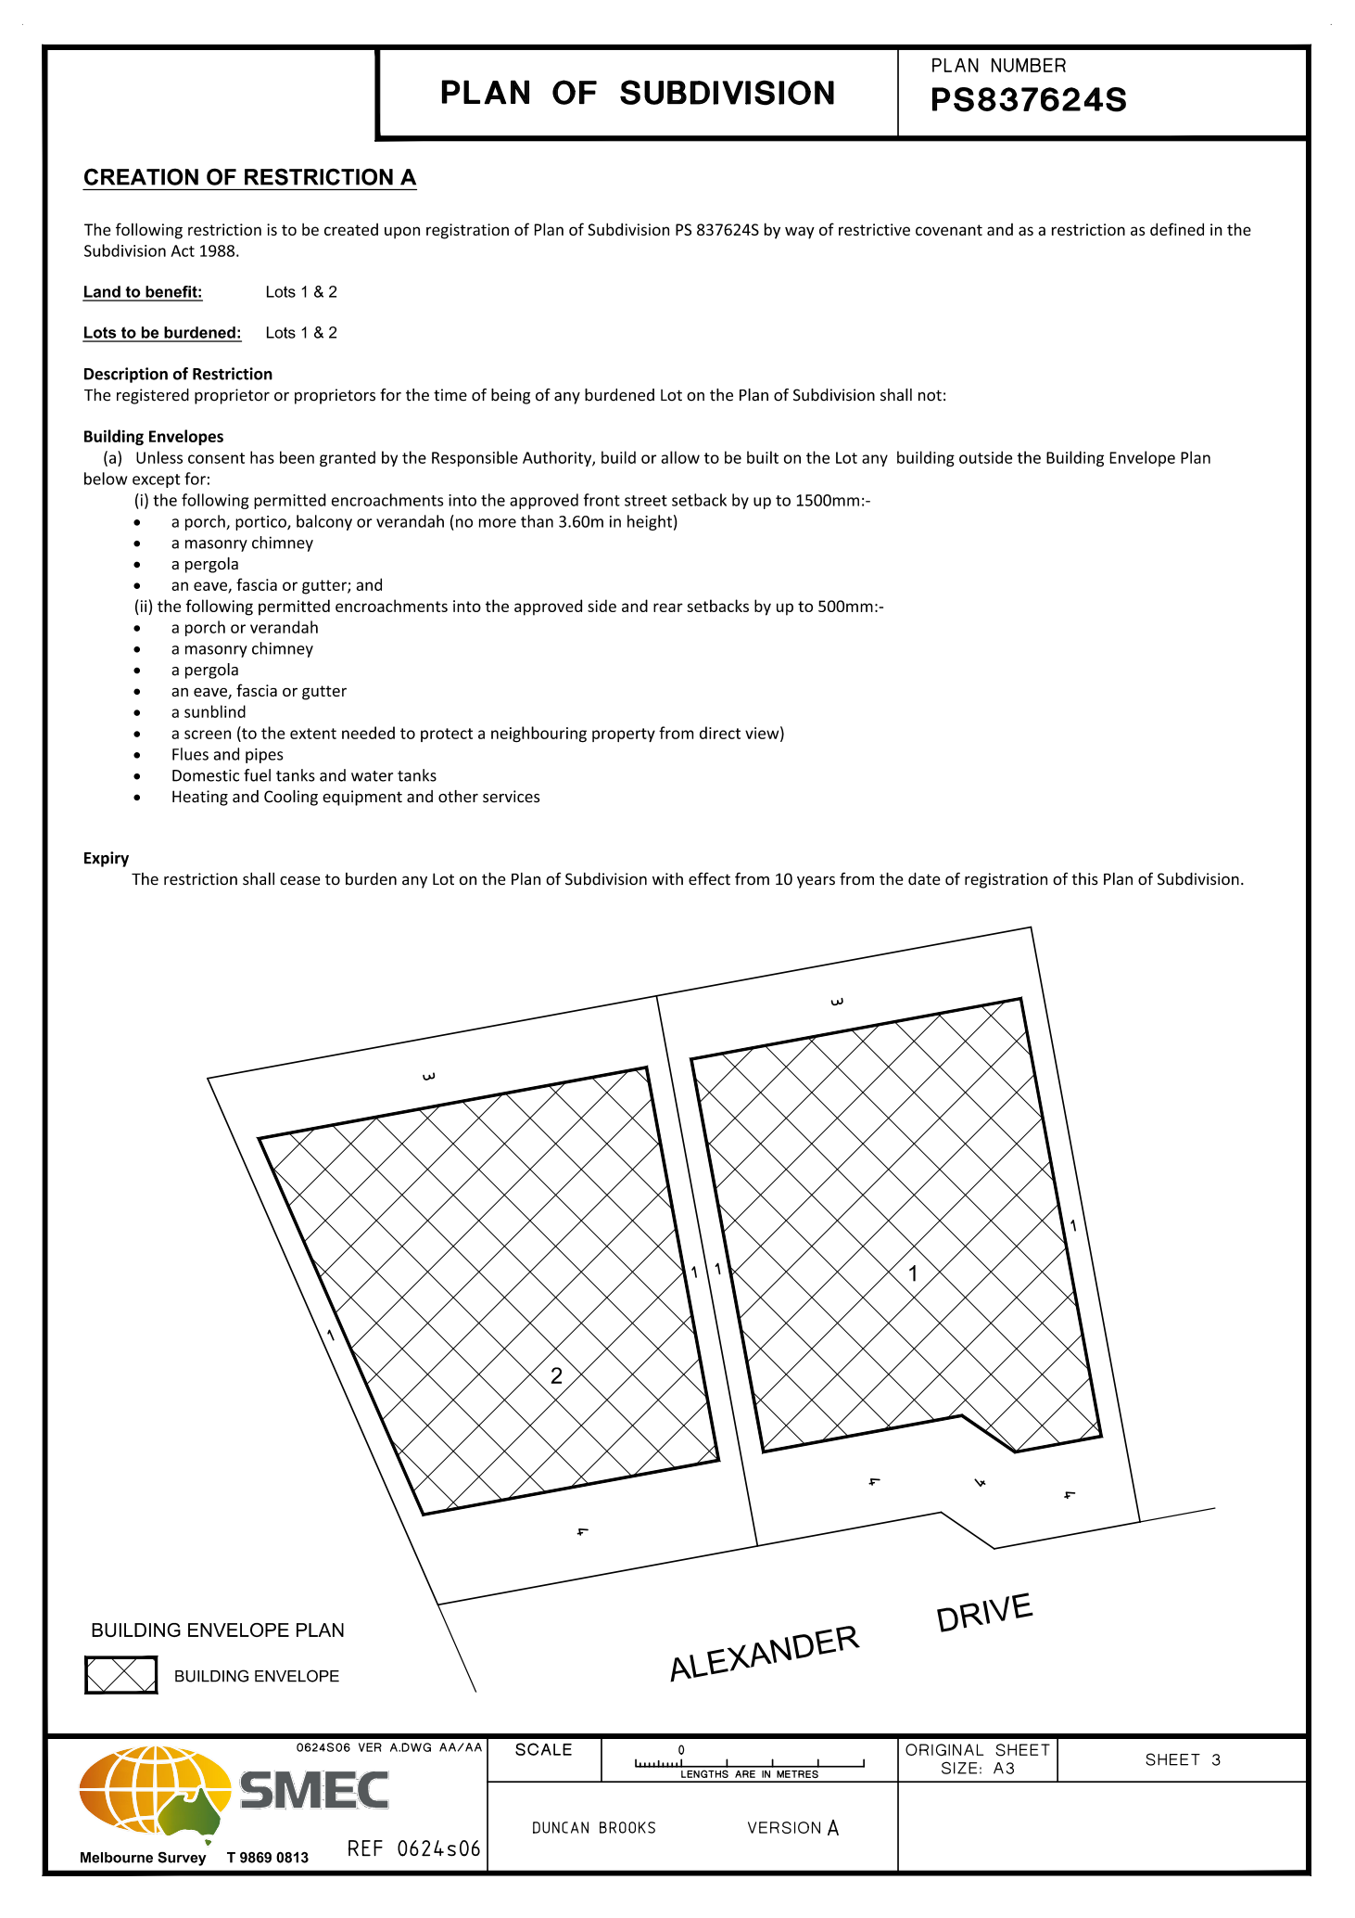

7.5 PA2019283 - Two Lot Subdivision at 1 Alexander Drive, Ballan
Author: Thomas Tonkin, Statutory Planner
Authoriser: Henry Bezuidenhout, Executive Manager Community Planning & Economic Development
Attachments: 1. Proposed plan of subdivision

Application Summary
Permit No: PA2019283
Lodgement Date: 6 December 2019
Planning Officer: Tom Tonkin
Address of the land: 1 Alexander Drive Ballan
Proposal: Two-Lot Subdivision
Lot size: 885 sqm
Why is a permit required? Clause 32.09 Neighbourhood Residential Zone, Schedule 7 - Subdivision
Clause 42.01 Environmental Significance Overlay, Schedule 1 - Subdivision

Recommendation
That Council, having considered all matters as prescribed by the Planning and Environment Act 1987, issue a Refusal to Grant Planning Permit PA2019283 for a Two Lot Subdivision at Lot 12 on PS 713325V known as 1 Alexander Drive, Ballan 3342, on the following grounds:
1. The proposed lot sizes do not meet the minimum allowable lot sizes specified in the Neighbourhood Residential Zone, Schedule 7, of the Moorabool Planning Scheme.
2. The proposal is inconsistent with relevant state and local planning policy in the Moorabool Planning Scheme for residential land subdivision in this location.
3. The proposal does not meet all relevant provisions of Clause 56 of the Moorabool Planning Scheme.

Public Consultation
Was the application advertised? | Yes.
Notices on site: | Yes.
Notice in Moorabool Newspaper: | No.
Number of objections: | Two.
Consultation meeting: | No consultation as the recommendation is for refusal.

Policy Implications
The Council Plan 2017-2021 provides as follows:
Strategic Objective 2: Minimising Environmental Impact
Context 2A: Built Environment
The proposal is consistent with the Council Plan 2017 – 2021.

Victorian Charter of Human Rights & Responsibilities Act 2006
In developing this report to Council, the officer considered whether the subject matter raised any human rights issues. In particular, whether the scope of any human right established by the Victorian Charter of Human Rights and Responsibilities is in any way limited, restricted or interfered with by the recommendations contained in the report. It is considered that the subject matter does not raise any human rights issues.

Officer’s Declaration of Conflict of Interests
Under section 80C of the Local Government Act 1989 (as amended), officers providing advice to Council must disclose any interests, including the type of interest.
Executive Manager – Henry Bezuidenhout
In providing this advice to Council as the Executive Manager, I have no interests to disclose in this report.
Author – Tom Tonkin
In providing this advice to Council as the Author, I have no interests to disclose in this report.

Executive Summary
Application referred? | Yes, to Council’s Infrastructure.
Any issues raised in referral responses? | No.
Preliminary concerns? | Non-compliance with the minimum 800 sqm lot size requirement of NRZ7, which was adopted by Council as part of Amendment C88 before the application was submitted. Amendment C88 was gazetted on 6 March 2020.
Any discussions with applicant regarding concerns? | Yes, informally before and after the application was submitted.
Any changes made to the application since being lodged? | No.
Brief history. | The subject site is part of a 12-lot subdivision approved by Council under planning permit PA2011316 issued on 21 August 2012.
Previous applications for the site? | None. This application has been lodged concurrently with four other two-lot subdivisions in the same street by the same applicant.
General summary. | The proposed 440 sqm and 445 sqm lot sizes do not meet the minimum 800 sqm lot size requirements of the Neighbourhood Residential Zone, Schedule 7, and are therefore in direct contravention of the Moorabool Planning Scheme. Council has no discretion to approve the application due to the minimum lot size requirement of 800 sqm.
Summary Recommendation
That, having considered all relevant matters as required by the Planning and Environment Act 1987, Council issue a Refusal to Grant a Permit for this application in accordance with Section 61 of the Planning and Environment Act 1987, on the grounds included in this report.

Site Description
The site is identified as Lot 12 on PS 713325V and is known as 1 Alexander Drive, Ballan, and is located on the south-west corner of Crook Court and Alexander Drive. The site is an irregular shape with an area of 885 sqm encumbered by a 2-metre-wide drainage easement parallel to the southern boundary. The site is vacant with no significant vegetation and minimal fall.

Proposal
It is proposed to subdivide the site into two lots. Lot 1 would be a rectangular shape with an area of 440 sqm with a frontage to Alexander Drive and Lot 2 would be an irregular shape with an area of 445 sqm on the corner of Crook Court and Alexander Drive. Both lots would be encumbered by building envelopes.

Background to Current Proposal
The subject site was rezoned to the Neighbourhood Residential Zone, Schedule 7 (NRZ7) on 6 March 2020 as part of Planning Scheme Amendment C88 which implemented the Ballan Strategic Directions (June 2018) policy in the Moorabool Planning Scheme. The NRZ7 imposes minimum lot sizes of 800 sqm for subdivision. There are no applicable transitional provisions in the Moorabool Planning Scheme to enable consideration of smaller lot sizes proposed in applications received prior to the Amendment’s gazettal on 6 March 2020.

History
None applicable.

Public Notice
Notice of the application was given to adjoining and surrounding landowners by mail and a sign erected on site from 14-29 January 2020. Two objections were received.

Summary of Objections
The objections received are detailed below with officer’s comments accompanying them:
Objection | Any Relevant Requirement
Safety impacts of multiple residents trying to exit properties in a fire event whose only vehicle egress point from Crook Court is to Old Melbourne Road. | Clause 56.

Officer’s Response:
Crook Court’s design is sufficient to cope with the traffic demands of existing residents and current proposed subdivisions.
Existing boundary fences are inadequate to protect privacy and limit noise, contain pets and domestic rubbish. | Clause 65.
Officer’s Response:
The construction of fencing between private properties and the associated costs is ultimately a civil matter between landowners.
Smaller lot sizes increase the likelihood of double storey development. The subdivider’s assurances that such construction would be prevented by covenants imposed on title does not allay our concerns. | Clause 65.
The proposed wording on title (covenant) does not prevent double storey construction. However, any future development (including double storey development) must meet ResCode requirements in terms of minimum boundary setbacks and overlooking. Furthermore, double storey construction may reasonably be expected in a residential zoned area.
Traffic impacts on noise levels and safety for children going to school. | Clause 65.
Officer’s Response:
The proposal would not be expected to impact on noise and safety to an unacceptable extent given the residential nature of the area. Council’s Infrastructure Unit assessed the traffic implications and raised no concern.
Any traffic safety issues raised at any point in the future due to changed circumstances will be reviewed.
The existing poor condition of the Crook Court carriageway would be exacerbated by increased traffic which creates a traffic hazard. | Clause 56.
Officer’s Response:
The need for repairs to existing roads are usually addressed through Council’s road maintenance program.
Should the development be approved, conditions relating to damages as a result of the development will be conditioned accordingly and may include reinstatement of the road.
Limited footpaths in Crook Court is a safety issue for pedestrians. | Clause 56.
Officer’s Response:
The existing footpath network in Crook Court enables pedestrians to walk on at least one side of the road for almost the entire length of the street, with progressive network extensions as land has been gradually subdivided.
Increased stormwater runoff resulting in flooding, due in part to inadequate kerb and channelling at the south end of Crook Court | Clause 56.
Officer’s Response:
Infrastructure conditions requiring a drainage design to Council requirements could address this issue.
Inadequate parking for visitors. | Clause 65.
Officer’s Response:
It is understood that currently there is an adequate supply of visitor car parking both on and off street and that the proposal would not impose an unreasonable burden on parking provision in the immediate area.

Locality Map
The map below indicates the location of the subject site and the zoning of the surrounding area.
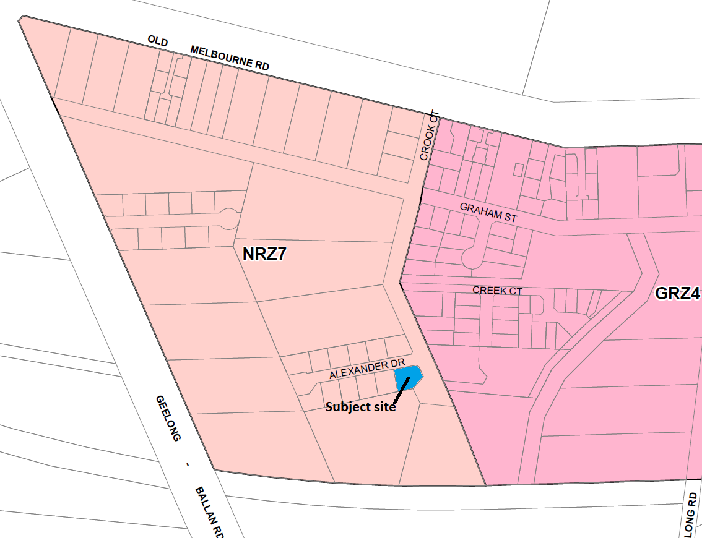
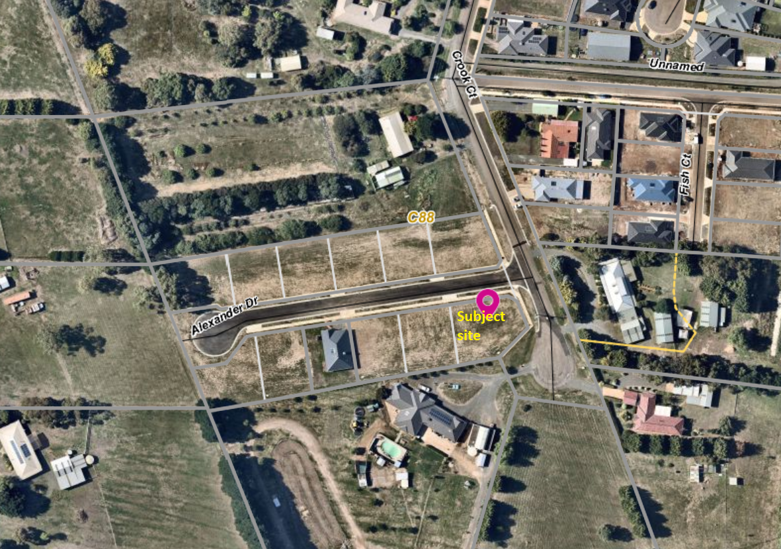

Planning Scheme Provisions
Council is required to consider the Victoria Planning Provisions and give particular attention to the Planning Policy Framework (PPF), the Local Planning Policy Framework (LPPF) and the Municipal Strategic Statement (MSS).
The relevant clauses are:
• Clause 11.03-3S Peri-urban areas
• Clause 14.02 Water
• Clause 15.01-3S Subdivision design
• Clause 15.01-5S Neighbourhood character
• Clause 16.01-2S Location of residential development
• Clause 21.02-3 Water and catchment management
• Clause 12.03-2 Urban Growth Management
• Clause 21.03-3 Residential Development
• Clause 21.03-4 Landscape and Neighbourhood Character
• Clause 21.08 Ballan
• Clause 22.02 Special Water Supply Catchments
In assessing the application against the relevant sections of the PPF and LPPF, the following significant non-compliances were identified:
PPF | Title | Response
Clause 15.01-5S | Neighbourhood character | The proposal does not respond positively to the preferred neighbourhood character, which encourages detached dwellings with conventional front and side setbacks in a garden setting. The proposed subdivision would prejudice such development.
Clause 16.01-2S | Location of residential development | The proposal would facilitate residential growth in an area of Ballan where limited growth is encouraged.
LPPF

Clause 21.03-2 | Urban Growth Management | The proposal would facilitate residential growth in an area of Ballan where limited growth is encouraged.
Clause 21.03-4 | Landscape and Neighbourhood Character | The proposal does not respond appropriately to the preferred neighbourhood character because the proposal would not facilitate site responsive future development.
Clause 21.08-7 | Strategies for Residential Development | The proposal would not facilitate the built form consistent with the preferred development outcomes for this area of Ballan, by limiting opportunities for low density housing with boundary setbacks to accommodate landscaping.

Zone
The subject site is in the Neighbourhood Residential Zone, Schedule 7 (NRZ7). The purpose of the Zone is:
• To implement the Municipal Planning Strategy and the Planning Policy Framework.
• To recognise areas of predominantly single and double storey residential development.
• To manage and ensure that development respects the identified neighbourhood character, heritage, environmental or landscape characteristics.
• To allow educational, recreational, religious, community and a limited range of other non-residential uses to serve local community needs in appropriate locations.
Under Clause 32.09-3 a permit is required to subdivide land. A zone schedule may specify a minimum lot size to subdivide land, and each lot must be at least the area specified for the land. Schedule 7 specifies a minimum 800 sqm lot size for subdivision.
The proposed lot sizes do not meet the minimum lot size requirement; therefore, the proposal is fundamentally inconsistent with the Zone provisions.

Overlays

The site is affected by Environmental Significance Overlay, Schedule 1 (Proclaimed Water Catchment Areas). Under Clause 42.01-2 a permit is required to subdivide land. There are no relevant exemptions under Schedule 1. The subject site is sewered and drains more than 100 metres from the nearest waterway. Subject to conditions the proposal would not cause detriment to potable water quality or supply.

Relevant Policies
The Ballan Strategic Directions (June 2018) policy underpins Planning Scheme Amendment C88 which was recently approved by the Minister for Planning and gazetted on 6 March 2020. The proposed lot sizes less than 800 sqm are inconsistent with Amendment C88 adopted by Council.

Particular Provisions
Clause 53.01 Public Open Space Contribution and Subdivision
A subdivision is exempt from a public open space requirement specified in this scheme if it subdivides land into two lots and the Council considers it unlikely that each lot will be further subdivided. If the application could be considered for approval by Council, it would be unlikely for either lot to be further subdivided and no public open space contribution would be required.
Clause 56 Residential Subdivision
The proposal complies with ResCode (Clause 56), with the exception of the following:
Clause ResCode | Title | Response
56.03-5 | Neighbourhood Character | The proposal does not adequately respond to the key features of the preferred neighbourhood character.

Discussion
Overall, the proposal is inconsistent with relevant State and local planning policy, the Neighbourhood Residential Zone and Clause 56 of the Moorabool Planning Scheme.
The proposed 440 sqm and 445 sqm lot sizes are less than the minimum allowable 800 sqm lot sizes specified in Schedule 7 to the Neighbourhood Residential Zone, gazetted on 6 March 2020. It is noted that despite the application being lodged with Council prior to the gazettal date there is no transitional provision in the Moorabool Planning Scheme which would enable Council to consider approving the application. Furthermore, it is noted that when the application was submitted on 6 December 2019, Amendment C88 had already progressed through the Panel Hearing process, been adopted by Council and submitted to the Minister for Planning for approval. The applicant was aware of the Amendment C88’s status when submitting the application. The proposal explicitly contravenes the Moorabool Planning Scheme and is therefore recommended for refusal.

General Provisions
Clause 65 – Decision Guidelines have been considered by officers in evaluating this application.
Clause 66 – Stipulates all the relevant referral authorities to which the application must be referred.

Referrals
Authority | Response
Western Water  Southern Rural Water | Consent with conditions in accordance with Council’s MoU with these authorities.
Infrastructure | Consent with conditions.

Financial Implications
There are no financial implications for Council in refusing the subdivision application.

Risk & Occupational Health & Safety Issues
The recommendation to refuse this subdivision application does not have any risk or OH&S implications for Council.

Communications Strategy
Notice was undertaken for the application, in accordance with s.52 of the Planning and Environment Act 1987, and further correspondence is required to all interested parties to the application as a result of a decision in this matter. All submitters and the applicant were invited to attend this meeting and address Council if required.

Options
• Issue a Refusal to Grant a Permit in accordance with the grounds in the recommendation of this report; or
• Issue a Refusal to Grant a Permit with amendments to the grounds in the recommendation of this report.

Conclusion
Overall, the proposal is inconsistent with the relevant provisions of the Moorabool Planning Scheme, in particular the NRZ7 given that the proposed lot sizes do not meet the minimum 800 sqm lot size requirement.

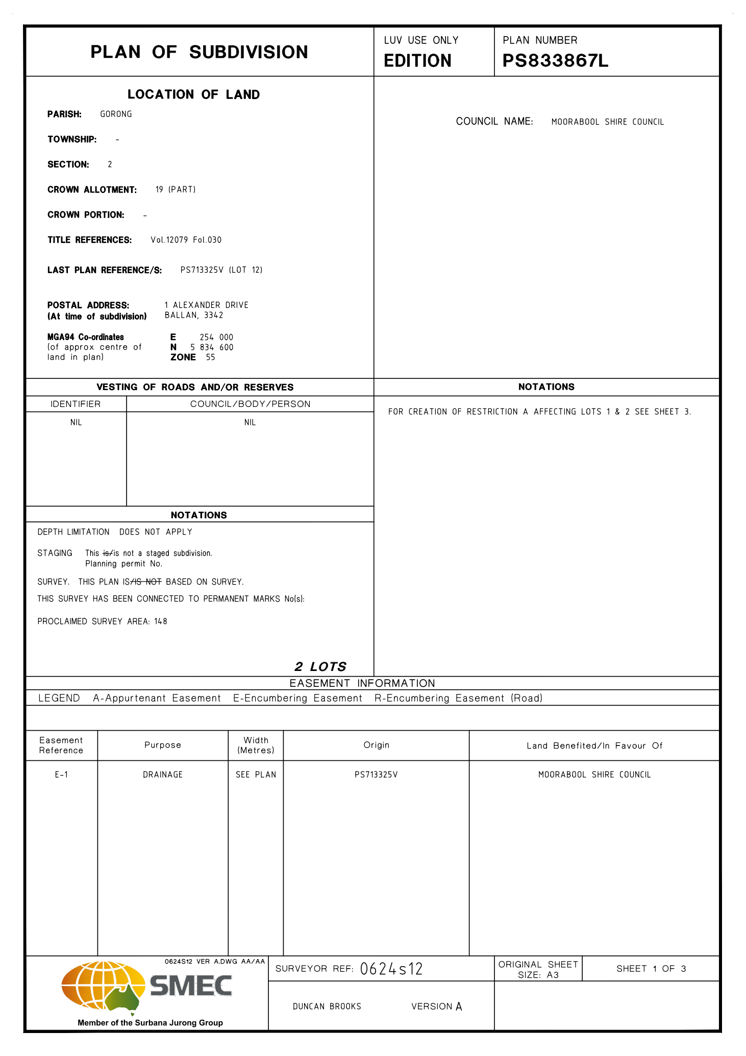
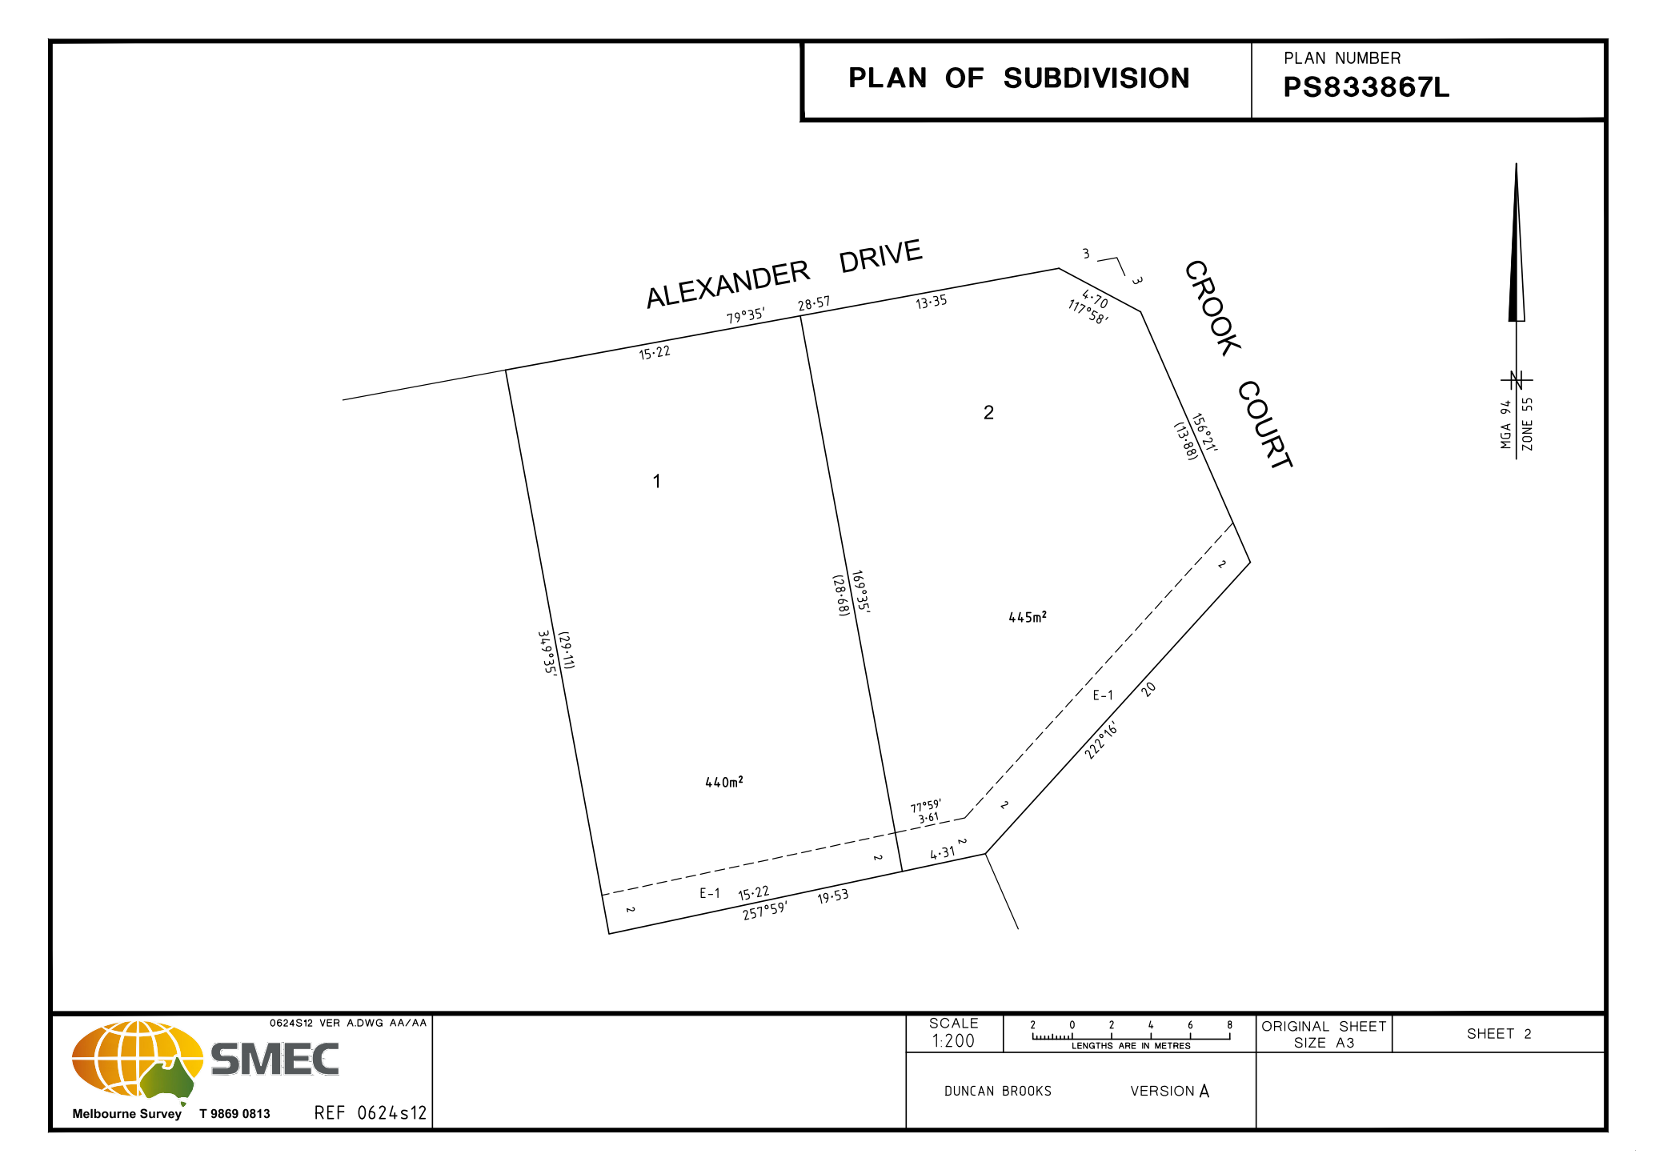
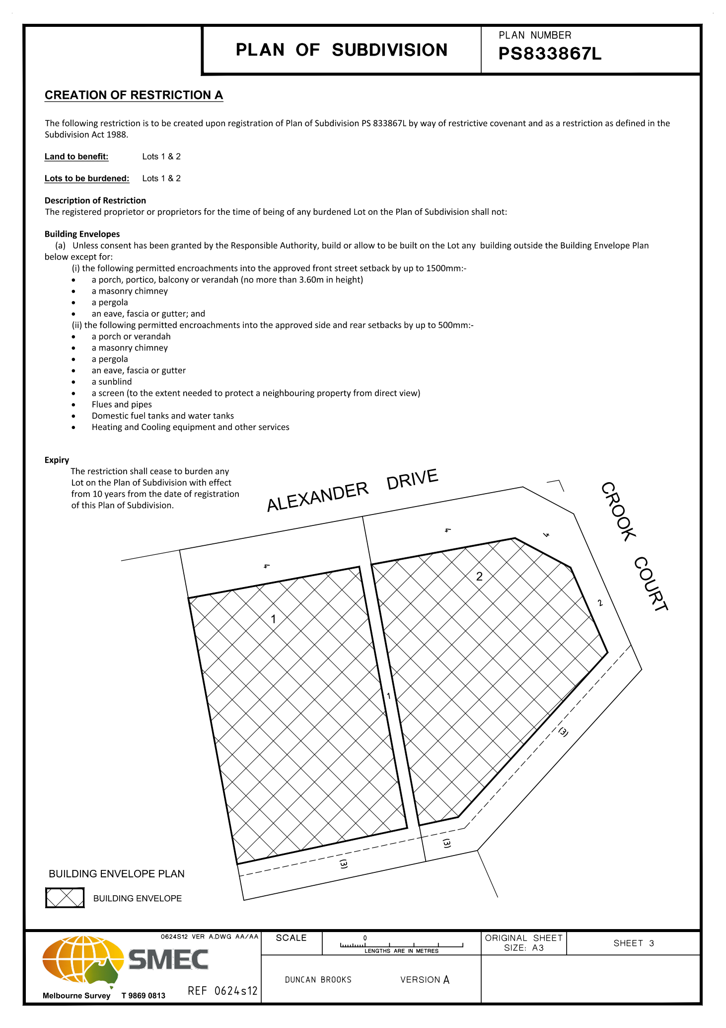

7.6 PA2019284 - Two Lot Subdivision at 5 Alexander Drive, Ballan
Author: Thomas Tonkin, Statutory Planner
Authoriser: Henry Bezuidenhout, Executive Manager Community Planning & Economic Development
Attachments: 1. Proposed plan of subdivision

Application Summary
Permit No: PA2019284
Lodgement Date: 6 December 2019
Planning Officer: Tom Tonkin
Address of the land: 5 Alexander Drive Ballan
Proposal: Two-Lot Subdivision
Lot size: 736 sqm
Why is a permit required? Clause 32.09 Neighbourhood Residential Zone, Schedule 7 - Subdivision
Clause 42.01 Environmental Significance Overlay, Schedule 1 - Subdivision

Recommendation
That Council, having considered all matters as prescribed by the Planning and Environment Act 1987, issue a Refusal to Grant Planning Permit PA2019284 for a Two-Lot Subdivision at Lot 11 on PS 713325V known as 5 Alexander Drive, Ballan 3342, on the following grounds:
1. The proposed lot sizes do not meet the minimum allowable lot sizes specified in the Neighbourhood Residential Zone, Schedule 7, of the Moorabool Planning Scheme.
2. The proposal is inconsistent with relevant state and local planning policy in the Moorabool Planning Scheme for residential land subdivision in this location.
3. The proposal does not meet all relevant provisions of Clause 56 (Rescode) of the Moorabool Planning Scheme.

Public Consultation
Was the application advertised? | Yes.
Notices on site: | Yes.
Notice in Moorabool Newspaper: | No.
Number of objections: | One.
Consultation meeting: | No.

Policy Implications
The Council Plan 2017-2021 provides as follows:
Strategic Objective 2: Minimising Environmental Impact
Context 2A: Built Environment
The proposal is consistent with the Council Plan 2017 – 2021.

Victorian Charter of Human Rights & Responsibilities Act 2006
In developing this report to Council, the officer considered whether the subject matter raised any human rights issues. In particular, whether the scope of any human right established by the Victorian Charter of Human Rights and Responsibilities is in any way limited, restricted or interfered with by the recommendations contained in the report. It is considered that the subject matter does not raise any human rights issues.

Officer’s Declaration of Conflict of Interests
Under section 80C of the Local Government Act 1989 (as amended), officers providing advice to Council must disclose any interests, including the type of interest.
Executive Manager – Henry Bezuidenhout
In providing this advice to Council as the Executive Manager, I have no interests to disclose in this report.
Author – Tom Tonkin
In providing this advice to Council as the Author, I have no interests to disclose in this report.

Executive Summary
Application referred? | Yes, to Council’s Infrastructure.
Any issues raised in referral responses? | No.
Preliminary concerns? | Non-compliance with the minimum 800 sqm lot size requirements of NRZ7, which was adopted by Council as part of Amendment C88 before the application was submitted. Amendments C88 was gazetted on 6 March 2020.
Any discussions with applicant regarding concerns? | Yes, informally before and after the application was submitted.
Any changes made to the application since being lodged? | No.
Brief history. | The subject site is part of a 12-lot subdivision approved by Council under planning permit PA2011316 issued on 21 August 2012.
Previous applications for the site? | None. This application has been lodged concurrently with four other two-lot subdivisions in the same street by the same applicant.
General summary. | The proposed 368 sqm lot sizes do not meet the minimum 800 sqm lot size requirements of the Neighbourhood Residential Zone, Schedule 7, and are therefore in direct contravention of the Moorabool Planning Scheme. Council has no discretion to approve the application due to the minimum lot size requirement of 800 sqm.
Summary Recommendation
That, having considered all relevant matters as required by the Planning and Environment Act 1987, Council issue a Refusal to Grant a Permit for this application in accordance with Section 61 of the Planning and Environment Act 1987, on the grounds included in this report.

Site Description
The site is identified as Lot 11 on PS 713325V and is known as 5 Alexander Drive, Ballan, and is located on the southern side of Alexander Drive. The site is a roughly rectangular shape with an area of 736 sqm, encumbered by a 2-metre-wide drainage easement parallel to the southern boundary. The site is vacant with no significant vegetation and a slight fall.

Proposal
It is proposed to subdivide the site into two lots. Both lots would be 368 sqm in size and rectangular in shape and both encumbered by building envelopes.

Background to Current Proposal
The subject site was rezoned to the Neighbourhood Residential Zone, Schedule 7 (NRZ7) on 6 March 2020 as part of Planning Scheme Amendment C88 which implemented the Ballan Strategic Directions (June 2018) policy in the Moorabool Planning Scheme. The NRZ7 imposes minimum lot sizes of 800 sqm for subdivision. There are no applicable transitional provisions in the Moorabool Planning Scheme to enable consideration of smaller lot sizes proposed in applications received prior to the Amendment’s gazettal on 6 March 2020.

History
None applicable.

Public Notice
Notice of the application was given to adjoining and surrounding landowners by mail and a sign erected on site from 14-29 January 2020. One objection was received.

Summary of Objections
The objections received are detailed below with officer’s comments accompanying them:
Objection | Any Relevant Requirement
Safety impacts of multiple residents trying to exit properties in a fire event whose only vehicle egress point from Crook Court is to Old Melbourne Road. | Clause 56.
Officer’s Response:
Crook Court’s design is sufficient to cope with the traffic demands of existing residents and current proposed subdivisions.
Existing boundary fences are inadequate to protect privacy and limit noise, contain pets and domestic rubbish. | Clause 65.
Officer’s Response:
The construction of fencing between private properties and the associated costs is ultimately a civil matter between landowners.
Smaller lot sizes increase the likelihood of double storey development. The subdivider’s assurances that such construction would be prevented by covenants imposed on title does not allay our concerns. | Clause 56.
Officer’s Response:
The proposed wording on title (covenant) does not prevent double storey construction. However, any future development (including double storey development) must meet ResCode requirements in terms of minimum boundary setbacks and overlooking. Furthermore, double storey construction may reasonably be expected in a residential zoned area.
Traffic impacts on noise levels and safety for children going to school. | Clause 65.
Officer’s Response:
The proposal would not be expected to impact on noise and safety to an unacceptable extent given the residential nature of the area. Council’s Infrastructure Unit assessed the traffic implications and raised no concerns. Any traffic safety issues raised at any point in the future due to changed circumstances will be reviewed.
The existing poor condition of the Crook Court carriageway would be exacerbated by increased traffic which creates a traffic hazard. | Clause 56.
Officer’s Response:
The need for repairs to existing roads are usually addressed through Council’s road maintenance program.
Should the development be approved, conditions relating to damages as a result of the development will be conditioned accordingly and may include reinstatement of the road.

Locality Map
The map below indicates the location of the subject site and the zoning of the surrounding area.
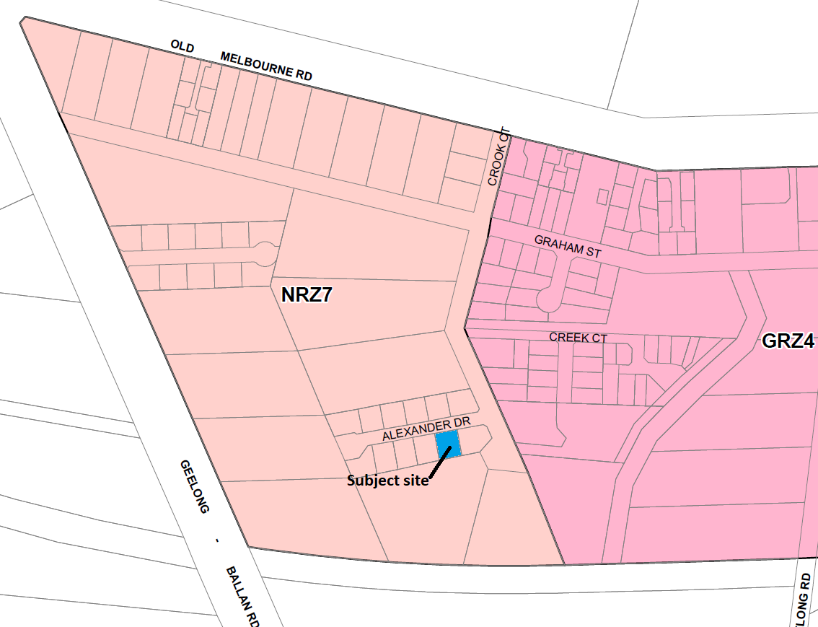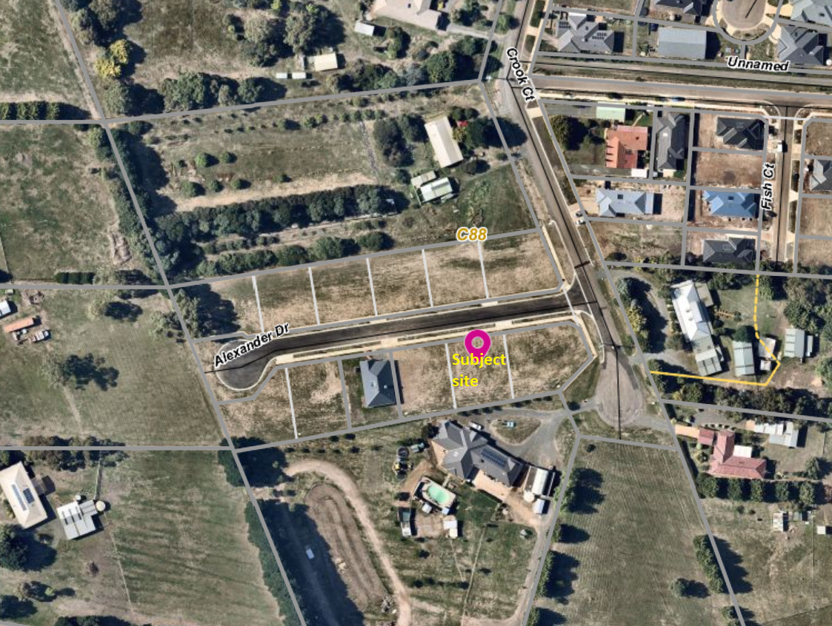

Planning Scheme Provisions
Council is required to consider the Victoria Planning Provisions and give particular attention to the Planning Policy Framework (PPF), the Local Planning Policy Framework (LPPF) and the Municipal Strategic Statement (MSS).
The relevant clauses are:
• Clause 11.03-3S Peri-urban areas
• Clause 14.02 Water
• Clause 15.01-3S Subdivision design
• Clause 15.01-5S Neighbourhood character
• Clause 16.01-2S Location of residential development
• Clause 21.02-3 Water and catchment management
• Clause 12.03-2 Urban Growth Management
• Clause 21.03-3 Residential Development
• Clause 21.03-4 Landscape and Neighbourhood Character
• Clause 21.08 Ballan
• Clause 22.02 Special Water Supply Catchments
In assessing the application against the relevant sections of the PPF and LPPF, the following significant non-compliances were identified:
PPF | Title | Response
Clause 15.01-5S | Neighbourhood character | The proposal does not respond positively to the preferred neighbourhood character, which encourages detached dwellings with conventional front and side setbacks in a garden setting. The proposed subdivision would prejudice such development.
Clause 16.01-2S | Location of residential development | The proposal would facilitate residential growth in an area of Ballan where limited growth is encouraged.
LPPF

Clause 21.03-2 | Urban Growth Management | The proposal would facilitate residential growth in an area of Ballan where limited growth is encouraged.
Clause 21.03-4 | Landscape and Neighbourhood Character | The proposal does not respond appropriately to the preferred neighbourhood character because the proposal would not facilitate site responsive future development.
Clause 21.08-7 | Strategies for Residential Development | The proposal would not facilitate the built form consistent with the preferred development outcomes for this area of Ballan, by limiting opportunities for low density housing with boundary setbacks to accommodate landscaping.

Zone
The subject site is in the Neighbourhood Residential Zone, Schedule 7 (NRZ7). The purpose of the Zone is:
• To implement the Municipal Planning Strategy and the Planning Policy Framework.
• To recognise areas of predominantly single and double storey residential development.
• To manage and ensure that development respects the identified neighbourhood character, heritage, environmental or landscape characteristics.
• To allow educational, recreational, religious, community and a limited range of other non-residential uses to serve local community needs in appropriate locations.
Under Clause 32.09-3 a permit is required to subdivide land. A zone schedule may specify a minimum lot size to subdivide land, and each lot must be at least the area specified for the land. Schedule 7 specifies a minimum 800 sqm lot size for subdivision.
The proposed lot sizes do not meet the minimum lot size requirement; therefore, the proposal is fundamentally inconsistent with the zone provisions.

Overlays

The site is affected by Environmental Significance Overlay, Schedule 1 (Proclaimed Water Catchment Areas). Under Clause 42.01-2 a permit is required to subdivide land. There are no relevant exemptions under Schedule 1. The subject site is sewered and drains more than 100 metres from the nearest waterway. Subject to conditions the proposal would not cause detriment to potable water quality or supply.

Relevant Policies
The Ballan Strategic Directions (June 2018) policy underpins Planning Scheme Amendment C88 which was recently approved by the Minister for Planning and gazetted on 6 March 2020. The proposed lot sizes less than 800 sqm are inconsistent with Amendment C88 adopted by Council.

Particular Provisions
Clause 53.01 Public Open Space Contribution and Subdivision
A subdivision is exempt from a public open space requirement specified in this scheme if it subdivides land into two lots and the Council considers it unlikely that each lot will be further subdivided. If the application could be considered for approval by Council, it would be unlikely for either lot to be further subdivided and no public open space contribution would be required.
Clause 56 Residential Subdivision
The proposal complies with ResCode (Clause 56), with the exception of the following:
Clause ResCode | Title | Response
56.03-5 | Neighbourhood Character | The proposal does not adequately respond to the key features of the preferred neighbourhood character.

Discussion
Overall, the proposal is inconsistent with relevant State and local planning policy, the Neighbourhood Residential Zone and Clause 56 of the Moorabool Planning Scheme.
The proposed 368 sqm lot sizes are less than the minimum allowable 800 sqm lot sizes specified in Schedule 7 to the Neighbourhood Residential Zone, gazetted on 6 March 2020. It is noted that despite the application being lodged with Council prior to the gazettal date there is no transitional provision in the Moorabool Planning Scheme which would enable Council to consider approving the application. Furthermore, it is noted that when the application was submitted on 6 December 2019, Amendment C88 has already progressed through the Panel Hearing process, been adopted by Council and submitted to the Minister for Planning for approval. The applicant was aware of the Amendment C88’s status when submitting the application. The proposal explicitly contravenes the Moorabool Planning Scheme and is therefore recommended for refusal. Council has no discretion to approve the application.

General Provisions
Clause 65 – Decision Guidelines have been considered by officers in evaluating this application.
Clause 66 – Stipulates all the relevant referral authorities to which the application must be referred.

Referrals
Authority | Response
Western Water  Southern Rural Water | Consent with conditions in accordance with Council’s MoU with these authorities.
Infrastructure | Consent with conditions.

Financial Implications
There are no financial implications for Council in refusing the subdivision application.

Risk & Occupational Health & Safety Issues
The recommendation to refuse this subdivision application does not have any risk or OH&S implications for Council.

Communications Strategy
Notice was undertaken for the application, in accordance with s.52 of the Planning and Environment Act 1987, and further correspondence is required to all interested parties to the application as a result of a decision in this matter. The submitter and the applicant were invited to attend this meeting and address Council if required.

Options
Issue a Refusal to Grant a Permit in accordance with the grounds in the recommendation of this report; or Issue a Refusal to Grant a Permit with amendments to the grounds in the recommendation of this report.

Conclusion
Overall, the proposal is inconsistent with the relevant provisions of the Moorabool Planning Scheme, in particular the NRZ7 given that the proposed lot sizes do not meet the minimum 800 sqm lot size requirement.

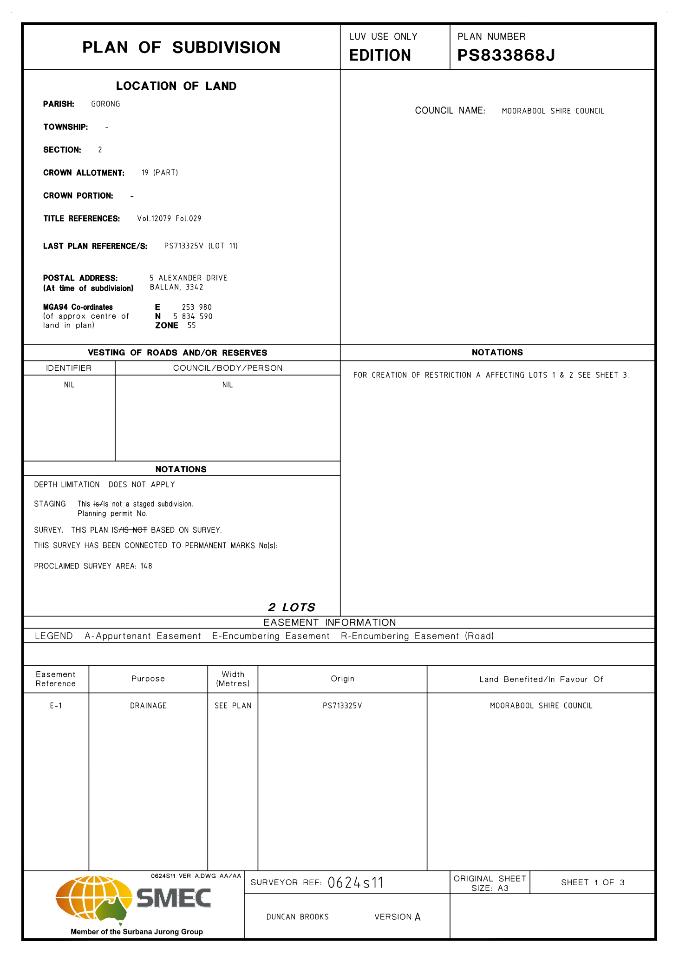
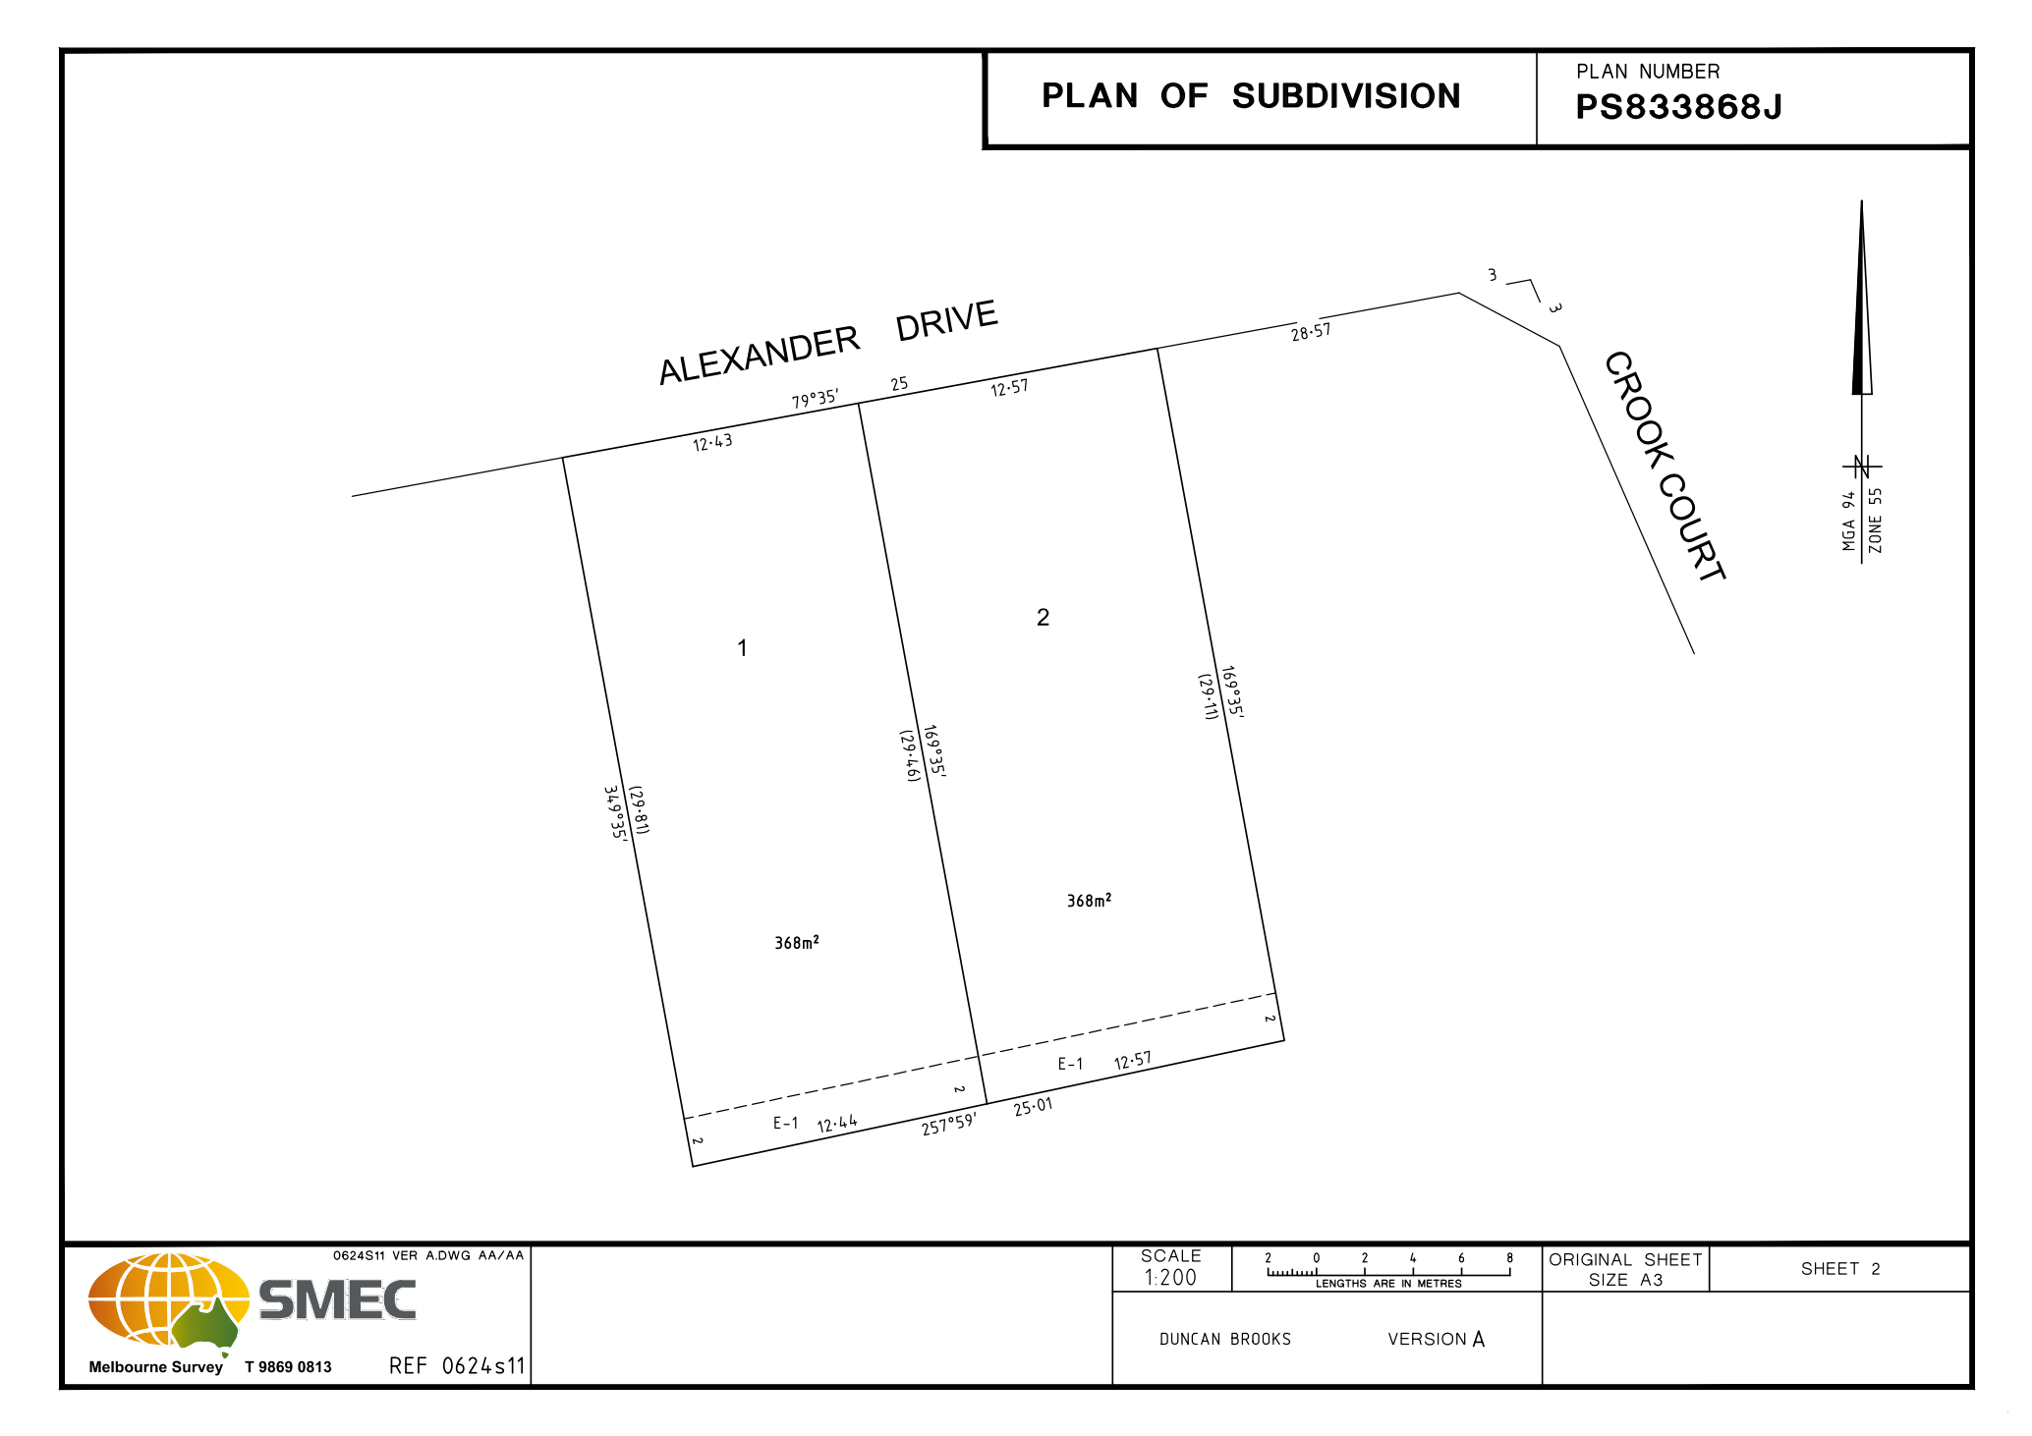
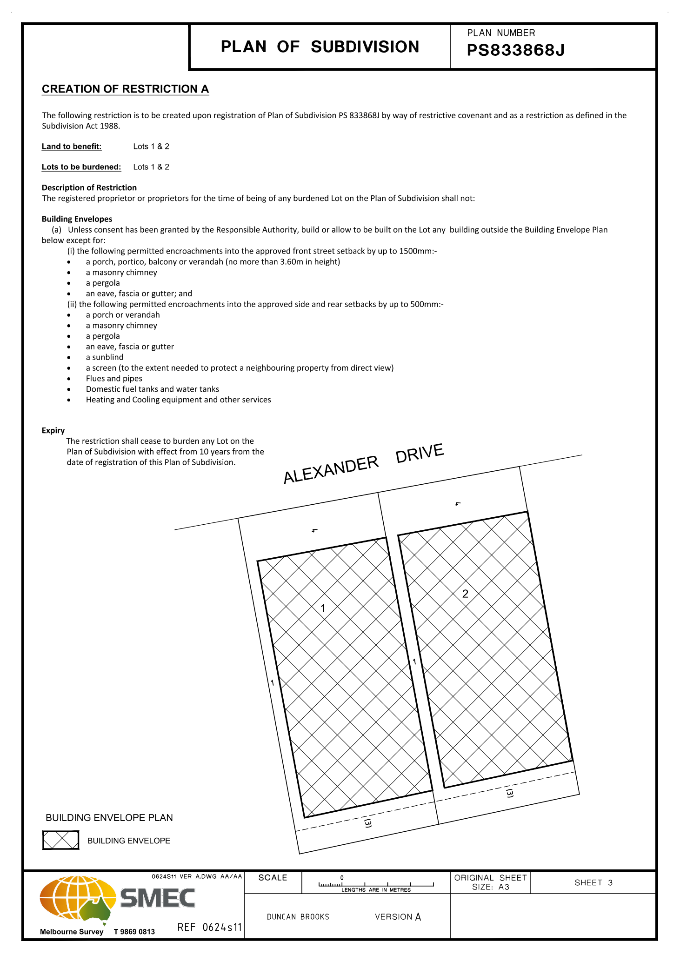

7.7 PA2019285 - Two Lot Subdivision at 15 Alexander Drive, Ballan
Author: Thomas Tonkin, Statutory Planner
Authoriser: Henry Bezuidenhout, Executive Manager Community Planning & Economic Development
Attachments: 1. Proposed plan of subdivision

Application Summary
Permit No: PA2019285
Lodgement Date: 6 December 2019
Planning Officer: Tom Tonkin
Address of the land: 15 Alexander Drive Ballan
Proposal: Two-Lot Subdivision
Lot size: 725 sqm
Why is a permit required? Clause 32.09 Neighbourhood Residential Zone, Schedule 7 - Subdivision
Clause 42.01 Environmental Significance Overlay, Schedule 1 - Subdivision

Recommendation
That Council, having considered all matters as prescribed by the Planning and Environment Act 1987, issue a Refusal to Grant Planning Permit PA2019285 for a Two-Lot Subdivision at Lot 7 on PS 713325V known as 15 Alexander Drive, Ballan 3342, on the following grounds:
1. The proposed lot sizes do not meet the minimum allowable lot sizes specified in the Neighbourhood Residential Zone, Schedule 7, of the Moorabool Planning Scheme.
2. The proposal is inconsistent with relevant state and local planning policy in the Moorabool Planning Scheme for residential land subdivision in this location.
3. The proposal does not meet all relevant provisions of Clause 56 (Rescode) of the Moorabool Planning Scheme.

Public Consultation
Was the application advertised? | Yes.
Notices on site: | Yes.
Notice in Moorabool Newspaper: | No.
Number of objections: | One.
Consultation meeting: | No.

Policy Implications
The Council Plan 2017-2021 provides as follows:
Strategic Objective 2: Minimising Environmental Impact
Context 2A: Built Environment
The proposal is consistent with the Council Plan 2017 – 2021.

Victorian Charter of Human Rights & Responsibilities Act 2006
In developing this report to Council, the officer considered whether the subject matter raised any human rights issues. In particular, whether the scope of any human right established by the Victorian Charter of Human Rights and Responsibilities is in any way limited, restricted or interfered with by the recommendations contained in the report. It is considered that the subject matter does not raise any human rights issues.

Officer’s Declaration of Conflict of Interests
Under section 80C of the Local Government Act 1989 (as amended), officers providing advice to Council must disclose any interests, including the type of interest.
Executive Manager – Henry Bezuidenhout
In providing this advice to Council as the Executive Manager, I have no interests to disclose in this report.
Author – Tom Tonkin
In providing this advice to Council as the Author, I have no interests to disclose in this report.

Executive Summary
Application referred? | Yes, to Council’s Infrastructure.
Any issues raised in referral responses? | No.
Preliminary concerns? | Non-compliance with the minimum 800 sqm lot size requirements of NRZ7, which was adopted by Council as part Amendment C88 before the application was submitted. Amendment C88 was gazetted on 6 March 2020.
Any discussions with applicant regarding concerns? | Yes, informally before and after the application was submitted.
Any changes made to the application since being lodged? | No.
Brief history. | The subject site is part of a 12-lot subdivision approved by Council under planning permit PA2011316 issued on 21 August 2012.
Previous applications for the site? | None. This application has been lodged concurrently with four other two-lot subdivisions in the same street by the same applicant.

General summary. | The proposed 350 sqm and 375 sqm lot sizes do not meet the minimum 800 sqm lot size requirements of the Neighbourhood Residential Zone, Schedule 7, and are therefore in direct contravention of the Moorabool Planning Scheme. Council has no discretion to approve the application due to the minimum lot size requirement of 800 sqm.
Summary Recommendation
That, having considered all relevant matters as required by the Planning and Environment Act 1987, Council issue a Refusal to Grant a Permit for this application in accordance with Section 61 of the Planning and Environment Act 1987, on the grounds included in this report.

Site Description
The site is identified as Lot 7 on PS 713325V and is known as 15 Alexander Drive, Ballan, and is located on the southern side of Alexander Drive at the end of the cul-de-sac. The site is an irregular shape with an area of 725 sqm, encumbered by a 4-metre-wide drainage easement parallel to the western boundary. The site is vacant with no significant vegetation and a slight fall.

Proposal
It is proposed to subdivide the site into two lots. Lot 1 would have an area of 350 sqm and Lot 2 would have an area of 375 sqm. Both lots would be irregular in shape with direct frontages to Alexander Drive and be encumbered by building envelopes.

Background to Current Proposal
The subject site was rezoned to the Neighbourhood Residential Zone, Schedule 7 (NRZ7) on 6 March 2020 as part of Planning Scheme Amendment C88 which implemented the Ballan Strategic Directions (June 2018) policy in the Moorabool Planning Scheme. The NRZ7 imposes minimum lot sizes of 800 sqm for subdivision. There are no applicable transitional provisions in the Moorabool Planning Scheme to enable consideration of smaller lot sizes proposed in applications received prior to the Amendment’s gazettal on 6 March 2020.

History
Not applicable.

Public Notice
Notice of the application was given to adjoining and surrounding landowners by mail and a sign erected on site from 14-29 January 2020. One objection was received.

Summary of Objections
The objections received are detailed below with officer’s comments accompanying them:
Objection | Any Relevant Requirement
Safety impacts of multiple residents trying to exit properties in a fire event whose only vehicle egress point from Crook Court is to Old Melbourne Road. | Clause 56.
Officer’s Response:
Crook Court’s design is sufficient to cope with the traffic demands of existing residents and current proposed subdivisions.
Existing boundary fences are inadequate to protect privacy and limit noise, contain pets and domestic rubbish. | Clause 65.
Officer’s Response:
If approved, the height and type of fencing can potentially be conditioned, where appropriate.
Smaller lot sizes increase the likelihood of double storey development. The subdivider’s assurances that such construction would be prevented by covenants imposed on title does not allay our concerns. | Clause 56.
Officer’s Response:
The proposed wording on title (covenant) does not prevent double storey construction. However, any future development (including double storey development) must meet ResCode requirements in terms of minimum boundary setbacks and overlooking. Furthermore, double storey construction may reasonably be expected in a residential zoned area.
Traffic impacts on noise levels and safety for children going to school. | Clause 65.
Officer’s Response:
The proposal would not be expected to impact on noise and safety to an unacceptable extent given the residential nature of the area. Council’s Infrastructure Unit assessed the traffic implications and raised no concerns.
Any traffic safety issues raised at any point in future due to changed circumstances will be reviewed.
The existing poor condition of the Crook Court carriageway would be exacerbated by increased traffic which creates a traffic hazard. | Clause 56.
Officer’s Response:
The need for repairs to existing roads are usually addressed through Council’s road maintenance program.
Should the development be approved, conditions relating to damages as a result of the development will be conditioned accordingly and may include reinstatement of the road.

Locality Map
The map below indicates the location of the subject site and the zoning of the surrounding area.
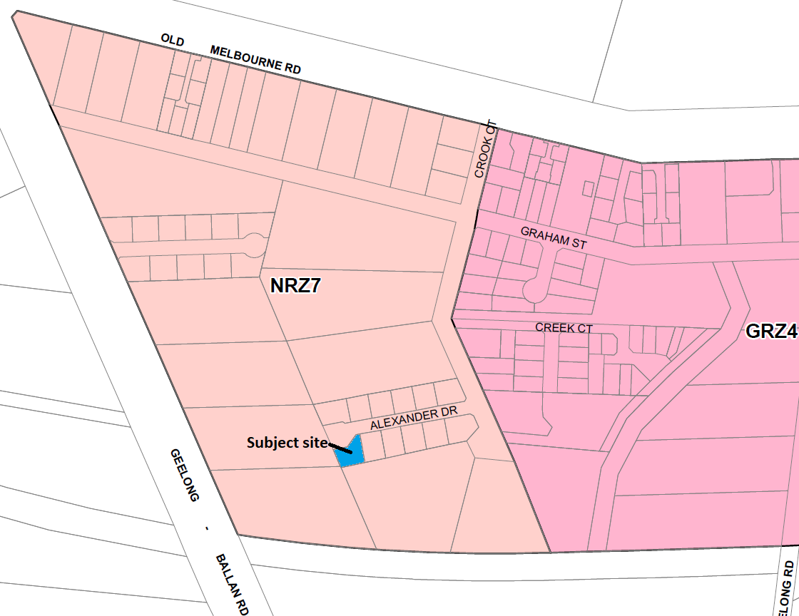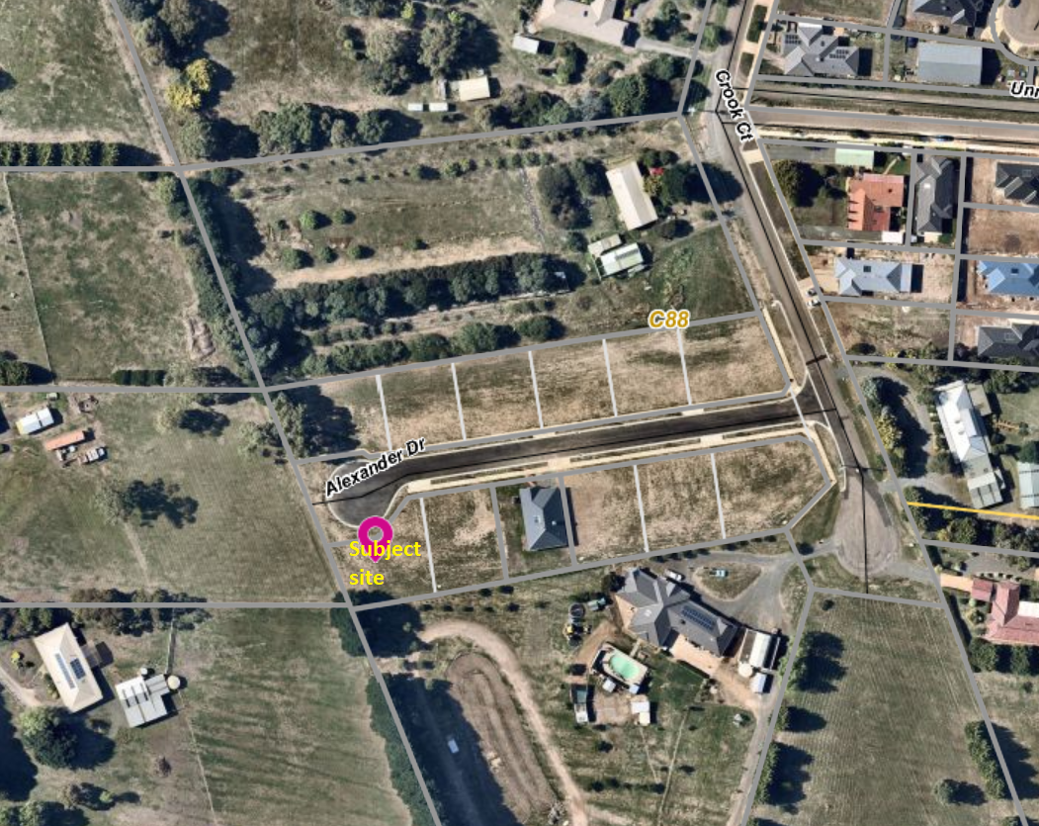

Planning Scheme Provisions
Council is required to consider the Victoria Planning Provisions and give particular attention to the Planning Policy Framework (PPF), the Local Planning Policy Framework (LPPF) and the Municipal Strategic Statement (MSS).
The relevant clauses are:
• Clause 11.03-3S Peri-urban areas
• Clause 14.02 Water
• Clause 15.01-3S Subdivision design
• Clause 15.01-5S Neighbourhood character
• Clause 16.01-2S Location of residential development
• Clause 21.02-3 Water and catchment management
• Clause 12.03-2 Urban Growth Management
• Clause 21.03-3 Residential Development
• Clause 21.03-4 Landscape and Neighbourhood Character
• Clause 21.08 Ballan
• Clause 22.02 Special Water Supply Catchments
In assessing the application against the relevant sections of the PPF and LPPF, the following significant non-compliances were identified:
PPF | Title | Response
Clause 15.01-5S | Neighbourhood character | The proposal does not respond positively to the preferred neighbourhood character, which encourages detached dwellings with conventional front and side setbacks in a garden setting. The proposed subdivision would prejudice such development
Clause 16.01-2S | Location of residential development | The proposal would facilitate residential growth in an area of Ballan where limited growth is encouraged.
LPPF

Clause 21.03-2 | Urban Growth Management | The proposal would facilitate residential growth in an area of Ballan where limited growth is encouraged.
Clause 21.03-4 | Landscape and Neighbourhood Character | The proposal does not respond appropriately to the preferred neighbourhood character because the proposal would not facilitate site responsive future development.
Clause 21.08-7 | Strategies for Residential Development | The proposal would not facilitate the built form consistent with the preferred development outcomes for this area of Ballan, by limiting opportunities for low density housing with boundary setbacks to accommodate landscaping.

Zone
The subject site is in the Neighbourhood Residential Zone, Schedule 7 (NRZ7). The purpose of the Zone is:
• To implement the Municipal Planning Strategy and the Planning Policy Framework.
• To recognise areas of predominantly single and double storey residential development.
• To manage and ensure that development respects the identified neighbourhood character, heritage, environmental or landscape characteristics.
• To allow educational, recreational, religious, community and a limited range of other non-residential uses to serve local community needs in appropriate locations.
Under Clause 32.09-3 a permit is required to subdivide land. A zone schedule may specify a minimum lot size to subdivide land, and each lot must be at least the area specified for the land. Schedule 7 specifies a minimum 800 sqm lot size for subdivision.
The proposed lot sizes do not meet the minimum lot size requirement; therefore, the proposal is fundamentally inconsistent with the zone provisions.

Overlays

The site is affected by Environmental Significance Overlay, Schedule 1 (Proclaimed Water Catchment Areas). Under Clause 42.01-2 a permit is required to subdivide land. There are no relevant exemptions under Schedule 1. The subject site is sewered and drains more than 100 metres from the nearest waterway. Subject to conditions the proposal would not cause detriment to potable water quality or supply.

Relevant Policies
The Ballan Strategic Directions (June 2018) policy underpins Planning Scheme Amendment C88 which was recently approved by the Minister for Planning and gazetted on 6 March 2020. The proposed lot sizes less than 800 sqm are inconsistent with Amendment C88 adopted by Council.

Particular Provisions
Clause 53.01 Public Open Space Contribution and Subdivision
A subdivision is exempt from a public open space requirement specified in this scheme if it subdivides land into two lots and the Council considers it unlikely that each lot will be further subdivided. If the application could be considered for approval by Council, it would be unlikely for either lot to be further subdivided and no public open space contribution would be required.

Clause 56 Residential Subdivision
The proposal complies with ResCode (Clause 56), with the exception of the following:
Clause ResCode | Title | Response
56.03-5 | Neighbourhood Character | The proposal does not adequately respond to the key features of the preferred neighbourhood character.

Discussion
Overall, the proposal is inconsistent with relevant state and local planning policy, the Neighbourhood Residential Zone and Clause 56 of the Moorabool Planning Scheme.
The proposed 350 sqm and 375 sqm lot sizes are less than the minimum allowable 800 sqm lot sizes specified in Schedule 7 to the Neighbourhood Residential Zone, gazetted on 6 March 2020. It is noted that despite the application being lodged with Council prior to the gazettal date there is no transitional provision in the Moorabool Planning Scheme which would enable Council to consider approving the application. Furthermore, it is noted that when the application was submitted on 6 December 2019, Amendment C88 has already progressed through the Panel Hearing process, been adopted by Council and submitted to the Minister for Planning for approval. The applicant was aware of the Amendment C88’s status when submitting the application. The proposal explicitly contravenes the Moorabool Planning Scheme and is therefore recommended for refusal.

General Provisions
Clause 65 – Decision Guidelines have been considered by officers in evaluating this application.
Clause 66 – Stipulates all the relevant referral authorities to which the application must be referred.

Referrals
Authority | Response
Western Water  Southern Rural Water | Consent with conditions in accordance with Council’s MoU with these authorities.
Infrastructure | Consent with conditions.

Financial Implications
There are no financial implications for Council in refusing the subdivision application.

Risk & Occupational Health & Safety Issues
The recommendation to refuse this subdivision application does not have any risk or OH&S implications for Council.

Communications Strategy
Notice was undertaken for the application, in accordance with s.52 of the Planning and Environment Act 1987, and further correspondence is required to all interested parties to the application as a result of a decision in this matter. The submitter and the applicant were invited to attend this meeting and address Council if required.

Options
• Issue a Refusal to Grant a Permit in accordance with the grounds in the recommendation of this report; or
• Issue a Refusal to Grant a Permit with amendments to the grounds in the recommendation of this report.

Conclusion
Overall, the proposal is inconsistent with the relevant provisions of the Moorabool Planning Scheme, in particular the NRZ7 given that the proposed lot sizes do not meet the minimum 800 sqm lot size requirement.

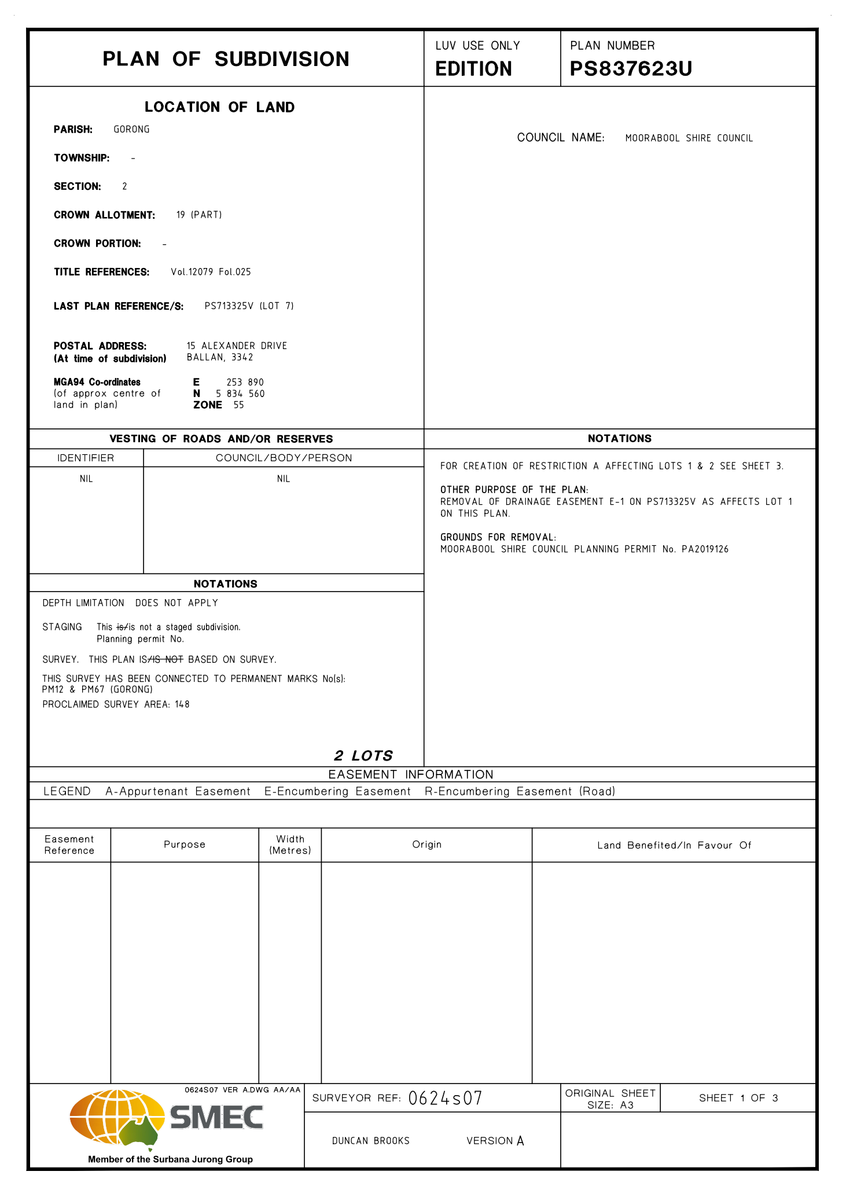
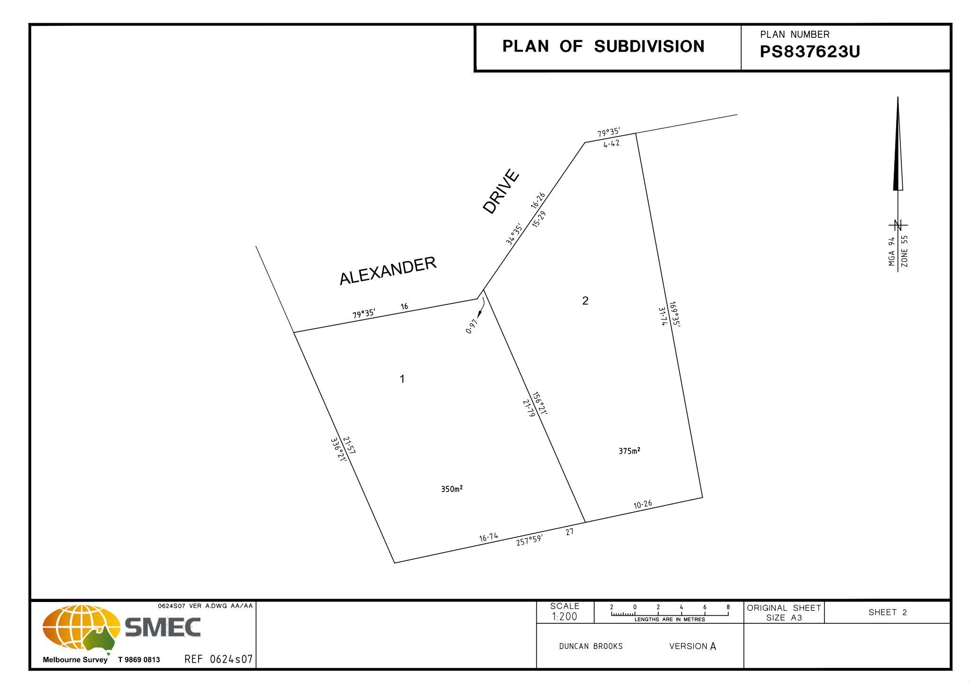
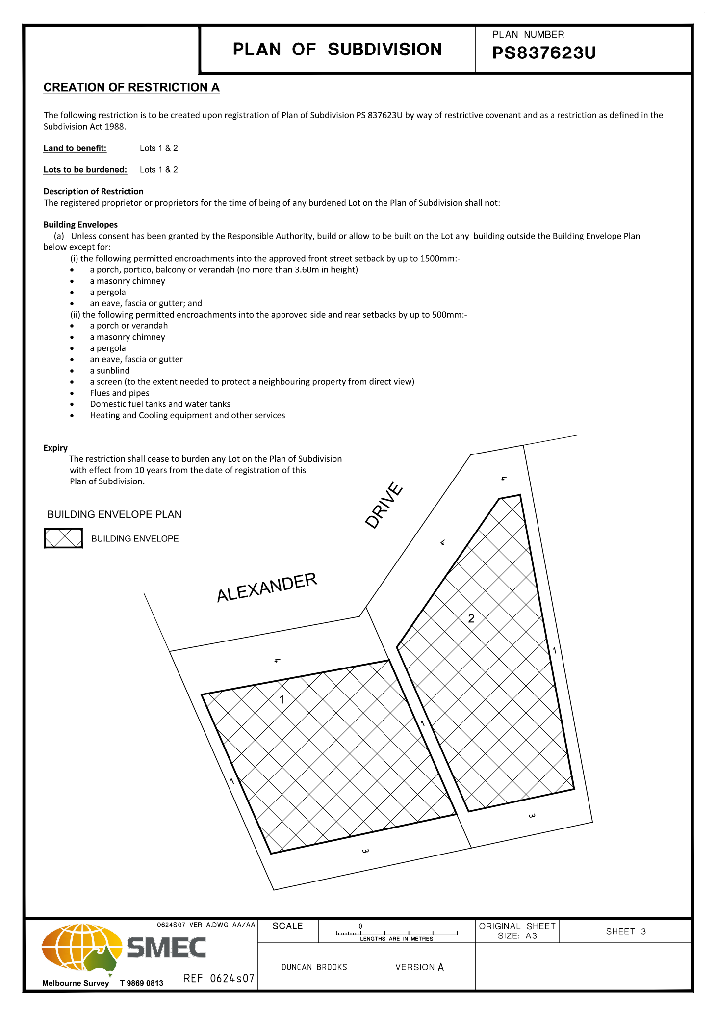

7.8 PA2019261 - Use of an existing dwelling as a retail premises (cafe) at 15 Martin Street, Blackwood
Author: Victoria Mack, Statutory Planner
Authoriser: Henry Bezuidenhout, Executive Manager Community Planning & Economic Development
Attachments: 1. Sketch plans of cafe proposal

Application Summary
Permit No: PA2019261
Lodgement Date: 11 November 2019
Planning Officer: Victoria Mack
Address of the land: 15 Martin Street, Blackwood
Proposal: Use of an existing dwelling as a retail premises (café)
Lot size: 2000sqm
Why is a permit required? Clause 32.05-2, Township Zone, Use of retail premises (café)

Recommendation
That Council, having considered all matters as prescribed by the Planning and Environment Act 1987, issues a Notice of Decision to Grant a Planning permit subject to the following conditions:

1. Before the use and/or development starts, plans to the satisfaction of the Responsible Authority must be submitted to and approved by the Responsible Authority. When approved, the plans will be endorsed and will then form part of the permit. The plans must be drawn to scale with dimensions and two copies must be provided. The plans must show:
a) A Bushfire Management Plan in accordance with the Country Fire Authority's condition 18.
b) Details of the signage proposed including the number of signs, their dimensions, total area, the wording and colour scheme. Total signage area cannot exceed 3 sqm.
c) A detailed floor plan and site plan showing all the operational areas within, and outside the building including car parking, drawn to scale with accurate dimensions. The designated car parking area must show all five car spaces.
Unless otherwise approved in writing by the Responsible Authority, all buildings and works are to be constructed and or undertaken in accordance with the endorsed plans to the satisfaction of the Responsible Authority prior to the commencement of the use.

General Conditions:
2. The approved hours of operation are between 9am and 4pm on Saturday and Sunday and Public Holidays.
3. The maximum number of patrons at any one time is 30.
4. Prior to the commencement of the use, Crown Allotments 10 and 11 Section B Parish of Blackwood must be consolidated in accordance with the Subdivison Act 1988 and a new title issued by the Reigstrar of Titles.
Amenity:
5. The amenity of the area must not be detrimentally affected by the use or development, through the:
(a) transport of materials, goods or commodities to or from the land.
(b) appearance of any building, works or materials.
(c) emission of noise, artificial light, vibration, smell, fumes, smoke, vapour, steam, soot, ash, dust, waste water, waste products, grit or oil.
(d) presence of vermin.
(e) any other way.
6. The owner, occupier or manager of the premises must make reasonable endeavours to ensure that people associated with the site do not create a nuisance and annoyance to neighbours or otherwise disturb the amenity of the area.
Environmental Health:
7. The current onsite wastewater treatment system must be upgraded to an onsite waste water management system with the capacity to treat effluent to a minimum of 20/30/10 (BOD/Suspended Solids and Chlorination).
8. The wastewater management system including all effluent must be wholly contained within the property boundaries at all times.
9. The effluent disposal area must be kept free of buildings, driveways, vehicular traffic and services trenching.
10. All setback distances must be adhered to as dictated by Table 5 of the Code of Practice, Onsite Wastewater Management, EPA Publication Number 891.4.
11. A shallow surface water cut off drain or surface water diversion mound, must be provided on the high side of the disposal areas to divert any surface water flows around the effluent fields.
12. Subsurface Irrigation system must be installed to a depth of 150mm in situ or if the soil is of poor quality, imported good quality topsoil may be required, with a 1m spacing in between lines.
13. The owner must maintain all drainage lines at all times to divert surface water and subsurface water clear of the effluent disposal field.
14. A commercial size grease trap must be installed by a certified plumber.
15. The kitchen must comply with Food Standards Code 3.2.3 Food Premises and Equipment with regards to design and fit-out.
16. Plans are required to be submitted to Environmental Health for assessment against the Food Standards Code. The plans to be submitted must be drawn to a scale not less than 1:100 and clearly show the premises layout, fixtures, fittings and equipment. A description of materials to be used for all surfaces including floors, walls, benches etc must also be provided.
Country Fire Authority:
17. The bushfire mitigation measures forming part of this permit or shown on the endorsed plans, including those relating to construction standards, defendable space, water supply and access, must be maintained to the satisfaction of the Responsible Authority on a continuing basis. This condition continues to have force and effect after the development authorised by this permit has been completed.
18. Before the development starts, a bushfire management plan must be submitted to and endorsed by the Responsible Authority. The plan must show the following bushfire mitigation measures, unless otherwise agreed in writing by the CFA and the Responsible Authority:
a) Defendable Space
Show an area of defendable space to the property boundaries where vegetation (and other flammable materials) will be modified and managed in accordance with the following requirements:
• Grass must be short cropped and maintained during the declared fire danger period.
• All leaves and vegetation debris must be removed at regular intervals during the declared fire danger period.
• Within 10m of a building, flammable objects must not be located close to the vulnerable parts of the building.
• Plants greater than 10cm in height must not be placed within 3m of a window or glass feature of the building.
• Shrubs must not be located under the canopy of trees.
• Individual and clumps of shrubs must not exceed 5 sqm in area and must be separated by at least 5m.
• Trees must not overhang or touch any elements of the building.
• The canopy of trees must be separated by at least 5m.
• There must be a clearance of at least 2m between the lowest tree branches and ground level.
b) Construction Standard
Nominate a minimum Bushfire Attack Level of BAL 19 that the building will be designed and constructed.
c) Water Supply
Show 5,000 litres of effective water supply for firefighting purposes which meets the following requirements:
• Be stored in an above ground water tank constructed of concrete or metal.
• Have all fixed above ground water pipes and fittings required for firefighting purposes must be made of corrosive resistant metal. Include a separate outlet for occupant use.
Western Water:
19. A wastewater treatment system that produces wastewater to a minimum standard of 20/30/10 (BOD/suspended solids/E.Coli) must be installed to the satisfaction of the Council's Environmental Health Officer and Western Water to treat all sullage and sewage waste on site.
20. Wastewater is to be dispersed to the satisfaction of Council's Environmental Health Officer and Western Water using methods that will prevent waste and treated waste from discharging from the property at all times.
21. The effluent system must be maintained by a suitably qualified person in accordance with the manufacturer's specifications and EPA requirements.
22. The wastewater effluent being released from the treatment facility must be monitored annually to ensure compliance with the 20/30/10 standard.
23. Reports on water quality and maintenance must be submitted to the Responsible Authority at the completion of each maintenance period. This report must be made available to Western Water on request.
24. The Owner shall meet the costs of the inspections and reports referred to in Condition 23.
25. The owner shall carry out such works including replacing effluent treatment, storage pumping and disposal systems within the time specified to do so by the Council's Environmental Health Officer or Western Water to cease and prevent waste and treated waste from discharging from the property.
26. If the wastewater program proves to be unsustainable, the land holder must immediately rectify the sewerage disposal system.
27. The owner shall have the wastewater treatment system desludged at least once every three years and evidence of this fact shall be provided in the annual written report referred to in condition 22.
28. The effluent disposal field must be protected by being isolated from any building, driveway, livestock, vehicles or permanent recreational area that could render it unavailable in the future and should be planted with suitable grasses that will aid in moisture removal.
29. Stormwater is to be managed in a way to minimise risk to erosion of the surrounding land. No stormwater should be allowed to move into the effluent disposal field.
Parking and Access
30. Before the use or occupation of the development starts, the area(s) set-aside for the parking of vehicles and access lanes as shown on the endorsed plans must be:
a) Constructed.
b) Properly formed to such levels that they can be used in accordance with the plans.
c) Surfaced with an all-weather-seal coat.
d) Drained.
e) Line marked to indicate each car space and all access lanes.
f) Clearly marked to show the direction of traffic along access lanes and driveways to the satisfaction of the Responsible Authority.
g) A minimum of 5 on site car spaces must be provided
h) Car spaces, access lanes and driveways must be kept available for these purposes at all times.
Advertising Sign:

31. The location, design, content, colours and materials of all advertising signs must not be altered without the written consent of the Responsible Authority.
32. The advertising signs must be not contain any moving parts or flashing lights.
33. The permit for signage expires 15 years from the date of issue.
Permit Expiry:
34. This permit will expire if one of the following circumstances applies:
a) the development and the use are not started within two years of the date of this permit; and
b) the development is not completed within four years of the date of this permit.
Permit Note:
35. A permit will be required to register the kitchen under the Food Act 1984.
36. A separate permit is required from Council’s Community Safety for seating placed on the road side outside of the title boundary.
37. The Bushfire Management Plan (BMP) referred to CFA is for a proposed shed and is separate to this application. Hence a BMP showing the information above is required to be submitted to the Responsible Authority for endorsement. To assist, a Bushfire Management Plan template (Template 3) can be found on the CFA website: https://www.cfa.vic.gov.au/plan-prepare/bushfire-management-plan.
CFA also recommend that an Emergency Management Plan is developed for the Cafe to identify the risks and procedures in an emergency (in particular a bushfire). If you wish to discuss this matter in more detail, please do not hesitate to contact the Fire Safety Team on (03) 5329 5570.

Public Consultation
Was the application advertised? | Yes.
Notices on site: | Yes.
Notice in Moorabool Newspaper: | No.
Number of objections: | Two.
Consultation meeting: | Not held.

Policy Implications
The Council Plan 2017-2021 provides as follows:
Strategic Objective 3: Stimulating Economic Development
Context 2A: Built Environment
The proposal is not provided for in the Council Plan 2017-2021 and can be actioned by utilising existing resources.

Victorian Charter of Human Rights & Responsibilities Act 2006
In developing this report to Council, the officer considered whether the subject matter raised any human rights issues. In particular, whether the scope of any human right established by the Victorian Charter of Human Rights and Responsibilities is in any way limited, restricted or interfered with by the recommendations contained in the report. It is considered that the subject matter does not raise any human rights issues.

Officer’s Declaration of Conflict of Interests
Under section 80C of the Local Government Act 1989 (as amended), officers providing advice to Council must disclose any interests, including the type of interest.
Executive Manager – Henry Bezuidenhout
In providing this advice to Council as the Executive Manager, I have no interests to disclose in this report.
Author – Victoria Mack
In providing this advice to Council as the Author, I have no interests to disclose in this report.

Executive Summary
Application referred? | Referred to Country Fire Authority, Central Highlands Water, Southern Rural Water, Western Water and to Council’s Environmental Health and Infrastructure Departments.
Any issues raised in referral responses? | Water authorities required further information in relation to the waste water treatment system. This was provided and they, as well as Environmental Health, consented to the application with conditions that the existing older style septic on the site was to be replaced. The Country Fire Authority required a Bushfire Management Plan, but they have made this a condition of any permit issued.
Preliminary concerns? | Nil.
Any discussions with applicant regarding concerns? | Range of discussions with applicant about referral authority requirements and related matters including objections.
Any changes made to the application since being lodged? | No.
Brief history. | The current owner has advised that:  Lerdies Restaurant at 15 Martin Street first opened in 1987 and continued to operate variously as a wine bar, fine dining restaurant, pizza place and casual eating until 2012. The premises had a liquor license and seated 85 people utilising the house and the garden where live bands would play. Bands and solo performers also played inside the building particularly during its wine bar phase where many international artists played.  Between 2012 (after the restaurant closed) the premise was turned into an antique centre operating Friday Saturday and Sunday and also public holidays. This continued until it was sold in 2015 to the current owner for use as a dwelling.
Previous applications for the site? | PA2007039 being for Variation to Existing On-Premises Liquor Licence issued on 27/06/2007;  PA2008172 being for the Development of a Verandah Ancillary to an Existing Restaurant issued on 22/10/2008; and  PA2019218 being for the Development of Outbuildings Ancillary to Existing Dwelling (Workshop, Tool Shed, Carport & Studio).
General summary. | The applicant, who is the owner and resident of the dwelling on the property, wishes to recommence the operation of a café on the site specifically on weekends to provide food and drink for Blackwood’s weekend visitors and tourists.  The café would serve breakfast, morning tea, lunch and afternoon tea from a room of the house (sunroom) and with access to the rear deck with pretty views to the west. It is proposed to also have tables on the deck and at the front of the building on the footpath (weather and relevant footpath dining permits permitting).  A liquor licence is not proposed.  The owner has purchased a portable food van which would be located on the west side of the house where food would be prepared in a dedicated commercial grade “kitchen” for the café.  The maximum number of patrons (seating) would be 30, and the hours of operation would be 9am – 4pm on both Saturday and Sunday as well as public holidays.  Signs would be erected at the front of the building and on the vacant lot on the north in the same ownership with wording along the lines of “The Happy Café - Open weekends and public holidays 9am – 4pm”.
Summary Recommendation
That, having considered all relevant matters as required by the Planning and Environment Act 1987, Council issues a Notice of Decision to Grant a Planning permit subject to conditions.

Site Description
The site is located on the west side of Martin Street, Blackwood, approximately 32m south of the intersection with Golden Point Road, the Blackwood Hotel and the beginning of Blackwood’s small shopping strip. The site slopes down from the frontage on Martin Street west towards the Greendale Trentham Road and overlooking at least two vacant lots.
The land to the north of the site is a vacant lot in the same ownership. To the south is a dwelling. To the east across Martin Street is public land, then Byres Road and then further to the east is the Blackwood Hall.
The subject site is currently used for a dwelling but prior to March 2015 the building was variously used as a restaurant known as “Lerdies”, and also as a retail premise.
The existing owner furthermore runs a single room bed and breakfast from the dwelling which opened in 2015. In 2017, another room in the dwelling was developed as the Blackwood Hat Shoppe, which is allied with the Gordon Hat Shoppe. This opens on weekends between 11am and 4pm and is considered to be ancillary to the bed and breakfast.
The site has an existing septic system.
An aerial photo of the site is shown below:
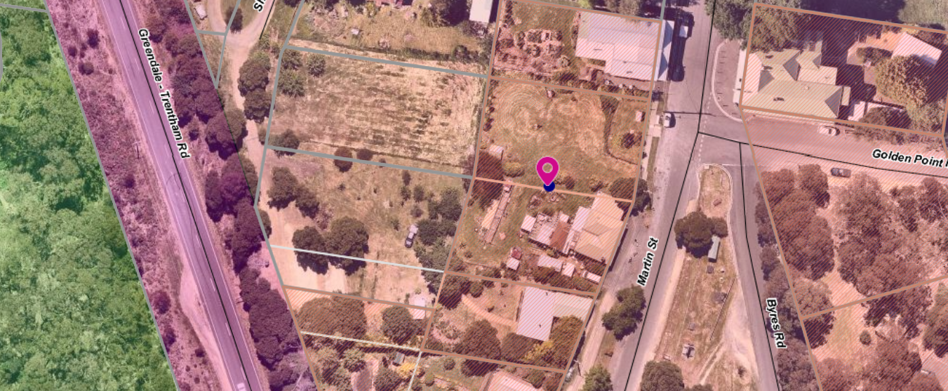

Proposal
It is proposed to use one room of the existing dwelling, referred to as the sunroom, for a café which would have space for approximately three tables seating a total of 12 patrons. Additionally, the sun room has a doorway to a west facing outside deck which would allow for an additional three tables to seat a further 12 patrons, weather permitting. The application has also included two tables at the front of the dwelling on the footpath which could seat another 6 patrons. This would be subject to a separate Local Laws permit for outdoor dining.
The dwelling has two toilets one of which would meet the requirements of a disabled toilet.
A disabled parking bay would be located on the south side of the dwelling and disabled access would be available through a south side entrance door.
Four on-site car spaces would be provided on the northern side of the dwelling on the separate vacant lot in the same ownership.
The café would serve breakfast, morning tea, lunch and afternoon tea. A liquor licence is not being sought and the use of a licenced premises has not been requested.
The owner has purchased a portable food van which is to be located on the west side of the house where food would be prepared in a dedicated commercial grade “kitchen” for the café.
The maximum number of patrons is proposed to be 30 (24 seats on site and 6 seats on the footpath (road reserve) which would require an additional approval under Council’s Local Laws. The hours of operation would be 9am – 4pm on both Saturday and Sunday and public holidays.
Signs are proposed including one at the front of the building hanging from the front verandah and one on the vacant lot on the north, on the vacant lot in the same ownership.
The wording suggested was “The Happy Café - Open weekends and public holidays 9am – 4pm”. No specific signage details were provided.
Background to Current Proposal
The site was used as a restaurant over many years (1987 – 2012) and mostly traded as ‘Lerdies’ restaurant.

PERMIT History
A search of Council records reveals that the following permits have been issued on the site:
• PA2007039 being for Variation to Existing On-Premises Liquor Licence issued on 27/06/2007.
• PA2008172 being for the Development of a Verandah Ancillary to an Existing Restaurant issued on 22/10/2008.
• PA2019218 being for the Development of Outbuildings Ancillary to Existing Dwelling (Workshop, Tool Shed, Carport & Studio).

Public Notice
The application was notified to adjoining and surrounding landowners. Two objections were received both of which are the proprietors of 21 Martin Street, who operate the retail premises known as Martin Street Coffee. It is understood that this business does not operate on weekends.
Both objectors stated that in-principle they were supportive of the application and acknowledged that it would be good for the township. However, their concerns generally related to the suitability of the dwelling at 15 Martin Street to meet the standards required such that the use of a café does not disrupt the amenity of neighbours. There comments are summarised below.
It is also noted that a petition of support with 280 signatories was received by Council. This petition requested a planning permit be granted for a cafe.

Summary of Objections
The objections received are detailed below with officer’s comments accompanying them:

Objection | Any Relevant Requirement
Privacy of neighbours with multiple uses occurring at 15 Martin Street: the residence; the café; bed and breakfast; and Hat Shoppe.
Officer’s Response: Permit conditions can protect the amenity of nearby residents
Waste water should be retained on one lot only and if this cannot be achieved then the lots should be consolidated. The vacant lot, in the same ownership, could be sold at any time. | EPA Victoria - Code of practice on-site waste water management (publication 891)
Officer’s Response: The application was referred to the relevant water authorities. Western Water, Southern Rural Water and Council’s Environmental Health all determined that the older style septic on the property needed to be replaced with a Waste Water Treatment System that produces wastewater to a minimum standard of 20/30/10 (BOD/suspended solids/E.Coli). This can be satisfied by a permit condition.
The application does not mention a grease trap which would be required with the use of the cafe.
Officer’s Response: The requirement for a grease trap would be dealt with by Council’s Environmental Health Department under the relevant legislation.
Loss of privacy particularly due to the use of rear outdoor space. This is not being respectful of the potential impact on neighbour’s own rear outdoor space: peace, privacy, comfort and rural lifestyle.
Officer’s Response: The impact of a use or development on local amenity in a small township is a planning consideration. The site for the café is within the township boundaries where there are several commercial businesses operating including the Hotel.
As there is no application for a Liquor licence | Clause 52.29 Licenced Premises
Officer’s Response: No liquor licence or use of a licenced premise has been proposed as part of this application.
There are no safety plans referenced in the application.
Officer’s Response: Building and Health regulations can control safety issues
The building does not appear sound for a food premises. There are also chickens in the yard which will attract vermin. | Council’s Environmental Health
Officer’s Response: These concerns will be addressed by Environmental Health’s regulations.
Can a commercial kitchen in a temporary food van remain as a permanent fixture for the café? Does this meet the requirements for food safety and storage? | Council’s Environmental Health
Officer’s Response: These concerns will be addressed by Environmental Health’s regulations.

Locality Map
The map below indicates the location of the subject site and the zoning of the surrounding area.
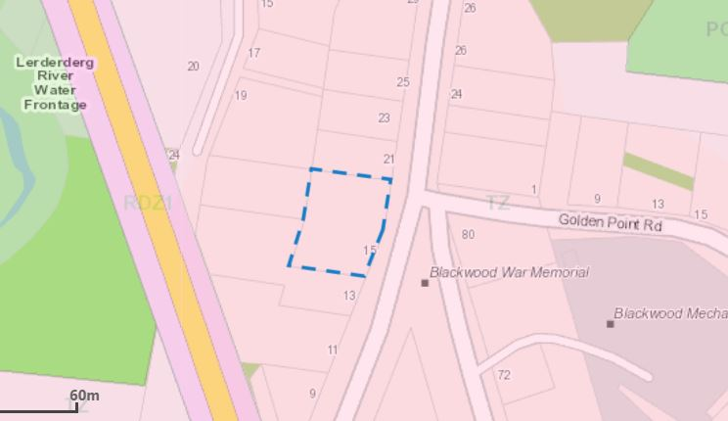

Planning Scheme Provisions
Council is required to consider the Victoria Planning Provisions and give particular attention to the Planning Policy Framework (PPF), the Local Planning Policy Framework (LPPF) and the Municipal Strategic Statement (MSS).
The relevant clauses are:
Clause 17.01-1R Diversified economy - Central Highlands
Clause 17.04-1S Facilitating tourism
Clause 21.09-1 Small Towns and Settlements - Economic Development and Tourism - Blackwood
The proposal generally complies with the relevant sections of the PPF and LPPF

Zone
Township Zone
In accordance with Clause 32.05-2, Section 2 of the Moorabool Planning Scheme a permit is required for a retail premises (café).
The purpose of the Township Zone is:
• To implement the Municipal Planning Strategy and the Planning Policy Framework.
• To provide for residential development and a range of commercial, industrial and other uses in small towns.
• To encourage development that respects the neighbourhood character of the area.
• To allow educational, recreational, religious, community and a limited range of other non-residential uses to serve local community needs in appropriate locations.

Overlays

Environmental Significance Overlay, Schedule 1

In accordance with Clause 42.01-2 of the Moorabool Planning Scheme a permit is required under this overlay as buildings or works to construct the car parking spaces.

Design and Development Overlay, Schedule 2

In accordance with Clause 42.01-2 of the Moorabool Planning Scheme a permit is not required under this overlay for buildings or works to construct the car parking spaces.

Vegetation Protection Overlay, Schedule 1

In accordance with Clause 42.01-2 of the Moorabool Planning Scheme a permit is not required under this overlay as no vegetation would be removed.

Bushfire Management Overlay

In accordance with Clause 44.06 of the Moorabool Planning Scheme a permit is required for buildings and works associated with the use of land for a retail premises. However, while no buildings or works are occurring on the site it was considered that a referral to the Country Fire Authority was required.

Relevant Policies

Planning Scheme Amendment C78 - Small Towns and Settlements Strategy
Planning Scheme amendment C78 was gazetted into the Moorabool Planning Scheme on 31 May 2018 with Clause 21.09 added to the Local Planning Policy Framework.
Clause 21.09 highlights some specific directions for Blackwood including:
• Economic Development and Tourism – Blackwood.
• Encourage any future commercial/retail development to establish in the existing central area, especially those uses which draw people in from out of area.

PARTICULAR PROVISIONS
Clause 52.05 Signs
The Township Zone is in Category 3 for signs under this Clause 52.05. Category 3 states that a permit is required to display a Business Identification sign. There is no size limits specified within category 3 for business identification signs.
The application has specified that signs would be required for the café but details were not complete. This can be satisfied through the submission of revised plans. It is recommended that Council limits the total area of all signs on the premises to 3 sqm. This maximum limit is appropriate to provide adequate business identification while not dominating or cluttering the existing commercial streetscape in Blackwood with signage.
Clause 52.06 Car parking
Table 1 of Clause 52.06-5 specifies the number of car spaces required for a range of uses. The use listed as food and drink premise which requires 4 car spaces for each 100 sqm of leasable floor area. The application provides for one disabled space and an additional four car spaces on the vacant lot to the north in the same ownership
It is estimated that the leasable floor area is approximately 75 sqm but the plans did not provide dimensions. The five car spaces would provide adequate car parking on site for this development. It should be noted that these car parks will also be used for the current dwelling and bed and breakfast operation. It is however, not considered that a permit is required for a reduction in car spaces.

Discussion
The application is to use an existing dwelling as a retail premises (café). Between 1987 and 2012 the building was used as variously as a food and drink premises including Lerdies restaurant. Between 2012 and 2015 the building was used as a retail premises to sell antiques until the current owner purchased the building to use as a dwelling.
The owner has advised that the building did have a commercial kitchen which was destroyed when a tree fell onto it.
The owner is not planning to redevelop this kitchen and has purchased a portable commercial grade food van which she has located on the south side of the building to prepare meals for the café.
The hours of operation would be between 9am and 4pm on Saturday and Sunday with a maximum of 30 patrons (seats). A licenced premise to allow for the on-site consumption of liquor is not proposed.
The application was referred to Central Highlands Water who consented to the application without conditions.
However, Western Water and Council’s Environmental Health both required that the existing older style septic system be completely replaced with a new wastewater treatment system. They maintain that the existing septic system, which they believe is at least 35 years old, has well exceeded its functional life expectancy.
The application was referred to the Country Fire Authority who consented to the application but with a condition that before the development starts, a bushfire management plan must be submitted to and endorsed by the Responsible Authority. The plan must show bushfire mitigation measures listed in the conditions, unless otherwise agreed in writing by the CFA and the Responsible Authority.
The application was referred to Council’s Infrastructure Department who consented to the application, also confirming that the car parking requirements were considered to be satisfactory.
The application was advertised with two objections received. The grounds of objection relates to the use of the outdoor area (deck) and its impact of on the amenity of neighbours. They also questioned such matters as the septic system, waste water management and grease traps, the chooks in the back yard attracting vermin, the suitability of the building for the uses being proposed and fire safety plans.
It is considered that a number of the concerns raised by the objectors will be addressed by permit conditions. These would include: that the waste water treatment system is replaced; that noise and other emissions from the site must not affect the amenity of the neighbourhood; that a bushfire safety plan should be provided; and bushfire mitigation measures must be implemented.
A petition with 280 signatories was also received by Council in support of the application to open a weekend café in Blackwood. The petition generally stating that it would be very beneficial to town, both for locals and visitors.
On balance it is considered that the operation of a weekend café to provide food and drink services to locals, visitors and tourists would be beneficial to the small township and meets zone objective of promoting commercial activity.
Clause 21.09 of the Local Planning Policy Framework in relation to Economic development and tourism aims to: Encourage any future commercial/retail development to establish in the existing central area, especially those uses which draw people in from out of area.
It is recommended that the application is supported with conditions.

General Provisions
Clause 65 – Decision Guidelines have been considered by officers in evaluating this application.
Clause 66 – Stipulates all the relevant referral authorities to which the application must be referred.

Referrals
Authority | Response
Western Water  Southern Rural Water  Central Highlands Water  CFA | Consent with conditions.  No response after repeated requests. Referral sent 14 November 2019.  Consent with conditions.  Consent with conditions.
Infrastructure  Environmental Health | Consent with conditions.  Consent with conditions.

Financial Implications
There is no financial implication associated with an approval to grant a permit.

Risk & Occupational Health & Safety Issues
The recommendation of approval of this application does not implicate any risk or OH&S issues to Council.

Communications Strategy
Notice was undertaken for the application, in accordance with s.52 of the Planning and Environment Act 1987, and further correspondence is required to all interested parties to the application as a result of a decision in this matter. All submitters and the applicant were invited to attend this meeting and invited to address Council if required.

Options
Council could consider the following options:
• Issue a Notice of Decision to Grant a permit in accordance with the conditions recommended in this report; or
• Issue a Notice of Decision to Grant a permit with varied conditions in this report; or
• Issue a Refusal to grant a permit.

Conclusion
The application is to meet an identified dearth of food and beverage availability at weekends in the small township of Blackwood. While the conditions contained in this report will require the applicant to provide revised plans and undertake adequate bushfire mitigation measures in bushfire prone area, it is considered that the application is worthy of Council support.

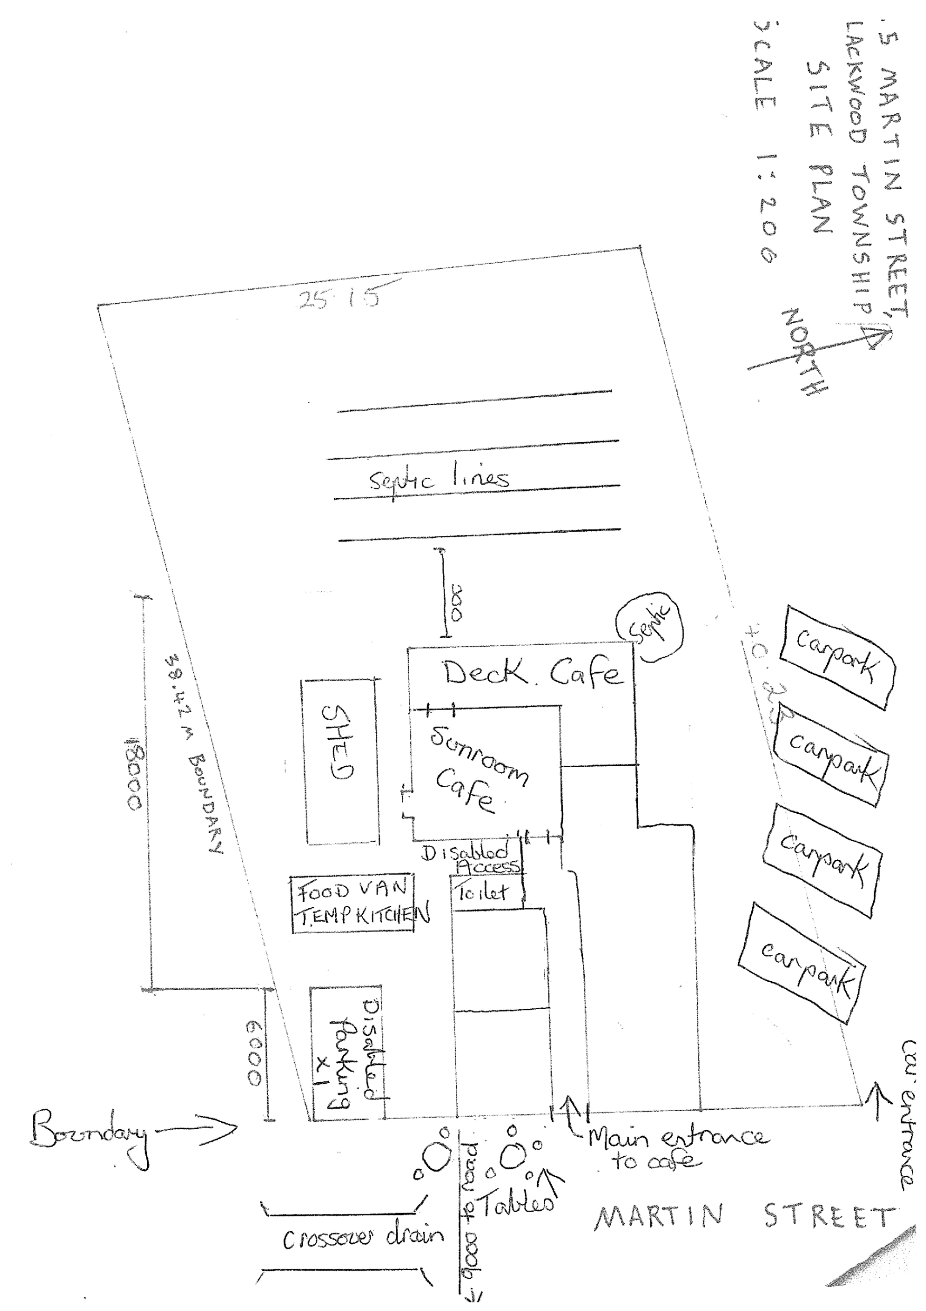

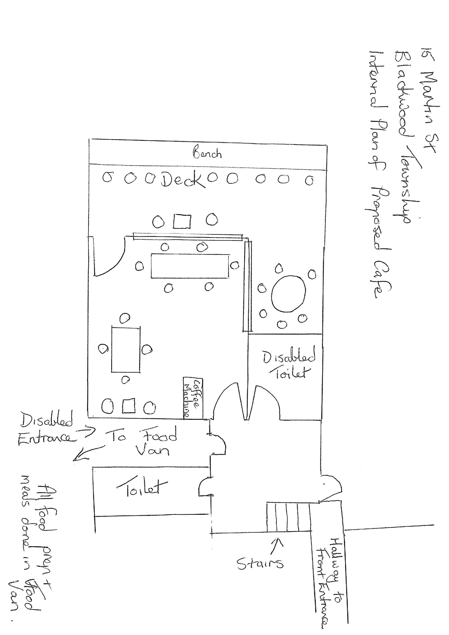

8 Update on Trends, Issues and Other Matters

9 Process Forward and Work Program

10 Update on VCAT Decisions

11 Other Business

12 Date of Next Meeting

13 Meeting Close

