AGENDA

Development Assessment Committee Meeting
Wednesday, 17 March 2021

In accordance with s.395 of the Local Government Act 2020, this meeting will not
be available for public attendance, however will be streamed live via accessing the
Council Internet site.
I hereby give notice that a Development Assessment Committee Meeting will be held on:
Date: | Wednesday, 17 March 2021
Time: | 6.00pm
Location: | Pavilion Room, Darley Civic and Community Hub
Derek Madden
Chief Executive Officer

Order Of Business
1 Opening 5
2 Present and Apologies 5
3 Recording of Meeting 5
4 Confirmation of Minutes 5
5 Matters Arising from Previous Minutes 5
6 Disclosure of Conflicts of Interests 5
7 Community Planning Reports 6
7.1 PA2020032 - Use of land for Landscape Gardening Supplies and Materials Recycling (road base, concrete, asphalt and aggregate) at Gisborne Road Merrimu 6
7.2 PA2020222 - Staged Multi-lot Subdivision and Creation of Reserves at 22, 24A and 26 Taverner Street Maddingley 29
7.3 PA2020093 - Use and Development for a Restaurant with Liquor Licence and Waiver of Bicycle Parking Facilities at 388 Bacchus Marsh Road, Bacchus Marsh 76
7.4 PA2020125 Variation of Restrictive Covenant PS 612677A at 42 Adriana Court, Rowsley 93
8 Update on Trends, Issues and Other Matters 104
9 Process Forward and Work Program 104
10 Update on VCAT Decisions 104
11 Other Business 104
12 Date of Next Meeting 104
13 Meeting Close 104

1 Opening

2 Present and Apologies

3 Recording of Meeting
In accordance with Moorabool Shire Council’s Governance Rules, the meeting will be livestreamed.

4 Confirmation of Minutes
Nil

5 Matters Arising from Previous Minutes

6 Disclosure of Conflicts of Interests
Conflict of interest laws are prescribed under the Local Government Act 2020 (the Act) and in the Local Government (Governance and Integrity) Regulations 2020 (the Regulations). Managing conflicts of interest is about ensuring the integrity and transparency of decision-making.
The conflict of interest provisions under the Act have been simplified so that they are more easily understood and more easily applied. The new conflict of interest provisions are designed to ensure relevant persons proactively consider a broader range of interests and consider those interests from the viewpoint of an impartial, fair-minded person.
Section 126 of the Act states that a Councillor has a conflict of interest if they have a general conflict of interest or a material conflict of interest. These are explained below:
- A Councillor has a general conflict of interest in a matter if an impartial, fair-minded person would consider that the member’s private interests could result in them acting in a manner that is contrary to their public duty as a Councillor.
- A Councillor has a material conflict of interest in a matter if an affected person would gain a benefit or suffer a loss depending on the outcome of the matter.
A relevant person with a conflict of interest must disclose the interest in accordance with Council’s Governance Rules and not participate in the decision-making process on the matter. This means the relevant person must exclude themselves from any discussion or vote on the matter at any Council meeting, delegated committee meeting, community asset committee meeting or, if a Councillor, any other meeting conducted under the auspices of the Council. The relevant person must also exclude themselves from any action in relation to the matter, including an action taken to implement a Council decision, for example, issuing a planning permit.

7 Community Planning Reports

7.1 PA2020032 - Use of land for Landscape Gardening Supplies and Materials Recycling (road base, concrete, asphalt and aggregate) at Gisborne Road Merrimu
Author: Victoria Mack, Statutory Planner
Authoriser: Henry Bezuidenhout, Executive Manager Community Planning & Economic Development
Attachments: Nil

Application Summary
Permit No: PA2020032
Lodgement Date: 12 February 2020
Planning Officer: Victoria Mack
Address of the land: Gisborne Road, Merrimu
Lots 1 and 2 on PS 541145E
Proposal: Use of land for landscape gardening supplies and materials recycling (road base, concrete, asphalt and aggregate)
Lot size: 32.46ha
Why is a permit required? Clause 37.01 - Change of use of land

Recommendation
That Council, having considered all matters as prescribed by the Planning and Environment Act 1987, issue a Notice of Decision to Grant a Planning Permit for the Use of land for landscape gardening supplies and materials recycling (road base, concrete, asphalt and aggregate) at Gisborne Road, Merrimu otherwise known as Lots 1 and 2 on PS 541145E subject to the following conditions:
1. Before the use starts, amended plans to the satisfaction of the Responsible Authority must be submitted to and approved by the Responsible Authority. When approved, the plans will be endorsed and will then form part of the permit. The plans must be drawn to scale with dimensions and three copies must be provided. The plans must be generally in accordance with the plans submitted with the application or some other specified plans but modified to show:
(a) Detailed site plan showing all operational areas, buildings and roadways and works areas to be contained within Lot 1 on PS 541145E and annotated that no activities relating this permit are permitted on Lot 2 on PS 541145E.
(b) A landscape plan in accordance with Condition 14.
(c) The Operational Environmental Management Plan (OEMP) must be updated within 45 days of the permit being issued to include erosion management on the site, otherwise operations on the site must cease.

Unless otherwise approved in writing by the Responsible Authority, all buildings and works are to be constructed and or undertaken in accordance with the endorsed plans to the satisfaction of the Responsible Authority prior to the commencement of the use.
2. The works site will be confined to Lot 1 on PS541145E only.
3. The hours of operation will be as follows:
(a) Rock and concrete crushing and breaking activities must only be undertaken between the hours of 7am to 6pm Monday to Friday.
(b) All other activities must only be undertaken between the hours of 7am and 6pm Monday to Saturday.
4. Unless with the written consent of the Responsible Authority, the maximum number of truck movements per day is 40.
5. Records of all truck movements are required to be logged on a daily basis and provided to the Responsible Authority for inspection upon request.
6. The owner must conduct further acoustic readings within six months of approval to ensure the use is operating in compliance with the NIRV recommended maximum noise levels, and then every 12 months thereafter. If noise levels exceed the NIRV maximum noise levels on the site, the owner will be required to cease operations until it can be demonstrated that noise levels are compliant with permit conditions and to the satisfaction of the Responsible Authority.
7. The materials recycling on the site are restricted to road base; concrete; asphalt; and aggregate and cannot be varied unless with the written consent of the Responsible Authority.
8. No fill is to be permanently disposed of on the site. Unless with the written consent of the Responsible Authority the activities permitted to be undertaken on the site are restricted to:
(a) Screen and blend topsoil.
(b) Stockpile, sort and downsize rock for retaining walls and landscape feature rocks.
(c) Storing of machinery related to the above tasks.
(d) Recycle, salvage and repurpose road base, concrete, asphalt and aggregate.
(e) Sorting of waste materials generated from civil construction. i.e. stockpile of the above, sort and dispose.
(f) Rock crushing and breaking.
(g) Concrete crushing and breaking.
Amenity
9. Any equipment used on site must not exceed noise levels in accordance with the Acoustic Engineering Report.
10. The amenity of the area must not be detrimentally affected by the use or development, through the:
(a) Transport of materials, goods or commodities to or from the land;
(b) Appearance of any building, works or materials;
(c) Emission of noise, artificial light, vibration, smell, fumes, smoke, vapour, steam, soot, ash, dust, wastewater, waste products, grit or oil;
(d) Presence of vermin; and
(e) Any other way.
11. Goods, equipment or machinery must not be stored or left exposed in a position that can be seen from the street.
12. Noise emitted from the premises must not exceed the recommended levels as set out in Noise from Industry in Regional Victoria (NIRV; EPA Publication 1411, 2011).
13. The operator must adhere to at all times to the approved OEMP.
Landscaping:
14. A landscape plan and planting plan including number and botanical name of the species to be planted must be provided. The landscaping should consist of screen plantings or mound plantings to the satisfaction of the Responsible Authority.
15. The approved landscaping must be implemented within 12 months of the date of this permit.
16. The landscaping must be maintained until the plants are established, and dead plants must be replaced to the satisfaction of the Responsible Authority.
17. Existing screen planting/treatments located adjacent to Gisborne Road frontage must not be removed.
Infrastructure:
18. Stormwater drainage from the proposed buildings and impervious surfaces must be retained and disposed of within the boundaries of the subject land to the satisfaction of the Responsible Authority. Overflows from on-site storage systems must be directed away from any wastewater disposal areas.
19. Sediment discharges must be restricted from any construction activities within the property in accordance with relevant Guidelines including Construction Techniques for Sediment Control (EPA 1991).
20. Unless otherwise approved by the Responsible Authority there must be no buildings, structures, or improvements located over any drainage pipes and easements on the property.
21. Sediment discharges must be restricted from any construction activity to within the property boundaries and any truck movements beyond the site that creates sediment discharges must comply with the Environmental Guidelines for Major Construction Sites (EPA 1995) to the satisfaction of the Responsible Authority.
22. Prior to the commencement of the development and post completion, notification including photographic evidence must be sent to Council’s Asset Services department identifying any existing damage to Council assets. Any existing works affected by the development must be fully reinstated at no cost to and to the satisfaction of the Responsible Authority.
Environment Protection Authority:
23. The permit holder must ensure that nuisance dust and/or nuisance airborne particles must not be discharged or emitted beyond the boundaries of the premises.
24. There must be no emissions of noise and/or vibrations from the premises which are detrimental to either of the following:
(a) the environment in the area around the premises.
(b) the wellbeing of persons and/or their property in the area around the premises.
25. Pollution control devices must be installed to prevent the discharge of waste to the environment and stormwater system.
26. A secondary containment system must be provided for liquids which if spilt are likely to cause pollution or pose an environmental hazard.
Department of Transport:
27. The access crossover shall be upgraded generally in accordance with the drawing Truck Access to Rural Properties Type A (VicRoads Standard Drawing SD 2064A). Specifically, the surface is to be sealed from the edge of pavement of the Bacchus Marsh-Gisborne Rd to the property gate at a minimum and drainage improved.
Operational:
28. No materials or equipment can be stored outside the designated work area identified on the endorsed Site Plan.
Permit expiry:
29. This permit will expire if one of the following circumstances applies:
(a) the development and the use are not started within two years of the date of this permit;
(b) the development is not completed within four years of the date of this permit; and
(c) 24 months after the gazettal of the rezoning of land in the Merrimu Precinct to a residential zone.

Public Consultation
Was the application advertised? | Yes.
Notices on site: | Yes, one notice.
Notice in Moorabool Newspaper: | No.
Number of objections: | Four.
Consultation meeting: | Not held; discussion has been held with some objectors and the applicant responded to objector’s concerns in writing. There was no resolution achieved.

Policy Implications
The Council Plan 2017-2021 provides as follows:
Strategic Objective 3: Stimulating Economic Development
Context 3A: Land Use Planning
The proposal is not provided for in the Council Plan 2017-2021 and can be actioned by utilising existing resources.

Victorian Charter of Human Rights & Responsibilities Act 2006
In developing this report to Council, the officer considered whether the subject matter raised any human rights issues. In particular, whether the scope of any human right established by the Victorian Charter of Human Rights and Responsibilities is in any way limited, restricted or interfered with by the recommendations contained in the report. It is considered that the subject matter does not raise any human rights issues.

Officer’s Declaration of Conflict of Interests
Under section 130 of the Local Government Act 2020, officers providing advice to Council must disclose any interests, including the type of interest.
Executive Manager – Henry Bezuidenhout
In providing this advice to Council as the Executive Manager, I have no interests to disclose in this report.
Author – Victoria Mack
In providing this advice to Council as the Author, I have no interests to disclose in this report.

Executive Summary
Application referred? | Yes, referred to the Victorian Planning Authority, Department of Transport, Environment Protection Authority, Department of Jobs, Precincts and Regions, and to Community Assets and Infrastructure and Strategic Planning.
Any issues raised in referral responses? | The Environment Protection Authority (EPA) requested further information:  • the total amount of all the different types of wastes to be accepted annually;  • an Acoustic Report that demonstrates compliance with relevant noise limits with regard to surrounding sensitive land uses; and  • an Environment Management Plan to ensure that adverse amenity impacts (dust, odour, waste) from the proposed use of the site are prevented and mitigated.  The EPA advised that should offsite impacts be identified, the applicant should provide an odour and dust impact assessment, that demonstrates compliance with the State Environment Protection Policy (Air Quality Management).
Preliminary concerns? | Proximity of the site to land under strategic investigation for residential development as part of the Merrimu Precinct Structure Plan (PSP).
Any discussions with applicant regarding concerns? | EPA’s request for further information was forwarded to the applicant.
Any changes made to the application since being lodged? | No, but further information was provided as requested by the EPA.
Brief history. | The site is currently used for landscape gardening supplies which has a permit, but also operating is materials recycling without the required approvals. This is therefore a retrospective permit in relation to the use land for materials recycling.
Previous applications for the site? | Development and Use of a Contractor's Depot – withdrawn.  Use of Land for Landscape Garden Supplies - issued 3 December 2004.  PA2006-367 Boundary Realignment and Creation of Access to RDZ1 - issued on 28 July 2007.
General summary. | The proposal is to add materials recycling (road base, concrete, asphalt and aggregate) to the existing landscaping garden supplies business.  The site is close to the area under investigation known as the Merrimu residential precinct.  Concerns have been expressed that permitting this use would impact on the future sensitive uses (residential dwellings) in the proposed Merrimu precinct.  The application was referred to all required authorities, all of which consented to the application. This included the Victorian Planning Authority which is a stakeholder in the Merrimu Precinct Structure Plan strategic investigation and Council’s Strategic Planning Unit.  The proposed use could be an appropriate use within the current Special Use Zone, subject to appropriate conditions are included on the permit to effectively manage the site and restrictions on operating hours.  The proposed conditions would limit any adverse detriment to any future development in the surrounding area. On this basis the application should be supported subject to conditions which control amenity impacts.

Summary Recommendation
That, having considered all relevant matters as required by the Planning and Environment Act 1987, Council issue a Notice of Decision to Grant a Planning Permit for the Use of land for landscape gardening supplies and materials recycling (road base, concrete, asphalt and aggregate) at Gisborne Road, Merrimu otherwise known as Lots 1 and 2 on PS 541145E subject to conditions.

Site Description
The site is irregular in shape and is located on the eastern side of Gisborne Road approximately 1.9km north of the Western Freeway and 3.2km north-east of the Bacchus Marsh township. The site has an area of 32.07ha made up of two lots.
Lot 1 on PS 541145E, on the northern part of the site, has an area of 21.83ha and contains the works area. This lot was originally used as a quarry. The works site is therefore on two levels, with the lower ‘excavated’ level, closer to the Gisborne Road, used for storage, the preparation of garden soils, sorting of salvage materials from civil construction, processing and also the rock crushing operations. The topography of the works site provides an acoustic and visual buffer to the surrounding area. The works area is not visible from Gisborne Road and to the east.
The eastern side site is elevated above the works area and is used for storage of unprocessed materials and some surplus equipment. However, the works site has limited visibility from the surrounding area.
Lot 2 on PS 541145E on the southern part of the site is vacant land and contains scattered trees and native vegetation. Lot 2 has an area of 10.24ha.
Several designated waterways dissect both lots from east to south-west flowing generally towards the Lerderderg River. There would be no impact on these waterways nor any environmental contamination because of the products processed on site and their location within the site.
To the west of the site across Gisborne Road is the Barro Properties Pty Ltd operational sand quarry. To the west south-west of the works site across Gisborne Road are two small land parcels with dwellings approximately 400m from the site.
To the south-west, the nearest dwellings are located approximately 240m and 380m respectively from the site. The works area does not visually impact upon these nearby dwellings.
To the south, the nearest dwellings from the works site in McKenzie Court are located approximately 520m to 720m from the site. The works site does not visually impact upon these nearby dwellings.
To the east, north-east and north is largely vacant land interspersed with dwellings on rural allotments variously 600m to over 1,000m from the works site.
To the north, the nearest neighbouring dwelling is approximately 940m from the site.
The Merrimu residential precinct (proposed growth area) is located to the north-east, east and south-east of the site through to Bences Road, and south and south-east to the Western Freeway and is 500m from the boundary of this site. There is also a 500m sand quarry buffer located between the site and the Merrimu precinct (proposed growth area) as shown in Figure 1 below.

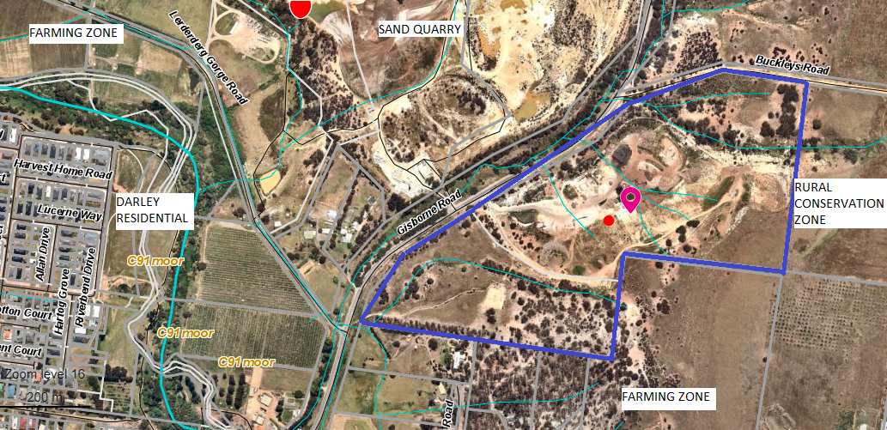
Figure 1: Aerial photograph with the site outlined blue and surrounding land uses
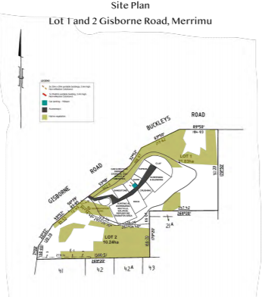
Figure 2: Site plan provided with the application showing the works area
Legend: Black – Internal Accessway, Green/Brown – Native Vegetation, Turquoise – Car Parking
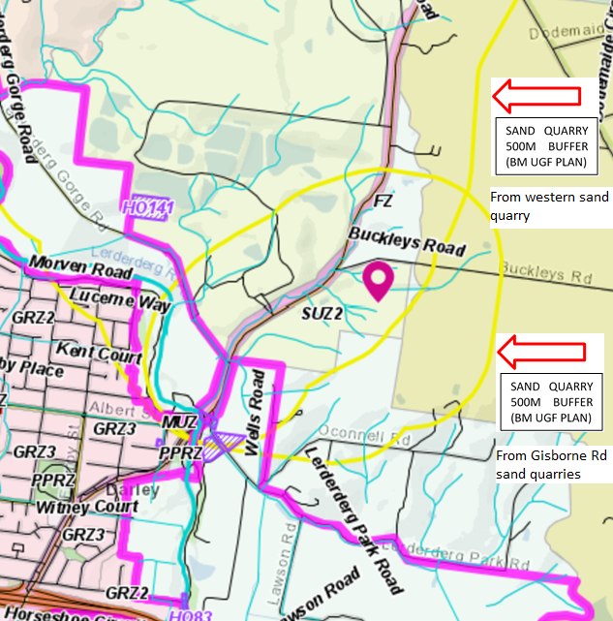
Figure 3: Site plan showing 500m Sand Quarry buffer contour lines in yellow.

Proposal
The current planning permit allows for a landscape garden supplies business with the following allowable activities to be carried out on site:
• Screen and blend topsoil.
• Stockpile, sort and downsize rock for rock retaining walls and landscape feature rocks.
• Storing of machinery related to the above tasks.
• The existing hours are 7am to 7pm Monday to Sunday.
There are three demountable buildings on the site and a car parking area.

The proposal is to amend the permitted use of the property to include the following additional uses and activities, which are currently conducted without planning approval:
• Recycle, salvage and repurpose road base, concrete, asphalt and the like;
• Transfer station for waste materials generated from civil construction. i.e. stockpile of the above, sort and dispose;
• Rock crushing and breaking;
• Concrete crushing and breaking; and
• The hours of operation proposed are between 6am to 6pm, Monday to Sunday.
The proposed use does not include any new buildings or works.
The number of staff proposed would be two to three, matching the existing operation.
There will be up to 40 truck movements per day, including existing and proposed truck movements.

History
The site was originally used as a quarry. Since 2004 the site has been operating with a permit for Landscape Gardening Supplies. Since approximately 2018 the operation has been extended to include materials recycling including rock, asphalt, concrete and aggregate and related waste materials from civil construction operations.
In August 2019, a planning enforcement investigation determined that the use of the land for materials recycling did not have a valid permit.

Public Notice
The application was notified to adjoining and surrounding landowners.

Summary of Objections
The objections received are detailed below with officer’s comments accompanying them:
Objection |  | Any Relevant Requirement
The surrounding area is made up of houses on small farms growing crops and animals. A salvage and material recycling business should be in an industrial area, not in a rural setting where there are residences close by. |  | Special Use Zone, Schedule 2.
Officer’s Response: The purpose of the Special Use Zone, Schedule 2, is to recognise, or provide, for the use and development of land for earth and energy resources industry; and to encourage interim use of the land compatible with the use and development of nearby land. The proposed use of the land for materials recycling of salvage of materials from the earth resources industry is consistent with the purposes of the zone.
Commercial rock/concrete crushing and breaking generates dust. Windy weather will raise dust from the proposed stockpiles and the site in general.  Health and my family's health will be affected. The dust from the recycling process will also be bad for the health of my vegetables/fruit trees and my animals. |  | Permit conditions.
Officer’s Response: Dust suppression has been addressed in permit conditions, specifically through the OEMP.
There will be more heavy traffic on Gisborne Road. And trucks bringing in materials for recycling will also make lots of noise and generate lots of dust. Up to 40 trucks per day, as per current usage means more noise in general on the roads to and from the site through town. That section of Gisborne Road is already hazardous with the volume and size of the trucks coming in and out of the sand quarries.  All this will affect the peace and quiet enjoyment my family and I enjoy in our home. | Permit conditions.
Officer’s Response: The truck movements per day will be controlled by permit conditions. The 40 truck movements per day includes existing and proposed activities on site.
Plant and machinery noise now at this level of operations, and a commercial operation will be far noisier than the levels measured by the consultant engaged. To operate commercially - larger crushers, conveyors etc. are required.
Officer’s Response: The acoustic report made recommendations that: “administrative measures are (to be) developed to restrict the operation of the rock crushing equipment to the NIRV ‘Day’ and ‘Evening’ Periods (i.e. 7 am to 10 pm all days). The operation can be further restricted beyond the recommendation of the acoustic report. It is recommended that the hours of operation for approval will be restricted to 7am to 6pm Monday to Friday for rock crushing; and all other operations on site between 7am and 6pm Monday to Saturday.
Hours of operation - "6am to 6pm" - 7 days a week? Why were the noise level tests not conducted over a much broader range than 6am to 6pm? We will not accept operation outside of 6am to 6pm. We will not accept any operation on Sunday.  It is noted that acoustic assessment data was based on limited recording of the data only. I do not know how much noise is going to impact in the future should this commence. | Permit conditions.
Officer’s Response: The hours and days of operation will be controlled by permit conditions. It is recommended that the hours of operation for approval will be restricted to 7am to 6pm Monday to Friday for rock crushing; and all other operations on site between 7am and 6pm Monday to Saturday.
Our property value would decrease if this proposal went ahead.
Officer’s Response: VCAT case law is that the impact of a use or development on property values is not a valid planning consideration.

There is concern regarding the lack of clarity for the use of Lot 2 in this planning submission. I would be very concerned that Lot 2 would become part of the operations and be used to store, or process, materials being brought into the business in the future. | Permit conditions.
Officer’s Response: Recommended permit conditions will restrict all operations to Lot 1.
Material is being deposited on the site for what appears to be the purpose of fill, again presumably without a permit and therefore in breach of the Planning Scheme. The images show the material has been deposited over time since approximately December 2016 and then spread out over the northern sections of the site. The areas where this is occurring are well separated from the other operations on the site and appear to have no connection. | Permit conditions.
Officer’s Response: Recommended permit conditions will restrict any material other than civil construction by-products on the site. The applicant has subsequently advised that: the material stockpiled on the northern end of the site is topsoil and mulch. This all gets utilised in our nursery grade topsoil blend. We have been undertaking some reclamation works of the batters, which is rectifying the soil erosion incurred over time. This will help the surface to revegetate and stabilise the batters.
The planning report states that no works are proposed, in direct contraction to the OEMP which recommends drainage works. The planning report also fails to address the works already undertaken in association with the use. The planning report should be corrected to accurately reflect the full extent of the uses and works that are proposed, that have been previously undertaken without a permit and are recommended by the OEMP. We are particularly concerned as to the quality of the fill and whether it is classified as ‘clean fill’. Given the fact that the applicant is already in breach of a number of permit conditions and planning regulations, we are concerned as to whether Council has examined this fill to ensure that it satisfies the requirements of the Environment Protection Act 1970. | Planning Enforcement.
Officer’s Response: This application has come about due to an investigation undertaken by Council’s Planning and Enforcement. The applicant has been given an opportunity to formalise the use which is not prohibited under the zone. The application was referred to the EPA who have the responsibility of ensuring that the fill is appropriate, and Council can work with the EPA should issues be raised.

The existing Permit includes a number of conditions that require additional facilities to be constructed at the site to ensure the uses can be undertaken. This includes Condition 1 requirements and additional requirements at subsequent conditions. It is unclear if the plans associated with Condition 1 were prepared and endorsed as required. It is evident from aerial photography that numerous permit conditions have never been satisfied. | Planning Enforcement.
Officer’s Response: This application has come about due to an investigation undertaken by Council’s Planning and Enforcement. The applicant has been given an opportunity to formalise the use which is not prohibited under the zone. If this amendment is not approved, Planning Enforcement Officers will revisit the existing permit conditions.
The proposed use would result in more significant adverse impacts than that already permitted. Additionally, the operator of the site has demonstrated a disregard for due process and existing conditions placed on the use and developed of the site by Council. Accordingly, the site presents an ongoing and unacceptable risk to Council and the community. | Planning Enforcement.
Officer’s Response: As part of the enforcement process, Council officers clarified with the applicant what the current permit allowed and once they understood that, the applicant made an application for this amendment. The original issue outlined has been addressed by this application. The additional issues raised by the objector will be further investigated.
The proposed use will generate significant noise, dust and other emissions which will have a significant detrimental impact on the amenity of the sensitive uses associated with future residential development at the adjoining Merrimu Precinct and existing residential use. The proposed use will create an unacceptable land use conflict; and is inconsistent with clause 13.07-1S which requires that wherever possible, there should be a suitable separation between land uses that reduce air amenity and sensitive land uses.
Officer’s Response: There are already buffers in place in relation to the quarries, to the west and to the east of this site.
The Merrimu Precinct is the most significant growth area in the Moorabool municipality and is in an advanced stage of planning. The future residential uses, which will provide significant benefit to the area, must be protected from the proposed remnant use of the SUZ2 land. | Victorian Planning Authority.

Officer’s Response: The Victorian Planning Authority referral response did not object to the proposal and stated that the proposal does not impact upon the future Merrimu residential area. The proposed is an appropriate use in the Special Use Zone.

Locality Map
The map below indicates the location of the subject site and the zoning of the surrounding area.
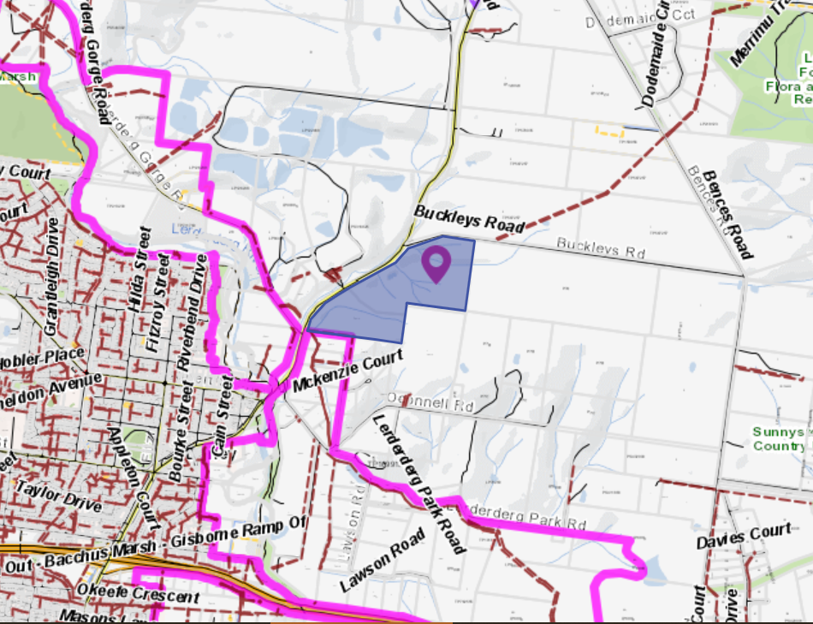
Figure 4: Locality map

Planning Scheme Provisions
Council is required to consider the Victoria Planning Provisions and give particular attention to the Planning Policy Framework (PPF), the Local Planning Policy Framework (LPPF) and the Municipal Strategic Statement (MSS).
The relevant clauses are:
• Clause 13.07-1S Land use compatibility
• Clause 13.05-1S Noise abatement
• Clause 13.06-1S Air quality management
• Clause 17.03-2S Sustainable industry
• Clause 21.04 Economic Development and Employment
• Clause 21.04-1 Key issues and influences: Industry
• Clause 21.04-4 Objective—Industry
The proposal complies with the relevant sections of the PPF and LPPF, further detailed below.
PPF | Title | Response
Clause 13.07-1S | Land use compatibility  Objective To protect community amenity, human health and safety while facilitating appropriate commercial, industrial, infrastructure or other uses with potential adverse off-site impacts. | Strategies include to:  • Ensure that use or development of land is compatible with adjoining and nearby land uses.  • Avoid locating incompatible uses in areas that may be impacted by adverse off-site impacts from commercial, industrial and other uses.  • Avoid or otherwise minimise adverse off-site impacts from commercial, industrial and other uses through land use separation, siting, building design and operational measures.  It is considered that the operation of this use can be managed with permit conditions. The land is zoned Special Use Zone and has a buffer of 500m to the Rural Conservation Zoned land to the east and Farming Zone land to the south.
LPPF
Clause 21.04-4 | Objective—Industry  To provide for a range of industrial development and activities in proximity to transport networks and existing infrastructure and avoid off-site impacts on residential amenity, environmental quality, or agricultural values. | Strategies include to:  • Support best practice management of industrial uses, to minimise offsite amenity impacts.  • Manage off-site impacts and avoid conflict with sensitive uses to realise economic development opportunities.  It is considered that the operation of this use can be managed with permit conditions.

Zone
Special Use Zone
In accordance with Clause 37.01-1 of the Moorabool Planning Scheme and Schedule 2 of the Special Use Zone relating to the Earth and Energy Resources Industry, Clause 1.0 Section 2, a permit is required to use land for materials recycling.
In accordance with Schedule 2 of Clause 37.01 a permit is required for works.

Overlays
Design and Development Overlay – Schedule 2 - Visual Amenity and Building Design
In accordance with Clause 43.02 and Schedule 2 of the Moorabool Planning Scheme a permit is not required for the use of land for materials recycling or for works. No new building works are proposed.
Relevant Policies
Bacchus Marsh Urban Growth Framework
The Bacchus Marsh Urban Growth Framework (UGF) was implemented via Planning Scheme Amendment C81 to the Moorabool Planning Scheme which was gazetted on 6 December 2018.
Clause 21.07-2 (Managing urban growth) of the planning scheme includes the following relevant objectives:
- To accommodate medium to long term residential growth within the investigation areas at Merrimu, Parwan Station and Hopetoun Park.
- To protect existing and future industrial and agribusiness land uses (particularly Maddingley Waste and Resource Recovery Hub, Darley/Coimadai sand quarries, South Maddingley industrial precinct south of Kerrs Road, Parwan Employment Precinct, Bacchus Marsh Aerodrome and Bacchus Marsh Recycled Water Plant) from the encroachment of sensitive land uses.
The subject land is identified as being part of the ‘Darley sand quarries investigation area’, as per the Bacchus Marsh UGF plan in Clause 21.07 of the Moorabool Planning Scheme. The UGF Plan shows that the subject land is separated from the Merrimu residential growth investigation area by a 500m wide buffer area. The buffer area is intended to exclude future sensitive land uses.
In regard to the ‘Darley sand quarries investigation area’, the UGF states that: “Protection of this resource in the short–medium term is critical for Melbourne. However, as the resource is exhausted (and following rehabilitation), there may be opportunities for this area to transition towards other land uses.
The permit application anticipates that the key environmental risks associated with the current and planned additional use relate to potential pollution of waterways via stormwater runoff, air quality (dust), storage and disposal of waste, noise and hazardous materials.
It is noted that the site plan indicates that the proposed use will be fully contained within Lot 1 PS 541145E. The applicant has provided an OEMP which seeks to implement risk monitoring and mitigation procedures.
The applicant has also provided an Acoustic Engineering Report which considered noise due to rock crushing and breaking, concrete crushing and breaking, sorting and stockpiling of materials, truck movements, and noise from other activities associated with the recycling, salvage and civil construction operations. The report concludes that the proposed use will comply with the Noise from Industry in Regional Victoria (NIRV) recommended noise levels at the nearest ‘noise sensitive area’ during ‘day’ and ‘evening’ periods (i.e. 7am to 10pm all days). The nearest ‘noise sensitive area’ is an existing dwelling located approximately 240m south-west of the southern boundary of the subject site.
The acoustic engineers also provided a rationale of how noise measures were undertaken. They noted that future noise emissions from the site were modelled using SoundPLAN environmental noise modelling software.
The purpose of the short-term attended noise measurements described in Table 7 of the Acoustic Engineering Report was to determine the noise level and frequency spectrum generated by the individual operations taking place on the site, so that this information could be used in the computer model. Measurements of only short duration are sufficient for this purpose if the noise level and character of the noise are steady.
The noise model was used to calculate the effective Sound Pressure Level at the nearest Noise Sensitive Area and was configured to represent a worst-case scenario, with the most significant noise sources present on site (crushing unit, screening unit and truck movements) modelled as operating at the same time and continuously. Contributions from any other quieter noise sources at the site that have not been specifically modelled would not materially increase the levels calculated by the model. The result of L_{eff} = 45 dB(A) was found to comply with the NIRV Recommended Maximum Noise Levels for the ‘Day’ and ‘Evening’ periods, and to exceed the NIRV Recommended Maximum Noise Levels for the ‘Night’ period by up to 5 dB(A).
As a result of this modelling, the acoustic engineers recommended ‘that the rock crushing operation be restricted to operate only during the NIRV ‘Day’ and ‘Evening’ periods, because this was found to be the loudest piece of equipment on site by a significant margin. When the operational noise of the site is modelled without the rock crusher, it does not exceed the NIRV ‘Night’ period Recommended Maximum Noise Level. For this reason, restricting the operating times of other items of equipment is not considered necessary’.
The Bacchus Marsh UGF plan indicates that future sensitive land uses (i.e. residential) could be located 500m from the subject land. There is some potential that the buffer could be altered in the future, if extraction of the remaining sand resource from sand quarries was demonstrated to be unviable.
The Victorian Planning Authority (VPA) is working with Moorabool Shire Council to prepare a Precinct Structure Plan (PSP) and Infrastructure Contributions Plan (ICP) for 7,200 lots and 1,800 jobs at Merrimu (Bacchus Marsh). Merrimu has potential for new residential development accommodating growth to 2042 whilst integrating landscape values. Merrimu will provide local job opportunities and will be pivotal in delivering the Eastern Link Road It is relevant that the VPA did not object to this proposal based on the Merrimu future direction in residential development.
The Merrimu Precinct is shown on the map below. The subject site and the Darley sand quarry is shown as orange hatched and is described as an investigation area where no sensitive land uses are permitted. The land to the east of the subject site is shown as purple hatched which is described as a buffer where no sensitive uses are permitted.
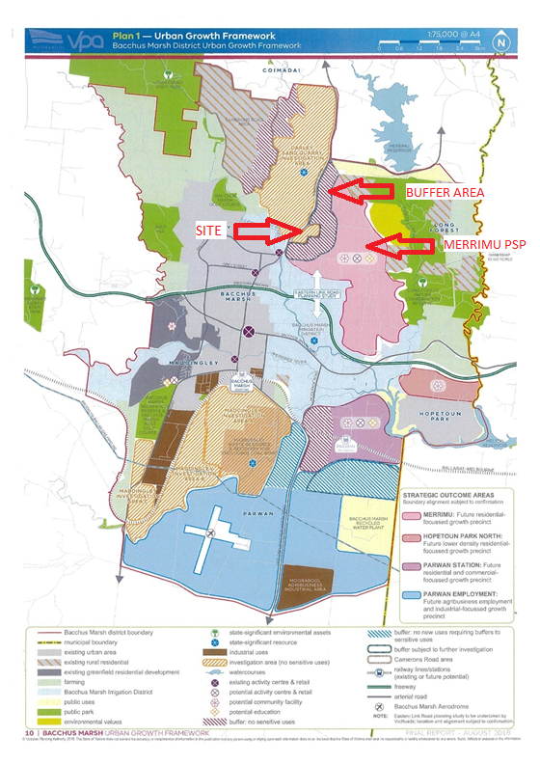Figure 5: Merrimu Precinct Plan. The 500m buffer area is for sand quarrying.

Particular Provisions
Clause 53.14 Resource Recovery
Purpose: To facilitate the establishment and expansion of a Transfer station and/or a Materials recycling facility in appropriate locations with minimal impact on the environment and amenity of the area.
Clause 53.14-1 Application
This clause applies to all land used and developed or proposed to be used and developed for:
• Transfer station; and
• Materials recycling facility.
Before deciding on an application, in addition to the Decision Guidelines of Clause 65, the Responsible Authority must consider:
• The contribution of the proposal to achieving resource recovery targets established by the Victorian Government.
• The impact of the proposal on the amenity of the surrounding area.
• The Statewide Waste and Resource Recovery Infrastructure Plan (Sustainability Victoria, 2015).
• Any Regional Waste and Resource Recovery Implementation Plan including the Metropolitan Waste and Resource Recovery Implementation Plan (Metropolitan Waste and Resource Recovery Group, 2016).
• Relevant guidelines applicable to the application including the guideline for Designing, Constructing and Operating Composting Facilities (Environmental Protection Authority, 2015), the Guide to Best Practice for Organics Recovery (Sustainability Victoria, 2009) and the Guide to Best Practice at Resource Recovery Centres (Sustainability Victoria, 2009).

Discussion
The material recycling use has been operating without the required planning approval for some time and this use is proposed to continue in the same form. No expansion is proposed on the current operation and recommended permit conditions will control the impacts of the use upon surrounding and nearby land uses.
Special Use Zone
The proposal complies with the zone provisions and the use of materials recycling is an activity which can occur in this zone. The important planning consideration is to minimise off site impacts and ensure the site operates to specific conditions including hours of operation. The use, subject to permit conditions, can operate as a viable commercial business while not adversely affecting surrounding land uses. The existing sand quarries are not affected by the change of use and the earth and resource industry can continue to expand within the Special Use Zone, Schedule 2.
Recommended permit conditions include that the works site is confined to Lot 1 on PS541145E only, which is the northern most lot. This will ensure that the works are confined to the current works area and no further expansion onto Lot 2 will be permitted. Lot 2 is mostly comprised of native vegetation and has no internal accessway road suitable for trucks. The retention of native vegetation within Lot 2 assists with the visual buffering of the site from the adjoining residential land uses.
Bacchus Marsh Urban Growth Framework/Strategic Planning Implications.
There is a 500m “sand quarry buffer” that surrounds the site. The Bacchus Marsh UGF plan indicates that future sensitive land uses (i.e. residential) could be located 500m from the subject land. However, it is important to note that the purpose of the 500m buffer is to protect the sand resource. There is no sand quarrying conducted on the subject site. This use application does not prevent or limit sensitive land uses such as future housing within the Merrimu Precinct Structure Plan. The use of the land for material recycling on this site does not undermine any of Council’s strategic directions for Merrimu.

The Victorian Planning Authority stated:
• ‘The subject site is located outside the Merrimu PSP and the PSP is only at the background report stages and is currently scheduled not to be completed before December 2021.
• The proposal is consistent with land uses envisaged in the Bacchus Marsh Urban Growth Framework Plan.
• The proposed use is consistent with the purpose of the zone and relevant particular provisions. the proposal is located outside the Merrimu PSP, is consistent with land uses envisaged in the Bacchus Marsh Urban Growth Framework Plan and the proposed use is consistent with the purpose of the zone and relevant particular provisions.’
Future residential areas within the Merrimu Structure Precinct Plan can occur and the existing buffers have the purpose to protect residential areas and restrict encroachment of sensitive uses within the buffer area.
Access:
The site will be accessed via an existing crossover in Gisborne Road. Truck access to and from the site can be conducted in a safe and convenient manner. Regional Roads Victoria has no objection the application with reference to accessing a Road Zone Category 1.
Truck movements
The number of truck movements will not increase compared to the existing operations. The applicant has advised that the maximum number of trucks movements is 40 per day. The number of truck movements will be controlled by a permit condition. Council’s Engineering Services and Regional Roads Victoria had no objection to the number of vehicle movements.
Amenity Impacts
The applicant provided an OEMP by iEnvironmental Australia dated 30 April 2020.
The Operational Environmental Management Plan (OEMP) covered a wide range of matters with details pertaining to:
• Environmental Management Framework – incident response, recording complaints, staff training and monitoring, inspection and audit; and
• Environmental Management plans – for dust and air quality management, wastewater management, general waste management, noise management, hazardous materials management; and responsibilities and impacts register.
The management plan provides a framework for the site to operate and mitigate adverse environmental impacts.

There will be several amenity permit conditions proposed for this type of land use to ensure the amenity of the surrounding area is protected from all types of emissions including noise, vibration, dust, and fumes. The operator must adhere at all times to the OEMP by iEnvironmental Australia dated 30 April 2020; and the Acoustic Engineering Report by Cogent Acoustics dated 25 June 2020.
The environmental management plan will limit off site impacts and environmental damage. Conditions require the applicant to operate the material recycling use in accordance with the environmental management plan. The OEMP addresses the amenity of surrounding land uses.
Acoustic Report/Noise Impacts
The applicant has submitted an Acoustic Engineering Report by Cogent Acoustics dated 25 June 2020 with noise readings taken on 5 May 2020. There is limited rock crushing on the site at the moment, but the machines were operated in order to gain data for the acoustic report.
The key matter covered by the acoustic report was an acoustic analysis of the environmental noise emissions to nearby residences and other sensitive areas. Noise is generated from rock crushing and breaking, concrete crushing and breaking, sorting and stockpiling materials, truck movements and noise from other activities associated with the recycling, salvage and civil construction operations.
The Acoustic Report in the Executive Summary stated that:
‘Based on the documented design and the results of numerous measurements presented in this report, it is considered that noise from the operation of equipment at the project side will comply with the NIVR Recommended Maximum Noise Levels at the nearest and potentially most-affected Noise Sensitive Areas during the ‘Day’ and ‘Evening’ Periods (i.e. 7am to 10pm all day)’.
This Report recommended that noise from the operation of equipment at the site will comply at the nearest and potentially most affected noise sensitive areas during the ‘day’ and ‘evening’ periods i.e. 7am to 10pm ‘all days’.
It is recommended that the hours of operation be restricted to 7am to 6pm Monday to Friday for rock and concrete crushing and breaking activities; and all other activities between the hours of 7am and 6pm Monday to Saturday. This permit limits the extent of amenity impacts.
There will be a requirement for the owner to conduct acoustic readings within six months of approval, to ensure the use is operating in compliance within the NIRV recommended maximum noise levels, and then every 12 months thereafter. If noise levels exceed the NIRV maximum noise levels on the site, the owner will be required to cease operations until it can be demonstrated that noise levels are compliant with permit conditions.

Visual impact
The works area is located within a former quarry located below natural ground level and is not visible from Gisborne Road and is not visible when viewed from the nearest residential dwellings. This site, due to its topography, has no visual impact to any surrounding properties. Appropriate conditions will be placed on the permit address adverse visual impacts external to the site.

Future compliance
Objectors were concerned that the use has commenced without approval and the lack of adherence to permit conditions. Council will be undertaking post approval inspections to confirm the site is operating in accordance with its conditions.

General Provisions
Clause 65 – Decision Guidelines have been considered by officers in evaluating this application.
Clause 66 – Stipulates all the relevant referral authorities to which the application must be referred.

Referrals
Authority | Response
Victorian Planning Authority  DJPR  EPA  Dept of Transport | Consent - no conditions  Consent - no conditions  Consent with conditions  Consent with conditions
Engineering Services  Strategic Planning | Consent with conditions  Consent with conditions

Financial Implications
It is not considered that the recommendation of approval represents any financial risk or implications to Council.

Risk & Occupational Health & Safety Issues
The recommendation of approval of this development does not implicate any risk or OH&S issues to Council.

Communications Strategy
Notice was undertaken for the application, in accordance with s.52 of the Planning and Environment Act 1987, and further correspondence is required to all interested parties to the application as a result of a decision in this matter. All submitters and the applicant were invited to attend this meeting and invited to address Council if required.

Options
Council could consider the following options:
- issue a Notice of Decision to Grant a Planning Permit in accordance with the recommendations contained within this report; or
- issue a Refusal to grant a Planning Permit. Council would need to consider how the proposal does not comply the Moorabool Planning Scheme.

Conclusion
It is considered that the proposed use of land for materials recycling (road base, concrete, asphalt and aggregate) is an appropriate land use subject to conditions to ensure that the operation of the site meets industry best practice for materials recycling. The proposed use complies with the Special Use Zone provisions and does not affect the existing earth and resource industry comprised of the surrounding sand quarries in Gisborne Road. The use complements the earth and resource industry and is an effective utilisation of land for a commercial business.
The proposed use does not compromise future residential growth as contained in the Merrimu Precinct Structure Plan and does not affect Council’s strategic directions for Merrimu.
On balance, the proposed use should be supported with conditions that provide for amenity protection, manage environmental risk and limit the hours of operation and the number of truck movements. It is recommended a Notice of Decision to grant a permit be issued.

7.2 PA2020222 - Staged Multi-lot Subdivision and Creation of Reserves at 22, 24A and 26 Taverner Street Maddingley
Author: Jyoti Makan, Senior Statutory Planner
Authoriser: Henry Bezuidenhout, Executive Manager Community Planning & Economic Development
Attachments: Nil

Application Summary
Permit No: PA2020222
Lodgement Date: 9 October 2020
Planning Officer: Jyoti Makan
Address of the land: 22, 24A and 26 Taverner Street, Maddingley
Proposal: Staged Multi-lot subdivision and creation of easement
Lot size: Site area: 69,975sqm
Why is a permit required? Clause 32.08-3 – General Residential Zone – Subdivide land Clause 43.01 – Heritage Overlay (HO170) – Subdivide the land and tree controls. Clause 42.01-2 – Environmental Significance Overlay – Schedule 2 and 8 – Subdivide land and control River Red Gum trees.

Recommendation
That Council, having considered all matters as prescribed by the Planning and Environment Act 1987, issue a Planning Permit PA2020222 for a Staged Multi-lot Subdivision and Creation of Reserves at 22, 24A and 26 Taverner Street, Maddingley, subject to the following conditions:
Amended plans
1. Prior to certification of a plan of subdivision, amended plans to the satisfaction of the Responsible Authority must be submitted to and approved by the Responsible Authority. When approved the plans will be endorsed and will then form part of the permit. The plans must be generally in accordance with the Taverner Street Staging and Subdivision Plan (Version 1 dated 1 October 2020) prepared by Urban Terrain but amended to show:
(a) A different coloured “park frontage road 14.5m” colour in the plan and legend as it is similar to the stage boundaries.
(b) Include way finding signage symbols.
(c) Average lot size and density levels per hectare within the land budget in the subdivision plan.
(d) A notation of the plan indicating Section 173 Agreement required to include Conservation Management, detailed Arborist Assessment and Tree Protection Plan to address the retention and management of all open spaces across the site.
(e) Show the width of temporary turning areas fronting 22 Taverner Street at Lots 15 and 87 for ease of access.
(f) Inclusion of the Fisken Street Tree Reserve into Stage 1.
(g) Lots 1 – 8 be shown as a superlot with a maximum yield of eight dwellings.
(h) Lots 9-14 be identified as a superlot with a maximum yield of six dwellings.
(i) Lots 59-72 be identified as a superlot with a maximum yield of 14 dwellings.
(j) Lots 87-92 be identified as a superlot with a maximum yield of six dwellings.
(k) Lots 73-86 be identified as a superlot with a maximum yield of 14 dwellings.
Endorsed plans
2. The formal plan of subdivision lodged for certification must be generally in accordance with the endorsed plan and must not be modified except to comply with statutory requirements or with the written consent of the Responsible Authority.
Subdivision
3. Prior to certification, the plan of subdivision submitted for certification must include the following:
Creation of Restriction: All lots to be burdened and benefitted by the restriction. Description of the Restriction: No development to be constructed or allowed to remain on a lot unless in complete compliance with the approved Taverner Street Development Plan Key Design Elements.
General Conditions
4. All staging must be provided in numerical sequence, unless otherwise agreed in writing by the Responsible Authority.
5. All Infrastructure must be constructed in sequence and as identified for construction in the approved Taverner Street Development Plan, unless otherwise agreed in writing by the Responsible Authority.
6. Development staging must provide for the timely provision and delivery of:
(a) Connector streets.
(b) Street links between properties, constructed to the property boundary.
(c) Connection of the on-road and off-road pedestrian and bicycle network.
7. Utility service substations, kiosk sites and the like must not be located on any land identified as public open space or land to be used for any municipal purpose unless otherwise agreed by the Responsible Authority.
8. Before the issue of a Statement of Compliance for any stage of the subdivision under the Subdivision Act 1988, operable hydrants must be provided either above or below ground, with a maximum distance between hydrants and the rear of all building envelopes/the rear of lots of 120m and be no more than 200m apart, to the satisfaction of the Responsible Authority.

Environmental Audit
9. Before the construction or carrying out of buildings and works in association with a sensitive use (residential use, childcare centre, pre-school centre or primary school) commences, either:
  - a certificate of environmental audit must be issued for the land in accordance with Part IXD of the Environment Protection Act 1970, or
  - an environmental auditor appointed under the Environment Protection Act 1970 must make a statement in accordance with Part IXD of that Act that the environmental conditions of the land are suitable for the sensitive use.
10. Where there are conditions on a Statement of Environmental Audit that require significant ongoing maintenance and/or monitoring, the applicant must enter into a Section 173 Agreement under the Planning and Environment Act 1987. The Agreement must be executed on title prior to the commencement of the use and prior to the issue of a Statement of Compliance under the Subdivision Act 1988. The applicant must meet all costs associated with drafting and execution of the Agreement, including those incurred by the Responsible Authority.
Arboricultural Assessment and Tree Protection
11. Prior to any works commencing, an Arboricultural Impact Assessment and Tree Protection Plan must be prepared to the satisfaction of the Responsible Authority. The Tree Protection Plan must be in accordance with Australian Standard AS4970-2009 ‘Protection of Trees on Development Sites’, by a professional with no less than AQFL5 in Arboriculture.
The Arboricultural Impact Assessment and Tree Protection Plan shall include (in table format or similar):
(a) Unique tree identification number.
(b) Botanical and common name.
(c) Physical dimensions of height, canopy spread trunk diameter (DBH).
(d) An assessment of tree condition, health, age and useful life expectancy.
(e) Tree removal plan showing all trees being removed.
(f) Determination of the Tree Protection Zone (TPZ) and Structural Root Zone (SRZ) in accordance with AS4970-2019).
(g) The encroachment percentage for any works within the Tree Protection Zone of any tree.
(h) The report must contain an existing condition plan and an indicative proposed development/subdivision plan, to scale, showing the locations of the trees (referencing the unique tree identification number). The plans must show the SRZ and TPZ of all trees. The plan must also indicate the areas of encroachment from the proposal from any building or driveway, or any areas of significant level changes (cut and fill).
(i) The report must provide a detailed section describing the impacts of the development on the assessed trees. The assessment must detail how the impact, including impact on heritage values, may be minimised.
(j) The report must include a suitable Tree Protection / Retention Plan for all trees to be retained. These must be specific for each tree identified for retention and or protection and must include to the satisfaction of the Responsible Authority.
(k) The Tree Protection Zone (TPZ) and Structural Root Zone (SRZ) calculated in accordance with AS4970-2009, for all trees to be protected on site or neighbouring properties where the Tree Protection Zone falls partially within the subject site. This must be shown on a plan.
(l) Tree protection fencing, or ground protection where required, provided in accordance with AS4970-2009.
(m) All tree protection and management actions required during each stage of the development of the relevant stage (demolition, construction and landscaping).
(n) How excavation impacts, including soil level changes, within the TPZ of trees to be retained will be managed or minimised.
(o) Any pruning to be undertaken being in accordance with AS4373-2007-Pruning of Amenity Trees.
(p) Appropriate signage on any tree protection fencing.
(q) Any non-destructive root investigation previously undertaken to determine the location and distribution of roots of trees nominated on the Tree Protection Plans.
(r) Where known, proposed footings and construction methods for any buildings or structures (including but not limited to, driveways, paths retaining walls or other hard infrastructure) within the TPZs nominated on the Tree Protection.
(s) Where known, details of suitable driveway/path materials and construction methods (i.e. permeable paving above grade) and the timing of the works within the tree protection zones.
(t) A watering regime during construction and method of protection of exposed roots.
(u) A maintenance regime following the completion of development and timing of the final inspection so the tree protection fencing can be removed.
(v) Stages of development at which inspections are required to ensure tree protection measures are adhered to must be specified.
(w) Appropriate methods of certification by a suitably qualified arborist of the required tree protection measures during the development including details of site visits, actions and photographic evidence.
(x) The process that will be followed if any damaged occurs to a protected tree, including reporting of damage for privately or publicly owned trees.
(y) Any other measures required to demonstrate the successful ongoing retention and viability during, and post-construction of any trees identified on the Tree Protection Plan.
(z) How tree retention, removal and protection will enhance and contribute to the heritage values of the site.
(aa) How tree retention, removal and protection will enhance and contribute to the future public open space uses on the site.

Note: The Arboricultural Impact Assessment and Tree Protection Plan will be prepared in connection with and referenced throughout the Conservation Management Plan required under this permit.
12. All protection measures identified in the endorsed Arboricultural Impact Assessment and Protection Plan must be implemented, and development works undertaken on the land in accordance with that plan, to the satisfaction of the Responsible Authority. Any damaged tree must be inspected by the Project Arborist immediately and actions must be undertaken to rectify damage. All actions are to be documented by the Project Arborist.
13. Before the development starts, including demolition or removal of vegetation, the name and contact details of the project Arborist responsible for implementing the Arboricultural Impact Assessment and Protection Plan must be submitted to the Responsible Authority, or included on the Arboricultural Impact Assessment and Tree Protection Plan.
14. The Tree Protection Plan must be available on site at commencement of and during works. All visitors or workers induced onto the site should include a siting and explanation of the Tree Protection Plan.
15. Prior to works commencing, all existing dwellings and outbuildings within the permit area must be removed without impacting of trees retained as part of the Conservation Management Plan and Tree Protection Plan.
Conservation Management Plan
16. Prior to the commencement of any works to the land covered by the Heritage Overlay (HO170), associated with the permit, including any vegetation removal or works required by other authorities, a Conservation Management Plan must be submitted to and approved by the Responsible Authority. When approved, the plan will be endorsed and will then form part of the permit. The plan must adhere to the guidance ‘Conservation Management Plans: Managing Heritage Places – A Guide’ (Heritage Council of Victoria, 2010), and be prepared by suitably qualified professionals with experience in arboriculture and landscape heritage management. The Conservation Management Plan be submitted electronically in PDF and address to the satisfaction of the Responsible Authority:
17. The Conservation Management Plan must address all the land covered by Heritage Overlay Schedule HO170 in the Moorabool Planning Scheme plus additional relevant surrounding land, including the land at 24 and 24a Taverner Street.
18. Works associated with the Conservation Management Plan must commence within three months of its endorsement by Council.
19. The Conservation Management Plan must include an assessment of the heritage values of the whole site against relevant criteria and thresholds and provide a revised place citation and curtilage.
(a) The tree survey data must include (in a table format or similar).
(b) Unique tree identification number.
(c) Botanical and common name:
(i) physical dimensions of height, canopy spread trunk diameter (DBH).
(ii) an assessment of tree condition, health, age and useful life expectancy.

(iii) determination of the Tree Protection Zone (TPZ) and Structural Root Zone (SRZ) in accordance with AS4970-2019).
(iv) tree dimensions (including height, diameter at breast height (DBH) and canopy spread).
(v) must be assessed with regard to its relative heritage value. This includes the level of significance to the site, as well as independent of any association with the site (for instance, based on the size, age).
(d) The Conservation Management Plan must address matters relating to immediate-, short-, medium- and long-term term conservation, management and remedial works to the heritage trees and other elements of the site, as necessary. This may include (but is not limited to):
(i) remedial works to significant trees.
(ii) conservation measures to be undertaken to increase the useful life expectancy of significant trees.
(iii) pest and disease control.
(iv) management of fruit drop on an annual basis.
(v) a staged replanting plan, which must include the planned propagation of new trees from the existing plant material on site.
(vi) works to manage the trees in the short, medium and long term.
(e) The Conservation Management Plan must also address the subdivision of the site and any development on or around the site, including but not limited to:
(i) Relevant design recommendations to protect and enhance the heritage elements such as fencing and building envelopes for lots adjacent to significant trees.
(ii) Location and design of roads abutting the heritage park and significant trees.
(iii) Building envelopes of residential lots immediately adjacent to significant trees or the heritage park.
(iv) Vegetation retention / removal. and
(v) Other matters as necessary, to the satisfaction of the Responsible Authority.
20. The Conservation Management Plan will include a Heritage Interpretation Plan prepared by a suitably qualified consultant, submitted to and approved by the Responsible Authority. The Heritage Interpretation Plan must:
(a) adhere to the guidance set out in the Australia ICOMOS Practice Note ‘Interpretation’ (November 2013).
(b) identify appropriate Interpretation Policy to be included in the Policy Section of the Conservation Management Plan.
(c) identify and document significant themes and stories about the place.
(d) analyse the place to identify interpretive opportunities and issues.
(e) profile the likely audiences for the interpretive activities.
(f) identify and present how these themes and stories will be presented.
(g) provide a draft interpretation board/s or other interpretation medium to be placed into the heritage park and indicate an appropriate location/s on a site plan.
Section 173 Agreement – Conservation Management Plan
21. Prior to commencement of works, the owner must enter into an agreement under Section 173 of the Planning and Environment Act 1987 with the Responsible Authority which requires that:
(a) The owner must comply with and implement the recommendations of the following documents approved under the is planning permit (as amended or referred to in any subsequent permit) to the satisfaction of the Responsible Authority:
(i) Conservation Management Plan.
(ii) Arboricultural Impact Assessment and Tree Protection Plan.
22. The owner/applicant must pay the Responsible Authority’s reasonable costs for the preparation, execution and registration of the Section 173 Agreement.
Remediation Action Plan
23. Prior to commencement of works, and after the tree protection plan is approved by Council and implemented, any required works in a Remediation Action Plan must be conducted prior to the construction of residential lots or any other sensitive use.
Tree Protection Zones
24. Prior to the commencement of works, tree protection fencing must be erected around the Tree Protection Zone of all trees to be retained on or adjacent to works (including street trees) prior to the commencement of works. The fence must remain in place until all works are completed to the satisfaction of the Responsible Authority.
All tree protection zones, and fencing must comply with AS 4970-2009 Protection Trees on Development Sites and Moorabool Shire Tree Protection Guidelines to the satisfaction of the Responsible Authority.
Except with the written consent of the Responsible Authority, within the tree protection zone, the following are prohibited:
(a) vehicular or pedestrian access.
(b) trenching or soil excavation.
(c) storage or dumping of any soils, materials, equipment, vehicles, machinery or waste products.
(d) entry and exit pits for underground services; and
(e) any other actions or activities that may result in adverse impacts to retained native vegetation.
25. Any encroachment into the Tree Protection Zone will condition a requirement to submit a Tree Management Plan as per AS4970-2009 to the satisfaction of the Responsible Authority.

Open Space Transfer
26. Land required for open space as a local or district park as set out in the approved Taverner Street Development Plan must be transferred to or vested in Council at no cost to Council and to the satisfaction of Council.
Open Space Delivery
27. All Open Space must be finished to a standard that satisfies the requirements of the Responsible Authority as per the adopted Landscape Design Manual prior to the transfer of the open space to Council.
Native Vegetation Offset
28. Prior to Statement of Compliance of any stage, a native vegetation offset is required as follows:
(a) Offset type: General.
(b) Offset Amount: 0.003 general habitat units.
(c) Offset attributes:
(i) Offset must be within Port Phillip and Westernport Catchment Management Authority CMA or Moorabool Shire Council.
(ii) Offset must have a minimum strategic biodiversity value of 0.216.
(iii) 0.0 large tree.
Offsets can be either.
29. First party – located on land owned by the landholder who is proposing to remove the native vegetation.
30. Third party – located on land owned by a third party.
The offsets that are required to account for vegetation loss on site are to be achieved by creating third party offsets off-site. The required offsets are available from multiple brokers, evidence of which is provided in the quote in Appendix 5 of the Flora and Fauna Assessment, Project Number: VMB2652, dated January 2020, prepared by Practical Ecology.
31. Prior to Statement of Compliance, evidence that the required offset has been secured must be provided to the satisfaction of the Responsible Authority. This evidence is one or both of the following:
(a) An established first party offset site including a security agreement signed by both parties, and a management plan detailing the 10-year management actions and ongoing management of the site and/or
(b) A Credit extract allocated to the permit from the Native Vegetation Credit Register.

Tree Removal Works
32. Prior to any works commencing, the tree removal works, erosion conduction, tree protection zones, weed management, vehicle hygiene, fauna salvage and relocation must be conducted in accordance with the Flora and Fauna Assessment, Native Vegetation Impact Assessment and Environmental Management Plan, dated January 2020, prepared by Practical Ecology.
Updated Flora and Fauna Assessment
33. Prior to commencement of any works associated with a permit, an updated Flora and Fauna Assessment that assesses the development plan area in the spring must be undertaken to confirm that there has been no significant change to the flora and fauna values, unless otherwise agreed by the Responsible Authority.
Fauna Management Plan
34. Prior to Statement of Compliance of Stage 1, a Fauna Management Plan, as required by the Flora and Fauna Assessment, Native Vegetation Impact Assessment and Environmental Management Plan, dated January 2020, prepared by Practical Ecology, must be submitted to and approved by Council detailing the following:
(a) Tree Protection Zones and Fencing locations included on a site plan.
(b) Ensure Tree Protection fencing is erected prior to any vegetation removal or fauna salvage.
(c) Fauna salvage must be completed by a qualified zoologist /wildlife handler.
(d) A copy of a fauna salvage/tree removal plan must be followed and available on site.
(e) Management of wildlife to prevent harm or injury.
(f) Steps to manage wildlife during construction.
(g) Retention of Habitat Zone 1 and Habitat Zone 3 as required within the Flora and Fauna Assessment dated January 2020 prepared by Practical Ecology.
Site Environmental Management Plan
35. Prior to commencement of any works associated with a permit, a Site Environmental Management Plan (SEMP), in accordance with the Landscape Plans, Conservation Management Plan and Tree Protection Plan must be prepared approved by the Responsible Authority and will then form part of the permit. The SEMP applies to all land works approved in this Permit up to where public land is handed over (and accepted) by the relevant authority and the remainder is completely in private ownership. This SEMP must include but not limited to the following:
(a) Access to the site must always be made available for Council representatives to monitor the implementation of the SEMP.
(b) Prior to the commencement of works, contractors must be inducted into the SEMP and all flora and fauna conservation requirements.

(c) Prior to commencement of works, the works zone must be enclosed by secure and obvious temporary fencing. The work zone fence must remain in place until works are completed. Fill machinery and building materials must not be placed outside of the works zone.
(d) All litter and building waste must be contained on the site and must not be allowed to leave the site until the time it is correctly disposed of.
(e) Remnant trees that are being retained in public open space and reserves must have bollards placed around the Tree Protection Zone (as defined by Australian Standard AS4970). The area under the tree must be mulched and planted with appropriate ground cover species to the satisfaction of the Responsible Authority.
(f) Protection and Management conditions of the Aboriginal Cultural Heritage Place Taverner Street provided in the approved CHMP 15953 which must include (in part):
(i) Management and protection measures of the Aboriginal Cultural Heritage Plan (ACHP) – Taverner Street, Maddingley LDAD1 (7722-1199 [VAHR]) – a low density artefact comprised of eight stone artefacts located in the south-west, north-west and north-east quadrants as shown in the CHMP 15953.
Werribee Corridor Management Plan
36. Prior to commencement of any works associated with a permit, Werribee River Corridor Management Plan must be submitted that:
(a) Is in accordance with all requirements from Melbourne Water.
(b) Addresses all of the Taverner Street Development Plan land within the Werribee River Corridor.
(c) Provides guidance for how the Landscape Plan should consider the incorporation of this area into the open space network of the development plan area.
(d) Provides specific detail relating to the recommended number of each species for revegetation, density of plantings, and location of the species.
Weed Control
37. Any weed infestations resulting from soil disturbance and/or the importation of sand, gravel and other material must be controlled during the construction period to ensure that there is no weed spread outside of the subject site to the satisfaction of the Responsible Authority.
38. Prior to Statement of Compliance all noxious weeds on the land must be eradicated to the satisfaction of the Responsible Authority.
Sewer Pump Station
39. Prior to commencement of any works, plans for the sewer pump station must be provided that illustrate how any components of the pump station that are visible will be screened. The plans should include design elements to integrate them into the surrounding wetland area and streetscape. This should be in the form of screening or landscaping utilising materials, colours and plant species taken from the immediate surrounds. The plans must be approved by the Responsible Authority.
Landscape Masterplan
40. Prior to the plan of subdivision being certified for the first stage of the subdivision under the Subdivision Act 1988, a landscape master plan for the whole of the development must be prepared by an experienced landscape architect, landscape designer or suitably qualified person, in accordance with the approved Taverner Street Development Plan, the Arboricultural Impact Assessment and Tree Protection Plan and Conservation Management Plan, to the satisfaction of the Responsible Authority.
41. The landscape master plan must be drawn to a scale appropriate for the detail to be shown, indicating all relevant concept layouts and sections/elevations, including but not limited to:
(a) A Landscape Design Statement addressing issues such as design intent; design principles; response to heritage and environment.
(b) A Landscaping Theming Document consisting of graphical concepts depicting the landscape character including the surface finishes and materials, fencing, retaining walls and planting palette.
(c) Tree removal plan
(d) The location of open space.
(e) Way finding and heritage signage
(f) Entrance treatments and signage if applicable.
(g) Site connectivity and relationship to existing context.
(h) Retention of Habitat Zone 1 and Habitat Zone 3 as required within the Flora and Fauna Assessment dated January 2020 prepared by Practical Ecology.
(i) Plans must reference the relevant standards and details as per the ‘Moorabool Landscape Design Manual (LDM).
When approved, the plan will be endorsed and will then form part of the permit.
Detailed Landscape Plans
42. Prior to certification, for each stage of the subdivision, a detailed landscape plan and plant schedule for that stage prepared by a person suitably qualified or experienced in landscape design to the satisfaction of the Responsible Authority must be submitted to and approved by the Responsible Authority.
The plan must show the proposed landscape and plant schedule for all public open space areas, including streetscapes, wetlands, parkland water retention areas, buffer zones, service corridors, areas adjacent to the freeway and community uses and be generally in accordance with the Landscape Master Plan. The plan must be drawn to scale with dimensions, indicating all relevant details, sections/elevations and dimensions and all relevant specifications (including but not limited to):
(a) The details and locations of all landscaping works.
(b) Mature tree landscaping along the Fisken Street and Taverner Street permit area.

(c) A detailed plant schedule including all proposed tree, shrub, groundcover and climbing plant species, botanical names, common names, pot sizes, sizes at maturity, plant densities and quantities of each plant with reference to the relevant Australian Standards and NATSPECS.
(d) Detailed planting and construction drawings including site contours and any proposed changes to existing levels including any structural elements such as retaining walls.
(e) Additional supporting information, such as certified structural designs or building forms.
(f) Details and locations of the proposed surface finishes of pathways and driveways including slip resistance.
(g) Existing vegetation that is approved to be retained; and
(h) Retention of Habitat Zone 1 and Habitat Zone 3 as required within the Flora and Fauna Assessment dated January 2020 prepared by Practical Ecology.
(i) Plans must reference the relevant standards and details as per the ‘Moorabool Landscape Design Manual (LDM).
(j) Include detailed landscaping for the Heritage Park, all open space, tree reserves and Werribee Corridor (to include all Melbourne Water’s requirements).
All planted trees must be in accordance with the LDM. Plant species selection for the landscaping of the tree reserve must contribute to habitat for indigenous fauna species, animals and birds that use trees as habitat. The plant species selected must be in accordance with the indigenous Ecological Vegetation Class (EVC). All species selected must be to the satisfaction of the Responsible Authority.
Landscape Maintenance
43. All open space reserves created as part of any subdivision, including landscaping, heritage trees and drainage assets, must be maintained to the satisfaction of the Responsible Authority, as per the LDM, before the Council takes over maintenance responsibilities.
Landscape Completion
44. Before the issue of a Statement of Compliance for any stage of the subdivision under the Subdivision Act 1988, or by any later date that is approved in writing by the Responsible Authority, the landscape works shown on the endorsed landscape plans must be carried out and completed to the satisfaction of the Responsible Authority.
Cultural Heritage Management Plan
45. All recommendations, management conditions and requirements set out in the Cultural Heritage Management Plan (CHMP) AV Management Plan Number: 15953 must be complied with. Failure to comply with the CHMP conditions is an offence under Section 67A of the Aboriginal Heritage Act 2006.
46. A copy of the CHMP must be held on site at all times. Table 1 – Compliance checklist of the Cultural Heritage Management Plan (CHMP) AV Management Plan Number: 15953 must be verified by the site manager.
Contributions
47. Prior to Statement of Compliance of Stage 1, land required for road widening including right of way flaring for the ultimate design of any intersection within an existing or proposed local road must be transferred to or vested in Council at no cost to Council, in accordance with the approved Taverner Street Development Plan and to the satisfaction of the Responsible Authority.
48. Prior to the statement of compliance for Stage 1, the applicant or owner must pay the Responsible Authority a sum of equivalent to 0.3% of the site value of all the land in the subdivision for public open space purposes in accordance with the section 18 of the Subdivision Act 1988. The permit holder/developer must pay the reasonable costs of Council in having the land valued for this purpose.
Telecommunications
49. Before the issue of a Statement of Compliance for any stage of the subdivision under the Subdivision Act 1988, the owner of the land must provide written confirmation from:
(a) telecommunications network or service provider that all lots are connected to or are ready for connection to telecommunications services in accordance with the provider’s requirements and relevant legislation at the time; and
(b) a suitably qualified person that fibre ready telecommunication facilities have been provided in accordance with any industry specifications or any standards set by the Australian Communications and Media Authority, unless the applicant can demonstrate that the land is in an area where the National Broadband Network will not be provided by optical fibre.
Development Plan Overlay – Schedule 4 Conditions
50. Prior to any works commencing on the land a "Construction Management Plan" must be prepared to the satisfaction and approval of the Responsible Authority, detailing how the developer will manage the environmental and construction issues associated with the development. This Plan must address, but not be limited to the following:
(a) How the land is to be accessed during the construction period.
(b) All measures to be introduced to ensure that construction on the land does not impact on any vegetation to be retained.
(c) All measures to be introduced to minimise soil erosion and runoff.
(d) Details relating to the storage of all plant and equipment during the construction period.
(e) Measures to be implemented to ensure the containment of dust, dirt and mud within the site and method and frequency of clean up procedures in the event of build-up of matter outside of the site.
51. Easements in favour of Southern Rural Water must be maintained and no buildings are to be constructed within those easements without the consent of Southern Rural Water.
52. Where vehicle access is provided onto land from Boyes Close, de-commissioning and replacement of irrigation infrastructure will be required. The construction of a road along the Werribee River environs must be carried out by the developers of the land to the following standards, unless otherwise agreed in writing by the Responsible Authority:
(a) 10.1m wide sealed pavement.
(b) Concrete footpath and kerb and channel on the northern side of the road.
(c) 2.3m wide indented parking bays on the southern side of the road.
(d) Any additional traffic management measures required by the Responsible Authority.
Environmental Health
53. All proposed dwellings must be connected to the reticulated sewer.
54. If dust is created by construction and/or demolition works, appropriate measures must be immediately taken to suppress dust movement off site.
55. Noise must be adequately controlled during construction and development approved under this permit. Noise must comply with the Environment Protection Act 1970, the State Environment Protection Policy (Control of noise from commerce, industry and trade) No. N-1 and the Public Health & Wellbeing Act 2008.
Infrastructure
56. Unless otherwise approved by the Responsible Authority there must be no buildings, structures, or improvements located over any drainage pipes and easements on the property.
57. Prior to the construction commencing, engineering drainage plans and detailed computations must be submitted and approved by the Responsible Authority. The drainage plans are to be undertake in accordance with the Infrastructure Design Manual and Australian Rainfall and Runoff 2016 and shall incorporate (but not limited to) the following:
(a) The development as a whole must be self-draining to the legal point of discharge.
(b) All drainage courses within the development must pass through easements or reserves shown on the plan of subdivision.
(c) All outfall drainage passing through other land must be provided at the cost of the developer and be constructed within easements shown on the plan of subdivision.
(d) Volume of water discharging from the development in a 10% AEP storm shall not exceed the 20% AEP storm prior to development. Peak flow must be controlled by the use of a detention system located and constructed to the satisfaction of the Responsible Authority.
(e) Each lot must be provided with a stormwater legal point of discharge at the low point of the lot, to the satisfaction of the Responsible Authority.
(f) Stormwater runoff must meet the “Urban Stormwater Best Practice Environmental Management Guidelines (CSIRO 1999)”.
(g) Flow paths of the 1% AEP storm must be determined, and the subdivision designed so that no property is inundated by such a storm. The flow paths must be indicated on the engineering plans.
(h) The drainage system must be designed to include provision to intercept litter.

The drainage design must take into account any applicable drainage or flood management strategy.
58. Prior to the approval of the Detailed Design, the internal and external road network layout (including all associated infrastructure) must be designed and constructed to the standards detailed in the Infrastructure Design Manual, to the satisfaction of the Responsible Authority. A justification to the satisfaction of the Responsible Authority is to be provided to any variation/discrepancy to the Infrastructure Design Manual.
59. Design computations for all road pavement construction, based on a geotechnical investigation of the site, must be prepared and submitted to the Responsible Authority for approval prior to the detailed design being issued.
60. Plans and specifications of all road, traffic and drainage works must be prepared and submitted to the Responsible Authority for approval prior to the commencement of such works and all such works must be carried out in accordance with the approved plans to the satisfaction of the Responsible Authority. The upgrade of Fisken Street is to form part of Stage 1 of the Development and completed prior to the issue of the Statement of Compliance.
61. Traffic management treatments must be provided in the form of linemarking, signage, intersection upgrades external to the site as required and pavement markers at intersections and vehicle turning areas, to the satisfaction of the Responsible Authority and approved prior to construction commencing.
62. Prior to certification of the plan of subdivision, and endorsement of the Tree Protection Plan, a Functional Layout Plan must be submitted and approved by the Responsible Authority. The Functional Layout Plan is to include all internal roads proposed to be constructed as well as Taverner Street and Fisken Street frontages. Following the approval of the Functional Layout plan(s) by the Responsible Authority, a submission can be made to Council for the Detailed Design. The submission is to include but not limited to all construction issued plans in line with the Infrastructure design manual, all appropriate reports and investigations, a completed checklist from the infrastructure design manual and any other documents/information to support the Detailed Drainage design.
63. Prior to the works commencing on the development, notification including photographic evidence must be sent to Council’s Infrastructure Services department identifying any existing damage to council assets. Any existing works affected by the development must be fully reinstated at no cost to and to the satisfaction of the Responsible Authority. If photographic evidence cannot be provided, then the damage must be fully reinstated at no cost to and to the satisfaction of the Responsibility Authority.
64. Prior to the submission of the Detailed Design, a “Stormwater Management Strategy” must be prepared and submitted to the responsible authority for approval, based on the objectives and standards of the Moorabool Planning Scheme and the “Urban Stormwater Best Practice Environmental Management Guidelines – CSIRO 1999”. The Strategy must:
(a) Encompass the entire area of the development.
(b) Propose techniques to manage the quantity and quality of stormwater emanating from the site during construction and after completion of the development in accordance with the Best Practice Guidelines.
(c) Provide for outfall drainage from the site connecting to an approved discharge point.
(d) Propose techniques to manage the overland flow paths within the development for the 1% AEP storm for the catchment.
(e) If additional outfall drainage or upgrading of the existing drainage network is required.
Once approved, the stormwater strategy will form the basis for preparation of detail design documentation of a stormwater system for the development.
65. An Environmental/Construction Management Plan for the construction works must be submitted to the and approved by the Responsible Authority prior to the commencement of construction. All works must be performed in accordance with the approved Environmental/Construction Management Plan. The Environmental/Construction Management Plan shall include (but not limited to the following items):
(a) Details of Site security.
(b) Off Street parking for employees and site access for construction vehicles and equipment.
(c) Public safety in the event that the construction site is adjacent to public active areas.
(d) Provisions for loading and unloading.
(e) Ensuring the safety of members of the public and Council staff who may have occasion to enter and be in attendance on the site.
(f) Details of management of stormwater run-off and the propose sediment and erosion control measures including the location of any rubble grids.
(g) Details of any air and dust management.
(h) Details of noise and vibration controls.
(i) Provision of Traffic Management Plan (TMP) and Traffic Control Plans (TCP).
(j) Proposed start and completion time of construction activities including the delivery of material to site.
66. Sediment discharges must be restricted from any construction activities within the property in accordance with the relevant Guidelines including “Construction Techniques for Sediment Control” (EPA 1991) and “Environmental Guidelines for Major Construction Sites” (EPA 1995).
67. No work shall commence onsite until all approvals are obtained by the relevant authority. The approvals include, but not limited to:
(a) Detailed Designs in the form of Stamped for Construction Plans.
(b) Approved Environmental Management Plan.
(c) Approved Construction Management Plan (which is to include TMP, PMP).
(d) Any other approvals forming part of other planning Certificate conditions.
68. A copy of all approved documents must be kept onsite at all times and consent from the relevant authority is required for any departure to the approvals.
69. Prior to the issue of Statement of Compliance for each stage, street lighting must be provided in accordance with the requirements of AS1158 – Lighting for Roads and Public Places, to the satisfaction of the Responsible Authority.
All lighting fittings must be “Standard” fittings maintained by the electricity network provider at no additional cost to Council. All lights must utilise LED type luminaires where available.
70. Street names and street signs must be provided to the satisfaction of the Responsible Authority.
71. Prior to the issue of a Statement of compliance for each stage of the subdivision, the developer must pay:
72. 0.75% of the total estimated cost of works for the checking of engineering plans associated with that stage of the development.
(a) 2.5% of the total estimated cost of works for the supervision of works associated with that stage of the development.
(b) The fees are to be determined based on the requirements as specified within the Infrastructure Design Manual and the Subdivision Act 1988.
73. Prior to the issue of a Statement of Compliance for the relevant stage of the subdivision, after all engineering works pertaining to the stage have been completed in accordance with the approved plans, the following “as constructed” details must be submitted in the specified format and approved by the Responsible Authority:
(a) Drainage construction details in “D-Spec” format.
(b) Roadworks construction details in “R-Spec” format.
(c) Open space details in “O-Spec” format.
(d) As built plans clearing detailing any changes from the as approved drawings.
(e) CCTV for all stormwater drainage infrastructure.
(f) All relevant test results, including but not limited to, compaction test of each road layer, compaction test of earthworks and certificates for the soil used.
74. Upon the completion of all works as approved by the relevant authority for each appropriate stage, a minimum of 7 days’ notice is to be provided to the relevant authority for the purpose of organising an on-maintenance inspection.
75. All road, drainage and infrastructure works must be maintained in good condition and repair for a minimum of three months after completion of the works, to the satisfaction of the Responsible Authority.
76. Prior to the issue of a Statement of compliance for each stage of the subdivision, a security deposit of 5% of the total value of engineering works for that stage as approved by the Responsible Authority must be lodged with the Responsible Authority, to cover the maintenance of all works. The deposit will be returned after the final inspection of works, 3 months after the completion of works, subject to the satisfactory completion of all required maintenance and rectification works
77. Prior to landscaping works being undertaken and prior to the issue of Statement of Compliance, a landscaping plan must be submitted to the satisfaction of the Responsible Authority. Landscaping within the development must be provided in accordance with this approved landscape plan, to the satisfaction of the responsible authority. All landscape plans and associated works must comply with Moorabool Shire’s Landscape Design Manual.
78. Street trees must be provided at approved locations in all internal roads of the subdivision at a rate of one tree per lot frontage and one tree per lot sideage, with an approved species to the satisfaction of the responsible authority. All street trees must be installed as per the guidelines identified within Moorabool Shire’s Landscape Design Manual.
79. Street trees and Landscaping must be maintained for a minimum period of 24 months including watering, mulching, weeding and formative pruning, to the satisfaction of the responsible authority.
80. A security deposit equal to 150% of the cost of planting street trees and Landscaping must be lodged with the Council. The deposit will be returned after the final inspection of street trees, 24 months after the completion of planting of the trees, only if Council requires no further maintenance of the trees to be undertaken.
81. Prior to Statement of Compliance being issued for Stage 1 under the Subdivision Act 1988, a monetary contribution is to be made to Council for the construction of Taverner street, in accordance with the IDM and to the satisfaction of the Responsible Authority.
82. Fisken Street being constructed as detailed in the Traffic Report prepared by Cardno (5 Oct 2020) to the following standard and to the satisfaction of the Responsible Authority:
(a) Kerb and channel and pavement widening along the frontages of the site
(b) Stormwater drainage -
(c) Nature strip and landscaping
(d) Public Lighting
(e) A 2.5m wide concrete footpath
83. This condition can be satisfied by the payment, indexed to the Melbourne Construction Index, from the date of the permit being granted, in lieu of the actual construction to be held in a Council reserve account for use in the future construction of the relevant road, drainage and footpath, to the satisfaction of the Responsible Authority, unless otherwise agreed in writing by the Responsible Authority.
84. Prior to Statement of Compliance being issued for the relevant stage of the subdivision under the Subdivision Act 1988, a water tank (2000 L) must be provided on each lot that is greater than 300sqm. This requirement is to be enforced by Section 173 Agreement recorded on each Lot Title within the development.
PowerCor
85. The plan of subdivision submitted for certification under the Subdivision Act 1988 shall be referred to the Distributor in accordance with Section 8 of that Act.
86. The applicant shall provide an electricity supply to all lots in the subdivision in accordance with the Distributor’s requirements and standards.
87. The applicant shall ensure that existing and proposed buildings and electrical installations on the subject land are compliant with the Victorian Service and Installation Rules (VSIR).
88. The applicant shall, when required by the Distributor, set aside areas with the subdivision for the purposes of establishing a substation or substations.

89. The applicant shall establish easements on the subdivision, for all existing Distributor electric lines where easements have not been otherwise provided on the land and for any new powerlines to service the lots or adjust the positioning existing easements.
Downer
90. The plan of subdivision submitted for certification must be referred to AusNet Gas Services in accordance with Section 8 of the Subdivision Act 1988.
Melbourne Water
91. All new lots must be filled to a minimum of 600mm above the 1% AEP flood level at the location. (Applicable 1% AEP flood level for the property grades from 100.64m to Australian Height Datum (AHD) at south western property boundary down to 97.50m to AHD at south eastern property boundary).
92. Proposed lots must be set back a minimum of 8m from the southern property boundary (Taverner Street – shown as a Reserve on lot layout plan).
93. An 8m Reserve at southern boundary must be kept on natural ground surface levels with no solid obstructions such as earth filling, retaining walls, solid fencing etc.
Note: Sewer Pump Station room as shown within this reserve and minor earth filling required to raise the pump room are acceptable.
94. Setbacks to the lot layout and road from the waterway top of bank as per plan submitted must be maintained. (Refer to Annexure A for Setback measurements from the Top of Bank of Werribee River on northern interface).
95. Flood storage must be maintained within the property. Any proposal for earth cut and fill within the property must be submitted to Melbourne Water for approval.
96. Flows must be retarded back to existing conditions.
97. Stormwater Management Strategy (SMS) 'In principle' acceptance is provided by Melbourne Water to the SMS dated Oct 2020 prepared by LDeng. However, as the development/retarding basin/wetland outlet has been proposed to be connected into Council's drainage system, SMS must be to the satisfaction of the Council Drainage Engineer to ensure Council’s drainage system has sufficient capacity to take the flow from the proposed subdivision.
98. Prior to the issue of a Statement of Compliance for the subdivision, the Owner/Applicant shall enter into and comply with an agreement with Melbourne Water Corporation for the acceptance of surface and storm water from the subject land directly or indirectly into Melbourne Water’s drainage systems and waterways, the provision of drainage works and other matters in accordance with the statutory powers of Melbourne Water Corporation.
99. Existing outfall connection to the river to be maintained is acceptable to Melbourne Water. Any upgrade associated utilising this existing outfall will require separate Melbourne Water approval. (Separate on-line application. Note: Fees and Conditions will apply).
100. Stormwater runoff from the subdivision must achieve State Environment Protection Policy (Waters of Victoria) objectives for environmental management of stormwater as set out in the 'Urban Stormwater Best Practice Environmental Management Guidelines (CSIRO) 1999'.
101. Prior to the issue of a Statement of Compliance for the subdivision, a detailed landscape plan for the waterway reserve must be submitted to Melbourne Water for approval.
102. Prior to the issue of a Statement of Compliance for the subdivision, engineering plans of the subdivision (in electronic format) must be submitted to Melbourne Water for our records. These plans must show road and drainage details and any overland flow paths for the 100 year ARI storm event.
103. Prior to the issue of a Statement of Compliance for the subdivision, a Site Management Plan detailing pollution and sediment control measures must be submitted to Melbourne Water.
104. Prior to undertaking any works near Melbourne Water’s asset (waterway), the contractor must be in receipt of a Melbourne Water Permit to Work. Please contact Melbourne Water’s Asset Services Team on telephone 96796614 for more information.
105. Prior to the issue of a Statement of Compliance for the subdivision, a certified survey plan (CSP) prepared by a licensed land surveyor, showing levels reduced to the Australian Height Datum, must be submitted to Melbourne Water to demonstrate that the land has been filled in accordance with Melbourne Water's requirements.
Southern Rural Water
106. No structures must be built over any South Rural Water Easements.
107. Clear access at all times to Southern Rural Water assets for maintenance, repair and replacement.
Western Water
108. Payment of new customer contributions for each lot created by the development, such amount being determined by Western Water at the time of payment.
109. Provision of reticulated water mains and associated construction works to front each allotment within the development, at the developer's expense, in accordance with standards of construction adopted by and to the satisfaction of Western Water.
110. Any existing water service which crosses any of the proposed allotment boundaries within the proposed development must be disconnected and relocated at the developer's expense, to be wholly within one allotment only and to the satisfaction of Western Water.
111. Provision of reticulated sewerage and associated construction works to each allotment within the development, at the developer's expense, in accordance with standards of construction adopted by and to the satisfaction of Western Water.
112. The owner shall reach an agreement with Western Water regarding the construction of any Shared Assets (potable water mains that are greater than 150mm diameter and gravity sewerage mains that are greater than 225mm diameter), required to service the subdivision/development. The construction of Shared Assets reimbursable by Western Water shall comply with Western Water’s Procurement Procedure and Guide to New Customer Contributions.
113. Provision of easements in favour of Western Region Water Corporation over all existing and proposed sewer mains located within private property. Easement widths and sewer offsets must comply with the current version of the Gravity Sewerage Code of Australia - Melbourne Retail Water Agencies.
114. Pursuant to Section 36 of the Subdivision Act 1988, Western Water considers that for the economical and efficient subdivision and servicing of the land covered by the Application for Permit it requires the owner of the land to acquire an easement over other land in the vicinity, namely, any land not owned by the Developer through which a sewerage extension servicing the development is to be located. The easements created shall be in favour of Western Water; The developer must produce for approval by Western Water an Integrated Water Management Plan (IWMP) that incorporates water efficiency measures and water-sensitive urban design techniques that reduce reliance on potable water by increasing utilisation of fit-for-purpose alternative water supplies.
115. The IWMP must set out subdivision outcomes that appropriately respond to the site and its context for integrated water management to the satisfaction of Western Water. When approved by Western Water, the IWMP must be endorsed and form part of the permit.
116. The operator under this permit must enter into an Agreement with Western Water relating to the design and construction of any sewerage or water works required. The form of such Agreement shall be to the satisfaction of Western Water. The owner/applicant shall make a written request to Western Water for the terms and conditions of the Agreement.
117. All contractors engaged on construction of Subdivision Infrastructure obtain a Water Carters Permit from Western Water and comply with that permit at all times. The permit will include a requirement for the Water Carter Permit holder to:
(a) Own a metered hydrant approved by Western Water.
(b) Meter and pay for all water taken.
(c) Display a Western Water Permit Number Sticker on the tanker.
(d) Only take water from nominated hydrants or standpipes.
(e) Only use water for the purpose approved in the Water Carters Permit.
(f) Avoid wastage of water on site.
(g) Comply with any water restrictions imposed by Western Water at the time water is used.
For the purpose of this condition, Subdivision Infrastructure includes new and alterations to existing roads, drains, water mains, sewer mains, power supply, telephone, gas and any other service infrastructure required by this permit and dust suppression during construction of the same.
Notwithstanding the above, a Water Carters Permit is not required if the permit holder and contractors engaged by the permit holder can demonstrate to the satisfaction of Western Water that water is not required from Western Water's town water supply systems to construct Subdivision Infrastructure as defined above. Where the land is to be developed in stages, the above conditions will, in general, apply to any subsequent stage of the estate development. However, as any future stages of the development will be connected to Western Water’s water supply and sewerage systems independently of this stage, Western Water reserves the right to revise any conditions applicable to any subsequent stages lodged.

Permit expiry
118. This permit will expire if one of the following circumstances applies:
(a) The first stage of the plan of subdivision is not certified within two years of the date of issue of the permit.
(b) Each subsequent stage is not certified within two years of the date of certification of the previous stage.
Statement of Compliance must be achieved, and certified plans registered at Titles office within five years from the date of certification of each stage.
Permit notes:
Southern Rural Water Note:
The Southern Rural Water pipeline is pressurised, and leakage could cause damage to roads and near-by properties.

Public Consultation
Was the application advertised? | No, the applicant is exempt from advertising that is generally in accordance with the approved Development Plan.
Notices on site: | n/a.
Notice in Moorabool Newspaper: | n/a.
Number of objections: | n/a.
Consultation meeting: | n/a.

Policy Implications
The Council Plan 2017-2021 provides as follows:
Strategic Objective 3: Stimulating Economic Development
Context 3A: Land Use Planning
The proposal consistent with the Council Plan 2017 – 2021.

Victorian Charter of Human Rights & Responsibilities Act 2006
In developing this report to Council, the officer considered whether the subject matter raised any human rights issues. In particular, whether the scope of any human right established by the Victorian Charter of Human Rights and Responsibilities is in any way limited, restricted or interfered with by the recommendations contained in the report. It is considered that the subject matter does not raise any human rights issues.

Officer’s Declaration of Conflict of Interests
Under section 130 of the Local Government Act 2020, officers providing advice to Council must disclose any interests, including the type of interest.
Executive Manager – Henry Bezuidenhout
In providing this advice to Council as the Executive Manager, I have no interests to disclose in this report.
Author – Jyoti Makan
In providing this advice to Council as the Author, I have no interests to disclose in this report.

Executive Summary
Application referred? | Council’s Infrastructure; Environmental Health; Strategic Planning; and Environmental Management, Downer Utilise Australia Pty Ltd, EPA, Melbourne Water, Southern Rural Water, Transport for Victoria, Western Water and PowerCor.
Any issues raised in referral responses? | Yes, Infrastructure raised issues traffic impact and stormwater management. Further information was requested from the applicants, but the applicants preferred to be a condition on the planning permit. Conditions are stipulated in the recommendations to address traffic, stormwater management.  Transport for Victoria had issues with traffic impact at the following intersections:  a. Taverner Street and Grant Street;  b. Fisken Street and Main Street; and  c. Fisken Street and Geelong Bacchus Marsh Road.  However, upon further considerations, Transport for Victoria advised Council that they had no objections to the proposal.
Preliminary concerns? | Yes, density, proposed land use of the Superlot, retention of heritage trees, interface of built form to abutting high activity land uses.
Any discussions with applicant regarding concerns? | Yes, numerous consultation meeting and discussions took place between Council, referral agencies and the applicant.
Any changes made to the application since being lodged? | None.
Brief history. | The site is highly vegetated along the creek and “The Avenue” or “The Windbreak” with Osage Orange and River Red Gum trees. Each lot holds a dwelling and associated outbuilding and was previously used for irrigated farming.  24A Taverner Street is currently vacant.
Previous applications for the site? | No previous planning permit application are evident.

General summary. | This proposal has gone through an extensive consultation process which resulted in a satisfactory outcome as it is generally in accordance with the approved Taverner Street Development Plan.
Summary Recommendation
That, having considered all relevant matters as required by the Planning and Environment Act 1987, Council issue a planning permit for application number PA2020222 for a staged subdivision and creation of reserves at 22, 24A and 26 Taverner Street, Maddingley, subject to permit conditions.

Site Description
The subject site consists of three land holdings establishing an area of 69,975sqm, which was historically used as the former market gardens but now used as large residential allotments each consisting of dwellings and outbuildings. The 3 sites are known as:
- 22 Taverner Street Maddingley – Crown Allotment 2 Parish of Parwan of TP18719L
- 24A Taverner Street Maddingley – Lot 2 on Plan of Subdivision 637441R
- 26 Taverner Street Maddingley – Crown Allotment 4 Parish of Parwan of TP947992J.
The site located north of Taverner Street and can also be described with fundamental interfaces also shown in Figure 1 below:
• Eastern Interface (Fisken Street) – The site sits west of Fisken Street across the Watson’s Bulk Logistics where land is used as a transport terminal, silos (rural store) and reflective building materials. 26 Taverner Street gains access from Fisken Street and also fronts three large River Red Gum trees.
• Northern Interface (Werribee River Corridor) – this interface comprises of several River Red Gum and Osage Orange Trees and promotes the irregular shaped site.
• Taverner Street – Currently, 22, 24A Taverner Street gain access from Taverner Street. The future Bacchus Marsh Leisure Centre will be established along this interface.
Holistically, the site holds high environmental significance holding a number of heritage protected trees forming “The Avenue” and “The Windbreak” covered by the Heritage Overlay (HO170) and River Red Gum trees.
As shown in Figure 1A and 1B below, the landscape character of the area comprises of heritage-controlled allotments, significant vegetation along the creek lines and land subject to inundation/flooding in blue hatched overlay. Cultural heritage is also present for 200m from either side of the Werribee River Corridor.
A gradual downward slope is evident from the north west towards the south east corner which frames the proposal towards the use of these portions as reserves as explained below.
Overall, the site is within 400m-500m to the Bacchus Marsh Train Station, Werribee River Corridor, Maddingley Park Reserve, Industrial land uses to the south and less than 700m away from the existing Aquatic Centre, Bacchus Marsh College, day cares, places of employment. The site is within 1km away from the Bacchus Marsh and Melton Regional Hospital and the Main Street where a variety of Mixed Use, Commercial and Residential Zones exist.

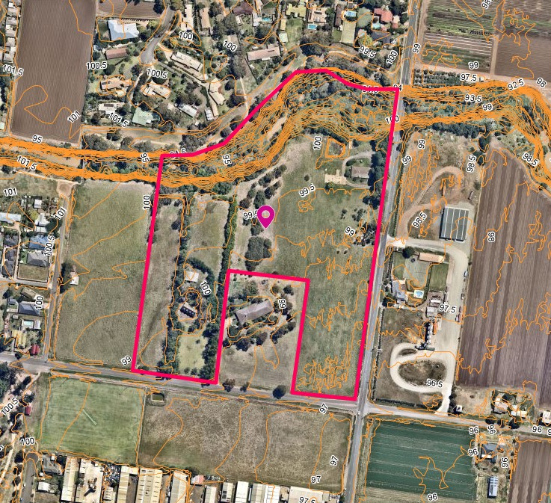
Figure 1 – Aerial photograph

Proposal
The proposal includes a Staged Multi-lot Subdivision comprising of 92 lots 1 Superlot and creation of Reserves.
The subdivision will include the following land budget and density yield as shown in Figure 2 and Figure 3 (Subdivision and Staging Plan):
 | Lot sizes | Number of lots | Staging
Residential lots | 170-300sqm | 56 | 1, 3 and 4
 | 300-500sqm | 35 | 1, 2, 3 and 5
Superlot | 2,858sqm | 1 | 2
Open Space Reserve | 3,337sqm | 1 | 4
Werribee River Corridor | 16,369sqm | 1 | 2 and 3
Tree Reserves | 3,409sqm | 1 | 4
Drainage Reserve | 4,721sqm | 1 | 1
Intersection Flaring | 175sqm | NA | Allocated towards future roundabout at Fisken and Taverner Street intersection
As, shown in the table above, 56 lots are less than 300sqm will result in a planning permit application for a single dwelling on each lot. Upon receipt of a response to further information, the Superlot will be used as a childcare centre and a separate planning application will be required.
Fisken Street will provide two main access points in the subdivision and forms the main north south linkage between Main Street (north) and Taverner Street (south). It will also provide direct access to the proposed Superlot (highlighted in yellow on Figure 2).
Several trees along the Werribee Corridor and The Avenue are being removed however the proposed plans are generally in accordance with the Approved Taverner Street Development Plan.
The proposal also includes the retention of high value Heritage Osage Orange trees within a proposed Heritage Park which will be visible from Taverner Street and retention of three large River Red Gum trees by creating tree reserve at the eastern side of Fisken Street to form a visual landmark within this interface.
The proposed drainage reserve in the south east corner will treat stormwater and the Werribee River Corridor will consist of a shared path connection from Boyes Close to Fisken Street. The shared path will link through the residential area within the open space network and to the railway station.
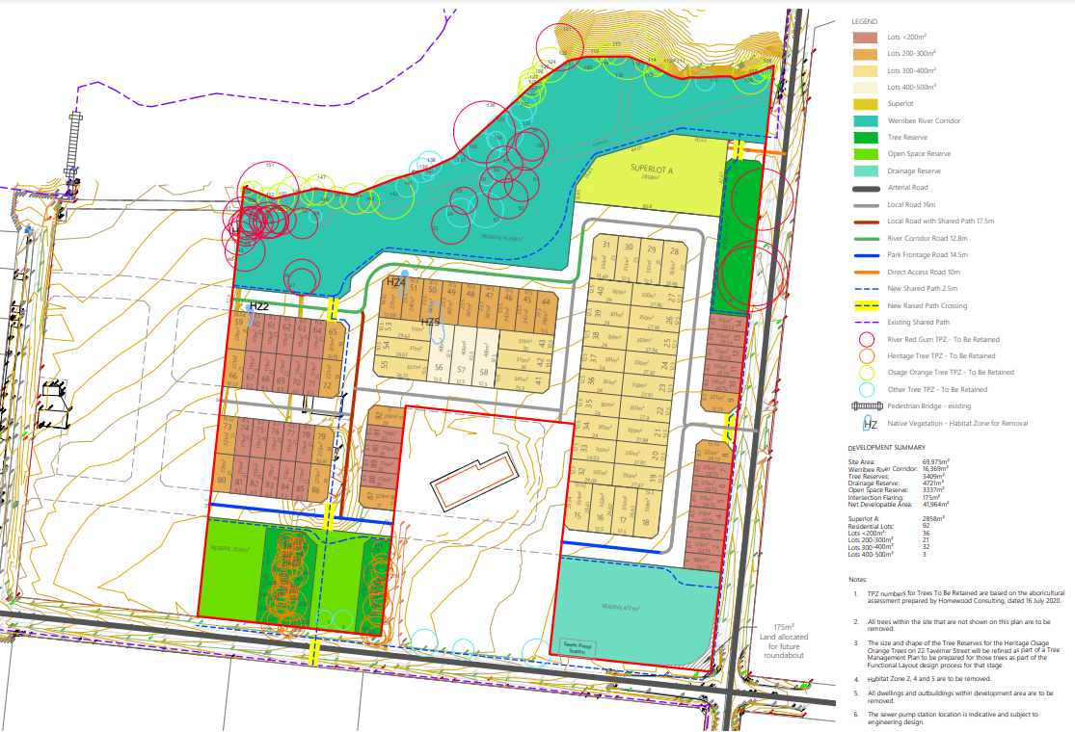
Figure 2: Proposed Subdivision Plan

Background to Current Proposal
• 147 residential lots with frontages of between 8.5m and 15m which include double fronted and front-loaded lots.
• A Superlot to include a potential childcare centre or residential allotments.
• A 1.2ha heritage park incorporating a long avenue and windbreak of Osage orange trees planted prior to 1876.
• Two drainage reserves on either side of the heritage park, to include landscaping and a sewerage pump station.
• Shared paths and extension of the Werribee River.
The proposed subdivision is generally in accordance with the approved Development Plan.
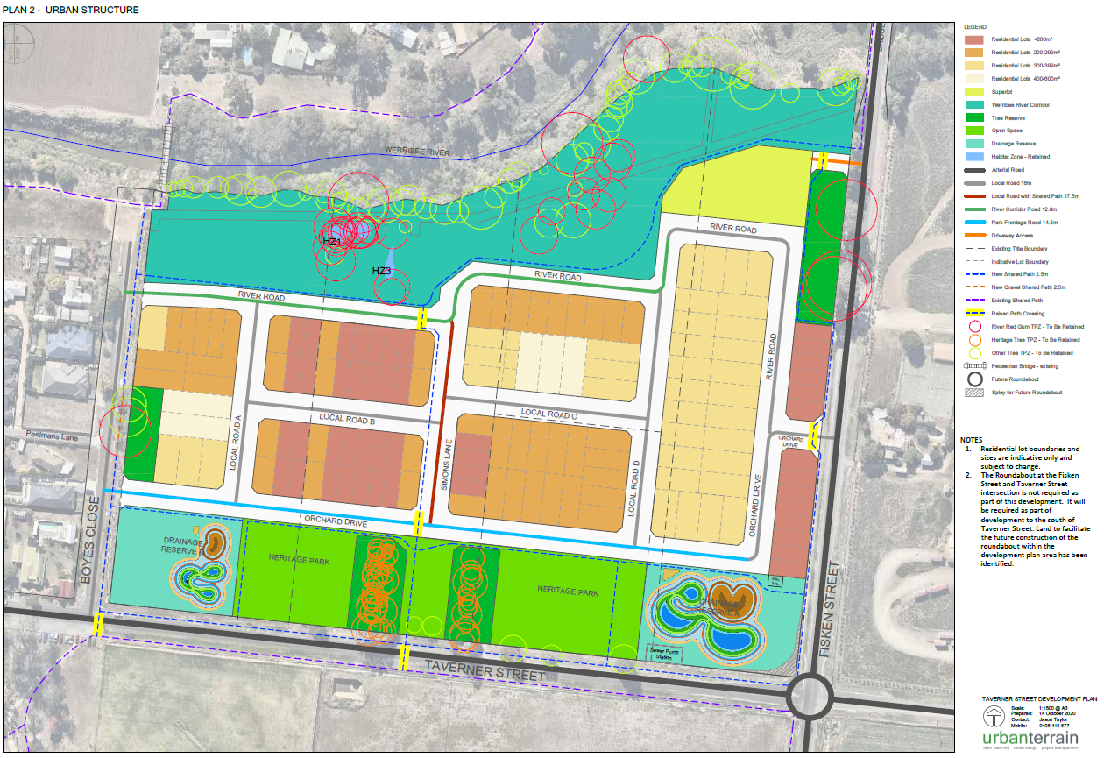
Figure 3 – Approved Taverner Street Development Plan (TSDP)

History
The Taverner Street Development Plan was approved by Council on 16 December 2020 as explained above.

Public Notice
The application was exempt from advertising in accordance with Development Plan Overlay Schedule 4 pursuant to Clause 43.04-3 of the Planning Scheme.

Locality Map
The map below indicates the location of the subject site and the zoning of the surrounding area.

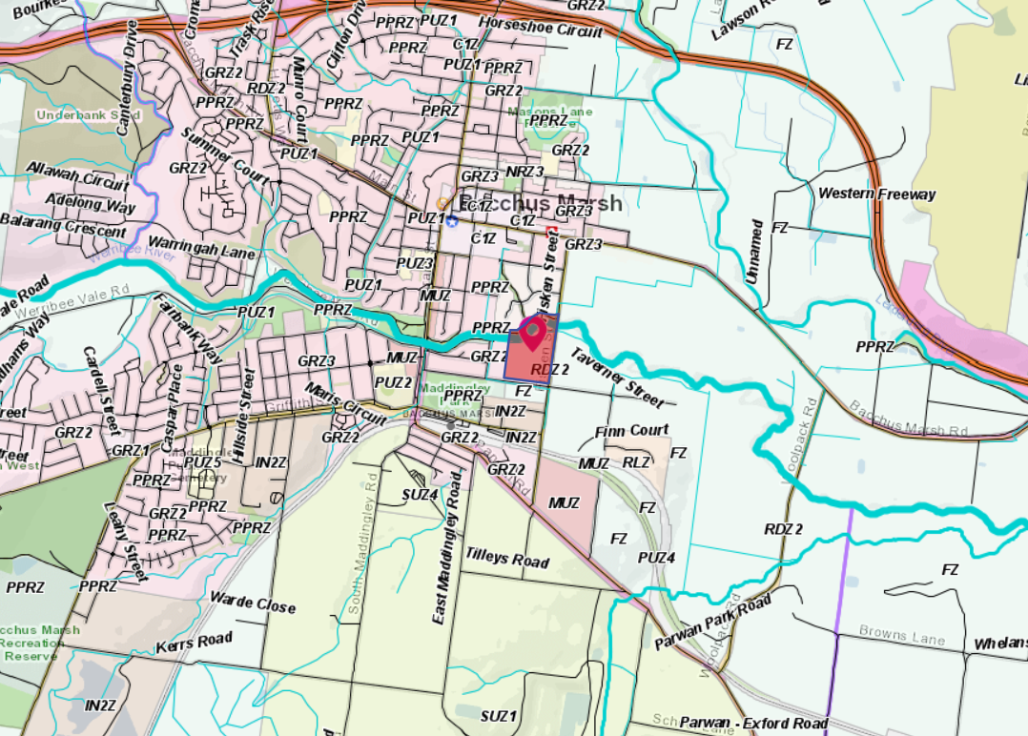
Figure 4 – Locality and Zoning Map

ASSESSMENT OF Planning Scheme Provisions
Council is required to consider the Victoria Planning Provisions and give particular attention to the Planning Policy Framework (PPF), the Local Planning Policy Framework (LPPF) and the Municipal Strategic Statement (MSS).
The relevant clauses are:
• Clause 11.01-1S – Settlement
• Clause 11.02-3S – Sequencing of development
• Clause 11.03-5S – Distinctive areas and landscapes
• Clause 11.03-2S – Growth Areas
• Clause 12 – Environment and Landscape Values:
• Clause 12.01-2S – Native vegetation management
• Clause 12.03-1S – River corridors, waterways, lakes and wetlands
• Clause 13.03-1S – Floodplain management
• Clause 13.04-1S – Contaminated and potentially contaminated land
• Clause 15.01-3S – Subdivision Design
• Clause 15.01-4S – Healthy Neighbourhoods
• Clause 15.01-5S – Neighbourhood Character
• Clause 15.03-1S – Heritage Conservation
• Clause 15.03-2S – Aboriginal Cultural Heritage
• Clause 16.00 - Housing
• Clause 16.01 – Residential Development
• Clause 15.01-3S – Subdivision Design
• Clause 15.01-4S – Healthy Neighbourhoods
• Clause 15.01-5S – Neighbourhood Character
• Clause 15.02-1S – Energy and Resource Efficiency
• Clause 15.03-1S – Heritage Conservation
• Clause 15.03-2S – Aboriginal Cultural Heritage
• Clause 16. 01-1S – Housing Supply
• Clause 17 – Economic Development
• Clause 18 – Transport
• Clause 19 – Infrastructure
Local Planning Policy Framework
Clause 21.03 – Settlement and Housing
Clause 21.06 –Heritage
Clause 21.07 – Bacchus Marsh
The proposal complies with the objectives and relevant sections of the PPF and LPPF with slight variations which are discussed in the assessment section of this report.

Zone
The subject site falls within the General Residential Zone – Schedule 2 (GRZ2) which is applied to natural and greenfield residential growth areas.
The purpose of the General Residential Zone is:
• To implement the PPF and the LPPF Framework, including the MSS and local planning policies.
• To encourage development that respects the neighbourhood character of the area.
• To encourage a diversity of housing types and housing growth particularly in locations offering good access to services and transport.
Clause 32.08-2 of the General Residential Zone requires a planning permit to subdivide land.

Overlays
The site is affected by several overlays:

Clause 43.01 - Heritage Overlay (HO170)
Heritage Overlay 170 relates to 22 Taverner Street only and applies tree controls to the site.
The Heritage Overlay identifies the Heritage Place as the Osage Orange Avenue and applies tree
controls to 22 Taverner Street. It requires an assessment of any tree removal against the heritage
overlay.
The purpose of the Heritage Overlay is to:
• To implement the MPS and the PPF.
• To conserve and enhance heritage places of natural or cultural significance.
• To conserve and enhance those elements which contribute to the significance of heritage places.
• To ensure that development does not adversely affect the significance of heritage places.
• To conserve specified heritage places by allowing a use that would otherwise be prohibited if this will demonstrably assist with the conservation of the significance of the heritage place.
Clause 43.01-1 of the Heritage overlay requires a permit to subdivide land and remove vegetation where tree controls apply.

Clause 42.01 Environmental Significance Overlay – Schedule 2 and Schedule 8 (ESO2 and ESO8)
The purpose of this clause is to identify areas where the development of land may be affected by environmental constraints and to ensure the development is compatible with the environmental values of the area.
Environmental Significance Overlay - Schedule 2 relates to proclaimed waterway catchments including the Werribee River. It seeks to conserve flora and fauna habitats, protect waterways from increased surface runoff and provide for appropriate development in the surrounding area.
Environmental Significance Overlay - Schedule 8 relates to River Red Gums in the Bacchus Marsh Valley. It seeks to retain all hollow bearing trees, minimise disturbance to the Tree Protection Zones and support regeneration of River Red Gums. It identifies River Red Gums on Boyes Close, along Fisken Street and along the Werribee River.

Environmental Audit Overlay (EAO)
The EAO has the purpose “to ensure that potentially contaminated land is suitable for a use which could be significantly adversely affected by any contamination”. It also has the purpose to implement the MPS and the PPF.

Design and Development Overlay 13 (DDO13)
The purpose of application of the DDO13 is to identify areas which are affected by specific requirements relating to the design and built form of new development
The specific objectives of the DDO13 are:
- To encourage a new mixed density residential neighbourhood that responds to the characteristics and context of the locality and is respectful to the historic Osage Orange Avenue and Windbreak.
- To encourage high quality, innovative and sustainable development that is contextually relevant and responds to the ‘country town’ character and protects the Osage Orange Avenue and Windbreak which is of historical significance for its association with orcharding in the Bacchus Marsh area.
- To ensure new residential development is oriented towards the Werribee River corridor to promote public safety in the public and private realm.
- To ensure residential development abutting Fisken Street is set back to provide a buffer from nearby horticultural activities.
- To encourage increased density development oriented towards Boyes Close.
- To design an internal street network that provides permeable, accessible and safe neighbourhood system for pedestrians, cyclists and motor vehicles.
DDO13 also provides guidance of the design for the subdivision of land as follows:
• The subdivision of land must encourage passive surveillance opportunities of the Werribee River corridor and Boyes Close.
• The subdivision of land must provide for an active frontage along Taverner Street.
• The subdivision of land must ensure that property boundaries will not impact on the Osage Orange Avenue and Windbreak.

Design and Development Overlay – Schedule 2 (DDO2) – Visual Amenity and Building Design
The design objectives of the DDO2 are as follows:
• To enhance visual amenity in rural, township and vegetated areas of the Moorabool Shire.
• To encourage the use of external cladding, such as non-reflective materials for building
• construction.
• To discourage the use of materials, such as reflective cladding for building construction, which could have a detrimental effect on amenity.
A planning permit is not required to subdivide land.

Development Plan Overlay – Schedule 4 – Taverner Street
The site is affected by Development Plan Overlay 4 (DPO4) which states that:
• The Taverner Residential Development Area has an opportunity to provide housing choices within a five-minute walk to the Bacchus Marsh Railway Station.
• The overall design of the site needs to incorporate the important site features including the locally significant Osage Orange Avenue and Windbreak, and the Werribee River.
A permit may be granted before a development plan has been prepared to the satisfaction of the
responsible authority to construct buildings and works associated with an alteration or addition to
an existing dwelling.

An assessment conducted by the Strategic Planning Department and heard at the Council Meeting on 16 December 2020 stated that the Development Plan (now approved by Council as shown in Figure 4) met the requirements of the DPO4 and the Moorabool Planning Scheme and is considered satisfactory. However, the assessment also informs that future planning decisions are subject to an appropriate level of detail against the scheme. It also outlines several specific requirements under the DPO4 to be addressed at the planning permit stage.

Current Planning Amendment
Proposed Land Subject to Inundation Overlay advertised as part of Amendment C91:
Moorabool Shire Council has prepared Amendment C91 to the Moorabool Planning Scheme, at the request of Melbourne Water as the relevant floodplain management authority. Amendment C91 seeks to apply the Land Subject to Inundation Overlay (LSIO) and the Special Building Overlay (SBO) to land affected by a 1 in 100 year flood event.
This LSIO has the following purposes:
• To implement the Municipal Planning Strategy and the Planning Policy Framework.
• To identify land in a flood storage or flood fringe area affected by the 1 in 100 year flood or any other area determined by the floodplain management authority.
• To ensure that development maintains the free passage and temporary storage of floodwaters, minimises flood damage, is compatible with the flood hazard and local drainage conditions and will not cause any significant rise in flood level or flow velocity.
• To reflect any declaration under Division 4 of Part 10 of the Water Act 1989 where a declaration has been made.
• To protect water quality in accordance with the provisions of relevant State Environment Protection Policies, particularly in accordance with Clauses 33 and 35 of the State Environment Protection Policy (Waters of Victoria).
• To ensure that development maintains or improves river and wetland health, waterway protection and flood plain health.
Part of the site is affected by this active planning scheme amendment.
Aboriginal Cultural Heritage Sensitivity
The site is within an area of Aboriginal Cultural Heritage Sensitivity as it is within 200m of a waterway in accordance with Clause 26 of Division 3 of the Aboriginal Heritage Regulations 2018. The proposed subdivision is classified as a High Impact Activity according to that Regulation. A Cultural Heritage Management Plan was submitted with the application and must be adhered to.

Relevant Policies
Housing Bacchus Marsh to 2041 – This policy addresses the management of growth, housing and guides neighbourhood character in Bacchus Marsh and surrounds. Maddingley is one of the three suburbs within close proximity to Bacchus Marsh in terms of both physical proximity as well as significant natural features and distance with the Western Freeway warranting the adoption of planning and housing strategies to support sustainable neighbourhoods. This policy guides development towards sustainable principles such as:
• Environmentally Sustainable Design
• Compact Neighbourhoods
• Walkable and Pedestrian Scale
• Mixed Land Uses
• Diverse Housing, Streets and Public Spaces
• Interconnected Streets
• Variety of Transport Options
• Range of green spaces as features
The subject site is located within Precinct 30 which is for Natural Residential Growth.
Open Space Framework to 2041
The Bacchus Marsh & Ballan Open Space Framework 2041 includes the following objectives which have been considered in the design and provision of open space:
• Be designed for maximum community benefit and consider all potential opportunities and activities to facilitate the development of the site (e.g. funding, community involvement and social engagement).
• Provide quality and accessible open space for all residents.
• Be a connected and safe network for all the community to use.
• In existing areas of Bacchus Marsh and Ballan all residents should be within 400m of an area of open space.
• new greenfield developments must provide publicly accessible open space within a 400m walkable catchment.
• Reflect the landscape and Indigenous and European cultural heritage of Moorabool.
• Identify and budget for future maintenance and staff resourcing requirements.

Particular Provisions
Clause 52.17 – Native Vegetation
Clause 52.17 seeks to ensure that there is no net loss to biodiversity as a result of the removal,
destruction or lopping of native vegetation.
This is to be achieved by:
- Avoiding the removal, destruction or lopping of native vegetation.
- Minimising impacts from the removal, destruction or lopping of native vegetation that cannot be avoided.
- Providing an offset to compensate for the biodiversity impact if a permit is granted to remove, destroy or lop native vegetation.
Clause 56 – Residential Subdivision
Clause 56 has the purpose to create liveable and sustainable neighbourhoods and urban places with character and identify which appropriately respond to the site and its contect. Please see discussion section for further details on a Clause 56 assessment.

Clause 53.01 – Public Open Space Contribution and Subdivision
A person who proposes to subdivide land must make a contribution to the council for public open
space in an amount specified in the schedule to this clause (being a percentage of the land
intended to be used for residential, industrial or commercial purposes, or a percentage of the site
value of such land, or a combination of both). If no amount is specified, a contribution for public
open space may still be required under section 18 of the Subdivision Act 1988.

Clause 53.18 – Stormwater Management and Urban Development
Clause 53.18 has the purpose to ensure that stormwater in urban development, including retention and reuse, is managed to mitigate the impacts of stormwater on the environment, property and public safety, and to provide cooling, local habitat and amenity benefits.

Objectives:

- To minimise damage to properties and inconvenience to the public from stormwater.
- To ensure that the street operates adequately during major storm events and provides for public safety.
- To minimise increases in stormwater and protect the environmental values and physical characteristics of receiving waters from degradation by stormwater.
- To encourage stormwater management that maximises the retention and reuse of stormwater.
- To encourage stormwater management that contributes to cooling, local habitat improvements and provision of attractive and enjoyable spaces.

Discussion
Overall, the subdivision application is in accordance with the approved Taverner Street Development Plan. Some variations on planning controls have been accepted subject to planning permit conditions.
Maddingley is prominent for special non-sensitive land uses and some residential land which sprawled from the nearby Bacchus Marsh area down towards Maddingley where the railway station, and places of employment are within close proximity.

Zone
The proposal is consistent with the General Residential Zone as it encourages diversity of housing types and housing growth in an area that offers good access to services and transport. Schedule 2 to this zone guides that garages, car ports and second storey developments do not visually dominate dwellings or streetscapes with minimal or low front fencing and setbacks that respects the streetscapes with appropriate landscaping to soften the public realm. Initially, housing design guidelines were recommended as part of planning permit conditions, more especially because of the 56 smaller lots proposed for residential development ranging from 170sqm to 277sqm. The application did not accompany housing design guidelines nor plans to determine the potential housing products for these lots.

Each of these lots will require a planning permit for the dwellings pursuant to Clause 32.08-5 and will be guided by the elements produced in the DP process and this planning permit application. Upon request for further information from the applicant, the potential housing typologies were provided as shown in Figure 5:
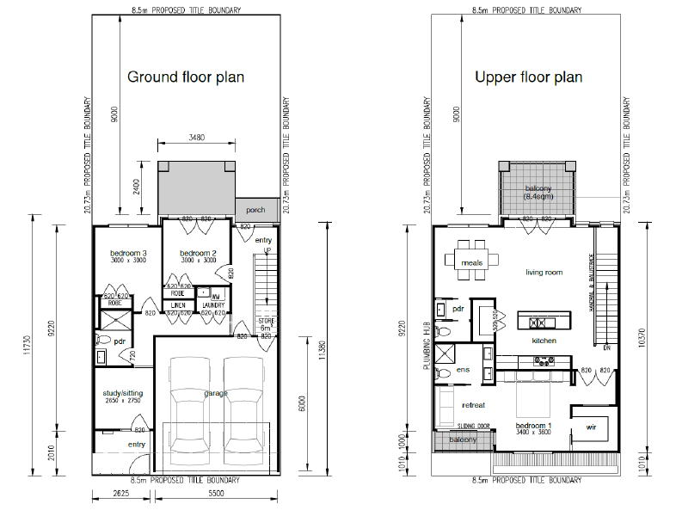
Figure 5 – Possible building typology for lots less than 300sqm
Considering Figure 5 above and noting the 8.5m frontages and 21m lot depth, these typologies will result in a no setback to Orchard Drive which is in accordance with the approved Development Plan but will be better controlled in a ResCode Clause 55 (multi-unit development) assessment where Council Officers get the opportunity to assess neighbourhood character rather than individual landowners developing the land via ad hoc Clause 54 (one dwelling on a lot). Assessment where no neighbourhood character can be assessed. It was therefore agreed that the smaller lots be recommended as superlots to gain more control over the ResCode assessment, housing typologies, and overall neighbourhood character. Additionally, this will streamline the planning processes by receiving fewer planning permit applications rather than 56 ad hoc Clause 54 (One dwelling on a lot) applications.
Overlays
Heritage Overlay (HO170 – Osage Orange Avenue)
According to the Heritage Council Victoria database, the Osage Orange Avenue and Windbreak at 22 Taverner Street, Maddingley are of local historical and aesthetic significance to the Shire of Moorabool as they are rare surviving examples of Osage Orange trees for landscaping purposes. At least 50 of these trees were planted from seeds imported by A.C Simon from United States in 1883 probably originally intended as hedges and forms along driveway avenue and boundary windbreak for 22 Taverner Street as shown in Figure 6.
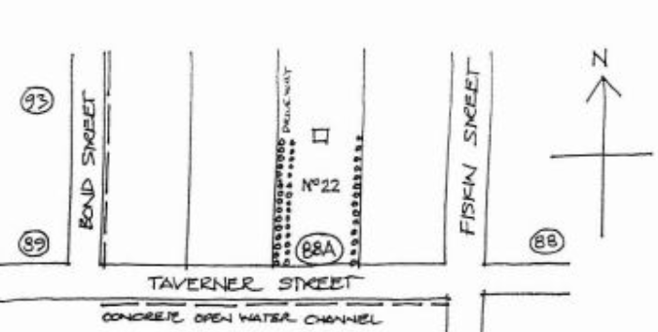
Figure 6 – Osage Orange Avenue trees

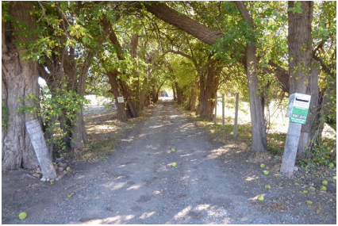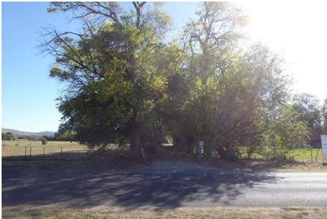
Photo 1 and 2 – Osage Oranage Trees “The Avenue” and vehicle entry to 22 Taverner Street.
The Heritage Overlay holds a number of decisions guidelines which ensures that the cultural and natural significance of the heritage place is not compromised. To ensure that the retained heritage trees are not impacted a Conservation Management Plan is required as part of conditions to the permit. This plan will include the detailed tree survey, all the land covered by the heritage overlay, an assessment of the heritage values as well as short, medium and long-term conservation, management and remedial works required for the heritage trees. This will ensure that trees will not be impacted to any works conducted on the site and that Council will have a Management Plan to maintain the trees upon hand over of the Heritage Park.
Design and Development Overlay – Schedule 13 (DDO13)
DDO13 requires that the wall height of Fisken Street must not exceed 7m above natural ground level and should have a setback of 9m from Fisken Street. For this application, we are not assessing a development proposal, only a subdivision however this is noted due to the smaller lots proposed across the development.
The subdivision complies with the requirements of the DDO13 by encouraging passive surveillance opportunities to the Werribee River Corridor. However, the requirement for active frontages along Taverner Street is not formed with built form but rather by landscaping, a heritage park and drainage reserve due to the stormwater mitigation and the buffer required from the Industrial land to the south. The proposal is also non-complaint with this overlay as it impacts on the Osage Orange Trees, The Avenue and Windbreak. Considering that the approved DP accounted for the loss of these trees for reasons being stormwater management, subdivision design and amenity impacts for all future dwellings, a variation of the requirements under this overlay is acceptable.
Development Plan Overlay – Schedule 4 (DPO4) - The Taverner Street Development Plan (DP)
An assessment against the DPO4 was conducted for the DP and was found that the land will be developed in a manner responsive to the surrounding land uses and site constraints and incorporates the Werribee River and Osage Orange Avenue and Windbreak in accordance with the DPO4 requirements. The DP was assessed against density, indicative staging, the Osage Orange Avenue, Irrigation District, movement network, Werribee Creek Corridor, water management, Infrastructure, open space, environmental assessment and economic development apart from other issues.
Tree Removal
The proposal will require removal of three patches of native vegetation with a combined area of
0.021ha.
The Flora and Fauna Assessment, Native Vegetation Impact Assessment and Environmental Management Plan prepared by Practical Ecology includes offset requirements for Habitat Zones 2, 4 and 5. Habitat Zones 1 and 3 are both within the Werribee River Corridor and should be retained if possible.
Habitat Zone 1 is 0.02ha of Red Gum Swamp located within the River Red Gums and will therefore
be retained. Habitat Zone 3 is 0.006ha of Wallaby Grass and should be retained if possible.
However, it is acknowledged that this patch is in an area with some trees that are to be removed
and where Environmental Audit works are to occur. More detailed consideration of retaining
Habitat Zone 1 and Habitat Zone 3 will be required to be retained as a condition of permit and must be identified on all landscaping plans, fauna management plan and environmental management plan.
During the Taverner Street Development Plan (DP) process, a referral to DELWP was not conducted because DELWP provided an approval of the rezoning of the land (Amendment C51). It was concluded that the vegetation was compromised on the land at the time of the rezoning approval from Farming to Residential. However, this permit application was referred to Department of Environment, Land, Water and Planning (DELWP) to ensure that no further conditions were required. DELWP had no conditions for the permit but recommended that TPZ’s and open space areas are protected via long term solutions such as rezoning.
Further from this, conditions for a permit holder to meet the provided Flora and Fauna Assessment, Native Vegetation Information Management report and Arborist Reports requirements are recommended by the Officer.
Whilst the development is in keeping with retaining some of the Osage Orange Trees “The Avenue”, it also removes many habitats where tree removal is required to cater for the drainage, stormwater management, and to gain a residential yield of the overall site that would be economical and feasible for residential development. This was decided upon at the strategic planning stage where the rezoning and development plan was approved.
The environmental and landscape values pursuant to Clause 21.03 and heritage values under the Heritage Overlay is most fundamental to control and assess the proposal to remove and retain vegetation on the land and hence conditions on the planning permit such as for a tree protection plan, weed control, retention of Habitat Zone 3 and provision of offsets apart from many others have been drafted to ensure that these controls are maintained.

Environmental Significance Overlay – Schedule 2 – Waterway Protection (ESO2)
The ESO2 preserves the waterway which in this proposal is retained as the Werribee Creek Corridor. Management Plan for protection and conversation are required to ensure that this waterway is conserved to prevent increased surface runoff, conserve existing flora and fauna, encourage habitat regeneration and prevent pollution of water. Melbourne Water set requirements for development to reside 50m from the top of bank of the creek and also posed a number of conditions for the planning permit. Southern Rural Water, Western Water and Council’s Environmental Health Department has consented to the development subject to planning permit conditions.
Environmental Significance Overlay–Schedule 8–River Red Gums in the Bacchus March Valley (ESO8)
The decision guidelines under this overlay stipulates that the loss of habitat and food sources as well as damage to private property or threats to life must be considered. In response to these requirements as well as the protection of Tree Protection Zones and the need for remedial or restorative works are placed as conditions for the planning permit to ensure that the land owner is obliged to comply with the requirements.
Environmental Audit Overlay
Conditions are placed on the permit to ensure that the requirements under this overlay are met before a sensitive land use begins. Further form this, a detailed assessment of the soil and groundwater was undertaken, and a Remediation Action Plan (RAP) was prepared. The RAP identified that all pesticide contaminated soil that may pose a human health or environmental risk to future receptors, demolition and removal of all infrastructure/buildings were possible is required in part of many other requirements within the RAP. A condition is placed on the permit to ensure that all works associated with the RAP are complied with and will not impact on the retained TPZ’s.
Policy Response
Planning Policy Framework response
Clause 11.01-1S – Settlement – The proposal capitalises on urban renewal and infill development where land uses of high activity are prominent. It develops a compact neighbourhood around existing or planned to maximise accessibility to facilities and services therefore supporting sustainable transport modes.
Clause 11.02-3S – Sequencing of development – The proposed stage plan shows that Stages 1 and 2 include the south eastern drainage reserve and access from Fisken Street to the proposed lots in stage 1. Conditions will be posed to require that water supply, sewerage and drainage work receives high priority in the early stages of the development. A small contribution of 174sqm of the south east corner of the site is contributed towards the future roundabout which Council is said to deliver as part of the proposed Leisure Centre works south of Taverner Street.
The Heritage Park is part of Stage 4 as cooperation is required from neighbouring landowners to ensure that the engineering fill works are conducted appropriately in consideration with protecting the heritage trees. It must also be noted that the detailed engineering plans recommended as conditions on the planning permit will provide information for a detailed assessment on the level of corporation required from neighbouring landowners.
Clause 11.03-5S – Distinctive areas and landscapes – the historical value and landscape significance of the Osage Orange Trees/Windbreak also known as “The Avenue” has been retained however many trees have been removed due to the nature of the site, requirements from Melbourne Water for stormwater drainage as well as the decisions made at the time of the rezoning of the land from Farming to Residential 1 Zone in Amendment C51, March 2014.
Clause 11.03-2S – Growth Areas – encourage residential densities of a minimum of 15 dwellings per net developable hectare and seeks to increase to more than 20 dwellings per net developable hectare over time where abundant access to transport and mixed land uses exist. The proposal has a Net Development Area of 41,964sqm from a total site area of 69,975sqm and with 92 residential lots proposed and one Superlot the development yields an average density of 21 dwellings per hectare. Considering the number of engineering works required to mitigate the stormwater flows and landscape works along the creek and the heritage park, the economic viability of the residential yield was compromised therefore the proposed density is considered acceptable if the streetscape is well planted and the future dwellings are designed in accordance with the elements listed in the approved DP and based on compliance with ResCode.
Clause 12 – Environment and Landscape Values: Clause 12.01-2S – Native vegetation management – ensures that there’s no net loss of biodiversity as a result of the removal, destruction or lopping of native vegetation.
A Flora and Fauna Assessment (F&F), Native Vegetation Impact Assessment and Management Plan has been prepared by Practical Ecology which includes a Native Vegetation Impact Assessment and Werribee Corridor Management Plan. River Red Gums, Osage Orange Trees – The Avenue, Windbreak and scattered vegetation, Peppercorn Trees, Wallaby Grass, Various native birds, Variety of native and non-native small mammals were all identified on the site however no rare or threatened flora and fauna of state or national significance within the development plan area. The assessment of 24 Taverner Street was not conducted and will need to be conducted for any further development on that site. The development plan approved three patches of native vegetation with a combined area of 0.021ha and offset requirements are stipulated as conditions on the planning permit.
The Flora and Fauna Assessment recommended that Habitat Zone 1 and Habitat Zone 3 are both within the Werribee River Corridor and should be retained if possible. Habitat Zone 1 is 0.02ha of Red Swamp located within the River Red Gums and will be retained. Habitat Zone 3 is made up of 0.006ha of Wallaby Grass and might be impacted upon the Environmental Audit works required under the Environmental Audit Overlay (EAO). Additionally, the approved DP states that 32 River Red Gums are being retained within the development. As part of this development, it is proposed to retain three of the largest River Red Gums along Fisken Street, apart from other trees and will be contained in a tree reserve. Other River Red Gum trees (native) and the retained heritage trees will be located on the proposed tree reserves in the heritage park and the creek corridor. The protection of the tree reserves is recommended in the conditions of the permit.
Clause 12.03-1S – River corridors, waterways, lakes and wetlands – the Werribee River Corridor is being protected and designed in accordance with Melbourne waters requirements for a 50m setback for development from the top of bank. Within this setback a 10m passive open space buffer is proposed with vegetation, walking trails and seating arrangements. To protect the existing large old River Red Gums, River Road is designed to link to Orchard Drive with access to Fisken Street to avoid harm to the River Red Gum trees.
Conditions are placed on the permit to ensure that the Corridor is managed, and development takes place in future in accordance with the approved DP.
Clause 13.03-1S – Floodplain management – The property is subject to flooding from Werribee River as shown in Figure 1 where land hatched in blue is proposed in the Land Subject to Inundation Overlay (LSIO) as part of Amendment C91.
These matters will be addressed as part of the detailed engineering design for the earthworks on the site and will meet the requirements stipulated by Melbourne Water and Council as detailed in the recommended conditions of permit. Further from this, the development plan addressed many requirements from Melbourne Water to mitigate flood risk to the dwellings and infrastructure which informed the current layout and design. Melbourne water required that dwellings be constructed 600mm or greater above flood level, an all flood water storage capacity of the site be maintained to limit impact to downstream properties. This also informed that location of the wetlands and heritage park along Taverner Street. Melbourne water had also stipulated conditions which are recommended herewith.
Clause 13.04-1S – Contaminated and potentially contaminated land – contamination from past agricultural uses may be present. Preliminary site investigations were conducted during the DP process as the site is covered by the Environmental Audit Overlay. This included a detailed remediation plan developed to remove sources or hotspots of soil contamination including pesticides, hydrocarbons, septic tanks, asbestos fragments and buried waste across numerous properties. Conditions are laid out to ensure that the remedial works takes place prior to any development associated with a sensitive use and to ensure that retained vegetation is not impacted upon.
Clause 15.01-3S – Subdivision Design – the subdivision is designed creating a compact neighbourhood with diverse housing choice to walkable distances between activities.
Clause 15.01-4S – Healthy Neighbourhoods – the site is conveniently located near the proposed Bacchus March leisure centre and close to parks, recreation, and mixed use activities and a walking distance to the train station provision opportunities for healthier neighbourhoods.
Clause 15.01-5S – Neighbourhood Character – the surrounding area is made up of conventional housing and lots of approximately 1,000-2,000sqm in extent. The immediate surrounds is made up of Farming Zone to the east and south. However, the site south of the site is proposed as the Bacchus Marsh Leisure Centre. Sites to the west of Boyes Close is around 800-900sqm therefore the proposed lots ranging from 170sqm – 356sqm is out of neighbourhood character but due to the principle of accessibility to mixed land uses to create a healthy 20-minute neighbourhood approach, this required has been varied as part of the DP approval process.
Clause 15.02-1S – Energy and Resource Efficiency – the application did not accompany any environmentally sustainable practices however landscaping with canopy vegetation as well as tree reserves, Werribee Creek and the heritage park will provide urban cooling. Only 50% of the proposed lots face north south so energy efficiency in a Clause 54 (ResCode) assessment to future dwellings will be assessed upon receipt of permit applications for the lots below 300sqm.

Clause 15.03-1S – Heritage Conservation- A heritage assessment plan was not provided with the application upon its request and Council was requested to condition this on the permit therefore a Conservation Management Plan is required to include a Heritage Assessment Plan and Tree Protection Plan as tree controls apply to the heritage overlay.
Clause 15.03-2S – Aboriginal Cultural Heritage – A CHMP was provided and conditions are laid out to ensure that all management conditions contained it the CHMP is adhered to and approved by the Registered Aboriginal Party.
Clause 16. 01-1S – Housing Supply – the proposal for residential lots provide an opportunity for a diverse housing supply within an established location.
Clause 17 – Economic Development – the proposal provides residential development within close proximity to the industrial and retail land uses as well as a train station therefore supporting the employment precincts. The proposal facilitate tourism with the heritage park being a highlight and possible nature walking trail to link to the Werribee River Corridor trail.
Clause 18 – Transport– the transport system surrounding the proposed lots are well integrated linking public and private transport towards jobs and services.
Clause 19 – Infrastructure – a small portion of the land at the corner of Fisken and Taverner Street will be handed over to Council for the purposes of the future roundabout. The applicant is also required to adhered to onsite infrastructure requirements for stormwater mitigation by creating drainage reserves and internal access roads. The infrastructure works are required in accordance with the stage plan received with this application. Conditions for a planning permit require that a monetary contribution towards Taverner Street roadworks in accordance with the IDM be provided to Council. As per the permit conditions, the developer is required to deliver Fisken Street in accordance with IDM standards.
Local Planning Policy Framework response
Clause 21.03 – Settlement and Housing – the proposal maintains a sustainable long term supply to accommodate the projected increase in population. Whilst it is against the existing character and removes a number of trees, it also retains the most valuable heritage and native trees and is located close to various land uses to support the number of lots proposed.
Clause 21.06 – Heritage – Interpretation signage is required to maintain the heritage value and provide environmental and historical significance to the retained heritage trees. Clause 21.07 – Bacchus Marsh – with an ever-growing population around 19 000 and increasing in Bacchus Marsh and Maddingley, these towns are an increasingly popular alternative housing destination making this a targeted area for increased urban growth. This proposal supports the consolidation of land uses to support the Bacchus Marsh Housing Strategy objectives and the planning scheme requirements for growth management.
Potential Amenity Impacts
One of the issues provided in the Moorabool Planning Scheme Amendment C51, Panel report, dated 24 March 2014 is from the Environmental Protection Authority where the need for adequate buffers between existing industrial land and the proposed residential zone on the north side of Taverner Street.
Southern Interface - The proposal has made efforts to provide adequate buffers in the form of Drainage Reserves and a Heritage Park north for Taverner Street thus keeping an approximate 80-90m from Taverner Street to the closet residential allotment. With the proposed Leisure Centre providing an additional 100m buffer from the existing industrial developments to the proposed residential lots.
According to the Bacchus Marsh Urban Growth Framework, a 2000m separation distance should be kept from the composting operations at Maddingley Brown Coal and the subject site is within this distance.
Eastern Interface - Additionally, Watson’s Bulk Logistics (WBL) is located east of the site at 18 Fisken Street. This grain, wheat, canola and grain stores from a number of local growers in the region and handles up to 20,000 tonnes per year where a distance of 250m to any residence was recommended as published in EPA publication 1518.
The DP provides key elements, specifically Element 6 which sets a 9m setback from Fisken Street to the proposed residential development along the eastern interface.
In accordance with Clause 13.07-1S – Land Use Compatibility, the rezoning of the land from Farming to Residential 1 Zone was considered in terms of emissions of odour, dust, light spill and noise from both the east and the south and the Panel acknowledged these and approved the rezoning on the basis that the concrete batching plant to was used occasionally and an environmental sustainable development report be provided in the initial planning stages of the subdivision.
Though the proposed buffers may not be in accordance with the requirements from the EPA and inconsistent with Clause 13.07-1S, it was provided on the basis that the Rezoning C51 was approved in March 2014. Conditions have been placed on the planning permit to ensure that an Environmental Audit will be conducted.
Clause 56 – Residential Subdivision
An assessment against Clause 56 was conducted and some non-compliances, comments and variations are discussed below:
Site context
The applicant did not provide a full site and context description but made comment in the submitted planning report that the application corresponds with the Taverner Street Development Plan which is now approved. The submitted planning report also provided a plan showing the surrounding land uses as shown in Figure Upon assessment of the application, the site is within 400m – 500m to the Bacchus Marsh Train Station, Werribee River Corridor, Maddingley Park Reserve, Industrial land uses to the south and less than 700m away from the existing Aquatic Centre, Bacchus Marsh College, day cares, places of employment. The site is within 1km away from the Bacchus Marsh and Melton Regional Hospital and the Main Street where a variety of Mixed Use, Commercial and Residential Zones exist. The close proximity and proposed footpaths will provide for adequate accessibility for pedestrians, cyclists and drivers to nearby high activity land uses.
The proposal provides for diverse housing choices within an area close to varied land uses promoting the objectives of local planning policy for liveable and sustainable neighbourhoods.
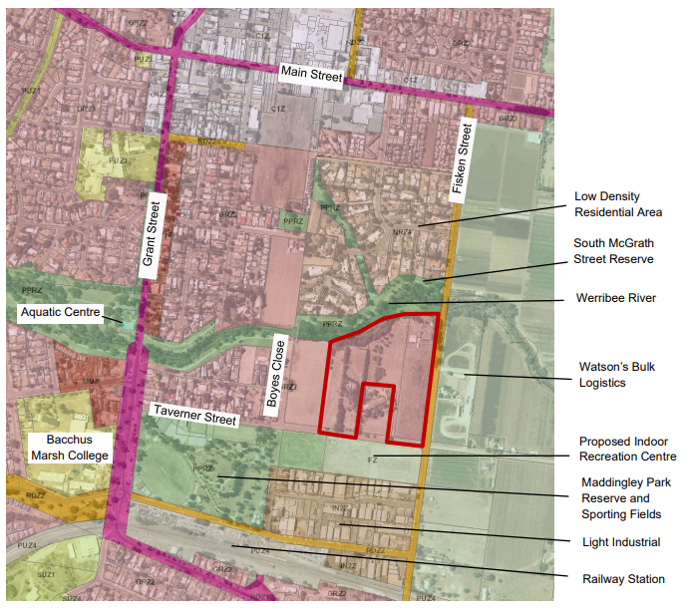
Figure 7- Surrounding Land Uses
Lot Design
About 50% of the site is proposed with east west facing lots, the other 50% are north south facing having ample solar access to future dwellings. 56 of the 92 lots are smaller than 300sqm as shown in Figure 7 above, on most lots which are 170sqm with an 8.5m frontage and 20.7m depth. The proposed typologies are not supported especially along Fisken Street where a 9m setback is already approved to create a buffer from the Agribusiness land use activities east of the site. After various discussions with the applicant and attempts to gain a planning application for the dwellings to assess them against Clause 54 of the Planning Scheme, the applicant suggested a condition towards Housing Design Guidelines. However, Housing Design guidelines must accord to both Clause 54 and the approved Taverner Street Development Plan (DP) elements. The approved DP and the Design and Development Overlay provides guidance on the fundamental interface treatments based on mitigating risk impacts and to heighten amenity to future residents. Element 6 from the DP states that no setback is required from Orchard Drive/River Road however this will lead to abundant garages fronting the road reserve and no setback from the vehicle entry. Cross sections are required to determine the landscaping and footpaths along all proposed internal roads. Due to this and after consultation with Strategic Planning, the applicant and Statutory Planning, it was agreed that superlots being integrated into the development where smaller lots apply in order for Officers to control the neighbourhood character and design elements (ResCode) via a Clause 55 assessment.
Neighbourhood Character:
The site is within Precinct 30 in the Neighbourhood Character Study as part of the Housing Bacchus Marsh to 2041 Strategy. This precinct comprises of mostly conventional dwellings with minimal landscaping within properties and some lots with reduced front and side setbacks and higher site coverage. Taverner Streets and nearby Grant Street road reserves consist of established street tree planting, some street have only single sided footpaths. The preferred neighbourhood character according to the Neighbourhood Character study is for Natural Residential Growth to occur where some intensification may be appropriate and assessed on a site by site basis. For new developments front setbacks should be sufficient to allow for well landscaped front gardens and reduce additional crossovers, create a positive street interface to ensure strong passive surveillance. It also states that garages and carports should not visually dominate dwellings or streetscapes and should be recessed from the front building line. Considering these factors, upon receipt of Housing Design Guidelines and/or planning permit applications for development on the smaller lots, one must assess the future dwellings, not only against the proposed setbacks produced in the approved DP but also consider the planning controls and provisions guided by the planning scheme to ensure good urban design outcomes.
Public Open Space Contributions
Public Open Space Contribution have been incorporated as part of the approved TSDP
The proposal includes the following open space provisions:
• Expansion of the Werribee River Corridor
• Osage Orange Heritage Park and Tree Reserve
• River Red Gums Tree Reserve
• Expansion of shared path network providing access to existing public space and outdoor facilities in the immediate surrounding area.
Public Open Space provisions have been made as works on the Heritage Park comprising of 3,337sqm with an overall 4.7% of the site as a public open space contribution. All tree reserves, creek corridors and drainage reserves are not considered as public open space contributions as they are encumbered land. Therefore, 0.3% as a monetary contribution towards public open space pursuant to s18 of the Subdivision Act 1988 must be made to Council and will be recommended as a condition of the permit.
Superlot
The use of the Superlot was questioned during the consultation process and the applicant stated that it will be used for the purposes of a childcare centre. The DP stipulated that if the Superlot is used as a childcare, vehicle and pedestrian access can be from Fisken Street and River Road and Fisken Street must allow for a raised path crossing. The design of the childcare centre in a future permit must ensure that open space areas are activated towards the Werribee River and the shared path for passive surveillance and reduced visual bulk from the built form. It also states that the site frontage must activate River Road by providing an alternative entrance, windows, outdoor areas, transparent fencing and varied built form.
Movement Network and Infrastructure
A grid iron layout is designed to access the proposed lots. Two points of access to proposed from Fisken Street, one towards Stage 1 and one towards the proposed Superlot above the River Red Gum tree reserve.
Due to the fragmented land approach where 24 Taverner Street is not part of this subdivision, the subdivision design surrounds the site but also provides an indicative road layout if 24 Taverner Street were to be developed in the future.
The Bacchus Marsh train station is approximately 400m-500m away and on-road and off road bicycle paths are proposed.
Footpaths were not required along the western portion of Fisken Street, northern side of Taverner Street nor eastern side of Grant street during the DP process due to the other infrastructure costs which the developer had undergone to cater for the development.
Both Taverner Street and Fisken Street are two way carriageways with posted speed limited of 50-60kms per hour respectively.
Sustainable Development Framework Trial Assessment (SDF)
The applicant did not participate in the SDF trial. This program is to encourage applicants to consider environmentally sustainable measures within subdivisions on a voluntary basis.

General Provisions
Clause 65 – Decision Guidelines have been considered by officers in evaluating this application.
Clause 66 – Stipulates all the relevant referral authorities to which the application must be referred.

Referrals
Authority | Response
Section 55 – Determining Authorities
Downer | Consent subject to one condition.
Melbourne Water | Consent subject to fifteen conditions.
Southern Rural Water | Consent subject to conditions.
Department of Transport | Initially requested further information however now consents to the proposal.
Western Water | Consent subject to eleven conditions.
PowerCor | Consent subject to six conditions.
Section 52 – Recommending Authority
Environmental Health | Consents subject to three conditions.
Infrastructure Department | Further information required related to Stormwater Management and Traffic.
Strategic Planning | Consent.
Connected Communities | Concerns related to use of the Superlot for childcare and small lots which will unlikely attract families, cost of housing could be higher with higher access to various land uses.
Environmental Management | No comment.

DELWP | Recommendations made on rezoning tree reserves and Public Open Space to ensure protection over these areas. Further comments were made on Tree Protection Zones which may be impacts by future walking tracks.
EPA | Comments provided for assessment of environmental impacts and conditions were recommended for an Environmental Audit.

Financial Implications
There are no financial implications in approving (supporting) the subdivision application.

Risk & Occupational Health & Safety Issues
The recommendation of approval of this development does not implicate any risk or OH&S issues to Council.

Communications Strategy
Notice was undertaken for the application, in accordance with s.52 of the Planning and Environment Act 1987, and further correspondence is required to all interested parties to the application as a result of a decision in this matter. All submitters and the applicant were invited to attend this meeting and invited to address Council if required.

Options
Council could consider the following options:
• issue an approval (support of the application) in accordance with the recommendations of this report; or
• should Council wish to refuse the application, Councillor’s need to explore reasons for refusing the subdivision based on the approved Amendment C51 rezoning from Farming to Residential Zone 1 and the approved Taverner Street Development Plan and compliances with the Moorabool Planning Scheme.

Conclusion
Upon receipt of the application for a multi-lot subdivision and creation of reserves, further information was required to support the proposed 92 residential lot subdivision, Superlot, creation of drainage reserves, tree reserves, Werribee Creek corridor and heritage park. Considering that proposal is generally in accordance with the approved Taverner Street Development Plan and with consultation processes conducted between the applicant, Council and all referral agencies, Council has reached a satisfactory planning consensus to allow support the of the application subject to planning permit conditions.

7.3 PA2020093 - Use and Development for a Restaurant with Liquor Licence and Waiver of Bicycle Parking Facilities at 388 Bacchus Marsh Road, Bacchus Marsh
Author: Thomas Tonkin, Statutory Planner
Authoriser: Henry Bezuidenhout, Executive Manager Community Planning & Economic Development
Attachments: 1. Proposed plans (under separate cover)

Application Summary
Permit No: PA2020093
Lodgement Date: 25 May 2020
Planning Officer: Tom Tonkin
Address of the land: 388 Bacchus Marsh Road, Bacchus Marsh
Proposal: Use and development for a Restaurant with Liquor Licence
Lot size: 2.264ha
Why is a permit required? Clause 35.07 Farming Zone – Use and development for a Restaurant
Clause 52.27 Licenced Premises – Liquor licence
Clause 52.34 Bicycle Facilities – Waiver of bicycle spaces and associated facilities

Recommendation
That Council, having considered all matters as prescribed by the Planning and Environment Act 1987, issue a Refusal to Grant Planning Permit PA2020093 for Use and Development for a Restaurant with Liquor Licence and Waiver of Bicycle Parking Facilities at Lot 1 on PS 749369W known as 388 Bacchus Marsh Road, Bacchus Marsh, 3340, on the following grounds:
1. The proposal does not align with relevant State and local planning policy in the Moorabool Planning Scheme to protect State significant productive agricultural land from incompatible use and development.
2. The proposal does not meet the purpose of the Farming Zone.
3. The location of car parking within Heritage Overlay, Schedule 47, does not meet the purpose of Clause 43.01 to conserve and enhance, and avoid adverse impacts on, a heritage place.

Public Consultation
Was the application advertised? | Yes.
Notices on site: | One.
Notice in Moorabool Newspaper: | No.
Number of objections: | None.
Consultation meeting: | Not required.

Policy Implications
The Council Plan 2017-2021 provides as follows:
Strategic Objective 3: Stimulating Economic Development
Context 2B: Natural Environment
The proposal does not conflict with the Council Plan 2017 – 2021.

Victorian Charter of Human Rights & Responsibilities Act 2006
In developing this report to Council, the officer considered whether the subject matter raised any human rights issues. In particular, whether the scope of any human right established by the Victorian Charter of Human Rights and Responsibilities is in any way limited, restricted or interfered with by the recommendations contained in the report. It is considered that the subject matter does not raise any human rights issues.

Officer’s Declaration of Conflict of Interests
Under section 130 of the Local Government Act 2020, officers providing advice to Council must disclose any interests, including the type of interest.
Executive Manager – Henry Bezuidenhout
In providing this advice to Council as the Executive Manager, I have no interests to disclose in this report.
Author – Tom Tonkin
In providing this advice to Council as the Author, I have no interests to disclose in this report.

Executive Summary
Application referred? | Yes, to Western Water, Melbourne Water and Transport for Victoria, and to Council’s Asset and Infrastructure, Strategic Planning, Economic Development and Environmental Health. In addition, formal written advice was obtained from Heritage Victoria.
Any issues raised in referral responses? | Yes. Strategic Planning objected based on the incompatibility of the proposal with the site’s location in the State significant Bacchus Marsh Irrigation District and that the proposal should be located in a commercial precinct such as Main Street.  Heritage Victoria (HV) objected to the location of proposed car parking beneath trees forming part of the Avenue of Honour which is listed on the Victorian Heritage Register (VHR). Parks and Gardens referred to the Bacchus Marsh Avenue of Honour Strategic Management Plan (June 2004) in advising that the proposed parking location at the front of the site is inconsistent with the appropriate management of the heritage elm trees.
Preliminary concerns? | The lack of any substantive nexus between the proposed restaurant and any local farming activity. The application also did not satisfactorily address the State planning policies relevant to the application.
Any discussions with applicant regarding concerns? | Yes, the applicant was advised of concerns.
Any changes made to the application since being lodged? | Yes, the proposed patron capacity was reduced from 100 to 60 with a consequential reduction in car parking spaces from 40 to 29 and relocation of most of the car parking spaces from an arable field on the southern side of the restaurant to the front, northern of the site.
Brief history. | The produce stall on the site has operated from its current premises for approximately 40 years. A plant nursery previously operated from the site of the proposed restaurant, but no further details are known.
Previous applications for the site? | Numerous planning permits including for buildings and works associated with primary produce sales, a caretaker’s dwelling and subdivision.
General summary. | Overall, the proposal does not align with relevant State and local planning policy or the purpose of the Farming Zone or Heritage Overlay. The proposed restaurant is not linked to any farming activities and is a standalone retail use, located in an area of productive farmland of State significance. The proposal would contribute to undermining the sustainability of farming and farm infrastructure in this location and is not supported. Additionally, the proposal does not make acceptable provision for the protection or enhancement of heritage elm trees in the Avenue of Honour.
Summary Recommendation
That, having considered all relevant matters as required by the Planning and Environment Act 1987, Council issue a Refusal to Grant a Permit for use and development for a restaurant with liquor licence and waiver of bicycle parking facilities at Lot 1 on PS 749369W known as 388 Bacchus Marsh Road, Bacchus Marsh, on the grounds included in this report.

Site Description
The site, identified as Lot 1 on PS 749369W and known as 388 Bacchus Marsh Road, Bacchus Marsh, is a 2.264ha lot located on the south side of the road approximately 1.1km west of Woolpack Road and 700m east of Fisken Street. The section of Bacchus Marsh Road adjoining the site forms part of the Avenue of Honour which is included on the Victorian Heritage Register. The Avenue of Honour is the main approach route to Bacchus Marsh from the east and provides an attractive entry to the town with a consistent character of farming. There is an existing produce stall near the front northwest corner of the site with associated car parking and vehicle access in the front setback via two crossovers to Bacchus Marsh Road, all of which occupies approximately 0.14ha. A dwelling is set back approximately 20m from the east title boundary and 50m from the road frontage in an extensive landscaped setting amongst established trees and shrubs occupying approximately 0.6ha. Several outbuildings for storage of farm machinery and goods are located close to the west title boundary towards the rear of the site with associated accessways through the site including to separate lots to the south and east. Approximately 0.64ha of the site is available for cropping. The site is encumbered by a 2.0m wide sewerage easement which runs in an east-west direction towards the front of the site, beneath the area proposed to be used and developed as outlined under ‘Proposal’ below.
The subject site is approximately 1.2km from the Bacchus Marsh town centre. The subject site and surrounding land is in the Farming Zone, within the Bacchus Marsh Irrigation District and is extensively used for crop raising and ancillary activities such as the storage and packing of produce. There are a limited range of other uses in the area including an abattoir, dwellings and stalls selling a range of fresh produce and foodstuffs produced locally or imported from outside the district.
To the west is a 7.44ha property used for cropping with an ancillary dwelling and sheds located near the northeast corner of the site adjoining the subject site. To the south is a 13.46ha lot used for cropping. To the north, across Bacchus Marsh Road, is a 5.85ha lot used for cropping with an ancillary dwelling and sheds located near the southwest corner of the site. To the northeast is a 1.8ha lot used for cropping with an ancillary dwelling located at the front of the site.
The subject site is connected to reticulated sewer, water and electricity.

Proposal
It is proposed to use and develop the subject site for a restaurant with a liquor licence, operating seven days per week from 9.00am-11.00pm. The restaurant would occupy:
• a fenced off area of approximately 610sqm;
• one 40ft shipping container used as kitchen and servery for patrons dining in as well as for takeaway food sales;
• one 20ft shipping container used to serve alcohol with seating at the counter for 14 patrons;
• a meat smoking area;
• a semi-enclosed undercover seating area; and
• outdoor seating under a mature exotic canopy tree.
The red line area for the service and consumption of liquor would be confined to the fenced area described above.
In addition, approximately 12m to the south-west are existing toilet facilities separated by a vehicle accessway and two accessible parking spaces.
In the northern front setback 24 of the 29 car parking spaces will be provided. These will be in an existing parking area utilising existing accessways and crossovers.
There would be no live amplified music performed on site, however live acoustic music may be played from time to time. Up to eight staff would be present on site at any time.
Waste collection would be by a private contractor, five times per week between 9.00am-7.00pm as required.
Signage is not included as part of this proposal and would be subject to separate approval.
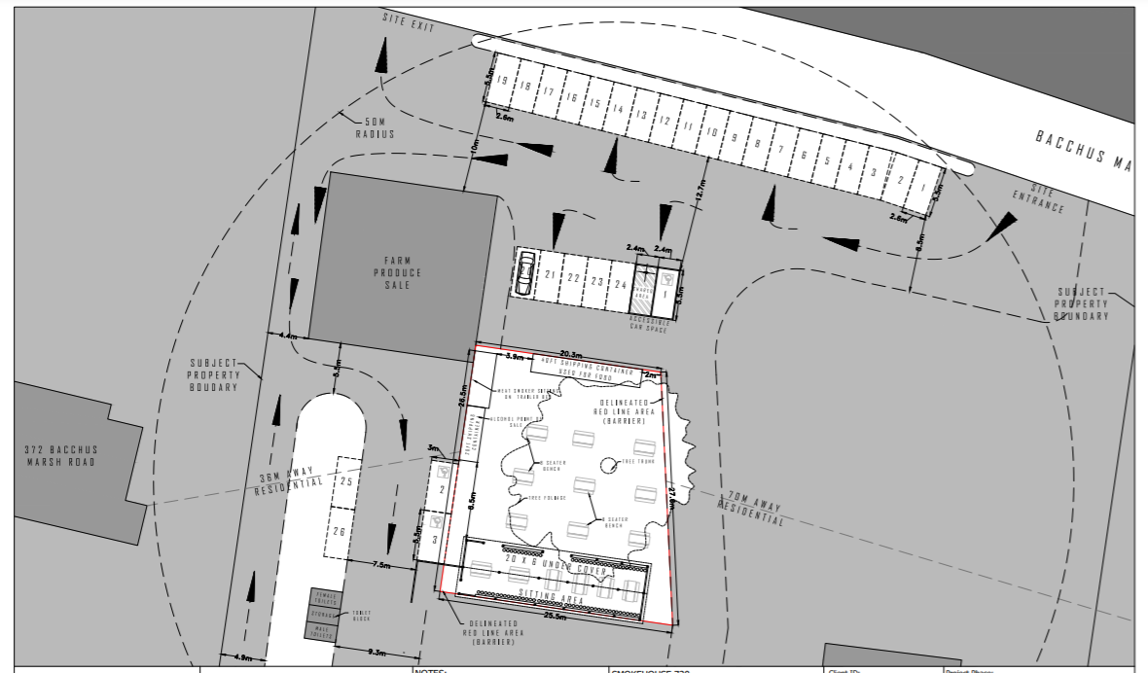
Figure 1: Proposed part site plan
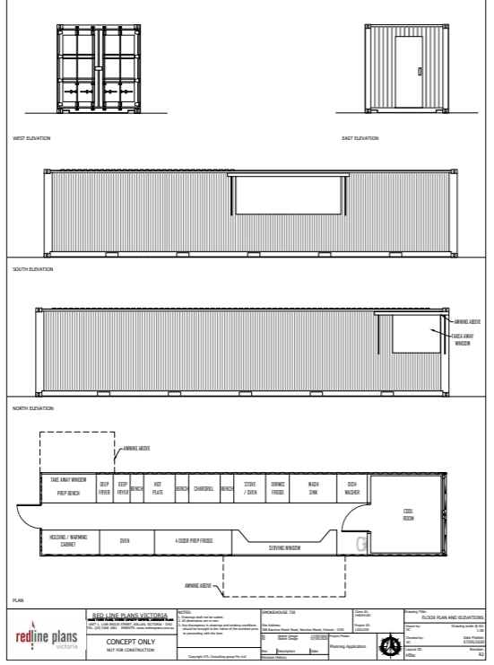
Figure 2: Proposed shipping container kitchen & servery
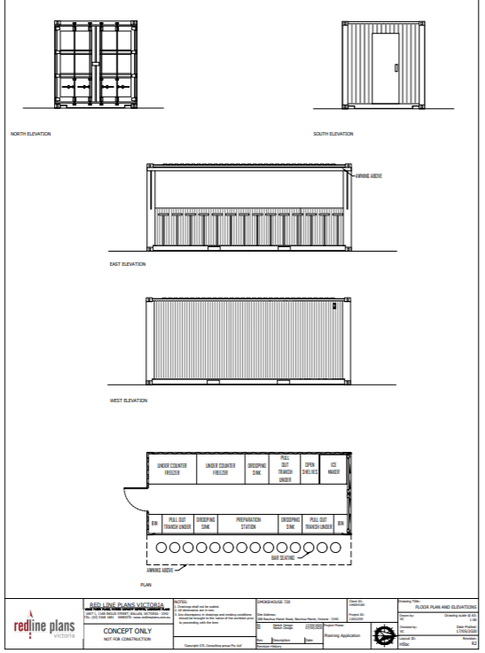
Figure 3: Proposed shipping container bar
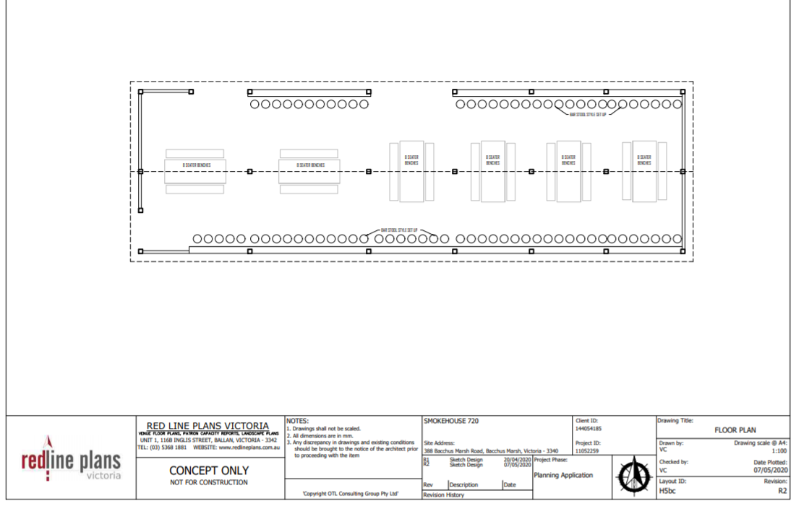
Figure 4: Proposed semi-enclosed patron seating area

Background to Current Proposal
Not applicable.

History
The produce stall on the site has operated from its current premises for approximately 40 years. A plant nursery previously operated from the site of the proposed restaurant, but no further details are known.
Previous applications for the site include numerous planning permits including for buildings and works associated with primary produce sales, a caretaker’s dwelling and subdivision.

Public Notice
Notice of the application was given by mail to adjoining and nearby landowners and occupiers and a sign erected on site for a minimum of 14 days. No objections were received.

Locality Map
The map below indicates the location of the subject site and the zoning of the surrounding area.
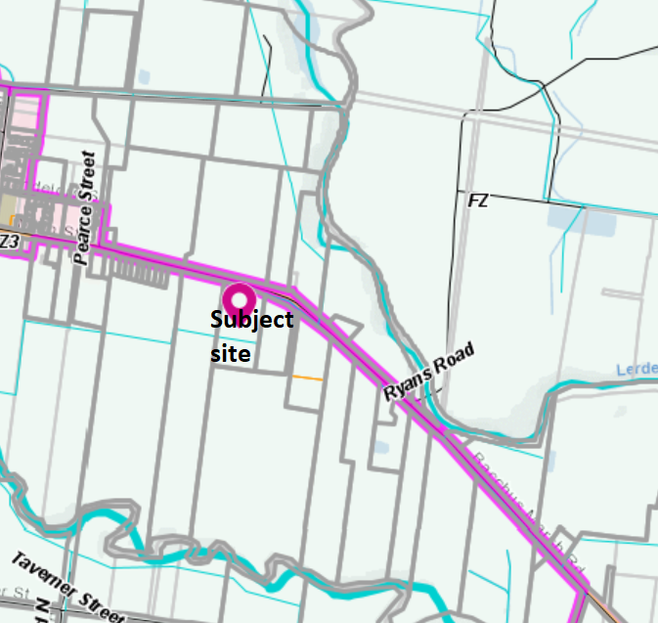
Figure 5: Zone map
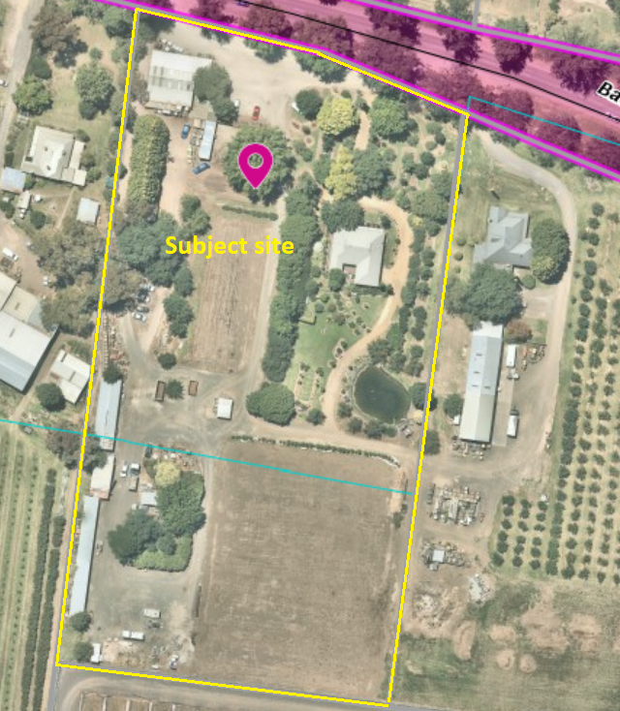
Figure 6: Aerial photograph

Planning Scheme Provisions
Council is required to consider the Victoria Planning Provisions and give particular attention to the Planning Policy Framework (PPF), the Local Planning Policy Framework (LPPF) and the Municipal Strategic Statement (MSS).
The relevant clauses are:
• Clause 11.03-3S Peri-urban areas
• Clause 13.07-1S Land use compatibility
• Clause 14.01-1S Protection of agricultural land
• Clause 14.01-2S Sustainable agricultural land use
• Clause 14.02-3S Protection of declared irrigation districts
• Clause 15.01-6S Design for rural areas
• Clause 15.03-1S Heritage conservation
• Clause 17.04-1S Facilitating tourism
• Clause 21.02-2 Non-urban landscapes
• Clause 21.03-2 Urban growth management
• Clause 21.03-4 Landscape and neighbourhood character
• Clause 21.04-2 Agriculture
• Clause 21.04-3 Commercial
In assessing it against the relevant sections of the PPF and LPPF, the following significant non-compliances were identified:
PPF and LPPF assessment
PPF | Title | Response
Clause 11.03-3S | Peri-urban areas | The proposal does not align with the strategy to protect areas which are strategically important for agriculture.
Clause 13.07-1S | Land use compatibility | The proposed location for a non-farming use – a restaurant – in an area primarily used for crop raising is considered incompatible due to the potential amenity impacts created by ‘as of right’ agricultural activities.
Clause 14.01-1S | Protection of agricultural land | The proposal does not align with the strategy to protect productive farmland of State strategic importance, would result in dispersed urban related activity in a farming area, is incompatible with agriculture and may further erode the viability of farming related activities.
Clause 14.01-2S | Sustainable agricultural land use | The proposal is a non-farming related activity located in a strategically important farming area. The proposal does not support the appropriate use of natural resources or related farming infrastructure or contribute to sustainable agricultural production.
Clause 14.02-3S | Protection of declared irrigation districts | The proposal contributes to undermining the future viability of agricultural production and irrigation infrastructure in the Bacchus Marsh Irrigation District.
LPPF
Clause 21.03-2 | Urban growth management | The proposal is non-farming related in an area with high agricultural value.

Clause 21.04-2 | Agriculture | The proposal does not meet the objective to increase productivity and investment associated with the Bacchus Marsh Irrigation District and is incompatible with productive agricultural land.
Clause 21.04-3 | Commercial | The proposal does not support the objective to maintain the primacy of the Bacchus Marsh Main Street Activity Centre as the key location for retail activity such as the proposed use.

Zone
The subject site is in the Farming Zone (FZ). The purpose of the Farming Zone is:
• To implement the Municipal Planning Strategy and the Planning Policy Framework.
• To provide for the use of land for agriculture.
• To encourage the retention of productive agricultural land.
• To ensure that non-agricultural uses, including dwellings, do not adversely affect the use of land for agriculture.
• To encourage the retention of employment and population to support rural communities.
• To encourage use and development of land based on comprehensive and sustainable land management practices and infrastructure provision.
• To provide for the use and development of land for the specific purposes identified in a schedule to this zone.
Under Clause 35.07-1 a restaurant is a Section 2 use which requires a permit. Under Clause 35.07-4 a permit is required for the associated buildings and works.
Overall, the proposal is inconsistent with the purpose of the zone.
Overlays
The site is affected by the following overlays: Environmental Significance Overlay, Schedules 2 (ESO2) (part) and 8 (ESO8) (part), Heritage Overlay, Schedule 47 (HO47) (part) and Design and Development Overlay, Schedule 2 (DDO2).
Under Clause 42.01-2 (ESO) a permit is required to construct buildings and works. The proposed development is not within the area affected by ESO2 and is exempt under ESO8. A permit is not required under this overlay.
Under Clause 43.01-1 (HO) a permit is required to construct buildings and works. The proposed restaurant is not within the area affected by HO47 but most of the proposed parking spaces are within the area affected by HO47 which is listed on the Victorian Heritage Register and subject to the requirements of the Heritage Act 2017. The application states that minor car parking indications (signage) are proposed within the coverage of HO47. Under Clause 43.01-3 a permit is not required to develop a heritage place which is included in the Victorian Heritage Register – approval must be obtained from Heritage Victoria. Council sought Heritage Victoria’s formal advice, with their response raising concerns about the potential impacts on the health of trees due to the proximity of car parking. It is not considered that the proposal meets the purpose of the Heritage Overlay. See ‘Discussion’ below.
Under Clause 43.02-2 (DDO) a permit is required to construct buildings and works. Under Schedule 2 there is an exemption for use of non-reflective building cladding. In this instance a permit is not required.

Relevant Policies
The Bacchus Marsh Avenue of Honour Strategic Management Plan (June 2004). The Plan identifies in Part 7.1 the recommended approach to protecting trees from the impacts of buildings and works. The proposed car parking location within the Heritage Overlay does not align with the Plan.

Particular Provisions
Clause 52.06 Car Parking
Under Clause 52.06-5 a restaurant requires 0.4 car spaces per patron. Based on the applicant’s request to accommodate up to 60 patrons, 24 car spaces are required as a minimum. The applicant proposes 29 car spaces, including three accessible car spaces. The accessway and car space dimensions meet the requirements of Clause 52.06-9.
Clause 52.27 Licenced Premises
A permit is required to use land to sell or consume liquor because a licence is required under the Liquor Control Reform Act 1998.
Clause 52.29 Land Adjacent to a Road Zone, Category 1
A permit is required to construct or alter access to a road in a Road Zone, Category 1. There are no proposed changes to access therefore a permit is not required in this instance.
Clause 52.34 Bicycle Facilities
Under Clause 52.34-5 a restaurant requires the following bicycle parking facilities:
• For employees: 1 space to each 100sqm of floor area available to the public.
• For patrons: 2 plus 1 to each 200sqm of floor area available to the public if the floor area available to the public exceeds 400sqm.
The area occupied by the restaurant and toilets but not including car parking is approximately 625sqm. Excluding the shipping containers and meat smoking area, the area available to the public exceeds 550sqm. Therefore, six employee spaces and five customer spaces are required. Where five or more employee spaces are required, one shower for the first five employee spaces and change room facilities must be provided. No provision for bicycle parking or facilities have been made as part of this application.

Discussion
Overall, the proposed use and development does not align with relevant State and local planning policy, the Farming Zone, Heritage Overlay or relevant decision guidelines at Clause 65.01 of the Moorabool Planning Scheme.
The subject site is located within the Bacchus Marsh Irrigation District (BMID), an irrigation district declared under the Water Act 1989, which is a strategically significant location for crop raising and identified as such in state and local planning policy. Accordingly, land use and development in this area must be carefully managed to ensure that the long-term viability of agricultural production and irrigation infrastructure, and the associated economic, social and environmental benefits, are protected and enhanced. Furthermore, the site is located on the Avenue of Honour, renowned for its scenic qualities characterised by large established trees in a river valley farmland setting. Maintaining and enhancing this area’s landscape values for their scenic qualities provides a vast range of benefits for locals and visitors alike, and therefore land use and development proposals must be carefully considered in this context.
The subject site and surrounding land is in the Farming Zone and used predominantly for crop raising, with a limited range of other uses, most notably long established dwellings and primary produce stalls. Farm related buildings including for storage, treating and packaging farm produce are some of the more prominent buildings in the area.
In the context of relevant state and local planning policy, the Farming Zone provisions, Heritage Overlay purpose and the nature of surrounding use and development, the proposed restaurant with liquor licence is not considered to be appropriate in this location. The key considerations are:
• Is the use and development for a restaurant appropriate in this location?
• Is a licenced premise appropriate in this location?
• Does the proposal compromise the Avenue of Honour heritage elm trees?
• Is a lack of bicycle facilities appropriate?
Is the use and development for a restaurant appropriate in this location?
The proposed restaurant would occupy 610sqm of predominantly vacant land centred around a mature exotic canopy tree which contributes significantly to the site’s landscape appeal. Although this particular part of the site appears to have limited scope for agricultural production the proposal does not have any direct connection to the farming activities occurring on the site or adjoining land. The applicant has advised that produce from the onsite stall would be purchased where possible and meat sourced from the local abattoir, however this does not demonstrate a value adding nexus between agricultural and non-agricultural use which might otherwise be deemed desirable. In any case, the proprietor has advised that the produce stall is expected to cease operating in the near future. Furthermore, considering the site’s location in the BMID and the associated value of ensuring land in this area is maximised for agricultural use it is important to ensure that non-agricultural land uses do not prejudice agricultural activities from occurring on the balance of the site or adjoining land.
The applicant has emphasised that the site and surrounding land along the Avenue of Honour is a significant tourist drawcard and thus the proposal should be supported to capitalise on this appeal. However, it is important to consider whether there is planning policy support for tourism in this location and any relevant competing factors. Local planning policy identifies the Avenue of Honour and farmland around the township as defining character elements of Bacchus Marsh and that highly productive irrigated horticultural land provides a source of employment and fresh food that needs to be protected from the urban expansion of Bacchus Marsh. The objective of Clause 21.04-2 (Agriculture) of the Moorabool Planning Scheme is:
• To protect good quality agricultural land and support the productivity and sustainability of existing and future agricultural and horticultural activities.
• To increase productivity and investment associated with the Bacchus Marsh Irrigation District.
Strategies to achieve this include:
• Require land use changes and new developments in productive agricultural areas to demonstrate that they do not impact detrimentally on existing agricultural activities.
• Encourage the use and development of land for small-scale tourist activities that are associated with or enhance the use of the land for agricultural purposes.
• Ensure that incompatible land use and development does not encroach upon productive agricultural land, particularly the Bacchus Marsh Irrigation District.
• Facilitate value-adding enterprises associated with the Bacchus Marsh Irrigation District, by working with landowners to achieve vertical or horizontal integration.
The proposed use and development for a restaurant does not meet the objective or align with the relevant strategies. Whilst the area occupied by the restaurant would be small in relative terms it is nonetheless non-farming related retail activity which has no strategic basis for support. Whilst tourism and retail activities may be appropriate on the Avenue of Honour, planning policy clearly identifies that there must be a connection and benefit to the main purpose of the area which is for agriculture.
Other local planning policy gives guidance to the preferred locations for retail activity. Clause 21.04-3 (Commercial) states the objective ‘to maintain the primacy of the Bacchus Marsh Main Street Activity Centre with a corresponding strategy being to ‘facilitate appropriate investment attraction and development of the core activity centres shown on the Bacchus Marsh Urban Growth Framework Plan’ with Moorabool’s Major Activity Centre (MAC) – Main Street – being at the top of the activity centre hierarchy.
The objective of Clause 21.04-5 (Local Employment) is ‘to increase local employment opportunities in activity centres, industrial precincts and the agricultural/agribusiness sector.’ Strategies applicable to this application are to:
• Facilitate development of the tourism sector by protecting the natural environment, heritage and town character; and
• Promote tourist-related industries (wineries, art, festivals), and strengthen tourism links with surrounding municipalities.
It is considered that the location of the proposed restaurant, a non-farming related retail use isolated from the Moorabool Major Activity Centre does not meet the policy intention to cluster retail and other complementary land uses together for the broad range of benefits this creates. Furthermore, the takeaway food offering proposed as part of this proposal, by way of a counter serving patrons not dining in, is a particularly problematic aspect of the proposal due to takeaway food premises being a prohibited use, along with most retail premises, in the Farming Zone. Ensuring that this feature of the proposal maintains compliance with the Moorabool Planning Scheme may prove difficult for Council to enforce and further exemplifies the unsuitability of the proposal in this location, compared to commercial zoned land generally more amenable to the flexibility required for this type of use.
In terms of built form, the shipping container construction does not generally match existing development in the area, although the scale and form of the containers would be generally consistent with the overall scale, bulk and form with the existing primary produce stall building. Furthermore, the shipping container nearest the road would be further set back than the produce building and the existing trees would to some extent soften its appearance. No details are provided as to colours or finishes but would be required to blend with the surrounding landscape if approved. Additionally, screening vegetation up to the maximum height of the container would be required to soften its appearance.

Are licenced premises appropriate in this location?
Licenced premises in this location are not necessarily considered to be an issue, subject to being appropriately managed to ensure that alcohol consumption occurs only within the designated red line area and that noise levels and hours of operation do not prejudice the amenity of the area or the functioning of adjoining and nearby land uses. This liquor licence would be associated with a restaurant where food would be consumed on site and in an area isolated from other licenced premises. The intent of Clause 52.27 is to prevent the clustering of licensed premises that may cause adverse amenity impacts. The site is within 80m of three existing dwellings, and whilst there is potential for amenity impacts these are likely to be manageable by way of permit conditions, if approved.
A liquor licence provided it is associated with food consumed on site is appropriate.
Does the proposal compromise the Avenue of Honour heritage elm trees?
The proposed parking in the front setback would be within the coverage of Heritage Overlay, Schedule 47 (HO47), occupying an existing gravelled informal car parking area served by existing accessways and crossovers to Bacchus Marsh Road. Comment was sought from Heritage Victoria (HV) due to the area covered by HO47 being listed on the Victorian Heritage Register (VHR), noting that any buildings and works within the HO47 coverage are subject to approval from HV and exempt from a planning permit. HV advised that they object to the proposed location of car parking in the area covered by HO47 due its potential impact on the health of the heritage listed trees forming part of the Avenue of Honour, notwithstanding that the only works proposed by the applicant are minor parking indentations. HV acknowledge that vehicles already park within this area and object to formalising this arrangement through the approval of car parking in this location. HV are concerned about the long-term impacts on the health of trees due to ground compaction beneath the trees and the associated impacts on their cultural heritage values. HV advise that this area should be remediated by reinstating a grassed verge under the trees, as exists for most of the Avenue of Honour. HV advise that the proposed car parking area should be relocated outside of the Tree Protection Zone of the elm trees.
It is noted that in the original plans submitted with the application, most car parking was located on the south side of the proposed restaurant, outside the coverage of HO47, on an area of arable land. Prior to advertising, Council raised concerns with the applicant regarding this arrangement, due to the loss of arable land to car parking.
Part 7.1.1 of the Bacchus Marsh Avenue of Honour Strategic Management Plan (June 2004) states that car parking should not be approved within the optimal root zone, which extends at least as far the tree canopy edge and sometimes further, due to the damaging impact of root compaction. An encroachment of up to 20% of the root zone may be acceptable if there is no reasonable alternative location for parking. The Plan notes that damage from works can take up to 10 years to become apparent.
Although works within HO47 are subject to the approval of HV, it is not appropriate for Council to determine an application before considering whether a proposal may detrimentally impact on the significance of a heritage place. In this instance, based on the advice of HV and the Bacchus Marsh Avenue of Honour Strategic Management Plan (June 2004), it is not considered that the proposal represents orderly planning or meets the purpose of the Heritage Overlay. If Council approves the proposal in its current form, it is understood that the applicant must still seek advice from HV as to their requirements before being able to commence developing the site.

Is a lack of bicycle facilities appropriate?
As outlined above, 11 bicycle parking spaces, one (1) shower and changeroom facilities would be required under Clause 52.34 of the Moorabool Planning Scheme. No spaces or associated facilities are proposed, and it is noted under Clause 52.34-2 that a permit may be granted to reduce or waive these requirements. In this instance, a partially reduction would be acceptable for the following reasons:
• The site is not served by existing bicycle infrastructure such as on-road or off-road cycle paths which encourage cycling in this area.
• The site is not proximate to other land uses which would encourage cycling as a form of transport, including for multi-purpose trips.
• The floor area of the proposal, upon which the bicycle parking calculation is based, is significantly larger than that occupied by many restaurants hosting 60 patrons. The spacious arrangement of seating therefore inflates the bicycle parking requirements compared to many restaurants accommodating the same number of patrons.
• Council’s Hike and Bike Strategy (2014) identified potential for off road paths along the Avenue of Honour, subject to further investigation. The Council Plan (2017-2021) identified that Council’s Leisure and Recreation Strategy (incorporating the Hike and Bike Strategy) would be revised in the 2020/2021 financial year, and it has been confirmed that no recommendations have been drafted for consultation or adopted by Council.
The complete waiver of the requirement is unacceptable as it removes an alternative form of transport and the land is of sufficient size where on site bicycle space could be provided. There has been no justification for the complete removal of all of the required bicycle spaces in accordance with Clause 52.34.

General Provisions
Clause 65 – Decision Guidelines have been considered by officers in evaluating this application.
Clause 66 – Stipulates all the relevant referral authorities to which the application must be referred.

Referrals
Authority | Response
Western Water  Melbourne Water  Transport for Victoria  Heritage Victoria | Consent  Consent  No response  Refusal
Infrastructure  Environmental Health  Economic Development  Strategic Planning | Consent with conditions  Consent with conditions  Consent  Refusal

Financial Implications
There are no financial implications for Council in refusing the application.

Risk & Occupational Health & Safety Issues
The recommendation to refuse this application does not have any risk or OH&S implications for Council.

Communications Strategy
Notice was undertaken for the application, in accordance with s.52 of the Planning and Environment Act 1987, and further correspondence is required to all interested parties to the application as a result of a decision in this matter. The applicant was invited to attend this meeting and address Council if required.

Options
• Issue a Refusal to Grant a Permit in accordance with the grounds in the recommendation of this report; or
• Issue a Refusal to Grant a Permit with amendments to the grounds in the recommendation of this report. Either option to refuse the application may result in the applicant appealing Council’s decision at VCAT; or
• Should Council wish to support the application, issue a Planning Permit with conditions.

Conclusion
Overall, the proposal is inconsistent with relevant State and local planning policy, the Farming Zone, Heritage Overlay and relevant decision guidelines at Clause 65 of the Moorabool Planning Scheme. The proposed restaurant is a non-farming retail premises in an area of State significant irrigated farmland where non-agricultural uses are discouraged if there is no direct connection with, or established benefit to, farming activities. The proposal represents ad hoc commercial activity which would contribute to eroding the sustainability of farming activities and infrastructure in a strategically important location. Furthermore, the proposal does not respond appropriately to preserving the heritage significance of the Avenue of Honour.

7.4 PA2020125 Variation of Restrictive Covenant PS 612677A at 42 Adriana Court, Rowsley
Author: Thomas Tonkin, Statutory Planner
Authoriser: Henry Bezuidenhout, Executive Manager Community Planning & Economic Development
Attachments: 1. Proposed building envelope (under separate cover)

Application Summary
Permit No: PA2020125
Lodgement Date: 26 June 2020
Planning Officer: Tom Tonkin
Address of the land: 42 Adriana Court, Rowsley
Proposal: Variation of Restrictive Covenant PS 612677A
Lot size: 70.23ha
Why is a permit required? Clause 52.20 Easements, Restrictions and Reserves – Variation of a Restriction

Recommendation
That Council, having considered all matters as prescribed by the Planning and Environment Act 1987, issue a Notice of Decision to Grant Planning Permit PA2020125 for a Variation of Restrictive Covenant PS 612677A to change the building envelope at Lot 5 on PS 612677A known as 42 Adriana Court, Rowsley, 3340, subject to the following conditions:
1. The plan of variation of the restriction must be certified under Section 6 of the Subdivision Act 1988 and then must be registered with the Registrar of Titles before a Building Permit is issued for any buildings and works.
2. Within 30 days of registration of the variation of restrictive covenant PS 612677A, the existing dwelling must be demolished or removed to within the approved building envelope to the satisfaction of the Responsible Authority.
3. This permit will expire if the approved variation of the restriction is not registered with the Land Titles Office within two years of the date of this permit.

Public Consultation
Was the application advertised? | Yes.
Notices on site: | Yes, one.
Notice in Moorabool Newspaper: | Yes.
Number of objections: | Two.
Consultation meeting: | No.

Policy Implications
The Council Plan 2017-2021 provides as follows:
Strategic Objective 2: Minimising Environmental Impact
Context 2A: Built Environment
The proposal does not conflict with the Council Plan 2017 – 2021.

Victorian Charter of Human Rights & Responsibilities Act 2006
In developing this report to Council, the officer considered whether the subject matter raised any human rights issues. In particular, whether the scope of any human right established by the Victorian Charter of Human Rights and Responsibilities is in any way limited, restricted or interfered with by the recommendations contained in the report. It is considered that the subject matter does not raise any human rights issues.

Officer’s Declaration of Conflict of Interests
Under section 130 of the Local Government Act 2020, officers providing advice to Council must disclose any interests, including the type of interest.
Executive Manager – Henry Bezuidenhout
In providing this advice to Council as the Executive Manager, I have no interests to disclose in this report.
Author – Tom Tonkin
In providing this advice to Council as the Author, I have no interests to disclose in this report.

Executive Summary
Application referred? | Yes, to Melbourne Water, Southern Rural Water and Council’s Environmental Health.
Any issues raised in referral responses? | No.
Preliminary concerns? | None.
Any discussions with applicant regarding concerns? | Not applicable.
Any changes made to the application since being lodged? | No.
Brief history. | Not applicable.
Previous applications for the site? | None.
General summary. | It is proposed to vary the size and location of the building envelope registered as a restrictive covenant on title to double its size to 8,000sqm and position it a further 70m from the street frontage. Two objections were received relating to overlooking and loss of privacy, impacts on livestock and fauna habitat and neighbourhood character. Subject to conditions, the proposed covenant variation is acceptable and would not have any detrimental impacts on the covenant beneficiaries or any other person.
Summary Recommendation
That, having considered all relevant matters as required by the Planning and Environment Act 1987, Council issue a Notice of Decision to Grant a Permit for this application for a variation of covenant in accordance with Section 61 of the Planning and Environment Act 1987, subject to the conditions included in this report.

Site Description
The subject site, identified as Lot 5 on PS612677A and known as 42 Adriana Court, Rowsley, is an irregular shaped 70.23ha lot with a 100m wide frontage to Adriana Court. The site contains a single storey dwelling and shed towards the front of the site, with the balance of the land being vacant. Various minor tributaries of Parwan Creek are sourced within and flow through the rear of the site, which is relatively flat towards the front, but which gradually falls westwards by up to 100m. Most of the site is substantially cleared of vegetation. A 50m x 80m (4,000sqm) building envelope set back 55m from the front title boundary and 18m from the nearest title boundary to the northeast is registered as a restriction on title.
The subject site and surrounding land is in the Farming Zone and Adriana Court is characterised by six rural residential lots varying in size from 15-70ha, five of which are developed with single dwellings. Each lot is burdened by a 4,000sqm building envelope registered as a restriction on title. The subdivision was created in 2010 and the building envelopes were imposed by the original landowner.

Proposal
It is proposed to vary restrictive covenant PS 612677A to change the size and location of the abovementioned building envelope. The building envelope would be increased in size to 100m x 80m (8,000sqm) and the setback from the front title boundary increased to 125m. The 18m northeast side setback would be maintained. A Land Capability Assessment (LCA) report was submitted with the application to show that the proposed building envelope would also contain an effluent field.
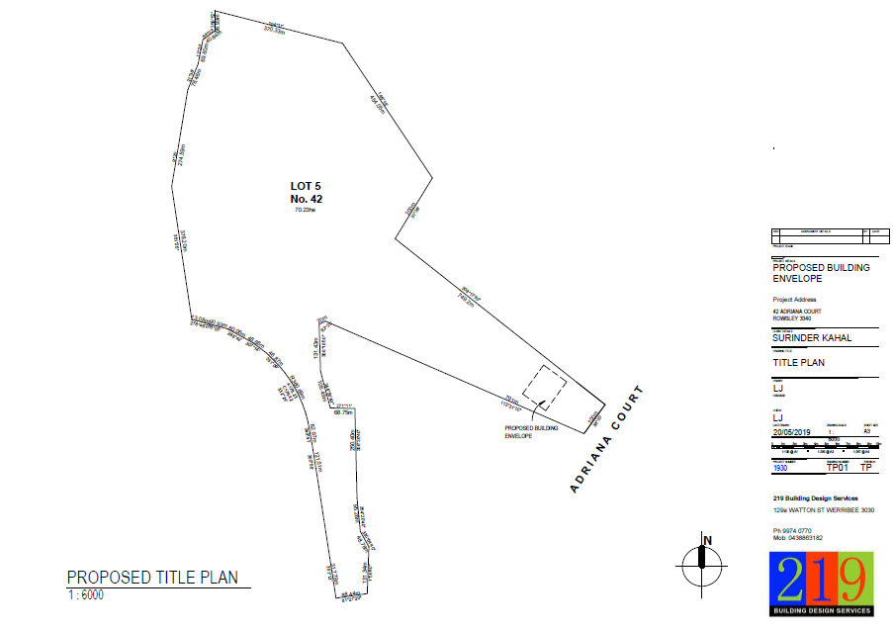
Figure 1: Site plan showing location of proposed building envelope.
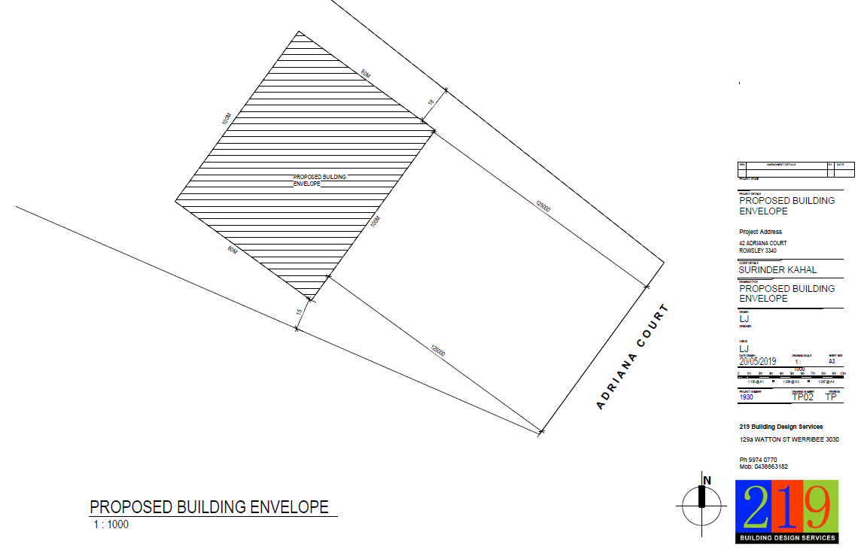
Figure 2: Detailed plan showing location of proposed building envelope.

Background to Current Proposal
None applicable.

History
None applicable.

Public Notice
Notice of the application was given to the covenant beneficiaries including adjoining landowners in Adriana Court by way of direct letters, a sign erected on site and a notice in the Moorabool News. Two objections were received, both from beneficiaries of the covenant.

Summary of Objections
The objections received are detailed below with officer’s comments accompanying them:
Objection | Any Relevant Requirement
The proposed change to the building envelope location would enable a future dwelling to overlook the rear of our dwelling. The purpose of the building envelopes was to ensure dwellings were positioned in a uniform position on each lot and limit overlooking of the rear of adjoining dwellings. | Clause 52.02 and S.60(2) of the Planning and Environment Act 1987.
Officer’s Response:
A future dwelling built within the proposed building envelope would be set back at least 100m and 180m from the rear of both adjoining dwellings. Overlooking from these distances is not considered to have an unreasonable impact on the amenity of neighbouring landowners. See ‘Discussion’ below.
The proposed building envelope location would completely change the character of my property, resulting in a visually dominant dwelling. | Clause 52.02 and S.60(2) of the Planning and Environment Act 1987.
Officer’s Response:
Works have commenced on the property but in a different location to the proposed building envelope which would be located closer to the property frontage on land with flatter topography. It is not considered that the proposal would detrimentally affect the character of the adjoining property or the area more generally.
The new dwelling will overlook most of my land and take away all sense of privacy. | Clause 52.02 and S.60(2) of the Planning and Environment Act 1987.
Officer’s Response:
The proposal is to change the building envelope. No dwelling designs are required to be submitted for assessment. As previously stated, the proposed building envelope would be located on relatively flat topography, closer to the existing dwelling and would not result in unreasonable impacts on privacy.
The building envelope locations on each property in the subdivision are positioned to cluster buildings together and avoid development on hillsides and valleys, meaning these areas are more secluded for each landowner. This was a key reason for buying the property. | Clause 52.02 and s.60(2) of the Planning and Environment Act 1987.
Officer’s Response:
The proposed building envelope would be located on relatively flat land and avoid sloping topography further towards the rear of the site in the area of concern for the objector.
I have planted 10,000 native trees using a $60,000 grant. Daily family activity on the hillside would disturb this habitat for flora and fauna. | Clause 52.02 and s.60(2) of the Planning and Environment Act 1987.
Officer’s Response:
As previously stated, the proposed building envelope avoids hilly topography and future development would not be expected to have any detrimental impacts on fauna and flora habitat.
I have established trails to walk and ride my horses which are close to the common property boundary and am concerned that activity occurring within the proposed building envelope would spook the horses and pose a safety issue for me. | Clause 52.02 and s.60(2) of the Planning and Environment Act 1987.
Officer’s Response:
The proposed building envelope would be set back a minimum 15m from the common property boundary, no closer than the current envelope, and positioned closer to the front of the property than the objector perceives, with lesser potential impact on livestock and existing trails.

Locality Map
The map below indicates the location of the subject site and the zoning of the surrounding area.
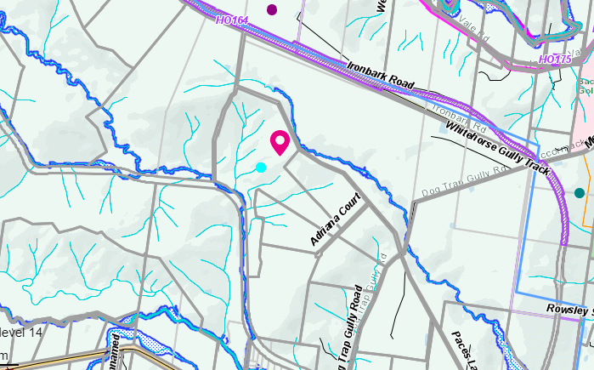
Figure 3: Zoning map

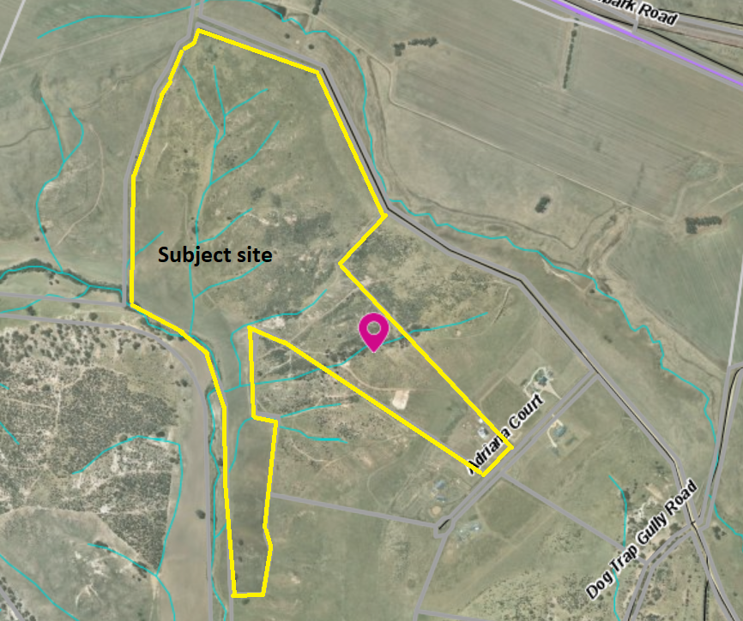
Figure 4: Aerial photograph

Planning Scheme Provisions
Council is required to consider the Victoria Planning Provisions and give particular attention to the Planning Policy Framework (PPF), the Local Planning Policy Framework (LPPF) and the Municipal Strategic Statement (MSS).
The relevant clauses are:
• Clause 11.03-3S Peri-urban areas
• Clause 15.01-5S Neighbourhood character
• Clause 21.03-4 Landscape and Neighbourhood Character
The proposal is generally consistent with the relevant sections of the PPF and LPPF.

Zone
The subject site is in the Farming Zone. The purpose of the Zone is:
• To implement the Municipal Planning Strategy and the Planning Policy Framework.
• To provide for the use of land for agriculture.
• To encourage the retention of productive agricultural land.
• To ensure that non-agricultural uses, including dwellings, do not adversely affect the use of land for agriculture.
• To encourage the retention of employment and population to support rural communities.
• To encourage use and development of land based on comprehensive and sustainable land management practices and infrastructure provision.
• To provide for the use and development of land for the specific purposes identified in a schedule to this zone.
There is no permit requirement under the zone provisions for a variation of covenant.

Overlays
The site is affected by Environmental Significance Overlay, Schedule 1 (ESO1) and Design and Development Overlay, Schedule 2 (DDO2).
There are no permit requirements under the overlay provisions for a variation of covenant.

Relevant Policies
There are no Council policies applicable to the assessment of this application.

Particular Provisions
Clause 52.02 Easements, Restrictions and Reserves
A permit is required before a person proceeds under Section 23 of the Subdivision Act 1988 to vary or remove a restriction.

Discussion
The relevant consideration for assessment of this application are the provisions of Section 60(2) of the Planning and Environment Act 1987 Under Section 60(2) of that Act, the Responsible Authority must not grant a permit which allows the variation of a restriction (within the meaning of the Subdivision Act 1988) unless it is satisfied that the owner of any land benefited by the restriction will be unlikely to suffer the following as a consequence of the variation of the restriction:
a) financial loss
VCAT have consistently stated that the impact of financial loss cannot be easily determined and would require expert evidence. The objectors have not provided any information which convinces Council that this is the case.
b) loss of amenity
The covenant currently allows for development to occur within a 4,000sqm building envelope on the subject site and all other lots within the subdivision. The proposal seeks to vary the covenant to double the size of the envelope to 8,000sqm to accommodate a future dwelling and farm sheds which the applicant has advised would comprise two sheds of 150sqm and 750sqm. Accordingly, to maintain desirable separation between buildings and avoid future requests to either incrementally increase the building envelope size or build outside the envelope. The location of the proposed envelope would be maintained on the relatively flat land within approximately 220m of the Adriana Court frontage and not encroach upon the sloping land further to the rear of the site. Considering the site is 70ha and in the Farming Zone, the requirement for a building envelope large enough to accommodate multiple buildings including farm sheds is considered reasonable, notwithstanding the apparent constraints imposed by site topography.
Concerns were raised regarding overlooking, given the proposed building envelope would be set back further from the street than the envelopes on both adjoining lots. The existing building envelope side setbacks would not be reduced by the proposal. Furthermore, the proposed envelope would be located at least 100m from the rear of each adjoining dwelling. Overlooking of existing residential dwellings and secluded private open space is assessed when new dwellings are sited within 9m, which the proposal would far exceed. Notwithstanding that amenity expectations and perceptions of overlooking in a rural area generally differ than in a conventional residential area, the proposed building envelope would maintain an acceptable separation from adjoining dwellings.
A search of the planning permit application and assessment which approved the subdivision does not provide any indication that the building envelope locations were primarily for anything other than to guide where development should occur regarding land capability and to provide a general uniformity for development of each lot. However, the front setbacks of building envelopes on each lot vary between 20m-118m, due in part to the varying frontage widths and lot shapes. In this context, and considering the size of the subject site, the proposal to increase the building envelope’s front setback by 70m is deemed acceptable.
c) loss arising from change to the character of the neighbourhood
The character of the neighbourhood is defined by single storey dwellings clustered with ancillary outbuildings on spacious allotments in an open rural setting with generally unobstructed views in all directions. There are no use or development restrictions registered on title apart from the building envelopes. Changing the building envelope size and location as proposed would result in development being set back further from the property frontage than development on both adjoining lots and opposite the subject site. As previously stated, five of the six lots in the subdivision are developed with dwellings, with one vacant lot at the end of Adriana Court which has its building envelope set back 118 from the street frontage. The relatively uniform nature of existing front setbacks in the streetscape is apparent from a site inspection. However, the proposed change to the building envelope location, in particular increasing the front setback from 55m to 125m, is not considered to be detrimental to the character of the area. The spacious character would be maintained, with no reduction to side setbacks. It is not considered that any person would suffer loss as a result of any change to the character of the neighbourhood.
d) any other material detriment
An objector raised concerns about the impact on livestock and native fauna and flora. As stated above, the proposed location of the building envelope differs from the location described in the objection. The proposed location does not reduce the existing side setbacks and maintains a location relatively close to the street frontage which allows for reasonable separation from livestock trails and native habitat to avoid any unreasonable impacts.
In addition to the above matters, given the applicant’s proposal to retain the existing relocatable dwelling on the site, it is recommended that a condition be imposed which requires the building to be repositioned within the approved building envelope within 30 days of registration of the proposed covenant variation.

General Provisions
Clause 65 – Decision Guidelines have been considered by officers in evaluating this application.
Pursuant to Clause 65 of the Moorabool Planning Scheme, the Responsible Authority must consider, among other things, the matters set out in Section 60 of the Planning and Environment Act 1987, as per the ‘Discussion’ above.
Clause 66 – Stipulates all the relevant referral authorities to which the application must be referred.

Referrals
Authority | Response
Southern Rural Water  Melbourne Water | No response.  Consent.
Environmental Health | Consent with conditions.

Financial Implications
There are no financial implications for Council in approving the application for a variation of covenant.

Risk & Occupational Health & Safety Issues
The recommendation to approve this application for a variation of covenant does not have any risk or OH&S implications for Council.

Communications Strategy
Notice was undertaken for the application, in accordance with s.52 of the Planning and Environment Act 1987, and further correspondence is required to all interested parties to the application as a result of a decision in this matter. All submitters and the applicant were invited to attend this meeting and address Council if required.

Options
- issue a Notice of Decision to Grant a Permit in accordance with the conditions in the recommendation of this report; or
- issue a Notice of Decision to Grant a Permit with amendments to the conditions in the recommendation of this report. Either of these options may result in the objectors appealing Council’s decision to VCAT; or
- issue a Refusal to Grant a Permit on grounds. Council would need to consider what reasonable grounds there would be to refuse the application. This option may result in the applicant appealing Council’s decision to VCAT.

Conclusion
Overall, the proposed covenant variation is considered to be acceptable, subject to conditions. It is deemed that the proposal would satisfy the relevant requirements of the Moorabool Planning Scheme, in particular the decision guidelines at Clause 65 which require consideration of section 60(2) of the Planning and Environment Act 1987 and the objections raised by covenant beneficiaries were considered in the assessment. The variation of covenant is recommended for approval. Subject to conditions, this would then allow the applicant to apply for a building permit and not contravene the restrictive covenant on title.

8 Update on Trends, Issues and Other Matters

9 Process Forward and Work Program

10 Update on VCAT Decisions

11 Other Business

12 Date of Next Meeting
Wednesday 21 April 2021

13 Meeting Close

