AGENDA
S86 Development Assessment Committee Meeting
Wednesday, 15 July 2020

In accordance with s. 395 of the COVID-19 Omnibus (Emergency Measures) Bill 2020, this meeting will not be available for public attendance, however will be streamed live via accessing the Council Internet site

I hereby give notice that a S86 Development Assessment Committee Meeting will be held on:
Date: | Wednesday, 15 July 2020
Time: | 6.00pm
Location: | The Pavilion Room, Darley Civic Hub
Derek Madden
Chief Executive Officer

Order Of Business
1 Opening 5
2 Present and Apologies 5
3 Recording of Meeting 5
4 Confirmation of Minutes 5
5 Matters Arising from Previous Minutes 5
6 Disclosure of Conflicts of Interests 5
7 Community Planning Reports 7
7.1 PA2019170 - Staged Subdivision (Stages 24 and 25 Stonehill Estate) and construction of 10 dwellings on lots less than 300sqm at McCormacks Road Maddingley 7
7.2 PA2019059 - Two Lot Re-Subdivision and Use and Development of a Dwelling at 139 Pound Creek Road Navigators 34
7.3 PA2019230 - Two Lot Subdivision at 47 Corbetts Road, Gordon 47
7.4 PA2019141 - Seven Lot Staged Subdivision and Vegetation Removal at 6 O'Donnell Street, Gordon 60
7.5 PA2019232 - Development of a second dwelling and 2 Lot subdivision - 3 Davies Street, Darley 76
8 Update on Trends, Issues and Other Matters 89
9 Process Forward and Work Program 89
10 Update on VCAT Decisions 89
11 Other Business 89
12 Date of Next Meeting 89
13 Meeting Close 89

1 Opening

2 Present and Apologies

3 Recording of Meeting
As well as the Council for its minute taking purposes, the following organisations have been granted permission to make an audio recording of this meeting:
- The Moorabool News; and
- The Star Weekly.

4 Confirmation of Minutes
S86 Development Assessment Committee Meeting – Wednesday 20 May 2020

5 Matters Arising from Previous Minutes

6 Disclosure of Conflicts of Interests
Under the Local Government Act (1989), the classification of the type of interest giving rise to a conflict is; a direct interest; or an indirect interest (section 77A and 77B). The type of indirect interest specified under Section 78, 78A, 78B, 78C or 78D of the Local Government Act 1989 set out the requirements of a Councillor or member of a Special Committee to disclose any conflicts of interest that the Councillor or member of a Special Committee may have in a matter being or likely to be considered at a meeting of the Council or Committee.
Definitions of the class of the interest are:
- A direct interest (section 77A, 77B)
- An indirect interest (see below)
- indirect interest by close association (section 78)
- indirect financial interest (section 78A)
- indirect interest because of conflicting duty (section 78B)
- indirect interest because of receipt of gift(s) (section 78C)
- indirect interest through civil proceedings (section 78D)
- indirect interest because of impact on residential amenity (section 78E)
Time for Disclosure of Conflicts of Interest
In addition to the Council protocol relating to disclosure at the beginning of the meeting, section 79 of the Local Government Act 1989 (the Act) requires a Councillor to disclose the details, classification and the nature of the conflict of interest immediately at the beginning of the meeting and/or before consideration or discussion of the Item.
Section 79(6) of the Act states:
While the matter is being considered or any vote is taken in relation to the matter, the Councillor or member of a special committee must:
- Leave the room and notify the Mayor or the Chairperson of the special committee that he or she is doing so; and
- Remain outside the room and any gallery or other area in view of hearing of the room.
The Councillor is to be notified by the Mayor or Chairperson of the special committee that he or she may return to the room after consideration of the matter and all votes on the matter.
There are important reasons for requiring this disclosure immediately before the relevant matter is considered.
- Firstly, members of the public might only be in attendance for part of a meeting and should be able to see that all matters are considered in an appropriately transparent manner.
- Secondly, if conflicts of interest are not disclosed immediately before an item there is a risk that a Councillor who arrives late to a meeting may fail to disclose their conflict of interest and be in breach of the Act.

7 Community Planning Reports

7.1 PA2019170 - Staged Subdivision (Stages 24 and 25 Stonehill Estate) and construction of 10 dwellings on lots less than 300sqm at McCormacks Road Maddingley
Author: Mark Lovell, Senior Statutory Planner
Authoriser: Henry Bezuidenhout, Executive Manager Community Planning & Economic Development
Attachments: Nil

Application Summary
Permit No: PA2019170
Lodgement Date: 23 July 2019. Amended application lodged 30 March 2020.
Planning Officer: Mark Lovell
Address of the land: Lot A on PS807655A and Lot 1 on Title Plan 741538F
McCormacks Road, Maddingley
Proposal: Staged subdivision and construction of ten dwellings on lots less than 300sqm
Lot size: 29.96ha
Why is a permit required? Clause 32.08-3 GRZ2 – Subdivide land
Clause 32.08-5 Construction of dwellings on lots less than 300sqm
Clause 52.17 Native Vegetation – Remove Vegetation

Recommendation
That Council, having considered all matters as prescribed by the Planning and Environment Act 1987, issue a Planning Permit for a staged subdivision, construction of 10 dwellings on lots less than 300sqm and removal of native vegetation for land known as Stonehill Estate, Stages 24 and 25, McCormacks Road, Maddingley.
Endorsed Plans:
1. Before the plan of subdivision is certified under the Subdivision Act 1988, amended plans to the satisfaction of the Responsible Authority must be submitted to and approved by the Responsible Authority. When approved, the plans will be endorsed and then form part of the permit. The plans must be drawn to scale with dimensions and three copies must be provided. The plans must be generally in accordance with the plans submitted with the application/other specified plans but modified to show:
a) Subdivision and lot layout to accord with the plan drawn by SMEC, Revision JI dated 26 April 2020.
b) Subdivision plan without colour coding.
c) Submission of Memorandum of Common Provisions (MCP) to the satisfaction of the Responsible Authority that addresses
i. front setbacks, garage design, dwelling entry design, roof forms, dwelling separation, window design, materials and colours, fencing and driveways for the lots than 300sqm.
ii. Corner lots less than 300sqm restricted to double storey dwellings only.
iii. Dwelling orientation and fencing treatments to the lots adjacent to Werribee Vale Road
iv. Fencing treatments to corner lots.
d) Fencing or bollard barriers/treatment to prevent vehicle access to Werribee Vale Road along the entire northern boundary.

2. The layout of the staged subdivision as shown on the endorsed plans must not be altered or modified except with the written consent of the Responsible Authority.

Subdivision/Development:

3. The plan of subdivision submitted for certification under the Subdivision Act 1988 must be referred to the Relevant Authority in accordance with Section 8 of that Act.

4. The subdivision of the land must proceed in the order of stages shown on the endorsed plans except with the prior written consent of the Responsible Authority.

5. Prior to the construction of a dwelling on each lot less than 300sqm, the land owner must submit a developer approved site plan with setbacks, floor plan with dimensions and elevation plans with heights in accordance with the endorsed MCP and obtain written consent from the Responsible Authority that plans are to the satisfaction of Council.

6. Prior to any works commencing on the land a "Construction Management Plan" (CMP) must be prepared to the satisfaction and approval of the Responsible Authority, detailing how the developer will manage the environmental and construction issues associated with the development. The plan must address, but not be limited to the following:

• how the land is to be accessed during the construction period;
• all measures to be introduced to ensure that construction on the land does not impact on any vegetation to be retained;
• all measures to be introduced to minimise soil erosion and runoff;
• details relating to the storage of all plant and equipment during the construction period; and
• measures to be implemented to ensure the containment of dust, dirt and mud within the site and method and frequency of clean up procedures in the event of build-up of matter outside of the site.

7. Developer contributions are required for the provision of infrastructure on the developable land, and also where the development impacts on infrastructure demand beyond the developable area, including social and road network infrastructure based on the Community Infrastructure Report and Traffic Impact Assessment Report, and must be provided for within an agreement made with Moorabool Shire Council under Section 173 of the Planning and Environment Act 1987.

8. Prior to certification, detailed design of the local network park including landscaping must be submitted and approved by the Responsible Authority.

9. Prior to the issue of a Statement of Compliance for first stage unless with the written consent of the Responsible Authority, the local network park must be completed to the satisfaction of the Responsible Authority and in accordance with the approved detailed design.

10. Prior to the issue of a Statement of Compliance for the relevant stage, the applicant will submit post construction levels done to survey.

Telecommunications:

11. The owner of the land must enter into agreements with:

a. a telecommunications network or service provider for the provision of telecommunication service to each lot shown on the endorsed plan in accordance with the provider’s requirements and relevant legislation at the time; and
b. a suitably qualified person for the provision of fibre ready telecommunication facilities to each lot shown on the endorsed plan in accordance with any industry specifications or any standards set by the Australian Communications and Media Authority, unless the applicant can demonstrate that the land is in an area where the National Broadband Network will not be provided by optical fibre.

12. Before the issue of Statement of Compliance for any stage of the subdivision under the Subdivision Act 1988, the owner of the land must provide written confirmation from:

a. a telecommunications network or service provider that all lots are connected to or are ready for connection to telecommunications services in accordance with the provider’s requirements and relevant legislation at the time; and
b. a suitably qualified person that fibre ready telecommunication facilities have been provided in accordance with any industry specifications or any standards set by the Australian Communications and Media Authority, unless the applicant can demonstrate that the land is an area where the National Broadband Network will not be provided by optical fibre.

Infrastructure:

13. The internal road network layout must be designed and constructed to be generally in accordance with the Approved West Maddingley Development Plan, to the standard detailed in the Infrastructure Design Manual, to the satisfaction of the Responsible Authority.

14. Prior to the commencement of the development, a Storm Water Management Strategy must be prepared for the Stonehill Western Precinct and submitted for the approval of the Responsible Authority. The Strategy must identify the measures to be employed managing the storm water quality and quantity outcomes for the precinct and must identify the overland flow paths and outfall for the precinct.

15. Prior to the Statement of Compliance, the subdivision must be provided with drainage system to a design approved by the Responsible Authority and must ensure that:
i. The subdivision as a whole must be self-draining.
ii. All drainage courses within the subdivision must pass through easements or reserves shown on the plan of subdivision.
iii. All outfall drainage passing through other land must be provided at the cost of the applicant and be constructed within easements shown on the plan of subdivision.
iv. Volume of water discharging from the subdivision in a 10% AEP storm shall not exceed the 20% AEP storm prior to development. Peak flow must be controlled by the use of retardation basin(s) located and constructed to the satisfaction of the Responsible Authority.
v. Flow paths of the 1% AEP storm must be determined, and the subdivision designed so that no property is inundated by such a storm. The flow paths must be indicated on the engineering plans.
vi. The drainage system must be designed to include provision to intercept litter.
vii. All lots must be provided with a stormwater legal point of discharge at the lot point of the lot, to the satisfaction of the Responsible Authority.
viii. The drainage design must take into account the approved Stormwater Management Strategy for the overall development.

If required, the layout of the subdivision must be modified based on the approved stormwater design.

16. Prior to the commencement of any works, design computations for drainage of the whole site must be prepared and submitted to the Responsible Authority for approval, and must include analysis of the existing stormwater drainage system in the area to determine:
i. The requirements for drainage of the whole site.
ii. If the existing drainage network has sufficient capacity to cater for the additional runoff from the ultimate development.
iii. If additional outfall drainage or upgrading of the existing drainage network is required.

17. Prior to the commencement of any works, design computations for all road pavement construction, based on a geotechnical investigation of the site, must be prepared and submitted to the Responsible Authority for approval.

18. Prior to the commencement of any works, plans and specifications of all road, traffic and drainage works must be prepared and submitted to the Responsible Authority for approval and all such works must be carried out in accordance with the approved plans to the satisfaction of the Responsible Authority.

19. Telecommunications “fibre to premises” (FTTP) network (including all pipes, conduits, active equipment, equipment shelters and optical fibre cables) shall be provided to the lots to the satisfaction of the Responsible Authority.

20. Unless otherwise approved by the Responsible Authority there must be no buildings, structures, or improvements located over proposed drainage pipes and easements on the property.
21. An Environmental Management Plan for the road construction works must be submitted to the Responsible Authority for approval prior to the commencement of construction. All works must be performed in accordance with the approved Environmental Management Plan.

22. Sediment discharges must be restricted from any construction activities within the property in accordance with the relevant Guidelines including “Construction Techniques for Sediment Control” (EPA 1991) and “Environmental Guidelines for Major Construction Sites” (EPA 1995).

23. Traffic management treatments must be provided in the form of line-marking, signage and pavement markers at intersections and vehicle turning areas, to the satisfaction of the Responsible Authority.

24. Prior to the issue of Statement of Compliance for each stage, street lighting must be provided in accordance with the requirements of AS1158 – Lighting for Roads and Public Places, to the satisfaction of the Responsible Authority. All lighting fittings must be “Standard” fittings maintained by the electricity network provider at no additional cost to Council. All lights must utilise LED type luminaires where available.

25. Prior to the issue of Statement of Compliance for each stage, street names and street signs must be provided to the satisfaction of the Responsible Authority.

26. Prior to the issue of a Statement of Compliance, permanent survey marks must be provided at a maximum spacing of 200m and registered, to the satisfaction of the Responsible Authority.

27. Prior to the issue of a Statement of Compliance, Street trees must be provided at approved locations in all internal roads of the subdivision at a rate of one tree per lot frontage and one tree per lot sideage, with an approved species to the satisfaction of the Responsible Authority. All street trees must have an existing height of 1.5 metres upon planting, must be planted to an approved standard incorporating two hardwood stakes, tree ties, Ag pipe, water crystals, 100mm of mulch and initial watering, to the satisfaction of the Responsible Authority.

28. Prior to the issue of Statement of Compliance, landscaping within the development must be undertaken in accordance with an approved Landscape Plan, to the satisfaction of the Responsible Authority.

29. Landscaping (including Street trees) must be maintained for a minimum period of 18 months including watering, mulching, weeding and formative pruning, to the satisfaction of the Responsible Authority.

30. If a Statement of Compliance is sought prior to the landscape works being undertaken, then a security deposit of 150% of the cost of the landscaping must be lodged with the Responsible Authority. The landscape work must then be completed within six months from the issue of the Statement of Compliance (Practical Completion). Once the landscaping works are “Practically Compete”, the security deposited may be returned.

31. Prior to the issue of a Statement of Compliance, a security deposit equal to 25% of the cost of landscaping must be lodged with the Council. The deposit will be returned after the final inspection of Street trees, 18 months after the completion of planting of the trees, only if Council requires no further maintenance of the trees to be undertaken.

32. The applicant must pay:
i. 0.75% of the total estimated cost of works for the checking of engineering plans associated with that stage of the development.
ii. 2.5% of the total estimated cost of works for the supervision of works associated with that stage of the development.

33. After all engineering works pertaining to each stage of the subdivision have been completed, the following “as constructed” details must be submitted in the specified format to the Responsible Authority:
i. Drainage construction details in “D-Spec” format.
ii. Roadworks construction details in “R-Spec” format.

34. All road and drainage works must be maintained in good condition and repair for a minimum of three months after completion of the works, to the satisfaction of the Responsible Authority.

35. A security deposit of 5% of the total value of engineering works as approved by the Responsible Authority must be lodged with the Responsible Authority to cover the maintenance of all works. The deposit will be returned after the final inspection of works, three months after the completion of works, subject to the satisfactory completion of all required maintenance and rectification works.

36. Any existing works affected by the development must be fully reinstated at no cost to and to the satisfaction of the Responsible Authority.

Downer Utilities:

37. The plan of subdivision submitted for certification must be referred to AusNet Services (Gas) in accordance with Section 8 of the Subdivision Act 1988.

Powercor:

38. The plan of subdivision submitted for certification under the Subdivision Act 1988 shall be referred to Powercor Australia Ltd in accordance with Section 8 of that Act.

39. The applicant shall provide an electricity supply to all lots in the subdivision in accordance with the Distributor’s requirements and standards.
Notes: Extension, augmentation or rearrangement of the Distributor’s electrical assets may be required to make such supplies available, with the cost of such works generally borne by the applicant.

40. The applicant shall ensure that existing and proposed buildings and electrical installations
on the subject land are compliant with the Victorian Service and Installation Rules (VSIR).
Notes: Where electrical works are required to achieve VSIR compliance, a registered electrical contractor must be engaged to undertake such works.

41. The applicant shall, when required by Powercor, set aside areas with the subdivision for the purposes of establishing a substation or substations.
Notes: Areas set aside for substations will be formalised to the Distributor’s requirements under one of the following arrangements:
• RESERVES established by the applicant in favour of Powercor.
• SUBSTATION LEASE at nominal rental for a period of 30 years with rights to extend the lease for a further 30 years. Powercor will register such leases on title by way of a caveat prior to the registration of the plan of subdivision.

42. The applicant shall establish easements on the subdivision, for all existing Powercor electric lines where easements have not been otherwise provided on the land and for any new powerlines to service the lots or adjust the positioning existing easements.
Notes:
• Existing easements may need to be amended to meet the Powercor’s requirements.
• Easements required by Powercor shall be specified on the subdivision and show the Purpose, Origin and the In Favour of party as follows: Powerline, Section 88 Electricity Services Act 2000, Powercor Australia Ltd.

Melbourne Water:

43. Prior to Certification, the Owner shall enter into and comply with an agreement with Melbourne Water Corporation for the acceptance of surface and storm water from the subject land directly or indirectly into Melbourne Water’s drainage systems and waterways, the provision of drainage works and other matters in accordance with the statutory powers of Melbourne Water Corporation.

44. Prior to Certification of any stage of this subdivision, Melbourne Water requires that the applicant submit and receive approval for a detailed Drainage and Stormwater Management Strategy, which demonstrates how stormwater runoff from the subdivision will achieve flood protection standards and State Environment Protection Policy (Waters of Victoria) objectives for environmental management of stormwater.

45. Stormwater runoff from the subdivision must achieve State Environment Protection Policy (Waters of Victoria) objectives for environmental management of stormwater as set out in the 'Urban Stormwater Best Practice Environmental Management Guidelines (CSIRO) 1999'.

46. Unless otherwise agreed in writing by the relevant drainage authority, the subdivision must retard stormwater back to pre-development levels before entering the downstream drainage system and/or retard stormwater back to the sufficient capacity of the downstream drainage system, whichever is appropriate.
47. Prior to the issue of Statement of Compliance, engineering plans of the subdivision (in electronic format) must be forwarded to Melbourne Water for approval.
48. All new lots must achieve appropriate freeboard in relation to local overland flow paths to Council's satisfaction.

49. Local drainage infrastructure must be to the satisfaction of Council.

50. Any vehicular and/or pedestrian access must be designed and constructed to comply with the following safety criteria associated with the applicable flood level.

a) Depth of flow does not exceed 0.35m;
b) Velocity of flow does not exceed 1.5m/s;
c) The Depth Velocity product does not exceed 0.35m2/s.

51. Prior to the commencement of works, a Site Environmental Management Plan (SEMP) must be submitted to Melbourne Water for approval. The SEMP must show the location and nature of environmental values identified through site environmental assessments and includes details of measures to protect or mitigate risk to those values. The SEMP must include a site map detailing the location and design of all measures in relation to significant site values including the following:
a) Silt fencing;
b) Access tracks;
c) Spoil stockpiling;
d) Trenching locations;
e) Machinery/ Plant locations; and
f) Exclusion fencing around native vegetation/ habitat.

52. Prior to the commencement of works, a separate application direct to Melbourne Water must be made for approval of any new or modified stormwater connection to Melbourne Water's drains or watercourses, and/or waterway crossing.

53. Prior to Certification, adequate drainage outfall arrangements with the relevant downstream landowners must be finalised. A copy of written approval from the relevant affected parties to the satisfaction of Council for the arrangement of appropriate drainage outfall for the subdivision must be provided to Melbourne Water.

54. Any works or development (including vegetation removal) within the waterway corridor requires separate approval from Melbourne Water.

Western Water:

55. Payment of new customer contributions for each lot created by the development such amount being determined by Western Water at the time of payment.

56. Provision of reticulated water mains and associated construction works to front each allotment, at the developer's expense in accordance with the standards of construction adopted by and to the satisfaction of Western Water.
57. Any existing water service which crosses any of the proposed allotment boundaries within the proposed development must be disconnected and relocated at the developer's expense, to be wholly within one allotment only and to the satisfaction of Western Water.
58. Provision of reticulated sewerage services and associated construction works to each allotment within the subdivision/development, at the developer's expense, in accordance with the standards of construction adopted by and to the satisfaction of Western Water.

59. The owner shall reach an agreement with Western Water regarding the construction of any Shared Assets (water mains that are greater than 150mm diameter and gravity sewerage mains that are greater than 225mm diameter) required to service the subdivision/development. The construction of Shared Assets reimbursable by Western Water shall comply with Western Water Procurement and Guide to New Customer Contributions.

60. Provision of easements in favour of Western Water over all existing and proposed sewer mains located within private property. The easement shall be 3m wide for combined sewer and drainage easements and 2.5m wide for a dedicated sewerage easement.

61. Pursuant to Section 36 of the Subdivision Act 1988, Western Water considers that for the economical and efficient subdivision and servicing of the land covered by the Application for Permit it requires the owner of the land to acquire an easement over other land in the vicinity, namely, any land not owned by the Developer through which a sewerage extension servicing the development is to be located. The easements created shall be in favour of Western Water.

62. The operator under this permit shall be obliged to enter into an Agreement with Western Water relating to the design and construction of any sewerage or water works required. The form of such Agreement shall be to the satisfaction of Western Water. The owner/applicant shall make a written request to Western Water for the terms and conditions of the Agreement.

63. The developer must produce for approval by Western Water an Integrated Water Management Plan (IWMP) that incorporates water efficiency measures and water sensitive urban design techniques that reduce reliance on potable water by increasing utilisation of fit for purpose alternative water supplies.

64. The IWMP must set out subdivision outcomes that appropriately respond to the site and its context for integrated water management to the satisfaction of Western Water. When approved by Western Water, the IWMP must then form part of the permit.

65. All contractors engaged on construction of Subdivision Infrastructure obtain a Water Carters Permit from Western Water and comply with that permit at all times. The permit will include a requirement for the Water Carter Permit holder to:
• own a metered hydrant approved by Western Water;
• meter and pay for all water taken;
• display a Western Water Permit Number Sticker on the tanker;
• only take water from nominated hydrants or standpipes;
• only use water for the purpose approved in the Water Carters Permit;
• avoid wastage of water on site; and
• comply with any water restrictions imposed by Western Water at the time water is used.
For the purpose of this condition, Subdivision Infrastructure includes new and alterations to existing: roads, drains, water mains, sewer mains, power supply, telephone, gas and any other service infrastructure required by this permit and dust suppression during construction of the same. Notwithstanding the above, a Water Carters Permit is not required if the permit holder and contractors engaged by the permit holder can demonstrate to the satisfaction of Western Water that water is not required from Western Water's town water supply systems to construct Subdivision Infrastructure as defined above.

Country Fire Authority

66. The subdivision as shown on the endorsed plans must not be altered without the consent of CFA.

67. Prior to the issue of a Statement of Compliance under the Subdivision Act 1988 the following requirements must be met to the satisfaction of the CFA:
i. Above or below ground operable hydrants must be provided. The maximum distance between these hydrants and the rear of all building envelopes (or in the absence of building envelopes, the rear of the lots) must be 120m and the hydrants must be no more than 200m apart. These distances must be measured around lot boundaries.
ii. The hydrants must be identified with marker posts and road reflectors as applicable to the satisfaction of the Country Fire Authority.
Note – CFA’s requirements for identification of hydrants are specified in ‘Identification of Street Hydrants for Firefighting Purposes’ available under publications on the CFA web site (www.cfa.vic.gov.au).

68. Roads must be constructed to a standard so that they are accessible in all weather conditions and capable of accommodating a vehicle of 15 tonnes for the trafficable road width:
i. The average grade must be no more than 1 in 7 (14.4%) (8.1 degrees) with a maximum of no more than 1 in 5 (20%) (11.3 degrees) for no more than 50m. Dips must have no more than a 1 in 8 (12%) (7.1 degree) entry and exit angle.
ii. Curves must have a minimum inner radius of 10m.
iii. Have a minimum trafficable width of 3.5m and be clear of encroachments for at least 0.5m on each side and 4m above the access way.
iv. Roads more than 60m in length from the nearest intersection must have a turning circle with a minimum radius of 8m (including roll-over kerbs if they are provided) T or Y heads of dimensions specified by the CFA may be used as alternatives.

Transport for Victoria:

69. The connector must be constructed to accommodate public transport access for buses in accordance with the 'undivided connector road a' cross section as shown in the Public Transport Guidelines for Land Use and Development. Any alteration to the approved cross section must be referred to the Head, Transport for Victoria for approval.

70. Any roundabouts constructed on roads designated a future public transport route within the subdivision, must be designed to accommodate ultra-low floor buses, to the satisfaction of the Department of Transport.

71. Intersections, slow points, splitter islands and any other local area traffic management treatments must be designed and constructed in accordance with the Public Transport Guidelines for Land Use and Development. The use of speed humps, raised platforms, one-way road narrowing and 'weave points' must not be constructed on any portion of a road identified as a potential bus route.

Operational:

72. Sediment discharges must be restricted from any construction activity to within the property boundaries and any truck movements beyond the site associated with the activity that creates sediment discharges must comply with the Environmental Guidelines for Major Construction Sites (EPA 1995) to the satisfaction of the Responsible Authority.

Permit Expiry:

73. This permit will expire if one of the following circumstances applies:

a. the development is not started within two years of the date of this permit;
b. the development is not completed within four years of the date of this permit; and
c. the plan of subdivision is not certified within two years of the date of issue of the permit.

Statement of Compliance must be achieved, and certified plans registered at Titles office within five years from the date of certification.

Powercor Note:

It is recommended that applications for electricity supply to each lot be submitted at the earliest opportunity so that the precise requirements of the Distributor can then be determined and accommodated. Applications for electricity supply shall be submitted via the Distributor’s web portal, “mySupply” which can be accessed via the following link https://customer.portal.powercor.com.au/mysupply/CIAWQuickCalculator

Public Consultation
Was the application advertised? | Exempt from advertising.
Notices on site: | Nil.
Notice in Moorabool Newspaper: | Nil.
Number of objections: | None.
Consultation meeting: | Several meetings held with the applicant to discuss subdivision design issues.

Policy Implications
The Council Plan 2017-2021 provides as follows:
Strategic Objective 3: Stimulating Economic Development
Context 3A: Land Use Planning
The proposal is consistent with the Council Plan 2017 – 2021.

Victorian Charter of Human Rights & Responsibilities Act 2006
In developing this report to Council, the officer considered whether the subject matter raised any human rights issues. In particular, whether the scope of any human right established by the Victorian Charter of Human Rights and Responsibilities is in any way limited, restricted or interfered with by the recommendations contained in the report. It is considered that the subject matter does not raise any human rights issues.

Officer’s Declaration of Conflict of Interests
Under section 80C of the Local Government Act 1989 (as amended), officers providing advice to Council must disclose any interests, including the type of interest.
Executive Manager – Henry Bezuidenhout
In providing this advice to Council as the Executive Manager, I have no interests to disclose in this report.
Author – Mark Lovell
In providing this advice to Council as the Author, I have no interests to disclose in this report.

Executive Summary
Application referred? | Yes, Powercor Australia, Melbourne Water, Downer Utilities, Western Water, Southern Rural Water (SRW), Transport for Victoria, CFA, Department of Environment, Land, Water & Planning (DELWP), Council’s Infrastructure and Council’s Strategic Planning.
Any issues raised in referral responses? | Strategic Planning - raised concerns with lot sizes.  SRW - objected, required a legal agreement regarding a disused water channel.  DELWP - required a new biodiversity report and then requested native vegetation be added as a permit trigger.
Preliminary concerns? | Concerned with the lot arrangement on sloping land and the location of public open space on sloping land.
Any discussions with applicant regarding concerns? | Several meetings with the applicant resulting in the submission of revised plans known as  Revision G1,  Revision H1,  Revision I, and  Revision J1.  The permit applicant also had several meetings with SRW and DELWP regarding their concerns.
Any changes made to the application since being lodged? | On 14 February 2020, the applicant relocated the large public open space reserve to the flattest part of the site.  On 30 March 2020, the applicant lodged an application in process adding native vegetation removal as a permit trigger.  The applicant has modified the design and layout on several occasions to address Council officer concerns.
Brief history. | This lot is part of Stonehill Estate and is required to be developed generally in accordance with development plan under the Development Plan Overlay Schedule 3.
Previous applications for the site? | Several permits have been issued within the DPO3.
General summary. | The proposal is the subdivision of land of which 10 lots are less than 300sqm and the removal of native vegetation. The subdivision accords with the intent of the Development Plan Overlay.  Through an extensive negotiation process, Council officers have sought less lots with resultant larger lot sizes to better adapt to the sloped topography and reduce the extent of retaining walls, that was not sufficiently addressed in the Development Plan Overlay for this section of Stonehill Estate.  The latest plan has resulted in a total loss of 22 lots from the original plans and improved lot dimensions. The application is exempt from the notice provisions.  The subdivision as reflected in the latest set of plans is sufficient for approval subject to conditions.
Summary Recommendation
That, having considered all relevant matters as required by the Planning and Environment Act 1987, Council issue a Planning Permit for a staged subdivision, construction of 10 dwellings on lots less than 300sqm and the removal of native vegetation for land at McCormack Road, Maddingley known as Stages 24 and 25 of Stonehill Estate.

Site Description
The subject site forms part of the area identified in the Development Plan Overlay Schedule 3 – West Maddingley Development – Part 1 (the Stonehill Project). The subject site is known as Lot A and is a super lot which has been excised from a farming zone property accessing Werribee Vale Road. The lot is irregular in shape with frontage to McCormacks Road via Government Road and has a total area of 29.96ha. The site is comprised of vacant land with undulating terrain sloping in a south to north direction. The extent of slope across the entire lot is approximately 40m with a steep escarpment section concentrated in the south-west corner.
The property to the immediate east is under different ownership and has planning approval for a staged subdivision of residential lots and removal of vegetation. This estate is known as Queen Brook Estate. Located to the south-east are Stages 19 and Stage 20A of Stonehill Estate with former stage now comprises of some dwellings under construction. To the south-west will be a future reserve and beyond will be Stage 27 of Stonehill Estate. Located to the north, are agricultural fields and the Werribee River located within the Farming Zone under the Moorabool Planning Scheme.

Proposal
With reference to the Version J1 plans, it is proposed to subdivide the land into 157 lots. This is a loss of 22 lots from the original proposal and loss of the proposed two medium density housing sites.
The lot make up is as follows:
LOT SIZE | NUMBER OF LOTS | PERCENTAGE OF TOTAL
Less than 300sqm | 10 | 6.37%
300sqm -400sqm | 45 | 28.66%
400sqm- 500sqm | 62 | 39.49%
500sqm-600sqm | 34 | 21.66%
600sqm + | 6 | 3.82%
TOTAL | 157 | 100

The average lot size is 461sqm. This is an increase from the average of 403sqm in the original proposal or an average gain per lot of 58sqm.

The lot alignment is north and south orientated frontages in the southern section of the subdivision and east and west orientated frontages in the northern section of the subdivision.

The applicant also proposes border open spaces that separate road reserves and will mostly be limited to plantings with no active recreational benefit. A large public park is proposed at the southern end of the subdivision closest to the existing completed stages within Stonehill Estate and will have an area of 0.73ha. The park in the context of the surrounding completed stages is in flattest part of the site, adjacent to the main thoroughfare Stonehill Drive and is adjacent to the drainage reserve and ponds that will form Queens Brook Estate and is visibly prominent.

There will be a series of internal roadways. The existing main east west roadway called Stonehill Drive connects the south-east corner of the site and curves around on steep decline. One of the main south-north roadway (unmade) currently called Government Road on title will continue in its current alignment and will be separated by a landscaped reserve to force vehicles to use Stonehill Drive as main roadway through the estate. There will be no vehicle access to Werribee Vale Road along the northern property boundary.

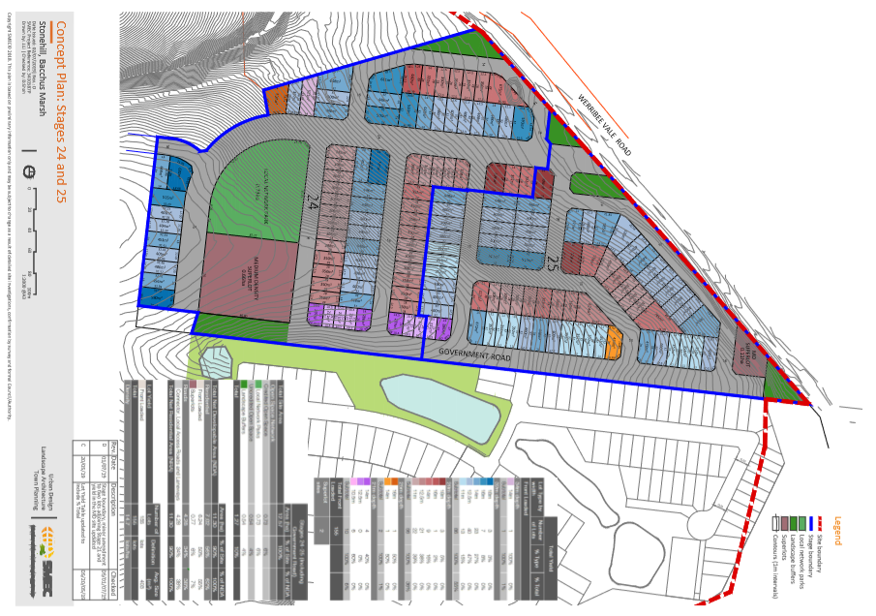
Plan of original proposed Subdivision as lodged (Revision D)

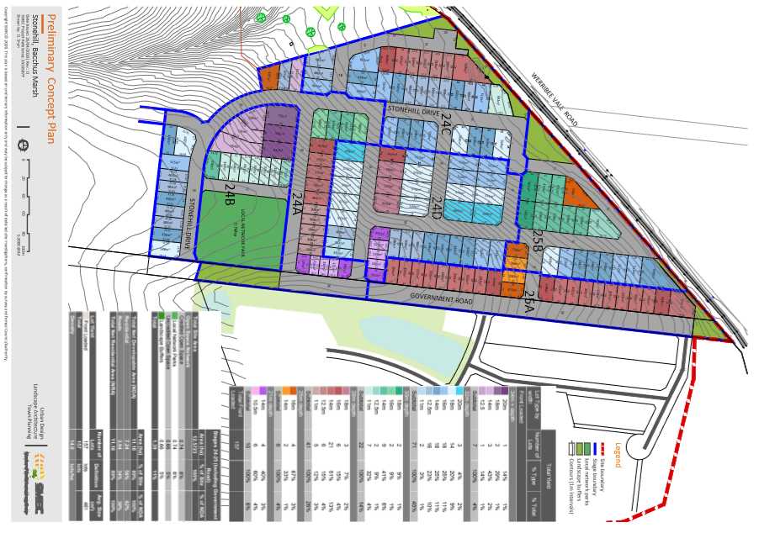
Plan of final amended Subdivision Revision J1.

Background to Current Proposal
The proposal has originated from prior subdivisions of the land with several stages of Stonehill completed or currently under construction.

History
There have several permits issued within DPO3 with the majority contained in Stonehill Estate as shown by the following list:-
• PA2010216 - Staged Subdivision of West Maddingley Part 2. A total of 146 lots approved.
• PA2011054 - Stage 1 and 2 of West Maddingley Part 1. A total of 121 lots approved.
• PA2011313 - Stage 3 of West Maddingley Part 1. A total of 45 lots approved.
• PA2011352 - Stage 5, 6 and 7 West Maddingley Part 1. A total of 108 lots approved.
• PA2011345 - Use of the Land for a Display Village, Associated Car parking, Landscaping and Buildings & Works, West Maddingley Part 1
• PA2013044 - Development of Six Dwellings
• PA2013135 - Staged subdivision Stage 4. A total of 38 lots approved.
• PA2013301 - Development of Eight Dwellings.
• PA2014170 - Stage 8 and 9 West Maddingley Part 1. A total of 43 lots approved.
• PA2014256 - Two lot re-subdivision.
• PA2014279 - Two lot subdivision.
• PA2015048 - Two lot subdivision.
• PA2015086 - Subdivision (Stage 10) of land, creation of reserve and development of 11 dwellings, West Maddingley Part 1. A total of 163 lots approved.
• PA2015091 - Staged Subdivision (Stages 11-16) creation of reserve, removal of native vegetation and development of 17 dwellings. West Maddingley Part 1. A total of 169 lots approved.
• PA2015142 - Removal of native vegetation
• PA2015249 - Staged subdivision and removal of native vegetation (not part of Stonehill Estate). A total of 59 lots created within Stage 1 and 2. Known as Queens Brook Estate.
• PA2015166 - Two lot subdivision and creation and removal of easements at 165 Werribee Vale Road, Maddingley.
• PA2016136 - Three lot subdivision, West Maddingley Part 1.
• PA2017063 - Staged 65 subdivision (Stages 17 and 18) West Maddingley Part 1. A total of 65 lots approved.
• PA2018121 - 44 lot subdivision and development of dwellings on lots less than 300sqm. Stage 19, West Maddingley Part 1. A total of 44 lots approved.
• PA2018242 - Issued at the direction of VCAT for fifty seven (57) lot subdivision and construction of three dwellings on lots less than 300sqm in area. Stage 20A, West Maddingley Part 1. A total of 57 lots approved.
• PA2018274 - 92 lot staged subdivision (Stages 20B and 21), Development of a Dwelling on lots less than 300sqm and removal of native vegetation. West Maddingley Part 1 . A total of 92 lots approved.
• PA2019002 - 21 lot staged subdivision and removal of vegetation (Not part of Stonehill Estate). A total of 21 lots approved. Known as Caldera Estate.
• PA2019181 – Staged 118 lot subdivision and removal of vegetation (Stages 22 and 23). West Maddingley Part 3 and also known as the further investigation area. This is an active application and a decision has not been made at this stage.

Public Notice
The application is considered exempt from the notice provisions as the Stonehill project was subject of extensive public advertisement process through the West Maddingley Development Plan pursuant to the Development Plan Overlay, Schedule 3. The development plan showed road layout and lot layout orientations. The proposed subdivision is generally in accordance with approved Development Plan. Within this plan, it states the detail at the subdivision and development stage may vary or fine tune a development plan without changing its intent.

Locality Map
The map below indicates the location of the relevant subject site and the zoning of the surrounding area.
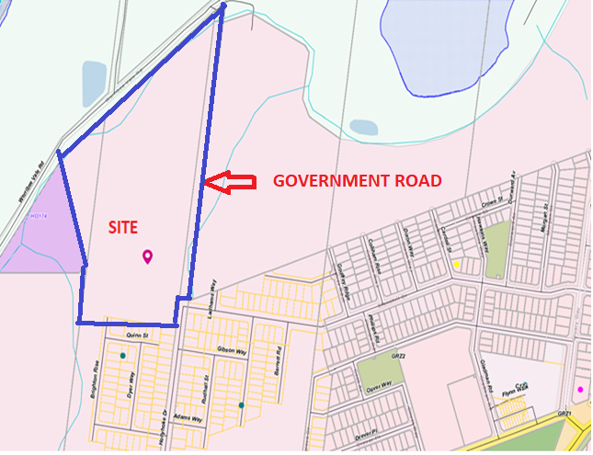
Map 1: Zone Map
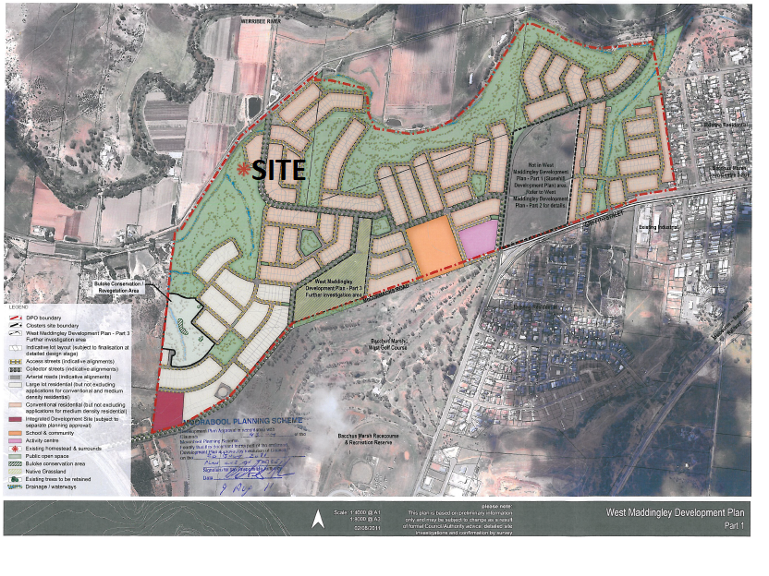
Map 2: Aerial photograph, Stage 24 and 24.

Planning Scheme Provisions
Council is required to consider the Victoria Planning Provisions and give particular attention to the Planning Policy Framework (PPF), the Local Planning Policy Framework (LPPF) and the Municipal Strategic Statement (MSS).
The relevant clauses
• Clause 11.01-1R Settlement Central Highlands.
• Clause 11.02-1S Supply of urban land.
• Clause 11.03-3S Peri-urban areas.
• Clause 12.01-2S Native Vegetation Management
• Clause 12.05-2R Landscapes Central Highlands.
• Clause 15.01-3S Subdivision Design.
• Clause 15.01-5S Neighbourhood Character.
• Clause 18.02-2S Public Transport
• Clause 19.03-3S Water supply, Sewerage and Drainage
• Clause 21.03-2 Urban Growth Management.
• Clause 21.03-3 Residential Development.
• Clause 21.02-3 Biodiversity
• Clause 21.03-4 Landscape and Neighbourhood Character.
• Clause 21.07-2 Bacchus Marsh

Zone
The subject site is in the General Residential Zone, Schedule 2 (GRZ2).

The purpose of the Zone is:
• To implement the Municipal Planning Strategy and the Planning Policy Framework.
• To encourage development that respects the neighbourhood character of the area.
• To encourage a diversity of housing types and housing growth particularly in locations offering good access to services and transport.
• To allow educational, recreational, religious, community and a limited range of other non-residential uses to serve local community needs in appropriate locations.

Under Clause 32.08-3, a permit is required to subdivide land. An application to subdivide land must meet the relevant requirements of Clause 56 for a residential subdivision.

Clause 32.08-3 states an application to subdivide land that would create a lots less than 400sqm capable of a development for a dwelling must ensure the vacant lot contains at least 25% as garden space. This does not apply to a lot created in accordance with an approved development plan. With an approved development plan under the Development Plan Overlay Schedule 3, the garden space provisions does not apply.

Decision guidelines are listed under Clause 32.08-12. Under the subdivision section has the following decision guidelines:

• The pattern of subdivision and its effect on the spacing of buildings.
• For subdivision of land for residential development, the objectives and standards of Clause 56.
Part 1 of the Schedule 2 has the following neighbourhood character objectives.

• To encourage new development, including innovative and unique development that enhances and responds positively to the existing neighbourhood character.
• To encourage an increase in landscaping within the public and private realm.
• To encourage new development to respect existing setbacks within the streetscape. To encourage new development to have minimal or low scale front fencing.
• To ensure garages, carports, and second storey development do not visually dominate dwellings or streetscapes.

Overlays
Development Plan Overlay Schedule 3
Pursuant to Clause 43.04-1 of the Moorabool Planning Scheme a permit must not be granted to use or subdivide land, construct a building or construct or carry out works until a development plan has been prepared to the satisfaction of the Responsible Authority. This does not apply if a schedule to this overlay specifically states that a permit may be granted before a development plan has been prepared to the satisfaction of the Responsible Authority.

A permit granted must:
• Be generally in accordance with the development plan.
• Include any conditions or requirements specified in a schedule to this overlay in accordance with the Development Plan.

The objectives of Schedule 3 of the Development Plan Overlay are:

• release of land for residential development in a logical, cost effective and sequential manner;
• efficient use of infrastructure, and land, whilst managing any impacts on the environment and amenity;
• co-ordinated provision of community infrastructure and public open space that enhances the amenity, safety and liveability of the precinct and surrounds; and
• preparation of an integrated Development Plan generally in accordance with the West Maddingley Concept Plan shown in Clause 5.0 of this schedule.

The development plan was endorsed on 9 August 2011 in accordance with Clause 43.04.

Relevant Policies
Housing Bacchus Marsh to 2041
Council has prepared a housing strategy called Housing Bacchus Marsh to 2041, to address how it will manage growth pressures and preserve important neighbourhood character into the future. Bacchus Marsh has been specifically identified in Plan Melbourne and the Central Highlands Regional Growth Plan as a suitable location to accommodate growth. Key reasons for this strategic direction relate to Bacchus Marsh’s regional service centre role, its relative accessibility to Melbourne, Geelong and Ballarat, its well-established town centre and the availability of greenfield and infill development opportunities. Housing Bacchus Marsh 2041 is one of several key projects that will input into the preparation of Moorabool 2041.
Stonehill Estate/West Maddingley is a greenfield estate that will support a master planned residential development as approved under the Development Plan Overlay, Schedule 3. The proposed subdivision supports the broad objectives of Moorabool 2041.

Particular Provisions
Clause 52.17 – Native Vegetation

After further review by DELWP, it was determined native vegetation would be removed as part of this subdivision.

Under Clause 52.17-2, an application to remove, destroy or lop native vegetation must comply with the application requirements specified in the Guidelines. Under Clause 52.17-5 then lists offset requirements.

The purpose of this particular provision is

• To ensure that there is no net loss to biodiversity as a result of the removal, destruction or lopping of native vegetation. This is achieved by applying the following three step approach in accordance with the Guidelines for the removal, destruction or lopping of native vegetation (Department of Environment, Land, Water and Planning, 2017) (the Guidelines):
1. Avoid the removal, destruction or lopping of native vegetation.
2. Minimise impacts from the removal, destruction or lopping of native vegetation that cannot be avoided.
3. Provide an offset to compensate for the biodiversity impact if a permit is granted to remove, destroy or lop native vegetation.
• To manage the removal, destruction or lopping of native vegetation to minimise land and water degradation.

Clause 53.01 Public Open Space Contribution and Subdivision

A person who proposes to subdivide land must make a contribution to Council for public open space in an amount specified in the schedule to this clause (being a percentage of the land intended to be used for residential, industrial or commercial purposes, or a percentage of the site value of such land, or a combination of both). If no amount is specified, a contribution for public open space may still be required under Section 18 of the Subdivision Act (1988).

An open space requirement exceeding 5% of the total area was completed in accordance with Development Plan Overlay, Schedule 3. No further requirement can be made.

Clause 54 - Construction of one dwelling

There are 10 proposed lots that are less than 300sqm. There is no intent of the applicant to construct dwellings in these lots but instead seeks planning permission to prevent future land owners, when titles are released, from having to apply for separate planning approvals and having to wait a considerable period of time for construction to commence. The applicant has not provided development plans but strictly controls these lots through a Memorandum of Common Provisions (MCP) which are design controls attached to the parent title. This MCP requires land owners to obtain developer approval. The MCP adopts all of the Clause 54 standards within the provisions and exceeds a number of the minimum requirements to achieve a higher level of design and finish compared to what can be achieved with ResCode, Clause 54. In addition to the developer approval, plans are required to submitted to Council for endorsement under a stand-alone permit condition.

The proposed dwellings will comply with all of the provisions of Clause 54, therefore a separate assessment against each standard is not undertaken at this stage.

Clause 56 Residential Subdivision
The proposal complies with most of the relevant ResCode standards applying to a 157 lot subdivision of land with the following exception

Clause ResCode | Title | Response
Clause 56.03-5 | Neighbourhood Character | The standard of this clause is to respect the existing neighbourhood character or achieve a preferred neighbourhood character consistent with any relevant neighbourhood character objective, policy or statement set out in this scheme.  The development plan overlay background document marked Stages 24 and 25 as yellow are larger lot subdivisions (first below map) due to the steep topography. The approved development plan then identified the same area as conventional lot sizes (second map below) with larger lots restricted to the south-west corner of the estate.  The correct design response based on the site constraints is larger lots despite the requirement for the applicant to comply with the endorsed development plan.  Council officers through extensive negotiation process has sort larger lots. After a number of months and meetings with the applicant’s representatives, the applicant has agreed to remove 22 lots and alter lot sizes and widths to better respect the existing site features. This has enabled wider lots in the area with the greatest slope.  The latest ‘without prejudice’ plans, Revision J1, are considered to achieve compliance with this standard. This will need to be formalised by a permit condition requiring endorsement of plans.

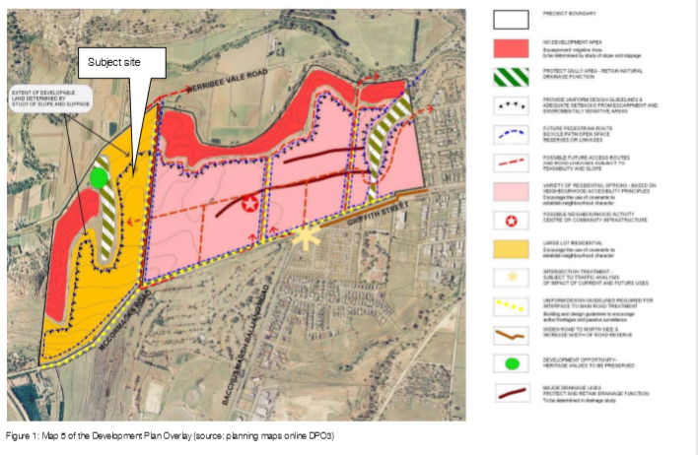

Discussion
Development Plan Overlay
When the development plans overlay was prepared it clearly identified where residential development would be of typical sized lots marked pink and were site constraints such as sloping land or interface with the farming land where residential development would be of larger lots marked yellow. It also identified areas where no development would allowed due to either steep river escarpment or to maintain the river vista view lines marked red on the plans. The approved development plan which the applicant must follow included some of the steep topography as conventional lots. The applicant was able to calculate total lot yield based on conventional and larger lots as approved on the development plan.
An escorted site inspection undertaken revealed that Stages 24 and 25 designated as conventional lots would produce lot sizes that would severely be constrained by slope and required a series of retaining walls. These can have the effect of reducing or segmenting secluded private open spaces and creating congested streetscape patterns due to the lack of side spacings between future dwellings. The amenity of future residents must be taken into consideration with the intent of the development plan to facilitate a master designed estate.
Council since the early stages of the application has sought major changes to the plans. After several months of negotiations, the applicant in the latest plan (revision J1) has reduced lots, eliminated the medium density housing site, widened lots and re-positioned the public open space to the best part of the estate with the least slope. The applicant has agreed to lose 22 lots compared to the planed initially submitted. Specific lots were targeted by Council officers due to their slope for larger lot sizes and larger lot widths. Cross section plans were prepared to fully understand the extent of post construction cutting and filling. Through series of revised plans, the applicant has lost lots and re-configured the subdivision pattern. The current plan is considered generally to accord with the development plan while providing larger lot sizes in response to the sloping land.
Cultural Heritage Management

The applicant advised the Wathaurung Aboriginal Corporation (trading as Wadawurrung) issued a Notice of Approval for Cultural Heritage Management Plan on 22 August 2018 in accordance with Section 64(1) of the Aboriginal Heritage Act 2006.

Dwelling on lots less than 300sqm/Memorandum of Common Provision (MCP)

There are 10 lots of the proposed subdivision that are less than 300sqm and the applicant has applied for planning approval to allow buildings within these lots without the need for future owners to apply for separate planning permits.

For lots less than 300sqm, there will be conditions in place to ensure all of the Clause 54 standards have been satisfied in the approval of the MCP by Council. The Stonehill MCP has achieved a higher quality of design and generally exceeds the minimum requirements of ResCode. In addition, as part of a stand-alone condition, plans for the final dwelling layout and elevations will need to be provided Council can approve under the secondary consent provisions. This process has previously been used in Stonehill Estate and allows for well-designed dwellings on small lots with suitable landscape treatments and minimal off-site impacts. The proposed dwellings on these smaller sized lots will comply with the standards of Clause 54.
Servicing and referral authorities
All the referral authorities have consented to the issue of a planning permit and have not identified any servicing concerns. The applicant will be required to lodge a heavyweight plan of subdivision prior to the certification in accordance with Section 6 of the Subdivision Act 1988.

The applicant was required to enter into a separate legal agreement with Southern Rural Water regarding the disused water channel. The applicant has taken few months to have the agreement finalised and Southern Water have removed their initial objection to the application.

Vegetation removal
The applicant undertook a Biodiversity Assessment Report prepared by Ecology Partners which did not identify any native vegetation removal. On review by DELWP, it asked for further work to be undertaken. The revised Report noted there were no native patches or scattered trees within the study area however there are some native scattered understorey species. These species do meet the threshold for a patch of native vegetation using the NVIM tool but are regarded as native vegetation removal that requires a planning permit. DELWP advised there are no offsets required for this native vegetation removal in accordance with Guidelines for the removal, destruction or lopping of native vegetation (DELWP, 2017). DELWP consented to the application without conditions. The proposed removal of native vegetation is considered to accord with the objectives of Clause 52.17 as the study area is predominately covered by understory vegetation that are weed species with only scattered native grasses.

Public Park
A key feature of these two stages is the provision of a large public open space. Initially, the park was located on significant sloping land with a terraced arrangement for the play area and landscaped areas with the adjacent flatter topography intended for medium density housing. This park given its size and location in Stonehill Estate required to be positioned in flattest land topography which can assist the recreational needs of people with limited mobility and can be easily accessible for most of the residents. As part of the negotiation process, the applicant has eliminated the medium density site and re-positioned the public open space to the best available location within these two stages. The current location and generous dimensions will allow for a well-designed public open space that can be focal point for this estate and therefore an asset to the local community.
Permit conditions will be in place to ensure the detailed design including play equipment and types of plant species are approved to Council’s satisfaction.

General Provisions
Clause 65 – Decision Guidelines have been considered by officers in evaluating this application.
Clause 66 – Stipulates all the relevant referral authorities to which the application must be referred.

Referrals
Authority | Response
Southern Rural Water  Melbourne Water  Western Water  Powercor Australia  Downer Utilities  CFA  DELWP  Transport for Victoria | Consent no conditions.  Consent subject to twelve conditions  Consent subject to eleven conditions  Consent subject to six conditions  Consent subject to one condition  Consent subject to three conditions  Consent, no conditions.  Consent subject to three conditions
Infrastructure | Consent

Financial Implications
The recommendation of approval of this subdivision application would not represent any financial implications for Council

Risk & Occupational Health & Safety Issues
The recommendation of approval of this subdivision does not implicate any risk or OH&S issues to Council.

Communications Strategy
Notice was not undertaken for the application as proposal was exempt from the notice provisions. the applicant were invited to attend this meeting and invited to address Council if required.

Options
Council could consider the following options:
• Issue a permit in accordance with the recommendations of this report;
• Issue a permit with amendments to conditions within the recommendation of this report; or
• Should Council wish to consider refusal of the application, Councillor’s need to explore reasons based on the proposal not complying with the Moorabool Planning Scheme.

Conclusion
The latest plans submitted by the applicant to the proposed subdivision has resulted from an extensive negotiation process with meetings, revised plans, discussions and debate of issues. After several months, the applicant has progressed the plan to an acceptable level to warrant support subject to conditions. The proposed subdivision is consistent with the planning scheme provisions including the Development Plan Overlay which supports the development of new estates well connected to existing infrastructure and in close proximity to the Bacchus Marsh township. The applicant has revised plans and has agreed with Council’s position to reduce lot numbers and increase lot sizes to ensure there is adequate amenity provided to future residents in an area with sloping topography. The wider lots will reduce the extent of retaining walls and cater towards the first home buyer’s market and most builders who seek lots that are generally of a flat topography. It is recommended the application be approved with conditions.

7.2 PA2019059 - Two Lot Re-Subdivision and Use and Development of a Dwelling at 139 Pound Creek Road Navigators
Author: Thomas Tonkin, Statutory Planner
Authoriser: Henry Bezuidenhout, Executive Manager Community Planning & Economic Development
Attachments: 1. Existing subdivision layout (under separate cover)
2. Proposed subdivision layout (under separate cover)
3. Proposed dwelling (under separate cover)
4. Farm Management Plan (under separate cover)

Application Summary
Permit No: PA2019059
Lodgement Date: 7 March 2019. Amended in process on 14 August, 2019
Planning Officer: Tom Tonkin
Address of the land: 139 Pound Creek Road Navigators
Proposal: Two Lot Re-Subdivision and Use and Development of a Dwelling
Lot size: 28.02 hectares
Why is a permit required? Clause 35.07 Farming Zone – Subdivision and Use and Development of a Dwelling
Clause 42.01 Environmental Significance Overlay, Schedule 1 – Subdivision and Development of a Dwelling
Clause 44.06 Bushfire Management Overlay - Subdivision

Recommendation
That Council, having considered all matters as prescribed by the Planning and Environment Act 1987, issue a Refusal to Grant Planning Permit PA2019059 for Two Lot Re-Subdivision and Use and Development for a Dwelling at Lot 1 on PS 633637U and Crown Allotment 4A Section 20A Parish of Warrenheip, known as 139 Pound Creek Road, Navigators 3352, on the following grounds:
1. The proposal is inconsistent with the purpose and objectives of the Farming Zone.
2. The proposal does not comply with the Planning Policy Framework or the Local Planning Policy Framework of the Moorabool Planning Scheme relevant to the development and use of rural land.
3. The proposed subdivision will result in a fragmentation of agricultural land.
4. There has been insufficient justification provided to support a further dwelling on the land.
5. The proposed agricultural activity can be undertaken utilising the existing dwelling on the land.
6. A Section 173 Agreement AD935687W is registered on title to Lot 1 on Plan of Subdivision 633637U and this Agreement is considered necessary based on the current planning control applying to the lot.

Public Consultation
Was the application advertised? | Yes.
Notices on site: | Yes.
Notice in Moorabool Newspaper: | No.
Number of objections: | Two.
Consultation meeting: | The Council officer consulted with one objector. The other objector did not wish to consult because of a fundamental opposition to the proposal. A formal meeting was not conducted as the recommendation is for refusal.

Policy Implications
The Council Plan 2017-2021 provides as follows:
Strategic Objective 2: Minimising Environmental Impact
Context 2B: Natural Environment
The proposal does not conflict with the Council Plan 2017 – 2021.

Victorian Charter of Human Rights & Responsibilities Act 2006
In developing this report to Council, the officer considered whether the subject matter raised any human rights issues. In particular, whether the scope of any human right established by the Victorian Charter of Human Rights and Responsibilities is in any way limited, restricted or interfered with by the recommendations contained in the report. It is considered that the subject matter does not raise any human rights issues.

Officer’s Declaration of Conflict of Interests
Under section 80C of the Local Government Act 1989 (as amended), officers providing advice to Council must disclose any interests, including the type of interest.
Executive Manager – Henry Bezuidenhout
In providing this advice to Council as the Executive Manager, I have no interests to disclose in this report.
Author – Tom Tonkin
In providing this advice to Council as the Author, I have no interests to disclose in this report.

Executive Summary
Application referred? | Yes, to Council’s Infrastructure, Council’s Environmental Health, Central Highlands Water and CFA.
Any issues raised in referral responses? | The original application submitted on 7 March 2019 proposed a two-lot re-subdivision. Central Highlands Water (CHW) raised concerns with the application due to its potential to create a lot capable of accommodating a dwelling in an area where CHW calculate the existing dwelling density per hectare to be 1:19, well in excess of the 1:40 ratio recommended in the catchment authority guidelines.
Preliminary concerns? | No detailed information as to how the proposed subdivision would support and enhance farming the land and concerns that the proposal would fragment agricultural land.
Any discussions with applicant regarding concerns? | Yes, the Council officer wrote to the applicant regarding the abovementioned concerns.
Any changes made to the application since being lodged? | Yes. After notice of the original application (re-subdivision) was given and the CHW referral response was received, the applicant amended the application on 14 August 2019 to include the use and development of a dwelling. The amended application was advertised.
Brief history. | History including previous planning approvals relevant to the land are summarised under ‘History’ below.
Previous applications for the site? | PA2010145 for a Two Lot Subdivision (Boundary Realignment) was approved by Council on 1 October 2010.
General summary. | It is proposed to re-subdivide to create two lots and develop the vacant lot for a dwelling, in addition to the existing dwelling on the landholding. The applicant has provided insufficient justification for why the proposal is required to support an agricultural enterprise and how it would avoid further fragmenting of agricultural land. The current farming enterprise does not require two dwellings over two lots to supports its operation. Two objections were received which raised concerns generally consistent with those of the planning officer. Additionally, Council has obtained legal advice that the proposal is in breach of a Section 173 Agreement registered as a restriction on one of the titles.
Summary Recommendation
That, having considered all relevant matters as required by the Planning and Environment Act 1987, Council issue a Refusal to Grant a Permit for this application in accordance with Section 61 of the Planning and Environment Act 1987, for two lot re-subdivision and use and development of a dwelling at 139 Pound Creek Road, Navigators on the grounds included in this report.

Site Description
The subject site comprises the following lots:
• Crown Allotment 4A, Section 20A, Parish of Warrenheip which is a 3313sqm parcel of land, with a maximum 11.53m width x 372.32m length. The lot is undeveloped and contains no vegetation; and
• Lot 1 on PS633637U, which is an irregular shaped lot of 27.69 ha containing a dwelling and ancillary outbuildings. Other than a few scattered trees the site is cleared of vegetation. This lot is encumbered by a 12m-wide powerline easement which crosses the site in an east-west direction. Beyond the residential use the land is used predominantly for cattle grazing. Two Section 173 Agreements are registered on the title to this lot.
A small waterway flows northwards through the site which is otherwise relatively flat.
The site and surrounding land is in the Farming Zone and comprises a range of lot sizes. The surrounding area is typified by a mix of small-scale farming and rural residential properties.

Proposal
It is proposed to re-subdivide the existing lots and to use and develop the new vacant lot for a dwelling. Proposed Lot 1 would be 16.94ha in size, irregular in shape with a 367.35m wide frontage to Pound Creek Road and contain the existing dwelling and outbuildings with the existing access to Pound Creek Road retained. Proposed Lot 2 would be 11.07ha in size, irregular in shape and vacant and almost entirely cleared of trees. The existing powerline easement would be contained within Lot 1 but parallel to the common boundary with Lot 2. There is no existing formal vehicle access to Lot 2.
The proposed dwelling on Lot 2 would be set back approximately 30m from Pound Creek Road and will be single storey in height and traditional in design with a low-pitched hipped roof, and weatherboard and masonry cladding. The dwelling would comprise of four bedrooms, main with ensuite, bathroom, separate toilet, laundry, study, living room, children’s room and open plan kitchen, meals and family area leading to a rear alfresco area. An attached double garage would be provided for car parking and the building would have an overall floor area of 303.53sqm.
The application documents state that the proposed dwelling is required for succession planning purposes and that the current landowner would shift from the existing dwelling to the proposed dwelling, with a nephew moving into the existing dwelling to manage farm operations and ultimately inherit the land. The Farm Management Plan provided by the applicant states that the proposed subdivision will allow an increase in overall stocking capacity and hence a significant increase in productivity. The dwelling is stated as being vital for proper functioning of the proposed enterprise including stock monitoring and security.

Background to Current Proposal
Not applicable.

History
The current application was considered at the S86 Development Assessment Committee of Council (DAC) on 20 May 2020 where it was resolved to defer a decision on the application to allow for further discussion between both parties and further documents supplied by applicant to be circulated to all Councillors. Separate legal advice provided to Council (Beck Legal) and to the applicant (King Lawyers and Maddocks) has been received and circulated to all Councillors.
The existing dwelling was approved under planning permit PA2004140 issued by Council on 27 September 2004. PA2005007 was issued by Council on 1 June 2005 and re-subdivided the land from five lots to two lots creating parcels of 32.73ha and 3.671ha respectively. A condition of this permit required the landowner to enter into a Section 173 Agreement (AD935687W) to not further subdivide the lots created by the permit and not allow more than one dwelling to exist on either lot created by the permit at any one time.
Council has obtained recent legal advice that the current permit application is in breach of this Agreement and is prohibited. The applicant’s legal advice stated Council can issue a permit in breach of an agreement after considering the facts and circumstance of the case.
Lot 1 on PS633637U, part of the subject site, was created as part of a two-lot re-subdivision approved under planning permit PA2010145 issued by Council on 1 October 2010. The re-subdivision created two lots of 27.69 ha and 8.713ha, both in separate ownership, derived from parent lots created under PA2005007 of 32.73ha and 3.671 ha. The re-subdivision resulted in the smaller lot increasing by 5.04 ha at the expense of the larger lot.

Public Notice
Notice of the original application was given to adjoining and nearby landowners by mail and a sign erected on site. One objection was received. Notice of the amended application was given consistent with the original application and a sign erected on site from 20 January 2020 until 11 February 2020. The previous objector made a further objection and a second objection was received from another person.

Summary of Objections
The objections received are detailed below with officer’s comments accompanying them:
Objection | Any Relevant Requirement
The subdivision is a misguided use of the re-subdivision provision of the Farming Zone. | Clause 35.07.
Officer’s Response:
See ‘Discussion’ below.
The proposal results in the loss and fragmentation of productive farming land and impacts on food security. | Clauses 14.01-1S & 35.07.
Officer’s Response:
See ‘Discussion’ below.
The application documents contain a weak and theoretical agricultural justification which fails to demonstrate a sufficient link between the dwelling and the farming of the land. | Clauses 14.01-1S & 35.07.
Officer’s Response:
See ‘Discussion’ below.
The subdivision is not supported by Council’s Small Towns and Settlements Strategy 2016. | Clause 21.09.
Officer’s Response:
See ‘Discussion’ below.
The proposal is inconsistent with the Rural Planning policy and Special Water Supply Catchment policy. | Clauses 14.02-2S & 22.02.
Officer’s Response:
See ‘Relevant Policies’ and ‘Discussion’ below.
The proposal will result in a risk to adjoining and nearby agricultural operations. | Clause 35.07.
Officer’s Response:
See ‘Discussion’ below.
The capacity of the site to sustain an agricultural use is not demonstrated. | Clause 35.07.
Officer’s Response:
See ‘Discussion’ below.

Locality Map
The map below indicates the location of the subject site and the zoning of the surrounding area.
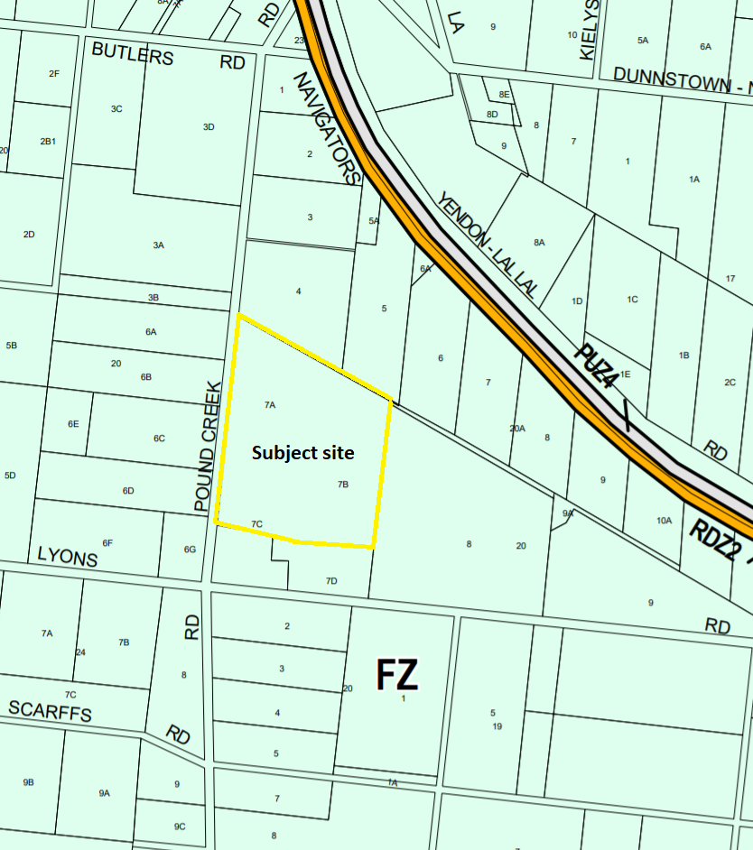
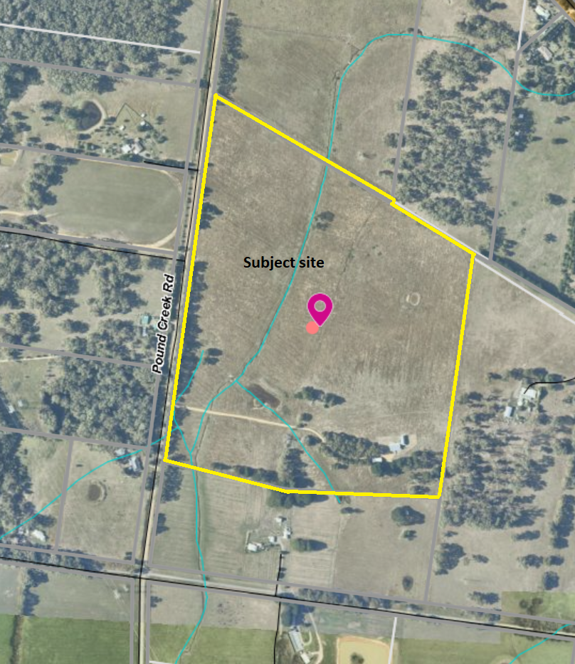

Planning Scheme Provisions
Council is required to consider the Victoria Planning Provisions and give particular attention to the Planning Policy Framework (PPF), the Local Planning Policy Framework (LPPF) and the Municipal Strategic Statement (MSS).
The relevant clauses are:
Clause 11.03-3S Peri-urban areas
Clause 14.01-1S Protection of agricultural land
Clause 14.02 Water
Clause 15.01-6S Design for rural areas
Clause 21.02-2 Non-Urban Landscapes
Clause 21.02-3 Water and Catchment Management
Clause 21.03-3 Residential Development
Clause 21.03-4 Landscape and Neighbourhood Character
Clause 22.02 Special Water Supply Catchments
Clause 22.03 Houses and House Lot Excisions in Rural Areas
The proposal complies with the relevant sections of the PPF and LPPF, with the exception of the clauses outlined in the table below:

PPF | Title | Response
Clause 11.03-3S | Peri-urban areas | The proposal would intensify residential use of the site, resulting in loss of farm land.
Clause 14.01-1S | Protection of agricultural land | The proposal increases residential use of farm land and diminishes the capacity of the site to support agriculture.
LPPF

Clause 21.02-2 | Non-Urban Landscapes | The proposal would increase residential development in a rural location which erodes the rural character of the area.
Clause 21.03-4 | Landscape and Neighbourhood Character | The proposed dwelling’s benefit to agriculture is not sufficiently justified.
Clause 21.03-6 | Rural Lifestyle Opportunities | The proposal would fragment farm land.
Clause 21.04-2 | Agriculture | The proposal would not support productive, sustainable farming in both the short and longer term.
Clause 22.03 | Houses and House Lot Excisions in Rural Areas | The proposed agricultural activity is not considered sufficient justification for the proposed subdivision and dwelling.

Zone
The subject site is in the Farming Zone. The purpose of the Zone is:
• To implement the Municipal Planning Strategy and the PPF.
• To provide for the use of land for agriculture.
• To encourage the retention of productive agricultural land.
• To ensure that non-agricultural uses, including dwellings, do not adversely affect the use of land for agriculture.
• To encourage the retention of employment and population to support rural communities.
• To encourage use and development of land based on comprehensive and sustainable land management practices and infrastructure provision.
• To provide for the use and development of land for the specific purposes identified in a schedule to this zone.
Under Clause 35.07, a permit is required to subdivide land and to use and develop a lot of less than 40ha for a dwelling. The default minimum lot size for subdivision is 100ha, however there is an exemption for the re-subdivision of existing lots where the number of lots is not increased.
Overall, the proposal is inconsistent with the purpose of the zone – see ‘Discussion’ below.

Overlays

The site is affected by Environmental Significance Overlay, Schedule 1, Design and Development Overlay, Schedule 2, and partially by the Bushfire Management Overlay.

Environmental Significance Overlay Schedule 1 (ES01)

Under Clause 42.01 of the Environmental Significance Overlay, a permit is required to subdivide land and construct buildings and works. There are no relevant exemptions under Schedule 1.

Design & Development Overlay Schedule 2 (DD02)

Under Clause 43.02 of the Design and Development Overlay, a permit is required to subdivide land and construct buildings and works. Under Schedule 2 there is an exemption for subdivision and for buildings and works where non-reflective external building cladding is proposed. In this instance a permit is not required.

Bushfire Management Overlay (BMO)

Under Clause 44.06 of the Bushfire Management Overlay, a permit is required to subdivide land and construct buildings and works. As only a portion of the land is affected the BMO a permit is only required for subdivision.

Subject to conditions, the proposal is generally consistent with the applicable overlay provisions.

Relevant Policies
Council’s Rural Growth Policy Statement
Council’s Rural Growth Policy Statement was adopted by Council on 19 September 2012. The document applies to all land in Farming Zone under the Moorabool Planning Scheme.
The policy states:
• Encourage dwellings in areas nominated in Map 1 of Council Rural Growth Policy Statement.
• Ensure the siting of any dwellings is designed to have a minimal impact on any existing or future agricultural activities on the site and on surrounding land.
• Ensure it is clear whether the dwelling is required for agricultural operation use or to maintain rural communities.
• Ensure sufficient infrastructure is available or that alternative methods are available which do not require normal infrastructure.
• Encourage development of dwellings to support communities of land which is unlikely to support agricultural land which still considering any other overlays which may impact the land. This is land which is constrained for use as agriculture by other environment factors such as vegetation, slope, soil quality etc.
• Ensure any subdivision is undertaken in accordance with the scheme in order to discourage fragmentation of agricultural land.
It is noted, that the site is located in an area where dwelling development on lots greater than 8ha is encouraged, as per the Policy’s Map 1 – Rural Development Areas. However, the proposal only responds to part of this policy for sites of 8-20ha, noting that the proposed agricultural enterprise gives insufficient justification for the additional dwelling. The proposed re-subdivision would further fragment agricultural land and in this instance, they have not demonstrated that two dwellings are required to support one farming activity.
Council’s Rural Housing Policy
Council’s Rural Housing Policy has been developed to provide direction for how limited farming potential rural dwellings should be considered, and more broadly, rural settlement patterns. The policy seeks to articulate support for resilient and integrated rural communities and agricultural enterprises, asserting that PPF does not adequately recognise or support agriculture trends and rural settlements in the Moorabool Shire’.
The principles of the policy relevant to this application include:
• Support the agricultural sector so that it can be more productive, diverse, resilient and adaptive to changing agricultural trends, including supporting agricultural activities that recognise Moorabool’s advantageous proximity to market.
• Protect agricultural land use from loss and allow development that increases agricultural productivity.
• Focus growth opportunities in settlements along major transport corridors, in particular where there is physical and social infrastructure and services.
• Recognise that there are substantial existing lots under 40ha capable of supporting the viable operation of agricultural enterprises.
• Promote a rural housing market that meets the needs of the Shire’s rural communities
• Land parcels for the proposed on-farm living dwellings are to have a minimum lot size of 8ha as identified in Map 1.
The proposed subdivision is not aligned with the above principles of the policy and is furthermore considered to undermine the agricultural potential of the land. The existing single dwelling in support of one farm enterprise should be maintained rather than two dwellings on two re-subdivided lots in support of a single farm enterprise.

Particular Provisions
Clause 53.02 Bushfire Planning
The application was assessed by CFA who consent to the application. The proposed dwelling would be sited outside of the area of BMO coverage.

Discussion
Overall, the proposed subdivision and use and development for a dwelling is considered to be inconsistent with the PPF and LPPF, the Farming Zone and relevant decision guidelines at Clause 65 of the Moorabool Planning Scheme. Furthermore, the proposal breaches Section 173 Agreement AD935687W registered on the title to one of the existing lots. The intent of the Agreement was to prevent further subdivision of the land and was created to allow the previous planning permit approval.
The Moorabool Planning Scheme provides discretion for a permit to be granted to use and develop land for a dwelling on a lot less than 40ha. Where a permit is required, the decision guidelines of the Farming Zone require a range of matters be considered.
In relation to dwellings in the Farming Zone the decision guidelines require that the responsible authority consider whether a dwelling:
• Will result in the loss or fragmentation of productive agricultural land.
• Whether the dwelling will be adversely affected by agricultural activities on adjacent and nearby land due to dust, noise, odour, use of chemicals and farm machinery, traffic and hours of operation.
• Whether the dwelling will adversely affect the operation and expansion of adjoining and nearby agricultural uses.
• The potential for the proposal to lead to a concentration or proliferation of dwellings in the area and the impact of this on the use of the land for agriculture.
In relation to agricultural issues in the Farming Zone the decision guidelines require that the responsible authority also consider:
• Whether the use or development will support and enhance agricultural production.
• Whether the use or development will adversely affect soil quality or permanently remove land from agricultural production.
• The potential for the use or development to limit the operation and expansion of adjoining and nearby agricultural uses.
• The capacity of the site to sustain the agricultural use.
• The agricultural qualities of the land, such as soil quality, access to water and access to rural infrastructure.
• Any integrated land management plan prepared for the site.
The proposed dwelling is stated to be in support of a small cow-calf breeding enterprise. The proposed subdivision would re-subdivide the existing landholding to provide two lots of 11.07ha and 16.94ha, with the proposed dwelling to be sited on the smaller lot and the larger lot to accommodate an existing dwelling and sheds.
The application includes a detailed farm management plan in support of the proposal. However, whilst the proposed dwelling is purported to benefit the proposed farming enterprise, there is an existing dwelling on the property which could readily serve the function of the proposed dwelling, positioned to visually survey most of the property. The applicant claims that the proposed subdivision would improve the current land fragmentation, but the justification given is insufficient.
It is acknowledged that the existing 3313sqm lot is a particularly small ‘fragment’ of land. However, it is contiguous with the proponent’s adjoining 27.69ha lot and being in common ownership the fact of being separate titles does not prevent a farming enterprise being carried out on two or more titles. The landholding comprises two titles rather than one is irrelevant to the property’s productivity. The proposition that re-subdividing the property in the manner proposed and constructing an additional dwelling improves the current land fragmentation is refuted. Rather, it is considered that the proposed subdivision and dwelling development will not only fragment the property further without any tangible benefit to agricultural output or sustainable land practices but also result in an additional dwelling in a rural zone, which contributes to inflated land values ultimately hindering the site’s viability for bona fide agricultural uses in the longer term. The PPF and LPPF seeks to protect viable agricultural land for that purpose, and prevent incompatible land uses from encroaching and permanently removing that land from agricultural use. The proposal represents the incremental loss of land from productive agricultural. Limiting land fragmentation would be best achieved by consolidating the existing titles.
By allowing the proposed dwelling on the land, when the existing dwelling would readily serve the same function in support of the one farming activity, the site’s use for residential purposes is intensified, and its agricultural viability eroded. This is characteristic of incremental fragmentation of farming land. Such an outcome is not supported by either the PPF or the LPPF which includes the following objectives:
• To manage growth in peri-urban areas to protect and enhance their identified valued attributes. (Clause 11.03-3S).
• To protect the state’s agricultural base by preserving productive farmland. (Clause 14.01-1S.)
• To maintain and enhance the natural environment and the Shire’s rural identity and character. (Clause 21.02-2).
Further to these objectives, the PPF and LPPF includes the following relevant strategies:
• Prevent dispersed settlement and provide for non-urban breaks between urban areas. (Clause 11.03-3S).
• Protect productive agricultural land from unplanned loss due to permanent changes in land use. (Clause 14.01-1S).
• Prevent inappropriately dispersed urban activities in rural areas. (Clause 14.01-1S).
• Limit new housing development in rural areas by directing housing growth into existing settlements. (Clause 14.01-1S).
• In considering a proposal to use, subdivide or develop agricultural land, consider the desirability and impacts of removing the land from primary production, given its agricultural productivity. (Clause 14.01-1S).
• Avoid the subdivision of productive agricultural land from diminishing the long-term productive capacity of the land. (Clause 14.01-1S).
• Focus rural living development in areas close to urban centres with good access to services and facilities where there is minimal impact on productive agriculture and horticulture or areas with environmental values. (Clause 21.03-5).
The site is evidently productive for grazing, in terms of the climate, soil conditions and water supply, and forms part of a larger rural area in the wider Melbourne and Ballarat rural hinterland. The proposal undermines these attributes for the reasons outlined above.

General Provisions
Clause 65 – Decision Guidelines have been considered by officers in evaluating this application.
Clause 66 – Stipulates all the relevant referral authorities to which the application must be referred.

Referrals
Authority | Response
Central Highlands Water  Country Fire Authority | Consent with conditions.  Consent.
Infrastructure  Environmental Health | Consent with conditions.  Consent with conditions.

Financial Implications
There are no financial implications for Council in deciding to refuse the application.

Risk & Occupational Health & Safety Issues
The recommendation to refuse the application does not have any risk or OH&S implications for Council.

Communications Strategy
Notice was undertaken for the application, in accordance with s.52 of the Planning and Environment Act 1987, and further correspondence is required to all interested parties to the application as a result of a decision in this matter. All submitters and the applicant were invited to attend this meeting and address Council if required.

Options
• Issue a Refusal to Grant a Permit in accordance with the grounds in the recommendation of this report. This option may result in the applicant appealing Council’s decision at VCAT; or
• issue a Refusal to Grant a Permit with amendments to the grounds in the recommendation of this report.
• issue a Notice of Decision to Grant a Permit not in accordance with the recommendation of this report.
In any case, issuing a Notice of Decision to Grant a Permit may result in the objectors appealing Council’s decision at VCAT.

Conclusion
Overall, the proposed re-subdivision and use and development for a dwelling is inconsistent with the PPF, the LPPF and the Farming Zone in respect of agricultural land use and rural housing development. The proposal is inconsistent with the orderly planning of rural land, resulting in the loss of agricultural land to rural residential use, detrimental impacts on sustainable agricultural land use and is an example of inappropriate development of rural land to the longer term detriment of the Shire’s agricultural base. Furthermore, the proposal is in breach of Section 173 Agreement AD935687W registered on the title to Lot 1 on PS 633637U and this agreement is still considered valid based on the current planning controls and should remain with the lot.

7.3 PA2019230 - Two Lot Subdivision at 47 Corbetts Road, Gordon
Author: Samuel Duff, Statutory Planner
Authoriser: Henry Bezuidenhout, Executive Manager Community Planning & Economic Development
Attachments: 1. Proposed Plans (under separate cover)

Application Summary
Permit No: PA2019230
Lodgement Date: 11 October, 2019
Planning Officer: Samuel Duff
Address of the land: Crown Allotment 4, Section 10, Parish of Kerrit Bareet, located at 47 Corbetts Road, Gordon
Proposal: Two Lot Subdivision
Lot size: Approximately 2,670sqm
Why is a permit required? Clause 32.09 - Subdivision in the Neighbourhood Residential Zone
Clause 42.01 - Subdivision under the Environmental Significance Overlay, Schedule 1
Clause 43.02 - Subdivision under the Design and Development Overlay, Schedule 5

Recommendation
That Council, having considered all matters as prescribed by the Planning and Environment Act 1987, issues a Notice of Decision to Grant a Planning Permit for the Two Lot Subdivision at 47 Corbetts Road, Gordon, subject to the following conditions:
Endorsed Plans:
1. Before the plan of subdivision is certified under the Subdivision Act 1988, amended plans to the satisfaction of the Responsible Authority must be submitted to and approved by the Responsible Authority. When approved, the plans will be endorsed and then form part of the permit. The plans must be drawn to scale with dimensions and three copies must be provided. The plans must be generally in accordance with the plans submitted with the application/other specified plans but modified to show:
(a) Landscaping plan showing the landscaping works to Lot 2 in accordance with condition 5 contained herein.
(b) A 5m building exclusion zone along the entire length of the southern boundary of Lot 2.
Servicing:
2. The owner of the land must enter into agreements with the relevant authorities for the provision of water supply, drainage, sewerage facilities, electricity and gas services to each lot shown on the endorsed plan in accordance with the relevant authority’s requirements and relevant legislation at the time.
3. All existing and proposed easements and sites for existing or required utility services and roads on the land must be set aside in the plan of subdivision submitted for certification in favour of the Relevant Authority for which the easement or site is to be created.
4. The plan of subdivision submitted for certification under the Subdivision Act 1988 must be referred to the Relevant Authority in accordance with Section 8 of that Act.
General Conditions:
5. Landscaping is to be provided along the accessway of Lot 2 and to be completed prior to the issue of a Statement of Compliance. The landscaping should be along each side of the accessway and each side is to be a minimum of 2m wide.
6. No side fencing between the internal boundary of the subdivided lots is to be created within 10m of Corbetts Road.
Infrastructure:
7. Prior to the issue of a Statement of Compliance for the subdivision, each lot must be provided with a standard rural residential vehicle crossing to the satisfaction of the Responsible Authority. Any redundant vehicle crossings must be removed, and the kerb and channel and nature strip reinstated to the satisfaction of the Responsible Authority. A vehicle crossing permit must be taken out for the construction of the vehicle crossing.
8. Prior to the issue of a Statement of Compliance for the subdivision, Corbetts Road from Lyndhurst Street to the Western boundary of the subject land, including the intersection of Corbetts Road and Lyndhurst Street, must be constructed in accordance with the requirements of the Infrastructure Design Manual to the satisfaction of the responsible authority. The road profile must be in accordance with IDM Standard Drawing SD610, for a Group A Council, with minimum 4.0 metre width.
9. Prior to the issue of a Statement of Compliance for the subdivision, the development must be provided with a drainage system constructed to a design approved by the Responsible Authority, and must ensure that:
(i) The development as a whole must be self draining.
(ii) All drainage courses within the development must pass through easements or reserves shown on the plan of subdivision.
(iii) Volume of water discharging from the development in a 10% AEP storm shall not exceed the 20% AEP storm prior to development. Peak flow must be controlled by the use of a detention system located and constructed to the satisfaction of the Responsible Authority.
(iv) Each lot must be provided with a stormwater legal point of discharge at the low point of the lot, to the satisfaction of the Responsible Authority.
(v) Stormwater runoff must meet the “Urban Stormwater Best Practice Environmental Management Guidelines (CSIRO 1999)”.
10. Prior to the commencement of the development design computations for drainage of the whole site must be prepared and submitted to the Responsible Authority for approval.
11. Storm water drainage from the development must be directed to a legal point of discharge to the satisfaction of the Responsible Authority. A legal point of discharge permit must be taken out prior to the construction of the stormwater drainage system.
12. Plans and specifications of all road, traffic and drainage works must be prepared and submitted to the responsible authority for approval prior to the commencement of such works and all such works must be carried out in accordance with the approved plans to the satisfaction of the Responsible Authority.
13. Sediment discharges must be restricted from any construction activities within the property in accordance with relevant Guidelines including Construction Techniques for Sediment Control (EPA 1991).
14. Unless otherwise approved by the Responsible Authority there must be no buildings, structures, or improvements located over proposed drainage pipes and easements on the property.
15. Prior to the commencement of the development and post completion, notification including photographic evidence must be sent to Council’s Asset Services department identifying any existing damage to council assets. Any existing works affected by the development must be fully reinstated at no cost to and to the satisfaction of the Responsible Authority.
16. Prior to the issue of a Statement of compliance for each stage of the subdivision, the developer must pay:
(i) 0.75 % of the total estimated cost of works for the checking of engineering plans associated with that stage of the development.
(ii) 2.50% of the total estimated cost of works for the supervision of works associated with that stage of the development.
17. Prior to the issue of a Statement of Compliance for the relevant stage of the subdivision, after all engineering works pertaining to the stage have been completed, the following “as constructed” details must be submitted in the specified format to the Responsible Authority:
(i) Drainage construction details in “D-Spec” format.
(ii) Roadworks construction details in “R-Spec” format.
Subject to the consent of the responsible authority, the data may be provided prior to the end of the maintenance period for the relevant stage of the subdivision.
18. All road and drainage works must be maintained in good condition and repair for a minimum of three months after completion of the works, to the satisfaction of the Responsible Authority.
19. Prior to the issue of a Statement of Compliance for each stage of the subdivision, a security deposit of 5% of the total value of engineering works for that stage as approved by the Responsible Authority must be lodged with the Responsible Authority, to cover the maintenance of all works. The deposit will be returned after the final inspection of works, three months after the completion of works, subject to the satisfactory completion of all required maintenance and rectification works.
Barwon Water:
20. Each lot created in the development must be connected to a reticulated sewerage system.

21. No stormwater is to be discharged less than 100m from a waterway unless into an approved drainage system
Permit Expiry:
22. This permit will expire if the plan of subdivision is not certified within two (2) years of the date of issue of the permit.
Statement of Compliance must be achieved, and certified plans registered at Titles office within five years from the date of certification.

Public Consultation
Was the application advertised? | Yes.
Notices on site: | Yes.
Notice in Moorabool Newspaper: | Not required.
Number of objections: | Two.
Consultation meeting: | Consultation meeting between applicants and objectors for PA2019230 and PA2019234 held on 14 January 2020. Issues discussed and no resolution achieved. Further clarification was sought to the proposed infrastructure conditions.

Policy Implications
The Council Plan 2017-2021 provides as follows:
Strategic Objective 3: Stimulating Economic Development
Context 3A: Land Use Planning
The proposal of a Two (2) Lot Subdivision is consistent with the Council Plan 2017 – 2021.

Victorian Charter of Human Rights & Responsibilities Act 2006
In developing this report to Council, the officer considered whether the subject matter raised any human rights issues. In particular, whether the scope of any human right established by the Victorian Charter of Human Rights and Responsibilities is in any way limited, restricted or interfered with by the recommendations contained in the report. It is considered that the subject matter does not raise any human rights issues.

Officer’s Declaration of Conflict of Interests
Under section 80C of the Local Government Act 1989 (as amended), officers providing advice to Council must disclose any interests, including the type of interest.
Executive Manager – Henry Bezuidenhout
In providing this advice to Council as the Executive Manager, I have no interests to disclose in this report.
Author – Samuel Duff
In providing this advice to Council as the Author, I have no interests to disclose in this report.

Executive Summary
Application referred? | The application was referred to Barwon Water and Council’s Infrastructure Department.
Any issues raised in referral responses? | Both referral authorities consented subject to conditions.
Preliminary concerns? | Another planning application for the site to the immediate west (49 Corbetts Road) was lodged at a similar time for a two-lot subdivision. Because of this it was thought that some of the objections could be resolved by a joint re-design.
Any discussions with applicant regarding concerns? | A discussion was held between Council and the applicants of both the PA2019230 and PA2019234 applications however the owner of 49 Corbetts did not want a re-design as it would reduce the usable land area of the proposed lots on for that site. The application for 49 Corbetts Road has since been withdrawn.
Any changes made to the application since being lodged? | Nil.
Brief history. | An application was lodged for a Two Lot subdivision, the application was advertised where two objections were received by Council.
Previous applications for the site? | A search of Council records shows that there are no planning permits associated with the subject site.
General summary. | It is proposed to subdivide the subject site. The layout of the subdivision would be as a battle axe subdivision. Proposed Lot 1 (the front lot) would be 22m x 50m (1,100sqm). The other lot would have a battle axe ‘handle’ that would be 10m wide. The ‘head’ of the axe would be approximately 30m x 32m with the total land area of Lot 2 would be 1,483sqm.
Summary Recommendation
That, having considered all relevant matters as required by the Planning and Environment Act 1987 Council issue a Notice of Decision to Grant a Planning Permit for the Two Lot Subdivision at 47 Corbetts Road, Gordon, subject to conditions.

Site Description
The subject site is identified as Crown Allotment 4, Section 10, Parish of Kerrit Bareet, located at 47 Corbetts Road, Gordon. The land is of rectangular shape with a land area of 2,592sqm. The site sloping from a highpoint from the north of the site to a low point to the south, which adjoins the Paddock Creek Reserve. The subject site is largely cleared of vegetation and there are no existing dwellings or outbuildings that occupy the site.
The surrounding area is undulating and consists of a range of residential type developments, with the predominant built form being single or double story detached dwellings. The lot sizes of the surrounding land parcels are varied.
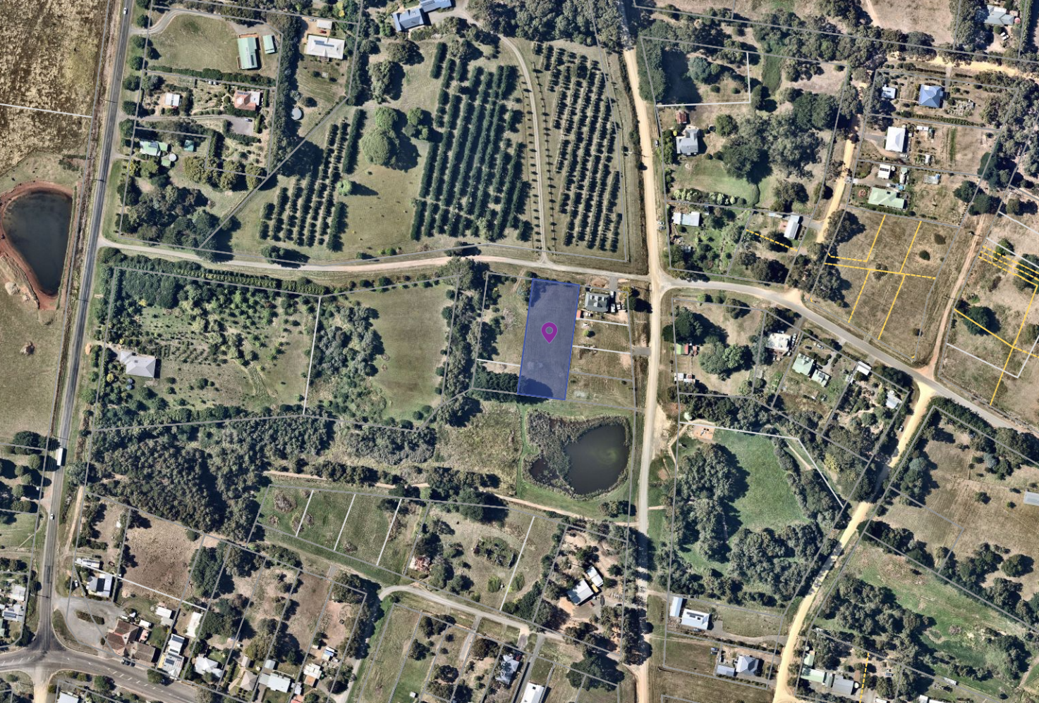
Corbetts Road along the front of the property is unsealed, with Corbetts Road being sealed from the Lyndhurst Street intersection towards the east. The land to the south is the Paddock Creek Reserve and in the Public Park and Recreation Zone and the land to the north is the within the Rural Living Zone. Further to the south is Gordon’s Main Street precinct.
Figure 1 Map of the subject site.

Proposal
The dimensions of the lot that is proposed to be subdivided is 80.5m x 32.2m. The layout of the proposed subdivision is as a battle axe formation. The battle axe handle allowing access to the rear lot is proposed to be located to the east of the front lot and would be 10m wide. The front lot (Lot 1) would have direct access to Corbetts Road and would be 22.2m x 50m. Towards the front of this lot is a stand of non-native vegetation.
The rear lot (Lot 2) is the battle axe lot with the head of the axe would be 30.5m x 32.2m, with a 50m x10m handle. The handle is wider than what is typical for a battle-axe subdivision, which was on advice of Council’s Planning Unit and also allows for better landscaping treatments to be implemented.
In total, Lot 1 would be 1,100 sqm and Lot 2 would be 1,483sqm.
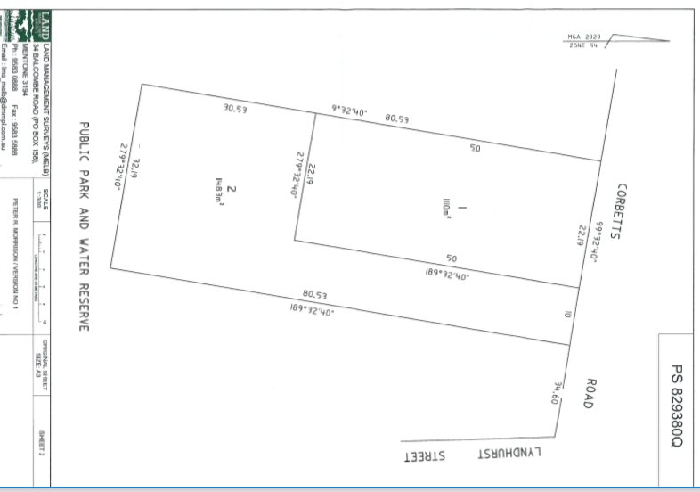
Figure 1: Plan of Subdivision

History
A search of Council records shows that there is no planning permit history associated with the subject site.

Public Notice
The application was notified to adjoining and surrounding landowners. As a result of the advertising process, two objections were received.

Summary of Objections
The objections received are detailed below with officer’s comments accompanying them:
Objection | Any Relevant Requirement
The suitability of Corbetts Road to the western side of the Lyndhurst Street intersection  Dust and light pollution from the driveway servicing Lot 2, specifically requesting a sealed driveway and either a boundary fence or vegetation to be provided on the boundary.  Supply of the essential services, including electricity, water and sewer via easements when easement has been drawn on the plan.  The final main section is that the layout of the subdivision is as a battle axe subdivision. | Requirement under ResCode
Officer’s Response:
The design of the subdivision allows for a 10m wide driveway for access as well as landscaping treatment to reduce the impact of the light and dust, however there are no requirements under the Planning Scheme for driveways to be sealed.
While a battle axe subdivision is not the preferred layout of development for reasons included within the objection – such as lack of street addressing, servicing and access considerations, applications can be assessed on their merits against the Moorabool Planning Scheme.
Seeks the protection of the waterway, including wanting a 30m buffer between any development and waterways. The objection calls for a 20m buffer at the rear of the site to be revegetated and used as a buffer zone. | Clause 14.02 Water
Officer’s Response:
Clause 14.02-1 Water Catchment Planning and Management does have a strategy to retain vegetated buffer zones around waterways. The application was referred to the relevant water authority, Barwon Water. Barwon Water consented to the application, subject to conditions. These conditions are included as part of the proposed conditions within this report.

Locality Map
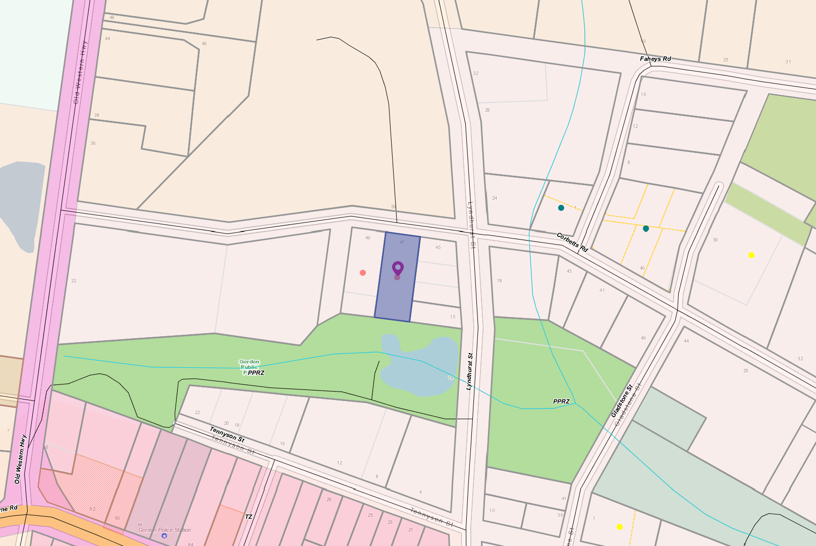
The map below indicates the location of the subject site and the zoning of the surrounding area.
Figure 2 Zoning Map of the area with the subject site highlighted

Planning Scheme Provisions
Council is required to consider the Victoria Planning Provisions and give particular attention to the Planning Policy Framework (PPF), the Local Planning Policy Framework (LPPF) and the Municipal Strategic Statement (MSS).
The relevant clauses are:
Clause 11.03 Planning for Places
Clause 12.05 Significant Environments and Landscapes
Clause 13.02 Bushfire
Clause 14.02 Water
Clause 15.01 Built Environment
Clause 16.01 Residential Development
Clause 21.02 Natural Environment
Clause 21.03 Settlement and Housing
Clause 21.09 Small Towns and Settlements
Clause 22.02 Special Water Supply Catchments.

The proposal complies with the relevant sections of the PPF and LPPF, with the exception of the clauses outlined in the table below:

PPF | Title | Response
Clause 14.02 | Water | The application does not provide a significant buffer between the waterway to the south of the property and the Paddock Creek reserve, less than the 30m specified within the strategies of this policy.  It should be noted that Barwon Water has consented to the application, subject to conditions. These conditions include connecting to sewer and the appropriate management of stormwater. Council has also deemed it appropriate to include a building exclusion zone on the plan of subdivision so as to ensure the distance between any development on the site and the waterway, which is the Condition 1 requirement

Zone
The land is within the Neighbourhood Residential Zone, Schedule 1.
The purpose of this Zone is:
• To implement the Municipal Planning Strategy and the Planning Policy Framework.
• To recognise areas of predominantly single and double storey residential development.
• To manage and ensure that development respects the identified neighbourhood character, heritage, environmental or landscape characteristics.
• To allow educational, recreational, religious, community and a limited range of other non-residential uses to serve local community needs in appropriate locations
There is a planning permit requirement under Clause 32.09-3 for subdivision in this zone. Under the schedule to the zone the minimum lot size is 800 square meters. Both lots proposed under this application exceed the minimum lot size mandated by the zone.

Overlays
The following overlays apply to the subject site:
Clause 42.01 Environmental Significance Overlay, Schedule 1
The environmental objectives to be achieved under the provisions of this overlay are:
• To protect the quality and quantity of water produced within proclaimed water catchments.
• To provide for appropriate development of land within proclaimed water catchments.
A permit is required under the provisions of this overlay.
Clause 42.03 Significant Landscape Overlay, Schedule 2
• The landscape character objectives to be achieved under the provisions of this overlay are:
• To retain and protect significant trees, vegetation and windbreaks that are significant component of local identity and landscape of the township character of Gordon.
• To protect vegetation and trees of special significance, natural beauty, interest and importance.
• To retain trees where they have high amenity value, unless identified as an environmental weed.
• To support the retention and planting of further exotic and indigenous trees.
As no vegetation is proposed to be removed as part of this application, this overlay does not trigger a planning permit
Clause 43.02 Design and Development Overlay, Schedule 5
The design objectives to be achieved under the provisions of this overlay for the Residential Zones are:
• To protect the village character of the township.
• To ensure that buildings with visible roof forms make a positive contribution to the character of the township.
• To protect the spacious character of the township by maintaining larger lot sizes.
A permit is required under the provisions of this overlay.

Particular Provisions
Clause 56 Residential Subdivision
Clause 56 provides objectives and standards for residential subdivision. This clause requires the submission of detailed information. A subdivision must meet all of the objectives and should meet all of the standards of this clause.

The proposal meets the relevant standards and objectives of Clause 56 for residential subdivision. The lot design is generally consistent with the existing neighbourhood character and the lot dimensions would comfortably accommodate building envelopes which exceed the minimum requirements under Clause 56.

Discussion
Overall, the proposed subdivision is considered to be generally in accordance with the PPF and the LPPF, the Neighbourhood Residential Zone, relevant overlays and Particular and General Provisions of the Moorabool Planning Scheme.
Gordon is the third largest township in the municipality and is in the Central Highlands region and located in the Melbourne-Ballarat corridor with convenient vehicle connections to the Western Freeway and rail in Ballan. As such, the Gordon township is expected to grow, in which infill development is a crucial part of the growth expected to occur. The subject site is in an area zoned for residential purposes and within convenient walking distance of some of the town’s local amenities. Utilities are in close proximity to the subject site, with mains water, electricity and sewer being located near the Lyndhurst Street intersection.

The proposal to subdivide the site would create two lots, the front lot of 1,110sqm and the rear lot being 1,483sqm, inclusive of the access driveway. Within the Moorabool Planning Scheme, both the State and Local planning provisions and policies encourage intensification of development, however this is to be balanced against the neighbourhood character values. These include new development maintaining the separated, low density development within the Gordon township, retention of local vegetation as well protection and maintain the natural environment features. In this context, a balance must be struck between supporting growth in appropriate locations whilst identifying those site characteristics which contribute to the neighbourhood and landscape character of the site. The two lots created exceed the minimum lot size and prevent any further subdivision of the land.
The key points for consideration in assessing this proposal are considered to be; Is the layout appropriate and size of the subdivision appropriate? Would the development impact the natural environment?
The proposed subdivision layout is as a battle axe subdivision, which typically faces issues due to a range of reasons including a lack of street addressing and access considerations. The proposed plan of subdivision includes a 10m wide accessway down the eastern boundary. This battle axe handle would provide both a sufficient access route and the frontage of the property, with part of the reason for the wider handle being sufficient to include landscaping treatments to further reduce the limited amenity impacts of the driveway. The front lot of the subdivision would have a 22m wide frontage and is generally in accordance with the wider streetscape character of Corbetts Road. The size of the lots that are proposed are well in excess of the minimum 800sqm mandated by the Neighbourhood Residential Zone, Schedule 1 and the Design and Development Overlay, Schedule 5. The size of the subdivided lots would allow a separation between the new future dwellings. The separation of lots with a front and rear lot alleviates the need for future dwellings to build close to side or rear boundaries. The battle axe arrangement allows for effective landscaping treatments to both lots.
There are some additional conditions implemented on the permit requiring landscaping down the eastern side of the parent title, including limiting internal fencing for the purpose of presenting to the street that it is one lot.
Council’s Infrastructure Department have imposed certain requirements on any permit given for the application. The permit holder would be required to upgrade the road in the front of the subject land to a standard defined within the IDM. Under Clause 18.02-3S Road System, there is a strategy to ensure that road space complements land use and is managed to meet community needs. The upgrade that is specified would create a road that is scaled to the use to be expected on the area. The Gordon Infrastructure Study undertaken by Cardno Engineering identified that the Corbetts Road to the west of Lyndhurst Street is to be improved. This road upgrade is considered to be appropriate in allowing approval of a two lot subdivision. The Road is to be done to a standard specified in the Infrastructure Design Manual and while not to be sealed with bitumen, asphalt or similar, the road will be upgraded to be of a minimum of 4m in width.
The approval of the planning permit application would not result in a detrimental impact to the natural environment of Gordon. The subdivision is required to be connected to sewer, which would remove the requirement for an onsite waste water treatment system which would have a higher chance of impacting the health of Paddock Creek.
Having regard for the policy demands applicable to this application it is considered to be acceptable. Should this application be approved, subject to conditions, the application would represent a modest contribution to growth of Gordon.

General Provisions
Clause 65 – Decision Guidelines have been considered by officers in evaluating this application.
Clause 66 – Stipulates all the relevant referral authorities to which the application must be referred.

Referrals
Authority | Response
Barwon Water | Consent with Conditions
Infrastructure | Consent with Conditions

Financial Implications
The recommendation for approval of this subdivision application would not have any financial implications for Council.

Risk & Occupational Health & Safety Issues
The recommendation of approval of this subdivision does not implicate any risk or OH&S issues to Council.

Communications Strategy
Notice was undertaken for the application, in accordance with s.52 of the Planning and Environment Act 1987, and further correspondence is required to all interested parties to the application as a result of a decision in this matter. All submitters and the applicant were invited to attend this meeting and invited to address Council if required.

Options
Council could consider the following options:
• issue a Notice of Decision to Grant a Permit in accordance with the recommendations in this report;
• issue a Notice of Decision to Grant a Permit with amendments to recommended conditions in this report; or
• issue a Notice of Refusal to Grant a Permit on specific grounds.

Conclusion
Subject to conditions, the proposal is generally consistent with the relevant provisions of the Moorabool Planning Scheme. The proposed subdivision would facilitate consolidated development within the existing township generally in keeping with the surrounding neighbourhood character typified by spacious lot sizes. The subdivision achieves the minimum lot size in accordance with the zone and overlay provisions. The lots are well proportioned to prevent dwellings building close to side or rear boundaries and allow for good landscaping treatments. The application should be approved with conditions that include infrastructure upgrades.

7.4 PA2019141 - Seven Lot Staged Subdivision and Vegetation Removal at 6 O'Donnell Street, Gordon
Author: Thomas Tonkin, Statutory Planner
Authoriser: Henry Bezuidenhout, Executive Manager Community Planning & Economic Development
Attachments: 1. Proposed plan of subdivision (under separate cover)
2. Bushfire Management Plan (under separate cover)

Application Summary
Permit No: PA2019141
Lodgement Date: 21 June 2019
Planning Officer: Tom Tonkin
Address of the land: 6 O’Donnell Street Gordon
Proposal: Seven Lot Staged Subdivision and Vegetation Removal
Lot size: 1.024 ha
Why is a permit required? Clause 32.09 Neighbourhood Residential Zone, Schedule 1 - Subdivision
Clause 42.01 Environmental Significance Overlay, Schedule 1 – Subdivision and Vegetation Removal
Clause 42.03 Significant Landscape Overlay, Schedule 2 – Vegetation Removal
Clause 43.02 Design and Development Overlay, Schedule 5 - Subdivision
Clause 44.06 Bushfire Management Overlay - Subdivision
Clause 52.17 Native Vegetation – Native Vegetation Removal

Recommendation
That Council, having considered all matters as prescribed by the Planning and Environment Act 1987, issues a Refusal to Grant Permit PA2019141 for Seven Lot Staged Subdivision and Vegetation Removal at Lot 1 on PS 729816L known as 6 O’Donnell Street, Gordon 3345, on the following grounds:
1. The proposed subdivision and vegetation removal is inconsistent with State and local planning policy in the Moorabool Planning Scheme for the protection and enhancement of neighbourhood character and landscape character.
2. The proposed subdivision does not satisfy the purpose of the Neighbourhood Residential Zone, Schedule 1, in the Moorabool Planning Scheme.
3. The proposed subdivision does not meet the relevant design objectives or subdivision requirements under the Design and Development Overlay, Schedule 5, in the Moorabool Planning Scheme.
4. The proposed vegetation removal does not meet the landscape character objectives of the Significant Landscape Overlay, Schedule 2, in the Moorabool Planning Scheme.
5. The proposed native vegetation removal does not meet the purpose of Clause 52.17 of the Moorabool Planning Scheme to avoid the removal of vegetation.
6. The proposed subdivision does not meet the objectives of Clause 56 of the Moorabool Planning Scheme in relation to neighbourhood character and vegetation retention.

Public Consultation
Was the application advertised? | Yes.
Notices on site: | Yes.
Notice in Moorabool Newspaper: | No.
Number of objections: | 14 objections.
Consultation meeting: | No. The applicant did not wish to participate in a consultation meeting. The Council officer offered objectors the opportunity to individually discuss their objections.

Policy Implications
The Council Plan 2017-2021 provides as follows:
Strategic Objective 2: Minimising Environmental Impact
Context 2A: Built Environment
The proposal does not conflict with the Council Plan 2017 – 2021.

Victorian Charter of Human Rights & Responsibilities Act 2006
In developing this report to Council, the officer considered whether the subject matter raised any human rights issues. In particular, whether the scope of any human right established by the Victorian Charter of Human Rights and Responsibilities is in any way limited, restricted or interfered with by the recommendations contained in the report. It is considered that the subject matter does not raise any human rights issues.

Officer’s Declaration of Conflict of Interests
Under section 80C of the Local Government Act 1989 (as amended), officers providing advice to Council must disclose any interests, including the type of interest.
Executive Manager – Henry Bezuidenhout
In providing this advice to Council as the Executive Manager, I have no interests to disclose in this report.
Author – Tom Tonkin
In providing this advice to Council as the Author, I have no interests to disclose in this report.

Executive Summary
Application referred? | Yes, Council’s Infrastructure, Council’s Strategic Planning, Council’s Environmental Planning, Barwon Water, Downer Utilities, Powercor, Central Highlands Water and Country Fire Authority.
Any issues raised in referral responses? | Council’s Strategic Planning objected to the application.
Preliminary concerns? | Yes – removal of vegetation which contributes to the local landscape character; proposed frontage widths for the lots fronting Corbetts Road are inconsistent with the neighbourhood character and do not support vegetation retention; and construction of a fence along the proposed boundary between Lot 6 and Lot 7 may negatively impact on the health of existing trees.
Any discussions with applicant regarding concerns? | Yes, the officer wrote to the applicant regarding the abovementioned concerns and had subsequent discussions with the applicant.
Any changes made to the application since being lodged? | Documents specifically related to native vegetation removal were updated but the proposed subdivision layout was not changed.
Brief history. | None applicable.
Previous applications for the site? | PAP98/202 for Development of a Dwelling, Carport and Garage was approved on 12 February 1999.
General summary. | Overall, the proposed subdivision and vegetation removal is inconsistent with the applicable planning controls in the Moorabool Planning Scheme. The subdivision layout is not sufficiently site responsive to the neighbourhood and landscape character, does not adequately support vegetation retention and would result in future development inconsistent with the identified valued characteristics of the surrounding area.  Fourteen objections were received on a range of matters including tree removal and the proposed subdivision layout.
Summary Recommendation
That, having considered all relevant matters as required by the Planning and Environment Act 1987, Council issue a Refusal to Grant a Permit for a seven Lot Staged Subdivision and Vegetation at 6 O’Donnell Street, Gordon in accordance with Section 61 of the Planning and Environment Act 1987, on the grounds included in this Report.

Site Description
The subject site is identified as Lot 1 on PS729816L and known as 6 O’Donnell Street, Gordon. The site is an irregular shape and area of 1.024ha. The lot has a northern frontage width of 130.32m to O’Donnell Street, secondary 84.89m wide frontage to Corbetts Road to the south and depth of 101.63m. The site falls generally from north to south by up to 6m and there is a drainage line which lies towards the western boundary and flows south through the site. The site is developed with a single storey dwelling towards the north-east corner but is otherwise vacant apart from stands of native and exotic trees along sections of the north and south boundaries and scattered native trees within the site. Existing vehicle access is via a single crossover to O’Donnell Street and boundary fencing is a post and wire type.
The site and surrounding land to the east, west and south is in the Neighbourhood Residential Zone and comprises lots of varying sizes, either similar to or smaller than the subject site but generally at least 1,000sqm. Land to the north, across O’Donnell Street, is in the Rural Living Zone, and comprises lots mostly larger than the subject site and developed with single dwellings and ancillary outbuildings. The pattern of subdivision in the area is notable for its inconsistency and reflects a different development pattern that has occurred over time, although the recent sewering of Gordon has resulted in recent subdivisions in the area which is creating lots of a generally more uniform size and shape.
The surrounding landscape character is typified by gently undulating land, generally falling to Paddock Creek further to the south of the site. This part of Gordon is strongly characterised by established vegetation within road reserves and on private land including large trees, with distant views of trees in the wider neighbourhood contributing to the broader landscape character enhanced by the varied topography and low scale of development in the area.
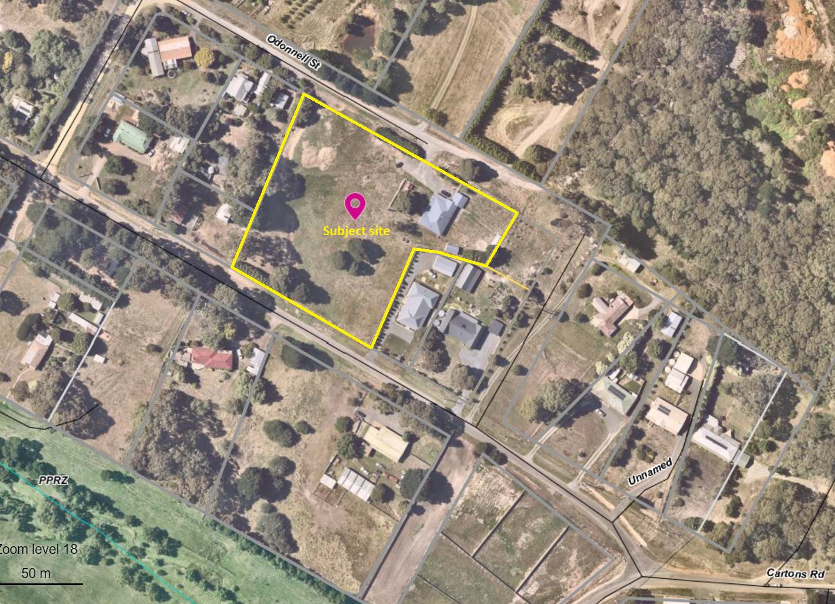
Figure 1: Aerial Photograph

Proposal
It is proposed to subdivide the site into seven lots and to remove vegetation. Lots 1, 2, 3 and 4 would front Corbetts Road with respective frontage widths of 23, 21, 21.89m and 19m and respective lot sizes of 1,217sqm, 1,229sqm, 1,279sqm and 1,305sqm and be generally rectangular in shape. Lots 5, 6 and 7 would front O’Donnell Street with respective frontage widths of 43m, 29m and 58.32m and respective lot sizes of 1,725sqm, 1,233sqm and 2,256sqm. Lot 7 would contain the existing dwelling. The subdivision would be created in three stages and not in lot numeric order – Lots 3 and 4 are to be created in Stage 1, then Lots 1 and 2 in Stage 2, with the balance of lots to be created in Stage 3.
Four native trees on Lots 2 and 3 and five exotic trees on Lot 4 are proposed to be removed.

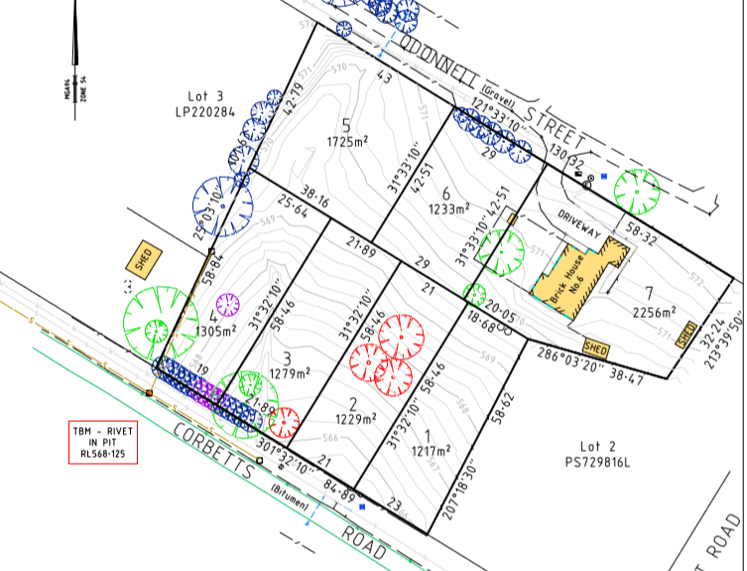
Figure 2: Subdivision Plan

Background to Current Proposal
Not applicable.

History
There is no site history relevant to this application.

Public Notice
Notice of the application was given to adjoining and surrounding landowners and occupiers by post and signs erected on both street frontages from 12 September 2019 until 5 October 2019. 14 objections were received from persons living at 10 separate addresses.

Summary of Objections
The objections received are detailed below with officer’s comments accompanying them:
Objection | Any Relevant Requirement
Road frontage widths as narrow as 19m are not in keeping with the streetscape. Future development of the lots fronting Corbetts Road would be constrained by the 19-23m widths resulting in a fairly dense “terrace like” appearance out of character with the “village” character. | Clauses 11.03-3S, 15.01-3S, 15.01-5S, 21.03-4, 21.09-2 & 32.09.
Officer’s Response:
The cluster of four lots fronting Corbetts Road with proposed frontage widths of 19-23m do not respond to the surrounding pattern of development and would negatively impact on the neighbourhood character. See ‘Discussion’ below.
Lots larger than those proposed would provide more space for larger trees. | Clauses 11.03-3S, 15.01-5S, 21.03-4, 21.09-2, 32.09, 42.03 and 65.01.
Officer’s Response:
Based on the current proposal, planting of larger trees would be substantially constrained by the defendable space requirements required to be met for each future dwelling in order for the bushfire hazard to be reduced to an acceptable extent. The current proposal is not considered to make adequate provision for a balance of future development and vegetation retention and planting. It is unknown how large lots would need to be to accommodate larger tree plantings, which would require a separate bushfire assessment.
The proposed lots fronting Corbetts Road are too small and a cluster of small lots is not in keeping with the surrounding neighbourhood character. | Clauses 11.03-3S, 15.01-3S, 15.01-5S, 21.03-4, 21.09-2 & 32.09.
Officer’s Response:
Setting aside the lot shapes, their sizes are considered to be generally acceptable being substantially larger than the minimum allowable 800sqm. However, the dimensions of Lots 1-4 and the impact on the streetscape is not considered acceptable. See ‘Discussion’ below.
Despite having been partially filled, the drainage line traversing the property regularly floods, which must be considered. | Clauses 56.07-4 and 65.02.
Officer’s Response:
The application was referred to Council’s Infrastructure, who have considered the site’s drainage and recommend approval, subject to conditions which would satisfy the relevant requirements.
The proposed lot layout does not support vegetation retention which contributes to the local landscape. Not all trees proposed for removal would need to be removed to facilitate the subdivision. | Clauses 11.03-3S, 15.01-5S, 21.03-4, 21.09-2, 32.09 and 42.03.
Officer’s Response:
It is agreed that not all trees proposed for removal are required to be to facilitate subdivision. If the application was to be approved, conditions should be imposed to ensure trees are retained accordingly.
Notwithstanding that Lot 5 is encumbered by a drainage line, it’s 1,725sqm size would facilitate further subdivision and the boundary between Lot 5 and 6 should be amended to reduce Lot 5’s size to less than 1,600sqm to prevent it being subdivided in future. | Clauses 32.09, 43.02 and 65.02.
Officer’s Response:
The proposed lot sizes on the northern section of the site are considered appropriate. The existing drainage line significantly constrains future development and would be expected to impede further subdivision of Lot 5. If in the future, Lot 5 is proposed to be subdivided, it would subject to a separate planning assessment.
There is limited infrastructure capacity – power and sewer – to support too many subdivisions in Gordon. | Clause 65.02.
Officer’s Response:
The application was referred to Powercor, the relevant electricity supply/distribution authority and Central Highlands Water as the relevant sewer authority, and both provided conditional consent to the proposed subdivision.
The subject site is part of a wildlife corridor, including for kangaroos, between Paddock Creek to the south and forest to the north of the site. | Clauses 21.02-4, 43.02 (Schedule 2), 65.01 and 65.02.
Officer’s Response:
Under Clause 42.03 (Schedule 2) (Significant Landscape Overlay – SLO2) Council must, in assessing proposed vegetation removal, consider whether it is possible to provide compensatory habitat for native fauna.
Whilst it is acknowledged that the site forms part of a wildlife corridor there are no other applicable planning controls in the Moorabool Planning Scheme specific to wildlife habitat protection for the site or surrounding land. Council must consider, as relevant, the effect of the proposal on the amenity of the area, the extent and character of native vegetation on the site, the likelihood of its destruction and whether it can be protected or planted. Only one native tree (on Lot 3) would likely require removal to facilitate the proposed subdivision (for access purposes). All other native vegetation should be retained if the subdivision is approved, on the understanding that future vegetation removal to enable development of the lots,
in particular Lot 3, would be subject to a separate permit application and assessment of whether suitable replacement planting is possible. However, this outcome does not allay Council officer concerns regarding the impact of the lot layout on the longer-term retention of native vegetation on the site.
The proposal is inconsistent with applicable planning policy in support of protecting urban and landscape elements which contribute to the town’s rural character. | Clauses 11.03-3S, 15.01-3S, 15.01-5S, 21.03-4, 21.09-2, 32.09, 42.03, 43.02, 65.01 and 65.02.
Officer’s Response:
See ‘Planning Scheme Provisions’, ‘Overlays’ and ‘Discussion’ below.
The subdivision does not accord with the surrounding landscape or environmental context. | Clauses 11.03-3S, 12.01-2S, 15.01-5S, 21.02-2, 21.02-3, 21.02-4, 21.02-6, 21.03-4, 21.09-2, 42.03, 43.02 and 52.17.
Officer’s Response:
See ‘Planning Scheme Provisions’, ‘Overlays’, ‘Particular Provisions’ and ‘Discussion’ below.
The subdivision does not accord with the purpose of the Zone. | Clause 32.09.
Officer’s Response:
See ‘Zone’ and ‘Discussion’ below.
The subdivision does not accord with the subdivision objectives of the DDO5. | Clause 43.02.
Officer’s Response:
See ‘Overlays’ and ‘Discussion’ below.
The proposal does not meet the neighbourhood character standard C6. | Clause 56.03-5.
Officer’s Response:
See ‘Particular Provisions’ and ‘Discussion’ below.
The proposal does not accord with Council’s local planning policy specific to Gordon. | Clause 21.09-2.
Officer’s Response:
See ‘Planning Scheme Provisions’ and ‘Discussion’ below.
The subdivision is not in accordance with the Gordon Structure Plan 2011. | Clauses 21.09-2, 42.03 (Schedule 2) and 43.02 (Schedule 5).
Officer’s Response:
The Gordon Structure Plan is not listed under Clause 21.11 in the Moorabool Planning Scheme as a reference document and is therefore not specifically considered in the assessment of the application. Planning Scheme Amendment C53 implemented recommendations made in the Structure Plan by changing local planning policy and applying the Design and Development Overlay Schedule 5 and Significant Landscape Overlay Schedule 2 to land in and around the town.
Concerns regarding information contained in the Stormwater Management Strategy. | Clauses 56.07-4 and 65.02.
Officer’s Response:
Council’s Infrastructure have identified shortcomings in the documentation and have been advised of the specific concerns of objectors, and accordingly recommend changes as a condition of approval, should a permit be granted. It is considered that these changes would address the concerns raised.
Removal of all native vegetation. | Clause 52.17.
Officer’s Response:
See ‘Particular Provisions’ below. In accordance with the requirements of Clause 52.17 all native vegetation is identified for removal as part of this application given there would be no future opportunity to require offsets for its removal. However, if a permit is issued then it is recommended that only vegetation required to facilitate subdivision be removed as part of this application, with any future removal or lopping subject to an assessment against the relevant Overlay controls.
Building envelopes shown on the Bushfire Management Plan should be shown on the plan of subdivision, with the street setbacks and side and rear boundary setbacks in accordance with DDO5 notated on the plans. | Clause 43.02 (Schedule 5), 44.06 and 53.02-4.4.
Officer’s Response:
It is considered that should a permit be granted these requirements can reasonably be imposed as a condition of approval. Consideration of front setback requirements in respect of neighbourhood character would be recommended as part of an approval, if required.
A landscape plan should be provided as part of this application. | Clause 42.03 (Schedule 2).
Officer’s Response:
It is noted that a landscape plan is identified as an application requirement. Should a permit be granted, there is an opportunity to require submission of a landscape plan to Council’s satisfaction as a condition of approval.
Content of the arborist report and native vegetation removal report. | Clauses 42.03 (Schedule 2) and 52.17.
Officer’s Response:
The Council officer assessment of the proposal has taken into consideration all submitted documentation, accounting for discrepancies, errors and views expressed, and where necessary has clarified content to inform the recommendations herein.

Locality Map
The map below indicates the location of the subject site and the zoning of the surrounding area.
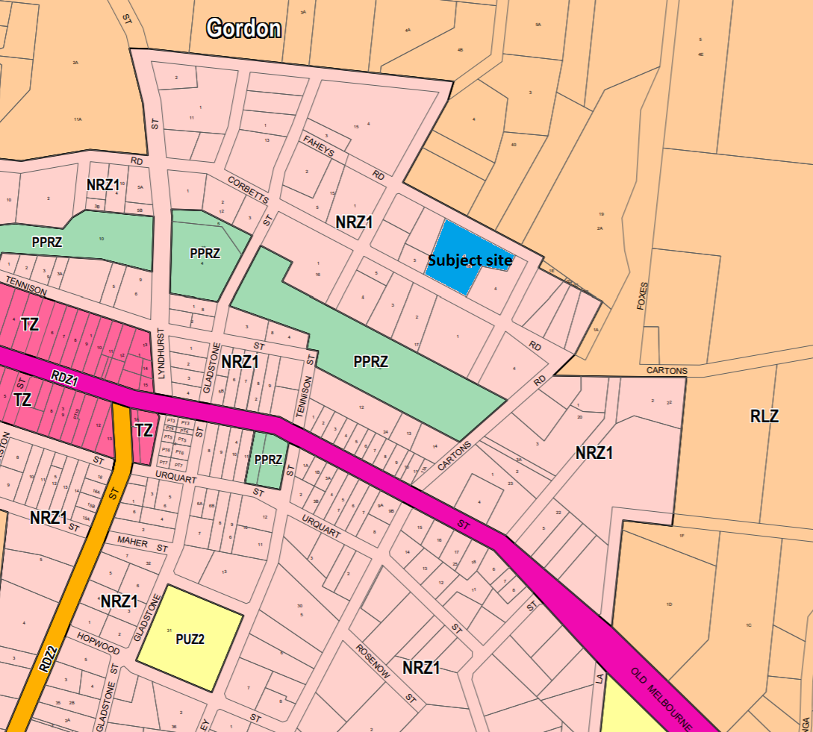
Figure 3: Zone Map

Planning Scheme Provisions
Council is required to consider the Victoria Planning Provisions which includes the Planning Policy Framework (PPF), the Local Planning Policy Framework (LPPF) and the Municipal Strategic Statement (MSS).
The relevant clauses are:
• Clause 11.03-3S Peri-urban areas
• Clause 12.01-2S Native vegetation management
• Clause 14.02-2S Water quality
• Clause 15.01-3S Subdivision design
• Clause 15.01-5S Neighbourhood character
• Clause 16.01-2S Location of residential development
• Clause 21.02-2 Non-urban landscapes
• Clause 21.02-3 Water and Catchment Management
• Clause 21.02-4 Biodiversity
• Clause 21.02-6 Environmentally sustainable development
• Clause 21.03-2 Urban growth management
• Clause 21.03-3 Residential development
• Clause 21.03-4 Landscape and Neighbourhood Character
• Clause 21.09-2 Gordon
• Clause 22.02 Special Water Supply Catchments
In assessing the application against the relevant sections of the PPF and LPPF, the following significant non-compliances were identified:

PPF | Title | Response
Clause 11.03-3S | Per-urban areas | The proposal is an overdevelopment of the site and would erode the neighbourhood character, attractiveness and amenity of the area.
Clause 15.01-5S | Neighbourhood character | The proposal does not respect the existing neighbourhood character. The lot layout does not respond to the pattern of surrounding development or the site and surrounds’ landscape values.
LPPF

Clause 21.03-4 | Landscape and neighbourhood character | The proposed subdivision design is not suitably responsive to the site characteristics or surrounding neighbourhood character.
Clause 21.09-2 | Gordon | The proposal does not protect urban and landscape elements of the site and surrounding neighbourhood which contribute to the neighbourhood and landscape character.

Zone
The subject site is in the Neighbourhood Residential Zone, Schedule 1 (NRZ1).
Under Clause 32.09-3 a permit is required to subdivide land. An application to subdivide land must meet the relevant requirements of Clause 56 for residential subdivision.
Schedule 1 to the zone specifies a minimum lot size of 800sqm.

The purpose of the Zone is:
• To implement the Municipal Planning Strategy and the Planning Policy Framework.
• To recognise areas of predominantly single and double storey residential development.
• To manage and ensure that development respects the identified neighbourhood character, heritage environmental or landscape characteristics.
• To allow educational, recreational, religious, community and a limited range of other non-residential uses to serve local community needs in appropriate locations.
The proposed lot sizes exceed the minimum lot size requirement, but the proposed lot layout does not adequately respond to the existing neighbourhood character.
OVERLAYS
The site is affected by several planning overlays.
Environmental Significance Overlay, Schedule 1 (ESO1)
The ESO1 applies to land in a Special Water Supply Catchment. Under Clause 42.01-2 a permit is required to subdivide land and remove vegetation. The site is in the Special Water Supply Catchment and has access to reticulated sewer in Corbetts Road. The site is more than 100m from a waterway and, subject to conditions, the proposal would satisfy the provisions of the ESO1
Design and Development Overlay, Schedules 2 and 5 (DDO2 & 5)
The DDO2 applies to development using reflective exterior cladding and is not applicable to this proposal.
The DDO5 applies to the Gordon township and rural surrounds. Under Clause 43.02-3 a permit is required to subdivide land, with a minimum lot size requirement of 800sqm. All proposed lots are substantially above the minimum 800sqm stipulated under the NRZ1 and DDO5 generally in keeping with the characteristically larger lots in this area of the town. However, the proposed lot layout does not meet the relevant design objectives or subdivision requirements of the DDO5 and is not an acceptable design response to the surrounding neighbourhood character.
Significant Landscape Overlay, Schedule 2 (SLO2)
Under the SLO2 there is no permit requirement for subdivision, but a permit is required to remove vegetation.
The landscape objectives under Part 2 of Schedule 2:
• To retain and protect significant trees, vegetation and windbreaks that are significant component of local identity and landscape of the township character of Gordon.
• To protect vegetation and trees of special significance, natural beauty, interest and importance.
• To retain trees where they have high amenity value, unless identified as an environmental weed. To support the retention and planting of further exotic and indigenous trees.
Overall, the proposed vegetation removal is considered to be inconsistent with the SLO2 provisions, in particular the removal of trees from proposed Lot 2.
Bushfire Management Overlay (BMO)
Under the BMO a permit is required to subdivide land. Subject to conditions, the proposal would satisfy the provisions of the BMO.
Relevant Policies
Gordon Structure Plan 2013
The Structure Plan identified that the construction of a sewerage treatment plant and the sewering of the core township area by Central Highlands Water would boost demand for further residential development and provide opportunities for infill development and increased densities of residential and other development in the sewered area.
Accordingly, the Structure Plan sets out requirements for the preferred form and scale of future development. Consultation with the community indicated a strong community desire to retain the small town feel and the quality of the rural setting.
The town’s landscape character was also acknowledged as quite complex, comprised of a diverse range of elements – natural, introduced and built – with considerable care needed to ensure that the location, scale and form of new development reinforces the qualities and character of that landscape. It acknowledged there are considerable opportunities to reinforce the landscape and character of the town particularly through further carefully selected and sited planting associated with new development and along key roads and routes.
It was noted that future development based on higher density and smaller lot residential development should be focused in the area bound by Urquhart, Lyndhurst, Tennyson Streets and the western edge of the established township area.
An identified principle of the Structure Plan was ‘the retention of the rural character of the township area and surrounds is paramount to retaining the lower density scale residential and vegetated areas in the surrounds and the wider rural living setting of the township’.
Particular Provisions
Clause 52.12 Bushfire Protection: Exemptions
There are no applicable exemptions under this Clause relating to subdivision for residential purposes.
Clause 52.17 Native Vegetation
The purpose of this particular provision
• To ensure that there is no net loss to biodiversity as a result of the removal, destruction or lopping of native vegetation. This is achieved by applying the following three step approach in accordance with the Guidelines for the removal, destruction or lopping of native vegetation (Department of Environment, Land, Water and Planning, 2017) (the Guidelines):
1. Avoid the removal, destruction or lopping of native vegetation.
2. Minimise impacts from the removal, destruction or lopping of native vegetation that cannot be avoided.
3. Provide an offset to compensate for the biodiversity impact if a permit is granted to remove, destroy or lop native vegetation.
• To manage the removal, destruction or lopping of native vegetation to minimise land and water degradation.
Under Clause 52.17-1 a permit is required to remove, destroy or lop native vegetation, including dead vegetation.
Under Clause 52.17-5 the biodiversity impacts of removal or lopping must be offset in accordance with the Guidelines for the removal, destruction or lopping of native vegetation (Department of Environment, Land, Water and Planning, 2017) (“the Guidelines”). The conditions on the permit for the removal, destruction or lopping of native vegetation must specify the offset requirement and the timing to secure the offset.
In accordance with the Guidelines, although not all native vegetation on the site is proposed for removal, all native vegetation has been assessed as being removed from the site and the strategic biodiversity value accounted for to determine the required offset for removal. This is because if the land is subdivided as proposed, there would be no future opportunity to require offsets for removal or lopping under Clause 52.17 due to the proposed lot sizes being less than .4ha. Eight native trees, including four large trees (as defined in the Guidelines) would require an offset for removal, but it is noted that four of the trees would be retained as part of the proposed design. If a permit were granted, conditions would specify the offset requirement and timing to secure the offset. However, the proposal is considered to have made inadequate provision to avoid the removal of the three native trees on proposed Lot 2 and therefore does not meet the purpose of this Clause.
Clause 53.01 Public Open Space Contribution and Subdivision
A person who proposes to subdivide land must make a contribution to the Council for public open space in an amount specified in the schedule to this clause (being a percentage of the land intended to be used for residential, industrial or commercial purposes, or a percentage of the site value of such land, or a combination of both). If no amount is specified, a contribution for public open space may still be required under section 18 of the Subdivision Act 1988. It is recommended that if a permit were granted a condition that a contribution to be made equivalent to 5% of the site value is required. There would be increased population as a result of the subdivision and a greater demand to utilise existing public open spaces.
Clause 53.02 Bushfire Planning
The application meets the applicable requirements of Clause 53.02-4.
Clause 56 Residential Subdivision
In assessing the application against the relevant sections of Clause 56, the following significant non-compliances were identified:
Clause ResCode | Title | Response
56.03-5 | Neighbourhood character | The proposed lot design, in particular frontage widths to Corbetts Road and protection of vegetation, does not adequately respond to the surrounding neighbourhood character.
56.04-2 | Lot area and building envelopes | The proposed lot boundaries do not adequately seek to protect or enhance the retention of trees on the site.

Discussion
Overall, the proposed subdivision and vegetation removal is not supported by relevant planning policy in the Moorabool Planning Scheme.
Gordon is in the Central Highlands region and located in the Melbourne-Ballarat corridor with convenient vehicle connections to the Western Freeway and rail in Ballan. The subject site is in a sewered area zoned for residential purposes, although many of the town’s local amenities are not within convenient walking distance of the site. The site is relatively large, with a mix of native and exotic trees, some being mature specimens, mostly clumped in different parts of the site creating a distinct visual impact in the immediate vicinity but also contributing to the town’s local landscape character. These characteristics contribute to the site’s unique qualities compared to most surrounding lots, many of which are smaller and with generally less expansive open spaces.
The proposal is to subdivide the site into seven lots of between 1,217sqm and 2,256sqm, and to remove nine native and exotic trees. Assessment of the proposal under the Moorabool Planning Scheme requires consideration of several layers of planning controls which relate to both the intensification of development within the existing township and the protection and enhancement of valued characteristics relating to neighbourhood character, the contribution of trees and vegetation to landscape character and protection of potable water supply. In this context, a balance must be struck between supporting growth in appropriate locations whilst identifying those site characteristics which contribute to the neighbourhood and landscape character of the site. It is considered that the proposal would make a modest contribution to Gordon’s growth and that the site is suitable for subdivision, however the overall lot design does not respond positively to the surrounding neighbourhood character or respect the landscape values of the site, as discussed below.
The proposed lot sizes, ranging from 1,217sqm and 2,256sqm, and averaging 1,463sqm, are generally smaller than immediately adjoining lots, which are at least 1,500sqm in size, but are generally consistent with recently approved subdivisions further along Corbetts Road in both directions. The key issue regarding the lot design is not the size of lots but their layout, particularly the proposed lots fronting Corbetts Road. Whilst similar in size to other recently approved subdivisions nearby, a key difference and the critical issue for this proposal are the frontage widths of Lots 1-4 which average 21.22m. Furthermore, this cluster of lots in a location where the varied lot sizes and frontage widths are a feature, is likely to result in future housing development which is visually incompatible with the established neighbourhood character facilitated in part by wider frontage widths than proposed here. Future dwellings will have minimal side setbacks due to the lack of property widths. Additionally, the proposed lot design does not facilitate the likely retention of the three native trees on Lot 2 which are proposed for removal. As previously outlined, the clumps of trees on this site in an undulating grassed setting are particularly striking when viewed from Corbetts Road and contribute to the identified landscape character in this area of Gordon. The trees on Lot 2 exemplify this aspect of the site well. The creation of lots with wider frontages would likely enable the retention of at least one of these trees, taking account of the defendable space requirements to mitigate the identified bushfire hazard. Based on the current proposal, the subdivision and vegetation removal is not supported.

General Provisions
Clause 65 – Decision Guidelines have been considered by officers in evaluating this application.
Clause 66 – Stipulates all the relevant referral authorities to which the application must be referred.

Referrals
Authority | Response
Powercor  Downer Utilities  Central Highlands Water  Barwon Water  Country Fire Authority | Consent with conditions.  Consent.  Consent with conditions.  Consent with conditions.  Consent with conditions.
Infrastructure  Environmental Planning  Strategic Planning | Consent with conditions.  Consent with conditions  Refusal.

Financial Implications
There are no financial implications for Council in refusing this subdivision application.

Risk & Occupational Health & Safety Issues
The recommendation to refuse this application does not have any risk or OH&S implications for Council.

Communications Strategy
Notice was undertaken for the application, in accordance with s.52 of the Planning and Environment Act 1987, and further correspondence is required to all interested parties to the application as a result of a decision in this matter. All submitters and the applicant were invited to attend this meeting and invited to address Council if required.

Options
• Issue a Refusal to Grant a Permit in accordance with the grounds in the recommendation of this report; or
• issue a Refusal to Grant a Permit with amendments to the grounds in the recommendation of this report. Either option for refusal may result in the applicant appealing Council’s decision at VCAT; or
• issue a Notice of Decision to Grant a Permit with conditions. This option may result in objectors appealing Council’s decision at VCAT.

Conclusion
Overall, the proposed subdivision and vegetation removal does not adequately respond to the applicable planning policies in the Moorabool Planning Scheme. The subdivision layout is not sufficiently site responsive to the neighbourhood and landscape character and would result in future development inconsistent with the identified valued characteristics of the surrounding neighbourhood. It is recommended that the application be refused on specified grounds.

7.5 PA2019232 - Development of a second dwelling and 2 Lot subdivision - 3 Davies Street, Darley
Author: Victoria Mack, Statutory Planner
Authoriser: Henry Bezuidenhout, Executive Manager Community Planning & Economic Development
Attachments: 1. Development and subdivision plans (under separate cover)
2. Landscape plan (under separate cover)

Application Summary
Permit No: PA2019232
Lodgement Date: 15 October 2019
Planning Officer: Victoria Mack
Address of the land: 3 Davies Street, Darley
Proposal: Development of a second dwelling and 2 Lot Subdivision
Lot size: 651.36sqm
Why is a permit required? Clause 32.08 General Residential Zone – development of 2 dwellings on a lot and a 2 Lot Subdivision

Recommendation
That Council, having considered all matters as prescribed by the Planning and Environment Act 1987, issues a Notice of Decision to Grant a Planning Permit at 3 Davies Street, Darley, otherwise known as Lot 12 on PS 122385 subject to the following conditions:
1. Before the use and/or development starts, amended plans to the satisfaction of the Responsible Authority must be submitted to and approved by the Responsible Authority. When approved, the plans will be endorsed and will then form part of the permit. The plans must be drawn to scale with dimensions and three copies must be provided. The plans must be generally in accordance with the plans submitted with the application or some other specified plans but modified to show:
a) Widening of the driveway to Dwelling 2 to allow for 1m of landscaping to the northern side of the accessway
b) Landscaping changes to accord with Condition 1a and a Landscape Plan in accordance with condition 11.
c) The southern wall for Unit 2 setback 150mm from the south side boundary to allow for the location of the boundary fence. The plans for dwelling 2 must be adjusted accordingly.
2. Site plan to include fully dimensioned building plans and setbacks. Unless otherwise approved in writing by the Responsible Authority, all buildings and works are to be constructed and or undertaken in accordance with the endorsed plans to the satisfaction of the Responsible Authority prior to the commencement of the use.

3. The formal plan of subdivision lodged for certification must be generally in accordance with the endorsed plan and must not be modified except to comply with statutory requirements or with the written consent of the Responsible Authority.
Operational:
4. Before the development starts, a new wooden paling boundary fencing must be constructed to 1.8m in height on all boundaries tapering to 900mmm at Davies Street. Security fencing must be installed while the new fences are being constructed.
5. Prior to the issue of a Statement of Compliance, modifications to the existing dwelling including construction of a garage must be completed to the satisfaction of the Responsible Authority.
Servicing:
6. The owner of the land must enter into agreements with the relevant authorities for the provision of water supply, drainage, sewerage facilities, electricity and gas services to each lot shown on the endorsed plan in accordance with the authority’s requirements and relevant legislation at the time.
7. All existing and proposed easements and sites for existing or required utility services and roads on the land must be set aside in the plan of subdivision submitted for certification in favour of the relevant authority for which the easement or site is to be created.
8. The plan of subdivision submitted for certification under the Subdivision Act 1988 must be referred to the relevant authority in accordance with Section 8 of that Act.
Telecommunications:
9. The owner of the land must enter into agreements with:
a) A telecommunications network or service provider for the provision of telecommunication service to each lot shown on the endorsed plan in accordance with the provider’s requirements and relevant legislation at the time; and
b) a suitably qualified person for the provision of fibre ready telecommunication facilities to each lot shown on the endorsed plan in accordance with any industry specifications or any standards set by the Australian Communications and Media Authority, unless the applicant can demonstrate that the land is in an area where the National Broadband Network will not be provided by optical fibre.
10. Before the issue of Statement of Compliance for any stage of the subdivision under the Subdivision Act 1988, the owner of the land must provide written confirmation from:
a) A telecommunications network or service provider that all lots are connected to or are ready for connection to telecommunications services in accordance with the provider’s requirements and relevant legislation at the time; and
b) A suitably qualified person that fibre ready telecommunication facilities have been provided in accordance with any industry specifications or any standards set by the Australian Communications and Media Authority, unless the applicant can demonstrate that the land is an area where the National Broadband Network will not be provided by optical fibre.

Landscape plans:
11. Before the development starts, a landscape plan to the satisfaction of the Responsible Authority must be submitted to and approved by the Responsible Authority. When approved, the plan will be endorsed and will then form part of the permit. The plan must be drawn to scale with dimensions and three copies must be provided. The landscape plan must be generally in accordance with the landscape concept plan dated 6 February 2020 prepared by Red Line Plans Victoria except that the plan must show:
a) A survey (including botanical names) of all existing vegetation to be retained and/or removed.
b) Buildings and trees (including botanical names) on neighbouring properties within three metres of the boundary.
c) Details of surface finishes of pathways and driveways.
d) A planting schedule of all proposed trees, shrubs and ground covers, including botanical names, common names, pot sizes, sizes at maturity, and quantities of each plant.
e) Landscaping and planting within all open areas of the site.
f) Two canopy trees (minimum two metres tall when planted) in the following front setback. All species selected must be to the satisfaction of the Responsible Authority.
12. Before the use/occupation of the development starts or by such later date as is approved by the Responsible Authority in writing, the landscaping works shown on the endorsed plans must be carried out and completed to the satisfaction of the Responsible Authority.
13. The landscaping shown on the endorsed plans must be maintained to the satisfaction of the Responsible Authority, including that any dead, diseased or damaged plants are to be replaced.
Infrastructure conditions
14. Prior to the issue of a Statement of Compliance for the subdivision, each lot must be provided with a standard urban residential vehicle crossing on Davies Street to the satisfaction of the Responsible Authority. Any redundant vehicle crossings must be removed, and the kerb and channel and nature strip reinstated to the satisfaction of the Responsible Authority. A vehicle crossing permit must be taken out for the construction of the vehicle crossing.
15. Prior to the issue of a Statement of Compliance for the subdivision, the development must be provided with a drainage system to the satisfaction of the Responsible Authority, constructed in accordance with “Proposed Drainage Layout Plan” prepared by Land Management Surveys dated 10 February 2020, Ref No: 11954 Revision A.
16. Sediment discharges must be restricted from any construction activities within the property in accordance with relevant Guidelines including Construction Techniques for Sediment Control (EPA 1991).
17. Unless otherwise approved by the Responsible Authority there must be no buildings, structures, or improvements located over proposed drainage pipes and easements on the property.
18. Prior to the commencement of the development and post completion, notification including photographic evidence must be sent to Council’s Asset Services department identifying any existing damage to council assets. Any existing works affected by the development must be fully reinstated at no cost to and to the satisfaction of the Responsible Authority.
Permit Expiry
19. This permit will expire if one of the following circumstances applies:
a) The development is not started within two years of the date of this permit;
b) the development is not completed within four years of the date of this permit; and
c) The plan of subdivision is not certified within two years of the date of issue of the permit.
Statement of Compliance must be achieved, and certified plans registered at Titles office within five years from the date of certification.

Public Consultation
Was the application advertised? | Yes.
Notices on site: | Yes.
Notice in Moorabool Newspaper: | No.
Number of objections: | Four.
Consultation meeting: | Not held. Two objectors were phoned individually.

Policy Implications
The Council Plan 2017-2021 provides as follows:
Strategic Objective 3: Stimulating Economic Development
Context 2A: Built Environment
The proposal does not conflict with the Council Plan 2017 – 2021.

Victorian Charter of Human Rights & Responsibilities Act 2006
In developing this report to Council, the officer considered whether the subject matter raised any human rights issues. In particular, whether the scope of any human right established by the Victorian Charter of Human Rights and Responsibilities is in any way limited, restricted or interfered with by the recommendations contained in the report. It is considered that the subject matter does not raise any human rights issues.

Officer’s Declaration of Conflict of Interests
Under section 80C of the Local Government Act 1989 (as amended), officers providing advice to Council must disclose any interests, including the type of interest.
Executive Manager – Henry Bezuidenhout
In providing this advice to Council as the Executive Manager, I have no interests to disclose in this report.
Author – Victoria Mack
In providing this advice to Council as the Author, I have no interests to disclose in this report.

Executive Summary
Application referred? | Yes, to Council’s Infrastructure Department and Council’s Strategic Planning.
Any issues raised in referral responses? | Council’s Strategic Planning raised concerns with the originally submitted application.
Preliminary concerns? | The original submitted plan was for a double storey dwelling at the rear of the existing dwelling with the layout not meeting a number of ResCode objectives and standards. Also, a carport and a tandem car space were shown to be located at the front of the existing dwelling within the front setback area. The proposal was not considered to be satisfactory on neighbourhood character grounds and a re-design was requested.
Any discussions with applicant regarding concerns? | The applicant was sent a request for further information and a concerns letter. A meeting was subsequently held with the applicant to work through a new concept plan.
Any changes made to the application since being lodged? | Yes, the proposed development was considerably revised. The application is now for a single storey dwelling behind the existing dwelling. One bedroom has been removed from the existing dwelling, so it becomes a two-bedroom dwelling where only one car space is required. The single car space garage has been incorporated into the dwelling footprint.
Brief history. | The site has an existing single storey red/brown brick dwelling with a tiled roof most probably constructed in the 1980s.
Previous applications for the site? | None recorded.
General summary. | The revised application for a second dwelling on the lot and a 2 Lot Subdivision generally complies with ResCode objective and standards and the preferred neighbourhood character of Precinct 13 identifying the area as suitable for increased residential growth. The site is within the General Residential Zone Schedule 3 which is also identified as suitable for increased residential growth.  The existing dwelling has a 7m setback from the street which will allow space for the planting of canopy trees which will soften the appearance of the site.  It is recommended that the application is supported.
Summary Recommendation
That, having considered all relevant matters as required by the Planning and Environment Act 1987, Council issues a Notice of Decision to Grant a Planning Permit for the development of a second dwelling and two lot subdivision at 3 Davies Street, Darley, otherwise known as Lot 12 on PS 122385 subject to conditions.

Site Description
The site in located on the western side of Davies Street and has an area of 651.36sqm. The lot has a width of 18.4m and a length of 35.4m.
It is located approximately 11m south of the T intersection of Davies Street with Taylor Drive in Darley.
The site slopes upwards slightly to the west. It has an existing brown/red brick single storey three-bedroom dwelling and shedding, some of which has recently been removed. The dwelling may have been constructed in approximately the 1980s.
A modest site cut would be required to construct the second dwelling.
The site is surrounded by lots of similar size, or slightly smaller, with single storey single dwellings in garden settings.
The site is located approximately 1.1kms west south-west of the Darley Plaza shopping centre and approximately 2.2kms north-west of the Bacchus Marsh shopping precinct.
A regular 435 Bacchus Marsh Station - Darley via Bacchus Marsh bus service travels each way along Holts Lane, Davies Street and Taylor Drive at approximately 30-minute intervals from Links Road to the Bacchus Marsh railway station.
Below is an aerial photo of the site and surrounds:
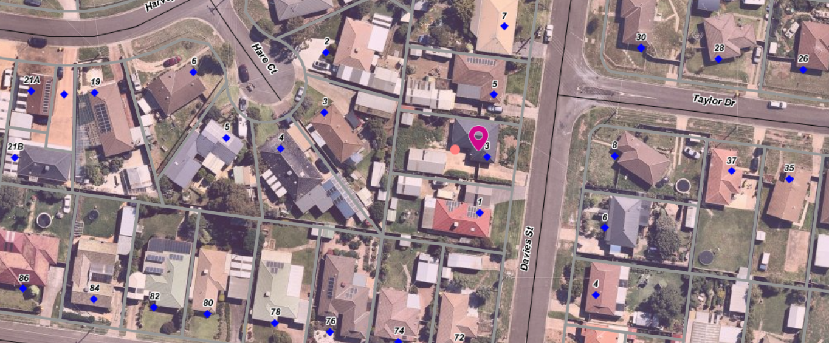

Proposal
The proposal is to construct a second dwelling on the lot behind the existing dwelling and to subdivide the land into two lots.
The existing Dwelling 1 would have the following details:
• Two bedrooms (reduced from three), a combined bathroom/laundry, an open plan family/meals area with scullery kitchen and an attached lounge with entry doorway to the lounge. A one car space garage would be inset into the dwelling footprint.
• The dwelling area including garage and porch would be 104.13sqm.
• The dwelling would be provided with 60.69sqm of private open space with a minimum width of 3m to the rear with a northerly orientation and a total area of private open space of 96.94sqm
• The dwelling is setback 7m from the street. A new crossover would be constructed in the north-east corner of the site for Dwelling 1.
The second dwelling at the rear would have the following details:
• Three bedrooms, the master with WIR and ensuite, a separate family bathroom, a separate laundry and an open plan kitchen, dining and living area with entrance doorway to the living area. A single car space garage would be inset into the dwelling footprint. A tandem car space would be located in the front of the garage.
• The dwelling area including garage and porch would be 164.24sqm.
• The dwelling would be provided with 40.62sqm of private open space with a minimum width of 3m located on the north side of the dwelling and a total area of private open space of 82.79sqm
• A new crossover would replace the existing crossover in the south-east corner of the site for Dwelling 2.
The site coverage would be 41.2%. Permeability would be 45.18%. Total garden area would be 35%.
A landscape plan was provided showing a planting range of mostly exotic species and surface treatments including paving, grass and concrete driveways.
Lot 1 containing Dwelling 1 would have an area of 300.05sqm
Lot 2 with the new Dwelling 2 would have an area of 351.31sqm.

History
There is no history that is relevant to this application.

Public Notice
The application was notified to adjoining and surrounding landowners with 4 objections received.

Summary of Objections
The objections received are detailed below with officer’s comments accompanying them:
Objection | Any Relevant Requirement
The traffic in the street is already busy with a regular bus service travelling both ways along Taylor Drive, Davies Street and Holts Lane. Tradie vehicles building on this site will add to the traffic hazards and get in the way of the buses travelling each way along Taylor Drive. | Infrastructure Design Manual
Officer’s Response: Commercial vehicles are not entitled to impede regular traffic flow including public buses on residential roads. It is also noted that tradesmen will only access the site during the short construction stage of the development.
The quality of life for existing residents is being sacrificed for developers’ financial gain. This will be a major disruption to our privacy.
Officer’s Response: One additional dwelling once constructed is unlikely to disrupt the neighbourhood’s privacy. Furthermore the proposal meets ResCode requirements.
This will set a negative precedent and soon every back yard in the area will have another dwelling: more congestion; poor infrastructure; and destroying the amenity for everyone who lives here. | ResCode
Officer’s Response: Applications for dwellings and subdivision must comply the Moorabool Planning Scheme, State and local policies including the objectives of ResCode.
The building and works will create dust emissions which is of great concern to neighbouring residents who live with health issues and lung conditions. Dust suppression must be put in place to prevent neighbours form adverse dust impacts.
Officer’s Response: This is discussed in the discussion section of this report.
Disruption to neighbours’ amenity and privacy during construction and afterwards. | Neighbourhood Character precinct 13
Officer’s Response: Precinct 13 is recommended for increased residential growth.
Not in keeping with neighbourhood character where single dwellings on a lot are the norm. | Neighbourhood Character precinct 13
Officer’s Response: Precinct 13 is recommended for increased residential growth.
How will the builders protect our privacy and security when the fence is pulled down between our properties and replaced - with all our assets exposed. We also have a large dog. How will they guarantee the dog’s safety? The developers must sort this out. | Requirement under ResCode
Officer’s Response: This concern is discussed in the discussion section of this report.
I do not want a garage wall as part of my boundary. I ask that the developers provide a 200mm gap and a 1.8m fence on the boundary and not a brick garage wall. | Requirement under ResCode
Officer’s Response: This concern is discussed in the discussion section of this report.

Locality Map
The map below indicates the location of the subject site and the zoning of the surrounding area.

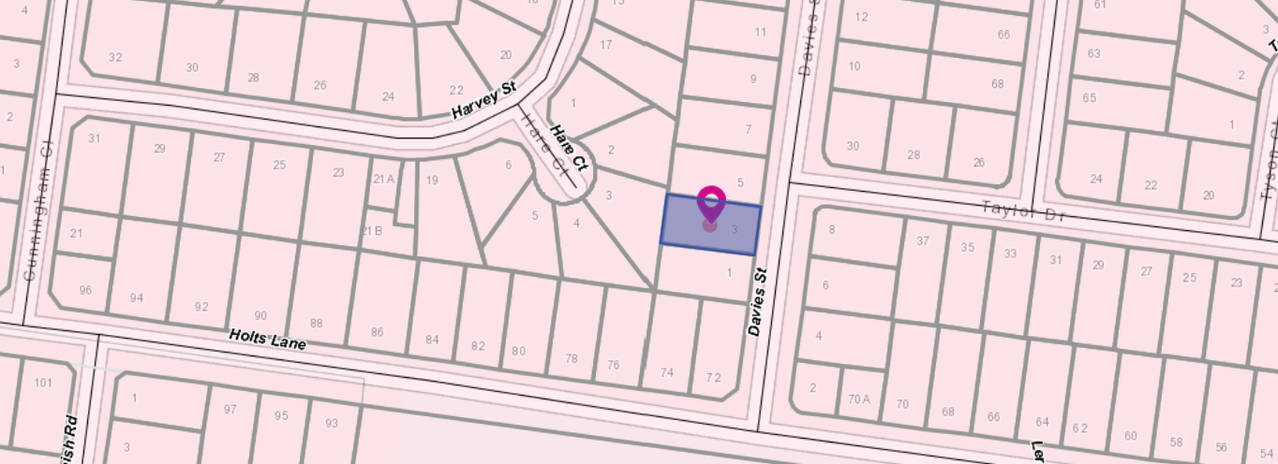

Planning Scheme Provisions
Council is required to consider the Victoria Planning Provisions and give particular attention to the Planning Policy Framework (PPF), the Local Planning Policy Framework (LPPF) and the Municipal Strategic Statement (MSS).
The relevant clauses are:
• Clause 11.03-2S Growth areas
• Clause 11.03-3S Peri-urban areas
• Clause 15.01-1S Urban design
• Clause 15.01-2S Building design
• Clause 15.01-5S Neighbourhood character
• Clause 16.01-1S Integrated housing
• Clause 16.01-2S Location of residential development
• Clause 16.01-3S Housing diversity
• Clause 21.03 Settlement and Housing and Clause 21.03- Key issues and influences
• Clause 21.03-2 Objectives—Urban growth management
• Clause 21.03-3 Objectives—Residential development
• Clause 21.07 Bacchus Marsh and Clause 21.07-2 Objectives - Managing urban growth
The proposal complies with the relevant sections of the PPF and LPPF.

Zone
General Residential Zone - Schedule 3
A permit is required under the following clauses of the General Residential Zone:
Clause 32.08-3 to subdivide land.
Clause 32.08-6 to construct two or more dwellings on a lot. A development must meet the requirements of Clause 55, ResCode.
In accordance with Clause 32.08-4 an application to construct or extend a dwelling or residential building on a lot must provide a minimum garden area of 35% where the lot area is greater than 6,650sqm.
Schedule 3 of the General Residential Zone
Schedule 3 applies to areas identified for Increased Residential Growth.
The Neighbourhood character objectives in Schedule 3 include:
• To encourage new development, including innovative and unique development that enhances and responds positively to the existing neighbourhood character.
• To encourage sufficient front setbacks to allow for enhancement of the front garden character including increasing canopy tree plantings.
• To encourage new development to have minimal or low scale front fencing.
• To ensure new garages and carports do not dominate dwellings or streetscapes.

Overlays
No overlays apply to the site.
RELEVANT POLICIESNeighbourhood Character Precinct 13
The preferred neighbourhood character statement for Precinct 13 states the precinct is recommended for Increased Residential Growth which:
Generally, applies to residential land that is well located to services and facilities and has been identified as suitable for infill and increased densities of development. This will include a range of multi units, townhouses and alternative housing options within a walkable catchment of residents’ daily needs.
The preferred character statement includes that:
This precinct will allow for increased housing choice over time in a proximate location to several services and facilities. Site coverage will be increased, however new development, including multi dwelling developments will need to ensure adequate private open space and garden plantings are provided.
Front setbacks will be sufficient to allow for enhancement of the front garden character, including increasing canopy tree plantings. Front fences will be low or absent, allowing for views into front gardens.
New developments will minimise the need for additional crossovers to the street and have a positive street interface to ensure strong passive surveillance is achieved. Building to both side boundaries will generally be avoided, however may be considered where the preferred character of the precinct is not compromised. Garages and carports that do not visually dominate dwellings or streetscapes are encouraged and should be recessed from the front building line or located to the side or rear of the dwelling.
Innovative and unique development that enhances the character of the precinct is encouraged.
Particular Provisions
Clause 55 – ResCode – two dwellings on a lot
The proposal generally complies with ResCode (Clause 55) with the possible exception being ResCode Standard B14 where two crossovers would be required which does not strictly minimise the number of crossovers to the street and is not reflective of the existing neighbourhood character. However, the crossovers represent 32.6% of the frontage which does meet the standard.

Discussion
The application originally submitted would not have been supported on the basis that the double storey dwelling was an overdevelopment of the site and did not meet a large number of ResCode objectives or standards. In addition, the existing dwelling plans showed that the two car spaces would be located in front setback of the existing dwelling and would dominate the street frontage.
The applicant reviewed the proposal and completely changed the concept to a single storey dwelling. Discussion with the applicant went through each of the ResCode requirements in detail and the resulting proposal is generally compliant with ResCode.
The existing dwelling also needed modification and it was reduced from 3 bedrooms to 2 bedrooms and a single car space inserted within the dwelling footprint. The existing dwelling was then also generally compliant with ResCode.
The application was referred to Council’s Infrastructure Department which requested that a Storm Water Strategy for the development, as specified in Clause 53.18-3 of the Moorabool Planning Scheme, was provided. This was provided and Council’s Infrastructure subsequently consented to the application subject to conditions.
The original application was referred to Council’s Strategic Planning which initially raised significant concerns with the original plans. After the plans were amended the application was re-referred to them with no further comment being received.
The application was advertised to adjoining land owners and occupiers. Four objections were received.
The issues of most concern to objectors was that the construction works would create a significant detriment to the immediate neighbourhood including dust, noise, vehicles and traffic and disruption to their security and amenity.
An immediate neighbour was concerned about how the shared fence would be replaced between properties without severe disruption to the security of their assets and their large dog in their rear yard. They did not want the proposed garage to be used as a fence and wanted a 1.8m fence constructed for the full length of the shared boundary plus security measures addressed. Conditions have been include to mitigate the objectors concerns.
Dust was a particular concern of another immediate neighbour who has health issues including severe dust allergies and lung disease.
It is recommended that new wooden paling boundary fencing is constructed to 1.8m on all boundaries tapering to a height of 900mm at Davies Street. It is recommended that security fencing is installed while the new fences are constructed to secure a neighbour’s dog.
The application complies with Schedule 3 of the General Residential Zone where this area has been identified for increased residential growth. The site is within the Neighbourhood Character Precinct 13 also identified as an area suitable for increased residential growth.
This is largely because the area has good access to services and particularly a regular public bus service that provides access to the Bacchus Marsh township and the railway station.
While it is acknowledged that the current neighbourhood character comprises lots of similar area with single dwellings, it is considered that strategic infill development and intensification would not detrimentally impact on neighbourhood character.

General Provisions
Clause 65 – Decision Guidelines have been considered by officers in evaluating this application.
Clause 66 – Stipulates all the relevant referral authorities to which the application must be referred.

Referrals
Authority | Response
No external referrals required | None required
Infrastructure  Strategic and Sustainable Development | Consent with conditions.  No additional comment.

Financial Implications
There is no financial implication associated with an approval to grant a permit for the development and subdivision

Risk & Occupational Health & Safety Issues
The recommendation of approval of this development does not implicate any risk or OH&S issues to Council.

Communications Strategy
Notice was undertaken for the application, in accordance with s.52 of the Planning and Environment Act 1987, and further correspondence is required to all interested parties to the application as a result of a decision in this matter. All submitters and the applicant were invited to attend this meeting and invited to address Council if required.

Options
Council could consider the following options:
• Issue a Notice of Decision to Grant a permit in accordance with the conditions recommended in this report; or
• Issue a Notice of Decision to Grant a permit with varied conditions in this report; or
• Issue a Refusal to grant a permit.

Conclusion
The application is for a Second Dwelling on the lot and a 2 Lot Subdivision. The site is located in a precinct identified as suitable for increased residential growth. Both the proposed dwelling and the existing dwelling generally comply with the ResCode standards and objectives. The application received four objections. The concerns mostly related to the impost that the construction process would have on their amenity and peaceful living environment. While these concerns are understood it is not considered that they have sufficient weight to recommend refusal of this application. Construction is a normal activity with a limited duration and is controlled by separate legislation to minimise amenity issues.
Neither is it considered that one additional dwelling behind an existing dwelling would create a detriment to neighbourhood character. It is acknowledged that this development might create a precedent in the area for increased development and subdivision, but development in the area also affords increased opportunity for housing choice, access to services and affordability.
It is recommended that the application is supported.

8 Update on Trends, Issues and Other Matters

9 Process Forward and Work Program

10 Update on VCAT Decisions

11 Other Business

12 Date of Next Meeting

13 Meeting Close

