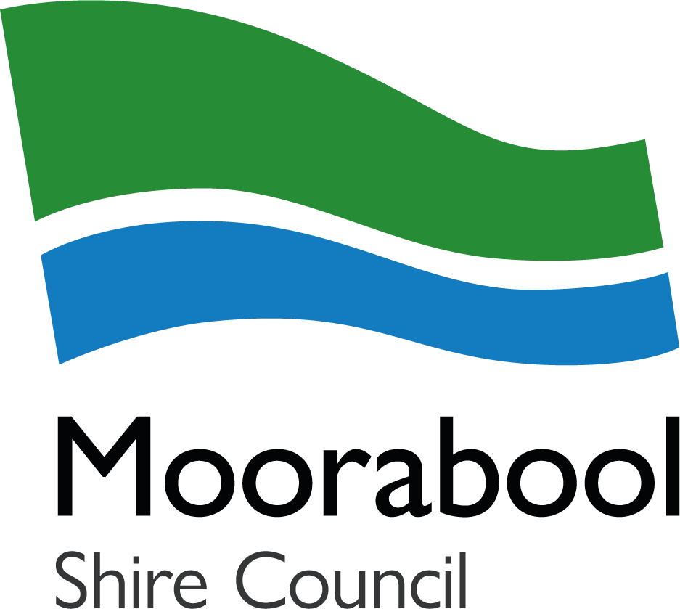
Event Application Form

This form should only be used if the online application, is not available. If you are unfamiliar with using the online application, please contact an Economic Development Officer (03 5366 7100 or tourism@moorabool.vic.gov.au) for assistance and support.

- Council’s Community Event Guide has been created to help event organisers and community groups and should be read prior to submission.
- Mandatory supporting documents uploaded as part of the submission include Certificate of Currency, detailed site plan, Event Management Plan incorporating emergency, risk and waste management, completion of accessible events checklists, and community notification letter. Templates can be downloaded from Council's website.
- This form should be submitted as per Council’s time frames noted in the Guide.

Privacy notice: Moorabool Shire Council is collecting your personal information in order to process and review this event permit application. The personal information collected in this application and supporting documents (risk management, event management and emergency management templates) will be used by Council for that primary purpose or directly related purposes. In order to assess this application, this information may be shared with regulatory authorities and emergency services. You may request access and/or correction of your personal information held by Council, by contacting Council’s Privacy Officer on 5366 7100 or via info@moorabool.vic.gov.au

1. CONTACT DETAILS
Name
Organisation/Group
ABN/CAN
Postal Address
Phone |  |  |  |  |  |  | Email
2. EVENT DETAILS
Is this a community-based organisation? |  |  |  |  |  |  | ☐ Yes ☐ No
A community-based organisation:
- is not established primarily for the purposes of profit or gain; and
- does not distribute any part of any profit or gain made in the conduct of its activities to any member of the organisation; and
- operates in a community wholly for -
  - a philanthropic or benevolent purpose, including the promotion of art, culture, science, religion, education or charity; or
  - any sporting or recreational purpose, including the benefiting of any sporting or recreational club or association
Event Name
Description
(include proposed program with timings and activities)
Event Dates and Times
Event Date/s |  |  | Start: |  |  |  |  |  |  |  | Finish:
Event Times |  |  | Start: |  |  |  |  |  |  |  | Finish:
Set Up |  |  | Date:  Start Time: Finish Time:
Pack Down |  |  | Date:  Start Time: Finish Time:
Event Location
Maximum event attendees
Entry Fee
Free |  |  |  |  |  | ☐ Yes |  |  | ☐ No
Ticketed |  |  |  |  |  | ☐ Yes (please provide amounts) |  |  | ☐ No
Gold Coin/Donation |  |  |  |  |  | ☐ Yes |  |  | ☐ No
Multi-Year Permit
Would you like your event to be considered for a multi-year event permit (up to 3 years)?  Multi-year event permits are not available for new events. |  |  |  | ☐ Yes  ☐ No
3. ACTIVITIES
Will the event require roads to be closed or impacts footpaths and public parking areas in and around the event site?  If yes, please submit a traffic management plan as approval is required from the road manager. |  |  |  |  |  |  |  | ☐ Yes  ☐ No
Where is the designated parking area for those attending the event?
Will you be selling or serving food? |  |  |  |  |  |  |  | ☐ Yes |  |  |  |  | ☐ No
Will alcohol be supplied, BYO or sold at your event? |  |  |  |  |  |  |  | ☐ No |  |  |  | ☐Sold (Liquor license required) |  |  | ☐ Supplied at no charge
Describe how your event will address the tobacco law requirements.
4. INFRASTRUCTURE AND SITE DETAILS
Complete all that apply, providing details (including amount, size, contractor). These should also be included on your site map.

Important:
- EPA guidelines and Local Laws are to be observed for all events.
- Pegging of temporary infrastructure is not permitted on Council owned parklands and reserves.
- Power and water on these sites are not included in the event permit. Event organisers will need to make their own arrangements.
☐ Fencing or temporary barriers
Details
☐ Marquees
Pegging is not permitted into any Council owned grounds. This includes stakes to secure marquees/tents, flags or signage. Marquees must be weighted down as per manufacturers specifications or the HRIA Marquee Weighting Guide.)
Details |  | Qty:  Size:  Intended use:
☐ Stage
Details
☐ Temporary seating
Details
☐ Amusement rides
For example, amusement rides, inflatable items, including swimming/ wading pools) Heavy trucks and associated rides are not permitted on Council grounds. Please advise the weight of the structures for Council assessment.)
Details

☐ Toilets
Provide information on the number of toilets available to the public including disabled accessible toilets and intended cleaning schedule.
Details | Males:  Females:  Accessible:
☐ Shade.
Details
☐ Water requirements
Free accessible drinking water should be available to attendees.
Details
☐ Power requirements
Details
☐ Musical entertainment
Details
☐ Fireworks
Details
☐ Amplified noise
Details
☐ Signage
If you intend to use Council’s Township Entrance Signs, please provide the intended dates (maximum 1 month) and which towns (see the Guide to Host an Event in Moorabool Shire for further information). Additionally, please advise other signage you may use. Council do not approve real estate signs or other signs placed on public land.
Details

☐ Other
Details
5. WASTE, RECYCLING AND LITTER MANAGEMENT
Events can generate large volumes of waste and litter – but good planning at the outset can reduce environmental impacts before, during and after your event. Avoid waste in the first place.
- The Victorian Single-use plastics ban prohibits the supply of plastic drinking straws, plates, drink stirrers, cutlery, and expanded polystyrene (foam) cups/food containers
- Vendors are aware of the ban and have sought alternative items
- I understand that non-compliance can result in fees and penalties
- Engage staff and vendors early to discuss any waste or recycling materials they may generate to identify what can be avoided, reduced, recycled
- Consider applying for a hydration station through Central Highlands Water and advertising to patrons to bring a refillable water bottle
- Encourage attendees, staff, and volunteers to bring their own reusable cups, cutlery, and food containers if food and beverages will be supplied

Litter management
- Ensure bins are not overflowing during the event
- Staff have been assigned to swap out full bins as required
- Ensure site is left clean after the event
- Staff have been assigned to pick up any litter at the event location

Waste and recycling removal arrangements
- Event holders are required to budget for waste collection services in the planning stage. This includes the supply and collection of sufficient waste and recycling bins through a reputable contractor
- Yes, waste collections have been budgeted for
- Consider that most recyclables generated will be drink containers – which are accepted for a 10c refund as per the Container Deposit Scheme. Collect eligible containers separately to return and earn at participating locations.

Setting up bins at the event
- Waste and recycling bins are to be set up as pairs (bin stations) at key event locations such as near food outlets, back of house for vendors, entrance/exit of event
  - Yes, bins will be set up in pairs (waste and recycling) and
  - Yes, key locations for bins has been considered
- Display posters on bins/above bins to assist users in correct bin use and reduce contamination. Posters can be downloaded from here Events - Recycling and Landfill signs .

☐ Yes - I declare that I have read all above points and will reduce environmental impacts before, during and after the event.

☐ Yes - I want to use the Sustainable Events Trailer (if available). The Sustainable Events Trailer is available for hire for low impact events only. A member of the Waste team will be in contact to confirm availability of the trailer. The terms and conditions of hiring the trailer can be read in Section 11 Declaration.

6. NOTIFICATIONS
It is important that the event organiser notifies residents and businesses in the vicinity of the event site and all emergency services of the proposed event.
Have you notified neighbouring businesses and residents that the event is taking place? | ☐ Yes  ☐ No – I will do this soon
Please advise the distribution and date of notifications
Have you notified emergency services that the event is taking place? | ☐ Yes  ☐ No – I will do this soon
Please advise the date of notification
7. RISK ASSESSMENT AND EMERGENCY MANAGEMENT
Have you organised First Aid for your event? | ☐ Yes  ☐ No – I will do this soon
Please provide details of who you have contracted to administer First Aid, or how you intend to provide appropriate duty of care

8. SUPPORTING DOCUMENTS
Please ensure all relevant documentation is sent with your application. Late documentation will result in delays to assessing your application and may result in the cancellation of your event.

Applications should be submitted to tourism@moorabool.vic.gov.au

COMPULSORY
☐ Venue Booking
The event organiser is solely responsible for the direct booking of the venue. This application DOES NOT reserve the venue space requested.

☐ Copy of Certificate of Currency
All public liability insurance must cover a minimum of $20,000,000.

☐ Detailed Site Plan
Items to include are parking, road closures, location of infrastructure, alcohol dry zones (if applicable), location of bins and toilets etc.

☐ Event Management Plan
A template has been made available on Council’s website as a guide.

☐ Emergency Management Plan
A template has been made available on Council’s website as a guide.

☐ Risk Management Plan
A template has been made available on Council’s website as a guide.

☐ Waste Management Plan
A template has been made available on Council’s website as a guide.

☐ Completion of Accessible Events Checklists
A template has been made available on Council’s website as a guide.

☐ Notification Letter to neighbouring residents and businesses

☐ This Application Form

Council will contact the event organiser directly with any queries regarding additional permissions/permits that may be required.

OTHER REQUIREMENTS DEPENDING ON THE NATURE OF YOUR EVENT
☐ Application for Occupancy Permit for a Place of Public Entertainment (POPE)

☐ Application for Planning or Building Permit

☐ Traffic Management Plan and associated forms

☐ Copy of Working with Children’s Check card if your event will attract minors

9. DECLARATION
☐ I agree to the below indemnity

- By submitting this application, you are agreeing to indemnify Council.
- The Indemnifier agrees that this event will be held at their own risk and is solely their responsibility. Further, they accept that the road or public area, as it stands may not be totally free of defects, either hidden or exposed. The Indemnifier agrees to hold harmless Moorabool Shire Council its servants and agents, and each of them in connection with all claims resulting from damage loss, death, or injury whatsoever which may otherwise be brought or made or claimed by the Indemnifier against Moorabool Shire Council, except to the extent that Moorabool Shire Council is negligent. The Indemnifier shall, at all times during the period identified above and one full day prior and one full day following the event be the holder of a current public liability policy of insurance (The Public Liability Policy) to cover legal liability to third parties for personal injury or property damage as a result of an occurrence in connection with the event being organised and run by the insured. The Public Liability shall provide coverage of a minimum amount of $20,000,000.
☐ I agree to the below terms and conditions

- I am the authorised person to apply for the Event Application and all information provided in this application is true and correct.
- I have read Council’s Guide to Holding an Event in Moorabool Shire and accept the conditions for the event/s.
- I agree to comply with all event conditions, local laws and all relevant legislation.
- The event will be organised and managed as I have described unless advised otherwise to Moorabool Shire Council and/or its authorities.
- I understand that this Event Application does not constitute event approval.
- I have reached out, in the first instance to Moorabool Shire businesses for the supply of goods and services for the event including food vendors and shall holders.
- I have not advertised the event prior to gaining approval from Moorabool Shire Council.
- Council may cancel or modify events at any stage due to: • public safety concerns • extreme weather • identified high risks • site safety or conditions • conflict in applications (i.e. date, nature of the event)
- Council reserves the right to decline any event which is not in line with these conditions.
- The event meets all legal requirements, including (but not limited to) obtaining approvals related to building occupancy, health and liquor licensing.
- Council officers may consult other agencies, including Victoria Police and VicRoads, in considering applications and applying conditions.
- A bond is a condition if the permit is approved. Council must receive payment of the bond before the permit will be issued.
- If I hire the Sustainable Events Trailer I agree to the following conditions:
  - The events trailer is available to be picked up and returned weekdays, to Bacchus Marsh Council Depot (7.30am - 4.00pm) or Ballan Council Depot (8.30am - 4:30pm).
  - Procedures for the use/handling of the event trailer will be suplied. As the hirer, you must familiarise yourself with these prior to taking receipt of the trailer.
  - A bond is to be paid to Council prior to the Events Trailer being taken. This bond will be returned to your organisation upon satisfactory inspection of the trailer and contents. All of the garbage/recycling bins and caps are to be emptied and cleaned prior to returning them to Council with trailer.
  - It is responsibility of your organisation to disposal of garbage/recycling at one of Council's transfer sections (Bacchus Marsh, Ballan or Mt Egerton). There is currently no cost to your organisation to do so. Paper/cardboard must be separate from the other recyclables to be accepted.
  - Council will not accept responsibility for damage to the trailer or the contents within trailer. If any damage occurs, it is the responsibility of your organisation to pay full costs for repair or replacement of any items (at Counci's directive), including the trailer.
- I have developed and implemented other relevant event plans including (but not limited to) risk management, emergency management, noise management, site and waste management.
- I acknowledge this application does not reserve the venue space requested and I am responsible for the direct booking of the venue.
- I will ensure the event is accessible and inclusive for all and have completed the Accessible Events Checklists.
- I will not use Council’s logo unless the event has been funded by Council and in this case, I will use the logo as per the terms and conditions as outlined in the Guide.
- I am required to reimburse Council for the cost of any restoration or repairs which are required as a result of the event and/or its associated activities. A bond in advance may be required.
- It is my legal responsibility to ensure that I have designed a COVIDSafe event that does not risk the spread of coronavirus (COVID-19).
- If the event is held on public land, I will provide Council with a post event evaluation within eight weeks of the conclusion of the event.
- Council reserve the right to terminate an event if: • event application conditions are breached • any laws are broken • a misrepresentation is identified in application.
- I agree to conduct the event as per the Victorian Government COVIDSafe settings at time of event and will adjust the event as needed.
- By signing this Event Application, the Event Applicant agrees to hold harmless the Moorabool Shire Council and both releases and indemnifies and keeps released and indemnified the Moorabool Shire Council from and against all actions, suits, claims, demands, costs, charges and expenses for which Council, its servants, agents or employees may be held liable in respect of any loss damage, accident or injury of whatsoever nature or kind and however sustained or occasioned and whether to property of persons in connection with the use of the public area and any work connected therewith pursuant to this Application, but excluding such liability arising from any negligent act, default or omission, on the part of the Council, its servants, agents or employers either solely or in contribution thereto. Council’s liability shall be limited to the extent, and in proportion to, the degree to which any negligent act, default or omission on its part has contributed to the loss.
- I understand that the Council Officer will advise the next steps required for my event to gain approval.
- Should your event permit be approved, you agree to the conditions that will be presented on the Event Permit.

