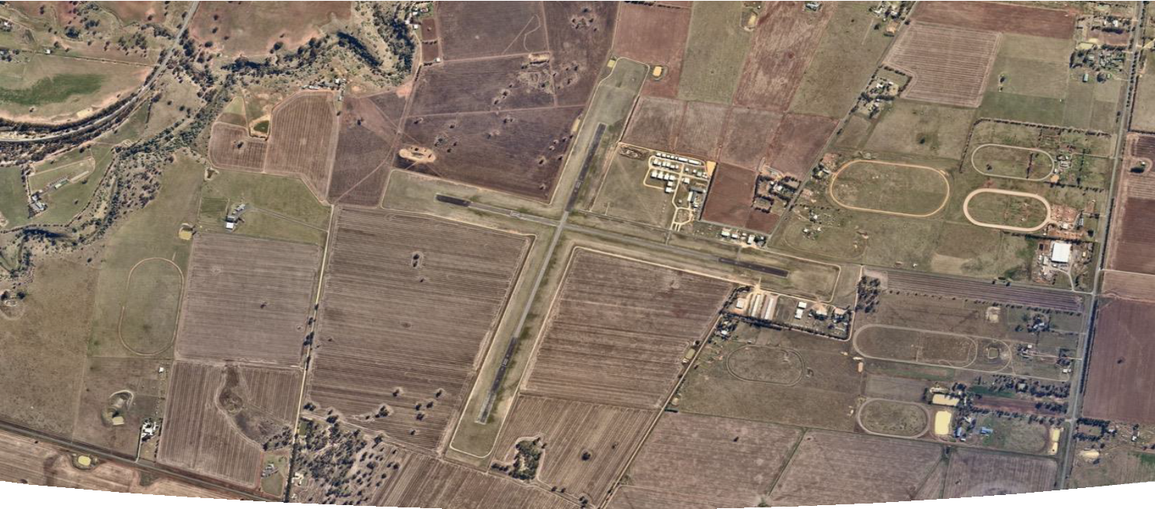

Bacchus Marsh Aerodrome Master Plan

May 2022

Imagery: Jaroslaw Mosiejewski © 2022

DISCLAIMER: This Master Plan has been prepared with the assistance of Lower Capital Pty Ltd on the specific instructions of our client. Lower Capital Pty Ltd does not provide financial, tax, legal or other regulated advice or guarantee outcomes. The materials provided herein reflect general insight based on information provided by third parties. Such information has not been generated or independently verified by Lower Capital Pty Ltd and is inherently uncertain and subject to change. Any variance in the underlying information will affect the contents and recommendations provided. Lower Capital Pty Ltd has no obligation to update these materials and makes no representation or warranty and expressly disclaims all liability with respect to the material contained herein.
This document and its related materials are solely for our client’s use for the purpose for which it is intended in accordance with the agreed scope of work. Any use or reliance by any person or entity contrary to the above, to which Lower Capital Pty Ltd has not given its prior written consent, is at that person or entity’s own risk.

Contents

Contents 2
Executive Summary 4
- Introduction 6
  - Overview of the Aerodrome 7
  - Purpose and Objectives of the Master Plan 7
  - Methodology and Consultation 8
    - Stage 1 – Situation Analysis 8
    - Stage 2 – Future Direction 8
    - Stage 3 – Strategy & Master Plan Development 8
    - Stage 4 – Final Master Plan Adoption & Implementation 8
  - Report Structure 9
- Background Information 10
  - Master Plan Context 11
    - Historical Background 11
    - Regional Context 11
    - Strategic Context 11
    - Socio-Economic Context 12
    - Regulatory Context 13
    - Moorabool Planning Scheme 14
    - Previous and Current BMA Plans and Reports 16
    - Related Documents Currently Under Preparation 18
    - Key Stakeholders 19
  - Current Situation 20
    - Ownership and Management 20
    - Site Description 20
    - Surrounding Land 20
    - Existing Activities 20
    - Existing Facilities 21
    - Ground Transport Access and Parking 22
    - Utility Services 23
    - Environmental Values 23
    - Heritage Values 24
  - SWOT Analysis 24
    - Strengths and Advantages 24
    - Weaknesses and Constraints 25
    - Opportunities and Prospects 25
    - Threats and Risks 26
  - Strategic Direction 27
    - Strategic Vision 27
    - Objectives 27
  - Critical Airport Planning Parameters 27
    - Forecast of Future Operations 27
    - Aerodrome Reference Code System 30
    - Selected Design Aircraft 31
    - Navigation Systems 31
    - Aircraft Movement Area 31
    - Pavement Strength 32
    - Aviation Support and Landside Facilities 33
    - Passenger Terminal 33
    - Security Requirements 33
    - Airspace Protection Surfaces 33
    - Aircraft Noise Contours 34
- Aerodrome Master Plan 35
  - Land Use Plan 36
    - Land Use Precincts 36
    - Land Use Precinct Guidelines 36
    - General Land Use Guidelines 38
    - Planning Scheme Zoning 38
  - Facilities Development Plan 39
    - Movement Area Facilities 39
    - Aviation Support Facilities 40
    - Other Facilities 41
  - Aerodrome Safeguarding Plan 42
    - National Airports Safeguarding Framework 42
    - Airspace Protection Surfaces 43
    - Aircraft Noise Contours 43
    - Planning Policies and Controls 43
  - Implementation Plan 45

Executive Summary
This Master Plan provides Moorabool Shire Council (MSC) and Bacchus Marsh Aerodrome Management Inc. (BMAM) with a strategic direction for the future development of Bacchus Marsh Aerodrome. It is a broad strategic document that aims to assist both council and BMAM in their decision-making over the next 20 years.
Background

Bacchus Marsh Aerodrome (BMA) is located within the Shire of Moorabool, approximately 45 km west of the Melbourne CBD and approximately 6 km south of central Bacchus Marsh. The aerodrome is owned by MSC and leased under a long-term lease to BMAM. In December 2018, the lease was extended for a further term through to the year 2043.
The aerodrome is a General Aviation (GA) facility hosting gliding, commercial flying training and engineering operations, private flying and aerial firefighting aircraft from adjoining gliding club land during the Victorian fire season.
In addition to three gliding clubs and the Australian Gliding Museum, two flight training schools and two aircraft maintenance businesses use BMA as the base for their operations. There are also a number of private aircraft owners who base their aircraft in hangars at the aerodrome and use the facilities on a regular basis.
A Strategic Location

The Parwan Employment Precinct (PEP) covers an area of approximately 2,500 ha. The current vision for the Precinct is to attract a mix of businesses and investors from across the industrial, commercial, agribusiness and aviation sectors.
BMA’s location within the PEP is advantageous in its potential to facilitate complementary activities, such as air charters servicing business activity, corporate jet operations, helicopter movements and air freight movement of locally-produced products. Additionally, the aerodrome’s proximity to Melbourne and Ballarat as major commerce centres and its geographic surrounds mean it is ideally positioned to capture growth opportunities in the flight training, aircraft maintenance and specialised airfreight sectors.
When viewed in conjunction with Moorabool Shire’s forecast population growth, BMA is ideally positioned to support
increased social and economic benefits for the municipality.

Growth and Development

As a General Aviation aerodrome, future growth and development at BMA will be particularly influenced by growth in gliding, flight training, recreational and sport aviation activities. From a base of approximately 30,000 aircraft movements in 2022, traffic at BMA is forecast to grow over the life of this Master Plan to 44,600 by 2042.
In order to assist in planning the future use and development of the aerodrome site to accommodate this growth, five new land use precincts across BMA are established under this plan, along with the existing Gliding Precinct:
- Aerodrome Precinct
- Aerodrome Expansion Precinct
- Hangar Precinct
- Terminal Precinct
- Aviation Services Precinct
- Gliding Precinct

Each precinct has different characteristics and long-term planning objectives. Central to these objectives is the adoption of a Code 2B design aircraft, which is considered to cover the full range of activities and growth that is likely to occur at BMA in the foreseeable future including pilot training, emergency services, charter, corporate and light freight.
A Unified Vision

A detailed consultation process was undertaken in preparing this Master Plan involving the Moorabool Shire community and key stakeholders. The process revealed strong support for the development of BMA and ultimately identified the following vision for the aerodrome:

As a critical aspect of the Parwan Employment Precinct, Bacchus Marsh Aerodrome is a core economic and social driver for Moorabool Shire through increased aviation activity, job creation and tourism, and the provision of direct access to emergency and other essential services for its local communities.
This vision underpins the planning and development initiatives detailed throughout this Master Plan.

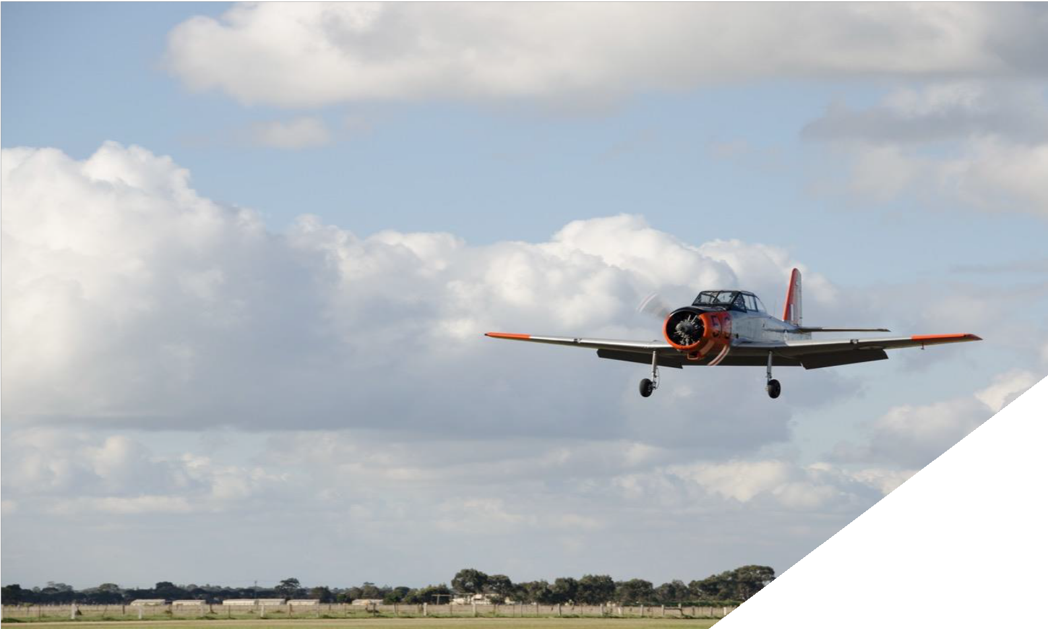

Introduction

Overview of the Aerodrome
Governance
Bacchus Marsh Aerodrome (BMA) is located within the Shire of Moorabool, approximately 45 km west of the Melbourne CBD and approximately 6 km south of central Bacchus Marsh. Access to the aerodrome is via Aerodrome Road, which runs off Geelong – Bacchus Marsh Road.

BMA is owned by Moorabool Shire Council (MSC) and leased under a long-term lease to Bacchus Marsh Aerodrome Management Inc. (BMAM). In December 2018, the lease was extended for a further term through to the year 2043.
BMA is not currently certified aerodrome under the Civil Aviation Safety Regulations 1998 and is therefore considered to be an Aeroplane Landing Area (ALA).

Site Description
The aerodrome site has an area of approximately 92 ha, excluding the adjoining land owned by the three gliding clubs.
BMA has two runways; a north-south runway (01/19) and an east-west runway (09/27). A private hangar estate, buildings and grassed parking areas are located on the north side of Runway 09/27, east of Runway 01/19. There are two bitumen-sealed taxiways connecting Runway 09/27 to a parallel bitumen-sealed taxiway, and access to the hangar estate containing 28 hangars and separate aircraft parking areas is via gravel taxilanes. A bitumen sealed taxiway connects to Runway 01/19. An aircraft refuelling facility is located adjacent to the aircraft parking area.

User Groups
Three gliding clubs, together with the Australian Gliding Museum, are located on an adjoining privately owned parcel of land abutting the south-east end of Runway 09/27. Access to the gliding facilities is from Jensz Road, which runs off Aerodrome Road.
Two flight training schools and two aircraft maintenance businesses, together with the gliding clubs, use BMA as the base for their operations. There are also a number of private aircraft owners who base their aircraft in hangars at the aerodrome and use the facilities on a regular basis.

The aerodrome is a General Aviation (GA) facility hosting gliding, commercial flying training and engineering operations, private flying and aerial firefighting aircraft from adjoining gliding club land during the Victorian fire season.

Purpose and Objectives of the Master Plan
This BMA Master Plan provides MSC with a long-term (20-year) planning framework for the safe, secure, efficient, and sustainable use and development of the aerodrome site and its surrounds. Importantly, this relates to the use and development of land both on and off the aerodrome site. The consideration of off-aerodrome land use and development opportunities within the Parwan Employment Precinct (PEP or the Precinct) are particularly important, as activities around an aerodrome can have a significant impact on its operations and viability. The strategic context and vision for the PEP are articulated in the Parwan Employment Precinct Scoping Study (unpublished draft prepared by Urban Enterprise) and have informed this Master Plan.

The BMA Master Plan provides clear direction as to how growth is to be accommodated, particularly the continued growth and expansion of GA activities. The plan provides an optimal spatial outcome for the aerodrome based on Council’s objectives for future development of the PEP, current and projected resources, and in keeping with its environmental, planning and operational obligations. While the emphasis of this Master Plan is aviation growth, development, and protecting the site for the future expansion of aviation facilities, MSC also recognises the considerable local social benefits the aerodrome could provide to its communities into the future.

The key objectives of the BMA Master Plan are therefore to:
- Identify land use and facility development requirements for the aerodrome over the planning period;
- Identify strategies and facilities required to ensure the long-term sustainability of the aerodrome;
- Enhance the viability of the aerodrome and create positive gains for the community;
- Ensure that the aerodrome is not inhibited by a lack of facilities and service infrastructure or other constraints;
- Support aviation-related and compatible development and provide a clear direction as to how the aerodrome should be developed;

- Protect the aerodrome and options for growth and prevent inappropriate activities on surrounding land; and
- Ensure compliance with environmental, planning and operational obligations.

Methodology and Consultation
This Master Plan was prepared with reference to the Australian Airports Association’s (AAA) Regional Airport Master Planning Guideline. This guideline is widely used across Australia in the preparation of Master Plans for regional and remote aerodromes.

The BMA Master Plan was prepared over four stages as depicted in Figure 1. The stages were interdependent, with the outcomes from one directly informing the inputs for the next.

Stage 1
Situation Analysis
Stage 3



Strategy & Master Plan Development

Stage 2
Future Direction
Stage 4
Final Master Plan Adoption & Implementation

Figure 1 – Bacchus Marsh Aerodrome Master Plan Process

Stage 1 – Situation Analysis
Stage 1 involved the detailed review of current and historical plans, reports and data for BMA in order to gain a thorough understanding of BMA’s existing situation and strategic planning context. A number of previous attempts at preparing a Master Plan for BMA have been made, and this plan draws on these and related documents wherever appropriate and applicable as described in Sections 2.1.7 and 2.1.8.

Stage 2 – Future Direction
Stage 2 of the BMA Master Plan process sought to gain an understanding of how the aerodrome is likely to change over the planning period and, importantly, how MSC and BMAM, as owner and operator respectively, would like to see it change.

A detailed consultation process was undertaken incorporating a series of workshops with key stakeholders, as well as an online survey. The outcomes and key findings of Stage 2 were distilled into the Bacchus Marsh Aerodrome Consultation Process Report (2022) and directly informed the preparation of the Draft Master Plan.

Stage 3 – Strategy & Master Plan Development

Stage 3 involved the preparation of the Draft Master Plan, drawing on the work undertaken in the previous two stages.
A vision statement and key objectives for BMA were developed to provide broad guidance and direction for preparation of a Draft Master Plan. Additionally, the existing materials identified in Stage 1 were drawn upon wherever appropriate.

Stage 4 – Final Master Plan Adoption & Implementation

The Draft Master Plan report was submitted to council officers and BMAM for review and feedback, as well as being presented to Councillors for discussion. This feedback was then assessed and incorporated into the Draft Master Plan where appropriate, to form the Final BMA Master Plan for public consultation.

Community feedback was then compiled into an updated Consultation Process Report, showing the reasoning for suggestions being applied or not applied. The report was then presented along with the Final BMA Master Plan for consideration and adoption by BMAM and MSC.

Report Structure
This report has been structured in three parts.
- Part 1: provides an overview of Bacchus Marsh Aerodrome, the purpose and objectives of this Master Plan and the methodology and consultation process undertaken in its preparation.

- Part 2: provides a clear description of the issues that have been considered in the preparation of the Master Plan.

- Part 3: describes the strategic direction and identified needs that comprise the Master Plan and its implementation.

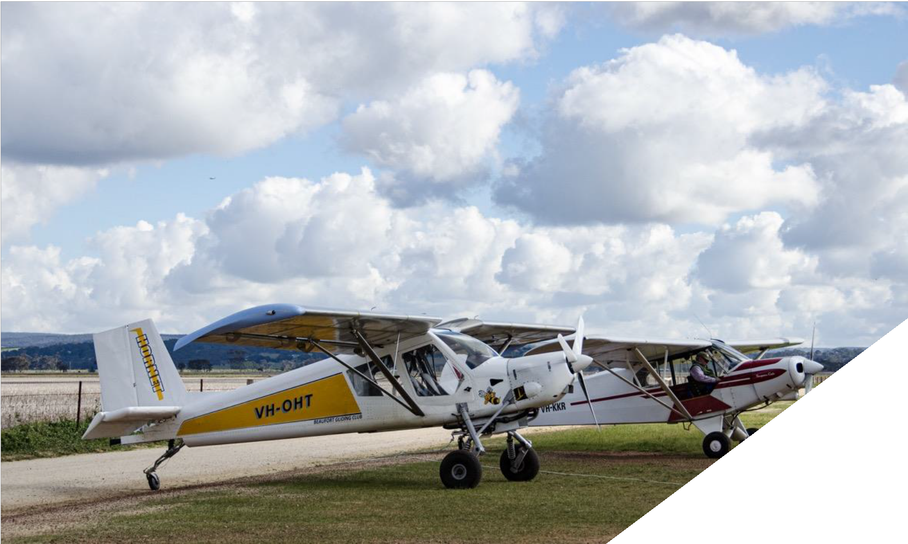

Background Information

Master Plan Context

Historical Background
Bacchus Marsh Aerodrome was established by the Australian Government in the late 1940s through compulsory land acquisition. The runway strips were initially grass, with the central 45 m becoming established as gravel in the 1950s. Data from 1971 shows that bitumen sealing had been applied at all four runway ends and to 45 m in width. During the 1970s and 1980s, further sealing was carried out on remaining sections of both runways but to lesser widths, namely 30 m towards the four ends, and 18 m for the central section of Runway 01/19. Sealing to 18 m width of the residual unsealed sections of Runway 09/27 between the displaced thresholds was accomplished by BMAM and MSC following the leasing of the aerodrome to BMAM.

In the late 1980s, the Australian Government proposed to dispose of its remaining small aerodromes and in October 1992, BMA was transferred from Australian Government ownership to MSC under a Deed of Transfer.

A lease agreement with BMAM was signed in December 1993. Since then, BMAM has managed the aerodrome and undertaken a number of improvements to aerodrome infrastructure.

Regional Context
Moorabool Shire is located in western Victoria, approximately 70 km west of the Melbourne CBD. The Shire is bounded by Hepburn Shire to the north, Macedon Ranges Shire to the north-east, the City of Melton to the east, the City of Wyndham to the south-east, the City of Greater Geelong and Golden Plains Shire in the south, and the City of Ballarat to the west.

Bacchus Marsh is located in the east of Moorabool Shire, situated approximately 45 km to the north-west of Melbourne, along the main road and rail corridor connecting Melbourne and the regional centre of Ballarat. The strategic location of Bacchus Marsh within the Melbourne – Ballarat corridor has been a key influence on its growth and development.

The aerodrome is located approximately 6 km south of Bacchus Marsh within PEP and has functional capacity, is free of any high-density residential encroachment and is not adversely inhibited by natural features. Given its location within PEP, regional growth projections, the proposed future development of the PEP and its proximity to Melbourne and Geelong, BMA has a potentially significant economic role in the Shire into the future.

Strategic Context
Bacchus Marsh Urban Growth Framework

Bacchus Marsh is the second largest settlement in the Central Highlands region (behind Ballarat) and the closest to Melbourne. Growth in Bacchus Marsh has well exceeded the rates of Ballarat or Melbourne for many years. As such, an Urban Growth Framework (UGF) was developed for Bacchus Marsh by the Victorian Planning Authority (VPA) and Council in 2018, to address how the planning framework will accommodate this.

The UGF contains specific actions for BMA, including:

      - Prepare a Master Plan and governance process for Bacchus Marsh Aerodrome
      - Identify the obstacle limitation surface protection area (OLSPA) applicable to the environs of BMA, and:
        - Implement via appropriate overlays
        - Review the AEO1 and revise the extent and provisions as appropriate
Importantly, the PEP is also identified as a strategic growth area within the Bacchus Marsh UGF. It highlights the potential for the PEP to be a regionally significant employment hub for agribusiness and industry. It outlines the employment objective to 'Plan for a regionally significant employment hub of value-adding agribusiness and export businesses within the PEP'.

Parwan Employment Precinct
The PEP is located in Parwan, Moorabool Shire, and covers an area of approximately 2,500 ha. The current vision for the Precinct is to attract a mix of businesses and investors from across the industrial, commercial, agribusiness and aviation

sectors, to capitalise on its locational advantages, strategic infrastructure investment and the place brand as a circular economy location of choice.
There are a variety of current land uses and businesses within the Precinct, primarily across the uses of intensive agriculture, aviation (BMA), rural living and light industrial. From a spatial perspective, the western section contains the Aerodrome and associated services, the central section accommodates agriculture and related uses and the eastern section has larger lot sizes used for agriculture and recreation purposes.

Land within PEP is primarily zoned and used for farming purposes, although the recent rezoning of the Industrial 1 Zone (to the south-east) is likely to serve as a catalyst for urban development in part of the Precinct. Landownership is relatively concentrated in parts of the Precinct and several major landowners have progressed plans to develop land primarily for urban industrial and business purposes.
BMA’s location is advantageous in its potential to facilitate activities complementary to the Precinct, such as air charters servicing business activity, corporate jet operations, helicopter movements and air freight movement of product produced within PEP. There is also potential to evolve aviation education and training as an extension to current Aerodrome operations, explore regional aerospace manufacturing and maintenance, as well as introducing solar farms to reduce power costs.

When viewed in conjunction with Moorabool Shire’s forecast population growth, BMA is ideally positioned to support increased social and economic benefits for the municipality.

Socio-Economic Context
The municipality of Moorabool continues to expand, with an estimated population of 37,002 in 2022. Annual growth has averaged approximately 2.3% since 2005 and the population is forecast to increase to 63,831 by 2041 – nearly double its 2016 base.

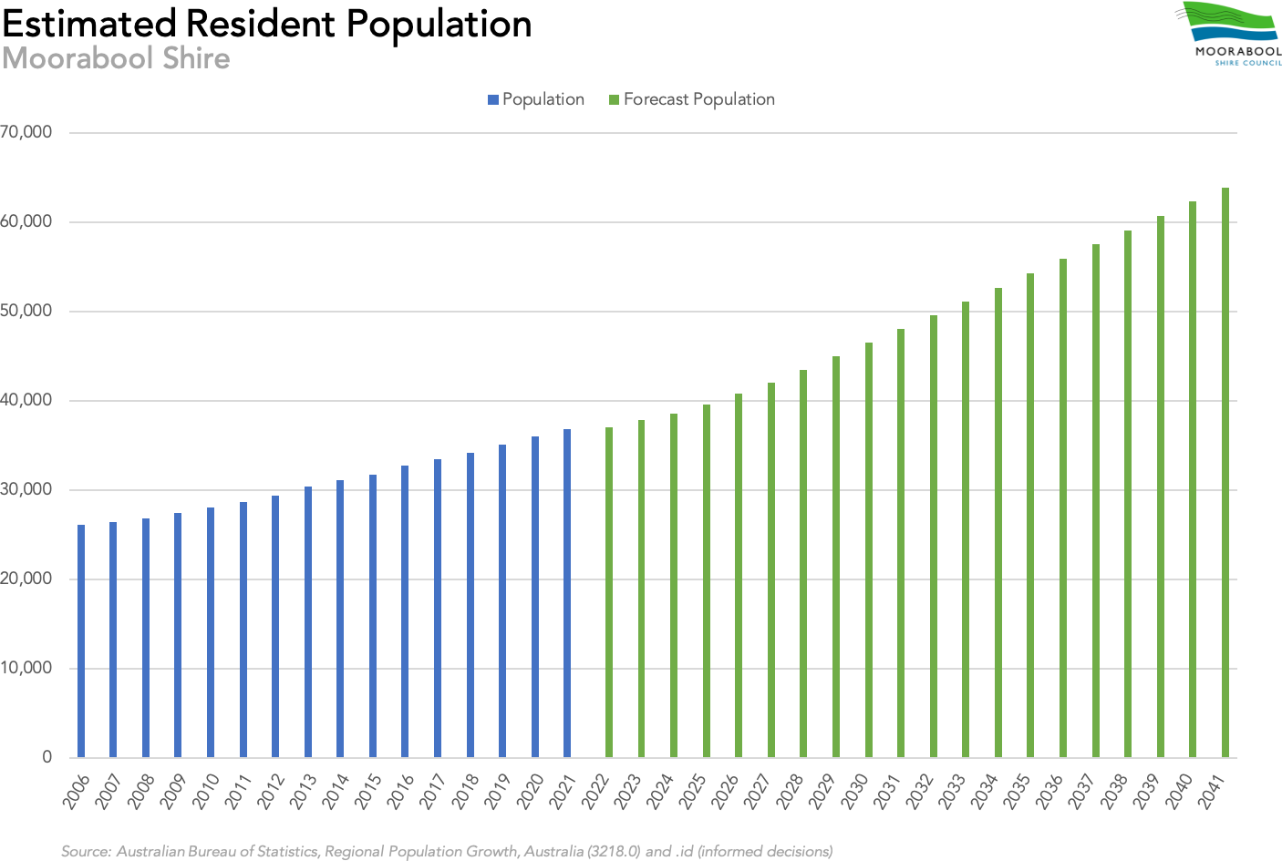
Figure 2 – Estimated Resident Population Moorabool Shire

Bacchus Marsh’s growth can be attributed to its proximity to Melbourne and the jobs and opportunities this brings. Lifestyle and amenity are key growth drivers, along with affordable land and housing, and quality regional health and education facilities. High-quality surrounding rural landscapes and open space enhance liveability. Agriculture, natural resources (sand and coal) and local industry provide employment opportunities.

In 2021, the value of the municipality’s Gross Regional Product was estimated at $1.5 billion, supported by approximately 2,996 local businesses and an employed workforce of 17,443 residents. The municipality’s unemployment rate in September 2021 was estimated at 5.4%, slightly lower than the national rate of 5.6%, and a notable decrease from its high of 6.7% in December 2020 during the Covid-19 pandemic.
Agriculture is the Shire’s largest export industry and is a large driver of employment and economic output. In 2019, the agriculture and extractive industries made up almost half of the Shire’s annual export value. Similarly, population driven industries such as construction, education and training and rental/real estate services also generate significant combined output and employment opportunities across the Shire.

Regulatory Context
Civil Aviation Safety Regulations
Aviation is governed by a significant body of legislative and regulatory instruments around the world. In Australia, the Civil Aviation Safety Regulations 1998 (CASRs) and the associated Part 139 Manual of Standards (MOS) are the key instruments that govern aerodrome physical standards, operations and safety.

In 2017, the Civil Aviation Safety Authority (CASA) commenced a post-implementation review of Part 139. In addition to aligning the regulatory framework with international standards, the review also sought to simplify existing aerodrome categories and introduce a graduated, scalable certification structure. Consequently, CASR Part 139 and its associated MOS were amended, with the new regulations coming into force in August 2020.

Manual of Standards – Part 139
The Part 139 – MOS is made pursuant to CASR Part 139 and sets out the detailed standards and operating procedures required for aerodromes used in air transport operations in Australia.

BMA is deemed an Aeroplane Landing Area (ALA) under the CASRs, meaning the standards articulated in Part 139 – MOS do not strictly apply to the aerodrome. Nevertheless, it is open for the owner or operator of an ALA to adopt MOS Part 139 standards, albeit without statutory force, to the extent desired for the benefit being sought. For ALAs, the CASA’s Civil Aviation Advisory Publication CAAP 92-1(1): Guidelines for Aeroplane Landing Areas is typically used to guide the layout, development and operation of aerodrome facilities.
Environment Protection and Biodiversity Conservation Act 1999
The Environment Protection and Biodiversity Conservation Act 1999 (EPBC Act) is the Australian Government's principal piece of environmental legislation. It provides a legal framework to protect and manage nationally and internationally important flora, fauna, ecological communities and heritage places.

The BMA site is recognised as residing within the Natural Temperate Grassland of the Victorian Volcanic Plain. The grassland is a critically endangered ecological community under the Australian EPBC Act.

While the Moorabool Planning Scheme does not identify any significant areas of environmental interest or apply any Environmental Significance Overlays to the BMA site, a flora survey conducted in 2009 identified some examples of native vegetation adjacent to the runways and onsite facilities. As such, MSC likely has obligations under the EPBC Act in relation to the future development of BMA. These and other environmental considerations are discussed later in this plan.
Flora and Fauna Guarantee Act 1988

The Flora and Fauna Guarantee Act 1988 (FFG Act) is designed to protect species, genetic material and habitats, prevent extinction and allow for maximum genetic biodiversity across the state of Victoria. It enables the listing of threatened species and communities and the declaration of critical habitat necessary for the survival of native plants and animals.

As discussed above, while the Moorabool Planning Scheme does not identify any significant areas of environmental interest or apply any Environmental Significance Overlays to the BMA site, a previous flora survey identified some examples of native vegetation adjacent to the runways and onsite facilities. As such, MSC may also have obligation under the FFG Act in relation to the future development of BMA.

Local Government Act 2020 (Victoria)

The Local Government Act 2020 gives the Victorian Parliament the power to make laws it considers necessary for local government, including laws relating to the constitution of councils, council elections and the powers and duties of councillors and council staff.

As a council-owned asset, BMA is subject to the provisions of the Local Government Act 2020 as they relate to the acquisition, sale, lease, transfer, exchange and use of land.
Planning and Environment Act 1987 (Victoria)
BMA is subject to planning policies and controls under the Planning and Environment Act 1987, which sets out broad objectives for planning in Victoria, and key planning procedures and systems.

The Act establishes the following:
- The planning scheme system, which sets out how land may be used and developed;
- The Victoria Planning Provisions that provide a template for the construction and layout of planning schemes;
- Procedures for preparing and amending the Victoria Planning Provisions and planning schemes;
- The procedures for settling disputes, enforcing compliance with planning schemes and, and other administrative procedures.

Section 6 of the Act describes matters that a planning scheme may provide for. A planning scheme is a statutory document which sets out objectives, policies and provisions for the use, development and protection of land. A planning scheme regulates the use and development of land through planning provisions to achieve those objectives and policies.

Moorabool Planning Scheme
Planning Policy Framework

The Planning Policy Framework (PPF) forms the policy content of planning schemes in Victoria. It is based on a three-tier structure that integrates part of the Victoria Planning Provisions (VPP) in the form of state and regional planning policies and local content in the form of local planning policies

The PPF has replaced the State Planning Policy Framework (SPPF) and, in conjunction with a new Municipal Planning Strategy (MPS), will also replace the Local Planning Policy Framework (LPPF) in the Moorabool planning scheme.
Airports and Airfields
The key policy within the Moorabool PPF applicable to the development of BMA is VPP 18.02-7S Airports and Airfields. This policy has the clear objectives of strengthening the role of Victoria’s airports and airfields within the state's economic and transport infrastructure, facilitating their siting and expansion and protecting their ongoing operation.
In order to achieve its objectives, the policy defines a number of key strategies that directly relate to the development of BMA, including:

- protect airports from incompatible land uses;
- ensure that in the planning of airports, land use decisions are integrated, appropriate land use buffers are in place and provision is made for associated businesses that service airports;
- ensure the planning of airports identifies and encourages activities that complement the role of the airport and enables the operator to effectively develop the airport to be efficient and functional and contribute to the aviation needs of the state;
- plan the location of airfields, nearby existing and potential development, and the land-based transport system required to serve them, as an integrated operation.
- plan the visual amenity and impact of any use or development of land on the approaches to an airfield to be consistent with the status of the airfield.
- plan for areas around all airfields so:
  - any new use or development that could prejudice the safety or efficiency of an airfield is precluded.
  - the detrimental effects of aircraft operations (such as noise) are taken into account in regulating and restricting the use and development of affected land.
  - any new use or development that could prejudice future extensions to an existing airfield or aeronautical operations, in accordance with an approved strategy or Master Plan for that airfield, is precluded.

Municipal Strategic Statement
The Municipal Strategic Statement (MSS) contained within the Moorabool Planning Scheme provides a localised planning statement, objectives and strategies to guide and implement key strategic planning, land use and development objectives for the municipality. A number of key clauses within the MSS directly relate to the development of BMA.
Clause 21.04 Economic Development and Employment

Clause 21.04 outlines key objectives for agriculture, commercial, industry and local employment within the municipality, along with implementation strategies and further work that will be required to achieve these objectives.
With regard to BMA, the identification of the Obstacle Limitation Surfaces (OLS) protection area applicable to the environs of aerodrome and the application of a Design and Development Overlay to that area are highlighted as further work that is required.

Clause 21.05 Development and Community Infrastructure
Clause 21.05 identifies better utilisation of BMA as a key objective for integrated transport planning across the Shire. Additionally, it also defines a number of strategies that will be employed by MSC in order to achieve this objective, namely:

- Plan for future transport infrastructure needs of business including roads, rail, and air;
- Prepare a Master Plan to guide future development of the Bacchus Marsh Aerodrome, with due consideration of:
  - Options to better utilise the aerodrome including attracting new investment and job creation;
  - Potential to acquire additional land to expand the aerodrome, if full commercialisation occurs; and
  - Develop and implement a marketing plan to attract business, including the tourism industry, to the Bacchus Marsh Aerodrome.

Clause 21.07 Bacchus Marsh
Clause 21.07 highlights BMA as one of a number of strategically important land uses to the south of Bacchus Marsh. These uses are inherently incompatible with residential development due to their off-site impacts.

As such, Clause 21.07 identifies a key objective of protecting existing and future industrial and agribusiness land uses, including BMA and the PEP, from the encroachment of sensitive developments.
Planning Controls
Land use planning within and around the BMA site is primarily the responsibility of MSC under guidance from state and local planning policy and controls. Effective land use planning has a major role to play in minimising activities incompatible with aviation in the vicinity of BMA.

Zoning

Under the Moorabool Planning Scheme, the BMA site and surrounds are currently located within a Farming Zone (FZ). The main purpose of the FZ is to provide for the use and protection of land for agriculture and the retention of productive agricultural activities. The use of the land for the purposes of an aerodrome is not prohibited under the FZ, however, a permit is required.
Nevertheless, existing use rights likely exist by virtue of the continuous uninterrupted operation of the land as an
aerodrome since the early 1950’s.

Overlays
The following overlays apply to the BMA site:

- Airport Environs Overlay - Schedule 1 (AEO1). The purpose of the AEO and its associated schedule is to identify areas, which are or will be subject to high levels of aircraft noise, including areas where the use of land for uses sensitive to aircraft noise will need to be restricted. Additionally, the AEO seeks to ensure that land use and development are compatible with the operation of airports in accordance with the appropriate

airport strategy or master plan and with safe air navigation for aircraft approaching and departing the airfield.
- Design and Development Overlay – Schedule 2 (DDO2). The DDO2 seeks to implement a number of design objectives to enhance the visual amenity in rural, township and vegetated areas of the Moorabool Shire.

Planning Permit
The ongoing development and use of aircraft hangars and aeronautical facilities at BMA was largely controlled by Planning Permit 2004-172 until its extinguishment in 2016. The permit contained a series of endorsed plans and conditions that governed development at the aerodrome site and had regard to matters such as maintenance, noise, amenity, waste management, lighting, human occupancy, car parking, access and driveways.

Further use and development of land within BMA can occur subject to the endorsed plans and conditions of a new planning permit. Any additional buildings or works that are not specifically envisaged by earlier planning permits will be subject to a planning permit requirement. Additionally, as the area surrounding BMA is also contained within the Farming Zone, any extension of the aerodrome outside of its existing boundary would require a planning permit.
National Airports Safeguarding Framework

The National Airports Safeguarding Framework (NASF) was incorporated into the Moorabool Planning Scheme as a policy guideline via an amendment in October 2015.

The NASF is a national land use planning framework that aims to:

- Improve community amenity by minimising aircraft noise-sensitive developments near airports including through the use of additional noise metrics and improved noise-disclosure mechanisms; and
- Improve safety outcomes by ensuring aviation safety requirements are recognised in land use planning decisions through guidelines being adopted by jurisdictions on various safety-related issues.
The NASF is designed ensure the current and future use of aerodromes across Australia is protected through appropriate land use planning. It comprises a set of seven guiding principles with nine guidelines relating to aircraft noise, windshear and turbulence, wildlife strikes, wind turbines, lighting distractions, protected airspace, communication equipment, helicopter landing sites and public safety areas.

Since its release, NASF has been reflected in key Victorian strategic land use and transport documents referenced in planning schemes including the State Planning Policy Framework, Plan Melbourne and Regional Growth Plans.

Previous and Current BMA Plans and Reports
Aerodrome Safety Inspection Report (2020)
MSC commissioned an Aerodrome Safety Inspection (ASI) of BMA in October 2020 to check that the physical characteristics of the aerodrome meet the minimum guidelines provided in Civil Aviation Advisory Publication (CAAP) 92-1(1) Guidelines for Aeroplane Landing Areas. The inspection also included a check of the records held by the Aerodrome Reporting Officers for serviceability inspections, wildlife monitoring, etc. and published aeronautical information.
A further two ASIs had been conducted previously. The first in 2007 was an initial requirement to have the aerodrome registered by CASA which subsequently did not proceed. The second ASI was undertaken in 2017 at the request of MSC but did not proceed past the draft stage.

The 2020 ASI found that the aerodrome generally complied with the standards applicable for Code 1A aircraft operations as defined under the Part 139 – MOS, based primarily on existing runway and taxiway widths. The ASI report identified 13 recommendations and 8 observations that required addressing.

Agribusiness Analysis: Proposed Parwan Employment Precinct (2015)

The Agribusiness Analysis: Proposed Parwan Employment Precinct report provides an analysis and evaluation of prospective employment activities within the proposed PEP, with a specific focus on increasing long-term sustainable employment through agribusiness focused activities.

The PEP Vision Statement notes ‘favourable access to sea, rail and air freight…will drive development demand’ and ‘the site’s location is positioned in close proximity to sea, rail, air freight and markets relative to other agribusiness precincts’ noting Parwan’s accessibility to the Avalon and Melbourne Airports.

Key observations from this analysis in relation to the BMA include:

- Moorabool Shire Council believes the aerodrome precinct has future development potential. It is a primary area for future investment, such as air industry related and other compatible development such as warehousing and related freight forwarding. As expansion occurs, opportunities may arise to sell ground leases for hangars and adjacent airport services.
- Development of BMA should provide for accommodating medium sized twin-engine light aircraft, more officially known as Class 2B aircraft operations. The inability to accommodate heavier aircraft is a potential limitation on investment in aerodrome related businesses that would rely on heavier aircraft with substantial freight capacity.
- Planned improvement works to the runways to better accommodate existing traffic are constrained by the financial position of the BMAM.
- Clarification is needed in terms of buildings and uses near the aerodrome and within the existing Airport Environs Overlay.
Bacchus Marsh Aerodrome Review 2015 (Draft)

The Bacchus Marsh Aerodrome Review was prepared by MSC as a background review to help inform Council’s decision making regarding the future management and development of the aerodrome. The review comprised two elements, namely a Technical Review and Community Consultation.

The Technical Review considered the status of BMA from four positions: Physical Condition, Airspace, Regulation and Security. Key findings included:
- Physical Condition. The aerodrome comprises two runways (Runway 01/19 and 09/27), a sealed taxiway, gravel taxiways, aircraft parking, refuelling point and glider launch strips. Maximum tyre pressures are low by modern standards and will limit the aircraft types able to use the aerodrome. The report recommends MSC investigates and verifies the physical properties of the runways to assist in determining appropriate Pavement Classification Numbers (PCNs) and maximum tyre pressures.
- Airspace. No major obstacles were identified in runway approaches, however, the terrain to the North West and West of the Aerodrome was observed to intrude into the surrounding airspace.
- Regulation. BMA operates as an unregulated aerodrome (it does not fall within Civil Aviation Safety Regulations for physical standards and operating procedures) and is not ‘Registered’ or ‘Certified’. The report recommended MSC maintain BMA as an ‘Unregistered Aerodrome’ pending the outcome CASA’s review of regulatory processes that was taking place at the time of writing.
- Security. The report recommended that security fencing be installed to ensure no possibility of conflict between aircraft and unsupervised visitors.
Over 190 people participated in a BMA Community Consultation process. Detailed surveys, one-on-one interviews, direct consultation with BMAM and a strategic planning workshop were held between June and August 2015.
The consultation process identified BMA’s key strengths as being its location, low cost and functional nature. Additionally, potential opportunities were also identified, including the development of the aerodrome and adjoining land to increase commercial and recreational aviation activities.

A number of challenges and issues associated with BMA were also identified, including:

- Infrastructure. A lack of parallel runways and supporting taxiways and hard standing areas; power; telecommunications; lighting; instrument approaches; waste removal; grass landing areas; and toilet amenities.
- Fees and Charges. A need for regular collection and a more equitable fee structure. Lack of fee collection, coupled with the low rate of commercial return from sub-leases and low user access fees, was seen to
significantly inhibit BMAM’s ability to effectively manage the aerodrome, deliver services, and reinvest in
plant, equipment and infrastructure.
- Development. Developing non-aeronautical activity on-site may be vital to maintain existing airport infrastructure and aviation capacity.

Bacchus Marsh Industry and Investment Opportunity Study – Aerodrome Precinct (2009)

The Bacchus Marsh Industry and Investment Opportunity Study – Aerodrome Precinct focussed on the Bacchus Marsh Central Activity Precinct and the BMA Precinct. The report outlined a range of findings, recommendations and key issues in relation to BMA, including:
- There is limited space for additional commercial operations as only the runways, runway shoulders, and a small landside facilities area are owned by MSC;
- The landside area has existing permits for hangar development. It has reached development capacity based upon the original permit. A new permit will be required for additional hangar development; and
- Surrounding land is privately owned and may have potential zoning issues (and buffer issues around sensitive uses) for any future proposed aerodrome related development.
The report identifies the broader area surrounding BMA as providing an opportunity for large industrial allotments with a focus on supporting expansion of existing operators, and the option of attracting new vertically integrated agribusinesses. Future economic activity may be through expansion of current business activities, new aviation industry opportunities, transport (charter flights - passenger and produce), warehousing and tourism.

The report also provided a detailed assessment against the state and local planning policy frameworks. BMA resides in a Farming Zone, however, the use of the land for the purposes of an aerodrome is not listed as a Section 1 Use under the Farming Zone. The report recommended that BMA be rezoned to the Special Use Zone (SUZ) or Comprehensive Development Zone.

Bacchus Marsh Aerodrome Master Plan (1999)
The first Master Plan for BMA was prepared in 1999 by MSC and the Western Region Sporting Aviation Group Inc, subsequently renamed BMAM in 2003. The plan incorporated a broad range of matters including a management plan, emergency plan, a marketing plan and financial plan.
Core elements of this Master Plan can be broadly summarised as follows:

- The aerodrome shall remain uncertified;
- A Code 2B aircraft is the most demanding aircraft type that is likely to use the aerodrome over the planning period;
- The airside layout shall have regard to possible Code 3C operations in the very long term, where this is practical;
- The likelihood of introducing parallel runways is remote;
- The option of a 150m wide parallel runway strip on the eastern side of the north-south runway for gliding operations was identified;
- Airside infrastructure costings should be identified closer to the time of their possible realisation given operational complexities and the quantum of expenditure;
- Provision for a terminal building as part of the long-term planning for the aerodrome should be made;
- A new public toilet block and access control measures were required.

A number of the recommendations in the plan have not been progressed due to financial, operational and planning constraints.

Related Documents Currently Under Preparation
Parwan Employment Precinct Scoping Study
Council, in partnership with the Victorian Planning Authority (VPA), commissioned Urban Enterprise in 2020 to undertake a Scoping Study for the PEP, which is expected to be finalised in 2022. The Scoping Study provides economic and property market research to inform the preparation of a refreshed land use vision and planning framework for implementation. The findings are based on research and stakeholder consultation, which lead to a clearer articulation of the Precinct’s competitive advantages, market trends and vision for future development.

The report identifies BMA as a strategic asset and highlights potential for aviation operations to expand and complement the future development of the Precinct, specifically:
      - Aviation-related opportunities: air charters (servicing business activity), corporate jet operations, helicopter movements, air freight (movement of product produced within the PEP)
      - Potential synergistic opportunities with the PEP: aviation education and training (as an extension to current operations), regional aerospace manufacturing and maintenance, solar farms (to reduce power costs)

Gas, Power, Water, Sewerage and Network Planning

A $4.3M gas connection for PEP is on track for delivery by mid-2022, jointly funded by Regional Development Victoria (RDV), Council and industry partners. To fully unlock its employment potential, the Precinct requires further infrastructure upgrades to power, water, sewerage and drainage.
Council, together with RDV and Greater Western Water, have jointly contributed $250,000 towards network planning investigations to determine the level of infrastructure required to adequately service the Precinct. Service infrastructure investment to provide for power, water, sewerage and drainage is currently estimated in the region of $80 million.
Further network planning is expected to be completed in 2022 and will provide more precise investment figures that can be used to seek further funding for infrastructure delivery.
Parwan Employment Precinct Planning

The VPA is working with Council to undertake the precinct planning for PEP. The Precinct holds significant economic and employment potential for Bacchus Marsh, with the ability to attract significant levels of new industrial and agribusiness investment and businesses that value-add and complement the Bacchus Marsh irrigation district.
Economic Development Strategy
The Economic Development Strategy will provide Council with strategic guidance to facilitate employment growth, investment attraction and business development in the Shire. It supersedes the previous version prepared in 2015.

The Strategy describes PEP as a major employment precinct that will attract suitable industries and provide local employment opportunities. It contains the following priorities specific to BMA:
      - Finalise the PEP Scoping Study and Precinct Structure Planning, to identify appropriate land uses and infrastructure requirements to generate economic outcomes and local employment, including complementary uses to support the Bacchus Marsh Aerodrome.
      - Complete the network planning required to understand infrastructure development requirements to connect power, water and sewerage to the area, which will facilitate future business investment and support productive use of the land.

Visitor Economy Strategy
Moorabool Shire’s Visitor Economy Strategy provides a unified strategic direction for the evolution of the visitor economy between 2022 and 2027, with a focus on driving awareness, product development, and enabling infrastructure. This will be achieved by empowering and supporting local industries.
Parwan Employment Precinct is identified in the strategy for its status as a major infrastructure development and potential to contribute to the local visitor economy. For example, product produced within the precinct, aviation-based experiences, or working with the Traditional Owners, the Wadawurrung people, to interpret Parwan’s rich Aboriginal cultural heritage values, could form the basis of authentic cultural tourism activities for the Precinct.

Key Stakeholders
As described in Section 1.3 of this plan, a detailed consultation process was undertaken that employed a combination of workshops and an online survey to gain direct feedback from key stakeholders on their vision, goals and objectives for the aerodrome.

Online workshops were held with the following stakeholders:
      - MSC Councillors
      - MSC Council Officers (representatives from Executive Leadership Team, Strategic Planning and Major Developments)
      - Victorian Planning Authority (VPA)
      - BMAM
Workshop attendees were asked a series of questions regarding the importance of BMA, their long-term strategic vision for the aerodrome and its perceived strengths, weaknesses, opportunities and threats (SWOT).

An online survey was also distributed to key tenants, user groups, immediately adjoining landholders and operators at BMA for wider distribution to the general Shire and aviation communities. Survey participants were asked a series of questions on their long-term strategic vision for BMA, desired facilities and infrastructure upgrades and the aerodrome’s perceived strengths, weaknesses, opportunities and threats.
A full SWOT analysis was prepared based on the combined outcomes of the consultation process and Stage 1 – Situation Analysis, and key airside and landside issues for the Master Plan were identified. The SWOT analysis is discussed in further detail in Section 2.3 of this plan.

Current Situation
The following section provides information regarding the existing site conditions at BMA and the surrounding land.

Ownership and Management
In October 1992, BMA was transferred from Australian Government ownership to MSC under a Deed of Transfer. A Head Lease for BMA between MSC and Bacchus Marsh Aerodrome Management Incorporated (BMAM), under its earlier name, was signed in December 1993 and was subsequently renewed in December 2018 through to 2043. Under the long-term lease, BMAM has the following obligations to MSC with regard to aerodrome access and operations:

      - Plan the development of the aerodrome
      - Operate and maintain the aerodrome; and
      - Together with MSC, develop the aerodrome.

Site Description
The BMA site has an area of approximately 92 ha. This is the area of the land owned by MSC, which accommodates the existing runways, taxiways, hangars and aircraft parking areas. Four commercial operators are also located in this area. Access to the aerodrome is via Aerodrome Road, which runs off Geelong – Bacchus Marsh Road, and Cummings Road.

Three gliding clubs, the Melbourne Gliding Club, Geelong Gliding Club and Beaufort Gliding Club, together with the Australian Gliding Museum, are located on the adjoining parcel of land owned by the clubs and abutting the south-east end of Runway 09/27. Access to the gliding precinct is from Jensz Road, which runs off Aerodrome Road.

Surrounding Land
Land surrounding the aerodrome is generally either vacant or utilised for agricultural purposes with some rural lifestyle activities. The Parwan Creek is located approximately 600 to 800 m to the north-west of BMA, and runs in a north-easterly/south-westerly direction.

Land to the north-east and east of the aerodrome comprises privately owned smaller farming/rural lifestyle allotments of approximately 8 to 32 ha in size. Land to the south-west, west and north-west of the aerodrome comprises larger farming land parcels of approximately 30 to 105 ha.
Land holdings situated in the eastern half of the proposed PEP, on the east side of Geelong-Bacchus Marsh Road, are predominately utilised for equine, rural lifestyle and primary production in the form of dryland cropping and grazing. Land areas range from approximately 5 to 180 ha. The Greater Western Water Treatment Plant is also located in this area.

The Maddingley Brown Coal mine and waste facility exists a short distance to the north. Owned by the Calleja Group, the estimated 400 million tonne deposit at the Maddingley Coal Mine is the largest of three known deposits of high value Leonardite in the world.

Existing Activities
BMA is a General Aviation (GA) facility and it is not currently used by any Regular Public Transport (RPT) services. The primary use of the aerodrome is for gliding, pilot training, recreational/sporting aviation and private flying activities. Aerial firefighting aircraft also base out of the aerodrome on a seasonal basis providing the only fixed-base aerial fire-fighting capability in the immediate western districts.

Four commercial operators and three gliding clubs all use BMA as the base for their operations. There are over 500 members across the three gliding clubs and museum located at the aerodrome.
There are also a number of private aircraft owners who base their aircraft in hangars at the aerodrome and use the facilities and infrastructure on a regular basis. Aircraft owners either own their own hangar, rent space in a hangar, or park their aircraft outside. This increases key users to potentially in excess of 600.

    - Existing Facilities Runways
BMA comprises two runways: a north-south Runway 01/19 and east-west Runway 09/27. The characteristics of these runways are summarised in Table 1 below.

Runway | Total Length | Take-off Run Available | Take-off Distance Available | Landing Distance Available | Runway Width (Minimum) | Runway Strip
Runway 01 | 1554m | 1554m | 1733m | 1259m | 18m | 150m x 1850m
Runway 19 | 1554m | 1554m | 1682m | 1259m | 18m | 150m x 1850m
Runway 09 | 1525m | 1525m | 1688m | 1199m | 18m | 150m x 1790m
Runway 27 | 1525m | 1525m | 1657m | 1226m | 18m | 150m x 1790m
Table 1 – Bacchus Marsh Aerodrome Runway Data
Source: Aerodrome Safety Inspection Report, Airports Plus, September 2007.

Due to gliding operations, both of the runways at the aerodrome are modified to enable powered aircraft to operate in conjunction with gliders operating within the runway strip. All four runway thresholds are displaced to allow for glider operations to be staged prior to launch without interfering with powered aircraft operating on the runway. For Runways 19 and 27 there are sealed glider launch strips located beside the runway for this purpose. Documented procedures are in place to ensure that the safety of both types of aircraft operations are not jeopardised.

Both runways are bitumen sealed to a minimum width of 18m over the central sections, with end sections sealed and maintained to 30m. The central 18 m sections were resealed in March 2022 with the exception of immediately west of the runway intersection.

A number of hangars and grassed parking areas are located on the north side of Runway 09/27, east of Runway 01/19.

Taxiways
There are two taxiways that enter Runway 09/27 from the northern side and connect to a taxiway running parallel to the runway. This taxiway continues in a westerly direction and enters Runway 01/19 just north of the runway intersection.

The taxiways at BMA have not been given letter designations. For the purpose of this plan and to assist in identifying each taxiway, the main parallel taxiway has been designated as Taxiway A and the most easterly taxiway designated as Taxiway B and the third taxiway designated as Taxiway C. A loop taxiway providing access to the GA aircraft parking area and hangar development has been designated as Taxiway D.
Taxiway A

Taxiway A runs parallel to and is situated 87 m from the centreline of Runway 09/27 and has been bitumen spray sealed to a total length of 735 m and a width of 8.0 m. The taxiway was resealed in March 2022.
Taxiway B

Taxiway B, the most easterly taxiway, connects Runway 09/27 with Taxiway A. The taxiway has a bituminous sprayed seal surface 9 m wide and was also resealed in March 2022.

Taxiway C

Taxiway C connects Taxiway A to Runway 09/27, approximately 235 m west of the runway threshold. This taxiway has a bituminous sprayed seal which is 7.5 m wide and was also resealed in March 2022.

Taxiway D
Taxiway D provides access to the GA parking area, the refuelling facility and all of the taxilanes servicing the hangar development area. The taxiway has a gravel surface which is 7.5m wide. Two concrete aircraft run-up bays are accessed either via this taxiway or Taxiway A.

Taxilanes

Access to the majority of the hangars is via Taxiway D that then turns into two taxilanes. The two taxilanes have gravel surfaces.
Aprons
The visiting aircraft parking area located north of Taxiway A and east of Taxiway C is the only area currently available for General Aviation aircraft parking that is not allocated to tenants. This apron has a grass surface and is in reasonable condition. A gravel apron at the east end of Taxiway A is used for staging gliders and provides towing aircraft with access to Runway 27.
The establishment of further businesses in this area will require the existing parking area to be relocated to the west.

Aerodrome Lighting
BMA does not have permanently installed aerodrome lighting. However, battery powered portable lighting can be provided in an emergency. The primary wind indicator does have solar powered battery-operated lighting that comes on during the night time.

Navigational Aids

There are currently no navigational aids available at BMA.
Airspace

Aircraft separation at BMA is maintained by the pilots of powered aircraft and gliders communicating through a Common Traffic Advisory Frequency (CTAF). This procedure is standard at aerodromes and airports throughout Australia where and/or when there is no Air Traffic Service present. In support of this procedure the carriage and use of radio have been made mandatory at BMA by BMAM.
Additionally, the aerodrome is only available on a Prior Permission Required basis, which is controlled by BMAM.

The airspace above BMA is Class G non-controlled airspace up to a height of 4,500 feet above mean sea level. Above 4,500 feet the airspace becomes Class C controlled airspace. The Class G airspace steps down to 3,500 feet a short distance to the east of BMA.

Ground Transport Access and Parking
Public access to the aerodrome is via Aerodrome Road and Cummings Road, which connect into the interior aerodrome access road. Both of these public roads are sealed with a single lane in each direction.

Aerodrome Road intersects with the Geelong-Bacchus Marsh Road (GBMR) which is a 100 kph main road. The absence of traffic turning and joining lanes at the intersection presents a potential safety risk, as traffic builds up seeking to turn into Aerodrome Road or join from Aerodrome Road into traffic on the GBMR. Increased vehicle traffic is anticipated with increased aerodrome activity and also the potential doubling of Parwan Valley Mushroom’s business adjacent to the road intersection.
The two primary car parking locations at BMA are the sealed car parking provided adjacent to the flight school buildings and unsealed car parking areas situated on the northern side of the gliding clubrooms. Informal car parking in and around the hangars also occurs.

Utility Services
Existing Utility Services

At the time of writing, electricity was the only reticulated utility service provided to the BMA site. Water and sewage services were not available.

The absence of reticulated water has important consequences under the National Construction Code (NCC) for larger building developments. The presence of a local fire service, in this case the Parwan Fire Brigade, triggers the requirement under the NCC for any building with more than 500 sqm floor area to install suitable fire hydrant systems to facilitate the fire brigade’s firefighting operations. Without access to a reliable, high-volume water source, significant development at BMA will likely remain constrained.
Facility Upgrades

The Parwan Station PSP and Parwan Employment Precinct High Level Servicing Report 2020 provides an assessment of the existing infrastructure within the Parwan Precinct, which includes the BMA site. The servicing issues identified by the plan are summarised as follows:
      - Water. Greater Western Water is the responsible authority for the provision of water supply to the region. It is considered likely that the water infrastructure will require upgrading to service the potential future developments that have been identified within the area.
      - Sewerage. Greater Western Water is the responsible authority for the provision of sewer reticulation in the region. It was found that there is no reticulation sewer present in the study area, thus new sewer infrastructure will be required to service any new areas of proposed development. Due to the flat nature of the site, the majority of any proposed development will likely not be able to be serviced by a gravity sewer. Therefore, pump stations and rising main sewers will most likely be required to service a significant proportion of proposed development.
      - Electricity. Powercor is the main provider responsible for electricity in the Parwan area. Powercor has extensive electricity networks in the area and all new industrial precincts are well positioned to make connection to electricity.
      - Telecommunications. Telstra is the main telecommunications provider in the Parwan area. The region has relatively good access to telecommunications connections which should be sufficient to support future development.
      - Gas. APA Group owns an underground gas transmission pipeline in the Parwan area, with an existing 150,000 kPa underground high-pressure pipeline within the vicinity of BMA.
Moorabool Shire Council, in collaboration with Regional Development Victoria and local industry partners, invested in the construction of a gas city gate in Parwan. Construction is due for completion mid-2022 and provides opportunity for connection to gas in the precinct.

In addition, Moorabool Shire Council has been successful in securing grant funding from Regional Development Victoria to carry out the network planning for power, water and sewer. This project will provide an options analysis and concept design for this critical infrastructure. This project is due for completion late-2022.

Environmental Values
A flora survey of the BMA site was completed on behalf of Council in 2009. The study area was limited to the areas immediately surrounding the BMA runways and BMA on-site facilities.

The flora survey identified that:

      - Vegetation was found to comprise native and introduced grasses, forbs and small shrubs. The predominant grasses were Bristly Wallaby Grass, Spear Grass and Windmill Grass;
      - Most of the area was found to contain some examples of native vegetation in the form of Plains Grassland. This vegetation has a bioregional status of ‘endangered’. The grasses at BMA are routinely mown as aircraft landing areas and to maintain runway/taxiway sight lines. It is unlikely that undisturbed areas of native vegetation are present on the aerodrome precinct, however the survey recommended that the volume of previously identified native vegetation be re-assessed prior to any development projects commencing.
      - All Plains Grassland recorded is also recognised as Western (Basalt) Plains Grassland Community.
      - Most of the grassland met the Commonwealth community criteria and as such is also considered Natural Temperate Grassland of the Victorian Volcanic Plain.

Heritage Values
The aerodrome site does not contain any significant historic heritage places or objects protected under the Heritage Act 2017. There are no Heritage Overlays under the Moorabool Planning Scheme affecting this site.
However, a peripheral portion of the area surrounding BMA is identified as being in an area of aboriginal cultural heritage sensitivity. Areas of cultural heritage sensitivity are registered Aboriginal cultural heritage places, as well as landforms and land categories that are generally regarded as more likely to contain Aboriginal cultural heritage. These areas are protected under the Aboriginal Heritage Act 2006. The preparation of a Cultural Heritage Management Plan is required when a listed high impact activity is proposed in an area of high cultural heritage sensitivity, as defined by the Aboriginal Heritage Regulations 2007.
Depending on the scale and scope of future expansion of the aerodrome site beyond its current boundaries, a Cultural Heritage Management Plan may be required to ensure that areas identified as being of cultural significance are preserved.

SWOT Analysis
MSC conducted a Strengths, Weaknesses, Opportunities and Threats (SWOT) analysis of BMA to help define its future direction and inform the development of this Master Plan. The analysis combined a desktop review of relevant policies, planning criteria and background material and facilitated input from key stakeholders on the aerodrome’s existing facilities.

The key themes emerging from the SWOT analysis are summarised in the sections that follow.

Strengths and Advantages
Strategic Location

Common across both workshops and the online survey was recognition of the strategic location of BMA, with the vast majority of survey respondents nominating its location as the principal reason they use its facilities.

Additionally, both workshop participants and survey respondents suggested the aerodrome’s proximity to Melbourne and Ballarat as major commerce centres and its geographic surrounds mean it is ideally positioned to capture growth opportunities in the flight training, aircraft maintenance and specialised airfreight sectors.

Parwan Employment Precinct
Stakeholders also recognised that BMA’s position within the PEP could also facilitate significant economic growth in the
Moorabool Shire and surrounding regions.

The PEP is strategically located in between key urban and regional centres, including Melbourne, Geelong, Ballarat and growth areas in Bacchus Marsh, providing access to a significant population base, labour force and industry base.
The precinct is also proximate to major arterial roads and freeways, including the Western Freeway (providing access to Melbourne and Ballarat), as well as the Geelong-Bacchus Marsh Road which provides access to Geelong and Bacchus Marsh and is also the main road travelling through the Precinct. These arterials facilitate the movement of freight and general traffic to the area.
Runway Infrastructure

The length and maximum width of the existing runway infrastructure was identified as a key advantage of BMA. Few other regional aerodromes proximal to Melbourne have comparable facilities, and while they may require resealing, both runways were identified as having the potential to facilitate the attraction of new aviation-related businesses to the region.

Underdeveloped Land
The availability of land, minimal encroachment of residential or sensitive developments and generally underdeveloped nature of BMA were highlighted as key advantages of the aerodrome. Survey respondents and workshop participants recognised the need to further develop the aerodrome in order to secure its viability. It was acknowledged that any such

development should be compatible with BMA’s functioning as an aerodrome and occur in a controlled and staged manner to mitigate the risk of limiting the future potential of the aerodrome.

Weaknesses and Constraints
Physical Extent
Stakeholders considered the physical extent of the council-owned aerodrome site as a key constraint that may be limiting potential opportunities for logistics and industrial developments, as well as the expansion of existing businesses.

Pavement Surface Condition and Strength

As described in Section 2.2.5, both runways exhibit variable widths along their lengths and require resealing to address areas of pavement distress and failure.
A number of survey respondents suggested that the ability to attract larger aircraft operators to the site will be limited until pavement strengths have been identified and investment in appropriate strengthening works carried out to suit target operators.

Governance
Stakeholders identified that the current management structure and governance of BMA may not necessarily be conducive to realising the aerodrome’s full potential. A governance review remains outside the scope of the BMA Master Planning process. However, future work may be required in this area to ensure appropriate structures and resources are in place to support BMA’s safe operation and growth into the future.

Lack of Master Plan
The absence of a Master Plan for BMA was considered by stakeholders to have increased the complexity associated with planning and implementing initiatives to further develop the site. Without clear direction and certainty, future investment in aerodrome facilities by current and potential users is unlikely.

All available hangars are currently occupied, with minimal space allocated for future facilities to be constructed. As such, and as described above, revenue generation is limited as it is difficult for BMA to attract new businesses to the aerodrome.

Limited Revenue

A lack of current revenue and a limited ability to generate alternative revenue sources were considered significant constraints for the aerodrome. Due to BMA’s proximity to Regular Public Transport (RPT) airports such as Melbourne and Avalon, the potential for RPT operations and associated revenue opportunities at BMA is considered unlikely.

Without the injection of significant additional revenue from aviation and non-aviation development, and/or government funding, it will be difficult to make the necessary enabling investments in aerodrome infrastructure and aviation-related business growth.

Opportunities and Prospects
Capture Overflow Demand

An opportunity exists to position BMA to capture displaced user demand from the higher-cost lease environment of Moorabbin and Essendon Airports. With increased costs and decreasing land availability for aviation businesses at both locations, BMA could offer an attractive value proposition for aircraft owners and operators wishing to relocate to a proximal aerodrome.
The existing hangar precinct has development potential to the south and west which should be made available. Properly planned, the hangar precinct could potentially double in size within the current aerodrome boundaries. Future growth in hangar developments will need to be planned and integrated with the broader aerodrome requirements.

Promote Strong Heritage
With a long history and association with gliding, stakeholders highlighted that BMA could be positioned as a glider port or hub for Melbourne and the western region of Victoria.
Promoting and showcasing the long gliding heritage on display at the BMA Gliding Museum is another opportunity that could raise the overall profile and reputation of the aerodrome. There is limited knowledge of the Gliding Museum and the aerodrome’s long association with the Victorian gliding sector outside of the current BMA user base.

A number of regional airports showcase Australia’s aviation heritage such as Temora, Illawarra and Mildura Airports. Warbirds and historical aircraft enthusiasts are recognised as passionate and generally travel to aviation displays and exhibits. Attracting warbirds and historical aircraft to BMA on a permanent basis could facilitate it becoming a destination point for aviation tourists.

Aviation Related Events

BMA has hosted an annual Wings and Wheels event for a number of years, bringing together collections of classic aircraft and cars for public viewing. Stakeholders considered this and other related events, such as airshows, trade shows and public flying displays, as further opportunities to increase visitation to the site and enhance its attractiveness as a tourism destination.

Adjacent Land Development

Stakeholders also identified the use of adjacent land for aviation-related and other compatible development as a key opportunity for BMA. Any such developments would require detailed planning to ensure they did not limit the future potential of the aerodrome or drive operational movements to unsustainable levels given capacity issues resulting from current runway and taxiway limitations.

Leverage the Parwan Employment Precinct

A number of regional airports in eastern Australia are examining the future possibilities for air cargo and freight. Workshop participants and survey respondents identified that BMA is ideally situated within PEP to capture the potentially significant air cargo and freight opportunities that may emerge from the future development and expansion of the precinct.

Establish Adjacent Industries
There is potentially significant scope to grow BMA’s aircraft maintenance and servicing offer. A regional example where this has been successfully implemented is Horsham Aerodrome in Victoria where multiple maintenance businesses specialise in general aviation and recreational aircraft maintenance and employ a large number of locally engaged staff.
Opportunities may also exist to attract other adjacent industries to establish at BMA.

Threats and Risks
Planning and Development

Stakeholders identified that a lack of coordinated planning and development may limit BMA’s ability to pursue future
high-value opportunities.
Additionally, the current state of some existing facilities at BMA significantly reduces the attractiveness of the aerodrome to potential tenants and users, further compounding its underutilisation. This Master Plan sets out to address these weaknesses.

Maintenance and Investment

Increasing maintenance costs and limited investment in BMA were identified as potentially contributing to a loss of capacity, capability and potential tenancies at the aerodrome. In the absence of additional revenue from aviation and non-aviation development and/or government funding, the continued maintenance of facilities to safe and satisfactory levels presents a significant challenge to BMA’s future viability.

Competitive Challenges
The risk of other municipalities capturing the potential demand overflow, adjacent industries and key tenant opportunities identified in the previous sections was considered relatively high by key stakeholders. With comparatively enhanced infrastructure, aerodromes such as Benalla, Bendigo, Tyabb and La Trobe Valley offer a more attractive value proposition for potential visitors and tenants than BMA in its current position.

Strategic Direction
The following vision statement and objectives provide broad guidance and direction for the future development of BMA. Each was defined through detailed strategic analysis and key stakeholder engagement as described in Section 2.1.9 of this plan.

Strategic Vision
The vast majority of stakeholders engaged in the consultation process shared a unified vision for BMA.

A broad consensus was observed that the aerodrome is a community asset with significant potential that should be proactively developed to capture aviation (training, gliding, freight etc.), economic and employment opportunities for the local community. This consensus is reflected in the following vision statement for BMA:

As a critical aspect of the Parwan Employment Precinct, Bacchus Marsh Aerodrome is a core economic and social driver for Moorabool Shire through increased aviation activity, job creation and tourism, and the provision of direct access to emergency and other essential services for its local communities.

Objectives
The following objectives are proposed in order to guide the realisation of the above strategic vision for BMA:

      - Enhance the viability and safety of the aerodrome;
      - Safeguard the aerodrome and its options for future growth;
      - Facilitate the growth of aviation and compatible activities at the aerodrome;
      - Position the aerodrome as a core asset of PEP;
      - Promote the aerodrome as an essential part of Moorabool Shire transport infrastructure that provides access to the local communities for emergency services, tourism, recreation, and education;
      - Deliver timely, appropriate and cost-effective infrastructure.

Critical Airport Planning Parameters
This section provides an analysis of the airport against relevant airport planning parameters to help guide the Master Plan and achieve the strategic vision and objectives for BMA.

Forecast of Future Operations
Current Aircraft Movements

Current aircraft movement data is used to assess whether current airport facilities are adequate for the indicated movements and also to assess the timing for future airport infrastructure development.

BMAM engaged Avdata Australia in 2015 to start recording aircraft movements at BMA. A ‘movement’ is defined as the landing or take-off of an aircraft. Practice Approach, Stop & Go and Touch & Go operations have both a landing and a take-off. It is also assumed that every Landing also has a corresponding take-off. Therefore, in terms of landings and
take-offs, each operation type is counted twice to determine total "movements". A summary of historical aircraft movement numbers at BMA is provided in Figure 3.

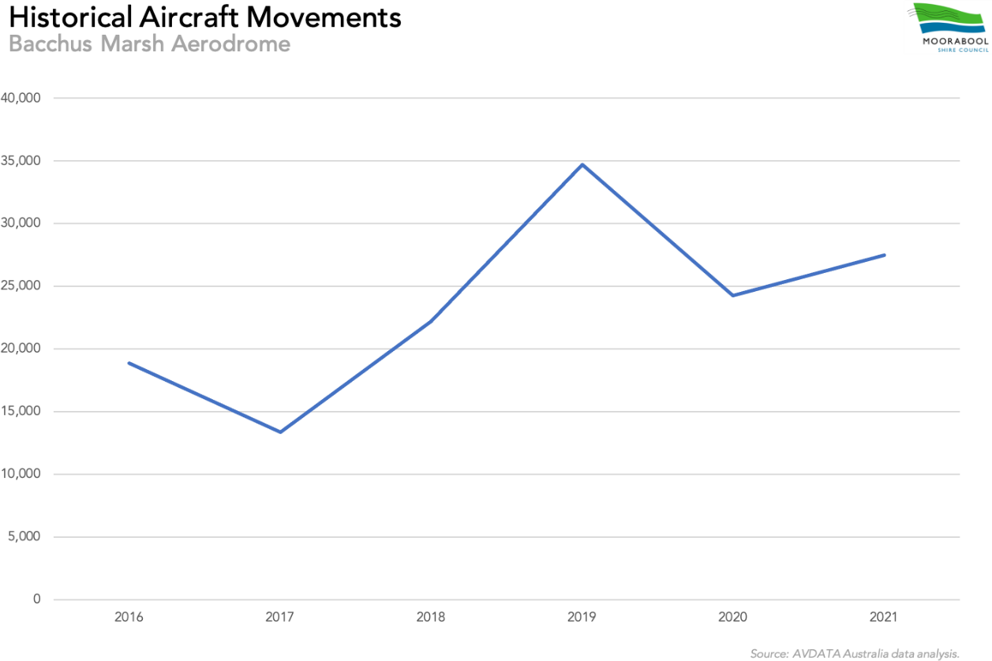
Figure 3 – Historical Aircraft Movements (2016-2021)

The data above has some inherent limitations. Avdata systems record radio broadcasts on the primary frequency associated with the given aerodrome. With aerotow take-offs for gliders, such as those that occur at BMA, the tug aircraft alone gives a radio call using its aircraft registration, and then on landing, both tug and glider conduct separate landings making their individual radio calls. Consequently, one take-off movement logged against the tug powered aircraft generates two landing movements: one against the tug and one against a glider. This means that take-offs of glider aircraft being towed by tug aircraft are not recorded.

While the aircraft movement data has these limitations, it is the only data available at this time. Nevertheless, based on observations, discussions with aerodrome users and anecdotal evidence it is considered that an estimate of 30,000 annual movements is reasonable for planning purposes.

Forecast Aircraft Movements
Airspace Considerations

The Capacity of Aviation Facilities in the Port Phillip Region (2000) report nominated the theoretical capacity of BMA as approximately 60,000 movements, a figure that was subsequently validated in the Ballarat Airport Master Plan 2013-2033.

Airspace is considered a determining factor in the overall movement capacity of an airport. BMA’s airspace is non-controlled Class G airspace up 4,500 feet, above which controlled Class C airspace is in place. Only a short distance to the east of the aerodrome there is an airspace step where Class C airspace drops down to 3,500 feet. Additionally, there is another step to the south-east of the aerodrome where Class C airspace drops down to 2,500 feet.

The current Class G airspace at BMA is considered likely to be able to accommodate up to approximately 60,000 movements per year without additional controls being required.
Capacity Analysis
The current number of aircraft movements at BMA can be easily accommodated with the current runway configuration and airspace arrangements. In 20 years-time, however, movement numbers could be significantly higher depending upon realised annual rates of growth. Additionally, the mix of powered aircraft and glider operations using the same runways is a potentially limiting factor that must be taken into account. Improved infrastructure and operational management at BMA will likely be required to accommodate forecast growth over the planning period of this Master Plan.

As detailed above, powered aircraft and glider movements at BMA are currently in the order of 30,000 per annum. However, there is no evidence of any significant issues with concurrent powered and glider operations at BMA at present, and there are documented procedures in place to manage the safety of both types of aircraft movements when gliders are in operation. Nevertheless, it is possible that as aircraft movements increase over time there is likely to be a need to consider the introduction of separate glider runway strips parallel to the existing runway strips. This is discussed further in Section 3.2.1 of this plan.
Growth Forecast
There have been significant changes in recent years in the composition of the GA sector, particularly in relation to the rise of sport aviation. Consequently, future growth and development at BMA over the life of this Master Plan will be particularly influenced by growth of the following activities:

- Pilot training
- Sport aviation
- Gliding
- Demand for private aircraft storage
- Regional aerial firefighting capabilities
- Commercial aviation support for industries in the PEP
- Community charitable events and air shows
A compound growth rate of between 1% and 3% has typically been adopted for planning purposes at other GA airports across Australia, based on annualised GA activity growth rates provided by the Bureau of Infrastructure, Transport and Regional Economics (BITRE). For the purposes of the BMA Master Plan a 2% growth rate has been assumed. Applying this growth rate to BMA (based on 30,000 movements in 2022) indicates that the forecast movements in the year 2042 could be in the order of 44,600 movements per year (Figure 4).
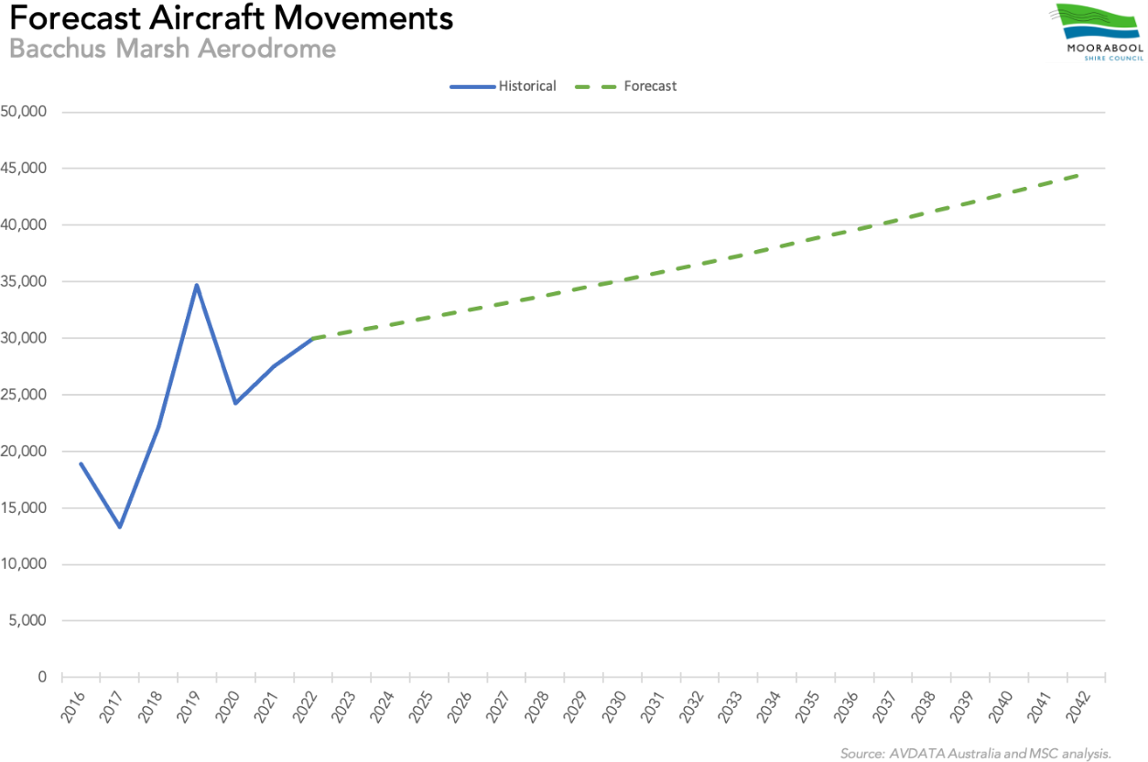
Figure 4 – Forecast Aircraft Movements (2022-2042)

A 2% growth rate is considered to be a reasonable figure for the purposes of this Master Plan based on available information. However, the reality is that it would only take the expansion of the existing flying schools and/or the addition of another flying school (with a subsequent increase in circuit training) beyond that currently projected, and/or the gliding clubs to increase operations for a significantly higher growth rate to be experienced at the BMA and for movements to increase dramatically in a relatively short period of time.

Although the forecast movements could be accommodated within the theoretical capacity of the current aerodrome and its airspace, as previously stated there must be some consideration of the type of activity at the aerodrome and the mix of aircraft types.

The mix of powered and glider aircraft activity at BMA is considered to be a capacity limiting factor due to their different modes and speeds of operation. The fact that there is pilot training, including circuit training, at BMA is also considered a relevant factor in this regard. As a result, it is considered that improved infrastructure and operational management will be required to accommodate and manage forecast growth at BMA over the period of this Master Plan.

Aerodrome Reference Code System
The Part 139 – MOS contains the mandatory standards that apply to all facilities of a Certified aerodrome. It may also be used to provide guidance to an Aeroplane Landing Area such as BMA to ensure a higher level of safety for aircraft operations.

Australia has adopted the International Civil Aviation Organisation (ICAO) methodology of using a code system, known as the Aerodrome Reference Code (ARC), which defines the standards which an aerodrome facility must meet to be suitable for use by aircraft with particular performance and size characteristics. The ARC is described in the Part 139 – MOS by a two-character alphanumeric code that comprises three elements:

      - Code Element 1 corresponds to the highest value of the Aeroplane Reference Field Length (ARFL) for which the runway is intended. The ARFL for an aircraft is the minimum field length required for take-off under prescribed conditions as shown in the appropriate aeroplane flight manual.
      - Code Element 2 corresponds to the greatest wingspan of the aeroplane for which the aerodrome facility is intended.
      - Code Element 3 corresponds to the greatest Outer Main Gear Wheel Span (OMGWS) of the aeroplanes for which the aerodrome facility is intended.

The tables below have been extracted from the Part 139 – MOS and describe each of the component parts of the ARC.

Code Element 1
Code Number | Aeroplane Reference Field Length
1 | Less than 800 m
2 | Not less than 800 m
3 | Not less than 1200 m
4 | Not less than 1800 m

Code Element 2
Code Letter | Wingspan
A | Up to but not including 15 m
B | 15 m up to but not including 24 m
C | 24 m up to but not including 36 m
D | 36 m up to but not including 52 m
E | 52 m up to but not including 65 m
F | 65 m up to but not including 80 m

Code Element 3
OMGWS up to but not including 4.5 m
OMGWS 4.5 m up to but not including 6 m
OMGWS 6 m up to but not including 9 m
OMGWS 9 m up to but not including 15 m

Aerodrome operators are responsible for determining their ARC and rely on a large variety of inputs to make a determination. In doing so, consideration is given to the most demanding aircraft types and operations to be accommodated at an aerodrome into the future, as these dictate the appropriate design, operating and reporting standards for the facility. Selecting an inappropriate ARC can have material consequences, as it can result in operational limitations for particular aircraft types that may require access to the aerodrome.

At the time of its construction, BMA’s facilities were likely built to a general standard and not to suit a specific aircraft type or category. However, over time, the aerodrome has progressively developed so that within the context of the current regulatory environment, it can accommodate Code 1A aircraft with an OMGWS up to but not including 4.5 m.

Selected Design Aircraft
A key consideration for both MSC and BMAM in infrastructure investment decisions is the aerodrome’s design aircraft.

The term ‘design aircraft’ is used to reference the most demanding aircraft type, or grouping of aircraft with similar characteristics, that make regular use of an aerodrome. The design aircraft determination is an important aspect of airport planning, as it helps to ensure the proper development of airport facilities and inform investment decisions. It sets dimensional requirements across an airport, such as the distance between taxiways and runways, and the size of certain areas protecting the safety of aircraft operations and passengers.
The design aircraft for BMA planning purposes is nominated as a Code 2B aircraft.

The adoption of a Code 2B design aircraft is considered to cover the full range of activities that are likely to occur at BMA in the foreseeable future including pilot training, emergency services, charter, corporate and light freight.

Navigation Systems
There are no navigational, lighting or meteorological aids at BMA other than a centrally-located wind direction indicator near the intersection of the two runways.
With the increased adoption of satellite-based navigation systems, there is considered to be no need for the installation of ground-based navigational aids at BMA for the foreseeable future. However, the design and implementation of non-precision instrument flight procedures at BMA could increase its attractiveness and utility into the future. This would require the aerodrome to become certified under the CASRs.

Aircraft Movement Area
While the requirements of the Part 139 – MOS do not apply to BMA as an Aeroplane Landing Area, it is desirable to comply with those standards where possible. This ensures that the facilities provided to aerodrome users are safe, and minimises any potential issues should MSC ever seek to have BMA certified under the CASRs.

Within the context of a Code 2B design aircraft, the key planning parameters from the Part 139 – MOS that may apply to BMA are set out in the table below.

Criteria | Code 2B
Criteria | Non-Instrument | Non-Precision Instrument
Aeroplane Reference Field Length | Not less than 800 m | Not less than 800 m
Wing Span | 15 m up to but not including 24 m | 15 m up to but not including 24 m
Outer Main Gear Wheel Span | 4.5 m up to but not including 6 m | 4.5 m up to but not including 6 m
Runway Strip Width | 80 m | 140 m
Runway Width | 23 m | 23 m
Runway Centreline to Taxiway Centreline | 52 m | 82 m

Criteria | Code 2B
Criteria | Non-Instrument | Non-Precision Instrument
Taxiway Strip Width (Each Side of Centreline) | 20 m | 20 m
Taxiway Width | 10.5 m | 10.5 m
Source: Manual of Standards – Part 139. Compilation date 13 August 2020 (F2020L00931)

The existing runways at BMA are classified as Code 1B runways due to their minimum width being 18 m. Given each runway’s available length exceeds 1,200 m, widening each to 23 m could see them classified as Code 2B. However, the existing taxiways would also need to meet the applicable standards for that classification.

Taxiway A, which runs parallel to Runway 09/27, is currently 8 m wide and its centreline is located 87 m from the centreline of Runway 09/27. While it exceeds the minimum separation distance required from the runway, it will need widening in order to become a Code B taxiway.

Taxiway B, the eastern taxiway connecting Taxiway A to Runway 09/27, is 9 m wide and therefore requires widening to become a Code B taxiway.

Taxiway C, the western taxiway connecting Taxiway A to Runway 09/27, is 7.5 m wide and therefore a Code A taxiway. This taxiway would need to be widened to 10.5 m to become a Code B taxiway.
The need to reduce runway occupancy time by aircraft backtracking or taxiing on the runway will become essential as movements at BMA increase into the future. The future provision of parallel taxiways will greatly improve the capacity of the runways and will provide for safer operations of all aircraft using the aerodrome.

Any proposed new parallel taxiways for Runway 01/19 should be initially constructed to Code B standards (10.5 m wide). If it is envisaged that one or both of the runways may become non-precision approach runways in the future, the centreline of the parallel taxiway(s) will need to be located 82 m away from the centreline of the runway(s) and within a taxiway strip of 20 m (each side of centreline) to meet the requirements of the Part 139 - MOS. This is likely to require the acquisition of additional land beyond the current title boundary of the aerodrome (subject to survey) and is not envisaged during the planning period this Master Plan.
A Runway End Safety Area (RESA) is also provided at the end of each runway strip to protect aircraft in the event of undershooting or overrunning the runway. The RESA must, as a minimum, be twice the width of its associated runway and 120m in length.

Pavement Strength
The movement area pavement strength can also be a major limiting factor for aircraft operations. The construction materials used and the constructed depth of the pavements determine pavement strength. For a pavement to be determined suitable for an aircraft operation the designated Pavement Classification Number (PCN) should match or exceed the Aircraft Classification Number (ACN), which is determined by the aircraft manufacturer. When the ACN of the aircraft is greater than the PCN of the pavement, the pavement is being overloaded.

BMA’s runways were originally constructed to a high-level gravel surface standard by the Department of Civil Aviation. The runways, or portions thereof, have since been bitumen spray sealed at various stages to protect the underlying pavement from damage due to moisture penetration. The spray seal is vulnerable to damage if recommended tyre pressures of aircraft are exceeded.

A pavement’s PCN can determined and reported via two means:

      - Technical Evaluation. The specific study of the pavement characteristics through the application of pavement behaviour technology; and
      - Using Aircraft Experience. Determined through knowledge of the specific type and mass of aircraft satisfactorily being supported by the pavement under regular use.

If a PCN is not available either through technical evaluation or historical use observation, aircraft gross weight and tyre pressure limits can also be employed. In these circumstances, an aircraft may use any part of the movement area where its weight and tyre pressure are below published figures shown at the time of the operation.

Runway 01/19 at BMA currently has a maximum allowable aircraft tyre pressure of 450 kpa and a maximum operating mass of 5,700 kg. Similarly, Runway 09/27 has a maximum allowable aircraft tyre pressure of 400 kpa and a 5,700 kg mass operating limit.

Aviation Support and Landside Facilities
A number of hangars and grassed parking areas are located on the north side of Runway 09/27, east of Runway 01/19. Four commercial operators are located in this area. A combination of bitumen-sealed taxiways and gravel taxilanes connect Runway 09/27 to the hangar precinct and aircraft parking areas and a gravel taxiway connects Runway 01/19 to the sealed taxiways. An aircraft refuelling facility is located adjacent to the aircraft parking area.

Three gliding clubs, together with the Australian Gliding Museum, are located on the adjoining parcel of land abutting the south-east end of Runway 09/27. Access to the gliding facilities is from Jensz Road, which runs off Aerodrome Road.

Passenger Terminal
There are no passenger terminals or visitor facilities at BMA, with the latter being identified during the stakeholder consultation process as essential to improving the amenity of the aerodrome.

A passenger terminal incorporating public amenities should be considered in planning BMA’s medium-term infrastructure.

Security Requirements
All airports require a minimum level of security having regard to basic risk management principles.
New fencing, together with appropriate locked gates, has recently been installed across the aerodrome site. Future work will be required to ensure the integrity of the entire airside boundary and appropriate access controls will need to be installed and monitored to prevent unauthorised access to the aerodrome.

Airspace Protection Surfaces
Airspace protection is critically important for all airports. International standards define two sets of invisible surfaces
above the ground around an airport. The airspace above these surfaces forms the airport’s protected airspace. These two
surfaces are the:

      - Obstacle Limitation Surface (OLS); and
      - Procedures for Air Navigational Services—Aircraft Operations (PANS-OPS) surface.

The OLS is generally the lowest surface and is designed to provide protection for aircraft flying into or out of the airport when the pilot is flying by sight. The PANS-OPS surface is generally above the OLS and is designed to safeguard an aircraft from collision with obstacles when the aircraft’s flight may be guided solely by instruments, in conditions of poor visibility.

The physical dimensions of the OLS are based on the Aerodrome Reference Code number for each runway. PANS-OPS surfaces are generally determined by the instrument flight procedure designer and are dependent on the nature of the given procedure.

The airspace protection surfaces are critical for airport safeguarding purposes, in relation to both on-airport and off-airport development.
Within the airport site, the airspace protection surfaces are particularly relevant for the development of landside facilities and will influence the location and height of future development on the site. Limiting the height of development close to the runway(s) is critical. Future development areas on the aerodrome, particularly close to the runways, should have a maximum building height restriction applied to ensure that buildings and other structures do not penetrate through the applicable obstacle limitation surface into the upper protected airspace. The height of development further away from the runway(s) may increase in accordance with the height of the applicable OLS surface at the particular location.

Outside the aerodrome site, appropriate airspace protection planning controls should be in place based on the applicable airspace surfaces, as recommended in the National Airports Safeguarding Framework – Guideline F: Managing the Risk of Intrusions into the Protected Airspace of Airports.

At BMA the main runways are currently both Code 1B. An OLS chart for BMA was produced by Airport Survey Consultants in May 2008 and the chart was based on Runways 01/19 and 09/27 both being Code 2 non-instrument runways.
As BMA does not have any instrument flight procedures there are no PANS-OPS surfaces in place at this time.
The OLS produced in 2008 revealed no major obstacles in the approaches. However, it is understood that the terrain approximately 2.5 km to the west and north-west of the aerodrome does intrude into protected airspace. The implications of this intrusion would need to be discussed with CASA in the future, especially in the circumstance where BMA may seek transition to certified status under the CASRs.

A new OLS chart was produced in August 2020 following a survey and the OLS chart was based on Code 2 non-precision approach runways in order to consider the most demanding possibility for BMA in the long term. The terrain issues are significant for operations on Runway 09/27 but much less so for Runway 01/19.

The OLS will need to be resurveyed and a new chart prepared if take-off locations are varied from those used in generating the existing drawing.

The protection of the OLS in the planning scheme is discussed in Section 3.3.2 of this plan.

Aircraft Noise Contours
The assessment of aircraft noise effects is an important consideration in the development of an airport Master Plan. It aims to ensure that:

      - Sensitive land uses are not located in areas of unacceptable aircraft noise;
      - The amenity of surrounding developments is not adversely affected by aircraft noise; and
      - Airport operations are protected long term from conflicts due to the encroachment of inappropriate development into noise affected areas.

The Australian Noise Exposure Forecast (ANEF) system is a planning tool used to forecast the level of noise generated by aircraft operations in the vicinity of an aerodrome. It is underpinned by AS 2021:20151 which provides guidance on the siting and construction of buildings in the vicinity of aerodromes to minimise aircraft noise intrusion.
Aircraft noise levels are influenced by range of factors including aircraft size, type, the number of movements, time of day, ambient weather conditions and runway orientation. These inputs are used to generate an ANEF model that may be depicted on contour chart to indicate forecast noise exposure at a given location surrounding an aerodrome.
Recommendations relating to land use within the ANEF contours are contained in AS 2021:2015 and are used to guide land use planning decisions by local authorities.
There is no current need for ANEF modelling for BMA given low aircraft volumes and no immediate expectations that a significant increase in commercial or business activity will occur. The contours produced by an ANEF model would all likely fall within the aerodrome boundary and provide limited value in land use planning decisions at this time. MSC will review the need for ANEF modelling within the next five years.

1 Australian Standard AS 2021:2015 Acoustics — Aircraft noise intrusion — Building siting and construction

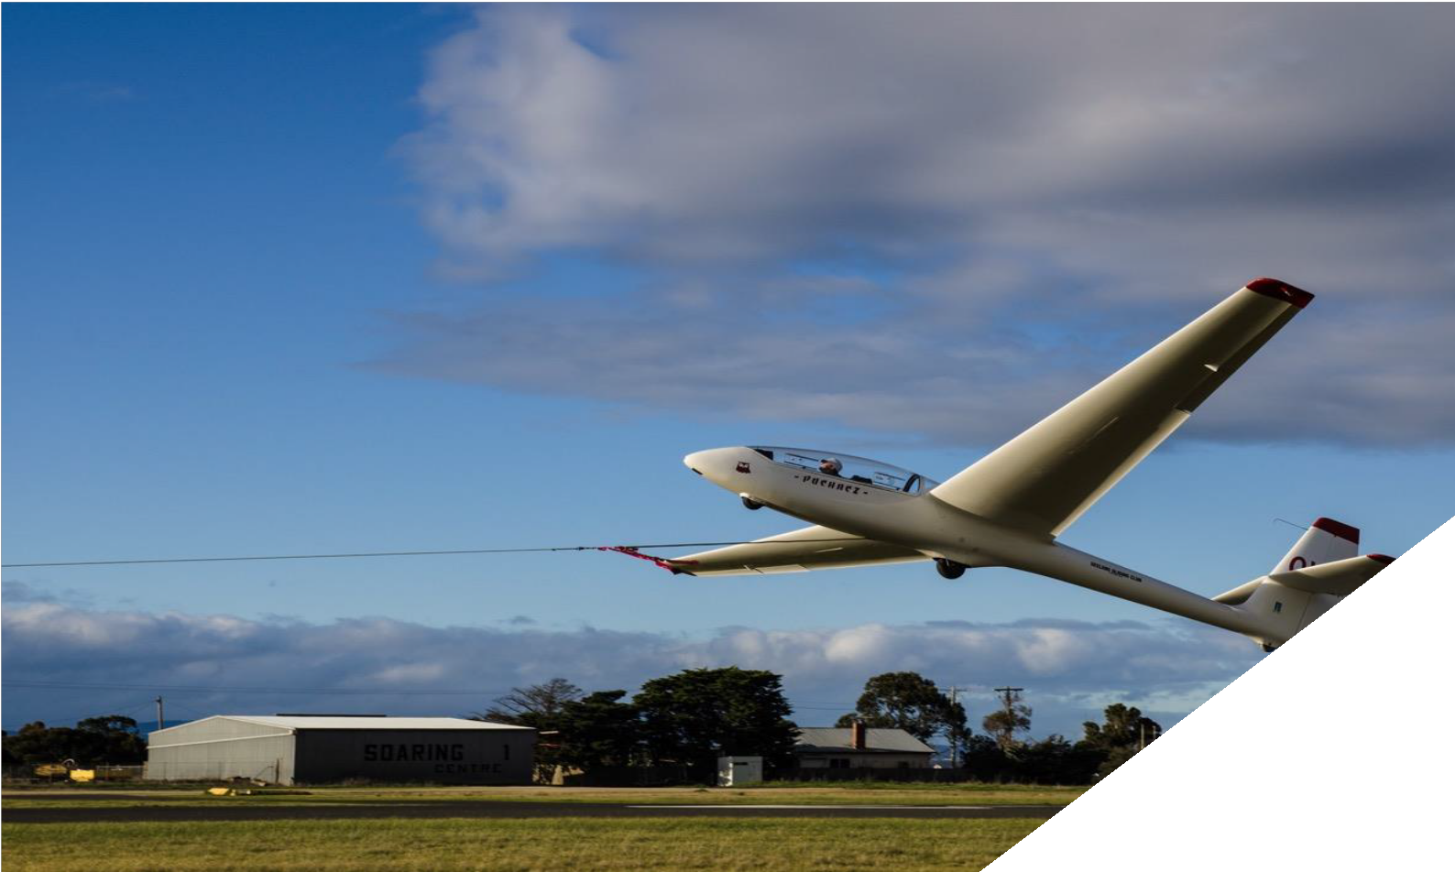

Aerodrome Master Plan

Land Use Plan
This section sets out the land use plan for the aerodrome, including a description of specific land use precincts and their general land use guidelines.
A key objective of this Master Plan is to provide clear direction as to how growth at BMA is to be accommodated, particularly the continued growth and expansion of GA activities. The plan provides a spatial outcome for the aerodrome based on MSC’s economic development objectives, current and projected resources and in keeping with its environmental, planning and operational obligations.

While the emphasis of this Master Plan is aviation growth, development and protecting the BMA site for the future expansion of aviation facilities, it is within the context of ensuring that this development is realistic, achievable and within the resources likely to be available to MSC throughout the planning period. As such, this plan identifies land use planning measures that will be employed to ensure development on adjoining land is complementary and does not limit the future growth of BMA.

Land Use Precincts
To assist MSC in planning future use and development of the aerodrome site, five land use precincts have been identified across the BMA site, along with an existing Gliding Precinct located to the south-east of Runway 09/27:
- Aerodrome Precinct
- Aerodrome Expansion Precinct
- Hangar Precinct
- Terminal Precinct
- Aviation Services Precinct
- Gliding Precinct
Each precinct has different characteristics and long-term planning objectives which are discussed in turn in the sections that follow.

Land Use Precinct Guidelines
The use and development of the precincts shown on the Land Use Precincts Plan should be consistent with the guidelines and requirements outlined below. Detailed development plans will be prepared for each precinct prior to the commencement of any works.

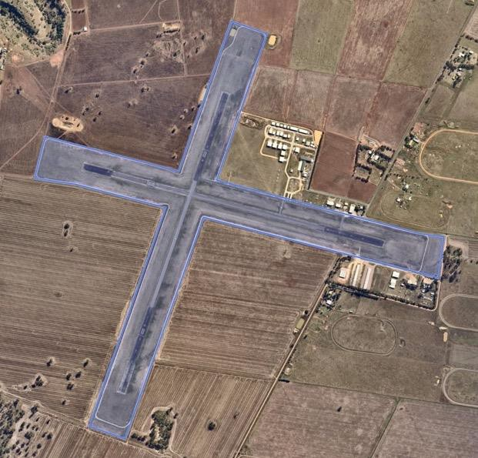 | Aerodrome Precinct  The Aerodrome Precinct contains the two existing runways and associated runway strips and is therefore the most important aerodrome precinct. This precinct must be retained and protected for runway operations in accordance with CASA standards.  The existing runway strips are both 150 m wide. While this exceeds what is currently required according to CASA standards for Code 2 non-instrument runways, the 150m width should be protected for:  - Possible future introduction of a non-precision approach procedure; and  - Glider operations.

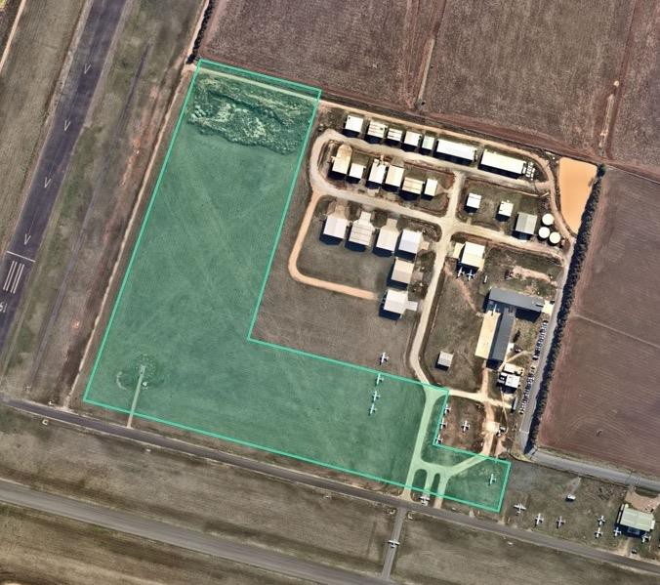 | Aerodrome Expansion Precinct  The land designated Aerodrome Expansion is set aside for provision of possible future:  - Parallel taxiways;  - Aircraft parking aprons;  - Potential establishment of more permanent firefighting aircraft facilities.  The reservation of a dedicated helicopter parking/hangar area within the Aerodrome Expansion precinct is considered prudent having regard to the nature of helicopter operations. This would provide an opportunity to market the aerodrome to helicopter operators, not just fixed-wing aircraft operators.

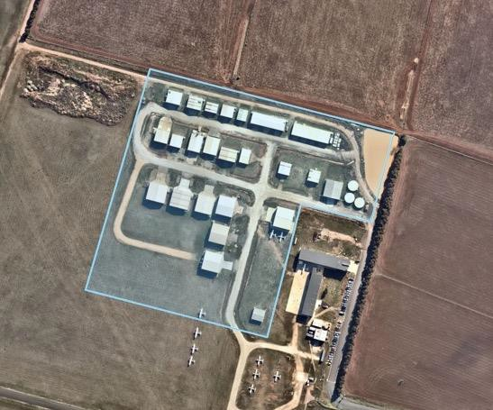 | Hangar Precinct  The Hangar Precinct contains the existing hangar buildings and should continue to be used for these purposes.  There is some capacity for further development in this precinct, including the provision of new hangar sites and taxiways or taxilanes. However, a detailed precinct plan should be prepared and approved prior to any further development, taking into account issues such as the existing native grass, obstacle limitation surfaces, runway sightlines and separation of aircraft from vehicles.

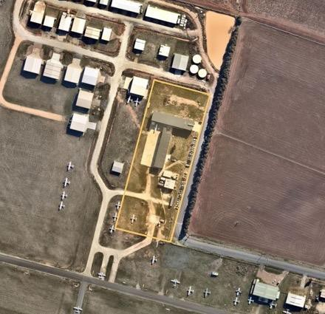 | Terminal Precinct  The Terminal Precinct contains aircraft parking areas, a flying school and fuel facility and should continue to be used for these purposes. The future construction of a terminal building, public amenities such as toilets and additional all-hours and public-use fuel facilities are contemplated for this precinct.

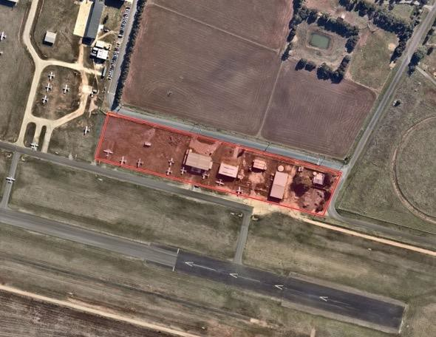 | Aviation Services Precinct  The Aviation Services Precinct contains an existing aircraft Maintenance, Repair and Overhaul service provider and should continue to be used for these and other related purposes. By establishing this precinct, MSC could potentially market it to other metropolitan and regional aviation service providers interested in establishing or relocating their operations at BMA.  The siting of additional hangars and facilities here must take into the Obstacle Limitation Surfaces of the adjacent Runway 09/27 and necessary offsets from the parallel Taxiway A on the northern side.

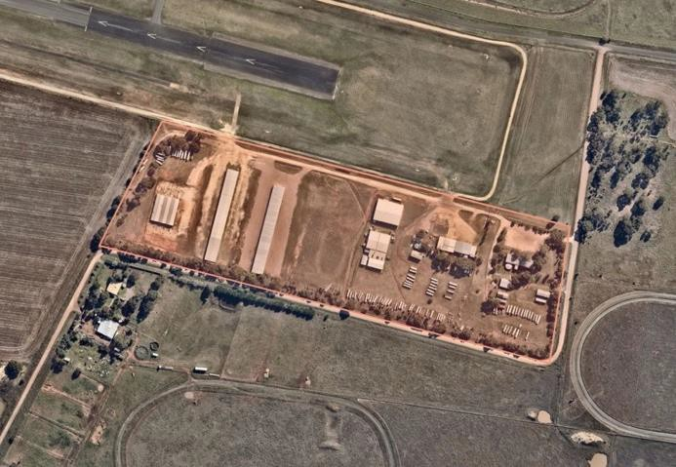 | Gliding Precinct  The Gliding Precinct contains all the existing facilities of the three gliding clubs and the gliding museum. This precinct should continue to be used and developed for gliding facilities and related activities.  Any further development in this precinct must take into the obstacle limitation surfaces of the adjacent Runway 09/27.

General Land Use Guidelines
Use and development of the aerodrome site should comply with the following general guidelines:
      - Future use and development should comply with this Master Plan and be compatible with ongoing aerodrome operation;
      - The aerodrome land should be reserved for its designated use in accordance with the Land Use Precincts Plan;
      - Development in any individual precinct should be undertaken in accordance with the detailed precinct development plan;
      - Ensure that appropriate utility services are provided for new development;
      - Ensure that industrial activities do not produce air emissions that are likely to impact on aviation activities;
      - Ensure that surrounding lighting does not affect aerodrome operations;
      - Ensure that buildings do not exceed the heights specified in the established Obstacle Limitation Surfaces (OLS) plan as detailed elsewhere;
      - Ensure that neighbouring land uses are not sensitive to aircraft noise (residential uses should generally be discouraged);
      - Ensure that land uses and landscaping do not attract wildlife that could be a hazard to aircraft operations; and
      - Ensure that convenient, safe and efficient vehicle access is provided within and to the site.

Planning Scheme Zoning
While the future development and expansion of the BMA is not prohibited by the site’s containment within the Farming Zone, the zone would not facilitate the proposed future development of the aerodrome as outlined in this Master Plan, as permits would be required for each development initiative.
One option is to rezone the land to the Special Use Zone (SUZ), which is applied when an appropriate combination of the other available zones, overlays and local policies cannot give effect to the desired objectives or requirements for that

land. The SUZ provides for the use and development of land for specific purposes as identified in a schedule to the zone. The application of the SUZ would therefore provide clearer direction and control over the future use, development and expansion of the BMA.

The rezoning from FZ to SUZ would reflect a consistency approach, with Special Use Zones currently applied to other airports across Victoria including, but not limited to, Avalon Airport, Ballarat Airport, Bendigo Airport and Mildura Airport. However, the specifics of the planning will be addressed by the VPA during the PEP planning process and planning scheme amendment.
Regardless of the planning mechanism employed for the BMA land, the associated schedule must clearly define the purpose of the zone and the outcomes being sought – these will reflect the outcomes of the BMA Master Plan. The schedule to the SUZ for example would provide for the ‘coordinated use and development of land in the vicinity of the Bacchus Marsh Aerodrome’. The schedule should include decision guidelines that will reinforce the achievement of the Master Plan’s purpose in future planning permit applications.

Facilities Development Plan
This section outlines the future facilities and physical infrastructure requirements for BMA based on the strategic analysis, strategic direction and critical airport planning parameters.

Movement Area Facilities
Existing Runways
The existing runways are generally considered adequate for the aircraft types that currently use BMA. During the planning horizon of this Master Plan, as aircraft movements increase and potentially larger aircraft seek access to the aerodrome, the following runway facility upgrades are likely to be required:
      - Widening of Runway 09/27 and Runway 01/19 to Code 2B standard (23 m) in the long term. It is noted that some sections of the runways are already sealed to 30 m.
      - Removal of the existing displaced thresholds to increase the Landing Distance Available. This would require the glider operations to be relocated to separate parallel strips, which is discussed below.
      - Pavement strength may need to be upgraded, subject to further investigation. This matter is discussed further below.
      - Installation of a runway lighting system. This matter is discussed further below.

Parallel Glider Runway Strips
Given the forecast growth in aircraft movements at BMA, parallel glider runway strips could be needed during the life of this Master Plan. It is noted that parallel glider runway strips were first proposed in the 1999 BMA Master Plan. However, the provision of significantly offset, parallel glider runway strips presents significant challenges with respect to siting and construction costs, and as such, it is not considered feasible within the medium term.

The Part 139 – MOS now contains provisions relating to the siting of glider runway strips both within and immediately adjacent to existing runway strips. In the short to medium term, BMAM should investigate whether narrowing both the Runway 01/19 and Runway 09/27 strips to 80 m would be feasible, in terms of siting and cost, to permit the establishment of dedicated glider runway strips immediately adjacent to each. Alternatively, runway strip lengths could also be reduced so that the glider staging areas are located outside each runway.
Taxiways

At present, aircraft are forced to backtrack on runways to reach the turn-around point for start of take-off on all runways, excluding Runway 27. Due to a forecast increase in aircraft movements, the need to reduce runway occupancy time by aircraft taxiing on the runway will become critical. The provision of parallel taxiways will greatly improve the capacity of the runways and increase the safety of operations of all aircraft using BMA.

Taxiway A extends from the eastern end of Runway 09/27 to meet Runway 01/19. There are no other taxiways serving Runway 01/19. Powered aircraft have to enter and backtrack on Runway 01/19 to effect a full-length take-off, resulting in the runway not being available for take-off or landing by any other aircraft during this time. This is particularly an issue with Runway 01 where backtracking of at least 700 m is required in order to take-off to the north. Given that there is aerodrome land on the east side of Runway 01/19 there is scope to consider the installation of a parallel taxiway to towards the northern end of the runway.

During the planning horizon of this Master Plan the following taxiway facility upgrades are required:

      - Seal the full length of Taxiway A to Code B standard; and
      - Construct a taxiway from the existing hangar precinct directly to the northern end of Runway 01/19. This will avoid the need for aircraft to taxi to Taxiway A and then back along the runway.

It must be noted that the flora survey conducted in 2009 identified significant areas of BMA, particularly within and adjacent to the runway strips, that are subject to federal and state environment protection laws. This will need to be considered and addressed during the detailed design phases of any new taxiway developments.

Pavement Strength
An ongoing issue for any airport is the structural integrity and condition of the runway infrastructure.

Having regard to the longer-term operational aspirations of BMA, current tyre pressure limitations are likely to constrain BMA’s ability to accommodate increased organic growth and attract new users. The maximum tyre pressures in place are considered low by modern standards and will limit the aircraft types able to use the aerodrome. Verification of the physical properties of the movement area surfaces and substrate will need to be undertaken prior to considering any future pavement works.
Additionally, a comprehensive pavement analysis would:

      - assess the physical condition of the existing runway pavements;
      - advise on an appropriate PCN for the current traffic loadings;
      - advise on the impacts of introducing larger aircraft on the runway; and
      - provide a design recommendation with regard to rehabilitation or strengthening that may be required to accommodate larger aircraft in future.
Lighting
The issue of lighting the runways for night operations has been raised by users during consultation activities. Lighting was specifically identified as limiting growth, especially in relation to night flight training, charter, emergency services and freight forwarding. Addressing this issue would open significant opportunities for a number of tenants at the aerodrome.

The lack of lighting on either runway limits flight operations and training activities to daylight hours only. During the stakeholder consultation process, this was identified as potentially impeding existing businesses from expanding and limiting the attraction of other commercial opportunities for the aerodrome.
The installation of aerodrome lighting at BMA should be investigated in the short to medium term.

Helicopter Facilities
While the majority of existing traffic at BMA is fixed wing (powered and non-powered), consideration should be given to establishing a dedicated Helicopter Landing Site (HLS) to increase the attractiveness of the facility to rotary aircraft users.

While a variety of potential sites exist across the aerodrome, it is recommended any HLS be incorporated into the Airfield Expansion Precinct as described in Section 3.1.2 above.

Aviation Support Facilities
Passenger Terminal

There is no terminal building at BMA. During the consultation process a number of key stakeholders identified a preference for multi-user, terminal-like facility at the aerodrome. For example, the provision of a limited food and beverage offering and meeting rooms to support local business and community groups were considered highly likely to promote greater utilisation of the aerodrome. These facilities should be incorporated into the scope of any future terminal development at BMA.

Aircraft Hangars
A precinct plan should be prepared for the existing Hangar Precinct to ensure that any new hangars, taxiways and taxilanes are planned and constructed with due consideration to aviation safety and in compliance with the Part 139 - MOS. The preparation of the Hangar Precinct Plan must have regard to:
      - OLS building height restrictions;
      - Runway sightlines;
      - Separating vehicles and aircraft where possible; and
      - Native grass constraints where applicable.

Commercial aviation activities should preferably be located in the Aviation Services Precinct where aircraft maintenance service providers are currently located. As with the existing Hangar Precinct, a precinct plan should be prepared prior to the construction of new hangars in this area to ensure that the hangars are constructed in a planned and coordinated manner and do not constrain the future development of the movement area.
Fuel Facilities

The fixed AVGAS facilities currently in place were upgraded during 2018/2019 period to provide for credit card purchases. A mobile AVGAS refuelling service is also available at BMAM via prior arrangement.

Consideration should be given to the provision of public use fuel facilities incorporating Jet A-1 fuel in future. The availability of Jet A-1 may represent an attractive proposition for larger transient aircraft users such as Victoria Police, aerial firefighting helicopters and turboprop fixed wing charter aircraft.

The location of the existing and future fuel facilities needs to be considered.
Navigational and Meteorological Aids

There are no navigational or meteorological aids at BMA. While there does not appear to be any need for future ground-based navigational aids, the provision of an Aerodrome Weather Information Service should be considered in the medium term.

Other Facilities
Amenities
The lack of public toilets for local and itinerant visitors was also raised during the stakeholder consultation process as a current aerodrome deficiency. It is recommended that public toilets be provided in the short term within the proposed Terminal Precinct. Consideration should be given to the installation of self-cleaning facilities to minimise any administrative and service overhead for BMAM and MSC.

Ground Transport Facilities
A safe and efficient ground transport system is an important and essential component of any airport and its operations.

BMA is well serviced in terms of road access. The existing road network at BMA is generally informal and until recently, lacked appropriate security control. An ongoing risk to aviation and personnel safety remains the mixing of motor vehicles and aircraft in the existing hangar precinct. Future hangar development in this area should plan for the segregation of motor vehicles and aircraft.
Concerns were raised during the stakeholder consultation process regarding the lack of dedicated turning lanes from Geelong-Bacchus Marsh Road onto Aerodrome Road. MSC should consider their provision within the short term in collaboration with Regional Roads Victoria (see Section 2.2.6).

Aerodrome Road, as a sealed single lane in each direction road, appears to be fit for purpose over the life of the Master Plan. Cummings Road also provides a good road access point from the north.

Internal roads should be sealed to control dust and minimise ongoing management.

Utility Services
The existing situation with respect to utility services was outlined in Section 2.2.7 of this report. The key upgrades or enhancements that will likely be required to facilitate further growth and development of BMA are outlined below:

- Water. Greater Western Water is the responsible authority for the provision of water supply to the region. This infrastructure may require upgrading in the medium to long term to service the potential future development outlined in this Master Plan.
- Sewerage. Greater Western Water is the responsible authority for the provision of sewer reticulation in the region. New sewer infrastructure will be required to service any new areas of proposed development.
- Electricity. All existing and proposed precincts appear well positioned to make connection to the existing electricity supply network.
- Telecommunications. Relatively good access to telecommunications exists at BMA and will be unlikely to require significant upgrading in the medium term. However, the provision of high-speed internet access may be required to support the attraction of future tenants or commercial businesses to BMA.
- Gas. The construction of a gas city gate in Parwan is due for completion in mid-2022. Connection to this network will likely be required in the medium term to support future industry development at BMA.

Environmental Management

As detailed in Section 2.2.8, the aerodrome site contains vegetation comprising native and introduced grasses, forbs and small shrubs in the form of Plains Grassland.
It is recommended that the ecological values are considered throughout the implementation of this Master Plan. Impacts to native flora and fauna are to be minimised where possible. Planning permits and other approvals may need to be sought if impacts are unavoidable.

Heritage Management
As outlined under Section 2.2.9, the aerodrome site does not contain any significant heritage places or objects protected under the Heritage Act 1995. Additionally, there are no Heritage Overlays affecting the site.

Aerodrome Safeguarding Plan
The capacity of an airport to operate unencumbered is fundamentally dependent on what occurs on the land surrounding it. The erection of structures that physically intrude into the flight paths of arriving and departing aircraft can significantly limit or prevent the use of an airport, as can the encroachment of incompatible development such as:
- residential developments adjacent to airports and under flight paths may lead to complaints about aircraft noise and eventually lead to the introduction of curfews;
- industrial activities that generate vertical plumes, smoke or similar hazards; or
- other activities such as agriculture, animal husbandry or wetland developments that may attract birds and/or wildlife species and pose a hazard to operating aircraft.

National Airports Safeguarding Framework
The National Airports Safeguarding Framework (NASF) discussed in Section 2.1.5 of this plan provides a set of principles and guidelines to assist in addressing these and other airport safeguarding issues to better protect the ongoing operation of airports in Australia.

The key issue in relation to airport protection is to ensure that the use and development of land surrounding an airport does not prejudice the ongoing operation of that airport. The two most important issues involve ensuring that:
      - development proposals near an airport and under flight paths do not penetrate its Obstacle Limitation Surfaces (OLS); and
      - changes of land use near the airport and under flight paths are not for land uses that may be sensitive to aircraft noise (e.g., residential land uses).

These two critical safeguarding matters, as they relate to BMA, are discussed below.

Airspace Protection Surfaces
Obstacle Limitation Surfaces

The Obstacle Limitation Surfaces (OLS) are designed to provide protection for aircraft operating within the vicinity of an aerodrome when the pilot is flying by visual reference. The composition of each surface is defined in Part 139 – MOS and the OLS are often depicted on a chart to aid in obstacle control and land use planning decisions.

An OLS chart for BMA was produced in 2020 based on the existing runways and has been considered in the preparation of this Master Plan to ensure that future developments on, and in the vicinity of, the aerodrome do not adversely impact or constrain its future operations. For example, development of the Hangar Precinct will not affect the OLS, provided buildings closest to the runway fall below the height of the Transitional Surface (to be confirmed by survey). Building heights can be progressively increased the further the subject site is away from the runway. Amended OLS will be required once the ultimate design lengths for Runway 09/27 and Runway 01/19 have been determined.
In order to protect Runway 01/19 for possible future Code 2 aircraft operations the OLS chart produced in 2020 should be adopted as it is based on Code 2, non-precision instrument runway standards. It is recommended that protection for Runway 09/27 be limited to Code 2 non-instrument runway standards due to the presence of infringing terrain to the west and north-west of the aerodrome site.

From a planning perspective, the BMA OLS can be protected through the application of a Design and Development Overlay (DDO) and incorporation into the Moorabool Planning Scheme. This approach is discussed in detail in Section
3.3.4 below.

As BMA does not have any instrument flight procedures there are no PANS-OPS surfaces.

Aircraft Noise Contours
The Australian Noise Exposure Forecast (ANEF) system is a planning tool used to forecast the level of noise generated by aircraft operations in the vicinity of an aerodrome. It is underpinned by AS 2021:20152 which provides guidance on the siting and construction of buildings in the vicinity of aerodromes to minimise aircraft noise intrusion.
Aircraft noise levels are influenced by range of factors including aircraft size, type, the number of movements, time of day, ambient weather conditions and runway orientation. These inputs are used to generate an ANEF model that may be depicted on contour chart to indicate forecast noise exposure at a given location surrounding an aerodrome.
Recommendations relating to land use within the ANEF contours are contained in AS 2021:2015 and are used to guide land use planning decisions by local authorities.
There is no current need for ANEF modelling for BMA given low aircraft volumes and no immediate expectations that a significant increase in commercial or business activity will occur. The contours produced by an ANEF model would all likely fall within the aerodrome boundary and provide limited value in land use planning decisions. MSC should review the need for ANEF modelling within the next five years.

Planning Policies and Controls
The existing planning policies and controls applying to BMA were discussed in Section 2.1.5 of this Master Plan. However, a number of planning tools and controls exist within the Victoria Planning Provisions for safeguarding airports:

      - Zones. A variety of zones may be employed to ensure land use and development in the vicinity of an aerodrome does not impact on its existing and future use; and
      - Overlays. The Design and Development Overlay (DDO) and Airport Environs Overlay (AEO) can provide for the protection of airspace surfaces and the management of surrounding areas subject to aircraft noise.
The applicability of each of the above tools in safeguarding BMA is discussed in the sections that follow.

2 Australian Standard AS 2021:2015 Acoustics — Aircraft noise intrusion — Building siting and construction

Zones
As discussed in Section 3.1.4 of this plan, the aerodrome site should be rezoned from Farming Zone (FZ) to a Special Use Zone (SUZ) to better align with the use of the land as an aerodrome.
Overlays

Design and Development Overlay
In the absence of a specific mechanism within the Victoria Planning Provisions, the Design and Development Overlay (DDO) can be employed as a means of airspace protection. When applied to the Obstacle Limitation Surfaces (OLS), a DDO can limit the height of structures in the vicinity of an aerodrome that could adversely impact its existing or future use. The most critical surfaces requiring protection are the take-off, approach and transitional surfaces, as these are lowest and most proximal to an aerodrome.

While a DDO is currently in place over the aerodrome site (Figure 5), it does not appear to limit the height of built structures within its vicinity. As discussed in Section 3.3.2, new surfaces should be prepared and a planning scheme amendment undertaken to ensure the DDO references the OLS applicable to the ultimate runway configurations. This will ensure the DDO provides adequate protection for future use of the aerodrome.
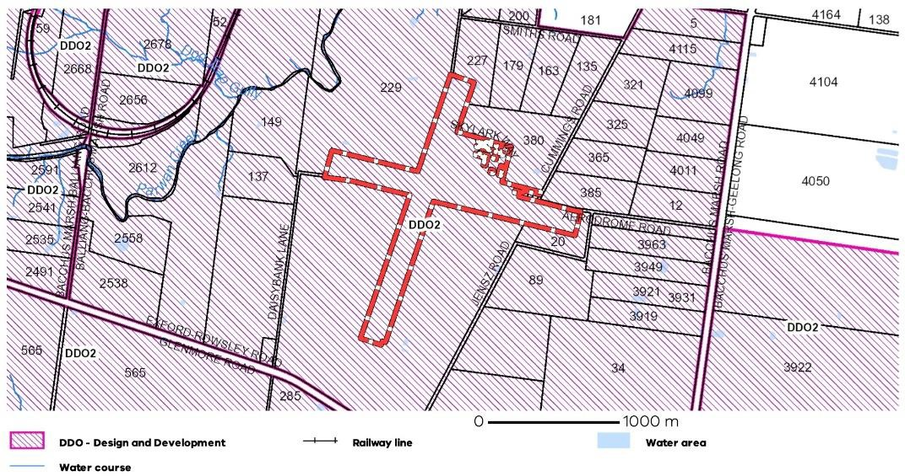
Figure 5 – Existing Design Development Overlay (DDO)
Airport Environs Overlay
The Airport Environs Overlay (AEO) is a standard overlay available in the Victoria Planning Provisions specifically for implementing the land use recommendations within AS 2021:2015.
An AEO is typically based on aircraft noise contours, however, no ANEF currently exists for BMA nor is one anticipated to be required within the next five years. Regardless, Council has applied an AEO over the aerodrome and its surrounding land to ensure protection from inappropriate development in future (Figure 6). While the existing AEO should be retained, its amendment will ultimately be required to align with any future ANEF prepared for BMA.

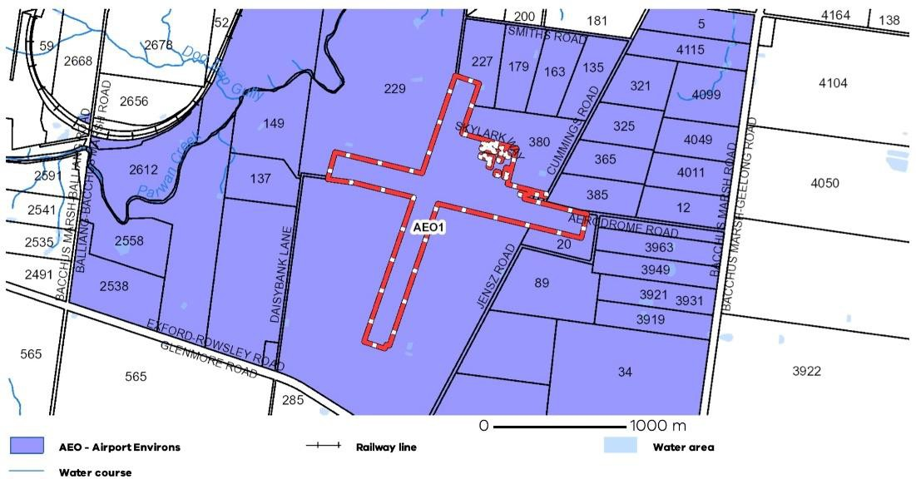
Figure 6 – Existing Airport Environs Overlay (AEO)

Implementation Plan
This Master Plan provides MSC and BMAM with strategic direction for the future development of BMA. It is a broad strategic document that aims to assist both council and BMAM in their decision-making and to draw on as a funding advocacy tool over the next 20 years.

A series of actions have been developed in order to implement this Master Plan, some of which will require further business planning to establish detailed design and costings to secure external funding sources for delivery. These are described in the table below, along with indicative trigger points and an estimation of the likely timing for each action.

Airport Master Plans are typically reviewed every five years to ensure they address any changes in relevant circumstances or conditions. One of the actions in the table below is to therefore review this Master Plan in five years. For this reason, the Implementation Plan focuses on the first five years of the planning period. Other actions may be required but they are likely to be related to non-aviation or industrial development and will likely be market driven.

BMA Master Plan Implementation Plan

Action | Trigger Point | Indicative Timing | Lead Responsibility
Strategic Planning
Prepare a detailed development plan for each Precinct | Prior to commencement of any future works | 2022-2023 | MSC + BMAM
Prepare a Business Plan and Funding Strategy | Following council adoption of the Master Plan | 2022-2023 | MSC + BMAM
Develop a business case for installation of runway lighting | Following council adoption of the Master Plan | 2023 | BMAM
Ensure OLS from 2020 based on Code 2B runway layouts reflects ultimate runway lengths. | Following next OLS survey | 2023 | BMAM
Prepare a Planning Scheme Amendment to Rezone BMA to Special Use Zone and incorporate OLS as a DDO. | Following council adoption of the Master Plan | 2022-2023 | VPA + MSC
Develop a business case for the establishment of a terminal facility | Following completion of Terminal Precinct Development Plan | 2024 | MSC + BMAM
Investigate opportunity for establishing a Helicopter Landing Site within the Airfield Expansion Precinct | Following completion of Airfield Expansion Precinct Development Plan | 2024 | BMAM
Investigate establishment of JET-A1 fuel facilities | Completion of Terminal Precinct Development Plan and following a significant increase in jet aircraft movements at BMA | 2025 | BMAM
Investigate the requirement for an Australian Noise Exposure Forecast (ANEF) | Significant increase in powered aircraft movements at BMA | 2027 | MSC
Review Master Plan | Every 5 years or earlier in response to any significant economic development opportunity | 2027 | MSC + BMAM

Action | Trigger Point | Indicative Timing | Lead Responsibility
Operational
Investigate reducing runway strip widths to 80 m to facilitate the establishment of parallel gliding strips | Following council adoption of the Master Plan | 2022 | BMAM
Investigate removal of displaced runway thresholds | Following council adoption of the Master Plan | 2022 | BMAM
Undertake pavement testing | Prior to commencing pavement works | 2024 | BMAM
Install improved public toilet facilities for itinerant visitors | Acceptance of Terminal Business Case and allocation of funding | 2024 | BMAM
Infrastructure
Complete network planning investigations to facilitate future service infrastructure investment for Parwan Employment  Precinct | At the time of writing, this work was nearing completion | 2022 | MSC
Complete sealing residual gravel section of Runway 09/27 | Receipt of acceptable quotation for works and allocation of funding | 2022-23 | BMAM
Investigate turning lanes into Aerodrome Road servicing BMA site and seal internal roads | Approval and/or endorsement from Regional Roads Victoria (as required) | 2025-2027 | MSC
Widen runways to 23m (Code 2B) | Council acceptance of business case, completion of Airfield Precinct Development Plan and securing of required funding | 2025-2027 | BMAM
Widen Taxiway A to Code B standard | Council acceptance of business case, completion of Airfield Precinct Development Plan and securing of required funding | 2025-2027 | BMAM
Taxiway from the existing hangar estate direct to the north end of Runway 01/19 | Council acceptance of business case, completion of Airfield Precinct Development Plan and securing of required funding | 2025-2027 | BMAM
Construct a common user terminal facility | Completion of the Terminal Precinct Development Plan, council acceptance of associated business case and the securing of funding | 2027+ | BMAM

