COMMUNITY LOCAL LAW No. 1 2019 PART 9 OPEN AIR BURNING APPLICATION FOR PERMIT TO BURN

(Not for any day during the fire season as declared by the Country Fire Authority)

Incomplete applications will not be processed. Please complete the whole application.

Please note: Permits will only be granted in circumstances where there is no reasonable option to dispose of green waste, such as a green waste bin or delivering the waste to the transfer station. Permits will only be considered in heavily populated areas or dense commercial or industrial areas where all other options have been exhausted.

Please attach a photograph of the material to be burned to this application.

 |  |  |  | Name
 |  |  |  | Residential Address
 |  |  | Street
 | Applicant |  | Suburb
 | Details |  | State |  | Post Code
 |  |  | Telephone No.
 |  |  | Email
 |  |  | Preferred contact times:

Note - If you are not the owner, give the name and address of the owner. You must also declare that you have notified the owner of this application.

 | Owner |  |  | Name
 | Owner |  |  | Residential Address
 | Details |  | Street
 |  |  | Suburb
 |  |  | State |  | Post Code
 |  |  | Telephone No.

I/We declare that I/we have notified the Owner about this application:

Applicant’s signature: _____________________________ Date: __________________

DETAILS OF PROPOSED BURN
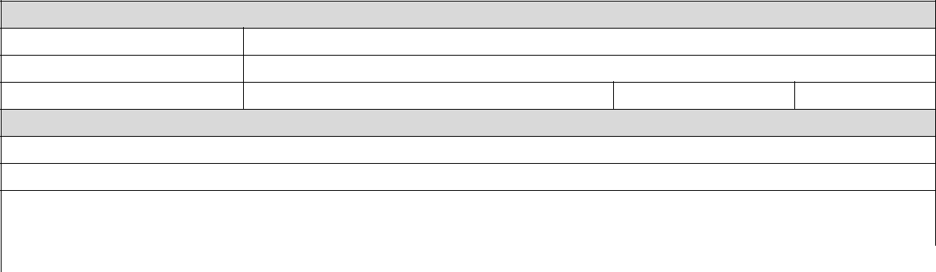

Address of Proposed Burn

Street

Suburb

State Post Code

Description of Material to be Burned

 |  | Quantity of Material to be burned
Length : |  | Width: |  | Height: |  | Total:
 | Include photographs of the material with this application
Before submitting this application, please consider the following:
 | Requirements |  |  |  | Equipment
3m firebreak around and above cleared |  |  |  | Town water supply or a fire pump and
of all flammable material |  |  |  |  | water tank
Check weather conditions on day |  |  |  |  | Adequate length of hose
Number of adults to be present |  |  |  |  | Long handled metal rake
 | Adequate water supply |  |  |  | Long handled shovel
Fire must be completely extinguished |  |  |  | Suitable protective clothing

Map of Proposed burn.
(include 3m firebreak around burn pile and proximity to any neighbouring premises)

DECLARATION

I_____________________________________________(please print) understand that the

information provided above will be used in accordance with relevant legislation and declare that this information is correct to the best of my knowledge.

Applicant’s signature: | _____________________________ | Date: __________________
Name of Owner: | _____________________________
Owners signature: | _____________________________ | Date: __________________

The above information is required to enable Moorabool Shire Council to process your application. It may be disclosed to other parties, such as referral authorities and residents who may be affected by the proposal.

Non-compliance with any permit issued or any provision of Part 9 of the Moorabool Shire Council Community Local Law No.1 2019 may result in enforcement action or prohibition from being granted an open air burning permit in the future.

This Personal Information is held by Moorabool Shire Council in accordance with the Privacy and Data Protection Act 2014

