Studio 22 Youth Space
Permission Form

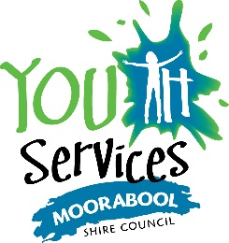
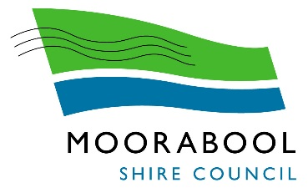

Registration Form
Participant’s Name
Age |  | Date of Birth
School
Telephone (home) |  | Mobile
Email
Address
Has the participant attended a Moorabool Council Youth Services Program before? (circle) |  |  | Yes No
Contact details of parent / guardian during the program
Name of Parent/Guardian
Telephone (home) |  | Mobile
Address
Alternative contact, if above is unavailable
Name |  | Relationship
Telephone (home) |  | Mobile
Address
Medical Information
Does the participant suffer from any illness, condition or disability or have any additional needs? (circle) |  |  | Yes No
Details:
Does the participant have any allergies i.e. food, medication, etc (circle) |  |  | Yes No
Details:
Does the participant take any medication that we need to know about? (circle) |  |  | Yes No
(Please Note: Youth Services staff are not authorised to administer medications of any kind. In the event of a medical emergency an ambulance or appropriate medical services will be called.)
Details:
Court Orders in Relation to Your Child
Are there any:
• Court orders, parenting orders, or parenting plans relating to the powers, duties, responsibilities or authorities of any person in relation to your child or access to your child?
• other court orders relating to your child’s residence or the child’s contact with a parent or other person?
If yes, please bring the original order/s Youth Service Officers to sight and attach a copy to this enrolment form; please describe the orders and provide the contact details of any person given powers, duties, responsibilities or authorities
Details:

Behaviour Management Agreement
Moorabool Youth Services has implemented a Behaviour Management Procedure to maintain its responsibility of duty of care to young people and to manage inappropriate behaviour.
Inappropriate behaviour whilst at a Youth Services program or activity includes:
• Any behaviour that threatens the health and safety of the individual young person, other young people attending the program, Youth Services staff or the general public.
• Drug/ Alcohol use
• Disrespecting peers or Youth Services staff
• Offensive and Aggressive behaviour towards staff, peers or property
• Deliberate property damage
• Swearing, bullying, harassment or abusive behaviour towards peers or staff (electronic or physical)
• Inability to follow instructions/ directions given by Youth Services staff
Actions taken by Youth Services staff when addressing inappropriate behaviour will be in accordance with this procedure and include; a warning system and if necessary, parents/guardians will be contacted to remove the young person from the program. For further information contact Moorabool Youth Services on 5366 7100.
Privacy
The personal information requested on this form is being collected by Council for reference and identification purposes. We will only use personal information provided by you for the purposes for which it was collected and in order for Council to fulfil its business requirements. In accord with our Privacy Policy, we will not disclose your personal information without consent to a third party, institution or authority except where required by law or other regulation.
Photograph / Video Permission
I do /do not (please circle) give permission for photographs/film featuring the participant to be used for the promotion of programs, in publications and the media by Moorabool Shire Council and its agency partner’s.
Moorabool Shire Council and its partners agree not to use any image in a manner that may be deemed adverse, or defamatory to the person in the photographs or video or to the person signing this form. Moorabool Shire Council and its partners further agree that it will not use the image for any commercial gain.
For further information contact Moorabool Youth Services on 03) 5366 7100.
Indemnity
I,…………………..……………… the Parent / Guardian of …………………………………(young person’s name) being the undersigned, acknowledges that the Moorabool Shire Council Officers, Servants or Agents will take due care and attention during the course of the activity/ies, however in the event of an incident occurring, I indemnify and keep indemnified the Moorabool Shire Council and its servants, agents and partners against any / all actions, loss, damage, death or injuries which may be suffered and/or sustained as the result of the said activities as defined within this form. I authorise the obtaining of any necessary medical attention and agree to meet any expenses incurred.
Young people attending Studio 22 will be required to sign in and out of the program to ensure their safety. Young people are free to come and go as they please. Once a young person has signed out of the program, Youth Services staff no longer hold a duty of care for them.
I hereby agree to the terms and understand the conditions set out above and give consent for ………………………… to attend Studio 22.
(name of participant)

Parent / Guardian Name |  | Participants Name
Parent / Guardian Signature |  | Participants Signature
Date |  | Date
If you have any questions about this form or Studio 22 Youth Space, please contact Moorabool Shire Council’s Youth Services on 03) 5366 7100.

