
Council Policy… Council Policy … Council Policy…
Policy No.: | SOD012 | Community Facilities Funding Policy
Review Date: | August 2019 | Community Facilities Funding Policy
Revision No.: | 03 | Community Facilities Funding Policy
Policy Manual Version No.: | 03 | Community Facilities Funding Policy
Adopted by: | Council | Date: August 2016

- Introduction and Purpose

The purpose of the Community Facility Funding Policy is to provide guidelines regarding the Council’s role in supporting community facilities through the provision of annual operational funding.

The Moorabool Shire Council is committed to supporting the management and operation of community facilities across the Shire, including recreation reserves, community halls, community/neighbourhood houses, heritage facilities and other facilities that support community members. The operational funding for community facilities supports these facilities being managed and operated efficiently and effectively. The principles and rationale for the development of the Community Facility Funding Policy are derived from the Moorabool Shire Council Plan 2013 – 2017, Recreation & Leisure Strategy 2015-2021, and the Recreation Reserves Management Framework.

PURPOSE

The purpose of the Policy is to provide Council, and community stakeholders with clarity regarding the operational funding and service level required for the management and maintenance of use of the community facilities within the Shire. The Recreation and Leisure Strategy 2015-2021 recommended that a new Reserve Management Framework be developed to ensure that there is a coordinated, integrated, consistent approach to the management and operation of recreation reserves across Moorabool Shire. In the case of Recreation Reserves this policy is an integral component of the Reserve Management Framework.

DEFINITIONS

The following definitions are referred to throughout this Policy:

Regular User Group: refers to a body of people united for sporting or recreation purposes including sports clubs / associations, community organisations, and other groups that have an agreement with Council permitting use of the nominated community facility or an agreement with the Committee of Management for the use of the community facility. Typically, a regular user group is based at the nominated facility for a specific period.

Council: refers to the Moorabool Shire Council.

Committee of Management (S.86): Reserve or Building Committees of Council appointed by Council

Non Council Committee of Management: Reserve Committees of Management appointed by agencies other than Council.

Recreation Reserve: Open space containing facilities for recreational opportunities, such as sports fields, courts, pavilions, practice facilities, gardens, and playgrounds

Facilities: refers to the Community Facility itself and other support infrastructure at the location which are made available for use to the regular user group and casual hirers as per the use agreement.

- Scope / Strategic Context

This Policy applies directly to all Community Facilities receiving operational facility funding from Council.

In regards specifically to Recreation Reserves, the Moorabool Recreation & Leisure Strategy 2015- 2021 is the guiding strategic document for recreation and leisure provision and management. The strategy provides the principles and strategic rationale for Councils reserve management policies.
Recreation Reserve Management Framework

The Reserves Management Framework has been formalised as a direct recommendation from the Recreation & Leisure Strategy recommendations and outlines the management and operational procedures regarding the management and use for Moorabool Shire recreation reserves.

Council recognises that there is a “mix” of management models in operation at Recreation Reserves across the municipality. This policy seeks to provide a consistent approach to providing operational funding support to community facilities consistent with all elements within the framework.

Community Facility Maintenance

Council recognises that different activities and differing levels of participations influence maintenance requirements on community facilities to varying levels. Council will develop an annual management and maintenance plan with desired service levels for all community facilities to ensure that facilities meet particular user requirements and are maintained in a safe condition to support their intended use.

In the case specifically of Recreation Reserves, the service level for maintenance works within the annual plan will be commensurate with the reserve classification (hierarchy) and demand/level of use outlined in Councils Recreation and Leisure Strategy, and specific to each Recreation Reserve.

As user fees and charges are an integral component of the Community Facility Model that provides for facility maintenance, Council has an expectation that users of facilities will contribute towards the cost of maintaining and operating facilities via user fees. User fees are a key component of the funding model to support the maintenance of community facilities.

- Objectives

The objectives of the Community Facilities Funding Policy are to:

- support the management of community facilities
- ensure that community facilities are maintained appropriately to meet community needs
- support Committees of Management to manage facilities
- improve community facilities
- allocate operational funding to support achievement of desired service level for key activities

- Strategic Principles

- Council recognises the value of community facilities within the Shire and how community facilities provide opportunities for recreation, community activities, heritage recognition and support for the community and local residents.

- Funding for community facilities is determined/allocated according to ‘defined’ service standards and levels required to maintain a facility in a safe condition appropriate to meet its demand for use (usage hours)

- Funding for recreation reserves that maintain significant public facilities for passive community use will be considered as part of the operational funding model.

- The management structure of a specific community facility is not considered when funding allocations are determined.

- This policy acknowledges the invaluable contribution that volunteers have provided to Council in managing and maintaining community facilities and encourages this support to continue where volunteer capacity exists

- Funding is vital to the sustainability of community facilities across the Shire and is Council’s commitment to the ongoing provision of community facilities to facilitate health and wellbeing benefits for the community.

- The Council recognises that community facilities across the Shire are owned differently i.e. Council owned; DELWP owned; Incorporated Associations; and does not discriminate between different ownership for operational funding as some communities in the Shire do not have any Council owned facilities. However, accountability in the management of the funding provided is consistent across all facilities.

- Operational grants will be increase by CPI annually to ensure that the funding allocation is sufficient to meet external cost increases.

- It is recognised that some facilities may be able to source in kind works to substitute for funding allocated to some maintenance tasks. This practice will continue to be approved, as long as the appropriate service standards are maintained by the in kind contribution.

- Where a Committee of Management receives an operational grant, the committee will be required to submit an annual acquittal at the end of the funding period. It the acquittal is not received by 31 July each year then operational grants for the following year will be put on hold until the acquittal is received.

- Council Section 86 Committees of Management must abide by the Council’s Appointments and Delegations Policy when expending operational grant funds.

- All major building infrastructure maintenance and improvements at Council managed/owned facilities will be planned and managed by Council’s Infrastructure Services Department in consultation with the Committee of Management and user groups. This includes structural modifications or improvements.

- Council acknowledges that the funding levels required for future management and maintenance of facilities may need to be increased during the life of this policy. Therefore, all operational grants will be reviewed annually and referred to the annual budget process for consideration.

- User fees and charges is a vital component of the funding model and it is assumed that user fees and charges consistent with the Reserve Management Framework are implemented at all reserves.

All management and maintenance activities and processes (including those undertaken by volunteer Committees of Management) must be consistent with Council policy and procedures including procurement, conflict of interest, occupational health and safety, risk management and privacy

- Community Facility Funding

Recreation Reserves

Council is committed to financially contributing toward the essential management and maintenance requirements for sport and recreation facilities to ensure facilities are accessible for all within the community. These requirements include:

- Sportsground maintenance including but not limited to mowing, aeration, top dressing, scarifying, spraying, maintenance of core infrastructure such as irrigation systems, over sowing of different turf species for each winter and summer season.
- Annual court maintenance
- General park (passive) maintenance
- Public utilities and lighting
- Fencing furniture and signage
- Tree maintenance
- Public toilet cleaning and maintenance
- Irrigation costs
- Public litter bin clearances
- Playground (BMX / Skate) inspections
- Building maintenance

Community Buildings

Community buildings will be provided with an operational grant annually for the following expenses:
- Utilities (electricity, water, gas)
- Cleaning
- Consumables
- Committee expenses
- Minor breakages and equipment replacement
- Emergency service equipment
- Minor maintenance expenses

Funding to Council Managed Facilities

Funding allocated to each facility for the financial year will be confirmed upon the adoption of the Council budget. Volunteer Committees of Management managing reserves will be notified of funding levels committed at this time. Council encourages volunteers to continue the invaluable in kind support provided to Council towards the maintenance of reserves.

Council will provide volunteers with the appropriate framework to undertake maintenance activities including the general maintenance of passive areas. However, maintenance of playgrounds, tree management, litter collection and public toilets on Council owned land will be managed by Council.

It is acknowledged that the technical knowledge and hours required to maintain and manage sportsground facilities continues to increase and the capacity of a volunteer committee to undertake these responsibilities will vary depending on the skills and expertise of its volunteers. Therefore, to protect the sportsground assets of all reserves governed by this policy framework, as part of preparing the Annual Management and Maintenance Agreement, the agreement will outline which of the following two management models will be adopted for the reserve for the financial year:

  - Council to manage the maintenance of the sportsground facilities with support and assistance provided by Reserve Committees of Management; or
  - Committee of Management to manage the maintenance of the sportsground facilities with support and assistance provided by Council.

These options acknowledge that a one size fits all management model is not appropriate for all reserves and provides opportunities where volunteer expertise and capacity exists for the community to continue to maintain the sportsground facilities. The Annual Management and Maintenance Plan will be signed off by Council officers and the Committee of Management and provide a reference to the accountabilities to the maintenance of the reserve throughout the year.

Funding payments made directly to Committees of Management will be made in August and December each financial year.

Funding to Non Council Managed Facilities

Council financial contributions to Community Facility Committees of Management are made based on the following terms and conditions;

- The Committee has signed an Annual Management Agreement with Council.
- All user groups have an appropriate Tenancy/Occupancy Agreement in place.
- Fees and charges levied by Committees are fair, equitable and consistent at all reserves.
- Committees provide annual reporting to Council with audited financial statements outlining how the contribution was expended against the service level in the agreement.
- At all Non Council directly managed reserves collecting user fees, the user fees total will be deducted from the gross amount of Facility Funding determined required as user fees form part of the money allocated toward reserve / hall management and maintenance.

Council’s funding allocated for Council managed recreation reserves will include maintaining the reserve for both active and passive recreation use.

Council funding allocated for recreation reserves managed by Department of Environment Land Water and Planning (DELWP) will include maintaining the sportsgrounds (ovals and courts) for active recreation use but not for facilities used specific for passive recreation usage.

Council will support Committees of Management to ensure that the above terms and conditions are in place and management processes and procedures are developed and implemented.

- Implementation and Review of Policy

The Moorabool Recreation & Leisure Strategic Advisory Committee acts as the driving group in relation to the implementation of the Recreation and Leisure Strategy, and plays a significant role in the development and review of Council Recreation & Leisure Policies.

The committee will make recommendations to Council for amendments and updates to this Policy every three years.

- Related Legislation

This Policy and the associated appendices relate to the Crown Land (Reserves) Act 1978 as some reserves are located on Crown Land and managed by either Council or a delegated community Committee of Management.

This Policy is strategically supported by the Moorabool Recreation & Leisure Strategy 2015-2021 and should be implemented in the strategic context of the Recreation Reserves Management Framework.

- Council Plan Reference – Key Performance Area

Key Result Area Community Well-Being

Objective Increase and encourage participation in a range of sport, recreation and leisure activities

Strategy Promote community health and well - being through the provision of recreation facilities, open space, programs and activities

- References

Department | Department
Council | Moorabool Shire Council
LG Act | Local Government Act 1989 and supporting regulations
Section 86 | Section 86 of the Local Government Act 1989

Attachments

Schedule 1: Recreation Reserve and Hall Ownership and Management Structures
Schedule 2: Recreation Reserve Management Service levels
Schedule 3: Halls and Reserve Committee of Management Annual Management and Maintenance Agreement Template
Schedule 4: Community House/Neighbourhood House Funding Schedule including Heritage and Welfare Facilities Funding Schedule

Schedule 1: Current Reserve Management Structures

Reserve Name | Ownership Status | Mode of Management | Management Status
Ballan Racecourse and Recreation | DELWP | CoM | DELWP
Ballan Recreation Reserve | DELWP | CoM | DELWP
Balliang Recreation Reserve (and hall) | DELWP | CoM | DELWP
Berembroke Recreation Reserve | DELWP | CoM | DELWP
Blackwood Sports Ground Crown Reserve | DELWP | CoM | DELWP
Bullarook Recreation Reserve | DELWP | CoM | DELWP
Bungaree Recreation Reserve | DELWP | CoM | DELWP
Clarendon Recreation Reserve | DELWP | CoM | DELWP
Gordon Public Park (Tennis courts) | DELWP | CoM | DELWP
Gordon Recreation Reserve | DELWP | CoM | DELWP
Korweinguboora Recreation Reserves | DELWP | CoM | DELWP
Morrisons Recreation Reserve | DELWP | CoM | DELWP
Mt Egerton Recreation Reserve | DELWP | CoM | DELWP
Mt Wallace Hall | DELWP | CoM | DELWP
Myrniong Recreation Reserve | DELWP | CoM | DELWP
Yendon Recreation Reserve (tennis) | DELWP | CoM | DELWP
BM Racecourse and Recreation Reservation | DELWP | s86CoM | MSC
Maddingley Park | DELWP | s86CoM | MSC
Darley Park | DELWP | Council | MSC
Darley Civic Community Hub | MSC | Council | MSC
Mason's Lane Reserve | MSC | Council | MSC
Dunnstown Recreation Reserve | MSC | s86CoM | MSC
Elaine Sports Ground Recreation Reserve | MSC | s86CoM | MSC
Greendale Reserves | MSC | s86CoM | MSC
Millbrook Community Centre | MSC | s86CoM | MSC
Navigators Community Centre Recreation | MSC | s86CoM | MSC
Wallace Recreation Reserve | MSC | s86CoM | MSC

Current Community Facility / Hall Management Structures

Reserve Name | Ownership Status | Mode of Management | Management Status
Ballan & District Community Centre | DELWP | CoM | DELWP
Balliang Public Hall | DELWP | CoM | DELWP
Blackwood Hall | DELWP | CoM | DELWP
Elaine Hall | DELWP | CoM | DELWP
My Edgerton Hall | DELWP | CoM | DELWP
Myrniong Hall | DELWP | CoM | DELWP
Rowsley Public Hall | DELWP | CoM | DELWP
Lerderderg Library | MSC | Council | MSC
Bacchus Marsh Public Hall | MSC | s86CoM | MSC
Bungaree Town Hall | MSC | s86CoM | MSC
Gordon Public Hall | MSC | s86CoM | MSC
Lal Lal Soldiers Memorial Hall | MSC | s86CoM | MSC
Millbrook Community Centre | MSC | s86CoM | MSC
Navigators Community Centre | MSC | s86CoM | MSC
Wallace Public Hall | MSC | S86CoM | MSC

Schedule 2: Recreation Reserve Existing Service Levels 2016
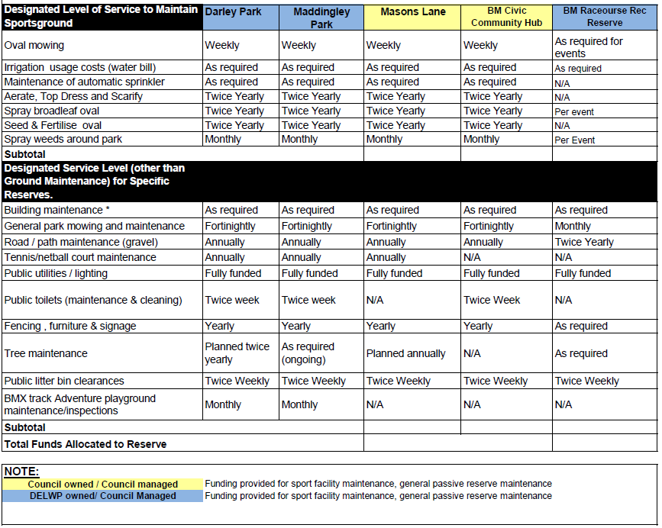

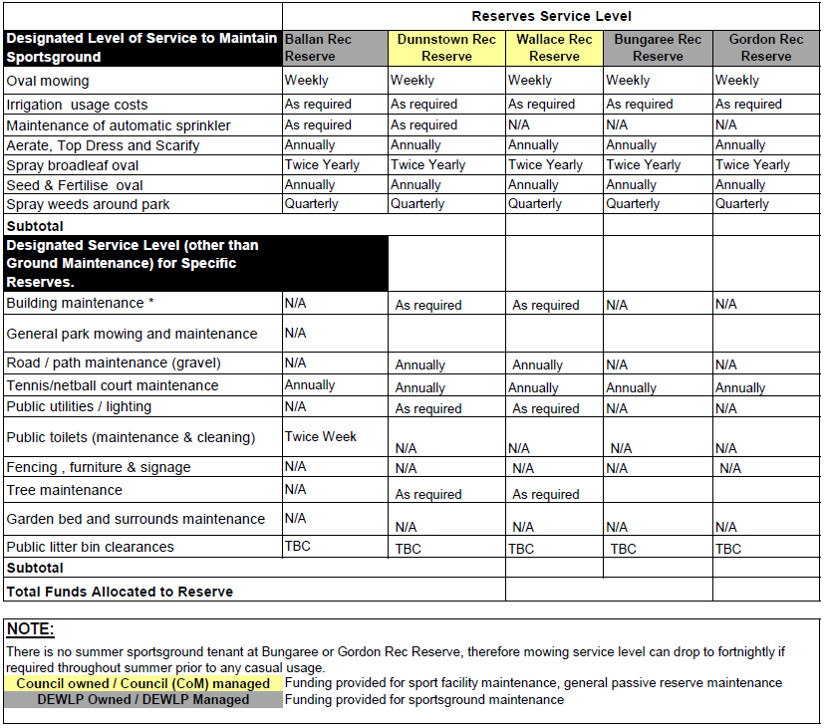
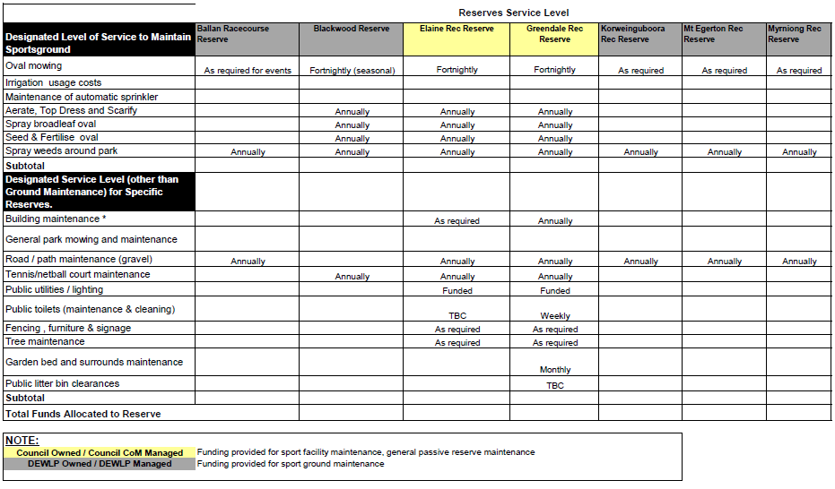
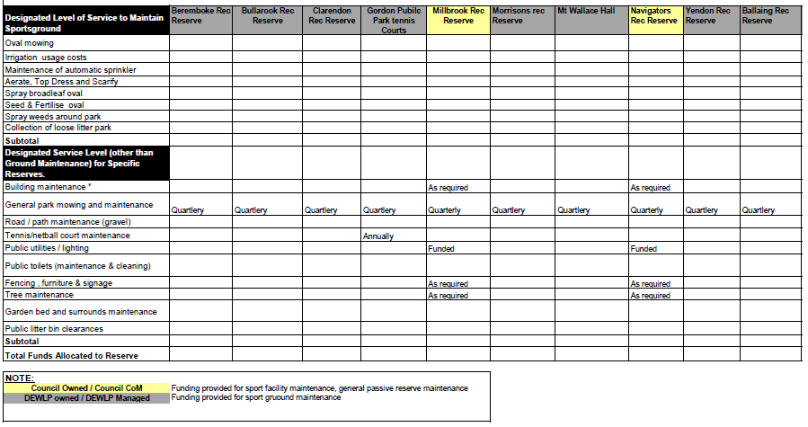

Schedule 3: HALL/RESERVE COMMITTEE OF MANAGEMENT
ANNUAL MANAGEMENT & MAINTENANCE AGREEMENT

Council allocates funding toward the essential management and maintenance requirements for facilities under the Moorabool Shire Community Facilities Funding Policy.

This Annual Management and Maintenance Agreement details the funding committed to the XXXXXXXXXXXX Committee of Management and the essential management and maintenance requirements to be undertaken at the hall during the XXXX financial year.

The funding allocated to undertake the XXXXXX maintenance of the XXXX including the roles and responsibility of the Committee of Management and Council are detailed in Appendix 1.

The operational funding for all facilities will be reviewed annually and considered as part of Council’s budget process. The roles and responsibilities agreed for the Committee of Management and Council will also be reviewed annually.

SECTION A: COUNCIL PROJECT MANAGER DETAILS

Name of Service Unit:
Contact person:
Position/Title:
Telephone: (W) (M)
Email:

SECTION D: DECLARATION

The Committee of Management and Council agrees the information within this agreement is true and correct.
XXXXXXXXXXXXXXXXXXXX
Signature:

Name:

Position (if applicable):

Date:

MOORABOOL SHIRE COUNCIL
Signature:

Name:

Position (if applicable):

Date:

The Maintenance Schedule clearly articulates the maintenance responsibilities by Council and the Committee of Management at the XXXXXXXXXXXXX.

The following factors have been considered in determining the level of maintenance provided by Council at the facility.

- Maintenance Ability: Capacity of the Committee to maintain the facility
- Revenue potential: Hire fees, financial support already provided
- Grants/Funding: Access to MSC Community Grant Program as well as external funding opportunities
- Other: Any special or unique maintenance needs incurred by Council or the Committee

MAINTENANCE SCHEDULE

 | Committee of Management | Council | Estimated Cost / Comments

GENERAL MAINTENANCE

General - cleaning

General - maintenance

Hall Equipment and fixtures (Cutlery, kitchen equipment, tables and chairs)

Pest Control

Waste Removal

 | Committee of Management | Council | Estimated Cost / Comments

BUILDING MAINTENANCE BREAKDOWN
Structure
Roof
Gutter and Spouting
External and Internal Walls
Floor
Stumps, footing
Services
Electrical wiring
Plumbing (including sewerage)
Sub surface drain pipes
Drainage service pits
Fittings
Air conditioning and/ or heating
Curtains/ drapes/ blinds
Electrical fittings and lights
External Lighting
Plumbing fittings (toilet, sink, taps )
Floor surfaces and coverings
Plate glass
Windows
Keys and locks
Internal wall surfaces (paint, wallpaper)
External wall surfaces
Skylight
Doors
Hot Water System
Non-fixed appliances (microwave, fridge, kettle)
Fixed appliances (e.g. stove, dishwasher)

Testing and Tagging of fixed and non-fixed electrical items

Essential Services
Fire extinguishers / fire blankets
Fire service levee
Emergency exits
Other
Car park & driveway
Pest Control
Waste removal
Signage

OPEN SPACE
Paths
Loose litter / leaves
Garden beds
Irrigation
Trees

Definitions

Maintain: | Clean and maintain. Keep in good condition. Inspect. Service. Maintain to Australian Standard. Maintain to Council standards.
Replace: | Fix if broken. Replace or Repair.
Full Maintenance: | Clean, maintain, repair, replace.
Blank: | No Maintenance
Undertake: | Carry out specified activity

The Committee of Management must notify Council immediately where a building maintenance issue arises whereby Council has primary responsibility. Committee representatives can contact Council after hours by calling 53667100 and following the out of hours instructions provided.

The replacement of certain items may be dependent upon budget provisions.

The annual maintenance activities for the Hall/Reserve are to be agreed upon by the Committee and Council. Activities are to be set out in the XXXXXXX Maintenance Plan. This document is to be developed by Council in consultation with the appointed Committee of Management. It provides a framework for annual maintenance activities and is intended as a tool to enable productive discussion between Council and the Committee of Management in determining the annual priorities for the Hall, as well as outlining estimated costs and responsibility. The plan is to be agreed upon and signed off by both parties at the beginning of each financial year.

Schedule 4:

Community and Neighbourhood Houses Funding

Community and Neighbourhood Houses will be provided with an annual operational grant for:

Rent expenses
Utilities (electricity, water, gas, phone)
Cleaning
Committee expenses
Administration costs
Minor maintenance expenses

Funding guidelines

Operational grant will be increased by CPI annually
Grants will be paid in August annually
Community and Neighbourhood House Committees are required to submit an annual acquittal in July each year, if this acquittal is not submitted the next years grant payment will not be provided until the acquittal is completed

Funding Agreement

An annual ‘funding agreement’ will be developed to be signed by the Council and the Community/Neighbourhood House that stipulates the funding guidelines and requirements

Insurance

The Council will not provide any insurance coverage for Community and Neighbourhood Houses

(* Note: The Ballan Community House is a part of the Ballan Mechanics Institute and therefore covered for building insurance under their coverage)

Funding amounts 2016/17

Community/Neighbourhood Houses | 2016/17 grant
Darley Neighbourhood House | $ 9,382
Ballan Community House | $ 8,132
The Laurels | $ 16,200
TOTAL | $ 33,713

Schedule

- Heritage and Welfare Facilities Funding

Heritage and Welfare Facilities will be provided with an annual operational grant for:

- Rent expenses
- Utilities (electricity, water, gas, phone)
- Cleaning
- Committee expenses
- Administration costs
- Minor maintenance expenses
- Rate Rebate (The Neighbours Place only)

Ballan Shire Historical Society is provided with an annual grant to offset water utility expenses, this is due to a past arrangement when the Council was Committee of Management for this facility. The Council handed back Committee of Management responsibilities to the former DEPI in 2011 but continued to support the Historical Society to fund this utility cost.

Funding guidelines

- Operational grant will be increased by CPI annually
- Grants will be paid in August annually
- Organisations receiving funding are required to submit an annual acquittal in July each year, if this acquittal is not submitted the next years grant payment will not be provided until the acquittal is completed

Insurance

The Council will provide Building and Contents Insurance and Public Liability Insurance for the Blacksmith Cottage only. All other Heritage and Welfare facilities must provide their own insurance at their own cost.

