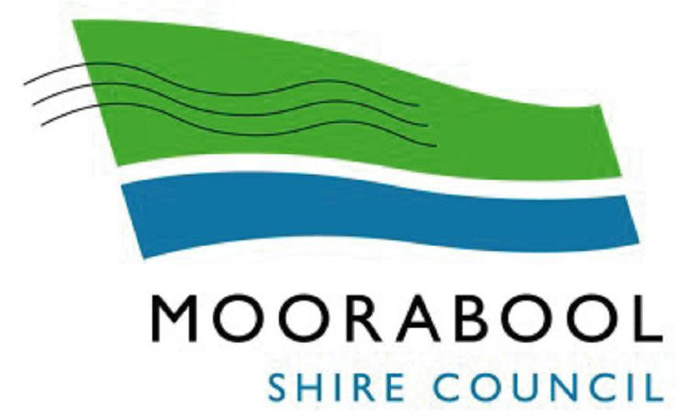
Development of a Dam
- Before an application is made to Moorabool Shire Council to construct a dam, you should first contact Southern Rural Water on 1300 139 510 (or alternatively Melbourne Water on 131 722) to determine whether a licence is required to construct the dam, or to take and use water from the dam, under the Water Act 1989.
Note in accordance with the Water (Resources Management) Amendment Regulations 2010, land owners must register with the relevant Rural Water Authority their intent to either construct a new or alter an existing domestic and stock use dam, on land which is less than 8 hectares in size and is within either a Rural Living Zone or a Residential Zone.
- a) If a licence is required in accordance with section 1. above, no planning permit is required for the dam.
b) If a licence is not required, a planning permit may be required from Council for the dam (refer to section 3.)
- Contact Council to establish whether a planning permit is required to construct a dam.
Is a planning permit from Council required to construct a dam?
No – I need a licence from the relevant rural water licensing authority
Yes – refer to following planning application checklist and the requirements of Clause 22.01 Dams of the Moorabool Planning Scheme.

For all planning applications the following MUST be provided:
An Application form completed and signed
A full current copy of Title for the land, including the map showing current ownership details, title plan and a full copy of any registered covenants, restrictions or Section 173 Agreements that apply to the land. (The Copy of Title must be clearly legible and no older than 90 days.)
Titles are available at www.land.vic.gov.au , select “Titles, Certificates and Crown Land Status “option and then follow the prompts.
The prescribed application fee
In addition to the information required above, the following MUST be provided for the construction of a dam:
Cover letter advising what the proposed dam is to be used for
A site plan, drawn to scale, showing:
The location of the proposed dam, with dimensions and setbacks from at least the two nearest title boundaries
Contours of land and ground level
The extent of vegetation clearing works proposed (if vegetation is proposed to be removed also refer to Council’s checklist for Removal of vegetation
The location of roads, buildings, other dams, waterways, etc. with their setbacks from the proposed dam
Any proposed landscaping to remediate the visual impact of the works
An engineering plan prepared by a suitably qualified person with specifications of the dam showing:
Length and width of the dam and width of the dam wall
Location of the spillway
Cross section details of the dam including
- Width at base of dam wall
- Width at top of dam wall
- Depth and length
- Slope batters
Capacity of the dam in megalitres
Material to be used in the construction including dam foundation details
Construction specifications including spillway / overflow construction details
Erosion prevention measures
The name of the earthmoving contractor who will construct the dam

The following is also important to note for the construction of a dam:
- Spillways should be designed to cater for a 1 in 5 year storm level.
- Any vegetation to be removed must be marked on the site plan; however, vegetation removal should be avoided. Offsets for native vegetation removal may be required.
- Soil types on the site must be suitable for water retention and if not suitable, adequate mechanical or chemical means must be employed.
- Top soil stripped from the site should be spread on any exposed batters and exposed soils should be revegetated with perennial grasses and appropriate indigenous vegetation as soon as possible after construction.
- The location of the proposed dam should be appropriate to the terrain characteristics of the land and the capacity of the proposed dam appropriate to the catchment area of the site.
- The Department of Environment and Primary Industry (DEPI) has a useful guide called Your dam your responsibility which can be downloaded at:
http://www.depi.vic.gov.au/__data/assets/pdf_file/0009/176949/YourDamYourResponsibility.pdf.

Pre-application Meetings:
Pre-application meetings are recommended as a part of the application process. Council officers can provide specific advice to applicants on whether the proposal is generally consistent with the Moorabool Planning Scheme.
Council officers will also aim to assist applicants to become fully aware of the expected standard and extent of documentation they are required to provide with their application to reduce or avoid the need for Council to request further information.
To arrange an appointment for a pre-application meeting with a Planning Officer please contact the Statutory Planning Unit on (03) 5366 7100.
Online Application enquiry Greenlight services
Greenlight is Council’s online electronic status enquiry service. This service allows customers to view planning permit applications and current status via the internet. To access this service please go to the front page at www.moorabool.vic.gov.au and follow the links.
Disclaimer:
Please note that this checklist is only for the standard information required for a pre-application meeting. Additional information may be required by the assessing planning officer upon or after registration.
Please check the planning scheme requirements by visiting the Moorabool Shire website at www.moorabool.vic.gov.au or www.dpcd.vic.gov.au.
General Enquiries:
If you have any further enquiries please contact Council’s Customer Service Department on ph: (03) 5366 7100 or visit 182 Halletts Way, Darley Victoria between 8:30am to 5:00pm, Monday to Friday.

