

Workforce Planning at Moorabool Shire

Moorabool Shire Council has developed a strategic workforce plan through data gathering of our current state, and analysis of our future requirements. Our workforce plan will ensure we have the right people, with the right skills, at the right time, in the right roles and locations to effectively deliver excellent customer service to our community, and achieve our Council Plan Objectives.

Our Staff in numbers



53.8% of our

workforce is Female 40.4% of our workforce is Male

We have 294 staff members, the equivalent of 273.2 FTE

Average Age of our workforce

is 47.4 years

The average tenure of our staff

is 7.78 years



Gender Equality, diversity and inclusiveness

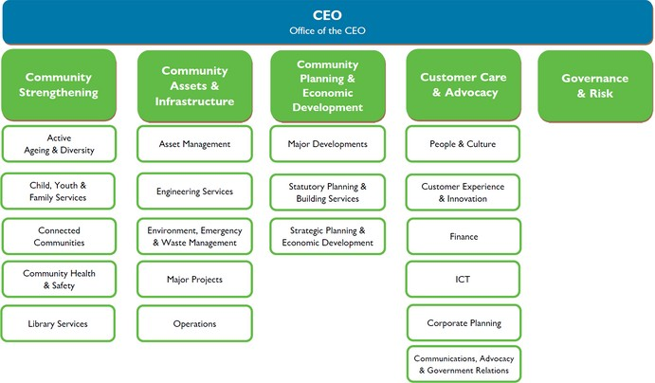As an employer, a service provider and a touch point for all residents, Moorabool Shire Council is in a visible position to role model gender equality, diversity and inclusiveness across our diverse community. We will empower people from all walks of life to contribute and be valued for their broad range of skills and experiences.

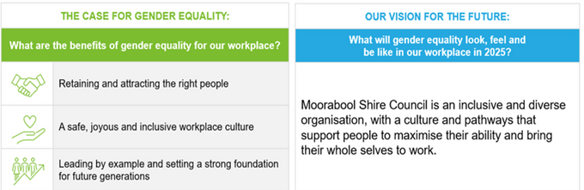

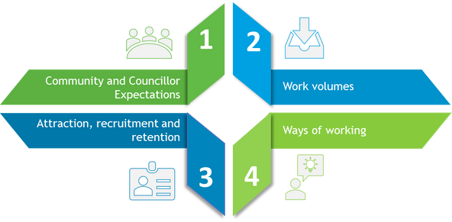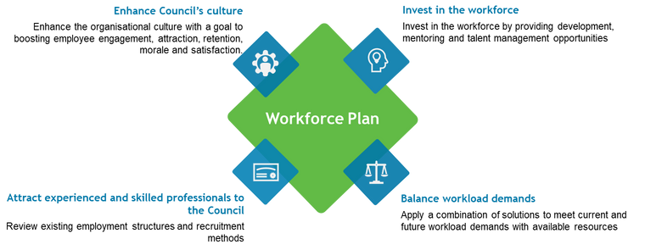

Current Challenges

Workforce Action Plan

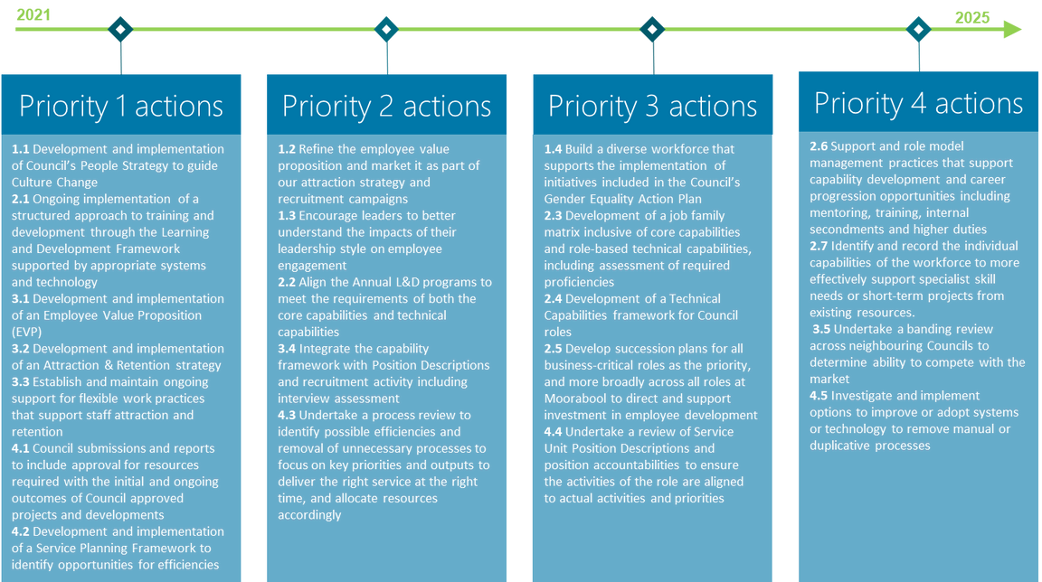

Roadmap to meet future demand

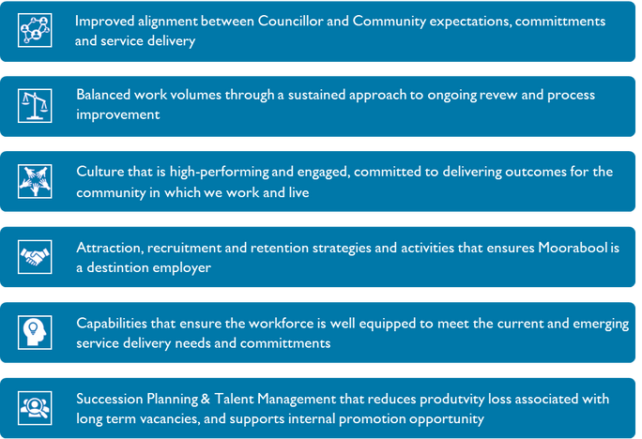

**Measures of Success**