ATTACHMENTS

Ordinary Council Meeting
Under Separate Cover
Wednesday, 7 April 2021

Table of Contents

11.1 LGBTIQA+ Inclusion for Moorabool Shire (NoM No. 293)
Attachment 1
Flag Flying Policy 4
13.1 Establishment of the Maddingley Park Advisory Committee
Attachment 1
Maddingley Park - Advisory Committee Terms of Reference 15
13.2 Establishment of the Bacchus Marsh Racecourse and Recreation Reserve Advisory Committee
Attachment 1
BMRRR - Advisory Committee Terms of Reference 20
14.1 Advisory Committees of Council - Reports
Attachment 1
Minutes - Audit and Risk Advisory Committee Meeting –
9 December 2020 25
15.1 Draft Asset Management Policy
Attachment 1
Draft Asset Management Policy 32
15.2 Draft Management & Maintenance of Unmade Paper Roads Policy
Attachment 1
Draft Management & Maintenance of Unmade Paper Roads Policy 37

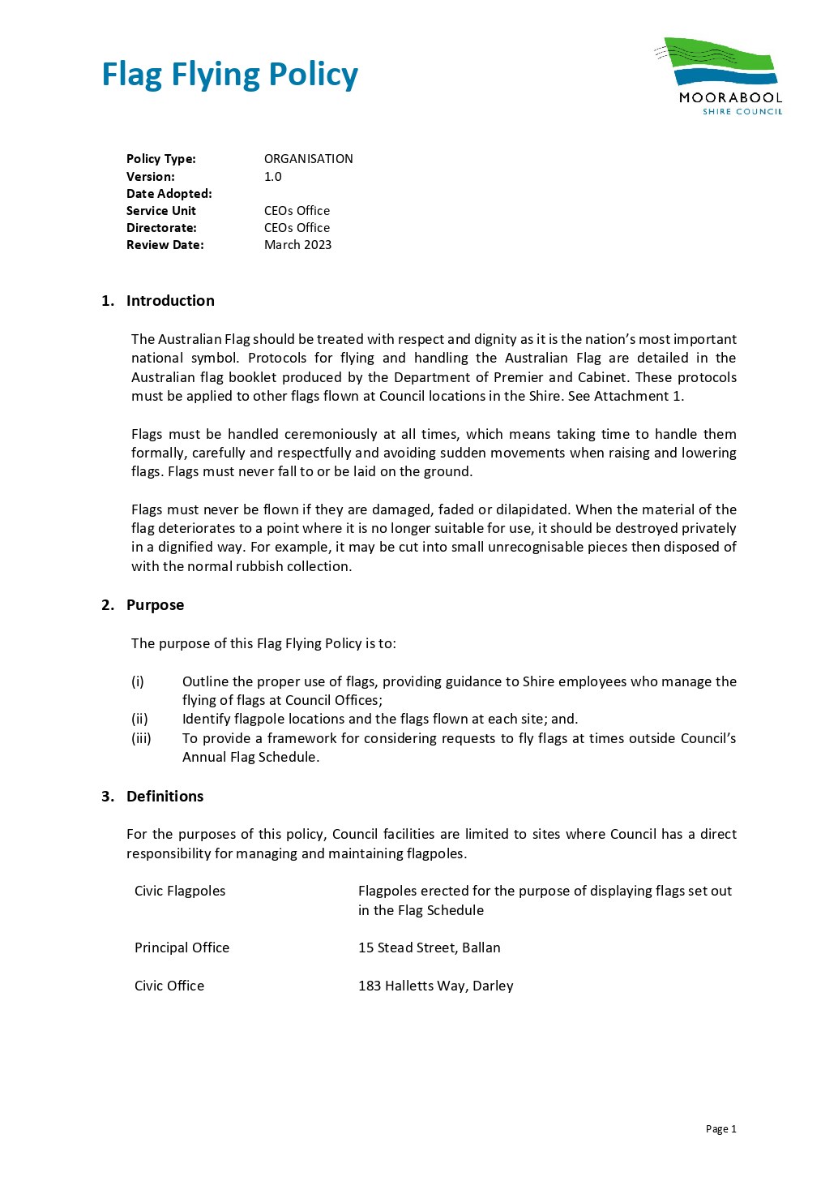

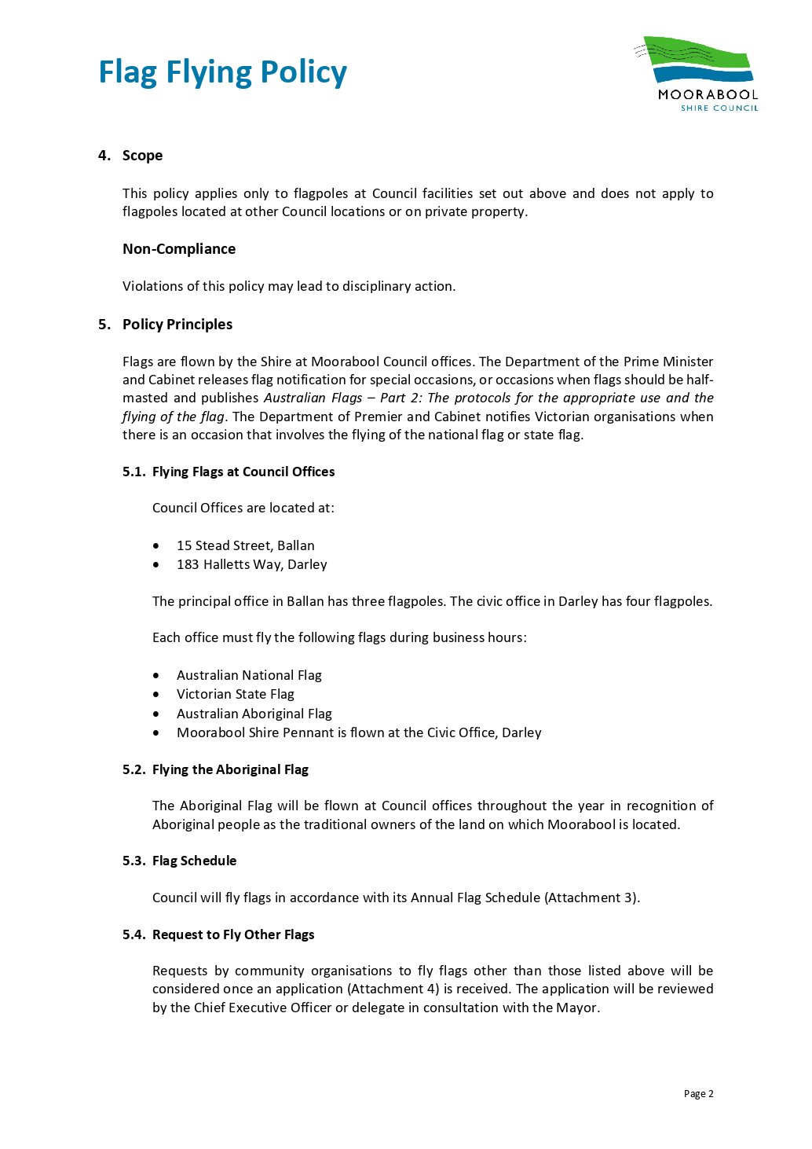

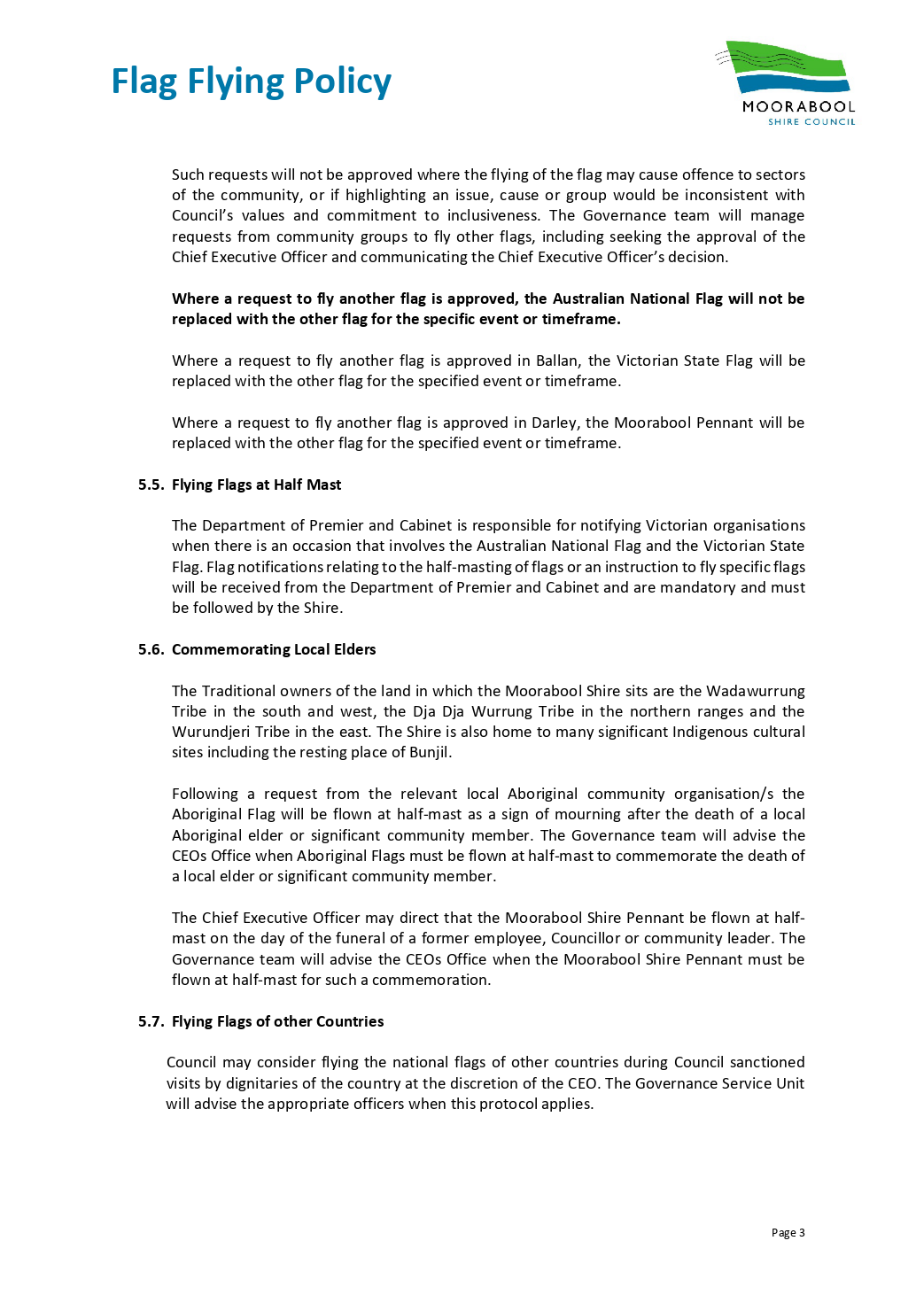

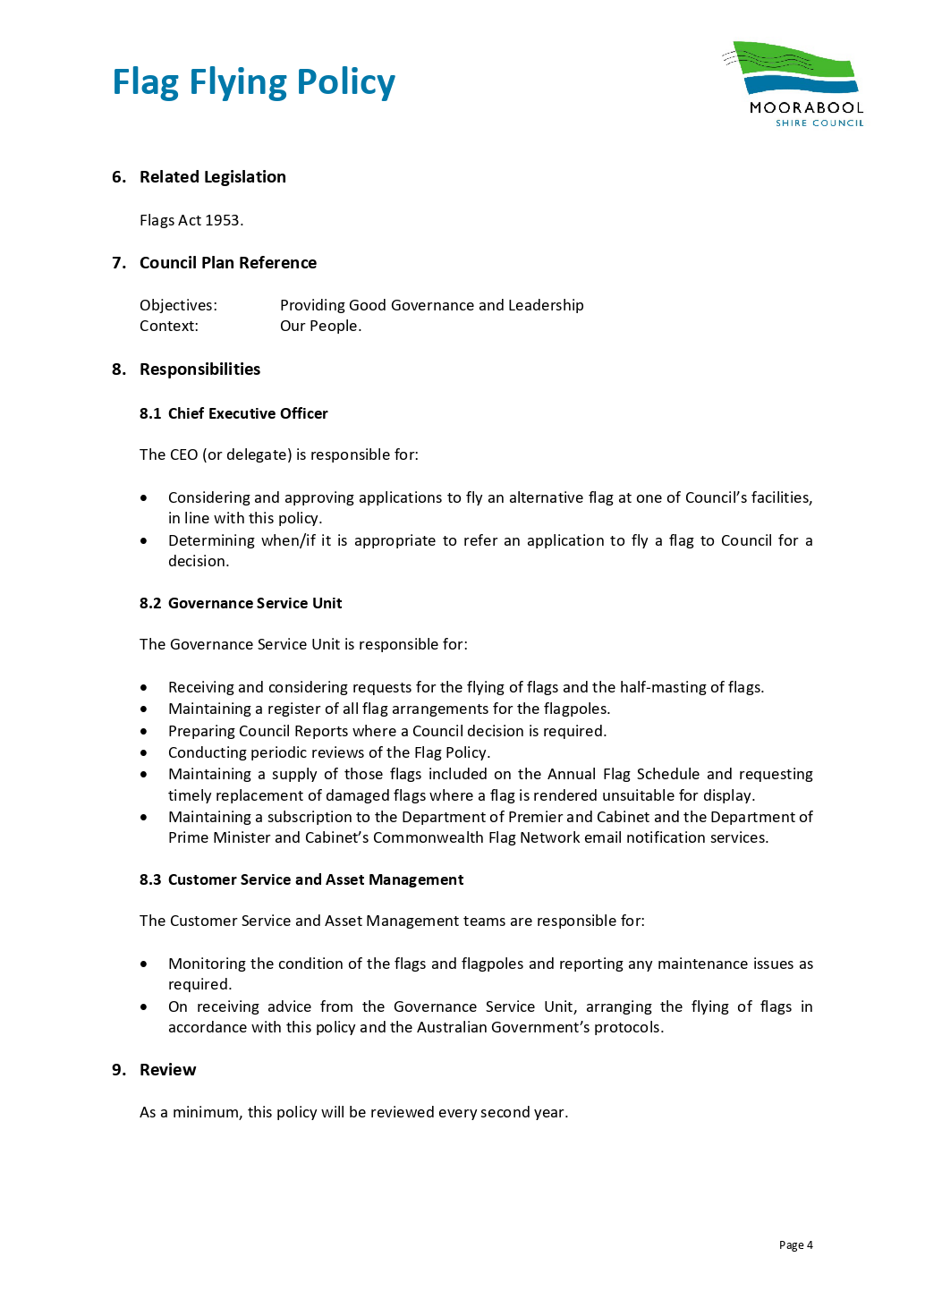

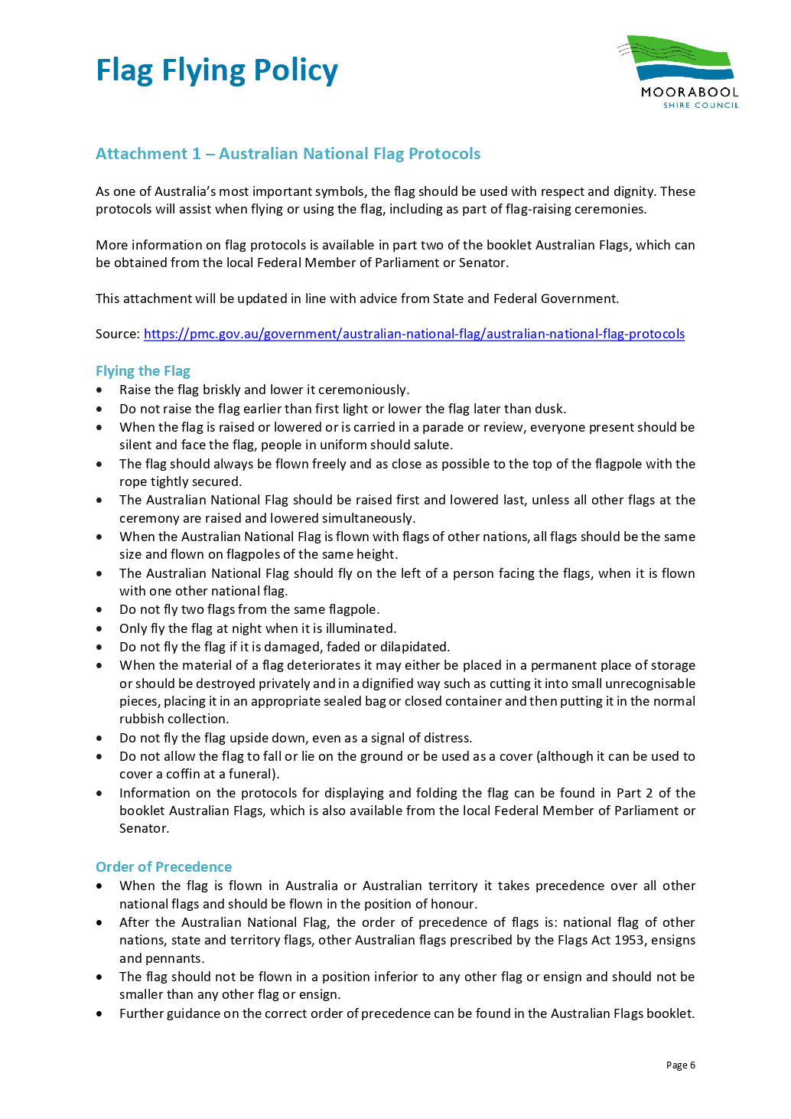

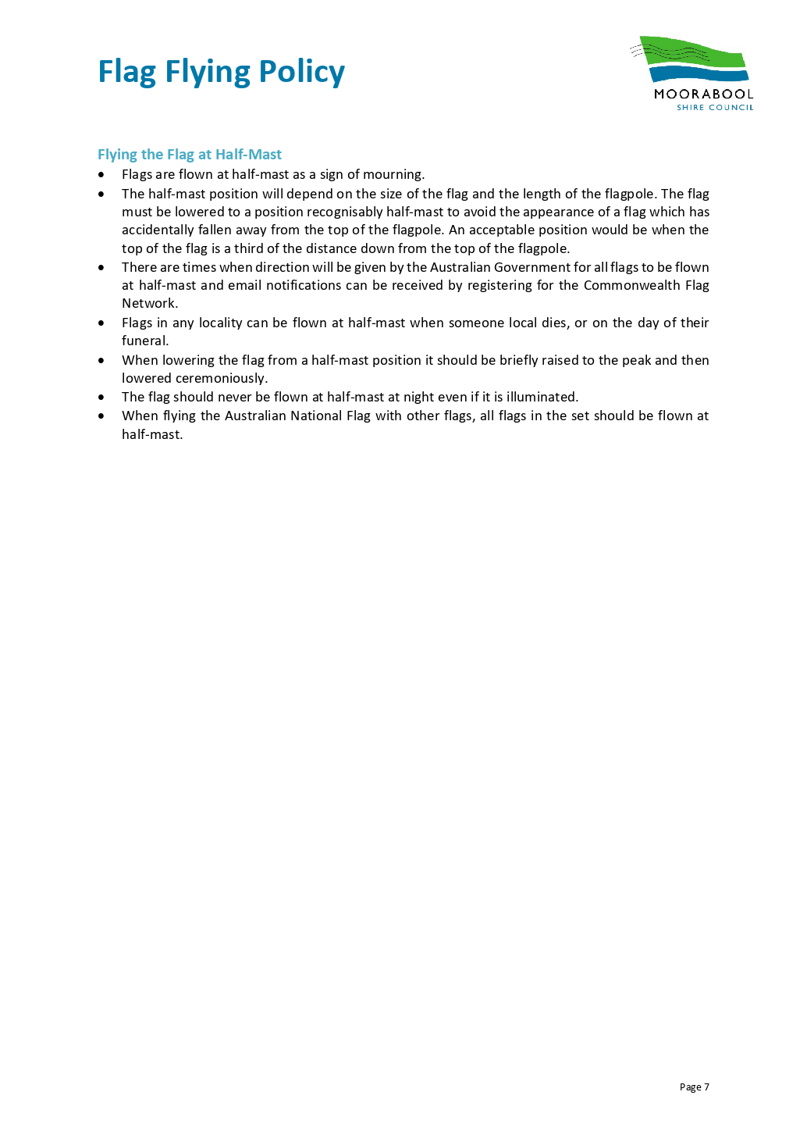

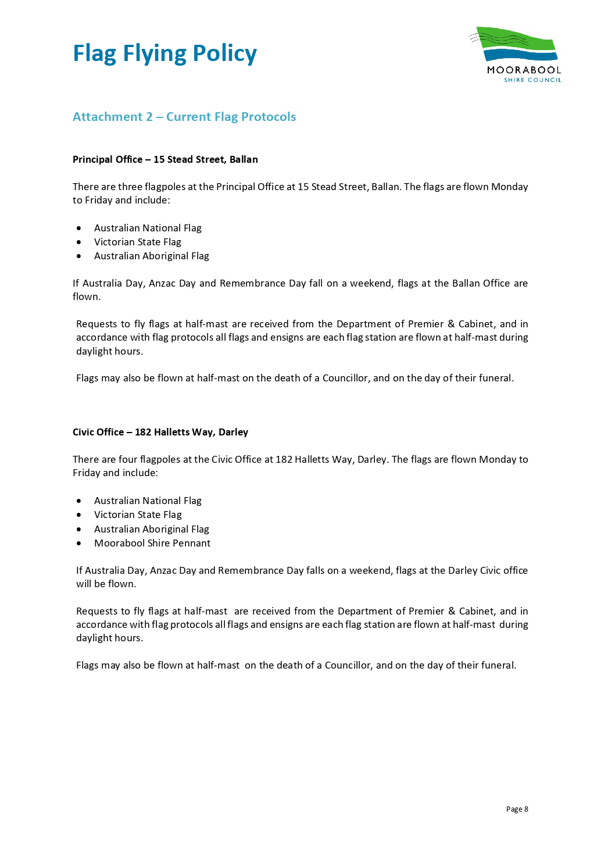

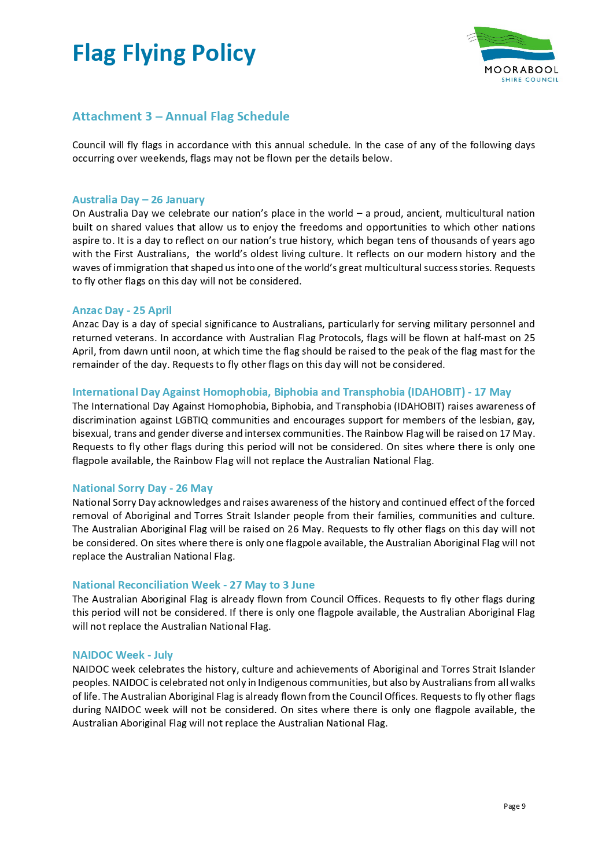

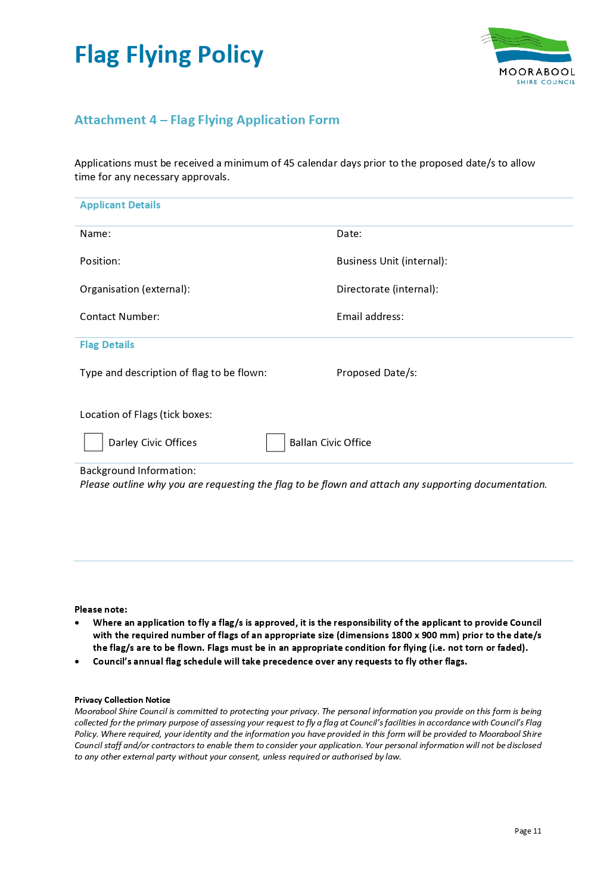

Maddingley Park Advisory Committee
Terms of Reference

1. Purpose
The purpose of Advisory Committees is to support strategy and policy development for the municipality and to ensure Council decisions are evidence based and informed by strong community input.

2. Objectives
The Committee is an Advisory Committee of Council with the primary function of advising Council on matters pertaining to the usage, operations, maintenance and development of Maddingley Park and its associated facilities, as identified by the user groups.

3. Definitions
• Acting Chairperson means a Councillor (appointed as a sub representative) or alternative Senior Council Officer/delegate, in the absence of the Chairperson
• Chairperson means a Councillor or Senior Officer of Council Staff appointed to support the Committee
• Chief Executive Officer means the Chief Executive Officer of Council
• Committee means any Council created Advisory Committee
• Community Member is a member of a Committee who is not a Councillor or a member of Council staff
• Council means Moorabool Shire Council
• Councillor means a Councillor of Moorabool Shire Council

4. Dates, Times and Places of Meetings

4.1 Times and dates of meetings of Council Advisory Committees shall be at the discretion of the Chairperson, after seeking the views of members of the Committee.

4.2 The Advisory Committees will hold a minimum of 3 meetings over the period February – November period inclusive. Additional meetings throughout the period will be subject to the approval of the Chairperson.

4.3 Meetings shall be held at an appropriate location (as determined by Council officers) or conducted virtually if circumstances require.

4.4 An agenda for meetings held, will be sent electronically to each Committee member at least 48 hours prior to the date of each meeting.

5. Membership and Attendance
5.1 Appointments to Committee
a) Council shall seek nominations from the relevant user groups at Maddingley Park for a single representative to be appointed as a Community Member.
b) Council shall seek nominations from the previously appointed Community Representatives that were members of the former Maddingley Park Committee of Management, for appointment as Community Members.
c) The Committee will be convened by Council and shall comprise:
• Council officer/s
• Community Members
- Bacchus Marsh Junior Cricket Club
- Bacchus Marsh Senior Cricket Club
- Bacchus Marsh Junior Football Club
- Bacchus Marsh Senior Football Club
- Bacchus Marsh Netball Club
- Bacchus Marsh Junior Tennis Club
- Bacchus Marsh Senior Tennis Club
- Friends of Maddingly Park
- Community Representatives (in accordance with section 5.1b)
5.2 Term of Appointment
Councillor members shall be appointed for a period, as deemed appropriate, so long as the period of appointment does not extend past the Council term.
The period of appointment for Community members shall be for no longer than the duration of the existing Council term.

5.3 Attendance
A Committee member shall endeavour to advise the Chairperson and/or delegate of non-attendance at any meeting.
5.4 Failure to Attend Meetings
Any member who is unable to attend three (3) consecutive Advisory Committee meetings shall notify the Chairperson or Chief Executive Officer in writing as to his/her availability to continue to be a member of the Committee.
5.5 Resignation of Committee Member
A Committee member may resign from the Committee by advising the Chairperson or Chief Executive Officer in writing.

6. Conflict of Interest and Confidentiality

6.1 Committee Members will enter into a Pledge of Confidentially agreement at the commencement of their term.

6.2 Committee Members must disclose a Conflict of Interest in accordance with the Local Government Act 2020.

6.3 In the event of a Conflict of Interest arising the Committee Member:

a) Must disclose the interest and clearly state the nature of the interest at the meeting before the matter is considered.

b) Must leave the room and not participant in any discussion and/or decision.

c) The disclosure must be recorded in the meeting minutes.

7. Quorum

7.1 A quorum is the majority of appointed members but must include either the Chairperson or Acting Chairperson.

7.2 If a quorum is not present within 30 minutes of the time appointed for the commencement of the meeting, the meeting shall lapse. If a quorum fails after the commencement of the meeting, the meeting shall lapse.

7.3 Business that is unfinished at the completion of a meeting may at the discretion of the Chairperson be referred to the next meeting of the Committee.

8. Chairperson

8.1 Meetings will be chaired by a Councillor or relevant Senior Officer of Council Staff and /or delegate.

8.2 Duties and Discretions

a) must not accept any motion, question or statement which is derogatory, or defamatory of any Councillor, Committee Member, member of Council staff, or member of the community; and

b) must call to order any person who is disruptive or unruly during any meeting.

9. Operations

9.1 Meetings shall be held in accordance with adopted Council meeting guidelines contained in its Governance Rules.

9.2 The Committee has no budgetary responsibilities, decision-making powers or delegated authority but serves to make recommendations for Council’s consideration.

9.3 The Committee shall follow the general consensus principle, when determining its preferred position on matters under discussion.

9.4 Committee members will not publicly comment on behalf of the group. Neither will it seek to advocate on the needs of individual organisations.

9.5 The Council will provide the necessary support to assist the Committee to function effectively including:

a) Maintaining contacts details of members.

b) Preparing and distributing agendas.

c) Preparing and distributing meeting minutes.

10. Sub-Committees

10.1 The Advisory Committee may auspice the establishment of special interest working groups as needed to progress specific initiatives for a defined period of time.

10.2 Subject to the approval of the Committee, these Sub-Committees may invite other members as required to address the specific subject matter at hand.

10.3 All Sub-Committees will comprise two or more Committee Members and may include relevant Council Staff.

11. Media

11.1 Committee Members are not to represent the Committee to the media.

12. Reporting

12.1 Endorsed minutes of the Committee meetings shall be presented to the next practicable Ordinary Meeting of Council.

13. Review

13.1 A review of the role, function, membership and productivity of the Advisory Committee will be conducted as required to ensure currency, effectiveness and stakeholder engagement.

13.2 Council retains the right to:

a) Review, amend or alter the operations and membership of this Committee as it deems appropriate and necessary.

b) Revoke these Terms of Reference at any time.

Bacchus Marsh Racecourse & Recreation Reserve Advisory Committee
Terms of Reference

1. Purpose
The purpose of Advisory Committees is to support strategy and policy development for the municipality and to ensure Council decisions are evidence based and informed by strong community input.

2. Objectives
The Committee is an Advisory Committee of Council with the primary function of advising Council on matters pertaining to the usage, operations, maintenance and development of the Bacchus Marsh Racecourse & Recreation Reserve and its associated facilities, as identified by the user groups.

3. Definitions
• Acting Chairperson means a Councillor (appointed as a sub representative) or alternative Senior Council Officer/delegate, in the absence of the Chairperson
• Chairperson means a Councillor or Senior Officer of Council Staff appointed to support the Committee
• Chief Executive Officer means the Chief Executive Officer of Council
• Committee means any Council created Advisory Committee
• Community Member is a member of a Committee who is not a Councillor or a member of Council staff
• Council means Moorabool Shire Council
• Councillor means a Councillor of Moorabool Shire Council

4. Dates, Times and Places of Meetings

4.1 Times and dates of meetings of Council Advisory Committees shall be at the discretion of the Chairperson, after seeking the views of members of the Committee.

4.2 The Advisory Committees will hold a minimum of 3 meetings over the period February – November period inclusive. Additional meetings throughout the period will be subject to the approval of the Chairperson.

4.3 Meetings shall be held at an appropriate location (as determined by Council officers) or conducted virtually if circumstances require.

4.4 An agenda for meetings held, will be sent electronically to each Committee member at least 48 hours prior to the date of each meeting.

5. Membership and Attendance
5.1 Appointments to Committees
a) Council shall seek nominations from the relevant user groups at the Bacchus Marsh Racecourse & Recreation Reserve for a single representative to be appointed as a Community Member.
b) The Committee will be convened by Council and shall comprise:
• Council Officers
• Community Members (User group representatives)
- Bacchus Marsh BMX Club
- Bacchus Marsh Campdraft Club
- Bacchus Marsh Cricket Club
- Bacchus Marsh Football Netball Club
- Bacchus Marsh Harness Racing Club
- Bacchus Marsh Pony Club
- Bacchus Marsh and Melton Poultry Club
- Footscray Poultry Club
- Bacchus Marsh Soccer Club
- Bacchus Marsh West Golf Club
5.2 Term of Appointment
Councillor members shall be appointed for a period, as deemed appropriate, so long as the period of appointment does not extend past the Council term.
The period of appointment for Community members shall be for no longer than the duration of the existing Council term.

5.3 Attendance
A Committee member shall endeavour to advise the Chairperson and/or delegate of non-attendance at any meeting.
5.4 Failure to Attend Meetings
Any member who is unable to attend three (3) consecutive Advisory Committee meetings shall notify the Chairperson or Chief Executive Officer in writing as to his/her availability to continue to be a member of the Committee.
5.5 Resignation of Committee Member
A Committee member may resign from the Committee by advising the Chairperson or Chief Executive Officer in writing.

6. Conflict of Interest and Confidentiality

6.1 Committee Members will enter into a Pledge of Confidentially agreement at the commencement of their term.

6.2 Committee Members must disclose a Conflict of Interest in accordance with the Local Government Act 2020.

6.3 In the event of a Conflict of Interest arising the Committee Member:

a) Must disclose the interest and clearly state the nature of the interest at the meeting before the matter is considered.

b) Must leave the room and not participant in any discussion and/or decision.

c) The disclosure must be recorded in the meeting minutes.

7. Quorum

7.1 A quorum is the majority of appointed members but must include either the Chairperson or Acting Chairperson.

7.2 If a quorum is not present within 30 minutes of the time appointed for the commencement of the meeting, the meeting shall lapse. If a quorum fails after the commencement of the meeting, the meeting shall lapse.

7.3 Business that is unfinished at the completion of a meeting may at the discretion of the Chairperson be referred to the next meeting of the Committee.

8. Chairperson

8.1 Meetings will be chaired by a Councillor or relevant Senior Officer of Council Staff and /or delegate.

8.2 Duties and Discretions

a) must not accept any motion, question or statement which is derogatory, or defamatory of any Councillor, Committee Member, member of Council staff, or member of the community; and

b) must call to order any person who is disruptive or unruly during any meeting.
9. Operations

9.1 Meetings shall be held in accordance with adopted Council meeting guidelines contained in its Governance Rules.

9.2 The Committee has no budgetary responsibilities, decision-making powers or delegated authority but serves to make recommendations for Council’s consideration.

9.3 The Committee shall follow the general consensus principle, when determining its preferred position on matters under discussion.

9.4 Committee members will not publicly comment on behalf of the group. Neither will it seek to advocate on the needs of individual organisations.

9.5 The Council will provide the necessary support to assist the Committee to function effectively including:

a) Maintaining contacts details of members.

b) Preparing and distributing agendas.

c) Preparing and distributing meeting minutes.

10. Sub-Committees

10.1 The Advisory Committee may auspice the establishment of special interest working groups as needed to progress specific initiatives for a defined period of time.

10.2 Subject to the approval of the Committee, these Sub-Committees may invite other members as required to address the specific subject matter at hand.

10.3 All Sub-Committees will comprise two or more Committee Members and may include relevant Council Staff.

11. Media

11.1 Committee Members are not to represent the Committee to the media.

12. Reporting

12.1 Endorsed minutes of the Committee meetings shall be presented to the next practicable Ordinary Meeting of Council.

13. Review

13.1 A review of the role, function, membership and productivity of the Advisory Committee will be conducted as required to ensure currency, effectiveness and stakeholder engagement.

13.2 Council retains the right to:

a) Review, amend or alter the operations and membership of this Committee as it deems appropriate and necessary.

b) Revoke these Terms of Reference at any time.

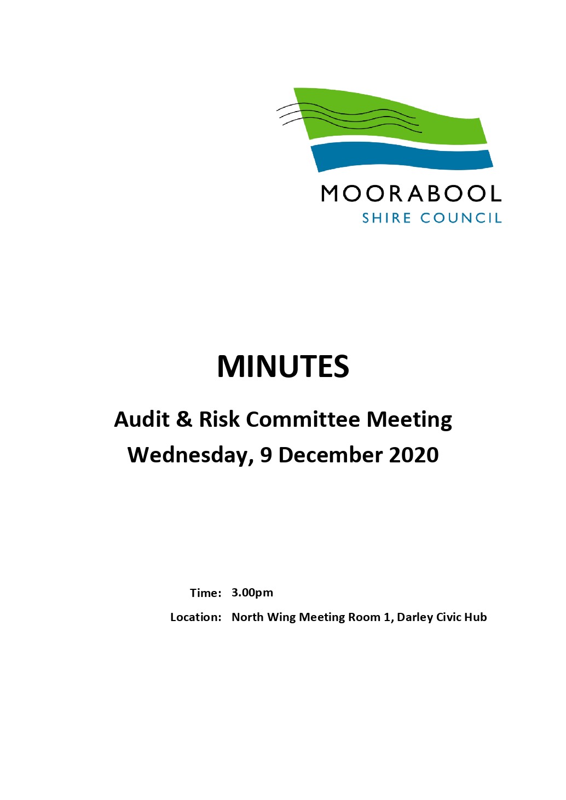

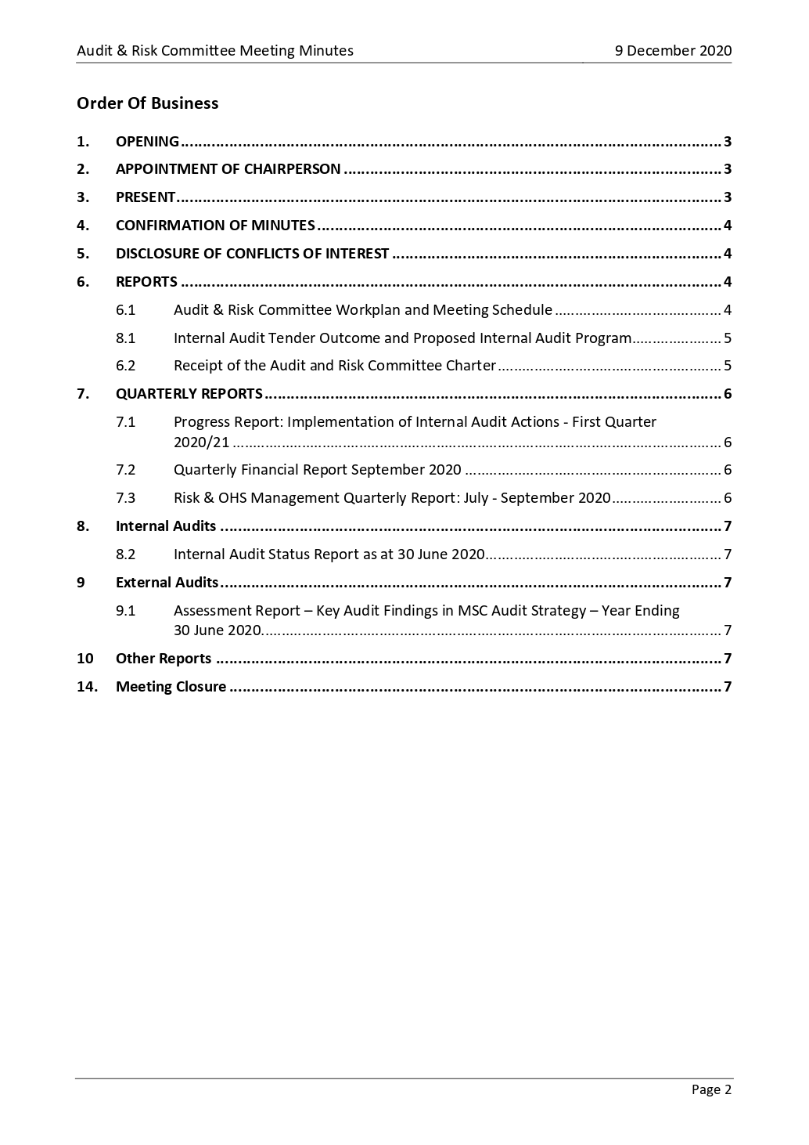

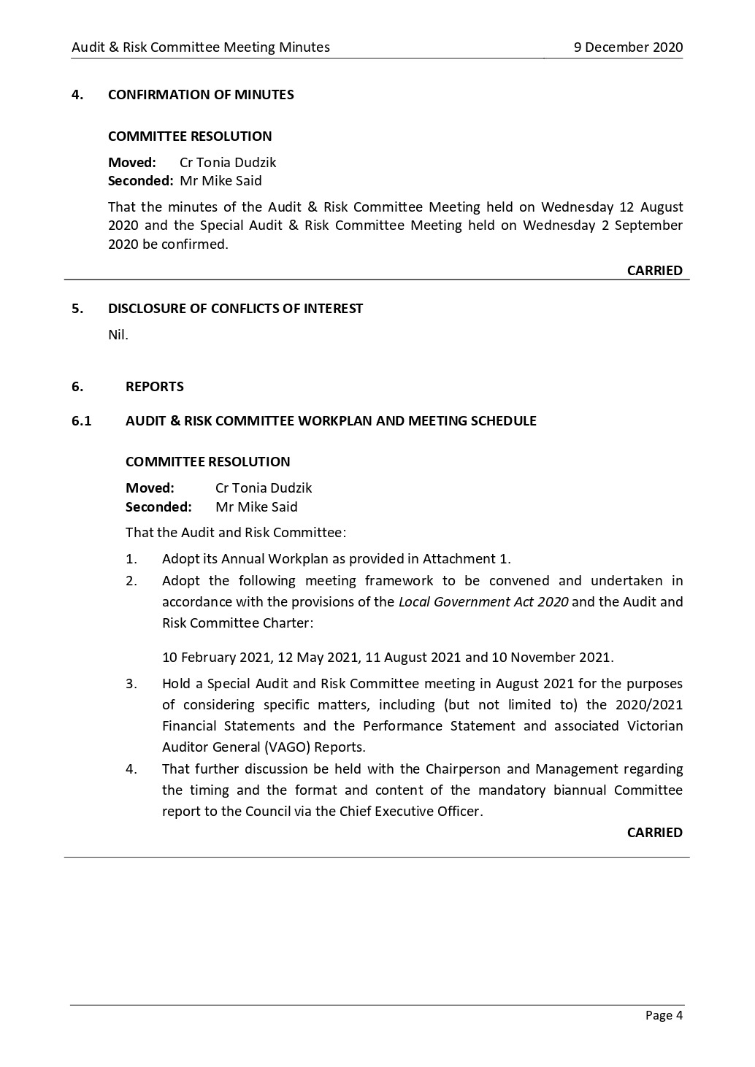

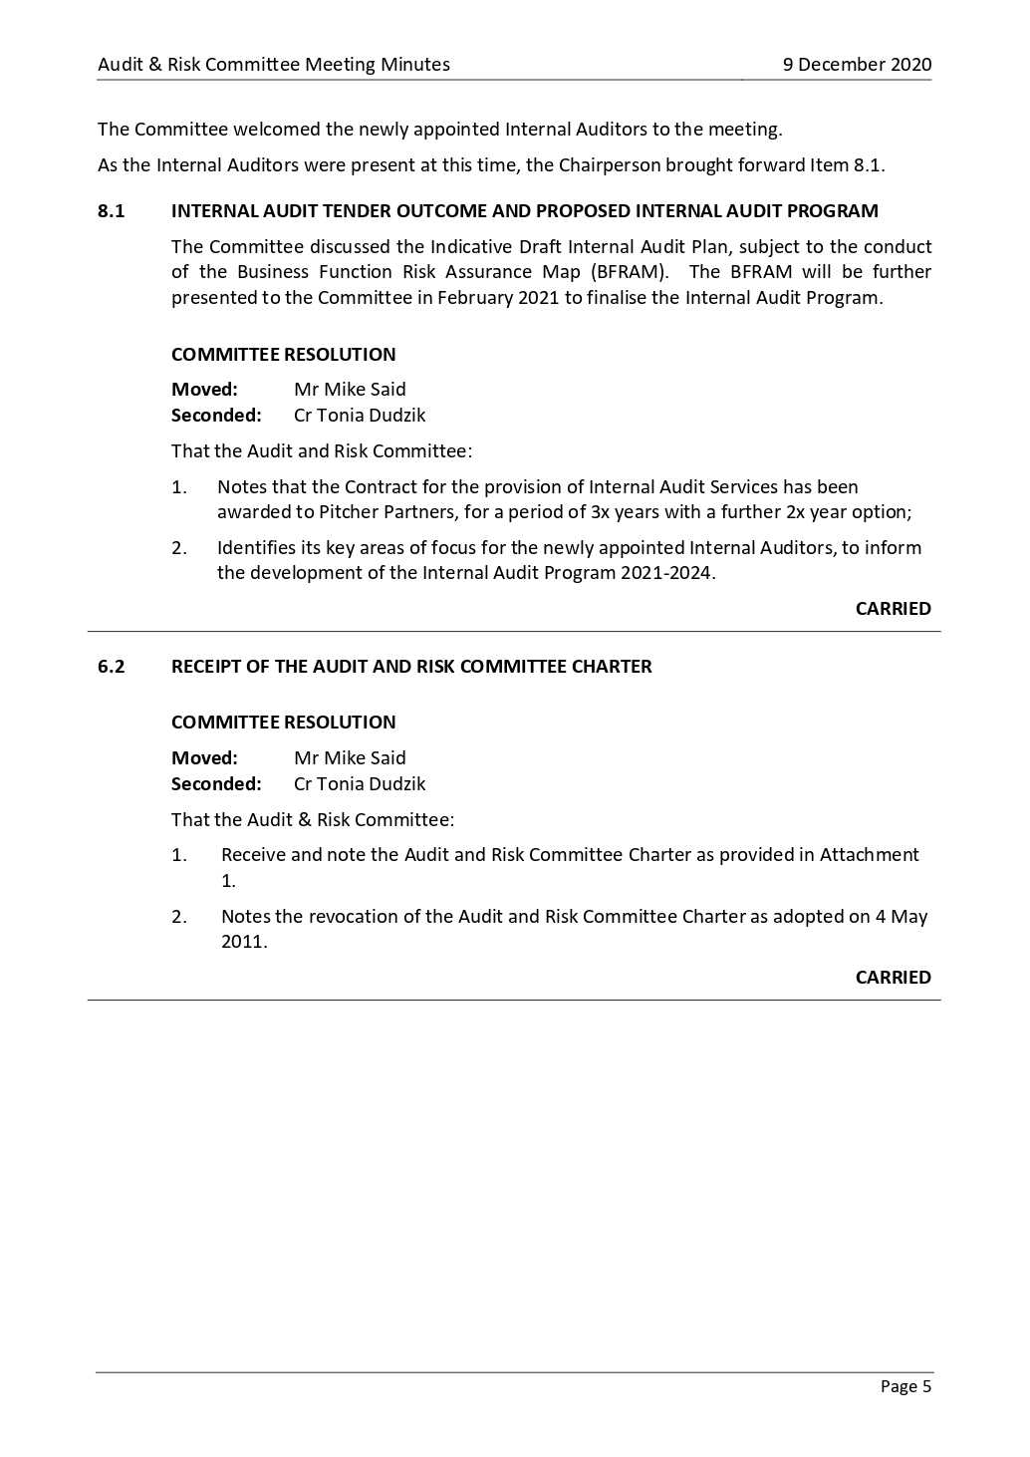

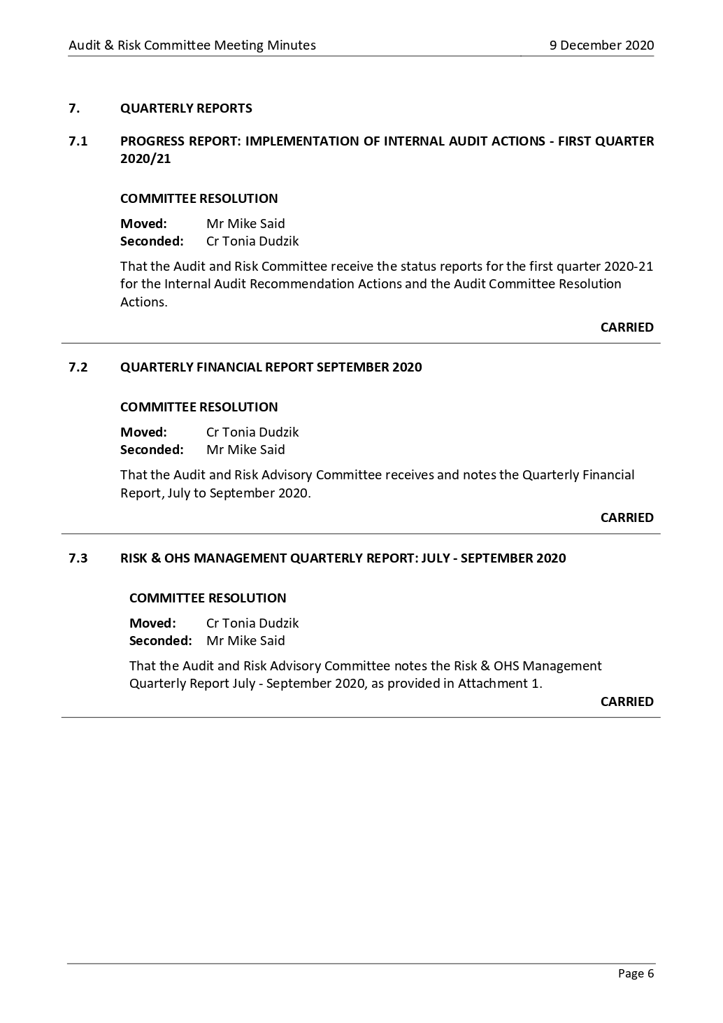

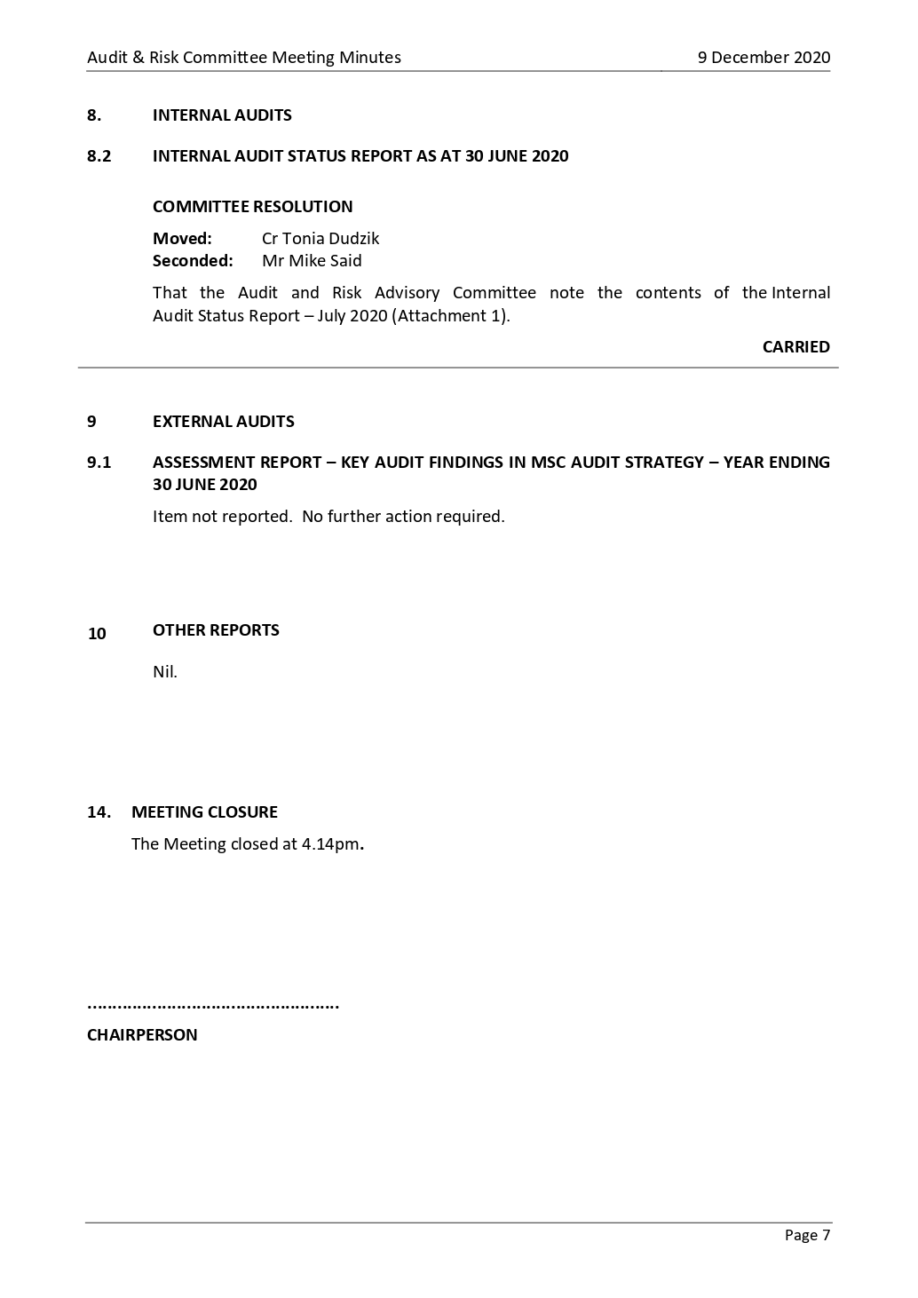

Policy Type: | Council
Version: | 3.0
Date Adopted: | April 2021
Service Unit | Asset Management
Directorate: | Community Assets & Infrastructure
Review Date: | 2024-25

1. Purpose

The purpose of this policy is to acknowledge Council’s commitment to asset management and provide a consistent asset management approach with clear principles and guidelines in order to manage Council’s assets for the current and future community. The policy establishes a framework to ensure a structured, coordinated, cost effective and financially sustainable approach to asset management across the organisation.

2. Context

Moorabool Shire Council is responsible for the management of almost $0.7B of infrastructure assets that support the delivery of services to the local community. As custodian of these assets, Council ensures that they are effectively managed and fit for purpose, so they continue to meet the needs to the growing community whist achieving best value, sustainable outcomes.

Asset management is a core service and is at the centre of Council’s financial and strategic planning decision making. The Local Government Act 2020 requires that Councils have adequate control over their assets and mandates the development and adoption of a ten-year Asset Plan to guide the management of Council assets throughout the asset lifecycle.

Together with the Asset Management Strategy and Asset Plans, it provides a framework for comprehensive, accountable, and transparent asset management practices.

Image 1: Relationship with other strategic asset management documentation

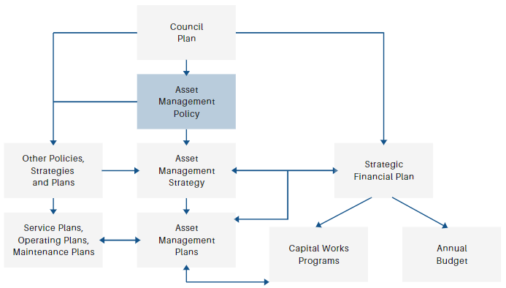

3. Definitions

Asset | A physical asset constructed to provide a service to the community, and which requires management by Council.
Asset Management | The systematic and coordinated activities and practices through which Council optimally manages its physical assets and their associated performance, risks, and expenditure over the assets’ lifecycle.
Asset Management Plans | A tactical plan developed for the management of a class of assets over the lifecycle of that asset in the most cost-effective manner to provide a specified level of service.
Asset Management Strategy | A strategic plan that documents the relationship between organisational objectives and asset management objectives, and defines the framework and actions required to achieve those asset management objectives.
Level of Service | An attribute of service (quantity, quality, availability etc) against which service performance can be measured.
Lifecyle | The cycle of activities that an asset goes through over its life (planning, construction/acquisition, operation, maintenance, renewal, upgrade and/or disposal).
Strategic Financial Plan | The key financial planning document of Council which establishes the financial framework upon which sound financial decisions are made.

4. Scope

This policy relates to all physical infrastructure assets owned and/or managed by Council and contained within its formal asset registers, such as the assets identified below. The policy will also provide high level guidance to Council and its officers in the development and implementation of the Asset Management Strategy and Asset Management Plans.

5. Policy

To ensure that infrastructure assets are fit for purpose and support services that are appropriate, accessible, responsive, timely and sustainable to the community, in accordance with responsible asset management that will preserve the life of the asset and ensure that the community is receiving the best value for money.

5.1. Policy Principles

Council is committed to the following key principles:

▪ Appropriate investment in the renewal of Council owned assets.
▪ Long term financial planning will be guided by asset renewal demand.
▪ Identified asset renewal funding will be considered non-discretionary and new projects will be considered discretionary.

▪ Asset planning and management has a direct link with Council’s strategic documentation (including the Council Plan and Strategic Financial Plan), budgets and reporting processes.
▪ Service delivery guides asset management practices and decisions.
▪ Asset management decisions are based on the benefits and risks of assets and the evaluation of alternative options that take into account full life cycle costs as well as impacts of those costs on the ability to fund future maintenance and renewal.
▪ Grant funded new or upgrade projects are reviewed for whole of life costs as part of the project development process.
▪ Asset Management Plans will communicate information about assets and the actions required to deliver a defined level of service within a best value for money framework.
▪ Asset Management Plans are to be informed by community consultation and integrate with financial reporting frameworks.
▪ Councillors and staff with asset and financial management responsibilities will be appropriately trained in relevant asset and financial management principles, practices, and processes.
▪ Financial and asset management reporting must be categorised in terms of operational, maintenance, renewal, upgrade, expansion, and new expenditure classifications to enable sound asset management decisions.

In order to achieve the above, Council will:

▪ Identify core asset and financial management functions.
▪ Identify gaps between asset management capability and needs.
▪ Through the development and implementation of strategic asset management documentation and ongoing reporting, raise the awareness and understanding of the importance of asset management principles and practices.
▪ Use asset management to ensure that assets support Council’s delivery of service.
▪ Adopt and maintain an Asset Management Strategy and Asset Management Plans.
▪ Facilitate long term integrated decision making by the Council and participative decision making by the community, and subsequent accountability to the community about the asset management activities of the Council.
▪ Give consideration to funding the renewal of existing assets before creating new or upgraded assets.
▪ Incorporate capital renewal demands from the adopted Asset Management Plans into the long-term financial planning process.
▪ Implement asset reporting categorised in terms of operational, maintenance and capital works. Capital works will be further split into sub-categories (new, upgrade, renewal, or expansion) as required in the financial reporting regulations.
▪ Ensure whole of life costs of assets are accounted for in the Asset Management Plans and the Strategic Financial Plan.

5.2. Key Responsibilities

To implement this policy the following key roles and responsibilities are identified:

Council

▪ Act as stewards for Council’s assets.
▪ Adopt Council’s Asset Management Policy, Asset Management Strategy and Asset Management Plans and monitor the outcomes of these.
▪ Adopt sustainable levels of service, budget, risk, and cost standards.
▪ Ensure adequate resources for asset management activities are made available and considered in Council’s Strategic Resource Plan.
▪ Promote and raise awareness of asset management in the community.

Council’s Executive Group

▪ Support and promote the principles of the Asset Management Policy to Council.
▪ Implement the Asset Management Strategy with adequate resources.
▪ Monitor and review the performance of Council staff in achieving the key objectives outlined within the Asset Management Strategy.
▪ Ensure that accurate and reliable information is presented to Council for decision making.
▪ Recommend to Council appropriate levels of service, budgets, risk, and cost standards.
▪ Report on a regular basis, the status of the implementation of the Asset Management Strategy, as required

Asset Management Service Unit

▪ Develop and implement Asset Management Plans for individual asset groups, using principles of lifecycle analysis.
▪ Liaise with Finance in the development of the Strategic Resource Plan.
▪ Coordinate the development of annual and long-term Capital Improvement Programs.
▪ Manage Council’s asset information and report on it under Council’s statutory requirements.
▪ Identify, recognise, and record electronically, the existence of all Council and community owned assets using the standardised asset attributes.
▪ Regularly determine the operational condition of all assets and undertake asset inspections as per service level agreements.
▪ Audit and maintain asset information to ensure statutory requirements are met.
▪ Assist in the determination of the value of assets to verify their remaining useful life and to report on the financial and risk implications under the accounting standards of the day.

Service Managers

▪ Consult with the community in the development of service delivery needs.
▪ Develop, review, and deliver levels of service, to agreed risk and cost standards.
▪ Assist in the development of Asset Management Plans relevant to their service, using the principles of lifecycle analysis.

▪ Assist to develop and implement improvement plans (such as maintenance programs, capital works programs) in accordance with Asset Management Strategy and Asset Management Plan.
▪ Undertake a ‘whole of life costing’ for all capital projects.
▪ Ensure continuous, timely, efficient, and effective service delivery to an agreed community standard.
▪ Liaise with the asset managers.

Maintenance Service Providers

▪ Manage the maintenance of assets under their control to ensure continuous, timely, efficient, and effective service delivery to an agreed level of service.
▪ Undertake asset maintenance inspections and works as per service level agreements.
▪ Proactively identify and advise asset management of asset condition and risk issues as they arise.

Asset Management Steering Committee

▪ Develop a long-term plan for key asset management improvements and identify innovative methods to improve the management of Council’s assets
▪ Monitor the planning and ongoing delivery of asset management improvement actions
▪ Monitor the delivery of asset management functions across Council
▪ Review and provide input into strategic and tactical asset management documentation (strategies, plans and policies)
▪ Review and provide input into asset management reporting (eg. cyclical reporting, Audit Committee and Council reporting)

6. Related Legislation

▪ Local Government Act 2020
▪ Road Management Act 2004
▪ MSC Council Plan
▪ International Infrastructure Management Manual (IIMM) 2015
▪ Australian Infrastructure Financial Management Manual (AIFM) 2015
▪ Applicable Australian Accounting Standards

7. Council Plan Reference

Objectives: Providing good governance and leadership
Context: Our assets and infrastructure

8. Review

This policy will be reviewed in 2024-25, or sooner if there is a requirement due to changes in related policies, procedures, or legislation.

Policy Type: | Council
Version: | 2.0
Date Adopted:
Service Unit | Asset Management
Directorate: | Community Assets & Infrastructure
Review Date: | 2024/25

1. Purpose

The purpose of this policy is to establish a framework for making consistent, structured and justifiable decisions as to whether a road or area of land is reasonably required for general public use and is therefore considered to be a “public road” for the purpose of including it in Council’s Register of Public Roads.

2. Context

Under Section 19(1) of the Road Management Act 2004, ‘A road authority must keep a register of public roads specifying the public roads in respect of which it is the coordinating road authority’. For a road to be included in the register Council has to decide whether ‘… the road is reasonably required for general public use…..’ Section 17(3).

Council is not obliged to assume responsibility for any road until it has made a decision under the Act, that the road is reasonably required for general public use. This policy sets the criteria for when a road will be deemed required for general public use and subsequently added to Council’s Register of Public Roads. The inclusion in the register is an acknowledgement by Council that it is the coordinating road authority with respect to the road, and therefore has the responsibility for its ongoing management and maintenance in accordance with the service levels defined in its Road Management Plan.

’Paper road’ is a term commonly used for a road that is legally established (ie. a designated road reservation is recorded in survey plans) but the physical road has not formally been constructed. Paper roads typically comprise a natural surface generally cleared for access to property and formed only with a worn path from local vehicle usage. Paper roads are not uncommon, with several hundred kilometres throughout the Shire. Although the public have the right to access these road reservations at any time, they are not included on Council’s Register of Public Roads and as such, are not managed or maintained by Council.

3. Policy Objectives

This policy will specify the criteria for the expansion of Council’s existing road network considering a range of impacts and providing a framework for making consistent, structured and justifiable decisions as to whether a road or area of land should be included on Council’s Register of Public Roads.

4. Definitions

Public Highway | Any road area over which the public may pass as a right (all Government Roads are Public Highways).
Maintained Road | A constructed road that has been included in Council’s Register of Public Roads and is therefore managed and maintained in accordance with its Road Management Plan.
‘Paper’ Road | ‘Paper road’ is a term commonly used for a road that is legally established and recorded in survey plans, but the physical road has not been formally constructed. They typically comprise a natural surface and exist only on paper. Paper roads are not included on Council’s Register of Public Roads.
Private Access Roads | Tracks that may provide access to land parcels and have the characteristic of a private driveway. In addition, a small number of constructed roads within the Shire are private roads owned and managed by an owner’s corporation. Council is not responsible for these roads and they are not included in the Register of Public Roads.
Fire Access Tracks | Formed or unformed tracks which have been identified by the Country Fire Authority (CFA) specifically to provide access for emergency vehicles and are listed within Council’s Municipal Fire Management Plan.

5. Scope

This policy relates to paper roads within the local road network in Moorabool Shire. It does not apply to roads or road reservations under the management of other authorities such as Regional Roads Victoria, the Department of Environment, Land, Water & Planning, water authorities or private access roads.

6. Policy

Responsibility for Maintenance of Paper Roads

Council is not obliged to assume responsibility for any paper road until it has made a decision under the Road Management Act 2004 that the road is reasonably required for general public use and includes the road on its Register of Public Roads. These roads have typically been constructed by Council or by another party to Council standards and formally handed over to and accepted by Council.

Should a landowner/s require access to private property via a paper road, the cost of any maintenance of that road is the responsibility of the land owner/s who use the road for access. Property owners may also choose to upgrade the section of road to a standard lower than Council would accept (akin to a driveway) to access their property, however this will be at their own cost and continued maintenance responsibility.

Paper roads may also be subject to a license by adjacent land owners under the Land Act. Similarly, in such circumstances, Council would not include this section of road in the public register nor undertake any road maintenance.

Although there is no obligation to undertake maintenance on paper roads, the following exceptions may apply:

• Maintenance of fire access tracks as defined by the CFA and Municipal Fire Management Plan.
• To reduce fire risk at the request of the CFA.
• Where there is an identified hazard or risk of significant injury, or other legislative requirement (ie. weed control, drainage etc) considered on a case by case basis.

Upgrading Paper Roads

Council will accept written applications from residents to formally construct a road and applications will be generally assessed against the criteria outlined in this policy.

Conditions and standards of construction will typically be in accordance with the Infrastructure Design Manual (IDM) and relevant engineering standards. The General Manager Community Assets & Infrastructure has the authority to amend these requirements appropriate to the situation.

The formation/construction of a road (through any mechanism) to Council standards does not automatically imply that Council will include the road in the Register of Public Roads and assume management and maintenance responsibility. Council as a rule will only take on the management and maintenance of a road subject to the availability of funds, if it provides wider community benefit and if it satisfies the following minimum criteria, determining it ‘reasonably required for public use’.

Mandatory Criteria (both must be satisfied)

▪ The road is a public highway
▪ The road has been constructed to a standard acceptable to Council or Council has previously constructed the road

Non-mandatory Criteria (at least 6 must be satisfied)

▪ The road provides primary access to at least one full time occupied residence
▪ The construction of the road provides clear benefit to more than one property owner
▪ The road provides access to public open space, community facilities, sporting facilities or car parking areas
▪ The road is named and signed
▪ The road has previously been regularly maintained by Council
▪ The road contains assets owned and maintained by public service authorities (eg. gas, electricity, telecommunications, sewerage or water)
▪ The road connects into and forms part of the wider network of public roads
▪ The road is fenced on both sides
▪ The road has a minimum estimated average daily traffic count of 40 vehicles per day

Where a section of road does meet the above and is determined as reasonably required for public use, it does not automatically imply that Council will include the road in the Register of Public Roads and assume management and maintenance responsibility in every scenario. The set of criteria has however, been developed in order to reasonably consider the financial impacts on Council, management and maintenance implications, as well as a wider community benefit.

Where a section of road meets the above criteria and it is determined that it should be included on Council’s Register of Public Roads, it will be assigned a hierarchy and managed and maintained in accordance with Council’s Road Management Plan.

Under the Road Management Plan, the General Manager Community Assets & Infrastructure is delegated the authority to approve amendments to the register to ensure its ongoing currency.

7. Related Legislation

▪ Land Act 1958
▪ Forests Act 1958
▪ National Parks Act 1975
▪ Crown Land (Reserves) Act 1978
▪ Subdivisions Act 1988
▪ Local Government Act 2020
▪ Road Management Act 2004

8. Council Plan Reference

Objectives: Providing good governance and leadership
Context: Our assets and infrastructure

9. Review

This policy will be reviewed in 2024-25, unless required sooner as a result of changes to related policies, procedures or legislation.

