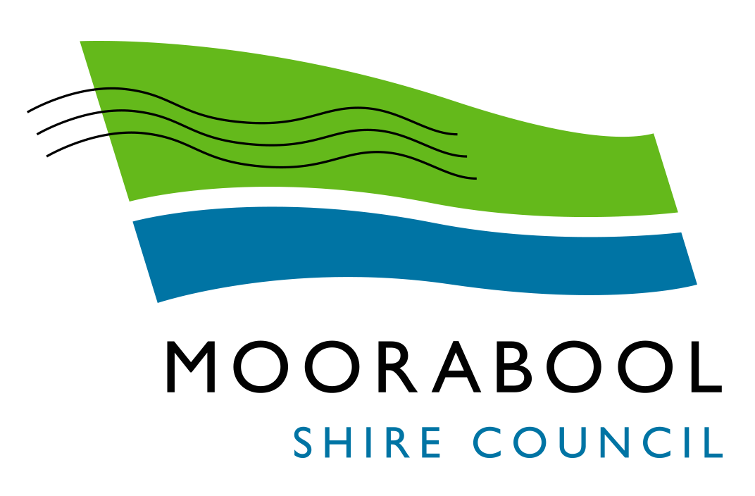
AGENDA

Moorabool Growth Management Committee Meeting
Wednesday, 2 December 2020
I hereby give notice that a Moorabool Growth Management Committee Meeting will be held on:
Date: | Wednesday, 2 December 2020
Time: | 5.00pm
Location: | Darley Civic & Community Hub
Derek Madden
Chief Executive Officer

Order Of Business
1 Opening 4
2 Present and Apologies 4
3 Recording of Meeting 4
4 Confirmation of Minutes 4
5 Matters Arising from Previous Minutes 4
6 Disclosure of Conflicts of Interests 4
7 Update on Trends, Issues and Other Matters 5
8 Process Forward and Work Program 5
9 Update on VCAT Decisions 5
10 Other Business 5
11 Date of Next Meeting 5
12 Closed Session of the Meeting to the Public 5
12.1 Ballan Growth Area Update 5
12.2 Bacchus Marsh Growth Area Update 5
13 Meeting Close 6

1 Opening

2 Present and Apologies

3 Recording of Meeting
As well as the Council for its minute taking purposes, the following organisations have been granted permission to make an audio recording of this meeting:
- The Moorabool News; and
- The Star Weekly.

4 Confirmation of Minutes
Moorabool Growth Management Committee Meeting - Wednesday 2 September 2020

5 Matters Arising from Previous Minutes

6 Disclosure of Conflicts of Interests
Conflict of interest laws are prescribed under the Local Government Act 2020 (the Act) and in the Local Government (Governance and Integrity) Regulations 2020 (the Regulations). Managing conflicts of interest is about ensuring the integrity and transparency of decision-making.
The conflict of interest provisions under the Act have been simplified so that they are more easily understood and more easily applied. The new conflict of interest provisions are designed to ensure relevant persons proactively consider a broader range of interests and consider those interests from the viewpoint of an impartial, fair-minded person.
Section 126 of the Act states that a Councillor has a conflict of interest if they have a general conflict of interest or a material conflict of interest. These are explained below:
- A Councillor has a general conflict of interest in a matter if an impartial, fair-mindedperson would consider that the members private interests could result in themacting in a manner that is contrary to their public duty as a Councillor.
- A Councillor has a material conflict of interest in a matter if an affected personwould gain a benefit or suffer a loss depending on the outcome of the matter.
A relevant person with a conflict of interest must disclose the interest in accordance with Council’s Governance Rules and not participate in the decision-making process on the matter. This means the relevant person must exclude themselves from any discussion or vote on the matter at any Council meeting, delegated committee meeting, community asset committee meeting or, if a councillor, any other meeting conducted under the auspices of the council. The relevant person must also exclude themselves from any action in relation to the matter, including an action taken to implement a council decision, for example, issuing a planning permit.

7 Update on Trends, Issues and Other Matters

8 Process Forward and Work Program

9 Update on VCAT Decisions

10 Other Business

11 Date of Next Meeting

12 Closed Session of the Meeting to the Public

Recommendation
That Council considers the confidential reports listed below in a meeting closed to the public in accordance with Section 66(2)(a) of the Local Government Act 2020:

12.1 Ballan Growth Area Update

12.2 Bacchus Marsh Growth Area Update

13 Meeting Close

